

E.111

Health New Zealand | Te Whatu Ora

Statement of Intent

1 July 2024–30 June 2028

Citation: Health New Zealand. 2024. *Statement of Intent for Health New Zealand | Te Whatu Ora for the period 2024 to 2028*. Wellington: Health New Zealand.

Presented to the House of Representatives pursuant to section 149 of the Crown Entities Act 2004.

Published in December 2024 by Health New Zealand | Te Whatu Ora

PO Box 793, Wellington 6140, New Zealand

ISSN 3021-2170 (online)



This document is available at [**tewhatuora.govt.nz**](https://www.tewhatuora.govt.nz/)

|  |  |
| --- | --- |
| **CCBY** | This work is licensed under the Creative Commons Attribution 4.0 International licence. In essence, you are free to: share i.e., copy and redistribute the material in any medium or format; adapt i.e., remix, transform and build upon the material. You must give appropriate credit, provide a link to the licence and indicate if changes were made. |

Contents

Foreword from the Commissioner 4

Introduction 6

Who we are 6

Our purpose and objectives 6

We work with others for better healthcare and health outcomes 7

Our operating context 8

The health of our population 8

There are opportunities to improve 9

Funding change sustainably 10

Te Tiriti o Waitangi 10

Iwi Māori Partnership Boards 11

Hauora Māori Advisory Committee 11

We uphold Te Mauri o Rongo 12

Our strategic framework 13

Achieving the vision of timely access to quality healthcare 15

Deliver the NZ Health Plan 15

Empower and enable leadership at all levels 16

Measuring our performance 17

Our performance framework 17

Outcome measures 20

Intermediate Outcomes 22

Impact Measures 30

Our organisational capability 34

Supporting and sustaining our workforce 34

Looking after our people 34

A diverse and inclusive workforce 35

Being a good employer 35

A sustainable organisation 35

Building data-led knowledge to drive change 36

Managing our assets and capital investment 37

Managing our finances 39

# Foreword from the Commissioner

I am pleased to present this Statement of Intent for Health New Zealand I Te Whatu Ora (Health NZ).

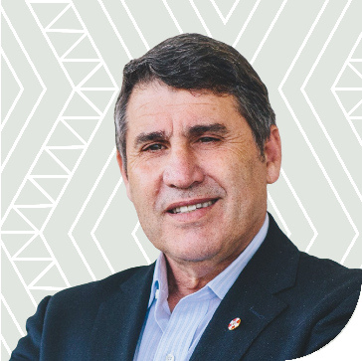Our role at Health NZ is to provide quality, compassionate, affordable healthcare to New Zealanders, at the right time and in the right place.

In July 2024, I was appointed Commissioner by the Minister of Health and tasked with implementing a turnaround plan to return Health NZ to live within its budget and provide timely access to quality healthcare. Health NZ has received a significant funding uplift from the government in Budget 2024/25 and it is important that we use that funding and all our resources efficiently and effectively to strengthen the frontline and support better health outcomes.

The Chief Executive, Deputy Commissioners and I have moved swiftly to initiate Health NZ’s financial turnaround and ensure that the appropriate, effective financial and management controls are in place across the organisation. We also plan to embed a culture of accountability for clinical and financial performance throughout the organisation.

We are undertaking a reset of the way Health NZ operates which is very challenging given current performance. We are determined that New Zealanders receive the health care they need and deserve. We also want our committed, compassionate and skilled health workforce to be supported and empowered in their work of delivering high quality and compassionate health care to their communities. We have substantial work to do to create the type of clinical culture that ensures work is rewarding for all.

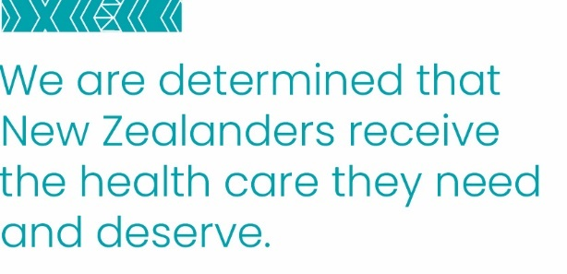The reset includes a devolved model of decision-making empowering regions to make decisions closer to home about how health care is delivered for local communities. Four new establishment Deputy Chief Executive roles are responsible for these devolved services with the focus on delivering on the Government’s national health targets and mental health and addiction targets as well as restoring the organisation to financial health.

It will take time to address many of our system challenges such as a reduction of waiting times but we are determined to make very tangible year-on-year progress over the next four years.

**Professor Lester Levy,** CNZM   
Commissioner, Health New Zealand   
14 November 202

# Introduction

Health NZ was established on 1 July 2022 under the Pae Ora (Healthy Futures) Act 2022 (the Pae Ora Act). It replaced the 20 district health boards (DHBs), seven shared service agencies, and absorbed some functions from the Ministry of Health.

## Who we are

We lead the day-to-day delivery of publicly funded health services. Many of these services are delivered directly by Health NZ (e.g. hospital services), and other services are funded by us through contracts with other health sector providers (e.g. primary and community care).

On 5 March 2024, Parliament passed the Pae Ora (Disestablishment of the Māori Health Authority) Amendment Act 2024 to disestablish the Māori Health Authority from 30 June 2024.

On 1 April 2024, some of the functions of the Māori Health Authority were transferred to Health NZ, including planning and commissioning of Māori health services and support for Iwi Māori Partnership Boards.

The funding set aside for delivering hauora Māori services remains as a separate appropriation within Health NZ.

Note, as this Statement of Intent (SOI) is being finalised during a time of change for Health NZ there could be instances where the information included becomes out of date or incorrect. Should this occur the Crown Entities Act (S148 and S149k) provides for the entity to produce a revised version.

## Our purpose and objectives

The purpose of the Pae Ora Act is to fund and provide services to:

* protect, promote and improve the health of all New Zealanders,
* achieve equity in health outcomes among New Zealand’s population groups, including by striving to eliminate health disparities, in particular for Māori, and

build towards pae ora (healthy futures) for all New Zealanders.

Health NZ’s five objectives under the Act are to:

* design, arrange, and deliver services to achieve the purpose of the Act in accordance with the health sector principles,
* encourage, support, and maintain community participation in health improvement and service planning,
* promote health, and prevent, reduce, and delay ill-health, including by collaborating with other agencies, organisations, and individuals to address health determinants,
* achieve the best possible health outcomes for all New Zealanders,

ensure that planning and service delivery respond to the population’s aspirations and needs.

## We work with others for better healthcare and health outcomes

Operating and improving the delivery of publicly funded healthcare services depends on close relationships with others. These include working with consumer groups, professional bodies, unions, non-government organisations, government agencies, Primary Health Organisations (PHOs), general practice teams, pharmacies, and communities who are active contributors to and co-designers of better health services and outcomes.

This means that the responsibility for delivery on some of our major objectives and measures may be shared across a range of stakeholders.

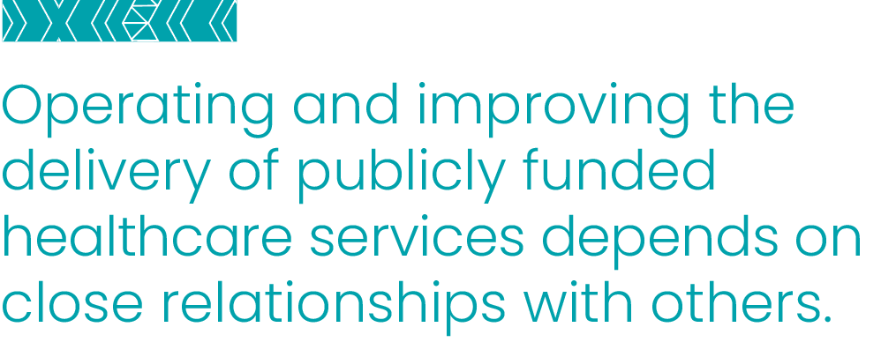We engage with Māori and work alongside Iwi Māori Partnership Boards to ensure that we stay informed of Māori perspectives on the needs and aspirations of Māori in health, and on the design and delivery of health services.

# Our operating context

Health NZ is working towards building a more joined-up approach to delivery and funding of health services that provides better health experiences and outcomes for people, their whānau and communities.

## The health of our population

Our [**Health Status Report**](https://www.tewhatuora.govt.nz/assets/Publications/Health-status-reports/HNZ-TWO-Health-Status-Report_FULL.pdf) shows New Zealanders are living longer lives, compared to other countries – we rank sixteenth in the world. Overall life expectancy is 82 years, a three-year increase over the past two decades.

These improvements, however, are not universal across the population. Life expectancy is lower for Māori, Pacific peoples, disabled people | tāngata whaikaha, and people living in low socioeconomic areas. These groups are more likely to experience long-term health conditions that impact life expectancy and quality of life, such as respiratory conditions, poor mental health, diabetes, cancers, and cardiovascular disease. In addition, other important (and preventable) causes of health loss include communicable diseases and injuries, particularly for children and young people.

Although 88% of adults report their health as excellent, very good or good, people experience long waits for healthcare, full emergency departments and longer stays in hospital than needed.

Access and timeliness challenges stem from both supply and demand issues. Many community providers are at capacity, hospitals are often full, and preventative services (e.g. immunisation) are not easily accessible for everyone.

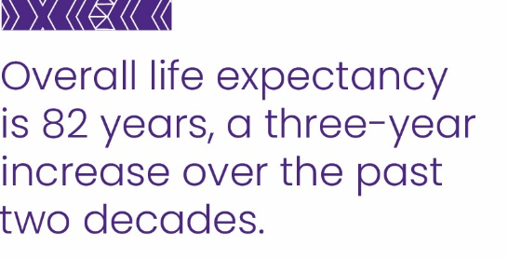We are not alone in facing these challenges. Australia, Canada and the United Kingdom face similar and significant service pressures.

Health service demand is expected to further increase because of a growing and ageing population.

## There are opportunities to improve

We can enhance primary and community care, as well as care in hospital settings, by ensuring that we have a skilled and capable workforce, delivering timely care, to better meet the needs of diverse patients, whānau and communities.

Across publicly funded healthcare services more broadly:

* We can reduce unwarranted variation, so people get the care they need by assisting clinicians and consumers with a clear route through the system (health pathways) and use national clinical networks to the full extent
* Better access to primary and community care will mean improved prevention, early detection, and management of non-communicable diseases and more New Zealanders are vaccinated against communicable diseases
* We can continue our work to modernise our buildings and upgrade much of our supporting infrastructure around New Zealand, and invest in health technology that can help us deliver quality healthcare to more New Zealanders
* Empowering regional decision-making and accountability provides an opportunity to tailor health service delivery to meet local needs

Strengthening clinical leadership will ensure a clinical lens across decision making at all levels.

It will also be important to work with others to have an impact on the many determinants of health – social, environmental, commercial and others.

## Funding change sustainably

**Our focus must be on delivering more healthcare for New Zealanders while living within the taxpayer resource we have been allocated.**

We need new ways of working to meet our significant budget challenges while striving to ensure people don’t wait too long for the care they need. This includes moving decision making closer to patients and communities where care is provided.

This means better understanding our productivity challenges and improving monitoring of impacts and outcomes achieved for the money spent.

This will enable money to be allocated for best results, using divestment as well as investment processes to ensure value-for-money. In these ways, we will ensure the health system’s financial sustainability.

Over the next four years, we will:

* Enable a culture shift from a cost-plus to an evidence-based, outcomes and sustainability focused approach for all health investment and disinvestment.
* Review all contracts on a rolling basis for alignment with priorities, effectiveness and value for money.
* Ensure year-on-year improvements in productivity and sustainability, and regular reporting on both.
* Improve visibility of expenditure and service delivery for key priorities and population groups.

Continue foundational work to understand cost structures and funding flows across the system.

## Te Tiriti o Waitangi

Health NZ acknowledges the enduring inequity in health outcomes experienced by some population groups in New Zealand, including Māori. The establishing legislation of Health NZ, the Pae Ora (Healthy Futures) Act 2022 (Pae Ora Act) acknowledges those populations with specific strategies including Pae Tū the Hauora Māori Strategy, intended to improve the health sector for Māori and improving Māori outcomes. We will work closely with Iwi-Māori Partnership Boards in holding ourselves accountable for equitable outcomes.

## Iwi Māori Partnership Boards

Iwi Māori Partnership Boards are central to the health reforms, championing the perspectives of Māori communities in a specific rohe (geographical area). The Boards represent the Māori communities in their area and therefore their representation may include iwi, mātāwaka (tangata whenua who are not mana whenua to the rohe), whaikaha and hauora Māori experts.

Fifteen Iwi Māori Partnership Boards are now established. Their functions include:

* engaging with whānau, hapū, and hapori Māori about local health needs and communicating these insights to Health NZ.
* evaluating hauora Māori locally to determine priorities for improvement.
* monitoring the performance of the local health system.
* reporting to local Māori on the activities of Health NZ.

engaging with Health NZ on hauora Māori and supporting priorities for kaupapa Māori investment and innovation.

Iwi Māori Partnership Boards represent Māori perspectives on Māori needs and aspirations, how the sector is performing to meet those needs and how services can best be designed within their rohe.

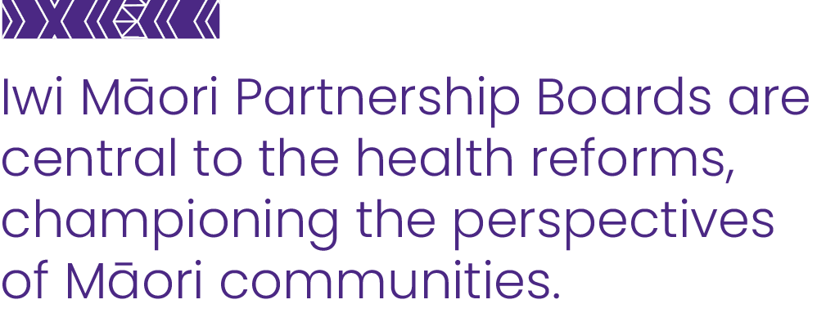These Boards ensure that whānau, hapū and iwi are partners in developing services that reflect the needs and aspirations of those who use them. They empower local communities, whānau, hapū and iwi to determine their own hauora solutions in collaboration with Health NZ.

## Hauora Māori Advisory Committee

The Hauora Māori Advisory Committee, established under the Pae Ora Act, provides advice to the Minister of Health on various matters, including appointments to the Public Health Advisory Committee.

Our work will be informed by the findings of Committee’s monitoring efforts.

## We uphold Te Mauri o Rongo

Te Mauri o Rongo | the Health Charter (Te Mauri o Rongo) is a statement of values, principles, and behaviours that workers in Health NZ and all other health entities are expected to demonstrate at a collective, organisational, and an individual level. Te Mauri o Rongo sits alongside the Health Quality and Safety Commission’s ‘Code of expectations for health entities’ engagement with consumers and whānau’, and the Health and Disability Commissioner’s ‘Code of Health and Disability Services Consumers’ Rights’ (Code of Rights) as key expectations of Health NZ.

|  |
| --- |
| The four pou of Te Mauri o Rongo are:   * **Wairuatanga** working with heart * **Rangatiratanga** supporting our people to lead at all levels * **Whanaungatanga** we are a team of teams working together for common purpose * **Te Korowai Āhuru** cloak our people with regard for their safety and comfort. |

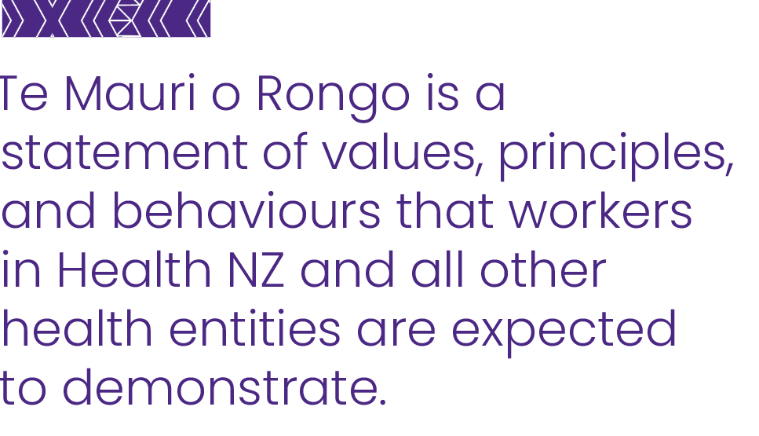

# Our strategic framework

Our strategic framework shows the connections between our Strategic Objectives for the 2024-2028 period, key intended activities within the New Zealand Health Plan, and the longer-term objectives of the [**Government Policy Statement**](https://www.health.govt.nz/system/files/documents/publications/government-policy-statement-on-health-2024-2027-v4.pdf) (GPS) on Health.

The GPS lays out the government’s long-term vision for health and wellbeing – to achieve longer life expectancy and improved quality of life for all New Zealanders.

The Government is focused on achieving timely access to quality health care. This includes both mental and physical health. The Government has identified five health targets and five mental health and addiction targets to ensure a focus on action. These are included as part of our performance framework measures.

Our Strategic Priorities give effect to the GPS. They are:

|  |
| --- |
| **Deliver the NZ Health Plan**  **Empower and enable leadership at all levels** |

Our achievement against our Strategic Priorities will be reported through the milestones and measures included in the New Zealand Health Plan 2024-2027, and the impact, intermediate and long-term outcomes of our Performance Framework.

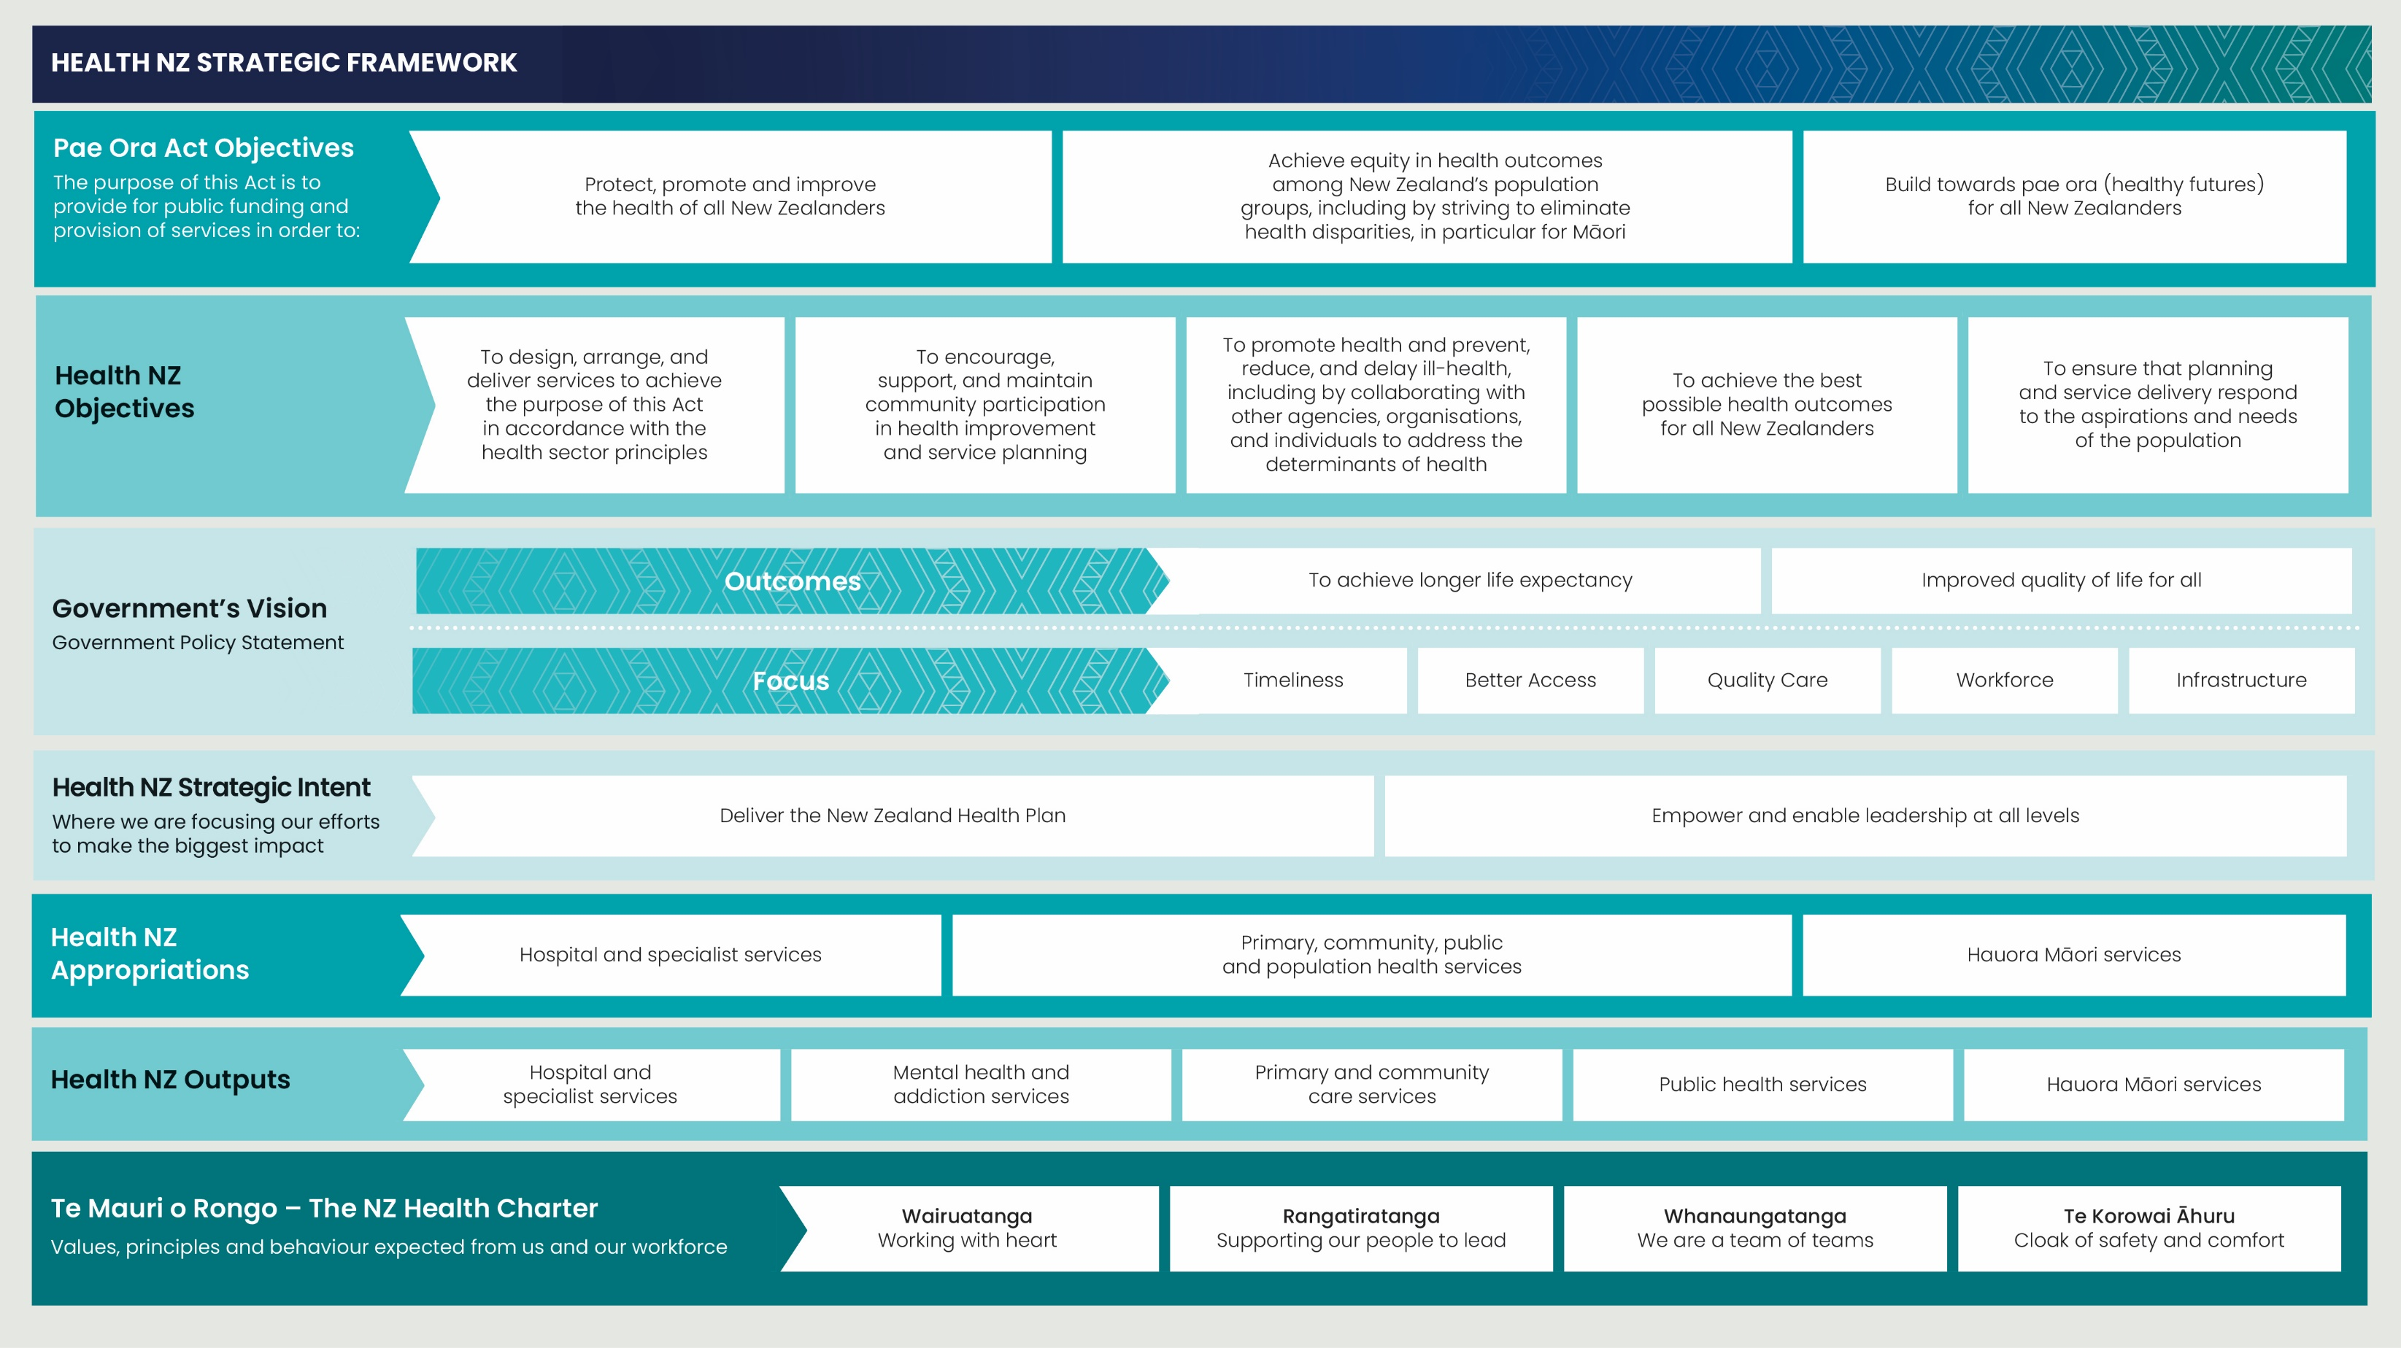

## Achieving the vision of timely access to quality healthcare

|  |
| --- |
| Deliver the NZ Health Plan |

The New Zealand Health Plan 2024-2027 lays out the actions we will deliver on to meet the priorities described in the GPS within our available resources in the next three years, including:

* Achieving Timely Access to Quality Healthcare through delivery of five national health targets, five targets for mental health and addiction, action to address five risk factors of poor health, and improvement in prevention and management of five key long-term conditions that contribute to ill health, reduced quality of life, and reduced life expectancy.
* Strengthening enablers of delivery including a continued focus on workforce development and infrastructure – both technological (digital) and physical.

Improving equity of outcomes for and meeting the needs of key population groups – Māori, Pacific, disabled people | tāngata whaikaha and rural populations.

### Focus on modifiable risk factors and priority long-term conditions

There are five modifiable risk factors and five priority non-communicable diseases that lead to substantial ill health, reduction in life expectancy, and health system demand. The risk factors are smoking, poor nutrition, lack of physical inactivity, harmful alcohol consumption, and adverse social and environmental factors. The five conditions are cancer, diabetes, cardiovascular disease, respiratory conditions, and poor mental health.

Together, these conditions account for around 80% of deaths from non-communicable diseases in New Zealand and considerable health loss experienced by New Zealanders.

Improved prevention of these conditions will be achieved through addressing five modifiable risk factors.

Prevention, early detection, and management of these risk factors and long-term conditions requires actions across the health system and addressing the wider social, economic, and commercial determinants of health. As part of delivering on the New Zealand Health Plan, we will work with communities, others across the health sector, and other sectors to take focused action to reduce the impact of these risk factors and long-term conditions on the health of people in New Zealand.

|  |
| --- |
| Empower and enable leadership at all levels |

Health NZ will empower regions and bring decision making closer to the communities. Regional leadership has autonomy to arrange resources to deliver health services for their populations.

Integration of care and delivery within regions will be informed by clinical leadership, be responsive to local feedback and will support person and whānau-centred models of care.

Regional and local leadership will reflect the contributions of Iwi Māori Partnership Boards, community and provider networks, regional consumer councils, local government and other sector government agencies.

Clinical leadership will be supported nationally through National Clinical Networks and Clinical Governance structures, and regionally to address unwarranted variation in access to care and enabled by health pathways and clinically informed approaches to commissioning.

We will support our workforces to ensure they have the right capability and capacity and ensure diversity and representation.

Shifting care closer to home, at scale, requires investment in clinical and technology enablers that support clinicians in the community, including digital modernisation, national platform development that spans primary and secondary care and rapid enablement of diagnostics.

# Measuring our performance

Health NZ both delivers, and funds others to deliver, health services. Our impacts are achieved by how we organise, fund, and operate these services, so we and other health providers can deliver health promotion, preventive care, and treatment services to improve health outcomes for New Zealanders.

We will monitor and report on our performance regularly.

As Health NZ has emerged from 28 different entities, consolidation and reshaping of practices of measuring performance is ongoing to enable reporting that is fit for today’s purposes. Therefore, reporting against some performance measures will be iterative, and developments will be reflected in each annual Statement of Performance Expectations (SPE) issued during this Statement of Intent period.

## Our performance framework

Health NZ has developed a new Entity Performance Framework, with a set of high-level measures that enable us to tell our organisational performance story and provide clear line of sight on how we are going to achieve both intermediate and long-term equitable health outcomes. Our performance framework will undergo endorsement by the Ministry of Health and Health Quality and Safety Commission, and this endorsement process is underway alongside the development of our Statements of Intent and Performance Expectations. This process is likely to occur after the finalisation of the 2024/25 SPE.

Our performance framework reflects the key priorities detailed in the GPS and the Minister of Health’s Letter of Expectations that have informed the Health NZ Plan.

Good design and effective delivery of services (inputs and outputs) enable Health NZ to provide timely access to quality care (impacts), leading to equitable health improvement – improved quality of life and longer life expectancy – in the lives of New Zealanders over time (outcomes).

These outcome measures are long-term indicators. Therefore, the aim is for a measurable change in health status over time, rather than a fixed target.

Our medium-term outcomes focus on the five modifiable risk factors and five long term conditions which define our priorities for the next 3-5 years and allow us to measure the difference we are making for our population.

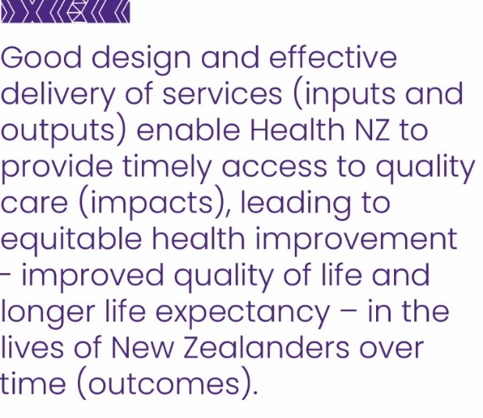To help identify equity gaps and measure gains, we will monitor all of our medium-term outcomes by ethnicity and track local progress. We are working to improve our data so that we can monitor measures for tāngata whaikaha | disabled people.

Our short-term impacts are essential to the achievement of our outcome goals and are front-line measurements of how well we are delivering timely access to quality healthcare.

Sitting under the impact measures and national targets are a cascade of service-specific indicators that can be reported on by geographical area to reflect local priority issues.

The inputs and outputs – resources available, decisions made and actions taken, along with the services delivered – will be reported on through the milestones and measures in the New Zealand Health Plan.

The impact measures selected are a subset of the measures detailed in our SPE and will be reported in our annual report. The SPE measures aim to represent the full scope of the services we provide or fund.

While the current approach to our performance measurement uses existing and well-tested measures, the development of new measures to better enable us to tell our performance story is a focus over the medium-term.

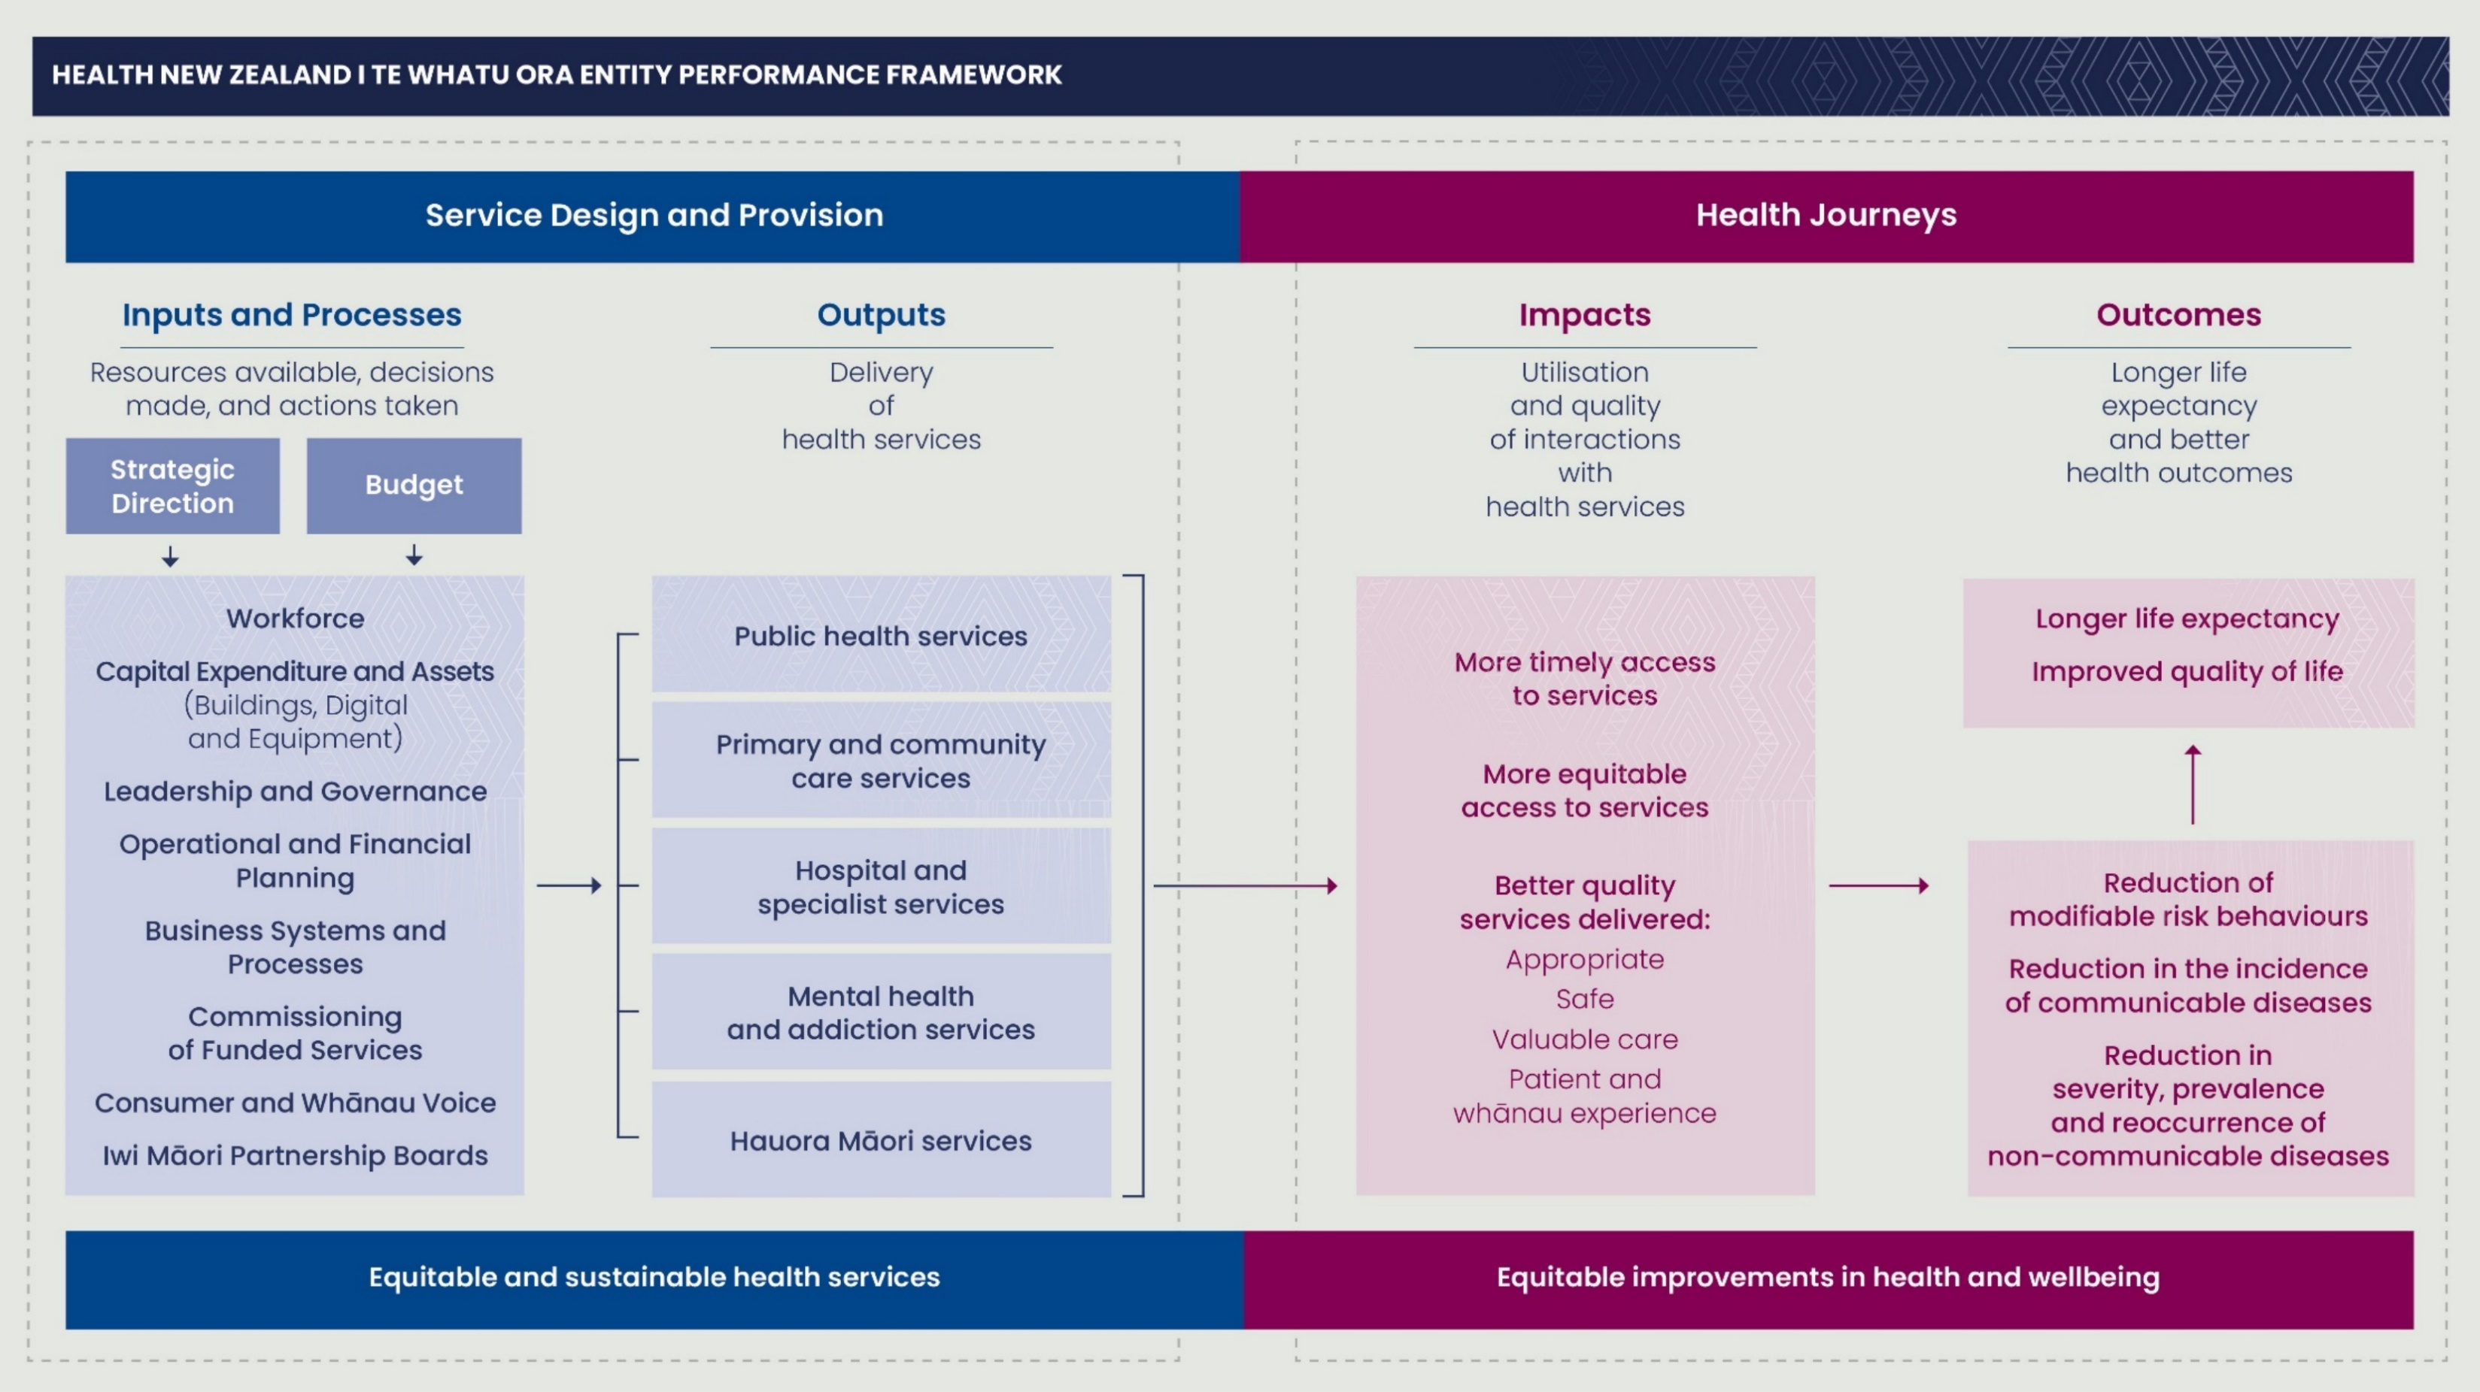

## Outcome measures

We have two overall population health outcome objectives:

* Longer life expectancy

Improved quality of life

Life expectancy is the most commonly used and easily understood summary measure of health outcomes. To gain a more comprehensive understanding of health status, particularly for health conditions that significantly impact morbidity or quality of life, additional indicators are necessary.

Quality of life is multi-dimensional, meaning there is no single indicator which can measure it in its entirety. There are a range of quality of life-related indicators and some critique of these is being considered, as well as limitations in data availability. In the interim, two measures will be monitored, related to improving health and wellbeing.

Given the long-term nature of these objectives, the aim is to see measurable improvement in health status over time.

|  |  |
| --- | --- |
| Life expectancy | |
| Life expectancy at birth is recognised as a summary measure of population health status.  Life expectancy in Aotearoa New Zealand has improved markedly over time (3.2 years since 2001) and has now reached 82.2 years. Māori life expectancy has increased from approximately 72 years to 77 years, and Pacific people from around 74 years to 77 years. However, life expectancy for both groups remains at least 6 years below that of non-Māori, non-Pacific ethnicities.  Over the longer term, we aim to continue to increase national life expectancy and close the gaps between ethnic groups. | Life expectancy (years) at birth by ethnicity, three year aggregated estimate, 2001-2022 |

|  |  |
| --- | --- |
| Quality of life – self rated health | |
| How individuals assess their own health provides a holistic overview of both physical and mental health and complements life expectancy and mortality indicators that only measure survival. Despite its subjective nature, self-rated health has proved to be a good predictor of future healthcare needs and mortality.  While there has been an overall decrease in people rating their health as good, very good or excellent over time, this is more pronounced for Māori and Pacific respondents.  As we deliver on our reset of Health NZ – focusing on the delivery of timely access to quality care – we expect to see an improvement in these ratings over time. | Percentage of adults aged 15+ years who rate their health as good or better by ethnicity, 2012-2023 |

|  |  |
| --- | --- |
| Quality of life – family wellbeing | |
| Family wellbeing evaluation reflects the importance of family and whānau to New Zealanders. Having high levels of family wellbeing can positively affect most dimensions of people's lives. Often, for Māori, Pacific and Asian peoples, for an individual to be well their families need to be well. (Kukutai et al. 2017)  Overall, 83.7% of respondents rated their family wellbeing as high or very high in 2022, with lower rates for Māori at 78.0%.  Family wellbeing data collection in the New Zealand Health Survey began in 2021/22. Therefore, it is not possible to assess trends for this indicator, but we expect to see continuing improvement in this measure over time. | Percentage of adults aged 15+ years who rate their family wellbeing as high or very high by ethnicity, 2022/23 |

## Intermediate Outcomes

Intermediate outcomes help us see progress toward our longer term objectives and show the effect of improvements in system level health service provision and working with others to influence determinants of health. Our intermediate outcome objectives are:

* Reduction of modifiable risk factors: alcohol, tobacco, poor nutrition, physical inactivity, and adverse social and environmental factors

Prevention and better management of non-communicable diseases: cancer, cardiovascular disease, respiratory disease, diabetes and poor mental health.

These objectives align with the Government’s focus on accelerating action to address the five non-communicable diseases, expressed in the GPS. Reducing the five modifiable risk factors will improve prevention and management of the five long-term conditions. In turn, these improvements will contribute to improving life expectancy and quality of life.

We have selected measures which will indicate how well we are achieving these goals. To help identify inequity and measure progress, we will monitor all of our intermediate outcome measures by ethnicity.

### Reduction of modifiable risk factors

The five key risk factors for poor health or illness that are within our control to change are smoking, poor nutrition, lack of physical inactivity, alcohol consumption and adverse social and environment factors.

People often experience these five risk factors because of differences in circumstances outside of the direct influence of the health system. We will work with the Ministry of Health and other organisations to understand and take action with the aim of reducing exposure to these risk factors.

|  |  |
| --- | --- |
| Alcohol consumption | |
| Alcohol use causes substantial physical and mental health loss and is the leading risk factor for health loss in those aged 15-49 years. Reductions in adult alcohol consumption also has beneficial effects for children.  In 2022/23 around one in six adults (16.0%) reported hazardous drinking (an established pattern of drinking that carries a high risk of future damage to physical or mental health), a decrease on the previous year, after being relatively stable from 2016/17 (when the current time series began). Adults in Asian ethnic groups had the lowest rate of hazardous drinking (5%), followed by people identifying as European/Other ethnicities (17%), Pacific peoples (22%) and Māori (25%). | Percentage of adults aged 15+ years reporting hazardous drinking patterns by ethnicity, 2017-2023 |

|  |  |
| --- | --- |
| Smoking | |
| Tobacco smoking is the most significant cause of premature and preventable death and morbidity in Aotearoa New Zealand. It is a key driver of inequities in health outcomes for Māori and Pacific people. Reduced smoking among adults also has beneficial effects for children.  6.8% of adults were daily smokers in 2022/23, down from 8.6% the previous year and 16.4% in 2011/12.  There has been a decline in daily smoking for all ethnic groups over the last decade, but Māori rates remain nearly 3 times higher than that of all other ethnicities. | Percentage of adults aged 15+ years who smoke daily by ethnicity, 2016-2023 |

|  |  |
| --- | --- |
| Physical inactivity | |
| Physical activity is protective against health conditions (such as heart disease, type 2 diabetes and some cancers) and benefits mental health. It also helps to reduce the prevalence of obesity. Current New Zealand guidelines recommend adults do at least 2.5 hours of moderate physical activity spread throughout the week.  In 2022/23, nearly half (47%) of adults met these guidelines. This is a decline from 51% in 2021/22. More Māori (47%) and people identifying as European/Other ethnicities (48%) are meeting the guidelines than Pacific peoples and people in Asian groups (40%). | Percentage of adults aged 15+ years meeting physical activity guidelines by ethnicity, 2012-2023 |

|  |  |
| --- | --- |
| Nutrition | |
| Optimal nutrition during childhood is essential to maintain growth and good health. Establishing healthy eating patterns in childhood contributes to good health throughout life. Vegetables and fruit provide many beneficial nutrients and protect against conditions, such as heart disease, stroke and some cancers.  In 2022/23, only 4.9% of children aged 2-14 years ate the recommended amount of fruit and vegetables every day (2.5-5.5 servings of vegetables and 1-2 servings of fruit, depending on age and gender). | Perecentage of children aged 2-14 years eating the recommended amount of vegetables and fruit a day by ethnicity, 2022/23 |

|  |  |
| --- | --- |
| Adverse social and environmental factors | |
| 'Psychological, or mental, distress' (in people aged 15+ years) refers to a person’s experience of symptoms (such as anxiety, psychological fatigue, or depression) in the past four weeks.  Where people experience these levels of psychological distress, there is a high or very high probability that they also have an anxiety or depressive disorder.  In 2021/22, more than one in 10 adults aged 15 years and over (11.9%) experienced psychological distress in the four weeks prior to taking part in the survey. This has increased over time, and is higher in Māori and Pacific peoples. | Percentage of population aged 15+ years with high or very high psychological distress by ethnicity, 2012-2023 |

#### Prevention and better management of non-communicable diseases

Five long-term conditions cause considerable demand for acute care and contribute significantly to ill health, and reduced quality of life and life expectancy. These are: cardiovascular disease, diabetes, respiratory disease, cancer and poor mental health.

Supporting people throughout their life means a focus on prevention and early intervention for these long-term conditions, as well as treatment and rehabilitation. Over time, improvement in risk factors will reduce the rate of people experiencing long-term conditions.

Early detection, management, and intervention by health services can help to slow disease progression and support people to better health.

The measures in this section provide an indication of how well we are performing at preventing and managing these conditions. Our aim is to decrease the hospitalisation and mortality rates presented below.

The suite of measures listed below were selected largely based on data availability. In future years, this suite may be revised.

|  |  |
| --- | --- |
| Cardiovascular diseases | |
| Cardiovascular diseases (CVDs) are a leading cause of mortality and contribute to the difference in life expectancy between Māori and Pacific peoples and non-Māori/non-Pacific populations. Māori, Pacific peoples and South Asian communities (including the Indian community) are considered priority populations in the 2018 CVD risk management guidelines.  Admissions to hospital for some CVDs are considered potentially avoidable (ambulatory sensitive hospitalisations or ASH) through prevention or management in primary and community care and action to address determinants.  In the four years to March 2024, the ASH rates for CVDs among Māori and non-Māori/non-Pacific peoples were stable, but there was a slight decrease for Pacific peoples. From 2020 to 2024, ASH rates remain consistently higher in Māori and Pacific than in the non-Māori/non-Pacific group. | Ambulatory sensitive hospitalisations (ASH) for cardiovascular conditions per 100,000 in those aged 45-64 years by ethnicity, 2012-2024 |

|  |  |
| --- | --- |
| Diabetes | |
| In 2022, there were estimated to be more than 307,000 people in Aotearoa New Zealand with diabetes. Diabetes is a major long-term condition that disproportionately impacts Māori, Pacific peoples and South Asian communities (including the Indian community) and that has significant downstream impacts and costs for patients, their whānau and the health and disability system. | Renal failure hospitalisations age-standardised per 100,000 ethnic specific population with diabetes |
| The presence of diabetes can lead to cardiovascular disease, blindness, dementia, nerve damage, foot disease and kidney disease (renal failure).  Peripheral vascular disease and diabetic neuropathy are conditions linked to diabetes that principally affect the lower limbs. In some cases, limb amputation is necessary, which has considerable implications for patients’ quality of life and increases the risk of mortality.  Early detection and good management of blood sugar, blood pressure and lipids can delay or avoid the onset of these problems. | Lower limb amputation hospitalisations age-standardised per 100,000 ethnic specific population diabetes |

|  |  |
| --- | --- |
| Respiratory conditions | |
| Respiratory conditions include acute infections (e.g. pneumonia and bronchitis) and chronic conditions (e.g. asthma, chronic obstructive pulmonary disease [COPD]) and cause many potentially avoidable hospital admissions.  ASH rates for respiratory conditions are presented for two age groups – children 0-4 years, and adults 45-64 years.  The data for children aged 0-4 years from 2020 to 2024 shows that Pacific children have a much higher rate of admission for respiratory illness than children from other ethnicities. Respiratory admissions dropped in 2021 as a result of strategies to manage the COVID-19 pandemic, but have since increased to pre-covid levels. Admissions for Pacific children are now significantly higher than they were at March 2020. | Ambulatory sensitive hospitalisations (ASH) for cardiovascular conditions per 100,000 in those aged 0-4 years |
| The data for adults 45-64 years from 2020 to 2024 also shows a decrease in the ASH rate for respiratory conditions in 2021, especially for Māori and Pacific, with an overall subsequent slight increase, but not to pre-covid levels.  In the 12 months ending in March 2024, the respiratory ASH rates are 4.4 times higher in Māori and 2.8 times higher in Pacific peoples than the rates in non-Māori/non-Pacific. | Ambulatory sensitive hospitalisations for respiratory conditions per 100,000 in those aged 45-64 years |

|  |  |
| --- | --- |
| Cancer | |
| Cancer is the most common cause of death in Aotearoa New Zealand, accounting for more than 30% of deaths (10,488 deaths in 2021). Breast and bowel cancer are two of the leading causes of these cancer deaths. While bowel cancer mortality is second only to lung cancer, breast cancer is the most common form of cancer to affect women in New Zealand and the second most common cause of female cancer death.  Overall age standardised cancer mortality rates are declining over time but many forms of cancer still disproportionately impact Māori and Pacific populations.  Improvements in access to and timeliness of cancer screening, investigations, diagnosis and treatment will result in better outcomes for cancer patients. | Bowel (colorectal) cancer mortality rates age standardised per 100,000 populationBreast cancer mortality rates, age standardised per 100,000 population |
|  |  |

|  |
| --- |
| Poor mental health |
| There currently is not one system indicator that adequately measures the population-level effects of our actions to better prevent and manage mental health conditions. Work is underway to refine mental health and addiction system measures for the five mental health and addiction targets, and to measure the prevalence of mental health conditions, which will inform this section in the future. |

## Impact Measures

Our Impact measures are front-line measurements of the success of the whole health system and contribute to achieving our suite of intermediate outcomes. These measures reflect the following three priority areas of the GPS:

**Access:** every person regardless of where they live in New Zealand, has equitable access to the health care services they need.

**Timeliness:** people can access the health care and services they need, when they need it in a prompt and efficient way.

**Quality:** health care and services delivered in New Zealand are safe, easy to navigate, understandable and welcoming to users, and are continuously improving.

The Government’s five health targets and five mental health and addiction targets sit alongside our Impact measures. Together these measures are part of Health NZ’s wider performance story.

Our Impact measures are focused on the access and quality aspects of service delivery. These are complementary to the Government’s health targets, which largely measure timeliness. The Government’s mental health and addictions targets provide a comprehensive picture of the delivery of mental health services, so we have not included any additional mental health impact measures.

|  |  |  |
| --- | --- | --- |
| Impact measure | **Latest available performance** | **Target** |
| Percentage of children fully immunised at 8 months of age | |  |  | | --- | --- | | **Q2 2023/24** |  | | Māori – 66.5% | Other – 86.5% | | Pacific – 76.9% | Total – 81.8% | | Asian – 94.8% |  | | **95%** |
| Percentage of women aged 45-69 years who have had a breast cancer screen in the last 2 years | |  |  | | --- | --- | | **2-year coverage to June 2024** | | | Māori – 62.3% | Other – 72.2% | | Pacific – 67.6% | Total – 69.1% | | Asian – 61.7% |  | | **70%** |
| Cervical (HPV) screening rates of eligible women aged 25–69 years (five-yearly screening interval) | |  |  | | --- | --- | | **3-year coverage to June 2024** | | | Māori – 60.4% | Other – 75.9% | | Pacific – 64.9% | Total – 69.3% | | Asian – 58.6% |  | | **80%** |
| Percentage of people enrolled with a general practice (or a kaupapa Māori provider delivering general practice care) | |  |  | | --- | --- | | **Q1 2023/24** |  | | Māori – 70.1% | Other – 100% | | Pacific – 80.5% | Total – 88.2% | | Asian – 94.6% |  | | **95%** |
| Percentage of children enrolled with a general practice (or a kaupapa Māori provider delivering general practice care) by age 3-months | |  |  | | --- | --- | | **April 2024** |  | | Māori – 85% | Other – 100% | | Pacific – 98% | Total – 97% | | **85%** |
| Patient experience - involvement:  Inpatients - percentage of patients who reported they were involved as much as they wanted to be in making decisions about their treatment and care | |  |  | | --- | --- | | **12 months to May 2024** | | | Māori – 80.2% | Other – 81.0% | | Pacific – 83.8% | Total – 81.5% | | Asian – 87.6% |  | | **Increase from 2022/23 baseline (as expressed  in SPE)** |
| Primary care – percentage of patients who reported being involved by the healthcare professional in decisions about treatment and care during their most recent appointment | |  |  | | --- | --- | | **12 months to May 2024** | | | Māori - 88.3% | Other – 90.2% | | Pacific – 88.7% | Total – 89.8% | | Asian – 89.4% |  | |
| Patient experience – respect:  Inpatients – percentage of patients who reported that their doctors treated them with respect and kindness | |  |  | | --- | --- | | **12 months to May 2024** | | | Māori – 90.4% | Other – 92.0% | | Pacific – 93.8% | Total – 92.0% | | Asian – 94.7% |  | | **Increase from 2022/23 baseline (as expressed  in SPE)** |
| Primary care – percentage of people reporting that the healthcare professional treated them with respect and kindness | |  |  | | --- | --- | | **12 months to May 2024** | | | Māori – 94.9% | Other – 96.2% | | Pacific – 96.0% | Total – 96.0% | | Asian – 96.0% |  | |

#### Targets

The Government’s health targets focus on improving access and timeliness to better meet people’s immediate health need. Mental health, addiction and suicide prevention are also key areas of focus for the Government, supported by specific mental health and addiction targets.

Both sets of targets have long-term goals. However, specific performance milestones to be achieved in each of the next three years have also been set. These will be adjusted and updated by Ministers as expectations are reviewed and current progress is assessed.

The health targets will be monitored quarterly where the baseline will Quarter 4 2023/24

|  |  |  |  |
| --- | --- | --- | --- |
|  | **Performance milestone** | | |
| Health target | **2024/25** | **2025/26** | **2026/27** |
| Faster cancer treatment | | | |
| 90% of patients to receive cancer management  within 31 days of the decision to treat | 86% | 87% | 88% |
| Improved immunisation | | | |
| 95% of children fully immunised at 24 months of age | 84% | 87% | 90% |
| Shorter stays in emergency departments | | | |
| 95% of patients to be admitted, discharged,  or transferred from an emergency department  within six hours | 74% | 77% | 80% |
| Shorter wait times for first specialist assessment | | | |
| 95% of patients wait less than four months for  a first specialist assessment | 62% | 65% | 70% |
| Shorter wait times for elective treatment | | | |
| 95% of patients wait less than four months  for elective treatment | 63% | 67% | 71% |

#### Mental health and addiction targets

|  |  |  |  |
| --- | --- | --- | --- |
|  | **Performance milestone** | | |
| Mental health and addiction target | **2024/25** | **2025/26** | **2026/27** |
| Faster access to specialist mental health and addiction services | | | |
| 80% of people accessing specialist mental health and addiction services are seen within three weeks | 80%  (under 25s – 72%) | 80%  (under 25s – 75%) | 80%  (under 25s – 78%) |
| Faster access to primary mental health and addiction services | | | |
| 80% of people accessing primary mental health and addiction services through the Access and Choice programme are seen within one week | Establish data collection and set baselines | 80%  (or an increase from baseline) | 80%  (or an increase from baseline) |
| Shorter mental health and addiction-related stays in emergency departments | | | |
| 95% of mental health and addiction-related emergency department presentations are admitted, discharged,  or transferred from an emergency department within  six hours | 74% | 77% | 80% |
| Increased mental health and addiction workforce development | | | |
| Train 500 mental health and addiction professionals each year | Confirm baseline | 500 | 500 |
| Strengthened focus on prevention and early intervention | | | |
| 25% of mental health and addiction investment is allocated towards prevention and early intervention | Confirm baseline | TBC | TBC |

# Our organisational capability

The services we deliver, and fund are enabled by hardworking, highly trained and committed professionals who provide excellent care.

## Supporting and sustaining our workforce

Through careful investment and working closely with our key stakeholders and delivery partners, we are building a more sustainable workforce and implementing actions to provide relief to workforces that we know are under pressure. Strengthening regional decision-making and leadership will support this.

Thoughtful implementation of Te Mauri o Rongo, in a way that makes it real for our staff, is a foundation for building the health culture required for success.

The development of a national Health Workforce Plan, informed by the Ministry of Health’s Health Workforce Strategic Framework, allows us to identify levers for change and our priority areas for the health workforce.

## Looking after our people

The pandemic legacy and other demand and supply pressures have had an additional impact on the health workforce. We are working to address these pressures sustainably in the longer term, and in the shorter term we have specific actions underway to ease pressure on our staff.

We want to strengthen and foster our safety and wellbeing culture so that our people and consumers are safe in healthcare environments. For services that we commission we want to ensure that, where relevant, we have commissioning practices that foster safety and wellbeing at work.

## A diverse and inclusive workforce

Our work is guided by key principles that uphold our commitment to Te Tiriti o Waitangi, diversity, inclusion, and equitable representation.

Health NZ continues to strengthen its inclusive recruitment practices to ensure diversity in our workforce and is also focused on promoting health as a career of choice.

## Being a good employer

Health NZ is committed to meeting its statutory, legal, and ethical obligations to be a good employer, including providing equal employment opportunities at all ages and stages of our employees’ careers. This is supported by policy, our good employer practices, and initiatives set out in our Health Workforce Plan.

## A sustainable organisation

Climate change is widely recognised as the single greatest threat to, and opportunity for, human health and wellbeing. Increasingly frequent and intense climate events have broad impacts on our health, our environment, and have potential to impact the ability of health services to operate. Climate events will disproportionately affect our more vulnerable communities. The goal is for a sustainable and resilient health system that delivers equitable health outcomes and lower emissions as a dimension of high-quality healthcare.

As a major public sector greenhouse gas emitter, Health NZ has a significant opportunity to reduce our emissions and environmental impact, creating direct health benefits through avoiding air pollutants. Showing leadership also helps bring others on the journey. In FY23/24 Health NZ cut emissions by ~15% from FY22/23 baseline.

Health NZ is committed to delivering against the Carbon Neutral Government Programme (CNGP), the National Adaptation Plan (NAP) and Health National Adaptation Plan (HNAP) requirements. Work is underway to deliver an Emissions Reduction Plan by December 2024 to achieve a 25% Category 1 and 2 emissions reduction in FY24/25. This will enable a pathway to support limiting global warming to 1.5-degrees Celsius from pre-industrial levels.

Health NZ supported the cross-sector development of climate change scenarios, outlining three plausible futures for the health sector in the face of climate change. Scenario analysis is fundamental to understanding the potential extent and breadth of climate impacts, which will be complete by December 2024. A climate resilience plan will be developed by the end of 2026 to understand what climate change means for health service delivery.

Health NZ will work closely with iwi, hapū and hauora Māori and sector partners to build sustainability practices across the wider healthcare services we deliver and fund.

Health NZ will continue to make progress on its key sustainability workstreams:

* Integration of sustainability into strategies and culture
* Health System Decarbonisation
* Environment in All Practices
* Health System Resilience.

## Building data-led knowledge to drive change

Data and digital systems are crucial to service delivery, underpinning the GPS outcomes of better access, quality of care and timeliness.

We inherited a complex data and digital portfolio, with different data structures and platforms, disparate data capture practices and legacy processes that are not well aligned and present some risk. We’re still building a complete picture of our data and digital landscape.

Data services need to continue evolving to ensure that we are getting the most from our investment and the opportunities we have.

The National Data Platform foundational work was delivered in 2023/24 and is technically ready to start ingesting our initial data sets. While the final assurance work is being completed on the platform, our data ingestion processes are underway.

Our focus now is to simplify the digital landscape (fewer, better systems), establish critical foundations (e.g. cybersecurity uplift), and progress priority initiatives.

Data integrity is critical. We are focusing on robust coding and data validation, but more is needed to improve quality and timeliness.

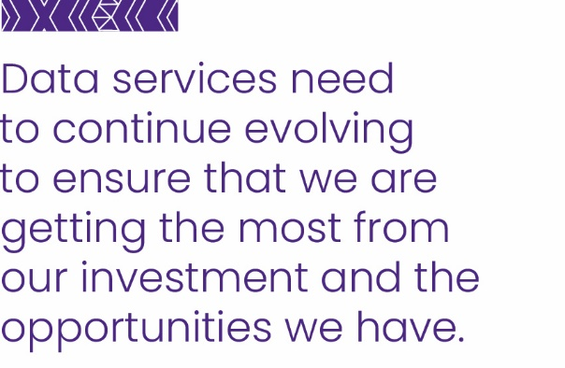

## Managing our assets and capital investment

Health NZ has one of the largest and most complex vertical infrastructure estates in New Zealand. As at 30 June 2024, our total assets have a net book value of $9 billion and a replacement value of $38 billion.

We are also delivering the largest health infrastructure projects in the country, with a project delivery portfolio of $7 billion and multi-year projects under implementation including these projects with a whole of life cost > $50 million:

* Project Whakatuputupu – New Dunedin Hospital
* Taranaki Base Hospital Redevelopment – Project Maunga – Stage 2

Facilities Infrastructure Remediation Programme – Tranche 1 and 2 (Auckland and Greenlane hospitals)

In 2023/24 we developed a 10-year national Infrastructure and Investment Plan and a National Asset Management Strategy. We have established a fit-for-purpose governance framework, management oversight structures and monitoring processes.

Our key focus areas over the next four year horizon are to:

* Implement the Infrastructure and Investment Group target operating model, from a people, processes, information and technology perspective, at a national and regional level to support investment planning and monitoring, asset management, land and property management and portfolio delivery.
* Implement the Infrastructure Investment Plan and National Asset Management Strategy.
* Improve planning, design management, project management and reporting processes to support the delivery of all capital projects so they are delivered on time, in budget, and within scope.
* Understand the condition and performance of the physical asset portfolio.

Grow a strong health and safety culture underpinned by consistently applied safe systems of working, clear site practices, improved incident and near miss reporting, and robust investigation processes.

These key focus areas are supported by the following detailed actions:

* Standardising procurement and commercial documentation, templates and guidance.
* Embedding design guidelines that standardise projects and lower costs and accommodate standards for disability access.
* The consistent use of business case guidance, templates and tools.
* Implementing an Asset Management Information System.
* Undertaking asset data migration and baseline condition assessments of the estate to populate the Asset Management Information System.
* Use Asset Management Information System for improved risk management and investment prioritisation.

## Managing our finances

**Managing within the significant financial resources allocated to Health NZ will be a focus of this organisation over the next four years.**

Providing value for money is a key focus for Health NZ. Funding is prioritised to enable us to deliver on the New Zealand Health Plan actions to achieve better health outcomes for the people of New Zealand.

We will absorb growing cost pressures through a financial sustainability programme that will deliver annual savings to bridge any funding gaps.

We are continuously seeking ways to improve our processes, systems and activities to release resources through efficiencies so these can be re-prioritised to other strategic priorities.

We will continue to develop and refine how we manage our financial resources to drive productivity improvements and cost efficiencies across the organisation.

We will enable better, more granular financial reporting by developing sub-categorisation of our output classes over the next four years.

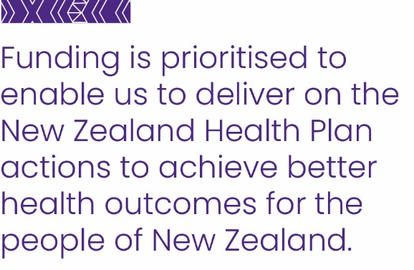



.



**www.tewhatuora.govt.nz**