New breast cancer diagnoses and treatments 2020
BreastScreen Aotearoa
Citation: Te Whatu Ora – Health New Zealand. 2023. BreastScreen Aotearoa: New breast cancer diagnoses and treatments 2020. Wellington: Te Whatu Ora – Health New Zealand.
Published in February 2024 by Te Whatu Ora – Health New Zealand
PO Box 793, Wellington 6140, New Zealand
ISBN 978-1-99-106780-7 (online)
This document is available at tewhatuora.govt.nz
This work is licensed under the Creative Commons Attribution 4.0 International licence. In essence, you are free to: share ie, copy and redistribute the material in any medium or format; adapt ie, remix, transform and build upon the material. You must give appropriate credit, provide a link to the licence and indicate if changes were made.

Acknowledgements and funding
Breast Cancer NZ Register Trust was commissioned and funded by the National Screening Unit, Te Whatu Ora to produce this report using data from Te Rēhita Mate Ūtaetae - Breast Cancer Foundation National Register.
Prepared by
Breast Cancer NZ Register Trust, with data from Te Rēhita Mate Ūtaetae - Breast Cancer Foundation National Register.
Citation: National Screening Unit, Te Whatu Ora, Wellington. 2023. New Breast Cancer Diagnoses and Treatments 2020.
Published in February 2024.

Acknowledgements
Breast Cancer NZ Register Trust would like to acknowledge the supervision and clinical consultation for this report provided by:
Mr Adam Stewart, Surgeon and National Clinical Lead, BreastScreen Aotearoa and Dr Jo Wall, Public Health Physician, National Screening Unit.
Prof Ian Campbell (University of Auckland, Waikato Campus), Vernon Harvey (University of Auckland), Prof Ross Lawrenson (University of Waikato, Te Whatu Ora, Health New Zealand, Waikato), Reena Ramsaroop (Te Whatu Ora, Health New Zealand, Waitematā).
Breast Cancer NZ Register Trust would like to thank the specialist clinicians who have given their time reviewing the data and commentary in this report and providing feedback and insights, in particular:
Dr Alison Foster (Te Whatu Ora, Health New Zealand, Capital, Coast), Ineke Meredith (Clinical Advisory Group, Te Rēhita Mate Ūtaetae - Breast Cancer Foundation National Register; Paris Breast Centre, France), Maria Pearse (Te Whatu Ora Health New Zealand, Te Toku Tumai, Auckland, Auckland Radiation Oncology) Magda Sakowska (Te Whatu Ora, Health New Zealand, South Canterbury).
For review and advice on Māori and Pacific data and commentary we would like to thank the Māori Monitoring and Equity Group and Harriet Pauga, Interim Regional Pacific Lead, Health NZ, Te Whatu Ora.
For review and advice from Dawn Wilson, Kaitohu Mātāmua, Chief Advisor and Acting Manager, Clinical Advisory Team, Te Aho O Te Kahu, Cancer Control Agency
Thanks to Breast Cancer Foundation NZ, funder of Te Rēhita Mate Ūtaetae - Breast Cancer Foundation National Register.
Thanks to the data management and analytics team at Te Rēhita Mate Ūtaetae - Breast Cancer Foundation National Register for their commitment to providing data that is as clean and complete as possible, expert analysis, and compilation of commentary and the report.
Thanks most of all to the patients of Aotearoa New Zealand represented in this report. Without you, this report would not exist. Your participation in Te Rēhita Mate Ūtaetae enables monitoring and improvement in equity and in the diagnosis, treatment and outcomes of breast cancer in New Zealand.

A message from BreastScreen Aotearoa
BreastScreen Aotearoa has partnered with Te Rēhita Mate Ūtaetae - Breast Cancer Foundation National Register in this collaborative report into breast cancer diagnoses and treatment outcomes for New Zealand women. The evidence that breast screening saves lives and reduces morbidity from breast cancer has accumulated over many years, both internationally and in New Zealand.
The 2015 report on breast cancer mortality showed the BreastScreen Aotearoa (BSA) programme had achieved a 34% reduction in overall breast cancer mortality in New Zealand women (28% for wāhine Māori and 40% for Pasifika women). But the benefits of screening extend much further than just reducing the risk of dying. These benefits include enabling less morbid treatments typically directed at earlier-stage breast cancer, resulting in much better health outcomes for New Zealand women.
Advances like these are achieved through the persistent, year-on-year effort to detect breast cancer in screening-age women (currently those aged 45 to 69).
This new report reveals how, in 2020, the BSA programme reduced the impact that the diagnosis of breast cancer had on the lives of New Zealanders. It also highlights where we need to do more.
This report analyses 2020 breast cancer diagnoses nationally in women aged 45 to 69, across all referral sources: BSA or other screening, and non-screened (primarily symptomatic) diagnoses. This gives a valuable insight into the differences in outcomes between population-based screening, opportunistic screening, and women who have not been screened.
We are delighted to report that BSA screening had a significant impact on many of the factors that contribute to breast cancer mortality and morbidity. Screened tumours were around 40% smaller than unscreened tumours, a key factor in tumour staging. Overall breast cancer stage was typically lower in BSA-screened patients – 90% had stage 1 disease, compared with only 61% of non-screened diagnoses. At the other end of the staging scale, the incidence of de novo metastatic disease with BSA screening was only a quarter that found in non-screened diagnoses.
Screened patients were more likely to have breast conserving surgery (nearly 70%) as opposed to mastectomy and had less invasive axillary surgery and less chemotherapy than unscreened patients.
These results give confidence in the ability of BSA to deliver high-quality screening for New Zealanders. But that high quality screening must also be equitable.
The 2020 data provides some reassurance where equity is concerned: of all ethnicities, wāhine Māori had the highest proportion of BSA screen-detected cancers and, for most treatment types, received treatment at the same rate as other ethnicities.
However, any sense that we’ve “made it” is still some way off. Instead, it’s a “we can do better”, as inequitable outcomes for wāhine Māori and Pasifika women are still apparent. These are due to delays along diagnosis and treatment pathways, including lower rates of screening and longer waits for first surgery. Wāhine Māori and Pasifika women had larger tumours and higher rates of stage 4 cancer at diagnosis. Wāhine Māori were least likely to receive treatment within 31 days of diagnosis, and most likely to wait 63 or more days. Pasifika women were next most likely to face treatment delays. The rates of axillary surgery and of anti-HER2 treatment received by wāhine Māori bear further investigation.
These insights and further investigations were made possible by the comprehensive data available in Te Rēhita Mate Ūtaetae - Breast Cancer Foundation National Register, which was the direct source of data and analysis.
No report on 2020 can be complete without mentioning the global pandemic that disrupted health services throughout Aotearoa. While we are yet to understand the full impact of that disruption, BreastScreen Aotearoa has worked hard to restore services and is committed to providing excellent, equitable screening for every eligible New Zealander, and to reporting our progress so that we can continue to save as many lives as possible.
Jane O’Hallahan Adam Stewart
Clinical Director Surgeon and Clinical Lead
National Screening Unit BreastScreen Aotearoa

A message from Te Rēhita Mate Ūtaetae - Breast Cancer Foundation National Register
This 2020 BreastScreen Aotearoa report draws on the knowledge and passion of the two partners involved in its creation: BreastScreen Aotearoa, experts in breast cancer screening and diagnosis, and Te Rēhita Mate Ūtaetae - Breast Cancer Foundation National Register, experts in breast cancer data collection, analysis and reporting.
The result is a report that provides far-reaching insights into the impact of BSA’s screening programme, with, for the first time, full analysis of data for wāhine Māori and Pacific women. It identifies areas where change may be needed to secure equitable access to early breast cancer diagnosis for all New Zealand women.
High-quality reports such as this promote evidence-based change and improvement. Working with BreastScreen Aotearoa on this 2020 report has been a privilege.
A huge thank-you must go to all the patients who participate in Te Rēhita, allowing your data to inform the future care of New Zealanders with breast cancer.
Justine Smyth CNZM
Chair, Breast Cancer Foundation NZ
Chair, Breast Cancer NZ Register Trust

Contents
Acknowledgements and funding 3
1 Introduction 11
1.1 Purpose 11
1.2 History of BreastScreen Aotearoa annual reporting of breast cancer diagnoses and treatment 12
1.3 Methods 13
1.4 Limitations 15
1.5 Definitions from Te Rēhita Mate Ūtaetae 16
2 Key findings of this report 20
2.1 Māori patients 20
2.2 Pacific patients 21
2.3 Invasive tumour characteristics 22
2.4 DCIS 22
2.5 Time to treatment 23
2.6 Surgery 23
2.7 Radiotherapy 24
2.8 Systemic therapy 24
2.9 Future reports – where to from here? 25
3 Overview of cases 26
3.1 Eligible cases by ethnicity and screening status 26
3.2 Diagnosis type 28
4 Priority BSA Group – Māori patients 30
4.1 Key findings 30
5 Priority BSA group – Pacific patients 41
5.1 Key findings 41
6 Invasive tumour characteristics 50
6.1 Type of invasive tumour 51
6.2 Size of invasive tumour 53
6.3 Histological grade of invasive tumour 58
6.4 Hormone receptor status of invasive tumour 61
6.5 HER2 status of invasive tumours 63
6.6 Triple negative status of invasive tumours 65
6.7 Regional nodal status 66
6.8 Distant metastases 68
6.9 Stage of cancer 69
6.10 Biological subtypes of invasive tumours 73
7 DCIS characteristics 76
7.1 Size of DCIS 76
7.2 Histological grade of DCIS 81
8 Time to treatment 85
8.1 Time to treatment from date of diagnosis to treatment 86
8.2 Time to first surgery (Date of diagnosis to first surgery – neoadjuvant cases excluded) 87
8.3 Time to neoadjuvant treatment (Date of diagnosis to first neoadjuvant treatment) 89
9 Breast surgery treatment 91
9.1 First breast surgery for invasive cancer 92
9.2 Further surgery after breast conserving surgery for invasive cancer 95
9.3 Reconstruction after mastectomy for invasive cancer 97
9.4 Final breast surgery for patients with invasive cancer 99
9.5 First breast surgery for DCIS by referral source 101
9.6 Further surgery after breast conserving surgery for DCIS 105
9.7 Reconstruction after mastectomy for DCIS by referral source 106
10 Axillary surgery treatment 108
10.1 Axillary procedures for invasive cancer 108
10.2 Axillary procedures for invasive cancers ≤3cm 113
10.3 Axillary procedures for >3cm invasive cancer 117
10.4 Axillary procedures for DCIS treated with breast conserving surgery 119
10.5 Axillary procedures for DCIS treated with mastectomy 120
11 Margins of excision for breast conserving surgery 121
11.1 Circumferential margins of excision for invasive cancer 122
11.2 Circumferential margins of excision for DCIS 123
12 Radiotherapy treatment 126
12.1 Radiotherapy for invasive cancer treated with breast conserving surgery 126
12.2 Post-mastectomy radiotherapy treatment for invasive cancers 128
12.3 Post-mastectomy radiotherapy treatment for high-risk invasive cancers 130
12.4 Radiotherapy for DCIS treated with breast conserving surgery by referral source 132
13 Endocrine treatment 134
13.1 Adjuvant endocrine treatment for ER+ invasive cancer, patients aged 45-69 134
13.2 Adjuvant endocrine treatment for ER+ invasive cancer, patients aged 65-69 137
14 Adjuvant chemotherapy treatment 139
14.1 Adjuvant chemotherapy treatment for invasive cancers 139
15 Neoadjuvant chemotherapy treatment 144
15.1 Neoadjuvant chemotherapy treatment for invasive cancers 144
16 Anti-HER2 treatment 148
16.1 Anti-HER2 treatment for invasive HER2+ cancer >1cm and/or node-positive 148
17 Key Performance Indicators for the management of New Zealand breast cancers in 2020 151
17.1 KPI 1: Percentage of invasive cancer cases undergoing breast conserving surgery which have been referred for radiotherapy, patients aged 45-69 (quality threshold 85%) 152
17.2 KPI 2: Percentage of invasive oestrogen-positive cases referred for endocrine therapy treatment, patients aged 45-69 (quality threshold 85%) 153
17.3 KPI 3: Percentage of invasive cases undergoing axillary surgery, patients aged 45-69 (quality threshold 90%) 154
17.4 KPI 4: Percentage of in situ cases undergoing breast surgery without axillary clearance, patients aged 45-69 (quality threshold 90%) 155
17.5 17.5 KPI 5: Percentage of high-risk invasive cases undergoing mastectomy and referred for radiotherapy, patients aged 45-69 (quality threshold 85%) 156
17.6 KPI 6: Percentage of high-risk* cases referred for chemotherapy, patients aged 45-69 (quality threshold 90%) 157
18 List of Figures 159
19 List of Tables 162
20 References 167

- Introduction
  - Purpose
BreastScreen Aotearoa (BSA) is New Zealand’s publicly funded national biennial breast screening programme. Its aim is to identify breast cancers at an early stage, allowing treatment to commence sooner, leading to reduced morbidity and mortality.
BSA is one of the cancer screening programmes within the National Screening Unit (NSU), which is committed to delivering equitable, high-quality screening programmes. The Ministry of Health established BSA in December 1998 to provide screening for asymptomatic participants aged 50-64. In July 2004, the eligible age range was extended to include participants aged 45-69.
The NSU commissioned Te Rēhita Mate Ūtaetae - Breast Cancer Foundation National Register (“Te Rēhita”) to prepare this report on the diagnosis and treatment of early and locally advanced breast cancers. It provides valuable comparisons between the treatment of cancers detected through BSA and those found outside BSA (for example, cancers presenting symptomatically, or those found incidentally in patients being investigated for other medical conditions). As such, this report forms an important part of the quality monitoring of the BSA programme and tangibly demonstrate the benefits of early detection of cancers through the programme. This report will be circulated to radiologists and breast surgeons accredited to the BSA programme and will be published on the NSU website for use by researchers and others interested in the treatment of breast cancer in New Zealand.
Improving Māori and Pacific uptake of the breast cancer screening programme is a key priority of the NSU as part of its commitment to Te Tiriti o Waitangi (Treaty of Waitangi) and to achieving equity. The inability to report by ethnicity was a limitation of the previous BreastScreen Aotearoa Annual Report prepared by the Royal Australasian College of Surgeons. This first BreastScreen Aotearoa Cancer Diagnoses and Treatment report includes analysis by Māori and non-Māori ethnicity. Due to small numbers of observations for Pacific ethnicity when analysed across multiple variables, Pacific patients are included in the non-Māori group across the main body of the report, in order to maintain confidentiality of participants. Future reports will aggregate data across multiple years to allow separate reporting of Pacific patients, while still preserving confidentiality.
  - History of BreastScreen Aotearoa annual reporting of breast cancer diagnoses and treatment
Previous reports prepared by Royal Australasian College of Surgeons 2008-2016 (BreastScreen Aotearoa Annual Reports)
Previous annual reports from 2008 to 2016 were prepared by the Royal Australasian College of Surgeons, with the assistance of University of South Australia, on behalf of the Breast Surgeons of Australia and New Zealand Inc (BreastSurgANZ) Quality Audit. The BreastSurgANZ Quality Audit inclusion criteria have the following limitations:
- The audit is limited to patients whose surgeon participated in the BreastSurgANZ audit. As BreastSurgANZ requires only 10 patients to be submitted to qualify for full membership, this may result in some patients being omitted (although members are supposed to submit all their breast cancer cases to the audit).
- Lobular carcinoma in situ (LCIS), Paget’s disease and other breast diseases (e.g. Phyllodes tumours and breast sarcomas) are not collected.
- BreastSurgANZ ethnicity data is restricted to non-Indigenous, Indigenous and Unknown. Māori, Pacific, Aboriginal and Torres Strait Islander ethnicity were therefore categorised as Indigenous Origin.
- For the period 2017 to 2019, no BreastScreen Aotearoa annual reports were produced.
- References throughout this report to the “2016 BSA report”, refer to the BreastSurgANZ Quality Audit (BQA) Report published in 2016.
2020 report preparation by Te Rēhita Mate Ūtaetae - Breast Cancer Foundation National Register (“Te Rēhita”)
NSU commissioned Breast Cancer NZ Register Trust to produce this report using data from Te Rēhita Mate Ūtaetae - Breast Cancer Foundation National Register. Te Rēhita Mate Ūtaetae offers the following key benefits:
Data Capture: As of 1 January 2020, all New Zealand breast cancers, in situ and invasive, are captured in Te Rēhita Mate Ūtaetae - Breast Cancer Foundation National Register, which has an opt-out rate of <1%. All invasive breast cancer and ductal carcinoma in situ (DCIS) registrations are audited against the Ministry of Health New Zealand Cancer Registry (NZCR) to ensure completeness.
The NZCR collects all primary malignant invasive cancers and in situ diseases diagnosed in New Zealand. Laboratories are the main source of its (breast) cancer data, with other national collections (National Minimum Data Set (NMDS) hospital discharges, Mortality, Radiation Oncology Collection) supplementing patient registrations. Since the Cancer Registry Regulations 1994 came into effect, all new breast cancer tissue diagnoses must be submitted to NZCR.
Like NZCR, Te Rēhita Mate Ūtaetae is a national dataset collecting breast cancers diagnosed in New Zealand, with both registers excluding people who were diagnosed overseas. Te Rēhita Mate Ūtaetae collects from a much broader range of sources to identify new diagnoses and local and distant recurrences. Sources include the NZCR, other national collections, local hospital lists (multidisciplinary team meetings, faster cancer treatment data, oncology and palliative care), BSA, private providers, GPs and other sources to help ensure that all cases are collected, including those that do not have a tissue biopsy diagnosis (e.g. metastatic and elderly endocrine-only patients).
Ethnicity: Multiple self-defined ethnicities are collected via automated link to the National Health Index (NHI).
Commitment to equity, tikanga Māori and Te Tiriti o Waitangi obligations: Te Rēhita Mate Ūtaetae is locally governed and managed, with Māori, Pacific and consumer (patient) representation on the Clinical Advisory Group. The data is stored in New Zealand on a Ministry of Health server.
  - Methods
All primary breast cancers with a year of diagnosis of 2020 (or year of first surgery, if diagnosis date was not provided) were extracted from Te Rēhita Mate Ūtaetae on 21 July 2023.
Counts and percentages have been reported by referral source (BSA and non-BSA) and by Māori and non-Māori under the following headings:
Chapter 6 – Invasive tumour characteristics
Chapter 7 – DCIS characteristics
Chapter 8 – Time to treatment
Chapter 9 – Breast surgery treatment
Chapter 10 – Axillary surgery treatment
Chapter 11 – Margins of excision for breast conserving surgery
Chapter 12 – Radiotherapy treatment
Chapter 13 – Endocrine treatment
Chapter 14 – Adjuvant chemotherapy treatment
Chapter 15 – Neoadjuvant chemotherapy treatment
Chapter 16 – Anti-HER2 treatment
Chapter 17 – Key Performance Indicators for the management of New Zealand breast cancers in 2020

Problems with confidentiality arise when low patient numbers make it possible to identify an individual, usually someone in a subgroup of the population. In this report, counts where the number is less than five have been suppressed to preserve confidentiality and support reliability of results.
The proportion of cases reported from BSA and other referral sources for each category were compared using a chi-square test via the R statistical package. A level of p<0.05 was used to indicate statistical significance. The P-value was not calculated (denoted “NC”) if the number of observations per category was zero. Differences between groups with continuous measures (e.g. size of tumour) were tested using the Kruskal-Wallis test. Results are reported to one decimal place in tables; rounding may cause some row totals to not equal 100%.
For consistency with the 2016 report, definitions of the terms provided in the report are from the BreastSurgANZ Quality Audit Data Dictionary, available from www.surgeons.org/bqa, unless noted otherwise.

Overall counts of 2020 diagnoses in Te Rēhita Mate Ūtaetae - Breast Cancer Foundation National Register
Number of people: Counts of people are based upon a primary diagnosis of breast cancer. Te Rēhita Mate Ūtaetae recorded 4,301 breast cancer cases in 4,299 unique patients with a diagnosis date in 2020. Of these patients, 4,255 were female and 44 were male (1%). Eight patients opted out (0.2%) and 110 (2.6%) were ineligible.
Number of cases: In 2020, Te Rēhita Mate Ūtaetae recorded a total of 3,592 invasive cases and 506 patients with DCIS for a total of 4,098 eligible cases. Herein we have used ‘invasive’ to define ductal and other breast cancer types such as lobular that are stage 1 or higher (AJCC staging system 8th edition) and ‘DCIS’ for ductal carcinoma in situ with no invasive component (Table 1.3.1). Patients who were diagnosed with both invasive cancer and DCIS are counted as invasive, and are not reported in the DCIS tables.

Exclusions
There were 42 cases of other in situ types and other breast disease diagnoses excluded from this report.
All males are excluded from this report as they are not eligible to participate in BSA breast screening.
Patients aged under 45 or over 69 are excluded from the report, with the exception of Table 1.3.1. For this reason, numbers may differ from BSA screening coverage reports, which may include some patients who turned 70 or 71 during the monitoring period.
All locoregional recurrences are excluded from the report. Of the 94 recurrences that occurred in 2020, two had a primary diagnosis in 2020 and 92 had their primary diagnosis before 2020.

Counts of screening-age patients (45-69 years) with invasive breast cancer or DCIS
This report analysed data for screening-age patients (aged 45-69). There were 2,605 patients of screening age diagnosed with breast cancer in 2020, representing 63.6% of all patients diagnosed with invasive breast cancer or DCIS (Table 1.3.1).
¹Table 1.3.1 Demographics of women diagnosed with invasive breast cancer or DCIS in 2020
 | Invasive  (N=3592) | DCIS  (N=506) | Overall  (N=4098)
Ethnicity
Māori | 503 (14%) | 54 (10.7%) | 557 (13.6%)
Pacific | 195 (5.4%) | 17 (3.4%) | 212 (5.2%)
Asian | 287 (8%) | 69 (13.6%) | 356 (8.7%)
Other | 2607 (72.6%) | 366 (72.3%) | 2973 (72.5%)
Age Group in Years
<40 years | 193 (5.4%) | 14 (2.8%) | 207 (5.1%)
40 - 44 years | 199 (5.5%) | 24 (4.7%) | 223 (5.4%)
45 - 54 years | 801 (22.3%) | 168 (33.2%) | 969 (23.6%)
55 - 69 years | 1394 (38.8%) | 242 (47.8%) | 1636 (39.9%)
70 - 74 years | 336 (9.4%) | 27 (5.3%) | 363 (8.9%)
75+ years | 669 (18.6%) | 31 (6.1%) | 700 (17.1%)
Just over a third (36.5%) of all breast cancers diagnosed in 2020 were in patients outside the eligible screening age range of 45-69; their cancers were not diagnosed by BSA.
  - Limitations
This first report presents data for one year, 2020, a year impacted by COVID-19. Data for 2020 is the first year that all New Zealand breast cancers were captured in Te Rēhita Mate Ūtaetae - Breast Cancer Foundation National Register. Prior to 2020, data was available from four regions. Future reports will enable analysis of trends over time based on national data and aggregation of national data over time will increase the number of records and precision of the analyses.
In 2020, 252 breast cancers were detected by private or surveillance screening in the 45-69 year screening age group (9.7% of all cases). In some instances, these non-BSA screened diagnoses have been grouped with clinically-detected and incidental diagnoses to form the “Symptomatic/Other” comparator group used in reporting of demographics, diagnoses and treatment. The inclusion of a small number of screened patients in this Symptomatic/Other group reduces the apparent variation between screened and symptomatic / other patients.
This report presents univariate analyses only and does not adjust for any additional factors that may affect treatment of patients diagnosed with breast cancer. For example, data presented by ethnicity is not adjusted for differences in underlying age structures. Some findings may be masked (confounded) by other factors that affect treatment and outcomes.
A cautious approach should be applied to the findings in this report, as:
- For some subgroup analyses, only a small number of records are available, which means small changes in numbers may appear to cause large changes in the percentage of patients affected. However, these may not represent statistically significant changes.
- A large number of significance tests have been run throughout this report without any corrections for multiple comparisons. This increases the chance that some results will appear statistically significant by chance alone. Confidence intervals are also not included in this report but will be included in future.
  - Definitions from Te Rēhita Mate Ūtaetae

Case:
A case refers to a new primary, or second primary, diagnosis and treatment period of a patient’s breast cancer regardless of laterality.

Second primary case:
A second primary case is recorded if a new lesion is recorded three or more months following a primary diagnosis and surgery with clear margins in the same or contralateral breast has been recorded.

Bilateral synchronous case:
If both breasts are diagnosed at the same time (or within three months) it is recorded as bilateral synchronous breast cancer. A bilateral synchronous diagnosis is counted as one case. The lesion with the highest Nottingham Prognostic Index (a value calculated using tumour size, tumour grade and number of involved nodes) and/or the histologically most invasive lesion is used for analysis. Note that prior reports (2008-2016) using BreastSurgANZ Quality Audit data recorded bilateral synchronous breast cancer as two separate cases.

Multifocal/multi-centric case:
Multi-focal/multi-centric cancer in the breast is recorded as one case. The largest invasive lesion is used for analysis.

Locoregional recurrences:
New lesions of the same nature, morphology, grade, receptor status and same location (quadrant) in the ipsilateral breast detected >3 months from primary diagnosis are recorded as locoregional recurrence. This is different from second primary breast cancer. If a lesion changes with regard to its nature (invasive/DCIS), type or grade, even if it is in the same breast, it is recorded as a second primary breast cancer.

Other in situ types and other breast disease:
Includes LCIS, and other breast lesions such as Paget’s disease, breast sarcomas and borderline/malignant Phyllodes tumours.

Register eligibility status:
Eligible - Female and male patients who reside in New Zealand (regardless of their residency status) at the time of their confirmed diagnosis of invasive breast cancer, DCIS or LCIS, and other breast lesions (Paget’s disease, breast sarcomas and borderline/malignant Phyllodes tumours)
Eligible patients must meet the following criteria:
- the patient has a new diagnosis of breast cancer and normally resides within the district health board (DHB) catchment area(s) of the region at the time of their diagnosis (regardless of residency status)
- any patient with a previous history of breast cancer before the regional register inception dates, diagnosed with a new breast primary in the contralateral breast or in the same breast, but of different morphology, is also eligible. Previous history includes: invasive, DCIS or pleomorphic lobular carcinoma in situ (PLCIS)
- the patient has not opted out (see below)
- patients who meet the above criteria and are diagnosed at death or time of autopsy are included.
Eligible but refused or opted out: Te Rēhita Mate Ūtaetae - Breast Cancer Foundation National Register is an opt-out register with an overall opt-out rate of 0.2% in 2020. All patients are included in the Register automatically, unless the patient advises the Register in writing or by telephone that they do not wish to be included. Patients may choose to opt out at any time, and this will not affect their breast cancer care in any way.

Ineligible
- Female and male patients who do not reside in New Zealand at the time of their confirmed diagnosis of invasive breast cancer, DCIS or LCIS, and other breast lesions (Paget’s disease, breast sarcomas and borderline/malignant Phyllodes tumours).
- Any patient with a previous history of breast cancer before the regional register inception dates (see dates under contributing regions), diagnosed with locoregional recurrence.

Gender:
Defined as sex (gender_code) at birth. This variable is automatically uploaded from the New Zealand Ministry of Health NHI database into the Register. The term sex refers to the biological differences between males and females at birth. Information collected for transsexuals and transgender people is treated in the same manner, i.e. their biological sex is reported.
- Female - Biological sex at birth is female
- Male - Biological sex at birth is male
- Unknown - Biological sex at birth is unknown/unidentified

Ethnicity:
Ethnicity data in the Register is sourced from the Ministry of Health through an interactive link with a person’s NHI. The data is updated every time a record is opened in the Register database and once a week all records are updated automatically. The ethnicity fields in the Register allow for up to three ethnicities to be selected.
In this report, ethnicity was prioritised using a modified HISO 10001:2017 Ethnicity Data Protocol using the Ethnicity New Zealand Standard Classification. This system assigned a person to a single ethnic group based on self-identified ethnicity. If multiple ethnicities were indicated, they were prioritised as follows: Māori, Pacific, Asian, European and Other.
In the Introduction, European and other (n=57) ethnicities have been combined into the group “Other”. In chapters 6 to 17 of this report, Pacific, Asian and Other ethnic groups have been combined into a “non-Māori” group due to low numbers of patients in some ethnic groups.

Contributing regions:
Prior to 1st January 2020, breast cancer data was collected in four main regions: Auckland (inception date,1 June 2000) Waikato (inception date, 1 June 2005, with patient data retrospectively added back to 1991), Wellington (inception date, 1 January 2010) and Christchurch (inception date, 15 June 2009), covering the following Te Whatu Ora districts or District Health Boards (DHBs) – Auckland, Canterbury, Capital and Coast, Counties Manukau, Hutt Valley, Waikato, Wairarapa, Waitematā and West Coast.
From 1st January 2020, data from every New Zealand DHB / Te Whatu Ora region has been collected and is used in this report unless specified. The new Te Whatu Ora districts or DHBs that joined in 2020 are Northland, Bay of Plenty, Tairāwhiti, Lakes, Taranaki, Hawke’s Bay, MidCentral (Palmerston North), Wairarapa, Nelson-Marlborough, South Canterbury, and Southern.

- Key findings of this report
There were 2,599 new breast cancers diagnosed in patients of screening age (45-69 years) in 2020 with a known referral source. Nearly two-thirds (62.8%) were screen-detected, either by BSA (53.1%) or another provider (9.7%) (Table 3.1.1).
BSA screening had a significant impact on stage of disease at diagnosis, and on the level of treatment required. Patients whose cancers were screen-detected on average had smaller tumours, were far more likely to be stage 1, and much less likely to be metastatic at diagnosis. They had less axillary surgery and less chemotherapy than patients with Symptomatic/Other diagnoses.
Unless otherwise stated, statistics reported in these findings refer to all breast cancers, regardless of detection method. Similarly, all statistics refer to screening-age patients (45-69), unless other stated.
  - Māori patients
- Māori comprised 15.2% of screening age diagnoses (Table 3.1.2).
- Māori had the highest proportion of BSA screen-detected cancers of all ethnicities – 57.5% of screening-age Māori patients were BSA-detected, compared with 49.3% of Pacific patients, 55% of Asian, and 52.2% of patients of Other ethnicity (Table 3.1.1).
- Symptomatic/Other diagnoses accounted for 38.2% of Māori diagnoses (Table 3.1.1)
- Median invasive tumour size was larger for Māori (18 mm) than for Asian (16 mm) and patients of Other ethnicity (15 mm) patients (Table 4.1.1).
- Hormone receptor (ER and PR) positivity, often an indicator of more favourable prognosis, was higher in Māori (80.2%) than patients of Other ethnicity (74.3%) (Table 4.1.2).
- While Māori appeared to have a higher proportion of stage 4 cancers at diagnosis (5.4%) than patients of Other ethnicity (3.9%), this table did not reach statistical significance (Table 4.1.4).
- For some tumour factors, there was no significant difference in distribution between Māori and non-Māori patients: HER2 positivity (Table 6.5.2), tumour grade (Table 6.3.2), regional nodal positivity (Table 4.1.3), and median size of DCIS (Table 4.1.5)
- Māori were least likely to receive treatment within 31 days of diagnosis (39.8%), and most likely to wait 63 or more days (9%) (Table 4.1.6)
- Māori patients were less likely than most other ethnicities to have either sentinel lymph node biopsy or axillary node dissection, and 11.1% had no axillary surgery. These findings merit further investigation (Figure 4.1 1).
- After breast conserving surgery (BCS) for invasive cancer, 87.1% of Māori received radiotherapy (Table 4.1.9). Nearly all eligible Māori were referred for post mastectomy radiotherapy for high-risk invasive cancer, and nearly three-quarters received it (Table 12.3.2).
- Three-quarters (74.3%) of Māori with ER+ invasive cancer commenced adjuvant endocrine therapy, the same rate as other ethnicities (Table 4.1.10).
- Just under half (47.4%) of Māori with invasive cancer were referred for chemotherapy, comparable with patients of Other ethnicity (47.4%) (Figure 4.1 2). Of all patients with invasive breast cancer, 24% had chemotherapy.
- It is of concern that a lower proportion of Māori patients received adjuvant anti-HER2 treatment (59.5%) compared with patients of all other ethnicities (>69%), although the absolute numbers were small (22 out of 37, Table 4.1.11).
  - Pacific patients
- Pacific patients comprised 5.8% of screening-age invasive diagnoses. Pacific diagnoses in 2020 were 55.2% screened (49.3% BSA and 5.9% non-BSA). Pacific patients had the highest proportion of Symptomatic/Other diagnoses (44.7%) (Table 3.1.2).
- Pacific patients had the largest median invasive tumour size (21 mm) of all ethnicities (Table 5.1.1).
- As shown in previous studies, a higher proportion of Pacific patients (25.4%) had HER2+ invasive cancer compared with all other ethnicities (14.9%) (Table 5.1.3).
- Pacific patients had a similar distribution of regional nodal positivity to other ethnicities (Table 5.1.2).
- Less than 50% of Pacific patients received their first treatment within 31 days of diagnosis; fewer than any ethnicity except Māori (Table 5.1.5).
- Pacific patients had the same proportion as other ethnicities of BCS to mastectomy (60% to 40%) as their first surgery for invasive cancer (Figure 5.1 1).
- While Pacific patients received endocrine therapy (Table 5.1.9) at the same rate as other ethnicities and the rate of radiotherapy was not significantly different (Table 5.1.8), they were much more likely to be referred for chemotherapy (68.9%), and more likely to receive it (Figure 5.1 2). Although they had a higher incidence of high-risk tumours (larger size and HER2+), a very small proportion (5.4%) were referred for or received neoadjuvant therapy (Figure 5.1-3).
- All HER2+ Pacific patients with invasive cancer >1 cm and/or node-positive were referred for anti-HER2 treatment. Of these, 69.2% received adjuvant anti-HER2 treatment (Table 5.1.10).
  - Invasive tumour characteristics
- Screened tumours were ~40% smaller than unscreened tumours. Median invasive tumour size differed significantly between screened patients (BSA 13 mm, non-BSA 12 mm) and Symptomatic/Other patients (22 mm) (Table 6.2.1). More than half of BSA patients had a tumour size <15 mm, compared to less than one-third of patients referred from other sources. (Table 6.2.1b).
- The proportion of tumours that were <20 mm was also significantly greater for patients with BSA-detected cancers (72.5%) compared to patients referred from other sources (45.3%) (Table 6.2.1b).
- Symptomatic/Other patients had nearly double the proportion of grade 3 tumours detected compared with BSA-screened patients. This is likely to be because screening tends to detect more slow-growing cancers (Table 6.3.1).
- Lower proportions of HER2+ and triple negative invasive breast cancers were detected among patients with BSA screen-detected tumours (Table 6.5.1 and Table 6.6.1) compared to patients with Symptomatic/Other cancers.
- There was a lower proportion of patients with distant metastases detected via screening (1% BSA and 2.6% non-BSA) compared to 8.6% of Symptomatic/Other patients (Table 6.8.1).
- Patients with BSA-detected cancers had a higher node-negative rate (79.9%) than patients referred from other sources (66.9%) (Table 6.7.1). Fewer BSA-screened patients required axillary node dissection surgery (Table 10.1.1); this reduces the risk of lymphoedema resulting from treatment.
- Screened cancers were more likely to be stage 1 (89.2% BSA, 81.7% non-BSA). Far fewer Symptomatic/Other cancers (60.7%) were stage 1. A lower proportion of BSA-detected cancers were stage 4 (1%) compared with screened non-BSA cancers (2.7%) and Symptomatic/Other cancers (8.4%) (Table 6.9.1).
- When looking at biological subtypes, BSA-screened patients had a higher proportion of more favourable Luminal A subtype tumours (74.3%) compared with patients referred from other sources (58.7%) (Table 6.10.1).
  - DCIS
- In 2020, 410 patients with DCIS diagnosed were aged 45-69 years, representing 15.7% of breast cancers (Table 3.2.1).
- Most patients with DCIS (76%) were detected by BSA (310 cases); 15% (62 cases) were screened non-BSA referrals, 9% (35 cases) were Symptomatic/Other (Table 3.2.1).
- Screen-detected DCIS tended to be of smaller median size (17 mm BSA, 22 mm non-BSA) than DCIS detected in Symptomatic/Other patients (25 mm) (Table 7.1.1).
- Half of all DCIS diagnosed was high-grade (Table 7.2.1).
- A lower proportion of patients with BSA-detected DCIS diagnosed in 2020, had mastectomy (24.5%) compared to patients with Symptomatic/Other DCIS diagnoses (42.4%) (Table 9.5.1).
- The proportion of patients from Other Sources having any further surgery was double that of the BSA patients (44.8% vs 21.5%), including 13.8% of patients referred from Other Sources undergoing completion mastectomy (vs 7% of BSA patients). (Table 9.6.1).
  - Time to treatment
- A lower proportion of patients with BSA-detected invasive cancers received their surgery within 31 days of diagnosis (42%) compared with patients with non-BSA screened cancers (63.3%) and Symptomatic/Other cancers (54.2%) (Table 8.2.1).
- A lower proportion of Māori received their surgery within 31 days of diagnosis (36%) compared to non-Māori (51%) (Table 8.2.2). Time to surgery statistics combine both public and private hospital treatment data; a public-only analysis would likely reduce the difference, but an inequity would remain.
- A larger proportion of Māori received surgery more than 62 days after diagnosis (11.6%), compared with non-Māori (7.5%) (Table 8.2.2).
- Among patients who received neoadjuvant treatment in 2020, over half received treatment within 31 days of diagnosis, and 94.3% within 62 days of diagnosis (Table 8.3.1).
  - Surgery
- A larger proportion of patients with screen-detected cancers achieved breast conservation after final surgery: 67.5% for BSA-screened and 50.5% non-BSA screened. In comparison, 44.8% of Symptomatic/Other cancers achieved breast conservation (Table 9.4.1).
- Patients with BSA-screened cancers were far less likely to require axillary surgery beyond sentinel lymph node biopsy, with 10.6% of BSA-screened patients having any Level I-III axillary dissection, compared with 26.8% of patients referred from other sources (Table 10.1.1).
- A higher proportion of patients with BSA-detected cancers had BCS as their first surgery (72.1%) than non-BSA screened patients (56.6%) and Symptomatic/Other patients (49.7%) (Table 9.1.1).
- Lower proportions of Māori had reconstruction following mastectomy (10%) compared to non-Māori (19.1%) (Table 9.3.2).
- The rate of further surgery after BCS (re-excision or completion mastectomy) was 16.9% (Table 9.2.1).
- Three-quarters of DCIS patients had BCS as their first surgery (Table 9.5.1); a quarter required further surgery (Table 9.6.1).
- A larger proportion of patients with BSA-detected invasive cancers had final circumferential margins of ≥2 mm (88.5%) compared to patients referred from other sources (84%) following BCS (Table 11.1.1).
- A higher proportion of Māori with invasive cancers had ≥22 mm circumferential margins (93.1%) compared to non-Māori (85.4%) (Table 11.1.2).
  - Radiotherapy
- The rate of radiotherapy administered following BCS for invasive cancers was similar by referral source (BSA-screened, 88.1%, non-BSA screened 87.2%, Symptomatic/Other 90.6%) (Table 12.1.1), and ethnicity (Māori 87.1%, non-Māori 89.2%) (Table 12.1.2).
- The proportion of patients receiving radiotherapy following mastectomy was lower for patients with BSA-detected invasive cancers (31.1%) compared to patients referred from other sources (42.1%), reflecting lower risk cancers in the BSA group (Table 12.2.1).
- Proportions of radiotherapy administered following BCS for DCIS were similar across referral sources (BSA 56.1%, Other Sources 60%) (Table 12.4.1).
  - Systemic therapy
- Of patients with ER+ cancers, BSA-detected patients were less likely to receive endocrine treatment (68.3%) compared to patients with Symptomatic/Other cancers (82.7%) (Table 13.1.1).
- Among patients aged 65-69 (a subgroup prone to frailty):
- a lower proportion with BSA-detected tumours received endocrine treatment (63%) compared to those referred from other sources (78.3%) (Table 13.2.1).
- a higher proportion of Māori received endocrine treatment (73.8%) compared to non-Māori (68.7%) (Table 13.2.2).
- A lower proportion of patients with BSA-detected invasive cancers received chemotherapy (19.4%) compared with patients whose cancers were non-BSA screen-detected (31.1%) or Symptomatic/Other (37.1%) (Table 14.1.1). This is most likely a reflection of the smaller size, lower stage and grade, and higher Luminal A status of tumours detected by BSA screening.
- Similar proportions of Māori (24.5%) and non-Māori (28%) received chemotherapy in 2020 (Table 14.1.2).
- Nearly 10% of patients were referred for neoadjuvant chemotherapy (Table 15.1.1).
- A lower proportion of patients with BSA-detected HER2+ cancers received anti-HER2 treatment (81%) compared with patients referred from other sources (85.5%) (Table 16.1.1) This may reflect a higher proportion of smaller HER2+ breast cancers (for which anti-HER2 treatment would not be indicated) being detected by BSA. However, low patient numbers mean these differences should be interpreted with caution.
  - Future reports – where to from here?
- Future reports should seek to analyse the impact of both BSA and non-BSA screening on treatment.
- Aggregation of two years of data will provide large enough sample sizes to allow analysis by Pacific and Asian ethnicities, and more analysis by Māori ethnicity. It will also allow analysis by BSA screening regions. These findings will assist BSA with service delivery planning and implementation.
- Confidence intervals will be calculated, providing more insight into the significance of the findings reported.
- The Breast Cancer Quality Performance Indicators (QPIs), currently in preparation by Te Aho o Te Kahu, should be incorporated into future reports.

- Overview of cases
Where subgroup numbers allow, screened diagnoses are reported as Screened BSA and Screened non-BSA. Non-screening diagnoses are reported as Symptomatic/Other. However, due to low numbers in some subgroups, some tables in this report combine Screened non-BSA diagnoses and Symptomatic/Other diagnoses under the label “Other Sources”.
  - Eligible cases by ethnicity and screening status
²Table 3.1.1 Ethnicity of eligible patients by screening status, patients aged 45-69
 | Referral Source | Māori | Pacific | Asian | Other | Overall
Screening | Screened BSA | 227 (57.5%) | 75 (49.3%) | 137 (55%) | 942 (52.2%) | 1,381 (53.1%)
 | Screened non-BSA | 17 (4.3%) | 9 (5.9%) | 15 (6%) | 211 (11.7%) | 252 (9.7%)
Non-screening | Symptomatic/Other | 151 (38.2%) | 68 (44.7%) | 97 (39%) | 650 (36.1%) | 966 (37.2%)
 | Total (N=) | 395 | 152 | 249 | 1,803 | 2,599
Unknown/missing data excluded: Referral source unknown for 6 cases.
³Table 3.1.2 Screening status of eligible patients by ethnicity, patients aged 45-69
Ethnicity | Screened BSA | Screened non-BSA | Symptomatic/Other | Overall
Māori | 227 (16.4%) | 17 (6.7%) | 151 (15.6%) | 395 (15.2%)
Pacific | 75 (5.4%) | 9 (3.6%) | 68 (7%) | 152 (5.8%)
Asian | 137 (9.9%) | 15 (6%) | 97 (10%) | 249 (9.6%)
Other | 942 (68.2%) | 211 (83.7%) | 650 (67.3%) | 1,803 (69.4%)
Total (N=) | 1,381 | 252 | 966 | 2,599
Unknown/missing data excluded: Referral source unknown for 6 cases

Comments
There were 2,599 new breast cancers diagnosed in patients of screening age (45-69 years) in 2020. Two-thirds (62.8%) were screen-detected, either by BSA (53.1%) or another provider (9.7%).
Māori comprised 15.2% of screening age diagnoses, Pacific patients 5.8% and Asian patients 9.6%. Other ethnicities made up the remaining 69.4% of new cancer diagnoses. This compares with the ethnic breakdown of the overall New Zealand female population aged 45-69, being 11.7% Māori, 4.8% Pacific, 11.6% Asian and 71.9% Other. (Statistics NZ 2018 Census).
Among Māori of screening age, 57.5% of new breast cancers were diagnosed by BSA screening. This is higher than the proportion of Pacific patients with BSA-diagnosed cancers (49.3%) and patients of Other ethnicity (52.2%).
Symptomatic/Other diagnoses accounted for 38.2% of Māori screening-age diagnoses, compared with 44.7% for Pacific, 39% for Asian, and 36.1% for patients of Other ethnicity.
Symptomatic/Other diagnoses include:
- cancers diagnosed in patients who do not participate in screening and present through a symptomatic pathway (e.g. a palpable breast mass)
- interval cancers (diagnosed through a symptomatic pathway during the time between screening mammograms, in patients who participate in BSA or private screening)
- incidentally diagnosed cancers during investigation of other medical conditions (e.g. a breast cancer found on a chest CT scan).

Audit data used
Information was derived from eligible patient data where field is “Source of referral”. This field allows the options “A&E after hours”, “Emergency department”, “GP (symptomatic)”, “Other (specify)”, “Other department; same hospital”, “Other hospital”, “Private hospital”.
Up to three ethnicity fields can be entered in the register. Where multiple ethnicities are recorded, these have been prioritised as follows: “Māori”, “Pacific”, “Asian” and “Other” for all breast cancer, in situ and other breast condition episodes in 2020.

Definitions
Referral source: records the source from where the person was referred to the surgeon,
Screening
- Screened BSA: patients referred via the BSA programme.
- Screened non-BSA: patients referred through private screening, or through private or public hospital follow-up surveillance screening after a previous breast cancer.
Symptomatic/Other
- Includes symptomatic patients referred to a breast clinic after presenting to a GP or other health professional with symptoms such as breast lump, pain, skin changes or discharge.
- Includes patients referred from other sources such as A&E after hours, emergency department, other (specify), other department; same hospital, other hospital, private hospital, private specialists.
Refer to “Ethnicity” in Section 1.5 Definitions from Te Rēhita Mate Ūtaetae Mate Ūtaetae.
  - Diagnosis type
⁴Table 3.2.1 Diagnosis type by referral source, patients aged 45-69
 | Referral Source | Invasive | DCIS
Screening | Screened BSA (n=1381) | 1071 (77.6%) | 310 (22.4%)
 | Screened non-BSA (n=252) | 190 (75.4%) | 62 (24.6%)
Non-screening | Symptomatic/Other (n=966) | 931 (96.4%) | 35 (3.6%)
Total | (n=2599) | 2192 (84.3%) | 407 (15.7%)
Unknown/missing data excluded: Referral source unknown for 6 patients.

Comments
DCIS was more frequently detected via screening, comprising 22.4% of BSA-screened cases vs 3.6% of cases referred from Symptomatic/Other sources. This reflects the presentation of DCIS, which is abnormal calcifications rather than palpable lesions. The higher proportion of DCIS meant that invasive cancers made up a smaller proportion of all BSA diagnoses (77.6%) than diagnoses from other sources (96.4%).

Audit data used
Information was derived from eligible patient data where field is “Diagnosis Type” and “Source of Referral”

Definitions
Invasive: cancer that has invaded beyond the basement membrane of the breast ducts, into surrounding tissues.
DCIS: Ductal carcinoma in situ. A pre-invasive lesion with appearance similar to cancer, but where the malignant-looking cells are confined to within the lining of the breast duct.

⁵Table 3.2.2 Private and public treatment by referral source, patients aged 45-69
Referral Source | Private | Public
BSA (n=1381) | 285 (20.6%) | 1096 (79.4%)
Other Sources (n=1218) | 356 (29.2%) | 862 (70.8%)
Total (n=2599) | 641 (24.7%) | 1958 (75.3%)
Unknown/missing data excluded: Referral source - 6 patients.

Comments
One-fifth (20.6%) of patients with BSA-detected cancers elected to receive treatment for their cancers privately. A higher proportion of patients referred from other sources received private treatment (29.2%).

Audit data used
Information was derived from eligible patient data where field is “Clinic”. This field allows the clinic name options to split into private and public.
Information was derived from eligible patient data where field is “Clinic”, “Ethnicity” and “Source of Referral”.

Definitions
Private treatment: a person who, on admission to a recognised hospital or soon after:
- elects to be a private patient treated by a medical practitioner of their choice
- chooses to be admitted to a private hospital, although eligible for public healthcare.
Public treatment: a person eligible for public healthcare who, on admission to a recognised hospital or soon after:
- receives a public hospital service free of charge
- elects to be a public patient
- has their treatment contracted to a public hospital, or outsourced to a private hospital funded by a DHB.

- Priority BSA Group – Māori patients
The NSU is committed to reducing inequalities and effecting improvements across all population groups that participate in screening programmes, particularly Māori and Pacific peoples. The NSU will ensure that strategies are developed that ensure priority is given to groups of patients known to be at increased risk of developing breast cancer and/or who are likely to be under-screened. Groups identified as a priority for invitation, screening, rescreening and treatment within BSA are: wāhine Māori, Pacific women, unscreened women (women who have either never been screened or have not been screened for five years) and under-screened women (groups of women whose participation is well below those of the total eligible population) (BreastScreen Aotearoa National Policy and Quality Standards, 2013, revised September 2020).
Māori have one of the highest rates of breast cancer incidence in the world. (Lawrence, R., et al., 2016). Poorer access to early diagnosis and screening, the presence of comorbidities and poorer access to best-practice treatments have all been associated with disparities in survival between Māori and non-Māori cancer patients. (Cancer Control Agency, 2021; Gurney, J., et al., 2020; Seneviratne, S., et al, 2015; Tin, S., et al., 2018).
BSA typically has lower coverage rates for Māori than for Pacific and other ethnicities. In the two years to December 2020, Māori screening coverage was 60.8%, compared to 66.6% for Pacific and 67.9% for other ethnicities.
  - Key findings
Of the 395 Māori diagnosed in 2020, 352 had invasive breast cancer and 43 had DCIS. Māori represented 15.2% of all screening-age diagnoses: approximately 16.1% of invasive cancers and 10.6% of DCIS.
Two thirds of Māori (61.8%) were diagnosed via either BSA (57.5%) or non-BSA (4.5%) screening. Symptomatic/Other diagnoses accounted for 38.2% of Māori screening-age diagnoses, compared with 44.7% of Pacific, 39% of Asian, and 36.1% of Other ethnicity diagnoses (Table 3.1.1).

Tumour characteristics
- Median invasive tumour size was larger for Māori (18 mm) than for Asian (16 mm) and Other (15 mm) patients (Table 4.1.1).
- Hormone receptor (ER and PR) positivity, often an indicator of more favourable prognosis, was higher in Māori (79.3%) than patients of Other ethnicity (74.6%) (Table 4.1.2).
- While Māori appeared to have a higher proportion of stage 4 cancers at diagnosis (5.4%) than patients of Other ethnicity (3.9%), this table did not reach statistical significance.
- For some tumour factors, there was no significant difference in distribution between Māori and non-Māori ethnicities: HER2 positivity (Table 6.5.2), tumour grade (Table 6.3.2), regional nodal positivity (Table 4.1.3), and median size of DCIS (Table 4.1.5).

Treatment
- Māori were least likely to receive treatment within 31 days of diagnosis (39.8%), and most likely to wait 63 or more days (9%) (Table 4.1.6).
- Māori patients were less likely than most other ethnicities to have either sentinel lymph node biopsy or axillary node dissection, and 11.1% had no axillary surgery. These findings merit further investigation (Figure 4.1 1).
- In 2020, 93.1% of Māori with invasive cancer had clear circumferential margins ≥2 mm following breast conserving surgery (BCS) (Table 4.1.8).
- After BCS for invasive cancer, 87.1% of Māori received radiotherapy (Table 4.1.9). A lower proportion of Māori with high-risk invasive tumours who had mastectomy received radiotherapy (72.2%) compared with non-Māori patients (86.5%) (Table 12.3.2).
- Three-quarters (74.4%) of Māori commenced adjuvant endocrine therapy, the same rate as other ethnicities. (Table 4.1.10)
- Just under half (47.4%) of Māori with invasive cancer were referred for chemotherapy, comparable with Other ethnicity (47.4%), and 24.5% went on to have chemotherapy (Figure 4.1 2).
- It is of concern that a lower proportion of Māori patients received adjuvant anti-HER2 treatment (59.5%) compared with patients of all other ethnicities (>69%), although the absolute numbers were small (22 out of 37, Table 4.1.11).
- Five of the six Key Performance Indicator (KPI) targets were met for Māori, with the exception of KPI 6 - Percentage of high-risk cases referred for chemotherapy (quality threshold 90%, Māori 82.6%). When the Luminal A subtype group is removed from the high-risk group in line with current guidelines (KPI 6A), the quality threshold is met for Māori (91.7%) (Table 4.1.12). Refer to Chapter 17 (page 88) for definitions of KPIs.

⁶Table 4.1.1 Size of invasive tumour by ethnicity, patients aged 45-69
Ethnicity | Median (mm) | IQR (mm)
Māori (n=319) | 18.0 | (10.6, 28.0)
Pacific (n=126) | 21.0 | (12.0, 32.4)
Asian (n=167) | 16.0 | (10.0, 25.0)
Other (n=1390) | 15.0 | (9.0, 24.0)
Total (n=2002) | 16.0 | (10.0, 25.0)
Kruskal-Wallis p-value: <0.0001
Unknown/missing data excluded: Size of invasive tumour - 87 patients (may be invasive tumour size is zero or not assessable). Size of invasive tumour - 106 patients (may be primary surgery not done).
Includes 113 patients treated with neoadjuvant chemotherapy; tumour size measurement is based on excised tumour.
*IQR = Interquartile range
Median invasive tumour size was larger for Māori (18 mm) than for Asian (16 mm) and Other (15 mm) patients. Future reports may allow for analysis of ethnicity data by referral source, when multiple years’ data can be aggregated to provide robust statistics that preserve confidentiality.
⁷Table 4.1.2 Hormone receptor status of invasive tumour by ethnicity, patients aged 45-69
Ethnicity | ER+ | PR+ | ER+PR+
Māori (n=348) | 319 (91.7%) | 277 (79.6%) | 276 (79.3%)
Pacific (n=135) | 117 (86.7%) | 101 (74.8%) | 99 (73.3%)
Asian (n=189) | 163 (86.2%) | 134 (70.9%) | 132 (69.8%)
Other (n=1488) | 1288 (86.6%) | 1134 (76.2%) | 1110 (74.6%)
Total (n=2160) | 1887 (87.4%) | 1646 (76.2%) | 1617 (74.9%)
Unknown/missing data excluded: Hormone receptor status - 35 patients.
Hormone receptor (ER and PR) positivity, often an indicator of more favourable prognosis, was higher in Māori than non-Māori. Other studies have variously reported higher hormone receptor positivity for Māori (Campbell, I., et al., 2015) or no difference (Seneviratne, S., et al., 2015).
⁸Table 4.1.3 Regional nodal status by ethnicity, patients aged 45-69
Ethnicity | No nodal involvement | Isolated tumour cells | Micro Metastasis | Macro Metastasis
Māori (n=351) | 254 (72.4%) | 12 (3.4%) | 18 (5.1%) | 67 (19.1%)
Pacific (n=138) | 100 (72.5%) | N/S | N/S | 28 (20.3%)
Asian (n=191) | 141 (73.8%) | N/S | N/S | 37 (19.4%)
Other (n=1514) | 1113 (73.5%) | 31 (2%) | 94 (6.2%) | 276 (18.2%)
Total (n=2194) | 1608 (73.3%) | 46 (2.1%) | 132 (6%) | 408 (18.6%)
Chi-square p-value: 0.6826
N/S: not shown due to low numbers in one or more subgroup
There was no difference in nodal status between Māori and other ethnicities.
⁹Table 4.1.4 Stage of cancer by ethnicity, patients aged 45-69
Ethnicity | Stage 1 | Stage 2 | Stage 3 | Stage 4
Māori (n=351) | 265 (75.5%) | 39 (11.1%) | 28 (8%) | 19 (5.4%)
Pacific (n=136) | 95 (69.9%) | 25 (18.4%) | N/S | N/S
Asian (n=187) | 134 (71.7%) | 30 (16%) | N/S | N/S
Other (n=1496) | 1165 (77.9%) | 168 (11.2%) | 104 (7%) | 59 (3.9%)
Total (n=2170) | 1659 (76.5%) | 262 (12.1%) | 156 (7.2%) | 93 (4.3%)
Chi-square p-value: 0.1427
Comparison with Pacific and Asian patients was not possible due to small numbers. While it appeared that a higher proportion of Māori than Other ethnicity (8% vs 7%) were diagnosed with stage 3 breast cancer, and more Māori than Other patients were stage 4 at initial diagnosis (5.4% vs 3.9%), this table did not reach statistical significance.

¹⁰Table 4.1.5 Median size of DCIS by ethnicity, patients aged 45-69
Ethnicity | Median (mm) | IQR (mm)
Māori (n=42) | 15.5 | (9.2, 35.8)
Pacific (n=11) | 15.0 | (7.5, 30.5)
Asian (n=56) | 13.5 | (7.0, 20.0)
Other (n=277) | 21.0 | (9.0, 37.0)
Total (n=386) | 18.0 | (9.0, 35.0)
Kruskal-Wallis p-value: 0.1323
Unknown/missing data excluded: Tumour size - 24 patients.
*IQR = Interquartile range
There was no statistically significant difference in size of DCIS.
¹¹Table 4.1.6 Time to treatment from date of diagnosis for invasive cases by ethnicity, patients aged 45-69
Ethnicity | 0-31 Days | 32-62 Days | 63+ Days
Māori (n=344) | 137 (39.8%) | 176 (51.2%) | 31 (9%)
Pacific (n=132) | 60 (45.5%) | 66 (50%) | 6 (4.5%)
Asian (n=189) | 97 (51.3%) | 84 (44.4%) | 8 (4.2%)
Other (n=1499) | 841 (56.1%) | 574 (38.3%) | 84 (5.6%)
Total (n=2164) | 1135 (52.4%) | 900 (41.6%) | 129 (6%)
Chi-square p-value: <0.0001
Māori were least likely to receive treatment within 31 days of diagnosis, and most likely to wait 63 or more days. This statistic combines both public and private hospital treatment data; a public-only analysis would likely reduce the difference, but an inequity would remain.

¹Figure 4.1-1: First surgery type by ethnicity, all regions, 2020
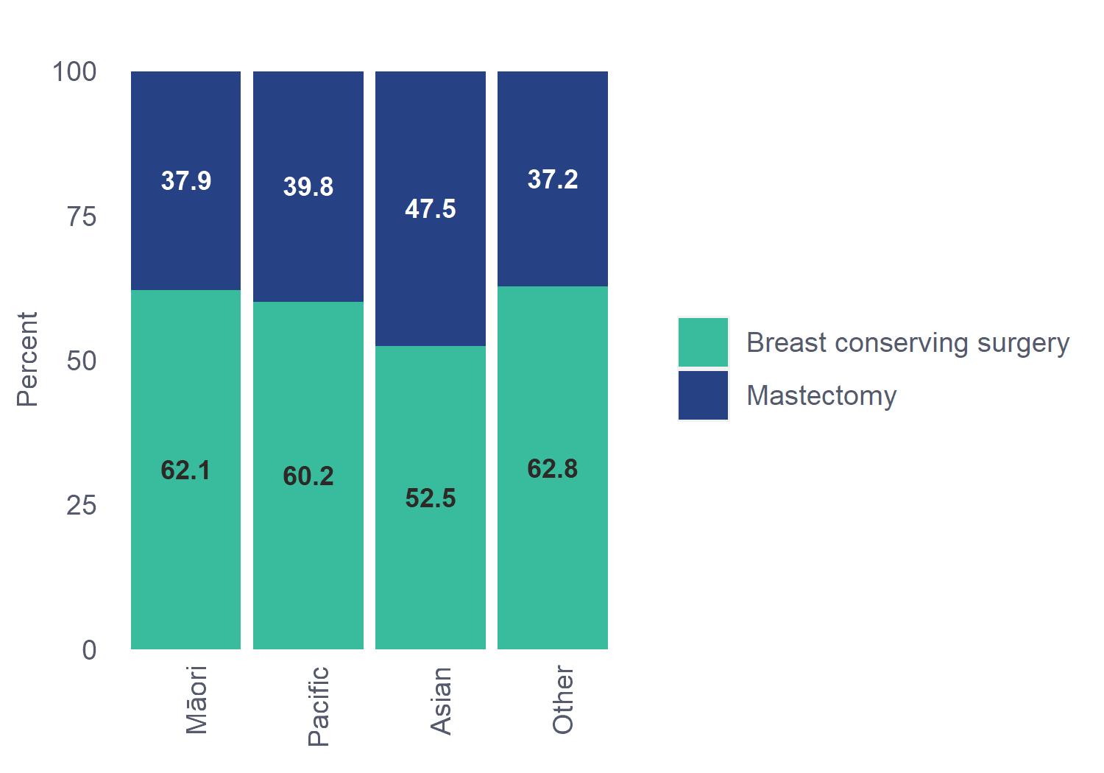
¹²Table 4.1.7 Further breast surgery after breast conserving surgery for invasive cancer by ethnicity, patients aged 45-69
Ethnicity | Any further surgery | No further breast surgery
Māori (n=203) | 40 (19.7%) | 163 (80.3%)
Pacific (n=77) | 15 (19.5%) | 62 (80.5%)
Asian (n=96) | 12 (12.5%) | 84 (87.5%)
Other (n=908) | 150 (16.5%) | 758 (83.5%)
Total (n=1284) | 217 (16.9%) | 1067 (83.1%)
Chi-square p-value: 0.1708
Unknown/missing data excluded: No breast conserving surgery - 910 patients.
There was no significant difference in the proportion of Māori patients requiring re-excision or completion mastectomy after BCS.

²Figure 4.1-1: Axillary procedures for invasive cancer by ethnicity, all regions, 2020
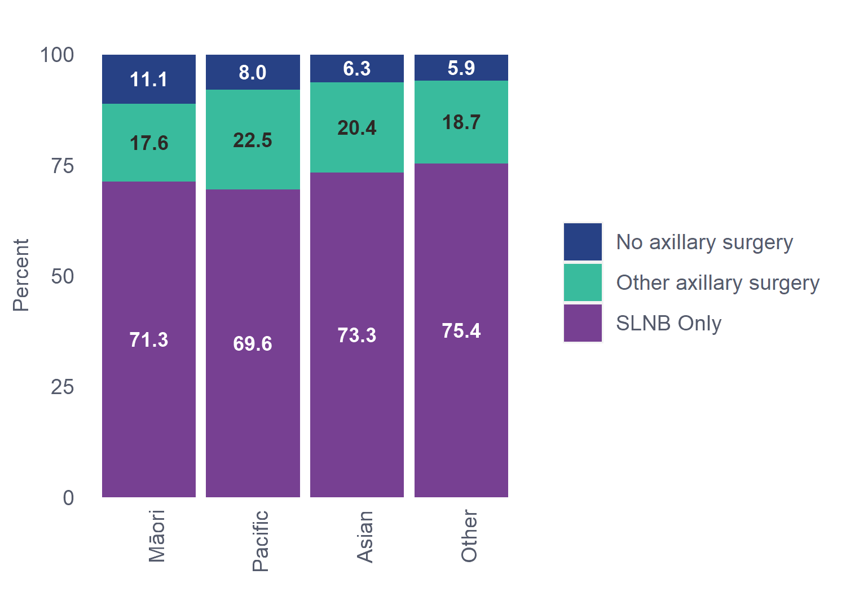
Māori patients were less likely than most other ethnicities to have either sentinel lymph node biopsy or axillary node dissection; 11.1% had no axillary surgery. Possible explanations include comorbidities that contraindicate axillary surgery, or a higher rate of stage 4 presentation. This finding merits further investigation.
¹³Table 4.1.8 Circumferential margins of excision for invasive cancer by ethnicity, patients aged 45-69
Ethnicity | ≥ 2 mm margin
Māori (n=203) | 189 (93.1%)
Pacific (n=75) | 64 (85.3%)
Asian (n=95) | 78 (82.1%)
Other (n=883) | 757 (85.7%)
Total (n=1256) | 1088 (86.6%)
Chi-square p-value: 0.1271
Unknown/missing data excluded: Margin - 107 patients (either surgery not done, or not assessable).
Not shown due to low numbers in one or more subgroup; 13 (1%) patients with involved margins, 95 (7.6%) with 1 mm margins, and 60 (4.8%) with clear but unspecified margins.
While a high 93.1% of Māori patients had their invasive tumour excised with a margin ≥2 mm, this was not significantly different from other ethnicities.
¹⁴Table 4.1.9 Radiotherapy received for invasive cancer treated with breast conserving surgery by ethnicity, patients aged 45-69
Ethnicity | Treatment received
Māori (n=194) | 169 (87.1%)
Pacific (n=72) | 59 (81.9%)
Asian (n=93) | 82 (88.2%)
Other (n=855) | 769 (89.9%)
Total (n=1214) | 1079 (88.9%)
Chi-square p-value: 0.1129
Unknown/missing data excluded: Radiotherapy treatment - 2 patients.
42 patients (3.5%) were not referred for radiotherapy, 93 patients (7.7%) were referred but radiotherapy was not used.
Differences between ethnicities were not significant, with nearly 90% of patients who had BCS receiving radiotherapy.
¹⁵Table 4.1.10 Adjuvant endocrine treatment prescribed/given for ER+ invasive tumours by ethnicity, patients aged 45-69
Ethnicity | Treatment received | Referred but  not used | Not referred
Māori (n=289) | 215 (74.4%) | 40 (13.8%) | 34 (11.8%)
Pacific (n=110) | 82 (74.5%) | 14 (12.7%) | 14 (12.7%)
Asian (n=155) | 108 (69.7%) | 12 (7.7%) | 35 (22.6%)
Other (n=1223) | 907 (74.2%) | 172 (14.1%) | 144 (11.8%)
Total (n=1777) | 1312 (73.8%) | 238 (13.4%) | 227 (12.8%)
Chi-square p-value: 0.0078
Unknown/missing data excluded: Endocrine treatment - 10 patients.
Māori received adjuvant endocrine therapy for ER+ breast cancer at the same rate as other ethnicities.

³Figure 4.1-2: Adjuvant chemotherapy treatment for invasive cancer in patients aged 45-69 by ethnicity, all regions, 2020
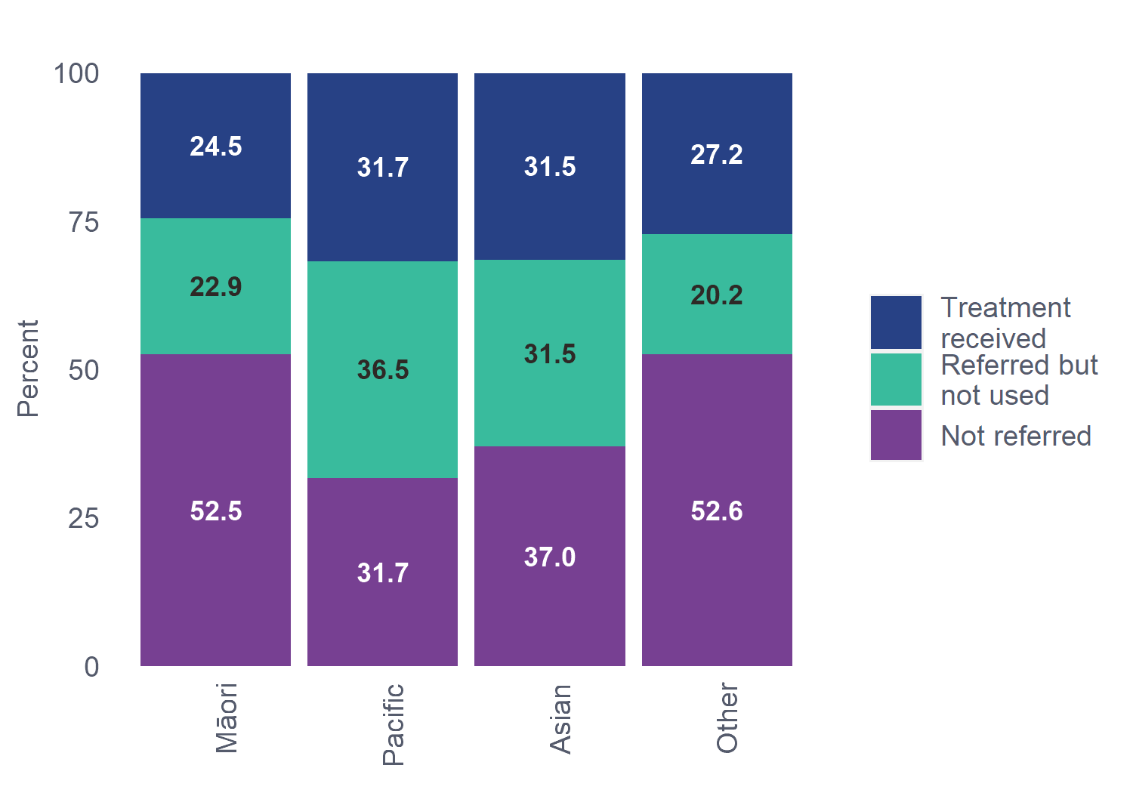
Māori were referred for adjuvant chemotherapy at the same rate as patients of Other ethnicity (47.4% vs 47.4%).
Of all Māori patients, 24.5% had chemotherapy vs 27.2% of patients of Other ethnicity. Tumour factors, in particular higher rates of grade 3 and HER2+ tumours, may account for the higher chemotherapy treatment rates for Pacific and Asian patients.
⁴Figure 4.1-3: Neoadjuvant chemotherapy treatment for invasive cancer in patients aged 45-69 by ethnicity, all regions, 2020
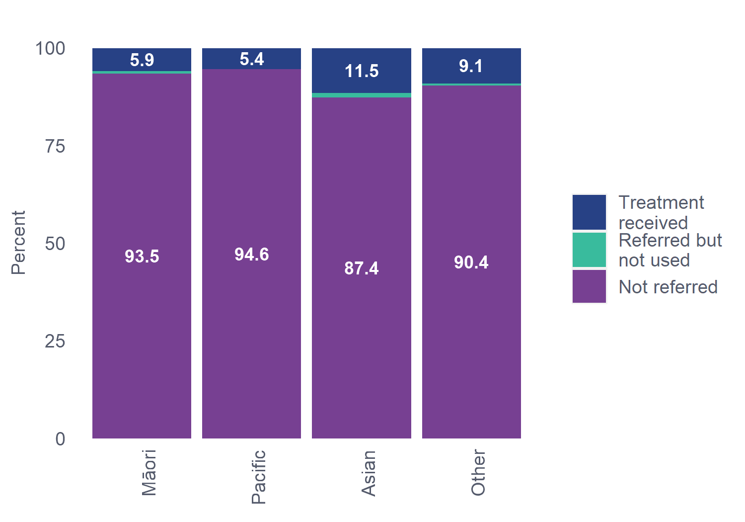
The proportion of Māori referred for neoadjuvant chemotherapy (5.9%) did not differ significantly from other ethnicities.
¹⁶Table 4.1.11 Adjuvant anti-HER2 treatment for invasive HER2+ cancer >1cm and/or node-positive by ethnicity, patients aged 45-69
Ethnicity | Adjuvant anti-HER2 treatment
Māori (n=37) | 22 (59.5%)
Pacific (n=26) | 18 (69.2%)
Asian (n=22) | 18 (81.8%)
Other (n=144) | 102 (70.8%)
Total (n=229) | 160 (69.9%)
Chi-square p-value: 0.4347
Unknown/missing data excluded: Anti-HER2 treatment - 3 patients.
Of Māori patients diagnosed with HER2+ breast cancer, 59.5% received adjuvant anti-HER2 treatment. This is lower than the proportion of patients receiving adjuvant anti-HER2 treatment across all other ethnicities and may be worthy of further investigation. However, small absolute numbers were involved (22 out of 37 patients).
¹⁷Table 4.1.12 KPI 6 Percentage of high-risk cases referred for chemotherapy (target 90%)
Ethnicity | KPI 6 | KPI 6A
Māori | 76 (82.6%) | 44 (91.7%)
Pacific | 46 (92%) | 31 (96.9%)
Asian | 44 (91.7%) | 29 (93.5%)
Other | 354 (90.5%) | 248 (96.1%)
Total | 520 (89.5%) | 352 (95.4%)
The BreastSurgANZ Quality Audit directed by the Royal Australasian College of Surgeons (RACS) provides six evidence-based Key Performance Indicators (KPIs) against which participating members audit their practice. KPIs 1-5 were met in 2020 for Māori and non-Māori patients; these are presented in detail in Chapter 17.
The 90% target for KPI 6 Percentage of high-risk cases referred for chemotherapy was not met for Māori in 2020 (82.6%). This result is likely influenced by the higher proportion of Luminal A subtype tumours in Māori. Luminal A tumours are no longer considered high-risk in the USA NCCN guidelines followed in New Zealand (National Comprehensive Cancer Network, 2020), so regional variation may occur where Luminal A cases are less likely to be referred to chemotherapy from multidisciplinary meetings. When KPI 6 is recalculated to exclude Luminal A cases (KPI 6A), the 90% threshold is reached for Māori patients (91.7%).

- Priority BSA group – Pacific patients
Pacific patients have poorer breast cancer survival than other ethnicities as a result of late diagnosis, socio-economic factors and differences in access to, and quality of care after diagnosis (Tin, S., et al.; Cancer Control Agency, 2021).
Improving Pacific uptake of breast cancer screening has been a key priority of the NSU, with coverage rates monitored closely as part of its commitment to achieving equity. Prior to COVID-19, the national screening coverage rate for Pacific women was above the national target.
In 2020, 152 Pacific patients of screening age were diagnosed with invasive breast cancer or DCIS (5.8% of all patients diagnosed). The low number of diagnoses means analysis by BSA and other referral sources was not possible for Pacific patients; instead, they are included in the non-Māori group in all tables reported by referral source. In future reports, data will be aggregated over two or more years to enable reporting of Pacific patients as a separate subgroup.
This chapter provides limited reporting on tumour characteristics and breast cancer treatment for Pacific patients, where patient numbers are sufficient to ensure privacy. Note that many of the tables are not statistically significant.
  - Key findings
- Pacific diagnoses in 2020 were 55.2% screened (49.3% BSA and 5.9% non-BSA). Pacific patients had the highest proportion of Symptomatic/Other diagnoses (44.7%), compared with 38.2% of Māori screening-age diagnoses, 39% of Asian and 36.1% of Other diagnoses.

Tumour characteristics
- Pacific patients had the largest median invasive tumour size (21 mm) of all ethnicities (Error! Reference source not found.).
- As shown in previous studies, a higher proportion of Pacific patients (25.4%) had HER2+ invasive cancer than all other ethnicities (Error! Reference source not found.).
- Pacific patients had a similar distribution of regional nodal positivity to other ethnicities (Error! Reference source not found.).

Treatment
- Less than 50% of Pacific patients received their first treatment within 31 days of diagnosis; less than any ethnicity except Māori (Error! Reference source not found.).
- Pacific patients had the same ratio of breast conserving surgery (BCS) as their first surgery for invasive cancer as other ethnicities (Error! Reference source not found.).
- Pacific patients also had the same rate of re-excisions. (Error! Reference source not found.).
- While Pacific patients received radiotherapy (Error! Reference source not found.) and endocrine therapy (Error! Reference source not found.) at the same rate as the other ethnicities, they were more likely to be referred for chemotherapy (68.2%), and more likely to receive it than other ethnicities (Error! Reference source not found.).
- Although they had a greater incidence of high-risk tumours (larger size and HER2+), only a very small proportion (5.4%) were referred for or received neoadjuvant chemotherapy (Figure 5.1-3Error! Reference source not found.)
- All HER2+ Pacific patients with invasive cancer >1 cm and/or node-positive were referred for anti-HER2 treatment. Of these, 69.2% received adjuvant anti-HER2 treatment (Error! Reference source not found.).
- All six Key Performance Indicator (KPI) targets were exceeded for Pacific patients (Error! Reference source not found.).
¹⁸Table 5.1.1 Size of invasive tumour by ethnicity, patients aged 45-69
Ethnicity | Median (mm) | IQR (mm)
Māori (n=319) | 18.0 | (10.6, 28.0)
Pacific (n=126) | 21.0 | (12.0, 32.4)
Asian (n=167) | 16.0 | (10.0, 25.0)
Other (n=1390) | 15.0 | (9.0, 24.0)
Total (n=2002) | 16.0 | (10.0, 25.0)
Kruskal-Wallis p-value: <0.0001
Unknown/missing data excluded: Size of invasive tumour - 87 patients (may be invasive tumour size is zero or not assessable). Size of invasive tumour - 106 patients (may be primary surgery not done).
Includes 113 patients treated with neoadjuvant chemotherapy; tumour size measurement is based on excised tumour.
*IQR = Interquartile range
Pacific patients had the largest median invasive tumour size (21 mm) of all ethnicities.
¹⁹Table 5.1.2 Regional nodal status by ethnicity, patients aged 45-69
Ethnicity | No nodal involvement | Macro Metastasis
Māori (n=351) | 254 (72.4%) | 67 (19.1%)
Pacific (n=138) | 100 (72.5%) | 28 (20.3%)
Asian (n=191) | 141 (73.8%) | 37 (19.4%)
Other (n=1514) | 1113 (73.5%) | 276 (18.2%)
Total (n=2194) | 1608 (73.3%) | 408 (18.6%)
Chi-square p-value: 0.6826
Macro-metastasis: at least one nodal metastasis >2 mm
46 patients had isolated tumour cells, 132 had micro metastasis.
There was no difference in the proportion of Pacific patients with no nodal involvement, compared with other ethnicities.
²⁰Table 5.1.3 HER2 status of invasive tumour by ethnicity, patients aged 45-69
Ethnicity | HER2+
Māori (n=351) | 50 (14.2%)
Pacific (n=138) | 35 (25.4%)
Asian (n=190) | 33 (17.4%)
Other (n=1513) | 226 (14.9%)
Total (n=2192) | 344 (15.7%)
Chi-square p-value: 0.0099
Unknown/missing data excluded: HER2 status - 3 patients (including not tested).
Pacific women have a much higher proportion of HER2+ breast cancer than any other ethnicity.

²¹Table 5.1.4 Median size of DCIS by ethnicity, patients aged 45-69
Ethnicity | Median (mm) | IQR (mm)
Māori (n=42) | 15.5 | (9.2, 35.8)
Pacific (n=11) | 15.0 | (7.5, 30.5)
Asian (n=56) | 13.5 | (7.0, 20.0)
Other (n=277) | 21.0 | (9.0, 37.0)
Total (n=386) | 18.0 | (9.0, 35.0)
Kruskal-Wallis p-value: 0.1323
Unknown/missing data excluded: Tumour size - 24 patients.
*IQR = Interquartile range
The small number of Pacific patients with DCIS means that comparison with other ethnicities is not statistically significant.
²²Table 5.1.5 Time from date of diagnosis to treatment for invasive cases by ethnicity, patients aged 45-69
Ethnicity | 0-31 Days | 32-62 Days | 63+ Days
Māori (n=344) | 137 (39.8%) | 176 (51.2%) | 31 (9%)
Pacific (n=132) | 60 (45.5%) | 66 (50%) | 6 (4.5%)
Asian (n=189) | 97 (51.3%) | 84 (44.4%) | 8 (4.2%)
Other (n=1499) | 841 (56.1%) | 574 (38.3%) | 84 (5.6%)
Total (n=2164) | 1135 (52.4%) | 900 (41.6%) | 129 (6%)
Chi-square p-value: <0.0001
Unknown/missing data excluded: Diagnosis date/ first treatment date - 22 patients (includes patients whose first treatment date is before their diagnosis date).
Pacific patients were less likely than all other ethnicities except Māori to receive treatment within 31 days of diagnosis. This statistic combines both public and private hospital treatment data; a public-only analysis would likely reduce the difference, but an inequity would remain.

⁵Figure 5.1-1: First surgery type by ethnicity, all regions, 2020
²³Table 5.1.6 Further breast surgery after breast conserving surgery for invasive cancer by ethnicity, patients aged 45-69
Ethnicity | Any further surgery | No further breast surgery
Māori (n=203) | 40 (19.7%) | 163 (80.3%)
Pacific (n=77) | 15 (19.5%) | 62 (80.5%)
Asian (n=96) | 12 (12.5%) | 84 (87.5%)
Other (n=908) | 150 (16.5%) | 758 (83.5%)
Total (n=1284) | 217 (16.9%) | 1067 (83.1%)
Chi-square p-value: 0.1708
Unknown/missing data excluded: No breast conserving surgery - 910 patients.
There was no difference in the proportion of Pacific patients having BCS as their first surgery, nor any difference in the rate of re-excisions.

²⁴Table 5.1.7 Final circumferential margins of excision for invasive cancer by ethnicity, patients aged 45-69
Ethnicity | ≥2 mm margin
Māori (n=203) | 189 (93.1%)
Pacific (n=75) | 64 (85.3%)
Asian (n=95) | 78 (82.1%)
Other (n=883) | 757 (85.7%)
Māori (n=203) | 189 (93.1%)
Chi-square p-value: 0.1271
Unknown/missing data excluded: Margin - 107 patients (either surgery not done, or not assessable).
Not shown due to low numbers in one or more subgroup; 13 (1%) patients with involved margins, 95 (7.6%) with 1 mm margins,
and 60 (4.8%) with clear but unspecified margins.
Pacific patients had similar margins of excision to other ethnicities after BCS for invasive cancer.
²⁵Table 5.1.8 Radiotherapy for invasive cancer treated with breast conserving surgery by ethnicity, patients aged 45-69
Ethnicity | Treatment received
Māori (n=194) | 169 (87.1%)
Pacific (n=72) | 59 (81.9%)
Asian (n=93) | 82 (88.2%)
Other (n=855) | 769 (89.9%)
Total (n=1214) | 1079 (88.9%)
Chi-square p-value: 0.1129
42 patients (3.5%) were not referred for radiotherapy, 93 patients (7.7%) were referred but radiotherapy was not used.
There was no significant difference in the proportion of Pacific patients receiving radiotherapy, compared to other ethnicities.
²⁶Table 5.1.9 Adjuvant endocrine treatment prescribed/given for ER+ invasive tumours by ethnicity, patients aged 45-69
Ethnicity | Treatment received | Referred but  not used | Not referred
Māori (n=289) | 215 (74.4%) | 40 (13.8%) | 34 (11.8%)
Pacific (n=110) | 82 (74.5%) | 14 (12.7%) | 14 (12.7%)
Asian (n=155) | 108 (69.7%) | 12 (7.7%) | 35 (22.6%)
Other (n=1223) | 907 (74.2%) | 172 (14.1%) | 144 (11.8%)
Total (n=1777) | 1312 (73.8%) | 238 (13.4%) | 227 (12.8%)
Chi-square p-value: 0.0078
Unknown/missing data excluded: Endocrine treatment - 10 patients.
Pacific patients received endocrine therapy at the same rate as other ethnicities.
⁶Figure 5.1-2: Adjuvant chemotherapy treatment for invasive cancer in patients aged 45-69 by ethnicity, all regions, 2020

⁷Figure 5.1-3: Neoadjuvant chemotherapy treatment for invasive cancer in patients aged 45-69 by ethnicity, all regions, 2020
Pacific patients were more likely to be referred (68.2%) for adjuvant chemotherapy than other ethnicities, likely due to their larger tumours and higher rate of HER2+ breast cancer. However, very few (5.4%) were referred for or received neoadjuvant therapy.
²⁷Table 5.1.10 Adjuvant anti-HER2 treatment for invasive HER2+ cancer >1cm and/or node-positive by ethnicity, patients aged 45-69
Ethnicity | Adjuvant Anti-HER2 treatment
Māori (n=37) | 22 (59.5%)
Pacific (n=25) | 18 (69.2%)
Asian (n=22) | 18 (81.8%)
Other (n=144) | 102 (70.8%)
Total (n=228) | 160 (69.9%)
Chi-square p-value: 0.4347
Unknown/missing data excluded: Anti-HER2 treatment - 3 patients.
All eligible HER2+ Pacific patients were referred for anti-HER2 treatment. Of these, 69.2% received adjuvant anti-HER2 treatment.

²⁸Table 5.1.11 KPI Summary
Ethnicity | KPI 1  (85%) | KPI 2  (85%) | KPI 3  (90%) | KPI 4  (90%) | KPI 5  (85%) | KPI 6  (90%) | KPI 6A  (90%)
Māori | 189 (97.9%) | 269 (88.5%) | 306 (96.5%) | 43 (100%) | 30 (93.8%) | 76 (82.6%) | 44 (91.7%)
Pacific | 69 (95.8%) | 98 (87.5%) | 124 (98.4%) | 11 (100%) | 11 (91.7%) | 46 (92%) | 31 (96.9%)
Asian | 89 (96.7%) | 123 (77.8%) | 177 (97.8%) | 58 (100%) | 21 (100%) | 44 (91.7%) | 29 (93.5%)
Other | 822 (96.5%) | 1089 (87.6%) | 1406 (98.3%) | 288 (100%) | 105 (92.9%) | 354 (90.5%) | 248 (96.1%)
Total | 1169 (96.7%) | 1579 (86.9%) | 2013(98%) | 400 (100%) | 167 (93.8%) | 520 (89.5%) | 352 (95.4%)
All six Key Performance Indicator (KPI) targets were exceeded for Pacific patients. These are discussed in detail in Chapter 17.

- Invasive tumour characteristics
This report includes 2,195 patients aged 45-69 who were diagnosed with invasive breast cancer. The majority of invasive cancers (79%) were histologically ductal carcinoma no special type (Ductal NST) (Table 6.1.1).
For the purposes of this report, a patient is included if they had an invasive breast carcinoma diagnosed from a tissue sample, or tumour size (as determined by surgical histopathology or tissue sample) >0 mm (including micro-invasion and with or without presence of DCIS).

Key Findings
- Screened tumours were ~40% smaller than tumours referred from other sources. Median invasive tumour size differed significantly between screened patients (BSA 13 mm, non-BSA 12 mm) and Symptomatic/Other patients (22 mm) (Table 6.2.1).
- More than half of BSA patients had a tumour size <15 mm, compared to less than one-third of patients referred from other sources (Table 6.2.1).
- The proportion of tumours that were <20 mm was greater for patients with BSA-detected cancers (72.5%) compared with patients referred from other sources (45.3%) (Table 6.2.1).
- Māori tended to have a larger median tumour size (18 mm) compared with non-Māori (16 mm) across all referral sources (Table 6.2.2).
- Symptomatic/Other patients had nearly double the proportion of grade 3 tumours of BSA-screened patients. This is likely to be because screening tends to detect more slow growing cancers (Table 6.3.1).
- BSA-detected tumours were more likely to be hormone receptor-positive (91.5% ER+) (Table 6.4.1); Māori had a higher rate of hormone receptor-positive cancers than non-Māori (Section 6.4).
- Lower proportions of HER2+ and triple negative breast cancers were detected among patients with BSA-detected tumours (Table 6.5.1 and Table 6.6.1).
- There was a lower proportion of patients with distant metastases detected via screening (1% BSA and 2.6% non-BSA) than Symptomatic/Other patients (8%) (Table 6.8.1).
- Patients with BSA-detected cancers had a higher node-negative rate (79.9%) than patients referred from other sources (66.9%). Fewer BSA-screened patients required axillary node dissection surgery; this reduces the risk of lymphoedema resulting from treatment Table 6.7.1).
- Screened cancers were more likely to be stage 1 (89.2% BSA-detected, 81.7% non-BSA detected). Far fewer Symptomatic/Other cancers (60.7%) were stage 1. A lower proportion of BSA-detected cancers were stage 4 (1%) compared with screened non-BSA cancers (2.7%) and Symptomatic/Other cancers (8.4%) (Table 6.9.1).
- When looking at biological subtypes, BSA-screened patients had a higher proportion of more favourable Luminal A subtype tumours (74.3%) compared with patients referred from other sources (58.7%) (Table 6.10.1).
  - Type of invasive tumour
²⁹Table 6.1.1 Type of invasive tumour by referral source, patients aged 45-69
 | Ductal NST | Invasive Lobular | Mucinous | Tubular | Other Invasive of  mixed type | Other neoplasm
BSA (n=1062) | 842 (79.3%) | 119 (11.2%) | 27 (2.5%) | 21 (2%) | 30 (2.8%) | 23 (2.2%)
Other Sources (n=1109) | 874 (78.8%) | 137 (12.4%) | 25 (2.3%) | 7 (0.6%) | 32 (2.9%) | 34 (3.1%)
Total (n=2171) | 1716 (79%) | 256 (11.8%) | 52 (2.4%) | 28 (1.3%) | 62 (2.9%) | 57 (2.6%)
Chi-square p-value:0.0721
Unknown/missing data excluded: Referral source - 3 patients, type of invasive tumour - 21 patients.
The Other Sources group includes 187 patients whose cancer was detected by non-BSA screening; the remainder were from other sources.

Comments
The distribution of types of invasive tumour follows expected patterns, with the majority being Ductal NST histological type. There was no significant difference between BSA and Other Sources.

³⁰Table 6.1.2 Type of invasive tumour for Māori and non-Māori patients aged 45-69
Ethnicity | Ductal NST | Invasive Lobular | Mucinous | Tubular | Other Invasive of mixed type | Other neoplasm
Māori (n=350) | 272 (77.7%) | 46 (13.1%) | 10 (2.9%) | N/S | 12 (3.4%) | N/S
Non-Māori (n=1824) | 1445 (79.2%) | 210 (11.5%) | 42 (2.3%) | N/S | 51 (2.8%) | N/S
Total (n=2174) | 1717 (79%) | 256 (11.8%) | 52 (2.4%) | 28 (1.3%) | 63 (2.9%) | 58 (2.7%)
Chi-square p-value: 0.4411
Unknown/missing data excluded: type of invasive tumour - 15 patients.
The Non-Māori group includes 136 Pacific patients due to low numbers in one or more subgroup.
N/S – Not shown due to small numbers in one or more subgroups.

Comments
There was no statistical difference between Māori and non-Māori, with both groups showing a predominance of ductal NST, followed by invasive lobular carcinoma.

Audit data used
Information was derived from eligible patient data fields “Morphology of invasive carcinoma (histological type)” (from surgical procedures) and “Morphology of invasive carcinoma” (for small tissue samples). Morphology fields options were grouped into ductal carcinoma NST, invasive lobular, tubular, mucinous, other invasive of mixed type (where more than one option is selected) and other neoplasm, for consistency with the previous 2016 BSA report. Note. Medullary carcinoma is no longer used (World Health Organization, 2020).

Definitions
Histological tumour type defines the microscopic appearance of the invasive breast cancer cells in the principal tumour. A person is included as having an invasive carcinoma if they have:
- an invasive tumour of any size >0 mm (± DCIS) identified in either their surgical histopathology (including patients who did not have a pathologic complete response after neoadjuvant chemotherapy), or tissue sample if no surgery was undertaken, or
- an invasive carcinoma diagnosed from a tissue sample, and then underwent neoadjuvant chemotherapy treatment resulting in a pathologic complete response.
  - Size of invasive tumour
³¹Table 6.2.1 Size of invasive tumour by referral source, patients aged 45-69
 | Referral Source | Median (mm) | IQR (mm)
Screening | Screened BSA (n=1021) | 13.0 | (9.0, 20.0)
 | Screened non-BSA (n=179) | 12.0 | (9.0, 21.0)
Non-screening | Symptomatic/Other (n=799) | 22.0 | (14.0, 33.0)
Total | (n=1999) | 16.0 | (10.0, 25.0)
Kruskal-Wallis p-value: <0.0001
Unknown/missing data excluded: Referral source - 3 patients. Size of invasive tumour- 87 patients (may be invasive tumour size is zero or not assessable). Size of invasive tumour- 106 patients (may be primary surgery not done).
Includes 113 patients treated with neoadjuvant chemotherapy; tumour size measurement is based on excised tumour.
*IQR = Interquartile range
³²Table 6.2.1b
 | Micro Invasion | <10 mm | 10-14 mm | 15-19 mm | 20-29 mm | 30-39 mm | ≥ 40 mm
BSA (n=1021) | 15 (1.5%) | 294 (28.8%) | 241 (23.6%) | 190 (18.6%) | 182 (17.8%) | 51 (5%) | 48 (4.7%)
Other Sources (n=978) | 9 (0.9%) | 152 (15.5%) | 148 (15.1%) | 135 (13.8%) | 250 (25.6%) | 119 (12.2%) | 165 (16.9%)
Total (n=1999) | 24 (1.2%) | 446 (22.3%) | 389 (19.5%) | 325 (16.3%) | 432 (21.6%) | 170 (8.5%) | 213 (10.7%)
Chi-square p-value: <0.0001
Unknown/missing data excluded: Referral source - 3 patients. Size of invasive tumour - 87 patients (may be invasive tumour size is zero or not assessable). Size of invasive tumour - 106 patients (may be primary surgery not done).
The Other Sources group includes179 patients whose cancer was detected by non-BSA screening; the remainder were from other sources.
Includes 113 patients treated with neoadjuvant chemotherapy; tumour size measurement is based on excised tumour.
⁸Figure 6.2-1: Median tumour size by referral source, all regions, 2020
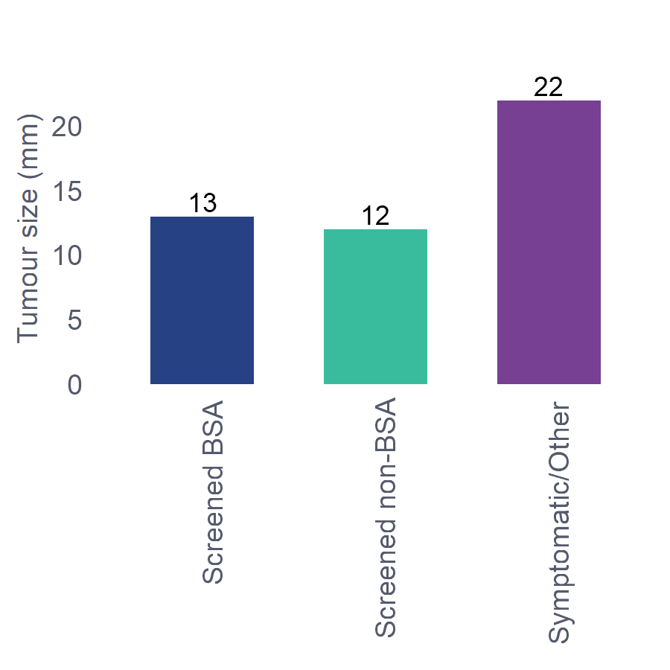
⁹Figure 6.2-2: Historical trends for contributing regions: Median tumour size by referral source, 2016-2020
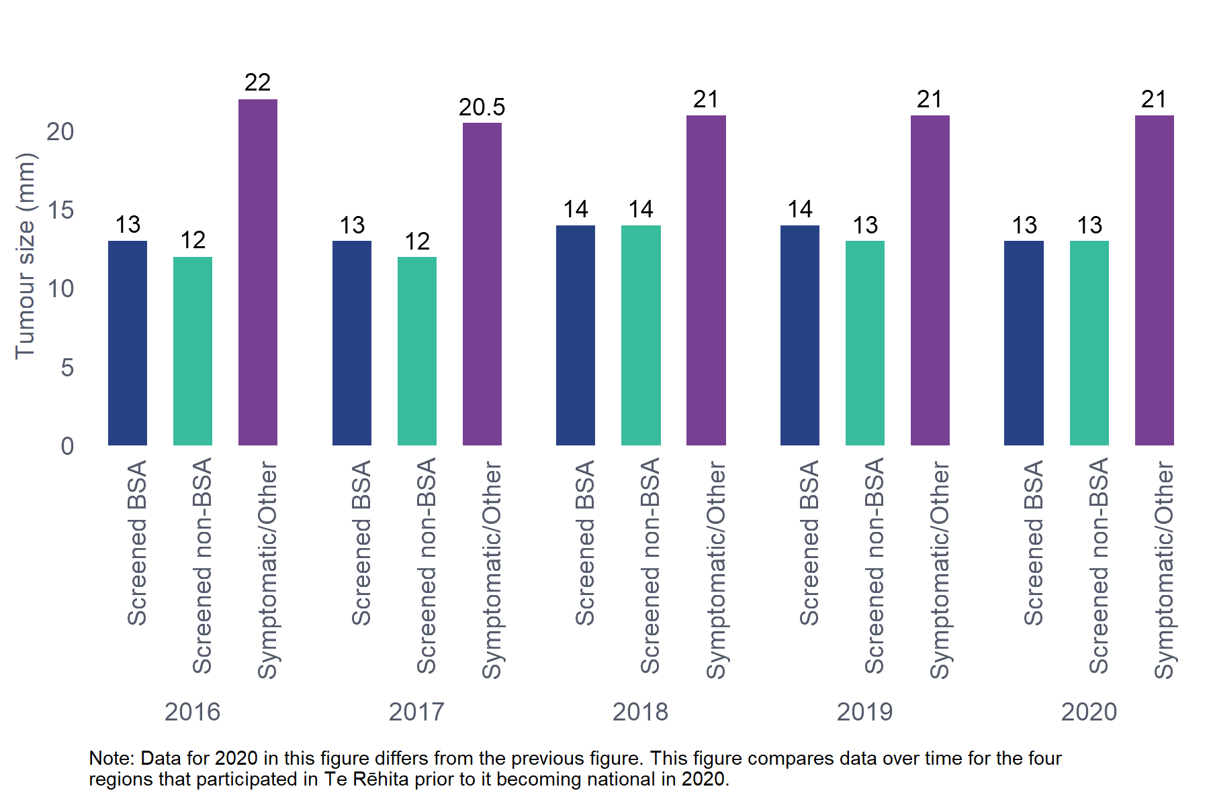

Comments
One of the most important screening programme goals is to find smaller sized tumours. In 2020, median invasive tumour size differed significantly between Screened patients (BSA 13 mm, non-BSA 12 mm) and Symptomatic/Other patients (22 mm) (p<0.0001). Size in Screened and Symptomatic/Other groups remained relatively stable over time (See Figure 6.2 1 and Figure 6.2 2), and is concordant with the 2016 BSA report (BSA 13 mm; other referral sources 20 mm).
This finding is consistent with results for the four-year period to December 2020 from the BSA programme data, which found the proportion of all BSA screen-detected invasive cancers ≤15 mm amongst patients aged 45-69 was approximately 54% following an initial screen and 64% following a subsequent screen (Robson, et al).
More than half of BSA patients had a tumour size <15 mm, compared to less than one-third of patients referred from other sources (Table 6.2.1b).
The proportion of tumours that were <20 mm was also significantly greater for patients with BSA detected cancers (72.5%) compared with patients referred from other sources (45.3%). This does not quite correlate to pathological T (tumour) stage 1 (≤20 mm), as screening has historically reported <10 mm, <15 mm, <20 mm etc.
Compared with the 2016 BSA report, BSA detected a slightly lower proportion of cancers sized <20 mm in 2020 (72.5% vs 75.1%). This may be related to the impact of COVID-19 on screening closures or delays.
³³Table 6.2.2 Size of invasive tumour for Māori and non-Māori patients aged 45-69
Ethnicity | Median (mm) | IQR (mm)
Māori (n=319) | 18.0 | (10.6, 28.0)
Non-Māori (n=1683) | 16.0 | (10.0, 25.0)
Total (n=2002) | 16.0 | (10.0, 25.0)
Kruskal-Wallis p-value: 0.0148
Unknown/missing data excluded: Size of invasive tumour - 87 patients (may be invasive tumour size is zero or not assessable). Size of invasive tumour - 106 patients (may be primary surgery not done).
Includes 113 patients treated with neoadjuvant chemotherapy; tumour size measurement is based on excised tumour.
*IQR = Interquartile range

³⁴Table 6.2.2b
Ethnicity | Micro Invasion | <10 mm | 10-14 mm | 15-19 mm | 20-29 mm | 30-39 mm | ≥ 40 mm
Māori (n=319) | 0 (0%) | 64 (20.1%) | 58 (18.2%) | 54 (16.9%) | 70 (21.9%) | 36 (11.3%) | 37 (11.6%)
Non-Māori (n=1683) | 24 (1.4%) | 383 (22.8%) | 331 (19.7%) | 271 (16.1%) | 363 (21.6%) | 134 (8%) | 177 (10.5%)
Total (n=2002) | 24 (1.2%) | 447 (22.3%) | 389 (19.4%) | 325 (16.2%) | 433 (21.6%) | 170 (8.5%) | 214 (10.7%)
Chi-square p-value: 0.1408
Unknown/missing data excluded: Size of invasive tumour - 87 patients (may be invasive tumour size is zero or not assessable). Size of invasive tumour- 106 patients (may be primary surgery not done).
The Non-Māori group include 126 Pacific patients due to low numbers in one or more subgroup.
Includes 113 patients treated with neoadjuvant chemotherapy; tumour size measurement is based on excised tumour.
¹⁰Figure 6.2-3: Median invasive tumour size by year and ethnicity, all regions, 2020
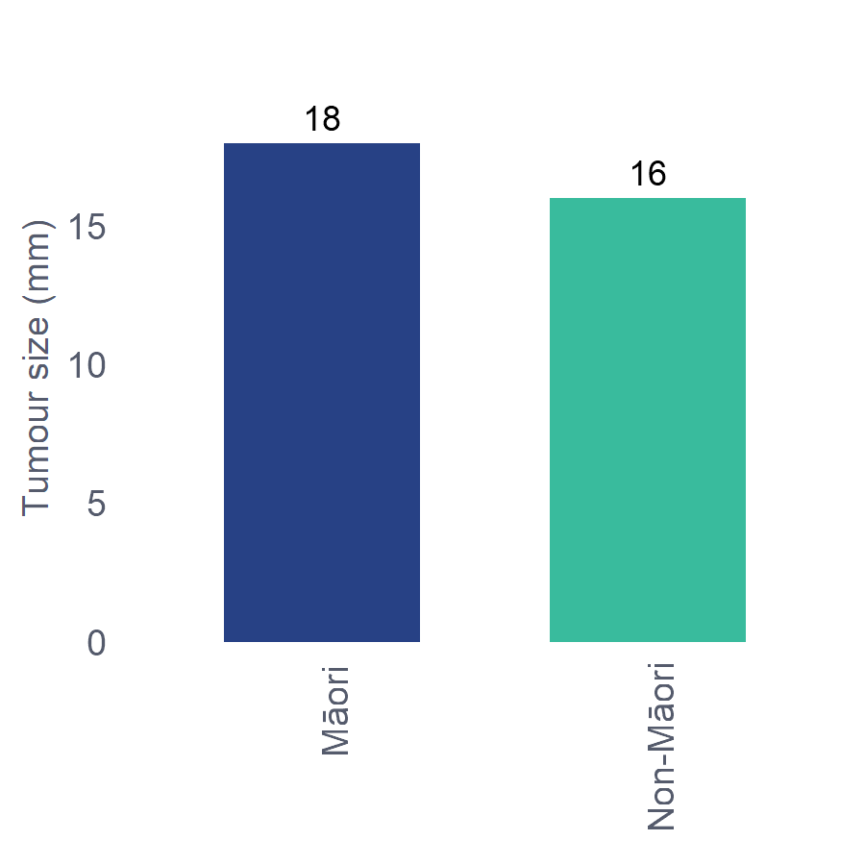

¹¹Figure 6.2-4: Historical trends for contributing regions: Median tumour size by ethnicity 2016-2020
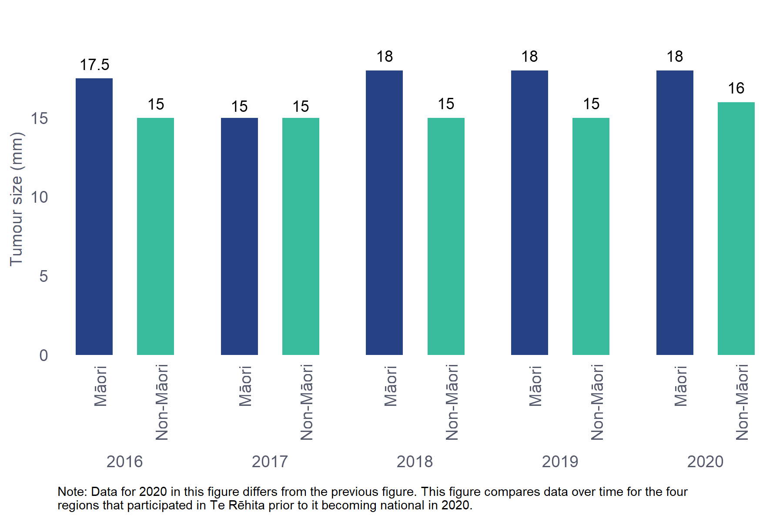

Comments
Median invasive tumour size differed between Māori (18 mm) and non-Māori (16 mm) (p=0.0148). The median tumour sizes for Māori and non-Māori have remained consistent over the 2016-2020 period (see Figure 6.2 2 and Figure 6.2 3). Future reports may allow for analysis of ethnicity data by referral source, when multiple years’ data can be aggregated to provide robust statistics that preserve confidentiality.
In 2020, 38.3% of Māori had a median tumour size <15 mm, compared with 43.9% of non-Māori.
Over half of all patients had tumours <20 mm, comprising 55.2% of Māori and 60% of non-Māori; this difference is not significant.

Audit data used
Information was derived from eligible patient data field “Invasive tumour size (in mm)”.

Definitions
Tumour size refers to the maximum diameter in millimetres of the furthest points of extension of the invasive tumour cells in the principal tumour. Size of invasive tumour is measured for patients who had a primary surgery, and where the invasive tumour size was >0 mm. Note: Micro-invasive tumours (>0 mm and ≤1 mm) are counted as invasive.
  - Histological grade of invasive tumour
³⁵Table 6.3.1 Histological grade of invasive tumour by referral source, patients aged 45-69
 | Referral Source | Grade 1 | Grade 2 | Grade 3
Screening | Screened BSA (n=1055) | 235 (22.3%) | 570 (54%) | 250 (23.7%)
 | Screened non-BSA (n=186) | 35 (18.8%) | 101 (54.3%) | 50 (26.9%)
Non-screening | Symptomatic/Other (n=914) | 88 (9.6%) | 438 (47.9%) | 388 (42.5%)
Total | (n=2155) | 358 (16.6%) | 1109 (51.5%) | 688 (31.9%)
Chi-square p-value: <0.0001
Unknown/missing data excluded: Referral source - 3 patients. Histological grade of invasive tumour - 37 patients.
¹²Figure 6.3-1: Grade of NZ invasive tumours by referral source and year of diagnosis, all regions, 2020
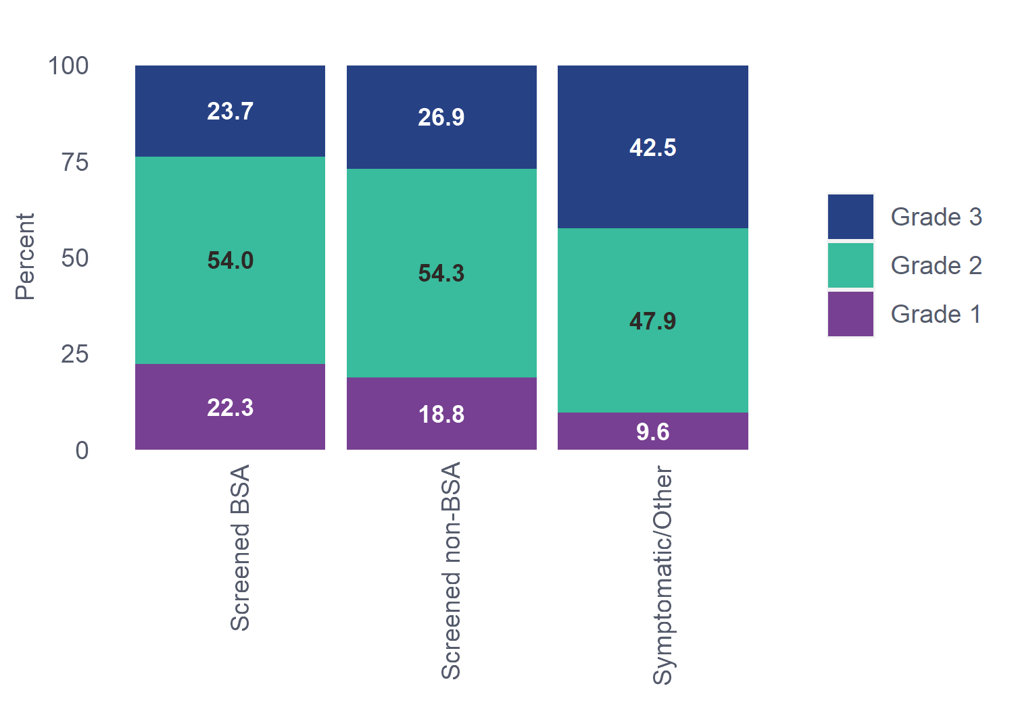

¹³Figure 6.3-2: Historical trends for contributing regions: Grade of NZ invasive tumours by referral source and year of diagnosis 2016-2020
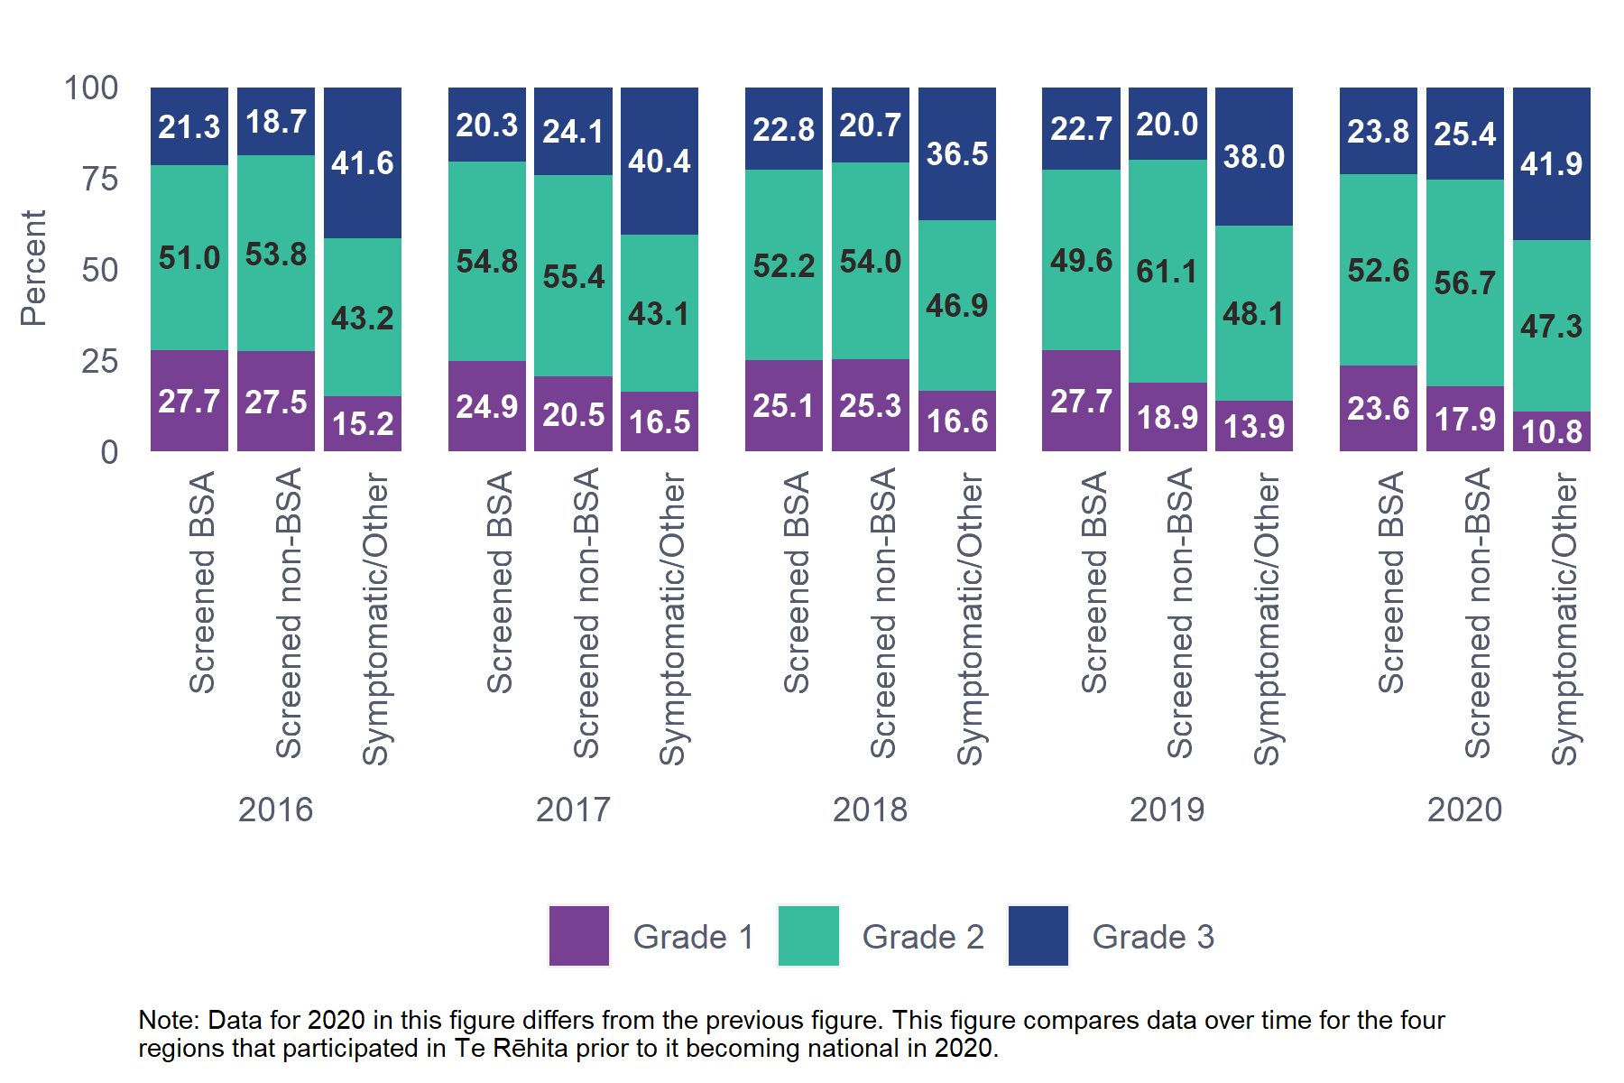

Comments
There was a significant difference in grade of tumour detected by Screened and Symptomatic/Other referral sources (p<0.0001), with nearly double the proportion of grade 3 tumours detected in the Symptomatic/Other group compared with BSA screening. Screening, by nature, tends to detect more slow growing cancers, because these cancers spend a longer time in the preclinical detectable phase, offering more opportunity for detection prior to becoming symptomatic (the cause of length time bias).
³⁶Table 6.3.2 Histological grade of invasive tumour for Māori and non-Māori patients aged 45-69
Ethnicity | Grade 1 | Grade 2 | Grade 3
Māori (n=347) | 51 (14.7%) | 180 (51.9%) | 116 (33.4%)
Non-Māori (n=1811) | 307 (17%) | 932 (51.5%) | 572 (31.6%)
Total (n=2158) | 358 (16.6%) | 1112 (51.5%) | 688 (31.9%)
Chi-square p-value: 0.5454
Unknown/missing data excluded: Histological grade of invasive tumour - 37 patients.
The non-Māori group includes 135 Pacific patients due to low numbers in one or more subgroup.
¹⁴Figure 6.3-3: Grade of NZ invasive tumours by ethnicity and year of diagnosis, all regions, 2020
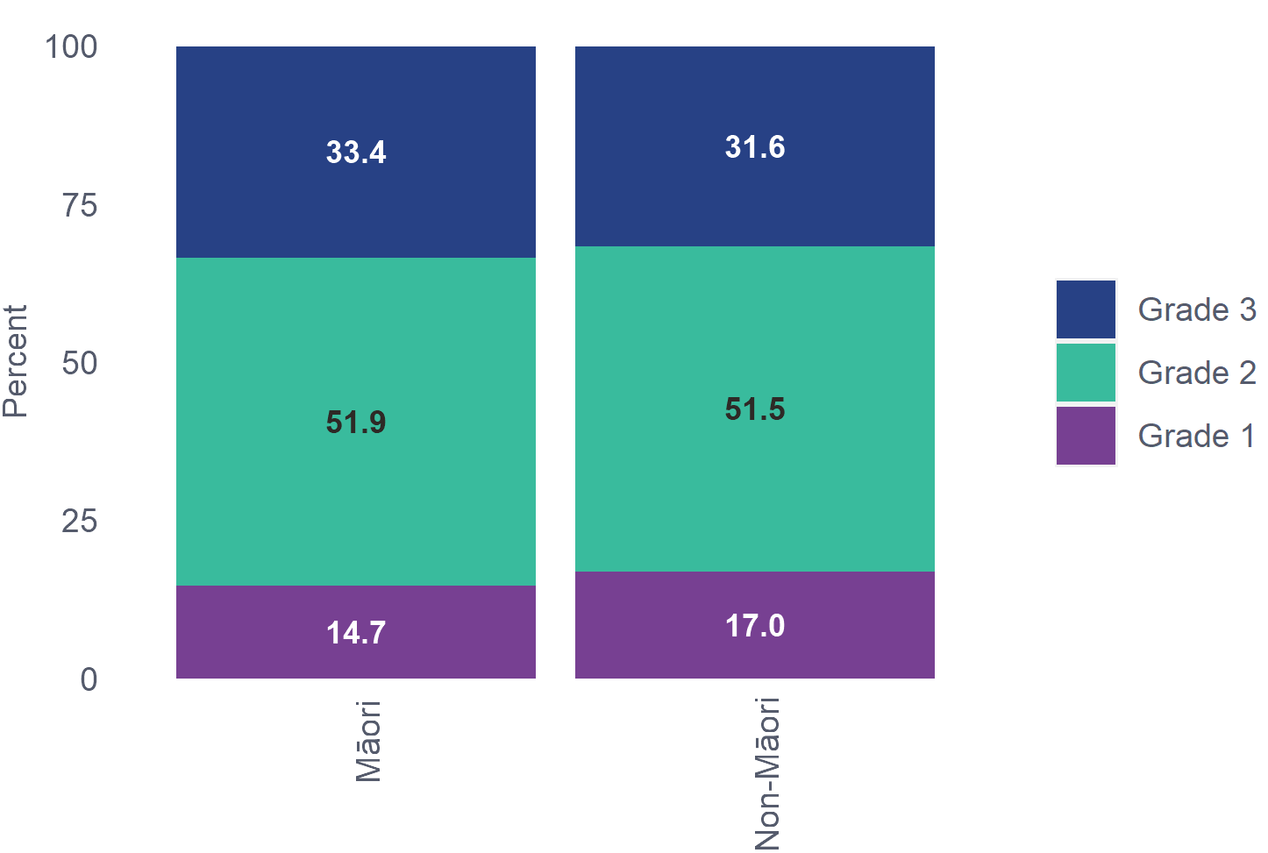
¹⁵Figure 6.3-4: Historical trends for contributing regions: Grade of NZ invasive tumours by ethnicity and year of diagnosis 2016-2020
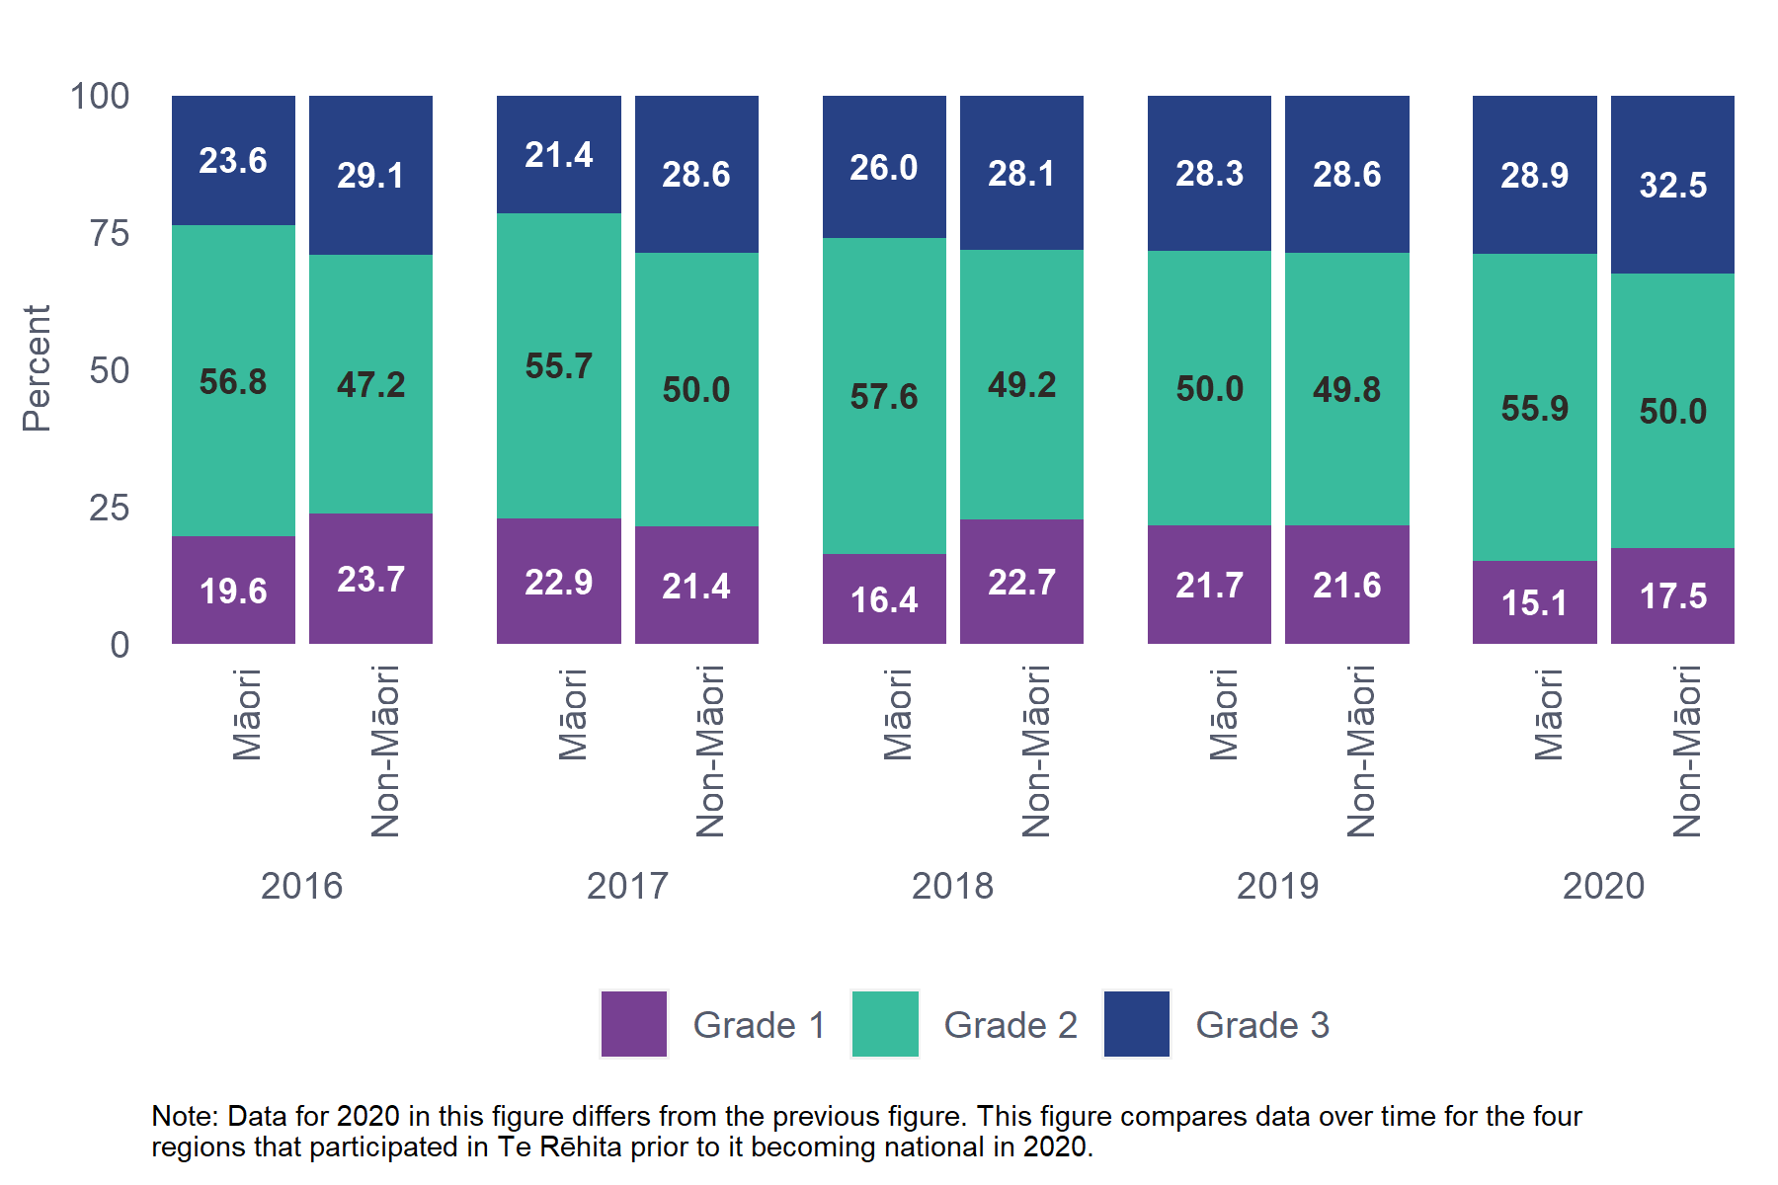

Comments
There was no significant difference in grade between Māori and non-Māori patients nationally in 2020. The proportions of each grade in the historically contributing regions have varied year-on-year and it is not possible to draw any conclusions as to trend over time.

Audit data used
Information was derived from eligible patient data fields “Histological Invasive cancer grade” and ”Core biopsy invasive cancer grade”, which allows the options of Grade 1, Grade 2, Grade 3 and Unknown / not assessable.

Definitions
Histological grade is the degree of differentiation of the breast cancer, or the degree to which it resembles normal tissue, as assessed by the pathologist according to Pathology Reporting Guidelines. The tumour is assigned a Nottingham histologic grade 1, 2 or 3. This is derived from the total of three scores (mitosis, nuclear, and tubular differentiation, each given a score of 1-3):
Grade 1: Total score of 3–5
Grade 2: Total score of 6–7
Grade 3: Total score of 8–9
  - Hormone receptor status of invasive tumour
³⁷Table 6.4.1 Hormone receptor status of invasive tumour by referral source, patients aged 45-69
 | Referral Source | ER+ | PR+ | ER+PR+
Screening | Screened BSA (n=1051) | 962 (91.5%) | 864 (82.2%) | 857 (81.5%)
 | Screened non-BSA (n=185) | 171 (92.4%) | 143 (77.3%) | 140 (75.7%)
Non-screening | Symptomatic/Other (n=921) | 751 (81.5%) | 636 (69.1%) | 617 (67%)
Total | Total (n=2157) | 1884 (87.3%) | 1643 (76.2%) | 1614 (74.8%)
P-value |  | <0.0001 | <0.0001 | <0.0001
Unknown/missing data excluded: Referral source - 3 patients. Hormone receptor status - 35 patients

Comments
As expected, the majority of patients had hormone receptor-positive tumours, similar to 2016, when 90.2% of BSA patients were ER+, 80.7% PR+, and 80.3% ER+PR+.
In future reports it may be useful to quantify the small proportion of patients whose cancer is PR+ but ER-, as these patients have significantly poorer survival. (Parise, C., et al., 2014).
³⁸Table 6.4.2 Hormone receptor status of invasive tumour for Māori and non-Māori patients aged 45-69
Ethnicity | ER+ | PR+ | ER+PR+
Māori (n=348) | 319 (91.7%) | 277 (79.6%) | 276 (79.3%)
Non-Māori (n=1812) | 1568 (86.5%) | 1369 (75.6%) | 1341 (74%)
Total (n=2160) | 1887 (87.4%) | 1646 (76.2%) | 1617 (74.9%)
P-value | 0.0107 | 0.1200 | 0.0432
Unknown/missing data excluded: Hormone receptor status - 35 patients.
The Non-Māori group includes 135 Pacific patients due to low numbers in one or more subgroup.

Comments
Hormone receptor (ER and PR) positivity, often an indicator of more favourable prognosis, was higher in Māori than non-Māori. Other studies have variously reported higher hormone receptor positivity for Māori (Campbell, I., et al., 2015) or no difference (Seneviratne, S., et al., 2015).

Audit data used
Information was derived from eligible patient data fields “core biopsy oestrogen result”, “oestrogen result”, “core biopsy progesterone result” and “progesterone result” which allows the options negative, positive, not tested and unknown.
Where ER or PR is tested at both core biopsy and at definitive excision, international guidelines recommend using the core biopsy to determine receptor status.

Definitions
Hormone receptor status: the presence or absence of oestrogen or progesterone receptors on the tumour cells.
Oestrogen receptor (ER): an intracellular receptor protein that binds oestrogens and anti-oestrogens, mediating their effects by binding to DNA and altering the expression of specific genes. Oestrogen receptors are predictive (of response to treatment) and prognostic indicators.
Progesterone receptor (PR): a protein found inside the cells of female reproductive tissue, some other types of tissue and some cancer cells. The hormone progesterone will bind to the receptors inside the cells and may cause the cells to grow.
  - HER2 status of invasive tumours
³⁹Table 6.5.1 HER2 status of invasive tumours by referral source, patients aged 45-69
 | Referral Source | Positive
Screening | Screened BSA (n=1069) | 121 (11.3%)
 | Screened non-BSA (n=190) | 33 (17.4%)
Non-screening | Symptomatic/Other (n=930) | 190 (20.4%)
Total | (n=2189) | 344 (15.7%)
Chi-square p-value: <0.0001
Unknown/missing data excluded: Referral source - 3 patients. HER2 status - 3 patients (including not tested).

Comments
A lower proportion of HER2+ tumours were detected in BSA-screened patients (11.3%) than in non-BSA screened patients (17.4%) and Symptomatic/Other patients (20.4%) The BSA-screened finding aligns with published data from New Zealand (Lawrenson, R., et al., 2019) and international literature reporting lower proportions of screen-detected HER2+ and triple negative cancers compared with clinically-detected cancers (patient age group 50-70) (Alanko, J., et al., 2021). It is unclear why non-BSA screened patients would have higher rates of HER2+ cancer than BSA-screened; however, the numbers in this group are much smaller than the other two groups.
HER2+ cancers can be more aggressive and therefore more likely to be detected via a palpable mass. This may explain why the proportion of HER2+ BSA screened patients is slightly lower than in the 2016 BSA report (13.4%), with COVID-related screening delays potentially allowing more HER2+ cancers to become symptomatic in 2020.

⁴⁰Table 6.5.2 HER2 status of invasive tumours for Māori and non-Māori patients aged 45-69
Ethnicity | Positive
Māori (n=351) | 50 (14.2%)
Non-Māori (n=1841) | 294 (16%)
Total (n=2192) | 344 (15.7%)
Chi-square p-value: 0.4630
Unknown/missing data excluded: HER2 status - 3 patients (including not tested).
The Non-Māori group includes 138 Pacific patients due to low numbers in one or more subgroup.

Comments
There was no significant difference in HER2 status of cancers in Māori (14.2%) compared with non-Māori (16%).

Audit data used
Information was derived from eligible patient data fields “IHC Her2 result” and “FISH Her2 result” which allows the options of positive, negative, equivocal, not tested and not done.
Where IHC Her2 and FISH results were both available the FISH result was taken as the final result.
Where IHC Her2 was tested more than once, the positive result superseded an equivocal or negative result.
Where IHC Her2 and/or FISH results were equivocal the result was counted as negative (n=10).

Definitions
Positive: biopsy revealed abnormally high levels of the HER2 gene or protein
Negative: biopsy revealed a normal level of the HER2 gene or protein
Levels of HER2 are tested via immunohistochemistry (IHC) or fluorescence in situ hybridisation (FISH) testing.

  - Triple negative status of invasive tumours
⁴¹Table 6.6.1 Triple negative status of invasive tumours by referral source, patients aged 45-69
 | Referral Source | Triple Negative
Screening | Screened BSA (n=1049) | 62 (5.9%)
 | Screened non-BSA (n=185) | 7 (3.8%)
Non-screening | Symptomatic/Other (n=920) | 98 (10.7%)
Total | (n=2154) | 167 (7.8%)
Chi-square p-value:<0.0001
Unknown/missing data excluded: Referral source - 3 patients. Triple negative status - 38 patients.

Comments
A lower proportion of triple negative cancers were in screened than Symptomatic/Other patients: 5.9% of BSA-screened cancers and 3.8% of non-BSA screened (non-BSA numbers were very small), compared with 10.7% Symptomatic/Other. These findings are consistent with the 2016 BSA report. The lower proportion of triple negative tumours detected by screening may be due to the more aggressive and faster-growing nature of triple negative tumours. In the screening population, these are more likely to be detected as interval cancers (Holm, J., et al., 2015).
⁴²Table 6.6.2 Triple negative status of invasive tumours for Māori and non-Māori patients aged 45-69
Ethnicity | Triple Negative
Māori (n=347) | 17 (4.9%)
Non-Māori (n=1810) | 150 (8.3%)
Total (n=2157) | 167 (7.7%)
Chi-square p-value: 0.0400
Unknown/missing data excluded: Triple negative status - 38 patients.
The Non-Māori group includes 135 Pacific patients due to low numbers in one or more subgroup.

Comments
A lower proportion of triple negative tumours were detected in Māori (4.9%) compared with non-Māori (8.3%).

Audit data used
Information was derived from eligible patient data fields “Oestrogen receptor status”, “Progesterone receptor status” and “HER2 status” which allow the options of positive, negative, equivocal, not tested and not done.

Definitions
Triple Negative Breast Cancer (TNBC): invasive tumours that test negative for all three receptors (oestrogen, progesterone and HER2).
  - Regional nodal status
Nodal status refers to level of cancer involvement in lymph nodes on the same side (ipsilateral) as the breast cancer, and is used in the calculation of breast cancer stage.
⁴³Table 6.7.1 Regional nodal status by referral source, patients aged 45-69
 | No nodal involvement | Isolated tumour cells | Micro Metastasis | Macro Metastasis
BSA (n=1070) | 855 (79.9%) | 18 (1.7%) | 61 (5.7%) | 136 (12.7%)
Other Sources (n=1121) | 750 (66.9%) | 28 (2.5%) | 71 (6.3%) | 272 (24.3%)
Total (n=2191) | 1605 (73.3%) | 46 (2.1%) | 132 (6%) | 408 (18.6%)
Chi-square p-value: <0.0001
Unknown/missing data excluded: Referral source - 3 patients.
The Other Sources group includes 190 patients whose cancer was detected by non-BSA screening; the remainder were from other sources.
Macro-metastasis: at least one nodal metastasis >2 mm

Comments
Patients with breast cancer referred from BSA had a higher node-negative rate (79.9%) than patients referred from other sources (66.9%). This is an essential component of achieving a higher proportion of early-stage disease as a result of mammographic screening, and therefore a higher chance of survival. In addition, fewer BSA-screened patients will require axillary node dissection surgery, reducing the risk of lymphoedema resulting from treatment.
Even for patients with nodal burden (i.e. positive lymph nodes were found), a lower proportion of macro metastatic nodes were detected by BSA (12.7%) compared to other sources (24.3%).
⁴⁴Table 6.7.2 Regional nodal status for Māori and non-Māori patients aged 45-69
Ethnicity | No nodal involvement | Isolated tumour cells | Micro Metastasis | Macro Metastasis
Māori (n=351) | 254 (72.4%) | 12 (3.4%) | 18 (5.1%) | 67 (19.1%)
Non-Māori (n=1843) | 1354 (73.5%) | 34 (1.8%) | 114 (6.2%) | 341 (18.5%)
Total (n=2194) | 1608 (73.3%) | 46 (2.1%) | 132 (6%) | 408 (18.6%)
Chi-square p-value: 0.2472
Macro-metastasis: at least one nodal metastasis >2 mm

Comments
There was no significant variation in distribution of regional nodal status by Māori vs non-Māori ethnicity.

Audit data used
Information was derived from eligible patient data fields “Number of nodes involved by tumour” and “Nodal metastasis based on the largest deposit” which allows the options isolated tumour cells, micro metastasis and macro metastasis.

Definitions
Number of nodes involved by tumour: number of nodes found to be positive for cancer when examined by a pathologist. The total number of involved nodes includes positive nodes found from axillary node dissection and sentinel lymph node biopsy.
No nodal involvement: no nodes are found to be positive for metastases.
Nodal status is defined by the size of the largest nodal metastases in largest dimension:
- Isolated tumour cell clusters (ITC): small clusters of cells not larger than 0.2 mm, or single tumour cells, or fewer than 200 cells in a single histologic cross-section. Nodes containing only ITCs are interpreted as negative.
- Micro metastasis: at least one node must contain a tumour deposit larger than 0.2 mm but not larger than 2.0mm in largest dimension.
- Macro metastasis: at least one node must contain a tumour deposit larger than 2.0 mm.
  - Distant metastases
A small proportion of breast cancers have metastasised by the time they are diagnosed, referred to as de novo metastatic breast cancer. This report includes de novo diagnoses of metastatic breast cancer. It does not include recurrences of an earlier primary breast cancer.
⁴⁵Table 6.8.1 Distant metastases by referral source, patients aged 45-69
 | Referral Source | Metastases
Screening | Screened BSA (n=1071) | 11 (1%)
 | Screened non-BSA (n=190) | 5 (2.6%)
Non-screening | Symptomatic/Other (n=931) | 80 (8.6%)
Total | (n=2192) | 96 (4.4%)
Chi-square p-value: <0.0001
Unknown/missing data excluded: Referral source - 3 patients.

Comments
There was a lower proportion of patients with distant metastases detected via screening (1% BSA and 2.6% non-BSA) compared to 8.6% of Symptomatic/Other patients. This is consistent with the overall lower stage profile of screen-detected disease in this report (Section 6.9).
⁴⁶Table 6.8.2 Distant metastases for Māori and non-Māori patients aged 45-69
Ethnicity | Metastases
Māori (n=352) | 21 (6%)
Non-Māori (n=1843) | 75 (4.1%)
Total (n=2195) | 96 (4.4%)
Chi-square p-value: 0.1465
The Non-Māori group includes 138 Pacific patients due to low numbers in one or more subgroup.

Comments
While a higher proportion of de novo metastatic disease was detected among Māori (6%) than non-Māori (4.1%), these findings were not statistically significant.

Audit data used
Information was derived from eligible patient data fields “Date of metastasis”, “Date of tissue diagnosis” and “Metastatic Disease” which allows the options Yes or No.
Episodes are counted where metastatic disease was confirmed in 2020.

Definitions
Metastases: the spread of cancer from one part of the body to another, causing cancer in parts of the body remote from the site of the primary tumour.
De novo metastatic breast cancer: breast cancer that has already metastasised to bones and/or organs and/or contralateral nodes at the time of diagnosis.
  - Stage of cancer
⁴⁷Table 6.9.1 Stage of cancer by referral source, patients aged 45-69
 | Referral Source | Stage 1 | Stage 2 | Stage 3 | Stage 4
Screening | Screened BSA (n=1061) | 946 (89.2%) | 73 (6.9%) | 31 (2.9% | 11 (1%)
 | Screened non-BSA (n=186) | 152 (81.7%) | 18 (9.7%) | 11 (5.9%) | 5 (2.7%)
Non-screening | Symptomatic/Other (n=920) | 558 (60.7%) | 171 (18.6%) | 114 (12.4%) | 77 (8.4%)
Total | (n=2167) | 1656 (76.4%) | 262 (12.1%) | 156 (7.2%) | 93 (4.3%)
Chi-square p-value:<0.0001
Unknown/missing data excluded: Referral source - 3 patients. Stage of cancer - 14 patients.

Comments
Regardless of referral source, most cancers were staged as early breast cancer (stage 1 or 2). However, a higher proportion of BSA-screened cancers were stage 1 (89.2%) compared with non-BSA screened cancers (81.7%). Far fewer Symptomatic/Other cancers (60.7%) were stage 1. A lower proportion of BSA-detected cancers were stage 4 (1%) compared with non-BSA screened cancers (2.7%) and Symptomatic/Other cancers (8.4%).

⁴⁸Table 6.9.2 Stage of cancer for Māori and non-Māori patients aged 45-69
Ethnicity | Stage 1 | Stage 2 | Stage 3 | Stage 4
Māori (n=351) | 265 (75.5%) | 39 (11.1%) | 28 (8%) | 19 (5.4%)
Non-Māori (n=1819) | 1394 (76.6%) | 223 (12.3%) | 128 (7%) | 74 (4.1%)
Total (n=2170) | 1659 (76.5%) | 262 (12.1%) | 156 (7.2%) | 93 (4.3%)
Chi-square p-value: 0.1427
Unknown/missing data excluded: Stage of cancer - 14 patients.
The Non-Māori group includes 136 Pacific patients due to low numbers in one or more subgroup.

Comments
While it appears that a slightly higher proportion of Māori than non-Māori were diagnosed with stage 3 (8% vs 7%), and more Māori than non-Māori were stage 4 at initial diagnosis (5.4% vs 4.1%), this table did not reach significance.

Audit data used
Information was derived from eligible patient data field “OverallTNM” which allows the options of Stage 0, 1A, 1B, 2A, 2B, 3A, 3B, 3C and 4. Some of these groups have been combined so Stage 1A and Stage 1B are grouped into Stage 1; Stage 2A and 2B are grouped into Stage 2; Stage 3A, 3B and 3C are grouped into Stage 3.
Where a patient had neoadjuvant treatment the data field “Clinical prognostic stage” is used, which allows the same options of Stage 0, 1A, 1B, 2A, 2B, 3A, 3B, 3C and 4. Some of these groups have been combined so Stage 1A and Stage 1B are grouped into Stage 1, Stage 2A and 2B are grouped into Stage 2, Stage 3A, 3B and 3C are grouped into Stage 3. Stage 0 has been excluded as this denotes patients with DCIS (these cases are reported in Chapter 7).

Definitions
Pathologic Prognostic Stage is determined for breast cancer patients treated with surgery as the initial treatment. Stage group is defined following the American Joint Committee on Cancer (AJCC) Cancer Staging Manual, Eighth Edition, Part XI. Each stage is based on the Tumour size (T stage), Regional lymph nodes (N stage), Distant Metastasis (M stage), histological grade and ER, PR and HER2 receptors.
Stage 0: No invasive disease, (residual) in situ disease only
Stage 1: the cancer is small and only in the breast tissue or it might be found in lymph nodes close to the breast.
- Stage 1A: the cancer is 2 centimetres (cm) or smaller and has not spread outside the breast.
- Stage 1B: small areas of breast cancer cells are found in the lymph nodes close to the breast and:
- no tumour is found in the breast; or
- the breast tumour is 2cm or smaller.
Stage 2: the cancer is growing, but is still contained in the breast or growth has only extended to the nearby lymph nodes. This stage is divided into groups: Stage 2A and Stage 2B. The difference is determined by the size of the tumour and whether the breast cancer has spread to the lymph nodes.
- Stage 2A means one of the following:
- No tumour or a tumour 2 centimetres (cm) or smaller in the breast and cancer cells are found in 1-3 lymph nodes in the armpit or in the lymph nodes near the breastbone.
- The tumour is larger than 2cm but not larger than 5cm and there is no cancer in the lymph nodes.
- Stage 2B means one of the following
- The tumour is larger than 2cm but not larger than 5cm and there are small areas of cancer cells in the lymph nodes.
- The tumour is larger than 2cm but not larger than 5cm and the cancer has spread to 1-3 lymph nodes in the armpit or to the lymph nodes near the breastbone.
- The tumour is larger than 5cm and hasn't spread to the lymph nodes.
Stage 3: the cancer has spread from the breast to lymph nodes close to the breast or to the skin of the breast or to the chest wall. It is also called locally advanced breast cancer. This stage is divided into three groups: Stage 3A, Stage 3B and Stage 3C.
- Stage 3A means one of the following:
- No tumour is seen in the breast or the tumour may be any size and cancer is found in 4-9 lymph glands under the arm or in the lymph glands near the breastbone.
- The tumour is larger than 5cm and small clusters of breast cancer cells are in the lymph nodes.
- The tumour is larger than 5cm and has spread into up to three lymph nodes in the armpit or to the lymph nodes near the breastbone.
- Stage 3B means one of the following:
- The tumour has spread to the skin of the breast or the chest wall. The chest wall means the structures surrounding and protecting the lungs, such as the ribs, muscles, skin or connective tissues. The cancer has made the skin break down (an ulcer) or caused swelling. The cancer may have spread to up to nine lymph nodes in the armpit or to the lymph nodes near the breastbone.
- Cancer that has spread to the skin of the breast might be an inflammatory breast cancer.
- Stage 3C means the tumour can be any size, or there may be no tumour. But there is cancer in the skin of the breast, causing swelling or an ulcer and it has spread to the chest wall. It has also spread to one or more of the following structures:
- 10 or more lymph nodes in the armpit
- lymph nodes above or below the collar bone
- lymph nodes in the armpit and near the breastbone.
Stage 4: the breast cancer has spread (metastasised) beyond the breast and nearby lymph nodes to other parts of the body, and:
- the tumour can be any size
- the lymph nodes may or may not contain cancer cells
- the cancer has spread (metastasised) to other parts of the body such as the bones, lungs, liver or brain.
Early-stage breast cancer: the breast cancer has not spread beyond the breast or the axillary lymph nodes. This includes DCIS and Stage 1A, Stage 2B, Stage 2A, Stage 2B, and Stage 3A breast cancers. Clinical Prognostic Stage is determined for all patients with breast cancer. Clinical classification includes information from the date of cancer diagnosis until the start of definitive treatment, or within four months, whichever is shorter. Stage group is defined by the clinical tumour size (T), regional lymph nodes (N), distant metastases (M), histological grade and ER, PR and HER2 receptors based on the triple clinical assessment of the physical examination, imaging and biopsy.

  - Biological subtypes of invasive tumours
⁴⁹Table 6.10.1 Biological subtypes of invasive tumours by referral source, patients aged 45-69
 | Luminal A | Luminal B HER2- | Luminal B HER2+ | HER2+ Enriched | Triple Negative
BSA (n=1049) | 779 (74.3%) | 87 (8.3%) | 100 (9.5%) | 20 (1.9%) | 62 (5.9%)
Other Sources (n=1105) | 649 (58.7%) | 120 (10.9%) | 168 (15.2%) | 55 (5%) | 105 (9.5%)
Total (n=2154) | 1428 (66.3%) | 207 (9.6%) | 268 (12.4%) | 75 (3.5%) | 167 (7.8%)
P-value | <0.0001 | 0.0516 | <0.0001 | 0.0002 | 0.0024
Unknown/missing data excluded: Referral source - 3 patients. Receptor status - 38 patients.
The Other Sources group includes 185 patients whose cancer was detected by non-BSA screening; the remainder were from other sources.

Comments
A substantially higher proportion of BSA patients had more favourable Luminal A subtype tumours (74.3%) compared with non-BSA patients (58.7%). Conversely, a higher proportion of Luminal B, HER2-enriched and triple negative subtype tumours were detected in non-BSA patients.

⁵⁰Table 6.10.2 Biological subtypes of invasive tumours for Māori and non-Māori patients aged 45-69
Ethnicity | Luminal A | Luminal B HER2- | Luminal B HER2+ | HER2+ Enriched | Triple Negative
Māori (n=347) | 249 (71.8%) | 29 (8.4%) | 40 (11.5%) | 10 (2.9%) | 17 (4.9%)
Non-Māori (n=1810) | 1182 (65.3%) | 178 (9.8%) | 228 (12.6%) | 65 (3.6%) | 150 (8.3%)
Total (n=2157) | 1431 (66.3%) | 207 (9.6%) | 268 (12.4%) | 75 (3.5%) | 167 (7.7%)
P-value | 0.0233 | 0.4496 | 0.6424 | 0.6166 | 0.0400
Unknown/missing data excluded: Triple negative status - 38 patients.
The Non-Māori group includes 135 Pacific patients due to low numbers in one or more subgroup.

Comments
The table shows Māori were more likely to have Luminal A tumours (71.8%) than non-Māori (65.3%) and less likely to have triple negative tumours (4.9% vs 8.3%). Luminal B HER2+ and HER2-enriched data are not statistically significant.

Audit data used
Information was derived from eligible patient data fields “Oestrogen receptor status”, “Progesterone receptor status” and “HER2 status” which allow the options of positive, negative, equivocal, not tested and not done.

Definitions
Biological subtype classification used above are surrogate groupings as Ki-67 is not uniformly collected, tested or reported across New Zealand. Currently, the American Society of Clinical Oncology (ASCO) clinical practice guidelines recommend Ki-67 protein levels should not be used to guide decisions about chemotherapy choices after surgery.
Luminal A: invasive tumours with a molecular biomarker status of ER+, PR+ and HER2-negative.
Luminal B HER2-: invasive tumours with a molecular biomarker status of ER+ or PR+ (but not both positive), and HER2-.
Luminal B HER2+: invasive tumours with a molecular biomarker status of ER+ and/or PR+, and HER2+.
HER2-enriched: invasive tumours with a molecular biomarker status of ER-, PR-, and HER2+.
Triple Negative Breast Cancer (TNBC): invasive tumours that test negative for all three receptors (oestrogen, progesterone and HER2).

- DCIS characteristics
DCIS is a pre-invasive cancer in which abnormal cells are found in the lining of a breast duct. The abnormal cells have not spread outside the duct to other tissues in the breast. Its ICD-10 diagnostic code (D051) differs from invasive breast cancer (C50).
In 2020, 410 patients aged 45-69 were diagnosed with DCIS, representing 15.7% of breast cancers diagnosed in people of screening age. It has long been recognised internationally that the introduction of breast screening increases the incidence of DCIS (Bleyer, A., et al., 2016, Park, T., et al., 2016).
The majority of patients with DCIS (76%) were detected by BSA (310 cases); 15% (62 cases) were screened non-BSA referrals, 9% (35 cases) were Symptomatic/Other.

Key Findings
- Screen-detected DCIS tended to be of smaller median size (17 mm BSA) than DCIS detected in Screened non-BSA and Symptomatic / Other patients (22 mm and 25 mm respectively).
- Half of all DCIS diagnosed was high grade.
- A lower proportion of patients aged 45-69 with BSA-detected DCIS diagnosed in 2020 had:
- mastectomy (24.5%) compared with patients with unscreened cancers (42.4%) (Table 9.5.1);
- further breast surgery after breast conserving surgery (BCS) (21.5%) compared with patients with non-BSA detected cancer (44.8%) (Table 9.6.1).
  - Size of DCIS
⁵¹Table 7.1.1 Median size of DCIS by referral source, patients aged 45-69
 | Referral Source | Median (mm) | IQR (mm)
Screening | Screened BSA (n=290) | 17.0 | (8.2, 34.8)
 | Screened non-BSA (n=61) | 22.0 | (10.0, 35.0)
Non-screening | Symptomatic/Other (n=32) | 25.0 | (15.2, 52.5)
Total | (n=383) | 18.0 | (9.0, 35.0)
Kruskal-Wallis p-value (screening vs. non-screening): 0.0406
Unknown/missing data excluded: Referral source - 3 patients. Size - 24 patients.
*IQR = Interquartile range

Comments
Screen-detected DCIS tended to be of smaller median size (17 mm BSA) than DCIS detected in Screened non-BSA and Symptomatic/Other patients (22 mm and 25 mm respectively) - see Figure 7.1 1. The greater median size of DCIS in Symptomatic/Other is likely to be because these patients were referred after presenting with a symptom such as a palpable mass or nipple discharge. This difference is consistent over time (Figure 7.1-2).
¹⁶Figure 7.1-1: Median DCIS size (mm) by year and referral status, patients aged 45-69, diagnosed in all regions, 2020
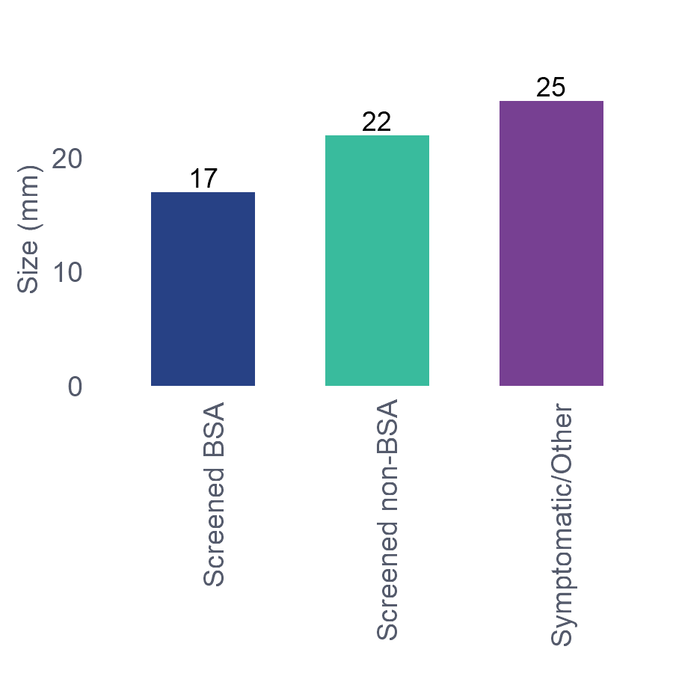
¹⁷Figure 7.1-2: Historical trends for contributing regions: Median DCIS size (mm) by year and referral status, patients aged 45-69, diagnosed between 2016-2020
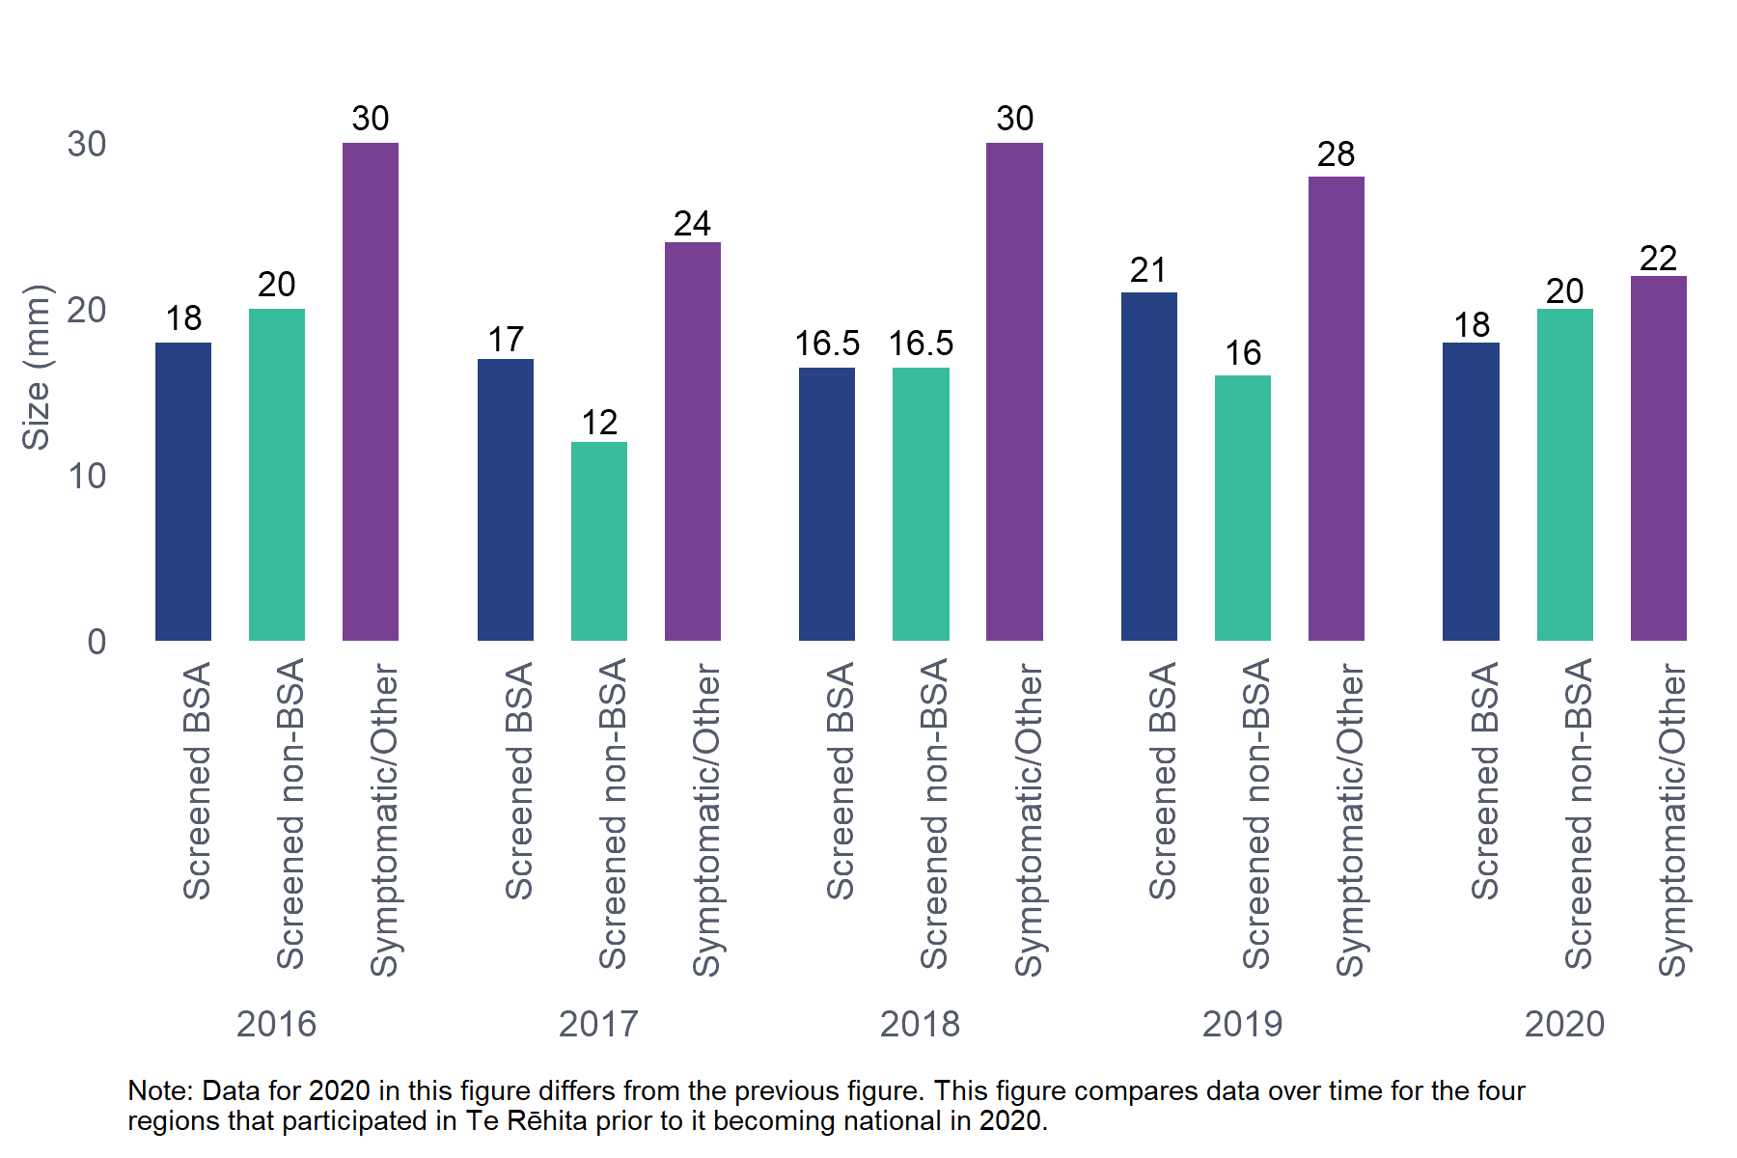

Comments
BSA screening supports detection of smaller volume DCIS. In 2020 (all regions) DCIS detected by BSA screening had a smaller median size than Symptomatic/Other DCIS (17 mm compared to 25 mm).
⁵²Table 7.1.2 Size of DCIS by referral source, patients aged 45-69
Referral Source | <10 mm | 10-14 mm | 15-19 mm | 20-29 mm | 30-39 mm | ≥ 40 mm
BSA (n=290) | 82 (28.3%) | 41 (14.1%) | 38 (13.1%) | 34 (11.7%) | 38 (13.1%) | 57 (19.7%)
Other Sources (n=93) | 21 (22.6%) | 10 (10.8%) | 6 (6.5%) | 17 (18.3%) | 13 (14%) | 26 (28%)
Total (n=383) | 103 (26.9%) | 51 (13.3%) | 44 (11.5%) | 51 (13.3%) | 51 (13.3%) | 83 (21.7%)
Chi-square p-value: 0.1208
Unknown/missing data excluded: Referral source - 3 patients. Size - 24 patients.
The Other Sources group includes 61 patients whose cancer was detected by non-BSA screening; the remainder were from other sources.
More than half (55.5%) of DCIS detected by BSA screening measured <20 mm. This table combines non-BSA screened patients and Symptomatic/Other patients in the “Other Sources” category, so is less useful than the median size Table 7.1.1. The data in this table is not statistically significant; no inference can be drawn.
⁵³Table 7.1.3 Median size of DCIS for Māori and non-Māori patients aged 45-69
Ethnicity | Median (mm) | IQR (mm)
Māori (n=42) | 15.5 | (9.2, 35.8)
Non-Māori (n=344) | 18.0 | (9.0, 35.0)
Total (n=386) | 18.0 | (9.0, 35.0)
Kruskal-Wallis p-value: 0.9486
Unknown/missing data excluded: Size - 24 patients.
The Non-Māori group includes 11 Pacific patients due to low numbers in one or more subgroup.
*IQR = Interquartile range

Comments
Māori comprised approximately 11% of all patients diagnosed with DCIS in 2020. There was no significant difference in the median size of DCIS detected in Māori (15.5 mm) and non-Māori patients (18 mm).
¹⁸Figure 7.1-3: Median DCIS size (mm) by year and ethnicity, patients aged 45-69, diagnosed in all regions, 2020
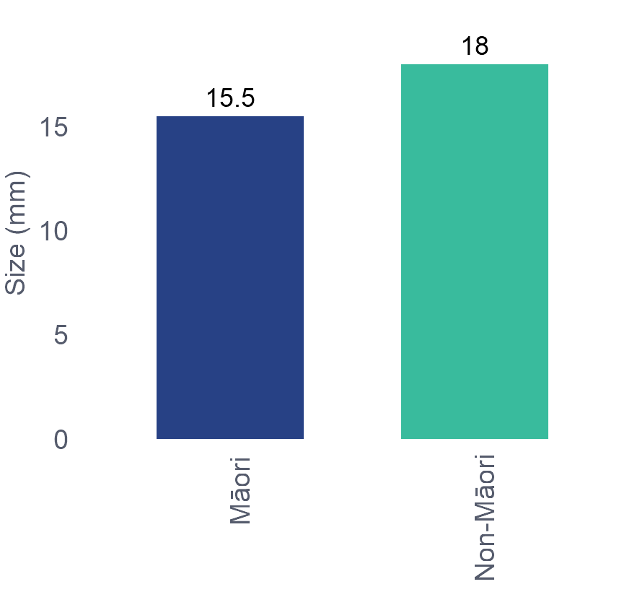
¹⁹Figure 7.1-4: Historical trends for contributing regions: Median DCIS tumour size (mm) by year and ethnicity, patients aged 45-69, diagnosed 2016-2020
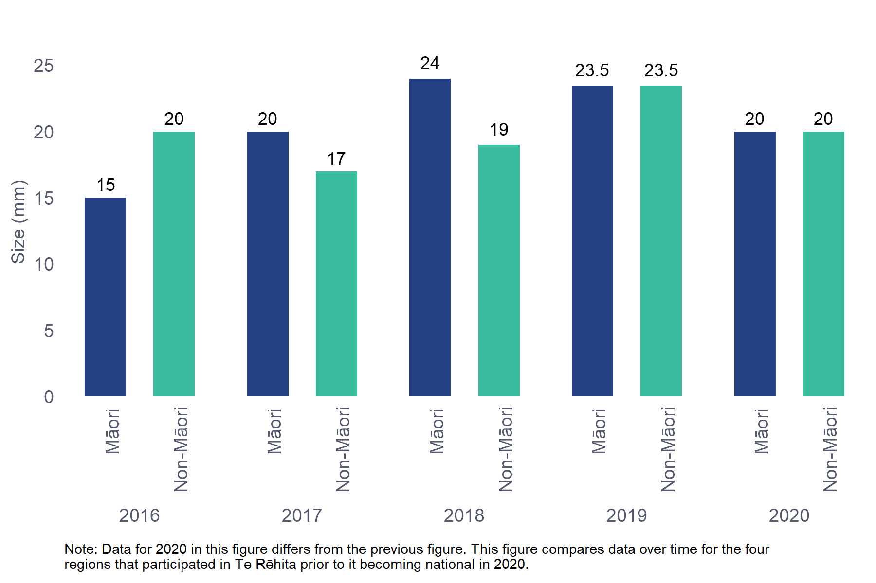
⁵⁴Table 7.1.4 Size of DCIS for Māori and non-Māori patients aged 45-69
Ethnicity | <10 mm | 10-14 mm | 15-19 mm | 20-29 mm | 30-39 mm | ≥40 mm
Māori (n=42) | 11 (26.2%) | 8 (19%) | 5 (11.9%) | N/S | N/S | 9 (21.4%)
Non-Māori (n=344) | 94 (27.3%) | 44 (12.8%) | 39 (11.3%) | N/S | N/S | 74 (21.5%)
Total (n=386) | 105 (27.2%) | 52 (13.5%) | 44 (11.4%) | 51 (13.2%) | 51 (13.2%) | 83 (21.5%)
Chi-square p-value: 0.8936
Unknown/missing data excluded: Size - 24 patients.
The Non-Māori group includes 11 Pacific patients due to low numbers in one or more subgroup.
N/S – Not shown due to small numbers in one or more subgroups.

Comments
Nearly 60% of Māori diagnosed with DCIS in 2020 had DCIS <20 mm in size. Due to very small numbers, this table is not statistically significant, so is not useful for comparison between ethnicities.

Audit data used
Information was derived from eligible, DCIS-diagnosed patients who have had primary surgery. The data field used is “DCIS tumour size” (in mm).

Definitions
DCIS size refers to the maximum diameter in millimetres of the furthest points of extension of the neoplastic cells in breast ducts.
DCIS size is a pathological assessment. An unknown tumour size is recorded for those patients who did not have any breast surgery, and those patients who had surgery but where no DCIS was detected (i.e. where the tumour was completely removed at biopsy) or DCIS was detected but the size was not specified in the histopathology report.

  - Histological grade of DCIS
⁵⁵Table 7.2.1 Histological grade of DCIS by referral source, patients aged 45-69
 | Referral Source | Low | Intermediate | High
Screening | Screened BSA (n=310) | 37 (11.9%) | 115 (37.1%) | 158 (51%)
 | Screened non-BSA (n=62) | 7 (11.3%) | 27 (43.5%) | 28 (45.2%)
Non-screening | Symptomatic/Other (n=35) | 5 (14.3%) | 11 (31.4%) | 19 (54.3%)
Total | (n=407) | 49 (12%) | 153 (37.6%) | 205 (50.4%)
Chi-square p-value (screening vs. non-screening): 0.7174
Unknown/missing data excluded: Referral source - 3 patients.
²⁰Figure 7.2-1: New Zealand DCIS grade by referral source and year, patients aged 45-69, diagnosed in all regions, 2020
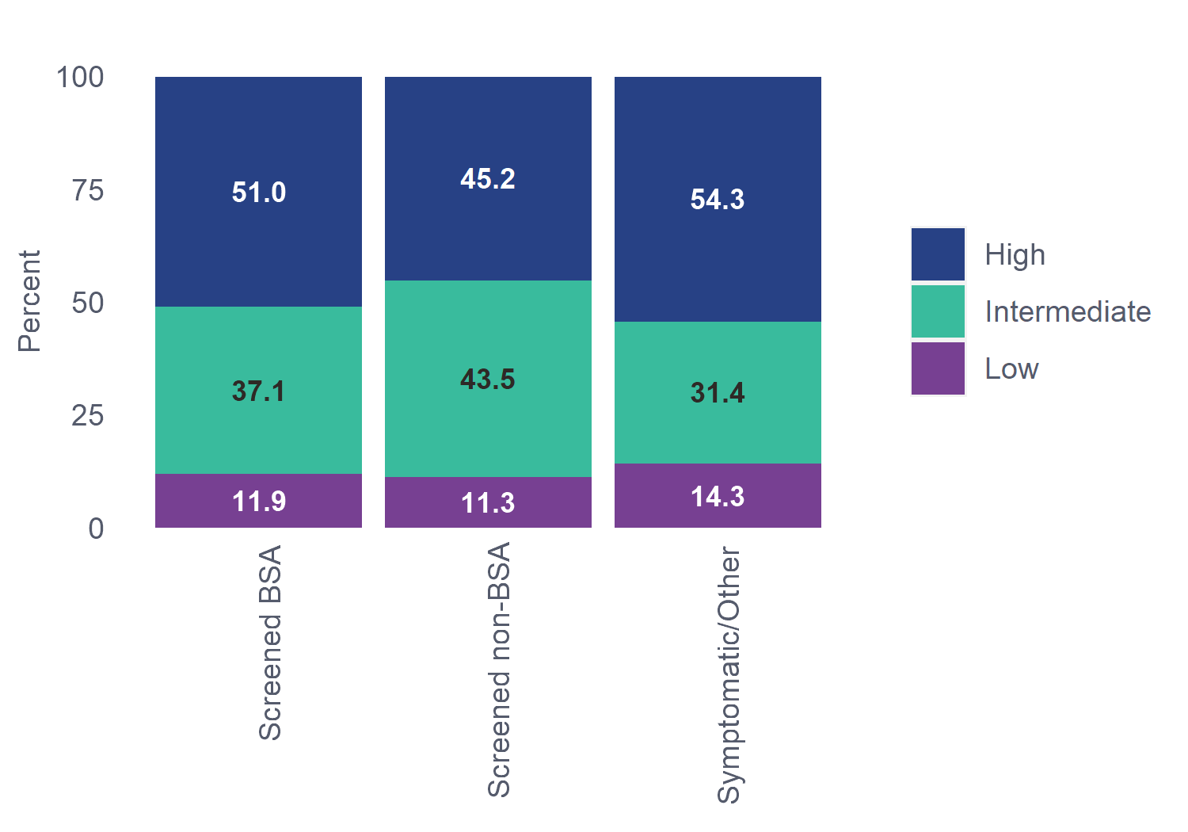

²¹Figure 7.2-2: Historical trends for contributing regions: DCIS grade by referral source and year, patients aged 45-69, diagnosed 2016-2020
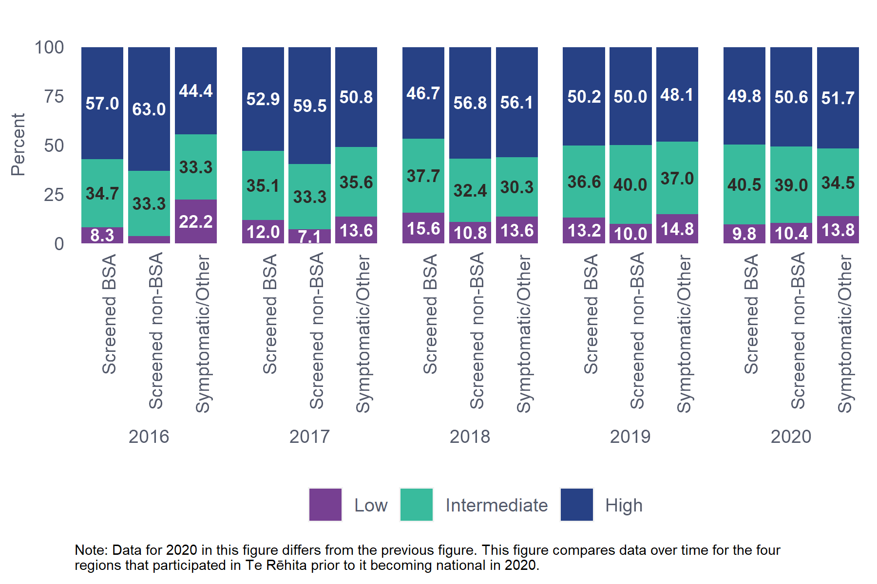

Comments
Half of all DCIS diagnosed in 2020 was high-grade. Some studies show that high-grade DCIS is more likely to progress to invasive cancer (Maxwell, A., et al., 2012) while others have found no difference in the likelihood of progression by grade, though progression may be more rapid with high-grade DCIS (Manuu, G., et al, 2020). The rate of high-grade DCIS has remained fairly consistent over time. There was no statistical difference between screened and Symptomatic/Other grade at diagnosis.
⁵⁶Table 7.2.2 Histological grade of DCIS tumours for Māori and non-Māori patients aged 45-69
Ethnicity | Low | Intermediate | High
Māori (n=44) | 8 (18.2%) | 16 (36.4%) | 20 (45.5%)
Non-Māori (n=366) | 42 (11.5%) | 138 (37.7%) | 186 (50.8%)
Total (n=410) | 50 (12.2%) | 154 (37.6%) | 206 (50.2%)
Chi-square p-value: 0.4290
Unknown/missing data excluded:
The Non-Māori group includes 14 Pacific patients due to low numbers in one or more subgroup.

²²Figure 7.2-3: DCIS tumour grade by ethnicity and year, all regions, 2020
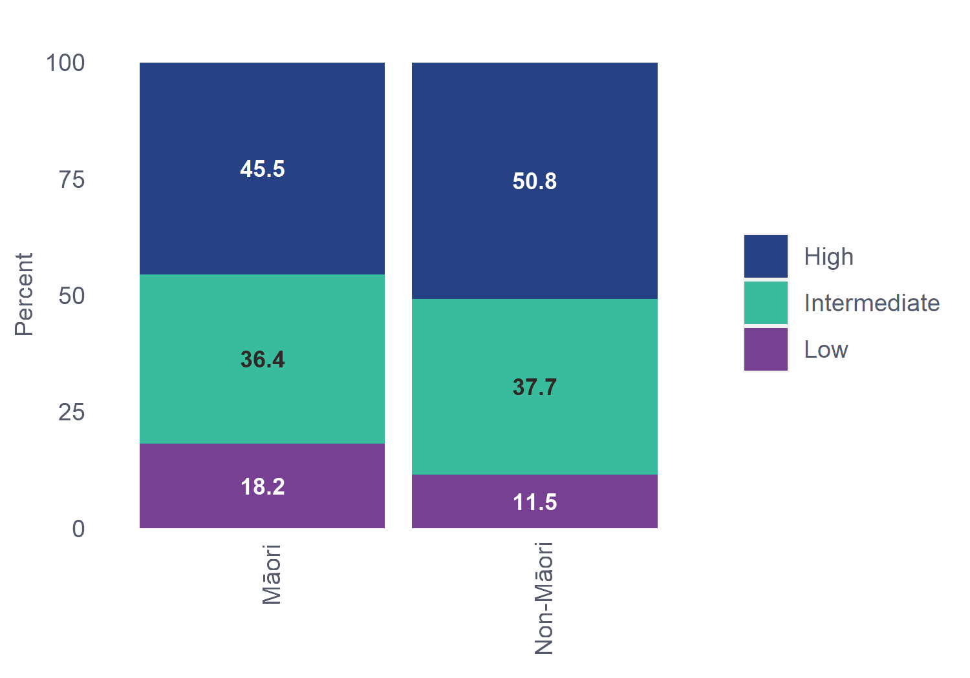
²³Figure 7.2-4: Historical trends for contributing regions: DCIS tumour grade by ethnicity and year, patients aged 45-69, diagnosed 2016-2020
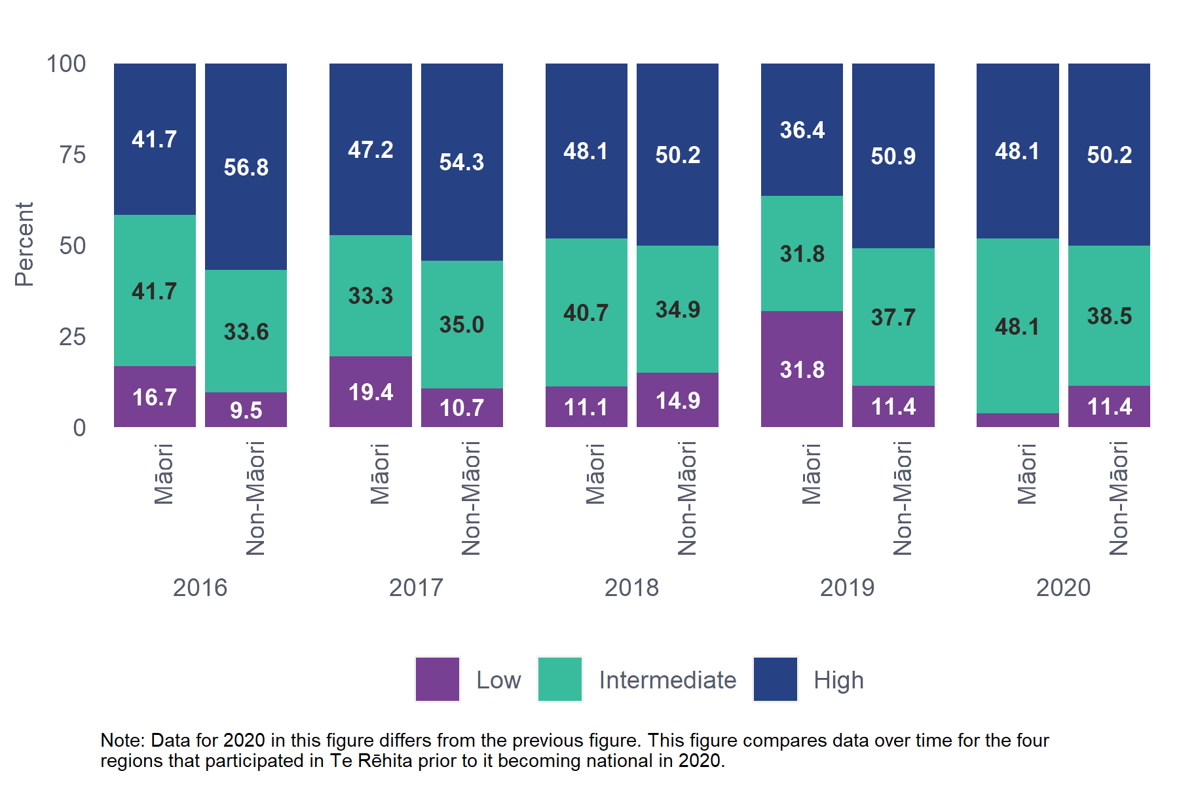

Comments
DCIS grade did not differ by ethnicity, with the proportion of high-grade DCIS detected among Māori (45.5%) similar to the proportion of high-grade DCIS detected in non-Māori patients (50.8%). Proportions of high-grade DCIS detected have remained fairly stable over time.

Audit data used
Information was derived from eligible patient data field “Highest DCIS grade” which allows the following options: low, intermediate, high and unknown.

Definitions
The grade used for in situ carcinomas is the nuclear grade based on the WHO classification system, 5th edition. This is the degree of differentiation of the breast cancer or the degree to which it resembles normal tissue as assessed by the pathologist.
- Low Grade: well differentiated, where there is a proliferation of small and monomorphic neoplastic cells, with inconspicuous nucleoli and few mitoses.
- Intermediate Grade: moderately differentiated, neoplasia with overlapping features between low- and high-grade DCIS.
- High Grade: poorly differentiated, where there are large-sized, pleomorphic neoplastic cells with large and irregular nuclei, multiple and prominent nucleoli, high mitotic index, and often necrosis.

- Time to treatment
This chapter reports on time to first treatment from date of diagnosis (in most cases date of biopsy) for invasive cancers. The alternative measure, time to first treatment from date of decision to treat, is subject to considerable variation in the way it is calculated by different hospitals, making it difficult to measure with accuracy and consistency.
The proposed Breast Cancer Quality Performance Indicators (QPIs) from Te Aho o Te Kahu include two treatment timeliness indicators:
- Proportion of patients receiving their first definitive treatment (of surgery or chemotherapy or endocrine therapy) within 45 days of date of diagnosis.
- Proportion of patients treated with surgery within:
- six weeks of decision to treat with breast surgery
- eight weeks of decision to treat with breast surgery and undergoing immediate reconstruction (Cancer Control Agency, 2022) (in this QPI, decision to treat is defined as “being placed on the waiting list for surgery”).
It may be practical for future BSA annual reports to adopt the same timeliness measures as the QPIs.
The time to treatment statistics in this report combine both public and private hospital treatment data. Other studies have shown that patients treated in private hospitals have a shorter time to treatment, and that Māori and Pacific patients are less likely to have private treatment than non-Māori (Breast Cancer Foundation NZ, 2022). A public-only analysis of the data in this report would likely reduce the difference in time to treatment for Māori vs non-Māori, but an inequity would remain.

Key Findings
- A lower proportion of patients with BSA-detected invasive cancers received their surgery within 31 days of diagnosis (42%) compared to patients with non-BSA screened cancers (63.3%) and Symptomatic/Other cancers (54.2%) (Table 8.2.1). Surgery waiting times in the public sector in 2020 were significantly impacted by COVID-19 and this may be one of the reasons for the difference between BSA and non-BSA receiving surgery within 31 days.
- A lower proportion of Māori received their surgery within 31 days of diagnosis (36%) compared to non-Māori patients (51%) (Table 8.2.2).
- Similarly, a larger proportion of Māori received surgery more than 62 days after diagnosis (11.6%), compared with non-Māori patients (7.5%) (Table 8.2.2).
- Among patients who received neoadjuvant treatment in 2020, over half received treatment within 31 days of diagnosis, and 94.3% within 62 days of diagnosis (Table 8.3.1).
  - Time to treatment from date of diagnosis to treatment
⁵⁷Table 8.1.1 Time to treatment for invasive cases by referral source, patients aged 45-69
Referral Source | 0-31 Days | 32-62 Days | 63+ Days
BSA (n=1064) | 472 (44.4%) | 510 (47.9%) | 82 (7.7%)
Other Sources (n=1097) | 661 (60.3%) | 389 (35.5%) | 47 (4.3%)
Total (n=2161) | 1133 (52.4%) | 899 (41.6%) | 129 (6%)
Chi-square p-value: <0.0001
Unknown/missing data excluded: Referral source - 3 patients. Diagnosis date/ first treatment date - 31 patients (includes patients whose first treatment date is before their diagnosis date).
The Other Sources group includes 189 patients whose cancer was detected by non-BSA screening; the remainder were from other sources.

Comments
This table reports on time from Date of diagnosis to Date of first treatment (no exclusions) by referral source. In 2020, 52.4% of patients were treated within 31 days of their diagnosis. A higher proportion of patients referred from other sources received treatment within 31 days of their diagnosis (60.3%), compared with patients whose tumours were detected by BSA screening (44.4%). This table differs from the Ministry of Health Faster Cancer Treatment indicator, which measures the proportion of patients with 31 or fewer days from Date of decision to treat to Date of treatment.
⁵⁸Table 8.1.2 Time to treatment for invasive cases for Māori and non-Māori patients aged 45-69
Ethnicity | 0-31 Days | 32-62 Days | 63+ Days
Māori (n=344) | 37 (39.8%) | 176 (51.2%) | 31 (9%)
Non-Māori (n=1820) | 998 (54.8%) | 724 (39.8%) | 98 (5.4%)
Total (n=2164) | 1135 (52.4%) | 900 (41.6%) | 129 (6%)
Chi-square p-value: <0.0001
Unknown/missing data excluded: Diagnosis date/ first treatment date - 31 patients (includes patients whose first treatment date is before their diagnosis date).
The Non-Māori group includes 132 Pacific patients due to low numbers in one or more subgroup.

Comment
A lower proportion of Māori (39.8%) received treatment within 31 days of their diagnosis date than non-Māori (54.8%). This statistic combines both public and private hospital treatment data; a public-only analysis would likely reduce the difference, but an inequity would remain.
This table differs from the Faster Cancer Treatment 31-day indicator, substituting Date of diagnosis for Date of decision to treat, measuring to Date of first treatment (no exclusions) by ethnicity.

Audit data used
Information was derived from eligible patient data fields: “Date of tissue diagnosis”, “Date of first cancer treatment”.
  - Time to first surgery (Date of diagnosis to first surgery – neoadjuvant cases excluded)
⁵⁹Table 8.2.1 Time to first surgery for invasive cases by referral source, patients aged 45-69
 | Referral Source | 0-31 Days | 32-62 Days | 63+ Days
Screening | Screened BSA (n=1008) | 423 (42%) | 494 (49%) | 91 (9%)
 | Screened non-BSA (n=177) | 112 (63.3%) | 56 (31.6%) | 9 (5.1%)
Non-screening | Symptomatic/Other (n=712) | 386 (54.2%) | 272 (38.2%) | 54 (7.6%)
Total | (n=1897) | 921 (48.6%) | 822 (43.3%) | 154 (8.1%)
Chi-square p-value: 0.0006
Unknown/missing data excluded: Referral source -3patients.Date of diagnosis/ First surgery - 295 patients (may be patients with no primary surgery, primary surgery date before diagnosis, or patients who have received neoadjuvant treatment).

Comments
In 2020, 42% of BSA-screened patients for whom surgery was the first definitive treatment received their surgery within 31 days of diagnosis. Non-BSA screened patients were more likely to receive treatment within 31 days (63.3%), possibly reflecting use of private surgical services after detection in private screening. Just over half of Symptomatic/Other patients (54.2%) were treated within 31 days. For all referral sources, more than 90% of patients received surgery within 62 days.
⁶⁰Table 8.2.2 Time to first surgery for invasive cancer for Māori and non-Māori patients aged 45-69
Ethnicity | 0-31 Days | 32-62 Days | 63+ Days
Māori (n=303) | 109 (36%) | 159 (52.5%) | 35 (11.6%)
Non-Māori (n=1597) | 814 (51%) | 664 (41.6%) | 119 (7.5%)
Total (n=1900) | 923 (48.6%) | 823 (43.3%) | 154 (8.1%)
Chi-square p-value:<0.0001
Unknown/missing data excluded: Date of diagnosis/ First surgery - 295 patients (may be patients with no primary surgery, primary surgery date before diagnosis, or patients who have received neoadjuvant treatment).
The Non-Māori group includes 120 Pacific patients due to low numbers in one or more subgroup.

Comments
A lower proportion of Māori received their surgery within 31 days of diagnosis (36%) compared to non-Māori patients (51%). This statistic combines both public and private hospital treatment data; a public-only analysis would likely reduce the difference, but an inequity would remain.
A larger proportion of Māori with invasive breast cancer diagnoses received surgery more than 62 days after diagnosis (11.6%), compared with non-Māori patients (7.5%).

Audit data used
Information was derived from eligible patient data fields: “Date of tissue diagnosis”, “Date of surgery” and “Date of neoadjuvant therapy”.

Definitions
*Patients reported as diagnosed at their first surgical procedure (i.e. 0 days between diagnosis and first surgery) are included in the 0-31 Days group.
Time to first surgery: Calculated as the number of days from date of tissue diagnosis to date of first breast cancer surgery, excluding patients who had neoadjuvant treatment before their surgery.
Date of tissue diagnosis: Date first definitive tissue diagnosis performed (i.e. proven malignancy on fine needle aspiration cytology (FNA), core needle biopsy, vacuum assisted needle biopsy or open surgical biopsy). If tissue diagnosis is not recorded, then first diagnosis date documented is used (e.g. mammogram, ultrasound, clinical examination). Note that this is not the date of the histopathology diagnosis being reported.
Date of surgery: Date (first) surgical procedure performed. Types of surgery included are those not excluded in the Faster Cancer Treatment Indicators: Business Rules and Data Definitions (Ministry of Health 2014), where type of first treatment is defined as “the treatment or other management that attempts to begin the patient’s first treatment”: hookwire or other localisation excision, lumpectomy, excision biopsy, mastectomy, breast conserving surgery (BCS)/partial mastectomy and axillary surgery-only.
  - Time to neoadjuvant treatment (Date of diagnosis to first neoadjuvant treatment)
⁶¹Table 8.3.1 Time to neoadjuvant treatment for invasive cases by referral source, patients aged 45-69
Referral Source | 0-31 Days | 32-62 Days | 63+ Days
BSA (n=46) | 22 (47.8%) | N/S | N/S
Other Sources (n=150) | 90 (60%) | N/S | N/S
Total (n=196) | 112 (57.1%) | 73 (37.2%) | 11 (5.6%)
Chi-square p-value: 0.3426
Unknown/missing data excluded: Referral source - 3 patients. Treatment/surgery - 1996 patients (may be patients with primary surgery or no Neoadjuvant treatment).
The Other Sources group includes 8 patients whose cancer was detected by non-BSA screening; the remainder were from other sources.
N/S – Not shown due to small numbers in one or more subgroups.

Comments
Among patients who received neoadjuvant treatment in 2020, over half (57.1%) received treatment within 31 days of diagnosis, and nearly 95% within 62 days of diagnosis. It appears a lower proportion of patients with cancers diagnosed by BSA screening (47.8%) received neoadjuvant treatment within 31 days of diagnosis compared to patients referred from other sources. However, these patient numbers are small and not statistically significant.
⁶²Table 8.3.2 Time to neoadjuvant treatment for invasive cases for Māori and non-Māori patients aged 45-69
Ethnicity | 0-31 Days | 32-62 Days | 63+ Days
Māori (n=24) | 11 (45.8%) | N/S | N/S
Non-Māori (n=172) | 101 (58.7%) | N/S | N/S
Total (n=196) | 112 (57.1%) | 73 (37.2%) | 11 (5.6%)
Chi-square p-value: 0.4689
Unknown/missing data excluded: Treatment/surgery - 1999 patients (may be patients with primary surgery or no Neoadjuvant treatment).
The Non-Māori group includes8 Pacific patients due to low numbers in one or more subgroup.
N/S – Not shown due to small numbers in one or more subgroups.

Comments
The proportion of Māori with invasive cancers who received neoadjuvant treatment within 31 days of diagnosis (45.8%) appears lower than the proportion of non-Māori patients receiving treatment within 31 days (58.7%); however, patient numbers are small and this data is not statistically significant.

Audit data used
Information was derived from eligible patient data fields: “Date of tissue diagnosis”, “Date decision to treat”, “First specialist assessment”, “Date of first cancer treatment” and “Type of first cancer treatment” where type of first cancer treatment options are chemotherapy, biological therapy (e.g. Herceptin), radiation therapy and hormone therapy (excluding 132 cases where duration of hormone therapy was <12 weeks).

Definitions
Neoadjuvant treatment: administration of therapeutic agents before surgery to enhance the outcome of primary treatment.
Time to neoadjuvant treatment: is calculated as the number of days from date of tissue diagnosis to the first date of neoadjuvant treatment given.

- Breast surgery treatment
Surgery is the first treatment for invasive breast cancer that most patients undergo in New Zealand (89% in 2020). The 11% of patients who did not have surgery as first treatment were likely a mix of patients with de novo metastatic breast cancer, patients diagnosed with inoperable stage 3 cancers, patients who were elderly with significant comorbidities, and/or patients who declined surgery.
The type of first surgery (breast conserving surgery (BCS) or mastectomy) is a reflection of a number of factors including breast size, tumour size, surgeon’s choice and patient’s choice. Breast conservation and less radical axillary treatment are among the major benefits for patients with screened rather than symptomatic diagnoses.

Key Findings
- A higher proportion of patients with BSA-detected cancers had BCS as their first surgery (72.1%) than non-BSA screened patients (56.6%) and Symptomatic/Other patients (49.7%) (Table 9.1.1).
- The proportion of Māori (62.1%) and non-Māori (61.5%) patients having BCS as their first surgery is similar (Table 9.1.2).
- There was no difference in re-excision rates between ethnicities. In 2020, 57.7% of all Māori patients achieved breast conservation by their final surgery (including 47.5% BCS and 10.2% re-excision) (Table 9.4.2).
- Most (84.1%) patients had no further surgery after BCS. The rate of (re-excision or completion mastectomy) was 15.9% (Table 9.2.1).
- A larger proportion of patients with screen-detected cancers achieved breast conservation after final surgery: 67.5% for BSA-screened and 50.5% non-BSA screened. In comparison, 44.8% of Symptomatic/Other cancers achieved breast conservation (Table 9.4.1).
- Lower proportions of Māori had reconstruction following mastectomy (10%) compared to non-Māori patients (19.1%) (Table 9.3.2).
- Three-quarters of DCIS patients had BCS as their first surgery; a quarter required further surgery. The proportion of patients from Other Sources having any further surgery was double that of BSA patients (44.8% vs 21.5%), including 13.8% of patients referred from Other Sources undergoing completion mastectomy (vs 7% of BSA patients). (Table 9.5.1 and Table 9.6.1).
  - First breast surgery for invasive cancer
⁶³Table 9.1.1 First breast surgery for invasive cancer by referral source, patients aged 45-69
 | Referral Source | Breast conserving surgery | Mastectomy
Screening | Screened BSA (n=1046) | 754 (72.1%) | 292 (27.9%)
 | Screened non-BSA (n=182) | 103 (56.6%) | 79 (43.4%)
Non-screening | Symptomatic/Other (n=843) | 419 (49.7%) | 424 (50.3%)
Total | (n=2071) | 1276 (61.6%) | 795 (38.4%)
Chi-square p-value: <0.0001
Unknown/missing data excluded: Referral source -3 patients. First breast surgery - 108 patients (either surgery not done, or not assessable).
²⁴Figure 9.1-1: First surgery by referral source, all regions, 2020
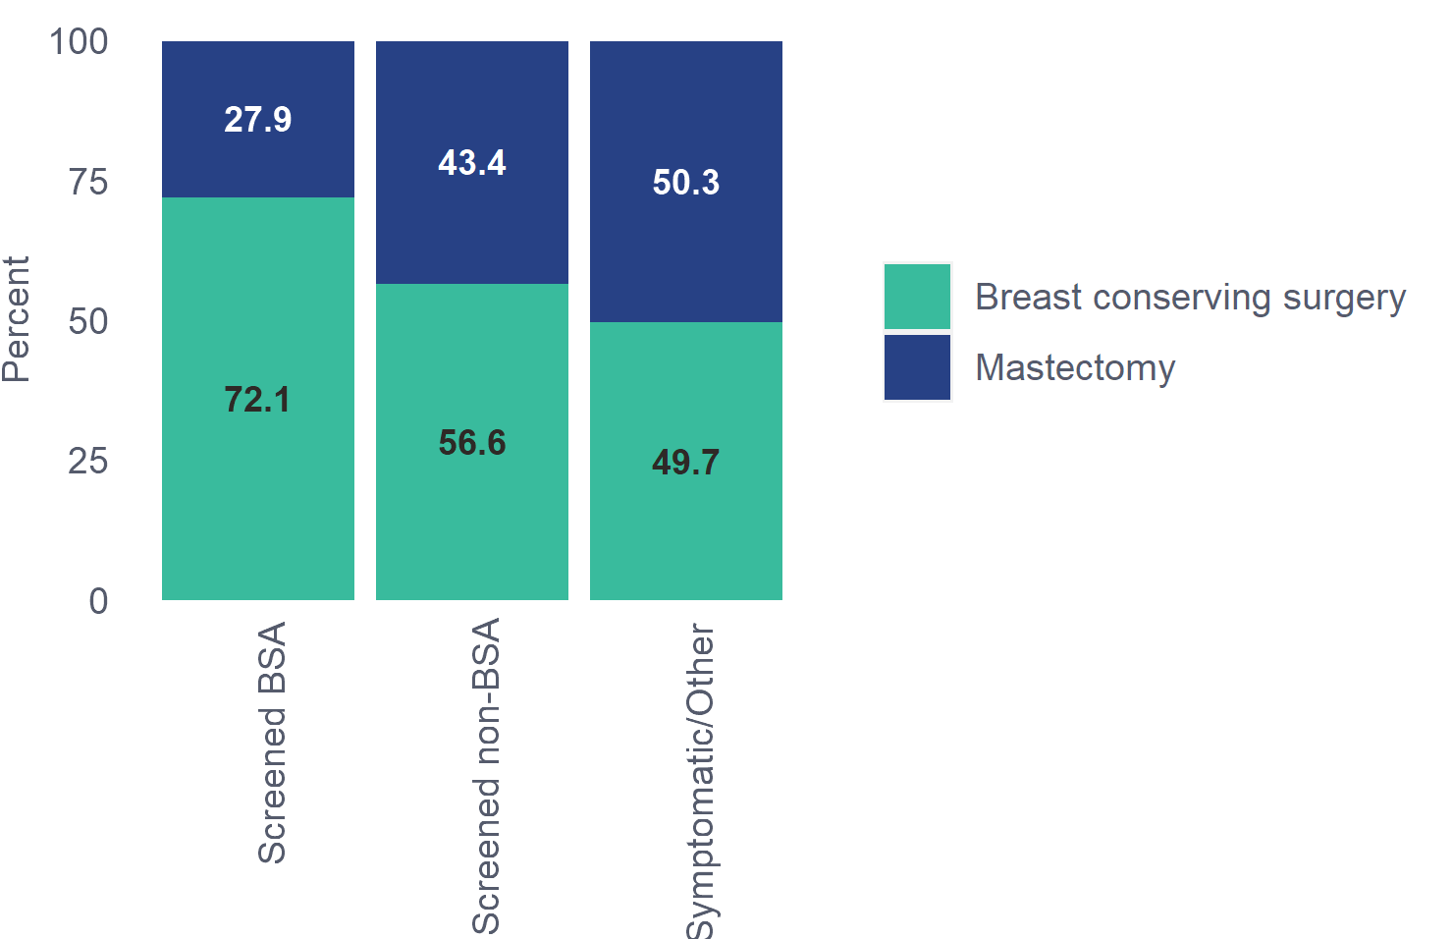

²⁵Figure 9.1-2: Historical trends for contributing regions: first surgery by referral source, 2016-2020
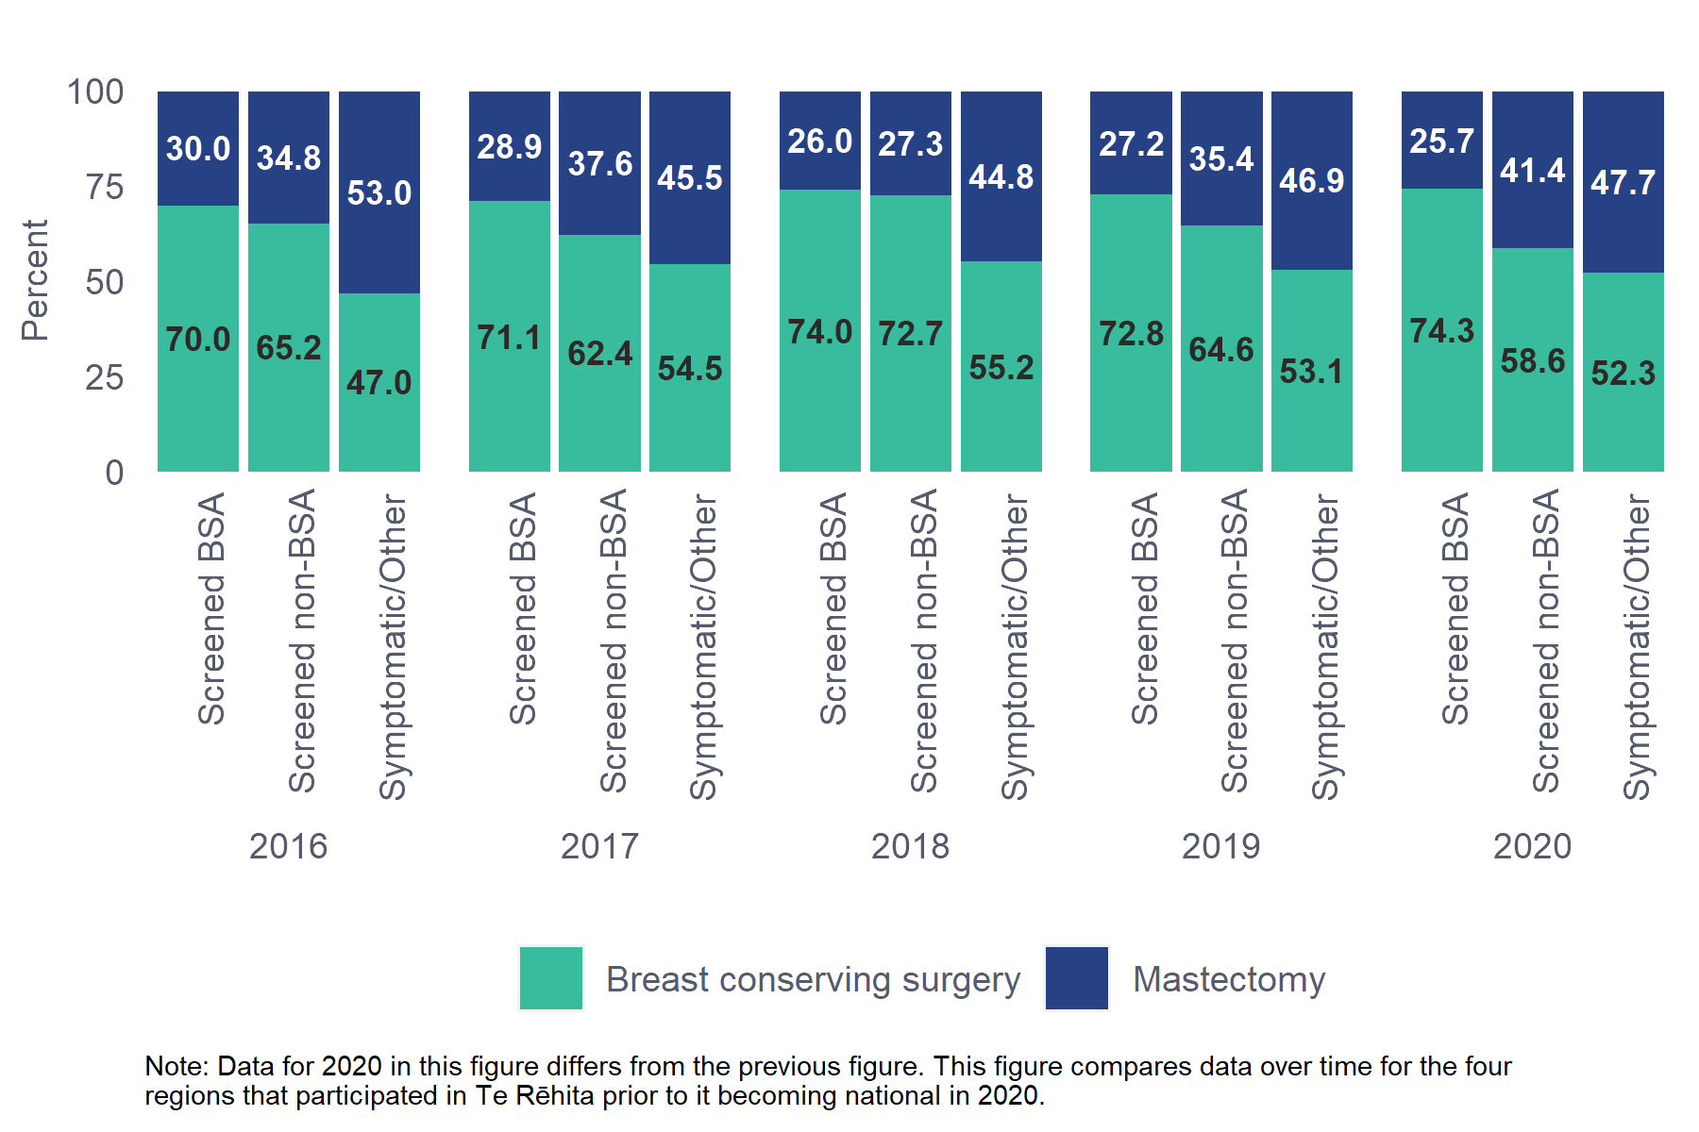

Comments
A higher proportion of patients with BSA screen-detected cancers underwent BCS (72.1%) compared to non-BSA screened patients (56.6%) and Symptomatic/Other patients (49.7%). This aligns with the 2016 BSA report where 65.9% of BSA-referred cases had BCS and 31.6% had a mastectomy, and is likely a reflection of the more advanced size and stage of cancers detected in Symptomatic/Other patients.
Over time there has been little variation in the proportion of BCS or mastectomy by referral source.
⁶⁴Table 9.1.2 First breast surgery for invasive cancer for Māori and non-Māori patients aged 45-69
Ethnicity | Breast conserving surgery | Mastectomy
Māori (n=322) | 200 (62.1%) | 122 (37.9%)
Non-Māori (n=1752) | 1078 (61.5%) | 674 (38.5%)
Total (n=2074) | 1278 (61.6%) | 796 (38.4%)
Chi-square p-value: 0.8925
Unknown/missing data excluded: First breast surgery - 108 patients (either surgery not done, or not assessable).
The Non-Māori group includes 128 Pacific patients due to low numbers in one or more subgroup.
²⁶Figure 9.1-3: First surgery by ethnicity, all regions, 2020
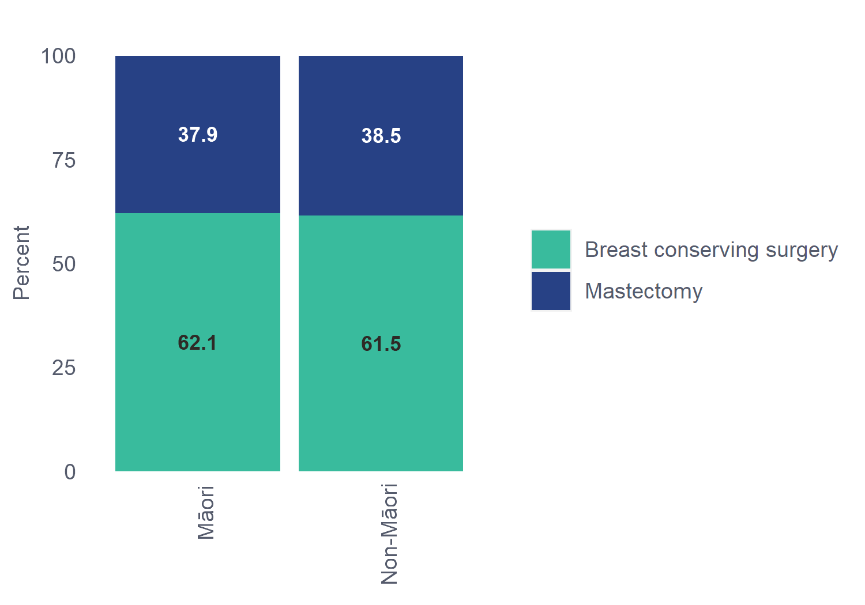
²⁷Figure 9.1-4: Historical trends for contributing regions: first surgery for invasive tumour by ethnicity, 2016-2020
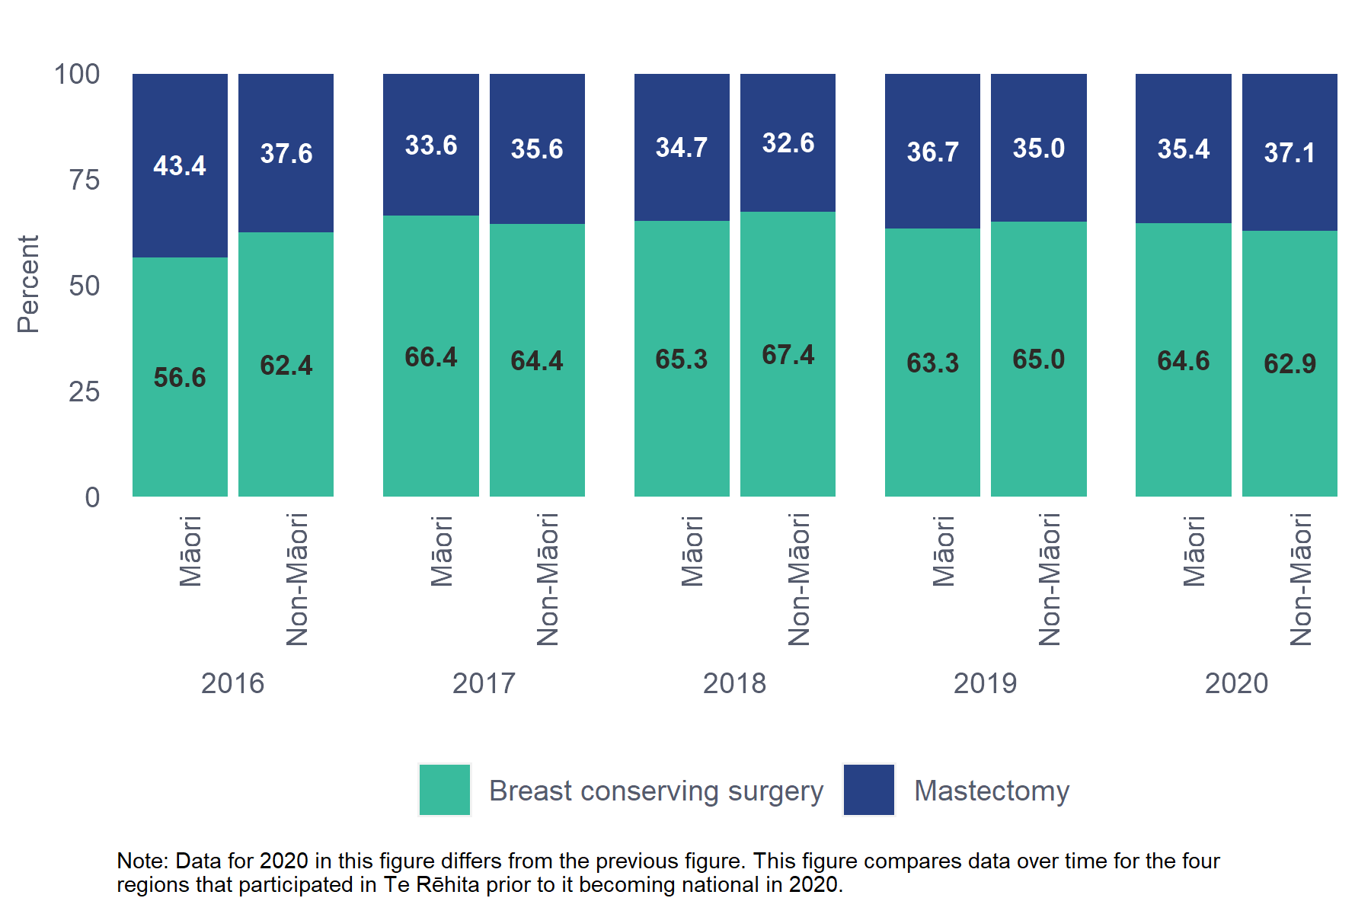

Comments
There was no difference in the proportion of Māori (62.1%) and non-Māori patients (61.5%) undergoing BCS as first surgery for invasive breast cancer. This has been fairly consistent over the last five years.

Audit data used
Information was derived from eligible patient data fields “Date of surgery” and “Type of breast surgery” which for this table allows the following options: mastectomy, BCS, excision biopsy. Due to the small number of excision biopsies these have been combined with BCS. Re-excision and Other surgery types are excluded from these tables.

Definitions
Mastectomy: surgical removal of the breast.
Breast conserving surgery includes:
- Wide local excision (WLE): the complete excision of an entire tumour mass with the intention to have clear surgical margins. Also called a lumpectomy or partial mastectomy.
- Excision biopsy: surgical procedure where a sample of breast tissue for histological examination is obtained in a conventional surgical procedure using an excision biopsy. Also called an open surgical biopsy.
  - Further surgery after breast conserving surgery for invasive cancer
⁶⁵Table 9.2.1 Further surgery after breast conserving surgery for invasive cancer by referral source, patients aged 45-69
 | Referral Source | Re-excision | Mastectomy | Any further surgery | No further breast surgery
Screening | Screened BSA (n=756) | 89 (11.8%) | 31 (4.1%) | 120 (15.9%) | 636 (84.1%)
 | Screened non-BSA (n=103) | 16 (15.5%) | 8 (7.8%) | 24 (23.3%) | 79 (76.7%)
Non-screening | Symptomatic/Other (n=423) | 49 (11.6%) | 24 (5.7%) | 73 (17.3%) | 350 (82.7%)
Total | (n=1282) | 154 (12%) | 63 (4.9%) | 217 (16.9%) | 1065 (83.1%)
Chi-square p-value (Any further surgery vs. no further breast surgery): 0.8866
Unknown/missing data excluded: Referral source - 3 patients. No breast conserving surgery - 910 patients.

Comments
The majority of patients treated with BCS for invasive cancer had no further surgery (83.1%). This is similar to the figures reported in the 2016 BSA report (84.7%). Patients with BSA screen-detected cancers had the lowest proportion undergoing mastectomy after BCS (4.1%); however, this difference is not significant.
One of the BSA monitoring indicators (4b) is the percentage of patients diagnosed with invasive cancer who have a single excisional breast treatment procedure (whether BCS or mastectomy), as a proportion of the number of patients diagnosed with invasive cancer who have a surgical breast treatment procedure. BSA’s own data shows that nearly 60% of patients diagnosed with invasive tumours in 2020 only had one procedure (either BCS or mastectomy, data not shown).
⁶⁶Table 9.2.2 Further surgery after breast conserving surgery for invasive cancer for Māori and non-Māori patients aged 45-69
Ethnicity | Re-excision | Mastectomy | Any further surgery | No further breast surgery
Māori (n=203) | 34 (16.7%) | 6 (3%) | 40 (19.7%) | 163 (80.3%)
Non-Māori (n=1081) | 120 (11.1%) | 57 (5.3%) | 177 (16.4%) | 904 (83.6%)
Total (n=1284) | 154 (12%) | 63 (4.9%) | 217 (16.9%) | 1067 (83.1%)
Chi-square p-value (Any further surgery vs. no further breast surgery): 0.0486
Unknown/missing data excluded: No breast conserving surgery - 910 patients.
The Non-Māori group includes 77 Pacific patients due to low numbers in one or more subgroup.

Comments
The proportion of Māori who received further surgery after BCS (19.7%) was higher than the proportion of non-Māori patients who received further surgery (16.4%); however, non-Māori patients were more likely to have a completion mastectomy than Māori patients.

Audit data used
Information was derived from eligible patient data fields “Date of surgery” and “Type of breast surgery” which allows the following options: mastectomy, BCS, excision biopsy, re-excision and other.

Definitions
Breast conserving surgery (BCS): involves removing the tumour, usually with a small amount of surrounding healthy tissue (called the surgical margin). For invasive cancers, lymph nodes are usually also removed (sentinel lymph node biopsy or axillary node dissection). Breast-conserving surgery is sometimes called wide local excision, lumpectomy, quadrantectomy, partial mastectomy, or segmental mastectomy, depending on how much tissue is removed.
Further surgery: any breast surgery undertaken after a BCS.
  - Reconstruction after mastectomy for invasive cancer
⁶⁷Table 9.3.1 Reconstruction after mastectomy for invasive cancer by referral source, patients aged 45-69
 | Referral Source | Reconstruction | No Reconstruction
Screening | Screened BSA (n=329) | 53 (16.1%) | 276 (83.9%)
 | Screened non-BSA (n=89) | 29 (32.6%) | 60 (67.4%)
Non-screening | Symptomatic/Other (n=451) | 72 (16%) | 379 (84%)
Total | (n=869) | 154 (17.7%) | 715 (82.3%)
Chi-square p-value: 0.1868
Unknown/missing data excluded: Referral source - 3 patients. No mastectomy surgery - 1323 patients.

Comments
While this table does not reach statistical significance, data shows the majority of mastectomy patients (82.3%) with invasive tumours did not have a reconstruction regardless of their screening status. This is in line with other studies. While it appears that a larger proportion of patients with non-BSA screen-detected cancers had reconstruction (32.6%) compared to patients with BSA screen-detected cancers (16.1%) and Symptomatic/Other patients (16%), the number of non-BSA screened patients is small and not statistically significant. Since the 2016 BSA report, there has been a slight drop in the proportion of patients with BSA screen-detected cancers who received reconstruction, from 17.7% down to 16.1%. This may be due to COVID-19 related delays, and de-prioritisation by DHB’s of immediate breast reconstruction during the pandemic.

⁶⁸Table 9.3.2 Reconstruction after mastectomy for invasive cancer for Māori and non-Māori patients aged 45-69
Ethnicity | Reconstruction | No Reconstruction
Māori (n=130) | 13 (10%) | 117 (90%)
Non-Māori (n=740) | 141 (19.1%) | 599 (80.9%)
Total (n=870) | 154 (17.7%) | 716 (82.3%)
Chi-square p-value: 0.0178
Unknown/missing data excluded: No mastectomy surgery - 1325 patients.
The Non-Māori group includes 57 Pacific patients due to low numbers in one or more subgroup.

Comments
A greater proportion of Māori (90%) had no reconstruction after mastectomy compared to non-Māori patients (80.9%). The incidence of limiting factors such as clinical comorbidities, body mass index (BMI) and smoking status could be explored to further investigate this inequity. Pacific patients are included in the non-Māori group due to the low number who had reconstruction presenting a privacy risk; the higher rate of reconstruction in this group overall is therefore not reflective of Pacific reconstruction rates.

Audit data used
Information was derived from eligible patient data field “Reconstruction” which allows the following options: yes, referred – deemed not necessary, referred – patient declined, referred – patient unfit, not referred – deemed not necessary, not referred – patient declined, not referred – patient unfit.
Reconstruction = Yes
No reconstruction = all other categories (referred – deemed not necessary, referred – patient declined, referred – patient unfit, not referred – deemed not necessary, not referred – patient declined, not referred – patient unfit).

Definitions
Reconstruction: the use of a prosthesis or tissue from other parts of the body to re-build a breast. Both immediate and delayed reconstructions are included in this report.
  - Final breast surgery for patients with invasive cancer
⁶⁹Table 9.4.1 Final breast surgery for invasive cancer by referral source, patients aged 45-69
 | Referral Source | Breast conserving  surgery | Re-excision | Mastectomy | Other
Screening | Screened BSA (n=1050) | 618 (58.9%) | 90 (8.6%) | 314 (29.9%) | 28 (2.7%)
 | Screened non-BSA (n=184) | 76 (41.3%) | 17 (9.2%) | 83 (45.1%) | 8 (4.3%)
Non-screening | Symptomatic/Other (n=843) | 329 (39%) | 49 (5.8%) | 434 (51.5%) | 31 (3.7%)
Total | (n=2077) | 1023 (49.3%) | 156 (7.5%) | 831 (40%) | 67 (3.2%)
Chi-square p-value: <0.0001
Unknown/missing data excluded: Referral source - 3 patients. Final breast surgery - 115 patients (either surgery not done, or not assessable).

Comments
A larger proportion of patients with screen-detected cancers achieved breast conservation after final surgery (being the total of BCS and re-excision): 67.5% for BSA-screened and 50.5% non-BSA screened. In comparison, 44.8% of unscreened cancers achieved breast conservation. Conversely, a larger proportion of patients with unscreened cancers underwent a mastectomy (51.5%) as their final surgery, compared to BSA-screened (29.9%) or non-BSA screened (45.1%) patients.

⁷⁰Table 9.4.2 Final breast surgery for invasive cancer for Māori and non-Māori patients aged 45-69
Ethnicity | Breast conserving  surgery | Re-excision | Mastectomy | Other
Māori (n=322) | 153 (47.5%) | 33 (10.2%) | 121 (37.6%) | 15 (4.7%)
Non-Māori (n=1758) | 872 (49.6%) | 123 (7%) | 711 (40.4%) | 52 (3%)
Total (n=2080) | 1025 (49.3%) | 156 (7.5%) | 832 (40%) | 67 (3.2%)
Chi-square p-value: 0.0694
Unknown/missing data excluded: Final breast surgery - 115 patients (either surgery not done, or not assessable).
The Non-Māori group includes 129 Pacific patients due to low numbers in one or more subgroup.

Comments
Similar proportions of Māori (47.5%) and non-Māori patients (49.6%) underwent BCS as their final surgery. Māori were more likely to have a re-excision (10.2% vs 7% non-Māori), though this is not significant.

Audit data used
Excision biopsies as final surgical procedure were very low so have been combined with BCS to create the BCS category.

Definitions
Final surgery: last operation performed within 12 months of initial diagnosis. This includes patients whose first operation is also their final operation.
Other Surgery: includes all other breast surgeries that do not fit any other category, e.g. axillary tail surgery, prophylactic mastectomy or reconstruction where cancer was found incidentally, and where only axillary surgery was performed (i.e. no surgery to the breast tissue).

  - First breast surgery for DCIS by referral source
⁷¹Table 9.5.1 First breast surgery for DCIS by referral source, patients aged 45-69
 | Referral Source | Breast conserving surgery | Mastectomy
Screening | Screened BSA (n=302) | 228 (75.5%) | 74 (24.5%)
 | Screened non-BSA (n=60) | 39 (65%) | 21 (35%)
Non-screening | Symptomatic/Other (n=33) | 19 (57.6%) | 14 (42.4%)
Total | (n=395) | 286 (72.4%) | 109 (27.6%)
Chi-square p-value: 0.0739
Unknown/missing data excluded: Referral source - 3 patients. First breast surgery - 9 patients (either surgery not done, or not assessable).
28 Figure 9.5-1: First surgery for DCIS by referral source, all regions, 2020
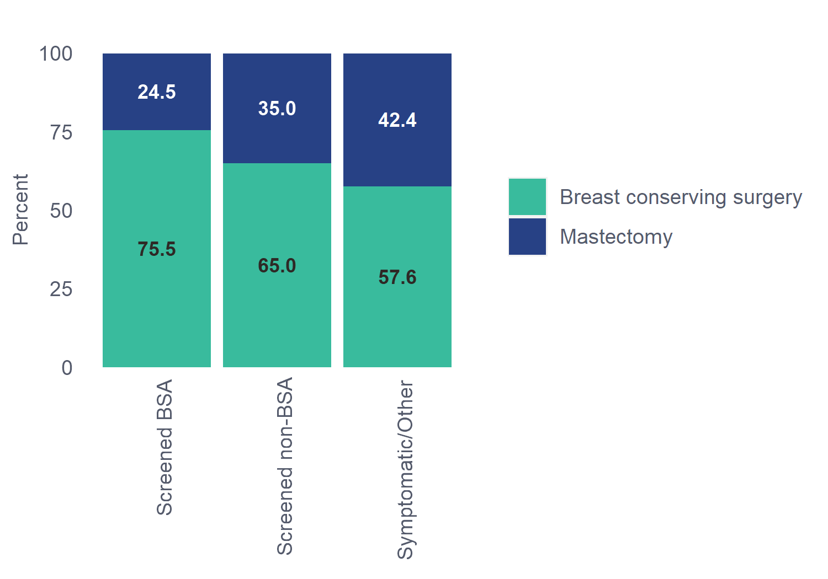

²⁹Figure 9.5-2: Historical trends for contributing regions: First surgery for DCIS by referral source, 2016-2020
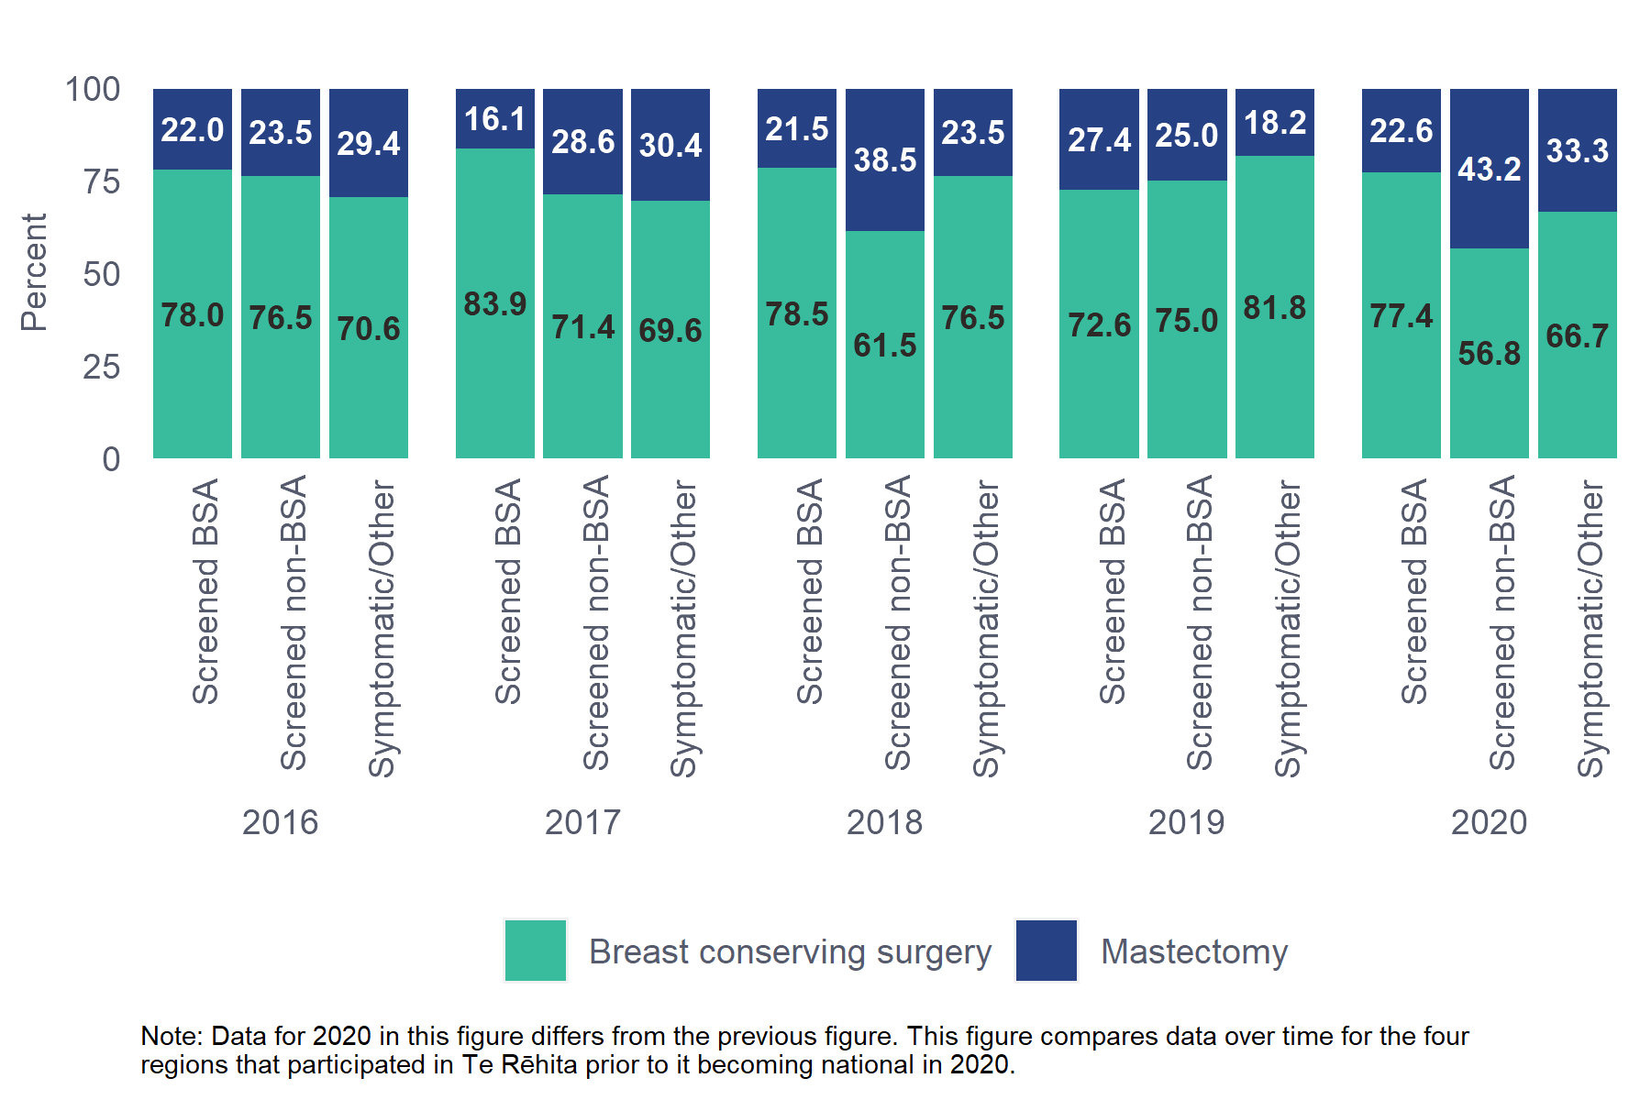

Comments
A lower proportion of patients with BSA screen-detected DCIS underwent mastectomy as their first operation (24.5%) for DCIS compared to patients with non-BSA screened DCIS (35%) or Symptomatic/Other DCIS (42.4%). This may be a reflection of the difference in size of DCIS for each referral source (see Chapter 7).
The numbers of patients with DCIS in the Screened non-BSA and Symptomatic/Other groups is typically very small; it is not inferring a trend from these figures.
⁷²Table 9.5.2 First breast surgery performed for DCIS for Māori and non-Māori patients aged 45-69
Ethnicity | Breast conserving surgery | Mastectomy
Māori (n=43) | 29 (67.4%) | 14 (32.6%)
Non-Māori (n=354) | 259 (73.2%) | 95 (26.8%)
Total (n=397) | 288 (72.5%) | 109 (27.5%)
Chi-square p-value: 0.5399
Unknown/missing data excluded: First breast surgery - 9 patients (either surgery not done, or not assessable).
The Non-Māori group includes 11 Pacific patients due to low numbers in one or more subgroup.
³⁰Figure 9.5-3: First surgery for DCIS by ethnicity, all regions, 2020
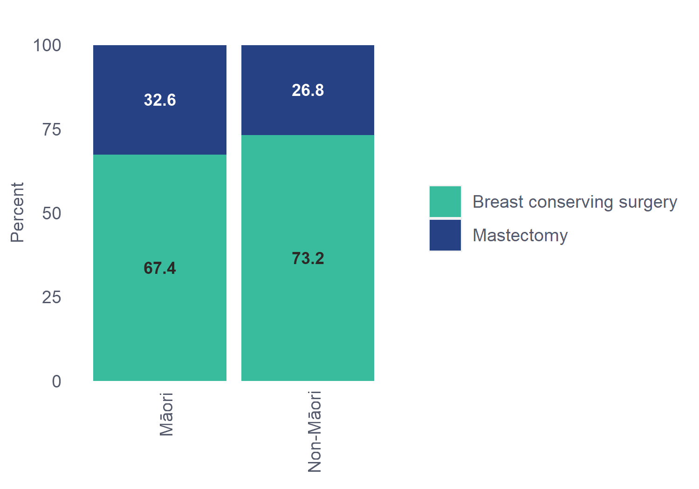

³¹Figure 9.5-4: Historical trends for contributing regions: First surgery for DCIS by ethnicity, 2016-2020
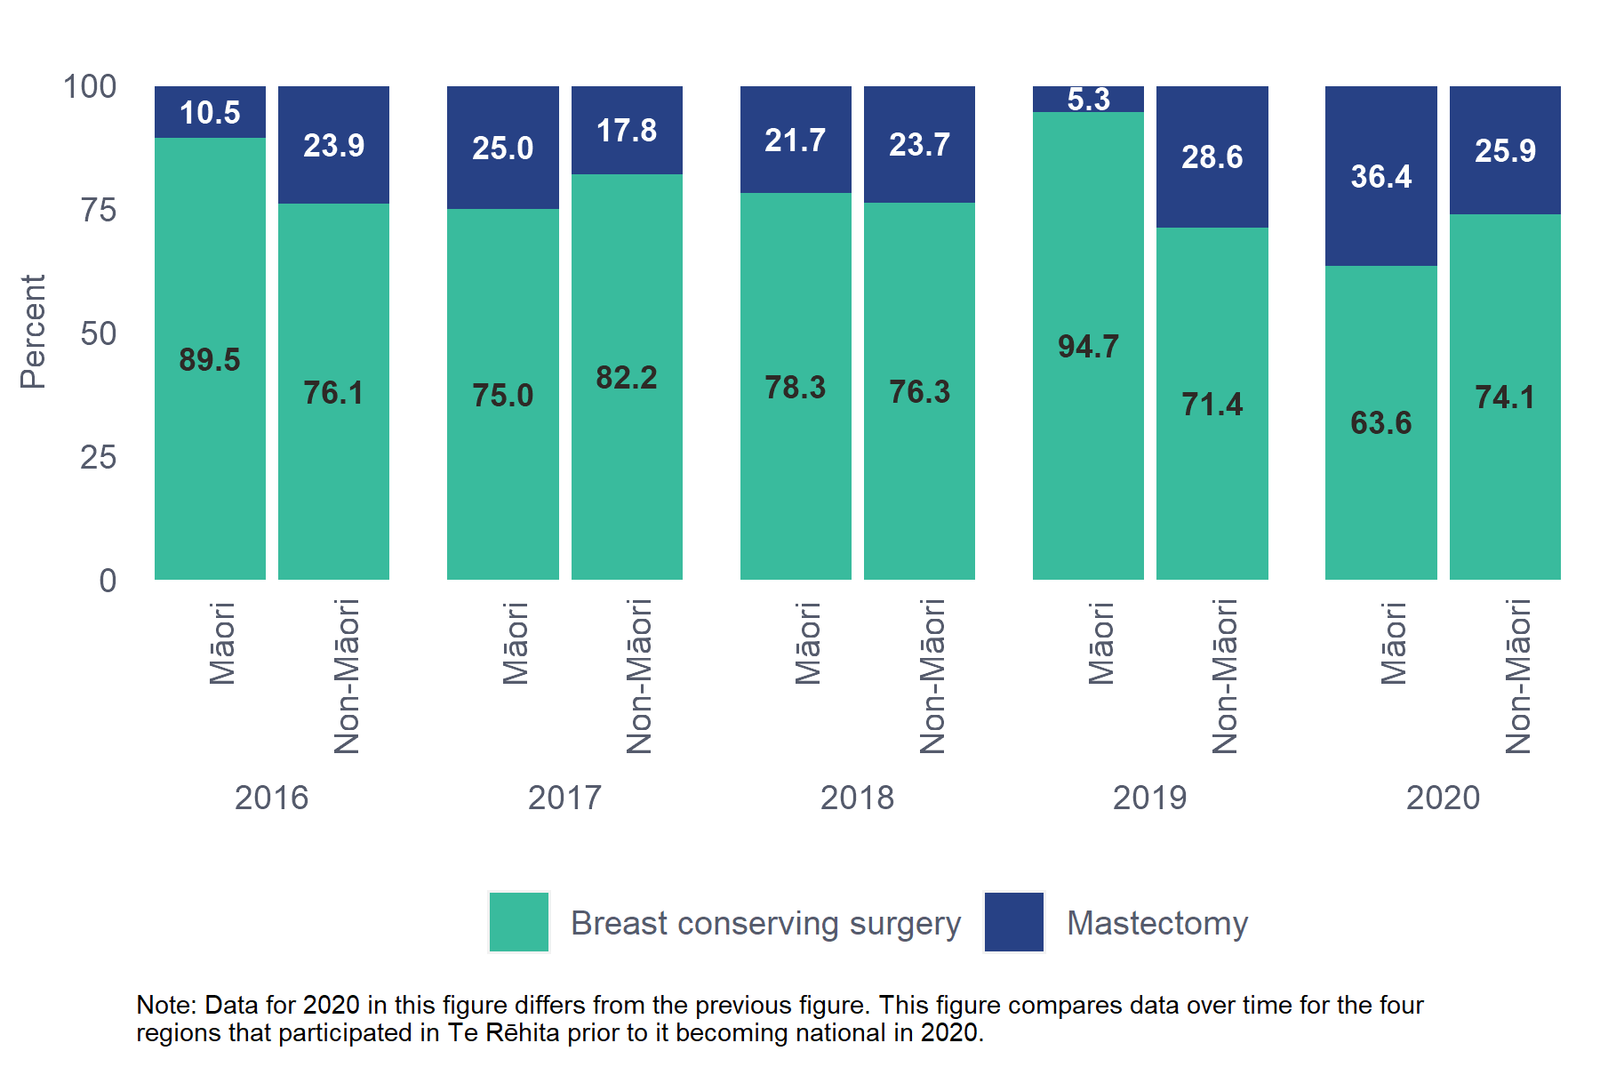

Comments
There was no significant difference in the proportion of Māori and non-Māori patients undergoing BCS as their first operation for DCIS.

Audit data used
Information was derived from eligible patient data fields “Date of surgery” and “Type of breast surgery” which in this table allows the following options: mastectomy, BCS, excision biopsy.
Where excision biopsy is indicated, this includes patients where a diagnostic excision biopsy was performed and DCIS cancer was found with clear surgical margins. Where margins were not clear and a BCS was performed, then the BCS was counted as their first treatment procedure.

  - Further surgery after breast conserving surgery for DCIS
⁷³Table 9.6.1 Further surgery after breast conserving surgery for DCIS by referral source, patients aged 45-69
Referral Source | Re-excision | Mastectomy | Any further surgery | No further breast surgery
BSA (n=228) | 33 (14.5%) | 16 (7%) | 49 (21.5%) | 179 (78.5%)
Other Sources (n=58) | 18 (31%) | 8 (13.8%) | 26 (44.8%) | 32 (55.2%)
Total (n=286) | 51 (68%) | 24 (32%) | 75 (26.2%) | 211 (73.8%)
Chi-square p-value (Any further surgery vs. no further breast surgery): 0.0006
Unknown/missing data excluded: Referral source - 3 patients.
The Other Sources group includes 39 patients where cancer was detected by non-BSA screening.

Comments
More than three-quarters (78.5%) of patients treated with BCS for DCIS had no further surgery. This has increased since 2016 when 65.8% did not have further surgery after BCS. In contrast, the proportion of patients from Other Sources having any further surgery was double that of the BSA patients (44.8% vs 21.5%), including 13.8% of patients referred from Other Sources undergoing completion mastectomy (vs 7% of BSA patients).
Unfortunately, we are unable to report this by ethnicity due to small numbers in some subgroups. We will look to aggregate two years of data for reporting next year.

Audit data used
Information was derived from eligible patient data fields “Date of surgery” and “Type of breast surgery” which allows the following options: mastectomy, BCS, excision biopsy, re-excision and other.
BCS describes cases where the first surgery is either a WLE, excision biopsy or other. Further breast surgery is grouped as Re-excision(s) only or Mastectomy, which includes mastectomy and cases where a patient has re-excision(s) then a mastectomy
  - Reconstruction after mastectomy for DCIS by referral source
⁷⁴Table 9.7.1 Reconstruction after mastectomy for DCIS by referral source, patients aged 45-69
Referral Source | Reconstruction | No Reconstruction
BSA (n=92) | 29 (31.5%) | 63 (68.5%)
Other Sources (n=43) | 13 (30.2%) | 30 (69.8%)
Total (n=135) | 42 (31.1%) | 93 (68.9%)
Chi-square p-value: 1.0000
Unknown/missing data excluded: Referral source - 3 patients. No mastectomy surgery - 272 patients.
The Other Sources group includes 27 patients where cancer was detected by non-BSA screening.

Comments
This table did not reach statistical significance, as numbers are very small. The distribution of patients with DCIS receiving reconstruction after mastectomy was very similar between referral sources; 31.5% for patients with BSA screen-detected DCIS, compared with 30.2% for patients referred from other sources.
More than two-thirds of patients with DCIS treated with mastectomy had no reconstruction (68.9%). This is higher than the proportion reported in the 2016 BSA report (61.3%). This may reflect that reconstructions were de-prioritised in 2020 due to the COVID-19 pandemic.
Unfortunately, we are unable to report this by ethnicity due to small numbers in some subgroups. We will look to aggregate two years of data for reporting next year.

Audit data used
Information was derived from eligible patient data field “Reconstruction” which allows the following options: yes, referred – deemed not necessary, referred – patient declined, referred – patient unfit, not referred – deemed not necessary, not referred – patient declined, not referred – patient unfit.
Reconstruction = Yes
No reconstruction = all other categories (referred – deemed not necessary, referred – patient declined, referred – patient unfit, not referred – deemed not necessary, not referred – patient declined, not referred – patient unfit).

- Axillary surgery treatment

Key Findings
- Patients with BSA-screened cancers were far less likely to require axillary surgery beyond sentinel lymph node biopsy (SLNB), with 10.6% of BSA-screened patients had any Level I-III axillary dissection, compared with 26.8% of patients referred from other sources (Table 10.1.1). In this section, non-BSA screening patients have been combined with Symptomatic /Other as “Other Sources”.
- A higher proportion of patients with BSA detected invasive cancers had any axillary surgery (97.1%) compared to patients with non-BSA detected cancers (89.3%). This is due to a much higher rate of SLNB; BSA patients had a higher proportion of earlier stage cancers less likely to have clinically detectable positive nodes (Table 10.1.1).
- A lower proportion of Māori had any axillary surgery (88.9%) compared to non-Māori patients (93.9%) (Table 10.1.2).
  - Axillary procedures for invasive cancer
⁷⁵Table 10.1.1 Axillary procedures for invasive cancer by referral source, patients aged 45-69
Referral Source | SLNB Only | Level I | Level II | Level III | SLNB  + Level I-III | Any axillary  Surgery | No axillary  surgery
BSA (n=1071) | 926 (86.5%) | 11 (1%) | 59 (5.5%) | 20(1.9%) | 24 (2.2%) | 1040 (97.1%) | 31 (2.9%)
Other Sources (n=1121) | 700 (62.4%) | 16 (1.4%) | 170 (15.2%) | 72(6.4%) | 43 (3.8%) | 1001 (89.3%) | 120 (10.7%)
Total (n=2192) | 1626 (74.2%) | 27 (1.2%) | 229 (10.4%) | 92 (4.2%) | 67 (3.1%) | 2041 (93.1%) | 151 (6.9%)
Chi-square p-value (BSA vs Other Sources comparing any axillary surgery and no axillary surgery): <0.0001
Unknown/missing data excluded: Referral source - 3 patients.
The Other Sources group includes 190 patients whose cancer was detected by non-BSA screening; the remainder were from other sources.
* Level I includes axillary sampling
³²Figure 10.1-1: Axillary procedures for invasive cancer by referral source, patients aged 45-69, diagnosed in all regions, 2020
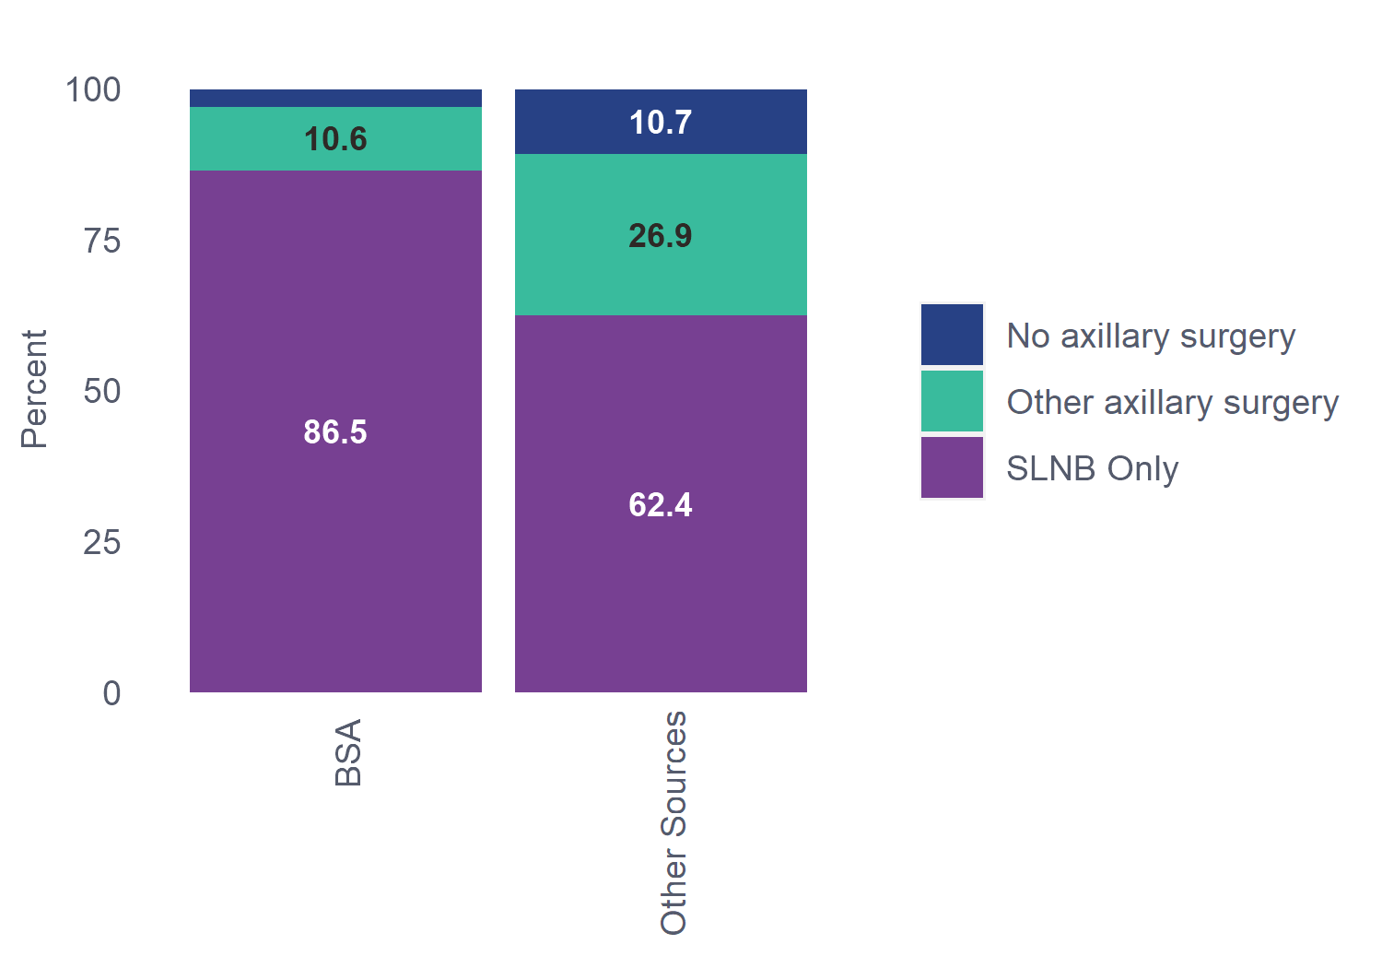

³³Figure 10.1-2: Historical trends for contributing regions: Axillary procedures for invasive by referral source, patients aged 45-69, diagnosed 2016-2020
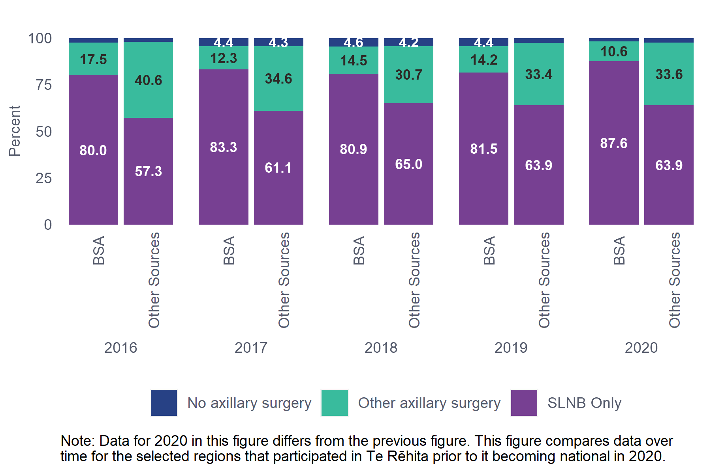

Comments
SLNB is used for patients who are clinically and radiologically node-negative at baseline, that is, patients who have no palpable lymph node involvement and none seen on imaging.
A higher proportion of patients with BSA detected invasive cancers had any axillary surgery (97.1%) compared to patients with non-BSA detected cancers (89.3%). This is due to a much higher rate of SLNB; BSA patients had a higher proportion of earlier-stage cancers that are less likely to have clinically detectable positive nodes, thus requiring SLNB to determine the presence of involved nodes. The higher rate of SLNB Only (meaning SLNB without additional axillary surgery) in patients with BSA screen-detected invasive cancers (86.5%) in comparison to patients referred from other sources (62.4%) is again related to the higher proportion of early-stage cancer in screen-detected patients less likely to require additional axillary surgery beyond SLNB. The proportion of BSA screen-detected patients receiving SLNB Only has increased over time from 75.3% in the 2016 BSA Annual Report to 86.5% in 2020.
In 2020, 10.6% of BSA-screened patients had any Level I-III axillary dissection, compared with 26.8% of patients referred from other sources.

⁷⁶Table 10.1.2 Axillary procedures for invasive cancer for Māori and non-Māori patients aged 45-69
Ethnicity | SLNB Only | Level I | Level II | Level III | SLNB + Level I-III | Any axillary surgery | No axillary surgery
Māori (n=352) | 251 (71.3%) | 6 (1.7%) | 31 (8.8%) | 14 (4%) | 11 (3.1%) | 313 (88.9%) | 39 (11.1%)
Non-Māori (n=1843) | 1378 (74.8%) | 21 (1.1%) | 198 (10.7%) | 78 (4.2%) | 56 (3%) | 1731 (93.9%) | 112 (6.1%)
Total (n=2195) | 1629 (74.2%) | 27 (1.2%) | 229 (10.4%) | 92 (4.2%) | 67 (3.1%) | 2044 (93.1%) | 151 (6.9%)
Chi-square p-value (comparing any axillary surgery and no axillary surgery): 0.0010
³⁴Figure 10.1-3: Axillary procedures for invasive cancer by ethnicity, patients aged 45-69, diagnosed in all regions, 2020
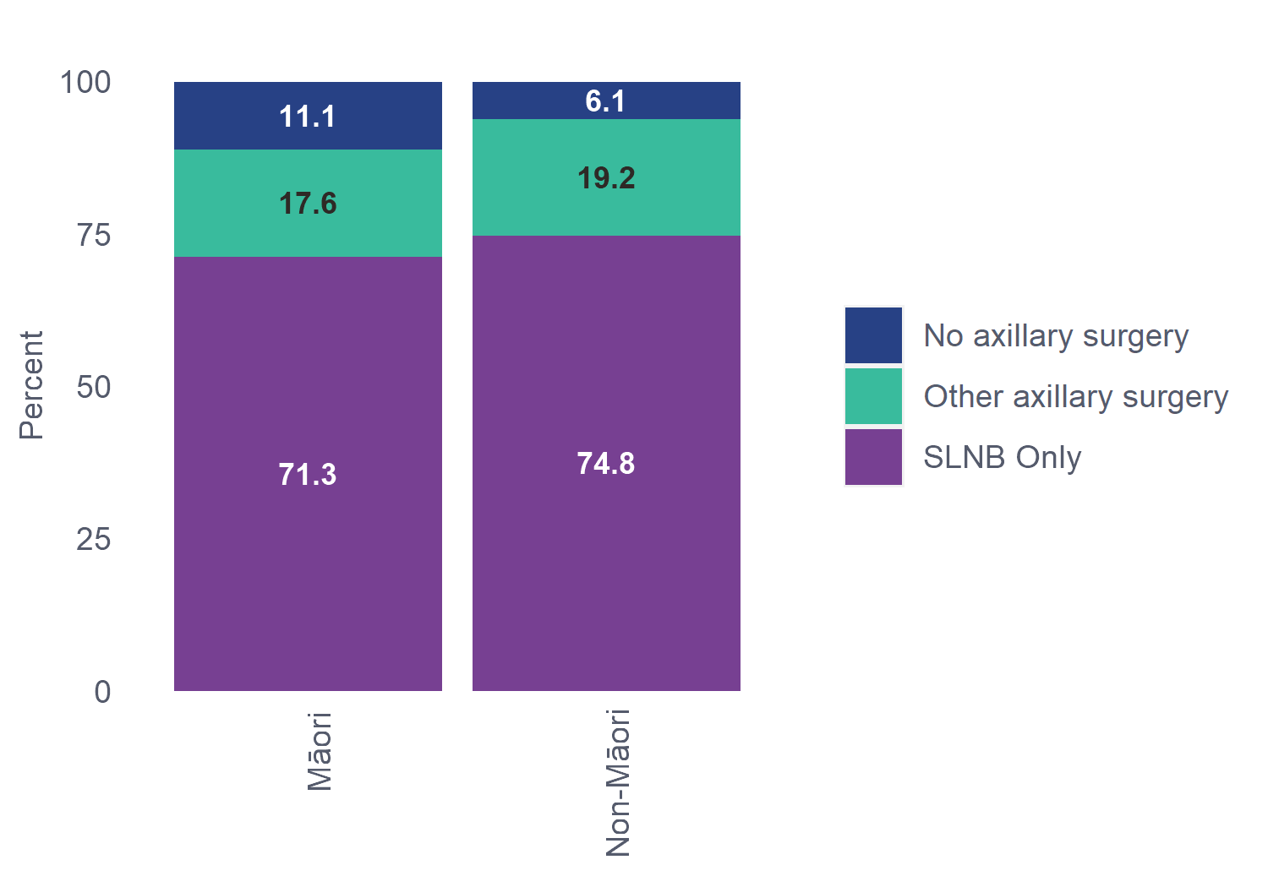

³⁵Figure 10.1-4: Historical trends for contributing regions: Axillary procedures for invasive cancer by ethnicity, patients aged 45-69, diagnosed 2016-2020
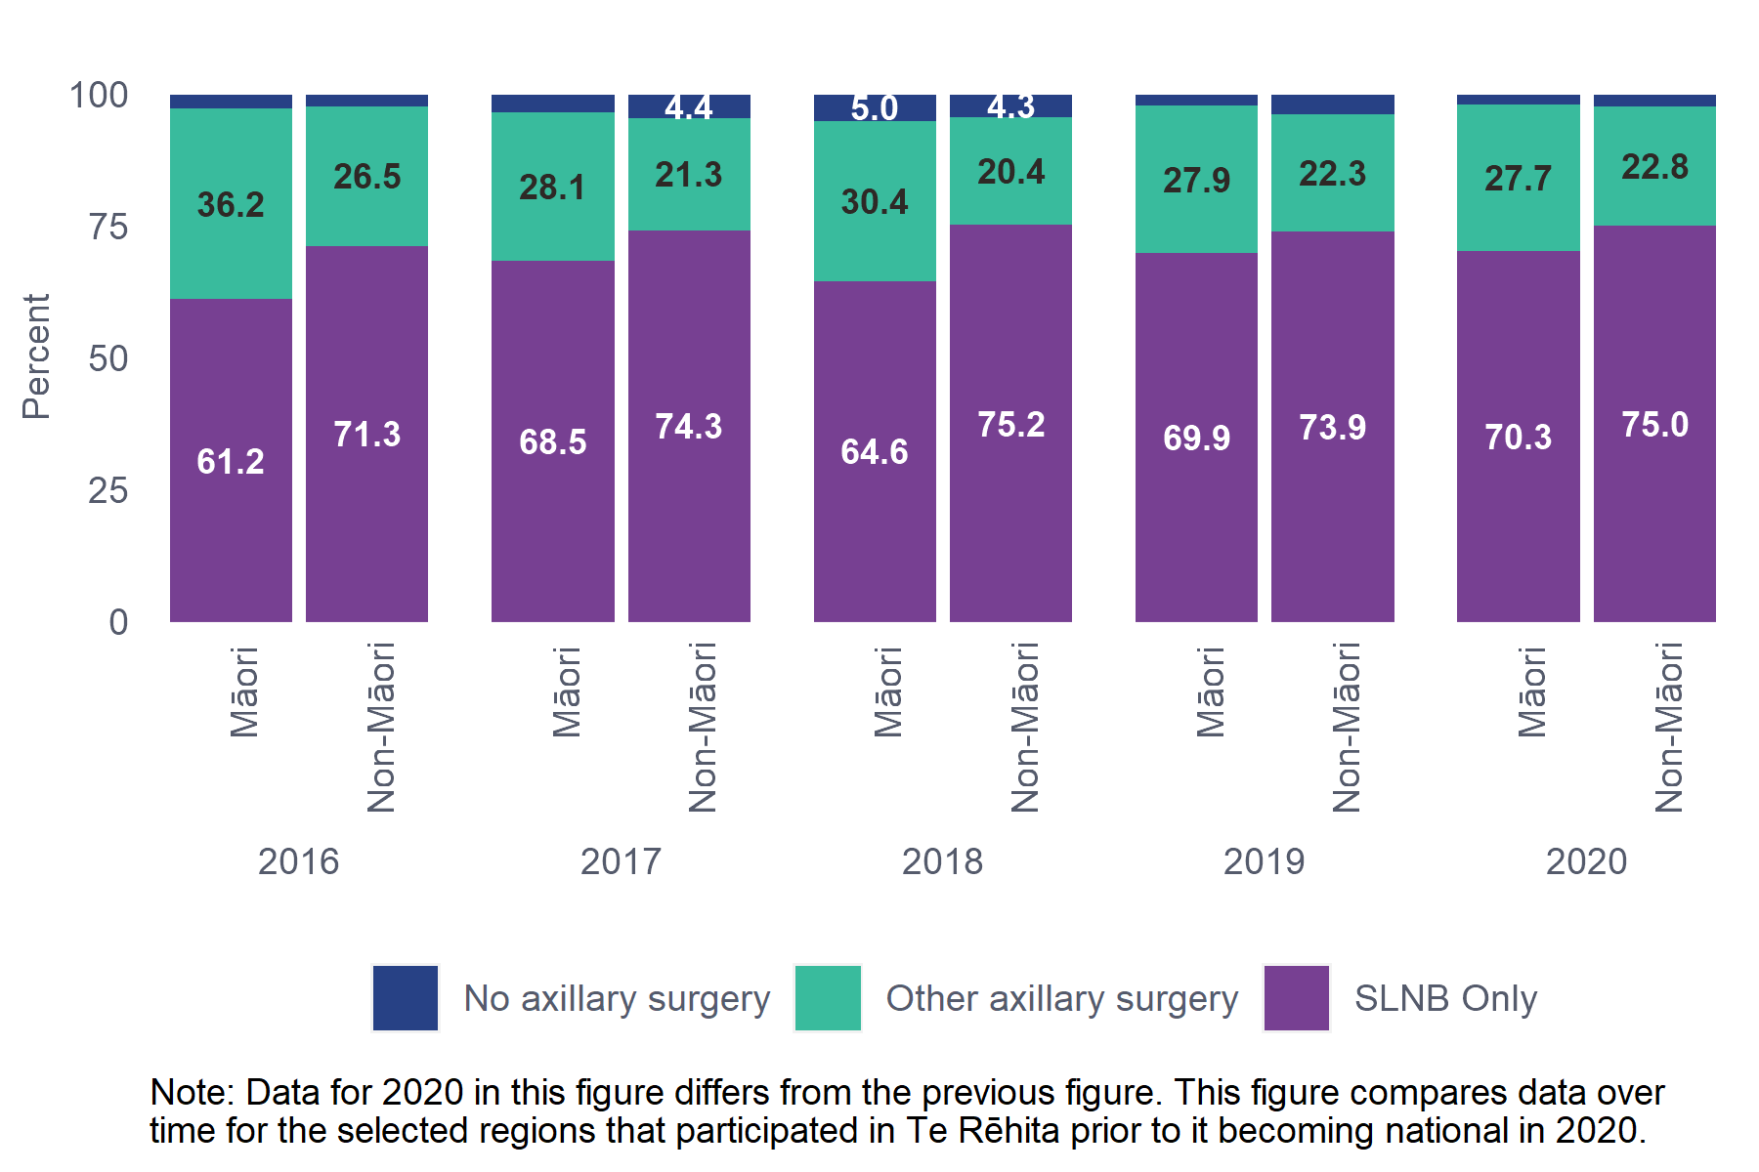

Comments
A lower proportion of Māori received any axillary surgery (88.9%) compared with non-Māori patients (93.9%). Reasons for no axillary surgery in any ethnicity can include elderly patients with low-risk tumours (less likely to be Māori), stage 4 at presentation (more likely to be Māori), pregnancy, and comorbidities that contraindicate axillary surgery. It is also possible that there is inequitable access to SLNB; this may need further investigation.

Audit data used
Information was derived from eligible patient data field “type of axillary surgery” which allows the following options: no axillary surgery required, Level I & axillary sampling, Level II (axillary node dissection), Level III (axillary node clearance), Sentinel lymph node biopsy, declined, different through patient choice, and unknown.

Definitions
Sentinel lymph node biopsy: identification and excision of the sentinel lymph node (the first node(s) draining the primary tumour in the regional lymphatic basin).
Axillary dissection: surgical excision of the axillary contents (fat and lymph nodes).
- Level I: excision of the axillary contents up to the lateral border of the pectoralis minor muscle, includes axillary sampling and also axillary node biopsy (the excision of one or two nodes for diagnostic purposes, noting here this is not Level 1 dissection, and strictly speaking nor is axillary sampling).
- Level II: Excision of the axillary contents up to medial border of the pectoralis minor muscle.
- Level III: Excision of the axillary contents medial to pectoralis minor and up to the apex of the axilla.
  - Axillary procedures for invasive cancers ≤3cm
⁷⁷Table 10.2.1 Axillary procedures for ≤3cm invasive cancers by referral source, patients aged 45-69
 | SLNB Only | Level I | Level II | Level III | SLNB +  Level I-III | Any axillary surgery | No axillary  surgery
BSA (n=696) | 618 (88.8%) | 5 (0.7%) | 32 (4.6%) | 15 (2.2%) | 14 (2%) | 684 (98.3%) | 12 (1.7%)
Other Sources (n=644) | 478 (74.2%) | 8 (1.2%) | 88 (13.7%) | 25 (3.9%) | 23 (3.6%) | 622 (96.6%) | 22 (3.4%)
Total (n=1340) | 1096 (81.8%) | 13 (1%) | 120 (9%) | 40 (3%) | 37 (2.8%) | 1306 (97.5%) | 34 (2.5%)
Chi-square p-value (BSA vs Other Sources comparing any axillary surgery and no axillary surgery): 0.0728
Unknown/missing data excluded: Referral source - 3 patients. Axillary procedure - 748 patients (Invasive tumour size over 3 cm or not assessable).
The Other Sources group includes 190 patients whose cancer was detected by non-BSA screening; the remainder were from other sources.

³⁶Figure 10.2-1: Axillary procedures for ≤3cm invasive cancer by referral source, patients aged 45-69, diagnosed in all regions, 2020
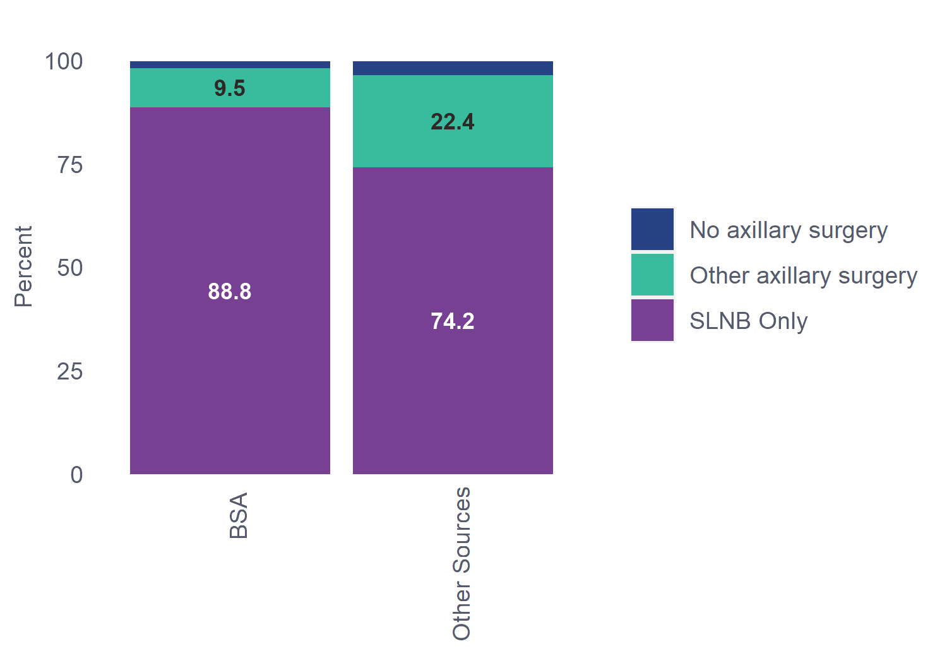
³⁷Figure 10.2-2: Historical trends for contributing regions: Axillary procedures for ≤3cm invasive cancer by referral source, patients aged 45-69, diagnosed 2016-2020
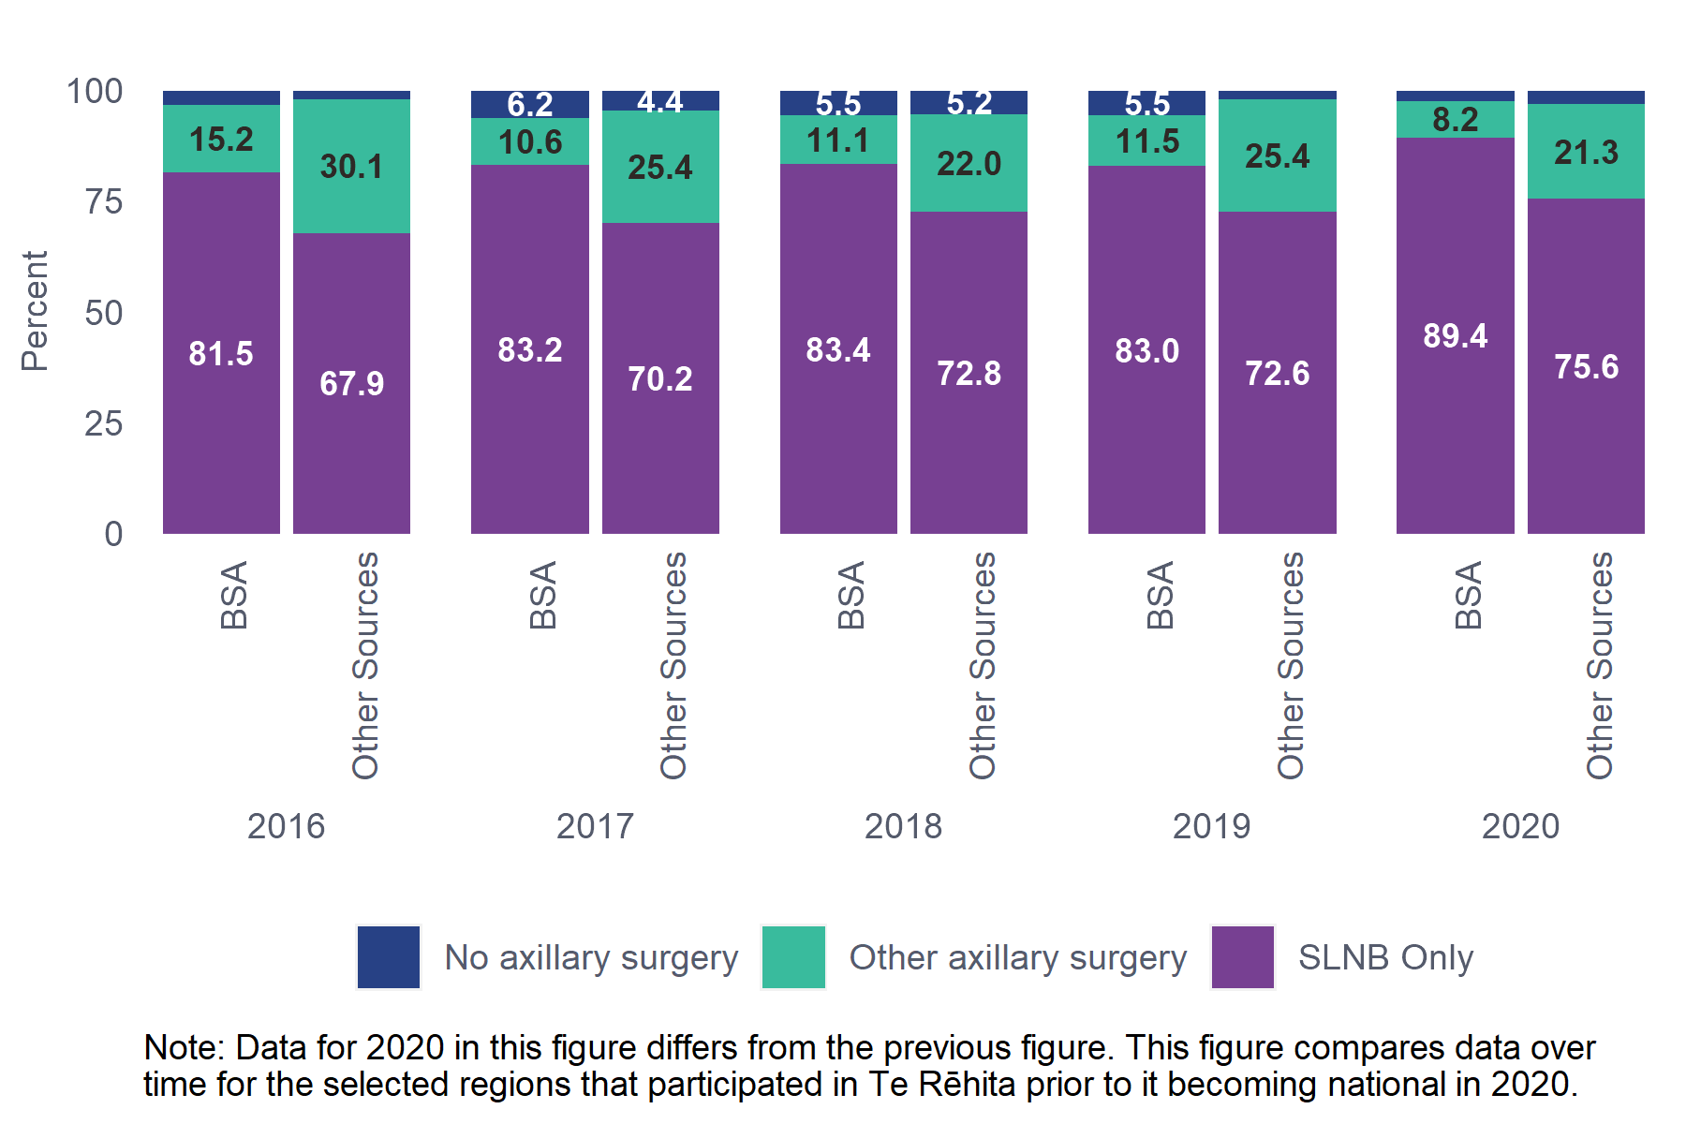

Comments
BSA Programme Monitoring Indicator 4.a.1 monitors patients with invasive breast cancers ≤30 mm who have SLNB as their first axillary procedure.
It appears that patients referred from other sources with cancers ≤3cm in size were twice as likely to have any axillary node dissection (levels I-III) than BSA-detected patients (22.4% vs 9.5%), however this difference was not significant. Axillary node dissection greatly increases patients’ risk of lymphoedema. BSA-screened patients were more likely to require only the much less invasive SLNB.
The proportion of patients who underwent any axillary surgery was very similar for patients with BSA screen-detected cancers (98.3%) and those referred from other sources (96.6%).
⁷⁸Table 10.2.2 Axillary procedures for ≤3cm invasive cancer for Māori and non-Māori patients aged 45-69
Ethnicity | SLNB Only | Level I | Level II | Level III | SLNB  + Level I-III | Any axillary surgery | No axillary surgery
Māori (n=201) | 162 (80.6%) | N/S | 14 (7%) | 8 (4%) | N/S | 193 (96%) | 8 (4%)
Non-Māori (n=1141) | 936 (82%) | N/S | 106 (9.3%) | 32 (2.8%) | N/S | 1115 (97.7%) | 26 (2.3%)
Total (n=1342) | 1098 (81.8%) | 13 (1%) | 120 (8.9%) | 40 (3%) | 37 (2.8%) | 1308 (97.5%) | 34 (2.5%)
Chi-square p-value (comparing any axillary surgery and no axillary surgery): 0.2412
Excluded: Axillary procedure - 748 patients (Invasive tumour size over 3 cm or not assessable).
The Non-Māori group includes 138 Pacific patients due to low numbers in one or more subgroup.
N/S – Data not shown due to low numbers in at least one subgroup.

³⁸Figure 10.2-3: Axillary procedures for ≤3cm invasive cancer by ethnicity, patients aged 45-69, diagnosed in all regions, 2020
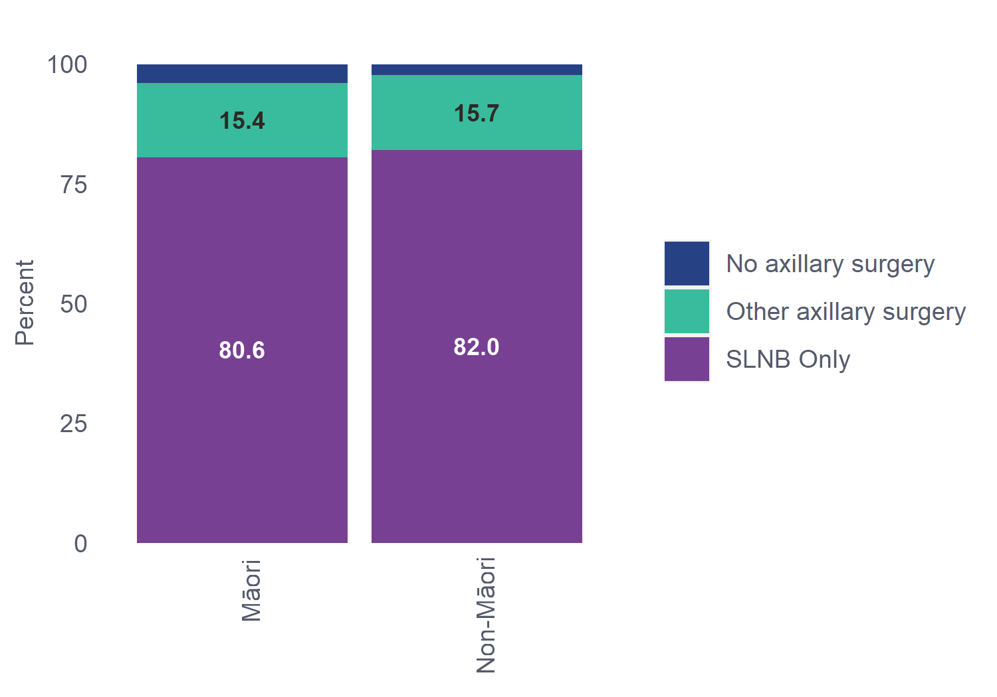
³⁹Figure 10.2-4: Historical trends for contributing regions: Axillary procedures for ≤3cm invasive cancer by ethnicity, patients aged 45-69, diagnosed 2016-2020
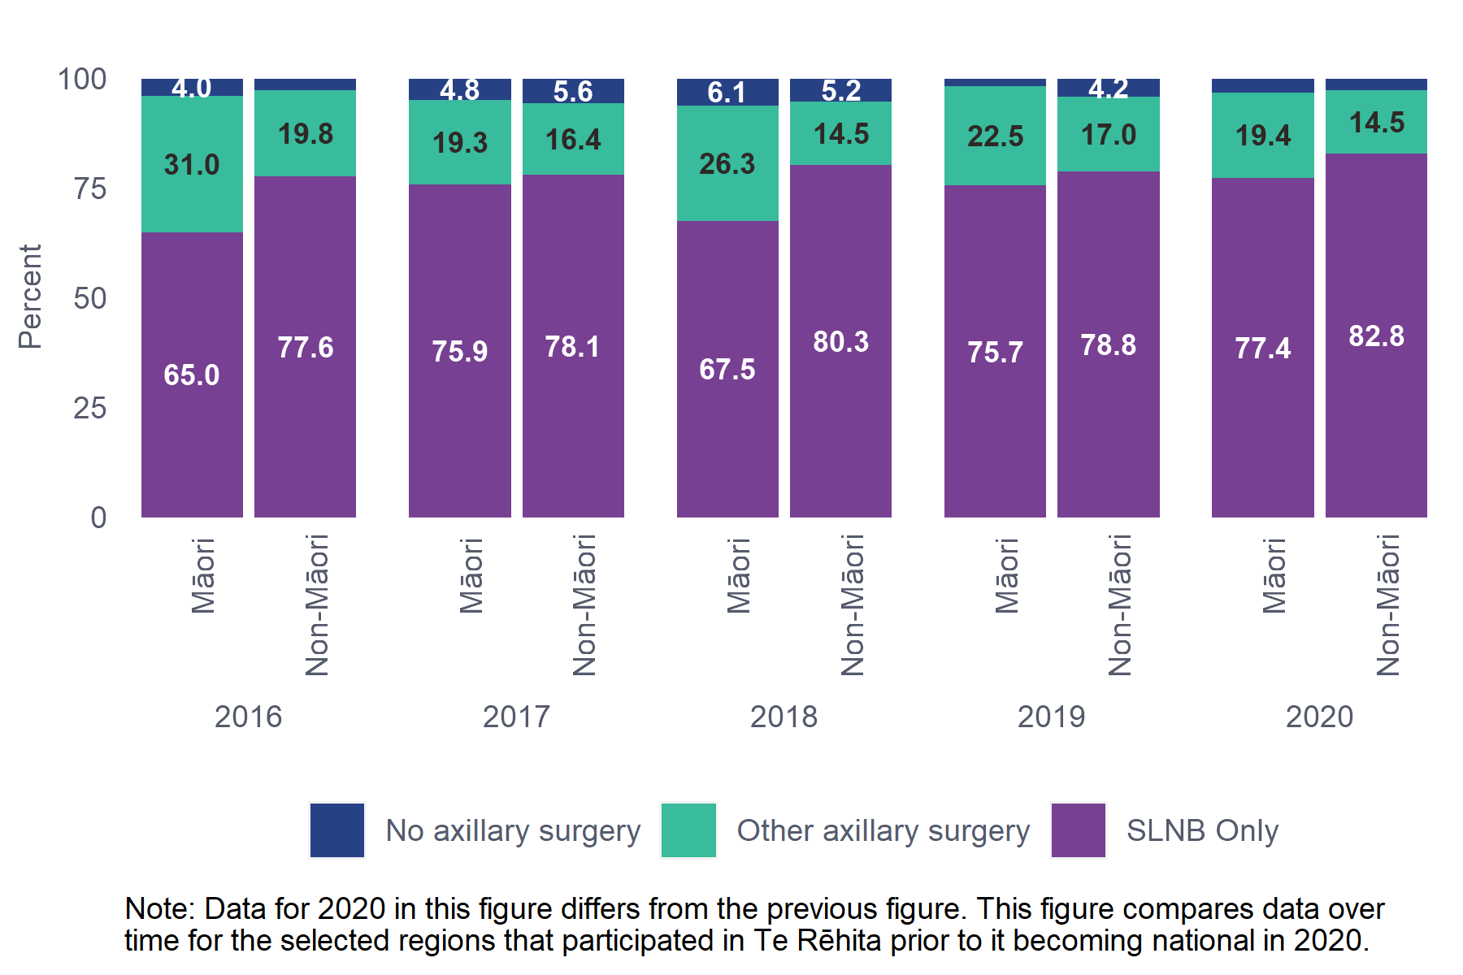

Comments
The BSA Programme Monitoring Indicator, 4.a.1 monitors patients with invasive breast cancers ≤30 mm who have SLNB as their first axillary procedure.
The proportion of Māori with invasive cancers ≤3cm who received SLNB Only (80.6%) was similar to the proportion for non-Māori patients (82%). Similarly, the proportion of Māori who underwent any axillary surgery (96%) was similar to the proportion of non-Māori patients (97.7%).
  - Axillary procedures for >3cm invasive cancer
⁷⁹Table 10.3.1 Axillary procedures for >3cm for invasive cancer by referral source, patients aged 45-69
 | SLNB Only | Level I | Level II | Level III | SLNB +  Level I-III | Any axillary  surgery | Unknown / No  axillary surgery
BSA (n=358) | 308 (86%) | 6 (1.7%) | 27 (7.5%) | 5 (1.4%) | 10 (2.8%) | 356 (98.6%) | 5 (1.4%)
Other Sources (n=390) | 222 (56.9%) | 8 (2.1%) | 82 (21%) | 47 (12.1%) | 20 (5.1%) | 379 (97.2%) | 11 (2.8%)
Total (n=748) | 530 (70.9%) | 14 (1.9%) | 109 (14.6%) | 52 (7%) | 30 (4%) | 735 (97.9%) | 16 (2.1%)
Chi-square p-value (BSA vs. Other Sources comparing any axillary surgery and no axillary surgery): 0.0371
Unknown/missing data excluded: Axillary procedure - 1340 patients (Invasive tumour size <= 3 cm or not assessable).
In the Unknown/No Axillary Surgery column, the BSA group is combined with a small number of Patients with unknown Referral source to preserve privacy.
The Other Sources group includes 190 patients whose cancer was detected by non-BSA screening; the remainder were from other sources.

Comments
A larger proportion of patients with BSA screen-detected invasive cancers >3cm underwent SLNB Only surgery (86%) compared with patients with non-BSA detected cancers (56.9%).

⁸⁰Table 10.3.2 Axillary procedures for >3cm for invasive cancer for Māori and non-Māori patients aged 45-69
Ethnicity | SLNB Only | Level I | Level II | Level III | SLNB +  Level I-III | Any axillary  Surgery | No axillary  surgery
Māori (n=125) | 89 (71.2%) | N/S | 17 (13.6%) | 6 (4.8%) | N/S | 120 (96%) | 5 (4%)
Non-Māori (n=624) | 442 (70.8%) | N/S | 92 (14.7%) | 46 (7.4%) | N/S | 616 (98.7%) | 8 (1.3%)
Total (n=749) | 531 (70.9%) | 14 (1.9%) | 109 (14.6%) | 52 (6.9%) | 30 (4%) | 736 (98.3%) | 13 (1.7%)
Chi-square p-value (comparing any axillary surgery and no axillary surgery): 0.0804
Unknown/missing data excluded: Axillary procedure - 1340 patients (Invasive tumour size <= 3 cm or not assessable).
The Non-Māori group includes 138 Pacific patients due to low numbers in one or more subgroup.
N/S – Not shown due to small numbers in one or more subgroups.

Comments
The proportion of Māori with invasive cancers >3cm in size who underwent SLNB Only surgery (71.2%) is the same as non-Māori patients (70.8%).

  - Axillary procedures for DCIS treated with breast conserving surgery
⁸¹Table 10.4.1 Axillary procedures for DCIS treated with breast conserving surgery by referral source, patients aged 45-69
Referral Source | SLNB Only | Level I | Level II | Level III | SLNB +  Level I-III | Any axillary  Surgery | No axillary  surgery
BSA (n=212) | 16 (7.5%) | 0 (0%) | 0 (0%) | 0 (0%) | 0 (0%) | 16 (7.5%) | 196 (92.5%)
Other Sources (n=50) | 8 (16%) | 0 (0%) | 0 (0%) | 0 (0%) | 0 (0%) | 8 (16%) | 42 (84%)
Total (n=262) | 24 (9.2%) | 0 (0%) | 0 (0%) | 0 (0%) | 0 (0%) | 24 (9.2%) | 238 (90.8%)
Chi-square p-value (BSA vs Other Sources comparing any axillary surgery and no axillary surgery): 0.1115
Unknown/missing data excluded: Referral source - 3 patients. Axillary procedure - 145 patients (different types of breast surgery, or type of axillary surgery is unknown).
The Other Sources group includes 190 patients whose cancer was detected by non-BSA screening; the remainder were from other sources.

Comments
Axillary surgery is rare in pure DCIS, as by definition the cancer has not spread beyond the duct of the breast (patients whose lesion includes both DCIS and invasive cells are reported in the invasive tables). However, occasionally a multidisciplinary team meeting may recommend limited axillary surgery in cases such as “mass-forming DCIS”, or if the pathologist has suspicions of micro-invasion on the core biopsy, or high-grade DCIS of a significant size. In 2020, a small number of DCIS patients (n=24) received SLNB with breast conserving surgery (BCS), and it appears the proportion was smaller (7.5%) for BSA-detected patients than non-BSA detected. However, this should be interpreted with caution.
We are unable to report this by ethnicity due to small numbers in some subgroups. We will look to aggregate two years of data for inclusion in the next report.
  - Axillary procedures for DCIS treated with mastectomy
In 2020, n=134 patients aged 45-69 were diagnosed with DCIS and treated with mastectomy. Of these, 94% received Any axillary surgery. Unfortunately, numbers are too low to report by screening status or ethnicity. Data will be aggregated in future reports to allow for more detailed reporting.

- Margins of excision for breast conserving surgery
This chapter reports the final circumferential margins of excision after breast conserving surgery and any re-excisions performed in an attempt to achieve clear margins.

Key Findings
- A larger proportion of patients with BSA-detected invasive cancers had final circumferential margins following breast conserving surgery (BCS) of more than or equal to 2 mm (88.5%) compared to patients referred from other sources (84%) (Table 11.1.1).
- A higher proportion of Māori with invasive cancers had more than or equal to 2 mm circumferential margins (93.1%) compared to non-Māori patients (85.4%) (Table 11.1.2).
- A larger proportion of patients with BSA-detected DCIS (82.6%) had final circumferential margins more than or equal to 2 mm compared to patients with non-BSA detected DCIS (86.5%) (Table 11.2.1). A lower proportion of Māori with DCIS had more than or equal to 2 mm margins (78.6%) compared to non-Māori patients (83.3%) (Table 11.2.2).

  - Circumferential margins of excision for invasive cancer
⁸²Table 11.1.1 Margins of excision for invasive cancer by referral source, patients aged 45-69
Referral Source | Involved margin | 1 mm margin | ≥ 2 mm margin | Clear but unspecified margin
BSA (n=740) | N/S | 55 (7.4%) | 655 (88.5%) | N/S
Other Sources (n=514) | N/S | 39 (7.6%) | 432 (84%) | N/S
Total (n=1254) | 13 (1%) | 94 (7.5%) | 1087 (86.7%) | 60 (4.8%)
Chi-square p-value: 0.0014
Unknown/missing data excluded: Referral source - 2 patients. Margin - 107 patients (either surgery not done, or not assessable).
The Other Sources group includes 107 patients where cancer was detected by non-BSA screening.
N/S – Not shown due to small numbers in one or more subgroups.

Comments
The majority of patients with invasive cancer (86.7%) had a clear margin of at least 2 mm after BCS, and only 1% of patients had an involved margin. BSA-screened patients had the highest proportion of margins at least 2 mm (88.5%) though this is lower than the proportion reported in 2016 (91.9%).
⁸³Table 11.1.2 Margins of excision for invasive cancer for Māori and non-Māori patients aged 45-69
Ethnicity | Involved margin | 1 mm margin | ≥ 2 mm margin | Clear but unspecified margin
Māori (n=203) | N/S | 10 (4.9%) | 189 (93.1%) | N/S
Non-Māori (n=1053) | N/S | 85 (8.1%) | 899 (85.4%) | N/S
Total (n=1256) | 13 (1%) | 95 (7.6%) | 1088 (86.6%) | 60 (4.8%)
Chi-square p-value: 0.0194
Unknown/missing data excluded: Margin - 107 patients (either surgery not done, or not assessable).
N/S – Not shown due to small numbers in one or more subgroups.

Comments
A higher proportion of Māori with invasive cancers had margins of excision ≥2 mm (93.1%), compared with non-Māori (85.4%).

Audit data used
Information on final margin size was derived from all eligible patients who had breast surgery, excluding mastectomy, for invasive cancer using the data fields “Invasive closest circumferential margin (mm)” and “resection margin”.
Final margins are recorded in whole numbers; an entry of 0 is an involved margin; margins between 0.1 and 0.9 have been rounded up to 1 mm. For cases where the pathologist indicated a “clear margin” without specifying a specific value, a code of “999” can be used in the system. This is interpreted as “clear but unspecified margin”. Where no margin is indicated then the resection margin field with options negative or positive was used.

Definitions
Surgical margin: the final closest circumferential margin (measured in millimetres), after BCS and any re-excisions, of apparently benign tissue around a tumour that has been surgically removed.
The margin is described as involved or positive when the pathologist finds cancer cells at the edge of the surgical specimen.
A clear, negative or clean margin means the pathologist has not found cancer cells at the outer edge of the surgical specimen that was removed.
  - Circumferential margins of excision for DCIS
Evidence shows that for DCIS patients having BCS and radiation therapy, margins of at least 2 mm are associated with a reduced risk of local recurrence than narrower margins. Treatment guidelines therefore recommend 2 mm margins for this group. For patients who omit radiation, a margin >2 mm might be preferred, though evidence for this is inconsistent (Schnitt, S., et al., 2020).

⁸⁴Table 11.2.1 Margins of excision for DCIS by referral source, patients aged 45-69
Referral Source | Involved margin | 1 mm margin | ≥ 2 mm margin | Clear but unspecified margin
BSA (n=213) | N/S | N/S | 176 (82.6%) | N/S
Other Sources (n=52) | N/S | N/S | 45 (86.5%) | N/S
Total (n=265) | 5 (1.9%) | 14 (5.3%) | 221 (83.4%) | 25 (9.4%)
Chi-square p-value: 0.0541
Unknown/missing data excluded: Referral source - 3 patients. Margin - 8 patients (either surgery not done, or not assessable).
The Other Sources group includes 35 patients where cancer was detected by non-BSA screening.
N/S – Data not shown due to low numbers in at least one subgroup.

Comments
A lower proportion of patients with DCIS detected by BSA screening had margins ≥2 mm, or clear margins (82.6%) compared with patients referred from other sources (86.5%). However, there was no statistically significant variation between BSA and Other Sources (p=0.0541).
⁸⁵Table 11.2.2 Margins of excision for DCIS, Māori and non-Māori patients aged 45-69
Ethnicity | Involved margin | 1 mm margin | ≥ 2 mm margin | Clear but unspecified margin
Māori (n=28) | N/S | N/S | 22 (78.6%) | 5 (17.9%)
Non-Māori (n=240) | N/S | N/S | 200 (83.3%) | 21 (8.8%)
Total (n=268) | 5 (1.9%) | 15 (5.6%) | 222 (82.8%) | 26 (9.7%)
Chi-square p-value: 0.3878
Unknown/missing data excluded: Margin - 8 patients (either surgery not done, or not assessable).
N/S – Data not shown due to low numbers in at least one subgroup

Comments
Overall, 1.9% of patients with DCIS had involved margins after final surgery. The proportion of Māori with clear margins ≥2 mm (78.6%) is similar to the proportion of non-Māori patients (83.3%).

Audit data used
Information on final margin size was derived from all eligible patients who had surgery, excluding mastectomy, for DCIS using the data fields “DCIS closest circumferential margin (mm)” and “resection margin”.
Final margins were recorded in whole numbers; an entry of 0 is an involved margin; margins between 0.1 and 0.9 have been rounded up to 1 mm. For cases where the pathologist indicated a “clear margin” without specifying a specific value, a code of “999” can be used in the system. This is interpreted as “clear but unspecified margin”. Where no margin is indicated then the resection margin field with options negative or positive was used where Positive = Involved margin and Negative = clear but unspecified margin.

- Radiotherapy treatment

Key Findings
- The rate of radiotherapy administered following breast conserving surgery (BCS) for invasive cancers was similar by referral source (BSA-screened 88.1%, non-BSA screened 87.2%, Symptomatic/Other 90.6%) (Table 12.1.1), and ethnicity (Māori, 87.1% and non-Māori, 89.2%) (Table 12.1.2).
- The proportion of patients receiving radiotherapy following mastectomy was lower for patients with BSA-detected invasive cancers (31.1%) compared to patients referred from other sources (42.1%) (Table 12.2.1).
- Proportions of radiotherapy administered following BCS for DCIS were similar by referral source (BSA detected 56.1%, non-BSA detected 60%) (Table 12.4.1).
- The number of patients with high-risk invasive cancers who had mastectomies in 2020 was much higher than reported in 2016 (n=189 vs n=59). In 2020, 82% received radiotherapy following their mastectomy (Table 12.3.1).
  - Radiotherapy for invasive cancer treated with breast conserving surgery
⁸⁶Table 12.1.1 Radiotherapy for invasive cancer treated with breast conserving surgery by referral source, patients aged 45-69
 | Referral Source | Treatment  received | Referred but  not used | Not referred
Screening | Screened BSA (n=723) | 637 (88.1%) | 64 (8.9%) | 22 (3%)
 | Screened non-BSA (n=94) | 82 (87.2%) | 5 (5.3%) | 7 (7.4%)
Non-screening | Symptomatic/Other (n=395) | 358 (90.6%) | 24 (6.1%) | 13 (3.3%)
Total | (n=1212) | 1077 (88.9%) | 93 (7.7%) | 42 (3.5%)
Chi-square p-value: 0.3318
Unknown/missing data excluded: Referral source - 2 patients. Radiotherapy treatment - 2 patients.

Comments
BSA Programme Monitoring indicator 4g sets a 95% target for patients who have BCS for invasive breast cancer to go on to have radiotherapy.
In 2020, 96.6% of patients with invasive cancer who had BCS were referred for radiation treatment (includes Treatment received 88.9% and Referred but not used 7.7%). There was no significant difference in radiation therapy referrals or delivery between BSA-screened, non-BSA screened and Symptomatic/Other patients.
The proportion of patients with BSA-detected cancer referred for radiotherapy appears to have increased from 93.3% noted in the 2016 BSA report to 97% in 2020.
The proportion of BSA patients referred for radiotherapy who did not receive treatment increased from 6.3% (2016 BSA report) to 8.9% in 2020. Contributing factors may include the EXPERT clinical trial underway at several New Zealand sites, where some patients with very small tumours omitted radiotherapy, and possible service disruption or patient reluctance due to COVID-19 lockdowns. The proportion of patients referred but not treated decreased among patients whose cancers were non-BSA screened or Symptomatic/Other, from 7.5% (2016) to 6.1% in 2020; however, the numbers are very small and hard to interpret.
⁸⁷Table 12.1.2 Radiotherapy for invasive cancer treated with breast conserving surgery for Māori and non-Māori patients aged 45-69
Ethnicity | Treatment  received | Referred but  not used | Not referred
Māori (n=194) | 169 (87.1%) | N/S | N/S
Non-Māori (n=1020) | 910 (89.2%) | N/S | N/S
Total (n=1214) | 1079 (88.9%) | 93 (7.7%) | 42 (3.5%)
Chi-square p-value: 0.1107
Unknown/missing data excluded: Radiotherapy treatment - 2 patients.
The Non-Māori group includes 72 Pacific patients due to low numbers in one or more subgroup.
N/S – Not shown due to small numbers in one or more subgroups

Comments
In 2020, 87.1% of Māori with invasive cancers treated with BCS received radiotherapy treatment after surgery. This is similar to the proportion of non-Māori patients (89.2%) who received treatment.

Audit data used
Information was derived from eligible patient data field “Adjuvant radiation therapy” which allows one of the following options: yes, referred – deemed not necessary, referred – patient declined, referred – patient unfit, not referred – deemed not necessary, not referred – patient declined, not referred – patient unfit, other and unknown. Radiotherapy treatment is given where yes is selected.
For consistency with the 2016 report, the categories yes (=Treatment received) and referred but not used (includes referred – deemed not necessary, referred – patient declined and referred – patient unfit) were combined to calculate the number referred for radiotherapy.
Information was also derived from eligible patient data field “type of breast surgery” which allows the following options: no breast surgery, excision biopsy, BCS/partial mastectomy, re-excision, total mastectomy, other and unknown.
BCS includes excision biopsy (open biopsy), axillary tail surgery, and BCS/partial mastectomy (also called lumpectomy).
There was one episode where the patient received neoadjuvant radiation therapy, and eight episodes where radiation therapy was given as the primary treatment (no primary surgery indicated). These cases were excluded from the counts.

Definitions
Radiotherapy: use of radiation, usually X-rays or gamma rays, to eliminate tumour cells.
Referred includes both treatment received and referred but not used categories.
Referred but not used includes referred – deemed not necessary, referred – patient declined, and referred – patient unfit.
  - Post-mastectomy radiotherapy treatment for invasive cancers
Post-mastectomy radiotherapy is used to treat high-risk breast cancers. This section includes all invasive cancers; section 13.3 includes only high-risk cancers.

⁸⁸Table 12.2.1 Post-mastectomy radiotherapy treatment for invasive cancers by referral source, patients aged 45-69
Referral Source | Treatment  received | Referred but  not used | Not referred
BSA (n=325) | 101 (31.1%) | 20 (6.2%) | 204 (62.8%)
Other Sources (n=534) | 225 (42.1%) | 58 (10.9%) | 251 (47%)
Total (n=859) | 326 (38%) | 78 (9.1%) | 455 (53%)
Chi-square p-value: <0.0001
Unknown/missing data excluded: Referral source - 3 patients. Radiotherapy treatment - 10 patients.
The Other Sources group includes 89 patients whose cancer was detected by non-BSA screening; the remainder were from other sources.

Comments
The proportion of patients with BSA screen-detected invasive cancer referred for radiotherapy after mastectomy increased slightly over five years, from 35.5% in 2016 to 37.3% in 2020 (includes treatment received and referred but not used). The proportion of patients referred for radiotherapy from other sources also increased, from 49.9% in 2016 to 53% in 2020. The significantly lower rate of post-mastectomy radiotherapy referrals for BSA-detected cancers is likely due to the overall smaller, less aggressive nature of BSA screen-detected cancers.
For probably similar reasons, the percentage of patients receiving radiotherapy after mastectomy for invasive cancer was lower in patients with BSA screen-detected invasive cancers (31.1%) compared with those referred from other sources (42.1%).
⁸⁹Table 12.2.2 Post-mastectomy radiotherapy treatment for invasive cancers for Māori and non-Māori patients aged 45-69
Ethnicity | Treatment  received | Referred but  not used | Not referred
Māori (n=127) | 45 (35.4%) | 17 (13.4%) | 65 (51.2%)
Non-Māori (n=733) | 281 (38.3%) | 61 (8.3%) | 391 (53.3%)
Total (n=860) | 326 (37.9%) | 78 (9.1%) | 456 (53%)
Chi-square p-value: 0.1830
Unknown/missing data excluded: Radiotherapy treatment - 10 patients.
The Non-Māori group includes 57 Pacific patients due to low numbers in one or more subgroup.

Comments
The proportion of Māori referred for radiotherapy (includes Treatment received + Referred but not used) following mastectomy for invasive cancers was 48.8%, slightly higher than the proportion of non-Māori patients who were referred (46.6%). The proportion of Māori who received treatment was 35.4% compared with 38.3% for non-Māori patients. The difference is not significant.
  - Post-mastectomy radiotherapy treatment for high-risk invasive cancers
“High-risk” invasive tumours are tumours of at least 50 mm, or with at least four positive lymph nodes.
⁹⁰Table 12.3.1 Post-mastectomy radiotherapy treatment for high-risk invasive cancers by referral source, patients aged 45-69
Referral Source | Treatment  received | Referred but  not used | Not  referred
BSA (n=46) | 41 (89.1%) | N/S | N/S
Other Sources (n=143) | 114 (79.7%) | N/S | N/S
Total (n=189) | 155 (82%) | 18 (9.5%) | 16 (8.5%)
Chi-square p-value: 0.1957
Unknown/missing data excluded: Referral source - 1 patient. Radiotherapy treatment - 7 patients.
The Other Sources group includes 16 patients whose cancer was detected by non-BSA screening; the remainder were from other sources.
N/S – Not shown due to small numbers in one or more subgroups

Comments
There were 189 patients diagnosed with high-risk invasive cancers who had mastectomies in 2020. The fact that this is much higher than reported in 2016 (n=59) may be due to 2020 diagnoses including a higher proportion of regional and rural patients, now that the Te Rēhita Mate Ūtaetae collections data from all districts; regional and rural patients are more likely to opt for mastectomy over BCS rather than travel for radiotherapy. The proportion referred for radiotherapy was similar in 2016 and 2020. In 2020, 82% of these patients received radiotherapy, 89.1% of patients with BSA-detected cancers and 79.7% of patients referred from other sources; this difference is not significant.

⁹¹Table 12.3.2 Post-mastectomy radiotherapy treatment for high-risk invasive cancers for Māori and non-Māori patients aged 45-69
Ethnicity | Treatment  received | Referred but  not used | Not  referred
Māori (n=34) | 24 (70.6%) | N/S | N/S
Non-Māori (n=155) | 131 (84.5%) | N/S | N/S
Total (n=189) | 155 (82%) | 18 (9.5%) | 16 (8.5%)
Chi-square p-value: 0.0499
Unknown/missing data excluded: Radiotherapy treatment - 7 patients.
The Non-Māori group includes 13 Pacific patients due to low numbers in one or more subgroup.
N/S – Not shown due to small numbers in one or more subgroups.

Comments
A lower proportion of Māori with high-risk invasive tumours who had mastectomy received radiotherapy (70.6%) compared with non-Māori patients (84.5%).

Definitions
Invasive cancer episode: defined as “high-risk” when either an invasive tumour size of at least 50 mm, or at least four positive lymph nodes were found.

  - Radiotherapy for DCIS treated with breast conserving surgery by referral source
⁹²Table 12.4.1 Radiotherapy for DCIS treated with breast conserving surgery by referral source, patients aged 45-69
Referral Source | Treatment  received | Referred but  not used | Not  referred
BSA (n=212) | 119 (56.1%) | N/S | N/S
Other Sources (n=50) | 30 (60%) | N/S | N/S
Total (n=262) | 149 (56.9%) | 49 (18.7%) | 64 (24.4%)
Chi-square p-value: 0.1832
Unknown/missing data excluded: Referral source - 2 patients. Radiotherapy treatment - 7 patients.
The Other Sources group includes 33 patients whose cancer was detected by non-BSA screening; the remainder were from other sources.
N/S – Not shown due to small numbers in one or more subgroups.

Comments
Small numbers mean the radiation therapy data for DCIS is not statistically significant. This table suggests that, among patients with DCIS treated with BCS, more than half had radiotherapy treatment, with no difference between BSA-detected DCIS and DCIS referred from other sources. Nearly a fifth of patients who were referred for radiotherapy following surgery did not receive it.

⁹³Table 12.4.2 Radiotherapy for DCIS treated with breast conserving surgery for Māori and non-Māori patients aged 45-69
Ethnicity | Treatment  received | Referred but  not used | Not  referred
Māori (n=27) | 17 (63%) | N/S | N/S
Non-Māori (n=237) | 134 (56.5%) | N/S | N/S
Total (n=264) | 151 (57.2%) | 49 (18.6%) | 64 (24.2%)
Chi-square p-value: 0.7478
Unknown/missing data excluded:
The Non-Māori group includes 9 Pacific patients due to low numbers in one or more subgroup.
N/S – Not shown due to small numbers in one or more subgroups.

Comments
The difference in Māori (63%) and non-Māori (56.5%) radiation therapy for DCIS treated with BCS was not statistically significant. This may be due to small numbers of Māori patients.

- Endocrine treatment

Key Findings
- A lower proportion of patients with BSA detected ER+ invasive cancers received endocrine treatment (68.3%) compared to patients with Symptomatic/Other cancers (82.7%) (Table 13.1.1).
- A similar proportion of Māori (74.4%) and non-Māori patients (73.7%) with ER+ invasive cancers received endocrine treatment (Table 13.1.2).
- Among patients aged 65-69 (an age deemed at risk of frailty):
- a lower proportion of patients with BSA detected tumours received endocrine treatment (63%) compared to those referred from other sources (78.3%) (Table 13.2.1)
- a higher proportion of Māori received endocrine treatment (73.8%) compared to non-Māori patients (68.7%) (Table 13.2.2).
  - Adjuvant endocrine treatment for ER+ invasive cancer, patients aged 45-69
⁹⁴Table 13.1.1 Adjuvant endocrine treatment for ER+ invasive cancer by referral source, patients aged 45-69
 | Referral Source | Treatment  received | Referred but  not used | Not  referred
Screening | Screened BSA (n=939) | 641 (68.3%) | 143 (15.2%) | 155 (16.5%)
 | Screened non-BSA (n=164) | 114 (69.5%) | 26 (15.9%) | 24 (14.6%)
Non-screening | Symptomatic/Other (n=671) | 555 (82.7%) | 68 (10.1%) | 48 (7.2%)
Total | (n=1774) | 1310 (73.8%) | 237 (13.4%) | 227 (12.8%)
Chi-square p-value: <0.0001
Unknown/missing data excluded: Referral source - 3 patients. Endocrine treatment - 10 patients.

Comments
This table replaces Table 11.1 from the 2016 BSA report, which listed Selective Oestrogen Receptor Modulators (SERMs) and Aromatase Inhibitors (AIs) separately; all endocrine therapies are now combined in the Treatment received columns.
In 2020, a lower proportion of BSA screened patients received adjuvant endocrine treatment (68.3%) compared with 69.5% of those screened by non-BSA providers and 82.7% of Symptomatic/Other patients. This is likely be a reflection of tumour size, grade and/or stage at diagnosis.
The main reasons patients were not referred for endocrine treatment are likely to be early stage (1A ,1B) of disease, small tumours, low grade or micro-invasion. It should be noted that there are no national clinical prescribing guidelines for adjuvant endocrine treatment. Prescribing is based on regional MDM treatment practice. This may be an area for future reduction in variation.
⁹⁵Table 13.1.2 Adjuvant endocrine treatment for ER+ invasive cancer for Māori and non-Māori patients aged 45-69
Ethnicity | Treatment  received | Referred but  not used | Not  referred
Māori (n=289) | 215 (74.4%) | 40 (13.8%) | 34 (11.8%)
Non-Māori (n=1488) | 1097 (73.7%) | 198 (13.3%) | 193 (13%)
Total (n=1777) | 1312 (73.8%) | 238 (13.4%) | 227 (12.8%)
Chi-square p-value: 0.8429
Unknown/missing data excluded: Endocrine treatment - 10 patients.
The Non-Māori group includes 110 Pacific patients due to low numbers in one or more subgroup.

Comments
Similar proportions of Māori (74.4%) appeared to receive endocrine treatment as non-Māori patients (73.7%).

Audit data used
Information for number of patients prescribed and/or referred for endocrine treatment was derived from the data fields ”Adjuvant hormone therapy” and “Ovarian ablation” which allows the options yes, referred – deemed not necessary, referred – patient declined, referred – patient unfit, not referred – deemed not necessary, not referred – patient declined, not referred – patient unfit, other and unknown.
Information for oestrogen receptor positive status was derived from the data fields relating to “Oestrogen result” and “Core biopsy oestrogen result” which allows the options of positive, negative, equivocal, unknown.
Where oestrogen receptor status is tested on both core biopsy and at excision with differing results then the international guideline is to accept the core biopsy results. This method has been applied.
CDK 4/6 inhibitors (palbociclib, ribociclib and abemaciclib) are excluded from the counts.

Definitions
Endocrine treatment for early breast cancer includes: Selective Oestrogen Receptor Modulators (SERMs), Selective Oestrogen Receptor Degraders (SERDs), anti-oestrogens, aromatase inhibitors and chemical ovarian ablation.
Oestrogen receptors: an intracellular receptor protein that binds oestrogens and anti-oestrogens, mediating their effects by binding to DNA and altering the expression of specific genes. Oestrogen receptors are prognostic indicators.
SERMs: inhibit the growth of hormone responsive cancer cells after primary treatment, either by surgery or radiotherapy or a combination of these, to eradicate micro metastatic cancer. The most widely-used SERM for breast cancer is tamoxifen.
SERDs: a type of drug that binds to the oestrogen receptor (ER) and, in the process of doing so, causes the ER to be degraded and thus downregulated.
Anti-oestrogens: also known as oestrogen receptor antagonists or oestrogen receptor blockers, are a class of drugs that prevent oestrogens, such as oestradiol, from mediating their biological effects in the body. They act by blocking the ER and/or inhibiting or suppressing oestrogen production.
Aromatase inhibitors: refer to the class of drugs that lower the level of oestrogen in the tumour. They are primarily used in post-menopausal patients. Examples are letrozole, anastrozole and exemestane.
Chemical ovarian ablation: treatment (ovarian function suppression medication) that stops or lowers the amount of oestrogen made by the ovaries.
  - Adjuvant endocrine treatment for ER+ invasive cancer, patients aged 65-69
Patients diagnosed with breast cancer at ages 65-69 are selected for analysis as a subgroup that is prone to frailty (a UK study found the prevalence of frailty among patients aged 64-74 was 8.5%). Patients with frailty or pre-frailty are at increased risk of mortality (Handford, C., et al., 2015).
⁹⁶Table 13.2.1 Adjuvant endocrine treatment for ER+ invasive cancer by referral source, patients aged 65-69
Referral Source | Treatment  received | Referred but  not used | Not  referred
BSA (n=235) | 148 (63%) | 40 (17%) | 47 (20%)
Other Sources (n=175) | 137 (78.3%) | 23 (13.1%) | 15 (8.6%)
Total (n=410) | 285 (69.5%) | 63 (15.4%) | 62 (15.1%)
Chi-square p-value: 0.0015
Unknown/missing data excluded: Referral source - 3 patients. Endocrine treatment - 2 patients.
The Other Sources group includes 37 patients whose cancer was detected by non-BSA screening; the remainder were from other sources.

Comments
Among patients aged 65-69, a group deemed at risk of frailty, 69.5% received endocrine therapy compared with 73.8% in the overall screening age (Table 13.1.1). A lower proportion of patients whose cancers were detected by BSA screening received endocrine therapy (63%) compared with patients whose cancers were detected by other methods.

⁹⁷Table 13.2.2 Adjuvant endocrine treatment for ER+ invasive cancer for Māori and non-Māori patients aged 65-69
Ethnicity | Treatment  received | Referred but  not used | Not  referred
Māori (n=61) | 45 (73.8%) | 9 (14.8%) | 7 (11.5%)
Non-Māori (n=351) | 241 (68.7%) | 55 (15.7%) | 55 (15.7%)
Total (n=412) | 286 (69.4%) | 64 (15.5%) | 62 (15%)
Chi-square p-value: 0.6600
Unknown/missing data excluded: Endocrine treatment - 2 patients.
The Non-Māori group includes 17 Pacific patients due to low numbers in one or more subgroup.

Comments
Amongst Māori aged 65-69 with ER+ invasive cancers, 73.8% received endocrine treatment compared with 68.7% of non-Māori patients; this difference is not statistically significant.

Audit data used
Information for number of patients prescribed and/or referred for hormonal therapy was derived from the data fields ”Adjuvant hormone therapy” and “Ovarian ablation” which allows the options yes, referred – deemed not necessary, referred – patient declined, referred – patient unfit, not referred – deemed not necessary, not referred – patient declined, not referred – patient unfit, other and unknown.
Information for ER+ status was derived from the data fields relating to “Oestrogen result” and “Core biopsy oestrogen result” which allows the options of positive, negative, equivocal, unknown.
Where oestrogen receptor status is tested on both core biopsy and at excision with differing results then the international guideline is to accept the core biopsy results. This method has been applied.
CDK4/6 inhibitors (palbociclib, ribociclib and abemaciclib) are excluded from the counts.

- Adjuvant chemotherapy treatment
Adjuvant therapy is treatment provided after the primary treatment. This chapter includes all eligible patients diagnosed with invasive breast cancer who have had primary surgery. It excludes people who had neoadjuvant chemotherapy (chemotherapy before surgery).

Key Findings
- A lower proportion of patients with BSA screen-detected invasive cancers received adjuvant chemotherapy (19.4%) compared with patients whose cancers were non-BSA detected (31.1%) or Symptomatic/Other (37.1%). This may be a reflection of the smaller size and lower stage and grade of tumours detected by BSA screening (Table 14.1.1).
- Similar proportions of Māori (24.5%) and non-Māori patients (28%) received adjuvant chemotherapy in 2020 (Table 14.1.2).
  - Adjuvant chemotherapy treatment for invasive cancers
⁹⁸Table 14.1.1 Adjuvant chemotherapy treatment for invasive cancers by referral source, patients aged 45-69
 | Referral Source | Treatment  received | Referred but  not used | Not  referred
Screening | Screened BSA (n=1043) | 202 (19.4%) | 234 (22.4%) | 607 (58.2%)
 | Screened non-BSA (n=180) | 56 (31.1%) | 52 (28.9%) | 72 (40%)
Non-screening | Symptomatic/Other (n=817) | 303 (37.1%) | 175 (21.4%) | 339 (41.5%)
Total | (n=2040) | 561 (27.5%) | 461 (22.6%) | 1018 (49.9%)
Chi-square p-value: <0.0001
Unknown/missing data excluded: Referral source - 3 patients. Chemotherapy treatment - 6 patients.
⁴⁰Figure 14.1-1: Adjuvant chemotherapy treatment for invasive cancers by referral source, patients aged 45-69, diagnosed in all regions, 2020
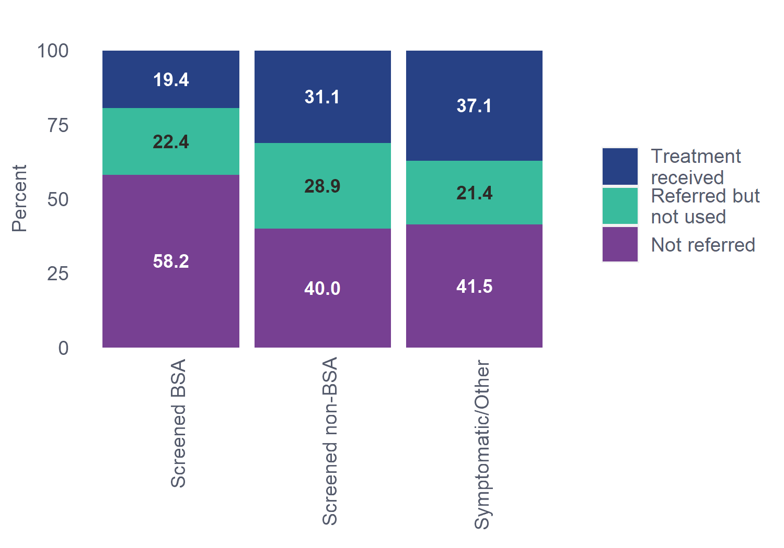
⁴¹Figure 14.1-2: Historical trends for contributing regions: Adjuvant chemotherapy treatment for invasive cancers by referral source, patients aged 45-69, diagnosed 2016-2020
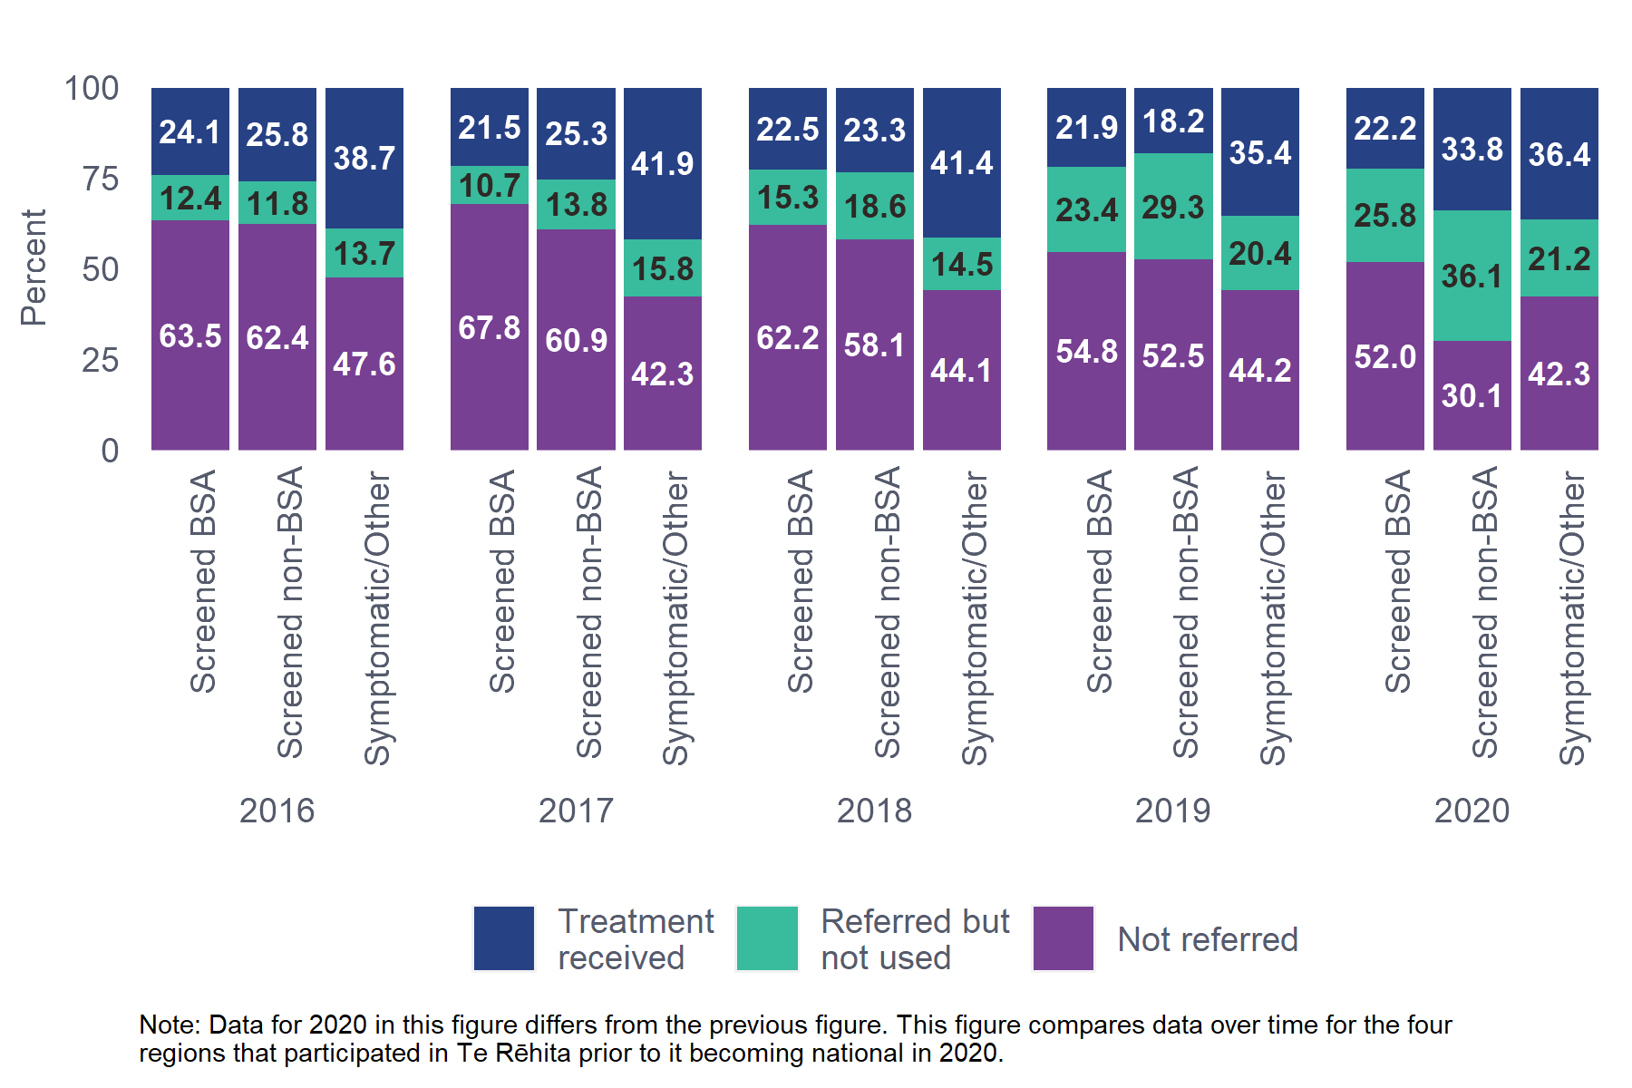

Comments
More than a quarter of patients of screening age diagnosed with invasive cancers in 2020 received chemotherapy following surgery (27.5%). A lower proportion of patients with BSA screen-detected invasive cancers received chemotherapy (19.4%) compared with patients whose cancers were non-BSA detected (31.1%) or Symptomatic/Other (37.1%). This trend has been fairly consistent over time and aligns with previous findings that BSA screen-detected tumours tend to be smaller, and of a lower stage and grade, thus requiring less toxic intervention such as chemotherapy.
The high proportion of ‘Referred but not used’ can be due to a number of reasons (see Audit Data Used below), including that chemotherapy was ultimately not recommended for the patient.
⁹⁹Table 14.1.2 Adjuvant chemotherapy treatment for invasive cancers for Māori and non-Māori patients aged 45-69
Ethnicity | Treatment  received | Referred but  not used | Not  referred
Māori (n=314) | 77 (24.5%) | 72 (22.9%) | 165 (52.5%)
Non-Māori (n=1729) | 484 (28%) | 390 (22.6%) | 855 (49.5%)
Total (n=2043) | 561 (27.5%) | 462 (22.6%) | 1020 (49.9%)
Chi-square p-value: 0.4290
Unknown/missing data excluded: Chemotherapy treatment - 6 patients.
The Non-Māori group includes 126 Pacific patients due to low numbers in one or more subgroup.

⁴²Figure 14.1-3: Adjuvant chemotherapy treatment for invasive cancers by ethnicity, patients aged 45-69, diagnosed in all regions, 2020
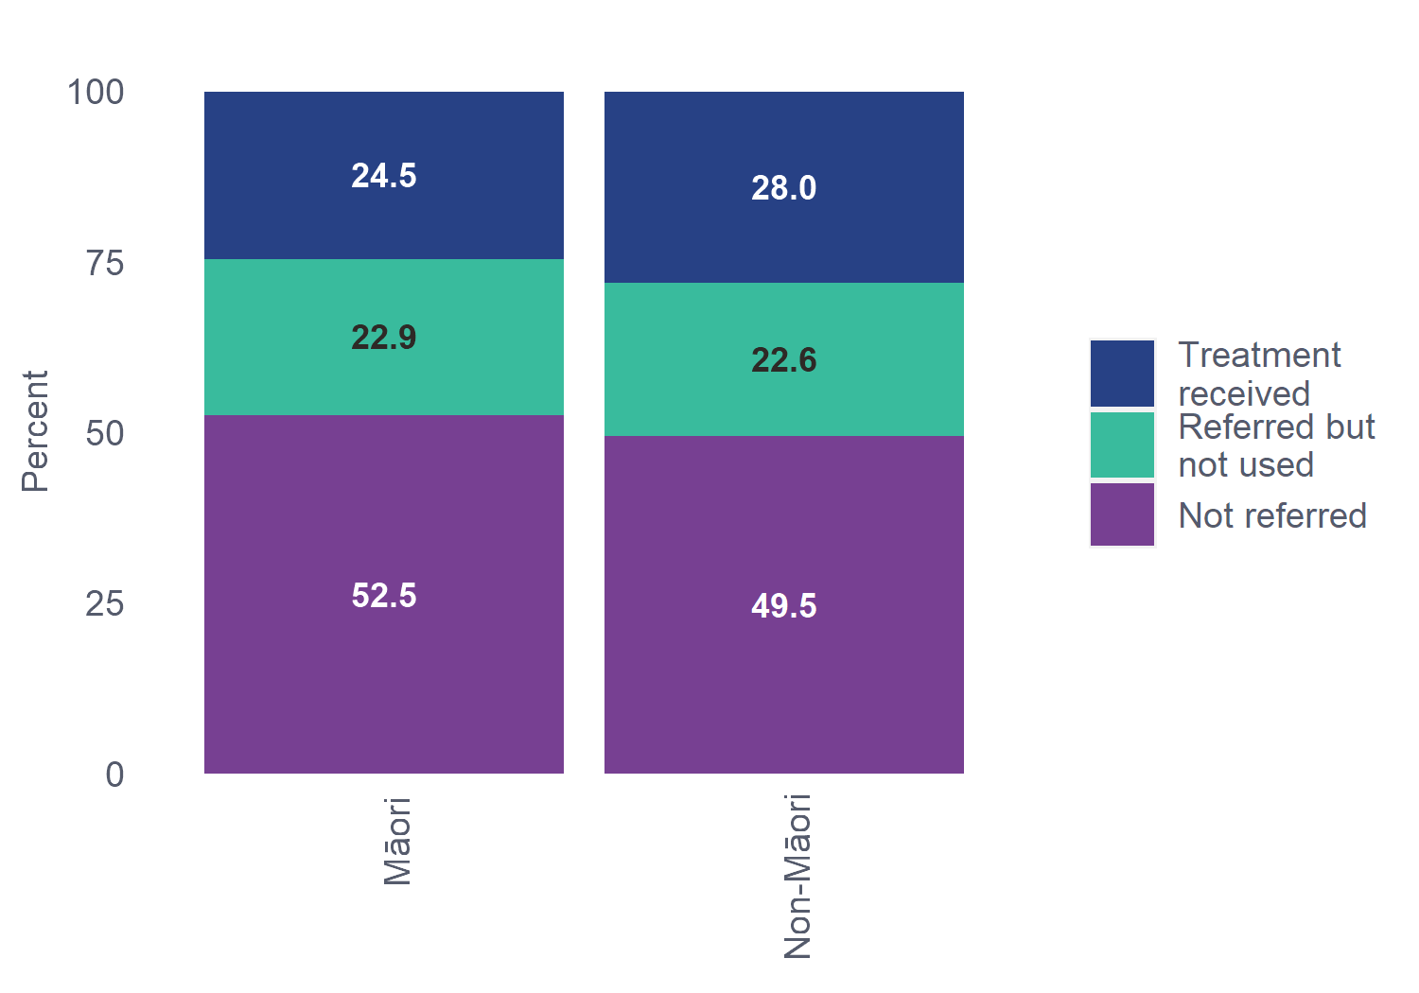
⁴³Figure 14.1-4: Historical trends for contributing regions: Adjuvant chemotherapy treatment for invasive cancers by ethnicity, patients aged 45-69, diagnosed 2016-2020
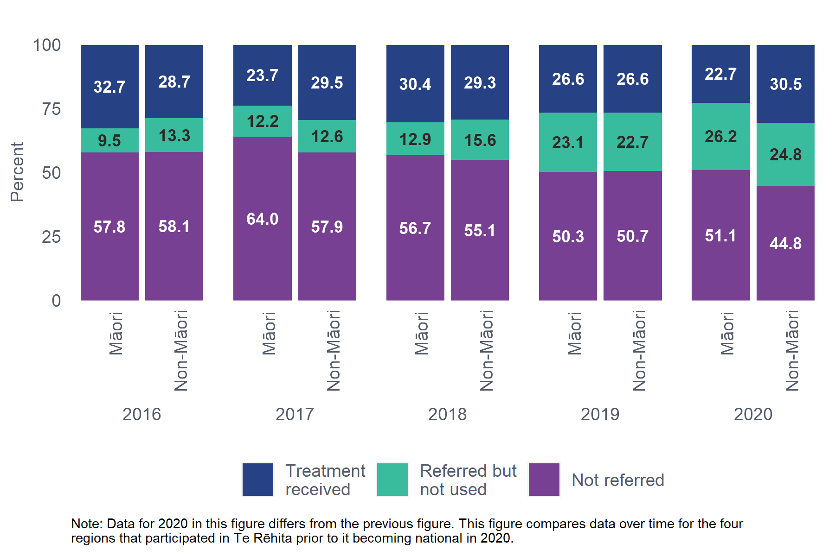

Comments
A quarter (24.5%) of Māori with invasive cancers received chemotherapy following surgery, this is not significantly different from the proportion of non-Māori patients (28%). These proportions have been fairly consistent over time.

Audit data used
Information on eligible patients undergoing adjuvant chemotherapy was derived from the register field “Adjuvant chemotherapy” where one of the following options may be chosen: yes, referred – deemed not necessary, referred – patient declined, referred – patient unfit, not referred – deemed not necessary, not referred – patient declined, not referred – patient unfit, other and unknown.
For consistency with the 2016 report these categories have been combined to display Treatment received (where Adjuvant chemotherapy is yes), Not referred (No chemotherapy prescribed includes all not referred options), and Referred but not used (includes all referred options).
Age is based on age at date of tissue diagnosis.

Definitions
Chemotherapy: the use of cytotoxic drugs that aim to eliminate, prevent or slow the growth of cancer cells.
Treatment received: chemotherapy treatment received. The patient received chemotherapy treatment.
Referred but not used: surgeon referred for consideration of chemotherapy, but it was not received for some reason, e.g. patient declined, patient unfit for treatment, or the medical oncologist felt treatment was of limited or minimal benefit and may have advised against its use.
Referred: includes therapy received and referred but not used categories.
Not referred: Patient was not referred for chemotherapy.
Unknown: not stated or inadequately described.

- Neoadjuvant chemotherapy treatment
This chapter includes episodes of invasive breast cancer in eligible patients with a defined date of primary surgery. This is a new chapter not reported in the 2016 BSA report.
Neoadjuvant chemotherapy is chemotherapy given before surgery, and may be offered to patients with higher-risk cancers, e.g. high-risk HER2+ or triple negative subtype, or very large (inoperable) tumours. It can be used with the aim of shrinking the tumour to enable breast conserving surgery (BCS) (or render an inoperable tumour operable), or to assess the responsiveness of the cancer to chemotherapy and the need for adjuvant treatment after surgery. It can also be used as a temporising measure before surgery to facilitate planning of important further investigations such as molecular genetic testing, and the in-depth planning of immediate breast reconstruction where mastectomy may be indicated.

Key Findings
- Nearly 10% of screening age patients were referred for neoadjuvant chemotherapy. The prevalence of smaller tumours and low-risk subtypes in BSA-screened patients vs those referred from other sources will explain the small proportion (4.1% vs 13.2%) of BSA-screened patients having neoadjuvant chemotherapy (Table 15.1.1).
- Māori (6.5%) were less likely than non-Māori patients (9.6%) to be referred for neoadjuvant chemotherapy; the difference was not significant (Table 15.1.2).
  - Neoadjuvant chemotherapy treatment for invasive cancers
¹⁰⁰Table 15.1.1 Neoadjuvant chemotherapy treatment for invasive cancers by referral source, patients aged 45-69
Referral Source | Treatment  received | Not  referred
BSA (n=1051) | 43 (4.1%) | 1008 (95.9%)
Other Sources (n=1021) | 136 (13.3%) | 885 (86.7%)
Total (n=2072) | 179 (8.6%) | 1893 (91.4%)
Chi-square p-value: <0.0001
Unknown/missing data excluded: Referral source - 3 patients. Neoadjuvant chemotherapy treatment - 3 patients.
Excludes 11 patients referred for neoadjuvant chemotherapy but who did not receive it (exclude for privacy reasons, numbers too small to report by referral source).
The Other Sources group includes 184 patients whose cancer was detected by non-BSA screening; the remainder were other sources.
⁴⁴Figure 15.1-1: Historical trends for contributing regions: Neoadjuvant chemotherapy treatment for invasive cancers, patients aged 45-69, diagnosed 2016-2020
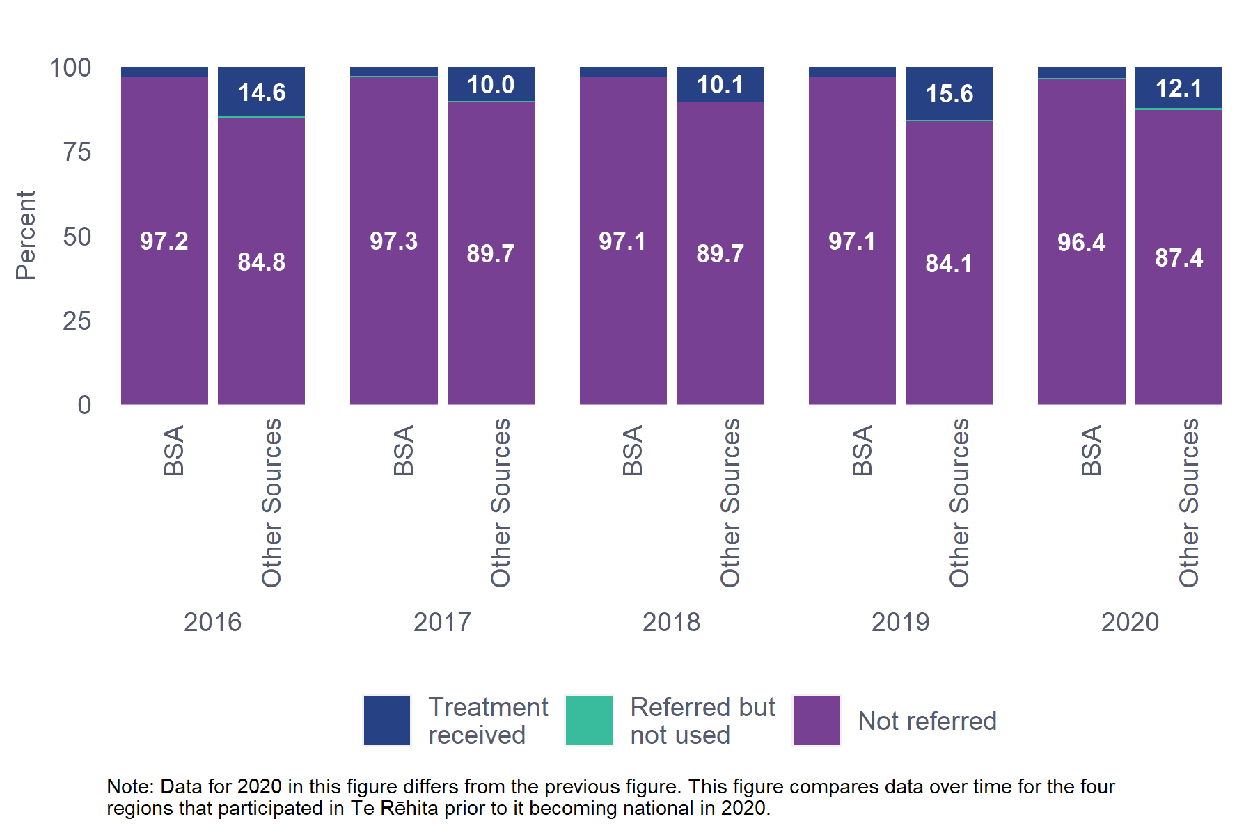

Comments
Nearly 10% of screening age patients were referred for neoadjuvant chemotherapy for invasive breast cancer. The prevalence of smaller tumours and higher proportion of ER+ tumours in BSA-screened patients vs those from other sources will explain the small proportion (4.1% vs 13.2%) of BSA-screened patients having neoadjuvant chemotherapy. Over the five-year period 2016-2020, this trend has been consistent.
The “Referred but not used” and “Not referred” groups include patients who had adjuvant chemotherapy. In future reports, it may be useful to analyse the rate of neoadjuvant chemotherapy in the cohort of patients for referred for and receiving any chemotherapy.

¹⁰¹Table 15.1.2 Neoadjuvant chemotherapy treatment for invasive cancers for Māori and non-Māori patients aged 45-69
Ethnicity | Treatment  received | Not  referred
Māori (n=321) | 19 (5.9%) | 302 (94.1%)
Non-Māori (n=1754) | 160 (9.1%) | 1594 (90.9%)
Total (n=2075) | 179 (8.6%) | 1896 (91.4%)
Chi-square p-value: 0.1661
Unknown/missing data excluded: Neoadjuvant chemotherapy treatment - 3 patients.
Excludes 11 patients referred for neoadjuvant chemotherapy but who did not receive it (exclude for privacy reasons, numbers too small to report by referral source).

Comments
The proportion of Māori referred for neoadjuvant chemotherapy was 6.5%, similar to the proportion of non-Māori patients (9.6%); the difference is not statistically significant. Future reports may also calculate neoadjuvant treatment as a proportion of all recommended chemotherapy.

Audit data used
Information on eligible patients undergoing neoadjuvant chemotherapy was derived from the data field “Neoadjuvant chemotherapy” where one of the following options may be chosen: yes (therapy received), referred – deemed not necessary, referred – patient declined, referred – patient unfit, not referred – deemed not necessary, not referred – patient declined, not referred – patient unfit, other and unknown.
Age is based on age at date of tissue diagnosis.

Definitions
Neoadjuvant chemotherapy: administration of chemotherapy prior to breast cancer surgery.
Not referred: patient was not referred and therefore did not receive any chemotherapy treatment.
Treatment received: the patient received chemotherapy treatment.
Referred but not used: patient was referred by a surgeon or breast physician for consideration of neoadjuvant chemotherapy, but it was not administered for some reason, e.g. another specialist such as a medical oncologist felt it was not appropriate or not indicated, patient refused or patient unfit for treatment.
Unknown: not stated or inadequately described.

- Anti-HER2 treatment
Targeted anti-HER2 medicine, given in conjunction with chemotherapy, has been the mainstay of treatment for HER2+ early breast cancer in New Zealand since 2007. Trastuzumab (Herceptin) is the most widely used medicine. However, anti-HER2 treatment is sometimes omitted in patients with small tumours. The proposed Te Aho o Te Kahu Breast Cancer QPIs include a measure of the number of patients with HER2+ early breast cancer with a tumour >1cm or are node-positive who received chemotherapy and trastuzumab.

Key Findings
- A lower proportion of patients with BSA detected HER2+ cancers received anti-HER2 treatment (81%) compared with patients referred from other sources (85.5%) (Table 16.1.1). Small numbers mean these differences should be interpreted with caution.
  - Anti-HER2 treatment for invasive HER2+ cancer >1cm and/or node-positive
¹⁰²Table 16.1.1 Anti-HER2 treatment for invasive HER2+ cancer >1cm and/or node-positive by referral source, patients aged 45-69
Referral Source | Neoadjuvant  Anti-HER2 treatment | Adjuvant Anti-HER2 treatment | No Anti-HER2  treatment
BSA (n=84) | 11 (13.1%) | 57 (67.9%) | 16 (19%)
Other Sources (n=145) | 21 (14.5%) | 103 (71%) | 21 (14.5%)
(n=229) | 32 (14%) | 160 (69.9%) | 37 (16.2%)
Chi-square p-value: 0.6583
Unknown/missing data excluded: Anti-HER2 treatment - 3 patients.
The Other Sources group includes 24 patients whose cancer was detected by non-BSA screening; the remainder were from other sources.

Comments
In 2020, 229 patients were diagnosed with invasive HER2+ cancers >1cm and/or node-positive. Overall, 83.9% received anti-HER2 treatment (neoadjuvant and adjuvant total). Small numbers mean differences in this table should be interpreted with caution.
A lower proportion of patients with BSA screening detected cancers received anti-HER2 therapy (81%), compared with patients whose cancers were detected by other methods (85.5%).
¹⁰³Table 16.1.2 Anti-HER2 treatment for invasive HER2+ cancer >1cm and/or node-positive for Māori and non-Māori patients aged 45-69
Ethnicity | Neoadjuvant  Anti-HER2 treatment | Adjuvant  Anti-HER2 treatment | No Anti-HER2  treatment
Māori (n=37) | 6 (16.2%) | 22 (59.5%) | 9 (24.3%)
Non-Māori (n=192) | 26 (13.5%) | 138 (71.9%) | 28 (14.6%)
Total (n=229) | 32 (14%) | 160 (69.9%) | 37 (16.2%)
Chi-square p-value: 0.2638
Unknown/missing data excluded: Anti-HER2 treatment - 3 patients.
The Non-Māori group includes 26 Pacific patients due to low numbers in one or more subgroup.

Comments
A lower proportion of Māori appeared to receive anti-HER2 therapy (75.7%) compared with non-Māori patients (85.4%). This finding should be treated with caution given the low numbers of patients involved.

Audit data used
Information was derived from all invasive cancer episodes in eligible patients who had surgery and are either HER2+ with a tumour size >1cm, or HER2+ with positive nodes.
The data fields used are:
- “Neoadjuvant biological therapy” where one of the following options may be chosen: yes, referred – deemed not necessary, referred – patient declined, referred – patient unfit, not referred – deemed not necessary, not referred – patient declined, not referred – patient unfit, other and unknown.
- “Adjuvant biological therapy” where one of the following options may be chosen: yes, referred – deemed not necessary, referred – patient declined, referred – patient unfit, not referred – deemed not necessary, not referred – patient declined, not referred – patient unfit, other and unknown.
Patients whose anti-HER2 treatment commenced prior to surgery were included in the Neoadjuvant column only, even if their anti-HER2 treatment continued after surgery.

Definitions
Biological therapy: (for example Herceptin) or other immunotherapy are medications to treat HER2 gene amplification and/or protein over-expression.
Received anti-HER2 therapy: includes any patients with HER2+ invasive tumours >1cm in size, and/or HER2 node-positive tumours who were prescribed Anti-HER2 medications.
No anti-HER2 treatment received: includes patients not prescribed biological therapy (includes all not referred options), as well as patients who were referred for treatment but did not receive it (referred not used (includes all options)).

- Key Performance Indicators for the management of New Zealand breast cancers in 2020
Many New Zealand surgeons participate in the BreastSurgANZ Quality Audit (BQA) directed by The Royal Australasian College of Surgeons. The audit includes six evidence-based Key Performance Indicators (KPIs) against which participating members audit their practice. The KPIs were introduced in 2004 and are used to audit the treatment of patients with breast cancer over time.
The following tables use the BQA KPI table definitions (Royal Australasian College of Surgeons, KPIs). The tables are descriptive only. Statistical significance has not been determined for any differences. The result from the 2016 BSA Report for each of the KPIs is noted in the comments. The 2016 BSA report included all ages in the non-BSA group while this report only includes screening-age patients (45-69 years) across all referral sources.

Key Findings
- KPI 1 – The 85% quality threshold for the percentage of invasive cancer cases undergoing breast conserving surgery (BCS) who were referred for radiotherapy, was met by all referral sources (BSA detected 97.2%, non-BSA detected 92.6%, Symptomatic/Other 96.7%), and by ethnicity (Māori 97.9%, non-Māori 96.5%).
- KPI 2 – The proportion of patients with BSA-detected ER+ invasive cancers referred for endocrine treatment (84%) was slightly lower than the quality threshold (85%).
- KPI 3 – The KPI for patients undergoing axillary surgery, quality threshold (90%), was met by referral source (BSA detected 98.8%, non-BSA detected 94.5%, Symptomatic/Other 97.7%) and ethnicity (Māori 96.5%, non-Māori 98.2%).
- KPI 4 – All DCIS cases (100%) underwent breast surgery without axillary clearance, exceeding the 90% quality threshold.
- KPI 5 – The percentage of patients with high-risk invasive cancers undergoing mastectomy and referred for radiotherapy exceeded the quality threshold (85%) for both referral source (BSA-screened 97.8%, other sources 92.4%) and ethnicity (Māori, 93.8% and non-Māori 93.8%).
- KPI 6 – The Luminal A subtype is no longer considered to meet the high-risk definition for referral to chemotherapy. When excluding this subtype (Table 17.6.1), the quality threshold (90%) for this KPI is achieved for referral source (BSA detected 91.7%, non-BSA detected 97.1%, Symptomatic/Other 97.9%) and ethnicity (Māori, 91.7% and non-Māori, 96%).
  - KPI 1: Percentage of invasive cancer cases undergoing breast conserving surgery which have been referred for radiotherapy, patients aged 45-69 (quality threshold 85%)
Note: The denominator n=1206 is patients with invasive breast cancer undergoing BCS not treated with mastectomy and excludes ‘other specify’ cases (e.g. patients with metastatic disease on presentation). The numerator n=1167 is patients referred for radiotherapy.
 | Referral Source | Meeting KPI
Screening | Screened BSA (n=721) | 700 (97.2%)
 | Screened non-BSA (n=94) | 87 (92.6%)
Non-screening | Symptomatic/Other (n=393) | 380 (96.7%)
Total | (n=1208) | 1167(96.7%)
Unknown/missing data excluded: Referral source - 2 patients.

Ethnicity | Meeting KPI
Māori (n=194) | 189 (97.9%)
Non-Māori (n=1016) | 980 (96.5%)
Total (n=1209) | 1169 (96.7%)
The Non-Māori group includes 71 Pacific patients due to low numbers in one or more subgroup.

Comments
The quality threshold of 85% for KPI 1 was met for the overall total (96.7%) and for all referral sources and all ethnicities in 2020. There is little variation from the 2016 BSA report (95.7%).
  - KPI 2: Percentage of invasive oestrogen-positive cases referred for endocrine therapy treatment, patients aged 45-69 (quality threshold 85%)
Note: This KPI includes patients who received both neoadjuvant and adjuvant endocrine therapy (n=72) and excludes patients with metastatic disease.
 | Referral Source | Meeting KPI
Screening | Screened BSA (n=949) | 797 (84%)
 | Screened non-BSA (n=167) | 141 (84.4%)
Non-screening | Symptomatic/Other (n=698) | 638 (91.4%)
Total | (n=1814) | 1576 (86.9%)
Unknown/missing data excluded: Referral source - 3 patients.

Ethnicity | Meeting KPI
Māori (n=304) | 269 (88.5%)
Non-Māori (n=1513) | 1310 (86.6%)
Total (n=1817) | 1579 (86.9%)
The Non-Māori group includes 112 Pacific patients due to low numbers in one or more subgroup.

Comments
The 85% quality threshold for KPI 2 was met for the overall total in 2020 (86.9%) and for both Māori and non-Māori. In the 2016 BSA report the quality threshold was not met (83.3%).
Patients referred through BSA just failed to meet the quality threshold in 2020 (84%).
  - KPI 3: Percentage of invasive cases undergoing axillary surgery, patients aged 45-69 (quality threshold 90%)
Note: Includes SLNB and may include a small number of patients on clinical trials where axillary surgery is omitted in some cases. Excludes ‘Other, specify’.
 | Referral Source | Meeting KPI
Screening | Screened BSA (n=1047) | 1034 (98.8%)
 | Screened non-BSA (n=182) | 172 (94.5%)
Non-screening | Symptomatic/Other (n=823) | 804 (97.7%)
Total | (n=2052) | 2010 (98%)
Unknown/missing data excluded: Referral source - 3 patients.

Ethnicity | Meeting KPI
Māori (n=317) | 306 (96.5%)
Non-Māori (n=1738) | 1707 (98.2%)
Total (n=2055) | 2013 (98%)
The Non-Māori group includes 126 Pacific patients due to low numbers in one or more subgroup.

Comments
The 90% quality threshold for KPI 3 was met for BSA (98.8%), non-BSA (94.5%) and Symptomatic/Other patients (97.7%), and for Māori and non-Māori. The overall total was 98%. In the 2016 BSA report the overall total was 93.8%.
  - KPI 4: Percentage of in situ cases undergoing breast surgery without axillary clearance, patients aged 45-69 (quality threshold 90%)
 | Referral Source | Meeting KPI
Screening | Screened BSA (n=304) | 304 (100%)
 | Screened non-BSA (n=60) | 60 (100%)
Non-screening | Symptomatic/Other (n=34) | 34 (100%)
Total | (n=398) | 398 (100%)
Unknown/missing data excluded: Referral source - 2 patients.

Ethnicity | Meeting KPI
Māori (n=43) | 43 (100%)
Non-Māori (n=357) | 357 (100%)
Total (n=400) | 400 (100%)
The Non-Māori group includes 11 Pacific patients due to low numbers in one or more subgroup.

Comments
The 90% quality threshold for KPI 4 was met overall for all patients for all referral sources and ethnicities (100%). This quality threshold was met for all patients in the 2016 BSA report (98.6%).
  - 17.5 KPI 5: Percentage of high-risk invasive cases undergoing mastectomy and referred for radiotherapy, patients aged 45-69 (quality threshold 85%)
Referral Source | Meeting KPI
BSA (n=46) | 45 (97.8%)
Other Sources (n=132) | 122 (92.4%)
Total (n=178) | 167 (93.8%)
The Other Sources group includes 15 patients whose cancer was detected by non-BSA screening; the remainder were from other sources.

Ethnicity | Meeting KPI
Māori (n=32) | 30 (93.8%)
Non-Māori (n=146) | 137 (93.8%)
Total (n=178) | 167 (93.8%)
The Non-Māori group includes 12 Pacific patients due to low numbers in one or more subgroup.

Comments
The 85% quality threshold for KPI 5 was met for all patients (93.8%), all referral sources (BSA 97.8%, Other Sources 92.4%) and for Māori and non-Māori.
In the 2016 BSA report, the overall threshold was also met (87.5%).

Definitions
High risk: patients are deemed as having high-risk invasive breast cancer if they have at least four positive lymph nodes or their tumour is at least 50 mm.
  - KPI 6: Percentage of high-risk* cases referred for chemotherapy, patients aged 45-69 (quality threshold 90%)
 | Referral Source | Meeting KPI
Screening | Screened BSA (n=217) | 189 (87.1%)
 | Screened non-BSA (n=49) | 45 (91.8%)
Non-screening | Symptomatic/Other (n=315) | 286 (90.8%)
Total | (n=581) | 520 (89.5%)

Ethnicity | Meeting KPI
Māori (n=92) | 76 (82.6%)
Non-Māori (n=489) | 444 (90.8%)
Total (n=581) | 520 (89.5%)
The Non-Māori group includes 50 Pacific patients due to low numbers in one or more subgroup.

Comments
The 90% quality threshold for KPI 6 was almost met for total cases in 2020 (89.5%), with 91.8% of Screened non-BSA and 90.8% of Symptomatic/Other patients attaining the threshold. The quality threshold was not met for BSA screen-detected patients (87.1%) and Māori (82.6%). The quality threshold was also not met in the 2016 BSA report (86%).
This shortfall in 2020 is likely influenced by Luminal A subtype tumours, of which Māori have a higher proportion but which is no longer considered to meet the high-risk definition for referral to chemotherapy (National Comprehensive Cancer Network, 2020). This means regional variation may occur where Luminal A cases are less likely to be referred to chemotherapy from multidisciplinary meetings (MDM). Table 17.6.1 below reports on this threshold with the exclusion of Luminal A.

¹⁰⁴Table 17.6.1 KPI 6A: Percentage of high-risk cases referred for chemotherapy, patients aged 45-69 (excluding Luminal A subtype) (quality threshold 90%)
 | Referral Source | Meeting KPI
Screening | Screened BSA (n=144) | 132 (91.7%)
 | Screened non-BSA (n=34) | 33 (97.1%)
Non-screening | Symptomatic/Other (n=191) | 187 (97.9%)
Total | (n=369) | 352 (95.4%)

Ethnicity | Meeting KPI
Māori (n=48) | 44 (91.7%)
Non-Māori (n=321) | 308 (96%)
Total (n=369) | 352 (95.4%)
The Non-Māori group includes 1 Pacific woman due to low numbers in one or more subgroup.

Comments
When the Luminal A subtype is excluded, all referral sources and ethnicities met the 90% quality threshold for KPI 6.

Definitions
*High-risk invasive tumours are any of the following:
- Age less than 55 AND Grade more than 1 AND Tumour size more than 2 cm.
- Age less than 55 AND Grade more than 1 AND Tumour size not more than 2 cm AND Nodes involved.
- Age not more than 70 AND Tumour HER2+ AND Tumour size more than 5 mm.
- Age not more than 70 AND Receptors - triple negative AND Tumour size more than 5 mm.
Luminal A subtype: invasive tumours with a molecular biomarker status of ER+ and PR+, and HER2-.
- List of Figures
Figure 4.1-1: First surgery type by ethnicity, all regions, 2020 35
Figure 4.1-1: Axillary procedures for invasive cancer by ethnicity, all regions, 2020 36
Figure 4.1-2: Adjuvant chemotherapy treatment for invasive cancer in patients aged 45-69 by ethnicity, all regions, 2020 38
Figure 4.1-3: Neoadjuvant chemotherapy treatment for invasive cancer in patients aged 45-69 by ethnicity, all regions, 2020 38
Figure 5.1-1: First surgery type by ethnicity, all regions, 2020 45
Figure 5.1-2: Adjuvant chemotherapy treatment for invasive cancer in patients aged 45-69 by ethnicity, all regions, 2020 47
Figure 5.1-3: Neoadjuvant chemotherapy treatment for invasive cancer in patients aged 45-69 by ethnicity, all regions, 2020 48
Figure 6.2-1: Median tumour size by referral source, all regions, 2020 54
Figure 6.2-2: Historical trends for contributing regions: Median tumour size by referral source, 2016-2020 54
Figure 6.2-3: Median invasive tumour size by year and ethnicity, all regions, 2020 56
Figure 6.2-4: Historical trends for contributing regions: Median tumour size by ethnicity 2016-2020 57
Figure 6.3-1: Grade of NZ invasive tumours by referral source and year of diagnosis, all regions, 2020 58
Figure 6.3-2: Historical trends for contributing regions: Grade of NZ invasive tumours by referral source and year of diagnosis 2016-2020 59
Figure 6.3-3: Grade of NZ invasive tumours by ethnicity and year of diagnosis, all regions, 2020 60
Figure 6.3-4: Historical trends for contributing regions: Grade of NZ invasive tumours by ethnicity and year of diagnosis 2016-2020 60
Figure 7.1-1: Median DCIS size (mm) by year and referral status, patients aged 45-69, diagnosed in all regions, 2020 77
Figure 7.1-2: Historical trends for contributing regions: Median DCIS size (mm) by year and referral status, patients aged 45-69, diagnosed between 2016-2020 77
Figure 7.1-3: Median DCIS size (mm) by year and ethnicity, patients aged 45-69, diagnosed in all regions, 2020 79
Figure 7.1-4: Historical trends for contributing regions: Median DCIS tumour size (mm) by year and ethnicity, patients aged 45-69, diagnosed 2016-2020 79
Figure 7.2-1: New Zealand DCIS grade by referral source and year, patients aged 45-69, diagnosed in all regions, 2020 81
Figure 7.2-2: Historical trends for contributing regions: DCIS grade by referral source and year, patients aged 45-69, diagnosed 2016-2020 82
Figure 7.2-3: DCIS tumour grade by ethnicity and year, all regions, 2020 83
Figure 7.2-4: Historical trends for contributing regions: DCIS tumour grade by ethnicity and year, patients aged 45-69, diagnosed 2016-2020 83
Figure 9.1-1: First surgery by referral source, all regions, 2020 92
Figure 9.1-2: Historical trends for contributing regions: first surgery by referral source, 2016-2020 93
Figure 9.1-3: First surgery by ethnicity, all regions, 2020 94
Figure 9.1-4: Historical trends for contributing regions: first surgery for invasive tumour by ethnicity, 2016-2020 94
Figure 9.5-1: First surgery for DCIS by referral source, all regions, 2020 101
Figure 9.5-2: Historical trends for contributing regions: First surgery for DCIS by referral source, 2016-2020 102
Figure 9.5-3: First surgery for DCIS by ethnicity, all regions, 2020 103
Figure 9.5-4: Historical trends for contributing regions: First surgery for DCIS by ethnicity, 2016-2020 103
Figure 10.1-1: Axillary procedures for invasive cancer by referral source, patients aged 45-69, diagnosed in all regions, 2020 109
Figure 10.1-2: Historical trends for contributing regions: Axillary procedures for invasive by referral source, patients aged 45-69, diagnosed 2016-2020 110
Figure 10.1-3: Axillary procedures for invasive cancer by ethnicity, patients aged 45-69, diagnosed in all regions, 2020 111
Figure 10.1-4: Historical trends for contributing regions: Axillary procedures for invasive cancer by ethnicity, patients aged 45-69, diagnosed 2016-2020 112
Figure 10.2-1: Axillary procedures for ≤3cm invasive cancer by referral source, patients aged 45-69, diagnosed in all regions, 2020 114
Figure 10.2-2: Historical trends for contributing regions: Axillary procedures for ≤3cm invasive cancer by referral source, patients aged 45-69, diagnosed 2016-2020 114
Figure 10.2-3: Axillary procedures for ≤3cm invasive cancer by ethnicity, patients aged 45-69, diagnosed in all regions, 2020 116
Figure 10.2-4: Historical trends for contributing regions: Axillary procedures for ≤3cm invasive cancer by ethnicity, patients aged 45-69, diagnosed 2016-2020 116
Figure 14.1-1: Adjuvant chemotherapy treatment for invasive cancers by referral source, patients aged 45-69, diagnosed in all regions, 2020 140
Figure 14.1-2: Historical trends for contributing regions: Adjuvant chemotherapy treatment for invasive cancers by referral source, patients aged 45-69, diagnosed 2016-2020 140
Figure 14.1-3: Adjuvant chemotherapy treatment for invasive cancers by ethnicity, patients aged 45-69, diagnosed in all regions, 2020 142
Figure 14.1-4: Historical trends for contributing regions: Adjuvant chemotherapy treatment for invasive cancers by ethnicity, patients aged 45-69, diagnosed 2016-2020 142
Figure 15.1-1: Historical trends for contributing regions: Neoadjuvant chemotherapy treatment for invasive cancers, patients aged 45-69, diagnosed 2016-2020 145

- List of Tables
Table 1.3.1 Demographics of women diagnosed with invasive breast cancer or DCIS in 2020 15
Table 3.1.1 Ethnicity of eligible patients by screening status, patients aged 45-69 26
Table 3.1.2 Screening status of eligible patients by ethnicity, patients aged 45-69 26
Table 3.2.1 Diagnosis type by referral source, patients aged 45-69 28
Table 3.2.2 Private and public treatment by referral source, patients aged 45-69 29
Table 4.1.1 Size of invasive tumour by ethnicity, patients aged 45-69 32
Table 4.1.2 Hormone receptor status of invasive tumour by ethnicity, patients aged 45-69 32
Table 4.1.3 Regional nodal status by ethnicity, patients aged 45-69 33
Table 4.1.4 Stage of cancer by ethnicity, patients aged 45-69 33
Table 4.1.5 Median size of DCIS by ethnicity, patients aged 45-69 34
Table 4.1.6 Time to treatment from date of diagnosis for invasive cases by ethnicity, patients aged 45-69 34
Table 4.1.7 Further breast surgery after breast conserving surgery for invasive cancer by ethnicity, patients aged 45-69 35
Table 4.1.8 Circumferential margins of excision for invasive cancer by ethnicity, patients aged 45-69 36
Table 4.1.9 Radiotherapy received for invasive cancer treated with breast conserving surgery by ethnicity, patients aged 45-69 37
Table 4.1.10 Adjuvant endocrine treatment prescribed/given for ER+ invasive tumours by ethnicity, patients aged 45-69 37
Table 4.1.11 Adjuvant anti-HER2 treatment for invasive HER2+ cancer >1cm and/or node-positive by ethnicity, patients aged 45-69 39
Table 4.1.12 KPI 6 Percentage of high-risk cases referred for chemotherapy (target 90%) 39
Table 5.1.1 Size of invasive tumour by ethnicity, patients aged 45-69 42
Table 5.1.2 Regional nodal status by ethnicity, patients aged 45-69 43
Table 5.1.3 HER2 status of invasive tumour by ethnicity, patients aged 45-69 43
Table 5.1.4 Median size of DCIS by ethnicity, patients aged 45-69 44
Table 5.1.5 Time from date of diagnosis to treatment for invasive cases by ethnicity, patients aged 45-69 44
Table 5.1.6 Further breast surgery after breast conserving surgery for invasive cancer by ethnicity, patients aged 45-69 45
Table 5.1.7 Final circumferential margins of excision for invasive cancer by ethnicity, patients aged 45-69 46
Table 5.1.8 Radiotherapy for invasive cancer treated with breast conserving surgery by ethnicity, patients aged 45-69 46
Table 5.1.9 Adjuvant endocrine treatment prescribed/given for ER+ invasive tumours by ethnicity, patients aged 45-69 47
Table 5.1.10 Adjuvant anti-HER2 treatment for invasive HER2+ cancer >1cm and/or node-positive by ethnicity, patients aged 45-69 48
Table 5.1.11 KPI Summary 49
Table 6.1.1 Type of invasive tumour by referral source, patients aged 45-69 51
Table 6.1.2 Type of invasive tumour for Māori and non-Māori patients aged 45-69 52
Table 6.2.1 Size of invasive tumour by referral source, patients aged 45-69 53
Table 6.2.1b 53
Table 6.2.2 Size of invasive tumour for Māori and non-Māori patients aged 45-69 55
Table 6.2.2b 56
Table 6.3.1 Histological grade of invasive tumour by referral source, patients aged 45-69 58
Table 6.3.2 Histological grade of invasive tumour for Māori and non-Māori patients aged 45-69 59
Table 6.4.1 Hormone receptor status of invasive tumour by referral source, patients aged 45-69 61
Table 6.4.2 Hormone receptor status of invasive tumour for Māori and non-Māori patients aged 45-69 62
Table 6.5.1 HER2 status of invasive tumours by referral source, patients aged 45-69 63
Table 6.5.2 HER2 status of invasive tumours for Māori and non-Māori patients aged 45-69 64
Table 6.6.1 Triple negative status of invasive tumours by referral source, patients aged 45-69 65
Table 6.6.2 Triple negative status of invasive tumours for Māori and non-Māori patients aged 45-69 65
Table 6.7.1 Regional nodal status by referral source, patients aged 45-69 66
Table 6.7.2 Regional nodal status for Māori and non-Māori patients aged 45-69 67
Table 6.8.1 Distant metastases by referral source, patients aged 45-69 68
Table 6.8.2 Distant metastases for Māori and non-Māori patients aged 45-69 68
Table 6.9.1 Stage of cancer by referral source, patients aged 45-69 69
Table 6.9.2 Stage of cancer for Māori and non-Māori patients aged 45-69 70
Table 6.10.1 Biological subtypes of invasive tumours by referral source, patients aged 45-69 73
Table 6.10.2 Biological subtypes of invasive tumours for Māori and non-Māori patients aged 45-69 74
Table 7.1.1 Median size of DCIS by referral source, patients aged 45-69 76
Table 7.1.2 Size of DCIS by referral source, patients aged 45-69 78
Table 7.1.3 Median size of DCIS for Māori and non-Māori patients aged 45-69 78
Table 7.1.4 Size of DCIS for Māori and non-Māori patients aged 45-69 80
Table 7.2.1 Histological grade of DCIS by referral source, patients aged 45-69 81
Table 7.2.2 Histological grade of DCIS tumours for Māori and non-Māori patients aged 45-69 82
Table 8.1.1 Time to treatment for invasive cases by referral source, patients aged 45-69 86
Table 8.1.2 Time to treatment for invasive cases for Māori and non-Māori patients aged 45-69 86
Table 8.2.1 Time to first surgery for invasive cases by referral source, patients aged 45-69 87
Table 8.2.2 Time to first surgery for invasive cancer for Māori and non-Māori patients aged 45-69 88
Table 8.3.1 Time to neoadjuvant treatment for invasive cases by referral source, patients aged 45-69 89
Table 8.3.2 Time to neoadjuvant treatment for invasive cases for Māori and non-Māori patients aged 45-69 90
Table 9.1.1 First breast surgery for invasive cancer by referral source, patients aged 45-69 92
Table 9.1.2 First breast surgery for invasive cancer for Māori and non-Māori patients aged 45-69 93
Table 9.2.1 Further surgery after breast conserving surgery for invasive cancer by referral source, patients aged 45-69 95
Table 9.2.2 Further surgery after breast conserving surgery for invasive cancer for Māori and non-Māori patients aged 45-69 96
Table 9.3.1 Reconstruction after mastectomy for invasive cancer by referral source, patients aged 45-69 97
Table 9.3.2 Reconstruction after mastectomy for invasive cancer for Māori and non-Māori patients aged 45-69 98
Table 9.4.1 Final breast surgery for invasive cancer by referral source, patients aged 45-69 99
Table 9.4.2 Final breast surgery for invasive cancer for Māori and non-Māori patients aged 45-69 100
Table 9.5.1 First breast surgery for DCIS by referral source, patients aged 45-69 101
Table 9.5.2 First breast surgery performed for DCIS for Māori and non-Māori patients aged 45-69 102
Table 9.6.1 Further surgery after breast conserving surgery for DCIS by referral source, patients aged 45-69 105
Table 9.7.1 Reconstruction after mastectomy for DCIS by referral source, patients aged 45-69 106
Table 10.1.1 Axillary procedures for invasive cancer by referral source, patients aged 45-69 108
Table 10.1.2 Axillary procedures for invasive cancer for Māori and non-Māori patients aged 45-69 111
Table 10.2.1 Axillary procedures for ≤3cm invasive cancers by referral source, patients aged 45-69 113
Table 10.2.2 Axillary procedures for ≤3cm invasive cancer for Māori and non-Māori patients aged 45-69 115
Table 10.3.1 Axillary procedures for >3cm for invasive cancer by referral source, patients aged 45-69 117
Table 10.3.2 Axillary procedures for >3cm for invasive cancer for Māori and non-Māori patients aged 45-69 118
Table 10.4.1 Axillary procedures for DCIS treated with breast conserving surgery by referral source, patients aged 45-69 119
Table 11.1.1 Margins of excision for invasive cancer by referral source, patients aged 45-69 122
Table 11.1.2 Margins of excision for invasive cancer for Māori and non-Māori patients aged 45-69 122
Table 11.2.1 Margins of excision for DCIS by referral source, patients aged 45-69 124
Table 11.2.2 Margins of excision for DCIS, Māori and non-Māori patients aged 45-69 124
Table 12.1.1 Radiotherapy for invasive cancer treated with breast conserving surgery by referral source, patients aged 45-69 126
Table 12.1.2 Radiotherapy for invasive cancer treated with breast conserving surgery for Māori and non-Māori patients aged 45-69 127
Table 12.2.1 Post-mastectomy radiotherapy treatment for invasive cancers by referral source, patients aged 45-69 129
Table 12.2.2 Post-mastectomy radiotherapy treatment for invasive cancers for Māori and non-Māori patients aged 45-69 129
Table 12.3.1 Post-mastectomy radiotherapy treatment for high-risk invasive cancers by referral source, patients aged 45-69 130
Table 12.3.2 Post-mastectomy radiotherapy treatment for high-risk invasive cancers for Māori and non-Māori patients aged 45-69 131
Table 12.4.1 Radiotherapy for DCIS treated with breast conserving surgery by referral source, patients aged 45-69 132
Table 12.4.2 Radiotherapy for DCIS treated with breast conserving surgery for Māori and non-Māori patients aged 45-69 133
Table 13.1.1 Adjuvant endocrine treatment for ER+ invasive cancer by referral source, patients aged 45-69 134
Table 13.1.2 Adjuvant endocrine treatment for ER+ invasive cancer for Māori and non-Māori patients aged 45-69 135
Table 13.2.1 Adjuvant endocrine treatment for ER+ invasive cancer by referral source, patients aged 65-69 137
Table 13.2.2 Adjuvant endocrine treatment for ER+ invasive cancer for Māori and non-Māori patients aged 65-69 138
Table 14.1.1 Adjuvant chemotherapy treatment for invasive cancers by referral source, patients aged 45-69 139
Table 14.1.2 Adjuvant chemotherapy treatment for invasive cancers for Māori and non-Māori patients aged 45-69 141
Table 15.1.1 Neoadjuvant chemotherapy treatment for invasive cancers by referral source, patients aged 45-69 144
Table 15.1.2 Neoadjuvant chemotherapy treatment for invasive cancers for Māori and non-Māori patients aged 45-69 146
Table 16.1.1 Anti-HER2 treatment for invasive HER2+ cancer >1cm and/or node-positive by referral source, patients aged 45-69 148
Table 16.1.2 Anti-HER2 treatment for invasive HER2+ cancer >1cm and/or node-positive for Māori and non-Māori patients aged 45-69 149
Table 17.6.1 KPI 6A: Percentage of high-risk cases referred for chemotherapy, patients aged 45-69 (excluding Luminal A subtype) (quality threshold 90%) 158
¹Table 1.3.1 Demographics of women diagnosed with invasive breast cancer or DCIS in 2020

- References
- Alanko, J., et al., Triple-negative and HER2-positive breast cancers found by mammography screening show excellent prognosis. Breast Cancer Res Treat, 2021. 187(1): p. 267-274.
- Bleyer, A., et al., Effect of three decades of screening mammography on breast-cancer incidence. N Engl J Med, 2012. 367(21): p. 1998-2005.
- Breast Cancer Foundation NZ, 30,000 Voices: Informing a better future for breast cancer in Aotearoa New Zealand. Te Rēhita Mate Ūtaetae - Breast Cancer Foundation National Register 2003-2020, 2022.
- BreastScreen Aotearoa Annual Reports, retrieved from: https://www.surgeons.org/en/research-audit/morbidity-audits/morbidity-audits-managed-by-racs/breastsurganz-quality-audit/research-reports-publications-consumer-summaries/breastscreen-aotearoa-annual-reports
- Campbell, I., et al, Breast Cancer Survival Differences between Maori, Pacific and other New Zealand Women. Asian Pacific Journal of Cancer Prevention, 2015. 16.6.2465
- Cancer Control Agency, Breast Cancer Quality Performance Indicators, 2022, Wellington, retrieved from https://teaho.govt.nz/reports/consultations/breast-consultation, 10 December 2022.
- Cancer Control Agency, He Pūrongo Mate Pukupuku o Aotearoa 2020 The State of Cancer in New Zealand 2020, 2021, Wellington, retrieved from https://teaho.govt.nz/reports/cancer-state.
- Gurney, J., et al., Disparities in cancer-specific survival between Māori and non-Māori New Zealanders, 2007-2016. JCO Global Oncology, 2020. 6(6): p. 766-774.
- Handford, C., et al., The prevalence and outcomes of frailty in older cancer patients: a systemic review. Ann Oncol, 2015. 26(6): p. 1091-1101.
- Holm, J., et al., Risk factors and tumor characteristics of interval cancers by mammographic density. J Clin Oncol, 2015. 33(9): p. 1030-1037.
- Lawrenson, R., et al., Breast cancer inequalities between Māori and non-Māori patients in Aotearoa/New Zealand. Eur J Cancer Care (Eng), 2016. 25(2): p. 225-230.
- Lawrenson, R., et al., Outcomes in different ethnic groups of New Zealand patients with screen-detected vs non-screen detected breast cancer. Journal of Medical Screening, 2019. 26 (4).
- Manuu, G., et al., Invasive breast cancer and breast cancer mortality after ductal carcinoma in situ in patients attending for breast screening in England, 1988-2014: population based observational cohort study. BMJ, 2020. 369:m1570.
- Maxwell, A., et al. Risk factors for the development of invasive cancer in unresected ductal carcinoma in situ. Eur J Surg Oncol, 2018. 44(4): p. 429-435.
- National Comprehensive Cancer Network, Guidelines Version 4, 2020. Retrieved from https://www.nccn.org/guidelines/recently-published-guidelines
- Parise, C., et al., Breast cancer survival defined by the ER/PR/HER2 subtypes and a surrogate classification according to tumor grade and immunohistochemical biomarkers. J Cancer Epidemiol, 2014. 2014:469251.
- Park, T., et al., Current trends in the management of ductal carcinoma in situ. Oncology (Williston Park), 2016. 30(9): p. 823-831.
- Robson, B.et al., BreastScreen Aotearoa Monitoring Report for women screened between 1 July 2018 and 30 June 2020, 2022. [Manuscript submitted for publication]
- Royal Australasian College of Surgeons. Key Performance Indicators (KPIs). Retrieved from https://www.surgeons.org/en/research-audit/morbidity-audits/morbidity-audits-managed-by-racs/breastsurganz-quality-audit/benefits-of-participating-performance-indicators.
- Schnitt, S., et al., Lumpectomy margins for invasive breast cancer and ductal carcinoma in situ: Current guideline recommendations, their implications, and impact. J Clin Oncol, 2020. 38(20): p. 2240-2245.
- Seneviratne, S., et al., Breast cancer biology and ethnic disparities in breast cancer mortality in New Zealand: A cohort study. PLoSONE, 2015. 10(4). e0123523
- Statistics NZ 2018 Census, retrieved from: https://nzdotstat.stats.govt.nz/wbos/, 22 February 2023.
- Tin, S., et al., Ethnic disparities in breast cancer survival in New Zealand: which factors contribute? BMC Cancer, 2018. 58.
- World Health Organization, The 2019 World Health Organization classification of tumours of the breast, Histopathology, 2020. 77(2): p. 181-185.

