

Quarterly Performance Report

Quarter ending 31 March 2024

Citation: Health New Zealand | Te Whatu Ora. *Quarterly Performance Report: Quarter ending 31 March 2024*. Wellington: Health New Zealand | Te Whatu Ora.

Published in July 2024 by Health New Zealand | Te Whatu Ora  
PO Box 793, Wellington 6140, New Zealand

ISSN 2816-1823 (online)



This document is available at [**tewhatuora.govt.nz**](https://www.tewhatuora.govt.nz/)

|  |  |
| --- | --- |
| CCBY | This work is licensed under the Creative Commons Attribution 4.0 International licence. In essence, you are free to: share ie, copy and redistribute the material in any medium or format; adapt ie, remix, transform and build upon the material. You must give appropriate credit, provide a link to the licence and indicate if changes were made. |

# Summary from our CE

This report summarises our work during quarter three (1 January – 31 March 2024) and presents our progress against expectations set out in Te Pae Tata | the interim New Zealand Health Plan and the Statement of Performance Expectations. Highlights you will see expanded in this quarterly report are set out below.

* This quarter, the extension of breast cancer screening to women aged 70-74 was announced. This will begin in Nelson-Marlborough at the end of 2024.
* To increase childhood immunisation rates, we began expanding vaccinator eligibility, with training for pharmacists as vaccinators starting in April.
* Planned care productivity was affected in the first month of the quarter due to annual seasonal factors (eg public holidays). By the end of quarter three, this was ahead of schedule. Increased investment and outsourcing in planned care have led to more elective surgeries (eg orthopaedics, cataracts) delivered, resulting in a sustained reduction in the number of patients waiting longer than 365 days for treatment.
* Work progressed on the implementation plans to monitor the five National Health Targets, which come into effect on 1 July 2024. We will publish results on each of the five targets every quarter, starting with quarter one 2024/25 (July – September 2024).
* We released the [Aotearoa New Zealand Health Status Report 2023](https://www.tewhatuora.govt.nz/publications/health-status-report/), which provides a nationwide picture of the population’s health. The report highlights challenges such as the country’s ageing population and gaps in health outcomes for some population groups.
* As part of delivering on the Health Workforce Plan 2023/24, we re-launched the Midwifery Return to Practice fund to attract more midwives back into the profession. The funding available has increased to reflect actual costs incurred for the programme and offers additional support for transport, family care and other costs.
* We recruited more than 2,432 nurses in February, bringing the year-to-date total to 38,915 Full Time Employees (FTEs) compared to a budgeted 36,483. The increase in nursing staff is partly due to the employment of more than 1,200 new graduate nurses in December and January.
* The Aotearoa Immunisation Register (launched in December) can take vaccination data from more than 8,000 providers including nearly 1,000 general practices. More than 200,000 vaccinations were recorded this quarter.
* We worked alongside Te Aka Whai Ora and the Ministry of Health to support the transition of Te Aka Whai Ora kaimahi to Health NZ into a new Hauora Māori Services group from 1 April. Additional connections were made with the Iwi Māori Partnership Boards and the Hauora Māori Advisory Committee.

During the quarter we also faced several challenges. In particular:

* First Specialist Assessment (FSA) waitlist increased (waiting more than four months). We are working on phase one of our patient communications (contact) project, starting with those waiting over four months for FSA in General Surgery, Ophthalmology, Gynaecology, and Orthopaedics. The purpose is to contact patients to apologise for delays, verify their information, and inform about what to do if their condition changes or they want to discuss options.
* Planned care waitlist (people waiting more than four months for a procedure) increased. A national performance monitoring framework is now operational, providing insights for improvement plans. An intensive support team will work with underperforming areas, with specific attention given to Canterbury, Southern, Bay of Plenty, Taranaki, and Midcentral due to performance challenges.
* Eligible cancer patients receiving their first treatment within 31 days decreased. We are committed to improving cancer treatment by focusing on improving access to diagnostic equipment, and international recruitment for radiation therapists and oncologists.

**Fepulea’i Margie Apa   
Chief Executive   
Health New Zealand | Te Whatu Ora**

Contents

**Summary from our CE** 2

**1.** **Snapshot for the quarter** 5

**2. Delivering the Interim New Zealand Health Plan** 8

**3.** **Achieving equity** 14

**4.** **Delivering Ola Manuia Pacific Health and Wellbeing Action Plan** 17

**5.** **Non-financial performance results** 18

1 Immunisation coverage for age at 24 months 20

2 Shorter stays in Emergency Departments 21

3 People waiting more than four months for first specialist assessment………..22

4 People waiting more than four months for a procedure 24

5 Cancer patients waiting less than 31 days for first treatment 26

6 Primary care enrolment 28

7 Involvement in care decisions – primary care 29

8 Ambulatory sensitive hospitalisations 0-4 years 30

9 Ambulatory sensitive hospitalisations 45-64 years 31

10 Access to primary mental health and addiction services 32

11 Access rates for specialist mental health services 33

12 Mental health wait times for under 25-year-olds 34

13 Emergency Department presentations 35

14 Admissions from Emergency Departments 36

15 Acute bed days per capita 37

16 Inpatient length of stay >7 days 38

17 Involvement in care decisions – in hospital 39

18 People waiting more than 365 days for a procedure 40

19 Medical appointments through digital channels 41

20 Missed appointments 42

21 Delivery of planned care interventions 43

22 Acute readmissions within 28 days of discharge 44

Our milestones 45

**6.** **Financial performance** 47

**Appendix 1: Measure definitions** 56

**Appendix 2: Local trends** 62

1 Snapshot for the quarter

## Immunisation

* During the quarter, we supported pharmacists to become 'authorised vaccinators' by offering a free three hour training package. Beginning 1 April, pharmacists who have completed this training and choose to offer childhood immunisations will be able to vaccinate children aged 6 weeks and older. This offers families another option to access free vaccines in their communities, particularly if they are not enrolled with a general practice[1]. In some areas we have identified pharmacists lack local support and onboarding resources to confidently become whole-of-life vaccinators. We are working with the sector to identify the support needed.
* To date, the Aotearoa Immunisation Register (AIR) (launched in December 2023) has recorded more than 200,000 immunisations. Sixty percent of these were delivered in general practice, with the remainder in other care settings. The AIR has more than 8,000 active users across pharmacy, hauora Māori services, Pacific health services and occupational health, including nearly 1,000 general practices. The AIR provides information about vaccination coverage across the country by recording administered vaccinations.
* During the quarter, a social marketing campaign was launched to increase childhood immunisation rates. It featured on television and social media, and in public places such as shopping malls, community centres, gyms, and bus stops, until the end of June 2024. There has been high demand for Te Whainga o te Mārama resources, which focus on supporting informed decision making by Māori about immunising pēpi and tamariki. These resources include a book about informed consent and an indigenised view of the immunisation schedule. So far, 9,000 resources have been distributed, and the Central Region plans to distribute a further 25,000 copies in te reo Māori and 50,000 copies in English.
* The 2024 Flu vaccination season started on 2 April. During the quarter, vaccinating teams received resources and vaccinator information from our National Public Health Service (NPHS) Immunisation team and the Immunisation Advisory Centre (IMAC). Training was held across the country for vaccinators, including a series of hui, webinars, and a flu booklet with essential information for health professionals, which is available to download. Some providers have taken a self-funded approach to meet the eligibility criteria, to provide free immunisations in their community. We continue to advocate to Pharmac that a health-needs approach is fundamental when determining eligibility for the flu vaccine.

## Primary Care

* During the quarter, the Ka Ora Telehealth service provided 2,089 general practitioner appointments, with a total of 2,696 having been provided since the service’s inception in November 2023. There were 2,899 nurse appointments in March, totalling 3,580 since the service’s establishment. Additionally, our kaiawhina answered 2,923 calls this quarter, a total of 3,571 calls since its establishment. From November until 31 March, 15% of all service users identified as Māori, 55% as female, and 28% of the users related to children under 15 years old.

## Wait times for Planned Care

* Planned Care productivity was affected in the first month of the quarter due to annual seasonal factors (eg public holidays) but recovered to normal levels in the latter two months. By the end of quarter three, delivery was ahead of plan.
* Additional surgical elective volumes have been delivered (eg orthopaedics, cataracts) through increased investment in planned care and outsourcing. This has contributed to a sustained reduction in the number of patients waiting longer than 365 days for treatment.
* We have developed a standardised process with regions to ensure a sustained focus on reducing the ‘tail’ of the waitlist. This includes forward modelling of patients requiring treatment and oversight of patients potentially ‘tipping in’ to the >365 days overdue list.
* As the proportion of long-waiters reduces, the remaining long-waiters tend to:
  1. have more complex health needs (eg multiple surgeons to be coordinated)
  2. have cancelled planned care bookings which need to be rescheduled or
  3. be unable to travel to another public hospital for treatment.

## Workforce

* During the quarter, our staff provided positive feedback about the extra 200 personnel (93 FTE) employed in quarter two to provide 24 / 7 security across 32 Emergency Departments (EDs).
* Additional security continues at eight of our highest-risk EDs: Dunedin, Christchurch, Wellington, Waikato, Middlemore, Auckland, Waitakere and North Shore. Security contracts were extended to 30 June for EDs where requested. Support will also be available to other EDs needing surge capacity over the coming months. The focus remains on having integrated and appropriate security across all sites.
* Since December, more than 15,000 frontline staff have completed de-escalation training to support them with improved skills to handle violent behaviour.
* Our International Recruitment Centre continues to help address immediate pressures and recruit into hard-to-fill specialist roles. From November 2022 (when the campaign was launched) to the end of March, we received 9,284 expressions of interest for international recruitment, with 796 health professionals employed (8.6% conversion rate). In the week of 17 March, seven health professionals were employed, including a physiotherapist, three registered medical officers and three nurses.

1. Delivering the Interim New Zealand Health Plan

The Interim New Zealand Health Plan | Te Pae Tata consists of 187 actions, each with milestones, summarised below[2]:

|  |  |  |  |  |  |
| --- | --- | --- | --- | --- | --- |
| Sections | Total Actions | Green | Amber | Red | Still Assessing[3] |
| People and whānau at the heart of health | 24 | 19 | 5 |  |  |
| Improving health outcomes and equity | 39 | 28 | 10 |  | 1 |
| A unified health system | 63 | 47 | 13 | 2 | 1 |
| Priority populations | 61 | 44 | 15 | 2 |  |
| Total | 187 | 138 | 43 | 4 | 2 |

## 2.1 People and whānau at the heart of health

* During the quarter, two models of gender-affirming care were launched with community support in Auckland, Canterbury and the West Coast. Four more models are expected to launch in quarter four. This will support access to multiple forms of gender-affirming care (including holistic models of care) across the motu. Upcoming training programmes and updated guidelines will help clinical staff build confidence and skills in providing gender-affirming care. During the quarter, nearly 180 requests for training were received.

## 2.2 Valuing the voices of consumers and whānau

* During the quarter, the eCALD (culturally and linguistically diverse) training programme had 2,052[4] new enrolments. The programme seeks to improve healthcare services for culturally and linguistically diverse communities, covering Asian, Middle Eastern, Latin American and African backgrounds.
* During the quarter, a ‘National Hospital Visitor Policy’ was approved, strengthening our focus on patient-centred care. This will be implemented over the next 12 months, allowing nominated individuals to stay around the clock with patients of all ages (worked through with the hospital team). While some hospitals already allow this, the policy aims to ensure there is a consistent approach across the country.
* There have been ongoing challenges with reimbursing consumer representatives due to complex payroll systems. This is impacting consumer engagement, which we are working to resolve.
* During the quarter, we developed a Pacific Patient Experience Framework (PPEF) to capture key aspects of the Pacific patient voice in different care settings. The PPEF will help us better engage with Pacific communities using culturally appropriate methodologies and measures to capture what matters most to them. The PPEF is being trialled in Waitematā by our Pacific health team through various mediums, including interviews with Pacific patients.
* The existing Regional Patient Experience workforce and processes faced challenges in aligning with the PPEF due to variations in digital platforms and workforces across the old DHBs and regions.

## 2.3 Valuing the health workforce

* Delivery of the Health Workforce Plan 2023/24 is ongoing. The following are highlights from this quarter (aligned to the start of the academic year).
  1. Supporting 239 General Practice Education Programme (GPEP) Year 1 trainees in 2024 - an increase of 60 registrars starting compared to 2023 and the biggest intake to date.
  2. Funding 121 places (including 17 Māori and 5 Pacific) on the Nurse Practitioner Training Programme (NPTP), up from the 100 committed to in the Health Workforce Plan and an increase of 51.3% compared to the 2023 academic year.
  3. Development of the Health Workforce Plan 2024/25. This second plan will build on the first plan by supporting an expanded range of health workforce professions which may not have been prioritised in 2023/24. The Plan will be fully funded.
* The Midwifery Return to Practice Programme was re-launched during the quarter to attract more midwives back into the profession. The funding available has increased to reflect actual costs incurred for the programme and offers additional support for transport, family care and other costs. The increased funding will also be available to midwives currently on the programme to incentivise completion.

## 2.4 Improving health outcomes and equity

* During the quarter, an operational performance framework was developed to support management of quality, safety and timely access to healthcare in hospitals and specialist services. The framework, along with reporting, will enable monitoring of performance and implementation of Hospital & Specialist Services improvement interventions when performance concerns are identified.
* To strengthen our work on addressing health inequities, an operational committee focused on equity considerations has been established.

# A unified health system

## 2.5.1 Access to a comprehensive range of support in local communities

* Recruitment for roles in Comprehensive Primary and Community Teams (CPCT) is ongoing. To date, more than 200 FTE CPCT professionals have been contracted and employed across the motu. Of these, about 85% are kaiāwhina, who will be employed by Hauora Māori and Pacific partners.
* In Te Manawa Taki, the CPCT is working with kaupapa Māori providers to develop models of care to better support general practice and improve access to first response services, particularly for Māori. Support for providers ranges from non-clinical kaiāwhina to care coordination and allied health services, relative to community needs. Whānau connections with primary and community care teams will assist with managing illness at earlier stages, reducing likelihood of hospitalisation.

## 2.5.2 Access to high-quality emergency and specialist care

* Additional funding and recruitment have resulted in more ambulances being deployed, improving response times. In the year to February 2024, ambulance providers increased FTE by 138.5 (including communications centre personnel) of whom 51 FTE commenced in quarter three.
* The percentage of urban RED priority (life threatening or time critical) incidents responded to within eight minutes improved by 4% between June 2023 and February 2024, from 41% to 45%. For the same period, there was also a 13% reduction in the number of ORANGE priority (serious but not immediately life threatening) incidents waiting more than 60 minutes for an ambulance response.
* To further strengthen air ambulance resilience, existing helipads were improved, plans are in place for new helipads (in Northland and East Cape) and new or additional fuel trailers have been purchased. These activities will improve timely access for remote communities and disaster resilience for the East Cape.
* During the quarter, Nelson welcomed a new fixed-wing air ambulance to replace an existing one no longer fit-for-purpose. This will improve reliability and patient experience in the Nelson Marlborough region.
* During the quarter, Palmerston North Regional Hospital's new intervention cardiac catheterisation lab (opened in November 2023) began performing Percutaneous Coronary Intervention procedures (insertion of a stent into a coronary artery to unblock the artery and improve flow to the cardiac muscle). Previously, patients had to travel to Wellington for these procedures. This is part of the Central Region's wider cardiac plan to increase capacity, provide specialist cardiac services for MidCentral patients closer to home, and reduce pressure on the regional service provided by Wellington Hospital.
* In quarter three, we began implementing the Hospital and Specialist Services acute care plan, a multi-year programme focusing on patient flow through hospitals and consistent practices across the motu. Many hospitals remain challenged with patient flow and consistently operate at greater than 90% occupancy.
* As of 31 March, 74 people have accessed Te Mana ki Tua, a specialist bariatric medicine service in Counties Manukau (set up in July 2023). The ethnic breakdown of users mirrors the adult population with a BMI over 35 in Counties Manukau, with 20% Māori and 47% Pacific Peoples. As of 31 March, 43% achieved remission of type 2 diabetes at three months and 48% at six months. During the quarter, 32 people accessed the service, with 22% Māori and 34% Pacific Peoples. The service supports patients referred for bariatric surgery but are ineligible or not considering surgery. It has a multi-specialist team to provide medical support, psychosocial support, health coaching, well-being advice, and guidance on healthy lifestyles and wellbeing during a 12-month programme that includes total meal replacement and stepped food reintroduction. Initial results from an independent evaluation showed positive feedback regarding the service.

## 2.5.3 National Clinical Networks

* During the quarter, 16 National Clinical Networks were announced.[5] National Clinical Networks aim to strengthen and align clinical practice, reduce variation in service quality and access to health services and improve health outcomes for all New Zealanders.
* This quarter, we appointed co-leads to establish and operationalise several of the networks. One challenge is to ensure clinicians' involvement in network delivery does not compromise front-line service delivery and participating clinicians are effectively supported.

## 2.5.4 Digital services in homes

* During the quarter, the Remote Patient Monitoring Pilot, Piki Te Ora, enrolled 15 participants from the Chatham Islands, bringing the total to 45 participants.
* The Remote Patient Monitoring Pilot is recruiting 60 whānau from rural Māori communities and aims to reduce hospital and specialist service utilisation, reduce whānau travel costs and other out-of-pocket expenditure, improve the efficiency of primary care delivery, and provide positive outcomes to the community. The pilot focuses on heart failure and chronic obstructive pulmonary disease (COPD) care plans and uses a mobile application, Piki Te Ora, to collect data on a participant’s physiological parameters (heart and respiratory rate, blood pressure, heart rate variability and oxygen saturation).
* In March, the My Health Record website released the demographic view in My Health Account, enabling users to see their information from NHI and update their address, preferred name, ethnicity, and gender. This is a major milestone in enabling rangatiratanga, improving the ethnicity dataset, and supporting outreach through more up-to-date addresses.
* During the quarter, we transferred the final functionality from My COVID Record to My Health Record and decommissioned My COVID Record in February. Users are now able to upload RAT test results to the My Health Record website. The International Travel Certificates were also decommissioned, resulting in a monthly cost reduction of approximately $100,000.[6]
* During the quarter, there were 62,000 logins to My Health Record, with the main activity associated with immunisations and self-reporting of COVID tests.
* During the quarter, My Health Account had 252,000 logins (these are not unique individuals).  The My Health Account offers login to multiple applications.[7] The top three applications users logged into were My COVID Record (79,000 - 31%), My Health Record (62,000 - 24%), and Manage My Health (26,000 - 11%).
* We are consolidating inherited web content and websites into our new consumer-facing website, Health Information and Services, which forms part of the Health NZ web platform. Highlights for the quarter include:
  1. one website has been decommissioned as content shifted to the new site, with direct cost savings of $93,960 excl. GST per annum
  2. 479,000 users have accessed info.health.nz, with the most popular page continuing to be ‘If you have COVID-19’, which has had 126,500 views in the quarter
  3. two websites have had their content transferred in preparation for redirection before being decommissioned.

## Priority populations

* The Auckland Metro Bowel Screening Programmes (Counties Manukau, Te Toka Tumai and Waitematā)are launching a regional video campaign in quarter four that aims to improve participation rates for Māori. On average, Māori have a 5% lower participation rate than non-Māori across the Auckland region. The videos were previewed in March at an event held at Te Mahurehure Marae to emphasise the importance of bowel screening.

## Embedding te Tiriti

* During the quarter, we focused on building cultural capability and cultural safety by delivering e-learning and face-to-face programmes. We started developing a Cultural Capability Kete, including te Tiriti o Waitangi and tikanga e-learning modules. We are now building on these programmes to develop a nationally-led option for all kaimahi.

1. Achieving equity

Better health in our communities

* A range of innovative testing to expand early identification of HIV and syphilis continues, including weekly nurse-led clinics, university clinics, outreach services and promoting testing via a range of digital platforms across the country. Initiatives include connecting with Māori providers, refugee migrant and asylum seeker groups, needle exchange services and sex workers to enable them to support their communities to deliver HIV testing.
* We have successfully engaged with communities, such as non-English speaking communities, by building relationships and trust with community leaders. We have provided them with training to increase uptake and create sustainable models of care across the regions. HIV providers delivering point-of-care testing in a range of community settings have contributed significantly to increasing access to HIV testing by breaking down barriers, reducing stigma and reaching people who may not typically attend other health services.
* During the quarter, eight health providers along with hospital ophthalmology, breast and bowel screening teams collaborated to host a free event at Tokoroa Hospital to improve access to healthcare services for those living in the area. More than 600 people received various health checks at this event. This included 103 general health checks, 19 general practice consults, 37 cervical screenings, 82 eye care screenings, and 48 administered vaccinations.

Mate pukupuku | People living with cancer

* During the quarter, the Government announced an extension to the free breast screening age range, from 45-69 years to include 70–74 year olds. Rollout is planned for Nelson-Marlborough this year on a small scale, with national rollout scheduled to commence in late 2025. This will be implemented in phases, based on age group. Once the programme is implemented, the extension will enable women to receive an additional two to three mammograms on average. Equipment, facilities and staffing are being evaluated to support this service extension and will be progressively rolled out.
* During the quarter, a new mobile breast screening unit was launched in Counties Manukau. This initiative aims to provide better access to breast cancer screening for women in this area, focusing on reaching those who are under-screened or who have never been screened. This service is expected to reach up to 6,000 women each year.

Kahu taurima | Maternity and early years

* During the quarter, we completed procurement for redesigning the Midwifery Graduate Support Programme. The chosen providers are a partnership of the New Zealand College of Midwives and Ngā Maia Māori Midwives. The redesign is expected to be completed by December 2024 and will be implemented for graduates who have completed their studies by the end of 2024. The redesign will be mātauranga Māori based and will embed te ao Māori approaches.
* During the quarter, we completed procurement to test the prototype for the Child Growth and Development Schedule redesign. The redesigned schedule is intended to improve equity, access, clinical quality and safety, and whānau-centred care.
* As part of the South Island Child Development Improvement Programme, 44 Speech Language Therapists from across the country participated in a workshop (online and in person in Christchurch) in March, on paediatric dysphagia. The workshop provided them with skills to help children with swallowing difficulties. This will help with access to consistent levels of therapy in both community and hospital settings. A second workshop will take place in May.
* Changes in communication-resourcing and delays in appointing a sector engagement lead for Kahu Taurima have limited the ability to communicate work plans and progress to key stakeholders. In some instances, this has impacted provider relationship management.

Māuiuitanga taumaha | People living with chronic health conditions

* During the quarter, the NZ Health Application Library (run by Healthify) added assessments of 112 apps for categories spanning alcohol use to warfarin. The updated landing page for the App Library is now live.[8] Usage information will be available in quarter four. The library aims to make it easier and safer for the public and health professionals to identify useful and relevant health applications to support lifestyle disease management, mental well-being, and behaviour change.

Oranga hinengaro | People living with mental distress, illness and addictions

* During the quarter, a social marketing campaign was launched as part of a wider de-stigmatisation project identified in the Strategy to Prevent and Minimise Gambling Harm 2022/23 to 2024/25. The Let’s Kōrero Series Influencer Campaign is a collaboration between Health NZ and the Problem Gambling Foundation and will run for five weeks on social platforms such as TikTok, Instagram, and LinkedIn. The series aims to start normalising conversations about gambling harm and the associated stigmas for Māori and provide a new way to engage and talk about gambling harm.
* During the quarter, we also signed three new agreements with incumbent providers for services to prevent and minimise gambling harm. Te Aka Whai Ora contracted 15 providers for equivalent Kaupapa Māori services to be delivered from quarter four. Those contracts have transferred to Health NZ as part of the transition for Te Aka Whai Ora. The next step is to implement workforce development and coordination initiatives, including public health and clinical intervention supports and services, new services to reduce inequities in gambling harm, and new digital self-help tools.

1. Delivering Ola Manuia Pacific Health and Wellbeing Action Plan

The plan sets out the priority outcomes and accompanying actions for the health and disability system for Pacific peoples.

## Pacific Provider Development Fund

* During the quarter, as part of an initiative to enhance Pacific health providers' capability and capacity, there were 15 active contracts with Pacific health providers, eight awaiting provider signatures and one in draft. The initiative has committed $5.702 million in 2023/24 to ensure that healthcare services meet the needs of Pacific Peoples.

## Pacific Health Scholarships

* Applications for the 2024 Pacific Health scholarships significantly increased (428 applications compared to 288 last year). Scholarships are expected to be awarded to more than 300 students, providing $2 million (an increase from $1.5 million in 2023) to support Pacific students to complete their health studies. Awards were confirmed in April.

## Pacific Health Science Academies

* We fund the Pacific Health Science Academies (HSA) in the Northern Region. In February, six high school leavers from schools that ran the HSA completed a three-week summer internship with MedTech (the HealthTech Challenge), focusing on research projects identifying digital solutions for community health. The students gained exposure to the health and medical technology and research development field, with solutions designed using their local context.

1. Non-financial performance results

We track performance using measures and milestones in our Statement of Performance Expectations (SPE) for 2023/24, the interim New Zealand Health Plan | Te Pae Tata 2022-2024 and some additional clinical performance metrics that our Board decided to publish for transparency in December 2022.

This report includes results for 22 measures which are reported quarterly, six-monthly and / or annually. The measures aim to assess our performance across the country, track performance consistently over time and enable us to develop solutions that address local issues.

We remain unable to report Newborn Enrolment results. Previously this measure was calculated using data from the National Immunisation Register (NIR). The NIR has now been decommissioned and replaced with the Aotearoa Immunisation Register (AIR). We are moving to use the national enrolment system to calculate this measure and methods of calculation are still being refined.  We will be able to report this measure from quarter four.

From quarter two, we included the clinical performance metrics in this report (previously published separately). The clinical performance metrics are identified with a ‘+’ symbol for ease of navigation.

We have provided, where possible, breakdowns of our measures by region, ethnicity and areas (using former DHB boundaries). Ethnicity data is sourced from prioritised ethnicity in the National Health Index system. For Ambulatory Sensitive Hospitalisations and Acute Bed Day rates, ethnicity data was matched to prioritised ethnicity in Stats NZ’s Usual Resident Population projections.

All performance data provides a snapshot in time. On any given day, there may be variances depending on when data is uploaded and subsequently extracted. While we have taken all reasonable steps to ensure the accuracy and completeness of the information in this report, we accept no liability or responsibility for how the information is used or subsequently relied on. When comparing the data from the last quarterly reports to the current one, you may notice slight variations due to the latter data being more complete.

Data validation is done at both national and (where relevant) local levels, by clinical and data teams, subject matter experts and those involved in the creation of the report. Where the term “district” is used throughout this report, it refers to the geographic boundaries covered by former DHBs.

Details of the measure definition, target, baseline, and accountability document where the measure is drawn from, are included in Appendix 1.

Results for local areas are available for clinical performance metrics in Appendix 2.

### Performance measures – high-level summary

The table below shows the quarter three results for 22 measures, compared to quarter two 23/24. Those with more than 2% change (a level adopted to indicate some materiality) are marked **Ý** **Þ** improving (1), or **Þ** **Ý** slipping (8). All measures are discussed on the following pages.

| # | Measure | Q2  23/24 | Q3  23/24 |
| --- | --- | --- | --- |
| 1 | Immunisation coverage for age at 24 months 🎯 + | * | 77.9% |
| 2 | Shorter stays in Emergency Departments 🎯 Wellington Beehive coloring page + | 69.8% | 69.9% |
| 3 | People waiting more than four months for first specialist assessment (FSA) 🎯 + | 68,179 36.5% | 77,755 **Ý**  40.2% |
| 4 | People waiting more than four months for a procedure 🎯 Wellington Beehive coloring page + | 30,474 39.5% | 34,428 **Ý**  44.0% |
| 5 | Cancer patients waiting less than 31 days for first treatment 🎯 + | 85.4% | 81.9% **Þ** |
| 6 | Primary care enrolment | 96.8% | 94.4% **Þ** |
| 7 | Involvement in care decisions – primary care | 89.0% | 89.3% |
| 8 | Ambulatory sensitive hospitalisations 0-4 years + | 7,269 | 7,237 |
| 9 | Ambulatory sensitive hospitalisations 45-64 years + | 3,845 | 3,857 |
| 10 | Access to primary mental health and addiction services | 1,142 | 1,063 **Þ** |
| 11 | Access rates for specialist mental health services | 1,388 | 1,338 **Þ** |
| 12 | Mental health wait times for under 25-year-olds + | 66.1% | 68.2% **Ý** |
| 13 | Emergency Department presentations + | 327,633 | 332,355 |
| 14 | Admissions from Emergency Departments + | 29.4% | 29.0% |
| 15 | Acute bed days per capita + | 423 | 419 |
| 16 | Inpatient length of stay >7 days | 8.7% | 8.4% |
| 17 | Involvement in care decisions – in hospital | 81.2% | 81.2% |
| 18 | People waiting more than 365 days for a procedure + | 2,175 | 2,362 **Ý** |
| 19 | Medical appointments through digital channels | 10.0% | 9.8% |
| 20 | Missed appointments | 7.5% | 7.4% |
| 21 | Delivery of planned care interventions | 84,206 | 80,365 **Þ** |
| 22 | Acute readmission within 28 days of discharge | 12.3% | 12.2% |

🎯 National Health Targets commencing 1 July 2024, (note these Targets are similar to the accountability targets measures established by Health NZ for 2023/24 and) included in this report). Two of these targets (marked with a Wellington Beehive coloring page) are also Government targets. See <https://www.dpmc.govt.nz/our-programmes/government-targets> for more information.

+ Clinical Performance Metrics

* Result not provided as a comparator due to a change in denominator from quarter two to quarter three (detail provided on the following pages).

## 1 Immunisation coverage for age at 24 months

This measure shows the percentage of children who have all their scheduled vaccinations by the time they are two years old.

The overall immunisation rate for children at 24 months shows a reduction of 3.1% from the previous quarter and 12.1% below the 2023/24 target of 90%. The overall drop in immunisation rates is impacted by the change in the source data. The latest immunisation coverage rate is calculated using the Aotearoa Immunisation Register (AIR) denominator – previously (in quarter two) it was calculated using the National Immunisation Register (NIR) denominator. The AIR captures a greater number of eligible children compared to the NIR, which reflects a drop in coverage due to the denominator being larger. Going forward we will continue to use the AIR dataset and methodology to calculate immunisation coverage.

To improve childhood immunisation coverage, our focus during quarter three was on eliminating barriers to accessing immunisation, supporting immunisation delivery, and raising awareness. During the quarter, work was undertaken to enable pharmacies to deliver all childhood immunisations to support increased access. This change came into effect on 1 April 2024, so data about its impacts will be available next quarter.

Public Health Nurses have continued to support childhood immunisation delivery across all regions, in schools with low immunisation coverage and at locally planned immunisation events. All regions have progressed their prevention programmes and established processes to support regional coordination with immunisation and screening services to increase immunisation uptake.

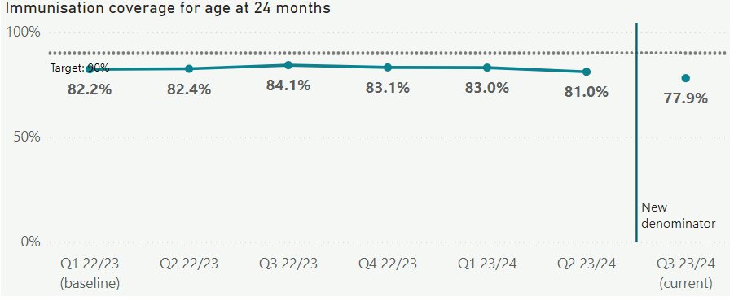

All ethnic groups and regions are below the target.

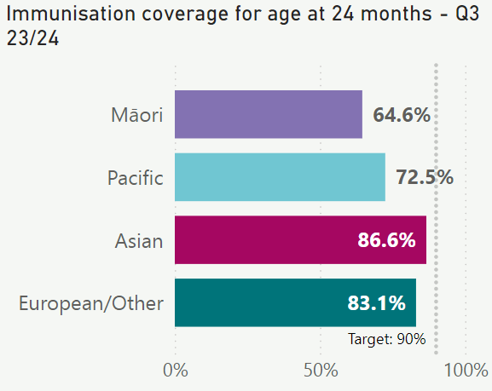 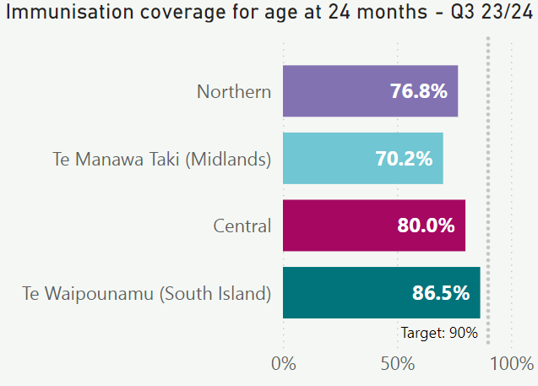

*Data source is the Aotearoa Immunisation Register (AIR), which results in a drop in coverage as the denominator is now larger.*

## 2 Shorter stays in Emergency Departments

This measure reports patients admitted, discharged or transferred from an Emergency Department (ED) within six hours (Shorter Stays in ED – SSED) as a percentage of all patients who left the ED in the period.

ED length of stay remained static nationally between quarters two and three; however, total performance remains below the baseline and well below the national target. Performance in this measure is related to volumes of ED presentations (see measure 13). Access to inpatient hospital beds has a significant impact on patient flow through ED and length of stay in ED.

All hospitals have acute flow plans in place. A national Hospital and Specialist Services Acute Care initiative is a multi-year programme focused on leveraging the best of different plans and implementing consistent acute flow practices across all locations and teams.

In quarter three, a national escalation policy was implemented to provide greater visibility and clarity of areas under pressure. It supports a consistent daily operating rhythm across the country and enables escalation of pressures regionally. Monthly performance reviews are held with an acute flow focus, including SSED.

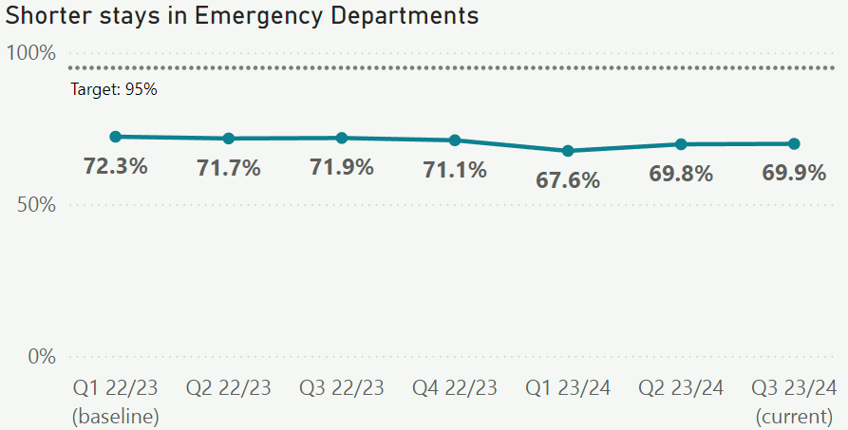

SSED performance across ethnic groups was static compared to quarter two 23/24. Regional rates of SSED were static or slightly decreased in all regions. Performance drivers for length of stay in ED vary by location and include increased demand, availability of resources and variability in acute flow practices.

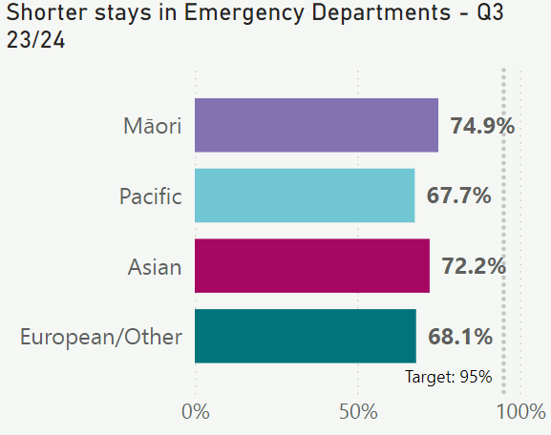 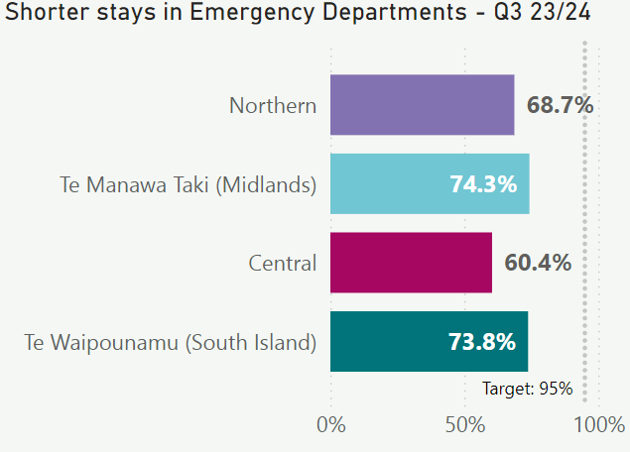

*Source of data is the National Non-Admitted Patient Collection (NNPAC). There is a material data gap for Southern at the end of 2023 due to system change. This impacts the previous quarter result (Q2 23/24 period).*

## 3 People waiting more than four months for first specialist assessment (FSA)

This measure reports people waiting longer than four months for first specialist assessment (FSA). This measure is also known as Elective Services Performance Indicator 2 (ESPI2).

There has been a long-term increase in the national total FSA waitlist, both in the number and proportion waiting longer than four months. At the end of quarter three more than 77,000 people on the waitlist (have waited more than 120 days), which is 40.2% of all those waiting.

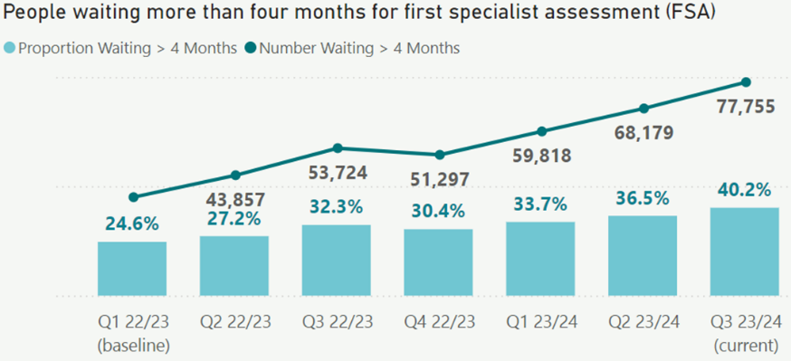

During quarter four we will continue to work locally on phase one of our patient communications (contact) project, targeting patients waiting more than 120 days for FSA in General Surgery, Ophthalmology, Gynaecology, and Orthopaedics. These people represent 20% of all people who have waited more than 120 days. Patients waiting for other specialist appointments will be our focus from July. The purpose of a nationally consistent approach to contacting people is to acknowledge and apologise for the delay, make sure the information we have on file is correct (to assist with waitlist validation), and ensure people know what to do if their condition changes or if they wish to discuss their options.

We are working to reduce variation in access, booking and waitlist management processes. This includes harmonisation of priority mapping, developing a national Planned Care Patient Pathway (on track for delivery in May 2024), and defining the operational standards and business rules for waitlist management.

We are working collaboratively with sector partners such as Physiotherapy NZ and the New Zealand Orthopaedic Association to refine and deploy the national Musculoskeletal pathway. This aims to improve our management of orthopaedic FSA demand and the timeliness of patients receiving assessments. The prototype is live across multiple areas.

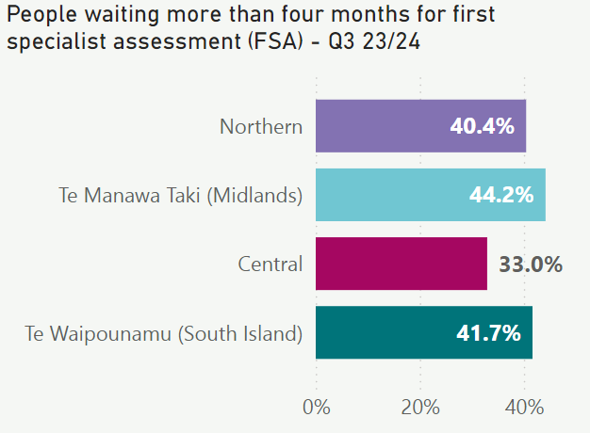

*Source of data is National Booking Reporting System KPI (NBRS KPI). Ethnicity breakdown is not available for this measure*.[9]

## 4 People waiting more than four months for a procedure

This measure reports people given a commitment to treatment but not treated within four months as a proportion of all people waiting for a procedure. This measure is also known as Elective Services Performance Indicator 5 (ESPI5).

The total treatment waitlist continued to increase in quarter three across all ethnicities and regions.

A national performance monitoring framework is now operational, providing insights for regions and locations to focus improvement plans. An Intensive Support Team has been created, which along with other functions will work with underperforming areas in April for acute care, followed by planned care in May 2024, focusing on Canterbury, Southern, Bay of Plenty, and Taranaki. A key focus will also be MidCentral given systemic challenges with performance.

A national Theatre Metrics dashboard using operational data is now live and informing local and regional improvement plans. Specific areas for improvement include:

* theatre productivity, including reducing hospital-initiated day of surgery cancellations (continuing to trend downwards in quarter three to 5%)
* increasing day of surgery admissions and exploring options such as standing up additional weekend theatre capacity to protect delivery during periods of higher acute demand (included in our System Pressures Plan for 2024)
* a focus on late starts - early finishes and theatre session utilisation
* harmonising rostering across professional groups to optimise in-theatre time.

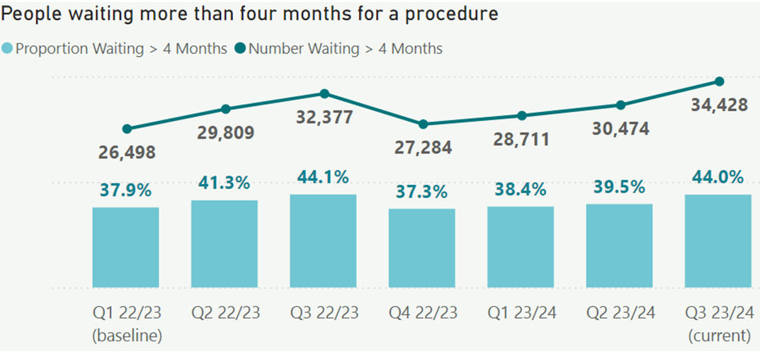

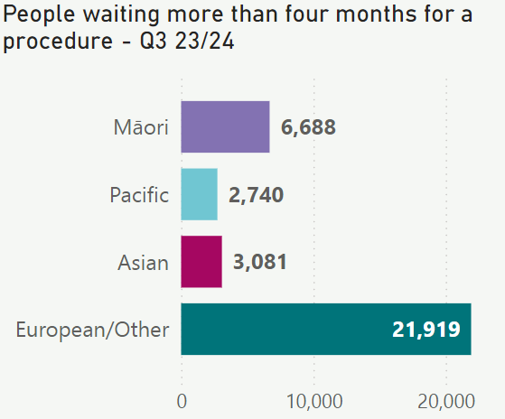 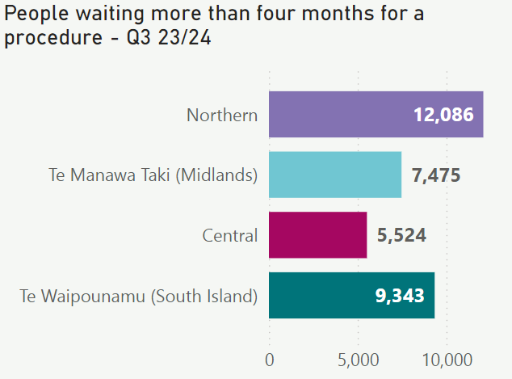

*Source of data is the National Booking Reporting System (NBRS).  Data for two districts has not been included in regional and national data due to data issues, which will have an effect when our quarter four report is published. Volume in Te Waipounamu for people waiting more than 4 months would have been affected by number of patients waiting more than 12 months.*

## 5 Cancer patients waiting less than 31 days for first treatment

This measure shows the proportion of eligible cancer patients who receive their first treatment within 31 days of a health professional’s decision to treat.

This quarter, the proportion of eligible cancer patients who received their first treatment within 31 days fell by 3.5% compared with quarter two and is now 3.1% below the target.

A dashboard is in development which will provide visibility of cancer treatment pressures at a local, regional, and national level, acting as a tool for service improvement. In addition, a national cancer performance operating framework is being developed to provide a real time view of patients in the system, including waitlist data, volumes of patients receiving treatment and follow up. This will enable national, regional, and local teams to understand the demand and plan effectively to provide timely treatment and care.

National programmes in progress include the abnormal uterine bleeding pathway which will be completed for review by the Royal Australian and New Zealand College of Obstetricians and Gynaecologists. We anticipate this will show challenges for Pacific and Māori women with endometrial cancer.

Workforce, diagnostics, and access to diagnostic equipment are currently key areas of focus for improving our timely cancer service delivery. Initiatives to improve performance include:

* international recruitment for radiation therapists and oncologists
* developing national clinical pathways to facilitate rapid diagnosis of suspected cancer and to eliminate unwarranted variation in the system
* our National Bowel Screening Unit commencing planning for the roll out of the faecal immunochemical test (FIT) for symptomatic pathway for patients on the colonoscopy waiting list, to four sites in 25/26, and an evaluation before rolling the pathway out nationwide. The aim of the pathway is to ensure patients are prioritised appropriately.

Planned Care and the radiology transformation programmes will also impact the cancer pathway through standardisation, efficiencies and pathway improvements.

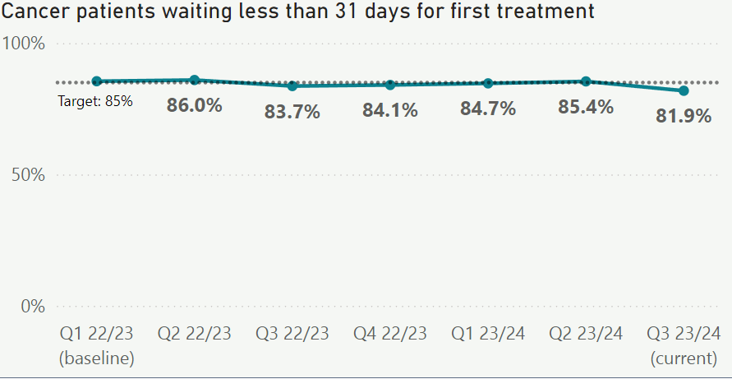

Addressing constraints across the cancer pathway is a focus in all regions with service improvement plans in place. Examples include a focus on gynaecology in the Northern region, theatre utilisation in Te Manawa Taki, Central and Te Waipounamu, and addressing workforce vacancies through recruitment and retention.

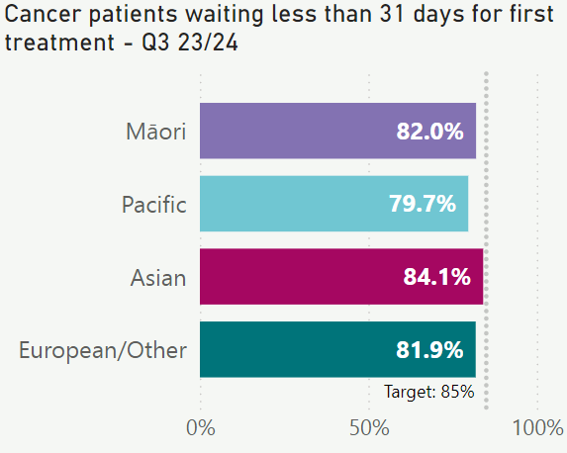 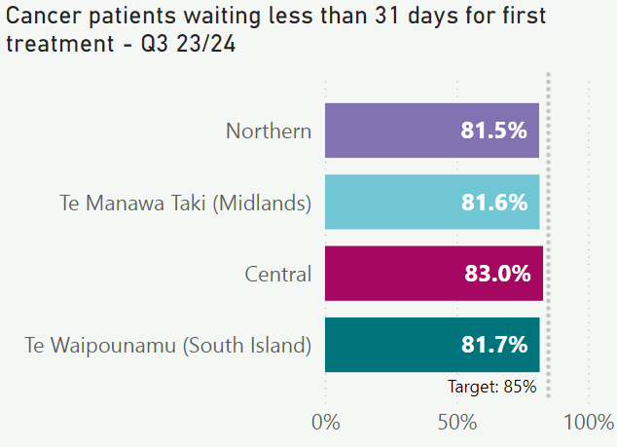

*Source of data is Faster Cancer Treatment Data (FCT). Data for two districts has not been included in regional and national data due to data issues, which will have a small effect when our quarter four report is published.*

6 Primary care enrolment

This measure shows people enrolled with a general practice (or Kaupapa Māori provider delivering general practice care), as a percentage of the Stats NZ estimated resident population.

Overall, the proportion of people enrolled decreased slightly in quarter three. The health system continues to experience high rates of patient enrolment. Primary care continues to manage workforce and resourcing constraints, resulting in some being unable to enrol new patients. This may continue into quarter four. Despite these pressures, enrolment has remained close to the 95% target. Primary Healthcare Organisations (PHOs) are working with general practices to encourage enrolment based on capacity constraints and local priorities. PHOs continue to provide information about which practices are open to new enrolments.

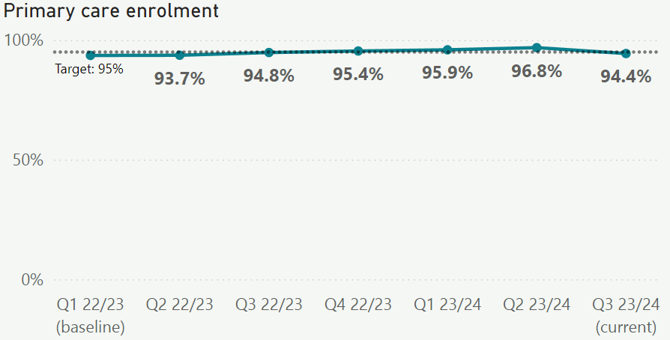

We have seen small fluctuations in enrolment rates over the past 12-months across all ethnic groups. Enrolment rates for Māori are currently lower than the national average. While it is known there are instances of misclassification of some individuals as Pacific or European in the PHO enrolment system, it is important to note this factor alone does not fully account for the gap in Māori enrolment. The coding of ethnicity is a multifaceted process influenced by various factors. This should improve as we move to unify ethnicity coding protocols within commissioning frameworks.

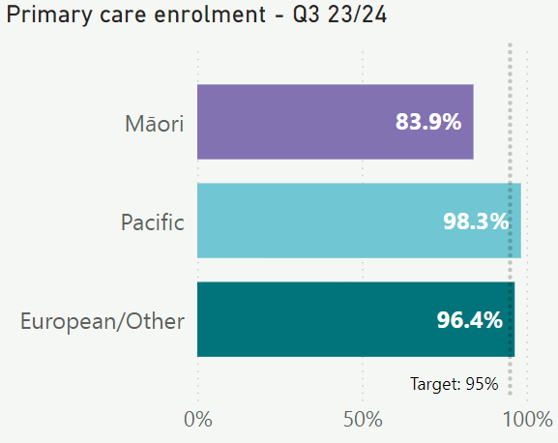 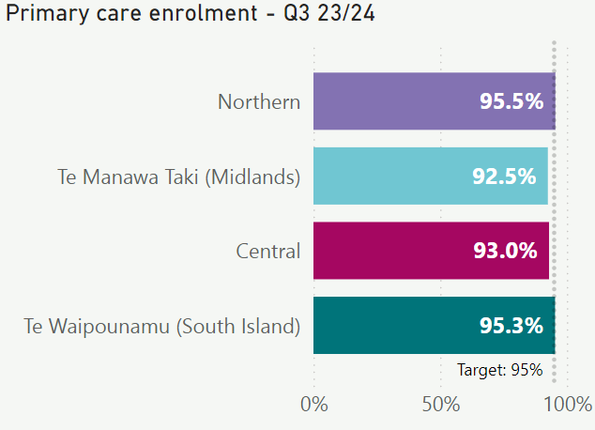

*Source of data is the Primary Care Enrolment System (PES). This metric is not yet available with an ethnicity breakdown for Asian people.*

7 Involvement in care decisions – primary care

This measure reports the proportion of people who responded “yes” to the question “Did the health care professional involve you as much as you wanted to be in making decisions about your treatment and care?”, in a Health Quality and Safety Commission (HQSC) quarterly survey of primary care patients.

Results show that most people feel involved in the care delivered by their general practice team.

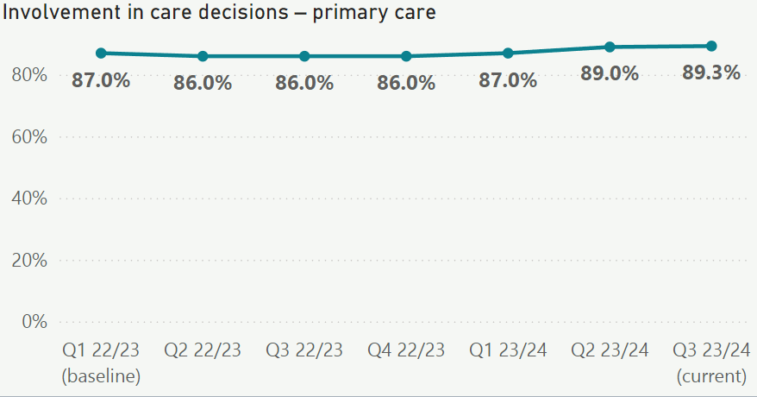

National results for European/Other, Māori, Pacific and Asian remained relatively stable over the last quarter. Regional results have also remained stable compared to quarter two.

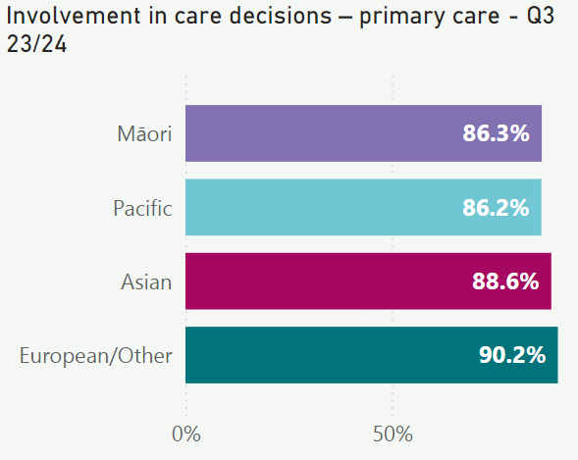 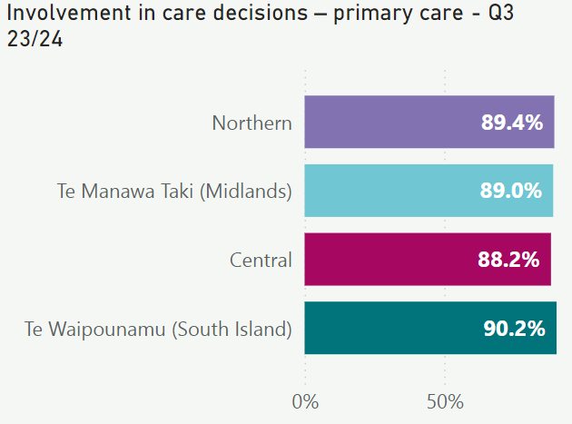

*Source of data is the Adult primary care patient experience survey from HQSC. Results are based on weighted data.*

8 Ambulatory sensitive hospitalisations 0-4 years

This measure shows hospitalisations for children aged 0-4 years for an illness that might have been prevented or better managed in a primary care setting, as a rate per 100,000 population (ASH 0-4).

The national results show a slight decrease in quarter three. Primary care initiatives at the PHO and regional level such as newborn enrolment and immunisation help reduce the risk of hospitalisations.

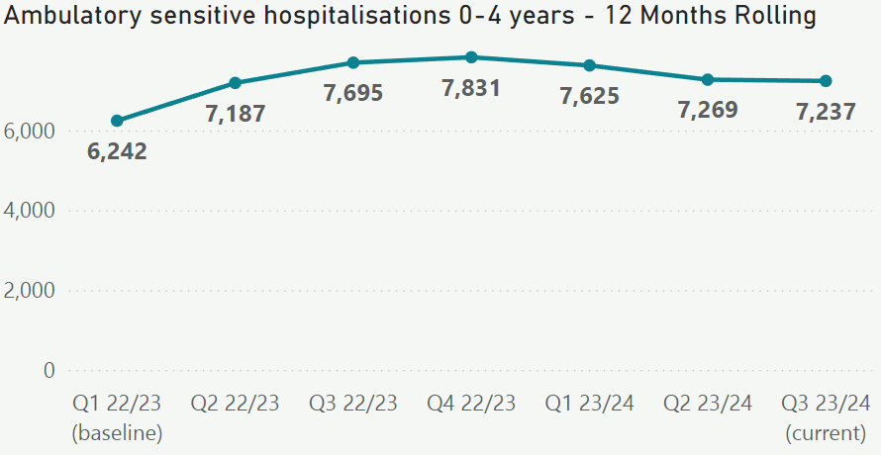

Differences in rates for Māori and Pacific, compared to other children, remain higher than those for other groups.

The Northern Region has the highest number of hospitalisations. There are various local initiatives tailored to reduce ASH rates for 0-4 years, such as supporting immunisation, implementing childhood respiratory pathways, and improving childhood dental services.

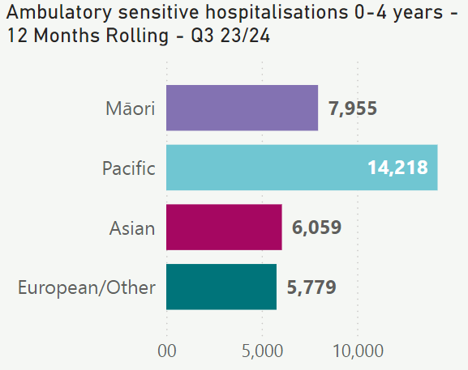 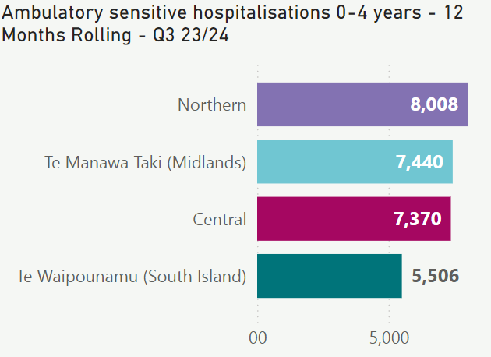

*Source of data is the National Minimum Data Set (NMDS).*

9 Ambulatory sensitive hospitalisations 45-64 years

This measure shows hospitalisations for people aged 45-64 years for an illness that might have been prevented or better managed in a primary care setting, presented as a rate per 100,000 population (ASH 45-64).

The national result has remained relatively stable.  Primary care services are focused on providing better support for acute and proactive care in the community at a PHO and regional level. The key area of focus is better management of long-term conditions, which contribute to these admissions. The Health Navigator Charitable Trust is upgrading guidelines on self-management support for people with long-term conditions, working with a user focus group which includes Māori and Pacific providers, primary health organisations and kaimahi.

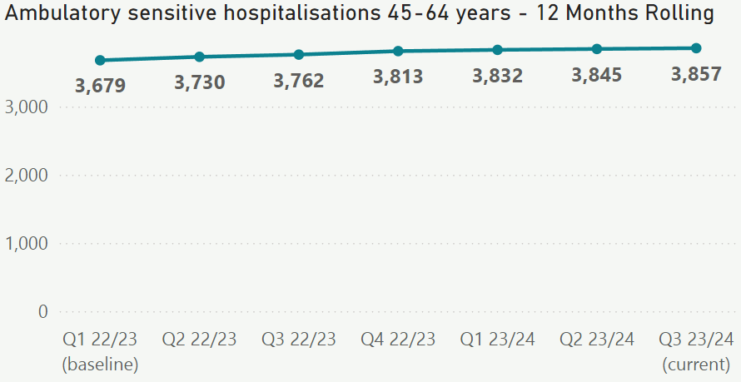

The rates for Māori and Pacific remain higher when compared to other populations. Te Waipounamu has the lowest rate of ambulatory sensitive hospitalisation for people aged 45-64 years.

A number of initiatives to improve rates are locally tailored based on need. Examples of local initiatives include the completion of cardiovascular risk assessments, diabetes checks and the roll-out of comprehensive primary care teams.

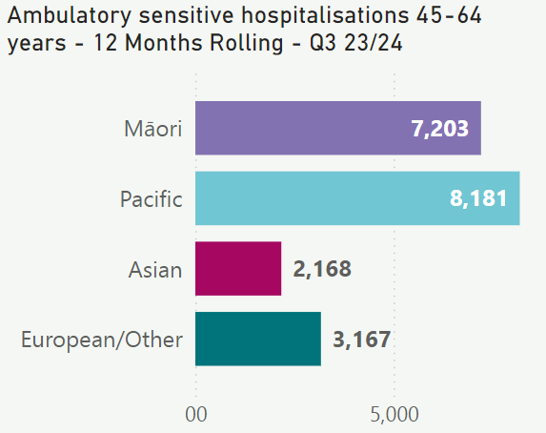 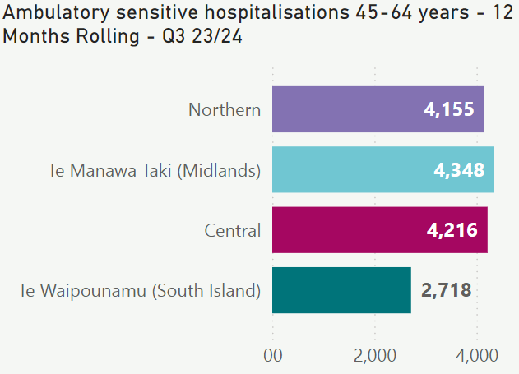

*Source of data is National Minimum Data Set (NMDS).*

10 Access to primary mental health and addiction services

This measure reports the rate of people accessing primary mental health and addiction services (Health NZ and NGO combined) per 100,000 people.[10]

The decrease in access to primary mental health this quarter is likely to be a seasonal variance, with decreased access experienced over the summer holiday period. In addition, challenges with reporting, such as not receiving reporting from some districts, may have contributed to the decrease. This is being investigated and should be resolved in the next quarter.

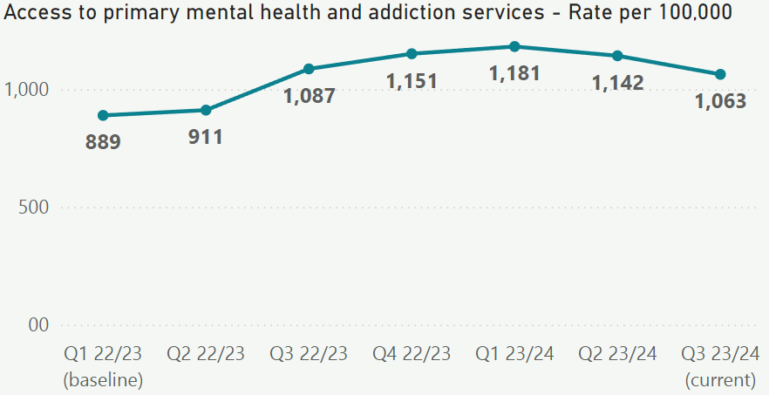

The access rates for Māori and Pacific are higher than for other ethnicities.Access is low among Asian populations when compared to all other population groups, and Asian access to services will be a focus for future planning and improvement.

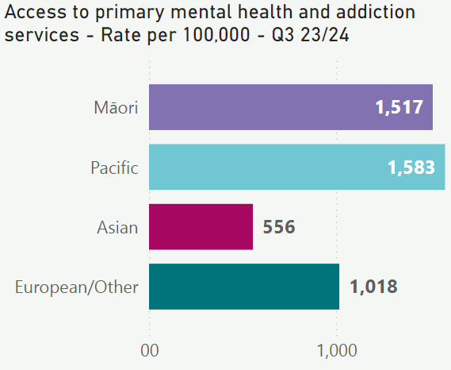

*Source of data is the Access and Choice System and Population Statistics from Stats NZ. Results are presented as a rate per 100,000 population. Regional breakdown of this data is not available.*

11 Access rates for specialist mental health services

This measure reports the rate of people per capita served by specialist mental health services (Health NZ and NGO combined).

Access rates have slipped over the last three quarters, and for quarter three are the lowest since the baseline in 2022/23. Access rates for Māori remain significantly higher than the national rate, while rates for Asian populations remain significantly lower.

These access rates reflect referrals to specialist mental health services based on need. Access to specialist mental health services for all population groups is a priority element of future planning and improvement.

There continues to be evidence of increased demand, particularly in younger age groups, with workforce constraints impacting access rates.

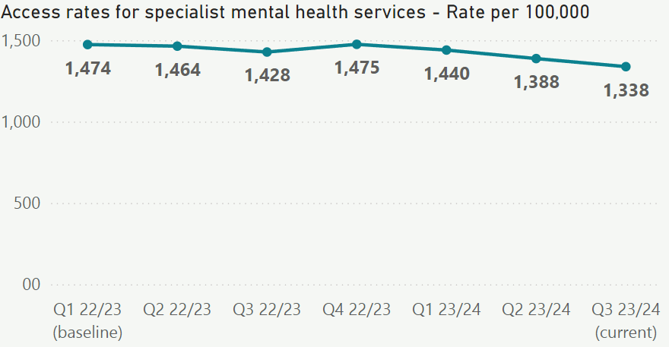

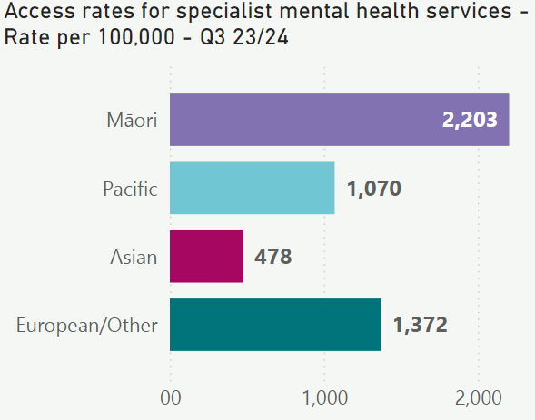

*Source of data is the Programme for the Integration of Mental Health Data (PRIMHD) and Population Statistics from Stats NZ. Reporting by region is not currently possible but is expected to be available from quarter four.*

12 Mental health wait times for under 25-year-olds

This measure reports under 25 year olds being seen by specialist mental health services within three weeks of referral as a proportion of referrals received.

The national result has remained relatively stable.  Data continues to show an increase in demand from this age group for specialist mental health services. Workforce shortages impact our ability to meet this demand.

Workforce development initiatives to increase training opportunities and international recruitment to key clinical professions are having some impact, but vacancy concerns continue.

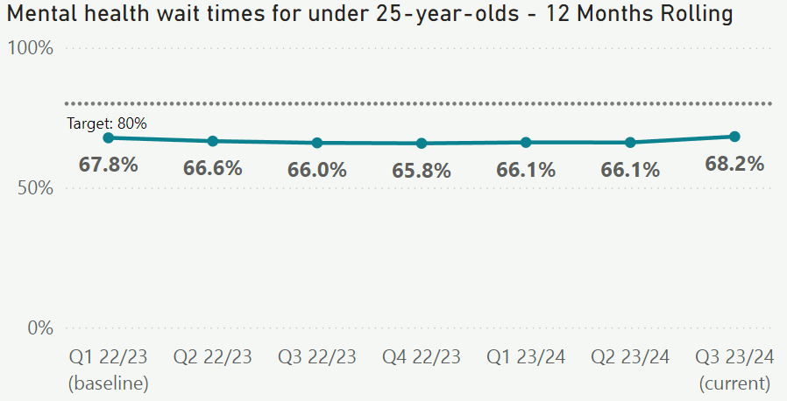

Overall performance remained stable across ethnicities. Te Manawa Taki increased its performance, while Central Region’s performance decreased in quarter three when compared to quarter two. Northern and Te Waipounamu remained stable compared to quarter two.

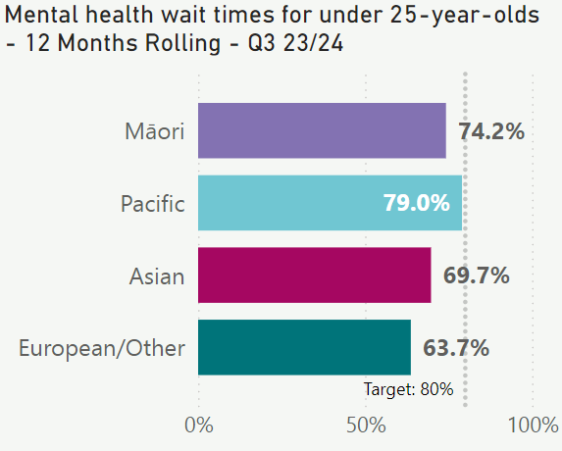

*Source of data is the Programme for the Integration of Mental Health Data (PRIMHD). With effect from July 2023, the data presented for this measure includes updated PRIMHD data for the two latest 12-month periods, ending with the relevant quarter. Previously published data has been removed and replaced with the latest information. Measure is presented as a rolling 12 months to the quarter.*

13 Emergency Department presentations

This measure reports the number of people who present to an emergency department including those who did not wait to be seen.

Quarter three 2023/2024 has experienced a 4% increase in presentations compared to quarter three 2022/2023.

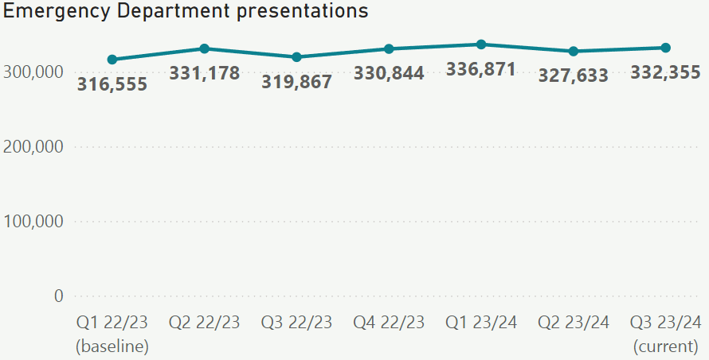

Europeans have the highest number of Emergency Department presentations, in proportion to their population size.

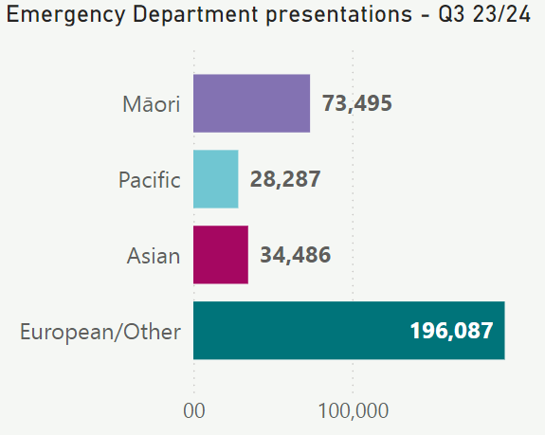

*Source of data is the National Non-Admitted Patient Collection (NNPAC).* *There is a material data gap for Southern at the end of 2023 due to system change. This impacts the previous quarter result (Q2 23/24 period).*

14 Admissions from Emergency Departments

This measure reports patients admitted to a hospital ward following attendance at an Emergency Department (ED) as a proportion of all patients who attended an ED.

There has been a rise in ED presentations over time which is largely in line with population growth. For example, in the 2018-2023 period there was a 6.7% growth in population and a 7% increase in acute adult admission events.

As the total number of presentations and admissions rises, we are focusing on ensuring supportive and accessible primary, urgent and after-hours care which is part of a national acute care programme of work.

Although presentations are increasing, we have seen a slight decrease in admissions between quarters two and three.

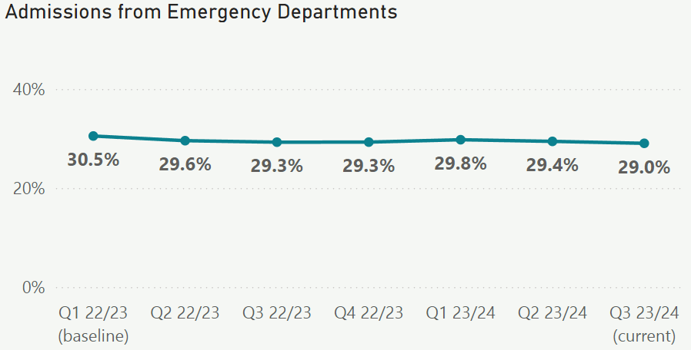

The admission rates are higher for European / Other than for Māori, Pacific and Asian populations. This is because European / Other have a higher percentage of older people compared to other ethnic groups. Additionally, Te Manawa Taki and the Northern Region have higher admission rates compared to other areas.

*Source of data is the National Non-Admitted Patient Collection (NNPAC). There is a material data gap for Southern at the end of 2023 due to system change. This impacts the previous quarter result (Q2 23/24 period).*

15 Acute bed days per capita

This measure reports bed days spent in hospital following an acute admission per 1,000 population, age standardised.

The demand for acute care has remained relatively stable over the past 12 months.

We are continuing to focus on primary care services (at a PHO and regional level) to provide better support for chronic conditions in the community. For example, increasing the number of vaccinations delivered over the winter period for high-risk populations is expected to result in a lower chance of hospitalisation over winter months, impacting acute bed days.

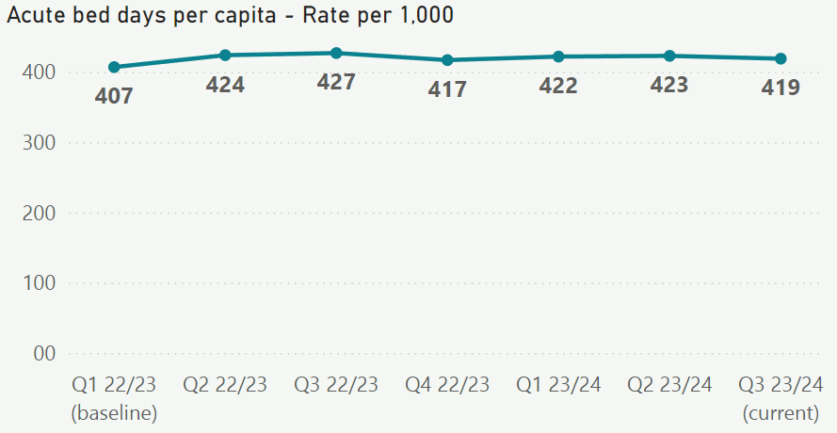

Māori and Pacific have more acute bed days when compared to other ethnicities. This is partly explained by the rate of paediatric admissions and inequities in health outcomes and access to healthcare resulting in a greater rate of underlying chronic conditions for these population groups.

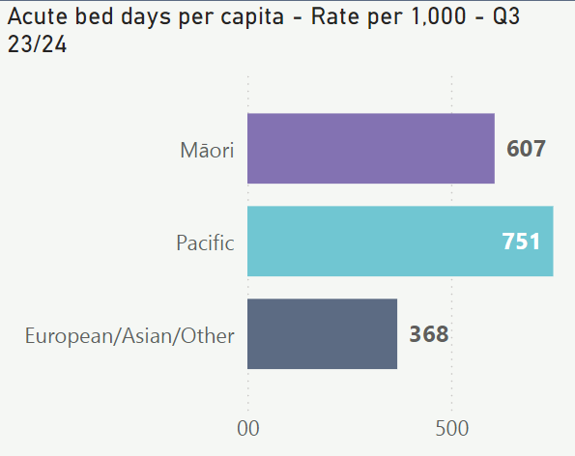

*Source of data is the National Minimum Data Set (NMDS) and Population Statistics from Stats NZ. Due to this measure being created in legacy systems, the Asian split is not yet available. However, this should be available shortly. Regional results are not available for this measure.*

16 Inpatient length of stay >7 days

This measure reports hospital discharges with an inpatient length of stay of greater than seven days as a proportion of all discharges in the period.

Long inpatient stays are an indicator of system performance in relation to hospital flow, impacted by complexity, aging and, in some areas, delays in discharge caused by lack of access to suitable community or residential care facilities. There was a slight decrease in inpatient length of stay greater than seven days between quarters two and three. A national set of actions are being progressed to improve long length of stays, these include setting expectations for discharge planning and developing an escalation pathway framework for complex discharges back into the community.

Long-stay rates for Māori, Pacific and Asian populations are lower than for the European / Other population. Rates for Asian have decreased by just over 3% from quarter two, while rates have increased by just over 3% for European/Other.

*Source of data is the National Minimum Data Set (NMDS). Results are presented as a percentage of acute discharges after more than seven nights in medical or surgical specialties, divided by all acute discharges in medical or surgical specialties.*

17 Involvement in care decisions – in hospital

This measure shows the people who report they were involved as much as they wanted to be in decisions about their treatment as a proportion of all adult inpatients who responded to the Health Quality and Safety Commission (HQSC) quarterly survey of hospital patients.

The proportion of patients reporting involvement in care decisions through the HQSC survey increased by 5% compared to the baseline in quarter one 2022/23. Involvement in care decisions remained static nationally between quarters two and three. This result shows that our hospital staff keep working hard to ensure consumers and whānau are involved in decisions about their care.

Performance continues to improve incrementally. We would expect performance to remain stable.

Experience for Asian and Pacific is higher than that for Māori and European / Other. Experience remains lowest for Māori, in comparison to other ethnic groups. There is work to do to ensure that this improves, along with performance in particular regions.

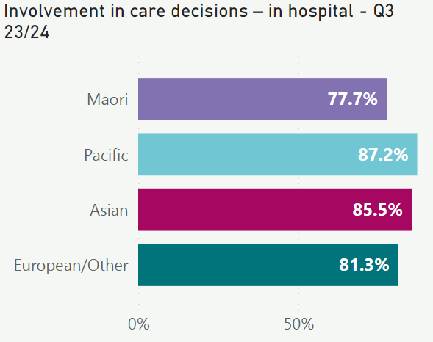 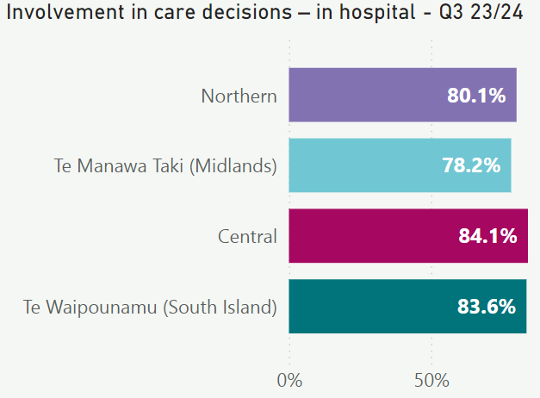

*Source of data is the HQSC Adult Hospital Inpatient Experience Survey. Results are based on weighted data.*

18 People waiting more than 365 days for a procedure

This measure reports the number of people who have been waiting for a procedure for more than 365 days from when they were ready for treatment.

There has been a decrease in the number of people waiting more than 365 days for a procedure compared with 12 months ago. Improved booking processes have contributed to this. Regions are collaborating to identify and address local issues. This includes improving outsourcing processes and promoting the National Travel Assistance Scheme to support patients to access the care they need outside their home area.

We have embedded operational tools such as the national Rapid data set and processes for weekly long-waiter reporting to regional directors and Planned Care senior responsible officers. Regions use a 300-day flag to predict upcoming demand and enable appropriate planning.

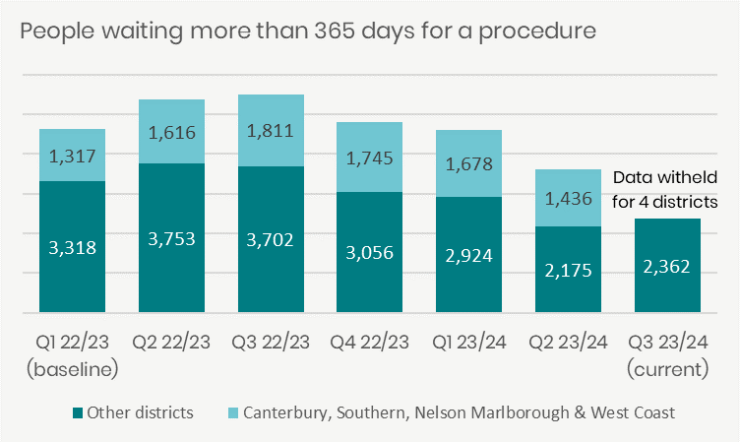

*Source of data is the National Booking Reporting System (NBRS). Results for Canterbury, Nelson Marlborough, Southern and West Coast areas are not validated for quarter three. These areas are omitted from the above chart and local area-specific charts in Appendix Two. Ethnicity and regional breakdowns have been withheld for this quarter because of the distortion caused by the omission of these four local areas.*

19 Medical appointments through digital channels

This measure reports outpatient attendances completed via telephone or video as a proportion of all outpatient attendances.

The number of medical appointments through digital channels slightly decreased in quarter three.

Our primary focus is on delivering targeted initiatives to significantly improve digital access to health services. This includes Remote Patient Monitoring, which enables healthcare providers to collect and monitor health information from patients in remote or rural areas and the Ka Ora Telecare service, which has provided a total of 2,696 appointments since its inception in November 2023.

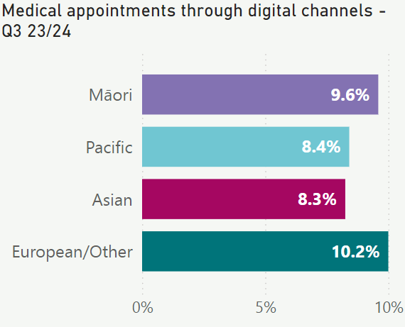

*Source of the data is the National Non-Admitted Patient Collection (NNPAC).*

20 Missed appointments

This measure reports the proportion of people who did not attend or did not wait for a first specialist assessment or follow-ups.

The national rate of missed appointments saw a slight slip in quarter three compared to quarter two. We are working on several initiatives to improve rates of missed appointments. These include:

* patient communications project and waitlist validation
* reducing patient-initiated day of surgery cancellations.

While some progress has been made towards reductions, there is still a much higher rate of missed appointments for Māori and Pacific.Target initiatives are being implemented at a local level to reduce missed appointments among specific ethnic groups. Examples of initiatives include the establishment of the Kaiarahi Nahi and Pacific navigation teams within Te Toka Tumai Auckland, which support patients to attend appointments and treatment. Text-reminder functions have been developed regionally to alert patients to their upcoming appointments.

Te Waipounamu and Central regions had reduced rates of missed appointments in quarter three compared to quarter two. However, rates increased slightly for Northern. Regions are working to reduce patient-initiated day of surgery cancellations.

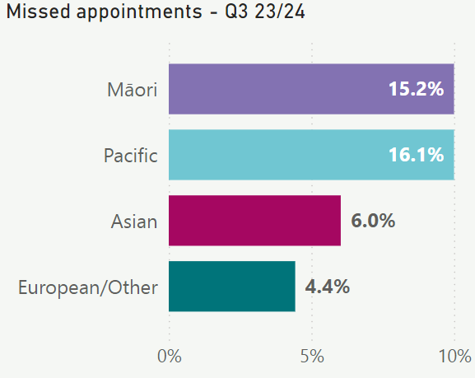 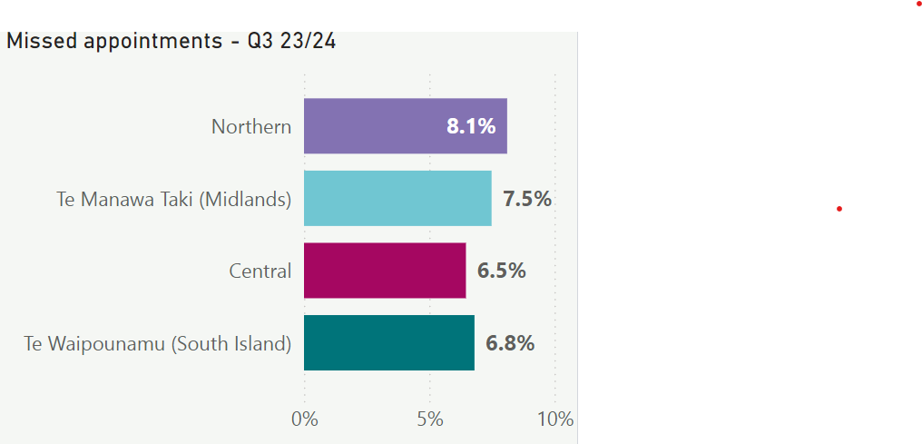

*Source of data is the National Non-Admitted Patient Collection (NNPAC).*

21 Delivery of planned care interventions

This measure reports the number of planned care interventions including inpatient surgical discharges, minor procedures delivered in inpatient, outpatient and community settings, and non-surgical interventions.

There was an uplift of 6% in the delivery of planned care interventions in the first three quarters of 2023/24, compared to the same period in the 2022/23 year. Delivery of planned care interventions is seasonal and therefore has been presented differently to other measures.

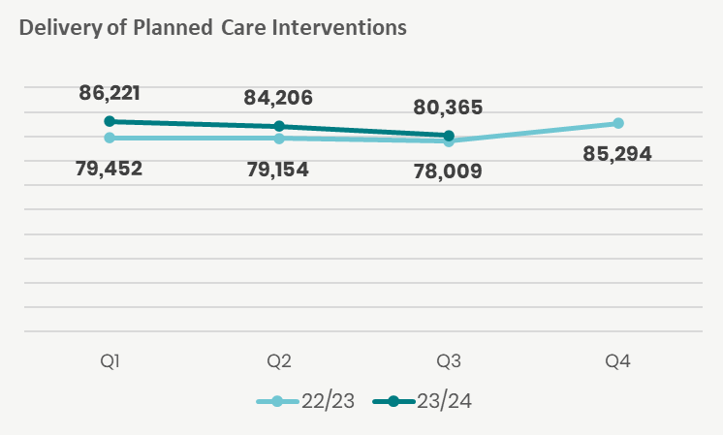

The delivery of planned care interventions for European / Other increased compared to the previous quarter. Similarly, Māori and Pacific populations experienced a slight increase in planned care interventions, while the Asian demographic saw a slip relative to the previous quarter. Planned care interventions decreased in Northern and Central compared to quarter two. Weekly reporting of planned care delivery was rolled out at a local and regional level to support monitoring and targeted waitlist support.

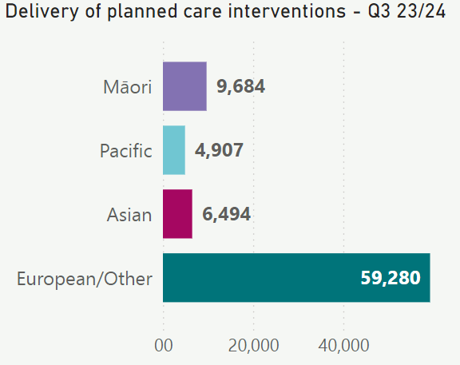

*Source of data is the National Minimum Data Set (NMDS) and the National Non-Admitted Patient Collection (NNPAC).  Reporting in previous quarters has excluded two categories of planned care: minor procedures performed in inpatient setting and surgical interventions discharged under non-surgical specialties. This error has been corrected for all historical quarters.*

22 Acute readmissions within 28 days of discharge

This measure shows the proportion of acute readmissions to hospital within 28 days of discharge.

Performance has remained relatively stable over the past 12 months. Acute readmissions within 28 days of discharge is a system performance balance measure: a measure a health system should track to ensure an improvement in one area isn’t negatively impacting another area. For example, in improving hospital flow by reducing length of stay (LOS), we need to ensure the right patients are discharged and there is not an inappropriate increase in readmissions to hospital.

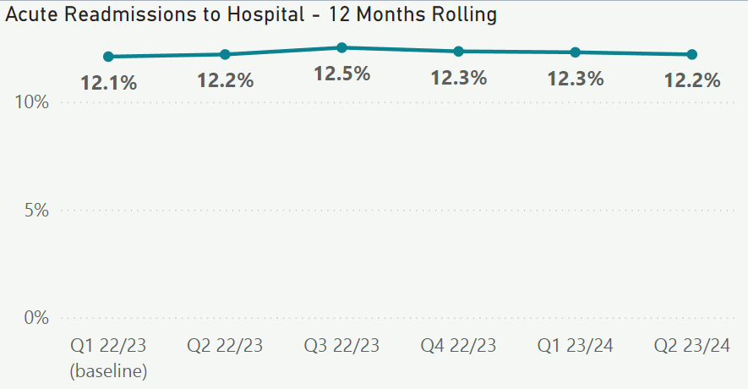

*Inpatient discharge data is not fully complete for the quarter three period to enable a full picture of readmissions for the quarter three period, therefore the data has been updated to quarter two only. Regional results are not available for this measure. Due to this measure being created in legacy systems, the Asian split is not yet available*, *however this should be available shortly.*

## 

## Our milestones

The below sets out milestones in our Statement of Performance Expectations

|  |  |  |
| --- | --- | --- |
| Milestones | Progress made – Quarter Three 2024 |  |
| Continue COVID-19 response in line with policy settings and build towards a new business-as-usual pandemic resilient system. | To support COVID-19 community testing, five million Rapid Antigen Tests (RATs) were ordered in January to support the continued provision of publicly funded RATs until June 2024. The first batch of approximately 2.1 million RATs was received in late February, and the remaining batch arrived at the end of March. These free RATs are available through the established national network of distribution providers, comprising  health providers and some pharmacies.  Summer 2023/24 COVID-19 booster vaccinations were recommended for groups at higher risk of becoming severely ill, coinciding with a wave of COVID-19 over the Christmas and summer period. | Te Pae Tata Priority 2 - Embed te Tiriti o Waitangi across the health sector |
| Improve digital access to primary and mental healthcare to improve access and choice, including virtual after-hours and telehealth with a focus on rural communities | Of 230 rural practices identified to access the Ka Ora Telecare programme, 190 have been approached and offered the service. Of those, 95 practices (41% of all rural practices) have signed up for the service (a 6% increase from end of last quarter) while five practices (2% of all rural practices) declined. The provider is awaiting responses from the remaining 90 practices, which were approached in the initial tranche of engagement and will, in time, engage with the remaining 40 rural practices.  The Rural Health Conference will be held in quarter four, helping to engage with practitioners further and promote the service | Te Pae Tata Priority 5 - Develop greater use of digital services to provide more care in homes and communities |
| Progress the approved capital infrastructure projects that are underway, taking all practicable measures to ensure that project milestones are met, and anticipated benefits are realised, within budget. | As of 29 February 2024,[11] we had 75 in-flight projects that were more than $10 million or funded from the HCE. Of these, 36 projects were on track with no issues and 17 were identified as having significant budget and milestone risks. Last quarter we had 16 “at risk” projects. The increase is based on two new change requests and one project where the issues have been resolved. | Te Pae Tata Priority 6 - Establish Health NZ and Te Aka Whai Ora to support a financially sustainable system |
| Deliver the approved digital capital projects in line with business cases.Error! Bookmark not defined. | Overall delivery of capital projects in line with their respective business cases is progressing as planned for the most part. For the 10 most significant projects or programmes currently underway, (based on overall implementation value) none have a red status, and the balance are currently indicating an overall RAG status of green or amber. Common challenges have been highlighted across projects in relation to resource constraints, particularly through the current period of change. While the market appears to be beginning to shift, specialist skills remain scarce and attract a premium. | Te Pae Tata Priority 6 - Establish Health NZ and Te Aka Whai Ora to support a financially sustainable system |

1. Financial performance

### High-level summary: key issues, risks and work plan

* The operating result for the month of March was a $196 million surplus, which was $220 million favourable to budget. The year-to-date result as at 31 March was a surplus of $299 million, which was $300 million favourable to budget.
* Movements in March were in line with the previous month’s forecast track, and there was an improvement in the run rate for Hospital & Specialist Services and Infrastructure & Investment. The major items that improved the result in March were Pharmac revenue for pharmaceutical cancer treatments and hospital medicines catching up with the spending, release of expenditure accruals not required, release of income in advance, and expected upsides for nursing costs.
* Closing cash for Te Whatu Ora as at 31 March 2024 was $1.73 billion, including trust funds.
* Savings achieved for the nine months to 31 March 2024 amounted to $409 million and include unplanned savings and budget improvements amounting to $184.7 million. The full year savings target is $540 million.
* In March, nursing FTEs were greater than budget by 2,079 in the month and 878 year-to-date. Unbudgeted Care Capacity and Demand Management (CCDM) costs resulting in payment of higher-than-budgeted ordinary hours for nursing are the largest risk to achieving the desired surplus. In addition, settlement of collective agreements above budgeted levels, unfunded impact of pay equity, and Holidays Act payments on leave revaluations, are also increasing pressure on the budgeted expenditure levels.
* Capital Expenditure (Capex) for the year-to-date to 29 February 2024 is $935 million, against a budget of $1.827 billion, thus $892 million below plan. Work is ongoing to develop the medium to long-term Capex intentions for asset portfolios and to develop indicative capital intentions for the medium-to-long-term. Current Capex performance is also being reviewed as part of the 2024/25 Capex planning processes.
* The Statement of Performance Expectation (SPE), including prospective financial statements, has been prepared based on the parameters set for the Budget 2024. The detailed operational budgets are also being developed in line with the Budget 2024 parameters.
* Roll out of the Finance, Procurement and Information System (FPIM) system continues with 26 components now migrated, Lakes and HealthShare being the most recent addition in March. There is now one more district (Tairāwhiti) and one shared service agency (Central TAS) yet to be migrated onto FPIM. These will be completed by June 2024.

## Cash Flows & Balance Sheet March 2024

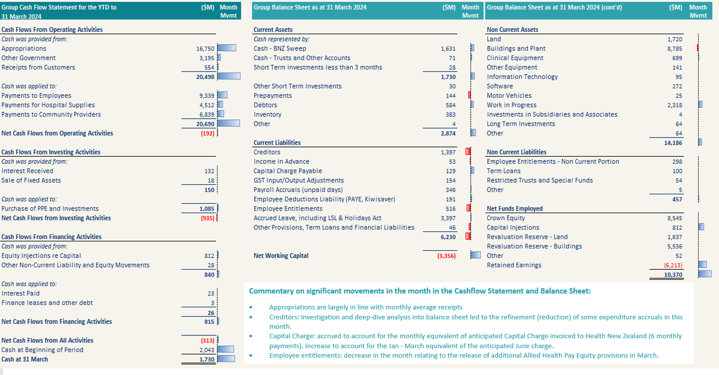

## Consolidated savings report and trends YTD to March 2024

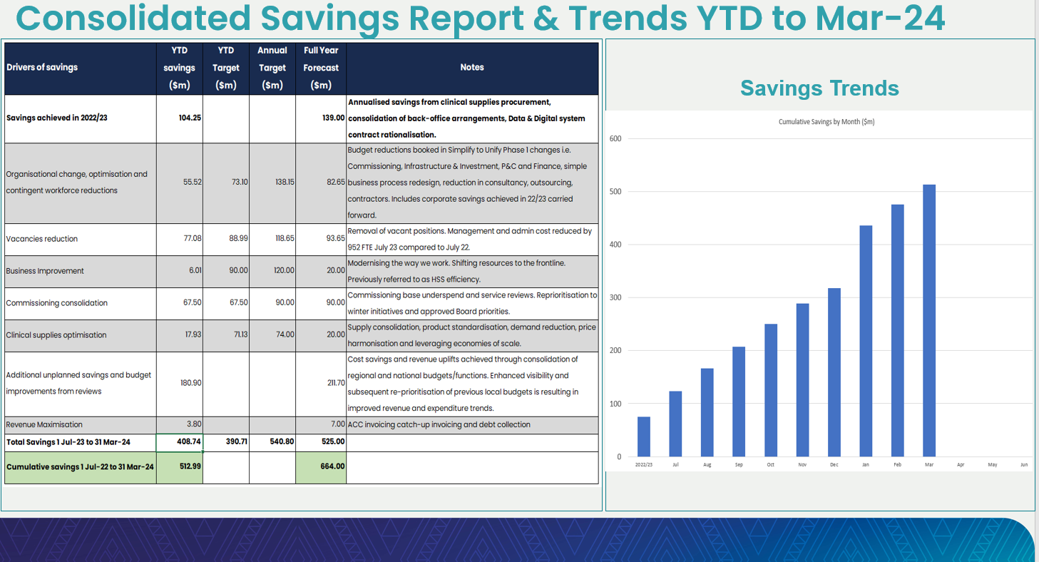

## Savings target realisation

* A $540 million savings programme was agreed by the Board as part of the Budget for the 2023/24 year. The planned savings were to be applied to cost pressures and key initiatives.
* The in-year savings programme of $540 million was established to balance the 2023/24 budget and free up funds for reinvestment in priority areas. $187 million of funding generated from these planned savings was dedicated to a range of initiatives approved by the Board and the Minister at that time, with a further $63 million of budget set aside for 500 additional nursing FTEs.
* It was decided that a further reallocation of savings of up to $187 million would be made to priority areas after the first six months of the year, subject to this funding being available.
* Savings of $525 million are forecast. Over the last three months adverse financial performance has occurred, driven materially by an increase in ordinary nursing hours paid and an increase in leave revaluation costs above budget (driven by Holidays Act 2003 remediation payments and pay equity settlements). The savings generated need to be applied to these cost overruns.
* In the nine months to 31 March, $409 million savings (including unplanned savings and budget improvements have been realised against the $540 million target, and year end forecast is to achieve $525 million of the $540 million savings target. Of the originally identified savings initiatives $224 million of the $391 million have been achieved year- to-date, while further savings of $184.7 million have been identified through line-by-line reviews of budget versus actual expenditure and removed from budgets on an ongoing basis.

## Hospital & Specialist Services / Efficiency reporting

* Hospital & Specialist Services (H&SS) has established a methodology for reporting an ‘underlying’ result for each region, taking into account expenditure where budgets are held centrally or where additional revenue is received to offset expenditure. This has been socialised with regional directors. Ongoing analysis of costs and budget risks continue.

## Actions and analysis underway

* Ongoing cost reviews are underway at a regional level ($500 million savings target) with added focus on options to restrain cost growth in Q4 and into the 2024/25 financial year.
* Care Capacity Demand Management (CCDM) is used for safe staffing levels for nursing and will be used for Allied Health shortly. A review of the CCDM methodology and wider nursing investment and productivity is underway. Nursing is a $5 billion per year investment category. A longer-term review of inter-professional models of care is planned. This will result in more affordable workforce models for nursing, Allied Health, resident medical officers and specialised medical officers.
* Clinical supply costs will be informed by engagement with National Clinical Networks to recruit clinicians to champion reduction in variation of practice (collapsing 250,000 supply lines to closer to 60,000 which is best practice). This is a long-term initiative, which will shift the cost curve over the next five years.
* Productivity measures are limited to those which can be reliably collected by Service Improvement and Innovation (SI&I), and we have a one-year roadmap in play (SI&I, Finance, H&SS and EY). Our focus is on operating theatres and bed flow management. The first report has been delivered to central agencies covering:
  1. case-weighted hospital discharges per FTE
  2. average length of stay – medical and surgical episodes of care
  3. percentage long stay (>7 Days) – medical and surgical episodes of care.
* Work is underway to refine existing and develop suites of productivity measures, supported by performance and quality measures, to enable an understanding of not just productivity trends but also drivers of and influences on productivity within service delivery settings. This is expected to be a 12-month work programme.
  1. Development of productivity measures and the efficiency and performance measures that help understand drivers of productivity.
  2. Consolidation and automation of data sources including data quality assessment and control.
  3. Productivity insight generation to increase the use of productivity reporting to support business decision making.
  4. National laboratory commissioning (two years).
  5. National radiology commissioning (two years).
  6. National outsourced surgical services commissioning (two years).
  7. National payroll and rostering to drive workforce analytics and overtime / leave management (five years).
  8. National and regional hospital operating models and control centres (one year).
  9. National booking system, referral management and waitlist management (unknown timeline Data & Digital (D&D) enabler).
  10. Laboratory and Radiology results access (unknown timeline D&D enabler).
  11. Regional Clinical Delivery Networks implemented across a range of specialities (roadmap to be announced).

## Mental health output class

The quarter three 2023/24 mental health output class shown in the table below indicates that mental health expenditure is higher than the draft budget by $23.372 million.

**(YTD to March 2024)**



* Salary increases from collective employment agreements settlement contribute to the high personnel expenditure. This is expected to continue for the remainder of the year and may further increase with further wage increases eg nursing agreement has a further 3% increase from 1 April 2024.
* Commissioning has “contracted” with H&SS using service level agreements (SLAs) to deliver community services during the year. This has contributed to H&SS higher spend against budget and lower spend in Primary and Community as the SLAs budget hasn’t been included in H&SS but in Primary and Community. Primary and Community actual expenditure included corrections of financial reporting in this quarter.
* The budget is currently draft due to Ministry of Health (MoH) letter in December 2023 indicating a mental health $2,284.824 million ringfence budget. Work on agreeing to the ringfence amount with MoH is continuing.

## Finance reporting roadmap

|  |  |
| --- | --- |
| FPIM Deliverables Summary | Status |
| All deliverables are on track year-to-date. More than 98% of Health NZ financial system transactions are live on FPIM.   * Hawke’s Bay District **migrated on 2 October 2023** * Nelson Marlborough District **migrated on 1 November 2023** * Health Promotion Agency **migrated on 27 November 2023** * Lakes District **migrated on 4 March 2024** * HealthShare **migrated on 25 March 2024** | ◉ |
| Whole of Health NZ Delegations Policy updated and delegations to match loaded into FPIM system. | ◉ |

|  |  |
| --- | --- |
| Financial Reporting Deliverables Summary | Status |
| All costs across the business were mapped in 2022/23 to the new functional structure | ◉ |
| The Mental Health ringfence for 2022/23 was confirmed with MoH in June 2023 | ◉ |
| Opening Balance Sheet was finalised in July and audit clearance provided | ◉ |
| Year-end Financial Statements were consolidated, audited and signed off by the Board, then Audit Clearance was provided by the 31 October 2023 deadline | ◉ |
| Quarterly CFIS reporting was delivered | ◉ |

## Appropriation and Output Class Reporting

### Summary: Output Class Expenditure YTD to 31 March 2024

|  |  |  |  |
| --- | --- | --- | --- |
| **Output Class Expenditure (in $ million)** | **2023/24 Actual** | **2023/24 Budget** | **2023/24 Variance** |
| Hospital & Specialist Services | 11,439 | 10,722 | (717) |
| Mental Health & Addictions | 1,700 | 1,676 | (23) |
| Primary & Community Services | 6,216 | 6,751 | 535 |
| Public Health | 482 | 365 | (118) |
| COVID-19 | 127 | 221 | 94 |
| **Total** | **19,964** | **19,735** | **(229)** |

### Summary: Appropriation Income YTD to 31 March 2024

|  |  |  |  |  |
| --- | --- | --- | --- | --- |
| **in $millions** | **Hospital & Specialist Services** | **Primary, Public & Community \*** | **Covid** | **Total** |
| Appropriation Income | 10,756 | 6,551 | 235 | 17,542 |
| Other Income | 1,691 | 1,030 | 0 | 2,721 |
| **Total Income** | **12,447** | **7,581** | **235** | **20,263** |
| Expenditure | 12,950 | 6,887 | 127 | 19,964 |
| **Variance** | **(502)** | **694** | **108** | **299** |

* includes $17m of Problem gambling appropriation

## Commentary on financial performance by Output Class

* H&SS’ expenditure is tracking below funded appropriation by $502 million, reflecting cost pressures above funded levels–mainly from Multi-Employer Collective Agreements settlements above budget and contractual obligation impacts including: unbudgeted CCDM, pay equity and Holidays Act remediation impacts on leave revaluations, depreciation from revaluations and maintenance costs above budget.
* Primary and Community expenditure is below funded appropriation by $694 million –mainly for maternity services, primary care, mental health and staffing costs.

## Infrastructure and investment

The Infrastructure and Investment Group (IIG) is delivering approximately 1,600 capital projects across New Zealand. The vast majority are funded through the Health NZ baseline (depreciation). The new Dunedin Hospital has its own appropriation, and the rest is funded through the Health Capital Envelope (HCE).

We have 73 in-flight projects that are more than $10 million or funded from the HCE.

Performance reporting indicates that most projects are on track with 47 projects in delivery. The table below shows the number of projects in each project phase and the movement from the previous quarter:

|  |  |  |  |  |
| --- | --- | --- | --- | --- |
|  | **Define** | **Design** | **Deliver** | **Total** |
| **Portfolio as at 29 February 2023** | 4  $0.09 billion | 22  $1.64 billion | 49  $5.02 billion | 75  $6.75 billion |
| **Portfolio as at 31 March 2024** | 4  $0.10 billion | 22  $2.926 billion | 47  $3.425 billion | 73  6.451 billion |
| **Movement in** |  | 1 | 1 | 1 |
| **Movement out** |  | 1 | 3 | 3 |

*(i) One baseline funded project in Delivery phase has increased in value to over $10 million and now falls within the scope of this report.

# Appendices

## Appendix 1: Measure definitions

The table below provides additional information for each of the performance measures listed in section 6 (non-financial performance) above. A definition of each measure has been provided, along with information on the target (where possible) and baseline performance for the period quarter one 2022/23. The accountability documents (Doc) aligned to each measure are indicated as well with the below key:

* Statement of Performance Expectations 2023-24 (SPE)
* Te Pae Tata | Interim New Zealand Health Plan (TPT)
* Board identified Clinical Performance Metric for transparency reporting.

Performance measures with a ‘**+’** symbol have additional data at a local level which can be found in Appendix 2.

* National Health Target specific reporting commencing 1 July 2024.

| # | Measure name | Definition | 23/24 Target | National Baseline[12] | Document |
| --- | --- | --- | --- | --- | --- |
| 1 | Immunisation coverage at 24 months 🎯+ | Percentage of children who have all of their scheduled vaccinations by the time they are two years old. Coverage is calculated as the percentage of children who turned two during the period who are recorded as fully immunised for their age on the National Immunisation Register (NIR) / Aotearoa Immunisation Register (AIR). | 90% | National baseline 82% (Q1 2022/23) | SPE  TPT  Board |
| 2 | Shorter stays in Emergency Departments 🎯 + | This measure reports patients admitted, discharged, or transferred from an ED within six hours (Shorter Stays in ED) as percentage of all patients who left ED in the period. | 95% | National baseline 72% (Q1 2022/23) | SPE  Board |
| 3 | People waiting more than four months for first specialist assessment 🎯 + | Proportion of people waiting longer than four months for their first specialist assessment. The target wait time for people to receive a first specialist assessment is four months from the date of referral. This measure is Elective Services Performance Indicator 2 (ESPI2).  **NOTE** From 1 July, this will be reported as the percentage of patients waiting less than four months for a first specialist assessment in alignment with the National Health Targets. The target will be 95%. | 0% | National baseline 25% (Q1 2022/23) | SPE  TPT  Board |
| 4 | People waiting more than four months for a procedure 🎯 + | People given a commitment to treatment but not treated within four months as a proportion of all people waiting for a procedure. This measure is Elective Services Performance Indicator 5 (ESPI5).  **NOTE** From 1 July, this will be reported as the percentage of patients waiting less than four months for elective treatment in alignment with the National Health Targets. The target will be 95%. | 0% | National baseline 38% (Q1 2022/23) | SPE  Board |
| 5 | Cancer patients waiting less than 31 days for first treatment 🎯 + | This measure shows the proportion of eligible cancer patients who receive their first treatment within 31 days of a health professional’s decision to treat. | 85% and maintain performance for populations exceeding this target | National baseline 86% (Q1 2022/23) | Board |
| 6 | Primary care enrolment | People enrolled with a general practice (or a Kaupapa Māori provider delivering general practice care) as percentage of estimated resident population, Stats NZ. | 95% overall and maintain performance for populations | National baseline 94% (Q1 2022/23) | SPE |
| 7 | Involvement in care decisions – primary care | Percentage of people who say they felt involved in decisions about treatment and care with their GP or nurse. Results presented as a proportion of people who responded “yes” to the question “Did the health care professional involve you as much as you wanted to be in making decisions about your treatment and care?” in HQSC quarterly survey. | N/A | National baseline 87% (Q1 2022/23) | SPE |
| 8 | Ambulatory sensitive hospitalisations 0-4 years + | Hospitalisations for children under five years of age for an illness that might have been prevented or better managed in a primary care setting. Results are presented as a rate per 100,000 population.  This rate is calculated by dividing the number of avoidable hospital admissions for children aged between 0 and 4 years by the number of children aged between 0 and 4 years in the population x 100,000. This measure is calculated for a full year to the end of the reported quarter. | Improve from baseline (trend to decrease) | National baseline 25% (Q1 2022/23) | SPE  TPT  Board |
| 9 | Ambulatory sensitive hospitalisations 45-64 years + | Hospitalisations for people aged 45–64 for an illness that might have been prevented or better managed in a primary care setting. Results are presented as a rate per 100,000 population. This rate is calculated by the number of avoidable admissions to hospital for adults aged between 45 and 64 years divided by the number of adults aged 45-64 years in the population x 100,000. This measure is calculated for a full year to the end of the reported quarter. | Improve from baseline (trend to decrease) | National baseline 3,605 per 100,000 (Q1 2022/23) | SPE  TPT  Board |
| 10 | Access to primary mental health and addiction services | Number of people accessing Access and Choice services. This measure is presented as a rate per 100,000 people and is calculated by the number of people accessing primary mental health and addiction services divided by population number x 100,000. | Improve from baseline (trend to increase) | National baseline 916 (Q1 2022/23) | SPE  TPT |
| 11 | Access rates for specialist mental health services | People served by specialist mental health services (Health NZ and NGO combined). This measure is presented as a rate per 100,000 people. | Improve from baseline (trend to increase) | National baseline 1,344 (Q1 2022/23) | SPE |
| 12 | Mental health wait times for under 25 year olds + | The proportion of under 25 year olds who have been referred to and seen by a specialist mental health service within three weeks of referral. This measure is calculated for a full-year to the end of the reported quarter. | 80% and maintain performance for populations exceeding this target | National baseline 68.5% (Year to Sep 2022) | SPE  TPT  Board |
| 13 | Emergency Department presentations + | Number of people who present to an emergency department including those who did not wait to be seen. | N/A | 318,151 (Q1 2022/23) | Board |
| 14 | Admissions from Emergency Departments + | Patients admitted to a hospital ward following attendance at an Emergency Department (ED) as a proportion of all patients who attended an ED. | N/A | 31% (Q1 2022/23) | Board |
| 15 | Acute bed days per capita + | Acute bed days are the number of days a person spends in hospital, following an acute admission. The acute bed days rate is presented as the number of bed days for acute hospital stays per 1,000 population, age-standardised. This measure is calculated for a full-year to the end of the reported quarter. | N/A |  | SPE  TPT  Board |
| 16 | Inpatient length of stay >7 days | Number of hospital discharges with an inpatient length of stay of greater than seven days as proportion of all discharges in period. | Improve from baseline (trend to decrease) | National baseline 9% (Q1 2022/23) | SPE |
| 17 | Involvement in care decisions – in hospital | People who reported they were involved as much as they wanted to be in decisions about their treatment as a proportion of all adult inpatients who responded to the HQSC quarterly survey. | Improve from baseline (trend to increase) | National baseline 76% (quarter two 2022/23) | SPE |
| 18 | People waiting more than 365 days for a procedure + | The number of people who have been waiting for a procedure for more than 365 days **from the time they were ready for treatment.** | N/A | National baseline 4,625 (Q1 2022/23) | Board |
| 19 | Medical appointments through digital channels | This measure reports outpatient attendances that were completed via telephone or video as a proportion of all outpatient attendances. | Improve from baseline (trend to increase) | National baseline 12% (Q1 2022/23) | SPE |
| 20 | Missed appointments | Patients who did not attend or did not wait for first specialist assessment or follow-ups as proportion of total appointments. | Improve from baseline (trend to decrease) | National baseline 8% (Q1 2022/23) | SPE |
| 21 | Delivery of planned care interventions | Number of planned care interventions delivered against target by district of domicile, including: inpatient surgical discharges; minor procedures delivered in inpatient, outpatient and community settings; and non-surgical interventions. | Maintain delivery of planned care intervention volumes | 79,680 | SPE |
| 22 | Acute readmission within 28 days discharge | This measure shows the proportion of acute readmissions to hospital within 28 days of discharge. | N/A | 12.1% | SPE |

## 

## Appendix 2: Local trends

## Northern Region

|  |  |
| --- | --- |
|  |  |
|  |  |
|  |  |
|  |  |
|  |  |

|  |  |
| --- | --- |
|  |  |
|  |  |
|  |  |

## Te Manawa Taki (Midlands) Region

|  |  |
| --- | --- |
|  |  |
|  |  |
|  |  |
|  |  |
|  |  |

|  |  |
| --- | --- |
|  |  |
|  |  |
|  |  |

## Central Region

|  |  |
| --- | --- |
|  |  |
|  |  |
|  |  |
|  |  |
|  |  |

People waiting more than four months for a procedure: Hawke’s Bay could not validate their numbers for National Collections and therefore their results could not be published for quarter three 2023/24.

|  |  |
| --- | --- |
|  |  |
|  |  |
|  |  |

## Te Waipounamu (South Island) Region

|  |  |
| --- | --- |
|  |  |
|  |  |
|  |  |
|  |  |
|  |  |

People waiting more than four months for a procedure: West Coast could not validate their numbers for National Collections and therefore their results could not be published for quarter three 2023/24.

Cancer patients waiting less than 31 days for first treatment: West Coast for quarter three withheld due to data submission issues and are omitted from area-specific charts.

Shorter Stays in Emergency Department: There is a material data gap for Southern at the end of 2023 due to system change. This impacts the previous quarter result (Q2 23/24 period).

|  |  |
| --- | --- |
|  |  |
|  |  |
|  |  |

People waiting more than 365 days for a procedure: Results for Canterbury, Nelson Marlborough, Southern and West Coast are withheld due to various issues at source; therefore, their results could not be published for quarter three 2023/24. These districts are omitted from local area-specific charts.

Emergency Department Presentations and Admissions from Emergency Department: There is a material data gap for Southern at the end of 2023 due to system change. This impacts the previous quarter result (Q2 23/24 period).

1. Additional details regarding Pharmacist Vaccinators is available here: <https://www.tewhatuora.govt.nz/health-services-and-programmes/vaccine-information/vaccine-service-delivery/vaccinating-workforce/>
2. Please note that previous quarterly status updates have referred to the number of milestones within the quarter. As we are close to the end of the Te Pae Tata period 2022-2024, we are now tracking overall delivery of actions.
3. No update was received for these actions prior to publication. Actions are monitored assessed monthly.
4. Variation in the cumulative course uptake between the end of march (59,570) and end of December (57,581). Data extracted from <https://www.ecald.com/about-us/our-performance/course-uptake/>
5. The networks are Mental Health and Addiction; Diabetes; Maternity; Oral Health; Cancer; Urology; Pathology; Respiratory; Rural Health; Vascular Surgery; Ear, Nose and Throat; Child Health; Critical Care; Eye Health; Radiology; Infection Services; Stroke, Cardiac; Trauma; Renal 
6. You can access My Health Record via the following link: <https://my.health.nz/>
7. My COVID Record was decommissioned at the end of February 2024. Additional details regarding My Health Account is available here: <https://www.tewhatuora.govt.nz/health-services-and-programmes/digital-health/my-health-account/>
8. The Application Library is available on: <https://healthify.nz/app-library/>
9. Hawke's Bay had a submission error but is included in summary graphs, otherwise results would be understated rather than likely overstated.
10. This measure reflects access to primary mental health and addiction services funded since 2019 only and excludes previously existing primary mental health and addiction services because of a lack of reliable data from those services.
11. Most recent information as of the time of writing this report.
12. Baseline for all measures is based on the National achievement as at quarter one 2022-23.