

Quarterly Performance Report

Quarter ending 30 June 2024

Citation: Health New Zealand | Te Whatu Ora. *Quarterly Performance Report: Quarter ending 30 June 2024*. Wellington: Health New Zealand | Te Whatu Ora.

Published in September 2024 by Health New Zealand | Te Whatu Ora  
PO Box 793, Wellington 6140, New Zealand

ISBN 2816-1823 (online)



This document is available at [tewhatuora.govt.nz](https://www.tewhatuora.govt.nz/)

|  |  |
| --- | --- |
| CCBY | This work is licensed under the Creative Commons Attribution 4.0 International licence. In essence, you are free to: share ie, copy and redistribute the material in any medium or format; adapt ie, remix, transform and build upon the material. You must give appropriate credit, provide a link to the licence and indicate if changes were made. |

## Summary from our chief executive

This report summarises our performance during quarter four (1 April – 30 June 2024) and is our last against expectations set out in the Interim New Zealand Health Plan | Te Pae Tata and the 2023/24 Statement of Performance Expectations. We can report completion of 124 out of 174 actions in Te Pae Tata with thirteen actions stopped as they were deemed no longer required during the year. Further detail will be reported within a Te Pae Tata annual report, to be published later this year.

Professor Lester Levy commenced as board chair of Health NZ on 1 June 2024, and later as Commissioner from 24 July 2024.

The Government Policy Statement on Health 2024–27 (GPS) sets out what the health system is expected to deliver and achieve, including health targets, and how success will be measured, monitored and reported. The GPS is informing our organisational reset, and the development of the New Zealand Health Plan 2024-27.

#### Financial performance

Our financial position continued to deteriorate throughout the quarter. We are committed to resetting Health NZ to ensure that every hour and every dollar we put into our services are adding value to patient care and community wellbeing.

The quarter four result declined from the $299 million forecasted surplus reported in quarter three. The preliminary and unaudited financial result for the year ended 30 June 2024 is a deficit of $934 million. This is due to one-off impacts amounting to $589 million and deterioration in underlying financial performance.

One-off impacts include COVID-19 stock written off or consumed; uplift for non-compliance with the Holidays Act; COVID-19 funding not used that was returned; reduction in Hauora Māori funding; one-off adjustments to receivables and depreciation; and other year-end staff liability revaluations.

A key contributor to the deterioration in underlying financial performance is staffing exceeding the 2023/24 budget, accompanied by higher outsourcing across all employment groups.

#### Non-financial performance

Health NZ has cared for more people in 2023/24 than ever before, with increased discharges and complex treatments. Provisional analysis suggests this is in line with population growth.

A winter system pressures plan was implemented with emphasis on timely access to care and safe discharge over winter.

The start of quarter four aligned with the transition of Te Aka Whai Ora kaimahi into a newly formed Hauora Māori services group within Health NZ. Quarter four activity for Hauora Māori services will be reported within the Te Aka Whai Ora annual report. Reporting will be fully integrated from quarter one 2024/25.

Highlights expanded on in this quarterly report include:

* The proportion of people waiting more than four months for a first specialist assessment reduced by 1.9 per cent and, for a procedure, reduced by 3.7 per cent compared with quarter three.
* The proportion of under 25-year-olds seen by specialist mental health services within three weeks of referral increased by four per cent which is encouraging as this represents a population group who, as signalled in the Health Status Report published earlier this year, are exhibiting increased demand for support.
* Newborn enrolment increased during the quarter, which is a lead indicator to improving childhood immunisations and enabling lifelong continuity of care for babies as they develop.
* Tōtara Haumaru, a new hospital building on the North Shore Hospital campus, opened on 30 June with 2,000 elective surgery procedures planned to take place in its first year. This implements our intention to separate acute demand from planned care. By separating these workflows, we provide certainty to booked patients, and can be confident that acute pressure will not divert capacity.
* Preparations began with other health agencies for implementing investments in new cancer medicines, which will benefit about 175,000 patients in the first year beginning 1 October.

Some challenges also outlined in this report include:

* Increasing pharmacy and other providers (outreach) offering vaccinations when they cannot or prefer to seek other options. Although there has been an increased uptake in pharmacists training, we have work to do to promote this as a safe option.
* Despite efforts over 2023/24 to reduce the tail of long waiters or those waiting more than 365 days, there was an increase in people waiting more than 365 days for a procedure. The health target to shorten waits to less than 120 days is key but we will continue to monitor to ensure we do not lose sight of long waiters.

We look ahead to the 2024/25 year with focused implementation and quarterly public reporting of the health and mental health and addiction targets. Our targets, and the supports required to lead them, represent a significant proportion of the work we do in health to improve care for patients.

There will be an elaboration of some aspects of our performance in the upcoming annual report.

I acknowledge and thank the many health professionals across the health system who every day provide care and support to New Zealanders.

**Fepulea’i Margie Apa   
Chief Executive   
Health New Zealand | Te Whatu Ora**

Contents

Summary from our chief executive 2

1 Performance measures 5

1 Immunisation coverage at 24 months of age 🎯  7

2 Shorter stays in Emergency Departments 🎯 Wellington Beehive coloring page  9

3 People waiting more than four months for first specialist assessment (FSA) 🎯  10

4 People waiting more than four months for a procedure 🎯 Wellington Beehive coloring page  12

5 Cancer patients waiting less than 31 days for first treatment 🎯  13

6 Newborn enrolments 15

7 Primary care enrolment 16

8 Involvement in care decisions – primary care 17

9 Ambulatory sensitive hospitalisations rates 0-4 years  18

10 Ambulatory sensitive hospitalisations rates 45-64 years  19

11 Access to primary mental health and addiction services 21

12 Access rates for specialist mental health services 22

13 Mental health wait times for under 25-year-olds  23

14 Emergency Department presentations  24

15 Admissions from Emergency Departments  26

16 Acute bed days per capita  27

17 Inpatient length of stay >7 days 28

18 Involvement in care decisions – in hospital 29

19 People waiting more than 365 days for a procedure  30

20 Medical appointments through digital channels 32

21 Missed appointments 33

22 Delivery of planned care interventions 34

2 Achievement against the New Zealand Health Plan 36

2.1 People and whānau at the heart of health 36

2.2 Improving health outcomes and equity 39

2.3 A unified health system 44

2.4 Priority populations 51

3 Financial performance 53

Appendix 1: Local trends 60

Appendix 2: Measure definitions 68

## Performance measures

We track performance using measures and milestones in our Statement of Performance Expectations (SPE) for 2023/24, the Interim New Zealand Health Plan | Te Pae Tata 2022-2024 and some additional clinical performance metrics that our Board added from December 2022.

This report includes results for 22 measures which are reported quarterly, six-monthly and / or annually. The measures aim to assess our performance across the country, track performance consistently over time and enable us to develop solutions that address local issues.

We are unable to report acute readmission within 28 days of discharge results. The data is not fully complete for the period to enable a full picture of re-admissions for quarter four. We will be able to report this measure in our annual report.

A data quality issue affecting 2-3 per cent of Canterbury records was uncovered during an audit, impacting the ‘Mental health wait times for under 25-year-olds’ measure. However, the impact on the quarter four results is minimal. The validated numbers in the 2023/24 annual report may differ slightly.

From quarter two, we included the clinical performance metrics in this report (previously published separately). The clinical performance metrics are identified with a ‘+’ symbol for ease of navigation.

We have provided, where possible, breakdowns of our measures by region, ethnicity and areas (using former DHB boundaries). Ethnicity data is sourced from prioritised ethnicity in the National Health Index system. For ambulatory sensitive hospitalisations and acute bed day rates, ethnicity data was matched to prioritised ethnicity in Stats NZ’s estimated resident population projections.

All performance data provides a snapshot in time. On any given day, there may be variances depending on when data is uploaded and subsequently extracted. While we have taken all reasonable steps to ensure the accuracy and completeness of the information in this report, we accept no liability or responsibility for how the information is used or subsequently relied on. When comparing the data from previous quarterly reports to the current one, you may notice slight variations due to the latter data being more complete. There are likely to be slight variations between the quarter four results reported in this report, compared to those reported in the 2023/24 Annual Report due to different draw down dates for the data.

Data validation is done at both national and (where relevant) local levels, by clinical and data teams, subject matter experts and those involved in the creation of the report. Where the term “district” is used throughout this report, it refers to the geographic boundaries covered by former DHBs.

Ongoing quality assurance processes for the National Booking Reporting System (NBRS) data are being implemented to improve the timeliness and completeness of national reporting. These processes may result in data corrections and updates, some of which will lead to adjustments in historical data.

Results for local areas are available for clinical performance metrics in Appendix 1.

#### Performance measures – high-level summary

The table below shows the quarter four results for 22 measures, compared to quarter three 2023/24. Those with more than two per cent change (a level adopted to indicate some materiality) are marked **Ý** **Þ** improving (6), or **Þ** **Ý** slipping (1). All measures are discussed on the following pages.

|  |  |  |  |
| --- | --- | --- | --- |
| # | Measure | Q3 23/24 | Q4 23/24 |
| 1 | Immunisation coverage at 24 months of age 🎯 Ê | 77.2% | 76.5% |
| 2 | Shorter stays in Emergency Departments 🎯 Wellington Beehive coloring page Ê | 70.1% | 71.2% |
| 3 | People waiting more than four months for first specialist assessment (FSA) 🎯 Ê | 77,950 40.4% | 74,850 **Þ** 38.5% |
| 4 | People waiting more than four months for a procedure 🎯 Wellington Beehive coloring page Ê | 32,399 42.3% | 30,880 **Þ** 38.6% |
| 5 | Cancer patients waiting less than 31 days for first treatment 🎯 Ê | 82.7% | 83.5% |
| 6 | Newborn enrolments | 86.2% | 88.1% |
| 7 | Primary care enrolment | 94.4% | 94.4% |
| 8 | Involvement in care decisions – primary care | 89.3% | 90.0% |
| 9 | Ambulatory sensitive hospitalisations rates 0-4 years Ê | 7,237 | 7,321 |
| 10 | Ambulatory sensitive hospitalisations rates 45-64 years Ê | 3,857 | 3,865 |
| 11 | Access to primary mental health and addiction services | 1,110 | 1,239 **Ý** |
| 12 | Access rates for specialist mental health services | 1,385 | 1,414 **Ý** |
| 13 | Mental health wait times for under 25-year-olds Ê | 65.2% | 69.2% **Ý** |
| 14 | Emergency Department presentations Ê | 339,321 | 348,165 |
| 15 | Admissions from Emergency Departments Ê | 29.2% | 29.6% |
| 16 | Acute bed days per capita Ê | 419 | 425 |
| 17 | Inpatient length of stay >7 days | 8.6% | 8.7% |
| 18 | Involvement in care decisions – in hospital | 81.2% | 80.2% |
| 19 | People waiting more than 365 days for a procedure Ê | 2,858 | 2,930 **Ý** |
| 20 | Medical appointments through digital channels | 6.7% | 7.0% |
| 21 | Missed appointments | 7.4% | 7.2% |
| 22 | Delivery of planned care interventions | 81,400 | 86,293 **Ý** |

🎯 Health targets commencing 1 July 2024, (note these targets are similar to the accountability targets measures established by Health NZ for 2023/24 and included in this report). Two of these targets (marked with a Wellington Beehive coloring page) are also Government targets. See <https://www.dpmc.govt.nz/our-programmes/government-targets> for more information.

The baseline for all measures is based on the national achievement as at quarter one 2022/23.

Measures with a ‘Ê**’** symbol are clinical performance metrics and have data broken down at a local level in Appendix 1.

#### Performance measures

All measures are presented in the following pages and expanded to reflect national results, trends over time, regional and ethnic data where possible, supported by performance narrative. Definitions for each measure can be found in Appendix 2.

### 1 Immunisation coverage at 24 months of age 🎯 Ê

**Overall performance:** The overall immunisation rate for children at 24 months of age is 76.5 per cent, a reduction of 0.7 percentage points since the previous quarter and 13.5 per cent below the 2023/24 target of 90 per cent. From quarter one 2024/25, the target milestone is 84 per cent, with milestone increases year on year to ensure we meet the health target of 95 per cent coverage by 2030.[1]

Immunisation rates have been decreasing steadily over the past few years. Anecdotally, we have seen this is due to a range of contributing factors, such as vaccine hesitancy, vaccine misinformation / disinformation and barriers to access vaccinations (including capacity issues within general practice who deliver between 85 – 90 per cent of childhood vaccinations). We are implementing a range of initiatives to improve childhood immunisation rates.

One example is the Enabling Community Pharmacies Project, which allows pharmacies to deliver immunisations with a key focus on childhood immunisations. It started in April 2024 and will be a phased implementation across 3 years. However, uptake was slow between April and June 2024. The factors driving slow uptake include workforce capacity and capability; training; site requirements and business models. We are implementing a range of activities to support pharmacies to increase uptake of childhood immunisation. This includes having Regional Pharmacy Engagement Leads in place to work locally to support and onboard pharmacies. These roles support with cold chain, site sign off, arranging or providing mentoring services, and training support. In addition, funding locum cover while pharmacists undertake training is being implemented by the Pharmaceutical Society of New Zealand.

We are working with Whānau Awhina Plunket to support the onboarding and establishment costs for Plunket vaccinators. We expect this will progress to a full agreement shortly. Plunket has a sizeable workforce with existing vaccinator capability and the potential to expand this in coming months and years.

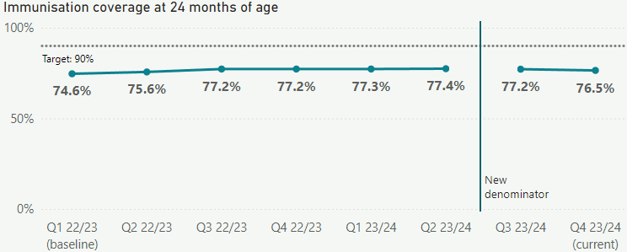

**Performance by region and population groups:** Immunisation rates for all ethnic groups and regions are below target and have declined slightly from the previous quarter.

During the quarter, we launched a social media marketing campaign to boost immunisation rates for Māori and Pacific children. Promotions featured on television, social media and in public places such as shopping malls, community centres, gyms and bus stops, and reached more than 91 per cent of parents of tamariki (based on modelling).

An initiative for community engagement involving Hauora Māori and Pacific health Providers to address vaccine hesitancy and promote informed choices for childhood vaccinations will run until September 2024.

We are also providing investment over two years to increase the number of vaccinations (including childhood vaccinations) that are provided by Hauora Māori partners.

A range of activities were carried out within regions to improve performance:

* A two-day wānanga in Auckland to support trainees to become qualified vaccinators.
* An immunisation status data sharing agreement with Whānau Manaaki kindergartens in the Central region progressed; to identify children who are not up to date with their immunisations and who are not enrolled with a GP so they can be contacted.
* Launch of a regional Pacific immunisation action plan for Te Manawa Taki which includes outreach provider clinics, vaccination events targeting children and families, the provision of vaccine fridges, mobile cold chain equipment, vehicles, and comprehensive training.

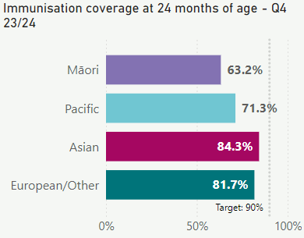 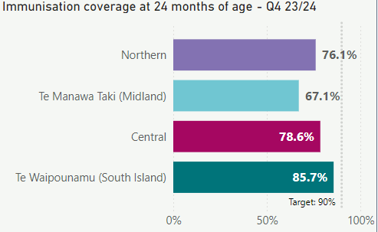

*Data source is the Aotearoa Immunisation Register (AIR).*

### 2 Shorter stays in Emergency Departments 🎯 Wellington Beehive coloring page Ê

**Overall performance:** People admitted, discharged or transferred from an emergency department (ED) within six hours increased slightly to 71.2 per cent between quarters three and four, and is similar to performance in quarter four 2022/23. Total performance remains below the baseline and well below the national target of 95 per cent.

Access to inpatient hospital beds has a significant impact on patient flow through, and length of stay, in ED. We are focused on improving flow through hospitals with improved processes to support discharge for patients with complex care and acute flow plans.

This quarter, we focused on improving discharge pathways for patients through the implementation of a complex discharge pathway in hospitals.

A national escalation framework was also implemented to enable visibility of hospital operational pressures including actions to support patient flow.

As this measure is a health target starting quarter one 2024/25, a national plan has been developed to support implementation.

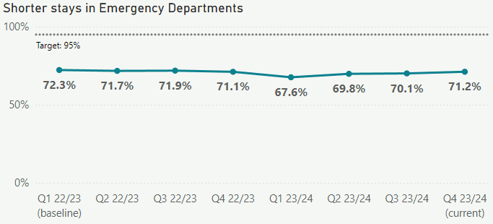

**Performance by region and population groups:** The proportion of people leaving ED within six hours for Māori and European/Other decreased slightly in quarter four. Regional rates decreased in Te Manawa Taki and Central regions. Performance drivers for length of stay in ED vary by location and include increased demand, availability of resources (beds and staff) and variability in acute flow practices.

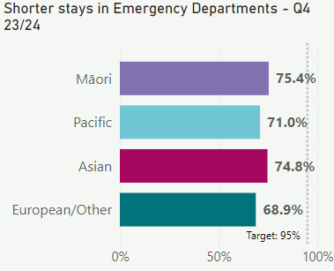 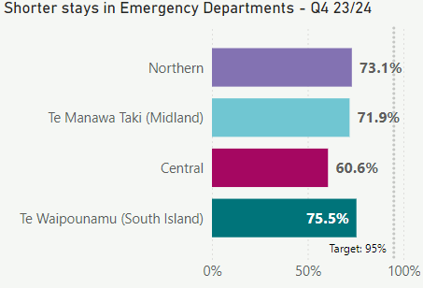

*Source of data is National Non-Admitted Patient Collection (NNPAC). In quarter four, three level two facilities (not publicly funded) were excluded from this measure. This change has been applied to the results of the previous quarter as published in this report and will continue to be applied in the future.*

### 3 People waiting more than four months for first specialist assessment (FSA) 🎯 Ê

**Overall performance:** There has been a decrease in the number of people waiting more than four months for a first specialist assessment (FSA) compared to quarter three. Over the last quarter, the total size of the waitlist grew by 1 per cent from 192,256 patients to 194,227.

In quarter four, we continued to develop initiatives that aim to improve waiting times for patients, including:

* Detailed health target implementation plans, focusing on actions to improve performance. These plans will be monitored within regions and via our national performance framework.
* A musculoskeletal pathway, to reduce the time people wait for an FSA and ensure they are on the most clinically appropriate pathway was prototyped in 12 locations. We worked with the New Zealand Orthopaedic Association, Physiotherapy New Zealand and other sector stakeholders to agree the national competencies for physiotherapists. This has included creating new ways to acknowledge the work done by allied health and nursing professions to provide FSAs within agreed national pathways and competencies.
* As part of our patient communication initiative, we contacted about 25,000 patients, focusing on those who have been waiting more than four months for surgery across four services, ophthalmology, orthopaedics, general surgery, and gynaecology. Through this process we identified around 3,000 patients (12 per cent) who were on the waitlist in error, mainly due to having already received their FSA. We are currently continuing to verify waitlists for FSAs in districts.
* In parallel, we developed an expected wait time dashboard. This information will be reported at a district and service level for urgent, semi-urgent and routine assessment and treatment, initially for primary care, from quarter one 2024/25.
* Outpatient models of care for districts and regions, focused on areas such as patient-directed (rather than automatic) follow-ups, virtual care and telehealth. Reducing unnecessary follow-ups, or delivering these in different ways, helps to create capacity within services to provide more timely access to FSAs.
* The draft national Planned Care Patient Pathway was released for consultation with a range of local, regional and national stakeholders, including the Ministry of Health, local and regional planned care leads, administrative teams, clinicians, and theatre and outpatient schedulers. This sets a national policy on FSA waitlist management, suspensions, missed appointments and a range of other operational business rules. Our goal is to have this policy agreed and ready for deployment from quarter two 2024/25.

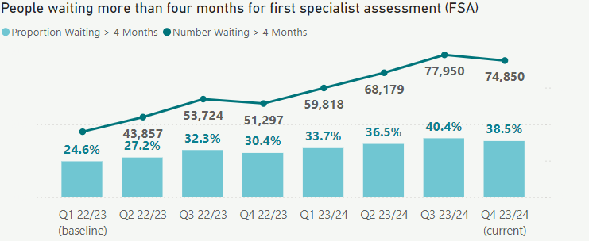

**Performance by region and population groups:** Regional results have slightly decreased compared to quarter three. Te Manawa Taki has the largest proportion of people waiting more than four months for FSA.

Population groups breakdown is not available for this measure.

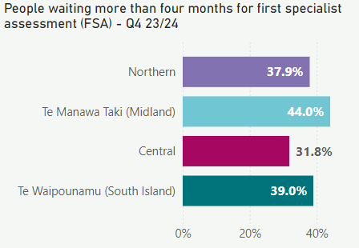

*Source of data is National Booking Reporting System KPI (NBRS KPI).*

### 4 People waiting more than four months for a procedure 🎯 Wellington Beehive coloring page Ê

**Overall performance:** As at the end of quarter four, 38.6 per cent of patients were waiting longer than four months following a commitment to treatment, an improvement of 3.7 percentage points from quarter three. The target is to get to 95 per cent being treated within four months. The reduction represents a drop of 1,519 people (4.7 per cent) between quarters three and four, though the total still remains higher than the same period in the previous year.

Over the quarter we have carried out a number of initiatives that aim to improve timely access to treatment:

* Deployed a national Theatre Metrics Dashboard to provide live operational data on theatre performance at a district and site level. This supports district and regional theatre performance improvement programmes to optimise our theatre capacity, including driving down late starts/early finishes and hospital-initiated day of surgery cancellations.
* Developed an expected wait time dashboard that includes elective treatment wait times.
* Established the national performance monitoring framework that covers performance down to a district and service level. This includes surgical performance such as theatre utilisation, FSA, treatment and diagnostics. Further developments through our national Rapid data platform, including the capability to report performance by ethnicity, rurality and deprivation are underway. This work will continue throughout 2024/25 as we work to bring together data from 20 different districts into a coherent national data set.
* Continued to progress the national harmonisation of access thresholds for cataract surgery, which is on track for completion by the target date of 31 December 2024. To support this, we have funded more than 3,000 additional cataract surgeries nationally and met our quarter four target for delivery.
* Outsourced to private providers to make the most of capacity across the whole system. We will continue to optimise this capacity through the next financial year.

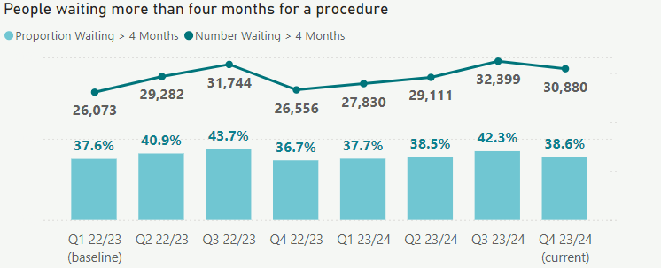

**Performance by region and population groups:** The number of people waiting more than four months for a procedure fell for all ethnicities and within all regions.

This quarter, we opened the new dedicated planned care surgical capacity with the launch of the Tōtara Haumaru site to support the Northern region and work to ring-fence elective and planned surgical capacity in sites such as Burwood Hospital. Work continues in developing the Counties Manukau Health Hub which will add further capacity in 2025.

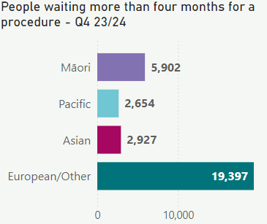 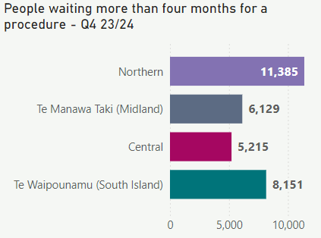

*Source of data is the National Booking Reporting System (NBRS). Data for Tairāwhiti has not been included in district-specific charts due to data issues. This will have a small effect on quarter four results, which will differ from validated numbers for quarter four results when annual report is published.*

### 5 Cancer patients waiting less than 31 days for first treatment 🎯 Ê

**Overall performance:** This quarter, the proportion of eligible cancer patients who received their first treatment within 31 days of a health professional’s decision to treat, increased by 0.8 percentage points to 83.5 per cent, just 1.5 per cent below the target of 85 per cent.

In response to the Government’s New Medicine Initiative, a national implementation programme with Te Aho o Te Kahu will ensure timely delivery of and access to new medicines. The programme builds new capacity and focuses on the movement of care to periphery and community sites.

Work is progressing with the faecal immunochemical test (FIT) for the colonoscopy symptomatic pathway with implementation in early 2025.  The aim of the pathway is to ensure patients are prioritised for treatment appropriately.

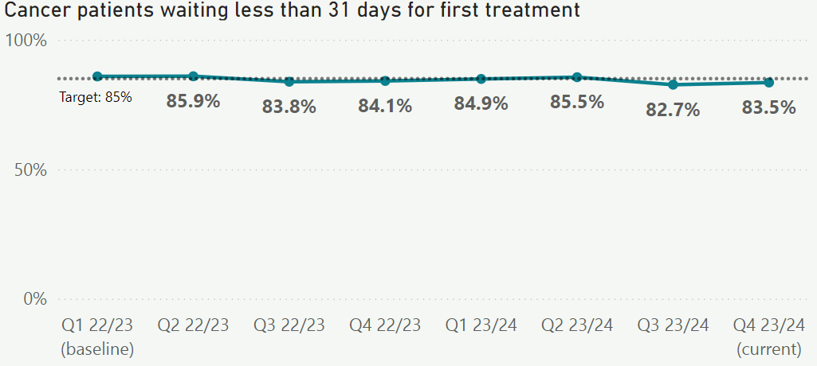

**Performance by region and population groups:** Pacific Peoples and Asian had a slight decrease in access timeliness compared to quarter three, while Māori and European/Other had a slight improvement. Northern, Central and Te Waipounamu improved their performance, while Te Manawa Taki remained stable compared to quarter three.

Service improvement plans are in place across the regions and districts to provide timely access to care and reduce access inequities, this includes a focus on specific tumour stream groups such as breast, lung, gynaecology and urology and treatment modalities including radiation oncology, surgery and medical oncology.

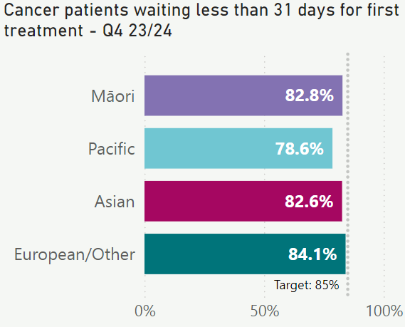 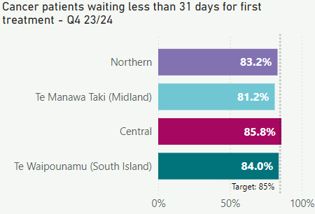

*Source of data is faster cancer treatment data (FCT). District results are accurate as populated in clinical systems. Some districts are still updating June entries. Validated numbers for Q4 results will be updated in the annual report when it is published.*

### 6 Newborn enrolments

**Overall performance:** Newborn enrolment rates with a general practice / primary health organisation increased 1.9 percentage points to 88.1 per cent over the last quarter and are now 3.1 per cent above the target of 85 per cent. The newborn enrolment service notification system (established in late 2023) has provided more timely notifications to general practice teams for newborns where parents have a known general practice.

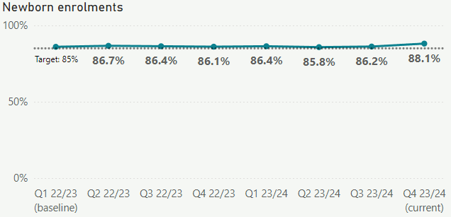

**Performance by region and population groups:** Enrolments for Māori and Pacific Peoples are currently below the national average. A range of initiatives are underway to support newborn enrolment for Māori and Pacific Peoples, including changes to the Primary Health Organisation Services Agreement to extend the provisional enrolment period for newborns from three months to 12 months, clarification that a birth certificate is not required for full enrolment of a newborn, and more timely reporting from the National Enrolment Service[2] about the number of newborns enrolled across all ethnicities, to enable targeted improvement initiatives.

These shifts will allow more time for providers to work together to support families who may have difficulty in accessing general practice services. Additionally, the Hauora Māori Advisory Committee have identified newborn enrolments as one of the key measures of Māori health that they will be monitoring. This measure is included as part of their focus on māmā and pēpi receiving consistent quality care during pregnancy and into the early years.

Newborn enrolment rates within all regions are above target, with Te Waipounamu well above national average performance at 92.8 per cent.

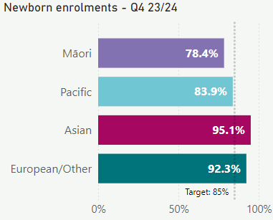 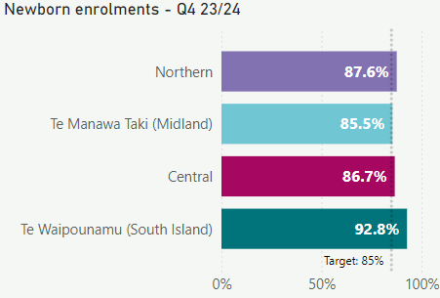

*Source of data is Primary Health Organisations enrolments (numerator) and National Health Index system for all New Zealand births (denominator). Note this measure used a different method of calculation to previous methods.*

### 7 Primary care enrolment

**Overall performance:** Primary care enrolment remained stable between quarters three and four, at 94.4 per cent. Enrolment rates are slightly below the target of 95 per cent. The health system continues to achieve high rates of patient enrolment.

Primary care capacity continues to be constrained due to workforce and resourcing, resulting in some practices being unable to enrol new patients. To help address this, we have provided a 5.88 per cent total revenue uplift for primary care, for the 2024/25 financial year.

General practice also received an increase from the nurse pay parity payment ($31 million) and equity adjustor ($22 million) in 2023, which are both ongoing Budget 22 initiatives.

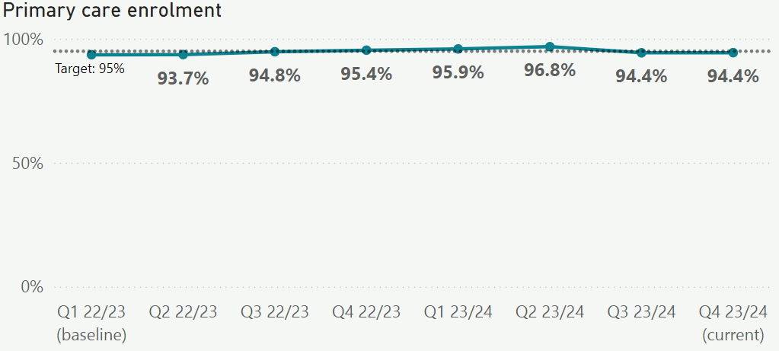

**Performance by region and population groups:** Regional results have also remained stable compared to quarter three. Enrolment rates for Māori and Pacific Peoples slightly increased compared to last quarter. However, Māori remain below the national average, and the 95 per cent target.

To improve our understanding of Māori under-enrolment, we are working on a nationally consistent approach to quantify the number of general practice locations with closed books in real-time by the end of quarter one 2024/25.

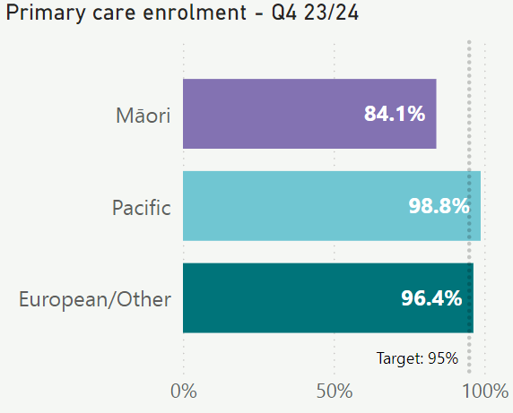 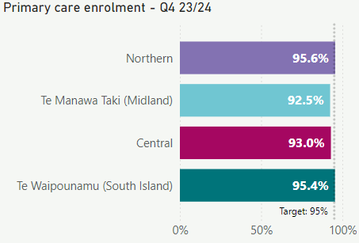

*Source of data is the National Enrolment System (NES). Denominator is Stats NZ estimated resident population. This metric is not yet available with an ethnicity breakdown for Asian people.*

### 8 Involvement in care decisions – primary care

**Overall performance:** This measure looks at the percentage of people who felt involved in decisions made by their GP or nurse about their treatment and care,with the results in quarter four showing a slight increase, to the highest it has been since baseline (quarter one 2022/23). There has been continuous improvement, despite capacity constraints within general practice, reflecting the quality of care provided by this workforce.

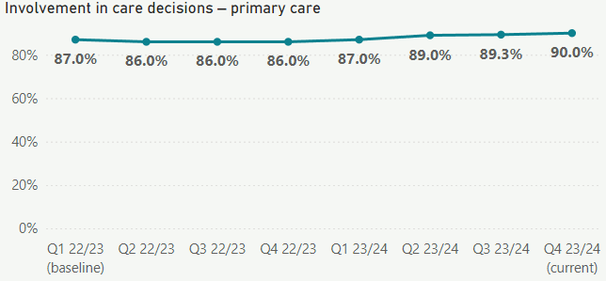

**Performance by region and population groups:** Performance in this measure improved across all ethnic groups and most regions compared to quarter three 2023/24. Māori and Pacific Peoples have slightly lower perceptions of involvement compared to European/Other, but the trend remains positive over time for Māori and Pacific Peoples in line with the total population result.

Work continues with primary care to focus on culturally appropriate approaches to support practice staff. In addition to local activities, there has been targeted workforce development funding to support team-based cultural competency practice alongside the establishment of comprehensive primary care teams. Northern, Te Manawa Taki and Central regions had an uplift in their rates compared to quarter three. Te Waipounamu remained stable compared to quarter three.

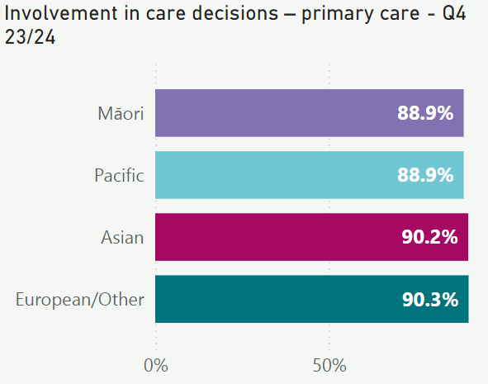 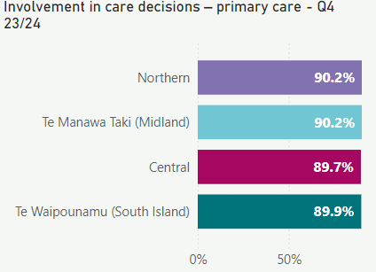

*Source of data is the adult primary care patient experience survey from HQSC. Results are based on weighted data. This measure is monitored for patient experience trends; there is no official target.*

### 9 Ambulatory sensitive hospitalisations rates 0-4 years Ê

**Overall performance:** This measure looks at hospitalisation rates (per 100,000) for children (under five years old) for an illness that might have been prevented or better managed in a community setting.Quarter four 2023/24 saw a 6.5 per cent decrease in hospitalisation rates compared to the same time last year. Primary care initiatives through primary health organisations and regional programmes help reduce the risk of hospitalisations.

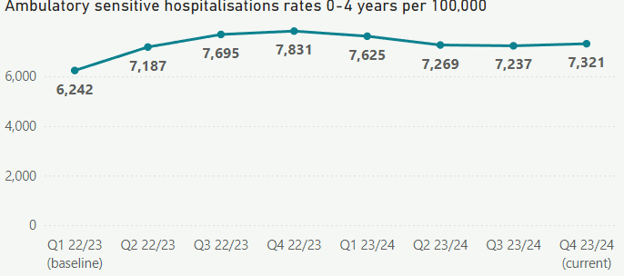

**Performance by region and population groups:** The rates for Māori and Pacific Peoples remain higher than other ethnicities and the national rate (per 100,000). The Northern region has the highest rates. However, rates have decreased slightly for both Northern and Te Waipounamu compared to quarter three.

There is clear evidence that primary care is under capacity pressure, which has a flow on effect to this measure. Newborn enrolment rates improved across all areas to promote children's well-being within the community. This quarter, our focus remained on assessing the capacities of general practice, optimising the patient flow between primary care and hospitals, and strategically investing in primary care solutions for acute conditions.

An oral health promotion initiative delivered toothbrushes and toothpaste to preschoolers and their whānau across the country through Well Child Tamariki Ora providers. Local-led initiatives included better pathways for children with respiratory conditions, promoting six-week best start checks and follow up of children post admission.

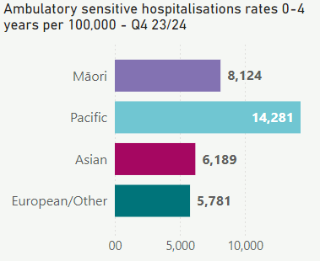 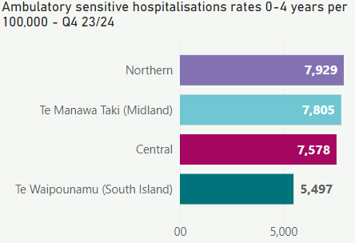

*Source of data is the National Minimum Data Set (NMDS). Denominator is Stats NZ estimated resident population.*

### 10 Ambulatory sensitive hospitalisations rates 45-64 years Ê

**Overall performance:** This measure looks at hospitalisation rates (per 100,000) for adults for an illness that might have been prevented or better managed in a community setting.The rate of hospitalisations for 45 to 64 year-olds was stable in quarter four.

Nationally, there was a 3.4 per cent increase in general practice qualifying encounters (GPQEDs) over the quarter. Similarly, GPQED volumes for Māori are 3.2 per cent higher for the quarter.[3]

Primary care services are focused on providing better support for acute and proactive care in the community. The key area of focus is better management of long-term conditions, which contribute to these admissions.

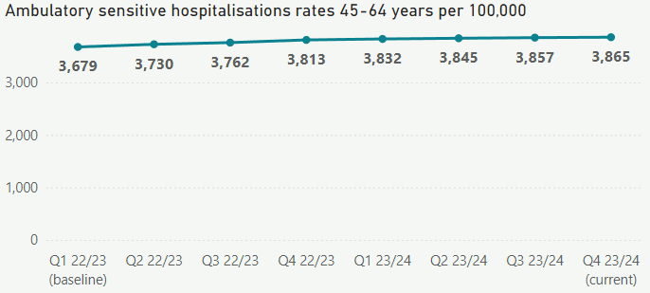

**Performance by region and population groups:** Hospitalisation rates (per 100,000) for Māori and Pacific Peoples remain higher when compared to other populations. Asians have the lowest rates when compared to all other population groups. Te Waipounamu has the lowest rate of ambulatory sensitive hospitalisations for people aged 45 to 64 years old.

Regional initiatives underway include:

* the development of regional clinical dashboards to help with cardiovascular disease management and diabetes
* health coaches to focus on healthy eating, physical activity, medication adherence and supporting people to understand their condition
* the development of proactive care plans for those with complex health issues.

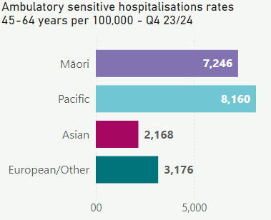 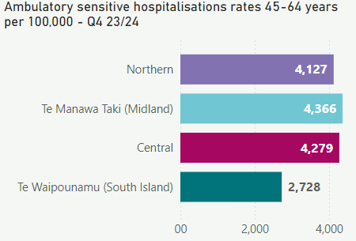

*Source of data is National Minimum Data Set (NMDS). Denominator is Stats NZ estimated resident population.*

### 11 Access to primary mental health and addiction services

**Overall performance:** Use of Access and Choice primary mental health and addiction services increased by 11.6 per cent compared to quarter three. The increase reflects ongoing work to implement and promote the services to support more people, as well as seasonal trends following a decrease in demand in January 2024 (quarter three).

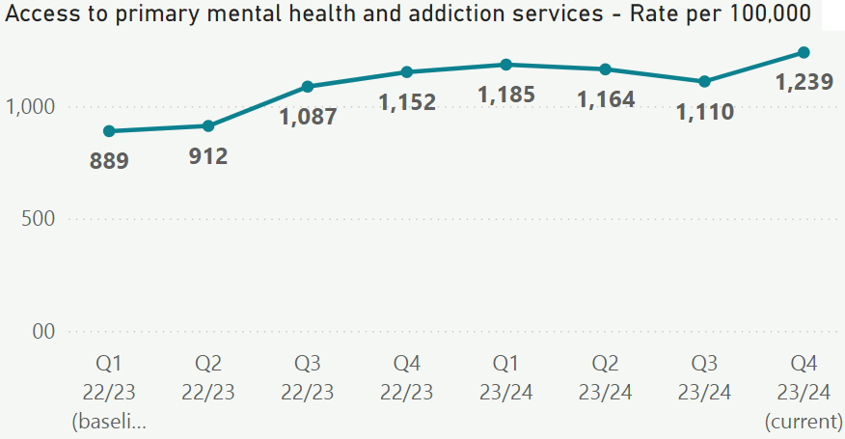

**Performance by region and population groups:** The access rates for Māori and Pacific Peoples are higher than for other ethnicities.Access rates for all ethnic groups increased between quarters three and four.

Performance by region is not available for this measure.

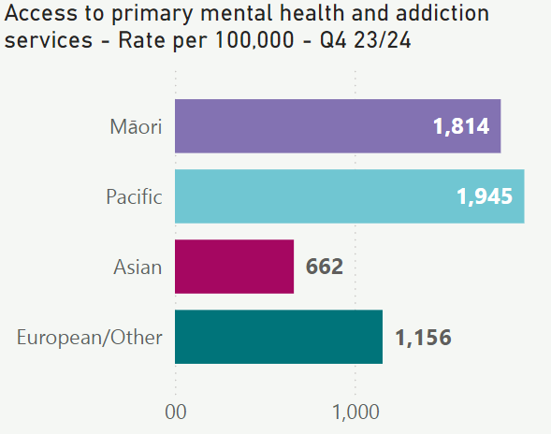

*Source of data is Access and Choice System and Stats NZ Estimated resident population. Results are presented as a rate per 100,000 population.*

### 12 Access rates for specialist mental health services

**Overall performance:** Quarter four saw a 2.1 per cent increase in access rates for specialist mental health services compared to quarter three. While there has been an improvement in performance, access rates remain lower than the baseline in 2022/23.

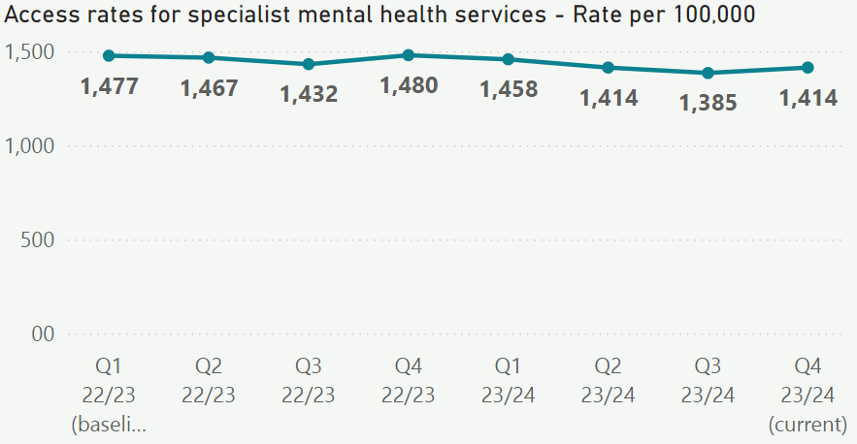

**Performance by region and population groups:** Access rates have increased for all populations in comparison to quarter three and in line with the national rate increase above. However, access rates for Māori remain significantly higher than the national rate, while rates for Asian populations remain significantly lower. These access rates reflect referrals to specialist mental health services based on need.

There is a wide range of initiatives to integrate Kaupapa Māori approaches into the models of care of specialist mental health services. The initiatives will vary at the district level depending on the needs of local communities.

We continue to face significant workforce and inpatient capacity challenges impacting access to specialist mental health and addiction services. Over the last two quarters, we have been working to improve recruitment, particularly in nursing vacancies. This may have had an influence on the improvement in the measure.

Performance by region is not available for this measure.

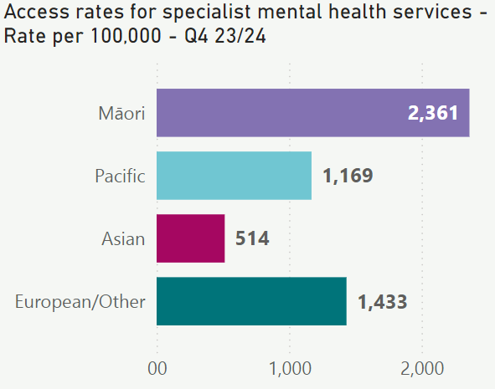

*Source of data is the Programme for the Integration of Mental Health Data (PRIMHD) and Stats NZ estimated resident population. With effect from July 2023, the data presented for this measure will include updated PRIMHD data for the two latest 12-month periods, ending with the relevant quarter. Previously published data has been removed and replaced with the latest information. This measure is monitored for an improvement from baseline (trend to increase).*

### 13 Mental health wait times for under 25-year-olds Ê

**Overall performance:** Quarter four saw a 4 percentage point improvement in wait times for under 25-year-olds seen by mental health services compared to the same quarter last year.

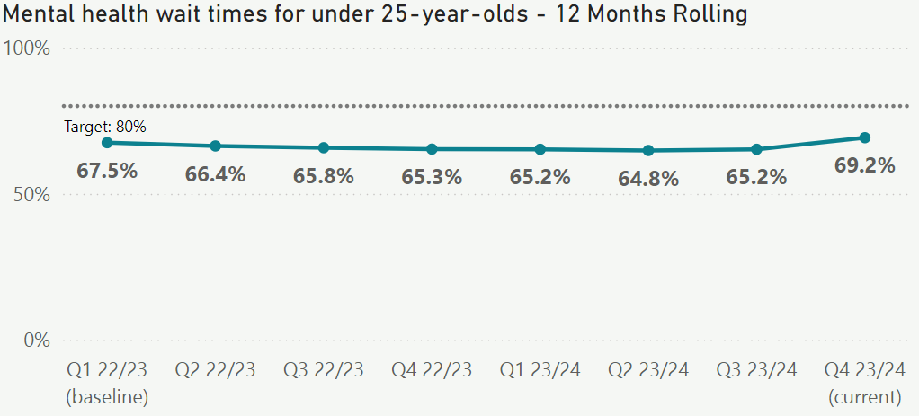

**Performance by region and population groups:** Performance increased across all ethnicities, with Pacific Peoples very close to meeting the target of 80 per cent. Northern was the only region to increase its performance with a significant increase from 64.7 per cent to 68.4 per cent. All other regions have slightly reduced rates of meeting the ‘within-three-weeks’ threshold in quarter four compared to quarter three. Workforce vacancies are the major limiting factor in improving performance in this measure.

The 2024-27 Health Workforce Plan has a dedicated mental health and addiction focus and the national target to train 500 mental health and addictions professionals each year, will support improvement in performance in this measure.

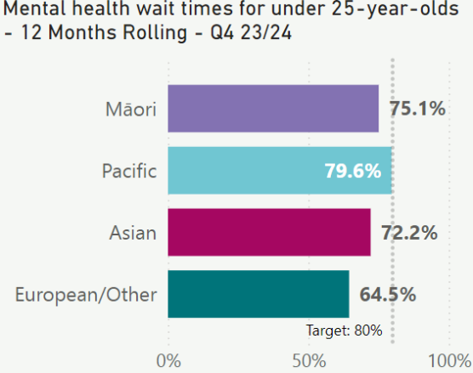 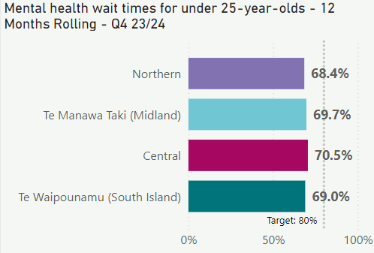

*Source of data is Programme for the Integration of Mental Health Data (PRIMHD). With effect from July 2023, the data presented for this measure will include updated PRIMHD data for the two latest 12-month periods, ending with the relevant quarter. Previously published data has been removed and replaced with the latest information. Measure presented as a rolling 12 months to the quarter.*

*A data quality issue affecting 2-3 per cent of Canterbury records was uncovered during an audit, impacting the ‘Mental health wait times for under 25-year-olds’ measure. However, the impact on the quarter four results is minimal. The validated numbers in our 2023/24 annual report may differ slightly.*

### 14 Emergency Department presentations Ê

**Overall performance:** In quarter four 348,165 people presented to an ED, which is a 4.9 per cent increase compared to the same time last year.

Initiatives to alleviate pressure on EDs include:

* investment of $17 million (1 January 2024 - 30 June 2025) in urgent care to stabilise opening hours and reduce the number of unplanned closures.
* ongoing implementation of Ka Ora telehealth service as an additional source of advice and primary care for rural patients in urgent need.

Total number of patients presenting are rising over time in all triage levels.[4] However, triage level four (potentially serious) and level five (less urgent) patient presentations continue to decline as a proportion of overall presentations. Triage four and five events can often be managed in primary care. This trend shows that primary care services remain responsive to patient need despite workforce and other challenges.

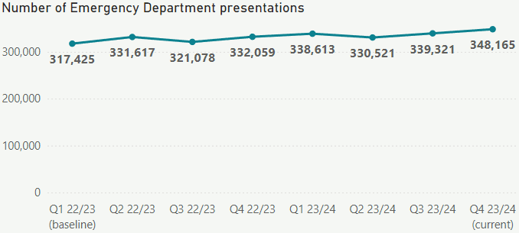

**Performance by region and population groups:** ED presentations increased across ethnic groups and regions compared to quarter three 2023/24. Europeans have the highest number of ED presentations, proportionate to their population size.

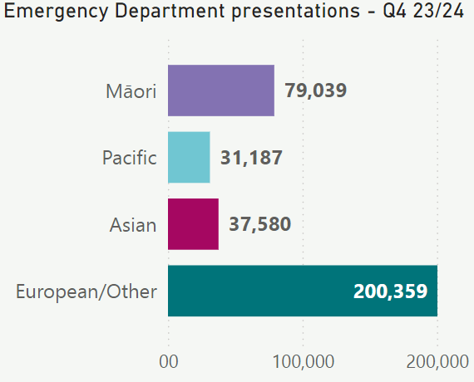 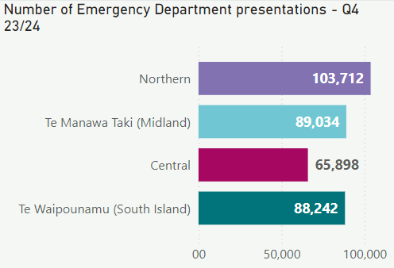

*Source of data is the National Non-Admitted Patient Collection (NNPAC).*

### 15 Admissions from Emergency Departments Ê

**Overall performance:** There was a slight increase in people admitted to a hospital ward from an ED between quarters three and four.

As ED presentations continue to rise, patients requiring admission to the hospital also rises (although this has remained stable as a proportion of total presentations). Health NZ continues to focus on ensuring supportive and accessible primary, urgent and after-hours care.

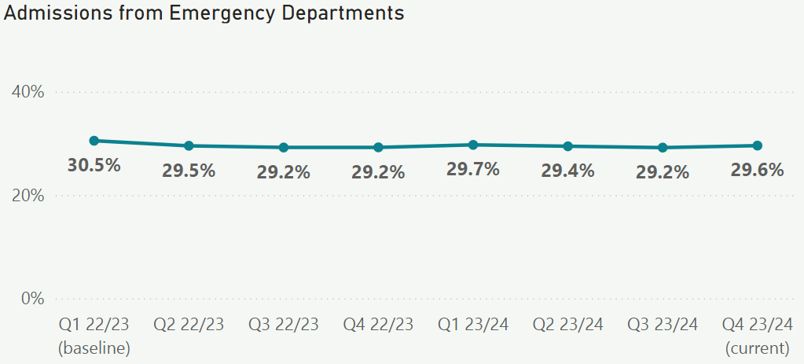

**Performance by region and population groups:** The admission rates are higher for European/Other compared to Māori, Pacific Peoples and Asian populations. This may be because European/Other have a higher proportion of older people compared to other ethnic groups. Te Manawa Taki and the Northern Region have higher admission rates compared to other areas.

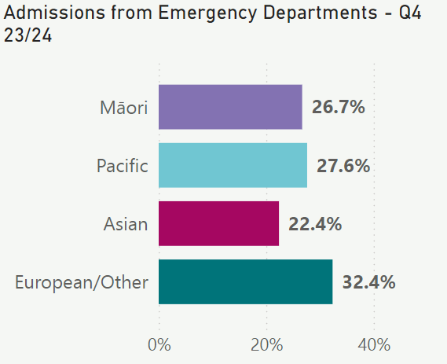 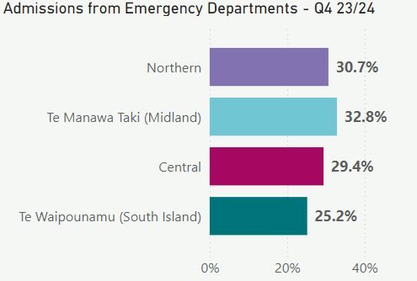

*Source of data is the National Non-Admitted Patient Collection (NNPAC).*

### 16 Acute bed days per capita Ê

**Overall performance:**  The acute bed day rate increased by 1.4 per cent compared to quarter three.

Over time, patients presenting to hospitals have become more complex and unwell due to an aging population. This means they often need longer hospital stays and more community support on discharge.  During periods of surge, hospitals continue to provide care by opening flex beds.  Every winter, hospitals have actions in place to support an increase in winter illness. In quarter four, the system pressures plan was put in place with a focus on timely access to care and safe discharge.

The system pressures plan had three focus areas designed to improve the patient journey through the health care system:

* **Prevention:** initiatives focused on encouraging people to take preventative measures, such as keeping up to date with immunisations;
* **Community:** emphasising the provision of alternate healthcare options like Healthline;
* **Emergency departments and hospitals:** improving patient flow and each person’s journey through hospital.

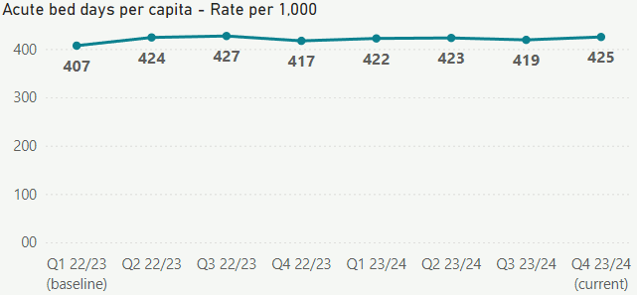

**Performance by region and population groups:** The acute bed days rate slightly increased in quarter four for Māori but dropped for Pacific Peoples.

Performance by region is not available for this measure.­­

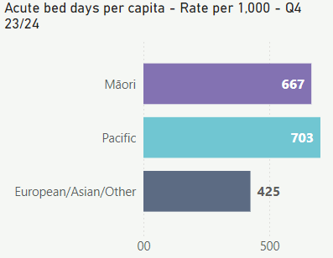

*Source of data is National Minimum Data Set (NMDS) and Stats NZ estimated resident population. Results are presented as the number of bed days for acute hospital stays per 100,000 population, age standardised for a rolling year.*

### 17 Inpatient length of stay >7 days

**Overall performance:** Inpatient lengths of stay greater than seven days has remained stable between quarters three and four.

Long inpatient stays are an indicator of system performance in relation to hospital flow, impacted by complexity, aging and, in some areas, delays in discharge caused by lack of access to suitable community or residential care facilities.

A complex discharge escalation pathway was implemented in quarter four. Patients with a length of stay over seven days are reported daily with regular review to remove barriers to discharge.

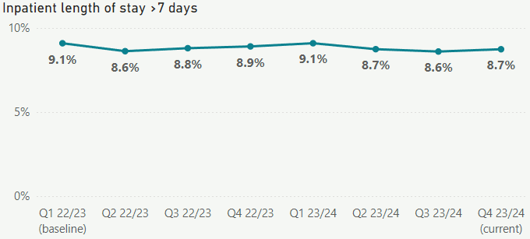

**Performance by region and population groups:** Long-stay rates were highest in the Northern region. Most rates for ethnicities and regions remained stable, except for European/Other, Central and Te Waipounamu which all increased since quarter three. Winter illness affects our very young and older populations, impacting on length of stay because these patients often require longer and more complex care.

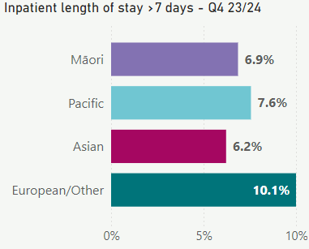 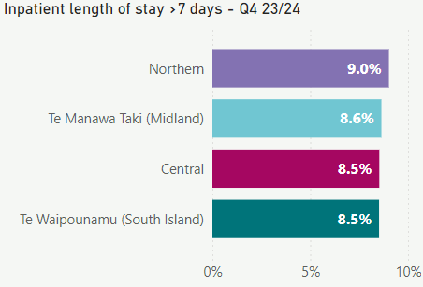

*Source of data is the National Minimum Data Set (NMDS). Results are presented as a percentage of acute discharges after more than seven nights in medical or surgical specialties, divided by all acute discharges in medical or surgical specialties.*

### 18 Involvement in care decisions – in hospital

**Overall performance:** The proportion of people in hospital reporting involvement in decisions about their care for quarter four is 80.2 per cent, which is an increase of 4.2 percentage points compared to baseline in quarter one 2022/23. There was a slight decrease between quarters three and four. A similar trend was identified in the previous year indicating potential impact of the beginning of the winter demand period in quarter four.

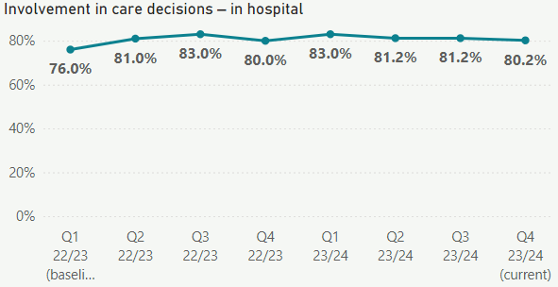

**Performance by region and population groups:** There is only a 2.2 per cent variation among the four regions, demonstrating that national performance is steady and our hospital staff continue to actively involve patients and whānau in decisions about their care.

Over the last quarter, experience in decision making for Māori increased by 3.2 percentage points, while experience for Pacific Peoples decreased by 5.7 percentage points (although based on a relatively small sample).

Improvement is likely driven by a range of initiatives that create a better experience for hospitalised Māori patients and their whānau.

We have been testing a talanoa based patient experience tool in some regions to supplement insights from the Health Quality and Safety Commission (HQSC) quarterly inpatient surveys with more detailed narrative around the experience of Pacific Peoples and their families to drive improvements.

In quarter four, we established an advisory group to support the development of a National Whānau Feedback and Insights Framework with the HQSC and consumer representatives. This aims to improve staff capability around using whānau voice to inform improvements. Over time this should see less variation between different populations and their involvement in health care decision making.

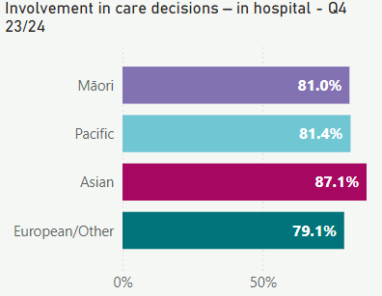 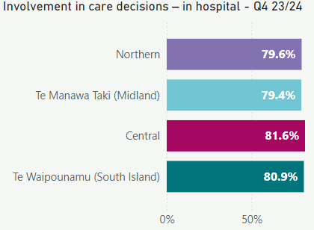

*Source of data is the HQSC Adult Hospital Inpatient Experience Survey. Results are based on weighted data.*

### 19 People waiting more than 365 days for a procedure Ê

**Overall performance:** As at the end of quarter four there were 2,930 people waiting longer than 365 days for elective treatment, compared with 4,279 at the same time last year. Between quarters three and four 2023/24, the percentage of patients waiting more than 365 days is relatively stable; although the actual number of patients waiting more than 365 days increased.

We did not see a reduction between quarters in part due to sustained industrial action, where routine planned care needed to be deferred as care was prioritised for urgent and non-deferrable care. Higher acute presentations and hospital occupancy over the quarter have also impacted planned care.

Our goal is to have no patients waiting longer than 365 days for planned treatment by 30 June 2025. Each district continues to focus on reducing the number of long-waiting patients, and progress will be actively monitored at a district and service level as part of district and regional performance monitoring.

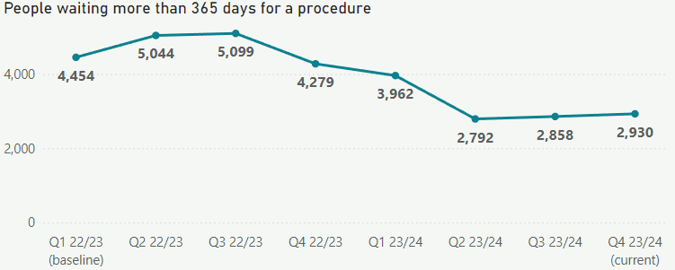

**Performance by region and population groups:** A larger proportion of Māori is waiting more than 365 days for a procedure compared to other ethnic groups. Northern region has the lowest rates of people waiting more than 365 days for a procedure, which is reflective of services available in the region, while Te Waipounamu has the highest rates. There has been a decrease in people waiting more than 365 days between quarters three and four in Te Waipounamu.

Improved consistency of booking processes and waitlist management business rules are to be implemented by each district as part of health target plans.

The commissioning of elective sites such as Tōtara Haumaru in quarter four enables the Northern region to better coordinate care for long-waiting patients, and also releases capacity in other regional sites that can be used to provide services.

In Te Waipounamu, we are focused on reducing waiting times for services with the highest number of patients waiting more than 365 days, such as ear, nose and throat (otolaryngology) and orthopaedics.

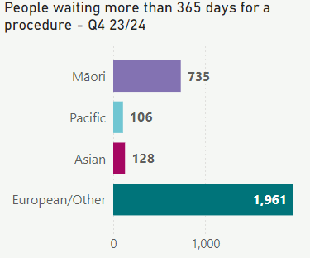 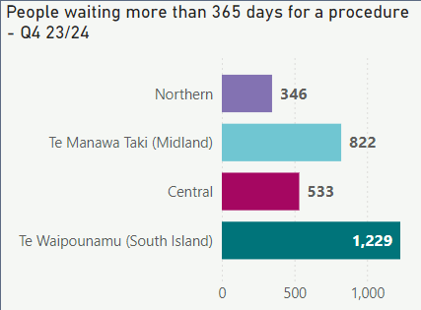

*Source of data is the National Booking Reporting System (NBRS). Results for Tairawhiti and Hawke’s Bay districts are not validated for quarter four. These districts are omitted from district-specific charts but included in ethnicity and region charts; otherwise, results would be understated rather than likely slightly overstated.*

### 20 Medical appointments through digital channels

**Overall performance:** The number of hospital outpatient medical appointments through telephone or video slightly increased in quarter four.

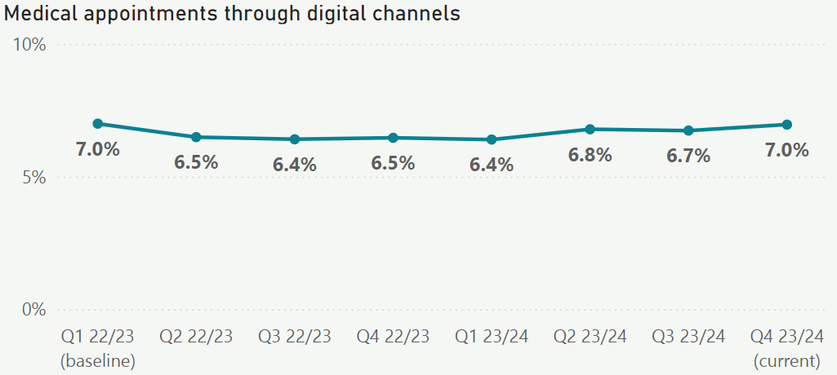

**Performance by region and population groups:** Medical appointments through digital channels are lower for Pacific Peoples than other ethnic groups. Te Waipounamu has the highest proportion of medical appointments through digital channels compared to other regions.

Each district is to include increasing delivery of care through virtual and telehealth modes that will be monitored through regional and national performance frameworks. The goal is for each district to deliver at least 10 per cent of care through digital channels by quarter four 2024/25.

This is a particular area of opportunity in regions where there is a larger rural population such as Te Waipounamu. This is an important step in bringing care closer to home, delivered in a way that works better for our communities.

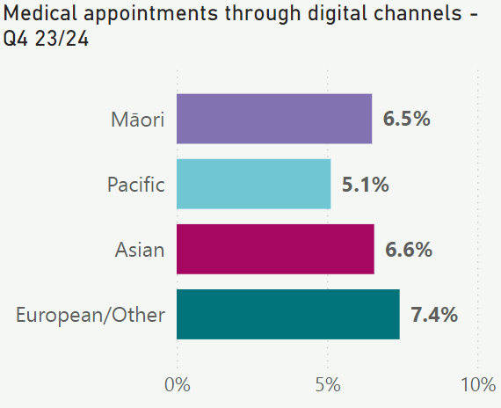 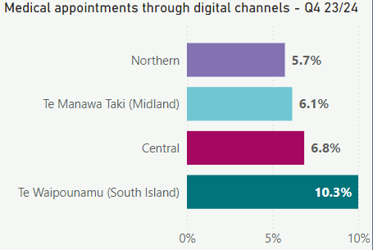

*Source of the data is the National Non-Admitted Patient Collection (NNPAC).*

### 21 Missed appointments

**Overall performance:** The national rates for people who did not attend or did not wait for FSAs or follow-ups was 7.2 per cent in quarter four, a reduction of 0.2 percentage points from quarter three.

While impacting the delivery and timeliness of care for the patient, a missed appointment also represents capacity that has been resourced but unused, which impacts everyone’s ability to access timely first specialist appointments. Reducing missed appointments is a key factor in optimising our clinic capacity and meeting the first specialist assessment health target.

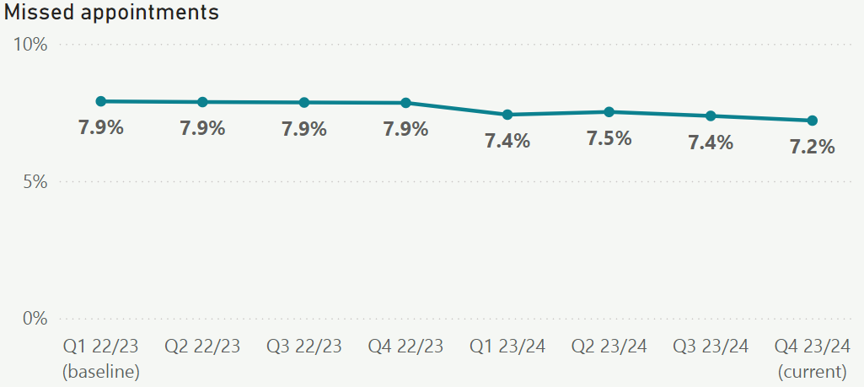

**Performance by region and population groups:** Te Waipounamu, Te Manawa Taki and Central region saw a slight decline in quarter four compared to quarter three. There was a slight increase for Northern.

Missed appointments are highest for Māori and Pacific Peoples.

There are some good examples of cultural support and navigation services that are operational in each region. Contacting patients using multi-channel communications (text, phone calls, letters and email) is routine practice. However, individual contact with patients to understand their needs and what support can be provided is a key part of reducing missed appointments and work is happening in this area.

For the Northern region, examples include Kaiārahi Nāhi and Pacific Health navigation teams, which provide a coordinated approach to support patients’ attendance at FSA. This focuses on a streamlined referral process, timely appointment scheduling, patient-centred navigation, cultural and language support and travel assistance.

In Te Manawa Taki, initiatives underway include contacting patients to understand their need for transport to appointments, their preferred method of communication and the date of their appointment. If the patient lives further way, follow-up appointments via phone consultation are considered.

In the Central region, examples include early follow up, coordination and navigation support for vulnerable patients with high rates of missed appointments and multiple comorbidities. There is work underway in the Hawkes Bay to develop a pre-operative process to provide education and cultural support to Pacific Peoples through talanoa.

In Te Waipounamu, WellSouth Pou Manaaki team contact Māori and Pacific patients prior to their appointments to confirm attendance and offer assistance (such as travel support) as required.

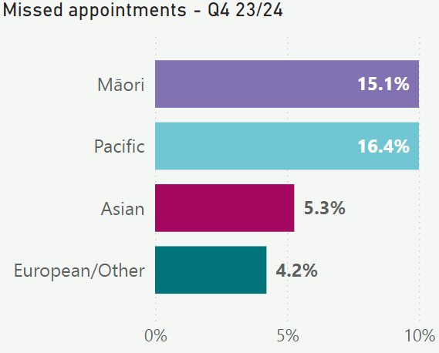 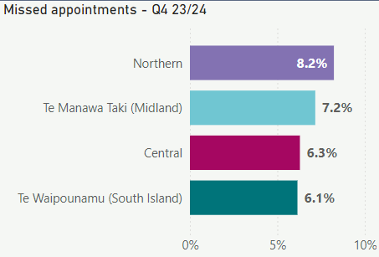

*Source of data is the National Non-Admitted Patient Collection (NNPAC).*

### 22 Delivery of planned care interventions

**Overall performance:** Quarter four has experienced an uptick of 0.7 per cent in the delivery of planned care interventions, compared to quarter four 2022/23.

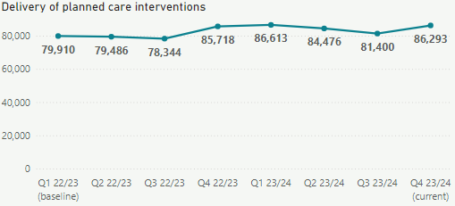

**Performance by region and population groups:** The delivery of planned care interventions increased for all ethnicities, and within all regions between quarters three and four.

Districts and regions continue to work to increase planned care delivery through better waitlist management, operational processes and improved theatre utilisation.

Improved visibility of performance at a district and service-specific level that is regionally and nationally monitored has driven improved performance over this quarter. Additional investment in planned care has enabled outsourcing for services such as orthopaedics and ophthalmology (e.g. hips and knees, cataracts) which has contributed to this uplift in delivery.

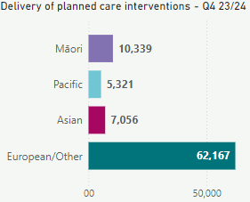 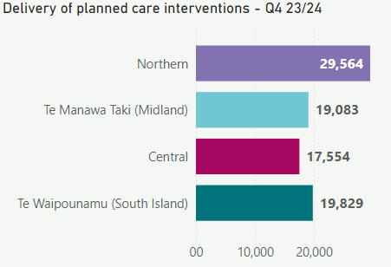

*Source of data is the National Minimum Data Set (NMDS) and the National Non-Admitted Patient Collection (NNPAC).*

## Achievement against the New Zealand Health Plan

The Interim New Zealand Health Plan | Te Pae Tata 2022-2024 outlines our actions to prioritise people and families in healthcare, improve health outcomes, promote equity, and organise effective health services. Te Pae Tata consists of 187 actions, each with milestones, summarised below:

|  |  |  |  |  |
| --- | --- | --- | --- | --- |
| Sections | Total Actions | Actions Stopped# | Actions Late* | Actions Completed |
| People and whānau at the heart of health | 24 | 2 | 2 | 20 |
| Improving health outcomes and equity | 39 | 3 | 16 | 20 |
| A unified health system | 63 | 3 | 18 | 42 |
| Priority populations | 61 | 5 | 14 | 42 |
| **Total** | **187** | **13** | **50** | **124** |

# Stopped: Actions stopped as they were deemed no longer required during the year.

* Late: actions not delivered as at 30 June 2024, but are expected to be completed subsequently.

This quarterly report presents a focused update on the progress of Te Pae Tata. We highlight and provide updates on specific actions where significant progress has been made during the quarter.

Our quarterly reporting will be complemented by a comprehensive annual report that will provide an overview of all 187 actions, offering an audited account of our yearly progress over the 2022-2024 period.

As we transition from Te Pae Tata towards the upcoming NZ Health Plan 2024-2027 (in development), our quarterly reporting will undergo significant changes. Once the NZ Health Plan is finalised and implemented, our quarterly reports will provide updates on its strategic priorities aligned to output class, outlined in our Statement of Performance Expectations.

### 2.1 People and whānau at the heart of health

We want to build a system that is always thinking about the people and whānau it serves ensuring that the delivery of health services works for them and improves health outcomes. This means we need to ensure people participate in the design and delivery of care that supports them to live well in their communities.

#### 2.1.1 Valuing the voices of consumers and whānau

We completed a number of activities this quarter to ensure we are listening to the people and engaging consistently with diverse communities:

* Appointed consumers to regional consumer councils. These councils started operating from 1 July 2024 and provide a consistent pathway for consumer feedback across the four regions of Health NZ. The appointees are diverse, representing a range of ethnicities and a broad geographical spread.
* Established a Rainbow Expert Advisory Group and purchased a platform to gather insights from Takatāpui, Rainbow and MVPFAFF+ communities.
* Established an advisory group to support a National Whānau Feedback and Insights Framework. The framework will facilitate the collection and monitoring of consumer and whānau experiences and provide national guidance for best practice in using feedback and engaging with consumers. The group comprises consumer and Health NZ representatives and key external stakeholders.
* Enrolled 4,291 new applicants between January and June 2024 in our culturally and linguistically diverse training programme, an increase of 733 enrolments compared to the previous six months. This indicates more staff are aware of the importance of cross-cultural practice, and the programme will help them improve the way they provide healthcare services for culturally and linguistically diverse communities.

To ensure people have more influence over how we plan and design services, and shape the care available to them locally, we did the following:

* Successfully launched four community-driven models of care (CDMC) that provide gender-affirming services in Hawke’s Bay, Auckland, and the Wellington and Whanganui region. One CDMC is delivering care virtually to the entire country. Workforce development programmes have been implemented within primary care with 284 attendees so far and a further 170 requesting training.
* Increased reimbursement for mileage and accommodation, and introduced easier email claiming options, for the national travel scheme. We expect around 4,500 New Zealanders to benefit each year as a result of changes to the scheme. This is crucial support for people who need to travel long distances, or frequently, to access care. The changes will be particularly beneficial to rural communities, and the one in four Māori living in rural communities who often have to travel to access hospital and specialist services.

#### 2.1.2 Strengthening workforce whānau

Our health workforce is highly capable and dedicated. We face challenges as our workforce experiences increasing strain. We’ve taken a number of steps this quarter to ensure we grow, nurture and develop a diverse workforce that feels valued and chooses health care as a lifelong career.

* We continued to grow our nursing workforce. Since Health NZ began in July 2022, our number of nursing employed full-time equivalents (FTE) has increased by around 12 per cent. We currently employ more than 29,000 nursing FTE (compared with 25,863 in June 2022). There are indications this growth has had a positive effect through reduced overtime hours and increased uptake of annual leave. We also have a record number of midwifery FTE employed, and we continue to see growth in other key clinical workforces.
* Our International Recruitment Centre continues to address immediate pressures with recruiting into hard-to-fill specialist roles. From November 2022 (when the campaign was launched) to the end of June 2024, the centre received 13,075 expressions of interest, with 971 health professionals employed (a 7.4 per cent conversion rate). Campaigns active in the quarter were for critical care, radiation therapy, radiology, anaesthetic technicians, senior medical officers, psychiatrists, radiation oncologists, resident medical officers, sonography, pharmacists and mental health clinical staff.
* During the quarter, we evaluated the effectiveness of the increased security personnel we put in place over the summer. With 423 incidents attended by the additional security personnel, when adjusted to exclude Auckland,[5] the national rate of incidents reduced compared to the same period last year.
* Continued additional security at eight of our highest-risk emergency departments: Dunedin, Christchurch, Wellington, Waikato, Middlemore, Auckland, Waitakere and North Shore. The May 2024 Budget announcement included significant investment to make hospitals safer for staff and patients, which will enable continued increased security across the motu and will inform the development of our national security roadmap.
* We continued to train frontline staff in situational awareness and de-escalation to support them handling violent behaviour. Since December 2023**,** almost 20,000 frontline staff have completed training. We are on track to meet our target of 33,000 frontline staff trained by 31 October 2024.
* Received 175 applications for a one-off grant for rurally-based people wanting to study towards a healthcare qualification, provided by Rural Women New Zealand | Ngā Wahine Taiwhenua o Aotearoa, with our support. Grants range from $2,500 to $5,000, from a total pool of $90,000. These grants are to grow the rural health workforce and improve healthcare in rural communities.
* Received 984 registrations of interest for the 2024 Voluntary Bonding Scheme. The scheme offers financial incentives to newly-qualified health professionals to work in the communities and specialties that need them most. Registrations received align with Health NZ’s key workforce priority areas.
* Started development of an e-learning module for Te Mauri o Rongo – The New Zealand Health Charter. Te Mauri o Rongo guides the culture, values and behaviours of the health sector. The e-learning module will go live in quarter one 2024/25 and will support our staff to embed the four values and principles of Te Mauri o Rongo into their everyday work.
* Provided the Pūhoro Charitable Trust with $300,000 (for the period 12 February to 30 June 2024) to promote health careers, in addition to the $1.7 million already invested in the Pūhoro STEMM Academy for 2023/24. The aim is to develop a health career pathway that supports rangatahi Māori into careers in STEMM (science, technology, engineering, mathematics, and mātauranga).

#### 2.1.3 Developing an inclusive leadership and culture

Leadership and culture are critical to the effectiveness and sustainability of our health system. Our aim is for leadership in the health system to be inclusive and reflect the diversity of the communities we serve. Our leaders support a culture that is safe and supports staff to succeed in their jobs.

* We launched two new e-learning modules for leaders. These modules are now available across all learning management systems. One module, Developing High Performing Teams, supports leaders to ensure their teams perform well as quickly as possible. A second module, Leading Virtual and Hybrid Teams, supports leaders to enhance the effectiveness of virtual and/or hybrid teams.

#### 2.1.4 Strengthening the use of health insights and intelligence

Insights and intelligence data about the people we serve are crucial to keep people and whānau at the centre of service design, delivery and performance. Our priority is to integrate our information sources, strengthen our intelligence function across data collection, analysis, monitoring and evaluation, and to understand the voices and feedback from consumers and whānau. In this quarter we developed intelligence and analytics products that enables consumers and whānau to interpret and present data through Māori, Pacific and Disability world views.

We also progressed a number of initiatives including:

* production of Iwi Māori Partnership Board profiles
* development of a faster cancer treatment dashboard and a national cancer dashboard to give visibility of cancer service data, and cancer pathways
* development of Māori expertise in the new national data platform and business intelligence reporting tool.

### 2.2 Improving health outcomes and equity

One of the primary goals of our health reforms is to improve health outcomes and achieve health equity. To do this, Te Pae Tata prioritises five areas with the greatest opportunity for health gain:

* better health in our communities
* maternity and the early years
* people with cancer
* people living with chronic health conditions
* people living with mental distress, illness and addictions.

#### 2.2.1 Pae Ora | Better health in our communities

We continue to systematically address the determinants of health, working alongside the Public Health Agency to support a ‘health in all policies’ approach.

**Reduction in harm from tobacco**

* We continued to roll out a social marketing campaign aimed at reducing vaping harm among young people. Marketing covered paid channels, including online video, social media, cinemas, and out-of-home advertising (bus shelters, posters and 3D screens). The campaign also included the Later Vaper Arcade, an online interactive installation featuring a series of games that take young people on a journey to explore their wellbeing and consider alternatives for coping with stress. Young people have been able to access the arcade at high-profile youth-focused events, including Polyfest and Te Tairāwhiti Regional Kapa Haka competition.

**Immunisation**

* We launched a social marketing campaign targeted towards Māori and Pacific whānau to increase childhood immunisation rates, given the significantly lower uptake in these populations. Promotions featured on television, social media and in public places such as shopping malls, community centres, gyms and bus stops, and reached over 91 per cent of tamariki (based on modelling). Māori and Pacific initiatives to increase accessibility of immunisations (focused on COVID-19, influenza and childhood immunisations) are underway using $2.5 million in funding allocated to 34 organisations nationwide. Initiatives include hapū māmā wānanga, region-wide kōhanga reo events and rangatahi-led long-term trust in immunisation programmes.
* The authorised vaccinator programme continued to expand. As of 5 July, 84 pharmacists have signed up to become authorised vaccinators and 17 have completed the free training. Expanding training to pharmacists will help to increase accessibility to childhood immunisations. Of the 17 pharmacists who completed the free training, seven can now independently vaccinate children five years old and over and vaccinate, under supervision those between six weeks and four years old. Two authorised vaccinators can independently vaccinate those over six weeks old. The uptake and numbers authorised to vaccinate is lower than expected. We understand this is influenced by a shortage of appropriate child-friendly rooms and facilities to provide the vaccinations, and the need to grow the workforce’s confidence and experience in vaccinating babies. We are working to address these challenges.
* We allocated $4.6 million (through to 30 June 2025) for immunisation recall, pre-call and referrals in general practice. General practices receive $40 for each baby who completes their six-week immunisations and an additional $40 for vaccinated babies meeting high-needs criteria (Māori, Pacific, Community Services Card, quintile five[6] and rural). The first round of reporting from primary health organisations on this initiative showing the number of immunisations delivered is due in late August 2024.
* Free Measles, Mumps and Rubella (MMR) vaccines were offered to recognised seasonal employer (RSE) workers via Pacific providers, due to this group’s high risk of measles. There are 19,500 RSE workers in Aotearoa New Zealand from the Pacific Islands and more from Asia. We held events in Nelson and Northland, with about 100 RSE workers vaccinated for MMR. This initiative will ramp up between September and December 2024 as more RSE workers arrive for summer seasonal work.
* As part of the first phase of our winter campaign, 50,000 COVID-19 vaccinations were given to people aged 65 years old and over or to Māori and Pacific Peoples aged 50 years old and over. The second phase of the campaign began in the last week of June with more than 400,000 follow-up emails and texts sent.
* The 2024 flu vaccination promotion campaign continued. During phase one of our promotion campaign (before 15 April), we sent more than 560,000 emails and 130,000 text messages to those 65 years old and over in high-risk groups, and more than 330,000 people were vaccinated, with:
* an uptake of 43.8 per cent among those who received an email or text, compared to 31.1 per cent for those who didn’t receive any communications
* the average uptake for Māori and Pacific Peoples contacted was 40 per cent
* general practices administered 50 per cent of vaccines and pharmacies 42 per cent.
* The second phase of the 2024 flu vaccination campaign focused on promotion to Māori and Pacific Peoples not vaccinated in phase one. A total of 270,000 emails and texts were sent out by mid-June and 10,000 vaccinations delivered (uptake of 3.8 per cent compared to two per cent for those not contacted). Whakarongorau (the National Telehealth Service) has been calling eligible unvaccinated people, targeting those aged 65 years old and over and Māori and Pacific Peoples aged 50 years old and over.
* In partnership with Ngā Maia Māori Midwives ō Aotearoa in the Northern Region we expanded support among the midwifery workforce for vaccination in pregnancy. The collaboration aims to identify additional tools, resources, workforce development and other approaches to reduce barriers to vaccination for whānau and hapū māmā.
* The launch of a winter advertising campaign delivered messaging in three key areas – prepare, protect, and care options – to help reduce pressure from respiratory illnesses and transmissible viruses during winter. During the campaign, Healthline calls in June increased by 22 per cent compared to May, and calls from Māori have increased by 16 per cent compared to last year. The campaign has been on radio, social media, video on demand, and in Briscoes and The Warehouse stores around the country. Results from the full campaign will be available after its completion in September 2024.

#### 2.2.2 Kahu taurima | Maternity and early years

Kahu Taurima is an approach to maternity and early years (pre-conception to five years old or the first 2,000 days of life) for all whānau in Aotearoa New Zealand. It includes redesign of models of care and service delivery to ensure health is making the greatest contribution to intergenerational wellbeing.

* Kurawaka: Waipapa, a new community birthing unit opened in Christchurch, the only one in the central city. The service will benefit 2,000 whānau annually, providing culturally appropriate care and reducing pressure on Christchurch Women’s Hospital. From April through to the start of July, 147 hapū wāhine laboured at the facility, with 107 births occurring at the facility. The remaining 40 wāhine were transferred to Christchurch Women's Hospital for delivery. This service enables wāhine to transfer to Kurawaka: Waipapa for postnatal care, with positive feedback received from whānau.
* The Wānaka primary birthing unit, Rākai Kahukura, opened. The unit is expected to provide services for approximately 400 whānau and accommodate around 50 births each year. Services include access to antenatal, birthing, postnatal and early childhood services, including Well Child checks and childhood vaccinations. The unit provides an option for women with low-risk pregnancies to stay locally, removing the need to travel long-distances for maternity care. The unit will be fully operational in late July when the clinical fit-out is complete.
* New medical facilities opened at Whangārei Hospital, including a 12-cot neonatal unit and a 26-bed paediatric ward. The new facilities, codesigned with consumers, includes modern amenities such as negative pressure rooms and additional treatment spaces. This work is part of a wider programme aimed at creating a comprehensive mother, child and baby health hub by 2026. In addition, a state-of-the-art laboratory was also opened.
* We supported the introduction of a mobile dental service for mothers and babies in Gisborne, improving accessibility of health services to the community. The first clinic ran over two days in early July 2024.

#### 2.2.3 Mate pukupuku | People living with cancer

Cancer is the leading cause of health loss in New Zealand. While cancer survival is improving, our rate of improvement is slower than other comparable countries and there is significant inequity in cancer outcomes. We are focusing on the delivery of equitable care across the care continuum, so that everyone can access high-quality cancer care regardless of who they are or where they live.

* It has now been two years since the last area implemented the National Bowel Screening Programme. Since the start of the programme in 2017 more than one million screening kits have been returned – 41,835 results were positive, and 2,485 cancers have been detected. Over a third of these cancers were detected at an early stage and were highly treatable (greater than 90 per cent chance of five-year survival), compared to approximately only 12 per cent detected at an early stage in symptomatic patients.
* In partnership with Pharmac, the Ministry of Health and the Cancer Control Agency we have rapidly developed plans to implement the recently announced investment in new cancer medicines. The partnership aims to improve co-ordination and access to medicines and will benefit about 175,000 patients in the first year.

#### 2.2.4 Māuiuitanga taumaha | People living with chronic health conditions

One in four New Zealanders lives with multiple chronic health conditions. Five chronic health conditions create a greater burden of illness for some communities: diabetes, cardiovascular disease, respiratory diseases, stroke, and gout. To improve treatment for these chronic health conditions, we want to ensure our health services work alongside whānau to improve the health and wellbeing of affected people, and reduce the need for hospital stays.

In this quarter we completed a total of 188 heart health plans since the launch of a pilot in 2023. The pilot will conclude next quarter and we are collating feedback from providers to inform next steps. The pilot was designed to offer support for individuals who have had a cardiovascular risk assessment. The programme helps consumers to set goals to make behavioural changes to lower their risk of a future cardiovascular event[7].

#### 2.2.5 Oranga hinengaro | People living with mental distress, illness and addictions

Over half of all New Zealanders will experience mental distress and addiction challenges at some point in their lives. There is strong evidence that effective investment in mental health and addiction services positively impacts both people’s health and wellbeing and the national economy. Our current mental health services are complex and confusing to navigate. We are building on the momentum of He Ara Oranga[8] which highlighted the need to transform mental health and addiction services across the full continuum of care.

In this quarter we saw the three national gambling harm service providers establish new models of service delivery to cover the whole country. This includes peer support services and the capacity to support people who want to exclude themselves from gambling venues through a multi-venue exclusion process. Efforts are underway to provide more telehealth services and develop self-help digital options as an alternative to face-to-face services.

### 2.3 A unified health system

We are re-setting the foundations of our health system to unify health service delivery and deliver joined-up quality care. We plan to improve service delivery in public health, primary and community care, rural healthcare and hospital and specialist services.

Four areas of focus for performance of our unified health system are

* ensuring we have future capability for pandemic responses
* supporting healthy ageing through strong integrated care pathways

providing a continuum of care to ensure we have services to prevent the unnecessary use of hospitals and manage people’s flow through our hospitals

and ensuring access to planned care (elective services) across all settings.

* + 1. **Nationally-consistent strategic networks: clinical networks**

A priority for the health reforms is the removal of unwarranted variations in access to care, waiting times and clinical practice. Achieving national consistency depends on evidence-informed leadership, insights from health intelligence, the voices of consumers and experts from a wide range of fields. As part of our health system transformation, we are implementing networks both nationally and regionally to provide governance to clinical service delivery for complex issues.

* As at June 2024, we have established seven national clinical networks covering: stroke, cardiac, trauma, renal, eye health, radiology and infection services. The National Clinical Networks aim to drive unified health care standards, reduce unwarranted variation in access to care, reduce waiting times, improve clinical practice and ultimately achieve better health outcomes for all New Zealanders.
* Our key focus has been on appointing leadership for the networks. The networks involve experts from different parts of the health system and across professional disciplines working with consumers and whānau. They work in collaboration with relevant national, regional, and local stakeholders to identify what care and services are required at different levels, who should provide these services, and how they should be delivered.
* A phased approach is being taken to establish the networks. Expressions of interest for co-leads of a mental health and addiction, rural health, oral health, diabetes, urology, vascular surgery and maternity networks opened in March/April this year. Maternity co-leads have been appointed and this network is currently being established.
  + 1. **Joined-up and integrated pathways of care**

Health pathways are designed to deliver better treatment outcomes for people. We aim to establish a platform of programmes to develop effective pathways of care and reduce unwarranted treatment variation across the country.

In this quarter we continued to develop a national pathways programme with equity embedded at each phase. The programme has a three yearly review cycle for pathways. National pathways developed and localised by teams across the country include: chronic hepatitis C, cervical screening, endometrial cells on cervical screening results, female pelvic mesh complications, poliomyelitis, post natural disaster health, and a suite of sexual health pathways.

**2.3.3 Quality and safety of our services**

We need to ensure health services are safe for all people to access and use, and are continuously improving. We are focusing on standardising the quality of care so that people can be assured no matter who they are or where they live in Aotearoa New Zealand, they will be treated well and receive excellent care. Clinical leadership and monitoring, and improving quality, safety and risk are a critical part of this change.

In this quarter we partnered with the HQSC, clinical leaders, Hauora Māori Services, and subject matter experts to develop a national quality and safety measures framework and digital reporting system. We sought sector-wide feedback on the framework and are continuing to develop the framework and reporting system. The quality and safety measures are reported to our National Clinical Governance Group.

**2.3.4 Stronger primary and community care**

Strengthening primary and community care is one of our opportunities to reduce the risk and burden of disease, reduce demand for more costly and intensive specialist care, and ultimately achieve better and more equitable health and wellbeing outcomes for all New Zealanders. We are working closely with our primary care and community providers to ensure we support what is needed to grow the breadth and depth of services.

* Funding of $30 million was approved for faster and consistent access to radiology services, to improve access to diagnosis and treatment. Implementation will take up to two years, and the initial focus will be establishing common access criteria for X-ray, CT and diagnostic ultrasound.
* We continued to see high use of the Interim New Zealand Health Application Library, which had 67,975 page views, totalling 236,641 page views for the financial year. The library aims to make it easier and safer for the public and health professionals to identify useful and relevant health applications that support lifestyle disease management, mental well-being and behaviour change[9]. The library’s top five most viewed applications are Emergency Q, Calorie Counter, Virtual Consult, My Indici, and Self Harm Prevention.
* Taakiri Tuu, a wellness and diagnostic centre based in Hamilton, opened. The centre was developed in partnership with Te Kōhao Health. The centre provides Whanāu Ora-supported access to health services, breast screening, mental health and addictions services and is developing new indigenous models and services. An additional 5,500 mammograms are projected to be delivered annually through this service, significantly enhancing breast screening capacity within Hamilton.
* We continued to establish regional comprehensive primary and community care teams (CPCTs) to improve access to health care and promote better health and wellbeing[10]. A national reporting framework has been established for regions to report outcome measures. This funding was time-limited through Budget 22, and will cease at the end of 2024/25.

**2.3.5 Rural healthcare**

More than 700,000 people, nearly one in seven, live in rural parts of Aotearoa New Zealand. Compared to urban populations, people living rurally, particularly Māori, Pacific Peoples and those on lower incomes, face inequitable access to care. There are also inequities in health outcomes particularly for Māori and tāngata whaikaha | disabled people who live rurally. We aim to address barriers for both communities and providers, to provide appropriate access to high-quality care.

In this quarter the Ka Ora Telehealth service provided 2,765 general practitioner appointments, totalling 5,461 since the service began in November 2023. There were 3,880 nurse appointments this quarter, totalling 7,460 since the service began. Additionally, our Kaiāwhina answered 3,828 calls this quarter, totalling 7,399 calls since establishment. Between April and 30 June 2024, 16 per cent of all service users identified as Māori, 55 per cent as female, and 30 per cent of the calls related to children under 15 years old.



**Improve digital access to primary and mental health care to improve access and choice, including virtual after-hours and telehealth with a focus on rural communities.**

* A total of 257 rural practices were identified for the Ka Ora Telehealth programme (increased from 230 through rural reclassification). A further 219 have been approached and offered the service. Of those, 107 practices (42 per cent) have signed up for the service, while 21 practices (8 per cent) have declined. Responses are expected from the remaining 91 practices, along with engagement with the remaining 38 rural practices.
* In May, we visited more than 36 practices, both new and follow up practices we have previously engaged with but are yet to sign up. Visits focused on the southern region with WellSouth primary health organisations having the highest number of rural practices registered (35).
* We held two winter wellness webinars, hosted by Ka Ora Telecare and supported by Hauora Taiwhenua. These webinars were intended to connect with practices yet to engage or onboard, and to provide a six-monthly progress update and service utilisation information to practices that have onboarded.

**2.3.6** **Hospital and specialist service delivery**

Demand for hospital and specialist services is growing due to population growth, ageing, increased numbers of people with chronic health conditions, and new technologies that introduce new treatments. We aim to ensure hospital and specialist services work cohesively across New Zealand, making optimal use of capacity and improve consistency of access and health outcomes.

* We continued to deliver elective procedures, treatments and services ahead of schedule. In total for this financial year, we delivered 64,833 additional elective treatment volumes (during 1 July 2023 to the end of June 2024) compared with what was forecasted, including 6,502 additional cataract services, 3,098 orthopaedic procedures and 55,233 other treatments from the planned care waitlist.
* Significant progress was made to reduce the number of people who have been waiting more than 365 days for non-orthopaedic and orthopaedic treatment (a reduction of 61 per cent and 45 per cent respectively over the past 12 months). This result has been achieved by developing a standardised process to maintain a focus on reducing the ‘tail’ of long-waiting patients on the waitlist and through additional investment in planned care delivery (e.g. outsourcing).
* Tōtara Haumaru, a new hospital building on the North Shore Hospital campus, was opened on 30 June. We plan to deliver 2,000 elective surgery procedures in the facility in the first year. At full capacity, the facility will be able to carry out approximately 8,000 surgical procedures and 7,500 endoscopy procedures each year.
* A new computed tomography (CT) scanner was installed at Lakes Hospital in Rotorua and as a result, 985 patients had CT scans between 28 May and 8 July. The scanner has lower radiation levels and a spacious design, providing greater safety and comfort for patients.
* Access to the speciality bariatric medicine service at Counties Manakau, Te Mana ki Tua, was improved, with 48 patients accessing the service, compared to 32 patients in quarter three. A total of 122 patients have accessed the service since opening in July 2023, over half of the patients are Pacific Peoples. Two particular patient groups were enrolled into the service - young adults with diabetes who have a high risk of complications and patients who are accepted for bariatric surgery but are too heavy to safely undergo an anaesthetic. Te Mana ki Tua is working with these groups to get them to a target weight where surgery is a possibility. As of 30 June, 35 per cent of patients achieved remission of type two diabetes at three months (down from 43 per cent in quarter three), and 48 per cent at six months (same as quarter three). Results from an independent evaluation of the service will be available in quarter one 2024/25.
* A total of 457 patients were provided with access to Palmerston North Regional Hospital’s interventional cardiac catheterisation lab (as at June 2024), which opened in November 2023. Of these patients, 112 had pacemaker insertions (previously completed in general theatre), 326 patients had cardiac angiograms (previously completed at a medical imaging service), and 19 had uncomplicated percutaneous coronary interventions (previously completed at Wellington Hospital). The lab increases capacity within the medical imaging department and surgical theatres, provides specialist cardiac services closer to home, and reduces pressure on Wellington Regional Hospital.
* A monthly sexual health clinic at Hāwera Hospital has been trialled for six months (March to August 2024), in response to limited availability of services in Taranaki. Patients can talk privately about risks and fears, and onsite diagnosis is available. An evaluation will be completed, which will inform a decision on a permanent roll-out.
* A $2.6 million refurbishment and relocation of Middlemore Hospital’s acute stroke ward was completed. New facilities include an on-ward gym, kitchen to cater for the specialised needs of acute stroke patients, and increased capacity (three beds) to allow for future growth. Since opening, the ward’s 20 beds have been fully occupied.
* A new cardiology clinic at Manukau Health Park, was opened. The clinic is part of a broader redevelopment of the park, which is on schedule for completion in 2025. Once operational, the park will create 150,000 additional specialist appointments each year, provide improved access for South Auckland’s growing population, and will help reduce pressure on Middlemore Hospital.

#### 2.3.7 Outbreak response and managing COVID-19

We work in close cooperation with the Ministry of Health’s Public Health Agency to continue to strengthen our national COVID-19 response, and to deliver a long-term management strategy to manage outbreaks of communicable disease such as influenza, respiratory syncytial virus (RSV), whooping cough, and measles.



**Continue COVID-19 response in line with policy settings and build towards a new business-as-usual pandemic resilient system.**

This quarter, we continue the COVID-19 response in line with policy settings and build towards a new business-as-usual pandemic resilient system. This was the final quarter for delivery of services funded to 30 June 2024, such as:

* consultations in primary care and community pharmacies for clinical assessment
* prescribing of antivirals;
* delivery of the Care in the Community work programme.

The supply of rapid antigen tests will be funded up to   
30 September 2024.

Most initiatives associated with COVID-19 are transitioning or ceasing as part of establishing a business-as-usual approach alongside other respiratory conditions.

#### 2.3.8 Strengthening our system enablers: digital healthcare

Digital tools can make an important contribution to improve efficiency, outcomes and equity in health services. We aim to grow the opportunities for people to use digital tools to access and use their health information, make appointments, receive phone and video consultations and use equipment to monitor their health at home. In addition, integrating digital technologies into our health service delivery system is an essential part of the shift to a single health system. Interoperable digital systems and standardised data will enable information to be accessed and shared seamlessly. Good progress has been made this quarter:

* The [My Health Account](https://identity.health.nz/) is Health NZ’s digital health identity service that connects consumers to their health information online and lets them securely access digital health services from anywhere. There was an 11 per cent increase in unique logins to the platform compared with the previous quarter, with a total of 278,000 unique logins across the 24 applications that can be accessed. The top three applications users accessed were: My Health Record (133,000), Manage My Health (27,000), and the Aotearoa Immunisation Register (24,000).
* We shifted content to our new [consumer-facing website](https://identity.health.nz/) and decommissioned six websites as a result, giving us annual direct cost savings of $258,000 excluding GST.
* The most popular search term on Google continues to be 'BMI calculator', with 1,082 clicks, doubling from 503 last quarter. Other top searches were related to COVID-19, whooping cough, and vaccines, marking a change in patterns from the previous month when flu vaccines and COVID-19 were the leading searches. This indicates that activity generated from media and promotion campaigns is influencing search terms.
* We continued to work on bringing the next notifiable disease, meningococcal disease, into our National Disease Management System, this is expected to be completed by 14 August. This ensures nationally consistent management of meningococcal disease outbreaks.



**Deliver the approved digital capital projects in line with business cases:**

Overall delivery of capital projects is progressing in line with their respective business cases. Of the 10 most significant projects or programmes currently underway (based on overall implementation value) none have a red status – the balance currently indicates an overall status of green or amber. A common challenge across projects is resource constraint, particularly in the current period of change. While the market appears to be beginning to shift, specialist skills remain scarce and attract a premium.

#### 2.3.9 Procurement and supply chain

Development of a progressive procurement policy has continued and is on track to be approved in quarter one 2024/25. This policy will enable us to consider broader social outcomes in the procurement process to maximise value from spending. Costs and benefits to society, the environment and the economy will be considered in addition to the whole-of-life cost of the procurement. The policy will enable an increase in the number of Māori suppliers to Health NZ, which was 6.8 per cent in June 2023 against a 2023 target of eight per cent set by the Ministry of Business, Innovation and Employment and Te Puni Kōkiri.[11]

#### 2.3.10 Action on climate change

Given our operations across Aotearoa New Zealand, and the criticality of health services, Health NZ needs to robustly understand climate risk and plan accordingly. During the quarter, we worked with the Ministry of Health, ACC and 30 other public and private organisations to publish health sector climate change scenarios (three different scenarios to help understand both the impacts of climate change on population health and subsequent impacts to health sector service planning and delivery). The report was publicly released in May 2024 by Sustainable Healthcare Aotearoa. Health NZ will make use of the scenarios in future work to plan for climate impacts, such as those related to service delivery needs, emergency preparedness, and the design and location of infrastructure.

Work was also advanced on supporting the Ministry of Health develop a Health National Adaptation Plan, progressing Health NZ’s mandated annual emissions inventory report (showing positive signs of a greenhouse gas emissions reduction against last years’ baseline) and Health NZ’s first detailed Emissions Reduction Plan. Both emissions documents are required to be submitted to the Ministry for the Environment by 1 December.

Our actions on climate change are reported on [Health New Zealand website](https://www.tewhatuora.govt.nz/publications/?start=0&publications-topic=Sustainability)

### 2.4 Priority populations

#### 2.4.1 Māori health

The health needs assessment for Māori, including the main causes of avoidable death and illness for Māori, influenced the selection of four of the six health priorities selected for action in Te Pae Tata. These areas offer the greatest potential for positive intervention and results: mate pukupuku | people with cancer; māuiuitanga taumaha | people living with chronic conditions; kahu taurima | maternity and early years; oranga hinengaro | people living with mental distress, illness and addictions. In this quarter actions and achievements across these priority areas include the following:

* Added a new feature to My Health Record so individuals with a verified My Health Account can view and update their ethnicity information, which is linked to their National Health Index (NHI) identifier. My Health Record and its features will be promoted through direct campaigns such as text and e-mail, and indirectly through posters, brochures and our website. This change is particularly important for Māori who tend to be undercounted in the NHI compared to census data. This new feature ensures Māori have another way to make sure that their health records accurately reflect their personal information.
* Introduced tohutō (macron) support within our NHI and address validation (eSAM) services. This ensures we record and communicate information about Māori health consumers that is culturally and linguistically accurate.

#### 2.4.2 Pacific Health

The health and disability system reform is an important opportunity to ensure equity in our health system. We know that many areas of the health system are not working well for Pacific Peoples, whānau, aiga, ngutuare tangata, kainga, famili, kāiga, magafaoa, vuvale and kaaiga (families) and communities. Ola Manuia | Interim Pacific Health Plan sets out Health NZ’s approach to strengthening Pacific health enablers and taking action on priorities to support Pacific Peoples and communities to stay well, access the care they need more easily, where and when they need it. In this quarter we have taken the following steps to deliver Ola Manuia:

* Increased the number of applications approved for Pacific health scholarships. From a total of 428 applicants, 319 applications were approved, marking a 47 per cent increase compared to 2023 when 217 applications were approved. For professional groups, nursing had the largest number of approved applications (113 up from 72 in 2023), followed by medical (108 up from 78 in 2023), allied (65 up from 40 in 2023), midwifery (16 up from 15 in 2023), and dental (13 up from 12 in 2023).
* We implemented 24 active contracts under our Pacific provider development fund, with one more awaiting provider signature. The fund has assisted providers to enhance their organisational leadership and governance functions, strengthen internal strategy and planning, and promote service evaluation and continuous improvement.
* The Puaseisei Health Centre, a church-based community health initiative, opened in South Auckland and provided services to 181 individuals, with 17 patients enrolled in the general practice. Nurse-led clinics offer health screenings, face-to-face consultations, vaccinations for adults and children, and general advice and health checks, including blood pressure and blood sugar checks. This initiative improves access and outcomes for Pacific Peoples by providing services in culturally appropriate, safe and familiar settings, fostering community ownership and mobilisation. Pacific medical students from the University of Otago will be able to gain practicum experience at this service.
* Fale Pasifika Te Tai Tokerau opened in Whangārei - a service designed to meet community needs, offering comprehensive healthcare (including screening and immunisations), wellness, Whānau Ora and business mentoring services, and serving as a hub for Pacific Peoples in the area. It is a space for preserving language and celebrating the Pacific identity.

#### 2.4.3 Health of Tāngata whaikaha | Disabled people

In this quarter a sunflower lanyards pilot programme was launched in Counties Manukau for a one-year period. Sunflower lanyards can be used by patients, visitors and staff to signify they have a hidden disability and may need additional assistance or have different communication needs. By 30 June, the majority of lanyards were distributed to staff, however a key focus is to encourage use by patients. Staff have been offered training to support those with sunflower lanyards. Other areas are implementing the same initiative – Waitematā started a year ago, and Auckland also launched a programme in this quarter.

## Financial performance

#### High-level summary, key issues, risks and work plan

* The operating result for the month of June was a deficit of $866 million, representing a significant deterioration on the $299 million surplus reported in quarter three ended March 2024.
* The preliminary and unaudited financial result for the year ended 30 June 2024 is a deficit of $934 million which is unfavourable to the revised plan of $54 million surplus (which was agreed subsequent to the completion of the 2023/24 Statement of Performance Expectations).
* The deterioration in the financial result in quarter four is due to a combination of one-off impacts and also a significant deterioration in underlying financial performance in the last quarter. Key contributors to the unfavourable result in the last quarter include:
* $121 million of additional COVID-19 stock transferred from the Ministry of Health that has expired and has been written off or consumed – full year impact is $193 million
* $172 million for uplift in the Holidays Act remediation liability and project costs, noting that work continues to calculate the actual liability for Holidays Act – the full impact will only be able to be confirmed once all districts and shared services have completed the remediation calculations based on actual data for current and former employees
* over the 2023/24 budget in staff costs, both in numbers and pay rates, accompanied by higher outsourcing across all employment groups
* overall, total expenditure for the full year was $1.8 billion greater than planned, with this partially offset by $900 million of greater than planned funding. Of the $1.8 billion expenditure overrun, $908 million was in staffing (internal and outsourced).
* In 2023/24, we expected to receive $529 million of funding to fully offset pay equity payments to allied health, midwifery and nursing staff. This would have contributed to Health NZ achieving a surplus of $583 million. Pay equity funding was not received during the year, resulting in the target surplus expectation reducing to $54 million (as mentioned above). Health NZ did not achieve this revised target surplus.
* Our 2023/24 budget included a savings target of $540 million. Reported savings achieved amount to $499 million including additional unplanned savings of $216 million. The savings achieved are summarised in the consolidated savings report below.
* A complete budget and savings reset is underway for 2024/25. A governance structure is in place to oversee development of savings across all functional areas and for these to be embedded in budgets devolved down to responsibility centre level.
* On 1 April 2024, the bulk of Hauora Māori services previously provided by the disestablished Māori Health Authority: Te Aka Whai Ora transferred to Health NZ. The financials for Hauora Māori services are included in the results noted above.
* The closing cash balance at 30 June 2024 was $1.2 billion. This includes Hauora Māori cash of $138 million and trust and other funds of $56 million. Cashflow analysis based on the losses recorded and forecast run rate indicates a tightened cash environment which is now managed closely. This will be mitigated via receipt of pay equity funding from the Ministry of Health in 2024/25 and impact of the turnaround programme in managing costs within budget levels going forward progressively into 2024/25.
* Capital expenditure (Capex) for the full year at 30 June was reported at $1.58 billion, against a budget of $3.4 billion. Work is continuing on the development of the 2024/25 Capex budget which is to be funded by depreciation free cash and ongoing funds from the Health Capital Envelope.
* The draft 2024/25 Statement of Performance Expectations including prospective financial statements has been prepared based on the parameters set in the Budget 2024. Work is underway to confirm the savings targets which will inform the final budgets to be included in the final Statement.
* Roll out of the Finance, Procurement and Information Management (FPIM) service to all of Health NZ is now complete, with all components migrated successfully by 30 June 2024, a significant achievement given the historical disparity of finance systems.

**Finance Dashboard: June 2024**

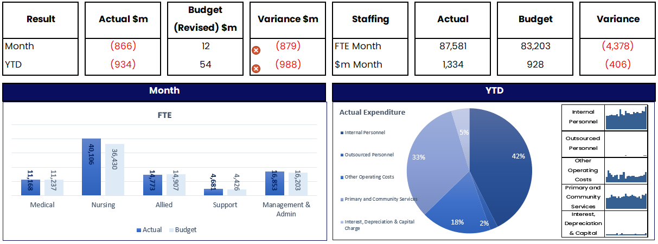

Note, the $1.334 billion of staffing cost for the month of June includes the uplift in provision for the liability of non-compliance with the Holidays Act and other year-end adjustments in the month.

Graphic showing cash flows and balance sheet of year to date

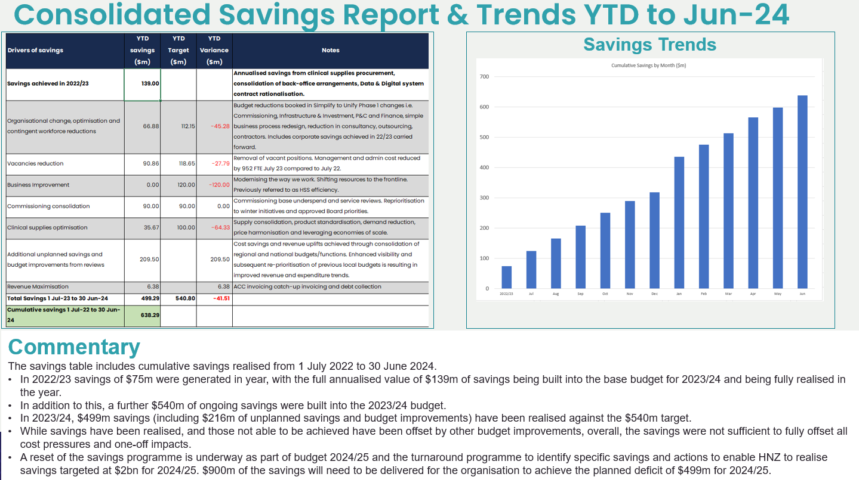

#### Infrastructure and investment

We are delivering approximately about 1,600 capital projects across Aotearoa New Zealand. The vast majority are funded through Health NZ baseline (depreciation). The new Dunedin Hospital has its own appropriation, the rest are funded through the health capital envelope.

Of the projects that are more than $10 million or funded from the health capital envelope, 68 are in-flight projects.

Performance reporting indicates that most projects are on track with 46 projects in the delivery phase, and three projects practically completed. The table below shows the number of projects in each project phase and the movement within the previous quarter:

|  |  |  |  |  |
| --- | --- | --- | --- | --- |
|  | Define | Design | Deliver | Total |
| **Portfolio as at 31 May 2024** | 3  $48 million | 20  $2,894 million | 49  $3,385 million | 72  $6,328 million |
| **Portfolio as at 30 June 2024** | 3  $33 million | 19  $2,962 million | 46  $3,377 million | 68  $6,372 million |
| **Movement in** |  |  | 1 |  |
| **Movement out** |  | 1 | 4 | 4 |

Four projects reached practical completion: Wellington Hospital copper pipes tranche 1 (30008), Parkside building refurbishment, Christchurch Hospital (30006), Tokoroa Hospital ED reconfiguration (30048), and Hawke’s Bay Hospital seismic remediation works (10148).

One project, generator and electrical upgrade and electrical supply to site, Tairāwhiti (10258), completed its design phase and started procurement and formally began its deliver phase.



**Progress the approved capital infrastructure projects that are underway, taking all practicable measures to ensure that project milestones are met, and anticipated benefits are realised, within budget:**

At 30 June 2024, we had 68 in-flight projects with budgets of more than $10 million or funded from the health capital envelope. Of these, 34 projects were rated as green (on track with no issues), 16 rated as amber (had manageable risks and issues) and 18 were rated red (significant budget and milestone risks).

We are currently establishing a Portfolio Management Office which will improve the quality of our reporting, provide greater consistency in how our projects are managed, and carry-out health checks of the projects within our delivery portfolio.

## Appendix 1: Local trends

#### Northern region

|  |  |
| --- | --- |
|  |  |
|  |  |
|  |  |
|  |  |
|  |  |
|  |  |

#### A graph of a number of people Description automatically generated with medium confidenceTe Manawa Taki (Midland) region

|  |  |
| --- | --- |
|  |  |
|  |  |
|  |  |
|  |  |
|  |  |
|  |  |

#### Central region

|  |  |
| --- | --- |
|  |  |
|  |  |
|  |  |
|  |  |
|  |  |
|  |  |

#### A graph of a number of people Description automatically generated with medium confidenceTe Waipounamu (South Island) region

|  |  |
| --- | --- |
|  |  |
|  |  |
|  |  |
|  |  |
|  |  |
|  |  |

## Appendix 2: Measure definitions

|  |  |  |
| --- | --- | --- |
| # | Measure | Definition |
| 1 | Immunisation coverage at 24 months of age | Percentage of children who have all of their scheduled vaccinations by the time they are two years old. Coverage is calculated as the percentage of children who turned two during the period who are recorded as fully immunised for their age on the National Immunisation Register (NIR) / Aotearoa Immunisation Register (AIR). |
| 2 | Shorter stays in Emergency Departments | This measure reports patients admitted, discharged, or transferred from an ED within six hours (SSED) as percentage of all patients who left ED in the period. |
| 3 | People waiting more than four months for first specialist assessment (FSA) | Proportion of people waiting longer than four months for their first specialist assessment (FSA). The target wait time for people to receive a FSA is four months from the date of referral. This measure is also known as Elective Services Performance Indicator 2 (ESPI2). [12] |
| 4 | People waiting more than four months for a procedure | People given a commitment to treatment but not treated within four months as a proportion of all people waiting for a procedure. This measure is also known as Elective Services Performance Indicator 5 (ESPI5).12 |
| 5 | Cancer patients waiting less than 31 days for first treatment | This measure shows the proportion of eligible cancer patients who receive their first treatment within 31 days of a health professional’s decision to treat. |
| 6 | Newborn enrolments | This measure shows the percentage of newborns who are enrolled with a General Practice / Primary Health Organisation (PHO) at six weeks and three months of age. |
| 7 | Primary care enrolment | People enrolled with a general practice (or a Kaupapa Māori provider delivering general practice care) as percentage of estimated resident population, Stats NZ. |
| 8 | Involvement in care decisions – primary care | Percentage of people who say they felt involved in decisions about treatment and care with their GP or nurse. Results presented as a proportion of people who responded “yes” to the question “Did the health care professional involve you as much as you wanted to be in making decisions about your treatment and care?” in a Health Quality and Safety Commission (HQSC) quarterly survey. |
| 9 | Ambulatory sensitive hospitalisations rates  0-4 years | Hospitalisations for children under five years of age for an illness that might have been prevented or better managed in a primary care setting. Results are presented as a rate per 100,000 population.  The rate is calculated by dividing the number of avoidable hospital admissions for children aged between 0 and 4 years by the number of children aged between 0 and 4 years in the population x 100,000.  This measure is calculated for a rolling 12 months to the quarter. |
| 10 | Ambulatory sensitive hospitalisations rates 45-64 years | Hospitalisations for people aged 45–64 for an illness that might have been prevented or better managed in a primary care setting. Results are presented as a rate per 100,000 population.  The rate is calculated by the number of avoidable admissions to hospital for adults aged between 45 and 64 years divided by the number of adults aged 45-64 years in the population x 100,000. This measure is calculated for a full year to the end of the reported quarter.  This measure is monitored for an improvement from baseline (trend to decrease). |
| 11 | Access to primary mental health and addiction services | Number of people accessing Access and Choice services. This measure is presented as a rate per 100,000 people and is calculated by the number of people accessing primary mental health and addiction services divided by population number x 100,000.[13]  This measure is monitored for an improvement from baseline (trend to increase). |
| 12 | Access rates for specialist mental health services | People served by specialist mental health services (Health NZ and NGO combined). This measure is presented as a rate per 100,000 people. |
| 13 | Mental health wait times for under 25-year-olds | The proportion of under 25-year-olds who have been referred to and seen by a specialist mental health service within three weeks of referral. This measure is calculated for a full-year to the end of the reported quarter. |
| 14 | Emergency Department presentations | Number of people who present to an emergency department (ED) including those who did not wait to be seen. |
| 15 | Admissions from Emergency Departments | Patients admitted to a hospital ward following attendance at an Emergency Department (ED) as a proportion of all patients who attended an ED. |
| 16 | Acute bed days per capita | Acute bed days are the number of days a person spends in hospital, following an acute admission. The acute bed days rate is presented as the number of bed days for acute hospital stays per 1,000 population, age-standardised. This measure is calculated for a full-year to the end of the reported quarter. |
| 17 | Inpatient length of stay >7 days | Number of hospital discharges with an inpatient length of stay of greater than seven days as proportion of all discharges in period.  This measure is monitored for an improvement from baseline (trend to decrease). |
| 18 | Involvement in care decisions – in hospital | People who reported they were involved as much as they wanted to be in decisions about their treatment as a proportion of all adult inpatients who responded to the HQSC quarterly survey.  This measure is monitored for an improvement from baseline (trend to increase). |
| 19 | People waiting more than 365 days for a procedure | The number of people who have been waiting for a procedure for more than 365 days from the time they were ready for treatment. |
| 20 | Medical appointments through digital channels | This measure reports outpatient attendances that were completed via telephone or video as a proportion of all outpatient attendances.  This measure is monitored for trends in the usage of digital channels for medical appointments, there is no official target. |
| 21 | Missed appointments | Patients who did not attend or did not wait for first specialist assessment or follow-ups as proportion of total appointments.  This measure is monitored for an improvement from baseline (trend to decrease). |
| 22 | Delivery of planned care interventions | Number of planned care interventions delivered against target by district of domicile, including inpatient surgical discharges; minor procedures delivered in inpatient, outpatient and community settings; and non-surgical interventions.  This measure maintains delivery of planned care intervention volumes; no specific target is set. |

1. During the 2023/24 financial year (quarter three, December 2023), immunisation reporting transitioned from the retired National Immunisation Register (NIR) to the Aotearoa Immunisation Register (AIR). As of quarter three 2023/24, all consumers were onboarded to the AIR which captures a greater number of eligible children, resulting in a larger denominator and reported immunisation rates being lower than previously reported (in quarter two 2023/24 and prior). However, AIR provides a better estimation of immunisation coverage. The immunisation denominator is now consistent (between quarter three and four). It is important to note, data is sourced from AIR and may be subject to any data quality issues still to be resolved in AIR.
2. The National Enrolment Service has been developed to provide up to date national enrolment and identity data. For further information, please visit <https://www.tewhatuora.govt.nz/for-health-providers/claims-provider-payments-and-entitlements/national-enrolment-service/>
3. GPQED provides an overview of general practice interactions, which include, but are not limited to, doctor and nurse consultations (in-person and remote), follow-up comms, prescription requests and immunisations.
4. New Zealand EDs use the Australasian triage scale which has five categories; triage 1 patients are very urgent, while triage 5 patients are less urgent. For more information, see: <https://www.tewhatuora.govt.nz/health-services-and-programmes/hospitals-and-specialist-services/emergency-departments/emergency-department-triage>
5. Changes in Auckland’s use of reporting tools have limited our ability to compare trends over time.
6. Quintile five represents the 20 per cent of areas with the highest level of deprivation.
7. Additional details regarding heart health plans is available here: <https://www.tewhatuora.govt.nz/for-health-professionals/clinical-guidance/diseases-and-conditions/long-term-conditions/cardiovascular-disease/heart-health-plan-care-planning-tool/>
8. [*He Ara Oranga: Report of the Government Inquiry into Mental Health and Addiction*](https://mentalhealth.inquiry.govt.nz/inquiry-report/he-ara-oranga/). Published in November 2018 by the Government Inquiry into Mental Health and Addiction Available at: [He-Ara-Oranga.pdf (inquiry.govt.nz)](https://mentalhealth.inquiry.govt.nz/assets/Summary-reports/He-Ara-Oranga.pdf)
9. The Application Library is available for the public at: <https://healthify.nz/app-library/>.
10. Additional details on CPCTs is available here: <https://www.tewhatuora.govt.nz/health-services-and-programmes/primary-care-development-programme/comprehensive-primary-and-community-care-teams/>
11. We are completing reporting on the 2023 target of 8 per cent set by the Ministry of Business, Innovation and Employment and Te Puni Kōkiri.
12. From 1 July, this measure will be reported as the percentage of patients waiting less than four months for a FSA/elective treatment in alignment with the National Health Target. The target will be 95 per cent.
13. This measure reflects access to primary mental health and addiction services funded since 2019 only and excludes previously existing primary mental health and addiction services because of a lack of reliable data from those services.