

Quarterly Performance Report
  - Quarter 1 2024/25

Citation: Health New Zealand | Te Whatu Ora. Quarterly Performance Report: Quarter ending 30 September 2024.
Wellington: Health New Zealand | Te Whatu Ora.
Published in December 2024 by Health New Zealand | Te Whatu Ora
PO Box 793, Wellington 6140, New Zealand
ISSN 2816-1823 (online)

This document is available at tewhatuora.govt.nz
 | This work is licensed under the Creative Commons Attribution 4.0 International licence. In essence, you are free to: share i.e., copy and redistribute the material in any medium or format; adapt i.e., remix, transform and build upon the material. You must give appropriate credit, provide a link to the licence and indicate if changes were made.

Contents
Navigating this report 4
Organisational performance 6
Measures – high-level summary 8
Financial summary 10
Output class 1: Public health services 11
Output class 2: Primary and community care services 25
Output class 3: Hospital and specialist services 37
Output class 4: Mental health and addiction services 56
Output class 5: Hauora Māori services 69
Workforce 76
Physical infrastructure 81
Digital infrastructure 82
Financial performance 85

Navigating this report
The report begins with an overall performance summary, including an overview of quarterly results for the five health targets, five mental health and addictions targets, all other performance measures and our finances.
Heath New Zealand then presents detail of our performance by output class (reflecting the nature of services funded for and delivered) along with enabling functions.
Each section includes results for a selection of performance measures from our Statement of Intent 2024-2028 (SOI); and Statement of Performance Expectations 2024/25 (SPE) that are able to be reported quarterly. The complete set of performance measures, from across all accountability documents listed above, will be reported annually.
Each output class starts by presenting national results for relevant measures, as a quick snapshot of performance. Long and short names for measures, reference numbers, definitions, data sources and methods are published as a standalone document on our website. Breakdowns for each measure by region and district are provided where possible. The term ‘district’ refers to the geographic boundaries covered by former DHBs. Detail about our two strategic priorities are outlined on page 7 of our SPE.

Data completeness
All performance data provides a snapshot in time. On any given day, there may be variances depending on when data is uploaded and subsequently extracted. While all reasonable steps have been taken to ensure the accuracy and completeness of the information in this report, Health NZ accepts no liability or responsibility for how the information is used or subsequently relied on.
When comparing the data from previous quarterly reports to the current one, there may be slight variations due to the latter data being more complete.
Data validation is done at both national and (where relevant) local levels, by clinical and data teams, subject matter experts and those involved in the creation of the report.

Time periods
The financial year spans 1 July – 30 June, and quarters refer to the following periods:
- Quarter 1: 1 July – 30 September
- Quarter 2: 1 October – 31 December
- Quarter 3: 1 January – 31 March
- Quarter 4: 1 April – 30 June

How to read the charts
Performance measure results are presented in comparison to results for the same quarter in the previous year, and against the target (if one was set). This accounts for and acknowledges the impact of seasonal changes in health measures. Where data is available, trend lines present results over the past eight quarters (including current), to provide an indication of performance over time. A key to the charts is below:

Summary charts:
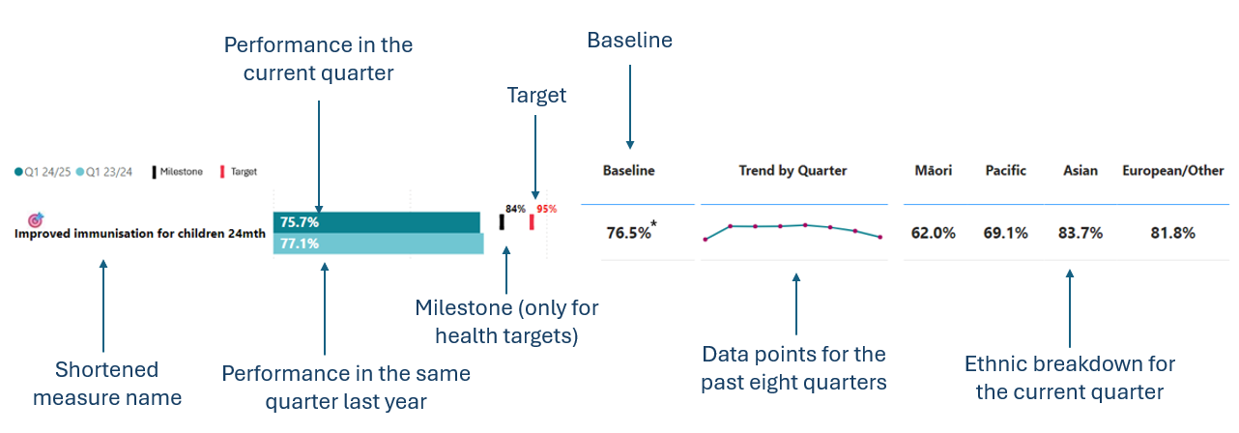

Performance is also presented by region and district, where data is available:
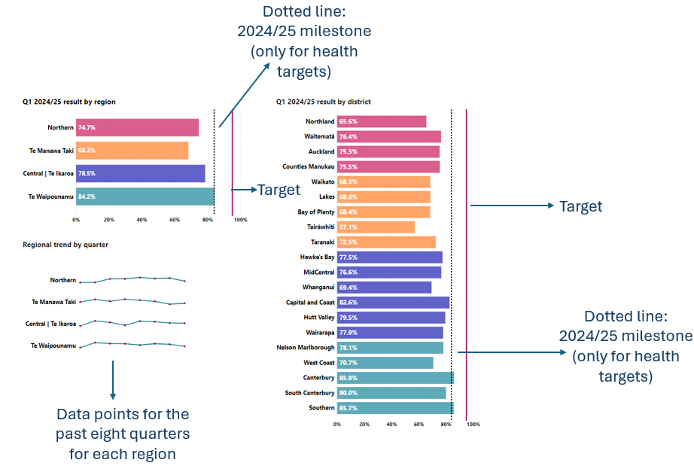

Organisational performance

Summary for the quarter
This report reflects Health New Zealand’s performance during quarter 1 and aligns with the SPE which, along with the New Zealand Health Plan | Te Pae Waenga 2024-2027 (NZHP), gives effect to the 2024-2027 Government Policy Statement on Health (GPS). The draft NZHP is currently being audited and once this is complete it will be presented to the Minister of Health for approval. Reporting on the NZHP will be part of our quarterly reporting from 2025, once published. A comprehensive report on delivery of the Interim New Zealand Health Plan | Te Pae Tata (July 2022 – June 2024) will be published in early 2025.
Highlights expanded on in this report include:
- Newborn enrolment increased which should help improve childhood immunisation rates.
- Ambulatory sensitive hospitalisation rates for children 0-4 years reduced, meaning fewer children being admitted to hospital with preventable illness. This is notable, given this was the winter quarter.
- Screening coverage for cervical and breast cancers improved.
Some challenges outlined in this report include:
- Immunisation rates for children at eight months and 24 months fell compared with the same quarter last year. Concentrated efforts are being made on improving immunisation rates.
- The number of people waiting for more than four months for a first specialist assessment increased.
- There was a notable increase in the number of pertussis cases over the quarter, from 71 cases in July, 75 cases in August and 188 cases in September (an epidemic for pertussis has recently been declared, as of late November 2024).
- Health NZ’s financial position continues to be challenging, with an organisation-wide reset being worked through. The quarter 1 result was a $442m deficit ($213m unfavourable to budget).
Many of the initiatives outlined in this report will improve performance over time and may not necessarily contribute to results for this quarter.
The target dashboards on the following page provide a snapshot of national performance during quarter 1 against the 2024/25 milestone (where this was set by the GPS) and the overarching target. The milestones increase year-on-year to ensure we meet the overarching targets by 2030.

Five health targets
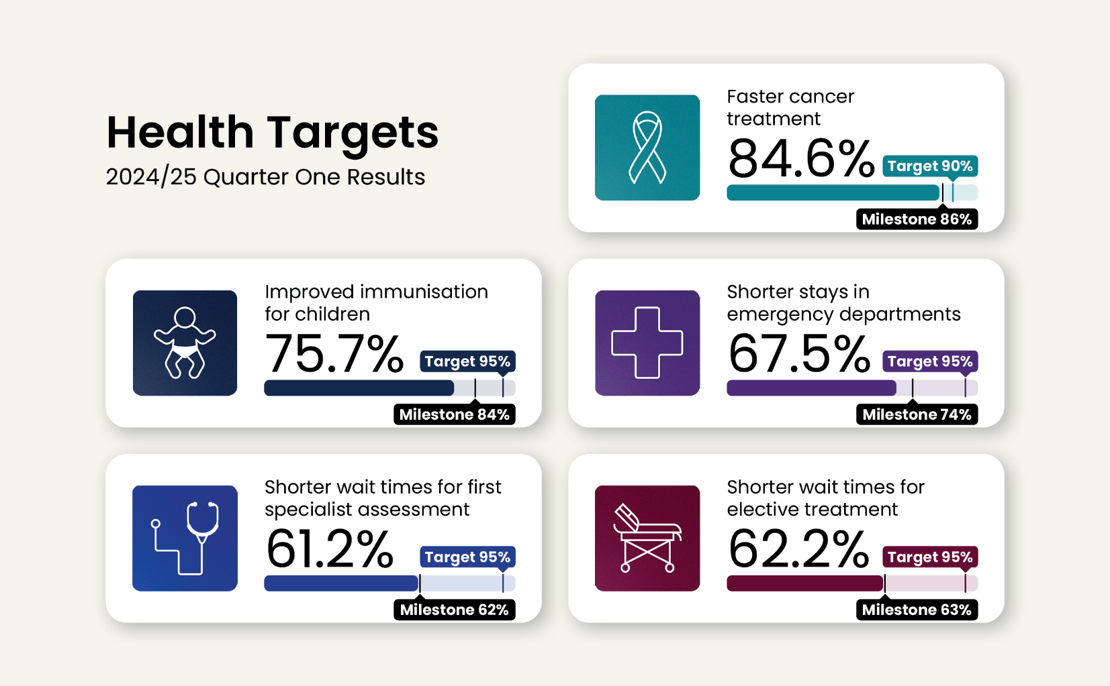

Five mental health and addiction targets
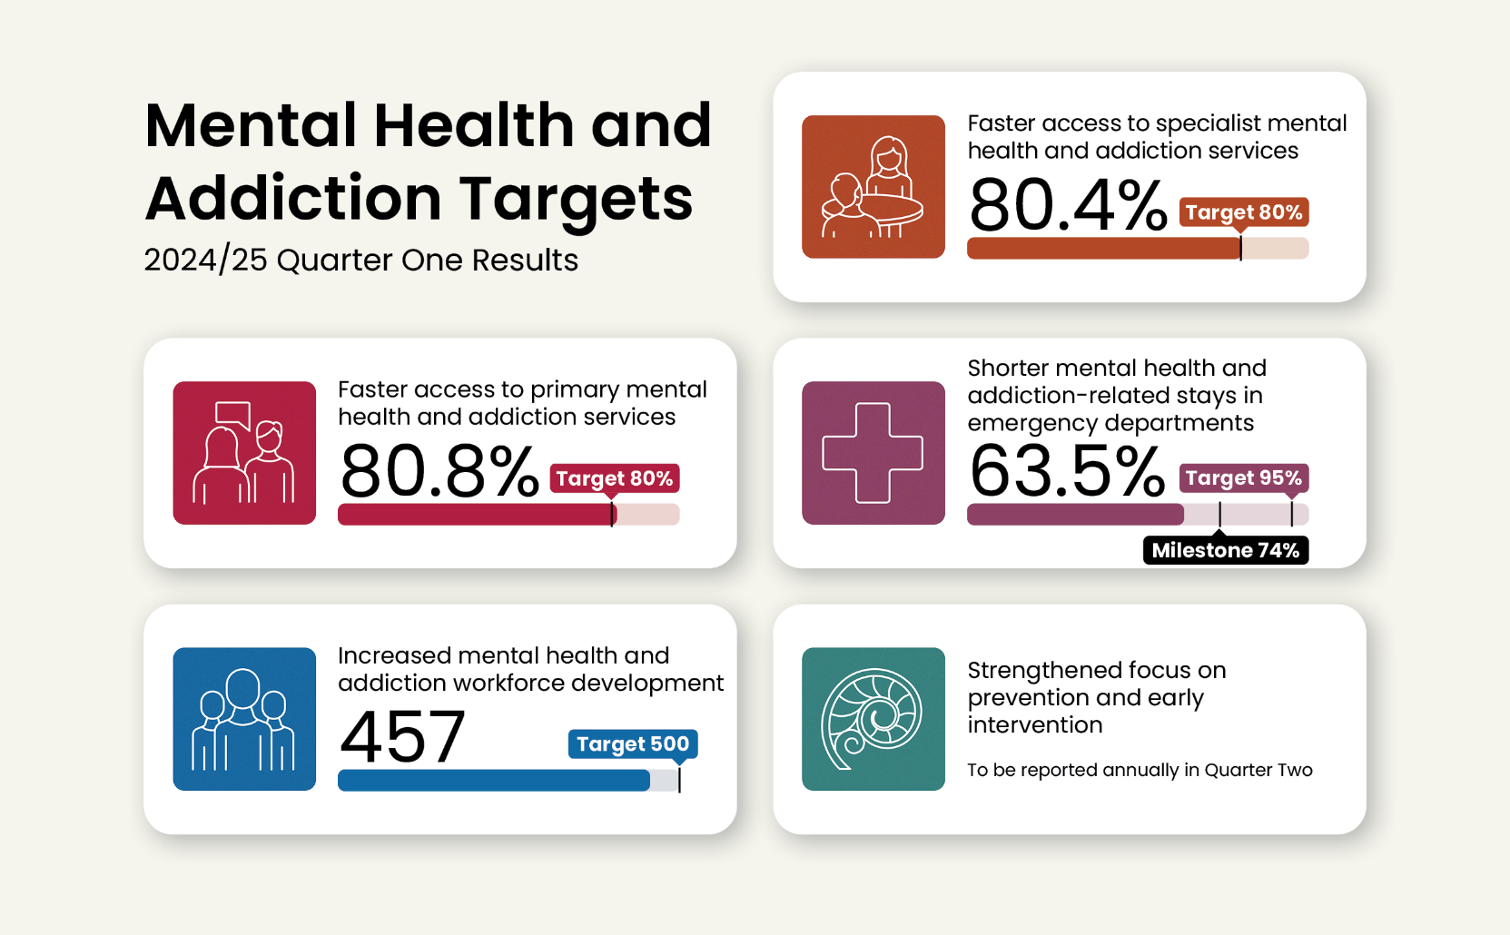

Measures – high-level summary
The table shows the quarter 1 results for all the measures included in this report compared to quarter 1 2023/24. Comparing with the same quarter last year accounts for seasonal variation. The baseline result for the five health targets (quarter 4, 2023/24) is provided in brackets alongside the quarter 1 2024/25 results.
Those with more than an absolute two or more percentage point change (a level adopted to indicate some materiality) between quarter 1 2023/24 and quarter 1 2024/25 are marked Ý Þ improving (6), or Þ Ý slipping (2).
is used throughout the report to identify the five health and five mental health and addiction targets.  is used to identify targets that also form part of the Government’s nine targets. See https://www.dpmc.govt.nz/our-programmes/government-targets.
Area | Ref | Short name | Q1 23/24 | Q1 24/25  (baseline) | 2% or more
Public health services | P2-03 | Improved immunisation for children 24mth | 77.1% | 75.7%  (76.5%)
 | P2-140 | Improved immunisation for children 8mth | 79.7% | 78.4%
 | P2-09 | Cervical HPV screening coverage | 67.0% | 71.6% | Ý
 | P2-07 | Breast screening coverage | 67.1% | 69.3% | Ý
 | P2-158 | Bowel screening participation | 58.4% | 57.1%
Primary and community care services | P2-38 | Newborn GP enrolment | 85.7% | 87.8% | Ý
 | P2-17 | GP enrolment | 95.9% | 94.7%
 | P2-23 | ASH rate adults 45-64yrs per 100,000 | 3,786 | 3,781
 | P2-22 | ASH rate child 0-4yrs per 100,000 | 7,614 | 7,278 | Þ
 | P2-176 | GP accessed when wanted | 77.3% | 78.4%
Hospital and specialist services | P2-45 | Shorter stays in ED <6hrs | 67.5% | 67.5%  (71.2%)
 | P2-51 | Faster cancer treatment <31 days | 84.9% | 84.6%  (83.5%)
 | P2-39 | Shorter wait times for FSA | 66.3% | 61.2%  (61.5%) | Þ
 | P2-40 | Shorter wait times for elective  treatment | 62.1% | 62.2%  (61.4%)
 | P2-58 | Missed FSA appts | 7.4% | 7.1%
 | P2-88 | Medical appts via telehealth (digital) | 6.4% | 7.2%
 | P2-194 | Hospital pressure injuries (rate per 10,000 hospitalisations) | 8.0 | 7.2 | Þ
 | P2-195 | Hospital falls (rate per 10,000 hospitalisations) | 3.5 | 4.5 | Ý
 | P2-44 | Involved in care decisions, hospital | 82.9% | 83.2%
Mental health and addiction services | P2-198 | MHA workforce development | NEW* | 457#
 | P2-201 | Shorter MHA stays in ED <6hrs | NEW* | 63.5%
 | P2-202 | MHA Access and Choice <1 wk | NEW* | 80.8%
 | P2-203 | MHA faster specialist access <3 wks | NEW* | 80.4%
 | P2-69 | MHA youth seen <3 wks | 73.2% | 72.8%
 | P2-199 | MHA access, Integrated Primary | 51,528 | 59,264 | Ý
 | P2-187 | MHA services access per 100,000 | 2,956 | 2,987
Hauora Māori services | P2-206 | Hauora Māori contracts | NEW* | 44%
 | P2-208 | IMPB strategic involvement | NEW* | Being Developed
 | P2-205 | Hauora Māori outcomes | NEW* | From Q2
Workforce | P2-152 | Health NZ workforce turnover | 2.9% | 2.5%
 | P2-153 | Health NZ Māori and Pacific Peoples workforce | NEW* | 13.3%
Digital | P2-169 | My Health Record access | NEW* | 56,403
* Measures marked as NEW are those where data was not being collected in quarter 1 2023/24 (see relevant data caveats throughout the report).
# Result is for the 2024 calendar year.

Financial summary
This table summarises financial performance for the quarter. Additional entity wide financial performance is provided on pages 85-88 and within each output class.
 | Year to Date (30 Sep-24) |  |  | 2024/25 SPE
 | Actual  $m | Budget  $m | Variance  $m | Budget  $m
Revenue
Appropriation funding | 6,177 | 6,202 | (25) | 24,810
Other Government funding | 794 | 753 | 41 | 3,016
Other revenue | 142 | 118 | 24 | 471
Total revenue | 7,113 | 7,073 | 40 | 28,297
Expenditure – operating costs
Personnel costs | 3,181 | 3,117 | (63) | 12,466
Other operating costs | 1,449 | 1,349 | (101) | 5,272
External service providers | 2,575 | 2,488 | (87) | 10,235
Interest, depreciation and capital charge | 350 | 348 | (2) | 1,424
Total expenditure | 7,555 | 7,303 | (253) | 29,397
Surplus/(Deficit) | (442) | (229) | (213) | (1,100)
The quarter 1 result was a deficit of $442m, which was $213m unfavourable to the budget. Total revenue received was $40m greater than budgeted, primarily due to higher revenue from ACC and Pharmac, and greater than expected interest income.
Total expenditure was $253m more than budgeted. Higher personnel and other operating costs reflect greater than anticipated acute activity in hospital and specialist services during July and August, accruals for liability for non-compliance with the Holidays Act and timing of realising savings in our back-to-budget programme.
External service provider expenses (for age-related residential care, community care, community pharmaceuticals, primary care, primary maternity and oral health) were also more than budget, reflecting actual demand-driven activity compared to the phased budget. Budget reset work is underway to ensure anticipated cost pressure impacts and timing of realising planned savings are reflected in the budget phasing for the balance of the year.

Output class 1: Public health services
This section presents the results for the public health services output class. For more background, see pages 14-15 of the SPE.

Performance measures
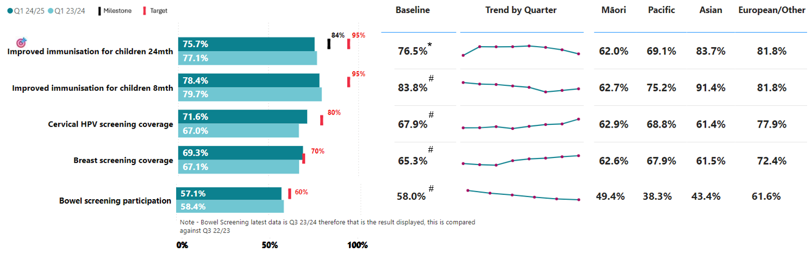
Two out of five performance measures for this output class have improved performance compared to the same quarter last year and from the baseline. All measures remain below target.

Data caveats
* Baseline is quarter 4 2023/24.
# Baseline is 2022/23, taken from the SPE.
All immunisation measures: Data extraction occurred on 26 November 2024. The data captures:
- records that had historically not been in the Aotearoa Immunisation Register (AIR) due to issues with Patient Management Systems
- records that have been entered into AIR at a lag (i.e the immunisation occurred during the quarter but the record was entered into AIR after the quarter ended)
- changes to the number of eligible children (denominator) because of them having since entered or left the population.
Due to the extraction date, the results presented in this report will differ to other immunisation coverage reporting – specifically the tier one childhood immunisation milestone coverage statistics that are due to be published by the end of 2024, from which data was extracted from the AIR on 5 September 2024.
Cervical HPV screening coverage: Data extraction occurred on 25 October 2024. This measure is referred to as ‘cervical coverage: up to date’ as the calculation considers when the participant’s most recent test was in relation to the implementation of HPV primary screening, to account for the change to the screening interval from three to five years. The reporting period accounts for the change to HPV primary screening from the previous cytology-based programme. For example, a participant whose more recent test was prior to 12 September 2023 is considered up to date for a period of three years following that date. A participant whose most recent test was after 12 September 2023 is considered up to date for a period of five years following that test.
Breast screening coverage: As eligible people are invited to be screened for breast cancer every two years, the breast screening coverage rate is calculated over a two-year period. Data extraction occurred on 16 October 2024.
Bowel screening participation: Latest data available is quarter 3 2023/24. This is the result displayed and compared with quarter 3 2022/23. Once kits are sent out, participants have six months to complete and return them. Therefore, reporting on this indicator requires a six-month lag. As the bowel screening programme invites participants back every two years, bowel screening participation rates are calculated over a two-year period. Data extraction occurred on 1 November 2024.

P2-03 Improved immunisation for children 24mth
This measure shows the percentage of children who have all their scheduled vaccinations by the time they are two years old.
National result:
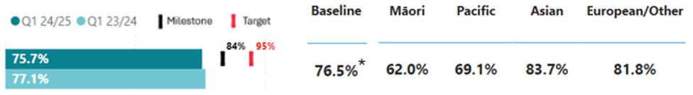
* See caveats on page 12

Results by region and district:
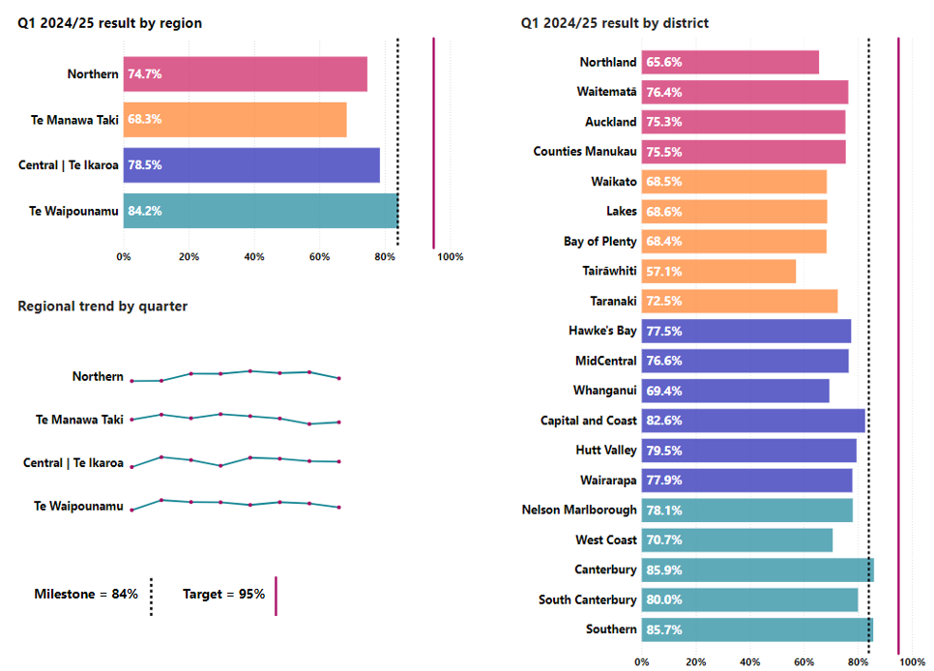

P2-140 Improved immunisation for children 8mth
This measure shows the percentage of children who have all their scheduled vaccinations by the time they are eight months old.
National result:
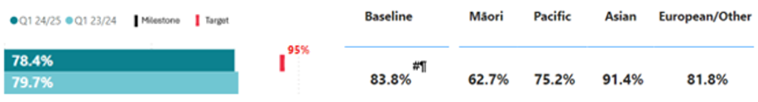
# See caveats on page 12

Results by region and district:
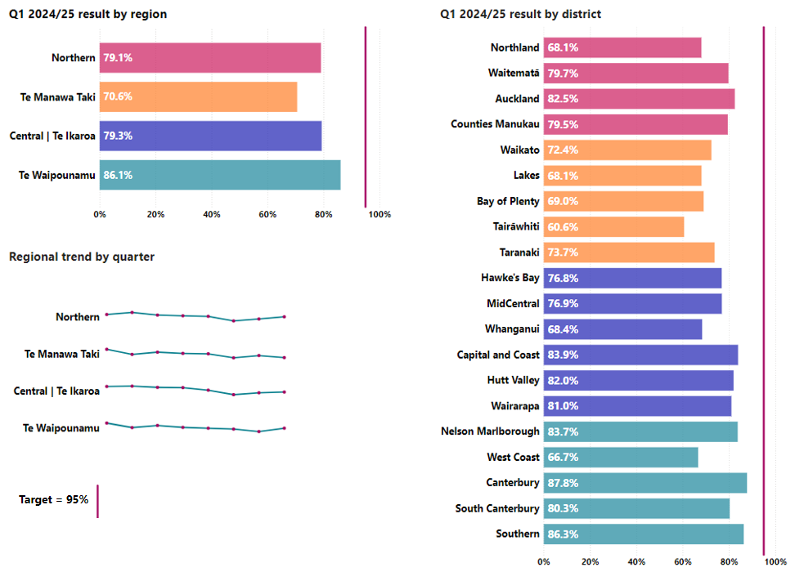
Immunisation rates have been decreasing over recent years. Health NZ is implementing a range of initiatives to improve childhood immunisation rates.
Enabling our pharmacists to undertake childhood vaccinations
The Enabling Community Pharmacies Project allows pharmacies to deliver immunisations with a key focus on childhood immunisations. It started in April 2024 and is being phased over three years. Uptake has improved this quarter with 30 pharmacists authorised as whole-of-life vaccinators. The intention of the project is to provide alternative access opportunities to those needing immunisations.
Regional pharmacy engagement leads were recruited during the quarter to support and onboard pharmacies to expand the range of immunisations they offer. Leads provide support with cold chain, site sign off, arranging or providing mentoring services and training support.
In the Northern region, the leads and a newly-approved clinical assessor have engaged with more than 200 pharmacies, including 12 in Te Tai Tokerau (an area of low vaccination coverage) who now have or are progressing towards authorisation. Early engagement is underway in other regions, with two leads recruited in Te Manawa Taki, one in Central and one in Te Waipounamu.
Changes were also made to simplify the vaccinator health worker training pathway to increase the number of vaccines a worker can administer and to enable them to apply for authorisation as soon as they have completed their training.
At the end of the quarter, 157 pharmacists had registered for extending vaccinator skills (whole-of-life) training; 45 had completed the training; 30 had been authorised to vaccinate; five pharmacies had been onboarded and can now order funded vaccines from the national schedule to undertake vaccinations; and 185 doses were administered to children aged up to 24 months through the pharmacies.
Pre-call / recall for six-week immunisations
For the period 1 April 2024 to 30 June 2025, $4.6 million has been made available to support general practice best practice pre-call and recall activities. General practices are paid $40 for every baby who receives their six-week immunisations, and an additional $40 for babies meeting high-needs criteria (Māori, Pacific, Community Services Card, quintile five and rural).
Whānau Awhina Plunket
In quarter 1, Health NZ progressed a partnership with Whānau Awhina Plunket – Well Child Tamariki Ora to establish and deliver a pilot for delivery of childhood immunisation services to areas of high need.
The pilot will run until June 2026 with up to 27 sites being onboarded over that time. The first pilot site will be Whangārei by December 2024, followed by a further four sites in Kaikohe, Hamilton, Taumarunui and Whanganui by 31 March 2025. If successful, this pilot could be rolled out to include other Well Child Tamariki Ora providers in all areas of New Zealand.

Pertussis
There was a notable increase in the number of pertussis cases over the quarter, from 71 cases in July, 75 cases in August and 188 cases in September. Central had the highest rate of pertussis cases, followed by the Northern region. A key focus is on protecting infants who are the most at risk of severe illness, hospitalisation and death, through antenatal vaccination and on-time childhood immunisations from six weeks of age (see above initiatives for childhood immunisations). As at late November 2024, an epidemic has been declared.
Sharing best practice
Health NZ has implemented an immunisation health target operating model that integrates national, regional and district level activity across the immunisation system to deliver improved immunisation coverage for children.
The operating model outlines the flow of information and decision making, across national, regional and local groups. The groups coordinate service delivery, share knowledge and best practice across multi-disciplinary teams.
Clinical and operational immunisation champions have been put in place at the national, regional and district level.
Immunisation best practice is learned and shared through:
- fortnightly immunisation sector meetings;
- clinical assessments by immunisation coordinators (includes best practice) to support the vaccinators authorisation process;
- six weekly clinical and operational updates to the immunisation handbook;
- fortnightly immunisation sector Pānui – sharing updates and resources;
- call centre support of best practice clinical and technical immunisation guidance, hosted on the web, commissioned by the Immunisation Advisory Centre.

P2-09 Cervical HPV screening coverage
This measure shows the number of participants screened for Human Papillomavirus (HPV) as a percentage of the estimated eligible population (adjusted for the prevalence of hysterectomy).
National result:
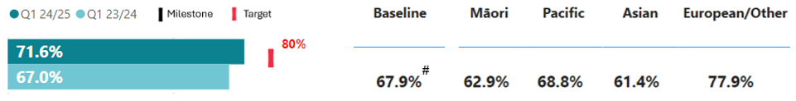
# See caveats on page 12

Results by region and district:
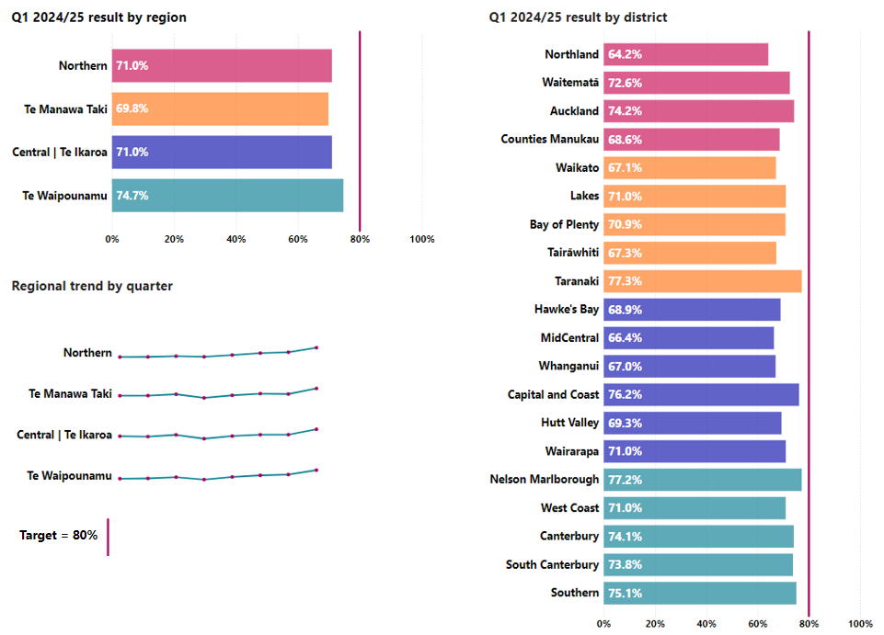
For this measure, ‘screened’ includes participants who have had primary screens or follow-up tests within the relevant time period (i.e. HPV, cytology or histology, whichever is most recent). For this quarter, cervical screening numbers improved.
In September 2023, the screening programme transitioned from cytology testing to HPV testing as the main cervical screening test. This includes the option to self-test using a swab which enables more choice, more privacy and comfort, and offers cultural acceptability for many population groups.
Since September 2023, more than 380,000 people have been tested. Of those, 80.8 per cent had self-tests, and of Māori and Pacific Peoples tested, approximately 87 per cent chose to self-test.
In September 2024, the HPV primary screening workforce expanded with the launch of the unregistered kaimahi workforce expansion initiative, which will increase cervical screening capacity and capability by approximately 200 workers. The initiative enables kaimahi to complete eLearning modules and authorisation processes so they can work in a professional partnership, with a responsible clinician, to facilitate HPV self-testing.
September 2024 was Cervical Screening Awareness Month, with 39 screening events held across New Zealand, including community events at Te Wānanga o Aotearoa, marae-based activities in rural settings and other promotion events at local celebrations and festivals. The purpose of screening events is to raise awareness, educate, answer questions and provide confidence in the screening process.

P2-07 Breast screening coverage
This measure shows the number of individuals aged 45-69 who have had breast cancer screening in the past two years.
National result:
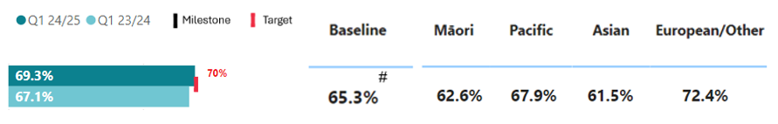
# See caveats on page 12

Results by region and district:
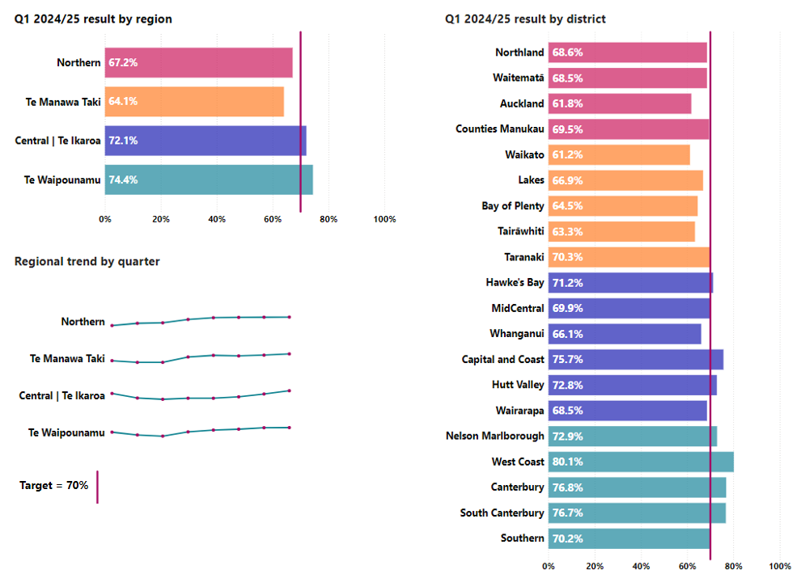
In this quarter there were several initiatives which focused on developing partnerships to improve participation and equitable access to breast screening. Nationally, we partnered with the Māori Women’s Welfare League to roll-out a programme of education, training and community events.
Overall breast screening results have improved compared to the previous year and is currently less than one per centage point away from achieving the national target (70 per cent). Central and Te Waipounamu regions are both exceeding the target.
Initiatives are underway across all regions to improve breast screening rates.
- In Northern, BreastScreen Auckland Central and Whakarongorau have partnered to deliver a trial to follow up and engage with Māori and Pacific Peoples who did not respond to invitations for breast screening appointments.
- In Te Manawa Taki, BreastScreen Aotearoa partnered with Hauraki Primary Health Organisation (PHO) to design and implement a pilot that will connect with unscreened and under-screened women through secondary health settings (and community) to encourage them to be screened.
- In Central, a new mobile location was launched by BreastScreen Coast to Coast for the women of Pātea to remove travel and cost barriers. At the end of the quarter, 121 women were screened, including 18 first-time screening participants.
- In Te Waipounamu, ScreenSouth in Nelson-Marlborough, and Otago Southland, have collaborated with primary health networks to provide breast screening services for women in districts. The programmes have extended the current delivery model and have a focus on improving equitable access for Māori and Pacific Peoples.

P2-158 Bowel screening participation
This measure presents the number of eligible individuals (aged 60-74) who returned a testing kit with a definitive result over a rolling 24-month period (as at 31 March 2024), as a proportion of the total number of eligible individuals invited to participate in screening during the same timeframe.
National result:
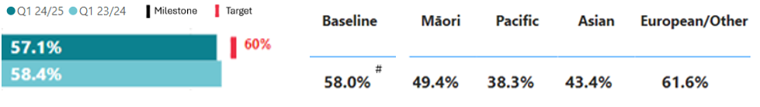
# See caveats on page 12

Results by region and district:
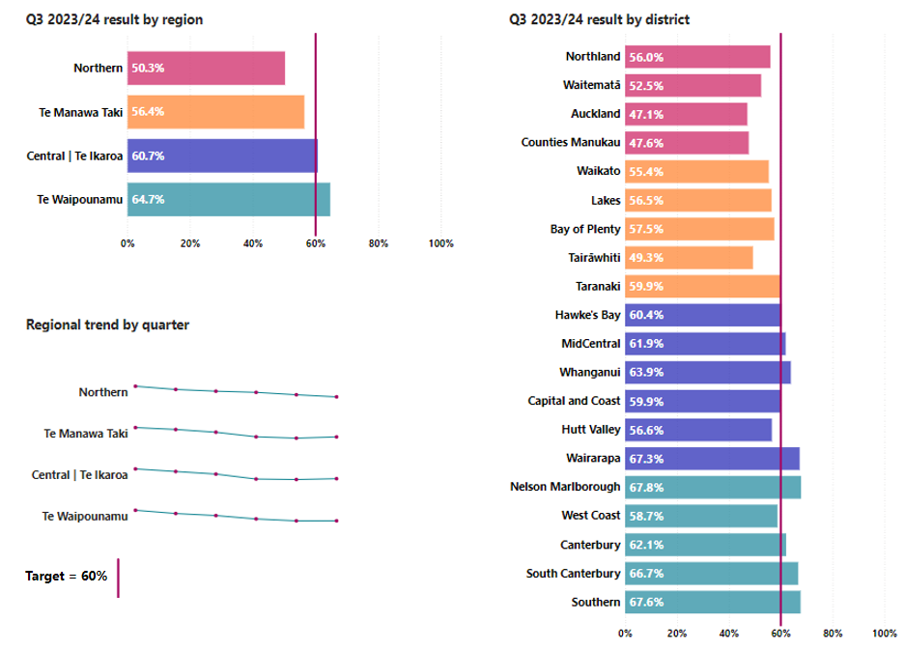
In the Northern region, a pilot that enables participants to drop completed bowel screening test kits to a community laboratory, rather than via mail, was extended from Waitematā and Auckland to include Counties Manukau. This pilot will run in these three districts until 30 June 2025, supporting understanding of alternative kit-return options for priority populations. Increased numbers of tests are expected, as individuals prefer to drop their test to a laboratory, rather than return it in the mail.
In Te Manawa Taki, several health promotion initiatives were delivered, including four screening promotion events with a focus on priority populations in the Tairāwhiti district. There was also a seven-week pilot programme within the migrant and refugee settlement centre in the Waikato district. This pilot focused on delivering tailored health promotion activities to migrant and refugee communities, emphasising screening to priority populations and addressing key health needs such as mental health, dental needs and nutritional deficiencies.

Key outputs
Output | Q1 2024/25  (Year to date) | Q4 2023/24  (Target baseline)
Number fully immunised at  24 months of age | 11,642  (Q1 23/24: 13,168) | 11,551
Number of eligible children at 24 months of age | 15,373  (Q1 23/24: 15,871) | 15,076
Number offered vaccination at 24 months of age but declined | 1,079 (7.0%)  (Q1 23/24 1,029 (6.5%)) | 1,023 (6.8%)

Output caveats
Number fully immunised at 24 months of age: The data above may be different from other data published due to different extraction dates (for example the Health NZ tier one statistics).
Overall, there was a decrease in both the number of children eligible for their 24-month vaccinations and the number of children who were vaccinated, when compared with quarter 1 2023/24. However, compared to quarter four 2023/24, the number of children eligible has increased, but the number of children fully immunised has slightly slipped. The number of vaccinations offered but declined, has slightly increased (by 0.5 per cent) compared with quarter 1 2023/24, and increased by 0.2 per cent compared with quarter 4 2023/24.

Financial performance
 | Year to Date (30 Sep-24) |  |  | 2024/25  Budget
Revenue and expenditure | Actual  $m | Budget  $m | Variance  $m | Budget  $m
Total operating revenue | 145 | 133 | 12 | 533
Total operating expense | 143 | 145 | 2 | 533
Surplus/(deficit) | 2 | (12) | 14 | 0

Strategic priority one: Deliver the New Zealand Health Plan
Reporting against the NZ Health Plan | Te Pae Waenga will begin in 2025, once the plan has been finalised and published.

Strategic priority two: Empower and enable leadership at all levels

Alcohol
Health NZ works to help reduce alcohol-related harm, including reporting on alcohol licences, collaborating with territorial authorities on their policies for alcohol licences and supporting local communities. We supported Auckland Council in litigation on the adoption of the Auckland Council Local Alcohol Policy, which came into effect on 16 September. This policy includes reduced off licence maximum trading hours and a temporary freeze on new off licences in priority areas with high alcohol-related harm. The Council’s success has encouraged other local territorial authorities to begin or restart development of their own alcohol policies, with support from Health NZ.

Outbreaks
Measles
During this quarter we made progress on measles preparedness actions and activities. Outbreak immunisation implementation planning in the regions is underway, supported by development of a ring vaccination strategy. This focuses vaccination activities on susceptible people around a measles case and their primary contacts to prevent further waves of transmission. This has been developed, agreed and shared widely with the sector.
The Northern region led three measles training exercises to strengthen outbreak readiness, resilience and response. A total of 243 nurses, doctors, health protection officers, and other staff who may be involved in case and contact management, participated. Additionally, 70 kaimahi are now Co-ordinated Incident Management System trained in the Northern region.
Mpox
Health NZ managed a co-ordinated response to an outbreak of Mpox cases. Staff worked alongside primary care and sexual health services across Aotearoa, with cases identified in the Northern, Central and Te Waipounamu regions. The response has been completed, with all cases and contacts successfully managed. It was a great example of enabling activity at local levels and supporting communities. The nationally co-ordinated incident management team was supported by clinical leadership to support case and contact management. Clinical expertise informed the response, including managing sensitive public information and communications.
Vancomycin-resistant enterococci
While Vancomycin-resistant enterococci (VRE) is not currently endemic in New Zealand (unlike many other countries), there has been an increase in hospital patients with VRE in some regions of New Zealand. We have taken a co-ordinated approach to respond to this increase, including monitoring locations of current cases, and enhancing interventions to limit further transmission. The national focus is on screening the international transfer of patients, while surveillance services continue with regional autonomy at a local level to ensure tailored and appropriate responses.

Campaigns
Smokefree Rockquest and Tangata Beats music events
Health NZ has worked with the organisers of Rockquest and Tangata Beats for several years on smokefree, and now also vapefree, messaging. The national finals for both events were held in Auckland in September and promoted smokefree and vapefree messages during the lead-up and at the events themselves. Messaging is included in the student curriculum and in the material for the performances. In 2024, the events reached more than 12,000 students, more than 30,000 live audience members, and hundreds of thousands of people online.

Output class 2: Primary and community care services
This section presents the results for the primary and community care services output class. For more background, see pages 16-18 of the SPE.

Performance measures
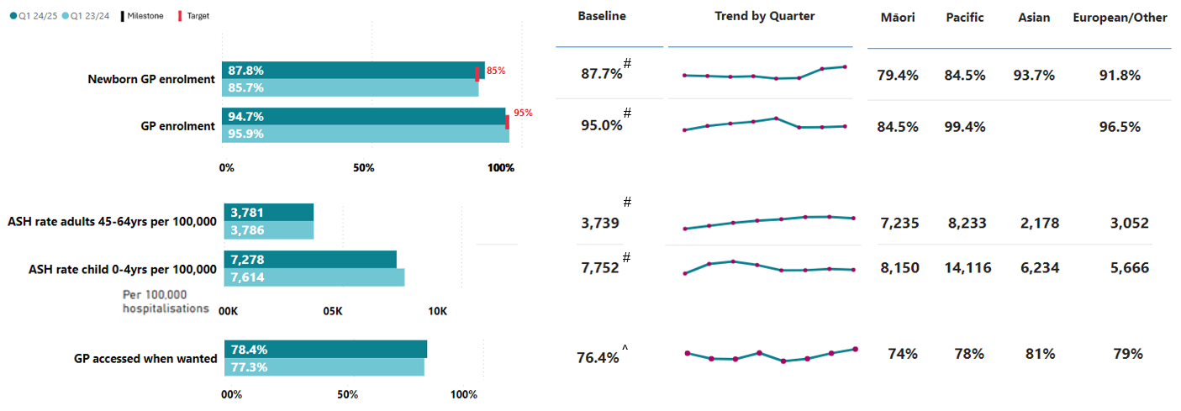
Performance measures in this output class have remained relatively stable compared to the same quarter last year. Most have improved from the baseline.

Data caveats
# Baseline is 2022/23, taken from the SPE.
^ Baseline is 12 months to 05/2023.
Newborn GP enrolment: From quarter 4 2023/24, this measure used a different method of calculation compared to previous quarters.
GP enrolment: This metric is not yet available with an ethnicity breakdown for Asian peoples.
ASH rate adults 45-64yrs per 100,000 and ASH rate child 0-4yrs per 100,000: Data submissions from Wairarapa and Whanganui districts in quarter 1 were incomplete due to a system upgrade. As such, their results for quarter 1 may change in the next quarter. While data completeness is always the goal, the overall results remain largely unaffected by these districts.
GP accessed when wanted: Results are based on weighted data.

P2-38 Newborn GP enrolment
This measure shows the percentage of newborns enrolled with a general practice (or a kaupapa Māori provider delivering general practice care) by three months of age.
National result:
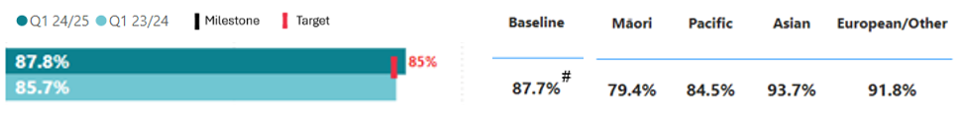
# See caveats on page 26

Results by region and district:
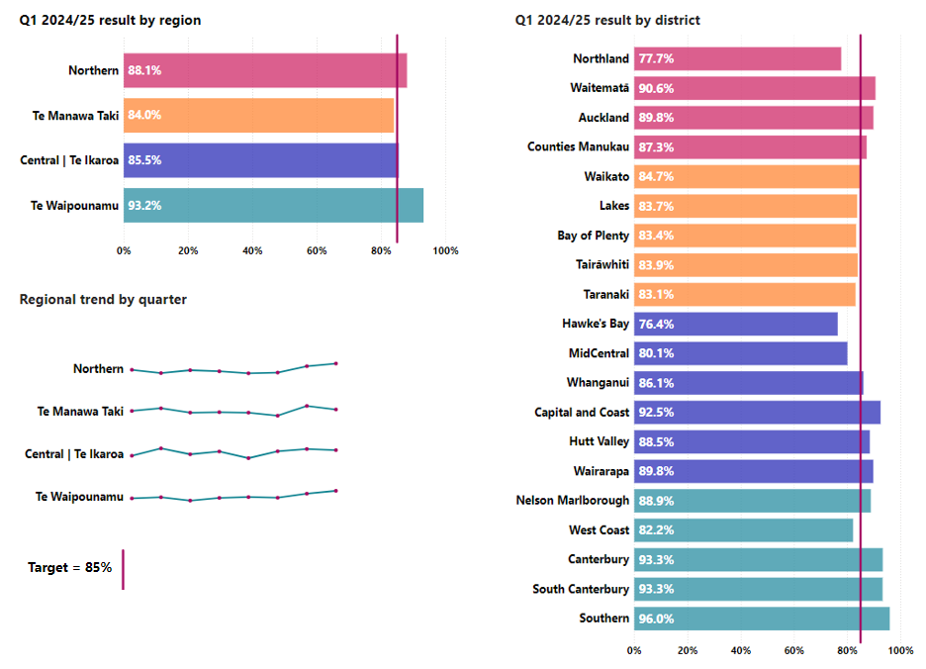
Newborn enrolment continues to be more than the 85 per cent target for the total population. Enrolment for Māori is notably lower, and for Pacific Peoples, it remains close to the target.
Details of newborns, for whom parents have nominated a general practice at birth, are notified to the selected general practice and the AIR – this aims to support the connection with general practice teams.
Scoping for a Newborn enrolment system integration project was completed in July 2024. Based on the parents’ choice, the system will automate pre-enrolment with a general practice and pre-registration with a Well Child Tamariki Ora provider before the child is born. The system will identify parents who need significant support, particularly those with children who may have health conditions and, without early intervention, may end up in hospital unnecessarily. This will enable providers to support them to navigate the health services they need.
Initiatives are underway across all regions to improve newborn enrolment rates.
- Northern is working on ensuring babies can be enrolled at the same practice as their mother (regardless of closed or open GP books).
- In Te Manawa Taki, Hauraki PHO has established kaiāwhina led enrolment for whānau referred to the Outreach Immunisation Service. The service supports whānau to enrol with a general practice when they are referred for overdue childhood immunisations.
- In Te Waipounamu, every child who comes through the Whaihua newborn enrolment system is tracked. If enrolment has not been completed within five days, the general practice is contacted. Follow up is by telephone to encourage and confirm enrolment.

P2-17 GP enrolment
This measure shows the percentage of people enrolled with a general practice (or a kaupapa Māori provider delivering general practice care) as a percentage of the estimated resident population provided by Stats NZ.
National result:
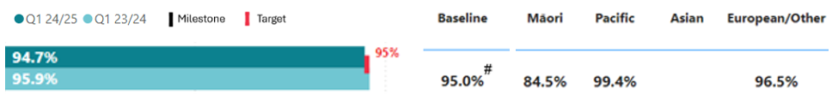
# See caveats on page 26

Results by region and district:
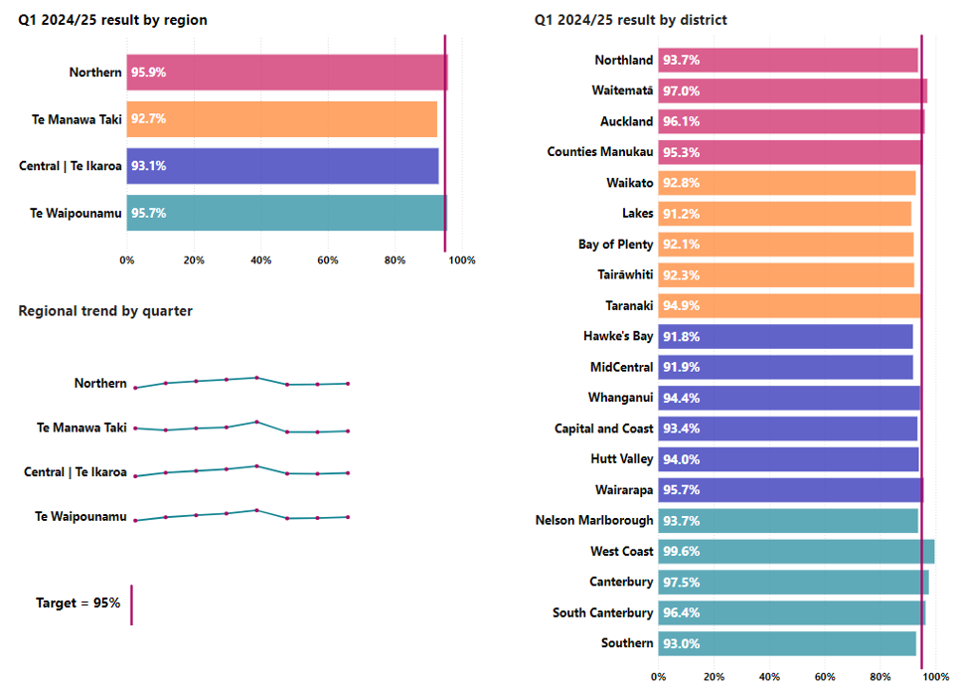

P2-23 ASH rate adults 45-64yrs per 100,000
This measure shows ambulatory sensitive hospitalisations for people aged 45-64 years old for an illness that might have been prevented or better managed in a primary care setting, as a rate per 100,000 population.
National result:
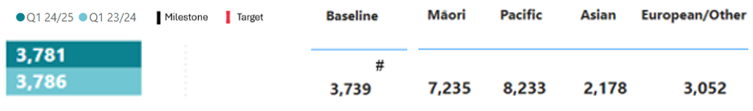
# See caveats on page 26

Results by region and district:
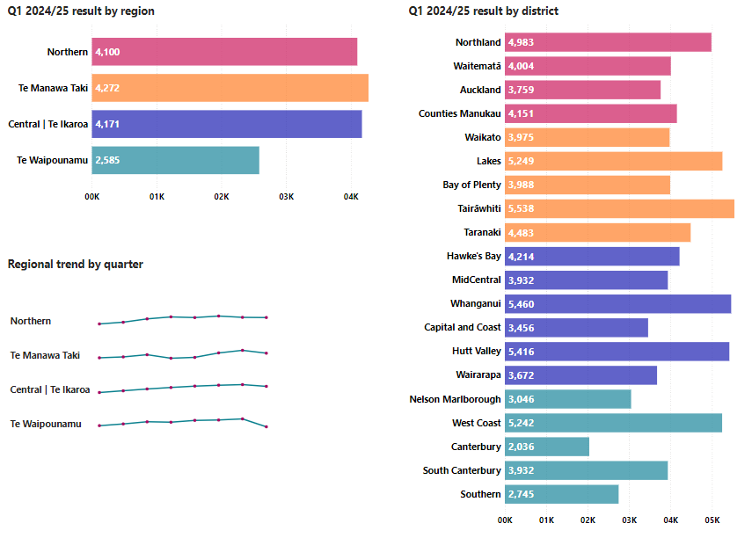

P2-22 ASH rate child 0-4yrs per 100,000
This measure shows ambulatory sensitive hospitalisations for people aged 0-4 years old for an illness that might have been prevented or better managed in a primary care setting, as a rate per 100,000 population.
National result:
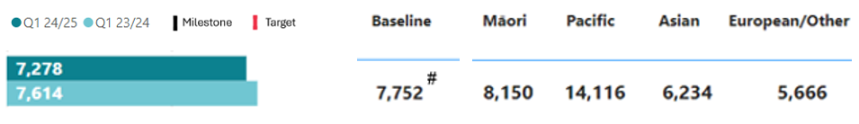
# See caveats on page 26

Results by region and district:
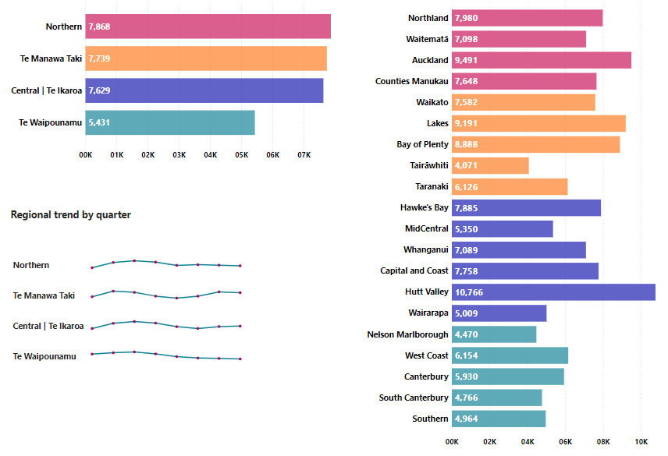
Pacific Peoples have more than double the rate of ambulatory sensitive hospitalisations per 100,000 compared to the total population. Ambulatory sensitive hospitalisations per 100,000 for children and adults are considerably lower in Te Waipounamu compared to other regions.
Initiatives outlined below are intended to improve ambulatory sensitive hospitalisation rates for both children and adults.
Work is underway with PHOs to provide more timely and nationally consistent access to hospital data by linking dashboards to general practice systems and integrating whole-of-population data. Data governance and data sharing arrangements are being aligned to effect legal and safe exchange of patient level information to primary care, based on obligations to support enrolled populations.
A respiratory package of care has been rolled out across primary care providers in
Te Manawa Taki for people at risk of hospitalisation due to respiratory conditions. Initial reporting demonstrates 77 packages of care were delivered in the quarter, of which 40 per cent were delivered to Māori.
The Western Bay of Plenty PHO has developed a diabetes dashboard which went live in August 2024 to support clinicians to track improvements in diabetes care, align to best practice and prioritise those with the highest needs. This will provide greater clarity to primary care staff to be able to target care towards those in greatest need of better diabetes management. Through improved monitoring and proactive care, there should be a reduction in presentations to emergency department (ED) and better health outcomes for patients.
We have redesigned local after-hours primary care services in Te Waipounamu to ensure sustainability of access, new after-hours service models were implemented in Invercargill, Wānaka and Te Tai Poutini the West Coast, to improve accessibility and reduce ED visits and hospitalisations.
We have also provided funding to urgent care providers across Te Manawa Taki to ensure access to urgent and after-hours care services are stable and available to respond to increasing demand. This contributed to a reduction in co-payments for those under 14 years old and low-income households accessing urgent and after-hours care.

P2-176 GP accessed when wanted
This measure shows the percentage of people who received health care from a general practice or nurse when they wanted it in the past 12 months, self-reported from the HQSC primary care patient experience survey.
National result:
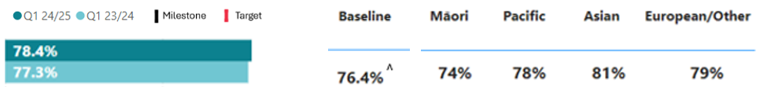
^ See caveats on page 26

Results by region and district:
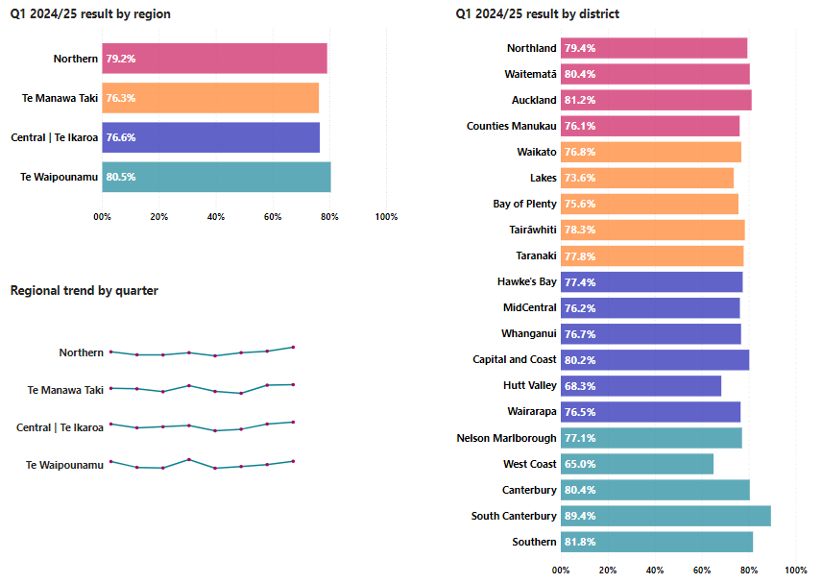
General practice qualifying encounters (see figures under key outputs below) show sustained growth, which is likely due to increased enrolment and the impact of winter. Despite this volume growth, the performance in this measure has remained relatively steady between quarter 1 last year and this quarter.

Key outputs
 | Q1 (Year to date) | Annual Forecast | Proportion of annual forecast delivered to date
PHO enrolments  (cumulative total) | 5,050,051  (Q1 23/24: 4,933,692) | 5,131,395 | 98%
GP qualifying encounters | 5,688,958  (Q1 23/24: 5,453,323) | 22,860,024 | 25%
Dispensed pharmaceuticals* | 22,628,987  (Q1 23/24: 23,451,585) | 97,751,775 | 23%
Emergency ambulance service incidents | 157,835  (Q1 23/24: 155,706) | 625,700 | 25%
Aged residential care occupied bed days# | 2,551,453  (Q1 23/24: 2,505,951) | Not yet available | N/A

Output caveats
PHO enrolments and GP qualifying encounters: Forecasting is determined using population projections as a base, stratified by the PHO funding age bands (0-4, 5-14, 15-24, 25-44, 45-64, and 65+), to account for the different population growth rates for each age band. PHO enrolments forecast is based on cumulative/overall enrolments in primary care for 2024/25 rather than additional enrolments for 2024/25 which is used for the other key outputs.
Dispensed pharmaceuticals: * Data extraction occurred on 5 November 2024. Pharmaceutical collections data recommends a two-month delay between collection and reporting. Due to the date of extraction being within the two-month window, this data should be considered incomplete and subject to change. Forecasting aligns with methodology used for the Integrated Community Pharmacy Services Agreement.
Emergency ambulance service incidents: Exponential triple smoothing is used for forecasting, which is a method that takes into account seasonal variation present in the data.
Aged Residential Care Occupied Bed days: # Data includes residents in long-term residential care funded by Health NZ. It does not include rest home residents who fund the full cost themselves or younger disabled residents or short-term (e.g. respite) who are funded via separate contracts. The data is extracted from an operational system, so the numbers are subject to change, particularly for the more recent quarter 1 2024/25 result. Aged residential care occupied bed days annual forecasting is currently being reviewed so our annual forecast is not yet available. Forecasting uses population projections for those 65 years and over.
The majority of New Zealanders are enrolled with a general practice. During 2023/24, 116,000 more people enrolled, an increase of 2.4 per cent. Similarly, there were 235,635 (4.3 per cent) more general practice qualifying encounters than a year ago. Growth is expected to continue with more than 5.1 million people expected to be enrolled by 30 June 2025 and up to 23 million GP encounters forecasted to be delivered.
Emergency ambulance service incidents were 1.4 per cent higher this quarter compared to this time last year. This increase is slightly lower than the historical trend of three per cent growth year-on-year. This winter was milder for ambulance usage (in terms of demand and system pressure) than previous winters, and this is reflected in the volumes.

Financial performance
 | Year to Date (30 Sep-24) |  |  | Full Year 2024/25
 | Actual | Budget | Variance | Budget
Revenue and expenditure | $m | $m | $m | $m
Total operating revenue | 2,437 | 2,347 | 90 | 9,387
Total operating expense | 2,529 | 2,421 | (108) | 9,637
Surplus/(deficit) | (92) | (74) | (18) | (250)

Strategic priority one: Deliver the New Zealand Health Plan
Reporting against the NZ Health Plan | Te Pae Waenga will begin in 2025, once the plan has been finalised and published.

Strategic priority two: Empower and enable leadership at all levels
Extensions to primary and community care service types are live in Southern, South Canterbury, Te Tai Poutini the West Coast and Nelson-Marlborough districts. These services aim to reduce demand on hospitals.
Health NZ launched an oral health initiative in Te Tai Poutini the West Coast, to provide a package of support for high-risk tamariki and their whānau. This includes prevention, education and access to treatment, both in terms of minimising ‘did not attends’ and improving clinic provision. Six clinics are planned for delivery from July to December 2024 to address the current specialist wait list.
Rural communities across Central without local aged residential care service options are being reviewed to ensure they have robust and sustainable health services for their kaumātua to live and age well. Health NZ have developed a plan for the Wairoa district, which remains a priority given the closure of its only aged residential care facility following longstanding challenges exacerbated by Cyclone Gabrielle in early 2023.

Output class 3: Hospital and specialist services
This section presents the results for the hospital and specialist services output class. For more background, see pages 19-21 of the SPE.

Performance measures
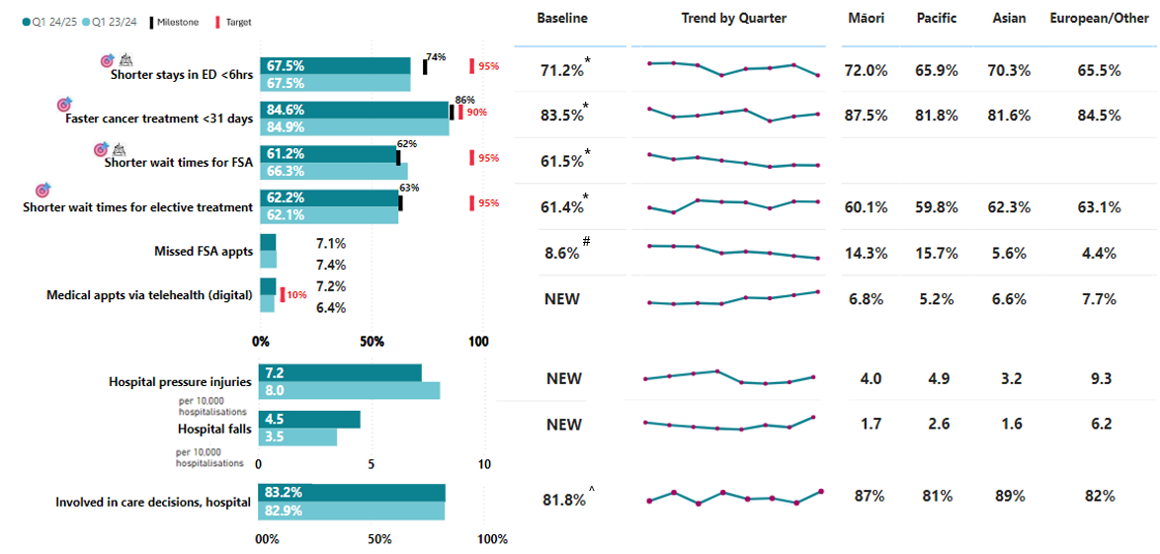
Performance has deteriorated for two out of the four health targets in this output class, and two have remained relatively stable compared to the same quarter last year. All health targets are below the 2024/25 milestone.

Data caveats
* Baseline is quarter 4 2023/24.
# Baseline is 2022/23, taken from the SPE.
^ Baseline is 12 months to 05/2023.
All measures with NEW for baseline will have baselines set in 2024/25.
Shorter stays in ED <6hrs: From quarter 4 2023/24, three level two facilities (not publicly funded) were excluded from this measure. This change has been applied to the results of the previous quarter as published in this report and will continue to be applied in the future. Southern District ED data (Dunedin, Invercargill and Lakes) is incomplete for October and November 2023 due to a system change at that time. Work is underway to rectify this.
Faster cancer treatment <31 days: District results are accurate as populated in clinical systems; some districts are still catching up on September entries. District results are unavailable for Taranaki due to a submission issue and are omitted from district-specific charts. They are included in national and regional figures. This will have a small effect on quarter 1 results, which will differ from validated numbers for quarter 2, when they are published.
Shorter wait times for FSA: We do not yet collect ethnicity data for FSA wait times.
Shorter wait times for elective treatment: Southern had data issues and is removed from district-specific charts. It is included in national and regional figures. This will have a small effect on quarter 1 results, which will differ from validated numbers for quarter 2, when they are published.
Hospital pressure injuries and hospital falls: Data submissions from Wairarapa and Whanganui districts in quarter 1 were incomplete due to a system upgrade. As such, their results for quarter 1 may change in the next quarter. While data completeness is always the goal, the overall results remain largely unaffected by these districts.
Hospital falls: Wairarapa quarter 1 results have been withheld in the district chart due to submission issues outlined above, but are included in regional and national results as impact on these results are minimal.
Involved in care decisions, hospital: Results are based on weighted data. Some ethnicity and district data are obfuscated due to low volumes.

P2-45 Shorter stays in ED <6hrs
This measure reports patients admitted, discharged or transferred from an ED within six hours as a percentage of all patients who attended ED.
National result:
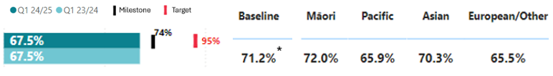
* See caveats on page 38

Results by region and district:
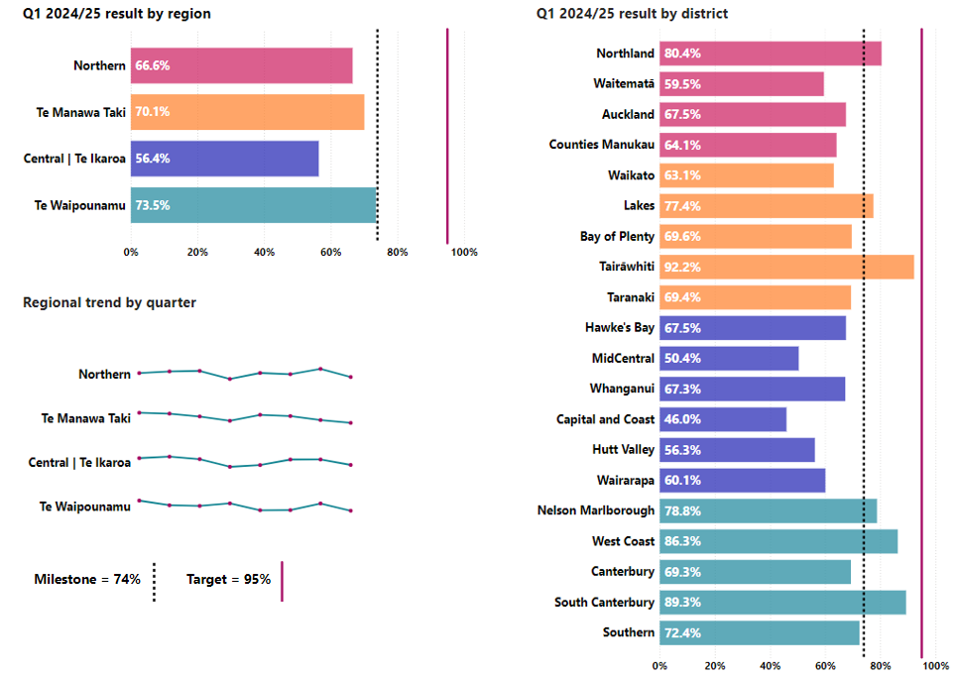
Historically, ED performance is lowest during quarter 1 because seasonal winter illnesses place pressure on hospitals and limit their flexibility to respond to ED demand. There is a 17.1 per cent variation between the four regions’ results for this measure, with Te Waipounamu the best performing (73.5 per cent) and Central the lowest (56.4 per cent).
The total number of patients presenting are rising over time, however triage category four (potentially serious) patients and triage category five patients (less urgent) continue to decline as a proportion of overall presentations. Patients presenting with triage categories two and three continue to grow and is associated with an increased number of patients admitted to hospital.
We deployed a range of initiatives during the quarter to improve performance, for example:
- In Te Manawa Taki, the START (supported transfer and accelerated rehab team) programme began its roll out, following its success in Waikato. START supports patients to make a safe and quicker transition out of hospital, by providing the intensive support and rehabilitation needed in their home.
- In the MidCentral district, $6 million in funding was allocated to the following initiatives to improve acute flow, including: establishing a discharge lounge; forming an early supported discharge service for frail, elderly and stroke patients; creating a system flow clinical co-ordinator role; using the hospital’s fracture clinic to treat and discharge lower acuity patients; and staffing the newly opened children’s area in the ED.
- The national acute flow operational standards were launched. These focus on ensuring hospitals have the right systems and processes in place to manage acute patient flow and improve performance in this measure. Hospitals are currently completing self-assessments against the standards to identify opportunities for improvement.
- National teams are meeting with each district to understand their immediate focus areas for acute flow improvement, with the aim of sharing best practice already underway and ensuring a strong focus on acute flow going forward. Monthly forums are also in place with districts, regions and national teams to collaborate on areas for improvement and to share best practice and ideas.

P2-51 Faster cancer treatment <31 days
This measure shows the proportion of eligible cancer patients who received their first treatment within 31 days of a health professional’s decision to treat.
National result:
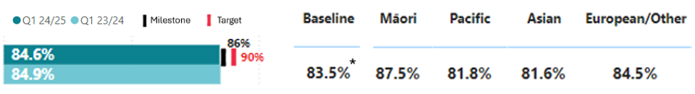
* See caveats on page 38

Results by region and district:
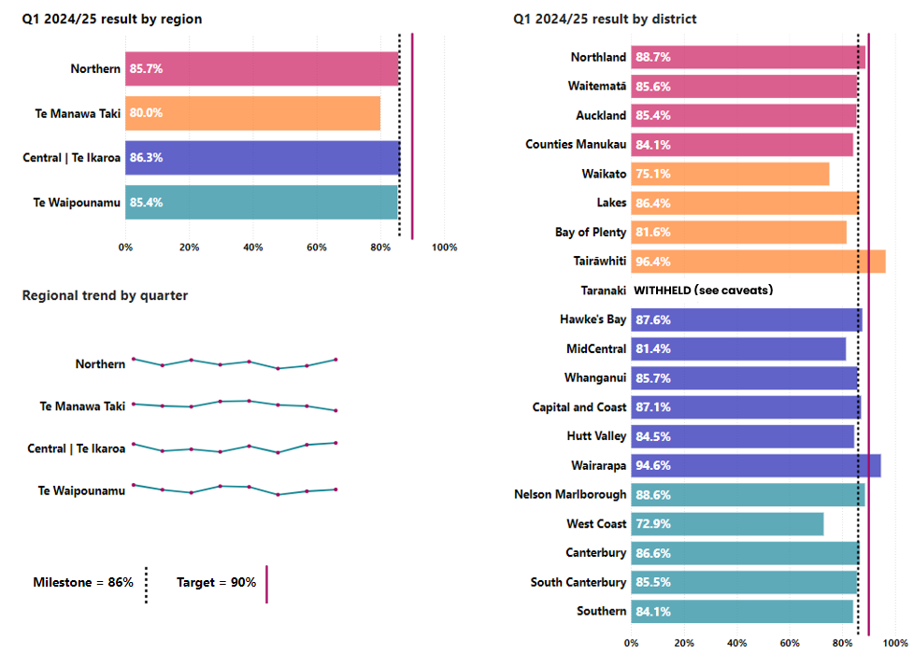
One region met the milestone for 2024/25 this quarter, with two other regions less than one per cent away from achieving the milestone.
We are developing a cancer service delivery and transformation programme to improve capacity to meet growing demand and ensure cancer services are delivered closer to where people live. Work is progressing on integrated service delivery planning, national models of care and national clinical pathways (which aim to streamline diagnosis and treatment and address unwarranted variation).
A range of local initiatives are underway to improve performance, for example:
- In Waitematā, the medical day stay unit at Waitākere Hospital began offering subcutaneous chemotherapy treatments for the first time. This new service reduces the need for patients to travel to North Shore Hospital every week, saving them time and money, and reducing stress.
- In Tamaki Makaurau Auckland, qualified radiation therapists have greater responsibility for patients requiring urgent treatment within the palliative radiotherapy setting, taking a load off senior radiation oncologists, and freeing them up for other important mahi. Having the first advanced practitioner radiation therapists in the country is leading the way in supporting improved access to care – resulting in 98 per cent of urgent patients now being treated within 24 hours of referral.

P2-39 Shorter wait times for FSA
This measure presents the proportion of people waiting less than four months for their FSA from the date of referral.
National result:
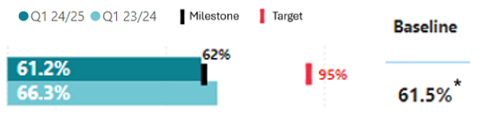
* See caveats on page 38

Results by region and district:
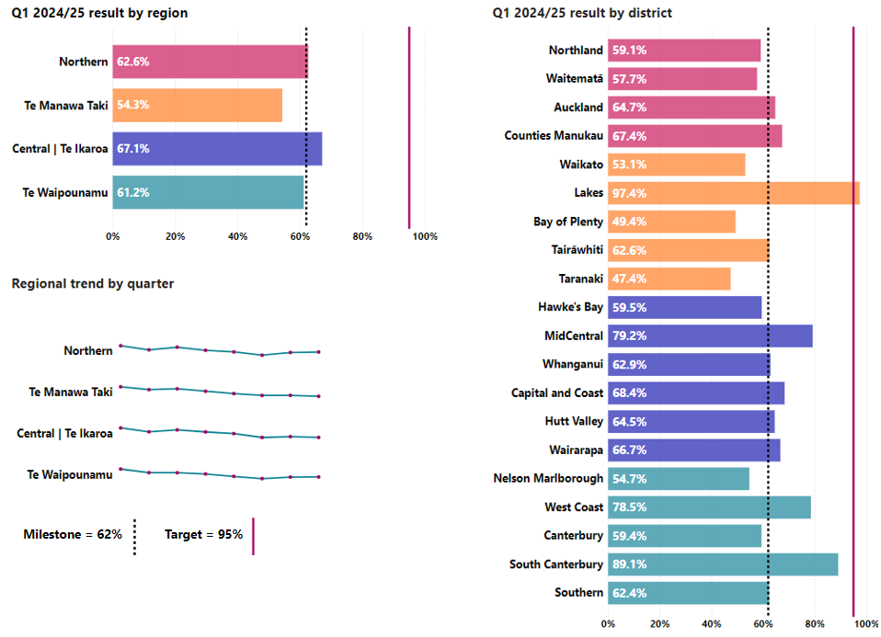
The total number of people on the FSA and total elective treatment wait lists is more stable after a period of growth since 2018/19.
A range of initiatives were progressed nationally during the quarter to improve performance, for example:
- release of the national musculoskeletal pathway for local implementation – this sees physiotherapists, as opposed to doctors, complete FSAs for certain orthopaedic conditions, thereby reducing wait times (patients will be referred to a doctor by the physiotherapist after their FSA, where needed).
- developing new clinical pathways that enable allied health professionals (e.g. orthoptists, audiologists) to complete FSAs for certain conditions.
- work to agree national standards for booking, and waitlist management.
A range of local initiatives was also progressed, for example:
- In Northland, Health NZ launched a complete cataract care pathway at Kaitaia Hospital. This is focused on reducing wait times and provides for up to 20 patients per month to receive end-to-end care (from FSA to cataract surgery to post-operative follow-up).
- In Waikato, Health NZ have introduced a process for clinical nurse specialist and clerical review of FSA wait lists. This involves starting with the patient who has been waiting the longest and working backward. To date, 27 per cent of patients reviewed have been found to no longer require an FSA, which releases capacity for other patients.
- In the Central region, Health NZ have rolled out a gastroscopy access criteria tool to provide clear guidance to primary care on which patients benefit most from gastroscopy – to ensure consistency in access and reducing inappropriate referrals (which can inflate wait times).
- In Te Waipounamu, Health NZ are developing regional guidelines in relation to waitlist management and rolling out an acuity tool across all districts. The acuity tool improves visibility of patients who are waiting longer than their ‘treat by’ period. The tool is to enable patients to be booked in order of clinical urgency and wait time.
Reducing the number of missed FSAs is critical to achieving our health target. A missed FSA impacts on the timeliness of care for that patient and other patients (as the original appointment time could have been used for someone else). Activity underway includes:
- In the Bay of Plenty, the Pacific Island Community Trust follows up with Pacific patients who miss their FSA and works to ensure patients attend subsequent appointments to get the care they need. Similarly, Te Pare o Toi (Bay of Plenty’s Māori health service) provides practical support for patients to attend appointments such as petrol vouchers, health shuttles and care co-ordination.
- In Tairāwhiti, there is a strong focus on booking patients promptly while they are engaged. Patients are also provided with clear, timely updates about their appointments, and given reminders.
Each region is developing a 90-day action plan to improve health target performance and focus on FSAs and elective treatment (see measure below). This ensures there is coordination of activity and focus on the right areas at a district level. A bimonthly forum is in place (Regional Collaboration Forum) with district, region and national representation to enable sharing of good practice. National working groups are in place, i.e.:
- Clinical prioritisation advisory group
- Operational wait list management standards through the planned care patient pathway working groups
- Clinical pathway expert advisory groups across orthopaedic, ophthalmology and otorhinolaryngology services

P2-40 Shorter wait times for elective treatment
This measure presents the proportion of people given a commitment to treatment and treated within four months as a proportion of all people waiting for a procedure.
National result:
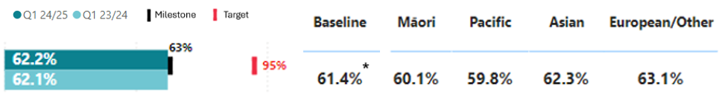
* See caveats on page 38

Results by region and district:
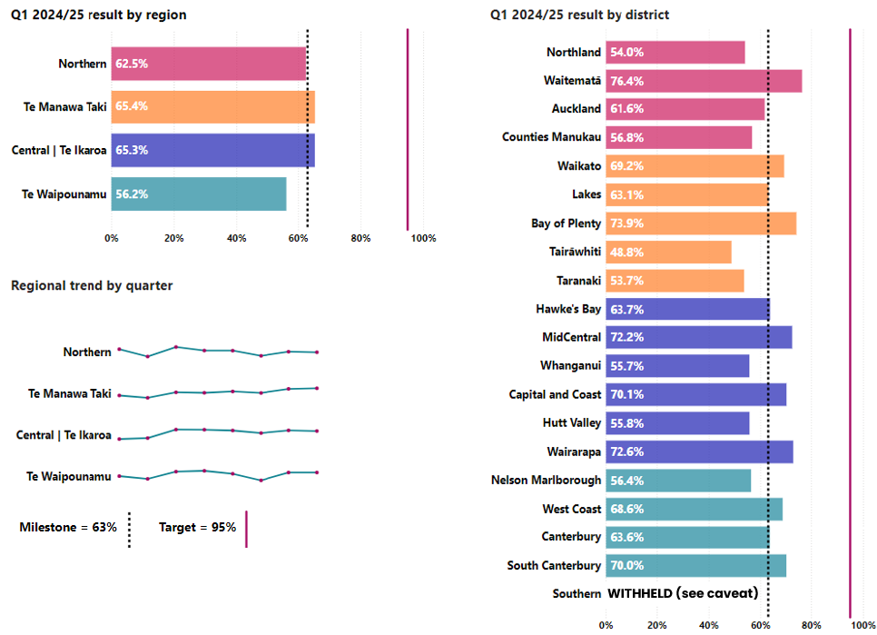
During quarter 1, a range of initiatives were progressed at the national level to improve performance against this measure, for example:
- The National Theatre Expert Advisory Group is developing recommendations for improved evening and weekend use of theatres to protect the delivery of planned care during periods of higher acute demand.
- The development of new capability to monitor planned care bookings at a district and service level, enabling regions to identify and respond to issues.
- Benchmarking our services nationally by procedure type, initially focused on identifying opportunities to increase day of surgery provision and reduce elective bed days.
- Requests for proposal for regional panel agreements were issued and closed in September. Panel agreements are important to purchasing planned care from private providers, because they result in better use of public and private capacity.

P2-58 Missed FSA appts
This measure presents the patients who did not attend or did not wait for their FSA as a proportion of total appointments.
National result:
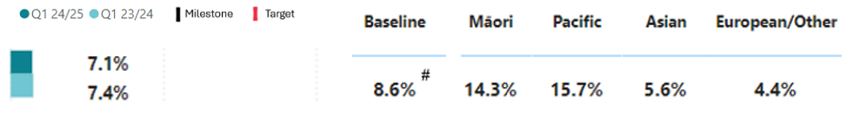
# See caveats on page 38

Results by region and district:
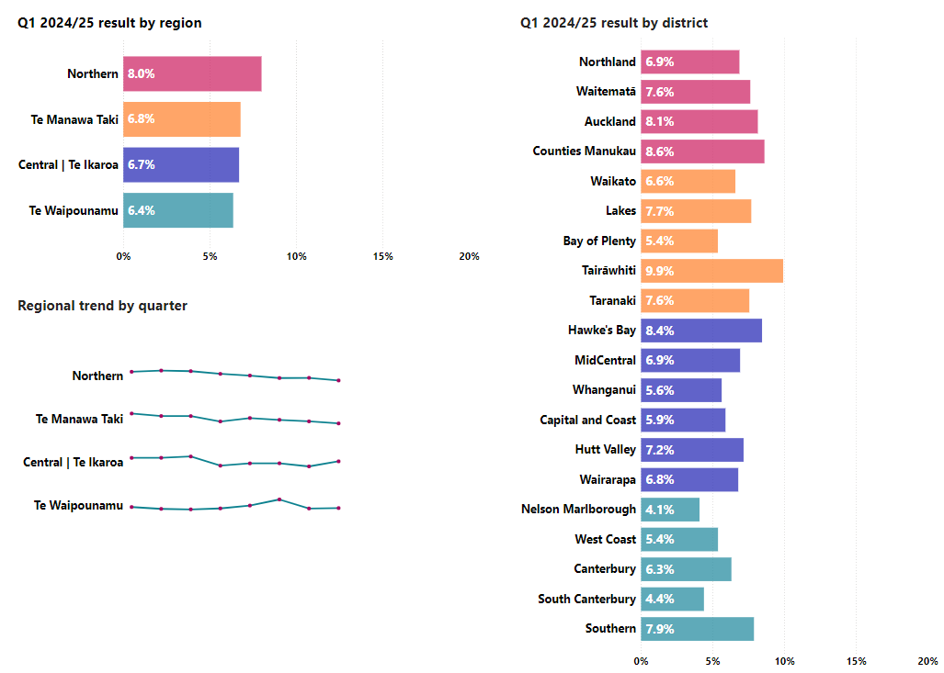
Māori and Pacific Peoples have around double the percentage of missed appointments compared to the total population, and around three to four times that of European/other.

P2-88 Medical appts via telehealth (digital)
This measure reports outpatient attendances that were completed via telephone or video as a proportion of all outpatient attendances.
National result:
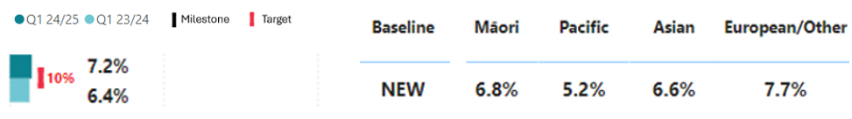
NEW: See caveats on page 38
Results by region and district:
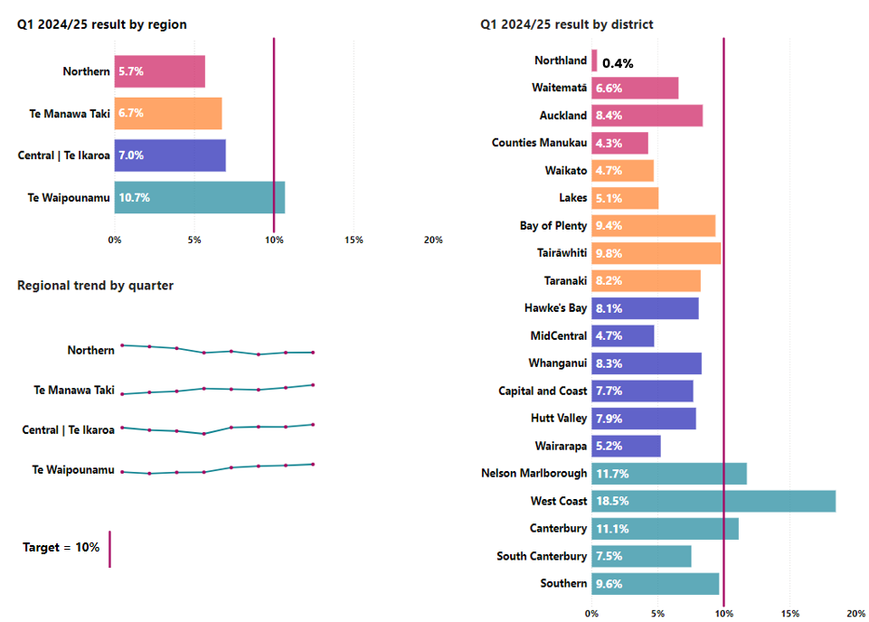
Increasing the proportion of planned care outpatient appointments completed through digital channels has a range of potential benefits, including providing faster access to care, reducing wait times, bringing care closer to home, and delivering care that works better for patients and whānau.
Use of telehealth is more appropriate for certain services (e.g. medical specialities) and types of appointment (e.g. follow-up appointments after elective treatment).

P2-194 Hospital pressure injuries
This measure presents the rate of hospital acquired pressure injuries per 10,000 hospitalisations, where the number of inpatient stays with pressure injuries are divided by the total number of stays and multiplied by 10,000 to give a rate for reference.
National result:
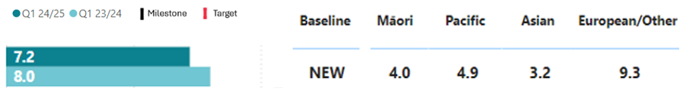
NEW: See caveats on page 38

Results by region and district:
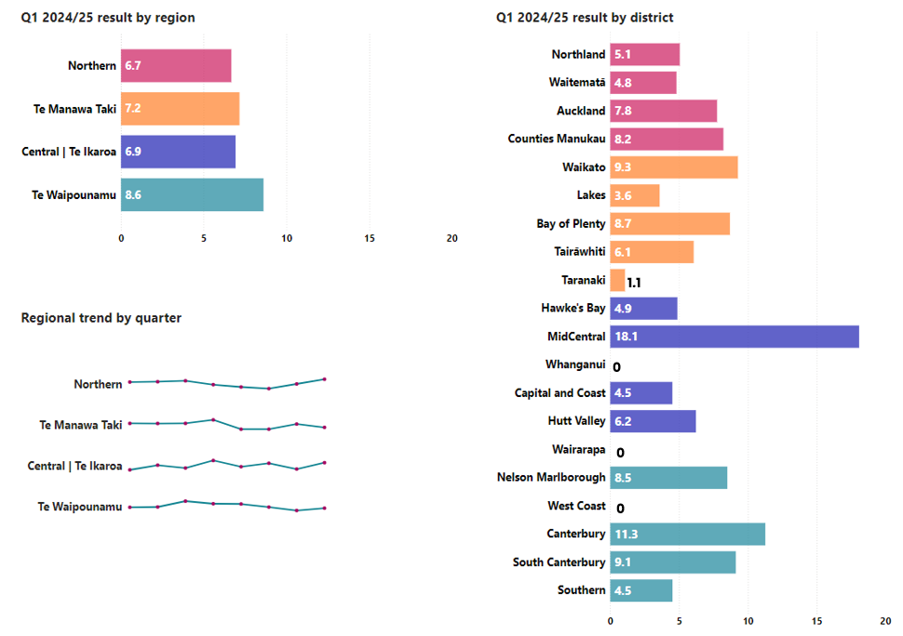
The rate of hospital acquired pressure injuries per 10,000 hospitalisations was zero in Whanganui, Wairarapa and West Coast districts for quarter one 2024/25.
Pressure injuries are a major cause of preventable harm for patients. Pressure injuries increase patients’ length of stay, ACC treatment injury claims and care costs.
Te Tāhū Hauora ǀ HQSC has an active pressure injury prevention programme. Under this programme, all inpatients in Health NZ facilities should be assessed for pressure injury and have a preventative management plan. Districts also have a range of initiatives to prevent pressure injuries, e.g.:
- In Waikato, a ‘patient pressure injury’ diary is being rolled out across orthopaedic wards. The intensive care unit has undertaken an audit of device-related pressure injuries (an ongoing issue), and ward staff have completed education on the difference between pressure areas and moisture lesions.
- In the Bay of Plenty, we are developing a process to enable health care assistants to conduct ‘skin integrity checks’, and a dressing product with strong evidence of preventing and treating pressure injuries has undergone comparative evaluation (with a view to replacing existing products).
- In Hawke’s Bay, we are offering patients and their whānau information to understand the risks associated with pressure injuries, and how they can play a part in reducing them.
- In Capital and Coast and Hutt Valley, we are using life-sized models for staff education, and lanyard cards to support assessment and early intervention.

P2-195 Hospital falls
This measure presents the rate of hospital acquired falls resulting in fracture or other intracranial injury per 10,000 hospitalisations where the number of inpatient stays with falls are divided by the total number of stays, and then multiplied by 10,000 to give a rate for reference.
National result:
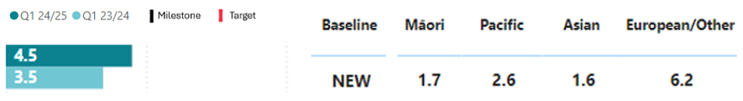
NEW: See caveats on page 38

Results by region and district:
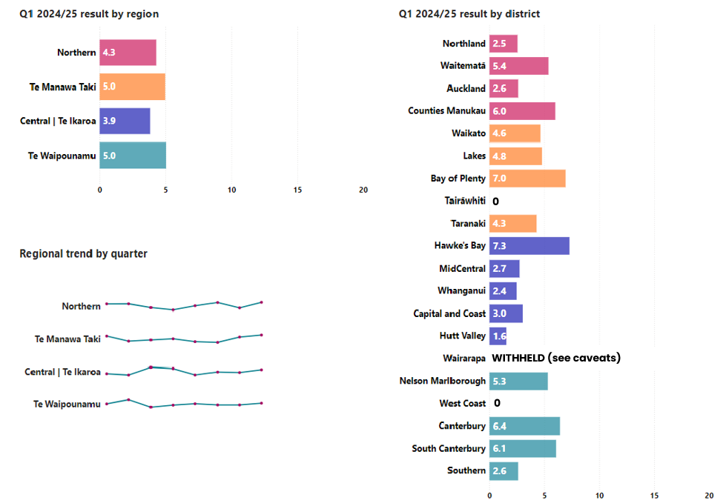
The rate of hospital acquired falls per 10,000 hospitalisations was zero in Tairāwhiti and West Coast districts for quarter 1 2024/25.
All inpatients should be assessed for risk of falling and have a risk management plan put in place, where necessary. Equipment should also be assessed to ensure accessibility and reduce the risk of falls.

P2-44 Involved in care decisions, hospital
This measure indicates people who reported they were involved as much as they wanted to be in decisions about their treatment as a proportion of all adult inpatients who responded to the HQSC adult inpatient survey.
National result:
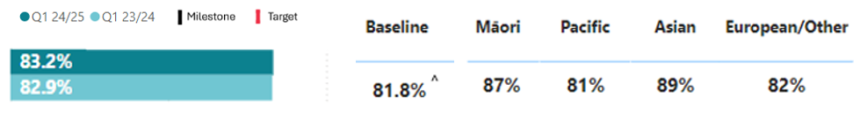
^ See caveats on page 38

Results by region and district:
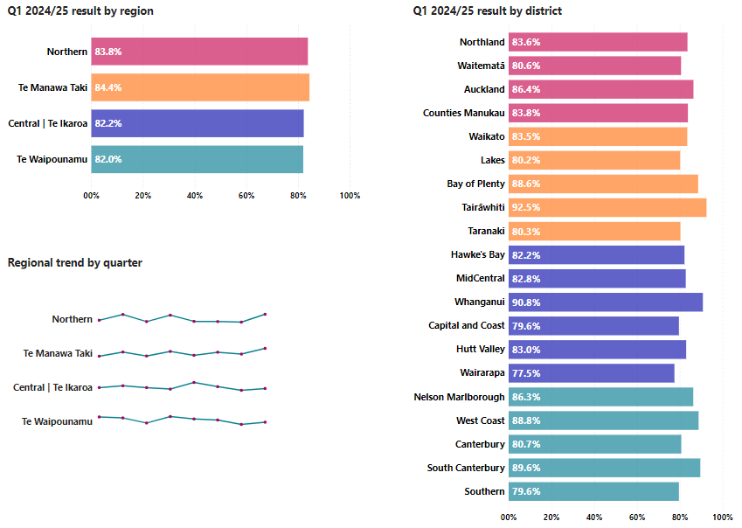
Our Whānau Feedback and Engagement Advisory Group has developed national guidelines for using patient stories to inform improvement activities (including work to better involve patients in making decisions about their treatment and care). The group consists of representatives from Health NZ, Te Tāhū Hauora ǀ HQSC, and consumers.
Key outputs
 | Q1 2024/25 (Year to date) | Annual forecast | Proportion of annual forecast delivered to date
Case weighted discharges | 266,000  (Q1 23/24: 255,000) | 1,038,000 | 26%
FSA | 188,000  (Q1 23/24: 176,000) | 689,000 | 27%
Follow-ups | 412,000  (Q1 23/24: 396,000) | 1,507,000 | 27%
*Numbers rounded to the nearest 1,000
We have developed a national plan for core activities of hospital and specialist services, which will be reviewed over the year and adjusted over the next few years. The annual forecasted position is based on current delivery against the plan.
Case weighted discharges (a measure of the number of patients and complexities treated in hospitals) were four per cent more than the same period last year (255,000).
Health NZ has delivered seven per cent more FSAs and four per cent more follow ups in outpatient settings compared to the same time last year.

Financial performance
 | Year to Date (30 Sep-24) |  |  | Full Year 2024/25
 | Actual | Budget | Variance | Budget
Revenue and expenditure | $m | $m | $m | $m
Total operating revenue | 3,713 | 3,778 | (65) | 15,116
Total operating expense | 4,129 | 3,963 | (166) | 15,966
Surplus/(deficit) | (416) | (185) | (231) | (850)

Strategic priority one: Deliver the New Zealand Health Plan
Reporting against the NZ Health Plan | Te Pae Waenga will begin in 2025, once the plan has been finalised and published.

Strategic priority two: Empower and enable leadership at all levels
Waikato Hospital introduced New Zealand’s first stand-alone video assisted thoracic surgery (VATS) for left atrial appendage ligation. This innovative, minimally invasive procedure allows for faster recovery and offers a new, safer option for heart patients. While VATS is commonly used for other types of chest surgery, this is the first time it has been used on its own for heart care. For patients, it means a shorter hospital stay – usually less than 24 hours–and a quick return to normal life, often within five to 10 days. Most don’t need strong painkillers after just three to five days. Three patients have so far had the VATS clip, and two more have had the VATS clip combined with other VATS heart operations. We have had eight referrals, which is lower than anticipated, however this is likely due to referrers’ lack of awareness.
The Waikato team has opened the Community Dialysis House in Hamilton, a new facility for dialysis patients who are trained to perform their own haemodialysis but don’t have a suitable space at home. This service provides better access to care by enabling patients to self-dialyse on their own schedule in a comfortable, supportive environment. The Community Dialysis House is designed as an unstaffed unit, creating a ‘home away from home’ for up to 10 patients.
By September, seven out of our 14 clinical networks are in the establishment phase: cancer, child health, diabetes, maternity, mental health and addiction, oral health and rural health. The remaining seven are in the delivery phase: cardiac, eye health, infection services, radiology, renal, stroke and trauma. Key achievements for these networks include:
- re-establishing the Regional Cardiac Network in Te Waipounamu.
- the Eye Health Network is growing and strengthening clinical leadership from across the ophthalmic professional group. A national stocktake is underway to inform local models of care for eye health. A cross-linking survey will be completed in quarter 2 to understand the current state of treatment outcomes and natural history of keratoconus.
- the Renal Network completed a dialysis stocktake in regions which will inform an investment report and development of models of care. Work began on developing an overarching data governance framework, and work continued on the implementation of a remote dialysis facility in Wairau to improve accessibility.

Output class 4: Mental health and addiction services
This section presents the results for the mental health and addiction (MH&A) services output class. For more background, see pages 22-23 of the SPE.

Performance measures
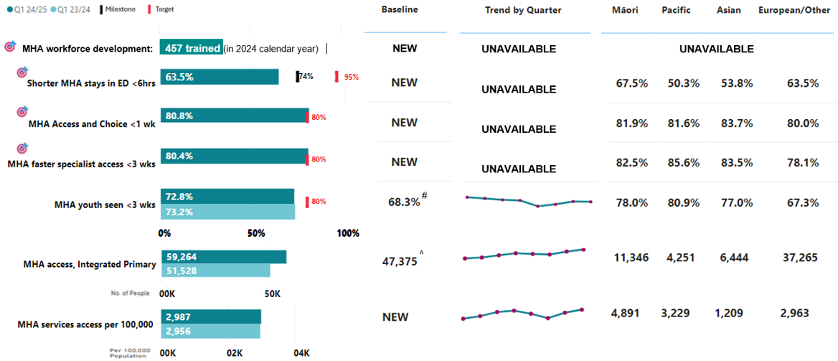
The MH&A targets were announced in July 2024. Implementation planning for the five MH&A targets began in quarter 1 and focused on the activities and mechanisms required to empower regions to lift performance.
Most notably, planning has also focused on improving and addressing data quality and completeness concerns to ensure an accurate view of performance. Several caveats apply as a result (see below).
In this quarter, two out of the four MH&A targets we are reporting have been met.

Data caveats
# Baseline is 2022/23, taken from the SPE.
^ Baseline is quarter 4 2022/23 result.
All measures with NEW for baseline will have baselines set in 2024/25.
Shorter MHA stays in ED <6hrs: Quarter 1 reporting is under-estimated due to a high proportion (9 per cent) of ED presentations having no specific presenting complaint recorded. Presenting complaint is required to identify MH&A related presentations. The result excludes three level 2 ED facilities (not publicly funded).
MHA Access and Choice <1 wk: Inclusion of referral date was mandated in October 2024. As such, data is incomplete for quarter 1 and will be rectified in quarter 2. Data for Tairāwhiti is unavailable for quarter 1. Youth, Māori and Pacific providers are not included in the results as they are not yet submitting data at a patient level. These providers represent approximately 30 per cent of activity in the Access and Choice programme. Work is underway to ensure we can include these providers in future quarters, starting with youth providers in quarter two.
MHA faster specialist access <3 wks and MHA youth seen <3 wks: Measurement change occurred for 2024/25 to support more current and inclusive monitoring. We have moved from a rolling 12 month average to measuring each quarter separately, by activity seen dates and inclusion of addiction services. This is reflected in results presented for any prior quarters in this report.
MHA faster specialist access <3 wks: Results for quarter one are estimated to be under-reported by 2 per cent due to delays in the data pipeline.
MHA access, integrated primary: Data for Tairāwhiti is unavailable for quarter 1.
MHA services access per 100,000: Wait time data for the youth, kaupapa Māori, Pacific and other primary MH&A services is not currently collected and therefore not included.

MHA workforce development: Workforce training figures exclude psychiatry training figures in quarter 1. The definition only includes psychology interns, new entry to specialist practice nurses, occupational therapists, social workers and stage one psychiatry registrars. Other key workforces including support workers and alcohol and drug practitioners cannot be measured at this stage but work will be undertaken to add them in the future.

P2-198 MHA workforce development
500 MH&A professionals are trained each year | 457
There continues to be an increased focus on increasing the MH&A workforce, with a total of 457 people in training in the 2024 academic (calendar) year.
This result covers two quarters, as it is based on a six-month training semester. Several initiatives are underway to support this target, including the release of the Mental Health and Addiction Workforce Plan.

P2-201 Shorter MHA stays in ED <6hrs
This measure presents the percentage of MH&A related ED presentations admitted, discharged or transferred from an ED within six hours as a proportion of all MH&A related attendances.
National result:
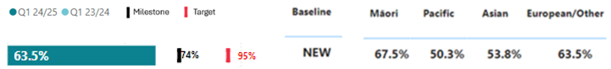
NEW: See caveats on page 57

Results by region and district:
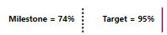
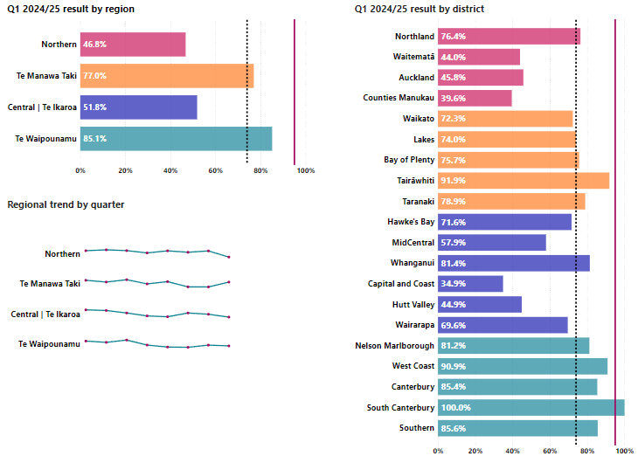

National performance is below the target and the 2024/25 milestone. In all regions, a strong operational drive to increase performance is underway, including:
- Northern is facilitating the management of patient discharges and capacity across MH&A inpatient units through its network.
- Te Manawa Taki is expanding the assessment and brief care team to operate 24/7 to support the ED in Taranaki and dedicated mental health professionals are working with the ED in Tairāwhiti to provide consult liaisons and facilitate inpatient admissions. Lakes is using data and insights to develop mental health support bundles for ED clinicians to ensure initial assessments promote achievement of the target, including when timely assessment from mental health clinicians will be necessary.
- Central is developing a rapid response function, as opposed to the traditional crisis model, which will include having crisis staff based in, or closer to local EDs (particularly in Wellington city).
- Te Waipounamu is in the early stages of developing its approach to performance management.

P2-202 MHA Access and Choice <1 wk
This measure presents the percentage of people accessing primary MH&A services through the Access and Choice programme within one week.
National result:
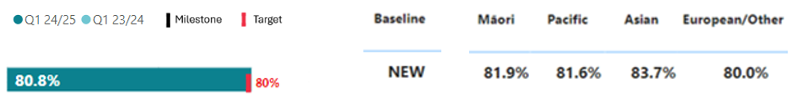
NEW: See caveats on page 57

Results by region and district:
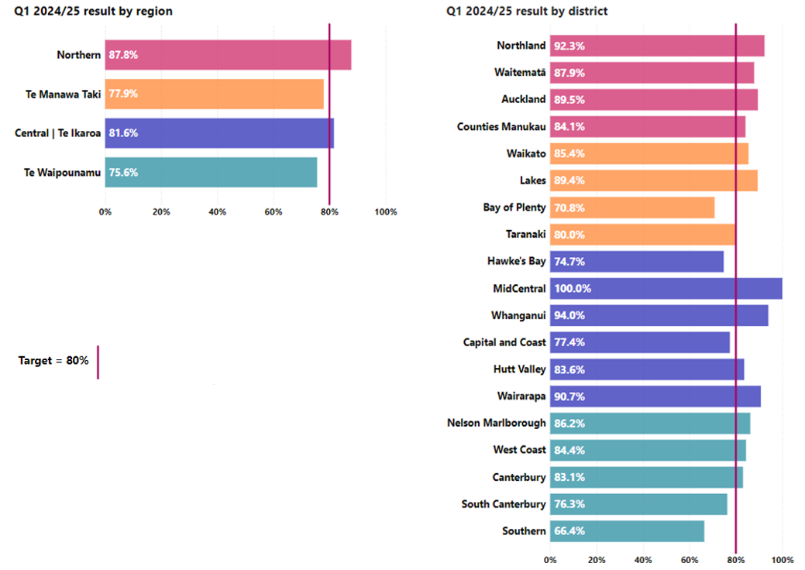
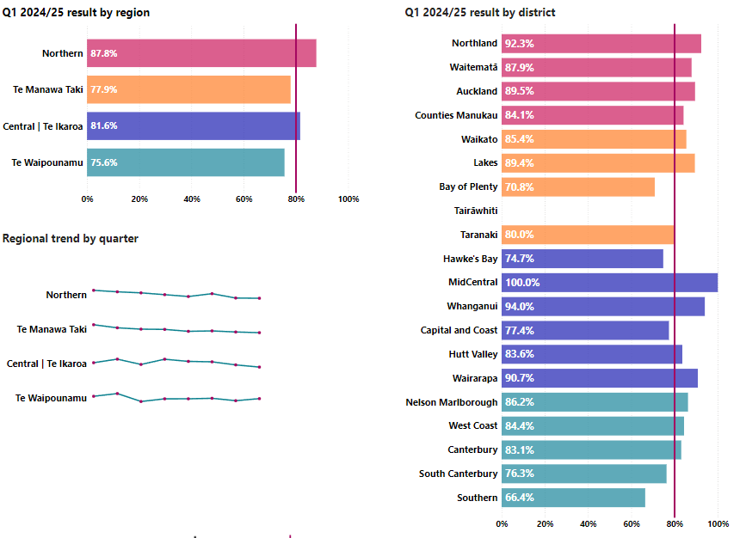
UNAVAILABLE (see caveats)
Nationally, 80.7 per cent of people are accessing integrated primary MH&A services through the Access and Choice programme within one week of referral.

P2-203 MHA faster specialist access <3 wks
This measure presents the percentage of people accessing specialist MH&A services who are seen within three weeks of referral.
National result:
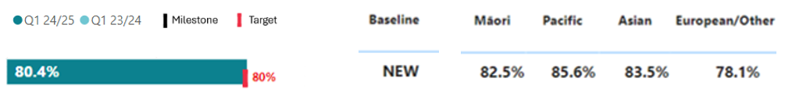
NEW: See caveats on page 57

Results by region and district:
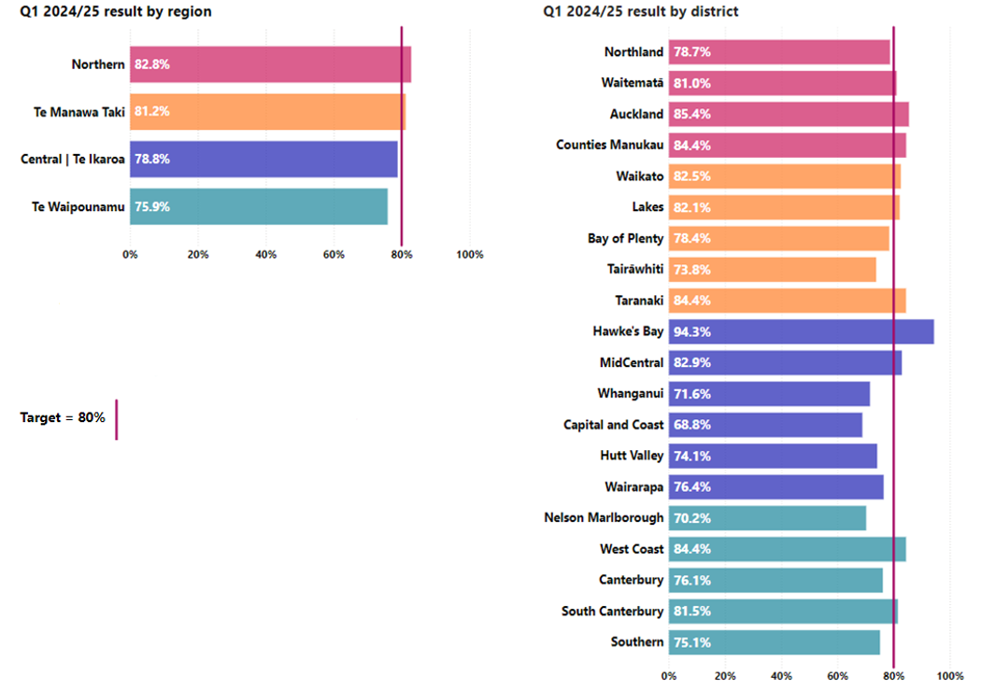
This target was met at a national level, although performance for the alcohol and other drugs sector and the under-25s age group was below target. Planning is underway to improve performance, for example:
- Taranaki have set up targeted phone contact approaches for whaiora who meet entry criteria for choice appointment arrangements, as well as using audio visual link clinics in rural community mental health teams.
- Central has commenced an improvement project to reduce the average accepted referral wait times for a first appointment by at least 50 per cent in the Wellington, Kapiti, Porirua, Wairarapa and Hutt Valley adult and infant, child and adolescent services. Elements of this include reviewing procedures and policies and streamlining referral management processes, including by working with general practice, and auditing the effectiveness of the referral processes.
- Te Waipounamu is creating a district-level database to support discussions about performance.

P2-69 MHA youth seen <3 wks
This measure presents the percentage of rangatahi (under 25-year-olds) seen within three weeks from a MH&A referral.
National result:
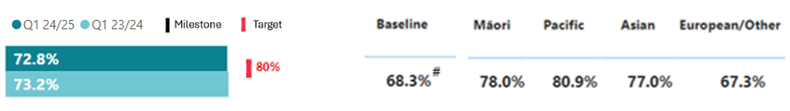
# See caveats on page 57

Results by region and district:
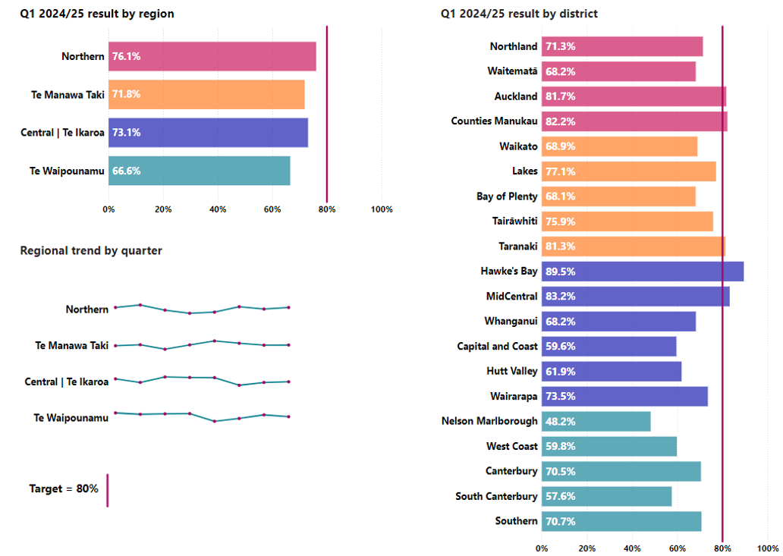
This age-group remains below target nationally and in all regions.
- The Northern region established a programme to improve pathways for referral between child and adolescent mental health services and paediatric medicine, given the increased demand for neurodevelopmental disorders.
- Lakes is trialling a pathway to support timely access in under 25s by leveraging capacity in the primary mental health intervention services pathway to provide interventions to adolescents with high-end moderate needs.

P2-199 MHA access, integrated primary
This measure presents the number of people accessing primary MH&A services through the integrated primary MH&A services (a subset of the Access and Choice programme).
National result:
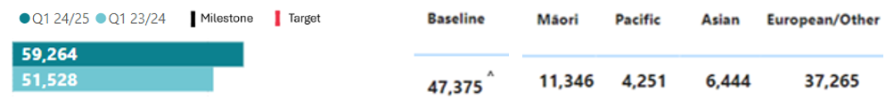
^ See caveats on page 57

Results by region and district:
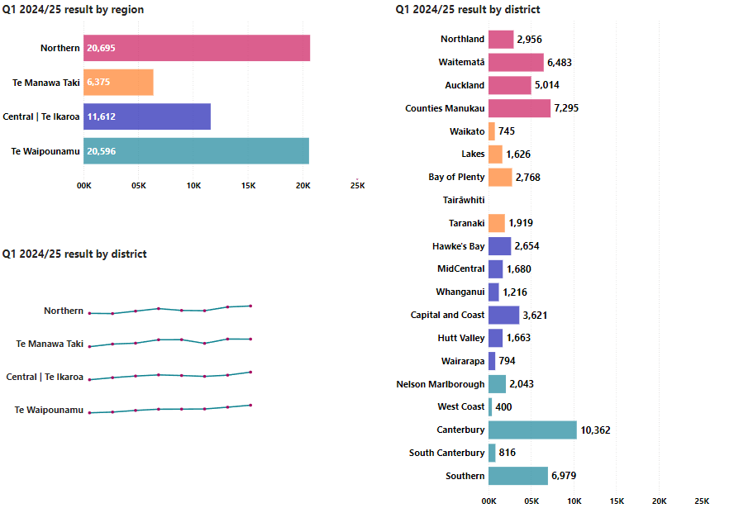
UNAVAILABLE (see caveats)
Increasing access to integrated primary MH&A services reflects ongoing service expansion over the past two years. 2023/24 was the final year of roll-out of these new services.

P2-187 MHA services access per 100,000
This measure presents the rates of new people accessing both primary (through the Access and Choice programme) and specialist MH&A services per 100,000 people.
National result:
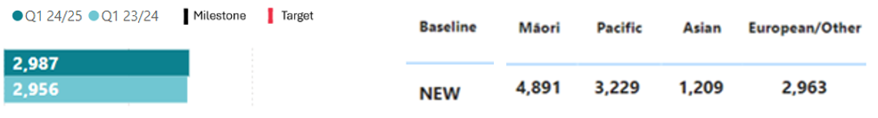
NEW: See caveats on page 57

Results by region and district:
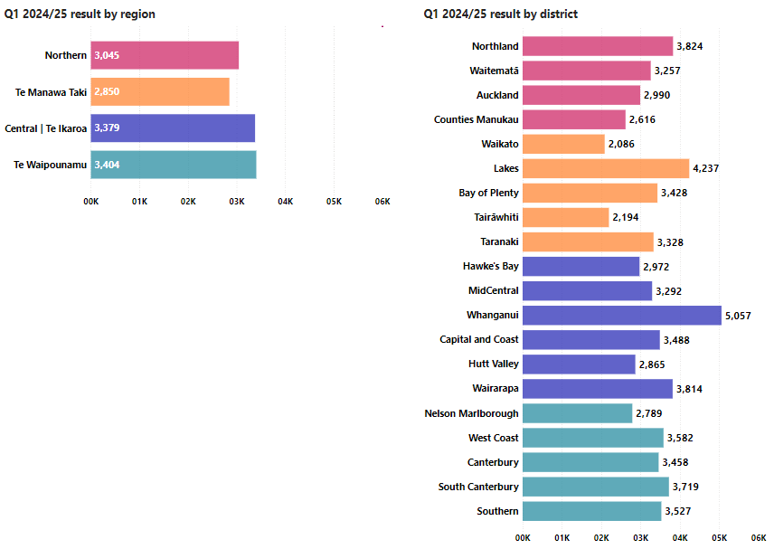
This is the first time we have reported combined primary and specialist MH&A services access. We will continue to track trends over time.

Key outputs
Q1
(Year to date)
Number of people seen – Access and Choice Services | 71,137
Number of sessions delivered – Access and Choice Services | 198,049
Mental health inpatient or equivalent occupied bed nights (intensive care, acute and sub-acute) | 65,677
Secure forensic inpatient occupied bed nights (maximum, medium and minimum) | 21,617
Peer support contacts - Specialist MH&A Services# | 23,541
Individual treatment attendance - Specialist MH&A Services | 435,235
Mental health crisis attendances - Specialist MH&A Services | 40,742

Output data caveats
# Refers to a contact with tāngata whaiora where the primary purpose of the contact was to provide peer support as part of specialist MH&A services. Peer support involves people with a lived experience of mental illness or addiction providing support that is individualised to each person with the goals of engagement, modelling recovery and strengthening tāngata whaiora involvement in the wider community.
Quarter 1 output data does not include completed reporting for integrated primary MH&A services in Waikato and one large provider from the Pacific workstream. Health NZ teams are working with these providers to improve reporting.
Activity reporting is new for specialist MH&A. It is intended that undertaking activity reporting will improve data quality and thereby planning and forecasting capability. The activity provided above is not complete for the quarter, which means results may be updated in our quarter 2 report.

The number of people seen, and sessions delivered continue to increase across primary MH&A services – the Access and Choice programme.

Financial performance
 | Year to Date (30 Sep-24) |  |  | Full Year 2024/25
 | Actual | Budget | Variance | Budget
Revenue and expenditure | $m | $m | $m | $m
Total operating revenue | 671 | 671 | 0 | 2,683
Total operating expense | 650 | 653 | 3 | 2,683
Surplus/(deficit) | 21 | 18 | 3 | 0

Strategic priority one: Deliver the New Zealand Health Plan
Reporting against the NZ Health Plan | Te Pae Waenga will begin in 2025, once the plan has been finalised and published.

Strategic priority two: Empower and enable leadership at all levels
This quarter the mental health and addictions clinical network welcomed the recruitment of its co-leads. MH&A professionals and those with lived experience will be recruited to join.
Central introduced an Oranga Tamariki liaison role to improve well-being outcomes for tamariki and rangatahi involved with the Regional Rangatahi Adolescent Inpatient Service and Oranga Tamariki. The liaison role will support with information and data sharing, relationship management and escalation issues, and will ensure there are planning meetings for all admissions where Oranga Tamariki is involved. The liaison will also support understanding of roles, responsibilities and models across agencies (e.g. knowledge of mental health pathways and what types of support can be expected from infant, child and adolescent mental health services).
Quarter 1 also continued the rollout of the peers in ED trial. The programme marks a new model for supporting individuals who present with MH&A challenges in the ED by integrating peer support specialists into the ED team. They use their lived experiences to connect with whaiora, offering empathy, active listening and guidance on wellness strategies. Middlemore debuted the service in its ED on 26 September. The rapid establishment of the peers in ED programme reflects Counties Manukau's long-standing commitment to incorporating peer support within its multi-disciplinary mental health workforce, enhancing whaiora recovery through collaboration and community engagement.

Output class 5: Hauora Māori services
This section presents the results for the hauora Māori services output class. For more background, see pages 24-25 of the SPE.

Performance measures
Performance measure | What the activity intended to achieve | Baseline and 2024/25 target | Quarter 1 2024/25 result

P2-206 Hauora Māori contracts
Percentage of Hauora Māori partners that have moved to integrated or outcomes contracts by 30 June 2025. | Holistic, transformational and whānau-led models of care. | Baseline: NEW  Target: An increase from baseline | 44%  All 169 hauora Māori partners are expected to move to outcomes-based contracts did so by 30 September 2024. This represents 44 per cent of all contracted hauora Māori providers.

P2-208 Iwi Māori Partnership Board (IMPB) strategic involvement
Percentage of IMPBs that participate in setting strategic priorities for commissioning in Health NZ. | Health system commissioning investments are shaped and informed by the context, needs and priorities of the communities they are intended to serve. | Baseline: NEW  Target: 80% | Being developed  The first set of IMPBs is scheduled to commence their role in influencing Health NZ commissioning in quarter 3 2024/25. As such, progress for this measure will be reported from quarter 3.

P2-205 Hauora Māori outcomes
Percentage of Hauora Māori partners that are meeting their contracted outcome targets as defined in the new outcomes-based contracts. | High-quality, holistic and whānau-led hauora Māori services | Baseline: NEW  Target: 50% | A new performance reporting framework has been developed for partners on outcomes-based contracts. The first reports are scheduled to be received from providers in quarter 2. As such, progress for this measure will be reported from quarter 2.
One hundred and sixty-nine hauora Māori contracted providers moved to integrated outcome-based agreements for the 2024/25 year. The total value of these is approximately $478 million. Outcomes based contracts cover health services across all service types delivered in a community setting (including public health services).
This is a shift to a more whānau-centred and outcomes-focused approach, representing a significant change in the way in which Health NZ commissions services from hauora Māori providers. The success of this model relies on the high-trust working relationship established with hauora Māori providers, which underpins the co-design and development of a new outcomes framework for contracting and reporting.
Priority outcome areas include mental health and wellbeing, maternity, early years and family planning. We are measuring a range of outcomes, which are identified by the Hauora Māori providers themselves.
Examples of outcomes for maternity services include:
- Improved child health outcomes for whānau receiving care and support
- Intensive antenatal support for parents and whānau
- Connectedness to services and to the community for pregnant and post-partum women experiencing mental wellbeing challenges or in distress
Examples of outcomes for mental health services include:
- Better stress and anxiety management
- Improved mental wellbeing
- Reduced drug and alcohol use
A performance monitoring framework to enable reporting on outcome data from quarter 2 has been developed.
A further tranche of hauora Māori providers with contracts expiring at 30 June 2025 will also transition to outcome-based contracts in the next 12 months.
As Health NZ progresses changes to its regional structure, an important focus will be integrating IMPBs into Health NZ commissioning decisions. IMPBs will play an increasingly critical role over the next 12 months as they look to influence strategic priorities for funding to ensure these are informed by local needs.

Key outputs

Immunisation
The ‘Immunising our Tamariki’ initiative invested $50 million over two years to deliver additional vaccinations and close the equity gap between Māori and non-Māori. Since August 2024, providers have increased their focus on immunising pēpi and tamariki in line with the immunisation target set by the Government.
- In the 10 months to 30 September 2024, hauora Māori providers contracted through the Whānau Ora Commissioning Agency delivered 43,531 vaccinations.
- In the six-month period from 1 April to 30 September 2024, hauora Māori providers contracted directly by Health NZ delivered 19,881 vaccinations.
- In September 2024, 5,391 vaccinations were delivered under this initiative (data for this result has been collected from a range of sources, including the AIR and reporting submitted by providers).
An increasing number of providers have also signed data sharing agreements to enable more precise targeting of their immunisation efforts with 21 hauora Māori providers (30 per cent) now participating in shared data arrangements.
Key strategies that have proven to be successful for providers this quarter included:
- increased access – mobile units, in-home visits, placing themselves in settings where and when whānau are available.
- wrap-around services for the whole whānau to address need for services in addition to immunisations, such as ENT, GP, education, chronic conditions, eye/vision and rongoā. These services might also include care packs.
- community collaboration – working with local business, iwi, kura, other hauora Māori providers and general practice.
Six providers were selected to test the proposed new Well Child Tamariki Ora child growth and development clinical schedule alongside the move towards a ‘see and support’ prototype model, which commenced on 5 August 2024:
- Raukura Hauora o Tainui Trust
- Starship Community
- Te Puawaitanga Ki Ōtautahi Trust
- Te Rūnanga o Te Āti Awa
- Papakura Marae
- Whānau Awhina Plunket – Whakatane.
The prototypes have a strong focus on whānau Māori and Pacific Peoples, to help address low immunisation rates and high needs for whānau in these population groups.
Over the next year (to June 2025), qualitative and quantitative data will be collected from the prototypes to inform the future development and finalisation of a national child growth and development clinical schedule.

Number of IMPB community health plans received
Expectation | Number expected | Number received by  30 September 2024
IMPB would submit their Community Health Plans by 30 September 2024 | 6 | 12
Workshops with IMPBs to support the development of their respective community health plans and regional priorities were held during quarter 1.
Community health plans are intended to set out how IMPBs will deliver on their legislative functions over the next three to five years.
They include prioritised local needs assessments to aid in determining health priorities across their respective communities, as well as accountability and monitoring arrangements.
It was expected six IMPBs would submit a community health plan by 30 September 2024, and 12 met this milestone. A further two submitted their plans by mid-October. The remaining IMPB is expected to submit its plan in December.

Financial performance
 | Year to Date (30 Sep-24) |  |  | 2024/25  Budget
 | Actual | Budget | Variance | Budget
Revenue and expenditure | $m | $m | $m | $m
Total operating revenue | 147 | 144 | 3 | 578
Total operating expense | 104 | 121 | 16 | 578
Surplus/(deficit) | 43 | 24 | 19 | 0

Strategic priority one: Deliver the New Zealand Health Plan
Reporting against the NZ Health Plan | Te Pae Waenga will begin in 2025, once the plan has been finalised and published.

Strategic priority two: Empower and enable leadership at all levels

Regional public health services
During quarter 1, hauora Māori regional teams focused on:
- increasing Māori immunisation rates
- supporting hauora Māori providers to transition to outcomes-based contracts
- supporting and helping to embed IMPBs as a key feature of the health system, to help make better decisions closer to whānau.
These priorities were set at a national level, with regions primarily responsible for their implementation and delivery.

Te Whiri Kaha, the Māori Clinical Senate
Te Whiri Kaha – the Māori Clinical Senate underwent a reset to better align with the broader needs of Health NZ. Te Whiri Kaha is a trusted clinical and advisory group which brings together Māori clinicians and practitioners from a wide range of professional disciplines and backgrounds.
The group has a draft work programme that includes a focus on workforce development, cultural safety and competence training, and strategic advice on meeting the health targets.

Oranga hinengaro clinical and lived experience
Significant work in quarter 1 included:
- completing the evaluation of the Māori specific prevention and minimising gambling harm procurement approach. The published report presented key conclusions and recommendations to support kaupapa Māori approaches in procurement and commissioning of new services that are underpinned by lived experience, whānau voice and mātauranga Māori
- advancing the crisis response service and infant maternal mental health regional projects led through Te Manawa Taki.
- co-designing micro-credential health programmes with Te Manawa Taki, Wintec and the Ministry of Education
- contributing to the development of national training for least restrictive practice within mental health inpatient facilities
- supporting the success of the following key programmes:
- Kia Piki Te Ora – suicide prevention services
- He Kete Whai Ora – packages of care that focused on developing a sense of self-identity through connection to te ao Māori and whakapapa
- Whakahohoro Te Hau – an alternative solution for whānau presenting to crisis and emergency services in acute mental distress in the Waitaha/Canterbury region
- Hāpai Nga Rangatahi – an alternative pathway of care for rangatahi and whānau focused on reducing mental health wait lists
- Tūā Pātia – Māori access pathway to alcohol and other drug services.

Whānau voice
The Whānau Voice Current State of the System report was completed in July 2024 and highlighted the need for an action plan to support IMPBs in elevating the voices of whānau in the system.
The formalisation in July 2024 of the Whānau Voice Advisory Group into a governance group including general managers and executive directors from Te Tāhū Hauora ǀ HQSC, the Ministry of Health, Health NZ, and the Health and Disability Commission, will ensure the development and implementation of whānau voice action plans to achieve this.
Implementation of the whānau voice action plans will start in quarter 2.

Puna Ako (school-based health services) in kura kaupapa Māori
Work is underway with the Puna Ako programme to extend school-based health services into Māori immersion education settings.
Quarter 1 saw an approach agreed to develop services for eight to 10 pilot schools of highest need. Early indications from engagement with education peak bodies (Te Rūnanga Nui ō Ngā Kura Kaupapa Māori ō Aotearoa, and Ngā Kura ā Iwi ō Aotearoa) suggests that the highest need areas are Te Tai Tokerau me Tamaki Makaurau (Northern Region) and Te Manawa Taki (Midland) regions. The kura selection process is currently being finalised.
The service will be supported with a research evaluation to measure successes and areas of improvement.
Services are expected to commence in selected kura from the start of term one, 2025. Once established, this initiative will increase delivery of school-based health services in Māori immersion and kaupapa Māori-based schools.

Pūhoro STEMM Academy
Health NZ continues to support the Pūhoro STEMM Academy, which supports hundreds of rangatahi Māori into careers in STEMM subjects: science, technology, engineering, mathematics and mātauranga, for the second year. In quarter 1, Pūhoro successfully engaged 872 rangatahi in the health career pathways, exceeding the initial target of 750. These engagements were achieved through 69 health-focused workshops delivered across 10 Pūhoro regions, which also aligned to each of the regional areas within Health NZ. As a result, 320 high-school rangatahi have expressed a desire to pursue a health-related career.

Te Pitomata grants
In 2024, 1,218 students were supported in their health studies across both undergraduate and post-graduate disciplines with Te Pitomata grants. Te Pitomata provides a one-off grant to students currently enrolled in a relevant programme of healthcare study to address the low rate of Māori in health-related employment.
Project planning is underway to release the 2024/25 round of grants in early 2025.

Workforce

P2-152 Health NZ workforce turnover
This measure presents the percentage of Heath NZ staff who have left the organisation’s payroll systems in the period as a proportion of all staff registered on these systems as current staff.

National results:
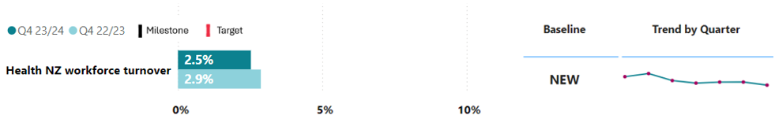

Results by region:
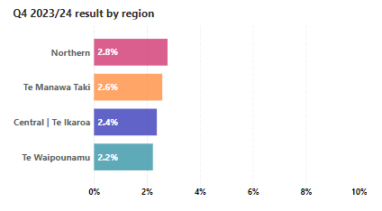
We are seeing declining turnover rates, which means that we are retaining our highly-skilled and sought-after staff.

P2-153 Health NZ Māori and Pacific Peoples workforce
This measure presents Heath NZ staff, who identify as Māori or Pacific Peoples, who joined our payroll systems over a rolling 12-month period to 30 June 2024 as a proportion of all new staff registered on these systems during that period.
Ethnicity | New employee count | Percentage of total new hires
European/ Other | 8,871 | 47.0%
Asian | 6,751 | 35.8%
Māori | 1,646 | 8.7% | 13.3%
Pacific | 875 | 4.6%
Unknown | 725 | 3.8%
TOTAL | 18,868 | 100.0%

Data caveats
The Health Workforce Information Programme (HWIP) collects data from all Health NZ districts as at the end of each quarter. Data as at 30 June 2024 is the most current data available.
- The programme does not currently include national office data and workforce data from former shared agencies. However, we are working to include these additional payrolls into HWIP datasets by the end of 2024.
- Data includes permanent employees and excludes fixed term, contractors, employees on long-term leave, parental leave, leave without pay and those with zero contracted hours.
- Employee count is used to calculate both measures and is a distinct count base on an individual's employee number. Because our measurement in anonymised, there is the potential for individuals to be counted more than once if they have roles across multiple groupings (i.e. if they have roles as both a nurse and a midwife) or if they hold roles with more than one district.
- Resident medical officers are excluded from both measures. This is due to the nature of their roles. In HWIP data they would be identified as starters and leavers every time they rotate districts to take on new runs.
- New hires are employees whose reported employment start date was between 1 July 2023 and 30 June 2024. New hires will include people who have left one district and started work in another. Due to the anonymised nature of the data collection, this cannot be tracked or quantified.
- The Health NZ workforce quarterly voluntary turnover rate excludes employees who have left due to reasons out of their control, health, death, dismissal and redundancy.

Strategic priority one: Deliver the New Zealand Health Plan
Reporting against the NZ Health Plan | Te Pae Waenga will begin in 2025, once the plan has been finalised and published. Health NZ workforce plans will be incorporated in the NZ Health Plan | Te Pae Waenga by reference.

Strategic priority two: Empower and enable leadership at all levels

Leadership, training and development
We recorded 79,132 training hours across our four learning management systems, bringing the total for the past 12 months to 1,077,811 hours. We continue to support and develop leaders with tools and training that build their health leadership capability, including through three 45-minute online workshops: Navigating Difficult Conversations, Leading Through Challenging Times and Working Through Challenging Times. Feedback on and participation in these three courses has been positive, with strong attendance from both clinical and non-clinical staff.
We launched an internal communication campaign in September to boost enrolment and completion rates of our Prevention First de-escalation training. By the end of quarter 1, over 24,000 patient-facing staff completed their training and enrolments are continuing. Additionally, we introduced online awareness training for hazardous substances as part of ongoing efforts to manage substances safely in our facilities.

The New Zealand Health Charter | Te Mauri o Rongo
Work is underway to integrate the four pou of Te Mauri o Rongo (Wairuatanga, Rangatiratanga, Whanaungatanga, Te Korowai Āhuru) across all our learning programmes. The first programme to fully integrate Te Mauri o Rongo is ‘Respect at Work’. In quarter 1, we piloted the programme in MidCentral and Canterbury. An engagement group with representatives from our four regions is supporting the ongoing pilot. Six eLearning modules for the programme were launched in November.
We continue to work with unions and other key stakeholders on our broader culture programme, and a Te Mauri o Rongo eLearning module will launch by the end of 2024. This initiative is part of a broader effort to embed Te Mauri o Rongo at the core of our operations, ensuring it influences and underpins every aspect of our work.

The Ngātahitanga Pulse Survey
The Ngātahitanga Pulse Survey enables us to monitor and enhance our employed workforce satisfaction, sentiment and culture. Following the second nationwide pulse survey conducted in March 2024, districts (along with clinical leaders) are identifying potential actions to address local survey feedback and reporting on implementation.
As of September, 702 actions were identified across districts. Of these, 17 have been completed and 60 are in progress. The remainder are in the process of being scoped and allocated to responsible owners before work to progress them is commenced. We will continue to identify, confirm and implement actions in the coming months. These initiatives are being driven locally and monitored nationally. While some actions (i.e. regular check-ins with staff) are quick and easy to implement, more significant actions (i.e. culture improvement) are longer-term projects that will be delivered throughout the year.

General Practice Training Programme
In quarter 1, we confirmed funding for all 257 applicants in the 2025 intake to the General Practice Training Programme. Continued investment into primary healthcare ensures New Zealanders can access specialist General Practitioners.

Candidate care for nurses
Candidate care for new graduate registered nurses is continuing, focused on providing supporting information, updates and job links. Actions to provide more support for new graduates in non-Health NZ practice settings are underway, with free access to online teaching launching in November. These actions help new registered nurses access the resources and information they need to transition smoothly into their careers in health. We recognise the vital role of nurses within our healthcare system, and supporting their growth and development remains a priority.

Growing the kaiāwhina workforce
MySkill (NZ Health Group) completed the training content for a micro-credential in non-complex reviews. This micro-credential is designed to enhance the skills of kaiāwhina in community and home-based roles and provides credits on the NZQA framework. A 12-month pilot programme has also been launched in partnership with the Ministry of Social Development and a Hutt Valley community provider, Te Paepae Arahi Trust, focusing on ‘earn while you learn’ opportunities for kaiāwhina.

Working with providers to increase the workforce pipeline
Health NZ continues to collaborate with tertiary education providers in the Northern region to develop new education pathways into health careers. This includes the development of the graduate entry Master’s Degree programmes and double degree programmes.
In July 2024, tertiary education providers launched a double degree pathway for anaesthetic technicians and paramedics, and another for anaesthetic technicians and nurses. These initiatives are crucial in addressing the growing demand for skilled healthcare professionals and enhancing career prospects for graduates through cross-training.
The Cardiac Sonography Post Graduate Diploma (PGDipHSc), launched by the University of Auckland in March 2024, is now being promoted to private healthcare providers to encourage them to enrol their workforces. This will extend the programme's reach and help ensure it remains sustainable to run.
The Foot Care Assistant qualification is progressing, with Toitū te Waiora developing a Level 4 qualification that will be approved by NZQA by December 2024. Once the qualification has been approved, a tertiary provider will develop the programme. In addition, two potential pilot sites are being costed to implement foot care assistant roles. This will include community, rural and secondary care settings based in our Northern region – Counties Manukau and Te Tai Tokerau.

New midwifery apprenticeship initiative
Health NZ launched a midwifery apprenticeship initiative in Nelson-Marlborough in 2021/2022 to address its midwifery workforce pressures. In quarter 1, we advertised positions, reviewed 101 applications, and interviewed shortlisted applicants for an updated model of the programme. We are now finalising contracts with successful candidates.
This initiative provides opportunities for people interested in midwifery who lack traditional academic pathways, which helps to foster inclusivity and diversity within the profession. Increasing the midwifery workforce aims to ensure better access to quality maternity care and promote the sustainability of our healthcare system.

Pacific Health Science Academies
The Pacific Health Science Academies programme aims to support the goal of increasing the diversity of our workforce. The programme provides secondary school Pacific students with career insights and practical exposure to the health sector in preparation for tertiary education. Health NZ is working with three universities to expand the programme.
The programme’s leadership events in quarter 1 were attended by 565 students in the Northern region, including 216 students visiting hospital sites. Schools with high Pacific rolls have been identified and engaged with – three in Te Manawa Taki, four in Central and five in Te Waipounamu.

Health, Safety, and Wellbeing
Ensuring a safe work environment is crucial for maintaining high-quality patient care and the overall wellbeing of all staff and patients. In quarter 1, we continued to develop and implement the funded ED Security Service Expansion. Additionally, we focused on our national programme to improve enabling systems and address critical risks such as workplace violence and aggression, and moving and handling injuries.

Health, Safety, and Wellbeing Committees and representatives
We continue to grow the number of health and safety representatives for our organisation, with over 3,600 in place by the end of quarter 1. Health and safety representatives play a critical role in representing workers by identifying and escalating any issues. We continue to empower their important work by building support and capability across districts to coordinate training and access to resources. We are also strengthening the functions of our Health, Safety, and Wellbeing Committees and ensuring that they have access to tools and resources to continue their work, including terms of reference.

Physical infrastructure

Overall performance
Health NZ is delivering approximately 1,600 capital projects across New Zealand. As of 30 September 2024, 69 are valued at over $10 million and/or funded from the health capital envelope, and actively monitored centrally. Of these, 51 are in delivery phase, 15 in design and three in define. Three projects reached practical completion during the quarter.
We have continued to progress foundational deliverables to improve the planning, delivery and maintenance of health infrastructure, with good progress made on the infrastructure investment plan; FY2024/25 capital plan; refresh of the national asset management strategy; and approval of an asset management information system business case.

Significant projects and status
The physical infrastructure work programme, over a three-year horizon, aims to address legacy issues Health NZ inherited. At the end of quarter 1, of the 69 major projects monitored centrally, 28 were overall on track with no issues, 20 had manageable risks and issues, and 21 have significant budget and milestone risks that require decisions from the Commissioner. Some of the more significant projects include:
- New Dunedin Hospital – In September, an independent review was completed of the inpatient building project and the Minister announced additional funding. Health NZ immediately implemented the affordability recommendations of the independent review and is rolling out the governance recommendations. The project for the outpatient building is progressing well against its approved scope and programme schedule, but the budget remains under stress.
- Whangatupuranga Nelson Hospital – requests for proposals have been developed for enabling work to commence demolition of buildings within the redevelopment footprint, and to fit out shell spaces to start the decanting process.
- Pihi Kaha Whangārei Hospital – construction of the Whānau House is finished. Migration and go-live in the new facility occurred in November 2024. Tira Ora Child Health Centre is on programme and budget.
- Linear Accelerators (LINACs) for external radiation therapy – the Auckland City Hospital LINACs reached practical completion in August and went live later in the year. The Taranaki LINAC is due to go live by the end of 2025, with a supporting business case being prepared for consideration by year end.
- Project Maunga (Taranaki) – construction continues on the new east wing building which will enable the relocation of the following core clinical services: ED, radiology, laboratory, maternity services, neonatal and intensive care unit, incorporating the high dependency unit and coronary care unit.
- Tauranga Te Whare Maiangiangi – detailed design was completed during quarter 1 and the building consent application was lodged with Tauranga City Council. The project team is engaging user groups and working towards issuing a request for tender.
- Wellington ED – a detailed business case will be considered in early 2025.

Strategic priority one: Deliver the New Zealand Health Plan
Reporting against the NZ Health Plan | Te Pae Waenga will begin in 2025, once the plan has been finalised and published.

Strategic priority two: Empower and enable leadership at all levels
The 2024/25 Health NZ Capital Plan was approved by the Commissioner at the end of October. Health NZ has prioritised available funding for new projects that represent the greatest clinical needs as prioritised by the regions. This includes two ED extensions (Bay of Plenty and Southland), interventional radiology projects in Auckland and Wellington, increasing inpatient capacity in Hawke’s Bay, anti-ligature projects to help prevent self-harm in mental health facilities, and a range of projects required to address critical health and safety risks.

Digital infrastructure

Overall performance
Health NZ continues to deliver on the prioritised set of capital investments for digital infrastructure. In the quarter, we had 81 go-lives across our digital portfolio.
A key priority for the quarter was the development of a digital infrastructure investment plan, which is a key input to our integrated 10-year infrastructure roadmap encompassing physical, digital and health technology investments. This will outline the digital investments needed over the next 10 years based on community health needs and changes in service delivery networks. It considers a national view of digital infrastructure, as well as regional and local cross-sections to ensure regional and local health needs are met and investment is optimised.
Digital investment is described in terms of foundations (core technology, data and interoperability and workforce capability), digital experience (clinical and operational, corporate, and consumer and whānau) and future shifts (support for service priorities such as radiology, analytics and insights, and emerging technology). An early draft of the plan will be ready for internal governance by the end of 2024 and the integrated roadmap will be ready in early 2025.
The information technology (IT) and telco cost optimisation programme started in quarter 1 and will deliver cost savings from our IT and telecommunications expenditure. We have identified more than 140 opportunities where we can realise savings by consolidating similar contracts for services, reviewing maintenance agreements, right-sizing some of our operating environments, turning off infrastructure that we have a limited use for, and reviewing all our licence allocations for systems and people.

Performance measure
P2-169 My Health Record access
This measure presents the number of registered users of My Health Record who can access their health information in the portal.

National results:
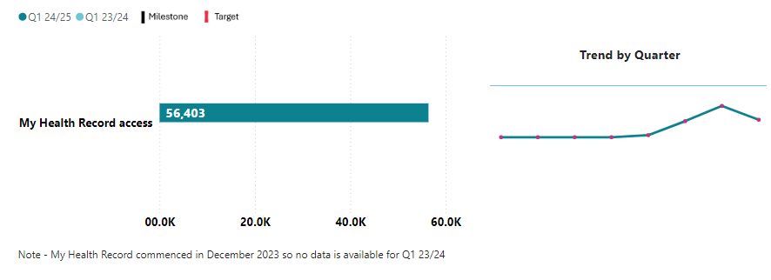
The My Health Record website is live and stable. A key focus in the quarter was to improve existing functions by making changes to improve the user experience. This will support more people using My Health Record in peak periods such as flu vaccine season.

Data caveat

These results are lower than those previously reported due to improvements in reporting processes, including reporting more specific to usage. Previously, My Health Account (identity.health.nz) was not able to segment consumer traffic clearly and may not have included consumers who used My Health Record (segmentation on app level).

Strategic priority one: Deliver the New Zealand Health Plan
Reporting against the NZ Health Plan | Te Pae Waenga will begin in 2025, once the plan has been finalised and published.

Strategic priority two: Empower and enable leadership at all levels
Health NZ continues to prioritise critical systems that support frontline care, ensure clinical quality and safety, and optimise workforce experience. We are proactively reducing unwarranted complexity in our technology environment by moving to fewer, better national platforms and services and avoiding investment that perpetuates unnecessary service variation. Digital services are being designed to be delivered nationally while supporting regional configuration, ways of working and innovation. The BadgerNet project described below exemplifies this approach.
BadgerNet is the national maternity system which supports a ‘one point of care’ clinical record. The system is now operational in 11 hospital districts and 17 primary birthing units, with 43 per cent of community-led maternity carers also using the system. This means smoother data sharing and record-keeping, which helps our clinicians provide better care for newborns. BadgerNet reached a significant milestone in October when Whanganui successfully implemented the system. This enabled the Central region to be the first in the country to fully adopt the system in all hospitals and primary birthing units.
The radiology information system in the Northern region has been upgraded. This is a significant step in the process of stabilising radiology infrastructure in the region and is the first major upgrade in over a decade. The project has also implemented a new booking and scheduling system (IMPAX scheduler) to support the more than 180,000 radiology outpatient bookings made each year and will streamline processes and improve workflow.
Te Manawa Taki is now connected to the National Event Management Service with a subscription to the death event. This means death information will be shared to their district patient administration systems and regional clinical portal. This has the potential to free up more than 1,000 appointments to people on wait lists (and save more than $500k annually in avoidable ‘did not attends’).
In Te Waipounamu ED-at-a-Glance is used by four of the five districts. The improved functionality makes it easier to collect and submit ACC data, saving time and greatly improving the experience of our staff.

Financial performance

Statement of comprehensive revenue and expenses
 | Year to Date (30 Sep-24) |  |  | 2024/25 SPE
 | Actual  $m | Budget  $m | Variance  $m | Budget
 |  |  |  | $m
Revenue
Appropriations – Crown funding ex MOH | 6,174 | 6,202 | (28) | 24,754
Other funding ex Crown/Crown entities | 794 | 753 | 41 | 3,016
Covid-19 funding | 3 | 0 | 3 | 0
Third party and other revenue | 111 | 98 | 12 | 393
Interest received | 31 | 20 | 12 | 78
Total revenue | 7,113 | 7,073 | 40 | 28,297
Expenditure – operating costs
Personnel costs | 3,181 | 3,117 | (63) | 12,466
Outsourced personnel | 135 | 70 | (65) | 270
Outsourced services | 183 | 189 | 5 | 752
Clinical supplies | 676 | 646 | (30) | 2,483
Depreciation and amortisation | 215 | 215 | (1) | 888
External service providers | 2,575 | 2,488 | (87) | 10,235
Capital charge and Interest | 134 | 133 | (1) | 536
Infrastructure, non-clinical supplies and other | 456 | 444 | (11) | 1,767
Total expenditure | 7,555 | 7,303 | (253) | 29,397
Surplus/(deficit) | (442) | (229) | (213) | (1,100)
Detail on variances per table in the main report (page 10)

Statement of cash flows | Year to Date (30 Sep-24) |  |  | 2024/25 SPE
 | Actual  $m | Budget  $m | Variance  $m | Budget  $m
Cash flows from operating activities
Funding from the Crown/Crown entities | 6,936 | 6,954 | (18) | 27,826
Interest received | 32 | 24 | 8 | 78
Other revenue | 115 | 95 | 20 | 393
Payments to employees | (2,966) | (3,138) | 172 | (14,616)
Payments to suppliers | (4,228) | (3,833) | (395) | (15,488)
Capital charge | 0 | 0 | 0 | (529)
Interest paid | (0) | (1) | 1 | (7)
GST (net) | (34) | 0 | (34) | 0
Net cash flows from operating activities | (147) | 101 | (248) | (2,343)
Cash flows from investing activities
Receipts from sale of property, plant and equipment | 1 | 0 | 1 | 5
Receipts from sale or maturity of investments and movement in restricted/trust funds | (4) | (2) | (2) | 1,108
Funds placed on short term deposit  >3 months |  |  | 0 | (750)
Purchase of property, plant and equipment | (409) | (450) | 41 | (2,028)
Purchase of intangible assets | (34) | (15) | (19) | (63)
Net cash flows from investing activities | (447) | (467) | 20 | (1,728)
Cash flows from financing activities
Capital project contributions from the Crown | 1,017 | 779 | 238 | 1,572
Holidays Act remediation Crown equity | (0) | 0 | (0) | 1,663
External borrowings | 0 | 12 | (12) | 50
Capital contributions returned to the Crown | 1 | (2) | 3 | (12)
External borrowings repaid | (1) | 0 | (1) | (11)
Net cash flows from financing activities | 1,017 | 789 | 227 | 3,262
Net increase/(decrease) in cash and cash equivalents | 423 | 423 | (0) | (809)
Cash and cash equivalents at the start of the year | 1,202 | 1,200 | 2 | 840
Cash and cash equivalents at the end of the year | 1,625 | 1,623 | 2 | 31
The opening cash balance at 1 July of $1.2bn includes short-term deposits that matured during quarter 1. Cash deficits generated from operating activities were $147m and from investing activities were $447m. These were offset by cash surpluses from financing activities of $1.017bn, mainly from Crown equity injections made up of:
- $419m to compensate for pay equity settlement costs for Allied Health and midwifery staff paid during 2023/24 with no associated funding in the year.
- $598m reimbursement for projects approved to be funded from the health capital envelope, including catch-up on claims for prior year spend of circa $283m.
Cash is expected to deteriorate over the rest of the year due to the operating deficit planned and also payments expected from Health NZ to contribute to remediation of the Holidays Act liability post 1 July 2022 circa $250m – the Crown is expected to contribute to liabilities up to 30 June 2022.
 | 30 Jun-24 | 30 Sep-24 | 2024/25 SPE
Statement of changes in equity | Actual  $m | Actual  $m | Budget  $m
Balance at 1 July | 9,313 | 9,396 | 9,614
MHA Balance transferred 1 April 2024 | 77 | 0 | 0
Capital contributions from the Crown | 957 | 1,017 | 3,234
Capital contributions returned to the Crown | (12) | 1 | (12)
Movements in trust, special funds and other reserves | (1) | (2) | (0)
 | 10,334 | 10,412 | 12,836
Comprehensive income
Surplus/(deficit) for the year | (722) | (442) | (1,100)
Other comprehensive revenue and expense | (722) | (442) | (1,100)
Gain/(loss) on property revaluations | 0 | 0 | 0
Total comprehensive revenue and expense for the year | (722) | (442) | (1,100)
Crown equity balance | 9,612 | 9,971 | 11,736
The Crown equity is expected to increase from capitalisation of capital projects under implementation. However, this will be offset by the impact of the financial deficit planned for the year.

Statement of financial position | 30 Jun-24  Actual $m | 30 Sep-24  Actual $m | 2024/25 SPE Budget $m
Assets
Current assets
Cash and cash equivalents | 840 | 1,625 | 31
Receivables | 409 | 474 | 426
Prepayments | 105 | 189 | 106
Investments | 393 | 35 | 33
Inventories | 184 | 184 | 165
Assets held for resale | 5 | 5 | 0
Total current assets | 1,936 | 2,511 | 761
Non-current assets
Prepayments | 6 | 6 | 6
Investments | 121 | 122 | 121
Investments in associates and joint venture | 3 | 3 | 3
Property, plant and equipment | 13,782 | 14,270 | 15,169
Intangible assets | 539 | 282 | 354
Total non-current assets | 14,451 | 14,683 | 15,654
Total assets | 16,387 | 17,195 | 16,415
Liabilities
Current liabilities
Payables and deferred revenue | 2,027 | 2,136 | 1,809
Borrowings | 11 | 11 | 11
Employee entitlements | 4,258 | 4,665 | 2,194
Provisions | 77 | 15 | 212
Total current liabilities | 6,373 | 6,827 | 4,226
Non-current liabilities
Borrowings | 97 | 85 | 147
Employee entitlements | 300 | 308 | 300
Restricted funds | 2 | 0 | 2
Provisions | 3 | 3 | 3
Total non-current liabilities | 402 | 396 | 452
Total liabilities | 6,775 | 7,223 | 4,678
Net assets | 9,612 | 9,971 | 11,736
Equity
Crown equity | 4,102 | 4,906 | 7,324
Accumulated surpluses / (deficits) | (1,735) | (2,177) | (2,835)
Revaluation reserves | 7,175 | 7,172 | 7,173
Trust and special funds | 67 | 66 | 72
Minority interests | 3 | 3 | 2
Total equity | 9,612 | 9,971 | 11,736



