Pacific Health Workforce
  - Learner Journey
Citation: Te Whatu Ora | Health New Zealand. 2021. Pacific Health Workforce – Learner Journey. Wellington: Te Whatu Ora | Health New Zealand.
Published in December 2021 by Te Whatu Ora | Health New Zealand
PO Box 793, Wellington 6140, New Zealand
ISBN 978-1-99-106792-0 (online)
This document is available at tewhatuora.govt.nz
This work is licensed under the Creative Commons Attribution 4.0 International licence. In essence, you are free to: share ie, copy and redistribute the material in any medium or format; adapt ie, remix, transform and build upon the material. You must give appropriate credit, provide a link to the licence and indicate if changes were made.

Contents
Acknowledgements 4
Introduction 5
Overview 5
Key findings 6
Context 7
Attrition 8
Enrolments 12
Outcomes 18
References 26

Acknowledgements
This report is a companion to the Pacific Health Workforce Forecast.
Pacific Perspectives Limited (PPL) was commissioned to prepare this report by Manatū Hauora Ministry of Health.
On 1 July 2022 the responsibility for health workforce development was transferred to Te Whatu Ora - Health New Zealand. The recommendations of the Pacific health workforce forecast will be reviewed and led by Te Whatu Ora Pacific Health Group.
Every effort has been made to provide accurate and factual content. The authors, however, cannot accept responsibility for any inadvertent errors or omissions that may have occurred.

Introduction
This report is a companion to the Pacific Health Workforce Forecast. It provides an overview of how the tertiary education system contributes to the development of the health workforce. This report is organised around three sections:
- Attrition, describing how the education system works to dissuade Pacific people from pursuing health-related careers,
- Enrolments, describing how the number of Pacific learners enrolled in health-related tertiary education and the number of completions produced by the system, and
- Outcomes, describing how the tertiary education system supports Pacific learners into employment and further study.

Overview
The section Attrition along the pathway describes how Pacific people experience the pathway through secondary school and to health-related tertiary education. Using a simple attrition model, we highlight the sharp inequity in outcomes for Pacific learners throughout the beginning of the workforce pipeline.
We then explore in the section Enrolments key data on the number of Pacific people attracted to tertiary education and training.
The section Outcomes looks at the proportion of Pacific health learners who go onto employment, further study, and the earnings they can expect to obtain.

Key findings
This report showed that:
- Pacific attrition on the journey from secondary schooling to health-related tertiary education is roughly twice that of non-Māori, non-Pacific. Only four out of every 100 Pacific learners who attempt NCEA level 1 biology will go on to complete a health-related undergraduate degree.
- Around 8,100 Pacific people enrol in health-related tertiary education and training each year, with around half engaged in work-based traineeships and apprenticeships. Around 2,520 pursued undergraduate degrees leading to roles in the regulated health workforce.
- Growth in Pacific undergraduate enrolments in health has outpaced all other discipline areas, increasing from 13.5 per cent of all enrolments to 19.5 per cent from 2010 to 2020. This net increase of 6.0 percentage points in the share of enrolments associated with the field of study of health outpaced all other disciplines, with all recording growth being less than one percentage point.
- There were around 1,800 Pacific health graduates each year between 2016-2019, with Pacific people more likely to complete lower-level qualifications than their non-Māori, non-Pacific peers.
- Employment outcomes for Pacific health graduates are strong (c. 68 per cent), and Pacific people appear to have a stronger attachment to the workforce than their non-Māori, non-Pacific peers.
- Pacific women appear to earn considerably less than both Pacific men and non-Māori, non-Pacific men, with the latter earning up to $28,000 per annum more.

Context
Tertiary education and training is an important, but not necessarily essential, part of the pathway for people into the health workforce.
Learners enter the workforce with a range of existing competencies, some of which, such as Pacific cultural knowledge, are critical to delivering quality healthcare services. However, these competencies are not necessarily valued or recognised by the tertiary education system or the workforce development system.
The pathways into the health workforce do not necessarily involve tertiary education. While completing an undergraduate degree is one of the crucial criteria for registration for the regulated health workforce, other health workforces such as community health workers are not required to obtain qualifications before entering the workforce.
Learners pursue a range of pathways into tertiary education, including that required for entry into the regulated health workforce. While overall, around 80.4 per cent of non-Māori, non-Pacific school leavers enter tertiary education within three years of leaving secondary school, the comparable rate for Pacific school leavers is 63.2 per cent (MoE, 2021).
Pacific learners are also more likely than non-Māori, non-Pacific peers to enter tertiary education at lower levels on the New Zealand Qualifications Framework. Pacific learners are 1.6 times as likely as their peers to enrol in sub-degree programmes (see Table 1).
Table 1: School leavers in their first year after leaving by qualification level, 2019 year
Ethnicity | Non-Māori, non-Pacific | Pacific
Bachelors and above | 62% | 39%
Certificates and Diplomas (levels 3-7) | 35% | 53%
Certificates (1-2) | 3% | 8%
Total | 100% | 100%
Source: (MoE, 2021)
Note: Learners who progress to tertiary education only.
Even among the regulated health workforce, entry into the workforce is blurred by the requirements of many tertiary education programmes. For example, clinical placement requirements mean that learners are actively engaged in providing health services well before completing their degrees, albeit under varying degrees of supervision.
Tertiary education and training needs also to be viewed as part of a continuum of workforce development activities. Much or indeed most competencies are developed on the job as part of formal and informal professional development. Nonetheless, tertiary education is an important component of the workforce development system.

Attrition
Pacific people are not well-supported to succeed in the education system. Our findings indicate that:
- Just four out of every 100 Pacific learners who attempt NCEA level one biology go on to complete a health-related undergraduate degree, roughly half the rate for non-Māori, non-Pacific.
- Pacific experience higher attrition rates than non-Māori, non-Pacific throughout the learner journey.

Understanding attrition
Attrition during the health workforce development pipeline may occur at several points, including before learners even consider health careers, during their secondary school as they do not pursue subjects relevant to health education, during the transition from secondary school to tertiary education, during tertiary education, in the transition from tertiary education to employment and during employment.
Figure 1 shows the effect of attrition between NCEA level 1 and the completion of health-related undergraduate degrees based on data analysis using the Integrated Data Infrastructure.
The results indicate that Pacific learners who undertake NCEA level one biology are half as likely to complete an undergraduate degree in a health-related field of study than their non-Māori, non-Pacific peers (four per cent versus eight per cent).
While NCEA biology may be an imperfect marker for preparation or inclination to pursue health-related undergraduate education, the results nonetheless provide a striking comparison and highlight some of the underlying processes of selection and achievement work.
Figure 2 provides a guide to how attrition between secondary school and graduation impacts the development of the Pacific health workforce. The most persistent feature is relatively low achievement rates during secondary and tertiary education.
The information presented in Figure 2 is illustrative only. Still, it depicts how achievement and subject area choice at secondary school restrict school leavers' opportunities and how the way tertiary education is organised restricts the ability of learners to achieve their aspirations for a career in the health workforce.
The results presented in Figure 1 and Figure 2 are not directly comparable as the latter does not attempt to track learner cohorts over time. Figure 2 is, however, useful in highlighting how a relatively small cohort of Pacific school leavers then progress to health-related tertiary education (around 250 per annum), but most (around 650) return to education and training to pursue health-related programmes after some time in employment or undertaking other activities.
The annual cohort of around 800 Pacific learners who embark on study at Bachelors degree level experiences attrition at a higher rate than their non-Māori, non-Pacific peers. Monitoring data indicate that around one-quarter do not re-enrol for a second year of study. After six years, only around half of the original cohort graduate with a bachelor's degree.

Figure 1: Attrition through secondary school to tertiary education
Pacific learners | Non-Māori, non-Pacific learners
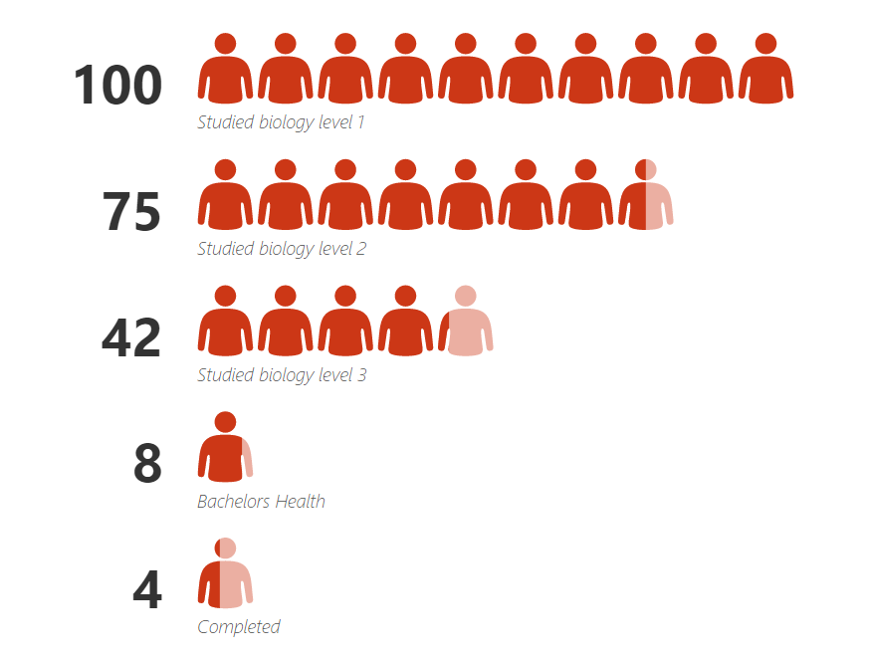 | 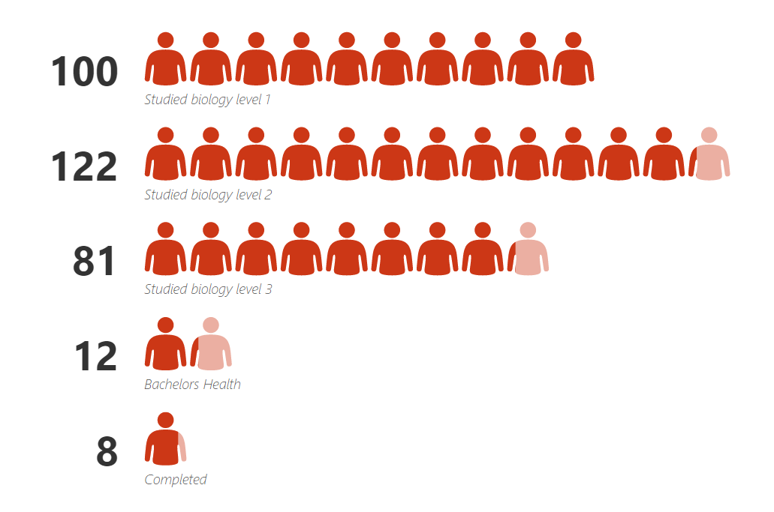
Source: (NZQA, 2021), (TEC, 2021)

Figure 2: Workforce development pipeline, key points of attrition on the secondary-tertiary pathway
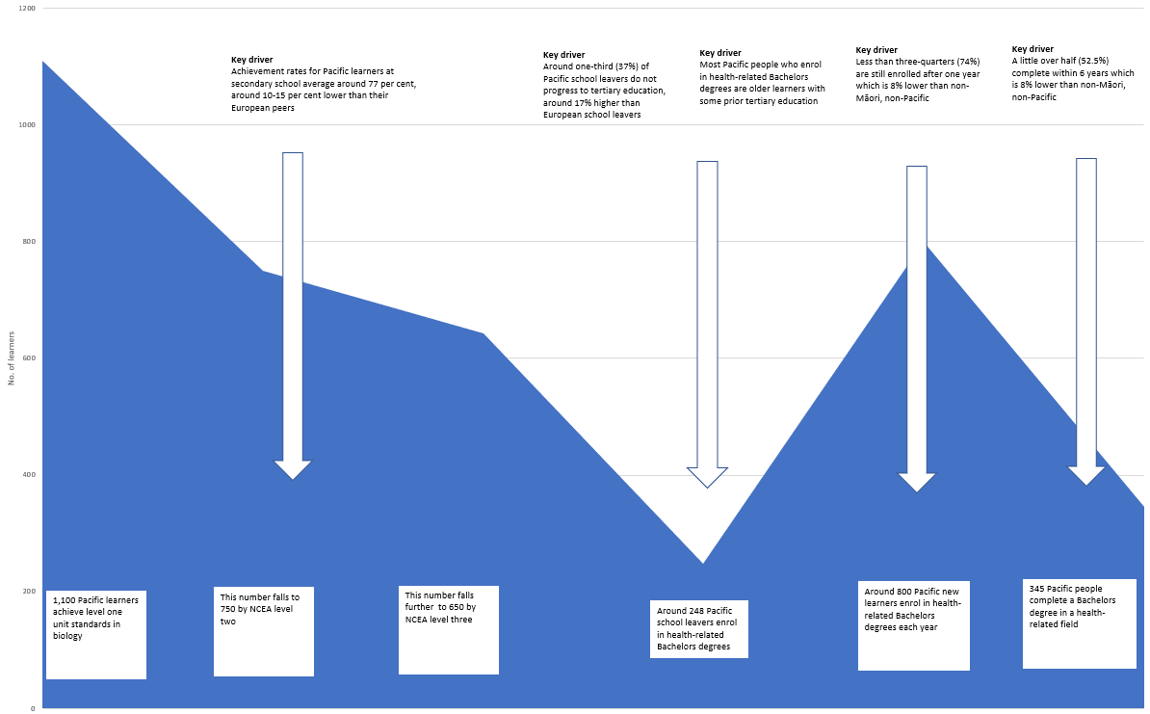
Sources: (NZQA, 2021), (TEC, 2021)

Enrolments
Around 8,100 Pacific people enrolled in health-related tertiary education and training in the 2020 calendar year. We can identify several main groups of learners:
- 4,000 learners enrolled in predominantly work-based traineeships and apprenticeships related to social and youth work, care for disabled and older people and counselling services,
- 2,520 learners enrolled in undergraduate degrees leading to roles in the regulated health workforce,
- 635 learners enrolled in level three and four programmes in health-related fields, and
- 460 learners enrolled in honours and postgraduate studies in health-related fields
The balance of around 5o0 learners is distributed across a mix of foundation and postgraduate studies in various discipline areas.

Health studies
There were around 4,000 learners who identified with one or more Pacific ethnicity (Pacific learners) enrolled in health-related tertiary education and training outside the workplace training system in 2020.
Pacific learners accounted for 10 per cent of all learners in health-related tertiary education and training. The three most popular fields of study in health among Pacific learners were nursing (36 per cent), Other Health (32 per cent) and Public Health (18 per cent) (see Table 2).

Table 2: Pacific learners enrolled in health-related provider-based tertiary education, 2020
Field of study | Pacific (no) | Pacific (%) of all learners
Medical Studies | 390 | 9%
Nursing | 1465 | 11%
Pharmacy | 90 | 6%
Dental Studies | 55 | 9%
Optical Science | 5 | 2%
Public Health | 725 | 14%
Radiography | 30 | 4%
Rehabilitation Therapies | 175 | 5%
Complementary Therapies | 20 | 3%
Other Health | 1290 | 13%
Health: Total | 3,990 | 10%
Source: Invalid source specified.
Notes: Excludes Human Welfare Studies and Services-related training.
Pacific learners are more likely to be engaged in Other Health studies (+ 8 percentage points), Public Health (+ five percentage points) and Nursing (+ 3 percentage points) compared to the general population as a whole.
Pacific learners are less likely than the general population as a whole to be engaged in Rehabilitation Studies (- 3 percentage points), Medical Studies, Pharmacy, Radiography, Complementary Therapies (all -1 percentage point) (see Table 4).

Table 3: Share of enrolments by detailed field of study, Pacific learners, 2020
Field of study | Pacific (%) | Variance compared to the total population (%)
Nursing | 36% | 3%
Other Health | 32% | 8%
Public Health | 18% | 5%
Medical Studies | 10% | -1%
Rehabilitation Therapies | 4% | -4%
Pharmacy | 2% | -1%
Dental Studies | 1% | 0%
Radiography | 1% | -1%
Complementary Therapies | 0% | -1%
Optical Science | 0% | 0%
Health: Total | 100% | 3%
Source: (MoE, 2020)
Notes: Excludes Human Welfare Studies and Services-related training.
The main trend in Pacific participation in health-related tertiary education and training has been a steady increase in enrolments in undergraduate (Bachelors) degrees and an almost commensurate reduction in foundation education.
The number of undergraduate degree enrolments by Pacific has more than tripled over the past two decades, from 904 in 2003 to 3,628 in 2021. This increase compares to a more modest increase for all Pacific undergraduates in any subject area of 120% over the same period.
The growth in the number of health-related undergraduate enrolments will be due to a range of factors. Still, initiatives like the preferential admissions schemes at the universities of Auckland and Otago will necessarily have played a significant role.
The sharp increase in the number of Pacific medical doctor graduates from these universities over the past several years will likely accelerate with the proposed strengthening of Te Kauae Parāoa (Whale's Jaw), the University of Otago affirmative action admissions policy for health professional programmes.

Figure 3: Enrolments by Pacific people in health-related education and training, 2003 to 2021

Source: (MoE, 2020).
The major providers of health-related tertiary education and training are universities (36 per cent), transition industry training organisations (28 per cent), Te Pūkenga (25 per cent), private training establishments (10 per cent) and wānanga (2 per cent) (see Table 4).
Table 4: Enrolments by Pacific learners in health-related education and training by tertiary education subsector, 2020 year
TEO type | Learner (no.) | Share (%)
Universities | 3,015 | 36%
Te Pūkenga | 2,061 | 25%
PTEs | 801 | 10%
Wananga | 155 | 2%
Industry training | 2,377 | 28%
Total | 8,409 | 100%
Source: (MoE, 2020)
Notes: Data for industry training relates to training arranged by transitional Industry Training Organisations relating to the ANZSIC level one classification Healthcare and social assistance.
Enrolments by Pacific people in health-related tertiary education are weighted heavily toward undergraduate programmes in nursing, other health and public health, which together account for 78 per cent of all enrolments.
Table 5: Enrolments by Pacific learners by detailed field of study including share of undergraduates, 2020
Field of study | Pacific (EFTS) | Undergraduates (%)
Medical Studies | 290 | 93%
Nursing | 975 | 77%
Pharmacy | 70 | 71%
Dental Studies | 50 | 100%
Optical Science | 5 | 100%
Public Health | 540 | 56%
Radiography | 15 | 100%
Rehabilitation Therapies | 115 | 83%
Complementary Therapies | 5 | 100%
Other Health | 650 | 62%
Total | 2,760 | 71%
Source: (MoE, 2020)
Growth in Pacific undergraduate enrolments in health has outpaced all other discipline areas, increasing from 13.5 per cent of all enrolments to 19.5 per cent from 2010 to 2020. This net increase of 6.0 percentage points in the share of enrolments associated with the field of study of health outpaced all other disciplines, with all recording growth of less than one percentage point.
The increase in the share of health enrolments mirrored and outperformed the general trend, with the share among non-Māori, non-Pacific learners increasing by 3.8 percentage points over the same period. In addition, most other changes in the relative share of enrolments by field of study for Pacific were similar to those shown for non-Māori, non-Pacific learners (+/- one percentage point) (see Figure 4).

Figure 4: Change in share of equivalent full-time undergraduate enrolments by field of study, 2010 to 2021

Source: (MoE, 2020)
Note: The base datasets for this analysis compares raw calculations of learner enrolments by field of study from 2010 with analysis identifying the specialisations of learners from 2020. While the methodologies are different, the comparison of datasets from 2020 calculated using both methodologies indicates a difference of +/- one percentage point.

Outcomes
Information on post-study outcomes of Pacific health graduates indicates the success people participating in tertiary education experience in terms of life outcomes and financial rewards. We can identify several key trends in the data relating to post-study outcomes:
- The tertiary education system produces around 1,110 Pacific health graduates at all levels annually, with 70 per cent identifying as female and 30 per cent identifying as male.
- Pacific health graduates are more likely to complete programmes at lower levels on the NZQF compared with non-Māori, non-Pacific graduates. They are almost half as likely to have completed a postgraduate degree.
- Around two-thirds (68 per cent) of Pacific people who graduate with health qualifications are in employment immediately following completion, a rate approximately 10 per cent lower than their non-Māori, non-Pacific (- 10 per cent).
- Around two in five (41 per cent) Pacific graduates pursue further study directly after completion, a higher rate than non-Māori, non-Pacific, which may explain the lower reported employment outcomes in part.
- Health-related tertiary education is an important mechanism for moving people into employment, with one-third (34 per cent) of Pacific graduates changing their employment status following completion, a similar rate to non-Māori, non-Pacific.
- Around three in five (59 per cent) Pacific graduates remained in employment nine years following graduation with some variation depending on the learner cohort, and relative to non-Māori, non-Pacific.
- The median earnings of Pacific graduates range between $33,000 and $82,000 per annum depending on their age profile and the qualification completed, with Pacific recording lower earnings on average compared to their non-Māori, non-Pacific peers.
- Completion of health programmes resulted in a significant earning premium for almost all Pacific cohorts, which was most pronounced among younger undergraduate (+$27,000 per annum) and postgraduate learners (+ $26,000 per annum).
- Nine years after graduation, Pacific women earn between $13,000 and $34,000 per annum less than non-Māori, non-Pacific men, and between $5,000 and $14,000 per annum less than Pacific men, a pattern that appears consistent across all levels of study and age cohorts.
Over the 2014-2017 calendar years, around 4,470 Pacific people completed qualifications in health-related fields, a simple average of 1,118 per year. Moreover, graduates were relatively evenly distributed between the major qualification groupings.
Women made up 70 per cent of all graduates and were more likely to be enrolled in programmes at levels four and above than their male peers (see Table 6).
Table 6: Number of Pacific graduates of health-related programmes, 2014-2017 calendar years by gender and level
Level | All | Female | Male
Certificates L1-3 | 1,056 | 52% | 48%
Certificates/Diplomas L4+ | 1,308 | 73% | 27%
Degrees/Graduate Diplomas | 1,305 | 76% | 24%
Post graduate | 801 | 81% | 19%
Total | 4,470 | 70% | 30%
Average per year | 1,118
Source: (MoE, 2021)
Note: Data provided for provider-based training only. There were also around 700 Pacific graduates of workplace-based industry training in 2019.
Pacific health graduates were more likely to complete programmes at lower levels on the NZQF compared with non-Māori, non-Pacific graduates.
Pacific people were more likely to complete at levels 1-3 and certificate and diplomas at levels four and above (+ 8 per cent each) and less likely to complete undergraduate degrees and graduate diplomas (- 5 per cent) and postgraduate programmes (-11 per cent) (see Table 7).
Table 7: Distribution of graduates by level and ethnicity, 2014-2017
Level | Pacific graduates (%) | NMNP graduates (%)
Certificates L1-3 | 24% | 16%
Certificates/Diplomas L4+ | 29% | 21%
Degrees/Graduate Diplomas | 29% | 34%
Post graduate | 18% | 29%
Total | 100% | 100%
Source: (MoE, 2021)
Pacific health graduates obtain strong employment outcomes, with around two-thirds (68 per cent) of Pacific people who graduate with health qualifications in employment immediately following graduation. Rates for Pacific people with undergraduate degrees and graduate diplomas (83 per cent) and postgraduate degrees (87 per cent) are stronger still.
Non-Māori, non-Pacific graduates are more likely to be in employment in the year following graduation (78 per cent), however, this effect is largely due to higher employment outcomes among those who completed certificates and diplomas (see Table 8).
Table 8: Employment outcomes within one year of completion, Pacific and NMNP, 2014-2017
Level | Pacific (%) | NMNP (%)
Certificates L1-3 | 59% | 73%
Certificates/Diplomas L4+ | 49% | 62%
Degrees/Graduate Diplomas | 83% | 84%
Post graduate | 87% | 87%
Total | 68% | 78%
Source: (MoE, 2021)
Some caution should be applied when interpreting these results as the rates shown do not reflect health-related employment per se but rather report any form of employment. It is possible, for example, that some Pacific graduates are more or less likely to obtain employment outside of the health sector.
The lower rate of measured employment outcomes will be influenced by the purpose of the training and education completed and the learners' motivations. For example, lower-level programmes are often designed to lead to study at higher levels on the NZQF, particularly foundation level programmes at levels 1-3.
Pacific graduates (41 per cent) are more likely than non-Māori, non-Pacific (31 per cent) to pursue further study directly after completing their programmes. This pattern holds across all levels of study, most notably among learners who completed certificates and diplomas at levels four and above (+ 11 per cent).

Table 9: Health graduates pursuing further study, Pacific and NMNP, 2014-2017
Level | Pacific (%) | NMNP (%)
Certificates L1-3 | 32% | 30%
Certificates/Diplomas L4+ | 51% | 40%
Degrees/Graduate Diplomas | 45% | 38%
Post graduate | 33% | 25%
Total | 41% | 34%
Source: (MoE, 2021)
Note: Some graduates may pursue further study and be in employment following completion, so the percentages in tables 8 and 9 may exceed 100 per cent.
Tertiary education generally is an important mechanism for moving people into employment. For example, around one in three (34 per cent) Pacific people who were not employed two years before completing their qualification were now in employment in the following year. This rate is similar to that recorded by non-Māori, non-Pacific (36 per cent) (see Table 10).
Notably, Pacific people who completed undergraduate degrees and graduate diplomas were slightly less likely to experience this change in employment status than non-Māori, non-Pacific (-5 per cent). While this finding may appear counterintuitive given the similar employment rates post-completion for these graduates, it may simply reflect some Pacific people pursuing employment between leaving secondary school and entering tertiary education.
Table 10: Proportion of graduates who experienced a change in employment status after completion, Pacific and NMNP, 2014-2017
Level | Pacific (%)' | NMNP (%)
Certificates L1-3 | 22% | 14%
Certificates/Diplomas L4+ | 23% | 23%
Degrees/Graduate Diplomas | 63% | 68%
Post graduate | 22% | 19%
Total | 34% | 36%
Source: (MoE, 2021)
Post-study outcome data tracks graduates up to nine years following completion. While the following results relate to learners who completed between 2006-2009, the ability to track outcomes over an extended period provides some comparative information, particularly in understanding how effective the transition to employment is over time.
Pacific graduates who completed in 2006-2009 were less likely to be employed than those who completed in 2014-2017 (- 9 per cent). Employment rates are markedly lower among those who had completed undergraduate degrees and graduate diplomas (- 26 per cent) and postgraduate degrees (- 24 per cent). Rates are higher among those who completed lower-level qualifications.
The lower rates for undergraduate degrees and graduate diplomas (- 26 per cent) and postgraduate degrees (- 13 per cent) are repeated among non-Māori, non-Pacific graduates (see Table 11). These results suggest that Pacific health graduates may have a stronger attachment to the labour market than their non-Māori, non-Pacific peers.
Table 11: Employment rates nine years after completion, Pacific and NMNP health graduates from 2006-2009
Level | Pacific (%)' | NMNP (%)
Certificates L1-3 | 65% | 61%
Certificates/Diplomas L4+ | 56% | 59%
Degrees/Graduate Diplomas | 57% | 58%
Post graduate | 63% | 71%
Total | 59% | 62%
Source: (MoE, 2021)
Pacific health graduates obtain median earnings between $33,000 and $82,000 per annum, depending on their age profile and completed qualification. The highest earnings are associated with postgraduates aged 40 years or older ($82,000) and the lowest with those aged 25 years or younger who completed certificate programmes at levels 1-3 ($33,000).
Non-Māori, non-Pacific health graduates attract higher median earnings than their Pacific peers in most cohorts, with some groups of postgraduate learners being an exception (see Table 12).

Table 12: Earnings one year after completion, Pacific and NMNP Health graduates, 2016-2019 completers
Age | Level | Pacific ($) | NMP ($) | Difference ($)
Under 25 | Certificates L1-3 | $ 33,000 | $ 35,000 | -$ 2,000
Under 25 | Certificates/Diplomas L4+ | $ 33,000 | $ 35,000 | -$ 2,000
Under 25 | Degrees/Graduate Diplomas | $ 51,000 | $ 53,000 | -$ 2,000
Under 25 | Post graduate | $ 62,000 | $ 58,000 | $ 4,000
25-39 | Certificates L1-3 | $ 49,000 | $ 57,000 | -$ 8,000
25-39 | Certificates/Diplomas L4+ | $ 45,000 | $ 45,000 | $ -
25-39 | Degrees/Graduate Diplomas | $ 53,000 | $ 54,000 | -$ 1,000
25-39 | Post graduate | $ 72,000 | $ 75,000 | -$ 3,000
40 and over | Certificates L1-3 | $ 53,000 | $ 67,000 | -$ 14,000
40 and over | Certificates/Diplomas L4+ | $ 50,000 | $ 51,000 | -$ 1,000
40 and over | Degrees/Graduate Diplomas | $ 50,000 | $ 53,000 | -$ 3,000
40 and over | Post graduate | $ 82,000 | $ 79,000 | $ 3,000
Source: (MoE, 2021)
Completing tertiary education qualifications is associated with higher earnings overall, with health no exception. Pacific people who completed generally recorded considerably higher earnings in the first year after graduation than in the two years before completing their qualification.
The highest increases in median earnings were associated with undergraduate degrees and graduate diplomas (up $27,000 for those under 25 years of age, and $19,000 for those aged 25-39 years), and postgraduate degrees (up $27,000 and up $14,000 respectively). Other programme cohorts for which data are available generally showed more modest increases (see Table 13).

Table 13: Pre and post-completion earnings, Pacific health graduates, 2016-2019
Age | Level | Median earnings ($) | Pre-study earnings ($) | Difference ($)
Under 25 | Certificates L1-3 | $ 33,000 | $ 33,000 | $ -
Under 25 | Certificates/Diplomas L4+ | $ 33,000 | $ 29,000 | $ 4,000
Under 25 | Degrees/Graduate Diplomas | $ 51,000 | $ 24,000 | $ 27,000
Under 25 | Post graduate | $ 62,000 | $ 36,000 | $ 26,000
25-39 | Certificates L1-3 | $ 49,000 | $ 46,000 | $ 3,000
25-39 | Certificates/Diplomas L4+ | $ 45,000 | $ 40,000 | $ 5,000
25-39 | Degrees/Graduate Diplomas | $ 53,000 | $ 34,000 | $ 19,000
25-39 | Post graduate | $ 72,000 | $ 58,000 | $ 14,000
40 and over | Certificates L1-3 | $ 53,000 | $ 58,000 | -$ 5,000
40 and over | Certificates/Diplomas L4+ | $ 50,000 | $ 48,000 | $ 2,000
40 and over | Degrees/Graduate Diplomas | $ 50,000 | $ 42,000 | $ 8,000
40 and over | Post graduate | $ 82,000 | $ 82,000 | $ -
Source: (MoE, 2021)
Tracking earnings over a longer period allows us to identify key differences by gender and ethnicity. While Pacific graduates with up to nine years of work experience recorded higher earnings than those with less experience (see Table 13) and non-Māori, non-Pacific women, there are marked differences between Pacific women and men, and Pacific women and non-Māori, non-Pacific men.
The difference between the median earnings of Pacific women and Pacific men ranges between $7,000 and $14,000 per annum. Compared to non-Māori, non-Pacific men, Pacific women earn between $5,000 and $28,000 per annum less. While the data available is incomplete, it appears that these differences are attenuated among those who completed postgraduate degrees (- $5,000 per annum) but still non-trivial (see Table 14).
Table 14: Earnings premium, Pacific men and NMNP men compared to Pacific women, 2016-2019 completers
Age | Level | Median earnings ($) | Earnings premium – NMNP women ($) | Earnings premium – Pacific men ($) | Earnings premium – NMNP men ($)
Under 25 | Certificates L1-3
Under 25 | Certificates/Diplomas L4+ | $ 51,000 | -$4,000 | $ 7,000 | $ 9,000
Under 25 | Degrees/Graduate Diplomas | $ 75,000 | -$9,000 | $ 12,000 | $ 16,000
Under 25 | Postgraduate |  | $63,000
25-39 | Certificates L1-3 |  | $50,000
25-39 | Certificates/Diplomas L4+ | $ 50,000 | -$2,000 | $ 11,000 | $ 21,000
25-39 | Degrees/Graduate Diplomas | $ 73,000 | -$6,000 |  | $ 16,000
25-39 | Post graduate | $ 90,000 | -$16,000 | $ 13,000 | $ 12,000
40 and over | Certificates L1-3 | $ 59,000 | -$6,000 | $ 5,000 | $ 28,000
40 and over | Certificates/Diplomas L4+ | $ 53,000 | -$3,000 | $ 14,000 | $ 16,000
40 and over | Degrees/Graduate Diplomas | $ 70,000 | -$1,000 |  | $ 15,000
40 and over | Post graduate | $ 94,000 | -$13,000 |  | $ 5,000

References
MoE, 2020. Provider-based Enrolments Predominant Field of Study, 2021: Ministry of Education.
MoE, 2021. Post study outcomes of tertiary graduates 2014-2017, Wellington: Ministry of Education.
MoE, 2021. School Leaver Destinations, Wellington: Ministry of Education.
NZQA, 2021. NCEA achievement data, s.l.: Unpublished dataset.
TEC, 2021. Administrative data - Learner enrolments and completions, s.l.: Unpublished.

Includes all Pacific learners in the broad field of study of Health (excluding Veterinary Studies) and those enrolled in the narrow field of study of Human Welfare Studies and Services, excluding level 5-7 certificates and diplomas which are predominantly focused on early childhood education and undergraduate degrees (700 learners) relating to counselling and social work.
Includes provider-based and industry training in the relevant fields, with around half in each. Data on work-based training offered by providers may be incomplete. Excludes learners enrolled in early childhood education programmes.
Covers programmes relating to nutrition and dietetics, human movement and sport science, paramedical studies, first aid and courses relating to medical biotechnology, therapies and therapeutic technology, medical and other health sciences.

