Pacific Health Workforce Forecast
  - Overview report
Citation: Mischewski, B & Ryan, D. 2023. Pacific Health Workforce Forecast - Overview report. Pacific Perspectives Limited: Wellington
Published in June 2023 by Te Whatu Ora | Health New Zealand
PO Box 793, Wellington 6140, New Zealand
ISBN 978-1-99-106791-3 (online)
This document is available at tewhatuora.govt.nz
This work is licensed under the Creative Commons Attribution 4.0 International licence. In essence, you are free to: share ie, copy and redistribute the material in any medium or format; adapt ie, remix, transform and build upon the material. You must give appropriate credit, provide a link to the licence and indicate if changes were made.

Contents
Document purpose 4
Acknowledgements 4
Introduction 5
Vision 7
Future focus 9
Forming the workforce 12
Describing the workforce 16
The learner journey 18
Voices from the field 20
Health needs 25
Future of the health system 28
Further reading 32

Document purpose
The Pacific health workforce forecast is intended to guide and support Te Whatu Ora on future investment of the Pacific Health Workforce investment. The forecast provides:
- A vision for the Pacific Health workforce which is aligned with key planning documents and was developed with the Pacific sector
- Describes the current profile of the Pacific Health workforce and how this workforce is trained, recruited, upskilled and retained
- Sets out the health needs of Pacific peoples
- Describes how health services will evolve through the health reforms
- Makes recommendations about how the workforce development system should change

Acknowledgements
Pacific Perspectives Limited (PPL) was commissioned to prepare this report by Manatū Hauora Ministry of Health.
The responsibility for health workforce development has since been transferred to Te Whatu Ora Health New Zealand from 1 July 2022. The recommendations of the Pacific health workforce forecast will be reviewed and led by Te Whatu Ora Pacific Health Group.
We were supported by the guidance and advice provided by an Advisory Group comprising Gerardine Clifford-Lidstone, Pam Doole, Martin Chadwick and To’a Fereti.
The authors include Pacific Perspectives’ team members: Dr Debbie Ryan and Brenden Mischewski. Dr Analosa Ulugia and Dr Lanuola Asiasiga conducted talanoa with people involved in developing the workforce, and Anne Alkema prepared a summary analysis. The work was supported by Jonathan Malifa, Harriette Kimiora and David Nicholson.
Matt Jones of the Tertiary Education Commission made several important contributions to the analytical products supporting the analysis of the learner journey.
PPL particularly acknowledges the extensive contributions made by participants in the vision workshop.
Every effort has been made to provide accurate and factual content. The authors, however, cannot accept responsibility for any inadvertent errors or omissions that may have occurred.

Introduction
The vision of ‘A health workforce that reflects our community’ summarises the key themes from a workshop with Pacific people involved in developing the Pacific health and disability workforce.
Our review of the state of the Pacific health workforce shows good progress was made in the last decade. The number of Pacific health workers totals 13,000, with those in the regulated health workforce up 50 per cent to around 3,500.
Still, there is a lot more work to do. We estimate a shortfall of around 5,500 Pacific health workers in the regulated health workforce. Simple modelling suggests that despite the progress to date, it will be 120 years before the workforce reflects the community it serves.
The Pacific health workforce exhibits similar characteristics as other ‘indigenous’ health workforces internationally with small numbers in gross, a low relative share and a clustering in roles of lower seniority and (recognised) technical complexity.
The reasons for this outcome are varied. The workforce development system does not work well with high attrition rates across the pipeline and inefficient transitions into study and employment.
Investment in Pacific health workforce development is also modest. Of the $78.1m per annum spent by government and learners on developing the Pacific health workforce, just $15m is deliberately targeted to Pacific learners. Much of that is focused on relatively privileged parts of the workforce.
There are many opportunities to accelerate the trajectory of the workforce.
The literature on indigenous workforce development highlights the importance of organisational commitment, the workforce pipeline, collaborative work practices, structural factors and deliberate, purposeful targeting.
Adopting pro-equity admissions and individualised support for learners is already paying dividends. Much more can be done by adopting learner success frameworks, expanding targeted wrap-around support, and a deliberate commitment to proactive recruitment and leadership development.
The health reforms offer great potential to take a more coordinated approach across the health and education sectors. We should be developing Pacific clinical and specialist networks and training Pacific people to support key functions like commissioning, health data business intelligence and to deliver new models of care.
Leadership development matters too. The number of Pacific people in leadership roles is tiny, and we need to see more emphasis put on developing and cultivating Pacific health workers for such roles.
There are many benefits from ethnic concordance in healthcare and in the context of acute shortages of skilled health workers, it is notable that over time Pacific health workers appear to demonstrate higher rates of attachment to the workforce than their peers.

Vision
A health workforce that reflects our community
Why is it important to develop a Pacific workforce?
- “I want my family to be fully understood by health clinicians”
- “Balance between supply (workforce) and demand (illness) is not aligned”
- “No understanding that future workforce is brown”
- “We are part of the solutions”

Commentary on the vision
We gathered together over fifty people involved in developing the Pacific health and disability workforce. Throughout the workshop, the participants articulated their aspirations for the workforce.
Participants responded strongly to a presentation of our initial findings, which highlighted how under the current rate of progress, it could be up to 120 years before the Pacific community was equitably represented in the health workforce.
The key themes from this discussion highlighted the:
- enormous value that the health system derives from the Pacific health workforce, which provides linguistically and culturally supportive health care, offers innovative models of care that are applicable widely, and represents the demographic future of the country,
- impatience with the pace of change which some attributed to sustained under-resourcing and institutionalised racism, reflecting a sense that the necessary change was not seen as a priority by key decision-makers, and
Need for comprehensive Pacific-led responses to what was seen as a complex problem with barriers right across the pipeline.
Participants pointed to a range of solutions, including better preparation for Pacific young people, addressing the socio-economic deprivation that many families experience, embedding cultural safety and competence across the system, shifting control of funding, resourcing and decision-making to Pacific, retaining and developing the current workforce and engendering a sense of urgency in addressing the challenge.
Having a workforce that reflects our Pacific communities would ensure that we are well-placed to deliver on the vision of Te Whatu Ora for Pacific health that the health system delivers healthy futures for all Pacific people, where families live longer, healthier lives and achieve equitable health outcomes.

Future focus

Recommendations
Future efforts to develop the Pacific health workforce ought to focus on the following:
- The key accountability documents for the reformed health system, such as the Government Policy Statement, Pacific Health Strategy and Pacific Health Plan, should embody a strong pro-equity approach emphasising the need for Pacific health workers at all levels.
- More public funding should be available to support Pacific health workforce development and recruitment at all levels across the whole workforce, particularly at leadership levels.
- The more coordinated approach to workforce development envisaged for the reformed health system should include deliberate initiatives to support Pacific people across the workforce pipeline
- A planned approach should be taken to building Pacific workforce capability to support key functions like commissioning, health data business intelligence and new models of care across Health New Zealand and the Pacific provider sector
- Pacific clinical and specialist networks should be cultivated and invested in so that we obtain the greatest benefit from the growing number of Pacific regulated health workers
- The health and education sectors should collaborate to support health career promotion, learner success, curriculum redesign, and direct funding to areas of undersupply.
- Policy and funding ought to understand and account for the distinctive age, family circumstances and socioeconomic characteristics of Pacific learners pursuing health-related programmes.
- Addressing the barriers to the success of Pacific people requires a coordinated approach across economic, housing and social service agencies.
- All tertiary education organisations should adopt pro-equity admissions policies for health programmes and provide tailored and individualised academic and pastoral support.
- Systematic learner success approaches that embed Pacific cultural frameworks should be adopted.
- Programmes that offer wrap-around support to Pacific tertiary education learners pursuing health careers should be expanded to all allied health programmes.
- Better evidence and monitoring are required to understand what current initiatives are working well to inform the commissioning of workforce development programmes.
- There needs to be greater leadership and organisational commitment to supporting workforce development at all levels

Specific actions
There are several concrete steps that can be taken to change the trajectory of the Pacific health workforce so that we achieve parity of representation much faster than the current settings allow.

Stipends for clinical placements
Pacific people enrolled in professional health programmes incur considerable expenses when participating in clinical placements, yet receive no financial compensation for these costs (with the exception of medical students).
There are direct costs associated with travel, parking and the uniform and vaccination requirements.
Clinical placements also lead to opportunity costs when learners cannot continue paid employment or have to obtain childcare services. These benefits to the organisations that offer clinical placements are also not fully recognised.
Learners should receive an appropriate stipend to recognise the service they provide. This stipend can offset the costs they incur personally and ensure equity both within health training and relative to other options for education and training.

Strengthening financial support
The financial costs to learners of study result in a disproportionate burden for Pacific health learners both in the short and long term.
The current fees, scholarships, student loans and allowances regime is inadequate relative to the financial pressures that Pacific health learners face. Pacific families often lack the financial reserves that enable them to smooth the costs of education and training over time.
Pacific health learners also tend to be older with family responsibilities meaning that they are likely to have greater food and housing costs, and have partners in paid employment limiting their access to student allowances.
The age profile of Pacific health learners means that they tend to have less time in the labour market to recoup the costs of studying and repay student loans.
The financial support available to Pacific health learners must recognise these structural inequities with much more comprehensive and generous assistance.

By Pacific, for Pacific
The performance of the mainstream tertiary education system for Pacific communities is highly variable.
Pacific nursing learners, for example, are much less likely than their non-Māori, non-Pacific peers to complete their qualifications. In some cases, fewer than half of the Pacific nursing learners at some major providers complete their programmes of study.
There needs to be much greater accountability for those providers of tertiary education and training that have consistently failed Pacific health learners.
Greater expectations need to be placed on providers to remove barriers to achievement and, in line with tertiary education priorities, funding ought to be directed to by Pacific, for Pacific solutions

Resourcing employers
Pacific health providers play a critical role in developing the Pacific health workforce, yet they have experienced a long history of structural underfunding.
Pay inequities reported by Pacific health workers employed by primary and community services are a salient example of the implications of this pattern.
There needs to be a comprehensive and sustained programme to invest in the capability and capacity of Pacific health providers.
This support will ensure that they can take full advantage of the growing supply of Pacific health workers and continue to offer welcoming and vibrant working environments.

Forming the workforce

Workforce development
Workforce development is a complex process, with several distinctive elements in a health context, including the use of pipeline and workforce substitution as a common frame (see ‘A system’).
It can encompass how well people are prepared to enter or re-enter the workforce, learning opportunities to improve workplace performance, organisations' responses to change, and changes in the current and potential workforce.
Factors like policy direction, national and regional labour markets, immigration settings, organisation context, the relationship between demography and service demand, regulation, output, productivity and service quality, and patient expectations are all important.
Globally indigenous health workforces are generally small in size, are often unrepresentative and tend to cluster in roles with lower seniority and technical complexity.
The literature on indigenous workforce development highlights the importance of organisational commitment, the workforce pipeline, collaborative work practices, structural factors and deliberate, purposeful targeting.
The policy context for health workforce development is changing as the health system reforms are worked through (see Future Service Models).
Still, the critical need expressed in the Ola Manuia Interim Pacific Health Plan for Pacific leadership capability and capacity and investment in focused workforce development remains.
The government and Pacific people provide funding of about $78.1m per annum in the education and training of the Pacific health and disability workforce (see Funding).
Only a small share ($15.4m) of that funding is targeted to Pacific people. This funding is spread across Health Research Council scholarships for researchers, undergraduate fees scholarships, STEM and health career promotion in secondary schools, targeted support for nurses and midwives and Pacific provider development funding.
There is a rich ecosystem of actors involved in developing the Pacific health workforce, with a small number of Pacific-led or focused organisations playing a key role.
An overview of these organisations is set out in the ‘Key entities’ figure.

A system
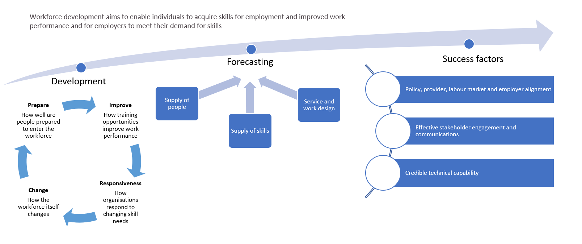

Funding
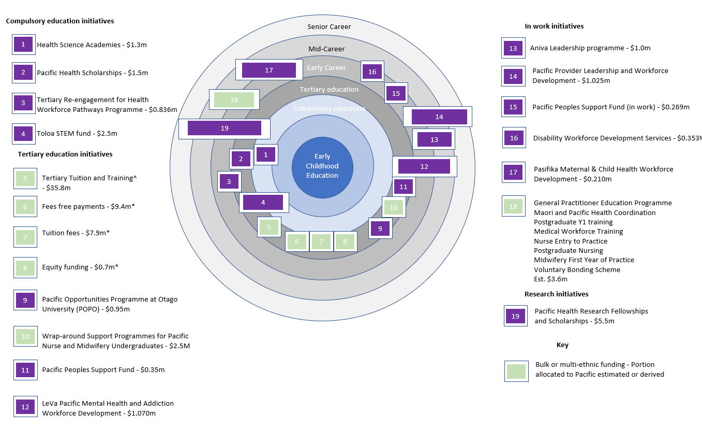

Key entities
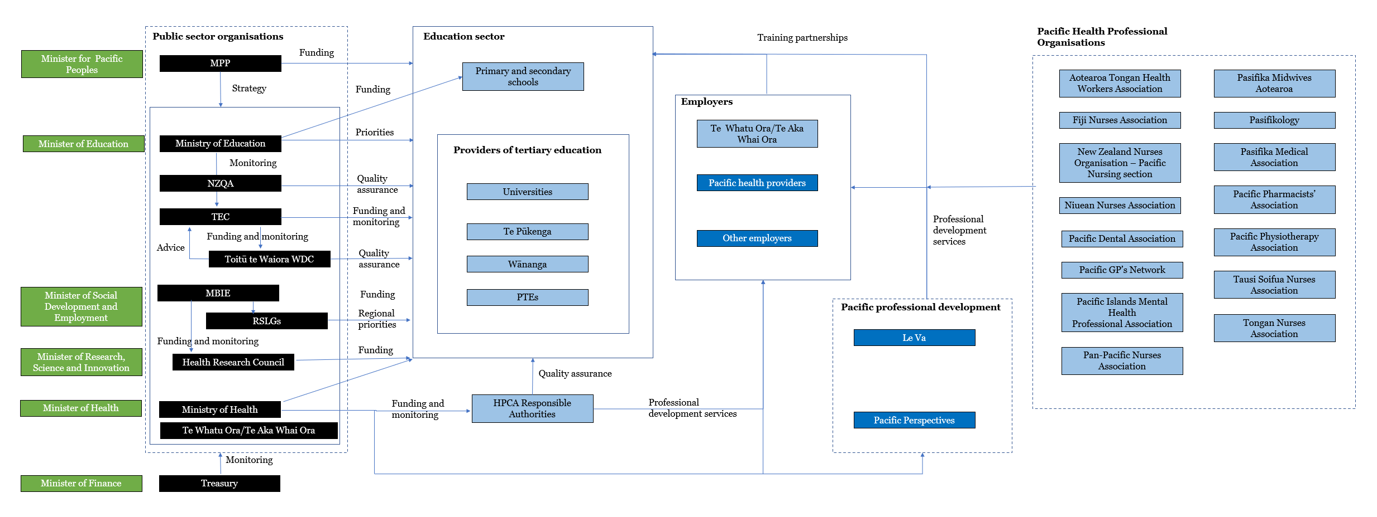

Describing the workforce

The workforce
There were an estimated 13,100 Pacific employees and 300 Pacific employers working in the health industry in New Zealand in 2017. The industry accounts for 8.3 per cent of all Pacific employment and 5.4 per cent of all Pacific employers.
The three main groups in the Pacific health workforce are regulated health workers (3,435 employees), non-regulated health professions (around 7,000 people) and other unregulated health sector roles (around 3,000 people).
The number of Pacific people in the regulated health workforce increased by 50 per cent over the past decade, lifting their share of all regulated health workers from 2.5 per cent to 3.1 per cent.
The main source of growth in the regulated health workforce were nurses (accounting for 56 per cent of all growth) and medical doctors (accounting for 16 per cent of all growth), but many allied health professions recorded large gains.
The system lacks quality data about the unregulated health workforce. Analysis of census data shows that personal support assistants (2,796), social and welfare workers (1,140) and youth workers (1,113) make up the biggest groups in the Pacific non-regulated health professions. Still, we lack reliable longitudinal information and analysis about this workforce.
Information about the contribution that Pacific people make to the public health system indicates that while increasing, Pacific people were:
- underrepresented in leadership roles, accounting for just two per cent of governance and management roles, and
- concentrated in care and support (9.2 per cent of people in such roles), and corporate roles in district health boards (5.4 per cent).
The Pacific regulated health workforce diverges from the wider population and the composition of the regulated health workforce. Specifically, the share of Pacific people in the regulated health workforce at 3.1 per cent is considerably smaller than the Pacific share of the working-age population (7.0 per cent) or of the national population (8.1 per cent).
Pacific regulated health workers are also much more likely to be nurses and much less likely to be involved in other health professions than the wider population of health workers.
There are around 5,500 fewer Pacific people in the regulated health workforce than the community’s share of the total population, with shortfalls in all the major professions.
Even with generous assumptions, simple modelling suggests that it may take 120 years to deliver parity of participation in the regulated health workforce for Pacific people.

The Pacific workforce at a glance
13,400 Pacific health workers | 3,465 regulated health workers | 10,000 unregulated health workers | 50% increase in Pacific regulated health workers since 2010
2,900 personal care workers | 2,399 nurses | 674 allied health workers | 392 medical doctors
3.1% share of all regulated health workers | 2.1% share of leadership roles in the public health system | -5,500 the shortfall in Pacific regulated health workers | 120 years – the time it will take to reach parity under current settings
141st global ranking of medical doctors if Pacific people in NZ were a country | -2,400 shortfall in Pacific nurses | -1,000 shortfall in Pacific doctors | -200 shortfall in Pacific midwives
Prioritised ethnicity – excludes Pacific people who also identify as Māori.

The learner journey

A rocky path
Tertiary education and training is an important, but not necessarily essential, part of the pathway for people into the health workforce.
Learners enter the workforce with a range of existing competencies, some of which, such as Pacific cultural knowledge, are critical to delivering quality healthcare services. However, these competencies are not necessarily valued or recognised by the tertiary education system or the workforce development system.
The pathways into the health workforce do not necessarily involve tertiary education. While completing an undergraduate degree for the regulated health workforce is one of the crucial criteria for registration, other health workforces such as community health workers are not required to obtain qualifications before entering the workforce.
Pacific learners who do pursue tertiary education experience sharp inequities throughout the learner journey.
Pacific attrition on the journey from secondary schooling to health-related tertiary education is roughly twice that of non-Māori, non-Pacific. Only four out of every 100 Pacific learners who attempt NCEA level 1 biology will go on to complete a health-related undergraduate degree (see Attrition).
Despite these inequities, around 8,100 Pacific people enrol in health-related tertiary education and training each year, with around half engaged in work-based traineeships and apprenticeships. Around 2,520 pursued undergraduate degrees leading to roles in the regulated health workforce.
A key shift has been growth in undergraduate enrolments. Growth in Pacific undergraduate enrolments in health has outpaced all other discipline areas, increasing from 13.5 per cent of all enrolments to 19.5 per cent from 2010 to 2020. The change in the relative share of nursing enrolments contrasted with other disciplines which recorded changes of less than one percentage point.
The system ‘produced’ around 1,800 Pacific health graduates each year between 2016-2019, with Pacific people more likely to complete lower-level qualifications than their non-Māori, non-Pacific peers.
Pacific learners who do succeed obtain good employment outcomes but we lack good data about whether they go on to employment in the health sector. Around 68 per cent of Pacific health graduates are in employment after five years, and Pacific people appear to have a stronger attachment to the workforce than their non-Māori, non-Pacific peers.
Gender inequities play a role, however, the median income for Pacific women appears to be up to $28,000 per annum less than both Pacific men and non-Māori, non-Pacific men.

The Pacific learner journey at a glance
8,100 is the number of Pacific people in health-related tertiary education | 2,500 are enrolled in degrees leading to roles in the regulated health workforce | 200% the increase in Pacific health undergraduates over the past two decades | 6.0% increase in the share of enrolments associated with health programmes
But Pacific health learners are:
17.2% less likely than others to enter tertiary education from school | 1.6 more likely to pursue sub-degree study | Half as likely to complete a health-related degree | 10% less likely to be in employment immediately post-completion
Despite these barriers:
1,800 is the number of Pacific graduates at all levels annually | 68% obtain employment immediately post-completion | 34 % use tertiary education as a pathway into employment | $27,000 is earning premium for Pacific health Bachelors graduates

Attrition on the pipeline
Pacific learners | Non-Māori, non-Pacific learners
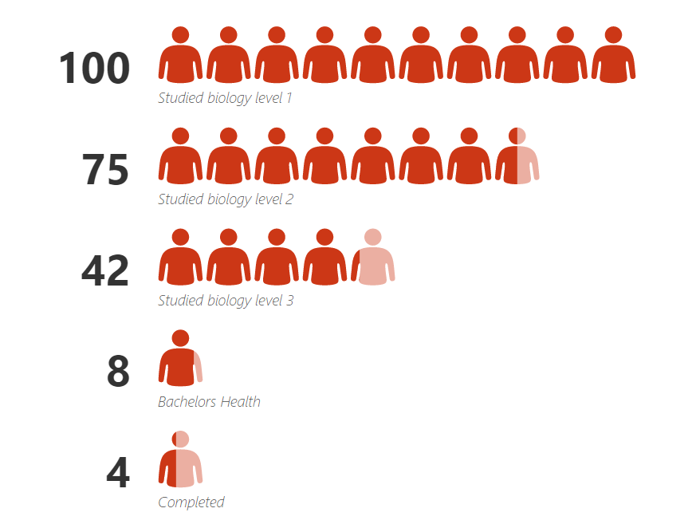 | 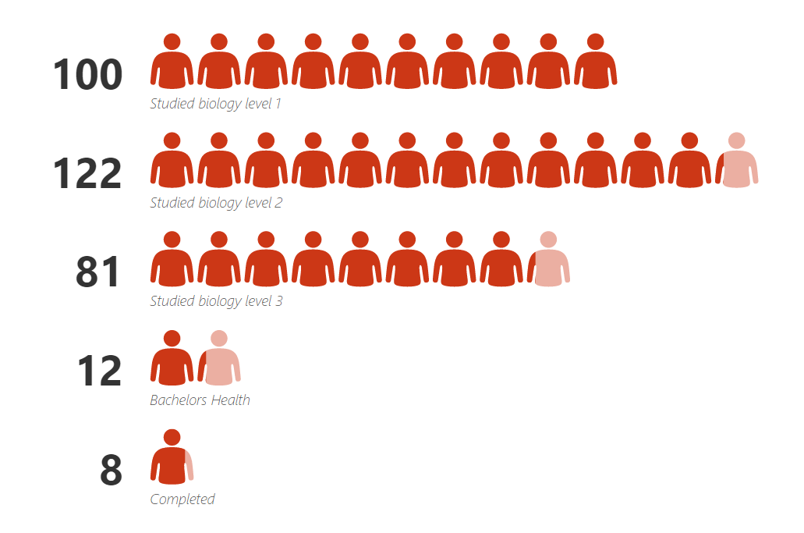
Shows attrition on the pipeline for undergraduate health learners using enrolment in NCEA level one biology as a proxy for interest in health-related careers.

Voices from the field

Realities at the frontline
As we have seen, there is considerable evidence that the current workforce development system is not configured to meet the needs of Pacific.
We interviewed fifteen Pacific people involved in by Pacific for Pacific workforce development initiatives to understand the context in which they work and gathered information about the learner experience.
It is clear from these interviews that the case for investing in the Pacific health workforce is not widely recognised or, at least, fails to attract the necessary urgency of action.
Interviewees argued that Pacific health and workforce issues are often siloed, and the key institutional actors often lack a focus on equity.
They reported a disconnect between the extent of the undersupply of Pacific health workers, the evident connection between that and the health needs of Pacific and providers experience of insecure and insufficient funding.
We heard that accountability for delivering for Pacific by ‘mainstream’ organisations is often absent.
Interviewees had several suggestions for change.
- There needed to be more coherence to the investment in Pacific workforce development with more effort put into cross-agency investment.
- Pacific workforce development needs to start with Pacific cultural frameworks, ownership and governance.
- Collaboration between the existing Pacific workforce development programmes and those working to develop the Māori workforce was considered important.
- Service commissioning needs to change to give more security to providers and reflect that people often require sustained support over an extended period.
- Programme design needs to incorporate more apprenticeship style programmes and offer more exit points.
- Scholarship funding is important in removing perceived barriers for learners. Still, the return in terms of smaller student loan balances comes later for learners who often require immediate financial support with living costs and the high hidden costs of professional health programmes.

FOU programme
The FOU programmes are a collaboration of the three Auckland District Health Boards that supports Pacific secondary school students in the city to pursue health careers.
The programme is funded by the Ministry of Health.
The programme has three key elements:
- FOU secondary, a Health Sciences Academy programme that works with Pacific learners from thirteen low decile schools with high Pacific enrolments promoting health careers.
- FOU tertiary, which supports learners as they transition from secondary school to tertiary education and connects them with academic services, such as career services.
- Employability package, which helps learners promote themselves, prepare for interviews and navigate through the first year of work.
The programme plays an important role in promoting awareness of the wide range of health careers.
“When we started the programme, there was a lot of students that all they knew about health being a doctor and a nurse”.
But it can sometimes face resistance from schools and tertiary education organisations whose staff don’t always see the ‘value-add’.
“…and we're like, "Hey, can we access your students? We'll run these workshops, and have these opportunities for mentors." And things like that. We do get pushback … that's why I said to the team, "You know what? Let's just go to the student group. Go straight to them that are actually needing the help."
The time it takes to translate support of secondary school students into a member of the health workforce, and the inability to easily track learners across the secondary-tertiary transition doesn’t always fit conveniently into public sector reporting expectations.
“While it's great to be having these kids interested in STEM subjects and supporting it with their education, there's no real way to track whether that's turning into any benefits for the health sector in terms of the health workforce.”
Although a three-year contract is in place now, the funding for the programme has been uncertain.
“I find it really hard, or actually difficult. We went up until December of ending of our contract, and we were still unsure whether the work was going to continue.”
Still demand for participation ‘…barely scratches the surface’, and the team report excessive workloads.
An important challenge is that the programme is seen as a discrete service contract rather than an integrated part of business-as-usual human resource development.

POPO
The Pacific Opportunities Programme at Otago (POPO) was established in 2011 to help recruit, train and support Pacific learners in health professional and health-related courses at the university.
POPO is a holistic, wrap-around support programme with complementary elements:
- An orientation programme that helps Pacific students transition from secondary school to university. This programme operates as a ‘crash course’ in how best to transition to university and share expectations and experiences with tools to support students in their journeys.
- POPO Foundation Programme which is a scholarship for Pacific students to undertake the University of Otago Pathways programme as a preparatory year before undertaking Health Sciences First Year.
- POPO Plus which is a mentoring programme accompanied by professional development and academic support throughout the academic year.
- POPO Internship programme which is a paid 10-week internship programme for students in their penultimate year of study.
We’re lucky, as Pacific students, to have some of the best support in the country…, the mentoring and tutorials of POPO, the Pacific Islands Centre, and Pacific staff that really care about our journeys, I know without that support I wouldn’t have made it this far
The programme is organised around Pacific values of aiga, kainga and community offering students a home away from home, alofa (love), tautua (leadership through service) and connectedness.
The programme complements the university’s preferential-entry system for health professional courses, the Mirror on Society policy. This policy together with POPO has contributed to a marked increase in the number of Pacific learners completing health science programmes, particularly medical graduates.
The university’s efforts have a long history. One major milestone was the endorsement of Pacific health as one of seven compulsory domains of learning at Otago Medical School.
This recognition was historic and reflected a marked shift from a situation in the recent past where there was virtually no Pacific teaching in the programme.
We have MoUs with the major Pacific providers across the country – which ensures a “fit for purpose training of our all health professional students” and we engage our community and providers in the teaching of our health professional students.
The results of these interventions have been striking. Research suggests that those who complete their first year in higher education, are more likely to progress to complete their qualification. Further, over the past 20 years the share of health science learners at the university who are Pacific has tripled.
This space is yours… Don’t be shy or afraid. Stand proud with your Pacific brothers and sisters to make a difference.

Aniva Future Nurse Leaders
The Aniva Future Pacific Nurse Leaders (Aniva Futures) Programme aims to support Pacific undergraduate student nurses to complete nursing programmes and transition into the workforce successfully by addressing some of the financial costs associated with nursing studies.
The programme supported 555 learners in 2022. It is delivered at the Auckland University of Technology, the Te Pūkenga campuses in Auckland (Unitec and Manukau Institute of Technology), Hamilton (Wintec), and Wellington (Weltec/Whitireia) and the University of Waikato.
The programme is focused on addressing systemic barriers to achievement by students. Nursing learners spend around $4,500 each during their studies on basic equipment, health checks and travel to clinical placements. These costs weigh heavily on Pacific learners who tend to be older and often have family responsibilities and obligations.
Aniva Futures meets the needs of Pacific nursing learners through cash grants of around $600K (excluding GST) each year that:
- allow first-year learners to purchase their uniforms, nursing kits, shoes and other items required for their studies,
- cover the ongoing cost of clinical placement travel, uniform, shoes and equipment for second and third-year students, and
- meet the costs of the State examination and registration fees charged to third-year learners, as well as the re-sit fee and examiner feedback report for those who are initially unsuccessful.
Learner surveys show that 91 per cent of participants found the programme met their needs very well, 97 per cent found the support to be timely and 98 per cent were satisfied with the support they received.
Academic staff report that easing the financial burden for learners means that they don’t have to work as much and can concentrate more on their placement and complements the support provided by tertiary education organisations well.
The need that Aniva Future Nurse Leaders meets is exemplified by comments from participants.
“They don’t see the struggle we are in. In general, they don’t think long term wise, they don’t think these are going to be our new generation. It affects the mindset of our Pacific students. It’s not fair to be sitting there asking our families”.
While there are strict eligibility criteria for the Aniva Future Nurse Leaders programme, there is something significant for learners about being able to access support from a distinctively Pacific source, that can overcome feelings of whakama that learners in need of help may feel.
“You align well with the Pacific nursing programme because …. it fits well with our community. It’s easier to access our own peoples’ funding. When we have you guys on board, it really helps us to feel comfortable for what we’re asking for”.

Health needs

More work to do
The health outcomes and conceptions of the purpose of health services provide insight into the health needs of Pacific people, and the persistent disparities in health and service outcomes tell us much about where the health and disability system is falling down for Pacific.
Avoidable differences in health outcomes are a long-standing and well-documented feature of the health system in New Zealand.
These health inequities are expressed across the life course of Pacific people including more intensive interventions during birth, poorer access to childhood screening programmes, greater barriers to primary health care among younger adults, higher incidence of long-term conditions into adulthood and greater burden of disability, particularly among older people.
There is evidence of strong uptake of health services, including enrolments in primary care, GP utilisation rates are similar to non-Māori non-Pacific people and childhood immunisation rates regularly exceed those of other communities, albeit with important exceptions.
These strengths are not consistently translated into good health outcomes by the health and disability system. Communication barriers, a clash in cultural worldviews and, at times, discriminatory and culturally insensitive behaviour have all been shown to affect the way Pacific peoples experience care and influence their health-seeking behaviour in the future.
Pacific peoples perceive the role of health services as fixing illness, rather than for maintaining function or preventing illness, and feelings of being overwhelmed, disorientation, fatalism, and denial are commonly reported when diagnosed with a health condition.
Qualitative research with Pacific peoples has also identified that understandings of wellness are strongly underpinned by a narrative of poverty and limited resources. People are clear that unhealthy lifestyles are not due to a lack of knowledge but a lack of economic resources and the ability to ‘make better choices’.
Strong connections are also made between high levels of stress and poor health. Particular sources of stress include complex family dynamics and obligations (particularly financial obligations), not being able to provide for families, and difficult life circumstances.
Despite these stresses, families endeavour to do the best for their children in challenging socio-economic and other circumstances.
The perspectives offered by Pacific people about what they expect from services offer a guide to how the workforce and service design need to change to better meet the needs of this community.
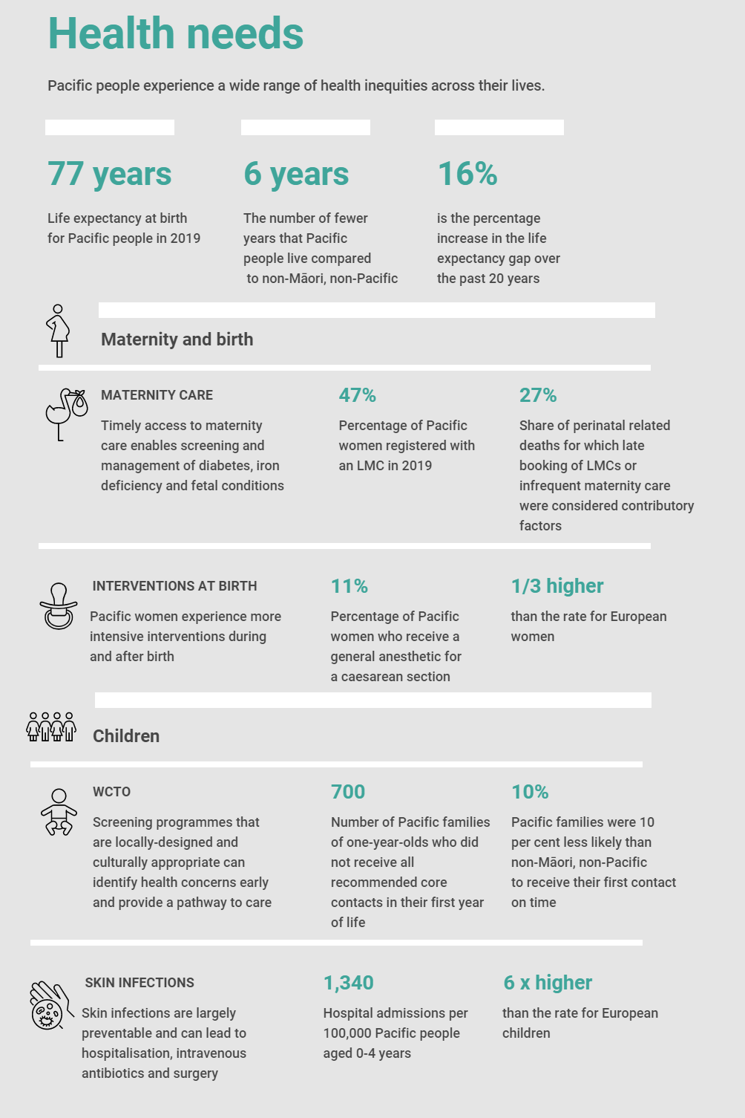
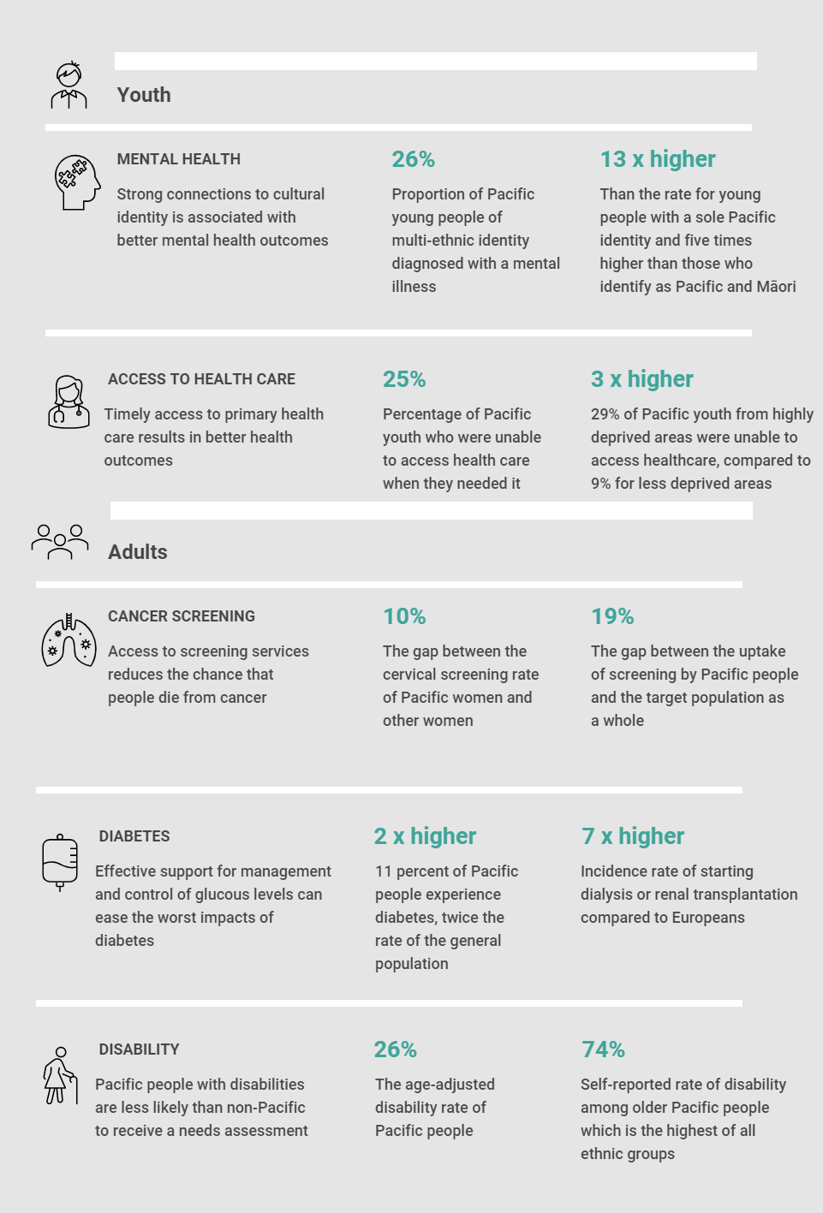
Source: Health Quality & Safety Commission. 2021. Bula Sautu – A window on quality 2021: Pacific health in the year of COVID-19. Wellington: Health Quality & Safety Commission

Future of the health system

The reformed health system
Over the period that this report was being prepared, the government announced and implemented major reforms of the health system.
The objectives of the reforms are:
- partnership: to develop a system that partners meaningfully with Māori and the communities that it serves and that works collaboratively across organisations to improve health and wellbeing.
- equity: to tackle persistent inequities in health outcomes and access to services for many of our communities.
- sustainability: to prevent, reduce or delay health need wherever possible, and ensure a more financially sustainable system.
- person and whānau-centred care: to refocus the design and delivery of health services around the needs and aspirations of people.
- quality: to drive improvements in the quality and safety of care, and reduce variation between services and areas. The vision for the transformation is a system that delivers healthy futures for all Pacific people, where families live longer, healthier lives and achieve equitable health outcomes.
The architecture of the reforms includes workforce development strategies, a simplified and more coordinated set of organisations, the introduction of locality and regional networks and an aligned reform of the workforce regulatory system.
The system now comprises three organisations – the Ministry of Health, Te Whatu Ora Health New Zealand and Te Aka Whai Ora Māori Health Authority.
Te Whatu Ora brings 28 agencies into a single health service deliver organisation employing 82,000 staff. As the delivery agency for the health system including for Pacific health, Te Whatu Ora operates health services, arranges for the provision of health services, commissions health services and promotes Public Health measures.
The twelve standalone Public Health Units have been combined into an integrated National Public Health Service.
The system is intended to deliver five key shifts:
- The health system will reinforce Te Tiriti principles and obligations
- All people will be able to access a comprehensive range of support in their local communities to help them stay well
- Everyone will have equal access to high quality emergency and specialist care when they need it
- Digital services will provide more people the care they need in their homes and communities
- Health and care workers will be valued and well-trained for the future health system.

Implications of the reforms for Pacific
The vision for the transformation is a system that delivers healthy futures for all Pacific people, where families live longer, healthier lives and achieve equitable health outcomes.
The transformation of Pacific Health is to allow the strength of the Pacific community to be front and centre of any reform.
New planning and accountability documents guide the system including the forthcoming Pacific Health Strategy and the Ola Manuia Interim Pacific Health Plan published in November 2022.
The emphasis on equity is particularly significant for Pacific peoples, particularly given the commitment to address the range of factors contributing to health and wellbeing, from housing to employment to social care.
The reforms have several important implications for the Pacific health workforce. These include:
- more emphasis throughout the health system on people-centred integrated care, which will increase the demand for skilled Pacific health workers at all levels
- the need for more Pacific people skilled in the policy, development, commissioning of health services application of health data, engagement with Pacific communities and employing population health approaches
- tighter integration between workforce development priorities and service design and delivery by bringing a workforce focus to policy statements, strategies and plans
- scope for the adoption of pro-equity and culturally appropriate workforce development practices across the public health system
- greater stability and security of funding for Pacific health providers enhancing their ability to reward and retain staff and to expand their integrated service offerings
- better coordination across the compulsory and tertiary education sectors and the health system through clearer feedback mechanisms
- increased expectations on the public health system to demonstrate visible and strong Pacific leadership in governance and management roles.
These implications signpost how the role of the Pacific health workforce will evolve over the coming years.

Evolving responses
Pacific health workforce development is highlighted in several key strategy and planning documents.
Health Workforce Strategy, which was under development at the time of writing. Emerging Information from that process highlights the relationship between workforce development and Pacific health priorities and outlines a programme of work to consolidate workforce information, prioritise activity and develop and implement a workforce plan.
Pacific Health Strategy, which is expected to be published during 2023. Workforce development is expected to be a feature of the strategy.
Te Pae Tata Interim New Zealand Health Plan (2022) highlights a broad range of workforce challenges and commits Te Whatu Ora to implement the workforce actions outlined in the Ola Manuia Interim Pacific Health Plan (see below).
Ola Manuia Interim Pacific Health Plan (2022-2024) published in July 2022 identifies ‘Support and grow a strong Pacific health workforce’ as a specific action supporting the plan. Key activities include developing a Pacific Health Workforce Development Strategy covering:
- barriers to education and training,
- investment in the Pacific health provider workforce,
- Pacific nurse specialist training, and
- more training opportunities for GPs within Pacific providers.
The emerging Pacific workforce development programme has three key threads:
- Attract, which focuses on recruitment in New Zealand, more flexible career pathways and financial support during training.
- Education and training, which focuses on reducing attrition during tertiary education, the redesign of health education, new qualifications, programmes and placement schemes and in-study support.
- Retain, which aims to offer more modular, flexible careers, career pathway development, extended scopes of practice, regulatory reform and support during the initial period of health sector employment.
The Pacific-specific actions complement a wider set of new and expanded initiatives announced by the government in 2022. Some key examples include:
- Recruitment initiatives backed up by an international recruitment campaign, immigration process changes and the introduction in July 2023 of the Graduate Diploma Nursing Pacific for nurses trained in Pacific Island Countries.
- Nurse and midwifery career promotion and support including initiatives to support people to return to these workforces, targeted promotion and expansion of nurse practitioner training.
- Increased support for General Practice education and bridging programmes and pay parity initiatives.

Further reading

Companion reports
This report is intended to be read in conjunction with a set of companion papers that discuss our findings in more detail.

The Pacific Health Workforce - Describing the workforce
The report provides an overview of the composition of the current workforce involving basic statistics on the regulated and unregulated workforce, information on the Pacific people in the public health system and provides commentary on the progress to parity of representation of Pacific people in the health workforce.

The Pacific Health Workforce - Forming the workforce
The report provides background to how the Pacific health workforce is formed exploring how workforce development happens in a health context, the particular policy context for Pacific health workforce development, the key components of the funding available to support Pacific health workforce development and identifies the key actors in the workforce development system.

The Pacific Health Workforce - Learner Journey
The report provides an overview of how the tertiary education system contributes to the development of the health workforce. It describes how the education system works to dissuade Pacific people from pursuing health-related careers and presents data on enrolments, completions and outcomes of learners and people in employment.

The Pacific Health Workforce - Voices from the field
The report is a synthesis of the results of talanoa with fifteen Pacific people working in the health workforce and health workforce development.
The report presents the realities of working in the Pacific health space at the policy level and at the interface between funders and the current and potential Pacific health workforce.

