Pacific Health Work Forecast
  - Forming the workforce
Citation: Te Whatu Ora | Health New Zealand. 2021. Pacific Health Workforce Forecast – Forming the workforce. Wellington: Te Whatu Ora | Health New Zealand.
Published in December 2021 by Te Whatu Ora | Health New Zealand
PO Box 793, Wellington 6140, New Zealand
ISBN 978-1-99-106790-6 (online)
This document is available at tewhatuora.govt.nz
This work is licensed under the Creative Commons Attribution 4.0 International licence. In essence, you are free to: share ie, copy and redistribute the material in any medium or format; adapt ie, remix, transform and build upon the material. You must give appropriate credit, provide a link to the licence and indicate if changes were made.

Contents
Acknowledgements 4
Introduction 5
Overview 5
Key findings 6
Workforce development 7
Policy context and settings 17
Funding 20
Actors 24
Bibliography 27

Acknowledgements
This report is a companion to the Pacific Health Workforce Forecast.
Pacific Perspectives Limited (PPL) was commissioned to prepare this report by Manatū Hauora Ministry of Health.
On 1 July 2022 the responsibility for health workforce development was transferred to Te Whatu Ora - Health New Zealand. The recommendations of the Pacific health workforce forecast will be reviewed and led by Te Whatu Ora Pacific Health Group.
Every effort has been made to provide accurate and factual content. The authors, however, cannot accept responsibility for any inadvertent errors or omissions that may have occurred.

Introduction
This report provides background to how the Pacific health workforce is formed and is organised around four sections:
- Workforce development, describing how workforce development happens in a health context,
- Policy context and settings, describing the particular policy context for Pacific health workforce development,
- Funding, setting out the key components of the funding available to support Pacific health workforce development,
- Actors, identifying the key actors in the workforce development system.

Overview
In the section Workforce Development, we drew on literature about the key success factors for workforce development, the distinct context of health workforce development and the emerging literature on the development of the indigenous health workforce.
To provide context to the current and emerging priorities for health workforce development, we explored in the section Policy context and settings how the reform of the health system and the Ola Manuia: Pacific Health and Wellbeing Action Plan 2020–2025 (Ola Manuia) will inform workforce development.
The section Funding builds on Ministry of Health work to document the workforce development initiatives by taking a Pacific lens and incorporating tertiary education funding.
We describe the key Actors in the Pacific health workforce development system and their key relationships to help readers understand how it operates.

Key findings
This report showed that:
- Workforce development is a complex process, with several distinctive elements in a health context, including the use of pipeline and workforce substitution as a common frame.
- The literature on indigenous workforce development highlights the importance of organisational commitment, the workforce pipeline, collaborative work practices, structural factors and deliberate, purposeful targeting.
- The policy context for health workforce development is changing as the health system reforms are worked through. Still, the critical need expressed in Ola Manuia for Pacific leadership capability and capacity and investment in focused workforce development remains.
- Targeted government funding for Pacific health workforce development totals around $15.4m per annum. A further $63.7m is spent each year on the education and training of the Pacific health and disability workforce through the general subsidies for tertiary education and professional development, and student fees.
- There is a rich ecosystem of actors involved in developing the Pacific health workforce, with a small number of Pacific-led or focused organisations playing a key role.

Workforce development
Workforce development is the effort by public and private sector organisations to enable individuals to acquire skills for employment or improved work performance and employers to communicate and meet their demand for skills (Tan, Lee, Valerio, & Nam, 2013).
It can encompass how well people are prepared to enter or re-enter the workforce, learning opportunities to improve workplace performance, organisations' responses to change, and changes in the current and potential workforce (Jacobs & Hawley, 2009).
The forecasting, design and delivery of workforce development tend to focus on the supply of people (Hollister, 1967), (Richardson & Tan, 2007), (Segal & Bolton, 2009), skills (Lassnigg, 2001) and integration with service and work design (Rees, 2019).
Key success factors in efforts to anticipate and respond to workforce development needs include clear alignment between policy, providers, the labour market and employers (ILO, 2017), (CEDEFOP, 2017), (OECD, 2019), successful stakeholder engagement (OECD, 2016), (Joyce, 2019), engaging communications (CEDEFOP, 2017) and credible technical capability (ILO, 2017), (Knudsen, Pedersen, Petersen, Stephensen, & Tier, 1998), (Cedefop, 2018), (BLS, 2019), (BIBB, 2020).

Workforce development in a health context
Health workforce development has several distinctive elements. For example, a high degree of uncertainty, the impact of internal labour markets, immigration settings, organisational context, the complex role that demography plays in terms of service demand, health and labour market regulation, the need to account for output, productivity and service quality, changing patient expectations and the disruption introduced by policy changes all play a role (Curson, Dell, Wilson, Bosworth, & Baldauf, 2010), (Dussault, Buchan, Sermeus, & Padaiga, 2010), (Kroezen, et al., 2015), (Rees, Crampton, Gauld, & MacDonell, 2018).
Structured workforce planning can play a useful role in health workforce development. The size and complexity of the workforce, the extended time needed to train and educate staff and the political sensitivity of health services make planning attractive. Additionally, conventional market equilibrating mechanisms are absent or attenuated because salaries are often not directly linked to market forces (Imison, Buchan, & Xavier, 2009), (Curson, Dell, Wilson, Bosworth, & Baldauf, 2010).
The governance of the health workforce development system occurs at a nexus between politics, power arrangements and stakeholder interests. Powerful stakeholders can constrain policy choice, and national or transnational regulation, fiscal resources and economic policy, employment practices and labour market flexibility and workforce resistance or openness to change all play a role (Rees, Crampton, Gauld, & MacDonell, 2018), (Rees, 2019), (Lim & Lin, 2021).
Health workforce planning is often framed in either pipeline or workforce substitution terms. Pipeline approaches tend to emphasise the supply and retention of health workers (Curtis, Wikaire, Stokes, & Reid, 2012), (Australian Health Ministers’ Advisory Council, 2017), (Lai, Taylor, Haigh, & Thompson, 2018). Workforce substitution, on the other hand, rather than asking ‘Do we have enough’ focuses on ‘how can we more effectively deploy”. (Duckett, 2005), (Rees, 2019).

Indigenous health workforce development
An important element of health workforce development relates to the capacity of these systems to develop and make the best use of indigenous health workers.
Pacific people share many of the experiences of indigenous health workers, whether in terms of a lack of research, a shared experience of colonisation, the effects of international migration of skilled labour and general underrepresentation in the health workforce.
The literature on the development of the Pacific health workforce is modest, meaning that it is necessary to draw from a wide range of other sources for insights (Curtis, Wikaire, Stokes, & Reid, 2012), even as the experience of each indigenous community varies in many ways (Anderson, et al., 2006).
While Pacific people are not indigenous to New Zealand, a common experience of high health needs (Durie, 2003a), (Hill, Barker, & Vos, 2007), (Ministry of Health, 2019), (Ryan, Grey, & Tukuitonga, 2021), health systems that are not designed to meet those needs (Ryan D., 2019), (Waitangi Tribunal, 2019) and impacts of colonial and post-colonial systems shape the lives of Pacific people and communities (Lee, 2009), (Tukuitonga, 2013).
Skilled health workers trained in developing countries are an important source of labour for more developed countries. Pacific health workers trained in Pacific Island Countries are no exception (Negin, 2008), with New Zealand being a notable case for nurses and aged care workers in particular (Zurn & Dumont, 2008). The impacts on the health systems of those source countries are significant, however (Connell, 2009).
The underrepresentation of indigenous people in the health workforce is recognised as a global challenge (DESA, 2013) attributable to a range of historical, political, demographic, cultural, academic and financial factors (Curtis, Wikaire, Stokes, & Reid, 2012), (Chin, et al., 2018). It is expressed in:
- gross numbers, with the number of indigenous health workers being few,
- relative shares, with the number of indigenous health workers being lower than their share of the overall population, and
- compositional terms, with indigenous health workers clustered in roles of lower seniority and technical complexity (Sibthorpe, Becking, & Humes, 1998), (Ratima, et al., 2007), (Australian Health Ministers’ Advisory Council, 2017).
The literature on indigenous workforce development highlights the importance of organisational commitment, the workforce pipeline, collaborative work practices, structural factors and deliberate, purposeful targeting
Figure 1: Workforce development – a system and process
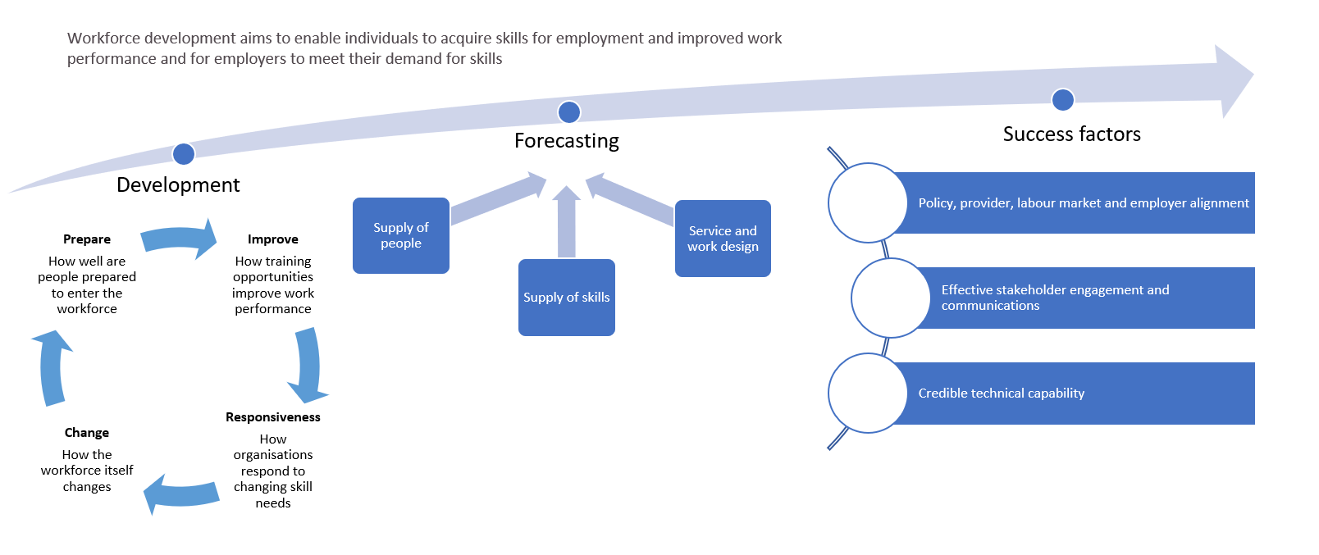

Figure 2: Characteristics of health workforce development and planning
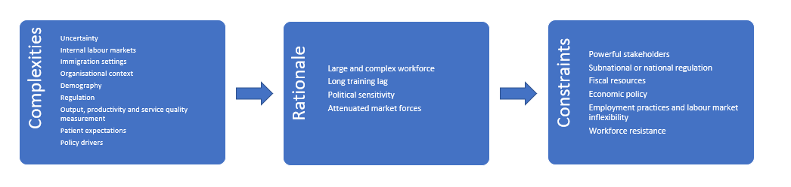

Figure 3: Experiences common to indigenous people and common needs for health workforce development
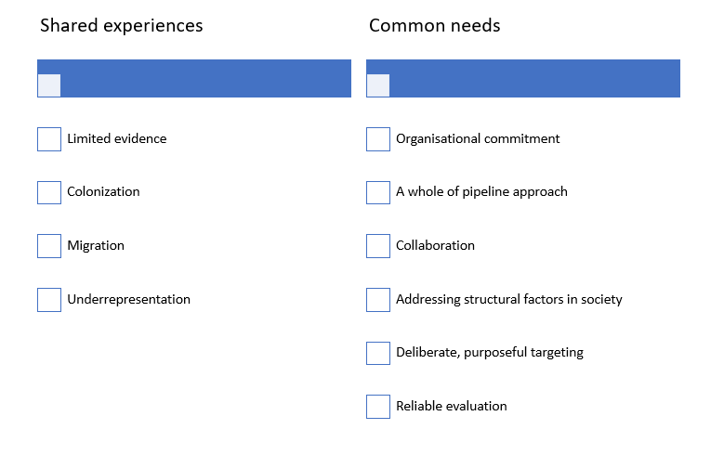

Figure 4: Workforce planning changes proposed in the Health and Disability System Review
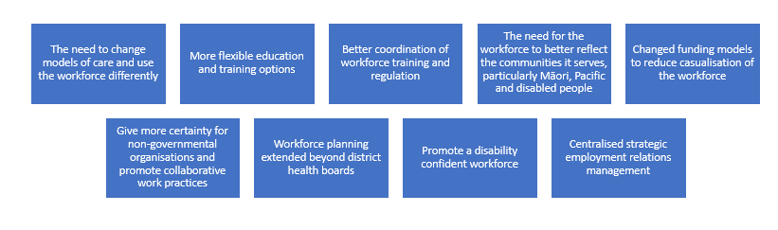
Source: (Health and Disability System Review, 2020)

Organisational commitment
Developing a stable and effective indigenous health workforce requires commitment among the employing organisations, professions, training institutions and professional bodies.
Strong executive leadership, sustained and prolonged investment, proactive employment and development policies and strategies, a supportive work environment and respectful culture and the existence of a dedicated workforce unit are all important (NZIER, 2007), (Ratima, et al., 2007), (Lai, Taylor, Haigh, & Thompson, 2018), (Taylor, et al., 2020).
A literature review relating to Pacific leadership needs and approaches in the health and disability sector identified a gap between recruitment policy rhetoric and practice and a ‘brown glass ceiling’ for Pacific employed by DHB. It argued that a broader system-wide transformation is required rather than more targeted initiatives (Mafile'o & Sanga, 2021).

A whole of pipeline approach
The paucity of indigenous health workers, particularly in more specialised roles, reflect long-standing and unrealised opportunities to improve the pipeline in the health workforce (Sibthorpe, Becking, & Humes, 1998), (HWAC, 2002), (Ratima, et al., 2007).
In particular, tertiary education organisations need to adopt recruitment and learner success strategies that proactively address the historical under-representation of indigenous people. Still, learner success is influenced by course selection and achievement in secondary school, family engagement, the performance of tertiary providers in terms of learner success and inclusiveness and the effectiveness of the transition into education and to employment (Ratima, et al., 2007), (Anderson, Ewen, & Knoche, Indigenous medical workforce development: current status and future directions, 2009), (Curtis & Reid, 2012a), (Curtis, Wikaire, Stokes, & Reid, 2012).

Collaboration
Meeting the needs of indigenous communities requires a mix of dedicated indigenous health services and more responsive conventional health services, particularly as 'mainstream' services continue to deliver the bulk of healthcare (Durie, 2003), (Anderson, et al., 2006).
Service design needs to prioritise collaboration whereby clinical acumen is sharpened by cultural knowledge (Jongen, McCalman, & Bainbridge, 2018) and community endeavours are strengthened by access to professional expertise (Durie, 2003), (Thompson, Shahid, Bessarab, Durey, & Davidson, 2011), (Opie, Lees, & Haines, 2019).
There is also an integrative element involved in fostering cultural and clinical competencies among health workers (Ratima, et al., 2007).

Addressing structural factors in society
The recruitment and retention of indigenous health workers need to account for the structural design of health systems, which may be expressed in more precarious, low-paid employment, undervaluing and invisibility of the 'indigenous health professional role' in the educational pipeline and service design, and pervasive culturally unsafe environments (Abbott, Gordon, & Davison, 2008), (Lai, Taylor, Haigh, & Thompson, 2018), (Jongen, McCalman, & Bainbridge, 2018), (Hughes, Lowah, & Kelly, 2019), (Mafile'o & Sanga, 2021), (Mafile’o, Halatuituia, & Samuelu, 2021).
Structural discrimination often also means that indigenous health workers can face challenges to their well-being due to significant familial responsibilities, difficult personal experiences and ‘intergenerational, suppressed and unresolved grief often not well understood by mainstream colleagues’ (Roche, Duraisingam, Trifonoff, & Tovell, 2012), (Opie, Lees, & Haines, 2019).

Deliberate, purposeful targeting
Focusing on developing indigenous health workers has an intrinsic equity value (Durie, 2003), offering the potential to deliver better health and life outcomes for individuals and communities.
Ethnic concordance between health workers and people using health services is identified as a key contributor to health service access and outcomes (Saha, Komaromy, & Koepsell, 1999), (Cooper & Powe, 2004), (National Prevention Council, 2011), (Pearce, 2014), (Crampton, Weaver, & Howard, 2018).
The impact of workforce development in terms of improved health, well-being and financial security of indigenous people is also sometimes cited (Opie, Lees, & Haines, 2019)

Reliable evaluation
The literature suggests that evaluation of indigenous health workforce development strategies and interventions is underdeveloped (Curtis, Wikaire, Stokes, & Reid, 2012), (Lai, Taylor, Haigh, & Thompson, 2018), an observation that appears to be generally applicable to workforce development (Kroezen, et al., 2015).
In assessing success, it is important to think of aspiration beyond simple parity of representation given how intersectionality contributes to marginalisation and disadvantage (Crampton, Weaver, & Howard, 2018), (Zeinali, Muraya, Govender, Molyneux, & Morgan, 2019).
Simple measures such as the number or proportion of Pacific people in the health workforce are therefore insufficient. The large share of women in the health workforce, the role of social identifiers and stratifiers within communities and the diverse array of ethnic identities within the ‘Pacific’ identity must all be considered.

Policy context and settings
Priority setting for health workforce development is informed by a range of factors (see Figure 2), including government policy settings.

Current reforms
The development of this report coincided with the announcement of major reforms to the health system designed to strengthen the system into a single national health service that provides consistent, high-quality health services for everyone, particularly groups who have been traditionally underserved. Further decisions relating to workforce development are to be announced later (NZ Government, 2021).
These changes have many goals, including delivering equity of access and outcomes for Pacific peoples, establishing a strong Pacific policy function with expertise in workforce development to develop a national Pacific health strategy, embedding the voice of Pacific people in planning, commissioning and delivery of health services, and providing a wider range of services grounded in Pacific worldviews and care approaches (NZ Government, 2021a), (DPMC, 2021).
Primary and community services are being reorganised around ‘localities’ organised by geographical unit or population groups, which will have a consistent range of core services, with the delivery of the services and workforce composition based on the needs and priorities of local communities (New Zealand Government, 2021b), (DPMC, 2021).
The changes signal that long-term planning will make it easier to anticipate demand and respond with investment in the health workforce and services increasing the government’s role in shaping the health workforce and increasing the number and skill level of health workers, particularly by centralising workforce planning and development into a new national entity, Health NZ (New Zealand Government, 2021c), (New Zealand Government, 2021d), (DPMC, 2021).
Other priorities include the publication of a New Zealand Health Plan that sets out the basis for workforce planning, development of a Pacific Health Plan and dedicated capability in commissioning services for Pacific people by Health NZ, enhanced digital leadership, capacity and literacy in the workforce and alignment of investment in facilities with workforce plans (DPMC, 2021).

Health and disability system review
The current reforms were informed by the findings of the Health and Disability System Review. While detailed decisions on the workforce implications are yet to be announced by the government, the review highlighted a wide range of issues and possible solutions to existing workforce challenges (see Figure 4).
The review's recommendations relating to workforce planning were organised around the themes of better planning, changes to the training and education system, a more flexible regulatory environment, more constructive employment relations and making sure the system is a good employer. The review also considered the Pacific health workforce, arguing that its overall small size restricts the number in leadership positions (Health and Disability System Review, 2020).

Ola Manuia
Ola Manuia: Pacific Health and Wellbeing Action Plan 2020–2025 (Ola Manuia) guides the health and disability system and other government agencies in supporting Pacific peoples to thrive in Aotearoa New Zealand (Ministry of Health, 2020).
Ola Manuia identifies Pacific leadership, the health and disability workforce, organisational and infrastructural capacity and funding and investment key resources (or system enablers) for achieving the outcomes of Ola Manuia (see Figure 5).
These enablers are interrelated and recognise that complex factors at all levels – individuals, families, communities, the health and disability system and the wider society – impact health and well-being. Key focus areas in Ola Manuia directly relevant to workforce concerns include:
- Leadership: To grow Pacific leadership capability and capacity within Pacific communities and across the health sector. This enabler responded to evidence that all DHBs lacked Pacific representation in senior management positions where decisions impacting on Pacific health are made.
- Workforce: To develop and grow a health and disability workforce that is culturally safe and responsive to the diverse health needs of Pacific communities and increase the capacity and capability of the Pacific health and disability workforce. Ola Manuia called for greater investment in focused workforce development programmes and improved recruitment and retention strategies.
Talanoa with Pacific communities, as part of the development of the action plan, identified increasing the Pacific workforce, upskilling and knowledge of the workforce, succession planning and Pacific leadership as important priorities for these stakeholders (Ministry of Health, 2020).
Figure 5: Intervention logic model – Ola Manuia
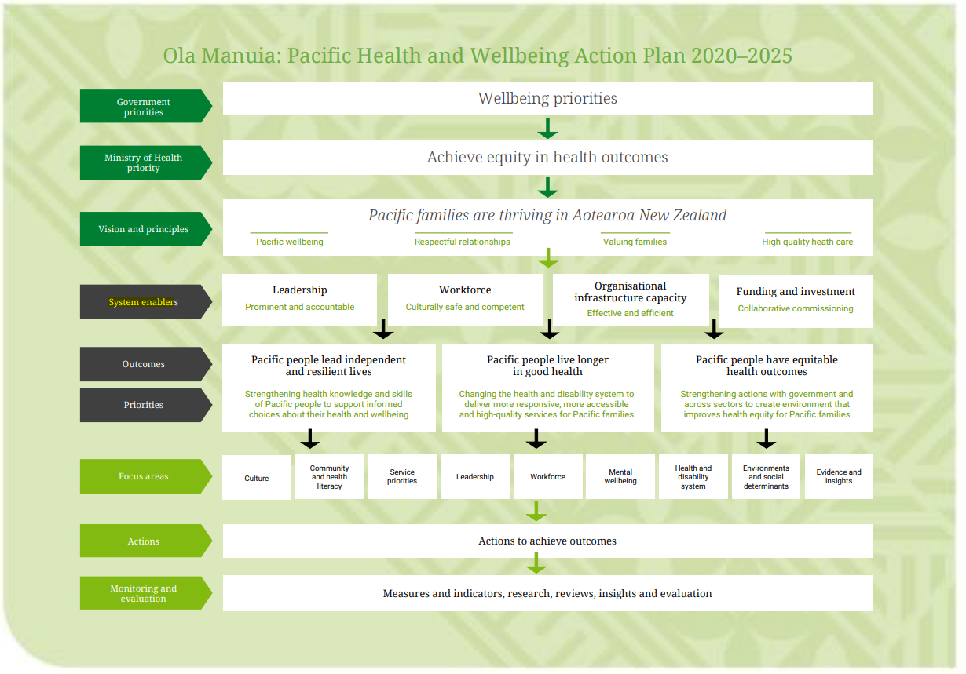
Source: (Ministry of Health, 2020)

Funding
The government and Pacific people provide funding of about $78.1m per annum in the education and training of the Pacific health and disability workforce. The major components of that funding are:
- $41.2m or 53 per cent allocated via the Tertiary Education Commission to support tertiary education and training based on the choices of Pacific people to pursue learning in health-related fields of study through tuition subsidies.
- $10.9m or 14 per cent allocated either through the fees-free subsidy for learners new to tertiary education or the Pacific Health Scholarships
- $5.5m or 7 per cent allocated by the Health Research Council to support masters and PhD scholarships and fellowship to develop the Pacific health research workforce.
- $5.4m or 7 per cent contributed by learners through the fees charged for tertiary education after scholarship programmes and the fees-free initiative are taken into account. This figure likely understates the true contribution. Learners pursuing health-related tertiary education will incur costs associated with clinical placements, such as the purchase of equipment and uniforms, requirements for health checks and vaccinations and additional travel and parking costs. These costs may be as high as $4,500 per learner throughout a three-year degree programme.
- $3.8m or 5 per cent allocated for initiatives to promote health career pathways from schools or engage Pacific learners with STEM careers.
- $3.6m or 5 per cent allocated to enhance educational outcomes of Pacific learners enrolled in health-related programmes at tertiary education organisations.
- $3.6m or 5 per cent made up of the approximate share associated with Pacific people of the mainstream early and mid-career funding provided to support the transition of health professionals into the health workforce and develop the specialist workforce.
- $3.1m or 4 per cent allocated for professional development for specific workforce groups to allow people engaged in such training to access pastoral and other support or promote re-engagement with the health workforce.
- $1.0m or 1 per cent to develop the capability of Pacific health and disability service providers, including enabling access to professional development for staff.
These funding sources mapped to the part of the workforce pipeline that they focus on are presented in Figure 7.
Around 80 per cent of this funding relates to general funding that Pacific people access along with all other participants and student fees paid by Pacific learners themselves. Just 20 per cent (or $15.4m) is targeted to Pacific health workforce development (see Figure 7).
This analysis does not consider other investments that contribute to the development of the Pacific health workforce. These investments include funding for compulsory education, which prepares people for entry to tertiary education or, more abstractly, funding immigration services, providing a pathway to health workers trained in Pacific Island Countries to gain employment in New Zealand.
We also have not calculated the funding allocated by district health boards and other employers to workforce professional development.
Figure 6: Funding for Pacific workforce development
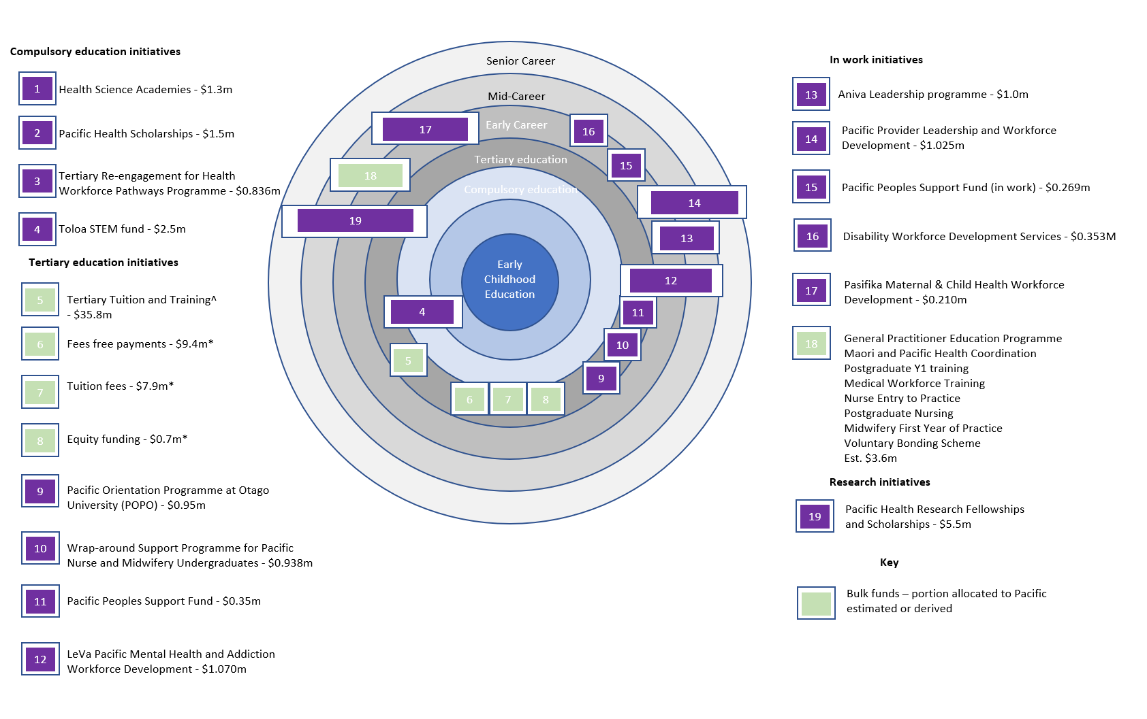
Source: (TEC, 2021).
Figure 7: General and targeted funding for Pacific health workforce development

Data table
General | 80%
Targeted | 20%

Actors
The health workforce development system involves learners and employees, education organisations, employers, unions, professional organisations, workforce peak bodies and government agencies. Figure 8 shows the key actors in the workforce development system and their key points of interaction, and a brief description of their respective contributions is presented below.
Pacific Health Professional Organisations includes several Pacific-led groups such as the Pasifika Medical Association, Pasifikology, Pacific GPs Association, Pan-Pacific Nurses Association, Aotearoa Tongan Health Workers Association, New Zealand Nurses Organisation (Pacific Nursing section), and Fiji Nurses Association.
These groups connect Pacific health professionals to promote the profession, share knowledge and information among members, and advocate for members' interests.
Several other groups are engaged in workforce advocacy, including the health sector unions, which have many Pacific health workers among their membership.
Pacific professional development is provided by organisations, including Le Va and Pacific Perspectives. These organisations deliver a range of training, leadership and scholarship programmes under contract to the Ministry of Health.
Public sector organisations that play a role in the workforce development system fulfil various roles, including high-level priority setting, funding for tertiary education providers, quality assurance and standard-setting, information and advice, and scholarships and fees support.
These organisations tend to operate arms-length from Pacific health workers working through agents in the education sector to deliver workforce development activities.
Education sector organisations include the primary, secondary and tertiary education sectors. Most effort in developing the Pacific health workforce during primary and secondary education arises through general education initiatives, with important exceptions such as the Pacific Health Academies in Auckland and the Toloa STEM initiatives.
Tertiary education providers offer the clearest pathways into the health workforce, with most Pacific health workers trained at Auckland University of Technology, the University of Auckland and University of Otago, and the Auckland subsidiaries of Te Pukenga.
The Health Practitioners Competence Assurance Act 2003 (HPCA) Responsible Authorities are a group of body corporates responsible for ensuring that all health practitioners are fully competent in the practice of their profession.
The regulated health workforce includes professions such as medical doctors, nurses, midwives, and dentists. Pacific people are represented to varying degrees in these professions and the governance of these organisations.
The HPCA Responsible Authorities provide a mix of ex-ante and ex post facto quality assurance of the tertiary education leading to roles in the regulated health workforce.
Finally, employers such as District Health Boards and Pacific health providers play a central role in workforce development through ongoing professional development, work organisation, and clinical placements.
Learners are excluded from this description as their experience of the workforce development system is discussed in the companion report – Pacific Health Workforce – Learner Journey. For simplicity, the role of the immigration system in supplying skilled labour for the health workforce is not addressed.

Figure 8: Key entities – Pacific health workforce development

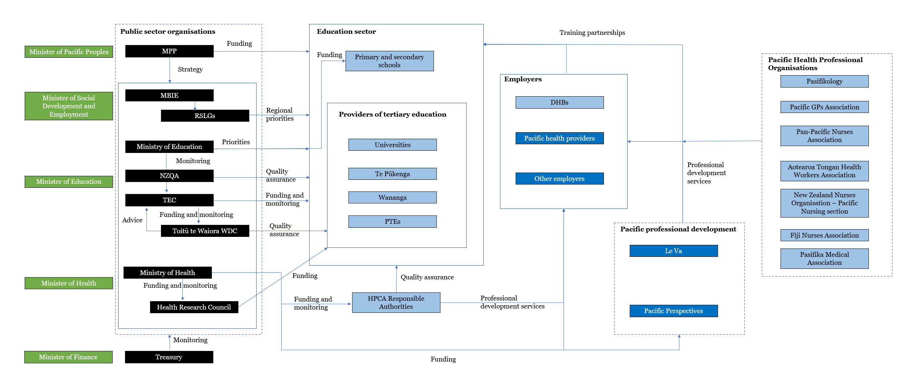

Bibliography
Abbott, P., Gordon, E., & Davison, J. (2008). Expanding roles of Aboriginal health workers in the primary care setting: Seeking recognition. Contemporary Nurse, 27(2).
Anderson, I., Crengle, S., Kamaka, M. L., Che, T.-h., Palafox, N., & Jackson-Pulver, L. (2006). Indigenous health in Australia, New Zealand, and the Pacific. Lancet, 367, 1775-85.
Anderson, I., Ewen, S., & Knoche, D. (2009, May 10). Indigenous medical workforce development: current status and future directions. Medical Journal of Australia, 190(10).
Australian Health Ministers’ Advisory Council. (2017). National Aboriginal and Torres Strait Islander Health Workforce Strategic Framework 2016-2023. Canberra: Aboriginal and Torres Strait Islander Health Workforce Working Group.
BIBB. (2020). The QuBE Data Portal. Bonn: Federal Institute for Vocational Education and Training.
BLS. (2019). Occupational Outlook Handbook. Washington, DC: U.S. Bureau of Labour Statistics.
CEDEFOP. (2017). Briefing Note: Skills Anticipation: Looking to the Future. Luxembourg: European Centre for the Development of Vocational Training.
Cedefop. (2018). Skills forecast: trends and challenges to 2030. Luxembourg: Publications Office Cedefop.
Chin, M., King, P., Jones, R., Jones, B., Ameratunga, S., Muramatsu, N., & Derrett, S. (2018). Lessons for Achieving Health Equity Comparing Aotearoa/New Zealand and the United States. Health Policy, 122(8).
Connell, J. (2009). 'I never wanted to come home': Skilled Health Workers in the South Pacific. In H. Lee, & S. T. Francis (Eds.), Migration and Transnationalism: Pacific Perspectives. Canberra: ANU E Press.
Cooper, L., & Powe, N. (2004). Disparities in Patient Experiences, Health Care Processes, and Outcomes: The Role of Patient-Provider Racial, Ethnic, and Language Concordance. The Commonwealth Fund.
Crampton, P., Weaver, N., & Howard, A. (2018). Holding a mirror to society? Progression towards achieving better sociodemographic representation among the University of Otago's health professional students. New Zealand Medical Journal, 131(1476).
Curson, J., Dell, M., Wilson, R., Bosworth, D., & Baldauf, B. (2010). Who does workforce planning well? Workforce review team rapid review summary. International Journal of Health Care Quality Assurance, 23(1).
Curtis, E., & Reid, P. (2012a). Indigenous Health Workforce Development: challenges and successes of the Vision 20:20 programme, 83, Indigenous Health in ANZ.
Curtis, E., Wikaire, E., Stokes, K., & Reid, P. (2012). Addressing indigenous health workforce inequities: a literature review exploring 'best' practice for recruitment into tertiary health programmes. International Journal for Equity in Health, 11(13).
DESA. (2013). State of the World's Indigenous People - Indigenous People's Access to Health Services. Geneva: United Nations.
DPMC. (2021). The Health and Disability System Review: Proposals for Reform. Wellington: New Zealand Government.
Duckett, S. (2005). Health workforce design for the 21st century. Australian Health Review, 29(2).
Durie, M. (2003). Providing health services to indigenous peoples, 327, British Medical Journal.
Durie, M. (2003a). The health of indigenous people, 326(7388), British Medical Journal.
Dussault, G., Buchan, J., Sermeus, W., & Padaiga, Z. (2010). Assessing future health workforce needs. Copenhagen: WHO.
Health and Disability System Review. (2020). Health and Disability System Review – Final Report – Pūrongo Whakamutunga. Wellington: HDSR.
Hill, K., Barker, B., & Vos, T. (2007). Excess Indigenous mortality: are Indigenous Australians more severely disadvantaged than other Indigenous populations? International Journal of Epidemiology, 36(3), 580-589.
Hollister, R. (1967). A technical evaluation of the First Stage of the Mediterranean Regional Project. Paris: Organisation for Economic Cooperation and Development.
Hughes, J., Lowah, G., & Kelly, J. (2019). Re-framing the Indigenous kidney health workforce. Medical Journal of Australia, 211(1).
HWAC. (2002). Health Workforce Advisory Committee - Second Annual Report to the Minister of Health. Wellington: Ministry of Health.
ILO. (2017). Skill needs anticipation: Systems and approaches. Analysis of stakeholder survey on skill needs assessment and anticipation. Geneva: ILO.
Imison, C., Buchan, J., & Xavier, S. (2009). NHS Workforce Planning: Limitations and possibilities. London: King's Fund.
Jacobs, R., & Hawley, J. (2009). Emergence of Workforce Development: Definition, Conceptual Boundaries and Implications. In R. MacLean, & D. Wilson (Eds.), International Handbook of Technical and Vocational Education and Training. Amsterdam: Springer.
Jongen, C., McCalman, J., & Bainbridge, R. (2018). Health workforce cultural competency interventions: a systematic scoping review. BMC Health Services Research, 18(232).
Joyce, H. S. (2019). Strengthening Skills: Expert Review of Australia’s Vocational Education and Training System. Canberra: Commonwealth of Australia.
Knudsen, M., Pedersen, L., Petersen, T., Stephensen, P., & Tier, P. (1998). Danish Rational Economic Agents Model DREAM, Version 1.2. Copenhagen: Statistics Denmark.
Kroezen, M., Dussault, G., Craveiro, I., Dieleman, M., jansen, C., Buchan, J., . . . Sermeus, W. (2015). Recruitment and retention of health professionals across Europe: A literature review and multiple case study research. Health Policy, 119.
Lai, G., Taylor, E., Haigh, M., & Thompson, S. (2018). Factors affecting the retention of indigenous Australians in the Health Workforce: A systematic review. International Journal of Environmental Research and Public Health, 15(914).
Lassnigg, I. (2001). Ways for improving the co-ordination of VET and employment. Vienna: Institute for Advanced Studies.
Lee, H. (2009). Introduction. In H. Lee, & S. T. Francis (Eds.), Migration and Transnationalism: Pacific Perspectives. Canberra: ANU E Press.
Lim, M. Y., & Lin, V. (2021). Governance in the health workforce: how do we improve on the concept? A network-based, stakeholder-driven approach. Human Resources for Health, 19(1).
Mafile’o, T., Halatuituia, N., & Samuelu, F. (2021). Pacific Stakeholder Engagement Report - Discovery Phase. Palmerston North: Mana Pacific Consultants.
Mafile'o, T., & Sanga, E. (2021). Literature Review on Pacific Health Leadership Development. Palmerston North: Mana Pacific Consultants.
Ministry of Health. (2019). Wai 2575 Māori Health Trends Report. Wellington: Ministry of Health.
Ministry of Health. (2020). ’Ola Manuia: Pacific Health and Wellbeing Action Plan 2020-2025. Wellington: Ministry of Health.
MoE. (2011). Domestic students by ethnic group, age group and gender 2003-2010. Wellington: Ministry of Health.
MoE. (2021). Provider-based enrolments: predominant field of study of students at tertiary education providers. Wellington: Ministry of Education.
National Prevention Council. (2011). National Prevention Strategy. Washington, DC: U.S. Department of Health and Human Services, Office of the Surgeon General.
Negin, J. (2008). Australia and New Zealand's contribution to Pacific Island health worker brain drain. Australian and New Zealand Journal of Public Health, 32(6).
New Zealand Government. (2021b). Our health and disability - Primary and community care. Wellington: New Zealand Government.
New Zealand Government. (2021c). Our health and disability system - Hospital and specialist services. Wellington: New Zealand Government.
New Zealand Government. (2021d). Our health and disability system - Mental Health. Wellington: New Zealand Government.
NZ Government. (2021). Our health and disability system - Building a stronger health and disability system that delivers for all New Zealanders. Wellington: New Zealand Government.
NZ Government. (2021a). Our health and disability system - Pacific communities. Wellington: New Zealand Government.
NZIER. (2007). Pacific public health workforce needs assessment - Final stage - strategy development. Unpublished.
OECD. (2016). Getting Skills Right: Assessing and Anticipating Changing Skill Needs, Getting Skills Right. Paris: OECD Publishing.
OECD. (2019). Getting Skills Right: Creating responsive adult learning systems. Paris: OECD.
Opie, C. G.-T., Lees, C., & Haines, H. (2019). ‘Believe in me and I will believe in myself’, a rural Australian health service learns how to mangan dunguludja ngatan (build strong employment) for Aboriginal and Torres Strait Islander people: a qualitative study. Human Resources for Health(17).
Pearce, E. (2014). Minority Physicians’ Role in the Care of Underserved Patients: Diversifying the Physician Workforce May Be Key in Addressing Health Disparities. JAMA Internal Medicine, 174(2).
Ratima, M. M., Brown, R. M., Garrett, N. K., Wikaire, E. I., Ngawati, R. M., Aspin, C. S., & Potaka, U. K. (2007). Strengthening Māori participation in the New Zealand health and disability workforce. The Medical Journal of Australia, 186(10).
Rees, G. (2019). Human Resources for Health, 17(51), The evolution of New Zealand's health workforce policy and planning system: a study of workforce governance and health reform.
Rees, G., Crampton, P., Gauld, R., & MacDonell, S. (2018). New Zealand's health workforce planning should embrace complexity and uncertainty. New Zealand Medical Journal, 131(1477).
Richardson, S., & Tan, Y. (2007). Forecasting Future Demands – What we can and cannot know. Adelaide: NCVER.
Roche, A. M., Duraisingam, V., Trifonoff, A., & Tovell, A. (2012). The health and well-being of Indigenous drug and alcohol workers: Results from a national Australian survey. Journal of Substance Abuse Treatment(44), 17-26.
Ryan D., G. C. (2019). Tofa Saili: A review of evidence about health equity for Pacific Peoples in New Zealand. Wellington: Pacific Perspectives Limited.
Ryan, D., Grey, C., & Tukuitonga, C. (2021). Bula Sautu Pacific Window 2020 Pacific Health in the year of COVID-19. Wellington: Health Quality and Safety Commission (forthcoming).
Saha, S., Komaromy, M., & Koepsell, T. (1999). Patient-Physician Racial Concordance and the Perceived Quality and Use of Health Care. Archives of Internal Medicine, 159.
Segal, L., & Bolton, T. (2009). Issues facing the future health care workforce: the importance of demand modelling. Australia and New Zealand Health Policy, 6(12).
Sibthorpe, B., Becking, F. B., & Humes, G. (1998). Positions and training of the indigenous health workforce. Australian and New Zealand Journal of Public Health, 22(6).
Tan, J.-P., Lee, K. H., Valerio, A., & Nam, J. Y.-J. (2013). What Matters in Workforce Development: A Framework and Tool for Analysis. Washington, DC: World Bank.
Taylor, E., Lyford, M., Parsons, L., Mason, T., Sabesan, S., & T. S. (2020). “We’re very much part of the team here”: A culture of respect for Indigenous health workforce transforms Indigenous health care. PLoS ONE, 15(9).
TEC. (2021). Nga Kete. Wellington: Tertiary Education Commission.
Thompson, S., Shahid, S., Bessarab, D., Durey, A., & Davidson, P. (2011). Not just bricks and mortar: planning hospital cancer services for Aboriginal people. BMC Research Notes, 62.
Tukuitonga, C. (2013). Access to health services by indigenous peoples in the Pacific region. In DESA (Ed.), State of the World's Indigenous People - Indigenous People's Access to Health Services. Geneva: United Nations.
Waitangi Tribunal. (2019). Hauora: Report on Stage One of the Health Services and Outcomes Kaupapa Inquiry. Lower Hutt: Legislation Direct.
Zeinali, Z., Muraya, K., Govender, V., Molyneux, S., & Morgan, R. (2019). Intersectionality and global health leadership: parity is not enough. Human Resource Health, 17(29).
Zurn, P., & Dumont, J.-C. (2008). Health Workforce and International Migration: Can New Zealand compete? Paris: OECD Publishing.

