Pacific Health Workforce
  - Describing the workforce
Citation: Te Whatu Ora | Health New Zealand. 2021. Pacific Health Workforce – Describing the workforce. Wellington: Te Whatu Ora | Health New Zealand.
Published in December 2021 by Te Whatu Ora | Health New Zealand
PO Box 793, Wellington 6140, New Zealand
ISBN 978-1-99-106788-3 (online)
This document is available at tewhatuora.govt.nz
This work is licensed under the Creative Commons Attribution 4.0 International licence. In essence, you are free to: share ie, copy and redistribute the material in any medium or format; adapt ie, remix, transform and build upon the material. You must give appropriate credit, provide a link to the licence and indicate if changes were made.

Contents
Acknowledgements 4
Introduction 5
Overview 5
Key findings 6
Context 7
Regulated and unregulated workforce 8
Focus on the public health system 15
Representation 19
Bibliography 23

Acknowledgements
This report is a companion to the Pacific Health Workforce Forecast.
Pacific Perspectives Limited (PPL) was commissioned to prepare this report by Manatū Hauora Ministry of Health.
On 1 July 2022 the responsibility for health workforce development was transferred to Te Whatu Ora - Health New Zealand. The recommendations of the Pacific health workforce forecast will be reviewed and led by Te Whatu Ora Pacific Health Group.
Every effort has been made to provide accurate and factual content. The authors, however, cannot accept responsibility for any inadvertent errors or omissions that may have occurred.

Introduction
This report provides an overview of the composition of the current workforce. It is organised around three sections:
- Regulated and unregulated workforce, providing basic statistics on the number of Pacific people employed in the regulated health workforce and estimates of the unregulated health workforce.
- Focus on the public health system, providing information on the number of Pacific people in leadership roles in the public health system, and the overall mix of staff employed by district health boards, and
- Representation, providing a commentary on the progress to parity of representation of Pacific people in the health workforce.

Overview
The section Regulated and unregulated workforce highlights the growth in the regulated health workforce over the past decade and provides an overview of the key workforce groups.
We then explore in the section Pacific leadership in the workforce the distribution of Pacific people among governance and management roles in the Ministry of Health, district health boards and statutory entities.
Finally, the section Representation compares the share of Pacific people in the health workforce with the Pacific share of the national population. Using a simple model, we forecast the length of time it will take for parity of representation to be achieved.

Key findings
Our key findings are as follows.
- Around 13,400 Pacific people are working in the health workforce.
- The three main groups in the Pacific health workforce are regulated health workers (3,435 employees), non-regulated health professions (around 7,000 people) and other unregulated health sector roles (around 3,000 people).
- There were 3,435 Pacific people in the regulated health workforce in 2020, up around 50 per cent or around 1,100-1,200 individuals since 2010.
- Because the growth in the Pacific regulated health workforce outpaced that of other ethnic groups, their share increased from 2.5 per cent in 2010 to 3.1 per cent in 2020.
- The main source of growth in the regulated health workforce were nurses (accounting for 56 per cent of all growth) and medical doctors (accounting for 16 per cent of all growth), but many allied health professions recorded large gains.
- Personal support assistants (2,796), social and welfare workers (1,140) and youth workers (1,113) make up the biggest groups in the Pacific non-regulated health professions. Still, quality data about the workforce is not readily available.
- While the share of Pacific employees in the public health system is growing, Pacific people are underrepresented in leadership roles (two per cent of the total) and concentrated in non-regulated health professions and other unregulated health sector roles.
- There are around 5,500 fewer Pacific people in the regulated health workforce than the community's share of the total population.
- Even with the growth in many fields, there is a nominal undersupply of around 378 Pacific people in leadership roles, 2,400 Pacific nurses, 1,000 Pacific medical doctors, 200 Pacific midwives and 250 Pacific oral health practitioners in New Zealand.
- Even with very generous assumptions, simple modelling suggests that the current settings will take around 120 years to deliver parity of participation in the regulated health workforce for Pacific people.

Context
There were an estimated 13,100 Pacific employees and 300 Pacific employers working in the health industry in New Zealand in 2017. The industry accounts for 8.3 per cent of all Pacific employment and 5.4 per cent of all Pacific employers. The annual earnings of Pacific employees in the health sector are around $46,800 per capita, a premium of 12 per cent above the average for all Pacific employees in the economy (The Treasury, 2018).
The health workforce has three main elements, which are the:
- regulated health workforce, which relates to health practitioners covered by the requirements of the Health Practitioners Competence Assurance Act 2003. This workforce includes professions such as medicine, nursing, psychology and dentistry.
- the non-regulated health professions, such as care and support workers, and
- other unregulated health sector roles that contribute to the system's success include corporate and other support workers.
Information about the regulated health workforce is comprehensive and reasonably accurate. Statutory organisations charged with registering such health professionals (known as responsible authorities) collect and report a range of demographic and other statistical information about health professionals to the Ministry of Health.
While the overall size of the unregulated health workforce is reasonably well-documented through census and other labour market statistics, information about the composition is less well-understood. As a result, we rely on estimates about the number and type of roles performed by Pacific health workers.
Both data sets are affected by inconsistencies in the treatment of ethnicity depending on the source.

Regulated and unregulated workforce
Of the three key workforce elements, there are around:
- 3,435 Pacific people in the regulated health workforce, and
- Around 10,000 Pacific people are in the unregulated health workforce, with the distribution between the non-regulated health professions and other unregulated roles unclear.
Both workforce groups have increased over the past several years, with much more certainty about the changes in the regulated health workforce.

The regulated health workforce has increased rapidly
There were 3,435 Pacific people in the regulated health workforce in 2020. This number represents an increase of 1,100-1,200 individuals or 50 per cent compared to the 2,215 recorded in 2010.
The average growth of around 5 per cent per annum over the past decade outpaced the growth in the regulated health workforce as a whole. As a result, the Pacific share of the regulated health workforce increased from 2.5 per cent in 2010 to 3.1 per cent in 2020 (see Figure 1 and Table 1).
Table 1: Pacific people in the regulated health workforce, 2010 to 2020
Ethnicity | 2010 |  | 2020
 | No. | % | No. | %
Pacific | 2,171 | 2.5 | 3,436 | 3.1
Total workforce | 90,009 |  | 109,361
Sources: (MoH, 2021a), (Pacific Perspectives, 2013)
The main sources of this increase were markedly higher numbers of Pacific nurses (up 646) and medical doctors (up 181). Almost all regulated health professions recorded increased numbers of Pacific people (see Table 2).

Table 2: Share of Pacific workforce growth, regulated health professions, 2010 to 2020
Role | 2010 | 2020 | Change(no) | Contribution to growth
Nurses | 1,752 | 2,398 | 646 | 56%
Doctors | 180 | 361 | 181 | 16%
Medical Sciences | 77 | 133 | 56 | 5%
Oral Health Practitioners | 35 | 88 | 53 | 5%
Pharmacists | 21 | 72 | 51 | 4%
Midwives | 40 | 71 | 31 | 3%
Occupational Therapists | - | 51 | 51 | 4%
Psychologists | 19 | 84 | 65 | 6%
Dietitians | 5 | 21 | 16 | 1%
Opticians | 12 | 10 | -2 | 0%
Medical Radiation Therapists | 30 | 40 | 10 | 1%
Medical Physicists | - | - | -
Total | 2,171 | 3,329 | 1,158 | 100%
Sources: (MoH, 2021a), (Pacific Perspectives, 2013)
Note: This table provides a like for like comparison, so it excludes changes in the composition of the regulated health workforce where professions were regulated for the first time or where no data were available for either 2010, 2020 or both. Data for medical doctors use non-prioritised ethnicity to allow intertemporal comparison.
The total count provided for nurses includes enrolled nurses, registered nurses and nurse practitioners. Consistent with the literature about indigenous health workforce development, the Pacific share of the less technically complex enrolled nurse workforce is 3.6 higher (5.5 per cent) than that for nurse practitioners (1.5 per cent) (MoH, 2021a).

Figure 1: Pacific regulated health workforce at a glance
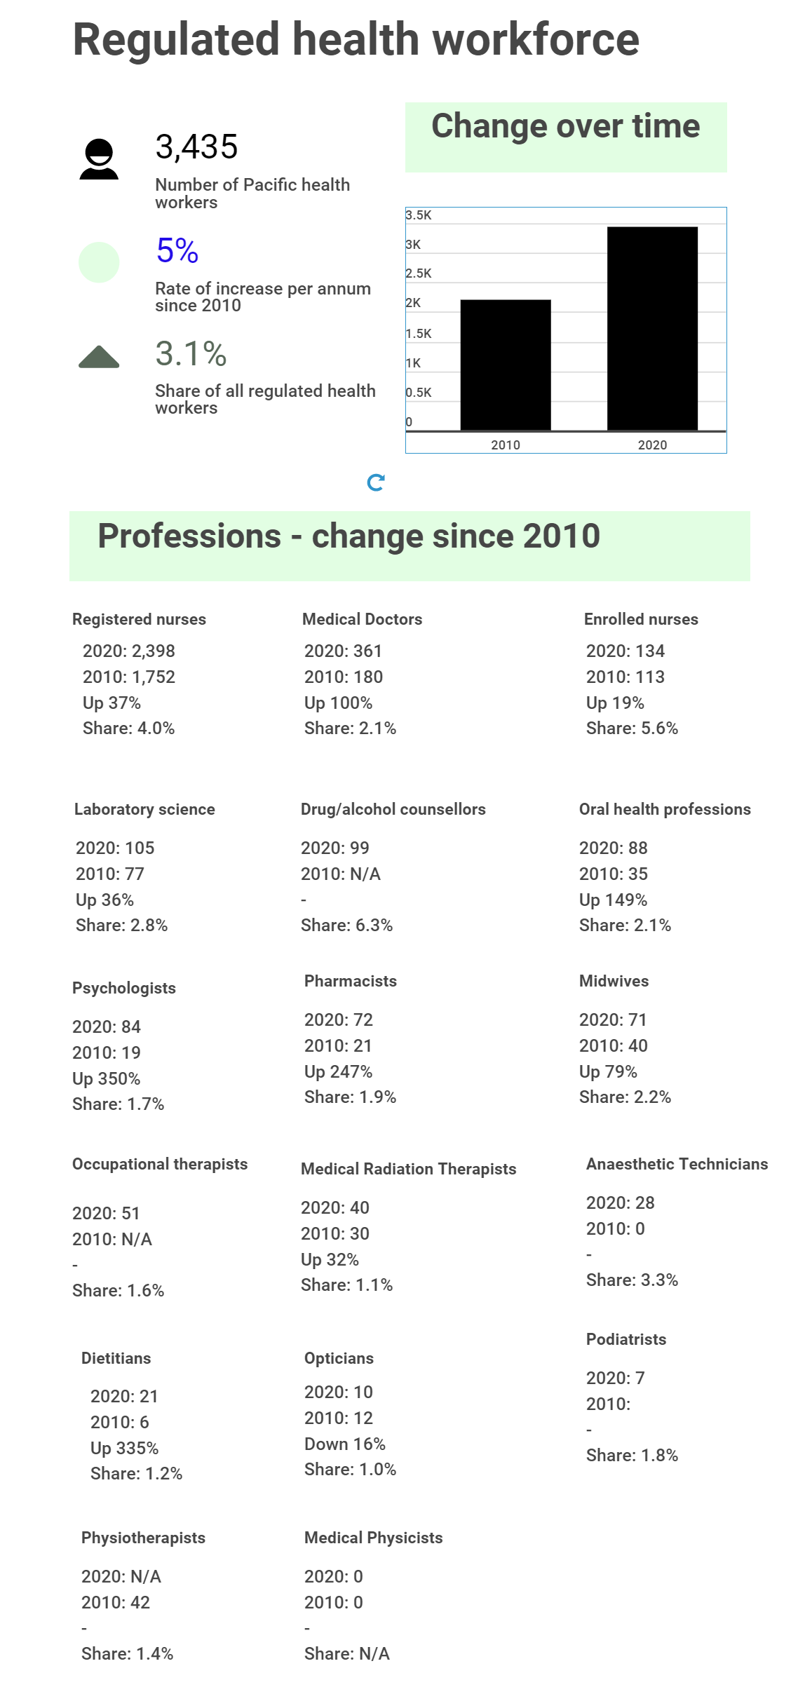
Sources: (MoH, 2021a), (Pacific Perspectives, 2013)

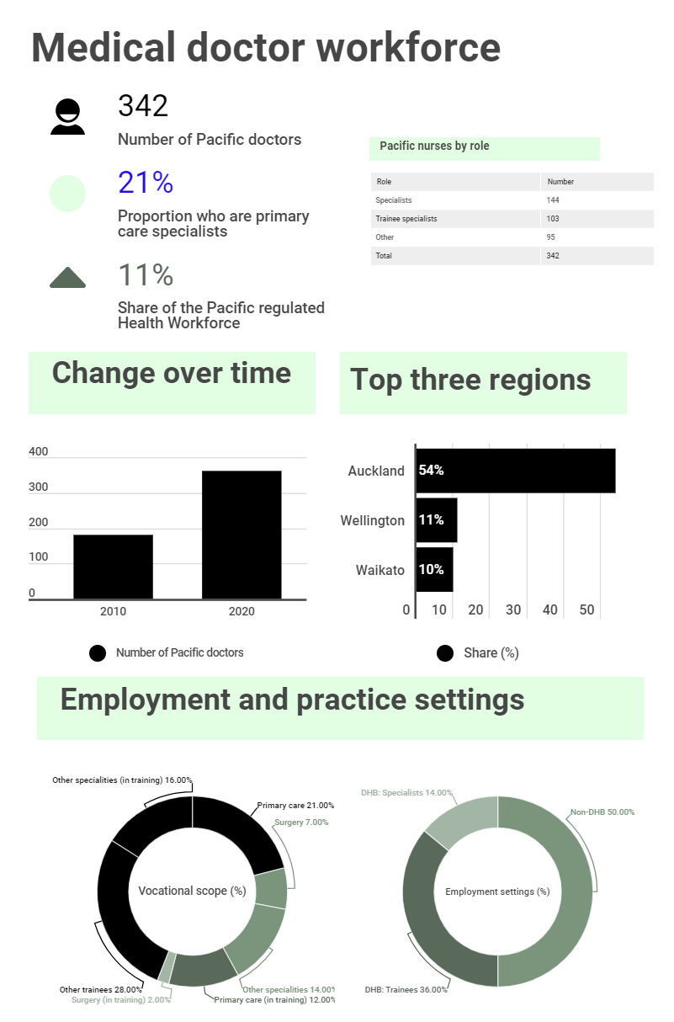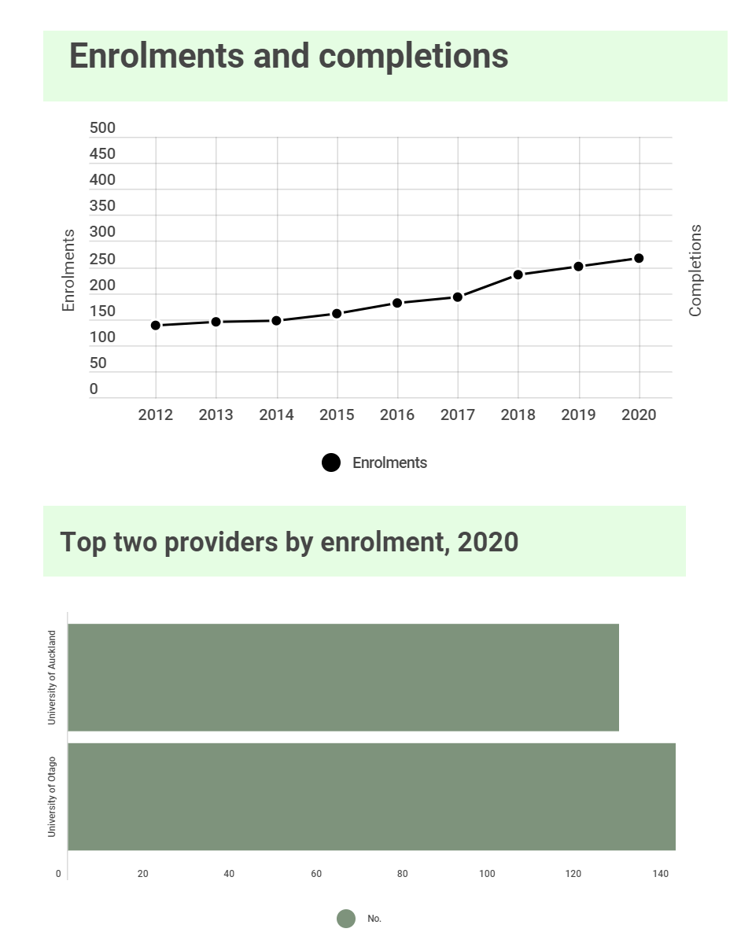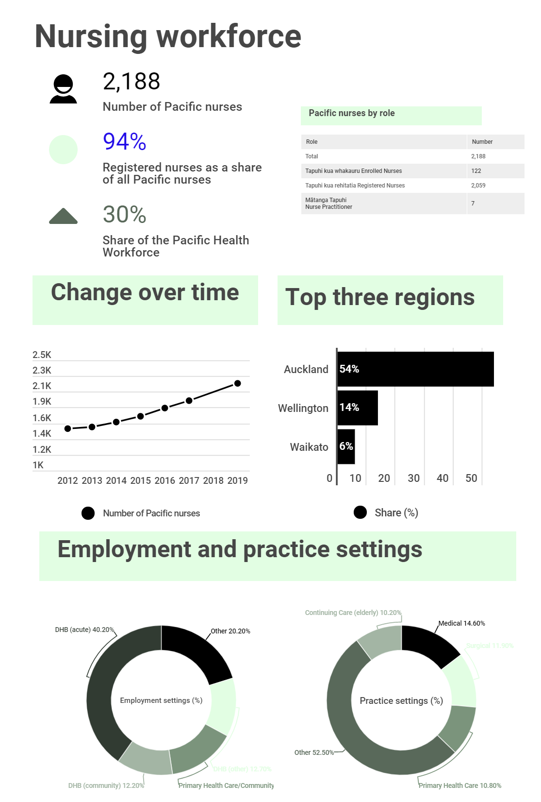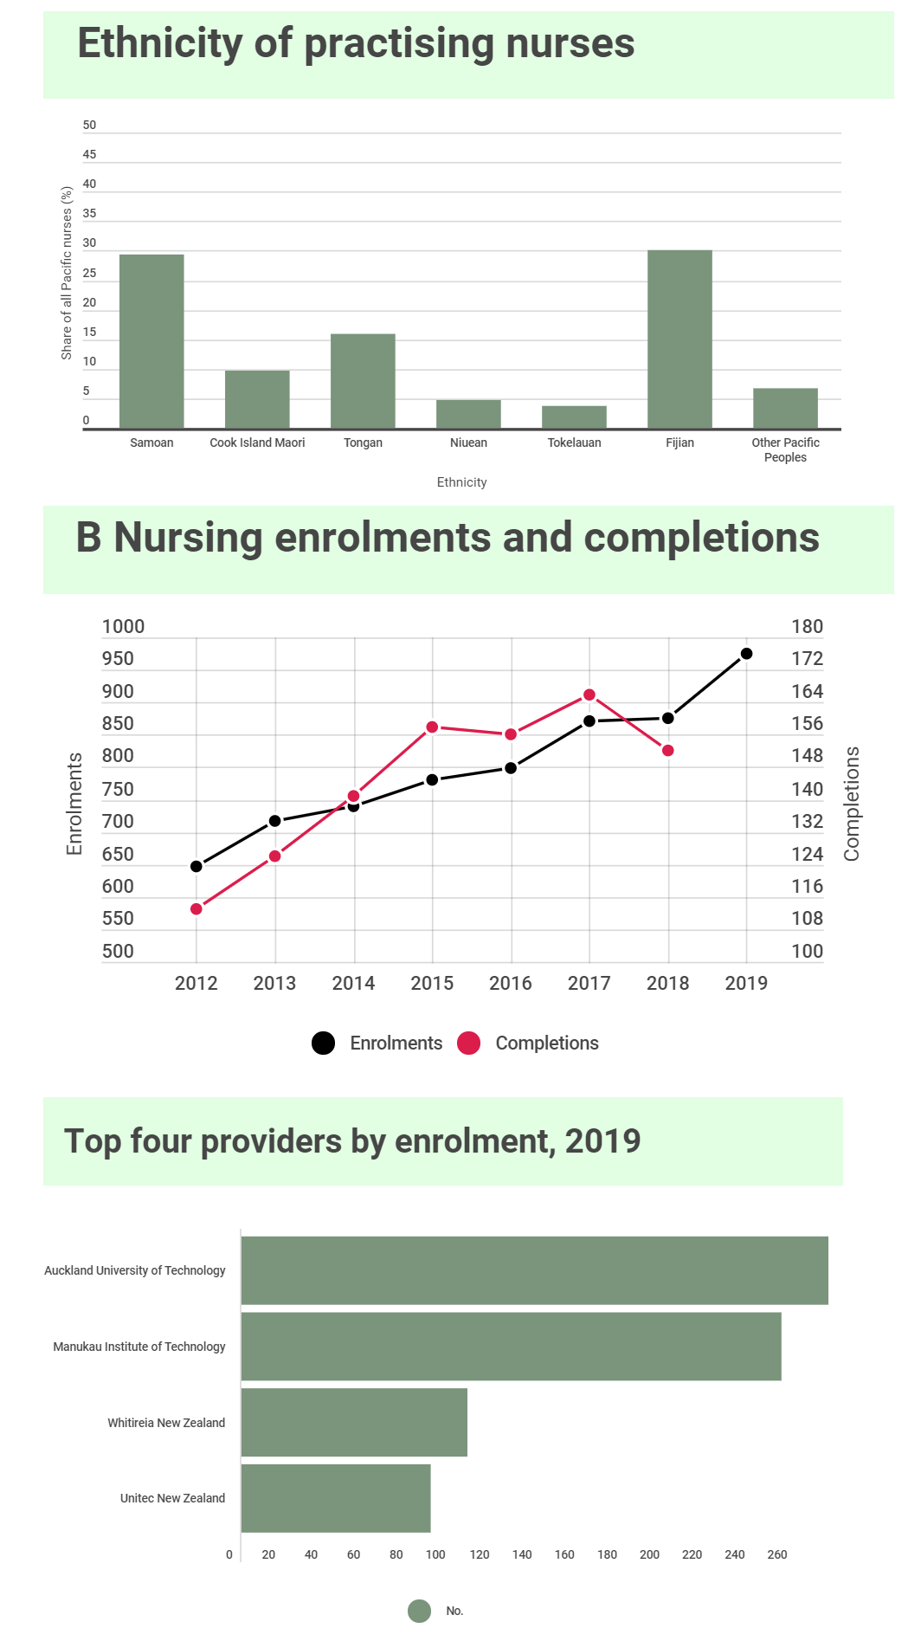

The unregulated health workforce has grown, but uncertainty remains
Our estimate of 10,000 unregulated Pacific health workers is based on a simple comparison between a national-level estimate of 13,000 health workers (The Treasury, 2018) and the information supplied by the Ministry of Health about the 3,435 regulated Pacific health workers (see above).
This estimate is unsatisfactory for several reasons. The unregulated workforce is diverse (see sidebar). Pacific representation in specific roles types is likely to vary considerably. Many people working in corporate and other support roles are not well accounted for.
Analysis of census data indicates that around 7,000 Pacific people were working in care and support roles in 2013, with Pacific people overrepresented in these professions relative to their share of the total workforce in 2013 (5 per cent) (see Table 3).
Table 3: Pacific people in selected unregulated health professions, 2013
Role | Pacific (no) | Pacific (%)
Counsellors | 159 | 5%
Social and Welfare Workers | 1,140 | 10%
Health support workers | 648 | 9%
Community workers | 51 | 10%
Welfare Support Workers | 378 | 19%
Youth Workers | 1,113 | 10%
Aged or Disabled Carers | 366 | 6%
Assistants or support workers | 360 | 6%
Personal Support Assistants | 2,796 | 9%
Total | 7,011 | 9%
Source: (Nana, et al., 2014)
More work is required to document this workforce, including its demographic and educational characteristics. Besides the analysis cited above, which focused on only a subset of the workforce, there has been little progress since the last workforce forecast (Pacific Perspectives, 2013).
We understand that the Ministry of Health has a work programme underway to better document the workforce. Such work is vital given the aspiration for the reformed health system to tackle the gap in access and outcomes for Pacific people and the role the unregulated health workforce could play in enabling access to a wider range of support to stay well in the community.

Unregulated health workforce - defined
The unregulated workforce can include community health workers, healthcare assistants, orderlies, cultural support workers, support workers, community homecare workers, whanau ora workers, mental health workers, youth workers, compulsory care coordinators, cultural assessors, care givers, care workers, care assistants, care managers, care support workers, mental health support workers, nurse assistants, care givers, nurse aides and rehabilitation assistants.
Terms which are commonly used within the Pacific health sector include matua, interpreters, consumer advisers, traditional healers, community support workers, cultural advisers, family advisers, interpreters and service administrative staff.
The unregulated workforce can also include parents providing in-home care (Pacific Perspectives, 2013).
The majority of the unregulated health workforce is employed by organisations such as primary health organisations, Pacific and Māori Health Service Providers, Private Hospitals, and rest homes and residential care facilities.

Focus on the public health system
Information about the contribution that Pacific people make to the public health system indicates that Pacific people are:
- underrepresented in leadership roles, accounting for just two per cent of governance and management roles,
- increasing in number, with the share of employees who are Pacific increasing from 4.5 per cent to 5.1 per cent in the past five years, and
- concentrated in care and support (9.2 per cent of people in such roles), and corporate roles in district health boards (5.4 per cent).
These data provide a guide to the workforce context that Health New Zealand and the Māori Health Authority will inherit but do not offer insight into the wider health system.

Low representation in leadership roles in the health system
Ministry of Health analysis suggests 112 Pacific people in people leadership roles in the Ministry of Health, governance and management roles in district health boards and appointed board members of statutory entities. The people in these roles account for 2 per cent of the total number in such roles across the public health system (see Table 4).
Table 4: Pacific people in leadership roles in the public health system by role type, number and share
Role type | Pacific (no.) | Pacific (%)
Governance | 23 | 4%
Management | 89 | 2%
Total | 112 | 2%
Source: Adapted from (MoH, 2021)
Representation in governance roles is slightly higher (4 per cent) than in management roles (2 per cent). This effect arises from the relatively high number of appointed board members to responsible authorities and crown entities (see Table 5).

Table 5: Pacific people in governance roles in the public health system
Entities | Pacific (no.) | Pacific (%)
Ethics committees | 1 | 2%
Crown entities | 5 | 11%
Responsible authorities | 8 | 6%
Health Practitioners Disciplinary Tribunals | 4 | 2%
District health boards | 5 | 2%
Total | 23 | 4%
Source: Adapted from (MoH, 2021)
A further 89 Pacific people are employed in management roles in the public health system, with the lions share employed by district health boards.
While the number reported appears relatively large, Pacific people account for only two per cent of people employed in such roles (see Table 6). It is also relevant to note that most Pacific managers tend to be employed in specifically Pacific leadership roles and are more likely to be women (Mafile’o, et al., 2021).
Table 6: Pacific people in management roles in the public health system
Entities | Pacific (no.) | Pacific (%)
District health boards | 85 | 2%
Ministry of Health | 4 | 2%
Total | 89 | 2%
Source: Adapted from (MoH, 2021)
Notes: Ministry of Health data current as of 30 April 2021. District Health Board data current to 31 December 2020. DHB data reflects people employed as of 31 December 2020 and includes employees whose job title had some variation of 'manager', 'Kaumatua', 'Kuia' or 'Chief Advisor' or whose role was coded under the ANZSCO major group for Managers (codes beginning with 1). Data excludes casuals, contractors, and people on parental leave or leave without pay.
Headcount is a position count, so possible that some individuals may have been counted more than once if they have split roles or hold roles with more than one DHB.

A growing workforce nonetheless
There were 794 Pacific people employed by DHBs in 2020, more than double the number employed in 2014 (394). The largest occupational groups were care and support roles, where Pacific people made up 9.4 per cent of the workforce, followed by corporate and other (5.4 per cent).
The total number of Pacific people employed by DHBs has more than doubled in the past seven years, increasing from 394 to 794. This increase outpaced that of the wider workforce, meaning that the Pacific share of the DHB workforce increased from 4.5 per to 5.1 per cent (see Table 7).

Table 7: Pacific people by occupation type, all DHBs, 2014 to 2020
 | 2014 |  | 2020
Occupation | No | % | No | %
Allied and scientific | 29 | 2.6% | 40 | 2.7%
Care and support | 191 | 8.3% | 344 | 9.2%
Corporate and other | 114 | 4.6% | 260 | 5.4%
Midwifery | 1 | 1.2% | 1 | 1.1%
Nursing | 51 | 2.2% | 133 | 2.8%
Resident Medical Officer (RMO) | 8 | 2.3% | 12 | 2.4%
Senior Medical Officer (SMO) | 1 | 0.7% | 2 | 0.8%
Total | 394 | 4.5% | 794 | 5.1%
Source: (MoH, 2021a)
Note: Occupations are coded against a common set of classifications (TAS, 2018).
The bulk of the growth in the Pacific DHB workforce occurred in care and support (38 per cent of all growth), corporate and other (37 per cent), and nursing (21 per cent), with other areas contributing much less or even null growth (see Table 8).
Table 8: Contribution to growth in the Pacific DHB workforce, 2014 to 2020
Occupation | No | Share (%)
Allied and scientific | 11 | 3%
Care and support | 153 | 38%
Corporate and other | 147 | 37%
Midwifery | 0 | 0%
Nursing | 83 | 21%
Resident Medical Officer (RMO) | 5 | 1%
Senior Medical Officer (SMO) | 1 | 0%
Total | 399 | 100%
Source: (MoH, 2021a)

Representation
The Pacific regulated health workforce diverges from the wider population and the composition of the regulated health workforce. Specifically, the:
- share of Pacific people in the regulated health workforce at 3.1 per cent is considerably smaller than the Pacific share of the working-age population (7.0 per cent) or of the national population (8.1 per cent),
- Pacific regulated health workers are much more likely to be nurses and much less likely to be involved in other health professions than the wider population, and
- It may take as long as 120 years to deliver parity of participation in the regulated health workforce for Pacific people.
In the preceding section, we highlighted the overall growth in both the regulated and unregulated health workforces. While this increase is encouraging, there is still a distance to travel to attain parity of representation generally and for specific professions (see Table 9).
The result is an undersupply relative to the share of the total population of Pacific peoples of around 2,400 Pacific nurses, 1,000 Pacific medical doctors, 200 Pacific midwives and 250 Pacific oral health practitioners, and around 1,700 other health professionals.
Similar analysis applied to the people appointed to governance and senior management roles in district health boards, other regulatory entities and the Ministry of Health shows a similar pattern. There would need to be another 266 Pacific people employed in such roles, predominantly in the management of district health boards or proposed Health New Zealand/Māori Health Authority regional and district offices.
The Pacific working-age population makes up a smaller share of the overall working-age population at 7.0 per cent (StatsNZ, 2021a), (MBIE, 2021). This lower share reflects the relatively youthful profile of the Pacific population (StatsNZ, 2021). However, setting an expectation that the Pacific regulated health workforce reflects the share of the working-age population still requires 215 Pacific people in leadership roles and 4,334 in the regulated health workforce.
Even allowing for the degree to which older people experience relatively high demand for healthcare services by seeking to match the Pacific population aged 55 years or older sees a shortfall of 333 regulated health workers, even after accounting for a nominal ‘oversupply’ of Pacific nurses.

Table 9: Pacific people representation in the health workforce, distance to parity
Workforce group | Current workforce |  | Distance to parity
 | Pacific (no.) | Pacific share (%) | Overall Pacific population = 8.1% share | Working age Pacific population = 7.0% | Aged 55+ = (3.4%)
Leadership roles (no.) | 112 | 2.40% | 266 | 215 | 47
Pacific regulated health workers (no.) | 3,445 | 3.10% | 5,556 | 4,334 | 333
Nurses | 2,398 | 4.0% | 2,458 | 1,799 | -360
Medical doctors | 361 | 2.2% | 968 | 788 | 197
Oral health practitioners | 88 | 2.1% | 250 | 204 | 54
Midwives | 81 | 2.5% | 181 | 146 | 29
Other regulated health workers | 517 | 2.0% | 1,699 | 1,398 | 413
-Source: Adapted from (MoH, 2021a), (StatsNZ, 2021a) (StatsNZ, 2021)

Comparison with the density of healthcare workers in other countries provides a stark contrast. For example, there are around 0.95 Pacific medical doctors per 1,000 Pacific people in New Zealand, a ratio comparable to that of Pakistan, Nicaragua, Bahrain and Tuvalu (The World Bank, 2021). This ratio was equivalent to a rank of 141st globally (see Table 10).
Table 10: Physicians per 1,000 people, selected comparators
Country, group or region | Physicians per 1,000 people | Rank order
European Union | 3.75 | 30
Australia | 3.68 | 32
New Zealand | 3.59 | 34
High Income countries | 3.07
OECD members | 2.92
North America | 2.61 | 68
Latin America & Caribbean | 2.28 | 83
East Asia and Pacific | 1.66
Low & middle income | 1.28
Pakistan | 0.98 | 139
Nicaragua | 0.97 | 140
Pacific medical doctors (NZ) | 0.95
Bahrain | 0.93 | 141
Tuvalu | 0.92 | 142
India | 0.84 | 146
Pacific island small states | 0.50
Source: (The World Bank, 2021)
We developed a simple model to understand how long it may take to approximate parity of participation in the regulated health workforce by Pacific people.
This model assumed that the Pacific population would remain unchanged for the foreseeable future, the current growth rate (five per cent) in the number of regulated Pacific health workers is sustained and the growth in the overall regulated health workers moderates from two per cent to one per cent.
The results indicated that parity of participation in the regulated health workforce for Pacific people would not be achieved for 120 years under the current settings.
Naturally, any forecasts of the future size of the workforce, even in the short term, are subject to some uncertainty. For example, the 2013 Pacific Health Workforce Service Forecast estimated that there would be around 231 Pacific medical doctors and between 1,911 and 2,348 Pacific nurses by 2020.
While the higher estimate for Pacific nurses was broadly in line with the actual result, the forecast number of Pacific medical doctors was considerably lower. The key reason was sustained and higher than assumed growth in the number of Pacific people admitted to medical training over the past decade. This result is indicative of how amenable the future size of the workforce is to decisions taken at a local level.

Bibliography
Bibliography
Mafile’o, T., Halatuituia, N. & Samuelu, F., 2021. Pacific Stakeholder Engagement Report - Discovery Phase, Palmerston North: Mana Pacific Consultants.
MBIE, 2021. Pacific Peoples in the Labour Market - June 2021 Quarter (unadjusted), Wellington: Ministry of Business, Innovation and Employment.
MoH, 2021a. Data extract: Pacific practitioners and graduates 2017-2020, Wellington: Unpublished administrative data.
MoH, 2021a. DHB Pacific Workforce data extract, s.l.: Unpublished dataset.
MoH, 2021. Pacific Health Workforce Action Plan - Stocktake, Wellington: Ministry of Health.
Nana, G., Stokes, F. & Khan, M., 2014. Profile of Careerforce's 2013 workforce, Wellington: BERL Economics.
Office of the Parliamentary Counsel, 2003. Health Practitioners Competence Assurance Act 2003, Wellington: New Zealand Government.
Pacific Perspectives, 2013. Pacific Health Workforce Service Forecast, Wellington: Pacific Perspectives.
StatsNZ, 2021a. Household labour force survey estimated working-age population: June 2021 quarter, Wellington: Statistics New Zealand.
StatsNZ, 2021. Pacific Peoples ethnic group, Wellington: Statistics New Zealand.
TAS, 2018. HWIP ANZSCO Code Manual, Wellington: TAS Kahui tuitui tangata.
The Treasury, 2018. The New Zealand Pacific Economy, Wellington: New Zealand Government.
The World Bank, 2021. Physicians (per 1,000 people), s.l.: The World Bank.

We cannot make a full comparison with 2010 due to data quality and completeness issues.
Retaining the current rate of increase of five per cent in the Pacific regulated health workforce and halving of the rate of growth of the workforce overall from two per cent to one per cent.

