



Aotearoa New Zealand

Health Status Report 2023 Executive Summary

February 2024

ISBN: 978-1-99-106779-1

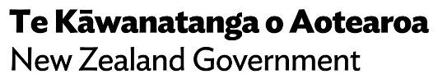

[tewhatuora.govt.nz](https://www.tewhatuora.govt.nz/)

|  |  |
| --- | --- |
| **CCBY** | This work is licensed under the Creative Commons Attribution 4.0 International licence. In essence, you are free to: share i.e., copy and redistribute the material in any medium or format; adapt i.e., remix, transform and build upon the material. You must give appropriate credit, provide a link to the licence and indicate if changes were made. |

# Introduction

In July 2022 Health New Zealand I Te Whatu Ora was formally established. It leads the day-to-day running of the publicly funded health system across Aotearoa New Zealand, with functions delivered at local, district, regional and national levels. It weaves the functions of the former District Health Boards (DHBs) into service areas within each region, ensuring continuity of services in the health system. The term “district” is used throughout this report, and refers to the geographic boundaries covered by the former DHBs.

This is the Executive Summary of the Aotearoa New Zealand Health Status Report 2023 prepared by Health NZ. The full report is available at [www.tewhatuora.govt.nz/publications/health-status-report](https://www.tewhatuora.govt.nz/publications/health-status-report).

The Health Status Report is similar to a Health Needs Assessment (HNA) and has the same definition: “a systematic method for reviewing the health issues facing a population, leading to agreed priorities and resource allocation that will improve health and reduce inequities.”1



“In Aotearoa New Zealand, people have differences in health that are not only avoidable but unfair and unjust. Equity recognises different people with different levels of advantage require different approaches and resources to get equitable health outcomes.”

Ministry of Health | Manatū Hauora

This report will help clarify inequities between different groups to inform areas for action to reduce inequities. It will support the development of the Aotearoa New Zealand health sector and support Health NZ to develop its structures, plans and work programmes, and prioritise resources.

It includes some aspects that would exist in a traditional HNA, such as:

* Demographic data – both current and projected
* Prevalence and incidence data related to health status
* Exposure to key preventable risk factors data to identify patterns and trends, and the likelihood of people requiring health and wellbeing services in the future
* Data about the people who use services, their needs and priorities.

It does not, however, include the perspectives of consumers and communities. In the future, Health NZ intends to develop a more comprehensive report which will include consumer and community perspectives.

Addressing inequities is complex and requires commitment and leadership at all levels. Te Tiriti o Waitangi provides an enduring foundation for achieving Māori health equity and sovereignty over health, wellbeing and decision-making.

The data in this report come from a range of sources, which are listed in full on pages 188–200 of the full report.

**88% Of adults described their overall health as excellent, very good or good but this is lower for Māori (81%) and Pacific people (83%).**

# The population

There were 5.1 million people living in Aotearoa New Zealand in 2022/23, with each of the four regions’ populations varying considerably in terms of numbers, age and ethnicity structure, socio-economic status and urban/rural mix.

By ethnicity, Aotearoa New Zealand’s population is 17% Māori, 7% Pacific, 16% Asian and 59% European/Other people.

The ethnic makeup varies considerably around the country.

The population of the Northern region by ethnicity is 15% Māori, 13% Pacific, 26% Asian and 46% European/Other people. By contrast, Te Waipounamu is 11% Māori, 3% Pacific, 10% Asian and 76% European/Other people.

A third of Māori live in either the Northern or Te Manawa Taki regions, with 22% living in Central region and 15% living in Te Waipounamu. 68% of Pacific people live in the Northern region, as do 60% of Asian people (Source: Stats NZ, population projections, 2022 update).

The Pacific population is predominantly Samoan (48% of Pacific people), Tongan (22%) and Cook Island Māori (21%). The Asian population is also diverse and is predominantly Chinese (35%), Indian (34%) and Filipino (10%). Migrant and refugee populations are also significant – in 2018 one in three people living in Aotearoa New Zealand was born overseas.

Of note are the differing age structures between population groups, with much greater proportions of the Māori, Pacific and Asian populations in younger age groups, and a larger proportion of the European/Other population aged 65 years or older.

In Te Waipounamu and Te Manawa Taki, 28% of the population lives in rural areas, compared with 17% of the Central region population and 9.3% of the Northern region population.

Significant population growth is expected in the future.

By 2042/43, Aotearoa New Zealand’s population is projected to increase by 400,000 people, making it 7.8% larger than it is now. The population will also be considerably older (particularly in the European/Other group), with the number of people aged 65 years or older expected to increase from the current 850,000 to approximately 1.3 million by 2042/43, and making up 22% of Aotearoa New Zealand’s population, compared with 17% at present.

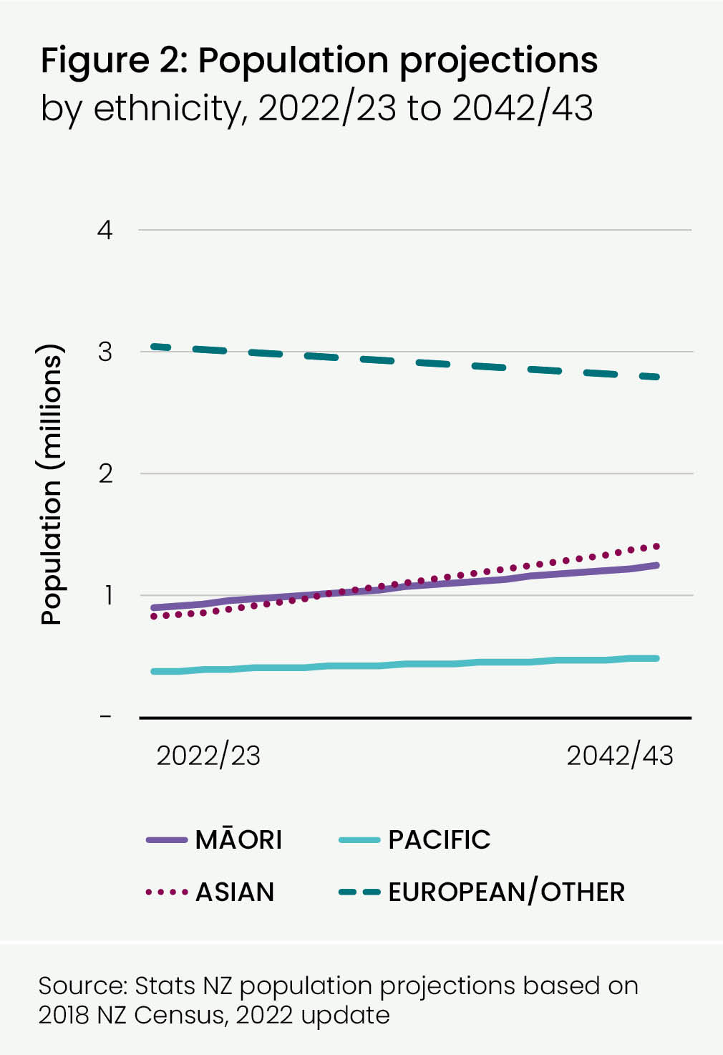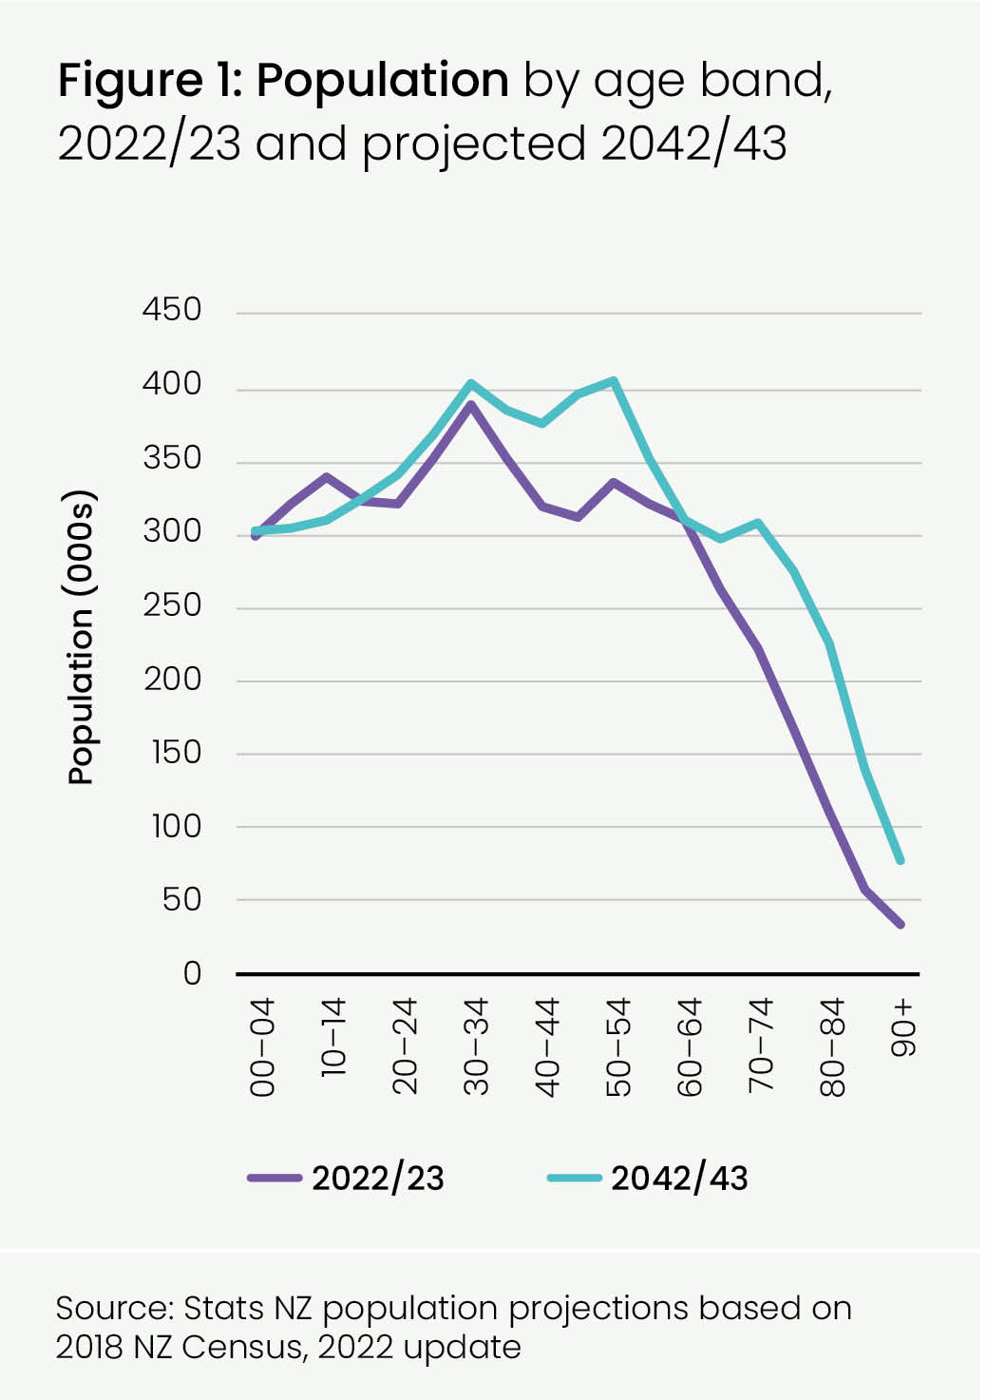

The rate of population growth is expected to vary by ethnic group and age group within that. The Māori population is projected to grow by 37% to 1.2 million, and Pacific people by 27% to 470,000. The Asian population is projected to grow by 68%, to 1.4 million. The number of European/Other people is expected to decrease by 8%, to 2.8 million.

The health system will need to respond to the contrasting health service needs of these population groups.

Meeting the needs of older people has to be balanced with recognising the importance of investing in the best start to life, particularly in relation to addressing inequities for Māori and Pacific people, and acknowledging the younger age structure of their populations. Health NZ also needs to work with other public agencies and services to improve the wider determinants of health, such as housing, education, employment and the physical environment, as well as improving access to health services.

# Pae Ora | Better health in communities

Factors such as income, housing, education and access to quality healthcare are powerful determinants of health and wellbeing. Important protective factors include connection to community, cultural identity, social capital and social cohesion.

Māori experience inequities when compared to others, across a range of social determinants, over and above socio-economic status.3

The New Zealand Index of Deprivation (NZDep) defines 20% of Aotearoa New Zealand’s areas as the most socio-economically deprived – i.e. quintile 5 of the NZDep score. This varies around the country.

In 2018, by district, Tairāwhiti, Te Tai Tokerau Northland and Whanganui had more than 40% of their populations in areas with the most socio-economically deprived NZDep scores; in Waitematā, 10% were in this category. Counties Manukau has the largest number of people living in quintile 5 areas (almost 200,000 people). Māori and Pacific people are much more likely to live in quintile 5 areas – 43% of Māori and 56% of Pacific people live in quintile 5 areas, compared with 17% of Asian people and 13% of European/Other people. Ethnic density can have a positive effect on health and lessen exposure to racial discrimination, however the benefits may be outweighed by the detrimental effects of area deprivation.4

Disabled people I tangata whaikaha make up nearly a quarter of Aotearoa New Zealand’s population, and belong to all age, ethnic and cultural groups, gender identities, sexualities, localities, socio-economic groups and every whānau and community. All disabled people I tangata whaikaha experience inequities but disabled people I tangata whaikaha belonging to other marginalised groups experience particularly intensified inequities.

Residents living in areas with more socio-economically deprived NZDep scores and those living in rural areas generally experience poorer health outcomes than those living in more affluent areas and in areas with better access to health services.

Using the Geographical Classification for Health (GCH), almost one in five people in Aotearoa New Zealand (19% or approximately 1 million people) live in rural areas. Rural areas have a higher proportion of Māori (23%) than urban areas (16%), and a higher proportion of people aged 65 years or older.

In 2018, 11.2% of people lived in crowded households. Crowding is more common among Māori (21%), Pacific (40%) and Asian people (19%) than European/Other people (4.5%) (Census 2018 additional tables prepared by Stats NZ).

Overall, one in four people (24%) report that their home is damp and one in five (20%) report that it has mould, with higher proportions for Māori and Pacific people. In 2022, 15% of households spent 40% or more of their income on housing.

In 2021, 67% of households said their household income was enough or more than enough to meet their everyday needs such as accommodation, food, clothing and other necessities.5 11% of children were living in households that experienced material hardship. This figure is made up of 20% of Māori children and 24% of Pacific children living in material hardship, along with 8% of European/Other children and 5% of Asian children.

Overall, 18% of adults left school with no qualification, although this varied across districts, from 10.7% (Auckland district) to 23.1% (Northland). The figure was much higher for Māori and Pacific people (25%) while 10% of Asian adults had no qualifications. In the December quarter 2022 Household Labour Force Survey,6 the overall unemployment rate was 3.3% but this varied by ethnicity – highest for Māori and Pacific people (Stats NZ).

The 2022 Quality of Life survey reported that about half (49%) of respondents felt a sense of community in their neighbourhood and 75% belonged to a social network or group. 54% reported experiencing some kind of racism or discrimination and more than a third had felt isolated some of the time.

The Stats NZ General Social Survey 2021 found that the percentage of people aged 15 years or older who reported experiencing happiness differed by ethnicity – 85% for Asian people, but only 73% for Māori. Pacific people are more likely to rate their family wellbeing highly (85%) and Māori less likely (73%).

**67% of households said their household income was enough or more than enough to meet their everyday needs such as accommodation, food, clothing and other necessities.**

# Exposure to preventable risk factors

Air and water quality are important environmental drivers of health. Other environmental drivers include access or exposure to healthy kai (food), green space, advertising of unhealthy commodities and hazardous substances, and density of alcohol and fast-food outlets.

The territorial authorities (TAs) with the highest estimated number of premature deaths due to air pollution were Auckland City (939 deaths) and Christchurch City (462 deaths). Other TAs with high estimated numbers of premature deaths from air pollution included Dunedin City (126 deaths), Tauranga City (107 deaths) and Hamilton City (100 deaths).7

Climate- related events exacerbate already poor health outcomes. Around half of those impacted by the loss of safe drinking water in 2023’s Cyclone Gabrielle were Māori and more than half were living in the most deprived areas.

Improving the wider determinants of health and wellbeing requires a coordinated approach across many agencies and services, working alongside communities.

Smoking is the largest cause of preventable ill health. Although smoking rates are declining, 13% of the adult population were regular smokers of cigarettes in 2018, with higher rates in the Māori (28%) and Pacific (21%) populations, as well as younger adults.

The most marked inequities in smoking are by socio-economic status, with adults living in areas with the most socio-economically deprived NZDep scores being 4.3 times as likely as adults in areas with the least socio-economically deprived NZDep scores to be smoking daily. The highest rates of smoking are reported in Te Manawa Taki at 15.5% and the lowest in Northern region at 12.0%. While smoking rates have declined, vaping has become more common in Aotearoa New Zealand with 18% of Year 10 students regularly vaping in 2022.

Data from the New Zealand Health Survey report that three out of ten adults in Aotearoa New Zealand are obese and almost two out of three are overweight or obese, with very little change in the past 10 years. The rate of childhood obesity in Pacific populations is high, with 29% of Pacific 2 to 14 year olds considered to be obese.

About half of Aotearoa New Zealand’s adult population is meeting daily exercise recommendations, and two in three people are meeting daily vegetable consumption guidelines, with about half meeting daily fruit consumption guidelines.

Fewer than half of children eat recommended servings of fruit and vegetables. If taken together, higher body weight and poor nutrition now rank as the largest cause of preventable ill-health in Aotearoa New Zealand.

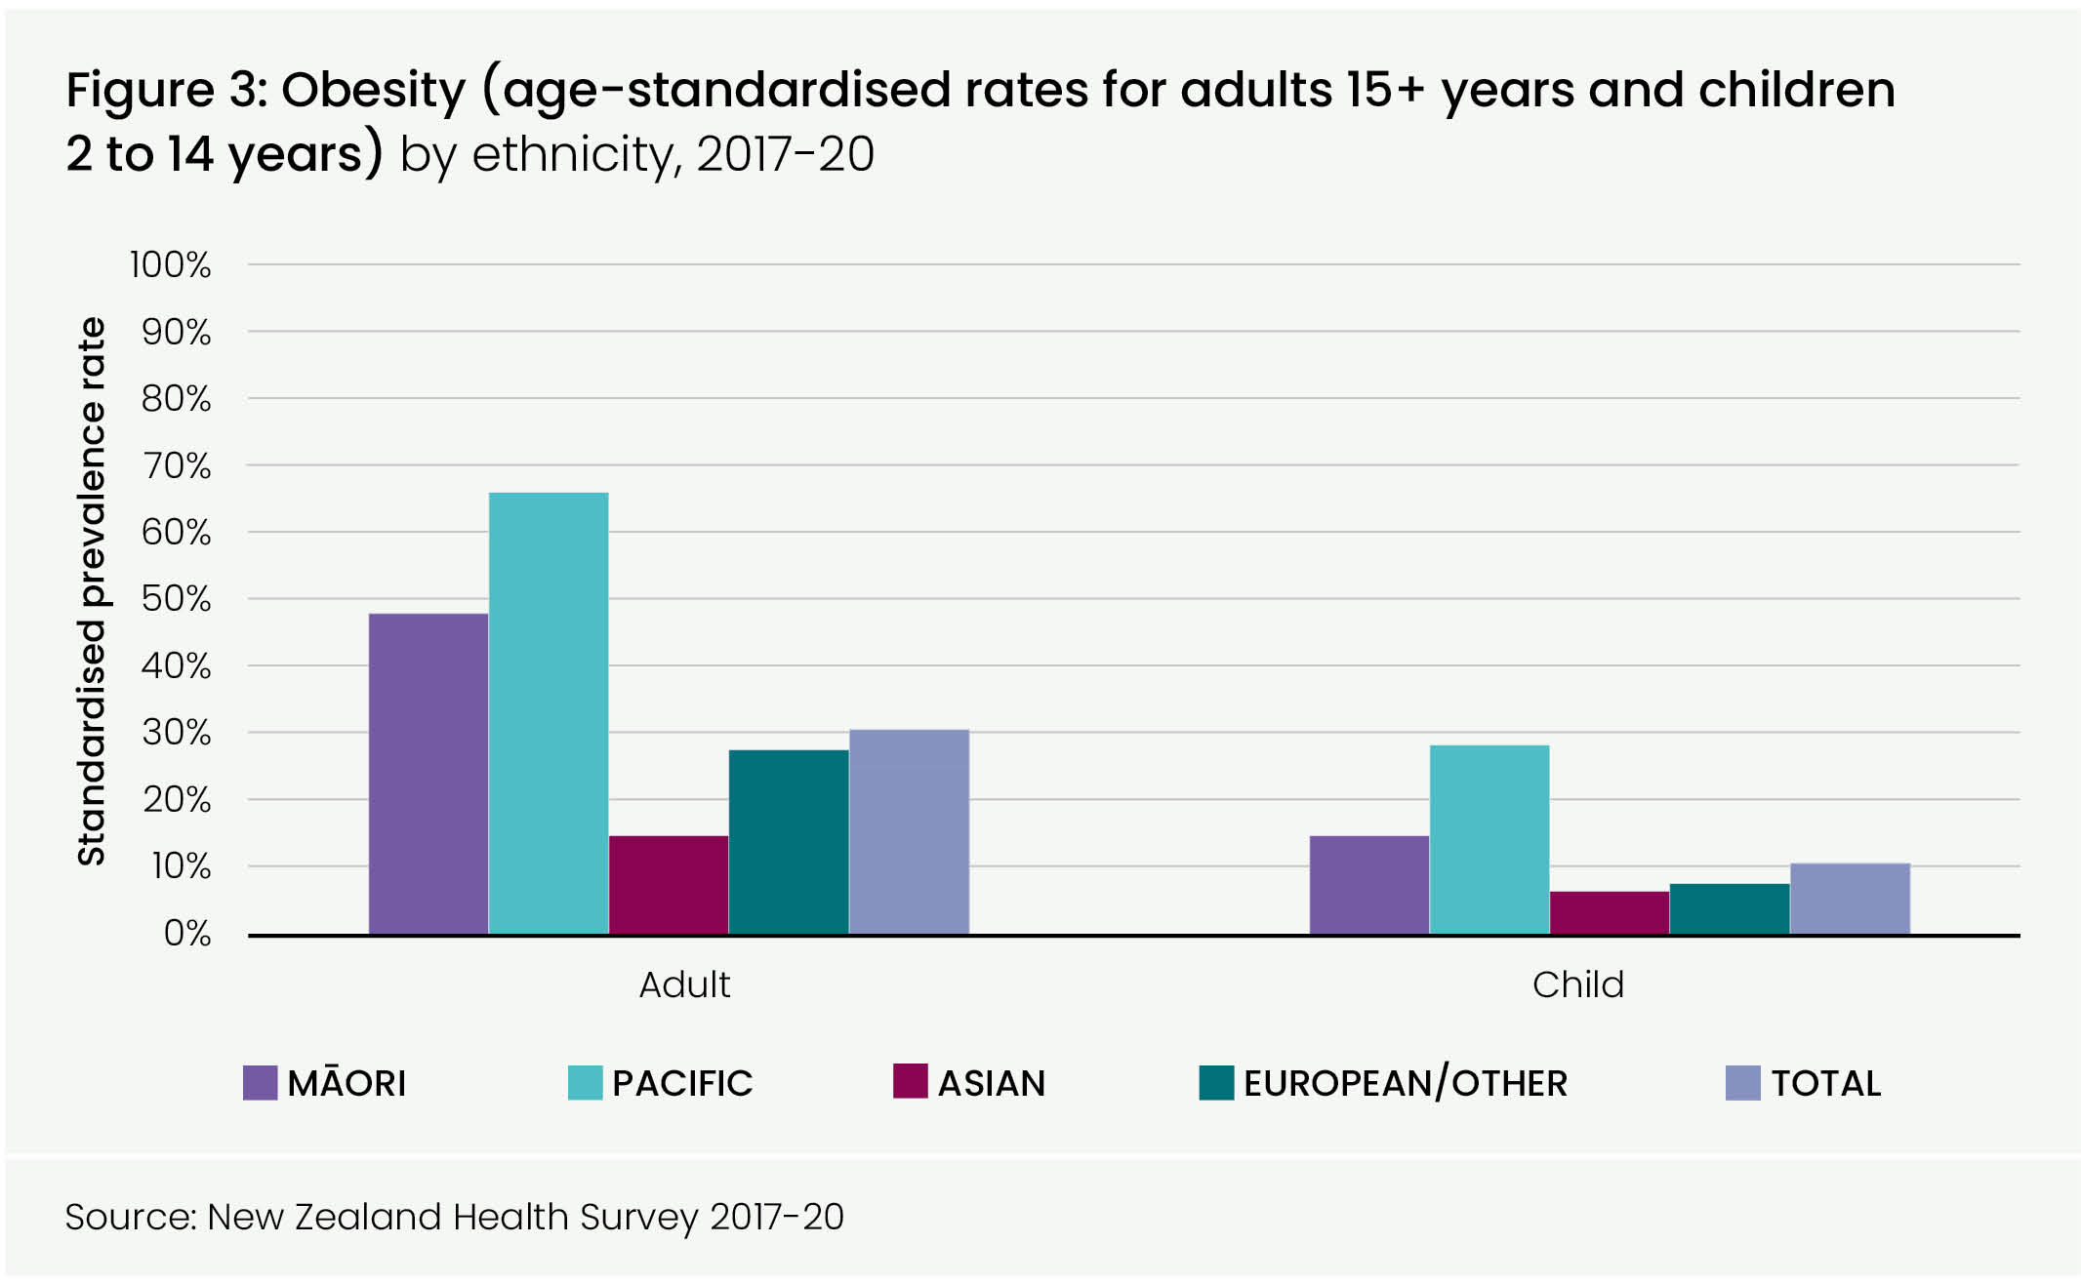

One in five young people in Aotearoa New Zealand drink alcohol in a way that is considered hazardous. Hazardous drinking is higher among men and Māori.

The commercial determinants of health (CDoH) refer to the actions and practices of commercial entities, such as industries and businesses, that have an influence on health outcomes. CDoH encompass a wide range of industries, including tobacco, alcohol, food and beverages, pharmaceuticals, and advertising. CDoH can significantly impact the availability and accessibility of goods and services that affect health outcomes. For instance, the availability of unhealthy food options, high-sugar beverages, and tobacco products in communities can contribute to poor dietary choices, unhealthy weight, and tobacco-related illnesses.

Similarly, limited access to affordable medications due to pricing practices can negatively impact health outcomes.

CDoH are closely linked to socio-economic factors and can exacerbate existing health inequities. They can target specific populations, such as low-income communities and children.8 Māori and Pacific people are disproportionately represented in areas with the most socio-economically deprived NZDep scores and therefore are more heavily impacted by negative CDoH.

# Health status

### Life expectancy and avoidable mortality

The self-reported health status of New Zealanders is ‘excellent’ with 88% of adults reporting that their overall health is excellent, very good or good, although this is lower for Māori (81%) and Pacific people (83%) (New Zealand Health Survey 2017–20). Although many New Zealanders enjoy very good health, particular population groups throughout the motu (country) experience inequities in health outcomes.

Aotearoa New Zealand’s overall life expectancy ranks 16th in the world at 82.2 years (2020–2022 combined data) and is generally increasing over time (by three years over the past 20 years). Life expectancy varies by region and ethnicity. This is most significant for Māori, nationally, where there is a gap of 6.6 years between Māori and non-Māori/non-Pacific life expectancy and for Pacific populations where the gap is 6.1 years. These gaps have persisted over the past two decades. While the gap has decreased by two years for Māori, it has not changed at all for Pacific people. Life expectancy is highest in areas with the least socio-economically deprived NZDep scores, and lowest in areas with the most socio-economically deprived NZDep scores, with a gap of 9.1 years between decile 1 and decile 10 areas for females, and 10.5 years for males. Overall males lag females by 3.5 years.

The top 10 avoidable contributors to the gaps in life expectancy for Māori and Pacific people when compared with non-Māori/non-Pacific are shown below. Cardiovascular disease and cancers are large contributors, along with diabetes. For Māori, respiratory disease, injuries and suicide are also major contributors, while for Pacific people, perinatal complications are significant.

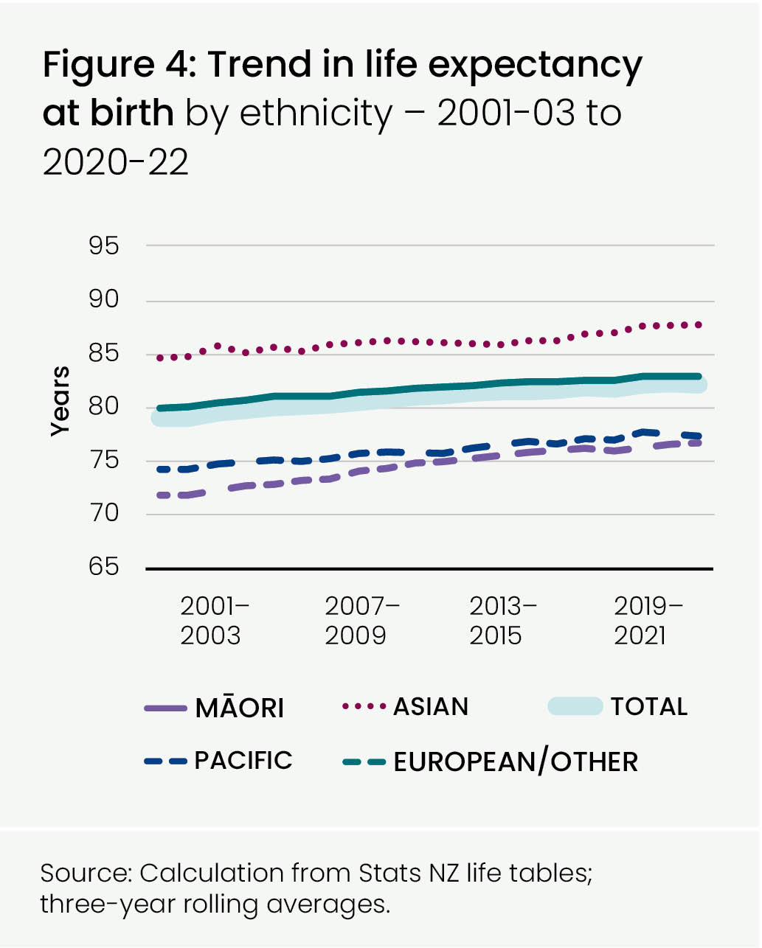

Figure 5: Top avoidable contributors to life expectancy gap between Māori and non-Māori/non-Pacific, 2018-2020

Figure 6: Top 10 avoidable contributors to life expectancy gap between Pacific people and non-Māori/non-Pacific, 2018-2020

Overall mortality rates from cardiovascular disease and cancer, the two biggest causes of avoidable deaths, have declined steadily over the last decade, though significant gaps remain for Māori and Pacific populations.

In 2018, there were 9,000 potentially avoidable deaths (27% of the total). For Māori and Pacific people, the avoidable mortality rates are more than double that of European/Other people. With better prevention of ill health, we could further reduce avoidable deaths and increase the number of healthy years of life for more of the population.

The marked differences between ethnic groups highlight the opportunity for eliminating health inequities. Many can be avoided through primary prevention, for example through creating healthier environments and supporting healthier lifestyles; or by early identification and managing conditions before they cause illness. Prompt identification and management of disease contributes to reducing avoidable mortality rates. We also need to plan and develop health services to respond to the significant growth and changes to Aotearoa New Zealand’s population.

In 2020 and 2021, the COVID-19 pandemic severely disrupted health services. Pre-existing inequities in the health system were often exacerbated as a result of the pandemic. To note, much of the information in this document is representative of historic patterns of service, as the COVID-19 period presented a very different picture.

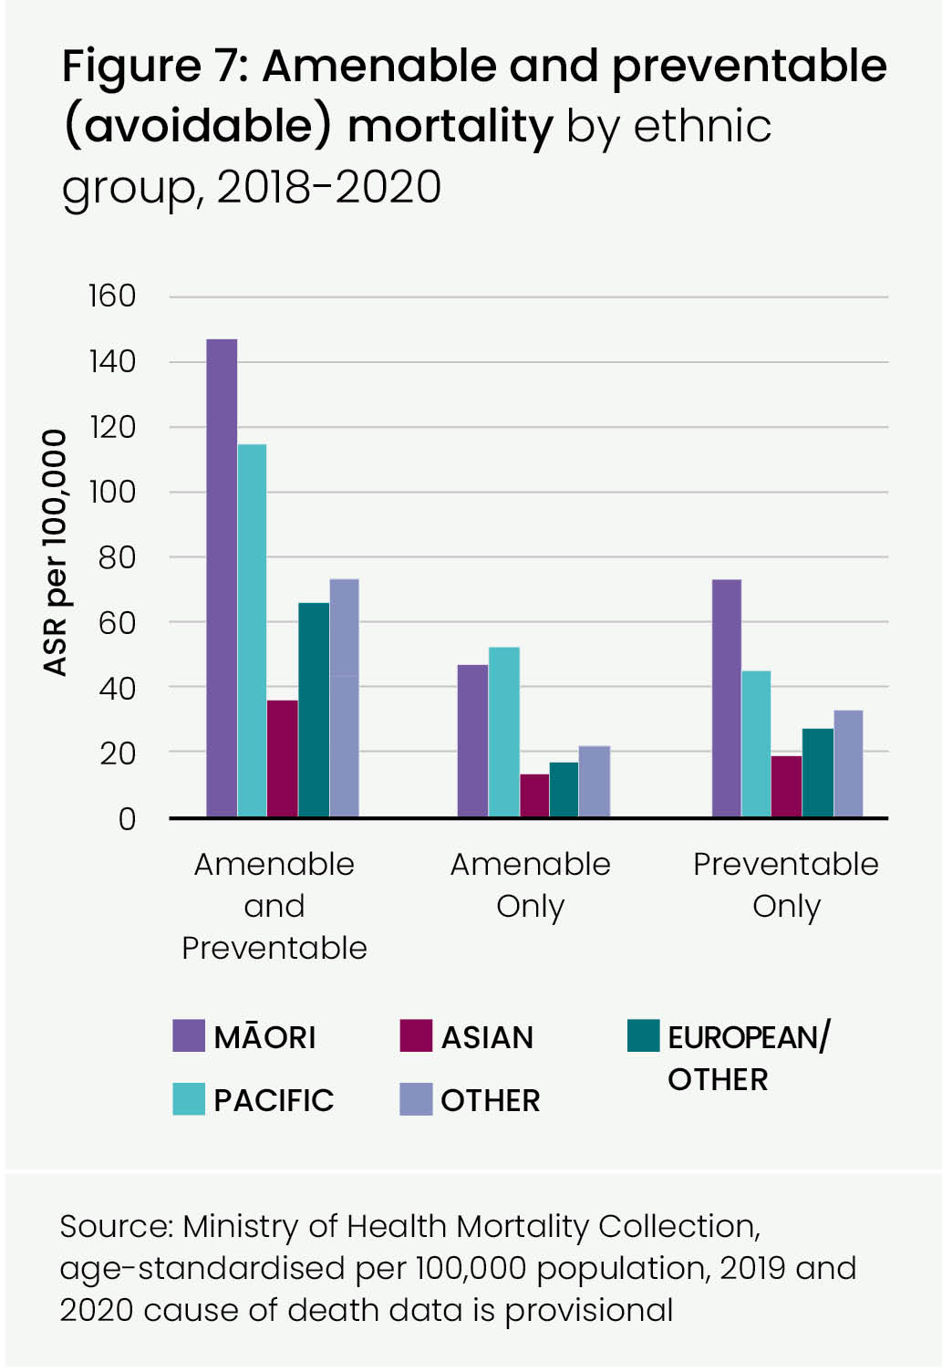

**9,000 In 2018, there were 9,000 potentially avoidable deaths (or 27% of the total deaths in Aotearoa New Zealand).**

### Maternity and early years

Ensuring children have the best start in life is essential for setting the foundation for lifelong learning, health and wellbeing.

Adopting a life course approach means identifying opportunities for minimising risk factors and enhancing protective factors through evidence-based interventions at important life stages, from the perinatal period, through early childhood to adolescence, working age, pre-conception and the family-building years, and into older age.9 It is now well recognised that psychosocial, cultural and environmental stressors experienced before and during pregnancy can be detrimental to pregnancy as well as maternal and fetal health, with intergenerational consequences.10

Between 1996 and 2020 there was a significant decrease in the infant death rate. The rate fell from 7.3 to 4.8 infant deaths per 1,000 live births. However, over the last decade rates have increased for some ethnic groups.

Critical to the health and wellbeing of children are their life circumstances i.e. whether they live in a warm, dry, uncrowded home with access to adequate nutrition, and with the opportunity to engage in developmentally appropriate play alongside caregivers who are able to protect and engage with them.11 The ability of parents to parent is impacted by unresponsive systems, health and social stressors, including family harm, psychosocial distress, and trauma.

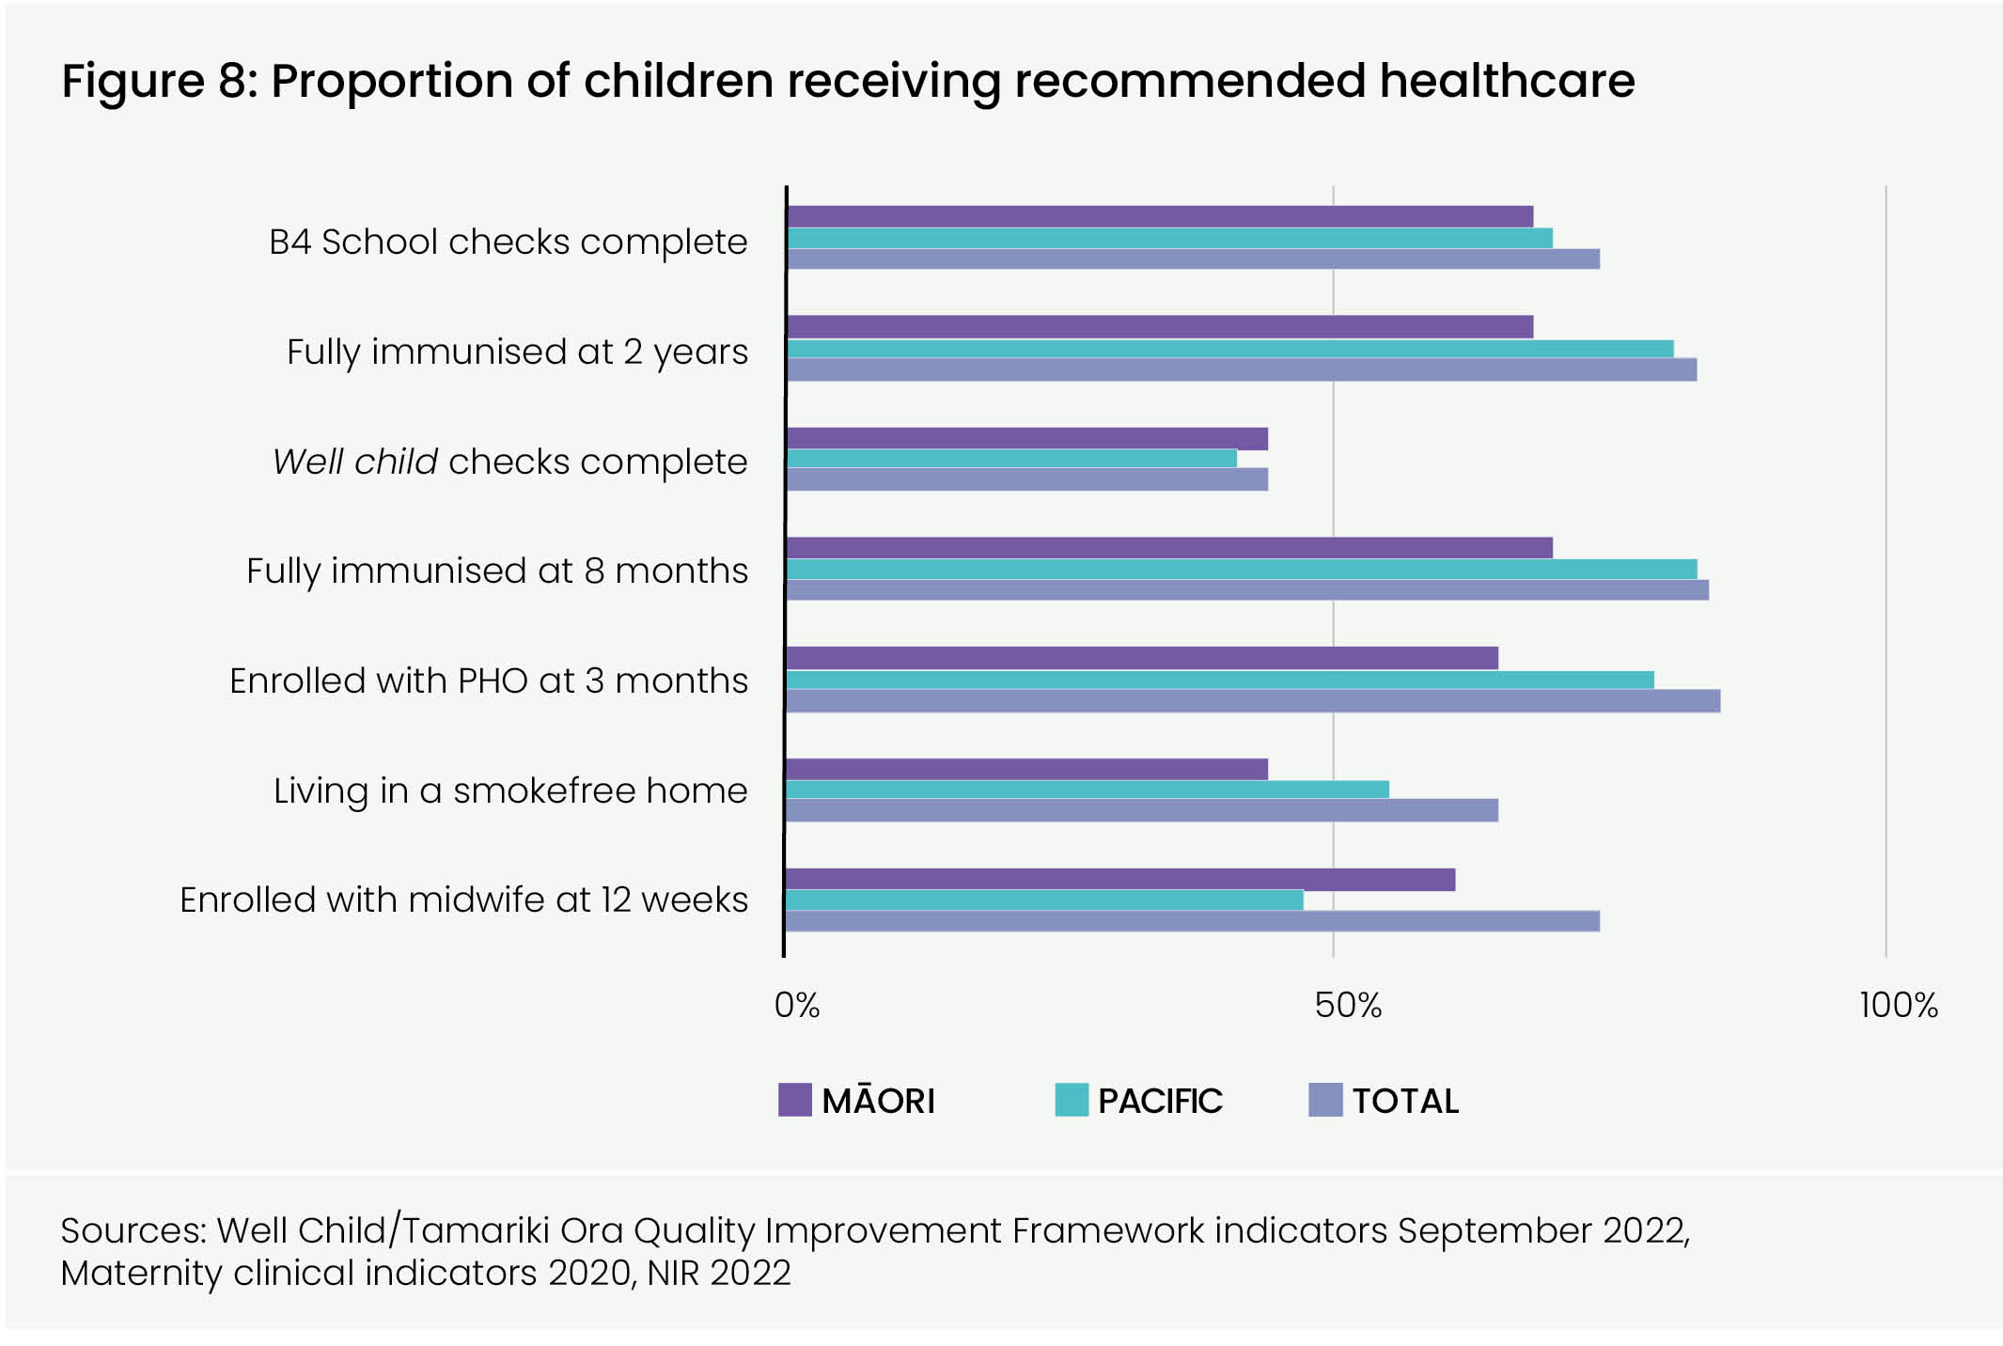

There are significant ethnic and socio-economic inequities across a range of health outcome measures for babies, children and youth living in Aotearoa New Zealand. The most common reasons for acute hospitalisation for children are injury or poisoning, bronchiolitis, acute upper respiratory tract infections and gastroenteritis. The most common reasons for acute hospitalisation for youth are injury or poisoning, pregnancy, delivery or postnatal-related conditions, mental health, and abdominal or pelvic pain.12

Nationally the childhood immunisation target is 95% at age 8 months and 24 months. In 2022, 84% of children were fully immunised at 8 months and 83% of children were fully immunised at 24 months. Māori immunisation rates were lowest at 70% at 8 months and 68% at 24 months, with Pacific children also lower than overall at 83% at 8 months and 81% at 24 months.

At a population level, Māori and Pacific children have poorer oral health than those of other ethnicities. For non-Māori, non-Pacific 5 year olds, two out of three (68%) were caries-free, compared with 41% of Māori and 33% of Pacific children. Five year olds have an average of 1.9 decayed, missing or filled teeth (DMFT). Māori children have an average of 2.9 DMFT and Pacific children have an average of 3.6 DMFT, while non-Māori/non-Pacific children have an average of 1.3 DMFT.

Māori and Pacific people’s immunisation rates and oral health were already in decline and this equity gap has been more pronounced since the start of the COVID-19 pandemic.

### People living with chronic health conditions

Cardiovascular diseases (CVD), diseases of the heart and blood circulation, are a leading cause of death and years lost to premature mortality. Māori, Pacific and South Asian (a sub-group of the Asian population) people are considered to be at higher risk of CVD in Aotearoa New Zealand. This shows in mortality data, with Māori at twice the European/Other rate, and Pacific people at 1.8 times the rate.

78% of the country’s eligible population have received a CVD risk assessment – 77% for Māori and 84% for Pacific people. This is important in the assessment and management of cholesterol and high blood pressure, key factors in the management of CVD. 11% of Aotearoa New Zealand adults are dispensed medication for high blood pressure, and around 8% are dispensed medication for high cholesterol (NZ Health Survey 2017–20). A higher proportion of Māori and Pacific people are dispensed these medications than European/Other people, reflecting higher rates of CVD.

In 2022, there were 10,000 admissions to hospital following a stroke. The mortality rate from stroke is higher for Māori and much higher for Pacific people. Prompt assessment, together with effective targeted treatment and rehabilitation, is essential in providing the best outcomes for these patients. Treatment for acute ischaemic stroke can include reperfusion therapy. Against a target of 12%, latest reperfusion rates (2022/23) show that 16.5% of ischaemic stroke patients are being thrombolysed and/or treated with clot retrieval across the country.

The number of people with diabetes is increasing and this is now estimated to affect more than 292,000 (5.7%) of the population – with higher rates for Pacific, South Asian and Māori people. Environments that support healthy food choices and physical activity are important for the prevention of diabetes and other chronic conditions, alongside optimising evidence-based treatment and good access to screening for complications of diabetes e.g. retinal screening and foot checks.

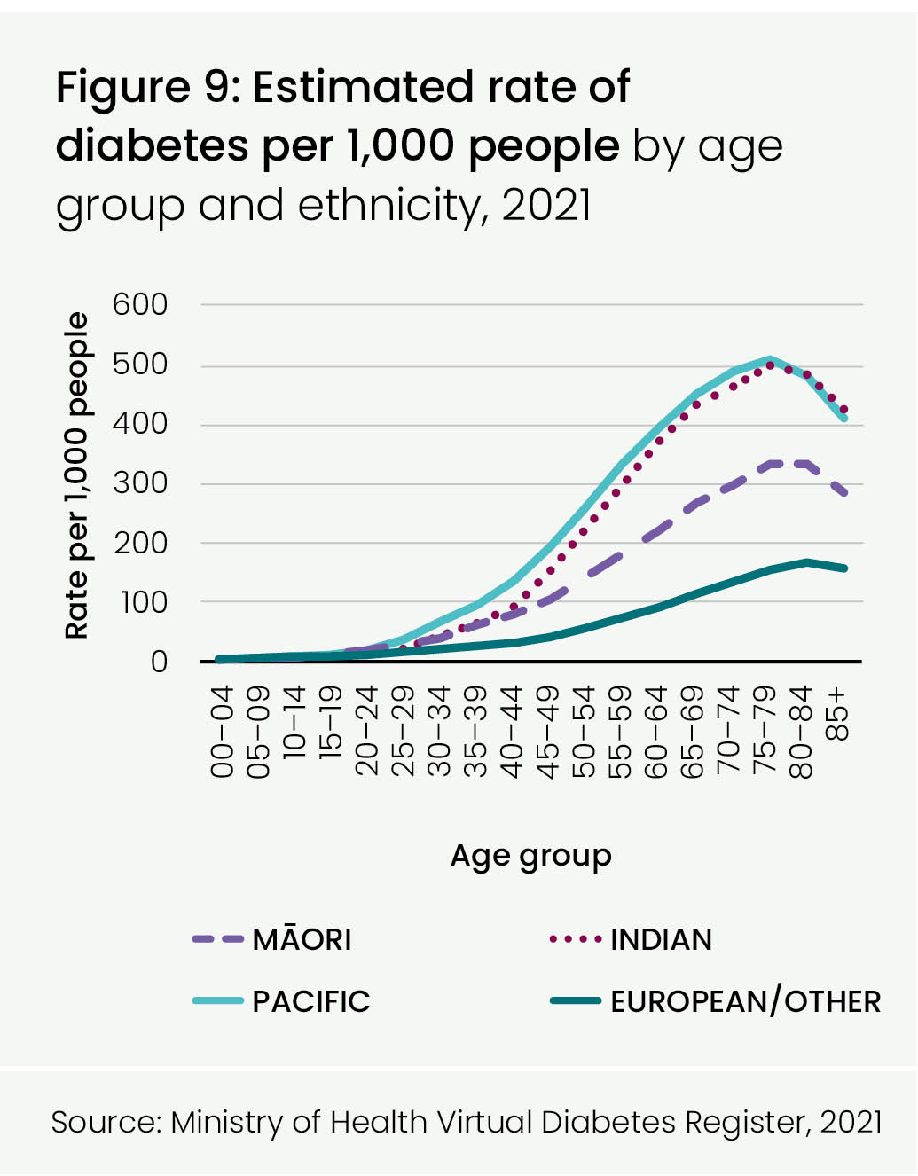

### People with cancer

In 2020, 27,000 people were diagnosed with cancer in Aotearoa New Zealand, some of whom have more than one cancer. Collectively, cancer causes 31% of all deaths with the most significant being breast (in women), lung and colorectal cancers, and prostate cancer (in men). Around 30–35% of cancers are caused by modifiable risk factors and are potentially avoidable. Early detection and prompt diagnosis and treatment can reduce mortality and morbidity from cancers.

The 5-year relative survival rate for cancer is 61% but this varies from 90% for melanoma to 12% for lung cancer. Across almost all cancers, Māori have a lower 5-year survival rate than non-Māori.

National screening programmes for breast and cervical cancer are well-established. Despite this, and with contributing COVID-19 disruptions over the last 2 years, many eligible women are not currently participating. Cervical screening rates are low for Māori (55%), Pacific (56%) and Asian (59%) women compared to the European/Other rate of 75% of eligible women (against a coverage target of 80%). Breast screening rates for Māori and Asian women are also low with rates of 59% and 57% respectively, compared to the overall population rate of 64% (against a coverage target of 70%). Bowel screening is now offered in all districts. Current coverage is 57% of eligible people (60 to 74 year olds). Coverage is lower for Pacific people (38%), Māori (48%) and Asian (47%) than for European/Other people (57%) (NSU, March 2023).

To support continued improvement in services and waiting times for people with cancer, accessing faster cancer treatment is a key priority. As at December 2022, 84% of cancer patients waited less than 62 days to commence treatment or other care compared with the target of 90% ([MoH quarterly report](https://www.health.govt.nz/new-zealand-health-system/accountability-and-funding/planning-and-performance-data/faster-cancer-treatment-and-shorter-stays-emergency-department)).

| Table 1: Most common causes of cancer registrations, five years 2016-2020  and five-year survival rates for 2013/14 registrations | | | | | |
| --- | --- | --- | --- | --- | --- |
| **cancer type** | **registrations: five year period** | **Five-year net survival rate** | | | **deaths  (2016–2020)** |
|  |  | **All** | **m**Ā**ori** | **non-m**Ā**ori** |  |
| Prostate | 19,800 | 87% | 85% | 87% | 3,400 |
| Breast | 17,200 | 85% | 83% | 85% | 3,400 |
| Colorectal | 16,200 | 61% | 53% | 61% | 6,200 |
| Melanoma | 13,200 | 90% | 89% | 90% | 1,600 |
| Lung | 11,900 | 12% | 9% | 13% | 8,900 |
| Other | 50,800 |  |  |  | 25,200 |
| Total | 129,100 | 61% | 51% | 62% | 48,700 |

Source: NZ Cancer Registry, NZ Mortality data collection using the cohort method, ethnic specific life tables and Pohar Perme

### People living with mental distress, illness, and addictions

More than half of people living in Aotearoa New Zealand will experience mental distress and addiction challenges at some point in their lives. Nationally, one in five people reported some kind of mental illness in the last year and 3% experienced a serious mental illness. Half of those who develop mental health disorders have problems evident by the age of 15 years. Three out of four people who develop a substance use disorder do so by the age of 24 years. According to the NZ Health Survey 2021/22, women were more likely than men to experience high or very high psychological distress (13% vs 9%) and Māori more likely than European/Other people (18% vs 11%). Almost one in four (23.6%) young people aged 15 to 24 years experienced high or very high levels of psychological distress in 2021/22, up from 5.1% in 2011/12. According to the World Health Organization (WHO), the global prevalence of anxiety and depression grew by 25% during the first year of the COVID-19 pandemic and has persisted since.13

Around 3.4% of the population (176,000 people) accessed specialist mental health or addiction services in 2020/21. Utilisation rates were higher among young people (aged 10 to 24 years), although rates remained high in later adulthood (age 25 to 64 years) for Māori. From the age of 25 years until 64 years, Māori have double the utilisation rates of Pacific people and European/Other ethnicities. In 2020/21, around 3% of the population accessed primary mental health services, an increase of almost 30,000 people from 2019/20.14 Nationally there were 538 suspected suicides in 2021/22; 137 of these were Māori – a rate of 15.9 per 100,000 population (age standardised), the highest rate of all ethnicities.

Mental illness is also associated with reduced life expectancy, with tangata whai ora (people seeking wellbeing) at increased risk of other illnesses, particularly cancer and cardiovascular disease. Even when these illnesses are recognised, rates of intervention are lower for this population compared to people without mental illness.

**1 in 4 One in four 15 to 24 year olds reports experiencing psychological distress.**

### Disabled people I tangata whaikaha

Whaikaha – Ministry of Disabled People is a recently established Ministry that fosters partnership between the disability community, Māori and the Government to ‘transform the disability system’ and honour Te Tiriti o Waitangi.

The most recent nationally representative data about disability rates was collected in the 2013 New Zealand Disability Survey (NZDS).

The survey estimated that one in four people (24% of the population) has a disability. Mobility, agility, hearing, sight and remembering were the most common disabilities in adults, while learning, speaking and psychological/psychiatric disabilities were the most common in children. More than half of people living with disabilities report more than one type of disability and disability increases with age. Māori and European/Other people have higher rates of disability than Asian people.

Disabled adults were less likely than non-disabled adults to rate their health as excellent, very good or good; more likely to experience psychological distress as assessed by the Kessler (K10) score; more likely to have asthma; and more likely to have chronic pain.

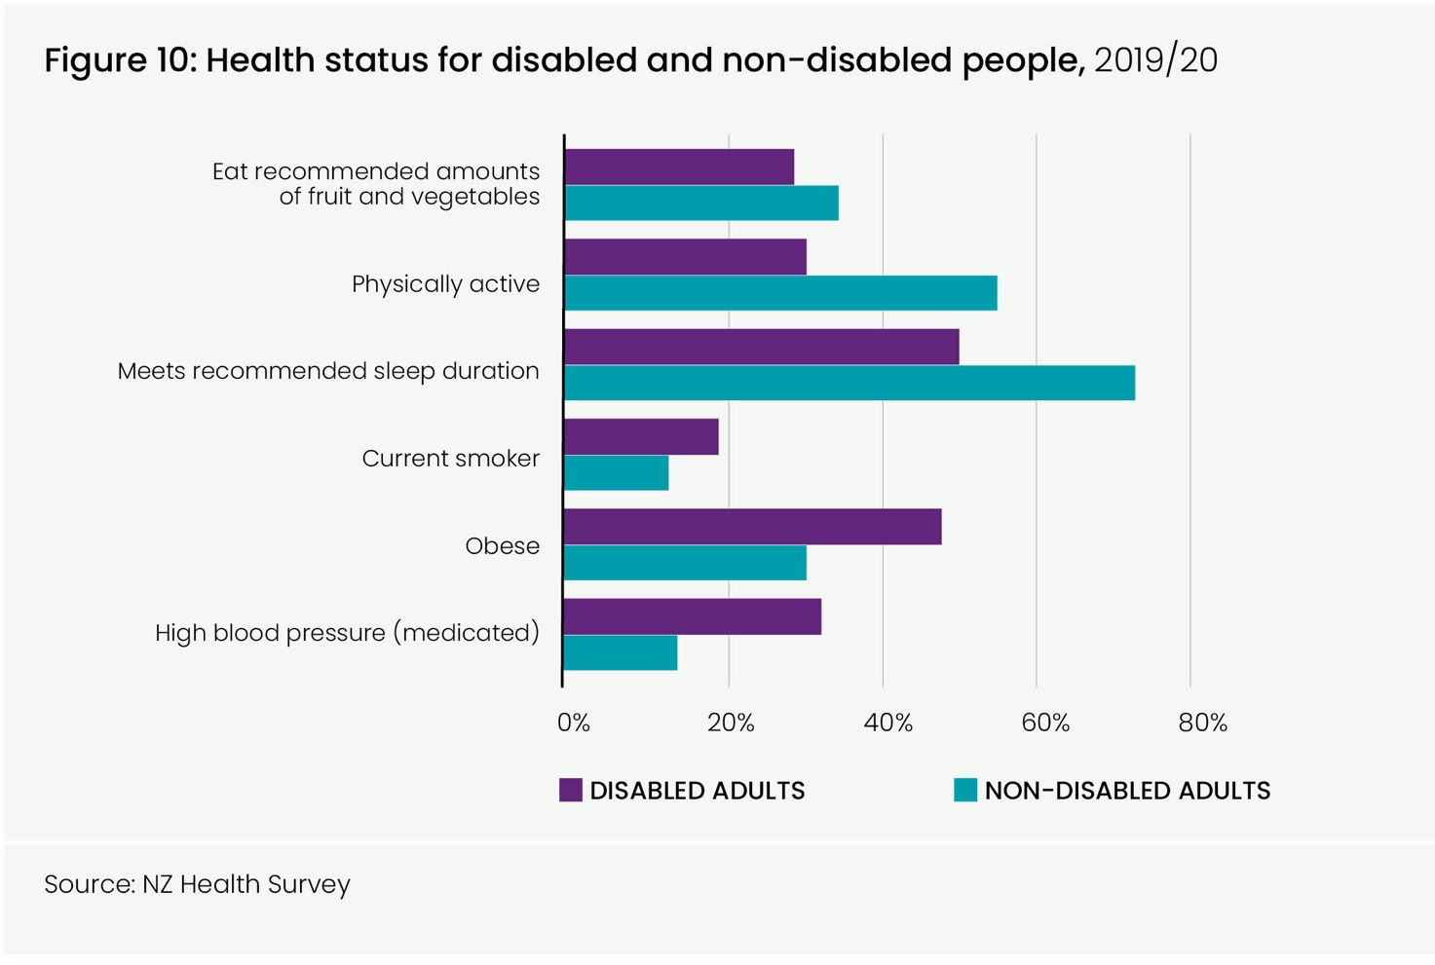

### Older people

17% (approximately 850,000) of Aotearoa New Zealand’s population is aged 65 years or older. This is expected to increase to approximately 1.3 million by 2042/43. Māori, Pacific and Asian populations are notable for the small proportion of older people they contain.

The large majority of older people across Aotearoa New Zealand are able to live unassisted in their own homes and have an overall self-reported positive health status. Around half the population aged 85 years or older live at home with home care support services, while another 28% live in residential care.

Protective dietary patterns such as eating the recommended number of servings of vegetables and fruit and eating takeaways infrequently are more common in older adults. However, disabilities increase with age, resulting in greater need for health services and hospital care. The NZ Disability Survey 2013 found that 59% of people aged 65 years or older have a disability. Falls are the largest cause of injury-related deaths for older people. With the projected increase in the population aged 65 years or older, meeting the associated increase in demand for healthcare will be challenging.

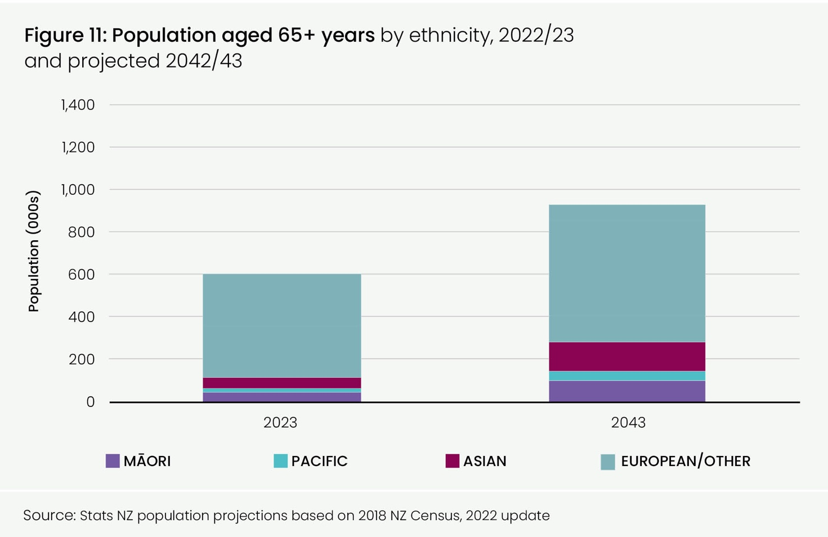

# Health services

### Community care

Community based healthcare is delivered by a variety of practitioners and providers (both publicly and privately funded) across the country. These include general practitioners (GPs), allied health professionals such as physiotherapists and dietitians, dentists, pharmacists, district nursing services, opticians, outreach immunisation services, Māori- and Pacific-specific providers and a range of others.

There are currently 38 primary health organisations (PHOs) operating in Aotearoa New Zealand. The national GP full-time equivalent rate estimates that there are 62 GPs per 100,000 population.

Nationally, 95% of residents are enrolled with a PHO (more than 4.8 million people), but Māori and Asian people have lower enrolment rates than average in many districts. Enrolment rates also vary by age, with low rates of enrolment in young adults.

According to the NZ Health Survey 2021/22, 11% of adults reported that the cost had prevented them, on at least one occasion in the past year, from visiting a GP, highest for those living in areas with the most socio-economically deprived NZDep scores. Inequity of access to care, particularly for Māori, is supported by the latest February 2023 survey results.

Ambulatory sensitive hospitalisations (ASH) are used as a proxy measure of avoidable hospital admissions.

During the 12 months to March 2023, the most common ASH diagnoses for 0 to 4 year olds were for asthma, respiratory infections, gastroenteritis/dehydration and dental conditions. The most common ASH diagnoses in the adult population (45 to 64 years) were for angina and chest pain, myocardial infarction, cellulitis and gastroenteritis/dehydration. Rates are highest among Māori and Pacific people in both age groups.

Dental services for adults are not publicly funded, apart from urgent relief of pain clinics delivered at some hospitals. One in three adults (37%) report that cost is a barrier to accessing dental healthcare. This rises to one in two Māori adults and 46% of Pacific adults.

The National Public Health Service has many responsibilities around the health of our communities, including communicable disease control, monitoring and protecting our environment and health promotion and regulatory activity in the areas of alcohol, tobacco and nutrition.

### Hospitals

Up until 2019, emergency department presentations steadily increased. Demand fell dramatically over 2020 with the reduction in infectious disease due to COVID-19 prevention measures. While rates have not returned to pre-COVID levels, they have increased again for Māori and Pacific people across Aotearoa New Zealand (6–7% growth between 2010 and 2022). In contrast, rates for non-Māori/non-Pacific people have remained relatively static. By region, rates are highest for all ethnic groups in Te Manawa Taki and lowest for all ethnic groups in the Northern region.

Over the past 10 years, admission volumes have steadily increased, creating increased need for inpatient capacity. However, this has largely been in line with expectations related to population growth and ageing, so age standardised acute admission rates to hospital have been relatively static apart from a decrease in 2020, which corresponded to the effective COVID-19 response measures. There was variation by region with Te Manawa Taki recording the highest (163 per 1,000 population) and Te Waipounamu the lowest (127). Rates for Pacific people are twice that of Asian people, while rates for Māori are also high.

Elective admission rates have been steadily declining for some years across all regions, with the lowest rate recorded for Te Waipounamu in 2022 at 22 per 1,000 population (age standardised). Other regions recorded very similar rates (25–26). Rates are highest for Pacific people, then Māori, and lowest for Asian people.

Future population growth, technology improvements and the impacts of an ageing population, along with constraints on funding and workforce will place pressure on hospital services. Climate change has serious implications for health, wellbeing, and livelihoods. Fully integrated services with a focus on prevention and good access to primary care services will be essential to meet the future health needs of the population.

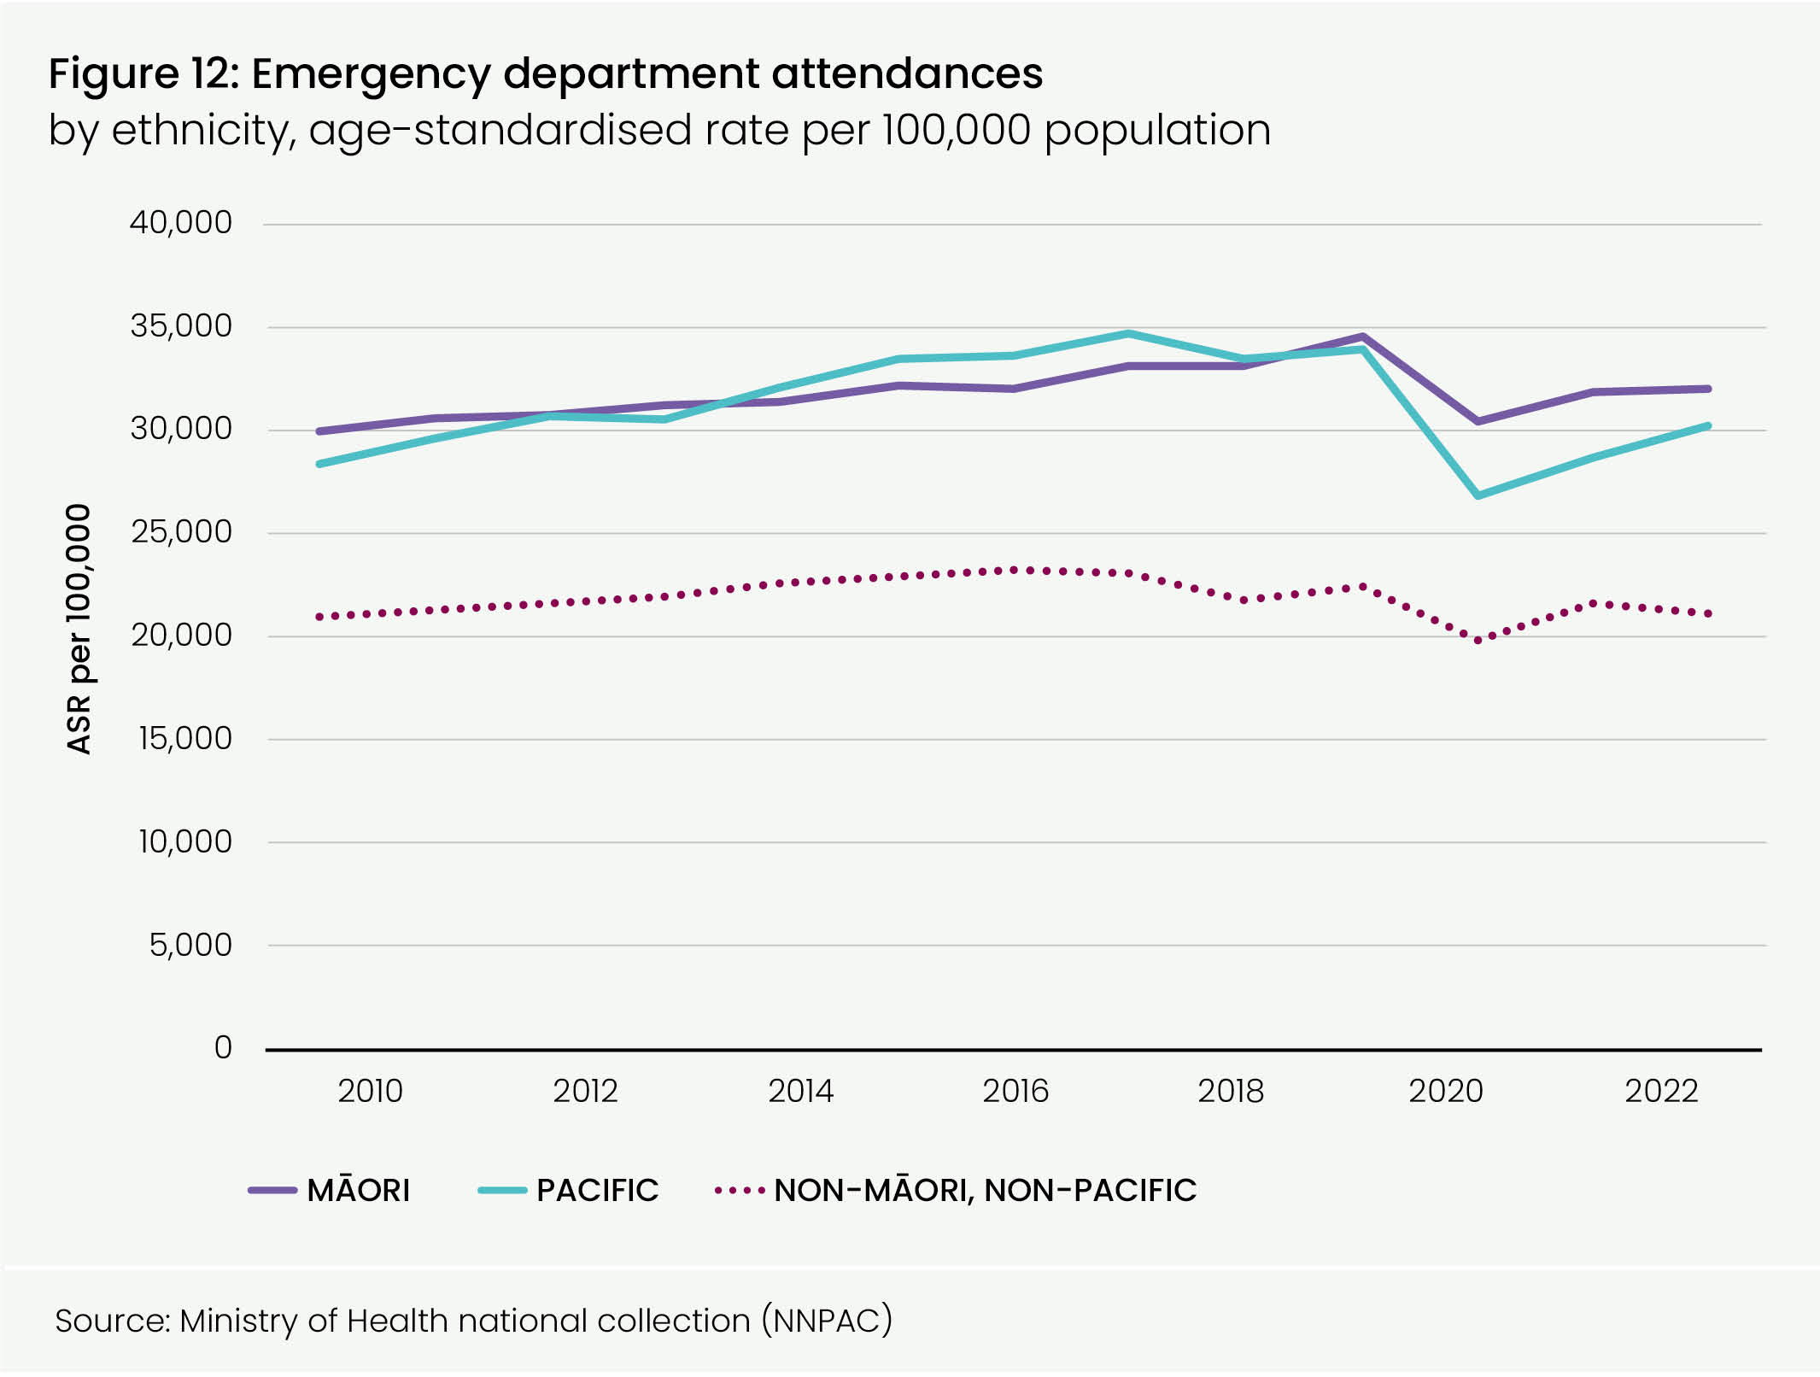

### References

1. Cavanagh, S. & Chadwick, K. Health Needs Assessment - A Practical Guide. <https://ihub.scot/media/1841/health_needs_assessment_a_practical_guide.pdf> (2005).

2. Health Quality & Safety Commission. A Window on the quality of Aotearoa New Zealand’s health care 2019. (Health Quality & Safety Commission, 2019).

3. Ministry of Health and University of Otago. Decades of Disparity III. (Ministry of Health, 2006).

4. Bécares, L., Cormack, D. & Harris, R. Ethnic density and area deprivation: Neighbourhood effects on Māori health and racial discrimination in Aotearoa/ New Zealand. *Soc Sci Med* 88, 76–82 (2013).

5. Statistics NZ. Wellbeing statistics: 2021. Stats NZ <https://www.stats.govt.nz/information-releases/wellbeing-statistics-2021/#families>. (2022)

6. Statistics NZ. Household labour force survey – estimated working-age population: December 2022. Stats NZ <https://www.stats.govt.nz/information-releases/household-labour-force-survey-estimated-working-age-population-december-2022-quarter/> (2023).

7. Environmental Health Intelligence New Zealand. Health effects of air pollution – HAPINZ 3.0 Study. Environmental Health Intelligence New Zealand <https://www.ehinz.ac.nz/indicators/air-quality/> health-effects-of-air-pollution/ (2022).

8. PHANZ. Public Health Association of New Zealand – *Think piece – commercial determinants of health* *explained.* <https://www.pha.org.nz/page-18200/13207956> (2023).

9. Public Health England. *Health matters: Prevention – a life course approach.* GOV.UK <https://www.gov.uk>/government/ publications/health-matters-life-course–approach-to-prevention/health-matters–prevention-a-life-course-approach. (2019)

10. Coussons-Read, M. E. Effects of prenatal stress on pregnancy and human development: mechanisms and pathways. *Obstet Med* 6, 52–57 (2013).

11. Department of the Prime Minister and Cabinet. *Child youth wellbeing strategy 2019*. (Department of the Prime Minister and Cabinet (DPMC), 2019).

### Figures

1 Population by age band, 2022/23 and projected 2042/43

2 Population projections by ethnicity, 2022/23 to 2042/43

3 Obesity (age-standardised rates for adults 15+ years and children 2 to14 years) by ethnicity, 2017–20

4 Trend in life expectancy at birth by ethnicity, 2001–03 to 2020–22

5 Top 10 avoidable contributors to life expectancy gap between Māori and non-Māori/non-Pacific, 2018–2020

6 Top 10 avoidable contributors to life expectancy gap between Pacific people and non-Māori/non-Pacific, 2018–2020

7 Amenable and preventable (avoidable) mortality by ethnic group, 2018–2020

8 Proportion of children receiving recommended healthcare

9 Estimated rate of diabetes per 1,000 people by age group and ethnicity, 2021

10 Health status for disabled and non-disabled people, 2019/20

11 Population aged 65+ years by ethnicity, 2022/23 and projected 2042/43

12 Estimated emergency department attendances by ethnicity, age-standardised rate per 100,000 population

[](https://www.govt.nz/)

[tewhatuora.govt.nz](http://www.tewhatuora.govt.nz/)