Diabetic Retinal Screening, Grading, Monitoring and Referral Guidance

Citation: Ministry of Health. 2016. Diabetic Retinal Screening, Grading, Monitoring and Referral Guidance. Wellington: Ministry of Health.
Published in March 2016
by the Ministry of Health
PO Box 5013, Wellington 6145, New Zealand
ISBN 978-0-947491-66-6 (online)
HP 6350
This document is available at health.govt.nz

This work is licensed under the Creative Commons Attribution 4.0 International licence. In essence, you are free to: share ie, copy and redistribute the material in any medium or format; adapt ie, remix, transform and build upon the material. You must give appropriate credit, provide a link to the licence and indicate if changes were made.

Acknowledgements
Feedback was received from:
- Auckland Diabetes Centre
- Barry Gainford Eyecare, Blenheim
- Diabetes New Zealand
- Diabetes Retinal Screening Group, Tairāwhiti District Health Board
- Diabetic Photographic Retinopathy Screening Service Governance Group, Canterbury Clinical Network, Canterbury District Health Board
- Hawke’s Bay District Health Board
- National Diabetes Service Improvement Group (NDSIG)
- New Zealand Association of Optometrists (NZAO)
- Northern Region Diabetes Network, Northern Regional Alliance, Auckland
- The Royal Australasian College of Physicians
- The Royal Australian and New Zealand College of Ophthalmologists.

Diabetic Retinal Screening, Grading and Management Guidance Steering Group (SG) and Implementation Group (IG) members:
- Olga Brochner, Ophthalmology Clinical Nurse Specialist, Auckland DHB (SG)
- Kirsten Coppell, Public Health Physician, University of Otago, Dunedin (SG)
- Stephanie Emma, General Manager, Mangere Community Health Trust (SG, IG)
- John Grylls, Optometrist, Kapiti (SG)
- Tofa Gush, Director, Pacific Peoples Health, Wairarapa and Hutt Valley DHBs (IG)
- Kit Hoeben, Funding and Planning Portfolio Manager, Canterbury DHB (IG)
- Jeff Lowe, General Practitioner, Karori Medical Centre (IG)
- Jayden MacRae, Chief Executive Officer, Patients First, Wellington (IG)
- Sam Kemp-Milham, Diabetes Programme Manager, Ministry of Health (SG, IG)
- Helen Rodenburg, Clinical Director, Long Term Conditions, Ministry of Health (IG)
- Gordon Sanderson (Chair), Optometrist, University of Otago, Dunedin (SG)
- Derek Sherwood, Ophthalmologist, Nelson Marlborough DHB (SG)
- Mary Jane Sime, Ophthalmologist, Southern DHB (SG)
- David Squirrel, Ophthalmologist, Auckland DHB (SG, IG)
- Wilson Sue, Optometrist, Upper Hutt (IG)
- Debbie Walker, Ministry of Health Long Term Conditions Consumer Advisory Panellist, Health Navigator Charitable Trust (IG)
- Fiona Wu, Consultant Diabetologist/Endocrinologist, Greenlane Clinical Centre (IG)
- Justina Wu, Endocrinologist, Waikato Regional Diabetes Service (IG).

Contents
Acknowledgements iii
Executive summary vii
1 Introduction 1
1.1 Overview 1
1.2 The diabetes retinal screening pathway 2
1.3 Key features 2
1.4 Risk of occurrence and progression of diabetic retinopathy: clinical modifiers 3
2 Screening the population 4
2.1 Eligibility for referral to diabetic retinal screening 4
2.2 Ineligibility for referral to retinal screening 4
3 When to start and stop screening for diabetic retinopathy 5
3.1 When to start diabetic retinal screening 5
3.2 When to cease diabetic retinal screening 5
3.3 Patients transferring between regional diabetic retinal screening services 5
4 Diabetic retinal screening intervals and recall 6
4.1 Referral guidance: clinical modifiers may result in earlier re-screening or referral 6
4.2 Communicating the results 7
5 Diabetic retinal screening methods 8
5.1 Visual acuity 8
5.2 Visualisation of the retina: methods 8
5.3 Pupil dilation 8
6 Standards for retinal imaging and grading 10
6.1 Photographic images 10
6.2 Grading 10
7 Pregnancy 11
7.1 Grading and referral guidance for pregnant women with diabetes 11
8 Diabetic retinal monitoring 12
9 Clinical governance 13
9.1 Designated lead clinical advisor 13
9.2 Retinal screening manager/coordinator 13
9.3 Professional competency 13
9.4 Service review 14
9.5 Quality assurance requirements 14
Appendices
Appendix A: Progression of diabetic retinopathy 15
Appendix B: Grading 16
Appendix C: Diabetic retinopathy monitoring 20
Appendix D: Case Study – Wellington Region Diabetic Retinal Screening and Monitoring 22
Appendix E: Draft retinal screening indicators and measures 24
References 27

List of Tables
Table 1: Changes to screening interval or referral guidance due to clinical modifiers 6
Table 2: Photographic field standard and size 10
Table 3: Grading and referral guidance for women with diabetes who are also pregnant 11
Table A: Guide to the rate of progression of disease 15
Table B: Grading for image clarity and field size 16
Table C: Diabetic retinopathy grading classification and referral guidance 17
Table D: Diabetic macular disease classification and referral guidance 18
Table E: Grading of non-diabetic pathology 19

List of Figures
Figure 1: Retinal screening pathway 2
Figure 2: Example optical coherence tomography image 12
Figure A: Retinal monitoring pathway for R3, R4 or previously treated PDR disease 20
Figure B: Proposed retinal monitoring macular pathway 21

Executive summary
Anyone with diabetes is at risk of developing diabetic retinopathy (DR), or damage to the retina. Continued damage can lead to blindness. More than 257,000 New Zealanders now live with diabetes, and approximately 20–25 percent of those with diabetes have some form of DR.

Fortunately, DR can be detected and early intervention can prevent or reduce vision loss. For service providers, DR screening is not only cost-effective but, in the long term, it can even save costs.

The elements of an organised national retinal screening programme first took shape in 2001. The National Diabetes Retinal Screening Grading System and Referral Guidelines 2006 (updated 2008) (Ministry of Health 2008) extended the information on DR screening for service providers and revised the grading system. The Diabetic Retinal Screening, Grading, Monitoring and Referral Guidance 2016 updates all previous guidelines and recommends:
- revising the screening interval to three-yearly for those without clinical modifiers and for those with no diabetic retinopathy detected
- updating the retinal screening pathway
- making pupil dilation a choice to be discussed with the person being screened
- focusing more on self management with better control if retinopathy progresses and timely re-screening if retinopathy control deteriorates
- screening for pregnant women with diabetes
- monitoring by optometrists, with each region having a central coordinator for its DR screening service based on national standards and an ophthalmologist overseeing the region’s programme
- encouraging the general practice as the health care home for people with diabetes, which includes accessing electronic information and ensuring enrolment with the screening programme, especially when a person with diabetes shifts to a different district health board (DHB) area
- providing screening and monitoring results within three weeks to the person with diabetes, their GP and their referring clinician.

Although the target population has type 2 diabetes, these guidelines also address diabetes in pregnancy and children and adults with type 1 diabetes to ensure these groups also have the support of an organised retinal screening programme.

New Zealand already has a variety of regional DR screening services, some of which are very effective. The updated standards for grading, referring and monitoring set out in these guidelines recognise that some established programmes will have to adjust their processes and also that technology is quickly evolving. As a result, the guidelines are flexible and should promote further integration of regional services to result in a consistent national standard.

1 Introduction

1.1 Overview
Anyone with diabetes is at risk of developing diabetic retinopathy (DR). This eye disease is defined as abnormal retinal changes associated with diabetes, and it can lead to visual loss. In New Zealand, approximately 20–25 percent of people with diabetes have some form of DR (Frederikson and Jacobs 2008; Coppell et al 2011; Papali’i-Curtin and Dalziel 2013). The main risk factors of DR are discussed in section 1.4 below.

People with diabetes should be encouraged to participate in an organised retinal screening service because there is good evidence that retinal screening and subsequent treatment reduces preventable blindness. Retinal screening is also cost effective (Javitt and Aiello 1996).

In 2014, the Ministry of Health (the Ministry) established the Diabetes Retinal Steering Group (the Steering Group) to update the National Diabetes Retinal Screening Grading System and Referral Guidelines (2006) and Resources (2008) (Ministry of Health 2007). The Steering Group produced the current guidance document, which outlines the key components of an organised DR screening service with the aim of providing high-quality, equitable screening for those at risk of diabetic eye disease.

The guidance represents a statement of best practice, based on evidence and expert consensus (at the time of publishing), and is intended to inform and guide the delivery of a nationally consistent retinal screening programme. For the first time, the guidelines attempt to distinguish between screening for and monitoring DR.

This guidance should be read in conjunction with:
- New Zealand Primary Care Handbook 2012 (New Zealand Guidelines Group 2012)
- Quality Standards for Diabetes Care (Ministry of Health 2014a)
- Living Well with Diabetes: A plan for people at high risk of or living with diabetes
2015–2020 (Ministry of Health 2015).

1.2 The diabetes retinal screening pathway
The main outcome of retinal screening is the identification and appropriate management of patients with DR. The screening can also recommend those people with worsening DR for a review of their overall diabetes medical management.

DR screening can be done opportunistically, but ideally it should be part of an organised screening programme. With organised screening, all activities along the screening pathway are planned, coordinated, monitored and evaluated. Figure 1 below provides an overview of the screening pathway.

Figure 1: Retinal screening pathway
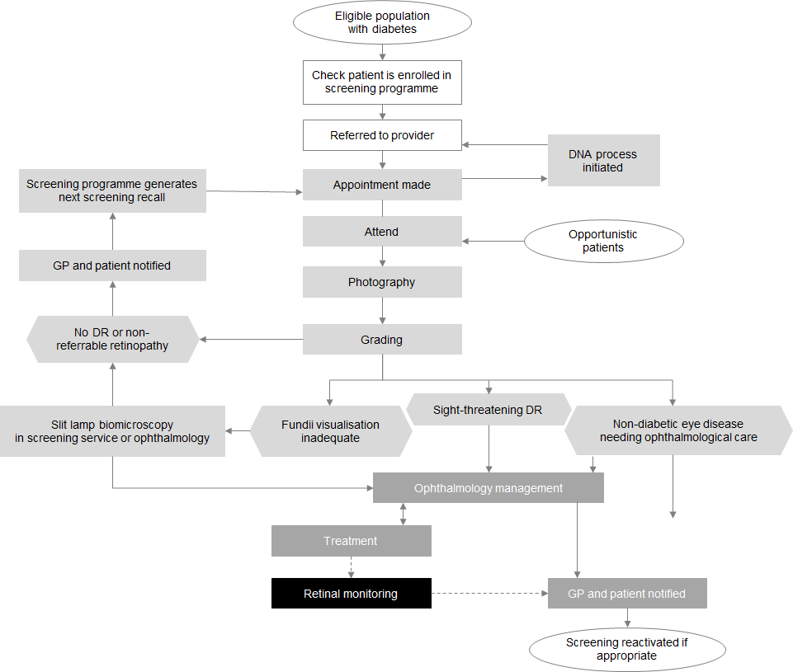

1.3 Key features
The following are some key features of an organised DR screening programme. Overall responsibility for the delivery of publicly funded organised retinal screening services lies with the 20 individual district health boards (DHBs).
- A primary health care service coordinates the overall health care of a person with diabetes. The general practice is the health care home for the person with diabetes, which includes accessing electronic information and ensuring the person is enrolled with a DR screening programme.
- Each region has a central coordinator for its DR screening service, who is responsible for processing appointment invitations and recalls, attendance at screenings, referrals to secondary health care for assessment and management, and dissemination of population management results.
- Each region delivers organised DR screening services based on national standards but using local models and solutions that are appropriate for the local area.
- Retinal screeners deliver competency-based services.
- Retinal screening and monitoring results are provided within three weeks (longer if secondary confirmation is required) to the person with diabetes, their GP and their referring clinician (where relevant).
- The DR screening programme collects and stores a core national minimum data set for clinical, quality improvement, audit, research and benchmarking purposes.
- Designated ophthalmologists provide oversight of the DR screening programme.
- Women who develop gestational diabetes after 20 weeks of pregnancy do not require screening for DR.
- Women with type 2 diabetes newly diagnosed during pregnancy (usually at booking visit) require monitoring during and after their pregnancy.
- People with diabetes should have a choice about pupil dilation.

1.4 Risk of occurrence and progression of diabetic retinopathy: clinical modifiers
The risk of developing, and the rate of progression of, DR increases with:
- poor blood glucose control
- duration of diabetes
- poor engagement with the health system
- rapid and marked improvement in blood glucose control (over a period of three to four months)
- uncontrolled hypertension
- renal impairment
- non-healing foot ulcers (Nwanyanwu et al 2013).
- pregnancy.

Good management of the modifiable risk factors, such as glycaemic control and blood pressure control, reduces the risk of occurrence and progression of DR (DCCT 1994; Klein et al 1994; Ohkubo et al 1995; UKPDS 1998, 1998b; Wong et al 2009).

The DR screening programme should be notified when any clinical modifiers change.

2 Screening the population

2.1 Eligibility for referral to diabetic retinal screening
People with a confirmed diagnosis of diabetes should be referred for DR screening.

2.2 Ineligibility for referral to retinal screening
People who are not eligible for referral to DR screening include:
- those with prediabetes (using the New Zealand definition, this includes the old categories of impaired glucose intolerance and impaired fasting glycaemia)
- those with gestational diabetes
- those under the active care of specialist eye services for DR
- those with advanced cataracts or otherwise where the retina cannot be visualised
- those unable/unlikely to benefit from treatment if DR is detected (eg, already blind, terminally ill).

3 When to start and stop screening for diabetic retinopathy

3.1 When to start diabetic retinal screening
- People with newly diagnosed type 1 diabetes should be enrolled in the DR screening programme and screening should occur within five years after diagnosis (Echouffo-Tcheugui et al 2013).
- For children with type 1 diabetes, screening can be delayed until age 10, or until five years after diagnosis, whichever occurs first (Donaghue et al 2014).
- People with newly diagnosed type 2 diabetes should be enrolled in the DR screening programme at the time of diagnosis of their diabetes (Looker et al 2013), when DR is often present.
- People with secondary diabetes, such as new onset diabetes after transplant (NODAT), post-pancreatectomy, chronic pancreatitis and cystic-fibrosis-related diabetes should be treated as per type 1 diabetes when there is a defined date of onset.
- People with uncertain types of diabetes, or without definite dates of onset, should be treated as per type 2 diabetes with immediate screening.

3.2 When to cease diabetic retinal screening
A person may be discharged from a DR screening service if they:
- have made an informed choice to decline screening
- have been transferred to the care of specialist ophthalmology services specifically for the management of their DR, though they may need re-referral when specialist supervision ends
- are unable or unlikely to benefit from treatment if DR is detected (eg, those who are already blind or the terminally ill).

3.3 Patients transferring between regional diabetic retinal screening services
When a patient moves domicile to a different DHB area, their DR screening information should transfer with their medical records and recall should be entered by their new primary health care practice with referral to the local DR screening programme.

4 Diabetic retinal screening intervals and recall
The recommended interval for the next DR examination is informed by a person’s grading result (see Appendix B). The standard screening interval is two years, but this can be extended to three years (Echouffo-Tcheugui et al 2013) if:
- no DR was detected at the previous screen and no clinical modifiers are present (Table 1)
- HbA1c has consistently been less than or equal to 64 mmol/mol.

These intervals are guidelines only; clinicians may vary them provided that patient safety, sensitivity and quality are not compromised.

4.1 Referral guidance: clinical modifiers may result in earlier re-screening or referral
Refer to Appendix B for grading details. Consider decreasing the screening interval or referral if any of the following clinical modifiers are present (Table 1).

Table 1: Changes to screening interval or referral guidance due to clinical modifiers
Clinical modifier | Note | Outcome
‘Did not attend’ (DNA) retinal screening two or more consecutive times. | May indicate increased risk. | Consider reducing screening interval or referral.
Poorly controlled diabetes:
HbA1c > 64 mmol/mol.
Duration of diabetes (> 10 years).
Rapid progression of DR.
Poorly controlled hypertension (BP ≥ 160/95). See New Zealand Primary Care Handbook (2012) and update (2013).
Asymmetrical DR.
Renal failure/proteinuria. | Last eGFR < 45 and/or last ACR > 100. | Consider reducing screening interval or review.
Type 1 diabetes > 15 years. | May have peripheral retinal ischaemia without significant changes in the fields covered by photography. Peripheral  neovascularisation or features of severe DR may be present beyond the field of view. | Advisable to refer to an ophthalmologist for clinical examination by slit lamp biomicroscopy of the peripheral retina.
Foot ulcers. | Their presence can be associated with an accelerated progression of DR. | Consider reducing screening interval.

HbA1c levels should be available to screeners and ideally should be no more than six months old. Screeners may need to liaise with the primary health care provider or the local laboratory to obtain this information or, ideally, would have shared-care record access.

4.2 Communicating the results
The results are provided to the patient, the primary health care provider and the relevant diabetes specialist service (if required) within a timely interval. This includes the screeners (if they are not doing the reporting) and the screening programme.

5 Diabetic retinal screening methods
The purpose of screening is to assess the status of the person’s retina for damage or changes caused by diabetes. The process of screening includes an assessment of visual acuity, visualisation of the retina and a review of clinical factors that may affect the recommended screening interval (ie, the clinical modifiers – see sections 1.4 and 4.1).

5.1 Visual acuity
Visual acuity should be tested in both eyes with best correction. Where this is not possible, pin-hole acuity is acceptable.

5.2 Visualisation of the retina: methods
Retinal visualisation can be undertaken using:
- colour digital retinal photography to the standard detailed in Table B in Appendix B
- a dilated pupil fundus examination, using binocular ophthalmoscopy (eg, slit-lamp biomicroscopy).

Digital retinal photography is the preferred method unless it is unsuitable for the patient. Where retinal photography is unsuitable, screening should be undertaken in a clinical setting. Referral to an approved provider (ophthalmologist or optometrist) is indicated if adequate visualisation and assessment of the retina are not possible.

If available, optical coherence tomography (OCT) imaging may be used, but its utility as a primary screening tool is yet to be established. It is likely to be more widely used over the next few years.

5.3 Pupil dilation
Pupil dilation is a choice and needs to be discussed with the person being screened. Pupil dilation may be required for good visualisation of the retina. Before attending screening, individuals should be informed that pupil dilation may be necessary and that side effects can include:
- temporary blurred or distorted vision
- temporary lack of tolerance to bright light or sunlight
- possible loss of balance.

A person should avoid driving or using machinery when their pupils are dilated.

These side effects may last up to four hours, but in certain circumstances (depending on the dilating agent used), the duration may be longer, and the patients should be advised accordingly.

There is an extremely small risk of precipitating acute angle closure glaucoma, which can occur three to six hours after pupil dilation. If a patient develops symptoms of acute closure glaucoma (including sudden severe eye pain, a red eye, blurred or reduced vision and a headache), they should be told to seek ophthalmic advice urgently.

Pupil dilation in pregnancy is safe.

6 Standards for retinal imaging and grading

6.1 Photographic images
A quality assured grading process requires photographs of adequate quality (see Appendix B). The minimum field size is two 45-degree fields. For those with type 1 diabetes or with R3 or more, an inferior and superior image are mandatory.

Details of the photographic field standard and size are shown in Table 2. These fields will provide approximately 75 degrees horizontal and 45 degrees vertical coverage. Photographs of less than 45 degrees will require extra photographs for the same areas.

Table 2: Photographic field standard and size
Field | Description | Extension
Adequate macular field | Centre of the optic disc at nasal edge of field. | Field extends temporally at least 4 DD from the temporal disc margin.
Adequate nasal field | Centre of the optic disc 1 DD from the temporal edge of the field. | Whole field extends nasally at least 3 DD from the nasal disc margin.
Superior retinal image | Centre of the optic disc positioned 1 DD from the inferior edge of the image. | Image extends superiorly at least 3 DD from the superior disc margin.
Inferior retinal image | Centre of the optic disc positioned 1 DD from the superior edge of the image. | Image extends inferiorly at least 3 DD from the inferior disc margin.
Note: DD = disc diameters

6.2 Grading
If photography is used, the grading process should commence with a quality assessment of the photograph to assess the definition of field clarity (see Appendix B). The screener who is taking the photograph is responsible for assessing the quality of the photograph. Each eye should be graded separately, and the overall DR grade should be based on the worst eye. All grading should be consistent with the standards and the National Diabetes Retinal Grading System outlined in these guidelines (see tables C and D in Appendix B).

7 Pregnancy
All pregnant women with established diabetes (type 1 or type 2) should be screened in the first trimester of their pregnancy (Kaziwe et al 2013).
- Pregnant women, previously unknown to have diabetes but found to have an HbA1c of 50 or greater at the time of booking their antenatal blood tests are likely to have had diabetes at conception (Ministry of Health 2014b). These women should also be screened in the first trimester or within four weeks of detection of their diabetes.
- Those who have no DR and no modifiable risk factors can continue with their normal two- or three-yearly screening.
- Women with gestational diabetes do not need to be screened.

Those women with:
- minimal DR will require more frequent screening during their pregnancy
- mild or more advanced DR will require a referral to an ophthalmologist for ongoing review during their pregnancy.

7.1 Grading and referral guidance for pregnant women with diabetes
Table 3 provides grading and referral guidance for women who have diabetes and are also pregnant. Some designated ophthalmologists may recommend screening every three months throughout pregnancy, regardless of retinopathy status or presence of clinical modifiers.

Table 3: Grading and referral guidance for women with diabetes who are also pregnant
Grade | Brief description | Clinical signs | Outcome
P0 | No DR or macular disease | No DR or macular disease (R0 M0). | Continue 2- to 3-yearly screening.  If clinical modifiers are present (see sections 1.4 and 4.1), retinal screen 3-monthly for the remainder of pregnancy.
P1 | Minimal | Minimal DR, no macular disease (R1 M0). | The retinal screening interval is a minimum of 3-monthly for the remainder of the pregnancy.
P2 | > Minimal | More than minimal DR and/or macular disease (> R1 > M0). | Urgent referral to an ophthalmologist

8 Diabetic retinal monitoring
Clinical training and scopes of practice for optometrists and nurse practitioners have changed since the Health Practitioners Competence Assurance Act 2003 was first introduced.

Changes to clinical training, scopes of practice and the advent of new technologies, such as optical coherence tomography (OCT)3 and ultra-wide field imaging, mean that it is now possible to monitor patients who would otherwise need to be reviewed by an ophthalmologist in a structured ‘virtual clinic’. Appendix D provides a Wellington region case study demonstrating how optometrists can be integrated into the DR screening pathway. If suitable clinicians and equipment are available, two groups of patients can be monitored this way. Those:
- with moderate non-proliferative DR
- who have quiescent (previously) treated proliferative DR and suspected diabetic maculopathy.

A ‘virtual clinic’ could exist in either the primary or secondary health care setting, with approval and oversight by the designated opthalmologist. While not intending to be prescriptive, suggested DR monitoring pathways are provided in Appendix C.

Figure 2: Example optical coherence tomography image
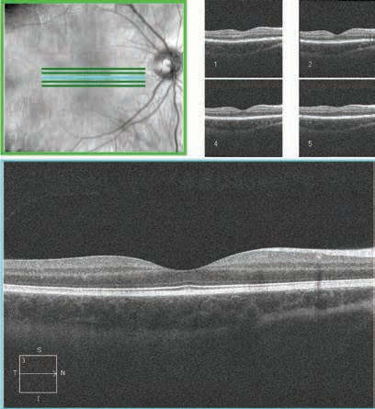

9 Clinical governance
Each retinal screening service should have a clinical governance group that includes consumers and that has oversight of the retinal screening pathway and provides clinical governance. Such governance should include clinical and service level audits and oversight of reporting information, which would usually be done annually.

9.1 Designated lead clinical advisor
Each DHB should appoint a designated lead clinical ophthalmologist as part of the multidisciplinary oversight group to be responsible for:
- clinical oversight
- providing clinical advice
- assuring retinal screening quality
- assessing performance, including assessing ‘near misses’ and approving and endorsing training and accreditation.

9.2 Retinal screening manager/coordinator
Within each regional retinal screening service, there should be a designated manager/ coordinator who is responsible for:
- managing and providing services
- operational oversight of referrals and associated care pathways
- communicating with primary health care stakeholders
- communicating with ophthalmology clinics.

9.3 Professional competency
All health practitioners providing retinal screening must participate in professional quality assurance activities, including a peer-review process. They should hold a current practising certificate from their respective professional body and be approved or accredited by the designated lead clinical advisor for retinal screening. Any retinal screening technician who does not have a practising certificate must be supervised. Anyone delivering retinal screening should have retinal screening defined within their scope of practice.

Photography, grading, slit-lamp biomicroscopy and OCT should be undertaken by a retinal-screener clinician (optometrist, ophthalmologist, registered nurse or trained technician, as required) (Looker et al 2013; Donaghue et al 2014). The level of work that clinician or technician should undertake depends on their competency and skill level.

9.4 Service review
The designated lead clinical advisor and/or retinal screening manager/coordinator must appraise the clinician or technician who delivers retinal screening annually. The annual appraisal should include reviewing the number of patients the person has screened over the previous 12 months and evidence of their clinical audit and/or quality assurance activities in the area of retinal screening.

9.5 Quality assurance requirements
Each regional retinal screening service must complete an annual report with the Ministry of Health. The report should include the following mandatory and recommended retinal screening, grading and monitoring indicators (refer to Appendix E for definitions). Include:
1. screened population demographic data
2. the proportion of people with diabetes screened each year
3. timely assessment of risk for people newly diagnosed with type 2 diabetes
4. the proportion of sight-threatening DR at first presentation
5. an assessment of the screening process
6. outcome grades
7. the retinal screening programme quality (additional DHB reporting)
8. validity measures (national or regional level, beyond the screening programme).

Appendix A: Progression of diabetic retinopathy
Table A: Guide to the rate of progression of disease
Retinopathy stage | Definition | Rate of progression (%)
 |  | To PDR |  | To referable disease
 |  | 1 year | 3 years | 1 year | 5 years
No DR |  | <0.5 | <0.5 | <1 | 2–3
Mild NPDR (level 30) | MAs and one or more of: retinal haem, HEx, but not meeting moderate NPDR definition | 1–2 | 2–4 | 5 | 8–15
Moderate NPDR (level 40) | H/MA> std photo ETDRS 2A: that is H/MA in at least one quadrant and one or more of: VB, IRMA, but not meeting severe NPDR definition | 12–26 | 15–30 | N/A | N/A
Severe NPDR pre-proliferative (level 50) | Any of: H/MA > std photo ETDRS 2A in all four quadrants, IRMA > std photo, ETDRS 8A in one or more quadrants, VB in two or more quadrants | 56 | 71 | N/A | N/A
PDR (level 60) | Any of: NVE or NVD < std photo 10A, vitreous/pre-retinal haem and NVE  < ½ disc area (DA) without NVD | Severe visual loss  (VA < 5/200) develops in 15–25% within 2 years. |  | N/A | N/A
High-risk PDR (level 70) | Any of: NVD> ¼ to ⅓ disc area or with vitreous/pre-retinal haemorrhages or NVE  > ½ DD with vitreous/pre-retinal haem | Severe visual loss (VA < 5/200) develops in  25–40% within 2 years
Advanced PDR | High-risk PDR with tractional detachment involving macula or vitreous haemorrhages obscuring ability to grade NVD and NVE
Macular oedema | Retinal thickening within 2 DD of fovea (macular centre) | Can occur at any stage of diabetic retinopathy
Clinically significant macular oedema | Retinal thickening within 500 μm of fovea or hard exudates within 500 μm of fovea with adjacent thickening | Can occur at any stage of diabetic retinopathy
PDR = proliferative diabetic retinopathy (Looker et al 2013); DR = diabetic retinopathy; NPDR = non-proliferative diabetic retinopathy; MA = microaneurysm; HEx = hard exudates; H/Ma = haemorrhages and microaneurysms; ETDRS = Early Treatment Diabetic Retinopathy Study; VB = venous beading; IRMA = intra-retinal microvascular abnormalities; NVE = neovascularisation and fibrous proliferans involving other areas of the retina; NVD = neovascularisation and fibrous proliferans involving the optic disc; DD = disc diameters

Appendix B: Grading

Grading for image clarity and field size
The outcome of retinal screening is that the visible retina is graded. Section 6 details the images that are required. The recommended minimal image quality for grading purposes is listed in Table B below.

Table B: Grading for image clarity and field size
Grade | Brief description | Minimum features | Action
QA | Adequate | Clarity:  - small vessels visible over majority of both fields, including maculae  Field size:  - macula field – extends temporally at least 4 DD from temporal disc margin  - nasal field – extends nasally at least 3 DD from nasal disc margin. | Proceed with grading.
QI | Inadequate | Does not meet all of the above criteria. | If retinal screening:  - has been performed undilated, repeat with mydriasis  - is inadequate with mydriasis, refer to ophthalmology, unless binocular ophthalmoscopy (eg, slit-lamp biomicroscopy screening) is available/ approved.  If image is poor but clear enough to establish moderate DR, then refer to an ophthalmologist for accurate assessment.

Grading for diabetic retinopathy and recommended screening and monitoring intervals
Note: Grading is based on the grade in the worst eye.

Table C: Diabetic retinopathy grading classification and referral guidance
Grade and brief description | Clinical signs | Outcome | Notes
R0  No DR | No abnormalities. | Type 1: re-screen at 2 years, adjusting for clinical modifiers.  Type 2: re-screen at 2–3 years, adjusting for clinical modifiers.  Presence of clinical modifiers may require earlier re-screening (see sections 1.4 and 4). | If screeners identify that clinical risk factors need attention, the patient and their GP and specialist should be advised if immediate intervention is required.  The re-screening interval can be extended to 3 years for some low-risk patients (see section 4).
R1  Minimal | < 5 microaneurysms (MAs) or dot haemorrhages. | Re-screen at 2 years depending on clinical modifiers (see section 1.4). | If screeners identify that clinical modifiers need attention, the patient and their GP and specialist should be advised if immediate intervention is required.  Presence of clinical modifiers may require earlier re-screening (see sections 1.4 and 4.1).
R2  Mild | > 4 MAs or dot haemorrhages. Exudates > 2 DD from fovea.  Some blot and larger haemorrhages acceptable.  If more than 20 MAs or haemorrhages per photographic field, upgrade to R3, moderate. | Rescreen after 12 months. | See additional notes for peripheral retinopathy.  Type 2: interval may be extended to 18 months if current HbA1c is < 64 mmol/mol.
R3  Moderate | Any features of Mild.  Blot or larger haemorrhages.  Up to one quadrant of venous beading. | Re-screen 6 months. | If HbA1c > 75 mmol/ mol, consider review by ophthalmologist within 4 months.
R4  Severe | One or more of:  - definite intra-retinal microvascular abnormalities (IRMA)  - two quadrants or more of venous beading  - four quadrants of blot or larger haemorrhages. | Review by ophthalmologist within 6 weeks.
R5  Proliferative | One or more of:  - neovascularisation  - sub-hyaloid or vitreous haemorrhage  - traction retinal detachment or retinal gliosis. | Urgent referral to ophthalmologist; consider review within 2 weeks.
Note: DD = disc diameters Source: Looker et al 2013.

R3 Moderate: R3 is the threshold for patient referral to ophthalmologic care, but some programmes may elect to keep these patients within the retinal screening programme for the purposes of diabetic retinopathy (DR) monitoring. However, it is recommended that individuals receive ophthalmic clinical examination to exclude significant peripheral disease beyond the photographic fields before continuing with retinal monitoring. The first specialist assessment is suggested within four months, and subsequent reviews may be at longer intervals.

RT: Previously treated proliferative retinopathy: Where a patient is known to have been discharged from ophthalmic care with previously treated but stable DR, they can be graded in terms of the guidance. Normally, before discharge, a period of at least two years should have passed since their last treatment. Clinicians should be aware that DR may be more difficult to visualise in the presence of laser scars. If there is any uncertainty, the patient should be referred to the local DR monitoring services.

Cotton-wool spots: These are no longer thought to correlate with DR severity or to be predictive of progression. They are therefore not part of the grading system but should prompt a search for the presence of other abnormalities, such as venous beading, intra-retinal microvascular abnormalities (IRMA) or hypertensive retinopathy.

Grading and recommended screening intervals for diabetic macular disease
Note: Grading is based on the grade in the worst eye. Any diabetic maculopathy, even in the absence of any peripheral DR, means a retinopathy grade of at least R1.

Table D: Diabetic macular disease classification and referral guidance
Grade | Brief description | Clinical signs | Outcome | Notes
M0 | No macular disease | No microaneurysms (MAs), haemorrhages or exudate within 2 DD of the fovea. | Type 1: re-screen at 2 years.  Type 2: re-screen at 3 years if HbA1c < 64 mmol/mol and clinical modifiers may result in earlier re-screening. | The presence of clinical modifiers may result in earlier re-screening (see sections 1.4 and 4.1).
M1 | Minimal | MAs and haemorrhages within 2 DD but outside 1 DD of the fovea (no exudate). | Re-screen at 1–2 years if current HbA1c < 64 mmol/mol. | HbA1c > 64 mmol/mol and/or the presence of other clinical modifiers should result in earlier re-screening at 12 or 18 months.
M2 | Mild | MAs or haemorrhages within 1 DD but no exudates or retinal thickening and no reduction in vision. | Re-screen at 12 months. | HbA1c > 64 mmol/mol and/or the presence of multiple central MAs or other clinical modifiers should result in earlier re-screening at 6 months.
M3 | Mild | Exudates (and/or retinal thickening) within 2 DD of the fovea but outside 1 DD. | Re-screen at 6 months, or review by ophthalmologist within 4 months.
M4 | Moderate | Exudates or retinal thickening within 1 DD of the fovea. Foveola not involved. | Small exudate around a solitary MA may be re-screened within 6 months.  All other cases should be reviewed by an ophthalmologist within 6 weeks.
M5 | Severe | Exudates or retinal thickening involving the foveola. | Ophthalmologist review within 6 weeks.
MT | Stable, treated macular disease |  | Biennial retinal monitoring.
Note: DD = disc diameters

Additional notes for M2, M3 and M4
Some methods of screening (eg, photographic screening) do not allow accurate assessment of retinal thickening. Referral of M3 and M4 grade patients may be deferred if techniques such as binocular ophthalmoscopy (eg, slit-lamp biomicroscopy or optical coherence tomography, OCT) are part of the screening assessment. The visual acuity result should also be considered. The presence of clinical modifiers would also influence referral of patients with this grade.

Grading for non-diabetic pathology and aberrations
When non-diabetes related pathology is identified (Table E), this will be assessed according to referral guidance developed by the local ophthalmic service.

Table E: Grading of non-diabetic pathology
Grade | Pathology | Outcome
NDP | Age-related macular degeneration  Naevi  Venous occlusions  Myelinated nerve fibres  Cataract  Glaucomatous cupping  Epi-retinal membrane  Hypertensive changes  Other | Identify and document non-diabetic pathology. Report to GP, patient and DHB ophthalmology clinic according to local referral guidance.
NDP = non-diabetes pathology

Appendix C: Diabetic retinopathy monitoring

Retinal monitoring pathway for R3, R4 or previously treated proliferative diabetic retinopathy disease
The aim of this process is to monitor more regularly patients who are stable or who are stable but with a DR above the threshold for community screening that does not require ophthalmologist review and treatment.

Monitoring has been made possible by technological advances in ocular imaging, which have allowed more accurate mapping of the mid-peripheral retina. Such mapping can be provided by ultra-wide field cameras or by conventional cameras using a montage of seven standardised field photographs.

Patients can be referred into the proposed retinal photographic monitoring programme from two sources: the screening programme (those patients with R3 disease) and/or existing medical retinal clinics (stable R3, R4 or previously treated proliferative diabetic retinopathy, PDR).

Figure A: Retinal monitoring pathway for R3, R4 or previously treated PDR disease
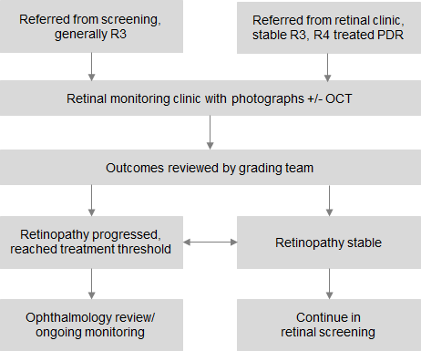

Pathway/protocol for maculopathy screen-positive patients within a proposed retinal monitoring service
The aim of this clinic is to effectively triage those patients with suspected diabetic maculopathy who have to be referred from the screening programme. Many such patients do not necessarily need to see an ophthalmologist because they have been referred with ‘suspected’ maculopathy, which initially needs to be assessed.

Following assessment with optical coherence tomography (OCT), people with:
- significant macular oedema should be referred on to an ophthalmologist for them to review treatment options
- no oedema on OCT should be referred back to diabetic retinal screening
- minimal maculopathy (not requiring treatment) should be kept under monitoring review with OCT until such time as they need treatment or there is any change to their condition.

These algorithms can be incorporated into a retinal monitoring programme that monitors R3 disease.

Figure B: Proposed retinal monitoring macular pathway
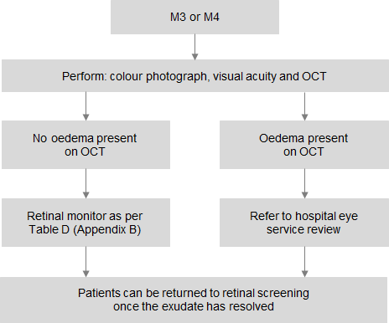

Appendix D: Case Study – Wellington Region Diabetic Retinal Screening and Monitoring
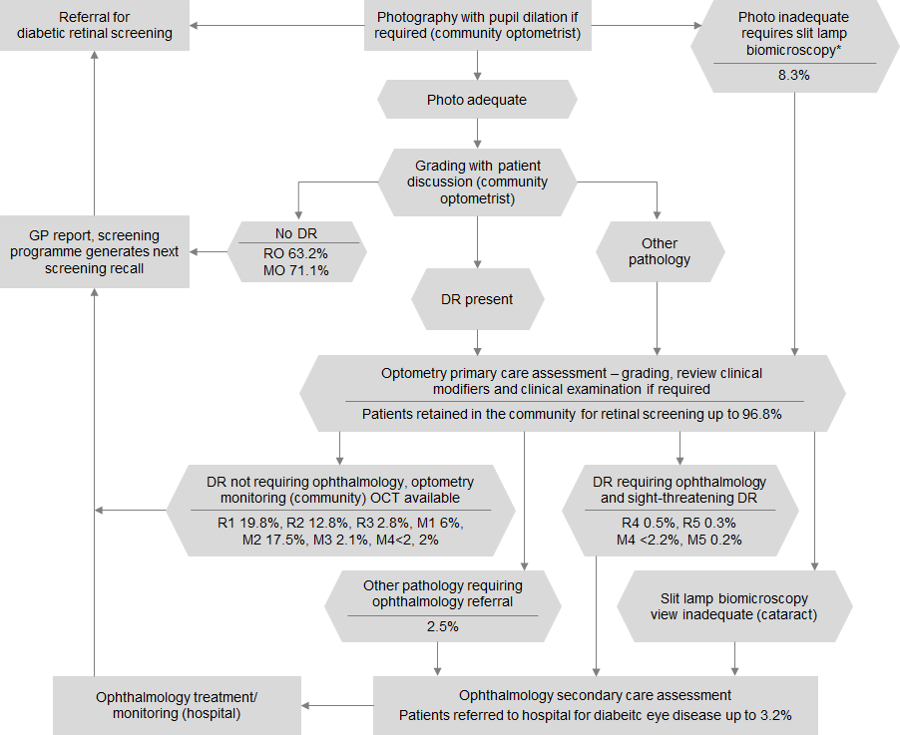
* Includes slit lamp biomicroscopy for assessment of macular oedema and peripheral retinal examination (Capital & Coast, Hutt Valley and Wairarapa DHBs 1 July 2014 to 30 June 2015 percentages per 10,000 screens).

Patient journey
A patient is diagnosed with diabetes or is known to have diabetes. A GP or GP nurse enters the patient’s information into the Wellington retinal screening database for Compass Health PHO and sends a referral form to the most conveniently located contracted community optometrist for the patient. The optometrist contacts the patient and arranges an appointment time that is suitable for the patient and explains the retinal screening process, including possible use of pupil dilation. Generally up to one hour is allocated for the appointment.

The patient attends the appointment; the optometrist reviews the GP/nurse referral form, measures the visual acuities and takes and grades the retinal photos. If the photos are inadequate, the optometrist performs a slit lamp biomicroscopy. The patient should have the opportunity to discuss the results with a health professional who can answer their questions. The patient’s whānau/support person can accompany them for the discussion of their results. The next retinal screening is scheduled or if referral to a hospital is required, this is discussed with the patient. A report is then sent to the GP who referred the patient and Compass Health PHO. The patient is screened within 90 days of referral to the hospital.

Screening programme overview
- In 2015, there were 291,630 patients enrolled with GPs in the Wellington region.
- The Wellington region diabetic retinal screening programme was established in December 2001.
- This programme won the supreme award in the Health Innovation Awards 2003.
- In 2012, about 17,860 of the region’s enrolled population were estimated to have diabetes and screening covered 92 percent of the population.
- There are nine community optometry sites located across the region in: Kapiti, Porirua, Wellington, Hutt Valley and the Wairarapa.
- The programme includes 23 optometrists with therapeutic pharmaceutical agents (TPA) endorsement and accreditation, 11 retinal cameras and 5 optical coherence tomographers (OCTs).
- Peer review takes place six times each year and is attended by optometrists, Wellington hospital ophthalmology registrars and lead ophthalmologist.
- The programme’s role as referral point from primary health care community screening to secondary health care hospital diabetic eye clinics has evolved from R2 or M2 (38 percent) to R4 or M4/M5 (1–3 percent).

Appendix E: Draft retinal screening indicators and measures
Reporting is expected for the following indicators by July 2017 for baseline indicators and by July 2018 for those indicators needing new data.

 | Indicator | Measure description
 | 1. Screened population demographic data | Intent  To determine the demographics of the population within the retinal screening programme.  Note  Standard Ministry of Health reporting, so can use existing definitions – age, gender, ethnicity, geo code and deprivation.
 | 2. Proportion of people with diabetes screened | Intent  - To ensure coverage of the population of people with diabetes.  - To determine the proportion of patients known to have diabetes who are screened regularly.  - To ensure there are no differences between populations (equity).  - To confirm that we are screening adequately.  - To report annually on screening coverage.  Rationale  To identify how well the population is covered and any gaps within those populations experiencing disparity and ensure population coverage.  Numerator  - The number of people with diabetes who have had a retinal screen within the last two years.  - The number of people with diabetes who have had a retinal screen within the last three years.  * With the change to three-yearly screening, we will need to look at screening at both two and three years.  Denominator  The number of people with diabetes enrolled in a primary health organisation (PHO) who live in a district health board (DHB) region, by lead DHB on the last day of the reporting period (reported at a patient level).  * For people enrolled in a cross-boundary PHO, DHB of domicile will determine the DHB area (reported at a patient level).  Notes  This needs to be at the DHB level and assumes DHBs will get the population with diabetes from the PHO register.  This is really a percentage of patients due to be screened. This is an annual reporting measure, and it depends on the enrolled population at the time of reporting.  All eligible people with diabetes should be screened, however, some may be under ophthalmology care or have co-morbidities preventing screening. It is expected that at least 90 percent of the population with diabetes PWD will be screened.
3. Timely assessment of risk for people newly diagnosed with type 2 diabetes |  | Intent  All people with the potential for DR should be screened within 90 days of referral.  Rationale  The wait time to the first screening reinforces the GP diagnosis and assessment process, and newly diagnosed people need to have a timely risk assessment.  Numerator  The number of people with type 2 diabetes 18 years of age and over screened within 90 days of referral.  Denominator  The number of people with type 2 diabetes 18 years of age and over receiving a new type 2 diabetes diagnosis within the past 12 months.  Notes  ‘Newly diagnosed’ relates to anyone in the previous calendar year. Screening programmes should be collecting the date or year of diagnosis.  People should be referred at diagnosis of type 2 diabetes or five years post-diagnosis of type 1 diabetes and screened within two months of receipt of referral.  Time to first screen depends on two factors: the referrer and the capacity/efficiency of the screening programme. If efficiency only is considered, then the wait time of interest is between receipt of referral and the actual screening date.  This indicator is aimed at people with type 2 diabetes as people with type 1 may be referred before their screening is due.
4. Proportion of sight-threatening DR at first presentation |  | Rationale  Understanding the condition of people at first screening and the proportion of people newly diagnosed with type 2 diabetes by retinal screening outcome grade at their first visit.  Intent  To show if early community detection of diabetes and early retinal screening will reduce the complications associated with sight-threatening retinal changes.  Numerator  The number of people with type 2 diabetes in a DHB area with diabetes diagnosed within the previous year who have sight-threatening DR on first screening (R3, R4, R5 or M3, M4, M5 in either eye).  Denominator  The number of people with type 2 diabetes diagnosed within the previous year in a DHB area.  Notes  ‘Newly diagnosed’ relates to anyone in the previous calendar year.  Screening programmes should be collecting the date or year of diagnosis.
 | 5. Assessment of screening process | Intent  To determine the proportion of patients whose images (in either eye) could not be reported because the image was not of acceptable quality or there were other clinical issues, such as cataracts or glaucoma.  Numerator  The number of people where a clinical assessment is required.  Denominator  The number of people screened in the programme.  Note  A clinical assessment is seen as an important step in obtaining the best possible retinal assessment.
 | 6. Outcome grades | a. No DR or maculopathy in either eye (only had grades R0, M0 as their outcome).  b. Had any DR in either eye (had outcome grades other than R0, M0 in either eye) – should match up with 1.  c. Had sight-threatening DR in either eye (had outcome grades of R3, R4, R5 or M3, M4, M5 in either eye).  d. Number of people with other eye diseases.  Numerator  The number of people with R0, R1, R2, R3, R4, R5 or M0, M1, M2, M3, M4, M5 or without DR.  Denominator  The number of people screened in the programme.  Notes  This data can allow flexible analysis.  All services should now be screening to the New Zealand 2006 guidelines for consistency.
 | 7. Retinal screening programme quality (additional DHB reporting) | Rationale  To understand if and how well people are being treated and ultimately prevent blindness.  Numerator  The number of people with diabetes seen in specialty ophthalmology.  Denominator  The number of people with diabetes, by DHB area, enrolled in a PHO.  Note  This is not the programme’s responsibility but an additional DHB report.
8. Validity measures (national or regional level, beyond the screening programme) |  | Intent  - Should be a national quality indicator (episodic) rather than being in screening programmes.  - Will include the entire pathway so that information should be supplied by ophthalmology departments for regional/national analysis.  Rationale  To determine if there is a drop in the rate of sight-threatening DR over time.  * This data would be used to benchmark the relevant programme against others around the country and internationally.  Indicator  - Sensitivity = (True positives)/(True Pos + False Neg)  - Specificity = (True Neg)/(True Neg + False Pos)  - Positive predictive value (PPV) = (True Pos)/(True Pos + False Pos).  Notes  There is a problem with getting the specificity measure since, if a patient has a negative result from screening, they don’t get a referral that would verify their screening result. It may be possible to commission research where patients with negative screening results are sampled for follow-up result verification.  Sensitivity and specificity are used internationally for benchmarking (International Council of Ophthalmology) but would likely be less frequently measured than PPV.  The best option would be to calculate PPV nationally for the country as a whole and for feedback DHBs.  False positive reporting would need to come via ophthalmology specialist services. This indicator should not be included in screening programme reporting but can be derived nationally.

References
Coppell K, Anderson K, Williams S, et al. 2011. The quality of diabetes care: a comparison between patients enrolled and not enrolled on a regional diabetes register. Primary Care Diabetes 131–7. DOI: 10.1016/j. pcd.2010.10.005.
DCCT. 1994. The effect of intensive treatment of diabetes on the development and progression of long-term complications in insulin-dependent diabetes mellitus. Retina 14(3): 286–7.
Donaghue K, Wadwa R, Dimeglio L, et al. 2014. Microvascular and macrovascular complications in children and adolescents. Pediatric Diabetes (15): 257–69. DOI: 10.1111.
Echouffo-Tcheugui J, Ali M, Roglic G, et al. 2013. Systematic review of meta-analysis screening intervals for diabetic retinopathy and incidence of visual loss: a systematic review. Diabetic Medicine 1272–92. DOI:10.111/ dme.12274.
Frederikson L, Jacobs R. 2008. Diabetes eye screening in the Wellington region of New Zealand: characteristics of the enrolled population. The New Zealand Medical Journal 131(1270): 21–34.
Javitt J, Aiello L. 1996. Cost-effectiveness of detecting and treating diabetic retinopathy. Annals of Internal Medicine 124: 164–9. DOI: 10.7326/0003-4819-124.
Kaziwe M, Sanders D, Kugelberg M, et al. 2013. A population-based study of the risk of diabetic retinopathy in patients with type 1 diabetes and celiac disease. Diabetes Care (36): 316–21.
Klein R, Klein B, Moss S, et al. 1994. Relationship of hyperglycemia to the long-term incidence and progression of diabetic retinopathy. JAMA Internal Medicine 154(19): 2169–78. DOI: 10.1001/archinte.1994.00420190068008 (accessed 25 February 2016).
Looker H, Nyangoma S, Cromie D, et al. 2013. Predicted impact of extending the screening interval for diabetic retinopathy: the Scottish Diabetic Retinopathy Screening programme. Diabetologia (56): 1716–25. DOI: 10.1007/ s00125-013-2928-7 (accessed 25 February 2016).
Ministry of Health. 2007. National Diabetes Retinal Screening Grading System and Referral Guidelines (2006) and Resources (2008). Wellington: Ministry of Health.
Ministry of Health. 2008. National Diabetes Retinal Screening Grading System and Referral Guidelines 2006. Wellington: Ministry of Health.
Ministry of Health. 2014a. Quality Standards for Diabetes Care. Wellington: Ministry of Health.
Ministry of Health. 2014b. Screening, Diagnosis and Management of Gestational Diabetes in New Zealand: A clinical practice guideline. Wellington: Ministry of Health.
Ministry of Health.2015. Living Well with Diabetes: A plan for people at high risk of or living with diabetes 2015– 2020. Wellington: Ministry of Health.
National Health Committee. 2003. Screening to Improve Health in New Zealand: Criteria to assess screening programmes. Wellington: National Health Committee. URL: https://nhc.health.govt.nz/system/files/documents/ publications/ScreeningCriteria.pdf (accessed 19 January 2016).
New Zealand Guidelines Group. 2012. New Zealand Primary Care Handbook 2012. 3rd ed. Wellington: New Zealand Guidelines Group.
Nwanyanwu K, Wrobel J, Talwar N, et al. 2013. Predicting development of proliferative diabetic retinopathy. Diabetes Care (36): 1562–68. DOI: 10.2337/dc12-0790 (accessed 25 February 2016).
Ohkubo Y, Kishikawa H, Araki E, et al. 1995. Intensive insulin therapy prevents the progression of diabetic microvascular complications in Japanese patients with non-insulin-dependent diabetes mellitus: a randomized prospective 6-year study. Diabetes Research and Clinical Practice 28(2): 103–17. DOI: 10.1016/0168-8227(95)01064-K (accessed 25 February 2016).
Papali’i-Curtin A, Dalziel D. 2013. Prevalence of diabetic retinopathy and maculopathy in Northland, New Zealand: 2011–2012. NZ Med J 126(1383): 20–8.
UKPDS. 1998. Intensive blood-glucose control with sulphonylureas or insulin compared with conventional treatment and risk of complications in patients with type 2 diabetes (UKPDS 33). The Lancet 352(9131): 837–53. DOI: 10.1016/S0140-6736(98)07019-6 (accessed 25 February 2016).
UKPDS. 1998b. Tight blood pressure control and risk of macrovascular and microvascular complications in type 2 diabetes (UKPDS 38). BMJ 317(7160): 703–13.
Wong T, Hernandez-Medina M, Mwamburi M, et al. 2009. Rates of progression in diabetic retinopathy during different time periods. Diabetes Care 2307–13. DOI: 10.2337/dc09-0615 (accessed 25 February 2016).

Screening is defined by the National Health Committee as ‘a health service in which members of a defined population, who do not necessarily perceive they are at risk of, or are already affected by, a disease or its complications, are asked a question or offered a test to identify those individuals who are more likely to be helped than harmed by further tests or treatments to reduce the risk of disease or its complications’ (National Health Committee 2003, page 29).
Retinal monitoring for the purposes of this guidance is defined as increased surveillance of the progress, or otherwise, of established DR.
Optical coherence tomography (OCT) is a non-invasive imaging technology that has been compared to ultrasound. It uses light waves rather than sound waves to take cross-sectional images of the transparent layers of the retina to a resolution of up to 15 microns (a human hair is 40 to 120 microns thick). OCT imaging provides diagnostic and treatment guidance for disorders of the retina, such as DR, macular degeneration and glaucoma.
A near miss is any incident that is prevented before it had the potential to cause harm.

