

National Bowel Screening

Programme Monitoring Report

January 2018 to December 2022

Citation: Health New Zealand | Te Whatu Ora. 2023. *National Bowel Screening Programme Monitoring Report*. Wellington: Health New Zealand | Te Whatu Ora.

Published in October 2024 by Health New Zealand | Te Whatu Ora  
PO Box 5013, Wellington 6140, New Zealand

ISBN 978-1-991139-09-2 (online)

This document is available at [tewhatuora.govt.nz](https://www.tewhatuora.govt.nz/)

|  |  |
| --- | --- |
| **CCBY** | This work is licensed under the Creative Commons Attribution 4.0 International licence. In essence, you are free to: share ie, copy and redistribute the material in any medium or format; adapt ie, remix, transform and build upon the material. You must give appropriate credit, provide a link to the licence and indicate if changes were made. |

# Foreword

We are delighted to publish this first monitoring report for the National Bowel Screening Programme (NBSP). The programme offers a single faecal immunochemical test (FIT), to eligible New Zealanders aged 60-74 years. Eligible New Zealanders are invited every two years from a population register and this is an opt-off programme. The national roll out was completed in May 2022 when the Hauora a Toi Bay of Plenty District went live. Health professionals involved in delivering the NBSP have access to a series of indicator reports that allow them to monitor the performance of the programme in their district and compare this with national data. This report is to inform other health professionals and the public about the performance of the NBSP. It aims to provide reassurance that the programme will deliver the anticipated mortality benefit, is being appropriately monitored and, where performance concerns have been identified, appropriate initiatives to address these have been implemented.

I am very happy to report that over 2000 bowel cancers have now been detected by the programme with at least two thirds of these being earlier stage (stage 1 and 2). The increased proportion of stage 1 bowel cancers, over 37% compared with 11% for those diagnosed with bowel cancer as a result of symptoms, means lives are being saved and the toll of this disease for individuals and families has been significantly reduced. However, the programme as currently structured does not deliver equitable benefit to all. To address this, on the recommendations of our invaluable advisory groups and NBSP Māori and Pacific Networks, new initiatives are underway including introduction of the community invitation campaign strategy (CICS) functionality in the register.

I want to thank my National Public Health Service colleagues, in particular Mandy Mackay, Manager Screening Insights, and Dr Bronwyn Rendle, Public Health Physician, for their enormous contribution in bringing this first monitoring report to fruition. The programme results reflect the commitment of so many people across the country and this makes it a real privilege to be the clinical lead of this programme.

Ngā mihi nui,

Dr Susan Parry

Clinical Lead NBSP, Te Whatu Ora

Contents

Foreword 3

Executive summary 7

Introduction 9

National Bowel Screening Programme 9

Purpose of this report 9

Districts 10

A focus on equity 11

COVID-19 impact 11

Data sources 12

Eligibility 12

Reporting lags 13

Programme monitoring 14

Invitation coverage (100) 14

Participation (200) 18

Positivity (204) 23

Spoilt kits (206) 27

Definitive spoilt kit rate (207) 31

Positive Predictive Value (PPV) (300) 34

Timeliness of initial contact for pre-assessment (303) 50

Preliminary interval cancer rate and sensitivity 52

Diagnostic assessment completion rate (305) 54

Timeliness of actual diagnostic assessment (colonoscopy wait time) (307) 57

Referral rate to diagnostic assessment following positive FIT (308) 59

Colorectal cancer (CRC) stage at diagnosis (402) 62

NBSP quality assurance 66

National colonoscopist quality assurance report 67

Unplanned admission rate 70

Figure 1: NBSP Invitation Coverage in the two years ending December 2019, 2020, 2021, 2022 by Ethnicity 15

Figure 2: NBSP Invitation Coverage in the two years ending December 2019, 2020, 2021, 2022 by Age Group 16

Figure 3: NBSP Invitation Coverage in the two years ending December 2019, 2020, 2021, 2022 by Gender 17

Figure 4: NBSP Participation in the two years ending December 2019, 2020, 2021, 2022 by Ethnicity 19

Figure 5: NBSP Participation in the two years ending December 2019, 2020, 2021, 2022 by Age Group 20

Figure 6: NBSP Participation in the two years ending December 2019, 2020, 2021, 2022 by Gender 21

Figure 7: NBSP Participation in the two years ending December 2019, 2020, 2021, 2022 by Deprivation Quintile 22

Figure 8: NBSP Positivity Rate by Ethnicity, 2018 - 2022 24

Figure 9: NBSP Positivity Rate by Age Group, 2018 – 2022 25

Figure 10: NBSP Positivity Rate by Gender, 2018 – 2022 26

Figure 11: NBSP Positivity Rate by Screening History, 2018 – 2022 26

Figure 12: NBSP Spoilt Kit Rate by Ethnicity, 2018 – 2022 28

Figure 13: NBSP Spoilt Kit Rate by Age Group, 2018 – 2022 29

Figure 14: NBSP Spoilt Kit Rate by Gender, 2018 – 2022 30

Figure 15: NBSP Definitive Spoilt Kit Rate, by Ethnicity, 2018 – 2022 32

Figure 16: NBSP Definitive spoilt Kit Rate by Age Group, 2018 – 2022 33

Figure 17: NBSP Definitive Spoilt Kit Rate by Gender, 2018 – 2022 34

Figure 18: NBSP PPV for Cancer by Ethnicity, 2018 – 2022 36

Figure 19: NBSP PPV for Cancer by Age Group, 2018 – 2022 37

Figure 20: NBSP PPV for Cancer by Gender, 2018 – 2022 38

Figure 21: NBSP PPV for Cancer by Screening History, 2018 – 2022 38

Figure 22: NBSP PPV for Advanced Adenoma by Ethnicity, 2018 – 2022 39

Figure 23: NBSP PPV for Advanced Adenoma by Age Group, 2018 – 2022 40

Figure 24: NBSP PPV for Advanced Adenoma by Gender, 2018 – 2022 41

Figure 25: NBSP PPV for Advanced Adenoma by Screening History, 2018 – 2022 42

Figure 26: NBSP PPV of Adenoma by Ethnicity, 2018 – 2022 43

Figure 27: NBSP PPV of Adenoma by Age Group, 2018 – 2022 44

Figure 28: NBSP PPV of Adenoma by Gender, 2018 – 2022 45

Figure 29: NBSP PPV of Adenoma by Screening History, 2018 – 2022 46

Figure 30: NBSP PPV of No Biopsy by Ethnicity, 2018 – 2022 47

Figure 31: NBSP PPV of No Biopsy by Age Group, 2018 – 2022 48

Figure 32: NBSP PPV of No Biopsy by Gender, 2018 – 2022 49

Figure 33: NBSP PPV of No Biopsy by Screening History, 2018 – 2022 49

Figure 34: NBSP Timeliness of Initial Contact for Pre-Assessment by Ethnicity, 2018 - 2022 51

Figure 35: NBSP Diagnostic Assessment Completion by Ethnicity, 2018 – 2022 55

Figure 36: Diagnostic Assessment Completion by Gender, 2018 - 2022 56

Figure 37: NBSP Timeliness of Actual Diagnostic Assessment (Colonoscopy Wait Time) by Ethnicity, 2018 – 2022 58

Figure 38: NBSP Referral Rate to Diagnostic Assessment Following Positive FIT by Ethnicity, 2018 – 2022 60

Figure 39: NBSP Colorectal Cancer Stage at Diagnosis, by Ethnicity, 2018 – 2022 63

Figure 40: NBSP Colorectal Cancer Stage at Diagnosis by Age Group, 2018 - 2022 64

Figure 41: NBSP Colorectal Cancer Stage at Diagnosis by Gender, 2018 - 2022 65

# Executive summary

This is the first monitoring report for the NBSP. It presents key indicators from across the screening pathway and shows how the programme has performed in its first five calendar years. This report helps providers, policy makers and the public to understand how well bowel screening is working, areas for improvement and if the programme is likely to deliver the expected benefits of reducing the impact of bowel cancer.

Covering the period from 1 January 2018 to 31 December 2022, the number of districts offering bowel screening grew from three to twenty. With all areas of Aotearoa New Zealand participating by May 2022, data represents all parts of the country. During that period, 668,456 kits were returned for testing and had a definitive result. There were 27,753 that received a positive result and 23,493 people received a colonoscopy in the screening programme. There were 1,731 people diagnosed with cancer.

The indicators show that the programme is detecting bowel cancers and detecting them at an early stage. Over a third of cancers detected in the programme are identified at stage 1 (37.4%), where bowel cancer has a much greater chance of being successfully treated compared to later stages and hence a higher survival rate. This benefit is seen for Māori participating in the programme, where 36.4% of cancers are at stage 1.

Delivering on the goal and responsibility to equitably reach participants from priority groups remains unachieved within the programme. Participation for Māori was 49.6% at the end of 2022 and 40.0% for Pacific Peoples. This is compared to 62.6% for Other participants, those identified as non-Māori, non-Pacific, non-Asian. The current programme structure does not support equitable access and hence equitable benefit for Māori and Pacific peoples and addressing this is an ongoing key focus. Multiple factors have contributed to this including the single service delivery model and the programme age range. The difficulties accessing the programme are also reflected in the higher spoilt kit rates among Māori, Pacific and Asian participants. Definitive spoilt kit rates, where a participant returned a spoilt kit but couldn’t be supported to subsequently return a definitive kit, increased in 2022 and were highest for Pacific (3.6%), Māori (2.6%) and Asian participants (2.7%) compared to 1.7% for other participants.

The performance of the screening test is at an expected level. The overall positivity rate was 3.9% at the end of 2022. Positivity over time and by screening round, age and sex follows predictable patterns, with higher rates seen in the first round of screening, in older age groups and for men. There are also differences by ethnicity, with Pacific and Māori participants more likely to have a positive test. The overall positive predictor value (PPV) for bowel cancer in the programme is 7.8%, which means that around eight out of every 100 people with a positive test who has a colonoscopy in the programme will have a cancer detected. Māori and Pacific participants have had a consistently lower PPV than other participants over the five monitored years. The provisional prevalent interval cancer rate (14.8 per 10,000 definitive screens) and FIT sensitivity for colorectal cancer (CRC) (71.8%, CI 67.0-76.1) shows the NBSP is within the range of similar bowel cancer screening programmes internationally and the bowel screening pilot where the overall FIT sensitivity for CRC was 78.7% (95% CI=74.9% to 82.1%)[1] . As the programme completes the first and second screening rounds in all districts, more data will be available to be analysed to help better understand the performance of the screening test for all populations in the context of changing bowel cancer epidemiology.

Challenges in ensuring timely access to colonoscopies remain, particularly as health services continue to recover from the COVID-19 pandemic. The NBSP colonoscopy wait time indicator (CWTI) however was above the target of 90% of participants having a diagnostic procedure within 60 days of a positive FIT test in 2021 and 2022 after being below this for the two years during the pandemic. There is inequity of timely access for Māori and Pacific. However, assessment completion rates are higher for Māori and Pacific compared to other groups.

The benefits of the NBSP will begin to be fully realised once all districts have completed their first screening round (June 2024). The monitoring indicators reported indicate that in due course the anticipated mortality benefit will be achieved.

# Introduction

## National Bowel Screening Programme

The goal of population-based cancer screening programmes is to reduce morbidity and mortality from cancer by finding cancers at an earlier, more treatable stage. Bowel screening can also find polyps that can be removed, reducing the risk that bowel cancer will develop. Early detection can reduce the chances of dying from, and the impact of, colorectal cancer at both an individual and societal level. This is particularly pertinent in Aotearoa New Zealand, which has high rates of colorectal cancer compared with other Organisation for Economic Co-operation and Development (OECD) countries (Shaw et al 2008).

The bowel screening pilot started screening Waitematā DHB residents aged 50 to 74 years in January 2012 after an initial trial of 500 in November 2011. The purpose of the BSP was to test the feasibility of rolling out a National Bowel Screening Programme (the NBSP).

The NBSP officially began in July 2017, offering free screening to New Zealanders aged 60 to 74 on a two-yearly cycle. Wairarapa DHB and Hutt Valley DHB were the first DHBs to join the national programme, with national roll-out to all districts in Aotearoa New Zealand completed by May 2022.

## Purpose of this report

Ongoing, systematic monitoring against performance indicators is one of a range of systems that national screening programmes use to ensure they are working well.

This NBSP monitoring report covers 1 January 2018 to 31 December 2022, the first five calendar years of the programme. It is the first monitoring report published about the programme. This report has been written with a technical audience in mind; in particular professional groups involved in the delivery of the NBSP. Future NSBP reports will provide more comprehensive, equity-focused monitoring data as all districts complete a full round of screening (two years).

This report shows indicators from key steps in the clinical pathway of the NBSP. The programme has a larger set of indicators which are regularly reviewed by clinical and operational staff to ensure a safe, effective, and equitable screening programme. Also included in this report are provisional sensitivity and interval cancer rates and colonoscopy quality assurance reports.

## Districts

Waitematā District hosted the bowel screening pilot from January 2012 and became part of the national programme in January 2018. The programme has been progressively rolled out across the country since July 2017. The table below shows the date each district (formerly district health boards or DHBs) joined the NBSP. As of December 2022, six districts were still in their first screening round.

Table 1: Dates districts joined the NBSP (in chronological order)

|  |  |
| --- | --- |
| District | Date district joined NBSP |
| Hutt Valley* | July 2017 |
| Wairarapa* | July 2017 |
| Waitematā* | January 2018 |
| Southern* | April 2018 |
| Counties Manukau* | July 2018 |
| Nelson Marlborough* | August 2018 |
| Hawke’s Bay* | October 2018 |
| Lakes* | February 2019 |
| Whanganui* | October 2019 |
| MidCentral* | November 2019 |
| Tairāwhiti* | August 2020 |
| South Canterbury* | October 2020 |
| Canterbury* | October 2020 |
| Auckland* | November 2020 |
| Waikato | March 2021 |
| Capital and Coast | April 2021 |
| West Coast | May 2021 |
| Taranaki | August 2021 |
| Northland | November 2021 |
| Bay of Plenty | May 2022 |

*Districts that had completed one round (24 months) of screening as of December 2022.

## A focus on equity

Equity is an essential component of a quality screening programme (National Screening Unit, 2015). This includes equity of access to the bowel screening programme and equity of care throughout the screening pathway. Priority populations for the bowel screening programme include Māori and Pacific Peoples and people living in the most deprived areas (NZ Deprivation Index deciles 9 and 10).

The NBSP works hard to increase the accessibility for priority populations, in particular Māori and Pacific participants, in the following ways.

* Districts actively engaging with communities through iwi, church and cultural networks.
* Enabling priority participants to have immediate access to screening as soon as it is available in their area.
* The National Coordination Centre actively following-up invitations when there has been no response, with phone calls and texts, including after hours.
* Outreach services, where districts reach out to people locally through text, calls and face to face visits.
* Trialling a system where people can drop off completed tests at labs rather than return them through the postal service.
* Convening Māori and Pacific networks.
* Television and social media campaigns to encourage increased awareness of the programme for Māori and Pacific.
* In 2023, the evaluation of age range extension to 50 years for Māori and Pacific Peoples in three districts.
* Introduction of the community invitation campaign strategy (CICS) functionality in the register.

Throughout this report, indicators are assessed by ethnicity, age, gender, deprivation, and screening history where relevant.

## COVID-19 impact

Due to the COVID-19 pandemic, NBSP invitations were paused for three months from late March to late June 2020. Hawke’s Bay DHB paused invitations for a further three-month period (six months in total). The impact of the invitation pause can be seen from March 2020 onwards (when invitation coverage was around 80%) down to a low of 53.2% in April 2021. By December 2022, invitation coverage had increased again to 88.8%.

A decrease in participation coverage (kits returned as a proportion of kits sent) has been seen since the pandemic began (from 62.2% in March 2020 to 59.0% in October 2022). The impact of the COVID-19 pandemic has been greatest for Māori. There has been less impact for Pacific Peoples, however participation for Pacific Peoples was low prior to the pandemic.

# Data sources

Bowel screening data is sourced from the NBSP data warehouse. The data warehouse combines data from the previous BSP+ register and the new Bowel Screening Register (BSR), allowing for reporting across both registers. Data for this report was sourced on 04/09/2023.

Population data is sourced from Statistics New Zealand and this report uses the 2022 update of the 2018 census.

This report uses the University of Otago’s NZDep index as an indicator of socio-economic deprivation. The NZDep index estimates the relative deprivation of an area using census data relating to income, home ownership, employment, qualifications, family structure, housing, access to transport and communications. Quintile 1 is the least deprived and quintile 5 is the most deprived.

The NBSP develops a database of eligible people through matching information stored in the National Health Index database (the NHI), including National Enrolment Service (NES) data. This data is then matched against healthcare events over the last three years to ensure the person is currently active in the Aotearoa New Zealand healthcare system. Ethnicity for this report is sourced from NHI records.

The Ministry of Health | Manatū Hauora does not have a database showing every person who may be in the country at any one time, and their current address. Statistics New Zealand uses census data to predict population volumes in a particular region by age, but this information is an estimate and can be used only as a guide.

Additional data for the interval cancer and sensitivity analysis was sourced from the New Zealand Cancer Registry on 22/04/2022. Additional data for the National Colonoscopist Quality Assurance report came from Provation Colonoscopy Database (PVCD) on 20/02/2023 and colonoscopy volume data for the Unplanned Admissions Report came from the National Bowel Screening Colonoscopy Quality Assurance report on 08/03/2023.

## Eligibility

Bowel screening is for people aged 60 to 74 years who are eligible for publicly funded health care. However, bowel screening is not right for everyone, and so those invited are advised not to take part if they:

* have symptoms of bowel cancer
* have had a colonoscopy within the last five years
* are on a bowel polyp or bowel cancer surveillance programme
* have had, or are currently being treated for, bowel cancer
* have had their large bowel removed
* have ulcerative colitis or Crohn’s disease that is currently active
* are seeing a doctor about bowel problems.

An eligible population is drawn from the NHI (described above). The register matches against the New Zealand Cancer Registry to ensure that people who have been diagnosed with bowel cancer in Aotearoa New Zealand are not invited to screen. At this point in time there are no data sources available to identify other reasons why someone should not participate in screening. This includes eligibility for publicly funded healthcare. However, individuals can contact the programme to update their status.

## Reporting lags

Many indicators have a reporting lag, where there needs to be a delay before rates can be calculated for a given period. The lag duration is variable depending on the nature of the indicator. For example, there is a time lag for participation as once FIT kits are sent out, participants have six months to complete and return the kit. Therefore reporting on this indicator requires the six months to elapse.

All indicators in this report are calculated after appropriate lag periods.

# Programme monitoring

Monitoring safety and performance is a critical factor in all national screening programmes. The NBSP has a set of programme performance indicators; some of these are monitored on a frequent basis (monthly / quarterly) while others are more appropriately reviewed on a less frequent basis (annual / biannual). Programme safety monitoring, including fail safe monitoring, occurs as part of the operational delivery and monitoring of the programme and is also essential to ensure all participants progress through the pathway as expected. This report shows indicators from key steps in the clinical pathway of the NBSP. Also included in this report are provisional NBSP sensitivity and interval bowel cancer rates and NBSP colonoscopy quality assurance reports.

## Invitation coverage (100)

An important measure of any screening programme is its ability to invite the eligible target population. The bowel screening programme aims to invite anyone aged 60-74 years who is eligible for publicly funded healthcare to take a bowel screening test, every two years. This means that approximately half of the eligible population is invited in one year, and the other half is invited the following year. Because the NBSP invites most participants back every two years, coverage counts invitations over two-year periods. The coverage reporting period is a rolling two-year period up to the reporting end date. Districts will be included if they were live at that reporting end date. This means that the indicator includes districts at different stages of roll out.

#### Indicator 100: Invitation Coverage

|  |
| --- |
| **Target:** 100% of the eligible population is invited to screen. |
| **Numerator:** The number of eligible people who were invited to screen in the reporting period. Spoilt kits are excluded from the numerator. |
| **Denominator:** The number of people in the population estimates in districts which were live at the end of each two-year period. |
| **Anchor date:** The date when a kit was sent determines which time period it is counted under. |

#### Comments

As each district rolled out the first round of the programme this indicator was initially useful to see progress as more and more of the register eligible population was invited.

As the national roll out nears completion, this indicator is more relevant for highlighting national data quality issues affecting different population groups. There is a numerator-denominator mismatch in the way the register and the census have captured ethnicity. Harris et al[2] have described the misclassification of Māori as non-Māori in the NHI resulting in a net under-count for Māori. This means that the programme has limitations in its ability to measure, understand, and act on inequities in the programme and deliver as a Te Tiriti partner. For Pacific Peoples, there is underrepresentation in population estimates such as the census[3]. These two different data issues result in the different invitation coverage patterns for Māori and Pacific Peoples.

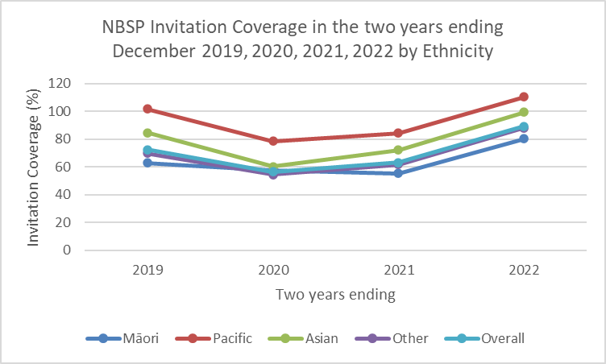

Figure 1: NBSP Invitation Coverage in the two years ending December 2019, 2020, 2021, 2022 by Ethnicity

Table 2: NBSP Invitation Coverage in the two years ending December 2019, 2020, 2021, 2022 by Ethnicity

|  |  |  |  |  |  |
| --- | --- | --- | --- | --- | --- |
| **Ethnicity** | | **2019** | **2020** | **2021** | **2022** |
| **Māori** | **Numerator** | 19290 | 25495 | 38584 | 64940 |
| **Denominator** | 30778 | 44151 | 69824 | 80856 |
| **Percentage** | 62.7 | 57.7 | 55.3 | 80.3 |
| **Pacific** | **Numerator** | 16893 | 18983 | 24880 | 34579 |
| **Denominator** | 16622 | 24204 | 29488 | 31354 |
| **Percentage** | 101.6 | 78.4 | 84.4 | 110.3 |
| **Asian** | **Numerator** | 33637 | 37875 | 54151 | 79268 |
| **Denominator** | 39737 | 63008 | 75142 | 79743 |
| **Percentage** | 84.6 | 60.1 | 72.1 | 99.4 |
| **Other** | **Numerator** | 184740 | 217186 | 333878 | 512893 |
| **Denominator** | 264486 | 398839 | 542335 | 582728 |
| **Percentage** | 69.8 | 54.5 | 61.6 | 88 |
| **Overall** | **Numerator** | 254560 | 299539 | 451493 | 691680 |
| **Denominator** | 351623 | 530202 | 716789 | 774681 |
| **Percentage** | 72.4 | 56.5 | 63 | 89.3 |

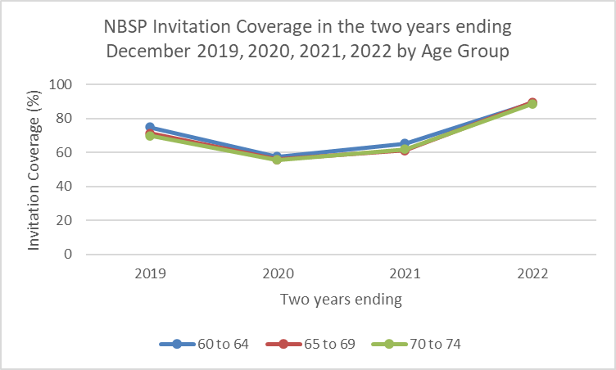

Figure 2: NBSP Invitation Coverage in the two years ending December 2019, 2020, 2021, 2022 by Age Group

Table 3: NBSP Invitation Coverage in the two years ending December 2019, 2020, 2021, 2022 by Age Group

|  |  |  |  |  |  |
| --- | --- | --- | --- | --- | --- |
| **Age Group** | | **2019** | **2020** | **2021** | **2022** |
| **60-64** | **Numerator** | 103396 | 119881 | 183479 | 272239 |
| **Denominator** | 137599 | 208332 | 281170 | 304733 |
| **Percentage** | 75.1 | 57.5 | 65.3 | 89.3 |
| **65-69** | **Numerator** | 82814 | 97443 | 144428 | 229422 |
| **Denominator** | 116225 | 174294 | 235885 | 255758 |
| **Percentage** | 71.3 | 55.9 | 61.2 | 89.7 |
| **70-74** | **Numerator** | 68350 | 82215 | 123586 | 190019 |
| **Denominator** | 97799 | 147576 | 199734 | 214190 |
| **Percentage** | 69.9 | 55.7 | 61.9 | 88.7 |

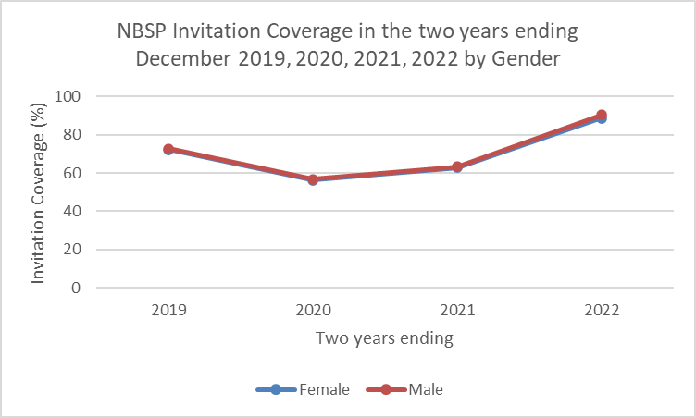

Figure 3: NBSP Invitation Coverage in the two years ending December 2019, 2020, 2021, 2022 by Gender

Table 4: NBSP Invitation Coverage in the two years ending December 2019, 2020, 2021, 2022 by Gender

|  |  |  |  |  |  |
| --- | --- | --- | --- | --- | --- |
| **Gender** | | **2019** | **2020** | **2021** | **2022** |
| **Female** | **Numerator** | 130840 | 153820 | 231803 | 354948 |
| **Denominator** | 181238 | 273180 | 369715 | 401208 |
| **Percentage** | 72.2 | 56.3 | 62.7 | 88.5 |
| **Male** | **Numerator** | 123720 | 145719 | 219690 | 336732 |
| **Denominator** | 170385 | 257022 | 347074 | 373473 |
| **Percentage** | 72.6 | 56.7 | 63.3 | 90.2 |

## Participation (200)

Participation is an important indicator of how well the programme is reaching its target population. Participation is defined as the percentage of people with a definitive test (positive or negative FIT) out of all those who were invited by the programme. As the bowel screening programme invites participants back every two years, participation counts invitations over a two-year period.

Bowel screening uses participation to measure access to the programme. Other screening programmes use coverage, where the denominator is based on the age specific census population. There are two key reasons for this. The NBSP was the first national screening programme to have a population register to provide this information. It also means that as the programme has been rolled out district-by-district, each over a two year, adjustments do not need to be made for the proportion of the population that has been invited. There are benefits and limitations of both approaches due to accuracy of national data sets and numerator-denominator mismatch.

The NBSP target is to screen 60% of the population (60-74 year olds) every two years. The NBSP has set a participation target of 60%. This target was determined based on international findings, the results of the bowel screening pilot and from analyses estimating possible reductions in bowel cancer mortality and bowel cancer incidence. The programme target is higher than the European guidelines[4] minimum uptake recommendation, which states 45% participation is acceptable.

#### Indicator 200: Participation

|  |
| --- |
| **Target:** 60% of eligible people invited return a completed FIT kit. |
| **Numerator:** The number of eligible people who have returned a FIT kit with a definitive result during the reporting period. |
| **Denominator:** The number of eligible people invited to screen during each two-year period. |
| **Anchor date:** The date when a kit was sent determines which time period it is counted under. |

#### Comments

Delivering on the goal and responsibility to equitably reach participants from priority groups remains unachieved within the programme. Participation for Māori was 49.6% at the end of 2022 and for Pacific Peoples it was 40.0%. The participation rate was 48.3% for Asian participants. This is compared to 62.6% for Other participants, those identified as non-Māori, non-Pacific, non-Asian. The current programme structure does not support equitable access and hence equitable benefit for Māori, Pacific Peoples and Asian participants - addressing this is an ongoing key focus. Multiple factors have contributed to this including the single service delivery model and the programme age range. Achieving equity of access and equity of benefit remains an ongoing key priority for the programme with ongoing monitoring.

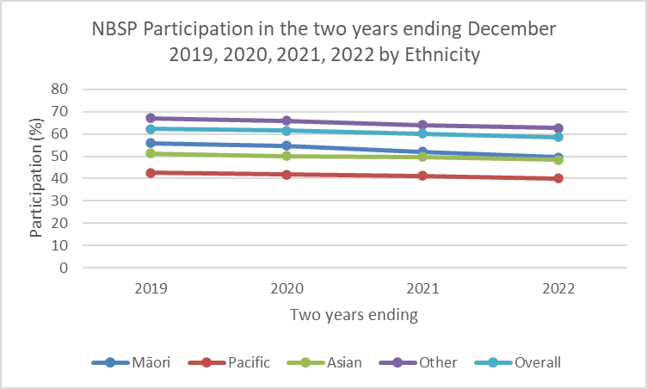

Figure 4: NBSP Participation in the two years ending December 2019, 2020, 2021, 2022 by Ethnicity

Table 5: NBSP Participation in the two years ending December 2019, 2020, 2021, 2022 by Ethnicity

|  |  |  |  |  |  |
| --- | --- | --- | --- | --- | --- |
| **Ethnicity** | | **2019** | **2020** | **2021** | **2022** |
| **Māori** | **Numerator** | 11095 | 14391 | 20651 | 33362 |
| **Denominator** | 19795 | 26278 | 39711 | 67265 |
| **Percentage** | 56.0 | 54.8 | 52 | 49.6 |
| **Pacific** | **Numerator** | 7463 | 8229 | 10589 | 14300 |
| **Denominator** | 17513 | 19679 | 25619 | 35768 |
| **Percentage** | 42.6 | 41.8 | 41.3 | 40.0 |
| **Asian** | **Numerator** | 17474 | 19267 | 27613 | 39462 |
| **Denominator** | 34103 | 38466 | 55432 | 81673 |
| **Percentage** | 51.2 | 50.1 | 49.8 | 48.3 |
| **Other** | **Numerator** | 130472 | 151512 | 226797 | 343465 |
| **Denominator** | 194404 | 229455 | 353830 | 548714 |
| **Percentage** | 67.1 | 66 | 64.1 | 62.6 |
| **Overall** | **Numerator** | 167199 | 193619 | 285650 | 430589 |
| **Denominator** | 268394 | 314961 | 474613 | 733423 |
| **Percentage** | 62.3 | 61.5 | 60.2 | 58.7 |

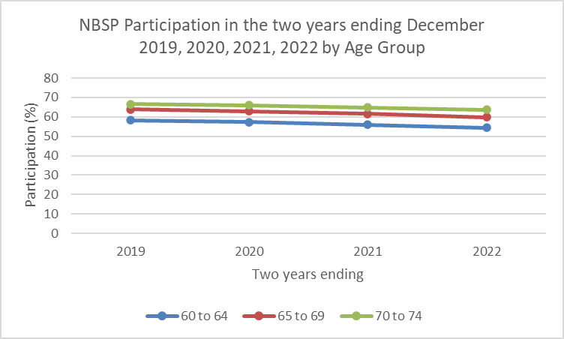

Figure 5: NBSP Participation in the two years ending December 2019, 2020, 2021, 2022 by Age Group

Table 6: NBSP Participation in the two years ending December 2019, 2020, 2021, 2022 by Age Group

|  |  |  |  |  |  |
| --- | --- | --- | --- | --- | --- |
| **Age Group** | | **2019** | **2020** | **2021** | **2022** |
| **60-64** | **Numerator** | 63668 | 74896 | 110415 | 164776 |
| **Denominator** | 109403 | 130618 | 197463 | 302453 |
| **Percentage** | 58.2 | 57.3 | 55.9 | 54.5 |
| **65-69** | **Numerator** | 52209 | 60166 | 87172 | 133386 |
| **Denominator** | 81857 | 95659 | 141483 | 222806 |
| **Percentage** | 63.8 | 62.9 | 61.6 | 59.9 |
| **70-74** | **Numerator** | 51322 | 58557 | 88063 | 132427 |
| **Denominator** | 77134 | 88684 | 135667 | 208164 |
| **Percentage** | 66.5 | 66 | 64.9 | 63.6 |

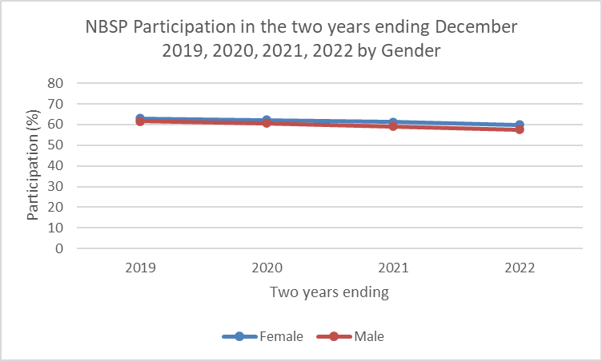

Figure 6: NBSP Participation in the two years ending December 2019, 2020, 2021, 2022 by Gender

Table 7: NBSP Participation in the two years ending December 2019, 2020, 2021, 2022 by Gender

|  |  |  |  |  |  |
| --- | --- | --- | --- | --- | --- |
| **Gender** | | **2019** | **2020** | **2021** | **2022** |
| **Female** | **Numerator** | 86614 | 100413 | 149093 | 225268 |
| **Denominator** | 137619 | 161420 | 243587 | 376310 |
| **Percentage** | 62.9 | 62.2 | 61.2 | 59.9 |
| **Male** | **Numerator** | 80520 | 93135 | 136447 | 205167 |
| **Denominator** | 130627 | 153335 | 230724 | 356612 |
| **Percentage** | 61.6 | 60.7 | 59.1 | 57.5 |

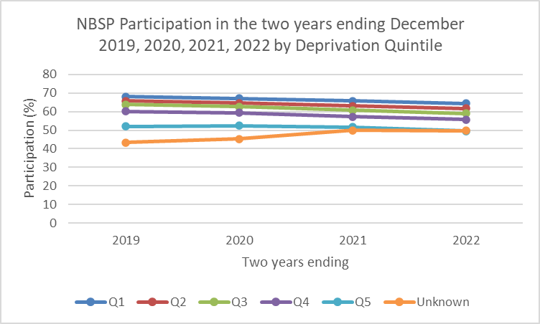

Figure 7: NBSP Participation in the two years ending December 2019, 2020, 2021, 2022 by Deprivation Quintile

Table 8: NBSP Participation in the two years ending December 2019, 2020, 2021, 2022 by Deprivation Quintile

|  |  |  |  |  |  |
| --- | --- | --- | --- | --- | --- |
| **Deprivation** | | **2019** | **2020** | **2021** | **2022** |
| **Quintile 1** | **Numerator** | 42792 | 48238 | 75340 | 113837 |
| **Denominator** | 62873 | 71771 | 114739 | 176355 |
| **Percentage** | 68.1 | 67.2 | 65.7 | 64.5 |
| **Quintile 2** | **Numerator** | 39191 | 44055 | 63985 | 95474 |
| **Denominator** | 59610 | 68113 | 101539 | 154709 |
| **Percentage** | 65.7 | 64.7 | 63 | 61.7 |
| **Quintile 3** | **Numerator** | 33127 | 38026 | 55460 | 83982 |
| **Denominator** | 51859 | 60753 | 91369 | 142026 |
| **Percentage** | 63.9 | 62.6 | 60.7 | 59.1 |
| **Quintile 4** | **Numerator** | 28295 | 33462 | 48755 | 74074 |
| **Denominator** | 47031 | 56399 | 85041 | 133017 |
| **Percentage** | 60.2 | 59.3 | 57.3 | 55.7 |
| **Quintile 5** | **Numerator** | 20341 | 26586 | 38128 | 57361 |
| **Denominator** | 39060 | 50732 | 73944 | 115535 |
| **Percentage** | 52.1 | 52.4 | 51.6 | 49.6 |
| **Quintile Unknown** | **Numerator** | 3453 | 3252 | 3982 | 5861 |
| **Denominator** | 7961 | 7193 | 7981 | 11781 |
| **Percentage** | 43.4 | 45.2 | 49.9 | 49.7 |

## Positivity (204)

Positivity is the proportion of people with a positive FIT kit result (also known as an abnormal result) from those who returned a definitive result in the measurement timeframe. Most participants with a positive result are referred for colonoscopy.

Differences in positivity may be due to variations within populations including prevalence of bowel cancer. Variations in positivity over time may also reflect variation in the quality of FIT analysis - this is strictly monitored by the programme. Positivity needs to be monitored closely as it impacts colonoscopy resource requirements.

The positivity rate for a population is affected by the positivity threshold - the haemoglobin level at which a test is deemed positive. The positivity threshold being used by the NBSP is 200 nanograms/millilitre of buffer (i.e. 200 ng Hb/ml buffer).

#### Indicator 204: Positivity

|  |
| --- |
| **Target:** No target established. |
| **Numerator:** The number of people who have returned a positive FIT kit during the calendar year. |
| **Denominator:** The number of people who completed a FIT kit and had a definitive result during the calendar year. |
| **Anchor date:** The date when a kit result was recorded in the register determines which time period it is counted under. |

#### Comments

Positivity rates in the NBSP follow the expected trends based on bowel cancer epidemiology and the findings of the bowel screening pilot. Higher positivity rates for Māori and Pacific were also seen in the pilot. Positivity rates increase with age and men are more likely to have a positive result than women. Also as expected, the positivity rate for a first screen is higher than for subsequent screening rounds.

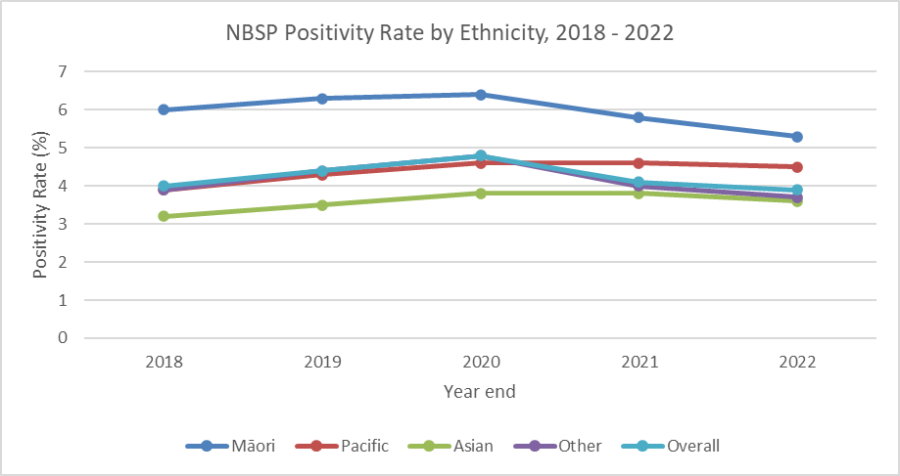

Figure 8: NBSP Positivity Rate by Ethnicity, 2018 - 2022

Table 9: NBSP Positivity Rate by Ethnicity, 2018 - 2022

|  |  |  |  |  |  |  |
| --- | --- | --- | --- | --- | --- | --- |
| **Ethnicity** | | **2018** | **2019** | **2020** | **2021** | **2022** |
| **Māori** | **Numerator** | 173 | 439 | 425 | 776 | 1025 |
| **Denominator** | 2902 | 6959 | 6623 | 13446 | 19295 |
| **Percentage** | 6 | 6.3 | 6.4 | 5.8 | 5.3 |
| **Pacific** | **Numerator** | 82 | 192 | 167 | 318 | 330 |
| **Denominator** | 2082 | 4512 | 3629 | 6898 | 7304 |
| **Percentage** | 3.9 | 4.3 | 4.6 | 4.6 | 4.5 |
| **Asian** | **Numerator** | 200 | 360 | 331 | 694 | 746 |
| **Denominator** | 6269 | 10232 | 8686 | 18474 | 20768 |
| **Percentage** | 3.2 | 3.5 | 3.8 | 3.8 | 3.6 |
| **Other** | **Numerator** | 1731 | 3419 | 3228 | 6133 | 6902 |
| **Denominator** | 43897 | 78564 | 67690 | 153447 | 186030 |
| **Percentage** | 3.9 | 4.4 | 4.8 | 4 | 3.7 |
| **Overall** | **Numerator** | 2236 | 4442 | 4151 | 7921 | 9003 |
| **Denominator** | 55611 | 100552 | 86631 | 192265 | 233397 |
| **Percentage** | 4 | 4.4 | 4.8 | 4.1 | 3.9 |

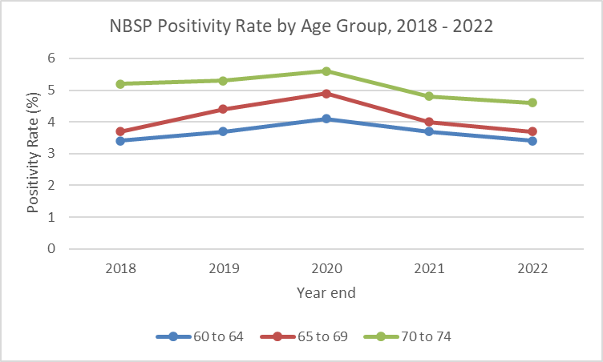

Figure 9: NBSP Positivity Rate by Age Group, 2018 – 2022

Table 10: NBSP Positivity Rate by Age Group, 2018 – 2022

|  |  |  |  |  |  |  |
| --- | --- | --- | --- | --- | --- | --- |
| **Age Group** | | **2018** | **2019** | **2020** | **2021** | **2022** |
| **60-64** | **Numerator** | 711 | 1405 | 1401 | 2704 | 2971 |
| **Denominator** | 21148 | 38196 | 33911 | 73811 | 88154 |
| **Percentage** | 3.4 | 3.7 | 4.1 | 3.7 | 3.4 |
| **65-69** | **Numerator** | 644 | 1375 | 1316 | 2343 | 2754 |
| **Denominator** | 17439 | 31180 | 26982 | 58427 | 73788 |
| **Percentage** | 3.7 | 4.4 | 4.9 | 4 | 3.7 |
| **70-74** | **Numerator** | 881 | 1662 | 1434 | 2874 | 3278 |
| **Denominator** | 17024 | 31176 | 25738 | 60027 | 71455 |
| **Percentage** | 5.2 | 5.3 | 5.6 | 4.8 | 4.6 |

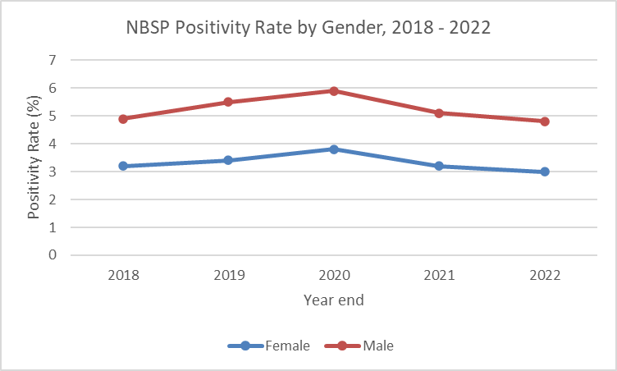

Figure 10: NBSP Positivity Rate by Gender, 2018 – 2022

Table 11: NBSP Positivity Rate by Gender, 2018 – 2022

|  |  |  |  |  |  |  |
| --- | --- | --- | --- | --- | --- | --- |
| **Gender** | | **2018** | **2019** | **2020** | **2021** | **2022** |
| **Female** | **Numerator** | 917 | 1769 | 1706 | 3249 | 3701 |
| **Denominator** | 28878 | 51998 | 45088 | 100304 | 122205 |
| **Percentage** | 3.2 | 3.4 | 3.8 | 3.2 | 3 |
| **Male** | **Numerator** | 1318 | 2670 | 2441 | 4670 | 5297 |
| **Denominator** | 26713 | 48520 | 41505 | 91885 | 111117 |
| **Percentage** | 4.9 | 5.5 | 5.9 | 5.1 | 4.8 |

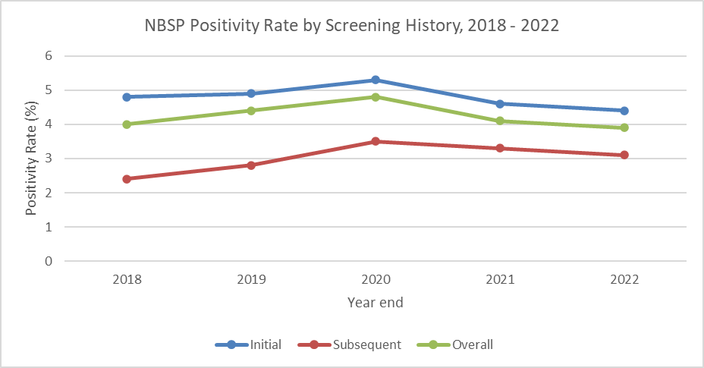

Figure 11: NBSP Positivity Rate by Screening History, 2018 – 2022

Table 12: NBSP Positivity Rate by Screening History, Jan 2018 – Dec 2022

|  |  |  |  |  |  |  |
| --- | --- | --- | --- | --- | --- | --- |
| **Screening History** | | **2018** | **2019** | **2020** | **2021** | **2022** |
| **Initial** | **Numerator** | 1803 | 3810 | 3308 | 5633 | 6238 |
| **Denominator** | 37337 | 77832 | 62618 | 122465 | 143201 |
| **Percentage** | 4.8 | 4.9 | 5.3 | 4.6 | 4.4 |
| **Subsequent** | **Numerator** | 433 | 632 | 843 | 2288 | 2765 |
| **Denominator** | 18274 | 22720 | 24013 | 69800 | 90196 |
| **Percentage** | 2.4 | 2.8 | 3.5 | 3.3 | 3.1 |
| **Overall** | **Numerator** | 2236 | 4442 | 4151 | 7921 | 9003 |
| **Denominator** | 55611 | 100552 | 86631 | 192265 | 233397 |
| **Percentage** | 4 | 4.4 | 4.8 | 4.1 | 3.9 |

## Spoilt kits (206)

Kits received by the testing lab but not suitable to give definitive results are considered spoilt. There are many reasons a kit may be spoilt, but all mean that an accurate screening result is less likely. The most common reasons are delays in transit, no collection date given and expired kits.

This indicator expresses the number of spoilt kits as percentage of all kits received. A participant may return more than one spoilt kit and will be counted more than once.

#### Indicator 206: Spoilt Kits

|  |
| --- |
| **Target:** No target established. |
| **Numerator:** The number of spoilt FIT kits during the calendar year. |
| **Denominator:** The number of FIT kits returned during the calendar year. |
| **Anchor date:** The date when a kit was received by the lab determines which time period it is counted under. |

#### Comments

The spoilt kit rates decreased in 2019 following equity focussed initiatives. There was disruption due to the pandemic and rates have been decreasing back to the pre-COVID-19 levels for all groups. Simultaneously, additional improvement initiatives were undertaken. The kit sent to participants has been redesigned with clearer instructions on how to do the test, prompts to put the supplied barcode on the sample tube and to write in the date the test was performed. Māori and Pacific participants who return a kit without a date, or a clearly incorrect date, are called on the day to get a correct date so that the kit can be processed. Information resources have been published in multiple languages.

The rates continue to be higher for Pacific and Asian participants, compared to Māori and Other participants. This pattern suggests that language may continue to be a barrier. The programme intends to continue to review and improve resources to support participants to complete kits that are suitable for testing.

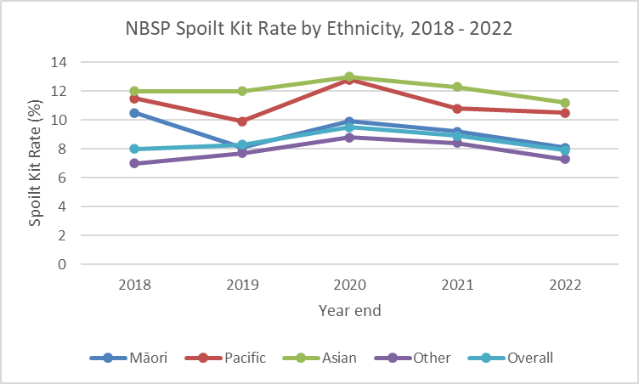

Figure 12: NBSP Spoilt Kit Rate by Ethnicity, 2018 – 2022

Table 13: NBSP Spoilt Kit Rate by Ethnicity, 2018 – 2022

|  |  |  |  |  |  |  |
| --- | --- | --- | --- | --- | --- | --- |
| **Ethnicity** | | **2018** | **2019** | **2020** | **2021** | **2022** |
| **Māori** | **Numerator** | 339 | 612 | 732 | 1359 | 1708 |
| **Denominator** | 3243 | 7574 | 7361 | 14820 | 21004 |
| **Percentage** | 10.5 | 8.1 | 9.9 | 9.2 | 8.1 |
| **Pacific** | **Numerator** | 270 | 497 | 534 | 834 | 859 |
| **Denominator** | 2354 | 5021 | 4167 | 7740 | 8172 |
| **Percentage** | 11.5 | 9.9 | 12.8 | 10.8 | 10.5 |
| **Asian** | **Numerator** | 858 | 1397 | 1301 | 2604 | 2612 |
| **Denominator** | 7139 | 11636 | 9998 | 21094 | 23387 |
| **Percentage** | 12 | 12 | 13 | 12.3 | 11.2 |
| **Other** | **Numerator** | 3325 | 6562 | 6540 | 14095 | 14756 |
| **Denominator** | 47295 | 85156 | 74263 | 167599 | 200842 |
| **Percentage** | 7 | 7.7 | 8.8 | 8.4 | 7.3 |
| **Overall** | **Numerator** | 4848 | 9112 | 9107 | 18892 | 19935 |
| **Denominator** | 60551 | 109717 | 95792 | 211253 | 253405 |
| **Percentage** | 8 | 8.3 | 9.5 | 8.9 | 7.9 |

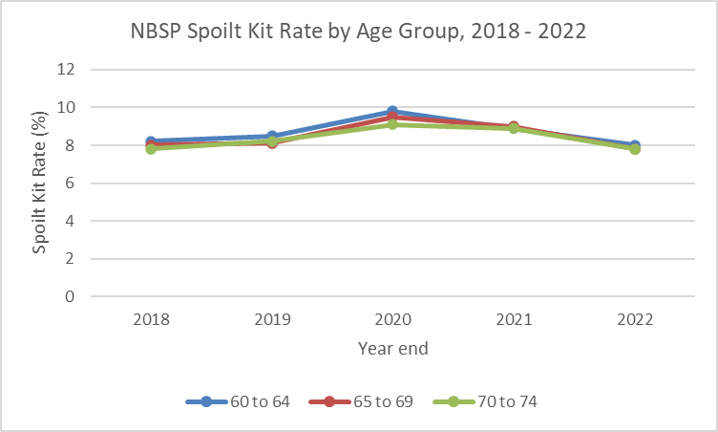

Figure 13: NBSP Spoilt Kit Rate by Age Group, 2018 – 2022

Table 14: NBSP Spoilt Kit Rate by Age Group, 2018 – 2022

|  |  |  |  |  |  |  |
| --- | --- | --- | --- | --- | --- | --- |
| **Age Group** | | **2018** | **2019** | **2020** | **2021** | **2022** |
| **60-64** | **Numerator** | 1887 | 3570 | 3690 | 7258 | 7681 |
| **Denominator** | 23066 | 41788 | 37620 | 81107 | 95856 |
| **Percentage** | 8.2 | 8.5 | 9.8 | 8.9 | 8 |
| **65-69** | **Numerator** | 1513 | 2764 | 2838 | 5802 | 6244 |
| **Denominator** | 18977 | 33960 | 29835 | 64262 | 80055 |
| **Percentage** | 8 | 8.1 | 9.5 | 9 | 7.8 |
| **70-74** | **Numerator** | 1448 | 2778 | 2579 | 5832 | 6010 |
| **Denominator** | 18508 | 33969 | 28337 | 65884 | 77494 |
| **Percentage** | 7.8 | 8.2 | 9.1 | 8.9 | 7.8 |

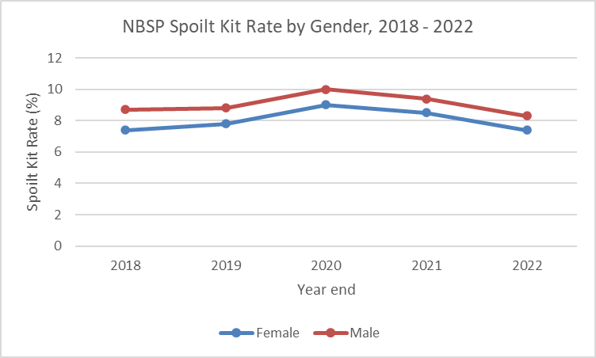

Figure 14: NBSP Spoilt Kit Rate by Gender, 2018 – 2022

Table 15: NBSP Spoilt Kit Rate by Gender, 2018 – 2022

|  |  |  |  |  |  |  |
| --- | --- | --- | --- | --- | --- | --- |
| **Gender** | | **2018** | **2019** | **2020** | **2021** | **2022** |
| **Female** | **Numerator** | 2306 | 4412 | 4464 | 9364 | 9829 |
| **Denominator** | 31227 | 56430 | 49574 | 109709 | 132063 |
| **Percentage** | 7.4 | 7.8 | 9 | 8.5 | 7.4 |
| **Male** | **Numerator** | 2540 | 4692 | 4638 | 9524 | 10097 |
| **Denominator** | 29302 | 53245 | 46175 | 101464 | 121258 |
| **Percentage** | 8.7 | 8.8 | 10 | 9.4 | 8.3 |

## Definitive spoilt kit rate (207)

This indicator tells us about people who returned a spoilt kit but have not subsequently returned a definitive kit.

The indicator counts all people whose screening episode result in the register is currently spoilt and it is expressed as a percentage of all people who returned kits.

This indicator counts people, not kits and takes into account the latest kit result only. For example, a participant who initially returned a spoilt kit and then subsequently returns a negative result will not be counted. However, a participant who returned two spoilt kits but has not returned a third kit will be included as a definitive spoilt kit (because their latest returned kit is spoilt).

#### Indicator 207: Definitive Spoilt Kit Rate

|  |
| --- |
| **Target:** No more than 2% of people have a definitive spoilt kit. |
| **Numerator:** The number of participants who returned a spoilt kit, but have not subsequently returned a definitive FIT result in the same screening episode. |
| **Denominator:** Number of people who returned a FIT kit during the calendar year. |
| **Anchor date:** The date when a kit was received by the lab determines which time period it is counted under. |

#### Comments

The definitive spoilt kit rate has been trending upwards for all groups since the pandemic. While the overall rate at the end of the period remains within target, the programme is not as accessible after a spoilt kit for Māori, Pacific, Asian, younger and male participants, where definitive spoilt kit rates are above target. As noted above, the rates for 2022 may potentially decrease as definitive kits can still be returned and counted within a two-year screening episode.

The programme intends to explore what is the best way to monitor this indicator in order to provide timely, actionable information.

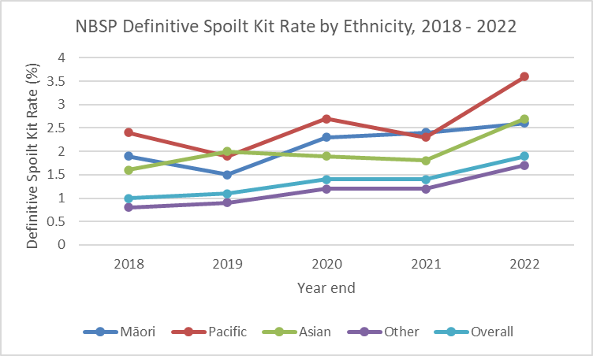

Figure 15: NBSP Definitive Spoilt Kit Rate, by Ethnicity, 2018 – 2022

Table 16: NBSP Definitive Spoilt Kit Rate, by Ethnicity, 2018 – 2022

|  |  |  |  |  |  |  |
| --- | --- | --- | --- | --- | --- | --- |
| **Ethnicity** | | **2018** | **2019** | **2020** | **2021** | **2022** |
| **Māori** | **Numerator** | 57 | 105 | 153 | 335 | 512 |
| **Denominator** | 2959 | 7064 | 6776 | 13781 | 19807 |
| **Percentage** | 1.9 | 1.5 | 2.3 | 2.4 | 2.6 |
| **Pacific** | **Numerator** | 51 | 88 | 100 | 163 | 273 |
| **Denominator** | 2133 | 4600 | 3729 | 7061 | 7577 |
| **Percentage** | 2.4 | 1.9 | 2.7 | 2.3 | 3.6 |
| **Asian** | **Numerator** | 99 | 205 | 168 | 342 | 573 |
| **Denominator** | 6368 | 10437 | 8854 | 18816 | 21341 |
| **Percentage** | 1.6 | 2 | 1.9 | 1.8 | 2.7 |
| **Other** | **Numerator** | 355 | 696 | 831 | 1931 | 3150 |
| **Denominator** | 44252 | 79260 | 68521 | 155378 | 189179 |
| **Percentage** | 0.8 | 0.9 | 1.2 | 1.2 | 1.7 |
| **Overall** | **Numerator** | 576 | 1110 | 1252 | 2771 | 4508 |
| **Denominator** | 56187 | 101662 | 87883 | 195036 | 237904 |
| **Percentage** | 1 | 1.1 | 1.4 | 1.4 | 1.9 |

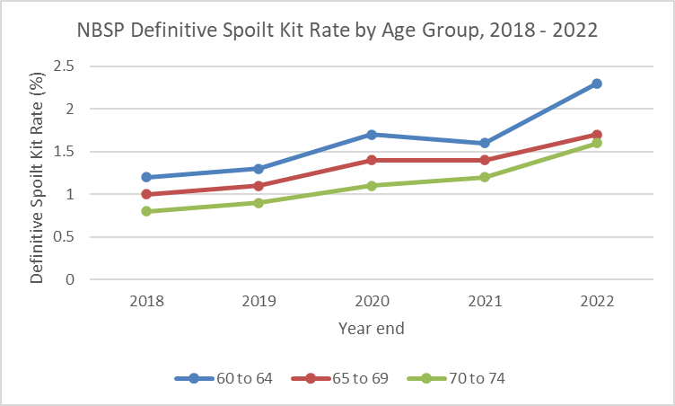

Figure 16: NBSP Definitive spoilt Kit Rate by Age Group, 2018 – 2022

Table 17: NBSP Definitive Spoilt Kit Rate by Age Group, 2018 – 2022

|  |  |  |  |  |  |  |
| --- | --- | --- | --- | --- | --- | --- |
| **Age Group** | | **2018** | **2019** | **2020** | **2021** | **2022** |
| **60-64** | **Numerator** | 267 | 504 | 584 | 1213 | 2058 |
| **Denominator** | 21415 | 38700 | 34495 | 75024 | 90212 |
| **Percentage** | 1.2 | 1.3 | 1.7 | 1.6 | 2.3 |
| **65-69** | **Numerator** | 175 | 333 | 373 | 813 | 1305 |
| **Denominator** | 17614 | 31513 | 27355 | 59240 | 75093 |
| **Percentage** | 1 | 1.1 | 1.4 | 1.4 | 1.7 |
| **70-74** | **Numerator** | 134 | 273 | 295 | 745 | 1145 |
| **Denominator** | 17158 | 31449 | 26033 | 60772 | 72599 |
| **Percentage** | 0.8 | 0.9 | 1.1 | 1.2 | 1.6 |

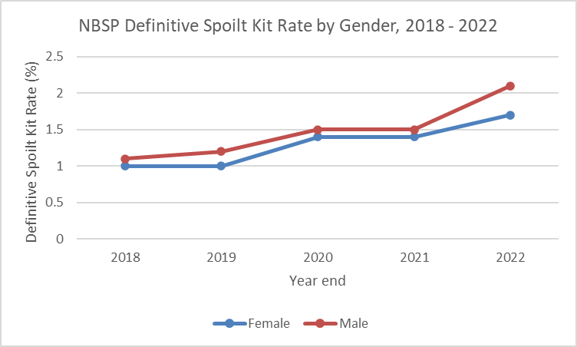

Figure 17: NBSP Definitive Spoilt Kit Rate by Gender, 2018 – 2022

Table 18: NBSP Definitive Spoilt Kit Rate by Gender, 2018 – 2022

|  |  |  |  |  |  |  |
| --- | --- | --- | --- | --- | --- | --- |
| **Gender** | | **2018** | **2019** | **2020** | **2021** | **2022** |
| **Female** | **Numerator** | 282 | 518 | 622 | 1379 | 2118 |
| **Denominator** | 29160 | 52516 | 45710 | 101683 | 124322 |
| **Percentage** | 1 | 1 | 1.4 | 1.4 | 1.7 |
| **Male** | **Numerator** | 294 | 592 | 628 | 1389 | 2386 |
| **Denominator** | 27007 | 49112 | 42133 | 93274 | 113503 |
| **Percentage** | 1.1 | 1.2 | 1.5 | 1.5 | 2.1 |

## Positive Predictive Value (PPV) (300)

PPV describes one aspect of the performance of the screening test for a population. It indicates the percentage of positive screening test results that are true positive results, that is, identify bowel cancer or polyps.

The numerator is based on the most significant pathology as identified following diagnostic assessment, or as subsequently updated following treatment, as recorded in the BSR.

This section is broken down into cancer, advanced adenoma, adenoma and no biopsy; with each group further sub-grouped by ethnicity, age group and gender. Serrated lesions are monitored separately.

#### Indicator 300: Positive Predictive Value (PPV)

|  |
| --- |
| **Target:** No target established. |
| **Numerator:** The number of people whose most significant pathology is a lesion of the type being measured. |
| **Denominator:** The number of people with a positive FIT result who completed a publicly funded colonoscopy in the calendar year. |
| **Anchor date:** The date when a diagnostic procedure (colonoscopy) was completed determines which time period it is counted under. |

#### Comments

The NBSP is detecting cancers, advanced adenomas and adenomas within the expected range. Overall, in 2022, for every 100 people who had a positive screening test, about eight people had a diagnosis of cancer and a further 24 people had advanced adenomas seen and removed.

PPVs are influenced by multiple factors, including the underlying incidence of bowel cancers in different populations, the threshold for positivity, the proportion of participants who may be symptomatic and the screening round. As the programme completes the first and second screening rounds in all districts, more data will be available to be analysed to help better understand these interactions.

Colonoscopy is an invasive procedure and it is therefore important to also monitor the number of people who have no significant bowel abnormality (indicated by no biopsy taken) identified at NBSP colonoscopy. Overall, 15 in 100 people have no biopsy taken at an NBSP colonoscopy. Conversely, 85% of people proceeding to NBSP colonoscopy have an abnormality detected – this indicates that the programme parameters and FIT threshold for positivity are appropriate.

#### Cancer

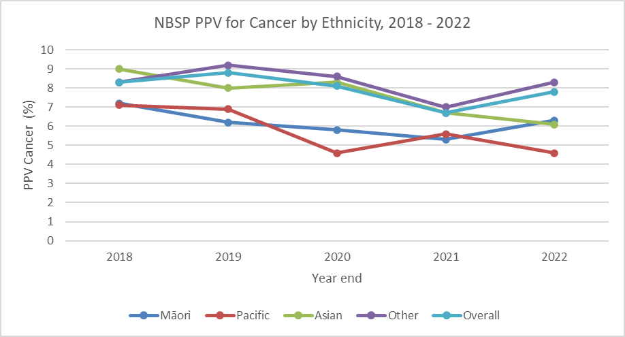

Figure 18: NBSP PPV for Cancer by Ethnicity, 2018 – 2022

Table 19: NBSP PPV for Cancer by Ethnicity, 2018 – 2022

|  |  |  |  |  |  |  |
| --- | --- | --- | --- | --- | --- | --- |
| **Ethnicity** | | **2018** | **2019** | **2020** | **2021** | **2022** |
| **Māori** | **Numerator** | 9 | 20 | 21 | 33 | 52 |
| **Denominator** | 125 | 323 | 362 | 620 | 820 |
| **Percentage** | 7.2 | 6.2 | 5.8 | 5.3 | 6.3 |
| **Pacific** | **Numerator** | 4 | 10 | 7 | 14 | 12 |
| **Denominator** | 56 | 145 | 153 | 252 | 262 |
| **Percentage** | 7.1 | 6.9 | 4.6 | 5.6 | 4.6 |
| **Asian** | **Numerator** | 14 | 24 | 23 | 39 | 36 |
| **Denominator** | 155 | 301 | 278 | 584 | 590 |
| **Percentage** | 9 | 8 | 8.3 | 6.7 | 6.1 |
| **Other** | **Numerator** | 110 | 248 | 235 | 327 | 455 |
| **Denominator** | 1324 | 2707 | 2727 | 4674 | 5450 |
| **Percentage** | 8.3 | 9.2 | 8.6 | 7 | 8.3 |
| **Overall** | **Numerator** | 140 | 306 | 286 | 413 | 555 |
| **Denominator** | 1692 | 3492 | 3520 | 6130 | 7122 |
| **Percentage** | 8.3 | 8.8 | 8.1 | 6.7 | 7.8 |

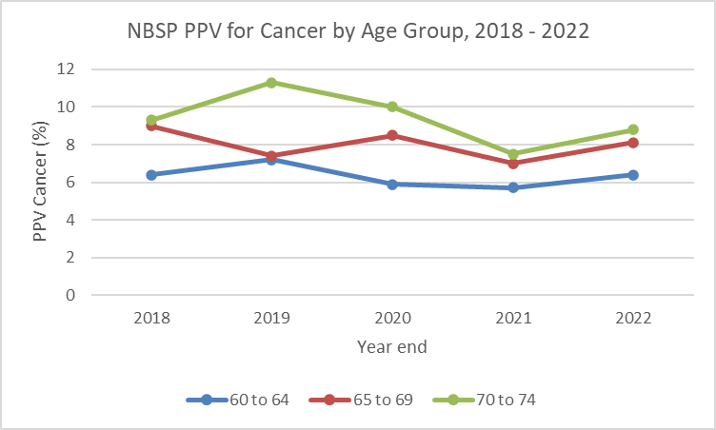

Figure 19: NBSP PPV for Cancer by Age Group, 2018 – 2022

Table 20: NBSP PPV for Cancer by Age Group, 2018 – 2022

|  |  |  |  |  |  |  |
| --- | --- | --- | --- | --- | --- | --- |
| **Age Group** | | **2018** | **2019** | **2020** | **2021** | **2022** |
| **60-64** | **Numerator** | 36 | 81 | 70 | 119 | 154 |
| **Denominator** | 562 | 1122 | 1189 | 2077 | 2397 |
| **Percentage** | 6.4 | 7.2 | 5.9 | 5.7 | 6.4 |
| **65-69** | **Numerator** | 44 | 80 | 95 | 132 | 174 |
| **Denominator** | 487 | 1088 | 1119 | 1882 | 2140 |
| **Percentage** | 9 | 7.4 | 8.5 | 7 | 8.1 |
| **70-74** | **Numerator** | 60 | 145 | 121 | 162 | 227 |
| **Denominator** | 643 | 1282 | 1212 | 2171 | 2585 |
| **Percentage** | 9.3 | 11.3 | 10 | 7.5 | 8.8 |

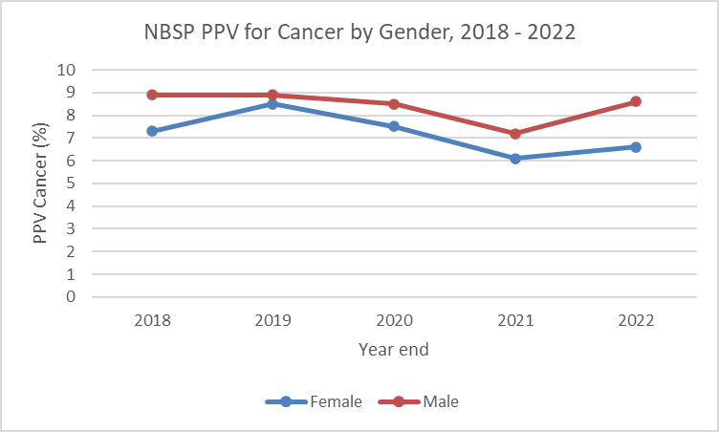

Figure 20: NBSP PPV for Cancer by Gender, 2018 – 2022

Table 21: NBSP PPV for Cancer by Gender, 2018 – 2022

|  |  |  |  |  |  |  |
| --- | --- | --- | --- | --- | --- | --- |
| **Gender** | | **2018** | **2019** | **2020** | **2021** | **2022** |
| **Female** | **Numerator** | 51 | 115 | 107 | 152 | 188 |
| **Denominator** | 694 | 1359 | 1419 | 2493 | 2867 |
| **Percentage** | 7.3 | 8.5 | 7.5 | 6.1 | 6.6 |
| **Male** | **Numerator** | 89 | 190 | 178 | 260 | 367 |
| **Denominator** | 997 | 2130 | 2099 | 3634 | 4252 |
| **Percentage** | 8.9 | 8.9 | 8.5 | 7.2 | 8.6 |

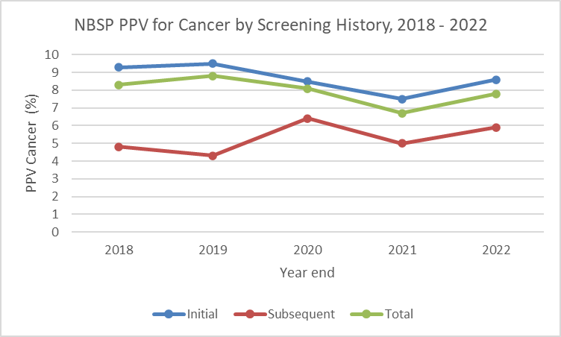

Figure 21: NBSP PPV for Cancer by Screening History, 2018 – 2022

Table 22: NBSP PPV for Cancer by Screening History, 2018 – 2022

|  |  |  |  |  |  |  |
| --- | --- | --- | --- | --- | --- | --- |
| **Screening History** | | **2018** | **2019** | **2020** | **2021** | **2022** |
| **Initial** | **Numerator** | 122 | 285 | 245 | 322 | 428 |
| **Denominator** | 1317 | 3004 | 2881 | 4294 | 4974 |
| **Percentage** | 9.3 | 9.5 | 8.5 | 7.5 | 8.6 |
| **Subsequent** | **Numerator** | 18 | 21 | 41 | 91 | 127 |
| **Denominator** | 375 | 488 | 639 | 1836 | 2148 |
| **Percentage** | 4.8 | 4.3 | 6.4 | 5 | 5.9 |
| **Total** | **Numerator** | 140 | 306 | 286 | 413 | 555 |
| **Denominator** | 1692 | 3492 | 3520 | 6130 | 7122 |
| **Percentage** | 8.3 | 8.8 | 8.1 | 6.7 | 7.8 |

#### Advanced Adenoma

Adenoma is advanced if:

* Adenoma ≥ 10 mm
* Adenoma with tubulovillous or villous histology. Minimum 25% of unequivocal villous component is required
* Adenoma with high-grade dysplasia

#### 

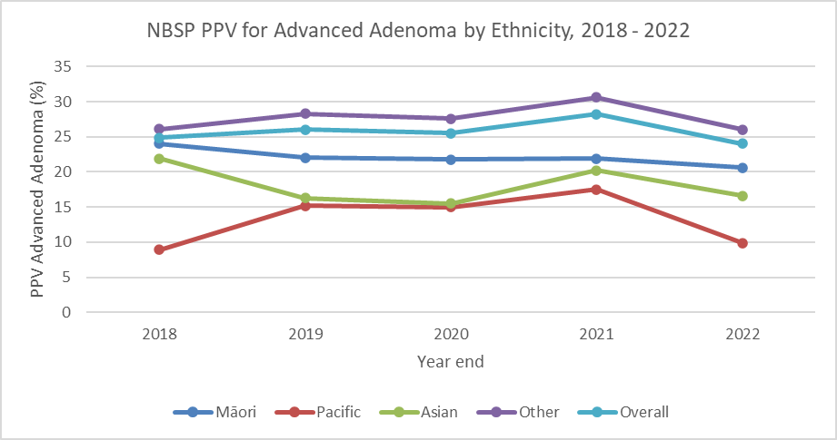

Figure 22: NBSP PPV for Advanced Adenoma by Ethnicity, 2018 – 2022

Table 23: NBSP PPV for Advanced Adenoma by Ethnicity, 2018 – 2022

|  |  |  |  |  |  |  |
| --- | --- | --- | --- | --- | --- | --- |
| **Ethnicity** | | **2018** | **2019** | **2020** | **2021** | **2022** |
| **Māori** | **Numerator** | 30 | 71 | 79 | 136 | 169 |
| **Denominator** | 125 | 323 | 362 | 620 | 820 |
| **Percentage** | 24 | 22 | 21.8 | 21.9 | 20.6 |
| **Pacific** | **Numerator** | 5 | 22 | 23 | 44 | 26 |
| **Denominator** | 56 | 145 | 153 | 252 | 262 |
| **Percentage** | 8.9 | 15.2 | 15 | 17.5 | 9.9 |
| **Asian** | **Numerator** | 34 | 49 | 43 | 118 | 98 |
| **Denominator** | 155 | 301 | 278 | 584 | 590 |
| **Percentage** | 21.9 | 16.3 | 15.5 | 20.2 | 16.6 |
| **Other** | **Numerator** | 345 | 766 | 753 | 1432 | 1416 |
| **Denominator** | 1324 | 2707 | 2727 | 4674 | 5450 |
| **Percentage** | 26.1 | 28.3 | 27.6 | 30.6 | 26 |
| **Overall** | **Numerator** | 421 | 909 | 898 | 1730 | 1709 |
| **Denominator** | 1692 | 3492 | 3520 | 6130 | 7122 |
| **Percentage** | 24.9 | 26 | 25.5 | 28.2 | 24 |

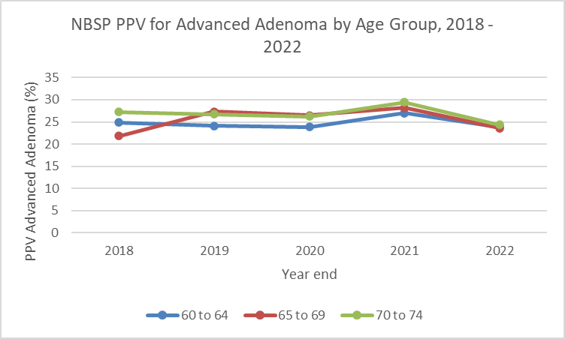

Figure 23: NBSP PPV for Advanced Adenoma by Age Group, 2018 – 2022

Table 24: NBSP PPV for Advanced Adenoma by Age Group, 2018 – 2022

|  |  |  |  |  |  |  |
| --- | --- | --- | --- | --- | --- | --- |
| **Age Group** | | **2018** | **2019** | **2020** | **2021** | **2022** |
| **60-64** | **Numerator** | 140 | 270 | 284 | 560 | 573 |
| **Denominator** | 562 | 1122 | 1189 | 2077 | 2397 |
| **Percentage** | 24.9 | 24.1 | 23.9 | 27 | 23.9 |
| **65-69** | **Numerator** | 106 | 297 | 297 | 531 | 504 |
| **Denominator** | 487 | 1088 | 1119 | 1882 | 2140 |
| **Percentage** | 21.8 | 27.3 | 26.5 | 28.2 | 23.6 |
| **70-74** | **Numerator** | 175 | 342 | 317 | 639 | 632 |
| **Denominator** | 643 | 1282 | 1212 | 2171 | 2585 |
| **Percentage** | 27.2 | 26.7 | 26.2 | 29.4 | 24.4 |

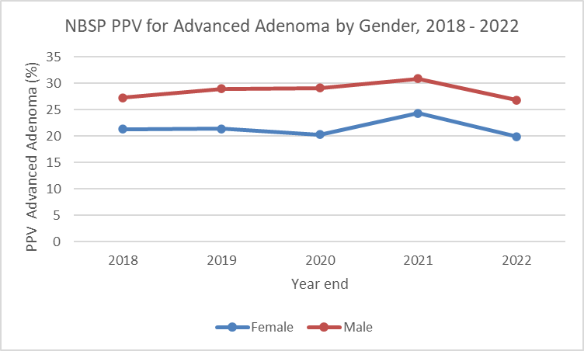

Figure 24: NBSP PPV for Advanced Adenoma by Gender, 2018 – 2022

Table 25: NBSP PPV for Advanced Adenoma by Gender, 2018 – 2022

|  |  |  |  |  |  |  |
| --- | --- | --- | --- | --- | --- | --- |
| **Gender** | | **2018** | **2019** | **2020** | **2021** | **2022** |
| **Female** | **Numerator** | 148 | 291 | 288 | 607 | 570 |
| **Denominator** | 694 | 1359 | 1419 | 2493 | 2867 |
| **Percentage** | 21.3 | 21.4 | 20.3 | 24.3 | 19.9 |
| **Male** | **Numerator** | 272 | 618 | 610 | 1123 | 1139 |
| **Denominator** | 997 | 2130 | 2099 | 3634 | 4252 |
| **Percentage** | 27.3 | 29 | 29.1 | 30.9 | 26.8 |

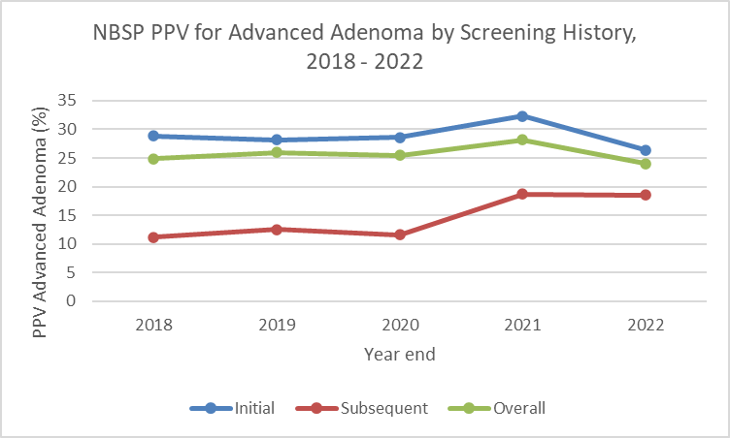

Figure 25: NBSP PPV for Advanced Adenoma by Screening History, 2018 – 2022

Table 26: NBSP PPV for Advanced Adenoma by Screening History, 2018 – 2022

|  |  |  |  |  |  |  |
| --- | --- | --- | --- | --- | --- | --- |
| **Screening History** | | **2018** | **2019** | **2020** | **2021** | **2022** |
| **Initial** | **Numerator** | 379 | 848 | 824 | 1386 | 1311 |
| **Denominator** | 1317 | 3004 | 2881 | 4294 | 4974 |
| **Percentage** | 28.8 | 28.2 | 28.6 | 32.3 | 26.4 |
| **Subsequent** | **Numerator** | 42 | 61 | 74 | 344 | 398 |
| **Denominator** | 375 | 488 | 639 | 1836 | 2148 |
| **Percentage** | 11.2 | 12.5 | 11.6 | 18.7 | 18.5 |
| **Overall** | **Numerator** | 421 | 909 | 898 | 1730 | 1709 |
| **Denominator** | 1692 | 3492 | 3520 | 6130 | 7122 |
| **Percentage** | 24.9 | 26 | 25.5 | 28.2 | 24 |

#### Adenoma

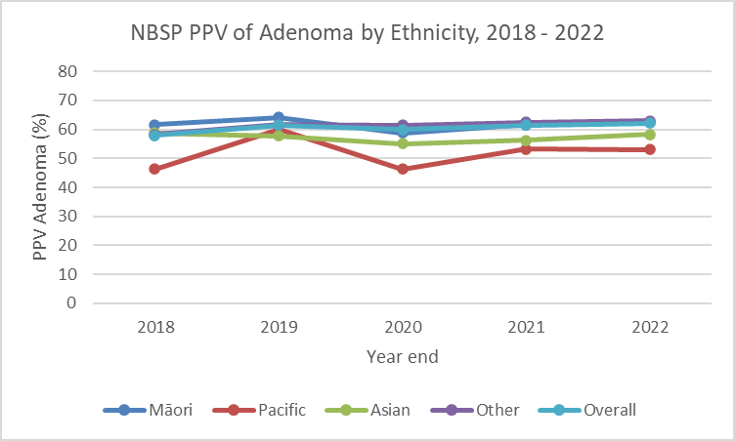

Figure 26: NBSP PPV of Adenoma by Ethnicity, 2018 – 2022

Table 27: NBSP PPV of Adenoma by Ethnicity, 2018 – 2022

|  |  |  |  |  |  |  |
| --- | --- | --- | --- | --- | --- | --- |
| **Ethnicity** | | **2018** | **2019** | **2020** | **2021** | **2022** |
| **Māori** | **Numerator** | 77 | 207 | 213 | 382 | 512 |
| **Denominator** | 125 | 323 | 362 | 620 | 820 |
| **Percentage** | 61.6 | 64.1 | 58.8 | 61.6 | 62.4 |
| **Pacific** | **Numerator** | 26 | 87 | 71 | 134 | 139 |
| **Denominator** | 56 | 145 | 153 | 252 | 262 |
| **Percentage** | 46.4 | 60 | 46.4 | 53.2 | 53.1 |
| **Asian** | **Numerator** | 91 | 174 | 153 | 329 | 344 |
| **Denominator** | 155 | 301 | 278 | 584 | 590 |
| **Percentage** | 58.7 | 57.8 | 55 | 56.3 | 58.3 |
| **Other** | **Numerator** | 772 | 1668 | 1674 | 2919 | 3431 |
| **Denominator** | 1324 | 2707 | 2727 | 4674 | 5450 |
| **Percentage** | 58.3 | 61.6 | 61.4 | 62.5 | 63 |
| **Overall** | **Numerator** | 982 | 2143 | 2111 | 3764 | 4426 |
| **Denominator** | 1692 | 3492 | 3520 | 6130 | 7122 |
| **Percentage** | 58 | 61.4 | 60 | 61.4 | 62.1 |

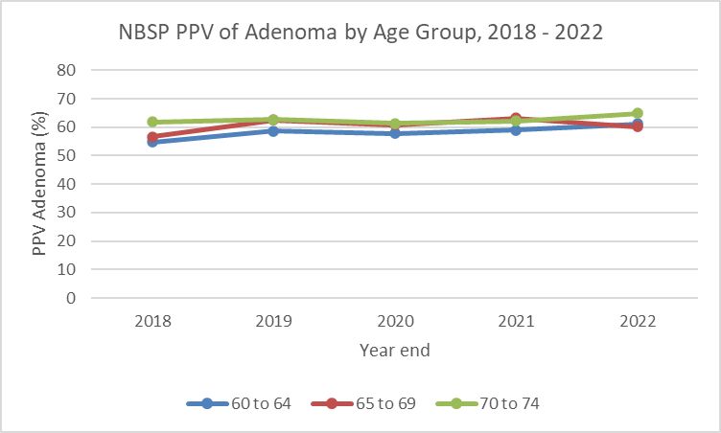

Figure 27: NBSP PPV of Adenoma by Age Group, 2018 – 2022

Table 28: NBSP PPV of Adenoma by Age Group, 2018 – 2022

|  |  |  |  |  |  |  |
| --- | --- | --- | --- | --- | --- | --- |
| **Age Group** | | **2018** | **2019** | **2020** | **2021** | **2022** |
| **60-64** | **Numerator** | 308 | 658 | 687 | 1223 | 1465 |
| **Denominator** | 562 | 1122 | 1189 | 2077 | 2397 |
| **Percentage** | 54.8 | 58.6 | 57.8 | 58.9 | 61.1 |
| **65-69** | **Numerator** | 276 | 681 | 681 | 1190 | 1287 |
| **Denominator** | 487 | 1088 | 1119 | 1882 | 2140 |
| **Percentage** | 56.7 | 62.6 | 60.9 | 63.2 | 60.1 |
| **70-74** | **Numerator** | 398 | 804 | 743 | 1351 | 1674 |
| **Denominator** | 643 | 1282 | 1212 | 2171 | 2585 |
| **Percentage** | 61.9 | 62.7 | 61.3 | 62.2 | 64.8 |

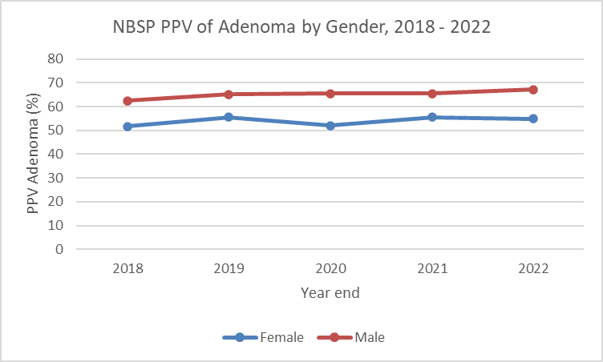

Figure 28: NBSP PPV of Adenoma by Gender, 2018 – 2022

Table 29: NBSP PPV of Adenoma by Gender, 2018 – 2022

|  |  |  |  |  |  |  |
| --- | --- | --- | --- | --- | --- | --- |
| **Gender** | | **2018** | **2019** | **2020** | **2021** | **2022** |
| **Female** | **Numerator** | 358 | 754 | 738 | 1384 | 1570 |
| **Denominator** | 694 | 1359 | 1419 | 2493 | 2867 |
| **Percentage** | 51.6 | 55.5 | 52 | 55.5 | 54.8 |
| **Male** | **Numerator** | 623 | 1388 | 1373 | 2378 | 2854 |
| **Denominator** | 997 | 2130 | 2099 | 3634 | 4252 |
| **Percentage** | 62.5 | 65.2 | 65.4 | 65.4 | 67.1 |

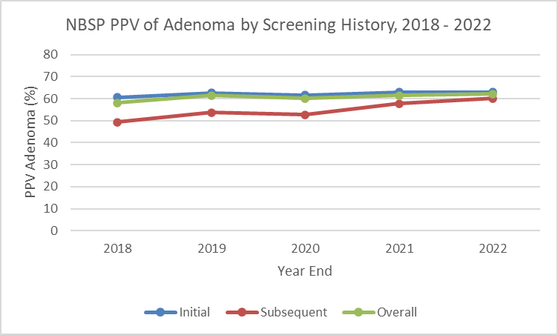

Figure 29: NBSP PPV of Adenoma by Screening History, 2018 – 2022

Table 30: NBSP PPV of Adenoma by Screening History, 2018 – 2022

|  |  |  |  |  |  |  |
| --- | --- | --- | --- | --- | --- | --- |
| **Screening History** | | **2018** | **2019** | **2020** | **2021** | **2022** |
| **Initial** | **Numerator** | 797 | 1881 | 1774 | 2704 | 3136 |
| **Denominator** | 1317 | 3004 | 2881 | 4294 | 4974 |
| **Percentage** | 60.5 | 62.6 | 61.6 | 63 | 63 |
| **Subsequent** | **Numerator** | 185 | 262 | 337 | 1060 | 1290 |
| **Denominator** | 375 | 488 | 639 | 1836 | 2148 |
| **Percentage** | 49.3 | 53.7 | 52.7 | 57.7 | 60.1 |
| **Overall** | **Numerator** | 982 | 2143 | 2111 | 3764 | 4426 |
| **Denominator** | 1692 | 3492 | 3520 | 6130 | 7122 |
| **Percentage** | 58 | 61.4 | 60 | 61.4 | 62.1 |

#### No Biopsy taken at colonoscopy

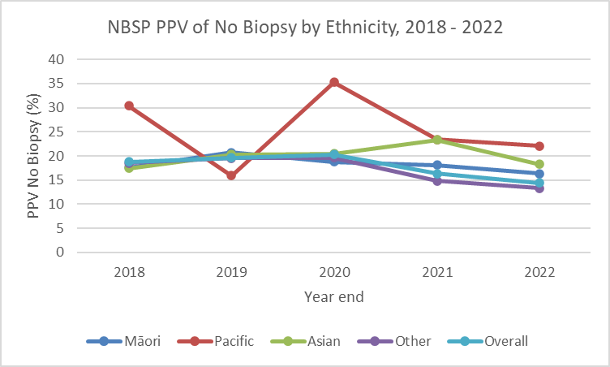

Figure 30: NBSP PPV of No Biopsy by Ethnicity, 2018 – 2022

Table 31: NBSP PPV of No Biopsy by Ethnicity, 2018 – 2022

|  |  |  |  |  |  |  |
| --- | --- | --- | --- | --- | --- | --- |
| **Ethnicity** | | **2018** | **2019** | **2020** | **2021** | **2022** |
| **Māori** | **Numerator** | 22 | 67 | 68 | 112 | 134 |
| **Denominator** | 125 | 323 | 362 | 620 | 820 |
| **Percentage** | 17.6 | 20.7 | 18.8 | 18.1 | 16.3 |
| **Pacific** | **Numerator** | 17 | 23 | 54 | 59 | 58 |
| **Denominator** | 56 | 145 | 153 | 252 | 262 |
| **Percentage** | 30.4 | 15.9 | 35.3 | 23.4 | 22.1 |
| **Asian** | **Numerator** | 27 | 61 | 57 | 136 | 108 |
| **Denominator** | 155 | 301 | 278 | 584 | 590 |
| **Percentage** | 17.4 | 20.3 | 20.5 | 23.3 | 18.3 |
| **Other** | **Numerator** | 245 | 528 | 534 | 690 | 725 |
| **Denominator** | 1324 | 2707 | 2727 | 4674 | 5450 |
| **Percentage** | 18.5 | 19.5 | 19.6 | 14.8 | 13.3 |
| **Overall** | **Numerator** | 318 | 683 | 713 | 997 | 1025 |
| **Denominator** | 1692 | 3492 | 3520 | 6130 | 7122 |
| **Percentage** | 18.8 | 19.6 | 20.3 | 16.3 | 14.4 |

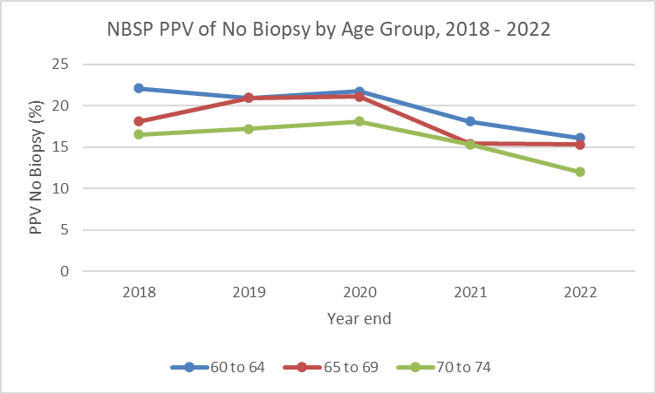

Figure 31: NBSP PPV of No Biopsy by Age Group, 2018 – 2022

Table 32: NBSP PPV of No Biopsy by Age Group, 2018 – 2022

|  |  |  |  |  |  |  |
| --- | --- | --- | --- | --- | --- | --- |
| **Age Group** | | **2018** | **2019** | **2020** | **2021** | **2022** |
| **60-64** | **Numerator** | 124 | 235 | 258 | 376 | 386 |
| **Denominator** | 562 | 1122 | 1189 | 2077 | 2397 |
| **Percentage** | 22.1 | 20.9 | 21.7 | 18.1 | 16.1 |
| **65-69** | **Numerator** | 88 | 227 | 236 | 289 | 328 |
| **Denominator** | 487 | 1088 | 1119 | 1882 | 2140 |
| **Percentage** | 18.1 | 20.9 | 21.1 | 15.4 | 15.3 |
| **70-74** | **Numerator** | 106 | 221 | 219 | 332 | 311 |
| **Denominator** | 643 | 1282 | 1212 | 2171 | 2585 |
| **Percentage** | 16.5 | 17.2 | 18.1 | 15.3 | 12 |

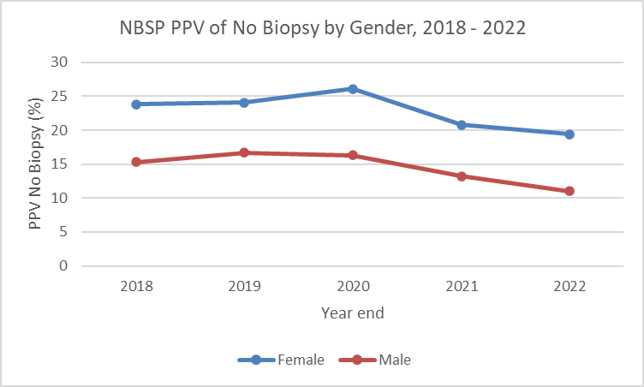

Figure 32: NBSP PPV of No Biopsy by Gender, 2018 – 2022

Table 33:NBSP PPV of No Biopsy by Gender, 2018 – 2022

|  |  |  |  |  |  |  |
| --- | --- | --- | --- | --- | --- | --- |
| **Gender** | | **2018** | **2019** | **2020** | **2021** | **2022** |
| **Female** | **Numerator** | 165 | 327 | 371 | 519 | 557 |
| **Denominator** | 694 | 1359 | 1419 | 2493 | 2867 |
| **Percentage** | 23.8 | 24.1 | 26.1 | 20.8 | 19.4 |
| **Male** | **Numerator** | 153 | 355 | 342 | 478 | 467 |
| **Denominator** | 997 | 2130 | 2099 | 3634 | 4252 |
| **Percentage** | 15.3 | 16.7 | 16.3 | 13.2 | 11 |

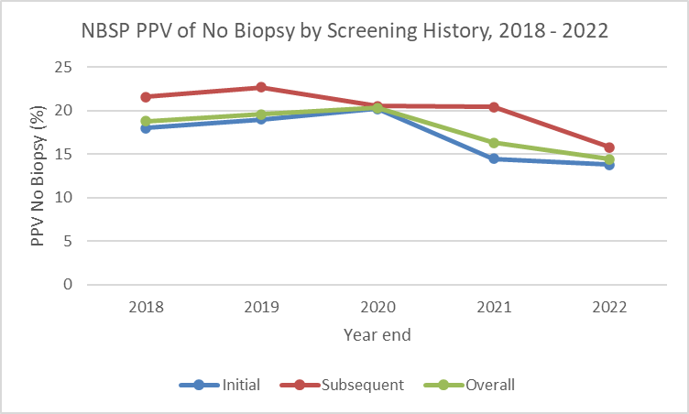

Figure 33: NBSP PPV of No Biopsy by Screening History, 2018 – 2022

Table 34: NBSP PPV of No Biopsy by Screening History, 2018 – 2022

|  |  |  |  |  |  |  |
| --- | --- | --- | --- | --- | --- | --- |
| **Screening History** | | **2018** | **2019** | **2020** | **2021** | **2022** |
| **Initial** | **Numerator** | 237 | 572 | 582 | 623 | 685 |
| **Denominator** | 1317 | 3004 | 2881 | 4294 | 4974 |
| **Percentage** | 18 | 19 | 20.2 | 14.5 | 13.8 |
| **Subsequent** | **Numerator** | 81 | 111 | 131 | 374 | 340 |
| **Denominator** | 375 | 488 | 639 | 1836 | 2148 |
| **Percentage** | 21.6 | 22.7 | 20.5 | 20.4 | 15.8 |
| **Overall** | **Numerator** | 318 | 683 | 713 | 997 | 1025 |
| **Denominator** | 1692 | 3492 | 3520 | 6130 | 7122 |
| **Percentage** | 18.8 | 19.6 | 20.3 | 16.3 | 14.4 |

## Timeliness of initial contact for pre-assessment (303)

This indicator relates to the percentage of people with positive FIT results who are contacted for a colonoscopy pre-assessment within an appropriate time frame. It also includes the small number of information referrals from general practitioners (GPs), where the GP advises that the participant opts not to have a colonoscopy or decides to use the private health system and therefore a pre-assessment is not required.

Ensuring timely pre-assessment is intended to reduce anxiety after receiving a positive result.

#### Indicator 303: Timeliness of Initial Contact for Pre-Assessment

|  |
| --- |
| **Target:** 95% of individuals receive initial contact for colonoscopy pre-assessment within 15 working days of a positive FIT result. |
| **Numerator:** The number of people contacted for pre-assessment within 15 working days of a positive FIT result being recorded in the NBSP register. |
| **Denominator:** The number of people with a positive FIT result during the calendar year. |
| **Anchor date:** The date when a kit result was recorded in the register determines which time period it is counted under. |

#### Comments

The timeliness target was finally achieved for the total population in 2021 but dropped to just below target in 2022. In 2022, Pacific and Asian participants tended to be contacted sooner than other groups. Timeliness was below target for Māori in 2022; this was due to one large outlier district where performance has improved in 2023. There are no other differences by age, or gender (graphs for age and gender therefore not included).

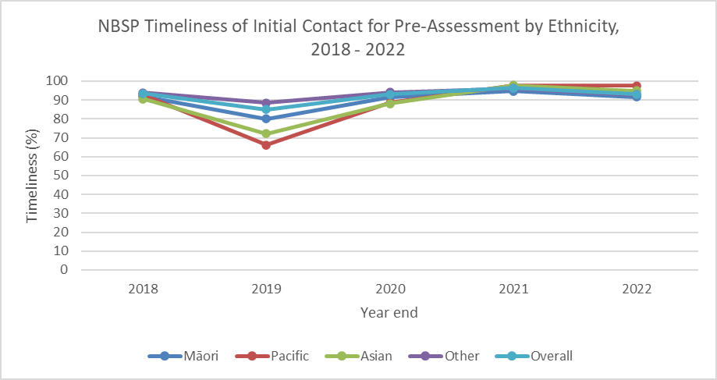

Figure 34: NBSP Timeliness of Initial Contact for Pre-Assessment by Ethnicity, 2018 - 2022

Table 35: NBSP Timeliness of Initial Contact for Pre-Assessment by Ethnicity, 2018 – 2022

|  |  |  |  |  |  |  |
| --- | --- | --- | --- | --- | --- | --- |
| **Ethnicity** | | **2018** | **2019** | **2020** | **2021** | **2022** |
| **Māori** | **Numerator** | 159 | 347 | 383 | 724 | 923 |
| **Denominator** | 173 | 433 | 419 | 764 | 1009 |
| **Percentage** | 91.9 | 80.1 | 91.4 | 94.8 | 91.5 |
| **Pacific** | **Numerator** | 75 | 127 | 146 | 307 | 319 |
| **Denominator** | 81 | 192 | 165 | 315 | 327 |
| **Percentage** | 92.6 | 66.1 | 88.5 | 97.5 | 97.6 |
| **Asian** | **Numerator** | 180 | 253 | 288 | 652 | 688 |
| **Denominator** | 199 | 351 | 327 | 667 | 724 |
| **Percentage** | 90.5 | 72.1 | 88.1 | 97.8 | 95 |
| **Other** | **Numerator** | 1567 | 2896 | 2914 | 5446 | 5900 |
| **Denominator** | 1668 | 3275 | 3099 | 5660 | 6354 |
| **Percentage** | 93.9 | 88.4 | 94 | 96.2 | 92.9 |
| **Overall** | **Numerator** | 2026 | 3641 | 3731 | 7129 | 7830 |
| **Denominator** | 2170 | 4282 | 4010 | 7406 | 8414 |
| **Percentage** | 93.4 | 85 | 93 | 96.3 | 93.1 |

Table 36: NBSP Timeliness of Initial Contact for Pre-Assessment by Age Group, 2018 – 2022

|  |  |  |  |  |  |  |
| --- | --- | --- | --- | --- | --- | --- |
| **Age Group** | | **2018** | **2019** | **2020** | **2021** | **2022** |
| **60-64** | **Numerator** | 642 | 1126 | 1268 | 2403 | 2585 |
| **Denominator** | 688 | 1344 | 1350 | 2488 | 2760 |
| **Percentage** | 93.3 | 83.8 | 93.9 | 96.6 | 93.7 |
| **65-69** | **Numerator** | 583 | 1150 | 1188 | 2125 | 2384 |
| **Denominator** | 622 | 1332 | 1276 | 2199 | 2573 |
| **Percentage** | 93.7 | 86.3 | 93.1 | 96.6 | 92.7 |
| **70-74** | **Numerator** | 801 | 1365 | 1275 | 2601 | 2861 |
| **Denominator** | 860 | 1606 | 1384 | 2719 | 3081 |
| **Percentage** | 93.1 | 85 | 92.1 | 95.7 | 92.9 |

Table 37: NBSP Timeliness of Initial Contact for Pre-Assessment by Gender, 2018 - 2022

|  |  |  |  |  |  |  |
| --- | --- | --- | --- | --- | --- | --- |
| **Gender** | | **2018** | **2019** | **2020** | **2021** | **2022** |
| **Female** | **Numerator** | 826 | 1457 | 1556 | 2889 | 3169 |
| **Denominator** | 882 | 1697 | 1656 | 3008 | 3407 |
| **Percentage** | 93.7 | 85.9 | 94 | 96 | 93 |
| **Male** | **Numerator** | 1199 | 2181 | 2172 | 4238 | 4657 |
| **Denominator** | 1287 | 2582 | 2350 | 4396 | 5002 |
| **Percentage** | 93.2 | 84.5 | 92.4 | 96.4 | 93.1 |

## Preliminary interval cancer rate and sensitivity

This section presents a preliminary analysis of interval cancers following a negative FIT in participants screened in the first two years of the NBSP, from July 2017 to June 2019, during which eight out of twenty districts were involved in delivering the NBSP. A final, more detailed analysis will be published at a later date.

Interval cancers are defined as cancers which occur in the 24-month period following a negative FIT (within the time period before the next screen would have occurred). The rate of interval cancers is an important performance indicator of a screening programme, reflecting the sensitivity of the screening test as well as the incidence of newly detected cancers which were not detected on the initial screen.

Data on participants who received a negative FIT test in the NBSP between July 2017 and June 2019 was matched to colorectal cancer (CRC) diagnoses within 24 months of the screen in the New Zealand Cancer Registry (NZCR), using the National Health Index (NHI) number. Participants that had previously been in the bowel screening pilot were excluded due to the differing age range (50–74 years) and FIT threshold (75ng Hb/mL buffer solution) used in the pilot. Data cleaning and analysis was carried out in Microsoft Excel.

#### Comments

The provisional prevalent interval cancer rate (14.8 per 10,000 definitive screens) and FIT sensitivity for CRC 71.8%, (CI 67.0-76.1) shows the NBSP is within the range of similar bowel cancer screening programmes internationally (with similar thresholds for positivity) and the bowel screening pilot where the overall FIT sensitivity for CRC was 78.7% (95% CI=74.9% to 82.1%)[5]. Of note, the more detailed analysis indicates that 65 of the 105 interval cancers (61.9%) had a FIT level less than 75ng Hb/mL buffer solution. The analysis will be repeated when a complete data set is available i.e. all districts have been delivering bowel screening for four years (to allow two years of screens followed by two years to develop an interval cancer).

Table 38: NBSP FIT Sensitivity, January 2017 to December 2019

|  |  |  |  |  |
| --- | --- | --- | --- | --- |
| **Age** | **Interval Cancers** | **Screen detected** | **Sensitivity** | **(95% CI)** |
| Total | 105 | 267 | 71.8 | (67, 76.1) |

Table 39: NBSP Rate of Interval Cancers per 10,000 Definitive Screens, January 2017 to December 2019

|  |  |  |  |
| --- | --- | --- | --- |
| **FIT level** | **Interval Cancers** | **Definitive screens** | **Interval cancer rate per 10,000 definitive screens** |
| Total | 105 | 70,932 | 14.8 |

## Diagnostic assessment completion rate (305)

This is the percentage of people with a positive FIT result who complete a publicly funded colonoscopy or CT colonography through the NBSP.

There are many reasons for the diagnostic assessment rate not being 100%. Some FIT positive participants may:

* elect to use a private health provider for their diagnostic test
* decline to have a colonoscopy
* not be suitable for diagnostic test (e.g. they may have other significant medical conditions)
* have recently had a colonoscopy.

#### Indicator 305: Diagnostic Assessment Completion Rate

|  |
| --- |
| **Target:** 85% or more of individuals who return a positive FIT in any given 24-month period, successfully complete a colonoscopy and/or Virtual CTC diagnostic assessment. |
| **Numerator:** The number of people who undertake a publicly funded colonoscopy or CT colonography within the National Bowel Screening Programme. |
| **Denominator:** The number of people with a positive FIT result. |
| **Anchor date:** The date when the positive kit result was received determines which time period it is counted under. |

#### Comments

The completion rate is similar by age and ethnicity, but higher for men than women in 2022 (graph for age not included).

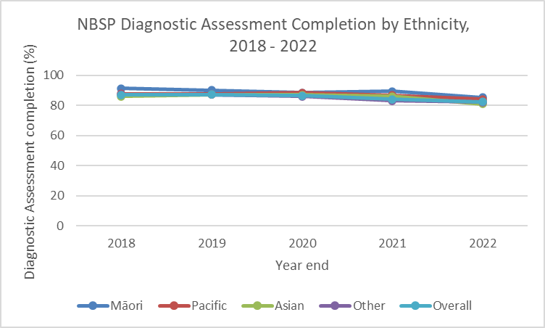

Figure 35: NBSP Diagnostic Assessment Completion by Ethnicity, 2018 – 2022

Table 40: NBSP Diagnostic Assessment Completion by Ethnicity, 2018 – 2022

|  |  |  |  |  |  |  |
| --- | --- | --- | --- | --- | --- | --- |
| **Ethnicity** | | **2018** | **2019** | **2020** | **2021** | **2022** |
| **Māori** | **Numerator** | 158 | 396 | 375 | 691 | 875 |
| **Denominator** | 173 | 439 | 424 | 772 | 1025 |
| **Percentage** | 91.3 | 90.2 | 88.4 | 89.5 | 85.4 |
| **Pacific** | **Numerator** | 72 | 168 | 148 | 273 | 277 |
| **Denominator** | 82 | 192 | 167 | 315 | 329 |
| **Percentage** | 87.8 | 87.5 | 88.6 | 86.7 | 84.2 |
| **Asian** | **Numerator** | 172 | 314 | 288 | 598 | 604 |
| **Denominator** | 200 | 360 | 331 | 694 | 746 |
| **Percentage** | 86 | 87.2 | 87 | 86.2 | 81 |
| **Other** | **Numerator** | 1509 | 2987 | 2777 | 5090 | 5673 |
| **Denominator** | 1731 | 3419 | 3226 | 6125 | 6900 |
| **Percentage** | 87.2 | 87.4 | 86.1 | 83.1 | 82.2 |
| **Overall** | **Numerator** | 1945 | 3879 | 3588 | 6652 | 7429 |
| **Denominator** | 2236 | 4442 | 4148 | 7906 | 9000 |
| **Percentage** | 87 | 87.3 | 86.5 | 84.1 | 82.5 |

Table 41: NBSP Diagnostic Assessment Completion by Age Group, 2018 - 2022

|  |  |  |  |  |  |  |
| --- | --- | --- | --- | --- | --- | --- |
| **Age Group** | | **2018** | **2019** | **2020** | **2021** | **2022** |
| **60-64** | **Numerator** | 628 | 1217 | 1223 | 2229 | 2464 |
| **Denominator** | 711 | 1405 | 1401 | 2692 | 2970 |
| **Percentage** | 88.3 | 86.6 | 87.3 | 82.8 | 83 |
| **65-69** | **Numerator** | 556 | 1219 | 1134 | 1992 | 2254 |
| **Denominator** | 644 | 1375 | 1314 | 2342 | 2753 |
| **Percentage** | 86.3 | 88.7 | 86.3 | 85.1 | 81.9 |
| **70-74** | **Numerator** | 761 | 1443 | 1231 | 2431 | 2711 |
| **Denominator** | 881 | 1662 | 1433 | 2872 | 3277 |
| **Percentage** | 86.4 | 86.8 | 85.9 | 84.6 | 82.7 |

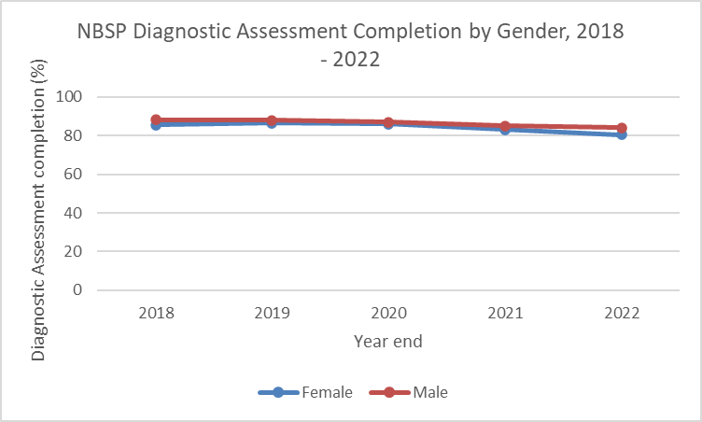

Figure 36: Diagnostic Assessment Completion by Gender, 2018 - 2022

Table 42: NBSP Diagnostic Assessment Completion by Gender, 2018 – 2022

|  |  |  |  |  |  |  |
| --- | --- | --- | --- | --- | --- | --- |
| **Gender** | | **2018** | **2019** | **2020** | **2021** | **2022** |
| **Female** | **Numerator** | 783 | 1529 | 1465 | 2692 | 2976 |
| **Denominator** | 917 | 1769 | 1706 | 3245 | 3700 |
| **Percentage** | 85.4 | 86.4 | 85.9 | 83 | 80.4 |
| **Male** | **Numerator** | 1161 | 2347 | 2120 | 3958 | 4450 |
| **Denominator** | 1318 | 2670 | 2438 | 4659 | 5295 |
| **Percentage** | 88.1 | 87.9 | 87 | 85 | 84 |

## Timeliness of actual diagnostic assessment (colonoscopy wait time) (307)

A programme standard to offer a complete a colonoscopy or CTC within 60 working days of abnormal FIT result exists to reduce unnecessary anxiety to screening participants and to facilitate timely investigation of abnormal FIT results and treatment when needed.

Providing access to diagnostic assessment services in a timely manner depends on many factors including demand for colonoscopy services, capacity and waiting list management protocols.

#### Indicator 307: Timeliness of Actual Diagnostic Assessment (Colonoscopy Wait Time)

|  |
| --- |
| **Target:** 90% participants returning a positive FIT have their diagnostic procedure within 60 working days of positive of FIT result being recorded in any 24-month reporting period. |
| **Numerator:** Number of participants who completed their colonoscopy or CTC within 60 working days of positive FIT result being received into the register. |
| **Denominator:** Number of participants who returned a positive FIT during the reporting period for whom their pre-assessment outcome was either a colonoscopy or CTC. |
| **Anchor date:** The date when a kit result was recorded in the register determines which time period it is counted under. |

#### Comments

For the total screening population, colonoscopy wait times have been improving since a low point was seen during the pandemic, despite increasing referral numbers to assessment. While services have not been achieving the target for Māori and Pacific participants, wait times have proportionally increased more in the last two years for those groups than for Others. The programme also monitors uptake rates for diagnostic assessment following a public referral; there is no significant difference in completion of a diagnostic procedure The colonoscopy wait time is similar by age and gender (graphs for age and gender not presented).

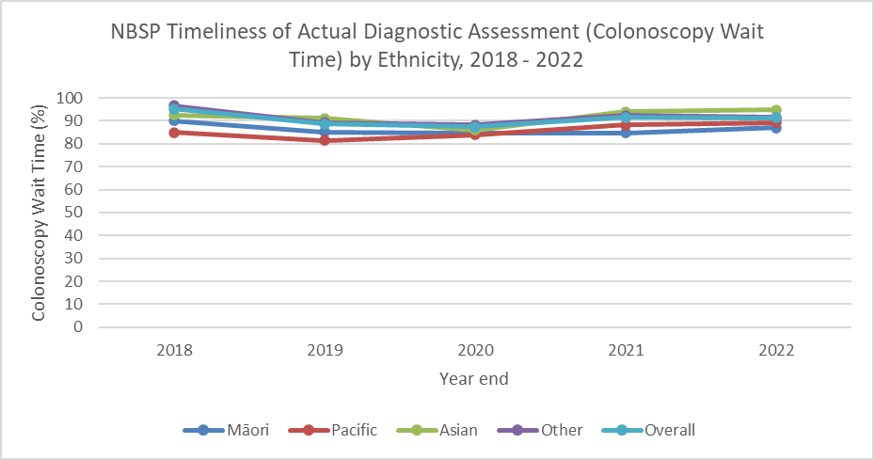

Figure 37: NBSP Timeliness of Actual Diagnostic Assessment (Colonoscopy Wait Time) by Ethnicity, 2018 – 2022

Table 43: NBSP Timeliness of Actual Diagnostic Assessment (Colonoscopy Wait Time) by Ethnicity, 2018 – 2022

|  |  |  |  |  |  |  |
| --- | --- | --- | --- | --- | --- | --- |
| **Ethnicity** | | **2018** | **2019** | **2020** | **2021** | **2022** |
| **Māori** | **Numerator** | 145 | 340 | 327 | 593 | 773 |
| **Denominator** | 161 | 399 | 386 | 700 | 887 |
| **Percentage** | 90.1 | 85.2 | 84.7 | 84.7 | 87.1 |
| **Pacific** | **Numerator** | 62 | 140 | 126 | 247 | 249 |
| **Denominator** | 73 | 172 | 150 | 280 | 279 |
| **Percentage** | 84.9 | 81.4 | 84 | 88.2 | 89.2 |
| **Asian** | **Numerator** | 160 | 290 | 251 | 566 | 575 |
| **Denominator** | 173 | 318 | 292 | 602 | 606 |
| **Percentage** | 92.5 | 91.2 | 86 | 94 | 94.9 |
| **Other** | **Numerator** | 1467 | 2698 | 2477 | 4742 | 5230 |
| **Denominator** | 1519 | 3021 | 2807 | 5132 | 5707 |
| **Percentage** | 96.6 | 89.3 | 88.2 | 92.4 | 91.6 |
| **Overall** | **Numerator** | 1867 | 3482 | 3181 | 6148 | 6827 |
| **Denominator** | 1959 | 3926 | 3635 | 6714 | 7479 |
| **Percentage** | 95.3 | 88.7 | 87.5 | 91.6 | 91.3 |

Table 44: NBSP Timeliness of Actual Diagnostic Assessment (Colonoscopy Wait Time) by Age Group, 2018 – 2022

|  |  |  |  |  |  |  |
| --- | --- | --- | --- | --- | --- | --- |
| **Age Group** | | **2018** | **2019** | **2020** | **2021** | **2022** |
| **60-64** | **Numerator** | 603 | 1081 | 1083 | 2059 | 2253 |
| **Denominator** | 631 | 1237 | 1232 | 2251 | 2477 |
| **Percentage** | 95.6 | 87.4 | 87.9 | 91.5 | 91 |
| **65-69** | **Numerator** | 528 | 1088 | 1011 | 1855 | 2068 |
| **Denominator** | 558 | 1227 | 1152 | 2012 | 2272 |
| **Percentage** | 94.6 | 88.7 | 87.8 | 92.2 | 91 |
| **70-74** | **Numerator** | 736 | 1313 | 1087 | 2234 | 2506 |
| **Denominator** | 770 | 1462 | 1251 | 2451 | 2730 |
| **Percentage** | 95.6 | 89.8 | 86.9 | 91.1 | 91.8 |

Table 45: NBSP Timeliness of Actual Diagnostic Assessment (Colonoscopy Wait Time) by Gender, 2018 – 2022

|  |  |  |  |  |  |  |
| --- | --- | --- | --- | --- | --- | --- |
| **Gender** | | **2018** | **2019** | **2020** | **2021** | **2022** |
| **Female** | **Numerator** | 760 | 1369 | 1292 | 2482 | 2727 |
| **Denominator** | 789 | 1551 | 1483 | 2721 | 2992 |
| **Percentage** | 96.3 | 88.3 | 87.1 | 91.2 | 91.1 |
| **Male** | **Numerator** | 1106 | 2110 | 1888 | 3664 | 4097 |
| **Denominator** | 1169 | 2372 | 2149 | 3991 | 4484 |
| **Percentage** | 94.6 | 89 | 87.9 | 91.8 | 91.4 |

## Referral rate to diagnostic assessment following positive FIT (308)

This is the percentage of participants with a positive FIT result who are referred for diagnostic assessment. This diagnostic assessment could be either a colonoscopy or CTC and be through either the public or private health system.

This measure helps assess the effectiveness of the programme in targeting people appropriately for screening and the pre-assessment procedures. An effective programme requires that individuals with a positive screening test result complete the appropriate diagnostic follow-up with colonoscopy and/or CTC. Monitoring this measure provides important information to plan strategies to improve messaging relating to eligibility for screening and diagnostic follow-up. Data is stratified to assess equitable access to diagnostic assessment.

#### Indicator 308: Referral Rate to Diagnostic Assessment Following Positive FIT

|  |
| --- |
| **Target:** No target established. |
| **Numerator:** The number of people whose have been referred to a colonoscopy or CT colonography - either public or private. |
| **Denominator:** The number of people for whom a positive FIT result was recorded on the register during the calendar year. |
| **Anchor date:** The date when a kit result was recorded in the register determines which time period it is counted under. |

#### Comments

After being relatively stable for all groups, the referral rate for Māori, Pacific and Asian participants decreased in 2022. Review of 2023 data shows a favourable increase for Māori participants. The referral rate is similar by age and gender (graphs for age and gender not presented).

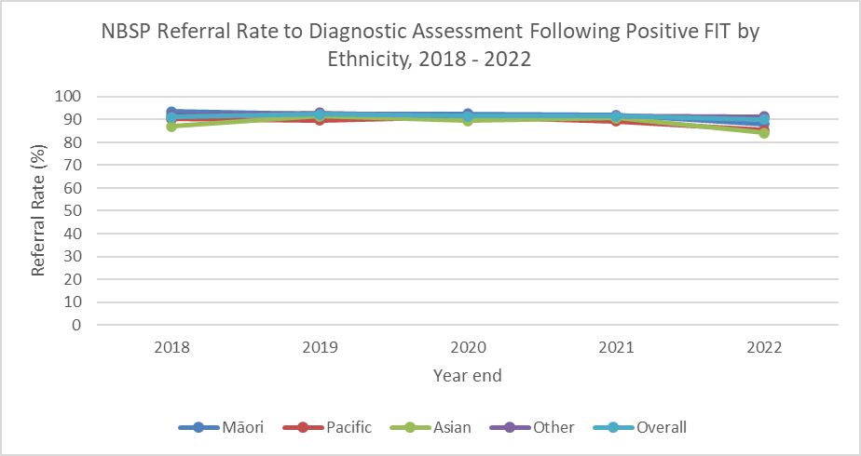

Figure 38: NBSP Referral Rate to Diagnostic Assessment Following Positive FIT by Ethnicity, 2018 – 2022

Table 46: NBSP Referral Rate to Diagnostic Assessment Following Positive FIT by Ethnicity, 2018 – 2022

|  |  |  |  |  |  |  |
| --- | --- | --- | --- | --- | --- | --- |
| **Ethnicity** | | **2018** | **2019** | **2020** | **2021** | **2022** |
| **Māori** | **Numerator** | 162 | 405 | 392 | 711 | 903 |
| **Denominator** | 173 | 439 | 424 | 774 | 1025 |
| **Percentage** | 93.6 | 92.3 | 92.5 | 91.9 | 88.1 |
| **Pacific** | **Numerator** | 74 | 172 | 152 | 283 | 281 |
| **Denominator** | 82 | 192 | 167 | 317 | 329 |
| **Percentage** | 90.2 | 89.6 | 91 | 89.3 | 85.4 |
| **Asian** | **Numerator** | 174 | 329 | 296 | 629 | 628 |
| **Denominator** | 200 | 360 | 331 | 694 | 746 |
| **Percentage** | 87 | 91.4 | 89.4 | 90.6 | 84.2 |
| **Other** | **Numerator** | 1590 | 3181 | 2958 | 5624 | 6296 |
| **Denominator** | 1731 | 3419 | 3225 | 6127 | 6900 |
| **Percentage** | 91.9 | 93 | 91.7 | 91.8 | 91.2 |
| **Overall** | **Numerator** | 2034 | 4104 | 3798 | 7247 | 8108 |
| **Denominator** | 2236 | 4442 | 4147 | 7912 | 9000 |
| **Percentage** | 91 | 92.4 | 91.6 | 91.6 | 90.1 |

Table 47: NBSP Referral Rate to Diagnostic Assessment Following Positive FIT by Age Group, 2018 – 2022

|  |  |  |  |  |  |  |
| --- | --- | --- | --- | --- | --- | --- |
| **Age Group** | | **2018** | **2019** | **2020** | **2021** | **2022** |
| **60-64** | **Numerator** | 658 | 1303 | 1291 | 2472 | 2704 |
| **Denominator** | 711 | 1405 | 1401 | 2698 | 2970 |
| **Percentage** | 92.5 | 92.7 | 92.1 | 91.6 | 91.0 |
| **65-69** | **Numerator** | 583 | 1277 | 1199 | 2164 | 2462 |
| **Denominator** | 644 | 1375 | 1314 | 2342 | 2752 |
| **Percentage** | 90.5 | 92.9 | 91.2 | 92.4 | 89.5 |
| **70-74** | **Numerator** | 793 | 1524 | 1308 | 2611 | 2942 |
| **Denominator** | 881 | 1662 | 1432 | 2872 | 3278 |
| **Percentage** | 90 | 91.7 | 91.3 | 90.9 | 89.7 |

Table 48: NBSP Referral Rate to Diagnostic Assessment Following Positive FIT by Gender, 2018 – 2022

|  |  |  |  |  |  |  |
| --- | --- | --- | --- | --- | --- | --- |
| **Gender** | | **2018** | **2019** | **2020** | **2021** | **2022** |
| **Female** | **Numerator** | 828 | 1628 | 1544 | 2969 | 3303 |
| **Denominator** | 917 | 1769 | 1706 | 3247 | 3700 |
| **Percentage** | 90.3 | 92 | 90.5 | 91.4 | 89.3 |
| **Male** | **Numerator** | 1205 | 2473 | 2251 | 4276 | 4802 |
| **Denominator** | 1318 | 2670 | 2437 | 4663 | 5295 |
| **Percentage** | 91.4 | 92.6 | 92.4 | 91.7 | 90.7 |

## Colorectal cancer (CRC) stage at diagnosis (402)

This indicator represents the proportion of people diagnosed with CRC by their cancer stages.

Pathological staging is usually considered to be more accurate because it allows direct examination of the tumour in its entirety, contrasted with clinical staging which is limited by the fact that the information is obtained by making indirect observations of a tumour which is still in the body.

The cancer stage reported by this indicator is the pathological stage. Where surgery has not been performed, the clinical stage is used.

The dataset includes four rectal cancers which have been historically coded as stage 0; these cases may be updated in future reports as additional information is made available. Some rectal cancers are treated with chemotherapy before surgery, and because of the response to treatment, no cancer is found at surgery. These are included in the denominator, but not the numerator.

Data from 2018-2022 have been grouped and reported together as there are a relatively small numbers in some groups and annual trends would be difficult to interpret.

#### Indicator 402: Colorectal Cancer (CRC) Stage at Diagnosis

|  |
| --- |
| **Target:** Long-term target: At least 20% diagnosed with Stage 1 cancer (anticipated benefit in business case). |
| **Numerator:** The number of people diagnosed with Colorectal cancer including Polyp cancer, by cancer stage, in the reporting period. |
| **Denominator:** The total number of people diagnosed with Colorectal cancer including Polyp cancer (regardless of their cancer stages) in the reporting period. |
| **Anchor date:** The date when a kit was received by the lab determines which time period it is counted under. |

#### Comments

For all groups, the programme is exceeding its target of at least 20% of cancers diagnosed at stage 1. It is a positive achievement for the NBSP that at least 37.4% of bowel cancers are being detected at stage 1. Stage 1 bowel cancer has a much greater chance of being successfully treated compared to later stages and hence a higher survival rate (>90% at five years). For comparison, the proportion of bowel cancers diagnosed at stage 1 in the Aotearoa New Zealand population before screening was 12% (27% stage 2, 25% stage 3, 24% stage 4, 5% non-metastatic, unable to be further define and 7% unknown stage)[6].

The programme has been working hard to improve the quality and completeness of staging data. Specific attention is being given to addressing completeness for Māori participants where there is a higher proportion of stage data that is not in the register.

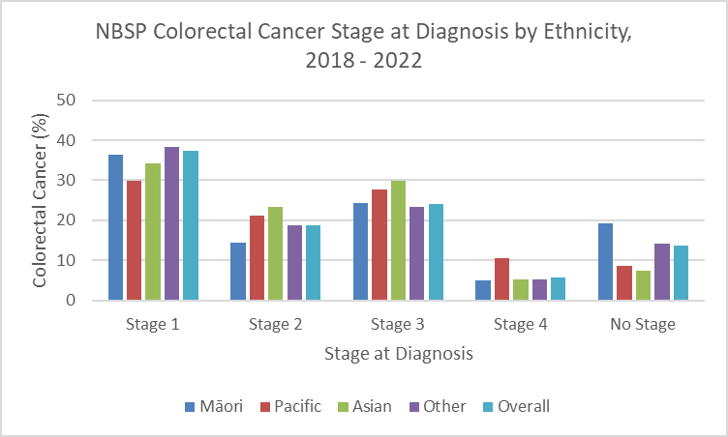

Figure 39: NBSP Colorectal Cancer Stage at Diagnosis, by Ethnicity, 2018 – 2022

Table 49: NBSP Colorectal Cancer Stage at Diagnosis, by Ethnicity, 2018 – 2022

|  |  |  |  |  |  |  |
| --- | --- | --- | --- | --- | --- | --- |
| **Ethnicity** | | **Stage 1** | **Stage 2** | **Stage 3** | **Stage 4** | **No Stage** |
| **Māori** | **Numerator** | 51 | 20 | 34 | 7 | 27 |
| **Denominator** | 140 | 140 | 140 | 140 | 140 |
| **Percentage** | 36.4 | 14.3 | 24.3 | 5.0 | 19.3 |
| **Pacific** | **Numerator** | 14 | 10 | 13 | 5 | 4 |
| **Denominator** | 47 | 47 | 47 | 47 | 47 |
| **Percentage** | 29.8 | 21.3 | 27.7 | 10.6 | 8.5 |
| **Asian** | **Numerator** | 47 | 32 | 41 | 7 | 10 |
| **Denominator** | 137 | 137 | 137 | 137 | 137 |
| **Percentage** | 34.3 | 23.4 | 29.9 | 5.1 | 7.3 |
| **Other** | **Numerator** | 536 | 263 | 328 | 74 | 197 |
| **Denominator** | 1400 | 1400 | 1400 | 1400 | 1400 |
| **Percentage** | 38.3 | 18.8 | 23.4 | 5.3 | 14.1 |
| **Overall** | **Numerator** | 648 | 325 | 418 | 98 | 238 |
| **Denominator** | 1731 | 1731 | 1731 | 1731 | 1731 |
| **Percentage** | 37.4 | 18.8 | 24.1 | 5.7 | 13.7 |

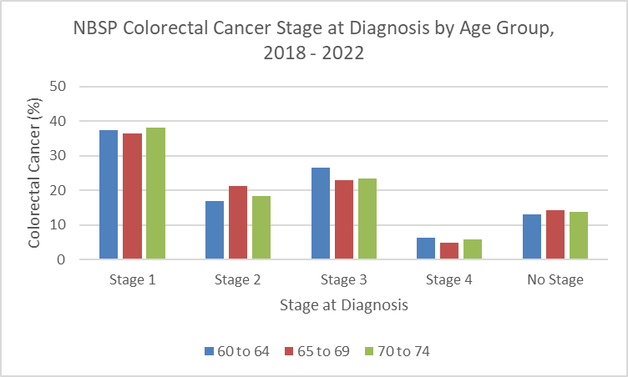

Figure 40: NBSP Colorectal Cancer Stage at Diagnosis by Age Group, 2018 - 2022

Table 50: NBSP Colorectal Cancer Stage at Diagnosis by Age Group, 2018 - 2022

|  |  |  |  |  |  |  |
| --- | --- | --- | --- | --- | --- | --- |
| **Age Group** | | **Stage 1** | **Stage 2** | **Stage 3** | **Stage 4** | **No Stage** |
| **60-64** | **Numerator** | 175 | 79 | 125 | 29 | 61 |
| **Denominator** | 469 | 469 | 469 | 469 | 469 |
| **Percentage** | 37.3 | 16.8 | 26.7 | 6.2 | 13.0 |
| **65-69** | **Numerator** | 193 | 112 | 121 | 26 | 76 |
| **Denominator** | 530 | 530 | 530 | 530 | 530 |
| **Percentage** | 36.4 | 21.1 | 22.8 | 4.9 | 14.3 |
| **70-74** | **Numerator** | 280 | 134 | 172 | 43 | 101 |
| **Denominator** | 732 | 732 | 732 | 732 | 732 |
| **Percentage** | 38.3 | 18.3 | 23.5 | 5.9 | 13.8 |

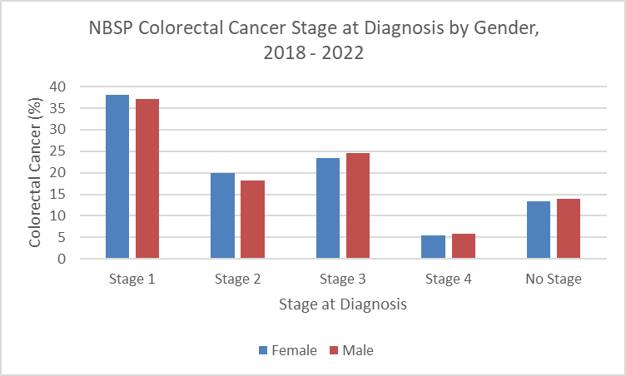

Figure 41: NBSP Colorectal Cancer Stage at Diagnosis by Gender, 2018 - 2022

Table 51: NBSP Colorectal Cancer Stage at Diagnosis by Gender, 2018 - 2022

|  |  |  |  |  |  |  |
| --- | --- | --- | --- | --- | --- | --- |
| **Gender** | | **Stage 1** | **Stage 2** | **Stage 3** | **Stage 4** | **No Stage** |
| **Female** | **Numerator** | 239 | 125 | 147 | 34 | 84 |
| **Denominator** | 629 | 629 | 629 | 629 | 629 |
| **Percentage** | 38.0 | 19.9 | 23.4 | 5.4 | 13.4 |
| **Male** | **Numerator** | 408 | 199 | 270 | 64 | 154 |
| **Denominator** | 1099 | 1099 | 1099 | 1099 | 1099 |
| **Percentage** | 37.1 | 18.1 | 24.6 | 5.8 | 14.0 |

## NBSP quality assurance

The NBSP Colonoscopy Quality and Assurance Group meets quarterly and is made up of clinical sector leaders. The NBSP Standards for Performing Bowel Screening Colonoscopy in New Zealand are set by the Endoscopy Guidance Group of New Zealand which is hosted and supported by the NBSP[7].

#### Comments

All targets are met except family history recording. There are multiple ways to record family history on the electronic colonoscopy reporting system and improving data capture is an ongoing focus. However, family history is always documented at preassessment. Collecting family history is important because it can determine if an individual is at increased risk of bowel cancer which requires monitoring outside of the screening programme.

Data sources: NBSP Datamart and the Provation Colonoscopy Database (PVCD) on 20/02/2023

## National colonoscopist quality assurance report

National Colonoscopist Quality Assurance Report

Figure 1: Caecal intubation rate (with 95% CI markers)

Figure 2: Adenoma detection rate (with 95% CI markers)

Figure 3: Non tissue collected scopes with >=6 min withdrawal rate (with 95% CI markers)

## Unplanned admission rate

Unplanned admissions are reported by districts and have severity of unplanned admission rated by the National Screening Unit using the *UK Key Performance Indicators & Quality Assurance Standards for Colonoscopy*[8].

Unplanned admissions are reported quarterly and have a one quarter reporting lag. Unplanned admission trends and any learning from intermediate and major serious unplanned admissions are discussed at the quarterly Colonoscopy Quality Assurance Group. Potential lessons identified after review of these unplanned admissions are circulated quarterly to the NBSP district clinical leads

Post NBSP colonoscopy interval colorectal cancers are now being reviewed quarterly as another indicator of quality of NBSP colonoscopy - this data will be included in subsequent reports.

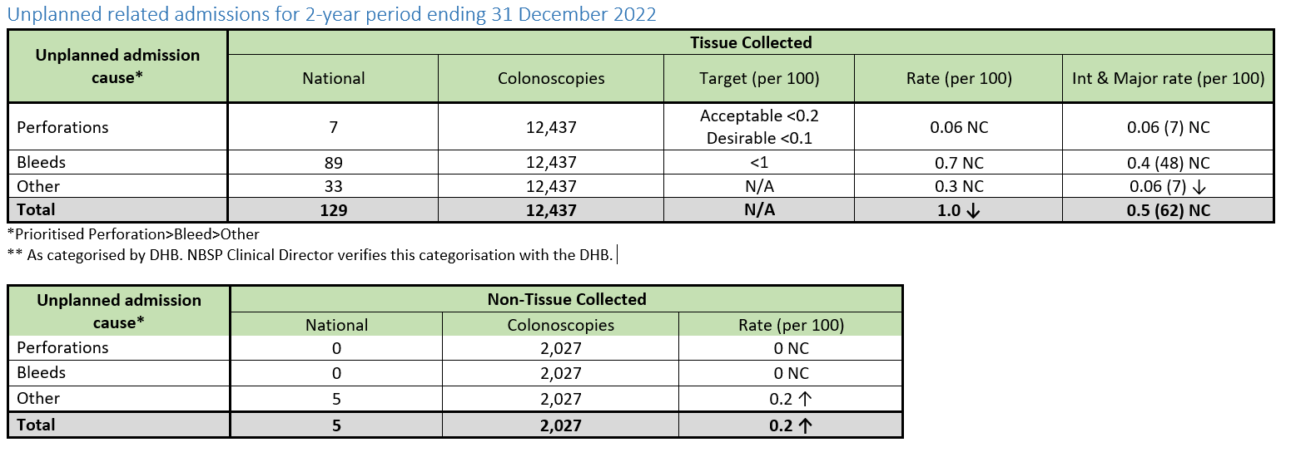

1. Saw KS, et al. BMJ Open Gastroenterol 2023;10:e001233. doi:10.1136/bmjgast-2023-001233
2. Harris R, Paine S-J, Atkinson J et al (2022) We still don’t count: the under-counting and under-representation of Māori in health and disability sector data. *New Zealand Medical Journal.* 135(1567): 54-79
3. Ministry for Pacific Peoples (2022) *Long-Term Insights Briefing 2022* https://www.mpp.govt.nz/assets/Reports/Long-Term-Insights-Briefing/MPP-LTIB-v3.pdf
4. Segnan N, Patnick J, von Karsa L (eds) (2010) *European Guidelines for Quality Assurance in Colorectal Cancer Screening and Diagnosis - First Edition*. Luxembourg: Publications Office of the European Union.
5. Ref Saw KS, et al. BMJ Open Gastroenterol 2023;10:e001233 doi:10.1136/bmjgast-2023-001233
6. Jackson et al (2015) The PIPER Project; An internal examination of colorectal cancer management in New Zealand Final Report.
7. <https://eggnz.endoscopyquality.co.nz/assets/Uploads/EGGNZ-MoH-Endoscopy-Individual-Standards-2021-FINAL3.pdf>
8. [UK Key Performance Indicators and Quality Assurance Standards for Colonoscopy - The British Society of Gastroenterology (bsg.org.uk)](https://www.bsg.org.uk/clinical-resource/uk-key-performance-indicators-and-quality-assurance-standards-for-colonoscopy/)