Neural Tube Defects At
Westown Maternity Hospital, 1965-72

A Report to the
Taranaki District Health Board

Prepared by

Dr Patrick O’Connor
Medical Officer of Health

August 2002

Table of Contents

Executive Summary 2
Introduction 3
Neural Tube Defects 4
Genetic factors 4
Reproductive and Family History 4
Socio-economic factors 4
Diet 4
Environmental & Occupational factors 4
Herbicides and dioxin 5
Monitoring of Birth Defects and Neural Tube Defects in NZ 6
2,4,5-T Production at Ivon-Watkins-Dow 7
Results 9
Discussion 17
Conclusions 19
Recommendations 19
Acknowledgements 19
References 20

Executive Summary

This study is one of a number that have investigated, or are investigating, concerns about possible adverse health effects from dioxin, which originated from 2,4,5-T manufacture in New Plymouth.

During the years 1965-71, the Charge Nurse at Westown Maternity Hospital collected information about birth defects at the hospital. In response to information from her, an investigation has taken place, based on labour ward records from Westown. Information has been collected regarding neural tube defects during the years 1965-72.

The study has been restricted to neural tube defects because the possibility of a link between dioxin and neural tube defects has been the subject of published research, and because the labour ward records did not record other less serious abnormalities. It is also restricted to the years 1965-72. It has not been possible to extend the case search beyond 1972 because of incomplete records and changes in the way the labour ward record was kept.

A total of 23 cases of neural tube defects were identified. The numbers identified in this study do not match completely with figures provided by the former Charge Nurse.

The rate of neural tube defects (3.2 per thousand births) is comparable with studies done at other centres in New Zealand at about that time.

Three cases were identified from the neighbourhood of the factory where 2,4,5-T was produced. It is estimated that about one case would be expected, given the neural tube defect rate at Westown Maternity Hospital. The surviving parents of these three cases have been contacted. One of the fathers had some occupational contact with the factory.

There are many factors involved in neural tube epidemiology, such as diet, genetic background, previous reproductive history, and postulated environmental factors. It is not possible from present data to link neural tube defects at Westown Maternity Hospital, and the three cases of neural tube defect in Paritutu, to any particular cause.

Introduction

There have been concerns about possible harmful health effects associated with 2,4,5-T production in New Plymouth. In response, the Taranaki District Health Board produced a report in 2001 which found no evidence, since 1988, of an increased local rate of cancer, birth defects, or multiple sclerosis. ¹ In 2001 the Taranaki Regional Council undertook a survey of alleged dump sites in Taranaki which found no evidence of contamination. ²² In 2002, the Ministry for the Environment is doing a survey of dioxin levels in soil in Paritutu. In addition the Ministry of Health is planning a serum dioxin study of long-term residents.

Concerns have also been expressed about possible health effects in the past, most notably birth defects. Information was received from the former Charge Nurse at Westown Maternity Hospital (who will be referred to in this study as CN). During the years 1965 she undertook a personal study of the birth defects she observed, or were recorded, for babies born at Westown. A copy of her findings is shown in Table 2.

At that time Westown was the largest maternity hospital in Taranaki, and the only one in New Plymouth. There were about 1,000 births per year at Westown. The other Taranaki units around this time were at Waitara, Inglewood, Opunake, Stratford and Hawera. There were referrals from the smaller units to Westown, especially for premature or complicated labours.

To gather further information about birth defects during 1965-71, an inspection was made of labour ward records. The inspection was carried beyond 1971, but this could only be done to 1972. Records are incomplete for 1973 and 1974. In 1975 a new recording system was put in place which does not appear to record abnormalities as comprehensively as in the years 1965-72. It was decided to include 1972 records in this present study because a case from an address in Moturoa was found in that year.

There are many different defects recorded in Table 2. Only the neural tube defects (anencephaly and spina bifida) are dealt with in this report. This is because the labour ward records mention only major defects, so there is no way of obtaining information about most of the defects in Table 1. Further reasons for concentrating on neural tube defects are that an estimate is available for prevalence in New Zealand in the 1960s, and because there is published literature about possible links between dioxin and this kind of defect. ²

The issue of neural tube defects in Taranaki has received some attention in the past. Between 1974-76 there were four neural tube defects in Opunake, and then a further case in Normanby in 1976. These cases were investigated along with similar groups of cases in Waikato and Northland. The conclusion was that no link to 2,4,5-T could be demonstrated. ³

This study aims to answer the following questions:

- During the years 1965-72, was the rate of neural tube defects at Westown Maternity Hospital higher than the national rate?
- Is there any evidence of a link between cases of neural tube defects, and the manufacture of 2,4,5-T in New Plymouth?

Neural Tube Defects

The main neural tube defects are anencephaly (rudimentary brain only) and spina bifida (spinal cord abnormality) resulting from failure of the neural tube to close spontaneously between the 3rd and 4th week of in utero development. Several factors are known, or postulated, to influence the prevalence of neural tube defects. ⁴

Genetic factors

Prevalence varies widely between ethnic groups and within countries. In New Zealand, prevalence is lower among Maori than non-Maori. ^{5,6} In the USA prevalence is lower in the black population than the white population. ⁷ In the British Isles an east-west gradient is observed with higher rates in Wales and Ireland. The increased rate in Ireland is also observed among children of parents who migrate to USA. ⁸

Reproductive and Family History

Related to genetic factors is the observation that after one neural tube defect, a couple have a higher chance of a subsequent NTD. After one child with a neural tube defect the recurrence rate is 4%, and after two it increases to 10%. An increase in risk is also observed among relatives of a child with a neural tube defect. ⁸

Socio-economic factors

Neural tube defects are more common among lower socio-economic groups. This may be related to a number of lifestyle factors, notably diet. ⁹

Diet

It is known that folic acid supplementation around the time of conception reduces the risk of neural tube defect. ¹⁰ In New Zealand the principal dietary sources of folate are vegetables (18%), bread (13%), breakfast cereals (11%), fruits, potato and kumara (8%), non-alcoholic beverages (6%), and sauces (5%). ¹¹ Related to this association with folate is the observation that anti-folate drugs, such as valproate, increase the risk of neural tube defect.

Environmental & occupational factors

In general the studies of such factors have been inconclusive. Factors studied have included: radiation, nitrates in drinking water, water pollution in general, and parental occupation. ^{9,21}

Herbicides and dioxin

The best-known population exposure to dioxin occurred at Seveso in Italy in 1976. A six-year follow-up of birth defects did not demonstrate an increased risk of birth defects in general, or neural tube defects in particular, for mothers who had been in the contaminated zone. The study was limited by small sample size, and a lack of information about terminated pregnancies. ¹²

A New Zealand study has investigated birth defects among children of men who used 2,4,5-T as sprayers and agricultural contractors. No associations were noted between herbicide exposure and birth defects for the years 1969-1980. ¹³

It has been suggested that the father’s exposure to herbicides or dioxin may increase the risk of birth defect. There has been considerable research into the possible role of 2,4,5-T and/or dioxin, especially in light of concerns about birth defects in children of Vietnam veterans who handled 2,4,5-T and 2,4-D (combined in Agent Orange) during the war. This issue is addressed in “Veterans and Agent Orange Update 1996”, a report from the Committee to Review the Health Effects in Vietnam Veterans of Exposure to Herbicides. The report says in its conclusion: ²

“There is limited/suggestive evidence of an association between exposure to the herbicides considered in this report and spina bifida. There is inadequate or insufficient evidence to determine whether an association exists between exposure to the herbicides and all other birth defects. The evidence regarding association is drawn from occupation and other studies in which subjects were exposed to a variety of herbicides and herbicide components”.

More recently a Ministry for the Environment report “Evaluation of the toxicity of dioxins and dioxin-like PCBS: a health risk appraisal for the NZ population” states:

“The available epidemiological evidence is insufficient or inadequate to determine whether an association exists between exposure to TCDD and…birth defects in humans” ¹⁴

For the purposes of this report it is assumed that a link between dioxin and neural tube defects in humans is unproven, but remains a possibility.

Monitoring of Birth Defects and Neural Tube Defects in NZ

In analysing data about neural tube defects that occurred 30-35 years ago it is worth noting that neural tube defects are now much less common. In the past six years in Taranaki there have been no anencephalic babies born, and two babies born with spina bifida. The main difference is that we now screen nearly all pregnancies with an ultrasound scan in early pregnancy. If a major deformity is noted the mother has the option of a termination. A second factor may be an improvement in diet, especially greater intake now of folate which is known to protect against neural tube defects.

Thirty-five years ago New Zealand did not have a comprehensive birth defect monitoring system. Reliable nation-wide estimates of the prevalence of neural tube defects are available for the year 1978, and for the years 1978-82. The estimated rates were 2.0 per thousand births (1978) and 1.7 per thousand births (1978-82). ^{5,6}

In 1976 a Medical Notification of Births Scheme was introduced which attempted to monitor birth defects. In its first year of operation the notification rate was estimated to be 70%, and on this basis the neural tube defect rate was estimated to be 2.23 per thousand, not greatly different from the 1978 estimate. ³

For estimates of rates during the 1960s and early 1970s, we rely on studies based at particular hospitals. The most widely recognised is that from National Women’s Hospital for the years 1964-67. This originally quoted a neural tube defect rate of 3.6 per 1,000. This estimate was subsequently revised to 2.9 per thousand, taking into account high-risk maternity referrals to the hospital. 1^{5,16}

Table 1 summarises the prevalence estimates from a number of studies. For each study it is assumed that cases of both spina bifida and anencephalus are classified as anencephalus. This is an accepted convention, but is not stated explicitly in all studies.

Table 1

Summary of NTD Studies in New Zealand, 1964-82

Area | Time period | NTD rate per  1,000 live births | Reference
Auckland | 64-67 | 3.6 | 15
Auckland (adjusted) | 64-67 | 2.9 | 16
Northland | 66-77 | 2.5 | 17
Dunedin | 67-73 | 2.9 | 18
Christchurch | 70-75 | 4.5 | 19
New Zealand | 1978 | 2.0 | 5
New Zealand | 78-82 | 1.7 | 6

These figures show some evidence of a trend, with lower rates as time progresses to the late 1970s. For studies that included the time-frame of this study the range of prevalence estimates is 2.5 to 4.5. For comparison purposes in this study, the adjusted estimate from the Auckland study is used, namely 2.9 per thousand. This estimate is mid-range, compared with others from that time period.

2,4,5-T Production at Ivon-Watkins-Dow

A brief overview of 2,4,5-T production is useful because any discussion of a link to neural tube defects must involve a plausible means of exposure.

IWD began manufacture of 2,4,5-T in New Plymouth in 1948. In 1962 its manufacturing plant moved from Buller Street to Paritutu. Until 1969 manufacture was based on imported trichlorophenol. After 1969 TCP was manufactured locally. Dioxin, specifically 2,3,7,8-TCDD, is a by-product of trichlorophenol manufacture. Before 1969 dioxin was in the imported TCP, and left the factory in the 2,4,5-T. After 1969 the dioxin was produced locally as well as leaving in the finished product.

From 1973, use of a solvent reduced the dioxin in the 2,4,5-T from about 1ppm to 0.1ppm. The solvent was stored at the site, and between 1975 and 1979 this was burned at a liquid waste incinerator installed on site. In 1978/79 the company introduced changes to the TCP process to reduce the amount of dioxin produced. By 1982 it is estimated that the dioxin concentration in 2,4,5-T was 0.01ppm. From 1980 waste was burned in a newly installed solid waste incinerator. 2,4,5-T manufacture stopped in 1987.

This information is presented graphically in figure 1. Estimates of dioxin in the 2,4,5-T are taken from a report to the Environmental Council in 1986. ²⁰ Estimates of dioxin removed for disposal are inferred from this same source. This shows an increase in total dioxin production through to about 1980; but from 1973 most of the dioxin was removed from the product and later disposed of by burning.

Also shown on figure 1 is a summary of possible sources of exposure to dioxin. It is to be emphasised that this seeks to identify possible exposure sources, and is not an analysis of whether this happened, or in what quantity.

Throughout the period exposure has been possible via use of 2,4,5-T. Also throughout the period workers may have been exposed during the process of converting TCP to 2,4,5-T. Fugitive emissions from the factory are also a possibility. From 1969 dioxin was produced in the manufacture of TCP, and this may also have involved exposure to workers, or to the population through fugitive emissions. From 1973 dioxin waste was incinerated. Some dioxin may have been released to the air, depending on incinerator efficiency. Finally there were two incidents involving release of gas to the environment. The first was a fire at the MCPB plant in 1972, and the second an emission of built-up gases at the TCP plant in 1986.

It should also be noted that odours from the factory were frequently experienced by local residents. This could have been from various sources such as: directly from phenoxy herbicides, steam cleaning of drums, and possibly fugitive process emissions.

During the years 1965-72 there was no exposure possible through waste incineration. The fire at the MCPB plant occurred late in this period. This fire was restricted to the MCPB plant, a process which did not involve dioxins. Possible sources of exposure are therefore through: use of 2,4,5-T; exposure of workers to production of 2,4,5-T from TCP and, from 1969, production of TCP; and possible fugitive emissions from the factory during both processes.
Figure 1
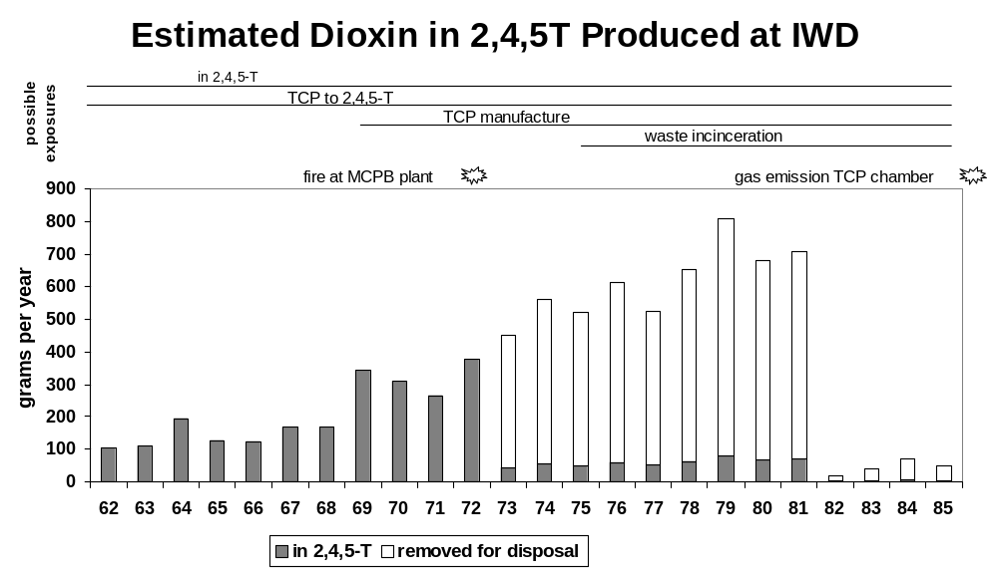
Data source: Coster AP et al. The use of 2,4,5-T in NZ. A report to the Environmental Council. Wellington. 1986
Method

A search was made of labour ward records from Westown Maternity Hospital for the years 1965-72. This involved a total of 7,183 births. The records note some birth defects. It is assumed that neural tube defects would always be noted, but this cannot be guaranteed. Although this study concentrates on neural tube defects, a supplementary list was kept of other major deformities noted.

For each neural tube defect it was possible to record a date of birth and the mother’s name. The record did not include the mother’s address. For this information, and for the father’s occupation, we contacted the Central Register for Births Deaths and Marriages. In most cases this information was available. Some missing information about addresses was obtained from another labour ward register kept at Westown, and available from 1967.

It was hoped to extend the study beyond 1972, but this was not possible because of a change in the way the labour ward records were kept.

Information about addresses identified three cases whose families lived close to IWD. It was possible to contact the surviving parents, and a summary of supplementary information from them is included in this report.

Results

For the years 1965-72, 23 cases of neural tube defect were identified. Table 2 is a copy of CN’s data, and Table 3 is a summary of information in the present study. It should be noted that the present study’s time period is slightly longer than CN. In extending the study period, a case from Paritutu was found in 1972, and it was decided to include the case and the year in the study. As already noted, it was not possible to extend this study further than 1972.

It is difficult to compare these two tables. One problem is that CN’s data is a count of abnormalities, rather than of affected individuals. There is also some interchange of the terms “spina bifida” and “meningocoel”. For the years 1965-71 CN documented 12 cases of anencephaly and 16 spina bifida; this study identifies 10 anencephaly and 13 spina bifida through the same time period. A comparison of figures from CN and from the present study is presented in Table 5.

Some other major birth defects were identified as part of the search of the daily labour ward registers. These were excluded as not being neural tube defects. A summary is shown in Table 4.

Table 3 also notes the occupation of the fathers. There is no way, from this information, of being sure that the father’s did not work at the IWD factory. However, the wide range of occupations is limited reassurance that such is not the case. Three cases are from addresses near the IWD factory. The fathers’ occupations for these three were: supervisor, motor mechanic and fitter. As noted in Table 8, the fitter had occasional work contact with IWD over a period of two years.

The 23 individual cases, out of 7,183 births, represent a prevalence rate of 3.2 per 1,000 births. Figure 2 shows a graphical comparison of the Taranaki and the rate of neural tube defects at National Women’s Hospital 1964-67. As has been discussed earlier, the NWH estimate is the most comparable for the time-period of this study. If the NWH rate of 2.86 per thousand is applied to the Westown birth statistics, the expected number of neural tube defects would be 20.5. This is very similar to the observed total of 23.

Map 1 shows the areas of New Plymouth where the families lived at the time of birth for 17 of the cases. Four other were from out of town, and the address of one is unknown. It should be noted that this is not necessarily the same address as in the first 30 days of pregnancy, which is when any causative environmental factor would be at work. The pattern of addresses shows five cases from Moturoa. In a previous report an area close to the factory was referred to as Paritutu, and it represented 33% of the Moturoa population. Of the five Moturoa cases, one is in this area, two are just outside, and two more are distant from the factory. The location of these five is shown in more detail in map 2.

In order to examine whether the three cases on the Paritutu side of Moturoa represent an excessive number, a study area has been defined and is shown in map 3. It has been obtained by drawing a circle based at the factory site, with its radius extending beyond the most distant of the three cases. The radius is half-way between the distance from the factory to the furthest Paritutu case, and the distance to the next nearest case which was in Moturoa. It is recognised that there is an arbitrary element to this choice of area.

A survey of births 1968-69 was examined. These years were chosen because they are in the middle of the study period, and because information on addresses was not available for the entire study period. A summary of findings is in table 6. On the basis of this, estimates have been made in Table 7 for the expected number of NTDs in the study period, depending on whether the study period is compared with urban New Plymouth births, or with all births at Westown. The respective estimates are 1.3 and 1.1, both less than the observed total of 3 NTDs in the Paritutu area.

If we assume that the expected total is 1.1, then the probability of observing 3 or more is 0.1. This means that the observed excess is not statistically significant.

To gather further information about the three cases, interviews were held with five of the six parents involved. One of the mothers died in 1981. A summary of information regarding these six people is shown in Table 8.

Of interest is that one of the fathers had some work contact with IWD. This shows that the information on the father’s occupation in Table 3 should be treated with caution as there is no indication from the occupation, “fitter”, that there was contact with IWD. No other risk factors are evident. In particular there is no personal or family history of other babies born with a neural tube defect.

Table 2

New Plymouth Hospital records of congenital malformations delivered at Westown Maternity Hospital

 | 1965 - 1966 | 1966 - 1967 | 1967 - 1968 | 1968 - 1969 | 1969 - 1970 | 1970 - 1971 | 1971 - 1972 | Total 6 years
Anencephalic | 3 | 0 | 4 | 2 | 1 | 2 |  | 12
Hydrocephaly | 2 | 2 | 6 | 1 | 0 | 4 |  | 15
Microcephaly | 1 | 1 | 2 | 0 | 1 | 0 |  | 5
Meningocele | 2 | 0 | 5 | 3 | 1 | 3 |  | 14
Spina Bifida | 0 | 0 | 0 | 0 | 0 | 2 |  | 2
Congenital Heart | 1 | 2 | 6 | 3 | 0 | 0 |  | 12
1 Artery Cord | 6 | 1 | 1 | 1 | 5 | 2 |  | 16
Cystic Kidney | 0 | 0 | 0 | 0 | 0 | 1 |  | 1
Renal Agenesis | 0 | 0 | 1 | 0 | 1 | 0 |  | 2
Atresia of Bowel | 0 | 1 | 1 | 1 | 1 | 2 |  | 6
Tracheo-esophageal Fistula | 0 | 1 |  |  |  |  |  | 1
Diaphragmatic Hernia | 0 | 1 | 0 | 0 | 0 | 0 |  | 1
Exomphalos | 3 | 0 | 0 | 0 | 0 | 0 |  | 3
Circulatory Defect | 0 | 0 | 0 | 1 | 0 | 0 |  | 1
Liver Defect | 0 | 0 | 1 | 0 | 0 | 0 |  | 1
Mongols | 0 | 1 | 1 | 0 | 0 | 2 |  | 4
Trisomy (5) | 0 | 1 | 0 | 1 | 0 | 0 |  | 2
Hare Lip | 1 | 0 | 3 | 2 | 3 | 1 |  | 10
Cleft Palate | 1 | 1 | 2 | 0 | 2 | 1 |  | 7
Talipes | 12 | 6 | 8 | 9 | 0 | 6 |  | 41
Extra Digits | 0 | 0 | 0 | 0 | 0 | 3 |  | 3
Hypospadias | 2 | 2 | 1 | 2 | 3 | 6 |  | 16
Web Digits | 1 | 1 | 0 | 2 | 2 | 0 |  | 6
Lung Deformity | 0 | 0 | 0 | 0 | 0 | 1 |  | 1
Eye Abnormality | 1 | 0 | 0 | 0 | 0 | 0 |  | 1
Ear Abnormality | 1 | 0 | 0 | 0 | 0 | 0 |  | 1
Angioma | 0 | 1 | 0 | 0 | 1 | 0 |  | 2
Tumour of Face | 0 | 0 | 0 | 0 | 1 | 0 |  | 1
Rare Blood Cord | 0 | 1 | 0 | 0 | 0 | 0 |  | 1
Stenosis of Larynx) Diagnosed before leaving hospital | 0 | 0 | 1 | 0 | 0 | 0 |  | 1
Pyloric Stenosis) Diagnosed before leaving hospital | 0 | 0 | 1 | 0 | 0 | 0 |  | 1
Teratoma | 0 | 0 | 0 | 1 | 2 | 0 |  | 3
Achondroplasia | 0 | 0 | 0 | 1 | 2 | 0 |  | 3
Oxycephaly | 0 | 0 | 0 | 0 | 1 | 0 |  | 1
Lymphangietasia | 0 | 0 | 0 | 1 | 0 | 0 |  | 1
Nasal Bone Defect | 0 | 0 | 0 | 1 | 0 | 0 |  | 1
Other Joint Defects | 5 | 3 | 3 | 1 | 0 | 2 |  | 14
Imperforate Anus | 0 | 0 | 1 | 0 | 1 | 0 |  | 2
TOTAL: | 42 | 26 | 48 | 32 | 27 | 38
Number of Babies Affected: | 37 | 24 | 29 | 27 | 22 | 28 |  | 167 | Total Babies
 | Total Babies 167 of 5,392 = 3%
CDH Hips Splint | 29 | 12 | 9 | 4 | 11 | 9 |  | 74
Note: Reconstruction of a table provided by CN based on her personal data collection
Table 3

Summary of Neural Tube Defects at Westown Maternity Hospital 1965-72

Year | Anen  cephaly | Spina  bifida | Father’s  occupation | Mother’s  address
1965 | ✓ |  | Electrician | Fitzroy
 | ✓ |  | Painter | Struan Park
 |  | ✓ | Post office clerk | Kawaroa
1966 |  | ✓ | Dairy farmer | Okato
1967 | ✓ |  | State servant | Marsland Hill
 | ✓ |  | Post office clerk | Frankleigh
 | ✓ | ✓ | Truck driver | Inglewood
 | ✓ |  | Contractor | Inglewood
 |  | ✓ | Police constable | Upper Westown
1968 |  | ✓ | Company director | Moturoa
 | ✓ |  | Field assistant | Merrilands
 |  | ✓
 |  | ✓ | Education board officer | Westown
 | ✓ | ✓ | Supervisor | Moturoa *
1970 |  | ✓ |  | Struan Park
 |  | ✓ | Photographer | Moturoa
 | ✓ | ✓ | Motor Mechanic | Moturoa *
 | ✓ |  | Dairy farmer | Rural
1971 |  | ✓ |  | Waitara
 |  | ✓ | Telecommunications technician | Spotswood
 | ✓ |  |  | Frankleigh
1972 |  | ✓ |  | Frankleigh
 | ✓ |  | Fitter | Moturoa *

- those marked with an asterisk are from the part of Moturoa near the IWD factory.

Table 4.

Other Major CNS Abnormalities Identified but Not Included in Study

Year | Abnormality
1965 | ?Hydrocephaly
1967 | Hydrocephaly
 | Hydrocephaly
1968 | Hydrocephaly
 | ?Oxycephaly
1971 | Hydrocephaly

Table 5.

Comparison of Table 1 with Information in Current Study

 |  | 65/66 | 66/67 | 67/68 | 68/69 | 69/70 | 70/71 | Total
Anencephaly | Table 1 | 3 | 0 | 4 | 2 | 1 | 2 | 12
Anencephaly | This study | 2 | 0 | 4 | 2 | 0 | 2 | 10
Spina bifida/  Meningocoel | Table 1 | 2 | 0 | 5 | 3 | 1 | 5 * | 16
Spina bifida/  Meningocoel | This study | 2 | 0 | 4 | 4 | 1 | 2 | 13 **

* For 1970/71, Table 1 has separate figures for spina bifida and meningocoel. It is not clear whether these apply to 5 different individuals, or whether one or two individuals are defined as having two defects.
** Initial copies of this report incorrectly had this total as 14.

Figure 2

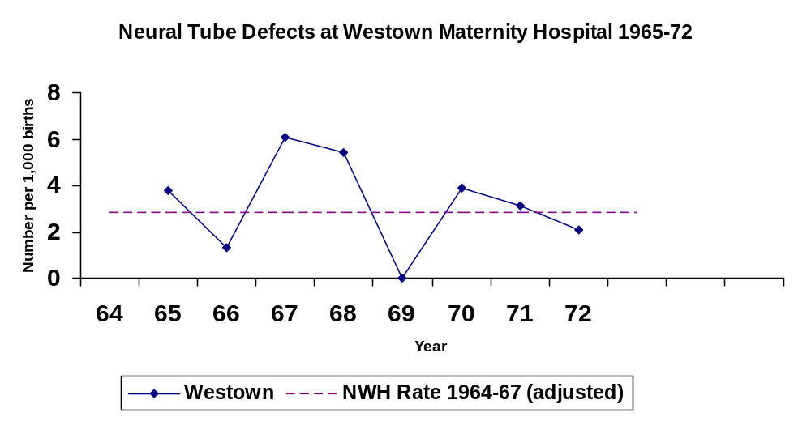

Map 1.

Neural Tube Defects in New Plymouth 1965-72

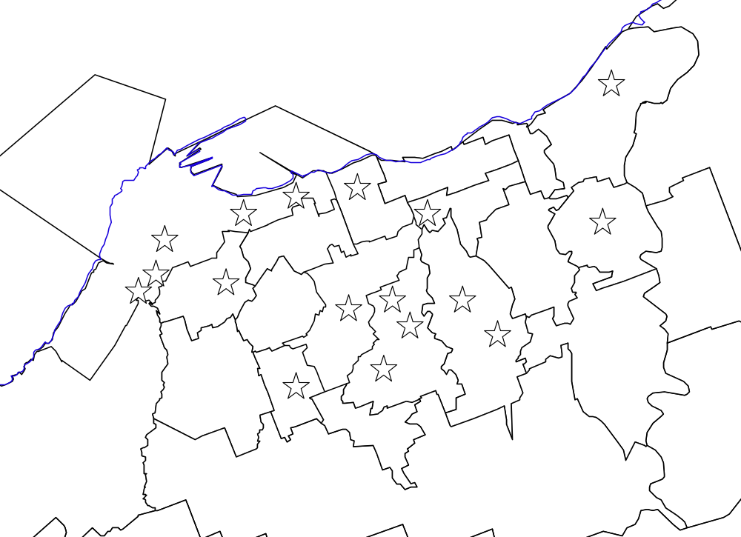

Map 2.

Neural Tube Defects in Moturoa, 1965-72

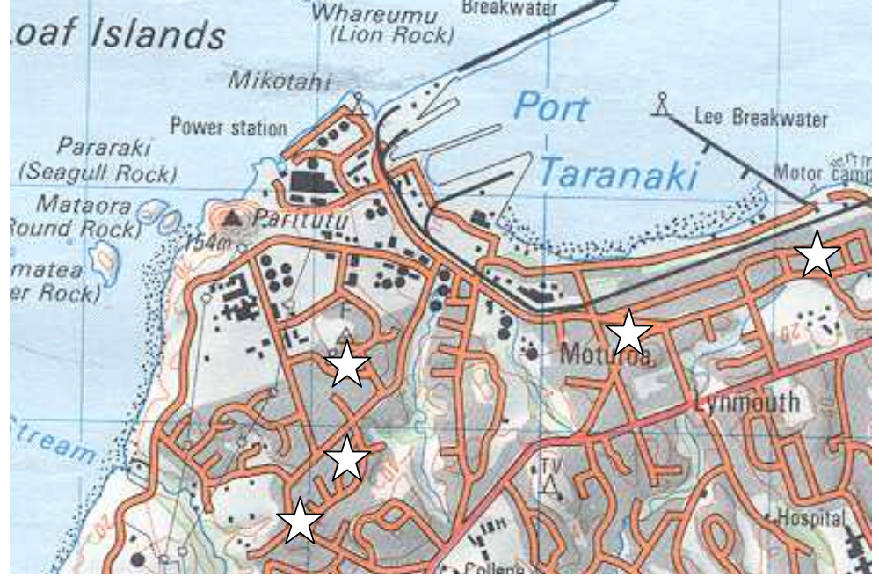

Map 3.

Study Area for Paritutu Neural Tube Defect Cases

note: radius of circle is halfway between distance from factory to furthest Paritutu case, and from factory to nearest non-Paritutu case.

Table 6

Birth Addresses at Westown Maternity Hospital 1968-69

 | Study Area | Rest of urban NP |  | Total
Births 1968-69 | 94 | 1145 | 618 | 1857

Table 7

Expected NTDs in Study Area on Basis of Birth Address Survey

 | Based on Urban Births Only | Based on all Westown Births
% births in study area | 7.6% | 5.1%
Total NTDs for study period | 17 | 22
Expected NTDs in study area | 1.3 | 1.1
Actual NTDs in study area | 3 | 3

Table 8.

Summary of Information from Parents of Paritutu Neural Tube Defect Babies

Year baby  born | Parent | Lived in  Paritutu | Work at IWD | Use of  herbicides | Obstetric  history | Family  history
1968 | Mrs A | 1964-90 | nil | Nil | Problems, but no other defects | Nil of note
1968 | Mr A | 1964-90 | nil | nil |  | Nil of note
1970 | Mrs B  (died in 1981) | 1956-67, then 1968-75 | nil | nil | Normal | Nil of note
1970 | Mr B | 1964 -75 | nil | nil |  | Nil of note
1972 | Mrs C | 1959 to now | nil | nil | Normal | Nil of note
1972 | Mr C | 1967 to now | 1967-69: mechanical engineer with company that had a maintenance contract at IWD | nil |  | Nil of note

Discussion

At the beginning of this report, it was stated that two questions were to be addressed, namely:
- During the years 1965-72, was the rate of neural tube defects at Westown Maternity Hospital higher than the national rate?
- Is there any evidence of a link between cases of neural tube defects, and the manufacture of 2,4,5-T in New Plymouth?

In answer to the first question we can say that the local rate was slightly higher than the best available estimate for the national rate at that time. The difference is not statistically significant.

This comparison is subject to a number of uncertainties. These include:

- An incomplete match between figures in this study, and the figures provided by CN
- An assumption that published studies have complied with the convention that cases involving both anencephalus and spina bifida are classified as anencephalus
- The choice of which prevalence estimate to use for comparison with the Westown figures.

To say the difference is not statistically significant is not to diminish the importance and the impact on the families of each case of neural tube defect. Neither is it a denial of any local influences on the local prevalence. It is simply to state that the observed excess is within the range that can be expected by chance.

Within New Plymouth an attempt has been made to calculate the number of cases that might be expected in the neighbourhood of the IWD factory. To do this it was not possible to use the definition of “Paritutu” used in the 2001 report, because, of the three cases, only one was within this area. Instead an area was defined on the basis of a circle with the factory site at the centre, and radius extending just beyond the furthest of the three cases. A two year sample of birth addresses from Westown was then used to estimate the expected number of NTDs in the study area. The estimates were 1.1 and 1.3. The observed total of 3 was therefore more than expected, but the difference was not found to be statistically significant on the basis of the study areas and time periods chosen.

The three cases in “larger Paritutu” occurred in the years 1968-72. One occurred in the last month of the study period, and would not have been included if we had restricted the time period of this study to the time period of CN's table of results. It may be argued that statistical significance should be calculated for a more limited time period than 1965-72. However it is unwise to fit boundaries too closely around cases after they are found – a practice sometimes referred to as the Texas sharpshooter (fire a bullet at a wall then draw the target). ¹² This criticism could be made of the decision to extend the study period and so include a further case from Paritutu. On balance it is reasonable to refer to the full study period of 1965-72.

Great caution is required in interpreting statistical significance, given the uncertainties of our data, and the fact that much depends on the definition of the study area. Perhaps it is best to say that the results indicate three neural tube defects in the vicinity of the factory where we would expect one, and that this finding is of uncertain statistical significance.

In order to make sensible comment on this observation, it is useful to reflect on the different kinds of cluster investigations undertaken regarding neural tube defects. These have been categorised as:

- Studies with no prior suspected cluster of aetiological agent.
- Investigations initiated because a possible cluster was observed.
- Investigations initiated because of concern about specific environmental exposures. ¹²

This investigation has arisen initially because of the second reason – CN observed a number of cases of neural tube defects. Subsequently this issue has been argued to be important because of the issue of dioxin. It must be emphasised that the two issues are distinct. Observing a number of neural tube defects does not establish a cause.

If we are to postulate a link between the three cases in Paritutu and the presence of the factory, this must involve a means of exposure. There is no reason to suppose that Paritutu residents had a particularly high use of 2,4,5-T. At that time there was no incineration of waste containing dioxin. There was an incident at the factory in 1972 involving a fire at the MCPB plant. This fire was restricted to the MCPB plant, a process which did not involve dioxins. It occurred on 3/11/92, after the first two Paritutu cases were born, and at about the 8 month stage of the pregnancy of the third case.

This then leaves worker exposure or fugitive emissions from the factory as possible means of exposure. Of the three local cases, one father worked at times at IWD between 1967 and 1969.

Fugitive emissions from the factory are a possibility, but we have no way of estimating quantity, or how far any emissions may have carried. The earliest known wipe tests at local houses date from 1987, when no evidence was found of any residue of 2,4,5-T or 2,4-D. The soil dioxin survey may give a clue to what has happened in the past, though it may be difficult to distinguish the effects of fugitive emissions, incineration, and the 1986 incident at the TCP process.

An often-quoted memory of those interviewed, is of the smell from the factory. There is no doubt that some chemicals were released from there, either from the chemical process, or cleaning procedures, or other means. It is likely that this smell was from highly volatile phenoxy compounds. This does not necessarily imply the presence of 2,3,7,8-TCDD, which is less volatile than phenoxy compounds, but neither can we rule this out. Perhaps the soil survey, with analysis of dioxin congeners, may shed some light on this issue.

In answering the question “Is there any evidence of a link between cases of neural tube defects, and the manufacture of 2,4,5-T in New Plymouth?”, we can say that three cases of neural tube defect were observed in the vicinity of the IWD factory, where we would expect to find one case. Possible explanations for this observation include: chance variation, exposure to dioxin, exposure to some other cause. On current information we cannot choose between these three hypotheses.

The number of cases in this study is small. It deals with an issue, neural tube defects, where a number of causal factors, such as diet, genetics, previous reproductive history, and environmental agents, are known or postulated. Any individual case is likely to involve the interaction of a number of causal factors. For the 23 cases identified in this study, and for the three cases who lived near to the factory, it is not possible to make any definitive statement about how these cases were caused.

Conclusions

- For the years 1965-72 the rate of neural tube defects at Westown Hospital was higher than the estimated national rate. There were 23 local cases. This is 2.5 more than would be expected, using the most comparable estimate of the national rate. The difference is not statistically significant.
- There is not an exact correlation between the number of cases identified by CN, and the number found in this study.
- For the years 1965-72, there were three cases of neural tube defects whose home address was near the IWD factory. Based on the New Plymouth rate the expected number is about one. This difference is of uncertain statistical significance.
- There is no obvious association between the father’s occupation and the cases for the group as a whole. Of the three Paritutu cases, one of the fathers had contact with IWD.
- It has not been possible to extend the case search beyond 1972 because of incomplete records and changes in the way the daily labour record was kept.
- There are many factors involved in neural tube epidemiology, such as diet, genetic background, previous reproductive history, and postulated environmental factors. It is not possible from present data, to link neural tube defects at Westown Maternity Hospital and the three cases of neural tube defect in Paritutu, to any particular cause.

Recommendations

- That a copy of this report be forwarded to the Ministry of Health for their consideration.
- That the findings of this report be reviewed when further information is available from the proposed soil and serum dioxin studies.

Acknowledgements

Firstly the author acknowledges the input of those parents contacted during this study. It was past practice not to show parents an abnormal still-born child. It is clear from reactions still apparent 35 years later that this practice was wrong.

Also acknowledged is information from Dr Barry Borman, Ministry of Health, and review comments from Professor Mark Elwood. Professor Elwood is Director, National Cancer Control Initiative, Australia, and the author of publications on neural tube defect epidemiology.

References

- O’Connor PM. Rates of reported illness in Paritutu and Moturoa. Taranaki District Health Board. New Plymouth. 2001.
- Veterans and Agent Orange Update 1996. Committee to Review the Health Effects in Vietnam Veterans of Exposure to Herbicides. Institute of Medicine. Washington DC. 1996.
- McQueen EG, et al. 2,4,5-T and Human Birth Defects. Department of Health Report. Wellington. June 1977.
- Behrman RE et al. (eds) Nelson Textbook of Pediatrics 16th ed. Ch.601: Congenital Anomalies of the Central Nervous System. Saunders/Philadephia/2000.
- Borman B, Smith A, Howard JK. Risk factors in the prevalence of anencephalus and spina bifida in New Zealand. Teratology 1986;33:221-230
- Borman B, Cryer C. The prevalence of anencephalus and spina bifida in NZ. J.Paediatr. Child Health 1993;29:282-288
- Botto LD et al. Neural Tube Defects. NEJM 1999;341(20):1509-19.
- Lemire RJ. Neural Tube Defects. JAMA 1988;259(4):558-62.
- Blatter BM et al. Review of neural tube defects: risk factors in parental occupation and the environment. Env Health Perspectives 1994;102(2):140-5.
- MRC (Medical Research Council) Vitamin Study Group. (1991). Prevention of neural tube defects: results of the Medical Research Council Vitamin Study. Lancet 1991;338:131-137.
- Food and Nutrition Guidelines for Health Adults. Draft for consultation. Ministry of Health. Wellington. 2002.
- Little J & Elwood M. Clustering in time and place. In: Elwood JM, Little J, Elwood JH eds. Epidemiology and control of neural tube defects. Vol 20 of Monographs in epidemiology and biostatistics. Oxford, England: Oxford University Press, 1992:247-305.
- Smith AH et al. Congenital defects and miscarriages among New Zealand 2,4,5-T sprayers. Arch Environ Health 1982;37:197-200.
- Smith AH & Lopipero P. Evaluation of the toxicity of dioxins and dioxin-like PCBs: a health risk appraisal for the New Zealand population. Ministry for the Environment. Wellington. 2001.
- Howie RN et al. Congenital malformations in the newborn: a survey at the National Women’s Hospital, 1964-67. NZMJ 1970;71:65-71
- Baker PA. Cost benefit analysis of screening spina bifida. NZMJ 1981;93:386-9
- Hanify J, et al. Congenital malformations in the newborn in Northland: 1966-1977. NZMJ 1980;92:245-8
- Buckfield P. Major congenital faults in newborn infants: a pilot study in NZ. NZMJ 1973;78:195-204
- Legge M. Incidence of central nervous system abnormalities in newborn infants born at the Christchurch Women’s Hospital between 1970 and 1975. NZMJ 1982;95:417-8
- Coster AP et al. The Use of 2,4,5-T in New Zealand. A report to the Environmental Council. Wellington. 1986.
- Elwood JM, Little J, Elwood JH eds. Epidemiology and control of neural tube defects. Vol 20 of Monographs in epidemiology and biostatistics. Oxford, England: Oxford University Press, 1992
- Investigation of alleged agrichemical waste disposal sites in New Plymouth. Technical Report 2001-42. Taranaki Regional Council. August 2001.

