Change Notification:
cn_2024_NCAMP_ PRIMHD Team and Activity Type Update to Team Types 12 and 26
Date of Issue:
05 December 2023
Proposed Implementation Date:  01 July 2024 |  | Subject: Team and activity type update – team types 12 and 26
CHANGE NOTIFICATION
Summary:
Updates required to the PRIMHD team type activity type matrix for team type 12 – intellectual disability dual and 26 – intellectual disability.
National Collections Impacted by Change: |  | PRIMHD
Context of the Change:
Ensures that current activity types being used for team type 12 and 26 are correctly enabled in the application. The matrix drives a warning that is generated rather than sending an error message.

This update will improve guidance and reporting of PRIMHD data.
Details of Proposed Change:
Update file specification and PRIMHD application for Team type 12 by adding an ‘x’ where highlighted:

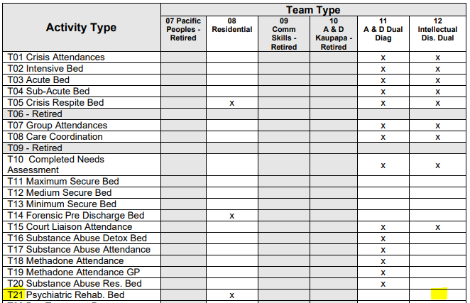

Update file specification and PRIMHD application for Team type 26 by adding an ‘x’ where highlighted:

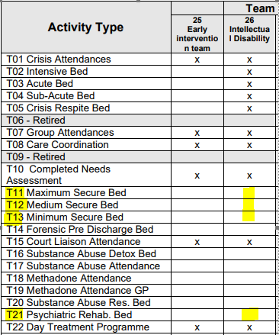

What is Expected of the Sector:
That planning commences to implement these changes for 1 July 2024.
Impact of Change on National Collection(s):
The PRIMHD file specification and application will be updated.
Contact: If you have any questions regarding this change notice, please email ncamp@health.govt.nz

