Change Notification:
cn_2023_NCAMP_ Removal of Indefinite Compulsory Treatment Orders (CTOs)
Date of Issue:
05 December 2022
Proposed Implementation Date:  01 July 2023 |  | Subject: Removal of Indefinite Compulsory Treatment Orders (CTOs)
CHANGE NOTIFICATION
Summary:
A small change has been made to the Mental Health (Compulsory Assessment and Treatment) Act 1992 which will come into effect from 29 October 2023. The change is to remove two indefinite Compulsory Treatment Order Statuses (CTOs) which means retiring two existing Legal Status codes and adding two new Legal Status codes.
National Collections Impacted by Change: |  | PRIMHD and NMDS
Context of the Change:
PRIMHD
Legal status records are reported to PRIMHD to describe the legal status of a tangata whaiora under the appropriate section of the Mental Health (Compulsory Assessment and Treatment) Act 1992, the Alcoholism and Drug Addiction Act 1966 (repealed 21 February 2018), the Intellectual Disability (Compulsory Care and Rehabilitation) Act 2003, the Criminal Procedure (Mentally Impaired Persons) Act 2003, and the Substance Addiction (Compulsory Assessment & Treatment) Act 2017.
NMDS
Legal status codes are reported to NMDS for inpatient mental health events as an HC record. The HC record is mandatory for IM events and optional for IP events. If present it must include all mandatory fields. Legal status is stored in the Event Legal Status table.
Note: Many providers do not have a mental health module on their local computer system but do treat mental health inpatients. Those providers recording legal status electronically have the option to supply legal status records with IP events as well as IM events.
Details of Proposed Change:
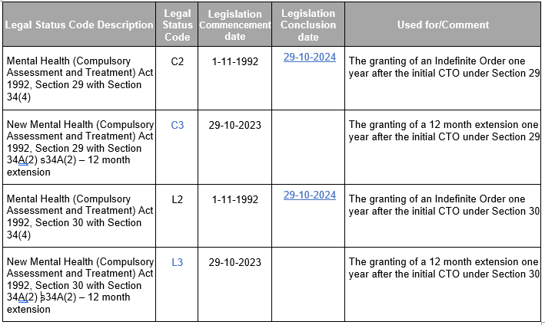
The legal status code changes are:
PRIMHD and NMDS - Patient Management Systems will need to be updated by retiring the two existing legal status codes and adding the new legal status codes.
Please refer to section 9.4 of the NMDS File Specification for further information.
What is Expected of the Sector:
There is a 12 month period for phasing in the new codes, therefore the end date for C2 and L2 is 29-10-2024 and not 29-10-2023 to enable a transition period to a new status over the 12 month period.
Impact of Change on National Collection(s):
The new legal status codes will be available from 1 July 2023 in PRIMHD and NMDS. The legal status codes that are being retired will be valid until 29 October 2024 .
Contact: If you have any questions regarding this change notice, please email ncamp@health.govt.nz

