Pacific Health Workforce Strategic Plan

2022-2024
Citation: Health New Zealand | Te Whatu Ora. 2024. Pacific Health Workforce Strategic Plan 2022-2024. Wellington: Health New Zealand | Te Whatu Ora.
Published in April 2024 by Health New Zealand | Te Whatu Ora
PO Box 793, Wellington 6140, New Zealand
ISBN 978-1-99-106786-9 (online)
This document is available at tewhatuora.govt.nz
This work is licensed under the Creative Commons Attribution 4.0 International licence. In essence, you are free to: share ie, copy and redistribute the material in any medium or format; adapt ie, remix, transform and build upon the material. You must give appropriate credit, provide a link to the licence and indicate if changes were made.

Contents
Introduction 4
Pacific Workforce Fale Malaga 5
Pacific Approach 7
Priority Pacific Workforces 9
Strategic Priorities 10
Implementation Actions 2023-2024 11
Call to Action 13
Appendix 1: Pacific Health Workforce Sept 2022 14
Appendix 2: Pacific Health Workforce Forecast 17

Introduction
The Pacific Health Workforce Strategic Plan outlines our journey to grow Pacific Peoples' participation in the health workforce over the next two years, and beyond as outlined in Ola Manuia – Interim Pacific Health Action Plan.
Our strategic plan contributes to the overarching government's vision of Pae Ora – Healthy Futures, and to the Lalanga Fou vision of a confident, thriving, resilient and prosperous Pacific Aotearoa. It is also an action outlined in Ola Manuia highlighting Pacific health workforce as a key enabler in addressing equity for Pacific peoples.
Ola Manuia is an accompaniment document to Te Pae Tata Interim New Zealand Health Plan, a formal document that sets out the first two years of action for Te Whatu Ora - Health New Zealand and Te Aka Whai Ora - Māori Health Authority.
Similar to our Pacific ancestors who voyaged across Te Moana-Nui-a-Kiwa, we work as a collective and journey towards success through a Pacific partnerships approach. Only then can we venture beyond our current shores and sail into a horizon of Pacific workforce growth and development for excellence.
Our intention is simple - a workforce journey of growth and development in priority areas. This will contribute to achieving equitable health outcomes for Pacific peoples through increased Pacific workforce participation.
Essential to increasing Pacific participation in the health sector is strengthening key elements of the workforce pathway – navigating into health careers, supporting course completion, transition into employment, ongoing career development and pathways into advanced practice and leadership.
To reach our first port of destination over the next two years we have identified the following three strategic priorities:
- Increase Pacific workforce supply;
- Develop Pacific workforce skills, knowledge, and capability; and
- Strengthen Pacific Provider capability and capacity.

Pacific Workforce Fale Malaga
The Pacific Workforce Fale Malaga is a framework outlining the approach to deliver the key initiatives of this strategy.
To orient ourselves for this journey we need to ensure that we have the right tools and resources, and that the environment that we are sailing in is favorable. This includes ensuring policies within Te Whatu Ora are enabling for Pacific; the right information and insight informs our journey; there is sustainable and increasing investment to match the destination; and there is trust and commitment across the organization.
Pacific Workforce Fale Malaga
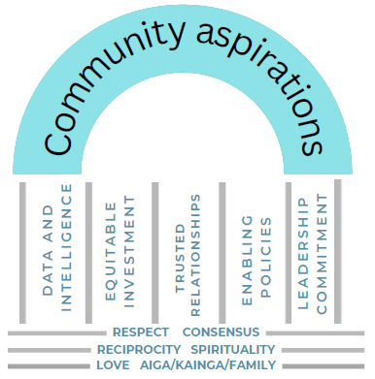
Fale / House
Malaga / Samoan concept of movement or migration.
Fale Malaga signifies the favorable conditions required and preparatory work necessary to embark on our journey.
A journey of growing and developing our Pacific health workforce participation underpinned by Pacific cultural values and principles.

Koe Pou 'e Nima
Each of the five (nima) Pou in the Workforce Fale Malaga represents key focus areas that needs to be strengthen within the context of Pacific workforce development.
Data and intelligence provide critical information to understand the current context and future trajectory needed for Pacific workforce growth and development.
Equitable investment ensures that investment and reinvestment meet the needs of Pacific workforce development that is also sustainable.
Trusted relationships encompass the various key stakeholders that are required to work in amore joined up way to create an environment whereby current and future health workforce participants succeed and thrive.
Enabling Policies is central to ensuring an environment whereby Pacific peoples are valued and are supported to succeed and thrive.
Leadership Commitment refers to leadership across Te Whatu Ora, Manatu Hauora and Te Aka Whai Ora, and the key roles that leaders play in terms of commitment to growing and developing Pacific workforce.

Pacific Approach
In addition to Fale Malaga are the all-of-Government Pacific Wellbeing Principles. The Pacific Principles and actions align to our Pacific Partnership Approach.
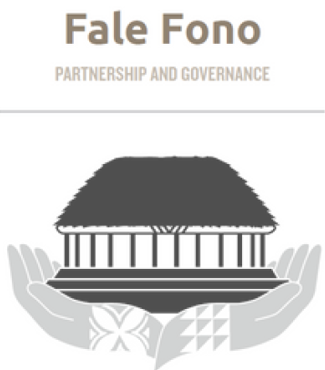 | Fale Fono (Partnership and Governance)  Pacific peoples are enabled to engage in the leadership and decision-making for Pacific health workforce development and initiatives.
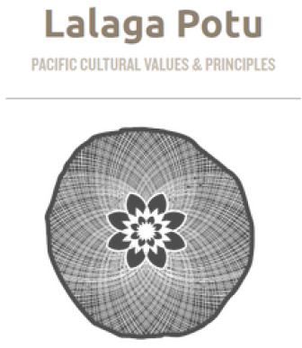 | Lalaga Potu (Values and Principles)  Pacific cultural values and principles-based approach underpin workforce development actions and initiatives.
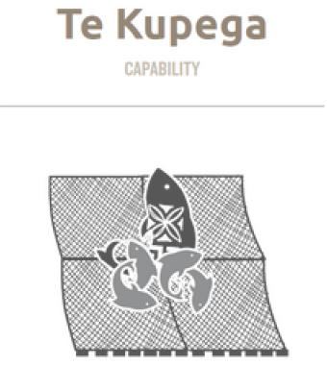 | Te Kupega (Capability)  The Pacific workforce approach build a skilled Pacific workforce including equitable access to development opportunities including leadership pathways. Pacific workforce initiatives and/or approaches support Pacific cultural safety in practice.
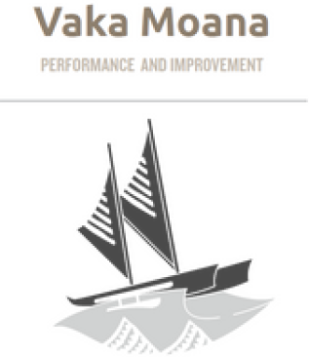 | Vaka Moana (Performance and Improvement)  The Pacific workforce approach is supported by data, evidence and a monitoring framework for highest impact, equity and accountability for Pacific peoples.
To work in a way that is truly Pacific we are committed to a foundation of Pacific values supported by community voices and aspirations.

Pacific Values
Pacific is an overarching term used to describe a grouping of various Pacific nations that are similar but also unique in their own cultures.
There are shared Pacific values that are recognized as important anchors in the way that Pacific peoples behave and engage. Pacific values underpin this strategy, which is essential in determining key actions outlined in this strategy.
Pacific values: respect, love, reciprocity, consensus, family/aiga/kainga and spirituality.

Community Aspirations
Pacific voices and aspirations are integral to this workforce strategy which have been captured in multiple ways.
The Aotearoa Lalanga Fou report capture community aspirations under the guide of the Ministry for Pacific Peoples; Pacific workforce voices captured by Pacific Perspectives in the work commissioned by Manatu Hauora; and Pacific provider voices and aspirations through COVID-19 learnings; ongoing talanoa with Pacific providers through national and regional engagements; and through Pacific staff professional groups and associations.

Priority Pacific Workforces
The Priority Pacific Workforces align with the Ola Manuia priorities of mothers & babies, children & youth, long term conditions, (cancer, diabetes, gout), mental health & wellbeing, tagata sa’ilimalo, older people, and pandemic response.
Nursing  - Maternity  - Early Years  - Women’s Health  - Primary Care  - Diabetes  - Gout  - Cancer  - Mental Health & Addictions  - Public Health | Kaiawhina  - Maternity  - Early years  - Diabetes  - Gout  - Mental Health & Addictions  - Nutrition  - Pharmacy Assistant / Techs  - Primary Care  - Oral Health  - Public Health
Medical  - Women’s Health  - Pediatrics  - Dentistry  - Primary Care  - Diabetes  - Mental Health & Addictions  - Cardiology  - Public Health | Enabling Roles  - Commissioning  - Policy  - Data & Intelligence  - General Management  - Administration
Allied Health, Technical & Scientific  - Podiatry  - Dietetics  - Optometry  - Oral Health Therapy  - Dental Assistant  - Pharmacist  - Psychology  - Counselling  - Social Workers | Midwifery

Strategic Priorities
The Pacific Workforce Strategic priority areas have been identified through various engagements with Pacific workforce, Pacific community leaders and Pacific providers. The priority areas are both internal and external given the nature of workforce planning and development.
- Streamline pathways for Pacific learners into health careers
We want a seamless pathway into health careers from study to employment in health for Pacific learners, with education and training options that reflect their needs and aspirations.

- Strengthen support for Pacific People’s in training
We need a Pacific health workforce that is thriving, engaged, and reflects the diversity and need of our Pacific communities. We need to invest now in growing our Pacific health workforces in areas that support health priorities for Pacific peoples and health reform priorities.

- Support for Pacific health workers to thrive in the workplace
We need a Pacific health workforce that can meet the community determined needs of localities and that Pacific providers are supported to thrive to serve their communities.

Pacific Workforce Fale Malaga

Implementation Actions
2023-2024
- Streamline pathways for Pacific learners into health career | We want a seamless pathway into health careers from study to employment in health for Pacific learners, with education and training options that reflect their needs and aspirations.  1.1 Implement Pacific Health Science Academies nationwide and expand the health career promotion component of the Academies.  1.2 Strengthen undergraduate support for Pacific learners in tertiary studies by scaling programmes that we know work, to provide cultural, academic and network support.  1.3 Expand access to internship programmes which expose Pacific learners to health careers early.  1.4 Improve access to earn-as-you-learn pathways for Pacific learners, including for midwifery assistant and kaiāwhina pathways.
- Strengthen support for Pacific peoples in training | We need a Pacific health workforce that is thriving, engaged, and reflects the diversity and need of our Pacific communities. We need to invest now in growing our Pacific health workforces in areas that support health priorities for Pacific peoples and reform priorities.  2.1 Develop the Nurse Practitioner Training Programme to increase engagement and support for Pacific nurses to enter and complete.  2.2 Expand the scholarships and hardship support for Pacific learners.
- Support for Pacific health workers to thrive in the workplace | We need a Pacific health workforce that can meet the community determined needs of localities and that Pacific providers are supported to thrive to serve their communities.  3.1 Establish a coordinated professional development pathway that connects primary, community and secondary care Pacific health workforces. Improve access to clinical coaches for our Pacific workforce.  3.2 Expand cultural and mentoring support for Pacific staff, particularly those who are training while working in health and who are newly in leadership roles.  3.3 Grow governance, leadership and management development for Pacific health workforces.

Call to Action
‘Fakataufata e mafiti he gutu mo e gahua he tau lima’
‘When you speak with authority, make sure you follow through with actions.’
Niuean Proverb

We are at a pivotal time in the evolution of the health system in Aotearoa New Zealand, and on the cusp of change that will deliver equitable health outcomes for Pacific peoples.
Sailing towards the priorities outlined by this plan will require a collective effort underpinned by Pacific cultures values and led by aspirations of Pacific communities, existing Pacific workforce, and prospective participants in the health workforce.
Our plan is only one part of our journey however, it is a critical part of our path towards far horizons. If we do not know which port we are sailing to, no wind will be favorable.
If you are developing workforce programmes and initiatives that also includes a Pacific component, here are some questions that can guide you in supporting the growth and development of the Pacific health workforce:
- Are any of the benefits to be realised in your programme or initiative dependent on a particular set of Pacific cultural attributes or values?
- How will the programme and/or initiative impact Pacific ethnic group or other sub-groups of Pacific peoples?
- Are there any barriers that would prevent Pacific peoples from benefitting from the implementation of your programme/initiative?
- Will implementation and delivery require a specific approach for Pacific peoples?

Appendix 1: Pacific Health Workforce Sept 2022
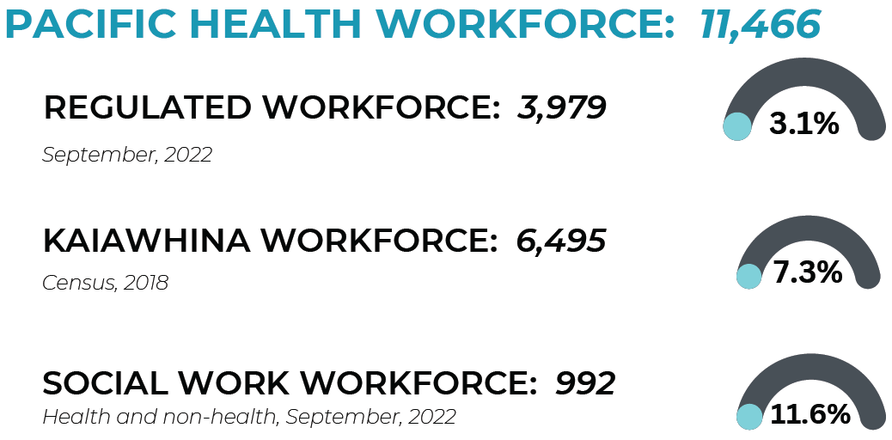

Role | No. of Pacific workforce | % total Pacific reg. health workforce | % total NZ reg. health workforce | % total Pacific health workforce^
Nurses | 2565 | 66.8% | 3.9% | 23.1%
Doctors | 432 | 10.8% | 2.3% | 3.7%
Pharmacist | 94 | 2.4% | 2.3% | 0.8%
Midwives | 92 | 2.4% | 3.0% | 0.8%
General Practitioners | 86 | 2.1% | 2.3% | 0.7%
Psychologists | 72 | 1.8% | 2.0% | 0.6%
Oral Health Therapy* | 64 | 1.6% | 4.7% | 0.5%
Podiatrists | 17 | 0.4% | 3.6% | 0.1%
Optometry | 6 | 0.2% | 0.7% | 0.05%
Dieticians | 11 | 0.2% | 1.5% | 0.09%
Counselling** | 162 | - | 4.4% ^^^ | 1.4%
Kaiawhina*** | 6,495 | - | 7.3% | 56.6%
Social Workers^^ | 992 | - | 11.6% | 8.6%

NOTE 1: Different methods are used to count Pacific ethnicity however prioritised ethnicity is the most common method. This has been identified as an issue due to the undercounting of Pacific ethnicity for Pacific peoples that also have Māori heritage. Work is underway to report using 'total Pacific' in the data.
NOTE 2: % of Pacific health workforce for counselling, kaiawhina and social work has been calculated by adding denominators of health workforce, kaiawhina and social worker totals.
*Oral Health Therapy data is 2021 and includes dental hygienists/therapists and oral health therapists.
**Roles are not regulated under the Health Practitioners Competence Assurance Act 2003. Data is analysed using the 2018 Census data based on the ANZSCO 2023Occupational Classification Codes. Counselling is recoded as a sub-set of kaiawhina.
*** Kaiawhina data is based on the 2018 Census data.
^This is a combination of the regulated, social work and kaiawhina workforces.
^^Social Worker denominator is 8,512 and includes health and non-health Social Workers.
^^^ Percentages are based on the denominator within these workforces.

Appendix 2: Pacific Health Workforce Forecast
In order to reflect the growth of our Pacific population we need to aim for 10% of the workforce in 10 years.
The graphs show the current gap between the current Pacific workforce numbers and the number required to reach the 2032 goals.
 | Current Pacific Workforce Numbers | Total needed to reach 10% in 2032
Nurses | 2,565 | 7,946
Midwives | 92 | 279
Pharmacists | 94 | 456
Doctors | 432 | 2,234
Psychologists | 72 | 456
Oral Health Therapists | 64 | 135

