Peer Review Report

October 2024

Background

The intention of the design assurance (DA) review is to assess the quality and completeness of the project documentation and to examine the design processes being demonstrated.
To ensure that project design teams deliver on Health New Zealand expectations, it is important to clearly articulate what will be reviewed.
This document outlines those requirements and provides guidance as to how to complete and manage the project Peer Review Report.

Purpose
The purpose of a Peer Review Report is to:
- provide an independent, detailed assessment of the design and documentation package.
- critically review the quality of the design response against the key briefing material such as the Functional Design Brief, Future Facility Plan (FFP) Australasian Health Facility Guidelines (AusHFG), and the New Zealand Design Guidance Notes (DGN).
- provide access to independent, expert assessment advice and recommendations relating to the project’s design and documentation; and
- include assessment and commentary regarding:
- the level of completeness of the project’s documentation.
- compliance with statutory building codes and standards.
- siting, orientation, and landscaping proposals.
- architectural design response including proposed building form and selection of building fabric and materials.
- departmental and room adjacencies, including circulation flows, walking times and access to natural light, fresh air and views.
- response to cultural, accessibility, environmental, resilience, pandemic response and futureproofing requirements.
- deviations and innovations from the AusHFG SOA and standard components (SC)
- standardisation strategies.
- the Schedule of Accommodation (SOA) and proposed project Gross Building Area; and
- the outline specification.

Why do we ask to see this document?
The peer review provides assurance that the project design package aligns with the expected design objectives and includes the appropriate level of responsiveness to the briefing documentation.
The Peer Review Report should provide insight and assessment across any deviations from the briefing documents and stimulate dialogue that results in acceptable solutions. The peer review process also provides a platform for the project design team to test any innovations and alternative solutions with independent, industry peers.

When do we expect to see this document?
A Peer Review Report will be completed by the end of the Concept Design phase. Alternatively, a peer review can be requested at any design phase where the benefits and opportunities have been clearly identified.
A detailed peer review is typically aligned with the initial design phases, relying on an adequate level of detail in order to review and assess the conceptual thinking and project direction.
Therefore, the most suitable timing for a peer review is at Concept Design and the report outcomes can then be cross-checked against future design phases.
ü Concept Design

What do we expect to see?
The peer review process should be transparent and robust with a systematic approach to the identification and documentation of:
- all documents reviewed (including revision information)
- design and documentation queries
- discussions and interactions between the project design team and the peer reviewer
- actions and solutions that the project team have implemented within the project.
- any outstanding points of discrepancy between the AusHFG and the project as well as the opinion/s held by the project team and peer reviewer.
- summary of findings history, recommendations, and project design team responses.
- how and when items have been closed out and which items remain unresolved; and
- ‘impact on outcomes’ statement that explains the significance of any unresolved noted peer review item.
The peer review should assess how the proposed design aligns with the required guidance and design obligations:

Guidance
Provide commentary relating to the assessment and review of the design response to the AusHFG and design principles as detailed in the NZ DGN.

Future Facility Plan and Functional Design Brief
Confirm that the design proposal is aligned with the Future Facility Plan (FFP) and Functional Design Brief (FDB). Where a deviation is proposed, an assessment of the acceptability of that deviation should be provided.

Kaupapa Māori considerations and concepts
Assess how the design proposal is aligned with Te Tiriti o Waitangi requirements and application within the project function, form, and building fabric. Make comment on the provision of culturally responsive spaces within the concept package.

Seismic and climatic considerations
Confirm that the design proposal has been assessed against the required seismic and climatic design considerations.

Environmentally Sustainable Design principles
Confirm the project commitment and response to the Environmentally Sustainable Design (ESD) principles as described in the DGN.
This includes:
- Planning
- Healing and Resilience
- Carbon Emissions
- Green Building Tools
- Recommended Targets
- Material Selection
- Performance Reporting

Architecture
Assess the design proposal and comment on the following architectural considerations:
- Context / Site / Environment / Access
- Proposed building form
- Design challenges and complexities.
- Departmental and inter-department adjacencies and travel times.
- Appropriateness of room layout and associated adjacencies.
- Alignment with Functional Design Brief.
- Buildability challenges, staging and innovations.
- Circulation flows for patient, staff, support, visitor/whānau & tūpāpaku.
- Evidence of pandemic response strategy within the proposed design.
- Orientation and access to views, natural light, sun, and wind paths.
- Futureproofing for expansion and advancing technologies.
- Any other relevant observations.

Schedule of Accommodation (SOA)
Review the project SOA and provide commentary for:
- Suitability of SoA format, layout, and level of detail.
- tracking and transparency of deviations from AusHFG Health Planning Unit / project SoA.
- Deviations from nominated AusHFG HPU SOA.
- Assessment of designed % over and under briefed area requirements.
- Travel, façade, and engineering allowances.
- Alternative recommendations.

Standardisation
Report on the standardisation approach with reference to the project Standard Rooms and include commentary:
- of the nominated project Standard Rooms.
- of the application and management of Standard Rooms across the project.
- as to whether the appropriate application and management of non-standard rooms across the project has occurred.
- as to whether tracking and transparency of project Room Data Sheet (RDS) deviations from AusHFG SC has occurred. Refer to the Supporting Documentation Section in this document for the link.
- as to whether the RDS and RLS for project standard rooms are correctly managed and aligned.
- as to whether any RDS or RLS content may impact health service delivery or patient experience; and
- of any findings and recommendations to further encourage standardisation.

Supporting documentation

Project Design Report
The Project Design Report and appendices should contain the required content needed to complete the majority of the peer review.

Future Facility Plan and Functional Design Brief
It is not an expectation that these documents be reviewed in their entirety. They are made available for verification and validation purposes should a deeper dive be required to clarify the design response.

Australasian Health Facility Guidelines
Familiarity with all the AusHFG parts is critical for the peer reviewer and the peer review assessments. Particular reference and analysis against the nominated Health Planning Units (HPUs) and the suite of Standard Components is required. There will be two levels of assessment expected:
- Assessment of the comparable level of detail contained in the project deliverables; and
- Assessment and commentary concerning the project design response and deviations from the AusHFG parts, HPUs and SC.
AusHFG | (healthfacilityguidelines.com.au)

New Zealand Design Guidance
The detailed project response to the New Zealand DGN should be contained within the Project Design Report and reflected within the designed response. As with the AusHFG, a detailed understanding of the DGN is required.
New Zealand Health Facility Design Guidance Note – Te Whatu Ora - Health New Zealand (cwp.govt.nz)

Peer Review Report format
The Peer Review Report should consist of an executive summary and summarise the key findings and recommendations. The report should include:
- The documentation reviewed.
- A detailed list of the items raised.
- A discussion summary for each item.
- Actions to address each item as agreed.
- Nominations of high and medium risk items.
- Close out notes and recommendations.
- Minutes capturing meetings with the project team; and
- A summary.
It is recommended that Excel is used to structure the detailed review. This file should be appended to the PDF report.

Risk identification
The peer reviewer is responsible for ensuring that all items raised in the review are categorised where appropriate into medium or high risk. This includes identifying and responding to queries and considerations as appropriate. It is also expected that the Peer Review Report should contain commentary regarding identified risk and the associated impact on outcomes for unresolved items.
Identified risks may be classified using the following definitions:
- Medium risk - partially meets the brief, some compromise to safety and service delivery, some design revision required at the onset next design phase.
- High risk - fails to satisfy the brief, significant compromise to safety and service delivery, design revision essential before commencing the next design phase

Process
The following diagram explains the expected process for the successful completion of the project Peer Review Report.
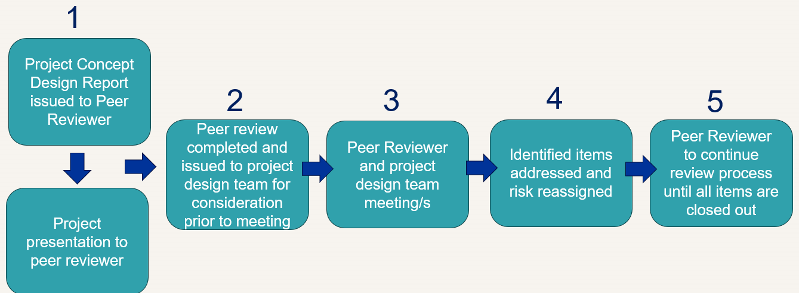

Step 1 – Project introduction.
Project information is issued to peer reviewer prior to the project presentation meeting by the project design team.
Step 2 – Completion of Peer Review.
Project reviewer liaison with project design team while peer review is completed. The report is issued to project design team for consideration.
Steps 3 - 5 – Resolution of identified items and Peer Review close out.
Identified items and associated risks are discussed and resolved. Several meetings and / or email exchanges may occur while items are being addressed. This process may involve revisiting the Peer Review Report during later design phases.
It is expected that the peer reviewer will establish whether the item has been sufficiently ‘closed out’.
Impact on Outcomes
When an item remains unresolved, the peer reviewer is expected to complete the ‘Impact on Outcomes’ section and the report should be elevated to the Project Governance Group for discussion and resolution.

Questions or further assistance?
For any questions, please contact facility.design@tewhatuora.govt.nz and one of the National Facility Design, Advisory and Assurance team will be in touch.

