**2023 Minor Health Conditions Service Pilot**

**Evaluation Report**

Prepared by:

Primary Care Team, Living Well, National Commissioning

Reviewed by:

|  |  |
| --- | --- |
| 2023 Minor Health Conditions Working Group | April 2024 |
| Strategic Advisor – Insights/Evidence and Performance, Funding and Investment | May 2024 |
| Director Living Well, National Commissioning | July 2024 |
|  |  |
|  |  |

Table of Contents

1. Executive summary 5

2. Background 8

The 2023 Pharmacy Minor Health Conditions Service Pilot 8

Pharmacies Treating Minor Health Conditions 10

3. Evaluation 12

Scope of the Evaluation 12

Evaluation Methodology 12

4. Results 14

Impact Analysis 14

Equity for Priority Populations 17

Stakeholder Perspectives 20

5. Discussion 26

Limitations 32

6. Conclusion 36

7. References 37

8. Appendix One: Service Specification: Minor Health Conditions Service 39

List of Tables and Figures

Table 1 Priority districts where the MHCS was funded. 9

Table 2 Number of MHCS consultations based on eligibility criteria. 15

Table 3 Number of MHCS consultations delivered by ethnicity 15

Table 4 Number and proportion of presenting conditions at MHCS consultations 15

Table 5 PHO enrolment status of MHCS users by region. 18

Table 6 Rurality of MHCS Users 19

Table 7 Patient experience of the MHCS compared to the NZ adult primary care experience survey (May 2023) 21

Table 8 MHCS overall user experience of care 22

Table 9 Pharmacist feedback submissions by district 24

Table 10 Gross spend for the winter 2023 MHCS. 25

Table 11 MHCS Cost-impact analysis. 30

Figure 1 Number of MHCS Consultations delivered per day during the pilot 14

Figure 2 Duration of MHCS consultations. Consultation time was documented in increments of five minutes. 16

Figure 3 Medicines supplied in MHCS consultations 17

Figure 4 New Zealand Index of Deprivation of MHCS Users. 19

Figure 5 MHCS experience: ‘How well did the visit meet your healthcare/advice needs?’ 21

Figure 6 Demographic differences in MHCS experiences of needs being met 22

Figure 7 Reason for choosing to visit a pharmacist for healthcare advice. 23

Figure 8 Awareness of pharmacists as a source of advice and treatment for minor health conditions 33

## 1. Executive summary

* A community pharmacy-based Minor Health Conditions Service (MHCS) was piloted in ten priority districts from 12 June 2023 to 30 September 2023. More than 700 community pharmacies opted in to deliver the service.
* The objectives were to:

1. Improve access to consultation, advice and treatment for common minor ailments and reduce inequity of health outcomes.
2. Promote care through community pharmacy by encouraging the use of community pharmacists as a first port of call for consultation and treatment.
3. Reduce pressure on general practice (GP), urgent care, and emergency departments (ED) by transfer of appropriate demand to pharmacists.

* In general, this evaluation found evidence that objectives 1 and 2 were partially or fully achieved. There was no strong evidence that objective 3 was achieved.
* People eligible for the service were:
  + Children under 14 years of age
  + Whānau members (any age) of a child under 14 years of age, with the same symptoms
  + Māori and Pacific people
  + Community Service Card (CSC) holders
* Conditions covered under the service were:
  + acute diarrhoea, and dehydration (e.g. due to vomiting or diarrhoea)
  + eye infections and inflammation
  + pain and fever
  + scabies
  + head lice
  + eczema/dermatitis
  + minor skin infections
* Nearly 120,000 people accessed the service, some more than once, with over 157,000 consultations occurring over the period.
* The quality of clinical care provided through MHCS consultations was appropriate. Most service users reported receiving high quality care. Patients reported a similar level of satisfaction with pharmacy clinical care as with GP care across all measures. The MHCS highlighted the public acceptability of the care offered by pharmacies.
* Patients reported that the MHCS was easy to access; it was available on a ‘walk in’ basis which avoids delays in waiting for an appointment at a general practice, or to be seen in ED. A quarter of all MHCS consultations occurred after 6pm or on weekends.
* The service reached priority populations. Over 40% of consultations were to people from high deprivation areas (8, 9 and 10). Pacific People were high users of the service. Further development of the service could focus on improving access to Māori who utilised the service slightly less than expected, based on the eligibility criteria.
* The MHCS provided service users with a clinically appropriate option for care of minor health conditions and the potential to reduce cost to service users compared to attending a GP appointment.
* Pharmacists were positive about the MHCS which required appropriate application of their clinical skills, with a high level of satisfaction in the provision of the service.
* There was no evidence that the MHCS pilot had an impact on acute demand volume during the winter period in terms of GP and ED attendance. Saturation of GP and urgent care services in many districts meant that immediate benefit to demand on these services was unlikely to be evident.
* Data on whether the service had any impact on the type or complexity of consultations in GP, urgent care or ED was not assessed.
* There was a significant public lack of awareness of the MHCS. Nearly half (47%) of people recruited by pharmacists to complete the survey following their consultation were not aware of the service prior to their visit. This indicates that the availability of the service did not drive their decision to go to the pharmacy instead of seeking care and advice elsewhere.
* Despite this, 55% of respondents to a MHCS user survey reported that they would have attended GP or urgent care services for their condition if they had not been able to access the pharmacist on that occasion. In addition, 6.5% of respondents to the survey reported that they would have attended an ED. It is difficult to disentangle in these answers the impact of access to the MHCS in the pharmacy from the general impact of access to pharmacy overall.
* With suitable development, the service may have potential to reduce pressure on other parts of the health system. This service provides a pathway for funded medicines to treat minor health conditions that would have otherwise required either an appointment at a GP or to be seen in ED or other urgent care setting or private purchase of the medicines on an over-the-counter basis.
* The following factors limited the ability of the MHCS pilot to demonstrate full impact on wider system pressures and are consequently areas for further development.
  + A narrow scope of eligible health conditions
  + A narrow range of funded medicines available to treat the eligible conditions
  + Insufficient marketing of the service to the public that would have raised awareness of health conditions that can be managed via the service
  + Supply constraints for some pharmaceuticals
  + Limited duration of the MHCS
  + The service was not available in some geographical locations with high priority populations
* The MHCS pilot successfully identified learnings which could be included in a scale-up strategy to implement a nationwide MHCS.
* A suitable targeted MHCS could potentially help reduce unnecessary pressure on GPs and EDs from patients seeking advice and treatment for minor health conditions and may be a cost-effective approach to improving access to care for some high need populations.
* Informational continuity of care was not a feature of the pilot – there was no expectation of consultation notes being passed back to the person’s GP.
* Total cost of the 2023 MHCS was approximately $5.2m. The 2023 MHCS covered ten Health NZ districts and approximately 75% of the NZ population. An estimated annual cost for a similar, all-of-New Zealand service based on the same settings is $23m. It is estimated that with better marketing, a MHCS covering a broader range of conditions, would cost $33m annually.
* The service was cost-effective compared to the cost of providing equivalent care in GP, urgent care or ED settings. Cost effectiveness against usual pharmacy care is unknown. There were no cost savings from the pilot.
* There is a moderately strong finding that the MHCS improved access to care for a group of patients for a specific range of conditions. The care that patients received was likely to be more comprehensive than otherwise, there was evidence of involvement of whānau and access after-hours, and a higher proportion of unenrolled people than in the general population used the service.
* The ability to access care after-hours was likely to be one of the most valuable attributes of the service.
* While there are current limitations to the return on investment that can be achieved from the MHCS diverting care from other settings, with development, the MHCS may be a cost-effective approach to improving access to care for some high need populations.
* Future development and future commissioning of the service should consider:
* an extended range of conditions that are available for funded treatment
* an extended range of funded medicines available to the pharmacist to provide effective treatment
* a permanent service available through the year
* a national service available to be commissioned through all Health NZ regions
* review of the eligibility criteria, for example including addition of unenrolled people
* national advertising and public communications, including awareness to other healthcare professionals and Whakarongorau
* ways to improve continuity of care
* what copayments could be charged to equalise access arrangements between settings and make services available to wider demographic groups
* the interface between a possible MHCS and expectations of access via GP capitation
* the relative cost effectiveness of private payment and over the counter supply vs funded consults
* Options for combining MHCS with other required features to improve access – e.g. extended opening hours, having a space for GP tele-consults, access to discretionary medicines and services.

## 2. Background

This section provides the context of the 2023 System Preparedness Plan which the MHCS pilot links to, as well as an overview of the 2023 MHCS pilot itself, together with a summary of findings from existing pharmacy-based minor health conditions services from around the world and in New Zealand.

The 2023 System Pressures Preparedness Plan

Due to severe pressures across the health sector in the winter of 2022, and the lack of respite in the following spring/summer, a national system pressures preparedness plan was agreed prior to the winter of 2023. This plan included 24 initiatives with the key goals being to:

* reduce, or slow growth of, acute demand through prevention, early intervention, and timely delivery of care in the community.
* provide timely access to acute care across the whole system, which is efficient, safely resourced, and improves staff experience.
* enable people to return home to their communities in a safe and timely way, with the support they need to keep them well at home.

Planning was also guided by:

* upholding obligations under Te Tiriti o Waitangi by improving access to quality, timely, and culturally safe and appropriate health care for Māori, and partnering with Māori providers and communities when designing services.
* improving equity for priority populations including Pacific people, disabled people, and rural communities.

### The 2023 Pharmacy Minor Health Conditions Service Pilot

One of the initiatives was funding pharmacies to treat minor health conditions through the Minor Health Conditions Service (MHCS). The objectives of the initiative were to:

1. Improve access to consultation, advice and treatment for common minor ailments and reduce inequity of health outcomes.
2. Promote care through community pharmacy by encouraging the use of community pharmacists as a first port of call for consultation and treatment.
3. Reduce pressure on general practice, urgent care, and emergency departments by transfer of appropriate demand to pharmacists.

The service would enable pharmacists to provide clinical support at an earlier intervention point for Māori, Pacific, children, and community services card holders and their families with minor health conditions (e.g. eczema, eye inflammation).

The MHCS, initially titled the Minor Ailments Service, was a fixed-term service commissioned by Health New Zealand | Te Whatu Ora from 12 June to 30 September 2023.

The service was not the first community pharmacy MHCS to be funded in New Zealand, with some former District Health Boards running similar fixed-term schemes previously and concurrently. For example, a similar service was operating in Hawke’s Bay as part of the Cyclone Gabrielle response. The 2023 MHCS was the largest of its kind to be implemented in a consistent manner across ten geographical areas in New Zealand.

The service was provided by community pharmacies to consult on a range of minor health conditions and provide funded treatment where clinically indicated with medicines and treatment aids.

People were eligible to receive the funded service if:

* they were eligible for publicly funded health services in NZ; and were;
* under 14 years of age; OR
* a whānau member (any age) of a child under 14 years of age, with the same symptoms; OR
* a holder of a Community Service Card (CSC), or the dependent child of a CSC holder and 14 to 17 years of age; OR
* of Māori or Pacific ethnicity.

And they had one or more of the following minor health conditions that were approved under the pilot:

* acute diarrhoea, and dehydration (e.g. due to vomiting or diarrhoea)
* eye infections and inflammation
* pain and fever
* scabies
* head lice
* eczema/dermatitis
* minor skin infections.

The approved conditions are typical of those already managed frequently in community pharmacies, however patients are required to pay for the cost of medicines and the pharmacy may at their discretion charge a consultation fee.

Pharmacies located in the geographical areas listed in Table 1 were able to participate in the pilot. These areas were identified as having consistent hospital flow challenges and wider system pressures.

Table 1 Priority districts where the MHCS was funded.

|  |  |
| --- | --- |
| **Region** | **District** |
| **Northern** | Northland |
| Waitematā |
| Auckland |
| Counties Manukau |
| **Te Manawa Taki** | Bay of Plenty |
| **Central** | MidCentral |
| Capital and Coast |
| Hutt Valley |
| **Te Waipounamu** | Canterbury |
| Southern* |

*Restricted to pharmacies located in the geographic catchment areas for the Invercargill emergency department.

The service was free to eligible people. Service users received a clinical consultation from a pharmacist, which included advice, and if necessary:

* + - provision of funded medicines from an approved medicine list
    - referral, such as to a GP, emergency department, or specialist.

Pharmacies were paid $25 (excl. GST) per consultation, based on an estimated average consultation of ten minutes, and were reimbursed for the cost price of the treatment aid (headlice comb or syringe) where provided. They were also paid normal dispensing fees and reimbursed for any approved medicine dispensed.

Pharmacists were required to exercise clinical and professional judgement to determine the quantity of the medicine to be dispensed to the service user. Long-term treatment and management of conditions was not within the scope of the service and pharmacists comply with all Pharmaceutical Schedule quantity supply restrictions. The Service Specification is attached in Appendix One.

### Pharmacies Treating Minor Health Conditions

#### International Literature

Internationally, governments have been investing in supporting pharmacists to facilitate self-care of minor health conditions for health system efficiency. In Scotland, Northern Ireland, Wales, England, Australia and Canada, there are strategies to encourage patient self-care of minor symptoms at community pharmacies through Minor Ailments Schemes (MASs) (UK and Australia) and Minor Ailment Prescribing Services (Canada).[1]

There is a medium evidence base of effectiveness from overseas models of community pharmacy based MHCSs. Most studies demonstrate clinical effectiveness and cite potential for cost-benefits. User satisfaction is generally high and service strength includes effective symptom resolution and reducing the workload in general practice1,[2],3 and reduced ED and GP visits.1 Positive impacts also include quality-adjusted life year (QALY) gains.1, 3

An Australian study demonstrated improved clinical and humanistic outcomes of a pharmacist led MHCS compared to usual care from a community pharmacy. Pharmacists were 1.2 times more likely to recommend an appropriate medicine meeting agreed protocols because of the MHCS consultation, compared to usual care. Pharmacists were also 2.6 times more likely to recommend an alternative medicine that was safer or more appropriate than requested by the patient. Service users were also 1.5 times more likely to receive an appropriate referral, and 5 times more likely to adhere to that referral, compared with usual pharmacist care. Cost-utility analysis showed the MHCS was more costly but also more effective (symptom resolution and QALY gains) compared to usual pharmacist care. Economic findings suggested that national implementation of the minor ailments service within the Australian context is highly cost-effective.1

Other jurisdictions have commissioned various minor health conditions services for ten years or more, and thus their evaluations are older. A 2013 systematic review examined evaluations of 31 United Kingdom (UK) pharmacy based MHCSs.[3] Between 68% and 94% of patients reported resolution of a minor health condition following their consultation. Most MHCSs remunerated participating pharmacists based on a fee per consultation, and pharmacies were reimbursed for the medicines supplied.

The review also reported six evaluations that measured the impact of MHCSs on the number of consultations for minor health conditions in GP, with observed rates of re-consultation and referrals, suggesting that MHCSs reduce GP consultation rates. One evaluation reported that the observed decline in the number of GP consultations for minor health conditions was offset by the number of consultations conducted as part of the MHCS, and in two others it was observed that GP consultations for minor health conditions were significantly lower due to a concurrent MHCS, despite overall GP consultation volume remaining unaffected. Ten evaluations showed that between 47% and 92% of patients would have used a GP if no MHCS had been available, with the next most likely outcome being the purchase of an over-the-counter (OTC) treatment. The satisfaction of MHCS users was comparable with non-users’ satisfaction with GP consultations3.

GPs expressed positive attitudes to greater pharmacist participation in the management of minor health conditions and the extension of the schemes. Two evaluations reported that although GPs perceived impact on their workload relating to minor health conditions was positive, they had doubts over whether there was a decline in overall consultations following the introduction of MHCS. In one area in the UK evaluation, the number of GP consultations for minor health conditions was significantly lower during the intervention period compared with baseline however, the total number of GP consultations for all conditions (minor and non-minor) remained unaffected.

NHS Clinical Commissioners and NHS England published guidance in 2018 that recommended certain minor health conditions which are either ‘self-limiting’ or ‘suitable for self-care’ should no longer be treated by the issuing of prescriptions in primary care.[4] The guidance supported the NHS’s wider ambition to ensure greater value is achieved from the annual medicines bill and highlight the alternatives to making a GP appointment or taking a medicine.[5]

The UK Pharmaceutical Services Negotiating Committee submitted in 2022 that it estimated that pharmacies could save the NHS up to £640 million each year by assisting more in the treatment of minor ailments. They estimated that if 40 million GP appointments were transferred from GPs to pharmacists via the Community Pharmacist Consultation Service, the net cost to the NHS would be £560m.  This compares to a cost of £1.2bn under the current system of only using GPs.[6]  Subsequently, NHS England has launched their Pharmacy First Service, which is similar to the 2023 NZ MHCS pilot, but covers a significantly broader range of conditions.

#### New Zealand Literature

Two New Zealand based studies can be drawn on in relation to MHCSs.

Research by Hikaka et al[7] found support for a MHCS from Māori participants. Māori are most likely to seek treatment from a pharmacy, instead of a doctor for minor health conditions such as eczema/dry skin, coughs and colds, headlice, insect bites, and hayfever. To support a MHCS participants noted that pharmacy environments need to be well designed, considering physical, professional and cultural environments. The authors make several recommendations that our future MHCS should consider:

* consultation with all relevant stakeholders prior to implementation as well as in the evaluation phase
* robust monitoring and evaluation to identify and respond to equity issues early on
* workforce development to ensure culturally and clinically safe service delivery
* the development of kaiāwhina roles to support access to the MHCS
* developing solid infrastructure to support safe and secure communication between the multiple services involved in care provision.

While it has been postulated that a publicly funded MHCS can improve equity in access to medicines and the associated outcomes resulting from improved access, a systematic review conducted by Hikaka and Haua[8] found that there is a lack of evidence that MHCS deliver equitable health outcomes, including equity in outcomes across ethnicities.

## 3. Evaluation

### Scope of the Evaluation

The scope of this evaluation is to assess the value and impact of the MHCS pilot according to the following measures, broken down by available demographics:

1. **Service volumes**
   * + Number of MHCS consultations
     + Number of medicines provided under the service
     + Proportion of consultations delivered in-person versus virtually
     + Funding spent
2. **Qualitative measures**
   * Health conditions presented
   * User and whānau experience of the service
   * Pharmacist provider experience
3. **Consultation outcomes**
   * Number of referrals to General Practice
   * Consultation time
   * User experience (were health needs met, informed of possible side effects, provided adequate information, family/ whānau involvement, what to do if condition deteriorates)
4. **System outcomes following consultation**
   * Referrals to General Practice, ED or elsewhere
   * General Practice attendance
   * Emergency Department attendance, and any subsequent hospital admission

### Evaluation Methodology

A mixed methods evaluation was planned to include both quantitative assessment of outcome data as well a qualitative exploration of the MHCS from various stakeholder perspectives.

The analyses draw on data recorded by pharmacists undertaking MHCS consultations and national datasets on health service activity and medicines dispensed.

#### Consultation data

Information was recorded by the pharmacist for every MHCS consultation including the service user’s demographic details, at least one eligible condition, timing of the consultation (within ‘working hours’ or ‘after hours’), duration of the consultation, whether other whānau were seen at the same time, and whether a referral was made to another healthcare setting.

#### Medicine data

Information on medicines dispensed as part of the MHCS was retrieved from the National Pharmaceutical Collection, including service user demographics, name of the medicine and quantity supplied.

Pharmaceutical data from Hawke’s Bay is omitted from the quantitative analyses, as Hawke’s Bay was running a similar programme to the MHCS with a different funding source, and different access criteria and list of medicines available through its programme.

#### Stakeholder Perspectives

##### Minor Health Condition Service Users

Health NZ commissioned Ipsos, an independent market research company, to research peoples’ perspectives of the MHCS pilot:

* how they found the experience and if the service met their needs
* where and how they heard about the service
* their pathway to using the service, including consideration and usage of alternative services for healthcare / advice.

The research was conducted by retrospective survey of adult users via a combination of an open link, disseminated by pharmacists following a MHCS consult, and an online panel survey. Information was gathered between 21 July and 5 October 2023. In some areas, Ipsos used results from a separate ‘Right Care Right Time’ survey and the results of the New Zealand Adult Primary Care Experience survey to provide a comparison and some context.

##### Pharmacies

Pharmacists were invited to submit general feedback via a webform to report any stock issues. The evaluation had not initially intended to collect feedback from pharmacists, however sector representatives felt it was important for pharmacists to have their say about the MHCS. At the conclusion of the pilot many pharmacists chose to use the same webform to provide their feedback on the MHCS pilot. There were no specific questions asked of the pharmacists, but rather a free-text box to complete. Pharmacists were asked to select their district; Hawke’s Bay was not available for selection as they were already operating a service slightly different to the MHCS pilot. It should be noted that the webform had a public link which means it was possible for anyone to have submitted a response.

## 4. Results

### Impact Analysis

##### Number of MHCS Consultations

During the MHCS pilot from 12 June to 30 September 2023, there were 157,382 consultations with 119,773 people.

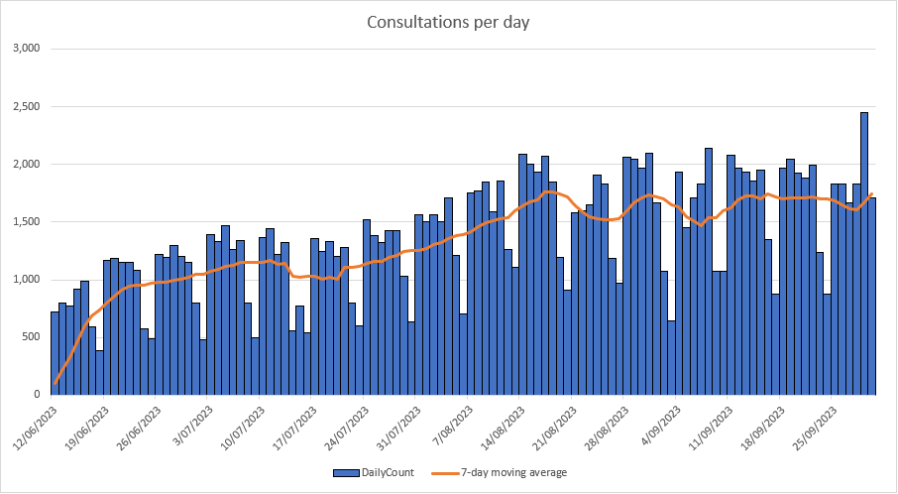

Figure 1 Number of MHCS Consultations delivered per day during the pilot

Demand for the service grew in the early months of the pilot until it reached a steady rate of approximately 1,700 consultations per day. Consultations were more common on weekdays compared to weekends or public holidays.

##### After-hours Consultations

24% of all consultations occurred after 6pm on weekdays or on a weekend.

##### Options to Access MHCS consultations

94% of consultations were carried out in-person; 5% were conducted remotely via virtual means such as by telephone or video calling. The consultation type was not recorded in 1% of consultations. All virtual MHCS providers were required to have means for service users to have timely access to treatment where necessary.

##### Consultations by MHCS eligibility criteria

Most consultations were for those under 14 years old. In 21% of consultations, at least one other whānau member also received a consultation (Table 2).

Table 2 Number of MHCS consultations based on eligibility criteria.

|  |  |  |
| --- | --- | --- |
| Eligibility Criteria | Consultations* | % of consultations |
| Under 14 years old | 107,127 | 68% |
| Pacific | 23,333 | 15% |
| Māori | 20,807 | 13% |
| CSC holder or dependent child of a CSC holder (14 to 17 years old) | 15,178 | 10% |
| Whānau member (any age) of a child <14 years old with the same symptoms | 9,693 | 6% |

* Some service users met multiple eligibility criteria, therefore percentages do not add up to 100%. Furthermore, these figures may undercount eligibility criteria, as it is possible pharmacists recorded only one reason for eligibility.

##### Consultations by ethnicity

Uptake of the MHCS was highest among Pacific people, while Māori had a similar utilisation to non-Māori, non-Pacific ethnicities (Table 3).

Table 3 Number of MHCS consultations delivered by ethnicity

|  |  |  |  |  |
| --- | --- | --- | --- | --- |
| Priority Ethnicity | Consultations | Population within included districts | Percentage of consultations | Consultations per 10,000 population |
| Māori | 20,807 | 545,700 | 13% | 381 |
| Pacific | 21,638 | 325,500 | 14% | 665 |
| Other* | 114,937 | 2,655,400 | 73% | 433 |
| TOTAL | 157,382 | 3,526,600 | 100% | 446 |

* Only a subset of this population was eligible for the MHCS (<14 years or a whānau member (any age) of a child under 14 years of age, with the same symptoms or a holder of a CSC or the dependent child of a CSC holder and 14 to 17 years of age).

##### Consultations by condition

Service users were able to consult the pharmacist about multiple conditions at one time. The proportion of consultations that tended to more than one health condition was 12% (Table 4).

Table 4 Number and proportion of presenting conditions at MHCS consultations

|  |  |  |
| --- | --- | --- |
| Condition | Consultations* | Percentage of consultations |
| Pain / fever | 89,372 | 57% |
| Minor skin infections | 26,173 | 17% |
| Eczema / dermatitis | 21,461 | 14% |
| Eye inflammation and infections | 20,360 | 13% |
| Diarrhoea / vomiting | 16,166 | 10% |
| Headlice | 9,331 | 6% |
| Scabies | 4,450 | 3% |

* Some consultations were for more than one condition. Consequently, the total number of consultations in this table is more than 157,382.

##### Length of consultation

Pharmacy MHCS consultations were, on average, ten minutes long. One quarter of consultations were longer than ten minutes, with the balance taking less than ten minutes (Figure 2).

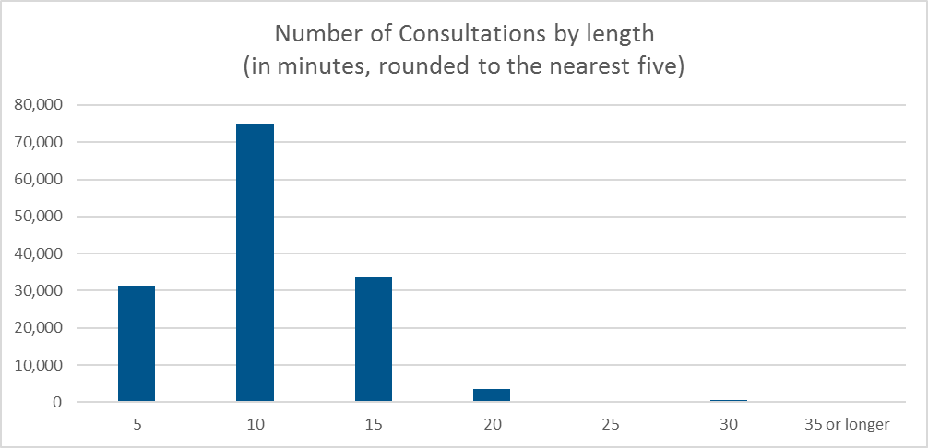

Figure 2 Duration of MHCS consultations. Consultation time was documented in increments of five minutes.

#### Referrals to other healthcare settings

Pharmacists referred service users on to another healthcare setting in 4% of consultations. In 2.5% of these, service users were referred to a GP and in 0.5% of occasions they were referred to an urgent care clinic or ED. In the balance of cases, service users were referred to other allied health professionals such as a dentist or optometrist.

##### Medicines supplied during MHCS Consultations

Over the duration of the MHCS pilot, 133,625 medicines were dispensed to 74,058 service users. 62% of service users received at least one medicine as a result of a MHCS consultation.

The most common medicines supplied were for symptomatic relief of pain or fever (paracetamol 26% and ibuprofen 13%) (Figure 3). Antibiotic eye drops (chloramphenicol), skin emollients and antiseptics, treatments for scabies, and dehydration medicines were also commonly provided as part of consultations.

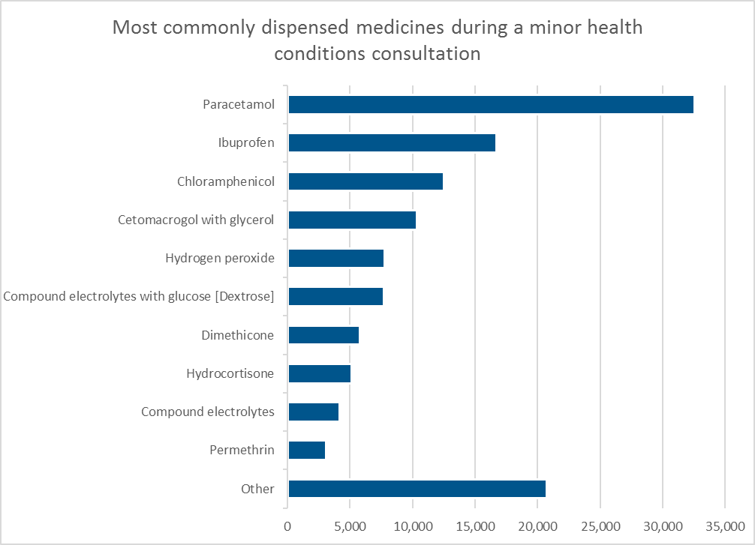

Figure 3 Medicines supplied in MHCS consultations

Immediate treatment was not always necessary, and some service users were given self-care advice, and advised when and how to seek further assistance should the condition persist or worsen. MHCS consultations could also result in provision non-pharmacological treatment.

Pharmacist feedback indicated that shortages of some medicines due to supply chain issues prevented treatment in some cases also.

### Equity for Priority Populations

##### Māori

There were 20,807 consultations for Māori service users, representing 381 consultations per 10,000 Māori people living within the geographical boundaries of the MHCS pilot. This is a slightly lower service utilisation rate compared to the general population (433 consultations per 10,000 people).

Māori were more likely to include whānau members in their consultation with the pharmacist than the general population. For 23.5% of consultations with Māori, another whānau member also received a consultation; this compares with 21.3% for consultations from the general population.

##### Pacific People

Pacific people accessed 21,638 consultations representing 665 consultations per 10,000 Pacific people living within the geographical boundaries of the MHCS pilot. This is a significantly higher utilisation rate of the service compared to the general population (433 consultations per 10,000 people).

##### Unenrolled people

It is estimated that 5.6% of all consultations (between 5.0% and 6.6%) were with people who were not enrolled with a Primary Health Organisation (PHO)[9]. A range is provided as a service user’s NHI was not always recorded and as such, it could not be determined whether they were enrolled. Where a NHI was not recorded, it may be more likely that the service user did not have an NHI, indicating they were not enrolled. In addition, without an NHI recorded, we are unable to determine if those service users accessed the service multiple times.

In each district, there was wide variation in the reach of the service to those who were unenrolled, illustrated in Table 5. There was significant variation by district in documentation of service user NHIs. Both observations warrant further investigation.

Table 5 PHO enrolment status of MHCS users by region.

|  |  |  |  |
| --- | --- | --- | --- |
| District | District population who are not enrolled in a PHO (%)+ | MHCS users not enrolled in a PHO (%)++ | MHCS consultations with unknown PHO enrolment status (%)+++ |
| Auckland | 0.7% | 6.8% | 0.8% |
| Bay of Plenty | 7.3% | 5.7% | 4.1% |
| Canterbury | 2.8% | 3.9% | 0.6% |
| Capital and Coast | 5.5% | 3.9% | 7.3% |
| Counties Manukau | 4.3% | 6.3% | 0.7% |
| Hutt Valley | 5.9% | 3.4% | 0.4% |
| MidCentral | 7.7% | 3.8% | 0.6% |
| Northland | 6.3% | 4.1% | 0.9% |
| Southern++++ | 5.1% | 6.2% | 0.9% |
| Waitematā | 2.1% | 5.4% | 0.7% |
| TOTAL | 4.6% | 5.6% | 1.4% |

+ July 2023: <https://www.tewhatuora.govt.nz/assets/For-the-health-sector/Primary-care/Enrolment-with-a-general-practice-and-primary-health-organisation/2023Q3-Primary-Care-Tier-1-Statistics.xlsx>

++ Percentage of people who used the MHCS who were not enrolled.

+++ MHCS user PHO enrolment status is unknown as no NHI was captured at the time of consultation.

++++ District unenrolled population is based on all of the Southern District. The MHCS was commissioned in the Southland catchment area of Invercargill Hospital only.

##### Rural Populations

The rurality of MHCS users is shown in Table 6. 7.6% of MHCS users were from rural areas, less than the rural population percentage of the areas where the MHCS pilot ran (12.5%).

Table 6 Rurality of MHCS Users

|  |  |  |
| --- | --- | --- |
| Rurality | Percent of MHCS users in that rurality | Population distribution of the pilot geographical areas |
| R3 (Most Rural) | 0.4% | 0.8% |
| R2 | 2.0% | 2.7% |
| R1 | 5.2% | 9.0% |
| U2 | 6.5% | 9.2% |
| U1 (Most Urban) | 86.0% | 78.3% |

##### People in high deprivation areas

The deprivation of MHCS users is shown in Figure 4. Accordingly, 40% of MHCS users were from highly deprived areas (i.e. deprivation index 8, 9 or 10[10]) with service users from deprivation index 10 areas making up nearly twice their proportion of the population. It is estimated that this analysis undercounts the highly deprived who are likely to be over-represented in the cohort for which no NHI or deprivation data was available. Deprivation was unknown for 2.5% of service users.

There was no correlation between level of deprivation and whether a service user accessed the MHCS more than once.

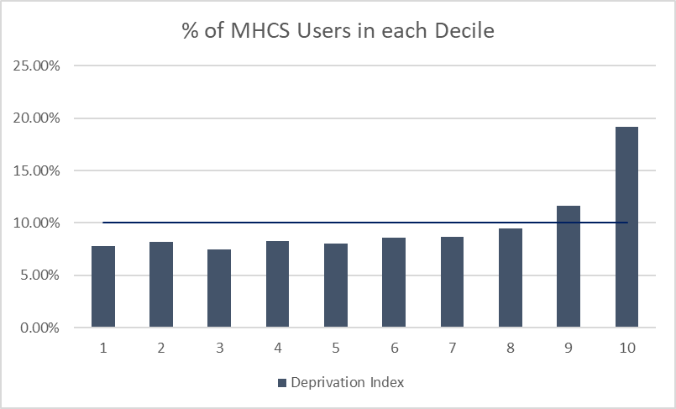

Figure 4 New Zealand Index of Deprivation of MHCS Users.

### Stakeholder Perspectives

#### Service Users and the General Population

826 responses were received to the service user survey, out of approximately 92,000 service users (0.9%), from when the survey became available, six weeks after the MHCS started. 2,408 responses were received to the survey of the general population residing in the relevant districts, regardless of whether they used the service or not.

Significant differences are reported at 95% confidence level, with a ±3.5% maximum margin of error.

There was a significant public lack of awareness of the MHCS. Nearly half (47%) of people recruited by pharmacists to complete the survey following their consultation were not aware of the service prior to their visit. This indicates that the availability of the service did not drive their decision to go to the pharmacy instead of seeking care and advice elsewhere.

The majority of MHCS users surveyed reported that they would have sought care from their GP, ED or urgent care if they were not able to receive care from the pharmacy on that occasion, with those living rurally significantly less likely to do this compared to the general population.

The service user survey question, *“If you were not able to see a pharmacist on this occasion, what would you have done instead?”* gives some insight into the behaviours of people had the MHCS not been in place:

* 55% would have gone to a GP, after-hours or urgent care centre
* 7% would have gone to an ED, Accident and Emergency (A&E), or the hospital
* 4% would have called Healthline
* 34%, would not have sought formal clinical care.

It is important to note that it is not possible to distinguish whether people were commenting on the action they would have taken if the pharmacy or pharmacist were not available or whether they were commenting on the action they would have taken if the minor conditions services was not available. It is therefore also not possible to distinguish the proportion that would have purchased the service privately on an over-the-counter basis anyway.

Māori MHCS users who were surveyed reported being more likely to have attended ED in the absence of the MHCS (17% vs 7% for non-Māori) and valued the speed of the service compared to alternatives. Of those surveyed, 90% of Māori said that their needs were met, which is similar to the whole population. Only 1% of Māori said their needs were not met, compared with 4% for the whole population.

71% of Pacific MHCS users surveyed felt their needs were met and 15% did not. In comparison, 88% of all people surveyed felt their needs were met and 4% did not (Figure 5).

Pharmacists reported that while patients were not necessarily aware that the service was available when they presented, it provided opportunity for pharmacists to provide timely and efficient care rather than referring patients to another setting to access funded care such as GP, urgent are or ED. One in three MHCS users also reported receiving prior care or advice related to the condition with which they had presented to the pharmacy. The vast majority of prior care was from a GP.

Approximately half the MHCS users accessed the service more than once. Māori & Disabled People were significantly more likely to be repeat users of the MHCS.

Patient experience of the MHCS was obtained through the user survey. Results of the MHCS survey were compared against the New Zealand Adult Primary Care Experience Survey (May 2023) which includes a national selection of adult patients (over 15 years) who had a qualifying encounter with the primary care service provider they are enrolled with. For MHCS users, 87% felt the pharmacist spent enough time with them, which is similar to primary care (i.e., general practice) in which 88% of reported the same.

The following questions (Table 7) were asked both in this survey and in the May 2023 survey of primary care users:

Table 7 Patient experience of the MHCS compared to the NZ adult primary care experience survey (May 2023)

|  |  |  |
| --- | --- | --- |
| **Question** | **MHCS user survey** | **NZ adult primary care experience survey** |
| **Treated with respect and kindness** | 94% | 96% |
| **Felt listened to** | 91% | 93% |
| **Explained in a way I could understand** | 93% | 93% |
| **Felt comfortable asking questions** | 88% | 91% |
| **Had trust and confidence in [clinician]** | 89% | 87% |
| **[Clinician] spent enough time with me** | 87% | 88% |

The user survey identified 78 service users who reside in rural locations. Of the rural respondents, 95% said they had their needs met, compared with 90% for the whole population. Rural residents were less likely to have gone to a doctor without this service, with qualitative feedback noting that a doctor’s visit was more difficult given distance.

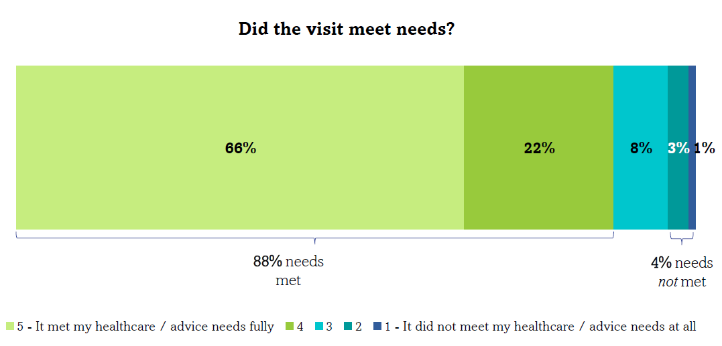

Figure 5 MHCS experience: ‘How well did the visit meet your healthcare/advice needs?’

Where a service user’s needs were not met, it was often because the MHCS list of approved medicines did not include the medicine necessary to treat the service user’s condition, for example antibiotics.

Service user experience was generally positive, particularly so for Māori, while consistently worse for Pacific and disabled respondents (Figure 6 and Table 8)

|  |
| --- |
|  |

Figure 6 Demographic differences in MHCS experiences of needs being met

Table 8 MHCS overall user experience of care

|  |  |  |  |  |
| --- | --- | --- | --- | --- |
| **Response** | **Overall**  (n=826) | **Māori**  (n=131) | **Pacific People**  (n=58) | **Disabled People**  (n=142) |
| **Treated with respect and kindness** | 94% | 95% | 84% | 89% |
| **Listened to** | 91% | 95% | 76% | 85% |
| **Received a clear explanation** | 93% | 97% | 91% | 87% |
| **Comfortable asking questions** | 88% | 89% | 79% | 80% |
| **Had trust and confidence in the pharmacist** | 89% | 90% | 79% | 82% |
| **The pharmacist spent enough time with them** | 87% | 90% | 76% | 80% |
| **Their needs were met** | 88% | 90% | 71% | 83% |
| **Their needs were not met** | 4% | 1% | 15% | 8% |

Green represents indicates that experiences were more favourable that the overall results, and red indicates that experiences were less favourable.

Ease of access was a core reason for choosing the MHCS (Figure 7). In the survey, 37% said they chose it as it was the ‘quickest way to get care’; another 17% said it was the ‘easy to get to / nearby’ and another 14% said it was the ‘easiest way to get help’.

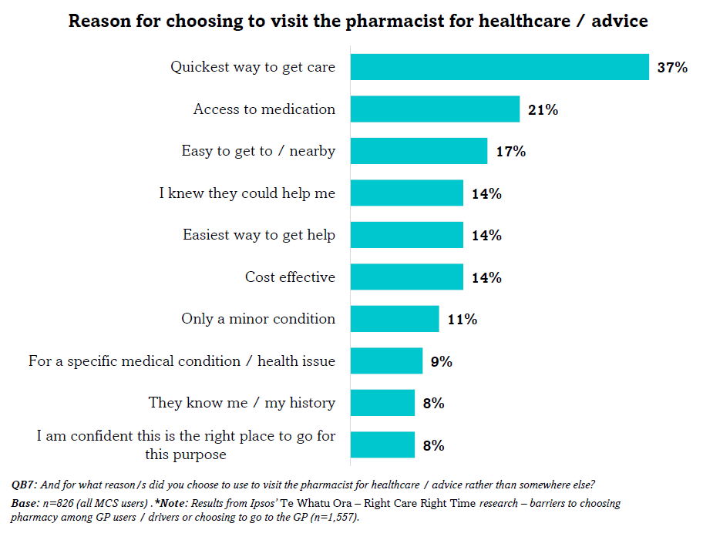

Figure 7 Reason for choosing to visit a pharmacist for healthcare advice.

Privacy was highlighted as an issue from the survey, with 55% of user survey respondents reporting that they were not offered a private room or space for the consultation.

##### Patient Perspectives on the Quality of Care

Overall, service users reported receiving good quality care from the pharmacist consultations in this pilot and similar to the reported quality of care from general practices:

* service users reported similar levels of satisfaction with their clinical care as other surveys have shown for general practice generally
* service users reported having sufficient time with a pharmacist for their needs to be addressed and usually resulted in receiving treatment for their condition
* referrals occurred where pharmacists did not feel they could address the problem under the service specification for the service, but these situations were not common
* over one fifth of service users were seen at the same time as a whānau member, aiding whānau-centred care.

One of the perceived negative features of the service was the restrictions on the range of approved medicines available under the service, meaning that service users sometimes had to go to a GP for a further consultation to get the necessary medicines that were not funded under the MHCS. Additionally, it is important to highlight the poorer experiences reported by Pacific people and Disabled people in the service user satisfaction survey, compared with the whole population, for most measures. While the small number of responses from Pacific people and Disabled people mean that care is required in extrapolating these results, this does require further investigation.

#### Pharmacies

There were 190 individual submissions made by pharmacies or pharmacists via the online webform (Table 9).

Table 9 Pharmacist feedback submissions by district

|  |  |  |
| --- | --- | --- |
| District | Number of responses | Proportion |
| Bay of Plenty | 12 | 6% |
| Canterbury | 36 | 19% |
| Wellington (Capital and Coast & Hutt Valley) | 25 | 13% |
| MidCentral | 14 | 7% |
| Northland | 17 | 9% |
| Southern | 12 | 6% |
| Tāmaki Makaurau (Waitemata, Auckland & Counties Manukau) | 74 | 39% |
| TOTAL | **190** | **100%** |

Comments made by pharmacists were significantly optimistic about the ability of the MHCS to help service users and their communities. A common theme in feedback was that the MHCS was particularly beneficial to Māori whānau. Examples of the positive feedback are provided below:

***The MHCS improves patients’ ability to access health care:*** *including “increased accessibility to healthcare for patients, those most vulnerable, in need” / “fast track” / “minimise[s] wait time” / “patients who are unable to see GP at short notice can access meds they required” / “pharmacy open 24-7 and afterhours” / “allows easy access to health services, especially for people that otherwise wouldn't seek help”.*

***MHCS is beneficial to the community:*** *including “much benefit to whānau in our area” / “able to further support their communities” / “[helps] low-income communities”*

***MHCS is a good way for families to access care:*** *including “Getting to the Dr in the city is tricky with a baby and toddler” / “esp[ecially] [good for] large families”.*

***Pharmacists providing MHCS received positive feedback from patients:*** *including “much positive feedback from grateful patients” / “customers are very pleased with this service” / “MAS has encouraged patients to come to the pharmacy to be triaged earlier”.*

***MHCS took pressure off other areas of the health system:*** *including “helps to release the backlog in ED etc” / “save trips to the doc” / “counter doc shortage”.*

Pharmacists submitted some negative feedback, particularly related to the limited scope of the MHCS. Many pharmacists wanted the ability to treat a wider range of conditions. Some requested that the MHCS be expanded nationwide, or that it be year-round instead of just during the winter months. A common piece of feedback was a request for improved advertising and promotion of the service, so that both service users and other healthcare providers were made aware of the MHCS. Pharmacists expressed frustration at supply-chain issues which limited the availability of some of the funded medicines during the pilot.

##### Cost

The average cost per MHCS consultation was $25.19 (Table 10), made up of consultation fee and treatment aid. Including average pharmaceutical cost ($3.18), and dispensing fees ($4.88) on consultation cost including treatment was $33.25. Total cost of the 2023 MHCS was approximately $5.2m.

Table 10 Gross spend for the winter 2023 MHCS.

|  |  |  |  |  |
| --- | --- | --- | --- | --- |
|  | **Consultations1** | **Pharmaceuticals** | **Dispensing fees** | **Total** |
| **Northern** | $2,671,293 | $342,388 | $538,125 | $3,551,806 |
| **Te Manawa Taki** | $252,460 | $18,825 | $30,860 | $302,145 |
| **Central** | $660,112 | $77,736 | $108,583 | $846,431 |
| **Te Waipounamu** | $380,922 | $60,950 | $90,712 | $532,584 |
| **Total** | **$3,964,787** | **$499,899** | **$768,280** | **$5,232,966** |
| **Per consultation** | $25.19 | $3.18 | $4.88 | $33.25 |

1 Consultation fee ($25) +/- treatment aid (if any). Lice comb ($6.60), Oral syringe ($0.22).

## 5. Discussion

Community pharmacies generally provide easy access to healthcare for patients. There are over 1,000 pharmacies widely distributed across New Zealand in urban and rural settings. Many have extended opening hours including evenings and weekends. Where general practice appointments often need to be booked days or weeks in advance or wait times in an urgent care or ED queues can be significant, community pharmacies routinely offer the ability for a patient to consult with a registered health professional on a ‘walk-in’ basis.

In the 2022/23 New Zealand Health Survey one in five adults (21.2%) and one in seven children (14.8%) experienced ‘time taken to get an appointment was too long’ as a barrier to visiting the GP in the previous 12 months. This barrier was amplified for disabled adults (24.3%) and disabled children (20.9%). One in eight adults (12.9%) reported not visiting a GP due to cost, and women were more likely than men to report cost as a barrier.[11] The broader impact of constrained access to care includes lost productivity, for example due to sick leave and delayed presentation of illness resulting in more specialised and costly care.

#### Reducing the burden on other health settings

A pharmacy based MHCS provides options for people to make more efficient use of the health system by accessing health services delivered in an appropriate setting. In addition to diversion of minor health conditions to nurse prescribers, or extended scope paramedics, for example, transferring care provided in ED and GP settings for minor illnesses to community pharmacy could increase access to care, decrease waiting times or improve timely treatment for individuals who require medical assessment and treatment.1

Despite overall GP encounters being up compared to prior years, the percentage of both adults and children in New Zealand, who have seen a GP in the prior twelve months has decreased over the last five years, while the proportion of adults and children who have visited an ED in the prior twelve months has increased (17.9% and 18% in 2022/23, up from 14.7% and 14.4% in 2017/18).9 In Northeast Scotland, the burden of minor health condition consultations (deemed suitable for management in community pharmacies) in GP settings was 13.2% and 5.3% for ED. This was despite a pharmacy minor ailments scheme already in existence, indicating effective strategies are required to raise awareness of health conditions that can be managed effectively in pharmacies, and to change patient health seeking behaviour for such conditions.[12] In addition to reducing wait-times, a well-run pharmacy MHCS may free up GP time to deal with people with more complex needs and provide an alternative service for non-urgent demand being placed on EDs, particularly after hours. It would also promote pharmacy as a first port of call for healthcare advice; an early intervention point that addresses health need in the community.

During the MHCS pilot, no quantifiable change in the number or demand for GP appointments in the relevant districts was detected. This was not unexpected, as the demand for GP appointments over the 2023 winter period was high, exceeding supply in most areas, meaning that if one patient avoided GP appointment due to the MHCS, another patient would have taken that available appointment. Data on whether the MHCS had any impact on the type or complexity of consultations in GP, urgent care or ED was not assessed. While there were roughly 151,000 MHCS consultations that did not result in on-referral to general practice or ED, this represents only approximately 4% of GP and nurse consultation volume in the commissioned districts,[13] thus further reducing the likelihood that any impact would be detectable. Given the highly capacity constrained environment in general practice and emergency departments, MHCS may have been providing care that would otherwise not have been delivered, or not delivered in a timely manner, rather than providing an opportunity to divert demand for care.

Nearly a third of pharmacists surveyed expressed a view that the MHCS took pressure off GPs, after-hours services, and ED. This could have occurred in local areas but is unable to be determined from the aggregate data. The number of ED attendances during the MHCS pilot was not assessed in this evaluation because multiple initiatives were implemented as part of the 2023 System Preparedness Plan, making it impossible to determine a causal relationship between any one initiative and the burden on EDs. Furthermore, initiatives in the 2023 System Preparedness Plan such as expansion of the primary options for acute care (POAC) and community radiology would have been likely to increase GP encounter volume, rather than reducing them, further masking any potential impact.

Responses to the service user survey question: *“If you were not able to see a pharmacist on this occasion, what would you have done instead?”* may provide some insight into the utility of the MHCS. To interpret the findings, however, it is important to note that survey responses were provided in the context of having accessed the MHCS immediately prior. The question could therefore have been interpreted by respondents as about whether the pharmacy was there and open, and not necessarily their specific choice to seek care under the MHCS. Consequently, from the responses alone, it is not clear who would have attended the pharmacy even if the MHCS was not available and purchased treatment OTC at their own cost. However, there is strong similarity between the findings of this evaluation with those of similar published MHCS evaluations, from similar health jurisdictions, where service users were provided opportunity to report whether they would have purchased OTC treatment from a pharmacist in the absence of a MHCS. In this pilot, 55% of service user survey respondents said they would have attended a GP or urgent care clinic if the MHCS was not available. Literature values range between 47% and 92%, and in each case, purchasing a medicine OTC was cited as the next most common choice after that3. The correlation is not unexpected as service users in this pilot met targeted eligibility criteria and were expected to benefit most from the MHCS. These factors should be considered before placing significant weight upon the diversion results reported in this evaluation. However, international comparisons are fraught because of the complexity of policy parameters and interdependencies. For instance, visiting a GP or urgent care centre in most comparable countries is much cheaper than in NZ, meaning that the applicability of overseas intention to seek treatment at GP or urgent care results may not be as applicable.

Nonetheless, if the findings are representative of all people who used the MHCS, then this would represent 82,626 GP appointments and 10,230 ED encounters that were potentially avoided over the 15 weeks of the pilot. If the MHCS was commissioned in all areas of the country, the annual reduction in GP and ED visits for the current range of minor health conditions is estimated to be approximately 405,000 and 50,000 respectively. This represents potentially about 4% of doctor or nurse visits at GP and about 4% of ED encounters.

While most MHCS user survey respondents stated they would have gone to a GP if they were unable to access a pharmacist, 34% of others said they would not have sought care. It is impossible to predict the consequence of doing nothing about the presenting conditions / symptoms in this pilot, however it is reasonable to assume that some would have been self-resolving, while other conditions might have worsened without adequate clinical advice and care. In these cases, the MHCS provides an opportunity for early intervention, saving on more complex and costly care later on, as well as reducing lost productivity such as that associated with time off work.

#### Improving access to healthcare

The MHCS consultation was free to service users. GP and Urgent Care appointments often incur a patient co-payment fee for those aged over 13 years, while ED visits are free. There are other potential benefits for the service user accessing this type of MHCS, such as savings in transport, time off work and childcare. Furthermore, medicines available under the service were free to service users which removes financial barriers to treatment and may improve access. The service user survey asked patients why they sought care at the pharmacy rather than somewhere else, and the single most common answer was that it was the quickest way to access care.

In more than 20% of MHCS consultations, other whānau members also received a consultation. This indicates that the service can help whānau in a collective manner and not just the individual presenting to the clinician. This is particularly important for treating conditions such as head lice and scabies which can spread quickly among close contacts.

24% of MHCS consultations took place after hours (i.e., after 6pm on weekdays, or on the weekend). Access to healthcare for minor health conditions after hours is limited in many areas, meaning a MHCS may be particularly beneficial after-hours. A well promoted MHCS has the potential to divert ED presentations for low acuity, pharmacy-manageable conditions to a nearby MHCS. Signage about the availability of local MHCS within EDs could assist with relieving the pressure on EDs.

The percentage of MHCS users who were not enrolled with a PHO/GP was higher than the general population percentage across all districts, suggesting that the service was accessible to the unenrolled. In areas that had high unenrolled populations, this was not always the case however, and potential exists to include unenrolled in the eligibility criteria of any future service to improve this.

Uptake of the service from priority populations was high for Pacific people and slightly lower than the population average for Māori. 40% of service users were from areas of highest deprivation (Decile 8, 9 and 10) with nearly half of these in Decile 10. Overall, the experience of care was excellent for Māori and poorer than average for Pacific and Disabled peoples. This indicates that the eligibility criteria for the pilot were appropriate and provides opportunity for further development to raise awareness among these populations and to ensure the service meets population needs.

Data from the pilot showed that only a small fraction of service users were referred to further clinical care after the MHCS consultation. This suggests that, generally speaking, service users’ need for care was satisfied and they had no need for GP or other care. Identifying and interpreting ‘red flags’ for referral is an important part of clinical practice in pharmacy. This evaluation did not assess service user adherence to pharmacist referral, however a recent Australian study demonstrated that patients were five times more likely to adhere to MHCS referral advice and seek medical care compared to usual care1.

These results indicate that most service users received complete clinical care from the consultation, and that where necessary, pharmacists made a referral to other clinicians according to the MHCS service specification. A requirement of the MHCS was that consultations were to be with a registered pharmacist, nurse, or pharmacy intern under the direct supervision of a registered pharmacist. This is not always the case when these types of consultations occur privately in community pharmacies. Consequently, the requirement improved quality and ensured competent care and decision-making.

#### Cost effectiveness

A core driver for commissioning MHCS internationally is making more efficient use of the health system. In doing so, the service should be cost effective.

In this pilot, Health NZ paid pharmacies $25 per consultation, plus costs for medicines and treatment aids provided. This was based on an anticipated average consultation time of ten minutes. Consultation records indicate that this funding was appropriate based on the duration of most consultations.

The closest comparator we have to the cost of a MHCS consultation is a GP appointment. The comparison is made complex because GPs are funded on a capitation basis per enrolled patient, instead of a fee per service provided. Additionally, a GP appointment will often incur a co-payment for enrolled patients over 13 years old, which is paid by the patient, whereas the MHCS was free to eligible users. In general, the average combined patient co-payment plus government funding per GP appointment provided is currently approximately $93 (Patient co-payment of $48 plus GST plus government funding of $45). These costs indicate that for the treatment of a minor health condition, at about $25 versus about $93, a pharmacist consultation costs less to society and government than a GP visit. However, this isn’t enough to demonstrate that establishing that the MHCS is cost-effective. While some people would utilise a pharmacy consultation instead of a GP visit, some would receive a pharmacy consultation instead of no healthcare at all. Some might use the pharmacy to address a need (e.g. head lice treatment) with or without the minor condition treatment subsidy. Others might go to the pharmacy consultation first but get referred to their GP or an ED anyway, incurring both costs.

One approach to determine cost effectiveness, is to break up service users who used the pharmacy service into six broad categories, we can then look at the system costs in each case (Table 11).

Based on consultation records and information available from service user feedback, we estimate that if the funded MHCS was not available:

1. 34% of service users would not have sought other care **(Scenario 1)**.
2. 4% of service users would have contacted Healthline **(Scenario 2)**.
3. 55% of service users would have sought a GP appointment or similar.
4. 7% would have gone to an ED or similar.

We were not able to determine what percentage of service users would have sought advice from a pharmacist and, or purchased a medicine OTC in the absence of the MHCS. Consequently, this is excluded from this analysis and is an important limitation. The literature does, however show that the percentage of service users who reported that they would have sought GP or similar care in the absence of seeing a pharmacist (55%) is consistent with that reported in similar jurisdictions3 and where seeking advice from a pharmacist and/or purchasing an OTC medicine was also an option for survey respondents. This gives us greater confidence in the reliability of this finding.

For those that did attend a MHCS consultation, we further split c) and d) above into:

1. 52.5% who would avoid that GP visit **(Scenario 3)**, and
2. 2.5% who would get referred to a GP following a consultation **(Scenario 4)**.
3. 6.5% who avoid that ED visit **(Scenario 5)**, and
4. 0.5% who get referred to ED following a consultation **(Scenario 6)**.

Table 11 MHCS Cost-impact analysis.

|  |  |  |  |  |  |  |  |
| --- | --- | --- | --- | --- | --- | --- | --- |
| **Scenario** | | **MHCS average consult. cost1** | **Average medicine cost2** | **Cost of event avoided3** | **%** | **Consultations** | **MHCS cost reduction potential4** |
| 1 | Would not have sought any care in the absence of a MHCS | -$25.19 | -$8.06 | $0.00 | 34.0%5 | 53,510 | -$1,779,208 |
| 2 | Would have called Healthline in the absence of a MHCS | -$25.19 | -$8.06 | $0.007 | 4.0%**5** | 6,295 | -$209,322 |
| 3 | Would have visited GP (that was avoided with a MHCS) | -$25.19 | $0.00 | $93.008 | 52.5%**5** | 82,626 | $5,602,663 |
| 4 | Would have visited GP (which was still required after MHCS) | -$25.19 | $0.00 | $0.00 | 2.5%**6** | 3,935 | -$99,120 |
| 5 | Would have gone to ED (that was avoided with a MHCS) | -$25.19 | $0.00 | $429.00 | 6.5%**5** | 10,230 | $4,130,886 |
| 6 | Would have gone to ED (which was still required after MHCS) | -$25.19 | $0.00 | $0.00 | 0.5%**6** | 787 | -$19,824 |
|  |  |  |  | **Total** | **100%** | **157,382** | **$7,626,075** |

1. Average MHCS cost (Includes consultation fee ($25) +/- treatment aid; lice comb ($6.60), oral syringe ($0.22).
2. Average cost of medicine provided under MHCS (includes Pharmaceutical Schedule medicine reimbursement cost and dispensing fees). Model assumes same costs whether consultation was provided by pharmacist, GP or ED clinician.
3. Pharmac Cost Resource Manual (2018) adjusted for estimated annual CPI increase at 3%.
4. Negative values (red) are a cost to Health NZ, positive values (black) are potential costs avoided, or costs that could be directed elsewhere.
5. Source: Service user feedback survey.
6. Source: Pharmacist consultation records.
7. No cost was available to attribute to a Healthline consultation for the analysis. It is estimated that a telehealth consultation costs on average approximately $40.
8. Estimated average cost. Includes both patient co-payment (~$48+GST) and government contribution (~$45).

Overall, while diversion of clinical setting does not have a direct cash return on investment in the context of this service, if considering investment into initiatives to improve primary care capacity and resilience, access and to reduce wait-times, the average MHCS visit provides the opportunity for cost avoidance or reinvestment into more advanced care of $23.26, including MHCS treatment costs (medicines), this remains positive at $15.21. From a government-only cost perspective (excluding patient co-payment for a GP visit), rather than being cost-avoiding, an average MHCS consultation costs $1.94.

Under several pessimistic sensitivity analyses, the service remains cost-effective. For example, for the service users who would have gone to GP or ED if the MHCS had not been available to them, even if four times as many had received a MHCS consult and still had to attend a GP visit or ED, and if the pharmaceutical costs associated with the MHCS were twice as expensive as usual care, with all of those factors applied, the model remains cost effective overall.

The authors of a recent United States study concluded that community pharmacist-provided care for minor ailments improved cost-effective access for patients, with comparable quality and reduced financial strains on the healthcare system. The study showed both feasibility and significant patient and public health cost savings when care for minor health conditions was provided by a community pharmacist compared to providers at traditional settings of care such as GP, urgent care, and ED. Median cost-of-care across these sites of care was $277.78 (USD) higher than care provided at the pharmacies, showing superiority. Also, of note, noninferiority was demonstrated for revisit care when the initial visit was conducted by a pharmacist compared to the traditional sites[14].

Specific metrics from this evaluation are not able to support a detailed return on investment analysis that focusses on whether improvement in access and quality of care alone was worth the investment, rather than diversion of clinical setting. It is worth noting, however, that international economic evaluations of similar schemes find good levels of cost effectiveness. A Spanish study for a very similar service found a better than 90% probability of cost-effectiveness[15], while an Australian trial found highly cost-effective results, with an investment of $2,277 (AUD) per Quality Adjusted Life Year gained from the service[16]. Investment at levels lower than approximately AUD $28,000 (AUD) per QALY are considered good investments, making this result a highly attractive investment on average.

The service was less expensive for the service user. GP co-payment costs (GST incl.) are nil for under 14’s, $19.50 for VLCA and CSC holders and about $56 for an adult, non-CSC holder. These fees may deter some people form seeking care, particularly for a minor health condition. The cost of seeking usual care from the pharmacist and paying for the cost of the medications privately will also vary considerably.

Importantly possible cost effectiveness does not equate to cost saving. The Health system pays for ED services on a bulk basis, and for GP care based on capitation. Therefore there are no actual cost savings from funding the MHCS even if the diversion assumptions are accurate.

#### Pharmacy Workforce

Some community pharmacists have reported poor job satisfaction[17],[18],[19] with existing roles and responsibilities, and wish to be doing more clinical work. Providing clinical guidance on dispensed medicines is already part of a pharmacist’s core role, however their skills remain under-utilised. Young pharmacists often leave the profession, and ‘being tied to the dispensary and being unable to use their clinical training’ is cited as one of the four main reasons for leaving.16

Pharmacists who provided feedback on the MHCS generally liked having greater ability to better serve the health needs of their community and felt valued that their clinical skills and time were acknowledged and reimbursed by Health NZ. Treatment of minor health conditions has historically not been publicly funded with pharmacies using revenue from the sale of OTC medicines to subsidise the activity. None of the pharmacist feedback received disapproved of the additional work the MHCS required beyond a few who complained about the effort required for submitting claims for their professional services.

It is theorised that a permanent MHCS could help to improve the sector’s retention of its pharmacy workforce by improving job satisfaction.

#### Alignment with Policy

A MHCS could offer support to priorities under Te Pae Tata and actions such as:

* develop whole-of-system pathways including for prevention, self-care, community and primary care and in hospital settings to achieve nationally consistent, evidence-based care in the best setting for people and whānau for priority health needs
* standardise pathways across New Zealand to remove differences in eligibility criteria and access to health pathways, including diagnostics
* commission comprehensive primary care models in high Pacific populations that address the needs of the community
* commission comprehensive primary and community care models in high Māori populations that address the needs of the community
* redesign primary care to remove barriers to access for Māori and to provide a more comprehensive option for whānau
* commission comprehensive primary and community care services for Māori, Pacific and Disabled populations that improve access.

The Government recently announced five Health Targets which are aimed to better support health outcomes for New Zealanders and improve the performance of health services. One of the targets is ‘shorter stays in emergency departments’, with the target set for 95% of patients to be admitted, discharged or transferred from an ED within six hours. ED wait times are a barometer for the health of hospitals and the level of pressure in the system.[20] A pharmacy-based MHCS aligns with this target by helping to reduce unnecessary pressure on EDs from patients seeking advice and treatment for minor health conditions. However, it is important to note that the estimated maximum potential ED consultations diverted under such a scheme, as piloted, would be around 4% based on stated intentions, with real life figures likely to be lower, and that the ED consultation diverted would be for minor conditions that take relatively little time to address by ED clinicians.

### Limitations

There were a number of limitations identified with the MHCS and its evaluation. These are outlined below alongside considerations for future development.

##### Limited duration of MHCS and confounding factors

MHCS was commissioned only over the winter months (June to September) as the primary goal was to help relieve pressure on GPs and hospital EDs during the period of greatest demand. While it is possible the MHCS did reduce pressure, the resulting evidence is weak and the evaluation was compromised due to the implementation of other initiatives at the same time, in the same areas, for the same reasons. The main benefit of a MHCS is to improve equity of access and health system benefits, which can occur at any time of year.

##### Insufficient marketing of the MHCS

The general public was not initially aware of the MHCS and it took time for people to recognise its availability and scope. A survey in June 2023 as part of the *Right Care Right Time* campaign showed that only 35% of responders were aware that pharmacists could conduct consultations for minor health issues. The same question was asked in September 2023 showing awareness increased to 80% (Figure 8). Lack of awareness is likely to have negatively impacted uptake of the MHCS.

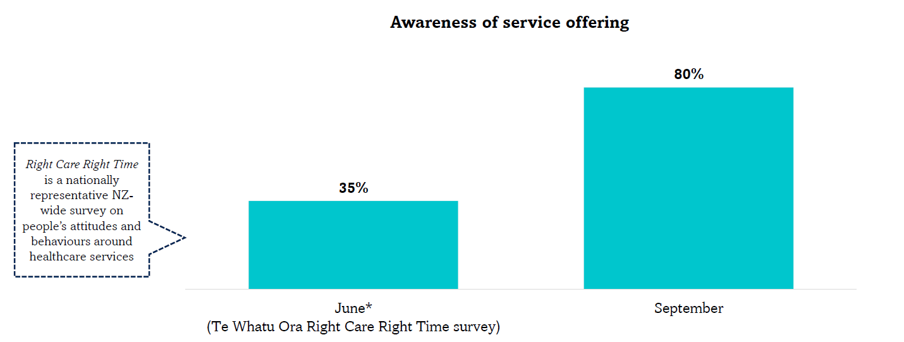

Figure 8 Awareness of pharmacists as a source of advice and treatment for minor health conditions

Consideration should be taken in ensuring that communication strategies are in place before any further service is implemented.

##### Service user survey was onerous, delayed and uptake was poor

Despite the MHCS starting on 12 June 2023, the service user survey was only made available from 21 July, missing around six weeks of data. Adding to this, completion of the survey was onerous, and some service users might have felt was disproportionately long compared with the short consultation they received. With a large proportion of children accessing the service, it could have been difficult for the caregivers of those unwell children to complete the survey.

In addition to the survey question limitations discussed previously, the MHCS user survey did not allow respondents to specify more than one health condition as their reason for accessing the service, however the pharmacists’ consultation record was able to accommodate multiple presenting health conditions.

##### Restricted geographical availability of the MHCS

The pilot was only available in ten districts. Nuanced and targeted public communications and advertising was therefore a challenge. Restricted availability also led to public and pharmacy provider confusion, with the public sharing information with friends in districts where the service was not available. If offered in future, national public communications would be logistically simpler. The service was also not available in areas with significant priority populations and constrained access to healthcare, such as in Tairāwhiti.

##### Limited range of health conditions accessible to care under MHCS

The health conditions covered during the pilot were limited, low acuity conditions, which may have reduced the opportunity for tangible impact on patient demand for GP and ED services. The MHCS covered the following minor conditions: acute diarrhoea, and dehydration (e.g. due to vomiting or diarrhoea); eye infections and inflammation; pain and fever; scabies; headlice; eczema/dermatitis; minor skin infections. Many pharmacists commented that the range of conditions covered in the MHCS should be widened to include acute asthma, urinary tract infections, vaginal yeast infections, emergency contraception, hayfever, cold sores and others.

##### Limited range of medicines to treat the approved conditions

A broader range of funded medicines available under the MHCS was called for by some pharmacists. For example, an extended range of products to treat skin conditions, including dressings for minor wounds.

Health NZ and Pharmac agreed on a defined list of approved medicines that pharmacists could dispense under the pilot. Any future service development must be done in close collaboration with Pharmac, including consideration of any necessary Pharmaceutical Schedule rule changes.

##### National medicine supply constraints

During the MHCS pilot there were national supply constraints for paracetamol, aqueous cream, permethrin lotion and dimethicone, meaning that for at least part of the pilot period, this constrained pharmacists’ ability of offer funded treatment for some conditions, which may have lessened the potential positive impact of the MHCS. The pilot may have contributed to increased demand for the medicines funded under the scheme, and while this is suggestive of increased access, it may also have exacerbated the supply constraints.

##### Privacy during MHCS consultations

Service user feedback revealed that more than half of the respondents were not offered a private space for the consultation. While pharmacies should have private consultation spaces already, ensuring that service users are provided the option to use them needs addressing for any further development. This shortcoming has also been identified through the Pharmacy Whakamahere[21] consumer engagement.

##### Quality of service to Pacific peoples and to Disabled People

In the service user survey, Pacific people and Disabled people reported a poorer experience care compared to Māori respondents and all ethnicities combined. Future development of the service should ensure that the design of the MHCS addresses these disparities, including co-design with Whaikaha – Ministry of Disabled People and representative community groups. Additional insights are also provided in the Pharmacy Whakamahere consumer engagement report.18

##### Sharing of clinical records

During the MHCS pilot there was no data or digital systems available for the sharing of service user clinical information between pharmacists and other health service providers. The ability to share clinical information would facilitate pharmacists’ clinical decision making and inform other healthcare providers of the treatment plan for shared patients.

Whilst a single electronic health record is on the development roadmap for the Health NZ Hira project this is unlikely to be available before 2026. The importance of this development is acknowledged for the ongoing care of patients accessing a MHCS and other pharmacy services.

##### Provider claiming systems

For the pilot, medicines and dispensing fees were claimed by pharmacies through their pharmacy management systems using standard business as usual processes.

Service fees and treatment aids were claimed through online claiming portals using a temporary process. For future services it is important to minimise administrative burden for pharmacies and that this or a similar process is retained.

##### Impact on continuity of care

There is strong evidence that seeing the same clinical provider (usually a GP) on an ongoing basis for primary health conditions improves health outcomes. Although these are minor conditions, many GPs report that the relationship developed in treating minor conditions is important in then managing more serious conditions. The impact on continuity of care of the services was not measured in the evaluation.

## 6. Conclusion

This evaluation of the winter 2023 minor health conditions service was unable to provide conclusive evidence that it had a direct impact on reducing demand in GP, urgent care or ED. Key contributors to this may be due to the range of constraints that have been identified, including the limited timeframe, geographical areas and conditions covered by the service and lack of public awareness.

The service did improve access to and options for treatment for minor health conditions, particularly for people who are unenrolled with a PHO/GP and for those requiring treatment after-hours. The MHCS has the potential to improve access in a cost-effective way. The after-hours availability of the service was particularly useful for patients and their families.

Future development and future commissioning of the service should consider:

* an extended range of conditions that are available for funded treatment
* an extended range of funded medicines available to the pharmacist to provide effective treatment
* a permanent service available through the year
* a national service available to be commissioned through all Health NZ regions
* review of the eligibility criteria, for example including addition of unenrolled people
* national advertising and public communications, including awareness to other healthcare professionals and Whakarongorau
* ways to improve continuity of care
* what copayments could be charged to equalise access arrangements between settings and make services available to wider demographic groups
* the interface between a possible MHCS and expectations of access via GP capitation
* the relative cost effectiveness of private payment and over the counter supply vs funded consults
* options for combining MHCS with other required features to improve access – eg extended opening hours, having a space for GP teleconsults; access to discretionary medicines and services
* further work with Pacific and Disabled people to ensure that the design of the service addresses the disparities identified in the evaluation.

## 7. References

## 8. Appendix One: Service Specification: Minor Health Conditions Service

**SERVICE SPECIFICATION**

**COMMUNITY PHARMACY MINOR AILMENTS SERVICE**

*The Services*

1. **Background and service objectives**

1.1 Te Whatu Ora wishes to fund a Community Pharmacy Minor Ailments Service (MAS) to:

1. improve access to consultations, advice and treatments for minor ailments and reduce inequity of health outcomes;
2. promote care through community pharmacy by encouraging the use of community pharmacists as a first port of call for consultation and treatment; and
3. assist in managing the time demands on general practice and urgent care through the transfer of care to pharmacists where appropriate.
4. **Eligible Service Users** 
   1. An Eligible Service User is a Service User who:
5. is one of the following:
   1. is under 14 years old;
   2. is a whānau member of Service User who is under 14 years old, and who has the same condition as that Service User;
   3. identifies as Māori or Pasifika ethnicity; or
   4. has a Community Services Card (CSC) or is the dependent child of a CSC holder and is 14 to 17 years of age; and
6. has an Approved Condition.

2.2 The Provider is not required to verify (i.e.., require evidence) an Eligible Service User’s ethnicity or CSC status.

**3. Access and delivery of the MAS**

3.1 The Provider will ensure that the MAS is always available to Eligible Service Users when the Provider’s premise is open for normal business, as specified in the Provider’s ICPSA.

3.2 The Provider will ensure safe and sustainable staffing levels so that it is able to continue to deliver all of the services that Te Whatu Ora contracts the Provider to deliver under the Provider’s ICPSA.

3.3 The Provider may only deliver the MAS to Eligible Service Users who are located within an Approved Area, unless Te Whatu Ora agrees otherwise in writing.

* 1. **Service Components**

4.1 The Provider must provide the MAS in accordance with the service components set out in this clause.

4.2 The Provider must assess the person or whānau member presenting to the Provider (which includes assessing their condition) to determine whether they are an Eligible Service User.

4.3 If the person is an Eligible Service User, the Provider will undertake a MAS Consultation. Each MAS Consultation must:

* 1. be undertaken in a private consultation room (where appropriate), unless clause 4.5 or clause 4.8 apply;
  2. establish the relevant history and clinical information of the Eligible Service User;
  3. include a primary diagnosis and a MAS Management Plan that is discussed with the Eligible Service User; and
  4. be carried out by either a pharmacist, a Nurse, or an Intern Pharmacist under the supervision of a Pharmacist who:
  5. is registered and holds an Annual Practicing Certificate under the Health Practitioners Competence Assurance Act 2003; and
  6. is practicing within their Scope of Practice.

4.4 Each MAS Management Plan may include one or more of the following:

* 1. advice and reassurance, including what to do if the Approved Condition worsens or does not improve;
  2. provision of an Approved Medicine or Approved Treatment Aid along with appropriate advice; and
  3. for any condition that requires treatment or further investigation that is beyond the scope of the Provider:
  4. referral to the Eligible Service User’s general practitioner (GP), urgent care or telehealth provider where appropriate.  The mode of referral will be based on the acuity of the condition observed by the person undertaking the MAS Consultation; or
  5. if the Eligible Service User’s GP is not available, or the Provider requires guidance, the Provider may seek assistance from the Whakarongorau clinical advice line: **0800 XXXXXX** between 8:00am and 8:00pm.Through this resource,the Provider can also provide the Eligible Service User direct referral to a Registered Doctor, who will contact the Eligible Service User for further consultation. **Please note that this phone number is not publicly available and should not be given to the public**.

4.5 The Provider may undertake a virtual MAS Consultation for an Eligible Service User if:

* 1. the Provider has determined that a virtual MAS Consultation is clinically and professionally justifiable to meet local need; and
  2. the Eligible Service User receives the same standard care as an in-person MAS Consultation, including any necessary Approved Medicines being supplied in a timeframe appropriate for the condition being treated.

4.6 If, during a virtual consultation with an Eligible Service User, it becomes evident to the Provider that an in-person MAS Consultation is necessary, the Provider must do one of the following depending on what is most practicable for the Eligible Service User:

(a) arrange for the Eligible Service User to have an in-person MAS Consultation with the Provider;

(b) refer the Eligible Service User to another pharmacy delivering MAS; or

(c) where no there is no other pharmacy delivering MAS accessible to the Eligible Service User, refer the Eligible Service User to another appropriate healthcare provider based on the acuity of the condition.

4.7 In clause 4.6(b) and (c) above, the Provider must not claim a MAS Consultation Fee as a full MAS Consultation has not been completed.

* 1. The Provider may provide MAS Consultations and Approved Medicines and Approved Treatment Aids at an off-site location such as a pre-school or marae provided all legislative requirements are met for the transport, custody and supply of any Approved Medicines provided under the service.
  2. If, following a MAS Consultation, the Provider decides to dispense an Approved Medicine, the Provider must:
     + 1. exercise clinical and professional judgement to determine the quantity of the Approved Medicine to be dispensed to the Eligible Service User. The long-term treatment and management of Approved Conditions is not within the scope of this service.; and
       2. comply with all Pharmaceutical Schedule quantity supply restrictions.
  3. For any person who is not an Eligible Service User, the Provider will follow its usual practice for advice, treatment and referral in accordance with its obligations under the ICPSA.

*Fees, payment and claiming rules*

**5. Consultation Fee**

5.1 Te Whatu Ora will pay the Provider a MAS Consultation Fee of $25.00 (GST exclusive) for each Eligible Service User that is provided a MAS Consultation.

5.2 The Provider will claim each MAS Consultation Fee through the Nominated Portal by providing the required information set out in the Nominated Portal. Subject to clause 4.7, a claim can be made for a MAS Consultation to an Eligible Service User, regardless of the outcome (i.e., regardless of whether an Approved Medicine is dispensed, only advice is provided, or the Eligible Service User is referred to a GP).

5.3 For each MAS Consultation, the Provider may only claim one MAS Consultation Fee for an Eligible Service User, whether the Eligible Service User presents with one or more Approved Conditions, or the Provider provides routine follow-up with the Eligible Service User in accordance with their management plan.

5.4 Despite clause 5.3, the Provider may claim an additional MAS Consultation Fee for the same Eligible Service User in respect of the same Approved Condition in exceptional circumstances if the Provider:

(a) has determined that a further full MAS Consultation is clinically necessary;

(b) records the clinical reasons and the circumstances which make the subsequent MAS Consultation necessary; and

(c) provides those records to Te Whatu Ora on request.

5.5 If an Eligible Service User presents to the Provider on a separate occasion with a different Approved Condition, including in the unlikely event that this occurs on the same day that an Eligible Service User has already received a MAS Consultation, the Provider may undertake a MAS Consultation in relation to that different Approved Condition and claim a MAS Consultation Fee for that separate MAS Consultation.

5.6 The Provider may claim a MAS Consultation Fee for each whānau member of a child under 14 years of age that has the same Approved Condition and requires management under MAS.

5.7 For the avoidance of doubt, the Provider cannot claim a MAS Consultation Fee for determining whether a Service User is an Eligible Service User.

**6. Approved Medicine**

6.1 Te Whatu Ora will pay the Provider a Dispensing Transaction Fee (including Approved Medicine reimbursement cost) and Case Mix Service Fee for each Approved Medicine that the Provider dispenses to an Eligible Service User following a MAS Consultation.

6.2 The Provider will claim the Dispensing Transaction Fee and Case Mix Service Fee for each Approved Medicine that has been dispensed in accordance with clause 6.1 through the Provider’s usual prescription batch claiming process, which is through the Provider’s pharmacy management system (RxOne/Toniq). The following are requirements for the Provider for each claim:

(a) the patient code for the dispensing(s) must be ‘C4’ (‘C1’ for Community Services Card holder); and

(b) the ‘prescriber’ must be entered as the Registered Health Professional who completed the MAS Consultation.

1. **Approved Treatment Aid**

7.1 Te Whatu Ora will pay the Provider (by way of reimbursement) for any Approved Treatment Aid that the Provider supplies to an Eligible Service User following a MAS Consultation.

7.2 The Provider will claim the reimbursement price for each Approved Treatment Aid that is supplied in accordance with clause 7.1 through the Nominated Portal.

7.2 The reimbursement price for each Approved Treatment Aid is listed in Appendix One.

**8. Provider must not charge an Eligible Service User**

* 1. Subject to clause 8.2 below, the Provider must not charge an Eligible Service User any amount for the MAS provided to that Eligible Service User. In particular, the Provider must not charge the Eligible Service User:
     + 1. for the MAS Consultation;
       2. a prescription co-payment (if any) for any Approved Medicine or Approved Treatment Aid;
       3. for any pharmaceutical treatment provided if there is an equivalent Approved Medicine available, unless the Eligible Service User specifically requests a medicine that is not an Approved Medicine;
       4. for any treatment aid provided if there is an equivalent Approved Treatment Aid available, unless the Eligible Service User specifically requests a treatment aid that is not an Approved Treatment Aid; and
       5. any after-hours charge for the provision of MAS.

8.2 Delivery of any medicines or any other item associated with MAS is not funded under this service. The Provider may charge an Eligible Service User a delivery fee if the Eligible Service User has requested a delivery and is made aware of reasonable alternatives to receive MAS treatment without incurring a delivery charge.

**9. Reporting**

* 1. The Provider will provide Te Whatu Ora with all information that it requires for reporting purposes by submitting claims for MAS through the Nominated Portal.
  2. The Provider agrees to assist Te Whatu Ora to gather feedback on the MAS from Eligible Service Users by:
     + 1. inviting Eligible Service Users to submit feedback using a feedback form provided by Te Whatu Ora; and
       2. supporting Eligible Service Users who do not have a device that can utilise a QR code.

*Definitions*

**Approved Area** means an area listed in Appendix Two of this Service Specification and listed on Te Whatu Ora MAS page ([https://www.tewhatuora.govt.nz/for-the-health-sector/community-pharmacy/community-pharmacy-minor-ailment-service/](https://aus01.safelinks.protection.outlook.com/?url=https%3A%2F%2Fwww.tewhatuora.govt.nz%2Ffor-the-health-sector%2Fcommunity-pharmacy%2Fcommunity-pharmacy-minor-ailment-service%2F&data=05%7C01%7CAndrew.Bary%40southerndhb.govt.nz%7C67ad5c0b85cf48bbd70108db62e1afdc%7C45107a8c6d7c411e9a7f787684a303df%7C0%7C0%7C638212493703779613%7CUnknown%7CTWFpbGZsb3d8eyJWIjoiMC4wLjAwMDAiLCJQIjoiV2luMzIiLCJBTiI6Ik1haWwiLCJXVCI6Mn0%3D%7C3000%7C%7C%7C&sdata=2%2FSBRobez05bUekQczGuJ5YnWgF1vNeCFD11CPZc0qA%3D&reserved=0)), which Te Whatu Ora may update from time to time by notifying the Provider of that update in writing.

**Approved Condition** means a condition listed in the first column of Appendix One of this Service Specification and a condition listed on Te Whatu Ora MAS page ([https://www.tewhatuora.govt.nz/for-the-health-sector/community-pharmacy/community-pharmacy-minor-ailment-service/](https://aus01.safelinks.protection.outlook.com/?url=https%3A%2F%2Fwww.tewhatuora.govt.nz%2Ffor-the-health-sector%2Fcommunity-pharmacy%2Fcommunity-pharmacy-minor-ailment-service%2F&data=05%7C01%7CAndrew.Bary%40southerndhb.govt.nz%7C67ad5c0b85cf48bbd70108db62e1afdc%7C45107a8c6d7c411e9a7f787684a303df%7C0%7C0%7C638212493703779613%7CUnknown%7CTWFpbGZsb3d8eyJWIjoiMC4wLjAwMDAiLCJQIjoiV2luMzIiLCJBTiI6Ik1haWwiLCJXVCI6Mn0%3D%7C3000%7C%7C%7C&sdata=2%2FSBRobez05bUekQczGuJ5YnWgF1vNeCFD11CPZc0qA%3D&reserved=0)), which Te Whatu Ora may update from time to time by notifying the Provider of that update in writing.

**Approved Medicine** means a medicine listed in Appendix One of this Service Specification and a medicine listed on Te Whatu Ora MAS page ([https://www.tewhatuora.govt.nz/for-the-health-sector/community-pharmacy/community-pharmacy-minor-ailment-service/](https://aus01.safelinks.protection.outlook.com/?url=https%3A%2F%2Fwww.tewhatuora.govt.nz%2Ffor-the-health-sector%2Fcommunity-pharmacy%2Fcommunity-pharmacy-minor-ailment-service%2F&data=05%7C01%7CAndrew.Bary%40southerndhb.govt.nz%7C67ad5c0b85cf48bbd70108db62e1afdc%7C45107a8c6d7c411e9a7f787684a303df%7C0%7C0%7C638212493703779613%7CUnknown%7CTWFpbGZsb3d8eyJWIjoiMC4wLjAwMDAiLCJQIjoiV2luMzIiLCJBTiI6Ik1haWwiLCJXVCI6Mn0%3D%7C3000%7C%7C%7C&sdata=2%2FSBRobez05bUekQczGuJ5YnWgF1vNeCFD11CPZc0qA%3D&reserved=0)), which Te Whatu Ora may update from time to time by notifying the Provider of that update in writing.

**Approved Treatment Aid** means a treatment aid that is highlighted yellow listed in Appendix One of this Service Specification and a treatment aid listed on Te Whatu Ora MAS page ([https://www.tewhatuora.govt.nz/for-the-health-sector/community-pharmacy/community-pharmacy-minor-ailment-service/](https://aus01.safelinks.protection.outlook.com/?url=https%3A%2F%2Fwww.tewhatuora.govt.nz%2Ffor-the-health-sector%2Fcommunity-pharmacy%2Fcommunity-pharmacy-minor-ailment-service%2F&data=05%7C01%7CAndrew.Bary%40southerndhb.govt.nz%7C67ad5c0b85cf48bbd70108db62e1afdc%7C45107a8c6d7c411e9a7f787684a303df%7C0%7C0%7C638212493703779613%7CUnknown%7CTWFpbGZsb3d8eyJWIjoiMC4wLjAwMDAiLCJQIjoiV2luMzIiLCJBTiI6Ik1haWwiLCJXVCI6Mn0%3D%7C3000%7C%7C%7C&sdata=2%2FSBRobez05bUekQczGuJ5YnWgF1vNeCFD11CPZc0qA%3D&reserved=0)), which Te Whatu Ora may update from time to time by notifying the Provider of that update in writing.

**Case Mix Service Fee** means the fee calculated in accordance with clause 17 of Schedule 1 of the ICPSA.

**Dispensing Transaction Fee** means the fee calculated in accordance clause 16 of Schedule 1 of the ICPSA.

**ICPSA** means the Integrated Community Pharmacy Services Agreement that the Provider has entered into with Te Whatu Ora.

**MAS Consultation** means a consultation that complies with the requirements in clause 4 of this Service specification.

**MAS Consultation Fee** means the fee of $25 (+GST).

**Nominated Portal** means the portal that is applicable in the District in which the Provider is based, as notified to the Provider.

**Service User** means a person who is eligible to receive publicly funded health services as specified in a direction issued by the Minister of Health that is continued under clause 30 of Schedule 1 of the Pae Ora (Heathy Futures) Act 2022, or specified in regulations made under section 102 of that Act.

**Appendix One: Approved Conditions, Approved Medicines and Approved Treatment Aids**

|  |  |  |  |
| --- | --- | --- | --- |
| **Approved Condition** | **Medication** **/ Treatment Aid** | **Pharmacode®** | **Subsidy**  **(where not listed in the Pharmaceutical Schedule)** |
| **Acute Diarrhoea/vomiting/dehydration** | |  |  |
|  | Oral rehydration powder sachets (Electral) | 2576937 |  |
|  | Pedialyte - Bubblegum | 2504308 |  |
|  | Loperamide 2mg tablets | 2184427 |  |
|  | Loperamide 2mg capsules | 2365545 |  |
| **Bacterial Eye** **Infection** | |  |  |
|  | Chloramphenicol 0.5% eye drops | 335142  2368137 |  |
|  | Chloramphenicol 1% eye ointment | 2576902 |  |
| **Eye Inflammation** | |  |  |
|  | Hypromellose 0.3% eye drops (with dextran 0.1%) | 229075 |  |
|  | Paraffin liq with woolfat (Polyvisc) | 2035812 |  |
|  | Sodium cromoglicate 2% eye drops | 2645416 |  |
|  | Lodoxamide (Lomide) | 424544 |  |
| **Pain/Fever** | |  |  |
|  | Paracetamol 120mg/5ml | 2650665 |  |
|  | Paracetamol 250mg/5ml | 2643650 |  |
|  | Ibuprofen oral liq 20mg/ml | 2551985 |  |
| **(Treatment Aid)** | BD Syringe, syringe 5 mL | 201952 | $0.22+GST |
| **(Treatment Aid)** | BD Syringe, syringe, 10 mL | 2029758 | $0.22+GST |
|  | Paracetamol 500mg tablets | 2612712 |  |
| **Skin** | |  |  |
| Scabies | Permethrin 5% Cream | 479233 |  |
|  | Permethrin 5% Lotion | 2332027 |  |
| Head lice | Dimethicone 4% | 2351293 |  |
| **(Treatment Aid)** | Parasidose Head Lice Comb (metal), shrink wrap | 2185083 | $6.70+GST |
| Eczema/Dermatitis | Emulsifying ointment | 2597535 |  |
|  | Paraffin liquid + paraffin soft white | 2639106 |  |
|  | Cetomacrogol aqueous 90% + glycerol 10% 500mL | 2642778 |  |
| Cetomacrogol aqueous 90% + glycerol 10% 1000Ml | 2642786 |  |
|  | Aqueous Cream SLS free (Gem brand) | 2615592 |  |
|  | Cetomacrogol Cream | 2615509 |  |
|  | Fatty Cream - AFT brand | 2627426 |  |
|  | Zinc and castor oil Oint | 2537753  2658399 |  |
|  | Hydrocortisone 1% Cream | 2646587 |  |
| Minor Skin Infections | Clotrimazole 1% Cream | 2184362 |  |
|  | Miconazole with H’cort 1% | 704733 |  |
|  | Hydrogen peroxide 1% Cream | 2399504 |  |
|  | Povidone Iodine 10% Ointment | 2159252 |  |
|  | Povidone Iodine 10% Antiseptic Solution (15mL) | 2013304 |  |
|  | Povidone Iodine 10% Antiseptic Solution (100mL) | 777447 |  |

**Appendix Two: Approved Areas**

|  |  |
| --- | --- |
| **Description of Approved Area** | **Representative geographical area** |
| Northland | As described in Schedule 1 of the New Zealand Public Health and Disability Act 2000 (relating to the former relevant DHB) |
| Waitematā |
| Auckland |
| Counties Manukau |
| Bay of Plenty |
| MidCentral |
| Capital & Coast/Hutt Valley |
| Canterbury |
| Invercargill | The territorial local authorities of Invercargill, Southland, Gore |

1. Dineen-Griffin, S, Garcia-Cardenas, V, Rogers, K, Vargas, C, Williams, KA & Benrimoj, SI; 2019, An Australian minor ailments scheme: Evaluation of an integrated approach by community pharmacists and general medical practitioners. University of Technology Sydney, Sydney, NSW. Available at: <https://www.uts.edu.au/sites/default/files/2019-11/Full%20Report%20%28wl%29.pdf>
2. Dineen-Griffin S, Benrimoj SI, Rogers K, et al. Cluster randomised controlled trial evaluating the clinical and humanistic impact of a pharmacist-led minor ailment service. BMJ Quality & Safety 2020;29:921-931.
3. Paudyal V, Watson MC, Sach T, et al. Are pharmacy-based minor ailment schemes a substitute for other service providers? A systematic review. Br J Gen Pract. 2013;63(612):e472-e481. doi:10.3399/bjgp13X669194
4. NHS England: Policy guidance: conditions for which over the counter items should not be routinely prescribed in primary car. Available at: <https://www.england.nhs.uk/publication/policy-guidance-conditions-for-which-over-the-counter-items-should-not-be-routinely-prescribed-in-primary-care/>
5. PSNC Briefing 022/18: Building a business care for a Minor Ailment Service. April 2018. Available at: <https://cpe.org.uk/briefings/psnc-briefing-022-18-building-a-business-case-for-a-minor-ailment-service-april-2018/>
6. The Pharmaceutical Journal, PJ, Minor ailment scheme extension could save NHS up to £640m annually, says PSNC; January 2022, Vol 308, No 7957;308(7957): DOI:10.1211/PJ.2022.1.124388
7. Hikaka J, Parore N, McIntosh B, Haua R, Hudson M, Anderson A, Brown R, Pewhairangi K. (2023). Achieving Medicines Access Equity for Māori – medicines adherence and minor ailments. Ngā Kaitiaki o Te Puna Rongoā o Aotearoa – The Māori Pharmacists’ Association and National Hauora Coalition.
8. Paudyal V, Watson MC, Sach T, et al. Are pharmacy-based minor ailment schemes a substitute for other service providers? A systematic review. Br J Gen Pract. 2013;63(612):e472-e481. doi:10.3399/bjgp13X669194[10.1016/j.rcsop.2022.100174](https://doi.org/10.1016%2Fj.rcsop.2022.100174).
9. Approximately 5% of the NZ population was not enrolled with a (PHO) in July 2023: Access to Primary Care as at July 2023: <https://www.tewhatuora.govt.nz/assets/For-the-health-sector/Primary-care/Enrolment-with-a-general-practice-and-primary-health-organisation/2023Q3-Primary-Care-Tier-1-Statistics.xlsx>
10. Socioeconomic Deprivation Indexes: NZDep and NZiDep, Department of Public Health: [https://www.otago.ac.nz/wellington/departments/publichealth/research-groups-in-the-department-of-public-health/hirp/socioeconomic-deprivation-indexes-nzdep-and-nzidep-department-of-public-health#new-zealand-indexes-of-deprivation](https://www.otago.ac.nz/wellington/departments/publichealth/research-groups-in-the-department-of-public-health/hirp/socioeconomic-deprivation-indexes-nzdep-and-nzidep-department-of-public-health%23new-zealand-indexes-of-deprivation)
11. Ministry of Health. 2023. Annual Data Explorer 2022/23: New Zealand Health Survey [Data File]. URL: <https://minhealthnz.shinyapps.io/nz-health-survey-2022-23-annual-data-explorer/>
12. Fielding S, Porteous T, Ferguson J, et al. Estimating the burden of minor ailment consultations in general practices and emergency departments through retrospective review of routine data in North East Scotland. *Fam Pract*. 2015;32(2):165-172. doi:10.1093/fampra/cmv003
13. Estimated from GP Qualifying Encounter and PHO service utilisation data. This data overestimates consultations that can prescribe or provide treatment where necessary.
14. Akers JM, Miller JC, Seignemartin B, MacLean LG, Mandal B, Kogan C. Expanding Access to Patient Care in Community Pharmacies for Minor Illnesses in Washington State. Clinicoecon Outcomes Res. 2024 May 3;16:233-246. doi: 10.2147/CEOR.S452743. PMID: 38716161; PMCID: PMC11075675.
15. Amador-Fernández, N., Benrimoj, S. I., García-Mochón, L., García-Cárdenas, V., Dineen-Griffin, S., Gastelurrutia, M. Á., Gómez-Martínez, J. C., Colomer-Molina, V., & Martínez-Martínez, F. (2021). A cost utility analysis alongside a cluster-randomised trial evaluating a minor ailment service compared to usual care in community pharmacy. BMC Health Services Research, 21(1), 1253. https://doi.org/10.1186/s12913-021-07188-4
16. Dineen-Griffin, S., Garcia-Cardenas, V., Rogers, K., Vargas, C., Williams, K. A., & Benrimoj, S. I. (2019). An Australian minor ailments scheme: Evaluation of an integrated approach by community pharmacists and general medical practitioners. https://researchoutput.csu.edu.au/files/210987912/65022364_published_report.pdf
17. Aspden TJ, Marowa M, Ponton R, Scahill SL. Why are we still waiting? Views of future-focused policy and the direction of the profession from dissatisfied recent pharmacy graduates. JHOM, 2021; 35(6): 744-762. DOI:[10.1108/JHOM-04-2020-0162](http://dx.doi.org/10.1108/JHOM-04-2020-0162).
18. Aspden TJ, Silwal PR, Marowa M, Ponton R. Why do pharmacists leave the profession? A mixed-method exploratory study. Pharmacy Practice 2021; 19(2):2332. <https://doi.org/10.18549/PharmPract.2021.2.2332>
19. Sapere. Independent review of community pharmacy services. Sapere December 2020. Available at: <https://www.tewhatuora.govt.nz/assets/For-the-health-sector/Community-pharmacy/Reviews/Independent-Review-Community-Pharmacy-Services-Stage-One-Sapere-2020.pdf>
20. Manatū Hauora. Health Targets. Available at: <https://www.health.govt.nz/new-zealand-health-system/health-targets>. Accessed 25.3.24.
21. Manatū Hauora and Te Whatu Ora.2023. Pharmacy Whakamahere: Understanding the pharmacy needs of our population. <https://www.tewhatuora.govt.nz/for-the-health-sector/community-pharmacy/pharmacy-whakamahere/>