Newborn Metabolic Screening Programme Annual Report
January to December 2015

Disclaimer
This publication reports on information provided to the Ministry of Health by the Auckland District Health Board. The purpose of this publication is to inform discussion and assist ongoing Newborn Metabolic Screening Programme development. All care has been taken in the production of this report, and the data was deemed to be accurate at the time of publication. However, the data may be subject to slight changes over time as further information is received. Before quoting or using this information, it is advisable to check the current status with the Ministry of Health.

Citation: Ministry of Health. 2017. Newborn Metabolic Screening Programme Annual Report 2015. Wellington: Ministry of Health.
Published in February 2017
by the Ministry of Health
PO Box 5013, Wellington 6140, New Zealand
ISBN 978-1-98-850221-2 (online)
HP 6566
This document is available at nsu.govt.nz

This work is licensed under the Creative Commons Attribution 4.0 International licence. In essence, you are free to: share ie, copy and redistribute the material in any medium or format; adapt ie, remix, transform and build upon the material. You must give appropriate credit, provide a link to the licence and indicate if changes were made.
Contents
Introduction 4
Background to the Programme 4
Data Summary 4
Executive Summary 5
Indicator 1: Coverage 6
Indicator 2: Timing of Sample Taking 10
Indicator 3: Quality of Blood Samples 12
Indicator 4: Sample Dispatch and Delivery 14
Indicator 5: Laboratory Testing Timeframes 16
Indicator 6: Timeliness of Reporting - Notification of Screen Positives 18
Indicator 7: Collection and Receipt of Second Samples 20
Indicator 8: Diagnosis and Commencement of Treatment 22
Indicator 9: Blood Spot Card Storage and Return 24
Appendix 1: List of Screened Conditions 25

Introduction
This annual report provides information on the performance of the Newborn Metabolic Screening Programme (NMSP) against the agreed set of national indicators. Regular analysis and reporting of NMSP data is a key tool in enabling continuous quality improvement of the programme.
This is the fifth annual report of the NMSP following the development of national indicators in 2010. The NMSP Monitoring Framework and monitoring reports are published on the National Screening Unit (NSU) website:
www.nsu.govt.nz/health-professionals/newborn-metabolic-screening-programme/procedures-guidelines-and-reports-2

Background to the Programme
The aim of the NMSP is to reduce morbidity and mortality by screening to facilitate detection and treatment of specific metabolic disorders in pre-symptomatic babies. Since 1969 almost all newborns in New Zealand have been screened through the programme. Currently over 20 disorders are screened for and the NMSP identifies around 50 newborns a year with one of the conditions. With early diagnosis, treatment can commence immediately, preventing life-threatening illness or reducing the severity of long term consequences of the condition.
A midwife, nurse, doctor or phlebotomist collects a blood sample from the newborn’s heel onto a blood spot card (a ‘Guthrie card’). Samples must be collected between 48 and 72 hours of age for optimal testing. Cards are then sent urgently for laboratory analysis at LabPlus at Auckland District Health Board (ADHB), and results reported to appropriate clinicians. Conditions tested for are listed in Appendix A.
Since 2005, the NMSP has been overseen nationally by the NSU at the Ministry of Health. A significant milestone for the programme was the introduction in 2006 of expanded newborn screening (adding fatty acid oxidation and more amino acid breakdown disorders).

Data Summary
Screening data is sourced from LabPlus at ADHB for all blood spot cards received in the 2015 calendar year. Birth data in the 2015 calendar year is sourced from the National Maternity Collection at the Ministry of Health. Ethnicity data is prioritised. When a newborn’s DHB of domicile is unknown, it is set to ‘Unknown’.

Executive Summary
- The NMSP screened 58,463 of the 59,058 newborns born in 2015; a national coverage rate of 99.0%. This high uptake was in line with coverage rates since newborn metabolic screening began in New Zealand in 1969. While overall national coverage was high, there was variance at a local DHB level, from 89% coverage upwards. Ethnicity coverage also varied, with 97.4% of Māori, 98.9% of Pacific, and 99.5% of all other newborns screened in 2015. DHB and ethnicity variances will be the subject of quality improvement focus in 2017.
- Congenital metabolic disorders are rare. 50 newborns were diagnosed with a screened disorder in 2015. Early diagnosis, enabled by NMSP screening, allowed for early treatment of those newborns, therefore reducing the serious impact on their lives and development that would have otherwise occurred.
- The NMSP monitors a series of timeframes that focus on collection of blood spot samples within the ideal timeframe, and subsequent quick dispatch of blood spot cards to the laboratory, followed by rapid turnaround time of test results. This ensures that newborns with positive screen results can be diagnosed and treated as soon as possible.
- While laboratory testing timeframes per disorder were uniformly high, and some disorder-specific follow-up timeframes were met, as in previous years few of the general timeframe measures came close to meeting expectations in 2015. For example, 75% of blood spot samples were taken in the ideal 48 – 72 hour timeframe, and 74% were received at the laboratory within the expected four days after sampling. The standard in both cases is 95%.
- To address these shortfalls, maternity units were asked about their blood spot sampling processes. Quarterly ‘transit’ time reports are now sent to DHBs providing feedback that resulted in immediate improvement in some timeframes over previous years. For example, a lift from the 2014 four day transit rate of 66% to 73% in 2015. Further work has also been done to review postal services to the laboratory, and higher volume maternity units will progressively shift to courier services from late 2016.
- A significant success for the programme in the year was establishment of a phone and text service between LabPlus and lead maternity carers (LMCs) that improved the 10-day turnaround time of requests for second samples. The rate of return rose from 38% in 2014 to 67% in 2015. Where the request was in follow-up to an initial abnormal result, the turnaround time rose to almost 100%.

Indicator 1: Coverage
Description: This indicator measures the proportion of newborns born in New Zealand who complete newborn metabolic screening.
Rationale: All newborns whose parent/guardians consent to screening should be screened. This indicator measures both the acceptability and completion of screening.
Standard: 100% of newborns whose parents/guardians consent to screening are screened.
Interpretation: Coverage at 99% is in line with an average of 99% between 2007 and 2014. Coverage by DHB varied from 89% upward. Coverage by ethnicity varied from 97% for Māori, to 99% for Pacific and Other.
Comment: As with previous years, it was difficult to align denominator data (birth volumes) with numerator data (newborns screened) because: each dataset has a different source, cross-matching and data cleansing is complex – though improving, the indicator reports DHB of domicile when increasing numbers of newborns (particularly in Auckland) are born and/or screened at a different DHB to where they live, and birth year and screened year can be different.
Overall programme coverage remained high, with seven DHBs achieving more than 99.5% coverage. Tairawhiti had the lowest coverage rate, though it is expected that initiatives such as the National Child Health Information Platform (NCHIP) that the DHB has joined will make a difference.

Figure 1: Coverage over Time
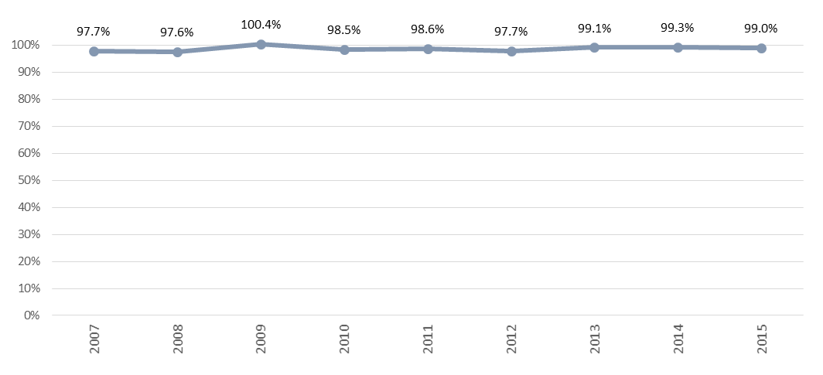

Table 1: Coverage over Time
Year | Births | Newborns screened | Coverage
2007 | 64,040 | 65,121 | 97.7%
2008 | 65,333 | 63,794 | 97.6%
2009 | 63,285 | 63,516 | 100.4%
2010 | 64,699 | 63,727 | 98.5%
2011 | 62,733 | 61,859 | 98.6%
2012 | 62,842 | 61,422 | 97.7%
2013 | 59,707 | 59,192 | 99.1%
2014 | 59,097 | 58,673 | 99.3%
2015 | 59,058 | 58,463 | 99.0%

Figure 2: Coverage by DHB of domicile, January to December 2015
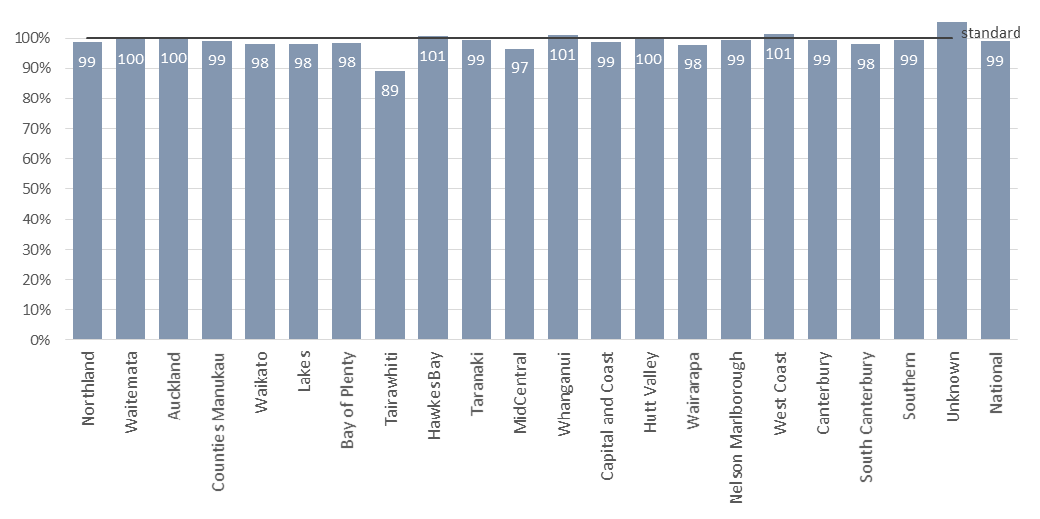
Table 2: Coverage by DHB of domicile, January to December 2015
DHB of Domicile | Births | Newborns Screened | Coverage
Northland | 2,104 | 2,074 | 98.6%
Waitemata | 7,596 | 7,566 | 99.6%
Auckland | 5,960 | 5,951 | 99.8%
Counties Manukau | 8,242 | 8,175 | 99.2%
Waikato | 5,360 | 5,256 | 98.1%
Lakes | 1,515 | 1,487 | 98.2%
Bay of Plenty | 2,784 | 2,742 | 98.5%
Tairawhiti | 768 | 685 | 89.2%
Hawkes Bay | 2,003 | 2,014 | *
Taranaki | 1,527 | 1,515 | 99.2%
MidCentral | 2,116 | 2,044 | 96.6%
Whanganui | 818 | 826 | *
Capital and Coast | 3,547 | 3,497 | 98.6%
Hutt Valley | 1,979 | 1,970 | 99.5%
Wairarapa | 427 | 418 | 97.9%
Nelson Marlborough | 1,434 | 1,423 | 99.2%
West Coast | 359 | 364 | *
Canterbury | 6,250 | 6,206 | 99.3%
South Canterbury | 663 | 650 | 98.0%
Southern | 3,434 | 3,407 | 99.2%
Unknown | 172 | 193 | *
National | 59,058 | 58,463 | 99.0%

*Percentages greater than 100% are suppressed because of a mismatch between numerator and denominator data due to such things as: newborns are not always born or screened in their DHB of domicile, year of birth and year of screening are not always the same.

Figure 3: Coverage by ethnicity, January to December 2015

Table 3: Coverage by ethnicity, January to December 2015
Ethnicity | Births | Newborns Screened | Coverage
Māori | 13,292 | 12,954 | 97.5%
Pacific | 5,954 | 5,891 | 98.9%
Other | 39,812 | 39,618 | 99.5%
Total | 59,058 | 58,463 | 99.0%

Indicator 2: Timing of Sample Taking
Description: This indicator monitors the age of the newborn when the sample is taken.
Rationale: Timely sample collection leads to the best possible chance of a newborn with a screened condition receiving early diagnosis and treatment. However, the newborn must have been independent of their mother long enough for some biochemical markers to show an abnormality.
Standard: 95% of first samples are taken between 48-72 hours after birth.
Interpretation: Timeliness of samples varied from 62% to 90% between DHBs, with a national average of 75%. In 2014 the national average was 77%, with no DHB meeting the 95% standard.
Comment: Canterbury DHB performed best, while Waikato and Counties Manukau lagged. A quality improvement initiative is underway to improve sample transit times from DHBs to LabPlus (Indicator 4). As part of that work DHBs are being asked to review all blood spot card processes and timeframes at maternity units from birth to sampling to transit. It is expected that this will lead to progressive improvement of the indicator.

Figure 4: Percentage of samples taken between 48 and 72 hours, January to December 2015
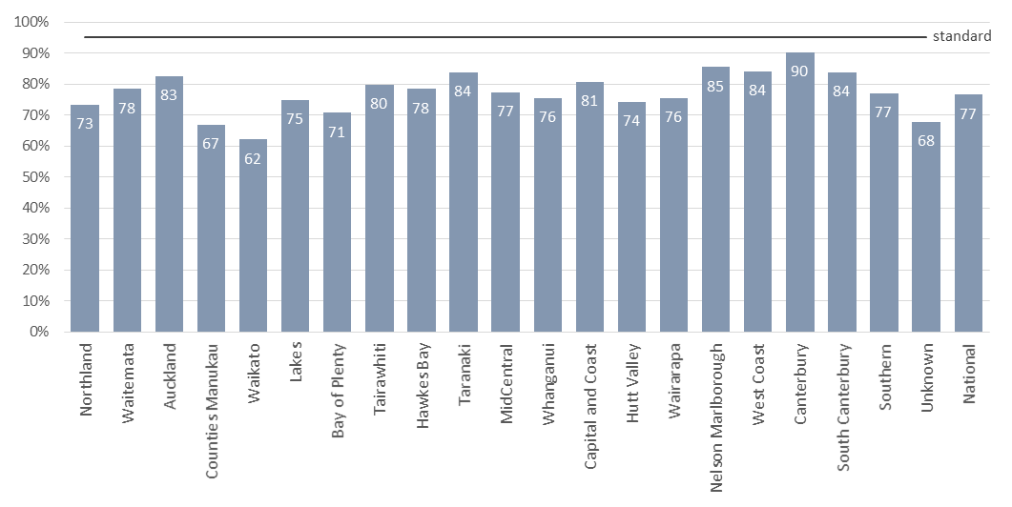
Table 4: Timing of sample taking, January to December 2015
DHB of Domicile | Less than 48 hours |  | 48 to 72 hours |  | More than 72 hours |  | Unknown |  | Total
 | no. | % | no. | % | no. | % | no. | % | no.
Northland | 23 | 1% | 1,521 | 73% | 474 | 23% | 56 | 3% | 2,074
Waitemata | 87 | 1% | 5,939 | 78% | 1,373 | 18% | 167 | 2% | 7,566
Auckland | 112 | 2% | 4,910 | 83% | 733 | 12% | 196 | 3% | 5,951
Counties Manukau | 104 | 1% | 5,464 | 67% | 2,288 | 28% | 319 | 4% | 8,175
Waikato | 73 | 1% | 3,268 | 62% | 1,754 | 33% | 161 | 3% | 5,256
Lakes | 11 | 1% | 1,114 | 75% | 324 | 22% | 38 | 3% | 1,487
Bay of Plenty | 30 | 1% | 1,940 | 71% | 683 | 25% | 89 | 3% | 2,742
Tairawhiti | 5 | 1% | 547 | 80% | 114 | 17% | 19 | 3% | 685
Hawkes Bay | 23 | 1% | 1,580 | 78% | 375 | 19% | 36 | 2% | 2,014
Taranaki | 24 | 2% | 1,269 | 84% | 192 | 13% | 30 | 2% | 1,515
MidCentral | 30 | 1% | 1,582 | 77% | 365 | 18% | 67 | 3% | 2,044
Whanganui | 5 | 1% | 624 | 76% | 177 | 21% | 20 | 2% | 826
Capital and Coast | 60 | 2% | 2,823 | 81% | 494 | 14% | 120 | 3% | 3,497
Hutt Valley | 19 | 1% | 1,462 | 74% | 434 | 22% | 55 | 3% | 1,970
Wairarapa | 6 | 1% | 316 | 76% | 84 | 20% | 12 | 3% | 418
Nelson Marlborough | 17 | 1% | 1,216 | 85% | 160 | 11% | 30 | 2% | 1,423
West Coast | 1 | 0% | 306 | 84% | 49 | 13% | 8 | 2% | 364
Canterbury | 70 | 1% | 5,599 | 90% | 388 | 6% | 149 | 2% | 6,206
South Canterbury | 4 | 1% | 545 | 84% | 88 | 14% | 13 | 2% | 650
Southern | 34 | 1% | 2,628 | 77% | 648 | 19% | 97 | 3% | 3,407
Unknown | 3 | 2% | 131 | 68% | 40 | 21% | 19 | 10% | 193
National | 741 | 1% | 44,784 | 77% | 11,237 | 19% | 1,701 | 3% | 58,463

While the overall rate of samples taken within the expected 48-72 hour timeframe sits below the national standard of 95%, this table does reflect an improvement in data quality. In the previous year 1,885 (3.2%) of blood spot cards had no collection date or birth date. In 2015 the volume and rate of cards without that information reduced. Most of those ‘unknowns’ now group into the ‘less than 48 hours’ category.

Indicator 3: Quality of Blood Samples
Description: This indicator monitors the quality of blood samples received by the laboratory.
Rationale: Accurate testing of newborn metabolic screening samples is reliant on the quality of the sample. Unsatisfactory samples require a repeat sample which could have been avoided.
Standard: 99% of samples are of satisfactory quality.
Interpretation: The rate of satisfactory quality blood samples ranged 97.4% to 99.5%, with a national average of 98.2%.
Comment: The national average was the same as in 2014 and, though of high quality generally, sat just below the expected standard. Sample collection quality, such as insufficient blood on the card, was the main reason for unsatisfactory samples. This is an ongoing focus of the programme’s LMC education and support initiatives.

Figure 5: Percentage of samples of a satisfactory quality, January to December 2015
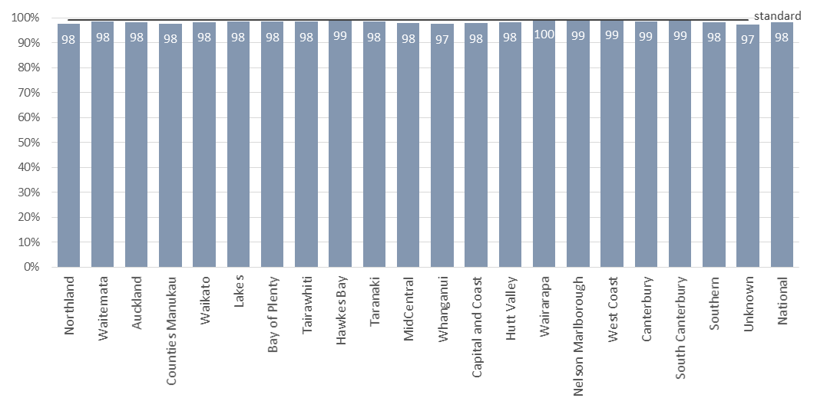
Table 5: Percentage of samples of a satisfactory quality, January to December 2015
DHB of Domicile | Satisfactory samples |  | Unsatisfactory samples |  | Total
 | no. | % | no. | % | no.
Northland | 2,023 | 97.5% | 51 | 2.5% | 2,074
Waitemata | 7,450 | 98.5% | 116 | 1.5% | 7,566
Auckland | 5,851 | 98.3% | 100 | 1.7% | 5,951
Counties Manukau | 7,990 | 97.7% | 185 | 2.3% | 8,175
Waikato | 5,167 | 98.3% | 89 | 1.7% | 5,256
Lakes | 1,463 | 98.4% | 24 | 1.6% | 1,487
Bay of Plenty | 2,699 | 98.4% | 43 | 1.6% | 2,742
Tairawhiti | 674 | 98.4% | 11 | 1.6% | 685
Hawkes Bay | 1,991 | 98.9% | 23 | 1.1% | 2,014
Taranaki | 1,492 | 98.5% | 23 | 1.5% | 1,515
MidCentral | 1,998 | 97.7% | 46 | 2.3% | 2,044
Whanganui | 805 | 97.5% | 21 | 2.5% | 826
Capital and Coast | 3,422 | 97.9% | 75 | 2.1% | 3,497
Hutt Valley | 1,935 | 98.2% | 35 | 1.8% | 1,970
Wairarapa | 416 | 99.5% | 2 | 0.5% | 418
Nelson Marlborough | 1,407 | 98.9% | 16 | 1.1% | 1,423
West Coast | 361 | 99.2% | 3 | 0.8% | 364
Canterbury | 6,120 | 98.6% | 86 | 1.4% | 6,206
South Canterbury | 644 | 99.1% | 6 | 0.9% | 650
Southern | 3,346 | 98.2% | 61 | 1.8% | 3,407
Unknown | 188 | 97.4% | 5 | 2.6% | 193
National | 57,442 | 98.3% | 1,021 | 1.7% | 58,463

Figure 6: Reason for unsatisfactory samples, January to December 2015
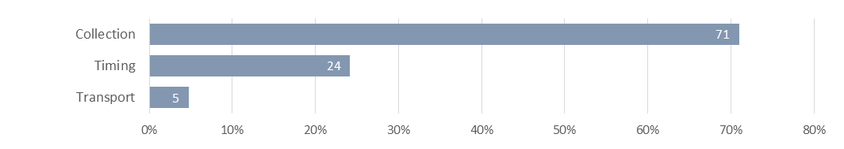

Collection: insufficient blood, incomplete demographics on the card, or the sample was contaminated.
Timing: samples were collected too early (before 48 hours of age).
Transport: took more than one month to arrive, blood was wet when folded, damaged in transit, or put wet into a plastic bag.

Table 6: Reason for unsatisfactory samples, January to December 2015
Reason | no. | %
Collection | 725 | 71%
Timing | 247 | 24%
Transport | 49 | 5%
Total | 1,021 | 100%

Indicator 4: Sample Dispatch and Delivery
Description: This indicator monitors the time between the sample being taken and receipt by the laboratory.
Rationale: To ensure early diagnosis and treatment, the NMSP relies on timeliness. Samples must be received by the laboratory as soon as possible after being taken.
Standard: 95% of samples are received at the laboratory within four (calendar) days of being taken.
Interpretation: Timeliness of sample dispatch and delivery varied widely between DHBs, ranging from 57% to 82%, with a national average of 74%. This is an improvement on the 2014 national average of 66%.
Comment: Since 2015 this indicator has been the focus of considerable quality improvement work. DHB maternity units were asked about their blood spot card process flow, and the NSU now provides DHBs with quarterly ‘transit’ reports that feedback timeframe summaries. It has become apparent that NZ Post changes, such as concentration of sorting centres and reduction in weekend services, together with variance in DHB postal providers (NZ Post, DX Mail), have affected DHBs’ ability to achieve the standard and that this impact is uneven across the country. A trial at four DHBs in early 2016 proved that use of courier rather than FastPost of blood spot cards makes a positive difference. Changes reflecting this are being rolled out.

Figure 7: Percentage of samples received by the laboratory within four days of being taken, January to December 2015
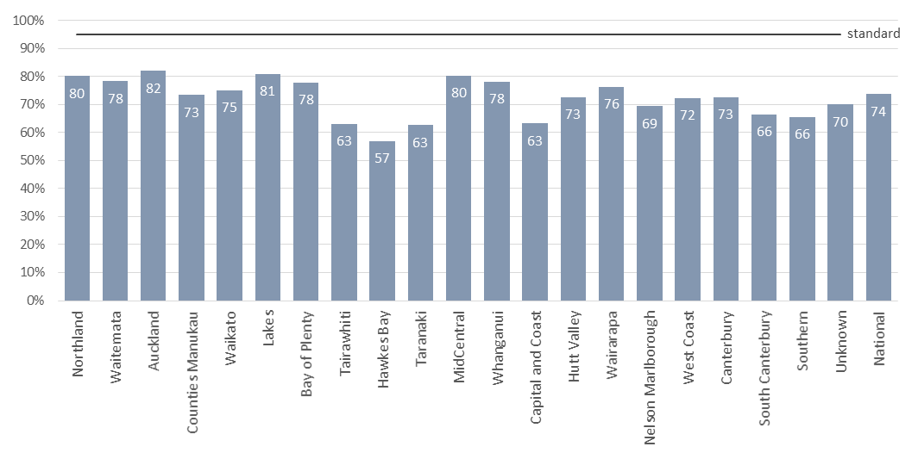
Table 6: Percentage of samples received by the laboratory within four days of being taken, January to December 2015
DHB of Domicile | Within 4 days |  | More than 4 days |  | Unknown |  | Total
 | no. | % | no. | % | no. | % | no.
Northland | 1,663 | 80% | 376 | 18% | 35 | 2% | 2,074
Waitemata | 5,922 | 78% | 1,570 | 21% | 74 | 1% | 7,566
Auckland | 4,882 | 82% | 1,006 | 17% | 63 | 1% | 5,951
Counties Manukau | 5,998 | 73% | 2,076 | 25% | 101 | 1% | 8,175
Waikato | 3,949 | 75% | 1,242 | 24% | 65 | 1% | 5,256
Lakes | 1,203 | 81% | 265 | 18% | 19 | 1% | 1,487
Bay of Plenty | 2,134 | 78% | 579 | 21% | 29 | 1% | 2,742
Tairawhiti | 432 | 63% | 246 | 36% | 7 | 1% | 685
Hawkes Bay | 1,146 | 57% | 852 | 42% | 16 | 1% | 2,014
Taranaki | 948 | 63% | 555 | 37% | 12 | 1% | 1,515
MidCentral | 1,640 | 80% | 375 | 18% | 29 | 1% | 2,044
Whanganui | 645 | 78% | 172 | 21% | 9 | 1% | 826
Capital and Coast | 2,211 | 63% | 1,244 | 36% | 42 | 1% | 3,497
Hutt Valley | 1,431 | 73% | 525 | 27% | 14 | 1% | 1,970
Wairarapa | 319 | 76% | 96 | 23% | 3 | 1% | 418
Nelson Marlborough | 988 | 69% | 420 | 30% | 15 | 1% | 1,423
West Coast | 263 | 72% | 99 | 27% | 2 | 1% | 364
Canterbury | 4,505 | 73% | 1,622 | 26% | 79 | 1% | 6,206
South Canterbury | 432 | 66% | 215 | 33% | 3 | 0% | 650
Southern | 2,235 | 66% | 1,120 | 33% | 52 | 2% | 3,407
Unknown | 135 | 70% | 52 | 27% | 6 | 3% | 193
National | 43,081 | 74% | 14,707 | 25% | 675 | 1% | 58,463

Indicator 5: Laboratory Testing Timeframes
Description: This indicator monitors the time taken by the laboratory to test for each of the screened disorders (turnaround time).
Rationale: Blood spot samples should be tested as soon as possible on receipt at the laboratory to ensure that screen positives can be acted on as quickly as possible.
Standard: 100% of samples have test results within the disorder specific number of working days from receipt by the laboratory.
Interpretation: The disorder specific timeframe was met for 2 of the 7 disorders, ranging from 99% to 100%.
Comment: Laboratory testing timeframes were not met for fatty acid oxidation disorders and amino acid breakdown disorders due to problems with the tandem mass spectrometer used to analyse acylcarnitines and amino acids. A back-up instrument has been purchased and validated.
Testing for congenital adrenal hyperplasia, galactosaemia and cystic fibrosis involves a further (second-tier) test to improve screening specificity and occasionally there are assay failures with both the first and second-tier tests. None of the test delays resulted in a delayed diagnosis.

Figure 8: Percentage of samples tested within disorder specific timeframes, January to December 2015
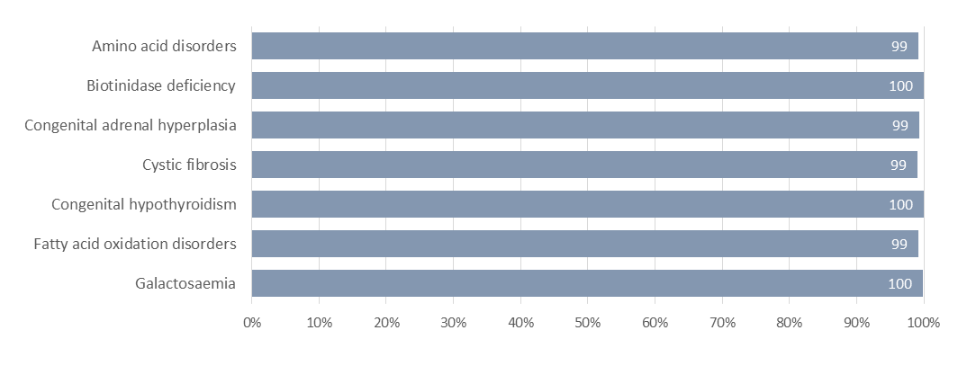

Table 7: Sample testing timeframes, January to December 2015
Disorder | Timeframe* | Timeframe met |  | Timeframe not met |  | Total
 | (working days) | no. | % | no. | % | no.
Amino acid disorders | 2 | 57,994 | 99.2% | 469 | 0.8% | 58,463
Biotinidase deficiency | 5 | 58,441 | 100.0% | 22 | 0.0% | 58,463
Congenital adrenal hyperplasia | 2 | 58,089 | 99.4% | 374 | 0.6% | 58,463
Cystic fibrosis | 5 | 57,890 | 99.0% | 573 | 1.0% | 58,463
Congenital hypothyroidism | 5 | 58,439 | 100.0% | 24 | 0.0% | 58,463
Fatty acid oxidation disorders | 2 | 58,015 | 99.2% | 448 | 0.8% | 58,463
Galactosaemia | 2 | 58,403 | 99.9% | 60 | 0.1% | 58,463

* The validity of these timeframes will be reviewed to more accurately reflect clinical utility, for example none of the sample testing timeframe delays resulted in a delayed diagnosis.

Indicator 6: Timeliness of Reporting - Notification of Screen Positives
Description: This indicator monitors the time between receipt of the sample in the laboratory to notification of a positive result to a referring practitioner.
Rationale: Early detection of screened disorders is dependent on timely referral of newborns with positive screening results for diagnostic testing.
Standard: 100% of screen positive results are notified to the referring practitioner within the disorder specific number of calendar days.
Interpretation: There was wide variation in timeliness of notification of screen positive results across the screened disorders. The disorder specific timeframe was met for 2 of the 7 disorders.
Comment: All ‘clinical critical’ results were reported in the timeframes. A clinical critical screening result is one which indicates a reasonable or high probability of a disorder that can present with severe illness in the early neonatal period, and where a delay of 1-2 days can affect the outcome.
Borderline newborn screening results are not reported until all results are available on the sample so the notification can include all results in one contact. For example, a borderline hypothyroid result may be available in two days, but if the sample also has a raised immune-reactive trypsin in the cystic fibrosis screen, it is sent for mutation analysis. The request for a second sample to confirm the thyroid result will be made after the cystic fibrosis mutation result is available.

Figure 9: Percentage of screen positives notified within the disorder specific timeframe, January to December 2015
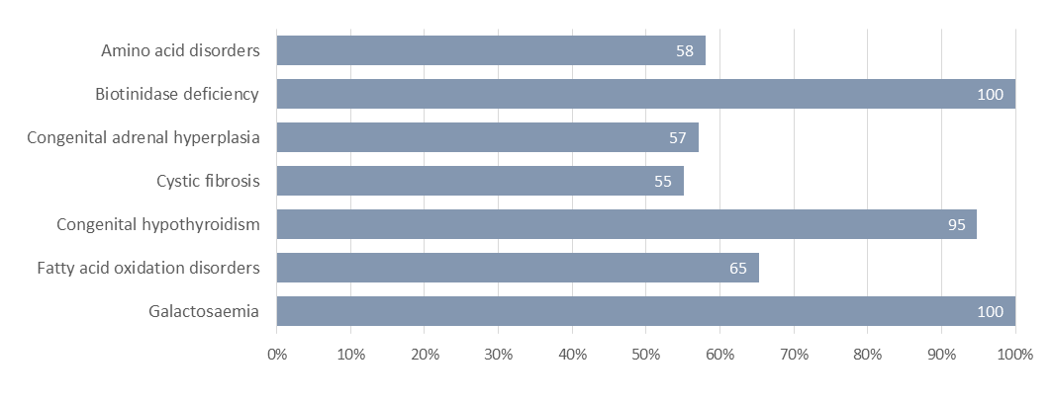
Table 8: Notification of screen positives, January to December 2015
Disorder | Timeframe* | Timeframe met |  | Timeframe not met |  | Total
 | (calendar days) | no. | % | no. | % | no.
Amino acid disorders | 3 | 90 | 58% | 65 | 42% | 155
Biotinidase deficiency | 9 | 2 | 100% | 0 | 0% | 2
Congenital adrenal hyperplasia | 3 | 20 | 57% | 15 | 43% | 35
Cystic fibrosis | 12 | 27 | 55% | 22 | 45% | 49
Congenital hypothyroidism | 4 | 55 | 95% | 3 | 5% | 58
Fatty acid oxidation disorders | 3 | 47 | 65% | 25 | 35% | 72
Galactosaemia | 3 | 6 | 100% | 0 | 0% | 6
Total |  | 247 | 66% | 130 | 34% | 377

* The validity of these timeframes will be reviewed to more accurately reflect clinical utility, for example not all screen positive cases were ‘clinical critical’.

Indicator 7: Collection and Receipt of Second Samples
Description: This indicator monitors the follow-up of requests for second blood spot samples.
Rationale: Second samples are required where a sample is not adequate or results are borderline. Second samples should be taken as soon as possible so that the newborn can be treated early if they have a disorder.
Standard: 100% of second samples requested are received by the laboratory, or screening declined by the parent, within 10 calendar days of the request.
Interpretation: There was wide variation between DHBs in receipt of second samples within the 10 day timeframe, ranging from 56% to 100% with a national average of 67%. This is a significant improvement on 2014 when the national average was 38% and no DHB met the 100% standard.
Comment: The time taken to receive a follow-up sample is influenced by: the time for the report to be generated, mailed and received; the second sample to be collected (usually at the next scheduled LMC visit), mailed and received by the laboratory. In May 2015 a new protocol for follow-up samples was introduced incorporating phone and text requests to the LMC in addition to the paper report, and regular reminders. This has improved both timing and completeness of receipt of follow-up samples and this will be reflected more fully in 2016 data.
Where there were abnormal test results, follow-up was almost 100%.
Figure 10: Percentage of second samples received, or screening declined by parent, within 10 days, January to December 2015
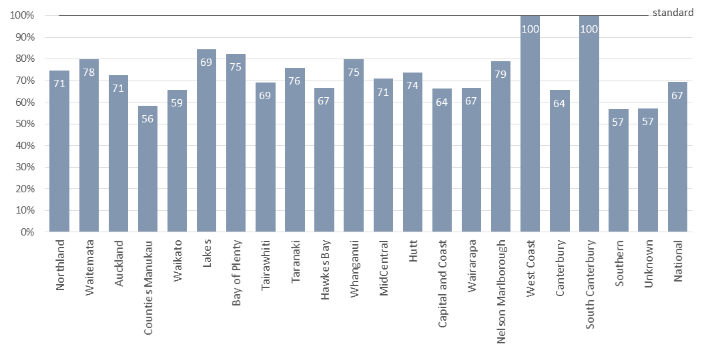
Table 9: Percentage of second samples received, or screening declined by parent, within 10 days, January to December 2015
DHB of Domicile | Within 10 days |  | Other follow up* |  | Follow up complete |  | No follow up |  | Total
 | no. | % | no. | % | no. | % | no. | % | no.
Northland | 45 | 71% | 16 | 25% | 61 | 97% | 2 | 3% | 63
Waitemata | 105 | 78% | 27 | 20% | 132 | 99% | 2 | 1% | 134
Auckland | 85 | 71% | 33 | 28% | 118 | 98% | 2 | 2% | 120
Counties Manukau | 110 | 56% | 82 | 42% | 192 | 97% | 5 | 3% | 197
Waikato | 62 | 59% | 36 | 34% | 98 | 93% | 7 | 7% | 105
Lakes | 18 | 69% | 4 | 15% | 22 | 85% | 4 | 15% | 26
Bay of Plenty | 38 | 75% | 9 | 18% | 47 | 92% | 4 | 8% | 51
Tairawhiti | 9 | 69% | 4 | 31% | 13 | 100% | 0 | 0% | 13
Hawkes Bay | 20 | 67% | 10 | 33% | 30 | 100% | 0 | 0% | 30
Taranaki | 22 | 76% | 7 | 24% | 29 | 100% | 0 | 0% | 29
MidCentral | 34 | 71% | 14 | 29% | 48 | 100% | 0 | 0% | 48
Whanganui | 15 | 75% | 4 | 20% | 19 | 95% | 1 | 5% | 20
Capital and Coast | 57 | 64% | 30 | 34% | 87 | 98% | 2 | 2% | 89
Hutt | 28 | 74% | 10 | 26% | 38 | 100% | 0 | 0% | 38
Wairarapa | 2 | 67% | 1 | 33% | 3 | 100% | 0 | 0% | 3
Nelson Marlborough | 15 | 79% | 4 | 21% | 19 | 100% | 0 | 0% | 19
West Coast | 3 | 100% | 0 | 0% | 3 | 100% | 0 | 0% | 3
Canterbury | 63 | 64% | 34 | 34% | 97 | 98% | 2 | 2% | 99
South Canterbury | 5 | 100% | 0 | 0% | 5 | 100% | 0 | 0% | 5
Southern | 41 | 57% | 31 | 43% | 72 | 100% | 0 | 0% | 72
Unknown | 4 | 57% | 3 | 43% | 7 | 100% | 0 | 0% | 7
National | 781 | 67% | 359 | 30% | 1140 | 97% | 31 | 3% | 1,171

*The screen was declined by the parents, or the newborn died, or there was a specialist referral, or tests were done in a community laboratory (especially thyroid tests).

Indicator 8: Diagnosis and Commencement of Treatment
Description: This indicator monitors the age of commencement of treatment for newborns diagnosed with a screened condition.
Rationale: The NMSP relies on early confirmed diagnosis and timely treatment to ensure that newborns with metabolic conditions have their development potential impacted as little as possible.
Standard: 100% of newborns who have a screen positive result and confirmed diagnosis have treatment commenced within the disorder specific time frame (age of newborn in days).
Interpretation: There was wide variation in timeliness of commencement of treatment for newborns diagnosed with a screened disorder. The disorder specific timeframe was met for 1 of the 5 disorders with cases, ranging from 21% to 100%.
Comment: Delays in treatment are caused by a combination of: later diagnosis of mild disease, difficulties obtaining diagnostic tests, or difficulty making a definitive diagnosis. Delayed diagnosis is far more likely when the disease is mild, for example where the initial test is marginally abnormal and confirmed with a second dried blood spot. Diagnosis may also be delayed due to diagnostic test processes, for example some laboratories do not do sweat tests for possible cystic fibrosis until the newborn is a month old. There were no known clinical consequences of delayed treatment for the 25 newborns in 2015 who did not receive treatment within their disorder specific timeframe.

Figure 11: Confirmed diagnosis commencement of treatment, January to December 2015
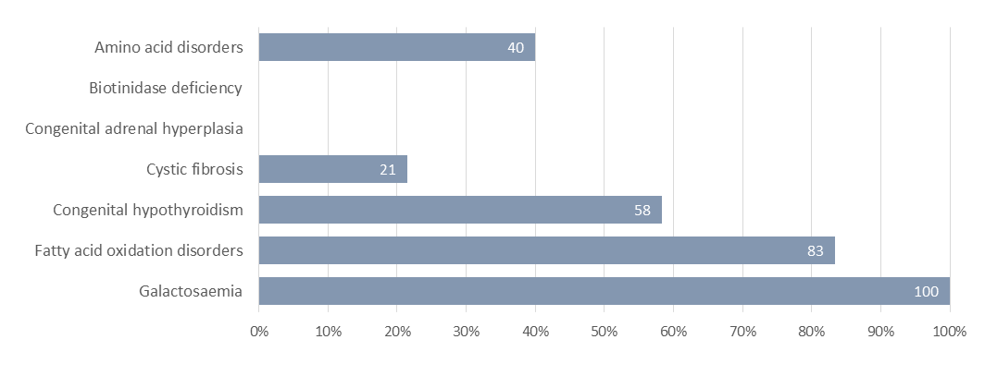

Table 10: Confirmed diagnosis commencement of treatment, January to December 2015
Disorder | Timeframe* | Timeframe met |  | Timeframe not met |  | Total
 | Age in Days | no. | % | no. | % | no.
Amino acid disorders | 10 | 2 | 40% | 3 | 60% | 5
Biotinidase deficiency | 14 | 0 |  | 0 |  | 0
Congenital adrenal hyperplasia | 10 | 0 |  | 0 |  | 0
Cystic fibrosis | 28 | 3 | 21% | 11 | 79% | 14
Congenital hypothyroidism | 10 | 14 | 58% | 10 | 42% | 24
Fatty acid oxidation disorders | 10 | 5 | 83% | 1 | 17% | 6
Galactosaemia | 10 | 1 | 100% | 0 | 0% | 1
Total |  | 25 | 50% | 25 | 50% | 50

* The validity of these timeframes will be reviewed to more accurately reflect clinical utility. There were no known clinical consequences of delayed treatment.

Indicator 9: Blood Spot Card Storage and Return
Description: This indicator monitors the return of blood spot card that are requested by parents/guardians or individuals.
Rationale: When requested, blood spot cards are to be returned securely and promptly.
Standard: 100% of blood spot cards requested are returned within 28 days of a valid request.
Interpretation: 99.7% of blood spot cards requested were returned within 28 days of a valid request. Last year the percentage was the same, 99.7%.
Comment: Two requests for card returns took more than 28 days to return. One request was received separately from the card without identification, and once the identification was received (84 days) the card was returned straight away. The other request involved a case that required a second screening sample. In these situations samples are not returned until the screen is complete, and the card was returned with the second sample at 30 days.

Figure 12: Return of cards requested by parents / caregivers / individuals, January to December 2015
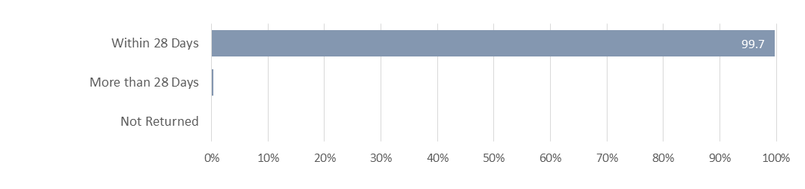

Table 11: Return of cards requested by parents / caregivers / individuals, January to December 2015
 | no. | %
Within 28 Days | 612 | 99.7%
More than 28 Days | 2 | 0.3%
Not Returned | 0 | 0.0%

Appendix 1: List of Screened Conditions

Amino Acid Disorders
Phenylketonuria
Maple syrup urine disease
Argininosuccinic aciduria (argininosuccinate lyase deficiency)
Citrullinaemia (argininosuccinate synthetase deficiency
Glutaric acidaemia type I (glutaryl-CoA dehydrogenase deficiency)
Homocystinuria (cystathionine beta-synthase deficiency)
Isovaleric acidaemia (isovaleryl-CoA dehydrogenase deficiency)
Methylmalonic acidurias (mutase deficiency, CblA, CblB, CblC, CblD defects)
Propionic acidaemia (propionyl-CoA carboxylase deficiency)
Tyrosinaemia (fumaryl acetoacetase deficiency, tyrosine aminotransferase deficiency)

Fatty acid oxidation disorders
CACT (carnitine acylcarnitine translocase deficiency
Carnitine transporter defect
CPT-I (carnitine palmitoyltransferase-I deficiency)
CPT-II (carnitine palmitoyltransferase-II deficiency)
LCHAD (3-hydroxy long-chain acyl-CoA dehydrogenase deficiency)
TFP (trifunctional protein deficiency)
MADD (multiple acyl-CoA dehydrogenase deficiency
MCAD (medium-chain acyl-CoA dehydrogenase deficiency)
VLCAD (very-long-chain acyl-CoA dehydrogenase deficiency)

Additional disorders
Congenital hypothyroidism (CH)
Congenital adrenal hyperplasia (CAH)
Cystic fibrosis (CF)
Biotinidase deficiency
Galactosaemia

