BSA Capital & Coast District Health Board Coverage Report
For the period ending 30 September 2016

Citation: Ministry of Health. November 2016. BSA Capital & Coast District Health Board Coverage Report: period ending 30 September 2016. Wellington: Ministry of Health.
Published in November 2016 by the
Ministry of Health
PO Box 5013, Wellington 6145, New Zealand
ISSN 2422-9482 (online)
This document is available at www.nsu.govt.nz

Contents
Introduction 1
Technical notes 2
Capital & Coast DHB coverage 3
Capital & Coast coverage by ethnicity in the two years ending 30 September 2016 3
Capital & Coast coverage trends by ethnicity 4
DHB coverage comparisons 5
DHB coverage by ethnicity in the two years ending 30 September 2016 5
DHB coverage by ethnicity 11
List of tables
Table 1: BSA coverage (%) in the two years ending 30 September 2016 by ethnicity, women aged 50–69 years, Capital & Coast District Health Board 3
Table 2: BSA number of screens in women aged 50–69 years by ethnicity and quarter, Quarter 3 2015 – Quarter 3 2016, Capital & Coast District Health Board 4
Table 3: BSA number of screens and coverage (%) of women aged 50–69 years in the two years ending 30 September 2016 by District Health Board 10
Table 4: BSA coverage (%) of women aged 50–69 years in the two years ending 30 September 2014, 2015 and 2016*, by ethnicity and District Health Board 11
List of figures
Figure 1: BSA coverage (%) in the two years ending 30 September 2016 by ethnicity, women aged 50–69 years, Capital & Coast District Health Board 3
Figure 2: BSA coverage (%) of women aged 50–69 years in the two years ending 30 September 2014, 30 September 2015 and 30 September 2016* by ethnicity, Capital & Coast District Health Board 4
Figure 3: BSA coverage (%) of Māori women aged 50–69 years in the two years ending
30 September 2016 by District Health Board 5
Figure 4: BSA coverage (%) of Pacific women aged 50–69 years in the two years ending
30 September 2016 by District Health Board 5
Figure 5: Overall BSA coverage (%) of women aged 50–69 years in the two years ending 30 September 2016 by District Health Board 6
Figure 1: BSA Māori coverage map of women aged 50-69 years in the two years ending
30 September 2016 by District Health Board 7
Figure 2: BSA Pacific coverage map of women aged 50-69 years in the two years ending
30 September 2016 by District Health Board 8
Figure 3: BSA Overall coverage map of women aged 50-69 years in the two years ending 30 September 2016 by District Health Board 9

Introduction
BreastScreen Aotearoa (BSA) is a national public health screening programme funded by the Government to offer free Mammography every two years to women aged 45–69 years of age. The aim of BSA is to reduce morbidity and mortality from breast cancer by the early detection and treatment of the disease.

BSA’s target is to screen 70 percent of eligible women aged 50–69 every two years. BSA does not have a target for women aged 45–49 years because there is less evidence of the benefits of this age group’s participation in a population health breast screening programme.

Improving uptake of the breast cancer screening programme by Māori and Pacific women is a key priority of the National Screening Unit (NSU) as part of its commitment to achieving equity. Coverage rates are monitored closely for these two groups.

While the majority (15) of District Health Boards (DHBs) are not directly contracted by the Ministry of Health to provide breast screening services, it is expected that all DHBs will have linkages to breast screening activities. The programme is delivered throughout the country by eight lead providers, their sub-contracted providers (where applicable), and mobile units that deliver services to rural and some urban communities. Working alongside the lead providers are 13 independent service providers in defined geographical areas providing recruitment and retention, and support services for Māori and Pacific women.

The purpose of this quarterly report is to demonstrate by DHB if the programme coverage targets are being met for the region.

Technical notes
The number of women screened for the two-year periods ending 30 September 2014, 30 September 2015 and 30 September 2016 were extracted from the national BreastScreen Aotearoa database (the Database) on 7 October 2016.

Screened women are included in the coverage calculations based on their age at the time of their screen. This means that coverage for women aged 50–69 years includes women who may have turned 70 or 71 during the monitoring period.

For both women screened and in the denominator, women have been prioritised to a single ethnicity using the following priority order: Māori, Pacific, Other. This means that if a woman chooses more than one category, and one of these is Māori, she is counted as Māori. For screened women with no ethnicity recorded in the Database, her screen contributes to overall coverage but not to any particular ethnicity. This means that the total number of women screened may be greater than the sum of women screened by ethnicity.

The denominators used for calculating coverage for the periods ending 30 September 2014, 30 September 2015 and 30 September 2016 are derived from Statistics New Zealand’s District Health Board (DHB) population projections 2015 update, based on the 2013 Census.

From September 2016, the National Screening Unit (NSU) begins reporting using the latest 2013 domicile codes and daily data loading process, compared to previous reports which used a monthly data loading process and were based on 2006 domicile codes. This may result in variances across time series.

The denominator is the projected population for the mid-point of the monitoring period.

This means that for the two-year period ending:

- 30 September 2014, the denominator is the population estimate for 30 September 2013
- 30 September 2015, the denominator is the projected population for 30 September 2014
- 30 September 2016, the denominator is the projected population for 30 September 2015

Delivery of BSA services through mobile units may also result in fluctuations in the number of women screened in a quarter which may impact on coverage from year to year depending on the mobile unit schedule.

Additional detail on the methodology can be obtained via a request made to screening@moh.govt.nz.

Capital & Coast DHB coverage

Capital & Coast coverage by ethnicity in the two years ending 30 September 2016
Figure 1: BSA coverage (%) in the two years ending 30 September 2016 by ethnicity, women aged 50–69 years, Capital & Coast District Health Board
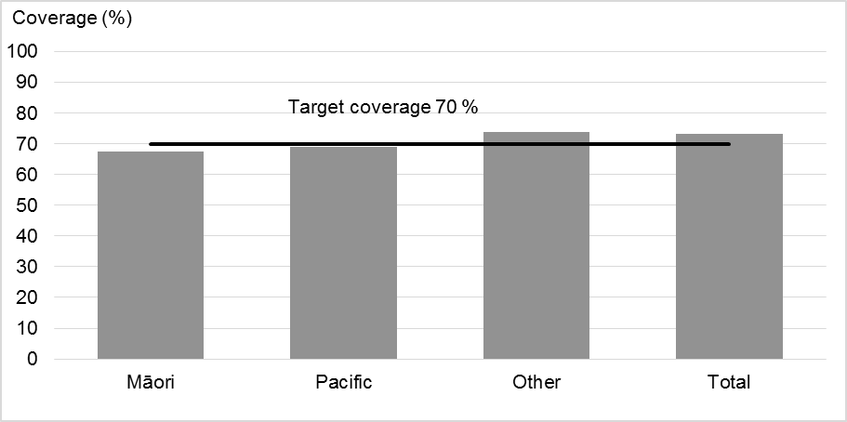
Table 1: BSA coverage (%) in the two years ending 30 September 2016 by ethnicity, women aged 50–69 years, Capital & Coast District Health Board
Ethnicity | Population | Women screened in last 2 years | 2-year coverage | Additional screens to reach 70% target
Māori | 2,605 | 1,759 | 67.5% | 64
Pacific | 1,863 | 1,288 | 69.1% | 16
Other | 29,574 | 21,823 | 73.8%
Unspecified | 0 | 41
Total* | 34,042 | 24,911 | 73.2%
*For the total population the number of additional screens is the number required to move the total population coverage to 70%. This may not be the same as the sum of additional screens required for each ethnic group to reach 70%.
Total includes women of unknown ethnicity, and therefore is greater than the sum of Māori, Pacific and Other.

Capital & Coast coverage trends by ethnicity
Figure 2: BSA coverage (%) of women aged 50–69 years in the two years ending 30 September 2014, 30 September 2015 and 30 September 2016* by ethnicity, Capital & Coast District Health Board
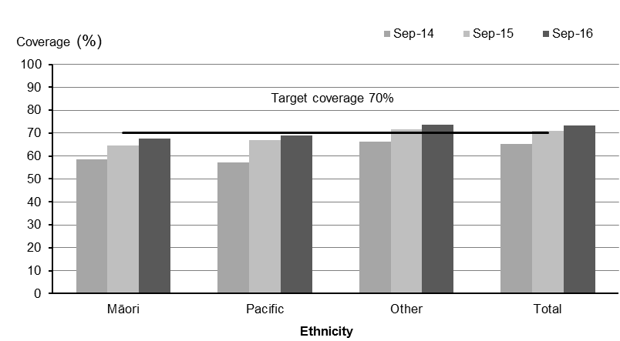
* September 2014 coverage is calculated using the 2014 update of the 2001 to 2013 DHB population estimates based on the 2013 Census, whereas the September 2015 and September 2016 calculations use 30 September 2014 update of the 2013 census based population projections
Table 2: BSA number of screens in women aged 50–69 years by ethnicity and quarter, Quarter 3 2015 – Quarter 3 2016, Capital & Coast District Health Board
Ethnicity | Number of screens by quarter
 | Q3 (Jul - Sep) 2015 | Q4 (Oct - Dec) 2015 | Q1 (Jan - Mar) 2016 | Q2 (Apr - Jun) 2016 | Q3 (Jul - Sep) 2016
Māori | 238 | 137 | 184 | 199 | 218
Pacific | 188 | 103 | 124 | 130 | 171
Other | 3,184 | 1,942 | 1,473 | 2,046 | 3,460
Total | 3,610 | 2,182 | 1,781 | 2,375 | 3,849

DHB coverage comparisons

DHB coverage by ethnicity in the two years ending 30 September 2016
Figure 3: BSA coverage (%) of Māori women aged 50–69 years in the two years ending 30 September 2016 by District Health Board
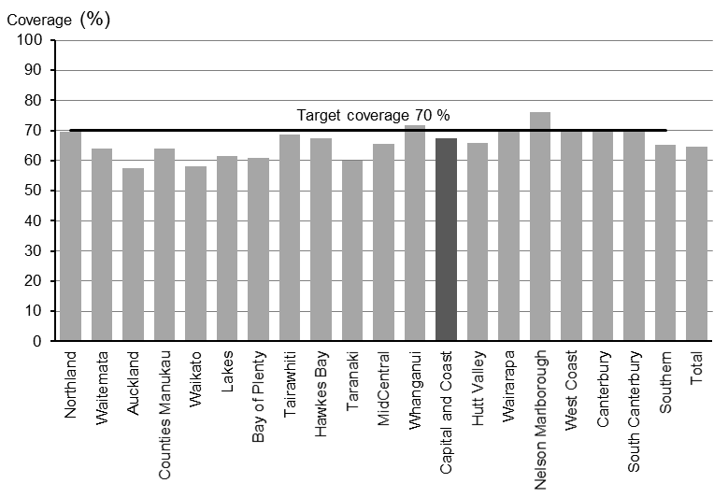
Figure 4: BSA coverage (%) of Pacific women aged 50–69 years in the two years ending 30 September 2016 by District Health Board
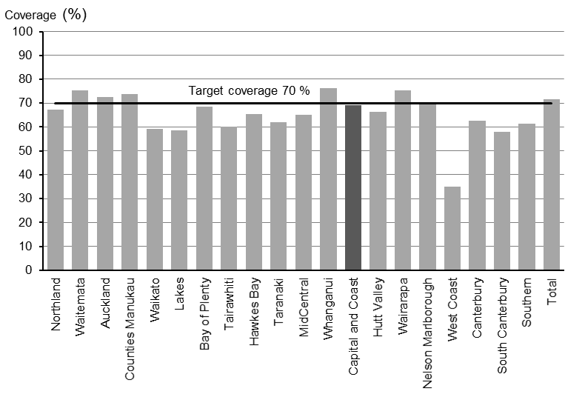

Figure 5: Overall BSA coverage (%) of women aged 50–69 years in the two years ending 30 September 2016 by District Health Board
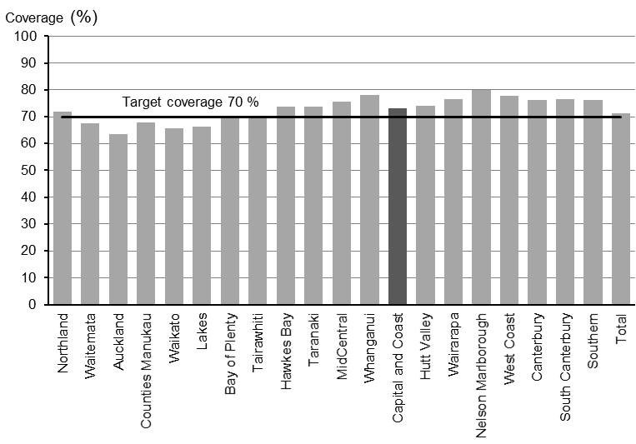
Figure 6: BSA Māori coverage map of women aged 50-69 years in the two years ending 30 September 2016 by District Health Board
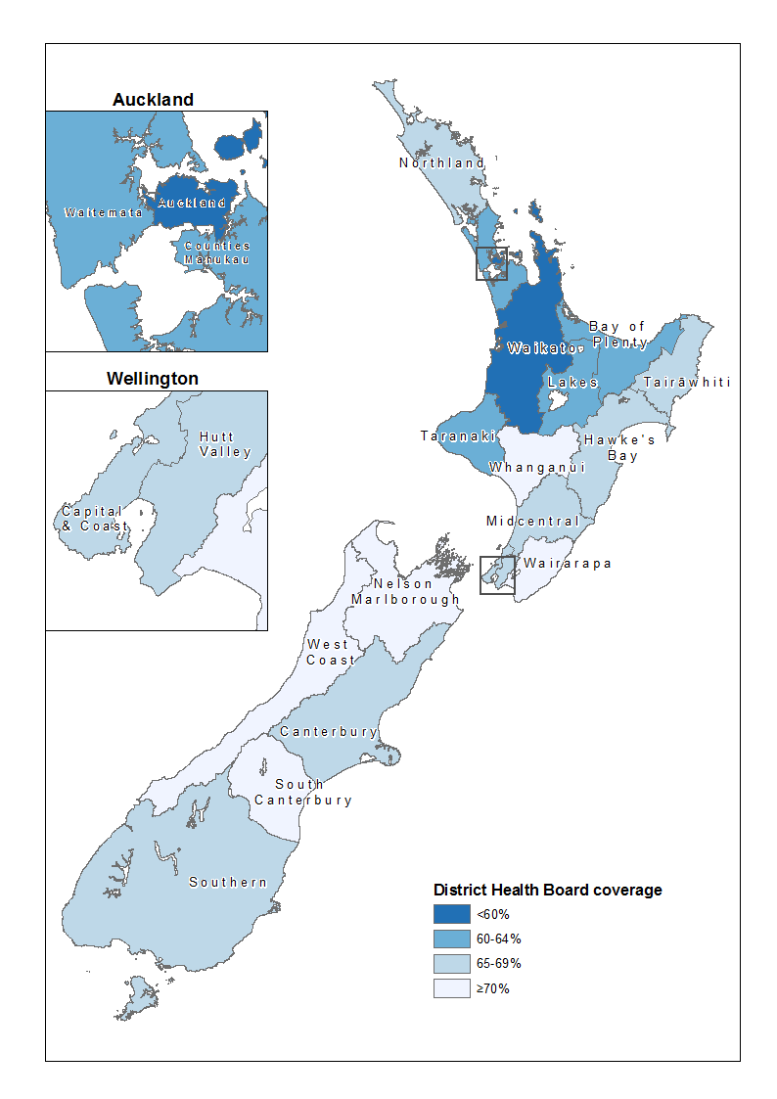
Figure 7: BSA Pacific coverage map of women aged 50-69 years in the two years ending 30 September 2016 by District Health Board
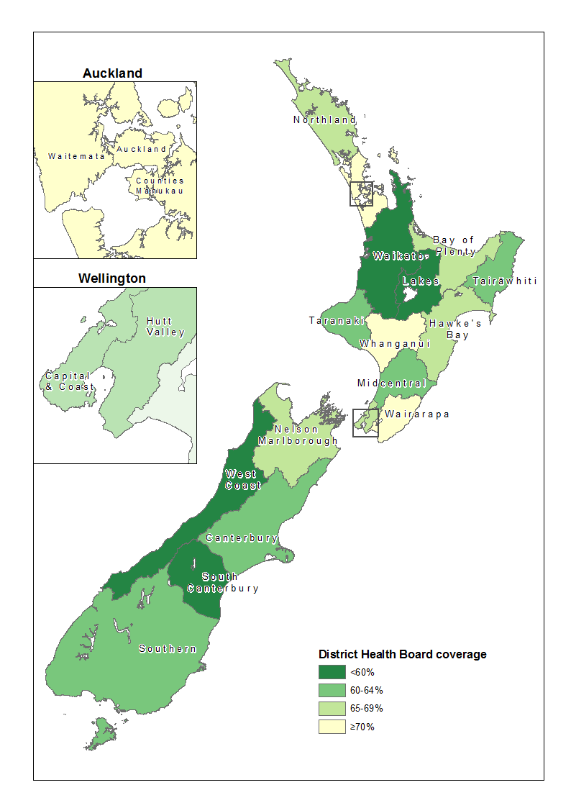

Figure 8: BSA Overall coverage map of women aged 50-69 years in the two years ending 30 September 2016 by District Health Board
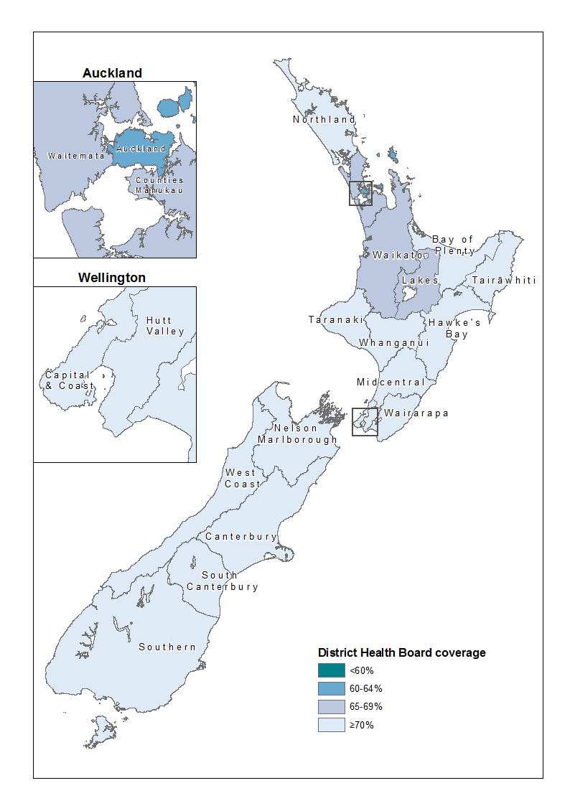

Table 3: BSA number of screens and coverage (%) of women aged 50–69 years in the two years ending 30 September 2016 by District Health Board
DHB name | Eligible population |  |  |  | Screens |  |  |  |  | Coverage
 | Māori | Pacific | Other | Total | Māori | Pacific | Other | N/A* | Total | Māori | Pacific | Other | Total
Northland | 5,654 | 254 | 18,157 | 24,065 | 3,939 | 171 | 13,158 | 7 | 17,275 | 69.7% | 67.3% | 72.5% | 71.8%
Waitemata | 4,451 | 3,346 | 60,174 | 67,971 | 2,842 | 2,523 | 40,409 | 28 | 45,802 | 63.9% | 75.4% | 67.2% | 67.4%
Auckland | 3,460 | 4,559 | 43,659 | 51,678 | 1,987 | 3,312 | 27,378 | 104 | 32,781 | 57.4% | 72.6% | 62.7% | 63.4%
Counties Manukau | 6,336 | 8,358 | 41,573 | 56,267 | 4,063 | 6,180 | 27,932 | 29 | 38,204 | 64.1% | 73.9% | 67.2% | 67.9%
Waikato | 7,291 | 788 | 39,292 | 47,371 | 4,242 | 466 | 26,283 | 101 | 31,092 | 58.2% | 59.1% | 66.9% | 65.6%
Lakes | 3,319 | 203 | 9,955 | 13,477 | 2,039 | 119 | 6,752 | 24 | 8,934 | 61.4% | 58.6% | 67.8% | 66.3%
Bay of Plenty | 5,081 | 251 | 24,667 | 29,999 | 3,095 | 172 | 17,796 | 47 | 21,110 | 60.9% | 68.5% | 72.1% | 70.4%
Tairawhiti | 2,259 | 90 | 3,512 | 5,861 | 1,550 | 54 | 2,514 | 0 | 4,118 | 68.6% | 60.0% | 71.6% | 70.3%
Taranaki | 1,665 | 87 | 13,101 | 14,853 | 1,000 | 54 | 9,877 | 4 | 10,935 | 60.1% | 62.1% | 75.4% | 73.6%
Hawkes Bay | 3,518 | 393 | 17,877 | 21,788 | 2,370 | 257 | 13,406 | 6 | 16,039 | 67.4% | 65.4% | 75.0% | 73.6%
Whanganui | 1,486 | 105 | 6,933 | 8,524 | 1,069 | 80 | 5,501 | 1 | 6,651 | 71.9% | 76.2% | 79.3% | 78.0%
MidCentral | 2,594 | 354 | 18,867 | 21,815 | 1,702 | 230 | 14,586 | 4 | 16,522 | 65.6% | 65.0% | 77.3% | 75.7%
Hutt Valley | 1,976 | 925 | 14,701 | 17,602 | 1,300 | 612 | 11,100 | 21 | 13,033 | 65.8% | 66.2% | 75.5% | 74.0%
Capital and Coast | 2,605 | 1,863 | 29,574 | 34,042 | 1,759 | 1,288 | 21,823 | 41 | 24,911 | 67.5% | 69.1% | 73.8% | 73.2%
Wairarapa | 648 | 61 | 5,585 | 6,294 | 456 | 46 | 4,301 | 3 | 4,806 | 70.4% | 75.4% | 77.0% | 76.4%
Nelson Marlborough | 1,273 | 133 | 20,155 | 21,561 | 969 | 93 | 16,152 | 36 | 17,250 | 76.1% | 69.9% | 80.1% | 80.0%
West Coast | 373 | 20 | 4,178 | 4,571 | 261 | 7 | 3,254 | 28 | 3,550 | 70.0% | 35.0% | 77.9% | 77.7%
Canterbury | 3,308 | 834 | 61,492 | 65,634 | 2,307 | 521 | 47,188 | 74 | 50,090 | 69.7% | 62.5% | 76.7% | 76.3%
South Canterbury | 383 | 31 | 7,982 | 8,396 | 270 | 18 | 6,132 | 2 | 6,422 | 70.5% | 58.1% | 76.8% | 76.5%
Southern | 2,224 | 313 | 37,167 | 39,704 | 1,450 | 192 | 28,572 | 45 | 30,259 | 65.2% | 61.3% | 76.9% | 76.2%
Unspecified | 0 | 0 | 0 | 0 | 80 | 26 | 633 | 2 | 741
Total | 59,904 | 22,968 | 478,601 | 561,473 | 38,750 | 16,421 | 344,747 | 607 | 400,525 | 64.7% | 71.5% | 72.0% | 71.3%

* N/A = not applicable, ethnicity of screened women was not recorded.

DHB coverage by ethnicity
Table 4: BSA coverage (%) of women aged 50–69 years in the two years ending 30 September 2014, 2015 and 2016*, by ethnicity and District Health Board
DHB | Māori |  |  | Pacific |  |  | European / Other |  |  | Total
 | Sep-14 | Sep-15 | Sep-16 | Sep-14 | Sep-15 | Sep-16 | Sep-14 | Sep-15 | Sep-16 | Sep-14 | Sep-15 | Sep-16
Northland | 69.3% | 67.7% | 69.7% | 69.9% | 69.1% | 67.3% | 71.3% | 71.2% | 72.5% | 70.8% | 70.4% | 71.8%
Waitemata | 65.0% | 64.7% | 63.9% | 77.5% | 77.4% | 75.4% | 67.1% | 67.9% | 67.2% | 67.5% | 68.2% | 67.4%
Auckland | 64.4% | 61.6% | 57.4% | 76.9% | 73.7% | 72.6% | 65.7% | 64.0% | 62.7% | 66.8% | 64.9% | 63.4%
Counties Manukau | 67.3% | 65.7% | 64.1% | 80.3% | 77.3% | 73.9% | 68.3% | 67.3% | 67.2% | 70.0% | 68.7% | 67.9%
Waikato | 54.8% | 58.9% | 58.2% | 56.6% | 61.5% | 59.1% | 67.5% | 69.6% | 66.9% | 65.6% | 68.0% | 65.6%
Lakes | 61.8% | 62.9% | 61.4% | 47.8% | 49.0% | 58.6% | 69.7% | 70.6% | 67.8% | 67.6% | 68.6% | 66.3%
Bay of Plenty | 57.5% | 59.0% | 60.9% | 70.6% | 72.9% | 68.5% | 67.5% | 71.5% | 72.1% | 66.0% | 69.6% | 70.4%
Tairawhiti | 63.4% | 64.9% | 68.6% | 59.5% | 58.1% | 60.0% | 71.3% | 71.3% | 71.6% | 68.1% | 68.7% | 70.3%
Taranaki | 60.6% | 62.0% | 60.1% | 64.8% | 66.2% | 62.1% | 75.3% | 75.6% | 75.4% | 73.7% | 74.1% | 73.6%
Hawkes Bay | 64.5% | 67.3% | 67.4% | 62.9% | 68.0% | 65.4% | 72.9% | 74.5% | 75.0% | 71.4% | 73.3% | 73.6%
Whanganui | 67.7% | 70.2% | 71.9% | 68.5% | 72.3% | 76.2% | 76.3% | 77.8% | 79.3% | 74.7% | 76.4% | 78.0%
MidCentral | 62.3% | 63.6% | 65.6% | 67.0% | 67.8% | 65.0% | 75.2% | 76.3% | 77.3% | 73.6% | 74.7% | 75.7%
Hutt Valley | 64.4% | 65.1% | 65.8% | 63.4% | 65.3% | 66.2% | 72.2% | 70.6% | 75.5% | 71.0% | 69.8% | 74.0%
Capital and Coast | 58.6% | 64.6% | 67.5% | 57.3% | 67.1% | 69.1% | 66.4% | 71.8% | 73.8% | 65.4% | 71.1% | 73.2%
Wairarapa | 65.3% | 64.2% | 70.4% | 80.4% | 80.4% | 75.4% | 70.4% | 71.6% | 77.0% | 70.0% | 70.9% | 76.4%
Nelson Marlborough | 79.7% | 74.8% | 76.1% | 66.4% | 63.4% | 69.9% | 80.3% | 76.7% | 80.1% | 80.4% | 76.7% | 80.0%
West Coast | 74.1% | 72.5% | 70.0% | 33.3% | 40.0% | 35.0% | 77.1% | 75.0% | 77.9% | 77.4% | 75.3% | 77.7%
Canterbury | 76.8% | 73.7% | 69.7% | 64.8% | 63.2% | 62.5% | 80.2% | 79.0% | 76.7% | 79.9% | 78.6% | 76.3%
South Canterbury | 74.3% | 74.0% | 70.5% | 46.7% | 53.3% | 58.1% | 79.4% | 78.8% | 76.8% | 79.0% | 78.6% | 76.5%
Southern | 66.0% | 64.4% | 65.2% | 55.3% | 60.9% | 61.3% | 73.8% | 72.3% | 76.9% | 73.4% | 71.9% | 76.2%
Total | 64.3% | 64.8% | 64.7% | 73.8% | 73.2% | 71.5% | 71.8% | 72.0% | 72.0% | 71.2% | 71.4% | 71.3%

* September 2014, 2015 and 2016 coverage is calculated using the 2015 update of the 2013 DHB population projections based on the 2013 Census

