**BSA New Zealand Capital and Coast District Health Board Coverage Report**

For the period ending

30 June 2017

Citation: Ministry of Health. July 2017. *BSA New Zealand District Health Board Coverage Report: period ending 30 June 2017*. Wellington: Ministry of Health.

Published in July 2017 by the  
Ministry of Health  
PO Box 5013, Wellington 6145, New Zealand

2422-927X (online)

This document is available at [www.nsu.govt.nz](http://www.nsu.govt.nz)

Contents

Introduction 2

Technical notes 3

Capital and Coast coverage 4

Capital and Coast coverage by ethnicity in the two years ending 30 June 2017 4

Capital and Coast coverage trends by ethnicity 5

DHB coverage comparisons 6

DHB coverage by ethnicity in the two years ending 30 June 2017 6

DHB coverage comparison trends by ethnicity 12

**List of tables**

Table 1: BSA coverage (%) in the two years ending 30 June 2017 by ethnicity, women aged 50–69 years 4

Table 2: BSA number of screens in women aged 50–69 years by ethnicity and quarter, Quarter 2 2016 - Quarter 2 2017 5

Table 3: BSA number of screens and coverage (%) in women aged 50–69 years in the two years ending 30 June 2017 by District Health Board 11

Table 4: BSA coverage (%) of women aged 50–69 years in the two years ending 30 June, 2015, 2016, 2017, by ethnicity and District Health Board 12

**List of figures**

Figure 1: BSA coverage (%) in the two years ending 30 June 2017 by ethnicity, women aged 50–69 years 4

Figure 2: BSA coverage (%) of women aged 50–69 years in the two years ending 30 June 2015, 30 June 2016 and 30 June 2017 by ethnicity 5

Figure 3: BSA coverage (%) of Māori women aged 50–69 years in the two years ending 30 June 2017 by District Health Board 6

Figure 4: BSA coverage (%) of Pacific women aged 50–69 years in the two years ending 30 June 2017 by District Health Board 6

Figure 5: Overall BSA coverage (%) of women aged 50–69 years in the two years ending 30 June 2017 by District Health Board 7

Figure 6: BSA coverage (%) of Māori women aged 50–69 years in the two years ending 30 June 2017 8

Figure 7: BSA coverage (%) of Pacific women aged 50–69 years in the two years ending 30 June 2017 9

Figure 8: Overall BSA coverage (%) of women aged 50–69 years in the two years ending 30 June 2017 by District Health Board 10

# Introduction

BreastScreen Aotearoa (BSA) is a national public health screening programme funded by the Government to offer free Mammography every two years to women aged 45–69 years of age. The aim of BSA is to reduce morbidity and mortality from breast cancer by the early detection and treatment of the disease.

BSA’s target is to screen 70 percent of eligible women aged 50–69 every two years. BSA does not have a target for women aged 45–49 years because there is less evidence of the benefits of this age group’s participation in a population health breast screening programme.

Improving uptake of the breast cancer screening programme by Māori and Pacific women is a key priority of the National Screening Unit (NSU) as part of its commitment to achieving equity. Coverage rates are monitored closely for these two groups.

While the majority (15) of District Health Boards (DHBs) are not directly contracted by the Ministry of Health to provide breast screening services, it is expected that all DHBs will have linkages to breast screening activities. The programme is delivered throughout the country by eight lead providers, their sub-contracted providers (where applicable), and mobile units that deliver services to rural and some urban communities. Working alongside the lead providers are 13 independent service providers in defined geographical areas providing recruitment and retention, and support services for Māori and Pacific women.

The purpose of this quarterly report is to demonstrate by DHB if the programme coverage targets are being met for the region.

# Technical notes

The data for the period ending 30 June 2017 was extracted from the national BreastScreen Aotearoa database (the Database) on 17 July 2017.

Screened women are included in the coverage calculations based on their age at the time of their screen. This means that coverage for women aged 50–69 years includes women who may have turned 70 or 71 during the monitoring period.

For both women screened and in the denominator, women have been prioritised to a single ethnicity using the following priority order: Māori, Pacific, Other. This means that if a woman chooses more than one category, and one of these is Māori, she is counted as Māori. For screened women with no ethnicity recorded in the Database, her screen contributes to overall coverage but not to any particular ethnicity. This means that the total number of women screened may be greater than the sum of women screened by ethnicity.

The denominators used for calculating coverage for the periods ending 30 June 2015, June 2016 and June 2017 are derived from Statistics New Zealand’s District Health Board (DHB) population projections 30 June 2016 update, based on the 2013 Census.

From June 2016, the National Screening Unit (NSU) began reporting using the latest 2013 domicile codes and daily data loading process, compared to previous reports which used a monthly data loading process and were based on 2006 domicile codes. This may result in variances across time series.

The denominator is the projected population for the mid-point of the monitoring period.

This means that for the two-year period ending:

* 30 June 2015, the denominator is the projected population for 30 June 2014
* 30 June 2016, the denominator is the projected population for 30 June 2015
* 30 June 2017, the denominator is the projected population for 30 June 2016

Delivery of BSA services through mobile units may also result in fluctuations in the number of women screened in a quarter which may impact on coverage from year to year depending on the mobile unit schedule.

Additional detail on the methodology can be obtained via a request made to [screening@moh.govt.nz](mailto:screening@moh.govt.nz).

# Capital and Coast coverage

## Capital and Coast coverage by ethnicity in the two years ending 30 June 2017

Figure : BSA coverage (%) in the two years ending 30 June 2017 by ethnicity, women aged 50–69 years

Table 1: BSA coverage (%) in the two years ending 30 June 2017 by ethnicity, women aged 50–69 years



*\*For the total population the number of additional screens is the number required to move from the total population coverage to 70%. This may not be the same as the sum of additional screens required for each ethnic group to reach 70%.*

## Capital and Coast coverage trends by ethnicity

Figure : BSA coverage (%) of women aged 50–69 years in the two years ending 30 June 2015, 30 June 2016 and 30 June 2017 by ethnicity

Table 2: BSA number of screens in women aged 50–69 years by ethnicity and quarter, Quarter 2 2016 - Quarter 2 2017

|  |  |  |  |  |  |
| --- | --- | --- | --- | --- | --- |
| **Ethnicity** | **Number of screens by quarter** | | | | |
| **Q2 (Apr - Jun) 2016** | **Q3 (Jul - Sep) 2016** | **Q4 (Oct - Dec) 2016** | **Q1 (Jan - Mar) 2017** | **Q2 (Apr - Jun) 2017** |
| Māori | 199 | 218 | 268 | 324 | 293 |
| Pacific | 130 | 171 | 213 | 219 | 219 |
| Other | 2,046 | 3,460 | 2,877 | 2,809 | 3,778 |
| **Total** | **2,375** | **3,849** | **3,358** | **3,352** | **4,290** |

# DHB coverage comparisons

## DHB coverage by ethnicity in the two years ending 30 June 2017

Figure : BSA coverage (%) of Māori women aged 50–69 years in the two years ending 30 June 2017 by District Health Board

Figure : BSA coverage (%) of Pacific women aged 50–69 years in the two years ending 30 June 2017 by District Health Board

Figure : Overall BSA coverage (%) of women aged 50–69 years in the two years ending 30 June 2017 by District Health Board

Figure : BSA coverage (%) of Māori women aged 50–69 years in the two years ending 30 June 2017

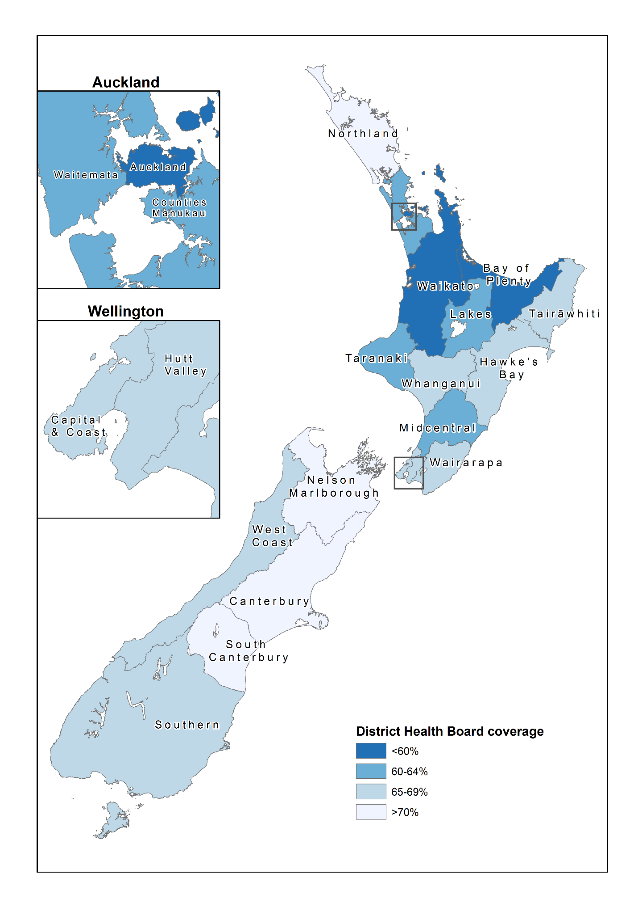

Figure : BSA coverage (%) of Pacific women aged 50–69 years in the two years ending 30 June 2017

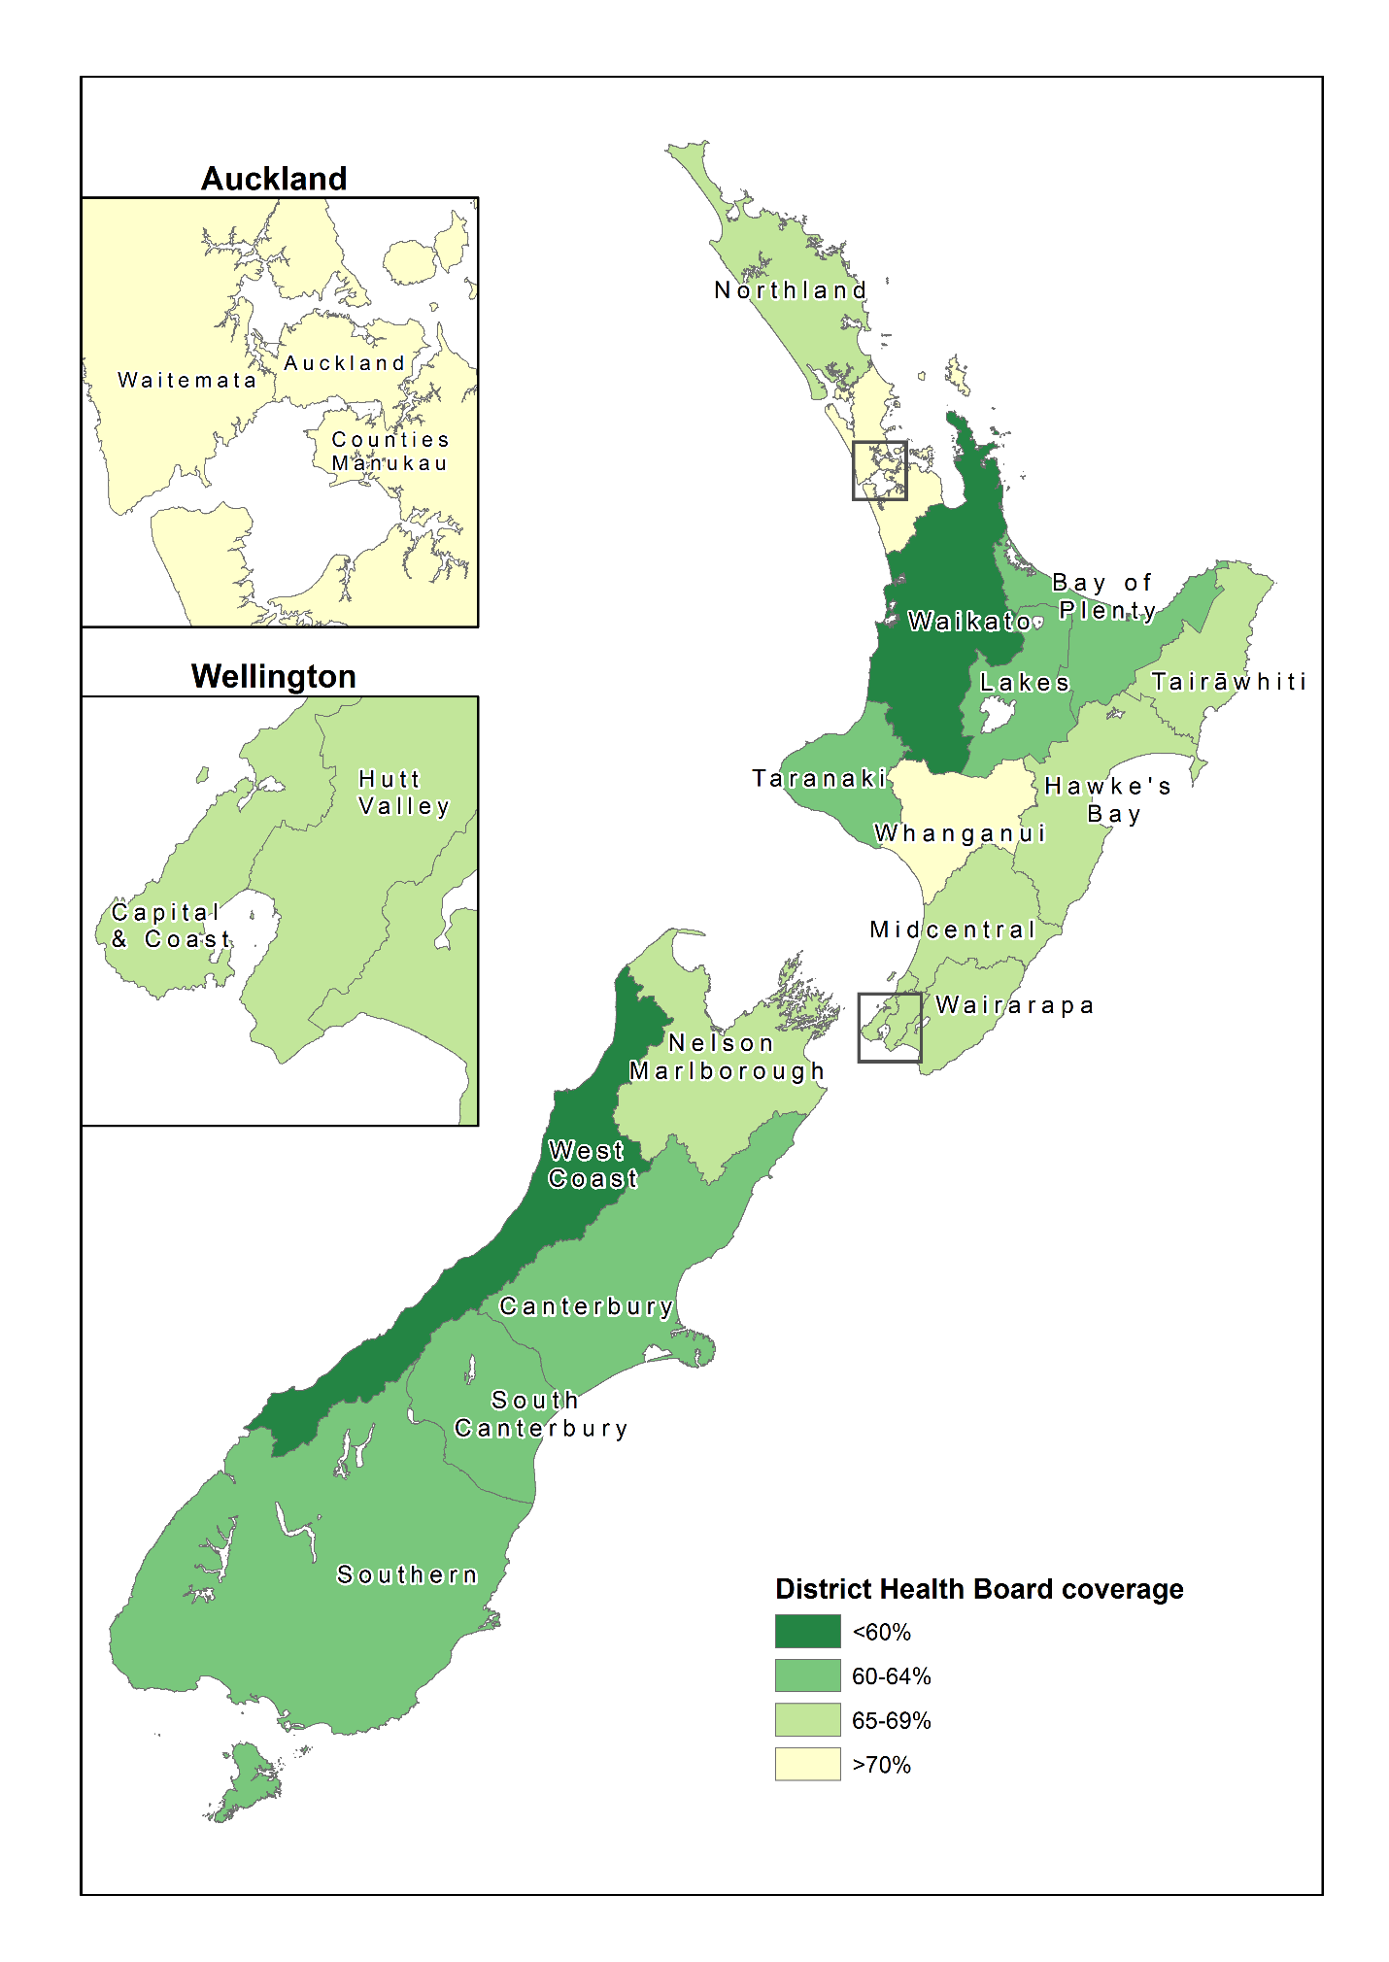

Figure : Overall BSA coverage (%) of women aged 50–69 years in the two years ending 30 June 2017 by District Health Board

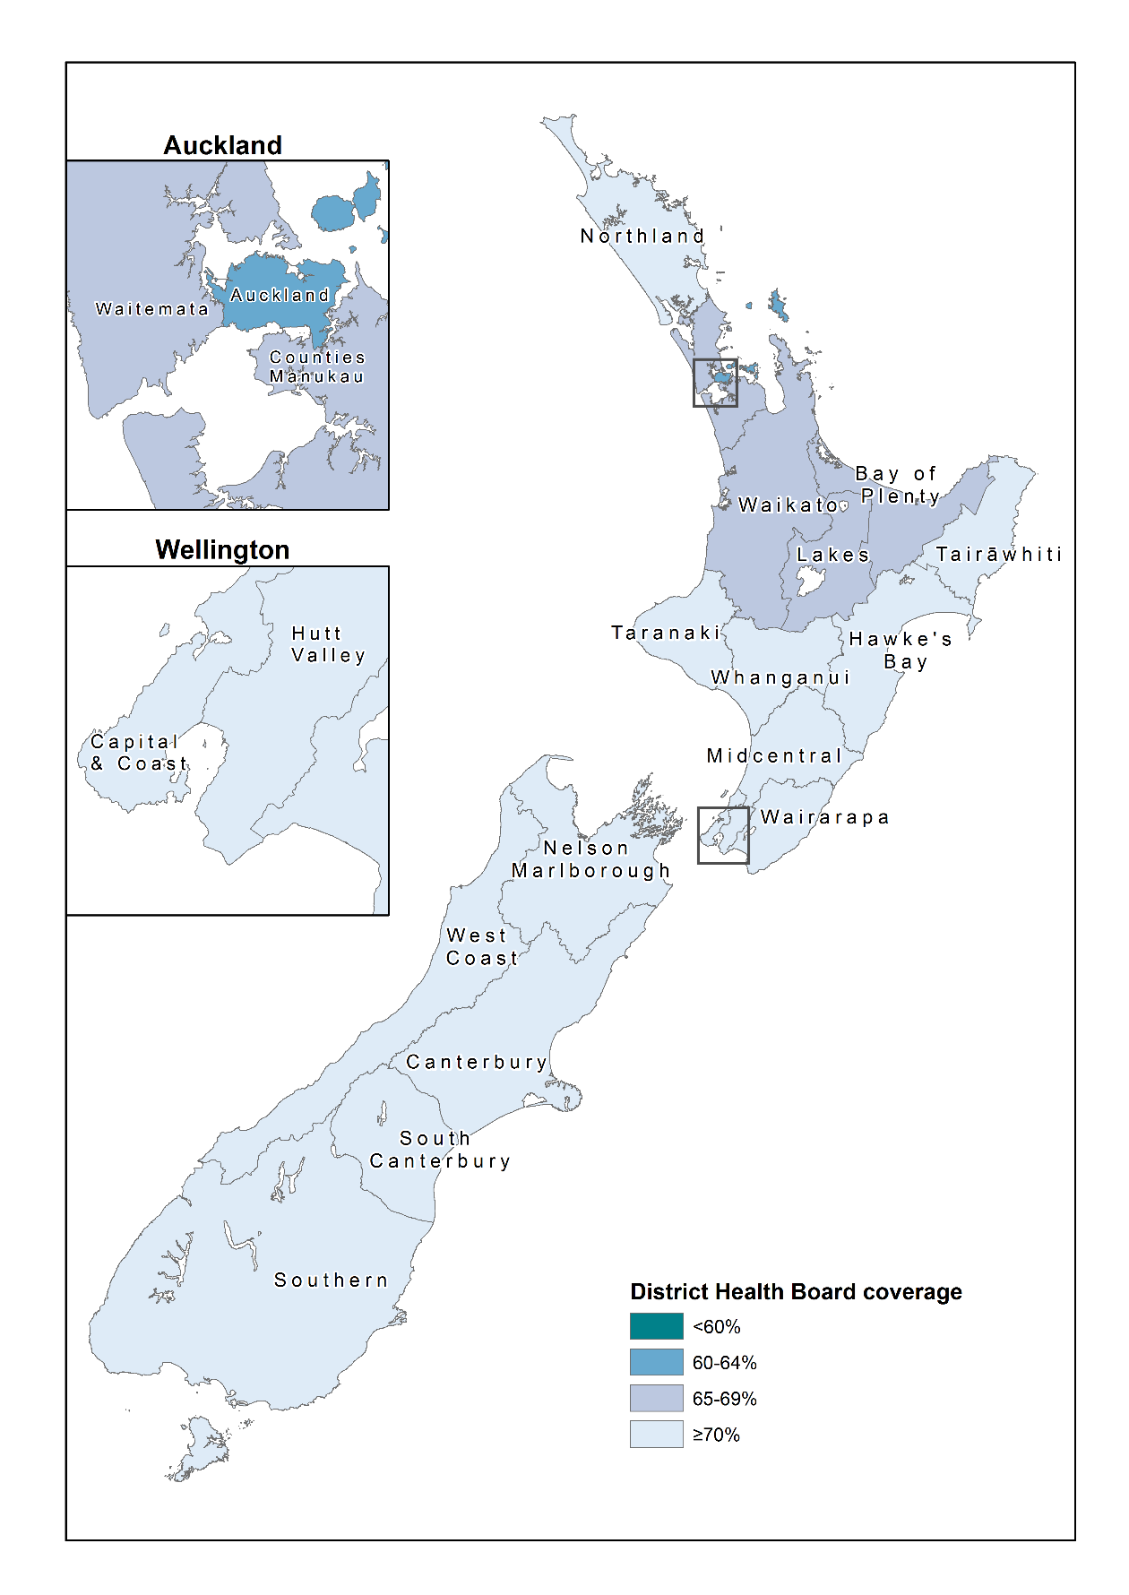

Table 3: BSA number of screens and coverage (%) in women aged 50–69 years in the two years ending 30 June 2017 by District Health Board



## DHB coverage comparison trends by ethnicity

Table 4: BSA coverage (%) of women aged 50–69 years in the two years ending 30 June, 2015, 2016, 2017, by ethnicity and District Health Board

