National Bowel Screening Programme
Consideration of the potential equity impacts for Māori of the age range for screening

Citation: Ministry of Health. 2018. National Bowel Screening Programme: Consideration of the potential equity impacts for Māori of the age range for screening. Wellington: Ministry of Health.
Published in July 2018
by the Ministry of Health
PO Box 5013, Wellington 6140, New Zealand
ISBN 978-1-98-853964-5 (online)
HP 6866
This document is available at www.health.govt.nz
This work is licensed under the Creative Commons Attribution 4.0 International licence. In essence, you are free to: share ie, copy and redistribute the material in any medium or format; adapt ie, remix, transform and build upon the material. You must give appropriate credit, provide a link to the licence and indicate if changes were made.

Contents
Key points iv
Summary v
Introduction 1
Equity as a key focus for the National Bowel Screening Programme 2
Potential impact of the National Bowel Screening Programme for equity for Māori 3
Underlying background of inequity in overall health outcomes 3
What is known about the frequency and distribution of bowel cancer amongst Māori and non-Māori New Zealanders? 3
What does New Zealand evidence suggest the NBSP impact on equity for Māori might be? 7
Eligible age range for screening 9
Other considerations for widening the age range for Māori: balancing the harms and benefits 9
Recommendations of the Bowel Screening Advisory Group 11
National Bowel Screening Programme approach 12
Maximise equitable participation in quality screening services 12
Add value along the screening pathway 12
Age range for screening 13
References 14

List of tables
Table 1: Bowel cancer registrations and deaths by sex, for Māori and non-Māori (2011–2013) 4

List of figures
Figure 1: Trends in rates of bowel cancer registrations and deaths for Māori and non-Māori by sex, 2004–2013 5
Figure 2: Annual age-specific rates of bowel cancer registrations, Māori and non-Māori (2011–2013) 6

Key points
- Equity is a key focus for the National Bowel Screening Programme (NBSP).
- Bowel screening has positive health gains for both Māori and non-Māori.
- NBSP is working towards achieving equitable access to and through the bowel screening pathway for Māori.
- Modelling shows that currently non-Māori overall health gains will be higher than Māori health gains in the NBSP.
- The Bowel Screening Advisory Group (BSAG) and the Ministry of Health have investigated lowering the Māori age range for bowel screening as a way of achieving equitable health gains.
- Given the balance of available evidence on harms and benefits, BSAG did not recommend lowering the age range for Māori currently. The Ministry has accepted BSAG’s recommendation.
- The Ministry will closely monitor programme data and review the programme parameters, including age range, once the programme has been fully implemented from 2021.

Summary

Bowel cancer is the second most common cancer registered for Māori females in New Zealand after breast cancer. For Māori males, it is the third most common cancer registered. Bowel cancer is currently more common amongst non-Māori, but bowel cancer incidence is increasing for Māori. Survival is lower for Māori than non-Māori, even when stage at diagnosis and comorbidities are adjusted for.

The National Bowel Screening Programme (NBSP) has been established to reduce the impact of bowel cancer. As a screening programme there is an obligation to ensure that the benefits of screening clearly outweigh any harm. The parameters of the national programme were set to achieve this.

Bowel screening has the potential to reduce the rates of new cases and deaths from bowel cancer for both Māori and non-Māori, however, it also has the potential to increase inequities. Analysis of New Zealand data found that while screening will offer health gains to all screened population groups, the gains will be lower for Māori, with Māori gaining fewer healthy days of life compared with non-Māori. This is because Māori have lower rates of new cases of bowel cancer registrations per year; screening programmes are less successful in engaging with Māori; and Māori have lower life expectancy than non-Māori.

Using a wider screening age for Māori (than for non-Māori) has been considered as a means of improving equity of outcomes for Māori in the NBSP. Research found that to achieve the same amount of health gain for Māori, compared with non-Māori, the screening age range would need to be 50–74 years for Māori and 60–74 years for non-Māori.

With critical consideration to the balance of benefits with harms of moving to screen the 50–59 year old age group for Māori, this balance was not clearly favourable, given the lower rate of cancer in this age group and the risk of harm from colonoscopy. There is also concern about the acceptance of a lower starting age range for Māori and that incorporating the wider age range would significantly stretch New Zealand’s current colonoscopy capacity.

There is need for further data about the rates of new cases of adenomas and changing rates of bowel cancer in Māori, which will come from the roll-out of the national programme. This may show that the equity gap is overestimated or there is the potential for screening to result in an equal health gain. Differences for males and females will be considered in more depth.

Based on a consideration of all factors, the Bowel Screening Advisory Group (BSAG) did not currently recommend a 10 year lower starting age for Māori.

The Ministry’s approach to bowel screening equity follows recommendations made by BSAG. The Ministry maintains a strong equity focus and will work on three actions; maximising equitable participation in quality screening services by using mechanisms to engage target populations; adding value along the screening pathway by addressing health risks that are large contributors to overall health inequalities (such as tobacco cessation programmes) and considering a pilot of lowering the age range for Māori by 10 years in three to four years when data to inform this decision is available.

Introduction
The Ministry of Health’s National Screening Unit (NSU) commenced a staged roll-out of a National Bowel Screening Programme (NBSP) in July 2017. The programme offers publically funded bowel screening to eligible New Zealanders aged 60 to 74 years who are asymptomatic and at average risk of bowel cancer. A non-invasive test (an immunochemical faecal occult blood test or ‘FIT’) is offered every two years, and participants with increased risk of bowel cancer are offered further assessment. The roll-out of the NBSP follows on from a bowel screening pilot in Waitemata District Health Board (DHB), which had an eligible age range of 50 to 74 years.

Bowel screening improves health outcomes by:
(1) detecting growths (known as adenomatous polyps or adenomas) that have the potential to develop into bowel cancers so that they can be removed, and
(2) detecting bowel cancers at an earlier stage (when the cancer has had less time to grow into deeper layers of the bowel or spread), which is associated with better outcomes (Cole et al 2013; Hewitson et al 2007).

The NSU’s delivery of organised screening programmes is underpinned by six quality principles and a wider set of quality requirements (National Screening Unit 2015). This rigour is important as screening is a complex service offered to people who feel well. Screening programmes aim to achieve benefits for the population and will also inevitably cause harm. Equity is tightly intertwined with quality in the NSU’s work, but the quality principle that the benefits must outweigh the harm is critical.

This paper considers the potential impact of the programme’s eligible age range on health outcome equity for Māori. It sets out the rationale for the NBSP to commence the roll-out of the programme without a lower starting age for Māori.

Equity as a key focus for the National Bowel Screening Programme
Equity is an essential component of a quality screening programme (National Screening Unit 2015). The World Health Organization defines equity as the absence of avoidable, unnecessary and unjust differences in the health of groups of people (Ministry of Health 2002; Whitehead 1990; Whitehead and Dahlgren 2006). These unfair and unjust differences in the health status between different groups arise when people experience a difference in access to the resources necessary to lead healthy lives (Ministry of Health 2014). While many of these resources sit outside the health system (eg, access to adequate income), differences from within the health system in access to, and the quality of, health care provided to different groups are a contributor to inequities in health outcomes (Hill et al 2010a; Hill et al 2013; Sarfati et al 2010).

Equity for Māori is a key focus of the NBSP as part of the Crown’s obligations to the indigenous people of New Zealand as a partner to Te Tiriti o Waitangi. The Ministry has been working with a range of experts to consider how best to maximise health outcomes and equity through the design and implementation of the NBSP while ensuring that the benefits of screening clearly outweigh potential harms.

Expert input into the programme design and implementation has been provided by the National Bowel Cancer Working Group (NBCWG), National Bowel Screening Advisory Group (subgroup of the NBCWG), NSU Māori Monitoring and Equity Group, Hei Āhuru Mōwai National Māori Cancer Group, Bowel Screening Pilot experts and academics from the University of Otago. Forums on equity have also been held with key sector stakeholders.

Potential impact of the National Bowel Screening Programme for equity for Māori

Underlying background of inequity in overall health outcomes
To understand the potential impact of the NBSP on health outcome equity for Māori, it is important to first consider that there are existing inequities in overall health between Māori and non-Māori. One measure that illustrates these inequities is life expectancy. Life expectancy at birth is the average number of years that a newborn is expected to live if current population death rates continue to apply (World Health Organization 2006). For Māori this is approximately seven years less than for non-Māori – with Māori males’ life expectancy 73.0 years compared with 80.3 years for non-Māori; and 77.1 years for Māori females and 83.9 years for non-Māori females (Ministry of Health 2015).

What is known about the frequency and distribution of bowel cancer amongst Māori and non-Māori New Zealanders?
There are existing differences in the frequency and distribution of bowel cancer and its main precursor (adenomatous polyps or adenomas) amongst Māori and non-Māori New Zealanders.

Bowel cancer is the second most common cancer registered for females in New Zealand (both Māori and non-Māori) after breast cancer. For Māori males, it is the third most common cancer registered (after prostate and lung cancers) and the second most common cancer registered for non-Māori males (after prostate cancer) (Ministry of Health 2015).

Māori have a lower rate of bowel cancer registration than non-Māori, but once diagnosed, Māori experience poorer survival (Hill et al 2010b). This results in no significant differences seen in mortality rates at a population level (see Table 1).

New Zealand researchers have found that Māori tend to have more advanced disease at time of diagnosis, higher levels of co-existence of other diseases and are more likely to live in socioeconomically deprived areas than non-Māori (C3 Quantitative Study; Hill et al 2010b; Jackson et al 2015). Poorer bowel cancer survival, however, is not fully accounted for by these differences. There is evidence that poorer access and quality of care are important, and amenable, contributors to this difference in survival (Hill et al 2010a; Hill et al 2010b; Hill et al 2013; Sarfati et al 2010).

Table 1: Bowel cancer registrations and deaths by sex, for Māori and non-Māori
(2011–2013)
Indicator | Māori |  |  | Non-Māori
 | Total | Male | Female | Total | Male | Female
Colorectal cancer registrations
Number of cases (annualised average) 2011–2013 | 157 | 86 | 71 | 2,817 | 1,498 | 1,319
Age-standardised rates (ASR) per 100,000 (95% CI), 2011–2013 | 33.55  (30.52, 36.58) | 39.97  (35.10, 44.84) | 28.04  (24.28, 31.81) | 42.96  (42.05, 43.88) | 49.45  (48.00, 50.90) | 37.12  (35.96, 38.28)
Standardised rate ratio (SRR) (95% CI) | 0.78  (0.71, 0.86) | 0.81  (0.71, 0.92) | 0.76  (0.66, 0.87) | Reference population for SRR
Colorectal cancer mortality
Number of cases (annualised average) 2011–2013 | 69 | 38 | 31 | 1,150 | 591 | 559
Age-standardised rates (ASR) per 100,000 (95% CI), 2011–2013 | 15.01  (12.98, 17.06) | 17.57  (14.34, 20.80) | 12.55  (9.99, 15.12) | 16.26  (15.72, 16.80) | 18.60  (17.74, 19.47) | 14.23  (13.55, 14.92)
Standardised rate ratio (SRR) (95% CI) | 0.92  (0.80, 1.07) | 0.94  (0.78, 1.15) | 0.88  (0.71, 1.09) | Reference population for SRR
Notes:
Number of cases are an annualised average across 2011–2013 (counts rounded).
ASR and SRR are age-standardised to WHO World Standard Population. Age-standardisation accounts for any underlying differences age structure of the populations. SRR is a measure of relative inequality.
Prioritised ethnicity has been used.
Colorectal cancer includes cancer of colon, rectosigmoid and rectum – ICD 10 (AM) codes C18–C20. Excludes cancer of anus and anal canal (C21).
Sources: Ministry of Health New Zealand Cancer Registry & National Mortality Collection Data Set (2011–2013)

For the period 2004–2013, the rates of death from bowel cancer for non-Māori males and females show a general decreasing trend. The corresponding rates for Māori are more variable (Ministry of Health 2016). For this same period, the rate of new bowel cancer registrations trends slightly downward for non-Māori males and females. However, while more variable, the rates for Māori show a slight upwards trend (particularly for males) (Figure 1).

Figure 1: Trends in rates of bowel cancer registrations and deaths for Māori and non-Māori by sex, 2004–2013
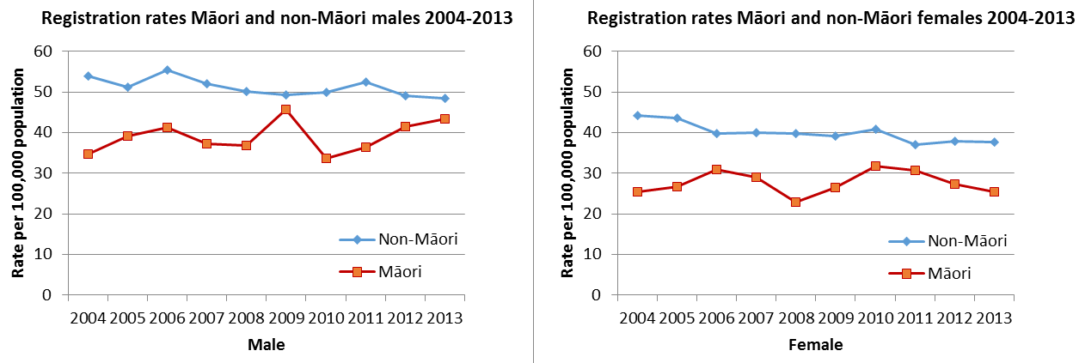
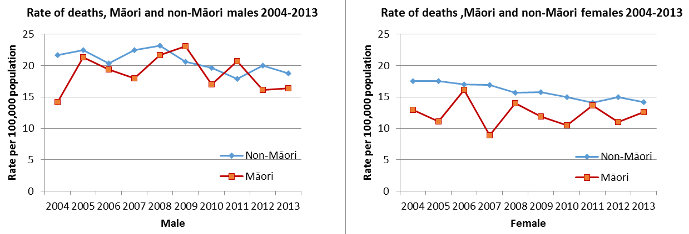
Source: Registration and mortality data for colorectal cancer (C18–20) sourced from the New Zealand Cancer Registry and National Mortality Collection respectively. Rates are expressed per 100,000 population and age-standardised to the WHO World Standard Population. Prioritised ethnicity has been used. Ministry of Health. 2016. Cancer: New registrations and deaths 2013. Wellington: Ministry of Health. (Ministry of Health 2016)

The rate of bowel cancer registrations increases with age for both Māori and non-Māori (Figure 2), with rates consistently lower for Māori in each age group. Considering the number of cancers, Māori have proportionally fewer cancers found in those aged 60 years or over than non-Māori and therefore a greater proportion in those under 60 years. Because of different population age distribution, 66 percent of new bowel cancer registrations are in people over 60 years amongst Māori and 83 percent among non-Māori. Similar percentages were seen in the bowel screening pilot (although the numbers of bowel cancer are small so extreme caution is needed with this result). For bowel cancer and advanced adenoma combined (advanced neoplasia), approximately 60 percent of advance neoplasia occurred in Māori aged 60+ years compared with 74 percent for non-Māori.

Figure 2: Annual age-specific rates of bowel cancer registrations, Māori and non-Māori (2011–2013)
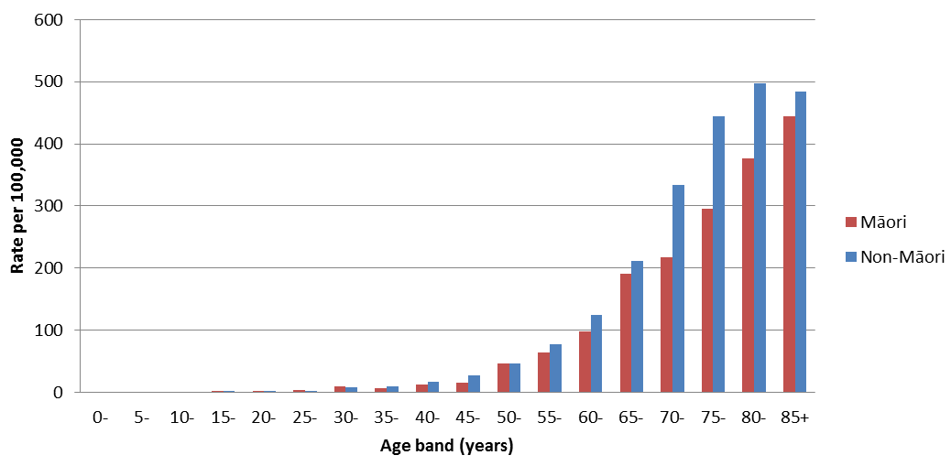
Prioritised ethnicity. Colorectal cancer includes cancer of colon, rectosigmoid and rectum – ICD 10 (AM) C18–C20. Note excludes cancer of anus and anal canal C21.
Source: NZCR 2011–2013 (annualised average)

Most bowel cancers are thought to develop from adenomatous polyps that grow and develop abnormalities (dysplasia) (cited in Doubeni 2017). Currently there is limited New Zealand evidence about the frequency and pattern of adenomatous polyps among New Zealand Māori and non-Māori.

The bowel screening pilot has provided some initial insights into the rate of adenomas and advanced adenomas (defined as either size ≥ 1 cm, high grade dysplasia or a villous component) in an asymptomatic screened population in the Waitemata DHB area. Over the first 36 months of the pilot, Māori were more likely to have adenoma detected than European/Other in both the first or subsequent screens (Litmus et al 2016). The rates of adenomas and advanced adenomas increased with age (Litmus et al 2016).

The high rate of detection of adenomas amongst Māori (compared with European/Other) in the pilot was an unexpected finding. There is some uncertainty about whether this finding, derived from a population residing in a single DHB area, is generalisable to the wider New Zealand population. This finding may support trend data suggesting a convergence of rates of new bowel cancer registrations between Māori and non-Māori, particularly for males.

What does New Zealand evidence suggest the NBSP impact on equity for Māori might be?
While bowel screening has the ability to reduce the rates of new cases and deaths from bowel cancer (Cole et al 2013; Hewitson et al 2007), it also has the potential to benefit some population groups more than others. This contributes to an increase in cancer inequities and to the gap in overall health outcomes such as life expectancy.

The final bowel screening pilot evaluation report found that the pilot, as designed and delivered, was likely to: achieve health benefits; be cost-effective for the whole population and for Māori but increase inequities in bowel cancer outcomes (between Māori and European/Other) in part because it was less successful in engaging eligible Māori participants to take part in screening (Litmus et al 2016).

In general, Māori had lower rates of participation in the screening pilot compared with European/Other. Notably there was no significant difference in rates of participation in subsequent screens once participating, or in colonoscopy uptake (see Final Evaluation Report of the Bowel Screening Pilot for full details www.health.govt.nz/publication/final-evaluation-report-bowel-screening-pilot-screening-rounds-one-and-two) (Litmus et al 2016).

Research by McLeod et al (2017) modelled the potential health gains per person (QALY), costs, cost-effectiveness and the impact on overall population health inequalities of a national bowel screening programme for Māori and non-Māori (based on two yearly screening FIT test of
50–74 year olds). This work drew on screening coverage data from the New Zealand Bowel Screening Pilot; New Zealand epidemiological data on bowel cancer from linked datasets; New Zealand cost data and international screening output data (McLeod et al 2017).

It was found that bowel screening will offer health gains to all screened population groups, but these health gains per person will be lower for Māori than for non-Māori. The authors note three key factors that underlie this difference:
(1) Māori having lower rates of new cases of bowel cancer registrations per year (so ‘less disease to prevent and treat’)
(2) screening programmes being less successful in engaging with Māori (so lower screening coverage)
(3) that Māori have lower life expectancy than non-Māori (‘so a shorter window of time to model improvements to their health’) (McLeod and Blakely 2017).

If equal participation in screening was reached for Māori compared with non-Maori, health gain inequities would persist.

This research examined the likely impact on overall health inequalities for Māori compared to non-Māori by measuring the change in quality adjusted life expectancy as a result of bowel screening. The analysis showed that a bowel screening programme would increase inequalities in overall health for Māori compared to non-Māori – with non-Māori gaining more healthy days of life compared to Māori across all age groups (McLeod and Blakely 2017; McLeod et al 2017).

Eligible age range for screening
Using a wider screening age for Māori (than for non-Māori) has been considered as a means of improving equity for Māori in the NBSP. There is some international and national precedence for having differential age eligibility for a screening programme by ethnic group or by another factor such as sex depending on risk. For example, in the United States of America, colorectal cancer screening guidelines recommend that routine screening for colorectal cancer should begin 5–10 years earlier for African Americans. In New Zealand, the age to start cardiovascular risk assessment is 10 years younger (ie, 35 years for males; 45 for females) for Māori, Pacific and Indo-Asian peoples compared with other ethnic groups who are otherwise asymptomatic without other risk factors (ie, 45 years for males; 55 years for females) (Ministry of Health 2013).

Further modelling undertaken by McLeod et al (2017) considered whether using a wider screening age range for Māori could achieve the same number of healthy days from bowel screening for Māori compared with non-Māori (ie, equity neutral bowel screening programme). This work found that to achieve the same number of healthy days for Māori compared with non-Māori, the screening age range for Māori would need to be 10 years wider than non-Māori (ie, 50–74 for Māori, compared with 60–74 for non-Māori) (McLeod et al 2017).

However, the authors note that this approach may result in greater risks for Māori given that Māori have lower rates of new cases of bowel cancer and rates are lower in younger age groups (McLeod and Blakely 2017).

Other considerations for widening the age range for Māori: balancing the harms and benefits
Screening programmes are for asymptomatic people and as such, the balance of benefits and risks need to be accounted for individuals and for populations.

The potential benefits of screening include:
- a reduction in deaths from bowel cancer
- a probable reduction in the rate of new cases registered through the detection and removal of adenomas in the bowel
- the detection of cancers at an earlier stage associated with less invasive treatment options and better prognosis (Cole et al 2013; Hewitson et al 2007)
- reassurance for those with negative screen results (Richardson and Potter 2014).

Recognised potential harmful effects of screening include:
- the potentially significant complications of colonoscopy (eg, bleeding, perforation, pain)
- the psycho-social consequences of receiving a false-positive result
- false reassurance for those with false-negative results
- the possibility of overdiagnosis (leading to unnecessary investigations or treatment)
- the complications associated with investigations or treatment (Richardson and Potter 2014).

The positive predictive value (PPV) is the proportion of people with positive FIT results that underwent a colonoscopy that found a bowel cancer (or one of its precursors). Analysis of the PPVs from the pilot shows there were a greater proportion of colonoscopies being performed for younger age groups that showed no significant abnormality for both Māori and non-Māori. In the 50–59 age group, the PPV for advanced adenomas was also lower for Māori than non-Māori. The number of Māori with abnormalities in the pilot were small so the results have been interpreted with caution but they are important as, although rare, colonoscopies can present some harms such as perforation and bleeding.

Like many other countries with similar health systems, New Zealand has limited colonoscopy resources. While initiatives are underway to increase this resource, it takes time to do so, particularly to train staff. Attention is needed to ensure sufficient colonoscopy capacity for the screening programme and also colonoscopies for people who have symptoms or who require regular surveillance colonoscopies (for which the demand is projected to increase as the NBSP rolls out) (Hill et al 2010a; Litmus et al 2016).

There are an estimated 71,330 Māori aged 50–59 (Statistics New Zealand 2017). Initiating screening for Māori at age 50 would result in an estimated 1500 additional screening colonoscopies (assuming target participation of 60 percent, a FIT positivity rate of 3.90 percent at 200 ng Hb/buffer and 90 percent colonoscopy uptake). If additional demand for colonoscopies exceeds the available resource, then there may be unintended consequences for screening and symptomatic colonoscopy services. This may have a disproportionate impact on Māori who experience existing barriers to equitable access and quality of cancer services (Cormack et al 2005; Hill et al 2010a; Hill et al 2010b; Hill et al 2013; Jackson et al 2015).

A number of comparable countries offering population screening for bowel cancer have initiated screening programmes with a limited age range (matched to the age where the majority of cancers and its precursors will be found) because of available colonoscopy capacity, with a view to expanding the age range when possible (Flitcroft et al 2011; Pignone et al 2011; Schreuders et al 2015; The Cancer Council 2007).

Recommendations of the Bowel Screening Advisory Group
The Bowel Screening Advisory Group (BSAG) is a multidisciplinary sub-group of the National Bowel Cancer Working Group providing advice to the Ministry on bowel screening. It comprises experts in bowel cancer epidemiology, colorectal surgery, endoscopy, Māori health, Pacific health, equity, pathology, primary care, public health and screening programmes.

BSAG is committed to improving health outcomes and achieving health equity for Māori and ensuring equity impacts of bowel screening are identified and widely and properly considered (National Bowel Screening Advisory Group 2017).

BSAG considered the available evidence including frequency and distribution of bowel cancer and its precursors, findings from the bowel screening pilot, cost-effectiveness and equity modelling, colonoscopy modelling and sector perspectives.

After extensive and in-depth discussion, taking into account the available evidence, BSAG did not recommend a 10 year lower starting age for Māori in the NBSP at this point in time (National Bowel Screening Advisory Group 2017). This decision was informed by a number of considerations, including:
- the need for further data from the roll-out of the programme as there is current uncertainty about the rates of new cases of adenomas and changing rates of bowel cancer in Māori. Bowel cancer rates may be increasing for Māori, thereby bowel screening could result in equal health gain from screening (equity neutral) or even greater health gain than non-Māori (equity positive)
- concern about the balance of harms and benefits of screening a younger age group. Increasing the eligible age range (and screening participation) would increase the potential benefits of screening and potential harms for Māori (given lower rates of new cases of bowel cancer in younger age groups for all population groups and as Māori have lower rates of disease, particularly Māori women)
- concern that the increase in eligible population in the 50–59 year age group could significantly stretch New Zealand’s current colonoscopy resource (including specialist staff) and undermine the programme. This may occur in geographical areas with a high number of Māori and potentially through demand for screening from age 50 years by non-Māori.
- wider acceptance of a policy based on ethnic group as Māori currently have a lower rate of new cases of bowel cancer.

The three key actions are:
(1) explore methods to add value to the NBSP for Māori by addressing other issues to improve Māori life expectancy. Potential areas discussed were breast screening and tobacco control
(2) explore methods to increase participation in the NBSP for Māori – programme must focus on ensuring that access to and through the screening pathway is equitable
(3) review programme data after round one of screening at Counties Manukau DHB to consider measures to enhance equity impact of the screening programme.

National Bowel Screening Programme approach
The Ministry’s current approach to bowel screening equity follows the recommendations received from BSAG.

Maximise equitable participation in quality screening services
NBSP will maintain a strong focus on equity through the entire screening pathway, recognising that there is potential for inequities to arise at any and all points along the pathway and contribute cumulatively to inequity in outcomes (Sarfati et al 2010). The programme aims to achieve at least equitable access to and through the screening pathway.

As recommended by BSAG (key action 2), the NBSP includes actions to increase participation for Māori. The programme also has an equity focus for Pacific and populations living in areas with high socioeconomic deprivation. Current examples include: targeted active follow-up on invitations; tailored health promotion; primary health care involvement in promoting participation; and engagement with community groups, churches and marae. Further mechanisms will be explored, building on key learnings from both the bowel screening pilot and, in time, from other DHB populations and settings as they commence screening.

Standardising care along the diagnostic and treatment pathway can reduce inequities by enabling fair access to quality services (Sarfati 2010). Interim Quality Standards have been implemented as part of the NBSP implementation.

Add value along the screening pathway
The NBSP will explore ways to add value along the bowel screening pathway by addressing health risks that are large contributors to overall health inequalities for Māori. For example, linking to initiatives, such tobacco cessation programmes. There may also be opportunities to promote participation in other screening programmes, particularly screening programmes where Māori have higher incidence of disease, and so potential for greater equity gains, for example, breast screening for females (McLeod and Blakely 2017). Any actions need to be mindful of concerns raised by the sector regarding potential unintended consequences such as deterring people from engaging in future with screening services.

Age range for screening
Aligned with these recommendations, the Ministry commenced roll-out of the NBSP with an age range of 60–74 years for all eligible participants, Māori and non-Māori.

Programme design parameters, including age range, will be reviewed based on clinical evidence, equity impacts and capacity of services once we have more data from the roll-out of the screening programme.
- A national monitoring and evaluation framework has been established to capture programme data, such as participation and detection rates of adenomas and bowel cancer by ethnic group, sex, socioeconomic deprivation and location.
- As the roll-out progress, the number of data held by the NBSP will increase and include data from different DHB populations and settings. This will enable the NBSP to have greater certainty about the rate of new cases of adenomas and bowel cancer in a screened average-risk Māori population by DHB, and further assessment of the harms and benefits for this population group. Rates for Māori men and women will be important to consider separately, given the high rate of bowel cancer among men. We will also be able to analyse the impact on service capacity across the bowel screening pathway and the pathways for those outside the screening programme (eg, those who have presented with symptoms).
- The programme data will be regularly reviewed to inform actions to enhance the equity impact of the screening programme. In accordance with BSAG (key action 3), programme data will be reviewed after round one of screening at Counties Manukau DHB for this purpose.
- The Ministry will consider piloting an earlier screening age for Māori if this is supported by the evidence (ie, disease detection rates for 60–74 year olds over the first three to four years of the roll-out and when the capacity for colonoscopy services is clearer).
- The Ministry will review the programme parameters, including age range, once the programme has been fully implemented.

References

C3 Quantitative Study. Cancer, Comorbidity and Care: Key findings from the C3 (Quantitative) Study. URL: www.otago.ac.nz/wellington/otago067851.pdf (accessed July).
Cole SR, Tucker GR, Osborne JM, et al. 2013. Shift to earlier stage at diagnosis as a consequence of the National Bowel Cancer Screening Program. Med J Aust 198(6): 327–30.
Cormack D, Ratima M, Robson B, et al. 2005. Access to Cancer Services for Māori: A report prepared for the Ministry of Health. Wellington.
Doubeni C. 2017. Screening for Colorectal Cancer: Strategies in patients at average risk. Wolters Kluwer.
Flitcroft KL, St John DJ, Howard K, et al. 2011. A comparative case study of bowel cancer screening in the UK and Australia: evidence lost in translation? J Med Screen 18(4): 193–203.
Hewitson P, Glasziou PP, Irwig L, et al. 2007. Screening for colorectal cancer using the faecal occult blood test, Hemoccult. Cochrane Database of Systematic Reviews (1).
Hill S, Sarfati D, Blakely T, et al. 2010a. Ethnicity and management of colon cancer in New Zealand: do indigenous patients get a worse deal? Cancer 116(13): 3205–14.
Hill S, Sarfati D, Blakely T, et al. 2010b. Survival disparities in indigenous and non-indigenous New Zealanders with colon cancer: the role of patient comorbidity, treatment and health service factors. J Epidemiol Community Health 64(2): 117–23.
Hill S, Sarfati D, Robson B, et al. 2013. Indigenous inequalities in cancer: what role for health care? ANZ J Surg 83(1–2): 36–41.
Jackson C, Sharples K, Fith M, et al. 2015. The PIPER Project: An internal examination of colorectal cancer management in New Zealand. Report prepared for the Health Research Council and Ministry of Health.
Litmus, Massey University Centre for Public Health Research, Sapere Research Group. 2016. Final Evaluation Report of the Bowel Screening Pilot: Screening Rounds One and Two. Wellington.
McLeod M, Blakely T. 2017. Nationwide Colorectal Screening in New Zealand: a tricky balance of improving overall population health and addressing inequalities. URL: https://blogs.otago.ac.nz/pubhealthexpert/2017/07/19/nationwide-colorectal-screening-in-new-zealand-a-tricky-balance-of-improving-overall-population-health-and-addressing-inequalities/. University of Otago Public Health Expert Blog.
McLeod M, Kvizhinadze G, Boyd M, et al. 2017. Colorectal c ancer screening: how health gains and cost-effectiveness vary by ethnic group, the impact on health inequalities, and the optimal age range to screen. Cancer Epidemiol Biomarkers Prev.
Ministry of Health. 2002. Reducing Inequalities in Health. Wellington: Ministry of Health.
Ministry of Health. 2013. Cardiovascular Disease Risk Assessment. Updated 2013. Wellington: Ministry of Health.
Ministry of Health. 2014. He Korowai Oranga: Māori Health Strategy 2014. Wellington: Ministry of Health.
Ministry of Health. 2015. Tatau Kahukura: Māori Health Chart Book 2015. Wellington: Ministry of Health.
Ministry of Health. 2016. Cancer: New registrations and deaths 2013. Wellington: Ministry of Health.
Ministry of Health. 2017. Age Range and Positivity Threshold for the National Bowel Screening Programme. Wellington: Ministry of Health.
National Bowel Screening Advisory Group. 2017. Recommendations from the National Bowel Screening Advisory Group regarding the Equity Impact for Māori of the National Bowel Screening Programme. Ministry of Health.
National Screening Unit. 2015. National Screening Unit Quality Framework 2015: Delivering screening programmes. Wellington: Ministry of Health.
New Zealand Guidelines Group. 2011. Guidance on surveillance for people at increased risk of colorectal cancer 2011. Wellington: New Zealand Guidelines Group
Pignone MP, Flitcroft KL, Howard K, et al. 2011. Costs and cost-effectiveness of full implementation of a biennial faecal occult blood test screening program for bowel cancer in Australia. Med J Aust 194(4): 180–5.
Richardson AK, Potter JD. 2014. Screening for colorectal cancer and prostate cancer: challenges for New Zealand. New Zealand Medical Journal 127(1395): 23–30.
Sarfati D, Hill S, Blakely T, et al. 2010. Is bowel cancer screening important for Māori? New Zealand Medical Journal 123(1320): 9–12.
Schreuders EH, Ruco A, Rabeneck L, et al. 2015. Colorectal cancer screening: a global overview of existing programmes. Gut 64(10): 1637–49.
Statistics New Zealand. 2017. Māori Population Estimates: Mean year ended 31 December 1991–2016. Stats NZ. URL: www.stats.govt.nz
The Cancer Council. 2007. National Cancer Prevention Policy 2007–2009. Australia.
Whitehead M. 1990. The Concepts and Principles of Equity and Health. Copenhagen: WHO Regional Office for Europe (document number: EUR/ICP/RPD 414).
Whitehead M, Dahlgren G. 2006. Concepts and Principles for Tackling Social Inequities in Health: Levelling up Part 1. WHO Regional Office for Europe: WHO Collaborating Centre for Policy Research on Social Determinants of Health University of Liverpool.
World Health Organization. 2006. Definition and Metadata. URL: www.who.int/whosis/whostat2006DefinitionsAndMetadata.pdf (accessed October 2017).

‘Average risk’ is defined by exclusion as individuals without a personal history of bowel cancer or adenomatous polyps or conditions that increase risk such as inflammatory bowel disease; or strong family history of bowel cancer (as determined by the number of affected first-degree relatives and the age at which they were diagnosed with bowel cancer). Those with a family history of bowel cancer should discuss this with their general practitioner. People with a strong family history can be referred for assessment and surveillance advice to the NZ Familial Gastrointestinal Cancer Service (see http://www.nzfgcs.co.nz/). Those with a moderate risk of developing bowel cancer on the basis of a family history should be referred for colonoscopy surveillance in line current guidelines (see https://www.health.govt.nz/publication/guidance-surveillance-people-increased-risk-colorectal-cancer) (New Zealand Guidelines Group, 2011).
A document describing the rationale for the age range selected for the NBSP is available on the Ministry of Health website (see http://www.health.govt.nz/our-work/diseases-and-conditions/cancer-programme/bowel-cancer-programme/national-bowel-screening-programme/key-documents-national-bowel-screening-programme) (Ministry of Health 2017).
The magnitude of the health benefits (eg, reduction in mortality) was not able to be assessed within the timeframe of the evaluation.
Quality adjusted life year (QALY), a measure of the state of health of a person or group in which the benefits, in terms of the length of life, are adjusted to reflect the quality of life. Used as a summary measure of health outcome for economic evaluation, enabling comparison of outcomes across different diseases and interventions. One QALY is equal to one year of life in perfect health.
Quality adjusted life expectancy – life expectancy is adjusted to allow for reduced quality of life caused by chronic conditions such as cancer.

