Age Range and Positivity Threshold for the National Bowel Screening Programme

Summary
In late 2011, a bowel screening pilot (BSP) began in the Waitemata District Health Board area. The aim was to gather information that would help with decisions around the design and roll-out of a national bowel screening programme.
The BSP provided critical insights that were used to develop new parameters for a New Zealand bowel screening programme. It showed:
- a strong link between the amount of blood detected in a participant’s screening test and the chance of that person having a cancer or an advanced adenoma in their bowel
- more than 80 percent of cancers were found following a positive test result that was above the threshold that has since been set for the national programme
- almost 40 percent of participants aged 50–54 years who returned a positive screening test underwent a colonoscopy where no bowel cancer or significant abnormality was detected
- about half the available colonoscopy resource was used on participants who were the least likely to have an outcome of cancer or advanced adenoma.

The findings of the Pilot were an important factor in decision-making on the National Bowel Screening Programme.
The age range for the National Bowel Screening Programme has been set at 60–74 years, and the positivity threshold will be higher than that used in the BSP. This document explains the decision-making processes and evidence these decisions are based on.

Age Range and Positivity Threshold for the National Bowel Screening Programme
New Zealand has one of the highest bowel cancer rates in the developed world.
In late 2011, a bowel screening pilot (BSP) began in the Waitemata District Health Board area to gather information that would contribute to decisions around the design and roll-out of a national bowel screening programme.
The intention was to test whether the New Zealand bowel screening experience was similar to that of other countries.
The parameters for the BSP were intentionally broad in order to gather as much information as possible about critical factors. These critical factors include:
- the optimum age range for a national bowel screening programme
- participation levels
- the acceptability of the test to participants
- the positivity threshold that would best balance cancer detection with colonoscopy capacity
- potential benefits and harms for participants
- alignment with available colonoscopy resources.

For the BSP, eligible people aged 50–74 years (a broad age range by international standards) were invited to complete a screening test every two years. The threshold that would trigger a ‘positive’ result was set at an intentionally low level, compared with international screening practices.
This approach provided critical insights that were used to develop new parameters for a New Zealand national bowel screening programme.
This document explains these changes, the decision-making processes and evidence behind them, and how the changes will affect people taking part in the programme.

Parameters used in the Waitemata BSP
Eligible people aged 50–74 years were invited to take part in the BSP. They were offered a faecal immunochemical test (FIT) to complete at home, so levels of blood in their faecal sample could be assessed.
The FIT used in the BSP was a quantitative test where the numerical value of the test result is used to determine whether a test is positive or negative. The threshold for a positive test, ie, the amount of blood in the sample that triggers a positive result, is known as the positivity threshold. It can be adjusted to a higher or lower level to meet the particular requirements of a country’s bowel screening programme.
In the BSP, a level of 75ng Hb/ml buffer solution was selected. This means that any FIT result containing at least 75 nanograms of haemoglobin per milliliter of solution was classified as ‘positive’ and the participant was offered a colonoscopy to check for bowel cancer.
This specific level (75ng Hb/ml buffer solution) was selected as it was at the lower end of the range that screening research studies in other countries have used as a threshold.
The level of haemoglobin in faeces recorded in the bowel screening pilot could be correlated with the subsequent findings at colonoscopy, providing robust data to inform the decisions about the national programme. There is no internationally agreed age range or positivity threshold for a bowel screening programme. As in New Zealand, countries need to use data from a pilot programme to determine the threshold for a positive test that best suits the needs of their population, balances benefits and harms for the participants and aligns with the available resources.
Throughout the life of the Pilot, analyses have consistently shown that altering age range and positivity threshold combinations do not alter the proportions of cancers found at stages I, II, III and IV.

Results of the New Zealand BSP
Analysis of the data from the BSP showed results that were in line with international findings. The data showed that:
- most bowel cancers were found in people aged over 60 years
- there was a correlation between the amount of blood (haemoglobin) found in a person’s FIT sample and the likelihood of that person subsequently having a bowel cancer detected at colonoscopy
- younger people with a positive FIT were more likely to undergo a colonoscopy where no cancer or abnormality was detected. Blood in their FIT sample may have been due to problems other than bowel cancer or bowel polyps (such as a hemorrhoid)
- the number of cancers being detected per 100 colonoscopies undertaken (after a positive FIT result) was low when compared with other countries’ results. This means that most people proceeding to colonoscopy did not have a significant bowel abnormality detected at that procedure
- rolling out a national bowel screening programme using the same combination of age range and positivity threshold as the BSP would result in New Zealand’s colonoscopy resource being overwhelmed
- using the proposed age range and threshold allows a national bowel screening programme to start sooner than would otherwise be possible and means that the age group where most cancers are found can be offered screening.

These findings led analysts and decision-makers to test various combinations of age and positivity thresholds to find a combination that struck a balance between:
- the number of cancers detected
- benefits and harms for participants
- the projected available resources
- reduced deaths from bowel cancer over time
- cost-effectiveness.

In making the decision on the age range and positivity threshold, the Ministry was provided with expert advice by the Bowel Screening Advisory Group and international advisors.
Subsequently, the findings of an independent Evaluation Report of the Bowel Screening Pilot (published in February 2017) and work undertaken by the University of Otago, Wellington, have further supported the Ministry’s decision-making.

Most bowel cancers were found in people aged over 60 years.
In the general population in New Zealand, 82 percent of colorectal cancers are found in those aged 60 years or over. In the BSP, very similar results were obtained, with about 80 percent of all cancers found in those aged 60–74 years.
Figure 1: Average number of annual colon and rectal cancer registrations by age and sex, 2010–2012

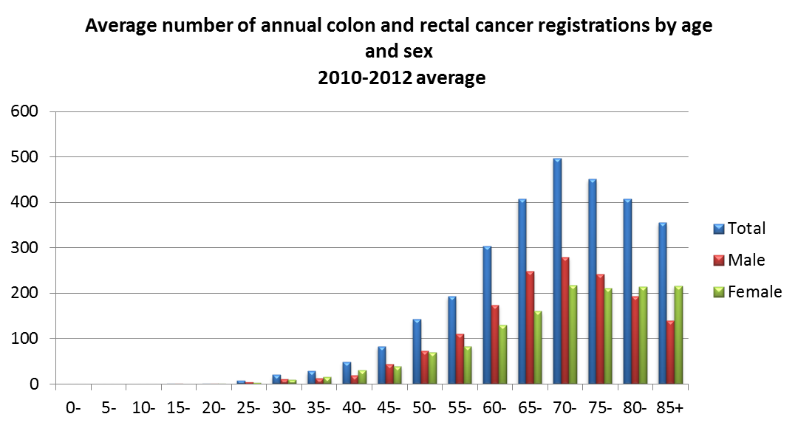

Source: Ministry of Health, Cancer Registry.
There was a correlation between the amount of blood (haemoglobin) found in a person’s FIT sample and the likelihood of that person subsequently having a bowel cancer detected at colonoscopy.
The FIT test looks for haemoglobin in a stool sample; the more blood in a sample, the higher the level of reported haemoglobin. Colorectal cancers can cause bleeding in the colon, and therefore blood detected in a FIT can be an indicator for bowel cancer. For this reason participants with blood in their sample who are reported as having a positive test are offered a colonoscopy to examine their bowel. This procedure can detect both bowel cancer and bowel polyps.
If bowel polyps are detected, they will usually be removed and examined under the microscope to see if they are ‘advanced adenomas’, which can often be precursors to bowel cancer. Detecting and removing advanced adenomas can sometimes prevent bowel cancer from developing in future.
The BSP showed there was a strong link between the amount of blood detected in a participant’s FIT and the chance of that person having a cancer or an advanced adenoma in their bowel.
Of the total positive tests identified in the BSP, just under half (47 percent) were between the 75ng and 200ng Hb/ml range. Almost 50 percent of the total number of colonoscopies performed as part of the BSP related to a test that showed less than 200ng of haemoglobin in the sample. However, of the colonoscopies performed after a FIT result of less than 200ng, 86 percent did not find a cancer or advanced adenoma.
More than 80 percent of cancers were found following a FIT result of greater than 200ng Hb/ml buffer. Almost 60 percent of cancers were found following a FIT result that was greater or equal to 1000ng Hb/ml buffer.
Figure 2: Numbers of colonoscopies performed by FIT result range

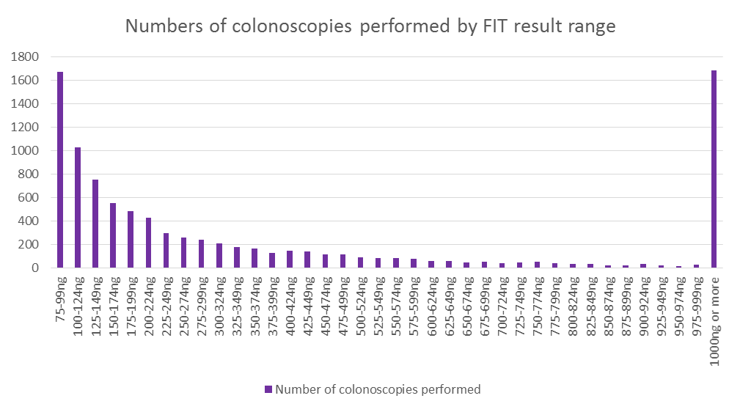
Source: Ministry of Health Bowel Screening Pilot IT system.
In summary, analysis showed a large proportion (86%) of the colonoscopies performed after a FIT result of between 75 and 200ng Hb/ml buffer did not find a cancer or an advanced adenoma. It was more likely that a cancer or advanced adenoma would be found in people who had shown more blood in their FIT.
The following chart shows the number of cancers and adenomas found per 100 colonoscopies performed, grouped by the person’s FIT result. There is a strong link between the amount of haemoglobin detected in the sample and the subsequent likelihood of a cancer or advanced adenoma being found.
Figure 3: Percentage of colonoscopies finding cancer or advanced adenoma by FIT result range
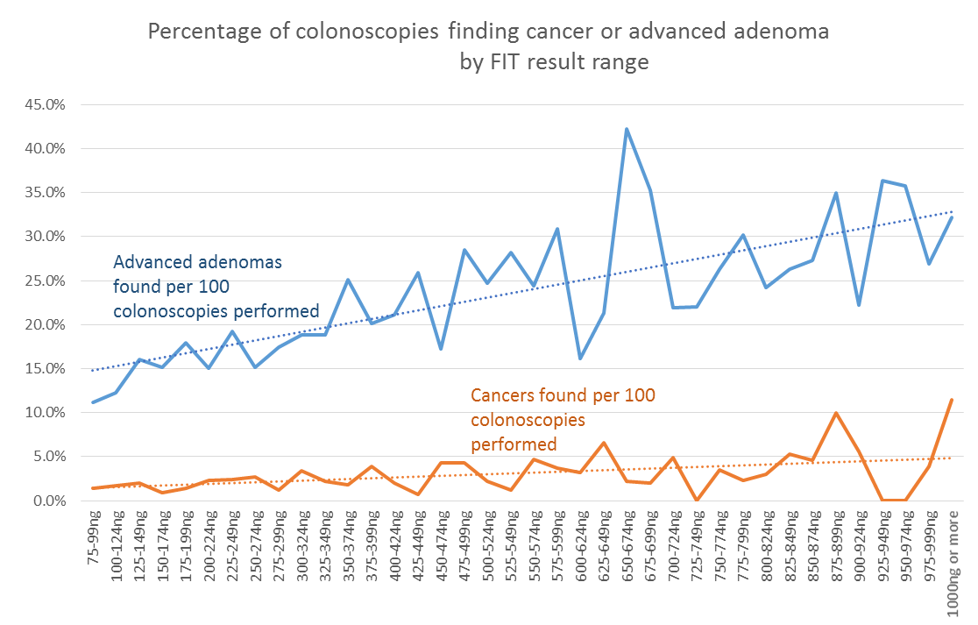
Source: Ministry of Health Bowel Screening Pilot IT system.
During the BSP, about half of the available colonoscopy resource was utilised for participants who were the least likely to have an outcome of cancer or advanced adenoma –represented by the yellow bars on the following chart.
Where too many colonoscopies are being performed that do not identify any significant bowel abnormalities, the positivity threshold may need to be adjusted to a higher level, to balance the benefits of finding an abnormality against the potential harms of the procedure and the burden on resources.
Figure 4: Number of colonoscopies performed by FIT result range and outcome
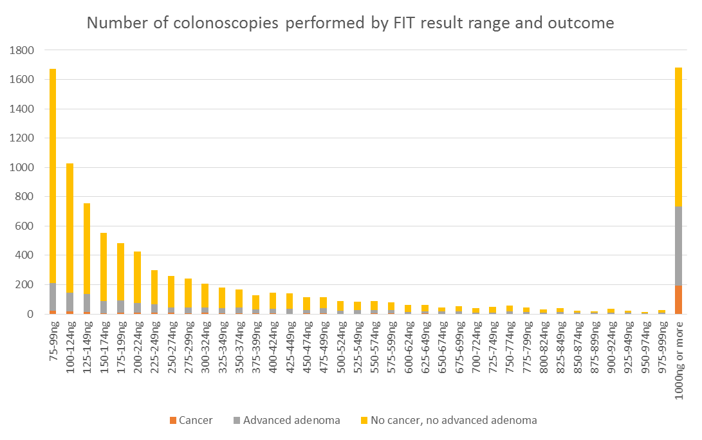
Source: Ministry of Health Bowel Screening Pilot IT system.
Younger participants with a positive FIT result were more likely to undergo a colonoscopy that resulted in no bowel cancer or significant bowel abnormality being detected.
Almost 40 percent of participants aged 50–54 years underwent a colonoscopy where nothing was removed from their bowel, ie, no potential abnormalities were detected and removed.
Figure 5: Percentage of colonoscopies that required no polyps to be removed, by age band
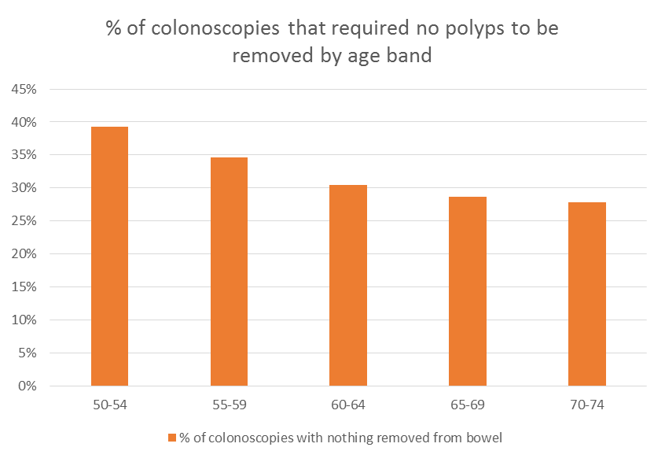
Source: Ministry of Health Bowel Screening Pilot IT system.

Rolling out a national bowel screening programme using the same age range and positivity threshold combination as used in the BSP would overwhelm New Zealand’s colonoscopy resource.
As in many countries with a public health system, New Zealand’s colonoscopy resource is constrained. This is due in large part to a limited workforce able to perform the colonoscopies. In the past, many DHBs have had long waiting lists for patients needing symptomatic and surveillance colonoscopies. This has now changed, and the majority of DHBs are providing colonoscopy services in a timeframe that meets national guidelines.
If a national bowel screening programme were rolled out to the same age range as the BSP (50–74 years) using the same low positivity threshold, the colonoscopy demand would be unachievable given the existing colonoscopy capacity. This was one of a number of factors considered when deciding on an appropriate age range and positivity threshold for New Zealand.

The number of cancers being detected per 100 colonoscopies undertaken was low when compared with other countries’ results – meaning many people were having a colonoscopy at which no significant bowel abnormality was detected.
In screening, there is the concept of a ‘positive predictor value’ or PPV. This value is a measure of how many positive results have an outcome of an abnormality or cancer being found. In the case of bowel screening, a PPV is the number of cancers found per 100 colonoscopies performed following a positive FIT result. If the PPV is low, then small numbers of cancers are being found for every 100 colonoscopies performed and many colonoscopies are being performed where there is no significant abnormality.
In the BSP, the PPV for cancer was low when compared with the results from other countries’ programmes, which have different combinations of age range and the positivity threshold. This indicated the need to alter the combination of age range and threshold for a positive FIT result in New Zealand to increase the numbers of cancers being found per 100 colonoscopies performed. Results from the BSP were used to model a large number of age range and positivity threshold combinations.
The combinations were presented to the Ministry of Health’s expert Bowel Screening Advisory Group in late 2015. The group assessed the options and determined that by narrowing the age range and elevating the positivity threshold of a FIT test, it was possible to maximise the number of cancers and advanced adenomas detected while reducing the required number of screening colonoscopy procedures. This would reduce risk for participants and bring screening colonoscopy delivery to a level that better matched capacity.
The preferred option was an age range of 60–74 years and a positivity threshold of 200ng Hb/ml buffer.
This combination will be used during the rollout of the National Bowel Screening Programme. The data will continue to be monitored to ensure that the age range and positivity threshold are the most appropriate for New Zealand.

What this means for participants in the National Bowel Screening Programme
Eligible people aged 60–74 years will be invited to participate in the National Bowel Screening Programme when it is rolled out in their DHB. Hutt Valley and Wairarapa DHBs will be the first to begin screening in 2017, with other DHBs following progressively in 2018 and 2019.
People aged 50–59 years who have been invited to take part in the Waitemata BSP who are not old enough to be invited to the national programme will continue to be offered screening if they continue to reside in the Waitemata area. These individuals will not experience a break in their screening service.
From 1 July 2017, the higher positivity threshold for FIT of 200ng Hb/ml buffer will be used for everyone in the country who is invited to participate in bowel screening. A participant completing a FIT in the national programme will be advised that their test is either positive or negative. They will not be informed of the numerical result of their test. This is consistent with what was undertaken in the BSP and with the practice of other countries, including England, which are using or planning to use FIT for bowel screening.

Will the changes in age range and threshold for positivity mean some cancers will not be detected?
Some people with a FIT result that was between the BSP threshold of 75ng and the national programme threshold of 200ng Hb/ml buffer would have been offered a colonoscopy under the BSP parameters and may have had a cancer detected.
However, most bowel cancers develop slowly over a number of years. This means that if people aged over 60 years return a bowel screening test every two years as part of the national programme, there will be repeated opportunities for a cancer to be detected.
Anyone with symptoms suggestive of bowel cancer should seek advice from their GP.

FIT and iFOBT (immunochemical faecal occult blood test) both describe exactly the same bowel screening test; the two names can be used interchangeably. Previous Ministry of Health documentation referred to iFOBT, however, FIT is now being used to align with international documentation.
In some international documentation, FIT results are expressed as micrograms of haemoglobin per gram of faeces. A 75ng Hb/ml buffer solution is equal to 15 µgHb/g faeces.
In some international documentation, FIT results are expressed as micrograms of haemoglobin per gram of faeces. A 200ng Hb/ml buffer solution is equal to 40 µgHb/g faeces.

