Antenatal Screening for Down Syndrome and Other Conditions
2018 Monitoring Report

Citation: Ministry of Health. 2021. Antenatal Screening for Down Syndrome and Other Conditions: 2018 Monitoring Report. Wellington: Ministry of Health.
Published in December 2021 by the Ministry of Health
PO Box 5013, Wellington 6140, New Zealand
ISBN 978-1-99-100798-8 (online)
HP 7998
This document is available at health.govt.nz
This work is licensed under the Creative Commons Attribution 4.0 International licence. In essence, you are free to: share ie, copy and redistribute the material in any medium or format; adapt ie, remix, transform and build upon the material. You must give appropriate credit, provide a link to the licence and indicate if changes were made.

Contents
Executive summary ix
Antenatal screening for Down syndrome and other conditions ix
Key points for 2018 x
Introduction 1
Background to screening for Down syndrome and other conditions in pregnancy in New Zealand 1
Programme monitoring and data collection 2
Information included in this report 3
Definitions 3
Inclusion criteria 4
Data calculations 4
Data limitations 7
Indicator 1: Screens commenced 8
Total screens commenced by trimester 8
Screens commenced by DHB 9
Screens commenced by age and ethnicity 12
Indicator 2: Screens completed 15
Total screens completed by trimester 15
Screens completed by DHB 16
Screens completed by age and ethnicity 19
Indicator 3: Screening pathway variance 21
Screening pathway variance by year 21
Screening pathway variance by DHB 22
Screening pathway variance by age and ethnicity 23
Indicator 4: Incomplete screens 24
Total incomplete screens 24
Incomplete T1 screens by reason incomplete 25
Incomplete T1 screens by reason and DHB 25
Incomplete T2 screens 27
Incomplete T2 screens by DHB 28
Indicator 5: Increased risk screening results for trisomy 21, trisomy 18 and trisomy 13 29
Total increased risk screening results for trisomy 21, 18 or 13 29
Increased risk screening results for trisomy 21, 18 or 13 by age and ethnicity 30
Increased risk screening results for trisomy 21, 18 or 13 by trimester of screen 31
Increased risk screening results stratified by risk level 33
Indicator 6: Diagnostic testing volumes for women with increased risk screens 34
Diagnostic testing volumes for women with increased risk screens by trimester of screen 34
Diagnostic testing volumes for women with increased risk screens by DHB 35
Diagnostic testing volumes for women with increased risk screens by age and ethnicity 37
Diagnostic testing volumes for women with increased risk screening results stratified by risk level 38
Indicator 7: Diagnostic testing volumes for women who receive a low risk screening result 39
Diagnostic testing volumes for women with low risk screens by trimester of screen 40
Diagnostic testing volumes for women with low risk screens by DHB 40
Diagnostic testing volumes for women with low risk screening results by age and ethnicity 42
Diagnostic testing volumes for women with low risk screening results stratified by risk 43
Indicator 8: Diagnostic testing for unscreened women 44
Diagnostic volumes for unscreened women 44
Diagnostic results for unscreened women 47
Indicator 9: Diagnostic testing outcomes for women with increased risk screening results 48
Positive predictive value of screening 48
Positive predictive value of screening for trisomy 21 stratified by risk level 50
Positive predictive value of screening for trisomy 21 by age and ethnicity 50
Indicator 10: False positive rate 52
False positive rate for screening 52
False positive rate for screening for trisomy 21 by age and ethnicity 53
Indicator 11: Detection rate 55
Detection rate of screening 55
Appendix 1 : Indicator definitions 57
Appendix 2 : Birth denominator data 59
Appendix 3 : Summary of diagnostic testing uptake and results for women that had an increased risk screen 61
Appendix 4 : Measuring screening performance 62
Appendix 5 : False negative screens by risk level 64
Appendix 6 : ROC curve 65
Appendix 7 : Glossary 66

List of Figures
Figure 1: Data collection process 2
Figure 2: Count and rate of screens commenced, January 2013 to December 2018 9
Figure 3: Screens commenced by DHB, January to December 2018 9
Figure 4: Screens commenced by age of mother at screen, January to December 2018 13
Figure 5: Screens commenced by ethnicity of mother, January to December 2018 13
Figure 6: Count and rate of screens completed, January 2013 to December 2018 16
Figure 7: Screens completed by DHB, January to December 2018 16
Figure 8: Screens completed by age of mother at screen, January to December 2018 20
Figure 9: Screens completed by ethnicity of mother, January to December 2018 20
Figure 10: Categorisation of screening results 62
Figure 11: ROC curve for trisomy 21, 18 and 13 screening 2018 65

List of Tables
Table 1: Total screens commenced by trimester, January 2013 to December 2018 8
Table 2: Screens commenced by trimester and DHB, January to December 2018 10
Table 3: Screens commenced per 100 births by DHB, January 2013 to December 2018 11
Table 4: Screens commenced by age and ethnicity of mother, January 2013 to December 2018 12
Table 5: Total screens completed by trimester, January 2013 to December 2018 15
Table 6: Screening completion by trimester and DHB, January to December 2018 17
Table 7: Screening completion by DHB, January 2013 to December 2018 18
Table 8: Screens completed by age and ethnicity of mother, January 2013 to December 2018 19
Table 9: Screening pathway variance by type, January 2013 to December 2018 21
Table 10: Screening pathway variance by DHB, January to December 2018 22
Table 11: Screening pathway variance by age and ethnicity, January to December 2018 23
Table 12: Incomplete screens by trimester, January 2013 to December 2018 24
Table 13: Incomplete T1 screens by reason incomplete, January 2013 to December 2018 25
Table 14: Incomplete T1 screens by reason and DHB, January to December 2018 26
Table 15: Incomplete T2 screens, January 2013 to December 2018 27
Table 16: Incomplete T2 screens by DHB, January to December 2018 28
Table 17: Number and rate per 100 screens of increased risk screening results for trisomy 21, 18 or 13, January 2013 to December 2018 29
Table 18: Increased risk screening results for trisomy 21, 18 or 13 by age and ethnicity, January to December 2018 30
Table 19: Increased risk screening results for trisomy 21, 18 and 13 by trimester of screen, January 2013 to December 2018 32
Table 20: Increased risk screening results for trisomy 21, 18 and 13 by risk level, January to December 2018 33
Table 21: Diagnostic testing volumes for women with increased risk screens by trimester of screen, January 2013 to December 2018 35
Table 22: Diagnostic testing volumes for women with increased risk screens by DHB, January 2013 to December 2018 36
Table 23: Diagnostic testing volumes for women with increased risk screens by age and ethnicity, January 2013 to December 2018 37
Table 24: Diagnostic testing volumes for women with increased risk screens by risk level, January to December 2018 38
Table 25: Diagnostic testing volumes for women with low risk screens by trimester of screen, January 2013 to December 2018 40
Table 26: Diagnostic testing volumes for women with low risk screens by DHB, January 2013 to December 2018 41
Table 27: Diagnostic testing volumes for women with low risk screens by age and ethnicity, January 2013 to December 2018 42
Table 28: Diagnostic testing volumes for women with low risk screens by risk level, aggregated 2017–2018 43
Table 29: Diagnostic testing volumes for unscreened women by DHB, January 2013 to December 2018 45
Table 30: Diagnostic testing volumes for unscreened women by age and ethnicity, January 2013 to December 2018 46
Table 31: Diagnostic testing results for unscreened women, January to December 2018 47
Table 32: Positive predictive value of screening for trisomy 21, 18 or 13, January 2013 to December 2018 49
Table 33: Positive predictive value of screening for trisomy 21, January 2013 to December 2018 49
Table 34: Positive predictive value of screening for trisomy 13 or 18, January 2013 to December 2018 49
Table 35: Positive predictive value of screening for trisomy 21 by risk level, aggregated 2017–2018 50
Table 36: Positive predictive value of screening for trisomy 21 by age and ethnicity, aggregated 2017–2018 51
Table 37: False positive rate for trisomy 21, 18 or 13, January 2013 to December 2018 52
Table 38: False positive rate for trisomy 21, 18 or 13 by trimester of screen, January to December 2018 52
Table 39: False positive rate for trisomy 21, January 2013 to December 2018 53
Table 40: False positive rate for trisomy 18 and 13, January 2013 to December 2018 53
Table 41: False positive rate for trisomy 21 by age and ethnicity, January 2013 to December 2018 54
Table 42: Detection rate for trisomy 21, 18 or 13, January 2013 to December 2018 55
Table 43: Detection rate for trisomy 21, January 2013 to December 2018 56
Table 44: Detection rate for trisomy 13 or 18, January 2013 to December 2018 56
Table 45: Definitions used for monitoring indicators 57
Table 46: Live births and still births by DHB, 2013–2018 59
Table 47: Live births and still births by age group, 2013–2018 60
Table 48: Live births and still births by ethnicity, 2013–2018 60
Table 49: Diagnostic results for women who accessed a prenatal diagnostic test following an increased risk screen for trisomy 21, 18 or 13 during the 2018 year 61
Table 50: False negative screens for trisomy 21, 18 and 13 by risk level, January 2017 to December 2018 aggregated 64

Executive summary
This report presents data on antenatal screening for Down syndrome and other conditions for the six calendar years from 1 January 2013 to 31 December 2018 and is based on screens that commenced during that time.

Antenatal screening for Down syndrome and other conditions
Antenatal screening for Down syndrome and other conditions provides a risk estimate for Down syndrome (trisomy 21), Edwards syndrome (trisomy 18), Patau syndrome (trisomy 13) and some other rare genetic disorders. This screening is optional for pregnant women. Women who are less than 20 weeks pregnant are advised about the availability of screening and provided with up-to-date information to support the screening discussion, to enable women to make an informed decision about whether to participate.

First trimester combined screening should be completed between 9 weeks and 13 weeks 6 days gestation. The recommended timing for the blood test is 9 to 10 weeks and the nuchal translucency ultrasound scan is ideally performed around 12 weeks. Second trimester maternal serum screening should be completed between 14 weeks and 20 weeks gestation. The recommended timing for this test is 14 to 18 weeks.

Key points for 2018
- Screening was commenced for 83 percent of women who gave birth in 2018.
- 2018 saw the lowest number of births for the six-year reporting period (approximately 58,000 births).
- There has been a steady increase in trimester two screens (both commenced and completed) since 2013.
- Māori screening completion rates have increased since 2013.
- The national screening completion rate has increased from 69 percent in 2013 to 74 percent of births being screened in 2018. First trimester screens made up 86 percent of all completed screens in 2018.
- Most district health boards (DHBs) showed a trend of increasing rates of screening commencement and completion.
- Ten percent of screens commenced in 2018 were not completed and nearly all related to screens commenced in the first trimester.
- The overall positive test rate (number of increased risk results per 100 screens) for trisomy 21, 18 and 13 was 4.1 in 2018, higher than 2016 (2.7).
- The positive test rate was higher for second trimester screens (6.3 per 100 screens) than for first trimester screens (3.7 per 100 screens) for 2018.
- The overall false positive rate for trisomy 21, 18 and 13 was 4 percent in 2018, higher than previous years (2–3%). The rate was higher for second trimester screens (6%) than for first trimester screens (3%).
- The overall detection rate for trisomy 21, 18 and 13 was 78 percent in 2018, compared to 79 percent in 2016.
- Over this reporting period several changes have occurred that may have impacted on the programme indicators, for example, nasal bone measurement has been excluded since March 2018.
- Despite the increasing availability of non-invasive prenatal screening (NIPS) to pregnant women in New Zealand, screening completion rates have increased over the reporting period, except for Auckland DHB.
- Changes to data linkage processes were implemented from 2017. Caution is required when comparing 2017 and 2018 data with previous years.

Introduction

Background to screening for Down syndrome and other conditions in pregnancy in New Zealand
Antenatal screening for Down syndrome and other conditions has been available to pregnant women in New Zealand since 1968. In October 2007, the government agreed to implement quality improvements to ensure consistency with international best practice at the time. The improvements were introduced in February 2010 and included incorporating maternal serum screening with ultrasound, providing practitioner guidelines and consumer resources.

Health practitioners providing maternity care are required to provide women with information about antenatal screening services for Down syndrome and other conditions. There are two screening options.
- First trimester combined screening, which includes a blood test and an ultrasound scan. The blood sample is collected between 9 weeks and 13 weeks 6 days gestation and measures two maternal serum markers: pregnancy-associated protein A (PAPP-A) and free beta-human chorionic gonadotropin (ßhCG). The ultrasound scan determines nuchal translucency (NT) and crown rump length (CRL) measurements and is performed between 11 weeks 2 days and 13 weeks 6 days gestation.
- Second trimester screening, which is a blood test taken between 14- and 20-weeks’ gestation that measures four maternal serum markers: ßhCG, alpha-fetoprotein (AFP), unconjugated oestriol (uE3) and inhibin A.

The results of the ultrasound scan and/or serum are combined with other demographic and maternal factors to provide a risk result. For consistency, all screening risk results are produced by the screening laboratories. The screening laboratories are LabPLUS at Auckland DHB (for samples from Taupo and north of Taupo) and Canterbury Health Laboratories at Canterbury DHB (for samples from south of Taupo). A shared data repository (PerkinElmer LifeCycle) contains data on all screens. Ultrasound scanning is performed by private and public radiology practices around New Zealand and the ultrasound report is sent to the screening laboratories to include in the risk calculation algorithm.

The conditions covered by screening include:
- trisomy 21 (Down Syndrome)
- trisomy 18 (Edwards syndrome)
- trisomy 13 (Patau syndrome)
- triploidy
- Turner syndrome
- neural tube defects.

Antenatal screening involves many health professionals including radiology staff, Lead Maternity Carers (LMCs), general practitioners (GPs) and laboratory personnel. The quality of the information provided by health professionals to the laboratories regarding the pregnancy details (such as gestation, maternal age, weight, ethnicity and the ultrasound finding) is critical because these details have a significant impact on the risk calculation that is produced by the laboratories.

Programme monitoring and data collection
This report presents monitoring results for antenatal screening for Down syndrome and other conditions for the period 1 January 2013 to 31 December 2018. The definitions for the 11 indicators in this report are contained in Appendix 1. Figure 1 outlines the data collection process the National Screening Unit used to produce indicators 1 to 11.

Figure 1: Data collection process
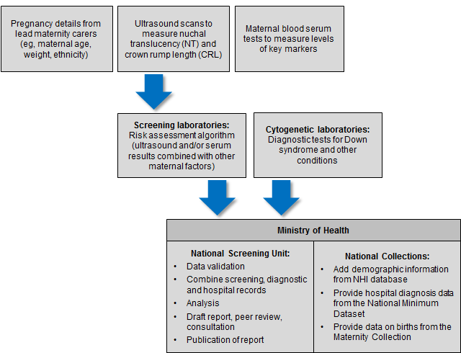

The indicators contained within this monitoring report form one part of the evaluation and audit of the quality improvements to antenatal screening for Down syndrome and other conditions. Other activities include:
- IANZ accreditation assessment
- contract monitoring and reporting on a six-monthly basis
- occasional studies and qualitative information.

Information included in this report
The screening data in this report was sourced from LabPLUS and covers all of New Zealand. As in 2016, diagnostic testing data was received from all cytogenetic laboratories (LabPLUS, Waikato, Capital & Coast, and Canterbury Health Laboratories).

The screening and cytogenetic data was matched with hospital discharge data, sourced from the National Minimum Data Set (NMDS), held by the Ministry of Health. This matching between data from screening laboratories, cytogenetic laboratories, and the NMDS was undertaken to identify the outcome for all screened women.

Definitions

Required components of each screening test
First trimester screening comprises analysis of two serum analytes (βhCG, PAPP-A) and an NT measurement. Second trimester screening comprises analysis of four serum analytes (βhCG, AFP, uE3 and Inhibin A).

Demographic and maternal factors are also required (eg, date of birth, weight).

Commenced screening
At least one of the required components of the screening test was completed (NT measurement or serum analytes).

Completed screening
All the required components of each screening test were completed, and a risk result was reported.

Low risk result
A low risk result is defined as a risk lower than 1:300. So, a risk of 1:310 is a low risk.

Increased risk result
An increased risk result is defined as a risk higher than or equal to 1:300. For some indicators increased risk screening results are further stratified into:
- 1:5 to 1:20
- >1:20 to 1:50
- >1:50 to 1:300.

Inclusion criteria
Screens were included in this analysis if the following criteria were met.
- Screening commencement date between 1 January 2013 and 31 December 2018 (ie, date of the first test the woman had as part of the screening pathway).
- Valid National Health Index (NHI) identifier.
- Age at screen from 12 years to 49 years (date of birth as supplied by the requestor).
- Single screening result per pregnancy.

Data calculations

DHB of domicile
Each woman was allocated to a DHB based on the residential address recorded in the National Health Index (NHI). Where the NHI database did not have a DHB recorded for an NHI, information from the LabPLUS database was used to assign the DHB.

Ethnicity
Ethnicity data in this report is grouped according to a prioritised system, which is commonly applied across the New Zealand health sector. Prioritisation involves allocating each person to a single ethnic group, based on the ethnicities that person has identified, in the prioritised order of Māori, Pacific, Asian and Other ethnicity. For example, if someone identifies as being New Zealand European and Māori, under the prioritised ethnicity method, they are classified as Māori for the purpose of the analysis. Under this method, the Other ethnicity group effectively refers to non-Māori, non-Pacific and non-Asian people.

NZ Deprivation
Due to issues with NZ Deprivation Index (NZ Dep), breakdown by deprivation has not been included in this report.

Births
Data on the number of live and still births was obtained from the National Maternity Collection for each calendar year. Appendix 2 contains tables for the denominators used in this report.

Small numbers
Small numbers can affect the reliability of results. Where an indicator calculation involves small counts (numerator less than six) then those results have been suppressed as they are considered too unstable.

Prenatal cytogenetic test
The focus of indicators 6, 7, and 8 is on tests that women choose to have as part of managing their pregnancy. For these indicators prenatal tests are a karyotype or array by chorionic villus sampling (CVS) or amniocentesis procedures (tests on products of conception are not included). For indicators 9, 10 and 11, cytogenetic tests on products of conception are used in addition to CVS, amniocentesis and infant diagnoses to determine the outcome of the pregnancy.

Repeat screens
A repeat screen was defined as a second screen for the same woman within 112 days. Where this occurred, the first completed screen was retained for the analysis. The figure of 112 days was based on the timing of the screening test and considering how soon a woman may become pregnant again following a miscarriage.

Linking rules
When matching screening and diagnosis data the following rules were followed.
- Joining Births: Births are joined where they match the mothers NHI and are between 0- and 230-days post screen (approximately 33 weeks).
- Joining NMDS Outcomes: Outcomes are joined where they match the babies NHI.
- Joining Cytogenetics Data: Cytogenetics data is joined where 1: they are from the mother and between 0- and 105-days post screen (15 weeks), or 2: are from the baby and are between 0- and 230-days post screen.

These were based on the possible timing of the different screening and diagnostic tests.

A project reviewing the end-to-end data analysis process for the Down syndrome and other conditions report was started in 2018 and has resulted in changes to data linking rules. These changes have been applied to 2017 and 2018 data but not for years prior to this. Caution is therefore required when comparing data for 2013–2016 with 2017–2018. Where a five-year rate would ordinarily have been applied, a decision has been made to supply a two-year rate (2017 and 2018) where this does not compromise privacy.

Data limitations

Denominator underestimation
Screening completion rates derived using total births may overestimate the proportion of women participating in antenatal screening for Down syndrome and other conditions. This is because the true denominator (ie, all pregnant women that reach 9 weeks gestation) is likely to be larger than the denominator used (ie, all births reaching at least 20 weeks gestation or at least 400 g birth weight).

Incomplete data
Missing or incomplete data for any screened woman will affect indicator calculations. Known data issues in this report relate to the following.
- Thirteen women had no DHB of domicile or ethnicity information recorded in either the NHI database or in the laboratory information system. These women are included in the national total but not in DHB or ethnicity breakdowns.

Indicator 1:
Screens commenced
This indicator reports the number of screens commenced by trimester of screening (first or second), by DHB, age and ethnicity.

Total screens commenced by trimester
During 2018, a total of 48,011 screens were commenced, a rate of 83 per 100 births. Table 1 shows the total number of screens commenced by year and trimester of screen. Throughout the report T1 is used to refer to first trimester and T2 to second trimester. The vast majority of screens were T1 screens. The rate of screens commenced per 100 births has increased over time from 75 in 2013 to 83 in 2018 (see Table 1 and Figure 2).

Table 1: Total screens commenced by trimester, January 2013 to December 2018
Trimester of screen | Number and rate of screens commenced
 | 2013 | 2014 | 2015 | 2016 | 2017 | 2018
T1 screen | 38,803 | 40,172 | 41,283 | 41,816 | 41,403 | 41,681
T2 screen | 5,487 | 5,613 | 5,742 | 6,152 | 6,369 | 6,330
Total screens | 44,290 | 45,785 | 47,025 | 47,968 | 47,772 | 48,011
Screens per 100 births | 75.3 | 78.0 | 80.3 | 80.9 | 80.6 | 82.7

Figure 2: Count and rate of screens commenced, January 2013 to December 2018
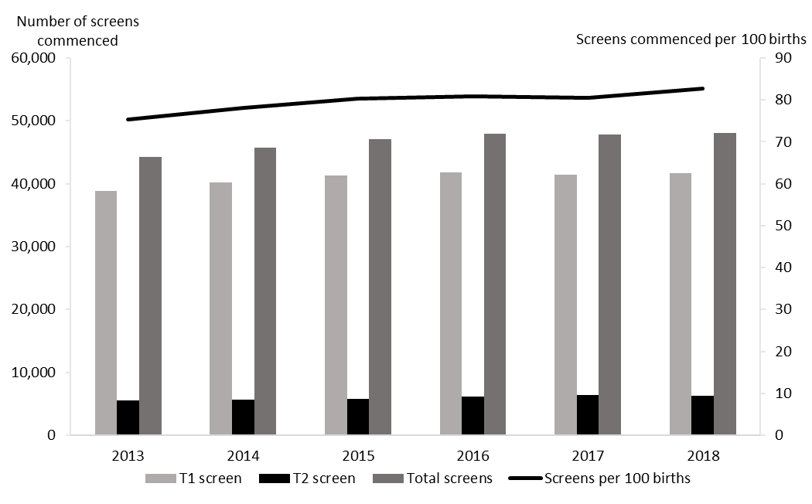

Screens commenced by DHB
Figure 3 shows the screening commencement rates by DHB for 2018. There was a large variation in rates from 62 per 100 births in Northland to 95 per 100 births in South Canterbury. Two-thirds (65%) of all DHBs had rates of above 80 per 100 births. Table 2 gives a full breakdown by the trimester of the screen.

Figure 3: Screens commenced by DHB, January to December 2018
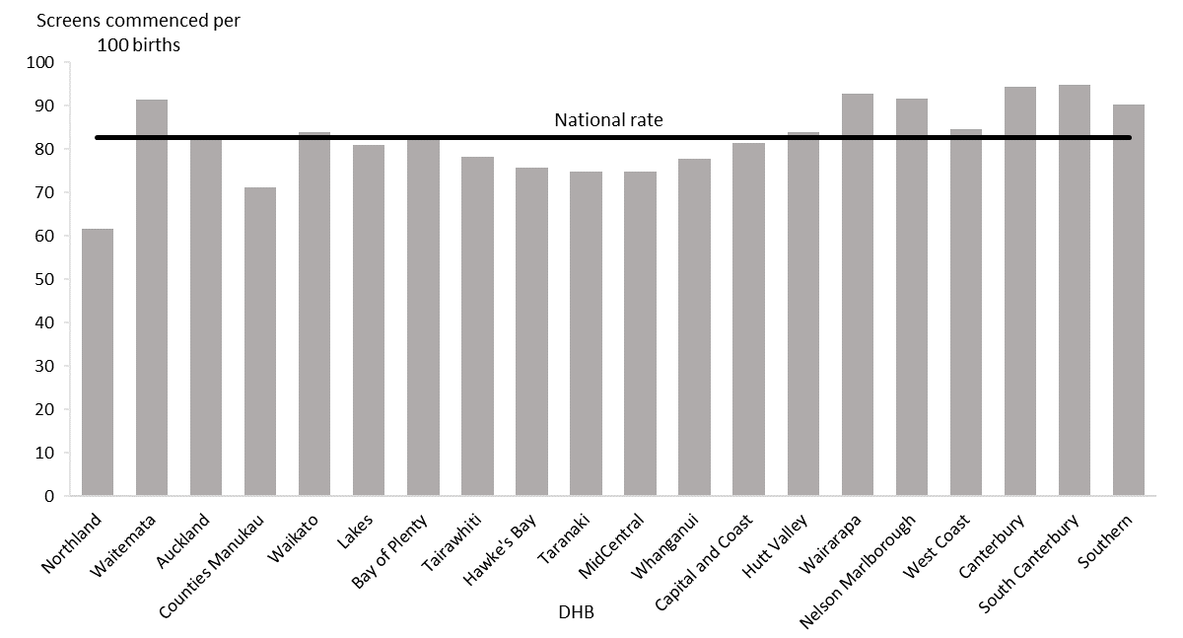

Table 2: Screens commenced by trimester and DHB, January to December 2018
DHB | Number of screens commenced |  |  | Screens commenced  (per 100 births)
 | First trimester | Second trimester | Total | First trimester | Second trimester | Total
Northland | 1,156 | 197 | 1,353 | 52.7 | 9.0 | 61.7
Waitematā | 6,007 | 781 | 6,788 | 80.9 | 10.5 | 91.4
Auckland | 3,873 | 591 | 4,464 | 71.3 | 10.9 | 82.2
Counties Manukau | 4,473 | 1,333 | 5,806 | 54.8 | 16.3 | 71.1
Waikato | 4,036 | 484 | 4,520 | 75.0 | 9.0 | 84.0
Lakes | 1,042 | 193 | 1,235 | 68.3 | 12.6 | 80.9
Bay of Plenty | 2,270 | 227 | 2,497 | 75.4 | 7.5 | 82.9
Tairāwhiti | 469 | 77 | 546 | 67.1 | 11.0 | 78.1
Hawke's Bay | 1,426 | 168 | 1,594 | 67.6 | 8.0 | 75.6
Taranaki | 874 | 293 | 1,167 | 56.0 | 18.8 | 74.7
MidCentral | 1,471 | 144 | 1,615 | 68.0 | 6.7 | 74.7
Whanganui | 534 | 95 | 629 | 66.1 | 11.8 | 77.8
Capital & Coast | 2,337 | 271 | 2,608 | 73.0 | 8.5 | 81.4
Hutt Valley | 1,408 | 219 | 1,627 | 72.7 | 11.3 | 84.0
Wairarapa | 417 | 43 | 460 | 84.1 | 8.7 | 92.7
Nelson Marlborough | 1,235 | 136 | 1,371 | 82.4 | 9.1 | 91.5
West Coast | 239 | 36 | 275 | 73.5 | 11.1 | 84.6
Canterbury | 5,230 | 671 | 5,901 | 83.6 | 10.7 | 94.3
South Canterbury | 495 | 76 | 571 | 82.1 | 12.6 | 94.7
Southern | 2,666 | 290 | 2,956 | 81.4 | 8.9 | 90.2
National | 41,681 | 6,330 | 48,011 | 71.8 | 10.9 | 82.7
Note: DHB counts do not sum to National total.

Most DHBs showed an increase in their rate of screens commenced between 2013 and 2018 or had fairly stable rates (see Table 3).

Table 3: Screens commenced per 100 births by DHB, January 2013 to December 2018
DHB | Screens commenced (per 100 births)
 | 2013 | 2014 | 2015 | 2016 | 2017 | 2018
Northland | 52.9 | 55.6 | 60.1 | 58.6 | 64.2 | 61.7
Waitematā | 86.3 | 86.3 | 88.4 | 87.1 | 86.7 | 91.4
Auckland | 82.4 | 84.0 | 85.7 | 82.0 | 75.8 | 82.2
Counties Manukau | 64.8 | 68.7 | 71.1 | 71.0 | 70.6 | 71.1
Waikato | 76.4 | 80.4 | 81.8 | 83.7 | 85.5 | 84.0
Lakes | 70.1 | 77.4 | 74.3 | 76.7 | 73.6 | 80.9
Bay of Plenty | 69.6 | 72.4 | 77.6 | 81.1 | 82.2 | 82.9
Tairāwhiti | 53.2 | 59.3 | 68.3 | 63.6 | 70.2 | 78.1
Hawke's Bay | 64.6 | 66.0 | 72.6 | 76.2 | 71.8 | 75.6
Taranaki | 61.4 | 68.2 | 74.9 | 67.8 | 72.7 | 74.7
MidCentral | 58.3 | 59.3 | 63.9 | 73.1 | 79.9 | 74.7
Whanganui | 47.9 | 61.0 | 70.5 | 74.1 | 71.8 | 77.8
Capital & Coast | 78.1 | 80.3 | 83.4 | 86.3 | 76.1 | 81.4
Hutt Valley | 72.7 | 78.6 | 78.7 | 82.2 | 76.3 | 84.0
Wairarapa | 76.6 | 81.6 | 83.8 | 89.0 | 90.1 | 92.7
Nelson Marlborough | 87.4 | 97.6 | 96.0 | 85.1 | 98.6 | 91.5
West Coast | 81.1 | 88.3 | 82.4 | 86.5 | 84.4 | 84.6
Canterbury | 90.3 | 89.5 | 89.4 | 91.5 | 92.4 | 94.3
South Canterbury | 88.1 | 78.8 | 86.4 | 87.5 | 94.0 | 94.7
Southern | 81.4 | 83.3 | 85.1 | 87.8 | 89.0 | 90.2
National average | 75.3 | 78.0 | 80.3 | 80.9 | 80.6 | 82.7

Screens commenced by age and ethnicity
Table 4 provides an overall view of screens commenced by age and ethnicity for January 2013 to December 2018. During this reporting period the overall rate of screens commenced has increased and though variation between age and ethnicity is still evident these differences have become less marked.

Table 4: Screens commenced by age and ethnicity of mother, January 2013 to December 2018
 | Number of screens commenced |  |  |  |  |  | Screens commenced (per 100 births)
 | 2013 | 2014 | 2015 | 2016 | 2017 | 2018 | 2013 | 2014 | 2015 | 2016 | 2017 | 2018
Age at screen (years)
Under 20 | 1,947 | 1,990 | 1,925 | 1,829 | 1,683 | 1,546 | 58.5 | 66.6 | 69.1 | 74.9 | 73.3 | 72.7
20–24 | 6,932 | 7,055 | 7,109 | 7,000 | 6,899 | 6,475 | 64.2 | 68.7 | 71.5 | 73.0 | 74.0 | 74.5
25–29 | 12,022 | 12,800 | 13,189 | 13,943 | 14,037 | 14,162 | 78.8 | 81.5 | 84.0 | 84.3 | 84.4 | 87.1
30–34 | 13,914 | 14,623 | 15,124 | 15,732 | 15,804 | 16,171 | 83.0 | 83.2 | 84.5 | 85.6 | 84.5 | 86.4
35–39 | 7,628 | 7,610 | 8,007 | 7,781 | 7,659 | 8,091 | 76.0 | 78.6 | 82.0 | 78.1 | 77.5 | 80.8
40–44 | 1,767 | 1,626 | 1,593 | 1,574 | 1,587 | 1,476 | 72.6 | 69.3 | 69.3 | 69.2 | 68.6 | 70.5
45 and over | 80 | 81 | 78 | 109 | 103 | 90 | 55.9 | 61.4 | 56.1 | 86.5 | 67.8 | 55.6
Ethnicity
Māori | 5,805 | 6,284 | 6,256 | 7,176 | 7,754 | 7,675 | 39.6 | 43.9 | 42.9 | 48.7 | 52.0 | 52.7
Pacific | 2,999 | 3,005 | 3,120 | 3,089 | 3,284 | 3,206 | 47.2 | 48.7 | 51.5 | 52.9 | 55.0 | 53.7
Asian | 7,474 | 4,835 | 8,695 | 9,851 | 9,720 | 10,330 | 91.7 | 91.8 | 94.4 | 93.6 | 92.0 | 97.5
Other | 28,012 | 28,058 | 28,954 | 27,852 | 27,005 | 26,796 | 94.5 | 96.6 | 100.9 | 98.7 | 97.0 | 99.5
National | 44,290 | 45,785 | 47,025 | 47,968 | 47,772 | 48,011 | 75.3 | 78.0 | 80.3 | 80.9 | 80.6 | 82.7
Note: Ethnic group counts do not sum to National total.

The 25–29 and 30–34 age groups had the highest rate of screens commenced for 2018 with 87 and 86 women commencing screening per 100 births respectively. From 2013 to 2018 rates have increased overall for most age groups, particularly the younger age groups. The only age groups that did not increase were 40–44 years and 45 years and over.

Figure 4: Screens commenced by age of mother at screen, January to December 2018
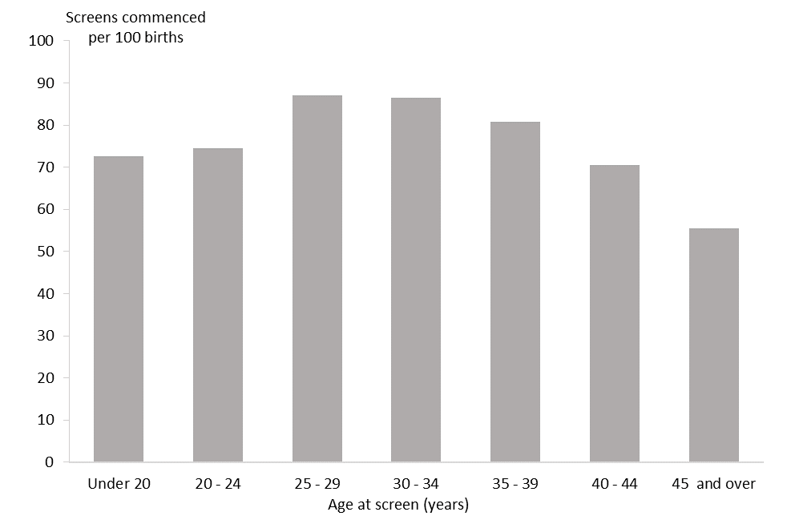

Figure 5: Screens commenced by ethnicity of mother, January to December 2018
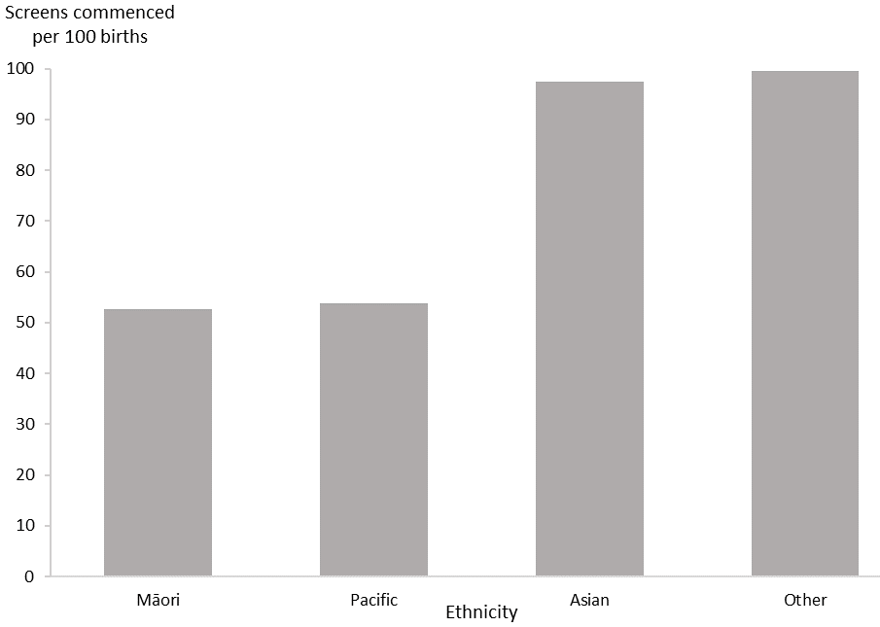

Differences in screening commencement rates by ethnicity remained consistent for 2018. Women of Other ethnicity had the highest rate (100 of 100 births) followed by Asian women (98 of 100 births). The rate of commenced screens for Pacific and Māori women was lower at 54 per 100 births and 53 per 100 births respectively (see Figure 5). All groups have shown increasing rates over the six years, particularly for Māori with an absolute increase of 13 percentage points from 40 percent in 2013 to 53 percent in 2018 (see Table 4). This rate is however well below the national rate of 83 per 100 births in 2018.

Indicator 2:
Screens completed
This indicator reports the number of screens completed by trimester of screening, DHB, age and ethnicity.

Total screens completed by trimester
During 2018, a total of 43,052 screens were completed, a rate of 74 screens per 100 births. Table 5 and Figure 6 show the total number of screens completed per year and trimester of screen. Across all years the majority of screens were completed in the first trimester. The total number and rate of completed screens has increased since 2013 (from 69 to 74 in 2018).

Table 5: Total screens completed by trimester, January 2013 to December 2018
Trimester of screen | Number and rate of screens completed
 | 2013 | 2014 | 2015 | 2016 | 2017 | 2018
T1 screen | 35,464 | 36,280 | 36,739 | 37,511 | 36,836 | 36,810
T2 screen | 5,269 | 5,456 | 5,517 | 6,008 | 6,284 | 6,242
Total screens | 40,733 | 41,736 | 42,256 | 43,519 | 43,120 | 43,052
Screens per 100 births | 69.3 | 71.1 | 72.2 | 73.4 | 72.7 | 74.2

Figure 6: Count and rate of screens completed, January 2013 to December 2018
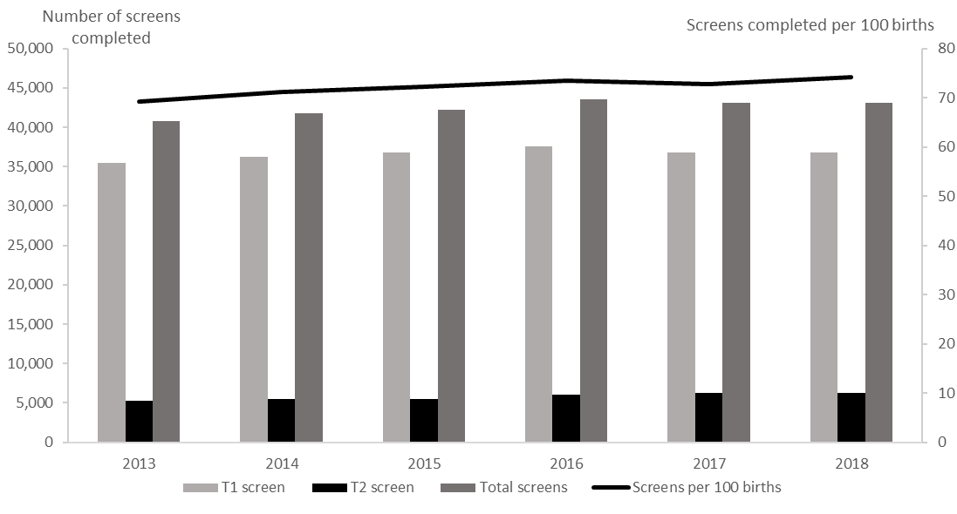

Screens completed by DHB
Screening completion rates for 2018 varied across DHBs from 54 per 100 births in Northland to 88 per 100 births in South Canterbury (see Figure 7). Table 6 gives a full breakdown by the trimester of screen.

Figure 7: Screens completed by DHB, January to December 2018
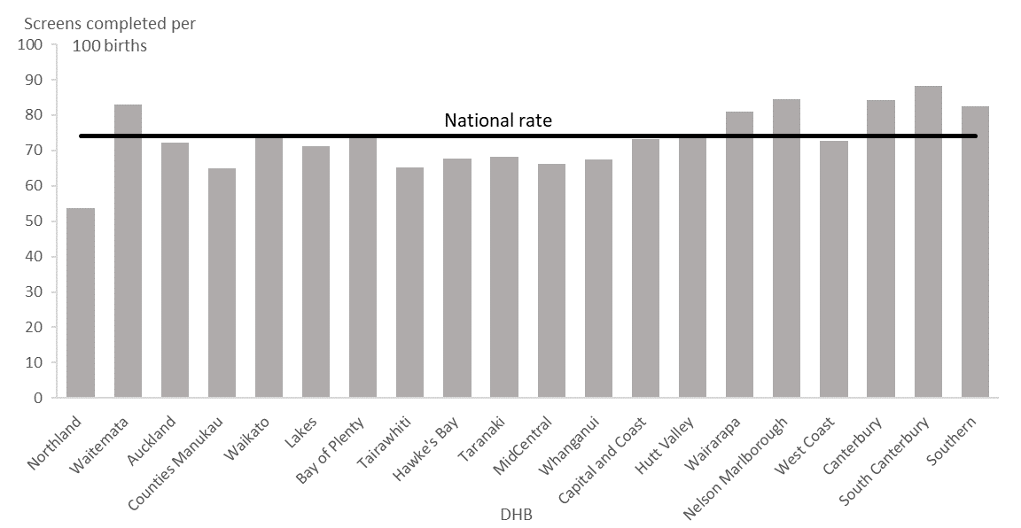

Table 6: Screening completion by trimester and DHB, January to December 2018
DHB | Number of screens completed |  |  | Screens completed  (per 100 births)
 | First trimester | Second trimester | Total | First trimester | Second trimester | Total
Northland | 980 | 195 | 1,175 | 44.7 | 8.9 | 53.6
Waitematā | 5,384 | 769 | 6,153 | 72.5 | 10.4 | 82.9
Auckland | 3,335 | 585 | 3,920 | 61.4 | 10.8 | 72.2
Counties Manukau | 3,986 | 1,311 | 5,297 | 48.8 | 16.1 | 64.9
Waikato | 3,548 | 479 | 4,027 | 65.9 | 8.9 | 74.8
Lakes | 896 | 190 | 1,086 | 58.7 | 12.5 | 71.2
Bay of Plenty | 2,020 | 226 | 2,246 | 67.1 | 7.5 | 74.6
Tairāwhiti | 382 | 73 | 455 | 54.6 | 10.4 | 65.1
Hawke's Bay | 1,260 | 166 | 1,426 | 59.8 | 7.9 | 67.6
Taranaki | 777 | 290 | 1,067 | 49.7 | 18.6 | 68.3
MidCentral | 1,292 | 141 | 1,433 | 59.8 | 6.5 | 66.3
Whanganui | 452 | 94 | 546 | 55.9 | 11.6 | 67.6
Capital & Coast | 2,084 | 264 | 2,348 | 65.1 | 8.2 | 73.3
Hutt Valley | 1,224 | 217 | 1,441 | 63.2 | 11.2 | 74.4
Wairarapa | 359 | 43 | 402 | 72.4 | 8.7 | 81.0
Nelson Marlborough | 1,133 | 134 | 1,267 | 75.6 | 8.9 | 84.6
West Coast | 200 | 36 | 236 | 61.5 | 11.1 | 72.6
Canterbury | 4,608 | 661 | 5,269 | 73.6 | 10.6 | 84.2
South Canterbury | 456 | 76 | 532 | 75.6 | 12.6 | 88.2
Southern | 2,415 | 287 | 2,702 | 73.7 | 8.8 | 82.5
National | 36,810 | 6,242 | 43,052 | 63.4 | 10.8 | 74.2
Note: DHB counts do not sum to National total.

Table 7: Screening completion by DHB, January 2013 to December 2018
DHB | Screens completed (per 100 births)
 | 2013 | 2014 | 2015 | 2016 | 2017 | 2018
Northland | 47.1 | 48.0 | 51.6 | 50.9 | 56.2 | 53.6
Waitematā | 82.1 | 81.0 | 81.8 | 81.4 | 79.8 | 82.9
Auckland | 77.7 | 78.8 | 79.1 | 75.6 | 68.6 | 72.2
Counties Manukau | 59.6 | 63.2 | 64.5 | 65.5 | 64.4 | 64.9
Waikato | 69.2 | 72.5 | 72.4 | 74.6 | 76.3 | 74.8
Lakes | 62.6 | 69.9 | 65.7 | 67.8 | 65.7 | 71.2
Bay of Plenty | 62.0 | 64.5 | 67.8 | 71.8 | 73.6 | 74.6
Tairāwhiti | 47.1 | 51.5 | 53.8 | 51.1 | 59.1 | 65.1
Hawke's Bay | 59.9 | 59.4 | 64.2 | 68.6 | 63.7 | 67.6
Taranaki | 55.1 | 61.2 | 66.3 | 62.1 | 66.4 | 68.3
MidCentral | 53.8 | 54.0 | 56.9 | 66.1 | 72.3 | 66.3
Whanganui | 45.0 | 53.1 | 58.5 | 65.8 | 63.6 | 67.6
Capital & Coast | 70.9 | 72.6 | 75.1 | 77.8 | 67.8 | 73.3
Hutt Valley | 64.7 | 68.9 | 68.0 | 71.6 | 67.3 | 74.4
Wairarapa | 66.7 | 70.6 | 72.8 | 77.9 | 80.6 | 81.0
Nelson Marlborough | 78.1 | 87.6 | 84.7 | 77.4 | 90.1 | 84.6
West Coast | 72.3 | 78.9 | 72.3 | 77.7 | 76.8 | 72.6
Canterbury | 81.9 | 81.2 | 80.6 | 82.5 | 83.0 | 84.2
South Canterbury | 85.6 | 75.3 | 79.8 | 81.5 | 85.4 | 88.2
Southern | 75.5 | 74.8 | 77.9 | 81.1 | 81.7 | 82.5
National average | 69.3 | 71.1 | 72.2 | 73.4 | 72.7 | 74.2

Similar to screens commenced, most DHBs showed a trend of increasing rates of screening completion over the six years covered in this report, with the exception of Auckland DHB, which showed a decreasing trend from 2016 to 2018 (the rate for 2013 was 77.7 compared with 72.2 per 100 births in 2018).

Screens completed by age and ethnicity
Table 8 provides an overall view of screens completed by age and ethnicity for January 2013 to December 2018, with similar trends to screening commencement. Screening completion rates were highest in the 25–29 years age group with 79 women completing screening per 100 births in 2018.

Screening completion rates were highest among women of Asian ethnicity at 91 per 100 births for 2018. This was followed closely by women of Other ethnicity at 90 per 100 births. The rate of completed screens for Pacific and Māori women remains lower at 47 per 100 births and 44 per 100 births respectively (see Figure 9).

Table 8: Screens completed by age and ethnicity of mother, January 2013 to December 2018
 | Number of screens completed |  |  |  |  |  | Screens completed (per 100 births)
 | 2013 | 2014 | 2015 | 2016 | 2017 | 2018 | 2013 | 2014 | 2015 | 2016 | 2017 | 2018
Age at screen (years)
Under 20 | 1,610 | 1,604 | 1,510 | 1,474 | 1,376 | 1,243 | 48.4 | 53.6 | 54.2 | 60.3 | 59.9 | 58.4
20–24 | 6,010 | 6,070 | 5,992 | 6,079 | 5,948 | 5,588 | 55.6 | 59.1 | 60.3 | 63.4 | 63.8 | 64.3
25–29 | 11,097 | 11,685 | 11,824 | 12,675 | 12,779 | 12,898 | 72.7 | 74.4 | 75.3 | 76.6 | 76.9 | 79.4
30–34 | 13,089 | 13,675 | 14,030 | 14,709 | 14,651 | 14,823 | 78.0 | 77.8 | 78.3 | 80.1 | 78.4 | 79.2
35–39 | 7,214 | 7,144 | 7,430 | 7,137 | 6,959 | 7,205 | 71.9 | 73.9 | 76.1 | 71.6 | 70.4 | 71.9
40–44 | 1,643 | 1,486 | 1,406 | 1,366 | 1,328 | 1,225 | 67.5 | 63.3 | 61.2 | 60.0 | 57.4 | 58.5
45 and over | 70 | 72 | 64 | 79 | 79 | 70 | 49.0 | 54.5 | 46.0 | 62.7 | 52.0 | 43.2
Ethnicity
Māori | 4,893 | 5,178 | 4,911 | 5,924 | 6,442 | 6,387 | 33.4 | 36.2 | 33.7 | 40.2 | 43.2 | 43.8
Pacific | 2,606 | 2,598 | 2,626 | 2,673 | 2,876 | 2,782 | 41.0 | 42.1 | 43.3 | 45.8 | 48.2 | 46.6
Asian | 7,091 | 8,034 | 8,114 | 9,304 | 9,093 | 9,594 | 87.0 | 87.4 | 88.1 | 88.4 | 86.1 | 90.6
Other | 26,143 | 25,926 | 26,605 | 25,618 | 24,701 | 24,287 | 88.2 | 89.2 | 92.7 | 90.8 | 88.7 | 90.2
National | 40,733 | 41,736 | 42,256 | 43,519 | 43,120 | 43,052 | 69.3 | 71.1 | 72.2 | 73.4 | 72.7 | 74.2
Note: Ethnic group counts do not sum to National total.

As seen in screening commencement rates, most groups showed an overall increase in completion rates over the six-year period, with the biggest increases seen in Māori and Pacific ethnicities and younger women. The only groups to show a decrease in screening completion rates were women aged 40–44 years and 45 years and over.

Figure 8: Screens completed by age of mother at screen, January to December 2018
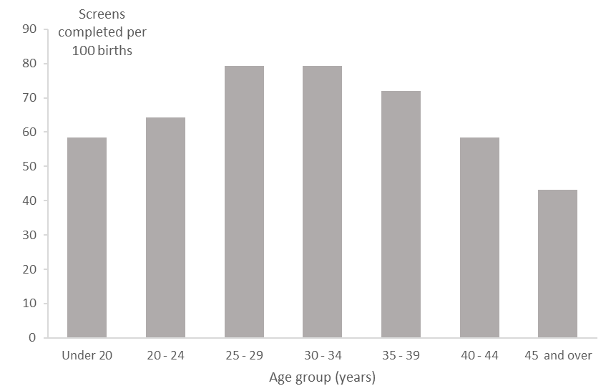

Figure 9: Screens completed by ethnicity of mother, January to December 2018
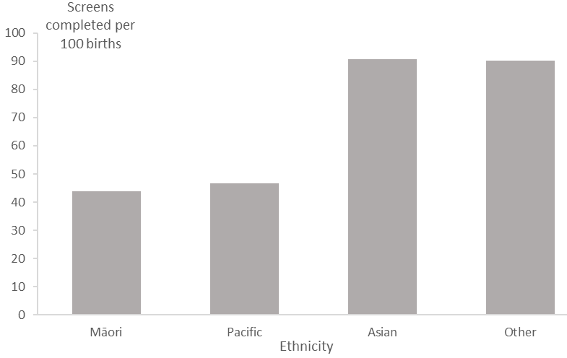

Indicator 3: Screening pathway variance
This section reports on the number of screens completed in the second trimester which included first trimester screening components. First trimester combined screening requires a blood sample (PAPP-A and ßhCG) and ultrasound scan measurements of NT and CRL. Without both items a risk is not calculated, and a second trimester blood sample is recommended. Any information available from the first trimester (NT or PAPP-A) will be included in the second trimester risk assessment.

Second trimester results with an NT measurement indicate that the screening laboratory did not receive a suitable first trimester blood sample. Second trimester results with PAPP-A indicate that the screening laboratory did not receive an NT scan report, or that the scan was performed outside the accepted timeframe for first trimester screening.

Screening pathway variance by year
Table 9 shows the number and proportion of second trimester screening results that included first trimester inputs over the period from 2013 to 2018. This has been broken down by the type of pathway variance.

The largest pathway variance was due to second trimester screens with an NT measurement (41 percent in 2018). PAPP-A was included in 12 percent of second trimester screens in 2018, higher than previous years.

Table 9: Screening pathway variance by type, January 2013 to December 2018
Year | Second trimester screening results
 | Number |  |  | Percentage
 | Total T2 screens | with NT | with PAPP-A | with NT | with PAPP-A
2013 | 5,269 | 2,219 | 361 | 42.1 | 6.9
2014 | 5,456 | 2,379 | 376 | 43.6 | 6.9
2015 | 5,517 | 2,466 | 344 | 44.7 | 6.2
2016 | 6,008 | 2,670 | 500 | 44.4 | 8.3
2017 | 6,284 | 2,561 | 656 | 40.8 | 10.4
2018 | 6,242 | 2,563 | 735 | 41.1 | 11.8

Screening pathway variance by DHB
Table 10 shows a breakdown of screening pathway variance by DHB and type of variance for the 2018 year. Care should be taken with interpretation given the low number of T2 screens for many DHBs. In general, the national result is reflected at DHB level with a far higher number of women having an NT scan and a T2 screen than those having a T2 screen with PAPP-A.

The crown rump length (CRL) measured by ultrasound is used by the screening laboratory to calculate gestation (may be different from the clinical gestation) leading to women being assessed in a different trimester.

Table 10: Screening pathway variance by DHB, January to December 2018
DHB | Second trimester screening results
 | Number |  |  | Percentage
 | Total T2 screens | with NT | with PAPP-A | with NT | with PAPP-A
Northland | 195 | 66 | 22 | 33.8 | 11.3
Waitematā | 769 | 316 | 107 | 41.1 | 13.9
Auckland | 585 | 199 | 101 | 34.0 | 17.3
Counties Manukau | 1,311 | 369 | 157 | 28.1 | 12.0
Waikato | 479 | 249 | 33 | 52.0 | 6.9
Lakes | 190 | 70 | 18 | 36.8 | 9.5
Bay of Plenty | 226 | 111 | 15 | 49.1 | 6.6
Tairāwhiti | 73 | 27 | 9 | 37.0 | 12.3
Hawke's Bay | 166 | 62 | 24 | 37.3 | 14.5
Taranaki | 290 | 57 | 45 | 19.7 | 15.5
MidCentral | 141 | 78 | 12 | 55.3 | 8.5
Whanganui | 94 | 43 | 9 | 45.7 | 9.6
Capital & Coast | 264 | 129 | 16 | 48.9 | 6.1
Hutt Valley | 217 | 107 | 22 | 49.3 | 10.1
Wairarapa | 43 | 29 | S | 67.4 | S
Nelson Marlborough | 134 | 78 | 13 | 58.2 | 9.7
West Coast | 36 | 19 | S | 52.8 | S
Canterbury | 661 | 351 | 93 | 53.1 | 14.1
South Canterbury | 76 | 29 | 17 | 38.2 | 22.4
Southern | 287 | 172 | 17 | 59.9 | 5.9
National | 6,242 | 2,563 | 735 | 41.1 | 11.8
Note: DHB counts do not sum to National total.
(S) Suppressed if the number of screens was < 6.

Screening pathway variance by age and ethnicity
Table 11 shows a breakdown of screening pathway variance by age and ethnicity for the 2018 year. The results show higher proportions for pathway variance for women in the 20–24 and 30–34 age groups (43%) and women of Other ethnicity (51%).

Table 11: Screening pathway variance by age and ethnicity, January to December 2018
 | Second trimester screening results
 | Number |  |  | Percentage
 | Total T2 screens | with NT | with PAPP-A | with NT | with PAPP-A
Age at screen (years)
Under 20 | 389 | 144 | 27 | 37.0 | 6.9
20–24 | 1,269 | 548 | 104 | 43.2 | 8.2
25–29 | 1,867 | 761 | 226 | 40.8 | 12.1
30–34 | 1,675 | 719 | 221 | 42.9 | 13.2
35–39 | 853 | 328 | 133 | 38.5 | 15.6
40–44 | 177 | 59 | 24 | 33.3 | 13.6
45 and over | 12 | 4 | 0 | 33.3 | 0
Ethnicity
Māori | 1,551 | 613 | 129 | 39.5 | 8.3
Pacific | 1,071 | 299 | 104 | 27.9 | 9.7
Asian | 1,364 | 492 | 202 | 36.1 | 14.8
Other | 2,256 | 1,159 | 300 | 51.4 | 13.3
National | 6,242 | 2,563 | 735 | 41.1 | 11.8

Indicator 4:
Incomplete screens
This section reports on the number of women who commenced screening but were not issued with a risk result. Women that start screening in trimester 1 but complete screening in trimester 2 are not included in this indicator and are instead covered under indicator 3, pathway variances.

Total incomplete screens
Table 12 shows the total number of incomplete screens by calendar year and trimester of screen. Nearly all incomplete screens related to the first trimester, which reflects the different components required to complete screening depending on the trimester. First trimester screening requires a blood sample and an NT scan, whereas second trimester screening involves only a blood sample. The total number of incomplete screens for 2018 was 4,959, which equates to 10 percent of screens commenced that year.

Table 12: Incomplete screens by trimester, January 2013 to December 2018
Trimester of screen | Number of incomplete screens
 | 2013 | 2014 | 2015 | 2016 | 2017 | 2018
T1 screens | 3,339 | 3,892 | 4,544 | 4,305 | 4,567 | 4,871
T2 screens | 218 | 157 | 225 | 144 | 85 | 88
Total screens | 3,557 | 4,049 | 4,769 | 4,449 | 4,652 | 4,959

Incomplete T1 screens by reason incomplete
Table 13 shows provides a breakdown of incomplete T1 screens according to which component of the screen was missing. Results have been reported as a percentage of all commenced screens, and then as a percentage of all incomplete screens.

The proportion of incomplete T1 screens out of all commenced T1 screens in 2018 was 12 percent. This was the result of both screens without blood samples and screens without NT scans. The majority of incomplete screens in T1 were due to a missing blood sample.

Table 13: Incomplete T1 screens by reason incomplete, January 2013 to December 2018
Year | Commenced first trimester |  |  | Reason incomplete |  |  | Incomplete as percentage of commenced |  |  | Type as percentage of all incomplete T1 screens
 | No result issued | Result issued | Total | No blood | No NT scan | No weight | T1 no blood | T1 no NT scan | Total T1 incompletes | T1 no blood | T1 no NT scan
2013 | 3,339 | 35,464 | 38,803 | 2,318 | 1,021 | – | 6.0 | 2.6 | 8.6 | 69.4 | 30.6
2014 | 3,892 | 36,280 | 40,172 | 2,630 | 1,262 | – | 6.5 | 3.1 | 9.7 | 67.6 | 32.4
2015 | 4,544 | 36,739 | 41,283 | 2,925 | 1,619 | – | 7.1 | 3.9 | 11.0 | 64.4 | 35.6
2016 | 4,305 | 37,511 | 41,816 | 2,946 | 1,335 | 24 | 7.0 | 3.2 | 10.3 | 68.4 | 31.0
2017 | 4,567 | 36,836 | 41,403 | 3,275 | 1,286 | 12 | 7.9 | 3.1 | 11.0 | 71.7 | 28.2
2018 | 4,871 | 36,810 | 41,681 | 3,530 | 1,334 | 13 | 8.5 | 3.2 | 11.7 | 72.5 | 27.4

Incomplete T1 screens by reason and DHB
Table 14 provides the same breakdown by DHB for the 2018 year. The lower numbers involved limit DHB comparisons. The range in the percentage of screens incomplete due to no blood sample was from 45 percent (at Taranaki) to 90 percent (at South Canterbury).

Table 14: Incomplete T1 screens by reason and DHB, January to December 2018
DHB | Commenced first trimester |  |  | Reason incomplete |  |  | Incomplete as percentage of commenced |  |  | Type as percentage of all incomplete T1 screens
 | No result issued | Result issued | Total | No blood | No NT scan | No weight | T1 no blood | T1 no NT scan | Total T1 incompletes | T1 no blood | T1 no NT scan
Northland | 176 | 980 | 1,156 | 132 | 44 | S | 11.4 | 3.8 | 15.2 | 75.0 | 25.0
Waitematā | 623 | 5,384 | 6,007 | 443 | 180 | S | 7.4 | 3.0 | 10.4 | 71.1 | 28.9
Auckland | 538 | 3,335 | 3,873 | 409 | 129 | S | 10.6 | 3.3 | 13.9 | 76.0 | 24.0
Counties Manukau | 487 | 3,986 | 4,473 | 334 | 153 | S | 7.5 | 3.4 | 10.9 | 68.6 | 31.4
Waikato | 488 | 3,548 | 4,036 | 374 | 113 | S | 9.3 | 2.8 | 12.1 | 76.6 | 23.2
Lakes | 146 | 896 | 1,042 | 107 | 39 | S | 10.3 | 3.7 | 14.0 | 73.3 | 26.7
Bay of Plenty | 250 | 2,020 | 2,270 | 182 | 68 | S | 8.0 | 3.0 | 11.0 | 72.8 | 27.2
Tairāwhiti | 87 | 382 | 469 | 66 | 21 | S | 14.1 | 4.5 | 18.6 | 75.9 | 24.1
Hawke's Bay | 166 | 1,260 | 1,426 | 106 | 60 | S | 7.4 | 4.2 | 11.6 | 63.9 | 36.1
Taranaki | 97 | 777 | 874 | 44 | 53 | S | 5.0 | 6.1 | 11.1 | 45.4 | 54.6
MidCentral | 179 | 1,292 | 1,471 | 135 | 41 | S | 9.2 | 2.8 | 12.2 | 75.4 | 22.9
Whanganui | 82 | 452 | 534 | 61 | 21 | S | 11.4 | 3.9 | 15.4 | 74.4 | 25.6
Capital & Coast | 253 | 2,084 | 2,337 | 184 | 67 | S | 7.9 | 2.9 | 10.8 | 72.7 | 26.5
Hutt Valley | 184 | 1,224 | 1,408 | 134 | 50 | S | 9.5 | 3.6 | 13.1 | 72.8 | 27.2
Wairarapa | 58 | 359 | 417 | 47 | 11 | S | 11.3 | 2.6 | 13.9 | 81.0 | 19.0
Nelson Marlborough | 102 | 1,133 | 1,235 | 72 | 29 | S | 5.8 | 2.3 | 8.3 | 70.6 | 28.4
West Coast | 39 | 200 | 239 | 29 | 10 | S | 12.1 | 4.2 | 16.3 | 74.4 | 25.6
Canterbury | 622 | 4,608 | 5,230 | 466 | 156 | S | 8.9 | 3.0 | 11.9 | 74.9 | 25.1
South Canterbury | 39 | 456 | 495 | 35 | S | S | 7.1 | S | 7.9 | 89.7 | S
Southern | 251 | 2,415 | 2,666 | 168 | 83 | S | 6.3 | 3.1 | 9.4 | 66.9 | 33.1
National | 4,871 | 36,810 | 41,681 | 3,530 | 1,334 | 13 | 8.5 | 3.2 | 11.7 | 72.5 | 27.4
(S) Suppressed if the number of screens was < 6.

Incomplete T2 screens
T2 screens do not require an NT scan, just a blood sample, but may be incomplete if missing dating information or no weight, if the sample is taken later than 20 weeks of pregnancy, or if the sample is damaged and not repeated. For 2018, 1 percent of T2 commenced screens were incomplete, compared with 12 percent of T1 commenced screens. As Table 15 shows, the percentage of incomplete T2 screens decreased from 4 percent in 2013 to 1 percent in 2018.

Table 15: Incomplete T2 screens, January 2013 to December 2018
Year | Commenced second trimester | No result issued | Percentage incomplete
2013 | 5,487 | 218 | 4.0
2014 | 5,613 | 157 | 2.8
2015 | 5,742 | 225 | 3.9
2016 | 6,152 | 144 | 2.3
2017 | 6,369 | 85 | 1.3
2018 | 6,330 | 88 | 1.4
Total | 35,693 | 917 | Ave: 2.6

Incomplete T2 screens by DHB
Table 16 shows a breakdown of incomplete T2 screens by DHB for the 2018 year. The very low numbers involved limit meaningful DHB comparisons.

Table 16: Incomplete T2 screens by DHB, January to December 2018
DHB | Commenced second trimester | No result issued | % incomplete
Northland | 197 | S | S
Waitematā | 781 | 12 | 1.5
Auckland | 591 | 6 | 1.0
Counties Manukau | 1,333 | 22 | 1.7
Waikato | 484 | S | S
Lakes | 193 | S | S
Bay of Plenty | 227 | S | S
Tairāwhiti | 77 | S | S
Hawke's Bay | 168 | S | S
Taranaki | 293 | S | S
MidCentral | 144 | S | S
Whanganui | 95 | S | S
Capital & Coast | 271 | 7 | 2.6
Hutt Valley | 219 | S | S
Wairarapa | 43 | S | S
Nelson Marlborough | 136 | S | S
West Coast | 36 | S | S
Canterbury | 671 | 10 | 1.5
South Canterbury | 76 | S | S
Southern | 290 | S | S
National | 6,330 | 88 | 1.4
Note: DHB counts do not sum to National total.
(S) Suppressed if the number of screens was < 6.

Indicator 5: Increased risk screening results for trisomy 21, trisomy 18 and trisomy 13
This indicator reports on the screening risk results issued for trisomy 21, trisomy 18 and trisomy 13. Women who complete screening receive a risk result, either low risk or increased risk, for each trisomy. This means that an individual woman may be at increased risk for more than one trisomy.

Total increased risk screening results for trisomy 21, 18 or 13
Table 17 shows total number of screening risk results that were classified as increased risk for one or more of trisomy 21, 18 or 13 by calendar year, together with the number of increased risk results per 100 screens (positive test rate). For the 2018 year, 4.1 increased risk results were issued for every 100 screens completed, which is higher than previous years.

Table 17: Number and rate per 100 screens of increased risk screening results for trisomy 21, 18 or 13, January 2013 to December 2018
 | Number and rate of increased risk screens
 | 2013 | 2014 |  | 2015 |  | 2016 |  | 2017 |  | 2018
Total increased risk results | 1,111 |  | 1,162 |  | 1,168 |  | 1,189 |  | 1,318 |  | 1,764
Positive test rate per 100 completed screens | 2.7 |  | 2.8 |  | 2.8 |  | 2.7 |  | 3.1 |  | 4.1

Increased risk screening results for trisomy 21, 18 or 13 by age and ethnicity
Table 18 shows the number and proportion of screening risk results that were classified as increased risk for any one or more of trisomy 21, 18, or 13 by age at screen and ethnicity for the 2018 year.

Positive test rate was higher for Pacific and Asian women compared with other ethnicities. Older women are more likely to have a positive test and are also more likely to have a higher detection rate. This is because of the inclusion of prior risk (age) as part of the risk calculation.

Table 18: Increased risk screening results for trisomy 21, 18 or 13 by age and ethnicity, January to December 2018
 | Number of screens that include an increased risk for trisomy 21, 18 or 13 | Total no. of completed screens | Positive test rate per 100 screens
Age at screen (years)
Under 20 | 14 | 1,243 | 1.1
20–24 | 74 | 5,588 | 1.3
25–29 | 208 | 12,898 | 1.6
30–34 | 453 | 14,823 | 3.1
35–39 | 648 | 7,205 | 9.0
40–44 | 345 | 1,225 | 28.2
45 and over | 22 | 70 | 31.4
Ethnicity
Māori | 209 | 6,387 | 3.3
Pacific | 151 | 2,782 | 5.4
Asian | 486 | 9,594 | 5.1
Other | 918 | 24,287 | 3.8
National | 1,764 | 43,052 | 4.1
Note: Ethnic group counts do not sum to National total (for total number of completed screens).

Increased risk screening results for trisomy 21, 18 or 13 by trimester of screen
Table 19 shows the positive test rate for each of trisomy 21, 18 and 13 individually as well as the positive test rate for the three trisomies together by trimester of screen and calendar year. The sum of the individual values for trisomy 21, 18 and 13 is greater than the value for the fourth grouping (any of the three trisomies) because a result can be at increased risk for more than one trisomy.

Trisomy 18 and 13 each had low positivity rates (0.4 per 100 screens) while the positive test rate for trisomy 21 has increased to 4 per 100 screens. The second trimester positive test rate for trisomy 21 was higher than the first trimester positive test rate (6.1 and 3.7 respectively). This difference was the same in 2014 (4.8 and 2.4) but has generally been a smaller difference in previous years. The difference in rates may be due to variability in nuchal translucency and crown rump length assessments and the removal of nasal bone from the risk calculation algorithm. The positive test rate for any one or more of trisomy 21, 18 or 13 was similar to that of trisomy 21 alone. This reflects the far higher number of increased risk screening results for trisomy 21 compared with trisomy 18 and 13.

Table 19: Increased risk screening results for trisomy 21, 18 and 13 by trimester of screen, January 2013 to December 2018
Year | Total results that include an increased risk for specified trisomy | Positive test rate per 100 screens | T1 results that include an increased risk for specified trisomy | Positive test rate per 100 T1 screens | T2 results that include an increased risk for specified trisomy | Positive test rate per 100 T2 screens
Trisomy 21
2013 | 1,089 | 2.7 | 848 | 2.4 | 241 | 4.6
2014 | 1,136 | 2.7 | 875 | 2.4 | 261 | 4.8
2015 | 1,145 | 2.7 | 942 | 2.6 | 203 | 3.7
2016 | 1,146 | 2.6 | 950 | 2.5 | 196 | 3.3
2017 | 1,287 | 3.0 | 1,033 | 2.8 | 254 | 4.0
2018 | 1,740 | 4.0 | 1,361 | 3.7 | 379 | 6.1
Trisomy 18
2013 | 150 | 0.4 | 130 | 0.4 | 20 | 0.4
2014 | 139 | 0.3 | 123 | 0.3 | 16 | 0.3
2015 | 147 | 0.3 | 129 | 0.4 | 18 | 0.3
2016 | 171 | 0.4 | 142 | 0.4 | 29 | 0.5
2017 | 140 | 0.3 | 123 | 0.3 | 17 | 0.3
2018 | 161 | 0.4 | 143 | 0.4 | 18 | 0.3
Trisomy 13
2013 | 162 | 0.4 | 148 | 0.4 | 14 | 0.3
2014 | 152 | 0.4 | 138 | 0.4 | 14 | 0.3
2015 | 161 | 0.4 | 149 | 0.4 | 12 | 0.2
2016 | 174 | 0.4 | 161 | 0.4 | 13 | 0.2
2017 | 161 | 0.4 | 143 | 0.4 | 18 | 0.3
2018 | 167 | 0.4 | 155 | 0.4 | 12 | 0.2
Any one or more of trisomy 21, 18 or 13
2013 | 1,111 | 2.7 | 855 | 2.4 | 256 | 4.9
2014 | 1,162 | 2.8 | 888 | 2.4 | 274 | 5.0
2015 | 1,168 | 2.8 | 947 | 2.6 | 221 | 4.0
2016 | 1,189 | 2.7 | 969 | 2.6 | 220 | 3.7
2017 | 1,318 | 3.1 | 1,046 | 2.8 | 272 | 4.3
2018 | 1,764 | 4.1 | 1,373 | 3.7 | 391 | 6.3

Increased risk screening results stratified by risk level
Table 20 shows the number of increased risk results stratified by risk level for each of trisomy 21, 18 and 13 for the 2018 year. A woman’s screen result may indicate an increased risk for more than one of trisomy 21, 18 and 13 so the sum of the values in Table 20 will be greater than the total number of increased risk results for 2018.

Table 20: Increased risk screening results for trisomy 21, 18 and 13 by risk level, January to December 2018
Risk level | Trisomy 21 | Trisomy 18 | Trisomy 13
1:5 to 1:20 | 245 | 50 | 62
>1:20 to 1:50 | 187 | 27 | 27
>1:50 to 1:300 | 1,308 | 84 | 78

Indicator 6: Diagnostic testing volumes for women with increased risk screens
This indicator reports information on the number and proportion of women who complete prenatal diagnostic testing (CVS or amniocentesis) following an increased risk screening result for trisomy 21, trisomy 18 or trisomy 13. Following an increased risk result, women may choose to have diagnostic testing (either amniocentesis or CVS) to determine the absence or the presence of the condition.

Diagnostic testing volumes for women with increased risk screens by trimester of screen
Table 21 shows the diagnostic testing rate from 2013 to 2018 by trimester of screen. In 2018, for every 100 women that received an increased risk result after a first or second trimester screen, 38 women had a diagnostic test. There has been a downward trend since 2013, although 2018 has seen a slight increase in the number of women having a diagnostic test compared to 2017. The diagnostic testing rate was lower for women who received an increased risk after a second trimester screen (35 women per 100 increased risk screens) compared with first trimester screens (38 per 100 increased risk screens). 2018 sees the smallest difference between the first and second trimester diagnostic testing rate and this has steadily dropped since 2013. See Appendix 3 for a summary of diagnostic test results for women who had an increased risk screen in 2018.

Table 21: Diagnostic testing volumes for women with increased risk screens by trimester of screen, January 2013 to December 2018
Trimester of screen | Diagnostic tests per 100 increased risk screens
 | 2013 | 2014 | 2015 | 2016 | 2017 | 2018
T1 screen | 66.0 | 62.5 | 59.0 | 46.9 | 36.7 | 38.4
T2 screen | 46.9 | 47.4 | 44.3 | 40.5 | 29.0 | 35.3
Total screens | 61.6 | 59.0 | 56.3 | 45.7 | 35.1 | 37.7

Diagnostic testing volumes for women with increased risk screens by DHB
The number of diagnostic tests and rate per 100 increased risk screens by DHB is given in Table 22. Many DHBs have low numbers and care should be taken with comparisons.

Table 22: Diagnostic testing volumes for women with increased risk screens by DHB, January 2013 to December 2018
DHB | Number of diagnostic tests |  |  |  |  |  | Diagnostic tests per 100 increased risk screens
 | 2013 | 2014 | 2015 | 2016 | 2017 | 2018 | 2013 | 2014 | 2015 | 2016 | 2017 | 2018
Northland | 28 | 26 | 21 | 12 | 12 | 18 | 56.0 | 59.1 | 48.8 | 40.0 | 34.3 | 38.3
Waitematā | 141 | 116 | 107 | 82 | 78 | 102 | 72.7 | 61.7 | 57.5 | 44.6 | 37.5 | 37.2
Auckland | 89 | 89 | 76 | 72 | 49 | 63 | 67.4 | 55.3 | 53.5 | 45.0 | 30.6 | 31.8
Counties Manukau | 73 | 76 | 86 | 78 | 55 | 99 | 47.1 | 50.3 | 53.8 | 54.9 | 31.4 | 39.6
Waikato | 41 | 41 | 42 | 45 | 29 | 56 | 57.7 | 64.1 | 60.0 | 52.9 | 30.2 | 39.4
Lakes | 21 | 21 | 28 | 16 | 14 | 19 | 67.7 | 53.8 | 71.8 | 59.3 | 46.7 | 46.3
Bay of Plenty | 21 | 21 | 20 | 17 | 18 | 26 | 53.8 | 63.6 | 66.7 | 44.7 | 40.0 | 39.4
Tairāwhiti | S | S | S | S | S | 7 | S | S | S | S | S | 43.8
Hawke's Bay | 21 | 20 | 15 | 8 | 7 | 15 | 53.8 | 58.8 | 51.7 | 28.6 | 26.9 | 33.3
Taranaki | 18 | 12 | 10 | 8 | S | 10 | 66.7 | 48.0 | 43.5 | 36.4 | S | 35.7
MidCentral | 10 | 11 | 8 | 15 | 20 | 19 | 38.5 | 57.9 | 44.4 | 46.9 | 50.0 | 52.8
Whanganui | 6 | S | S | 6 | S | 9 | 46.2 | S | S | 66.7 | S | 52.9
Capital & Coast | 55 | 46 | 65 | 41 | 30 | 34 | 74.3 | 59.7 | 60.7 | 60.3 | 32.6 | 37.0
Hutt Valley | 18 | 15 | 18 | 15 | 15 | 18 | 58.1 | 53.6 | 64.3 | 45.5 | 45.5 | 34.0
Wairarapa | 9 | S | S | S | S | S | 81.8 | S | S | S | S | S
Nelson Marlborough | 17 | 19 | 15 | 14 | 13 | 20 | 89.5 | 79.2 | 57.7 | 51.9 | 48.1 | 44.4
West Coast | S | 8 | S | 6 | S | S | S | 42.1 | S | 85.7 | S | S
Canterbury | 74 | 122 | 83 | 80 | 70 | 95 | 60.2 | 65.6 | 50.6 | 36.7 | 32.0 | 34.2
South Canterbury | S | S | 9 | S | 7 | S | S | S | 75.0 | S | 36.8 | S
Southern | 34 | 33 | 40 | 20 | 31 | 44 | 64.2 | 67.3 | 60.6 | 37.0 | 44.9 | 48.4
National | 684 | 685 | 657 | 543 | 463 | 665 | 61.6 | 59.0 | 56.3 | 45.7 | 35.1 | 37.7
(S) Suppressed if the number of diagnostic tests was < 6.

Diagnostic testing volumes for women with increased risk screens by age and ethnicity
Table 23 shows the diagnostic testing rate for women with increased risk screens by age and ethnicity for 2013 to 2018.

For 2018, diagnostic testing rates were highest for women of Other ethnicity (39 per 100 increased risk screens), followed by Asian and Māori women (38 and 37 per 100 increased risk screens respectively), and then Pacific women (33 per 100 increased risk screens). From age 25 years, diagnostic testing rates reduce with each age grouping.

Table 23: Diagnostic testing volumes for women with increased risk screens by age and ethnicity, January 2013 to December 2018
 | Diagnostic tests per 100 increased risk screens
 | 2013 | 2014 | 2015 | 2016 | 2017 | 2018
Age at screen (years)
Under 20 | 28.6 | 50.0 | 53.8 | 45.5 | 17.4 | 28.6
20–24 | 62.5 | 53.9 | 51.7 | 55.6 | 43.5 | 50.0
25–29 | 60.5 | 62.7 | 58.1 | 49.4 | 38.2 | 44.7
30–34 | 68.1 | 64.9 | 61.8 | 47.7 | 38.8 | 41.3
35–39 | 62.6 | 57.1 | 57.0 | 46.0 | 32.9 | 35.3
40–44 | 57.4 | 58.1 | 50.9 | 39.0 | 29.8 | 32.5
45 and over | 44.4 | 36.0 | 41.2 | 27.8 | 35.3 | 13.6
Ethnicity
Māori | 52.5 | 38.4 | 45.1 | 46.7 | 30.1 | 37.3
Pacific | 38.2 | 39.2 | 36.2 | 34.3 | 31.0 | 33.1
Asian | 69.2 | 67.0 | 63.3 | 56.3 | 37.7 | 37.9
Other | 65.2 | 62.8 | 58.7 | 42.1 | 35.9 | 38.5
National | 61.6 | 59.0 | 56.3 | 45.7 | 35.1 | 37.7

Diagnostic testing volumes for women with increased risk screening results stratified by risk level
Each screening result includes a separate risk for each of trisomy 21, 18 and 13. For the analysis in this report, women were assigned a combined trisomy risk level based on the highest risk score they received across the three trisomies. Table 24 shows the number of diagnostic tests for women that received an increased risk result during 2018 for one or more of trisomy 21, 18 or 13, stratified by risk level. As expected, the number of women having a diagnostic test increased with increasing risk level, increasing from 30 to 70 tests per 100 women with an increased risk.

Table 24: Diagnostic testing volumes for women with increased risk screens by risk level, January to December 2018
Risk level | Number of diagnostic tests | Number of increased risk screens | Tests per 100 increased risk screens
1:5 to 1:20 | 178 | 255 | 69.8
>1:20 to 1:50 | 96 | 185 | 51.9
>1:50 to 1:300 | 391 | 1,324 | 29.5

Indicator 7: Diagnostic testing volumes for women who receive a low risk screening result
This section reports information on the number and proportion of women who complete prenatal diagnostic testing (CVS or amniocentesis procedures) following a low risk screening result. Following a low risk screen, women may still choose to have diagnostic testing to determine the absence or the presence of a condition.

This indicator intends to capture only those that had a low risk screening result in isolation so for this calculation a woman was only counted as having a low risk screen if there was no increased risk for any of the other conditions covered by the screening test in addition to trisomy 21, 18 and 13. For example, if the result was low risk for each of trisomy 21, 18 and 13 but increased risk for neural tube defects then the woman was categorised as at increased risk for the purposes of this indicator.

Some women with low risk screening results may have other indications for diagnostic testing, for example, family history of another condition that diagnostic testing can identify or an abnormal ultrasound finding. Information on the indication for diagnostic testing is not reliably provided on laboratory forms so the calculations for this indicator cannot exclude these women.

Diagnostic testing volumes for women with low risk screens by trimester of screen
The national rate of diagnostic testing for women that received low risk screening results was 0.79 per 100 low risk screens in 2018, which was the highest rate for the reporting period.

Table 25: Diagnostic testing volumes for women with low risk screens by trimester of screen, January 2013 to December 2018
Trimester of screen | Diagnostic tests per 100 low risk screens
 | 2013 | 2014 | 2015 | 2016 | 2017 | 2018
T1 screen | 0.77 | 0.68 | 0.74 | 0.53 | 0.75 | 0.80
T2 screen | 0.48 | 0.56 | 0.36 | 0.69 | 0.70 | 0.74
Total screens | 0.73 | 0.67 | 0.69 | 0.55 | 0.75 | 0.79

Diagnostic testing volumes for women with low risk screens by DHB
The rate of diagnostic testing by DHB for women with low risk screens has varied each year from 2013 to 2018, as shown in Table 26. Given the low numbers involved, caution should be taken in making comparisons and some numbers have been withheld where the numerator is lower than six.

Table 26: Diagnostic testing volumes for women with low risk screens by DHB, January 2013 to December 2018
DHB | Number of diagnostic tests |  |  |  |  |  | Diagnostic tests per 100 low risk screens
 | 2013 | 2014 | 2015 | 2016 | 2017 | 2018 | 2013 | 2014 | 2015 | 2016 | 2017 | 2018
Northland | 7 | S | 7 | S | S | 11 | 0.74 | S | 0.66 | S | S | 0.98
Waitematā | 54 | 35 | 33 | 37 | 43 | 52 | 0.89 | 0.57 | 0.55 | 0.59 | 0.72 | 0.88
Auckland | 55 | 38 | 36 | 20 | 29 | 33 | 1.17 | 0.79 | 0.80 | 0.46 | 0.78 | 0.89
Counties Manukau | 27 | 18 | 23 | 28 | 45 | 29 | 0.57 | 0.35 | 0.45 | 0.53 | 0.87 | 0.57
Waikato | 18 | 30 | 21 | 16 | 33 | 34 | 0.51 | 0.80 | 0.56 | 0.41 | 0.83 | 0.88
Lakes | S | S | 8 | S | 6 | 7 | S | S | 0.84 | S | 0.60 | 0.67
Bay of Plenty | 9 | 14 | 7 | 12 | 13 | 20 | 0.54 | 0.80 | 0.38 | 0.59 | 0.58 | 0.92
Tairāwhiti | S | S | S | S | S | S | S | S | S | S | S | S
Hawke's Bay | 6 | 7 | 8 | S | 6 | 14 | 0.48 | 0.59 | 0.64 | S | 0.45 | 1.01
Taranaki | 9 | S | S | S | S | S | 1.11 | S | S | S | S | S
MidCentral | 9 | 8 | 11 | S | 11 | S | 0.81 | 0.72 | 0.93 | S | 0.73 | S
Whanganui | S | S | S | S | S | S | S | S | S | S | S | S
Capital & Coast | 21 | 15 | 22 | 19 | 15 | 18 | 0.84 | 0.60 | 0.86 | 0.72 | 0.66 | 0.80
Hutt Valley | 8 | 11 | 9 | 6 | 10 | 6 | 0.66 | 0.88 | 0.69 | 0.44 | 0.78 | 0.43
Wairarapa | S | S | S | S | 6 | S | S | S | S | S | 1.41 | S
Nelson Marlborough | 12 | S | 9 | 9 | 7 | 10 | 1.01 | S | 0.77 | 0.77 | 0.56 | 0.82
West Coast | S | S | S | S | S | S | S | S | S | S | S | S
Canterbury | 31 | 45 | 52 | 37 | 47 | 44 | 0.67 | 0.96 | 1.08 | 0.74 | 0.92 | 0.88
South Canterbury | S | S | S | 7 | 7 | S | S | S | S | 1.35 | 1.35 | S
Southern | 17 | 33 | 29 | 23 | 22 | 23 | 0.67 | 1.37 | 1.12 | 0.87 | 0.80 | 0.88
National | 290 | 271 | 283 | 233 | 312 | 325 | 0.73 | 0.67 | 0.69 | 0.55 | 0.75 | 0.79
(S) Suppressed if the number of diagnostic tests was < 6.

Diagnostic testing volumes for women with low risk screening results by age and ethnicity
Table 27 shows the rate of diagnostic testing for women with low risk screening results by age and ethnicity. The rate of diagnostic testing was higher for women in the older age groups. Māori women were the least likely to have a diagnostic test after a low risk screen.

Table 27: Diagnostic testing volumes for women with low risk screens by age and ethnicity, January 2013 to December 2018
 | Diagnostic tests per 100 low risk screens
 | 2013 | 2014 | 2015 | 2016 | 2017 | 2018
Age at screen (years)
Under 20 | 0.38 | 0.44 | 0.33 | 0.34 | 0.81 | 0.81
20–24 | 0.32 | 0.37 | 0.35 | 0.43 | 0.68 | 0.71
25–29 | 0.37 | 0.49 | 0.52 | 0.50 | 0.65 | 0.60
30–34 | 0.53 | 0.53 | 0.60 | 0.54 | 0.67 | 0.84
35–39 | 1.19 | 0.98 | 1.11 | 0.66 | 0.99 | 0.96
40–44 | 5.30 | 3.92 | 3.04 | 1.33 | 1.67 | 1.70
45 and over | 6.98 | 0.00 | 2.13 | 3.28 | 1.61 | 2.08
Ethnicity
Māori | 0.57 | 0.46 | 0.46 | 0.50 | 0.65 | 0.74
Pacific | 0.28 | 0.28 | 0.48 | 0.35 | 0.75 | 0.79
Asian | 0.65 | 0.58 | 0.80 | 0.54 | 0.89 | 0.76
Other | 0.83 | 0.78 | 0.72 | 0.58 | 0.73 | 0.80
National | 0.73 | 0.67 | 0.69 | 0.55 | 0.75 | 0.79

Diagnostic testing volumes for women with low risk screening results stratified by risk
Table 28 shows the rate of diagnostic testing for women with low risk screening results, stratified by risk level. Given the low numbers involved for some risk categories, numbers have been aggregated for 2017 and 2018.

Table 28: Diagnostic testing volumes for women with low risk screens by risk level, aggregated 2017–2018
Risk level | Number of diagnostic tests | Number of low risk screens | Tests per 100 low risk screens
1:301 to 1:500 | 43 | 1,550 | 2.77
1:501 to 1:1,000 | 65 | 3,882 | 1.67
1:1,001 to 1:2,000 | 58 | 6,144 | 0.94
1:2,001 to 1:3,000 | 54 | 4,997 | 1.08
1:3,001 to 1:4,000 | 35 | 4,392 | 0.80
1:4,001 to 1:5,000 | 23 | 3,783 | 0.61
1:5,001 to 1:10,000 | 93 | 14,523 | 0.64
1:10,001 to 1:100,000 | 266 | 43,819 | 0.61

Indicator 8: Diagnostic testing for unscreened women
This section reports information on the number of women who completed prenatal diagnostic testing but were not screened in the 105 days prior to the diagnostic test. The indication for diagnostic testing is not reliably reported on laboratory request forms but it is likely that many of these women will have had an increased prior risk (eg, family history, previous child with Down syndrome, late maternal age) or a diagnostic test done for another reason and the karyotype reported or an abnormal ultrasound finding.

Diagnostic volumes for unscreened women
During the 2018 year, 156 diagnostic tests were completed for unscreened women. This is generally lower than the number undertaken in previous years, with 2017 being the exception with only 107 diagnostic tests. Table 29 shows the number of tests by DHB and Table 30 shows the breakdown by age and ethnicity.

Table 29: Diagnostic testing volumes for unscreened women by DHB, January 2013 to December 2018
DHB | Number of diagnostic tests
 | 2013 | 2014 | 2015 | 2016 | 2017 | 2018
Northland | 6 | 7 | 8 | 6 | S | S
Waitematā | 24 | 22 | 22 | 19 | 14 | 24
Auckland | 23 | 25 | 18 | 23 | 10 | 13
Counties Manukau | 27 | 21 | 18 | 21 | 11 | 10
Waikato | 24 | 14 | 15 | 16 | 6 | 12
Lakes | S | 6 | 8 | S | S | 7
Bay of Plenty | 18 | 12 | 14 | 10 | S | S
Tairāwhiti | S | S | S | S | S | S
Hawke's Bay | 6 | 7 | 7 | 8 | S | S
Taranaki | 11 | S | 11 | S | S | 7
MidCentral | 11 | 11 | 8 | 9 | S | 6
Whanganui | S | S | S | S | S | S
Capital & Coast | 16 | 30 | 36 | 25 | 12 | 8
Hutt Valley | 11 | 11 | 22 | 10 | 6 | 6
Wairarapa | S | S | S | S | S | S
Nelson Marlborough | S | S | 6 | S | S | S
West Coast | S | S | S | S | S | S
Canterbury | 23 | 37 | 30 | 30 | 18 | 31
South Canterbury | S | S | S | S | S | 11
Southern | 18 | 13 | 19 | 14 | 6 | 6
National | 230 | 235 | 252 | 212 | 107 | 156
(S) Suppressed if the number of diagnostic tests was < 6.

Table 30: Diagnostic testing volumes for unscreened women by age and ethnicity, January 2013 to December 2018
 | Number of diagnostic tests
 | 2013 | 2014 | 2015 | 2016 | 2017 | 2018
Age at screen (years)
Under 20 | 13 | 10 | 16 | 12 | 4 | 4
20–24 | 33 | 29 | 19 | 17 | 12 | 18
25–29 | 35 | 39 | 53 | 36 | 27 | 29
30–34 | 56 | 66 | 70 | 60 | 26 | 47
35–39 | 50 | 54 | 54 | 56 | 22 | 45
40–44 | 39 | 34 | 35 | 28 | 15 | 13
45 and over | 4 | 3 | 5 | 3 | 1 | 0
Ethnicity
Māori | 49 | 31 | 44 | 32 | 14 | 32
Pacific | 14 | 20 | 21 | 11 | 11 | 7
Asian | 31 | 29 | 33 | 36 | 17 | 19
Other | 136 | 155 | 154 | 133 | 65 | 98
National | 230 | 235 | 252 | 212 | 107 | 156

Diagnostic results for unscreened women
A breakdown of prenatal diagnostic testing results for unscreened women for the 2018 year is given in Table 31. Of the 156 diagnostic tests in 2018 for unscreened women, 110 (71%) had a normal karyotype.

Table 31: Diagnostic testing results for unscreened women, January to December 2018
Karyotype result | Number | Percentage
Normal karyotype | 110 | 70.5
Trisomy 21 | 17 | 10.9
Trisomy 18 | 10 | 6.4
Trisomy 13 | 4 | 2.6
Turner Syndrome | 3 | 1.9
Triploidy | 5 | 3.2
Other chromosomal abnormality | 7 | 4.5
Total | 156 | 100.0

Indicator 9: Diagnostic testing outcomes for women with increased risk screening results
This section reports information on the positive predictive value of screening. Positive predictive value (PPV) is calculated by dividing the number of true positives (increased risk screening result and then a positive diagnostic test for trisomy, or a baby born with trisomy) by the number of true positives and false positives (increased risk screening result and then a negative diagnostic test for a trisomy, or a baby born without a trisomy). Appendix 4 contains a summary of how screening measures, such as PPV, are calculated.

Positive predictive value of screening
The combined PPV for trisomy 21, 18 or 13 was calculated by categorising any screening result that included an increased risk for any of trisomy 21, 18 or 13 as a positive screen. If there was a subsequent diagnosis of any of trisomy 21, 18 or 13 then it was classified as a true positive. If there was no diagnosis for any of these three trisomies it was classified as a false positive.

It should be noted that there were a small number of screens where the trisomy with the increased risk screening result was not the trisomy that was ultimately diagnosed. For example, a screening result may have shown an increased risk for trisomy 21 and normal risk for trisomy 13 but the cytogenetic result or infant diagnosis was trisomy 13. For indicators 9, 10 and 11, the calculations that combine the three trisomies together, this record was categorised as a true positive. For the calculations looking at trisomy 21 specifically it was a false positive and for the trisomy 13 calculations it was a false negative. Due to this conflict in categorisation, the breakdowns by screening risk level, age and ethnicity have only been reported for trisomy 21 rather than combining trisomy 21, 18 and 13.

The overall PPV for 2018 was 0.07, lower than previous years (see Table 32). A value of 0.07 means that if a woman receives an increased risk result for trisomy 21, 18 or 13 there is a 7 percent probability that she is carrying a fetus with one of these trisomies.
Table 32: Positive predictive value of screening for trisomy 21, 18 or 13, January 2013 to December 2018
Year | True positives | False positives | PPV | 95% confidence interval
2013 | 142 | 969 | 0.128 | (0.108, 0.147)
2014 | 122 | 1,040 | 0.105 | (0.087, 0.123)
2015 | 132 | 1,035 | 0.113 | (0.095, 0.131)
2016 | 110 | 1,079 | 0.093 | (0.076, 0.109)
2017 | 107 | 1,211 | 0.081 | (0.066, 0.096)
2018 | 118 | 1,646 | 0.067 | (0.055, 0.079)

The PPV changes when calculated for a specific trisomy. When looking at trisomy 21, the PPV for 2018 was lower than previous years at 0.05 (see Table 33). This means that if a woman receives an increased risk result for trisomy 21 there is a 5 percent probability that she is carrying a fetus with trisomy 21.

Table 33: Positive predictive value of screening for trisomy 21, January 2013 to December 2018
Year | True positives | False positives | PPV | 95% confidence interval
2013 | 109 | 980 | 0.100 | (0.082, 0.118)
2014 | 90 | 1,046 | 0.080 | (0.064, 0.095)
2015 | 99 | 1,046 | 0.090 | (0.070, 0.103)
2016 | 74 | 1,072 | 0.060 | (0.050, 0.079)
2017 | 79 | 1,184 | 0.063 | (0.049, 0.076)
2018 | 86 | 1,629 | 0.050 | (0.040, 0.060)

Trisomies 13 and 18 involve small numbers and have similar risk profiles so combined results for PPV and the remaining indicators have been calculated for these trisomies.

The combined PPV for trisomies 13 or 18 for 2018 was higher than the PPV for trisomy 21 at 0.14 and 0.05 respectively (see Table 34). However, the number of positive diagnoses for these two trisomies is low so caution should be taken when interpreting these results.

Table 34: Positive predictive value of screening for trisomy 13 or 18, January 2013 to December 2018
Year | True positives | False positives | PPV | 95% confidence interval
2013 | 30 | 153 | 0.160 | (0.110, 0.218)
2014 | 27 | 147 | 0.160 | (0.101, 0.209)
2015 | 33 | 148 | 0.180 | (0.126, 0.239)
2016 | 32 | 181 | 0.150 | (0.102, 0.198)
2017 | 25 | 183 | 0.120 | (0.076, 0.164)
2018 | 31 | 199 | 0.135 | (0.091, 0.179)

Positive predictive value of screening for trisomy 21 stratified by risk level
Table 35 shows PPV stratified by the risk level indicated in the screening result. Data have been aggregated for 2017 and 2018. Women that received an increased risk result of 1:5 to 1:20 for trisomy 21 had a 27 percent probability that they were carrying a fetus with trisomy 21. As expected, the PPV was lower for women with increased risks of >1:20 to 1:50 at 6 percent probability, and lower again for women with increased risk results of >1:50 to 1:300 at 1 percent probability.

Table 35: Positive predictive value of screening for trisomy 21 by risk level, aggregated 2017–2018
Risk level | True positives | False positives | PPV
1:5 to 1:20 | 120 | 320 | 0.27
>1:20 to 1:50 | 18 | 305 | 0.06
>1:50 to 1:300 | 27 | 2,188 | 0.01

Positive predictive value of screening for trisomy 21 by age and ethnicity
Table 36 shows true positives, false positives and PPV aggregated for 2017–2018 by age and ethnicity. The PPV of screening for trisomy 21 varied by age group. Pacific women had the lowest PPV (0.02 or 2%) and women in the Other ethnicity had the highest PPV (0.07 or 7%).

Table 36: Positive predictive value of screening for trisomy 21 by age and ethnicity, aggregated 2017–2018
 | True positives | False positives | PPV
Age at screen (years)
Under 20 | 0 | 34 | 0.00
20–24 | 7 | 142 | 0.05
25–29 | 20 | 359 | 0.05
30–34 | 34 | 758 | 0.04
35–39 | 62 | 954 | 0.06
40–44 | 40 | 531 | 0.07
45 and over | 2 | 35 | 0.05
Ethnicity
Māori | 19 | 351 | 0.05
Pacific | 6 | 258 | 0.02
Asian | 27 | 774 | 0.03
Other | 113 | 1430 | 0.07
Total | 165 | 2,813 | 0.06

Indicator 10:
False positive rate
This section reports information on the false positive rate. The false positive rate is calculated by dividing the number of false positives (increased risk screening result and then a negative diagnostic test for a trisomy, or a baby born without a trisomy) by the number of false positives and true negatives (low risk screening result and then a negative diagnostic test for a trisomy, or a baby born without a trisomy).

False positive rate for screening
The overall false positive rate for trisomy 21, 18 and 13 for 2018 was 0.04 (or 4%), the highest in the reporting period. This means that out of all women who had a negative diagnostic test or a baby without a trisomy, 4 percent had received an increased risk result for trisomy 21, 18 or 13.

Table 37: False positive rate for trisomy 21, 18 or 13, January 2013 to December 2018
Year | False positives | True negatives | False positive rate | 95% confidence interval
2013 | 969 | 39,584 | 0.02 | (0.022, 0.025)
2014 | 1,040 | 40,547 | 0.03 | (0.024, 0.027)
2015 | 1,035 | 41,063 | 0.02 | (0.023, 0.026)
2016 | 1,079 | 42,300 | 0.02 | (0.023, 0.026)
2017 | 1,211 | 41,767 | 0.03 | (0.027, 0.030)
2018 | 1,646 | 41,255 | 0.04 | (0.037, 0.040)

The false positive rate was higher for second trimester screens (6%) than for first trimester screens (3%), consistent with previous years.

Table 38: False positive rate for trisomy 21, 18 or 13 by trimester of screen, January to December 2018
Trimester | False positives | True negatives | False positive rate | 95% confidence interval
T1 screens | 1,262 | 35,406 | 0.034 | (0.033, 0.036)
T2 screens | 384 | 5,849 | 0.062 | (0.056, 0.068)
Total | 1,646 | 41,255 | 0.038 | (0.037, 0.040)

In 2018, the false positive rate for trisomy 21 when considered alone (0.04 or 4%) was the same as the overall false positive rate (see Table 39). However, the combined false positive rate for trisomy 18 and trisomy 13 is much lower (0.005 or 0.5% for 2018, see Table 40).

Table 39: False positive rate for trisomy 21, January 2013 to December 2018
Year | False positives | True negatives | False positive rate | 95% confidence interval
2013 | 980 | 39,618 | 0.02 | (0.023, 0.026)
2014 | 1,046 | 40,583 | 0.03 | (0.024, 0.027)
2015 | 1,046 | 41,093 | 0.02 | (0.023, 0.026)
2016 | 1,072 | 42,352 | 0.02 | (0.023, 0.026)
2017 | 1,184 | 41,794 | 0.03 | (0.026, 0.029)
2018 | 1,629 | 41,272 | 0.04 | (0.036, 0.040)

Table 40: False positive rate for trisomy 18 and 13, January 2013 to December 2018
Year | False positives | True negatives | False positive rate | 95% confidence interval
2013 | 153 | 40,535 | 0.004 | (0.003, 0.004)
2014 | 147 | 41,547 | 0.004 | (0.003, 0.004)
2015 | 148 | 42,067 | 0.004 | (0.003, 0.004)
2016 | 181 | 43,293 | 0.004 | (0.004, 0.005)
2017 | 183 | 42,862 | 0.004 | (0.004, 0.005)
2018 | 199 | 42,781 | 0.005 | (0.004, 0.005)

False positive rate for screening for trisomy 21 by age and ethnicity
False positive rates by age and ethnicity are shown in Table 41. The false positive rate for trisomy 21 increases with age. For example, the false positive rate for women under 20 years in 2018 was 0.01 (1%) compared with 0.31 (31%) for women 45 years and older. This difference is due to the inclusion of prior risk (age) in the calculation. Older women are more likely to have a positive test and are also more likely to have a higher detection rate. This difference has been consistent over time.

Table 41: False positive rate for trisomy 21 by age and ethnicity, January 2013 to December 2018
 | 2013 | 2014 | 2015 | 2016 | 2017 | 2018
Age at screen (years)
Under 20 | 0.00 | 0.01 | 0.01 | 0.01 | 0.02 | 0.01
20–24 | 0.01 | 0.01 | 0.01 | 0.01 | 0.01 | 0.01
25–29 | 0.01 | 0.01 | 0.01 | 0.01 | 0.01 | 0.01
30–34 | 0.02 | 0.02 | 0.02 | 0.02 | 0.02 | 0.03
35–39 | 0.05 | 0.05 | 0.05 | 0.05 | 0.05 | 0.08
40–44 | 0.15 | 0.15 | 0.19 | 0.15 | 0.17 | 0.26
45 and over | 0.37 | 0.32 | 0.27 | 0.21 | 0.17 | 0.31
Ethnicity
Māori | 0.02 | 0.03 | 0.02 | 0.02 | 0.02 | 0.03
Pacific | 0.04 | 0.04 | 0.04 | 0.04 | 0.04 | 0.05
Asian | 0.03 | 0.03 | 0.03 | 0.03 | 0.03 | 0.05
Other | 0.02 | 0.02 | 0.02 | 0.02 | 0.02 | 0.03

The false positive rate for 2018 varied across ethnic groups from 0.03 (3%) for Māori and Other to 0.05 (5%) for Pacific and Asian.

Indicator 11:
Detection rate
This section reports information on the detection rate, or sensitivity, of screening. Detection rate is calculated by dividing the number of true positive results (increased risk screening result for a specific trisomy and then a positive diagnostic test or a baby born with that specific trisomy) by the number of true positive and false negative results (low risk screening result for a specific trisomy and then a positive diagnostic test or a baby born with that specific trisomy).

Further information on the number of false negative results stratified by risk is given in Appendix 5.

Detection rate of screening
The overall detection rate for trisomy 21, 18 and 13 for the six years ending 2018 is given in Table 42. Rates for trisomy 21 alone, and for trisomies 18 and 13 together are given in Table 43 and Table 44 respectively. As each of these tables show, detection rates fluctuated over this period.

The overall detection rate for trisomy 21, 18 and 13 for 2018 was 0.78 (78%) (see Table 42). A detection rate of 0.78 means that there is a 78 percent probability that a woman carrying a fetus with one of trisomy 21, 18 or 13 will have an increased risk screening result for trisomy 21, 18 or 13.

Table 42: Detection rate for trisomy 21, 18 or 13, January 2013 to December 2018
Year | True positives | False negatives | Detection rate | 95% confidence interval
2013 | 142 | 38 | 0.79 | (0.729, 0.849)
2014 | 122 | 27 | 0.82 | (0.757, 0.881)
2015 | 132 | 25 | 0.84 | (0.784, 0.898)
2016 | 110 | 30 | 0.79 | (0.718, 0.854)
2017 | 107 | 35 | 0.75 | (0.683, 0.824)
2018 | 118 | 33 | 0.78 | (0.716, 0.847)

The detection rate for trisomy 21 alone is shown in Table 43. The rate for 2018 was higher (0.82) than the overall rate for trisomy 21, 18 and 13 (0.78). The detection rate for trisomy 13 and 18 was lower at 0.65 (Table 44).

Table 43: Detection rate for trisomy 21, January 2013 to December 2018
Year | True positives | False negatives | Detection rate | 95% confidence interval
2013 | 109 | 26 | 0.81 | (0.741, 0.874)
2014 | 90 | 17 | 0.84 | (0.772, 0.910)
2015 | 99 | 18 | 0.85 | (0.781, 0.912)
2016 | 74 | 21 | 0.78 | (0.696, 0.862)
2017 | 79 | 24 | 0.77 | (0.685, 0.849)
2018 | 86 | 19 | 0.82 | (0.745, 0.893)

Table 44: Detection rate for trisomy 13 or 18, January 2013 to December 2018
Year | True positives | False negatives | Detection rate | 95% confidence interval
2013 | 30 | 15 | 0.67 | (0.529, 0.804)
2014 | 27 | 15 | 0.64 | (0.498, 0.788)
2015 | 33 | 8 | 0.80 | (0.684, 0.926)
2016 | 32 | 13 | 0.71 | (0.579, 0.844)
2017 | 25 | 14 | 0.64 | (0.490, 0.792)
2018 | 31 | 17 | 0.65 | (0.511, 0.781)

- :
Indicator definitions
Table 45: Definitions used for monitoring indicators
Indicator | Methodology
Indicator 1: Screens commenced | Numerator: number of women who start screening  Denominator: number of live births and stillbirths
Indicator 2: Screens completed | Numerator: number of women who have a risk result calculated  Denominator: number of live births and stillbirths
Indicator 3: Pathway variances | Numerator: completed second trimester screens that have an ultrasound or PAPP-A reading recorded against them  Denominator: number of completed second trimester screens
Indicator 4: Incomplete screens | Numerator: number of screens commenced that have no risk result reported against them  Denominator: number of screens commenced
Indicator 5: Increased risk screening results | Numerator: number of women who receive an increased risk result  Denominator: number of women who have a risk result calculated
Indicator 6: Diagnostic testing, increased risk screens | Numerator: number of women with an increased risk result that have a diagnostic test  Denominator: number of women with increased risk results
Indicator 7: Diagnostic testing, low risk screens | Numerator: number of women with a low risk result that have a diagnostic test  Denominator: number of women with low risk results
Indicator 8: Diagnostic testing, unscreened women | Number of women who have diagnostic test that have not participated in screening
Indicator 9: Positive predictive value | Numerator: number of women given an increased risk screen result who have a positive diagnostic test/baby with positive diagnosis  Denominator: number of screened women with an increased risk result
Indicator 10: False positive rate | Numerator: number of women given an increased risk screen result who do not have a positive diagnostic test/baby with positive diagnosis  Denominator: number of screened women who do not have a positive diagnostic test/baby with positive diagnosis
Indicator 11: Detection rate | Numerator: number of women given an increased risk screen result who have a positive diagnostic test/baby with positive diagnosis  Denominator: number of screened women who have a positive diagnostic test/baby with positive diagnosis
Calculation rules
- Screen date is the date given as the ‘Collected date’ in the lab system.
- If a woman has more than one screen for the same pregnancy (defined as being within 112 days) then the first completed screen has been retained for the analysis and the others excluded.
- Denominator is live births and still births >20 weeks or >400g.
- Tests on products of conception are excluded from prenatal tests for the purposes of indicators 6, 7 and 8. However, they are included in the outcome set for indicators 9, 10 and 11.
- For a prenatal cytogenetic test to link to a screen the cytogenetic sample date must be later than the screen date, but not more than 105 days (15 weeks) later.
- For an infant diagnosis to link to a commenced screen the screen date must be earlier than the infant’s birth date and the date difference must not be greater than 230 days (approximately 33 weeks).

- :
Birth denominator data
Data on the number of live and still births was obtained from the National Maternity Collection for each year.

Table 46: Live births and still births by DHB, 2013–2018
DHB | 2013 | 2014 | 2015 | 2016 | 2017 | 2018
Northland | 2,126 | 2,099 | 2,136 | 2,267 | 2,236 | 2,192
Waitematā | 7,651 | 7,850 | 7,561 | 7,940 | 7,725 | 7,423
Auckland | 6,239 | 6,303 | 5,896 | 5,903 | 5,628 | 5,431
Counties Manukau | 8,179 | 8,286 | 8,199 | 8,239 | 8,283 | 8,161
Waikato | 5,215 | 5,244 | 5,274 | 5,357 | 5,318 | 5,381
Lakes | 1,421 | 1,392 | 1,506 | 1,548 | 1,556 | 1,526
Bay of Plenty | 2,753 | 2,787 | 2,789 | 2,896 | 3,107 | 3,012
Tairāwhiti | 704 | 683 | 734 | 775 | 704 | 699
Hawke's Bay | 2,155 | 2,062 | 2,000 | 2,056 | 2,131 | 2,108
Taranaki | 1,527 | 1,517 | 1,516 | 1,437 | 1,401 | 1,562
MidCentral | 2,123 | 2,088 | 2,112 | 2,078 | 2,133 | 2,162
Whanganui | 826 | 819 | 815 | 801 | 843 | 808
Capital & Coast | 3,630 | 3,529 | 3,536 | 3,461 | 3,496 | 3,202
Hutt Valley | 1,915 | 1,853 | 1,966 | 1,967 | 1,948 | 1,937
Wairarapa | 500 | 473 | 463 | 462 | 536 | 496
Nelson Marlborough | 1,548 | 1,421 | 1,417 | 1,550 | 1,424 | 1,498
West Coast | 375 | 352 | 357 | 314 | 358 | 325
Canterbury | 5,822 | 5,994 | 6,207 | 6,306 | 6,395 | 6,257
South Canterbury | 640 | 652 | 660 | 651 | 631 | 603
Southern | 3,448 | 3,284 | 3,412 | 3,314 | 3,439 | 3,276
Total | 58,797 | 58,688 | 58,556 | 59,322 | 59,292 | 58,059
Note that 2018 has the lowest number of births recorded over the six-year reporting period.

Table 47: Live births and still births by age group, 2013–2018
Age group (years) | 2013 | 2014 | 2015 | 2016 | 2017 | 2018
<20 | 3,326 | 2,991 | 2,782 | 2,442 | 2,296 | 2,128
20–24 | 10,810 | 10,265 | 9,944 | 9,580 | 9,319 | 8,692
25–29 | 15,268 | 15,697 | 15,719 | 16,542 | 16,626 | 16,251
30–34 | 16,765 | 17,568 | 17,897 | 18,383 | 18,692 | 18,708
35–39 | 10,036 | 9,682 | 9,764 | 9,961 | 9,883 | 10,016
40–44 | 2,436 | 2,342 | 2,297 | 2,274 | 2,314 | 2,095
45+ | 143 | 130 | 140 | 127 | 152 | 162
Unknown | 13 | 13 | 13 | 13 | 10 | 7
Total | 58,797 | 58,688 | 58,556 | 59,322 | 59,292 | 58,059

Table 48: Live births and still births by ethnicity, 2013–2018
Ethnicity | 2013 | 2014 | 2015 | 2016 | 2017 | 2018
Asian | 8,122 | 9,189 | 9,209 | 10,516 | 10,564 | 10,590
Māori | 14,885 | 14,497 | 14,785 | 14,969 | 14,918 | 14,569
Other | 29,403 | 28,812 | 28,486 | 27,983 | 27,837 | 26,934
Pacific | 6,387 | 6,190 | 6,076 | 5,854 | 5,973 | 5,966
Total | 58,797 | 58,688 | 58,556 | 59,322 | 59,292 | 58,059

- : Summary of diagnostic testing uptake and results for women that had an increased risk screen

Summary of prenatal diagnostic testing uptake by women with increased risks for trisomy 21, 18 or 13
Of the 1,764 women that had an increased risk for trisomy 21, 18 or 13 during 2018, 665 (38%) had a prenatal diagnostic test (CVS or amniocentesis) and 1,099 (62%) did not. Table 49 shows the diagnostic testing results for the 665 prenatal tests, of which 156 had an abnormal karyotype, including 86 confirmed with Down syndrome.

Table 49: Diagnostic results for women who accessed a prenatal diagnostic test following an increased risk screen for trisomy 21, 18 or 13 during the 2018 year
Karyotype result | Number | Percentage
Normal karyotype | 509 | 76.5
Confirmed Down syndrome | 86 | 12.9
Other result | 70 | 10.5
Total | 665 | 100.0

- : Measuring screening performance
Figure 10 shows the categorisation of screening results used to calculate screening performance measures such as positive predictive value, false positive rate and detection rate. The examples given in this appendix focus on trisomy 21.

Figure 10: Categorisation of screening results
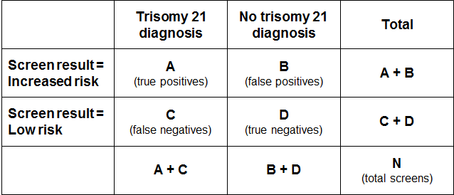

Positive predictive value and positive test rate
The positive test rate is the number of increased risk screens per 100 screens.
Positive test rate = ((A+B)/N)*100

Positive Predictive Value is the probability of having the condition given screen result was increased risk.
PPV = P (Disease | Screen Positive) = A/(A+B)

In order for PPV to increase, ‘A’ needs to be higher (more true positives) and/or ‘B’ needs to be lower (less false positives). However, an increase in positive test rate can come about when ‘A’ and/or ‘B’ increase. If the positive test rate increases due to higher true positives (A), then PPV will also increase. If instead the number of false positives increases, then the positive test rate will increase but PPV will decrease.

False positive rate
False positive rate is the number of false positives divided by false positives plus true negatives. It gives the proportion of women that did not have a baby or fetus with trisomy 21 that received an increased risk screening result.
FPR = B/(B+D)

Detection rate
Detection rate is the number of true positives divided by true positives plus false negatives. It gives the probability that a woman carrying a fetus with trisomy 21 will receive an increased risk screening result for trisomy 21.
Detection rate = A/(A+C)

- :
False negative screens by risk level
There were 68 false negative screens in total across the 2017–2018 period. A false negative means that the screen result was low risk for each of trisomy 21, 18 and 13 but there was then a positive diagnostic test or infant diagnosis for one of trisomy 21, 18 or 13.

Table 50 shows the number of false negatives aggregated for 2017 and 2018 broken down by the screening risk result in the first column. The second column gives the number of false negatives as a percentage of all negative (low risk) screens. Overall, false negative screens made up 0.08 percent of all negative screens for 2017 to 2018.

Table 50: False negative screens for trisomy 21, 18 and 13 by risk level, January 2017 to December 2018 aggregated
 | False negatives | % of negative screens that are false negatives
Risk level | 2017–2018 | 2017–2018
1:301 to 1:500 | 12 | 0.77
1:501 to 1:1000 | 20 | 0.52
1:1001 to 1:2000 | 10 | 0.16
1:2001 to 1:3000 | 7 | 0.14
1:3001 to 1:4000 | 2 | 0.05
1:4001 to 1:5000 | 2 | 0.05
1:5001 to 1:10,000 | 5 | 0.03
Less than 1:10,000 | 10 | 0.02
Total | 68 | 0.08
- : ROC curve
Figure 11 shows the false positive rate plotted against the detection rate in what is known as a ‘receiver operating characteristic’ (ROC) curve. This plots the false positive rate on the horizontal x axis against detection rate on the vertical y axis for different possible cut off points of the screening test. The aim for a screening test is to maximise detection rate while minimising false positive rate.

In New Zealand the cut off used for screening is 1:300. With this cut off the overall detection rate for trisomy 21, trisomy 18 and trisomy 13 in 2018 was 78 percent, and the false positive rate was 3.8%. To create the graph the detection rate and false positive rate were calculated for a range of other cut off points in order to plot the curve. What the curve shows is that if the cut off was lowered to increase the detection rate to 85 percent, the false positive rate would increase from 3.8 percent to 8.1 percent. This occurs at a risk cut off of 1:700.

Figure 11: ROC curve for trisomy 21, 18 and 13 screening 2018
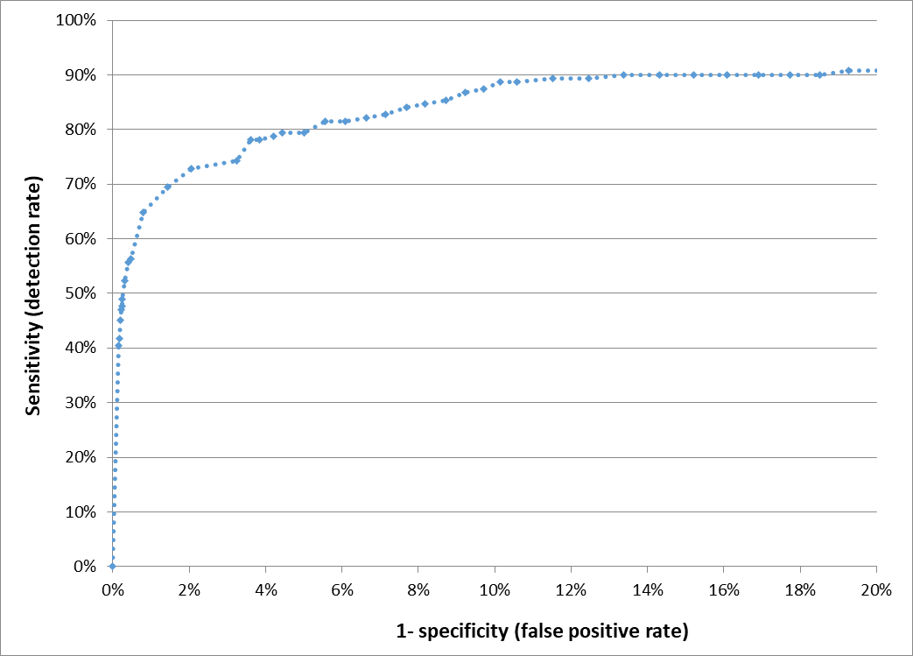

- : Glossary
Alpha-fetoprotein (AFP) – a protein that is normally produced by the fetus. Maternal serum AFP levels can be used as a biochemical marker in the detection of certain fetal abnormalities including neural tube defects (NTDs) from 15 weeks of pregnancy.
Amniocentesis – a procedure involving the withdrawal of a small amount of amniotic fluid by needle and syringe through the abdomen guided by ultrasound performed at the same time. The tests performed on fetal cells in this sample can detect a range of chromosomal and genetic disorders.
Analyte – a substance that is undergoing analysis or being measured. Analytes measured in antenatal screening include: pregnancy associated plasma protein-A, beta human chorionic gonadotropin, unconjugated oestriol, alpha fetoprotein and inhibin A.
Beta-human chorionic gonadotropin (ßhCG) – a hormone produced during pregnancy and present in maternal blood and urine. It is used as a biochemical marker for Down syndrome and other conditions in first trimester combined and second trimester maternal serum screening.
Chorionic villus sampling (CVS) – a procedure involving the withdrawal of a small amount of placental tissue by needle and syringe through the abdomen guided by ultrasound performed at the same time. Tests performed on placental cells can detect a range of chromosomal and genetic disorders.
Crown rump length (CRL) – the measurement from the fetal crown to the prominence of the buttocks or breech. This is used for dating in the first trimester.
Detection rate – the ability of screening to identify individuals with the condition screened for. A test with a high detection rate will have few false negative results. Also referred to as sensitivity.
False negative result – when a woman receives a low risk screening result but the baby does have the condition screened for.
False positive result – when a woman receives an increased risk screening result but the baby does not have the condition screened for.
False positive rate – the false positive rate is the number of false positives divided by the number of false positives and true negatives. A low false positive rate corresponds with a high level of specificity, which refers to the ability of screening to identify individuals who do not have the condition screened for.
Fetal Medicine Foundation (FMF) – a Registered Charity that aims to improve the health of pregnant women and their babies through research and training in fetal medicine. Further information can be found at: https://fetalmedicine.org
Inhibin A – a hormone secreted by the ovary that is used as a biochemical marker in second trimester maternal serum screening for Down syndrome and other conditions.
Multiple of the median (MoM) – a measure of how far an individual result compares to the median. MoM is commonly used to report the results of medical screening tests, particularly where the normal range varies according to parameters.
Nasal bone (NB) – an assessment of nasal bone was included in the risk calculation if it was reported at the same time as the NT measurement. Note that since March 2018 the nasal bone measurement is no longer included.
Neural tube defect (NTD) – a congenital anomaly involving the brain and spinal cord caused by failure of the neural tube to close properly during embryonic development. Open NTDs occur when the brain and/or spinal cord are exposed at birth through a defect in the skull or vertebrae. Examples of open NTDs are spina bifida (myelomeningocele), anencephaly, and encephalocele.
Nuchal translucency (NT) – sonographic appearance of the collection of fluid under the skin at the back of the fetal neck. NT is a marker for chromosomal and other anomalies and can be measured in the first trimester of pregnancy.
Pregnancy-associated plasma protein A (PAPP-A) – a protein originating from the placenta used as a biochemical marker in first trimester combined screening for Down syndrome and other conditions.
Risk calculation algorithm – an explicit protocol (in this case computer-based) that combines a number of factors in determining overall risk of a particular outcome or condition.
Screening – a way of identifying a group of people who are more likely than others to have a particular condition. The screening process involves testing people for the presence of the condition, and predicting the likelihood that they have the condition. Antenatal screening for Down syndrome and other conditions predicts the likelihood of the conditions being present in the fetus.
Triploidy – an extremely rare chromosomal disorder in which a baby has three of every chromosome making a total of 69 rather than the normal 46 chromosomes.
Trisomy – a group of chromosomal disorders in which there are three copies, instead of the normal two, of a particular chromosome present in the cell nuclei. The most common trisomies in newborns are trisomy 21 (Down syndrome), trisomy 18 (Edwards syndrome) and trisomy 13 (Patau syndrome).
True positive – when a woman receives an increased risk screening result and the baby does have the condition screened for.
Unconjugated oestriol (uE3) – a hormone produced by the placenta and used as a biochemical marker in second trimester maternal serum screening for Down syndrome and other conditions.

Further terms can be found at www.nsu.govt.nz.

Risk ratio values increase in increments of 5 between 1:10 and 1:100, increments of 100 between 1:100 and 1:10,000, and then increments of 1000 to 1:100,000.
Births reaching at least 20 weeks gestation or ≥400 g birth weight.
Births reaching at least 20 weeks gestation or ≥400 g birth weight.

