Antenatal Screening for Down Syndrome and Other Conditions
Monitoring Report
January 2011 to December 2014

Citation: Ministry of Health. 2016. Antenatal Screening for Down Syndrome and Other Conditions: Monitoring Report January 2011 to December 2014.
Wellington: Ministry of Health.
Published in July 2016
by the Ministry of Health
PO Box 5013, Wellington 6140, New Zealand
ISBN 978-0-947515-47-8 (online)
HP 6464
This document is available at www.health.govt.nz
This work is licensed under the Creative Commons Attribution 4.0 International licence. In essence, you are free to: share ie, copy and redistribute the material in any medium or format; adapt ie, remix, transform and build upon the material. You must give appropriate credit, provide a link to the licence and indicate if changes were made.

Contents
Executive summary ix
Introduction 1
Background to screening for Down syndrome and other conditions in pregnancy in New Zealand 1
Programme monitoring and data collection 2
Information included in this report 3
Definitions 3
Inclusion criteria 4
Data calculations 4
Data limitations 5
Final dataset 6
Indicator 1: Screens commenced 7
Total screens commenced by trimester 7
Screens commenced by DHB 8
Screens commenced by age, ethnicity and deprivation 10
Indicator 2: Screens completed 13
Total screens completed by trimester 13
Screens completed by DHB 14
Screens completed by age, ethnicity and deprivation 16
Indicator 3: Screening pathway variance 19
Screening pathway variance by year 19
Screening pathway variance by DHB 20
Screening pathway variance by age, ethnicity and deprivation 21
Indicator 4: Incomplete screens 22
Total incomplete screens 22
Incomplete T 1 screens by reason incomplete 22
Incomplete T1 screens by reason and DHB 23
Incomplete T1 screens by age, ethnicity and deprivation 24
Incomplete T2 screens 25
Incomplete T2 screens by DHB 25
Incomplete T2 screens by a.ge, ethnicity and deprivation 26
Indicator 5: Increased risk screening results for trisomy 21, trisomy 18 and trisomy 13 27
Total increased risk screening results for trisomy 21, 18 or 13 27
Increased risk screening results for trisomy 21, 18 or 13 by age, ethnicity and deprivation 28
Increased risk screening results for trisomy 21, 18 or 13 by trimester of screen 29
Increased risk screening results stratified by risk level 30
Indicator 6: Diagnostic testing volumes for women with increased risk screens 31
Diagnostic testing volumes for women with increased risk screens by trimester of screen 31
Diagnostic testing volumes for women with increased risk screens by DHB 32
Diagnostic testing volumes for women with increased risk screens by age, ethnicity and deprivation 33
Diagnostic testing volumes for women with increased risk screening results stratified by risk level 34
Indicator 7: Diagnostic testing volumes for women who receive a low risk screening result 35
Diagnostic testing volumes for women with low risk screens by trimester of screen 35
Diagnostic testing volumes for women with low risk screens by DHB 36
Diagnostic testing volumes for women with low risk screening results by age, ethnicity and deprivation 37
Diagnostic testing volumes for women with low risk screening results stratified by risk 38
Indicator 8: Diagnostic testing for unscreened women 39
Diagnostic volumes for unscreened women 39
Diagnostic results for unscreened women 40
Indicator 9: Diagnostic testing outcomes for women with increased risk screening results 41
Positive predictive value of screening 41
Positive predictive value of screening for trisomy 21 stratified by risk level 43
Positive predictive value of screening for trisomy 21 by age, ethnicity and deprivation 43
Indicator 10: False positive rate 45
False positive rate for screening 45
False positive rate for screening for trisomy 21 by age, ethnicity and deprivation 46
Indicator 11: Detection rate 48
Detection rate for screening 48
Detection rate for screening for trisomy 21 by age, ethnicity and deprivation 49
Appendices
Appendix 1: Indicator definitions 51
Appendix 2: Birth denominator data 52
Appendix 3: Summary of diagnostic testing uptake and results for women that had an increased risk screen 54
Appendix 4: Measuring screening performance 56
Appendix 5: False negative screens by risk level 58
Appendix 6: ROC curve 59
Appendix 7: Glossary 60

List of tables
Table 1: Screening dataset cleansing 6
Table 2: Total screens commenced by trimester, January 2011 to December 2014 7
Table 3: Screens commenced by trimester and DHB, January 2014 to December 2014 9
Table 4: Screens commenced per 100 births by DHB, January 2011 to December 2014 10
Table 5: Screens commenced by age of mother, ethnicity and NZ deprivation quintile, January 2011 to December 2014 11
Table 6: Total screens completed by trimester, January 2011 to December 2014 13
Table 7: Screening completion by trimester and DHB, January 2014 to December 2014 15
Table 8: Screening completion by DHB, January 2011 to December 2014 16
Table 9: Screens completed by age of mother, ethnicity and NZ deprivation quintile, January 2011 to December 2014 17
Table 10: Screening pathway variance by type, January 2011 to 31 December 2014 19
Table 11: Screening pathway variance by DHB, January 2014 to December 2014 20
Table 12: Screening pathway variance by age, ethnicity and NZ deprivation quintile, January 2011 to December 2014 21
Table 13: Incomplete screens by trimester, January 2011 to 31 December 2014 22
Table 14: Incomplete T1 screens by reason incomplete, January 2011 to December 2014 23
Table 15: Incomplete T1 screens by reason and DHB, 1 January 2014 to 31 December 2014 23
Table 16: Incomplete T1 screens by age, ethnicity and NZ deprivation quintile, 1 January 2014 to 31 December 2014 24
Table 17: Incomplete T2 screens, 1 January 2011 to 31 December 2014 25
Table 18: IncompleteT2 screens by DHB, 1 January 2011 to 31 December 2014 25
Table 19: Incomplete T2 screens by age, ethnicity and NZ deprivation quintile, 1 January 2014 to 31 December 2014 26
Table 20: Number and rate per 100 screens of increased risk screening results for trisomy 21, 18 or 13, January 2011 to 31 December 2014 27
Table 21: Increased risk screening results for trisomy 21, 18 or 13 by age, ethnicity and deprivation, January 2014 to December 2014 28
Table 22: Increased risk screening results for trisomy 21, 18 and 13 by trimester of screen, January 2011 to December 2014 29
Table 23: Increased risk screening results for trisomy 21, 18 and 13 by risk level, January 2014 to December 2014 30
Table 24: Diagnostic testing volumes for women with increased risk screens by trimester of screen, January 2011 to December 2014 31
Table 25: Diagnostic testing volumes for women with increased risk screens by DHB, January 2011 to December 2014 32
Table 26: Diagnostic testing volumes for women with increased risk screening results by age at screen, ethnicity and deprivation, January 2011 to December 2014 33
Table 27: Diagnostic testing volumes for women with increased risk screens by risk level, January 2014 to December 2014 34
Table 28: Diagnostic testing volumes for women with low risk screens by trimester of screen, January 2011 to December 2014 35
Table 29: Total diagnostic testing volumes for women with low risk screens by DHB January 2011 to December 2014 36
Table 30: Diagnostic tests per 100 low risk screens by age, ethnicity and NZ deprivation quintile, January 2011 to December 2014 37
Table 31: Diagnostic tests per 100 low risk screens stratified by risk level, January 2011–December 2014 aggregated 38
Table 32: Diagnostic testing volumes for unscreened women by DHB, January 2012 to December 2014 39
Table 33: Total diagnostic testing volumes for unscreened women by age, ethnicity and deprivation quintile, January 2012 to December 2014 40
Table 34: Total diagnostic testing results for unscreened women, January 2014 to December 2014 40
Table 35: Positive predictive value of screening for trisomy 21, 18 or 13, January 2011 to December 2014 42
Table 36: Positive predictive of screening for trisomy 21, January 2011 to December 2014 42
Table 37: Positive predictive of screening for trisomy 13 or 18, January 2011 to December 2014 42
Table 38: Positive predictive of screening for trisomy 21 stratified by risk level, January 2011 to December 2014 43
Table 39: Positive predictive of screening for trisomy 21 by age, January 2011 to December 2014 43
Table 40: Positive predictive of screening for trisomy 21 by ethnicity, January 2011 to December 2014 44
Table 41: Positive predictive of screening for trisomy 21 by NZ deprivation quintile, January 2011 to December 2014 44
Table 42: False positive rate for trisomy 21, 18 or 13, January 2011 to December 2014 45
Table 43: False positive rate for trisomy 21, January 2011 to December 2014 45
Table 44: False positive rate for trisomy 13 or 18, January 2011 to December 2014 46
Table 45: False positive rate for trisomy 21 by age, January 2011 to December 2014 46
Table 46: False positive rate for trisomy 21 by ethnicity, January 2011 to December 2014 47
Table 47: False positive rate for trisomy 21 by NZ deprivation quintile, January 2011 to December 2014 47
Table 48: Detection rate for trisomy 21, 18 or 13, January 2011 to December 2014 48
Table 49: Detection rate for trisomy 21, January 2011 to December 2014 49
Table 50: Detection rate for trisomy 13 or 18, January 2011 to December 2014 49
Table 51: Detection rate for trisomy 21 by age, January 2011 to December 2014 (aggregated) 49
Table 52: Detection rate for trisomy 21 by ethnicity, January 2011 to December 2014 (aggregated) 50
Table 53: Detection rate for trisomy 21 by NZ deprivation quintile, January 2011 to December 2014 (aggregated) 50
Table 54: Definitions used for monitoring indicators 51
Table 55: Live births and still births by district health board 2011–2014 52
Table 56: Live births and still births by age group 2011–2014 53
Table 57: Live births and still births by 2013 NZ deprivation quintile, 2011–2014 53
Table 58: Live births and still births by ethnicity 53
Table 59: Diagnostic results for women that accessed a prenatal diagnostic test following an increased risk screen for trisomy 21, 18 or 13 during the 2014 year 54
Table 60: Pregnancy outcomes (where known) for women that did not have a prenatal diagnostic test following an increased risk screen for trisomy 21, 18 or 13 during the 2014 year 55
Table 61: False negative screens for trisomy 21, 18 and 13 by risk level, January 2011 to December 2014 58

List of figures
Figure 1: Data collection process 2
Figure 2: Count and rate of screens commenced, January 2011 to December 2014 7
Figure 3: Screens commenced by DHB, January 2014 to December 2014 8
Figure 4: Screens commenced by age of mother at screen, January 2014 to December 2014 12
Figure 5: Screens commenced by ethnicity of mother, January 2014 to December 2014 12
Figure 6: Screens commenced by NZ deprivation quintile, January 2014 to December 2014 12
Figure 7: Count and rate of screens completed, January 2011 to December 2014 13
Figure 8: Screens completed by DHB, January 2014 to December 2014 14
Figure 9: Screens completed by age of mother at screen, January 2014 to December 2014 18
Figure 10: Screens completed by ethnicity of mother, January 2014 to December 2014 18
Figure 11: Screens completed by NZ deprivation quintile of mother, January 2014 to December 2014 18
Figure 12: Categorisation of screening results 56
Figure 13: Categorisation of trisomy 21 screening results 2014 57
Figure 14: ROC curve for trisomy 21, 18 and 13 screening 2014 59

Executive summary
This report presents the data for the four calendar years from 1 January 2011 to 31 December 2014 and is based on screening that occurred during that time. Due to lack of data from one of the diagnostic laboratories, the indicators that involve diagnostic data are only reported for 17 DHBs (indicators 6 to 11).

Antenatal screening for Down syndrome and other conditions
Antenatal screening for Down syndrome and other conditions provides a risk estimate for Down syndrome (trisomy 21), trisomy 18 (Edwards syndrome), trisomy 13 (Patau syndrome) and some other rare genetic disorders. This screening is optional for pregnant women. Women who are less than 20 weeks pregnant are advised about the availability of screening and provided with up-to-date information to support the screening discussion, to enable women to make an informed decision about whether to participate.

First trimester combined screening should be completed between 9 weeks and 13 weeks 6 days gestation. The recommended timing for the blood test is 9 to 10 weeks and the Nuchal Translucency scan should be done at 12 weeks. Second trimester maternal serum screening should be completed between 14 weeks and 20 weeks gestation. The recommended timing for this test is 14 to 18 weeks.

Key points for January 2011 to December 2014
- Screening was commenced for more than 75% of pregnancies [indicator 1].
- Screening uptake by Māori and Pacific women was less than half the rate of Other women in 2014 but has increased each year [indicators 1 and 2].
- The national screening completion rate exceeded two-thirds of births for the first time in 2013 (69%) and increased again in 2014 (71%). Trimester one screens made up 87% of all completed screens in 2014 [indicator 2].
- Most DHBs showed a trend of increasing rates of screening commencement and completion over the four years covered in this report [indicators 1 and 2].
- Nearly half of all completed trimester 2 screens were commenced in trimester 1 [indicator 3].
- Nine percent of screens commenced in 2014 were not completed and nearly all related to screens commenced in the first trimester. The rate of incomplete screens was higher for younger women, for Māori and Pacific women, and for women from areas of higher deprivation [indicator 4].
- The positive test rate (number of increased risk results per 100 screens) for trisomy 21, 18 and 13 was 2.8 in 2014, up from 2.7 in 2013. Positive test rate was higher for second trimester screens (5 per 100 screens) than for first trimester screens (2.4 per 100 screens) for 2014 [indicator 5].
- The false positive rate for trisomy 21, 18 and 13 was 2% in 2014, which was equal to 2013. The rate was higher for second trimester screens (5%) than for first trimester screens (2%) [indicator 10].
- The overall detection rate for trisomy 21, 18 and 13 was 80% in 2014, up from 76% in 2013. The detection rate was lower for first (79%) compared with second (86%) trimester screens [indicator 11].

Introduction

Background to screening for Down syndrome and other conditions in pregnancy in New Zealand
Antenatal screening for Down syndrome and other conditions has been available to pregnant women in New Zealand since 1968. In October 2007, the government agreed to implement quality improvements to ensure consistency with international best practice. The improvements were introduced in February 2010 and included incorporating maternal serum screening with ultrasound, providing practitioner guidelines and consumer resources.

Health practitioners providing maternity care are required to provide women with information about antenatal screening services for Down syndrome and other conditions. There are two screening options:
- first trimester combined screening, which includes a blood test that measures two maternal serum markers, pregnancy-associated protein A (PAPP-A) and free beta- human chorionic gonadotropin (ßhCG). The blood sample is collected between 9 weeks and 13 weeks and 6 days gestation and combined with an ultrasound scan to determine nuchal translucency (NT) and crown rump length (CRL) measurements between 11 weeks and 2 days and 13 weeks and 6 days, or
- second trimester screening, which is a blood test that measures four maternal serum markers free beta-human chorionic gonadotropin (ßhCG), alpha-fetoprotein (AFP), unconjugated oestriol (uE3) and inhibin A taken between 14 and 20 weeks gestation.

The results of the ultrasound scan and/or serum are combined with other demographic and maternal factors to provide a risk result. For consistency, all screening risk results are produced by the screening laboratories. The screening laboratories are LabPLUS at Auckland District Health Board (for samples from Taupo north) and Canterbury Health Laboratories at Canterbury District Health Board (for samples south of Taupo). A shared data repository (PerkinElmer LifeCycle) contains data on all screens. Ultrasound scanning is performed by private and public radiology practices around New Zealand and the ultrasound report is sent to the screening laboratories to include in the risk calculation algorithm.

The conditions covered by screening include:
- trisomy 21 (Down Syndrome)
- trisomy 18 (Edwards syndrome)
- trisomy 13 (Patau syndrome)
- triploidy
- Turner syndrome
- neural tube defects
- unusually high or low levels of the serum analytes.

Antenatal screening involves many health professionals including radiology staff, Lead Maternity Carers (LMCs), general practitioners (GPs) and laboratory personnel. The quality of the information provided by health professionals to the laboratories regarding the pregnancy details (such as gestation, maternal age, weight, ethnicity and the ultrasound finding) is critical because these details have a significant impact on the risk calculation and report that is issued.

Programme monitoring and data collection
This report presents information on antenatal screening for Down syndrome and other conditions between 1 January 2011 and 31 December 2014.

The indicators in this report are taken from the 2014 Antenatal Screening for Down Syndrome and Other Conditions, Monitoring and Evaluation Framework. Appendix 1 contains definitions for these indicators. Figure 1 outlines the data collection process used to produce this report.

The indicators contained within this monitoring report form one part of the evaluation and audit of the quality improvements to antenatal screening for Down syndrome and other conditions. Other activities include:
- yearly screening laboratory audits by IANZ
- two-yearly peer review of screening laboratories
- contract monitoring and reporting on a monthly and quarterly basis
- occasional studies and qualitative information.

Figure 1: Data collection process
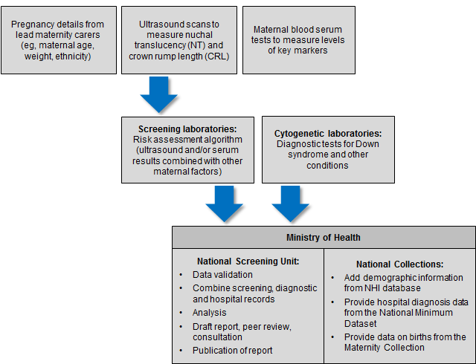

Information included in this report
The screening data in this report was sourced from LabPLUS and covers all of New Zealand. Cytogenetic testing data was received from LabPLUS, Waikato, and Capital and Coast laboratories but was not provided by Canterbury Health Laboratories (CHL). As CHL provides cytogenetic testing for Canterbury, South Canterbury, and West Coast DHBs, women from those DHBs were excluded from the analysis for indicators that required diagnostic data (indicators 6, 7, 8, 9, 10, and 11).

The screening and cytogenetic data was combined with hospital discharge data, sourced from the National Minimum Data Set (NMDS), held by the Ministry of Health. This matching between data from screening laboratories, cytogenetic laboratories, and the NMDS was undertaken to identify the outcome for all screened women.

Definitions

Commenced screening
At least one of the required components of the screening test was completed.

Completed screening
All the required components of each screening test were complete and a risk result was calculated.

Required components of each screening test
First trimester screening comprises analysis of two serum analytes (βhCG, PAPP-A) and a NT measurement.

Second trimester screening comprises analysis of four serum analytes (βhCG, AFP, uE3 and Inhibin A).

Low risk result
A low risk result is defined as a risk lower than 1:300. So a risk of 1:310 is a low risk.

Increased risk result
An increased risk result is defined as a risk higher than or equal to 1:300. For some indicators increased risk screening results are further stratified into:
- 1:5 to 1:20
- 1:25 to 1:50
- 1:55 to 1:300.

Inclusion criteria
Women’s screens were included in this analysis if the following criteria were met:
- screening commencement date between 1 January 2011 and 31 December 2014 (ie, date of the first test the woman had as part of the screening pathway)
- valid National Health Index identifier (NHI)
- known District Health Board (DHB) of domicile
- age at screen from 12 years to 49 years (calculated using the NHI database date of birth)
- single screening result per pregnancy.

Data calculations

DHB of domicile
Each woman was allocated to a DHB based on the residential address recorded in the National Health Index (NHI). Where the NHI database did not have a DHB recorded for an NHI, information from the LabPLUS database was used to assign the DHB.

Ethnicity
Ethnicity data in this report is grouped according to a prioritised system, which is commonly applied across the New Zealand health sector. Prioritisation involves allocating each person to a single ethnic group, based on the ethnicities that person has identified, in the prioritised order of Māori, Pacific, Asian and Other ethnicity. For example, if someone identifies as being New Zealand European and Māori, under the prioritised ethnicity method, they are classified as Māori for the purpose of the analysis. Under this method, the Other ethnicity group effectively refers to non-Māori, non-Pacific, non-Asian people. In this report, women identifying as New Zealand European/Pākehā made up approximately 79% of the Other ethnicity group. There were no women in the final dataset with ethnicity recorded as Unknown.

NZ Deprivation
The New Zealand deprivation index (NZ Dep) is the average level of deprivation of people living in an area at a particular point in time, relative to the whole of New Zealand. Deprivation refers to areas (based on New Zealand Census mesh blocks) rather than individuals. All reporting by NZ Dep is based on the 2013 New Zealand deprivation index decile associated with the residential address held in the NHI database for each woman at the time of data extraction.

This report presents results by 2013 NZ Dep quintiles. Each quintile groups two deciles together and contains about 20% of small areas in New Zealand. The two quintiles at opposite ends of the scale are quintile 1 (deciles 1 and 2), which represents children living in the least deprived 20% of small areas (‘the least deprived areas’), and quintile 5 (deciles 9 and 10), which represents children living in the most deprived 20% of small areas (‘the most deprived areas’). This is opposite to some other systems of classification, such as that used by education, where level 10 is the least disadvantaged and level 1 the most disadvantaged.

Births
Data on the number of live and still births was obtained from the national Maternity Collection for each calendar year. Appendix 2 contains tables for the denominators used in this report.

Small numbers
Small numbers can affect the reliability of results. Where an indicator calculation involves small counts (less than 10) then those results have been suppressed as they are considered too unstable.

Prenatal cytogenetic test
The focus of indicators 6, 7, and 8 is on tests that women choose to have as part of managing their pregnancy. For these indicators prenatal tests are defined as chorionic villus sampling (CVS) or amniocentesis (tests on products of conception are not included). For indicators 9, 10 and 11 cytogenetic tests on products of conception are used in addition to CVS, amniocentesis and infant diagnoses to determine the outcome of the pregnancy.

Repeat screens
A repeat screen was defined as a second screen for the same woman within 112 days. Where this occurred, the first completed screen was retained for the analysis. The figure of 112 days was based on the timing of the screening test and considering how soon a woman may become pregnant again following a miscarriage.

Linking rules
When matching screening and diagnosis data the following rules were followed:
- for a birth to link to a commenced screen the screen date must be earlier than the birth date and the date difference must not be greater than 230 days (approximately 33 weeks)
- for a prenatal cytogenetic test to link to a screen the cytogenetic sample date must be later than the screen date, but not more than 105 days (15 weeks) later.

These were based on the possible timing of the different screening and diagnostic tests.

Data limitations

Denominator underestimation
Screening completion rates derived using total births may overestimate the proportion of women participating in antenatal screening for Down syndrome and other conditions. This is because the true denominator (ie, all pregnant women that reach 9 weeks gestation) is likely to be larger than the denominator used (ie, all births reaching at least 20 weeks gestation or at least 400 g birth weight).

Missing data
Missing or incorrect data for any screened woman will affect indicator calculations. Known data issues in this report relate to the following.
- Some women may have incomplete data if they were screened outside of Canterbury, South Canterbury and West Coast DHBs but had a cytogenetic test through Canterbury Health Laboratories. Given known laboratory catchment areas it is unlikely that this has occurred in enough cases to be significant.
- 328 records did not have DHB of domicile information recorded in either the NHI database or in the laboratory information system. These records were excluded from the analysis.

Inconsistent data
In some instances there was variation between the demographic information held in the NHI database and that held by LabPLUS. The NHI database was used as the definitive source which led to instances where the age at screen calculated using the NHI date of birth was outside the range of 12 to 49 years (48 records less than 12 years, 69 records 50 years old or greater) and three instances where date of death as recorded in the NHI database was prior to the date of screen. For this report, records where the age at screen was younger than 12 or older than 49 have been excluded.

Final dataset
Table 1 summarises the records received and excluded from the screening dataset. The final dataset includes screening records for women from Canterbury, South Canterbury and West Coast DHBs. Records for these women are included in the results for indicators 1, 2, 3, 4 and 5 but excluded from indicators 6 to 11.

Table 1: Screening dataset cleansing
 | Number | Percentage
Records received for report period | 189,965 | 100.0%
Final screening dataset for analysis | 178,228 | 94.3%
Total excluded records¹ | 10,737 | 5.7%
Private/overseas screens | 4938 | 2.6%
Invalid NHI | 134 | 0.1%
Unknown DHB | 328 | 0.2%
Date of death prior to screen | 3 | <0.01%
Age at screen < 12 | 48 | <0.01%
Age at screen > 49 | 69 | <0.01%
Repeat screen¹ | 5217 | 2.7%
1 For this report data on both complete and incomplete screens was received. Where a completed screen exists for a pregnancy any incomplete screens (those with no risk reported) are not considered true incompletes and have been excluded. This has led to a higher number of repeat screen exclusions when compared with the July 2010 to June 2013 report.

Indicator 1:
Screens commenced
This indicator reports the number of screens commenced by trimester of screening (first or second), reported by DHB, age, ethnicity, and NZ deprivation quintile.

Total screens commenced by trimester
During 2014, a total of 45,840 screens were commenced, a rate of 78.0 per 100 births. Table 2 shows the total number of screens commenced by year and trimester of screen. Throughout the report T1 is used to refer to first trimester and T2 to second trimester. The vast majority of screens were T1 screens. The number of screens commenced per 100 births has increased over time from 71.2 in 2011 to 78.0 in 2014 (see Table 2 and Figure 2).

Table 2: Total screens commenced by trimester, January 2011 to December 2014
Trimester of screen | Number and rate of screens commenced
 | 2011 | 2012 | 2013 | 2014
T1 screen | 39,315 | 39,679 | 38,961 | 40,230
T2 screen | 4698 | 5238 | 5497 | 5610
Total screens | 44,013 | 44,917 | 44,458 | 45,840
Screens per 100 births | 71.2 | 72.6 | 75.6 | 78.0

Figure 2: Count and rate of screens commenced, January 2011 to December 2014
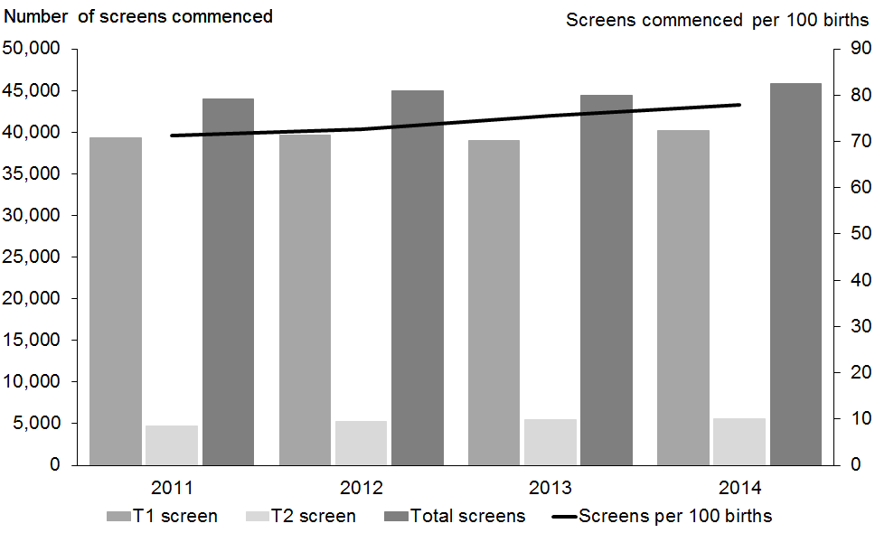

Screens commenced by DHB
Figure 3 shows the screening commencement rates by DHB for 2014. There was a large variation in rates from 56 per 100 births in Northland to 97 per 100 births in Nelson Marlborough (see Figure 3). Most DHBs (12) had rates of 77 per 100 births or above. Table 3 gives a full breakdown by the trimester of the screen.

Figure 3: Screens commenced by DHB, January 2014 to December 2014
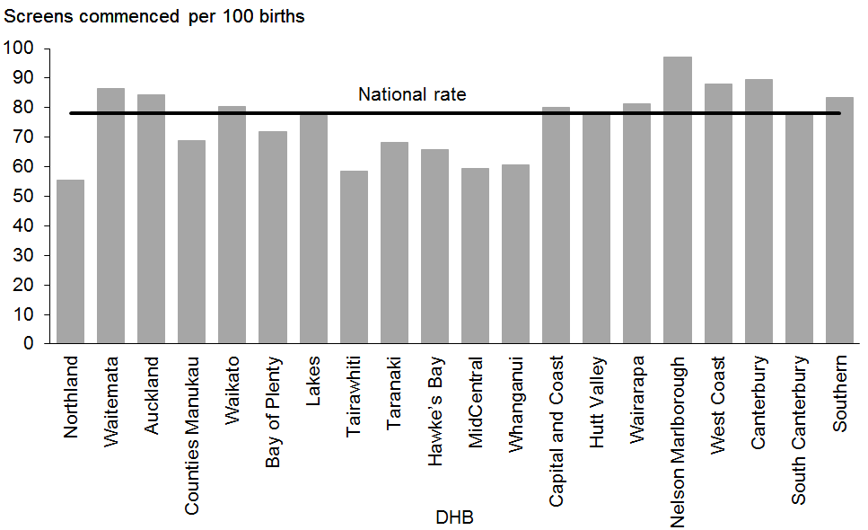

Table 3: Screens commenced by trimester and DHB, January 2014 to December 2014
DHB | Number of screens commenced |  |  | Screens commenced (per 100 births)
 | First trimester | Second trimester | Total | First trimester | Second trimester | Total
Northland | 1010 | 160 | 1170 | 48.0 | 7.6 | 55.6
Waitemata | 6069 | 722 | 6791 | 77.3 | 9.2 | 86.5
Auckland | 4673 | 643 | 5316 | 74.1 | 10.2 | 84.3
Counties Manukau | 4587 | 1125 | 5712 | 55.3 | 13.6 | 68.9
Waikato | 3768 | 455 | 4223 | 71.6 | 8.7 | 80.3
Bay of Plenty | 1813 | 196 | 2009 | 65.0 | 7.0 | 72.0
Lakes | 899 | 178 | 1077 | 64.5 | 12.8 | 77.3
Tairawhiti | 343 | 64 | 407 | 49.3 | 9.2 | 58.5
Taranaki | 827 | 210 | 1037 | 54.5 | 13.8 | 68.3
Hawke’s Bay | 1223 | 141 | 1364 | 58.9 | 6.8 | 65.7
MidCentral | 1105 | 134 | 1239 | 52.9 | 6.4 | 59.3
Whanganui | 418 | 77 | 495 | 51.1 | 9.4 | 60.5
Capital and Coast | 2575 | 257 | 2832 | 72.9 | 7.3 | 80.2
Hutt Valley | 1277 | 173 | 1450 | 68.8 | 9.3 | 78.1
Wairarapa | 343 | 42 | 385 | 72.4 | 8.9 | 81.2
Nelson Marlborough | 1238 | 144 | 1382 | 87.0 | 10.1 | 97.1
West Coast | 270 | 38 | 308 | 77.1 | 10.9 | 88.0
Canterbury | 4812 | 575 | 5387 | 80.0 | 9.6 | 89.6
South Canterbury | 472 | 40 | 512 | 72.2 | 6.1 | 78.3
Southern | 2508 | 236 | 2744 | 76.3 | 7.2 | 83.5
Total | 40,230 | 5610 | 45,840 | 68.4 | 9.5 | 78.0

Most DHBs showed a trend of increasing rates of screening over the four years covered in this report. Exceptions to this were Waitemata and Canterbury, where the rate levelled off between 2013 and 2014, and South Canterbury, which had a decreasing trend over the four-year period (see Table 4).

Table 4: Screens commenced per 100 births by DHB, January 2011 to December 2014
DHB | Screens commenced (per 100 births)
 | 2011 | 2012 | 2013 | 2014
Northland | 47.0 | 50.0 | 53.3 | 55.6
Waitemata | 84.2 | 83.1 | 86.5 | 86.5
Auckland | 75.2 | 74.7 | 82.6 | 84.3
Counties Manukau | 61.1 | 63.6 | 65.1 | 68.9
Waikato | 73.2 | 72.5 | 76.7 | 80.3
Lakes | 65.4 | 68.8 | 69.7 | 72.0
Bay of Plenty | 60.9 | 67.9 | 70.2 | 77.3
Tairawhiti | 44.5 | 49.5 | 53.0 | 58.5
Taranaki | 63.3 | 60.5 | 61.6 | 68.3
Hawke’s Bay | 56.1 | 62.0 | 64.6 | 65.7
Whanganui | 51.3 | 54.5 | 58.3 | 59.3
MidCentral | 45.5 | 45.4 | 48.2 | 60.5
Hutt Valley | 77.0 | 79.5 | 78.4 | 80.2
Capital and Coast | 71.5 | 71.0 | 72.7 | 78.1
Wairarapa | 73.0 | 69.4 | 76.5 | 81.2
Nelson Marlborough | 88.5 | 91.1 | 87.6 | 97.1
West Coast | 69.4 | 76.9 | 82.3 | 88.0
Canterbury | 85.9 | 87.2 | 90.7 | 89.6
South Canterbury | 92.0 | 86.0 | 88.8 | 78.3
Southern | 76.0 | 80.2 | 81.7 | 83.5
Total | 71.2 | 72.6 | 75.6 | 78.0

Screens commenced by age, ethnicity and deprivation
Table 5 provides an overall view of screens commenced by age, ethnicity and NZ deprivation quintile for January 2011 to December 2014. The 30–34 year age group had the highest rate of screens commenced with 83 women starting screening per 100 births in 2014. This was followed by the 25–39 years age group with 82 per 100 births (see Figure 4).

Screening commencement rates were highest among women of Other ethnicity at 96 per 100 births for 2014. This was followed closely by Asian women at 91. The rate of commenced screens for Pacific and Māori women was lower at 49 per 100 births and 44 per 100 births respectively (see Figure 5). However, both groups have shown significant increase in over the four years (see Table 5).

Screening commencement rates were highest among women in less deprived areas with 92 women per 100 per births starting screening for quintiles 1 and 2 in 2014 compared with 60 per 100 births for quintile 5 (see Figure 6). However, the rate decreased for quintile 1 between 2013 and 2014 (see Table 5).

Table 5: Screens commenced by age of mother, ethnicity and NZ deprivation quintile, January 2011 to December 2014
 | Number of screens commenced |  |  |  | Screens commenced (per 100 births)#
 | 2011 | 2012 | 2013 | 2014 | 2011 | 2012 | 2013 | 2014
Age at screen
Under 20 years | 2298 | 2136 | 1952 | 1989 | 56.7 | 54.7 | 58.6 | 66.3
20–24 years | 6863 | 6998 | 6959 | 7066 | 58.6 | 61.0 | 64.4 | 68.6
25–29 years | 11,584 | 12,131 | 12,066 | 12,804 | 74.5 | 76.1 | 79.0 | 81.5
30–34 years | 13,506 | 13,792 | 13,971 | 14,641 | 78.4 | 79.1 | 83.3 | 83.2
35–39 years | 8050 | 8063 | 7662 | 7631 | 75.0 | 77.5 | 76.3 | 78.7
40–44 years | 1639 | 1720 | 1768 | 1628 | 68.2 | 66.7 | 72.6 | 69.4
45 years and over | 73 | 77 | 80 | 81 | 58.4 | 63.6 | 55.9 | 61.4
Ethnicity
Māori | 5562 | 5903 | 5823 | 6294 | 35.2 | 37.8 | 40.2 | 44.4
Pacific | 3068 | 3116 | 3012 | 3012 | 43.4 | 45.4 | 47.5 | 48.9
Asian | 6515 | 7421 | 7491 | 8442 | 91.3 | 87.8 | 91.8 | 91.6
Other | 28,868 | 28,477 | 28,132 | 28,092 | 90.7 | 92.1 | 94.4 | 96.1
NZ Deprivation Quintile
Quintile 1 | 8176 | 8107 | 7692 | 7764 | 96.1 | 93.4 | 94.1 | 91.7
Quintile 2 | 8216 | 8425 | 8262 | 8415 | 86.4 | 87.6 | 89.3 | 91.7
Quintile 3 | 8575 | 8708 | 8757 | 8899 | 76.9 | 78.0 | 82.4 | 84.2
Quintile 4 | 9586 | 9859 | 9914 | 10,345 | 69.4 | 72.2 | 73.9 | 77.8
Quintile 5 | 9451 | 9814 | 9829 | 10,416 | 50.2 | 52.4 | 56.8 | 60.4
Unknown | 9 | 4 | 4 | 1 | – | – | – | –
Total | 44,013 | 44,917 | 44,458 | 45,840 | 71.2 | 72.6 | 75.6 | 78.0
# Rate suppressed if the number of screens was <10.

Figure 4: Screens commenced by age of mother at screen, January 2014 to December 2014
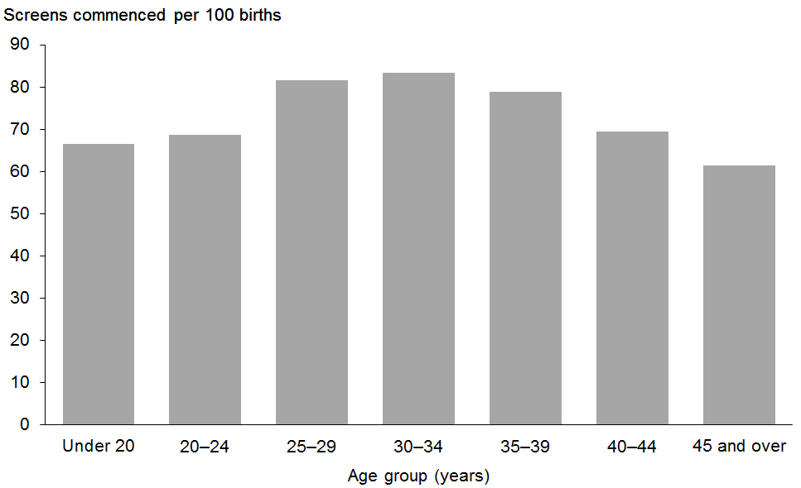

Figure 5: Screens commenced by ethnicity of mother, January 2014 to December 2014
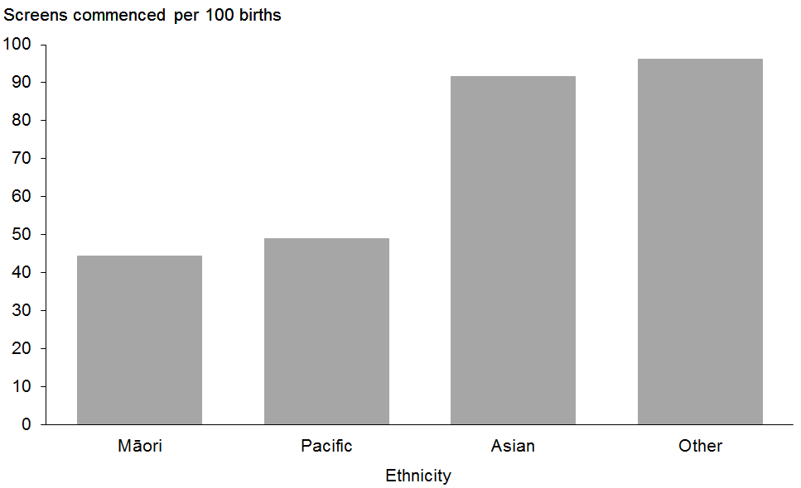

Figure 6: Screens commenced by NZ deprivation quintile, January 2014 to December 2014
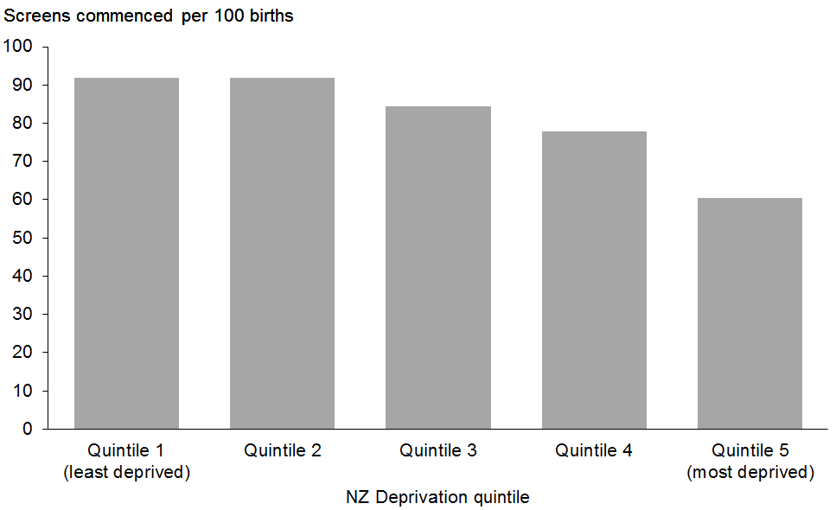

Indicator 2:
Screens completed
This indicator reports the number of screens completed by trimester of screening, DHB, age, ethnicity, and NZ deprivation quintile.

Total screens completed by trimester
During 2014, a total of 41,656 screens were completed, a rate of 71 per 100 births. Table 6 and Figure 7 show the total number of screens completed per year and trimester of screen. Across all years the majority of screens were completed in the first trimester. The total number of completed screens has increased annually since 2011. The trend for screens per 100 births was similar, with an increase of 7.5 per 100 births since 2011.

Table 6: Total screens completed by trimester, January 2011 to December 2014
Trimester of screen | Number and rate of screens completed
 | 2011 | 2012 | 2013 | 2014
T1 screen | 34,735 | 35,691 | 35,464 | 36,206
T2 screen | 4446 | 4957 | 5269 | 5450
Total screens | 39,181 | 40,648 | 40,733 | 41,656
Screens per 100 births | 63.4 | 65.7 | 69.3 | 70.9

Figure 7: Count and rate of screens completed, January 2011 to December 2014
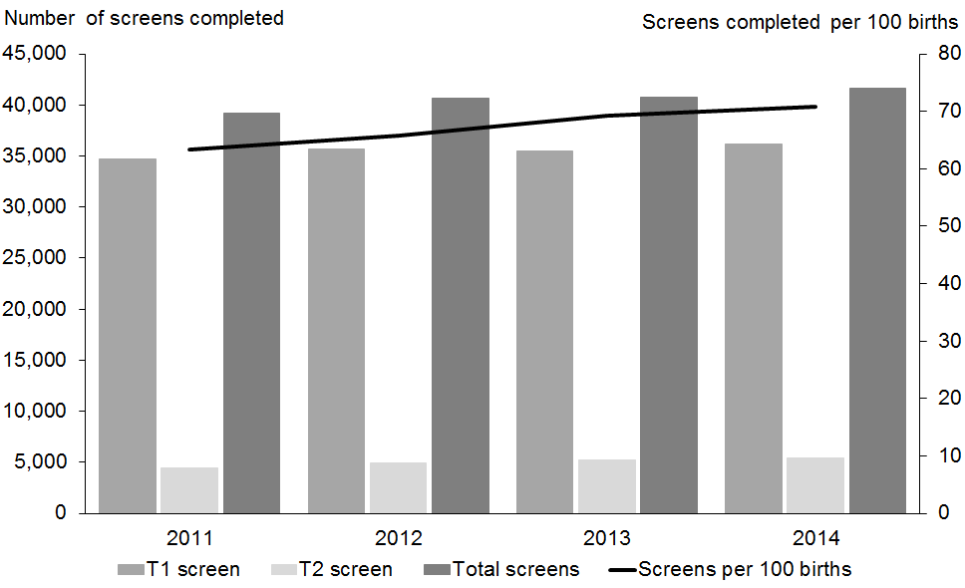

Screens completed by DHB
Screening completion rates for 2014 varied across DHBs from 87 per 100 births in Nelson Marlborough to 48 per 100 births in Northland (see Figure 8). Table 7 gives a full breakdown by the trimester of the screen.

Figure 8: Screens completed by DHB, January 2014 to December 2014
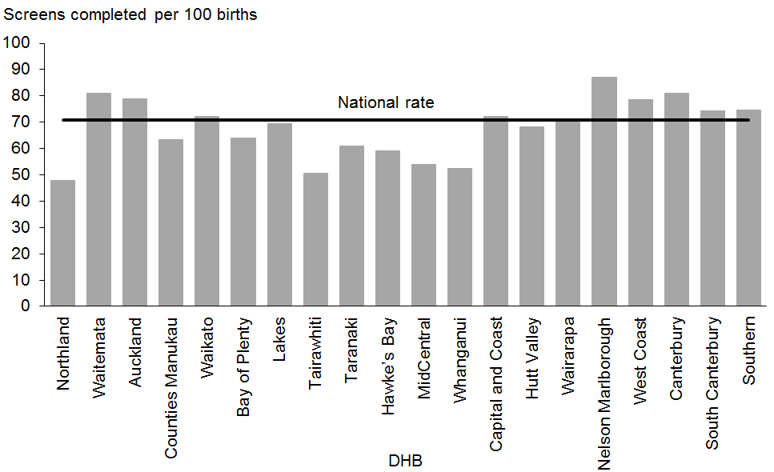

Table 7: Screening completion by trimester and DHB, January 2014 to December 2014
DHB | Number of screens completed |  |  | Screens completed (per 100 births)
 | First trimester | Second trimester | Total | First trimester | Second trimester | Total
Northland | 853 | 155 | 1008 | 40.5 | 7.4 | 47.9
Waitemata | 5653 | 704 | 6357 | 72.0 | 9.0 | 81.0
Auckland | 4344 | 625 | 4969 | 68.9 | 9.9 | 78.8
Counties Manukau | 4162 | 1080 | 5242 | 50.2 | 13.0 | 63.2
Waikato | 3354 | 440 | 3794 | 63.8 | 8.4 | 72.1
Lakes | 1596 | 191 | 1787 | 57.2 | 6.8 | 64.1
Bay of Plenty | 797 | 172 | 969 | 57.2 | 12.3 | 69.6
Tairawhiti | 290 | 63 | 353 | 41.7 | 9.1 | 50.7
Taranaki | 718 | 206 | 924 | 47.3 | 13.6 | 60.9
Hawke’s Bay | 1091 | 134 | 1225 | 52.6 | 6.5 | 59.0
Whanganui | 992 | 133 | 1125 | 47.5 | 6.4 | 53.8
MidCentral | 353 | 77 | 430 | 43.2 | 9.4 | 52.6
Hutt Valley | 2300 | 253 | 2553 | 65.1 | 7.2 | 72.3
Capital and Coast | 1095 | 173 | 1268 | 59.0 | 9.3 | 68.3
Wairarapa | 293 | 40 | 333 | 61.8 | 8.4 | 70.3
Nelson Marlborough | 1101 | 138 | 1239 | 77.4 | 9.7 | 87.1
West Coast | 237 | 38 | 275 | 67.7 | 10.9 | 78.6
Canterbury | 4307 | 558 | 4865 | 71.6 | 9.3 | 80.9
South Canterbury | 447 | 40 | 487 | 68.3 | 6.1 | 74.5
Southern | 2223 | 230 | 2453 | 67.7 | 7.0 | 74.7
Total | 36,206 | 5450 | 41,656 | 61.6 | 9.3 | 70.9

As for screens commenced, most DHBs showed a trend of increasing rates of screening completion over the four years covered in this report. South Canterbury was an exception to this with decreased completion rates, particularly between 2013 and 2014. Several other DHBs (Northland, Waitemata, Hawke’s Bay, Whanganui and Canterbury) showed a levelling off of completion rates between 2013 and 2014 (see Table 8).

Table 8: Screening completion by DHB, January 2011 to December 2014
DHB | Screens completed (per 100 births)
 | 2011 | 2012 | 2013 | 2014
Northland | 41.2 | 44.5 | 47.1 | 47.9
Waitemata | 77.9 | 77.8 | 82.1 | 81.0
Auckland | 70.4 | 69.4 | 77.6 | 78.8
Counties Manukau | 53.8 | 57.3 | 59.7 | 63.2
Waikato | 65.1 | 64.2 | 69.1 | 72.1
Lakes | 58.2 | 61.7 | 61.9 | 64.1
Bay of Plenty | 53.1 | 59.0 | 62.6 | 69.6
Tairawhiti | 39.2 | 44.6 | 46.8 | 50.7
Taranaki | 58.2 | 55.6 | 55.0 | 60.9
Hawke’s Bay | 50.2 | 55.8 | 59.7 | 59.0
Whanganui | 45.3 | 49.5 | 53.8 | 53.8
MidCentral | 40.2 | 41.8 | 45.1 | 52.6
Hutt Valley | 67.8 | 71.8 | 70.9 | 72.3
Capital and Coast | 59.1 | 62.6 | 64.6 | 68.3
Wairarapa | 62.8 | 59.6 | 66.5 | 70.3
Nelson Marlborough | 78.7 | 81.3 | 77.9 | 87.1
West Coast | 55.6 | 68.8 | 73.1 | 78.6
Canterbury | 72.3 | 75.8 | 81.9 | 80.9
South Canterbury | 86.9 | 82.6 | 85.5 | 74.5
Southern | 67.3 | 73.7 | 75.6 | 74.7
Total | 63.4 | 65.7 | 69.3 | 70.9

Screens completed by age, ethnicity and deprivation
Table 9 provides an overall view of screens completed by age, ethnicity and NZ deprivation quintile for January 2011 to December 2014, with similar trends shown as for screening commencement. Screening completion rates were highest in the 30–34 year age group with 78 women completing screening per 100 births in 2014. This was followed by the 25–39 years age group with 74 per 100 births (see Figure 9).

Screening completion rates were highest among women of Other ethnicity at 89 per 100 births for 2014. This was followed closely by Asian women at 87. The rate of completed screens for Pacific and Māori women remains lower at 42 per 100 births and 37 per 100 births respectively (see Figure 10). However, both groups have shown significant increase in screening completion over the four years (see Table 9).

Screening completion rates were highest among women in less deprived areas with rates around 85 per 100 per births for quintiles 1 and 2 in 2014 compared with 53 per 100 births for quintile 5 (see Figure 11).

Table 9: Screens completed by age of mother, ethnicity and NZ deprivation quintile, January 2011 to December 2014
 | Number of screens completed |  |  |  | Screens completed (per 100 births)#
 | 2011 | 2012 | 2013 | 2014 | 2011 | 2012 | 2013 | 2014
Age at screen
Under 20 years | 1808 | 1699 | 1610 | 1600 | 44.6 | 43.5 | 48.4 | 53.4
20–24 years | 5754 | 5890 | 6010 | 6059 | 49.2 | 51.4 | 55.6 | 58.8
25–29 years | 10,276 | 10,997 | 11,097 | 11,665 | 66.1 | 69.0 | 72.6 | 74.3
30–34 years | 12,353 | 12,859 | 13,089 | 13,645 | 71.7 | 73.7 | 78.1 | 77.5
35–39 years | 7453 | 7543 | 7214 | 7132 | 69.5 | 72.5 | 71.8 | 73.6
40–44 years | 1474 | 1588 | 1643 | 1483 | 61.3 | 61.6 | 67.5 | 63.2
45 years and over | 63 | 72 | 70 | 72 | 50.4 | 59.5 | 49.0 | 54.5
Ethnicity
Māori | 4561 | 4880 | 4893 | 5170 | 28.9 | 31.2 | 33.8 | 36.5
Pacific | 2479 | 2591 | 2606 | 2596 | 35.1 | 37.7 | 41.1 | 42.2
Asian | 6024 | 6990 | 7091 | 8021 | 84.4 | 82.7 | 86.9 | 87.1
Other | 26,117 | 26,187 | 26,143 | 25,869 | 82.1 | 84.7 | 87.7 | 88.5
NZ Deprivation Quintile
Quintile 1 | 7519 | 7520 | 7255 | 7236 | 88.4 | 86.7 | 88.7 | 85.4
Quintile 2 | 7480 | 7805 | 7749 | 7850 | 78.6 | 81.2 | 83.7 | 85.6
Quintile 3 | 7748 | 8028 | 8102 | 8181 | 69.5 | 71.9 | 76.2 | 77.4
Quintile 4 | 8401 | 8851 | 9001 | 9299 | 60.8 | 64.8 | 67.1 | 69.9
Quintile 5 | 8027 | 8441 | 8622 | 9089 | 42.7 | 45.0 | 49.8 | 52.7
Unknown | 6 | 3 | 4 | 1 | – | – | – | –
Total | 39,181 | 40,648 | 40,733 | 41,656 | 63.4 | 65.7 | 69.3 | 70.9
# Rate suppressed if the number of screens was <10.

Figure 9: Screens completed by age of mother at screen, January 2014 to December 2014
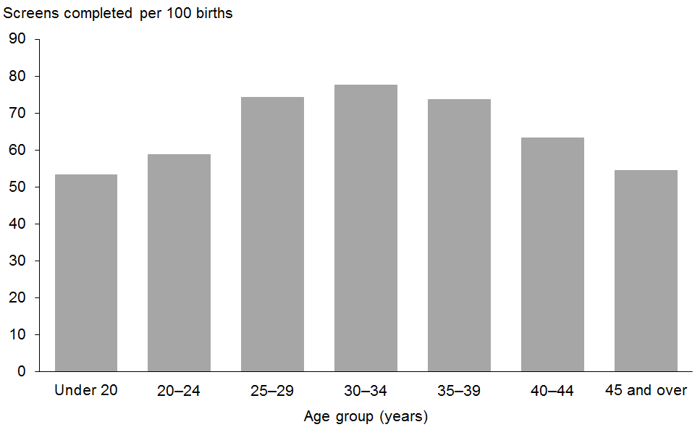

Figure 10: Screens completed by ethnicity of mother, January 2014 to December 2014
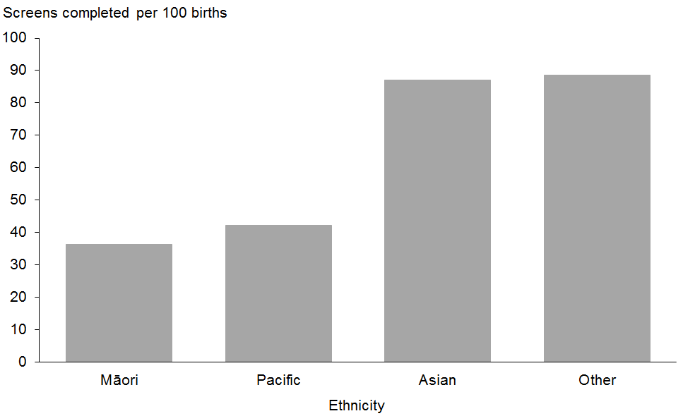

Figure 11: Screens completed by NZ deprivation quintile of mother, January 2014 to December 2014
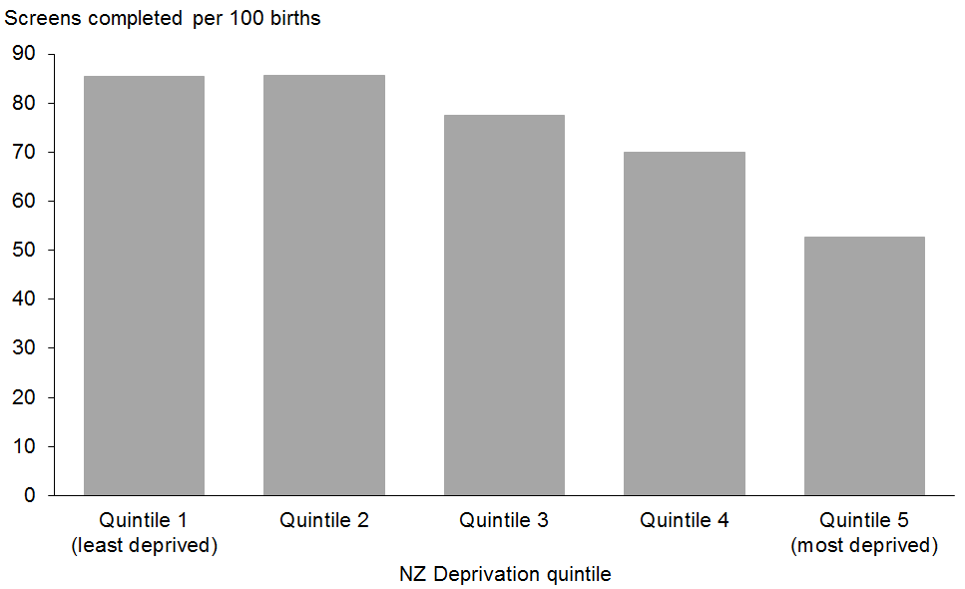

Indicator 3:
Screening pathway variance
This section reports on the number of screens completed in the second trimester which included first trimester screening inputs. First trimester combined screening requires a blood sample (PAPP-A and ßhCG) and ultrasound scan measurements of NT and CRL. Without both items a risk is not calculated and a second trimester blood sample is recommended. Information (NT or PAPP-A) from the first trimester will be included in the second trimester risk assessment.

Second trimester results with an NT measurement indicate that the screening laboratory did not receive a first trimester blood sample, or the blood sample was taken outside the accepted timeframe for first trimester screening. Second trimester results with PAPP-A indicate that the screening laboratory did not receive the NT scan report, or that the scan was performed outside the accepted timeframe for first trimester screening.

Screening pathway variance by year
Table 10 shows total number of second trimester screening results that included first trimester inputs over the period from 2011 to 2014. This has been broken down by the type of pathway variance.

The proportion of trimester 2 screens with an NT measurement has increased of the four year period from 41% to 44%. The proportion with PAPP-A increased slightly from 6% to 7% between 2012 and 2013.

Table 10: Screening pathway variance by type, January 2011 to 31 December 2014
Year | Second trimester screening results
 | Total T2 screens |  | with NT |  | with PAPP-A | with NT | with PAPP-A
 | Number |  |  |  |  | Percentage
2011 | 4446 | 1811 |  | 264 |  | 40.7 | 5.9
2012 | 4957 | 2048 |  | 291 |  | 41.3 | 5.9
2013 | 5269 | 2219 |  | 361 |  | 42.1 | 6.9
2014 | 5450 | 2378 |  | 376 |  | 43.6 | 6.9

Screening pathway variance by DHB
Table 11 shows a breakdown of screening pathway variance by DHB and type of variance for the 2014 year. Many DHBs did not have sufficient numbers to calculate the proportion with PAPP-A. Generally, the overall results are reflected at DHB level with a far higher proportion of T2 screens with NT compared with those with PAPP-A. Taranaki was an exception to this, with a higher proportion of T2 screens with PAPP-A (23%) than with NT (17%).

Table 11: Screening pathway variance by DHB, January 2014 to December 2014
DHB | Second trimester screening results
 | Total T2 screens | with NT | with PAPP-A | with NT | with PAPP-A#
 | Number |  |  | Percentage
Northland | 155 | 64 | 9 | 41.3 | –
Waitemata | 704 | 322 | 48 | 45.7 | 6.8
Auckland | 625 | 241 | 55 | 38.6 | 8.8
Counties Manukau | 1080 | 358 | 65 | 33.1 | 6.0
Waikato | 440 | 197 | 26 | 44.8 | 5.9
Bay of Plenty | 191 | 102 | 9 | 53.4 | –
Lakes | 172 | 75 | 7 | 43.6 | –
Tairawhiti | 63 | 28 | 4 | 44.4 | –
Taranaki | 206 | 34 | 48 | 16.5 | 23.3
Hawke’s Bay | 134 | 69 | 4 | 51.5 | –
MidCentral | 133 | 50 | 13 | 37.6 | 9.8
Whanganui | 77 | 43 | 1 | 55.8 | –
Capital and Coast | 253 | 120 | 22 | 47.4 | 8.7
Hutt Valley | 173 | 96 | 12 | 55.5 | 6.9
Wairarapa | 40 | 24 | – | 60.0 | –
Nelson Marlborough | 138 | 88 | 2 | 63.8 | –
West Coast | 38 | 23 | 1 | 60.5 | –
Canterbury | 558 | 300 | 41 | 53.8 | 7.3
South Canterbury | 40 | 15 | 1 | 37.5 | –
Southern | 230 | 129 | 8 | 56.1 | –
Total | 5450 | 2378 | 376 | 43.6 | 6.9
# Rate suppressed if the number of screens was <10.

Screening pathway variance by age, ethnicity and deprivation
Table 12 shows a breakdown of screening pathway variance by age, ethnicity and NZ deprivation quintile for the 2014 year. The results show higher proportions for pathway variance for older age groups, for women of Other ethnicity, and women in areas of lower deprivation.

Table 12: Screening pathway variance by age, ethnicity and NZ deprivation quintile, January 2011 to December 2014
 | Second trimester screening results
 | Total T2 screens |  | with NT |  | with PAPP-A | with NT# | with PAPP-A#
 | Number |  |  |  |  | Percentage
Age at screen
Under 20 years | 467 |  | 181 |  | 22 | 38.8 | 4.7
20–24 years | 1185 |  | 509 |  | 52 | 43.0 | 4.4
25–29 years | 1538 |  | 683 |  | 111 | 44.4 | 7.2
30–34 years | 1398 |  | 659 |  | 104 | 47.1 | 7.4
35–39 years | 681 |  | 283 |  | 69 | 41.6 | 10.1
40–44 years | 175 |  | 62 |  | 18 | 35.4 | 10.3
45 years and over | 6 |  | 1 |  | - | – | –
Ethnicity
Māori | 1337 |  | 529 |  | 66 | 39.6 | 4.9
Pacific | 905 |  | 275 |  | 61 | 30.4 | 6.7
Asian | 1003 |  | 373 |  | 85 | 37.2 | 8.5
Other | 2205 |  | 1201 |  | 164 | 54.5 | 7.4
NZ Deprivation quintile
Quintile 1 | 553 |  | 319 |  | 46 | 57.7 | 8.3
Quintile 2 | 717 |  | 354 |  | 59 | 49.4 | 8.2
Quintile 3 | 888 |  | 423 |  | 66 | 47.6 | 7.4
Quintile 4 | 1305 |  | 564 |  | 97 | 43.2 | 7.4
Quintile 5 | 1987 |  | 718 |  | 108 | 36.1 | 5.4
Total | 5450 |  | 2378 |  | 376 | 43.6 | 6.9
# Rate suppressed if the number of screens was <10.

Indicator 4:
Incomplete screens
This section reports on the number of women who commenced screening but were not issued with a risk result. Women that start screening in trimester 1 but complete screening in trimester 2 are not included in this indicator and are instead covered under indicator 3, pathway variances.

Total incomplete screens
Table 13 shows total number of incomplete screens by calendar year and trimester of screen. Nearly all incomplete screens related to the first trimester, which reflects the different components required to complete screening depending on trimester. First trimester screening requires a blood sample and an NT scan, whereas second trimester screening involves only a blood sample. The total number of incomplete screens for 2014 was 4184 which equates to 9% of screens commenced that year.

Table 13: Incomplete screens by trimester, January 2011 to 31 December 2014
Trimester of screen | Number of incomplete screens
 | 2011 | 2012 | 2013 | 2014
T1 screen | 4580 | 3988 | 3497 | 4024
T2 screen | 252 | 281 | 228 | 160
Total screens | 4832 | 4269 | 3725 | 4184

Incomplete T 1 screens by reason incomplete
Table 14 shows provides a breakdown of incomplete T1 screens according to which component of the screen was missing. Results have been reported as a percentage of all commenced screens, and then as a percentage of all incomplete screens.

The proportion of incomplete T1 screens out of all commenced T1 screens decreased from 12% in 2011 to 9% in 2013 before increasing slightly to 10% in 2014. This appears to be driven by an overall decrease in screens without blood samples (by 2% between 2011 and 2014) combined with fluctuation in the percentage without NT scans.

The split between the percentage of incompletes due to no blood or no NT scan has varied of the period covered in this report (see far right columns of Table 14), with an increasing proportion of incompletes being due to no NT scan (34% in 2014 compared with 26% in 2011).

Table 14: Incomplete T1 screens by reason incomplete, January 2011 to December 2014
Year | Commenced first trimester |  | Reason incomplete |  | Incomplete as percentage of commenced |  |  | Type as percentage of all T1 incomplete
 | Total commenced | Incomplete | No blood | No NT scan | T1 no blood | T1 no NT scan | Total T1 incompletes | T1 no blood | T1 no NT scan
2011 | 39,315 | 4580 | 3384 | 1196 | 8.6 | 3.0 | 11.6 | 73.9 | 26.1
2012 | 39,679 | 3,988 | 2892 | 1096 | 7.3 | 2.8 | 10.1 | 72.5 | 27.5
2013 | 38,961 | 3497 | 2368 | 1129 | 6.1 | 2.9 | 9.0 | 67.7 | 32.3
2014 | 40,230 | 4024 | 2657 | 1367 | 6.6 | 3.4 | 10.0 | 66.0 | 34.0

Incomplete T1 screens by reason and DHB
Table 15 provides the same breakdown by DHB. The lower numbers involved limit DHB comparisons. However, as with the pathway variance indicator, Taranaki DHB stands out with a much higher percentage of commenced screens being incomplete due to not having an NT scan (10%). Taranaki also stands out in the split of incomplete screens by type, with 73% due to no NT scan compared with the national average of 34%.

Table 15: Incomplete T1 screens by reason and DHB, 1 January 2014 to 31 December 2014
DHB | Commenced first trimester |  | Reason incomplete |  | Incomplete as percentage of commenced |  |  | Type as percentage of all T1 incomplete
 | Total commenced | Incomplete | No blood | No NT scan | T1 no blood | T1 no NT scan | Total T1 incomplete | T1 no blood | T1 no NT scan
Northland | 1010 | 157 | 123 | 34 | 12.2 | 3.4 | 15.5 | 78.3 | 21.7
Waitemata | 6069 | 416 | 267 | 149 | 4.4 | 2.5 | 6.9 | 64.2 | 35.8
Auckland | 4673 | 329 | 182 | 147 | 3.9 | 3.1 | 7.0 | 55.3 | 44.7
Counties Manukau | 4587 | 425 | 280 | 145 | 6.1 | 3.2 | 9.3 | 65.9 | 34.1
Waikato | 3768 | 414 | 276 | 138 | 7.3 | 3.7 | 11.0 | 66.7 | 33.3
Bay of Plenty | 1813 | 217 | 140 | 77 | 7.7 | 4.2 | 12.0 | 64.5 | 35.5
Lakes | 899 | 102 | 76 | 26 | 8.5 | 2.9 | 11.3 | 74.5 | 25.5
Tairawhiti | 343 | 53 | 34 | 19 | 9.9 | 5.5 | 15.5 | 64.2 | 35.8
Taranaki | 827 | 109 | 29 | 80 | 3.5 | 9.7 | 13.2 | 26.6 | 73.4
Hawke’s Bay | 1223 | 132 | 98 | 34 | 8.0 | 2.8 | 10.8 | 74.2 | 25.8
MidCentral | 1105 | 113 | 56 | 57 | 5.1 | 5.2 | 10.2 | 49.6 | 50.4
Whanganui | 418 | 65 | 43 | 22 | 10.3 | 5.3 | 15.6 | 66.2 | 33.8
Capital and Coast | 2575 | 275 | 196 | 79 | 7.6 | 3.1 | 10.7 | 71.3 | 28.7
Hutt Valley | 1277 | 182 | 148 | 34 | 11.6 | 2.7 | 14.3 | 81.3 | 18.7
Wairarapa | 343 | 50 | 36 | 14 | 10.5 | 4.1 | 14.6 | 72.0 | 28.0
Nelson Marlborough | 1238 | 137 | 96 | 41 | 7.8 | 3.3 | 11.1 | 70.1 | 29.9
West Coast | 270 | 33 | 24 | 9 | 8.9 | 3.3 | 12.2 | 72.7 | 27.3
Canterbury | 4812 | 505 | 349 | 156 | 7.3 | 3.2 | 10.5 | 69.1 | 30.9
South Canterbury | 472 | 25 | 13 | 12 | 2.8 | 2.5 | 5.3 | 52.0 | 48.0
Southern | 2508 | 285 | 191 | 94 | 7.6 | 3.7 | 11.4 | 67.0 | 33.0
Total | 40,230 | 4024 | 2657 | 1367 | 6.6 | 3.4 | 10.0 | 66.0 | 34.0

Incomplete T1 screens by age, ethnicity and deprivation
Table 16 shows a breakdown of incomplete screens by reason incomplete, age, ethnicity, and NZ deprivation quintile for the 2014 year. This shows higher rates of incomplete screens for younger women (25% for women up to 29 years of age). There were higher rates of incomplete screens for Māori (22%) and Pacific (18%) women when compared with Asian (5%) and Other (8%). The rate of incomplete screens also increased with increasing deprivation (15% for quintile 5 compared with 7% for quintile 1).

Table 16: Incomplete T1 screens by age, ethnicity and NZ deprivation quintile, 1 January 2014 to 31 December 2014
 | Commenced T1 screens |  | Reason incomplete |  | Incomplete as percentage of commenced |  |  | Type as percentage of all T1 incomplete#
 | Total commenced | Incomplete | No blood | No NT scan | No blood | No NT scan | All T1 incomplete | No blood | No NT scan
Age at screen
Under 20 years | 1501 | 368 | 274 | 94 | 18.3 | 6.3 | 24.5 | 74.5 | 25.5
20 – 24 years | 5851 | 977 | 731 | 246 | 12.5 | 4.2 | 16.7 | 74.8 | 25.2
25 – 29 years | 11,221 | 1094 | 774 | 320 | 6.9 | 2.9 | 9.7 | 70.7 | 29.3
30 – 34 years | 13,206 | 959 | 585 | 374 | 4.4 | 2.8 | 7.3 | 61.0 | 39.0
35 – 39 years | 6931 | 480 | 242 | 238 | 3.5 | 3.4 | 6.9 | 50.4 | 49.6
40 – 44 years | 1445 | 137 | 49 | 88 | 3.4 | 6.1 | 9.5 | 35.8 | 64.2
45 years and over | 75 | 9 | 2 | 7 | – | – | – | – | –
Ethnicity
Māori | 4905 | 1072 | 775 | 297 | 15.8 | 6.1 | 21.9 | 72.3 | 27.7
Pacific | 2059 | 368 | 238 | 130 | 11.6 | 6.3 | 17.9 | 64.7 | 35.3
Asian | 7419 | 401 | 212 | 189 | 2.9 | 2.5 | 5.4 | 52.9 | 47.1
Other | 25,847 | 2183 | 1432 | 751 | 5.5 | 2.9 | 8.4 | 65.6 | 34.4
NZ Deprivation quintile
Quintile 1 | 7199 | 516 | 322 | 194 | 4.5 | 2.7 | 7.2 | 62.4 | 37.6
Quintile 2 | 7687 | 554 | 335 | 219 | 4.4 | 2.8 | 7.2 | 60.5 | 39.5
Quintile 3 | 7986 | 693 | 437 | 256 | 5.5 | 3.2 | 8.7 | 63.1 | 36.9
Quintile 4 | 9000 | 1006 | 686 | 320 | 7.6 | 3.6 | 11.2 | 68.2 | 31.8
Quintile 5 | 8357 | 1255 | 877 | 378 | 10.5 | 4.5 | 15.0 | 69.9 | 30.1
Total | 40,230 | 4024 | 2657 | 1367 | 6.6 | 3.4 | 10.0 | 66.0 | 34.0
# Suppressed if the number of incomplete screens was <10.

Incomplete T2 screens
T2 screens do not require an NT scan, just a blood sample, making it less likely that a screen commenced in the second trimester will be incomplete. For the 2014 year 3% of T2 commenced screens were incomplete, compared with 10% of T2 commenced screens. As Table 17 shows, the percentage of incomplete T2 screens has decreased from 5% in 2011 to 3% in 2014.

Table 17: Incomplete T2 screens, 1 January 2011 to 31 December 2014
Year | Commenced second trimester | No result issued | Percentage incomplete
2011 | 4698 | 252 | 5.4
2012 | 4957 | 281 | 5.7
2013 | 5269 | 228 | 4.3
2014 | 5450 | 160 | 2.9

Incomplete T2 screens by DHB
Table 18 shows a breakdown of incomplete T2 screens by DHB for the 2014 year. The very low numbers involved limit meaningful percentage calculations and DHB comparisons.

Table 18: IncompleteT2 screens by DHB, 1 January 2011 to 31 December 2014
DHB | Commenced second trimester | No result issued | Percentage incomplete#
Northland | 160 | 5 | –
Waitemata | 722 | 18 | 2.5
Auckland | 643 | 18 | 2.8
Counties Manukau | 1125 | 45 | 4.0
Waikato | 455 | 15 | 3.3
Bay of Plenty | 196 | 5 | –
Lakes | 178 | 6 | –
Tairawhiti | 64 | 1 | –
Taranaki | 210 | 4 | –
Hawke’s Bay | 141 | 7 | –
MidCentral | 134 | 1 | –
Whanganui | 77 | – | –
Capital and Coast | 257 | 4 | –
Hutt Valley | 173 | – | –
Wairarapa | 42 | 2 | –
Nelson Marlborough | 144 | 6 | –
West Coast | 38 | – | –
Canterbury | 575 | 17 | 3.0
South Canterbury | 40 | – | –
Southern | 236 | 6 | –
Total | 5610 | 160 | 2.9
# Suppressed if the number of incomplete screens was <10.

Incomplete T2 screens by age, ethnicity and deprivation
Table 19 shows a breakdown of incomplete T2 screens by age, ethnicity and NZ deprivation quintile for 2014. Once again, the numbers involved are low. However, the percentage incomplete was higher for the youngest age group, and higher for Pacific compared with women of other ethnicities. There was no trend by NZ deprivation quintile.

Table 19: Incomplete T2 screens by age, ethnicity and NZ deprivation quintile, 1 January 2014 to 31 December 2014
 | Commenced second trimester | No result issued | Percentage incomplete#
Age at screen
Under 20 years | 488 | 21 | 4.3
20–24 years | 1215 | 30 | 2.5
25–29 years | 1583 | 45 | 2.8
30–34 years | 1435 | 37 | 2.6
35–39 years | 700 | 19 | 2.7
40–44 years | 183 | 8 | –
45 years and over | 6 | - | –
Ethnicity
Māori | 1389 | 52 | 3.7
Pacific | 953 | 48 | 5.0
Asian | 1023 | 20 | 2.0
Other | 2245 | 40 | 1.8
NZ Deprivation quintile
Quintile 1 | 565 | 12 | 2.1
Quintile 2 | 728 | 11 | 1.5
Quintile 3 | 913 | 25 | 2.7
Quintile 4 | 1345 | 40 | 3.0
Quintile 5 | 2059 | 72 | 3.5
Total | 5610 | 160 | 2.9
# Suppressed if the number of incomplete screens was <10.

Indicator 5:
Increased risk screening results for trisomy 21, trisomy 18 and trisomy 13
This indicator reports on the screening risk results issued for trisomy 21, trisomy 18 and trisomy 13. Women who complete screening receive a risk result, either low risk or increased risk, for each trisomy. This means that an individual woman may be at increased risk for more than one trisomy.

Total increased risk screening results for trisomy 21, 18 or 13
Table 20 shows total number of screening risk results that were classified as increased risk for one or more of trisomy 21, 18 or 13 by calendar year, together with the number of increased risk results per 100 screens (positive test rate). For the 2014 year, 2.8 increased risk results were issued for every 100 screens completed. This was slightly higher than 2013 but consistent with the rate for 2011 and 2012.

Table 20: Number and rate per 100 screens of increased risk screening results for trisomy 21, 18 or 13, January 2011 to 31 December 2014
 | Number and rate of increased risk screens
 | 2011 | 2012 | 2013 | 2014
Total increased risk results | 1099 | 1156 | 1103 | 1155
Positive test rate per 100 screens | 2.8 | 2.8 | 2.7 | 2.8

Increased risk screening results for trisomy 21, 18 or 13 by age, ethnicity and deprivation
Table 21 shows the number and proportion of screening risk results that were classified as increased risk for any one or more of trisomy 21, 18, or 13 by age at screen, ethnicity and deprivation for the 2014 year.

Positive test rate increases markedly with increasing age and is also higher for Pacific and Asian women compared with other ethnicities. Older women are more likely to have a positive test and are also more likely to have a higher detection rate. This is in keeping with the inclusion of prior risk (age) as part of the risk calculation. Different levels of deprivation do not appear to affect the positive test rate.

Table 21: Increased risk screening results for trisomy 21, 18 or 13 by age, ethnicity and deprivation, January 2014 to December 2014
 | Number of increased risks for trisomy 21, 18 or 13 | Total number of completed screens | Positive test rate per 100 screens
Age at screen
Under 20 years | 18 | 1600 | 1.1
20–24 years | 76 | 6059 | 1.3
25–29 years | 149 | 11,665 | 1.3
30–34 years | 245 | 13,645 | 1.8
35–39 years | 385 | 7132 | 5.4
40–44 years | 258 | 1483 | 17.4
45 years and over | 24 | 72 | 33.3
Ethnicity
Māori | 137 | 5170 | 2.6
Pacific | 97 | 2596 | 3.7
Asian | 279 | 8021 | 3.5
Other | 642 | 25,869 | 2.5
NZ Deprivation quintile
Quintile 1 | 231 | 7236 | 3.2
Quintile 2 | 190 | 7850 | 2.4
Quintile 3 | 238 | 8181 | 2.9
Quintile 4 | 242 | 9299 | 2.6
Quintile 5 | 254 | 9089 | 2.8
Unknown | – | 1 | –

Increased risk screening results for trisomy 21, 18 or 13 by trimester of screen
Table 22 shows the positive test rate for each of trisomy 21, 18 and 13 as well as the positive test rate for the three trisomies together by trimester of screen and calendar year.

Trisomy 18 and 13 each showed low positive test rates (from 0.3 per 100 screens) while the positive test rate for trisomy 21 was close to 3 per 100 screens for all years. The second trimester positive test rate for trisomy 21 was significantly higher than the first trimester positive test rate (approximately twice as high in all years). This may be due to variability in nuchal translucency scanning accuracy.

The positive test rate for any one or more of trisomy 21, 18 or 13 was similar to that of trisomy 21 alone. This reflects the far higher number of trisomy 21 increased risks compared with trisomy 18 and 13.

Table 22: Increased risk screening results for trisomy 21, 18 and 13 by trimester of screen, January 2011 to December 2014
Year | Total increased risks for specified trisomy | Positive test rate per 100 screens | T1 results with increased risk for specified trisomy | Positive test rate per 100 T1 screens | T2 results with increased risk for specified trisomy | Positive test rate per 100 T2 screens
Trisomy 21
2011 | 1081 | 2.8 | 868 | 2.5 | 213 | 4.8
2012 | 1144 | 2.8 | 871 | 2.4 | 273 | 5.5
2013 | 1081 | 2.7 | 840 | 2.4 | 241 | 4.6
2014 | 1129 | 2.7 | 868 | 2.4 | 261 | 4.8
Trisomy 18
2011 | 134 | 0.3 | 123 | 0.4 | 11 | 0.2
2012 | 161 | 0.4 | 149 | 0.4 | 12 | 0.2
2013 | 145 | 0.4 | 125 | 0.4 | 20 | 0.4
2014 | 135 | 0.3 | 119 | 0.3 | 16 | 0.3
Trisomy 13
2011 | 143 | 0.4 | 140 | 0.4 | 3 | 0.1
2012 | 169 | 0.4 | 161 | 0.5 | 8 | 0.2
2013 | 158 | 0.4 | 144 | 0.4 | 14 | 0.3
2014 | 148 | 0.4 | 134 | 0.4 | 14 | 0.3
Any one or more of trisomy 21, 18 or 13
2011 | 1099 | 2.8 | 878 | 2.5 | 221 | 5.0
2012 | 1156 | 2.8 | 874 | 2.4 | 282 | 5.7
2013 | 1103 | 2.7 | 847 | 2.4 | 256 | 4.9
2014 | 1155 | 2.8 | 881 | 2.4 | 274 | 5.0

Increased risk screening results stratified by risk level
Table 23 shows the number of increased risk results stratified by risk level for each of trisomy 21, 18 and 13 for the 2014 year. A woman’s screen result may indicate an increased risk for more than one of trisomy 21, 18 and 13 so the sum of the values in Table 23 will be greater than the total number of increased risk results for 2014.

Table 23: Increased risk screening results for trisomy 21, 18 and 13 by risk level, January 2014 to December 2014
Risk level | Trisomy 21 | Trisomy 18 | Trisomy 13
1:5 – 1:20 | 247 | 44 | 51
1:25 to 1:50 | 179 | 14 | 25
1:55 to 1:300 | 703 | 77 | 72

Indicator 6:
Diagnostic testing volumes for women with increased risk screens
This indicator reports information on the number and proportion of women who complete prenatal diagnostic testing (CVS or amniocentesis) following an increased risk screening result for trisomy 21, trisomy 18 or trisomy 13. Following an increased risk result, women may choose to have diagnostic testing (either amniocentesis or CVS) to determine the absence or the presence of the condition.

Results for this indicator, and all remaining indicators, exclude screened women from Canterbury, South Canterbury and West Coast DHBs due to unavailability of diagnostic data.

Diagnostic testing volumes for women with increased risk screens by trimester of screen
Table 24 shows the diagnostic testing rate from 2011–2014 by trimester of screen. In 2014, for every 100 women that received an increased risk result after a first trimester screen, 61 women had a diagnostic test. This is lower than previous years. The diagnostic testing rate was lower for women who received an increased risk after a second trimester screen (47 women per 100 increased risk screens) compared with first trimester screens. See Appendix 3 for a summary of diagnostic test results for women who had increased risk screen in 2014, as well as pregnancy outcomes (where known) for women that did not have a prenatal diagnostic.

Table 24: Diagnostic testing volumes for women with increased risk screens by trimester of screen, January 2011 to December 2014
Trimester of screen | Diagnostic tests per 100 increased risk screens
 | 2011 | 2012 | 2013 | 2014
T1 screen | 64.4 | 65.6 | 66.2 | 60.5
T2 screen | 41.9 | 42.7 | 48.5 | 46.6
Total screens | 59.7 | 59.8 | 62.0 | 57.1

Diagnostic testing volumes for women with increased risk screens by DHB
The rate of diagnostic testing for women with increased risk screens in 2014 varied across DHBs from 48 per 100 increased risk results in Taranaki, to 78.3 per 100 increased risk results in Nelson Marlborough. Bay of Plenty was next highest with 63.6 per 100 increased risks (see Table 25).

Table 25: Diagnostic testing volumes for women with increased risk screens by DHB, January 2011 to December 2014
DHB | Number of diagnostic tests |  |  |  | Tests per 100 increased risk screens#
 | 2011 | 2012 | 2013 | 2014 | 2011 | 2012 | 2013 | 2014
Northland | 24 | 13 | 28 | 26 | 49.0 | 38.2 | 56.0 | 59.1
Waitemata | 136 | 137 | 140 | 115 | 67.0 | 67.2 | 72.9 | 61.2
Auckland | 117 | 117 | 89 | 89 | 72.2 | 68.4 | 67.4 | 55.3
Counties Manukau | 67 | 75 | 72 | 76 | 54.5 | 50.7 | 46.5 | 50.3
Waikato | 15 | 26 | 40 | 40 | 20.5 | 38.2 | 57.1 | 63.5
Bay of Plenty | 11 | 22 | 21 | 21 | 36.7 | 68.8 | 55.3 | 63.6
Lakes | 15 | 23 | 21 | 21 | 55.6 | 69.7 | 67.7 | 53.8
Tairawhiti | 5 | 5 | 2 | – | – | – | – | –
Taranaki | 14 | 18 | 18 | 12 | 63.6 | 75.0 | 66.7 | 48.0
Hawke’s Bay | 22 | 17 | 21 | 19 | 62.9 | 47.2 | 53.8 | 55.9
MidCentral | 20 | 20 | 10 | 11 | 54.1 | 62.5 | 38.5 | 57.9
Whanganui | 4 | 4 | 6 | 3 | – | – | – | –
Capital and Coast | 52 | 61 | 55 | 45 | 72.2 | 69.3 | 75.3 | 60.0
Hutt Valley | 14 | 23 | 18 | 15 | 56.0 | 60.5 | 58.1 | 55.6
Wairarapa | 5 | 7 | 9 | 1 | – | – | – | –
Nelson Marlborough | 23 | 11 | 17 | 18 | 67.6 | 47.8 | 89.5 | 78.3
West Coast | n/a | n/a | n/a | n/a | n/a | n/a | n/a | n/a
Canterbury | n/a | n/a | n/a | n/a | n/a | n/a | n/a | n/a
South Canterbury | n/a | n/a | n/a | n/a | n/a | n/a | n/a | n/a
Southern | 33 | 39 | 32 | 28 | 66.0 | 53.4 | 61.5 | 57.1
Total | 577 | 618 | 599 | 540 | 59.7 | 59.8 | 62.0 | 57.1
# Rate suppressed if the number of diagnostic tests was <10.

Diagnostic testing volumes for women with increased risk screens by age, ethnicity and deprivation
Table 26 shows the diagnostic testing rate for women with increased risk screens by age, ethnicity and NZ deprivation quintile for 2011 to 2014. The diagnostic testing rate ranged from 52 per 100 increased risk screens for women aged 20 to 24 years, to 66 per 100 for women aged 30–34 years.

Diagnostic testing rates were highest for women of Asian ethnicity (67 per 100 increased risks), followed by Other (61 per 100 increased risks). While diagnostic testing rates are generally and have historically been higher in less deprived areas, 2014 suggests a change in this trend with a smaller difference in rates between quintile 5 and quintile 1 when compared with previous years.

Table 26: Diagnostic testing volumes for women with increased risk screening results by age at screen, ethnicity and deprivation, January 2011 to December 2014
 | Diagnostic tests per 100 increased risk screens#
 | 2011 | 2012 | 2013 | 2014
Age at screen
Under 20 years | – | – | – | –
20–24 years | 56.1 | 53.1 | 64.8 | 51.6
25–29 years | 60.4 | 61.9 | 62.1 | 61.8
30–34 years | 64.6 | 68.4 | 69.4 | 65.7
35–39 years | 65.1 | 59.9 | 62.0 | 54.9
40–44 years | 48.9 | 55.6 | 57.8 | 54.8
45 years and over | – | – | 44.0 | –
Ethnicity
Māori | 40.4 | 43.2 | 52.6 | 38.1
Pacific | 35.6 | 37.0 | 37.9 | 37.1
Asian | 70.7 | 72.1 | 70.2 | 66.4
Other | 64.2 | 63.7 | 66.3 | 61.0
NZ Deprivation quintile
Quintile 1 | 71.6 | 67.5 | 72.6 | 62.4
Quintile 2 | 70.4 | 71.6 | 66.9 | 61.6
Quintile 3 | 60.2 | 63.2 | 62.0 | 55.1
Quintile 4 | 52.5 | 52.1 | 59.4 | 60.6
Quintile 5 | 47.1 | 47.6 | 53.7 | 49.4
# Rate suppressed if the number of diagnostic tests was <10.

Diagnostic testing volumes for women with increased risk screening results stratified by risk level
Each screening result includes a separate risk level for each of the three trisomies. Women were assigned a risk level based on the highest risk across the three trisomies. As diagnostic data was not available for women from Canterbury, South Canterbury and West Coast, screening volumes for women from these three DHBs are not included for this indicator. Subsequently, the increased risk screen values do not match with indicator 5.

Table 27 shows the number of diagnostic tests for women with increased risk screening results during 2014 for one or more of trisomy 21, 18 or 13, stratified by risk level. Uptake of diagnostic testing was higher in the very increased risk groupings. While 51% of women with a risk between 1:55 and 1:300 had a prenatal diagnostic test, this increased to 67–68% for women with risks of 1:50 or above.

Table 27: Diagnostic testing volumes for women with increased risk screens by risk level, January 2014 to December 2014
Risk level | Number of diagnostic tests | Number of increased risk screens | Tests per 100 increased risk screens
1:5 to 1:20 | 135 | 198 | 68.2
1:25 to 1:50 | 97 | 144 | 67.4
1:55 to 1:300 | 308 | 604 | 51.0

Indicator 7:
Diagnostic testing volumes for women who receive a low risk screening result
This section reports information on the number and proportion of women who complete prenatal diagnostic testing (CVS or amniocentesis) following a low risk screening result. Following a low risk screen, women may still choose to have diagnostic testing to determine the absence or the presence of a condition.

This indicator intends to capture only those that had a low risk in isolation so for this calculation a woman was only counted as having a low risk screen if there was no increased risk for any of the other conditions covered by the screening test in addition to trisomy 21, 18 and 13. So for example, if the result was low risk for each of trisomy 21, 18 and 13 but increased risk for neural tube defects then the woman was categorised as at increased risk for the purposes of this indicator.

Some women with low risk screening results may have other indications for diagnostic testing, eg, family history of another condition that diagnostic testing can identify. Information on the indication for diagnostic testing is not reliably provided on laboratory forms so the calculations for this indicator cannot exclude these women.

Diagnostic testing volumes for women with low risk screens by trimester of screen
The national rate of diagnostic testing for women that received low risk screening results was 0.63 per 100 low risk screens in 2014. This was a decrease from the previous three years (see Table 28). This suggests that a diminishing number of women (now well under 1%) are having prenatal diagnostic tests after low risk screens.

Table 28: Diagnostic testing volumes for women with low risk screens by trimester of screen, January 2011 to December 2014
Trimester of screen | Diagnostic tests per 100 low risk screens
 | 2011 | 2012 | 2013 | 2014
T1 screen | 0.89 | 0.90 | 0.80 | 0.65
T2 screen | 0.65 | 0.61 | 0.39 | 0.51
Total screens | 0.86 | 0.86 | 0.75 | 0.63

Diagnostic testing volumes for women with low risk screens by DHB
The rate of diagnostic testing for women with low risk screens during 2014 varied across DHBs, as shown in Table 29. Given the low numbers involved, caution should be taken in making comparisons.

Table 29: Total diagnostic testing volumes for women with low risk screens by DHB January 2011 to December 2014
DHB | Number of diagnostic tests |  |  |  | Tests per 100 low risk screens#
 | 2011 | 2012 | 2013 | 2014 | 2011 | 2012 | 2013 | 2014
Northland | 5 | 2 | 7 | – | – | – | – | –
Waitemata | 62 | 60 | 55 | 34 | 1.04 | 1.00 | 0.90 | 0.55
Auckland | 71 | 71 | 54 | 38 | 1.60 | 1.58 | 1.15 | 0.79
Counties Manukau | 38 | 25 | 27 | 18 | 0.83 | 0.51 | 0.57 | 0.35
Waikato | 5 | 18 | 18 | 28 | – | 0.52 | 0.51 | 0.75
Bay of Plenty | 5 | 10 | 9 | 14 | – | 0.56 | – | 0.80
Lakes | 3 | 3 | 3 | 5 | – | – | – | –
Tairawhiti | – | 3 | – | 1 | – | – | – | –
Taranaki | 6 | 11 | 9 | 3 | – | 1.31 | – | –
Hawke’s Bay | 11 | 8 | 5 | 7 | 1.00 | – | – | –
MidCentral | 7 | 4 | 9 | 8 | – | – | – | –
Whanganui | 4 | 4 | 2 | 2 | – | – | – | –
Capital and Coast | 23 | 18 | 21 | 14 | 0.90 | 0.67 | 0.84 | 0.57
Hutt Valley | 12 | 10 | 8 | 11 | 1.01 | 0.82 | – | 0.89
Wairarapa | 1 | – | – | – | – | – | – | –
Nelson Marlborough | 9 | 14 | 12 | 6 | – | 1.15 | 1.01 | –
West Coast | n/a | n/a | n/a | n/a | n/a | n/a | n/a | n/a
Canterbury | n/a | n/a | n/a | n/a | n/a | n/a | n/a | n/a
South Canterbury | n/a | n/a | n/a | n/a | n/a | n/a | n/a | n/a
Southern | 24 | 35 | 16 | 32 | 0.99 | 1.36 | 0.63 | 1.33
Total | 286 | 296 | 255 | 221 | 0.86 | 0.86 | 0.75 | 0.63
# Rate suppressed if the number of diagnostic tests was <10.

Diagnostic testing volumes for women with low risk screening results by age, ethnicity and deprivation
Table 30 shows the rate of diagnostic testing for women with low risk screening results by age, ethnicity and NZ deprivation quintile. The rate of diagnostic testing was higher for older age groups, for women of Other ethnicity, and for women in the lowest deprivation quintiles.

Table 30: Diagnostic tests per 100 low risk screens by age, ethnicity and NZ deprivation quintile, January 2011 to December 2014
 | Diagnostic tests per 100 low risk screens#
 | 2011 | 2012 | 2013 | 2014
Age at screen
Under 20 years | – | – | – | –
20–24 years | 0.31 | 0.26 | 0.31 | 0.37
25–29 years | 0.35 | 0.38 | 0.35 | 0.38
30–34 years | 0.53 | 0.66 | 0.54 | 0.48
35–39 years | 1.92 | 1.56 | 1.20 | 0.95
40–44 years | 5.49 | 5.66 | 5.90 | 4.17
45 years and over | – | – | – | –
Ethnicity
Māori | 0.44 | 0.69 | 0.57 | 0.47
Pacific | 0.35 | 0.21 | 0.30 | 0.25
Asian | 0.89 | 0.79 | 0.67 | 0.55
Other | 0.99 | 0.99 | 0.86 | 0.73
NZ Deprivation quintile
Quintile 1 | 1.56 | 1.71 | 1.15 | 0.85
Quintile 2 | 1.05 | 0.98 | 0.77 | 0.76
Quintile 3 | 0.82 | 0.63 | 0.81 | 0.62
Quintile 4 | 0.67 | 0.79 | 0.62 | 0.56
Quintile 5 | 0.37 | 0.39 | 0.50 | 0.45
# Rate suppressed if the number of diagnostic tests was <10.

Diagnostic testing volumes for women with low risk screening results stratified by risk
Table 31 shows the rate of diagnostic testing for women with low risk screening results, stratified by risk level. Given the low numbers involved for some risk categories, numbers have been aggregated for all years. The rate of diagnostic testing was more than 10 times higher for the highest category compared with the lowest category and the rate of diagnostic testing drops away as risk decreases below 1:1000.

Table 31: Diagnostic tests per 100 low risk screens stratified by risk level, January 2011–December 2014 aggregated
Risk level | Number of diagnostic tests | Number of low risk screens | Tests per 100 low risk screens
1:301 to 1:500 | 137 | 2180 | 6.28
1:501 to 1:1000 | 187 | 5648 | 3.31
1:1001 to 1:2000 | 171 | 9813 | 1.74
1:2001 to 1:3000 | 103 | 8441 | 1.22
1:3001 to 1:4000 | 60 | 7714 | 0.78
1:4001 to 1:5000 | 56 | 6834 | 0.82
1:5001 to 1:10,000 | 136 | 27,316 | 0.50
1:10,001 to 1:100,000 | 208 | 68,542 | 0.30

Indicator 8:
Diagnostic testing for unscreened women
This section reports information on the number of women who complete prenatal diagnostic testing (CVS or amniocentesis) but were not screened in the 105 days prior to the diagnostic test. The indication for diagnostic testing is not reliably reported on laboratory request forms but it is likely that many of these women will have had a predetermined risk (eg, family history or previous child with Down syndrome) or an abnormal ultrasound finding.

Diagnostic volumes for unscreened women
During 2014, 221 diagnostic tests were completed for unscreened women. This is up from 208 in 2013 but similar to 2012. Table 32 shows the number of tests by DHB and Table 33 shows the breakdown by age, ethnicity and NZ deprivation quintile. Due to the low numbers involved, rates per 100 births are not shown.

Table 32: Diagnostic testing volumes for unscreened women by DHB, January 2012 to December 2014
DHB | Number of diagnostic tests
 | 2012 | 2013 | 2014
Northland | 10 | 7 | 8
Waitemata | 37 | 25 | 27
Auckland | 32 | 26 | 32
Counties Manukau | 18 | 28 | 25
Waikato | 16 | 24 | 22
Bay of Plenty | 2 | 5 | 7
Lakes | 10 | 19 | 15
Tairawhiti | 5 | - | 2
Taranaki | 13 | 12 | 5
Hawke’s Bay | 12 | 6 | 7
Mid Central | 4 | 3 | 3
Whanganui | 9 | 11 | 11
Capital and Coast | 10 | 11 | 11
Hutt Valley | 17 | 16 | 31
Wairarapa | 5 | 1 | 1
Nelson Marlborough | 6 | 1 | 4
West Coast | n/a | n/a | n/a
Canterbury | n/a | n/a | n/a
South Canterbury | n/a | n/a | n/a
Southern | 13 | 13 | 10
Total | 219 | 208 | 221
Table 33: Total diagnostic testing volumes for unscreened women by age, ethnicity and deprivation quintile, January 2012 to December 2014
 | Number of diagnostic tests
 | 2012 | 2013 | 2014
Age
Under 20 years | 13 | 11 | 13
20–24 years | 27 | 34 | 30
25–29 years | 37 | 33 | 36
30–34 years | 56 | 49 | 57
35–39 years | 49 | 40 | 52
40–44 years | 36 | 37 | 31
45 years and over | 1 | 4 | 2
Ethnicity
Māori | 28 | 47 | 31
Pacific | 15 | 16 | 22
Asian | 37 | 29 | 30
Other | 139 | 116 | 138
NZ Deprivation quintile
Quintile 1 | 52 | 31 | 41
Quintile 2 | 38 | 39 | 31
Quintile 3 | 39 | 34 | 49
Quintile 4 | 49 | 56 | 45
Quintile 5 | 41 | 48 | 55

Diagnostic results for unscreened women
A breakdown of prenatal diagnostic testing results for unscreened women for the 2014 year is given in Table 34. Of the 221 diagnostic tests in 2014 for unscreened women, 168 (76%) had a normal karyotype. There were 12 trisomy 21 diagnoses, nine trisomy 18 diagnoses and one diagnosis of trisomy 13.

Table 34: Total diagnostic testing results for unscreened women, January 2014 to December 2014
Karyotype result | Number | Percentage
Normal karyotype | 168 | 76.0%
Trisomy 21 | 12 | 5.4%
Trisomy 18 | 9 | 4.1%
Trisomy 13 | 1 | 0.5%
Turner syndrome | 3 | 1.4%
Triploidy | 4 | 1.8%
Other chromosome abnormality | 20 | 9.0%
Failed test | 4 | 1.8%
Total | 221 | 100.0%

Indicator 9:
Diagnostic testing outcomes for women with increased risk screening results
This section reports information on the positive predictive value of screening. Positive predictive value (PPV) is calculated by dividing the number of true positives (increased risk screening result and then a positive diagnostic test for trisomy, or a baby born with trisomy) by the number of true positive and false positives (increased risk screening result and then a negative diagnostic test for a trisomy, or a baby born without a trisomy). Appendix 4 contains a summary of how screening measures, such as PPV, are calculated.

Positive predictive value of screening
The combined PPV for trisomy 21, 18 or 13 was calculated by categorising any screening result that included an increased risk for any of trisomy 21, 18 or 13 as a positive screen. If there was a subsequent diagnosis of any of trisomy 21, 18 or 13 then it was classified as a true positive. If there was no diagnosis of any of these three trisomies it was a false positive.

It should be noted that there were a small number of screens where the trisomy with the increased risk screening result was not the trisomy that was ultimately diagnosed. For example, a screening result may have shown an increased risk for trisomy 21 and normal risk for trisomy 13 but the cytogenetic result or infant diagnosis was trisomy 13. For the indicator 9, 10 and 11 calculations that combine the three trisomies together this record was categorised as a true positive. For the calculations looking at trisomy 21 specifically it was a false positive and for the trisomy 13 calculations it was a false negative. Due to this conflict in categorisation, the breakdowns by screening risk level, age, ethnicity, and deprivation have only been reported for trisomy 21 rather than combining trisomy 21, 18 and 13.

The overall PPV for 2014 was 0.10, which was lower than previous years (see Table 35). A value of 0.10 means that if a woman receives an increased risk result for trisomy 21, 18 or 13 there is a 10% probability that she is carrying a fetus with one of these trisomies. When data was aggregated across all years the PPV value for second trimester screens was 0.04 compared with 0.14 for first trimester screens.

Table 35: Positive predictive value of screening for trisomy 21, 18 or 13, January 2011 to December 2014
Trimester of screen | True positives |  |  |  | False positives |  |  |  | Positive predictive  value#
 | Positive diagnostic test/infant diagnosis after increased risk screen |  |  |  | Negative diagnostic test/infant without diagnosis after increased risk screen
 | 2011 | 2012 | 2013 | 2014 | 2011 | 2012 | 2013 | 2014 | 2011 | 2012 | 2013 | 2014
T1 screens | 104 | 111 | 109 | 92 | 660 | 662 | 628 | 620 | 0.14 | 0.14 | 0.15 | 0.13
T2 screens | 6 | 10 | 12 | 6 | 197 | 250 | 217 | 228 | – | 0.04 | 0.05 | –
Total screens | 110 | 121 | 121 | 98 | 857 | 912 | 845 | 848 | 0.11 | 0.12 | 0.13 | 0.10
# Rate suppressed if the number of diagnostic tests was <10.

The PPV changes when calculated for a specific trisomy. When looking at trisomy 21 the PPV for 2014 was lower than the combined PPV at 0.08 (see Table 36). This means that if a woman receives an increased risk result for trisomy 21 there is an 8% probability that she is carrying a fetus with trisomy 21.

Table 36: Positive predictive of screening for trisomy 21, January 2011 to December 2014
Trimester of screen | True positives |  |  |  | False positives |  |  |  | Positive predictive  value#
 | Positive diagnostic test/infant diagnosis after increased risk screen |  |  |  | Negative diagnostic test/infant without diagnosis after increased risk screen
 | 2011 | 2012 | 2013 | 2014 | 2011 | 2012 | 2013 | 2014 | 2011 | 2012 | 2013 | 2014
T1 screens | 70 | 76 | 82 | 68 | 687 | 695 | 650 | 634 | 0.09 | 0.10 | 0.11 | 0.10
T2 screens | 3 | 7 | 12 | 5 | 193 | 244 | 202 | 218 | – | – | 0.06 | –
Total screens | 73 | 83 | 94 | 73 | 880 | 939 | 852 | 852 | 0.08 | 0.08 | 0.10 | 0.08
# Rate suppressed if the number of positive diagnoses was <10.

Trisomies 13 and 18 involve small numbers and have similar risk profiles so combined results for PPV and remaining indicators have been calculated for these trisomies.

The combined PPV for trisomies 13 or 18 for 2014 was higher than the trisomy 21 PPV at 0.16 (see Table 37). However, the number of positive diagnoses for these two trisomies is low so caution should be taken when interpreting these results.

Table 37: Positive predictive of screening for trisomy 13 or 18, January 2011 to December 2014
Trimester of screen | True positives |  |  |  | False positives |  |  |  | Positive predictive  value#
 | Positive diagnostic test/ infant diagnosis after increased risk screen |  |  |  | Negative diagnostic test/ infant without diagnosis after increased risk screen
 | 2011 | 2012 | 2013 | 2014 | 2011 | 2012 | 2013 | 2014 | 2011 | 2012 | 2013 | 2014
T1 screens | 33 | 29 | 25 | 22 | 98 | 118 | 101 | 97 | 0.25 | 0.20 | 0.20 | 0.18
T2 screens | 1 | 2 | – | – | 12 | 15 | 24 | 19 | – | – | – | –
Total screens | 34 | 31 | 25 | 22 | 110 | 133 | 125 | 116 | 0.24 | 0.19 | 0.17 | 0.16
# Rate suppressed if the number of positive diagnoses was <10.

Positive predictive value of screening for trisomy 21 stratified by risk level
Table 38 shows PPV stratified by the risk level indicated in the screening result. For 2014, women that received a very increased risk result of 1:5 to 1:20 for trisomy 21 had a 29% probability that they were carrying a fetus with trisomy 21. There were insufficient numbers to calculate PPV for the other two categories for 2014, but looking at previous years the PPV was lower for women with increased risks of 1:25 to 1:150, and lower again for women with increased risk results of 1:55 to 1:300.

Table 38: Positive predictive of screening for trisomy 21 stratified by risk level, January 2011 to December 2014
Risk level | True positives |  |  |  | False positives |  |  |  | Positive predictive value#
 | Positive diagnostic test/ infant diagnosis after increased risk screen |  |  |  | Negative diagnostic test/ infant without diagnosis after increased risk screen
 | 2011 | 2012 | 2013 | 2014 | 2011 | 2012 | 2013 | 2014 | 2011 | 2012 | 2013 | 2014
1:5 to 1:20 | 48 | 58 | 61 | 56 | 155 | 166 | 140 | 139 | 0.24 | 0.26 | 0.30 | 0.29
1:25 to 1:50 | 15 | 15 | 14 | 8 | 137 | 126 | 95 | 132 | 0.10 | 0.11 | 0.13 | –
1:55 to 1:300 | 10 | 10 | 19 | 9 | 588 | 647 | 617 | 581 | 0.02 | 0.02 | 0.03 | –
# Rate suppressed if the number of positive diagnoses was <10.

Positive predictive value of screening for trisomy 21 by age, ethnicity and deprivation
The PPV of screening for trisomy 21 also varied by age group, as shown in Table 39. For 2014 PPV was highest for the 40–44 years age group, with insufficient numbers to calculate a rate for the youngest and oldest age groups.

Table 39: Positive predictive of screening for trisomy 21 by age, January 2011 to December 2014
Age | True positives |  |  |  | False positives |  |  |  | Positive predictive value#
 | Positive diagnostic test/ infant diagnosis after increased risk screen |  |  |  | Negative diagnostic test/ infant without diagnosis after increased risk screen
 | 2011 | 2012 | 2013 | 2014 | 2011 | 2012 | 2013 | 2014 | 2011 | 2012 | 2013 | 2014
Under 20 years | – | 1 | – | 1 | 9 | 11 | 6 | 14 | – | – | – | –
20–24 years | – | 1 | 3 | 4 | 55 | 48 | 48 | 56 | – | – | – | –
25–29 years | 5 | 5 | 5 | 6 | 84 | 92 | 89 | 102 | – | – | – | –
30–34 years | 17 | 14 | 18 | 12 | 190 | 210 | 183 | 191 | 0.08 | 0.06 | 0.09 | 0.06
35–39 years | 32 | 36 | 36 | 21 | 317 | 334 | 290 | 288 | 0.09 | 0.10 | 0.11 | 0.07
40–44 years | 16 | 24 | 32 | 29 | 207 | 224 | 212 | 183 | 0.07 | 0.10 | 0.13 | 0.14
45 years and over | 3 | 2 | – | – | 18 | 20 | 24 | 18 | – | – | – | –
# Rate suppressed if the number of positive diagnoses was <10.

The number of true and false positive results by ethnicity is shown in Table 40. Aggregating data across all four years gives a PPV of 0.06 (6%) for Māori, 0.02 (2%) for Pacific, 0.05 for Asian, and 0.12 (12%) for women of Other ethnicity.

Table 40: Positive predictive of screening for trisomy 21 by ethnicity, January 2011 to December 2014
Ethnicity | True positives |  |  |  | False positives |  |  |  | Positive predictive value#
 | Positive diagnostic test/ infant diagnosis after increased risk screen |  |  |  | Negative diagnostic test/ infant without diagnosis after increased risk screen
 | 2011 | 2012 | 2013 | 2014 | 2011 | 2012 | 2013 | 2014 | 2011 | 2012 | 2013 | 2014
Māori | 7 | 7 | 9 | 3 | 95 | 115 | 103 | 120 | – | – | – | –
Pacific | 1 | 1 | 6 | 2 | 100 | 114 | 108 | 85 | – | – | – | –
Asian | 6 | 9 | 11 | 10 | 161 | 199 | 175 | 228 | – | – | 0.06 | 0.04
Other | 59 | 66 | 68 | 58 | 524 | 511 | 466 | 419 | 0.10 | 0.11 | 0.13 | 0.12
# Rate suppressed if the number of positive diagnoses was <10.

Table 41 shows PPV by NZ deprivation quintile. There does not appear to be any relationship between PPV and NZ deprivation quintile.

Table 41: Positive predictive of screening for trisomy 21 by NZ deprivation quintile, January 2011 to December 2014
NZ Deprivation quintile | True positives |  |  |  | False positives |  |  |  | Positive predictive value#
 | Positive diagnostic test/ infant diagnosis after increased risk screen |  |  |  | Negative diagnostic test/ infant without diagnosis after increased risk screen
 | 2011 | 2012 | 2013 | 2014 | 2011 | 2012 | 2013 | 2014 | 2011 | 2012 | 2013 | 2014
Quintile 1 | 16 | 23 | 24 | 16 | 159 | 167 | 151 | 160 | 0.09 | 0.12 | 0.14 | 0.09
Quintile 2 | 23 | 14 | 19 | 13 | 161 | 183 | 139 | 133 | 0.13 | 0.07 | 0.12 | 0.09
Quintile 3 | 13 | 24 | 14 | 12 | 168 | 184 | 150 | 182 | 0.07 | 0.12 | 0.09 | 0.06
Quintile 4 | 12 | 12 | 16 | 19 | 183 | 175 | 181 | 156 | 0.06 | 0.06 | 0.08 | 0.11
Quintile 5 | 9 | 10 | 21 | 13 | 209 | 230 | 231 | 221 | – | 0.04 | 0.08 | 0.06
# Rate suppressed if the number of positive diagnoses was <10.

Indicator 10:
False positive rate
This section reports information on the false positive rate. The false positive rate is calculated by dividing the number of false positives (increased risk screening result and then a negative diagnostic test for a trisomy, or a baby born without a trisomy) by the number of false positive and true negatives (low risk screening result and then a negative diagnostic test for a trisomy, or a baby born without a trisomy).

False positive rate for screening
The overall false positive rate for trisomy 21, 18 and 13 for 2014 was 0.02 (or 2%). This means that out of all women who have a negative diagnostic or a baby without a trisomy, 2% will have received an increased risk result for trisomy 21, 18 or 13. The false positive rate was higher for second trimester screens than for first trimester screens.

Table 42: False positive rate for trisomy 21, 18 or 13, January 2011 to December 2014
Trimester of screen | False positives |  |  |  | True negatives |  |  |  | False positive rate
 | Negative diagnostic tests/ infant without diagnosis after increased risk screen |  |  |  | Negative diagnostic tests/ infant without diagnosis after low risk screen
 | 2011 | 2012 | 2013 | 2014 | 2011 | 2012 | 2013 | 2014 | 2011 | 2012 | 2013 | 2014
T1 screens | 660 | 662 | 628 | 620 | 29,330 | 30,075 | 29,777 | 30,479 | 0.02 | 0.02 | 0.02 | 0.02
T2 screens | 197 | 250 | 217 | 228 | 3742 | 4152 | 4361 | 4579 | 0.05 | 0.06 | 0.05 | 0.05
Total screens | 857 | 912 | 845 | 848 | 33,072 | 34,227 | 34,138 | 35,058 | 0.03 | 0.03 | 0.02 | 0.02

The false positive rate for trisomy 21 when considered alone was similar to the overall false positive rate (see Table 43). However, the combined false positive rate for trisomy 18 and trisomy 13 is much lower (0.003 for 2014 – see Table 44).

Table 43: False positive rate for trisomy 21, January 2011 to December 2014
Trimester of screen | False positives |  |  |  | True negatives |  |  |  | False positive rate
 | Negative diagnostic tests/ infant without diagnosis after increased risk screen |  |  |  | Negative diagnostic tests/ infant without diagnosis after low risk screen
 | 2011 | 2012 | 2013 | 2014 | 2011 | 2012 | 2013 | 2014 | 2011 | 2012 | 2013 | 2014
T1 screens | 687 | 695 | 650 | 634 | 29,346 | 30,087 | 29,792 | 30,499 | 0.02 | 0.02 | 0.02 | 0.02
T2 screens | 193 | 244 | 202 | 218 | 3750 | 4163 | 4378 | 4590 | 0.05 | 0.06 | 0.04 | 0.05
Total screens | 880 | 939 | 852 | 852 | 33,096 | 34,250 | 34,170 | 35,089 | 0.03 | 0.03 | 0.02 | 0.02

Table 44: False positive rate for trisomy 13 or 18, January 2011 to December 2014
Trimester of screen | False positives |  |  |  | True negatives |  |  |  | False positive rate
 | Negative diagnostic tests/ infant without diagnosis after increased risk screen |  |  |  | Negative diagnostic tests/ infant without diagnosis after low risk screen
 | 2011 | 2012 | 2013 | 2014 | 2011 | 2012 | 2013 | 2014 | 2011 | 2012 | 2013 | 2014
T1 screens | 98 | 118 | 101 | 97 | 29,984 | 30,713 | 30,407 | 31,084 | 0.003 | 0.004 | 0.003 | 0.003
T2 screens | 12 | 15 | 24 | 19 | 3931 | 4398 | 4570 | 4794 | 0.003 | 0.003 | 0.005 | 0.004
Total screens | 110 | 133 | 125 | 116 | 33,915 | 35,111 | 34,977 | 35,878 | 0.003 | 0.004 | 0.004 | 0.003

False positive rate for screening for trisomy 21 by age, ethnicity and deprivation
The false positive rate for trisomy 21 increased with age. For example, in 2014 the false positive rate for women under 20 years was 0.01 (1%) compared with 0.30 (30%) for women 45 years and older (see Table 45). This difference is due to the inclusion of prior risk (age) in the calculation. Older women are more likely to have a positive test and are also more likely to have a higher detection rate.

Table 45: False positive rate for trisomy 21 by age, January 2011 to December 2014
Age | False positives |  |  |  | True negatives |  |  |  | False positive rate#
 | Negative diagnostic tests/ infant without diagnosis after increased risk screen |  |  |  | Negative diagnostic tests/ infant without diagnosis after low risk screen
 | 2011 | 2012 | 2013 | 2014 | 2011 | 2012 | 2013 | 2014 | 2011 | 2012 | 2013 | 2014
Under 20 years | 9 | 11 | 6 | 14 | 1586 | 1455 | 1392 | 1376 | – | 0.01 | – | 0.01
20–24 years | 55 | 48 | 48 | 56 | 4917 | 5062 | 5127 | 5174 | 0.01 | 0.01 | 0.01 | 0.01
25–29 years | 84 | 92 | 89 | 102 | 8818 | 9417 | 9450 | 9945 | 0.01 | 0.01 | 0.01 | 0.01
30–34 years | 190 | 210 | 183 | 191 | 10,534 | 10,902 | 11,055 | 11,610 | 0.02 | 0.02 | 0.02 | 0.02
35–39 years | 317 | 334 | 290 | 288 | 6134 | 6218 | 5933 | 5882 | 0.05 | 0.05 | 0.05 | 0.05
40–44 years | 207 | 224 | 212 | 183 | 1074 | 1155 | 1178 | 1060 | 0.16 | 0.16 | 0.15 | 0.15
45 years and over | 18 | 20 | 24 | 18 | 33 | 41 | 35 | 42 | 0.35 | 0.33 | 0.41 | 0.30
# Rate suppressed if false positives <10.

The false positive rate for 2014 was relatively consistent across ethnic groups. The Pacific rate, which showed a higher rate for 2011, 2012 and 2013, was consistent with other ethnic groups in 2014.

Table 46: False positive rate for trisomy 21 by ethnicity, January 2011 to December 2014
Ethnicity | False positives |  |  |  | True negatives |  |  |  | False positive rate
 | Negative diagnostic tests/ infant without diagnosis after increased risk screen |  |  |  | Negative diagnostic tests/ infant without diagnosis after low risk screen
 | 2011 | 2012 | 2013 | 2014 | 2011 | 2012 | 2013 | 2014 | 2011 | 2012 | 2013 | 2014
Māori | 95 | 115 | 103 | 120 | 4078 | 4392 | 4380 | 4670 | 0.02 | 0.03 | 0.02 | 0.03
Pacific | 100 | 114 | 108 | 85 | 2273 | 2349 | 2357 | 2363 | 0.04 | 0.05 | 0.04 | 0.03
Asian | 161 | 199 | 175 | 228 | 5377 | 6179 | 6262 | 7082 | 0.03 | 0.03 | 0.03 | 0.03
Other | 524 | 511 | 466 | 419 | 21,368 | 21,330 | 21,171 | 20,974 | 0.02 | 0.02 | 0.02 | 0.02

False positive rate was also relatively consistent by deprivation with rates between 2% and 3% for 2014 (see Table 47).

Table 47: False positive rate for trisomy 21 by NZ deprivation quintile, January 2011 to December 2014
NZ Deprivation quintile | False positives |  |  |  | True negatives |  |  |  | False positive rate
 | Negative diagnostic tests/infant without diagnosis after increased risk screen |  |  |  | Negative diagnostic tests/infant without diagnosis after low risk screen
 | 2011 | 2012 | 2013 | 2014 | 2011 | 2012 | 2013 | 2014 | 2011 | 2012 | 2013 | 2014
Quintile 1 | 159 | 167 | 151 | 160 | 6031 | 6006 | 5726 | 5770 | 0.03 | 0.03 | 0.03 | 0.03
Quintile 2 | 161 | 183 | 139 | 133 | 6067 | 6355 | 6256 | 6441 | 0.03 | 0.03 | 0.02 | 0.02
Quintile 3 | 168 | 184 | 150 | 182 | 6584 | 6804 | 6908 | 6915 | 0.02 | 0.03 | 0.02 | 0.03
Quintile 4 | 183 | 175 | 181 | 156 | 6906 | 7201 | 7272 | 7500 | 0.03 | 0.02 | 0.02 | 0.02
Quintile 5 | 209 | 230 | 231 | 221 | 7502 | 7882 | 8005 | 8462 | 0.03 | 0.03 | 0.03 | 0.03
Unknown | – | – | – | – | 6 | 2 | 3 | 1 | – | – | – | –

Indicator 11:
Detection rate
This section reports information on the detection rate, or sensitivity, of screening. Detection rate is calculated by dividing the number of true positives (increased risk screening result for a specific trisomy and then a positive diagnostic test or a baby born with that specific trisomy) by the number of true positives and false negatives (low risk screening result for a specific trisomy and then a positive diagnostic test or a baby born with that specific trisomy).

Further information on the number of false negatives stratified by risk result is given in Appendix 5, and the receiver operating characteristic (ROC) curve of detection rate against false positive rate for trisomies 21, 18 and 13 combined is contained in Appendix 6.

Detection rate for screening
The overall detection rate for trisomy 21, 18 and 13 for 2014 was 0.80 (80%). This was higher than all previous years (see Table 48). A detection rate of 0.80 means that there is an 80% probability that a woman carrying a fetus with one of trisomy 21, 18 or 13 will have an increased risk screening result for trisomy 21, 18 or 13.

Table 48: Detection rate for trisomy 21, 18 or 13, January 2011 to December 2014
Trimester of screen | True positives |  |  |  | False negatives |  |  |  | Detection rate#
 | Positive diagnostic test/ infant diagnosis after increased risk screen |  |  |  | Positive diagnostic test/ infant diagnosis after low risk screen
 | 2011 | 2012 | 2013 | 2014 | 2011 | 2012 | 2013 | 2014 | 2011 | 2012 | 2013 | 2014
T1 screens | 104 | 111 | 109 | 92 | 31 | 28 | 31 | 24 | 0.77 | 0.80 | 0.78 | 0.79
T2 screens | 6 | 10 | 12 | 6 | 2 | 6 | 6 | 1 | – | 0.63 | 0.67 | –
Total screens | 110 | 121 | 121 | 98 | 33 | 34 | 37 | 25 | 0.77 | 0.78 | 0.77 | 0.80
# Rate suppressed if the number of positive diagnoses was <10.

The detection rate for trisomy 21 alone is shown in Table 49. The rate for 2014 was slightly higher (0.83) than the overall rate for trisomy 21, 18 and 13. The detection rate for trisomy 13 and 18 was lower at 0.63 for 2014 (see Table 50).

Table 49: Detection rate for trisomy 21, January 2011 to December 2014
Trimester of screen | True positives |  |  |  | False negatives |  |  |  | Detection rate#
 | Positive diagnostic test/ infant diagnosis after increased risk screen |  |  |  | Positive diagnostic test/ infant diagnosis after low risk screen
 | 2011 | 2012 | 2013 | 2014 | 2011 | 2012 | 2013 | 2014 | 2011 | 2012 | 2013 | 2014
T1 screens | 70 | 76 | 82 | 68 | 22 | 18 | 21 | 14 | 0.76 | 0.81 | 0.80 | 0.83
T2 screens | 3 | 7 | 12 | 5 | 1 | 4 | 4 | 1 | – | – | 0.75 | –
Total screens | 73 | 83 | 94 | 73 | 23 | 22 | 25 | 15 | 0.76 | 0.79 | 0.79 | 0.83
# Rate suppressed if the number of positive diagnoses was <10.

Table 50: Detection rate for trisomy 13 or 18, January 2011 to December 2014
Trimester of screen | True positives |  |  |  | False negatives |  |  |  | Detection rate#
 | Positive diagnostic test/ infant diagnosis after increased risk screen |  |  |  | Positive diagnostic test/ infant diagnosis after low risk screen
 | 2011 | 2012 | 2013 | 2014 | 2011 | 2012 | 2013 | 2014 | 2011 | 2012 | 2013 | 2014
T1 screens | 33 | 29 | 25 | 22 | 10 | 16 | 12 | 12 | 0.77 | 0.64 | 0.68 | 0.65
T2 screens | 1 | 2 | – | – | 3 | 3 | 2 | 1 | – | – | – | –
Total screens | 34 | 31 | 25 | 22 | 13 | 19 | 14 | 13 | 0.72 | 0.62 | 0.64 | 0.63
# Rate suppressed if the number of positive diagnoses was <10.

Detection rate for screening for trisomy 21 by age, ethnicity and deprivation
Due to the low number of true positives and false negatives for some groups the detection rates for trisomy 21 have been calculated in aggregate across the four years in order to present more stable rates. Numbers for the youngest and oldest age groups were still too low after aggregation to present a rate. Across the other age groups the detection rate for trisomy 21 appears to increase with age from 0.68 for women 25–29 years to 0.94 for women 40-44 years (see Table 51).

Table 51: Detection rate for trisomy 21 by age, January 2011 to December 2014 (aggregated)
Age | True positives | False negatives | Detection rate#
 | Positive diagnostic test/ infant diagnosis after increased risk screen | Positive diagnostic test/ infant diagnosis after low risk screen
Under 20 years | 2 | 4 | –
20–24 years | 8 | 7 | –
25–29 years | 21 | 10 | 0.68
30–34 years | 61 | 31 | 0.66
35–39 years | 125 | 26 | 0.83
40–44 years | 101 | 7 | 0.94
45 years and over | 5 | – | –
# Rate suppressed if the number of positive diagnoses was <10.

The aggregated detection rate for Pacific women appears to be lower than for other ethnicities (see Table 52). However, low numbers mean this difference should be interpreted with caution.

Table 52: Detection rate for trisomy 21 by ethnicity, January 2011 to December 2014 (aggregated)
Ethnicity | True positives | False negatives | Detection rate
 | Positive diagnostic test/ infant diagnosis after increased risk screen | Positive diagnostic test/ infant diagnosis after low risk screen
Māori | 26 | 9 | 0.74
Pacific | 10 | 5 | 0.67
Asian | 36 | 11 | 0.77
Other | 251 | 60 | 0.81

The aggregated detection rates by deprivation quintile ranged from 0.76 to 0.84 (see Table 53). There was no clear trend with increasing deprivation.

Table 53: Detection rate for trisomy 21 by NZ deprivation quintile, January 2011 to December 2014 (aggregated)
NZ Deprivation quintile | True positives | False negatives | Detection rate
 | Positive diagnostic test/ infant diagnosis after increased risk screen | Positive diagnostic test/ infant diagnosis after low risk screen
Quintile 1 | 79 | 20 | 0.80
Quintile 2 | 69 | 18 | 0.79
Quintile 3 | 63 | 12 | 0.84
Quintile 4 | 59 | 19 | 0.76
Quintile 5 | 53 | 16 | 0.77

Appendix 1:
Indicator definitions
Table 54: Definitions used for monitoring indicators
Indicator | Methodology
Indicator 1: Screens commenced | Numerator: number of women who start screening  Denominator: number of live births and stillbirths
Indicator 2: Screens completed | Numerator: number of women who have a risk result calculated  Denominator: number of live births and stillbirths
Indicator 3: Pathway variances | Numerator: completed second trimester screens that have an ultrasound or PAPP-A reading recorded against them  Denominator: number of completed second trimester screens
Indicator 4: Incomplete screens | Numerator: number of screens commenced that have no risk result reported against them  Denominator: number of screens commenced
Indicator 5: Increased risk screening results | Numerator: number of women who receive an increased risk result  Denominator: number of women who have a risk result calculated
Indicator 6: Diagnostic testing, increased risk screens | Numerator: number of women with an increased risk result that have a diagnostic test  Denominator: number of women with increased risk results
Indicator 7: Diagnostic testing, low risk screens | Numerator: number of women with a low risk result that have a diagnostic test  Denominator: number of women with low risk results
Indicator 8: Diagnostic testing, unscreened women | Number of women who have diagnostic test that have not participated in screening
Indicator 9: Positive predictive value | Numerator: number of women given an increased risk screen result who have a positive diagnostic test/baby with positive diagnosis  Denominator: number of screened women with an increased risk result
Indicator 10: False positive rate | Numerator: number of women given an increased risk screen result who do not have a positive diagnostic test/baby with positive diagnosis  Denominator: number of screened women who do not have a positive diagnostic test/baby with positive diagnosis
Indicator 11: Detection rate | Numerator: number of women given an increased risk screen result who have a positive diagnostic test/baby with positive diagnosis  Denominator: number of screened women who have a positive diagnostic test/baby with positive diagnosis
Calculation rules
- Screen date is the date given as the ‘Collected date’ in the lab system.
- If a woman has more than one screen for the same pregnancy (defined as being within 112 days) then the first completed screen has been retained for the analysis and the others excluded.
- Denominator is live births and still births >20 weeks or >400g.
- Tests on products of conception are excluded from prenatal tests for the purposes of indicators 6, 7 and 8. However, they are included for indicators 9, 10 and 11.
- For a prenatal cytogenetic test to link to a screen the cytogenetic sample date must be later than the screen date, but not more than 105 days (15 weeks) later.
- For an infant diagnosis to link to a commenced screen the screen date must be earlier than the infant’s birth date and the date difference must not be greater than 230 days (approximately 33 weeks).

Appendix 2:
Birth denominator data
Data on the number of live and still births was obtained from the national Maternity Collection for each financial year.

Table 55: Live births and still births by district health board 2011–2014
DHB | 2011 | 2012 | 2013 | 2014
Northland | 2299 | 2292 | 2121 | 2105
Waitemata | 7883 | 7973 | 7655 | 7852
Auckland | 6542 | 6703 | 6243 | 6307
Counties Manukau | 8745 | 8768 | 8166 | 8288
Waikato | 5390 | 5485 | 5223 | 5259
Lakes | 1588 | 1559 | 1419 | 1393
Bay of Plenty | 2862 | 2967 | 2758 | 2790
Tairawhiti | 748 | 733 | 710 | 696
Taranaki | 1566 | 1558 | 1523 | 1518
Hawke’s Bay | 2257 | 2260 | 2160 | 2076
Whanganui | 830 | 874 | 827 | 818
MidCentral | 2297 | 2150 | 2122 | 2090
Hutt Valley | 2054 | 2006 | 1915 | 1856
Capital and Coast | 3861 | 3871 | 3631 | 3531
Wairarapa | 530 | 510 | 502 | 474
Nelson Marlborough | 1650 | 1531 | 1551 | 1423
West Coast | 405 | 407 | 372 | 350
Canterbury | 6064 | 5987 | 5826 | 6013
South Canterbury | 572 | 648 | 640 | 654
Southern | 3672 | 3593 | 3446 | 3286
Total | 61,815 | 61,875 | 58,810 | 58,779

Table 56: Live births and still births by age group 2011–2014
Age group | 2011 | 2012 | 2013 | 2014
Under 20 | 4053 | 3907 | 3329 | 2998
20–24 | 11,703 | 11,466 | 10,802 | 10,296
25–29 | 15,553 | 15,936 | 15,277 | 15,707
30–34 | 17,231 | 17,447 | 16,768 | 17,596
35–39 | 10,727 | 10,407 | 10,044 | 9691
40–44 | 2403 | 2579 | 2434 | 2346
45 and over | 125 | 121 | 143 | 132
Unknown | 20 | 12 | 13 | 13
Total | 61,815 | 61,875 | 58,810 | 58,779

Table 57: Live births and still births by 2013 NZ deprivation quintile, 2011–2014
NZ Dep 2013 quintile | 2011 | 2012 | 2013 | 2014
Quintile 1 | 8505 | 8677 | 8177 | 8471
Quintile 2 | 9512 | 9615 | 9256 | 9175
Quintile 3 | 11,154 | 11,165 | 10,628 | 10,570
Quintile 4 | 13,807 | 13,657 | 13,418 | 13,299
Quintile 5 | 18,814 | 18,743 | 17,299 | 17,239
Unknown | 23 | 18 | 32 | 25
Total | 61,815 | 61,875 | 58,810 | 58,779

Table 58: Live births and still births by ethnicity
Ethnicity | 2011 | 2012 | 2013 | 2014
Māori | 15,787 | 15,637 | 14,495 | 14,181
Pacific | 7069 | 6870 | 6344 | 6157
Asian | 7138 | 8455 | 8161 | 9213
Other | 31,821 | 30,913 | 29,810 | 29,228
Total | 61,815 | 61,875 | 58,810 | 58,779

Appendix 3:
Summary of diagnostic testing uptake and results for women that had an increased risk screen

Summary of prenatal diagnostic testing uptake for women with increased risks for trisomy 21, 18 or 13
Of the 1151 screens that had an increased risk for trisomy 21, 18 or 13 during 2014, 946 related to women in DHBs covered by a cytogenetic lab other than CHL. Of these 946 women, 540 had a prenatal diagnostic test (CVS or Amniocentesis) and 406 did not. Table 59 shows the diagnostic testing results for the 540 prenatal tests, of which 105 had an abnormal karyotype. Table 60 shows a breakdown of pregnancy outcomes for the 406 women that had an increased risk screen but did not have a prenatal diagnostic test.

Table 59: Diagnostic results for women that accessed a prenatal diagnostic test following an increased risk screen for trisomy 21, 18 or 13 during the 2014 year
Karyotype result | Number | Percentage
Normal karyotype | 435 | 80.56%
Confirmed Down syndrome | 63 | 11.67%
Other result* | 42 | 7.78%
Total | 540 | 100%
* The 42 ‘Other’ results were made up of the following:
Result | Number
Trisomy 18 | 14
Trisomy 13 | 5
Turner syndrome | 10
Triploidy | 1
Sex chromosome aneuploidy (other than non-mosaic 45, X) | 4
Autosomal trisomy (other than 13, 18, 21) (including mosaic) | 2
Partial aneuploidy (autosome) (including mosaic) | 2
Apparently balanced chromosome rearrangement | 4
Total | 42

Table 60: Pregnancy outcomes (where known) for women that did not have a prenatal diagnostic test following an increased risk screen for trisomy 21, 18 or 13 during the 2014 year
Result | Number
No abnormality detected on postnatal diagnostic test | 16
Trisomy 21 | 10
Trisomy 18 | 8
Triploidy | 5
Other aneuploidy | 2
No diagnosis | 365
Total | 406

Appendix 4:
Measuring screening performance
Figure 12 shows the categorisation of screening results used to calculate screening performance measures such as positive predictive value, false positive rate and detection rate. The examples given in this appendix focus on trisomy 21.

Figure 12: Categorisation of screening results
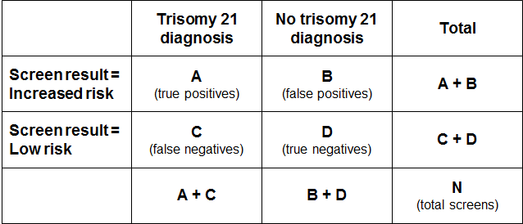

Positive predictive value and positive test rate
The positive test rate is the number of increased risk screens per 100 screens.
Positive test rate = ((A+B)/N)*100

Positive Predictive Value is the probability of having the condition given screen result was increased risk.
PPV = P (Disease | Screen Positive) = A/(A+B)

In order for PPV to increase, ‘A’ needs to be higher (more true positives) and/or ‘B’ needs to be lower (less false positives). However, an increase in positive test rate can come about when ‘A’ and/or ‘B’ increase. If the positive test rate increases due to higher true positives (A), then PPV will also increase. If instead the number of false positives increases, then the positive test rate will increase but PPV will decrease.

False positive rate
False positive rate is the number of false positives divided by false positives plus true negatives. It gives the proportion of women that did not have a baby or fetus with trisomy 21 that received an increased risk screening result.
FPR = B/(B+D)

Detection rate
Detection rate is the number of true positives divided by true positives plus false negatives. It gives the probability that a woman carrying a fetus with trisomy 21 will receive an increased risk screening result for trisomy 21.
Detection rate = A/(A+C)

Data for women screened during 2014
Figure 13 shows the data break down in relation to trisomy 21 for women screened during 2014. This data focuses on trisomy 21 and excludes Canterbury, South Canterbury and West Coast (because pregnancy outcomes for women in these areas are unknown) so the totals will not be the same as indicators 2 and 5 in this report.

Figure 13: Categorisation of trisomy 21 screening results 2014
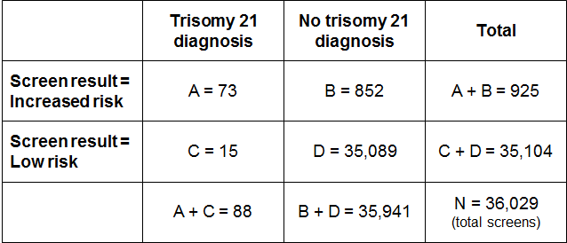

Positive predictive value (indicator 9)
PPV = A/(A+B)
= 73 / 925
= 0.08 (or 8%)

If a woman receives an increased risk screening result for trisomy 21, there is an 8% probability that she is carrying a fetus with trisomy 21.

False positive rate (indicator 10)
FPR = B/(B+D)
= 852 / 35,941
= 0.02 (or 2%)

Out of all women that ultimately have a negative diagnostic test or a baby without trisomy 21, 2% will have received an increased risk screening result.

Detection rate (indicator 11)
Detection rate = A/(A+C)
= 73 / 88
= 0.83 (or 83%)

There is an 83% probability that a woman carrying a fetus with trisomy 21 will have received an increased risk screening result for trisomy 21.

Appendix 5:
False negative screens by risk level
There were 130 false negative screens in total across the period covered by this report. A false negative means that the screen result was low risk for each of trisomy 21, 18 and 13 but there was then a positive diagnostic test or infant diagnosis for one of trisomy 21, 18 or 13.

Table 61 shows the number of false negatives for each of the four calendar years broken down by the screening risk result in the first group of columns. The next group of columns gives the total numbers of negative (low risk) screens. Overall, false negative screens made up 0.1% of all negative screens for each of the years from 2011 to 2013. The false negative rate for 2014 was lower at 0.07%.

Table 61: False negative screens for trisomy 21, 18 and 13 by risk level, January 2011 to December 2014
Risk level | False negatives |  |  |  | Total negative (low risk) screens |  |  |  | % of negative screens that are false negatives
 | 2011 | 2012 | 2013 | 2014 | 2011 | 2012 | 2013 | 2014 | 2011 | 2012 | 2013 | 2014
1:301 to 1:500 | 9 | 7 | 8 | 6 | 482 | 554 | 571 | 580 | 1.87 | 1.26 | 1.40 | 1.03
1:510 to 1:1,000 | 6 | 5 | 7 | 6 | 1407 | 1439 | 1395 | 1423 | 0.43 | 0.35 | 0.50 | 0.42
1:1100 to 1:2000 | 7 | 7 | 6 | 5 | 2377 | 2441 | 2496 | 2512 | 0.29 | 0.29 | 0.24 | 0.20
1:2100 to 1:3000 | 3 | 4 | 4 | 3 | 2017 | 2139 | 2089 | 2208 | 0.15 | 0.19 | 0.19 | 0.14
1:3100 to 1:4000 | – | 3 | 2 | – | 1914 | 1942 | 1955 | 1913 | – | 0.15 | 0.10 | –
1:4100 to 1:5000 | 4 | 2 | – | 1 | 1693 | 1741 | 1689 | 1713 | 0.24 | 0.11 | – | 0.06
1:5100 to 1:10,000 | 2 | 3 | 6 | 1 | 6699 | 6792 | 6880 | 6965 | 0.03 | 0.04 | 0.09 | 0.01
Less than 1:10,000 | 2 | 3 | 4 | 3 | 16,516 | 17,213 | 17,100 | 17,769 | 0.01 | 0.02 | 0.02 | 0.02
Total | 33 | 34 | 37 | 25 | 33,105 | 34,261 | 34,175 | 35,083 | 0.10 | 0.10 | 0.11 | 0.07

Appendix 6:
ROC curve
Figure 14 shows the false positive rate plotted against the detection rate in what is known as a ‘receiver operating characteristic’ (ROC) curve. This plots the false positive rate on the horizontal x axis against detection rate on the vertical y axis for different possible cut off points of the screening test. The aim for a screening test is to maximise detection rate while minimising false positive rate.

In New Zealand the cut off used for screening is 1:300. With this cut off the overall detection rate for trisomy 21, trisomy 18 and trisomy 13 in 2014 was 80%, and the false positive rate was 2.4%. To create the graph the detection rate and false positive rate were calculated for a range of other cut off points in order to plot the curve. What the curve shows is that if the cut off was lowered to increase the detection rate to 85.2%, the false positive rate would increase from 2.4% to 4.7%. This occurs at a risk cut off of 1:650.

Figure 14: ROC curve for trisomy 21, 18 and 13 screening 2014
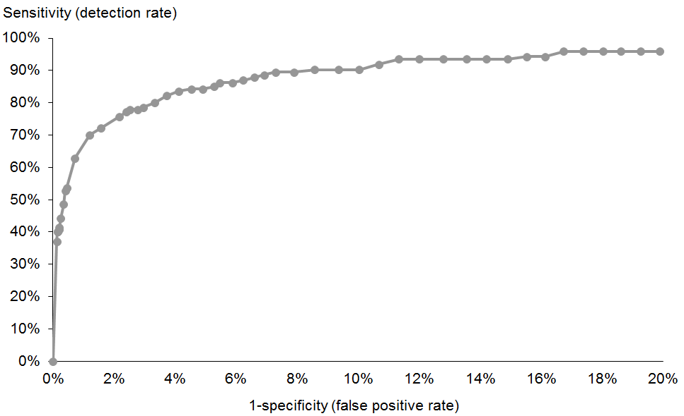

Appendix 7:
Glossary
Alpha-fetoprotein (AFP) – a protein that is normally produced by the fetus. Maternal serum AFP levels can be used as a biochemical marker in the detection of certain fetal abnormalities including neural tube defects (NTDs) after 15 weeks of pregnancy.

Amniocentesis – a procedure involving the withdrawal of a small amount of amniotic fluid by needle and syringe through the abdomen guided by ultrasound performed at the same time. The tests performed on fetal cells in this sample can detect a range of chromosomal and genetic disorders.

Analyte – a substance that is undergoing analysis or being measured. Analytes measured in antenatal screening include: pregnancy associated plasma protein-A, beta human chorionic gonadotropin, unconjugated oestriol, alpha fetoprotein and inhibin A.

Beta-human chorionic gonadotropin (ßhCG) – a hormone produced during pregnancy and present in maternal blood and urine. It is used as a biochemical marker for Down syndrome and other conditions in first trimester combined and second trimester maternal serum screening.

Chorionic villus sampling (CVS) – a procedure involving the withdrawal of a small amount of placental tissue by needle and syringe through the abdomen guided by ultrasound performed at the same time. Tests performed on placental cells can detect a range of chromosomal and genetic disorders.

Crown rump length (CRL) – the measurement from the fetal crown to the prominence of the buttocks or breech. This is used for dating in the first trimester.

Detection rate – the ability of screening to identify individuals with the condition screened for. A test with a high detection rate will have few false negative results. Also referred to as sensitivity.

False negative result – when a woman receives a low risk screening result but the baby does have the condition screened for.

False positive result – when a woman receives an increased risk screening result but the baby does not have the condition screened for.

False positive rate – the false positive rate is the number of false positives divided by the number of false positives and true negatives. A low false positive rate corresponds with a high level of specificity, which refers to the ability of screening to identify individuals who do not have the condition screened for.

Inhibin A – a hormone secreted by the ovary that is used as a biochemical marker in second trimester maternal serum screening for Down syndrome and other conditions.

Neural tube defect (NTD) – a congenital anomaly involving the brain and spinal cord caused by failure of the neural tube to close properly during embryonic development. Open NTDs occur when the brain and/or spinal cord are exposed at birth through a defect in the skull or vertebrae. Examples of open NTDs are spina bifida (myelomeningocele), anencephaly, and encephalocele.

Nuchal translucency (NT) – sonographic appearance of the collection of fluid under the skin at the back of the fetal neck. NT is a marker for chromosomal and other anomalies and can be measured in the first trimester of pregnancy.

Pregnancy-associated plasma protein A (PAPP-A) – a protein originating from the placenta used as a biochemical marker in first trimester combined screening for Down syndrome and other conditions.

Risk calculation algorithm – an explicit protocol (in this case computer-based) that combines a number of factors in determining overall risk of a particular outcome or condition.

Screening – a way of identifying a group of people who are more likely than others to have a particular condition. The screening process involves testing people for the presence of the condition, and predicting the likelihood that they have the condition. Antenatal screening for Down syndrome and other conditions predicts the likelihood of the conditions being present in the fetus.

Triploidy – an extremely rare chromosomal disorder in which a baby has three of every chromosome making a total of 69 rather than the normal 46 chromosomes.

Trisomy – a group of chromosomal disorders in which there are three copies, instead of the normal two, of a particular chromosome present in the cell nuclei. The most common trisomies in newborns are trisomy 21 (Down syndrome), trisomy 18 (Edwards syndrome) and trisomy 13 (Patau syndrome).

Unconjugated oestriol (uE3) – a hormone produced by the placenta and used as a biochemical marker in second trimester maternal serum screening for Down syndrome and other conditions.

Further terms can be found at www.nsu.govt.nz

Risk ratio values increase in increments of 5 between 1:10 and 1:100, increments of 100 between 1:100 and 1:10,000, and then increments of 1000 to 1:100,000.
Births reaching at least 20 weeks gestation or ≥400 g birth weight.
The sum of the values for trisomy 21, 18 and 13 separately is greater than the value for the fourth grouping (any trisomy) because a result can be at increased risk for more than one trisomy.
Births reaching at least 20 weeks gestation or ≥400 g birth weight.

