



**Antenatal Screening for Down Syndrome and Other Conditions**

**2020 Monitoring Report**

**Released 2023**

New Zealand Government logo

Citation: National Screening Unit. 2023. *Antenatal Screening for Down Syndrome and Other Conditions: 2020 Monitoring Report.* Wellington: National Screening Unit.

Published in November 2023 by the National Screening Unit  
PO Box 5013, Wellington 6140, New Zealand

ISBN 978-1-99-106771-5 (online)



This document is available at [www.nsu.govt.nz](http://www.nsu.govt.nz)

|  |  |
| --- | --- |
| **CCBY** | This work is licensed under the Creative Commons Attribution 4.0 International licence. In essence, you are free to: share ie, copy and redistribute the material in any medium or format; adapt ie, remix, transform and build upon the material. You must give appropriate credit, provide a link to the licence and indicate if changes were made. |

Contents

Executive summary 6

Antenatal screening for Down syndrome and other conditions 6

Key points for 2020 6

Introduction 8

Background to screening for Down syndrome and other conditions in pregnancy in New Zealand 8

Programme monitoring and data collection 9

Information included in this report 10

Definitions 11

Inclusion criteria 11

Data calculations 12

Data limitations 14

Indicator 1: Screens commenced 15

Total screens commenced by trimester 15

Screens commenced by DHB 16

Screens commenced by age, ethnicity and deprivation 19

Indicator 2: Screens completed 23

Total screens completed by trimester 23

Screens completed by DHB 24

Screens completed by age, ethnicity and deprivation 27

Indicator 3: Screening pathway variance 31

Screening pathway variance by year 31

Screening pathway variance by DHB 32

Screening pathway variance by age, ethnicity and deprivation 33

Indicator 4: Incomplete screens 35

Total incomplete screens 35

Incomplete T1 screens by reason incomplete 35

Incomplete T1 screens by reason and DHB 37

Incomplete T2 screens 39

Incomplete T2 screens by DHB 40

Indicator 5: Increased-risk screening results for trisomy 21, trisomy 18 and trisomy 13 41

Total increased-risk screening results for trisomy 21, 18 or 13 41

Increased-risk screening results for trisomy 21, 18 or 13 by age, ethnicity and deprivation 42

Increased-risk screening results for trisomy 21, 18 or 13 by trimester of screen 43

Increased-risk screening results stratified by risk level 45

Indicator 6: Diagnostic testing volumes for women with increased-risk screens 46

Diagnostic testing volumes for women with increased-risk screens by trimester of screen 46

Diagnostic testing volumes for women with increased-risk screens by DHB 47

Diagnostic testing volumes for women with increased-risk screens by age, ethnicity and deprivation 50

Diagnostic testing volumes for women with increased-risk screening results stratified by risk level 52

Indicator 7: Diagnostic testing volumes for women who receive a low-risk screening result 53

Diagnostic testing volumes for women with low-risk screens by trimester of screen 54

Diagnostic testing volumes for women with low-risk screens by DHB 54

Diagnostic testing volumes for women with low-risk screening results by age and ethnicity 57

Diagnostic testing volumes for women with low-risk screening results stratified by risk 58

Indicator 8: Diagnostic testing for unscreened women 59

Diagnostic volumes for unscreened women 59

Diagnostic results for unscreened women 62

Indicator 9: Diagnostic testing outcomes for women with increased-risk screening results 63

Positive predictive value of screening 63

Positive predictive value of screening for trisomy 21 stratified by risk level 65

Positive predictive value of screening for trisomy 21 by age, ethnicity and deprivation 66

Indicator 10: False positive rate 68

False positive rate for screening 68

False positive rate for screening for trisomy 21 by age, ethnicity and deprivation 70

Indicator 11: Detection rate 72

Detection rate of screening 72

Appendix 1: Indicator definitions 74

Appendix 2: Birth denominator data 76

Appendix 3: Summary of diagnostic testing uptake and results for women that had an increased-risk screen 79

Summary of prenatal diagnostic testing uptake and results for women with increased risks for trisomy 21, 18 or 13 79

Appendix 4: Measuring screening performance 80

Positive predictive value and positive test rate 80

False positive rate 81

Detection rate 81

Appendix 5: False negative screens by risk level 82

Appendix 6: ROC curve 84

Appendix 7: Glossary 85

# Executive summary

This report presents data on antenatal screening for Down syndrome and other conditions for the six calendar years from 1 January 2015 to 31 December 2020 and is based on screens that commenced during that time.

## Antenatal screening for Down syndrome and other conditions

Antenatal screening for Down syndrome and other conditions provides a risk estimate for Down syndrome (trisomy 21), Edwards syndrome (trisomy 18), Patau syndrome (trisomy 13) and some other rare genetic disorders. This screening is optional for pregnant women. Women who are less than 20 weeks pregnant are advised about the availability of screening and provided with up-to-date information to support the screening discussion, to enable women to make an informed decision about whether to participate.

First trimester combined screening should be completed between 9 weeks and 13 weeks 6 days gestation. The recommended timing for the blood test is 9 to 10 weeks, and the nuchal translucency ultrasound scan is ideally performed around 12 weeks. Second trimester maternal serum screening should be completed between 14 weeks and 20 weeks gestation. The recommended timing for this test is 14 to 18 weeks.

## Key points for 2020

* Screening was commenced for 86 percent of women who gave birth in 2020.
* There has been a steady increase in trimester two screens (both commenced and completed) since 2015.
* The national screening completion rate was 75 percent in 2020 (range 71–75 percent between 2015 and 2020). First trimester screens made up around 85 percent of all completed screens in 2020.
* Completion rates for Māori and Pacific have increased since 2015 but remain much lower in 2020 compared to Asian and Other women. Screening completion decreased with increasing deprivation in 2020.
* In 2020, while the number of women screened did not appear to be affected by COVID-19 restrictions, the reduced availability of nuchal translucency (NT) scans during the national lockdowns may have caused a slightly higher number of incomplete screens in March and April.[1]
* Thirteen percent of screens commenced in 2020 were not completed and nearly all were screens commenced in the first trimester. This is an increase from 10 percent in 2015.
* The overall positive test rate (number of increased-risk results per 100 screens) for trisomy 21, 18 and 13 was 4.2 in 2020, which is the same as 2019 but an increase from 2.8 in 2015. The positive test rate was higher for second trimester screens (5.3 per 100 screens) than for first trimester screens (4.0 per 100 screens) for 2020.
* Diagnostic testing volumes following an increased-risk screen decreased from 56 percent in 2015 to 30 percent in 2020 (diagnostic tests per 100 increased-risk screens).
* The overall false positive rate for trisomy 21, 18 and 13 was 4 percent in 2020, the same as in 2018 and 2019 but higher than previous years (2–3%). The rate was higher for second trimester screens (5%) than for first trimester screens (4%).
* The overall detection rate for trisomy 21, 18 and 13 was 82 percent in 2020 (range 75–84 percent between 2015 and 2020).
* Over this reporting period several changes have occurred that may have impacted on the programme indicators, for example, nasal bone assessment has been excluded since March 2018 and there is increasing use of non-invasive prenatal screening (NIPS). The information presented in this report will have been influenced by use of NIPS, but the impact cannot be quantified.

# Introduction

## Background to screening for Down syndrome and other conditions in pregnancy in New Zealand

Antenatal screening for Down syndrome and other conditions has been available to pregnant women in New Zealand since 1968. In October 2007, the government agreed to implement quality improvements to ensure consistency with international best practice at the time. The improvements were introduced in February 2010 and included incorporating maternal serum screening with ultrasound, providing practitioner guidelines and consumer resources.

Health practitioners providing maternity care are required to provide women with information about antenatal screening services for Down syndrome and other conditions. There are two screening options.

* First trimester combined screening, which includes a blood test and an ultrasound scan. The blood sample is collected between 9 weeks and 13 weeks 6 days gestation and measures two maternal serum markers: pregnancy-associated plasma protein-A (PAPP A) and free beta-human chorionic gonadotropin (ßhCG). The ultrasound scan determines nuchal translucency (NT) and crown rump length (CRL) measurements and is performed between 11 weeks and 2 days and 13 weeks and 6 days.
* Second trimester screening, which is a blood test taken between 14 and 20 weeks gestation that measures four maternal serum markers: free beta-human chorionic gonadotropin (ßhCG), alpha-fetoprotein (AFP), unconjugated oestriol (uE3) and inhibin A.

The results of the ultrasound scan and/or serum are combined with other demographic and maternal factors to provide a risk result. For consistency, all screening risk results are produced by the screening laboratories. The screening laboratories are LabPLUS at Te Toka Tumai Auckland (for samples from Taupō and north of Taupō) and Canterbury Health Laboratories at Waitaha Canterbury (for samples from south of Taupō). A shared data repository (PerkinElmer LifeCycle) contains data on all screens. Ultrasound scanning is performed by private and public radiology practices around New Zealand and the ultrasound report is sent to the screening laboratories to include in the risk calculation algorithm.

The conditions covered by screening include:

* trisomy 21 (Down Syndrome)
* trisomy 18 (Edwards syndrome)
* trisomy 13 (Patau syndrome)
* triploidy
* Turner syndrome.

Antenatal screening involves many health professionals including radiology staff, Lead Maternity Carers (LMCs), general practitioners (GPs) and laboratory personnel. The quality of the information provided by health professionals to the laboratories regarding the pregnancy details (such as gestation, maternal age, weight, ethnicity and the ultrasound finding) is critical because these details have a significant impact on the risk calculation that is produced by the laboratories.

Non-invasive prenatal screening (NIPS) is a genetic blood test that can be used to identify pregnancies with a higher risk of trisomy 21, 18 and 13. This blood test is not routinely accessible in New Zealand as it is not included in the screening programme and must be self-funded. In 2020, some women who received an increased-risk screening result were offered NIPS from Maternal Fetal Medicine services. NIPS was offered, where possible, as an alternative to invasive diagnostic testing (COVID-19 initiative). Use of NIPS is increasing in New Zealand but as the tests are mostly done privately, there is limited available data on how widespread use is, including which population groups are accessing it and at what stage of their pregnancy. The information presented in this report will have been influenced by use of NIPS, but the impact cannot be quantified.

During 2020, antenatal screening was considered an essential service and continued through the Level 3 and 4 national lockdowns. The data suggests that screening volumes were not affected by COVID-19 restrictions, but the reduced availability of NT scans may have caused a slightly higher number of incomplete screens in March and April 2020.[2]

## Programme monitoring and data collection

This report presents data on antenatal screening for Down syndrome and other conditions for the six calendar years from 1 January 2015 to 31 December 2020 and is based on screens that commenced during that time. The definitions for the 11 indicators in this report are contained in Appendix 1. Figure 1 outlines the data collection process the National Screening Unit used to produce indicators 1 to 11.

Figure : Data collection process

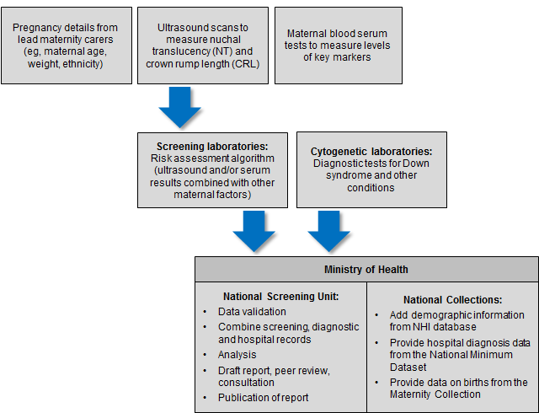

The indicators contained within this monitoring report form one part of the evaluation and audit of the quality improvements to antenatal screening for Down syndrome and other conditions. Other activities include:

* IANZ accreditation assessment
* contract monitoring and reporting on a six-monthly basis
* occasional studies and qualitative information.

## Information included in this report

The screening data in this report was sourced from LabPLUS and covers all of New Zealand. Diagnostic testing data was received from all cytogenetic laboratories (LabPLUS, Waikato, Capital & Coast, and Canterbury Health Laboratories).

The screening and diagnostic data was matched with hospital discharge data, sourced from the National Minimum Data Set (NMDS), held by Te Whatu Ora. This matching between data from screening laboratories, cytogenetic laboratories, and the NMDS was undertaken to identify the outcome for all screened women.

## Definitions

### Required components of each screening test

First trimester screening comprises analysis of two serum analytes (βhCG, PAPP-A) and an NT measurement. Second trimester screening comprises analysis of four serum analytes (βhCG, AFP, uE3 and Inhibin A).

Demographic and maternal factors are also required (eg, date of birth, weight).

### Commenced screening

At least one of the required components of the screening test was completed (NT measurement or serum analytes).

### Completed screening

All the required components of each screening test were completed, and a risk result was reported.

### Low-risk result

A low-risk result is defined as a risk lower than 1:300. So, a risk of 1:310 is a low risk.

### Increased-risk result

An increased-risk result is defined as a risk higher than or equal to 1:300. For some indicators, increased-risk screening results are further stratified into:

* 1:5 to 1:20
* 1:21 to 1:50
* 1:51 to 1:300.[3]

## Inclusion criteria

Screens were included in this analysis if the following criteria were met.

* Screening commencement date between 1 January 2015 and 31 December 2020 (ie, date of the first test the woman had as part of the screening pathway).
* Valid National Health Index (NHI) identifier.
* Age at screen from 12 years to 49 years (date of birth as supplied by the requestor).
* Single screening result per pregnancy.

## Data calculations

### DHB of domicile

Each woman was allocated to a DHB based on the residential address recorded in the National Health Index (NHI). Where the NHI database did not have a DHB recorded for an NHI, information from the LabPLUS database was used to assign the DHB.

### Ethnicity

Ethnicity data in this report is grouped according to a prioritised system, which is commonly applied across the New Zealand health sector. Prioritisation involves allocating each person to a single ethnic group, based on the ethnicities that person has identified, in the prioritised order of Māori, Pacific, Asian and Other ethnicity. For example, if someone identifies as being New Zealand European and Māori, under the prioritised ethnicity method, they are classified as Māori for the purpose of the analysis. Under this method, the *Other* ethnicity group effectively refers to non-Māori, non-Pacific and non-Asian people.

### NZ Deprivation

Figures have been broken down by NZ Deprivation Index Quintiles. Quintiles are aggregations of two NZ deprivation deciles. Deprivation is derived by obtaining the domicile code of the mother at time of screen and matching that to the NZ Deprivation Decile 2018 index.

### Births

Data on the number of live and still births[4] was obtained from the National Maternity Collection for each calendar year. Appendix 2 contains tables for the denominators used in this report.

### Small numbers

Small numbers can affect the reliability of results. Where an indicator calculation involves small counts (numerator less than six) then those results have been suppressed as they are considered too unstable, or privacy could be comprised.

### Prenatal cytogenetic test

The focus of indicators 6, 7, and 8 is on tests that women choose to have as part of managing their pregnancy. For these indicators, prenatal tests are a karyotype or array by chorionic villus sampling (CVS) or amniocentesis procedures (tests on products of conception are not included). For indicators 9, 10 and 11, cytogenetic tests on products of conception are used in addition to CVS, amniocentesis and infant diagnoses to determine the outcome of the pregnancy.

### Repeat screens

A repeat screen was defined as a second screen for the same woman within 112 days. Where this occurred, the first completed screen was retained for the analysis. The figure of 112 days was based on the timing of the screening test and considering how soon a woman may become pregnant again following a miscarriage.

### Linking rules

When matching screening and diagnosis data the following rules were followed.

* Joining Births: Births are joined where they match the mothers NHI and are between 0 and 230 days post screen (approximately 33 weeks).
* Joining NMDS Outcomes: Outcomes are joined where they match the babies NHI.
* Joining Cytogenetics Data: Cytogenetics data is joined where 1: they are from the mother and between 0 and 105 days post screen (15 weeks), or 2: are from the baby and are between 0 and 230 days post screen.

These were based on the possible timing of the different screening and diagnostic tests.

A project reviewing the end-to-end data analysis process for the Down syndrome and other conditions report was started in 2018 and has resulted in changes to data linking rules. These changes have been applied to 2017–2020 data but not for years prior to this. Caution is therefore required when comparing data for 2015–2016 with 2017–2020. Where a six-year rate would ordinarily have been applied, a decision has been made to supply a four-year rate (2017–2020) where this does not compromise privacy. An additional improvement was made for the 2020 report to better identify women who had a diagnostic test but no prenatal screening test (indicator 8).

## Data limitations

### Denominator underestimation

Screening completion rates derived using total births may overestimate the proportion of women participating in antenatal screening for Down syndrome and other conditions. This is because the true denominator (ie, all pregnant women that reach 9 weeks gestation) is likely to be larger than the denominator used (ie, all births reaching at least 20 weeks gestation or at least 400 g birth weight).

### Incomplete data

Missing or incomplete data for any screened woman will affect indicator calculations. Known data issues in this report relate to the following.

* In 2020, 27 women had no DHB of domicile ethnicity information recorded in either the NHI database or in the laboratory information system. These women are included in the national total but not in DHB breakdowns.

# Indicator 1: Screens commenced

This indicator reports the number of screens commenced by trimester of screening (first or second), DHB, age, ethnicity and deprivation.

## Total screens commenced by trimester

During 2020, a total of 49,990 screens were commenced, a rate of 86 per 100 births. Table 1 shows the total number of screens commenced by year and trimester of screen. Throughout the report, T1 is used to refer to the first trimester and T2 to the second trimester.

The majority of screens were T1 screens. The rate of screens commenced per 100 births has stayed largely flat over time, from 80.3 in 2015 to 80.6 in 2019, but has noticeably jumped to 86 in 2020 (see Table 1 and Figure 2).

Table : Total screens commenced by trimester, January 2015 to December 2020

|  |  |  |  |  |  |  |
| --- | --- | --- | --- | --- | --- | --- |
| Trimester of screen | Number and rate of screens commenced | | | | | |
| **2015** | **2016** | **2017** | **2018** | **2019** | **2020** |
| T1 screen | 41,283 | 41,816 | 41,403 | 41,681 | 41,365 | 43,102 |
| T2 screen | 5,742 | 6,152 | 6,369 | 6,330 | 6,503 | 6,888 |
| **Total screens** | **47,025** | **47,968** | **47,772** | **48,011** | **47,868** | **49,990** |
| Screens per 100 births | 80.3 | 80.9 | 80.6 | 82.7 | 80.6 | 86.0 |

Figure : Number and rate of screens commenced, January 2015 to December 2020

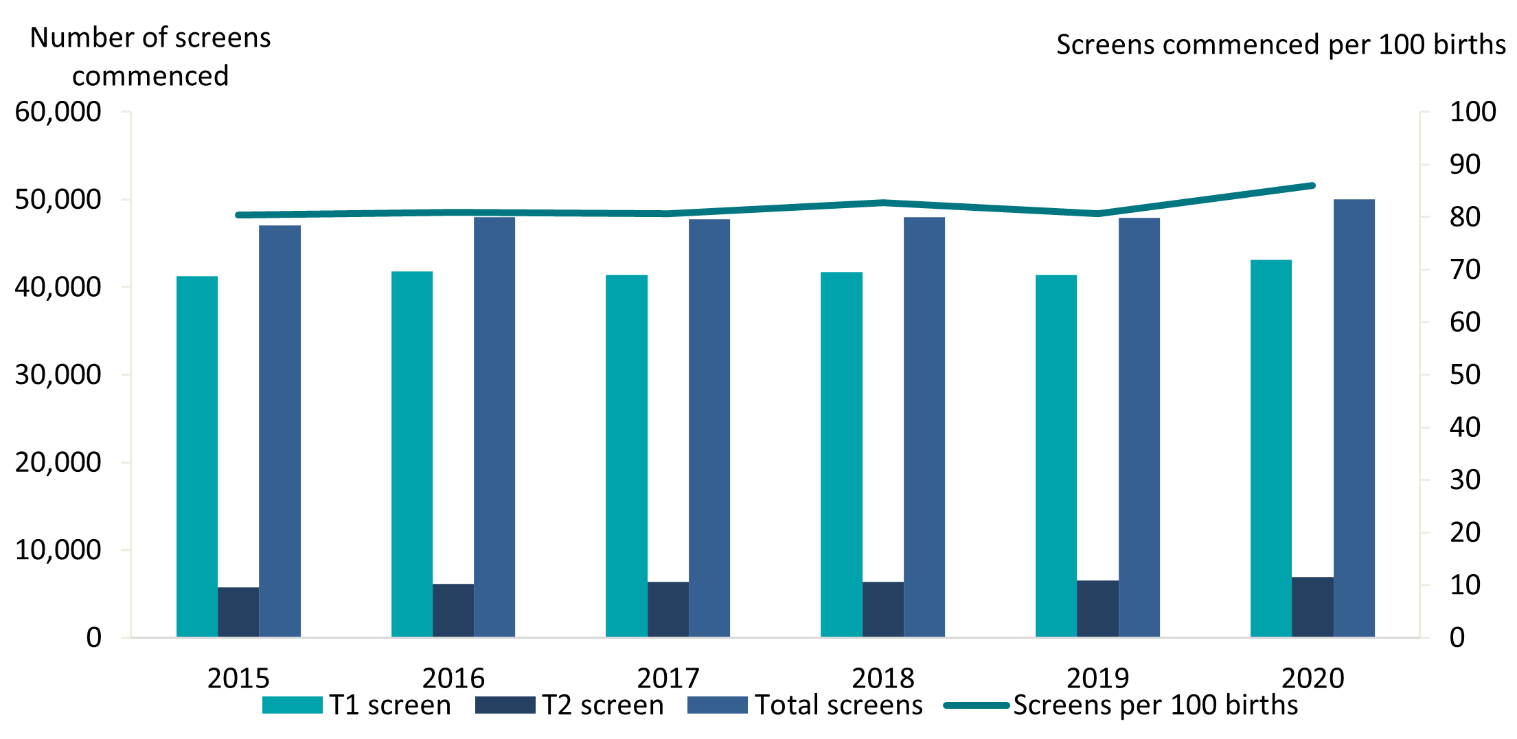

## Screens commenced by DHB

Figure 3 shows the screening commencement rates by DHB for 2020. There was a large variation in rates, from 64 screens commenced per 100 births in Northland to over 100 screens commenced per 100 births in Canterbury and Nelson Marlborough. Three-quarters (75%) of all DHBs had rates of above 80 per 100 births in 2020, compared to only half of DHBs in 2019. Table 2 gives a full breakdown by the trimester of the screen.

Figure : Screens commenced by DHB, January to December 2020

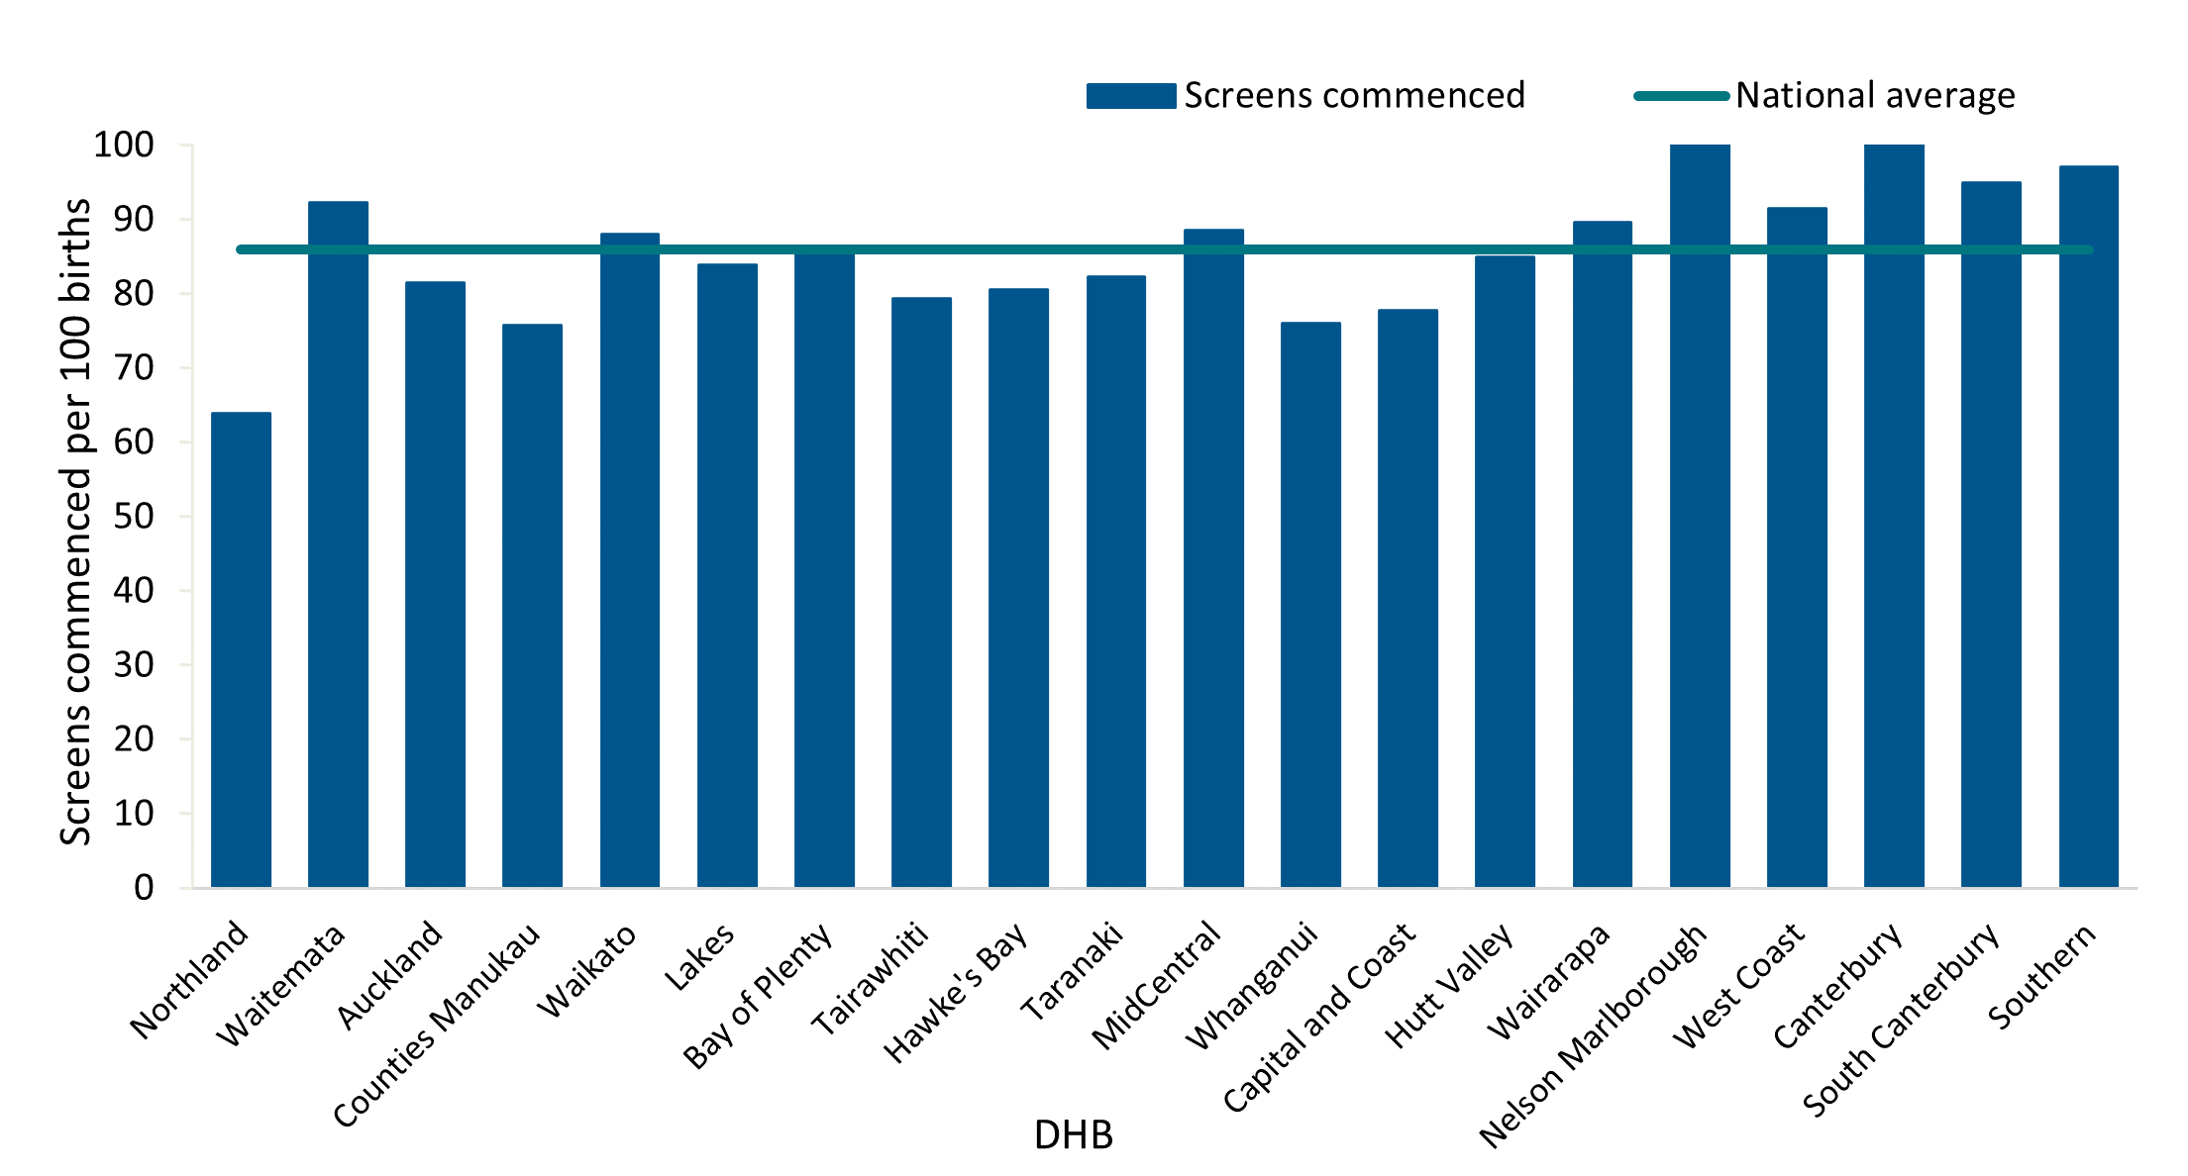

Table : Screens commenced by trimester and DHB, January to December 2020

|  |  |  |  |  |  |  |
| --- | --- | --- | --- | --- | --- | --- |
| DHB | Number of screens commenced | | | Screens commenced (per 100 births) | | |
| **First trimester** | **Second trimester** | **Total** | **First trimester** | **Second trimester** | **Total\*\*** |
| Northland | 1,257 | 265 | 1,522 | 52.8 | 11.1 | 63.9 |
| Waitematā | 6,109 | 788 | 6,897 | 81.8 | 10.5 | 92.3 |
| Auckland | 3,598 | 599 | 4,197 | 69.8 | 11.6 | 81.4 |
| Counties Manukau | 4,909 | 1,448 | 6,357 | 58.4 | 17.2 | 75.7 |
| Waikato | 4,320 | 583 | 4,903 | 77.6 | 10.5 | 88.0 |
| Lakes | 1,027 | 176 | 1,203 | 71.6 | 12.3 | 83.9 |
| Bay of Plenty | 2,440 | 266 | 2,706 | 78.0 | 8.5 | 86.5 |
| Tairāwhiti | 470 | 93 | 563 | 66.2 | 13.1 | 79.4 |
| Hawke's Bay | 1,425 | 246 | 1,671 | 68.7 | 11.9 | 80.6 |
| Taranaki | 1,061 | 137 | 1,198 | 72.9 | 9.4 | 82.3 |
| MidCentral | 1,685 | 216 | 1,901 | 78.4 | 10.0 | 88.5 |
| Whanganui | 467 | 155 | 622 | 57.0 | 18.9 | 76.0 |
| Capital & Coast | 2,150 | 254 | 2,404 | 69.6 | 8.2 | 77.7 |
| Hutt Valley | 1,438 | 265 | 1,703 | 71.7 | 13.2 | 85.0 |
| Wairarapa | 397 | 75 | 472 | 75.6 | 14.3 | 89.6 |
| Nelson Marlborough | 1,306 | 144 | 1,450 | 92.3 | 10.2 | 102.3 |
| West Coast | 231 | 37 | 268 | 78.3 | 12.5 | 91.5 |
| Canterbury | 5,455 | 731 | 6,186 | 88.3 | 11.8 | 100.2 |
| South Canterbury | 465 | 96 | 561 | 78.8 | 16.3 | 94.9 |
| Southern | 2,870 | 309 | 3,179 | 87.6 | 9.4 | 97.1 |
| **National\*** | **43,102** | **6,888** | **49,990** | **74.2** | **11.9** | **86.0** |

*DHB counts do not sum to National total and **screen rates may exceed 100% due to a lag in maternity data collection.

Most DHBs showed an increase in their rate of screens commenced between 2015 and 2020. All but one DHB showed an increase in the rate of screens commenced between 2019 and 2020 (see Table 3).

Table : Screens commenced per 100 births by DHB, January 2015 to December 2020

|  |  |  |  |  |  |  |
| --- | --- | --- | --- | --- | --- | --- |
| DHB | Screens commenced (per 100 births)* | | | | | |
| **2015** | **2016** | **2017** | **2018** | **2019** | **2020** |
| Northland | 60.1 | 58.6 | 64.2 | 61.7 | 62.1 | 63.9 |
| Waitematā | 88.4 | 87.1 | 86.7 | 91.4 | 86.0 | 92.3 |
| Auckland | 85.7 | 82.0 | 75.8 | 82.2 | 78.3 | 81.4 |
| Counties Manukau | 71.1 | 71.0 | 70.6 | 71.1 | 70.0 | 75.7 |
| Waikato | 81.8 | 83.7 | 85.5 | 84.0 | 85.1 | 88.0 |
| Lakes | 74.3 | 76.7 | 73.6 | 80.9 | 74.7 | 83.9 |
| Bay of Plenty | 77.6 | 81.1 | 82.2 | 82.9 | 84.1 | 86.5 |
| Tairāwhiti | 68.3 | 63.6 | 70.2 | 78.1 | 70.6 | 79.4 |
| Hawke's Bay | 72.6 | 76.2 | 71.8 | 75.6 | 76.6 | 80.6 |
| Taranaki | 74.9 | 67.8 | 72.7 | 74.7 | 71.0 | 82.3 |
| MidCentral | 63.9 | 73.1 | 79.9 | 74.7 | 78.3 | 88.5 |
| Whanganui | 70.5 | 74.1 | 71.8 | 77.8 | 75.0 | 76.0 |
| Capital & Coast | 83.4 | 86.3 | 76.1 | 81.4 | 77.6 | 77.7 |
| Hutt Valley | 78.7 | 82.2 | 76.3 | 84.0 | 80.6 | 85.0 |
| Wairarapa | 83.8 | 89.0 | 90.1 | 92.7 | 94.2 | 89.6 |
| Nelson Marlborough | 96.0 | 85.1 | 98.6 | 91.5 | 95.5 | 102.3 |
| West Coast | 82.4 | 86.5 | 84.4 | 84.6 | 84.5 | 91.5 |
| Canterbury | 89.4 | 91.5 | 92.4 | 94.3 | 91.3 | 100.2 |
| South Canterbury | 86.4 | 87.5 | 94.0 | 94.7 | 88.4 | 94.9 |
| Southern | 85.1 | 87.8 | 89.0 | 90.2 | 87.0 | 97.1 |
| **National average** | **80.3** | **80.9** | **80.6** | **82.7** | **80.6** | **86.0** |

*Screen rates may exceed 100% due to a lag in maternity data collection.

## Screens commenced by age, ethnicity and deprivation

Table 4 provides an overall view of screens commenced by age and ethnicity for the period from January 2015 to December 2020.

The rate of screens commenced for age groups up to 34 years have increased since 2015 while conversely the rate of screens commenced for age groups of 35 and over have decreased since 2015. The 25–29 years age group had the highest rate of screens commenced for 2020, with a rate of 93 women commencing screening per 100 births (see Figure 4). Screening commencement rates for women aged 45 and over dropped from 62 screens commenced per 100 births in 2019 to 41 per 100 births in 2020, the lowest for that age group in any year from 2015 to 2020. Low volumes in this age group may be contributing to the variation in rates.

Differences in screening commencement rates by ethnicity have continued in 2020. Women of Other ethnicity had the highest rate (100 of 100 births), followed by Asian women (97 of 100 births). The rate of commenced screens for Pacific and Māori women was lower at 58 per 100 births and 56 per 100 births respectively (see Figure 5). All groups have shown increasing rates over the reporting period, particularly for Māori, with an increase of 13 percentage points from 43 percent in 2015 to 56 percent in 2020. However, this rate is still well below the national rate of 86 per 100 births in 2020.

Table : Screens commenced by age and ethnicity of mother, January 2015 to December 2020

|  |  |  |  |  |  |  |  |  |  |  |  |  |
| --- | --- | --- | --- | --- | --- | --- | --- | --- | --- | --- | --- | --- |
|  | Number of screens commenced | | | | | | Screens commenced (per 100 births)** | | | | | |
| **2015** | **2016** | **2017** | **2018** | **2019** | **2020** | **2015** | **2016** | **2017** | **2018** | **2019** | **2020** |
| **Age at screen (years)** |  | | | | | |  | | | | | |
| Under 20 | 1,925 | 1,829 | 1,683 | 1,546 | 1,565 | 1,441 | 69.1 | 74.9 | 73.3 | 72.7 | 74.9 | 73.0 |
| 20–24 | 7,109 | 7,000 | 6,899 | 6,475 | 6,341 | 6,407 | 71.5 | 73.0 | 74.0 | 74.5 | 74.3 | 77.7 |
| 25–29 | 13,189 | 13,943 | 14,037 | 14,162 | 13,882 | 14,681 | 84.0 | 84.3 | 84.4 | 87.1 | 84.7 | 93.3 |
| 30–34 | 15,124 | 15,732 | 15,804 | 16,171 | 16,605 | 17,855 | 84.5 | 85.6 | 84.5 | 86.4 | 85.0 | 90.8 |
| 35–39 | 8,007 | 7,781 | 7,659 | 8,091 | 7,973 | 8,169 | 82.0 | 78.1 | 77.5 | 80.8 | 76.6 | 79.6 |
| 40–44 | 1,593 | 1,574 | 1,587 | 1,476 | 1,416 | 1,372 | 69.3 | 69.2 | 68.6 | 70.5 | 62.5 | 65.7 |
| 45 and over | 78 | 109 | 103 | 90 | 86 | 65 | 56.1 | 86.5 | 67.8 | 55.6 | 62.3 | 41.4 |
| **Ethnicity** |  | | | | | |  | | | | | |
| Māori | 6,256 | 7,176 | 7,754 | 7,675 | 7,844 | 8,388 | 42.9 | 48.7 | 52.0 | 52.7 | 52.9 | 55.9 |
| Pacific | 3,120 | 3,089 | 3,284 | 3,206 | 3,380 | 3,494 | 51.5 | 52.9 | 55.0 | 53.7 | 55.0 | 57.9 |
| Asian | 8,695 | 9,851 | 9,720 | 10,330 | 10,554 | 11,039 | 94.4 | 93.6 | 92.0 | 97.5 | 92.0 | 97.3 |
| Other | 28,954 | 27,852 | 27,005 | 26,796 | 26,090 | 27,069 | 100.9 | 98.7 | 97.0 | 99.5 | 96.9 | 105.2 |
| **National\*** | **47,025** | **47,968** | **47,772** | **48,011** | **47,868** | **49,990** | **80.3** | **80.9** | **80.6** | **82.7** | **80.6** | **86.0** |

*Ethnic group counts do not sum to National total.

**Screen rates may exceed 100% due to a lag in maternity data collection.

Figure 4: Screens commenced by age of mother at screen, January to December 2020

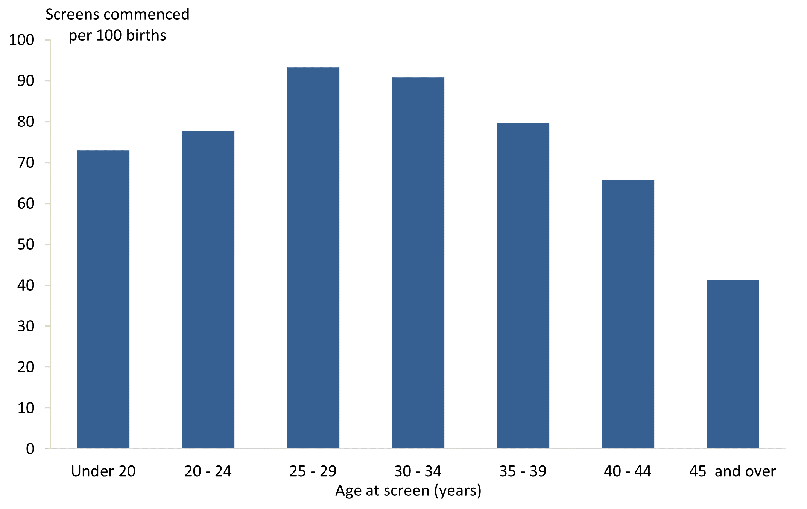

Figure 5: Screens commenced by ethnicity of mother, January to December 2020

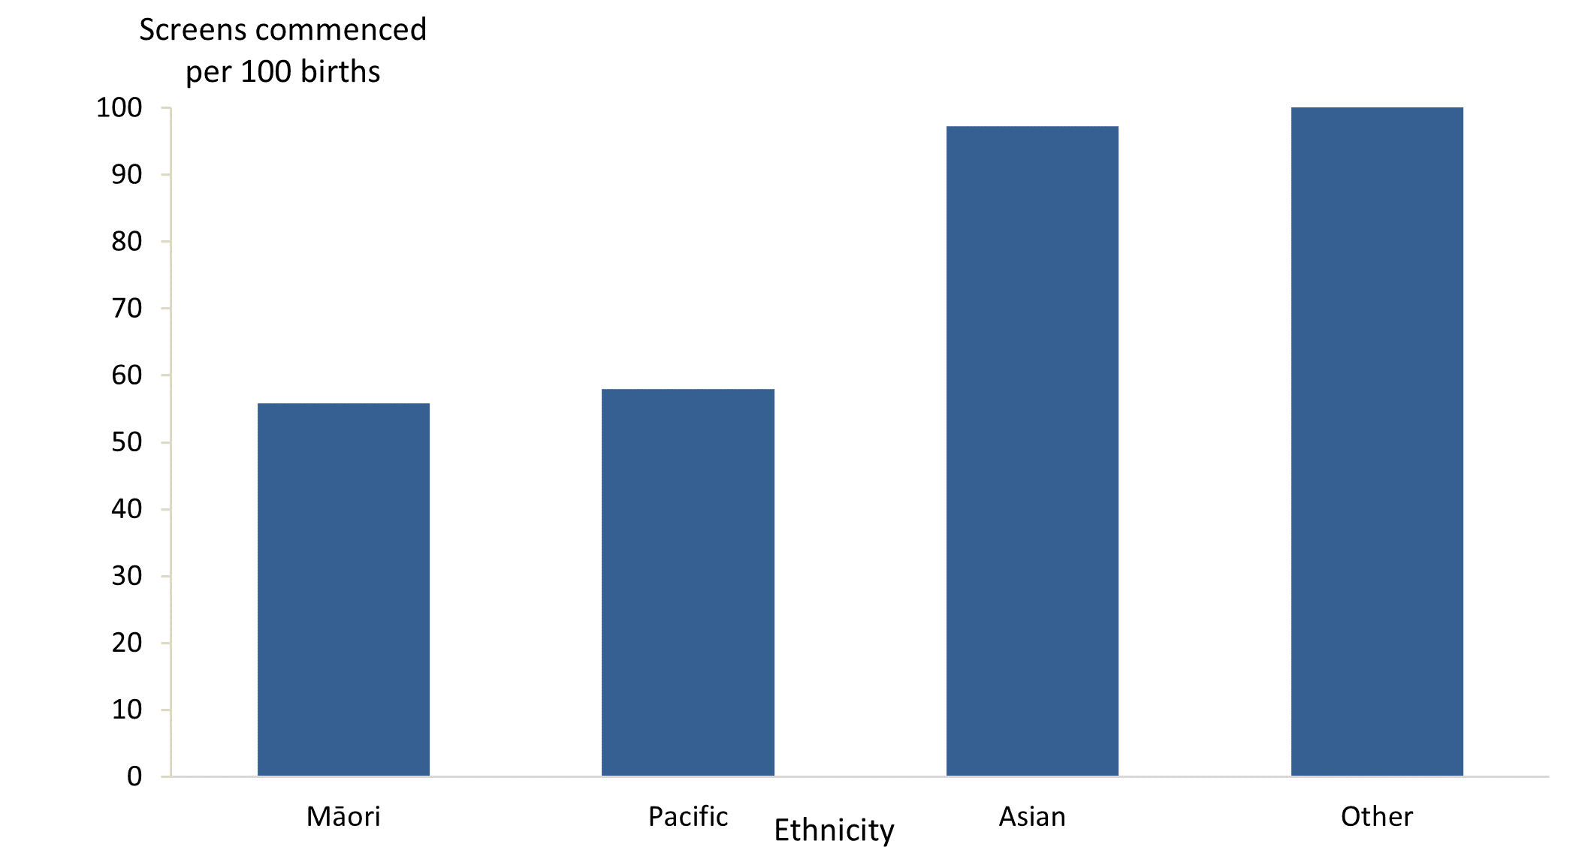

A trend of higher screening commencement rates for women in less deprived areas was evident, with 98 women per 100 per births starting screening for quintile 1 women in 2020 compared with 71 per 100 births for quintile 5 (see Table 5 and Figure 6).

Table 5: Screens commenced by deprivation quintile of mother, January to December 2020

|  |  |  |
| --- | --- | --- |
| NZ Deprivation quintile | Number of screens commenced | Screens commenced (per 100 births) |
| Quintile 1 (least deprived) | 8,941 | 97.9 |
| Quintile 2 | 9,475 | 94.7 |
| Quintile 3 | 9,637 | 89.5 |
| Quintile 4 | 11,398 | 85.2 |
| Quintile 5 (most deprived) | 10,510 | 71.0 |
| Unknown | 29 | - |
| **National** | **49,990** | **86.0** |

Figure 6: Screens commenced by deprivation quintile of mother, January to December 2020

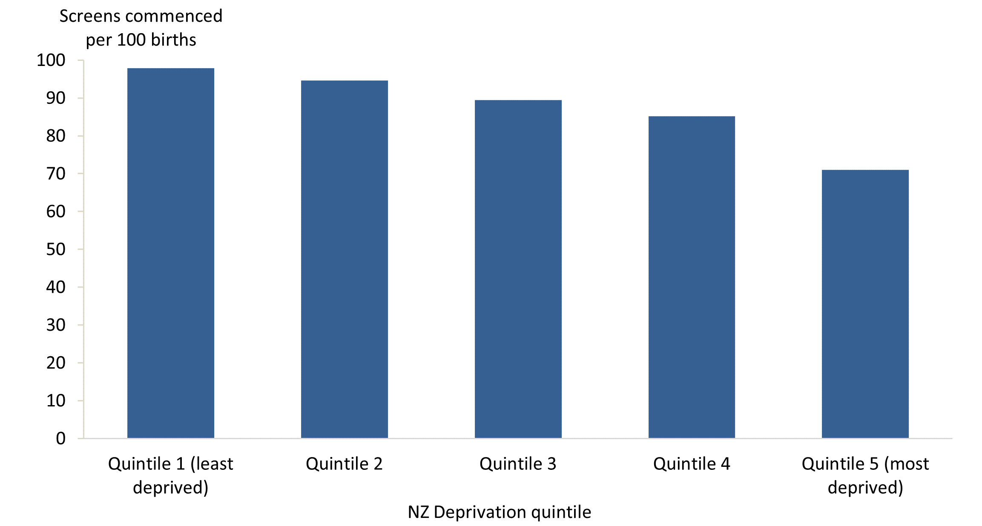

# Indicator 2: Screens completed

This indicator reports the number of screens completed by trimester of screening, DHB, age, ethnicity and deprivation.

## Total screens completed by trimester

During 2020, a total of 43,669 screens were completed, at a rate of 75 screens per 100 births.

Table 6 and Figure 7 show the total number of screens completed per year and trimester of screen. Across all years, the majority of screens were completed in the first trimester. The rate of completed screens increased from 72 per 100 births in 2015 to 75 per 100 births in 2020.

Table 6: Total screens completed by trimester, January 2015 to December 2020

|  |  |  |  |  |  |  |
| --- | --- | --- | --- | --- | --- | --- |
| Trimester of screen | Number and rate of screens completed | | | | | |
| **2015** | **2016** | **2017** | **2018** | **2019** | **2020** |
| T1 screen | 36,739 | 37,511 | 36,836 | 36,810 | 35,900 | 36,893 |
| T2 screen | 5,517 | 6,008 | 6,284 | 6,242 | 6,377 | 6,776 |
| **Total screens** | 42,256 | 43,519 | 43,120 | 43,052 | 42,277 | 43,669 |
| Screens per 100 births | **72.2** | **73.4** | **72.7** | **74.2** | **71.2** | **75.1** |

Figure 7: Number and rate of screens completed, January 2015 to December 2020

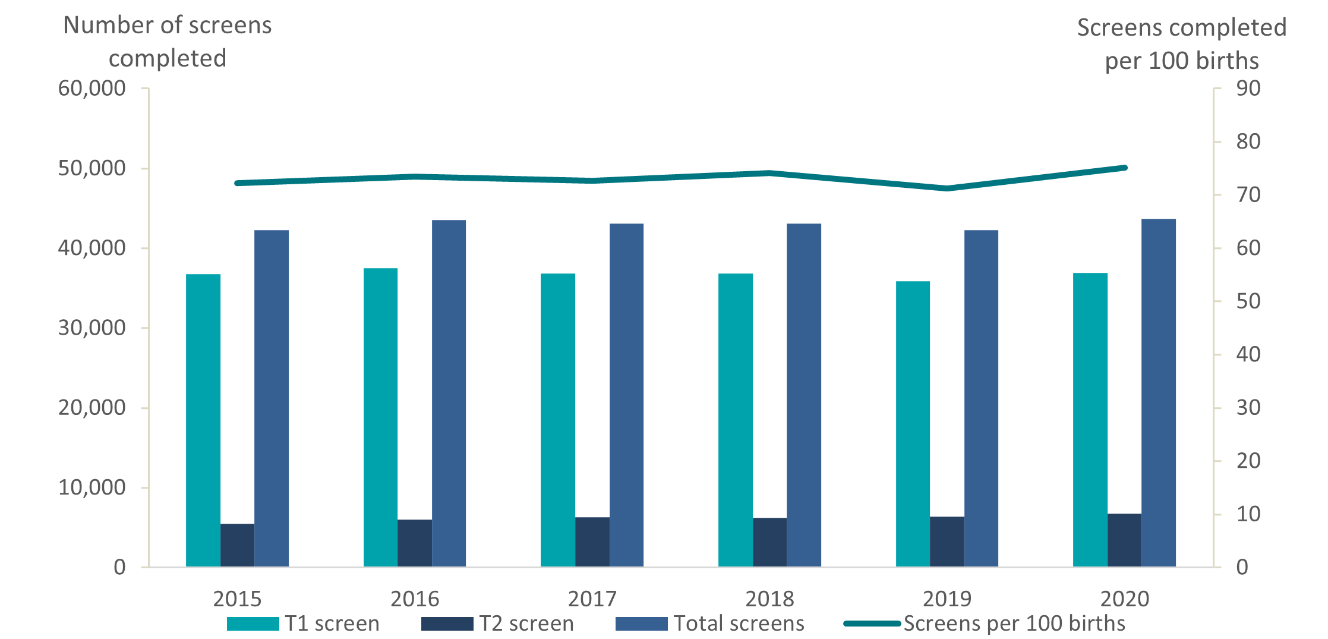

## Screens completed by DHB

Screening completion rates for 2020 varied across DHBs, from 55 completed screens per 100 births in Northland to 92 per 100 births in Nelson Marlborough (see Figure 8). Table 7 gives a full breakdown by the trimester of screen.

Figure 8: Screens completed by DHB, January to December 2020

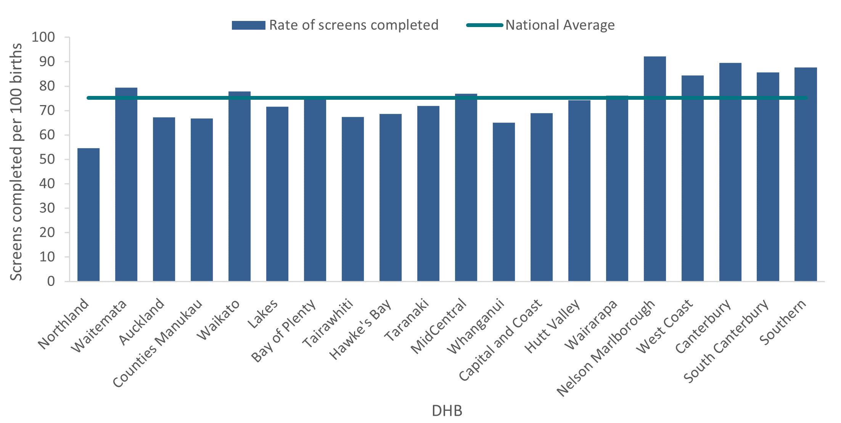

Table 7: Screening completion by trimester and DHB, January to December 2020

|  |  |  |  |  |  |  |
| --- | --- | --- | --- | --- | --- | --- |
| DHB | Number of screens completed | | | Screens completed (per 100 births) | | |
| **First trimester** | **Second trimester** | **Total** | **First trimester** | **Second trimester** | **Total** |
| Northland | 1,041 | 260 | 1,301 | 43.7 | 10.9 | 54.6 |
| Waitematā | 5,155 | 775 | 5,930 | 69.0 | 10.4 | 79.4 |
| Auckland | 2,874 | 591 | 3,465 | 55.8 | 11.5 | 67.2 |
| Counties Manukau | 4,186 | 1,426 | 5,612 | 49.8 | 17.0 | 66.8 |
| Waikato | 3,764 | 568 | 4,332 | 67.6 | 10.2 | 77.7 |
| Lakes | 853 | 174 | 1,027 | 59.5 | 12.1 | 71.6 |
| Bay of Plenty | 2,110 | 263 | 2,373 | 67.4 | 8.4 | 75.8 |
| Tairāwhiti | 387 | 91 | 478 | 54.6 | 12.8 | 67.4 |
| Hawke's Bay | 1,180 | 244 | 1,424 | 56.9 | 11.8 | 68.7 |
| Taranaki | 912 | 134 | 1,046 | 62.6 | 9.2 | 71.8 |
| MidCentral | 1,437 | 214 | 1,651 | 66.9 | 10.0 | 76.9 |
| Whanganui | 381 | 151 | 532 | 46.6 | 18.5 | 65.0 |
| Capital & Coast | 1,884 | 247 | 2,131 | 60.9 | 8.0 | 68.9 |
| Hutt Valley | 1,229 | 259 | 1,488 | 61.3 | 12.9 | 74.3 |
| Wairarapa | 326 | 75 | 401 | 61.9 | 14.2 | 76.1 |
| Nelson Marlborough | 1,164 | 142 | 1,306 | 82.1 | 10.0 | 92.2 |
| West Coast | 211 | 36 | 247 | 72.0 | 12.3 | 84.3 |
| Canterbury | 4,800 | 726 | 5,526 | 77.7 | 11.8 | 89.5 |
| South Canterbury | 413 | 93 | 506 | 69.9 | 15.7 | 85.6 |
| Southern | 2,570 | 302 | 2,872 | 78.5 | 9.2 | 87.7 |
| **National\*** | **36,893** | **6,776** | **43,669** | **63.5** | **11.7** | **75.1** |

*DHB counts do not sum to National total.

As shown in Table 8, many DHBs showed a trend of increasing rates of screening completion over the five years from 2015 to 2020. Furthermore, for the majority (85%) of DHBs, screening completion rates increased from 2019 to 2020.

Table 8: Screening completion by DHB, January 2015 to December 2020

|  |  |  |  |  |  |  |
| --- | --- | --- | --- | --- | --- | --- |
| DHB | Screens completed (per 100 births) | | | | | |
| **2015** | **2016** | **2017** | **2018** | **2019** | **2020** |
| Northland | 51.6 | 50.9 | 56.2 | 53.6 | 54.2 | 54.6 |
| Waitematā | 81.8 | 81.4 | 79.8 | 82.9 | 76.1 | 79.4 |
| Auckland | 79.1 | 75.6 | 68.6 | 72.2 | 66.1 | 67.2 |
| Counties Manukau | 64.5 | 65.5 | 64.4 | 64.9 | 62.7 | 66.8 |
| Waikato | 72.4 | 74.6 | 76.3 | 74.8 | 76.2 | 77.7 |
| Lakes | 65.7 | 67.8 | 65.7 | 71.2 | 67.4 | 71.6 |
| Bay of Plenty | 67.8 | 71.8 | 73.6 | 74.6 | 75.4 | 75.8 |
| Tairāwhiti | 53.8 | 51.1 | 59.1 | 65.1 | 59.8 | 67.4 |
| Hawke's Bay | 64.2 | 68.6 | 63.7 | 67.6 | 66.9 | 68.7 |
| Taranaki | 66.3 | 62.1 | 66.4 | 68.3 | 61.7 | 71.8 |
| MidCentral | 56.9 | 66.1 | 72.3 | 66.3 | 68.4 | 76.9 |
| Whanganui | 58.5 | 65.8 | 63.6 | 67.6 | 65.6 | 65.0 |
| Capital & Coast | 75.1 | 77.8 | 67.8 | 73.3 | 69.2 | 68.9 |
| Hutt Valley | 68.0 | 71.6 | 67.3 | 74.4 | 70.2 | 74.3 |
| Wairarapa | 72.8 | 77.9 | 80.6 | 81.0 | 81.1 | 76.1 |
| Nelson Marlborough | 84.7 | 77.4 | 90.1 | 84.6 | 86.8 | 92.2 |
| West Coast | 72.3 | 77.7 | 76.8 | 72.6 | 74.6 | 84.3 |
| Canterbury | 80.6 | 82.5 | 83.0 | 84.2 | 80.3 | 89.5 |
| South Canterbury | 79.8 | 81.5 | 85.4 | 88.2 | 80.1 | 85.6 |
| Southern | 77.9 | 81.1 | 81.7 | 82.5 | 78.1 | 87.7 |
| **National average** | **72.2** | **73.4** | **72.7** | **74.2** | **71.2** | **75.1** |

## Screens completed by age, ethnicity and deprivation

Table 9 provides an overall view of screens completed by age and ethnicity for January 2015 to December 2020, with similar trends to screening commencement.

In 2020, screening completion rates were highest in the 25–29 age group (see Figure 9), with 83 women completing screening per 100 births, an increase of 6 screens completed per 100 births compared to 2019. The completion rate for women aged 45 and over fell to 29 completed screens per 100 births in 2020, mirroring the drop in screening commencement for this age group. Low volumes in this age group may be contributing to the variation in rates.

Screening completion rates were highest among women of Other ethnicity, at 93 per 100 births in 2020 (see Figure 10). This was followed by women of Asian ethnicity at 88 per 100 births. Screening completion rates have increased over time for Māori and Pacific women; however the rates remain lower than other groups at 45 per 100 births and 50 per 100 births respectively.

Factors that may contribute to the differences in screening completion rates between ethnic groups include inequitable offer of screening and barriers such as the cost and accessibility of the first trimester ultrasound scan. However, the lower rates for Māori and Pacific women could also be partly due to personal choice and cultural or religious views.[5],[6]

Table 9: Screens completed by age and ethnicity of mother, January 2015 to December 2020

|  |  |  |  |  |  |  |  |  |  |  |  |  |
| --- | --- | --- | --- | --- | --- | --- | --- | --- | --- | --- | --- | --- |
|  | Number of screens completed | | | | | | Screens completed (per 100 births) | | | | | |
| **2015** | **2016** | **2017** | **2018** | **2019** | **2020** | **2015** | **2016** | **2017** | **2018** | **2019** | **2020** |
| **Age at screen (years)** |  | | | | | |  | | | | | |
| Under 20 | 1,510 | 1,474 | 1,376 | 1,243 | 1,282 | 1,129 | 54.2 | 60.3 | 59.9 | 58.4 | 61.3 | 57.2 |
| 20–24 | 5,992 | 6,079 | 5,948 | 5,588 | 5,426 | 5,400 | 60.3 | 63.4 | 63.8 | 64.3 | 63.6 | 65.5 |
| 25–29 | 11,824 | 12,675 | 12,779 | 12,898 | 12,554 | 13,056 | 75.3 | 76.6 | 76.9 | 79.4 | 76.6 | 83.0 |
| 30–34 | 14,030 | 14,709 | 14,651 | 14,823 | 14,940 | 15,913 | 78.3 | 80.1 | 78.4 | 79.2 | 76.5 | 81.0 |
| 35–39 | 7,430 | 7,137 | 6,959 | 7,205 | 6,897 | 7,046 | 76.1 | 71.6 | 70.4 | 71.9 | 66.3 | 68.7 |
| 40–44 | 1,406 | 1,366 | 1,328 | 1,225 | 1,119 | 1,080 | 61.2 | 60.0 | 57.4 | 58.5 | 49.4 | 51.7 |
| 45 and over | 64 | 79 | 79 | 70 | 59 | 45 | 46.0 | 62.7 | 52.0 | 43.2 | 42.8 | 28.7 |
| **Ethnicity** |  | | | | | |  | | | | | |
| Māori | 4,911 | 5,924 | 6,442 | 6,387 | 6,513 | 6,804 | 33.7 | 40.2 | 43.2 | 43.8 | 44.0 | 45.3 |
| Pacific | 2,626 | 2,673 | 2,876 | 2,782 | 2,927 | 2,988 | 43.3 | 45.8 | 48.2 | 46.6 | 47.6 | 49.5 |
| Asian | 8,114 | 9,304 | 9,093 | 9,594 | 9,649 | 9,973 | 88.1 | 88.4 | 86.1 | 90.6 | 84.1 | 87.9 |
| Other | 26,605 | 25,618 | 24,701 | 24,287 | 23,188 | 23,904 | 92.7 | 90.8 | 88.7 | 90.2 | 86.1 | 92.9 |
| **National\*** | **42,256** | **43,519** | **43,120** | **43,052** | **42,277** | **43,669** | **72.2** | **73.4** | **72.7** | **74.2** | **71.2** | **75.1** |

*Ethnic group counts do not sum to National total.

Figure 9: Screens completed by age of mother at screen, January to December 2020

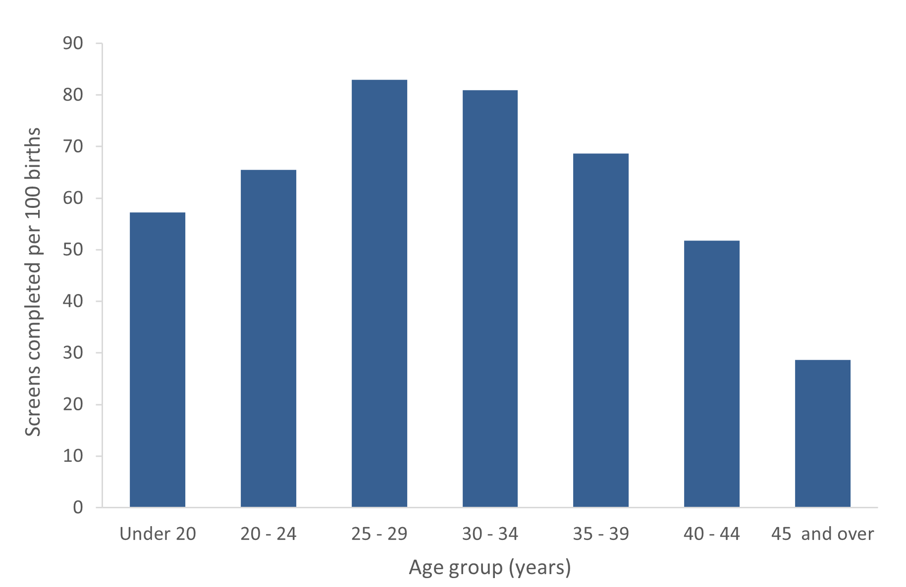

Figure 10: Screens completed by ethnicity of mother, January to December 2020

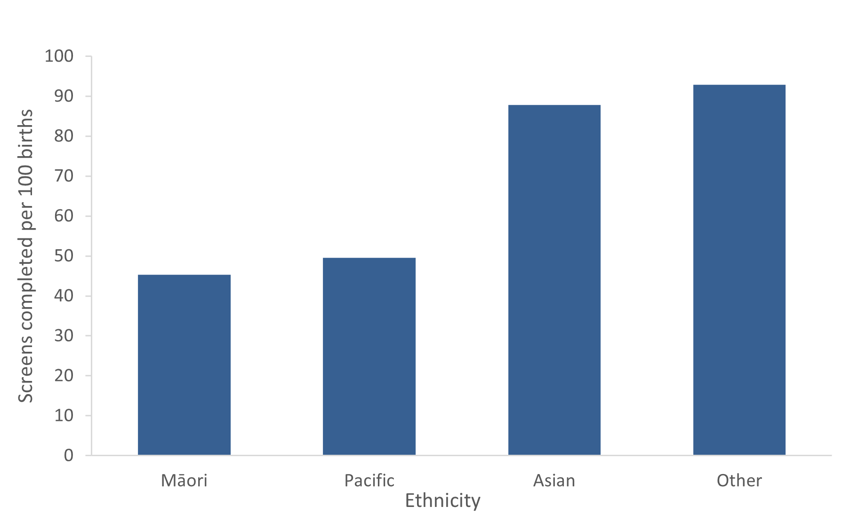

As shown in Table 10 and Figure 11, screening completion rates in 2020 were highest among women in less deprived areas with a rate of 86 per 100 births for quintile 1, compared with 61 per 100 births for quintile 5.

Table 10: Screens completed by deprivation quintile of mother, January to December 2020

|  |  |  |
| --- | --- | --- |
| NZ Deprivation quintile | Number of screens completed | Screens completed (per 100 births) |
| Quintile 1 (least deprived) | 7,820 | 85.6 |
| Quintile 2 | 8,248 | 82.4 |
| Quintile 3 | 8,541 | 79.3 |
| Quintile 4 | 10,058 | 75.1 |
| Quintile 5 (most deprived) | 8,979 | 60.7 |
| Unknown | 23 | - |
| **National** | **43,669** | **75.1** |

Figure 11: Screens completed by deprivation quintile of mother, January to December 2020

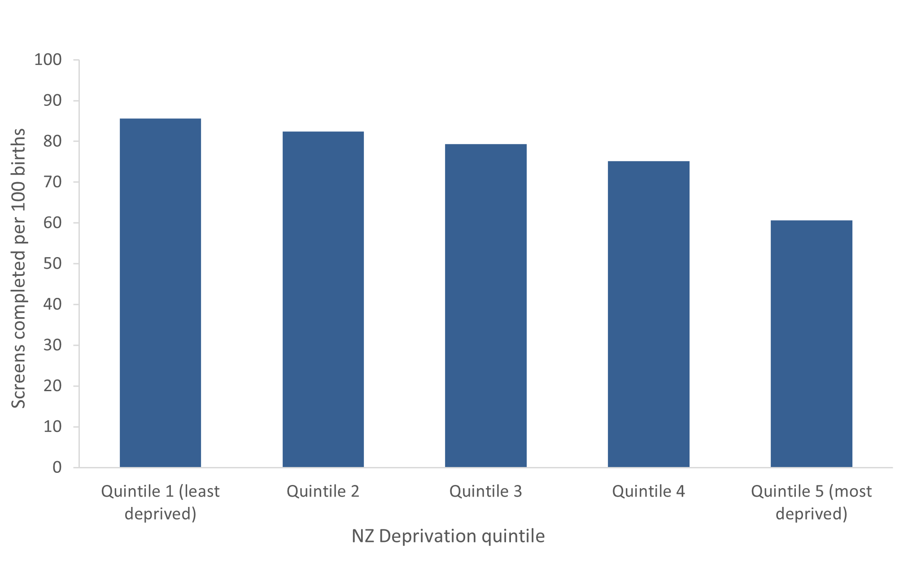

# Indicator 3: Screening pathway variance

This section reports on the number of screens completed in the second trimester which included first trimester screening components. First trimester combined screening requires a blood sample (PAPP-A and ßhCG) and ultrasound scan measurements of NT and CRL. Without both items a risk is not calculated, and a second trimester blood sample is recommended. Any information available from the first trimester (NT or PAPP-A) will be included in the second trimester risk assessment.

Second trimester results with an NT measurement indicate that the screening laboratory did not receive a suitable first trimester blood sample. Second trimester results with PAPP-A indicate that the screening laboratory did not receive an NT scan report, or that the scan was performed outside the accepted timeframe for first trimester screening.

## Screening pathway variance by year

Table 11 shows the number and proportion of second trimester screening results that included first trimester inputs over the period from 2015 to 2020. This has been broken down by the type of pathway variance.

The largest pathway variance was due to second trimester screens with an NT measurement (45.7% in 2020). PAPP-A was included in 13 percent of second trimester screens in 2020, up from 11.5 percent in 2019.

Table 11: Screening pathway variance by type, January 2015 to December 2020

|  |  |  |  |  |  |
| --- | --- | --- | --- | --- | --- |
| Year | Second trimester screening results | | | | |
| **Number** | | | **Percentage** | |
| **Total T2 screens** | **with NT** | **with PAPP-A** | **with NT** | **with PAPP-A** |
| 2015 | 5,517 | 2,466 | 344 | 44.7 | 6.2 |
| 2016 | 6,008 | 2,670 | 500 | 44.4 | 8.3 |
| 2017 | 6,284 | 2,561 | 656 | 40.8 | 10.4 |
| 2018 | 6,242 | 2,563 | 735 | 41.1 | 11.8 |
| 2019 | 6,377 | 2,743 | 732 | 43.0 | 11.5 |
| 2020 | 6,776 | 3,095 | 883 | 45.7 | 13.0 |

## Screening pathway variance by DHB

Table 12 shows a breakdown of screening pathway variance by DHB and type of variance for the 2020 year. Care should be taken with interpretation given the low number of T2 screens for many DHBs. In general, the national result is reflected at DHB level with a far higher number of women having an NT scan and a T2 screen than those having a T2 screen with PAPP-A.

The crown rump length (CRL) measured by ultrasound is used by the screening laboratory to calculate gestation (may be different from the clinical gestation) leading to women being assessed in a different trimester.

Table 12: Screening pathway variance by DHB, January to December 2020

|  |  |  |  |  |  |
| --- | --- | --- | --- | --- | --- |
| DHB | Second trimester screening results | | | | |
| **Number** | | | **Percentage** | |
| **Total T2 screens** | **with NT** | **with PAPP-A** | **with NT** | **with PAPP-A** |
| Northland | 260 | 125 | 29 | 48.1 | 11.2 |
| Waitematā | 775 | 376 | 113 | 48.5 | 14.6 |
| Auckland | 591 | 191 | 103 | 32.3 | 17.4 |
| Counties Manukau | 1,426 | 428 | 202 | 30.0 | 14.2 |
| Waikato | 568 | 334 | 31 | 58.8 | 5.5 |
| Lakes | 174 | 89 | 15 | 51.1 | 8.6 |
| Bay of Plenty | 263 | 153 | 22 | 58.2 | 8.4 |
| Tairāwhiti | 91 | 49 | S | 53.8 | S |
| Hawke's Bay | 244 | 99 | 47 | 40.6 | 19.3 |
| Taranaki | 134 | 73 | 18 | 54.5 | 13.4 |
| MidCentral | 214 | 123 | 22 | 57.5 | 10.3 |
| Whanganui | 151 | 58 | 17 | 38.4 | 11.3 |
| Capital & Coast | 247 | 135 | 12 | 54.7 | 4.9 |
| Hutt Valley | 259 | 137 | 24 | 52.9 | 9.3 |
| Wairarapa | 75 | 44 | S | 58.7 | S |
| Nelson Marlborough | 142 | 92 | 15 | 64.8 | 10.6 |
| West Coast | 36 | 15 | 10 | 41.7 | 27.8 |
| Canterbury | 726 | 356 | 145 | 49.0 | 20.0 |
| South Canterbury | 93 | 50 | 17 | 53.8 | 18.3 |
| Southern | 302 | 166 | 33 | 55.0 | 10.9 |
| **National\*** | **6,776** | **3,095** | **883** | **45.7** | **13.0** |

*DHB counts do not sum to National total.

(S) Suppressed if the number of screens was < 6.

## Screening pathway variance by age, ethnicity and deprivation

Table 13 shows a breakdown of screening pathway variance by age, ethnicity, and deprivation for the 2020 year. The results show higher proportions for pathway variance for women in the 25–29 age group (48.7%), women of Other ethnicity (55.1%) and NZ deprivation quintile 1 (54.2%).

Table 13: Screening pathway variance by age, ethnicity and deprivation, January to December 2020

|  |  |  |  |  |  |
| --- | --- | --- | --- | --- | --- |
|  | Second trimester screening results | | | | |
| **Number** | | | **Percentage** | |
| **Total T2 screens** | **with NT** | **with PAPP‑A** | **with NT** | **with PAPP-A** |
| **Age at screen (years)** |  |  |  |  |  |
| Under 20 | 379 | 173 | 20 | 45.6 | 5.3 |
| 20–24 | 1,316 | 604 | 121 | 45.9 | 9.2 |
| 25–29 | 2,056 | 1,002 | 259 | 48.7 | 12.6 |
| 30–34 | 1,994 | 859 | 331 | 43.1 | 16.6 |
| 35–39 | 849 | 379 | 128 | 44.6 | 15.1 |
| 40–44 | 174 | 75 | 22 | 43.1 | 12.6 |
| 45 and over | 8 | 3 | 2 | 37.5 | 25.0 |
| **Ethnicity** |  |  |  |  |  |
| Māori | 1,775 | 831 | 146 | 46.8 | 8.2 |
| Pacific | 1,105 | 364 | 95 | 32.9 | 8.6 |
| Asian | 1,460 | 557 | 261 | 38.2 | 17.9 |
| Other | 2,436 | 1,343 | 381 | 55.1 | 15.6 |
| **NZ Deprivation quintile** |  |  |  |  |  |
| Quintile 1 (least deprived) | 744 | 403 | 106 | 54.2 | 14.2 |
| Quintile 2 | 1004 | 520 | 156 | 51.8 | 15.5 |
| Quintile 3 | 1072 | 508 | 157 | 47.4 | 14.6 |
| Quintile 4 | 1715 | 757 | 233 | 44.1 | 13.6 |
| Quintile 5 (most deprived) | 2235 | 905 | 230 | 40.5 | 10.3 |
| **National\*** | **6,776** | **3,095** | **883** | **45.7** | **13.0** |

*Deprivation counts do not sum to National total.

# Indicator 4: Incomplete screens

This section reports on the number of women who commenced screening but were not issued with a risk result. Women that start screening in trimester 1 but complete screening in trimester 2 are not included in this indicator and are instead covered under indicator 3, pathway variances.

## Total incomplete screens

Table 14 shows the total number of incomplete screens by calendar year and trimester of screen. Nearly all incomplete screens are related to the first trimester, which reflects the different components required to complete screening depending on the trimester. First trimester screening requires a blood sample and an NT scan, whereas second trimester screening involves only a blood sample. The total number of incomplete screens for 2020 was 6,321, which equates to 12.6 percent of screens commenced that year and demonstrates an overall increase in incomplete screens over the past six years.

Table 14: Incomplete screens by trimester, January 2015 to December 2020

|  |  |  |  |  |  |  |
| --- | --- | --- | --- | --- | --- | --- |
| Trimester of screen | Number and percentage of incomplete screens | | | | | |
| **2015** | **2016** | **2017** | **2018** | **2019** | **2020** |
| T1 screens | 4,544 | 4,305 | 4,567 | 4,871 | 5,465 | 6,209 |
| T2 screens | 225 | 144 | 85 | 88 | 126 | 112 |
| **Total screens** | **4,769** | **4,449** | **4,652** | **4,959** | **5,591** | **6,321** |
| Percentage incomplete | 10.1 | 9.3 | 9.7 | 10.3 | 11.7 | 12.6 |

## Incomplete T1 screens by reason incomplete

Table 15 provides a breakdown of incomplete T1 screens according to which component of the screen was missing. Results have been reported as a percentage of all commenced screens, and then as a percentage of all incomplete screens.

In 2020, the proportion of incomplete T1 screens out of all commenced T1 screens was 14 percent. This was the result of both screens without blood samples and screens without NT scans. The majority of incomplete screens in T1 were due to a missing blood sample.

During 2020, antenatal screening was considered an essential service and continued through COVID-19 restrictions. Further analysis (not shown here) suggests that while the number of women screened was not impacted, the reduced availability of NT scans during the national lockdowns may have caused a slightly higher number of incomplete screens in March and April 2020.[7]

Table 15: Incomplete T1 screens by reason incomplete, January 2015 to December 2020

|  |  |  |  |  |  |  |  |  |  |  |  |
| --- | --- | --- | --- | --- | --- | --- | --- | --- | --- | --- | --- |
| Year | Commenced first trimester | | | Reason incomplete | | | Incomplete as percentage of commenced | | | Type as percentage of all incomplete T1 screens | |
| **No result issued** | **Result issued** | **Total** | **No blood** | **No NT scan** | **No weight** | **T1 no blood** | **T1 no NT scan** | **Total T1 incompletes** | **T1 no blood** | **T1 no NT scan** |
| 2015 | 4,544 | 36,739 | 41,283 | 2,925 | 1,619 | - | 7.1 | 3.9 | 11.0 | 64.4 | 35.6 |
| 2016 | 4,305 | 37,511 | 41,816 | 2,946 | 1,335 | 24 | 7.0 | 3.2 | 10.3 | 68.4 | 31.0 |
| 2017 | 4,567 | 36,836 | 41,403 | 3,275 | 1,286 | 12 | 7.9 | 3.1 | 11.0 | 71.7 | 28.2 |
| 2018 | 4,871 | 36,810 | 41,681 | 3,530 | 1,334 | 13 | 8.5 | 3.2 | 11.7 | 72.5 | 27.4 |
| 2019 | 5,465 | 35,900 | 41,365 | 4,063 | 1,398 | 17 | 9.8 | 3.4 | 13.2 | 74.3 | 25.6 |
| 2020 | 6,209 | 36,893 | 43,102 | 4,703 | 1,504 | 7 | 10.9 | 3.5 | 14.4 | 75.7 | 24.2 |

## Incomplete T1 screens by reason and DHB

Table 16 provides a breakdown of incomplete T1 screens by DHB and reason for the 2020 year. The lower numbers involved limit the comparisons that can be made between DHBs. The percentage of T1 screens that were incomplete due to no blood sample ranged from 61 percent (Nelson Marlborough) to 86 percent (Wairarapa).

Table 16: Incomplete T1 screens by reason and DHB, January to December 2020

|  |  |  |  |  |  |  |  |  |  |  |  |
| --- | --- | --- | --- | --- | --- | --- | --- | --- | --- | --- | --- |
| DHB | Commenced first trimester | | | Reason incomplete | | | Incomplete as percentage of commenced | | | Type as percentage of all incomplete T1 screens | |
| **No result issued** | **Result issued** | **Total** | **No blood** | **No NT scan** | **No weight** | **T1 no blood** | **T1 no NT scan** | **Total T1 incompletes** | **T1 no blood** | **T1 no NT scan** |
| Northland | 216 | 1,041 | 1,257 | 163 | 53 | S | 13.0 | 4.2 | 17.2 | 75.5 | 24.5 |
| Waitematā | 954 | 5,155 | 6,109 | 759 | 195 | S | 12.4 | 3.2 | 15.6 | 79.6 | 20.4 |
| Auckland | 724 | 2,874 | 3,598 | 591 | 133 | S | 16.4 | 3.7 | 20.1 | 81.6 | 18.4 |
| Counties Manukau | 723 | 4,186 | 4,909 | 523 | 200 | S | 10.7 | 4.1 | 14.7 | 72.3 | 27.7 |
| Waikato | 556 | 3,764 | 4,320 | 449 | 106 | S | 10.4 | 2.5 | 12.9 | 80.8 | 19.1 |
| Lakes | 174 | 853 | 1,027 | 144 | 30 | S | 14.0 | 2.9 | 16.9 | 82.8 | 17.2 |
| Bay of Plenty | 330 | 2,110 | 2,440 | 253 | 77 | S | 10.4 | 3.2 | 13.5 | 76.7 | 23.3 |
| Tairāwhiti | 83 | 387 | 470 | 66 | 17 | S | 14.0 | 3.6 | 17.7 | 79.5 | 20.5 |
| Hawke's Bay | 245 | 1,180 | 1,425 | 182 | 63 | S | 12.8 | 4.4 | 17.2 | 74.3 | 25.7 |
| Taranaki | 149 | 912 | 1,061 | 99 | 50 | S | 9.3 | 4.7 | 14.0 | 66.4 | 33.6 |
| MidCentral | 248 | 1,437 | 1,685 | 198 | 50 | S | 11.8 | 3.0 | 14.7 | 79.8 | 20.2 |
| Whanganui | 86 | 381 | 467 | 63 | 23 | S | 13.5 | 4.9 | 18.4 | 73.3 | 26.7 |
| Capital & Coast | 266 | 1,884 | 2,150 | 202 | 64 | S | 9.4 | 3.0 | 12.4 | 75.9 | 24.1 |
| Hutt Valley | 209 | 1,229 | 1,438 | 162 | 47 | S | 11.3 | 3.3 | 14.5 | 77.5 | 22.5 |
| Wairarapa | 71 | 326 | 397 | 61 | 10 | S | 15.4 | 2.5 | 17.9 | 85.9 | 14.1 |
| Nelson Marlborough | 142 | 1,164 | 1,306 | 86 | 56 | S | 6.6 | 4.3 | 10.9 | 60.6 | 39.4 |
| West Coast | 20 | 211 | 231 | 14 | 6 | S | 6.1 | 2.6 | 8.7 | 70.0 | 30.0 |
| Canterbury | 655 | 4,800 | 5,455 | 424 | 231 | S | 7.8 | 4.2 | 12.0 | 64.7 | 35.3 |
| South Canterbury | 52 | 413 | 465 | 38 | 14 | S | 8.2 | 3.0 | 11.2 | 73.1 | 26.9 |
| Southern | 300 | 2,570 | 2,870 | 221 | 78 | S | 7.7 | 2.7 | 10.5 | 73.7 | 26.0 |
| **National\*** | **6,209** | **36,893** | **43,102** | **4,703** | **1,504** | **7** | **10.9** | **3.5** | **14.4** | **75.7** | **24.2** |

*DHB counts do not sum to National total.

(S) Suppressed if the number of screens was < 6.

## Incomplete T2 screens

T2 screens do not require an NT scan, just a blood sample, but may be incomplete if they are missing dating information or weight, if the sample is taken later than 20 weeks of pregnancy, or if the sample is damaged and not repeated. In 2020, 1.6 percent of T2 commenced screens were incomplete, compared with 14.4 percent of T1 commenced screens. As Table 17 shows, the percentage of incomplete T2 screens decreased from 3.9 percent in 2015 to 1.6 percent in 2020.

Table 17: Incomplete T2 screens, January 2015 to December 2020

|  |  |  |  |
| --- | --- | --- | --- |
| Year | Commenced second trimester | No result issued | Percentage incomplete |
| 2015 | 5,742 | 225 | 3.9 |
| 2016 | 6,152 | 144 | 2.3 |
| 2017 | 6,369 | 85 | 1.3 |
| 2018 | 6,330 | 88 | 1.4 |
| 2019 | 6,503 | 126 | 1.9 |
| 2020 | 6,888 | 112 | 1.6 |
| **Total** | **37,984** | **780** | **2.1** |

## Incomplete T2 screens by DHB

Table 18 shows a breakdown of incomplete T2 screens by DHB for the 2020 year. The low volumes involved limit meaningful DHB comparisons.

Table 18: Incomplete T2 screens by DHB, January to December 2020

|  |  |  |  |
| --- | --- | --- | --- |
| DHB | Commenced second trimester | No result issued | Percentage incomplete |
| Northland | 265 | S | S |
| Waitematā | 788 | 13 | 1.6 |
| Auckland | 599 | 8 | 1.3 |
| Counties Manukau | 1,448 | 22 | 1.5 |
| Waikato | 583 | 15 | 2.6 |
| Lakes | 176 | S | S |
| Bay of Plenty | 266 | S | S |
| Tairāwhiti | 93 | S | S |
| Hawke's Bay | 246 | S | S |
| Taranaki | 137 | S | S |
| MidCentral | 216 | S | S |
| Whanganui | 155 | S | S |
| Capital & Coast | 254 | 7 | 2.8 |
| Hutt Valley | 265 | 6 | 2.3 |
| Wairarapa | 75 | S | S |
| Nelson Marlborough | 144 | S | S |
| West Coast | 37 | S | S |
| Canterbury | 731 | S | S |
| South Canterbury | 96 | S | S |
| Southern | 309 | 7 | 2.3 |
| **National\*** | **6,888** | **112** | **1.6** |

*DHB counts do not sum to National total.

(S) Suppressed if the number of screens was < 6.

# Indicator 5: Increased-risk screening results for trisomy 21, trisomy 18 and trisomy 13

This indicator reports on the screening risk results issued for trisomy 21, trisomy 18 and trisomy 13. Women who complete screening receive a risk result, either low-risk or increased-risk, for each trisomy. This means that an individual woman may be at increased risk for more than one trisomy.

## Total increased-risk screening results for trisomy 21, 18 or 13

Table 19 shows the total number of screening risk results that were classified as increased-risk for one or more of trisomy 21, 18 or 13 by calendar year, together with the number of increased-risk results per 100 screens (positive test rate). For 2020, 4.2 increased-risk results were issued for every 100 screens completed. This is the same as the rate reported in 2019 and similar to the rate reported in 2018.

Table 19: Number and rate per 100 screens of increased-risk screening results for trisomy 21, 18 or 13, January 2015 to December 2020

|  |  |  |  |  |  |  |
| --- | --- | --- | --- | --- | --- | --- |
|  | Number and rate of increased-risk screens | | | | | |
| **2015** | **2016** | **2017** | **2018** | **2019** | **2020** |
| Total increased-risk results | 1,168 | 1,189 | 1,318 | 1,764 | 1,764 | 1,844 |
| Positive test rate per 100 completed screens | 2.8 | 2.7 | 3.1 | 4.1 | 4.2 | 4.2 |

## Increased-risk screening results for trisomy 21, 18 or 13 by age, ethnicity and deprivation

Table 20 shows the number and proportion of screening risk results that were classified as increased risk for any one or more of trisomy 21, 18, or 13 by age at screen, ethnicity and deprivation for the 2020 year.

Older women are more likely to have a positive test and are also more likely to have a higher detection rate. This is because of the inclusion of prior risk (age) as part of the risk calculation. Positive test rate was higher for Pacific and Asian women compared with other ethnicities. Women in deprivation quintiles 4 and 5 had a higher positive test rate than women in less deprived areas.

Table 20: Increased-risk screening results for trisomy 21, 18 or 13 by age, ethnicity and deprivation, January to December 2020

|  |  |  |  |
| --- | --- | --- | --- |
|  | Number of screens that include an increased risk for trisomy 21, 18 or 13 | Total number of completed screens | Positive test rate per 100 screens |
| **Age at screen (years)** |  |  |  |
| Under 20 | 12 | 1,129 | 1.1 |
| 20–24 | 76 | 5,400 | 1.4 |
| 25–29 | 213 | 13,056 | 1.6 |
| 30–34 | 498 | 15,913 | 3.1 |
| 35–39 | 737 | 7,046 | 10.5 |
| 40–44 | 288 | 1,080 | 26.7 |
| 45 and over | 20 | 45 | 44.4 |
| **Ethnicity** |  |  |  |
| Māori | 233 | 6,804 | 3.4 |
| Pacific | 197 | 2,988 | 6.6 |
| Asian | 522 | 9,973 | 5.2 |
| Other | 892 | 23,904 | 3.7 |
| **NZ Deprivation quintile** |  |  |  |
| Quintile 1 (least deprived) | 313 | 7,820 | 4.0 |
| Quintile 2 | 322 | 8,248 | 3.9 |
| Quintile 3 | 340 | 8,541 | 4.0 |
| Quintile 4 | 457 | 10,058 | 4.5 |
| Quintile 5 (most deprived) | 412 | 8,979 | 4.6 |
| Unknown | 0 | 23 | 0.0 |
| **National** | **1,844** | **43,669** | **4.2** |

## Increased-risk screening results for trisomy 21, 18 or 13 by trimester of screen

Table 21 shows the positive test rate for each of trisomy 21, 18 and 13 individually as well as the positive test rate for the three trisomies together by trimester of screen and calendar year. The sum of the individual values for trisomy 21, 18 and 13 is greater than the value for the fourth grouping (any of the three trisomies) because a result can be at increased risk for more than one trisomy.

Trisomy 18 and 13 each had low positivity rates of 0.4 per 100 screens, while the positive test rate for trisomy 21 was 4.1 per 100 screens which is unchanged since 2019. The second trimester positive test rate for trisomy 21 was higher than the first trimester positive test rate (5.0 and 3.9 respectively). The difference in rates may be due to variability in nuchal translucency and crown rump length assessments and the removal of nasal bone from the risk calculation algorithm.

The positive test rate for any one or more of trisomy 21, 18 or 13 was similar to that of trisomy 21 alone. This reflects the far higher number of increased-risk screening results for trisomy 21 compared with trisomy 18 and 13.

Table 21: Increased-risk screening results for trisomy 21, 18 and 13 by trimester of screen, January 2015 to December 2020

|  |  |  |  |  |  |  |
| --- | --- | --- | --- | --- | --- | --- |
| Year | Total results that include an increased risk for specified trisomy | Positive test rate per 100 screens | T1 results that include an increased risk for specified trisomy | Positive test rate per 100 T1 screens | T2 results that include an increased risk for specified trisomy | Positive test rate per 100 T2 screens |
| **Trisomy 21** | | | | | | |
| 2015 | 1,145 | 2.7 | 942 | 2.6 | 203 | 3.7 |
| 2016 | 1,146 | 2.6 | 950 | 2.5 | 196 | 3.3 |
| 2017 | 1,287 | 3.0 | 1,033 | 2.8 | 254 | 4.0 |
| 2018 | 1,740 | 4.0 | 1,361 | 3.7 | 379 | 6.1 |
| 2019 | 1,718 | 4.1 | 1,416 | 3.9 | 302 | 4.7 |
| 2020 | 1,793 | 4.1 | 1,452 | 3.9 | 341 | 5.0 |
| **Trisomy 18** | | | | | | |
| 2015 | 147 | 0.3 | 129 | 0.4 | 18 | 0.3 |
| 2016 | 171 | 0.4 | 142 | 0.4 | 29 | 0.5 |
| 2017 | 140 | 0.3 | 123 | 0.3 | 17 | 0.3 |
| 2018 | 161 | 0.4 | 143 | 0.4 | 18 | 0.3 |
| 2019 | 170 | 0.4 | 142 | 0.4 | 28 | 0.4 |
| 2020 | 188 | 0.4 | 160 | 0.4 | 28 | 0.4 |
| **Trisomy 13** | | | | | | |
| 2015 | 161 | 0.4 | 149 | 0.4 | 12 | 0.2 |
| 2016 | 174 | 0.4 | 161 | 0.4 | 13 | 0.2 |
| 2017 | 161 | 0.4 | 143 | 0.4 | 18 | 0.3 |
| 2018 | 167 | 0.4 | 155 | 0.4 | 12 | 0.2 |
| 2019 | 151 | 0.4 | 136 | 0.4 | 15 | 0.2 |
| 2020 | 159 | 0.4 | 140 | 0.4 | 19 | 0.3 |
| **Any one or more of trisomy 21, 18 or 13** | | | | | | |
| 2015 | 1,168 | 2.8 | 947 | 2.6 | 221 | 4.0 |
| 2016 | 1,189 | 2.7 | 969 | 2.6 | 220 | 3.7 |
| 2017 | 1,318 | 3.1 | 1,046 | 2.8 | 272 | 4.3 |
| 2018 | 1,764 | 4.1 | 1,373 | 3.7 | 391 | 6.3 |
| 2019 | 1,764 | 4.2 | 1,442 | 4.0 | 322 | 5.0 |
| 2020 | 1,844 | 4.2 | 1,483 | 4.0 | 361 | 5.3 |

## Increased-risk screening results stratified by risk level

Table 22 shows the number of increased-risk results stratified by risk level for each of trisomy 21, 18 and 13 for the 2020 year. A woman’s screen result may indicate an increased-risk for more than one of trisomy 21, 18 and 13 so the sum of the values in Table 22 will be greater than the total number of increased-risk results for 2020.

Table 22: Increased-risk screening results for trisomy 21, 18 and 13 by risk level, January to December 2020

|  |  |  |  |
| --- | --- | --- | --- |
| Risk level | Trisomy 21 | Trisomy 18 | Trisomy 13 |
| 1:5 to 1:20 | 230 | 64 | 46 |
| 1:21 to 1:50 | 179 | 32 | 27 |
| 1:51 to 1:300 | 1,384 | 92 | 86 |

# Indicator 6: Diagnostic testing volumes for women with increased-risk screens

This indicator reports information on the number and proportion of women who complete prenatal diagnostic testing (CVS or amniocentesis) following an increased-risk screening result for trisomy 21, trisomy 18 or trisomy 13. Following an increased-risk result, women may choose to have diagnostic testing (either amniocentesis or CVS) to determine the absence or the presence of the condition.

## Diagnostic testing volumes for women with increased-risk screens by trimester of screen

Table 23 shows the diagnostic testing rate by trimester of screen from 2015 to 2020. In 2020, for every 100 women that received an increased-risk result after a first or second trimester screen, 30 women had a diagnostic test. There is an overall downward trend in diagnostic testing from 2015 to 2020, which may be partly due to increasing availability and uptake of non-invasive prenatal screening (NIPS). For the second consecutive year, the second trimester diagnostic testing rate (32.1) was slightly higher than the first trimester diagnostic testing rate (29.3) in 2020. See Appendix 3 for a summary of diagnostic test results for women who had an increased-risk screen in 2020.

Table 23: Diagnostic testing volumes for women with increased-risk screens by trimester of screen, January 2015 to December 2020

|  |  |  |  |  |  |  |
| --- | --- | --- | --- | --- | --- | --- |
| Trimester of screen | Diagnostic tests per 100 increased-risk screens | | | | | |
| **2015** | **2016** | **2017** | **2018** | **2019** | **2020** |
| T1 screen | 59.0 | 46.9 | 36.7 | 38.4 | 38.7 | 29.3 |
| T2 screen | 44.3 | 40.5 | 29.0 | 35.3 | 39.4 | 32.1 |
| **Total screens** | **56.3** | **45.7** | **35.1** | **37.7** | **38.8** | **29.9** |

## Diagnostic testing volumes for women with increased-risk screens by DHB

The number of diagnostic tests and rate per 100 increased-risk screens by DHB is given in Table 24. Many DHBs have low numbers and care should be taken with comparisons.

In 2020, many DHBs saw a significant drop in the rate of diagnostic testing for women with increased-risk screens.

Table 24: Diagnostic testing volumes for women with increased-risk screens by DHB, January 2015 to December 2020

|  |  |  |  |  |  |  |  |  |  |  |  |  |
| --- | --- | --- | --- | --- | --- | --- | --- | --- | --- | --- | --- | --- |
| DHB | Number of diagnostic tests | | | | | | Diagnostic tests per 100 increased-risk screens | | | | | |
| **2015** | **2016** | **2017** | **2018** | **2019** | **2020** | **2015** | **2016** | **2017** | **2018** | **2019** | **2020** |
| Northland | 21 | 12 | 12 | 18 | 25 | 19 | 48.8 | 40.0 | 34.3 | 38.3 | 44.6 | 39.6 |
| Waitematā | 107 | 82 | 78 | 102 | 97 | 66 | 57.5 | 44.6 | 37.5 | 37.2 | 37.2 | 25.1 |
| Auckland | 76 | 72 | 49 | 63 | 70 | 41 | 53.5 | 45.0 | 30.6 | 31.8 | 34.7 | 23.7 |
| Counties Manukau | 86 | 78 | 55 | 99 | 107 | 95 | 53.8 | 54.9 | 31.4 | 39.6 | 45.5 | 33.9 |
| Waikato | 42 | 45 | 29 | 56 | 66 | 56 | 60.0 | 52.9 | 30.2 | 39.4 | 40.2 | 32.4 |
| Lakes | 28 | 16 | 14 | 19 | 14 | 16 | 71.8 | 59.3 | 46.7 | 46.3 | 41.2 | 35.6 |
| Bay of Plenty | 20 | 17 | 18 | 26 | 24 | 25 | 66.7 | 44.7 | 40.0 | 39.4 | 38.1 | 35.2 |
| Tairāwhiti | S | S | S | 7 | S | 7 | S | S | S | 43.8 | S | 30.4 |
| Hawke's Bay | 15 | 8 | 7 | 15 | 13 | 17 | 51.7 | 28.6 | 26.9 | 33.3 | 40.6 | 35.4 |
| Taranaki | 10 | 8 | S | 10 | 17 | 14 | 43.5 | 36.4 | S | 35.7 | 51.5 | 41.2 |
| MidCentral | 8 | 15 | 20 | 19 | 25 | 19 | 44.4 | 46.9 | 50.0 | 52.8 | 44.6 | 33.3 |
| Whanganui | S | 6 | S | 9 | 11 | S | S | 66.7 | S | 52.9 | 57.9 | S |
| Capital & Coast | 65 | 41 | 30 | 34 | 37 | 23 | 60.7 | 60.3 | 32.6 | 37.0 | 36.3 | 20.9 |
| Hutt Valley | 18 | 15 | 15 | 18 | 19 | 24 | 64.3 | 45.5 | 45.5 | 34.0 | 28.4 | 28.6 |
| Wairarapa | S | S | S | S | 6 | S | S | S | S | S | 50.0 | S |
| Nelson Marlborough | 15 | 14 | 13 | 20 | 29 | 28 | 57.7 | 51.9 | 48.1 | 44.4 | 56.9 | 58.3 |
| West Coast | S | 6 | S | S | S | S | S | 85.7 | S | S | S | S |
| Canterbury | 83 | 80 | 70 | 95 | 90 | 65 | 50.6 | 36.7 | 32.0 | 34.2 | 34.5 | 27.4 |
| South Canterbury | 9 | S | 7 | S | S | S | 75.0 | S | 36.8 | S | S | S |
| Southern | 40 | 20 | 31 | 44 | 24 | 23 | 60.6 | 37.0 | 44.9 | 48.4 | 32.0 | 24.2 |
| **National\*** | **657** | **543** | **463** | **665** | **685** | **551** | **56.3** | **45.7** | **35.1** | **37.7** | **38.8** | **29.9** |

*DHB counts do not sum to National total.

(S) Suppressed if the number of diagnostic tests was < 6.

## Diagnostic testing volumes for women with increased-risk screens by age, ethnicity and deprivation

Table 25 shows the diagnostic testing rates for women with increased-risk screens by age and ethnicity for 2015 to 2020.

For 2020, women aged 20–24 had the highest rate of diagnostic testing compared to the other age groups. Diagnostic testing rates were highest for Asian and Māori women (32 tests per 100 increased-risk screens), followed by women of Other ethnicity (30 per 100 increased-risk screens). Pacific women had the lowest rate of diagnostic testing (23 per 100 increased-risk screens).

Table 25: Diagnostic testing volumes for women with increased-risk screens by age and ethnicity, January 2015 to December 2020

|  |  |  |  |  |  |  |
| --- | --- | --- | --- | --- | --- | --- |
|  | Diagnostic tests per 100 increased-risk screens | | | | | |
| **2015** | **2016** | **2017** | **2018** | **2019** | **2020** |
| **Age at screen (years)** |  |  |  |  |  |  |
| Under 20 | 53.8 | 45.5 | 17.4 | 28.6 | 64.3 | 33.3 |
| 20–24 | 51.7 | 55.6 | 43.5 | 50.0 | 48.6 | 42.1 |
| 25–29 | 58.1 | 49.4 | 38.2 | 44.7 | 43.1 | 35.7 |
| 30–34 | 61.8 | 47.7 | 38.8 | 41.3 | 42.7 | 33.3 |
| 35–39 | 57.0 | 46.0 | 32.9 | 35.3 | 36.0 | 27.5 |
| 40–44 | 50.9 | 39.0 | 29.8 | 32.5 | 33.1 | 21.9 |
| 45 and over | 41.2 | 27.8 | 35.3 | 13.6 | 43.8 | 35.0 |
| **Ethnicity** |  |  |  |  |  |  |
| Māori | 45.1 | 46.7 | 30.1 | 37.3 | 40.9 | 31.8 |
| Pacific | 36.2 | 34.3 | 31.0 | 33.1 | 36.1 | 23.4 |
| Asian | 63.3 | 56.3 | 37.7 | 37.9 | 39.5 | 32.0 |
| Other | 58.7 | 42.1 | 35.9 | 38.5 | 38.3 | 29.6 |
| **National** | **56.3** | **45.7** | **35.1** | **37.7** | **38.8** | **29.9** |

Table 26 provides diagnostic testing rates by deprivation quintile. Women in the least deprived quintile had the lowest rate of diagnostic testing in 2020 (25 tests per 100 increased-risk screens).

Table 26: Diagnostic testing volumes for women with increased-risk screens by deprivation, January to December 2020

|  |  |  |
| --- | --- | --- |
| NZ Deprivation quintile | Diagnostic tests | Diagnostic tests per 100 increased-risk screens |
| Quintile 1 (least deprived) | 77 | 24.6 |
| Quintile 2 | 93 | 28.9 |
| Quintile 3 | 107 | 31.5 |
| Quintile 4 | 150 | 32.8 |
| Quintile 5 (most deprived) | 124 | 30.1 |
| **National** | **551** | **29.9** |

## Diagnostic testing volumes for women with increased-risk screening results stratified by risk level

Each screening result includes a separate risk for each of trisomy 21, 18 and 13. For the analysis in this report, women were assigned a combined trisomy risk level based on the highest risk score they received across the three trisomies. Table 27 shows the number of diagnostic tests for women that received an increased-risk result during 2020 for one or more of trisomy 21, 18 or 13, stratified by risk level. As expected, diagnostic testing increased with increasing risk level, going from 23 tests per 100 women with a risk of 1:51 to 1:300 to 58 tests per 100 women with a risk of 1:5 to 1:20.

Table 27: Diagnostic testing volumes for women with increased-risk screens by risk level, January to December 2020

|  |  |  |  |
| --- | --- | --- | --- |
| Risk level | Number of diagnostic tests | Number of increased-risk screens | Tests per 100 increased-risk screens |
| 1:5 to 1:20 | 149 | 259 | 57.5 |
| 1:21 to 1:50 | 77 | 188 | 41.0 |
| 1:51 to 1:300 | 325 | 1,397 | 23.3 |

# Indicator 7: Diagnostic testing volumes for women who receive a low-risk screening result

This section reports information on the number and proportion of women who complete prenatal diagnostic testing (CVS or amniocentesis procedures) following a low-risk screening result. Following a low-risk screen, women may still choose to have diagnostic testing to determine the absence or the presence of a condition.

This indicator intends to capture only those that had a low-risk screening result in isolation; so for this calculation a woman was only counted as having a low-risk screen if there was no increased-risk for any of the other conditions covered by the screening test in addition to trisomy 21, 18 and 13. For example, if the result was low-risk for each of trisomy 21, 18 and 13 but increased-risk for Turner syndrome then the woman was categorised as at increased-risk for the purposes of this indicator.

Some women with low-risk screening results may have other indications for diagnostic testing, for example, family history of another condition that diagnostic testing can identify or an abnormal ultrasound finding. Information on the indication for diagnostic testing is not reliably provided on laboratory forms so the calculations for this indicator cannot exclude these women.

## Diagnostic testing volumes for women with low-risk screens by trimester of screen

The national rate of diagnostic testing for women that received low-risk screening results was 0.45 per 100 low-risk screens in 2020, the lowest it has been in the reporting period.

Table 28: Diagnostic testing volumes for women with low-risk screens by trimester of screen, January 2015 to December 2020

|  |  |  |  |  |  |  |
| --- | --- | --- | --- | --- | --- | --- |
| Trimester of screen | Diagnostic tests per 100 low-risk screens | | | | | |
| **2015** | **2016** | **2017** | **2018** | **2019** | **2020** |
| T1 screen | 0.74 | 0.53 | 0.75 | 0.80 | 0.84 | 0.48 |
| T2 screen | 0.36 | 0.69 | 0.70 | 0.74 | 0.64 | 0.28 |
| **Total screens** | **0.69** | **0.55** | **0.75** | **0.79** | **0.81** | **0.45** |

## Diagnostic testing volumes for women with low-risk screens by DHB

The rate of diagnostic testing by DHB for women with low-risk screens has varied each year from 2015 to 2020, as shown in Table 29. Given the low numbers involved, caution should be taken in making comparisons between DHBs.

Table 29: Diagnostic testing volumes for women with low-risk screens by DHB, January 2015 to December 2020

|  |  |  |  |  |  |  |  |  |  |  |  |  |
| --- | --- | --- | --- | --- | --- | --- | --- | --- | --- | --- | --- | --- |
| DHB | Number of diagnostic tests | | | | | | Diagnostic tests per 100 low-risk screens | | | | | |
| **2015** | **2016** | **2017** | **2018** | **2019** | **2020** | **2015** | **2016** | **2017** | **2018** | **2019** | **2020** |
| Northland | 7 | S | S | 11 | S | S | 0.66 | S | S | 0.98 | S | S |
| Waitematā | 33 | 37 | 43 | 52 | 53 | 41 | 0.55 | 0.59 | 0.72 | 0.88 | 0.94 | 0.72 |
| Auckland | 36 | 20 | 29 | 33 | 32 | 18 | 0.80 | 0.46 | 0.78 | 0.89 | 0.92 | 0.55 |
| Counties Manukau | 23 | 28 | 45 | 29 | 53 | 24 | 0.45 | 0.53 | 0.87 | 0.57 | 1.05 | 0.45 |
| Waikato | 21 | 16 | 33 | 34 | 30 | 18 | 0.56 | 0.41 | 0.83 | 0.88 | 0.75 | 0.43 |
| Lakes | 8 | S | 6 | 7 | 11 | 8 | 0.84 | S | 0.60 | 0.67 | 1.10 | 0.81 |
| Bay of Plenty | 7 | 12 | 13 | 20 | 17 | 12 | 0.38 | 0.59 | 0.58 | 0.92 | 0.75 | 0.52 |
| Tairāwhiti | S | S | S | S | S | S | S | S | S | S | S | S |
| Hawke's Bay | 8 | S | 6 | 14 | 7 | S | 0.64 | S | 0.45 | 1.01 | 0.53 | S |
| Taranaki | S | S | S | S | S | S | S | S | S | S | S | S |
| MidCentral | 11 | S | 11 | S | 6 | 8 | 0.93 | S | 0.73 | S | 0.42 | 0.50 |
| Whanganui | S | S | S | S | S | S | S | S | S | S | S | S |
| Capital & Coast | 22 | 19 | 15 | 18 | 17 | 8 | 0.86 | 0.72 | 0.66 | 0.80 | 0.81 | 0.40 |
| Hutt Valley | 9 | 6 | 10 | 6 | 7 | S | 0.69 | 0.44 | 0.78 | 0.43 | 0.53 | S |
| Wairarapa | S | S | 6 | S | S | S | S | S | 1.41 | S | S | S |
| Nelson Marlborough | 9 | 9 | 7 | 10 | 13 | S | 0.77 | 0.77 | 0.56 | 0.82 | 1.08 | S |
| West Coast | S | S | S | S | S | S | S | S | S | S | S | S |
| Canterbury | 52 | 37 | 47 | 44 | 47 | 20 | 1.08 | 0.74 | 0.92 | 0.88 | 0.96 | 0.38 |
| South Canterbury | S | 7 | 7 | S | S | S | S | 1.35 | 1.35 | S | S | S |
| Southern | 29 | 23 | 22 | 23 | 19 | 9 | 1.12 | 0.87 | 0.80 | 0.88 | 0.73 | 0.32 |
| **National\*** | **283** | **233** | **312** | **325** | **330** | **188** | **0.69** | **0.55** | **0.75** | **0.79** | **0.81** | **0.45** |

*DHB counts do not sum to National total.

(S) Suppressed if the number of diagnostic tests was < 6.

## Diagnostic testing volumes for women with low-risk screening results by age and ethnicity

Table 30 shows the rate of diagnostic testing for women with low-risk screening results by age and ethnicity for 2015 to 2020.

For 2020, the rate of diagnostic testing was highest for women aged 40–44 years. Asian women were the most likely to have a diagnostic test after a low-risk screen (0.7 tests per 100 low-risk screens) and Pacific women the least likely (0.1 tests per 100 low-risk screens).

Table 30: Diagnostic testing volumes for women with low-risk screens by age and ethnicity, January 2015 to December 2020

|  |  |  |  |  |  |  |
| --- | --- | --- | --- | --- | --- | --- |
|  | Diagnostic tests per 100 low-risk screens | | | | | |
| **2015** | **2016** | **2017** | **2018** | **2019** | **2020** |
| **Age at screen (years)** |  |  |  |  |  |  |
| Under 20 | 0.33 | 0.34 | 0.81 | 0.81 | 0.71 | 0.09 |
| 20–24 | 0.35 | 0.43 | 0.68 | 0.71 | 0.67 | 0.51 |
| 25–29 | 0.52 | 0.50 | 0.65 | 0.60 | 0.66 | 0.36 |
| 30–34 | 0.60 | 0.54 | 0.67 | 0.84 | 0.81 | 0.36 |
| 35–39 | 1.11 | 0.66 | 0.99 | 0.96 | 1.17 | 0.79 |
| 40–44 | 3.04 | 1.33 | 1.67 | 1.70 | 1.83 | 1.01 |
| 45 and over | 2.13 | 3.28 | 1.61 | 2.08 | 0.00 | 0.00 |
| **Ethnicity** |  |  |  |  |  |  |
| Māori | 0.46 | 0.50 | 0.65 | 0.74 | 0.68 | 0.30 |
| Pacific | 0.48 | 0.35 | 0.75 | 0.79 | 0.83 | 0.11 |
| Asian | 0.80 | 0.54 | 0.89 | 0.76 | 0.86 | 0.71 |
| Other | 0.72 | 0.58 | 0.73 | 0.80 | 0.83 | 0.43 |
| **National** | **0.69** | **0.55** | **0.75** | **0.79** | **0.81** | **0.45** |

## Diagnostic testing volumes for women with low-risk screening results stratified by risk

Table 31 shows the rate of diagnostic testing for women with low-risk screening results, stratified by risk level. Given the low numbers involved for some risk categories, numbers have been aggregated for 2017–2020.

Table 31: Diagnostic testing volumes for women with low-risk screens by risk level, aggregated 2017–2020

|  |  |  |  |
| --- | --- | --- | --- |
| Risk level | Number of diagnostic tests | Number of low-risk screens | Tests per 100 low-risk screens |
| 1:301 to 1:500 | 79 | 3,486 | 2.27 |
| 1:501 to 1:1,000 | 131 | 9,077 | 1.44 |
| 1:1,001 to 1:2,000 | 115 | 13,952 | 0.82 |
| 1:2,001 to 1:3,000 | 109 | 11,330 | 0.96 |
| 1:3,001 to 1:4,000 | 66 | 9,805 | 0.67 |
| 1:4,001 to 1:5,000 | 53 | 8,274 | 0.64 |
| 1:5,001 to 1:10,000 | 173 | 31,052 | 0.56 |
| 1:10,001 to 1:100,000 | 429 | 78,436 | 0.55 |

# Indicator 8: Diagnostic testing for unscreened women

This section reports information on the number of women who completed prenatal diagnostic testing but were not screened in the 105 days prior to the diagnostic test. The indication for diagnostic testing is not reliably reported on laboratory request forms but it is likely that many of these women will have had an increased prior risk (eg, family history, previous child with Down syndrome, advanced maternal age), a diagnostic test done for another reason and the karyotype reported, or an abnormal ultrasound finding.

The methodology for calculating unscreened[8] women has been updated for the 2020 report, improving identification of unscreened women. The improved identification means that figures for 2020 are higher than in recent years.

## Diagnostic volumes for unscreened women

During 2020, 247 diagnostic tests were completed for unscreened women. This is higher than 2018 and 2019 (156 and 174 tests respectively) but similar to the number of tests undertaken in 2015 (252). Part of this increase in 2020 is due to better data linkage to identify those women who have had a diagnostic test but have not had a prenatal screen. In addition, the increase may be partly due to COVID-19 isolation requirements and people choosing to stay home, despite screening services being available as they were considered essential services.

Table 32 shows the number of diagnostic tests by DHB for 2015–2020, and Table 33 shows the breakdown by age and ethnicity. Table 34 shows the breakdown by NZ deprivation quintile for 2020 only.

Table 32: Diagnostic testing volumes for unscreened women by DHB, January 2015 to December 2020

|  |  |  |  |  |  |  |
| --- | --- | --- | --- | --- | --- | --- |
| DHB | Number of diagnostic tests | | | | | |
| **2015** | **2016** | **2017** | **2018** | **2019** | **2020** |
| Northland | 8 | 6 | S | S | S | 9 |
| Waitematā | 22 | 19 | 14 | 24 | 23 | 45 |
| Auckland | 18 | 23 | 10 | 13 | 26 | 27 |
| Counties Manukau | 18 | 21 | 11 | 10 | 23 | 25 |
| Waikato | 15 | 16 | 6 | 12 | 12 | 23 |
| Lakes | 8 | S | S | 7 | S | 6 |
| Bay of Plenty | 14 | 10 | S | S | 6 | 7 |
| Tairāwhiti | S | S | S | S | S | S |
| Hawke's Bay | 7 | 8 | S | S | S | S |
| Taranaki | 11 | S | S | 7 | S | 9 |
| MidCentral | 8 | 9 | S | 6 | S | 12 |
| Whanganui | S | S | S | S | S | S |
| Capital & Coast | 36 | 25 | 12 | 8 | 16 | 13 |
| Hutt Valley | 22 | 10 | 6 | 6 | 8 | 7 |
| Wairarapa | S | S | S | S | S | S |
| Nelson Marlborough | 6 | S | S | S | S | S |
| West Coast | S | S | S | S | S | S |
| Canterbury | 30 | 30 | 18 | 31 | 25 | 30 |
| South Canterbury | S | S | S | S | S | S |
| Southern | 19 | 14 | S | 11 | 7 | 16 |
| **National** | **252** | **212** | **107** | **156** | **174** | **247\*** |

*DHB counts do not sum to National total.

(S) Suppressed if the number of diagnostic tests was < 6.

Table 33: Diagnostic testing volumes for unscreened women by age and ethnicity, January 2015 to December 2020

|  |  |  |  |  |  |  |
| --- | --- | --- | --- | --- | --- | --- |
|  | Number of diagnostic tests | | | | | |
| **2015** | **2016** | **2017** | **2018** | **2019** | **2020** |
| **Age at screen (years)** |  |  |  |  |  |  |
| Under 20 | 16 | 12 | 4 | 4 | 4 | 4 |
| 20–24 | 19 | 17 | 12 | 18 | 19 | 24 |
| 25–29 | 53 | 36 | 27 | 29 | 30 | 46 |
| 30–34 | 70 | 60 | 26 | 47 | 56 | 77 |
| 35–39 | 54 | 56 | 22 | 45 | 48 | 61 |
| 40–44 | 35 | 28 | 15 | 13 | 15 | 29 |
| 45 and over | 5 | 3 | 1 | 0 | 2 | 6 |
| **Ethnicity** |  |  |  |  |  |  |
| Māori | 44 | 32 | 14 | 32 | 18 | 34 |
| Pacific | 21 | 11 | 11 | 7 | 11 | 11 |
| Asian | 33 | 36 | 17 | 19 | 35 | 48 |
| Other | 154 | 133 | 65 | 98 | 110 | 154 |
| **National** | **252** | **212** | **107** | **156** | **174** | **247** |

Table 34: Diagnostic testing volumes for unscreened women by deprivation quintile, January to December 2020

|  |  |  |
| --- | --- | --- |
| NZ Deprivation quintile | Number of diagnostic tests | Percentage |
| Quintile 1 (least deprived) | 51 | 20.6 |
| Quintile 2 | 58 | 23.5 |
| Quintile 3 | 48 | 19.4 |
| Quintile 4 | 45 | 18.2 |
| Quintile 5 (most deprived) | 44 | 17.8 |
| Unknown | 1 | 0.4 |
| **National** | **247** | **100.0** |

## Diagnostic results for unscreened women

A breakdown of prenatal diagnostic testing results for unscreened women for the 2020 year is given in Table 35. Of the 247 diagnostic tests in 2020 for unscreened women, 194 fetuses (78.5%) had a normal karyotype.

Table 35: Diagnostic testing results for unscreened women, January to December 2020

|  |  |  |
| --- | --- | --- |
| Karyotype result | Number | Percentage |
| Normal karyotype | 194 | 78.5 |
| Trisomy 21 | 23 | 9.3 |
| Trisomy 18 | 13 | 5.3 |
| Trisomy 13 | 5 | 2.0 |
| Turner syndrome | 5 | 2.0 |
| Triploidy | 3 | 1.2 |
| Other chromosomal abnormality | 4 | 1.6 |
| **Total** | **247** | **100.0** |

# Indicator 9: Diagnostic testing outcomes for women with increased-risk screening results

This section reports information on the positive predictive value of screening. Positive predictive value (PPV) is calculated by dividing the number of true positives (increased-risk screening result and then a positive diagnostic test for trisomy, or a baby born with trisomy) by the number of true positives and false positives (increased-risk screening result and then a negative diagnostic test for a trisomy, or a baby born without a trisomy). Appendix 4 contains a summary of how screening measures, such as PPV, are calculated.

## Positive predictive value of screening

The combined PPV for trisomy 21, 18 or 13 was calculated by categorising any screening result that included an increased risk for any of trisomy 21, 18 or 13 as a positive screen. If there was a subsequent diagnosis of any of trisomy 21, 18 or 13 then it was classified as a true positive. If there was no diagnosis for any of these three trisomies it was classified as a false positive.

It should be noted that there were a small number of screens where the trisomy with the increased-risk screening result was not the trisomy that was ultimately diagnosed. For example, a screening result may have shown an increased risk for trisomy 21 and normal risk for trisomy 13 but the cytogenetic result or infant diagnosis was trisomy 13. For indicators 9, 10 and 11, for the calculations that combine the three trisomies together, this record was categorised as a true positive. For the calculations looking at trisomy 21 specifically it was a false positive and for the trisomy 13 calculations it was a false negative. Due to this conflict in categorisation, the breakdowns by screening risk level, age and ethnicity have only been reported for trisomy 21 rather than combining trisomy 21, 18 and 13.

The overall PPV for 2020 was 0.061, continuing a declining trend over the previous years (see Table 36). A value of 0.061 means that if a woman receives an increased-risk result for trisomy 21, 18 or 13, there is a 6 percent probability that she is carrying a fetus with one of these trisomies.

Table 36: Positive predictive value of screening for trisomy 21, 18 or 13, January 2015 to December 2020

|  |  |  |  |  |
| --- | --- | --- | --- | --- |
| Year | True positives | False positives | PPV | 95% confidence interval |
| 2015 | 132 | 1035 | 0.113 | (0.095, 0.131) |
| 2016 | 110 | 1079 | 0.093 | (0.076, 0.109) |
| 2017 | 107 | 1211 | 0.081 | (0.066, 0.096) |
| 2018 | 118 | 1646 | 0.067 | (0.055, 0.079) |
| 2019 | 113 | 1651 | 0.064 | (0.053, 0.075) |
| 2020 | 113 | 1731 | 0.061 | (0.050, 0.072) |

The PPV changes when calculated for a specific trisomy. When looking at trisomy 21, the PPV for 2020 is the lowest it has been in the six-year reporting period (0.047). This means that if a woman receives an increased-risk result for trisomy 21 there is a 4.7 percent probability that she is carrying a fetus with trisomy 21.

Table 37: Positive predictive value of screening for trisomy 21, January 2015 to December 2020

|  |  |  |  |  |
| --- | --- | --- | --- | --- |
| Year | True positives | False positives | PPV | 95% confidence interval |
| 2015 | 99 | 1,046 | 0.090 | (0.070, 0.103) |
| 2016 | 74 | 1,072 | 0.060 | (0.050, 0.079) |
| 2017 | 79 | 1,184 | 0.063 | (0.049, 0.076) |
| 2018 | 86 | 1,629 | 0.050 | (0.040, 0.060) |
| 2019 | 86 | 1,632 | 0.050 | (0.040, 0.060) |
| 2020 | 85 | 1,708 | 0.047 | (0.038, 0.057) |

Trisomies 18 and 13 involve small numbers and have similar risk profiles, so combined results for PPV and the remaining indicators have been calculated for these trisomies.

In 2020, the combined PPV for trisomies 18 or 13 was 0.104 (see Table 38) which is higher than the PPV for trisomy 21. However, the number of positive diagnoses for these two trisomies is low, so caution should be taken when interpreting these results.

Table 38: Positive predictive value of screening for trisomy 18 or 13, January 2015 to December 2020

|  |  |  |  |  |
| --- | --- | --- | --- | --- |
| Year | True positives | False positives | PPV | 95% confidence interval |
| 2015 | 33 | 148 | 0.180 | (0.126, 0.239) |
| 2016 | 32 | 181 | 0.150 | (0.102, 0.198) |
| 2017 | 25 | 183 | 0.120 | (0.076, 0.164) |
| 2018 | 31 | 199 | 0.135 | (0.091, 0.179) |
| 2019 | 23 | 207 | 0.100 | (0.061, 0.139) |
| 2020 | 27 | 233 | 0.104 | (0.067, 0.141) |

## Positive predictive value of screening for trisomy 21 stratified by risk level

Table 39 shows the PPV stratified by the risk level indicated in the screening result. Data has been aggregated for 2017–2020. Women that received an increased-risk result of 1:5 to 1:20 for trisomy 21 had a 27 percent probability of carrying a fetus with trisomy 21. As expected, the PPV was lower for women with increased risks of 1:21 to 1:50 at 4 percent probability, and lower again for women with increased-risk results of 1:51 to 1:300 at 1 percent probability.

Table 39: Positive predictive value of screening for trisomy 21 by risk level, aggregated 2017–2020

|  |  |  |  |
| --- | --- | --- | --- |
| Risk level | True positives | False positives | PPV |
| 1:5 to 1:20 | 237 | 639 | 0.27 |
| 1:21 to 1:50 | 30 | 653 | 0.04 |
| 1:51 to 1:300 | 69 | 4,861 | 0.01 |

## Positive predictive value of screening for trisomy 21 by age, ethnicity and deprivation

Table 40 shows true positives, false positives and PPV aggregated for 2017–2020 by age and ethnicity.

The PPV of screening for trisomy 21 varied by age group. Women aged 40–44 had the highest PPV (0.06 or 6%) and women under 20 had the lowest PPV (0.03 or 3%). The PPV also varied by ethnicity. Women of Other ethnicity had the highest PPV (0.07 or 7%), and Pacific women had the lowest PPV (0.02 or 2%).

**Table 40: Positive predictive value of screening for trisomy 21 by age and ethnicity, aggregated 2017–2020**

|  |  |  |  |
| --- | --- | --- | --- |
|  | True positives | False positives | PPV |
| **Age at screen (years)** |  |  |  |
| Under 20 | 2 | 58 | 0.03 |
| 20–24 | 16 | 277 | 0.05 |
| 25–29 | 34 | 733 | 0.04 |
| 30–34 | 80 | 1,642 | 0.05 |
| 35–39 | 127 | 2,245 | 0.05 |
| 40–44 | 73 | 1,129 | 0.06 |
| 45 and over | 4 | 69 | 0.05 |
| **Ethnicity** |  |  |  |
| Māori | 36 | 784 | 0.04 |
| Pacific | 11 | 599 | 0.02 |
| Asian | 60 | 1,775 | 0.03 |
| Other | 229 | 2,995 | 0.07 |
| **Total** | **336** | **6,153** | **0.05** |

Table 41 shows PPV by deprivation quintile for 2020. While there is little variation between quintiles, the PPV is lower for women from areas of higher deprivation (quintiles 4 and 5).

**Table 41: Positive predictive value of screening for trisomy 21 by deprivation, January to December 2020**

|  |  |  |  |
| --- | --- | --- | --- |
| NZ Deprivation quintile | True positives | False positives | PPV |
| Quintile 1 (least deprived) | 15 | 292 | 0.05 |
| Quintile 2 | 17 | 295 | 0.05 |
| Quintile 3 | 16 | 310 | 0.05 |
| Quintile 4 | 20 | 427 | 0.04 |
| Quintile 5 (most deprived) | 17 | 384 | 0.04 |
| **Total** | **85** | **1708** | **0.05** |

# Indicator 10: False positive rate

This section reports information on the false positive rate. The false positive rate is calculated by dividing the number of false positives (increased-risk screening result and then a negative diagnostic test for a trisomy, or a baby born without a trisomy) by the number of false positives and true negatives (low-risk screening result and then a negative diagnostic test for a trisomy, or a baby born without a trisomy).

## False positive rate for screening

The overall false positive rate for trisomy 21, 18 and 13 for 2020 was 0.04 (or 4%), which is unchanged since 2018. This means that out of all women who had a negative diagnostic test or a baby without a trisomy, 4 percent had received an increased-risk result for trisomy 21, 18 or 13.

Table 42: False positive rate for trisomy 21, 18 or 13, January 2015 to December 2020

|  |  |  |  |  |
| --- | --- | --- | --- | --- |
| Year | False positives | True negatives | False positive rate | 95% confidence interval |
| 2015 | 1,035 | 41,063 | 0.02 | (0.023, 0.026) |
| 2016 | 1,079 | 42,300 | 0.02 | (0.023, 0.026) |
| 2017 | 1,211 | 41,767 | 0.03 | (0.027, 0.030) |
| 2018 | 1,646 | 41,255 | 0.04 | (0.037, 0.040) |
| 2019 | 1,651 | 40,490 | 0.04 | (0.037, 0.040) |
| 2020 | 1,731 | 41,801 | 0.04 | (0.038, 0.042) |

As shown in Table 43, the false positive rate was higher for second trimester screens (5.2%) than for first trimester screens (3.8%), consistent with previous years.

Table 43: False positive rate for trisomy 21, 18 or 13 by trimester of screen, January to December 2020

|  |  |  |  |  |
| --- | --- | --- | --- | --- |
| Trimester | False positives | True negatives | False positive rate | 95% confidence interval |
| T1 screens | 1,382 | 35,388 | 0.038 | (0.036, 0.040) |
| T2 screens | 349 | 6,413 | 0.052 | (0.046, 0.057) |
| **Total** | **1,731** | **41,801** | **0.040** | **(0.038, 0.042)** |

The false positive rate for trisomy 21 when considered alone (0.04 or 4%) was the same as the overall false positive rate (see Table 44). However, the combined false positive rate for trisomy 18 and trisomy 13 is much lower (0.005 or 0.5% for 2020, see Table 45).

Table 44: False positive rate for trisomy 21, January 2015 to December 2020

|  |  |  |  |  |
| --- | --- | --- | --- | --- |
| Year | False positives | True negatives | False positive rate | 95% confidence interval |
| 2015 | 1,046 | 41,093 | 0.02 | (0.023, 0.026) |
| 2016 | 1,072 | 42,352 | 0.02 | (0.023, 0.026) |
| 2017 | 1,184 | 41,794 | 0.03 | (0.026, 0.029) |
| 2018 | 1,629 | 41,272 | 0.04 | (0.036, 0.040) |
| 2019 | 1,632 | 40,548 | 0.04 | (0.037, 0.041) |
| 2020 | 1,708 | 41,860 | 0.04 | (0.037, 0.041) |

Table 45: False positive rate for trisomy 18 and 13, January 2015 to December 2020

|  |  |  |  |  |
| --- | --- | --- | --- | --- |
| Year | False positives | True negatives | False positive rate | 95% confidence interval |
| 2015 | 148 | 42,067 | 0.004 | (0.003, 0.004) |
| 2016 | 181 | 43,293 | 0.004 | (0.004, 0.005) |
| 2017 | 183 | 42,862 | 0.004 | (0.004, 0.005) |
| 2018 | 199 | 42,781 | 0.005 | (0.004, 0.005) |
| 2019 | 207 | 41,993 | 0.005 | (0.004, 0.006) |
| 2020 | 233 | 43,366 | 0.005 | (0.005, 0.006) |

## False positive rate for screening for trisomy 21 by age, ethnicity and deprivation

False positive rates by age and ethnicity are shown in Table 46. The false positive rate for trisomy 21 increases with age. For example, the false positive rate for women under 20 years of age in 2020 was 0.01 (1%) compared with 0.44 (44%) for women 45 years and over. This difference is due to the inclusion of prior risk (age) in the calculation. Older women are more likely to have a positive test and are also more likely to have a higher detection rate. This difference has been consistent over time.

The false positive rate for 2020 varied across ethnic groups from 0.03 (3%) for Māori and Other to 0.06 (6%) for Pacific.

**Table 46: False positive rate for trisomy 21 by age and ethnicity, January 2015 to December 2020**

|  |  |  |  |  |  |  |
| --- | --- | --- | --- | --- | --- | --- |
|  | 2015 | 2016 | 2017 | 2018 | 2019 | 2020 |
| **Age at screen (years)** |  |  |  |  |  |  |
| Under 20 | 0.01 | 0.01 | 0.02 | 0.01 | 0.01 | 0.01 |
| 20–24 | 0.01 | 0.01 | 0.01 | 0.01 | 0.01 | 0.01 |
| 25–29 | 0.01 | 0.01 | 0.01 | 0.01 | 0.01 | 0.02 |
| 30–34 | 0.02 | 0.02 | 0.02 | 0.03 | 0.03 | 0.03 |
| 35–39 | 0.05 | 0.05 | 0.05 | 0.08 | 0.09 | 0.10 |
| 40–44 | 0.19 | 0.15 | 0.17 | 0.26 | 0.30 | 0.26 |
| 45 and over | 0.27 | 0.21 | 0.17 | 0.31 | 0.25 | 0.44 |
| **Ethnicity** |  |  |  |  |  |  |
| Māori | 0.03 | 0.02 | 0.02 | 0.02 | 0.03 | 0.03 |
| Pacific | 0.04 | 0.04 | 0.04 | 0.04 | 0.05 | 0.06 |
| Asian | 0.03 | 0.03 | 0.03 | 0.03 | 0.05 | 0.05 |
| Other | 0.02 | 0.02 | 0.02 | 0.02 | 0.03 | 0.03 |

In 2020, there appears to be little difference across deprivation quintiles (see Table 47). The false positive rate for trisomy 21 is slightly higher for women in the most deprived quintiles with Quintiles 4 and 5 having a false positive rate of 0.043 (4.3%) while Quintiles 2 and 3 have the lowest rate (0.036 or 3.6%).

**Table 47: False positive rate for trisomy 21 by deprivation, January to December 2020**

|  |  |  |  |
| --- | --- | --- | --- |
| NZ Deprivation quintile | False positives | True negatives | False positive rate |
| Quintile 1 (least deprived) | 292 | 7,507 | 0.037 |
| Quintile 2 | 295 | 7,933 | 0.036 |
| Quintile 3 | 310 | 8,212 | 0.036 |
| Quintile 4 | 427 | 9,609 | 0.043 |
| Quintile 5 (most deprived) | 384 | 8,576 | 0.043 |
| Unknown | - | 23 |  |
| **Total** | **1,708** | **41,860** | **0.039** |

# Indicator 11: Detection rate

This section reports information on the detection rate, or sensitivity, of screening. Detection rate is calculated by dividing the number of true positive results (increased-risk screening result for a specific trisomy and then a positive diagnostic test or a baby born with that specific trisomy) by the number of true positive and false negative results (low-risk screening result for a specific trisomy and then a positive diagnostic test or a baby born with that specific trisomy).

Further information on the number of false negative results stratified by risk is given in Appendix 5.

## Detection rate of screening

The overall detection rate for trisomy 21, 18 and 13 for the six years ending 2020 is given in Table 48. Rates for trisomy 21 alone, and for trisomies 18 and 13 together are given in tables 49 and 50 respectively. As each of these tables show, detection rates fluctuated over this period.

The overall detection rate for trisomy 21, 18 and 13 for 2020 was 0.82 (82%) (see Table 48). A detection rate of 0.82 means that there is an 82 percent probability that a woman carrying a fetus with one of trisomy 21, 18 or 13 will have an increased-risk screening result for trisomy 21, 18 or 13.

Table 48: Detection rate for trisomy 21, 18 or 13, January 2015 to December 2020

|  |  |  |  |  |
| --- | --- | --- | --- | --- |
| Year | True positives | False negatives | Detection rate | 95% confidence interval |
| 2015 | 132 | 25 | 0.84 | (0.784, 0.898) |
| 2016 | 110 | 30 | 0.79 | (0.718, 0.854) |
| 2017 | 107 | 35 | 0.75 | (0.683, 0.824) |
| 2018 | 118 | 33 | 0.78 | (0.716, 0.847) |
| 2019 | 113 | 23 | 0.83 | (0.768, 0.894) |
| 2020 | 113 | 24 | 0.82 | (0.761, 0.888) |

The detection rate for trisomy 21 alone is shown in Table 49. The rate for 2020 (0.84) was slightly higher than the overall rate for trisomy 21, 18 and 13 (0.82). The detection rate for trisomy 18 and 13 was lower, at 0.71 (Table 50).

Table 49: Detection rate for trisomy 21, January 2015 to December 2020

|  |  |  |  |  |
| --- | --- | --- | --- | --- |
| Year | True positives | False negatives | Detection rate | 95% confidence interval |
| 2015 | 99 | 18 | 0.85 | (0.781, 0.912) |
| 2016 | 74 | 21 | 0.78 | (0.696, 0.862) |
| 2017 | 79 | 24 | 0.77 | (0.685, 0.849) |
| 2018 | 86 | 19 | 0.82 | (0.745, 0.893) |
| 2019 | 86 | 11 | 0.89 | (0.823, 0.950) |
| 2020 | 85 | 16 | 0.84 | (0.770, 0.913) |

Table 50: Detection rate for trisomy 18 or 13, January 2015 to December 2020

|  |  |  |  |  |
| --- | --- | --- | --- | --- |
| Year | True positives | False negatives | Detection rate | 95% confidence interval |
| 2015 | 33 | 8 | 0.80 | (0.684, 0.926) |
| 2016 | 32 | 13 | 0.71 | (0.579, 0.844) |
| 2017 | 25 | 14 | 0.64 | (0.490, 0.792) |
| 2018 | 31 | 17 | 0.65 | (0.511, 0.781) |
| 2019 | 23 | 16 | 0.59 | (0.435, 0.744) |
| 2020 | 27 | 11 | 0.71 | (0.566, 0.855) |

# Appendix 1: Indicator definitions

Table 51: Definitions used for monitoring indicators

|  |  |
| --- | --- |
| Indicator | Methodology |
| Indicator 1: Screens commenced | Numerator: number of women who start screening  Denominator: number of live births and stillbirths |
| Indicator 2: Screens completed | Numerator: number of women who have a risk result calculated  Denominator: number of live births and stillbirths |
| Indicator 3: Pathway variances | Numerator: completed second trimester screens that have an ultrasound or PAPP-A reading recorded against them  Denominator: number of completed second trimester screens |
| Indicator 4: Incomplete screens | Numerator: number of screens commenced that have no risk result reported against them  Denominator: number of screens commenced |
| Indicator 5: Increased-risk screening results | Numerator: number of women who receive an increased-risk result  Denominator: number of women who have a risk result calculated |
| Indicator 6: Diagnostic testing, increased-risk screens | Numerator: number of women with an increased-risk result that have a diagnostic test  Denominator: number of women with increased-risk results |
| Indicator 7: Diagnostic testing, low-risk screens | Numerator: number of women with a low-risk result that have a diagnostic test  Denominator: number of women with low-risk results |
| Indicator 8: Diagnostic testing, unscreened women | Number of women who have a diagnostic test that have not participated in screening (no prenatal screen result) |
| Indicator 9: Positive predictive value | Numerator: number of women given an increased-risk screen result who have a positive diagnostic test/baby with positive diagnosis  Denominator: number of screened women with an increased-risk result |
| Indicator 10: False positive rate | Numerator: number of women given an increased-risk screen result who do not have a positive diagnostic test/baby with positive diagnosis  Denominator: number of screened women who do not have a positive diagnostic test/baby with positive diagnosis |
| Indicator 11: Detection rate | Numerator: number of women given an increased-risk screen result who have a positive diagnostic test/baby with positive diagnosis  Denominator: number of screened women who have a positive diagnostic test/baby with positive diagnosis |

**Calculation rules**

* Screen date is the date given as the ‘Collected date’ in the lab system.
* If a woman has more than one screen for the same pregnancy (defined as being within 112 days) then the first completed screen has been retained for the analysis and the others excluded.
* Denominator is live births and still births >20 weeks or ≥400g.
* Tests on products of conception are excluded from prenatal tests for the purposes of indicators 6, 7 and 8. However, they are included in the outcome set for indicators 9, 10 and 11.
* For a prenatal cytogenetic test to link to a screen the cytogenetic sample date must be later than the screen date, but not more than 105 days (15 weeks) later.
* For an infant diagnosis to link to a commenced screen, the screen date must be earlier than the infant’s birth date and the date difference must not be greater than 230 days (approximately 33 weeks).

# Appendix 2: Birth denominator data

Data on the number of live and still births[9] was obtained from the National Maternity Collection for each year.

Table 52: Live births and still births by DHB, 2015–2020

|  |  |  |  |  |  |  |
| --- | --- | --- | --- | --- | --- | --- |
| DHB | 2015 | 2016 | 2017 | 2018 | 2019 | 2020 |
| Northland | 2,135 | 2,265 | 2,235 | 2,190 | 2,310 | 2,381 |
| Waitematā | 7,560 | 7,930 | 7,720 | 7,425 | 7,780 | 7,470 |
| Auckland | 5,900 | 5,905 | 5,625 | 5,430 | 5,590 | 5,155 |
| Counties Manukau | 8,190 | 8,240 | 8,280 | 8,160 | 8,400 | 8,399 |
| Waikato | 5,275 | 5,355 | 5,320 | 5,380 | 5,450 | 5,572 |
| Lakes | 1,510 | 1,550 | 1,555 | 1,525 | 1,535 | 1,434 |
| Bay of Plenty | 2,790 | 2,900 | 3,105 | 3,005 | 3,105 | 3,130 |
| Tairāwhiti | 735 | 775 | 705 | 700 | 685 | 709 |
| Hawke's Bay | 1,995 | 2,055 | 2,125 | 2,110 | 2,020 | 2,073 |
| Taranaki | 1,515 | 1,435 | 1,400 | 1,565 | 1,515 | 1,456 |
| MidCentral | 2,110 | 2,080 | 2,135 | 2,160 | 2,165 | 2,148 |
| Whanganui | 815 | 800 | 845 | 810 | 865 | 818 |
| Capital & Coast | 3,535 | 3,455 | 3,500 | 3,200 | 3,185 | 3,092 |
| Hutt Valley | 1,965 | 1,970 | 1,950 | 1,940 | 1,965 | 2,004 |
| Wairarapa | 465 | 465 | 535 | 495 | 515 | 527 |
| Nelson Marlborough | 1,415 | 1,545 | 1,425 | 1,500 | 1,450 | 1,417 |
| West Coast | 355 | 320 | 355 | 325 | 345 | 293 |
| Canterbury | 6,215 | 6,310 | 6,395 | 6,250 | 6,440 | 6,174 |
| South Canterbury | 660 | 650 | 635 | 610 | 625 | 591 |
| Southern | 3,415 | 3,310 | 3,435 | 3,270 | 3,440 | 3,275 |
| **Total** | **58,560** | **59,310** | **59,290** | **58,050** | **59,375** | **58,118** |

Table 53: Live births and still births by age group, 2015–2020

|  |  |  |  |  |  |  |
| --- | --- | --- | --- | --- | --- | --- |
| Age group (years) | 2015 | 2016 | 2017 | 2018 | 2019 | 2020 |
| <20 | 2,780 | 2,445 | 2,290 | 2,130 | 2,090 | 1,973 |
| 20–24 | 9,945 | 9,585 | 9,325 | 8,685 | 8,535 | 8,246 |
| 25–29 | 15,705 | 16,540 | 16,630 | 16,250 | 16,395 | 15,737 |
| 30–34 | 17,910 | 18,370 | 18,695 | 18,705 | 19,535 | 19,654 |
| 35–39 | 9,770 | 9,965 | 9,875 | 10,020 | 10,415 | 10,261 |
| 40–44 | 2,295 | 2,275 | 2,310 | 2,095 | 2,265 | 2,087 |
| 45+ | 140 | 125 | 155 | 160 | 140 | 157 |
| Unknown | 15 | 15 | 10 | 5 | 5 | 3 |
| **Total** | **58,560** | **59,310** | **59,290** | **58,050** | **59,375** | **58,118** |

Table 54: Live births and still births by ethnicity, 2015–2020

|  |  |  |  |  |  |  |
| --- | --- | --- | --- | --- | --- | --- |
| Ethnicity | 2015 | 2016 | 2017 | 2018 | 2019 | 2020 |
| Māori | 14,805 | 15,000 | 14,955 | 14,595 | 14,865 | 15,015 |
| Pacific | 6,075 | 5,855 | 5,965 | 5,970 | 6,160 | 6,031 |
| Asian | 9,210 | 10,515 | 10,560 | 10,585 | 11,470 | 11,350 |
| Other | 28,475 | 27,950 | 27,810 | 26,895 | 26,885 | 25,722 |
| **Total** | **58,560** | **59,310** | **59,290** | **58,050** | **59,375** | **58,118** |

Table 55: Live births and still births by NZDEP 18, 2015–2020

|  |  |  |  |  |  |  |
| --- | --- | --- | --- | --- | --- | --- |
| NZDEP Quintile | 2015 | 2016 | 2017 | 2018 | 2019 | 2020 |
| 1 | 8,680 | 8,940 | 9,160 | 8,850 | 9,295 | 9,134 |
| 2 | 9,635 | 9,990 | 9,955 | 9,820 | 10,155 | 10,008 |
| 3 | 11,370 | 11,420 | 11,390 | 10,965 | 11,365 | 10,768 |
| 4 | 13,175 | 13,395 | 13,485 | 13,470 | 13,410 | 13,387 |
| 5 | 15,565 | 15,530 | 15,245 | 14,900 | 15,105 | 14,801 |
| Unknown | 135 | 35 | 55 | 40 | 45 | 20 |
| **Total** | **58,560** | **59,310** | **59,290** | **58,050** | **59,375** | **58,118** |

# Appendix 3: Summary of diagnostic testing uptake and results for women that had an increased-risk screen

## Summary of prenatal diagnostic testing uptake and results for women with increased risks for trisomy 21, 18 or 13

Of the 1,844 women that had an increased risk for trisomy 21, 18 or 13 during 2020, 551 (30%) had a prenatal diagnostic test (CVS or amniocentesis) and 1,293 (70%) did not. Table 56 shows the diagnostic testing results for the 551 prenatal tests, of which 96 had an abnormal karyotype, including 63 confirmed with Down syndrome.

Table 56: Diagnostic results for women who accessed a prenatal diagnostic test following an increased-risk screen for trisomy 21, 18 or 13 during the 2020 year

|  |  |  |
| --- | --- | --- |
| Karyotype result | Number | Percentage |
| Normal karyotype | 455 | 82.6 |
| Confirmed Down syndrome | 63 | 11.4 |
| Other result | 33 | 6.0 |
| **Total** | **551** | **100.0** |

# Appendix 4: Measuring screening performance

Figure 12 shows the categorisation of screening results used to calculate screening performance measures such as positive predictive value, false positive rate and detection rate. The examples given in this appendix focus on trisomy 21.

Figure 12: Categorisation of screening results

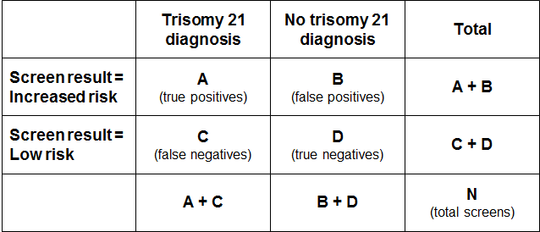

## Positive predictive value and positive test rate

The positive test rate is the number of increased-risk screens per 100 screens.

Positive test rate = ((A+B)/N)*100

Positive Predictive Value is the probability of having the condition given the screen result was increased risk.

PPV = P (Disease | Screen Positive) = A/(A+B)

In order for PPV to increase, ‘A’ needs to be higher (more true positives) and/or ‘B’ needs to be lower (less false positives). However, an increase in positive test rate can come about when ‘A’ and/or ‘B’ increase. If the positive test rate increases due to higher true positives (A), then PPV will also increase. If instead the number of false positives increases, then the positive test rate will increase but PPV will decrease.

## False positive rate

False positive rate is the number of false positives divided by false positives plus true negatives. It gives the proportion of women that did not have a baby or fetus with trisomy 21 that received an increased-risk screening result.

FPR = B/(B+D)

## Detection rate

Detection rate is the number of true positives divided by true positives plus false negatives. It gives the probability that a woman carrying a fetus with trisomy 21 will receive an increased-risk screening result for trisomy 21.

Detection rate = A/(A+C)

# Appendix 5: False negative screens by risk level

There were 170 false negative screens in total across the six-year period covered by this report. A false negative means that the screen result was low risk for each of trisomy 21, 18 and 13 but there was then a positive diagnostic test or infant diagnosis for one of trisomy 21, 18 or 13.

Table 57 shows the number of false negatives for each of the six calendar years broken down by the screening risk result in the first group of columns. The next group of columns gives the number of false negatives as a percentage of all negative (low risk) screens. Overall, false negative screens made up 0.08 percent or less of all negative screens for each of the years from 2015 to 2020.

Table 57: False negative screens for trisomy 21, 18 and 13 by risk level, January 2015 to December 2020

|  |  |  |  |  |  |  |  |  |  |  |  |  |
| --- | --- | --- | --- | --- | --- | --- | --- | --- | --- | --- | --- | --- |
| Risk level | False negatives | | | | | | % of negative screens that are false negatives | | | | | |
| **2015** | **2016** | **2017** | **2018** | **2019** | **2020** | **2015** | **2016** | **2017** | **2018** | **2019** | **2020** |
| 1:301 to 1:500 | 4 | 8 | 7 | 5 | 5 | 5 | 0.63 | 1.25 | 1.21 | 0.51 | 0.51 | 0.52 |
| 1:501 to 1:1,000 | 10 | 7 | 8 | 12 | 7 | 7 | 0.58 | 0.46 | 0.52 | 0.51 | 0.28 | 0.26 |
| 1:1,001 to 1:2,000 | 4 | 3 | 8 | 2 | 1 | 2 | 0.14 | 0.11 | 0.33 | 0.05 | 0.03 | 0.05 |
| 1:2,001 to 1:3,000 | 2 | 6 | 3 | 4 | 6 | 3 | 0.08 | 0.25 | 0.14 | 0.14 | 0.19 | 0.09 |
| 1:3,001 to 1:4,000 | 1 | 0 | 2 | 0 | 1 | 3 | 0.04 | 0.00 | 0.11 | 0.00 | 0.04 | 0.11 |
| 1:4,001 to 1:5,000 | 0 | 0 | 0 | 2 | 0 | 1 | 0.00 | 0.00 | 0.00 | 0.09 | 0.00 | 0.04 |
| 1:5,001 to 1:10,000 | 3 | 2 | 2 | 3 | 2 | 1 | 0.03 | 0.02 | 0.03 | 0.04 | 0.02 | 0.01 |
| Less than 1:10,000 | 1 | 4 | 5 | 5 | 1 | 2 | 0.00 | 0.02 | 0.02 | 0.03 | 0.01 | 0.01 |
| **Total** | **25** | **30** | **35** | **33** | **23** | **24** | **0.06** | **0.07** | **0.08** | **0.08** | **0.06** | **0.06** |

# Appendix 6: ROC curve

Figure 13 shows the false positive rate plotted against the detection rate in what is known as a ‘receiver operating characteristic’ (ROC) curve. This plots the false positive rate on the horizontal x axis against detection rate on the vertical y axis for different possible cut-off points of the screening test. The aim for a screening test is to maximise detection rate while minimising false positive rate.

In New Zealand the cut-off used for screening is 1:300. With this cut-off, the overall detection rate for trisomy 21, trisomy 18 and trisomy 13 in 2020 was 82.5 percent, and the false positive rate was 3.9 percent. To create the graph, the detection rate and false positive rate were calculated for a range of other cut-off points in order to plot the curve. What the curve shows is that if the cut-off was lowered to increase the detection rate to 85 percent, the false positive rate would increase from 3.9 percent to 5.0 percent. This occurs at a risk cut-off of 1:400.

Figure 13: ROC curve for trisomy 21, 18 and 13 screening, 2020

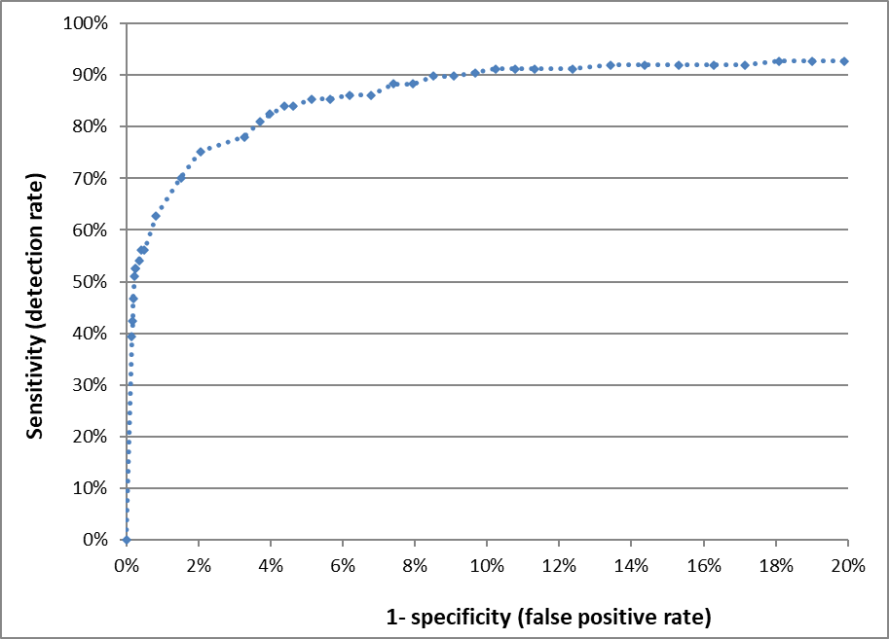

# Appendix 7: Glossary

**Alpha-fetoprotein (AFP)** – a protein that is normally produced by the fetus. Maternal serum AFP levels can be used as a biochemical marker in the detection of certain fetal abnormalities.

**Amniocentesis** – a procedure involving the withdrawal of a small amount of amniotic fluid by needle and syringe through the abdomen guided by ultrasound performed at the same time. The tests performed on fetal cells in this sample can detect a range of chromosomal and genetic disorders.

**Analyte** – a substance that is undergoing analysis or being measured. Analytes measured in antenatal screening include: pregnancy-associated plasma protein-A, beta-human chorionic gonadotropin, unconjugated oestriol, alpha-fetoprotein and inhibin A.

**Beta-human chorionic gonadotropin (ßhCG)** – a hormone produced during pregnancy and present in maternal blood and urine. It is used as a biochemical marker for Down syndrome and other conditions in first trimester combined and second trimester maternal serum screening.

**Chorionic villus sampling (CVS)** – a procedure involving the withdrawal of a small amount of placental tissue by needle and syringe through the abdomen guided by ultrasound performed at the same time. Tests performed on placental cells can detect a range of chromosomal and genetic disorders.

**Chromosome** – an organised structure of DNA and protein found in all living cells that carries the genes determining heredity.

**Crown rump length (CRL)** – the measurement from the fetal crown to the prominence of the buttocks or breech. This is used for dating in the first trimester.

**Detection rate** – the ability of screening to identify individuals with the condition screened for. A test with a high detection rate will have few false negative results. Also referred to as sensitivity.

**False negative result** – when a woman receives a low-risk screening result, but the baby does have the condition screened for.

**False positive result** – when a woman receives an increased-risk screening result, but the baby does not have the condition screened for.

**False positive rate** – the false positive rate is the number of false positives divided by the number of false positives and true negatives. A low false positive rate corresponds with a high level of specificity, which refers to the ability of screening to identify individuals who do not have the condition screened for.

**Fetal Medicine Foundation (FMF)** – a Registered Charity that aims to improve the health of pregnant women and their babies through research and training in fetal medicine. Further information can be found at: <https://fetalmedicine.org>

**Inhibin A** – a hormone secreted by the ovary that is used as a biochemical marker in second trimester maternal serum screening for Down syndrome and other conditions.

**Multiple of the median (MoM)** – a measure of how far an individual result compares to the median. MoM is commonly used to report the results of medical screening tests, particularly where the normal range varies according to parameters.

**Nasal bone** – an assessment of nasal bone was included in the risk calculation algorithm if it was reported at the same time as the NT measurement. Note that since March 2018 nasal bone assessment is no longer included.

**Nuchal translucency (NT)** – sonographic appearance of the collection of fluid under the skin at the back of the fetal neck. NT is a marker for chromosomal and other anomalies and can be measured in the first trimester of pregnancy.

**Pregnancy-associated plasma protein-A (PAPP-A)** – a protein originating from the placenta used as a biochemical marker in first trimester combined screening for Down syndrome and other conditions.

**Risk calculation algorithm** – an explicit protocol (in this case computer-based) that combines a number of factors in determining overall risk (or chance) of a particular outcome or condition.

**Screening** – a way of identifying people who are more likely than others to have a particular condition. The screening process involves testing people for the presence of the condition and predicting the likelihood that they have the condition. Antenatal screening for Down syndrome and other conditions predicts the likelihood of the conditions being present in the fetus.

**Triploidy** – an extremely rare chromosomal disorder in which a baby has three of every chromosome making a total of 69 rather than the normal 46 chromosomes.

**Trisomy** – a group of chromosomal disorders in which there are three copies, instead of the normal two, of a particular chromosome present in the cell nuclei. The most common trisomies in newborns are trisomy 21 (Down syndrome), trisomy 18 (Edwards syndrome) and trisomy 13 (Patau syndrome).

**True negative** – when a woman receives a low-risk screening result, and the baby does not have the condition screened for.

**True positive** – when a woman receives an increased-risk screening result, and the baby does have the condition screened for.

**Unconjugated oestriol (uE3)** – a hormone produced by the placenta and used as a biochemical marker in second trimester maternal serum screening for Down syndrome and other conditions.

1. Antenatal Screening for Down Syndrome and Other Conditions in Covid-19 time January to June 2020: report from LabPLUS and CHL
2. Antenatal Screening for Down Syndrome and Other Conditions in Covid-19 time January to June 2020: report from LabPLUS and CHL
3. Risk ratio values increase in increments of 5 between 1:10 and 1:100, increments of 100 between 1:100 and 1:10,000, and then increments of 1000 to 1:100,000.
4. Births reaching at least 20 weeks gestation or ≥ 400 g birth weight.
5. Implementing NIPT into publicly funded antenatal screening services for Down syndrome and other conditions in Aoteaora New Zealand. BMC Pregnancy and Childbirth (2017) 17:344
6. Inequity in timing of prenatal screening in New Zealand: Who are our most vulnerable? Aust NZ J Obstet Gynaecol (2017) 1-8
7. Antenatal Screening for Down Syndrome and Other Conditions in Covid-19 time January to June 2020: report from LabPLUS and CHL
8. Unscreened = no prenatal screen result so either didn’t start screening or started but didn’t complete screening.
9. Births reaching at least 20 weeks gestation or ≥ 400 g birth weight.