Kia Manawanui Aotearoa
Update on implementation of a mental wellbeing approach
2023

Citation: Ministry of Health. 2023. Kia Manawanui Aotearoa: Update on implementation of a mental wellbeing approach. Wellington: Ministry of Health.
Published in June 2023 by the Ministry of Health
PO Box 5013, Wellington 6140, New Zealand
ISBN 978-1-991075-34-5 (online)
HP 8749
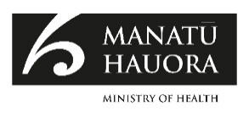
This document is available at health.govt.nz
This work is licensed under the Creative Commons Attribution 4.0 International licence. In essence, you are free to: share ie, copy and redistribute the material in any medium or format; adapt ie, remix, transform and build upon the material. You must give appropriate credit, provide a link to the licence and indicate if changes were made.

Foreword
Achieving pae ora (healthy futures) and mental wellbeing for all is going to take everyone working together – across government, communities, whānau and individuals.

Kia Manawanui Aotearoa: Long-term pathway to mental wellbeing (Kia Manawanui) provides the roadmap to enable this. Kia Manawanui is the Government’s 10-year strategy setting out the whole-of-government commitment to transform New Zealand’s approach to mental wellbeing. It builds on the agenda set by He Ara Oranga: Report of the Government Inquiry into Mental Health and Addiction (He Ara Oranga) and its vision for mental wellbeing whereby people have access to a wide range of support that meets their needs, when and where they need it.

I welcome this report on the progress made towards this fundamental shift in our approach to mental wellbeing. It’s clear that change has begun, and we’re well on the way to deliver on this substantial, multi-year transformation programme.

We can already see the changes making a real difference in the lives of people and whānau, backed by substantial Government investment. We have filled a long-standing gap in our system. We now have new primary mental health and addiction services in over 400 general practice sites, new kaupapa Māori services and supports for young people, Pacific peoples and rainbow communities, and new digital tools and campaigns that have expanded how and where people can get support. These services are helping thousands of people every month who may not have gotten the support they needed otherwise.

There have been some bumps on the road to change. The COVID-19 pandemic and the more recent flooding and cyclone events adversely impacted the mental wellbeing of many New Zealanders. Now more than ever we need the approach outlined in Kia Manawanui – ensuring people’s basic needs are met and equipping communities, whānau and individuals to look after their mental wellbeing. Demand for mental health and addiction services has increased, but despite these challenges, dedicated and skilled kaimahi continue to deliver and maintain a high standard of care and support.

Accessible, equitable, flexible and high-quality services that support recovery and mental wellbeing for those who need them are absolutely critical. The recent health system reforms and establishment of Te Whatu Ora – Health New Zealand and Te Aka Whai Ora – the Māori Health Authority provide opportunities to strengthen our service landscape. However, achieving the vision of mental wellbeing for all will require much more than a health system response or a government approach.

Mental wellbeing is fostered in our homes and communities and can be influenced in many settings, through schools, marae, workplaces and prisons. Kia Manawanui encourages all organisations, individuals, whānau and communities to consider their roles in supporting mental wellbeing.

We must all work together. This is why a whole-of-government approach to promote and protect mental wellbeing is so important. It will be the key focus as we continue to build the system for a healthy future for all New Zealanders.

Kiri Richards
Associate Deputy Director-General, Mental Health and Addiction System
Performance and Monitoring | Te Pou Mahi Pūnaha

Contents
Foreword iii
Overview of Kia Manawanui 1
A population-based mental wellbeing approach 1
Mental wellbeing framework 1
Opportunities in the new health system 2
Progress against actions 4
Leadership 5
Policy 7
Investment 9
Information 12
Technology 14
Workforce 15
Where to next? 20

Overview of Kia Manawanui

A population-based mental wellbeing approach
Kia Manawanui provides us with a framework to take a holistic, population-based approach to support mental wellbeing across the life course. We know that a range of factors influence mental wellbeing, including social inclusion, freedom from violence and discrimination, physical health and nutrition, cultural identity, spiritual wellbeing, and positive environments. With this in mind, we are thinking broadly about how to create and develop the system- level changes that we need to support the whole population to stay well, while addressing inequities and ensuring appropriate and tailored support is there for those who need it.

The impacts of COVID-19, the more recent Auckland floods and devastation caused by Cyclone Gabrielle have reinforced our belief that a whole-of-government approach to improve mental wellbeing is everybody’s business and is the right way to go. Through meeting people’s basic needs and ensuring the foundations for mental wellbeing are in place, we can make the biggest impact on keeping people well and addressing mental distress.

We know that transforming New Zealand’s approach to mental wellbeing is going to take time and that it will require us to work together. A shared vision and collective action across health, the social sector and wider government and with iwi Māori and communities is key.

Mental wellbeing framework
Kia Manawanui describes the vision of pae ora and an equitable and thriving Aotearoa in which mental wellbeing is promoted and protected.

Kia Manawanui provides a 10-year direction of travel and sets out 5 focus areas across which we need to rebalance our efforts – shifting to a stronger focus on addressing the wider determinants of mental wellbeing and promoting mental wellbeing across communities, whānau and individuals.

Using the mental wellbeing framework and a population-based approach, we have started rebalancing our efforts to:
- promote and invest in mental wellbeing promotion and early intervention strategies enabling individuals, whānau and communities to look after their own mental wellbeing
- work with Te Whatu Ora and Te Aka Whai Ora to expand primary mental wellbeing support in communities
- build the social, cultural, environmental and economic foundations for mental wellbeing by working with our cross- government partners and incorporating mental wellbeing into new and existing policies.

This rebalancing is important for long-term transformation. However, it does not detract from the need to ensure that mental health and addiction services are available to those who need them. We will need to embed an approach that focuses on wellbeing and recovery and acknowledges that mental wellbeing is attainable for all, including for people experiencing mental distress, mental illness and diagnosable mental health conditions, alcohol and other drug use, gambling harm and substance-related harm, or addiction. Supporting people with the highest needs remains a priority.

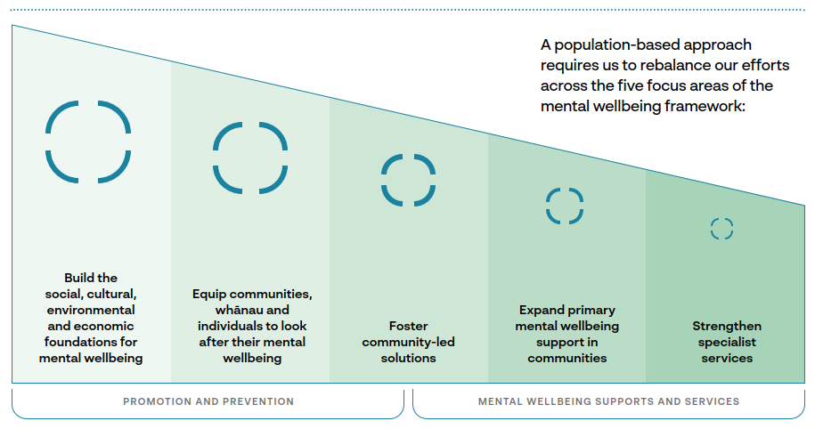

Opportunities in the new health system
Our context and operating environment have changed since Kia Manawanui was developed. Significantly, the Pae Ora (Healthy Futures) Act was passed in 2022. The Act put in place new health entities to change how the health system operates and to ensure a greater focus on collaboration, equity and consistency. The Pae Ora Act highlights that, first and foremost, we need to meet our obligations under Te Tiriti o Waitangi. The Pae Ora Act also calls us to:
- treat mental and physical health equitably
- collaborate to address the wider determinants of health
- ensure Māori and other priority groups have equity of access and health and wellbeing outcomes.

The objectives of the health system reforms align perfectly with the whole-of-population mental wellbeing approach that we committed to in Kia Manawanui with a strong focus on equity, community empowerment, improved access and options, and integration. The reforms will see a nationally planned, regionally delivered and locally tailored system that is digitally enabled and offers a range of support so people can get the help they need closer to home. The reforms give us a greater mandate to amplify the cross-agency and government partnerships that are already in place to improve the mental wellbeing of the population.

The health system reforms also provide a renewed stewardship and monitoring role for Manatū Hauora, including through the Suicide Prevention Office and the newly established Public Health Agency. Manatū Hauora retains responsibility for health system and cross- government leadership, providing mental wellbeing strategy and policy advice to the Government and working to ensure national system settings enable a mental wellbeing approach.

At the same time, the reforms enable a clear focus on service commissioning and delivery. Those responsibilities have transferred to Te Whatu Ora and Te Aka Whai Ora, with a strong focus on hauora Māori and achieving equity.

The health system reforms present opportunities to accelerate the change initiated by He Ara Oranga. We are working closely together across all health entities to ensure we maintain the momentum we have built since transformation began. Our aim is
to collectively move towards a health system that supports pae ora and mental wellbeing for all.

Progress against actions
Kia Manawanui is a 10-year programme of evolving and iterative change. We are systematically working through the short, medium and long-term actions it sets out, to achieve sustainable transformation. The actions in Kia Manawanui are intended to be flexible, rather than prescriptive.

They are sequenced across 3 timeframes:
- building the foundations (2021–2023)
- expanding innovation (2023–2027)
- embedding system-level change 2027–2031).

The actions in Kia Manawanui are organised according to 6 national key system enablers and speak as much to ‘how’ we do things as to ‘what’ we do. The actions are focused on the system settings that government agencies can influence under those 6 enablers, as follows:
- strengthening leadership (Leadership)
- ensuring appropriate policy settings and human-rights based legislation is developed and mandated (Policy)
- investing differently in mental wellbeing (Investment)
- working towards improving data and insights (Information)
- making better use of technology, including telehealth and digital services (Technology)
- building a diverse, skilled workforce that includes clinical, cultural, community and peer support roles (Workforce).

Over the last 2 years, we have focused on prioritising equity, started to address the gaps in our existing mental wellbeing system, and set expectations and created mechanisms to support more collaborative ways of working.

The sections that follow highlight some of the progress we have made in the last 2 years in implementing Kia Manawanui, based on these 6 enablers. This is not a comprehensive view of all activities that have contributed to the implementation of Kia Manawanui, but it provides a sense of the gains we have made since it was published and our focus over the next 2 years.

This update focuses mainly on the health system’s contributions to the whole-of- government mental wellbeing approach at a national level. That said, this is cross- government work: there is a need for everyone to play a part in improving the mental wellbeing of New Zealanders. Moving forward, we need everyone to work together at every level to achieve the transformation we are striving for.

Leadership

Action: Uphold Te Tiriti o Waitangi and support equity of mental wellbeing outcomes for Māori

Progress/Highlights
- Establishment of Te Aka Whai Ora, driving improvement for Māori in the health system, including a dedicated Oranga Hinengaro group and prioritisation of oranga hinengaro in Te Pae Tata: Interim New Zealand Health Plan 2022
- Continued establishment of iwi–Māori partnership boards to understand the current health context and to represent Māori so they are actively shaping local services
- Transferral of primary leadership for suicide prevention commissioning to Te Aka Whai Ora, in acknowledgement of the disproportionate impact of suicide on Māori whānau
- National hui to bring together the Māori suicide prevention workforce to discuss Kia Piki Te Ora (Māori suicide prevention programme)

Where to Next
- Facilitate establishment, leadership and decision- making in iwi–Māori partnership boards
- Strengthen the approach to Oranga Hinengaro with leadership from Te Aka Whai Ora
- Specifically focus on strengthening Māori suicide prevention efforts, including through the expansion of Kia Piki Te Ora to achieve national coverage and increased investment

Action: Strengthen national, regional and local leadership and collaboration for mental wellbeing

Progress/Highlights
- Formal establishment of Te Hiringa Mahara | Mental Health and Wellbeing Commission
- Enhancement of the stewardship role of Manatū Hauora, including through the Suicide Prevention Office, and through health reforms to strengthen leadership
- Demonstration of strong national, regional and local collaboration and new ways of working across sectors through psychosocial responses to significant events
- Implementation of regional public service commissioners to lead cross-sector responses; these commissioners have identified Kia Manawanui and mental wellbeing as a priority
- Strengthened oversight for the government-wide shift to a mental wellbeing systems approach through the Cabinet Priorities Committee, Social Wellbeing Committee, Social Wellbeing Board and regional leadership framework
- Establishment of cross-agency working groups to ensure consideration of mental wellbeing in cross-government strategies and plans, and to strengthen focus on priority areas
- Support for collaborative design in procurement of mental health and addiction services (eg, targeted funding for ‘enablers’ through the Access and Choice programme)

Where to Next
- Strengthen cross-sector engagement by establishing partnership director roles within Manatū Hauora, and supporting a wellbeing focus through the Caring for Communities forums
- Maintain collaborative ways of working through COVID-19
- Continue to strengthen cross-government relationships to develop integrated strategies and policies
- Continue to support and share lessons in collaborative design to inform locality planning and integrated community support

Action: Amplify the voices and strengthen the leadership of Māori, people with lived experience, whānau and populations with specific cultures and needs

Progress/Highlights
- Creation of dedicated lived experience roles in Manatū Hauora and establishment of the Ministry-led Lived Experience Knowledge Network to inform national strategy and policy
- Development of Te Whāriki o te Ara Oranga, a network of innovators, influencers and leaders driving change in mental health and addiction services
- Intensive engagement, public consultation and advisory arrangements on priority programmes (eg, repeal and replacement of the Mental Health (Compulsory Assessment and Treatment) Act 1992 (Mental Health Act) and the Oranga Hinengaro System and Service Framework), amplifying the voices of priority population groups

Where to Next
- Continue to advocate for and foster relationships with lived experience roles across health organisations
- Share best practice for engagement and collaboration with priority population groups and identify opportunities across sectors to elevate consumer and whānau voices

Policy

Action: Strengthen the focus on mental wellbeing, suicide prevention and equity across government strategies, policies and accountabilities

Progress/Highlights
- Establishment of new mental wellbeing priority in the government’s Child and Youth Wellbeing Strategy, led by Manatū Hauora
- Inclusion of mental wellbeing in the joint children’s agencies’ Oranga Tamariki Action Plan
- Strong mental wellbeing focus in joint work on housing and the Aotearoa New Zealand Homelessness Action Plan 2020–2023
- Collaboration with the Ministry of Education to support mental wellbeing in curricula and guidelines (eg, Mental Health Education: A Guide for Teachers, Leaders, and School Boards)
- Manatū Hauora representation on the Ministry of Social Development’s Oranga Mahi governance of integrated mental wellbeing and employment supports
- Suicide Prevention Office support for the development of Ara Poutama – Department of Corrections Suicide Prevention and Postvention Action Plan 2022–2025
- Setting of policy direction for enhanced crisis responses with a focus on community-based, peer-led supports and multi- agency responses, reflected in Te Pae Tata
- Development of Veterans Affairs’ New Zealand’s The Veteran, Family and Whānau Mental Health and Wellbeing Policy Framework

Where to Next
- Build mental wellbeing into the Pae Ora Strategies (the New Zealand Health Strategy, the Health Workforce Strategic Framework and population strategies for Māori, Pacific peoples, disabled people, women and rural communities)
- Develop the next 5-year Suicide Prevention Action Plan
- Broaden engagement across government to embed mental wellbeing, suicide prevention and equity in all government strategies and work programmes

Action: Improve the legislative and regulatory environment to support healthy environments and a mental wellbeing approach

Progress/Highlights
- Initial amendments to the Mental Health Act in October 2021 to better protect people’s rights and improve safety, including through elimination of indefinite treatment orders
- Release of refreshed Guidelines to the Mental Health (Compulsory Assessment and Treatment) Act 1992 to support a more rights-based and Te Tiriti emphasis and improve practice under the current Mental Health Act
- Completion of public consultation and progression of policy work to inform development of new mental health legislation
- Implementation of a drug-checking licencing scheme as part of strengthening the public health approach to regulation and enforcement for alcohol and other drugs
- Review of the Substance Addiction (Compulsory Assessment and Treatment) Act 2017

Where to Next
- Continue work to repeal and replace the Mental Health Act, and prepare to implement the new legislation
- Complete a review of the processes for investigating deaths by suicide and work alongside the Chief Coroner and New Zealand Police to implement the recommendations
- Contribute to wider government work with an impact on mental wellbeing, such as the New Zealand Law Commission’s review of legal responses to hate

Action: Develop frameworks and guidance to steer contemporary approaches to mental wellbeing

Progress/Highlights
- Development and publication of the Oranga Hinengaro System and Service Framework to set guidance and expectations for the availability of mental health and addiction services over a 10-year period, acknowledging the important interfaces across sectors

Where to Next
- Detailed stocktake/equity map of mental health and addiction investment to validate the current landscape, work on an equitable funding model to identify funding gaps, and a review of which services should be delivered nationally, regionally and locally
- Undertake monitoring of system shifts and new services through the framework, supporting a culture of quality improvement
- Work with partners to develop, refine and promote guidance material to support mental wellbeing in workplaces

Investment

Action: Strengthen investment in the foundations of mental wellbeing

Progress/Highlights
- $1.9 billion of funds within Budget 2019’s cross-government mental wellbeing package, allocating approximately $843 million to Votes including Social Development, Education, Housing and Urban Development, Corrections, Police, Justice, Courts, Defence Force and Internal Affairs to address the social determinants of mental wellbeing
- Joint initiatives across sectors to expand mental wellbeing support to a range of settings, with an initial focus on education and learning environments, for example:
- Expansion of the Mana Ake programme to approximately 195,000 primary and intermediate school-aged children
- Expansion of School Based Health Services to decile 1–5 secondary schools, Teen Parent Units, and Alternative Education sites, meaning supports are now available in approximately 300 education settings for approximately 115,000 students
- Rollout of mental wellbeing supports to all tertiary institutions
- Engagement with the Ministry of Education on the Counsellors in Schools, Social Emotional Learning Pilots and Positive Behaviour for Learning school-wide anti-bullying initiatives

Where to Next
- Continue delivery expansion of Mana Ake and mental wellbeing supports in tertiary institutions
- Implement joint initiatives with housing, employment and education agencies, Oranga Tamariki and others resulting from the strengthened focus on mental wellbeing in national strategies and action plans

Action: Strengthen investment in promoting mental wellbeing

Progress/Highlights
- Increased investment in whole-of-population wellbeing promotion campaigns, tools and resources, through psychosocial responses to COVID-19 and other significant events
- Engagement across agencies to support mental wellbeing promotion in education and workplace guidance, and for priority population groups and communities, for example:
- business communities with the Ministry for Business, Innovation and Employment
- rural communities with the Ministry for Primary Industries

Where to Next
- Work to embed a sustainable, strategic approach to mental wellbeing promotion, coordinated across sectors
- Expand the focus to strengthen mental wellbeing promotion across additional sectors and settings, including recreation, arts and cultural activities
- Increase investment from Te Aka Whai Ora in suicide prevention efforts

Action: Expand access and choice of mental health and addiction supports and provide recovery-based care, prioritising kaupapa Māori and whānau-centred approaches and addressing equity

Progress/Highlights
- Ongoing national rollout of the 5-year, Budget 2019 Access and Choice primary mental health and addiction programme to build a missing part of the mental health and addiction system for people with mild to moderate needs, as highlighted in He Ara Oranga. As of 31 March 2023:
- 471 general practice sites offer integrated primary mental health and addiction (IPMHA) services and have delivered 657,600 sessions
- 28 kaupapa Māori services have delivered 68,800 sessions
- 9 Pacific services have delivered 42,400 sessions
- 22 youth-specific services have delivered 75,100 sessions
- Contracting of 2 national services for rainbow young people as part of the youth-specific Access and Choice workstream, and provision of an endowment to the Rule Foundation to run 4 grants rounds of $200,000 for the Rainbow Wellbeing Legacy Fund
- Enhancement and expansion of community-based alcohol and other drug primary and specialist services
- Investment in digital and telehealth services to expand accessibility and reach, including the Groov app and Small Steps for all ages, and Headstrong and Sparklers/Sparklers at Home for children and young people
- Investment and co-design of Rapua Te Āhuru Mōwai to provide wrap-around support to people ‘stranded’ in acute inpatient units because they have no suitable accommodation
- Securing of sustainable funding for ongoing delivery of alcohol and other drug treatment courts

Where to Next
- Complete the national rollout of the Access and Choice primary mental health and addiction programme by 2023/24. A new Access and Choice website went live in March 2023, with an interactive map that will continue to be updated as services expand
- Continue to evaluate and improve Access and Choice services. Information about evaluations for the IPMHA, kaupapa Māori, Pacific and youth Access and Choice services can also be found on the Access and Choice website
- Roll out Budget 2022 investment in community- based, recovery-oriented specialist mental health and addiction services, including crisis responses; available funding will increase in the 4-year period through 2025/26
- Strengthen specialist Māori mental health and addiction service provision
- Continue to improve responsiveness and accessibility in supports tailored to a wider range of population groups with unique needs

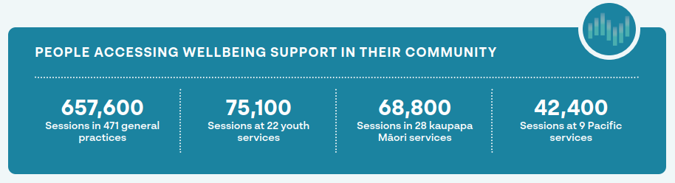

Action: Develop commissioning, funding and contracting approaches that enable joined-up investment in a broad range of supports and services

Progress/Highlights
- Development of the Commissioning for Pae Ora Healthy Futures framework, grounded in Te Tiriti o Waitangi and seeking to bring the whānau ora vision into the health system
- Piloted innovative commissioning through the kaupapa Māori Access and Choice stream, which has been documented and shared in a case study – A Kaupapa Māori Informed Approach to Commissioning for Pae Ora on the Manatū Hauora website
- Representation of Manatū Hauora mental health and addiction input in cross-agency procurement processes, to ensure consideration of mental wellbeing in investment decisions (eg, on evaluation panels for Ministry of Education-funded mental wellbeing initiatives)
- Multi-Vote investment in cross-sector joint initiatives (eg, Health and Education investment in the Mana Ake school- based programme, and Health and Housing investment in the Rapua Te Āhuru Mōwai pilot through the Homelessness Action Plan)

Where to Next
- Embed innovative direct commissioning approaches within Te Aka Whai Ora and co-commissioning processes across Te Aka Whai Ora and Te Whatu Ora
- Promote a wider uptake of innovative commissioning approaches across government

Information

Action: Build our understanding of mental wellbeing prevalence, needs and equity

Progress/Highlights
- Completion of 2021/22 New Zealand Health Survey with specific questions on anxiety and depression, psychological distress and unmet need in relation to mental health and addiction services access
- Publications from Te Hiringa Hauora | Health Promotion Agency (now part of the National Public Health Service in Te Whatu Ora) on population wellbeing, mental health and addiction service delivery, priority populations and COVID-19 insights and lessons
- Publication of mental wellbeing data (including on mental health, alcohol and gambling) from the Health and Lifestyles Survey (2006–2020) and the Alcohol Use in New Zealand survey (2020)
- Launch of the Suicide web tool, which centralises and streamlines annual reporting of provisional and confirmed suicide data
- Publication of mental health and addiction data in a landing page on the Manatū Hauora website
- Joint investigation by Oranga Tamariki and Manatū Hauora into the mental health and addiction needs of children and young people in care
- Publication of Maternal Mental Health Service Provision in New Zealand: Stocktake of district health board services

Where to Next
- Identify opportunities to address gaps in data and evidence, including prevalence information
- Undertake the 2023 gambling harm survey
- Complete a mental wellbeing analysis of the What About Me and Growing up in New Zealand datasets
- Undertake further analysis of and response to Oranga Tamariki needs assessment
- Oversee the Suicide Prevention Office’s development of a national suicide prevention research plan

Action: Enable innovation that allows us to easily share whānau-centred and community-led solutions, to encourage and enable change

Progress/Highlights
- Launch of the Access and Choice website to support people to connect with a diverse range of wellbeing services at the community, regional and national level
- Development of Te Whāriki o te Ara Oranga, a network of innovators, influencers and leaders driving change in mental health and addiction services
- Launch of He Kāpehu Whetū, a website which highlights suicide prevention initiatives across the motu and was designed to inspire community leaders and communities across New Zealand

Where to Next
- Collaborate with national health data and digital initiatives to ensure consideration of mental health and addiction information and improved accessibility to data

Action: Create and embed feedback loops so the experiences of Māori, people with lived experience, whānau and populations with specific cultures and needs inform continuous improvement

Progress/Highlights
- Use of the Lived Experience Knowledge Network to collect and validate lived experience perspectives to inform policy and initiative development
- Establishment of Te Taumata to advise the Suicide Prevention Office as well as sector accords with population groups, industry and sectors disproportionately affected by suicide
- Development of Te Hiringa Mahara’s He Ara Āwhina framework, which describes the mental health and addiction system from the perspective of tāngata whaiora and whānau

Where to Next
- Complete a review of the processes for investigating deaths by suicide that seeks input from representatives of bereaved families and whānau, as well as te ao Māori and tikanga oversight
- Strengthen data collection related to people’s experiences

Technology

Action: Engage with people using digital tools to understand what they use and prefer, including how choices change over time

Progress/Highlights
- Engagement with key stakeholders and participation in digital mental health and addiction service forums and conferences to share best practice
- Investment in and monitoring of the uptake of digital tools, to track use and trends

Where to Next
- Continue to engage with key stakeholders, providers and consumers to support improvement to digital tools and offerings

Action: Build a digital ecosystem of support across sectors

Progress/Highlights
- Development and publication of the Digital Mental Health and Addiction Tool as an assessment framework for the safe navigation of e-mental health in Aotearoa, intended to help those involved in the design, development and use of e-mental health tools to ensure the products meet acceptable quality standards

Where to Next
- Promote awareness and uptake of the Digital Mental Health and Addiction Tool, including across government, to inform future investment

Action: Facilitate access to digitally-enabled support for individuals, whānau, communities and services

Progress/Highlights
- Additional investment in digital and telehealth services to expand accessibility and reach, including:
- Groov and Small Steps, alongside ongoing investment in Beating the Blues and Depression.org.nz, to provide additional digital tools for all ages
- Headstrong and Sparklers/Sparklers at Home, alongside ongoing investment in SPARX and The Lowdown, to provide additional digital tools for children and young people
- expanding the capacity of mental health and addiction telehealth services and the establishment of a peer support line
- Amendments to the Mental Health Act in October 2021 to allow the use of audio-visual technology for assessments, reviews and whānau consultation, resulting in greater flexibility for individuals and whānau, particularly in rural areas
- Provision of access to e-prescribing for mental health and addiction services
- Launch of new online training and education materials by Te Pou, developed with Manatū Hauora, to support the implementation of the revised guidelines to the Mental Health Act
- Development of guidelines by the Suicide Prevention Office on how to talk safely about suicide on social media via 2 social media campaigns that targeted young people and reached over 400,000 young people

Where to Next
- Promote uptake of digitally enabled support
- Identify potential overlaps in cross-government investment of digital tools and opportunities for efficiencies
- Review processes and systems to identify opportunities to improve the timeliness of data availability

Workforce

Action: Develop workforces to promote mental wellbeing and increase mental wellbeing literacy

Progress/Highlights
- Expansion of mental health, addiction and suicide prevention literacy training programmes for communities and workforces, including:
- Te Whatu Ora investment in 80 additional Mental Health 101 and 80 additional Addiction 101 programmes per annum
- Government-funded LifeKeepers suicide prevention training for over 1,515 people across Aotearoa between April 2022 and March 2023
- Increased cross-sector efforts to upskill workforces, including through mental health and suicide prevention training across the New Zealand Police, Ministry of Social Development, Oranga Tamariki, Ara Poutama – Department of Corrections, universities and private businesses

Where to Next
- Continue to promote uptake of mental health, addiction and suicide prevention literacy training programmes across the health and other sectors

Action: Value, retain and support strong leadership across the mental health, addiction, and mental wellbeing workforce

Progress/Highlights
- Development of a Lived Experience Leadership training programme
- Enabling accreditation of counsellors to work in clinical roles, with 54 accredited so far
- Implementation of international and domestic workforce recruitment campaigns, including targeted campaigns for mental health and addiction nurses

Where to Next
- Undertake analysis to better understand workforce trends and exit patterns, to support retention

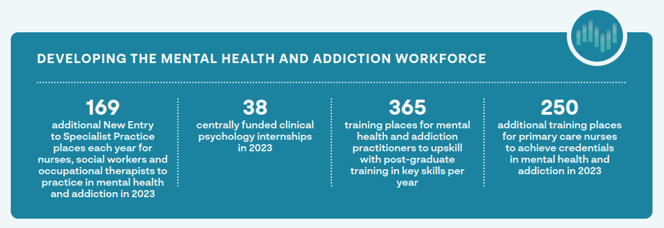

Action: Expand the mental health, addiction and mental wellbeing workforce across sectors

Progress/Highlights
- Increased training places for specialists in mental health, addiction, and suicide prevention to expand existing workforces, for example:
- 127 additional New Entry to Specialist Practice places for nurses funded in 2023 to allow nurses to practice in mental health and addiction (bringing the total funded places to 282) and 42 additional allied health places for social workers and occupational therapists funded in 2023 (bringing the total funded places to 78)
- an increase in centrally funded clinical psychology internship places from 12 in 2019 to 38 in 2023; the intention is to increase these to 40 by the end of 2024, along with an uplift in internship rates to the full multi-employer collective agreement value
- creation of 4 internship hub pilots for supporting clinical psychologists to complete their training
- 365 training places per annum for mental health and addiction practitioners to upskill with post-graduate training in cognitive behavioural therapy and brief interventions; core skills for specialist practice in infant, child, and adolescent mental health and addiction; assessment and management of co- existing substance use and mental health; and youth addiction (up from 68 in 2020)
- 250 additional training places funded in 2023 for primary care practice nurses to achieve credentialling in mental health and addiction (bringing the total to 340) and 39 training places per annum in clinical nurse leadership
- a new national nurse practitioner training programme that aims to increase the currently low numbers of nurse practitioners specialising in mental health and addiction over time, and to lift the ability of all nurse practitioners; 80 places were funded in 2023 and 100 places in 2024
- a programme to support nurse practitioners and enrolled nurses with substantive mental health and addiction roles into employment with health providers and rural health providers supporting 9 nurse practitioners/19 enrolled nurses per annum
- an initiative with the Royal Australian and New Zealand College of Psychiatrists to attract more junior doctors to specialise in psychiatry (with a focus on Māori and Pacific peoples) alongside work to align psychiatry training processes and funded positions to maximise numbers trained
- Establishment of a cross-agency mental health and addiction workforce working group, chaired by Manatū Hauora, to identify common barriers and cross-sector solutions for workforce development, including engagement with the education sector to consider training pipelines
- Introduction of Health Improvement Practitioners (HIPs) and Health Coach (HC) roles with 497 HIPs and 583 HCs having commenced training

Where to Next
- Within Manatū Hauora, develop the Health Workforce Strategic Framework alongside Pae Ora strategies
- Continue to expand opportunities for mental health and addiction workforce training to grow and upskill existing workforces
- Undertake cross-sector analysis of shared workforce requirements and development needs to improve coordination of efforts

Action: Transform the mental health, addiction and mental wellbeing workforce to enable it to respond to people’s mental wellbeing needs and to intervene early

Progress/Highlights
- Prioritised investment to grow Māori and Pacific workforces; for example:
- 70 bursaries for Māori students pursuing a career in mental health and addiction through the Te Rau Puawai programme at Massey University
- 65 scholarships for Pacific students pursuing a career in mental health and addiction through Le Va Futures that Work scholarships
- 800 places for Māori and Pacific cultural competence training per annum
- The Ao Mai Te Rā | The Anti-Racism Kaupapa programme of work, led by Manatū Hauora, to build collective responsibility for addressing racism at all levels
- 11 scholarships to grow the number of Muslim practitioner students in Canterbury in 2022, expanding nationwide in 2023
- Development of Asian, migrant and refugee competency training for the mental health and addiction workforce which launched at the end of 2022
- Investment in training to support the mental health and addiction workforce to better respond to the needs of rainbow communities with 856 people trained across two programmes as at the end of December 2022
- Development of mental health and addiction education modules for community pharmacists with 5 modules launched in 2022
- Creation of new primary mental health and addiction roles of health improvement practitioners and health coaches, and training for these
- Targeted workforce development programmes for Access and Choice youth, kaupapa Māori and Pacific primary mental health and addiction services
- Investment in peer-led services (eg, the Te Tāwharau crisis response service in Hawke’s Bay) and support for the use of peer roles alongside clinical roles to address workforce vacancies and enhance service offerings

Where to Next
- Continue to focus on growing a diverse mental health and addiction workforce that reflects the communities it serves
- Provide further support to grow peer and cultural workforces
- Identify training opportunities for workforces on harmful substance use and co-existing problems
- Support the use of Māori and Pacific approaches to health and wellbeing

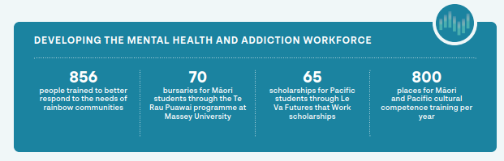

Where to next?
Change of the magnitude needed to achieve the vision in Kia Manawanui is going to take time. We’ve got the plan for where we want to go, we’ve laid our foundations and we’ve made good progress. Many New Zealanders are already accessing better mental health and wellbeing resources and care.

We acknowledge there is still much more to be done. In the coming months and years, we’ll continue to build on this momentum. We will expand on the work that is already under way in collaboration with government agencies, health providers, communities, schools, whānau and individuals.

We’ll keep you informed of progress along the way with 6-monthly updates on the Manatū Hauora website, through the mental health and addiction newsletter and through our ongoing engagements with sector stakeholders and communities.

Transforming New Zealand’s approach to mental wellbeing requires everyone to be part of the change. Success will take combined effort and real commitment from all of us, as we move towards our vision of an equitable and thriving Aotearoa in which mental wellbeing is promoted and protected.

