Horizon Research
COVID-19 Vaccine
Acceptance and potential uptake

In association with the
School of Population Health
University of Auckland

September 2020

Contents

EXECUTIVE SUMMARY 1
1. Potential uptake of vaccine 4
2. Reasons for being unlikely to accept a COVID-19 vaccine or unsure whether to do so 8
3. Follow-up vaccine 13
4. Child vaccine 16
5. Vaccine approval process 17
6. Priority access to an approved COVID-19 vaccine 20
APPENDIX 1 – SAMPLE 22
APPENDIX 2 – QUESTIONNAIRE 24
APPENDIX 3 – PROFILES (separate Excel attachment)
APPENDIX 4 – TABLES (separate Excel attachment)

EXECUTIVE SUMMARY
This report presents the results of an online survey of 1,451 respondents, members of Horizon Research’s panels and a third-party research panel, representing the New Zealand adult population (18 years of age or over) at the 2018 census. The survey was conducted between 24 and 28 September 2020, prior to the Government’s announcement that it had agreed to buy 1.5 million doses of a coronavirus vaccine, when available

The sample is weighted to reflect the New Zealand adult population at the 2018 census. At a 95% confidence interval, the maximum margin of error is ±2.6%.

The survey looked at the acceptance and potential uptake of a COVID-19 vaccine among New Zealand adults.

Key findings
- 69% overall (an estimated 2,487,900 adults) would be prepared to have a “well-tested and approved” COVID-19 vaccine, while 19% (an estimated 693,300 adults) were unlikely to do so. 11% (an estimated 413,500 adults) were unsure.
- Between 40% and 60% of New Zealand adults (estimated at 1,427,300 to 2,171,500 adults) will accept an offered vaccine with little urging. 16% of New Zealand adults (estimated 550,100 adults) will not accept an offered vaccine.
- The highest percentage of respondents who said they would definitely take a vaccine were those of Pasifika and Indian ethnicity.
- Māori appear to be the least inclined to accept a COVID-19 vaccine if offered, with 31% saying they would definitely accept a vaccine (compared with 40% of adults overall) and a total of 57% overall likely to accept (definitely plus most likely plus likely).

- The major reason for not accepting an offered vaccine or being unsure whether to do so was the need to be assured about the vaccine’s safety (an estimated 522,700 adults). The next most important reasons were “I’d rather wait and see if others who have taken it suffer any side effects” (which is strongly related to the need for assurance), lack of trust in vaccines overall and not seeing the need to have a COVID-19 vaccine.

- Just under 69% of respondents (an estimated 2,462,700 adults) would take a follow-up dose if required. 18% (an estimated 636,400 adults) were unlikely to do so and 14% (an estimated 496,200 adults) were unsure.

- If an approved COVID-19 vaccine becomes available for younger children, 49% of caregivers (an estimated 801,800 adults) would have it given to a child for whom they were the caregiver.

Uptake and follow-up dose
Uptake is likely to be highest among the among those aged 65+, with potentially 76% of 65-74-year olds in total and 87% of those aged 75 years or over in total likely to use an offered vaccine.

Uptake was least likely among 35-44-year olds, with 57% in total of this age group indicating that they would be likely to take an offered COVID-19 vaccine.

97% of those who would definitely accept an approved COVID-19 vaccine if it were offered to them would definitely take a follow-up dose if required.

As with uptake of an approved COVID-19 vaccine, taking a follow-up dose is more likely among those aged 65+ and least likely among those aged 35-44 years.

Reasons for not accepting a COVID-19 vaccine or being unsure whether to do so
The major reason for not accepting an offered vaccine or being unsure whether to do so, was a need to be assured about the vaccine’s safety (an estimated 522,700 adults).

Nearly 6 out of 10 of those who chose safety as a reason also selected “I’d rather wait and see if others who have taken it suffer any side effects”.

Ethnic differences were relatively marked. Requiring assurance about a vaccine’s safety was the most important factor for Māori, NZ Europeans and “Other Europeans” who said they were unlikely to accept a vaccine. There were also indications that:

- Pasifika and Indian respondents would rather wait and see if there were any side effects in others who had taken a vaccine.
- A higher proportion than average of Māori, “Other Europeans”, Pasifika, Indian and Asian respondents did not trust any vaccines.

Child vaccine
45.5% of respondents overall (an estimated 1,635,900 adults) said they were caregivers for a child or children. Of those, 49% (an estimated 801,800 adults) said that “if an approved COVID-19 vaccine becomes available for younger children” they would have it given to a child or children for whom they were the caregiver.

Pasifika and Indian respondents were the most likely to do this; Māori and “Other Europeans” the least likely.

27% of caregivers (an estimated 435,000 adults) said they were unlikely to have a COVID-19 vaccine given to a child and 24% (an estimated 399,100 adults) were unsure whether they would do that or not.
Vaccine approval process
10% of respondents (an estimated 355,900 adults) were concerned that the approval process for a COVID-19 vaccine would move too slowly (causing unnecessary delays to accessing a vaccine).

31% (an estimated 1,118,100 adults) were concerned that it would move too quickly (without fully establishing it is safe and effective).

45% (an estimated 1,625,100 adults) selected “I trust New Zealand health agencies to approve a well-tested and safe vaccine and supply it for use as quickly as possible”.

14% were unsure.

Priority access to an approved COVID-19 vaccine
Respondents were asked how confident they were that New Zealand would have priority access to a supply of an approved COVID-19 vaccine.

Confidence was effectively split: 41% expressed confidence while 38% lacked confidence; however, lack of confidence was, on average, stronger than confidence (nearly twice as many respondents were “not confident at all” as were “very confident”).

21% were unsure.

REPORT

Potential uptake of vaccine
Respondents were asked “If you were offered a well-tested and approved vaccine to prevent infection with COVID-19 today would you take it?”.

As shown in the chart below, 69% overall (an estimated 2,487,900 adults) would be prepared to have a “well-tested and approved” COVID-19 vaccine, while 19% (an estimated 693,300 adults) were unlikely to do so.

Note that 11% (an estimated 413,500 adults) were unsure.

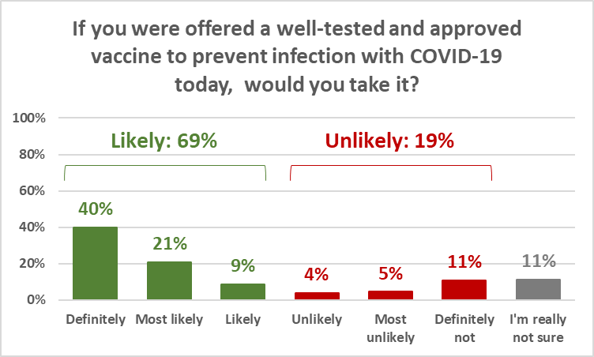
NOTE: Percentages in this chart do not sum to 100% or to the totals shown owing to rounding.

Uptake is likely to be highest among the among those aged 65+, with potentially 76% of 65-74-year olds in total and 87% of those aged 75 years or over in total likely to use an offered vaccine.

Uptake was least likely among 35-44-year olds, with 57% in total of this age group indicating that they would be likely to take an offered COVID-19 vaccine.

Note that, in general, Horizon’s experience has been that the percentage of people who say they will “definitely” do something approximates the percentage who actually do it. Those who say they are “most likely” or “likely” to do something tend to require some additional urging. In these results, 40% of respondents overall said they were definitely likely to take a vaccine if offered. The remaining 29% overall who would be likely to take a vaccine if offered would require some convincing.

Similarly, the percentage of people who say they will “definitely not” do something approximates the percentage who will not do it. The people who say they would be “unlikely” to do something are generally more easily swayed than those who say they would be “most unlikely” to do something. In these results, 11% of respondents said they would “definitely not” take a vaccine if offered and a further 5% would be “most unlikely” to do so.

The overall results suggest that:

- Between 40% and 60% of New Zealand adults (estimated at 1,427,300 to 2,171,500 adults) will accept an offered vaccine with little urging.
- 16% of New Zealand adults (estimated 550,100 adults) will not accept an offered vaccine.
- 24% of New Zealand adults (estimated at 873,300 adults) need to be thoroughly convinced to take the offered vaccine.

The following chart shows, by age group, the percentages of those who would “definitely” take a well-tested and approved vaccine if offered and those who would “definitely not” do so.

Note that the both the “definitely” and “definitely not” percentages for those under-65 years of age are relatively consistent.

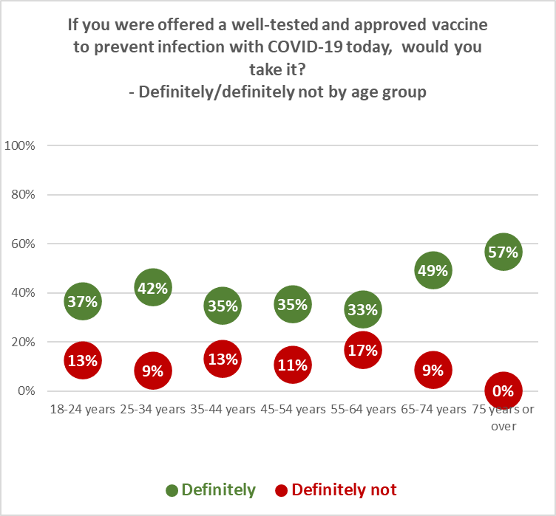

Those who indicated that they had opted to have a flu vaccine this year (48% of respondents overall) were much more likely to being accepting of a COVID-19 vaccine if one were offered: 55% would “definitely” accept a COVID-19 vaccine compared with 26% of those who had not had a flu vaccine.

Acceptance by ethnicity:
By ethnicity, Māori appear to be the least inclined to accept a COVID-19 vaccine if offered, with 31% saying they would definitely accept one and a total of 57% overall likely to accept. Indications are that New Zealanders of Asian ethnicity would need more urging to accept a vaccine (although 87% overall are likely to use a COVID-19 vaccine).

The highest percentage of respondents who said they would definitely take a vaccine were those of Pasifika and Indian ethnicity.

If you were offered a well-tested and approved vaccine to prevent infection with COVID-19 today would you take it? | ALL | ETHNICITY
 |  | Asian | Indian | Māori | NZ European/ Pakeha | Other European | Pasifika
Definitely | 40% | 28% | 54% | 31% | 41% | 41% | 50%
Most likely | 21% | 23% | 30% | 22% | 21% | 9% | 20%
Likely | 9% | 36% | 5% | 4% | 7% | 9% | 7%
Unlikely | 4% | 1% | 2% | 3% | 4% | 2% | 6%
Most unlikely | 5% | 0% | 3% | 6% | 5% | 8% | 4%
Definitely not | 11% | 5% | 3% | 14% | 10% | 12% | 9%
I'm really not sure | 11% | 7% | 4% | 20% | 12% | 19% | 4%
Total would take it | 69% | 87% | 88% | 57% | 69% | 58% | 78%
Total would not take it | 19% | 6% | 8% | 23% | 19% | 23% | 19%
N (unweighted) | 1,451 | 53 | 40 | 237 | 1,127 | 138 | 43

Overall, those who are unlikely to take an offered COVID-19 vaccine were:
- More likely to be female than male.
- Younger New Zealanders: 50% were below 45 years of age and their average age was around 6% lower than respondents overall.
- Likely to have lower household income: around 11% lower, on average, than respondents overall. In contrast, those who would be likely to take an offered vaccine have around 7% higher household incomes, on average, than respondents overall.
- Likely to have lower educational qualifications than those who are likely to take a vaccine if offered: 60% have sixth form/UE/NCEA Level 2 or less, compared with 45% of those who are likely to take a vaccine.
- More likely to be a parent with children in their household: 57% compared with 39% for those who are likely to take a vaccine if offered.
- Largely located in the North Island: 81% in comparison with a respondent location average of 76% North Island. 25% are in the upper North Island (Taupo north, excluding Auckland), compared with 20% of respondents overall.
- More likely to be Māori, NZ European or “Other European”.
- More likely to have not had a vaccination for flu this year.

Those who are unsure whether they would take an offered COVID-19 vaccine were:
- Of average age.
- More likely to be on lower household and personal incomes than respondents overall: household incomes around 24% lower, on average, and personal incomes around 28% lower, on average. In contrast, those who would be likely to take an offered COVID-19 vaccine have higher household and personal incomes than respondents overall: household incomes around 7% higher, on average, and personal incomes around 4.5% higher, on average.
- More likely to have lower educational qualifications than those who are likely to take a vaccine if offered: 60% have sixth form/UE/NCEA Level 2 or less, compared with 45% of those who are likely to take a vaccine.
- More likely to be a parent with children in their household: 57% compared with 39% for those who are likely to take a vaccine if offered.
- Largely located in the North Island: 83% in comparison with a respondent location split of 76% North Island. 30% are in the upper North Island (Taupo north, excluding Auckland) in comparison with 20% for respondents overall and 17% for those who are likely to take a vaccine if offered.
- More likely to be Māori, NZ European or “Other European”.
- More likely to have not had a vaccination for flu this year.

Reasons for being unlikely to accept a COVID-19 vaccine or unsure whether to do so
Those respondents who had indicated they were unlikely to accept a COVID-19 vaccine (“unlikely”, “most unlikely”, “definitely not”), or were unsure if they would do so (an estimated 1,107,400 adults overall) were asked why that was. Respondents were able to choose as many listed reasons as they thought applied and were able to give their own reasons where they thought the listed options had not adequately explained how they felt.

As shown in the following chart, the major reason was a need to be assured about the vaccine’s safety (an estimated 522,700 adults). This was particularly the case with female respondents (53% versus 37% for males), who appear to be more innately cautious: they also have a stronger “wait and see if others have side effects” result than males (42% for females, 29% for males). Note that nearly 6 out of 10 of those who chose safety as a reason also selected “I’d rather wait and see if others who have taken it suffer any side effects”.

Other main reasons given were:
- “I’d rather wait and see if others who have taken it suffer any side effects”: an estimated 414,200 adults.
- “I don’t trust any vaccine”: an estimated 284,600 adults. One in three of those who said they did not trust any vaccine also did not see any need to take a COVID-19 vaccine.
- “I don’t see the need to take a COVID-19 vaccine”: an estimated 225,900 adults.

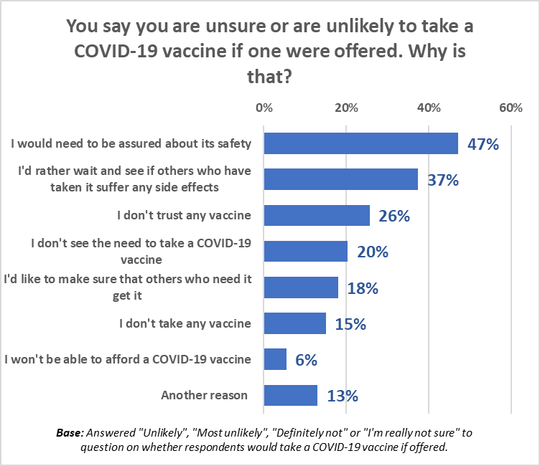

“Other reasons” included comments ranging from anti-vaccine and COVID-19 disbelief to those who had a medical reason for being cautious. Typical comments are shown below as an indication of the range of potential communication topics:

Anti-vaccine or conspiracy theories
“A Vaccine is putting the virus into you & I don't believe that should happen.”
“Everyone that has had the virus have recovered. We don't need a vaccine.”
“COVID is a scam and initiated by those who might profit from vaccine sales.”
“Vaccines contain thimerosal and aborted baby cells.”
“I have a God-given immune system that works and I don’t need to poison myself with a nasty vaccine.”
“I'm a child of God.”

Suspicious
“I don't know if I would trust the vaccine, because I reckon they have had the vaccine before or even as soon as the pandemic started.”
“Depends on who created the vaccine.”
“I don't trust the government to offer a safe vaccine.”
“I’m confident in my own ability to keep me free from COVID.”
“It looks unsafe and I don’t want to inject my body with chemicals.”
“It takes years to develop vaccines, and one has never been developed for a coronavirus and I am not confident that a vaccine will be available any time soon. The process has been very much rushed and I believe there is a world political agenda at play.”
“It's widely known that the testing and regulation of vaccines is minimal, so claims that it's "safe" are speculative, at best.”
“Long term risk of vaccine ill effect probably worse than catching COVID.”

Cautious
“Because I would rather wait until it has proven effectiveness as we have never as a species created an immunization so fast, and we've had worse viruses.”
“I may have higher immune reactions - I need to wait and see.”
“I would like research into the long-term effects of taking the vaccine.”
“I would want to know its efficacy and longevity.”
“This vaccine has not been through rigorous LONG-TERM safety trials and I won’t be having it for some years by which time we won’t need it!”
“It’s done too fast, will not take first one out, not safe to.”

Medical reasons
“I have a rare autoimmune disorder and it is highly unlikely that when a vaccination comes on the market that there will be evidence about whether or not it is safe for people with my disorder to take.”
“I have a sensitivity to a lot of drugs etc.; it’s not an option for me. Also, it’s not been tested long enough for me. I don't want to be a guinea pig.”
“I have allergies to components of certain vaccines including Influenza.”
“I have chemical sensitivities and can't take any vaccine. I am not anti-vaccines.”
“I have frequently had severe reactions to vaccinations.”
“I have health issues.”

Other reasons
“Only have it if I was going to a high-risk area.”
“Only when travelling to certain countries: USA, UK, and others.”
“The COVID vaccine effectiveness won't last and so will give false hope.”
“Only if it was made by a New Zealander.”
“I'm too old now to die young, let some younger person have my dose.”

Ethnic differences were relatively marked. While requiring assurance about a vaccine’s safety was the most important factor for respondents of Māori, NZ Europeans and “Other Europeans” ethnicity who said they were unlikely to accept a vaccine, there were indications that:

- Pasifika and Indian respondents would rather wait and see if there were any side effects in others who had taken a vaccine.
- A higher proportion than average of Māori, “Other Europeans”, Pasifika, Indian and Asian respondents did not trust any vaccines.

You say you are unsure or are unlikely to take a COVID-19 vaccine if one were offered. Why is that? | ALL | ETHNICITY
 |  | Asian | Indian | Māori | NZ European/ Pakeha | Other European | Pasifika
I would need to be assured about its safety | 47% | 27% | 30% | 39% | 48% | 50% | 27%
I'd rather wait and see if others who have taken it suffer any side effects | 37% | 20% | 45% | 29% | 37% | 29% | 46%
I don't trust any vaccine | 26% | 31% | 44% | 35% | 26% | 50% | 38%
I don't see the need to take a COVID-19 vaccine | 20% | 5% | 26% | 17% | 24% | 8% | 2%
I'd like to make sure that others who need it get it | 18% | 17% | 8% | 20% | 16% | 18% | 9%
I don't take any vaccine | 15% | 0% | 0% | 18% | 14% | 19% | 8%
I won't be able to afford a COVID-19 vaccine | 6% | 0% | 0% | 4% | 5% | 4% | 0%
Another reason | 13% | 0% | 0% | 15% | 14% | 8% | 2%
N (unweighted) - Answered "Unlikely", "Most unlikely", "Definitely not" or "I'm really not sure” to question on whether respondents would take a COVID-19 vaccine if offered. | 362 | 6 | 7 | 77 | 265 | 35 | 11

Overall, those who needed to be assured about a COVD-19’s safety were:
- More likely to be female (69%) than male (30%).
- Slightly below the average age.
- More likely to be on lower household and personal incomes than respondents overall: household incomes around 7% lower, on average, and personal incomes around 15% lower, on average.
- More likely to be a parent with children in their household: 54% compared with 44% overall.
- Largely located in the North Island: 84% in comparison with a respondent location average of 76% North Island. 26% are in the upper North Island (Taupo north, excluding Auckland), compared with 20% of respondents overall.
- More likely to be of NZ European or “Other European” ethnicity.
- Significantly less likely to have had a vaccination for flu this year.

Those who would rather wait and see if others who have taken it suffer any side effects were:
- More likely to be female (69%) than male (29%).
- 5% younger than the average age.
- More likely to have slightly lower household and personal incomes than respondents overall: household incomes around 4% lower, on average, and personal incomes around 5.5% lower, on average.
- More likely to be a parent with children in their household: 57% compared with 44% overall.
- Less likely than average to be in Auckland (29% versus and overall average of 34%) and more likely (29% versus and overall average of 20%) to be in the upper North Island (Taupo north, excluding Auckland), compared with 20% of respondents overall.
- More likely to be of Indian, NZ European or Pasifika ethnicity.
- Less likely than average to have had a vaccination for flu this year.

Those who chose “I don’t trust any vaccine” were:
- A little more likely to be female (58%) than male (44%).
- 12% younger than the average age: 6 out of 10 are under 45 years of age.
- More likely to have lower household and personal incomes than respondents overall: household incomes around 15% lower, on average, and personal incomes around 11% lower, on average.
- Significantly more likely to be a parent with children in their household: 62% compared with 44% overall.
- Significantly more likely to live in Auckland (50% versus an overall average of 34%) and less likely to live in the South Island (14% versus an overall average of 24%).
- More likely than average to be of Asian, Indian, Māori, “Other European” or Pasifika ethnicity.
- More likely than average (96%) to have NOT had a vaccination for flu this year.

The importance of the reasons changed as likelihood NOT to accept a COVID-19 vaccine increased. Note that:

- The percentages requiring assurance about vaccine safety and taking the position to wait and see if others who had taken it suffer any side effects declined as likelihood NOT to accept a COVID-19 vaccine increased. These two factors also constitute the primary messaging for those who were unsure whether or not they would accept a COID-19 vaccine.
- Lack of trust in vaccines and perception of need for a COVID-19 vaccine increased as likelihood NOT to accept a COVID-19 vaccine increased.
- Putting “others who need it” before oneself declined as likelihood to NOT accept a COVID-19 vaccine increased.

You say you are unsure or are unlikely to take a COVID-19 vaccine if one were offered. Why is that? | ALL | If you were offered a well-tested and approved vaccine to prevent infection with COVID-19 today would you take it?
 |  | Unlikely | Most unlikely | Definitely not | I'm really not sure
I would need to be assured about its safety | 47% | 49% | 45% | 24% | 69%
I'd rather wait and see if others who have taken it suffer any side effects | 37% | 48% | 38% | 24% | 46%
I don't trust any vaccine | 26% | 13% | 23% | 43% | 15%
I don't see the need to take a COVID-19 vaccine | 20% | 17% | 22% | 35% | 7%
I'd like to make sure that others who need it get it | 18% | 39% | 15% | 9% | 21%
I don't take any vaccine | 15% | 9% | 7% | 26% | 10%
I won't be able to afford a COVID-19 vaccine | 6% | 13% | 6% | 1% | 7%
Another reason | 13% | 6% | 12% | 16% | 13%
N (unweighted) - Answered "Unlikely", "Most unlikely", "Definitely not" or "I'm really not sure” to question on whether respondents would take a COVID-19 vaccine if offered. | 362 | 53 | 60 | 118 | 131

Follow-up vaccine
Respondents were asked if they would take a COVID-19 vaccine follow-up dose, if needed.

Just under 69% of respondents (an estimated 2,462,700 adults) would take a follow-up dose if required. 18% (an estimated 636,400 adults) were unlikely to do so and 14% (an estimated 496,200 adults) were unsure.

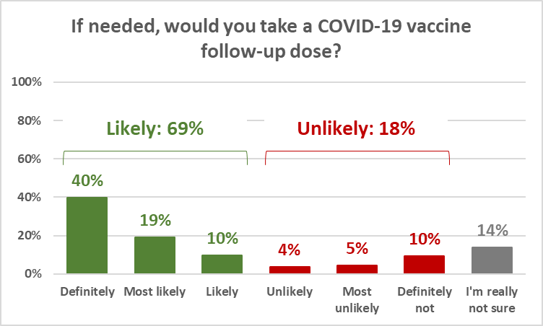
NOTE: Percentages in this chart do not sum to 100% or to the totals shown owing to rounding.

Note that while the percentage who would definitely take a follow-up dose was the same as the percentage who would take an initial COVID-19 vaccine, only 97% of those who would definitely accept a vaccine would definitely take a follow-up dose. Compliance was therefore strong, but not total.

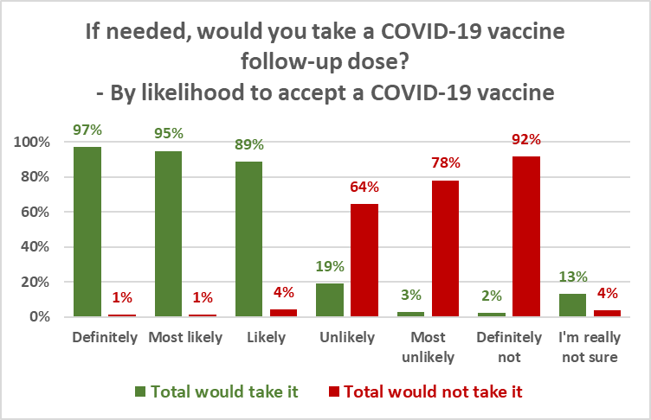

By age, the percentage who would definitely or definitely not take a follow-up dose if needed mirrors the pattern of the uptake shown in Section 1.

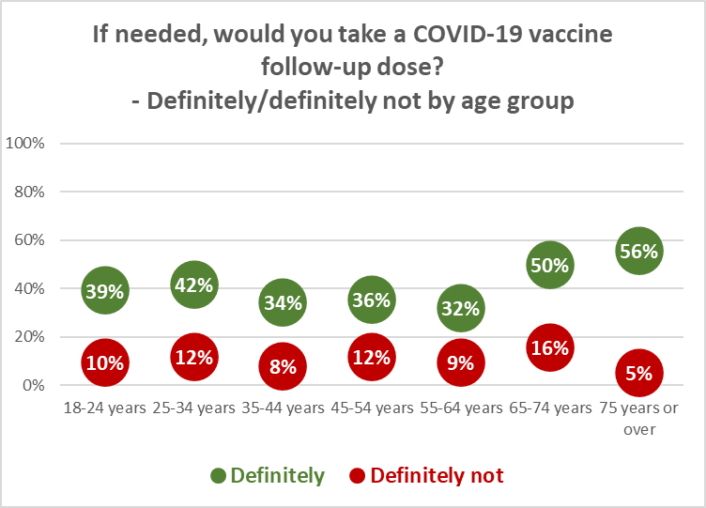

Respondents of Indian and Pasifika ethnicity were the most likely to take a follow-up dose if needed. Those of Asian ethnicity appear to need a little more urging, just as with the result for accepting an offered COVID-10 vaccine.

Māori were the least likely overall to take a follow-up dose if needed.

If needed, would you take a COVID-19 vaccine follow-up dose? | ALL | ETHNICITY
 |  | Asian | Indian | Māori | NZ European/ Pakeha | Other European | Pasifika
Definitely | 40% | 29% | 55% | 28% | 41% | 41% | 47%
Most likely | 19% | 31% | 30% | 20% | 18% | 11% | 17%
Likely | 10% | 22% | 6% | 6% | 9% | 7% | 9%
Unlikely | 4% | 1% | 0% | 4% | 4% | 2% | 6%
Most unlikely | 5% | 3% | 3% | 7% | 4% | 11% | 0%
Definitely not | 10% | 0% | 3% | 14% | 9% | 10% | 14%
I'm really not sure | 14% | 13% | 4% | 22% | 15% | 20% | 8%
Total would take it | 69% | 83% | 90% | 54% | 68% | 59% | 72%
Total would not take it | 18% | 4% | 6% | 25% | 17% | 22% | 20%
N (unweighted) | 1,451 | 53 | 40 | 237 | 1,127 | 138 | 43

Child vaccine
45.5% of respondents overall (an estimated 1,635,900 adults) said they were caregivers for a child or children. Of those, 49% (an estimated 801,800 adults) said that “if an approved COVID-19 vaccine becomes available for younger children” they would have it given to a child or children for whom they were the caregiver.

27% of caregivers (an estimated 435,000 adults) said they were unlikely to have a COVID-19 vaccine given to a child and 24% (an estimated 399,100 adults) were unsure whether they would do that or not.

As shown in the following chart, Pasifika and Indian respondents were the most likely to do this; Māori and “Other Europeans” the least likely.

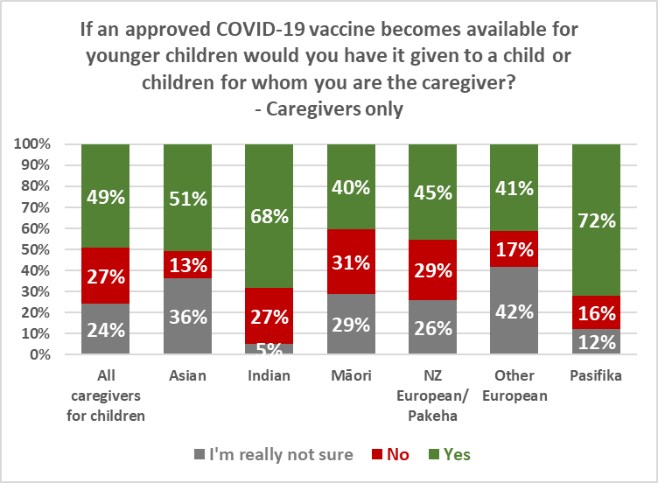

Note how willingness to give a child an approved COVID-19 vaccine declines as the willingness to accept a COVID-19 vaccine themselves declines.

86% of the caregivers who would “definitely” accept a COVID-19 vaccine themselves would have it given to the child/children for whom they are caregivers. 5% would not have it given and 9% were unsure.

At the other end of the spectrum, however, 3% of those who would “definitely not” accept a COVID-19 vaccine themselves would have a suitable vaccine given to the child/ children for whom they are caregivers.

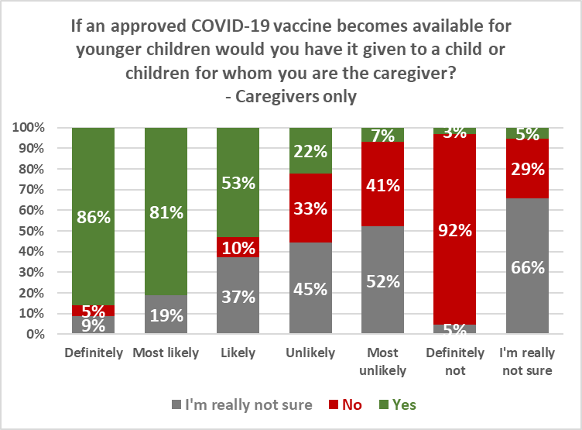

Vaccine approval process
Respondents were asked whether they were concerned that the COVID-19 approval process in New Zealand would move too quickly or too slowly.

As shown in the following chart, 10% (an estimated 355,900 adults) were concerned that it would move too slowly (causing unnecessary delays to accessing a vaccine), while 31% (an estimated 1,118,100 adults) were concerned that it would move too quickly (without fully establishing it is safe and effective).

45% (an estimated 1,625,100 adults) selected “I trust New Zealand health agencies to approve a well-tested and safe vaccine and supply it for use as quickly as possible”.

14% were unsure.

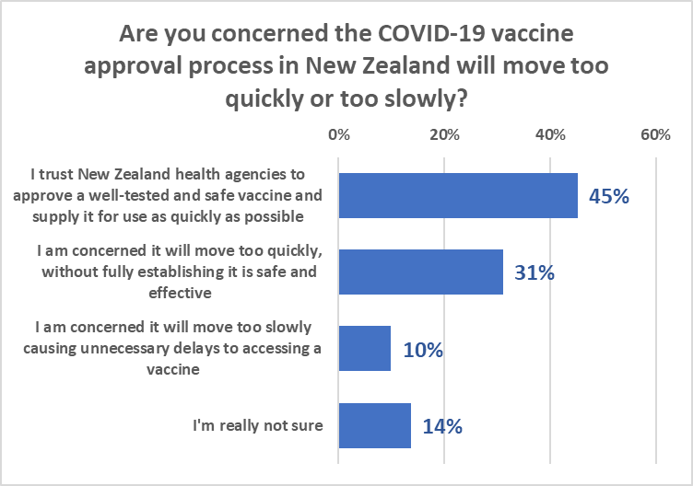

The following chart demonstrates that with declining willingness to accept a COVID-19 vaccine comes:
- Declining trust in the New Zealand health agencies “to approve a well-tested and safe vaccine and supply it for use as quickly as possible”; and
- Increasing concern that “it will move too quickly, without fully establishing it is safe and effective”.

It also demonstrates that concern that the approval and supply process will move too slowly declines with decreasing willingness to accept a COVID-19 vaccine.

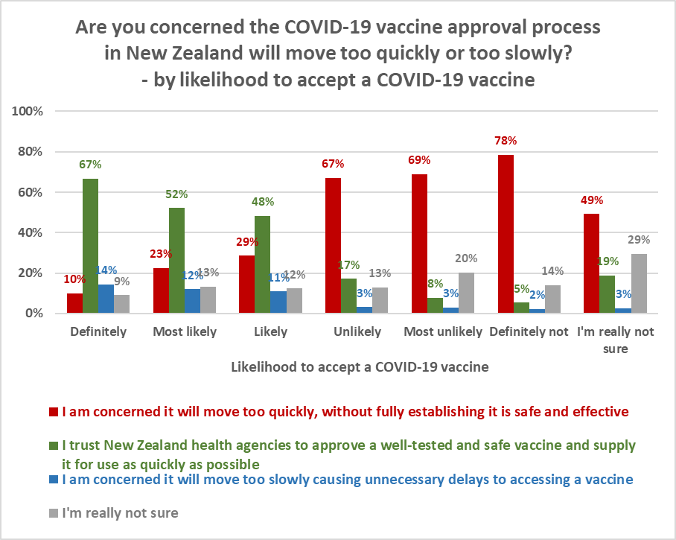

The implication is that to maximise acceptance and uptake, New Zealand should take a measured approach to COVID-19 vaccine approval and introduction and take steps to be as transparent as possible throughout that process. The transparency will be likely to encourage uptake from those who are currently less willing to accept a vaccine and reduce complaint that the process is going too slowly from those who are likely to accept a vaccine.

Those who were concerned that the COVID-19 vaccine approval process would move too slowly were:
- More likely to be male (59%) than female (41%).
- 7% younger, on average, than the overall average age for all respondents.
- More likely to be on higher household and personal incomes than respondents overall: household incomes around 13% higher, on average, and personal incomes around 27% higher, on average.
- More likely to be employed than respondents overall.
- Less likely than average to have children living in their household (30% versus 44% overall).
- More likely than average to be living in Auckland or the South Island.
- Significantly more likely to take a COVID-19 vaccine if offered and a follow-up dose if required (92% versus 69% overall).

Those who were concerned that the vaccine approval process would move too quickly were:
- More likely to be female (65%) than male (35%).
- 3% younger, on average, than the overall average age for all respondents.
- More likely to be on lower household income than respondents overall – average household income is around 8% lower, on average - but personal income is at the overall average for all respondents.
- More likely than average to have children living in the household (53% versus 44% overall).
- More likely than average to be living in the upper North island (excluding Auckland).
- Less likely than average to accept a COVID-19 vaccine (36% versus 69% overall) and to have a follow-up dose if required (40% versus 69% overall).

Priority access to an approved COVID-19 vaccine
Note: This survey was taken prior to the Government’s announcement that it had agreed to buy 1.5 million doses of a potential coronavirus vaccine, subject to the vaccine successfully completing all clinical trials and passing regulatory approvals, and provided the vaccine is approved for use in New Zealand by Medsafe.

Respondents were asked how confident they were that New Zealand would have priority access to a supply of an approved COVID-19 vaccine.

Confidence was effectively split: 41% expressed confidence while 38% lacked confidence; however, note that lack of confidence is, on average, stronger than confidence (nearly twice as many respondents were “not confident at all” as were “very confident”).

21% were unsure.

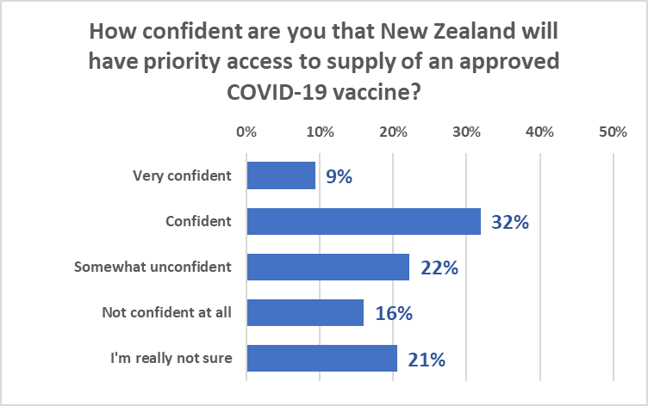

As shown in the following table, respondents of Indian ethnicity were the most confident overall. However, note that respondents of Pasifika ethnicity had the highest “very confident” rating, followed by Māori - despite Māori being the least likely to accept a vaccine if one were to be offered.

How confident are you that New Zealand will have priority access to supply of an approved COVID-19 vaccine? | ALL | ETHNICITY
 |  | Asian | Indian | Māori | NZ European/ Pakeha | Other European | Pasifika
Very confident | 9% | 9% | 10% | 13% | 8% | 6% | 19%
Confident | 32% | 25% | 45% | 29% | 32% | 21% | 31%
Somewhat unconfident | 22% | 24% | 34% | 19% | 25% | 20% | 14%
Not confident at all | 16% | 12% | 5% | 17% | 16% | 24% | 19%
I'm really not sure | 21% | 31% | 6% | 22% | 20% | 30% | 18%
N (unweighted) | 1,451 | 53 | 40 | 237 | 1,127 | 138 | 43

The most confident are those who would definitely accept a COVID-19 vaccine if it were offered. Lack of confidence and uncertainty increases with reducing likelihood to accept a COVID-19 vaccine.

How confident are you that New Zealand will have priority access to supply of an approved COVID-19 vaccine? | ALL | If you were offered a well-tested and approved vaccine to prevent infection with COVID-19 today would you take it?
 |  | Defini-tely | Most likely | Likely | Unlikely | Most unlikely | Defin-itely  not | I'm really not sure
Very confident | 9% | 13% | 7% | 6% | 8% | 6% | 7% | 8%
Confident | 32% | 44% | 40% | 34% | 19% | 7% | 2% | 17%
Somewhat unconfident | 22% | 22% | 24% | 29% | 27% | 27% | 8% | 22%
Not confident at all | 16% | 12% | 13% | 15% | 27% | 30% | 32% | 11%
I'm really not sure | 21% | 8% | 16% | 16% | 19% | 31% | 52% | 43%
N (unweighted) | 1,451 | 668 | 301 | 120 | 53 | 60 | 118 | 131

LIST OF APPENDICIES

Appendix 1: Sample
Appendix 2: Questionnaire
Appendix 3: Profiles (provided as an Excel attachment)
Appendix 4: Tables (provided as an Excel attachment)

Access to results online at the Horizon online platform are available to authorised users. These include respondents’ verbatim comments.

APPENDIX 1 – SAMPLE
1,451 members of Horizon Research’s specialist research panels and a third-party research panel, which represent the New Zealand adult population at the 2018 census, responded to the online survey between 24 and 28 September 2020.

The sample is weighted on age, personal income, region, highest qualification, employment status and ethnicity to reflect the New Zealand adult population at the 2018 census. At a 95% confidence interval, the maximum margin of error is ±2.6%.

Contact
For more information about this survey, please contact:

Grant McInman, Manager, 021 076 2040, email gmcinman@horizonresearch.co.nz.
Graeme Colman, Principal, 021 848 576, email gcolman@horizonresearch.co.nz.

APPENDIX 2 – QUESTIONNAIRE
The questionnaire consisted of 7 questions:

COVID-19 Vaccine
Q1. If you were offered a well-tested and approved vaccine to prevent infection with COVID-19 today would you take it?

A. Definitely
B. Most likely
C. Likely
D. Unlikely
E. Most unlikely
F. Definitely not
G. I'm really not sure

IF Q1 ANSWER WAS “UNLIKELY”, “MOST UNLIKELY”, “DEFINITELY NOT” OR “I’M REALLY NOT SURE” GO TO Q2.
OTHERS GO TO Q3.

Q2. You say you are unsure or are unlikely to take a COVID-19 vaccine if one were offered. Why is that?
Please tick all that apply

A. I would need to be assured about its safety
B. I don't take any vaccine
C. I don't trust any vaccine
D. I don't see the need to take a COVID-19 vaccine
E. I won't be able to afford a COVID-19 vaccine
F. I'd rather wait and see if others who have taken it suffer any side effects
G. I'd like to make sure that others who need it get it
H. Some other reason (please tell us what that is)

Q3. If needed, would you take a COVID-19 vaccine follow-up dose?

A. Definitely
B. Most likely
C. Likely
D. Unlikely
E. Most unlikely
F. Definitely not
G. I'm really not sure

COVID-19 vaccine for children
Q4. If an approved COVID-19 vaccine becomes available for younger children would you have it given to a child or children for whom you are the caregiver?

A. Does not apply - I am not the caregiver for any child
B. Yes
C. No
D. I'm really not sure

Q5. Are you concerned the COVID-19 vaccine approval process in New Zealand will move too quickly or too slowly?

A. I am concerned it will move too quickly, without fully establishing it is safe and effective
B. I trust New Zealand health agencies to approve a well-tested and safe vaccine and supply it for use as quickly as possible
C. I am concerned it will move too slowly causing unnecessary delays to accessing a vaccine
D. I'm really not sure

Q6. How confident are you that New Zealand will have priority access to supply of an approved COVID-19 vaccine?

A. Very confident
B. Confident
C. Somewhat unconfident
D. Not confident at all
E. I'm really not sure

Q7. Did you have a vaccination for influenza this year?

A. Yes
B. No

CLOSE

Note that Q7 was used as a classification question for cross analysis.

Small base, indications only.
“Other European” applies to any people of European extraction other than “New Zealand Europeans/Pakeha”
Small base, indications only.

