Horizon Research
COVID-19 Vaccine
28 October - 9 November 2021

Prepared for the Ministry of Health
In association with the School of Population Health
University of Auckland

Contents
EXECUTIVE SUMMARY 1
DETAILED FINDINGS 12
1. Decision timing for those not vaccinated 13
2. Vaccine uptake 20
2.1 Overall uptake estimate 20
2.2 Uptake by ethnicity 24
2.3 Uptake by people with impairment or who identify as disabled 27
2.4 Uptake by age group 28
2.5 Second dose uptake 29
2.6 Vaccination timing 30
3. Attitudes to vaccination of children under 15 years 31
3.1 Allow children to get a vaccine? 32
4. Barriers to COVID-19 vaccination 35
4.1 Reasons for being unsure or unlikely to get vaccinated 35
4.2 Perceived medical or health conditions 40
4.3 Factors holding back the unvaccinated 42
4.4 Misinformation 46
5. Where to get the COVID-19 vaccine 51
6. Incremental gains, including gains from potential messaging 53
6.1 Will people who are unsure about being vaccinated eventually get vaccinated? 53
6.2 Motivations to get the COVID-19 vaccine 55
6.3 Getting vaccinated against COVID-19 to go to work 57
6.3 Post-COVID-19 health problems 57
6.4 Protecting others from COVID-19 and the Delta strain by getting vaccinated 59
6.5 Getting vaccinated to protect children under 12 and others who can't take the vaccine for medical reasons 62
6.5 Getting vaccinated to use all businesses and be able to do activities 63
6.6 Getting two doses to use businesses, travel, attend family/whānau events or do activities 65
6.7 Ending lockdowns and restrictions for Auckland and the South Island 67
6.8 New COVID-19 management system 69
7. Information Needs 71
7.1 Do the unvaccinated have all the information they need to decide whether or not to get the COVID-19 vaccine? 71
7.2 Information required to help decide whether to get vaccinated 72
7.3 Preferred ways to get information 74
7.4 The one thing that would absolutely convince people to get a COVID-19 vaccine 75
7.5 Personal dialogue about the vaccine 81
7.6 Local meetings 83
8. Chances of being infected by the Delta strain at some time 85
9. Sources of official information about the vaccine 87
Impact of seeing an official COVID-19 vaccine advertisement 90
10. Experiences of those who have already been vaccinated 92
10.1 How people made the booking 92
10.2 Were people’s language needs met through the process? 92
10.3 Were people’s disability or impairment needs catered for through the process? 94
10.4 Likelihood of recommending vaccination to others 94
10.5. Who would you be prepared to talk with about them getting the vaccine? 95
10.6. What vaccinated people could say to others that would help convince them to get vaccinated? 97
10.7 Would information on any of these help you to talk with someone who hasn't had the COVID-19 vaccine? 101
10.8 How would you like to receive this support information? 102
11. Trust in the management of the pandemic and rating of the vaccination response 103
11.1 Management of the pandemic 103
11.2 Management of the vaccination response 105
APPENDIX 1 - SAMPLE 107
APPENDIX 2 - PROFILE BY LIKELIHOOD TO GET A COVID-19 VACCINE 109
APPENDIX 3 – NOT VACCINATED: PROFILE BY DECISION-MAKING TIME PERIOD 116
APPENDIX 4 – TABLES…………………………………………………………………………………………………….ATTACHED

EXECUTIVE SUMMARY
These results are from an online survey of 2,447 respondents in New Zealand aged 16 years of age or over. The survey was conducted between 28 October and 9 November 2021.

The sample is weighted on age, gender, employment status, ethnicity, personal income and region to match the 16+ population and at the most recent census.

At a 95% confidence level, the survey has a maximum margin of error of ±2.0% overall.

KEY FINDINGS
At the time of the survey in October 2021, 90% of the population 16+ had been vaccinated with at least one dose. Successive surveys have shown that the composition of the unvaccinated group and their vaccination intentions continue to change from survey wave to survey wave (and as the unvaccinated group gets smaller), so comparisons between October, September and August should be made cautiously.

- In October, of those 16+ who were not vaccinated (including those who had already booked), 24% were likely to get the vaccine, 21% were unsure, 17% were unlikely to get the vaccine and 38% said they would definitely not get the vaccine.
- In September, of those 16+ who were not vaccinated, 33% were likely to get the vaccine, 22% were unsure, 26% were unlikely to get the vaccine and 20% said they will definitely not get the vaccine.

The changes are best interpreted by converting the various percentages to the number of people 16+ they represent. The figures shown below demonstrate that among the remaining people who are unvaccinated:
- The number of those (16+) who definitely won’t get a vaccine is (effectively) unchanged from September.
- The number of people 16+ who are unsure about getting vaccinated has dropped by 49%, but there are still 83,700 who could possibly be convinced given the right approach and information.
- The number of people 16+ who said they are unlikely to get a vaccine has dropped by 66%.
- The number of people 16+ who are likely to get a vaccine has dropped by 64% and is now estimated at 91,100 people. Of those, it is estimated that 24,000 will “definitely” get the vaccine.

16+ population – Unvaccinated | Sep 2021 | Oct 2021 | Change (  no. people)
Likely to get vaccinated, not booked | 249,900 | 91,100 | -158,800
Unsure | 163,600 | 83,700 | -79,900
Unlikely to get a vaccine | 196,400 | 66,000 | -130,400
Definitely won’t get a vaccine | 152,100 | 152,800 | 700

Vaccine uptake - population estimates for key subgroups
- Based on HSU vaccination figures (at least one dose) as at the closing date of the survey and the vaccination intentions of unvaccinated respondents at the time of the survey, potential nationwide uptake for the 12+ population is estimated to be 92.4% (September 86.7%).

- Estimates for the 16+ population, 12 to 15 year-old population and overall 12+ population are as follows (“unsure”, “unlikely” and “definitely not” figures for 12 to 15 year-olds are calculated using parental permission data):

Vaccine uptake | 16+ population |  | 12 to 15 years |  | 12+ population
 | % 16+ popn | Estimated no. | %  12 to 15 yrs popn | Estimated no. | % 12+ popn | Estimated no.
Total population (HSU) | 100.0% | 3,949,600 | 100.0% | 259,500 | 100.0% | 4,209,100
Already vaccinated (HSU) | 89.9% | 3,550,100 | 83.5% | 216,700 | 89.5% | 3,766,800
Booked (HSU) | 0.1% | 5,900 | 0.2% | 500 | 0.2% | 6,400
TOTAL UNVACCINATED, NOT BOOKED | 10.0% | 393,600 | 16.3% | 42,300 | 10.4% | 435,900
Likely to get a vaccine  (12 to 15 years with parental permission) | 2.3% | 91,100 | 10.4% | 27,000 | 2.8% | 118,100
Potential uptake 16+,  12 to 15 years and 12+ population | 92.3% | 3,647,100 | 94.1% | 244,200 | 92.4% | 3,891,300
Unsure | 2.1% | 83,700 | 1.0% | 2,500 | 2.0% | 86,200
Unlikely | 1.7% | 66,000 | 3.1% | 8,000 | 1.8% | 74,000
Definitely not | 3.9% | 152,800 | 1.8% | 4,800 | 3.8% | 157,600
Total remaining unvaccinated population | 7.7% | 302,500 | 5.9% | 15,300 | 7.6% | 317,800

Taking into account when those 16+ who are not vaccinated and not booked will make a decision on whether to get vaccinated or not, it is estimated that:
- Total potential uptake by the end of 2021 among the 16+ population is likely to be 91.3% and uptake among the 12+ population nationwide is likely to be 91.4%.
- The remaining 1% who say they are likely to get a vaccine will be making their decision somewhere between January and April 2022.

- Total potential uptake for Māori 16+ is estimated at 78%.
- Total potential uptake for Pasifika 16+ is estimated at 89%.
- Total potential uptake for people who identify as disabled, is estimated at 87%.
- Overall, 399,500 people 16+ were not vaccinated as at 11:59 pm on 9 November 2021 (including those who were booked). Of these, it is estimated from the survey data that 222,800 people 16+ are currently “not definitely committed one way or the other (i.e., they are neither “Definitely” nor “Definitely not” going to get a COVID-19 vaccine). This is 5.6% of the 16+ population. The chart below shows the decline since August.
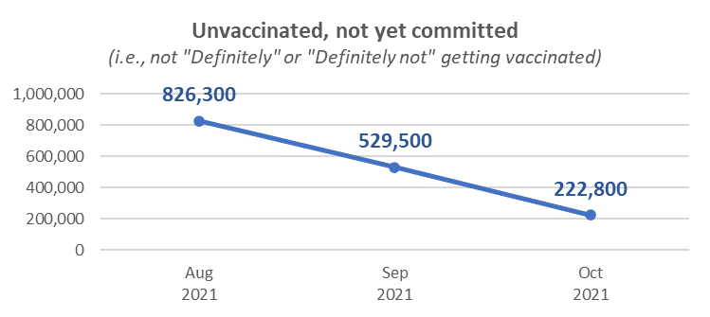
Chart shows estimated number of people 16+.
Base not vaccinated, not “definitely” nor “definitely not” intending to get a vaccine
October 2021 n=245, September n=414, August n=1,044

Respondents who have had one dose
- 85% of respondents who had had one dose said they were likely to get a second, down from 95% in September. 10% said they were not sure whether they would get a second dose or not and 5% said they were unlikely to get a second dose (although none of them ruled it out).
- Just 56% of those who have had one dose say they will “definitely” get another, below the 77% recorded in September, suggesting that effort needs to go into ensuring that second dose uptake is maximised.

Potential incremental gains among the unvaccinated

- Potential incremental gains from unvaccinated people who said they may eventually get the vaccine have declined. There is an additional potential incremental gain of 0.1% (equivalent to around 5,100 people 16+) from those currently not vaccinated, who said they may eventually get the vaccine (these are people who are currently unsure, unlikely to get the vaccine or said they would definitely not get the vaccine). Only 8% of that potential gain (around 400 people 16+) is likely to be achieved in 2021.

- A further nett incremental gain of 2.6% of the 16+ population (101,100 people) may ultimately be possible from those who are currently unsure whether they will eventually get the vaccine or not. Only 7% of that potential gain (around 7,400 people 16+) is likely to be achieved in 2021.

- 68% of caregivers of 5 to 11 year-olds said that if a vaccine is approved for use with 5 to 11 year-olds, they will allow their children in that age group to get vaccinated. The total potential uptake among the 5 to 11 year-old population if that were to happen is estimated at 72% or 344,800 children.

Decision time period for unvaccinated respondents
For respondents who were not vaccinated and were not definitely intending to get a vaccine:
- 12%, equivalent to just over 1% of the 16+ population, will decide in the next 2 months.
- 36% will decide in 2022, 2023, or later.
- 52% said they will definitely or probably never get the vaccine.

A key focus should be on accelerating the decision to get a vaccine so that 2021 uptake is maximised.

Caregivers for 12 to 15 year-olds and 5 to 11 year-olds
- 78% of caregivers for unvaccinated 12 to 15 year-olds said they would allow their children to get a vaccine. It is estimated that this will allow 64% of currently unvaccinated 12 to 15 year-olds to get a vaccine.
- 68% of caregivers of 5- to 11-year-olds said that if a vaccine is approved for use with 5-to-11-year-olds, they will allow their children in that age group to get vaccinated. The total potential uptake among the 5 to 11 year-old population if that were to happen is estimated at 72% or 344,800 children.

When would unvaccinated people most like to get vaccinated?
- Only 15% of people who had not been vaccinated say they intend to get vaccinated this year.
- 43% say they won’t get vaccinated and 25% say they are not sure when this will happen.

Main barriers to getting vaccinated
Respondents who were not vaccinated and were either unsure whether they would get a COVID-19 vaccine or said they were unlikely to get one, were asked to say in their own words why that was.

Main reasons were:
- Long term effects are not known/ it’s just an experiment or trial (27%).
- The government wants to control/bully us into getting the vaccine/I don't trust the government (20%).
- There are serious side effects/deaths from the vaccine – it is not safe/ its effects are worse than COVID/ it’s a poison (20%).

Compared with previous surveys, those who are unsure, unlikely to or definitely would not get vaccinated have become more negative about being vaccinated. Reflecting this change, the following responses each increased by 7% compared with the September results:

- The government wants to control/bully us into getting the vaccine/I don't trust the government (now in second place).
- It’s not a real vaccine. I want a real/traditional vaccine.
- I don't trust the vaccine/ don’t trust Pfizer or 'big pharma'.

Medical or health reasons not to get vaccinated
Around a quarter (24%) of unvaccinated people believe that health or medical reasons prevent them from getting vaccinated. The main conditions reported as preventing people being vaccinated are:
- Immunocompromised (33%).
- Taking blood-thinning medication (23%).
- Have had an allergic reaction to any vaccine (22%).

Factors holding unvaccinated respondents back
Respondents who were not vaccinated were also asked what was holding them back from getting a vaccine (from a prescribed list covering various emotional and physical aspects that were mentioned publicly in the previous month). For a significant proportion, the barriers are emotive, related to feeling pressured, anxious, and overwhelmed by the pandemic.

The main aspects holding them back are:
- There's too much social pressure to get vaccinated (33%).
- I'm under enough pressure coping with everyday life to think about getting the vaccine (14%).
- I'm feeling overwhelmed by the pandemic (12%).
- I'm feeling too anxious about the pandemic and the vaccine (9%).
- I'm feeling paralysed because I haven't been able to find the information that I want on the vaccine (7%).

These are the same top 5 factors as reported in an October 2021 Horizon survey of Māori.

Those who say there is “too much social pressure”, they are “under enough pressure coping with everyday life” or “feeling overwhelmed by the pandemic” are generally:
- More likely than average to be female.
- Generally younger than the average age – primarily under 45 years of age.
- Lower income.

Misinformation
Of all respondents, around six out of ten (57%) say they have noticed misinformation in the past 30 days. This includes 53% of those not vaccinated.

Main sources of this misinformation are mainstream social media such as Facebook and Twitter etc (66%), friends (22%) and mainstream media such as TV news, radio or newspapers (21%).

Respondents were also asked to describe in their own words what made them think it was misinformation. Focusing just on unvaccinated people, many of this group consider misinformation to be from the government – “the mainstream narrative is misinformation to me”. Only a small number indicated that ‘anti-vax’ views represent misinformation.

Respondents who had not had a COVID-19 vaccine and had seen misinformation were asked whether their decision to take or not take a COVID-19 vaccine would be influenced by the misinformation they noticed.

Overall, a nett 47% of respondents who had not had a COVID-19 vaccine and had seen misinformation said they would not get a COVID-19 vaccine if something they initially thought was misinformation either alarmed them or looked credible. Of these, 26% would look for official information; 74% would not.

Indications are that something respondents initially thought was misinformation and either alarmed them or looked credible could cause the following people to not get a vaccine:
- Around 4 out of 10 of those booked.
- Around a quarter of those who are not vaccinated but are likely to get a vaccine.
- Just under 2 out of 10 of those who are unsure whether to get a vaccine or not.
- 5 out of 10 of those who are not vaccinated and are unlikely to get a vaccine.
- 5 out of 8 of those who are not vaccinated and say they definitely won’t get a COVID-19 vaccine.

Where to go to get the COVID-19 vaccine
86% of those not vaccinated know where to go to get a vaccine.

Most comfortable place to get a vaccine
Respondents who were not vaccinated were asked where they would be most comfortable getting the COVID-19 vaccine.

The three top people and places are:
- A doctor/general practitioner (46%)
- Practice Nurse (19%).
- District Health nurse (17%).
- Pharmacy (16%).
- Hospital (14%).

Information needs
Do unvaccinated people have all the information they need to decide to get vaccinated?
- There was a strong increase in the percentage of respondents saying they definitely have enough information to decide (38% in October cf. 25% in September 2021).
- There was a fall in those who say they mostly have all the information they need, don’t quite have enough information or need to know more (in total this response fell from 64% in September to 50% in October 2021).

Information required to help decide whether to get a COVID-19 vaccine
Respondents who were not vaccinated were asked about their information needs. They said they would like:
- More information on possible side effects and risks (49%).
- Evidence the vaccine they are offered is unlikely to cause a serious adverse reaction (41%).
- Information about the number of people in New Zealand / Aotearoa and around the world that have safely taken the vaccine (18%).
- Information about the protection that the vaccination will give them (16%).
- What it's like to have COVID-19 and the potential long-term symptoms (15%).
- How likely they might be to catch COVID-19 (11%).

Preferred ways to get information about the vaccine
The main ways unvaccinated people, who are neither “definitely” nor “definitely not” intending to get the vaccine, would like to access information are online sources, plus TV news:

- Online news (37%).
- Government websites (29%).
- Email (23%).
- TV news (24%).

- 11% would like a personal chat about the vaccine with someone they trust. These people preferred to have this discussion with a medical provider (59%) or with family (52%). Note that only a small number answered this question (n=25) meaning these results are indicative.
- 10% said they are likely to or would definitely attend a local meeting at a sports club, marae, community hall or other places so they could chat about the vaccine with local doctors and others.
- Local meetings have the potential to reach around 5% of those not vaccinated and not “definitely” getting a vaccine, who would not be reached by a personal chat about the vaccine.

The one thing that would absolutely convince respondents to get a COVID-19 vaccine
Asked for the one thing that would convince them to get a vaccine:
- 15% said that access to a traditional/non-experimental vaccine may help convince them. Novavax was specifically mentioned.
- 13% wanted long-term data and long-term proof of safety.
- 8% wanted to know that the vaccine would work.
- 8% wanted transparency from the Government, Ministry of Health and the media and to be told the truth about the vaccine.
- 5% wanted a financial reward.
- 2% said they might be convinced if it was needed to protect them or their family.
- 2% said they might be convinced if it was not forced on them.
- 2% said if the government took responsibility if something went wrong for them after taking the vaccine.
- 1% said if it was safe for their medical condition.
- 33% overall said nothing would convince them.

Chances of being infected with COVID-19/Delta
All respondents were asked what they thought their chances were of being infected with the Delta strain of COVID-19 at some time.
- Those who think there is some chance or a high chance has more than doubled in the last month to 69%, from 30% in September.
- Those saying little to no chance has dropped from 55% in September to 22%.

Motivators to get vaccinated
Main motivators for those who are not currently vaccinated include:
- Protecting your own health (29%).
- Making sure hospitals are not overwhelmed (20%).
- Ensuring family can get medical care when needed (18%).
- Making sure medical care can continue (18%).

- Knowing about post-COVID health problems would make 19% of respondents more likely to get the vaccine. Indications are that these people were primarily those are already likely to get vaccinated, although it may have some effect in making those currently unlikely to get vaccinated “slightly more likely”.

Respondents who were not vaccinated were asked to select, from a list, who, if anyone, they would most like to protect from COVID-19 and the Delta strain by getting vaccinated.

- 45% selected at last one group they would like to protect by getting the vaccine themselves.
- 30% said they did not want to protect any of the groups listed and 25% said specifically that they would not get vaccinated to protect others.

- 18% indicated they could be motivated to get vaccinated to protect children under 12 and those who can't take the vaccine for medical reasons (down from 32% in September).

New COVID-19 Management System (including 90%+ vaccination targets, traffic light system and vaccine passes)
Overall, of those who were not vaccinated:
- 5% said they were happy with the new management system and would willingly get two doses; 6% were happy with the system but would not get the vaccine.
- 16% said they would get two doses but weren’t happy about it because they felt pressured.
- 18% said they weren’t happy with the new vaccine requirements and wouldn’t be motivated to get a vaccine because of them.
- 31% said they wouldn’t get the vaccine and no restrictions would change their mind.
- 8% said they won’t get the vaccine because there’s too much pressure.
- 1% said they would not get vaccinated to get a vaccine certificate because they believed there would be ways around that.

Getting vaccinated to do more
Of those who are currently not vaccinated:
- 37% would be more likely to get a vaccine to use all businesses and be able to do more activities once fully vaccinated.

- 39% would get two doses to be able to attend family/whānau gatherings
- 33% would get two doses to be able to travel region to region.
- 32% would get two doses to enter hospitality venues.
- 30% would get two doses to use a close contact business.

- 33% would be more likely to get two doses to get Auckland out of lockdown and the South Island out of restrictions.

- 18% of those not currently vaccinated would be likely to get the vaccine to retain their job. 46% said they definitely would not get vaccinated to go to work.

Experiences of those who have already been vaccinated
Among respondents who had already been vaccinated:
- 45% booked through Book My Vaccine.
- 25% booked directly with the clinic (includes “walk-ins”).
- 23% booked through the COVID Vaccination Healthline.

- 93% said their language needs were definitely met throughout the booking and vaccination processes, a similar result to the last 3 surveys.
- 56% of those with a disability or impairment who had received at least one vaccine said their needs were definitely met (a decrease from 62% in September; August 69%; July 68%) and 16% said they were “mostly” met (September 11%).

- 79% are very likely to recommend vaccination to others; 13% likely.

Prepared to talk with others about getting vaccinated
Those who had been vaccinated were asked if they were prepared to talk with unvaccinated people and what information they needed.
- 85% are willing to talk with others about:
  - Getting the vaccine (18%).
  - Getting vaccinated for friends and family (15%).
  - Getting vaccinated for the community (14%).

- 26% said they didn’t need any information from the MOH to talk with others; 74% selected at least one form of information they would like.
- The most effective forms of information that would help people talk about getting the vaccine consists of material that shows:
  - How the vaccine protects health (43%).
  - Where they can get expert advice (41%).
  - It is unlikely to cause a serious adverse reaction (40%).
  - What it is like to have COVID-19 (40%).
- The top five sources for receiving support information to use in conversations are:
  - Government websites (47%).
  - News online (43%).
  - Email (43%).
  - TV news (40%).
  - Printed information from GPs and pharmacies (40%).

Trust in the management of the pandemic and rating the vaccination response
- Average trust in the Ministry of Health and Government to manage the pandemic has dropped to 3.3 out of 5, the lowest since measurement started in February 2021. 74% now say they trust the Ministry of Health and Government (September 80%, August 83%, July 78%):

At this time, how much do you trust the Ministry of Health and Government to manage the COVID-19 pandemic in a way which best protects you and other New Zealanders? | Feb 2021 | Mar 2021 | Apr 2021 | May 2021 | Jun  2021 | Jul 2021 | Aug 2021 | Sep 2021 | Oct 2021
Average trust out of 5 | 3.5 | 3.6 | 3.8 | 3.7 | 3.5 | 3.6 | 3.8 | 3.7 | 3.3

- The average rating of the vaccination response (on a scale of 0 to 10, 10 being highest) has dropped to 5.9 out of 10, also the lowest since measurement started in February 2021.

Overall, on a scale of 0 to 10, how do you think the vaccination response to the COVID-19 pandemic is being managed in New Zealand? | Feb 2021 | Mar 2021 | Apr 2021 | May 2021 | Jun  2021 | Jul 2021 | Aug 2021 | Sep 2021 | Oct 2021
Average rating out of 10 | 7.2 | 7.1 | 7.1 | 6.6 | 6.1 | 6.4 | 6.8 | 6.8 | 5.9

DETAILED FINDINGS
These results are from an online survey of 2,479 respondents, resident in New Zealand and aged 16 years of age or over, conducted between 28 October and 9 November, 2021.

The sample is weighted on age, gender, employment status, ethnicity, personal income and region to match the 16+ population. This brought the sample percentage vaccinated (at least one dose) to within 1.5% of the official Ministry of Health figures for vaccinations as at 11:59pm on 9 November 2021, which is the cut-off date of this survey, without the need to specifically weight for vaccination rates.

At a 95% confidence level, the survey has a maximum margin of error of ±3.5% overall.

The survey sample was structured as follows:

Sub-Group | No. respondents | Weighted % | Sub-group margin of error
Had two doses | 2,022 | 80% | ±2.2%
Had one dose | 179 | 8% | ±7.3%
Total vaccinated | 2,201 | 88% | ±2.1%
Booked | 24 | 1% | ±20.0%
Not booked | 222 | 10% | ±6.6%
Total not vaccinated | 246 | 11% | ±6.2%
N.B. Percentages do not sum to 100% owing to rounding

Note that in projecting total potential uptake, estimates are based on the HSU data for the 12+ population, including vaccination counts, as at 11:59pm on 9 November 2021. The number who were booked was adjusted to reflect actual bookings reported on the MOH “COVID-19 vaccinations: daily update” web page, also as at 11:59pm on 9 November 2021.

The important criteria for uptake projections are the vaccination intentions of the unvaccinated group. These intentions continue to change from survey wave to survey wave and the unvaccinated group gets smaller, so comparisons between October, September and August should be made cautiously.

- In October, of those 16+ who were not vaccinated (including those who had already booked), 24% were likely to get the vaccine, 21% were unsure, 17% were unlikely to get the vaccine and 38% said they would definitely not get the vaccine.
- In September, of those 16+ who are unvaccinated, 33% were likely to get the vaccine, 22% were unsure, 26% were unlikely to get the vaccine and 20% said they will definitely not get the vaccine.

The changes are best interpreted by converting the various percentages to the number of people 16+ they represent. The figures shown below demonstrate that among the remaining people who are unvaccinated:
- The number of those who definitely won’t get a vaccine is (effectively) unchanged from September.
- The number of people 16+ who are unsure about getting vaccinated has dropped by 49%, but there are still 83,700 who could potentially be convinced given the right approach and information.
- The number of people who said they are unlikely to get a vaccine has dropped by 66%.
- The number of people 16+ who are likely to get a vaccine has dropped by 64% and is now estimated at 91,100 people.

16+ population – Unvaccinated | Sep 2021 | Oct 2021 | Change (  no. people)
Likely to get vaccinated, not booked | 249,900 | 91,100 | -158,800
Unsure | 163,600 | 83,700 | -79,900
Unlikely to get a vaccine | 196,400 | 66,000 | -130,400
Definitely won’t get a vaccine | 152,100 | 152,800 | 700

- Decision timing for those not vaccinated
This report is focused on messaging and measures that could be taken to maximise vaccine uptake.

Respondents who had not been vaccinated and were not definitely intending to get a COVID-19 vaccine (94% of all those who are not vaccinated) were asked ‘For you personally, how long do you think you'll need before you decide to get the vaccine, if at all?’
For respondents who were not vaccinated and were not definitely intending to get a vaccine:
- 12% will make their decision in the next 2 months. This represents around 1.2% of the total 16+ population. This group breaks down further into:
  - 74% who are already likely to get a vaccine. This represents around 0.9% of the total 16+ population.
  - 20% who are currently unsure whether they will get a vaccine or not. This represents around 0.2% of the total 16+ population.
  - 6% who are currently unlikely to get a vaccine. This represents less than 0.1% of the total 16+ population.
- 16% will decide in the next 3-12 months (i.e., somewhere during 2022). This represents just under 2% of the total 16+ population.
- 20% will decide in a year or more (i.e., in late 2022, 2023, or later). This represents 2% of the total 16+ population.
- 52% will definitely or probably never get the vaccine. This represents just under 5% of the total 16+ population.

- 95% of those who had said they were unsure whether they would get a vaccine or not, said they were unsure whether they would eventually get a vaccine or not.

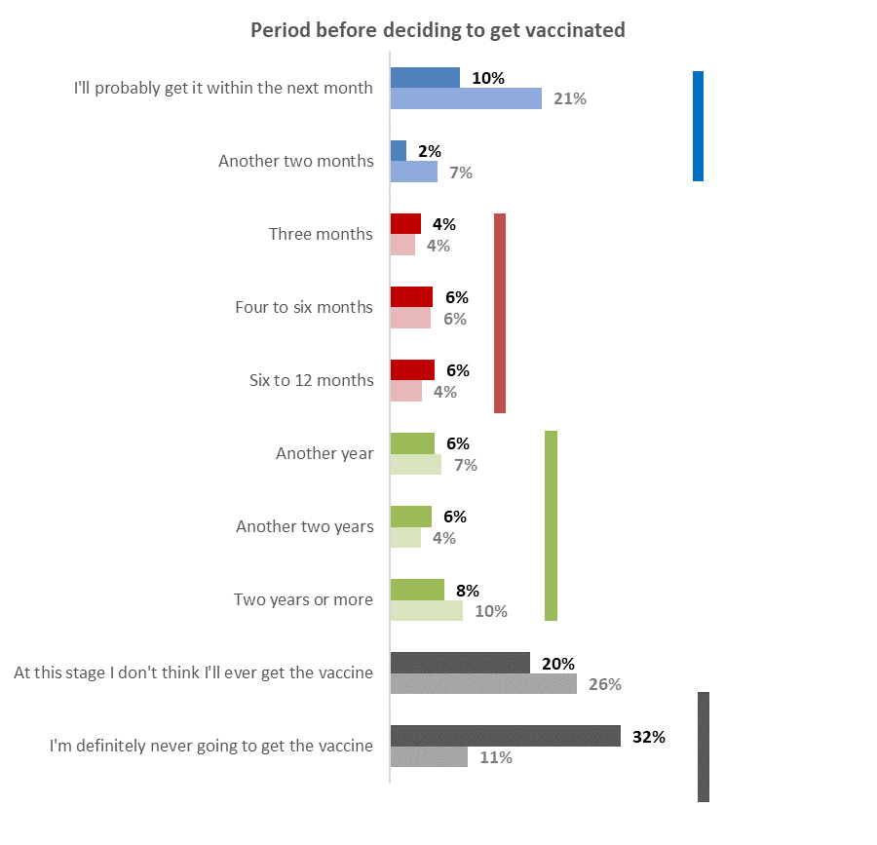
Definitely or probably never
October 52% (equivalent to 5% of the 16+ population)
September 37%
A year or more away
October 20% (equivalent to 2% of the 16+ population)
September 21%
Within 3-12 months
October 16% (equivalent to 1.5% of the 16+ population)
September 14%
Within 2 months
October 12% (equivalent to 1% of the 16+ population)
September 28%
Note: “Faded” colour bars are for September, darker colour bars are for October.
Base not vaccinated, not “definitely” intending to get a COVID-19 vaccine:
October n=231, September n=414

For targeting purposes:
- Of those who said they thought they would eventually get a vaccine:
  - 44%, equivalent to 0.6% of the 16+ population, are likely to decide in the next 2 months; but
  - 31%, equivalent to 0.4% of the 16+ population, won’t decide until somewhere during 2022.

- Of those who said they thought they would not eventually decide to get vaccinated (these people are nearly all among those who currently say they will definitely not get a vaccine):
  - 7%, equivalent to 0.3% of the 16+ population, won’t decide until late 2022 or longer. This suggests that these people are primarily waiting for “the end of the vaccine trial” before making a decision.
  - 88%, equivalent to 3.7% of the 16+ population, say they will not get the vaccine.

- Of those who said they were unsure whether they would eventually decide to get vaccinated (these people are mostly currently from the “unsure”, “likely” or “unlikely” to get a vaccine groups):
  - 13%, equivalent to 0.5% of the 16+ population, will be making a decision before the end of 2021.
  - 25%, equivalent to 1.0% of the 16+ population, won’t decide until somewhere during 2022.
  - 36%, equivalent to 1.4% of the 16+ population, said they won’t decide until late 2022, 2023 or longer.

To give indications of the communications themes that may be relevant to these groups, demographic characteristics of the various time period groups are shown below, together with messaging effectiveness for each of the groups.

DEMOGRAPHY | Grouped time period for vaccine decision
 | In next 2 months | 3-12 months | A year or more | Definitely, or probably, never
Gender | No particular characteristics. | No particular characteristics. | More likely to be female (70%). | No particular characteristics.
Age | 6% younger than average age. 49% are under 45 years. | 21% younger than average age. 49% are under 35 years, but as in Sept, 18% are 55 years or over. | 4% younger than average age | 7% older than average age.
Household Income | 24% lower than average | 3% higher than average | 20% lower than average | 26% lower than average
Personal Income | 21% lower than average | 16% higher than average | 16% lower than average | 15% lower than average
Employment status | No significant characteristics. | No significant characteristics. | No significant characteristics. | Less likely than average to be employed.
Highest qualification | More likely than average to have school-level qualifications only. | No significant characteristics. | No significant characteristics. | No significant characteristics.
Household Type | Less likely than average to be in a flatting/boarding situation. More likely than average to be in a one-parent household with children at home. Overall, more likely to have children in their household. | More likely than average to be in a two-parent family with children at home. Less likely than average to be in a single-person household. | Less likely than average to be in a couple-only household. No other significant characteristics. | Less likely than average to be in a two-parent household and more likely than average to be in a one-parent household with children at home
Ethnic group | Less likely than average to be Indian. | More likely than average to be Indian. | Less likely than average to be Asian. | Less likely than average to be Asian.
Child caregiver | No significant characteristics. | More likely than average to be a caregiver for 12 to 15 year-old children | No significant characteristics. | No significant characteristics.
Identify as disabled | No specific differences. | No specific differences. | No specific differences. | No specific differences.

DEMOGRAPHY | Grouped time period for vaccine decision
 | In next 2 months | 3-12 months | A year or more | Definitely, or probably, never
DHB. | Slightly more likely than average to be living in Auckland or the South Island. Slightly less likely than average to be living in the upper North Island outside of Auckland. | Slightly less likely to be living in Auckland and slightly more likely to be living in the Lower North Island. | Less likely to be living in Auckland or the lower North Island. Significantly more likely to be living in the South Island. | Less likely to be living in Auckland but more likely than average to living in the Upper North Island outside of Auckland.
Area Type | Less likely than average to be in a regional town. | Less likely than average to be living in a large city. | More likely than average to be living in a Rural area. | More likely than average to be in a regional town or a rural area.

BELIEFS | Grouped time period for vaccine decision
 | In next 2 months | 3-12 months | A year or more | Definitely, or probably, never
Believe medical or other health-related conditions mean they are not able to get a COVID-19 vaccine? | Less likely than average. | No specific differences. | No specific differences. | No specific differences.
Chances of being infected with the Delta variant of COVID-19 | Average (“some chance”). | Below average (“Little chance” to “some chance”). | Average (“some chance”). | Below average (“Little chance” to “some chance”).  22% believe there is “no chance” of being infected with the Delta variant of COVID-19.

The table below shows the effect of various messages about COVID-19 or the COVID-19 vaccine, incentives or restrictions on respondents in each of the time period groups.

Effect of messaging, incentives or restrictions. | Grouped time period for vaccine decision
 | In next 2 months | 3-12 months | A year or more | Definitely, or probably, never
Health problems post-COVID-19 infection. | More likely to get a vaccine. | Slightly more likely to get a vaccine. | Neither more nor less likely to get a vaccine. | Counter-productive; significantly less likely to get a vaccine as a result of this messaging.
Reasons to get vaccinated (e.g., preventing spread of virus, making sure hospitals are not overwhelmed and people can get the care they want, protecting own health). | More likely to get vaccinated to make sure they and their family can get the hospital and other medical care when they need it. | Average level of response to all reasons, but much less likely than average to say they would not get vaccinated for any of the reasons. | Less likely to respond to messaging about:  - Keeping the number of people needing intensive and other hospital care at manageable levels.  - Making sure hospital and other routine medical care can continue.  - Making sure they and their family, can get the hospital and other medical care when they need it.  - Slightly more likely to want to protect their own health. | 66% won’t get vaccinated for any of the reasons. Below average response for all reasons except “Keeping the number of people needing intensive and other hospital care at manageable levels”.
Protecting others | Less likely than average to say they won’t get a vaccine to protect others, but no specific groups they want to protect more (or less) than others. | Less likely than average to say they won’t get a vaccine to protect others, but no specific groups they want to protect more (or less) than others. | No differences from overall average. | Ineffective message; this group is more likely than average to say they will not get vaccinated to protect others or to say they want to protect “None of these”.
Protecting children under 12 years and others who can’t take the vaccine for medical reasons. | More likely to get a vaccine. | Splits this group: 37% more likely, 40% less likely, 24% not sure. | Makes 34% unsure; for 63%, it is counter-productive. | Counter-productive: Much less likely to get a vaccine (76% “definitely not” ).

Effect of messaging, incentives or restrictions. | Grouped time period for vaccine decision
 | In next 2 months | 3-12 months | A year or more | Definitely, or probably, never
Opportunity to use all businesses, do more activities if vaccinated. | Definitely receptive to this: makes 75% more likely to get a vaccine. | This group is split 50/50 more likely/less likely. | Counter-productive: Much less likely to get a vaccine. | Counter-productive: Much less likely to get a vaccine.
Getting vaccinated to attend gatherings/weddings/funerals. Indoor or outdoor events, use close contact businesses or gyms, travel regionally. | All options have average appeal. | All options have average appeal. | Significantly more likely to say “None of these, I won’t be getting the vaccine” or to say “It won’t apply to me because I will be exempt”. | Significantly more likely to say “None of these, I won’t be getting the vaccine” or to say “It won’t apply to me because I will be exempt”.
Ending Level 3 restrictions in Auckland and Level 2 restrictions in the South Island. | Much more likely than average to react positively to this (this group had slightly above-average representation from Auckland and the South Island). | No significant differences from average. | Less likely than average to react positively to this. | Significantly less likely than average to react positively to this.
Need to be vaccinated to go to work. | More likely to get a vaccine. | Slightly less likely to get a vaccine. | Less likely to get a vaccine. | Significantly less likely to get a COVID-19 vaccine. Note that this group has a lower-than-average level of paid employment (56% versus an overall average of 65%).

Vaccine uptake

2.1 Overall uptake estimate
Based on HSU vaccination figures (at least one dose) as at the closing date of the survey and the vaccination intentions of unvaccinated respondents at the time of the survey, estimated potential vaccine uptake among the 12+ population has increased from 86.7% in September to 92.4%.

Details, including for those who say they are unsure, unlikely to get a vaccine or definitely will not get a vaccine (for 12 to 15 year-olds, this is based on parental permission), are shown below.

Vaccine uptake | 16+ population |  | 12 to 15 years |  | 12+ population
 | % 16+ popn | Estimated no. | %  12 to 15 yrs popn | Estimated no. | % 12+ popn | Estimated no.
Total population (HSU) | 100.0% | 3,949,600 | 100.0% | 259,500 | 100.0% | 4,209,100
Already vaccinated (HSU) | 89.9% | 3,550,100 | 83.5% | 216,700 | 89.5% | 3,766,800
Booked (HSU) | 0.1% | 5,900 | 0.2% | 500 | 0.2% | 6,400
TOTAL UNVACCINATED, NOT BOOKED | 10.0% | 393,600 | 16.3% | 42,300 | 10.4% | 435,900
Likely to get a vaccine  (12 to 15 years with parental permission) | 2.3% | 91,100 | 10.4% | 27,000 | 2.8% | 118,100
Potential uptake 16+,  12 to 15 years and 12+ population | 92.3% | 3,647,100 | 94.1% | 244,200 | 92.4% | 3,891,300
Unsure | 2.1% | 83,700 | 1.0% | 2,500 | 2.0% | 86,200
Unlikely | 1.7% | 66,000 | 3.1% | 8,000 | 1.8% | 74,000
Definitely not | 3.9% | 152,800 | 1.8% | 4,800 | 3.7% | 158,600
Total remaining unvaccinated population | 7.7% | 302,500 | 7.0% | 15,300 | 7.6% | 317,800

Taking into account when those 16+ who are not vaccinated and not booked will make a decision on whether to get vaccinated or not, it is estimated that:
- Total potential uptake by the end of 2021 among the 16+ population is likely to be 91.3% and uptake among the 12+ population nationwide is likely to be 91.4%.
- The remaining 1% who say they are likely to get a vaccine will be making their decision somewhere between January and April 2022.

There is an additional potential incremental gain of 0.1% (equivalent to around 5,100 people) from those currently not vaccinated who said they may eventually get the vaccine (these are people who are currently unsure, unlikely to get the vaccine or said they would definitely not get the vaccine). Only 8% of that potential gain (around 400 people 16+) is likely to be achieved in 2021.

A further nett incremental gain of 2.6% of the 16+ population (101,100 people 16+) may ultimately be possible from those who are currently unsure whether they will eventually get the vaccine or not. Only 7% of that potential gain (around 7,400 people 16+) is likely to be achieved in 2021.

As reported in Section 3, 68% of caregivers of 5 to 11-year-olds said that if a vaccine is approved for use with 5 to 11 year-olds, they will allow their children in that age group to get vaccinated. That is equivalent to a further 344,800 people in New Zealand vaccinated.

The number of people 16+ who are not yet definitely committed one way or the other (i.e., they are neither “Definitely” nor “Definitely not” going to get a COVID-19 vaccine) is estimated at 222,800 – 5.6% of the 16+ population. The chart below shows the decline since August.

Chart shows estimated number of people 16+.
Base not vaccinated, not “definitely” nor “definitely not” intending to get a vaccine
October 2021 n=245, September n=414, August n=1,044

- 3 out of 8 of the uncommitted people are currently “Unsure” and nearly all of them (95%) remain unsure whether they will eventually get a COVID-19 vaccine. This may be where future messaging need to be targeted.
- 3 out of 10 of uncommitted people say they are likely to eventually get a COVID-19 vaccine.

Total population 16+ trends are shown below. Vaccination has slowed since September and the pool of willing vaccine candidates has dropped. There has been, however, a decline in those who are unlikely to get a COVID-19 vaccine or will definitely not do so (combined in the chart below).

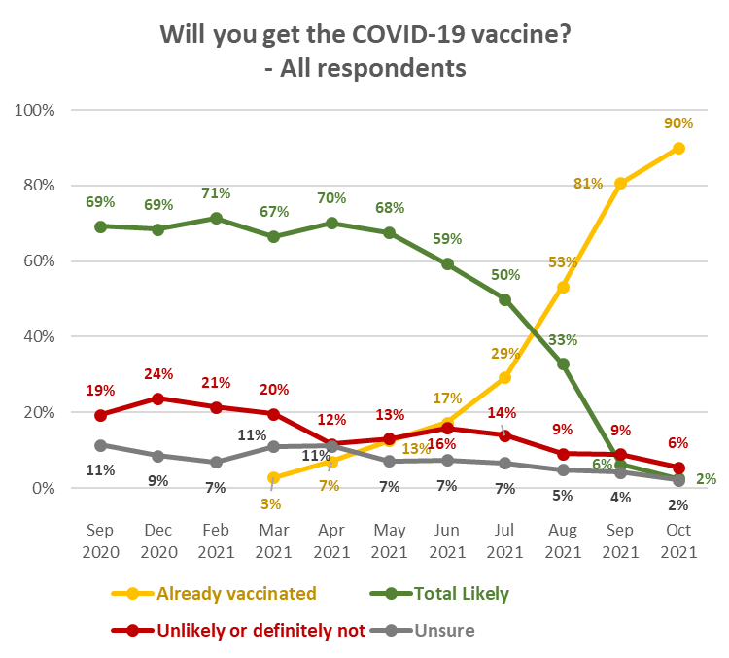
Base: all respondents: October, n=2,447; September n=2,479; August n=2,334; July n=2,509; June n=1,472;
May n=1,234; April n=1,387; March n=1,350; February2021 n=1,317;
December 2020 n=1,438; September 2020 n=1,451.

Profiles: “Total Likely”, “Total Unlikely”, and “Unsure”
The following table shows demographic characteristics of those who were not vaccinated and were “likely” or “unlikely” to get a COVID-19 vaccine, would “definitely not” get the vaccine or were not sure, to aid communications targeting. These demographic characteristics are dynamic and will change as people continue to be vaccinated

DEMOGRAPHY | Total Likely  to get a vaccine  (not vaccinated) | Total Unlikely  to get a vaccine  (not vaccinated) | Definitely will not get a vaccine  (not vaccinated) | Not sure whether  to get a vaccine  (not vaccinated)
Gender | Slightly more female (59%) than average. | Significantly more female (71%) than average. | No particular gender characteristics. | Slightly more female (59%) than average.
Age | 21% younger than average age | Average age | 7% older than average age. | Average age
Household Income | 12% lower than average | 17% lower than average | 22% lower than average | 27% lower than average
Personal Income | 24% lower than average | 6% lower than average | 9% lower than average | 26% lower than average
Employment status | Slightly less likely than average to be employed | Average rate of employment. | Significantly less likely to be in paid employment, | Slightly more likely than average to be employed
Highest qualification | More likely than average to have school-level qualifications only. | No particular characteristics. | More likely than average to have a vocational qualification. | No particular characteristics.
Household Type | Less likely than average to be in a single person household.  Slightly more likely than average to have children in their household. | More likely than average to be in a single-parent household with children at home. Less likely than average to be in a couple-only household. | More likely than average to be in a single-parent household with children at home. Less likely than average to be in a two-parent household. | No particular characteristics.
Ethnic group | No particular ethnic group characteristics. | Marginally more likely than average to be Māori. | More likely than average to be “Other European”. | Less likely than average to be Indian.  More likely than average to be “Other European”.
DHB | Less likely to be living anywhere in Auckland. More likely than average to be in the lower North Island DHB areas, particularly (indicatively) MIdCentral. | No particular differences from the overall sample. | Less likely the average to be living anywhere in Auckland. | No particular differences from the overall sample.
Area Type | Less likely than average to be living in a large city. Slightly more likely than average to be living in a rural area. | Slightly more likely than average to be living in a Rural area. | More likely than average to be living in a Rural area. | No particular area type characteristics.

2.2 Uptake by ethnicity
Unvaccinated Pasifika and Māori are (indicatively, owing to a small base) the ethnic groups that are least likely to get a COVID-19 vaccine

Unvaccinated people of Asian ethnicity are (indicatively, owing to a small base) the most likely to get a vaccine.

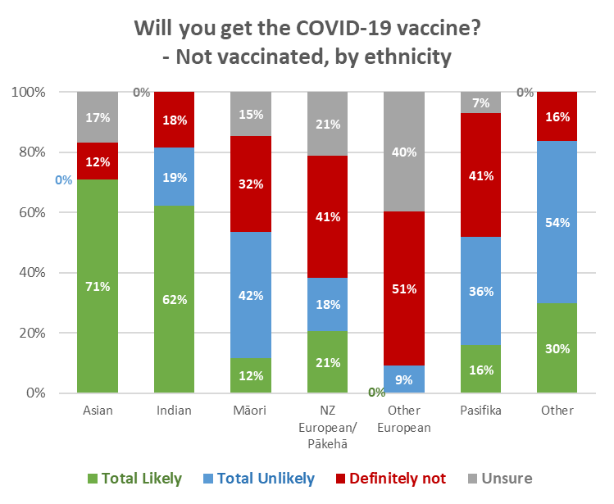
Base: not vaccinated: total n=245.
Ethnic groups: Asian n=13; Indian n=11; Māori n=28; NZ European/Pākehā n=182;
Other European n=30; Pasifika n=10; Other n=7.

Weighting for the general population is unlikely to produce accurate vaccination rates by ethnic group. This has been addressed by using vaccination counts for each ethnicity and applying the intentions of those in each group who are yet to be vaccinated (shown in the chart above) to the balance of the ethnic group population.

2.2.1 Māori
Overall vaccine intention by Māori respondents who were not vaccinated, and the percentage that represents among all Māori 16+, is shown in the following table.

Note that, except for the percentage vaccinated, this is an indicative result owing to the small base.

The total potential uptake for Māori 16+ is estimated at 78% (taking into account the margin of error on the survey data, which underlies the projections, the estimated range for Māori 16+ is between 77.4% and 78.5%).

VACCINE INTENTION | July 2021 |  | August 2021 |  | September 2021 |  | October 2021
 | Māori 16+  not vaccin-ated | All  Māori 16+ | Māori 16+  not vaccin-ated | All  Māori 16+ | Māori 16+  not vaccin-ated | All  Māori 16+ | Māori 16+  not vaccin-ated | All  Māori 16+
Already vaccinated |  | 18% |  | 34% |  | 55% |  | 75%
Likely to get a COVID-19 vaccine | 67% | 54% | 68% | 45% | 40% | 18% | 12% | 3%
Unlikely to, or will definitely not, get a COVID-19 vaccine | 23% | 22% | 22% | 14% | 39% | 18% | 77% | 18%*
Unsure | 10% | 8% | 10% | 7% | 21% | 10% | 15% | 4%
TOTAL POTENTIAL UPTAKE |  | 73% |  | 79% |  | 73% |  | 78%
* Note that this figure splits 10% “unlikely” and 8% “definitely not”
Base: Māori 16+ not vaccinated: October n=28; September 2021: n=95; August 2021 n=186, July 2021 n=236.
All Māori 16+: September 2021, n=367; August 2021 n=460, July 2021 n=481
N.B. Percentages shown may not sum to 100% owing to rounding.

2.2.2 Pasifika
Overall vaccine intention by Pasifika respondents who were not vaccinated, and the percentage that represents among all Pasifika 16+, is shown in the following table.

Note that, except for the percentage vaccinated, this is an indicative result owing to the small base.

The total potential uptake for Pasifika 16+ is estimated at 89% (taking into account the margin of error on the survey data, which underlies the projections, the estimated range for Pasifika 16+ is between 88.4% to 89.7%).

VACCINE INTENTION | July 2021 |  | August 2021 |  | September 2021
 | Pasifika  16+  not vaccin-ated | All  Pasifika  16+ | Pasifika  16+  not vaccin-ated | All  Pasifika  16+ | Pasifika 16+  not vaccin-ated | All  Pasifika  16+ | Pasifika 16+  not vaccin-ated | All  Pasifika  16+
Already vaccinated |  | 26% |  | 46% |  | 67% |  | 87%
Likely to get a COVID-19 vaccine | 62% | 46% | 72% | 38% | 42% | 14% | 16% | 2%
Unlikely to, or will definitely not, get a COVID-19 vaccine | 28% | 21% | 8% | 4% | 40% | 13% | 77% | 10%*
Unsure | 10% | 8% | 20% | 11% | 19% | 6% | 7% | 1%
TOTAL POTENTIAL UPTAKE |  | 72% |  | 85% |  | 81% |  | 89%
* Note that this figure splits 5% “unlikely” and 5% “definitely not”
Base: Pasifika 16+ not vaccinated: October n=10; September n=16; August n=91, July 2021 n=108.
N.B. Percentages shown may not sum to 100% owing to rounding.

2.3 Uptake by people with impairment or who identify as disabled
There has been an increase in the potential uptake result for respondents who self-identified as disabled. Comparing this result with September’s, it appears likely that those identifying as disabled will continue to have slightly below average vaccination rates.

Will you get a COVID-19 vaccine? (Including those who have already been vaccinated) | All respondents | Living with impairments or long-term health conditions | Identify as disabled
Definitely | 1% | 1% | 2%
Most likely | 1% | 0% | 0%
Likely | 2% | 1% | 1%
Unlikely | 1% | 0% | 1%
Most unlikely | 1% | 2% | 2%
Definitely not | 4% | 6% | 6%
I'm not sure | 2% | 3% | 4%
Already vaccinated | 88% | 88% | 85%
TOTAL LIKELY plus ALREADY VACCINATED | 91% | 89% | 87%
TOTAL UNLIKELY OR DEFINITELY NOT | 6% | 7% | 9%
N.B. Individual percentages shown may not sum to Total Likely, Total Unlikely or 100% owing to rounding

2.4 Uptake by age group
Total potential uptake is likely to be at 90% or over for all age groups expect 55–64-year-olds.
This survey suggests that the uptake for 45-54-year-olds will also be lower than the overall forecast. Figures for 16-17-year-olds are indicative because of the small base.

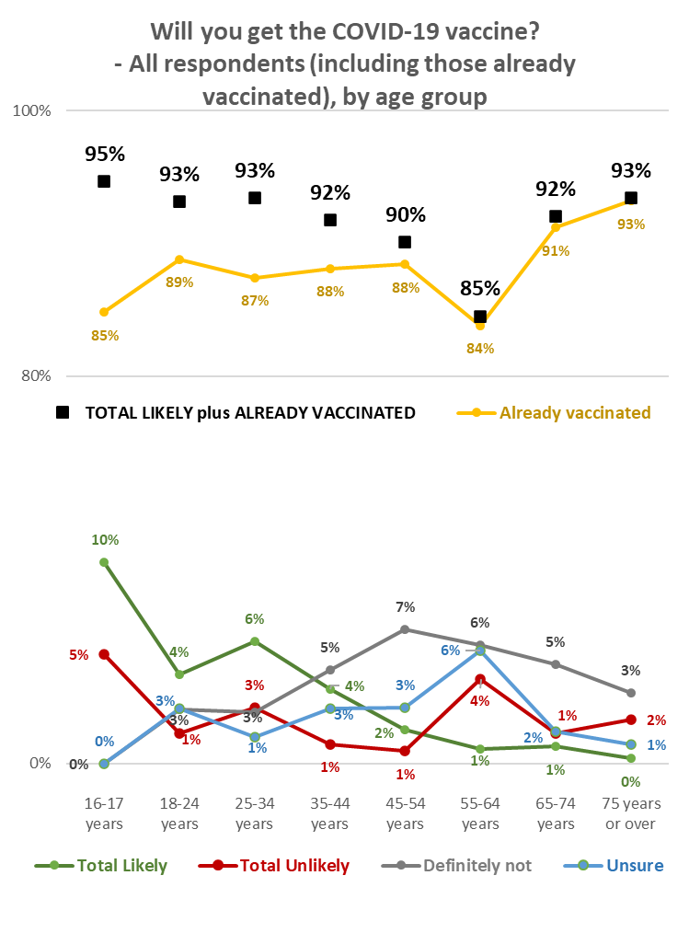
Base: all respondents: 16-17 years n=19; 18-24 years n=154; 25-34 years n=387; 35-44 years n=318,
45-54 years n=398; 55-64 years n=416; 65-74 years n=508; 75 years or over n=248.

2.5 Second dose uptake
Excluding those who had said they would “Definitely not” get a COVID-19 vaccine, respondents who had indicated that they had not had the vaccine, or had only had one dose, were asked how likely they were to have a second dose.

As more people get vaccinated, the unvaccinated group is consolidating around those who say they are unsure or unlikely to get a vaccine. The second dose result of 60% likely overall has dropped below September’s 77% (August 84%; July 81%; June 81%, May 82%).

85% of those who had one dose were likely to get a second, down from 95% in September. 10% of those who had one dose are unsure whether they will get a second. The “definitely” result for those who have already had 1 dose is 56%, down from 77% in October and 87% in August. This suggests that effort needs to go into ensuring that second dose uptake is maximised.

It is estimated that there are around 66,500 people 12+ who have had one dose but are not currently committed to having the second dose.

Likelihood to get second dose | LIKELIHOOD TO GET FIRST DOSE OR ALREADY HAD FIRST DOSE
 | Definitely | Most Likely | Likely | Unlikely | Most Unlikely | Unsure | Already had one dose
Total Likely | 97% | 98% | 55% | 10% | 0% | 0% | 85%
Total Unlikely | 3% | 2% | 10% | 54% | 65% | 1% | 5%
Definitely not | 0% | 2% | 0% | 0% | 14% | 1% | 0%
It depends if I have a reaction to the first dose | 0% | 0% | 31% | 29% | 15% | 28% | 1%
Not sure | 0% | 0% | 4% | 7% | 6% | 70% | 10%
Base - not vaccinated, not “definitely not” getting a vaccine, or had one dose | 10 | 10 | 33 | 17 | 28 | 46 | 179
N.B. Individual percentages may not sum to 100% owing to rounding
Base: not vaccinated, not “definitely not” getting a vaccine, or had one dose n=323

Of the 28 respondents who had already had one dose of the vaccine but said they were unsure or unlikely to get another:
- 9 said they might still get one.
- 12 had experienced side effects and 7 had had a serious adverse reaction.
- 7 said they were not sure the vaccine would be effective against the new strains (e.g., Delta).
- One indicated that getting the appointment had been too difficult.
- Four indicated that they didn’t think they needed a second dose.

2.6 Vaccination timing
Those not vaccinated were asked when they would most like to get a COVID-19 vaccine.

Almost seven out of ten (68% in total) said either they won’t get vaccinated (43%) or they are not sure when this will happen (25%). The proportion who say they won’t get vaccinated increased from 36% in September 2021 to 43% in the current October survey. This is very close to the 42% result in the October Horizon survey of Māori.

Only 15% in the current October general population survey say they intend to get vaccinated this year.
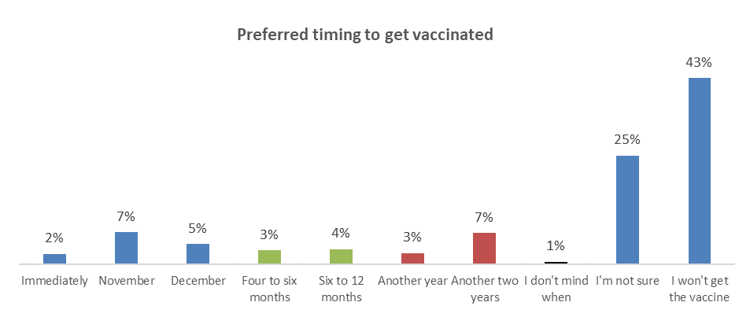
2023/4
Total 10%
2022
Total 7%
2021
Total 15%
Base: not vaccinated n=246

This suggests that the load on vaccination centres will be declining.

The remaining people who have not been vaccinated are primarily those who are unlikely to get a vaccine or definitely won’t get one (55% of those who are not vaccinated). 7 out of 10 of those who are unsure whether to get the vaccine or not (21% of those not vaccinated) are also unsure of when they want to get the vaccine, but 12% of those who are unsure want to wait for another year or two.

This is illustrated in the following table.

Although the bases are small, there is a clear trend.

Ideally, when would you most like to get a COVID-19 vaccine this year? | ALL | Will you get the COVID-19 vaccine?
 |  | Definitely | Most likely | Likely | Unlikely | Most unlikely | Definitely not | I'm not sure
% of not vaccinated | 100% | 6% | 5% | 14% | 7% | 10% | 38% | 21%
% of 16+ population | 10% | 1% | 0% | 1% | 1% | 1% | 4% | 2%
Immediately | 2% | 32% | 0% | 0% | 7% | 0% | 0% | 0%
November | 7% | 34% | 49% | 22% | 0% | 0% | 0% | 0%
December | 5% | 35% | 29% | 6% | 0% | 0% | 0% | 2%
Four to six months | 3% | 0% | 18% | 17% | 0% | 0% | 0% | 0%
Six to 12 months | 4% | 0% | 0% | 11% | 13% | 0% | 0% | 5%
Another year | 3% | 0% | 0% | 3% | 0% | 1% | 2% | 6%
Another two years | 7% | 0% | 0% | 7% | 26% | 27% | 2% | 6%
I don't mind when | 1% | 0% | 0% | 4% | 0% | 0% | 0% | 0%
I'm not sure | 25% | 0% | 2% | 30% | 43% | 29% | 1% | 72%
I won't get the vaccine | 43% | 0% | 2% | 0% | 12% | 43% | 95% | 9%
N (unweighted) - not vaccinated | 246 | 10 | 10 | 33 | 17 | 28 | 101 | 46

Attitudes to vaccination of children under 15 years
All respondents were asked if they were caregivers for young people aged 5 to 11 years and 12 to 15 years. As in September, 5- to 11-year-olds were included in the survey to evaluate the potential uptake if a vaccine is approved for this age.

78% said they were not caregivers and were excluded from the rest of the questions around vaccines and younger people. Of the total sample, 15% reported being caregivers for 5- to 11-year-olds and slightly under 12% were caregivers for 12- to 15-year-olds.

Each of these caregiver groups were asked:
- For how many young people they were a caregiver (a separate question for the caregivers of each age group).
- If they would allow their young people to get the vaccine (again, a separate question for the caregivers of each age group).

3.1 Allow children to get a vaccine?

Caregivers of 12 to 15 year-olds
Caregivers of 12 to 15-year-olds were asked ‘A COVID-19 vaccine is approved for use in young people aged 12- to 15-years-old. Will you allow the young people in this age group, for whom you are the primary caregiver, to get the vaccine?’

The following chart shows responses to this question compared with the August, July and June 2021 surveys. Respondents who reported their 12 to 15 year-olds had already been vaccinated were excluded from the analysis.

78% said that they would ‘definitely’ or ‘likely’ allow children of this age to be vaccinated – the same result as September (August 79%, July 67%, June 59%, May 55%, April 2021 56%).

There was an increase in the proportion who said they would not allow their 12 to 15 year-olds to get a COVID-19 vaccine or were unlikely to do so: up to 20% from 14% in September (August, 14%; July 21%, June 30%, May 26%, April 2021 22%). There was a commensurate drop in those who were unsure: down to 3% from 8% in September.
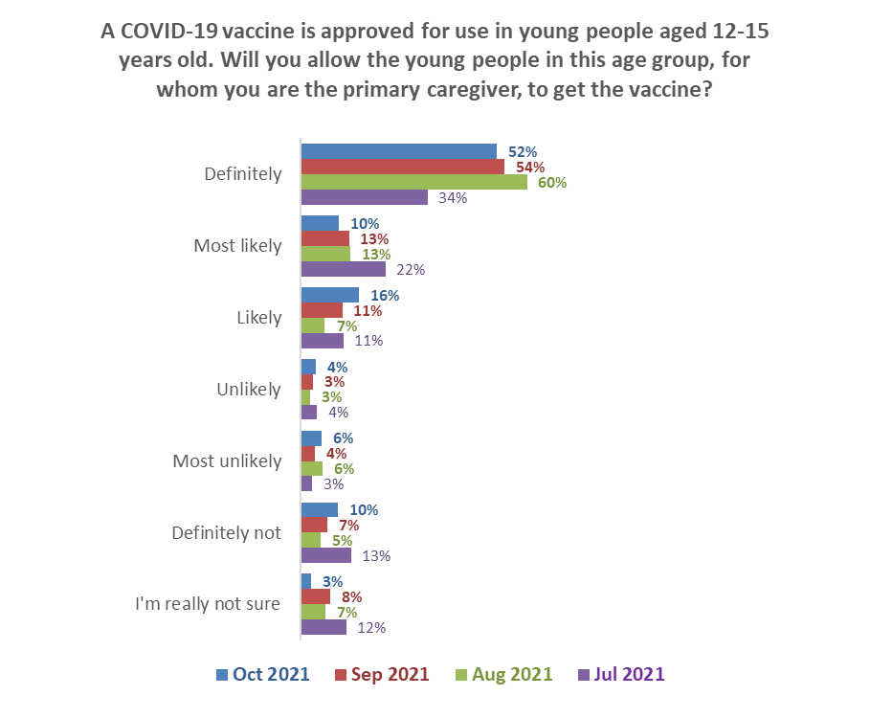Base: Caregivers for unvaccinated 12 to 15 year-olds:
Unlikely
Oct 2021 10%; Sep 2021 7%
Aug 2021 9%; Jul 2021 7%
Definitely & likely
October 2021 78%
September 2021 78% August 2021 79%
July 2021 67%
October n=181, September n=326, August 2021 n=315, July n=310

Caregivers of 5 to 11 year-olds.
A COVID-19 vaccine has not been approved for use with children aged 5 to 11 years. However, a question was asked in the September and October surveys to gain an indication of the likely uptake if a COVID-19 vaccine were to be approved.

As shown in the following chart, 68% overall of caregivers of 5- to 11-year-olds would allow their child or children to get a COVID-19 vaccine (September, 63%).

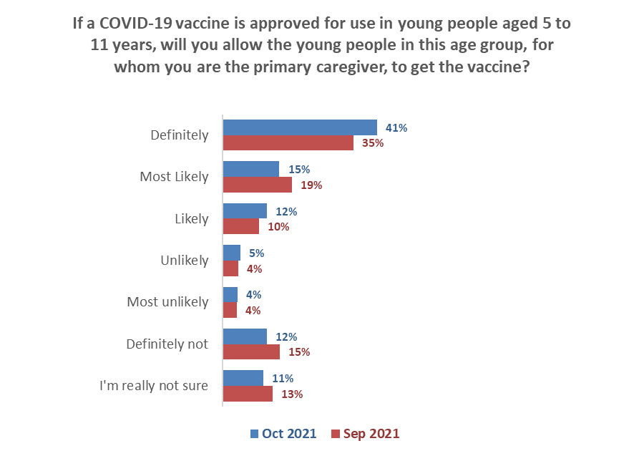
Unlikely
October 9%
September 8%
Definitely & likely
October 68%
September 63%
Base: Caregivers for all 5 to 11 year -olds: October 2021 n=322; September 2021, n=446.

Estimating the number of children likely to get a COVID-19 vaccine
Overall, it is estimated that caregivers would allow around 64% of their currently unvaccinated 12- to 15-year-olds and 72% of their 5- to 11-year-olds to get a vaccine This is calculated as follows (figures are rounded to the nearest 10):

 | 12 to 15 year-olds | 5 to 11 year-olds
Average number overall per caregiver | 1.62 | 1.66
Unvaccinated, not booked population estimate | 42,300 | 476,300
Estimated number of caregivers | 26,400 | 287,000
Percent of caregivers allowing vaccination | 77.5% | 68.3%
Number of caregivers allowing vaccination | 20,400 | 196,000
Average young people per caregiver allowing vaccination | 1.32 | 1.76
Estimated number of children allowed to get vaccine or already vaccinated | 27,000 | 344,800
Percent of unvaccinated in age groups | 64% | 72%

The difference between the two age groups is probably related to the fact that 84%¹⁴ of 12 to 15 year-olds are already vaccinated.

Caregiver ethnic groups except for NZ European/Pākehā are relatively small and figures by ethnic group are indicators. Note that, indicatively, 92% of Māori caregivers would now allow their 12 to 15 year-olds to get a vaccine, up from 73% in September.

Will you allow the young people for whom you are the primary caregiver, to get the vaccine? | ETHNIC GROUP
 | Asian | Indian | Māori | NZ European/ Pākehā | Other European | Pasifika * | Other *
Unvaccinated 12 to 15 year-olds
Would allow | 89%* | 51%* | 92% | 79% | 89%* | 88% | 100%
Would not allow | 11%* | 49%* | 7% | 18% | 11%* | 2% | 0%
Not sure | 0% | 0% | 1% | 3% | 0% | 10% | 0%
5 to 11 year-olds
Would allow | 67% | 87% | 51% | 68% | 60% | 90% | 71%
Would not allow | 22% | 6% | 28% | 23% | 28% | 3% | 3%
Not sure | 11% | 8% | 21% | 9% | 12% | 7% | 26%
Base: caregivers for unvaccinated 12 to 15 year-olds | 13 | 14 | 32 | 123 | 15 | 8 | 5
Base – caregivers for 5 to 11 year-olds | 27 | 31 | 35 | 223 | 20 | 6 | 12
* Indication only; small base

- Barriers to COVID-19 vaccination

4.1 Reasons for being unsure or unlikely to get vaccinated
Those who were not vaccinated and were unsure, unlikely to get vaccinated, or would definitely not get vaccinated, were asked an open-ended question: “You say you are unsure or are unlikely to take a COVID-19 vaccine if one were offered. Can you tell us in your own words why that is?”

181 people responded to this question, with their main responses being:
- Long term effects are not known/ it’s just an experiment or trial (27%).
- The government wants to control/bully us into getting the vaccine/I don't trust the government (20%).
- There are serious side effects/deaths from the vaccine – it is not safe/its effects are worse than COVID/it’s a poison (20%).

Compared with previous surveys, those who are unsure, unlikely to or definitely would not get vaccinated have become more negative about being vaccinated. Reflecting this change, the following responses each increased 7% compared with the September results:

- The government wants to control/bully us into getting the vaccine/I don't trust the government (now in second place).
- It’s not a real vaccine. I want a real/traditional vaccine.
- I don't trust the vaccine/ don’t trust Pfizer or 'big pharma'.
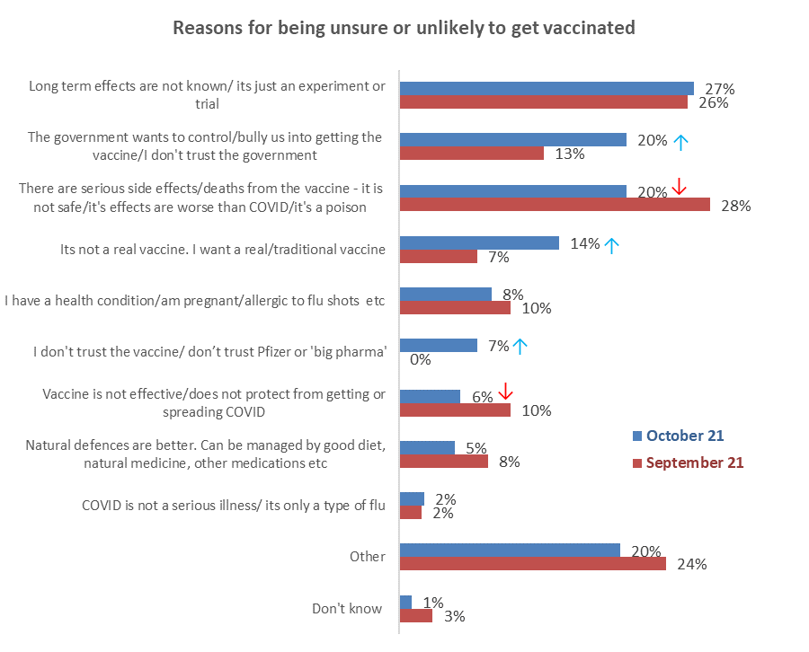
Base: not vaccinated, unsure, unlikely to or definitely won’t get vaccinated;
October 2021 n=181: September 2021 n=143 responses

Respondents’ comments illustrating the main reasons for being unsure or unlikely to take the vaccine include:

Long term effects are not known/ it’s just an experiment or trial
Because it is a trial medication, that has lots of adverse reactions, many of what are not known yet also Pfizer has and does not give the full details of what is in the experimental jab. (Female, Aged 55-64 years).
Because it is still not sure if the vaccine is safe to take. It hasn't been tested enough. (Female, Aged 65-74 years).
Because the jab is more dangerous than the virus and is a new experimental technology not a true vaccine, if it was a true vaccine then the jab would make the jabbed immune to the virus, but of course we know it doesn’t. (Female, Aged 55-64 years).
Because there is not sufficient data on the long-term implications of such a rushed vaccine. (Female, Aged 25-34 years).
Experimental gene therapy. Not a traditional vaccine. Serious side effects in the short term (including death) and unknown long-term effects. Does not prevent infection. (Female, Aged 55-64 years).
I do not feel confident getting the vaccine is the best thing I can do for my health long term, until the long-term effects of the vaccine are known (Female, Aged 55-64 years).

The government wants to control/bully us into getting the vaccine/I don't trust the government
Because Jacinda is a b**** and I don't believe a word that she says. They won't offer another vax even though the government has purchased other vax to take. (Female, Aged 35-44 years).
The side effects and deaths are becoming more evident, but are censored by media and government attempts at blocking information that contradicts their narrative. (Male, Aged 18-24 years).
Because I made my choice based on the OBVIOUS fact that something is seriously wrong with everything that is COVID. There is only one view allowed and all others are shut down along with any opposing view whatsoever even when opposing views come from highly qualified scientists. (Male, Aged 55-64 years).
Because the government is not telling the whole truth to enable me to make a considered judgement as to safety vs risks. (Male, Aged 75 years or over).
Don't believe the hype. It’s simply a mind control game where the rules are made up and broken to suit the leftist government. I went to two protests in Auckland in the weekend and numbers were far higher than reported by the Herald. PM previously said vaccinations would not be compulsory, and soon they will be for 40% of workers. (Male, Aged 55-64 years).
Don't like the Government telling me what to do. (Male, Aged 55-64 years).

There are serious side effects/deaths from the vaccine - it is not safe/its effects are worse than COVID/it’s a poison
I have three friends who have had adverse reactions to the vaccine. One with clots in both lungs, another with heart complications and swollen lymph nodes. I do not trust that it is safe, and I do not feel that the benefit outweighs the risk. If it actually did stop me catching COVID and transmitting COVID I would take the risk. (Female, Aged 25-34 years).
I’m not putting that poison in my body. (Male, Aged 65-74 years).
It may be more harmful to my health. (Female, Aged 25-34 years).
It’s unnecessary and very dangerous. I personally know people who have died of it. (Female, Aged 65-74 years).
The gene jab has no health benefit whatsoever and heaps of potential future negative health outcomes, so it makes absolutely zero sense. Logic says one would be foolish to buy into the dogma. (Male, Aged 75 years or over).
The vaccine is not going to help with COVID 19 its going to kill you faster. If I got the virus, I will die free, f*** you, government. (Another Gender, Aged 75 years or over).

It’s not a real vaccine. I want a real/traditional vaccine
Because it’s not a vaccine and you still catch COVID, It’s just an anti-viral medication which gives you no immunity from infection, just little or no symptoms if you’re lucky. (Male, Aged 55-64 years).
Due to the lack of vaccine options, I do not want to get the Pfizer vaccine and also, I am against it because the Govt is threatening me with my freedoms and that’s not okay. (Female, Aged 18-24 years).
I do not want to get the Pfizer vaccine - NZ needs to offer other vaccines that people are more comfortable with now rather than next year. (Female, Aged 18-24 years).
I do not wish to get an mRNA vaccine. I am waiting for an Inactivated virus vaccine (made the old school way). It is not right that NZ only offers one vaccine, where is the freedom of choice? It is also not right that the vaccine has been made mandatory for some sectors too. (Female, Aged 35-44 years).

I have a health condition/am pregnant/allergic to flu shots etc.
Because I have no interest in possibly making my pre-existing condition worse. The fear porn Cindy and her associated fuckwits are putting out is far more dangerous to people's mental health than the China virus ever will be. (Male, Aged 35-44 years).
Have only ever had 1 vaccination and that was the flu in March 2020 and was ill for 7 days. (Female, Aged 75 years or over).
I have underlying health issues; I don't believe that the vaccine has been tested properly as I know of two people personally who have died and had blood clots respectively. (Female, Aged 45-54 years).
My doctor has told me I am unwise to take the vaccine because of severe adverse reactions to smallpox, polio, etc. So, it is highly unlikely that I will get vaccinated. (Another Gender, Aged 65-74 years).
My health is bad enough and since I cannot risk it I will not get it. I also do not trust the makers of it (Female, Aged 45-54 years).
Don't trust the vaccine/ don’t trust Pfizer or 'big pharma'
Zero trust in it (Male, Aged 25-34 years).
Pfizer are an evil empire built on greed (Male, Aged 55-64 years).
Lack of trust in the product (Female, Aged 45-54 years).
It is made by Pfizer. Pfizer is a very evil company, and it has used Nigerians as guinea pigs for their drug Trovan, and it has done lots of unethical things in the past. I do not want to support this terrible company by taking their vaccine (Male, Aged 18-24 years).
It feels like pharmaceutical corporations are forcing their products on governments, using fear tactics and all the usual corporate might. The efficacy of the vaccines is reportedly waning, with booster shots now being required or recommended overseas. It seems that the pharmaceutical corporates will lock governments into contracts that require regular booster shots - because viruses naturally mutate - and I can see a scenario where people are required to have a booster every six months or a year. It feels like this is more driven by profit motives than by health (Female, Aged 55-64 years).
Vaccine is not effective/does not protect from getting or spreading COVID
The vaccine doesn't work. (Male, Aged 55-64 years).
because vaccine is not warranty that I can’t be infected. (Male, Aged 65-74 years).
Because people who have been vaccine are the one getting COVID. (Female, Aged 45-54 years).
Because I will not be forced to take something that will make no difference to how life is lived. I can still catch the virus and I still have to wear a mask so there is no point in the vaccine when the next variant comes around what then? (Male, Aged 25-34 years).

Natural defences are better. Can be managed by good diet, natural medicine, other medications etc
My body has always been strong and healthy, never have flu jabs, never sick, have donated blood 29 times. That’s how I will live the rest of my life. (Male, Aged 65-74 years).
Don't see any reason why I should take this vaccine. Never been to hospital for any sickness. (Female, Aged Under 18 years).
My immune system is all I need. (Female, Aged 45-54 years).
I don't feel its a permanent solution to the pandemic due to waning antibodies and risk of spread with delta even if vaccinated. I have no risk factors or comorbidities and some emerging research is revealing that natural infection may be better for future variants. (Female, Aged 25-34 years).
Because I am 75 very healthy, take supplements including Vit D, C and zinc. I am very careful about not being indoors in confined spaces. (Female, Aged 75 years or over).

COVID is not a serious illness/ its only a type of flu
Problem is this COVID bug is basically a flu, yes it can kill, but most unlikely to. Time for folk to be clear and rational thinking and not influenced by the scare mongering of media and government. (Male, Aged 65-74 years).
Don't need a vax to protect me from a virus that won't kill me. (Male, Aged 45-54 years).

Other
As an organic farmer I am not permitted to vaccinate my animals with a GE vaccine so why would I consider injecting myself? (Female, Aged 65-74 years).
Getting two opposing points of view. I need to talk to someone who is both knowledgeable and neutral. (Female, Aged 55-64 years).
Hate needles. (Male, Aged 45-54 years).
I don’t want it, but the law says I have to or lose my job. (Female, Aged 55-64 years).
I have to talk to my doctor first. (Female, Aged 45-54 years).
I will only get the jab if my employer threatens to fire me. (Male, Aged 45-54 years).
It is my choice - freedom of choice. (Female, Aged 65-74 years).
It’s a political weapon being used by China and the more vaccinated is only helping to spread it. (Male, Aged 25-34 years).

4.2 Perceived medical or health conditions
Those who had not been vaccinated were asked if they believe that medical or other health-related conditions mean they are not able to get a COVID-19 vaccine.
As the number of unvaccinated people drops, the percentage of those who believe that health conditions or medical reasons prevent them getting vaccinated has increased: the October figure is around a quarter of those not vaccinated (24%, an estimated 97,500 people 16+) compared with 19% in September. Converting that to numbers of the unvaccinated population shows that despite the percentage increase, there are now 17,300 fewer people, in comparison with September 2021, who believe this. | 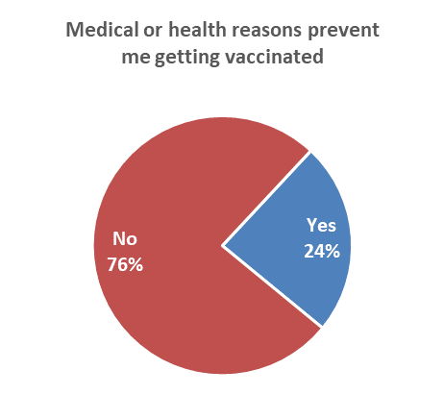  Base: not vaccinated n=245

Demographic groups who are more likely to say that medical or other health-related conditions mean they are unable to get a vaccine:

Living with an impairment or long-term health condition | 49% ↑
From a large city (e.g., Auckland, Hamilton, Tauranga, Wellington, Christchurch, Dunedin) | 32% ↑
From Auckland | 29% ↑

Sub-samples were generally too small to enable reliable cross-analysis of the above result for other demographic groups.

Health or medical conditions that prevent people being vaccinated (multiple responses allowed):
I am immunocompromised | 33% | Other health conditions mentioned:  - Heart disease 6%  - Allergies 4%  - Immune disorders 4%  - Fibromyalgia, Recent stroke, Adrenal issues, Anxiety, Lung disease – all 1 response only (2%)  - No comment or no conditions mentioned 26%
I am taking blood-thinning medication | 23%
I have had an allergic reaction to any vaccine | 22%
I am getting other vaccines | 14%
I am taking antibiotics | 7%
I have cancer | 7%
I am unwell or have a fever | 6%
I am pregnant, trying to have a baby, or breastfeeding | 2%
I am getting tested for COVID-19 or have had COVID-19 | 1%
I am having a CT scan or mammogram | 1%
I have HIV | 0%
Another health condition | 42%
Base Believe that medical or other health conditions mean that they are unable to get a vaccine n=54

All of the 6% who said they were unwell or had a fever were “Unsure” about getting vaccinated and all were not sure whether they would eventually get a COVID-19 vaccine.

Other reasons include the following:

Worried about side effects
I'm worried about side effects from the second dose but also the overall long-term effects much later down the track. I'm comfortable having one dose and wearing a mask and washing regularly and avoiding indoor gatherings to protect me and my children. My husband has had two doses though.
Worried about side effects of the second dose.
I'm concerned about the vaccine, side effects and efficacy.

I wish to wait longer than three weeks
I believe 6-8 weeks is better than the 3-week minimum, I also think that most of the benefit for me has come from the first dose. I will still get a second dose at 6-8 weeks unless there is a big change in the evidence or other circumstances.
I am getting my second dose, but it is eight weeks on from the first, as has been recommended.
Will get it after 12 weeks spacing to get maximum antibodies.

Resistance to government pressure
The Government is becoming authoritarian about this and trying to force us into vaccination instead of it being our own choice.
I'm not in favour of the way that the Government is FORCING me to have the vaccine. They claim that it is voluntary, yeah sure if you want to be a leper and cast out from society and treated as both a threat and as a problem and continually criticised and condemned for not being vaccinated. I get enough of that for merely being a male. We were never a team of any kind, let alone one of five million, what a total joke that is.

Vaccine is not safe
It’s not proven to be safe.
It’s not fully tested or fully approved by Medsafe, so how do we really know it’s safe?

Logistics
They closed the place where I got the first one, way out of the way for the alternative centre.

Worried about needles
Fear of needles.

My health condition
I have ME and it may worsen my condition.

4.3 Factors holding back the unvaccinated
Those who were not vaccinated were asked to select factors which they felt were holding them back, if any. Multiple selections were allowed.

While just under four out of ten respondents (38%) said that none of the things listed were holding them back, six out of ten selected at least one factor.

The top five responses all relate to being pressured and feeling anxious and overwhelmed. They are in the same order as for the October COVID-19 vaccine survey of Māori, but at a slightly lower level:

- There's too much social pressure to get vaccinated (33%).
- I'm under enough pressure coping with everyday life to think about getting the vaccine (14%).
- I'm feeling overwhelmed by the pandemic (12%).
- I'm feeling too anxious about the pandemic and the vaccine (9%).
- I'm feeling paralysed because I haven't been able to find the information that I want on the vaccine (7%).
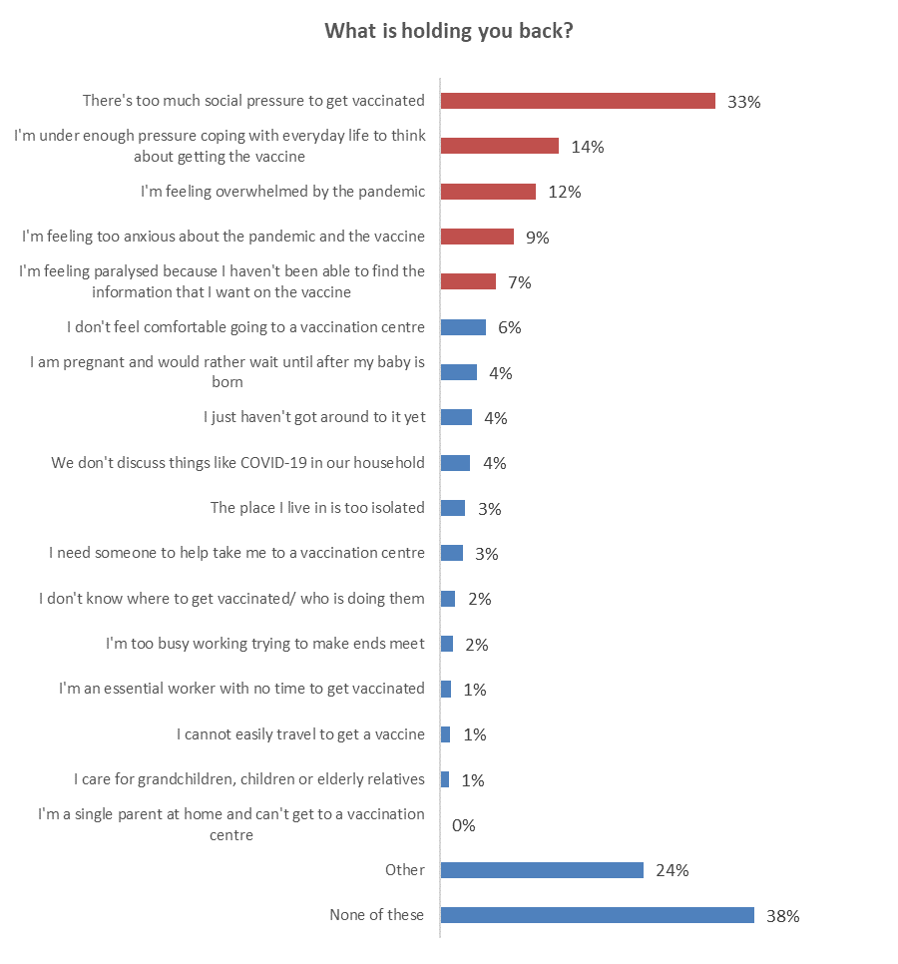
Emotive responses – feeling pressured and overwhelmed
Base: not vaccinated n=230

The top 5 things holding back the various groups among the unvaccinated are (indicatively, because the bases are small):

- Booked (n=24):
  - I’m feeling overwhelmed by the pandemic (24%).
  - We don't discuss things like COVID-19 in our household (18%).
  - I’m under enough pressure coping with everyday life to think about getting the vaccine (15%).
  - There’s too much social pressure to get vaccinated (15%).
  - I'm feeling too anxious about the pandemic and the vaccine (13%).

Note, 13% indicated that they need someone to help take them to a vaccination centre.

- Likely to get vaccinated but not booked (n=30):
  - There’s too much social pressure to get vaccinated (28%).
  - I don't feel comfortable going to a vaccination centre (21%).
  - I just haven't got around to it yet (17%).
  - I'm feeling too anxious about the pandemic and the vaccine (14%).
  - I'm feeling paralysed because I haven't been able to find the information that I want on the vaccine (12%).

- Unsure whether to get a vaccine: (n=37):
  - There’s too much social pressure to get vaccinated (38%).
  - I'm feeling paralysed because I haven't been able to find the information that I want on the vaccine (21%).
  - I’m under enough pressure coping with everyday life to think about getting the vaccine (20%).
  - I'm feeling too anxious about the pandemic and the vaccine (17%).
  - I’m feeling overwhelmed by the pandemic (13%).

These are the same top 5 as for the “unsure” group in the October survey of Māori.

- Unlikely to get vaccinated (n=41) (these people have only 4 reasons at 10% or more):
  - There’s too much social pressure to get vaccinated (58%).
  - I’m under enough pressure coping with everyday life to think about getting the vaccine (27%).
  - I'm feeling too anxious about the pandemic and the vaccine (13%).
  - I’m feeling overwhelmed by the pandemic (10%).

These reasons are included in the reasons listed for the “unsure” group, as in the October survey of Māori:
- Definitely won’t get a vaccine (n=98) (these percentages are much smaller because 54% of this group said that none of the options were holding them back. Only 3 reasons are over 5%):
  - There’s too much social pressure to get vaccinated (28%).
  - I’m under enough pressure coping with everyday life to think about getting the vaccine (9%).
  - I’m feeling overwhelmed by the pandemic (8%).

Profiles: “Too much social pressure”, “Under pressure coping with everyday life”, and “Feeling overwhelmed by the pandemic”
The following table shows demographic characteristics of those who said “There's too much social pressure to get vaccinated”, “I'm under enough pressure coping with everyday life to think about getting the vaccine” and “I'm feeling overwhelmed by the pandemic”. These were the only three answers for which there were sufficient respondents to be able to create indicative profiles. There is some commonality between these three groups.

DEMOGRAPHY | There's too much social pressure to get vaccinated | I'm under enough pressure coping with everyday life to think about getting the vaccine | I'm feeling overwhelmed by the pandemic
Gender | More female (57%) than average | More female (76%) than average | More female (74%) than average
Age | Average age | 19% younger than average age. 71% are under 45 years of age. | 21% younger than average age: 81% are under 45 years of age.
Household Income | 20% lower than average | 26% lower than average | 34% lower than average
Personal Income | Average personal income. | 6% lower than average | 13% lower than average
Employment status | Average rate of employment | Average rate of employment | Slightly higher than average (72% employed)
Highest qualification | More likely than average to have high school level qualifications. | More likely than average to have high school level qualifications. | More likely than average to have high school level qualifications.
Household Type | Less likely than average to be in a one-parent household. | No particular characteristics. | Less likely than average to be in a one-parent household.  More likely than average to have children in the household,
DHB | No particular characteristics. | No particular characteristics. | No particular characteristics.
Area type | More likely than average to be in a regional town. | No particular area type characteristics. | Less likely than average to be in a regional city.

In general, people in each of these groups have below average response to any of the messaging or activities measured.

4.4 Misinformation
All respondents were asked if they had come across what they believed to be misinformation about COVID-19 vaccines in the past 30 days.

The proportion of all people who had noticed misinformation about the vaccines is much the same as in the September survey – around six out of ten people (57%).
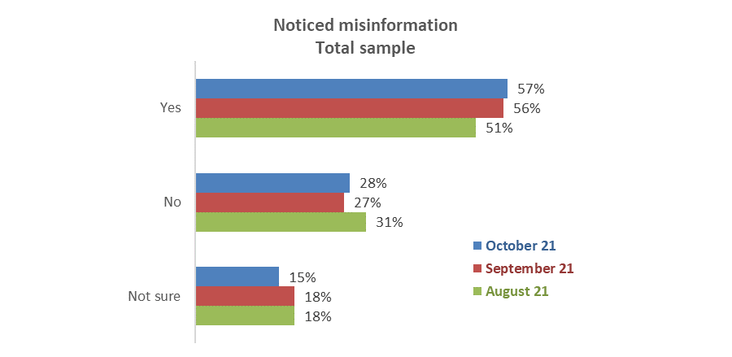
Base: all respondents: October n=2,389, September n=2,479, August n=2,334

In the latest survey those who had not been vaccinated have a similar level of noticing misinformation as the general population (53% of unvaccinated people cf. 57% of the overall population).
The proportion of unvaccinated people who noticed misinformation increased from 42% in September to 53% in October.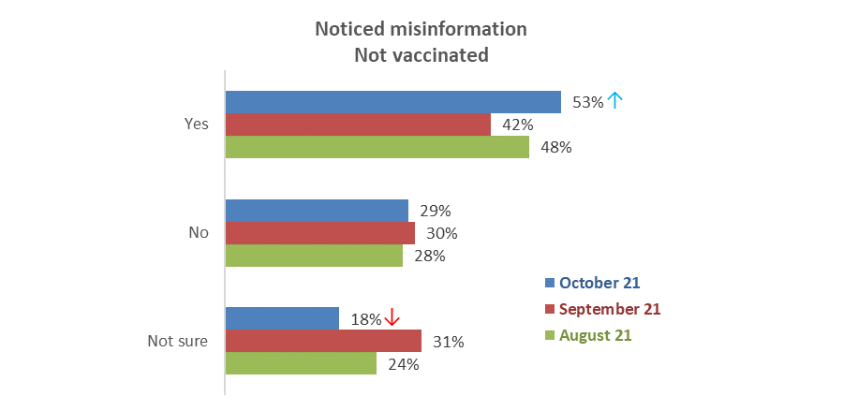
Base not vaccinated October n=222, September n=414, August n=1,044

Sources of misinformation
All those who said they had noticed misinformation in the past 30 days were asked to select where they had seen it from a list of possible sources. They could select more than one option.

As in the previous survey wave, social media was the main source of misinformation, mentioned by around seven out of ten people who noticed misinformation. Closed social media groups (a new response option in October) is mentioned by 12% of the total.

Where comparable, survey results are similar to September's.

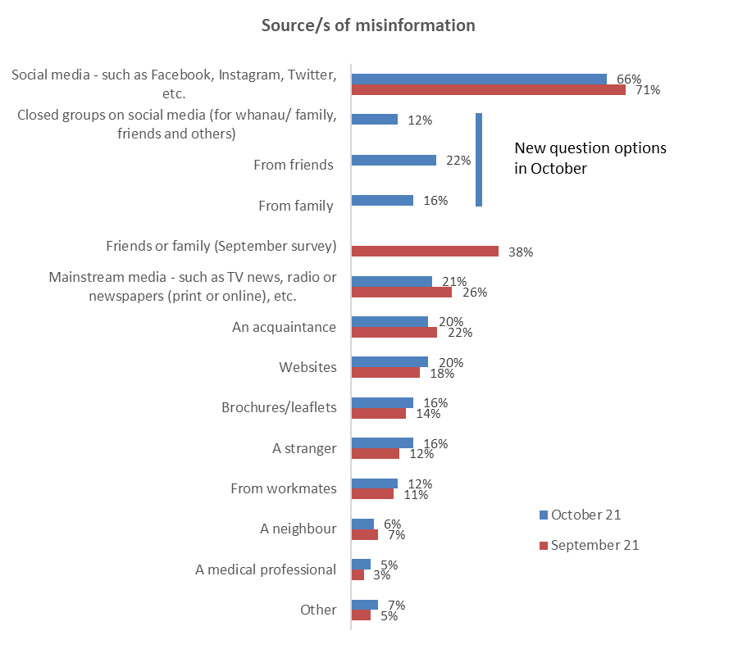
Base: noticed misinformation October 1,406, September n=1,459

What made people think it was misinformation?
As in the September survey, an open-ended question was asked of the 1,406 people who noticed something in the past 30 days that they felt was untrue about the COVID-19 vaccine. In total, 1,335 people responded to this question; of these, 111 answers were from unvaccinated people.

Key themes and illustrative comments follow. These comments are all from unvaccinated people as they are the main target group who will potentially be the most affected by misinformation. It was clear that many of this group consider misinformation to be from the government.

Key misinformation themes:

‘Anti-vax’ views are not credible (minority of comments from unvaccinated people)
Crazy stuff like 5G.
I knew what the person was saying was not true, she was trying to say there was lung tissue from an aborted foetus in the vaccine.
I studied up on them and some appeared completely like a load of rubbish e.g. from a member of a group I belong to saying that if you drink 4 cups of pine needle tea a day you will be ok!
Just antivax posts via TikTok.
They were saying silly things like tracing chip in the vaccine.

Official/government information is not believable/ has a sinister motive etc (majority of comments from the unvaccinated are that disinformation is coming from the government)
Because it is being constantly repeated: vaccinate or else lose your job/freedoms. The mainstream narrative is misinformation to me. I have done my own research and made this conclusion.
Everything that comes from the one source of truth i.e., our corrupt administration is all miss- information.
I am well read and literate and have a science background. The governments agenda has nothing to do with truth.
Its NZ Herald, its The Spinoff, its NewsHub. They are all trash reporting political propaganda to coerce us into falling into the line of the new upcoming bullshit regime.
Doctors and scientists speaking out, risking their career, money, reputation to counter the mainstream narrative. That's how I know we have been given misinformation.
All messaging from the government is one-sided and ignoring any emerging science and statistics around the world that don’t favour the vaccine.
Because it came from the government and conflicts with mainstream science.
Because it is just parroting the government slant without any thought or looking at the opposite views.
Because Jacinda’s lips moved and her head nodded funny, and the way she scratches her face.
Because the jab is a killer and you are trying to kill us and bring everyone in line like what was done to the Jews. Wake up - are you all so blind?
Because there is absolutely no mention in media about adverse effects of vaccines despite thousands of people posting on Jacinda's FB page - she just deleted them. There are deaths and serious rises in myocarditis, herpes and other illnesses while surgeries have been delayed. Cancer is on the up because of no treatments and suicide levels in teens is through the roof.
Because they are withholding all negative information and controlling media so no New Zealanders can make a truly informed decision.
There is no healthy debate of both sides. I do not trust a government that claims to be the "single source of truth".

Effects of misinformation
Respondents who had not had a COVID-19 vaccine and had seen misinformation were asked whether their decision to take or not take a COVID-19 vaccine would be influenced by the misinformation they noticed.
Two responses increased significantly compared with the September survey:
- I would look for official information if something I initially thought was misinformation about COVID-19 vaccines concerned me (45% cf. 36% in September).
- I would not take a vaccine if something I initially thought was misinformation, and against COVID-19 vaccines, looked credible (30% cf. 19%).

Overall, a nett 47% of respondents who had not had a COVID-19 vaccine and had seen misinformation said they would not get a COVID-19 vaccine if something they initially thought was misinformation either alarmed them or looked credible. Of these, 26% would look for official information; 74% would not.

Indications are that something respondents initially thought was misinformation and either alarmed them or looked credible could cause the following people to not get a vaccine:
- Around 4 out of 10 of those booked.
- Around a quarter of those who are not vaccinated but are likely to get a vaccine.
- Just under 2 out of 10 of those who are unsure whether to get a vaccine or not.
- 5 out of 10 of those who are not vaccinated and are unlikely to get a vaccine.
- 5 out of 8 of those who are not vaccinated and say they definitely won’t get a COVID-19 vaccine.

Note: The sub-sample size is now too small to allow further cross-analysis.

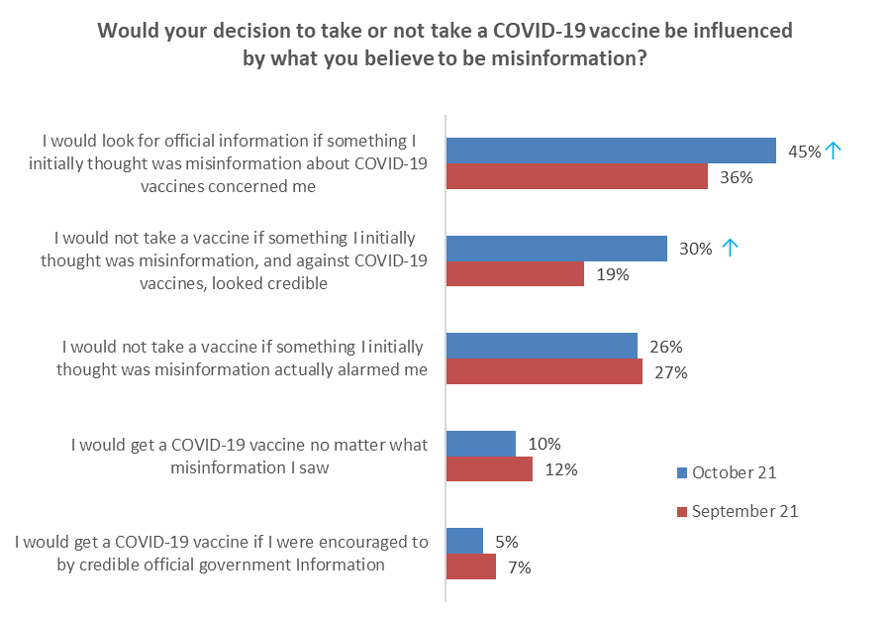
Base: not vaccinated and noticed misinformation in the last 30 days September n=153, October n=103

- Where to get the COVID-19 vaccine
Respondents who were not vaccinated were asked if they knew where to go if they decided to get vaccinated. Most unvaccinated people (86%) know where to go.

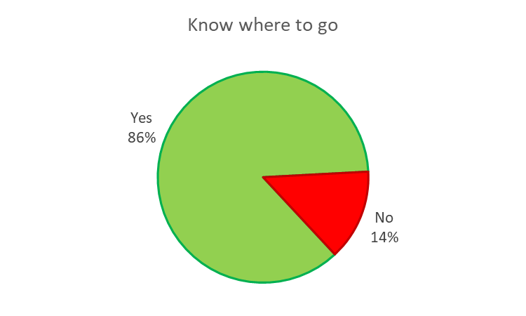
Base not vaccinated n=218.

There are no significant differences by any of the demographics we measure.

Respondents who were not vaccinated were asked where they would feel most comfortable getting a vaccine. Going to their own doctor is most preferred (46%).

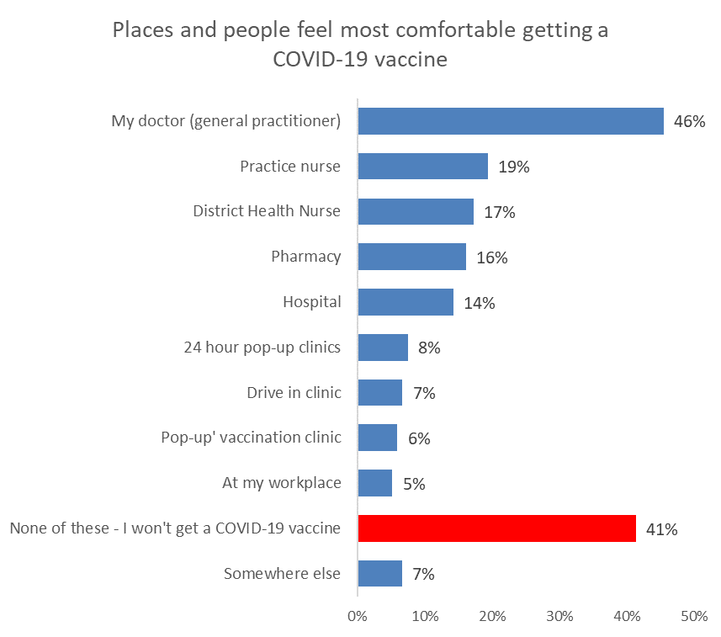
Base: not vaccinated of n=219

Unvaccinated people who are “unsure” whether they will eventually get vaccinated (36 respondents) say they would feel most comfortable with their doctor (71%), a practice nurse (42%) or a district health nurse (40%).

- Incremental gains, including gains from potential messaging

6.1 Will people who are unsure about being vaccinated eventually get vaccinated?

Respondents who were not vaccinated and were not “definitely” going to get the vaccine were asked ‘’Do you think you'll eventually decide to actually get vaccinated or not?”

The percentage who said they would eventually get vaccinated halved in comparison with September. There was a corresponding increase in the percentage who said they would not eventually get vaccinated.

The “unsure” group dropped 9%, suggesting that as the unvaccinated group shrinks, those who remain unvaccinated are those who are more definite (or “staunch”) in their opposition to getting vaccinated.

Base: not vaccinated, not "definitely" getting a vaccine October 2021 n=230, September n=368.

Groups who are more likely to give each response:

Will you eventually get vaccinated? | More likely
‘Yes’ (total 14%) | Personal income $50,001-$70,000  Aged 25 to 44 | 36%  26%
‘Unsure’ (total 42%) | Live rurally but not remotely  Aged 55 to 64  Live in a large city | 58%  57%  53%
‘No’ (total 45%) | Aged 45 to 54  In a couple-only household  Male | 51%  55%  49%
Results only shown for groups of at least 30 respondents

Respondents who were already likely to get a vaccine and answered "Yes", when asked if
they thought they would eventually get a vaccine, do not represent an incremental gain in the “Likely to get a vaccine” group as they are already counted in that group. However, where they said “No”, that is an incremental loss for the group.

That incremental loss is estimated at 0.3% of the overall 16+ population (September 0.3%, August 0.1%, July 0.3%), or around 10,700 people.

Respondents who were unsure whether to get a vaccine, or were unlikely to do so, and answered "Yes", when asked if they thought they would eventually get a vaccine, represent an incremental gain in the “Likely to get a vaccine” group as they are not already counted in that group.

The incremental gain from the “unsure or unlikely” group is estimated at 0.4% of the overall 16+ population (September 1.36%, August 2.0%, July 2.8%), or around 15,800 people. Nearly 6 out of 10 of these are likely to come from those who are currently unsure whether to get a vaccine or not.

Subtracting the incremental loss from the incremental gain gives a nett incremental gain of 0.1% of the 16+ population, or around 5,100 people (September 1.3%).

Potential for larger gains
Larger potential numbers are found among the respondents who, when asked if they would eventually get a vaccine, said they were unsure. Similar analysis to that note above shows that:
- There is a potential loss among those who are currently likely to get a vaccine of 0.7% - an estimated 26,500 people 16+.
- There is a potential gain of 3.2% from those who are currently unsure or unlikely to get a vaccine – an estimated 127,600 people 16+.
- Nett potential gain is 101,100 people or 2.6% of the 16+ population.

6.2 Motivations to get the COVID-19 vaccine
Respondents who were not vaccinated were asked to select from a list of reasons that would make them more likely to get a COVID-19 vaccine.
Over half of people who are not vaccinated said they would not get vaccinated for any of the reasons presented to them (54%).
This is much higher for those who “definitely won’t” get vaccinated (90% - that is, there is basically no reason listed that would change their mind). Those unsure would potentially get it to protect their own health (52%), to ensure hospitals are not overwhelmed (31%) and to ensure hospital and other routine medical care can continue (28%).
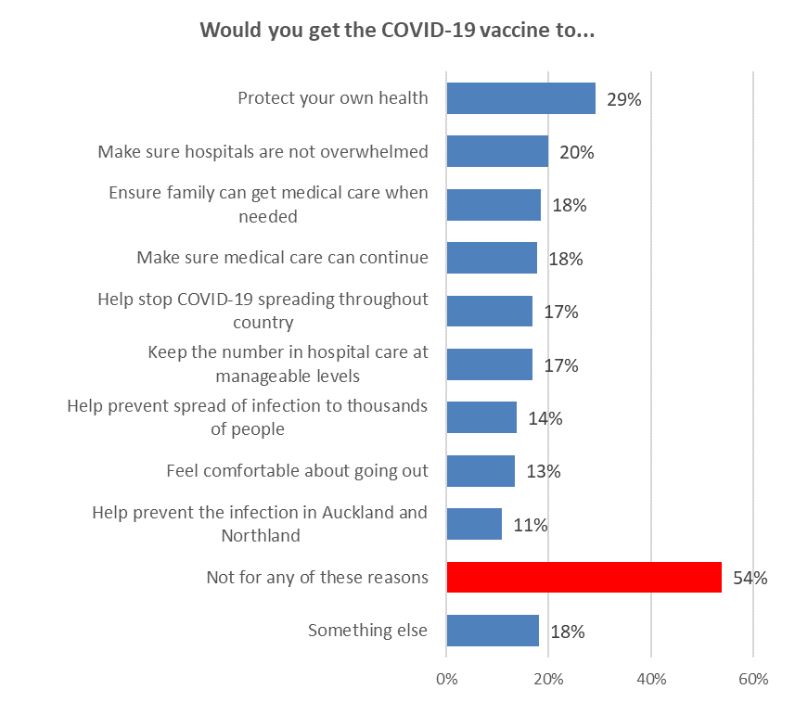
Base not vaccinated n=225

The resistance to vaccination (response selected was “Not for any of these reasons”) gets higher in the older age groups who are not vaccinated - 65% of those 55 to 64 years, 81% of those 65 to 74 years, and 82% of those over 75 years. These were age groups that were given priority earlier in the vaccination programme.
All these messages have strong incremental effect across those who are not vaccinated, especially the unsure and those likely to get a vaccine but not yet definite. A summary of the overall effect is shown in the table below.

Note that “keeping the number of people needing intensive and other hospital care at manageable levels”, “make sure hospitals are not overwhelmed”, “making sure hospital and other routine medical care can continue” are the most effective messages for those currently unlikely to get a vaccine.

Those messages, plus “helping stop COVID-19 spreading throughout Aotearoa New Zealand” and “making sure you and your family can get hospital and other medical care when you need it” are the most effective at shifting those already likely, but not “definite”, to “definite”.

Message | Likely to get a vaccine but not definite |  | Unlikely to get a vaccine |  | Definitely won't get a vaccine |  | Unsure
 | Incremental shift to "Definite" |  | Incremental gain |  | Incremental gain |  | Incremental gain
 | %  16+ popn | Estimated number | %  16+ popn | Estimated number | %  16+ popn | Estimated number | %  16+ popn | Estimated number
Help prevent the spread of infection to thousands of people | 0.3% | 12,500 | 0.2% | 7,000 | 0.1% | 4,300 | 0.3% | 10,400
Help prevent the infection of more than 5,300 people a week in Auckland and Northland | 0.1% | 5,200 | 0.1% | 3,800 | 0.1% | 4,300 | 0.3% | 10,400
Help stop COVID-19 spreading throughout Aotearoa New Zealand | 0.7% | 28,700 | 0.1% | 4,100 | 0.1% | 4,300 | 0.3% | 12,400
Keep the number of people needing intensive and other hospital care at manageable levels | 0.5% | 20,000 | 0.3% | 12,000 | 0.1% | 4,300 | 0.3% | 13,600
Make sure hospitals are not overwhelmed | 0.5% | 21,300 | 0.3% | 12,500 | 0.1% | 4,300 | 0.7% | 25,700
Make sure hospital and other routine medical care can continue | 0.4% | 15,900 | 0.4% | 14,200 | 0.1% | 4,300 | 0.6% | 23,600
So you can feel comfortable about going out | 0.3% | 12,300 | 0.2% | 8,100 | 0.1% | 4,300 | 0.4% | 14,900
Make sure you and your family, can get the hospital and other medical care when you need it | 0.7% | 26,900 | 0.2% | 8,100 | 0.1% | 4,300 | 0.5% | 19,500
Protect my own health | 0.9% | 33,800 | 0.5% | 18,900 | 0.1% | 4,700 | 1.1% | 43,000

6.3 Getting vaccinated against COVID-19 to go to work
Respondents who were not vaccinated were asked if they would get vaccinated to go to work.
Only 18% of those not currently vaccinated would be likely (or most likely or definitely) to get the vaccine to retain their job.
Of the unvaccinated respondents who are currently employed, 16% would get vaccinated to retain their job, 29% are unlikely to do so, and 39% would definitely not get a vaccine.
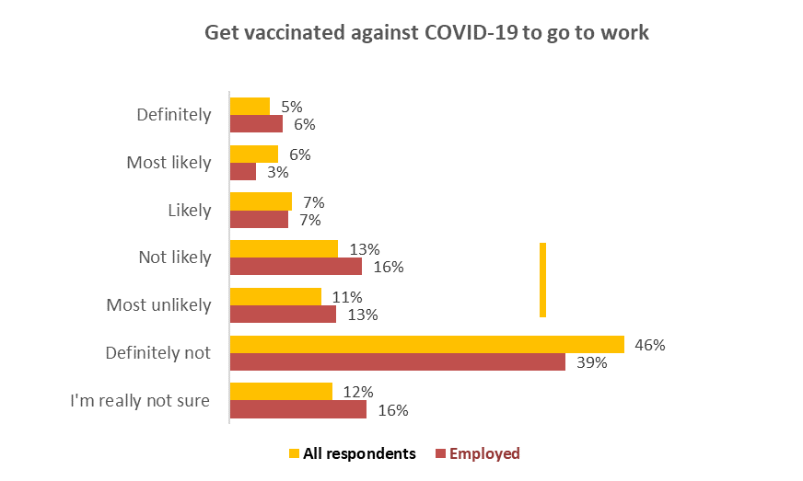
Unlikely
Overall 24%
Employed 29%
Likely
Overall 18%
Employed 16%
Base: not vaccinated n=219, not vaccinated, employed n=140

Getting vaccinated to go to work is likely to accelerate 20,400 people 16+ (0.5% of the 16+ population) who are already likely to get a vaccine.

The incremental gain from the unlikely group is around 0.03% of the 16+ population, or approximately 1,000 extra people. A similar result comes from those who are unsure. There is an increment of 0.1% or 4,400 people 16+ from those who currently say they will definitely not get a vaccine.

Those unlikely to get vaccinated to retain their job are more likely to be older. Over 55 years of age the total “likely” drops to 7% (from the overall of 18%).

6.3 Post-COVID-19 health problems
Unvaccinated respondents were told:
‘Experience with COVID-19 around the world indicates that many patients are suffering health problems six months after infection.

They are also at significantly greater risk of dying.

One study in the United States found that people who had been infected with COVID-19, and had recovered, had a 59% higher risk of dying within six months after contracting the virus: about 8 extra deaths per 1,000 patients. Many former COVID-19 patients require readmission, and some die, weeks after the COVID-19 viral infection abates.

Others suffer “long haul COVID”. This can leave them unwell, suffering from fatigue, aches and pains, “brain fog” and other conditions for long periods.’

They were asked whether, if they received this information, it would have any effect on their intention to get the vaccine. As a result of respondent feedback in the September survey, a “Neither more nor less likely” option was included in the semantic scale.

Overall, 19% of respondents said that this would make them more likely to get the vaccine. Indications are that these people were primarily those who are already likely to get vaccinated, although it may have some effect in making those currently unlikely to get vaccinated “slightly more likely”.

It has nil effect on those who currently say they will “definitely not” get vaccinated.

If you received information on post-COVID health problems, what effect would it have on your intention to get the vaccine? | All | Will you get the COVID-19 vaccine?
 |  | Defin-  itely | Most likely | Likely | Un-likely | Most unlikely | Defin-itely not | Not sure
Definitely more likely | 5% | 47% | 0% | 12% | 0% | 0% | 0% | 0%
Total more Likely | 19% | 50% | 43% | 43% | 43% | 10% | 0% | 17%
Definitely less likely | 22% | 0% | 5% | 1% | 0% | 6% | 52% | 2%
Total less likely | 27% | 3% | 5% | 10% | 15% | 20% | 55% | 3%
Not sure | 11% | 10% | 4% | 8% | 21% | 9% | 3% | 26%
Base not vaccinated | 237 | 10 | 10 | 33 | 16 | 27 | 100 | 41

Potential incremental gains are indicative because of the small sub-sample sizes. Receiving information on post-COVID health problems is likely to:
- Increase likelihood to get a vaccine among those who are currently likely to get a vaccine but not definite: 31,500 people 16_+ or 0.8% of the 16+ population.
- Make 15,800 people who are currently “unlikely” to get a vaccine “slightly” more likely to do so (0.4% of the 16+ population).
- Make 14,500 people who are currently “unsure” about whether to get a vaccine “slightly” more likely to do so (just under 0.4% of the 16+ population).

Indications are that this messaging would, in general, will have the greatest effect on those under 55 years of age. As in September, it also has more effect on those who are in paid employment than on those are not.

If you received in formation on post-COVID health problems, what effect would it have on your intention to get the vaccine? | AGE GROUP
 | 16-17 years | 18-24 years | 25-34 years | 35-44 years | 45-54 years | 55-64 years | 65-74 years | 75 years or over
Definitely more likely | 0% | 9% | 10% | 11% | 0% | 0% | 0% | 0%
Total more Likely | 65% | 26% | 24% | 19% | 22% | 11% | 5% | 0%
Definitely less likely | 0% | 0% | 13% | 16% | 28% | 20% | 54% | 36%
Total less likely | 35% | 7% | 18% | 16% | 33% | 26% | 56% | 41%
Not sure | 0% | 23% | 8% | 15% | 6% | 5% | 10% | 16%
Base not vaccinated | 4 | 18 | 43 | 31 | 34 | 55 | 38 | 4

Indications are that this messaging had more positive impact on Asian and Indian respondents, some positive impact on Pasifika and no positive impact on Māori.

6.4 Protecting others from COVID-19 and the Delta strain by getting vaccinated
Respondents who were not vaccinated were asked to select from a list who, if anyone, they would most like to protect from COVID-19 and the Delta strain by getting vaccinated.

45% selected at least one group whom they would most like to protect, led by elderly relatives (24%) and their parents (23%), the same top two as in September.

30% said they did not want to protect any of the groups listed and 25% said specifically that they would not get vaccinated to protect others.
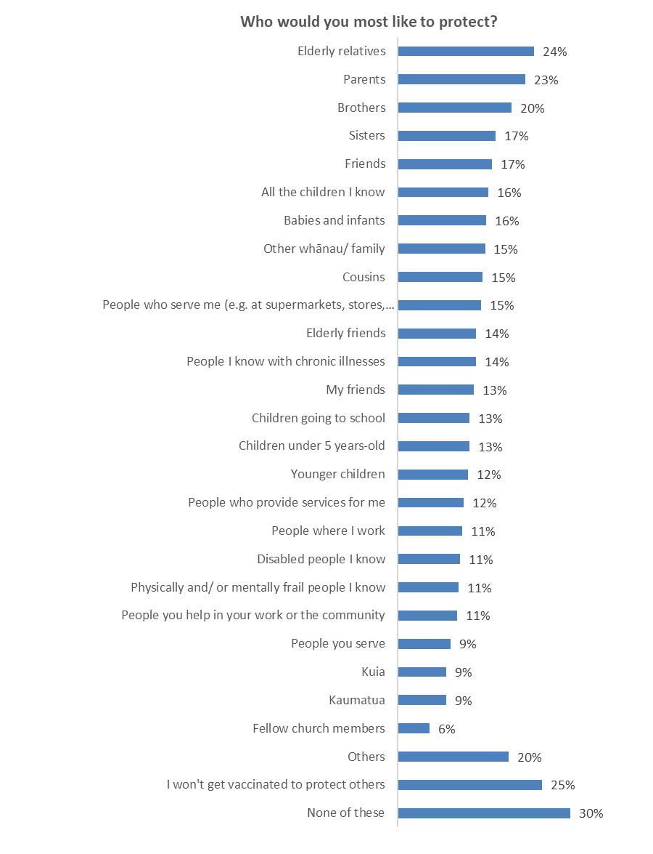
55% did not select anyone
Base: not vaccinated n=220

To assist with messaging/imaging, the top 5 for key groups are shown below. Note that the lists are indicative owing to the small sub-sample bases involved.
The unvaccinated who are already likely to get vaccinated are likely to be the most responsive to the argument to "get vaccinated to protect others".
  - In particular, those who are likely to get a vaccine want to protect:
  - Elderly relatives (42%).
  - Parents (39%).
  - Brothers (39%).
  - Friends (35%).
  - Sisters (35%).
- Those who are unsure would like to protect:
  - Elderly relatives (29%).
  - Parents (28%).
  - Brothers (24%).
  - Cousins (20%)
  - People they know with chronic illnesses (19%).
- Māori are most likely to want to protect:
  - Elderly relatives (24%)
  - Babies and infants (22%).
  - People they know with chronic illnesses (16%).
  - Other whānau/ family (15%).
  - Parents (13%).
- Pasifika are most likely to want to protect:
  - Parents (76%).
  - Elderly relatives (62%).
  - Sisters (62%).
  - Brothers (62%).
  - All the children they know (62%).
- People living in cities (both large and provincial cities) focus on:
  - Elderly relatives (24%).
  - Parents (23%).
  - Sisters (18%).
  - Friends (15%).
- People in regional towns place average importance on getting vaccinated to protect elderly relatives (33%) and parents (29%).
- People in rural communities prioritise on protecting:
  - Babies and infants (23%).
  - All the children they know (24%)
  - Cousins (23%).

6.5 Getting vaccinated to protect children under 12 and others who can't take the vaccine for medical reasons
All those who had yet to be vaccinated were asked ‘How likely or unlikely would you be to get the COVID-19 vaccine to specifically protect children under 12 years old and others who can't take it for medical reasons?’
18% indicated they could be motivated to get vaccinated to protect children under 12 and those who can't take the vaccine for medical reasons (down from 32% in September).
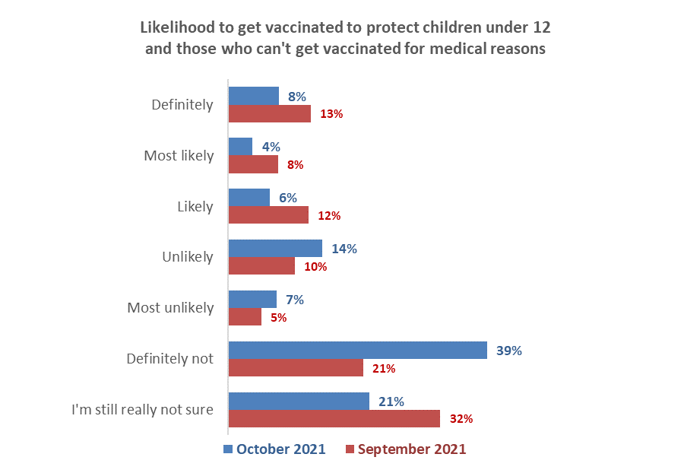
Unlikely
October 22%
September 15%
Likely
October 18%
September 32%
Base: Not vaccinated, October n=224; September n=414.

As in September, messaging about getting vaccinated to specifically protect children under 12 or those who can't take the vaccine for medical reasons is unlikely to have a significant impact on those who are currently unlikely to get a vaccine or definitely will not. It is likely to make around 7,600 people who are currently unlikely, slightly more likely to get a vaccine (0.2% of the 16+ population). It has negligible impact on those who will definitely not get a vaccine.

It will, however, make an estimated 30,200 people who are currently likely to get a vaccine (0.75% of the 16+ population) more likely.

Aucklanders are more likely than average to respond to this messaging. There are no other distinctive demographic criteria.

6.5 Getting vaccinated to use all businesses and be able to do activities
Respondents who were either not vaccinated or had only one dose were told:
“To cope in the future with on-going and widespread COVID-19 infection throughout New Zealand, the Government is making some changes.

- At least 90% of all people aged 12 or older, in each District Health Board area, to have had two doses of the COVID-19 vaccine (unless you are exempt).
- When this happens, a new Red, Orange and Green “traffic light” framework will be used to manage COVID-19
- At each level all businesses will be open and you will be able to do a wide range of activities (with varying levels of restrictions)
- You will need to prove you’re fully vaccinated (had two doses) to do certain close contact activities (e.g. go to the gym, sporting events, outdoor entertainment, hairdressers)
- Some businesses may decide not to implement the requirement to prove you’re fully vaccinated. These businesses will operate under further limits and restrictions.

They were asked “Does the opportunity to use all businesses, and be able to do more activities if you are fully vaccinated, make you more or less likely to get two doses of the vaccine?”

As shown in the following chart, overall, the response was relatively muted, despite 43% of the respondents having had one dose.

There is little doubt that this will motivate those who have had one dose and also those who are booked to get their vaccine to have two doses. Note, however, that 38% of those who are booked were not sure whether this opportunity would make them more or less likely to get a vaccine or not.
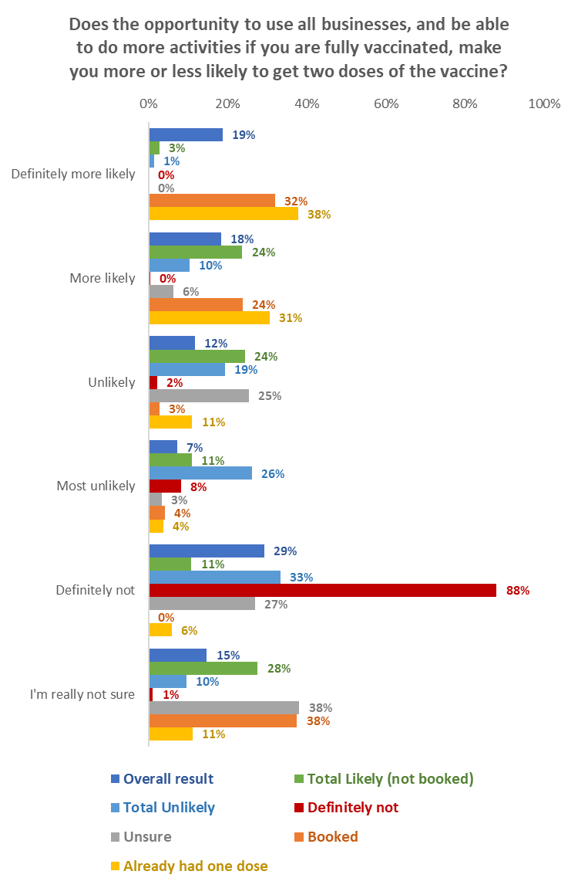
Vaccination intention
Base: not vaccinated or had only one dose n=393.

Nett incremental gains from this opportunity would be:
- A 0.8% incremental upward shift in likelihood to get a vaccine for all not vaccinated who are likely to get a vaccine. While this would represent 30,400 people, this is not an increase in the percentage uptake; it just means that people may get their intended vaccination earlier.
- A 0.25% potential incremental gain (9,800 people) from those who are unvaccinated and unlikely to get a vaccine.
- A 0.01% potential incremental gain (600 people) from those who are unvaccinated and unsure whether to get a vaccine or not.
- A 0.1% potential incremental gain (5,000 people) from those who currently say they will definitely not get a vaccine.

6.6 Getting two doses to use businesses, travel, attend family/whānau events or do activities
Respondents who were either not vaccinated or had only dose were told:
“When the new COVID-19 management rules are in place, at times you won’t be able to do some things unless you can prove you have had two doses of the COVID-19 vaccine (unless you are exempt from getting the vaccine).”

They were asked whether they would get two doses of the COVID-19 vaccine just so they could go to or do any of a list of things.

The most popular was attending family/whānau gatherings, followed by travel. Those who are currently booked are likely to be more motivated by using close-contact businesses, attending indoor and outdoor events than by travel.

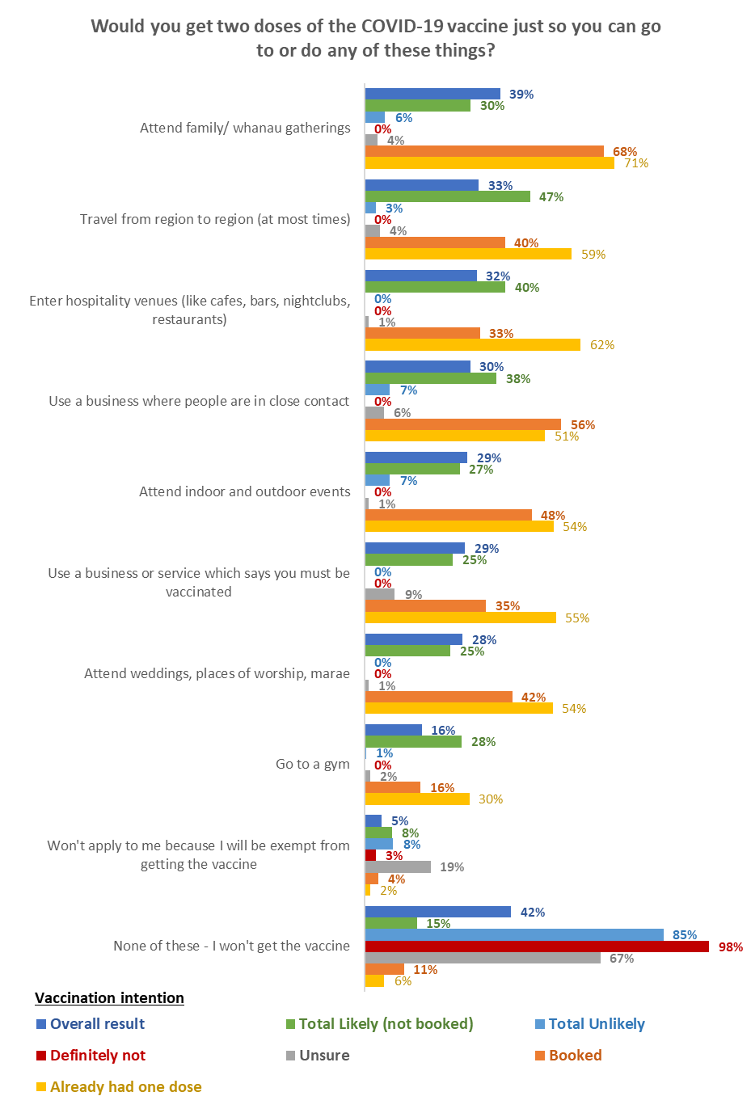
Base: not vaccinated or had only one dose n=377
None of the listed things would drive any change from those who currently say they would “definitely not” get a vaccine.

In terms of driving incremental gains, using close-contact businesses has the potential to motivate more people who are currently unsure or unlikely to get a vaccine. This is followed by attending family/whānau gatherings and inter-regional travel.

Message | Likely to get a vaccine but not definite |  | Unlikely to get a vaccine |  | Definitely won't get a vaccine |  | Unsure
 | Incremental shift to "Definite" |  | Incremental gain |  | Incremental gain |  | Incremental gain
 | %  16+ popn | Estimated number | %  16+ popn | Estimated number | %  16+ popn | Estimated number | %  16+ popn | Estimated number
Enter hospitality venues (like cafes, bars, nightclubs, restaurants) | 0.5% | 20,100 | 0.0% | 0 | 0.0% | 0 | 0.0% | 1,100
Attend family/ whanau gatherings | 0.6% | 23,700 | 0.2% | 6,100 | 0.0% | 0 | 0.1% | 2,900
Attend weddings, places of worship, marae | 0.4% | 15,200 | 0.0% | 0 | 0.0% | 0 | 0.0% | 1,100
Attend indoor and outdoor events | 0.4% | 16,400 | 0.1% | 4,700 | 0.0% | 0 | 0.0% | 1,100
Use a business where people are in close contact | 0.7% | 26,500 | 0.2% | 7,000 | 0.0% | 0 | 0.1% | 4,600
Go to a gym | 0.4% | 14,900 | 0.0% | 300 | 0.0% | 0 | 0.0% | 1,300
Use a business or service which says you must be vaccinated | 0.3% | 12,700 | 0.0% | 0 | 0.0% | 0 | 0.2% | 7,100
Travel from region to region (at most times) | 0.8% | 32,000 | 0.1% | 2,100 | 0.0% | 0 | 0.1% | 3,600

6.7 Ending lockdowns and restrictions for Auckland and the South Island
Those who were not vaccinated or had one dose of the vaccine were told:

“If 90% of people 12+ living in the three Auckland DHB areas get fully vaccinated during the next four to six weeks, the region could be open for business and other activities by Christmas.

If 90% of those aged 12+ in the South Island get fully vaccinated, the island could be moved to Green level management, ahead of other areas.”

They were then asked whether the prospect of ending Level 3 lockdown in Auckland and Alert Level 2 restrictions in the South Island would make them more or less likely to get two doses of the COVID-19 vaccine.

As the chart demonstrates, this had greater support among those who had already had one dose of the vaccine. Aucklanders were no more supportive of this prospect than the whole population overall result. Canterbury was the most supportive region in the South Island, but only slightly above average.

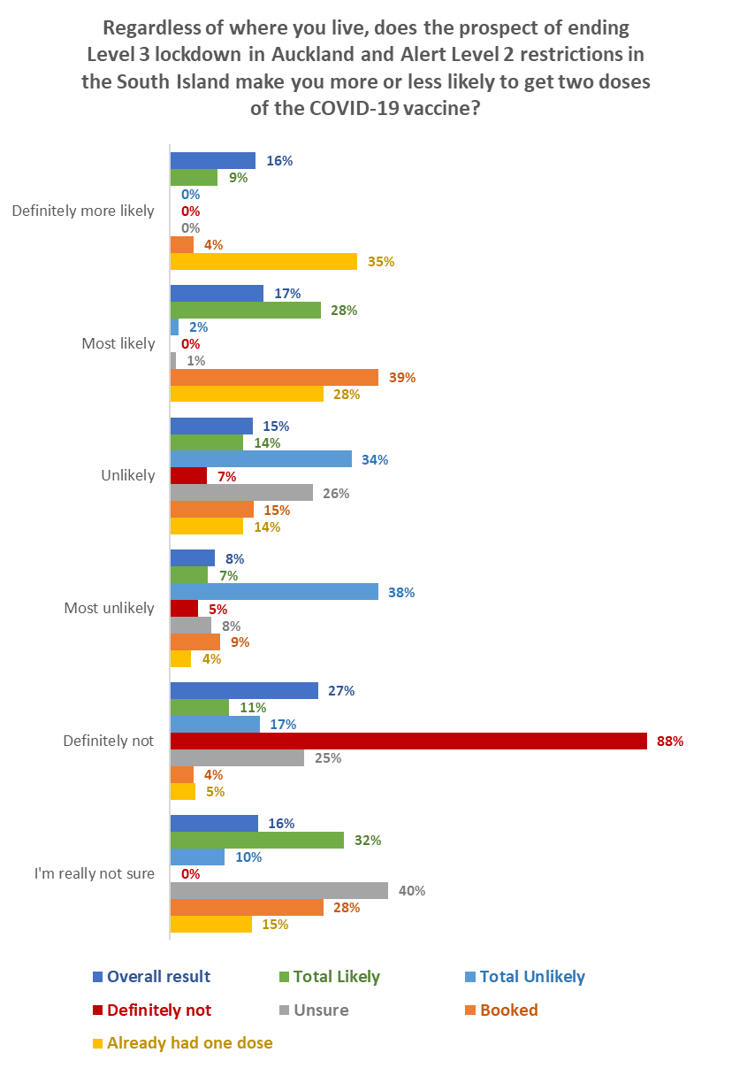
Vaccination intention
Base: not vaccinated or had one dose n=388.

Nett incremental gains from this would be:
- A 0.6% upward shift in likelihood to get a vaccine for all not vaccinated who are likely to get a vaccine. This represents 25,200 people, but is not an increase in the percentage uptake; it just means that people may get their intended vaccination earlier.
- A 0.02% incremental gain (1,000 people) from those who are unvaccinated and unlikely to get a vaccine.
- A 0.02% incremental gain (900 people) from those who are unvaccinated and unsure whether to get a vaccine or not.
- No gains at all from those who are unvaccinated and currently say they will definitely not get a vaccine.

6.8 New COVID-19 management system
Respondents who were not vaccinated were told:
“We understand some will welcome new freedoms delivered by getting fully vaccinated. Others may resent being required to get vaccinated in order to be free to use some businesses (like hospitality) and attend events.”

They were asked “Overall, how do you feel now about what you will do, given the new COVID-19 management system that will be put in place?” They were asked to choose the option that they felt best applied to them.

Overall:
- 5% said they were happy with the new management system and will willingly get two doses; 6% were happy with the system but said it would not make them get the vaccine.
- 16% said they would get two doses but weren’t happy about it because they felt pressured.
- 18% said they weren’t happy with the new vaccine requirements and wouldn’t be motivated to get a vaccine because of them.
- 31% said they wouldn’t get the vaccine and no restrictions would change their mind.
- 8% said they won’t get the vaccine because there’s too much pressure.

- 1% said they would not get a vaccine to get a vaccine certificate because they believed there would be ways around that.

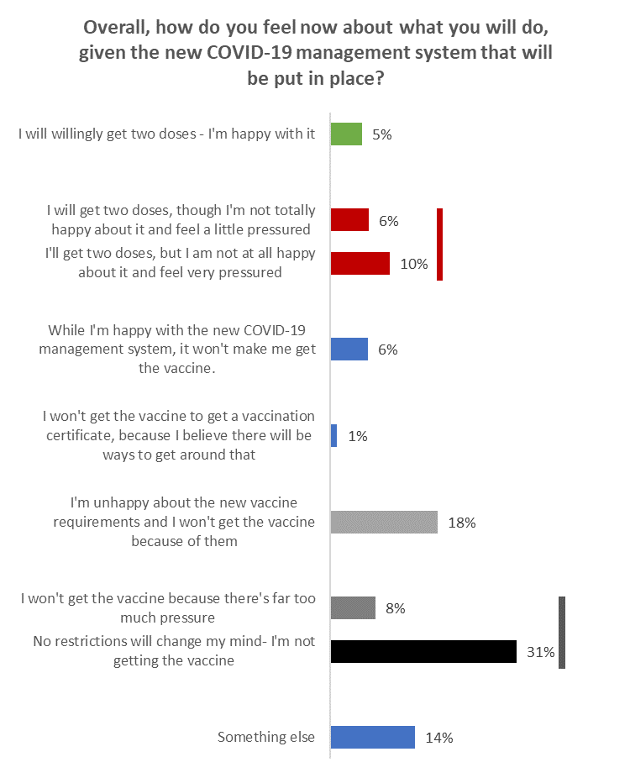
Will get vaccine but feeling pressured to do so: 16%
Won’t get the vaccine: 39%
Base: not vaccinated n=219

- Males (20%) felt more pressured than females (13%).
- 18–34-year-olds feel more pressured than other age groups.
- Indicatively, Asian and Indian respondents feel more pressured than respondents of other ethnic groups
- Those who say that no restrictions will change their minds - they are not getting the vaccine – are more likely to be 45 years or over. There is no difference by gender.

- Information Needs

7.1 Do the unvaccinated have all the information they need to decide whether or not to get the COVID-19 vaccine?

Those not vaccinated and not definitely getting a vaccine were asked if they have all the information they needed before deciding whether or not to get the COVID-19 vaccine.

There was a strong increase in the percentage of respondents saying they definitely have enough information to decide (38% in October cf. 25% in September 2021). There was a fall in those who say they mostly have all the information they need, don’t quite have enough information or need to know more (in total this response fell from 64% in September to 50% in October 2021).
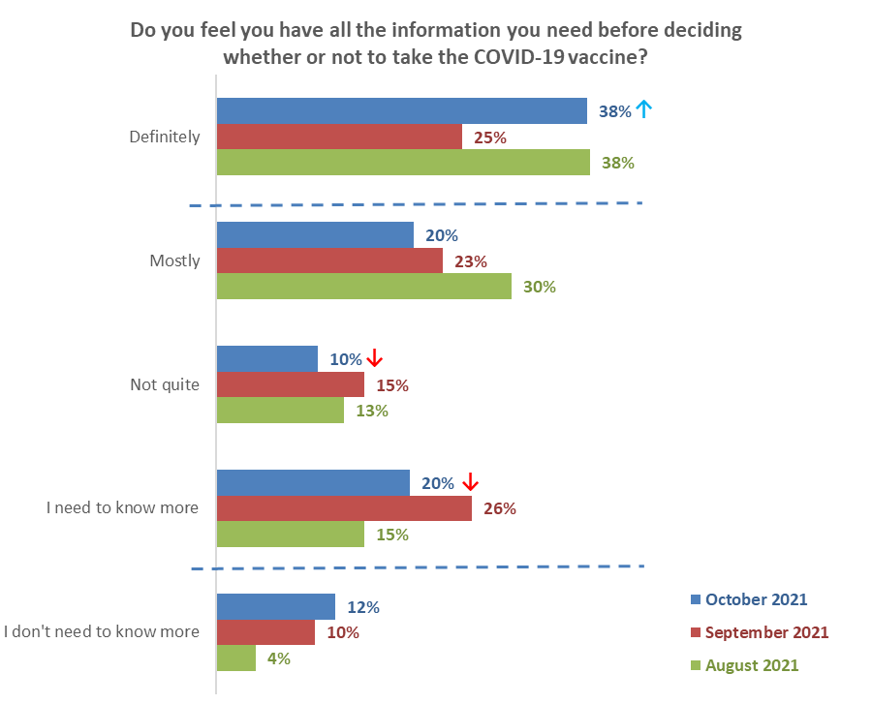
Potential information gaps
October 50%↓
September 64%
August 58%
Base: not vaccinated, not “definitely” getting a COVID-19 vaccine: October n=233; September n=414; August n=1,044.
↑
↑
Those who need more information are more likely to be from the following groups:

Potential information gap | October 2021
Total | 50%
Aged 25 to 34 | 70% ↑
Two-parent families with one or two children | 65% ↑
Results are for groups of at least n=30 respondents

7.2 Information required to help decide whether to get vaccinated
Unvaccinated respondents who were neither “definitely” nor “definitely not” getting the vaccine were asked “What would you like to know to help you decide whether or not to get the COVID-19 vaccine?”. Respondents were able to choose more than one answer.

The two main things people would like to know both relate to side effects of the vaccine:
- More information on possible side effects and risks (49%)
- Evidence the vaccine I am offered is unlikely to cause a serious adverse reaction (41%)

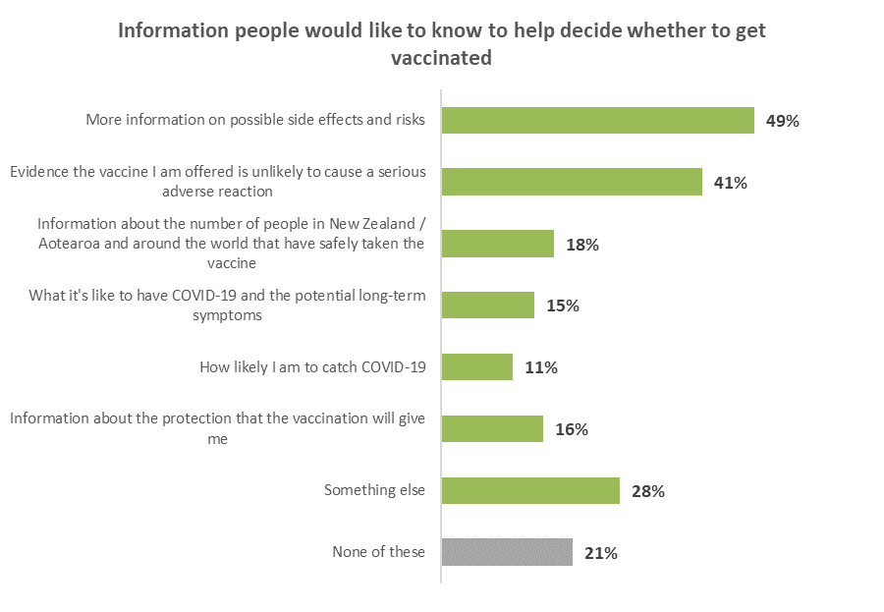
Base: not vaccinated, neither “definitely” nor “definitely not” getting the vaccine n=125.

Other responses
Those who said “Something else” were asked to record, in their own words, the information they are seeking. A number of people chose to express negative views about the vaccine, similar to those recorded as reasons for being unsure or unlikely to get vaccinated. The following verbatim comments illustrate the main themes from people who want information to help them decide:

Long term impacts of being vaccinated
Long term health implications.
Long term cumulative effects of mRNA boosters.
I would like to see the longer-term effects of taking the vaccine 2-5 years.
Information on the long-term effects of the vaccine, how many people have been hospitalised because of the vaccine. Apparently cannot be recorded as a primary cause of a hospitalization when it was.

Facts and figures on vaccine success
Figures on vaccinated people who have subsequently caught COVID and the number of those who have died!
Info of those in NZ that have had reactions.
Statistics on numbers affected by long term symptoms and what they are.
I want to know the stats of the COVID delta strain. Not the original COVID strain. How many have died from delta and what is the risk? So far, the risk seems less than a common cold and certainly far lower than the influenza virus.

Information on non-mRNA vaccines
More about other vaccines e.g., Moderna.
Non-RNA based vaccines available.
When the Oxford and Novavax will be available.

Proof the vaccine is safe for various medical conditions
Proof of clinical trials to show the vaccine is safe for pregnant and breastfeeding women.
Studies showing how this vaccine affects patients with severe long-term fibromyalgia.

What happens if I don’t get vaccinated?
How likely am I to not get COVID-19 or get COVID-19 but live?

How the vaccine works
What is in it and how does the body use it?

7.3 Preferred ways to get information
Having been asked what they would like to know to help them decide whether or not to get the COVID-19 vaccine, respondents who were not vaccinated and neither “definitely” nor “definitely not” getting the vaccine were asked how they would like to get information about the vaccine. This was a multi-choice question; respondents could choose multiple answers.

The three main preferred information sources are online sources plus TV news:
- Online news (37%).
- Government websites (29%).
- Email (23%).
- TV news (24%).
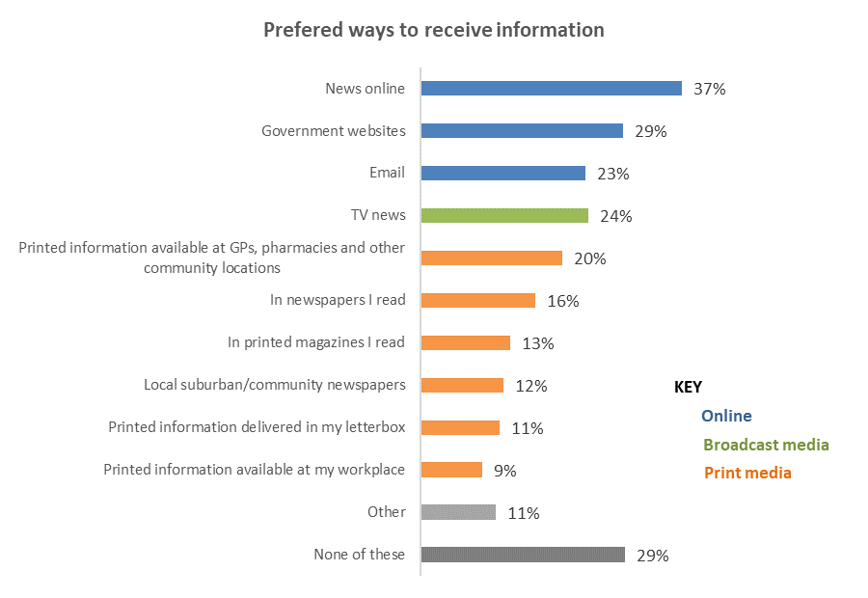
Base: not vaccinated, neither “definitely” nor “definitely not” getting the vaccine n=124

“Other” ways included:
The Prime Minister's 1pm news conference.
The information I require is not yet available.
Social media ad is fine.
Peer reviewed published papers.
Medical journals, scientific reports, evidence-based data.
Own research.
I will try to find it myself as there are no reliable sources available around.
My own research into reliable medical sites.
I have done my own research based on actually what is happening in other countries. Our media & govt is biased and I don't trust the information that is given from them.
Google search.
From my GP.
By waiting to see the results of what happens to people once they have been vaccinated longer term.
Actual critical debate between the viewpoints. no more propaganda.
Informed broadcast debate between appropriately qualified science communicators discussing ALL aspect of the mRNA and alternative and traditional vaccines, the actual risks stratified by age and co-morbidity etc.

Other comments made by respondents were:
The Government needs to show it respects and will honour human rights including right to consent to medical treatment.
An unbiased media would be great however, this no longer exists & is only parroting "news" at the behest of the Government.
After so many lies from the government and news outlets, I'm not sure I can believe anything given by the government or published in the news can be believed as truth!
Actual critical debate between the viewpoints. no more propaganda.

7.4 The one thing that would absolutely convince people to get a COVID-19 vaccine
Those who had not been vaccinated were asked an open-ended question to state in their own words the one thing that would absolutely convince them to get a vaccine.
Out of the 246 unvaccinated people in the survey, 212 responded to this question and the following main themes were apparent:
- Having access to a traditional vaccine/nonexperimental (15%, up from 3% in September).
- Long-term data (13%, the same as September).
- Knowing it works (8%, down from 15% in September).
- Transparency/Government transparency (8%, up from 1% in September).

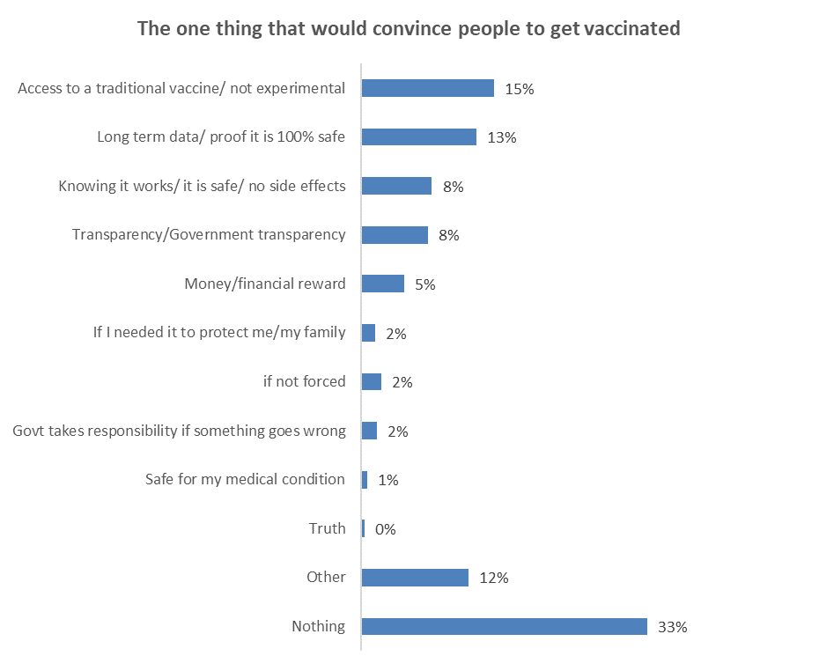

Base not vaccinated n=212 answered

Verbatim quotations illustrating each theme follow…

Access to a traditional vaccine/ not experimental
Make Novavax available would do it and also If this Government started spending money on ICU units instead of pretending vaccination was the only way out. Maybe if the government put as much effort into treatment as vaccines and made Ivermectin. a safe medicine that has been around for 30 yrs available, I’d be less suspicious of both their ability and their motives. (Female, 75 years or over).
It would be "Astrazeneca or Novavax are now available for use in NZ". (Male, 35-44 years).
if it was an inactivated virus vaccine. (Female, 35-44 years).
If a different type of vaccine was available that was not an mRNA type, and there was no possibility of me developing any further health issues, then I may consider it after discussions with my specialists and GP. (Female, 35-44 years).
I would take the Sputnik Vaccine from Russia. I object to using Pfizer’s products, Glaxosmith-Kline’s products (like the Novavax vaccine that they funded), AstraZeneca’s products, and Johnson and Johnson’s products due to their past unethical behaviours (fraud, vaccine malpractices, unlisted side effects, false marketing, etc). (Male, 18-24 years).
Having the option of an attenuated vaccine as opposed to the mRNA type on offer in NZ. (Male, 45-54 years).
Having another option of vax to choose from. (Female, 35-44 years).
Availability of a non mRNA vaccine such as Novavax. (Male, 55-64 years).
As long as it is not mRNA, I will probably take a regular shot, when it has been thoroughly tested. The mRNA is still experimental and testing is not expected to be concluded until 2023 or 2027 in respect of pregnancy. (Male, 65-74 years).

Long term data/ proof it is 100% safe
Ten years of clinical trials, possibly. (Male, 55-64 years).
Statistics on how many have been badly affected by COVID including age, sex, general health, underlining conditions. Same for long term COVID. Also suspect reporting on deaths post jab aren't investigated. i.e., person died of Heart attack, but never had heard condition before. Did jab have anything to do with death. (Male, 45-54 years).
Removal of all indemnity from Pfizer before the completion of the full long-term studies of the side effects, fully reported, of the vaccine designed to combat an isolated COVID 19 virus. (Male, 65-74 years).
Proof of no long-term risks or yet unknown side effects. (Male, 55-64 years).
Long term safety data. (Male, 35-44 years).
Long term data, clinical trials and accurate CARM reports and health workers able to express their concerns. (Female, 35-44 years).

Knowing it works/ it is safe/ no side effects
That the vaccine actually prevented spread of the disease, that it was not experimental but used traditional technology and that the disease actually killed a lot more than 0.03% of the population. Then I would get it. (Male, 55-64 years).
that the test results from trials prove that it works and isn't a risk. And for the companies that make it to have insurance that those affected by taking this can then claim against. (Female, 55-64 years).
That it safe and has no adverse reactions. Also, that it has been tested correctly and safely without any aborted babies DNA. (Female, 45-54 years).

Government transparency
Transparency from the govt and ministry of health. (Female, 18-24 years).
The government is honest about the amount of people having reactions plus the people it has killed, instead of saying we have had only one death, which at this point everyone knows is bullshit. (Female, 25-34 years).
Release the Pfizer contract AND a proper debate of the options and viewpoints on TV. But that won't happen because it would undermine the (perfectly) safe and effective messaging. There is no honesty. (Male, 35-44 years).
Knowing that the government was being truly truthful, that ALL information available was taken up by authority and made public, that there were long-term trials (10 years) on this particular mRNA and its envelope. (Female, 55-64 years).
If the government stopped lying about it. (Female, 55-64 years).
Honest media and government reporting of facts, BS is everywhere, when media and government representatives say you will be protected and then they report that someone fully vaccinated is in hospital with COVID it does not lead to confidence! (Male, 55-64 years).
Government being more open in regards to the side effects, different vaccine options than Pfizer and that other people’s rights will not be taken away if I contribute towards reaching a 90% vaccination rate and enforcing certificates. (Female, 18-24 years).
Government and pharma telling the truth, not using fraudulent science...but then that would blow the vaccine out of the water well this one. If a safe and effective vaccine came out, I would consider it but only for social convenience I am not concerned in the slightest about COVID or any other flu. I do know about health and science very well. This is not a vaccine BTW so stop calling those opposed to it anti vaxxers Some of the most pro vaccine and top scientists in the world are against it. (Female, 65-74 years).

Money/financial reward
Money- I'm really poor. (Female, 25-34 years).
Incentive maybe. (Female, 45-54 years).
Cash incentive. (Male, 25-34 years).

If I needed it to protect me/my family
My son's life on the line. (Female, 25-34 years).
If others stopped taking it (so as a sacrifice to save others harming especially young people..... (Male, 45-54 years).
If I had come into contact with an infected person. (Male, 35-44 years).
Actually getting COVID 19 Delta and my own immune system not being able to cope. (Male, 55-64 years).

If not forced
If it was real and free to choose rather than being forced - On that alone I would refuse whether it was efficacious or not and it is definitely not! (Male, 65-74 years).
If I was a solitary "voice in the wilderness" against taking the vaccine, but I'm not. Every day there are more and more people becoming defiant. Maybe because it's being mandated and costing hard working, conscientious people their livelihoods. It's causing utter resentment. (Male, 65-74 years).
I am not sure. I own a business and feel as if the government is holding a gun to my head. I am tossing up whether or not to close down the business. (Male, 65-74 years).
Human rights being taken away. (Male, 45-54 years).

Govt takes responsibility if something goes wrong
The government taking responsibility for my kids after I died. (Female, 45-54 years).
If government pays my family if something happens to me. (Female, 16-17 years).

Truth
Truth. (Female, 65-74 years).
Stop telling untruths about what is in the vaccine. (Female, 65-74 years).

Safe for my medical condition
My doctor’s advice. (Another Gender, 65-74 years).
Information to me for me. (Male, 45-54 years).

Other
The death of a loved one from COVID, not from something else and COVID but just COVID. I presume then I would have equal risk. (Female, 55-64 years).
That it was not abortion-tainted. (Female, 25-34 years).
That I needed it. Let those who are vaccinated be happy they are protected and those who don't want it risk themselves knowingly and that's ok. For my age group and health, I'm highly unlikely to get a bad case of COVID19. Nor the people I interact with daily. (Female, 25-34 years).
Stop mandating. (Male, 55-64 years).
People dying. (Female, 65-74 years).
Not using aborted foetal cells to develop or test the vaccine. (Male, 45-54 years).
Not having a vaccine mandate is a great start. Not having to choose between remaining employed and keeping my bodily sovereignty is great, too. (Female, 25-34 years).
No discrimination, no vaccine passports and lockdown ended. (Male, 35-44 years).
If all MPs, parliamentary staff etc weren't exempt AND it was proven each had genuinely received a dose and not a placebo. If it's so safe, why are they all exempt? (Female, 55-64 years).
Knowing the origins of where COVID came from. (Male, 25-34 years).
If there was a healthy debate, and the many medical professionals speaking out against the inoculation were heard. (Female, 35-44 years).
If the government was not involved. (Male, 35-44 years).
It’s not about being convinced, I want evidence and choice. (Female, 18-24 years).

Nothing
Nothing would. I consider it dangerous and taking all energy away from consideration of early treatment interventions. (Female, 75 years or over).
Nothing will convince me. (Male, 45-54 years).
Nothing. It’s far worse than the virus, and the govt forcing people is just a power grab. To say one has a choice then say they will lose their jobs is against all our rights. Just wait until people find out they need booster after booster yet more people are getting the virus, mostly jabbed as seen overseas. (Female, 55-64 years).
Nothing. Have already had an hour long talk with my GP re the vaccine and I am not going to put poison in my body. (Male, 65-74 years).
Nothing could ever convince me. (Male, 18-24 years).
Nothing can convince me. I’m surprised so many people are willing to be test subjects. (Male, 18-24 years).
Nothing at all. (Female, 65-74 years).
Nothing at all will convince me. (Male, 45-54 years).
Nothing and nobody would convince me! (Female, 55-64 years).

7.5 Personal dialogue about the vaccine
Those who had not been vaccinated, excluding those who were “definitely not” going to get a COVID-19 vaccine were asked ‘Would you like to have a personal chat about the vaccine with someone whom you trust?’
Base: not vaccinated, not “definitely” getting a COVID-19 vaccine n=232
11% would like a personal chat  about the vaccine with someone they trust. Most support for this comes from respondents in large cities. | 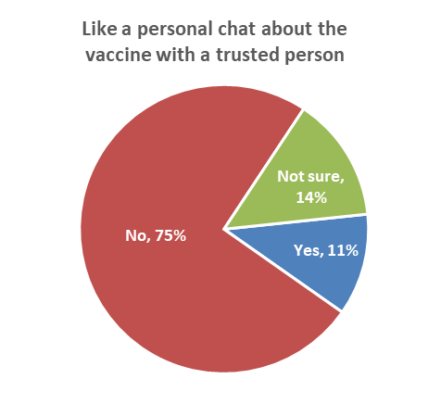

Those who would like a personal chat are more likely to be from the following groups:

Would like a personal chat about the vaccine with someone they trust | October 2021
Total | 11%
Live in a large city (e.g., Auckland, Hamilton,  Tauranga, Wellington, Christchurch, Dunedin) | 20%↑
Personal income between $20,001 and $30,000 | 20%↑
Māori* | 18%↑
Aged 25 to 34 | 17% ↑
Males | 15%↑
Results are for groups of at least n=30 respondents. * Indication, base n=27.

Those who said they would like to have a personal chat about the vaccine with someone they trust were asked with whom they would like to speak.

Preferred people to seek advice from are as follows, with the main response being ‘a medical professional’ (59%). Note, the small sample size (n=25), meaning this result is indicative:

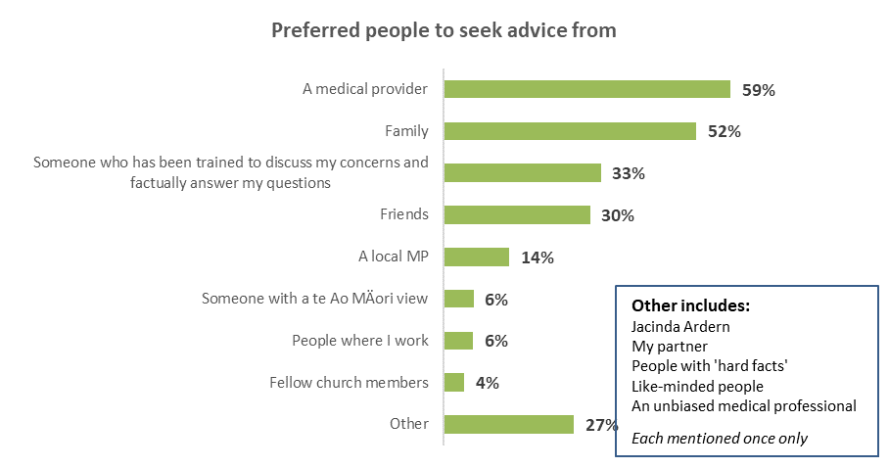
Base: would like to chat with someone about the vaccine n=25
Multiple responses allowed

Information they seek when having a personal chat includes:

What would you like to know to help you decide whether or not to get the COVID-19 vaccine? | Like to have a personal chat about the vaccine
 | All like to have a personal chat | With family | With friends | With a medical provider | With someone who has been trained to discuss my concerns and factually answer my questions
More information on possible side effects and risks | 67% | 55% | 58% | 77% | 100%
Evidence the vaccine I am offered is unlikely to cause a serious adverse reaction | 46% | 49% | 73% | 59% | 79%
Information about the number of people in New Zealand / Aotearoa and around the world that have safely taken the vaccine | 29% | 35% | 42% | 43% | 55%
What it's like to have COVID-19 and the potential long-term symptoms | 12% | 17% | 42% | 15% | 28%
How likely I am to catch COVID-19 | 8% | 0% | 0% | 12% | 0%
Information about the protection that the vaccination will give me | 30% | 38% | 42% | 44% | 59%
Something else | 29% | 20% | 13% | 32% | 21%
N (unweighted) - would like to have a personal chat about the vaccine | 21 | 9 | 7 | 12 | 6
Note: these results are indicative because of the small base.

7.6 Local meetings
Those who had not been vaccinated, excluding those who were “definitely” or “definitely not” going to get a COVID-19 vaccine were told “Some have organised local meetings, at sports clubs, marae, community halls and other places so people can chat about the vaccine with local doctors and others” and then asked, “Would you attend a local meeting like this?”

30% said they are unlikely to attend and 53% would definitely not attend a meeting to chat about the vaccine with local doctors and others.

10% said they are likely to, or definitely would attend such a meeting and 8% were not sure.
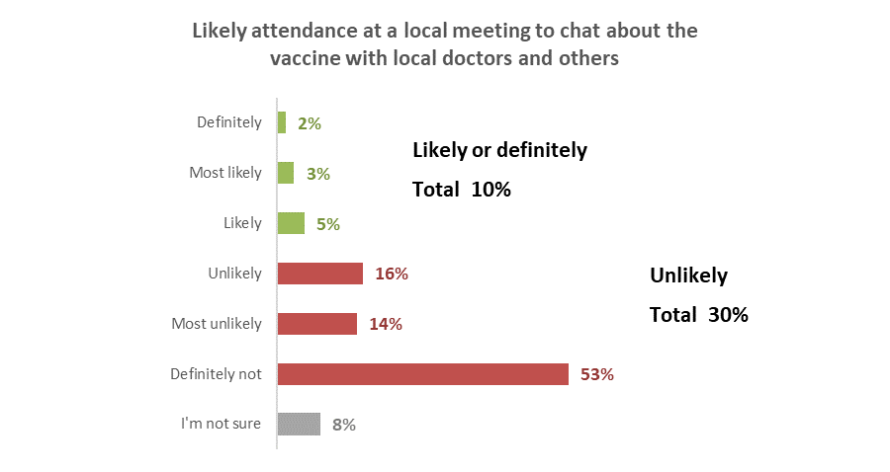
Base: not vaccinated, not “definitely” getting a vaccine n=233.

Those who would attend a meeting are relatively more likely to be from the following groups, the same groups as would like a personal chat about the vaccine with someone they trust:

Likely or definitely would attend a meeting to chat about the vaccine with local doctors and others | October 2021
Total | 10%
Aged 25 to 34 | 18% ↑
Live in a large city (e.g., Auckland, Hamilton,  Tauranga, Wellington, Christchurch, Dunedin) | 14%↑
Results shown are for groups of at least n=30 respondents

Meetings have the potential to reach around 5% of those not vaccinated and not “definitely” getting a vaccine, who would not be reached by a personal chat about the vaccine, so it would be important to offer both options.

Information sought by those likely to attend a local meeting is as follows (indicative answers, small base):

What would you like to know to help you decide whether or not to get the COVID-19 vaccine? | Likely to attend local meeting
Information about the protection that the vaccination will give me | 47%
More information on possible side effects and risks | 46%
Information about the number of people in New Zealand / Aotearoa and around the world that have safely taken the vaccine | 42%
Evidence the vaccine I am offered is unlikely to cause a serious adverse reaction | 39%
What it's like to have COVID-19 and the potential long-term symptoms | 36%
How likely I am to catch COVID-19 | 17%
Something else | 2%
N (unweighted) – not vaccinated, likely to attend a local meeting | 11

Chances of being infected by the Delta strain at some time
All respondents were asked what they thought their chances were of being infected with the Delta strain of COVID-19 at some time.

Those who think there is some chance or a high chance has more than doubled in the last month to 69%, from 30% in September. Those saying little to no chance has dropped from 55% in September to 22%.
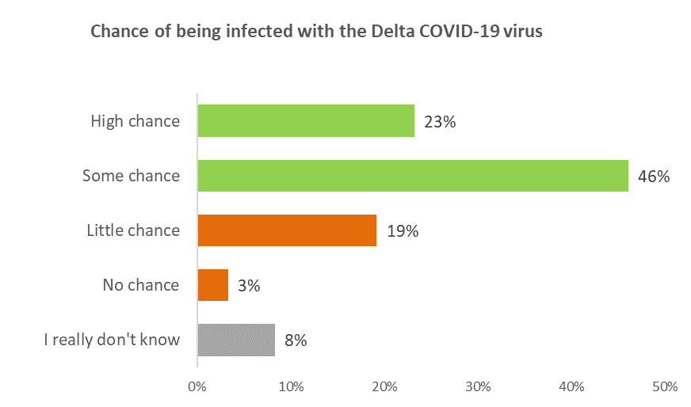
Base: all respondents n=2,416.
Perceived risk is slightly higher for females (71% some or high chance, compared to 67% for males).

74% of people aged 35 to 64 years say there is some to high chance of them contracting it, compared with 64% for those over 64, and 68% under 35.
Education plays a role in people’s assessment of their chances, with those with degrees more likely to think there is some chance (75%), compared to 62% with a high school education (or none at all.)
Asians, Indians and Pasifika think they are less likely to get the variant (59%, 57% and 48%) and Māori think they are more likely (77%).
There is no difference by health conditions, whether someone identifies as disabled or the presence of children in the home. Nor does it matter where someone lives, either in a city, town or rurally.

Those with two doses of the vaccine are more likely to think they will get infected.
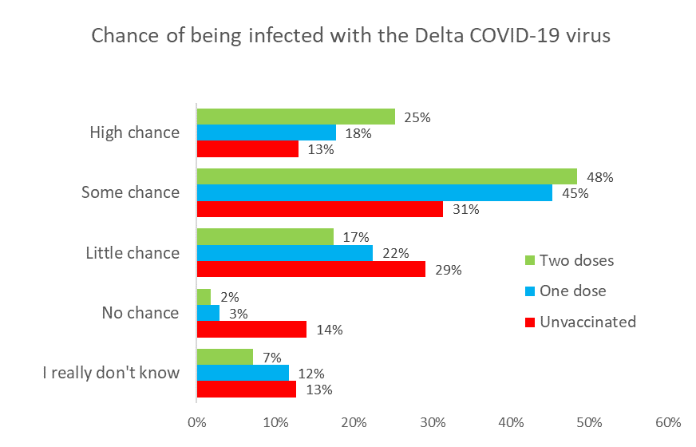
Base: All respondents n=2416

Putting it another way, the higher the chance someone thinks they will get the virus, the more likely they are to be vaccinated.
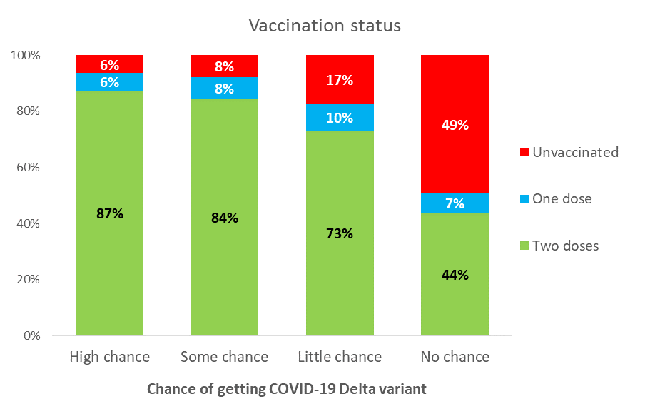
Base: All respondents n=2416

Sources of official information about the vaccine
All respondents were asked where they had seen official COVID-19 information and advertising, if any, in the past 30 days.
Almost everyone (91%) said they had seen official COVID-19 or vaccine information advertising in the past 30 days.
Television is the highest source (free to air 63%, on demand 21%) but social media advertising is also well-recalled (47%).
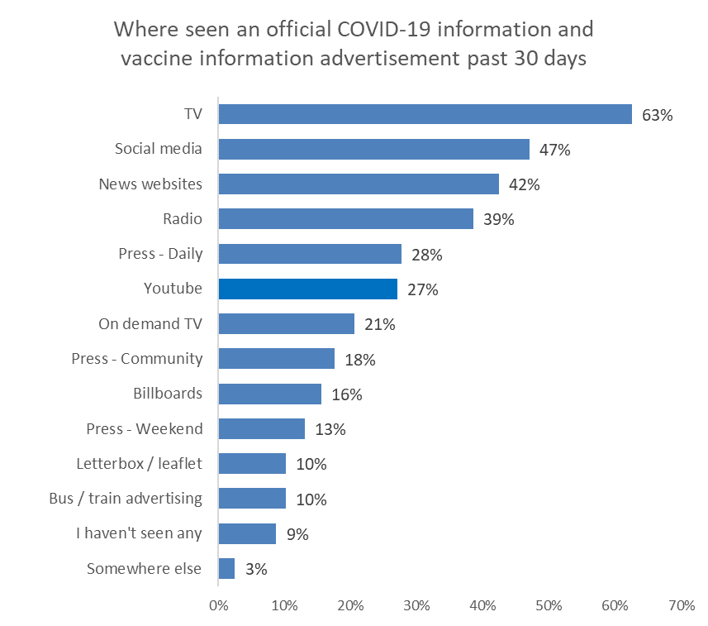
Base: all respondents n=2,390

The mean number of sources people had seen official information was 3.3.
There is no difference by gender, and no strong age trend.
Households with a higher income (over $100,000 per annum) had seen more (3.8 compared to 3.3 for those earning under $100,000).
Respondents in Asian, Indian and Pasifika ethnic groups were likely to have seen fewer advertising channels (2.9, 2.6, 2.7) compared with Māori, who had seen advertising in more channels than average (3.9).
No other demographics showed any significant trends or differences.

Other mentions of sources included:
Medical centres.
Websites.
Spotify.
Mobile gaming advertisement.
Podcast.
Advertising at the airport on screens.
Supermarket.
Everywhere.
Everywhere, and it’s too much.

In which media have you seen official COVID-19 information and vaccine advertising in the past 30 days? | Jul 2021 | Aug 2021 | Sep 2021 | Oct 2021 | Sept to Oct  Difference  % points
TV | 64% | 74% | 72% | 63% | - 9 ↓
Social media | 34% | 52% | 51% | 47% | - 4
Radio | 29% | 35% | 39% | 39% | 0
News websites | 24% | 39% | 38% | 42% | +4
YouTube | 18% | 25% | 30% | 27% | -3
Press – Daily (referred to as ‘Newspapers- Daily’ before September) | 17% | 20% | 26% | 28% | +2
On demand TV | 18% | 23% | 23% | 21% | -2
Letterbox / leaflet | 9% | 7% | 21% | 10% | - 11 ↓
Billboards | 9% | 9% | 15% | 16% | +1
Press – Weekend (referred to as ‘Newspapers – Weekend’ before September) | 9% | 11% | 13% | 13% | 0
Press – Community (referred to as ‘Local/Community Newspapers’ before September) | 15% | 13% | 11% | 18% | +7 ↑
Bus / train advertising | 8% | 8% | 11% | 10% | -1
Somewhere else | 2% | 2% | 2% | 3% | +1
I haven't seen any of these advertisements | 11% | 5% | 6% | 9% | + 3
Base n= | 2,509 | 2,334 | 2,447

Impact of seeing an official COVID-19 vaccine advertisement
Those who had seen official COVID-19 vaccine information or advertising in the previous 30 days were asked what impact this had, from a list of possible options.

38% said it had reinforced their decision, down from 49% a month ago.

18% said this official advertising made them more likely get a vaccine (up from 4% a month ago) while 49% said this advertising made no difference to their decision: this included 64% of those who were unlikely to get a vaccine and 76% of those who were unsure whether they would get one or not.

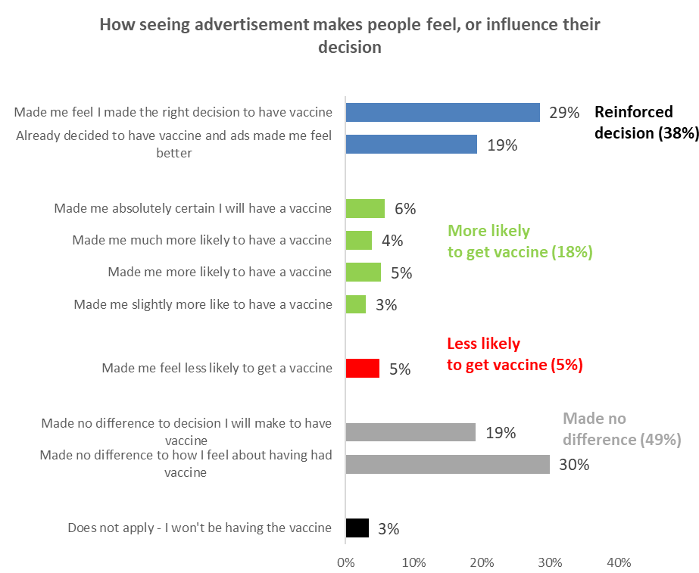
Base: seen official advertising n=2186

Males were more likely to have a positive response to official advertising (70% compared to females 61%).

Asian and Indian respondents were also more likely to have had a positive response as well (98% and 93% respectively).

People living in large cities were more likely to have a positive response to the advertising (74%, compared to 54% living rurally or in small towns).

No-one who said they were “definitely not” or “most unlikely” to get vaccinated viewed the advertising in a positive light. All of those said it made no difference, or made them less likely.

Analysis by age and gender is shown below.

Impact of seeing official advertising in the last 30 days | ALL | GENDER* |  | AGE
 |  | Male | Female | 16-17 years | 18-24 years | 25-34 years | 35-44 years | 45-54 years | 55-64 years | 65-74 years | 75 years or over
Made me absolutely certain I will get a vaccine | 6% | 7% | 4% | 13% | 7% | 7% | 6% | 3% | 3% | 6% | 9%
Made me much more likely to get a vaccine | 4% | 5% | 3% | 16% | 7% | 7% | 4% | 2% | 2% | 2% | 4%
Made me more likely to get a vaccine | 5% | 7% | 3% | 17% | 8% | 8% | 6% | 2% | 5% | 3% | 2%
Made me slightly more likely to get a vaccine | 3% | 4% | 2% | 0% | 6% | 6% | 6% | 1% | 1% | 1% | 0%
Total positive impacts | 18% | 23% | 13% | 46% | 28% | 28% | 22% | 8% | 11% | 11% | 15%
Made me feel less likely  to get a vaccine | 5% | 6% | 4% | 0% | 5% | 8% | 9% | 4% | 5% | 2% | 1%
NETT POSITIVE IMPACT | 13% | 17% | 9% | 46% | 23% | 20% | 13% | 4% | 6% | 9% | 14%
Base – Seen official advertising n= | 2,186 | 1,055 | 1,115 | 16 | 139 | 344 | 293 | 348 | 357 | 464 | 225
* The “Another gender” group is excluded due to a small sample n=16.
Some nett totals may be different from adding the individual results, due to rounding.

Experiences of those who have already been vaccinated

10.1 How people made the booking
People who had been vaccinated at least once were asked how they made their booking. For this survey, respondents were able to choose more than one answer.

Booking online through the Book My Vaccine website was the main method of booking (45%), followed by respondents booking through the COVID-19 Healthline (23%), and at a clinic/ vaccination centre (25% - a significant increase in comparison with September).

Specific methods used are shown in the chart below:

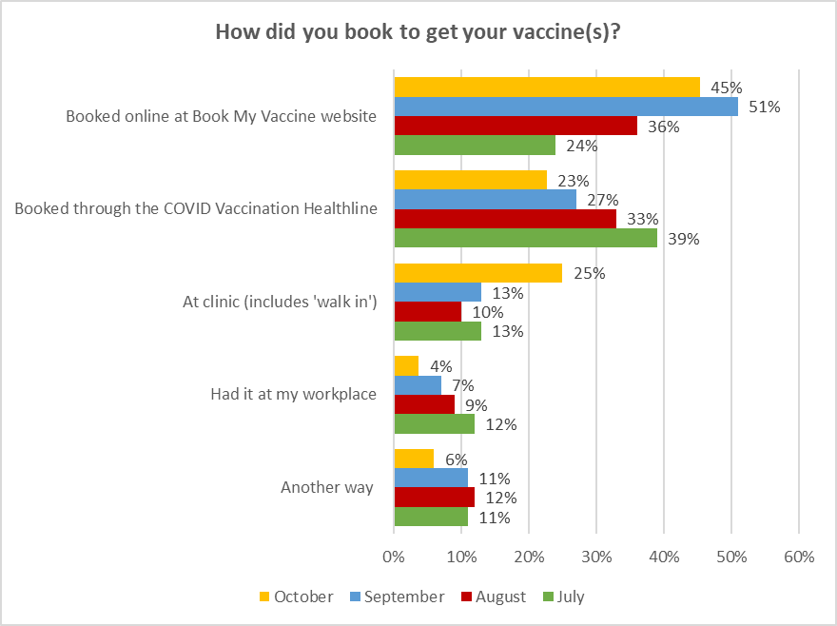
Base: vaccinated (one or two doses) October n = 2191; September n=2,065; August n=1,290; July n=934

10.2 Were people’s language needs met through the process?
All those who had received at least one dose of the vaccine were asked if their language needs were met throughout the booking and vaccination processes.
In October 93% of vaccinated people said their language needs had “definitely” been met; 97% said ‘definitely” or “mostly”. This is similar to the past 3 surveys.
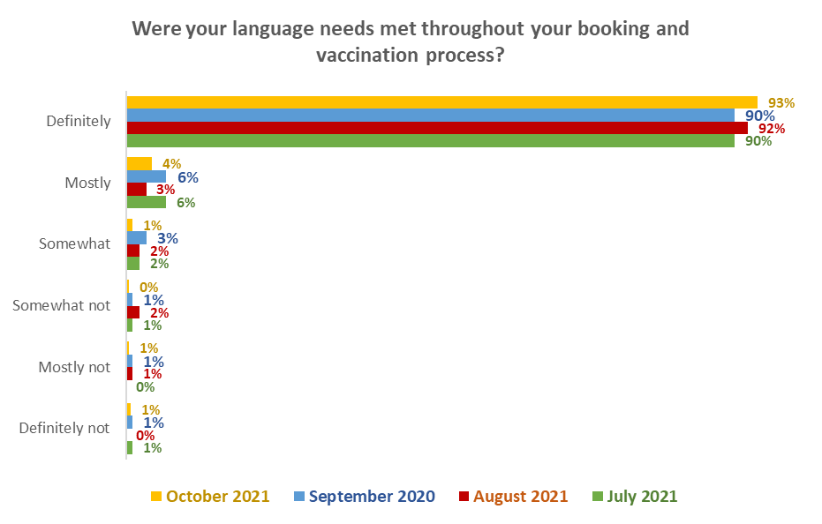
Percentages may not sum to totals in text owning to rounding.
Base: vaccinated with at least one dose: October n = 2,190; September n=2,065; August n=1,290; July n=934

Language needs met by ethnicity
By ethnic group, Asian respondents continue to be less likely to say their language needs were definitely or mostly met (a total of 82%) compared to other ethnic groups.

Were your language needs met throughout your booking and vaccination process? | Asian | Indian | Māori | NZ European/ Pākehā | Other European | Pasifika
Definitely | 71% | 82% | 87% | 97% | 98% | 90%
Mostly | 11% | 15% | 10% | 2% | 2% | 1%
Definitely and mostly | 82% | 97% | 97% | 99% | 100% | 91%
Somewhat | 8% | 0% | 1% | 0% | 0% | 0%
Somewhat not | 4% | 1% | 0% | 0% | 0% | 3%
Mostly not | 5% | 0% | 0% | 0% | 0% | 0%
Definitely not | 2% | 3% | 2% | 0% | 0% | 6%

10.3 Were people’s disability or impairment needs catered for through the process?
56% of those with a disability or impairment who had received at least one vaccine said their needs were “definitely” met (down from 62% in September), and 16% said they were “mostly” met (up from 11% in September).

29% of those with a disability or impairment said their needs were somewhat or definitely not met, on a par with September (28%).
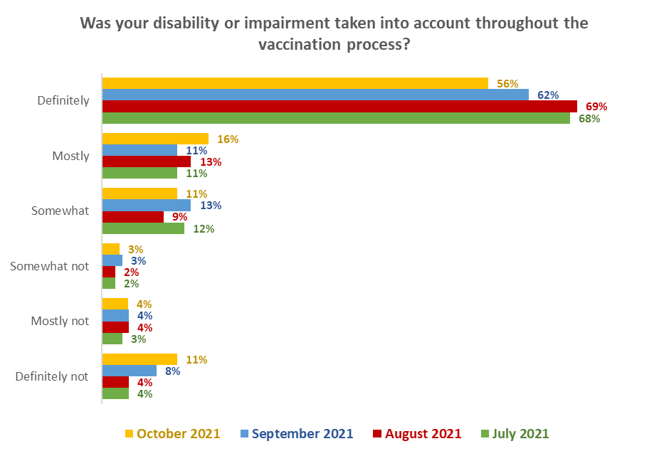
Base: vaccinated (one or two doses): October n=620; September n=708; August n=496; July n=461.

10.4 Likelihood of recommending vaccination to others
People who had been vaccinated were asked ‘Overall, how likely are you to recommend getting the COVID-19 vaccination to others?’

In comparison with previous surveys, there was a significant increase in those saying they were “very likely” to recommend getting the COVID-19 vaccine (79% versus 47% in September).

Across the larger DHB areas, all areas have an above average response and likelihood to recommend vaccination is highest in the Auckland, Counties Manukau, Waikato, Northland, Hawke’s Bay, Hutt, and Capital and Coast areas.

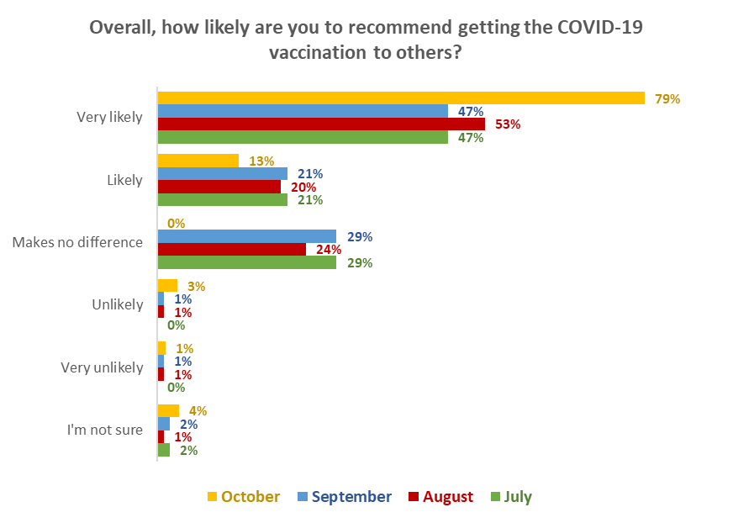
Base: vaccinated (one or two doses): October n = 2192, September 2,065, August n=1,290, July n=934
Note figures shown may not sum to 100% owing to rounding.

10.5. Who would you be prepared to talk with about them getting the vaccine?
All those who had already got the vaccine were asked to select from a list who they would be prepared to talk with about getting the vaccine.

85% were willing to talk with others and 15% were not.

- 61% were prepared to talk with their friends.
- A nett 65% were prepared to talk with their family/whanau, including:
  - Parents (44%)
  - Brothers (41%) and sisters (39%)
  - Other family/whānau (39%)
  - Elderly relatives (36%)
  - Cousins (34%)
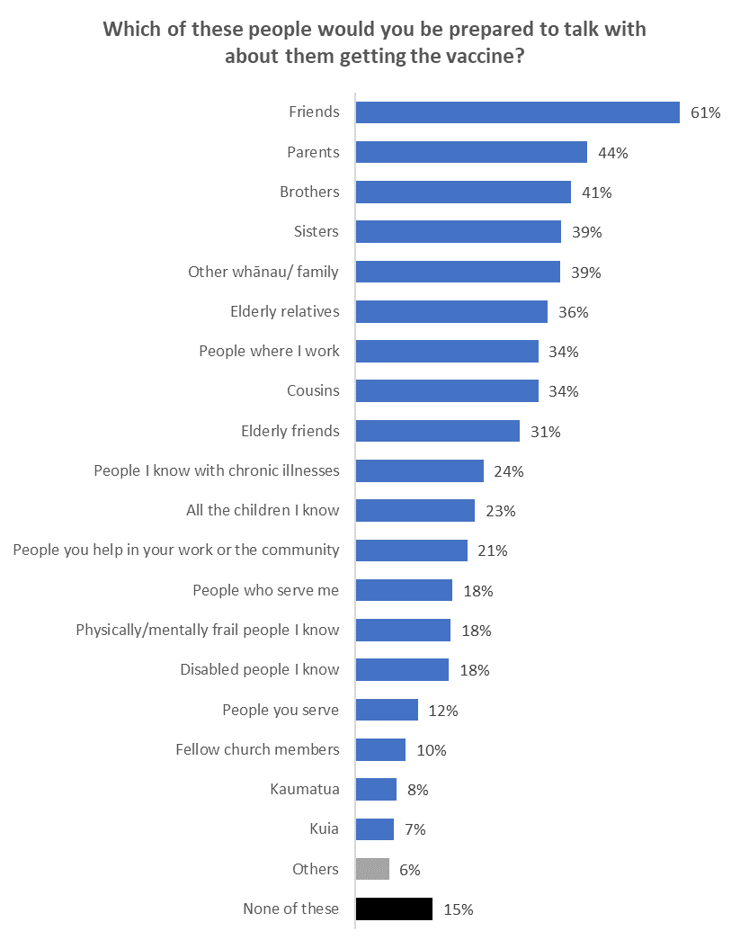
Base: vaccinated (one or two doses) n = 2175
“Other”, selected by 6% of respondents, included:
- Anybody that asked what it was like, what issues etc.
- Everyone I come in contact with, in person or by phone or online.
- Wife and kids.

10.6. What vaccinated people could say to others that would help convince them to get vaccinated?
All those who were already vaccinated and had said they would be prepared to talk with others about getting vaccinated were asked to state in their own words what they could say to people to help convince them to get vaccinated.

1693 out of the 1857 who would be prepared to talk with others responded to this question.

There were 10 themes isolated, the primary ones being:

- Talking about getting the vaccine (18%)
- Getting vaccinated for friends and family (15%)
- Getting vaccinated for the community (14%)

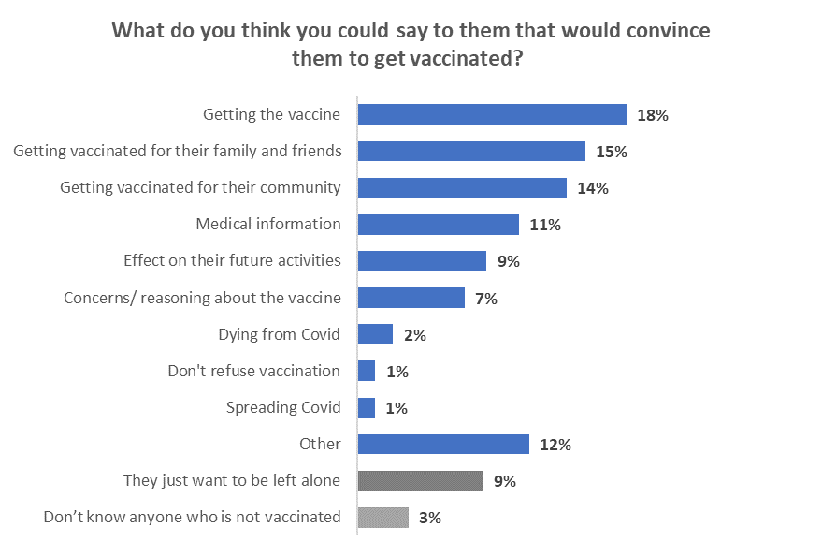Base: vaccinated (one or two doses), prepared to talk with others about vaccination n = 1693

Verbatim comments illustrating each theme follow…

Getting Vaccinated
It's in their interests to have one to protect themselves and Friends and Family. (Male, 65-74 years, NZ European/Pakeha).

I'd gently explain my journey with having vaccinations - like polio, whooping cough, tetanus, shingles etc and how life was like for those without them. (Male, 65-74 years, Other European).

Vaccination is much safer than getting COVID-19, and it gives you protection and more freedom. (Male, 25-34 years, Asian).

Getting vaccinated for their family and friends
Remember the measles outbreak in Samoa. That was mainly far too many being unvaccinated. COVID could have a similar effect on the unvaccinated. Are you prepared to both suffer and convey that disease to others such as your family? (Male, 65-74 years, NZ European/Pakeha).

To think of their family and friends. To help stop their friends and relatives get COVID 19. (Female, 75 years or over, NZ European/Pakeha).

Get the vaccine cuz; the parents and other cousins have immuno-compromised problem. (Female, 55-64 years, Asian).

Getting vaccinated for their community
I've had two minimal conversations with them. I don't think there is anything I could say that would make them get it. The only thing would be to have COVID-19 spreading in the community. (Female, 45-54 years, NZ European/Pakeha).

How does not being vaccinated help our community? (Male, 65-74 years, NZ European/Pakeha).

That it's for public and personal good. (Male, 35-44 years, Indian).

Medical information
I would show them the general statistics from New Zealand and overseas that show the safety and effectiveness of the vaccine. (Male, 18-24 years, NZ European/Pakeha).

First, I would sit down with a cup of tea and ask them to tell me about their concerns. Then talk through each point, referring to information on the NZ COVID website for info e.g., contents of the vaccine. I wouldn't be 'pushy' just make sure they have the right info. (Female, 65-74 years, NZ European/Pakeha).

Show them the stats from the Government COVID pages, explain we have had no side effects at all, and it's the best thing they can do to give themselves the best chance of surviving COVID. (Female, 75 years or over, NZ European/Pakeha).

Effect on their future activities
You want to travel in future, get vaccinated. (Male, 35-44 years, Pacific Islander).

How will you feel when you are no longer able to travel overseas or go to a concert? (Female, 65-74 years, Other European (includes Australian, South African, British etc).

If we want to get back to any normality and if you want to travel you will need to be vaccinated. (Female, 55-64 years, NZ European/Pakeha).

Getting vaccinated will mean you can attend events and participate in activities in the future. (Female, 25-34 years, NZ European/Pakeha).

Concerns/reasoning about the vaccine
Do a lot of listening, about what their concerns are and where they found out, suggest other sources and why they could check them out. Offer to go too, share my vaccine experience etc. (Female, 65-74 years, NZ European/Pakeha).

Listen to their reasons then try to Allay their fears first then talk about vaccinations and it changed our lives. Ask them to do it for their children." (Female, 75 years or over, NZ European/Pakeha).

Allow them time to ask their questions and respond with facts. (Female, 25-34 years, Asian, Indian).

Dying from COVID-19
If you don't get vaccinated but catch COVID you're welcome to stay at home to recover (or not) but if you have to be hospitalised, you are taking up a bed that may be needed for another sick patient or accident victim. Would you want someone to die from their injuries or an illness because they were unable to be admitted to hospital as there were no beds left?

My aunt died from COVID. It was a slow, painful, lonely death and I wouldn't want anybody to suffer that way. I would also show them a photo of her. (Female, 25-34 years, Other).

It will stop you dying! (Female, 55-64 years, Other European (includes Australian, South African, British etc).

Spreading COVID-19
You may spread the illness to old, young and disabled people. You won't be able to travel, go to concerts or lots of other events. (Female, 55-64 years, NZ European/Pakeha)

COVID is not selective and if you get the disease and are vaccinated chances are it will be less serious, and you are less likely to pass it on - in any event, you shortly won't be able to go to many places unvaxed. (Male, 75 years or over, NZ European/Pakeha).

It reduces spread and likelihood of getting COVID. By not getting vaxed you could take other people's freedoms away by taking up valuable hospital space when it could have avoided. (Male, 35-44 years, NZ European/Pakeha).

Don’t Refuse Vaccination
The health implications of not getting it, the risk to their life. (Male, 55-64 years, NZ European/Pakeha).

The consequences if you don’t. (Male, 45-54 years, Māori).

Have you thought about the debilitating effects of the \COVID \virus, should you catch it?
Unvaccinated people are far more likely to face complications from the disease than those already vaccinated. Think of your family, if not of yourself. (Female, 75 years or over, NZ European/Pakeha).

They just want to be left alone
I don't think there is anything I could say - they have been convinced by silly conspiracy theories they have read online. I think the mandates will be the only thing that will get them to do it, because they won't be able to go to bars/concerts/restaurants/university. (Female, 18-24 years, NZ European/Pakeha).

Sister-in-law with an anti-vac husband. Have tried talking but get nowhere. (Female, 65-74 years, NZ European/Pakeha).

Nothing, once they've made their minds up they refute all evidence of the benefits of the vaccine. (Male, 18-24 years, NZ European/Pakeha).

Other
It's the way the world is going and you'll be left behind. (Male, 25-34 years, NZ European/Pakeha).

I’d like to visit you at home rather than a grave site. (Male, 55-64 years, NZ European/Pakeha).

Know no one in this category, but would tell a story[narrative] to use as an allegory re the value of having the vax et al. (Male, 65-74 years, Māori).

Don’t know anyone who is not vaccinated
N/A - everyone I know has been vaccinated. (Male, 45-54 years, NZ European/Pakeha).

Everyone I know has had two vaccinations. (Male, 55-64 years, NZ European/Pakeha).

I don't know anyone who hasn't had it. (Female, 75 years or over, NZ European/Pakeha).

10.7 Would information on any of these help you to talk with someone who hasn't had the COVID-19 vaccine?
To assess what information would be useful to help people talk with others about getting the vaccine, vaccinated respondents were asked ‘Would information on any of these help you to talk with someone who hasn't had the COVID-19 vaccine?’

26% said they didn’t need any information; 74% selected at least one form of information they would like.

The most effective forms of information that would help people talk about getting the vaccine consists of material that shows:
- How the vaccine protects health (43%)
- Where they can get expert advice (41%)
- It is unlikely to cause a serious adverse reaction (40%)
- What it is like to have COVID-19 (40%)

These are not a 100% match with the things that those who are vaccinated and willing to talk with others said they would talk about; they would probably comprise supporting evidence to be woven into the conversation.
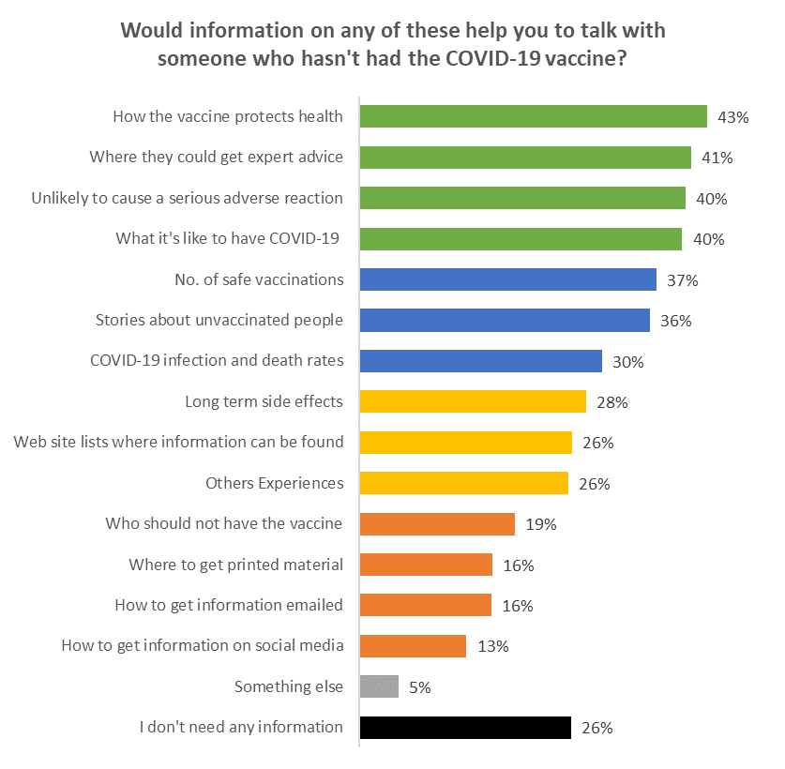
Base: vaccinated (one or two doses), prepared to talk with others about vaccination n = 1857

10.8 How would you like to receive this support information?
Vaccinated respondents were asked how they would like to receive support information. Results from the latest October 2021 survey highlight how people would like to receive this information.

The top five sources for receiving support information are:
- Government websites (47%).
- News online (43%).
- Email (43%).
- TV news (40%).
- Printed information from GPs and pharmacies (40%).

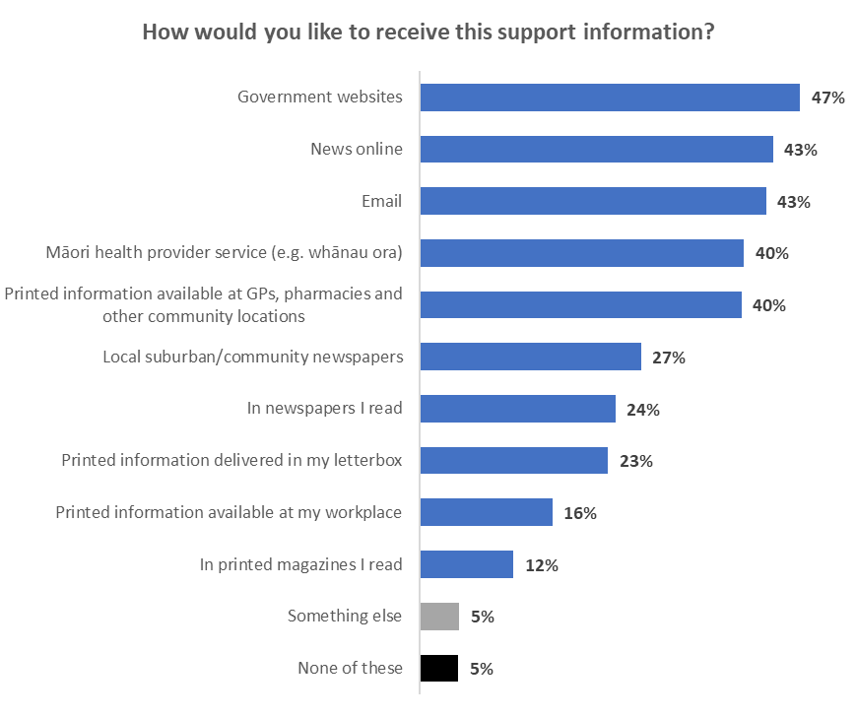
Base: vaccinated (one or two doses), prepared to talk with others about vaccination,
would like information n = 1,357

Trust in the management of the pandemic and rating of the vaccination response
All respondents were asked:
- How much they trusted the Ministry and Government to manage the COVID-19 pandemic in a way which best protected them and other New Zealanders.
- How they thought the vaccination response to the COVID-19 pandemic was being managed in New Zealand.

11.1 Management of the pandemic
The average trust in the Ministry of Health and Government to manage the pandemic, on a scale of 0 to 5 (with 5 being highest) has dropped to 3.3 out of 5, the lowest measured since the start of the series in February 2021.

Those who have been fully vaccinated (two doses) have an average trust level of 3.6 (and 62% totally trust or mostly trust the Ministry of Health and Government to manage the pandemic).

Those unvaccinated and unbooked have an average trust level of 1.0 out of 5 (with 48% saying they totally distrust) and only 8% of these respondents totally or mostly trusted the Ministry of Health and Government’s management of the pandemic.

This suggests a large divide in the population between those who trust the Ministry of Health or Government and those who do not, with a strong relationship between a person’s decision to get vaccinated or not and the level of trust.

Trust is much lower for those “definitely not” getting the vaccine (0.2), and 1.2 for those “unlikely” or “most unlikely”.

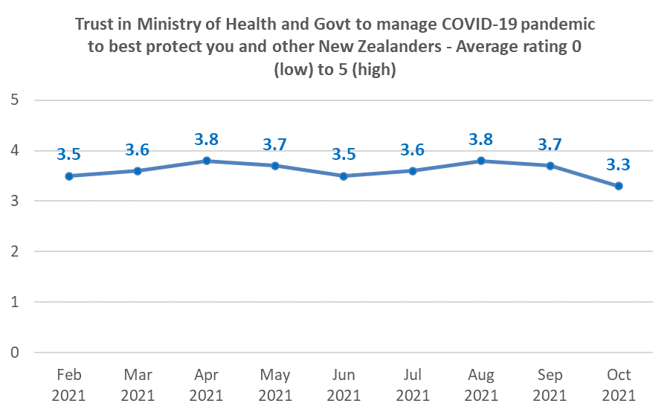
Base: all respondents n=2,386

Trust in the management of the pandemic and rating the vaccination response doesn’t vary by any of the demographic groups measured.

11.2 Management of the vaccination response
The average rating of the vaccination response (on a scale of 0 to 10, 10 being highest) for October 2021 has dropped to the lowest level measured, 5.9.
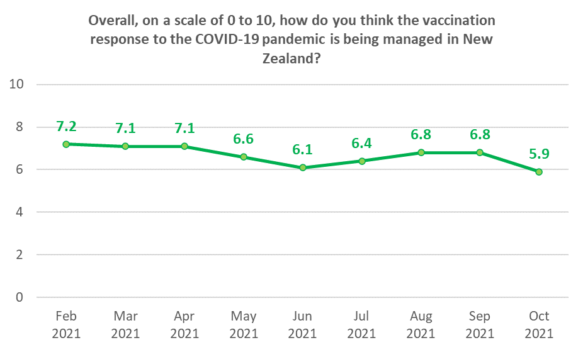
Base: all respondents n=2,383

Females are a little more likely to rate the response higher (6.1 to males 5.8).

There is no strong trend by age.

Respondents in different ethnic groups rated the vaccination response differently, with Asian respondents giving it an average of 6.8 out of 10, and Indian and Other European respondents rating it at an average of 5.4.

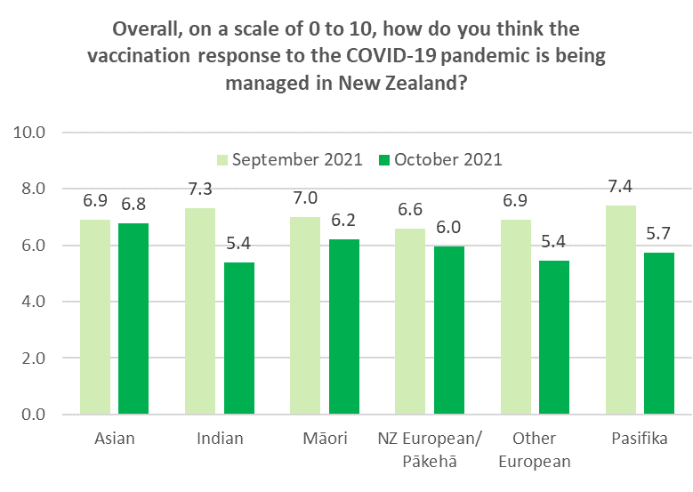
Base: all respondents n=2,383.
Asian n=155; Indian n=98; Māori n=194; NZ European/Pākehā n=1,835; Other European n=203; Pasifika n=47.

Those with higher levels of household income gave lower ratings to the vaccination response. Households earning $100,000 or more rate it 5.6, compared to those earning under $100,000 (6.1).

The level of education someone has does not seem to make a difference.

People who identify as disabled rate the response more favourably (6.6 compared to 6.0 for those who don’t identify as disabled).

People living in rural areas rate the response at a lower than average level (5.3 compared to 6.1 not living rurally).

Those “definitely not” going to get the vaccine rate the response as 0.6 (and 70% of them rate it zero out of ten).

APPENDIX 1 - SAMPLE
2,447 people aged 16+ who are members of the nationwide HorizonPoll panel and two third-party respondent panels (all of which are representative of the New Zealand population, with the broad mix of panels being used for source diversity), responded to this online survey between 28 October and 9 November 2021.

The total sample is weighted on age, gender, employment status, personal income and region to match the 16+ population at the most recent census. This weighting also produced alignment with the overall vaccination rate as at 9 November 2021.

At a 95% confidence level, the survey has a maximum margin of error of ±2.0% overall.

Sub-sample respondent counts and maximum margins of error (which occur when there is a 50%/50% answer) are shown below.

 | All respondents |  |  | Not vaccinated
 | Count | Maximum  sub-sample margin of error |  | Count | Maximum  sub-sample margin of error
TOTAL | 2,447 | ±2.0% |  | 246 | ±6.2.0%
GENDER
Male | 1,194 | ±2.8.0% |  | 119 | ±9%
Female | 1,234 | ±2.8% |  | 125 | ±8.8%
Another gender | 19 | ±22.5% |  | 2 | ±69.3%
AGE GROUP
16-17 years | 19 | ±22.5% |  | 4 | ±49%
18-24 years | 154 | ±7.9% |  | 18 | ±23.1%
25-34 years | 386 | ±5% |  | 45 | ±14.6%
35-44 years | 318 | ±5.5% |  | 31 | ±17.6%
45-54 years | 398 | ±4.9% |  | 37 | ±16.1%
55-64 years | 416 | ±4.8% |  | 57 | ±13%
65-74 years | 508 | ±4.3.0% |  | 39 | ±15.7%
75 years or over | 248 | ±6.2% |  | 15 | ±25.3%
IMPAIRMENT, LONG-TERM HEALTH CONDITIONS OR DISABLED
Impairment or long-term health conditions | 694 | ±3.7% |  | 71 | ±11.6.0%
Identify as disabled | 124 | ±8.8% |  | 16 | ±24.5%

 | All respondents |  |  | Not vaccinated
 | Count | Maximum  sub-sample margin of error |  | Count | Maximum  sub-sample margin of error
AREA TYPE
Large city | 1,126 | ±2.9% |  | 87 | ±10.5.0%
Regional City | 305 | ±5.6% |  | 30 | ±17.9%
Regional town | 376 | ±5.1% |  | 44 | ±14.8%
Rural, but not remote | 232 | ±6.4% |  | 31 | ±17.6%
Rural and remote | 24 | ±20% |  | 7 | ±37%
ETHNIC GROUP
Asian | 158 | ±7.8% |  | 13 | ±27.2%
Indian | 99 | ±9.8% |  | 11 | ±29.5%
Māori | 206 | ±6.8% |  | 28 | ±18.5%
NZ European/ Pākehā | 1,884 | ±2.3% |  | 182 | ±7.3%
Other European | 209 | ±6.8% |  | 30 | ±17.9%
Pasifika | 48 | ±14.1% |  | 10 | ±31%
Other | 46 | ±14.4% |  | 8 | ±34.6%
DHB AREA
Northland | 83 | ±10.8% |  | 11 | ±29.5%
Waitemata | 332 | ±5.4% |  | 33 | ±17.1%
Auckland | 279 | ±5.9% |  | 15 | ±25.3%
Counties Manukau | 179 | ±7.3.0% |  | 16 | ±24.5%
Waikato | 211 | ±6.7% |  | 23 | ±20.4%
Lakes | 44 | ±14.8% |  | 2 | ±69.3%
Bay of Plenty | 100 | ±9.8% |  | 15 | ±25.3%
Tairawhiti | 11 | ±29.5% |  | 1 | ±98%
Taranaki | 58 | ±12.9% |  | 8 | ±34.6%
Hawke's Bay | 90 | ±10.3% |  | 11 | ±29.5%
Whanganui | 34 | ±16.8% |  | 4 | ±49%
MidCentral | 102 | ±9.7% |  | 12 | ±28.3%
Hutt | 98 | ±9.9.0% |  | 3 | ±56.6%
Capital and Coast | 228 | ±6.5.0% |  | 24 | ±20%
Wairarapa | 35 | ±16.6% |  | 8 | ±34.6%
Nelson/ Marl-borough | 80 | ±11% |  | 11 | ±29.5%
West Coast | 13 | ±27.2.0% |  | 2 | ±69.3%
Canterbury | 288 | ±5.8% |  | 26 | ±19.2%
South Canterbury | 22 | ±20.9% |  | 2 | ±69.3%
Southern | 159 | ±7.8% |  | 19 | ±22.5%

Contact
For more information about this survey, please contact:

Grant McInman, telephone 021 076 2040, email gmcinman@horizonresearch.co.nz.
Andrew Stevenson, telephone 021 464 307, email andrew.stevenson@horizonresearch.co.nz
Graeme Colman, telephone 021 84 85 76, email gcolman@horizonresearch.co.nz.

APPENDIX 2 - PROFILE BY LIKELIHOOD TO GET A COVID-19 VACCINE

 | DEMOGRAPHIC PROFILE:  Likelihood to get a COVID-19 vaccine |  |  | Will you get a COVID-19 vaccine?
 |  |  |  | All |  | Total Likely |  | Total Unlikely |  | Definitely not |  | Unsure
 |  |  |  | 100% |  | 2% |  | 2% |  | 4% |  | 2%
GENDER
 |  | Male | 48% |  | 41% |  | 26% |  | 49% |  | 41%
 |  | Female | 51% |  | 59% |  | 71% |  | 51% |  | 59%
 |  | Gender diverse | 1% |  | 0% |  | 3% |  | 1% |  | 0%
AGE GROUP
 |  | 16-17 years | 2% |  | 6% |  | 6% |  | 0% |  | 0%
 |  | 18-24 years | 11% |  | 6% |  | 9% |  | 7% |  | 13%
 |  | 25-34 years | 18% |  | 40% |  | 27% |  | 10% |  | 10%
 |  | 35-44 years | 14% |  | 20% |  | 4% |  | 15% |  | 16%
 |  | 45-54 years | 20% |  | 20% |  | 7% |  | 29% |  | 23%
 |  | 55-64 years | 12% |  | 1% |  | 26% |  | 15% |  | 25%
 |  | 65-74 years | 16% |  | 6% |  | 13% |  | 18% |  | 10%
 |  | 75 years or over | 8% |  | 1% |  | 10% |  | 7% |  | 3%
 |  | AVERAGE AGE (years) | 48.0 |  | 38.1 |  | 47.9 |  | 51.5 |  | 48.3
 |  | % difference from overall average |  |  | --20.6% |  | --0.2% |  | +7.2% |  | +0.5.0%

 | DEMOGRAPHIC PROFILE:  Likelihood to get a COVID-19 vaccine |  |  |  |  | Will you get a COVID-19 vaccine?
 |  |  |  |  |  | All |  |  | Total Likely |  |  | Total Unlikely |  |  | Definitely not |  |  | Unsure
 |  |  |  |  |  | 100% |  |  | 2% |  |  | 2% |  |  | 4% |  |  | 2%
HOUSEHOLD INCOME
 |  |  | Less than $20,000 per year | 10% |  |  | 25% |  |  | 9% |  |  | 11% |  |  |  | 6%
 |  |  | Between $20,001 and $30,000 per year | 11% |  |  | 11% |  |  | 21% |  |  | 20% |  |  |  | 17%
 |  |  | Between $30,001 and $50,000 per year | 20% |  |  | 11% |  |  | 27% |  |  | 22% |  |  |  | 32%
 |  |  | Between $50,001 and $70,000 per year | 12% |  |  | 5% |  |  | 13% |  |  | 18% |  |  |  | 15%
 |  |  | Between $70,001 and $100,000 per year | 17% |  |  | 27% |  |  | 10% |  |  | 12% |  |  |  | 5%
 |  |  | Between $100,001 and $150,000 per year | 11% |  |  | 4% |  |  | 8% |  |  | 6% |  |  |  | 6%
 |  |  | Between $150,001 and $200,000 per year | 4% |  |  | 1% |  |  | 1% |  |  | 2% |  |  |  | 1%
 |  |  | More than $200,000 per year | 3% |  |  | 5% |  |  | 4% |  |  | 2% |  |  |  | 1%
 |  |  | Don't know/ prefer not to say | 12% |  |  | 11% |  |  | 8% |  |  | 10% |  |  |  | 18%
 |  |  | AVERAGE HOUSEHOLD INCOME ($) | $69,260 |  |  | $60,820 |  |  | $57,280 |  |  | $54,240 |  |  |  | $50,560
 |  |  | % difference from overall average |  |  |  | --12.2% |  |  | --17.3% |  |  | --21.7% |  |  |  | --27%
PERSONAL INCOME
 |  |  | Less than $20,000 per year | 39% |  |  | 50% |  |  | 49% |  |  | 38% |  |  |  | 42%
 |  |  | Between $20,001 and $30,000 per year | 14% |  |  | 7% |  |  | 15% |  |  | 18% |  |  |  | 23%
 |  |  | Between $30,001 and $50,000 per year | 21% |  |  | 18% |  |  | 18% |  |  | 23% |  |  |  | 16%
 |  |  | Between $50,001 and $70,000 per year | 6% |  |  | 7% |  |  | 5% |  |  | 5% |  |  |  | 1%
 |  |  | Between $70,001 and $100,000 per year | 6% |  |  | 5% |  |  | 4% |  |  | 3% |  |  |  | 3%
 |  |  | Between $100,001 and $150,000 per year | 3% |  |  | 0% |  |  | 1% |  |  | 3% |  |  |  | 1%
 |  |  | Between $150,001 and $200,000 per year | 1% |  |  | 0% |  |  | 1% |  |  | 0% |  |  |  | 1%
 |  |  | More than $200,000 per year | 1% |  |  | 0% |  |  | 3% |  |  | 1% |  |  |  | 1%
 |  |  | Don't know/ prefer not to say | 10% |  |  | 12% |  |  | 5% |  |  | 9% |  |  |  | 15%
 |  |  | AVERAGE PERSONAL INCOME ($) | $34,180 |  |  | $26,090 |  |  | $32,010 |  |  | $31,170 |  |  |  | $25,450
 |  |  | % difference from overall average |  |  |  | --23.7% |  |  | --6.3% |  |  | --8.8% |  |  |  | --25.5%
 | DEMOGRAPHIC PROFILE:  Likelihood to get a COVID-19 vaccine |  |  |  |  | Will you get a COVID-19 vaccine?
 |  |  |  |  |  | All |  |  | Total Likely |  |  | Total Unlikely |  |  | Definitely not |  |  | Unsure
 |  |  |  |  |  | 100% |  |  | 2% |  |  | 2% |  |  | 4% |  |  | 2%
EMPLOYED
 |  |  | Yes | 65% |  |  | 55% |  |  | 63% |  |  | 53% |  |  |  | 74%
 |  |  | No | 35% |  |  | 45% |  |  | 37% |  |  | 47% |  |  |  | 26%
OCCUPATION
 |  |  | Professional/Senior Government Official | 7% |  |  | 2% |  |  | 3% |  |  | 1% |  |  |  | 4%
 |  |  | Business Manager/Executive | 4% |  |  | 8% |  |  | 2% |  |  | 1% |  |  |  | 4%
 |  |  | Business Proprietor/Self-employed | 8% |  |  | 5% |  |  | 23% |  |  | 10% |  |  |  | 15%
 |  |  | Teacher/Nurse/Police or other trained service worker | 9% |  |  | 2% |  |  | 4% |  |  | 8% |  |  |  | 7%
 |  |  | Clerical/Sales Employee | 14% |  |  | 12% |  |  | 5% |  |  | 13% |  |  |  | 20%
 |  |  | Farm Owner/manager | 1% |  |  | 1% |  |  | 2% |  |  | 1% |  |  |  | 1%
 |  |  | Technical/mechanical/Skilled Worker | 8% |  |  | 8% |  |  | 6% |  |  | 10% |  |  |  | 7%
 |  |  | Labourer/Agricultural or Domestic Worker | 5% |  |  | 7% |  |  | 3% |  |  | 4% |  |  |  | 5%
 |  |  | Home-maker (not otherwise employed) | 8% |  |  | 14% |  |  | 10% |  |  | 13% |  |  |  | 5%
 |  |  | Student | 10% |  |  | 6% |  |  | 10% |  |  | 5% |  |  |  | 0%
 |  |  | Retired/Superannuitant | 16% |  |  | 13% |  |  | 13% |  |  | 17% |  |  |  | 13%
 |  |  | Unemployed/Beneficiary | 7% |  |  | 7% |  |  | 13% |  |  | 12% |  |  |  | 12%
 |  |  | Don't know/prefer not to say | 4% |  |  | 15% |  |  | 6% |  |  | 5% |  |  |  | 9%

 | DEMOGRAPHIC PROFILE:  Likelihood to get a COVID-19 vaccine |  |  |  |  | Will you get a COVID-19 vaccine?
 |  |  |  |  |  | All |  |  | Total Likely |  |  | Total Unlikely |  |  | Definitely not |  |  | Unsure
 |  |  |  |  |  | 100% |  |  | 2% |  |  | 2% |  |  | 4% |  |  | 2%
HIGHEST QUALIFICATION
 |  |  | Postgraduate degree (Masters' degree or PhD) | 11% |  |  | 1% |  |  | 0% |  |  | 7% |  |  |  | 4%
 |  |  | Undergraduate (Bachelor) degree | 27% |  |  | 22% |  |  | 21% |  |  | 14% |  |  |  | 23%
 |  |  | Vocational qualification (includes trade certificates, diplomas etc) | 25% |  |  | 16% |  |  | 37% |  |  | 40% |  |  |  | 35%
 |  |  | University Bursary or 7th form | 10% |  |  | 30% |  |  | 11% |  |  | 6% |  |  |  | 11%
 |  |  | Sixth form/UE/NCEA Level 2 | 11% |  |  | 10% |  |  | 16% |  |  | 19% |  |  |  | 8%
 |  |  | NCEA Level 1 or School Certificate | 8% |  |  | 10% |  |  | 4% |  |  | 3% |  |  |  | 6%
 |  |  | No formal school qualification | 6% |  |  | 6% |  |  | 10% |  |  | 8% |  |  |  | 10%
 |  |  | Prefer not to say | 3% |  |  | 5% |  |  | 1% |  |  | 3% |  |  |  | 5%
HOUSEHOLD TYPE
 |  |  | Single person household | 15% |  |  | 4% |  |  | 22% |  |  | 17% |  |  |  | 16%
 |  |  | Couple only (no children/none at home) | 29% |  |  | 17% |  |  | 15% |  |  | 28% |  |  |  | 18%
 |  |  | Two parent family, one or two children at home | 28% |  |  | 35% |  |  | 25% |  |  | 19% |  |  |  | 35%
 |  |  | Two parent family, three or more children at home | 8% |  |  | 12% |  |  | 10% |  |  | 8% |  |  |  | 2%
 |  |  | One parent family, one or two children at home | 5% |  |  | 10% |  |  | 18% |  |  | 13% |  |  |  | 12%
 |  |  | One parent family, three or more children at home | 1% |  |  | 0% |  |  | 0% |  |  | 1% |  |  |  | 1%
 |  |  | Flatting or boarding - not a family home | 9% |  |  | 5% |  |  | 3% |  |  | 9% |  |  |  | 8%
 |  |  | Extended family | 4% |  |  | 13% |  |  | 1% |  |  | 1% |  |  |  | 6%
 |  |  | Prefer not to say | 2% |  |  | 5% |  |  | 6% |  |  | 3% |  |  |  | 4%
 |  |  | Children in Household | 41% |  |  | 57% |  |  | 54% |  |  | 42% |  |  |  | 50%
 |  |  | Two-parent family | 36% |  |  | 47% |  |  | 36% |  |  | 27% |  |  |  | 37%
 |  |  | One-parent family | 6% |  |  | 10% |  |  | 18% |  |  | 15% |  |  |  | 13%

 | DEMOGRAPHIC PROFILE:  Likelihood to get a COVID-19 vaccine |  |  |  |  | Will you get a COVID-19 vaccine?
 |  |  |  |  |  | All |  |  | Total Likely |  |  | Total Unlikely |  |  | Definitely not |  |  | Unsure
 |  |  |  |  |  | 100% |  |  | 2% |  |  | 2% |  |  | 4% |  |  | 2%
ETHNIC GROUP
 |  |  | Asian | 7% |  |  | 14% |  |  | 0% |  |  | 2% |  |  |  | 4%
 |  |  | Indian | 4% |  |  | 6% |  |  | 4% |  |  | 3% |  |  |  | 0%
 |  |  | Māori | 8% |  |  | 4% |  |  | 16% |  |  | 6% |  |  |  | 5%
 |  |  | NZ European/Pākehā | 69% |  |  | 72% |  |  | 63% |  |  | 69% |  |  |  | 66%
 |  |  | Other European (includes Australian, South African, British etc) | 7% |  |  | 0% |  |  | 6% |  |  | 16% |  |  |  | 23%
 |  |  | Pasifika | 2% |  |  | 3% |  |  | 7% |  |  | 4% |  |  |  | 1%
 |  |  | Other | 2% |  |  | 1% |  |  | 5% |  |  | 1% |  |  |  | 0%
IDENTIFY AS DISABLED
 |  |  | Yes | 7% |  |  | 0% |  |  | 7% |  |  | 11% |  |  |  | 12%
 |  |  | No | 93% |  |  | 100% |  |  | 93% |  |  | 89% |  |  |  | 88%

 | DEMOGRAPHIC PROFILE:  Likelihood to get a COVID-19 vaccine |  |  |  |  | Will you get a COVID-19 vaccine?
 |  |  |  |  |  | All |  |  | Total Likely |  |  | Total Unlikely |  |  | Definitely not |  |  | Unsure
 |  |  |  |  |  | 100% |  |  | 2% |  |  | 2% |  |  | 4% |  |  | 2%
DHB
 |  |  | Northland | 4% |  |  | 2% |  |  | 2% |  |  | 7% |  |  |  | 11%
 |  |  | Waitemata | 14% |  |  | 8% |  |  | 16% |  |  | 12% |  |  |  | 16%
 |  |  | Auckland | 12% |  |  | 5% |  |  | 2% |  |  | 10% |  |  |  | 1%
 |  |  | Counties-Manukau | 8% |  |  | 10% |  |  | 10% |  |  | 3% |  |  |  | 11%
 |  |  | Waikato | 10% |  |  | 5% |  |  | 12% |  |  | 8% |  |  |  | 6%
 |  |  | Lakes | 2% |  |  | 0% |  |  | 0% |  |  | 2% |  |  |  | 0%
 |  |  | Bay of Plenty | 5% |  |  | 5% |  |  | 4% |  |  | 10% |  |  |  | 10%
 |  |  | Tairawhiti | 0% |  |  | 5% |  |  | 0% |  |  | 0% |  |  |  | 0%
 |  |  | Taranaki | 2% |  |  | 0% |  |  | 2% |  |  | 4% |  |  |  | 4%
 |  |  | Hawke's Bay | 4% |  |  | 17% |  |  | 0% |  |  | 9% |  |  |  | 0%
 |  |  | Whanganui | 1% |  |  | 0% |  |  | 2% |  |  | 4% |  |  |  | 0%
 |  |  | Midcentral | 4% |  |  | 20% |  |  | 2% |  |  | 1% |  |  |  | 5%
 |  |  | Hutt | 3% |  |  | 2% |  |  | 0% |  |  | 0% |  |  |  | 0%
 |  |  | Capital and Coast | 7% |  |  | 1% |  |  | 12% |  |  | 7% |  |  |  | 4%
 |  |  | Wairarapa | 2% |  |  | 0% |  |  | 8% |  |  | 2% |  |  |  | 2%
 |  |  | Nelson-Marlborough | 3% |  |  | 0% |  |  | 8% |  |  | 5% |  |  |  | 3%
 |  |  | West Coast | 1% |  |  | 0% |  |  | 4% |  |  | 0% |  |  |  | 3%
 |  |  | Canterbury | 12% |  |  | 18% |  |  | 2% |  |  | 10% |  |  |  | 11%
 |  |  | South Canterbury | 1% |  |  | 0% |  |  | 0% |  |  | 2% |  |  |  | 2%
 |  |  | Southern | 7% |  |  | 3% |  |  | 14% |  |  | 5% |  |  |  | 12%
 |  |  | North Island | 76% |  |  | 79% |  |  | 72% |  |  | 78% |  |  |  | 69%
 |  |  | Auckland | 33% |  |  | 22% |  |  | 28% |  |  | 25% |  |  |  | 28%
 |  |  | Upper North Island excluding Auckland | 20% |  |  | 12% |  |  | 19% |  |  | 26% |  |  |  | 27%
 |  |  | Lower North Island | 23% |  |  | 45% |  |  | 26% |  |  | 27% |  |  |  | 15%
 |  |  | South Island | 24% |  |  | 21% |  |  | 28% |  |  | 22% |  |  |  | 31%

 | DEMOGRAPHIC PROFILE:  Likelihood to get a COVID-19 vaccine |  |  |  |  | Will you get a COVID-19 vaccine?
 |  |  |  |  |  | All |  |  | Total Likely |  |  | Total Unlikely |  |  | Definitely not |  |  | Unsure
 |  |  |  |  |  | 100% |  |  | 2% |  |  | 2% |  |  | 4% |  |  | 2%
AREA TYPE
 |  |  | Large city | 56% |  |  | 35% |  |  | 52% |  |  | 41% |  |  |  | 53%
 |  |  | Regional city | 14% |  |  | 23% |  |  | 8% |  |  | 15% |  |  |  | 10%
 |  |  | Regional town | 18% |  |  | 24% |  |  | 16% |  |  | 25% |  |  |  | 20%
 |  |  | Rural, but not remote | 11% |  |  | 13% |  |  | 22% |  |  | 11% |  |  |  | 17%
 |  |  | Rural and remote | 1% |  |  | 6% |  |  | 1% |  |  | 8% |  |  |  | 0%

APPENDIX 3 – NOT VACCINATED: PROFILE BY DECISION-MAKING TIME PERIOD

DEMOGRAPHIC PROFILE:  Likelihood to get a COVID-19 vaccine |  | All | For you personally, how long do you think you'll need before you decide to get the vaccine, if at all?  - Grouped responses
 |  |  | In next 2 months | 3-12 months | A year or more | Definitely, or probably, never
 |  | 100% | 28% | 14% | 22% | 37%
GENDER
 | Male | 48% | 54% | 47% | 28% | 43%
 | Female | 51% | 46% | 53% | 70% | 57%
 | Another gender | 1% | 0% | 0% | 2% | 1%
AGE GROUP
 | 16-17 years | 2% | 0% | 16% | 0% | 0%
 | 18-24 years | 11% | 13% | 5% | 18% | 8%
 | 25-34 years | 18% | 21% | 28% | 15% | 14%
 | 35-44 years | 14% | 14% | 22% | 17% | 10%
 | 45-54 years | 20% | 25% | 12% | 11% | 24%
 | 55-64 years | 12% | 14% | 11% | 24% | 19%
 | 65-74 years | 16% | 6% | 6% | 12% | 17%
 | 75 years or over | 8% | 7% | 1% | 4% | 8%
 | AVERAGE AGE (years) | 48.0 | 45.1 | 38.1 | 46.3 | 51.5
 | % difference from overall average |  | --6.1% | --20.7% | --3.6% | +7.2%

DEMOGRAPHIC PROFILE:  Likelihood to get a COVID-19 vaccine |  | All | For you personally, how long do you think you'll need before you decide to get the vaccine, if at all?  - Grouped responses
 |  |  | In next 2 months | 3-12 months | A year or more | Definitely, or probably, never
 |  | 100% | 28% | 14% | 22% | 37%
HOUSEHOLD INCOME
 | Less than $20,000 per year | 10% | 15% | 12% | 11% | 9%
 | Between $20,001 and $30,000 per year | 11% | 9% | 8% | 19% | 22%
 | Between $30,001 and $50,000 per year | 20% | 25% | 20% | 19% | 23%
 | Between $50,001 and $70,000 per year | 12% | 19% | 12% | 23% | 15%
 | Between $70,001 and $100,000 per year | 17% | 16% | 21% | 6% | 11%
 | Between $100,001 and $150,000 per year | 11% | 4% | 12% | 5% | 4%
 | Between $150,001 and $200,000 per year | 4% | 2% | 1% | 3% | 1%
 | More than $200,000 per year | 3% | 0% | 6% | 2% | 2%
 | Don't know/ prefer not to say | 12% | 10% | 9% | 12% | 13%
 | AVERAGE HOUSEHOLD INCOME ($) | $69,260 | $52,580 | $71,390 | $55,260 | $51,380
 | % difference from overall average |  | --24.1% | +3.1% | --20.2% | --25.8%

DEMOGRAPHIC PROFILE:  Likelihood to get a COVID-19 vaccine |  | All | For you personally, how long do you think you'll need before you decide to get the vaccine, if at all?  - Grouped responses
 |  |  | In next 2 months | 3-12 months | A year or more | Definitely, or probably, never
 |  | 100% | 28% | 14% | 22% | 37%
PERSONAL INCOME
 | Less than $20,000 per year | 39% | 44% | 24% | 41% | 43%
 | Between $20,001 and $30,000 per year | 14% | 17% | 8% | 24% | 16%
 | Between $30,001 and $50,000 per year | 21% | 19% | 45% | 10% | 22%
 | Between $50,001 and $70,000 per year | 6% | 6% | 5% | 3% | 4%
 | Between $70,001 and $100,000 per year | 6% | 3% | 7% | 3% | 2%
 | Between $100,001 and $150,000 per year | 3% | 2% | 0% | 1% | 3%
 | Between $150,001 and $200,000 per year | 1% | 0% | 2% | 0% | 1%
 | More than $200,000 per year | 1% | 0% | 1% | 2% | 0%
 | Don't know/ prefer not to say | 10% | 10% | 9% | 17% | 9%
 | AVERAGE PERSONAL INCOME ($) | $34,180 | $27,130 | $39,650 | $28,560 | $29,180
 | % difference from overall average |  | --20.6% | +16% | --16.4% | --14.6%
EMPLOYED
 | Yes | 65% | 56% | 65% | 66% | 56%
 | No | 35% | 44% | 36% | 35% | 44%

DEMOGRAPHIC PROFILE:  Likelihood to get a COVID-19 vaccine |  | All | For you personally, how long do you think you'll need before you decide to get the vaccine, if at all?  - Grouped responses
 |  |  | In next 2 months | 3-12 months | A year or more | Definitely, or probably, never
 |  | 100% | 28% | 14% | 22% | 37%
OCCUPATION
 | Professional/Senior Government Official | 7% | 4% | 6% | 5% | 1%
 | Business Manager/Executive | 4% | 2% | 14% | 0% | 2%
 | Business Proprietor/Self-employed | 8% | 9% | 12% | 10% | 12%
 | Teacher/Nurse/Police or other trained service worker | 9% | 1% | 0% | 7% | 8%
 | Clerical/Sales Employee | 14% | 11% | 13% | 15% | 11%
 | Farm Owner/manager | 1% | 2% | 1% | 0% | 2%
 | Technical/mechanical/Skilled Worker | 8% | 10% | 8% | 2% | 9%
 | Labourer/Agricultural or Domestic Worker | 5% | 16% | 11% | 4% | 3%
 | Home-maker (not otherwise employed) | 8% | 10% | 6% | 6% | 13%
 | Student | 10% | 9% | 16% | 7% | 4%
 | Retired/Superannuitant | 16% | 12% | 1% | 15% | 19%
 | Unemployed/Beneficiary | 7% | 13% | 9% | 14% | 13%
 | Don't know/prefer not to say | 4% | 3% | 4% | 14% | 3%
 |  | 19% | 15% | 32% | 15% | 15%
HIGHEST QUALIFICATION
 | Postgraduate degree (Masters' degree or PhD) | 11% | 2% | 1% | 4% | 6%
 | Undergraduate (Bachelor) degree | 27% | 18% | 26% | 16% | 15%
 | Vocational qualification (includes trade certificates, diplomas etc) | 25% | 26% | 28% | 36% | 39%
 | University Bursary or 7th form | 10% | 12% | 18% | 21% | 5%
 | Sixth form/UE/NCEA Level 2 | 11% | 10% | 15% | 16% | 16%
 | NCEA Level 1 or School Certificate | 8% | 26% | 1% | 2% | 5%
 | No formal school qualification | 6% | 5% | 4% | 4% | 11%
 | Prefer not to say | 3% | 1% | 8% | 0% | 4%

DEMOGRAPHIC PROFILE:  Likelihood to get a COVID-19 vaccine |  | All | For you personally, how long do you think you'll need before you decide to get the vaccine, if at all?  - Grouped responses
 |  |  | In next 2 months | 3-12 months | A year or more | Definitely, or probably, never
 |  | 100% | 28% | 14% | 22% | 37%
HOUSEHOLD TYPE
 | Single person household | 15% | 13% | 5% | 20% | 19%
 | Couple only (no children/none at home) | 29% | 20% | 24% | 15% | 26%
 | Two parent family, one or two children at home | 28% | 33% | 31% | 28% | 20%
 | Two parent family, three or more children at home | 8% | 7% | 21% | 6% | 8%
 | One parent family, one or two children at home | 5% | 15% | 3% | 15% | 14%
 | One parent family, three or more children at home | 1% | 0% | 1% | 0% | 1%
 | Flatting or boarding - not a family home | 9% | 3% | 4% | 8% | 8%
 | Extended family | 4% | 9% | 12% | 4% | 2%
 | Prefer not to say | 2% | 2% | 0% | 6% | 3%
 | Children in Household | 41% | 54% | 55% | 48% | 43%
 | Two-parent family | 36% | 40% | 52% | 33% | 27%
 | One-parent family | 6% | 15% | 3% | 15% | 16%

DEMOGRAPHIC PROFILE:  Likelihood to get a COVID-19 vaccine |  | All | For you personally, how long do you think you'll need before you decide to get the vaccine, if at all?  - Grouped responses
 |  |  | In next 2 months | 3-12 months | A year or more | Definitely, or probably, never
 |  | 100% | 28% | 14% | 22% | 37%
ETHNIC GROUP
 | Asian | 7% | 13% | 7% | 0% | 1%
 | Indian | 4% | 1% | 20% | 3% | 2%
 | Māori | 8% | 9% | 7% | 13% | 6%
 | NZ European/Pakeha | 69% | 66% | 49% | 68% | 74%
 | Other European (includes Australian, South African, British etc) | 7% | 7% | 4% | 17% | 12%
 | Pasifika | 2% | 3% | 7% | 0% | 4%
 | Other | 2% | 0% | 7% | 0% | 1%
Identify as disabled
 | Yes | 7% | 11% | 12% | 11% | 11%
 | No | 93% | 89% | 88% | 89% | 89%

DEMOGRAPHIC PROFILE:  Likelihood to get a COVID-19 vaccine |  | All | For you personally, how long do you think you'll need before you decide to get the vaccine, if at all?  - Grouped responses
 |  |  | In next 2 months | 3-12 months | A year or more | Definitely, or probably, never
 |  | 100% | 28% | 14% | 22% | 37%
DHB
 | Northland | 4% | 2% | 1% | 13% | 6%
 | Waitemata | 14% | 26% | 4% | 12% | 12%
 | Auckland | 12% | 3% | 4% | 4% | 8%
 | Counties-Manukau | 8% | 8% | 23% | 4% | 4%
 | Waikato | 10% | 3% | 11% | 7% | 11%
 | Lakes | 2% | 1% | 0% | 0% | 1%
 | Bay of Plenty | 5% | 7% | 8% | 3% | 9%
 | Tairāwhiti | 0% | 0% | 4% | 0% | 0%
 | Taranaki | 2% | 4% | 5% | 2% | 3%
 | Hawke's Bay | 4% | 2% | 9% | 1% | 7%
 | Whanganui | 1% | 1% | 0% | 0% | 4%
 | Midcentral | 4% | 7% | 7% | 2% | 3%
 | Hutt | 3% | 0% | 1% | 0% | 0%
 | Capital and Coast | 7% | 8% | 1% | 9% | 7%
 | Wairarapa | 2% | 0% | 2% | 0% | 4%
 | Nelson-Marlborough | 3% | 5% | 3% | 10% | 3%
 | West Coast | 1% | 1% | 0% | 8% | 0%
 | Canterbury | 12% | 18% | 14% | 11% | 9%
 | South Canterbury | 1% | 0% | 0% | 0% | 3%
 | Southern | 7% | 6% | 5% | 14% | 7%

DEMOGRAPHIC PROFILE:  Likelihood to get a COVID-19 vaccine |  | All | For you personally, how long do you think you'll need before you decide to get the vaccine, if at all?  - Grouped responses
 |  |  | In next 2 months | 3-12 months | A year or more | Definitely, or probably, never
 |  | 100% | 28% | 14% | 22% | 37%
DHB (continued)
 | North Island | 76% | 71% | 78% | 57% | 79%
 | Auckland | 33% | 37% | 30% | 20% | 24%
 | Upper North Island excluding Auckland | 20% | 13% | 19% | 24% | 27%
 | Lower North Island | 23% | 21% | 29% | 13% | 28%
 | South Island | 24% | 29% | 22% | 43% | 21%
AREA TYPE
 | Large city | 56% | 63% | 43% | 42% | 42%
 | Regional city | 14% | 11% | 19% | 12% | 13%
 | Regional town | 18% | 10% | 25% | 12% | 29%
 | Rural, but not remote | 11% | 16% | 7% | 34% | 9%
 | Rural and remote | 1% | 0% | 6% | 0% | 7%
 | Total Rural | 12% | 16% | 13% | 34% | 16%
CAREGIVERS OF 5 TO 11 YEAR-OLDS AND 12 TO 15 YEAR-OLDS
 | 5 to 11 year-olds | 13% | 16% | 8% | 13% | 14%
 | 12 to 15 year olds | 10% | 16% | 24% | 8% | 12%
 | Not a caregiver | 77% | 68% | 68% | 80% | 74%

DEMOGRAPHIC PROFILE:  Likelihood to get a COVID-19 vaccine |  | All | For you personally, how long do you think you'll need before you decide to get the vaccine, if at all?  - Grouped responses
 |  |  | In next 2 months | 3-12 months | A year or more | Definitely, or probably, never
 |  | 100% | 28% | 14% | 22% | 37%
Believe medical or other health-related conditions mean they are not able to get a COVID-19 vaccine?
 | Yes | 23% | 10% | 17% | 27% | 27%
 | No | 77% | 90% | 83% | 73% | 73%
What do you think your chances are of being infected with the Delta COVID-19 virus at some time?
 | High chance | 24% | 13% | 13% | 14% | 18%
 | Some chance | 47% | 44% | 33% | 43% | 26%
 | Little chance | 19% | 24% | 38% | 24% | 24%
 | No chance | 3% | 3% | 10% | 10% | 22%
 | I really don't know | 8% | 16% | 8% | 10% | 11%

DEMOGRAPHIC PROFILE:  Likelihood to get a COVID-19 vaccine |  | All | For you personally, how long do you think you'll need before you decide to get the vaccine, if at all?  - Grouped responses
 |  |  | In next 2 months | 3-12 months | A year or more | Definitely, or probably, never
 |  | 100% | 28% | 14% | 22% | 37%
Generally, does the opportunity to use all businesses, and be able to do more activities if you are fully vaccinated, make you more or less likely to get two doses of the vaccine?
 | Definitely more likely | 18% | 44% | 8% | 0% | 1%
 | More likely | 19% | 31% | 16% | 5% | 3%
 | Unlikely | 11% | 7% | 19% | 8% | 9%
 | Most unlikely | 9% | 1% | 16% | 24% | 9%
 | Definitely not | 32% | 4% | 19% | 47% | 74%
 | I'm really not sure | 11% | 11% | 22% | 16% | 4%
Post-COVID infection health effects: If you received this information, what effect, if any, would it have on your intention to get the vaccine? Would you be...
 | Definitely more likely | 3% | 0% | 5% | 0% | 0%
 | More likely | 4% | 15% | 10% | 2% | 0%
 | Slightly more likely | 6% | 20% | 8% | 10% | 2%
 | Neither more nor less likely | 46% | 40% | 45% | 52% | 47%
 | Slightly less likely | 2% | 5% | 5% | 0% | 0%
 | Less likely | 5% | 0% | 5% | 10% | 4%
 | Definitely less likely | 25% | 5% | 3% | 7% | 43%
 | I'm still really not sure | 11% | 15% | 20% | 19% | 4%

DEMOGRAPHIC PROFILE:  Likelihood to get a COVID-19 vaccine |  | All | For you personally, how long do you think you'll need before you decide to get the vaccine, if at all?  - Grouped responses
 |  |  | In next 2 months | 3-12 months | A year or more | Definitely, or probably, never
 |  | 100% | 28% | 14% | 22% | 37%
Thinking about others in your life or community, who (if anyone) would you most like to protect from COVID-19 and the Delta strain by getting vaccinated?
 | Parents | 5% | 9% | 6% | 7% | 3%
 | Brothers | 4% | 4% | 5% | 4% | 3%
 | Sisters | 4% | 3% | 5% | 4% | 2%
 | Cousins | 3% | 3% | 6% | 3% | 1%
 | Elderly relatives | 6% | 7% | 7% | 4% | 5%
 | Other whānau/ family | 4% | 4% | 4% | 3% | 3%
 | Kuia | 2% | 1% | 2% | 3% | 1%
 | Kaumatua | 2% | 1% | 2% | 3% | 1%
 | All the children I know | 3% | 6% | 3% | 4% | 2%
 | Babies and infants | 3% | 3% | 3% | 4% | 3%
 | Elderly friends | 3% | 4% | 3% | 3% | 2%
 | Friends | 4% | 6% | 4% | 5% | 2%
 | People where I work | 3% | 1% | 4% | 3% | 1%
 | People who serve me (e.g., at supermarkets, stores, trades people) | 3% | 3% | 4% | 3% | 2%
 | People you serve | 2% | 1% | 2% | 3% | 1%
 | People you help in your work or the community | 2% | 3% | 3% | 3% | 1%
 | Disabled people I know | 2% | 1% | 2% | 3% | 2%
 | Physically and/ or mentally frail people I know | 2% | 3% | 2% | 3% | 2%
 | People I know with chronic illnesses | 3% | 3% | 3% | 3% | 4%
 | Fellow church members | 1% | 0% | 1% | 2% | 1%

DEMOGRAPHIC PROFILE:  Likelihood to get a COVID-19 vaccine |  | All | For you personally, how long do you think you'll need before you decide to get the vaccine, if at all?  - Grouped responses
 |  |  | In next 2 months | 3-12 months | A year or more | Definitely, or probably, never
 |  | 100% | 28% | 14% | 22% | 37%
 | My friends | 3% | 6% | 3% | 3% | 1%
 | Younger children | 2% | 3% | 4% | 3% | 1%
 | People who provide services for me | 2% | 3% | 3% | 3% | 1%
 | Children going to school | 3% | 4% | 4% | 3% | 1%
 | Children under 5 years-old | 3% | 4% | 4% | 3% | 1%
 | I won't get vaccinated to protect others | 8% | 3% | 2% | 6% | 21%
 | None of these | 11% | 7% | 6% | 10% | 23%
 | Others | 7% | 3% | 5% | 3% | 14%
Specifically, would you get the COVID-19 vaccine to protect children under 12 years old and others who can't take it for medical reasons?
 | Definitely | 5% | 0% | 8% | 3% | 0%
 | Most Likely | 3% | 20% | 8% | 0% | 0%
 | Likely | 6% | 15% | 21% | 0% | 3%
 | Unlikely | 12% | 20% | 26% | 18% | 5%
 | Most unlikely | 9% | 5% | 5% | 18% | 7%
 | Definitely not | 46% | 10% | 8% | 26% | 76%
 | I'm still really not sure | 18% | 30% | 24% | 34% | 10%

DEMOGRAPHIC PROFILE:  Likelihood to get a COVID-19 vaccine |  | All | For you personally, how long do you think you'll need before you decide to get the vaccine, if at all?  - Grouped responses
 |  |  | In next 2 months | 3-12 months | A year or more | Definitely, or probably, never
 |  | 100% | 28% | 14% | 22% | 37%
Would you get two doses of the COVID-19 vaccine just so you can go to or do any of these things?
 | Enter hospitality venues (like cafes, bars, nightclubs, restaurants) | 11% | 14% | 10% | 0% | 0%
 | Attend family/ whanau gatherings | 12% | 14% | 13% | 0% | 0%
 | Attend weddings, places of worship, marae | 10% | 12% | 5% | 0% | 0%
 | Attend indoor and outdoor events | 10% | 11% | 12% | 0% | 1%
 | Use a business where people are in close contact | 10% | 12% | 15% | 0% | 2%
 | Go to a gym | 7% | 8% | 7% | 0% | 1%
 | Use a business or service which says you must be vaccinated | 10% | 12% | 3% | 3% | 1%
 | Travel from region to region (at most times) | 12% | 15% | 10% | 5% | 1%
 | Won't apply to me because I will be exempt from getting the vaccine | 2% | 0% | 5% | 14% | 7%
 | None of these - I won't get the vaccine | 16% | 2% | 21% | 78% | 88%
Generally, does the opportunity to use all businesses, and be able to do more activities if you are fully vaccinated, make you more or less likely to get two doses of the vaccine?
 | Definitely more likely | 18% | 44% | 8% | 0% | 1%
 | More likely | 19% | 31% | 16% | 5% | 3%
 | Unlikely | 11% | 7% | 19% | 8% | 9%
 | Most unlikely | 9% | 1% | 16% | 24% | 9%
 | Definitely not | 32% | 4% | 19% | 47% | 74%
 | I'm really not sure | 11% | 11% | 22% | 16% | 4%

DEMOGRAPHIC PROFILE:  Likelihood to get a COVID-19 vaccine |  | All | For you personally, how long do you think you'll need before you decide to get the vaccine, if at all?  - Grouped responses
 |  |  | In next 2 months | 3-12 months | A year or more | Definitely, or probably, never
 |  | 100% | 28% | 14% | 22% | 37%
Regardless of where you live, does the prospect of ending Level 3 lockdown in Auckland and Alert Level 2 restrictions in the South Island make you more or less likely to get two doses of the COVID-19 vaccine?
 | Definitely more likely | 17% | 45% | 3% | 0% | 0%
 | Most likely | 18% | 25% | 17% | 0% | 1%
 | Unlikely | 12% | 9% | 22% | 19% | 8%
 | Most unlikely | 9% | 7% | 8% | 24% | 8%
 | Definitely not | 31% | 3% | 17% | 41% | 78%
 | I'm really not sure | 14% | 11% | 33% | 16% | 5%
If you had to be vaccinated against COVID-19 to go to work, would you get the vaccine?
 | Definitely | 3% | 0% | 3% | 0% | 1%
 | Most likely | 6% | 26% | 11% | 0% | 1%
 | Likely | 8% | 26% | 25% | 3% | 1%
 | Not likely | 9% | 16% | 17% | 14% | 4%
 | Most unlikely | 10% | 0% | 11% | 19% | 9%
 | Definitely not | 54% | 5% | 22% | 47% | 80%
 | I'm really not sure | 11% | 26% | 11% | 17% | 5%

Uptake estimates are based on the HSU data for the 12+ population (4,209,057), including vaccination counts, as at 11:59pm on 9 November 2021, downloaded from the Ministry of Health website. The booking count by age group was supplied by the MOH, also as at 9 November 2021. All data has been rounded to the nearest 100.
Caregivers who have unvaccinated 12 to 15 year olds in their household and are willing to allow them to be vaccinated have a lower average number of 12 to 15 year-olds in their households than those who are unwilling to allow them to get a vaccine, will “Definitely not” allow them to get a vaccine, or are unsure.
Around 2.7% of the 16+ population.
“Indian” includes Indian, Pakistani, Bangladeshi, Sri Lankan
Uptake estimates are based on the HSU data for the 12+ population, including vaccination counts, as at 11:59pm on 9 November 2021, downloaded from the Ministry of Health website. The booking count by age group was supplied by the MOH, also as at 9 November 2021. All data has been rounded to the nearest 100.
The percentage who are vaccinated (one dose or two doses) has been adjusted in this chart from the weighted sample percentage (88.4%) to reflect the actual vaccination rate (89.9% or 90% rounded to the nearest percentage).
“Indian” includes Indian, Pakistani, Bangladeshi, Sri Lankan
“Indian” includes Indian, Pakistani, Bangladeshi, Sri Lankan
There is a ±18.5% margin of error that applies to the Māori sub-sample of the survey data for this question. However, in this forecast uptake, that margin of error only applies to the underlying survey data, not to the “already vaccinated” figure, which is taken from HSU data as at 11:59pm on 9 November 2021. The Total Potential Uptake figure is calculated from the “already vaccinated” figure plus the “likely to get a COVID-19 vaccine” figure. The error therefore only applies to the 3% figure shown in the chart; i.e., at a 95% significance level the “likely to get a COVID-19 vaccine” figure is in the range 2.4% to 3.5% and therefore estimated total potential uptake is in the range 77.4% to 78.5%.
There is a ±31.0% margin of error that applies to the Pasifika sub-sample of the survey data for this question. However, in this forecast uptake, that margin of error only applies to the underlying survey data, not to the “already vaccinated” figure, which is taken from HSU data as at 11:59pm on 9 November 2021. The Total Potential Uptake figure is calculated from the “already vaccinated” figure plus the “likely to get a COVID-19 vaccine” figure. The error therefore only applies to the 2% figure shown in the chart; i.e., at a 95% significance level the “likely to get a COVID-19 vaccine” figure is in the range 1.4% to 2.7% and therefore total potential uptake is in the range 88.4% to 89.7%.
The HSU data indicated greater numbers of people vaccinated in some age groups than the total population count for that age group. This chart is therefore based on the survey data only.
Caregivers who have unvaccinated 12 to 15 year olds in their household and are willing to allow them to be vaccinated have a lower average number of 12 to 15 year-olds in their households than those who are unwilling to allow them to get a vaccine, will “Definitely not” allow them to get a vaccine, or are unsure.
Based on HSU data, rounded to nearest 100.
HSU count for 5 to 11 year old, rounded to nearest 100.
This is around 2.7% of the 16+ population.
Small base, indication only.
This is owing to low base sizes for the subgroups.
The sample size is low (99 people 55 years and over), but there does seem to be a trend.
The total sample mean is 3.349 and the mean for households under $100,000 is 3.252 which is why they both round to 3.3.
This is those who say it reinforced their decision to get one, or that it made them more likely to get one – the blue and green bars.
There is a strong relationship between the two factors but the data is unable to suggest whether this is a causal relationship.
An initial survey system error resulted in the questions to gather this data being asked of 2,080 respondents out of the 2447 total.
An initial survey system error resulted in the questions to gather this data being asked of 2,080 respondents out of the 2447 total.

