Horizon Research
COVID-19 Vaccine
28 September – 1 October, 2021

In association with the School of Population Health
University of Auckland

Contents
EXECUTIVE SUMMARY 1
REPORT 13
1. Decision time period for those not vaccinated 13
2. Vaccine uptake 19
2.1 Unlikely to get a COVID-19 vaccine and difficult to persuade 22
2.2 Uptake by ethnicity 23
2.3 Uptake by people with impairment or who identify as disabled 25
2.4 Uptake by age group 26
2.5 Uptake by DHB 26
2.6 Second dose uptake 30
2.7 Vaccination timing 31
3. Attitudes to children under 15 years being vaccinated 33
3.1 Allow children to get a vaccine? 33
4. Importance of being vaccinated to reduce transmission of the virus and protect the health of others 37
5. Barriers to COVID-19 vaccination 39
5.1 Reasons for being unsure or unlikely to get vaccinated 39
5.2 Perceived medical or health conditions 43
5.3 Misinformation 44
6. Incremental gains, including gains from potential messaging 53
6.1 Will people who are unsure about being vaccinated eventually get vaccinated? 53
6.2 Protection from the effects of COVID-19 55
6.3 Post-COVID health problems 56
6.4 Protecting others from COVID-19 and the Delta strain by getting vaccinated 62
6.5 Getting vaccinated to protect children under 12 and others who can't take the vaccine for medical reasons 65
6.6 Impact of the number of people getting vaccinated, on being comfortable getting vaccinated 66
6.7 Preferred incentives for people to definitely get vaccinated 67
6.8 Would paid time off work to recover from any side effects from getting the vaccine, make people more likely to get vaccinated? 70
6.9 Motivation to get vaccinated to travel to places and attend events 71
7. Information Needs 74
7.1 Do people who have not been vaccinated have all the information they need to decide whether or not to get the COVID-19 vaccine 74
7.2 What else do people need to know to help them decide whether to get the COVID-19 vaccine? 75
7.3 The one thing that would absolutely convince people to get a COVID-19 vaccine 80
8. Vaccine facts and beliefs 84
8.1 Facts and beliefs people have heard of 84
8.2 Facts and beliefs that are likely to be true 85
9. Attitudes to the Delta strain of COVID-19 87
9.1 True statements about the Delta strain 87
9.2 Chances of being infected by the Delta strain at some time 89
10. Tracking question results 90
10.1 Preferred ways to access the vaccine 90
10.2 Sources of official information about the vaccine 91
10.3 Impact of seeing an official COVID-19 vaccine advertisement 92
11. Experiences of those who have already been vaccinated 94
11.1 Did you receive enough information about your vaccination? 94
11.2 How invited to make a booking 99
11.3 How people actually made the booking 101
11.4 Ease of making a booking 103
11.5 Rating the booking experience 108
11.6 Assessing the appointment experience 110
11.7 Were people’s language needs met through the process? 113
11.8 Were people’s disability or impairment needs catered for through the process? 114
11.9 Likelihood of recommending vaccination to others 114
11.10 Suggested improvements to the vaccination process 115
12. Trust in the management of the pandemic and rating of the vaccination response 121
12.1 Management of the pandemic 121
12.2 Management of the vaccination response 122
APPENDIX 1 - SAMPLE 125
APPENDIX 2 - PROFILE BY LIKELIHOOD TO GET A COVID-19 VACCINE 127
APPENDIX 3 – NOT VACCINATED: PROFILE BY DECISION-MAKING TIME PERIOD 134
APPENDIX 4 – TABLES…………………………………………………………………………………………………….ATTACHED

EXECUTIVE SUMMARY
These results are from an online survey of 2,479 respondents in New Zealand aged 16 years of age or over. The survey was conducted between 28 September and 1 October 2021 (i.e., prior to the “Super Saturday” vaccination drive).

The sample is weighted on age, gender, employment status, ethnicity, personal income and region to match the 16+ population and at the most recent census.

At a 95% confidence level, the survey has a maximum margin of error of ±2.0% overall.

KEY FINDINGS
In August 47% of respondents said they were unvaccinated, in September this dropped to 19% of respondents. This means the unvaccinated group was very different this wave compared to the previous wave, so comparisons between August and September should be made cautiously. In September, there is a much higher proportion of unvaccinated respondents in the unvaccinated group who are unlikely to get a COVID-19 vaccine. Specifically:

- In August, of those who are unvaccinated, 70% were likely to get the vaccine, 10% were unsure, 10% were unlikely to get the vaccine and 10% said they would definitely not get the vaccine.
- In September, of those who are unvaccinated, 33% are likely to get the vaccine (as, presumably, some of the August ‘intenders’ did get vaccinated), 22% are unsure, 26% are unlikely to get the vaccine and 20% say they will definitely not get the vaccine.

Despite these shifts, the estimated actual proportion of the total 16+ population who are unlikely to get the vaccine or won’t get the vaccine is still the same as in August: around 9%.

Had one dose respondents
- 95% of those who had one dose were likely to get a second, the same overall result as both July and June 2021.
- 2% said they were unlikely to get a second dose of the vaccine.
- The “definitely” result for those who have already had 1 dose is below the 87% recorded in August, suggesting that effort should go into ensuring that second dose uptake is maximised.

Not vaccinated – population estimates
- An estimated 761,500 people 16+ are not vaccinated.
- Of these, 529,500 are “uncommitted” (i.e., are neither “Definitely” going to get the vaccine nor “Definitely not” going to get it). This is 13% of the 16+ population.

- Among those who are unlikely to get a vaccine or say they definitely won’t, there is a “core” who will probably be difficult to persuade to get a COVID-19 vaccine, because they have effectively stopped listening: they either don’t need more information or they already definitely or mostly have all the information they feel they need to justify their decision. Because of the reduced proportion of people who remain unvaccinated, this “core” has climbed to 29.7% of those aged 16+ who are not vaccinated (August 11.5%, July 9.0%, June 11.6%, May 7.0%, April 8.4% and 9.4% in March 2021). This is equivalent to 5.5% of the total 16+ population (August 5.4%).

- There is a potential incremental gain from unvaccinated people who said they may eventually get the vaccine, equivalent to 1.36% of the 16+ population or around 54,400 people.

- A further nett incremental gain of 5.9% (240,500 people 16+) may be possible from those who are currently unsure whether they will eventually get the vaccine or not. However, only 9% of that potential gain (around 20,900 people 16+) is likely to be achieved in 2021. If achieved, it would lift the overall 12+ potential uptake by 0.5%.

Vaccine uptake - population estimates for key subgroups
- Growth in potential uptake has slowed. It is now estimated at 87% of the 16+ population (August 86%).

- Including 12–15 -year-olds, the potential overall 12+ population uptake is estimated at 86.7%.

16+ population | % | Estimated no.
Already vaccinated | 81% | 3,329,300
Likely to get a vaccine | 6% | 249,600
Potential uptake 16+ population | 87% | 3,578,900
12–15-years | % | Estimated no.
Likely to get a vaccine (parental permission – includes already vaccinated) | 74% | 195,900
TOTAL POTENTIAL UPTAKE 12+ POPULATION | 86.7% | 3,774,800

- Estimated potential uptake for the 16+ population by ethnic group is:

Ethnic Group | Estimated uptake %
ALL | 87.5%
Asian | 87%
Indian | 93%
Māori | 73%
NZ European/Pākehā | 77%
Other European | 97%
Pasifika | 81%
Other | 89%

- 60% of caregivers of 5- to 11-year-olds said that if a vaccine is approved for use with 5-to-11-year-olds, they will allow their children in that age group to get vaccinated. The total potential uptake among the 5+ population if that were to happen is estimated at 84%.

5-11-years | % | Estimated no.
Parental permission to get a COVID-19 vaccine | 60% | 276,600

TOTAL POTENTIAL UPTAKE 5+ POPULATION | 84% | 4,051,400

Decision time period of unvaccinated respondents
Unvaccinated respondents were asked questions about their likelihood to get vaccinated, whether or not they would eventually decide to get vaccinated and how long they would need before they decide to get the vaccine, if at all. Drawing across these questions, the following decision time period is estimated for respondents:

- 2% will definitely get vaccinated.
- 5% will decide in the next 2 months.
- 2% will decide in the next 3-12 months (i.e., somewhere during 2022).
- 4% will decide in a year or more (i.e., in late 2022, 2023, or later).
- 6% will definitely or probably never get the vaccine.

A key focus should be on accelerating the decision to get a vaccine so that 2021 uptake is maximised.

Information needs
Do unvaccinated people have all the information they need to decide to get vaccinated?
- Around half (48%) of those not vaccinated feel they have enough information to decide. This has dropped sharply from 68% in August.

What else do people need to know?
Main themes are as follows:
- information on the long-term effects of the vaccine, based on longer and/or more clinical studies (mentioned by 29%).
- ‘facts’ on the success rate for vaccines, their effectiveness, their ingredients and the results from international studies (14%).
- information on side effects and risks (13%).
- being suspicious of government information/ ‘propaganda’ (9%) – an emerging response, only mentioned by 2% in August

These information needs on long-term effects of the vaccine, ‘facts’ on the vaccine, side effects and risks are also reflected in the comments made by those who are already vaccinated but said they would have liked more information.

The one thing that would absolutely convince people to get a COVID-19 vaccine
From an open-ended question, main themes are:
- Nothing would make me take the vaccine (23%).
- Knowing it works (15%).
- Long-term data on the vaccine, its safety and side effects (13%).

Importance of being vaccinated to reduce transmission of the virus and protect the health of others
Excluding ‘not sure’ responses, unvaccinated people have a broad range of views about the importance of getting the vaccine to help reduce the transmission of the virus and protect the health of others:
- High importance 31%.
- Medium importance 28%.
- Low importance 41%.

Barriers to vaccination

Reasons for being unsure or unlikely to get vaccinated
Main reasons from an open-ended question included:
- There are serious side effects/deaths from the vaccine (28%).
- Long term effects are not known/ it’s just a trial (26%).
- The government wants to control us/ is bullying us into getting the vaccine/I don't trust the government (13%).

Perceived medical or health conditions
19% of those not yet vaccinated believe medical or other health-related conditions mean they are not able to get a COVID-19 vaccine. This perception is highest among those who are either “Likely” or “Unlikely” to get the vaccine.

Of the respondents who believed medical or other health-related conditions meant they were not able to get a COVID-19 vaccine:

- 1 in 3 said they had had an allergic reaction to any vaccine.
- 1 in 6 said they were immunocompromised.
- 1 in 8 said they were being tested for COVID-19 or had had COVID-19.
- 1 in 8 said they were taking antibiotics.
- 1 in 14 said they were pregnant, trying to have a baby, or were breastfeeding.

Nearly all of the 8% who said they were unwell or had a fever were “Definitely” getting vaccinated.

Misinformation
- Those who had been vaccinated noticed more vaccine misinformation than in August, whereas unvaccinated people noticed less.
In September almost six out of ten people (56%) had noticed what they believed to be misinformation about the vaccines in the past 30 days, an increase from 51% in August. This compares with 42% of unvaccinated people having noticed misinformation, a decline from the August results (48%).

- Social media is the main source of perceived misinformation
Social media was mentioned by 71% of those who noticed misinformation and by 70% of the unvaccinated group.

- Key disinformation themes
From an open-ended question asking what made people think what they had seen was misinformation, key themes include:
- Unscientific and unsubstantiated claims
- Conspiracy theories.
- Stupid comments.
- Claims contrary to official information.
- Emotive, dramatic content.
- Side effects such as magnetism.
- Official/government statements are not believable/ ‘anti-vax’ views.

- Responses by unvaccinated people to perceived misinformation have changed dramatically compared with the August results.
In August, a nett 14% of unvaccinated people would not take a vaccine if something they initially thought was misinformation actually alarmed them or looked credible. Of potential concern, this result has increased to 46% in September.

- Responses by unvaccinated people to perceived misinformation vary according to their intentions to get vaccinated
 | All unvaccinated | Likely to get vaccinated | Unlikely
I would look for official information if something I initially thought was misinformation about COVID-19 vaccines concerned me | 36% | 40%↑ | 29%↓
Nett would not take a vaccine if something I initially thought was misinformation actually alarmed me or looked credible | 46% | 30%↓ | 61%↑
Key: ↑= above overall average, ↓ = below overall average

Incremental gains from messaging, incentives or needing proof of vaccination
Several key arguments for vaccination and possible incentives were tested for their potential to encourage those not vaccinated to get a COVID-19 vaccine. Restrictions on access to events, travel and places were also assessed. In all cases, the gains from these messages, incentives and restrictions were incremental rather than encouraging large numbers to get a vaccine.

In general, the messaging and incentives encouraging unvaccinated people to get the vaccine will have more impact on those who are already likely to get the vaccine, than on those who are unsure, or unlikely to get the vaccine.

Note that it is not valid to add together the estimated incremental gains in each of the following sub-sections to give a total effect as the same people may be responding to more than one message.

The nett incremental gain from using all of the messaging measured in the survey is estimated at 1.2% (50,400 people) of those who are unlikely to get vaccinated and 1.4% (58,900 people) of those who are currently unsure.

Messaging:

Protection from the effects of COVID-19 infection
Overall, 27% of respondents said that this would make them more likely to get the vaccine. These people were primarily those who would “Definitely’ or “Most Likely” get vaccinated.

The incremental gain from those unlikely to get a vaccine was around 0.4% of the 16+ population, or approximately 16,600 extra people from those who were currently unlikely to get a vaccine. It had greater impact on the unsure, with an incremental gain of 0.7% of the population 16+, or around 27,300 extra people.

Post-COVID health problems
This messaging was based on international experience indicating health problems being suffered by people around the world around six months after COVID-19 infection. It included “long-haul COVID”.

Overall, 34% of respondents said that this would make them more likely to get the vaccine. These people were primarily those who would “Definitely’ or “Most Likely” get vaccinated.

This “post-COVID health problem” messaging has almost double the effect of messaging about protection from the effects of COVID-19 among those who are currently not likely to get a vaccine: the incremental gain among this group is 0.76%, estimated at 31,300 people 16+. Among the unsure, it has an incremental gain of 1.1% or around 46,400 people 16+.

Protecting others by getting vaccinated
When prompted, unvaccinated people said they would most like to protect their parents (38%) and elderly relatives (25%) from COVID-19 and the Delta strain by getting vaccinated.

However, 17% (nearly all from those who said they were unlikely to get a vaccine) said they would not get vaccinated to protect others.

The unvaccinated who are already likely to get vaccinated are likely to be the most responsive to the argument to "get vaccinated to protect others".

Getting vaccinated to specifically protect children under 12 and those who can’t take the vaccine for medical reasons
Around a third of those who are yet to be vaccinated (32%) indicated they could be motivated to get vaccinated to protect children under 12 and those who can't take the vaccine for medical reasons.

This message line tends to engender ambivalence. It is likely to work best for those who are already likely to get a vaccine but may be better used in the context of "protecting others" rather than used on its own.

As a standalone message, it is likely to work best among Māori and Pasifika.

If it were to be used as a standalone message, the incremental gain from the unlikely group was around 0.5% of the 16+ population, or approximately 20,600 extra people from those who were currently unlikely to get a vaccine. It had slightly greater impact on the unsure, with an incremental gain of around 0.8% of the population 16+, or 33,800 extra people.

Impact of the number of people getting vaccinated on being comfortable getting vaccinated
Almost six out of ten unvaccinated people (59%) said the number of people getting vaccinated made no difference to their decision. However, 20% feel more comfortable getting vaccinated due to the number getting vaccinated; these were primarily (9 out of 10) those who are already likely to get vaccinated.

The incremental gain from those unlikely to get a vaccine was around 0.35% of the 16+ population, or approximately 14,400 extra people from those who were currently unlikely to get a vaccine. It had greater impact on the unsure, with an incremental gain of around 0.7% of the population 16+, or 27,300 extra people.

Incentives:
Would paid time off work to recover from any side effects from getting the vaccine make people more likely to get vaccinated?
18% say paid time off work would make them more likely to get vaccinated. However, 13% said this would make them less likely to get vaccinated. Therefore, the nett impact is only +5%. Perhaps such an offer reminds these people of possible side effects of the vaccine, which are a concern for unvaccinated people.

The incremental gain from paid time off to recover from side effects for the unvaccinated and unlikely group (58% of whom are employed) was around 0.5% of the 16+ population, or approximately 22,400 extra people from those who were currently unlikely to get a vaccine. It had a slightly greater impact on the unsure, with an incremental gain of around 0.7% of the population 16+, or 27,800 extra people.

Will incentives make unvaccinated people definitely get vaccinated?
While 25% of unvaccinated people say the health benefits of getting vaccinated mean they would not choose an incentive, still 75% chose an incentive of some type. Immediate $100 cash incentives (24%) and $100 gift card vouchers (21%) are the preferred options.

Of the various incentives measured, the highest incremental gain from those unlikely to get vaccinated was 0.8%, an estimated 33,500 people, for a $100 per person cash payment. None of the other incentives measured exceeded a 0.5% incremental gain.

Among those who were unsure, the highest incremental gain from those unlikely to get vaccinated was 0.8%, an estimated 33,500 people, for a $100 per person cash payment. None of the other incentives measured exceeded a 0.5% incremental gain.
The conclusion is that incentives are not going to have a massive impact on the overall number getting vaccinated. The impact is more on people who are currently likely to get vaccinated and that will not result in an increase in the overall percentage vaccination rate.

Restrictions without proof of vaccination
Would the ability to travel to places and attend events motivate people to get vaccinated?
While 47% said they don’t care where they can’t go as they are still not getting vaccinated and 21% said they would get vaccinated anyway, 32% chose at least one place to go that would motivate them to take the vaccine. The most popular option is overseas travel, selected by 23% of unvaccinated people.

Those who say they are likely to be vaccinated are much more likely to be motivated by travel and event opportunities than those who say they are unlikely or definitely not getting vaccinated. However, while the gains are still incremental, restrictions on overseas travel and domestic air travel have the potential to motivate a significantly greater number of those who are currently unlikely to get vaccinated to actually get vaccinated, than any other measure/messaging.

Examples are:
Being able to go to these places, or travel in this way | Likely to get a vaccine but not definite |  | Unlikely to get a vaccine |  | Unsure
 | Incremental shift to "Definite" |  | Incremental gain |  | Incremental gain
 | %  16+ popn | Estimated number | %  16+ popn | Estimated number | %  16+ popn | Estimated number
Nett Domestic air travel or overseas travel | 2.1% | 84,100 | 1.3% | 53,500 | 1.4% | 57,000
Nett overseas travel or overseas travel for business | 1.9% | 79,400 | 1.1% | 43,100 | 1.4% | 56,300
Nett Cafés and Restaurants | 0.8% | 33,000 | 0.5% | 19,700 | 0.6% | 23,900
Nett Concerts | 0.8% | 32,700 | 0.1% | 5,500 | 0.3% | 10,500
Nett Sports Events | 0.7% | 30,300 | 0.3% | 12,700 | 0.1% | 4,300
Nett Funerals/tangihanga, Family gatherings, Weddings | 1.5% | 60,000 | 0.6% | 26,000 | 0.9% | 37,800
Church services and events | 0.5% | 20,200 | 0.4% | 17,000 | 0.1% | 3,600
Events of more than 50 to 100 people at marae | 0.7% | 29,700 | 0.2% | 8,400 | 0.2% | 7,700

Vaccine facts and beliefs

Awareness of facts and beliefs
Those who say they definitely won’t get vaccinated are more likely than the general population to have heard the following information:

- The vaccine hasn’t been proven safe; it has long term side effects; it can affect your reproductive organs
- It contains DNA or RNA; it can affect your DNA and RNA
- The government will force some people to get vaccinated
- Taking the vaccine has spiritual or religious implications.

Which facts and beliefs are likely to be true?
Those who definitely won’t get vaccinated are around eight times more likely than the general population to believe:

- It is likely to be true the vaccine can affect your reproductive organs.
- It is likely to be true that the vaccine can affect your DNA or RNA.
- It is likely to be true that taking the vaccine has religious or spiritual implications.

Attitudes to the delta strain of COVID-19

True statements about the Delta strain
From a list of 15 statements about the Delta strain, the highest proportion of responses people believe are ‘true’ are for:
- Delta is twice as infectious as earlier strains of COVID-19 (54%); and
- The chance of infecting people in your household is higher with Delta (49%).

Almost three out of ten (28%) are unsure which statements are true or not.

Chances of being infected by the Delta strain at some time
Of note, some respondents consider they’re not at risk of being infected with virus. Fourteen percent (14%) of unvaccinated respondents consider there is no chance that they will be infected, and 41% consider they have little chance of being infected. Only 8% of the unvaccinated consider they have a ‘high chance’ of being infected. Believing there is a high chance or even some chance of being infected with the Delta variant is associated with a higher likelihood of getting vaccinated.

Preferred ways to access the vaccine
As in all previous surveys, the number one preference for those who are not vaccinated is being vaccinated by ‘my doctor (GP)’ (46%). ‘At the hospital’ is now in second place (15%).

Official information about the vaccine
Sources of official information about the vaccine in the past 30 days among all respondents
Main sources are TV (72%), Social media (51%) and Radio (39%). Accessing official information via Letterbox / leaflets (21%) has increased markedly since August (7%).

Impact of seeing an official COVID-19 vaccine advertising among those who had seen official advertising
4% said this official advertising made them more likely get a vaccine, while 39% said this advertising made no difference to their decision.

Overall, official advertising is not having a net positive impact for unvaccinated people in deciding to get vaccinated, especially for those who say they are unlikely to get vaccinated.

Experiences of those who have already been vaccinated
- 94% of those who had been vaccinated said they had received enough information about their vaccination.
- Main ways they were invited to make a booking were:
  - By text (32%, up from 25% in August and 20% in July).
  - By email (24%, up from 18% in August and 15% in July).
  - Through work (13%, down from 15% in August and 23% in July).
  - By mail (13% - August 2%, July 2%).
- Main ways people actually booked were:
  - Online (51%- August 36%, July 24%).
  - By phone (27% - August 33% July 39%).
- 95% of those who had booked in the past 30 days reported that booking was easy; 5% that is had been difficult.
- The main reasons for the booking being easy included:
  - The online booking system worked well (71%; August 65%).
  - I got the time and place I wanted (51%; August 54%).
  - It was easy to book my second vaccination (38%; August 44%).
  - I was able to make bookings for both first and second doses at the same time (34%; August 41%).
  - I found the booking number easily (27%; August 30%)
- The top three reasons for it being difficult were:
- The 'Book My Vaccine' online system did not work (53%). This is around 2% of all who had booked in the past 30 days.
- Too few vaccination centre choices (49%). This is around 2% of all who had booked in the past 30 days.
- Could not get the time or place they had wanted (46%). This is around 2% of all who had booked in the past 30 days.

- 75% rated being invited to book 8 to 10 out of 10 (very positive).
- 75% also rated actually booking at 8 to 10 out of 10 (very positive)
- As in August, peoples’ positive experiences of their vaccination appointment far outweigh their negative experiences, but compared with August, positive results eased back to the July level.
- Top positive experiences include friendly staff (72%; August 75%, July 71%), ease of getting to the centre (66%; August 70%, July 61%), and no trouble finding my booking (63%; August 66%, July 63%).
- By contrast, the biggest problem area, as in July, involved vaccination centre staff not knowing who the person was (13%; August 12%, July 13%).
- 90% of those who had received at least one dose said their language needs were definitely met, however, only 62% of those with a disability or impairment said their needs had been definitely met.
- 67% said their experience made them more likely to recommend vaccination to others.

Trust in the management of the pandemic and rating the vaccination response
- Average trust in the Ministry of Health and Government to manage the pandemic has fallen back slightly, but it is not a statistically significant change. 80% now say they trust the Ministry of Health and Government (August 83%, July 78%):

At this time, how much do you trust the Ministry of Health and Government to manage the COVID-19 pandemic in a way which best protects you and other New Zealanders? | Feb 2021 | Mar 2021 | Apr 2021 | May 2021 | Jun  2021 | Jul 2021 | Aug 2021 | Sep 2021
Average trust out of 5 | 3.5 | 3.6 | 3.8 | 3.7 | 3.5 | 3.6 | 3.8 | 3.7

- The average rating of the vaccination response (on a scale of 0 to 10, 10 being highest) is steady on 6.8 out of 10.

Overall, on a scale of 0 to 10, how do you think the vaccination response to the COVID-19 pandemic is being managed in New Zealand? | Feb 2021 | Mar 2021 | Apr 2021 | May  2021 | Jun  2021 | Jul 2021 | Aug  2021 | Sep 2021
Average rating out of 10 | 7.2 | 7.1 | 7.1 | 6.6 | 6.1 | 6.4 | 6.8 | 6.8

DETAILED FINDINGS

Respondents were asked if they had been offered an opportunity to get their COVID 19 vaccine. 81% of respondents said they had received at least one dose; this aligns with the official Ministry of Health figures for vaccinations as at 11:59pm on Sunday 01 October 2021, which is the cut-off date of this survey.

Have you already been offered an opportunity to get your COVID-19 vaccination? | May 2021 | Jun 2021 | Jul 2021 | Aug 2021 | Sep 2021 | Difference  % points
No | 77% | 69% | 43% | 18% | 3% | - 15 ↓
Yes - I have already had two doses | 6% | 11% | 19% | 31% | 50% | +19 ↑
Yes - I have already had one dose | 7% | 7% | 10% | 22% | 30% | +8 ↑
Yes - I have not had the first dose, but my appointment is booked | 5% | 6% | 13% | 15% | 2% | -13 ↓
Yes - but I have not had the first dose and have not booked an appointment yet | 4% | 4% | 10% | 9% | 8% | -1
Yes, but I declined/will decline to have the vaccine | 2% | 3% | 5% | 5% | 6% | +1
N.B. Percentages shown may not sum to 100% owing to rounding
- Decision time period for those not vaccinated
Given a vaccination rate of 81% in the general population at the time of the survey, a major theme of this report is on messaging to increase the vaccination rate.

Specific messaging is discussed in more detail in Section 6. The results have been used to inform the following analysis of when the non-vaccinated will be making a final decision on COVID-19 vaccination.

Those who had not yet been vaccinated were asked ‘For you personally, how long do you think you'll need before you decide to get the vaccine, if at all?’
While there was some inconsistency between the responses to this question and the responses to the question on whether people thought they would eventually get vaccinated (asked of non-vaccinated respondents who were not “Definitely” going to get a vaccine), it was possible to estimate when their vaccine decision would be made.

The estimates are:

- 2% will definitely get vaccinated.
- 5% will decide in the next 2 months.
- 2% will decide in the next 3-12 months (i.e., somewhere during 2022).
- 4% will decide in a year or more (i.e., in late 2022, 2023, or later).
- 6% will definitely or probably never get the vaccine.

The most common response from unvaccinated people is they don’t think they will ever get the vaccine or they definitely won’t (37%), while a further 21% want to delay for a year or more.

These two groups together constitute 58% of unvaccinated people and will probably be hard to persuade to get vaccinated in the short term.

37%
Definitely or probably never
(equivalent to 6% of the 16+ population)
21%
A year or more away
(equivalent to 4% of the 16+ population)
14%
Within 3-12 months
(equivalent to 2% of the 16+ population)
28%)
Within 2 months
(equivalent to 5% of the 16+ population)
Base not yet vaccinated n=414

The following table shows the decision time periods for those who believe they will eventually get a COVID-19 vaccine, those who are unsure, and those who believe that they will not eventually get a vaccine.

For you personally, how long do you think you'll need before you decide to get the vaccine, if at all? | ALL |  |  | You indicated that you are not yet definite about getting a COVID 19 vaccine. But do you think you'll eventually decide to actually get it or not?
 | Question % | Est. % of 16+ popn. |  | Yes (question %) | I'm really not sure (question %) | No (question %)
Within 2 months | 28% | 5% |  | 57% | 9% | 2%
3-12 months | 14% | 2% |  | 26% | 17% | 1%
A year or more | 21% | 4% |  | 8% | 40% | 17%
Definitely, or probably, never | 37% | 6% |  | 9% | 35% | 80%
N (unweighted) - All not vaccinated; crosstab results exclude those who are not vaccinated but will definitely get the vaccine. | 414 |  |  | 100 | 156 | 112

For targeting purposes:
- Of those who said they thought they would eventually get a vaccine:
  - 57%, equivalent to 3% of the 16+ population, are likely to decide in the next 2 months; but
  - 26%, equivalent to 1% of the 16+ population, won’t decide until somewhere during 2022.
- Of those who said they thought they would not eventually decide to get vaccinated (these people are nearly all among those who currently say they will not get a vaccine):
  - 17%, equivalent to 1% of the 16+ population, won’t decide until late 2022, 2023 or longer. This suggests that these people are primarily waiting for “the end of the vaccine trial” before making a decision.
- Of those who said they were unsure whether they would eventually decide to get or not get vaccinated (these people are mostly currently from the “unsure”, “likely” or “unlikely” to get a vaccine groups):
  - 17%, equivalent to 1% of the 16+ population, won’t decide until somewhere during 2022.
  - 40%, equivalent to 3% of the 16+ population, said they won’t decide until late 2022, 2023 or longer.

To give indications of the communications themes that may be relevant to these groups, demographic characteristics of the various time period groups are shown below, together with messaging effectiveness for each of the groups.

DEMOGRAPHY | Grouped time period for vaccine decision
 | In next 2 months | 3-12 months | A year or more | Definitely, or probably, never
Gender | No particular characteristics. | No particular characteristics. | More likely to be female (61%). | No particular characteristics.
Age | 22% younger than average age. 47% are under 35 years. | 14% younger than average age. 50% are under 35 years, but 18% are 55 years or over. | 3% younger than average age | 5% younger than average age.
Household Income | 26% lower than average | 20% lower than average | 12% lower than average | 35% lower than average
Personal Income | 25% lower than average | 14% lower than average | 30% lower than average | 24% lower than average
Employment status | No significant characteristics. | No significant characteristics. | No significant characteristics. | Less likely than average to be employed
Highest qualification | More likely than average to have school-level qualifications only. | No significant characteristics. | No significant characteristics. | More likely than average to have school-level qualifications only.
Household Type | Less likely than average to be in a couple-only or single person household or a flatting/boarding situation. More likely than average to be in an extended family. | More likely than average to be in a two-parent family with children at home. Less likely than average to be in a couple-only household. | No significant characteristics. | Less likely than average to be in a couple-only household. More likely than average to be in a single-parent household with children at home More likely than average to have children in their household.
Ethnic group | More likely than average to be Māori. | No particular ethnic group characteristics. | Less likely than average to be Indian. | Less likely than average to be Indian.
Child caregiver | More likely than average to be a caregiver for both 5-11 year and 12–15-year children. | More likely than average to be a caregiver for 5–11-year-old children | No significant characteristics. | More likely than average to be a caregiver for both 5-11 year and 12–15-year children
Identify as disabled | No specific differences. | No specific differences. | No specific differences. | More likely than average to identify as disabled.

DEMOGRAPHY | Grouped time period for vaccine decision
 | In next 2 months | 3-12 months | A year or more | Definitely, or probably, never
DHB. | Less likely to be living in Auckland. No other particular differences from the overall sample. | Less likely to be living in Auckland. No other particular differences from the overall sample. | Less likely to be living in Auckland or, indicatively, the Tairāwhiti and Hutt DHB areas. No other particular differences from the overall sample. | Less likely to be living in Auckland. Indicatively, less likely to be living in the Lakes, Tairāwhiti and Hutt DHB areas and more likely to be living in the Nelson/Marlborough DHB area.  No other particular differences from the overall sample.
Area Type | Less likely than average to be living in a large city. More likely than average to be living in a Rural area. | Less likely than average to be living in a large city. | Less likely than average to be living in a large city. More likely than average to be living in a Rural area. | Less likely than average to be living in a large city.

BELIEFS | Grouped time period for vaccine decision
 | In next 2 months | 3-12 months | A year or more | Definitely, or probably, never
Believe medical or other health-related conditions mean they are not able to get a COVID-19 vaccine? | Less likely than average. | No specific differences. | No specific differences. | No specific differences.
Beliefs about the vaccine. | No particular differences. | No particular differences. | More likely to believe that the vaccine has not been proved to be safe. | More likely to believe that:  - The vaccine can affect your reproductive organs.  - The vaccine has long-term side effects.  - The vaccine has not been proved to be safe.

The table below shows the effect of various messages about COVID-19 or the COVID-19 vaccine, incentives or restrictions on respondents in each of the time period groups.

Effect of messaging, incentives or restrictions. | Grouped time period for vaccine decision
 | In next 2 months | 3-12 months | A year or more | Definitely, or probably, never
Importance of getting a vaccine to help reduce the transmission of the virus and protect the health of others | Rate importance much more highly than average. | Rate importance more highly than average. | Counter- productive: importance rated below overall average. 31% rated the importance as “Not important at all”. | Counter- productive: importance rated below overall average. 52% rated the importance as “Not important at all”.
Protection from the effects of the virus | More likely to get a vaccine. | Slightly more likely to get a vaccine. | No more or less likely to get a vaccine. | Counter-productive: Much less likely to get a vaccine.
Health problems post-COVID-19 infection. | More likely to get a vaccine. | Slightly more likely to get a vaccine. | Less likely to get a vaccine, but more likely to be unsure. | Makes 50% unsure; for the other 50%, it is counter-productive.
Protecting others | Less likely than average to say they won’t get a vaccine to protect others, but no specific groups they want to protect. | Less likely than average to say they won’t get a vaccine to protect others, but no specific groups they want to protect. | Less likely than average to say they won’t get a vaccine to protect others, but no specific groups they want to protect. | Ineffective message; this group is more likely than average to say they will not get vaccinated to protect others.
Protecting children under 12 years. | More likely to get a vaccine. | Only slightly more likely to get a vaccine | Makes 47% unsure; for the other 53%, it is counter-productive. | Counter-productive: Much less likely to get a vaccine.
Number of people in New Zealand getting vaccinated. | Makes this group more comfortable. | No significant impact. | Makes no difference. | Makes no difference.
Incentives. | No significant differences from average. | No significant differences from average. | Cash incentives/ prizes have lower effect than average. | Smartphone prize, donations to schools and food/drink at vaccination centres have lower than average effect.
Paid time off work to recover from any side effects. | Much more likely to get a vaccine. | May reduce likelihood to get a vaccine. | May reduce likelihood to get a vaccine. | Makes no difference.
Need a vaccine certificate to access places/events/travel. | More likely to say they will get vaccinated anyway. No other particular differences from overall average. | More likely to get a vaccine for overseas travel to see friends or family, or go for a holiday. | Less likely to get a vaccine to go to restaurants,  concerts (indoor or outdoor), sports events (indoor or outdoor). | Less likely to get a vaccine to travel domestically by air, travel overseas, or go to  concerts (indoor or outdoor).

Vaccine uptake
The large increase in intended uptake evident in August as an apparent result of the Delta outbreak has not been repeated in September.

Estimated overall uptake among the 16+ population nationwide is 87% (August 86%; July, 79%, June 77%; May 80%; April 77% and March 2021 69%).

Including 12–15-year-olds, the potential overall 12+ population uptake is estimated at 86.7%.

16+ population | % | Estimated no.
Already vaccinated | 81% | 3,329,300
Likely to get a vaccine | 6% | 249,600
Potential uptake 16+ population | 87% | 3,578,900
12–15-years | % | Estimated no.
Likely to get a vaccine (parental permission – includes already vaccinated) | 74% | 195,900
TOTAL POTENTIAL UPTAKE 12+ POPULATION | 86.7% | 3,774,800

There is a potential incremental gain from unvaccinated people who said they may eventually get the vaccine, equivalent to 1.36% of the 16+ population or around 54,400 people (see Section 5).

If this were to be achieved, it would lift the overall 12+ potential uptake slightly to 88% or around 3,835,400 people. However, only around 57% of this potential gain is likely to be achieved in 2021 (see the discussion in Section 1 for the timing of this gain).

A further nett incremental gain of 5.9% (240,500 people 16+) may ultimately be possible from those who are currently unsure whether they will eventually get the vaccine or not. However, only 9% of that potential gain (around 20,900 people 16+) is likely to be achieved in 2021. It that were to be achieved, it would lift the overall 12+ potential uptake by 0.5%.

As reported in Section 3, 60% of caregivers of 5- to 11-year-olds said that if a vaccine is approved for use with 5-to-11-year-olds, they will allow their children in that age group to get vaccinated.

5-11-years | % | Estimated no.
Parental permission to get a COVID-19 vaccine | 60% | 276,600

TOTAL POTENTIAL UPTAKE 5+ POPULATION | 84% | 4,051,400

The following are overall estimates of the COVID-19 vaccine intentions of the estimated 761,500 New Zealanders 16+ who have not yet been vaccinated:

COVID-19 vaccine intention | May 2021  % | Jun  2021  % | Jul  2021  % | Aug 2021  % | Sep  2021  % | Sep 2021  Estimated number of people 16+
Definitely | 48% | 48% | 47% | 47% | 11% | 79,900
Most likely | 20% | 16% | 14% | 14% | 12% | 89,800
Likely | 9% | 8% | 10% | 9% | 11% | 79,900
Unlikely | 4% | 3% | 4% | 3% | 10% | 78,300
Most unlikely | 4% | 6% | 5% | 7% | 16% | 117,900
Definitely not | 7% | 10% | 11% | 10% | 20% | 152,100
Unsure | 8% | 9% | 9% | 10% | 22% | 163,600

Note that:
- The intentions of those who are unvaccinated are now skewed towards those who are unlikely to get vaccinated.
- The number of people 16+ who are not yet definitely committed one way or the other (i.e., they said they would be “Most likely” or “Likely” to get the vaccine, “Unlikely” or “Most unlikely” to get the vaccine plus those who were “Unsure”) is estimated at 529,500 – 13% of the 16+ population. This figure is down from 826,300 in August.
- 3 out of 10 of the uncommitted people are currently “Unsure”. This may be where future communications need to be targeted.
- 3 out of 10 of these uncommitted people say they are likely to eventually get a COVID-19 vaccine.
- 4 out of 10 of the uncommitted say they are unlikely to get a vaccine.

Total population 16+ trends are shown below. Note that the percentage who are still likely to get a vaccine is now less than the percentage who are unlikely to do so.
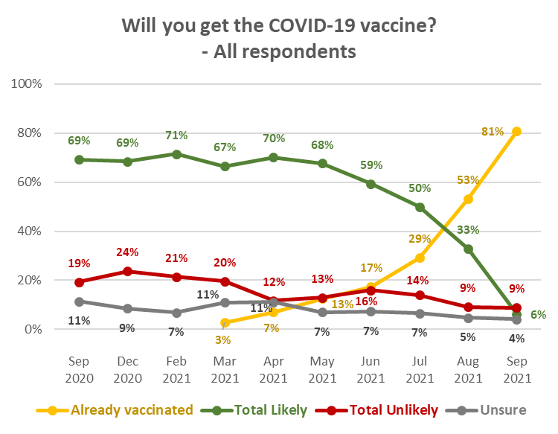
Profiles: “Total Likely”, “Total Unlikely”, and “Unsure”
The following table shows demographic characteristics of those who were not yet vaccinated and were “likely” and “unlikely” to get a COVID-19 vaccine or were not sure, to aid communications targeting. These demographic characteristics are dynamic and will change as people continue to be vaccinated.

DEMOGRAPHY | Total Likely  to get a vaccine  (not yet vaccinated) | Total Unlikely  to get a vaccine  (not yet vaccinated) | Not sure whether  to get a vaccine  (not yet vaccinated)
Gender | No particular gender characteristics. | No particular gender characteristics. | Significantly more female (65%) than average
Age | 22% younger than average age | 2% younger than average age | 9% younger than average age.
Household Income | 25% lower than average | 23% lower than average | 36% lower than average
Personal Income | 23% lower than average | 20% lower than average | 34% lower than average
Employment status | Less likely than average to be employed | Less likely than average to be employed | Less likely than average to be employed
Highest qualification | Less likely to have university-level qualifications but no other significant characteristics | More likely than average to have school-level qualifications only. | More likely than average to have school-level qualifications only.
Household Type | More likely than average to be in a two-parent family; less likely than average to be in a couple-only or single person household.  More likely than average to have children in their household. | More likely than average to be in a single-parent household with children at home. Less likely than average to be in a couple-only household. | Less likely than average to be in a couple-only household. More likely than average to have children in their household.
Ethnic group | More likely than average to be Māori. | No particular ethnic group characteristics. | Less likely than average to be Indian.
DHB | Less likely to be living in the areas covered by Waitematā, Auckland and Counties Manukau DHB areas (understandable, given the higher percentage vaccination rate in the Auckland Metro areas compared with the rest of New Zealand). No other particular differences from the overall sample. | Less likely than average to be in the Counties Manukau and Hutt DHB areas (and, indicatively, the Tairāwhiti DHB area). No other particular differences from the overall sample. | Less likely than average to be in the Auckland DHB area or in the lower North Island. More likely than average to be in the upper North Island (from Taupo north, excluding the Auckland region) – particularly the Bay of Plenty DHB area.,
Area Type | Less likely than average to be living in a large city. Slightly more likely than average to be living in a Rural area. | Less likely than average to be living in a large city. More likely than average to be living in a Rural area. | More likely than average to be living in a Rural area.
Identify as disabled | More likely than average to identify as disabled. | No specific differences. | No specific differences.

In previous surveys, living with impairments or long-term health conditions, or identifying as disabled, does not make a major difference to potential vaccine uptake. However, in this survey, people who identify as disabled are only likely to achieve 82% uptake of the COVID-19 vaccine.

2.1 Unlikely to get a COVID-19 vaccine and difficult to persuade
9% of respondents (estimated at 348,300 people 16+) say they are unlikely to get a COVID-19 vaccination. The “core” who will be difficult to persuade is estimated at 5.5% of the total 16+ population. It is calculated as follows:

- An estimated 153,500 (39%) of the 372,300 who are unlikely to get a COVID-19 vaccine say they either “Definitely” have all the information they need or “don’t need to know more”. The comparable estimates in the past three surveys were 145,800 in August, 237,200 in July, 291,600 in June, 168,900 in May, 267,000 in April and 301,400 in March 2021.
- Add those who “mostly” have all the information they need and the estimate rises to 226,000 or 65% of those who are unlikely to get a vaccine (August 219.100, July 303,900, June 392,400, May 249,300, April 320,000, and 368,900 in March 2021).

- Owing to the increased vaccination rate in comparison with August, the estimate for the “core” of those who will probably be difficult to persuade to get a COVID-19 vaccine has climbed to 29.7% of those aged 16+ who are not vaccinated (August 11.5%, July 9.0%, June 11.6%, May 7.0%, April 8.4% and 9.4% in March 2021).
- This is equivalent to 5.5% of the total 16+ population and has not changed from August’s estimate (5.4%).

The “difficult to persuade” (“core”) group has few different demographic characteristics from the overall “unlikely” group; there are minor differences in three areas:

DEMOGRAPHY | “Difficult to persuade”  group | Total Unlikely  to get a vaccine
Age | Average age | 2% younger than average age
Household Type | Less likely than average to be in a couple-only household.  More likely than average to have children in their household. | More likely than average to be in a single-parent household with children at home and, overall, more likely than average to have children in the household.  Less likely than average to be in a couple-only household.
Area Type | More likely than average to be living in a Rural area. | Less likely than average to be living in a large city. More likely than average to be living in a Rural area.

2.2 Uptake by ethnicity
NZ European/Pākehā respondents who had not been vaccinated were the most unlikely of the main ethnic groups to get a COVID-19 vaccine; plus, an indication (as in August) that people of “Other” ethnicities who have not yet been vaccinated (e.g., Latin American, African, Middle Eastern) may be the least likely to get a vaccine.

Respondents of Indian ethnicity who have yet not been vaccinated are the most likely to get a vaccine.

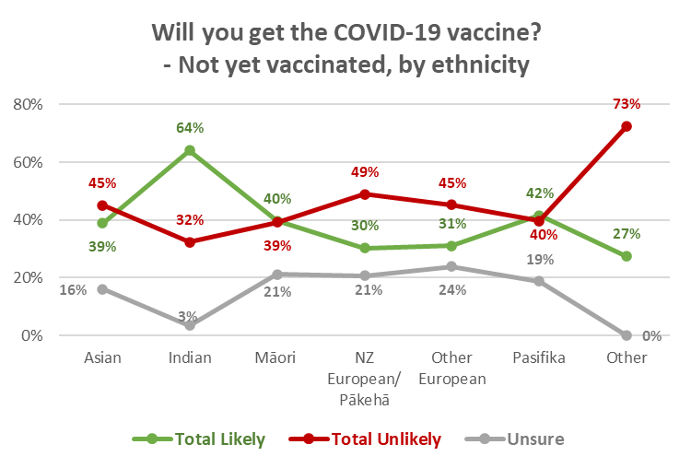

Weighting for the general population is unlikely to produce accurate vaccination rates by ethnic group. This has been addressed by using vaccination counts for each ethnicity and applying the intentions of those in each group who are yet to be vaccinated (shown in the chart above) to the balance of the ethnic group population.

2.2.1 Māori
Overall vaccine intention by Māori respondents who were not vaccinated, and the percentage that represents among all Māori, is shown in the following table. Note that among Māori who have not yet been vaccinated, the percentage who are likely to get vaccinated and the percentage who are unlikely to do so are now equal.

Total potential uptake for Māori has dropped back to the July level of 73% (79% in August 2021), but the apparent change is not statistically significant.

VACCINE INTENTION | July 2021 |  | August 2021 |  | September 2021
 | Māori 16+  Not yet vaccinated | All  Māori 16+ | Māori 16+  Not yet vaccinated | All  Māori 16+ | Māori 16+  Not yet vaccinated | All  Māori 16+
Already vaccinated |  | 18% |  | 34% |  | 55%
Likely to get a COVID-19 vaccine | 67% | 54% | 68% | 45% | 40% | 18%
Unlikely to get a COVID-19 vaccine | 23% | 19% | 22% | 14% | 39% | 18%
Unsure | 10% | 8% | 10% | 7% | 21% | 10%
TOTAL POTENTIAL UPTAKE |  | 73% |  | 79% |  | 73%
Base: Māori not yet vaccinated: September 2021: n=95; August 2021 n=186, July 2021 n=236.
All Māori: September 2021, n=367; August 2021 n=460, July 2021 n=481
N.B. Percentages shown may not sum to 100% owing to rounding.

2.2.2 Pasifika
Overall vaccine intention by Pasifika respondents who were not vaccinated, and the percentage that represents among all Pasifika people, is shown in the following table. As with Māori, the percentage who are likely to get vaccinated and the percentage who are unlikely to do so are now equal. Note that, except for the percentage vaccinated, this is an indicative result owing to the small base.

VACCINE INTENTION | July 2021 |  | August 2021 |  | September 2021
 | Pasifika  16+  Not yet vaccinated | All  Pasifika  16+ | Pasifika  16+  Not yet vaccinated | All  Pasifika  16+ | Pasifika 16+  Not yet vaccinated | All  Pasifika  16+
Already vaccinated |  | 26% |  | 46% |  | 67%
Likely to get a COVID-19 vaccine | 62% | 46% | 72% | 38% | 42% | 14%
Unlikely to get a COVID-19 vaccine | 28% | 21% | 8% | 4% | 40% | 13%
Unsure | 10% | 8% | 20% | 11% | 19% | 6%
TOTAL POTENTIAL UPTAKE |  | 72% |  | 85% |  | 81%
Base: Pasifika not yet vaccinated: September n=16; August n=91, July 2021 n=108.
All Pasifika: September 2021 n=130; August 2021 n=165, July 2021 n=157
N.B. Percentages shown may not sum to 100% owing to rounding.

2.3 Uptake by people with impairment or who identify as disabled
There has been an apparent drop in the potential uptake result for respondents who identified as disabled, but the difference in comparison with August is within the sub-sample margin of error and is not statistically significant.

Will you get a COVID-19 vaccine? (Including those who have already been vaccinated) | All respondents | Living with impairments or long-term health conditions | Identify as disabled
Definitely | 2% | 2% | 5%
Most likely | 2% | 3% | 3%
Likely | 2% | 2% | 5%
Unlikely | 2% | 2% | 3%
Most unlikely | 3% | 3% | 5%
Definitely not | 4% | 5% | 5%
I'm not sure | 4% | 3% | 4%
Already vaccinated | 81% | 81% | 71%
TOTAL LIKELY plus ALREADY VACCINATED | 87% | 87% | 82%
TOTAL UNLIKELY | 9% | 10% | 13%
N.B. Individual percentages shown may not sum to Total Likely, Total Unlikely or 100% owing to rounding

2.4 Uptake by age group
There was a similar percentage of “unlikely” and “unsure” across age groups. Respondents aged 25 to 44 years have the lowest potential uptake.

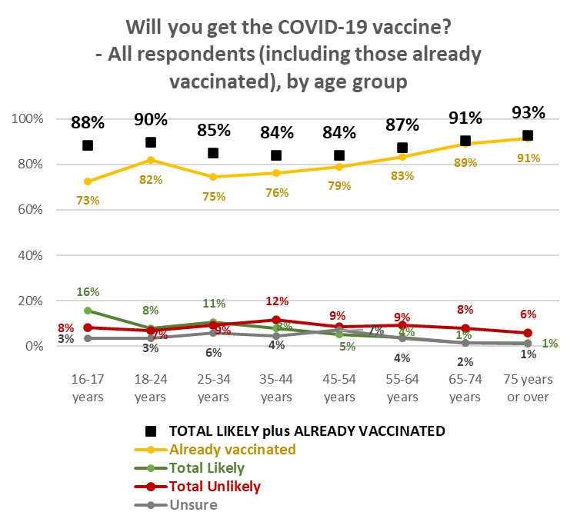

2.5 Uptake by DHB
As noted in previous reports, with a nationally representative sample, the respondent numbers within DHB areas vary in accordance with the relative population of the area. Results for some DHB areas therefore need to be treated as indications.

Vaccination rates by DHB are likely to vary in accordance with factors other than their share of the general population: ethnic mix in their area, area type (large city, regional city, regional town, rural, remote), income, employment status, all of which have an effect on vaccine uptake. Because of this potential variation, weighting for the general population vaccination rate is unlikely to produce accurate vaccination rates by DHB. This has been addressed by using vaccination counts for each DHB area and applying the intentions of those who are yet to be vaccinated in the DHB area to the balance of the DHB population.

Analysis of potential uptake by DHB is shown in the following pages, in 3 groups:
- The seven largest DHBs.
- 6 medium-sized DHB areas where subsample sizes are between 63 and 108, and are therefore relatively statistically reliable.
- The remaining 7 DHB areas where subsample sizes are generally less than 50, in line with their population proportion of the total sample. The smaller the subsample size, the less statistically reliable the results become and these should be treated as providing an indication only.

Seven largest DHBs:
- In the Waitematā and Counites Manukau DHB areas, potential uptake is above the overall average. In the Waikato DHB area, it is below average.

Will you get a COVID-19 vaccine?  (including those who have already had it) | ALL | DHBs
 |  | Waite-matā | Auckland | Counties Manukau | Waikato | Capital and Coast | Canter-  bury | Southern
Definitely | 2% | 1% | 1% | 0% | 2% | 2% | 3% | 0%
Most likely | 2% | 1% | 3% | 4% | 3% | 2% | 3% | 2%
Likely | 2% | 1% | 1% | 3% | 2% | 2% | 2% | 4%
Unlikely | 2% | 1% | 8% | 1% | 3% | 2% | 1% | 0%
Most unlikely | 3% | 1% | 1% | 1% | 5% | 3% | 2% | 4%
Definitely not | 4% | 2% | 2% | 2% | 4% | 4% | 2% | 5%
I'm not sure | 4% | 3% | 2% | 3% | 7% | 2% | 6% | 4%
Already vaccinated | 81% | 92% | 83% | 85% | 74% | 84% | 81% | 82%
TOTAL LIKELY plus ALREADY VACCINATED | 87% | 94% | 87% | 92% | 81% | 90% | 89% | 87%
TOTAL UNLIKELY | 9% | 3% | 11% | 4% | 12% | 9% | 6% | 9%
N (unweighted) | 2,479 | 299 | 262 | 190 | 199 | 243 | 279 | 185
N.B. Individual percentages may not sum to Total Likely or Total Unlikely owing to rounding.

6 DHBs with relatively statistically reliable results:
- As in August, July and June 2021, Northland DHB’s potential vaccine uptake is below the overall average.

Will you get a COVID-19 vaccine?  (including those who have already had it) | ALL | DHBs
 |  | North-land | Bay of Plenty | Hawke's Bay | Mid-Central | Hutt | Nelson/ Marl-borough
Definitely | 2% | 5% | 5% | 3% | 3% | 0% | 2%
Most likely | 2% | 1% | 3% | 2% | 2% | 0% | 0%
Likely | 2% | 2% | 0% | 3% | 2% | 7% | 1%
Unlikely | 2% | 1% | 2% | 1% | 1% | 0% | 3%
Most unlikely | 3% | 6% | 6% | 2% | 2% | 0% | 2%
Definitely not | 4% | 8% | 7% | 6% | 4% | 7% | 7%
I'm not sure | 4% | 6% | 2% | 5% | 5% | 4% | 4%
Already vaccinated | 81% | 71% | 76% | 78% | 82% | 82% | 81%
TOTAL LIKELY plus ALREADY VACCINATED | 87% | 78% | 84% | 86% | 89% | 90% | 84%
TOTAL UNLIKELY | 9% | 15% | 15% | 10% | 7% | 7% | 13%
N (unweighted) | 2,479 | 61 | 104 | 107 | 127 | 94 | 92
N.B. Individual percentages may not sum to Total Likely or Total Unlikely owing to rounding

DHBs with indicative results – these are presented in two groups:
Indications are that:
- Whanganui and South Canterbury have the lowest potential uptake. South Canterbury appears to be needing to convince the unsure in order to make further gains.
- Lakes and Tairāwhiti have the lowest level of vaccination but have above average Total Potential Uptake.

Will you get a COVID-19 vaccine?  (including those who have already had it) | ALL | DHBs
 |  | Lakes | Tairāwhiti | Taranaki | Whanganui
Definitely | 2% | 0% | 19% | 6% | 0%
Most likely | 2% | 9% | 0% | 6% | 1%
Likely | 2% | 10% | 0% | 3% | 4%
Unlikely | 2% | 4% | 0% | 2% | 3%
Most unlikely | 3% | 0% | 0% | 1% | 13%
Definitely not | 4% | 3% | 0% | 6% | 2%
I'm not sure | 4% | 2% | 8% | 2% | 4%
Already vaccinated | 81% | 72% | 73% | 74% | 74%
TOTAL LIKELY plus ALREADY VACCINATED | 87% | 91% | 92% | 89% | 79%
TOTAL UNLIKELY | 9% | 7% | 0% | 9% | 17%
N (unweighted) | 2,479 | 54 | 12 | 48 | 42
N.B. Individual percentages may not sum to Total Likely or Total Unlikely owing to rounding

Will you get a COVID-19 vaccine?  (including those who have already had it) | ALL | DHBs
 |  | Wairarapa | West Coast | South Canterbury
Definitely | 2% | 3% | 4% | 0%
Most likely | 2% | 0% | 3% | 0%
Likely | 2% | 3% | 0% | 0%
Unlikely | 2% | 5% | 0% | 0%
Most unlikely | 3% | 5% | 13% | 4%
Definitely not | 4% | 0% | 3% | 9%
I'm not sure | 4% | 3% | 3% | 6%
Already vaccinated | 81% | 80% | 74% | 81%
TOTAL LIKELY plus ALREADY VACCINATED | 87% | 87% | 81% | 81%
TOTAL UNLIKELY | 9% | 10% | 16% | 13%
N (unweighted) | 2,479 | 33 | 17 | 31
N.B. Individual percentages may not sum to Total Likely or Total Unlikely owing to rounding.

2.6 Second dose uptake
Excluding those who had said they would “Definitely not” get a COVID-19 vaccine, respondents who had indicated that they had not had any doses of the vaccine, or had only had one dose, were asked how likely they were to have a second dose.

With more people being vaccinated and the unvaccinated group consolidating more onto those who say they are unlikely to get a vaccine, the September results were expected to be lower than in previous months. This was the case: 77% of those not vaccinated would be likely to have a second dose, compared with 84% in August (July 81%; June 81%, May 82%).

95% of those who had one dose were likely to get a second (77% “Definitely”). The “definitely” result for those who have already had 1 dose is below the 87% recorded in August, suggesting that effort should go into ensuring that second dose uptake is maximised.

Likelihood to get second dose | LIKELIHOOD TO GET FIRST DOSE
 | Definitely | Most Likely | Likely | Unlikely | Most Unlikely | Unsure | Already had one dose
Total Likely | 99% | 100% | 84% | 4% | 1% | 1% | 95%
Total Unlikely | 0% | 0% | 8% | 83% | 75% | 3% | 2%
It depends if I have a reaction to the first dose | 1% | 0% | 5% | 6% | 7% | 25% | 1%
Not sure | 0% | 0% | 3% | 7% | 17% | 71% | 3%
N.B. Individual percentages may not sum to 100% owing to rounding

27 respondents who had already had one dose of the vaccine but said they were unsure or unlikely to get another:
- 12 said they might still get one (these were people who had said they were “unlikely” to get a second dose (4), were not sure whether to get a second dose (7) and “Most unlikely” to get a second dose (1).
- 10 had experienced side effects and 1 had had a serious adverse reaction.
- 10 said they were not sure the vaccine would be effective against the new strains (e.g., Delta).
- Two indicated that getting the appointment had been too difficult.
- One indicated that the experience had not been as good as they thought it could have been.
- One indicated that they didn’t think they needed a second dose.

2.7 Vaccination timing
As in previous surveys, those who had not been vaccinated were asked ‘Ideally, when would you most like to get a COVID-19 vaccine this year?’

The pent-up demand indicated in August, where 25% wanted to get vaccinated immediately and 29% wanted to get vaccinated by October, has been met.

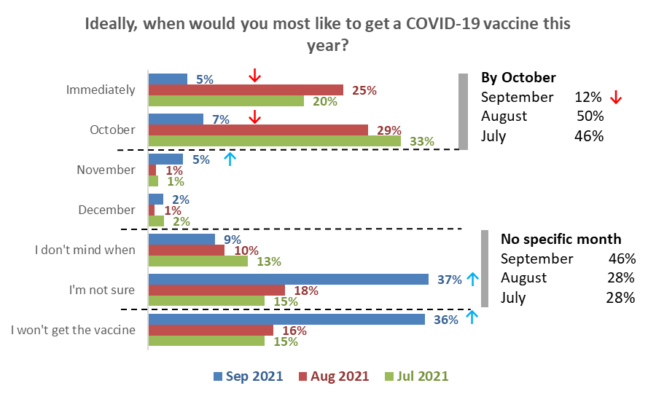
Base: Have not been vaccinated: September n=414, August n=1,044, July n=1,575.

The remaining people who have not yet been vaccinated are primarily those who are unlikely to get a vaccine (46% of those who are not vaccinated). Nearly 9 out of 10 of those who are unsure whether to get the vaccine or not (22% of those not vaccinated) are also unsure of when they want to get the vaccine.

This is illustrated in the following table.

Ideally, when would you most like to get a COVID-19 vaccine this year? | ALL | Will you get the COVID-19 vaccine?
 |  | Definitely | Most likely | Likely | Unlikely | Most unlikely | Definitely not | I'm not sure
% of not vaccinated | 100% | 11% | 12% | 11% | 10% | 16% | 20% | 22%
% of 16+ population | 19% | 2% | 2% | 2% | 2% | 3% | 4% | 4%
Immediately | 5% | 37% | 7% | 4% | 0% | 0% | 0% | 0%
October | 7% | 27% | 30% | 8% | 0% | 0% | 0% | 0%
November | 5% | 7% | 15% | 14% | 5% | 0% | 0% | 0%
December | 2% | 9% | 0% | 9% | 0% | 0% | 0% | 0%
I don't mind when | 9% | 19% | 26% | 17% | 8% | 0% | 0% | 5%
I'm not sure | 37% | 1% | 22% | 42% | 60% | 26% | 3% | 88%
I won't get the vaccine | 36% | 0% | 0% | 6% | 27% | 74% | 97% | 7%
N (unweighted) - All not yet vaccinated | 414 | 46 | 43 | 45 | 36 | 64 | 92 | 88

Groups who are more and less likely to want to take the vaccine immediately or by October are shown below:

Demographic groups | Want to be vaccinated immediately % | Want to be vaccinated by October %
With a postgraduate degree | 17% ↑ | 22% ↑
Aged 18-24 | 12% ↑ | 16% ↑
With an undergraduate degree | 10% ↑ | 20% ↑
Males | 8% ↑ | 16% ↑
Aged 16-17 years | 6% | 23% ↑
Total | 5% | 12%
Those with the lowest education levels  (no school qualification or School Certificate/NCEA Level 1) | 1%↓ | 6%↓
Business Proprietor/ self-employed | 1%↓ | 6%↓
From a single person household | 0%↓ | 7%↓
Females | 3%↓ | 11%
Living in regional towns or rural areas | 5% | 7%↓
Aged 65 or more | 5% | 8% ↓
Results for sample sizes of n=50 or more

Attitudes to children under 15 years being vaccinated
All respondents were asked if they were caregivers for young people aged 5 to 11 years and 12 to 15 years. 5- to 11-year-olds were included in the questions in the September survey to evaluate the potential uptake if a vaccine became approved for this age group at some stage in the future.

77% said they were not caregivers and were excluded from the rest of the questions around vaccines and younger people. Of the total sample, 11% reported being caregivers for 5- to 11-year-olds only (48% of all caregivers), slightly over 6% were caregivers for both 5- to 11-year-olds and 12- to 15-year-olds (27% of all caregivers), and slightly under 6% were caregivers for 12- to 15-year-olds only (25% of all caregivers).

Each of these caregiver groups were asked:
- For how many young people they were a caregiver (a separate question for the caregivers of each age group).
- If they would allow their young people to get the vaccine (again, a separate question for the caregivers of each age group).

3.1 Allow children to get a vaccine?
Caregivers of 12 to 15-year-olds
Caregivers of 12 to 15-year-olds were asked ‘A COVID-19 vaccine is approved for use in young people aged 12- to 15-years-old. Will you allow the young people in this age group, for whom you are the primary caregiver, to get the vaccine?’

The following chart shows responses to this question compared with the August, July and June 2021 surveys.

78% said that they would ‘definitely’ or ‘likely’ allow children of this age to be vaccinated (August 79%, July 67%, June 59%, May 55%, April 2021 56%).

As in August, 14% said they were unlikely to let their 12-15-year-olds get a COVID-19 vaccine or would ‘Definitely not’ allow it. (July 21%, June 30%, May 26%, April 2021 22%). 8% were unsure.
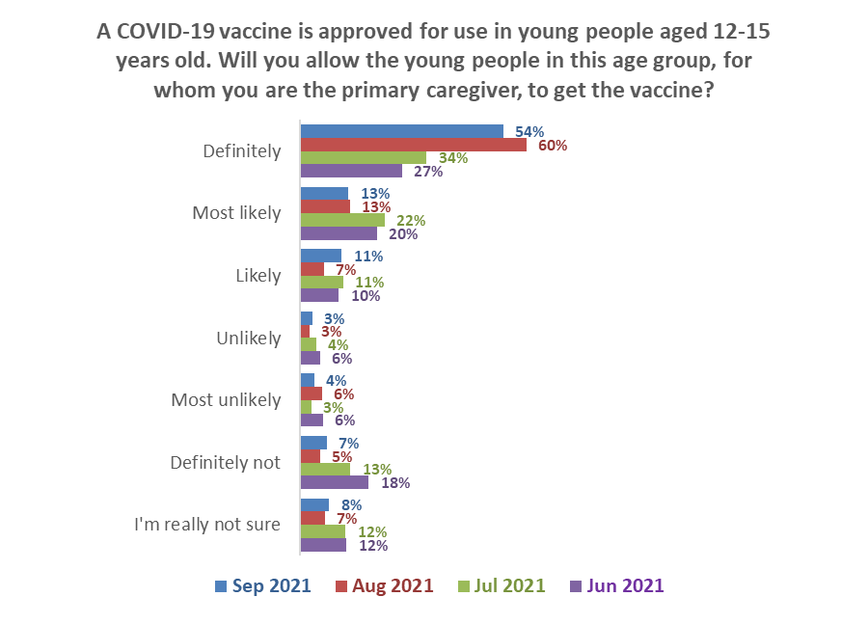Base (Caregivers for 12- to 15-year-olds):
Definitely & likely
September 2021 78% August 2021 79%
July 2021 67%
June 2021 59%
Definitely not & unlikely
September 2021 14%
August 2021 14%
July 2021 21%
June 2021 30%
September n=326, August 2021 n=315, July n=310

The overall average number of 12–15-year-olds reported by their caregivers was 1.64.

Caregivers who would allow their 12–15-year-olds to get a COVID-19 vaccine reported a slightly lower average of 1.56. As reported in previous surveys, this means that the overall percentage of 12–15-year-olds who will be allowed to get a vaccine will be slightly lower than the caregiver percentage shown in the chart above.

Caregivers of 5- to 11-year-olds.
A COVID-19 vaccine has not been approved for use with children aged 5 to 11 years. However, to gain an indication of the likely uptake if a COVID-19 vaccine were to be approved, caregivers of 5 to 11-year-olds were asked ‘If a COVID-19 vaccine is approved for use in young people aged 5- to 11-year-olds, will you allow the young people in this age group, for whom you are the primary caregiver, to get the vaccine?’

It is evident that caregivers of 5-to 11-year-olds are more reluctant than caregivers of 12- to 15-year-olds to allow their children to be vaccinated.

As shown in the following chart, 63% overall of caregivers of 5- to 11-year-olds would allow their child or children to get a COVID-19 vaccine.

Caregivers who have both 5- to 11-year-olds and 12- to 15-year-olds are a little more likely than the overall average to allow their 5- to 11-year-olds to get a COVID-19 vaccine, but less likely than the overall average to allow their 12- to 15-year-olds to get vaccinated. Caregivers for 5- to 11-year-olds only were more unsure than average.

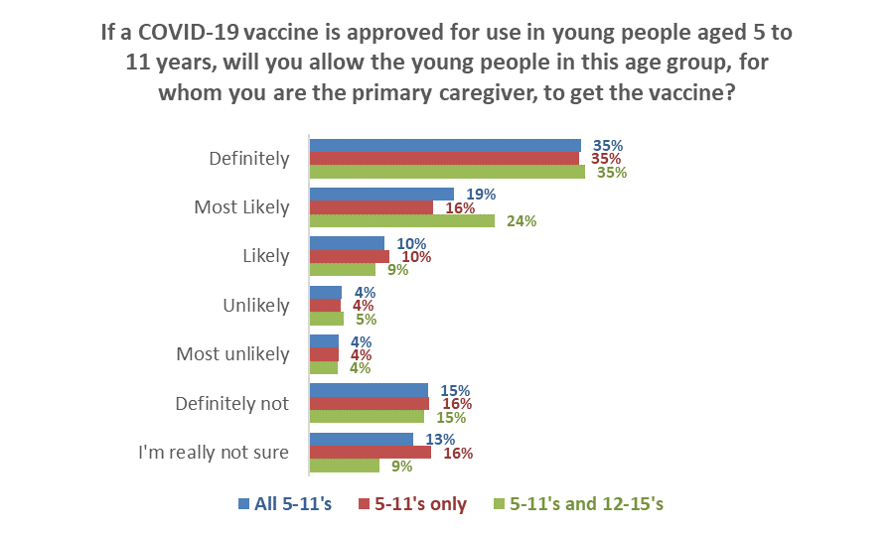
Definitely not & unlikely
23% overall
Have 5-11’s only: 24%
Have 5-11’s and 12-15’s: 23%
Definitely & likely
63% overall
Have 5-11’s only: 61%
Have 5-11’s and 12-15’s: 68%
Base (Caregivers for all 5-11’s: n=446.
Caregivers for 5-11’s only, n=309. Caregivers for both 5-11’s and 12-15’s, n=137

As with 12- to 15-year-olds, caregivers who would allow their 5- to 11-year-olds to get a COVID-19 vaccine reported a slightly lower average number of children than the overall average. This means that the overall percentage of 5- to 11-year-olds who would be allowed to get a vaccine if one was approved for use with this age group will be lower than the caregiver percentage shown in the chart above.

Estimating the number of children likely to get a COVID-19 vaccine
Overall, it is estimated that caregivers would allow around 74% of their 12- to 15-year-olds and 60% of their 5- to 11-year-olds to get a vaccine. This is calculated as follows (figures are rounded to the nearest 10):
 | 12–15-year-olds | 5–11-year-olds
Average number overall per caregiver | 1.64 | 1.74
Population estimate | 264,560 | 461,850
Estimated number of caregivers | 160,990 | 252,190
Percent of caregivers allowing vaccination | 77.8% | 63.2%
Number of caregivers allowing vaccination | 125,250 | 159,390
Average young people per caregiver allowing vaccination | 1.56 | 1.74
Estimated number of children allowed to get vaccine or already vaccinated | 195,870 | 276,580
Percent of population estimate | 74% | 60%

Caregiver ethnic groups except for NZ European/Pākehā are relatively small and comments by ethnic group are indicators.

Results indicate that, as in August, Māori were less likely than average to allow their 12–15-year-old tamariki to get a COVID-19 vaccine.

Will you allow the young people for whom you are the primary caregiver, to get the vaccine? | ETHNIC GROUP
 | Asian | Indian | Māori | NZ European/ Pākehā | Other European | Pasifika | Other *
12–15-year-olds
Would allow | 84% | 89% | 73% | 77% | 92% | 76% | 100%
Would not allow | 7% | 11% | 18% | 16% | 5% | 20% | 0%
Not sure | 9% | 0% | 10% | 8% | 3% | 5% | 0%
5–11-year-olds
Would allow | 70% | 87% | 62% | 60% | 79% | 66% | 61%
Would not allow | 14% | 13% | 22% | 25% | 10% | 25% | 39%
Not sure | 16% | 0% | 16% | 15% | 12% | 9% | 0%
* Indication only; small base: Caregivers of 5-11’s, n=4, caregivers of 12-15s n=4

Importance of being vaccinated to reduce transmission of the virus and protect the health of others
Those who were not vaccinated were asked ‘Just how important, or unimportant, do you think it is it for you to get the vaccine to help reduce the transmission of the virus and protect the health of others?’
Only around a quarter (26%) of unvaccinated people believe it is highly important to be vaccinated for these reasons, whereas 23% are ambivalent and 34% believe this is relatively unimportant. Therefore, overall, the results are fairly evenly balanced with the mean rating being 5.0, slightly lower than the middle of the scale (5.5). Excluding ‘not sure’ responses, the breakdown is as follows:
- High importance 31% of responses
- Medium importance 28%
- Low importance 41%
Mean result
5.0
23%
Medium importance (4 to 7)

34%
Low importance (1 to 3)

26%
High importance (8 to 10)

Importance of being vaccinated to reduce the transmission of the virus and protect the health of others by gender and age
While there was no difference by gender, those aged 25 to 34 rated this as more important and older people aged 55 or more rated this as less important.

* Caution – small size n=41
High and low mean importance ratings for other groups in the population
Group | Mean rating out of 10
Definitely, most likely or likely to get vaccinated | 8.0↑
Unemployed/beneficiary | 6.2↑
Offered the opportunity to have a vaccine but have not booked yet | 6.0↑
Not offered the opportunity to have a vaccine | 5.8↑
From a two-parent family, with one or two children at home | 5.6↑
Māori | 5.5↑
Total | 5.0
From a two-parent family, with three or more children at home | 4.5↓
Live rurally but not remotely | 4.3↓
Couple with no children at home | 3.5↓
Unlikely, most unlikely and definitely will not get vaccinated | 2.5↓
Offered a vaccine but declined to have it | 2.2↓
Results for groups of 50 or more people

- Barriers to COVID-19 vaccination

5.1 Reasons for being unsure or unlikely to get vaccinated
Those who had not yet been vaccinated and were unsure or unlikely to take the vaccine were asked an open-ended question, ‘You say you are unsure or are unlikely to take a COVID-19 vaccine if one were offered. Can you tell us in your own words why that is?’

258 people responded to this question, with their main responses being:
- There are serious side effects/deaths from the vaccine (28%)
- Long term effects are not known/ it’s just a trial (26%)
- The government wants to control us/ is bullying us into getting the vaccine/I don't trust the government (13%)

Verbatim quotations illustrating the main reasons for being unsure or unlikely to take the vaccine follow….
There are serious side effects/deaths from the vaccine
A relative died less than two weeks after receiving his first one (Male, Aged 45-54 years)
I am concerned about the side effects of the vaccine. I personally know of some people who have experienced serious side effects (Female, Aged 55-64 years)

Because I have done hundreds of hours of research involving highly qualified practitioners from all over the world and I now know what is going on. The "vaccine" is a dud and does not prevent any virus, has no medium or long term testing and there are many side effects and deaths being reported following vaccination around the world. The truth will come out. (Male, Aged 65-74 years)
I've read some stuff online that says there are adverse reactions to taking the COVID jab, I'm worried about this (Female, Aged 35-44 years)
It has limited effectiveness and many side effects (Male, Aged 45-54 years)
Doesn't stop you from getting seriously sick, doesn't stop you from spreading it, I know too many people with severe side effects including family members (Female, Aged 25-34 years)

Long term effects are not known/ it’s just a trial
It has not completed trials or been properly approved. People I know are having strokes from it (Female, Aged 18-24 years)
There is no data on the long term effects of this new mRNA technology (Female, Aged 35-44 years)
I don't think the vaccine trials have been properly concluded over a satisfactory length of time (Male, Aged 55-64 years)
There hasn't been enough research or info on it (Female, Aged Under 18 years)
I don’t believe it’s been properly tested over a period of time. I do not trust it. My human rights are being taken away from me (Female, Aged 65-74 years)

Government wants to control us/ bullying us into getting the vaccine/I don't trust the govt
I don't believe a word that comes out of this government's mouth. Deaths & adverse reactions are not reported publicly. The WHO has categorically been proven to be corrupt & not able to be believed. We are NOT allowed by this government to be prescribed therapeutics such Hydroxychloroquine, Ivermectin, Regeneron, etc. There are a multitude of therapeutic treatments available - which NZers are not allowed to have the benefit of. (Female, Aged 55-64 years).
It's a scam. Also, anything I can do to make Cindy's numbers look bad I will do. (Male, Aged 25-34 years).
I believe this virus is man-made and I am not comfortable with the way our government are trying to scare us into being vaccinated. (Female, Aged 55-64 years).
Don’t follow Satan’s governments. (Male, Aged 45-54 years).
It is too enforced by the government; it's not okay to gamble our basic rights and freedom. (e.g., you can't do XYZ if you don't have the vaccine). Very controlling. Also not being honest about the reactions, effects, deaths, etc caused by the vaccine. All of these do not make me trust the vaccine at all. (Female, 16-17 years).

I have a health condition/am allergic to flu shots etc.
Am allergic to most medications. Had the flu injection in 2020 and was ill for 7 days. Have never had any vaccinations that I recall. Polio was by mouth. Have never had vaccination for Smallpox, TB, Tetanus injections. The only time I've had a needle in my arm is for blood tests. (Female, Aged 75 years or over).
Too many allergic reactions to medications. (Female, Aged 65-74 years).
I have severe allergies and chemical sensitivities. Pfizer is one of the most corrupt corporations in history. (Male, Aged 45-54 years).
I suffer anxiety and certain medicines cause me to become suicidal, so I need to be carefully what I take. (Female, Aged 45-54 years).

The vaccine does not protect from getting or spreading COVID-19
It does not stop you from contracting or spreading the virus, so I don’t see the point. (Female, Aged 35-44 years).
Vaccinated are no less at risk of COVID than unvaccinated. (Female, Aged 35-44 years).
The percentage of death and disability/health concerns already caused by this vaccination are far higher than any other allowed vaccination and yet it continues to be given to people. More people have been affected by this vaccination than died in NZ from COVID. There is a misconception that vaccinations will prevent infection rates - even when vaccinated one can still contract the virus and still shed (perhaps be more contagious because the symptoms are impaired, so one does not know that one is ill). (Male, Aged 45-54 years).
Called a vaccine but it doesn't stop one contracting COVID nor from spreading it. (Female, Aged 65-74 years).

Natural defences are better. The disease can be managed by good diet, natural medicine etc
It’s poison, our own immune system is so much stronger. It’s wrong to mess with the Creators' creations. (Female, Aged 35-44 years).
I rely on my own body’s natural defences and I don't take any prescription drugs. (Male, Aged 55-64 years).
I'm already healthy, live a healthy life and have no reason for taking it. (Female, Aged 35-44 years).
I don't trust it or other vaccines I feel the best way to build an immune system is to get sick from time to time. (Female, Aged 25-34 years).
Because I just feel that if I keep up with daily home remedies that will build my immune system, I should have a decent chance to fight off COVID without the vaccine. (Female, Aged Under 18 years).

I want a real/traditional vaccine
It is not a vaccine as it does not confer immunity. It does not come out of clinical trials until 2023. There is no information I long term effects. There are widespread reports of side effects. (Male, Aged 55-64 years).
If the vaccine is a traditional type and shown not to have adverse effects. (Male, Aged 75 years or over).
I don’t want the Pfizer vaccine or one of the other mRNA vaccines. I would be open to having the Novavax vaccine which the NZ Govt has already pre-ordered. (Male, Aged 35-44 years).
It is not a vaccine as you can still get COVID-19 after you have had the vaccine. (Male, Aged 65-74 years).

COVID-19 is not a serious illness/ it’s only a type of flu
Because COVID is bullshit and anyone that believes it is in idiot. (Male, Aged 25-34 years).
COVID is only a common flu. (Female, Aged 35-44 years).

Other
My body, my choice. (Female, Aged 35-44 years).
Don't know if it covers for the different variants which are now applicable as vaccine was released before these variants. (Female, Aged 45-54 years).
I don’t know if I want to have it, mum is trying to get me to, but I said I am old enough to decide for myself. (Male, Aged Under 18 years).
Pfizer has not accepted any liability for adverse effects. The results of the experiment, as they describe it, will not be known until Feb 2023. Pfizer is a corporation that has previously been successfully sued for billions of dollars for fraud and bribing doctors. (Male, Aged 65-74 years).
The correct peer-review process hasn’t been followed as I would expect it should be. (Male, Aged 25-34 years).
Can’t handle needles. (Female, Aged 45-54 years).
Why take a vaccine when COVID is only in Auckland? (Male, Aged 35-44 years).
Efficacy is only for 6 months, what after that? I get too sick after flu shot. If my body is being injected on few times year. I am not sure how that will be viable. (Female, Aged 25-34 years).
Religious reasons. Besides I've been going to the store back and forth wearing my mask washing my hands and I still haven't got COVID. (Female, Aged 25-34 years).

5.2 Perceived medical or health conditions
19% of those not yet vaccinated believe medical or other health-related conditions mean they are not able to get a COVID-19 vaccine.

Note that this perception is highest among those who are “Likely” or “Unlikely” to get the vaccine.

Do you believe that medical or other health-related conditions mean you are not able to get a COVID-19 vaccine? | All | Will you get the COVID-19 vaccine?
 |  | Defin-  itely | Most likely | Likely | Un-likely | Most unlikely | Defin-itely not | Not sure
Yes | 19% | 14% | 12% | 36% | 28% | 16% | 14% | 17%
No | 82% | 86% | 88% | 64% | 72% | 84% | 86% | 83%

Of the respondents who believed medical or other health-related conditions meant they were not able to get a COVID-19 vaccine:

1 in 3 said they had had an allergic reaction to any vaccine.
1 in 6 said they were immunocompromised.
1 in 8 said they were being tested for COVID-19 or had had COVID-19.
1 in 8 said they were taking antibiotics.
1 in 14 said they were pregnant, trying to have a baby, or were breastfeeding.

Nearly all of the 8% who said they were unwell or had a fever were “Definitely” getting vaccinated.

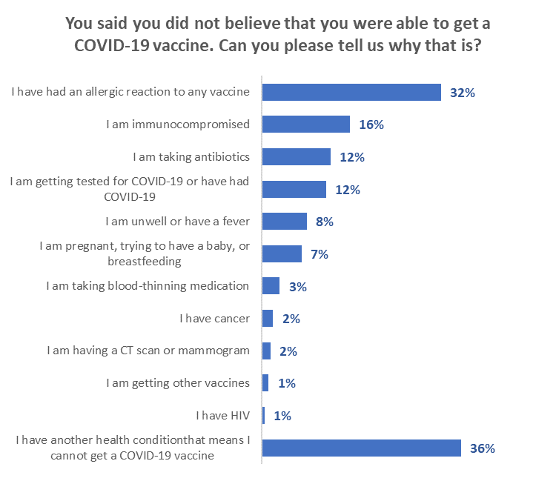
“Other” health conditions listed included:
Autism and fear of needles
Bell's palsy
Blood issues
Ehlers-Danlos syndrome - POTS - MCAS
Heart condition (3 respondents)
Heart disease
Heart is only working at 50% capacity
Heart murmur
High ferritin, previous T-cell leukaemia and B-cell lymphoma
I have chronic pain
I have RA and MS. My injuries take weeks to heal and my body attacks all the wrong stuff (2 auto immunes). I'm on strong medication for RA that I would have to stop for a while, and there's not enough research around these toxic medications I'm on combined with the new vaccine. I want it, but I'm not willing to take the risk. I'm already sick.
It hasn't been 10 years yet
Medication allergies and heart arrhythmia
N/a
Need OK from surgeon. Due for surgery.
No doctor
Phobia of medicine and vaccines
Predisposed health condition
PTSD
Recently in remission for cancer, blood counts low, will seriously consider getting vaccinated when they come right

Note that:
- A higher-than-average proportion of Māori reported being immunocompromised.
- Allergic reactions to any vaccine were more prevalent in cities.

5.3 Misinformation
All respondents were asked if they had come across what they believed to be misinformation about COVID-19 vaccines in the past 30 days.

The proportion of all people who had noticed misinformation about the vaccines increased from 51% in August to 56% in September 2021.
↓
↑
Base total sample August n=2,334, September n=2,479
Those who had not yet been vaccinated were less likely than the total sample to have noticed what they believed to be misinformation than the rest of general population in both the August and September survey waves. The proportion of unvaccinated people who noticed misinformation dropped from 48% in August to 42% in September.

Base not yet vaccinated August n=1,044, September n=414

Sources of misinformation
All those who said they had noticed misinformation in the past 30 days were asked to select the source(s) of this misinformation from a list of possible sources. They could select more than one option.
As in the August survey, social media was the main source of misinformation, mentioned by around seven out of ten people who noticed misinformation.
Mentions of mainstream media increased from 21% in August to 26% in September, while mentions of brochures and leaflets dropped from 23% to 14%.

Base: noticed misinformation August n=1,275, September n=1,459

Amongst unvaccinated people who said they are likely to get vaccinated, sources of misinformation that are higher than the total include:
- Friends or family (50% cf. 38% overall)
- An acquaintance (27% cf. 18%)
- Strangers (28% cf. 12%)
- Neighbours (16% cf. 7%)
For those who say they are unlikely to get vaccinated, sources of misinformation that are higher than the total include:
- Brochures/leaflets (65% cf. 26%)
- Medical professionals (18% cf. 3%)
- Other sources (28% cf. 5%)

How did you receive the misinformation? | ALL | TOTAL LIKELIHOOD TO GET VACCINE
 |  | Total Likely | Total Unlikely | Unsure | Already vaccinated
Social media - such as Facebook, Instagram, Twitter, etc. | 71% | 66% | 51% | 50% | 73%
Friends or family | 38% | 50%↑ | 25% | 30% | 38%
Brochures/leaflets | 26% | 31% | 65%↑ | 39% | 22%
Mainstream media - such as TV news, radio or newspapers (print or online), etc. | 22% | 24% | 12% | 28% | 23%
An acquaintance | 18% | 27%↑ | 23% | 7% | 17%
Websites | 14% | 5% | 14% | 1% | 15%
A stranger | 12% | 28%↑ | 5% | 1% | 12%
Someone at work | 11% | 13% | 7% | 6% | 11%
A neighbour | 7% | 16%↑ | 6% | 0% | 7%
A medical professional | 3% | 1% | 18%↑ | 8% | 2%
Some other way | 5% | 0% | 28%↑ | 10% | 4%
N (unweighted) | 1,459 | 60 | 86 | 26* | 1,287
*Note small sample

What made people think it was misinformation?
As in the August survey, an open-ended question was asked of the 1,459 people who noticed something in the past thirty days that they felt was untrue about the COVID-19 vaccines. In total, 1,327 people responded to this question; of these, 1,172 responses were from people who had already been vaccinated while 155 answers were from unvaccinated people.

Key themes and illustrative comments from respondents follow, with most of the comments selected from unvaccinated people, as they will potentially be the most affected by misinformation.

Key disinformation themes:

Unscientific claims
Not scientifically proven. (Unvaccinated Female, Aged 45-54 years).
Was scientific(ally) wrong. (Unvaccinated Female, Aged 65-74 years).
Claims could be not be backed up by scientific/factual evidence. (Vaccinated Female, Aged 35-44 years).
It was illogical with no scientific basis. (Unvaccinated Female, Aged 45-54 years).
Because I trust the scientists and the government, I believe, is following science. (Vaccinated Male, Aged 45-54 years).
Because the Government has said its false information. (Vaccinated Female, Aged 55-64 years).

Unsubstantiated claims
Can't believe what people say without any proof. (Unvaccinated Female, Aged 25-34 years).
They could not furnish any proof of their bullshit. (Unvaccinated Male, Aged 65-74 years).
Hard to believe if it's coming from somebody that hasn't done any research, the information wasn't credible enough for me to believe. (Unvaccinated Female, Aged 25-34 years).
Made up statistics to fit their own narrative. (Unvaccinated Female, Aged 45-54 years).
Links to untrustworthy sources - conflict with known facts. (Vaccinated Male, Aged 18-24 years).
Absurd claims with no factual basis. Conspiracy theories. (Vaccinated Female, Aged 25-34 years).
Because I am a General Practitioner and understand the science and what they are talking about is pure and simple bullshit. (Vaccinated Female, Aged 55-64 years).

Conspiracy theories
Falun Gong conspiracy theories. (Unvaccinated Male, Aged 45-54 years).
She thinks that 5G will give her cancer, which it doesn't, I believe science, not everything I read online, she gets her information from anti-vaccination websites and groups because that is her belief system. (Unvaccinated Female, Aged 18-24 years).
It was relating COVID to 5G. (Unvaccinated Male, Aged 35-44 years).
Because it was bullshit about depopulation issues, that COVID is just a social bio-weapon. (Unvaccinated Male, Aged 55-64 years).
Things like the vaccine having microchips etc. (Unvaccinated Gender diverse, Aged Under 18 years).
Obviously false statements like viruses don’t contain DNA, the vaccine contains dead COVID, or the government is incentivising Māori to get the shot because it reduces fertility. (Unvaccinated Male, Aged 35-44 years).
5G microchip sounds pretty far-fetched. (Unvaccinated Female, Aged 25-34 years).

Stupid comments
They talk a lot of rubbish. (Unvaccinated Female, Aged 35-44 years).
Seemed quite ridiculous and unbelievable. (Unvaccinated Female, Aged 25-34 years).
Well, you never know what’s the truth when people are talking a lot of nonsense. (Unvaccinated Female, Aged 25-34 years).
Because you can't fit a microchip into a needle that small. (Vaccinated Male, Aged 25-34 years).
It seemed a bit unbelievable/far-fetched. (Unvaccinated Female, Aged 25-34 years).
Outlandish obvious flaws in argument and content. (Unvaccinated Male, Aged 45-54 years).
Anti-vaxxers taking horse de-wormer to treat COVID. (Vaccinated Male, Aged 45-54 years).

Contrary to official information
Because it contradicts what official advice is. (Vaccinated Male, Aged 18-24 years).
Because I trust Dr Bloomfield implicitly. (Vaccinated Male, Aged 65-74 years).
Differs from Government information and was not believable. (Vaccinated Female, Aged 65-74 years).
Different from official information. (Vaccinated Female, Aged 55-64 years).

Emotive, dramatic content
Drama. (Unvaccinated Female, Aged 25-34 years).
It’s obviously scare-mongering, sounds way off reality, the people who are saying it get hyper-animated like they have a mental health issue going on and it sounds like made up bullshit. I have an auto lie detector built into my brain and I can hear a lie as it’s happening. I get my info from the Govt’s COVID website which I trust because Jacinda is our Prime Minister and she's not going to lie to us. (Unvaccinated Female, Aged 55-64 years).
Exaggerated and extreme outcomes of having vaccine e.g., dropping dead on the spot. (Unvaccinated Female, Aged 65-74 years).
Because it's fear mongering. They're using terror and shame tactics and creating hysteria. True information comes without emotion. (Vaccinated Female, Aged 25-34 years).
Full of emotive language and lacking in verifiable facts. (Vaccinated Male, Aged 45-54 years).

Side effects such as magnetism
I know the vaccine isn't magnetic. (Unvaccinated Female, Aged 65-74 years).
I haven't come across anyone who has had these side effects and I know quite a few people who have been vaccinated. (Unvaccinated Female, Aged 45-54 years).
Becoming magnetised is just SO ridiculous. (Vaccinated Female, Aged 65-74 years).

Mixed views
Frankly I do not trust many of the negative things I have read or heard, but by the same token, not all the information we have getting from authorities in New Zealand has been entirely credible either. (Unvaccinated Female, Aged 65-74 years).
Official/government statements are not believable/ ‘anti-vax’ views
If they say something often enough, people will believe it to be true. The vast majority of information we are hearing is from the govt and their agenda is clear. We are not hearing any contrary, or opposing view, we just have to accept that what the govt are telling us is true. Just like they did with thalidomide. (Unvaccinated Male, Aged 55-64 years).
Again, the government is not being transparent about the side effects. Take for example the recent Newstalk ZB discussion on their Facebook page. Kiwis were sharing their vaccine reaction stories - Newstalk ZB quickly shut off comments. WHY? If they have nothing to hide and the vaccine is safe, WHY? It just looks dodgy. Our PM recently asked for adverse vaccine stories on her Facebook page as well. Comments have been deleted from the discussion. WHY? If there is nothing to hide, WHY? Be transparent if you want people to trust you!!!!!!!! (Unvaccinated Female, Aged 35-44 years).
Because it displayed only the propaganda as the government wants us to hear. "Missing information' would be a more correct term. (Unvaccinated Male, Aged 65-74 years).
Constantly being told it is "safe and effective" it’s free, you will only have "mild" symptoms etc, none of those are remotely true. (Unvaccinated Male, Aged 45-54 years).
I consider the generally accepted information is untrue in many respects. I do think there is an illness known as COVID-19 and that for some it is serious or even fatal, but I do not accept the response which penalises in very many ways people and business is the solution. Vaccinating and/or quarantining the ill, and early treatments is. (Unvaccinated Female, Aged 75 years or over).
I don’t believe 7,000 people will die in NZ next year from COVID if we don’t get a high vac rate. That is nonsense. (Unvaccinated Male, Aged 55-64 years).
I KNOW it is misinformation. Jacinda and all the rest lie directly to our faces about the safety and the efficacy and the fact is that it's an experiment, not even trialled. We are the guinea pigs and she is hiding the information that is our RIGHT to know to make an informed decision. I can FIND that information all by myself (okay, with mum’s help), I've seen the fact that people easily recover from the flu, but millions are dead and injured from the jab. I've seen the bullying. How dare they threaten us with a passport, this is medical apartheid, Nazi times, I will NOT carry a yellow star, nor a medical treatment passport. This will never end. Booster after booster after booster after strain after strain after strain. How dare they! They think we are all stupid. (Unvaccinated Female, Aged 18-24 years).
It is pushing information already debunked by studies + the behaviour of the govt in general in the act of censoring information is disgusting enough. The media does what it’s told. (Unvaccinated Male, Aged 35-44 years).
It’s all lies, people are not dying in the numbers predicted but rather the jab is killing more people. (Unvaccinated Female, Aged 45-54 years).
Safe and effective is obviously not true. No trust in medical experts on TV. (Unvaccinated Male, Aged 35-44 years).
Media sold out and government corrupt. (Unvaccinated Male, Aged 35-44 years).

Effect of misinformation
Respondents who had not yet had a COVID-19 vaccine were asked whether their decision to take or not take a COVID-19 vaccine would be influenced by the misinformation they noticed.

The most common responses are:
- Looking for official information if the misinformation was of concern (36%)
- Not taking a vaccine if the information was alarming (27%)
- Not taking a vaccine if the information looked credible (19%)

As more people are being vaccinated, the group of people who are not vaccinated is changing and includes more people who are susceptible to not getting vaccinated if misinformation they observe is alarming or looks credible (up from 14% in August to 46% in September).

Would not take a vaccine if the misinformation observed was alarming or looked credible
46%
(up from 14% in August)

Base: not vaccinated and noticed misinformation in the last 30 days n=153
NB. The base excludes 19 people who did not respond to the question

Responses to perceived misinformation by vaccination intentions

Would your decision to take or not take a COVID-19 vaccine be influenced by what you believe to be misinformation? | ALL | TOTAL LIKELIHOOD TO GET VACCINE
 |  | Total  Likely | Total Unlikely | Unsure
I would look for official information if something I initially thought was misinformation about COVID-19 vaccines concerned me | 36% | 40%↑ | 29%↓ | 47%↑
I would get a COVID-19 vaccine no matter what misinformation I saw | 12% | 21%↑ | 4%↓ | 9%
I would get a COVID-19 vaccine if I were encouraged to by credible official government Information | 7% | 8% | 5% | 7%
I would not take a vaccine if something I initially thought was misinformation actually alarmed me | 27% | 22%↓ | 33%↑ | 18%↓
I would not take a vaccine if something I initially thought was misinformation, and against COVID-19 vaccines, looked credible | 19% | 8%↓ | 28%↑ | 19%
Total would not take a vaccine if something I initially thought was misinformation actually alarmed me or looked credible | 46% | 30%↓ | 61%↑ | 37%↓
N (unweighted) - Not vaccinated, seen or heard misinformation, excludes 'no response' | 153 | 58 | 79 | 24

- Incremental gains, including gains from potential messaging
In general, any messaging encouraging unvaccinated people to get the vaccine will have more impact on those who are already likely to get the vaccine, than on those who are unsure, or unlikely to get the vaccine.

Note that it is not valid to add together the estimated incremental gains in each of the following sub-sections to give a total effect as the same people may be responding to more than one message.

The nett incremental gain from using all of the messaging is estimated at 1.2% (50,400 people) of those who are unlikely to get vaccinated and 1.4% (58,900 people) of those who are currently unsure.

6.1 Will people who are unsure about being vaccinated eventually get vaccinated?

All those who were not “Definitely” going to get the vaccine were asked ‘’Do you think you'll eventually decide to actually get vaccinated or not?”

Only around three out of ten (28%) say they will eventually get vaccinated; around four out of ten (43%) are unsure; while three out of ten (30%) say they will not get vaccinated.
Base: Not yet vaccinated, but not "Definitely" getting a vaccine n=368

Groups who are more likely to give each response
Will you eventually get vaccinated? | More likely
‘Yes’ (total 28%) | Have a vocational qualification  Aged 25 to 34  Live in a regional city | 41%  36%  35%
‘Unsure’ (total 43%) | Aged 45 to 54  Live rurally but not remotely  Have sixth form/UE/ NCEA Level 2 | 59%  53%  49%
‘No’ (total 28%) | Aged 55 to 64  Live with impairments or long-term health conditions  In a single person household  Male  Identify as disabled  Live in a large city | 40%  39%  38%  36%  35%  35%
Results only shown for groups of at least 50 respondents

Respondents who were already likely to get a vaccine and answered "Yes", when asked if
they thought they would eventually get a vaccine, do not represent an incremental gain in the “Likely to get a vaccine” group as they are already counted in that group. However, where they said “No”, that is an incremental loss for the group.

That incremental loss is estimated at 0.03% of the overall 16+ population (August 0.1%, July 0.3%), or around 1,200 people. This indicates that people who already feel that they are likely to get a COVID-19 vaccine will nearly all get one.

Respondents who were unsure whether to get a vaccine, or were unlikely to do so, and answered "Yes", when asked if they thought they would eventually get a vaccine, represent an incremental gain in the “Likely to get a vaccine” group as they are not already counted in that group.

The incremental gain from the “unsure or unlikely” group is estimated at 1.36% of the overall 16+ population (August 2.0%, July 2.8%), or around 55,600 people. Nearly 6 out of 10 of these are likely to come from those who are currently unsure whether to get a vaccine or not.

Subtracting the incremental loss from the incremental gain gives a nett incremental gain of 1.33% of the 16+ population, or around 54,400 people. As in both August and July, this includes around 1 in 20 of those who said they already had been offered a COVID-19 vaccine but either had declined or would decline it.

Potential for larger gains
Larger potential numbers are found among the respondents who, when asked if they would eventually get a vaccine, said they were unsure. Similar analysis to that note above shows that:
- There is a potential loss among those who are currently likely to get a vaccine of 0.8% - an estimated 31,100 people.
- There is a potential gain of 6.6% from those who are currently unsure or unlikely to get a vaccine – an estimated 271,600 people. As in August and July, this includes 3 out of 10 of those who said they had been offered a COVID-19 vaccine but had declined it.

6.2 Protection from the effects of COVID-19
All respondents who were unvaccinated were told:
“We’d like your thoughts on what you think you’ll do when you consider the risks you could face if you get COVID-19 or take the vaccine to help protect against infection and severe illness.

Vaccine protection
Here’s some information to help you consider the next two questions…

Scientific evidence says:
- around 88% of those who have got the COVID-19 vaccine being used in New Zealand will be protected against becoming infected with Delta. It also says
- the vaccine protects about 96% (96 in every 100 people) who have had the vaccine from needing to go to the hospital if they do get the virus.

They were asked whether this information would make them more or less likely to get the vaccine.

Overall, 27% of respondents said that this would make them more likely to get the vaccine. These people were primarily those who would “Definitely’ or “Most Likely” get vaccinated.

Does information on protection from the effects of COVID-19 makes you more or less likely to get the vaccine? | All | Will you get the COVID-19 vaccine?
 |  | Defin-  itely | Most likely | Likely | Un-likely | Most unlikely | Defin-itely not | Not sure
Much more likely | 7% | 39% | 12% | 3% | 0% | 0% | 2% | 2%
Total more Likely | 27% | 83% | 72% | 36% | 11% | 3% | 2% | 16%
Neither more nor less likely | 44% | 15% | 28% | 43% | 61% | 60% | 50% | 43%
Much less likely | 9% | 0% | 0% | 0% | 3% | 13% | 31% | 3%
Total less likely | 15% | 0% | 0% | 8% | 16% | 23% | 36% | 7%
Not sure | 15% | 2% | 0% | 12% | 12% | 14% | 11% | 35%

Nett impact on those unlikely to get vaccinated was relatively minimal; in fact, this messaging has the lowest effect on those who are unlikely to get a vaccine.

The incremental gain from the unlikely group was around 0.4% of the 16+ population, or approximately 16,600 extra people from those who were currently unlikely to get a vaccine. It had greater impact on the unsure, with an incremental gain of 0.7% of the population 16+, or around 27,300 extra people.

Protection information had higher positive impact on younger people and those who identify as disabled.

It has the highest impact on Indian respondents, some positive impact on Māori and less positive impact on Pasifika.

Does information on protection from the effects of COVID-19 makes you more or less likely to get the vaccine? | ETHNIC GROUP
 | Asian | Indian | Māori | NZ European/ Pākehā | Other European | Pasifika | Other*
Much more likely | 13% | 23% | 13% | 5% | .4% | 2% | 16%
Total more Likely | 19% | 97% | 31% | 24% | 19% | 42% | 27%
Neither more nor less likely | 35% | 3% | 41% | 48% | 59% | 10% | 73%
Much less likely | 6% | 0% | 11% | 10% | 4% | 27% | 0%
Total less likely | 31% | 0% | 14% | 13% | 5% | 27% | 0%
Not sure | 16% | 0% | 14% | 14% | 16% | 20% | 0%
* Very small base, indication only

6.3 Post-COVID health problems
Unvaccinated respondents were told:
“Experience with COVID-19 around the world indicates that many patients are suffering health problems six months after infection.

They are also at significantly greater risk of dying.

One study in the United States found that people who had been infected with COVID-19 and had recovered, had a 59% higher risk of dying within six months after contracting the virus: about 8 extra deaths per 1,000 patients. Many former COVID-19 patients require readmission, and some die, weeks after the COVID-19 viral infection abates.

Others suffer “long haul COVID”. This can leave them unwell, suffering from fatigue, aches and pains, “brain fog” and other conditions for long periods.

They were asked whether, if they received this information, it would have any effect on their intention to get the vaccine.

Overall, 34% of respondents said that this would make them more likely to get the vaccine. These people were primarily those who would “Definitely’ or “Most Likely” get vaccinated.

If you received in formation on post-COVID health problems, what effect would it have on your intention to get the vaccine? | All | Will you get the COVID-19 vaccine?
 |  | Defin-  itely | Most likely | Likely | Un-likely | Most unlikely | Defin-itely not | Not sure
Definitely more likely | 10% | 47% | 21% | 9% | 4% | 0% | 0% | 7%
Total more Likely | 34% | 94% | 79% | 49% | 20% | 9% | 2% | 27%
Definitely less likely | 13% | 0% | 3% | 0% | 13% | 11% | 41% | 5%
Total less likely | 27% | 0% | 10% | 19% | 30% | 43% | 61% | 11%
Not sure | 39% | 6% | 11% | 32% | 49% | 48% | 37% | 63%

This post-COVID health problem messaging has almost double the effect of messaging about protection from the effects of COVID-19 among those who are currently not likely to get a vaccine: the incremental gain among this group is 0.76%, estimated at 31,300 people 16+. Among the unsure, it has an incremental gain of 1.1% or around 46,400 people 16+.

It has the greatest effect on younger people: under 25s, and also resonates with those who identify as disabled.

If you received in formation on post-COVID health problems, what effect would it have on your intention to get the vaccine? | AGE GROUP
 | 16-17 years | 18-24 years | 25-34 years | 35-44 years | 45-54 years | 55-64 years | 65-74 years | 75 years or over
Definitely more likely | 19% | 22% | 11% | 9% | 9% | 0% | 11% | 0%
Total more Likely | 54% | 49% | 41% | 31% | 32% | 19% | 24% | 5%
Definitely less likely | 1% | 11% | 6% | 14% | 16% | 23% | 20% | 6%
Total less likely | 15% | 26% | 21% | 31% | 22% | 46% | 34% | 16%
Not sure | 32% | 25% | 37% | 38% | 46% | 35% | 42% | 79%

It has the highest impact on Indian respondents, some positive impact on Māori and below average positive impact among Pasifika.

Does information on protection from the effects of COVID-19 makes you more or less likely to get the vaccine? | ETHNIC GROUP
 | Asian | Indian | Māori | NZ European/ Pākehā | Other European | Pasifika | Other*
Definitely more likely | 16% | 32% | 15% | 9% | 9% | 4% | 16%
Total more Likely | 40% | 87% | 37% | 32% | 24% | 40% | 16%
Definitely less likely | 24% | 0% | 12% | 13% | 7% | 14% | 0%
Total less likely | 32% | 10% | 31% | 29% | 24% | 16% | 0%
Not sure | 28% | 3% | 33% | 40% | 52% | 44% | 84%

Respondents who indicated that they were not likely to respond to this line of messaging were asked why that was. Most of their responses were related to the vaccine, long-term effects, lack of data on which to base a decision and information on the vaccine and its effects being withheld. Because the percentage of people who have been vaccinated has grown, the proportion, among the unvaccinated, of people who do not believe official information has grown and the comments reflect this). Typical comments were:

There is risk both ways
There is obviously a risk in getting COVID but there is also a risk in getting the vaccine. (Female, 25-34 years).
I understand there are potential long-term effects from contracting COVID-19 but still, there is no guarantee there aren't any caused by the vaccine. 2 years from now this will be no different to the average flu. (Female, 25-34 years).
I understand the risks of not taking it, however I have close people in my life that have all reacted severely to the vaccine so I’m seeing it dangerous either way. (Female, 45-54 years).

Not enough data/don’t believe the data about post-COVID health problems
There's a whole lot of information about what COVID does but none about what the vaccine does. Only that we need to get it because the chances are less to contract it and be hospitalized. What about some effects, what about long term effects? (Female, 25-34 years).
There isn't enough real data. (Female, 25-34 years).
Need to ensure there is a benefit to having something injected into me. The short-term test results won't be out until 2022. (Male, 45-54 years).
I would prefer more information but I would still lean towards the vaccine due to the serious health situation we are in. (Male, Under 18 years).
There isn't enough historical data to substantiate this statement. People need to look at improving their own health and weight and choices but none of this is being encouraged. Just take the jab, you say ... I want to see a holistic approach. Improve one’s own heath. (Female, 55-64 years).
The study doesn’t have comparison to the after effects and deaths of the vaccinated. Another study found natural immunity 27 times more efficient as fighting COVID than vaccine. (Male, 35-44 years).
I would need to check the validity of the information e.g., obesity levels, co-morbidities, ages, etc., of the subjects of the data. (Female, 65-74 years).
It is only focused on those with ongoing issues, what about those who are not having ongoing issues, what percentage are having on going issues and what percentage are not. What strain of infection did they have? They say COVID-19 has mutations but where is the actual scientific evidence of this? (Male, 45-54 years).
I believe it’s the mRNA vaccines causing these issue trends. (Male, 35-44 years).
Because you offered no empirical evidence that a vaccination makes any difference. (Male, 25-34 years).
There is a higher chance of getting an adverse reaction to the injection(s) than there is of getting COVID and then going on to get all of these supposed “after effects”. (Female, 55-64 years).
Even though I have read the reports of people with what is called long COVID, does not make me change my mind. (Female, 75 years or over).
All viral infection can last a long time, including years, as with post-viral syndrome, chronic fatigue syndrome. I have some CFS years after Glandular Fever. So, this possibility is not a surprise. (Female, 75 years or over).

Confusion
The whole thing is stressful and confusing to me. I'm a mum of 4 and want to protect myself and them but I also see a lot of negative things about it. (Female, 25-34 years).
I have read & seen sooo much information, it still doesn't help me or tell me if I am going to have a reaction that is worse than having COVID. I have listened to read everything & it has put the fear of God into me, which I hate, also I may not even be able to leave the house if you have to have a passport vaccine.....No one understands so now I feel there is actually no point in even discussing it as there is nothing new that I have seen or heard that gives me my answer. (Female, 65-74 years).

Effects/Long term effects of the vaccine
On the flip side, mRNA technology is very new, and we don’t know if there will be vaccine injury down the line. Will it put people at risk of chronic illness in the future, such as heart problems, cancer, pulmonary fibrosis, etc? The answer is, nobody actually knows. (Male, 25-34 years).
No, I was concerned about the long-term effects of the VACCINE, rather than the actual COVID-19 virus. (Female, 45-54 years).
Show evidence of vaxed people who have on going effects, too and long-term effects of the vaxination (sic). (Male, 35-44 years).
(I’m) more keen to know risk of vaccine on health. (Male, 45-54 years).
I am concerned about the possibility of ongoing health problems from vaccines that have not had the time to be fully tested. (Female, 65-74 years).
I already have life-long health conditions don’t want to add to the list. (Female, 45-54 years).
For me it’s all too quick, I need more time to evaluate the effects, i.e., more time to see what the long-term effects are. (Female, 65-74 years).
I'm waiting to see how effective this vaccine really is. People who are vaccinated are still ending up in the hospital. No one has discussed the long-term side effects of the vaccine. (Female, 45-54 years).

Big Pharma
ITS ALL LIES and BIG Pharma deals with NZ govt. (Female, 45-54 years).
Because I don't believe the information. Everything about the scamdemic has been gross exaggeration, hand-wringing and totalitarians milking a fabricated "crisis" for everything they can, very successfully, I might add. The globalists’ coffers have been fattened by at least billions since all the Big Pharma began fleecing the sheeple for the supposed "vaccine". Biggest rort in history, in plain sight! (Male, 45-54 years).
I know what is going on. Big Pharma is leading this "pandemic" as a money-making venture. Very effective treatments have always been available but squashed by the mainstream media which censors anything that does not fit the narrative. In NZ the govt has "bought" the media by handing them money. (Male, 65-74 years).

Strong immune system/natural remedies/vitamins/healthy lifestyle
My immune system is strong because I’m a Christian and more because my mum taught me things as a child and so did my dad; when you’re a child play with dirt, mud, eat foods that are bad I know it sounds not good but sometimes to build your immune system you have to do things - walk around with no shoes on it helps. (Female, 25-34 years).
The vaccine and COVID are one of the same, it is likely that this manufactured illness would have been designed to cope with whatever we throw at it. Therefore, good health, exercise and high doses of vitamins are the best way to fend off this disease using our own immunity. Is everyone blind? Notice how the world is changing while our lives are being manipulated. We are becoming a police state and a socialist bordering communist dictatorship with an ex- fish ‘n chip worker at the reigns. This whole COVID rubbish does not feel right. Therefore, it isn’t!! (Male, 55-64 years).
The media print rubbish, they have been doing it for years, when I look at what they print about my business I hope no one uses it for investment advice. Looks like the biggest risk is obesity and diabetes. I am fit and healthy exercise and eat well mostly Paleo. I am never going to put an experimental drug in my body especially a gene editing one. (Male, 55-64 years).
I use natural remedies against many different health conditions including colds and severe influenza and have great results. (Female, 55-64 years).
Because overseas research and clinical real-world experience shows there are successful early treatments for SARS-CoV-2 and some regimens have been developed for long COVID symptoms as well. The most essential thing is to strengthen your immune system and if you contract SARS-CoV-2 to get early treatment. Our Govt seems to just want to leave people alone treatment wise, until they get really ill then put them in hospital and by that time the virus has gained a strong foothold in the body causing thrombotic events. That is a disgraceful way to go about things. I wonder what the Pharmaceutical Company's Contracts with Govts, including ours, actually say? Do they dictate to sovereign governments about how they are to allow/not allow therapeutic medical treatment for their citizens if said governments have elected to purchase the experimental injections from them? These are questions that need answering urgently. (Female, 55-64 years).

Information is being withheld
There is a lot of info about that is questionable and people have their agendas they are pushing. Some info is also being withheld from the public. (Male, 75 years or over).
I want to see live footage of people in hospital or isolating at home or in MIQ who HAVE GOT COVID. The Govt isn’t showing enough real cases to show the people how bad it is, it’s like its being kept shut behind closed doors. You need to show us all exactly what COVID can do in all its forms, that will make more people get the vaccine. I want accurate statistics. I didn’t know that people have a higher chance of dying after they have recovered from COVID. Is that true or is it a lie to get people to take the vaccine? (Female, 55-64 years).
The NZ Government is failing to give full and honest information and blocking any true negative information for being published that negates any honest consideration. (Male, 75 years or over).
People who get COVID-19 have 13 times the immunity that these who have the vaccine. Plus, what about those who had reaction with the vaccine. Those facts are covered up. (Male, 65-74 years).
I don't believe the vaccine info and the endless push by all media to get everyone jabbed, yet that same media is ignoring the many reported serious side effects and deaths from the so-called safe Pfizer Vax. (Male, 55-64 years).
I answered that way purely because there was no means of putting a neutral answer. The thing with the "information" we are getting it is biased to hell. It suits the medical/scientific agenda. It is the same old story every time. Believe the bureaucracy, believe science, believe the Dr, hell, let's throw in a celebrity for them to fall into line. Let's quash any and all contrary opinion, let's forget about the fact this is a man-made virus that was released, let's have media reports to negate it, so it never happened. Let's use the deaths of all residents of a rest home in Christchurch and say they died of COVID, without even testing them. Do I trust anyone telling us the story about COVID? Hell no. Do I believe that it exists? Yep. Do I believe that the vaccine will save me? Possibly. Do I care? Not really, but do I have a choice? No. So I will probably fall into line at some point in the future, but I SURE AS HELL won't be rushing to get injected with it. (Male, 55-64 years).
Government is covering up the real causes of the deaths. (Female, 45-54 years).
Because half the "information" isn't true. Nor are negative effects of the vaccine being made public - even stories being removed from media of those who are sharing their story of their bad reactions. Vaccines are being sugar-coated, glorified, and used as control (threats of not being able to do things if you don’t get it), and the opposite for the virus. If there was honesty and claim the faults, etc, then I would have more respect. Additionally, the risk of getting a bad reaction from the virus itself is plenty lower than (from) the vaccine. (Female, 16-17 years).
I no longer believe the information being published. Studies are being “picked” for which ones to publish. No one really knows. Just like we were told masks were useless and now it’s mandated. One study involved 32 people and was published in mainstream media. Ridiculous. (Female, 35-44 years).

Too much pressure to get a COVID-19 vaccine
Because I feel like the media is coming at people who are yet to get vaccinated with all the scaremongering and worse case scenarios. I don’t like to make decisions under fear. (Female, 25-34 years).
Stop pressure, let me decide when I will go. I am not an antivaccine person; I don't like government pressure. Let me choose when I do it. (Female, 35-44 years).

Will get it when ready
I will get the vaccine when I feel it’s right for me. (Female, 55-64 years).
I will get it but not sure when. (Male, 45-54 years).
I will end up getting it in my own time. (Male, 25-34 years).
I will bide my time. (Male, 75 years or over).
I want to wait. (Female, 35-44 years).
I feel it's still early days especially regarding delta studies as it hasn't existed for very long. A lot of studies are ongoing regarding immunity after either vaccination or natural infection, some of which are contradicting or based on data with the original strain of COVID (may not accurately represent new strains like delta). Also, the fact that Pfizer and Modern a have released reports supporting the need for boosters kind of is a bummer. Couple that with the fact that many scientists from the World Health Organisation and other notable organisations are predicting that the virus will become endemic like the flu. I'd rather just find out if I'm immune naturally and save the vaccines for those who desperately need it. (Female, 25-34 years).

6.4 Protecting others from COVID-19 and the Delta strain by getting vaccinated
All those who not been vaccinated were asked to select, from a list, who, if anyone, they would most like to protect from COVID-19 and the Delta strain by getting vaccinated.

Two-thirds (67%) selected at least one group whom they would most like to protect, led by their parents (38%) and elderly relatives (25%).

16% did not select any of the people listed and 17% said specifically that they would not get vaccinated to protect others.
33% did not select anyone
The unvaccinated who are already likely to get vaccinated are likely to be the most responsive to the argument to "get vaccinated to protect others".
  - In particular, those who are likely to get vaccinated want to be able to protect:
  - Parents (62%).
  - Elderly relatives (47%).
  - All the children they know (43%).
  - Sisters (43%).
  - Friends (40%).
  - Other whānau/ family (42%).
  - Brothers (37%).
  - Babies and infants (36%).
  - Younger children (35%).
  - Elderly friends (31%).
  - People where they work (31%).
  - People they know with chronic illnesses (31%).
  - People who serve them (e.g., at supermarkets, stores, trades people, etc.) (31%).
  - Children going to school (30%).
  - Children under 5 years-old (30%).
- Māori and Pasifika are most likely to want to protect:
  - Parents (Māori 49%, Pasifika 46%).
  - Sisters (Māori 33%, Pasifika 31%).
  - All the children they know (Māori 32%, Pasifika 26%).
  - Elderly relatives (Māori 42%, Pasifika 27%).
  - Babies and infants (Māori 27%, Pasifika 30%).
  - Brothers (Māori 27%, Pasifika 33%).
  - Other whānau/family (Māori 25%, Pasifika 33%).
- Māori are also likely to want to protect kaumatua and kuia (24%).
- People living in cities (both large and provincial cities) focus on:
  - Friends (32%).
  - Cousins (32%).
  - Parents (22%).
  - All the children they know (22%).
  - Physically and/or mentally frail people they know (22%).
- People in regional towns place average importance on getting vaccinated to protect friends and relatives (both 36%).
- People in rural communities prioritise on protecting:
  - Their friends (50%).
  - Cousins (50%).
- Nearly 3 out of 10 (29%) of those who are unlikely to get vaccinated say they “won’t get vaccinated to protect others”. Only 3 groups of “Other people” score at 10% or above as some the unlikely to get a vaccine group would want to protect:
  - Parents (18%).
  - Friends (11%).
  - Other whānau and family (10%).

6.5 Getting vaccinated to protect children under 12 and others who can't take the vaccine for medical reasons
All those who had yet to be vaccinated were asked ‘How likely or unlikely would you be to get the COVID-19 vaccine to specifically protect children under 12 years old and others who can't take it for medical reasons?’
Around a third of those who are yet to be vaccinated (32%) indicated they could be motivated to get vaccinated to protect children under 12 and those who can't take the vaccine for medical reasons.
36% nett will not and unlikely

32% nett definite and likely

As shown in the chart above, messaging about getting vaccinated to specifically protect children under 12 or those who can't take the vaccine for medical reasons, engenders more ambivalence. It is likely to work best for those who are already likely to get a vaccine but may be better used in the context of "protecting others" rather than used on its own.

As a standalone message, it is likely to work best among Māori and Pasifika.

If it were to be used as a standalone message, the incremental gain from the unlikely group is assessed at around 0.5% of the 16+ population, or approximately 20,600 extra people from those who were currently unlikely to get a vaccine. It had slightly greater impact on the unsure, with an incremental gain of around 0.8% of the population 16+, or 33,800 extra people.

Groups who are relatively more likely to respond positively | Nett definite and likely
Total | 32%
Definitely or most likely to get vaccinated | 82%
Likely to get vaccinated | 69%
Not yet offered the opportunity to be vaccinated | 45%
Māori | 44%
From a two-parent family, with one or two children at home | 44%
Aged 25 to 34 years | 42%
Have a vocational qualification | 41%
Identify as disabled | 39%
Results for groups of 45 or more respondents

6.6 Impact of the number of people getting vaccinated, on being comfortable getting vaccinated
Those who have yet been vaccinated were asked ‘Overall, does the number of people in New Zealand who are getting the vaccine, including people you know, have any impact on how comfortable you feel about having it yourself?’
While almost six out of ten unvaccinated people (59%) said the number of people getting vaccinated made no difference to them, 20% feel more comfortable getting vaccinated themselves due to the number getting vaccinated; these were primarily (9 out of 10) those who are already likely to get vaccinated.
Base yet to be vaccinated n=414
59%
No difference
9%
Less comfortable
20%
More comfortable

Comfort levels due to the number of people getting vaccinated by gender and age
Those aged 25 to 44 are the most likely to feel comfortable taking the vaccine due to the numbers of people getting vaccinated.
Does the number of people in New Zealand who are getting the vaccine, including people you know, have any impact on how comfortable you feel about having it yourself? | ALL | GENDER* |  | AGE
 |  | Male | Female | Under 24 years | 25-34 years | 35-44 years | 45-54 years | 55-64 years | 65 years or over
Made me more comfortable | 20% | 19% | 21% | 25% | 28%↑ | 27%↑ | 13% | 9%↓ | 7%↓
Made me less  comfortable | 9% | 9% | 9% | 15%↑ | 8% | 7% | 14%↑ | 7% | 0%↓
Base – not yet vaccinated | 414 | 178 | 234 | 58 | 96 | 85 | 75 | 59 | 41*
* The gender diverse group is excluded due to a small sample n=2. *Note small sample
Some nett totals are different from adding the individual results, due to rounding.

The incremental gain from the unlikely group was around 0.35% of the 16+ population, or approximately 14,400 extra people from those who were currently unlikely to get a vaccine. It had greater impact on the unsure, with an incremental gain of around 0.7% of the population 16+, or 27,300 extra people.

6.7 Preferred incentives for people to definitely get vaccinated
Those who have yet been vaccinated were asked ‘Which of the following incentives, if any, would make you definitely decide to get the COVID-19 vaccine?’

While 25% said none of the options listed would incentivise them to get a vaccine, 75% chose an incentive of some type.

Looking at potential incentives from the perspective of likelihood to get a vaccine, the results indicate that incentives may not be necessary. In particular, they may not be necessary for those who are currently unsure, and those who are unlikely to get a vaccine are generally disinterested in incentives.

Immediate $100 cash incentives (24%) and $100 gift card vouchers (21%) were the preferred options, but those are more sought after by the "likely to get a vaccine" group (particularly those who would “most likely” or “definitely” get a vaccine) plus Pasifika.

Māori and Pasifika appear to be motivated at an above average level by donations to schools they could choose.

Younger people, Pasifika, those who identify as disabled, and those likely to get a vaccine would be interested in a smart-phone prize, but this holds little interest for the unsure or those who are currently unlikely to get a vaccine.

Note that younger people, Māori and those likely to get vaccinated would like free coffee at vaccination centres.

Base: not yet vaccinated n=368 (excludes 46 people who did not respond to this question)

The overall effect of the various potential incentives is shown in the following table. Note that:
- The question was "Which of the following incentives, if any, would make you definitely decide to get the COVID-19 vaccine?".
- The effect on those who would "definitely" get a vaccine was ignored in this analysis (they will definitely get a vaccine anyway), but the major effect for that group was only for $100 cash per person, which may move around 32,500 of the 16+ population to get a vaccine immediately.
- The "Likely to get a vaccine but not definite" group is those who would "Most likely" or were "likely" to get a vaccine only. For these people, the incentive shown would possibly make them bring their vaccination forward, but would not result in a changed decision, nor a gain in the number of people getting vaccinated. These are shown as an Incremental shift to "Definite"
- There are potential gains from those who were unlikely to get a vaccine or were unsure of whether to do so. These are shown as "Incremental gain". They are relatively small; for each of these groups, each of the incentives measured would have an incremental gain of less than 1% of the 16+ population.
- The conclusion is that incentives are not going to have a massive impact on the overall number getting vaccinated. The impact is more on people who are currently likely to get vaccinated and that will not result in an increase in the overall percentage vaccination rate.

Incentive | Likely to get a vaccine but not definite |  | Unlikely to get a vaccine |  | Unsure
 | Incremental shift to "Definite" |  | Incremental gain |  | Incremental gain
 | %  16+ popn | Estimated number | %  16+ popn | Estimated number | %  16+ popn | Estimated number
$100 cash payment to everyone getting the vaccine | 1.7% | 69,400 | 0.8% | 33,500 | 0.8% | 31,600
$100 gift card voucher | 1.6% | 67,400 | 0.5% | 20,500 | 0.7% | 30,400
Smart phone prize | 1.1% | 44,400 | 0.2% | 8,100 | 0.1% | 2,400
$70,000 in total daily prizes at a drive through vaccination centre | 0.8% | 32,100 | 0.4% | 17,600 | 0.1% | 4,800
Free ticket in $1 million lottery | 0.7% | 30,600 | 0.3% | 12,000 | 0.2% | 8,200
Free coffee at vaccination centres | 0.6% | 23,600 | 0.1% | 2,100 | 0.3% | 11,300
$5000 prize given to a local charity you choose | 0.6% | 24,200 | 0.3% | 12,600 | 0.3% | 11,900
Daily cash prize draw by the vaccination centre I go to | 0.7% | 28,800 | 0.3% | 12,000 | 0.0% | 0
Free bacon sandwich at vaccination centre | 0.7% | 27,500 | 0.0% | 0 | 0.1% | 5,200
$10,000 in donations to schools you choose | 0.5% | 22,300 | 0.1% | 3,900 | 0.1% | 5,200
$1,000 cash prize draw by my employer | 0.4% | 17,900 | 0.3% | 12,400 | 0.0% | 500
$10,000 in free stationery for a school which gets the most votes at a vaccination centre | 0.5% | 19,800 | 0.1% | 5,300 | 0.1% | 5,800
Draw for a free hotel stay | 0.4% | 15,100 | 0.1% | 4,700 | 0.1% | 4,800
NETT ALL LISTED INCENTIVES | 2.6% | 108,000 | 1.3% | 53,700 | 1.3% | 53,700

6.8 Would paid time off work to recover from any side effects from getting the vaccine, make people more likely to get vaccinated?
Those who have yet been vaccinated were asked ‘If you did have any side effects from getting the vaccine, would it make you more or less likely to get the vaccine if you were offered paid time off work to recover?’
While over half of unvaccinated people (52%) said that paid time off work for any side effects of the vaccine would make no difference to their decision, 18% said this would make them more likely to get vaccinated. However, this is counter-balanced by 13% who said this would make them less likely to get vaccinated. Perhaps such an offer reminds these people of possible side effects of the vaccine, which we know are a concern for unvaccinated people?

Likely to get vaccinated if paid leave was offered for any side effects of the vaccine by gender and age
As the table shows, younger people are more likely to be positive about paid leave than older people.
Does the number of people in New Zealand who are getting the vaccine, including people you know, have any impact on how comfortable you feel about having it yourself? | ALL | GENDER* |  | AGE
 |  | Male | Female | Under 24 years | 25-34 years | 35-44 years | 45-54 years | 55-64 years | 65 years or over
More likely  to get vaccinated | 18% | 19% | 18% | 29% | 27% | 14% | 17% | 11% | 1%
Less likely  to get vaccinated | 13% | 13% | 13% | 10% | 16% | 11% | 18% | 12% | 8%
NETT POSITIVE IMPACT | +5% | +7% | +4% | +20% | +11% | +3% | -1% | -1% | -7%
Base – not yet vaccinated | 414 | 178 | 234 | 58 | 96 | 85 | 75 | 59 | 41*
* The gender diverse group is excluded due to a small sample n=2. *Note small sample
Some nett totals are different from adding the individual results, due to rounding.

The incremental gain from paid time off to recover from side effects for the unvaccinated and unlikely group (58% of whom are employed) was around 0.5% of the 16+ population, or approximately 22,400 extra people from those who were currently unlikely to get a vaccine. It had a slightly greater impact on the unsure, with an incremental gain of around 0.7% of the population 16+, or 27,800 extra people.

6.9 Motivation to get vaccinated to travel to places and attend events
Those who have yet been vaccinated were asked ‘What would motivate you to get vaccinated, so you could go to these places, or travel in this way?’
Around a quarter of people who had not been vaccinated (23%) said that overseas travel would be a motivator to get vaccinated.
Base not yet vaccinated n=414

Travel and event attendance motivators by intentions to get vaccinated
As the table below shows, those who say they are likely to be vaccinated are much more likely to be motivated by travel and event opportunities than those who say they are unlikely or definitely not getting vaccinated. However, restrictions on overseas travel and domestic air travel have the potential to motivate a significantly greater number of those who are currently unlikely to get vaccinated to actually get vaccinated, than any other measure/messaging.

What would motivate you to get vaccinated, so you could go to these places, or travel in this way? | ALL | Will you get the COVID-19 vaccine?
 |  | Defin-itely | Most likely | Likely | Unlikely | Most unlikely | Defin-itely  not | I'm not sure
Overseas travel to see friends or family, or for a holiday | 23% | 13% | 52% | 31%↑ | 26% | 9%↓ | 6%↓ | 33%↑
Family/ whanau gatherings | 14% | 16% | 35%↑ | 24%↑ | 9% | 10% | 2%↓ | 15%
Funerals/ tangihanga | 14% | 22%↑ | 29%↑ | 23%↑ | 3% | 7%↓ | 3%↓ | 17%
Domestic air travel | 14% | 15% | 29%↑ | 20%↑ | 10% | 8%↓ | 3%↓ | 17%
Restaurants | 11% | 26%↑ | 20%↑ | 10% | 10% | 5%↓ | 3%↓ | 11%
Cafés | 10% | 21%↑ | 18%↑ | 16%↑ | 4% | 1%↓ | 3%↓ | 12%
Indoor concerts | 9% | 24%↑ | 24%↑ | 11% | 0% | 1%↓ | 3%↓ | 6%
Weddings | 9% | 17%↑ | 24%↑ | 12% | 1% | 6% | 3%↓ | 8%
Outdoor concerts | 8% | 24%↑ | 24%↑ | 12% | 0% | 1%↓ | 3%↓ | 5%
Bus travel | 7% | 23%↑ | 14%↑ | 10% | 4% | 2%↓ | 3%↓ | 2%↓
Indoor sports events | 7% | 12%↑ | 24%↑ | 9% | 1%↓ | 3%↓ | 3%↓ | 3%↓
Outdoor sports events | 7% | 21%↑ | 19%↑ | 9% | 5% | 2%↓ | 3%↓ | 2%↓
Events of more than 50 to 100 people at marae | 7% | 13%↑ | 22%↑ | 11% | 0%↓ | 3%↓ | 3%↓ | 5%
Overseas travel for business | 6% | 7% | 12%↑ | 15%↑ | 0%↓ | 1%↓ | 3%↓ | 7%
I would get vaccinated anyway | 21% | 86%↑↑ | 50%↑ | 39%↑ | 0%↓ | 0%↓ | 1%↓ | 7%↓
I don't care where I can't go, I'm still not getting vaccinated | 47% | 4%↓ | 0%↓ | 9%↓ | 52%↑ | 82%↑ | 93%↑ | 43%↑
N (unweighted) - All not yet vaccinated | 414 | 46 | 43 | 45 | 36 | 64 | 92 | 88

The following table shows the effect of the various restrictions on intention to get vaccinated. The table and the analysis shown in it is similar to that in sub-section 4.7.

Note that:
- Vaccination being required for overseas travel is as effective in motivating those who are unsure of whether to get a COVID-19 vaccine or not as restrictions on domestic air travel PLUS overseas travel.
- For those who are unlikely to get a vaccine, getting a vaccine to avoid restrictions on travel will be maximised by the inclusion of domestic air travel.
- For those who are unsure or unlikely to get vaccinated, the number of people likely to be motivated as a result of needing to get vaccinated to go to cafés or restaurants is greater than the number likely to be motivated as a result of needing to get vaccinated to attend concerts and sports events combined.

Being able to go to these places, or travel in this way | Likely to get a vaccine but not definite |  | Unlikely to get a vaccine |  | Unsure
 | Incremental shift to "Definite" |  | Incremental gain |  | Incremental gain
 | %  16+ popn | Estimated number | %  16+ popn | Estimated number | %  16+ popn | Estimated number
Bus travel | 0.5% | 21,600 | 0.2% | 9,700 | 0.1% | 2,700
Domestic air travel | 1.1% | 43,200 | 0.6% | 22,600 | 0.7% | 29,900
Overseas travel to see friends or family, or for a holiday | 1.8% | 74,700 | 1.0% | 42,200 | 1.4% | 56,400
Nett Domestic air travel or overseas travel | 2.1% | 84,100 | 1.3% | 53,500 | 1.4% | 57,000
Overseas travel for business | 0.6% | 22,900 | 0.1% | 5,200 | 0.3% | 12,200
Nett overseas travel or overseas travel for business | 1.9% | 79,400 | 1.1% | 43,100 | 1.4% | 56,300
Nett Domestic air travel, overseas travel or overseas travel for business | 2.2% | 88,800 | 1.3% | 54,400 | 1.4% | 57,000
Cafés | 0.7% | 30,100 | 0.2% | 8,400 | 0.5% | 20,100
Restaurants | 0.7% | 27,500 | 0.4% | 18,400 | 0.4% | 18,000
Nett Cafés and Restaurants | 0.8% | 33,000 | 0.5% | 19,700 | 0.6% | 23,900
Indoor concerts | 0.8% | 31,700 | 0.1% | 5,500 | 0.2% | 10,000
Outdoor concerts | 0.8% | 32,000 | 0.1% | 5,500 | 0.2% | 8,200
Nett Concerts | 0.8% | 32,700 | 0.1% | 5,500 | 0.3% | 10,500
Indoor sports events | 0.7% | 30,300 | 0.2% | 8,000 | 0.1% | 4,300
Outdoor sports events | 0.6% | 25,400 | 0.3% | 11,000 | 0.1% | 3,100
Nett Sports Events | 0.7% | 30,300 | 0.3% | 12,700 | 0.1% | 4,300
Funerals/ tangihanga | 1.1% | 45,600 | 0.4% | 16,600 | 0.7% | 29,700
Family/ whanau gatherings | 1.3% | 52,700 | 0.6% | 23,000 | 0.6% | 25,600
Weddings | 0.8% | 32,400 | 0.3% | 12,600 | 0.3% | 13,600
Nett Funerals/tangihanga, Family/whānau gatherings, Weddings | 1.5% | 60,000 | 0.6% | 26,000 | 0.9% | 37,800
Church services and events | 0.5% | 20,200 | 0.4% | 17,000 | 0.1% | 3,600
Events of more than 50 to 100 people at marae | 0.7% | 29,700 | 0.2% | 8,400 | 0.2% | 7,700

If all restrictions were in place, the nett incremental gains would be:
- A 4.1% incremental shift to “Definite” for all not vaccinated who are likely to get a vaccine. While this would represent 168,300 people, this is not an increase in the percentage uptake; it just means that people may get their intended vaccination earlier.
- A 1.8% incremental gain (72,100 people) from those who are unvaccinated and unlikely to get a vaccine.
- A 2.4% incremental gain (97,400 people) from those who are unvaccinated and unsure whether to get a vaccine or not.

- Information Needs

7.1 Do people who have not been vaccinated have all the information they need to decide whether or not to get the COVID-19 vaccine
Those who had not received a second dose of the COVID-19 vaccination were asked if they have all the information they need, to decide whether or not to take the COVID-19 vaccine.
The proportion of respondents who felt they definitely or mostly have enough information has dropped significantly (48% in September cf. 68% in August), presumably as a result of most of the willing already being vaccinated. There is a corresponding increase in the percentage of those who don’t have quite enough information or need more (from 28% in August to 41% in the current survey).
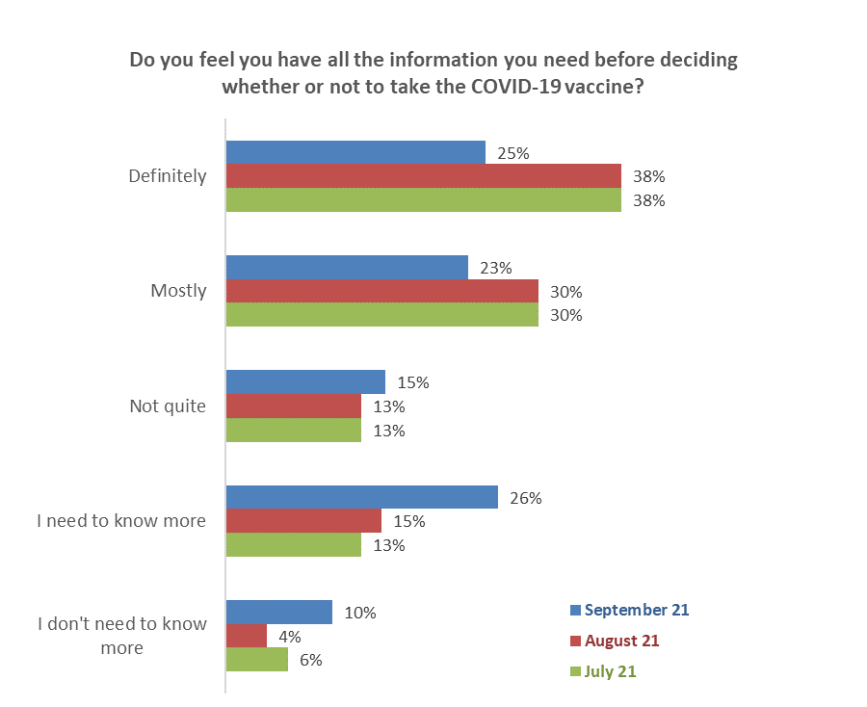
↓
Total definitely & mostly
September 48% ↓
August 68%
July 68%

↑
Total not quite & need more info
September 41% ↑
August 28%
July 26%
↑
↓
Base: Not yet vaccinated twice: July 2021 n=1,575; August n=1,044; September n=414.

Those who need more information are more likely to be from the following groups:

Do not have quite enough & need more information | June 2021 Results
Total | 41%
Aged 45 to 54 | 52% ↑
Live in a regional city | 51% ↑
From a two-parent family, with three or more children at home | 51% ↑
Unlikely or most unlikely to get vaccinated | 51% ↑
Couple with no children at home | 50% ↑
Highest qualification Sixth form/UE/ NCEA Level 2 | 50% ↑
Female | 49% ↑
Live rurally but not remotely | 49% ↑
Results are for groups of at least n=50 respondents

7.2 What else do people need to know to help them decide whether to get the COVID-19 vaccine?
Respondents who had not been vaccinated twice and who gave the following responses to the previous question: “I mostly have enough information to decide”, “Not quite enough information” and “I need to know more” were asked an open-ended question - what else do you need to know to help you decide whether or not to get vaccinated?

Main themes from their comments are illustrated in the following chart. These are compared with results from the previous survey wave in August where the same question was asked.

As in previous surveys, the main thing people want to know is information on the long-term effects of the vaccine, based on longer and/or more clinical studies (29%, up from 24% in August and 19% in July).

Wanting ‘the facts’ on the success rate for vaccines, their effectiveness, their ingredients and the results from international studies has moved into second place, with 16% of mentions compared with 14% in August.

Wanting information on side effects and risks was mentioned by 13%, the same level as in August and this theme has dropped to third place after being second in previous survey waves.

A new theme emerged in the current survey – being suspicious of government information/ ‘propaganda’. Nine percent made comments along these lines in the September survey compared with only 2% in August. Given the low level of these responses in August, these were classified under ‘other comments’ and we went back to the August results to re-code and re-measure these negative comments. Presumably, as the number of unvaccinated people in the community becomes smaller, the proportion of these people who are suspicious of government information will increase.

Note that queries about booster shots which emerged as a minor new theme in August (3% of responses) were not mentioned in September, although they were mentioned in other open response questions.
↑
↓
↑
Base: September n=241 people, August 2021 n=457 people who responded to this question.
NB. Totals add to more than 100% as people could provide multiple responses.

Examples of verbatim comments
Verbatim comments illustrating the main themes are included below…

Information on long-term effects/ based on longer/more clinical studies
I’m worried about side effects and how long the vaccine actually lasts and the long-term effects of having boosters etc. (Female, Aged 25-34 years).
More data about long term affects and side effects. (Female, Aged 35-44 years).
Long term effects, well we won’t have those quickly, will we? Some statistical information from countries ahead of us on the vaccination front. How effective is vaccine? (Female, Aged 45-54 years).
Long-term clinical trials will help me make up my currently undecided mind. (Female, Aged 45-54 years).
Long-term results/studies. (Male, Aged 25-34 years).
Medium- and long-term effects of the vaccine. Is it likely that having the vaccine will cause future health problems, associated with the vaccine? (Female, Aged 55-64 years).
Three years after the roll out of the vaccine would be enough time for me to make a decision as to whether or not I will take it. (Male, Aged 45-54 years).
Wait longer to see side effects on people; it was made too quickly. (Female, Aged 18-24 years).

Facts on success rate/effectiveness/ingredients/international results
I need scientific evidence. (Male, Aged 25-34 years).
I really just want to see as many statistics post 2nd dose as possible before I commit. (Female, Aged 45-54 years).
I would like some better information then I may change my mind but all I am seeing is negative things regarding the vaccine. (Female, Aged 25-34 years).
More statistics on adverse reactions, and effects on immune compromised., (Female, Aged 45-54 years).
Need more facts on clinical trials across the world. (Male, Aged 65-74 years).
There needs to be more research and more facts made easily available. What the government has published are not proper facts, for example that the vaccine is made of "chemicals and other ingredients". Which chemicals? (Female, Aged 45-54 years).
What are the ingredients of the vaccine? Why isn't this information readily available? (Female, Aged 25-34 years).

Information on side effects/risks
Studies of side effects. (Male, Aged 45-54 years).
The health complications it causes. (Male, Aged 45-54 years).
More explanation on different side effects and why they affect some people. (Female, Aged 35-44 years).
If it has side effects. (Female, Aged Under 18 years).
How to prevent blood clots. (Male, Aged 35-44 years).
I need to know specifics. I’d love to know how it affects people; I need to know if it will cause complications later on in life. I would like to know if it affects fertility. (Female, Aged 25-34 years).

Suspicious of government information/ 'propaganda'
Why the government is hiding the true damage that the vaccine is causing to people. (Female, Aged 35-44 years).
Unbiased and unfiltered truth that is not corrupted by agendas both nationally and globally. Most often corrupted by those controlling the narrative, government and mainstream media. (Female, Aged 35-44 years).
NZDSOS has lots of information researched from top international medical sources. Their opinions have more weight than the propaganda being fed to most New Zealanders via a biased media. (Male, Aged 65-74 years).
More transparency from govt. (Female, Aged 55-64 years).
Honesty from the world about this so-called vaccine. (Female, Aged 55-64 years).
Evidence. So many reports of bad reactions to vax etc on social media - interesting that they all seem to be removed - censorship at work. (Male, Aged 55-64 years).
Because Dr Doomsfield tells vulnerable people to get immunised but Medsafe website says immune compromised people should not. (Female, Aged 65-74 years).
A strange global agenda for a flu virus. (Female, Aged 65-74 years).
42,000 opinions on Jacinda’s Facebook page on Monday the 27th of Sept 2021 then about 12,000 were deleted. (Male, Aged 55-64 years).

Will it work for my health condition?
Whether my high blood pressure will be an issue. (Female, Aged 35-44 years).
Whether or not the vaccine is suitable for me, personally. I have breathing difficulties already and have been x-rayed for a chest infection. I'm also on antibiotics and am unsure how the vaccine will react to that and the other medication that I'm on. (Female, Aged 45-54 years).
While I'm pregnant I'm not sure I should get it. (Female, Aged 25-34 years).
Whether I will develop autoimmune disease again if I get vaccinated. (Female, Aged 45-54 years).
I'm allergic to penicillin, will it affect me? (Male, Aged 45-54 years).
I need in-depth information on how it may affect my current autoimmune disease. I have rheumatoid and what I read in health research means that I'm high risk for COVID. (Female, Aged 25-34 years).

Don't know/ just want more information
I’m not sure actually. There’s so much information and talk I don’t know what to believe. (Female, Aged 35-44 years).
Honestly just not sure yet .... (Female, Aged 45-54 years).
I'm not sure, that's why I want to do some research about it. (Female, Aged 35-44 years).

General information - how it works/ how long it will last/ do I need to take again/ effectiveness against new strains/ where and when it will happen/brand of vaccine etc
If it covers the Delta and South African variants. (Female, Aged 45-54 years).
If it really is necessary. (Male, Aged 25-34 years).
More details around how they’re making sure it. Is it safe for kids, especially when there’s places overseas only giving teens one dose yet here, we are doing two? Where’s the science behind those decisions? (Female, Aged 25-34 years).
Will I need to keep having booster shots for the rest of my life? Is this the best vaccine of the many available and why don't I have a choice of vaccine? Who will compensate me if I am harmed by the vaccine and what will the compensation be? (Male, Aged 45-54 years).

Assurance it is safe/ it will work for me
Is it safe? (Female, Aged 55-64 years).
Overall safety of the vaccine (Male, Aged 25-34 years).
I need to know that it is safe. At this point I do not believe it is. (Female, Aged 45-54 years).

Assurance by GP/ health professional/ government agency
I need to sit down with my doctor and go through exactly what the vaccine is made up of and whether it is safe for me. (Female, Aged 45-54 years).
Waiting to see if it works and will have to consult with my doctor. (Male, Aged 55-64 years).

Other
What is the best reason why to get the vaccine? (Female, Aged 18-24 years).
There has been recent news of a new treatment which I am very interested in, especially if I remain immunocompromised. (Male, Aged 25-34 years).
Stop using pressure, you must let people decide when. Don't text me every week. (Female, Aged 35-44 years).
Not to be bullied. (Male, Aged 75 years or over).
Other available options beside Pfizer. (Female, Aged 25-34 years).

7.3 The one thing that would absolutely convince people to get a COVID-19 vaccine
Those who had not yet been vaccinated were asked an open-ended question to state in their own words the one thing that would absolutely convince them to get a vaccine.
Out of the 414 unvaccinated people in the survey, 380 responded to this question and the following main themes were apparent:
- Nothing would make me take the vaccine (23%)
- Knowing it works (15%)
- Long-term data (13%)

Base not yet vaccinated n=414

Verbatim quotations illustrating each theme follow…

Knowing it works/ it is safe/ no side effects
Convince me there no side effects. (Female, Aged 25-34 years).
If it was proven to work and could definitely say I won't have any long-term harm. (Male, Aged 25-34 years).
If there had been no deaths from the vaccine, or if it was proven that there were real benefits that significantly outweighed the risks. (Female, Aged 45-54 years).
It doesn't harm people. (Female, Aged 45-54 years).

Long term data/ proof it is 100% safe
100% documented that I am unable to catch COVID 19. (Female, Aged 55-64 years).
100% effective from getting sick and 100% safe. (Female, Aged 25-34 years).
20 years of prior testing and absolute clarity on all of its safety and contra-indications. I remain dubious that Pfizer has been given indemnity. (Male, Aged 25-34 years).
5-10 years safety data, possibly. (Male, Aged 55-64 years).
Definite research on long term impact. (Female, Aged 25-34 years).

To protect my friends and family
A family member dying. (Female, Aged 18-24 years).
Family member getting COVID or friend. (Male, Aged 18-24 years).
For my baby nephews. (Female, Aged 35-44 years).

Money/financial reward
A money voucher. (Male, Aged Under 18 years).
A paid incentive. (Male, Aged 45-54 years).
An incentive. (Male, Aged 25-34 years).
Give out 100 dollars supermarket vouchers. (Male, Aged 18-24 years).

If COVID takes off in my area
If COVID was active in my area of living. (Female, Aged 18-24 years).
If it was rampant in Christchurch. (Female, Aged 45-54 years).

Access to a traditional vaccine/ not experimental
A conventional vaccine, with all the appropriate testing done. (Female, Aged 55-64 years).
If it was a traditional type, not experimental, and approved by the MDA. (Male, Aged 75 years or over).
It being a normal vaccine like the J&J one, or a long-term study of the effects of the one being offered in NZ. (Male, Aged 35-44 years).

If needed for overseas travel
Ability to travel overseas to see family and friends. (Female, Aged 35-44 years).
If I had to travel and get the vaccine, then I might get it. (Male, Aged 45-54 years).
If I was forced to get one to fly to Australia or America. Not that I want to travel any time soon anyway. (Female, Aged 35-44 years).

Safe for my medical condition
Clear cut and consistent information pertaining to vaccines in pregnant women and the outlined risks associated. (Female, Aged 25-34 years).
Having good solid research to prove I am not high risk & that taking the vaccine won’t harm me or my baby that I'm breastfeeding. (Female, Aged 25-34 years).

Government transparency
The true facts from the government. (Male, Aged 45-54 years).

Govt takes responsibility if something goes wrong
A government guarantee that I will receive compensation for any harm the vaccine causes, and the exact terms of the compensation, like an insurance contract. (Male, Aged 45-54 years).

Other
A pill, not a jab. (Female, Aged 45-54 years).
Don’t like injections needles at all. If there was a drinkable oral one, I would get it straight away. (Female, Aged 55-64 years).
Financial, losing my job cause no longer have rights to what I put in my body. (Female, Aged 45-54 years).
Being able to walk in off the street without appointment. (Female, Aged 45-54 years).
Being ostracized by employment, charitable and social organisations. (Male, Aged 65-74 years).
Company telling me I had to get it. (Male, Aged 55-64 years).
If I am unable to go to shops or restaurants with being vaccinated. (Female, Aged 25-34 years).
I am getting it. (Male, Aged 45-54 years).
Medical professional advice. (Female, Aged 35-44 years).

Nothing
Absolutely NOTHING. (Female, Aged 35-44 years).
I can't think of what that could be. I have truly gone into this, looking for answers and found enough evidence to persuade me the vaccination can do as much harm as COVID. I have to admit, I almost went with it, but more info came my way, that I trust. (Female, Aged 65-74 years).
Knowing what I have learned during the past 19 months (I have been seriously studying and researching SARS-Cov-2 since the beginning), I would never expose my body to this/these experimental therapy/therapies. Russian Roulette is not my game. (Female, Aged 55-64 years).
My body has its own built-in immunity defence system. No need for outside interference. (Female, Aged 55-64 years).
Nothing. I trust in my own immune system. (Male, Aged 55-64 years).
Nothing could convince me. Nothing anyone could offer me would make a difference. Anyone who says it is safe and useful is a liar, and many of those who are saying this are actually evil. (Male, Aged 55-64 years).
No bribes or blackmailing would convince me. (Female, Aged 55-64 years).

Vaccine facts and beliefs

8.1 Facts and beliefs people have heard of
In order to assess how prevalent various pieces of information (and misinformation) are, all those surveyed were asked, ‘Which of these pieces of information have you heard of?’ There were some striking differences between the general population and those who say they definitely won’t get vaccinated. The latter group is more likely to have heard the following facts and beliefs:
- The vaccine hasn’t been proven safe; it has long term side effects; it can affect your reproductive organs.
- It contains DNA or RNA; it can affect your DNA and RNA.
- The government will force some people to get vaccinated.
- Taking the vaccine has spiritual or religious implications.

Base September survey wave: Total sample n=2,479, definitely will not get vaccinated n=92

8.2 Facts and beliefs that are likely to be true
All those interviewed were then asked, ‘which of these pieces of information do you think are likely to be true?’.
Again, in the following chart we contrast the views of the general population with those who say they definitely won’t get vaccinated. There is a very marked difference between the understanding of all those interviewed and those who definitely won’t get vaccinated. For instance, those who definitely won’t get vaccinated are around eight times more likely than the general population to believe:
- It is likely to be true the vaccine can affect your reproductive organs.
- It is likely to be true that the vaccine can affect your DNA or RNA.
- It is likely to be true that taking the vaccine has religious or spiritual implications.

8.8 times higher
7.8 times higher
8.3 times higher
Base September survey wave: Total sample n=2,479, definitely will not get vaccinated n=92

Facts and beliefs likely to be true by intentions to get the vaccine
And which of these pieces of information do you think are likely to be true? | ALL | Will you get the COVID-19 vaccine?
 |  | Definitely | Most likely | Likely | Unlikely | Most unlikely | Definitely not | I'm not sure | Already vaccinated
Once vaccinated, a person can still get COVID-19 | 62% | 45% | 57% | 26% | 54% | 74%↑ | 65% | 51%↓ | 64%
People will probably have to get a dose every year | 57% | 49% | 43% | 30% | 58% | 63%↑ | 54% | 39%↓ | 59%
The longer between vaccine doses, the better it works | 37% | 28% | 18% | 21% | 18%↓ | 20%↓ | 5%↓ | 7%↓ | 42%↑
People can get sick from getting the COVID-19 vaccination | 32% | 32% | 24% | 28% | 34% | 69%↑ | 68%↑ | 35% | 29%
The government is going to force some people to get vaccinated | 16% | 19% | 25%↑ | 14% | 38%↑ | 44%↑ | 55%↑ | 26%↑ | 11%↓
The vaccine contains a type of DNA or RNA | 14% | 11% | 3%↓ | 12% | 14% | 14% | 35%↑ | 17% | 13%
The vaccine hasn't been proven to be safe | 13% | 15% | 24%↑ | 21%↑ | 35%↑ | 61%↑ | 62%↑ | 27%↑ | 7%↓
The vaccine has long-term side effects | 8% | 5% | 19%↑ | 21%↑ | 11% | 31%↑ | 49%↑ | 13% | 4%↓
The vaccine can affect your reproductive organs | 5% | 2%↓ | 6% | 2% | 19%↑ | 19%↑ | 46%↑ | 10% | 2%↓
The vaccine can affect your DNA or RNA | 4% | 9% | 7% | 4% | 13%↑ | 23%↑ | 36%↑ | 8% | 2%↓
Once someone is vaccinated, they can be tracked by the government | 3% | 3% | 2% | 3% | 3% | 1%↓ | 6%↑ | 1%↓ | 3%
Taking the vaccine has spiritual or religious implications | 2% | 10%↑ | 0% | 0% | 2% | 8%↑ | 18%↑ | 2% | 1%
The vaccine can make you magnetic | 2% | 0% | 3% | 0% | 3% | 5% | 14%↑ | 2% | 1%
The vaccine is related to the telecommunications 5G network | 1% | 1% | 1% | 1% | 0% | 0% | 6%↑ | 3% | 1%
The vaccine can cause autism if given to young children | 1% | 2% | 2% | 2% | 13% | 1% | 7%↑ | 3% | 1%
The vaccine contains a microchip | 1% | 1% | 4% | 2% | 0% | 0% | 4%↑ | 1% | 1%
None of these | 7% | 4% | 14%↑ | 16%↑ | 4% | 4% | 10% | 1% | 7%
I'm really not sure | 8% | 16%↑ | 3% | 18%↑ | 15% | 8% | 15%↑ | 35%↑ | 6%
N (unweighted) - All respondents | 2,479 | 46 | 43 | 45 | 36 | 64 | 92 | 88 | 2,065

Attitudes to the Delta strain of COVID-19

9.1 True statements about the Delta strain
Those who were not vaccinated were shown a list of 15 statements about the Delta strain and asked which of these are true, if any. The highest proportion of ‘true’ responses are for Delta is twice as infectious as earlier strains of COVID-19 (54%) and the chances of infecting people in your household is higher with Delta (49%). Almost three out of ten (28%) are unsure about which statements are true or not.
Base not yet vaccinated n=414
There were differences by likelihood to get the vaccine. Those who would definitely not get a vaccine were significantly less likely to believe that the Delta strain was different.

Which of these statements about the Delta strain of the COVID-19 virus are true, if any? | ALL | LIKELIHOOD TO GET VACCINE
 |  | Defin-itely | Most Likely | Likely | Un-likely | Most Unlikely | Defin-itely not | Unsure
Delta is twice as infectious as earlier strains of COVID-19 | 54% | 94% ↑ | 75% ↑ | 44% | 55% | 49% | 30%↓ | 52%
The chance of infecting people in your household is higher with Delta | 49% | 64% ↑ | 76% ↑ | 49% | 42%↓ | 59% ↑ | 27%↓ | 45%
One person with Delta can infect 5 or 6 other people | 40% | 66% ↑ | 55% ↑ | 34% | 23%↓ | 44% | 24%↓ | 41%
People fully vaccinated against COVID-19 have less risk of needing hospitalisation if they catch the Delta variant of COVID-19 | 37% | 75% ↑ | 50% ↑ | 35% | 31% | 45% ↑ | 11%↓ | 34%
People with Delta are at higher risk of needing hospital treatment | 32% | 53% ↑ | 66% ↑ | 39% | 16%↓ | 31% | 12%↓ | 27%
People with Delta carry much more of the virus (have a higher viral load) than those infected with earlier strains | 27% | 32% | 52% ↑ | 18%↓ | 13%↓ | 35% ↑ | 18%↓ | 23%
The time between being infected with Delta and getting symptoms is shorter | 16% | 31% ↑ | 23% ↑ | 7%↓ | 9%↓ | 20% | 6%↓ | 20%
Delta is no more infectious than earlier strains of COVID-19 | 16% | 8%↓ | 22% ↑ | 15% | 16% | 20% | 19% | 11%
People with Delta have no higher risk of needing hospital treatment | 13% | 4%↓ | 9% | 1%↓ | 13% | 24% ↑ | 27% ↑ | 6%↓
The time between being infected with Delta and getting symptoms is the same as for other stains | 13% | 14% | 20% ↑ | 5%↓ | 9% | 18% | 10% | 14%
People with Delta are infected for a longer time | 11% | 30% ↑ | 11% | 10% | 5% | 14% | 3% | 10%
One person with Delta can infect 1 to 3 other people | 8% | 5% | 16% ↑ | 13% | 7% | 9% | 5% | 5%
The chances of infecting people in your household are the same as earlier strains | 7% | 3% | 11% | 1%↓ | 6% | 11% | 10% | 4%
People infected with Delta have the same viral load as those who get earlier strains | 6% | 3% | 3% | 4% | 13% ↑ | 7% | 6% | 6%
People fully vaccinated against COVID-19 have higher risk of needing hospitalisation if they catch the Delta variant of COVID-19 | 6% | 0%↓ | 5% | 4% | 3% | 9% | 16% ↑ | 0%
None of these are true | 7% | 0% | 0% | 2% | 0% | 4% | 28% ↑ | 2%
I'm really not sure | 28% | 2% | 12%↓ | 35% ↑ | 46% ↑ | 32% | 28% ↑ | 35% ↑
N (unweighted) - All not vaccinated | 414 | 46 | 43 | 45 | 36 | 64 | 92 | 88

9.2 Chances of being infected by the Delta strain at some time
Those who had not yet been vaccinated were asked to assess their chances of being infected with the Delta COVID-19 virus at some time, using a scale from no chance to high chance.
The most common response was little chance (41%), with only 8% selecting high chance.

Base not yet vaccinated n=414
Perceived chance of getting the Delta strain by likelihood to get vaccinated
As the next table shows, believing there is a high chance or even some chance of being infected with the Delta variant is associated with a higher likelihood of getting vaccinated.
Likely to be vaccinated ↓ | Perceived chance of being infected with the Delta strain
 | High chance | Some chance | Little chance | No chance
Definitely | 16% | 13% | 8% | 11%
Most likely | 11% | 23% | 8% | 4%
Total definitely and most likely | 27% ↑ | 36% ↑ | 16% ↓ | 15%↓
Base not vaccinated n= | 39* | 100 | 161 | 52*
* Note two small sample sizes

Tracking question results

10.1 Preferred ways to access the vaccine
Those who had not yet been vaccinated were asked ‘From which of these places and people would you most like to access a COVID-19 vaccine, if any?’
As in July, the number one preference is being vaccinated by ‘my doctor’. However, this response has fallen from 65% in July to 46% in September. Indeed, all other choices dropped from July to September.
There is a corresponding increase in those who made no choice as they won’t get vaccinated (33% cf. 15%)

Base not yet vaccinated July survey n=1,287, September n=414
Multiple responses were allowed. More choices were included in September than in July.

10.2 Sources of official information about the vaccine
All respondents were asked where they had seen official COVID-19 information and advertising, if any, in the past 30 days. Results from the latest September 2021 survey are compared with those recorded in July and August 2021 in the table below.
In September the top four sources of official information are the same as in August and July; namely TV, social media, radio and news websites.
September results showed a sharp increase in awareness for letterbox and leaflets, up 14 percentage points from the previous month. Other media sources that with appreciable increases include YouTube (up 5 points), Daily Press (up 6 points) and Billboards (also up 6 points).
In which media have you seen official COVID-19 information and vaccine advertising in the past 30 days? | July | August | September | August to September  Difference  % points
TV | 64% | 74% | 72% | - 2
Social media | 34% | 52% | 51% | - 1
Radio | 29% | 35% | 39% | + 4
News websites | 24% | 39% | 38% | - 1
YouTube | 18% | 25% | 30% | + 5 ↑
Press – Daily (referred to as ‘Newspapers- Daily’ before September) | 17% | 20% | 26% | + 6 ↑
On demand TV | 18% | 23% | 23% | -
Letterbox / leaflet | 9% | 7% | 21% | + 14 ↑
Billboards | 9% | 9% | 15% | + 6 ↑
Press – Weekend (referred to as ‘Newspapers – Weekend’ before September) | 9% | 11% | 13% | + 2
Press – Community (referred to as ‘Local/Community Newspapers’ before September) | 15% | 13% | 11% | - 2
Bus / train advertising | 8% | 8% | 11% | + 3
Somewhere else | 2% | 2% | 2% | -
I haven't seen any of these advertisements | 11% | 5% | 6% | + 1
Base n= | 2,509 | 2,334 | 2,447

10.3 Impact of seeing an official COVID-19 vaccine advertisement
Those who had seen official COVID-19 vaccine information or advertising in the previous 30 days were asked what impact this had, from a list of possible options.

Almost half (49%) said that the official advertising they noticed reinforced their decision.

Only 4% said this official advertising made them more likely get a vaccine, while 39% said this advertising made no difference to their decision.

Base: September survey - have seen official advertising n=2,314

Likelihood to take the vaccine after seeing or hearing official advertising analysed by gender, age and likelihood to get vaccinated
The next table shows ‘more likely’ and ‘less likely’ responses to taking the vaccine by gender and age in the September survey wave.

Aside from the 16-17 years age group, the advertising is seen to have little nett effect on likelihood to be vaccinated. This contrasts with previous survey waves, where more positive nett effects were recorded and could reflect the changing nature of the unvaccinated group, as this group gets smaller in size.

Impact of seeing official advertising in the last 30 days | ALL | GENDER* |  | AGE
 |  | Male | Female | 16-17 years | 18-24 years | 25-34 years | 35-44 years | 45-54 years | 55-64 years | 65-74 years | 75 years or over
Made me absolutely certain I will get a vaccine | 1% | 1% | 2% | 2% | 2% | 3% | 2% | 1% | 1% | 0% | 0%
Made me much more likely to get a vaccine | 1% | 1% | 1% | 5% | 2% | 2% | 1% | 2% | 0% | 0% | 0%
Made me more likely to get a vaccine | 1% | 1% | 1% | 3% | 0% | 2% | 1% | 1% | 1% | 1% | 0%
Made me slightly more likely to get a vaccine | 1% | 1% | 1% | 1% | 2% | 1% | 2% | 0% | 0% | 1% | 2%
Total positive impacts | 4% | 4% | 5% | 10% | 5% | 8% | 5% | 4% | 1% | 2% | 2%
Made me feel less likely  to get a vaccine | 4% | 4% | 4% | 0% | 5% | 7% | 4% | 4% | 2% | 2% | 3%
NETT POSITIVE IMPACT | +1% | zero | +1% | +10% | zero | +1% | +2% | zero | -1% | 0% | -1%
Base – Seen official advertising n= | 2314 | 1,080 | 1,222 | 57 | 187 | 402 | 430 | 410 | 359 | 287 | 182
* The gender diverse group is excluded due to a small sample n=12.
Some nett totals are different from adding the individual results, due to rounding.

Official advertising is not having a net positive impact for unvaccinated people in deciding to get vaccinated, especially for those who say they are unlikely to get vaccinated.

Impact of seeing official advertising in the last 30 days | ALL | WILL YOU GET THE COVID-19 VACCINE?
 |  | Likely | Unlikely | I'm not sure
Made me absolutely certain I will have a vaccine | 1% | 0% | 1% | 2%
Made me much more likely to have a vaccine | 1% | 0% | 0% | 2%
Made me more likely to have a vaccine | 1% | 7% | 1% | 3%
Made me slightly more like to have a vaccine | 1% | 4% | 1% | 3%
Total positive impacts | 4% | 11% | 2% | 10%
Made me feel less likely to get a vaccine | 4% | 12% | 14% | 12%
NETT POSITIVE IMPACT | +1% | -1% | -12% | -2%
Base – Seen official advertising n= | 2,314 | 115 | 154 | 66

Experiences of those who have already been vaccinated
2,065 people in the survey had received at least one vaccine dose. This represents 80.7% of the total (those aged 16 or more). This result is up from 53.3% in August and 29.2% in July.

11.1 Did you receive enough information about your vaccination?
94% of those who had been vaccinated said they received enough information.  This is slightly down from the August result (97%) | 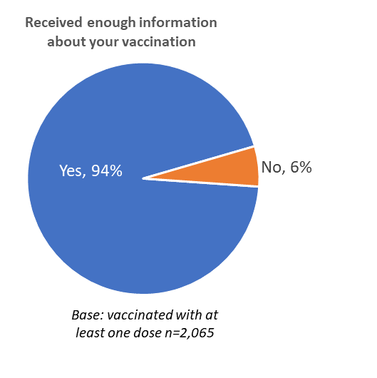
Respondents who had been vaccinated but said they had not received enough information were asked to comment on what else they would have liked to know. Note that some of the comments suggest that among those who have had the vaccine are some that would have originally been unlikely to have got it.

There are also some comments suggesting that respondents felt they did not have a chance for informed choice. One respondent from Wairoa District commented:
I was just forced by the Doctor without them even asking me first if I had wanted one or not. (Female, 35-44 years).

In general, respondents who felt they had not received enough information would have liked to know:

Side effects and risks (around 33% of comments)
A more balanced and comprehensive breakdown of the side effects - rather than just saying “it’s safe” - prove it! Show the data. Don’t disregard people’s concerns (which are valid). All the govt data presented is extremely basic and doesn’t go into the detail that people want. (Female, 35-44 years).
What side effects. (Male, 75 years or over).
Side effects, current stats on adverse side effects. (Female, 25-34 years).
Side effects, picking up other illness. (Male, 55-64 years).
Risks. (Female, 35-44 years).
Potential side effects and what to look out for. (Female, 65-74 years).
Not enough info about side effects - factual. (Male, 55-64 years).
Not a lot was given about side effects or how likely it is the vaccine saves my life if I get COVID. (Male, 35-44 years).
More information on side effects both short and long term. (Female, 55-64 years).
More information about possible side effects, even the rare ones. (Female, 25-34 years).
More info on vaccine side effects. this is barely mentioned in Govt media releases or 1pm updates. (Female, 55-64 years).
More about how long side effects can last. (Female, 35-44 years).
More about how it works and the less common side effects. (Female, 18-24 years).
Informed choice, side effects, sighting the actual vial. (Female, 55-64 years).
Information about side effects. (Male, 65-74 years).
I would have liked to know what the risks are. (Male, 45-54 years).
Effects how and how it works. (Female, 25-34 years).
Effect. (Female, 35-44 years).
Easier ability to talk to someone about anxieties about side effects (rather than feeling time pressured to ask right before getting the vaccination). (Female, 45-54 years).
Clearer info re side effects. (Female, 45-54 years).
Actual statistical risks. (Female, 45-54 years).
I would have liked information on adverse reactions (instead of having to visit the VAERS report), and on how the vaccine actually works. (Male, 65-74 years).
Better information as to what the vaccine actually protects against/level of protection and side effects. (Male, 25-34 years).
Informed consent, what adverse reactions or complications. (Female, 55-64 years).

Technical information about the vaccine: how it works and its ingredients (around 17% of comments)
I realize that here (in NZ) we are not hearing the truth; far more is freely given to the citizens of other countries. We want to know the plus and minus of each vaccine. (Female, 55-64 years).
About the way it works, side effects etc. (Female, 35-44 years).
What's in it and how it works. Technically. (Male, 35-44 years).
The ingredients. (Female, 65-74 years).
The background of mRNA and the reasons why the vaccine could have come to market so quick. (Male, 25-34 years).
That it is a different (new) vaccination technology and how it works and what groups were tested (long term illness groups). (Female, 45-54 years).
Research around it. (Male, 25-34 years).
Ingredients, how many strains it will protect from, side effects of both. (Female, 25-34 years).
ingredients independently checked to stop disinformation. (Male, 45-54 years).
I’d like to know what is in the vaccine. (Female, 35-44 years).
I would have liked to have known what the names of whatever is in the vaccine and how it works, the science of it. (Female, 25-34 years).
I wanted written detailed info about how the jab worked and written confirmation about the next jab. (Male, 65-74 years).
I had to educate myself using the internet to find scientific/medical data regarding the vaccine. I asked for information at the vaccination centre re: the risk of blood clots from the vaccine, they were not able to give the information so I found out for myself. I am not an anti-vaxxer so I knew where to look for the science/medical based information regarding my question. (Female, 45-54 years).
I googled what else I needed to know. (Female, 45-54 years).
exactly what is inside the injection and how it works precisely, compared to ordinary vaccines. (Female, 45-54 years).
details on effectiveness and clinical trial process. (Male, 45-54 years).
Deaths after vaccine, blood clots after vaccine, (Female, 55-64 years).
Background of the type of vaccine I had. (Male, 55-64 years).

Long-term effects (around 8% of comments)
What the long-term implications are and why we need a vaccine. (Female, 35-44 years).
(It) remains a very controversial vaccine, want to know long term effects. (Female, 25-34 years).
Reactions, how long you could feel unwell, and side effects in the long term. (Female, 45-54 years).
Possible long-term effects. (Male, 55-64 years).
More information on illnesses or long-term health issues and the side effects. (Female, 25-34 years).
More info about long term effects would be good but of course not possible since new vaccine. (Female, 35-44 years).
Long term side effects, success rate. (Male, 35-44 years).
Long term effects but they aren't known yet. (Male, 45-54 years).

How long does it last/will annual vaccinations/boosters be required? (around 8% of comments)
Will we be having yearly vaccination like the flu injection due to strains of COVID mutating? (Female, 45-54 years).
Responsibility/liability of the company that makes the Pfizer (vaccine), does it really work, do you have it yearly like the flu jab. (Female, 45-54 years).
More info about the top up medication for close contacts. (Female, 45-54 years).
How long two doses will last. (Female, 75 years or over).
How long till the antibodies are present in the system after getting vaccinated. (Male, 25-34 years).
How it will work out in future is if people will take vaccine every year. (Male, 45-54 years).
Details of boosters for everyone who had second shot 3weeks after their first. (Female, 45-54 years).

Specific information on conditions and medicines (around 9% of comments)
Specific Information for my Auto Immune Disease. (Male, 45-54 years).
More about impacts on breastfeeding. (Female, 35-44 years).
Info re vaccine and breastfeeding. (Female, 25-34 years).
I would have liked to know any and all side effects for people with FMS. (Female, 65-74 years).
Having heart condition, I had to wait too long for vaccination. (Female, 65-74 years).
Fertility concerns. (Female, 25-34 years).
Can people with lone term health issues take the vaccine? (Male, 35-44 years).
Effects of it, being pregnant. (Female, 35-44 years).

No information was provided (around 7% of comments)
There was no information on the waiver form I signed about the possible adverse reactions with the vaccine. In fact, upon doing my own research I couldn’t find that information anywhere. (Female, 25-34 years).
There was no information given with the vaccine unlike any other medical treatment I have received. (Female, 25-34 years).
The information was poor early on. Had first vaccination in July; the information and access via website was difficult and many "road blocks" as the criteria was too strict and restrictive. I had to persist and then (was) handled appallingly: booking not on line, overloaded facility. But on the 2nd dose in Sept, super well organised and the process was well planned - but the first process could have contaminated confidence in the Govt process. It was like being part of a "con' initially. (Male, 45-54 years).
No, I didn't get any information about it. (Female, 35-44 years).
(I) never got anything, needed to find it myself. (Male, 25-34 years).
I didn't receive any, just a txt saying book in, go to this site. (Female, 35-44 years).
Didn't receive any information really. (Male, 35-44 years).

Other comments (around 15% of comments)
If the batch my vaccine was in was part of the contaminated lot from Japan. (Female, 25-34 years).
I would have liked to know how to get an electronic version of my vaccine records. (Female, 35-44 years).
I would have liked to be able to talk to a medical professional to ask questions. (Female, 65-74 years).
I wish I had known it was advised a longer delay in between the jabs, I had everything booked and I wasn’t offered to change my booking for that reason. (Female, 35-44 years).
I wasn't aware that waiting 6 weeks between doses was recommended. Mine were done 3 weeks apart. (Female, 35-44 years).
I think there were pamphlets there on the day but we never got one. Because of health issues we were both happy to be getting it unexpectedly before our booking date. (Female, 55-64 years).
Did my own research, helps have medical people in family to ask questions. (Male, 45-54 years).
Benefits. (Male, 25-34 years).
Any real peer reviewed science that isn't political science. (Male, 55-64 years).
An appointment card for next time and confirmation that I've received the vaccine. (Male, 45-54 years).
after effects, still catch and carry after vac, how serious is catch after vac. (Male, 65-74 years).
About the entire thing to be honest. (Male, 25-34 years).
Should have sent every household info on COVID vaccine. (Female, 35-44 years).
Ringing the health line, they were vague and like they were reading of a piece of paper. (Female, 55-64 years).

Potential misinformation comments
Why, now, more boosters have to be taken? Why Jacinda didn't get the actual vaccine? Why all politicians didn't have it first? Why I was forced into having it for working at the port? Why the non-vaccinated are now the Jews of the country? Why we need to show a vaccine passport for travel outside of NZ? Why GPS tracking via the app is acceptable for citizens of a democracy? (Male, 35-44 years).
That it doesn't work well and the chances to infect more people are higher being vaccinated. (Male, 55-64 years).

11.2 How invited to make a booking
People who had been vaccinated at least once were asked how they were invited to make a booking. For the September survey, respondents were able to choose more than one answer. On average, those who had been invited to make their booking had been invited 1.3 different ways

Text (32%) and email invites (24%) were again the main methods mentioned and the percentage of people who had not been invited to book had increased. All other methods, except for invitations “through work”, increased.

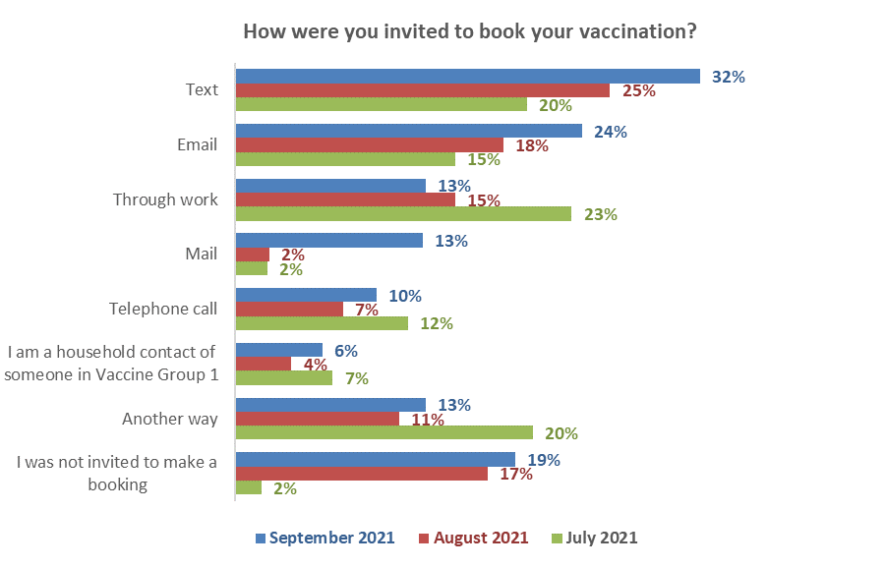
↑
↑
↑
↓
↑
↑
↑
Base: Vaccinated with at least one dose July n=934, August n=1,290

Other ways invited to make a booking
11% of vaccinated people said they were invited by another way, other than the ways listed in the survey.

In general, these people had taken the initiative prior to receiving an invitation:

Via my GP – ManageMyHealth
Via a doctor’s appointment
Through my doctors
Through the medical centre
Spoke to my doctor
While escorting my wife asked if there were any extras
Went to a medical appointment for my son and they offered the vaccine there.
Went along with my mother and asked if I can get mine also done.
We visited a site on the off chance and they gave us a booking which was awesome
We phoned the centre to see if we could drop in to get a leftover and were offered a slot the next day
Walk in at the clinic
Volunteer Fire Fighter
Visiting a retirement village when asked if I wanted one there and then.
University dorms offered
TV information.
Tv announced my age group/saying I was eligible.
Social media and TV ad that bookings were open for my age group, so I went online to confirm it and made the booking. An invitation arrived by mail about 2 weeks later.
Through my volunteer work with LGFB
Through my parents
Through my local pharmacy.
Through my daughter's workplace
Through my best friend as she sometimes lives with me and she is frontline therefore family and friends link to book
Through manage my health app
Through church via Ministry of Health
Through ADHB volunteer at Radio Lollipop
Through a person I know
Someone mentioned that you could register to go at the end of the day if any doses from a vial were spare.
Marae.
Māori health.
Made own appointment.
Made it (the booking) myself.
Local pharmacy.
Local advertising.
Knew my group was open so booked in.
Knew it was my turn.
Just went online.
Just booked as soon as the age group bracket for me opened up.
I phoned to get my husband and myself on the waiting list at the start of the roll out for group 3 - pre-existing conditions.
I phoned my GP and was given an appointment.
I phoned and just made an appointment.
I made the booking, got sick of waiting.
Both vaccines were at local walk-up vaccination events. I had booked appointments each time, which I then cancelled.

11.3 How people actually made the booking
People who had been vaccinated at least once were asked how they made their booking.
Online bookings continued to increase sharply compared with the August and July results, again driven by a strong increase in “Book my Vaccine” online bookings (now 47% of all bookings).

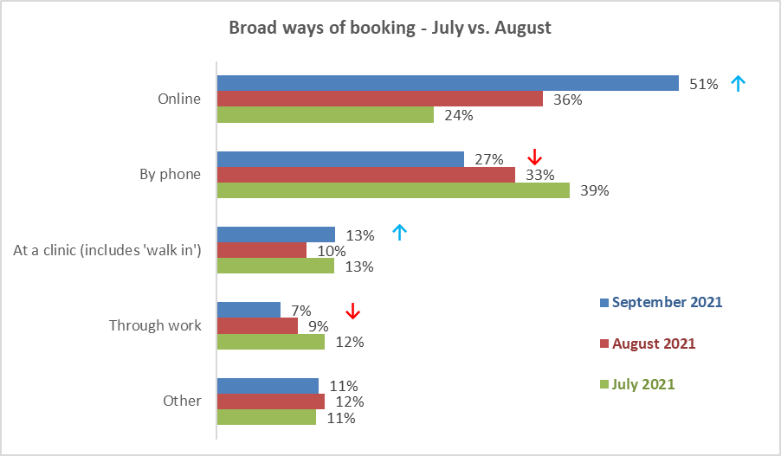

Specific methods used are shown in the following chart. The “July”, “August” and “September” figures are for all bookings made by people who had been vaccinated up to the respective month of the survey (i.e., up to July, up to August and up to September).

Note that “Book My Vaccine” is the predominant booking method used in the past 30 days.
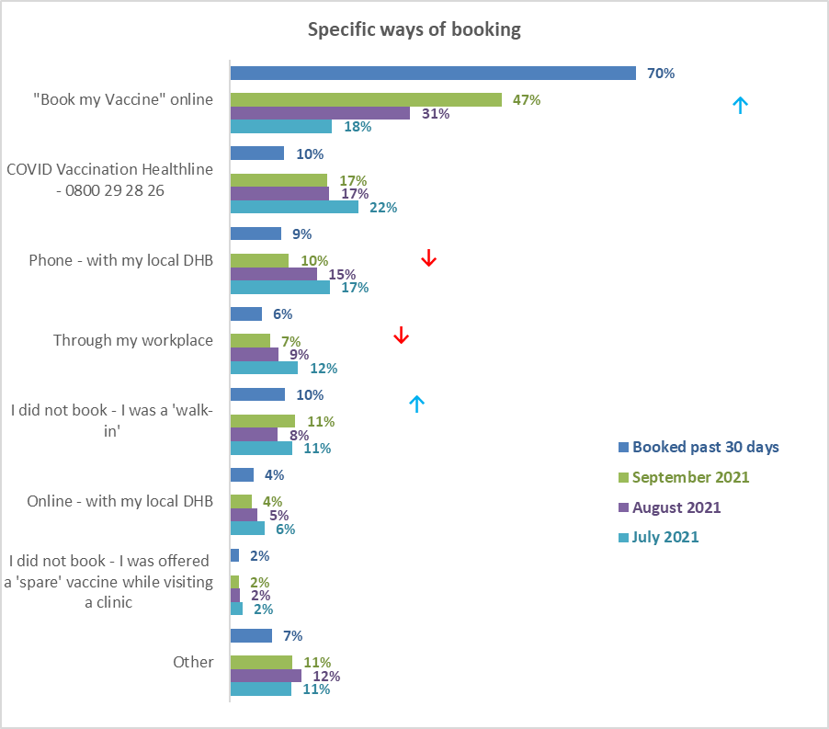
Base: vaccinated with at least one dose: September 2021 n=2,065, August n=1,290, July n=934

Other ways of booking
11% of vaccinated people mentioned another way of booking. Their main responses included:
- Drive thru vaccination
- Contacted local doctor/local medical centre for appointment
- Direct contact with the particular vaccination centre
- Booked directly at vaccination centre as I'm hearing impaired
- Direct with a pharmacy
- A site which allowed direct bookings
- By phone - to the health provider that was running this at the marae
- By email to local doctor, which was delayed by many months compared to other group 3 people. the DHB system had no bookings available at all for our town
- Booking made for me by text
- Booking for a local clinic via a link on social media
- Arowhenua whānau services

11.4 Ease of making a booking
27% of those who had already been vaccinated had booked in the past 30 days. They were asked ‘Overall, how easy or difficult was it to make your vaccination booking?’

The percentage having difficulty with booking has declined since June. In September, no-one had found it “very difficult” to book their vaccination.

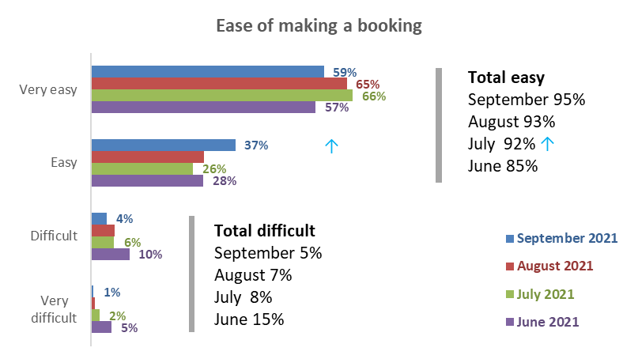
Base vaccinated with at least one dose: August 446 (booked in past 30 days), July n=934, June n=367 (July and June: All who had booked)

All individual booking methods are seen to be easy.
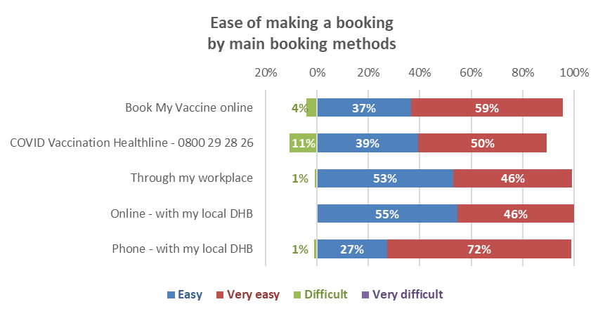

Reasons why the booking was difficult
Only 26 out of the 545 respondents who had booked in the past 30 days had difficulty with their booking. They were asked to indicate why, from a list of twenty reasons.

Because of the small base, these results should be regarded as indications only.

Those who had difficulty booking reported an average of 3.4 reasons.

The next chart shows the difficulties experienced by these 26 people.

A wide range of reasons were selected, with the top reasons (more than 20% of those who had experienced difficulties) involving:
- The 'Book My Vaccine' online system did not work (53%). This is around 2% of all who had booked in the past 30 days.
- Too few vaccination centre choices (49%). This is around 2% of all who had booked in the past 30 days.
- Could not get the time or place they had wanted (46%). This is around 2% of all who had booked in the past 30 days.
- Links in a text sent to them about booking did not work (33%). This is around 1% of all who had booked in the past 30 days.
- Too long before the booking number was answered (26%). This is around 1% of all who had booked in the past 30 days.
- Difficult finding booking from their District Health Board (23%). This is around 1% of all who had booked in the past 30 days.
- No choice of day or time. This is around 1% of all who had booked in the past 30 days.
Booking cancelled or changed
Lack of choice
Arranging a second dose
Finding booking information
Difficulty making the appointment
Base found the booking difficult n=30. Multiple choices were allowed.

‘Other’ reasons for finding the booking difficult included the following examples:
Initially said Kaikoura was not an option and would need to travel 72 km to nearest centre. (Female, 55-64, Canterbury DHB).
My vax was cancelled the day before then had to rebook a few weeks later then this was cancelled as both times sites weren't actually open at booking times they gave. (Female, 25-34, Auckland Metro/Waitematā DHB).
Booking was for Epsom/Alexandra Park which shut down at Level 4. (Male, 55-64, Auckland Metro/Auckland DHB).
I had to book in a different city to where I live to get a booking at all! (Female, 35-44, Hawke’s Bay DHB)
I could not book a drive through and had to call and it took a half hour for them to make the booking at the drive through. (Male, 55-64, Canterbury DHB).
Booking for my second dose was cancelled and it took 4 calls to rebook. (Male, 55-64, Canterbury DHB).
The Healthline staff kept asking the same questions on the phone I’d already answered. (Male, 25-34, Auckland Metro/Auckland DHB).
They took too long to find the NHI number. Male 35-44, Auckland Metro/Auckland DHB).

Reasons why the booking was easy
In total, 519 people out of the 545 who had booked in the past 30 days had found it easy to make a booking. These people were asked to select why this was easy from a list of reasons.

The main reasons for the booking being easy included:
- The online booking system worked well (71%; August 65%).
- I got the time and place I wanted (51%; August 54%).
- It was easy to book my second vaccination (38%; August 44%).
- I was able to make bookings for both first and second doses at the same time (34%; August 41%).
- I found the booking number easily (27%; August 30%)

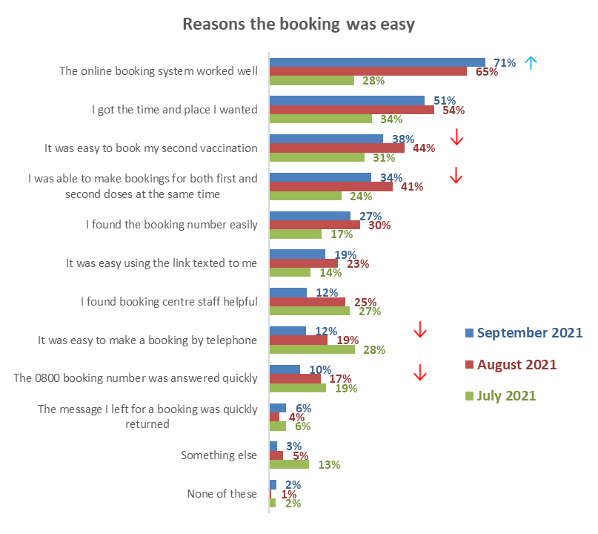
Base Booked past 30 days, found the booking easy n=519

Other reasons the booking was easy
The ‘other’ reasons the booking was easy included:
My doctor booked me.
Used GP service.
Being able to do it online.
The nurse who did my B12 injection booked me in.
Doctor made first booking.
Drive through very efficient.
It allowed me to book my mother in as well. They were able to answer ALL her questions n put her at ease. Well done!
Could book my children too on the phone call.
I tried to book on 0800 [useless] then online [useless] then weeks later online [excellent] - all up disorganised MoH & DHB.
It was also easy to cancel a no longer required booking.
It was easy to reschedule a current booking.
The feature that advised me of the closest vaccination centre was very helpful.
Everything was excellent and smoothly done.

11.5 Rating the booking experience
All those who had been vaccinated with at least one dose and had booked in the past 30 days were asked to rate their experience of 1) being invited to book, and 2) actually booking their vaccine appointment. These questions used a scale from ‘0’ (very poor) to ‘10’ (excellent).

The percentage who rated their experience of ‘actually booking’ their vaccination as 10 out of 10 (excellent) dropped from 54% in August to 40% in September. The percentage who rated their experience of ‘being invited to book’ at 10 out of 10 dropped from 43% in August to 36%.

As in August, ratings for ‘actually booking’ the appointment are ahead of ‘being invited to book’, with mean ratings of 8.4 and 7.9 respectively, a difference of 0.5 points. In August, the mean results were 8.5 and 7.7 respectively for these measures, a difference of 0.8 points.

As in August, “Book My Vaccine”: rated above all other methods of booking

Range of ratings | Being invited  to book | Actually  booking | Used Book My Vaccine
Not sure | 6% | 5% | 3%
0 to 4 (poor) | 9% | 5% | 4%
5 to 7 (moderate) | 19% | 16% | 16%
8 to 10 good | 75% ↑ (August 63%) | 75%↓ (August 77%) | 77% ↓ (August 81%)
Mean rating | 7.9 ↑ (August 7.7) | 8.4 (August 8.5) | 8.5 ↓ (August 8.8)

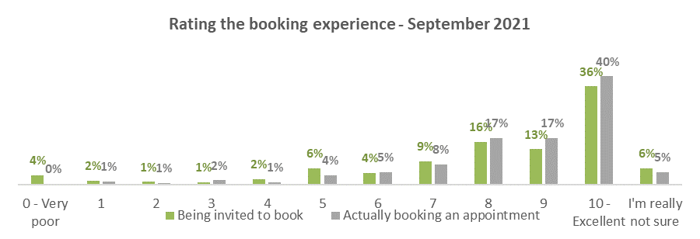
Base: Had at least one dose, booked in past 30 days n=446

Rating being invited to book by invitation method
“10 out of 10” ratings were generally lower in September across all methods of invitations to book. Indications are that vaccinated people who booked in the past 30 days were most satisfied with invitations through work, which received 47% excellent ratings (10 out of 10). As in August, those who didn’t receive an invitation are the least satisfied group (21% excellent ratings).
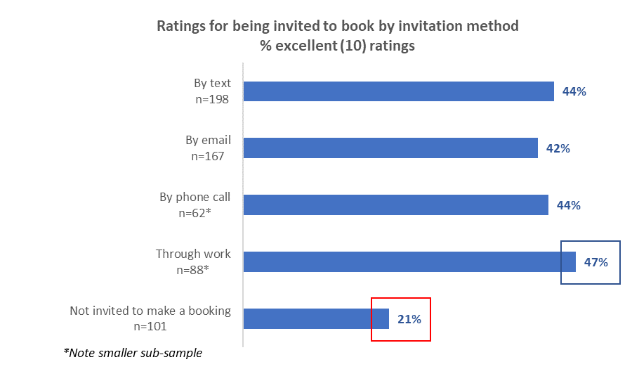

Ratings for actually booking by how people booked
“10 out of 10” ratings were also generally lower in September across all methods used to book. Indications are that vaccinated people were more satisfied with getting their vaccine via a walk-in or being offered a vaccine while visiting a clinic; these methods received 44% excellent ratings (10 out of 10).
Booking online received 40% excellent ratings (10 out of 10).
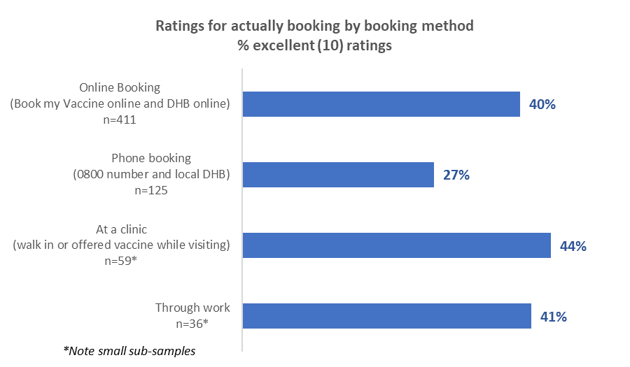

11.6 Assessing the appointment experience
People who had been vaccinated were shown a list of possible experiences they may have had in the course of their appointment, some positive and some negative. The next two charts show their positive and negative experiences.

Compared with August, positive results eased back, most to the July level.

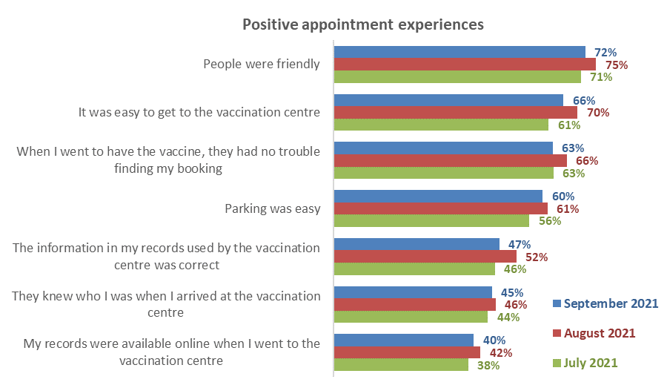
↓
↓
↓
↓
↑
↑

Negative experiences have a very similar pattern to both August and July.
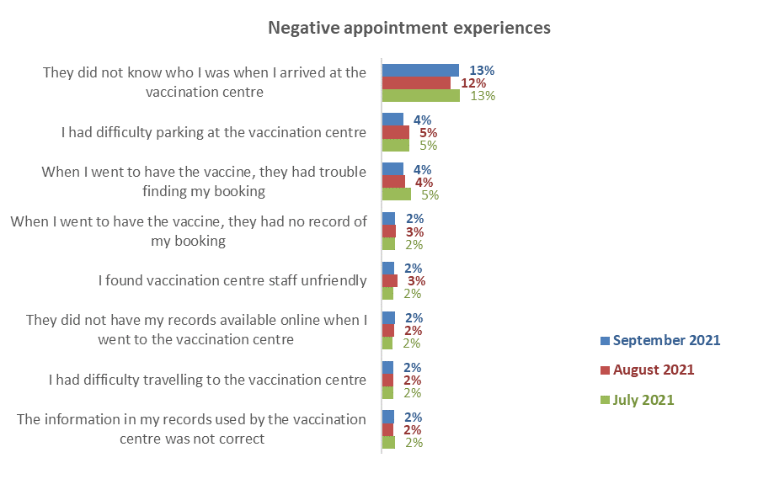
Base for both charts: vaccinated with at least one dose: September n=2,065, August n=1,290, July n=934

‘Other’ experiences of being vaccinated
7% of those who were vaccinated reported “other” experiences of being vaccinated. The responses from these 151 people were in the following categories:

Vaccinated at my GP/doctor
I didn’t go to a vaccination centre; it was my GP.
My doctor vaccinated me; it was easy to arrange myself. It would have been ages if I’d waited for the COVID site to invite me.
Went through my own GPs clinic.
Vaccinations done at local GP Health hub, familiar environment.
Was done through my GP, my 2 children were with me, 14, 12.

Good/great customer service
A seamless service.
A very pleasant experience - both times.
All staff happy, friendly and helpful. Also available for questions and just to have a bit of a laugh which I believe reduced the tension for all. Fantastic environment created by staff!
Being it was at the marae, full afternoon tea was provided.
Conducted at my workplace.
Could talk to people lining up more.
Didn’t hurt.
Done at work as they (had) left over vaccine as some border workers did not show up.
Fast and efficient service.
I had my 1st vaccination within 2hrs of making my booking.
Orchard Road centre, was brilliant both times, friendly and welcoming staff, great experience.
The Appointment was for my 15 yr and very easy and hassle free.
The Auckland Airport drive through worked extremely well. There should be more of these available to encourage more people to get the jab.
The vaccination centre was awesome and so was my doctor to get me in early
The vaccine experience was faultless.
They were awesome…
Want to say thanks to the team at Penrose, they were amazing and so helpful.

Encountered some issues
When I went for my vaccine, they told me the site had permanently shut down and were not offering vaccinations even though you could still book online for this place. I was turned away at the gate despite having a booked appointment and asked to rebook in town. The next week my friend posted that she had her vaccine done at this Marae - they weren’t shut after all. After rebooking, we were advised we could also book our 12-year-olds. I rang the 0800 number and had to rebook again to accommodate my son with me. So finally at our 3rd booking we got our 1st vaccine done. Although we persevered, I feel this could have put some people off.
Although I had an appointment, I had to wait 1.5 hours while entertaining a 2-year-old. We also had to wait outside and it started to rain. Was not a happy experience.
Because it was all car-focused and I do not have a car, for my second jab I was made to stand outside on footpath to have jab. But the real problem I had was waiting in the cold wind after the jab, my disability does not do well in the cold and I suffered because everything seized up and I was then bed bound for several days after...
Booking was for 13yo daughter. Nurse was perfunctory to the point of rudeness. No information given, no plaster for bleeding injection site.
Changed my 1st appointment as time unsuitable with the 0800 line. Then received email notification for 1st appointment on phoning the 0800 number no record found of change of appointment. I am group 3 and this put my first vaccination back 2wks as no appointment early than that available. I rely on other people for transport. Felt let down by the system.
Great nurse, chatted too long and then the observational staff were rude and sent me home with no observation time at all. This happened because the nurse chatted a bit long and it ran over the time period. Not a fun experience.
Having a booked in time meant nothing I was on time but made to stand in the cold and rain outside in. Car park so social distancing wasn’t possible or we would get hit by a car.
I turned up at my appointment to find all afternoon appointments had been moved to a drive-in centre (where there were no appointments so I ended up in the same queue as all the walk-ins.
I was surprised the vaccination team declined to fill out my card with batch number etc.
Medpro changed my bookings at short notice to less convenient time or location both jabs
The television people were there so we had to wait 30 minutes in the cold before the vaccinators caught up. I was PO-ed.
Was moved to the drive through centre in the first weekend of opening and it was hours in the line to get in. They directed us to the airport one instead which was quicker to get into but still close to 2 hours inside. In general, everyone was very helpful and friendly and professional in spite of the difficulties...

11.7 Were people’s language needs met through the process?
All those who had received at least one dose of the vaccine were asked whether their language needs were met throughout the booking and vaccination process.
In August 90% of vaccinated people said their language needs had “definitely” been met, while, as in August, 95% said “definitely” or “mostly”. | 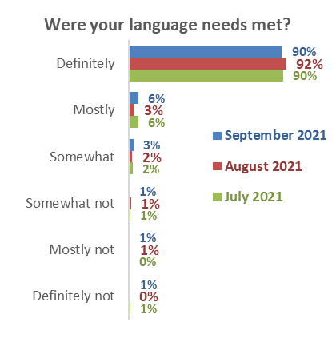  Percentages may not sum to totals in text owing to rounding.  Base: vaccinated with at least one dose:  September n=2,065; August n=1,290; July n=934
Language needs met by ethnicity – August results
People in the Asian and Indian ethnic groups were relatively less likely to say their language needs were definitely or mostly met (a total of 80% and 84%, respectively) compared with other ethnic groups.

Were your language needs met throughout your booking and vaccination process? | Asian | Indian | Māori | NZ European/ Pākehā | Other European | Pasifika
Definitely | 68% | 65% | 85% | 94% | 92% | 93%
Mostly | 12% | 19% | 12% | 3% | 6% | 6%
Definitely and mostly | 80% | 84% | 97% | 98% | 97% | 99%
Somewhat | 9% | 9% | 3% | 2% | 2% | 0%
Somewhat not | 1% | 3% | 0% | 0% | 1% | 0%
Mostly not | 5% | 0% | 0% | 0% | 0% | 1%
Definitely not | 5% | 4% | 0% | 0% | 0% | 0%
N (unweighted) - Received at least one dose of vaccine | 142 | 95 | 272 | 1,453 | 177 | 114

11.8 Were people’s disability or impairment needs catered for through the process?
62% of those with a disability or impairment who had received at least one vaccine said their needs were definitely met (down from 69% in August; July 68%) and 13% said they were “mostly” met (July 12%).  27%, an increase from 18% in August, gave low ratings from ‘somewhat’ to ‘definitely not (July 20%)’. | 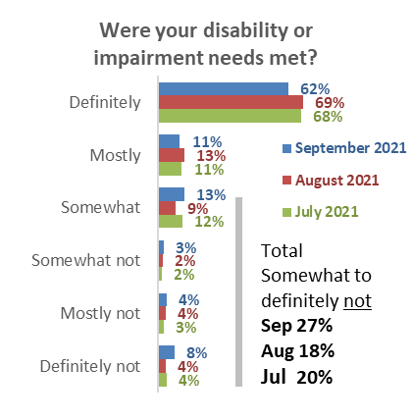  Base: Have an impairment or disability and vaccinated at least once: September n=708; August n=496; July n=461.

11.9 Likelihood of recommending vaccination to others
People who had been vaccinated were asked ‘Overall, does the experience you had when making bookings for and having a COVID-19 vaccine make you more or less likely to recommend vaccination to others?’

The September figures have reverted to the July levels after a change in August. Among the larger DHB areas, above average recommendation is likely to come from those in the Auckland, Counties Manukau, Waikato, Hawke’s Bay, MidCentral and Hutt DHB areas.

Below average recommendation is likely from those living in the Northland, Waitematā, Capital and Coast, Nelson/Marlborough, Canterbury, and Southern DHB areas.

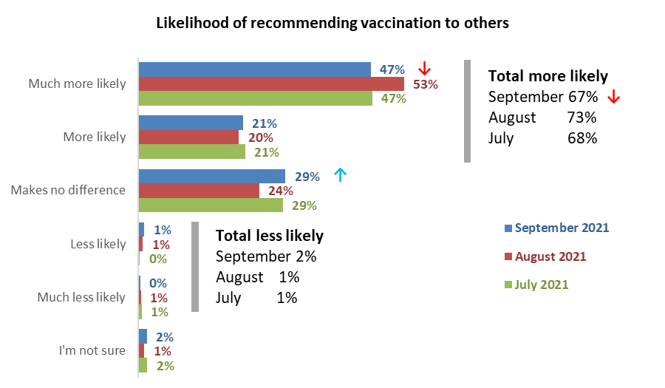
Base vaccinated with at least one dose: September 2,065, August n=1,290, July n=934
Note rounding affects some of the totals.

11.10 Suggested improvements to the vaccination process
Respondents who had been vaccinated at least once were asked an open-ended question, ‘Thinking about your experience of the whole vaccination process (from booking to getting the vaccine), is there anything that you think could be improved?’

In general, people who had been vaccinated were happy with the process:

A very pleasant experience no issues at all. (Male, 55-64 years).
I had no difficulty with the vaccination process, both times i.e.: 22/6/21 13/7/21. Therefore, I do not think there is anything that needs improvement. (Male, 65-74 years).
I was amazed at how well organised the airport drive through vaccination centre worked. Super organised, all staff knew their jobs. Very efficient. (Female, 25-34 years).
I was most impressed with the way the vaccination process was organised. All the people were friendly. (Female, 65-74 years).
A glass of wine would settle the nerves! Just joking, as all was good. (Male, 75 years or over).
Absolutely nothing we had high praise for all involved in giving us our two vaccinations. Made simple totally. (Female, 75 years or over).
After vaccination, I feel safe at night. (Male, 25-34 years).
Everyone I encountered on both visits were ANAZING. (Female, 55-64 years).
Everything was made very easy. Booking online was very simple. The centre was well laid out and staff were friendly. (Female, 25-34 years).
The staff were amazing. Got a wheel chair to the car and took me in and back to the car when I was done and dusted. (Female, 65-74 years).

Although 1,600 out of the 2,056 vaccinated in the sample commented, the comments and observations offered few suggestions for process improvement; the key ones are shown below.

Vaccination centre/process - suggested improvements
Queuing
*It would be better if there was a line for those of us that were 'booked’, as it did take time to process others that weren't. Their details had to be sorted out and computed. *Another idea, might be easier to have people print their name, DOB, NHI # onto a piece of paper and place it onto their side of the car/vehicle window. Saves time & protects both parties. (Female, 55-64 years).
1 line for people who booked and another line for people off the street. (Male, 55-64 years).
Booked times should take precedence over walk ins. (Male, 45-54 years).
I think there has been some confusing changes in communication as the rollout has changed over time, but my personal experience has been easy. I preferred the drive through experience to the large vaccination centre as it felt safer being in my own car. (Female, 45-54 years).
I waited outside longer than ideal, but it is understandable given the demand. It was a cold day (late August), so waiting inside would have been nicer. (Male, 45-54 years).
I was made to stand while getting my second vaccine, but that didn't bother me too much. It might not be a good idea for people who are nervous or afraid of needles though. (Female, 18-24 years).
I went to the Highbrook Centre and after the information check, they got people to sit in order of when they arrived to wait for vaccinators to be available. The line moved like a snake, which I think was a really good system, but then to wait the 15-20 minutes afterwards, the seating was random. This led to people needing to call names and a bit more confusion than I think was necessary. If people were told where to sit for the 15-20 minutes, the process would have been more straightforward. (Female, 25-34 years).
I don't think adults should be made to play musical chairs. Some of the group such as the elderly should have had priority in the queues. (Male, 45-54 years).
You should be seen at the time you booked not made to line up. (Female, 25-34 years).
There was no separate line for those who had bookings and those who were walk-ins. This would have been good at the time as it was quite busy and us with booked appointments were late due to waiting in the same line as walk-ins. (Female, 35-44 years).
There was a little confusion over who was next in line at my first appointment. (Female, 65-74 years).

Vaccination centre location, parking and signage
The location of the vaccination site in the Meridian Mall in Dunedin was terrible. Totally inaccessible, impossible parking (got ripped off for parking by the mall mgmt) and horrific traffic. That place is normally terra incognita to me and I absolutely hated it. (Male, 65-74 years).
Better parking. (Female, 45-54 years).
The position of the vaccination clinic was just advertised as Oamaru Hospital. We went to the main entrance to find that we then had to walk a distance around the hospital to find the clinic. This was at the beginning of the vaccination process, so hopefully more precise directions were given to people later. (Female, 65-74 years).
There was no street signage - hard to find how to get in. (Female, 55-64 years).

Vaccination centre people
Friendly staff- reception at first vaccine wasn't overly friendly and the second reception lady at my second vaccine wasn't overly polite, however all other staff were kind and friendly. (Female, 25-34 years).
I found some of the staff working at the entrance to the building to be unnecessarily aggressive. (Male, 65-74 years).
Parking space at Westgate had no one there when we arrived. We had one person on wheelchair, after waiting for 10 minutes in the car park, the parking person slowly come out, we showed the mobility parking permit card, however, the staff still directed us to the far away parking space with small too narrows spaces to turn for wheelchair person. However, the large mobility parking space has no one using it. (Male, 35-44 years).
When we went for our first vaccine the lady taking our info said to my Husband what makes you think you qualify for the vaccine, I thought that was rude he made the booking over the phone with the DHB; they would have made sure he qualified before making the booking. He is over 65yrs and has Leukaemia. There was no need for her to make that comment especially when there were people there looked like they were in there 20s. (Female, 55-64 years).
Well, I didn't really care, but when the last lady spoke to me when it was time to leave, she didn't keep her distance. Everyone else did when speaking to me. I was a bit surprised she got so close to me, but I'm not worried. (Female, 35-44 years).
The first time was fine. The person giving the injection was kind and listened and did the job gently. The second time was awful. The woman giving the injection didn't have a care. She practically threw the needle into my arm without finding the right muscle placing, so hard I jumped. My daughter who was with me was quite angry. My arm was extremely sore for at least a week and there was a LOT of swelling all around the arm. (Female, 65-74 years).

Vaccination centre process
Clarification on the vaccine cards needs to be more visible. my parents got cards when they had their vaccination but there was no mention of it when I got my jab until I asked. (Female, 45-54 years).
Communication by staff when waiting in line (I was a walk-in) a few walk-ins became walk-outs as there was no communication about wait times to people waiting in the line. I do think the staff were taking a much-needed lunch break but this was not communicated. (Female, 25-34 years).
Do it outside during level 4. Inside with other clients, shop customers, in a pharmacy is a bit un-nerving even with distancing. none asked if I had any concerns about the vaccine. (Female, 55-64 years).
We were in a pharmacy and thought we were allowed to shop during the observation period. I think it would be better if we were given clear instructions to stay seated through the duration of the observation period. (Male, Under 18 years).
They should be using NHI numbers and the national immunisation database so that people are correctly recorded. (Female, 45-54 years).
They didn’t ask me for and ID and did not give me any proof of the vaccine. (Female, 35-44 years).
The people checking you in need to be accurate that they have booked the right person in. (When I went for) my second shot (the system) said that I had already had the dose when I hadn't, and I was nowhere near the site where the shot was delivered - was a Pharmacy that I had never heard of before. (Male, 55-64 years).

Vaccination centre - Information
I would have liked to have been given a lot more information about the risks. e.g., What adverse effects I might experience after the shot. How safe the vaccine is. How effective it is. Etc. (Male, 45-54 years).
Advise people that live alone to stay with friends or family after the vaccination. (Female, 55-64 years).
More information could be supplied about the possible adverse reactions to the vaccine and I shouldn’t have been made to feel crazy for trying find out this information. (Female, 25-34 years).

Vaccination centre -Other
The printed cards handed out after the first and second vaccination could have replaced with online records visible in the COVID-19 tracer app. (Male, 55-64 years).
Checking that your make is spelt correctly; my name wasn’t, then given back card and my boss’ ended up being with gender change and call Patrick. (Female, 45-54 years).
I (felt) really unwell after my first dose but all they would say was maybe you should have a swab done. Standard answer to everything these days have a swab done. I was really annoyed after 2nd jab still have sore arm but will not go to doctors as I am not having a swab done as it isn’t COVID. Everyone is obsessed with getting a swab done and real issues are not being addressed. (Female, 55-64 years).
Forget telling me to wait 15 minutes after the shot as it’s not going to happen. If anything adverse could happen then they shouldn’t be giving it. (Male, 45-54 years).
The ability to update the NHI Database details on the spot - mine were out of date. (Male, 55-64 years).
The option to make yourself a cup of tea and have a biscuit while we wait 15 minutes. (Female, 55-64 years).

Online booking system
The online booking system was limited in showing availability are nearby areas, so to find spots you had to jump through hoops in order to find space without waiting two months. I eventually found a space for a few days later but about 40 minutes away on my 4th attempt checking for availability. (Male, 25-34 years).
The online booking system seems faulty. It would not allow me to rebook. When I tried, knowing earlier appointments were available, nothing would show in the calendar. (Female, 25-34 years).
The booking website. There were locations much closer to me that had earlier bookings available at the time I booked but I wasn't able to see them. (Female, 35-44 years).
The booking website was really unreliable. Initially it had no available slots for 6 weeks, then with a refresh it had many slots available for the next day. (Male, 45-54 years).
Seemed to be some glitches in the online system, around booking by specific vaccination centre, and then also changing appointments (I cancelled and re-booked but still received texts and emails to say I needed to cancel. Yet when I called there was no record of my old cancelled booking). But overall, these were pretty minor issues, and people at the call centre were always very prompt at answering, friendly and helpful. (Female, 35-44 years).

Other booking-related comments
The media and politicians need to realise small towns do not have the same facilities as cities. We waited for months despite being high risk group 3 people after they noted we should get notified soon, after getting notice to make appointment, indications were could not get for several months as minimal availability in our town in August and early September. I found it hard at first sending an email to the DHB, as can't hear well over phone, but only phone numbers were given out as they ignore hearing impaired people exist and assume everyone can ring. It was very hard getting info about making booking for both myself and my wife to be at the same time and location. No information provided on how that can be done. (Male, 65-74 years).
After choosing the "6-week" period between doses on the online system, I could not make it shorter: The date ~5 1/2 weeks after my first dose would have been perfect, but instead I have to wait until later week 7 due to work commitments. (Male, 25-34 years).
Allow me to book a drive through, my partner is younger and could book the drive through. I am 59 and I could only see places with wheel chair access and a toilet. Even the booking phone line had to get a manager to override the system so I could get it. They have cancelled my second visit because they can’t do the 8.30am time for some reason so have to book again, my partner as well. (Male, 55-64 years).
Booking 2 online with one email address was difficult. Took one but didn't take the other one. (Female, 65-74 years).
Confusion about waiting to get an invite vs just making one as soon as age bracket opened. Not getting reminders re either vaccine. Changing information re recommended timing between vaccines. (Female, 55-64 years).
English is my spoken language so it wasn’t an issue. The only issue I had was I had booked my 2nd vaccination for the same day and time as my husband, who has dementia. I was most distressed when the night before at 9.30pm I received a text to say my date and time was moved to another venue but not my husband’s. It took me a while on the phone to get through and get approval to retain my appt same as my husband’s. The stress was too much when caring full time. However, once we were there the staff from security through to clinician were absolutely wonderful. Everything worked like clockwork and they made sure my husband was not distressed and whisked through. The process and service is no barrier if anyone is having doubts about getting vaccinated. (Female, 55-64 years).
I had my first vaccine as a walk-in but due to being in group 4, I was unable to book my second vaccine (without lying on the online booking form) until Group 4 opened. I thought if you have had the first dose it should be fine to book the second dose, particularly when the recommended interval was 3 weeks. (Female, 25-34 years).
I had to try and book over 5 times because my booking couldn’t be processed. Parking was very hard and little to none available in that area. (Female, 35-44 years).
When I got my first vaccine the night before I found the next city over had places so moved it there, as opposed to having to wait another month at the closest place. When I arrive the next day, they didn’t have my details, and told me nobody is meant to be able to book within 24 hours of a spot. I felt bad for that, but would hope they would be encouraging anyone to get one sooner, and possibly printing the report on the morning would be better than the night before. (Male, 35-44 years).
when I changed the date for my second vaccine online, I received a confirmation txt. This was 2 days before the date. The centre called me to find why I hadn’t been and had no record of the reschedule. (Male, 65-74 years).
Took a couple of tries when trying to change date, said booking no didn't exist a few times. (Male, 25-34 years).
Current advertising uses BookMyVaccine URL but no reference to alternative phone number e.g., 0800. Not everyone has access to digital. (Male, 65-74 years).
the number of booking spaces could have been larger. and family should be able to accompany you as I have a family member who will not get the vaccine without someone there with her holding her hand. (Female, 18-24 years).
The booking process for vaccination centres is a sham. Just turn up and get jabbed, much like going to vote. You shouldn’t need an appointment at a vaccination centre. (Male, 25-34 years).

Trust in the management of the pandemic and rating of the vaccination response
All respondents were asked:
- How much they trusted the Ministry and Government to manage the COVID-19 pandemic in a way which best protected them and other New Zealanders.
- How they thought the vaccination response to the COVID-19 pandemic was being managed in New Zealand.

12.1 Management of the pandemic
The average trust in the Ministry of Health and Government to manage the pandemic, on a scale of 0 to 5 (with 5 being highest) has fallen back slightly to 3.7 out of 5, comparable with May 2021, but has maintained the overall steady trend.

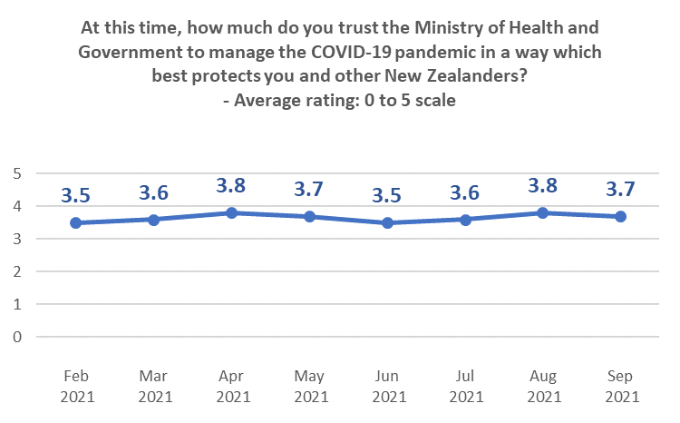

12.2 Management of the vaccination response
The average rating of the vaccination response (on a scale of 0 to 10, 10 being highest) for September 2021 has held at the August level.
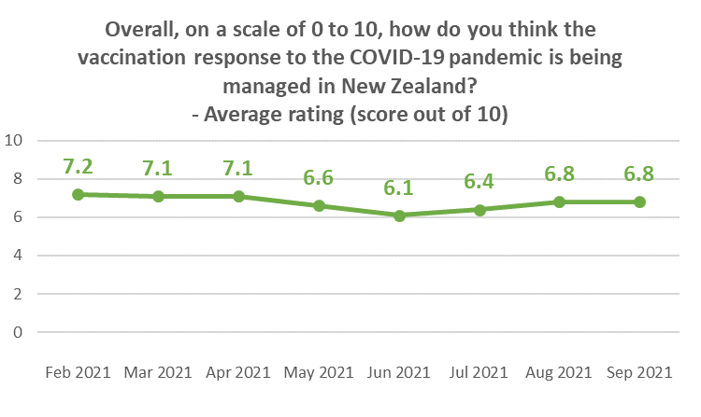
While these figures shown above are average ratings and the total percentage of respondents rating at 7 or above has not changed, not that the percentage of respondents rating at 7 or 8 has increased in comparison with August 2021, while the percentage rating at 9 or 10 has decreased.
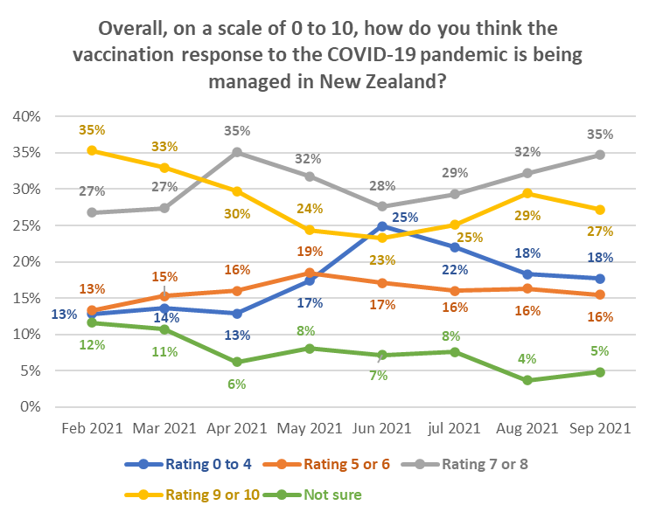

Lower than average ratings come from:
- Those with household income more than $150,000 per annum.
- Those with personal income of more than $150,000 per annum (as in August).
- Business managers/executives.
- People living in “rural and remote” areas (indication, because of the smaller base).
- Those with school level qualifications equivalent to NCEA levels 1 and 2.
- Those who were not sure when they wanted to get the vaccine.
- Those who had been offered an opportunity to get a COVID-19 vaccine but had declined, and those who are unlikely to get a COVID-19 vaccine - particularly those who said they would “Definitely not” get it (average rating of 2.6 out of 10 – August 3.2, July 2.6).
- Those who think vaccination is not important – particularly those who think it is “not important at all” (2.2 out of 10).

By ethnic group, Māori and Pasifika respondents rated the vaccination response more highly than NZ European/Pākehā respondents.

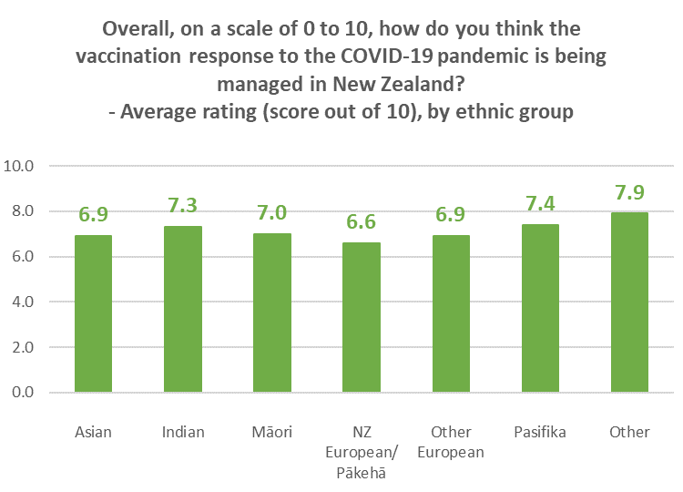

The 65% of respondents who think that vaccination is “very important” rated the vaccination response at 7.4 out of 10.

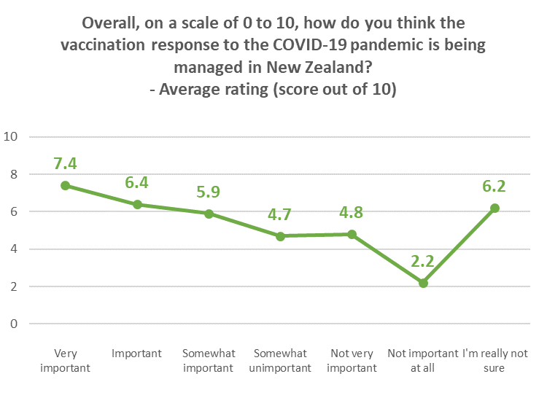

APPENDIX 1 - SAMPLE
2,479 people aged 16+ who are members of the nationwide HorizonPoll panel and two third-party respondent panels (all of which are representative of the New Zealand population, with the broad mix of panels being used for source diversity), responded to this online survey between 28 September and 1 October 2021.

The total sample is weighted on age, gender, employment status, personal income and region to match the 16+ population at the most recent census and the overall percentage of New Zealanders 16+ vaccinated as at 11:59pm on 29 August 2021.

At a 95% confidence level, the survey has a maximum margin of error of ±2.0% overall.

Sub-sample respondent counts and maximum margins of error (which occur when there is a 50%/50% answer) are shown below.

 | All respondents |  |  | Not yet vaccinated
 | Count | Maximum  sub-sample margin of error |  | Count | Maximum  sub-sample margin of error
TOTAL | 2,479 | ±2.0% |  | 414 | ±4.8%
GENDER
Male | 1,177 | ±2.9% |  | 178 | ±7.3%
Female | 1,290 | ±2.7% |  | 234 | ±6.4%
Gender Diverse | 12 | ±28.3% |  | 2 | ±69.3%
AGE GROUP
Under 18 years | 61 | ±12.5% |  | 18 | ±23.1%
18-24 years | 205 | ±6.8% |  | 40 | ±15.5%
25-34 years | 430 | ±4.7% |  | 96 | ±10.0%
35-44 years | 466 | ±4.5% |  | 85 | ±10.6%
45-54 years | 443 | ±4.7% |  | 75 | ±11.3%
55-64 years | 380 | ±5.0% |  | 59 | ±12.8%
65-74 years | 302 | ±5.6% |  | 27 | ±18.9%
75 years or over | 192 | ±7.1% |  | 14 | ±26.2%
IMPAIRMENT, LONG-TERM HEALTH CONDITIONS OR DISABLED
Impairment or long-term health conditions | 854 | ±3.4% |  | 150 | ±8.0%
Identify as disabled | 206 | ±6.8% |  | 47 | ±14.3%

 | All respondents |  |  | Not yet vaccinated
 | Count | Maximum  sub-sample margin of error |  | Count | Maximum  sub-sample margin of error
AREA TYPE
Large city | 1,265 | ±2.8% |  | 150 | ±8.0%
Regional City | 422 | ±4.8% |  | 77 | ±11.2%
Regional town | 482 | ±4.5% |  | 102 | ±9.7%
Rural, but not remote | 282 | ±5.8% |  | 74 | ±11.4%
Rural and remote | 28 | ±18.5% |  | 11 | ±29.5%
ETHNIC GROUP
Asian | 169 | ±7.5% |  | 27 | ±18.9%
Indian | 104 | ±9.6% |  | 9 | ±32.7%
Māori | 367 | ±5.1% |  | 95 | ±10.1%
NZ European/ Pākehā | 1,738 | ±2.4% |  | 285 | ±5.8%
Other European | 211 | ±6.7% |  | 34 | ±16.8%
Pasifika | 130 | ±8.6% |  | 16 | ±24.5%
Other | 32 | ±17.3% |  | 4 | ±49%
DHB AREA
Northland | 61 | ±12.5% |  | 20 | ±21.9%
Waitemata | 299 | ±5.7% |  | 45 | ±14.6%
Auckland | 262 | ±6.1% |  | 22 | ±20.9%
Counties Manukau | 190 | ±7.1.0% |  | 23 | ±20.4%
Waikato | 199 | ±6.9% |  | 46 | ±14.4%
Lakes | 54 | ±13.3% |  | 9 | ±32.7%
Bay of Plenty | 104 | ±9.6% |  | 21 | ±21.4%
Tairawhiti | 12 | ±28.3% |  | 2 | ±69.3%
Taranaki | 48 | ±14.1% |  | 17 | ±23.8%
Hawke's Bay | 107 | ±9.5% |  | 26 | ±19.2%
Whanganui | 42 | ±15.1% |  | 12 | ±28.3%
MidCentral | 127 | ±8.7% |  | 30 | ±17.9%
Hutt | 94 | ±10.1% |  | 4 | ±49%
Capital and Coast | 243 | ±6.3.0% |  | 25 | ±19.6%
Wairarapa | 33 | ±17.1% |  | 6 | ±40%
Nelson/ Marl-borough | 92 | ±10.2% |  | 20 | ±21.9%
West Coast | 17 | ±23.8% |  | 6 | ±40%
Canterbury | 279 | ±5.9% |  | 46 | ±14.4%
South Canterbury | 31 | ±17.6% |  | 4 | ±49%
Southern | 185 | ±7.2% |  | 30 | ±17.9%

Contact
For more information about this survey, please contact:

Grant McInman, telephone 021 076 2040, email gmcinman@horizonresearch.co.nz.
Graeme Colman, telephone 021 84 85 76, email gcolman@horizonresearch.co.nz.

APPENDIX 2 - PROFILE BY LIKELIHOOD TO GET A COVID-19 VACCINE

 | DEMOGRAPHIC PROFILE:  Likelihood to get a COVID-19 vaccine |  |  | All |  | Will you get a COVID-19 vaccine?
 |  |  |  |  |  | Definitely |  | Most likely |  | Likely |  | Unlikely |  | Most unlikely |  | Definitely not |  | I'm not sure |  | Already vaccin-ated
 |  |  |  | 100% |  | 2% |  | 2% |  | 2% |  | 2% |  | 3% |  | 4% |  | 4% |  | 81%
GENDER
 |  | Male | 49% |  | 55% |  | 38% |  | 47% |  | 37% |  | 42% |  | 52% |  | 35% |  | 50%
 |  | Female | 50% |  | 41% |  | 62% |  | 53% |  | 59% |  | 58% |  | 48% |  | 65% |  | 49%
 |  | Gender diverse | 1% |  | 4% |  | 0% |  | 0% |  | 4% |  | 0% |  | 0% |  | 0% |  | 1%
AGE GROUP
 |  | 16-17 years | 5% |  | 8% |  | 22% |  | 3% |  | 4% |  | 6% |  | 3% |  | 4% |  | 4%
 |  | 18-24 years | 11% |  | 17% |  | 2% |  | 25% |  | 11% |  | 6% |  | 11% |  | 9% |  | 12%
 |  | 25-34 years | 17% |  | 19% |  | 24% |  | 42% |  | 18% |  | 14% |  | 20% |  | 23% |  | 16%
 |  | 35-44 years | 17% |  | 18% |  | 34% |  | 8% |  | 21% |  | 22% |  | 22% |  | 18% |  | 16%
 |  | 45-54 years | 15% |  | 27% |  | 8% |  | 4% |  | 16% |  | 12% |  | 16% |  | 27% |  | 15%
 |  | 55-64 years | 15% |  | 7% |  | 6% |  | 15% |  | 8% |  | 21% |  | 16% |  | 13% |  | 16%
 |  | 65-74 years | 12% |  | 4% |  | 3% |  | 1% |  | 12% |  | 11% |  | 9% |  | 4% |  | 13%
 |  | 75 years or over | 8% |  | 0% |  | 2% |  | 4% |  | 10% |  | 8% |  | 2% |  | 2% |  | 9%
 |  | AVERAGE AGE (years) | 46.4 |  | 38.1 |  | 35.7 |  | 35.5 |  | 45.8 |  | 48.0 |  | 43.6 |  | 42.5 |  | 47.5
 |  | % difference from overall average |  |  | --17.9% |  | --23.2% |  | --23.6% |  | --1.4% |  | +3.3% |  | --6.2% |  | --8.5% |  | +2.4%

 | DEMOGRAPHIC PROFILE:  Likelihood to get a COVID-19 vaccine |  |  | All |  | Will you get a COVID-19 vaccine?
 |  |  |  |  |  | Definitely |  | Most likely |  | Likely |  | Unlikely |  | Most unlikely |  | Definitely not |  | I'm not sure |  | Already vaccin-ated
 |  |  |  | 100% |  | 22% |  | 7% |  | 4% |  | 1% |  | 3% |  | 5% |  | 5% |  | 53%
HOUSEHOLD INCOME
 |  | Less than $20,000 per year | 11% |  | 17% |  | 20% |  | 11% |  | 35% |  | 5% |  | 15% |  | 21% |  | 10%
 |  | Between $20,001 and $30,000 per year | 10% |  | 14% |  | 11% |  | 30% |  | 6% |  | 12% |  | 24% |  | 10% |  | 9%
 |  | Between $30,001 and $50,000 per year | 19% |  | 14% |  | 16% |  | 21% |  | 31% |  | 23% |  | 15% |  | 20% |  | 19%
 |  | Between $50,001 and $70,000 per year | 13% |  | 6% |  | 15% |  | 4% |  | 4% |  | 18% |  | 16% |  | 15% |  | 14%
 |  | Between $70,001 and $100,000 per year | 15% |  | 28% |  | 8% |  | 6% |  | 8% |  | 18% |  | 11% |  | 11% |  | 15%
 |  | Between $100,001 and $150,000 per year | 11% |  | 7% |  | 10% |  | 8% |  | 4% |  | 8% |  | 5% |  | 4% |  | 13%
 |  | Between $150,001 and $200,000 per year | 5% |  | 0% |  | 1% |  | 4% |  | 0% |  | 1% |  | 3% |  | 0% |  | 5%
 |  | More than $200,000 per year | 3% |  | 1% |  | 0% |  | 1% |  | 0% |  | 5% |  | 1% |  | 0% |  | 3%
 |  | Don't know/ prefer not to say | 13% |  | 14% |  | 21% |  | 15% |  | 11% |  | 12% |  | 11% |  | 19% |  | 12%
 |  | AVERAGE HOUSEHOLD INCOME ($) | $69,580 |  | $55,960 |  | $50,960 |  | $51,110 |  | $36,310 |  | $68,860 |  | $51,540 |  | $44,910 |  | $73,760
 |  | % difference from overall average |  |  | --19.6% |  | --26.8% |  | --26.5% |  | --47.8% |  | --1% |  | --25.9% |  | --35.5% |  | +6%
PERSONAL INCOME
 |  | Less than $20,000 per year | 39% |  | 44% |  | 59% |  | 54% |  | 66% |  | 51% |  | 38% |  | 54% |  | 36%
 |  | Between $20,001 and $30,000 per year | 14% |  | 11% |  | 12% |  | 10% |  | 6% |  | 11% |  | 20% |  | 11% |  | 14%
 |  | Between $30,001 and $50,000 per year | 21% |  | 25% |  | 15% |  | 14% |  | 13% |  | 14% |  | 22% |  | 15% |  | 22%
 |  | Between $50,001 and $70,000 per year | 6% |  | 6% |  | 5% |  | 3% |  | 5% |  | 6% |  | 5% |  | 5% |  | 6%
 |  | Between $70,001 and $100,000 per year | 5% |  | 1% |  | 2% |  | 5% |  | 2% |  | 4% |  | 3% |  | 2% |  | 6%
 |  | Between $100,001 and $150,000 per year | 3% |  | 2% |  | 1% |  | 3% |  | 2% |  | 1% |  | 2% |  | 1% |  | 4%
 |  | Between $150,001 and $200,000 per year | 1% |  | 1% |  | 0% |  | 0% |  | 0% |  | 0% |  | 1% |  | 0% |  | 1%
 |  | More than $200,000 per year | 1% |  | 1% |  | 0% |  | 0% |  | 0% |  | 0% |  | 1% |  | 0% |  | 1%
 |  | Don't know/ prefer not to say | 10% |  | 9% |  | 5% |  | 11% |  | 7% |  | 12% |  | 9% |  | 13% |  | 10%
 |  | AVERAGE PERSONAL INCOME ($) | $34,070 |  | $30,490 |  | $22,830 |  | $25,590 |  | $21,410 |  | $26,130 |  | $31,290 |  | $22,450 |  | $35,890
 |  | % difference from overall average |  |  | --10.5% |  | --33% |  | --24.9% |  | --37.2% |  | --23.3% |  | --8.2% |  | --34.1% |  | +5.3%

 | DEMOGRAPHIC PROFILE:  Likelihood to get a COVID-19 vaccine |  |  | All |  | Will you get a COVID-19 vaccine?
 |  |  |  |  |  | Definitely |  | Most likely |  | Likely |  | Unlikely |  | Most unlikely |  | Definitely not |  | I'm not sure | Already vaccin-ated
 |  |  |  | 100% |  | 22% |  | 7% |  | 4% |  | 1% |  | 3% |  | 5% |  | 5% | 53%
EMPLOYED
 |  | Yes | 65% |  | 60% |  | 60% |  | 40% |  | 57% |  | 67% |  | 52% |  | 55% |  |  | 67%
 |  | No | 35% |  | 40% |  | 40% |  | 60% |  | 43% |  | 33% |  | 48% |  | 45% |  |  | 33%
OCCUPATION
 |  | Professional/Senior Government Official | 6% |  | 9% |  | 3% |  | 1% |  | 1% |  | 4% |  | 2% |  | 0% |  |  | 7%
 |  | Business Manager/Executive | 4% |  | 4% |  | 4% |  | 2% |  | 8% |  | 3% |  | 2% |  | 1% |  |  | 5%
 |  | Business Proprietor/Self-employed | 7% |  | 8% |  | 13% |  | 1% |  | 1% |  | 20% |  | 12% |  | 5% |  |  | 7%
 |  | Teacher/Nurse/Police or other trained service worker | 10% |  | 3% |  | 2% |  | 14% |  | 11% |  | 3% |  | 5% |  | 8% |  |  | 11%
 |  | Clerical/Sales Employee | 12% |  | 15% |  | 4% |  | 8% |  | 5% |  | 12% |  | 5% |  | 12% |  |  | 12%
 |  | Farm Owner/manager | 1% |  | 1% |  | 2% |  | 1% |  | 5% |  | 0% |  | 0% |  | 0% |  |  | 1%
 |  | Technical/mechanical/Skilled Worker | 9% |  | 10% |  | 12% |  | 2% |  | 13% |  | 7% |  | 10% |  | 9% |  |  | 9%
 |  | Labourer/Agricultural or Domestic Worker | 7% |  | 8% |  | 17% |  | 8% |  | 9% |  | 10% |  | 11% |  | 9% |  |  | 6%
 |  | Home-maker (not otherwise employed) | 6% |  | 7% |  | 7% |  | 8% |  | 6% |  | 6% |  | 9% |  | 19% |  |  | 5%
 |  | Student | 10% |  | 10% |  | 20% |  | 8% |  | 4% |  | 5% |  | 9% |  | 10% |  |  | 10%
 |  | Retired/Superannuitant | 14% |  | 2% |  | 5% |  | 6% |  | 8% |  | 13% |  | 12% |  | 2% |  |  | 16%
 |  | Unemployed/Beneficiary | 9% |  | 14% |  | 10% |  | 33% |  | 18% |  | 8% |  | 15% |  | 15% |  |  | 8%
 |  | Don't know/prefer not to say | 6% |  | 9% |  | 1% |  | 8% |  | 13% |  | 9% |  | 9% |  | 10% |  |  | 5%

 | DEMOGRAPHIC PROFILE:  Likelihood to get a COVID-19 vaccine |  |  | All |  | Will you get a COVID-19 vaccine?
 |  |  |  |  |  | Definitely |  | Most likely |  | Likely |  | Unlikely |  | Most unlikely |  | Definitely not |  | I'm not sure | Already vaccin-ated
 |  |  |  | 100% |  | 22% |  | 7% |  | 4% |  | 1% |  | 3% |  | 5% |  | 5% | 53%
HIGHEST QUALIFICATION
 |  | Postgraduate degree (Masters' degree or PhD) | 10% |  | 14% |  | 11% |  | 0% |  | 8% |  | 4% |  | 4% |  | 4% |  |  | 11%
 |  | Undergraduate (Bachelor) degree | 24% |  | 19% |  | 14% |  | 14% |  | 30% |  | 9% |  | 12% |  | 17% |  |  | 26%
 |  | Vocational qualification (includes trade certificates, diplomas etc) | 25% |  | 24% |  | 33% |  | 27% |  | 15% |  | 29% |  | 23% |  | 24% |  |  | 25%
 |  | University Bursary or 7th form | 10% |  | 11% |  | 12% |  | 11% |  | 16% |  | 9% |  | 9% |  | 14% |  |  | 10%
 |  | Sixth form/UE/NCEA Level 2 | 11% |  | 12% |  | 11% |  | 24% |  | 11% |  | 18% |  | 14% |  | 13% |  |  | 10%
 |  | NCEA Level 1 or School Certificate | 10% |  | 15% |  | 16% |  | 5% |  | 8% |  | 13% |  | 21% |  | 17% |  |  | 9%
 |  | No formal school qualification | 7% |  | 4% |  | 2% |  | 9% |  | 4% |  | 18% |  | 15% |  | 9% |  |  | 7%
 |  | Prefer not to say | 2% |  | 2% |  | 2% |  | 11% |  | 7% |  | 2% |  | 2% |  | 3% |  |  | 2%
HOUSEHOLD TYPE
 |  | Single person household | 13% |  | 20% |  | 7% |  | 12% |  | 17% |  | 12% |  | 18% |  | 15% |  |  | 13%
 |  | Couple only (no children/none at home) | 28% |  | 20% |  | 6% |  | 11% |  | 19% |  | 20% |  | 13% |  | 16% |  |  | 32%
 |  | Two parent family, one or two children at home | 25% |  | 29% |  | 37% |  | 25% |  | 27% |  | 21% |  | 29% |  | 27% |  |  | 25%
 |  | Two parent family, three or more children at home | 9% |  | 1% |  | 23% |  | 9% |  | 2% |  | 17% |  | 13% |  | 14% |  |  | 8%
 |  | One parent family, one or two children at home | 7% |  | 6% |  | 5% |  | 11% |  | 19% |  | 16% |  | 9% |  | 13% |  |  | 6%
 |  | One parent family, three or more children at home | 2% |  | 4% |  | 1% |  | 4% |  | 5% |  | 5% |  | 3% |  | 2% |  |  | 1%
 |  | Flatting or boarding - not a family home | 8% |  | 7% |  | 1% |  | 5% |  | 4% |  | 8% |  | 12% |  | 2% |  |  | 9%
 |  | Extended family | 6% |  | 12% |  | 19% |  | 23% |  | 5% |  | 2% |  | 0% |  | 9% |  |  | 5%
 |  | Prefer not to say | 2% |  | 2% |  | 2% |  | 0% |  | 2% |  | 0% |  | 3% |  | 2% |  |  | 2%
 |  | Children in Household | 43% |  | 39% |  | 67% |  | 49% |  | 52% |  | 59% |  | 54% |  | 57% |  |  | 40%
 |  | Two-parent family | 34% |  | 30% |  | 60% |  | 34% |  | 28% |  | 38% |  | 42% |  | 41% |  |  | 33%
 |  | One-parent family | 8% |  | 9% |  | 7% |  | 15% |  | 24% |  | 21% |  | 12% |  | 16% |  |  | 7%

 | DEMOGRAPHIC PROFILE:  Likelihood to get a COVID-19 vaccine |  |  | All |  | Will you get a COVID-19 vaccine?
 |  |  |  |  |  | Definitely |  | Most likely |  | Likely |  | Unlikely |  | Most unlikely |  | Definitely not |  | I'm not sure | Already vaccin-ated
 |  |  |  | 100% |  | 22% |  | 7% |  | 4% |  | 1% |  | 3% |  | 5% |  | 5% | 53%
ETHNIC GROUP
 |  | Asian | 6% |  | 4% |  | 5% |  | 8% |  | 10% |  | 7% |  | 0% |  | 4% |  |  | 7%
 |  | Indian | 4% |  | 7% |  | 0% |  | 1% |  | 4% |  | 1% |  | 0% |  | 0% |  |  | 4%
 |  | Māori | 14% |  | 23% |  | 18% |  | 27% |  | 10% |  | 18% |  | 18% |  | 20% |  |  | 12%
 |  | NZ European/Pākehā | 63% |  | 60% |  | 56% |  | 57% |  | 62% |  | 71% |  | 66% |  | 65% |  |  | 63%
 |  | Other European (includes Australian, South African, British etc) | 7% |  | 4% |  | 11% |  | 5% |  | 11% |  | 1% |  | 10% |  | 9% |  |  | 7%
 |  | Pasifika | 5% |  | 1% |  | 10% |  | 1% |  | 3% |  | 1% |  | 4% |  | 3% |  |  | 5%
 |  | Other | 1% |  | 2% |  | 0% |  | 1% |  | 0% |  | 2% |  | 2% |  | 0% |  |  | 1%
IDENTIFY AS DISABLED
 |  |  | 9% |  | 22% |  | 10% |  | 21% |  | 14% |  | 15% |  | 12% |  | 10% |  |  | 8%
 |  |  | 91% |  | 78% |  | 90% |  | 80% |  | 86% |  | 85% |  | 88% |  | 90% |  |  | 92%

 | DEMOGRAPHIC PROFILE:  Likelihood to get a COVID-19 vaccine |  |  | All |  | Will you get a COVID-19 vaccine?
 |  |  |  |  |  | Definitely |  | Most likely |  | Likely |  | Unlikely |  | Most unlikely |  | Definitely not |  | I'm not sure | Already vaccin-ated
 |  |  |  | 100% |  | 22% |  | 7% |  | 4% |  | 1% |  | 3% |  | 5% |  | 5% | 53%
DHB
 |  | Northland | 3% |  | 8% |  | 1% |  | 3% |  | 1% |  | 7% |  | 7% |  | 5% |  |  | 3%
 |  | Waitemata | 14% |  | 10% |  | 9% |  | 12% |  | 10% |  | 10% |  | 11% |  | 18% |  |  | 14%
 |  | Auckland | 11% |  | 2% |  | 9% |  | 2% |  | 27% |  | 2% |  | 3% |  | 3% |  |  | 13%
 |  | Counties-Manukau | 8% |  | 0% |  | 14% |  | 9% |  | 3% |  | 3% |  | 4% |  | 6% |  |  | 9%
 |  | Waikato | 10% |  | 8% |  | 13% |  | 8% |  | 13% |  | 14% |  | 9% |  | 14% |  |  | 9%
 |  | Lakes | 3% |  | 0% |  | 6% |  | 7% |  | 3% |  | 0% |  | 1% |  | 1% |  |  | 3%
 |  | Bay of Plenty | 5% |  | 12% |  | 6% |  | 0% |  | 6% |  | 9% |  | 8% |  | 2% |  |  | 5%
 |  | Tairawhiti | 0% |  | 2% |  | 0% |  | 0% |  | 0% |  | 0% |  | 0% |  | 1% |  |  | 0%
 |  | Taranaki | 2% |  | 8% |  | 7% |  | 3% |  | 2% |  | 1% |  | 4% |  | 1% |  |  | 1%
 |  | Hawke's Bay | 4% |  | 6% |  | 4% |  | 8% |  | 3% |  | 4% |  | 8% |  | 6% |  |  | 3%
 |  | Whanganui | 2% |  | 0% |  | 1% |  | 4% |  | 3% |  | 8% |  | 1% |  | 2% |  |  | 1%
 |  | Midcentral | 4% |  | 10% |  | 4% |  | 6% |  | 3% |  | 4% |  | 6% |  | 7% |  |  | 4%
 |  | Hutt | 3% |  | 0% |  | 0% |  | 3% |  | 0% |  | 0% |  | 1% |  | 1% |  |  | 4%
 |  | Capital and Coast | 7% |  | 5% |  | 5% |  | 7% |  | 6% |  | 6% |  | 6% |  | 2% |  |  | 8%
 |  | Wairarapa | 1% |  | 3% |  | 0% |  | 3% |  | 4% |  | 3% |  | 0% |  | 1% |  |  | 1%
 |  | Nelson-Marlborough | 4% |  | 5% |  | 0% |  | 3% |  | 9% |  | 3% |  | 10% |  | 5% |  |  | 3%
 |  | West Coast | 1% |  | 3% |  | 3% |  | 0% |  | 0% |  | 8% |  | 2% |  | 1% |  |  | 0%
 |  | Canterbury | 11% |  | 19% |  | 14% |  | 9% |  | 7% |  | 7% |  | 7% |  | 15% |  |  | 10%
 |  | South Canterbury | 1% |  | 0% |  | 0% |  | 0% |  | 0% |  | 1% |  | 2% |  | 1% |  |  | 1%
 |  | Southern | 8% |  | 1% |  | 6% |  | 14% |  | 1% |  | 10% |  | 9% |  | 8% |  |  | 8%
 |  | North Island | 76% |  | 73% |  | 78% |  | 75% |  | 84% |  | 71% |  | 71% |  | 70% |  |  | 77%
 |  | Auckland | 33% |  | 12% |  | 31% |  | 23% |  | 40% |  | 15% |  | 19% |  | 27% |  |  | 36%
 |  | Upper North Island excluding Auckland | 20% |  | 28% |  | 25% |  | 18% |  | 22% |  | 31% |  | 25% |  | 22% |  |  | 19%
 |  | Lower North Island | 23% |  | 33% |  | 21% |  | 33% |  | 21% |  | 25% |  | 27% |  | 20% |  |  | 22%
 |  | South Island | 24% |  | 27% |  | 22% |  | 25% |  | 17% |  | 29% |  | 29% |  | 30% |  |  | 23%

 | DEMOGRAPHIC PROFILE:  Likelihood to get a COVID-19 vaccine |  |  | All |  | Will you get a COVID-19 vaccine?
 |  |  |  |  |  | Definitely |  | Most likely |  | Likely |  | Unlikely |  | Most unlikely |  | Definitely not |  | I'm not sure | Already vaccin-ated
 |  |  |  | 100% |  | 22% |  | 7% |  | 4% |  | 1% |  | 3% |  | 5% |  | 5% | 53%
AREA TYPE
 |  | Large city | 51% |  | 42% |  | 49% |  | 36% |  | 49% |  | 35% |  | 32% |  | 31% |  |  | 55%
 |  | Regional city | 15% |  | 10% |  | 12% |  | 25% |  | 14% |  | 19% |  | 15% |  | 18% |  |  | 15%
 |  | Regional town | 20% |  | 21% |  | 23% |  | 20% |  | 16% |  | 20% |  | 29% |  | 24% |  |  | 19%
 |  | Rural, but not remote | 12% |  | 27% |  | 12% |  | 11% |  | 17% |  | 26% |  | 18% |  | 22% |  |  | 11%
 |  | Rural and remote | 2% |  | 0% |  | 4% |  | 8% |  | 4% |  | 0% |  | 5% |  | 5% |  |  | 1%
 |  |  | 51% |  | 42% |  | 49% |  | 36% |  | 49% |  | 35% |  | 32% |  | 31% |  |  | 55%

APPENDIX 3 – NOT VACCINATED: PROFILE BY DECISION-MAKING TIME PERIOD

DEMOGRAPHIC PROFILE:  Likelihood to get a COVID-19 vaccine |  | All | For you personally, how long do you think you'll need before you decide to get the vaccine, if at all?  - Grouped responses
 |  |  | In next 2 months | 3-12 months | A year or more | Definitely, or probably, never
 |  | 100% | 28% | 14% | 22% | 37%
GENDER
 | Male | 49% | 43% | 40% | 37% | 48%
 | Female | 50% | 55% | 60% | 61% | 52%
 | Another gender | 1% | 1% | 0% | 2% | 0%
AGE GROUP
 | 16-17 years | 5% | 14% | 0% | 9% | 2%
 | 18-24 years | 11% | 9% | 17% | 7% | 12%
 | 25-34 years | 17% | 24% | 33% | 20% | 18%
 | 35-44 years | 17% | 25% | 14% | 15% | 23%
 | 45-54 years | 15% | 17% | 18% | 19% | 15%
 | 55-64 years | 15% | 7% | 9% | 15% | 17%
 | 65-74 years | 12% | 2% | 8% | 7% | 9%
 | 75 years or over | 8% | 2% | 1% | 8% | 3%
 | AVERAGE AGE (years) | 46.4 | 37.4 | 39.9 | 44.8 | 44.4
 | % difference from overall average |  | --19.5% | --14.1% | --3.4% | --4.5%

DEMOGRAPHIC PROFILE:  Likelihood to get a COVID-19 vaccine |  | All | For you personally, how long do you think you'll need before you decide to get the vaccine, if at all?  - Grouped responses
 |  |  | In next 2 months | 3-12 months | A year or more | Definitely, or probably, never
 |  | 100% | 28% | 14% | 22% | 37%
HOUSEHOLD INCOME
 | Less than $20,000 per year | 11% | 20% | 13% | 10% | 21%
 | Between $20,001 and $30,000 per year | 10% | 17% | 13% | 11% | 17%
 | Between $30,001 and $50,000 per year | 19% | 17% | 10% | 23% | 23%
 | Between $50,001 and $70,000 per year | 13% | 6% | 21% | 16% | 12%
 | Between $70,001 and $100,000 per year | 15% | 14% | 15% | 15% | 9%
 | Between $100,001 and $150,000 per year | 11% | 8% | 7% | 5% | 5%
 | Between $150,001 and $200,000 per year | 5% | 1% | 1% | 0% | 2%
 | More than $200,000 per year | 3% | 1% | 0% | 4% | 0%
 | Don't know/ prefer not to say | 13% | 16% | 20% | 15% | 11%
 | AVERAGE HOUSEHOLD INCOME ($) | $69,580 | $51,280 | $56,020 | $60,960 | $45,130
 | % difference from overall average |  | --26.3% | --19.5% | --12.4% | --35.1%

DEMOGRAPHIC PROFILE:  Likelihood to get a COVID-19 vaccine |  | All | For you personally, how long do you think you'll need before you decide to get the vaccine, if at all?  - Grouped responses
 |  |  | In next 2 months | 3-12 months | A year or more | Definitely, or probably, never
 |  | 100% | 28% | 14% | 22% | 37%
PERSONAL INCOME
 | Less than $20,000 per year | 39% | 54% | 42% | 58% | 48%
 | Between $20,001 and $30,000 per year | 14% | 11% | 13% | 10% | 15%
 | Between $30,001 and $50,000 per year | 21% | 20% | 14% | 13% | 19%
 | Between $50,001 and $70,000 per year | 6% | 4% | 9% | 6% | 4%
 | Between $70,001 and $100,000 per year | 5% | 1% | 5% | 3% | 3%
 | Between $100,001 and $150,000 per year | 3% | 2% | 1% | 1% | 1%
 | Between $150,001 and $200,000 per year | 1% | 0% | 0% | 0% | 1%
 | More than $200,000 per year | 1% | 0% | 0% | 1% | 0%
 | Don't know/ prefer not to say | 10% | 8% | 16% | 9% | 10%
 | AVERAGE PERSONAL INCOME ($) | $34,070 | $25,480 | $29,390 | $23,980 | $25,790
 | % difference from overall average |  | --25.2% | --13.7% | --29.6% | --24.3%
EMPLOYED
 | Yes | 65% | 56% | 56% | 65% | 51%
 | No | 35% | 44% | 44% | 35% | 49%

DEMOGRAPHIC PROFILE:  Likelihood to get a COVID-19 vaccine |  | All | For you personally, how long do you think you'll need before you decide to get the vaccine, if at all?  - Grouped responses
 |  |  | In next 2 months | 3-12 months | A year or more | Definitely, or probably, never
 |  | 100% | 28% | 14% | 22% | 37%
OCCUPATION
 | Professional/Senior Government Official | 6% | 4% | 0% | 2% | 3%
 | Business Manager/Executive | 4% | 2% | 6% | 4% | 2%
 | Business Proprietor/Self-employed | 7% | 8% | 9% | 12% | 8%
 | Teacher/Nurse/Police or other trained service worker | 10% | 7% | 5% | 7% | 6%
 | Clerical/Sales Employee | 12% | 9% | 10% | 13% | 6%
 | Farm Owner/manager | 1% | 1% | 1% | 0% | 2%
 | Technical/mechanical/Skilled Worker | 9% | 9% | 6% | 7% | 11%
 | Labourer/Agricultural or Domestic Worker | 7% | 12% | 6% | 8% | 11%
 | Home-maker (not otherwise employed) | 6% | 9% | 12% | 9% | 11%
 | Student | 10% | 13% | 13% | 6% | 8%
 | Retired/Superannuitant | 14% | 3% | 4% | 11% | 9%
 | Unemployed/Beneficiary | 9% | 20% | 18% | 11% | 14%
 | Don't know/prefer not to say | 6% | 5% | 10% | 10% | 10%
 |  | 17% | 14% | 15% | 18% | 13%
HIGHEST QUALIFICATION
 | Postgraduate degree (Masters' degree or PhD) | 10% | 8% | 3% | 7% | 4%
 | Undergraduate (Bachelor) degree | 24% | 15% | 20% | 19% | 13%
 | Vocational qualification (includes trade certificates, diplomas etc) | 25% | 27% | 32% | 25% | 21%
 | University Bursary or 7th form | 10% | 12% | 18% | 6% | 12%
 | Sixth form/UE/NCEA Level 2 | 11% | 17% | 7% | 20% | 12%
 | NCEA Level 1 or School Certificate | 10% | 14% | 4% | 11% | 21%
 | No formal school qualification | 7% | 5% | 11% | 11% | 12%
 | Prefer not to say | 2% | 2% | 6% | 1% | 5%

DEMOGRAPHIC PROFILE:  Likelihood to get a COVID-19 vaccine |  | All | For you personally, how long do you think you'll need before you decide to get the vaccine, if at all?  - Grouped responses
 |  |  | In next 2 months | 3-12 months | A year or more | Definitely, or probably, never
 |  | 100% | 28% | 14% | 22% | 37%
HOUSEHOLD TYPE
 | Single person household | 13% | 15% | 16% | 6% | 20%
 | Couple only (no children/none at home) | 28% | 11% | 12% | 26% | 12%
 | Two parent family, one or two children at home | 25% | 31% | 34% | 25% | 25%
 | Two parent family, three or more children at home | 9% | 11% | 15% | 13% | 11%
 | One parent family, one or two children at home | 7% | 5% | 9% | 10% | 18%
 | One parent family, three or more children at home | 2% | 2% | 3% | 1% | 5%
 | Flatting or boarding - not a family home | 8% | 4% | 4% | 6% | 8%
 | Extended family | 6% | 20% | 6% | 10% | 1%
 | Prefer not to say | 2% | 2% | 2% | 2% | 1%
 | Children in Household | 43% | 49% | 61% | 50% | 59%
 | Two-parent family | 34% | 42% | 49% | 39% | 36%
 | One-parent family | 8% | 7% | 12% | 12% | 23%

DEMOGRAPHIC PROFILE:  Likelihood to get a COVID-19 vaccine |  | All | For you personally, how long do you think you'll need before you decide to get the vaccine, if at all?  - Grouped responses
 |  |  | In next 2 months | 3-12 months | A year or more | Definitely, or probably, never
 |  | 100% | 28% | 14% | 22% | 37%
ETHNIC GROUP
 | Asian | 6% | 6% | 6% | 5% | 6%
 | Indian | 4% | 3% | 3% | 1% | 0%
 | Māori | 14% | 23% | 23% | 16% | 13%
 | NZ European/Pakeha | 63% | 57% | 57% | 67% | 65%
 | Other European (includes Australian, South African, British etc) | 7% | 7% | 7% | 7% | 10%
 | Pasifika | 5% | 4% | 4% | 3% | 4%
 | Other | 1% | 1% | 1% | 2% | 2%
Identify as disabled
 | Yes | 9% | 14% | 12% | 9% | 18%
 | No | 91% | 87% | 88% | 91% | 82%

DEMOGRAPHIC PROFILE:  Likelihood to get a COVID-19 vaccine |  | All | For you personally, how long do you think you'll need before you decide to get the vaccine, if at all?  - Grouped responses
 |  |  | In next 2 months | 3-12 months | A year or more | Definitely, or probably, never
 |  | 100% | 28% | 14% | 22% | 37%
DHB
 | Northland | 3% | 4% | 4% | 6% | 6%
 | Waitemata | 14% | 10% | 10% | 10% | 10%
 | Auckland | 11% | 5% | 5% | 8% | 9%
 | Counties-Manukau | 8% | 8% | 8% | 4% | 4%
 | Waikato | 10% | 10% | 10% | 12% | 11%
 | Lakes | 3% | 4% | 4% | 1% | 1%
 | Bay of Plenty | 5% | 6% | 6% | 8% | 9%
 | Tairāwhiti | 0% | 1% | 1% | 0% | 0%
 | Taranaki | 2% | 6% | 6% | 3% | 3%
 | Hawke's Bay | 4% | 6% | 6% | 5% | 3%
 | Whanganui | 2% | 1% | 1% | 4% | 1%
 | Midcentral | 4% | 7% | 7% | 5% | 6%
 | Hutt | 3% | 1% | 1% | 1% | 1%
 | Capital and Coast | 7% | 6% | 6% | 6% | 7%
 | Wairarapa | 1% | 2% | 2% | 2% | 3%
 | Nelson-Marlborough | 4% | 2% | 2% | 8% | 9%
 | West Coast | 1% | 2% | 2% | 3% | 1%
 | Canterbury | 11% | 14% | 14% | 7% | 8%
 | South Canterbury | 1% | 0% | 0% | 1% | 2%
 | Southern | 8% | 7% | 7% | 7% | 9%

DEMOGRAPHIC PROFILE:  Likelihood to get a COVID-19 vaccine |  | All | For you personally, how long do you think you'll need before you decide to get the vaccine, if at all?  - Grouped responses
 |  |  | In next 2 months | 3-12 months | A year or more | Definitely, or probably, never
 |  | 100% | 28% | 14% | 22% | 37%
DHB (continued)
 | North Island | 76% | 75% | 75% | 74% | 72%
 | Auckland | 33% | 23% | 23% | 22% | 22%
 | Upper North Island excluding Auckland | 20% | 24% | 24% | 27% | 27%
 | Lower North Island | 23% | 29% | 29% | 25% | 23%
 | South Island | 24% | 25% | 25% | 26% | 28%
AREA TYPE
 | Large city | 51% | 42% | 36% | 31% | 39%
 | Regional city | 15% | 13% | 25% | 15% | 17%
 | Regional town | 20% | 24% | 13% | 26% | 24%
 | Rural, but not remote | 12% | 17% | 21% | 25% | 18%
 | Rural and remote | 2% | 5% | 5% | 3% | 3%
 | Total Rural | 14% | 22% | 26% | 28% | 21%
CAREGIVERS OF 12-15 and 16-17 YEAR OLDS
 | 5-11 only | 11% | 14% | 25% | 9% | 14%
 | 12-15 only | 6% | 6% | 10% | 6% | 6%
 | Both 5-11 and 12-15 | 6% | 13% | 9% | 5% | 12%
 | Not a caregiver | 77% | 67% | 56% | 80% | 69%

DEMOGRAPHIC PROFILE:  Likelihood to get a COVID-19 vaccine |  | All | For you personally, how long do you think you'll need before you decide to get the vaccine, if at all?  - Grouped responses
 |  |  | In next 2 months | 3-12 months | A year or more | Definitely, or probably, never
 |  | 100% | 28% | 14% | 22% | 37%
Believe medical or other health-related conditions mean they are not able to get a COVID-19 vaccine?
 | Yes | 19% | 10% | 22% | 15% | 26%
 | No | 81% | 90% | 79% | 85% | 75%
Protection from the effects of COVID-19: Does this information make you more or less likely to get the vaccine?
 | Much more likely | 7% | 17% | 8% | 2% | 1%
 | More likely | 11% | 32% | 7% | 3% | 1%
 | Slightly more likely | 9% | 19% | 19% | 5% | 0%
 | No more or no less likely | 44% | 24% | 42% | 60% | 51%
 | Slightly less likely | 2% | 1% | 2% | 2% | 4%
 | Less likely | 3% | 1% | 0% | 9% | 3%
 | Much less likely | 9% | 0% | 2% | 7% | 20%
 | I'm really not sure | 15% | 6% | 20% | 12% | 21%
Post-COVID infection health effects: If you received this information, what effect, if any, would it have on your intention to get the vaccine? Would you be...
 | Definitely more likely | 10% | 27% | 5% | 3% | 4%
 | More likely | 11% | 32% | 7% | 1% | 1%
 | Slightly more likely | 13% | 18% | 40% | 9% | 2%
 | Slightly less likely | 6% | 2% | 5% | 10% | 7%
 | Less likely | 9% | 3% | 10% | 14% | 10%
 | Definitely less likely | 13% | 1% | 3% | 9% | 27%
 | I'm really not sure | 39% | 15% | 32% | 54% | 50%
DEMOGRAPHIC PROFILE:  Likelihood to get a COVID-19 vaccine |  | All | For you personally, how long do you think you'll need before you decide to get the vaccine, if at all?  - Grouped responses
 |  |  | In next 2 months | 3-12 months | A year or more | Definitely, or probably, never
 |  | 100% | 28% | 14% | 22% | 37%
Thinking about others in your life or community, who (if anyone) would you most like to protect from COVID-19 and the Delta strain by getting vaccinated?
 | Parents | 8% | 7% | 9% | 9% | 10%
 | Brothers | 4% | 5% | 5% | 3% | 4%
 | Sisters | 5% | 5% | 5% | 4% | 4%
 | Cousins | 3% | 4% | 3% | 2% | 2%
 | Elderly relatives | 5% | 6% | 6% | 7% | 4%
 | Other whānau/ family | 5% | 5% | 5% | 4% | 4%
 | Kuia | 2% | 2% | 2% | 3% | 2%
 | Kaumatua | 2% | 2% | 2% | 3% | 2%
 | All the children I know | 5% | 5% | 8% | 3% | 4%
 | Babies and infants | 4% | 5% | 6% | 3% | 3%
 | Elderly friends | 4% | 4% | 3% | 3% | 4%
 | Friends | 5% | 5% | 7% | 5% | 4%
 | People where I work | 3% | 4% | 4% | 2% | 2%
 | People who serve me (e.g. at supermarkets, stores, trades people..) | 4% | 4% | 4% | 4% | 2%
 | People you serve | 2% | 2% | 3% | 1% | 1%
 | Disabled people I know | 3% | 3% | 3% | 3% | 1%
 | Physically and/ or mentally frail people I know | 3% | 4% | 2% | 2% | 2%
 | People I know with chronic illnesses | 4% | 4% | 4% | 6% | 2%
 | Fellow church members | 2% | 2% | 2% | 1% | 2%
 | My friends | 5% | 6% | 6% | 4% | 3%

DEMOGRAPHIC PROFILE:  Likelihood to get a COVID-19 vaccine |  | All | For you personally, how long do you think you'll need before you decide to get the vaccine, if at all?  - Grouped responses
 |  |  | In next 2 months | 3-12 months | A year or more | Definitely, or probably, never
 |  | 100% | 28% | 14% | 22% | 37%
 | Younger children | 4% | 4% | 4% | 3% | 2%
 | People who provide services for me | 3% | 4% | 3% | 2% | 1%
 | Children going to school | 3% | 4% | 4% | 3% | 2%
 | Children under 5 years-old | 3% | 4% | 3% | 3% | 2%
 | I won't get vaccinated to protect others | 4% | 1% | 0% | 5% | 13%
 | None of these | 3% | 0% | 1% | 7% | 11%
 | Others (please tell us who that is) | 3% | 1% | 0% | 9% | 7%
How likely or unlikely would you be to get the COVID-19 vaccine to specifically protect children under 12 years old and others who can't take it for medical reasons?
 | Definitely | 13% | 41% | 5% | 0% | 1%
 | Most Likely | 8% | 18% | 8% | 4% | 2%
 | Likely | 12% | 19% | 29% | 7% | 4%
 | Unlikely | 10% | 6% | 6% | 20% | 10%
 | Most unlikely | 5% | 1% | 6% | 8% | 6%
 | Definitely not | 21% | 0% | 7% | 17% | 43%
 | I'm still really not sure | 32% | 15% | 39% | 46% | 34%

DEMOGRAPHIC PROFILE:  Likelihood to get a COVID-19 vaccine |  | All | For you personally, how long do you think you'll need before you decide to get the vaccine, if at all?  - Grouped responses
 |  |  | In next 2 months | 3-12 months | A year or more | Definitely, or probably, never
 |  | 100% | 28% | 14% | 22% | 37%
Just how important, or unimportant, do you think it is it for you to get the vaccine to help reduce the transmission of the virus and protect the health of others?
 | 1 - Not important at all | 28% | 4% | 7% | 31% | 52%
 | 2 | 3% | 0% | 0% | 9% | 3%
 | 3 | 3% | 1% | 3% | 2% | 6%
 | 4 | 3% | 1% | 3% | 6% | 3%
 | 5 | 9% | 3% | 19% | 20% | 4%
 | 6 | 6% | 7% | 10% | 1% | 7%
 | 7 | 5% | 9% | 13% | 2% | 0%
 | 8 | 6% | 14% | 7% | 0% | 3%
 | 9 | 6% | 12% | 8% | 1% | 3%
 | 10 - Extremely important | 14% | 43% | 8% | 0% | 3%
 | I'm really not sure | 17% | 5% | 21% | 27% | 17%
 | Average rating | 5.0 | 8.3 | 6.2 | 3.0 | 2.7
Overall, does the number of people in New Zealand who are getting the vaccine, including people you know, have any impact on how comfortable you feel about having it yourself?
 | Much more comfortable | 8% | 24% | 8% | 0% | 1%
 | More comfortable | 13% | 33% | 16% | 1% | 3%
 | Less comfortable | 6% | 3% | 13% | 7% | 4%
 | Much less comfortable | 3% | 1% | 5% | 4% | 3%
 | It makes no difference | 59% | 33% | 44% | 76% | 74%
 | I'm really not sure | 12% | 5% | 15% | 12% | 15%

DEMOGRAPHIC PROFILE:  Likelihood to get a COVID-19 vaccine |  | All | For you personally, how long do you think you'll need before you decide to get the vaccine, if at all?  - Grouped responses
 |  |  | In next 2 months | 3-12 months | A year or more | Definitely, or probably, never
 |  | 100% | 28% | 14% | 22% | 37%
Which of the following incentives, if any, would make you definitely decide to get the COVID-19 vaccine?
 | Free ticket in $1 million lottery | 4% | 6% | 2% | 1% | 5%
 | $1,000 cash prize draw by my employer | 3% | 4% | 4% | 1% | 3%
 | $100 cash payment to everyone getting the vaccine | 11% | 14% | 16% | 4% | 10%
 | Daily cash prize draw by the vaccination centre I go to | 4% | 6% | 1% | 2% | 2%
 | $70,000 in total daily prizes at a drive through vaccination centre | 5% | 8% | 3% | 1% | 4%
 | Smart phone prize | 6% | 9% | 6% | 1% | 2%
 | $100 gift card voucher | 10% | 13% | 16% | 2% | 7%
 | $5000 prize given to a local charity you choose | 4% | 5% | 3% | 4% | 3%
 | Draw for a free hotel stay | 2% | 3% | 2% | 2% | 1%
 | $10,000 in donations to schools you choose | 3% | 5% | 2% | 4% | 1%
 | $10,000 in free stationery for a school which gets the most votes at a vaccination centre | 3% | 3% | 3% | 3% | 1%
 | Free bacon sandwich at vaccination centre | 4% | 6% | 2% | 3% | 0%
 | Free coffee at vaccination centres | 4% | 6% | 5% | 2% | 2%
 | None of these | 12% | 8% | 20% | 14% | 14%
 | Something else (please tell us what that is) | 18% | 3% | 12% | 41% | 35%
 | No response given | 6% | 1% | 6% | 15% | 11%

DEMOGRAPHIC PROFILE:  Likelihood to get a COVID-19 vaccine |  | All | For you personally, how long do you think you'll need before you decide to get the vaccine, if at all?  - Grouped responses
 |  |  | In next 2 months | 3-12 months | A year or more | Definitely, or probably, never
 |  | 100% | 28% | 14% | 22% | 37%
If you did have any side effects from getting the vaccine, would it make you more or less likely to get the vaccine if you were offered paid time off work to recover?
 | Much more likely | 8% | 16% | 7% | 3% | 5%
 | More likely | 11% | 24% | 13% | 3% | 5%
 | Less likely | 7% | 5% | 22% | 10% | 2%
 | Much less likely | 6% | 1% | 9% | 10% | 6%
 | Makes no difference | 52% | 43% | 36% | 57% | 61%
 | I'm really not sure | 17% | 12% | 14% | 17% | 22%

DEMOGRAPHIC PROFILE:  Likelihood to get a COVID-19 vaccine |  | All | For you personally, how long do you think you'll need before you decide to get the vaccine, if at all?  - Grouped responses
 |  |  | In next 2 months | 3-12 months | A year or more | Definitely, or probably, never
 |  | 100% | 28% | 14% | 22% | 37%
Which of these pieces of information do you think are likely to be true?
 | The longer between vaccine doses, the better it works | 13% | 9% | 3% | 4% | 3%
 | People will probably have to get a dose every year | 21% | 17% | 16% | 13% | 12%
 | Once someone is vaccinated, they can be tracked by the government | 1% | 1% | 1% | 0% | 1%
 | The government is going to force some people to get vaccinated | 6% | 8% | 8% | 11% | 10%
 | The vaccine contains a type of DNA or RNA | 5% | 2% | 6% | 5% | 5%
 | The vaccine can affect your reproductive organs | 2% | 1% | 4% | 4% | 8%
 | The vaccine is related to the telecommunications 5G network | 1% | 1% | 0% | 0% | 1%
 | Once vaccinated, a person can still get COVID-19 | 23% | 19% | 18% | 16% | 14%
 | The vaccine can affect your DNA or RNA | 2% | 3% | 4% | 5% | 5%
 | The vaccine can cause autism if given to young children | 1% | 1% | 3% | 1% | 1%
 | Taking the vaccine has spiritual or religious implications | 1% | 2% | 1% | 2% | 2%
 | The vaccine has long-term side effects | 3% | 4% | 9% | 6% | 7%
 | The vaccine hasn't been proven to be safe | 5% | 9% | 7% | 15% | 10%
 | The vaccine contains a microchip | 0% | 1% | 1% | 0% | 1%
 | The vaccine can make you magnetic | 1% | 1% | 1% | 1% | 2%
 | People can get sick from getting the COVID-19 vaccination | 12% | 12% | 11% | 14% | 13%
 | None of these | 3% | 5% | 1% | 1% | 2%
 | I'm really not sure | 3% | 5% | 6% | 5% | 4%

DEMOGRAPHIC PROFILE:  Likelihood to get a COVID-19 vaccine |  | All | For you personally, how long do you think you'll need before you decide to get the vaccine, if at all?  - Grouped responses
 |  |  | In next 2 months | 3-12 months | A year or more | Definitely, or probably, never
 |  | 100% | 28% | 14% | 22% | 37%
What would motivate you to get vaccinated, so you could go to these places, or travel in this way?
 | I would get vaccinated anyway | 9% | 17% | 6% | 1% | 2%
 | Bus travel | 3% | 4% | 4% | 1% | 2%
 | Domestic air travel | 6% | 6% | 12% | 6% | 3%
 | Overseas travel to see friends or family, or for a holiday | 11% | 9% | 21% | 17% | 5%
 | Overseas travel for business | 3% | 3% | 4% | 3% | 2%
 | Cafés | 4% | 5% | 6% | 3% | 3%
 | Restaurants | 5% | 6% | 8% | 1% | 3%
 | Indoor concerts | 4% | 6% | 3% | 1% | 2%
 | Outdoor concerts | 4% | 6% | 3% | 1% | 2%
 | Indoor sports events | 3% | 5% | 2% | 1% | 2%
 | Outdoor sports events | 3% | 5% | 2% | 1% | 2%
 | Funerals/ tangihanga | 6% | 7% | 5% | 8% | 5%
 | Family/ whanau gatherings | 7% | 7% | 8% | 7% | 5%
 | Church services and events | 3% | 3% | 1% | 3% | 4%
 | Events of more than 50 to 100 people at marae | 3% | 4% | 3% | 3% | 2%
 | Weddings | 4% | 5% | 3% | 3% | 4%
 | I don't care where I can't go, I'm still not getting vaccinated | 22% | 1% | 10% | 41% | 55%

“Indian” includes Indian, Pakistani, Bangladeshi and Sri Lankan.
Indication; small unvaccinated base.
The “Other” ethnic group includes Middle Eastern, Latin American, African, etc. This result is indicative because of the small base (n=32 not yet vaccinated).
“Indian” includes Indian, Pakistani, Bangladeshi, Sri Lankan
“Indian” includes Indian, Pakistani, Bangladeshi, Sri Lankan
“Indian” includes Indian, Pakistani, Bangladeshi, Sri Lankan
Indication only; small base.
“Indian” includes Indian, Pakistani, Bangladeshi, Sri Lankan.
Stats NZ “Infoshare” population estimates as at Q2 2021.
Includes Indian, Pakistani, Bangladeshi and Sri Lankan.
Includes Indian, Pakistani, Bangladeshi and Sri Lankan.

