Horizon Research
COVID-19 Vaccine
General population survey March 2021

Produced for the Ministry of Health

In association with the School of Population Health
University of Auckland

Contents
EXECUTIVE SUMMARY 1
1. Respondent beliefs about the Pfizer/BioNTech COVID-19 vaccine 13
1.1 When effective 13
1.2 Protection 14
1.3 After having the Pfizer/BioNTech vaccination 15
2. True statements 16
3. Deciding whether to take a COVID-19 vaccine 19
3.1 Influencing factors 19
3.2 Decision thoughts 25
4. Confidence 31
5. Vaccine groups, approval of risk-based approach to vaccination roll-out and demand for vaccination 36
5.1 Vaccine groups 36
5.2 Risk-based approach to vaccination roll-out 36
5.3 Preferred time for vaccination 38
6. Vaccine Uptake 40
6.1 Already vaccinated 40
6.2 Vaccine uptake 40
6.2.1 Overall 40
6.2.2 Māori 42
6.2.2 Pasifika 42
6.2 Information to decide on vaccination 43
6.3 Second dose 45
6.4 Reasons for not taking a COVID-19 vaccine 46
7. Information about the rollout plan 47
8. Information sources on the Pfizer/BioNTech vaccine 49
9. Use of official websites 52
10. Use of the COVID Tracer app 53
11. Effect of social media posts and vaccine side-effects on vaccine decision 55
11.1 Social media posts 55
11.2 Vaccine side-effects 56
12. Trust 58
APPENDIX 1 – SAMPLE 61

EXECUTIVE SUMMARY
The results in this report are from an online survey of 1,350 New Zealand respondents aged 16 years of age or over. The survey was conducted between 26 March and 1 April 2021.

The sample is weighted on age, gender, employment status, highest educational qualification, personal income and region to match the 16+ population and at the most recent census. Although the survey was not specifically weighted on ethnicity, the weighted sample was in line with population ethnic mix.

At a 95% confidence level, the survey has a maximum margin of error of ±2.7% overall.

Questions in the survey track willingness to take a COVID-19 vaccine, confidence in vaccines which are being made available in New Zealand and benchmark New Zealanders’ knowledge and key information needs.

Key findings

Vaccine uptake  Likelihood to accept a COVID-19 vaccine remains steady at 69% – a consistent figure since September 2020.  Note that the March result includes those who have already been vaccinated.  Total Unlikely to take a vaccine remains steady at 20% | 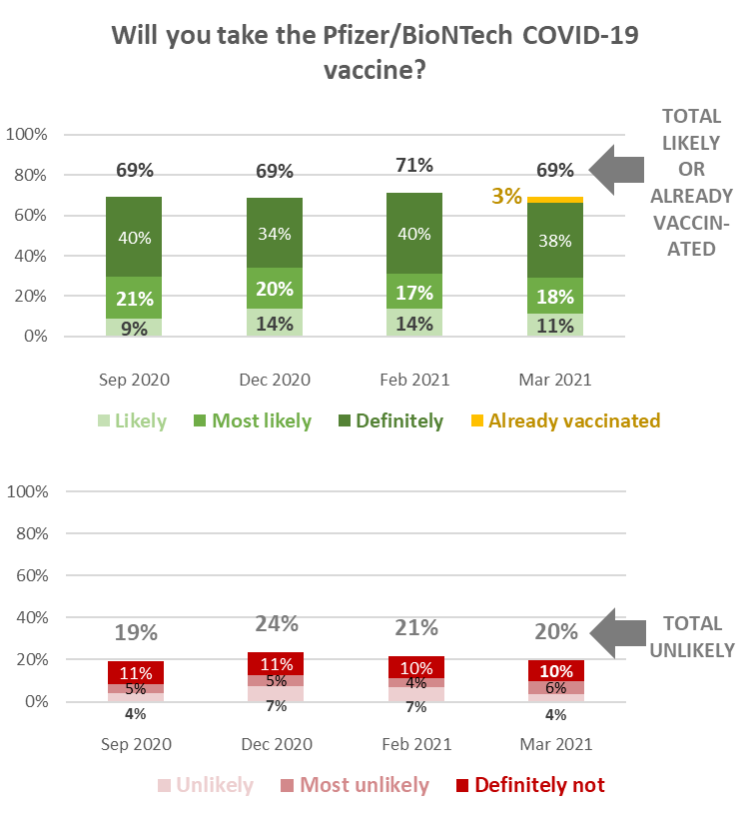
Second dose
Overall, 75% were likely to take a second dose and 10% were unlikely to do so.
26% of those who have already had their first dose say they are unlikely to have a second.

Beliefs about the Pfizer/BioNTech vaccine
There was a high level of uncertainty about what the Pfizer/BioNTech vaccine would do:
- 46% believed the vaccine would be effective by seven days after the second dose. 14% thought it would be immediately effective after either the first or second dose and 32% were not sure
- 59% believed the vaccine would protect them from the effects of COVID-19. 18% thought it would stop hem catching COVID-19 and 23% were unsure
- 68% believed the vaccine provided a 95% probability of protection from COVID-19. 7% thought it would provide full protection and 26% were not sure.
- 70% believed they would still have to continue with protective behaviours after taking the vaccine. 10% thought they would not need to do that and 21% were not sure.
- 40% believed they would still be able to pass COVID-19 on to others after taking the vaccine. 20% thought they would not be able to pass the virus on and 40% were not sure.

True statements
Respondents were shown a list of statements and asked which they thought were true.
Those who are unlikely to take the vaccine are less likely to believe vaccination is free  Those who are unlikely to take the vaccine are more likely to believe that you can still catch COVID-19 after vaccination. | 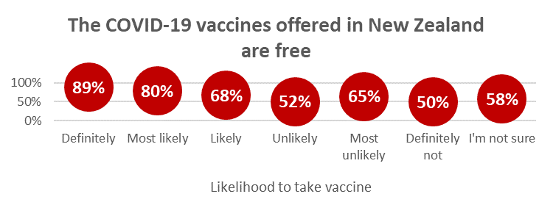  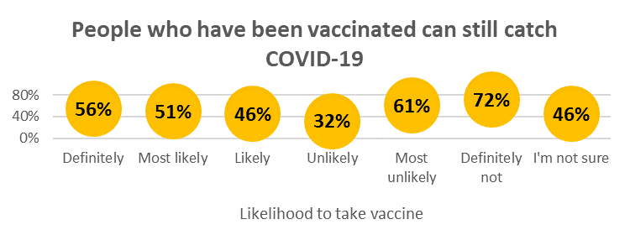

Those who will “Definitely not” take the vaccine are the most likely to believe that you can still pass the virus on to others after vaccination.  Those who are likely to take the vaccine have much greater belief that COVID-19 vaccines will play a critical role in protecting New Zealanders’ health and wellbeing.  Those who are likely to take the vaccine have much greater belief that COVID-19 vaccines will “allow a big step back to normality”. | 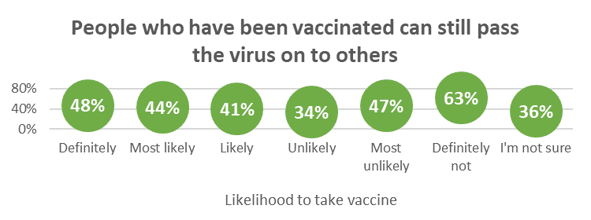  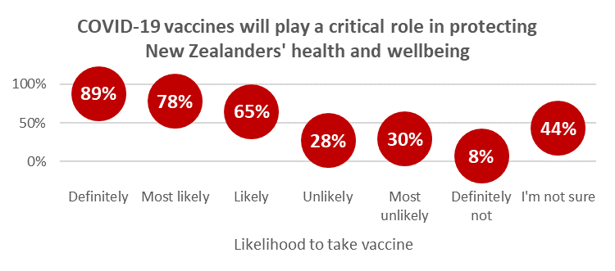  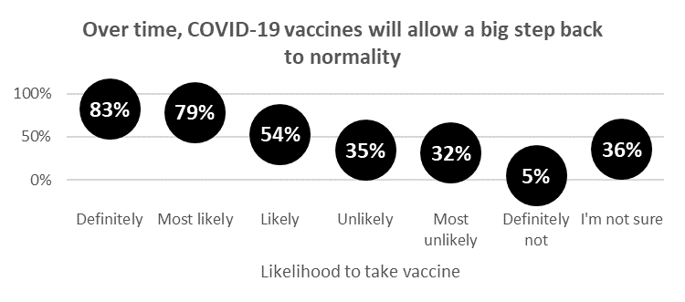

Influencing factors
The top 5 influencing factors were:
- Helping to protect all New Zealanders
- Vaccination is free (for both doses)
- Helping to end the COVID-19 pandemic more quickly
- Helping reduce the risk of COVID-19 infection and the prospect of further lockdowns and economic harm
- Being vaccinated will protect me from the effects of COVID-19.

There are some key trends:
“Vaccination is free” continues to increase in importance overall, but is of less importance for those who are unlikely to take a COVID-19 vaccine.  “Helping to protect all New Zealanders” grew as a key factor while “Helping to protect the health of my family/whānau” was down by the same amount. | 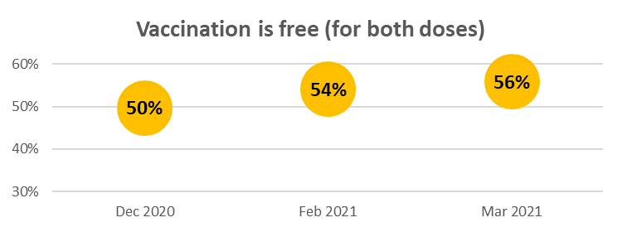  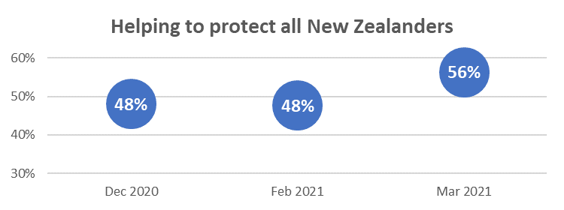  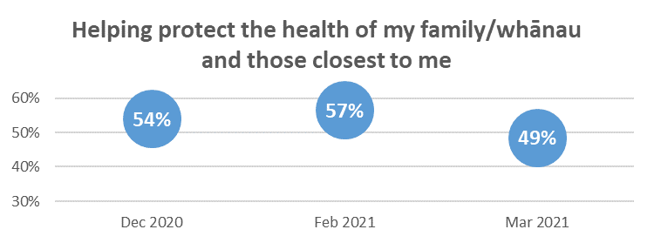

Overall, New Zealanders appear to be requiring less reassurance on clinical trials and side-effects, but both of these remain major considerations for those who are unlikely to take a vaccine. | 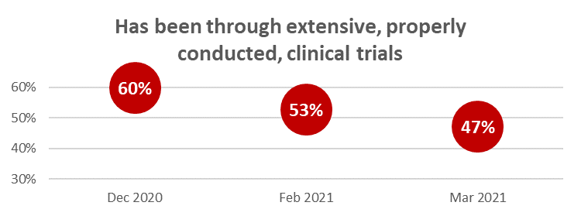  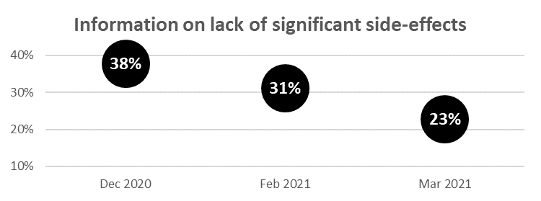

Decision thoughts
Supporting the decline in side-effects as an overall influencing factor, “I worry there will be unknown side-effects” and “I worry how the side-effects may affect me” have significantly declined in the thoughts measure. “It is too soon to see whether there are any long-term effects from the vaccine” has moved into top position. Both of these suggest a potential shift from concentration on the near-term to the long-term.

Worry about side-effects, and concern about the effect of the vaccine on their own health, are key thoughts that factor into the decision of those who are unlikely to take a vaccine. | 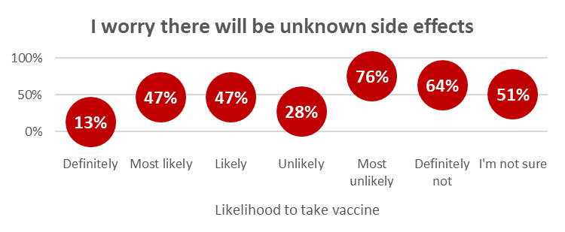  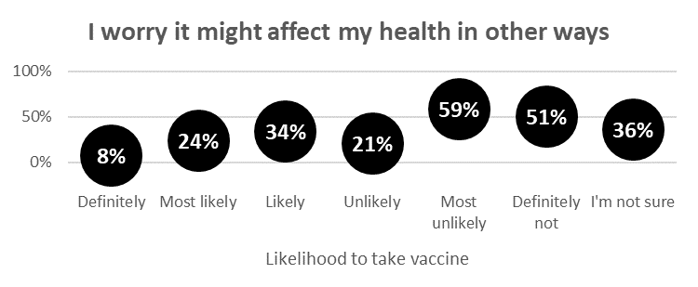  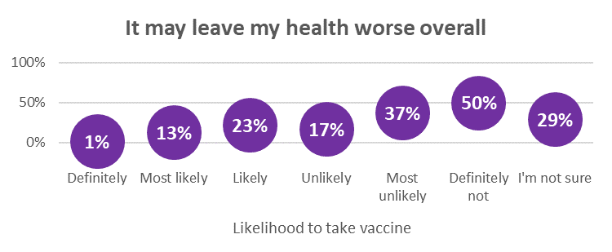

Confidence
Tracking continued on questions about confidence in:
- Any COVID-19 vaccine to be used in New Zealand meeting acceptable safety and quality standards
- Any COVID-19 vaccine made available in New Zealand:
  - Preventing COVID-19 infection
  - Preventing severe illness/death from COVID-19
  - Preventing the passing infection to others (this is a new measure).

The total who are confident in these four measures has not changed, but average confidence (which indicates the relative strength of respondent confidence) is increasing slightly. | 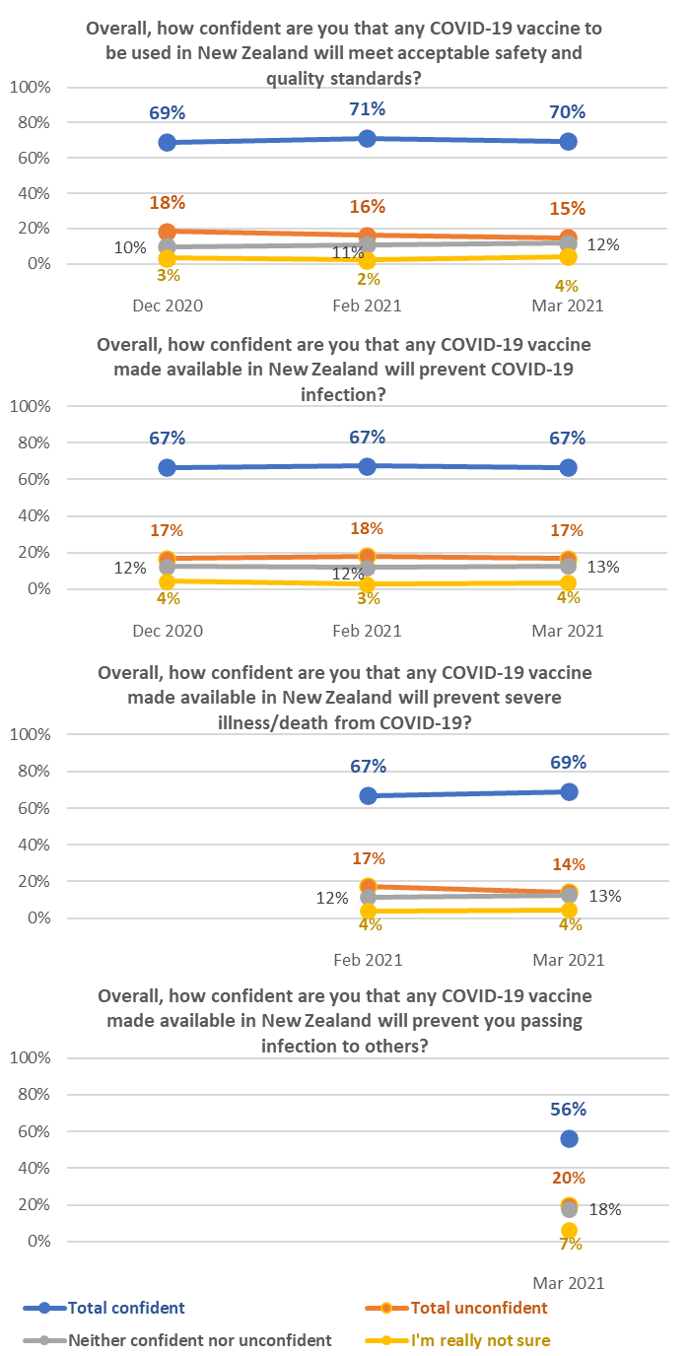

Risk-based approach to vaccination roll-out
66% overall approved of the risk-based approach to the vaccine roll-out and 10% disapproved. 17% were neutral. | 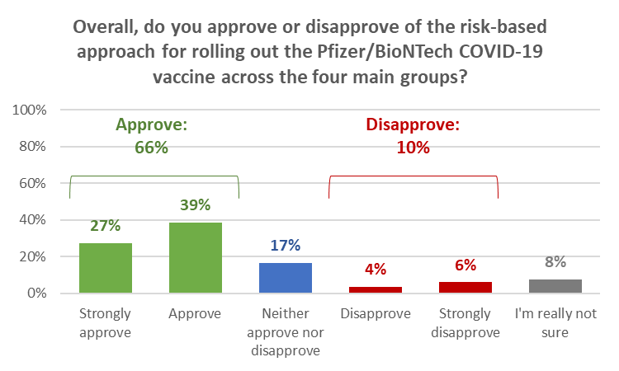

Disapproval was higher among those who were unlikely to take a COVID-19 vaccine.

Pasifika respondents were more likely to disapprove (27%) than respondents in other ethnic groups while Māori and Pasifika were the most likely to be neutral (22% and 21%, respectively).

Preferred time for vaccination
Asked when they would most like to take the Pfizer/BioNTech vaccine this year, 15% (an estimated 612,200 people 16 years of age or over) said “Immediately”.

This demand for immediate vaccination is slightly more likely to come from:
- Those in Vaccination Groups 1 to 3
- Those who have decided to “Definitely” take the vaccine
- Males
- Māori, “Other European” and Pasifika respondents
- Those in professional/senior government official, business management and executive roles or technical, mechanical and skilled worker roles.

Information to decide on vaccination
As in February 2021, 56% of respondents overall have mostly or definitely all the information they need to decide whether to take a COVID-19 vaccine. | 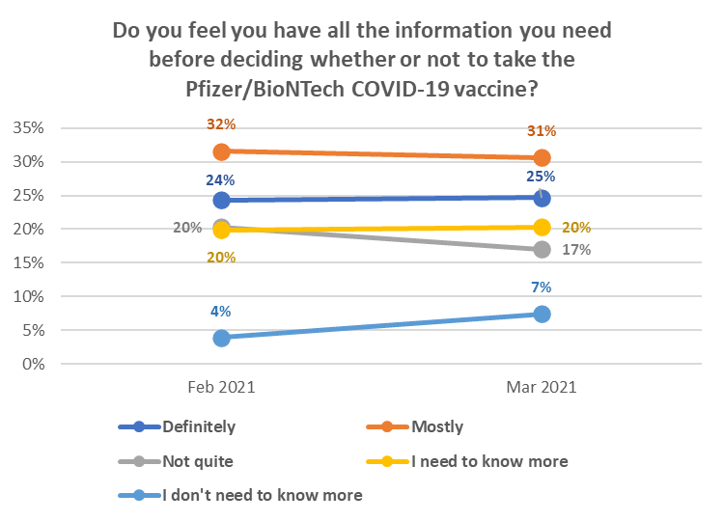

The “core” of those who will not be persuaded to take a COVID-19 vaccine is estimated at 9.4% of the 16+ population – a similar result to February. The data suggests that they may be becoming firmer in their determination not to be persuaded to take a vaccine.

Reasons for not taking a COVID-19 vaccine
The rank order of the reasons for not taking a COVID-19 vaccine is unchanged from February.

There are some significant changes, however:
The need to be assured about the vaccine’s safety has declined 11% since December 2020. | 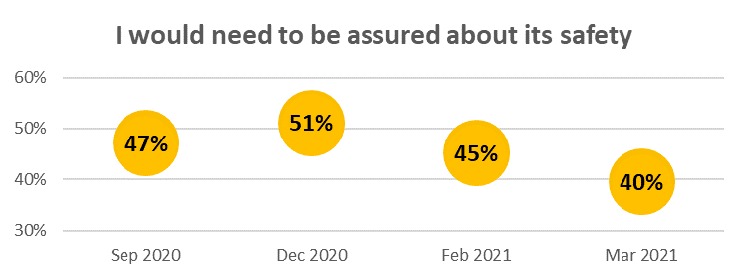

The percentage of those who are unsure, or unlikely to take a vaccine, and who selected “I’d rather wait and see if others who have taken it suffer any side effects”, has declined 9% since December 2020. | 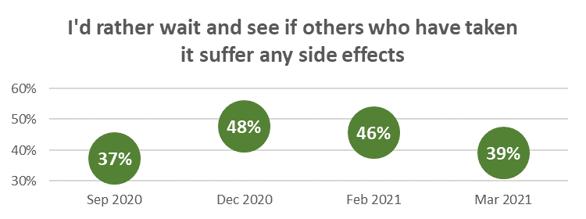

Information about the rollout plan
Respondents who had not yet had a first dose of the Pfizer/BioNTech vaccine were asked what information they needed about the roll-out plan.

Overall, they wanted information on:
- The vaccine’s side-effects and what would happen if they had an adverse reaction
- Where and when to get a vaccination, how to make an appointment/book for a vaccination and whether they had a choice of location
- How the vaccine works and what is in it.

Information sources about the vaccine
Television New Zealand is by far the most important source of information on the Pfizer/BioNTech vaccine. | 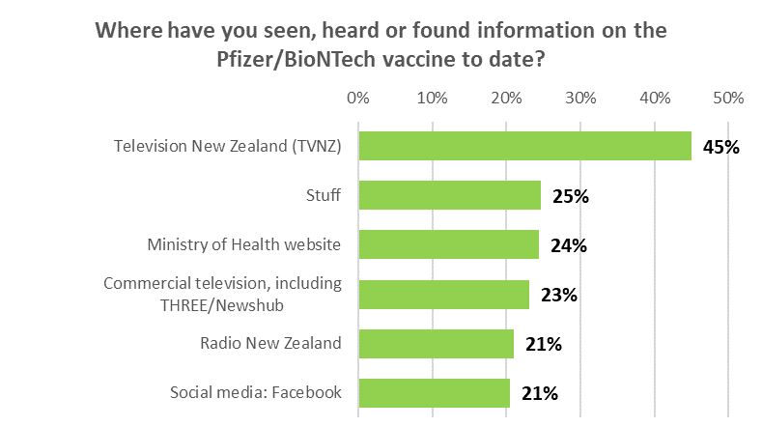

Use of official websites
29% overall had used the “Unite against COVID-19” information website in the past 30 days and 26% the Ministry of Health website. | 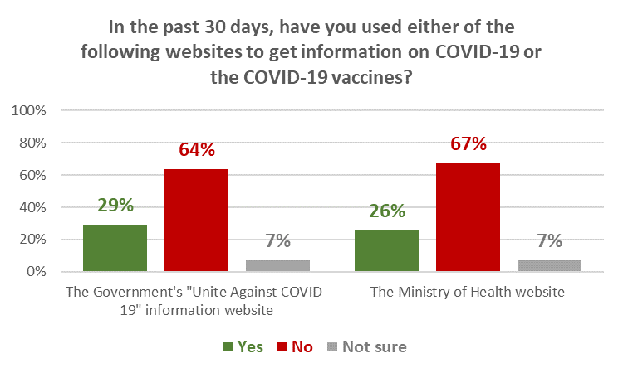

Use of the COVID Tracer app
An estimated 2.7 million are using the App with an estimated 2.0 million  Using it regularly or every time.  1.3 million are not using it, including an estimated 119,500 who have downloaded it. | 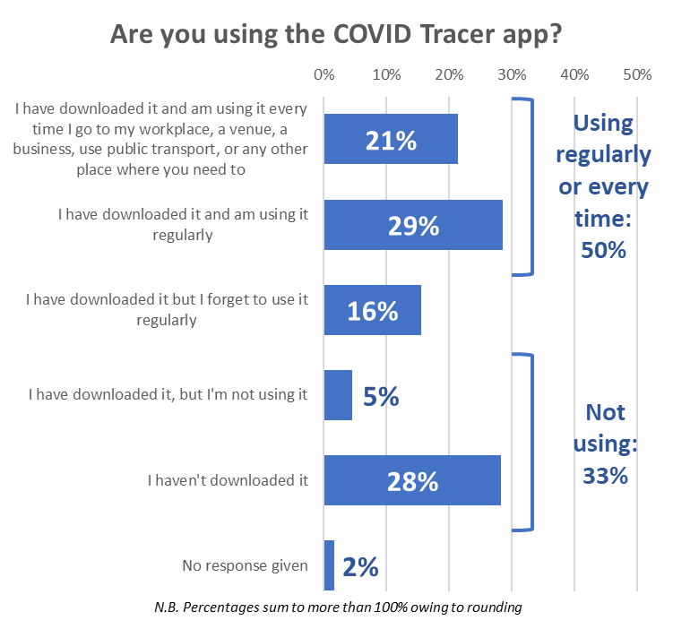

Effect of social media posts and vaccine side-effects on vaccine decision
Respondents were asked if they thought their decision to take the Pfizer/BioNTech vaccine would be influenced by social media posts or hearing of someone in New Zealand having a serious side-effect from taking it.

A nett 16% would not take a vaccine if a social media post or video alarmed them or an anti-vaccine post or video looked credible. Only 1 in 3 would then go on to look for official information.

11% said it would make them decide not to accept the vaccine when it was offered.

Trust
Average overall trust scores for all three trust measures are steady. | 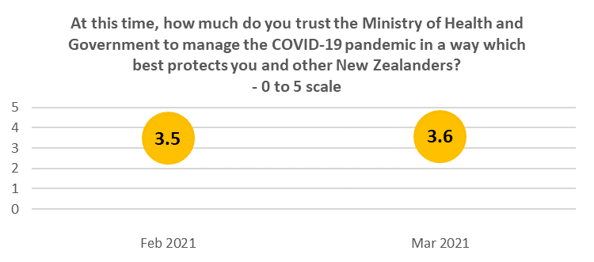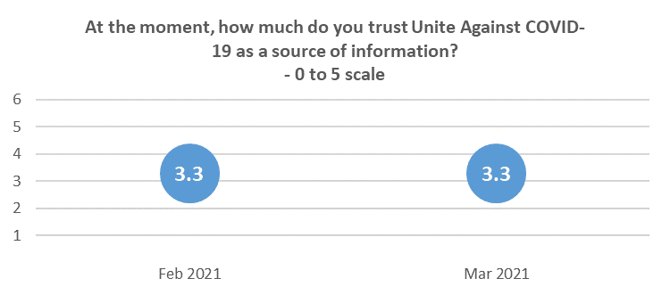  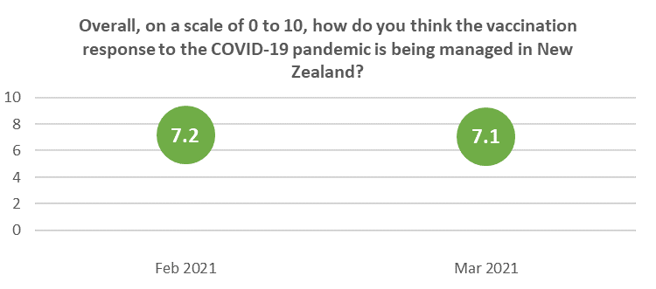

REPORT

Respondent beliefs about the Pfizer/BioNTech COVID-19 vaccine
There was continuing uncertainty shown about some aspects of the Pfizer/BioNTech vaccine, particularly when it would start becoming effective after vaccination and whether COVID-19 could be passed to others after having the vaccine. Just over a quarter of respondents were unsure about whether it would provide full protection.

1.1 When effective
32% of respondents were not sure when the Pfizer/BioNTech vaccine would start to become effective after vaccination. 46% thought it would be seven days after the second dose, but 14% thought it would be immediate – either after the first dose (5%) or second dose (9%).

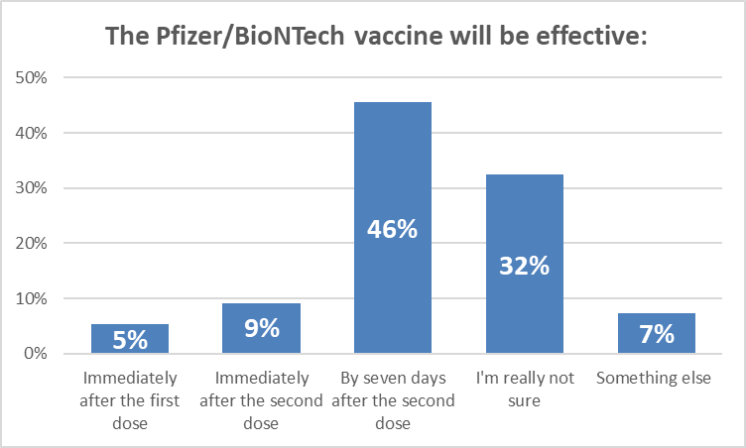

Of those who had answered “Something else”, 7 out of 20 said that it would be effective after two weeks/14 days.

47% of those who said they would “Definitely not” take a vaccine answered “Something else” with 3 out of 10 of that group saying it would not be effective at all.

“Not effective at all.”
“Non-effective.”
“No real proof of effectiveness.”
“NEVER. It's a dangerous SHAM!”
“NEVER!!!!!”
“Doesn’t work.”

1.2 Protection
59% overall thought it would protect them from the effects of COVID-19 while 18% thought vaccination would prevent them catching COVID-19. 23% were unsure.

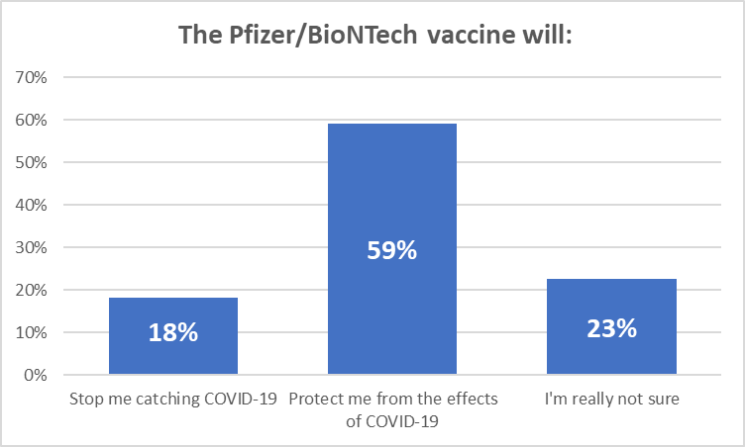

68% overall thought the Pfizer/BioNTech vaccine would provide a 95% probability of protection from COVID-19 while 7% believed it would provide full protection. 23% were unsure.

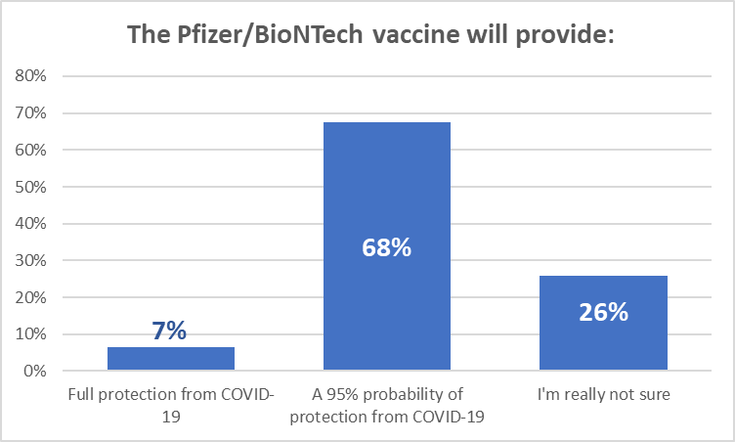
Note: Percentages may not sum to 100% owing to rounding

1.3 After having the Pfizer/BioNTech vaccination
70% believed they would still have to continue with protective behaviours; 10% believed you would not have to do this and 21% were unsure.

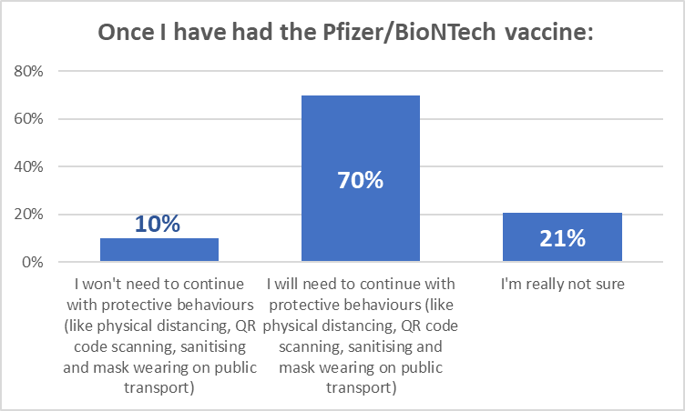

40% overall were unsure about whether they could pass on COIVID-19 to others after having been vaccinated. 20% thought you would not be able to and 40% thought that you could.

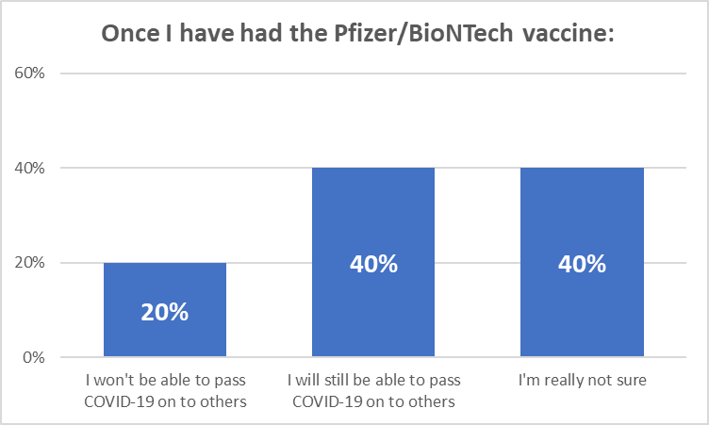

True statements
Respondents were shown a list of statements (presented in random order) and asked which they thought were true, if any.

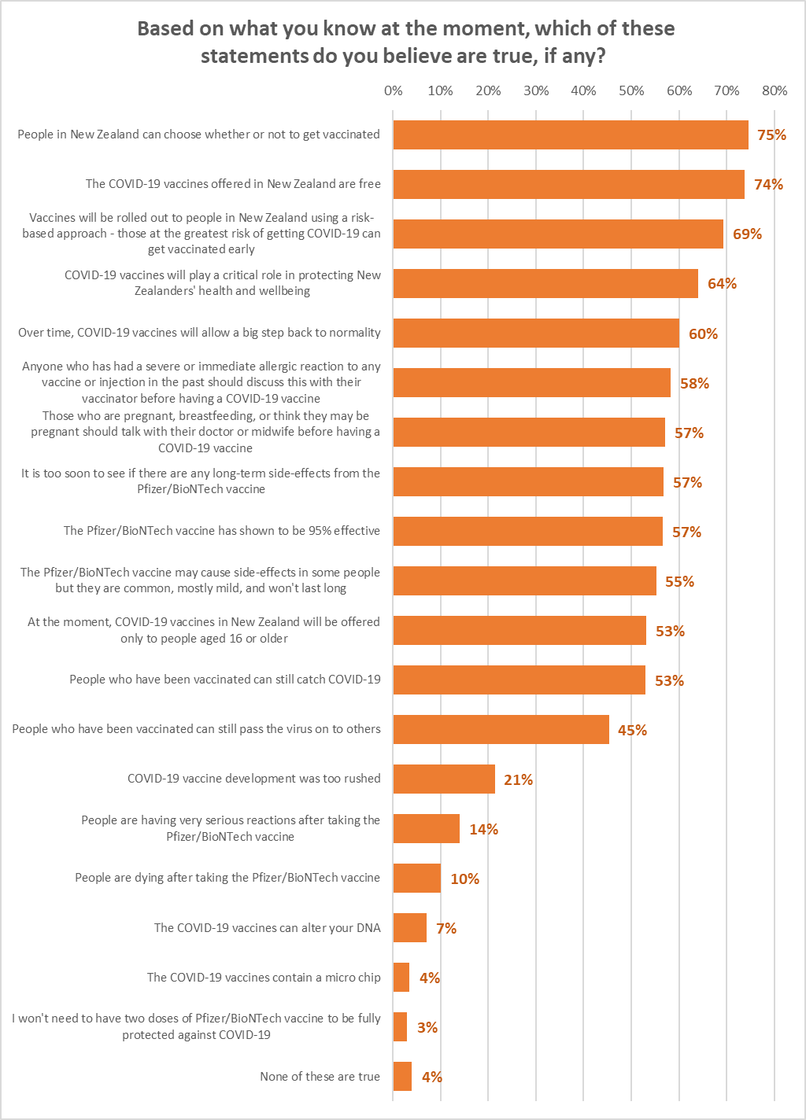

Note the following:

- Those who are unlikely to take the vaccine are less likely to believe vaccination is free
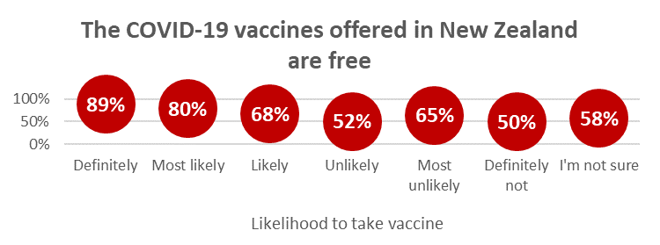

- Those who are unlikely to take the vaccine are more likely to believe that you can still catch COVID-19 after vaccination
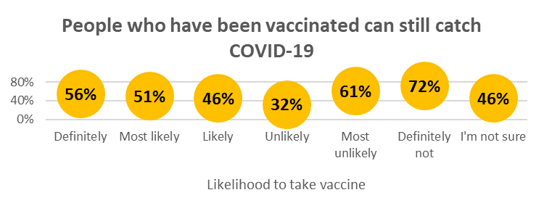

- Those who will “Definitely not” take the vaccine are the most likely to believe that you can still pass the virus on to others after vaccination.
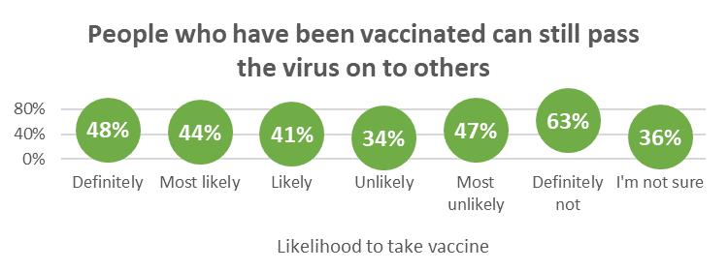

- Those who are likely to take the vaccine have much greater belief that COVID-19 vaccines will play a critical role in protecting New Zealanders’ health and wellbeing than those who are unlikely to take the vaccine.

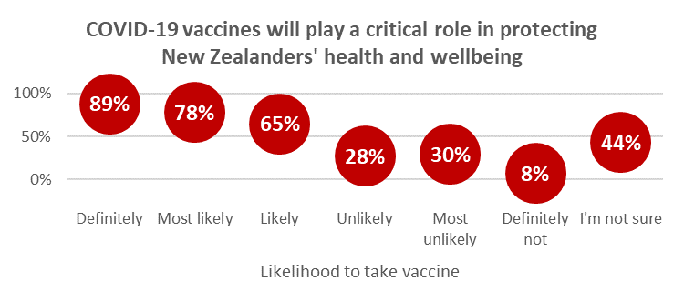

- Those who are likely to take the vaccine have much greater belief, than those who are unlikely to take the vaccine, that COVID-19 vaccines will “allow a big step back to normality”. This is effectively an aspirational appeal which is unlikely to be effective against those who have entrenched attitudes against the vaccine.

In general, those who are unlikely to take the vaccine have much lower belief that the Pfizer/BioNTech vaccine has shown to be 95% effective and that while it may cause side-effects in some people, such side effects are common, mostly mild, and won't last long. This is reflected in their reasons for not taking a vaccine (see Section 6.4 of this report).

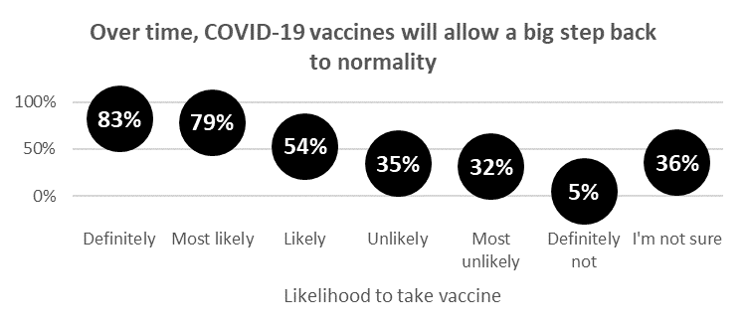

Deciding whether to take a COVID-19 vaccine
Tracking the factors that would influence a decision to take a vaccine and the thoughts that would occur to respondents in the course of that decision continued in March 2021.

3.1 Influencing factors
“Helping to protect all New Zealanders” was in top position in March 2021, together with “Vaccination is free”. In February 2021, “Vaccination is free” was the top factor.

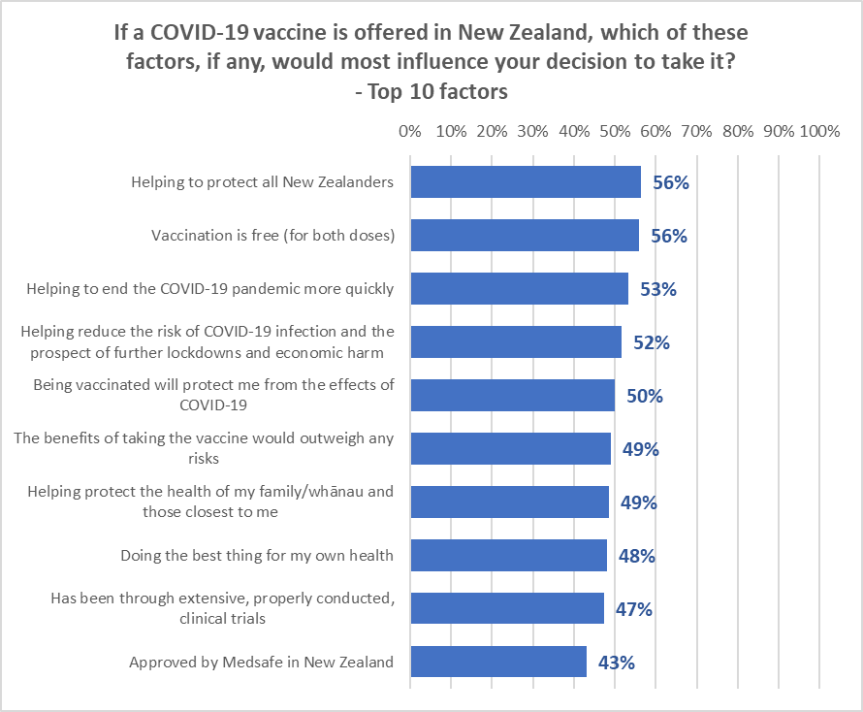

The full list of potential influencing factors and the percentage who thought they would influence their decision is shown in the attached APPENDIX 2 – TABLES.

Note the following trends:

- “Vaccination is free” continues to increase in importance overall, but is of less importance for those who are unlikely to take a COVID-19 vaccine.
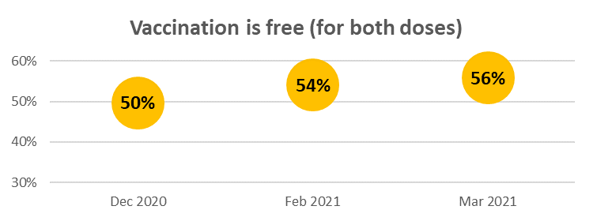

- “Helping to protect all New Zealanders” grew as a key factor while “Helping to protect the health of my family/whānau” was down by the same amount.

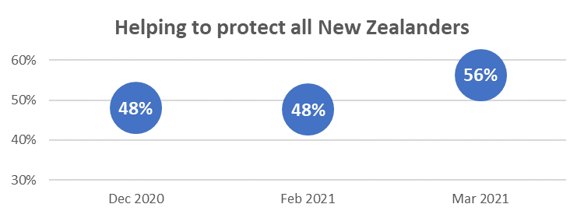
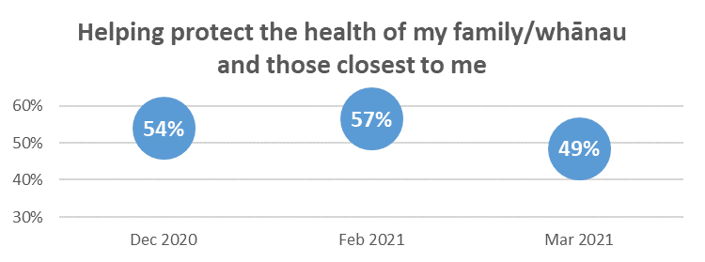

- Overall, New Zealanders appear to be requiring less reassurance on clinical trials and side-effects, but both of these remain major considerations for those who are unlikely to take a vaccine.

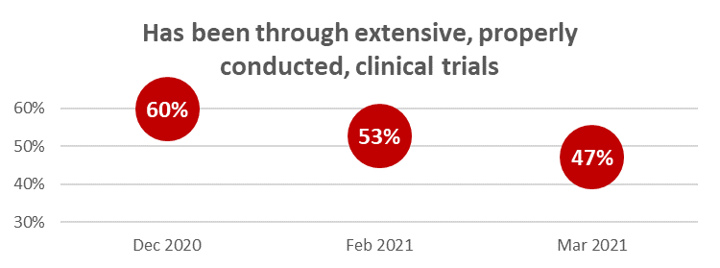
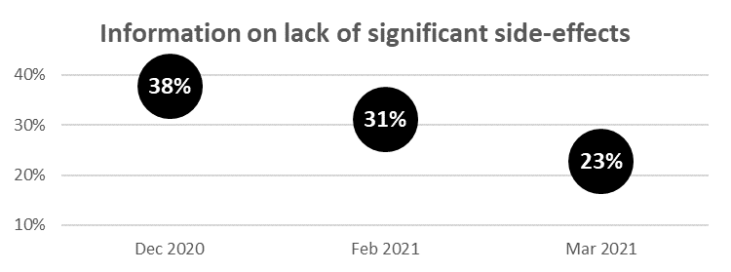

The top 5 influencing factors by likelihood to take a vaccine demonstrates how priorities have changed in a month:

If you were offered a well-tested and approved vaccine to prevent infection with COVID-19 today would you take it?
Definitely | Most likely | Likely | Unlikely | Most unlikely | Definitely not | I'm really not sure
Helping to protect all New Zealanders  (82%) | Helping to protect all New Zealanders  (70%) | Helping to protect all New Zealanders  (60%) | Has been through extensive, properly conducted, clinical trials  (25%) | Has been through extensive, properly conducted, clinical trials  (58%) | Has been through extensive, properly conducted, clinical trials  (15%) | Sufficient information on any side effects  (51%)
Helping to end the COVID-19 pandemic more quickly  (77%) | Vaccination is free (for both doses)  (70%) | Vaccination is free (for both doses)  (57%) | Sufficient information on any side effects  (22%) | Sufficient information on any side effects  (53%) | Sufficient information on any side effects  (10%) | Vaccination is free (for both doses)  (49%)
Helping reduce the risk of COVID-19 infection and the prospect of further lockdowns and economic harm  (77%) | Being vaccinated will protect me from the effects of COVID-19  (67%) | Helping to end the COVID-19 pandemic more quickly  (56%) | Doing the best thing for my own health  (20%) | Information on lack of significant side-effects  (34%) | Safely used overseas  (8%) | Helping to end the COVID-19 pandemic more quickly  (40%)
Doing the best thing for my own health  (76%) | Helping reduce the risk of COVID-19 infection and the prospect of further lockdowns and economic harm  (65%) | Being vaccinated will protect me from the effects of COVID-19  (49%) | Helping to protect all New Zealanders  (18%) | Vaccination is free (for both doses)  (32%) | Doing the best thing for my own health  (7%) | Has been through extensive, properly conducted, clinical trials  (34%)
The benefits of taking the vaccine would outweigh any risks  (75%) | Helping protect the health of my family/whānau and those closest to me  (63%) | Has been through extensive, properly conducted, clinical trials  (48%) | Recommended by the World Health Organisation  (17%) | Being vaccinated will protect me from the effects of COVID-19  (25%) | None of the factors listed  (75%) | Helping reduce the risk of COVID-19 infection and the prospect of further lockdowns and economic harm  (31%)

Compared with February 2021:
- “Definitely” take a vaccine: 3 out of the “Top 5” from February are retained. “Doing the best thing for my own health” (61% in February) and “The benefits of taking the vaccine would outweigh any risks” (62% in February) replace “Helping protect the health of my family and those closest to me” (71%, up from 67% in February) and “The vaccine is free” (74%, up from 66% in February).
- “Most likely” to take a vaccine: 2 out of the “Top 5” from February are retained. “Helping to protect all New Zealanders” (62% in February), “Being vaccinated will protect me from the effects of COVID-19” (63% in February) and “Helping reduce the risk of COVID-19 infection and the prospect of further lockdowns and economic harm” (64% in February) replace “Helping to end the COVID-19 pandemic more quickly” (63%, down from 69% in February), “Being vaccinated will help protect my family/whānau from COVID-19” (deleted in the March 2021 survey) and “Has been through extensive, properly conducted, clinical trials” (48%, down from 67% in February).
- “Likely” to take a vaccine: 2 of the “Top 5” from February are retained. “Helping to protect all New Zealanders” (36% in February), “Helping to end the COVID-19 pandemic more quickly” (45% in February) and “Being vaccinated will protect me from the effects of COVID-19” (38% in February) replace “Helping reduce the risk of COVID-19 infection and the prospect of further lockdowns and economic harm” (46%, slightly down from 49% in February), “Approved by Medsafe in New Zealand” (37%, down from 46% in February) and “Sufficient information on any side effects” (43%, equivalent to February’s 45%).
- “Unlikely” to take a vaccine: 2 of the “Top 5” from February are retained. “Doing the best thing for my own health” (13% in February), “Helping to protect all New Zealanders” (18% in February) and “Recommended by the World Health Organisation” (17% in February) replace “Helping reduce the risk of COVID-19 infection and the prospect of further lockdowns and economic harm” (46%, slightly down on February’s 49%), “Approved by Medsafe in New Zealand” (37%, down from 46% in February) and “Sufficient information on any side effects” (43%, equivalent to February’s 45%).
- “Most unlikely” to take a vaccine: 4 of the “Top 5” from February are retained. “Being vaccinated will protect me from the effects of COVID-19” (6% in February) replaces “Reputable manufacturer” (12%, down from 21% in February).
- “Definitely not” taking a vaccine: 2 of the “Top 4” from February are retained (included in February’s “Top 5” list was “None of the factors listed”, which has risen to 75% from 70%. “Safely used overseas” (4% in February) and “Doing the best thing for my own health” (3% in February) replace “Vaccination is free” (5%, down from 9% in February), “Information on lack of significant side-effects” (deleted in the march survey).
- “Not sure” whether to take a vaccine: 3 of the “Top 5” from February are retained. “Helping to end the COVID-19 pandemic more quickly” (40% in February) and “Has been through extensive, properly conducted, clinical trials” (34% in February) replace “Information on lack of significant side-effects” (deleted in the March survey) and “Doing the best thing for my own health” (21%, down from 31%).

Note that the following considerations were also nominated by more than 60% of those:

Who would “Definitely” take a vaccine:
- Vaccination is free (for both doses): 74%
- Being vaccinated will protect me from the effects of COVID-19: 71%
- Helping protect the health of my family/whānau and those closest to me: 71%
- Recommended by the New Zealand Ministry of Health: 68%
- Approved by Medsafe in New Zealand: 65%
- Recommended by the Director General of Health, Dr Ashley Bloomfield: 63%
- Has been through extensive, properly conducted, clinical trials: 62%.

Who would be “Most likely” to take a vaccine:
- Helping to end the COVID-19 pandemic more quickly: 63%
- Approved by Medsafe in New Zealand: 61%.

The following table shows the top 5 important influencing factors for each ethnic group.

In February 2021, “Recommended to me by my own doctor or personal medical service provider” was in the “Top 5” for Pasifika respondents, 50% of whom said this was a key factor. It was not in the “Top 5” in March 2021, but 43% of Pasifika respondents selected that factor as important. It is therefore vital that the GPS and medical service providers working with Pasifika people take a key role in vaccine communication to that target group.

ETHNIC GROUPS
Asian | Indian | Māori | NZ European/ Pakeha | Other European | Pasifika | Other
Helping to protect all New Zealanders  (58%) | Allowing more New Zealand citizens and residents to return  (47%) | Vaccination is free (for both doses)  (56%) | Helping to protect all New Zealanders  (60%) | Helping to end the COVID-19 pandemic more quickly  (56%) | Helping to protect all New Zealanders  (66%) | Vaccination is free (for both doses)  (47%)
Helping to end the COVID-19 pandemic more quickly  (52%) | Approved by Medsafe in New Zealand  (38%) | Helping protect the health of my family/whānau and those closest to me  (53%) | Vaccination is free (for both doses)  (59%) | Vaccination is free (for both doses)  (53%) | Helping protect the health of my family/whānau and those closest to me  (66%) | Helping to end the COVID-19 pandemic more quickly  (45%)
Being vaccinated will protect me from the effects of COVID-19  (51%) | Helping to protect all New Zealanders  (35%) | Helping to protect all New Zealanders  (52%) | Helping reduce the risk of COVID-19 infection and the prospect of further lockdowns and economic harm  (57%) | Helping to protect all New Zealanders  (49%) | Helping to end the COVID-19 pandemic more quickly  (65%) | Doing the best thing for my own health  (43%)
Vaccination is free (for both doses)  (45%) | Helping to end the COVID-19 pandemic more quickly  (35%) | Helping to end the COVID-19 pandemic more quickly  (48%) | Helping to end the COVID-19 pandemic more quickly  (57%) | The benefits of taking the vaccine would outweigh any risks  (49%) | Helping me to travel internationally once again  (63%) | The benefits of taking the vaccine would outweigh any risks  (42%)
Approved by Medsafe in New Zealand  (43%) | Vaccination is free (for both doses)  (34%) | Being vaccinated will protect me from the effects of COVID-19  (45%) | Being vaccinated will protect me from the effects of COVID-19  (54%) | Helping reduce the risk of COVID-19 infection and the prospect of further lockdowns and economic harm  (48%) | Vaccination is free (for both doses)  (61%) | Sufficient information on any side effects  (40%)

By ethnicity, and compared with February 2021:
- Asian: “Approved by Medsafe in New Zealand” (47% in February) replaced “Helping reduce the risk of COVID-19 infection and the prospect of further lockdowns and economic harm (38%, down from 53% in February)
- Indian: “Allowing more New Zealand citizens and residents to return” (20% in February), “Helping to protect all New Zealanders” (34% in February) and “Helping to end the COVID-19 pandemic more quickly” (42% in February) replaced “Being vaccinated will protect me from getting COVID-19” (23%, down from 548%), “Has been through extensive, properly conducted, clinical trials” (31%, down from 58%) and” Helping reduce the risk of COVID-19 infection and the prospect of further lockdowns and economic harm (17%, down from 49%)
- Māori: “Helping to end the COVID-19 pandemic more quickly” (46% in February) and “Being vaccinated will protect me from the effects of COVID-19” (40% in February) replaced “Helping reduce the risk of COVID-19 infection and the prospect of further lockdowns and economic harm” (45%, down from 51%) and “Being vaccinated will help protect my family/whānau from COVID-19” (deleted in the March survey)
- NZ European: “Being vaccinated will protect me from the effects of COVID-19” (48% in February) replaced “Has been through extensive, properly conducted, clinical trials” (51%, down from 58%)
- “Other European”: “Helping to protect all New Zealanders” (54% in February) and “The benefits of taking the vaccine would outweigh any risks” (50% in February) replaced “Vaccination is free” (53%, marginally down from 56%) and “Sufficient information on any side effects” (32%, down from 55%).
- “Other” ethnicities: “Vaccination is free (for both doses)” (30% in February), “Helping to end the COVID-19 pandemic more quickly” (20% in February), “Doing the best thing for my own health” (28% in February) and “The benefits of taking the vaccine would outweigh any risks” (30% in February) replaced “Approved by Medsafe in New Zealand” (18%, down from 40%), “Helping reduce the risk of COVID-19 infection and the prospect of further lockdowns and economic harm” (35%, equivalent to February’s 37%), “Has been through extensive, properly conducted, clinical trials” (29%, down from 33%) and “Being vaccinated will help protect my family/whānau from COVID-19” (deleted in the March survey).

3.2 Decision thoughts
Supporting the decline in side-effects as an overall influencing factor, “I worry there will be unknown side-effects” and “I worry how the side-effects may affect me” have significantly declined in the thoughts measure. “It is too soon to see whether there are any long-term effects from the vaccine” has moved into top position. Both of these suggest a potential shift from concentration on the near-term to the long-term.

The average number of thoughts per person dropped from 3.2 in February to 2.8, suggesting that people who are likely to take a vaccine may be becoming a little more certain about what is important in their decision-making. However, those who say they will “Definitely not” take a vaccine or are “most unlikely” to do so average 5.5 thoughts or more (5.1 or more in February).

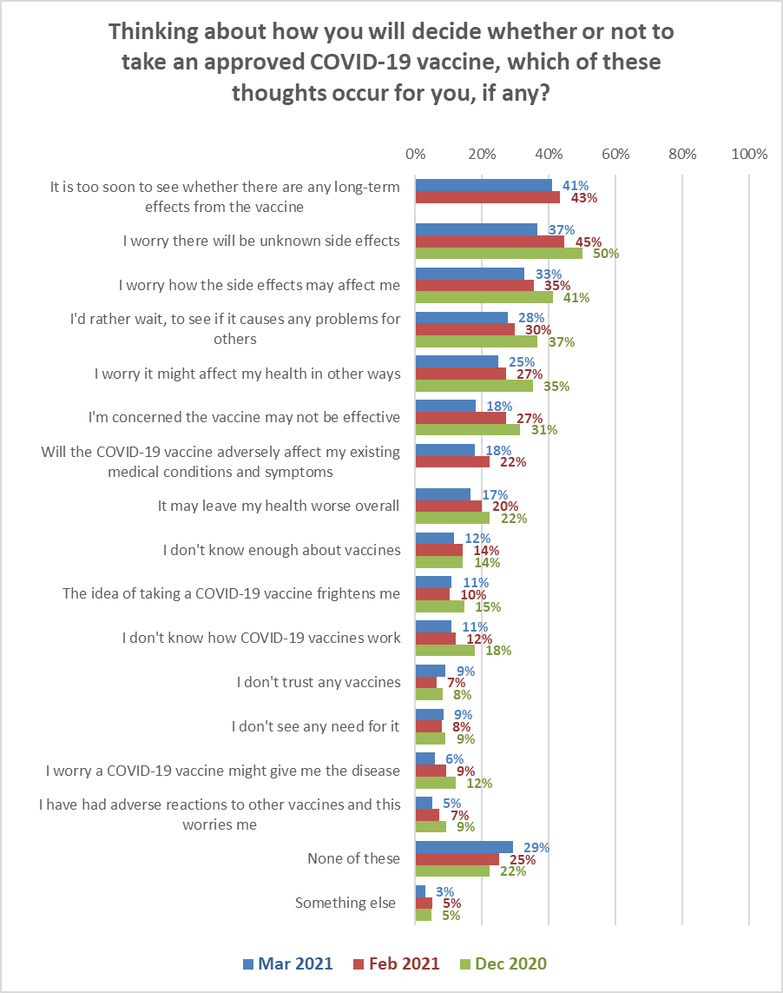

Note that worry about side-effects, and concern about the effect of the vaccine on their own health, are key thoughts that factor into the decision of those who are unlikely to take a vaccine.

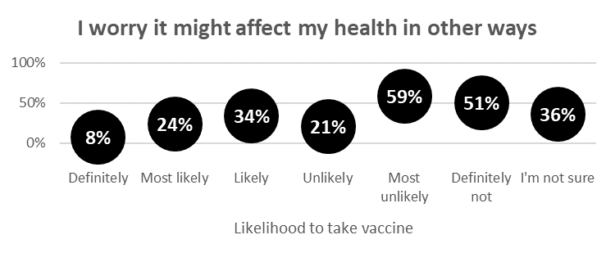
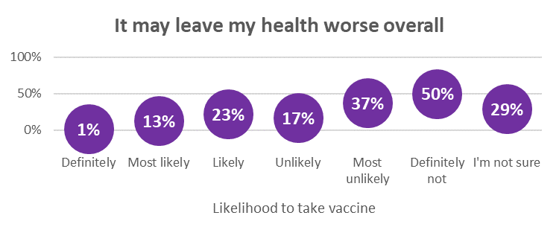

Five thoughts were selected by more than 25% of respondents. Demographic characteristics of these top six thoughts are:

Thinking about how you will decide whether or not to take an approved COVID-19 vaccine, which of these thoughts occur for you, if any?
It is too soon to see whether there are any long-term effects from the vaccine | I worry there will be unknown side effects | I worry how the side effects may affect me | I'd rather wait, to see if it causes any problems for others | I worry it might affect my health in other ways
41% | 37% | 33% | 28% | 25%
More likely to be female than male.  Average age.  Average household income but 11% lower personal income than average.  Slightly more likely than average to have school- level qualifications as their highest qualification.  Slightly more likely to have children in the household.  Slightly less likely than average to be Māori and slightly more likely to be NZ European/ Pakeha.  More likely to be living in the North Island but not in Auckland. | More likely to be female than male.  6% younger than average age.  Average household income but 14% lower than average personal income.  More likely than average to have school- level qualifications as their highest qualification.  No ethnic differences from average.  More likely to be living in the North Island from Taupo north, but not in Auckland. | More likely to be female than male.  5% younger than average age  7% lower household income and 20% lower personal income than average.  More likely than average to have school- level qualifications as their highest qualification.  More likely to have children in the household.  No location or ethnic differences from average. | More likely to be female than male.  7% younger than average age.  2% lower household income and 14% lower personal income than average.  More likely than average to have school- level qualifications as their highest qualification.  More likely to have children in the household.  More likely than average to be of Pasifika ethnicity.  More likely to be living in the North Island but not in Auckland. | More likely to be female than male.  3% older than average age.  7% lower household and 12% lower personal income than average.  More likely to have children in the household.  No ethnic differences.  More likely to be living in the North Island and slightly more likely to be in Auckland.

“I worry how the side effects may affect me”, “It is too soon to see whether there are any long-term effects from the vaccine” and “I worry there will be unknown side effects” are consistent top five thoughts which occur regardless of respondents’ likelihood to take a COVID-19 vaccine.

“I'd rather wait, to see if it causes any problems for others” is in the top 5 thoughts for all except those who would definitely not take a vaccine.

Top five thoughts by likelihood to take a COVD-19 vaccine are shown in the following table.

Will you take the Pfizer/BioNTech COVID-19 vaccine?
Definitely | Most likely | Likely | Unlikely | Most unlikely | Definitely not | I'm really not sure
It is too soon to see whether there are any long-term effects from the vaccine (223%) | I worry there will be unknown side effects  (47%) | I worry there will be unknown side effects (47%) | It is too soon to see whether there are any long-term effects from the vaccine (57%) | It is too soon to see whether there are any long-term effects from the vaccine (81%) | I worry there will be unknown side effects (64%) | It is too soon to see whether there are any long-term effects from the vaccine (56%)
I worry how the side effects may affect me. (14%) | It is too soon to see whether there are any long-term effects from the vaccine (46%) | It is too soon to see whether there are any long-term effects from the vaccine (47%) | I'd rather wait, to see if it causes any problems for others (53%) | I worry there will be unknown side effects  (76%) | I worry how the side effects may affect me (59%) | I worry how the side effects may affect me (52%)
I worry there will be unknown side effects  (13%) | I worry how the side effects may affect me (39%) | I worry how the side effects may affect me (43%) | I’m concerned the vaccine may not be effective  (29%) | I'd rather wait, to see if it causes any problems for others  (68%) | It is too soon to see whether there are any long-term effects from the vaccine (58%) | I worry there will be unknown side effects  (51%)
Will the COVID-19 vaccine adversely affect my existing medical conditions and symptoms (10%) | I'd rather wait, to see if it causes any problems for others (28%) | I'd rather wait, to see if it causes any problems for others (42%) | I worry there will be unknown side effects (28%) | I worry it might affect my health in other ways  (59%) | I don’t see any need for it  (51%) | I'd rather wait, to see if it causes any problems for others  (46%)
I worry it might affect my heath in other ways  (8%) | I worry it might affect my heath in other ways  (24%) | I worry it might affect my health in other ways (34%) | I don’t know enough about vaccines  (23%) | I worry how the side effects may affect me (51%) | I worry it might affect my heath in other ways  (51%) | I worry it might affect my health in other ways  (36%)

Compared with February 2021:
- “Definitely” take a vaccine: 4 out of the “Top 5” from February are retained. “I worry it might affect my heath in other ways” (12% in February) replaces “I’m concerned the vaccine may not be effective” (5%, down from 14% in February).
- “Most likely” to take a vaccine: 4 out of the “Top 5” from February are retained. “I worry it will affect my heath in other ways” (35% in February) replaces “I’m concerned the vaccine may not be effective” (23%, down from 42% in February)
- “Likely” to take a vaccine: All 5 of the “Top 5” from February are retained
- “Unlikely” to take a vaccine: 3 out of the “Top 5” from February are retained. “I’m concerned the vaccine may not be effective” (37% in February) and “I don’t know enough about vaccines” (29% in February) replace “I worry how the side effects may affect me” (22%, down from 57% in February) and “I worry it might affect my heath in other ways” (21%, down from 41% in February)
- “Most unlikely” to take a vaccine: All 5 of the “Top 5” from February are retained
- “Definitely not” taking a vaccine: 4 out of the “Top 5” from February are retained. “I worry it might affect my health in other ways” (40% in February) replaces “It may leave my health worse overall” (50%, not a significant change from 48% in February)
- “Not sure” whether to take a vaccine: All 5 of the “Top 5” from February are retained

As in February 2021, there was a degree of consistency by ethnicity.

ETHNIC GROUPS
Asian | Indian | Māori | NZ European/ Pakeha | Other European | Pasifika | Other
I worry there will be unknown side effects  (43%) | I worry how the side effects may affect me (41%) | It is too soon to see whether there are any long-term effects from the vaccine (36% | It is too soon to see whether there are any long-term effects from the vaccine (44%) | It is too soon to see whether there are any long-term effects from the vaccine  (35%) | It is too soon to see whether there are any long-term effects from the vaccine  (52%) | I worry how the side effects may affect me  (42%)
I worry how the side effects may affect me  (40%) | I worry there will be unknown side effects  (25%) | I worry there will be unknown side effects  (36%) | I worry there will be unknown side effects  (38%) | I'd rather wait, to see if it causes any problems for others  (26%) | I'd rather wait, to see if it causes any problems for others  (48%) | It is too soon to see whether there are any long-term effects from the vaccine  (41%)
It is too soon to see whether there are any long-term effects from the vaccine  (37%) | It is too soon to see whether there are any long-term effects from the vaccine  (21%) | I worry how the side effects may affect me  (32%) | I worry how the side effects may affect me (32%) | I worry there will be unknown side effects  (24%) | I worry how the side effects may affect me  (41%) | I worry there will be unknown side effects  (39%)
I worry it might affect my health in other ways  (28%) | I worry it might affect my health in other ways  (17%) | I worry it might affect my health in other ways  (30%) | I'd rather wait, to see if it causes any problems for others  (28%) | I worry it might affect my health in other ways  (20%) | I'm concerned the vaccine may not be effective  (39%) | It may leave my health worse overall  (35%)
I'm concerned the vaccine may not be effective  (20%) | I'd rather wait, to see if it causes any problems for other  (15%) | I'd rather wait, to see if it causes any problems for others  (26%) | I worry it might affect my health in other ways  (24%) | Will the COVID-19 vaccine adversely affect my existing medical conditions and symptoms  (20%) | I worry there will be unknown side effects  (39%) | I don't see any need for it  (34%)

Compared with February 2021:
- NZ European respondents retained their “Top 5” from February and in the same order
- Indian, Māori and Pasifika also retained their “Top 5” from February, but in a different order
- Asian respondents retained 4 of their February “Top 5” but same “I'm concerned the vaccine may not be effective” replaced “I'd rather wait, to see if it causes any problems for others”
- “Other European” respondents retained 3 of their February “Top 5” with “and “Will the COVID-19 vaccine adversely affect my existing medical conditions and symptoms” and “I worry it might affect my health in other ways” replacing “I'm concerned the vaccine may not be effective” and “I worry how the side effects may affect me”
- “Other” ethnicities (e.g., Middle Eastern, African, etc). retained 2 of their February “Top 5”, with “I worry how the side effects may affect me”, “It may leave my health worse overall” and “I don't see any need for it” replacing “I worry a COVID-19 vaccine might give me the disease”, “The idea of taking a COVID-19 vaccine frightens me” and “Will the COVID-19 vaccine adversely affect my existing medical conditions and symptoms”

Confidence
Tracking continued on questions about confidence in:
- Any COVID-19 vaccine to be used in New Zealand meeting acceptable safety and quality standards
- Any COVID-19 vaccine made available in New Zealand:
  - Preventing COVID-19 infection
  - Preventing severe illness/death from COVID-19
  - Preventing the passing infection to others (this is a new measure).

As shown, the total who are confident in these four measures has not changed.

However, average confidence (which indicates the relative strength of respondent confidence and is a score out 7) is increasing slightly.

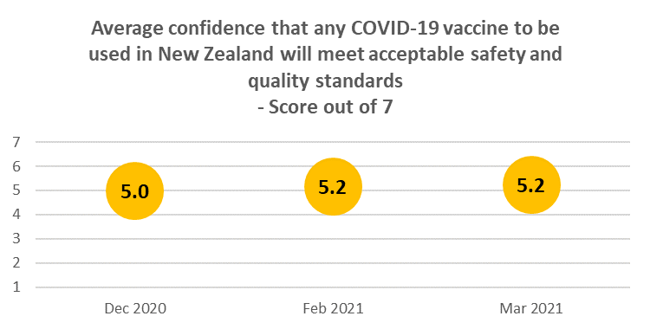
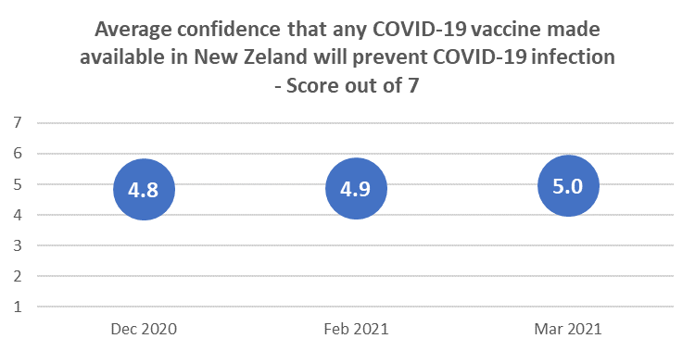
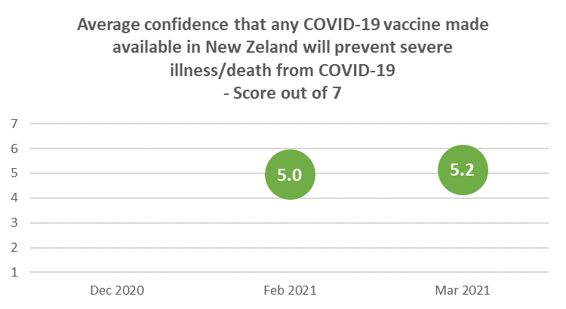

By ethnicity, confidence varies, with Māori and Pasifika generally having lower confidence.

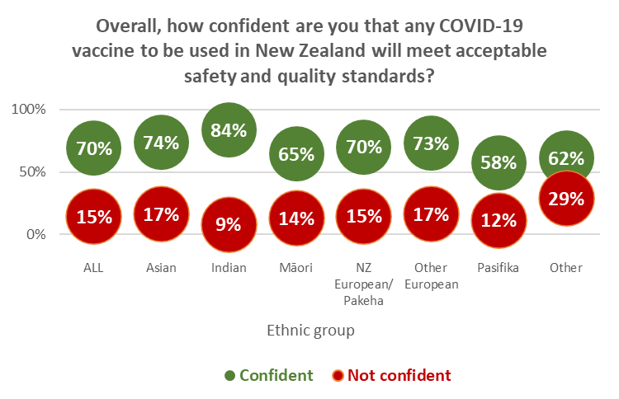

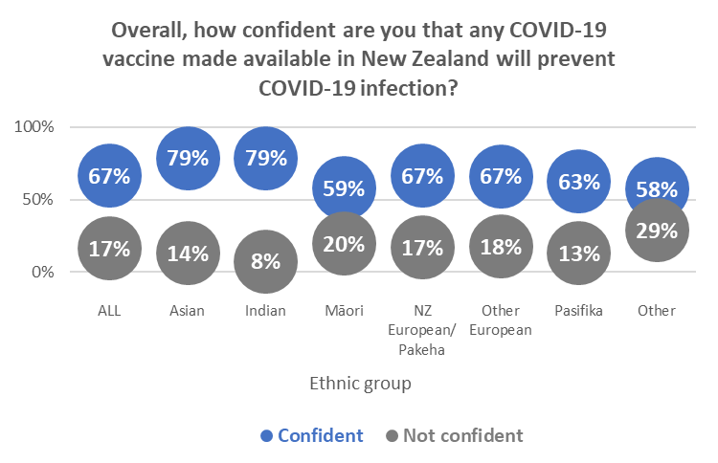

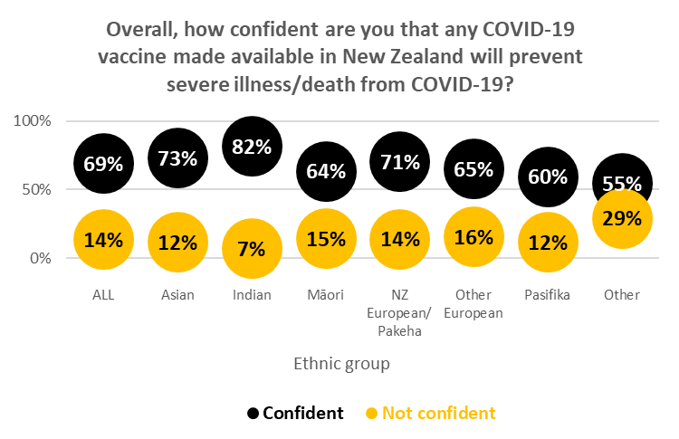

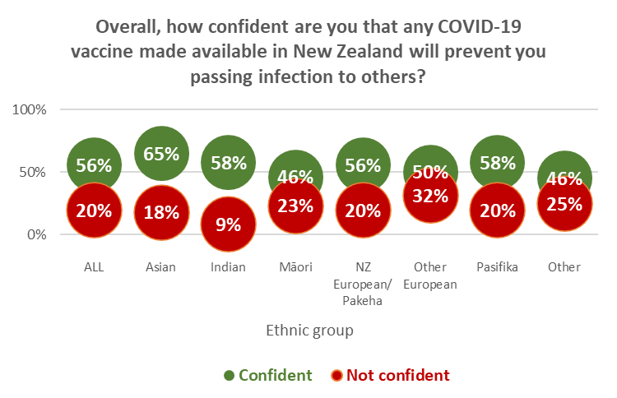

Vaccine groups, approval of risk-based approach to vaccination roll-out and demand for vaccination

5.1 Vaccine groups
Respondents were asked about their vaccine groups: first, without an explanation of the 4 groups (to see if they were aware of which group they were in), and second, with an explanation of the groups.

93% of those who initially thought they were in Group 4 were actually in that group. 76% of those who initially thought they were in Group 3 were actually in that group, but there was a degree of misapprehension among those who thought they were in Groups 1 or 2, as shown below.

After reading the above, which group do you fall into? | ALL | Without looking it up, do you know which group you are in?
 |  | Group 1 | Group 2 | Group 3 | Group 4 | I really don't know
Group 1 - Border and MIQ workers and the people they live with | 4% | 39% | 8% | 2% | 0% | 4%
Group 2 - High-risk frontline workers and people living in high-risk places | 9% | 30% | 40% | 5% | 1% | 6%
Group 3 - People who are at risk of getting very sick from COVID-19 | 30% | 14% | 47% | 73% | 5% | 22%
Group 4 - Everyone in New Zealand aged 16 and over | 58% | 17% | 5% | 20% | 93% | 69%
N (unweighted) | 1350 | 44 | 156 | 286 | 381 | 483

5.2 Risk-based approach to vaccination roll-out
66% overall approved of the risk-based approach to the vaccine roll-out and 10% disapproved. 17% were neutral.

Disapproval was higher among those who were unlikely to take a COVID-19 vaccine: 47% of those who said they would “Definitely not” take a vaccine strongly disapproved of the risk-based approach.

Pasifika respondents were more likely to disapprove (27%) than respondents in other ethnic groups while Māori and Pasifika were the most likely to be neutral (22% and 21%, respectively).

Note: Percentages may not sum to 100% owing to rounding

By ethnicity, Māori, Pasifika and respondents of “Other” ethnicities (e.g., Middle Eastern/Arabic, African, etc) were less likely to approve of the risk-based approach (although Māori were more likely to be neutral).

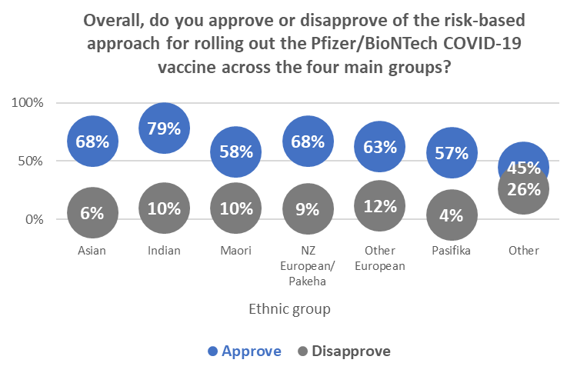

5.3 Preferred time for vaccination: projected demand
Asked when they would most like to take the Pfizer/BioNTech vaccine this year, 15% (an estimated 612,200 people 16 years of age or over) said “Immediately”.

This demand for immediate vaccination is slightly more likely to come from:
- Those in Vaccination Groups 1 to 3
- Those who have decided to “Definitely” take the vaccine
- Males
- Māori, “Other European” and Pasifika respondents
- Those in professional/senior government official, business management and executive roles or technical, mechanical and skilled worker roles.

57% of those who said they were “Unlikely” to take the vaccine answered “I’m not sure” when asked which month they would prefer. We interpret that as an encouraging sign of potential to change the minds of that sub-group, especially as only 17% of them selected “I won’t take the vaccine”.

As shown in the following chart, 16% overall “don’t mind” when they have their vaccination.

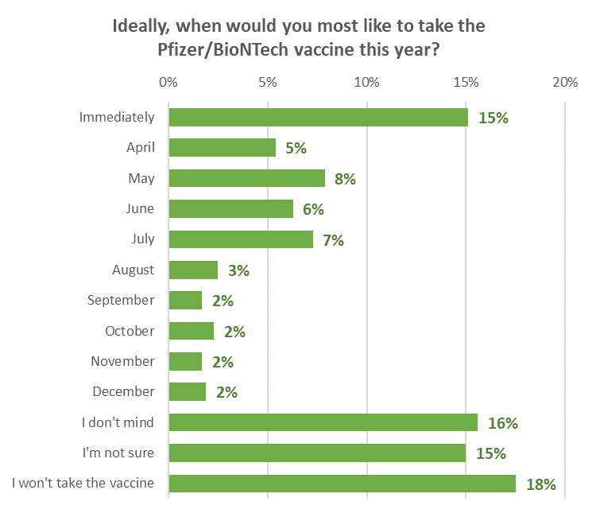

Respondents of Māori, Pasifika, “Other European” and “Other” ethnicities were the keenest to get take a vaccine immediately.

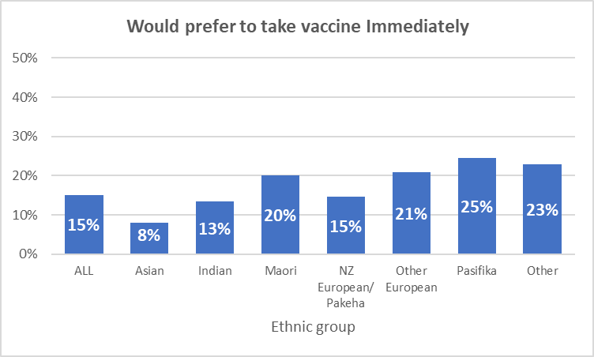

On the other hand, “Other Europeans” were the most likely not to mind when they had the vaccine.
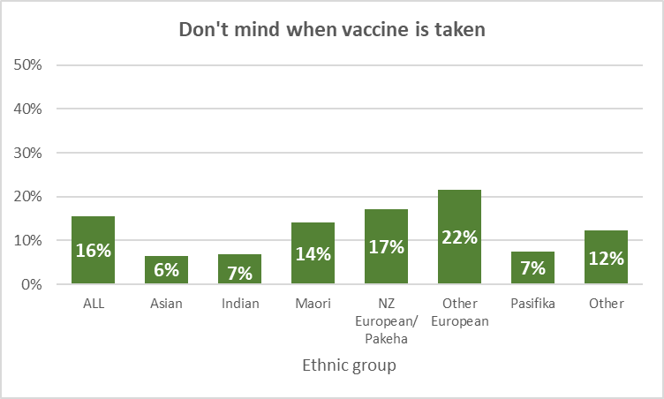

Vaccine Uptake

6.1 Already vaccinated – information needs met
Respondents were asked if they had already been offered an opportunity to have their COVID-19 vaccination. The survey timing was ahead of the actual vaccination numbers being publicly released by the Ministry of Health.

Offered an opportunity to have COVID-19 vaccination | %
Yes - I have already had two doses | 1.2%
Yes - I have already had one dose | 1.6%
Yes - I have not had the first dose, but my appointment is booked | 2.1%
Yes - but I have not had the first dose and have not booked an appointment yet | 2.1%
Yes, but I declined to have the vaccine | 2.0%
No | 91.0%

92% of those who had been vaccinated already felt they had received enough information about their vaccination. 8% said they would have liked to have had more information.

6.2 Vaccine uptake

6.2.1 Overall
Those who had not yet been vaccinated were asked if they would take the Pfizer/BioNTech COVID-19 vaccine

The responses were combined with the 2.8% who had already had the vaccine to produce a picture for all respondents 16 years of age or over.

Likelihood to accept a COVID-19 vaccine – including those who had already had a vaccine - remained steady at 69% – a consistent figure since September 2020 (the 71% result in the February survey did not denote an increase as the difference, as noted in that report, was not significant). The estimated number of New Zealanders 16+ who are likely to take a vaccine, including those who have already had one, is 2,809,600.

The total Unlikely to take a vaccine remains steady at 20% (an estimated 794,600 New Zealanders 16+), while the percentage unsure was similar to the September and December results (an estimated.

The lack of change in the percentages suggests that the population is largely following its initial thoughts on COVID-19 vaccination and has yet to see anything that might drive a significant change in attitude. As noted in Section 2, aspirational appeals are unlikely to be effective against those who have entrenched attitudes against the vaccine.
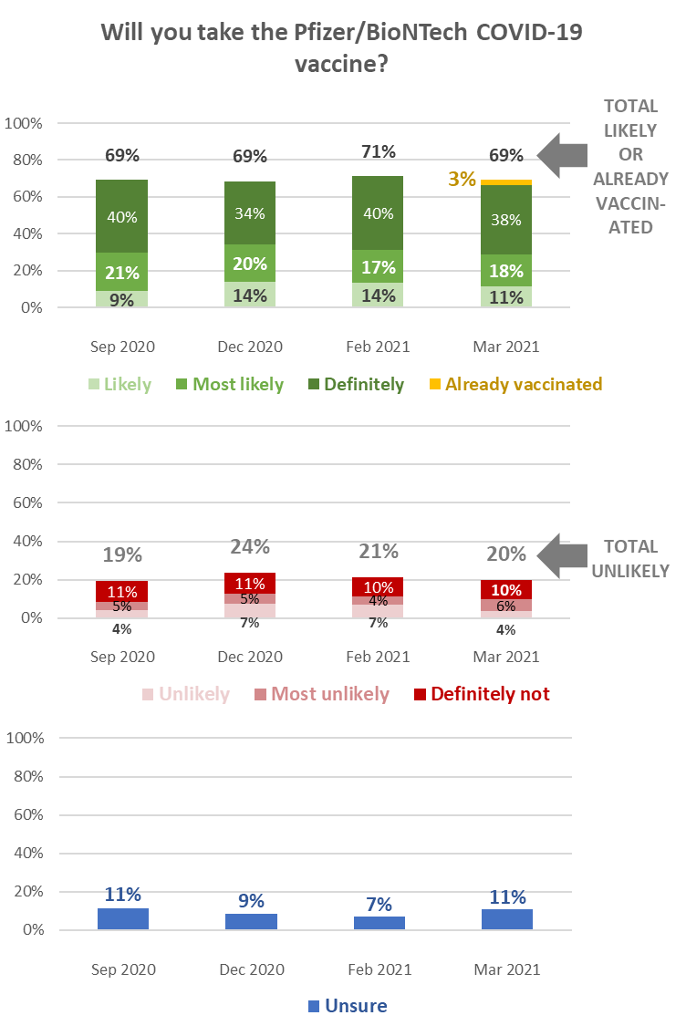

6.2.2 Māori
Māori overall have a similar intention to take a COVID-19 vaccine to the December and February results, but the percentage of those who are unlikely to take a vaccine has dropped from a peak of 27% in December to a below-average 18%. That decline is matched by an increase in those who are unsure, now at an above average 18%.
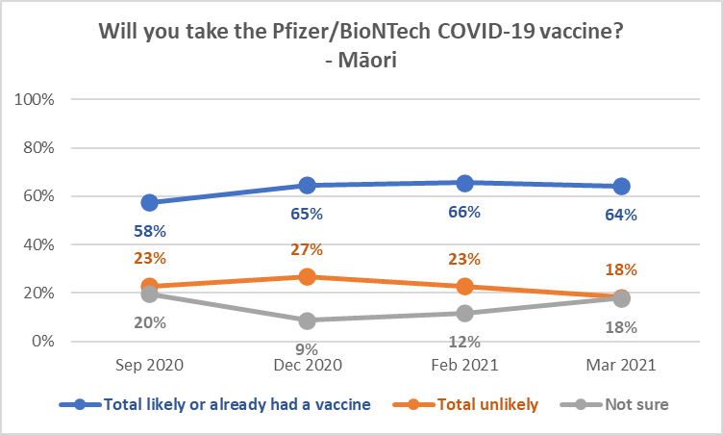
The September and December 2020 and March 2021 measures were part of general population surveys.
The February result is from a Māori-only survey with a larger sample.

6.2.2 Pasifika
Indications are that Pasifika intentions have been quite volatile after an initial high level of willingness to take a vaccine, but the level of those who are likely to take a vaccine appears to have stabilised since December 2020. Note the switch in March with the “Unlikely” level declining and the “not sure” level increasing.

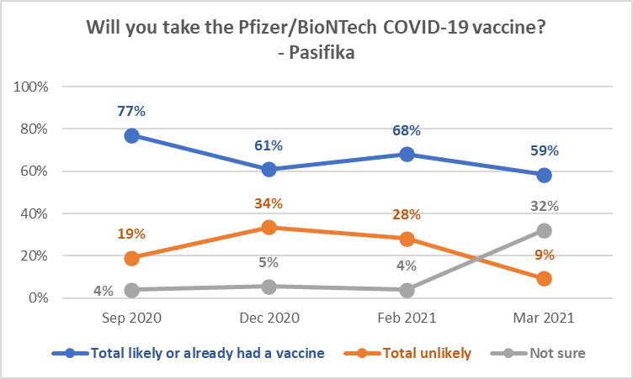

6.2 Information to decide on vaccination
As in February 2021, 56% of respondents overall have mostly or definitely all the information they need to decide whether to take a COVID-19 vaccine.

63% of those who will “Definitely not” take a COVID-19 vaccine either do not need to know more or definitely have all the information they need to make the decision.

Need to know more:
Pasifika are more likely than other ethnic groups to say they need to know more.

Do you feel you have all the information you need before deciding whether or not to take the Pfizer/BioNTech COVID-19 vaccine? | ALL | Ethnic Group
 |  | Asian | Indian | Maori | NZ Euro-pean/ Pakeha | Other Euro-pean | Pasifika | Other
Definitely | 25% | 15% | 23% | 24% | 27% | 26% | 15% | 10%
Mostly | 31% | 31% | 44% | 28% | 31% | 28% | 12% | 25%
Not quite | 17% | 40% | 18% | 19% | 15% | 22% | 36% | 17%
I need to know more | 20% | 10% | 13% | 21% | 21% | 12% | 25% | 6%
I don't need to know more | 7% | 5% | 2% | 8% | 6% | 11% | 11% | 42%
N (unweighted) | 1,294 | 83 | 35 | 250 | 936 | 100 | 42 | 18

Information needs rise as likelihood to take a vaccine decreases – except for those who will “definitely not” take a vaccine. 43% of those who are unsure need more information.

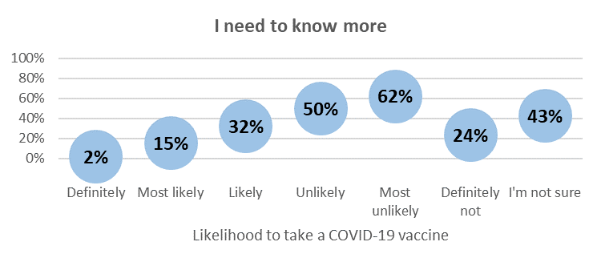

Those who have not definitely made up their minds either way or who are unsure, do not have all the information they seek.

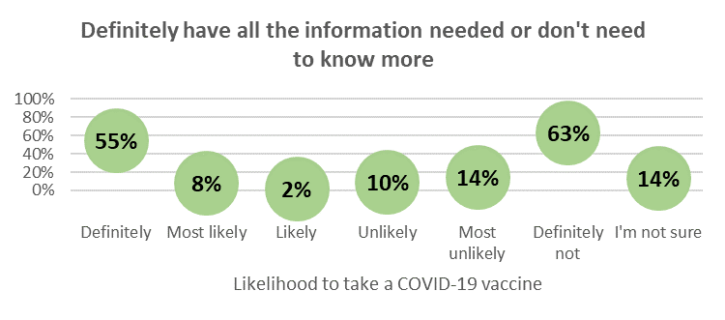

An estimated 301,400 (38%) of the 794,600 who are unlikely to take a COVID-19 vaccine say they either “Definitely” have all the information they need or feel they don’t need to know more – up from 29% in February. Add in those who “mostly” have all the information they feel they need and the estimate rises to 368,900 or 46% - a similar result to February. Because those who say they don’t need to know more or definitely have all the information they need is a higher proportion of the 46% than in February, the implication is that they may be becoming firmer in their determination not to be persuaded to take a vaccine.

This “core” of those who will not be persuaded to take a COVID-19 vaccine is estimated at 9.4% of the 16+ population – a similar result to February.

6.3 Second dose
Respondents who had not yet had a second dose of the Pfizer/BioNTech vaccine or who were “Definitely not” taking a first vaccine dose were asked if they would take the second dose.

Second dose acceptance is closely related to first dose acceptance.

75% were likely to take a second dose. These were primarily people who were likely to take a first dose.

10% were unlikely to take a second dose. These were primarily people who were unlikely to take a first dose, but also included some who were not sure when the Pfizer/BioNTech vaccine would be effective from.

Note that 26% of those who have already had their first dose say they are unlikely to have a second.

Will you take a second dose of the Pfizer/BioNTech vaccine? | ALL | Have you already been offered an opportunity to get your COVID-19 vaccination?
 |  | No | Yes  - I have already had one dose | Yes  - I have not had the first dose, but my appointment is booked | Yes  - but I have not had the first dose and have not booked an appoint-ment yet | Yes,  but I declined to have the vaccine
Definitely | 46% | 48% | 38% | 9% | 28% | 0%
Most likely | 17% | 17% | 10% | 37% | 20% | 0%
Likely | 11% | 11% | 27% | 21% | 21% | 6%
Unlikely | 4% | 3% | 14% | 32% | 7% | 40%
Most unlikely | 6% | 6% | 13% | 0% | 4% | 0%
Definitely not | 1% | 1% | 0% | 0% | 0% | 0%
It depends if I have a reaction to the first dose | 4% | 4% | 0% | 1% | 1% | 0%
I'm really not sure | 11% | 11% | 0% | 0% | 19% | 54%
N (unweighted) | 1236 | 1,135 | 35 | 27 | 33 | 6

6.4 Reasons for not taking a COVID-19 vaccine
Respondents who indicated they were unsure or unlikely to take a COVID-19 vaccine were asked why that was. The rank order of the reasons for not taking a COVID-19 vaccine is unchanged from February.

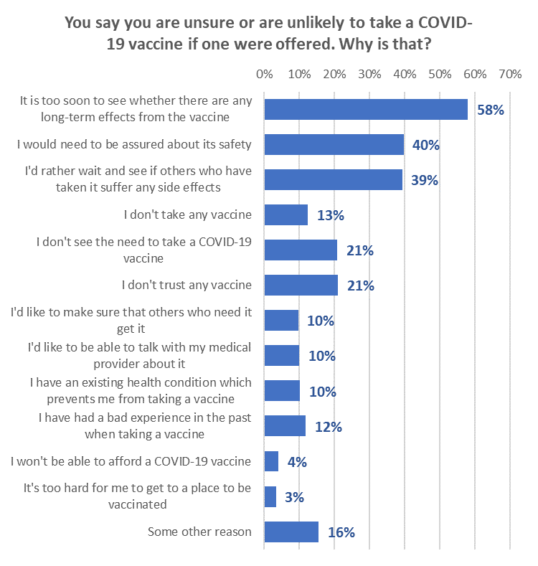

More than half of those who were unsure or unlikely to take a vaccine continue to say they are concerned about long-term effects.

This is particularly the case for those who are “Most unlikely” to or those who will “Definitely not” take a COVID-19 vaccine.

Significant changes
Among those who are unsure or unlikely to take a vaccine, the need to be assured about the vaccine’s safety has declined 11% since December 2020.
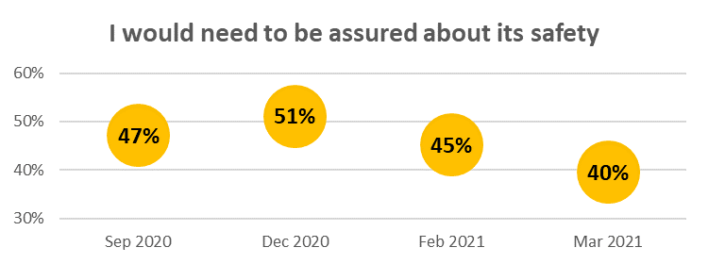

The percentage of those who are unsure, or unlikely to take a vaccine, and who selected “I’d rather wait and see if others who have taken it suffer any side effects”, has declined 9% since December 2020.
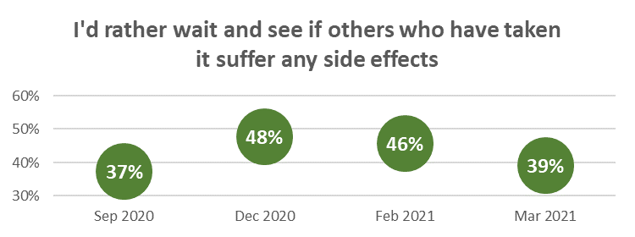

Information about the rollout plan
Respondents who had not yet had a first dose of the Pfizer/BioNTech vaccine were asked what information they needed about the roll-out plan.

As shown in the following chart, respondents overall wanted more information on the vaccine’s side-effects and what would happen if they had an adverse reaction. Those who had “Definitely” decided to take a vaccine were more focused on where, when and how to make an appointment/book for a vaccination, but side-effects and adverse reaction management came into play for all likelihood categories below that.
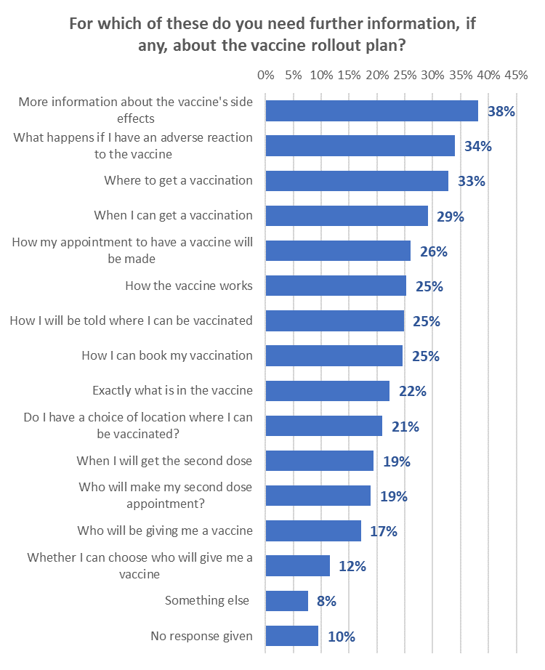
There were some ethnic group differences:
- Māori tended to mirror the overall result
- Pasifika ranked information on how the vaccine worked and what was in the vaccine ahead of where to get the vaccine and who would book their second dose appointment
- Indian respondents ranked how the vaccine worked ahead of where to get the vaccine, what was in it and adverse reaction management
- Asian respondents mirrored the overall result but how the vaccine worked was ranked in 3rd position for this ethnic group
- “Other European” respondents had more logistical concerns, ranking where to get a vaccine, whether they would have a choice of location and how they would be told where they could be vaccinated ahead of side-effects and adverse reaction management.
- Respondents in the “Other” ethnic group tended to mirror the overall result, but with their top 5 information needs ranked in a different order.

Information sources on the Pfizer/BioNTech vaccine
All respondents were asked where they had seen or heard information on the Pfizer/BioNTech vaccine. Note that TVNZ is by far the most important source of such information.

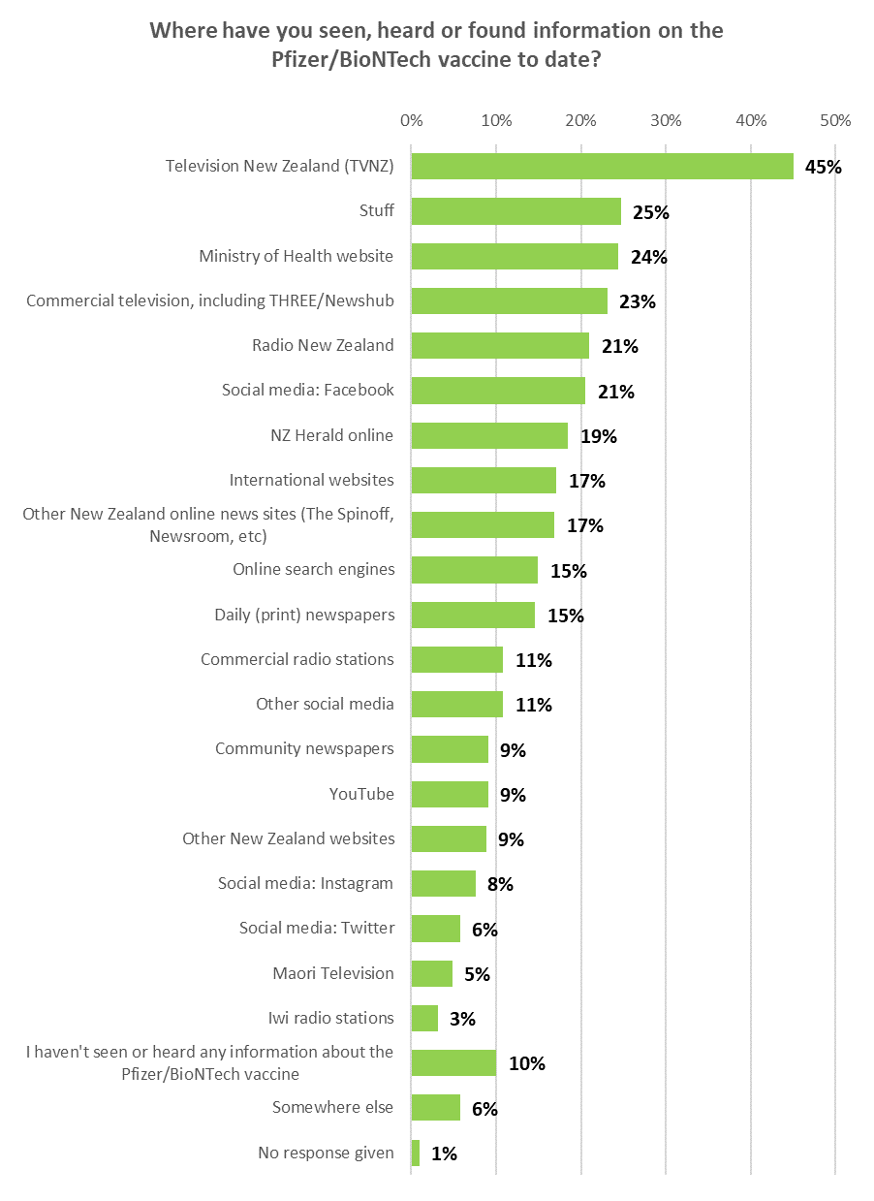

The following table shows the top 10 sources (ranked in order) by ethnic group:

ETHNIC GROUPS
Asian | Indian | Māori | NZ European/ Pakeha | Other European | Pasifika | Other
NZ Herald online | Ministry of Health website | Television New Zealand (TVNZ) | Television New Zealand (TVNZ) | Television New Zealand (TVNZ) | Television New Zealand (TVNZ) | Television New Zealand (TVNZ)
Social media: Facebook | Television New Zealand (TVNZ) | Ministry of Health website | Stuff | International websites | NZ Herald online | YouTube
Ministry of Health website | Other New Zealand online news sites (The Spinoff, Newsroom, etc) | Commercial television, including THREE/Newshub | Commercial television, including THREE/Newshub | Commercial television, including THREE/Newshub | Social media: Facebook | NZ Herald online
YouTube | NZ Herald online | Radio New Zealand | Ministry of Health website | Stuff | Online search engines | Radio New Zealand
Online search engines | Commercial television, including THREE/Newshub | Stuff | Radio New Zealand | Ministry of Health website | Ministry of Health website | Other New Zealand online news sites (The Spinoff, Newsroom, etc)
International websites | Community newspapers | Social media: Facebook | Social media: Facebook | Radio New Zealand | Commercial television, including THREE/Newshub | Social media: Facebook
Other social media | Radio New Zealand | NZ Herald online | International websites | Social media: Facebook | Radio New Zealand | Stuff
Stuff | International websites | Commercial radio stations | Other New Zealand online news sites (The Spinoff, Newsroom, etc) | Other social media | Social media: Instagram | Social media: Instagram
Other New Zealand online news sites (The Spinoff, Newsroom, etc) | Social media: Facebook | Online search engines | NZ Herald online | NZ Herald online | Stuff | Commercial radio stations
Radio New Zealand | Stuff | Other New Zealand online news sites (The Spinoff, Newsroom, etc) | Daily (print) newspapers | Other New Zealand online news sites (The Spinoff, Newsroom, etc) | Other New Zealand online news sites (The Spinoff, Newsroom, etc) | Ministry of Health website

Note that 11% of Māori and 10% of Pasifika were using Māori Television as a source of information on the Pfizer/BioNTech vaccine.

The top 10 sources by likelihood to take a vaccine were as follows. Note that TVNZ is ranked as the top source for all groups except those who are “Unlikely” to take a vaccine, where it ranks second.

Will you take the Pfizer/BioNTech COVID-19 vaccine?
Definitely | Most likely | Likely | Unlikely | Most unlikely | Definitely not | I'm really not sure
Television New Zealand (TVNZ) | Television New Zealand (TVNZ) | Television New Zealand (TVNZ) | Ministry of Health website | Television New Zealand (TVNZ) | Television New Zealand (TVNZ) | Television New Zealand (TVNZ)
Ministry of Health website | Stuff | Social media: Facebook | Television New Zealand (TVNZ) | Ministry of Health website | Social media: Facebook | Social media: Facebook
Stuff | Commercial television, including THREE/Newshub | Commercial television, including THREE/Newshub | Other social media | Commercial television, including THREE/Newshub | Online search engines | Stuff
Radio New Zealand | Radio New Zealand | NZ Herald online | International websites | Radio New Zealand | International websites | Commercial television, including THREE/Newshub
Commercial television, including THREE/Newshub | NZ Herald online | Ministry of Health website | Stuff | Online search engines | Commercial television, including THREE/Newshub | NZ Herald online
Other New Zealand online news sites (The Spinoff, Newsroom, etc) | Social media: Facebook | Stuff | Social media: Facebook | Stuff | Other social media | Other social media
NZ Herald online | Ministry of Health website | International websites | NZ Herald online | International websites | YouTube | International websites
Daily (print) newspapers | Daily (print) newspapers | Radio New Zealand | Radio New Zealand | Commercial radio stations | NZ Herald online | Ministry of Health website
International websites | Other New Zealand online news sites (The Spinoff, Newsroom, etc) | Daily (print) newspapers | Social media: Twitter | NZ Herald online | Ministry of Health website | Radio New Zealand
Social media: Facebook | Online search engines | Online search engines | Social media: Instagram | Other New Zealand online news sites (The Spinoff, Newsroom, etc) | Radio New Zealand | Other New Zealand online news sites (The Spinoff, Newsroom, etc)

Use of official websites
Respondents were asked whether they had used the official websites (the Government’s “Unite against COVID-19” information website and the Ministry of Health website) to get information on COVID-19 or the COVID-19 vaccines in the past 30 days.

29% overall had used the “Unite against COVID-19” information website and 26% the Ministry of Health website in the previous 30 days.

Other European” respondents had lower than average use of both official websites, particularly the “Unite against COVID-19” website.

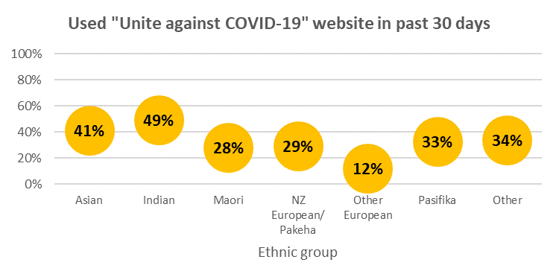

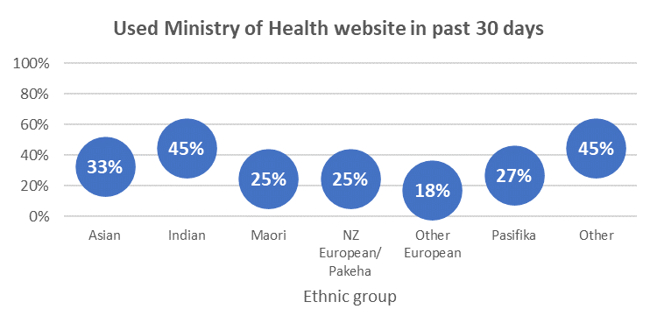

Use of the COVID Tracer app

2.7 million are using the App with an estimated 2.0 million using it “regularly” or “every time”.

1.3 million are not using it, largely because they have not downloaded it (an estimated 1.14 million).
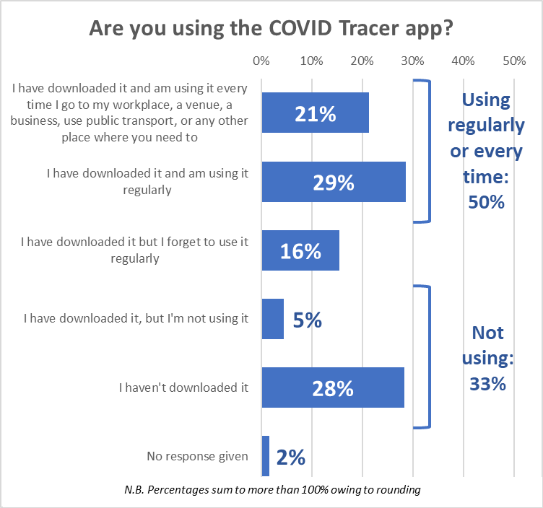

Demographic characteristics of the estimated 1.14 million New Zealanders 16+ who have not downloaded the app are:

- More likely than average to be male
- Average age
- 21% lower household income and 20% lower personal income than average
- Less likely to be in employment; more likely than average to be retired/superannuitants or unemployed/beneficiaries
- More likely than average to have school-level qualifications (primarily NCEA Levels 1 and 2) or no formal school qualification
- Slightly more likely to be living alone
- No particular ethnic differences
- More likely to be living in provincial North Island areas and less likely than average to be living in Auckland.

Demographic characteristics of the estimated 119,500 New Zealanders 16+ who have downloaded the app but are not using it are:

- No gender differences
- 3% younger than average age
- 14% higher than average household income and 54% higher than average personal income
- Significantly more likely to be in employment; more likely than average to be business managers/executives or business proprietors/self-employed
- Significantly less likely than average to have no formal school qualifications but less likely than average to have tertiary qualifications
- Less likely than average to be in a single-person household and slightly more likely to be in a two-parent household with one or two children
- Less likely to be NZ European/Pakeha and slightly more likely to be Māori
- Significantly more likely to be living in Auckland or Otago and less likely to be living in Northland, Waikato or Canterbury.

Effect of social media posts and vaccine side-effects on vaccine decision

11.1 Social media posts
Respondents were asked if they thought their decision to take or not take a well-tested and approved COVID-19 vaccine would be (or was, for those who were already vaccinated) influenced by social media posts.

A nett 16% would not take a vaccine if a social media post or video alarmed them or an anti-vaccine post or video looked credible. Only 1 in 3 of this sub-group would then go on to look for official information.

The effect of social media posts was most pronounced on those who are “Most unlikely” to take a vaccine or will “Definitely not”.

The effect was slightly lower on those who are “Unlikely” and lower still on those who are “Likely” to take a vaccine.

It has less effect on those who will “Definitely” or “Most likely” take a vaccine but they would look for official information if a social media post or video about COVID-19 alarmed them

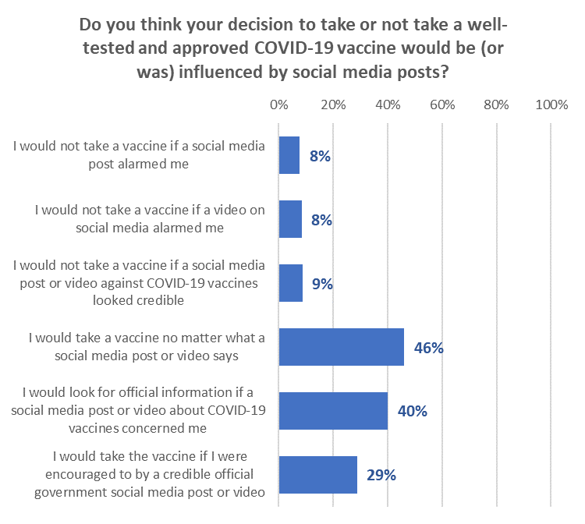

Pasifika people are significantly more likely to be affected by social media, although 50% say they would still take the vaccine no matter what a social media post said. They were the most likely to select “I would take the vaccine if I were encouraged to by a credible official government social media post or video” (40%).

Do you think your decision to take or not take a well-tested and approved COVID-19 vaccine would be (or was) influenced by social media posts? | ALL | Ethnic Group
 |  | Asian | Indian | Māori | NZ Euro-pean/ Pakeha | Other Euro-pean | Pas-ifika | Other
I would not take a vaccine if a social media post alarmed me | 8% | 4% | 4% | 13% | 6% | 5% | 25% | 26%
I would not take a vaccine if a video on social media alarmed me | 8% | 6% | 2% | 13% | 8% | 8% | 25% | 6%
I would not take a vaccine if a social media post or video against COVID-19 vaccines looked credible | 9% | 8% | 9% | 14% | 7% | 5% | 24% | 2%
I would take a vaccine no matter what a social media post or video says | 46% | 17% | 58% | 45% | 47% | 50% | 50% | 47%
I would look for official information if a social media post or video about COVID-19 vaccines concerned me | 40% | 40% | 31% | 37% | 42% | 36% | 30% | 28%
I would take the vaccine if I were encouraged to by a credible official government social media post or video | 29% | 39% | 22% | 24% | 29% | 21% | 40% | 27%
N (unweighted) | 1,269 | 110 | 54 | 320 | 1,226 | 126 | 65 | 26

11.2 Vaccine side-effects
Respondents were asked what their reaction would be if they heard of someone in New Zealand having a serious side effect from taking the Pfizer/BioNTech vaccine.

The effect of hearing about side-effects in New Zealand was most pronounced on those who said they were “Most unlikely” to take a vaccine or would “Definitely not”.

The effect on others is primarily to make them seek more information on the vaccine, but more than half of those who have “Definitely” decided to have the vaccine said it would not change their mind.

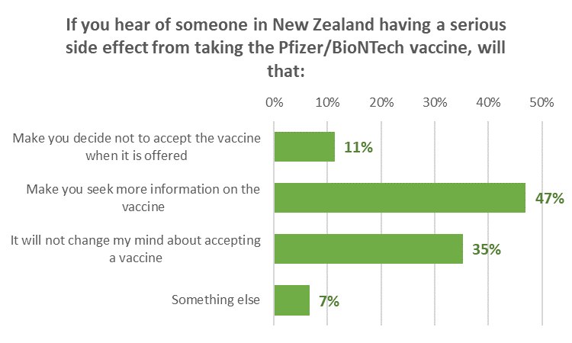

As well as being the most affected by social media posts, indications are that Pasifika people are likely to be the most affected by hearing about someone in New Zealand having a serious side-effect form the vaccine. However, for 44% of them, hearing about a serious side-effect will make them seek more information on the vaccine.

If you hear of someone in New Zealand having a serious side effect from taking the Pfizer/BioNTech vaccine, will that: | ALL | Ethnic Group
 |  | Asian | Indian | Māori | NZ Euro-pean/ Pakeha | Other Euro-pean) | Pasifika | Other
Make you decide not to accept the vaccine when it is offered | 11% | 15% | 8% | 11% | 10% | 10% | 23% | 19%
Make you seek more information on the vaccine | 47% | 59% | 83% | 43% | 47% | 38% | 44% | 25%
It will not change my mind about accepting a vaccine | 35% | 24% | 7% | 40% | 36% | 45% | 23% | 36%
Something else | 7% | 1% | 2% | 6% | 7% | 7% | 10% | 20%
N (unweighted) | 1,307 | 85 | 40 | 245 | 945 | 101 | 44 | 19

Trust
Average overall trust scores for all respondents are steady across all three trust measures.

Average trust across all three measures is higher than the average for those who will “Definitely” take a vaccine and declines to lower than the average with decreasing likelihood to take a vaccine.

Average trust measures compared with February 2021, and for March 2021, by ethnicity and likelihood to take a vaccine are shown below.
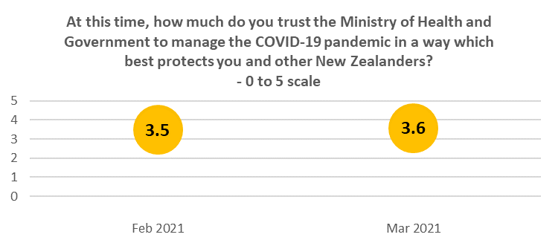
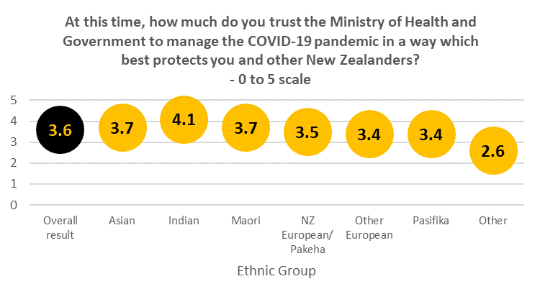
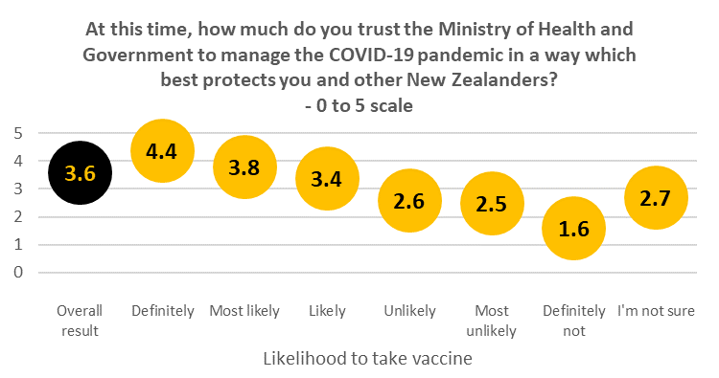

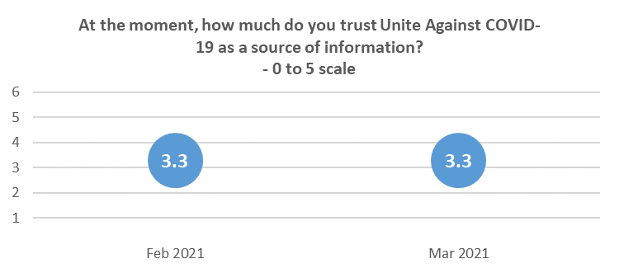
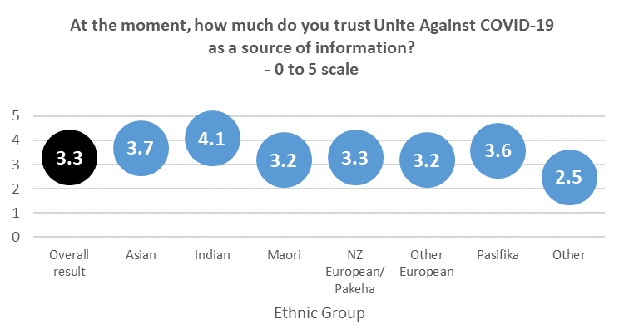
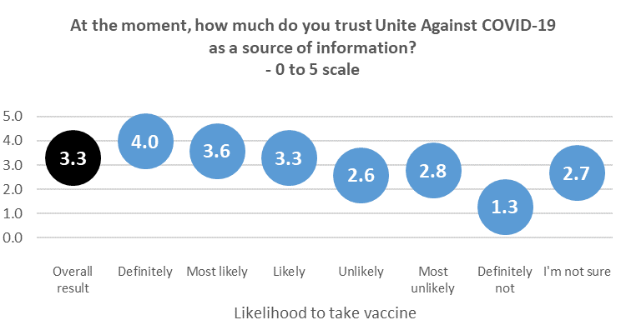

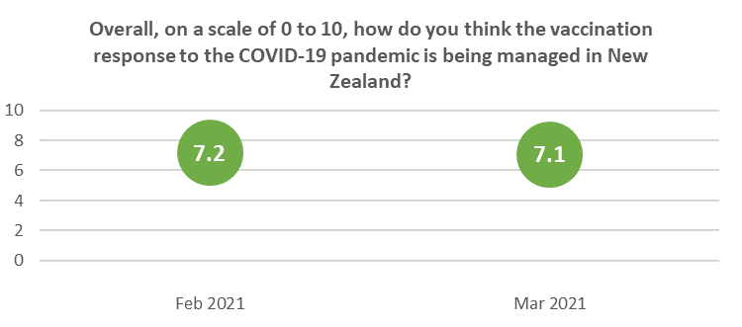
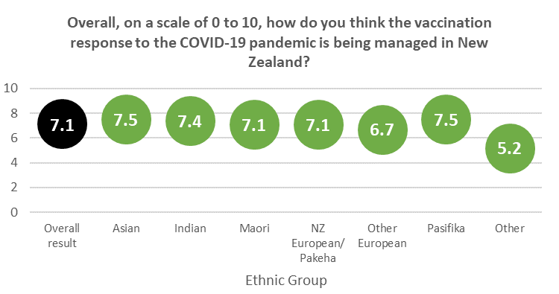
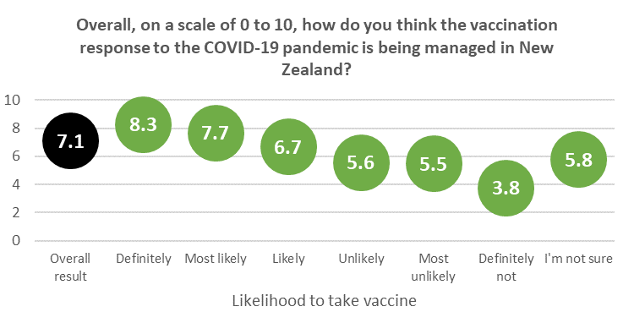

APPENDIX 1 – SAMPLE

1,350 people aged 16+ who are members of the nationwide HorizonPoll and Horizon Research Māori panels and a third-party respondent panel, responded to this online survey between 26 March and 1 April 2021. 16–17-year-olds, competed the survey with parental permission.

The total sample is weighted on age, gender, employment status, highest educational qualification, personal income and region to match the adult population at the most recent census. Although the survey was not specifically weighted on ethnicity, the weighted sample was in line with population ethnic mix.

At a 95% confidence level, the survey has a maximum margin of error of ±2.7% overall.

Contact
For more information about this survey, please contact:

Grant McInman, telephone 021 076 2040, email gmcinman@horizonresearch.co.nz.
Graeme Colman, telephone 021 84 85 76, email gcolman@horizonresearch.co.nz.

Figures quoted may not sum to 100% owing to rounding
Note that this result is within the margin of error for the survey.
Small base

