Horizon Research
COVID-19 Vaccine
26 July - 1 August, 2021

In association with the School of Population Health
University of Auckland

Contents
EXECUTIVE SUMMARY 1
REPORT 12
1. Vaccine Uptake 13
1.1 Unlikely to get a COVID-19 vaccine and difficult to persuade 16
1.2 Uptake by ethnicity 18
1.3 Uptake by people with impairment or who identify as disabled 20
1.4 Uptake by age group 20
1.5 Uptake by DHB 21
1.6 Gains from eventual decision on getting a vaccine 24
2. Second dose uptake 26
3. Importance of everyone in New Zealand who is able to be vaccinated, being vaccinated. 27
4. Making the decision to get a COVID-19 vaccine 30
5. Main influences on vaccine decision 34
6. Reasons for being unsure or unlikely to get vaccinated 39
7. Attitudes of those who have not been vaccinated 43
7.1 When people would most like to get vaccinated 43
7.2 Support for the plan to offer vaccines according to the age groups people are in 44
7.3 Preferences regarding the new national booking system 45
8. Information about the COVID-19 vaccine 48
8.1 Sources of information about the vaccine 48
8.2 Do people have enough information to decide whether or not to take the COVID-19 vaccine? 50
8.3 What else do people need to know to help them decide whether to get the COVID-19 vaccine? 51
8.4 Sources of official information and advertising 59
8.5 Impact of seeing an official COVID-19 vaccine advertisement 61
9. Experiences of those who have already been vaccinated 64
9.1 Did you receive enough information about your vaccination? 64
9.2 How invited to make a booking 64
9.3 How people actually made the booking 65
9.4 Ease of making a booking 66
9.5 Rating the booking experience 70
9.6 Assessing the appointment experience 71
9.7 Rating the care people received when they were vaccinated 73
9.8 Catering for people’s language needs through the process 74
9.9 Catering for people’s disability or impairment needs through the process 75
9.10 Likelihood of recommending vaccination to others 75
9.11 Suggested improvements to the vaccination process 76
10. Preferred information sources 84
11. Access points for COVID-19 vaccine 85
12. Attendance preferences for COVID-19 vaccine 87
13. Attitudes to children aged 12 to 17 being vaccinated 88
13.1 Would you allow the children for whom you are the primary caregiver to take the vaccine? 88
13.2 Reasons for being unsure or unlikely to encourage COVID-19 vaccination for younger people 91
14. Trust in the management of the pandemic and rating of the vaccination response 94
14.1 Management of the pandemic 94
14.2 Management of the vaccination response 95
APPENDIX 1 - SAMPLE 98
APPENDIX 2 -PROFILE BY LIKELIHOOD TO GET A COVID-19 VACCINE 100
APPENDIX 3 - TABLES Attached

EXECUTIVE SUMMARY
These results are from an online survey of 2,509 New Zealand respondents aged 16 years of age or over. The survey was conducted between 26 July and 1 August, 2021.

The sample is weighted on age, gender, employment status, ethnicity, personal income and region to match the 16+ population and at the most recent census. It is also weighted to reflect the overall percentage of New Zealanders 16+ vaccinated as at 11:59pm on 1 August 2021.

At a 95% confidence level, the survey has a maximum margin of error of ±2.0% overall.

Note that the sample was increased from a target of 1,000 respondents for all surveys up to June 2021, to a target of 2,000 respondents for this survey. Subsequent surveys on COVID-19 vaccines will remain at this level.

KEY FINDINGS

Already vaccinated
- After weighting, the sample contained 29.2% of respondents 16+ who had already been vaccinated (an estimated 1,193,300 New Zealanders 16+). This is within 0.21% of the official Ministry of Health figure of 1,195,824 New Zealanders vaccinated as at 11:59pm on 1 August, 2021.

Uptake
Of those who have not yet been vaccinated
- 71% said they were likely to get a vaccine (72% in June, 77% in May, 75% in April, 67% in March 2021). This is around 2,049,200 New Zealanders 16+.
- 20% said they were unlikely to get a COVID-19 vaccine. This is around 573,700 New Zealanders 16+ (19% in June: estimated at 650,100 people)
- 9% (an estimated 270,400 New Zealanders 16+) are unsure whether they will get a vaccine or not (9% in June: estimated at 302,600 people).

Converting these figures to the total 16+ population:
- Including those who had already been vaccinated, overall potential uptake is estimated at 79% (77% in June, 80% in May, 77% in April and 69% in March 2021). The differences from the June, May and April results are not statistically significant and, as in June, the overall result should be regarded as “no change”.

Overall, it is projected that 3,242,500 out of the 4,086,600 New Zealanders aged 16+ are likely to get vaccinated or have already been vaccinated.

- 14% of respondents (an estimated 573,700 New Zealanders 16+) were unlikely to get vaccinated (June 16%, May 13%, April 12%). The apparent decrease is not statistically significant.

- Those who are unsure was steady on 7% overall (estimated 274,400).

- The “core” of those who are unlikely to get vaccinated and will be difficult to persuade to get a COVID-19 vaccine has fallen to 9.0% of those aged 16+ population who are yet to get a vaccine (11.6% in June, 7.0% in May, 8.4% in April and 9.4% in March 2021), equivalent to 7.4% of the total 16+ population.

- There is the potential to achieve additional gains in uptake. Respondents who were not definitely intending to get a vaccine were asked if they thought they would eventually get one or not. Analysis shows that:

  - There is an incremental gain from the “unsure or unlikely” group of 2.5% of the 16+ population, or around 100,500 people, who may eventually decide to get a vaccine.

  - From those who were unsure whether they would eventually get a COVID-19 vaccine or not, there is a potential loss among those who are currently likely to get a vaccine of 1.8% - an estimated 75,200 people.
  - There is a potential gain of 10.3% from those who are currently unlikely to get a vaccine – an estimated 422,100 people. This includes nearly 3 out of 10 of those who said they had been offered a COVID-19 vaccine but had declined it.

Achieving that gain - and minimising the loss - relies on convincing all those who are unsure whether they will eventually get a vaccine, that they should get one.

- Note that caregivers of 16–17-year-olds are only likely to allow 67% of those in their care to get a vaccine. Uptake in that age group is therefore likely to be lower than shown in Section 1 of this report by around 11% or 13,660 young people.

- Total Māori uptake aged 16+ is estimated at 73% (±4.5%). Total Pasifika uptake 16+ is estimated at 72% (±7.8%).
- 99% of those who had one dose were likely to get a second (89% “Definitely”), the same overall result as June 2021. Only 1% said they were unlikely to get a second.
- 95% said they had been provided with enough information prior to their vaccination (June 93%, May 92%).

- 81% overall of those who have either not been vaccinated or have only had one dose are likely to get a second dose (June 81%, May 82%).

Importance of everyone in New Zealand who is able to be vaccinated, being vaccinated.
- 82% overall felt that it was important that everyone in New Zealand who was able to be vaccinated, was vaccinated (“very important” 59%; “important” 15%; “somewhat important” 8%).
- 10% overall felt that it was unimportant; 8% were unsure.

- By ethnicity, the percentages who felt vaccination was important were:
  - Asian: 89%.
  - Indian: 90%.
  - Māori: 81%.
  - NZ European/Pākehā: 81%.
  - Other European: 80%.
  - Pasifika: 75%.
  - “Other”: 88%

Vaccination status
- The vaccine had been offered to 57% of the respondent sample (2,329,400 New Zealanders). Of the sample:
  - 19.2% had received two doses and 10.0% had received one dose, a total of 29.2% of the 16+ population who had had at least one dose.
  - 13% were booked to be vaccinated (5% in May).
  - 10% had been offered the vaccine, had not turned it down but had not yet booked. These people were more in vaccine group 3.
  - 5% said they had declined the vaccination; the highest percentage of these people was in vaccine group 2.

In making a decision to get vaccinated, New Zealanders will think about:
- Whether there will be unknown side effects (36%; June 40%; May 37%).
- How the side effects may affect them (34%; June 37%, May 31% in May; April 35%)
- Concern that the vaccine may not be effective against new variants (29%). This was a new option introduced because of respondents’ comments in the June survey.
- What might happen if they have an adverse reaction to the vaccine (25%; June 29%; May 27%; April 28%).
- Whether the vaccine might affect their health in other ways (24%; June 30%; May 28%; April 26%).

- 16% selected another new option: “I worry that without the vaccine I might get a more infectious new strain of COVID-19”.
- 34% thought it was too soon to see whether there were any long-term effects from the vaccine.

Vaccine effectiveness against new variants is clearly playing on New Zealanders minds. Levels of concern that the vaccine may not be effective against new variants are shown below by likelihood to get a vaccine and age group (arrows denote 5% above or below overall result).

Thought | LIKELIHOOD TO GET VACCINE
 | Definitely | Most Likely | Likely | Unlikely | Most Unlikely | Definitely not | Unsure
I am concerned that the vaccine may not be effective against new strains of the virus | 26% | 37% ↑ | 24% ↓ | 33% | 51% ↑ | 25% | 35% ↑

Thought | AGE GROUP
 | 16-17 years | 18-24 years | 25-34 years | 35-44 years | 45-54 years | 55-64 years | 65-74 years | 75 years or over
I am concerned that the vaccine may not be effective against new strains of the virus | 27% | 19% ↓ | 29% | 28% | 35% ↑ | 38% ↑ | 29% | 22% ↓

Main influences on vaccine decision
This question, which has been tracked since December 2020, was modified for the July survey to elicit the top 3 things that respondents who had not yet been vaccinated regarded as most influential in their decision-making.

Based on their responses, the key influences were:
- Has been through extensive, properly conducted, clinical trials (23% overall).
- Helping protect the health of my family/whānau and those closest to me (21% overall).
- Helping to end the COVID-19 pandemic more quickly (21% overall).
- Helping to protect all New Zealanders (21% overall).
- The benefits of taking the vaccine would outweigh any risks (20% overall).
- Information about side-effects (20% overall).
- Helping reduce the risk of COVID-19 infection and the prospect of further lockdowns and economic harm (20% overall).
- Doing the best thing for my own health (19% overall).
- Being vaccinated will protect me from the effects of COVID-19 (18% overall).

Note that the key influences were in different orders for various demographic groups and for the various likelihoods to get a vaccine.

Reasons for being unsure or unlikely to get a vaccine
The three main reasons for people to be unsure, unlikely or opposed were the same as in June May and April 2021:
- Believing it is too soon to know if there are long-term effects (62%, up from 59% in June).
- Needing assurance of the vaccine’s safety (46%, up from 39% in June).
- Wanting to wait and see if others suffer side effects (41%, 41% in June).
A new reason added to the list was “The vaccine may not be effective against new variants”. This was included as a result of comments in the June survey and ranked in fourth position, on 31%.

When would New Zealanders like to get a vaccine?
- 20% of those who had not yet been vaccinated wanted to get vaccinated immediately.
- 46% want to be vaccinated by September (an estimated 1,316,500 New Zealanders 16+).

Support for the planned age group rollout in Group 4
There has been a slight softening of support for the plan to offer vaccines by age group: 60% now support this plan compared with 65% in June. 24% say they “neither support nor oppose” the plan, with 9% opposed and 5% unsure.

Invitations to make a vaccine booking – those who have not yet been vaccinated
As in the June survey, the two most preferred ways to receive booking information in July are by email (67%) and text (59%).

Comparing the results with the June 2021 survey, text messaging has gained support while email and telephone calls have both lost support.

Preferred way to make a booking
The most-preferred method to make a booking to get a vaccine is booking online although this result dropped a little compared with the June survey (59% in July cf. 64% in June).

As in the June survey, all age groups prefer online over telephone. However, online preference drops and telephone preference increases as people get older.

Vaccine preferences
- People would prefer to access a COVID-19 vaccine from:
  - Their doctor (general practitioner) (65%; June 70%; May 68%).
  - Practice nurse (33%; June 39%, May 39%).
  - A 'pop-up' vaccination clinic (e.g., malls, shopping centres, schools) (28%; June 28%; May 35%).
  - A pharmacy (26%; June 28%; May 24%).
  - A hospital (23%; June 23%; May 25%).
  - A District Health Nurse (20%; June 21%, May 21%).
  - At their workplace (16%; June 17%; May 16%).

- They would prefer to go for their vaccination:
  - On their own (42%).
  - At the same time as other members of their whānau/ family regardless of the age of the members of their whānau/family, or the respondent’s age (38%, or 65% of those who did not prefer to go on their own).
  - At the same time as those for whom they provide care or support, regardless of the age of the people they provide care or support for, or the respondent’s age (12%, or 21% of those who did not prefer to go on their own).
  - Where a respondent was 17 or under, to go at the same time as their parents (3% overall, 46% of those aged 16-17).

Note that going alone for a COVID-19 vaccination was included as an option in this survey, unlike the approach used in June.

Vaccination of 16–17-year-olds and 12–15-year-olds
- 71% of primary caregivers of children aged 16-17 years are likely to allow the young adults to be vaccinated.
- 67% of caregivers of children aged 12-15 years are likely to allow their young people to be vaccinated (May 55%).
- Māori were less likely than average to allow their 16–17-year-old taiohi to get a COVID-19 vaccine but more likely than average to allow their 12–15-year-old tamariki to get vaccinated.
- Pasifika and “Other European” respondents were the least likely to allow the 12–15-year-olds for whom they were the primary caregiver to be vaccinated. Pasifika were the most unsure about allowing their 16–17-year-olds to be vaccinated.
- As in May and April, the key concerns for those who won’t allow vaccination for their young people are vaccine safety and long-term effects.

Do those who are yet to get a vaccine have all the information they need to make a decision on getting a COVID-19 vaccine?
- 38% said “Definitely” (June 37%; May 35%; April 27%). These people are primarily those who will “Definitely” get a COVID-19 vaccine (62%) or those who will “Definitely not” (34%).
- 30% said “Mostly” (June 33%; May 32%; April 31%).
- 13% said “Not Quite” (June 13%; May 17%; April 18%).
- 13% said “I need to know more” (June 12%; May 14%; April 21%). As in May, those who need to know more are primarily those who say they are “Likely” (21%), “Unlikely” (36%) or “Most Unlikely” (44%) to get a COVID-19 vaccine; i.e., not definite either way.
- 6% say they don’t need to know more, (June 6%; May and April 3%). As reported in June, these are primarily those who will “Definitely not” get a vaccine (27%). Note that 60% of those who will “definitely not” get a vaccine either “definitely” have all the information they need or “don’t need to know more”.

Qualitative: From analysis of an open-response question, the two main things people said they need to know are:
- Information on side effects and risks (34%; June 26%; May 26%).
- Information on the long-term effects of the vaccine, based on longer and/or more clinical studies (19%; June 17%; May 16%).

The requirement for information on safety is growing; this is a characteristic of the group who are currently unlikely to get a vaccine, and as more of those who are likely to get a vaccine are actually vaccinated, the percentage of people not yet vaccinated who require information on vaccine safety is expected to grow.

Experiences of those who have already been vaccinated
Respondents who had been vaccinated at least once were asked a series of question on their experience. As the percentage of the population vaccinated grows, it is recommended that in future surveys these questions be asked only of those who have been vaccinated in the past 30 days.

- The two main ways people were invited to be vaccinated were through work (23%) and by text (20%).
- The two most common ways to book a vaccine were by phone (39%) and online (24%). Note that the release of “Book my Vaccine” on 28 July occurred in the middle of the survey period.
- The proportion who found booking easy increased to 92% in July from 85% in the June survey. Conversely, those who found booking difficult decreased from 15% to 8%.
- The top 3 reasons respondents had found booking difficult were:
  - Having to call the booking number more than once (32%).
  - Not being sent information on how to make a booking (29%)
  - Hard to find information on how to make a booking (29%).
- The top 3 reasons respondents had found booking easy were:
  - Getting the time and place that people wanted (34%).
  - Being easy to book the second dose (31%).
  - Easy to book by phone and the online system worked well (both 28%).

- The top 3 positive appointment experiences reported were:
  - Friendly people (71%).
  - Ease of getting to the centre (61%).
  - No trouble finding my booking (63%).
- By contrast, the most negative experience was centre staff not knowing who the person was (13%).

- On average, respondents rated:
  - The booking experience: 8.0 out of 10.
  - The booking experience: 8.4 out of 10.
  - The location of the vaccination centre: 8.7 out of 10.
  - The way in which the vaccination centre was laid out: 8.8 out of 10.
  - The staff I saw when I first arrived: 9.0 out of 10.
  - Finding my booking details: 8.9 out of 10.
  - The person who vaccinated me: 9.3 out of 10.
  - The way in which I was monitored after I had been vaccinated: 9.1 out of 10.

- 96% of those who had been vaccinated reported their language needs had definitely or mostly been met. By ethnicity, the results were:
  - Asian: 95%.
  - Indian: 83%.
  - Māori: 95%.
  - NZ European/Pākehā: 97%.
  - “Other European”: 96%.
  - Pasifika: 95%.
  - “Other”: 69%.

- 80% of those who said they lived with impairments or health conditions said that had been taken into account during the vaccination process.
- 72% of those who identified as disabled said their disability had been taken into account during the vaccination process.
- As a result of their vaccination experience:
  - 68% overall said they were more likely to recommend vaccination to others.
  - 31% said it made no difference.
  - 3% said they were less likely to recommend vaccination to others.

- 42% were very happy with their experience and had no suggestions for improvement.
- 25% had improvement suggestions for the vaccination centres.
- 19% had suggestions for booking system improvements.

Respondents who have not yet been vaccinated say that the best ways to get COVID-19 vaccine information to them are:
- Email (54%; June 60%; May 51%).
- Website (36%; June 47%; May 48%).
- Text (30%; June 27%; May 21%).
- TV News (27%; June 25%; May 30%).
- Social Media (22%; June 23%; May 23%).
- News media online (20%; June 22%; May 30%).
- Printed information delivered in their letterbox (15%; June 20%; May 27%).
- TV advertisements (14%; June 15%; May 16%).

There is limited change to where information on the COVID-19 vaccine has been seen or heard in the past 30 days, although television (both TVNZ and THREE/Newshub) has declined:
- Television New Zealand (39%; June 43%; May 44%).
- Facebook (29%; June 30%; May 25%).
- Ministry of Health website (28%; June 25%; May 29%).
- Stuff (27%; June 29%; May 29%).
- Unite Against COVID-19 website (25%; June 21%; May 22%).
- Commercial television, including THREE/Newshub (24%; June 28%; May 24%).
- NZ Herald online (17%; June 20%; May 17%).
- YouTube (17%; June 15%; May 12%).
- Radio New Zealand (19%; May19%).
- Online search engines (15%; June 16%; May 13%).
- Commercial radio stations (13%; June 16%; May 13%).
- Other New Zealand websites (13%; June 9%; May 9%).
- Daily (print) newspapers (12%; June 14%; May 17%).

Official COVID-19 advertising:
- 89% of all respondents said they had seen an official COVID-19 information and vaccine advertisement in the past 30 days.
- 64% of respondents had seen an official COVID-19 advertising on television in the past 30 days (June 62%; May 59%). Other media were:
  - Social media (34%: June 33%; May 20%).
  - Radio (29%; June 26%; May 19%).
  - News websites (24%; June 22%; May 15%).
  - On demand television (18%: June 16%; May 12%)
  - YouTube (18%; June 19%; May 10%).
  - Newspapers – daily (17%; June 22%; May 15%).

The percentage who said the advertising had increased their likelihood to get a vaccine increased to 18% from 11% in June (May: 20%).

Where an official advertisement had been seen the greatest impact was to reinforce the decision made, or being made, to get a COVID-19 vaccine:
- “Made me feel I made the right decision to get the vaccine” (34%; June and May 31%). As in June and May, this was the primary reaction from those who had already been vaccinated.
- “I have already decided to get a vaccine and the advertisements made me feel better about that” (11% 14%, May 18%).

A nett 43% (June 46%; May 31%) said the advertising made no difference to their decision:
- Made no difference to the way I feel about getting had the vaccine: 32% (June 33%; May 30%).
- Made no difference to the decision I will make to get or not get a vaccine: 18% (June 21%; May 23%.)

13% said the advertising they had seen made them at least “more likely” to get a vaccine (June 8%; May 12%). As in May, this was primarily those who had said they were likely to get vaccinated. A further 5% said that it had made them “slightly more likely” to get a vaccine.

The advertising had made 2% (June 3%) of those who said they were currently “unlikely” to get a COVID-19 vaccine slightly more likely to get a vaccine.

Trust in the management of the pandemic and rating the vaccination response
- Average trust in the Ministry of Health and Government to manage the pandemic has dropped. 76% now say they trust the Ministry of Health and Government (May 81%):

At this time, how much do you trust the Ministry of Health and Government to manage the COVID-19 pandemic in a way which best protects you and other New Zealanders? | Feb 2021 | Mar 2021 | Apr 2021 | May 2021 | June  2021 | July 2021
Average trust out of 5 | 3.5 | 3.6 | 3.8 | 3.7 | 3.5 | 3.6

- July’s average rating of the vaccination response (on a scale of 0 to 10, 10 being highest) halted the ongoing declining trend (although the apparent improvement in comparison with June is not statistically significant).

Overall, on a scale of 0 to 10, how do you think the vaccination response to the COVID-19 pandemic is being managed in New Zealand? | Feb 2021 | Mar 2021 | Apr 2021 | May  2021 | June  2021 | July 2021
Average rating out of 5 | 7.2 | 7.1 | 7.1 | 6.6 | 6.1 | 6.4

REPORT
Respondents were asked if they had been offered an opportunity to get their COVID 19 vaccine (note that this survey is weighted to reflect the overall percentage of New Zealanders vaccinated in the general population as at 11:59pm on Sunday, 1 August, 2021). The responses indicate that the rollout is ramping up:

Have you already been offered an opportunity to get your COVID-19 vaccination? | May 2021 | June 2021 | July 2021 | Difference  % points
No | 77% | 69% | 43% | - 26 ↓
Yes - I have already had two doses | 6% | 11% | 19% | +8 ↑
Yes - I have already had one dose | 7% | 7% | 10% | +3 ↑
Yes - I have not had the first dose, but my appointment is booked | 5% | 6% | 13% | +7 ↑
Yes - but I have not had the first dose and have not booked an appointment yet | 4% | 4% | 10% | +6 ↑
Yes, but I declined/will decline to have the vaccine | 2% | 3% | 5% | + 2 ↑
N.B. Percentages shown may not sum to 100% owing to rounding

8% overall (an estimated 306,500 New Zealanders 16+) did not know what Vaccine Group they were in.

July 2021 vaccination levels by Vaccine Group as identified by respondents.
Total:
July 2021: 11%
June 2021: 5%
Total:
July 2021: 48%
June 2021: 25%
Total:
July 2021: 77%
June 2021: 72%
Total: ‘
July 2021: 77%
June 2021:60%
N.B. Figures may not sum to totals shown owing to rounding

Respondents were asked if they lived with impairments or long-term health conditions and if they identified as disabled.

In percentage terms, results were similar to the June, May and April 2021 findings:
10% (an estimated 425,000 adults) identified as disabled.

Response | Do you live with impairments or long-term Health conditions? |  | Do you identify as Disabled?
 | Impairment | Estimated number | Disability | Estimated number
Yes | 38% | 1,561,100 | 10% | 425,000
No | 62% | 2,525,500 | 90% | 3,661,600

Vaccine Uptake
Of those who have not yet been vaccinated (70.7%% of the 16+ population):
- 71% said they were likely to get a vaccine (72% in June, 77% in May, 75% in April, 67% in March 2021). This is around 2,049,200 New Zealanders 16+.
- 20% said they were unlikely to get a COVID-19 vaccine. This is around 573,700 New Zealanders 16+ (19% in June: estimated at 650,100 people)
- 9% (an estimated 270,400 New Zealanders 16+) are unsure whether they will get a vaccine or not (9% in June: estimated at 302,600 people).

Converting these figures to the total 16+ population:
- Including those who had already been vaccinated, overall potential uptake is estimated at 79% (77% in June, 80% in May, 77% in April and 69% in March 2021). The differences from the June, May and April results are not statistically significant and, as in June, the overall result should be regarded as “no change”.

Overall, it is projected that 3,242,500 out of the 4,086,600 New Zealanders aged 16+ are likely to get vaccinated or have already been vaccinated.

- 14% of respondents (an estimated 573,700 New Zealanders 16+) were unlikely to get vaccinated (June 16%, May 13%, April 12%). The apparent decrease is not statistically significant.

- Those who are unsure was steady on 7% overall (estimated 274,400).

Total population 16+ trends are presented below:

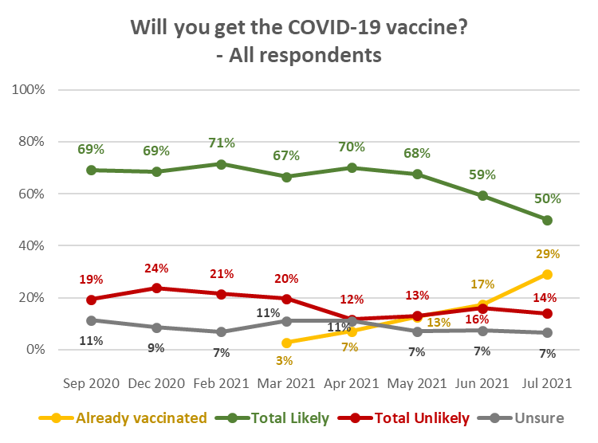
N.B. Percentages shown in this chart may not sum to 100% owing to rounding

The following are overall estimates of the COVID-19 vaccine intentions of the estimated 2,893,300 New Zealanders 16+ who have not yet been vaccinated:

COVID-19 vaccine intention | May 2021  % | June 2021  % | July 2021  % | July 2021  Estimated number of people 16+
Definitely | 48% | 48% | 47% | 1,356,500
Most likely | 20% | 16% | 14% | 405,700
Likely | 9% | 8% | 10% | 287,000
Unlikely | 4% | 3% | 4% | 122,900
Most unlikely | 4% | 6% | 5% | 139,300
Definitely not | 7% | 10% | 11% | 311,500
Unsure | 8% | 9% | 9% | 270,400

Profiles: “Total Likely”, “Total Unlikely”, and “Unsure”
The following table shows demographic characteristics of those who were not yet vaccinated and were “likely” and “unlikely” to get a COVID-19 vaccine or were not sure, to aid communications targeting. Note that these demographic characteristics are dynamic: they are likely to change as more people become vaccinated.

DEMOGRAPHY | Total Likely  to get a vaccine  (not yet vaccinated) | Total Unlikely  to get a vaccine  (not yet vaccinated) | Not sure whether  to get a vaccine  (not yet vaccinated)
Gender | Marginally more male (50%) than average | Slightly more female (55%) than average | Significantly more female (63%) than average
Age | 11% younger than average age | 6% younger than average age | 8% younger than average age.
Household Income | 7% higher than average | 17% lower than average | 1% lower than average
Personal Income | 1% higher than average | 16% lower than average | 6% lower than average
Employment status | Average | Significantly less likely to be employed | Average
Highest qualification | No particular educational characteristics. | Less likely than average to have tertiary-level qualifications and more likely than average to have no formal school qualifications. | Less likely than average to have tertiary-level qualifications and more likely than average to have school-level qualifications.
Household Type | More likely than average to be in a two-parent family with one or two children at home; less likely than average to be in a couple-only household.  More likely than average to have children in their household. | More likely than average to be in a two-parent family with three or more children at home. Slightly less likely than average to be in a couple-only household.  More likely than average to have children in their household. | Less likely than average to be in a couple-only household.
Ethnic group | Slightly less likely than average to be Māori. | Slightly less likely than average to be Asian or Indian. | No particular ethnic group characteristics.
DHB | Less likely than average to be in the upper North Island (from Taupo north, excluding Auckland), particularly the Northland DHB area. No other particular differences from the overall sample. | No particular differences from the overall sample. | Less likely than average to be in the Waitematā, Auckland and Capital and Coast DHB area. More likely than average to be in the upper North Island (from Taupo north, excluding the Auckland region),
Area Type | More likely than average to be in Large Cities. | More likely than average to be living in a Rural area. | Less likely than average to be in Large Cities. Slightly more likely than average to be in Regional Towns.
Vaccine Group | Less likely to be in Vaccine Groups 1, 2 and 3 or unsure of which Vaccine Group they are in. More likely than average to be in Vaccine Group 4. | Significantly more likely to be in Vaccine Group 4 or unsure of which Vaccine Group they are in. Less likely than average to be in Vaccine Groups 1, 2 or 3. | More likely than average to be unsure of which Vaccine Group they are in. Less likely than average to be in Vaccine Groups 2 or 3.

Note that:
- As in June, May and April 2021, living with impairments or long-term health conditions, or identifying as disabled, does not make a major difference to potential vaccine uptake.
- The highest percentage unlikely to get vaccinated occurred where the respondents were not sure which Vaccine Group they were in and among those in Vaccine Group 4, as shown below.

Will you get the COVID-19 vaccine?  (Including those who have been vaccinated) | ALL | VACCINE GROUP
 |  | Group 1 | Group 2 | Group 3 | Group 4- | Not sure
Definitely | 33% | 7% | 9% | 30% | 42% | 19%
Most likely | 10% | 4% | 4% | 5% | 15% | 7%
Likely | 7% | 0% | 4% | 5% | 9% | 8%
Unlikely | 3% | 2% | 2% | 2% | 3% | 7%
Most unlikely | 3% | 1% | 0% | 2% | 5% | 6%
Definitely not | 8% | 2% | 3% | 4% | 8% | 26%
I'm not sure | 7% | 7% | 3% | 5% | 7% | 14%
Already vaccinated | 29% | 77% | 77% | 48% | 11% | 13%
TOTAL LIKELY plus ALREADY VACCINATED | 79% | 89% | 92% | 88% | 77% | 47%
TOTAL UNLIKELY | 14% | 5% | 5% | 7% | 17% | 39%
N (unweighted) | 2,509 | 105 | 244 | 827 | 1,174 | 159

1.1 Unlikely to get a COVID-19 vaccine and difficult to persuade
A decline in the estimated number of people who are unvaccinated and say they are unlikely to get a vaccine has led to a reduction in the “core” who will be difficult to persuade, to 7.4% of the total 16+ population.

An estimated 237,200 (41%) of the 573,700 who are unlikely to get a COVID-19 vaccine say they either “Definitely” have all the information they need or feel they don’t need to know more. The comparable estimates in the past three surveys were 291,600 in June, 168,900 in May, 267,000 in April and 301,400 in March 2021.

Add those who “mostly” have all the information they feel they need and the estimate rises to 303,900 or 53% of those who are unlikely to get a vaccine (estimated at 392,400 in June, 249,300 in May, 320,000 in April and 368,900 in March 2021).

This “core” of those who will probably be difficult to persuade to get a COVID-19 vaccine has fallen to 9.0% of those aged 16+ who are yet to get a vaccine (11.6% in June, 7.0% in May, 8.4% in April and 9.4% in March 2021), equivalent to 7.4% of the total 16+ population.

The demographic characteristics of this “difficult to persuade” group are shown below, compared with the demographic characteristics of all who are unlikely to get a COVID-19 vaccine. They key differences are:

- They are more male (55%) than female.
- They are more likely to be living alone.
- They have lower average personal income.

DEMOGRAPHY | “Difficult to persuade”  group | Total Unlikely  to get a vaccine
Gender | More female (56%) than average. | Slightly more female (55%) than average
Age | 8% younger than average age. | 6% younger than average age
Household Income | 22% lower than average. | 17% lower than average
Personal Income | 16% lower than average. | 16% lower than average
Employment status | Significantly less likely than average to be employed, particularly employed in senior roles. | Significantly less likely to be employed
Highest qualification | Less likely than average to have degree qualifications and more likely than average to have vocational qualifications. | Less likely than average to have tertiary-level qualifications and more likely than average to have no formal school qualifications.
Household Type | More likely than average to be in a single person household and less likely to be in a couple-only household.  More likely than average to have children in their household. | More likely than average to be in a two-parent family with three or more children at home. Slightly less likely than average to be in a couple-only household.  More likely than average to have children in their household.
Ethnic group | Less likely than average to be Asian or Indian. | Slightly less likely than average to be Asian or Indian.
DHB | Less likely to live in Auckland and marginally more likely to live in the Northland DHB area. | No particular differences from the overall sample.
Area Type | Significantly less likely to live in a Large City. More likely than average to be living in a Regional City or a Rural area. | More likely than average to be living in a Rural area.
Vaccine Group | Significantly more likely to be unsure of which Vaccine Group they are in. | Significantly more likely to be in Vaccine Group 4 or unsure of which Vaccine Group they are in. Less likely than average to be in Vaccine Groups 1, 2 or 3.

1.2 Uptake by ethnicity
Pasifika who have not yet been vaccinated continue to be the least likely to get a COVID-19 vaccine. However, there is an indication that Pasifika are more likely to get a vaccine than in June 2021.

Respondents of Indian ethnicity continue to be the most likely to get vaccinated.
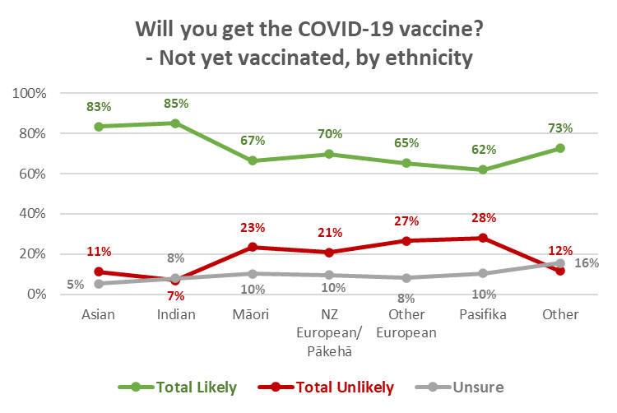
N.B. Percentages shown may not sum to 100% owing to rounding
Margins of error for those in ethnic groups who are not yet vaccinated are:
Asian: ±9.1%; Indian: ±10.8%; Māori: ±6.4%; NZ European/Pākehā: ±2.9%;
Other European: ±9.6%; Pasifika: ±9.4%; Other: ±26.2%.

Vaccination rates by ethnicity are likely to be affected by factors other than just their share of the general population, all of which have an effect on vaccine uptake, such as:
- The type of area they are living in (Māori, for example, have a lower-than-average proportion living in large cities and a higher-than-average proportion living in rural areas).
- Income levels.
- Employment status.

Because of this potential variation, weighting for the general population vaccination rate is unlikely to produce accurate vaccination rates by ethnic group. This has been addressed by using vaccination counts for each ethnicity and applying the intentions of those in each group who are yet to be vaccinated (shown in the chart above) to the balance of the ethnic group population.

As this is a new approach, no trend charts are shown.
1.2.1 Māori
Overall vaccine intention by Māori respondents who not yet been vaccinated, and the percentage that represents among all Māori, is shown in the following table.

VACCINE INTENTION | Māori 16+  Not yet vaccinated | All Māori 16+
Already vaccinated |  | 18%
Likely to get a COVID-19 vaccine | 67% | 54%
Unlikely to get a COVID-19 vaccine | 23% | 19%
Unsure | 10% | 8%
TOTAL POTENTIAL UPTAKE |  | 73%
Base: Māori not yet vaccinated n=236.
All Māori n=481
N.B. Percentages shown may not sum to 100% owing to rounding

1.2.2 Pasifika
Overall vaccine intention by Pasifika respondents who not yet been vaccinated, and the percentage that represents among all Pasifika people, is shown in the following table.

VACCINE INTENTION | Pasifika 16+  Not yet vaccinated | All Pasifika 16+
Already vaccinated |  | 26%
Likely to get a COVID-19 vaccine | 62% | 46%
Unlikely to get a COVID-19 vaccine | 28% | 21%
Unsure | 10% | 8%
TOTAL POTENTIAL UPTAKE |  | 72%
Base: Māori not yet vaccinated n=108.
All Pasifika n=157
N.B. Percentages shown may not sum to 100% owing to rounding

1.3 Uptake by people with impairment or who identify as disabled
July 2021 results for those living with impairments or long-term health conditions and those who identify as disabled were similar to June 2021.

Will you get a COVID-19 vaccine? (Including those who have already been vaccinated) | All respondents | Living with impairments or long-term health conditions | Identify as disabled
Definitely | 33% | 31% | 28%
Most likely | 10% | 7% | 8%
Likely | 7% | 5% | 8%
Unlikely | 3% | 3% | 3%
Most unlikely | 3% | 4% | 4%
Definitely not | 8% | 6% | 8%
I'm not sure | 7% | 6% | 5%
Already vaccinated | 29% | 38% | 37%
TOTAL LIKELY plus ALREADY VACCINATED | 79% | 81% | 81%
TOTAL UNLIKELY | 14% | 13% | 14%
N.B. Individual percentages may not sum to Total Likely or Total Unlikely owing to rounding

1.4 Uptake by age group
Those aged 18-24 years are the least likely to get a COVID-19 vaccine, but have similar potential uptake to all other age groups below 65 years. Those aged under 18 years are the most unsure.

Note that for those under 18 years, if parental approval to get a vaccine is relied upon, this may result in the potential uptake for this age group not being achieved (see Section 13).

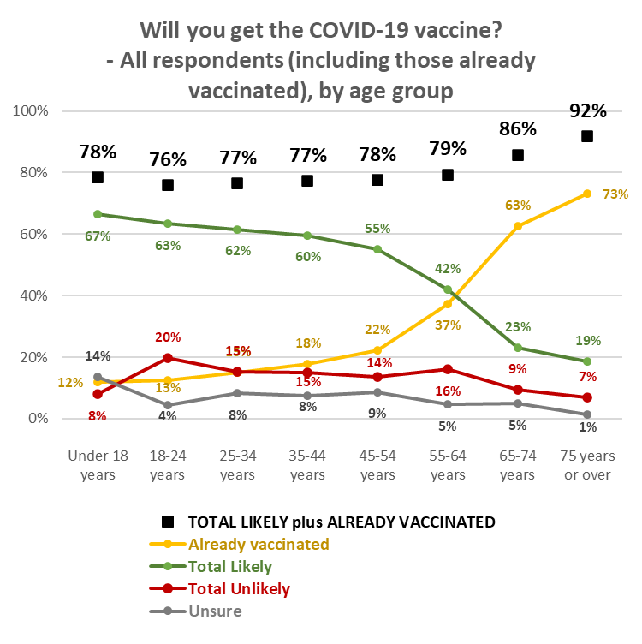

1.5 Uptake by DHB
With a nationally representative sample, the respondent numbers within DHB areas vary in accordance with the relative population of the area. Results for some DHB areas therefore need to be treated as indications.

Vaccination rates by DHB are likely to vary in accordance with factors other than their share of the general population: ethnic mix in their area, area type (large city, regional city, regional town, rural, remote), income, employment status, all of which have an effect on vaccine uptake. Because of this potential variation, weighting for the general population vaccination rate is unlikely to produce accurate vaccination rates by DHB. This has been addressed by using vaccination counts for each DHB area and applying the intentions of those who are yet to be vaccinated in the DHB area to the balance of the DHB population. The potential uptake in the various DHB areas is as follows.
Analysis by DHB is shown in the following pages, in 3 groups:
- The seven largest DHBs.
- 3 medium-sized DHB areas where subsample sizes are between 58 and 64, and are therefore relatively statistically reliable.
- The remaining 10 DHB areas where subsample sizes are generally less than 50, in line with their population proportion of the total sample. The smaller the subsample size, the less statistically reliable the results become and these should be treated as providing an indication only.

Seven largest DHBs:
- In Waikato and Southern DHB areas, potential uptake is lower than the overall average.

Will you get a COVID-19 vaccine?  (including those who have already had it) | ALL | DHBs
 |  | Waite-matā | Auckland | Counties Manukau | Waikato | Capital and Coast | Canter-  bury | Southern
Definitely | 33% | 35% | 32% | 22% | 35% | 49% | 42% | 33%
Most likely | 10% | 10% | 11% | 13% | 10% | 11% | 13% | 7%
Likely | 7% | 7% | 8% | 10% | 5% | 6% | 7% | 9%
Unlikely | 3% | 3% | 3% | 5% | 3% | 4% | 3% | 6%
Most unlikely | 3% | 3% | 4% | 3% | 3% | 1% | 1% | 4%
Definitely not | 8% | 9% | 7% | 5% | 10% | 5% | 7% | 6%
I'm not sure | 7% | 4% | 5% | 6% | 10% | 3% | 5% | 7%
Already vaccinated | 29% | 31% | 31% | 37% | 24% | 21% | 23% | 28%
TOTAL LIKELY plus ALREADY VACCINATED | 79% | 81% | 81% | 81% | 75% | 87% | 85% | 77%
TOTAL UNLIKELY | 14% | 14% | 15% | 12% | 15% | 10% | 10% | 16%
N (unweighted) | 2,509 | 250 | 243 | 204 | 229 | 217 | 263 | 155
N.B. Individual percentages may not sum to Total Likely or Total Unlikely owing to rounding

3 DHBs with relatively statistically reliable results:
- Northland and Bay of Plenty’s potential vaccine uptake figures are below the national average, as also reported in June 2021.
- Both of these DHBs have a slightly higher-than-average level of their population “unsure”.

Will you get a COVID-19 vaccine?  (including those who have already had it) | ALL | DHBs
 |  | Northland | Bay of Plenty | MidCentral
Definitely | 33% | 22% | 33% | 39%
Most likely | 10% | 12% | 8% | 9%
Likely | 7% | 6% | 7% | 5%
Unlikely | 3% | 1% | 0% | 2%
Most unlikely | 3% | 2% | 9% | 4%
Definitely not | 8% | 16% | 6% | 2%
I'm not sure | 7% | 11% | 10% | 7%
Already vaccinated | 29% | 31% | 27% | 33%
TOTAL LIKELY plus ALREADY VACCINATED | 79% | 71% | 75% | 86%
TOTAL UNLIKELY | 14% | 19% | 15% | 8%
N (unweighted) | 2,509 | 146 | 95 | 132
N.B. Individual percentages may not sum to Total Likely or Total Unlikely owing to rounding

DHBs with indicative results – these are presented in two groups of 5:
Indications are that:
- Tairawhiti has the lowest potential uptake.
- Tairawhiti and Hawke’s Bay residents are more likely than average to be unsure whether to get a vaccine or not.

Will you get a COVID-19 vaccine?  (including those who have already had it) | ALL | DHBs
 |  | Lakes | Tairawhiti | Taranaki | Hawke's Bay | Whanganui
Definitely | 33% | 31% | 33% | 30% | 33% | 20%
Most likely | 10% | 5% | 3% | 14% | 10% | 1%
Likely | 7% | 9% | 0% | 8% | 3% | 3%
Unlikely | 3% | 5% | 0% | 1% | 2% | 7%
Most unlikely | 3% | 1% | 5% | 4% | 2% | 8%
Definitely not | 8% | 8% | 9% | 14% | 7% | 8%
I'm not sure | 7% | 7% | 22% | 10% | 13% | 8%
Already vaccinated | 29% | 34% | 29% | 20% | 31% | 46%
TOTAL LIKELY plus ALREADY VACCINATED | 79% | 78% | 65% | 71% | 76% | 70%
TOTAL UNLIKELY | 14% | 15% | 13% | 19% | 11% | 22%
N (unweighted) | 2,509 | 65 | 25 | 87 | 90 | 35
N.B. Individual percentages may not sum to Total Likely or Total Unlikely owing to rounding

Will you get a COVID-19 vaccine?  (including those who have already had it) | ALL | DHBs
 |  | Hutt | Wairarapa | Nelson/  Marl-  borough | West Coast | South Canterbury
Definitely | 33% | 29% | 28% | 23% | 39% | 26%
Most likely | 10% | 1% | 5% | 4% | 18% | 3%
Likely | 7% | 20% | 3% | 8% | 5% | 3%
Unlikely | 3% | 4% | 4% | 1% | 5% | 12%
Most unlikely | 3% | 11% | 8% | 7% | 0% | 0%
Definitely not | 8% | 4% | 10% | 13% | 0% | 18%
I'm not sure | 7% | 7% | 4% | 6% | 0% | 3%
Already vaccinated | 29% | 25% | 38% | 38% | 34% | 36%
TOTAL LIKELY plus ALREADY VACCINATED | 79% | 74% | 74% | 73% | 95% | 68%
TOTAL UNLIKELY | 14% | 19% | 22% | 21% | 5% | 29%
N (unweighted) | 2,509 | 78 | 53 | 89 | 30 | 23
N.B. Individual percentages may not sum to Total Likely or Total Unlikely owing to rounding

1.6 Gains from eventual decision on getting a vaccine
1.6.1 Incremental gains
This survey for the first time sought to find an indication of how those unvaccinated might eventually behave.

Respondents who had not yet been vaccinated and had not answered “Definitely’ when asked if they would get a COVID-19 vaccine, were then asked whether they thought they would eventually decide to actually get the vaccine. This group represents close to 38% of the total 16+ population – an estimated 1,540,800 people 16+.

The results were as follows:

Do you think you'll eventually decide to actually get a COVID-19 vaccine or not? | Will you get a COVID-19 Vaccine?
 | Most Likely | Likely | Unlikely | Most Unlikely | Unsure | Already had one dose
% of 16+ population | 9.9% | 7.1% | 3.0% | 3.5% | 7.6% | 6.6%
Yes | 95% | 77% | 19% | 11% | 5% | 23%
No | 1% | 3% | 13% | 29% | 79% | 3%
Not sure | 4% | 20% | 69% | 61% | 17% | 74%

The gains and losses from the “Yes” and “No” responses this are small in percentage terms, and could be regarded as “incremental”.

Respondents who were already likely to get a vaccine and answered "Yes", when asked if
they thought they would eventually get a vaccine, do not represent an incremental gain in the “Likely to get a vaccine” group as they are already counted in that group. However, where they said “No”, that is an incremental loss for the group.

That incremental loss is estimated at 0.3% of the overall 16+ population, or around 13,900 people.

Respondents who were unsure whether to get a vaccine, or were unlikely to do so, and answered "Yes", when asked if they thought they would eventually get a vaccine, represent an incremental gain in the “Likely to get a vaccine” group as they are not already counted in that group.

The incremental gain from the “unsure or unlikely” group is estimated at 2.8% of the overall 16+ population, or around 114,400 people. Subtracting the incremental loss from the incremental gain gives a nett incremental gain of 2.5% of the 16+ population, or around 100,500 people. This includes 1 in 20 of those who said they had been offered a COVID-19 vaccine but declined it.

1.6.2 Potential for larger gains
Of more concern, and potentially higher gains, are the respondents who, when asked if they would eventually get a vaccine, said they were unsure. Similar analysis shows that:
- There is a potential loss among those who are currently likely to get a vaccine of 1.8% - an estimated 75,200 people.
- There is a potential gain of 10.3% from those who are currently unlikely to get a vaccine – an estimated 422,100 people. This includes nearly 3 out of 10 of those who said they had been offered a COVID-19 vaccine but had declined it.

Achieving that gain - and minimising the loss – relies on convincing those who are unsure whether they will eventually get a vaccine, that they should get one. Their key concerns are discussed in Section 6.

Second dose uptake
Excluding those who had said they would “Definitely not” get a COVID-19 vaccine, respondents who had indicated that they had not had any doses of the vaccine, or had only had one dose, were asked how likely they were to have a second dose. As previously commented, in general, if people are likely to get a vaccine, they will be likely to get a second dose and vice versa. This is illustrated by the following table.

Results were similar to June, May and April 2021: 81% overall of those who have either not been vaccinated or have only had one dose are likely to get a second dose (June 81%, May 82%).

99% of those who had one dose were likely to get a second (89% “Definitely”).

Likelihood to get second dose | LIKELIHOOD TO GET FIRST DOSE
 | Definitely | Most Likely | Likely | Unlikely | Most Unlikely | Unsure | Already had one dose
Total Likely | 99% | 96% | 88% | 16% | 5% | 2% | 99%
Total Unlikely | 0% | 2% | 6% | 64% | 75% | 2% | 1%
It depends if I have a reaction to the first dose | 1% | 2% | 5% | 10% | 8% | 22% | 0%
Not sure | 0% | 0% | 2% | 11% | 12% | 74% | 0%
N.B. Individual percentages may not sum to 100% owing to rounding

Six respondents who had already had one dose of the vaccine but said they were unsure or unlikely to get another. The reasons for this were the same as in June 2021:
- Three indicated that getting the appointment had been too difficult.
- Two indicated that the experience had not been as good as they thought it could have been.
- Two indicated that they didn’t think they needed a second dose.
- One had experienced a side effect.

Importance of everyone in New Zealand who is able to be vaccinated, being vaccinated.
Repeating a question first asked in the June 2021 survey, respondents were asked “Overall, how important do you think it is it that everyone in New Zealand who is able to have a COVID-19 vaccine, actually gets one?”

Overall, 82% (81% in June 2021) felt that it was important that everyone in New Zealand who was able to be vaccinated, was vaccinated (“very important” 59%; “important” 16%; “somewhat important” 7%). 10% overall felt that it was unimportant, while 8% were unsure.

The average importance rating was 4.2 out of 5.

As In June, total importance across all age groups up to 64 years was relatively consistent at close to the overall average level (and then increased where respondents were 65 year or over) suggesting that all ages believe that getting a COVID-19 vaccine is important; however, the strength of importance varied across the age groups, being lowest among 18-34-year-olds. The relative percentages who thought it was important or unimportant were:

Overall, how important do you think it is it that everyone in New Zealand who is able to have a COVID-19 vaccine, actually gets one? | AGE GROUP
 | 16-17 years | 18-24 years | 25-34 years | 35-44 years | 45-54 years | 55-64 years | 65-74 years | 75 years or over
Very important | 60% | 47% | 47% | 54% | 60% | 63% | 74% | 85%
Important | 18% | 21% | 25% | 19% | 17% | 8% | 8% | 6%
Somewhat important | 5% | 8% | 11% | 8% | 7% | 7% | 4% | 2%
Somewhat unimportant | 3% | 4% | 4% | 1% | 2% | 1% | 1% | 1%
Not very important | 5% | 3% | 4% | 1% | 2% | 3% | 1% | 1%
Not important at all | 0% | 8% | 4% | 7% | 6% | 8% | 6% | 2%
I'm really not sure | 9% | 8% | 6% | 11% | 7% | 9% | 7% | 4%
TOTAL IMPORTANT | 84% | 76% | 82% | 80% | 83% | 79% | 86% | 92%
TOTAL UNIMPORTANT | 8% | 16% | 12% | 9% | 10% | 13% | 7% | 4%
Average Importance (score out of 5; 5 being “very important”) | 4.4 | 3.9 | 4.0 | 4.2 | 4.2 | 4.1 | 4.4 | 4.7
N.B. Percentages may not sum to 100% owing to rounding

There was a similar result for Asian, Indian, Māori, Pasifika and NZ European/Pākehā respondents. Pasifika respondents were more likely than average to be unsure of the importance of all New Zealanders who could be, being vaccinated.

Overall, how important do you think it is it that everyone in New Zealand who is able to have a COVID-19 vaccine, actually gets one? | ETHNIC GROUP
 | Asian | Indian | Māori | NZ European/ Pākehā | Other European | Pasifika | Other
Very important | 59% | 66% | 61% | 58% | 59% | 52% | 73%
Important | 24% | 19% | 12% | 15% | 16% | 13% | 9%
Somewhat important | 6% | 5% | 7% | 7% | 6% | 9% | 6%
Somewhat unimportant | 5% | 2% | 1% | 2% | 1% | 3% | 2%
Not very important | 1% | 1% | 2% | 3% | 1% | 4% | 0%
Not important at all | 1% | 4% | 7% | 7% | 10% | 5% | 0%
I'm really not sure | 4% | 4% | 9% | 8% | 9% | 14% | 9%
TOTAL IMPORTANT | 89% | 90% | 81% | 81% | 80% | 75% | 88%
TOTAL UNIMPORTANT | 7% | 6% | 10% | 11% | 11% | 12% | 2%
Average Importance (score out of 5; 5 being “very important”) | 4.4 | 4.4 | 4.2 | 4.1 | 4.1 | 4.1 | 4.7
N.B. Percentages may not sum to 100% owing to rounding

As in June, importance dropped as likelihood to get a vaccine dropped, but some of those who are unsure or unlikely to get a vaccine think that it is important that everyone who is able to have a COVID-19 vaccine actually does so.

Overall, how important do you think it is it that everyone in New Zealand who is able to have a COVID-19 vaccine, actually gets one? | LIKELIHOOD TO GET VACCINE
 | Definitely | Most Likely | Likely | Unlikely | Most Unlikely | Definitely not | Unsure
Very important | 87% | 40% | 16% | 2% | 4% | 1% | 10%
Important | 11% | 46% | 31% | 18% | 5% | 4% | 20%
Somewhat important | 1% | 9% | 29% | 23% | 14% | 4% | 19%
Somewhat unimportant | 1% | 1% | 6% | 9% | 16% | 1% | 4%
Not very important | 0% | 0% | 6% | 13% | 11% | 10% | 2%
Not important at all | 0% | 0% | 1% | 9% | 10% | 65% | 5%
I'm really not sure | 1% | 4% | 12% | 27% | 41% | 16% | 40%
TOTAL IMPORTANT | 99% | 95% | 76% | 42% | 23% | 9% | 49%
TOTAL UNIMPORTANT | 1% | 1% | 13% | 30% | 36% | 75% | 11%
Average Importance (score out of 5; 5 being “very important”) | 4.9 | 4.3 | 3.5 | 2.5 | 2.1 | 0.5 | 3.3
N.B. Percentages may not sum to 100% owing to rounding

Respondents in Vaccine Group 4 and those who were not sure what Vaccine Group they were in placed lower importance on everyone being vaccinated.

Overall, how important do you think it is it that everyone in New Zealand who is able to have a COVID-19 vaccine, actually gets one? | VACCINE GROUP
 | Group 1 | Group 2 | Group3 | Group 4 | Not sure
Very important | 58% | 70% | 71% | 54% | 35%
Important | 29% | 16% | 12% | 18% | 10%
Somewhat important | 6% | 5% | 6% | 8% | 8%
Somewhat unimportant | 4% | 4% | 1% | 2% | 2%
Not very important | 2% | 2% | 1% | 3% | 6%
Not important at all | 1% | 1% | 2% | 7% | 21%
I'm really not sure | 0% | 2% | 7% | 9% | 18%
TOTAL IMPORTANT | 93% | 91% | 89% | 80% | 53%
TOTAL UNIMPORTANT | 7% | 7% | 4% | 12% | 29%
Average Importance (score out of 5; 5 being “very important”) | 4.3 | 4.5 | 4.6 | 4.1 | 3.0
N.B. Percentages may not sum to 100% owing to rounding

Making the decision to get a COVID-19 vaccine
Respondents who had not yet been vaccinated were asked to think about how they would decide whether or not to take an approved COVID-19 vaccine. They were shown a list of potential thoughts and asked which occurred to them, if any.

Key thoughts that occurred to more than 20% of respondents were:
- Whether there will be unknown side effects (36%; June 40%; May 37%, April 38%).
- How the side effects may affect them (34%; June 37%; May 31%, April 35%).
- Concern that the vaccine may not be effective against new variants (29%). This was a new option introduced because of respondents’ comments in the June survey.
- What might happen if they have an adverse reaction to the vaccine (25%; June 29%; May 27%, April 28%).
- Whether the vaccine may affect their health in other ways (24%; June 30%; May 28%, April 26%).

34% thought it was too soon to see whether there were any long-term effects from the vaccine (June 41%; 37% in both May and April), while 23% would “rather wait, to see if it causes any problems for others” (June, May and April all 23%).

Concern that the vaccine may not be effective fell back to 18% (June 22%; May 18%, April 20%), suggesting that the increase in June was related to the vaccine effectiveness against new strains, which has been addressed by adding a new option.

Note that 16% selected another new option: “I worry that without the vaccine I might get a more infectious new strain of COVID-19”.

Levels of concern that the vaccine may not be effective against new variants are shown below by likelihood to get a vaccine and age group (arrows denote 5% above or below overall result).

Thought | LIKELIHOOD TO GET VACCINE
 | Definitely | Most Likely | Likely | Unlikely | Most Unlikely | Definitely not | Unsure
I am concerned that the vaccine may not be effective against new strains of the virus | 26% | 37% ↑ | 24% ↓ | 33% | 51% ↑ | 25% | 35% ↑

Thought | AGE GROUP
 | 16-17 years | 18-24 years | 25-34 years | 35-44 years | 45-54 years | 55-64 years | 65-74 years | 75 years or over
I am concerned that the vaccine may not be effective against new strains of the virus | 27% | 19% ↓ | 29% | 28% | 35% ↑ | 38% ↑ | 29% | 22% ↓

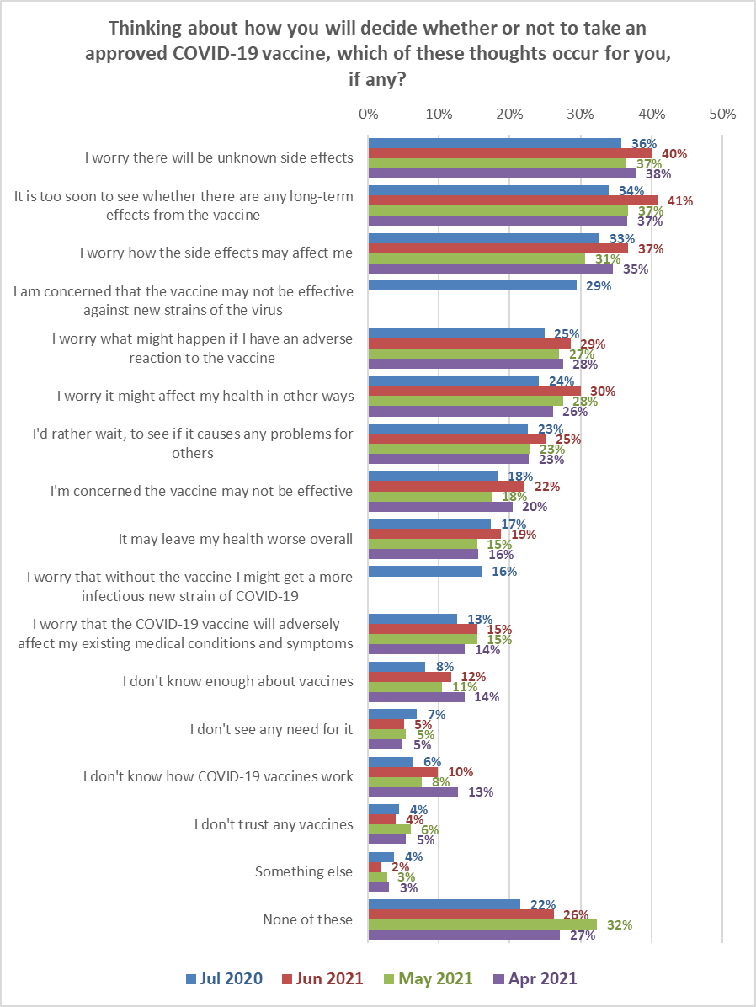

By ethnicity, and compared with the June results:
- Māori who have not yet been vaccinated continued to be concerned about side effects and how the side effects might affect them, although this concern is at a lower level than in June 2021. Effectiveness, especially effectiveness among new strains, is a key concern for Māori.

Shown below are the top 8 concerns for Māori and Pasifika respondents.

Māori:  Thoughts? | May 2021 | June 2021 | July 2021 | Change
I worry there will be unknown side effects | 36% | 48% | 32% | -16%
I worry how the side effects may affect me | 30% | 44% | 25% | -19%
I am concerned that the vaccine may not be effective against new strains of the virus |  |  | 23% | N/A
I worry it might affect my health in other ways | 34% | 37% | 21% | -16%
I worry what might happen if I have an adverse reaction to the vaccine | 25% | 34% | 21% | -13%
It may leave my health worse overall | 20% | 25% | 16% | -10%
I'm concerned the vaccine may not be effective | 22% | 28% | 16% | -12%
I worry that the COVID-19 vaccine will adversely affect my existing medical conditions and symptoms | 19% | 20% | 14% | -6%

- Pasifika appear to be less worried about unknown side effects and adverse reactions to the vaccine, but are concerned about new strains of the virus.

Pasifika:  Thoughts? | May 2021 | June 2021 | July 2021 | Change
I worry how the side effects may affect me | 33% | 36% | 36% | 0%
I worry there will be unknown side effects | 39% | 46% | 33% | -13%
I worry it might affect my health in other ways | 28% | 41% | 32% | -9%
I am concerned that the vaccine may not be effective against new strains of the virus |  |  | 27% | N/A
I worry what might happen if I have an adverse reaction to the vaccine | 27% | 49% | 21% | -28%
I'm concerned the vaccine may not be effective | 18% | 28% | 20% | -8%
It may leave my health worse overall | 15% | 21% | 18% | -3%
I don't know enough about vaccines | 15% | 31% | 18% | -13%

As in the February, March, April, May and June 2021 surveys, concern rose as likelihood to get a vaccine decreased.

Thought | LIKELIHOOD TO GET VACCINE
 | Definitely | Most Likely | Likely | Unlikely | Most Unlikely | Definitely not | Unsure
Will there be unknown side effects? | 21% ↓ | 42% ↑ | 42% ↑ | 38% | 65% ↑ | 51% ↑ | 60% ↑
How the side effects may affect me | 21% ↓ | 36% | 38% | 45% ↑ | 60% ↑ | 43% ↑ | 50% ↑
The vaccine may not be effective against new strains of the virus | 26% | 37% ↑ | 24% | 33% | 51% ↑ | 25% | 35% ↑
What might happen if I have an adverse reaction | 17% ↓ | 25% | 27% | 37% ↑ | 45% ↑ | 28% | 41% ↑
Will the vaccine affect my health in other ways | 12% ↓ | 25% | 29% ↑ | 30% ↑ | 55% ↑ | 41% ↑ | 41% ↑
It is too soon to see whether there are any long-term effects from the vaccine | 16% ↓ | 34% | 49% ↑ | 43% ↑ | 74% ↑ | 60% ↑ | 56% ↑
Arrows denote 5% above or below overall result.
By age:
- The 5 key overall concerns applied for all age groups.
- The number of concerns per person are highest among 65–74-year-olds.

Thought | AGE GROUP
 | 16-17 years | 18-24 years | 25-34 years | 35-44 years | 45-54 years | 55-64 years | 65-74 years | 75 years or over
Will there be unknown side effects? | 28% ↓ | 37% | 36% | 35% | 36% | 41% ↑ | 34% | 20% ↓
How the side effects may affect me | 35% | 34% | 31% | 30% | 31% | 39% ↑ | 38% | 19% ↓
The vaccine may not be effective against new strains of the virus | 27% | 19% ↓ | 29% | 28% | 35% ↑ | 38% ↑ | 29% | 22% ↓
What might happen if I have an adverse reaction | 28% | 23% | 20% | 26% | 24% | 30% ↑ | 28% | 19% ↓
Will the vaccine affect my health in other ways | 20% | 24% | 26% | 24% | 17% ↓ | 29% ↑ | 31% ↑ | 15% ↓
It is too soon to see whether there are any long-term effects from the vaccine | 30% | 30% | 33% | 33% | 33% | 38% | 45% ↑ | 27% ↓
Arrows denote 5% above or below overall result.

The 5 key concerns are also the key concerns for each ethnic group. However, 28% of Māori and Pasifika respondents are concerned about the effectiveness of the vaccine.

As reported in June, May and April, people who live with impairments or long-term health conditions, or who identify as disabled, were more concerned than average about:
- Whether the vaccine will adversely affect their existing medical conditions and symptoms.

Previously they had an above average concern about whether the vaccine would leave their health worse overall, but this concern is now at an average level.

Main influences on vaccine decision
This question, which has been tracked since December 2020, was modified for the July survey to elicit the top 3 things that respondents who had not yet been vaccinated regarded as most influential in their decision-making.

Based on their responses, the key influences were:
- Has been through extensive, properly conducted, clinical trials (23% overall).
- Helping protect the health of my family/whānau and those closest to me (21% overall).
- Helping to end the COVID-19 pandemic more quickly (21% overall).
- Helping to protect all New Zealanders (21% overall).
- The benefits of taking the vaccine would outweigh any risks (20% overall).
- Information about side-effects (20% overall).
- Helping reduce the risk of COVID-19 infection and the prospect of further lockdowns and economic harm (20% overall).
- Doing the best thing for my own health (19% overall).
- Being vaccinated will protect me from the effects of COVID-19 (18% overall).

Key influences were in different orders for various demographic groups and for the various likelihoods to get a vaccine (see tables for Q30 in attached table set).

To assist with messaging, the following show the top 3 influences by respondent age group, gender, the type of area they are living in and likelihood to get a vaccine.

AGE GROUP
16-17  years | 18-24  years | 25-34  years | 35-44  years | 45-54  years | 55-64  years | 65-74  years | 75 years or over
Helping to end the COVID-19 pandemic more quickly (30%). | Helping to end the COVID-19 pandemic more quickly (26%). | Has been through extensive, properly conducted, clinical trials (23%). | Helping protect the health of my family/whānau and those closest to me (26%). | Helping protect the health of my family/whānau and those closest to me (25%). | Has been through extensive, properly conducted, clinical trials (24%). | Has been through extensive, properly conducted, clinical trials (34%). | Doing the best thing for my own health (39%).
Helping to protect all New Zealanders (28%). | Helping to protect all New Zealanders (24%). | Helping protect the health of my family/whānau and those closest to me (23%). | Has been through extensive, properly conducted, clinical trials (25%). | Helping to protect all New Zealanders (24%). | Information about side-effects (24%). | Doing the best thing for my own health (24%). | Helping reduce the risk of COVID-19 infection and the prospect of further lockdowns and economic harm (34%).
Doing the best thing for my own health (26%). | The benefits of taking the vaccine would outweigh any risks (22%). | Helping to end the COVID-19 pandemic more quickly (23%). | Helping to protect all New Zealanders, and Information about side-effects (both 21%). | Has been through extensive, properly conducted, clinical trials (23%). | The benefits of taking the vaccine would outweigh any risks (24%) | Helping to protect all New Zealanders (22%) | Being vaccinated will protect me from the effects of COVID-19 (28%).

GENDER
Male | Female
Helping to protect all New Zealanders (23%). | Has been through extensive, properly conducted, clinical trials (27%).
Helping to end the COVID-19 pandemic more quickly (21%). | Helping protect the health of my family/whānau and those closest to me (25%).
Helping reduce the risk of COVID-19 infection and the prospect of further lockdowns and economic harm AND  The benefits of taking the vaccine would outweigh any risks AND Doing the best thing for my health (all 20%). | Helping to end the COVID-19 pandemic more quickly and  Information about side-effects  (both 22%).
N.B. No results are shown for “Gender Diverse” owing to the small base (n=8).

AREA TYPE
Large Cities | Provincial Cities | Provincial Towns | Rural but not remote | Rural and remote*
Helping to end the COVID-19 pandemic more quickly (23%). | Has been through extensive, properly conducted, clinical trials (25%). | Helping protect the health of my family/whānau and those closest to me (32%). | Has been through extensive, properly conducted, clinical trials (30%). | Helping to protect all New Zealanders (35%).
The benefits of taking the vaccine would outweigh any risks AND Has been through extensive, properly conducted, clinical trials AND Helping to protect all New Zealanders AND  Information about side-effects  (all 21%). | Helping to protect all New Zealanders (23%). | Has been through extensive, properly conducted, clinical trials (23%) | Helping to protect all New Zealanders (25%) | Helping protect the health of my family/whānau and those closest to me (31%).
 | Helping reduce the risk of COVID-19 infection and the prospect of further lockdowns AND economic harm and  Information about side-effects  (both 21%). | The benefits of taking the vaccine would outweigh any risks AND Doing the best thing for my own health AND Helping to end the COVID-19 pandemic more quickly (all 22%). | Helping reduce the risk of COVID-19 infection and the prospect of further lockdowns and economic harm  (24%). | Information on the effectiveness of the COVID-19 vaccine on new strains of the virus (30#).
* Indication only, small base (n=24).
Note that “Vaccination is free” is an important influence in regional cities (19%) and “information about side effects” is an important influence in “rural and remote” areas.

Those living with impairments or long-term health conditions selected the following key influences:
- “Has been through extensive, properly conducted, clinical trials” (24%).
- “Helping protect the health of my family/whānau and those closest to me” (23%).
- “Doing the best thing for my own health” (22%).
- “The benefits of taking the vaccine would outweigh any risks” (21%).
- “Information about side-effects” (20%).
- “Helping to end the COVID-19 pandemic more quickly” (20%).

Those who identify as disabled selected the following key influences:
- “Doing the best thing for my own health” (27%).
- “Helping protect the health of my family/whānau and those closest to me” (21%).
- “Being vaccinated will protect me from the effects of COVID-19” (20%).
- “Information about side-effects” (20%).
- “Has been through extensive, properly conducted, clinical trials” (20%).

LIKELIHOOD TO GET VACCINE
Definitely | Most Likely | Likely | Unlikely | Most unlikely | Definitely not | Unsure
Helping to end the COVID-19 pandemic more quickly (33%). | Helping protect the health of my family/whānau and those closest to me (27%), | Information about side-effects (34%). | Has been through extensive, properly conducted, clinical trials (32%). | Has been through extensive, properly conducted, clinical trials (39%). | Information about side-effects (38%). | Has been through extensive, properly conducted, clinical trials (40%).
Helping to protect all New Zealanders (32%) | Vaccination is free (for both doses) AND Information on the effectiveness of the COVID-19 vaccine on new strains of the virus (both 25%). | Has been through extensive, properly conducted, clinical trials (32%). | Information about side-effects (31%). | Information about side-effects (38%). | Has been through extensive, properly conducted, clinical trials (26%). | Information about side-effects (34%).
Helping reduce the risk of COVID-19 infection and the prospect of further lockdowns and economic harm (31%). | Information about side-effects (24%). | Information on the effectiveness of the COVID-19 vaccine on new strains of the virus (23%). | The benefits of taking the vaccine would outweigh any risks (22%). | The benefits of taking the vaccine would outweigh any risks AND  Information on the effectiveness of the COVID-19 vaccine on new strains of the virus  (both 24%). | Information on the effectiveness of the COVID-19 vaccine on new strains of the virus (15%) AND Doing the best thing for my own health (14%). | Information on the effectiveness of the COVID-19 vaccine on new strains of the virus (34%).

Note that other important influences are:
- “Definitely” get the vaccine: “Helping protect the health of my family/whānau and those closest to me” (28%) and “Being vaccinated will protect me from the effects of COVID-19” (26%).
- “Most likely” to get the vaccine: “Helping to end the pandemic more quickly” (23%) and “Has been through extensive, properly conducted, clinical trials” (22%).
- “Likely” to get the vaccine: “Helping protect the health of my family/whānau and those closest to me” (22%), “The benefits of taking the vaccine would outweigh any risks” (21%) and “Helping me to travel internationally once again” (20%).
- “Usure” whether to get the vaccine: “The benefits of taking the vaccine would outweigh any risks” (22%).

Different ethnic groups have the motivations in a different order, as shown in the following charts. This analysis is included to assist with message targeting.

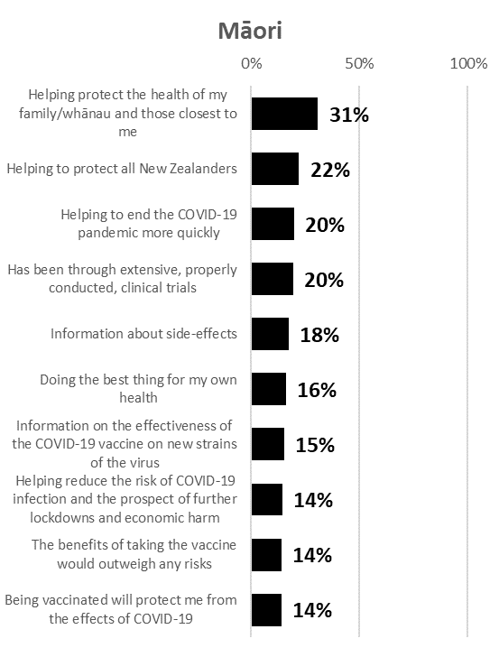 |  | 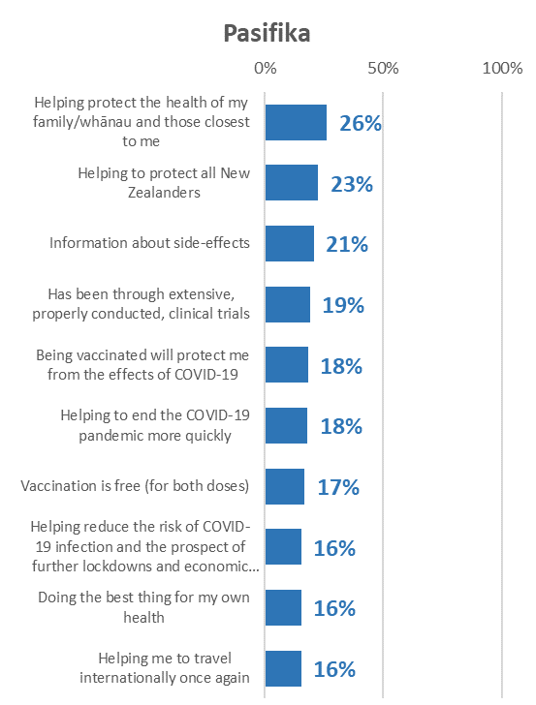
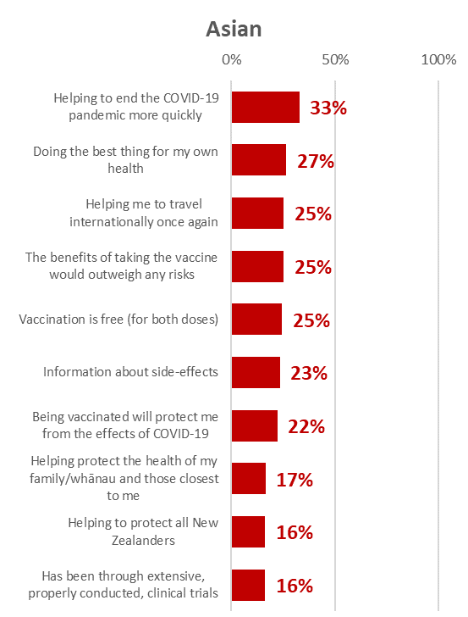 |  | 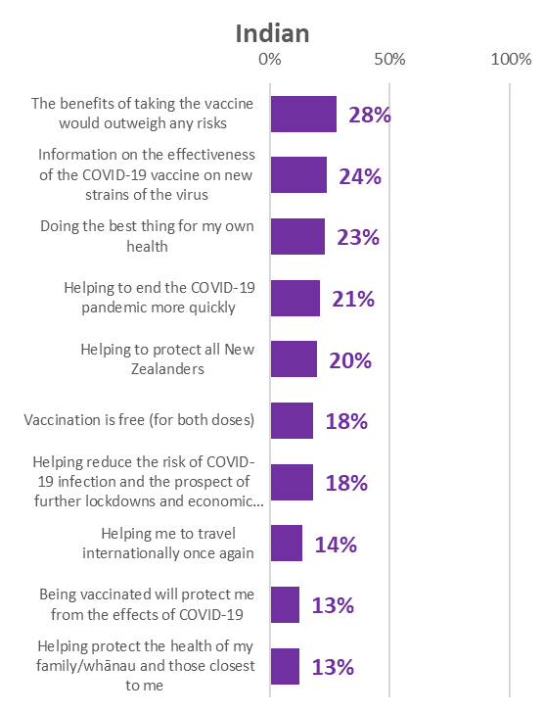

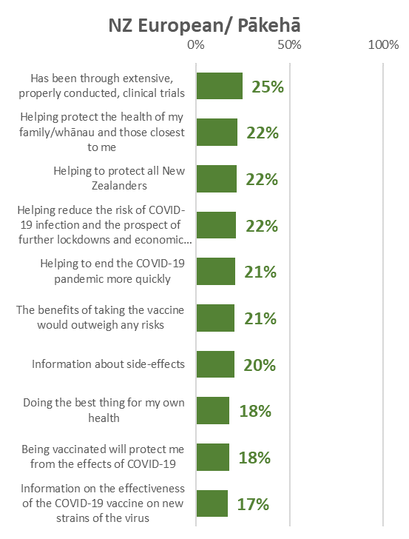 |  | 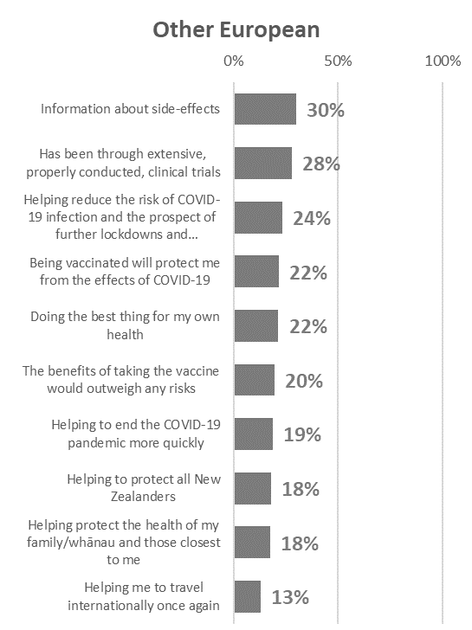

There were insufficient respondents who had not been vaccinated in the “Other” ethnic group for statistical reliability.

Reasons for being unsure or unlikely to get vaccinated
The 272 people who said they definitely would not get vaccinated or were unsure or unlikely were asked why they felt this way.

The three main reasons for people to be unsure, unlikely or opposed were the same as in June May and April 2021:
- Believing it is too soon to know if there are long-term effects (62%, up from 59% in June).
- Needing assurance of the vaccine’s safety (46%, up from 39% in June).
- Wanting to wait and see if others suffer side effects (41%, 41% in June).

A new reason added to the list was “The vaccine may not be effective against new variants”. This was included as a result of comments in the June survey and ranked in fourth position, on 31%.
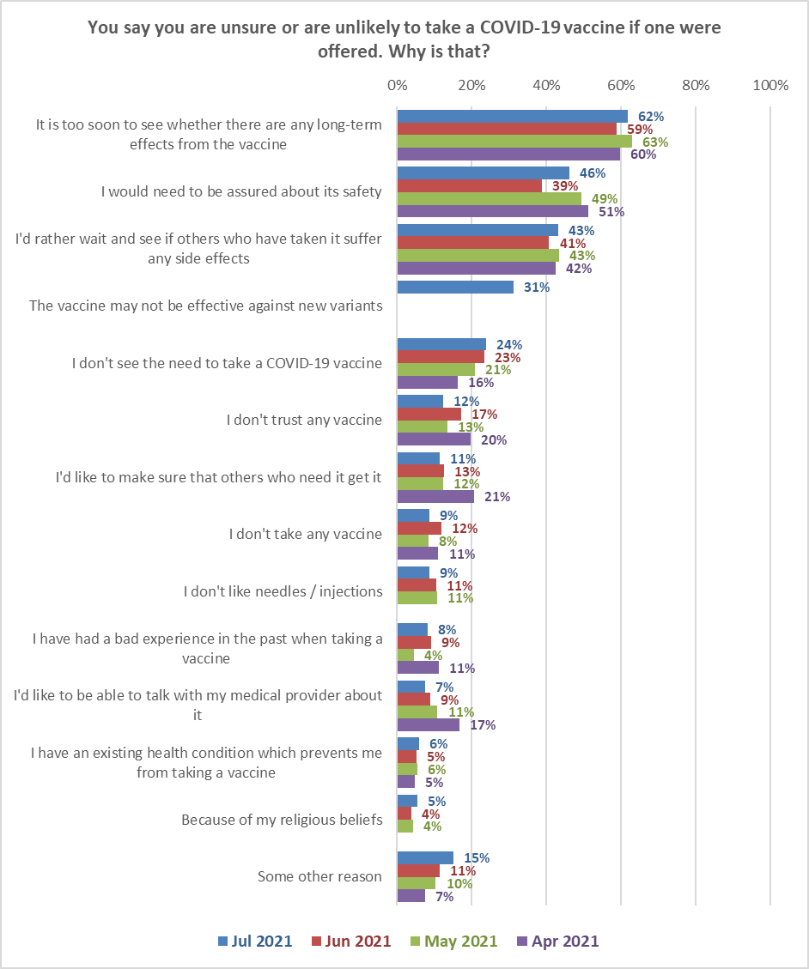
Base: Jul 2021, n=435; Jun 2021, n=272; May 2021, n=216; April 2021, n=395.

15% mentioned some other reason. Main themes from their comments were as follows:
Extreme views about the vaccine or political reasons
Science and the western world are the reason this planet is in the shitter right now. I do not trust mainstream thinking, it's all about profit, nobody actually gives a shit about people so why would I?
We need a population reduction and I believe in evolving or die.
I don't trust this rotten government.
No faith in this lying government at all.

Have an existing medical condition
I have breast implant illness and have hyper sensitivity to foods and medication we (my doctor and I) have tried to introduce over a period of ten years. Combine this with a now established anxiety surrounding trying new medications, I am extremely hesitant to take the vaccine onboard. Physical/psychological ramifications (side effects) are not much fun. I live an insular life due to chronic fatigue and other conditions so also do not class myself as mainstream. I continue to weigh up the pros and cons and have not fixed a definite position as yet.
Unsure if I can have it having had Guillain Barre syndrome.
I am pregnant and don't trust it on an unborn baby.
Multiple allergies to medicines, some of which have resulted in anaphylaxis.
Mental health: phobia of vaccinations and medications.

No benefits
Doesn't allow me to travel freely without isolation.
Because there is no health benefit.

Cautious
Will wait until the trials are over in 2023.
The vaccine is untested and is showing to not be safe for humans and animals.
I'd wait for post-marketing studies as this is a novel medicine

It is unnecessary
It’s unnecessary with a 99.98% survival rate.
There is no point. It doesn’t stop you getting it or carrying it and it’s still experimental.
Seriously? A vaccine that does not protect from anything, does not stop you getting the flu and does not stop you from transmitting it???
Other
My parents are still considering me getting it
Just not sure why I'm sitting on the fence about it? My teenage daughter asked & has had both shots ... being out and about and in college, she felt the need to “protect you at home mum…”

Key differences in the reasons given by the ‘unsure’ and ‘unlikely or definitely not’ groups are shown in the next chart. Only differences of more than five percentage points are shown.
The ‘unsure’ group is likely to be more persuadable than people who say they are unlikely to get vaccinated or definitely will not. For these unsure people, the following messages are likely to resonate:

- Assurance that the vaccine is safe.
- Messages from those who have already been vaccinated re little or no side effects.
- Having a discussion with their GP or health provider.
- Vaccine effectiveness against new variants.
Reasons mentioned more often by the ‘unlikely and ‘definitely not’ group
Reasons mentioned more often by the ‘unsure’ group

Attitudes of those who have not been vaccinated
In the following section, results are shown for those who have not been vaccinated (either once or twice).

7.1 When people would most like to get vaccinated
Those who had not been vaccinated were asked ‘Ideally, when would you most like to get a COVID-19 vaccine this year?’
There was very little change from the June survey.
In the latest July survey, 46% (an estimated 1,316,500 New Zealanders 16+) said they would like to be vaccinated by September (the same result recorded in June). Around three out of ten (28%) did not nominate a specific month (again with the same result in both the June and July surveys).
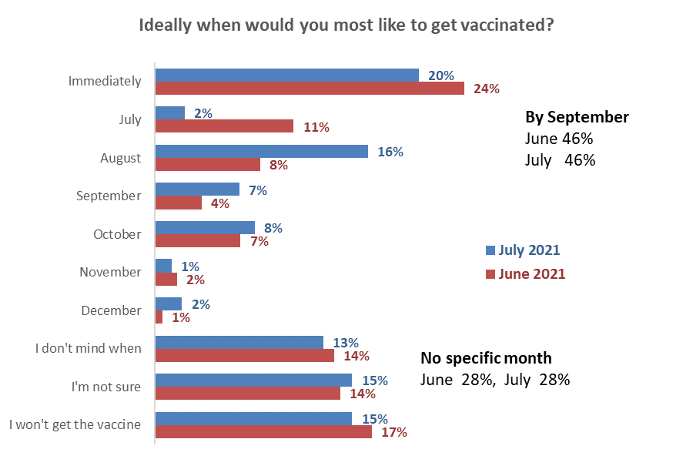
Base: have not been vaccinated: June survey n=1,105, July survey n=1,575

Demographic groups who are more and less likely to want to take the vaccine immediately are shown in the following table:

Want to be vaccinated immediately | %
With highest household incomes ($150k plus per year) | 32% ↑
Flatting or boarding | 30% ↑
Professionals /senior government officials | 28% ↑
With a postgraduate degree | 27% ↑
In Vaccine Group 3 | 27% ↑
Teacher/ nurse/ police or other trained service worker | 27% ↑
University Bursary or 7th form | 27% ↑
Aged 35-44 | 26% ↑
Overall total | 20%
Those with the lowest education levels  (no school qualification or School Certificate/NCEA Level 1) | 12%↓
Retired/ superannuitant | 9% ↓
Aged 65-74 | 7% ↓

7.2 Support for the plan to offer vaccines according to the age groups people are in
Those who had not been vaccinated were asked ‘Generally, do you support or oppose the plan to offer vaccines according to the age groups people are in?’
There has been a slight softening of support for the plan to offer vaccines by age group: 60% now support this plan compared with 65% in June.
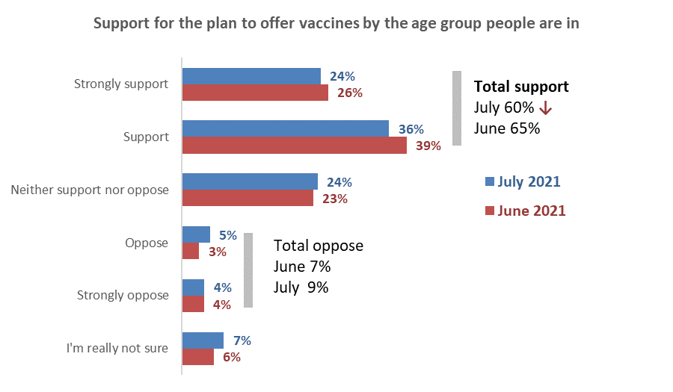 Base: have not been vaccinated: June survey n=1,105, July survey n=1,575
This increase is not statistically significant

Total support for this plan by gender and age (support and strongly support)
Support for this plan has fallen the most for those aged 55 or more
↓
↓

7.3 Preferences regarding the new national booking system
Those who had not been vaccinated were shown some information about the new booking system:
“When everyone in New Zealand aged 16 or older become progressively eligible for the COVID-19 vaccine from late July, people will be invited to use a new national “Book My Vaccine” online tool to book their first and second doses.

People will also be able to phone a new national vaccination booking call centre to make a booking if they wish.

You will receive an invitation to make a booking. You will get this invitation either by email, text, mail or by phone”.

Preferred ways to receive an invitation to make a booking
As in the June survey, the two most preferred ways to receive booking information in July are by email (67%) and text (59%).

Comparing the results with the June 2021 survey, text messaging has gained support while email and telephone calls have both lost support.
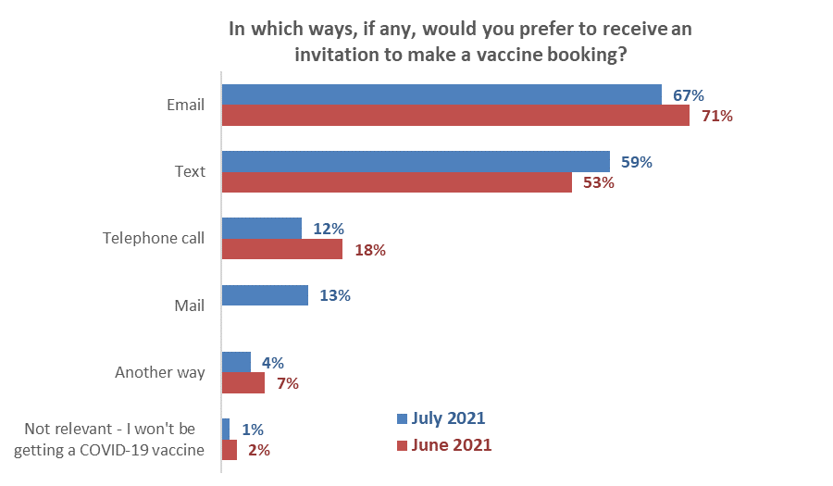
Not asked
↑
↓
Includes mention of mail
↓
Base: have not been vaccinated: June survey n=1,105, July survey n=1,575. Responses add to more than 100% as multiple responses were allowed.

Preferred way to make a booking
Those who had not been vaccinated were asked which way they would most prefer to make a booking.
By far the most-preferred method is booking online although this result dropped a little compared with the June survey (59% in July cf. 64% in June).
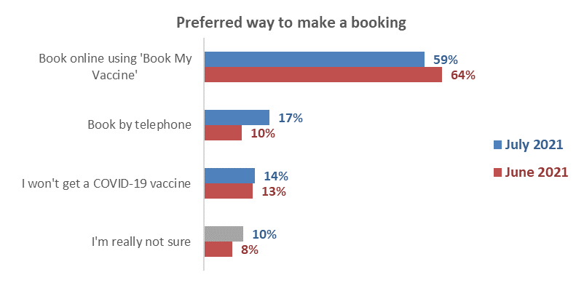
↓
Base: have not been vaccinated: June survey n=1,105, July survey n=1,575.
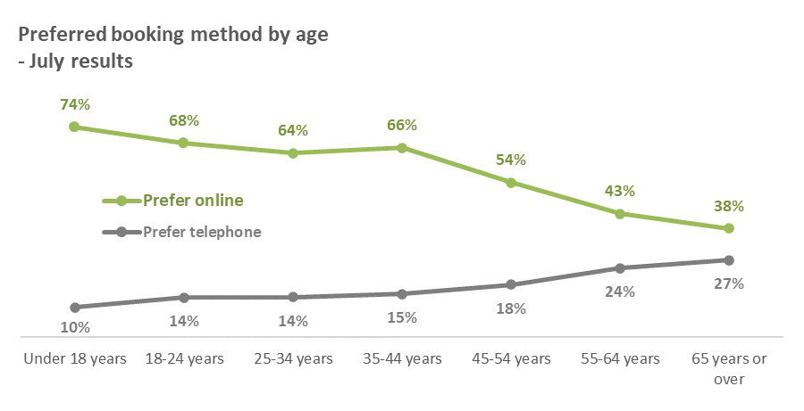
As in the June survey, all age groups prefer online over telephone. However, online preference drops and telephone preference increases as people get older.

Choices that would be helpful when making a booking
From a list of choices, those who haven’t been vaccinated were asked which choices would be most helpful to them when making a booking.
The top choices people would like were the same as in the June survey:
- Choice of location (64% in July)
- Choice of the time (55%), date (51%) and day (44%)
- Ability to change the booking (39%).
Two choices had an appreciably lower response than in June:
- Choice of day (44% cf. 50% in June)
- Ability to pre-book (20% cf. 27%).

↓
↓
Flexibility
Timing-related
Location-related

Information about the COVID-19 vaccine

8.1 Sources of information about the vaccine
Those who have yet to be vaccinated were asked where they had seen, heard or found information on the COVID-19 vaccine in the past 30 days. Results from the latest July 2021 survey are compared with those recorded in May and June 2021 in the table below.
Results are very similar to those recorded in June, with only 4 sources changing by 4 percentage points or more:
- Unite Against COVID-19 website – up 4 points
- Other New Zealand websites – up 4 points
- Television New Zealand – down 4 points
- Commercial television, including THREE/Newshub – down 4 points.

Where have you seen, heard or found information on the COVID-19 vaccine in the past 30 days? | April | May | June | July | June to July  Difference  % points
Television New Zealand (TVNZ) | 49% | 44% | 43% | 39% | - 4 ↓
Social media: Facebook | 25% | 25% | 30% | 29% | - 1
Ministry of Health website | 33% | 29% | 25% | 28% | + 3
Stuff | 28% | 29% | 28% | 27% | - 1
Unite Against COVID-19 website | 26% | 22% | 21% | 25% | + 4 ↑
Commercial television, including THREE/Newshub | 32% | 24% | 28% | 24% | - 4 ↓
NZ Herald online | 23% | 17% | 20% | 17% | - 3
YouTube | 13% | 12% | 15% | 17% | + 2
Radio New Zealand | 18% | 19% | 19% | 16% | - 3
Online search engines | 15% | 13% | 16% | 15% | - 1
International websites | 14% | 13% | 12% | 14% | + 2
Commercial radio stations | 14% | 13% | 16% | 13% | - 3
Other New Zealand websites | 11% | 9% | 9% | 13% | + 4 ↑
Daily (print) newspapers | 17% | 17% | 14% | 12% | - 2
Social media: Instagram | 10% | 8% | 11% | 12% | + 1
Other New Zealand online news sites (The Spinoff, Newsroom, etc) | 13% | 13% | 15% | 12% | - 3
Other social media | 10% | 11% | 14% | 11% | - 3
Community newspapers | 14% | 13% | 10% | 11% | + 1
Social media: Twitter | 5% | 8% | 6% | 6% | -
Māori Television | 4% | 5% | 4% | 3% | - 1
Iwi radio stations | 2% | 2% | 2% | 2% | -
Somewhere else | 5% | 5% | 3% | 6% | + 3
I haven't seen or heard any information about the COVID-19 vaccine | 6% | 9% | 6% | 9% | + 3
Base n= | 1,387 | 1,234 | 1,108 | 1,575

8.2 Do people have enough information to decide whether or not to take the COVID-19 vaccine?
Those who had not received a second dose of the COVID-19 vaccination were asked if they had all the information they needed to decide whether or not to take the COVID-19 vaccine. This question was asked in the previous three surveys and July results are compared with those for June, May and April 2021 in the chart below.

The proportion who felt they definitely or mostly have enough information was effectively static, as was the proportion of those who say they need more or they don’t quite have enough information.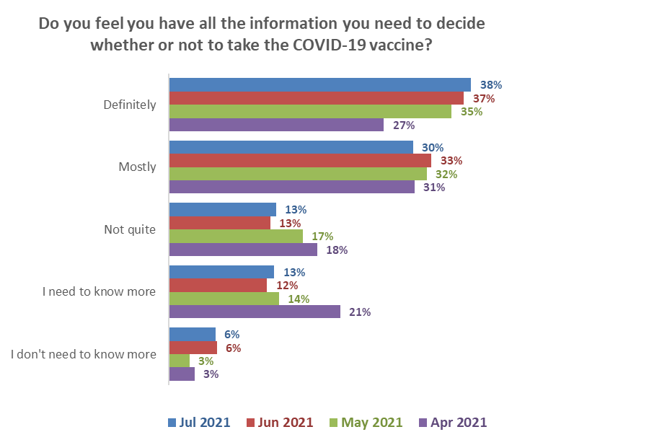
Total not quite & need more info
July 26%
June 25% ↓
May 30%* ↓
April 39%
Total definitely & mostly
July 68%
June 69%* ↑
May 67% ↑
April 58%

Base: Not yet vaccinated: July 2021 n=1,575; June n=1,105; May n=1,137; April n=1,270.
*Rounding accounts for the asterisked result being less than the two bars in the chart.
Those who need more information are more likely to be from the following groups:
Do not have quite enough & need more information | June 2021 Results
Total | 26%
“Likely” to get the vaccine | 50% ↑
Labourer/Agricultural or Domestic Worker | 38% ↑
From a two-parent family, three or more children at home | 35% ↑
Māori | 34% ↑
Pasifika | 34% ↑
Clerical/Sales Employee | 31% ↑
Home-maker (not otherwise employed) | 32% ↑
Low household income ($20k or less per year) | 32% ↑
Female | 31% ↑
Results are only shown for groups of at least n=50 respondents
Note that:
- Those who said “Definitely” are primarily those who will “Definitely” get a COVID-19 vaccine (62%) or those who will “Definitely not” (34%).
- As reported in June, those who need to know more are primarily those who say they are “Likely” (21%), “Unlikely” (36%) or “Most Unlikely” (44%) to get a COVID-19 vaccine; i.e., not definite either way.
- Those who said they don’t need to know more are primarily those who will “Definitely not” get a vaccine (27%).
- 60% of those who will “definitely not” get a vaccine either “definitely” have all the information they need or “don’t need to know more”.

8.3 What else do people need to know to help them decide whether to get the COVID-19 vaccine?
Respondents who had not been vaccinated and who gave the following responses to the previous question: “I mostly have enough information to decide”, “Not quite enough information”, “I need to know more”, were asked to say in their own words what else they needed to know to help them decide whether or not to get vaccinated.

706 people gave a response.

Main themes from their comments are illustrated in the following chart. These are compared with results from the June and May 2021 survey where the same question was asked.

In general, as more people get vaccinated, the percentage of those who are not yet vaccinated who want more information is likely to grow, particularly with specific information.

The two main things people said they need to know are:
- Information on side effects and risks (34%: June 26%; May 26%).
- Information on the long-term effects of the vaccine, based on longer and/or more clinical studies (19%, June 17%; May 16%).

Note that the requirement for information on safety is growing; this is a characteristic of the group who are currently unlikely to get a vaccine, and as more of those who are likely to get a vaccine are actually vaccinated, the percentage of people not yet vaccinated who require information on vaccine safety is expected to grow.

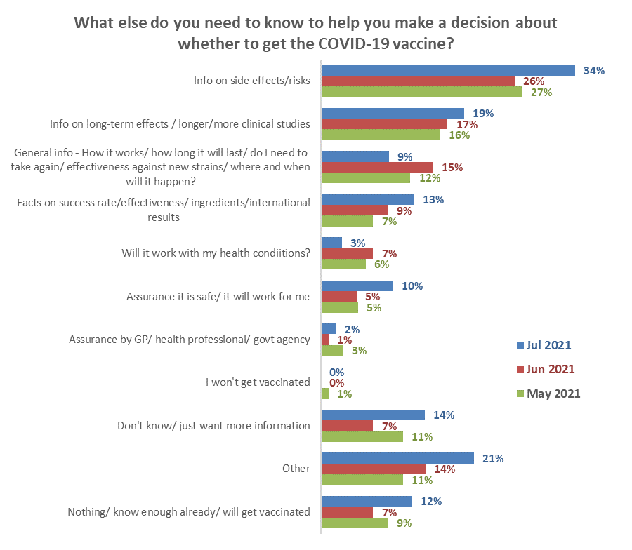 Base: May 2021 n= 480, June 2021 n=432 people who responded to this question. NB. Totals add to more than 100% as people could provide multiple responses.
↑
↓
↑

Verbatim comments illustrating each type of information need are included below…
Information on side effects/risks
Heard it can give you blood clots and a Chinese microchip is in the vaccine but not sure how true those statements are (Male, 35-44 years).
More about side effects and blood clots (Male, 55-64 years).
How it’s made and from what. How common are side effects and what those side effects may be and what safeguards are in place if I do have side effects? (Male, 55-64 years).
I will probably get this info when I get the invite, but I want to know side effects, what to expect, what strand (sic) it will protect me from (Female, 35-44 years).
Details of the side effects for my age group (Male, 25-34 years).
1. Why the NZ government still required a COVID-19 test for entry to NZ (from Australia) earlier this month if the vaccine was truly effective. 2. How effective the vaccine is against emerging variants. 3. Why serious side effects such as stroke, heart failure, etc, have not been reported in the media. 4. Why, if the Queensland director of health has withdrawn the COVID-19 vaccine from under 50s, the New Zealand government is still pushing it for all age groups at enormous expense to all the tax payers. (Male, 55-64 years).
Everyone is different and I am one of those everyone's! I have had the flu vaccination 2 times in my life and both times I was off sick from work for a month because my body would not accept it. I do not want to be in that position again as I was stuck in bed most of the time recuperating from the injection. So, unless they can prove different then I am still not sure. I also have seen close friends who have had the injection and fell ill immediately after which scared me, but then other friends that had the vaccine came out with no side effects what so ever? So yeah, still unsure. (Female, 55-64 years).
Side effects TRUTHFULLY (Male, 55-64 years).

Information on long-term effects/ based on longer/more clinical studies
If side effects are long-term, for example you develop a clot or a disability, what support is available especially if you are unable to work? What are the side effects someone with hypertension can experience? (Female, 45-54 years).
Long term what are the effects and how effective is the vaccine to new variants and new strains. I feel it's too rushed to produce a vaccine without all checks in place (Female, 25-34 years).
Evidence that there are no long-term side effects as well as evidence that we actually need it and that it works.as it was sooo rushed. I’m not sure how much I trust this vaccine just yet (Female, 25-34 years).
I don't know if people are being honest about the side effects (Female, 25-34 years).
Whether it's compatible with other medication and drugs and whether there are any long-term side effects (Male, 55-64 years).
Nothing really, just a little nervous about long term side effects (Female, 45-54 years).
Whether there are long-term effects, how long the vaccine will be effective for and if/when further boosters would be required (Female, 45-54 years).
Producers to finalise their full data reports and can guarantee the long-term safety of the vaccine (Male, 55-64 years).
Want to keep up to date with side effects of vaccines and effectiveness with variants - will not affect decision to get vaccinated (Female, 75 years or over).
Side effects - not just now, but in 10/20 years’ time (Female, 18-24 years).

General information - how it works/ how long it will last/ do I need to take again/ effectiveness against new strains/ where and when it will happen?
I will continue to watch while the evidence that this so called "vaccine" is both unnecessary and dangerous continues to mount. In the meantime, if I am unfortunate enough to get "COVID" I have already secured enough Ivermectin to take at the first onset of symptoms and, in spite of my age, I expect to survive it. I strongly believe that the jab is rapidly being proved to be more dangerous than the virus and the government's policy of pushing vaccination is deeply sinister. (Male, 65-74 years).
Whether the vaccine will cover any new strains of COVID-19, or will they need to keep updating it as the virus mutates. I am also concerned about any potential long-term effects of the virus which are currently unknown. (Female, 45-54 years).
Long-term data. will boosters be required. effectiveness against variants (Female, 35-44 years).
How it is different to the flu vaccine; side-effects - long and short term; how I can trust this vaccine to be effective when it was produced in such a short length of time yet apparently 'science' can't vaccinate or cure other things like cancer or HIV when they've had years of funding and focus to do so. (Female, 45-54 years).
Do two jabs cover Delta? (Male, 45-54 years).
Is there a third dose? (Female, 45-54 years).
Whether people are dying from this vaccine. show us some numbers! (Female, 55-64 years).
How it can prevent spreading, if I can still be a carrier, how the severity will be affected, how much it is actually going to help me. (Female, 35-44 years).
If it protects from all strains of covid and why it's being so encouraged when you can still get COVID with it (Female, 18-24 years).

Facts on success rate/effectiveness/ingredients/international results
If you can get while breastfeeding (Female, 25-34 years).
There is too much deception surrounding side effects & there being already an effective, cheap barrier to COVID, ivermectin There is no need to put NZ's population at risk. Especially the vulnerable, Māori & Pacifica (Male, 55-64 years).
Efficacy proof (Female, 25-34 years).
A workmate told me the second dose would be more effective 6 to 8 weeks after the first, not sure where he got the info from,3 weeks seems a little early, when I had my flu shot the nurse said 'not to get the vaccine until at least 4 weeks after flu shot. (Male, 55-64 years).
More long-term evidence it's effective and not just another jab you have to get every year (Female, 35-44 years).
Its effectiveness in preventing the spread of the disease (Female, 25-34 years).
What's in it, side-effects (short term and long term), effectiveness, manufacturer, what age groups are getting it? Will it be compulsory for overseas travel? (Female, 45-54 years).

Will it work for my health condition?
Whether or not my asthma needs to settle before getting the vaccine (Female, 55-64 years).
Whether it’s safe for people with asthma and COPD. (Female, 35-44 years).
If it would negatively affect someone with Chronic Fatigue Syndrome/M.E. and recovery time for them. (Female, 18-24 years).
Need to double check with GP that no allergy risk (Female, 25-34 years).
Whether it's safe for me to get it with my health conditions. (Female, 25-34 years).
I need to know more on the long-term effects for people with endometriosis (Female, 25-34 years).
I need to consult my GP as (I have never had the flu vaccine which has not been detrimental) I am not sure of the impact of the C19 vax on my health condition (Male, 65-74 years).
Medical info having recently had a triple bypass operation (Male, 55-64 years).

Assurance it is safe/ it will work for me
Is it safe? (Female, 45-54 years).
The true stats of how safe the vaccine is (Male, 25-34 years).
Whether it’s safe for pregnant women (Female, 18-24 years).
How safe it actually is and what tests have been done to prove this, I feel it's been made far too quickly and that makes me hesitant to put it in my body (Female, 25-34 years).
Whether people who have had Guillain-Barre are safe to get it. l have heard conflicting things (Male, 25-34 years).
I’m not sure if it’s safe. I’m not sure that its effective. COVID could just become the new flu, changing all the time (yr to yr). (Male, 35-44 years).
Need to know if it's safe. Personally, I think it's a waste of time and it's just another control tactic from our government. (Female, 35-44 years).
Is it safe? Only time will tell (Male, 45-54 years).

Assurance by GP/ health professional/ government agency
I am waiting for a diagnosis so it will depend if the doc says it’s safe for me. (Female, 45-54 years).
I know the available vaccine is synthetically produced, is this similar to the flu vaccines or is the flu vaccine developed from 'live' base? I have an appointment this week with my GP and will be discussing questions to this regard with them, as I have had severe reactions to other vaccines including Hepatitis vaccine. (Female, 45-54 years).
Need to double check with GP that there is no allergy risk (Female, 25-34 years).
I need to consult my GP as (I have never had the flu vaccine which has not been detrimental) I am not sure of the impact of the C19 vax on my health condition (Male, 65-74 years).
I need to know if my family GP can vaccinate me. I will be comfortable and feel confident if my GP can administer my vaccine for me. (Female, 45-54 years).
That's tricky - most of what I’d like to have, the govt cannot or will not deliver: 1) ACTUAL DATES that I will be able to get the vaccination: not media-friendly political messaging. Pointless asking me whether I need more information when I'm relying on the govt & bureaucrats DELIVERING when they are experts only in PROMISING. Given current performance I would not be surprised if I am not offered actual vaccination until 2022. I could be dead before then. 2) POSTPONEMENT: what happens if I have to postpone a vaccination appointment (due to e.g., health reasons such as a cough, cold, or other virus) - do I go to the back of the queue, or to the naughty corner blacklist, or get offered another appointment? 3) CHOICE: I trust my family GP's medical team; I have been with them (& they with me) for years. They have been through tough times with the COVID lockdowns: restrictions on unwell patients seeing their doctors; administering swabs to people who potentially have had Covid (including me); and now the govt will be paying a fortune to divert me & my GP's other patients to some organisation that somehow meets the govt's preferences. 4) TRUST: I trust my GP (team of GPs) & their staff: if they advised me to get the vaccine because the benefits outweigh the risks, that would be good enough for me. A complete stranger wearing a "vaccinator" t-shirt is just that: a stranger, someone who has minimal credibility, no identity, no professional relationship or reputation to protect. Their decision that I should, or should not, get the vaccine means almost nothing to me. 5) COMPETENCE: given the clown show that the entire COVID business (the political messaging; border closures & bubbles; MIQ bookings, capacity, security; the vaccine ordering, delivery, distribution, appointment booking, & now vaccine administration) has been, why would I have confidence in the competence of the chain of organisations the govt has chosen to deliver vaccinations? (Male, 55-64 years).
I would have liked to talk to my doctor first. I would have liked a free appointment with my GP just to feel certain that I am making the right choice in regards to my personal health challenges (Female, 35-44 years).

Don't know/ just want more information
Just more information, you literally have to talk to people or Google information about the vaccine and how often is doctor Google right. More information needs to be given to the public whether it is through GP or advertising (Female, 25-34 years).
Don't know what I don't know (Female, 35-44 years).
I’ve spoken to a pro vaccine friend who is a doctor. Still undecided. (Male, 35-44 years).
I actually don’t know anything about it as yet (Female, 25-34 years).
More info (Male, 45-54 years).
More about the vaccine (Female, 55-64 years).
Safety as already stated but also my family are not getting it for a number of reasons but I'm not sure how I feel about it I want to but then I don't (Female, 25-34 years).
More information on side effects (Female, 45-54 years).
Not sure (Female, 18-24 years).
More info about it (Female, 35-44 years).
I feel there has not been nearly enough information about the vaccine, it's been very disappointing. I was expecting a letterbox drop as well as social media adds etc, like there scan in campaign. (Female, 25-34 years).
I would like to be more informed as I know nothing about the vaccines being offered. And I have a family member who is against it so I’ll need knowledge to back myself up when they find out I’m planning to get the vaccine. (Female, 18-24 years).
All the truths, good and bad (Male, 35-44 years).

Other
It's a guessing game, trying to prevent something which is great but there are still pros and cons and with new strains from overseas we still don't know whether it helps (Female, 25-34 years).
If the govt decides to buy a different manufacturer to Pfizer I would like to know more about them before I accept their product, not all vaccines are created equal! (Male, 45-54 years).
I'm sure the info is out there, but I haven't looked into it yet. Group four of my age aren't till like the end of the year so I've got heaps of time (Female, 25-34 years).
I’m concerned about potential side effects but do see it necessary to protect the whole population however but hesitant still (Female, 35-44 years).
Which brand of vaccine it will be. (Female, 45-54 years).
I probably need to research it a bit more but overall, I'm happy with it (Male, 55-64 years).
I'm on a waiting list at my doctors, a three week wait. (Female, 55-64 years).
There has been a lot of issues about how well the vaccines have been developed. I am just a bit cautious. While Pfizer appears to be better than Astra-Zeneca there is still some element of uncertainty about whether Pfizer is without any risk. (Male, 75 years or over).
Time to see what happens to those that have already taken it (Male, 35-44 years).
Herd immunity means I won’t need to (Male, 55-64 years).
I haven't researched it yet, need to read some info. (Male, 35-44 years).
Have we got the correct vaccine? Not Johnson/Johnson? (Male, 45-54 years).
Only ever had a vaccine when I was 12 yrs & never had a flu event so I need to talk with my doctor but I'm sure he would recommend I take it but I'm just waiting for the time being. (Male, 75 years or over).
Time will tell, most vaccines take years to be useful (Male, 45-54 years).
More on potential side effects and what the vaccine actually protects against and how long it lasts for. Also, how long it takes to take effect (Female, 18-24 years).
A bit more definite and specific (Female, 35-44 years).
Does it actually work? Are we going to open our borders once everyone has had the opportunity to get it, not wait for a percentage to get it - if you don't want it that's your choice, the rest of the country shouldn't have to be put on hold because some don't wish to have it. If we're staying closed then what's the point of having it, since our borders are secure. (Female, 55-64 years).
I guess I want to wait a year or 2 before I decide so I see it's safe (Male, Under 18 years).
The government claims about safety while the paperwork by Pfizer says otherwise; the questions asked by Medsafe have not been answered; the reports of serious complications and deaths are muted; the questions are not answered and those who ask them are muzzled and threatened: makes you really confident about it (that is sarcasm in case you did not get it). (Male, 65-74 years).
I am just wary that the testing of the vaccine has been limited but will still get it regardless. (Female, 18-24 years).
I'll look at the latest data when it actually comes time to get the vaccine (Male, 25-34 years).
Just more general info (Male, 55-64 years).
Time - to see side effects and future variants which may not be covered in the vaccine (Female, 35-44 years).
Can we be allowed to travel afterwards? (Male, 35-44 years).
Time. I would wait until the vaccine is not in its trial period so I can be sure of its safety, because some people are having bad effects. (Female, 18-24 years).
Does it leave behind a microchip? (Female, 18-24 years).
I'd prefer to get Pfizer and am worried that, when my turns comes, it won't be available. (Female, 35-44 years).
I'm not anti Vax and most probably will get a shot after an impending operation. In the meantime, I'm observing those who have been vaccinated. Ideally, I'd prefer to wait a few years but know this is not possible. Covid-19 is a terrible thing but also the vaccinations are still trials. (Female, 65-74 years).
Primarily just waiting on post-marketing studies, so I can make an informed decision. (Male, 35-44 years).
After effects on unborn children. Waiting for NZ to make their own vaccine. (Female, 45-54 years).
I just need to look into it more as I haven't yet since I'm not yet eligible (Female, 18-24 years).
I just need to Google more (Female, 16-17 years).
Just organising a time and how long it will take. (Male, 25-34 years).
Honesty by the government so an informed decision can be made I'm getting it because I travel (Female, 55-64 years).
More testimony from people I know (Male, 35-44 years).
Vaccine passports and if the government guaranteed the borders will open to foreigners when NZ reach a certain vaccination level. (Male, 25-34 years).
I refuse to get a different brand other than the Pfizer. I don’t want the one that is suspected of causing blood clots. and any side effects anyone may have had. (Female, 35-44 years).
Will there be enough when the time comes (Male, 25-34 years).
Waiting to see how it rolls out (Male, 35-44 years).
What's in it, side-effects (short term and long term), effectiveness, manufacturer, what age groups are getting it? Will it be compulsory for overseas travel? (Female, 45-54 years).
The side effects and the choice to choose which brand I receive (Male, 35-44 years).
Which one is better Sputnik, Pfizer or Astra Zeneca? (Male, 35-44 years).
Rumours of a trial en masse do play on one’s mind. I will give it more time if I can. News about blood clots is upsetting - does it happen with Pfizer too? People still get Covid after being vaccinated? Will it cause my reactive arthritis to flare? (Female, 55-64 years).
everything is already explained (very well) (Male, 55-64 years).
If I am able to get a booster shot if that is actually available here in NZ if I were to travel overseas. (Female, 18-24 years).
Sorry, just really not sure at this point in time (Female, 45-54 years).

8.4 Sources of official information and advertising
All respondents were asked to identify the types of media in which they had seen official COVID-19 information and vaccine advertising in the past 30 days.

89% said they had seen an official COVID-19 information and vaccine advertisement in this period.

As In June and May, television was again the dominant medium with more than six out of ten (64%) seeing official material on television. Social media (34%) and radio (29%) are still in second and third place respectively.

Note that daily newspapers dropped one position. Daily newspapers are more important in rural areas (but not remote rural), regional cities and regional towns than in large cities.
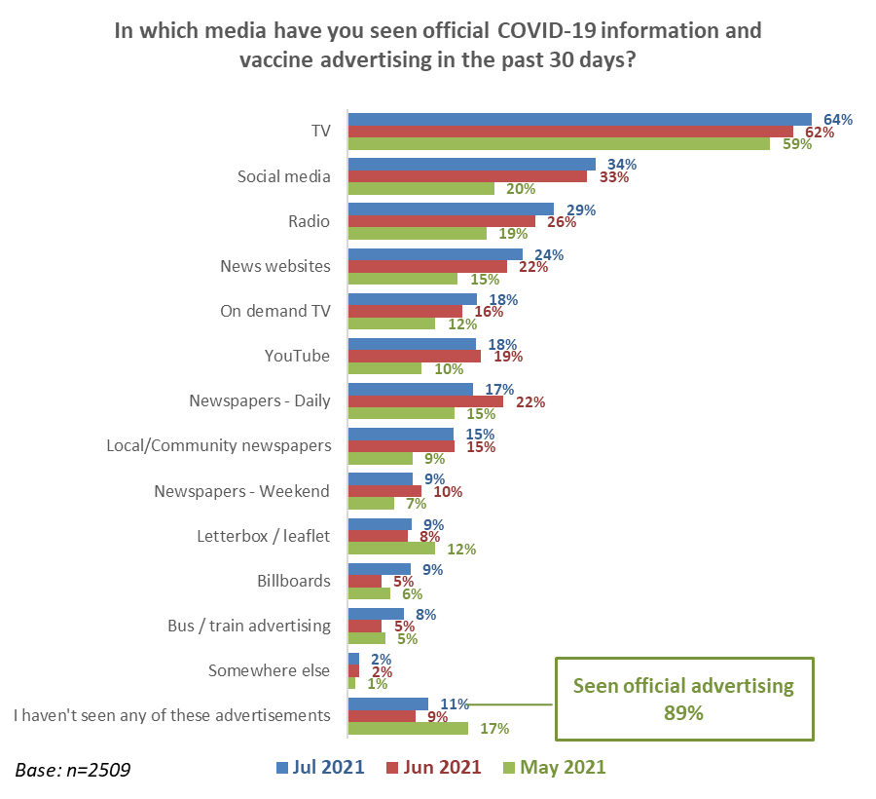

As the following table shows:
- Official vaccination information has a similar overall reach across all gender and age groups – a low of 86% among those aged 18 to 44 and a high of 97% among those aged 75 years or over.
- As in June, females are more likely than males to have seen official vaccination information on social media.
- The oldest age group (75 or more) is strongly more likely than the total to source this material from daily and weekend newspapers and local community newspapers.
- As in June, those aged 65 to 74 favour TV, daily and community newspapers.
- The 25 to 34 age group are relatively more likely to favour social media and on demand TV and YouTube.
- Those aged under 25 years are relatively more likely to favour social media and YouTube, with 16-17s including on-demand television.

KEY:
Eight points or more higher than the average is highlighted in bold blue font
Eight points or more lower than the average is highlighted in bold red font

In which media have you seen an official COVID-19 information and vaccine advertisement in the past 30 days? | ALL | GENDER* |  | AGE
 |  | Male | Female | 16-17 years | 18-24 years | 25-34 years | 35-44 years | 45-54 years | 55-64 years | 65-74 years | 75 years or over
TV | 64% | 63% | 66% | 70% | 61% | 52% | 55% | 67% | 70% | 72% | 89%
Social media | 34% | 29% | 40% | 44% | 37% | 43% | 34% | 30% | 28% | 35% | 26%
Radio | 29% | 28% | 29% | 33% | 28% | 30% | 28% | 28% | 27% | 31% | 32%
News websites | 24% | 24% | 25% | 30% | 22% | 26% | 21% | 27% | 22% | 27% | 26%
On demand TV | 18% | 15% | 21% | 26% | 22% | 22% | 20% | 22% | 12% | 13% | 6%
YouTube | 18% | 21% | 15% | 36% | 36% | 26% | 19% | 10% | 9% | 10% | 8%
Newspapers - Daily | 17% | 18% | 17% | 11% | 13% | 11% | 9% | 16% | 16% | 38% | 42%
Local/Community newspapers | 15% | 12% | 17% | 10% | 7% | 8% | 8% | 17% | 17% | 28% | 37%
Newspapers - Weekend | 9% | 10% | 9% | 6% | 7% | 9% | 7% | 8% | 10% | 12% | 21%
Letterbox / leaflet | 9% | 8% | 10% | 10% | 8% | 8% | 5% | 11% | 8% | 12% | 18%
Billboards | 9% | 9% | 8% | 13% | 10% | 11% | 8% | 7% | 6% | 11% | 10%
Bus / train advertising | 8% | 8% | 7% | 15% | 11% | 11% | 7% | 7% | 3% | 9% | 6%
Somewhere else | 2% | 1% | 2% | 0% | 2% | 0% | 1% | 1% | 3% | 3% | 2%
Have seen an advertisement | 89% | 86% | 91% | 94% | 86% | 86% | 86% | 87% | 91% | 95% | 97%
Base n= | 2,509 | 1,092 | 1,409 | 68 | 222 | 458 | 499 | 376 | 415 | 326 | 145
* The gender diverse group is excluded due to a small sample n=8.

8.5 Impact of seeing an official COVID-19 vaccine advertisement
Those who had seen an official COVID-19 vaccine advertisement in the previous 30 days were asked what impact this had, from a list of possible options.

The percentage who said the advertising had increased their likelihood to get a vaccine increased to 18% from 11% in June (May: 20%).

Slightly fewer people than in June said the advertising had made no difference to their decision; a nett 43% (compared with a nett 46% in June 46%; May 31%):
- Made no difference to the way I feel about getting the vaccine: 32%.
- Made no difference to the decision I will make to get or not get a vaccine: 18%.

34% said it made them feel they made the right decision to get vaccinated (as in June and May, this was the primary reaction from those who had already been vaccinated).and 11% said the advertising made them feel better about this decision (June 14%, May 18%).

13% said the advertising made them more likely to get vaccinated (4% absolutely certain, 3% much more likely, 6% more likely) and 5% said they were slightly more likely to get a vaccine after seeing the advertising. This is largely having an impact on those who are likely get a COVID-19 vaccine. The impact on those who are “Unlikely” to get a vaccine is significantly lower, and is minimal on those who are “Most unlikely” to get a vaccine or will “Definitely not” do so; In fact, 21% of the “most Unlikely” group and 18% of the “Definitely not” group said the advertising they were seeing had made them feel less likely to get a vaccine.

Made no difference:
July nett 43%;
June nett 46%
Less likely: No change
Reinforced my decision
July 44%, June 44%
Made me more likely to get vaccinated:
Total 18% overall (June 11%), but includes 5% with a marginal increase in likelihood

The advertising made 2% (June 3%) of those who said they were currently “unlikely” to get a COVID-19 vaccine slightly more likely to get a vaccine.
The next table shows ‘more likely’ and ‘less likely’ responses by gender and age.

In terms of likelihood to take the vaccine, the advertising has had the most nett positive impact on males and those under 45 years.

KEY:
4 points or more higher than the average is highlighted in bold blue font

Impact of seeing official advertising in the last 30 days | ALL | GENDER* |  | AGE
 |  | Male | Female | Under 18 years | 18-24 years | 25-34 years | 35-44 years | 45-54 years | 55-64 years | 65-74 years | 75 years or over
Made me absolutely certain I will get a vaccine | 4% | 5% | 3% | 7% | 6% | 6% | 5% | 1% | 3% | 2% | 3%
Made me much more likely to get a vaccine | 3% | 4% | 2% | 2% | 4% | 4% | 2% | 4% | 1% | 3% | 1%
Made me more likely to get a vaccine | 6% | 7% | 5% | 3% | 10% | 6% | 8% | 4% | 6% | 1% | 3%
Made me slightly more likely to get a vaccine | 5% | 5% | 5% | 4% | 9% | 12% | 7% | 4% | 2% | 0% | 1%
Total positive impacts | 18% | 21% | 15% | 16% | 28% | 28% | 23% | 13% | 12% | 7% | 8%
Made me feel less likely to get a vaccine | 4% | 4% | 5% | 0% | 8% | 5% | 6% | 2% | 4% | 3% | 0%
NETT POSITIVE IMPACT | 13% | 17% | 10% | 16% | 20% | 23% | 16% | 10% | 8% | 4% | 8%
Base – Seen official advertising n= | 2,257 | 969 | 1,282 | 62 | 194 | 400 | 445 | 332 | 377 | 309 | 138
* The gender diverse group is excluded due to a small sample n=8.

Experiences of those who have already been vaccinated
934 people in the survey had received at least one vaccine dose – on a weighted basis this represents 29.2% of the total (those aged 16 or more). This result is up from 17.3% in the June survey.

9.1 Did you receive enough information about your vaccination?
95% of those who had been vaccinated said they received enough information.

This is similar to the June result (93%)

9.2 How invited to make a booking
People who had been vaccinated at least once were asked how they were invited to get vaccinated.
The two main ways people were invited to be vaccinated were through work (23%) and by text (20%).

Base: vaccinated with at least one dose n=934

Other ways invited to make a booking
Two out of ten vaccinated people said they were invited in ways other than those listed in the survey.

The main response to this question was that they called the booking centre themselves, so technically these people should have selected the option – ‘I was not invited to make a booking’. Some comments from these people included:
I booked myself in
I was not invited - I called up to arrange
I had to telephone the incompetent DHB
I had to chase down an appointment, I was not contacted at all, so I called the phone number and forced the issue
I walked in
My wife found out a clinic in town was doing them. Otherwise, would never have known.

9.3 How people actually made the booking
People who had been vaccinated at least once were asked how they made their booking.
The two most common ways to book a vaccine were by phone (39%) and online (24%). Note that the release of “Book my Vaccine” on 28 July occurred in the middle of the survey period.

Base: vaccinated with at least one dose n=934

Other ways of booking
Around one in ten vaccinated people (11%) mentioned another way of booking. Their main responses included:
- Through my doctor or my local medical centre (the main other method mentioned)
- Through my marae/ through local whanau
- Through a social media contact
- Via email
- Through a disability team.

9.4 Ease of making a booking
Those who had been vaccinated were asked ‘overall, how easy or difficult was it to make your vaccination booking?’
The proportion who found booking easy increased to 92% in July from 85% in the June survey. Conversely, those who found booking difficult decreased from 15% to 8%.
↓
↓
Base vaccinated with at least one dose: June survey n=367, July survey n=934

Reasons why the booking was difficult
The 79 people who found it difficult to make a booking were asked to indicate why, from a list of twenty reasons. The next chart shows the reasons selected by at least 10% of this group.
A wide range of reasons were selected, with the top three reasons involving:
- Having to call the booking number more than once (32%)
- Not being sent information on how to make a booking (29%)
- Hard to find information on how to make a booking (29%).
Arranging a second dose
Difficulty making the appointment
Finding booking information
Lack of choice
Unhelpful staff
Base found the booking difficult n=79. Multiple choices were allowed.

‘Other’ reasons for finding the booking difficult included the following examples:
The MOH and DHBs could not agree on the correct process
The initial txt to make a booking gave me a link to the website to make a booking but I could find nowhere on the site to make a booking. The 2nd txt 2 weeks later worked perfectly.
The person I spoke to at the Healthline did not speak very intelligible English. I spent about an hour on the call, mostly waiting a) for the original response, and b) while the person I spoke to made various checks.
Went on line, changed my booking date, the system approved the new date, then as I was signing out it confirmed the booking, but with the original date.
The online system wouldn't allow me to change my booking.
Every time I chose a slot it would say sorry fully booked, pick another. Apparently, it needed to be confirmed via email which never happened, so I turned up at the vaccination centre and was turned away because the slot was not confirmed.
Northland DHB were totally ill prepared, chaotic and confused and it took a long time to get their act together.
At first, I tried to make my booking online, but I did not receive a reply for over 3 weeks and by then I had made my appointment via the 0800 number.
They booked me in for the first dose. Arrived at the centre and it was closed as they weren’t even open that day.
The lady on the phone was useless and couldn't speak very good English.
I called the booking number approx. 150 times before getting an appointment.

Reasons why the booking was easy
In total 852 people found it easy to make a booking. These people were asked to select why this was easy from a list of reasons.
Main reasons for the booking being easy include:
- Getting the time and place that people wanted (34%)
- Being easy to book the second dose (31%)
- Easy to book by phone and the online system worked well (both 28%)

Base found the booking easy n=852

Other reasons the booking was easy
Main ‘other’ reasons the booking was easy included:
- My work arranged the booking
- Someone else did it for me
- I just walked in
- My retirement village organised it
- I was already at the medical centre.

9.5 Rating the booking experience
All those who had been vaccinated with at least one dose were asked to rate their experience of 1) being invited to book, 2) actually booking their vaccine appointment. These questions used a scale from ‘0’ (very poor) to ‘10’ (excellent).
Ratings for both measures were very similar, with a slight lead for ‘actually booking’ the appointment (mean rating of 8.4) compared with ‘being invited to book’ (8.0). Similarly, 71% rated ‘actually booking’ 8 to 10 on the scale, compared with 70% who rated ‘being invited to book’ from 8 to 10.

Base: received at least one dose of the vaccine n=934

Rating the booking experience by age and gender
The following chart shows results for sample sizes of at least n=100 respondents.
The ratings recorded showed no difference by gender and only minor differences by age – notably, those aged 55 or more were relatively more positive regarding both measures (which may reflect any extra care they received as more elderly citizens).

9.6 Assessing the appointment experience
People who had been vaccinated were shown a list of possible experiences they may have had in the course of their appointment, some positive and some negative. The next two charts show their positive and negative experiences.
As the charts show, the July results are very similar to those recorded in June with positive experiences again far outweighing negative experiences. The most positive experiences recorded in July are friendly people (71%), ease of getting to the centre (61%) and no trouble finding my booking (63%). By contrast, the most negative experience was centre staff not knowing who the person was (13%).

Base for both charts: vaccinated with at least one dose: June survey n=367, July survey n=934

‘Other’ experiences of being vaccinated
Eight percent of those who were vaccinated reported some ‘other’ experience of being vaccinated (other than the experiences listed in the question). The responses from these 56 people were in the following categories:
Good/great customer service
Hot drink and biscuit afterwards were good
Staff were really good
A very pleasant experience. Truly pleasant and experienced staff
Very professional and clear protocol
Well done to the COVID advisors at 7 Westgate Road
Young staff, excellent couldn't have been better
Extremely efficient & friendly. No problems, whatsoever
Very well staffed and very efficient service from start to end
Sympathetic to my needle phobia.
Encountered some issues – especially long wait times
First dose no problem. Second dose took several calls and a photograph of my vaccination card to sort out that I had indeed had the first dose and was entitled to the second
Had to wait in a long line even though I had a booking
Two people booked for a time later than us went through before us as the 'receptionist' didn't check times or names
I had a booked appointment but was just lumped in with lots of other people who had just turned up the off chance
Long wait times. Arrived at 9.15 for 9.20 appointment. Was in a queue for 40 minutes. Got the vaccination at almost 10am
The waiting time was ridiculous. Had to wait a long time. It wasn't until someone made a complaint about waiting for an hour with no one checking on him that staff came rushing out to vaccinate us that were waiting
It took 3 hours to go through the first vaccination process!
The IT systems were abominable, and this is having spent 40 years in the IT industry.

9.7 Rating the care people received when they were vaccinated
All those who had received at least one dose of the vaccine were asked to rate six aspects of the care they received, using a ‘0’ to ‘10’ scale, from totally dissatisfied to totally satisfied.
The results were extremely positive with mean ratings ranging from 8.7 for “The location of the vaccination centre” to 9.3 for ‘The person who vaccinated me’.
Areas rated | Range of ratings |  |  | Mean rating
 | 0-4  (Poor)  % | 5-7 (Moderate)  % | 8-10 (Good)  %
The location of the vaccination centre | 7% | 13% | 80% | 8.7
The way in which the vaccination centre was laid out | 4% | 14% | 81% | 8.8
The staff I saw when I first arrived | 4% | 8% | 87% | 9.0
Finding my booking details | 4% | 9% | 82% | 8.9
The person who vaccinated me | 2% | 5% | 90% | 9.3
The way in which I was monitored after I had been vaccinated | 3% | 8% | 87% | 9.1

Mean ratings by age and gender
As the next table shows, those aged 65 or more were particularly positive about their vaccination experience; however, ratings were high across the board:
 | Male | Female | 25-34 years | 35-44 years | 45-54 years | 55-64 years | 65-74 years | 75 years plus
The location of the vaccination centre | 8.6 | 8.8 | 8.5 | 8.0 | 8.4 | 8.7 | 9.1↑ | 9.2↑
The way in which the vaccination centre was laid out | 8.7 | 8.8 | 8.4 | 8.1 | 8.6 | 8.9 | 9.2↑ | 9.3↑
The staff I saw when I first arrived | 9.0 | 9.0 | 8.3 | 8.5 | 8.9 | 9.0 | 9.4↑ | 9.4↑
Finding my booking details | 8.9 | 9.0 | 8.4 | 8.5 | 8.7 | 9.0 | 9.3↑ | 9.5↑
The person who vaccinated me | 9.3 | 9.4↑ | 8.9 | 8.9 | 9.3 | 9.4↑ | 9.7↑ | 9.7↑
The way in which I was monitored after I had been vaccinated | 9.0 | 9.2 | 8.7 | 8.7 | 9.0 | 9.1 | 9.6↑ | 9.5↑
Only age groups with at least n=100 respondents are featured in the above table

9.8 Catering for people’s language needs through the process
All those who had received at least one dose of the vaccine were asked whether their language needs were met throughout their booking and vaccination process.
90% of vaccinated people said their language needs had definitely been met, while 96% said definitely or mostly. | Base: vaccinated with at least one dose: n=934
Language needs met by ethnicity
Indicatively, due to small samples, people of Indian and Pasifika descent gave the lowest ratings for their language needs being met.
Were your language needs met throughout your booking and vaccination process? | Asian | Indian | Māori | NZ European/ Pākehā | Other European | Pasifika
Definitely | 93% | 78% | 88% | 93% | 86% | 82%
Mostly | 3% | 5% | 8% | 4% | 9% | 13%
Somewhat | 3% | 6% | 2% | 2% | 3% | 4%
Somewhat not | 2% | 4% | 1% | 1% | 0% | 0%
Mostly not | 0% | 6% | 0% | 0% | 1% | 0%
Definitely not | 0% | 2% | 2% | 0% | 0% | 1%
N (unweighted) - Received at least one dose of vaccine | 59* | 34* | 245 | 620 | 61* | 49*
*Small samples – treat these results as indicative

9.9 Catering for people’s disability or impairment needs through the process
Only 68% of those with a disability or impairment said their needs were definitely met, and 20% gave low ratings from ‘somewhat’ to ‘definitely not’. | Base: Have an impairment or disability: n=461

9.10 Likelihood of recommending vaccination to others
People who had been vaccinated were asked ‘Overall, does the experience you had when making bookings for and having a COVID-19 vaccine make you more or less likely to recommend vaccination to others?’
Results in the latest July survey are very similar to June. In July 68% said their experience made them more likely to recommend vaccination to others compared with only 3% who were less likely. ‘More likely to recommend’ is 23 times higher than ‘less likely’.

Base vaccinated with at least one dose: June survey n=367, July survey n=934

9.11 Suggested improvements to the vaccination process
The 934 people in the survey who had been vaccinated were asked an open-ended question, ‘Thinking about your experience of the whole vaccination process (from booking to getting the vaccine), is there anything that you think could be improved?’
Of these people, 539 either suggested improvements or said they were very happy with their experience and had no suggestions.
The themes identified are shown in the chart below, with the three main themes being:
- Very happy – no suggestions (42%)
- Vaccination centre suggestions (25%)
- Booking suggestions (19%).

These suggestions are analysed further below, with verbatim quotations illustrating the types of comments made.
Very happy - no suggestions
Don’t know about other DHBs but the Rotorua one was excellent in all aspects (Male, Aged 75 years or over)
Everything is perfectly fine (Male, Aged 25-34 years)
Excellent no problems at all (Female, Aged 75 years or over)
I am a retired doctor, so I realise the scale of the operation. Truly excellently achieved. (Male, Aged 75 years or over)
I think that some of us were just very very lucky and went to the first walk-in that they held in Dargaville and from there it was easy (Female, Aged 65-74 years)
I would not have changed anything and have nothing but pride and complete satisfaction in which the staff conducted my experience (Male, Aged 65-74 years)
If all vaccine centres were operated like the Wainui Marae Parkway, there would not have been any problems whatsoever with COVID vaccines given. They were marvellous and provided tea/coffee and biscuits to enjoy whilst awaiting our time to leave. Information sheets were given to us about the injections and what to do if there were any issues. (Female, Aged 65-74 years)
Sure, there was nothing fancy about the centre where vaccinations were given, but this was more than offset by the efficient and friendly manner in which everyone was treated. I say well done. (Female, Aged 75 years or over)
It all worked wonderfully for me and my wife. Couldn't have got a better crew to record our details and perform the vaccine. (Male, Aged 65-74 years)
It was good, had a video about the vaccine, lots of registered nurses available if a bad reaction to vaccine. Staff friendly. Areas separated. Large areas for seating. (Female, Aged 55-64 years)
It was perfect for me at Manurewa Marae (Male, Aged 75 years or over)
My experience and that of my family was faultless (Male, Aged 55-64 years)

Vaccination centre - suggested improvements
General comments
Better venue - not a dirty dark smelly old racecourse lounge that wasn’t fit for the horses (Male, Aged 65-74 years)
Cold building (Female, Aged 55-64 years)
I found the numbers of people turning up without a booking to be very distracting (Male, Aged 75 years or over)
I think it would be great if they had a list of people to call so no vaccines were thrown out at the end of the day (Female, Aged 25-34 years)
The vaccination centre at Princess Margret Hospital seemed like a recommissioned room to have more seating that was comfortable and undamaged and proper heating and the entry staff need to be warm and not robotic. The monitoring aspect at the end seemed empty and lacking civility - felt like a joke, a tick box process (Male, Aged 55-64 years)
Waiting outside the centre (in an open tent) was difficult in the cold weather (Female, Aged 55-64 years)
Re refreshments
A long black coffee would have been nice (Male, Aged 75 years or over)
A sweet at the end (Female, Aged 45-54 years)
Cup of tea / coffee / water available when waiting (Female, Aged 75 years or over)
I have heard some centres gave people food etc. Nothing like this was available at Okara Park. Perhaps something could have been offered (Male, Aged 65-74 years)
Perhaps a cup of tea for the frail elderly (Female, Aged 75 years or over)
Re the process
The information collection and checking system could be done at 1 counter, rather than the 3 we had to go through (Male, Aged 45-54 years)
More controlled direction of "patients" by "host staff" - we had to move between sitting areas, and it was a bit confused (Female, Aged 65-74 years)
At the Elliot Street centre when waiting on the chairs for the nurse, because it was going so fast, I had to change chairs every 20 seconds which I found a little annoying being so heavily pregnant (Female, Aged 25-34 years)
More streamlined. Not 6 steps with hours of waiting on chairs at different stages. I thought (foolishly) I would arrive at my time, be immediately seen to, vaccinated and be out in 30 mins. (Male, Aged 45-54 years)
Streamline the process to speed it up. Only need to check your details once then give a booking number instead of keeping to have lining up and everyone shifting seats. (Male, Aged 65-74 years)
Customer care
Friendlier vaccinator (Female, Aged 25-34 years)
Nurse to be a little more gentle when conducting the injection. She was mean and she was tough (Male, Aged 65-74 years)
Nurse was very negative and practically guaranteed I would have a bad reaction to my vaccination (Female, Aged 55-64 years)
Having young and appeared to be inexperienced customer service people greeting people doesn't convey a sense of credibility and lacks professionalism (Female, Aged 55-64 years)
I think the final step of monitoring people for the twenty minutes should be better as they were too busy talking about their weekend etc and my daughter ended up waiting half an hour and we had to ask if she was allowed to go and got a comment "Oh, I am not doing my job well am I?" - rude and sarcastic (Female, Aged 45-54 years)
It would be good to choose the marae as the vaccination venue. A respectful friendly greeting at the reception would have assisted. I would recommend the reception staff have a session on manaakitanga. (Female, Aged 55-64 years)
Probably they could ask if people have any needs as disabilities are sometimes hidden (Male, Aged 45-54 years)
Someone to help go over details with anyone hesitant (Female, Aged 35-44 years)
Use of masks/ social distancing
The experience was good. My only question is why we had to wear masks at the vaccination centre, but our seats weren't socially distanced? It didn't make sense (Female, Aged 35-44 years)
Rules of COVID not obeyed, no social distancing, no hand sanitizers, no visible sanitizers or QR code (Female, Aged 45-54 years)
Just a little worried that the layout of seating etc [prior to and after actual vaccination] could have been better to stop any spread of germs/bugs (Male, Aged 65-74 years)
I was surprised that I was at a centre that catered to at risk employees, hotels airports etc and hardly any masks on other than some staff - nurses didn’t have them on (Female, Aged 65-74 years)
Re parking
Being told of alternative parking areas close by in case of getting a parking ticket. (Female, Aged 55-64 years)
Disabled parking closer to the vaccination centre was not available (Female, Aged 75 years or over)
Free parking at MIT, we got towed cause the whole vaccination process took more than 2hours (Male, Aged 25-34 years)
Re signage
No Walk-in signage e.g., a person without an appointment thought that they could walk-in and were turned away. Then they aggressively questioned me for having an appointment because I looked under 55 (which I am), however, I fit group three. It was intimidating because I'm a part Pacific part White female and they are a White male trying to stand over me which made me feel helplessly unsafe. The staff were quick to intervene, however. (Female, Aged 35-44 years)
Lack of signage at centre explaining that you had to report to a counter (Male, Aged 65-74 years)
Information
Have simple brochure of vaccine info in seats for those who wish to read and know a bit more than just word of mouth (Female, Aged 55-64 years)
I think you should get something to explain what symptoms you might have after the vaccine and what contacts you can make if you have any concerns post vaccine (Male, Aged 55-64 years)
Language issues
Have someone that speaks English better please … was a lovely lady to talk to, was just hard to understand her accent (Female, Aged 45-54 years)
Te Reo staff speakers (Female, Aged 55-64 years)
Reading material
Maybe put in a distraction such as magazines or music to take away the uneasiness of getting vaccinated (Female, Aged 45-54 years)
Re personal identification
First time patients should be encouraged to bring their NHI number (Male, Aged 65-74 years)
Resourcing
Have more nurses - 2 for well over 100 is NOT enough (Female, Aged 18-24 years)
Re locating the centre
A link to Google Maps, showing the actual location would have been helpful. My appointment was at Westgate, which I incorrectly thought was a shopping mall style location. I drove around the area looking for signage, which was prominent on the building. (Male, Aged 55-64 years)

Booking-related
General comments
Difficulty with second booking. Had to re-register. Mixed messages about vaccine locations - different options over the phone compared to online options. (Female, Aged 25-34 years)
Getting the appointment was the most difficult and frustrating experience. It would be very easy to give up, and I know some of our friends have. (Male, Aged 75 years or over)
I didn’t use the 0800 system as everyone had told me how useless it was (Female, Aged 65-74 years)
I should have been allowed to go with my husband. They said ‘no’ (Female, Aged 65-74 years)
I tried phoning for my first, but 124 people were ahead of me on the phone, so I just rolled up to Kaitaia. I tried that for my second, but they wouldn't let me in, However I managed to get my 2nd in a chemist in Whangarei when I was down there. (Male, Aged 65-74 years)
If my wife hadn’t been told about the opportunity, we wouldn’t have known. The process for getting information is very poor (Male, Aged 55-64 years)
In my case I needed to try and change my booking time slot however the online system wouldn’t allow me to do so. I then had to call which took an extraordinary length of time. (Male, Aged 55-64 years)
It was really messy trying to get myself and my partner vaccinated! I ended up getting my two doses before he did even though he was in a higher risk occupation. (Female, Aged 25-34 years)
The booking process was very poor. GPs and chemists should have been doing vaccinations from the beginning (Female, Aged 75 years or over)
The entire booking process. It was a shambles. (Male, Aged 45-54 years)
The planning for the entire booking system was chaotic and confused and indicated a real lack of strategic planning. The various authorities had over a year to get a structure and system in place and failed. It was really a matter of learning on the way. (Male, Aged 65-74 years)
The text to book system failed me completely despite numerous attempts by myself as someone relatively tech savvy (Male, Aged 55-64 years)
Provide more information
Information regarding the check in process and parking to get to the venue would have been helpful due to the mass amount of people attending the vaccination centre (Female, Aged 35-44 years)
Check if people have had other vaccinations
There should be an additional question to check if the person had other vaccinations in the last 4 weeks. (Male, Aged 45-54 years)
Don’t insist on making second appointment when booking the first
Phone call to make booking was difficult because of requirement to make second appointment at the same time. Which actually wasn’t necessary. Appointment could be made later. (Female, Aged 65-74 years)
Lift staff knowledge
People on the other end of phone actually knowing what to do. The majority of people I talked to were clueless. It took so long to book my first dose as we had to call multiple times but none of the people knew anything, so were no help. (Female, Aged 18-24 years)
Have more staff
More staff answering the 0800 number (Male, Aged 75 years or over)
Reduce time to make a booking
Booking system takes too long (Male, Aged 25-34 years)
Have staff who speak English
I had to wait a long time on the phone for the staff member (who couldn’t speak English) to verify that I qualified for group 3. She asked the same questions three times even after I’d told her the answers (Male, Aged 25-34 years)
Should not be co-ordinated by DHBs
DHB bookings hopeless (Male, Aged 65-74 years)
Co-ordination of information with the vaccination centre
Better coordination with booking information and actual booking (Female, Aged 55-64 years)
Better IT system which shares information with Vaccine centre (Male, Aged 45-54 years)
Improved email/text confirmation
The email seemed a bit dodgy to be honest. I wasn’t even sure if it was the email I was supposed to expect when booking the vaccine and only confirmed with my colleagues who got the same email. It would be nice to include official logos e.g., NZ GOVT or whichever DHB it was for, because it is very possible that fake websites etc are coming out. (Female, Aged 18-24 years)
The text quoted a booking # that did not exist in the system. (Female, Aged 55-64 years)

Re invitations to be vaccinated
Getting an invitation. It would be really good to contact people to let them know that health authorities have them on their books, even if they aren’t eligible for a vaccine immediately (Male, Aged 25-34 years)
I am 82 years of age and I felt I should have been invited to make an appointment before several friends who are under 70. (Female, Aged 75 years or over)
I received text notification of first dose almost a fortnight after receiving my walk-in dose (Female, Aged 65-74 years)
I think the way invitations are sent out could definitely be improved as I did not receive an invitation at all (Female, Aged 45-54 years)
I thought I would have been contacted before I booked, myself being a diabetic (Male, Aged 55-64 years)
I was initially not ready to have the vaccine when invited and was told I would be rung 1 month later. That did not happen (Female, Aged 65-74 years)
People of my generation have still not received notice to book whilst much younger people were being vaccinated when I went. CDHB system is pathetic! (Female, Aged 75 years or over)
Perhaps earlier notifications to keep informed that my turn was coming. Would alleviate some fears that you had been missed (Female, Aged 55-64 years)
Yeah, they never told me or my mates whanau that it was our turn we had to ring them up and it’s not something that felt comfortable doing because I didn’t know exactly what I was setting myself up for (Female, Aged 65-74 years)

Vaccination rollout should be faster
Being able to get vaccinated sooner (Male, Aged 75 years or over)
Could have been sooner. I was expecting a vaccination end of June not end of July (Female, Aged 65-74 years)
Definitely trying to get a vaccination was traumatic. NZ could so easily experience an outbreak like places in Australia have and we should have all been vaccinated by now. (Female, Aged 65-74 years)
Faster vaccine logistics (Male, Aged 18-24 years)
Getting the vaccine earlier and having more vaccines. It is a deadly virus and needed to get everyone vaccinated ASAP to save lives. (Male, Aged 65-74 years)
I do think the rollout has been slow. But I get why vaccines were given to high-risk countries first. However, we opened our borders to international travellers before having even 5% of the population vaccinated, and this was a risk (Female, Aged 55-64 years)
Make it faster (Male, Aged 18-24 years)

Other suggestions/ comments
Practise and streamline - too much double checking i.e., admin time. Surely one "health database" would suffice - linked NHI number!! (Male, Aged 65-74 years)
Don't coerce people into taking a vaccine (Female, Aged 35-44 years)
I am surprised that Northland Māori were prioritised over all Māori. Seems odd, also Pacifica are prioritised - when will it be opened to all Māori? (Female, Aged 45-54 years)
I felt that my workplace could have been more supportive. We were told if we had side effects and had to take time off, we would not be paid for that time (Female, Aged 65-74 years)
I think those of us who have already been vaccinated fully need to have a better and more robust form of ID than a card on which it is handwritten! (Male, Aged 65-74 years)
More robust vaccination cards than just card/paper! Easy to damage/lose. (Female, Aged 25-34 years)
Most of the problems appear to be caused by the whole vaccination programme being administered by all those different DHBs, plus the government agency. The DHBs should not have been allowed to do it in their own different ways (Male, Aged 75 years or over)
Move teachers up the priority list! (Male, Aged 35-44 years)
It should have been a straightforward process like the other vaccinations e.g., flu, measles, shingles etc., via the doctor’s surgery (although I must admit the little COVID vaccine clinic near me at Kaeo was brilliant) (Male, Aged 65-74 years)
Take the DHBs out of the loop and leave it to the GPs and vaccine centres in local areas to sort (Male, Aged 65-74 years).

Preferred information sources
As in Jun e and May 2021, respondents who had not yet been vaccinated were asked “What's the best way for you to get information on the COVID-19 vaccine?”
As in June, the top 3 nominated sources of information are all online sources (email, website and text). The rank order of the top 8 sources is the same as in June 2021

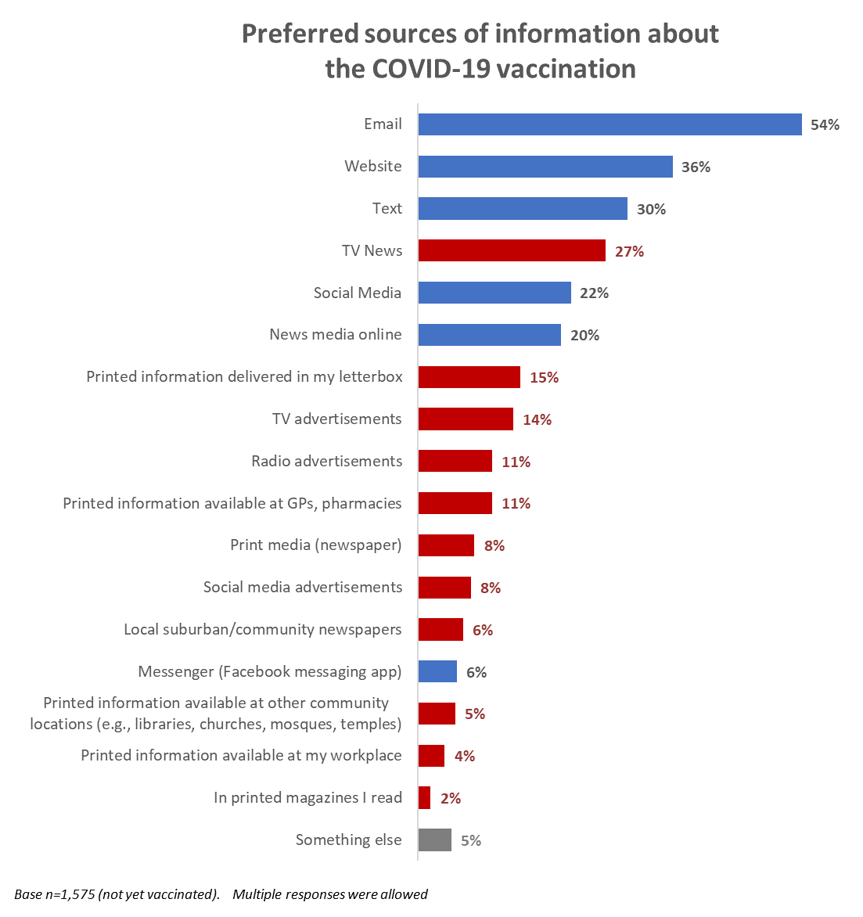
Traditional sources/media
Online sources
KEY

Access points for COVID-19 vaccine
Respondents who were not yet vaccinated and had not yet booked their vaccine were asked where and from whom they would you most like to access a COVID-19 vaccine, if any.

The top 2 access points from the May, February and December surveys continue to be the top 2, with “My doctor (general practitioner)” clearly the most important to respondents. “Pop-up vaccination clinics” has swapped places with “Pharmacy”.

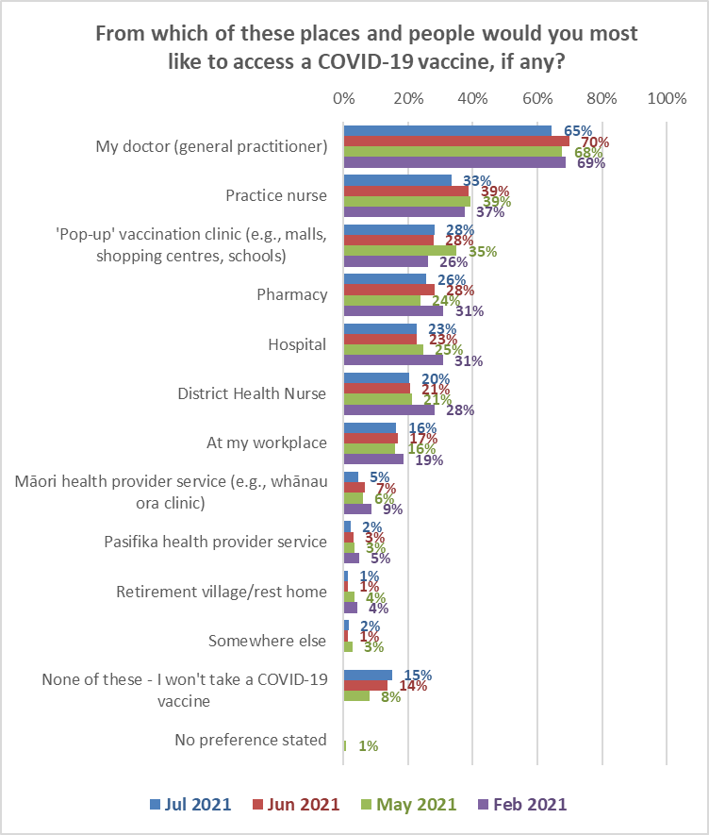

As in June and May 2021, the percentage of respondents who selected "none of these" increased as likelihood to get a COVID-19 vaccine decreased.

From which of these places and people would you most like to access a COVID-19 vaccine, if any? | LIKELIHOOD TO GET VACCINE
 | Definitely | Most Likely | Likely | Unlikely | Most Unlikely | Definitely not | Unsure
None of these - I won’t take a COVID-19 vaccine | 0% | 1% | 1% | 9% | 45% | 86% | 3%

“My doctor (general practitioner)” is ranked highest for all ethnic groups except “Other”. Note that each ethnic group has different acceptable access point priority order, as shown in the following table.

ETHNIC GROUPS
Asian | Indian | Māori | NZ European/ Pakeha | Other European | Pasifika | Other*
My doctor (general practitioner) (71%). | My doctor (general practitioner) (77%). | My doctor (general practitioner) (64%). | My doctor (general practitioner) (63%). | My doctor (general practitioner) (51%). | My doctor (general practitioner) (72%). | Hospital (63%).
'Pop-up' vaccination clinic (e.g., malls, shopping centres, schools) (34%). | Hospital (28%). | Practice nurse (31%). | Practice nurse (36%). | Practice nurse (39%). | Hospital (25%). | My doctor (general practitioner) (60%).
Hospital (27%). | Practice nurse (24%). | 'Pop-up' vaccination service (e.g., malls, shopping centres, schools) (25%). | 'Pop-up' vaccination clinic (e.g., malls, shopping centres, schools) (28%). | 'Pop-up' vaccination clinic (e.g., malls, shopping centres, schools) (35%). | At my workplace (22%). | 'Pop-up' vaccination clinic (e.g., malls, shopping centres, schools) (48%).
At my workplace (24%). | 'Pop-up' vaccination clinic (e.g., malls, shopping centres, schools) (20%). | Pharmacy (24%). | Pharmacy (28%). | At my workplace (26%). | Practice nurse (22%). | Pharmacy (45%).
Practice nurse (19%). | At my workplace (16%). | District Health Nurse (23%). | District Health Nurse (22%). | Pharmacy (26%). | 'Pop-up' vaccination clinic (e.g., malls, shopping centres, schools) (21%). | Practice nurse (22%).
Pharmacy (18%). | Pharmacy (14%). | Hospital (20%). | Hospital (21%). | District Health Nurse (21%). | Pharmacy (16%). | District Health Nurse (22%).
District Health Nurse (15%). | District Health Nurse (12%). | Māori health provider service (e.g., whānau ora clinic) (17%). | At my workplace (15%). | Hospital (20%) | Pasifika health provider service (16%). | At my workplace (17%).
Māori health provider service (e.g., whānau ora clinic) (1%). | Māori health provider service (e.g., whānau ora clinic) (3%). | At my workplace (11%). | Māori health provider service (e.g., whānau ora clinic) (3%). | Māori health provider service (e.g., whānau ora clinic) (2%). | District Health Nurse (13%). | NO FURTHER PREFERENCES
* Indication only, small base (n=11).

Attendance preferences for COVID-19 vaccine
Repeating a question from the June survey, those respondents who had not yet been vaccinated and had not booked were asked what preferences they had for vaccination, even though the vaccine would be offered to people at different times according to the Vaccine Group and age range they were in.

Unlike the June survey, however, going alone for a COVID-19 vaccination was presented as an option, and 42% of respondents selected that option.

There was also preference for being able to go for a vaccine with others, either:

- Going at the same time as other members of their whānau/ family regardless of the age of the members of their whānau/family, or the respondent’s age (38%, or 65% of those who did not prefer to go on their own).
- Going at the same time as those for whom they provide care or support, regardless of the age of the people they provide care or support for, or the respondent’s age (12%, or 21% of those who did not prefer to go on their own).
- Where a respondent was 17 or under, going at the same time as their parents (3% overall, 46% of those aged 16-17).

6% wanted to wait, and go with their children later in the year – a similar result to June 2021.

The following table shows the preferences by Vaccine Group.

Although the vaccine will be offered to people at different times according to the Group and the age range they are in, which of these would you also prefer, if any? | ALL | VACCINE GROUP
 |  | Group 1 | Group 2 | Group 3 | Group 4 | Unsure
I’d prefer to go on my own | 42% | 21% | 57% | 48% | 41% | 37%
Be able to go for a vaccine at the same time as other members of my whānau/ family regardless of their age or mine | 38% | 17% | 26% | 39% | 40% | 26%
Be able to go at the same time as those for whom I provide care or support, regardless of their age or mine | 12% | 2% | 6% | 12% | 13% | 11%
Wait and go with my children later in the year | 6% | 3% | 7% | 5% | 6% | 11%
I'm 17 or under, and would like to go at the same time as my parents | 3% | 45% | 0% | 1% | 4% | 1%
Something else | 8% | 13% | 0% | 7% | 7% | 20%
No response given | 5% | 0% | 8% | 5% | 6% | 4%
N (unweighted) - Not yet vaccinated and not booked | 1,017 | 12 | 30 | 259 |  | 716

Attitudes to children aged 12 to 17 being vaccinated

13.1 Would you allow the children for whom you are the primary caregiver to take the vaccine?
All respondents were asked if they were primary caregivers for young people aged 12-15 years or 16-17 years.

84% said they were not caregivers and were excluded from the rest of the questions around vaccines and younger people. 11% of the sample were primary givers for 12–15-year-olds, and 7% for primary caregivers for 16–17-year-olds.

Each of these caregiver groups were asked:
- For how many young people they were a caregiver (a separate question for the caregivers of each age group).
- If they would allow their young people to get the vaccine (again, a separate question for the caregivers of each age group).

Caregivers of 12–15-year-olds
Primary caregivers of 12–15-year-olds were asked ‘If a COVID-19 vaccine is approved for use in children aged between 12-15, would you allow the children for whom you are the primary caregiver to take the vaccine?’

The following chart shows responses to this question compared with the June, May and April 2021 survey.

67% said that they would ‘definitely’ or ‘likely’ allow children of this age to be vaccinated (June 59%, May 55%, April 2021 56%). Respondents who had already had their own COVID-19 vaccination or who had booked to have their vaccination were more likely than average to allow their 12–15-year-olds to also get vaccinated (already vaccinated: 90%; booked: 92%). There was a similar trend in June, but because fewer respondents had been vaccinated at that time, the overall effect was not as pronounced.

21% said they were unlikely to left their 12-15-year-olds get a COVID-19 vaccine or would ‘Definitely not’ allow it. (June 30%, May 26%, April 2021 22%). The unsure remained at 12% overall.
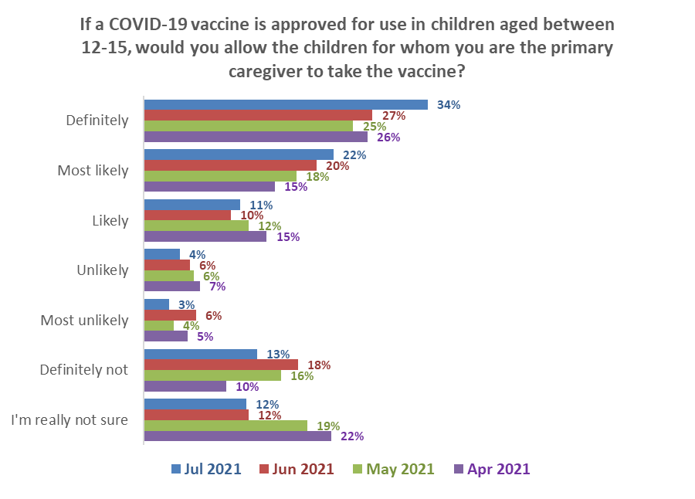Base (Caregivers for 12- to 15-year-olds): 310
Definitely & likely
July 2021 67%↑
June 2021 59%
May 2021 55%
April 2021 56%

Definitely not & unlikely
July 2021 21% ↓
June 2021 30%
May 2021 26%
April 2021 22%

↑
↑
The overall average number of 12–15-year-olds reported by their caregivers was 1.51. Caregivers who would allow their 12–15-year-olds to get a COVID-19 vaccine reported a slightly higher average of 1.54. This means that the overall percentage of 12–15-year-olds who will be allowed to get a vaccine will be higher than the caregiver percentage shown in the chart above.

As in June, a higher proportion of caregivers of 16–17-year-olds than caregivers of 12–15-year-olds was likely to allow their young people to get a vaccine (the apparent decline in comparison with the June result is not statistically significant):

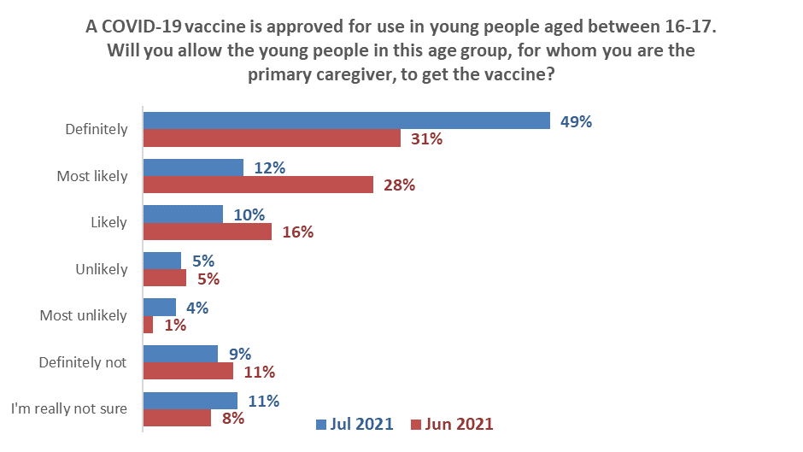
Definitely & likely
July 2021 71%
June 2021 74%
Definitely not & unlikely
July 2021 18%
June 2021 18%
Base (Caregivers for 16- to 17-year-olds): 175

The overall average number of 16–17-year-olds reported by their caregivers was 1.78. Caregivers who would allow their 16–17-year-olds to get a COVID-19 vaccine reported a slightly lower average of 1.69. This means that the overall percentage of 16–17-year-olds who will be allowed to get a vaccine will be lower than the caregiver percentage shown in the chart above.

Overall, it is estimated that caregivers would allow around 69% of their 12–15-year-olds and 67.5% of their 16–17-year-olds to get a vaccine (around 68% of all 12–17-year-olds). This is calculated as follows:

 | 12–15-year-olds | 16–17-year-olds
Average number overall per caregiver | 1.51 | 1.78
Population estimate | 200,360 | 125,550
Estimated number of caregivers | 133,040 | 70,455
Percent of caregivers allowing vaccination | 67.3% | 71.0%
Number of caregivers allowing vaccination | 89,540 | 50,020
Average young people per caregiver allowing vaccination | 1.54 | 1.69
Estimated number of 16-17s allowed to get vaccine | 138,245 | 84,770
Percent of population estimate | 69.0% | 67.5%

Māori were less likely than average to allow their 16–17-year-old taiohi to get a COVID-19 vaccine but more likely than average to allow their 12–15-year-old tamariki to get vaccinated.

Pasifika and “Other European” respondents were the least likely to allow the 12–15-year-olds for whom they were the primary caregiver to be vaccinated. Pasifika were the most unsure about allowing their 16–17-year-olds to be vaccinated.

Will you allow the young people for whom you are the primary caregiver, to get the vaccine? | ETHNIC GROUP
 | Asian | Indian | Māori | NZ European/ Pākehā | Other European | Pasifika | Other *
16–17-year-olds
Would allow | 85% | 73% | 66% | 71% | 72% | 74% | 41%
Would not allow | 15% | 27% | 22% | 17% | 9% | 0% | 59%
Not sure | 0% | 0% | 11% | 12% | 20% | 26% | 0%
12–15-year-olds
Would allow | 83% | 84% | 78% | 65% | 50% | 64% | 59%
Would not allow | 13% | 16% | 14% | 22% | 14% | 22% | 41%
Not sure | 5% | 0% | 9% | 13% | 36% | 13% | 0%
* Indication only; small base (n=4)

13.2 Reasons for being unsure or unlikely to encourage COVID-19 vaccination for younger people
Primary caregivers of younger people (either 16-17- or 12–15-year-olds) who said they were unsure or unlikely to encourage these children to be vaccinated were asked to select their reasons for this from a list presented to them. The table below compares the overall July results with those from June, May and April 2021.

As shown in the table:
- The main response – ‘I would need to be assured about its safety in children’ – was stable on 51% (June 52%, May 59%, April 60%).
- It is too soon to see whether there are any long-term effects for children from the vaccine increased by 7 percentage points (48%; June 41%; May 50%; April 43%).
- “I don't see the need for children to get a COVID-19 vaccine” reduced by 5 percentage points (17%; June 22%; May 23%; April 13%).
- “I don't allow the children I care for to take any vaccine” reduced by 7 percentage points (8%; June 15%; May 9%; April 10%).

Reasons for being unsure or unlikely | April  2021 | May  2021 | June  2021 | July  2012 | Difference  % points
I would need to be assured about its safety in children | 60% | 59% | 52% | 51% | - 1
It is too soon to see whether there are any long-term effects for children from the vaccine | 43% | 50% | 41% | 48% | +7 ↑
I'd rather wait and see if others who have taken it suffer any side effects | 21% | 28% | 30% | 32% | + 2
I don't see the need for children to get a COVID-19 vaccine | 13% | 23% | 22% | 17% | -5 ↓
I don't trust any vaccine | 12% | 10% | 7% | 11% | +4
I'd like to be able to talk with my health provider about it | 22% | 17% | 11% | 10% | -1
I personally don't take any vaccine | 7% | 10% | 10% | 8% | -2
I don't allow the children I care for to take any vaccine | 10% | 9% | 15% | 8% | -7 ↓
I'd like to make sure that others who need it can get it before my child/children | 9% | 6% | 6% | 6% | 0
Children I care for have an existing health condition which prevents them from taking a vaccine | 8% | 5% | 7% | 6% | -1
It is too hard to get them to a place to be vaccinated |  |  | 0% | 3% | +3
Because of my religious beliefs |  | 4% | 0% | 2% | +2
Children I care for have had a bad experience in the past when taking a vaccine | 5% | 3% | 4% |  | +1
I won't be able to afford a COVID-19 vaccine for the children I care for | 3% | 2% | 0% | 1% | +1
Some other reason | 10% | 11% | 9% | 13% | +4
Multiple answers were allowed
Bases: July n=127; June n=62. May and April results were from caregivers of 12–15-year-olds only

“Other reasons” mentioned included:
Will follow the order of the roll out and see statistics of everyone vaccinated and as the kids are healthy at present they can go last.”
Kids are in shared custody
It’s experimental
It is not safe
COVID is a cold. It’s not that serious and it’s just an excuse to control the population
My kids are alright and don’t need it.

Reasons for not allowing 16–17-year-olds to get a vaccine were much the same as for 12–15-year-olds. Comparisons are shown in the following table:

You say you are unsure or are unlikely to encourage COVID-19 vaccination for the young people for whom you're the caregiver if this were offered. Why is that? | ALL | For which of these groups of young people are you the primary caregiver?
 |  | Aged 12-15 | Aged 16-17
I would need to be assured about its safety in children | 51% | 58% | 40%
It is too soon to see whether there are any long-term effects for children from the vaccine | 48% | 52% | 46%
I'd rather wait and see if others who have taken it suffer any side effects | 32% | 35% | 28%
I don't see the need for children to get a COVID-19 vaccine | 17% | 18% | 10%
I don't trust any vaccine | 11% | 10% | 11%
I'd like to be able to talk with my health provider about it | 10% | 10% | 12%
I personally don't take any vaccine | 8% | 10% | 5%
I don't allow the children I care for to take any vaccine | 8% | 5% | 15%
I'd like to make sure that others who need it can get it before my child/children | 6% | 5% | 6%
Children I care for have had a bad experience in the past when taking a vaccine | 6% | 5% | 5%
It is too hard to get them to a place to be vaccinated | 3% | 4% | 1%
Because of my religious beliefs | 2% | 3% | 4%
Children I care for have an existing health condition which prevents them from taking a vaccine | 1% | 1% | 3%
I won't be able to afford a COVID-19 vaccine for the children I care for | 1% | 1% | 0%
Some other reason | 13% | 13% | 14%
N (unweighted) - Unsure or unwilling to allow 16-17s or 12-15s to get a COVID-19 vaccine | 127 | 92 | 54

Trust in the management of the pandemic and rating of the vaccination response
All respondents were asked:
- how much they trusted the Ministry and Government to manage the COVID-19 pandemic in a way which best protected them and other New Zealanders.
- how they thought the vaccination response to the COVID-19 pandemic was being managed in New Zealand.

14.1 Management of the pandemic
The average trust in the Ministry of Health and Government to manage the pandemic, on a scale of 0 to 5 (with 5 being highest) has been in the same general range since February 2021.

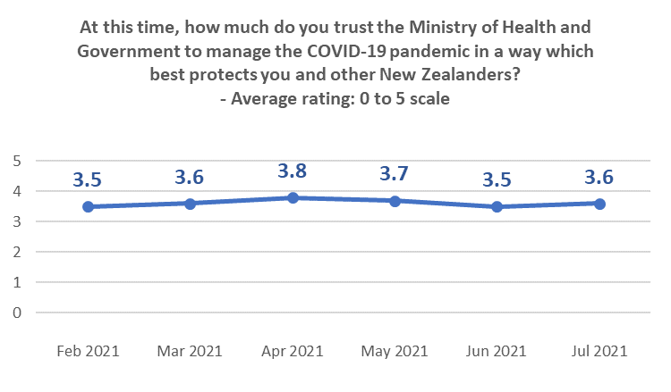

As in June, average trust falls as likelihood to get a vaccine falls. Average trust scores are quite consistent with the June results, and those who think that vaccination is “important” or “very important” rate their trust above 3 out of 5.

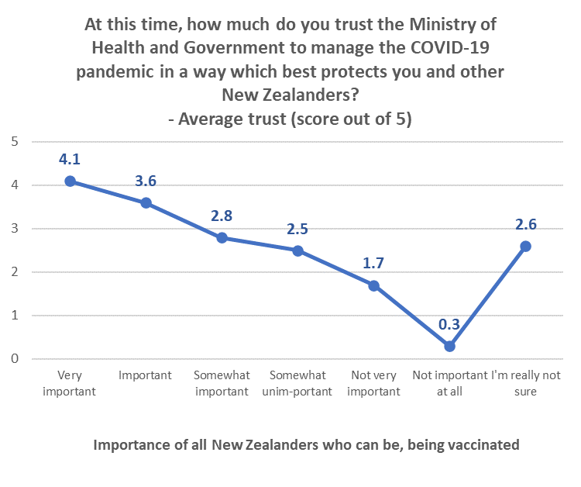

14.2 Management of the vaccination response
July’s average rating of the vaccination response (on a scale of 0 to 10, 10 being highest) halted the ongoing declining trend (although the apparent improvement in comparison with June is not statistically significant):

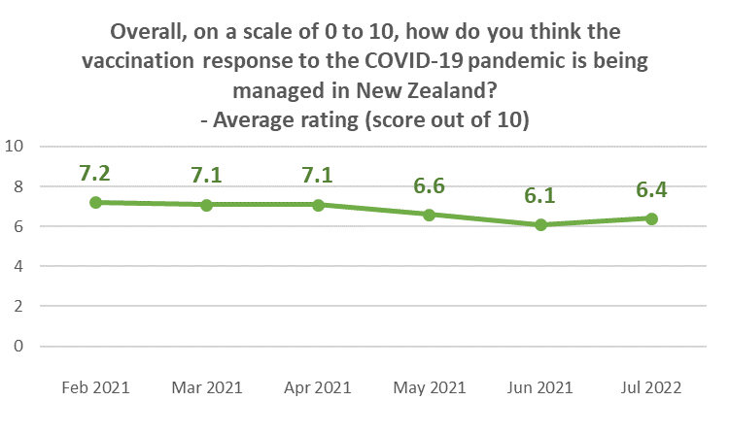

The previous declines in the percentage rating the vaccine response at 9 or 10, or 7 or 8, has been arrested.

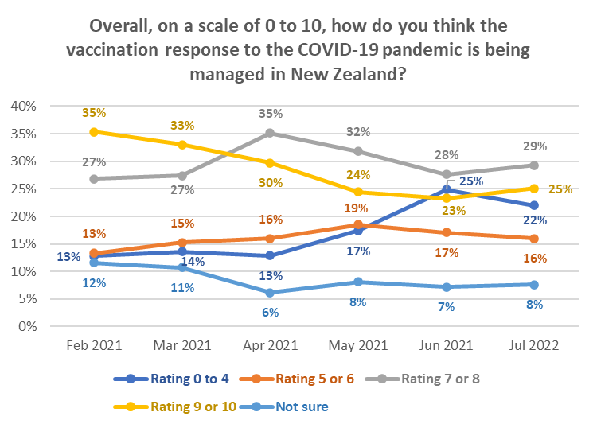

Lower than average ratings come from:
- Those with household income of less than $20,000 per year.
- Those who aren’t sure which Vaccine Group they are in.
- Those who wanted their vaccination in July and those who were not sure when they wanted to get the vaccine.
- Those who are unlikely to get a COVID-19 vaccine - particularly those who said they would “Definitely not” get it (average rating of 2.6 out of 10).
- Those who think vaccination is not important at all (1.8 out of 10).

Those who think that vaccination is “important” or “very important” rate vaccination response at 6.5 or above out of 10.

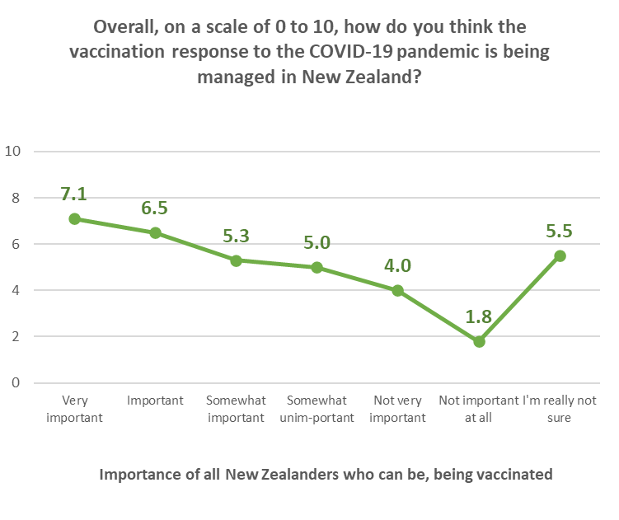

APPENDIX 1 - SAMPLE

2,509 people aged 18+ who are members of the nationwide HorizonPoll and Horizon Research Māori panels and two third-party respondent panels (used for source diversity), responded to this online survey between 26 July and 1 August 2021.

The total sample is weighted on age, gender, employment status, personal income and region to match the adult population at the most recent census and the overall percentage of New Zealanders 16+ vaccinated as at 11:59pm on 1 August 2021.

At a 95% confidence level, the survey has a maximum margin of error of ±2.0% overall.

Sub-sample respondent counts and maximum margins of error (which occur when there is a 50%/50% answer) are shown below.

 | All respondents |  |  | Not yet vaccinated
 | Count | Maximum  sub-sample margin of error |  | Count | Maximum  sub-sample margin of error
TOTAL | 2,509 | ±2.0% |  | 1,575 | ±2.5%
GENDER
Male | 1,092 | ±3.0% |  | 665 | ±3.8%
Female | 1,409 | ±2.6% |  | 905 | ±3.3%
Gender Diverse | 8 | ±34.6% |  | 5 | ±43.8%
AGE GROUP
Under 18 years | 68 | ±11.9% |  | 60 | ±12.7%
18-24 years | 222 | ±6.6% |  | 180 | ±7.3%
25-34 years | 458 | ±4.6% |  | 353 | ±5.2%
35-44 years | 499 | ±4.4% |  | 364 | ±5.1%
45-54 years | 376 | ±5.1% |  | 265 | ±6.0%
55-64 years | 415 | ±4.8% |  | 221 | ±6.6%
65-74 years | 326 | ±5.4% |  | 98 | ±9.9%
75 years or over | 145 | ±8.1% |  | 34 | ±16.8%
IMPAIRMENT, LONG-TERM HEALTH CONDITIONS OR DISABLED
Impairment or long-term health conditions | 947 | ±3.2% |  | 491 | ±4.4%
Identify as disabled | 252 | ±6.2% |  | 123 | ±8.8%

 | All respondents |  |  | Not yet vaccinated
 | Count | Maximum  sub-sample margin of error |  | Count | Maximum  sub-sample margin of error
AREA TYPE
Large city | 1,218 | ±2.8% |  | 793 | ±3.5%
Regional City | 463 | ±4.6% |  | 279 | ±5.9%
Regional town | 477 | ±4.5% |  | 282 | ±5.8%
Rural, but not remote | 310 | ±5.6% |  | 197 | ±7.0%
Rural and remote | 41 | ±15.3% |  | 24 | ±20.0%
ETHNIC GROUP
Asian | 174 | ±7.4% |  | 115 | ±9.1%
Indian | 117 | ±9.1% |  | 83 | ±10.8%
Māori | 481 | ±4.5% |  | 236 | ±6.4%
NZ European/ Pākehā | 1,734 | ±2.4% |  | 1,114 | ±2.9%
Other European | 166 | ±7.6% |  | 105 | ±9.6%
Pasifika | 157 | ±7.8% |  | 108 | ±9.4%
Other | 20 | ±21.9% |  | 14 | ±26.2%
DHB AREA
Northland | 146 | ±8.1% |  | 70 | ±11.7%
Waitemata | 250 | ±6.2% |  | 159 | ±7.8%
Auckland | 243 | ±6.3% |  | 144 | ±8.2%
Counties Manukau | 204 | ±6.9% |  | 121 | ±8.9%
Waikato | 229 | ±6.5% |  | 156 | ±7.8%
Lakes | 65 | ±12.2% |  | 28 | ±18.5%
Bay of Plenty | 95 | ±10.1% |  | 63 | ±12.3%
Tairawhiti | 25 | ±19.6% |  | 14 | ±26.2%
Taranaki | 87 | ±10.5% |  | 63 | ±12.3%
Hawke's Bay | 90 | ±10.3% |  | 61 | ±12.5%
Whanganui | 35 | ±16.6% |  | 17 | ±23.8%
MidCentral | 132 | ±8.5% |  | 81 | ±10.9%
Hutt | 78 | ±11.1% |  | 54 | ±13.3%
Capital and Coast | 217 | ±6.7% |  | 150 | ±8.0%
Wairarapa | 53 | ±13.5% |  | 34 | ±16.8%
Nelson/ Marl-borough | 89 | ±10.4% |  | 49 | ±14%
West Coast | 30 | ±17.9% |  | 15 | ±25.3%
Canterbury | 263 | ±6.0% |  | 175 | ±7.4%
South Canterbury | 23 | ±20.4% |  | 10 | ±31.0%
Southern | 155 | ±7.9% |  | 111 | ±9.3%

Contact
For more information about this survey, please contact:

Grant McInman, telephone 021 076 2040, email gmcinman@horizonresearch.co.nz.
Graeme Colman, telephone 021 84 85 76, email gcolman@horizonresearch.co.nz.

APPENDIX 2 -PROFILE BY LIKELIHOOD TO GET A COVID-19 VACCINE

 | DEMOGRAPHIC PROFILE:  Likelihood to get a COVID-19 vaccine |  |  | All |  | Will you get a COVID-19 vaccine?
 |  |  |  |  |  | Definitely |  | Most likely |  | Likely |  | Unlikely |  | Most unlikely |  | Definitely not |  | I'm not sure |  | Already vaccinated
 |  |  |  | 100% |  | 42% |  | 18% |  | 8% |  | 4% |  | 3% |  | 6% |  | 7% |  | 13%
GENDER
 |  | Male | 49% |  | 50% |  | 50% |  | 52% |  | 44% |  | 41% |  | 48% |  | 37% |  | 50%
 |  | Female | 51% |  | 49% |  | 50% |  | 48% |  | 56% |  | 59% |  | 52% |  | 63% |  | 50%
 |  | Gender diverse | 0% |  | 1% |  | 0% |  | 0% |  | 0% |  | 0% |  | 0% |  | 0% |  | 0%
AGE GROUP
 |  | 16-17 years | 4% |  | 6% |  | 6% |  | 3% |  | 3% |  | 2% |  | 2% |  | 9% |  | 2%
 |  | 18-24 years | 12% |  | 14% |  | 17% |  | 16% |  | 23% |  | 14% |  | 14% |  | 8% |  | 5%
 |  | 25-34 years | 15% |  | 16% |  | 22% |  | 22% |  | 30% |  | 20% |  | 9% |  | 18% |  | 8%
 |  | 35-44 years | 19% |  | 23% |  | 25% |  | 22% |  | 22% |  | 25% |  | 18% |  | 23% |  | 12%
 |  | 45-54 years | 15% |  | 17% |  | 14% |  | 16% |  | 14% |  | 13% |  | 15% |  | 19% |  | 11%
 |  | 55-64 years | 18% |  | 15% |  | 13% |  | 14% |  | 3% |  | 18% |  | 27% |  | 12% |  | 22%
 |  | 65-74 years | 13% |  | 7% |  | 3% |  | 5% |  | 5% |  | 4% |  | 12% |  | 10% |  | 27%
 |  | 75 years or over | 5% |  | 3% |  | 0% |  | 1% |  | 0% |  | 4% |  | 3% |  | 1% |  | 13%
 |  | AVERAGE AGE (years) | 46.2 |  | 42.3 |  | 38.2 |  | 40.4 |  | 35.2 |  | 42.8 |  | 47.5 |  | 42.3 |  | 57.0
 |  | % difference from overall average |  |  | --8.6% |  | --17.3% |  | --12.7% |  | --24.0% |  | --7.5% |  | +2.8% |  | --8.6% |  | +23.2%

 | DEMOGRAPHIC PROFILE:  Likelihood to get a COVID-19 vaccine |  |  | All |  | Will you get a COVID-19 vaccine?
 |  |  |  |  |  | Definitely |  | Most likely |  | Likely |  | Unlikely |  | Most unlikely |  | Definitely not |  | I'm not sure |  | Already vaccinated
 |  |  |  | 100% |  | 42% |  | 18% |  | 8% |  | 4% |  | 3% |  | 6% |  | 7% |  | 13%
HOUSEHOLD INCOME
 |  | Less than $20,000 per year | 10% |  | 8% |  | 7% |  | 18% |  | 24% |  | 18% |  | 17% |  | 12% |  | 6%
 |  | Between $20,001 and $30,000 per year | 10% |  | 9% |  | 6% |  | 12% |  | 11% |  | 6% |  | 9% |  | 9% |  | 13%
 |  | Between $30,001 and $50,000 per year | 18% |  | 16% |  | 13% |  | 17% |  | 15% |  | 18% |  | 18% |  | 13% |  | 24%
 |  | Between $50,001 and $70,000 per year | 15% |  | 14% |  | 22% |  | 11% |  | 6% |  | 9% |  | 21% |  | 15% |  | 14%
 |  | Between $70,001 and $100,000 per year | 15% |  | 18% |  | 14% |  | 12% |  | 16% |  | 21% |  | 7% |  | 16% |  | 14%
 |  | Between $100,001 and $150,000 per year | 12% |  | 13% |  | 12% |  | 12% |  | 14% |  | 11% |  | 8% |  | 11% |  | 13%
 |  | Between $150,001 and $200,000 per year | 4% |  | 6% |  | 5% |  | 1% |  | 3% |  | 1% |  | 2% |  | 5% |  | 4%
 |  | More than $200,000 per year | 3% |  | 4% |  | 3% |  | 2% |  | 1% |  | 3% |  | 1% |  | 2% |  | 2%
 |  | Don't know/ prefer not to say | 13% |  | 12% |  | 17% |  | 14% |  | 11% |  | 14% |  | 18% |  | 18% |  | 10%
 |  | AVERAGE HOUSEHOLD INCOME ($) | $70,370 |  | $78,100 |  | $76,220 |  | $58,320 |  | $58,060 |  | $65,050 |  | $55,580 |  | $69,780 |  | $68,200
 |  | % difference from overall average |  |  | +11% |  | +8.3% |  | --17.1% |  | --17.5% |  | --7.6% |  | --21% |  | --0.8% |  | --3.1%
PERSONAL INCOME
 |  | Less than $20,000 per year | 39% |  | 41% |  | 42% |  | 40% |  | 45% |  | 40% |  | 47% |  | 34% |  | 34%
 |  | Between $20,001 and $30,000 per year | 14% |  | 13% |  | 11% |  | 12% |  | 11% |  | 11% |  | 13% |  | 15% |  | 18%
 |  | Between $30,001 and $50,000 per year | 21% |  | 19% |  | 21% |  | 21% |  | 24% |  | 22% |  | 20% |  | 24% |  | 23%
 |  | Between $50,001 and $70,000 per year | 6% |  | 8% |  | 6% |  | 8% |  | 5% |  | 4% |  | 4% |  | 6% |  | 6%
 |  | Between $70,001 and $100,000 per year | 6% |  | 7% |  | 6% |  | 5% |  | 4% |  | 6% |  | 4% |  | 3% |  | 6%
 |  | Between $100,001 and $150,000 per year | 3% |  | 4% |  | 3% |  | 2% |  | 1% |  | 1% |  | 1% |  | 2% |  | 3%
 |  | Between $150,001 and $200,000 per year | 1% |  | 1% |  | 0% |  | 1% |  | 1% |  | 0% |  | 0% |  | 1% |  | 1%
 |  | More than $200,000 per year | 1% |  | 0% |  | 0% |  | 0% |  | 1% |  | 0% |  | 0% |  | 0% |  | 1%
 |  | Don't know/ prefer not to say | 10% |  | 8% |  | 12% |  | 12% |  | 9% |  | 15% |  | 10% |  | 16% |  | 9%
 |  | AVERAGE PERSONAL INCOME ($) | $33,590 |  | $34,930 |  | $31,860 |  | $32,140 |  | $30,430 |  | $30,010 |  | $26,660 |  | $31,440 |  | $36,040
 |  | % difference from overall average |  |  | +4% |  | --5.2% |  | --4.3% |  | --9.4% |  | --10.7% |  | --20.6% |  | --6.4% |  | +7.3%

 | DEMOGRAPHIC PROFILE:  Likelihood to get a COVID-19 vaccine |  |  | All |  | Will you get a COVID-19 vaccine?
 |  |  |  |  |  | Definitely |  | Most likely |  | Likely |  | Unlikely |  | Most unlikely |  | Definitely not |  | I'm not sure | Already vaccinated
 |  |  |  | 100% |  | 42% |  | 18% |  | 8% |  | 4% |  | 3% |  | 6% |  | 7% | 13%
EMPLOYED
 |  | Yes | 68% |  | 67% |  | 74% |  | 66% |  | 62% |  | 59% |  | 60% |  | 68% |  |  | 60%
 |  | No | 32% |  | 33% |  | 26% |  | 34% |  | 38% |  | 41% |  | 41% |  | 32% |  |  | 40%
OCCUPATION
 |  | Professional/Senior Government Official | 7% |  | 8% |  | 8% |  | 4% |  | 5% |  | 3% |  | 3% |  | 6% |  |  | 8%
 |  | Business Manager/Executive | 4% |  | 5% |  | 4% |  | 6% |  | 4% |  | 1% |  | 4% |  | 3% |  |  | 5%
 |  | Business Proprietor/Self-employed | 5% |  | 5% |  | 4% |  | 2% |  | 8% |  | 4% |  | 5% |  | 7% |  |  | 5%
 |  | Teacher/Nurse/Police or other trained service worker | 8% |  | 9% |  | 4% |  | 6% |  | 5% |  | 3% |  | 3% |  | 3% |  |  | 13%
 |  | Clerical/Sales Employee | 13% |  | 15% |  | 16% |  | 17% |  | 12% |  | 21% |  | 8% |  | 16% |  |  | 9%
 |  | Farm Owner/manager | 1% |  | 1% |  | 0% |  | 0% |  | 0% |  | 1% |  | 0% |  | 1% |  |  | 1%
 |  | Technical/mechanical/Skilled Worker | 9% |  | 8% |  | 11% |  | 8% |  | 7% |  | 12% |  | 15% |  | 9% |  |  | 6%
 |  | Labourer/Agricultural or Domestic Worker | 8% |  | 6% |  | 13% |  | 12% |  | 12% |  | 13% |  | 12% |  | 8% |  |  | 6%
 |  | Home-maker (not otherwise employed) | 7% |  | 8% |  | 7% |  | 9% |  | 7% |  | 11% |  | 11% |  | 11% |  |  | 3%
 |  | Student | 11% |  | 15% |  | 14% |  | 14% |  | 16% |  | 7% |  | 5% |  | 12% |  |  | 5%
 |  | Retired/Superannuitant | 13% |  | 6% |  | 1% |  | 6% |  | 0% |  | 8% |  | 10% |  | 5% |  |  | 30%
 |  | Unemployed/Beneficiary | 9% |  | 10% |  | 13% |  | 7% |  | 21% |  | 13% |  | 18% |  | 8% |  |  | 5%
 |  | Don't know/prefer not to say | 6% |  | 5% |  | 7% |  | 9% |  | 4% |  | 4% |  | 6% |  | 13% |  |  | 6%

 | DEMOGRAPHIC PROFILE:  Likelihood to get a COVID-19 vaccine |  |  | All |  | Will you get a COVID-19 vaccine?
 |  |  |  |  |  | Definitely |  | Most likely |  | Likely |  | Unlikely |  | Most unlikely |  | Definitely not |  | I'm not sure | Already vaccinated
 |  |  |  | 100% |  | 42% |  | 18% |  | 8% |  | 4% |  | 3% |  | 6% |  | 7% | 13%
HIGHEST QUALIFICATION
 |  | Postgraduate degree (Masters' degree or PhD) | 9% |  | 9% |  | 6% |  | 7% |  | 3% |  | 3% |  | 5% |  | 5% |  |  | 12%
 |  | Undergraduate (Bachelor) degree | 25% |  | 31% |  | 25% |  | 21% |  | 27% |  | 22% |  | 9% |  | 20% |  |  | 24%
 |  | Vocational qualification (includes trade certificates, diplomas etc) | 24% |  | 18% |  | 25% |  | 28% |  | 20% |  | 29% |  | 36% |  | 26% |  |  | 27%
 |  | University Bursary or 7th form | 10% |  | 13% |  | 10% |  | 13% |  | 20% |  | 7% |  | 6% |  | 7% |  |  | 7%
 |  | Sixth form/UE/NCEA Level 2 | 13% |  | 14% |  | 14% |  | 11% |  | 7% |  | 22% |  | 13% |  | 17% |  |  | 9%
 |  | NCEA Level 1 or School Certificate | 8% |  | 5% |  | 11% |  | 6% |  | 11% |  | 7% |  | 10% |  | 15% |  |  | 8%
 |  | No formal school qualification | 8% |  | 6% |  | 7% |  | 10% |  | 9% |  | 10% |  | 16% |  | 6% |  |  | 8%
 |  | Prefer not to say | 3% |  | 3% |  | 2% |  | 4% |  | 3% |  | 0% |  | 4% |  | 5% |  |  | 4%
HOUSEHOLD TYPE
 |  | Single person household | 14% |  | 14% |  | 9% |  | 21% |  | 14% |  | 15% |  | 14% |  | 11% |  |  | 17%
 |  | Couple only (no children/none at home) | 26% |  | 25% |  | 18% |  | 9% |  | 13% |  | 28% |  | 22% |  | 19% |  |  | 38%
 |  | Two parent family, one or two children at home | 26% |  | 29% |  | 36% |  | 28% |  | 33% |  | 27% |  | 18% |  | 32% |  |  | 19%
 |  | Two parent family, three or more children at home | 10% |  | 8% |  | 14% |  | 16% |  | 7% |  | 8% |  | 22% |  | 13% |  |  | 6%
 |  | One parent family, one or two children at home | 8% |  | 8% |  | 6% |  | 10% |  | 6% |  | 7% |  | 11% |  | 7% |  |  | 6%
 |  | One parent family, three or more children at home | 2% |  | 1% |  | 2% |  | 1% |  | 9% |  | 2% |  | 4% |  | 1% |  |  | 1%
 |  | Flatting or boarding - not a family home | 8% |  | 10% |  | 11% |  | 5% |  | 10% |  | 8% |  | 4% |  | 9% |  |  | 5%
 |  | Extended family | 4% |  | 3% |  | 4% |  | 4% |  | 6% |  | 2% |  | 3% |  | 1% |  |  | 6%
 |  | Prefer not to say | 3% |  | 2% |  | 2% |  | 5% |  | 2% |  | 4% |  | 3% |  | 6% |  |  | 2%
 |  | Children in Household | 45% |  | 47% |  | 57% |  | 56% |  | 54% |  | 44% |  | 55% |  | 53% |  |  | 32%

 | DEMOGRAPHIC PROFILE:  Likelihood to get a COVID-19 vaccine |  |  | All |  | Will you get a COVID-19 vaccine?
 |  |  |  |  |  | Definitely |  | Most likely |  | Likely |  | Unlikely |  | Most unlikely |  | Definitely not |  | I'm not sure | Already vaccinated
 |  |  |  | 100% |  | 42% |  | 18% |  | 8% |  | 4% |  | 3% |  | 6% |  | 7% | 13%
ETHNIC GROUP
 |  | Asian | 6% |  | 7% |  | 9% |  | 10% |  | 10% |  | 3% |  | 2% |  | 4% |  |  | 5%
 |  | Indian | 4% |  | 6% |  | 8% |  | 1% |  | 3% |  | 1% |  | 1% |  | 4% |  |  | 3%
 |  | Māori | 16% |  | 12% |  | 13% |  | 16% |  | 13% |  | 13% |  | 17% |  | 15% |  |  | 24%
 |  | NZ European/Pākehā | 61% |  | 63% |  | 61% |  | 63% |  | 57% |  | 71% |  | 63% |  | 64% |  |  | 58%
 |  | Other European (includes Australian, South African, British etc) | 6% |  | 7% |  | 4% |  | 3% |  | 0% |  | 9% |  | 10% |  | 5% |  |  | 6%
 |  | Pasifika | 6% |  | 5% |  | 6% |  | 7% |  | 15% |  | 4% |  | 7% |  | 7% |  |  | 5%
 |  | Other | 1% |  | 1% |  | 1% |  | 0% |  | 1% |  | 0% |  | 1% |  | 2% |  |  | 1%

 | DEMOGRAPHIC PROFILE:  Likelihood to get a COVID-19 vaccine |  |  | All |  | Will you get a COVID-19 vaccine?
 |  |  |  |  |  | Definitely |  | Most likely |  | Likely |  | Unlikely |  | Most unlikely |  | Definitely not |  | I'm not sure | Already vaccinated
 |  |  |  | 100% |  | 42% |  | 18% |  | 8% |  | 4% |  | 3% |  | 6% |  | 7% | 13%
DHB
 |  | Northland | 6% |  | 3% |  | 6% |  | 4% |  | 2% |  | 2% |  | 9% |  | 7% |  |  | 8%
 |  | Waitemata | 14% |  | 15% |  | 13% |  | 13% |  | 12% |  | 13% |  | 16% |  | 9% |  |  | 13%
 |  | Auckland | 10% |  | 9% |  | 11% |  | 10% |  | 10% |  | 11% |  | 9% |  | 7% |  |  | 11%
 |  | Counties-Manukau | 10% |  | 7% |  | 14% |  | 15% |  | 17% |  | 8% |  | 8% |  | 10% |  |  | 10%
 |  | Waikato | 9% |  | 9% |  | 9% |  | 6% |  | 7% |  | 7% |  | 11% |  | 13% |  |  | 7%
 |  | Lakes | 2% |  | 2% |  | 1% |  | 2% |  | 3% |  | 1% |  | 2% |  | 2% |  |  | 4%
 |  | Bay of Plenty | 4% |  | 4% |  | 3% |  | 4% |  | 0% |  | 10% |  | 3% |  | 6% |  |  | 3%
 |  | Tairawhiti | 1% |  | 1% |  | 0% |  | 0% |  | 0% |  | 1% |  | 1% |  | 2% |  |  | 1%
 |  | Taranaki | 3% |  | 3% |  | 4% |  | 3% |  | 1% |  | 4% |  | 5% |  | 5% |  |  | 2%
 |  | Hawke's Bay | 3% |  | 3% |  | 3% |  | 1% |  | 2% |  | 2% |  | 3% |  | 7% |  |  | 3%
 |  | Whanganui | 1% |  | 1% |  | 0% |  | 0% |  | 2% |  | 2% |  | 1% |  | 1% |  |  | 2%
 |  | Midcentral | 4% |  | 5% |  | 4% |  | 4% |  | 2% |  | 5% |  | 1% |  | 5% |  |  | 4%
 |  | Hutt | 2% |  | 2% |  | 0% |  | 6% |  | 2% |  | 6% |  | 1% |  | 2% |  |  | 2%
 |  | Capital and Coast | 6% |  | 9% |  | 7% |  | 5% |  | 8% |  | 3% |  | 4% |  | 3% |  |  | 5%
 |  | Wairarapa | 2% |  | 2% |  | 1% |  | 1% |  | 3% |  | 5% |  | 3% |  | 1% |  |  | 2%
 |  | Nelson-Marlborough | 4% |  | 3% |  | 1% |  | 4% |  | 2% |  | 8% |  | 7% |  | 4% |  |  | 4%
 |  | West Coast | 2% |  | 2% |  | 3% |  | 1% |  | 2% |  | 0% |  | 0% |  | 0% |  |  | 2%
 |  | Canterbury | 11% |  | 14% |  | 14% |  | 11% |  | 9% |  | 2% |  | 10% |  | 9% |  |  | 9%
 |  | South Canterbury | 1% |  | 0% |  | 0% |  | 0% |  | 2% |  | 0% |  | 1% |  | 0% |  |  | 1%
 |  | Southern | 7% |  | 8% |  | 5% |  | 10% |  | 14% |  | 10% |  | 6% |  | 8% |  |  | 5%
 |  | North Island | 76% |  | 74% |  | 77% |  | 74% |  | 72% |  | 81% |  | 76% |  | 79% |  |  | 78%
 |  | Auckland | 33% |  | 31% |  | 38% |  | 39% |  | 39% |  | 32% |  | 32% |  | 26% |  |  | 34%
 |  | Upper North Island excluding Auckland | 20% |  | 17% |  | 18% |  | 16% |  | 12% |  | 20% |  | 25% |  | 28% |  |  | 23%
 |  | Lower North Island | 23% |  | 25% |  | 20% |  | 20% |  | 21% |  | 29% |  | 19% |  | 25% |  |  | 21%
 |  | South Island | 24% |  | 26% |  | 24% |  | 26% |  | 28% |  | 20% |  | 24% |  | 21% |  |  | 22%

 | DEMOGRAPHIC PROFILE:  Likelihood to get a COVID-19 vaccine |  |  | All |  | Will you get a COVID-19 vaccine?
 |  |  |  |  |  | Definitely |  | Most likely |  | Likely |  | Unlikely |  | Most unlikely |  | Definitely not |  | I'm not sure | Already vaccinated
 |  |  |  | 100% |  | 42% |  | 18% |  | 8% |  | 4% |  | 3% |  | 6% |  | 7% | 13%
AREA TYPE
 |  | Large city | 50% |  | 53% |  | 59% |  | 56% |  | 53% |  | 47% |  | 45% |  | 42% |  |  | 47%
 |  | Regional city | 15% |  | 15% |  | 13% |  | 16% |  | 16% |  | 11% |  | 15% |  | 16% |  |  | 17%
 |  | Regional town | 20% |  | 20% |  | 15% |  | 19% |  | 17% |  | 17% |  | 19% |  | 24% |  |  | 23%
 |  | Rural, but not remote | 12% |  | 11% |  | 12% |  | 6% |  | 12% |  | 23% |  | 18% |  | 17% |  |  | 13%
 |  | Rural and remote | 2% |  | 1% |  | 2% |  | 3% |  | 2% |  | 2% |  | 3% |  | 2% |  |  | 2%
VACCINE GROUP
 |  | Group 1 - Border and MIQ workers and the people they live with | 3% |  | 1% |  | 1% |  | 0% |  | 1% |  | 1% |  | 1% |  | 3% |  |  | 7%
 |  | Group 2 - High-risk frontline workers and people living in high-risk places | 7% |  | 2% |  | 3% |  | 4% |  | 4% |  | 0% |  | 3% |  | 3% |  |  | 18%
 |  | Group 3 - People who are at risk of getting very sick from COVID-19 | 31% |  | 28% |  | 15% |  | 22% |  | 19% |  | 14% |  | 15% |  | 23% |  |  | 52%
 |  | Group 4 - Everyone in New Zealand aged 16 and over | 52% |  | 65% |  | 76% |  | 66% |  | 58% |  | 71% |  | 56% |  | 55% |  |  | 19%
 |  | Not sure | 8% |  | 4% |  | 5% |  | 9% |  | 17% |  | 14% |  | 26% |  | 16% |  |  | 3%

Based on Ministry of Health figures of 1,195,824 New Zealanders vaccinated as at 11:59pm 1 August 2021.
All estimates are based on Statistics NZ’s Q1 2021 projections for the population 16+: of 4,086,600 New Zealanders.
Note that it is likely that, as the number vaccinated increases, those who are unlikely to get a vaccine will form a higher proportion of those who have not yet been vaccinated and the proportion of those who are likely to get vaccinated will decrease.
Note that it is likely that, as the number vaccinated increases, those who are unlikely to get a vaccine will form a higher proportion of those who have not yet been vaccinated.
Whole percentages quoted do not sum to the reported total owing to rounding.
“Indian” includes Indian, Pakistani, Bangladeshi, Sri Lankan
“Other European” means ethnic Europeans from other countries such as anywhere in Europe, Ireland, the British Isles, Australia, South Africa, Canada, etc.
“Indian” includes Indian, Pakistani, Bangladeshi, Sri Lankan.
Note that it is likely that, as the number vaccinated increases, those who are unlikely to get a vaccine will form a higher proportion of those who have not yet been vaccinated.
This effect is already noticeable, particularly with age: as the rollout progresses, the age-based approach will drive down the average age of those not yet vaccinated. In this July 2021 survey, those who had already been vaccinated were 23% older than the average age.
“Indian” includes Indian, Pakistani, Bangladeshi, Sri Lankan
“Indian” includes Indian, Pakistani, Bangladeshi, Sri Lankan.
“Indian” includes Indian, Pakistani, Bangladeshi, Sri Lankan.
Stats NZ “Infoshare” population estimates as at Q1 2021.

