Horizon Research
COVID-19 Vaccine
24 - 29 August, 2021

In association with the School of Population Health
University of Auckland

Contents
EXECUTIVE SUMMARY 1
REPORT 13
1. Effect of new strains 14
1.1 Does the emergence of more infectious strains of COVID-19 put you more at risk? 14
1.2 Do these more infectious strains make people more or less likely to get vaccinated? 15
2. Vaccine uptake 16
2.1 Unlikely to get a COVID-19 vaccine and difficult to persuade 20
2.2 Uptake by ethnicity 22
2.3 Uptake by people with impairment or who identify as disabled 24
2.4 Uptake by age group 24
2.5 Uptake by DHB 25
2.6 Gains from eventual decision on getting a vaccine 29
3. Second dose uptake 30
4. Importance of everyone in New Zealand who is able to be vaccinated, being vaccinated 31
5. Making the decision to get a COVID-19 vaccine 34
6. Main influences on vaccine decision 38
7. Reasons for being unsure or unlikely to get vaccinated 43
8. Attitudes of those who have not been vaccinated 49
8.1 When people would most like to get vaccinated 49
8.2 Preferred ways to get vaccinated 50
9. Support for the plan to offer vaccines to all New Zealanders aged 12 years or over 52
10. Support for the Level 4 lockdown 53
11. Information about the COVID-19 vaccine 54
11.1 Do unvaccinated people have enough information to decide whether or not to take the COVID-19 vaccine? 54
11.2 What else do people need to know to help them decide whether to get the COVID-19 vaccine? 56
11.3 Preferred information sources 61
11.4 Sources of official information about the vaccine 62
11.5 Impact of seeing an official COVID-19 vaccine advertisement 63
12. Experiences of those who have already been vaccinated 66
12.1 Did you receive enough information about your vaccination? 66
12.2 How invited to make a booking 68
12.3 How people actually made the booking 70
12.4 Ease of making a booking 71
12.5 Rating the booking experience 77
12.6 Assessing the appointment experience 79
12.7 Satisfaction with the care people received when they were vaccinated 81
12.8 Were people’s language needs met through the process? 82
12.9 Were people’s disability or impairment needs catered for through the process? 83
12.10 Likelihood of recommending vaccination to others 84
12.11 Suggested improvements to the vaccination process 85
13. Attitudes to children aged 12 to 17 being vaccinated 94
13.1 Would you allow the children for whom you are the primary caregiver to take the vaccine? 94
13.2 Reasons for being unsure or unlikely to encourage COVID-19 vaccination for younger people 97
14. Noticed information on COVID-19 vaccines which was not true 100
14.1 What made respondents think it was misinformation 101
14.2 Effect of misinformation 107
15. Trust in the management of the pandemic and rating of the vaccination response 110
15.1 Management of the pandemic 110
15.2 Management of the vaccination response 111
APPENDIX 1 - SAMPLE 114
APPENDIX 2 - PROFILE BY LIKELIHOOD TO GET A COVID-19 VACCINE 116
APPENDIX 3 – TABLES…………………………………………………………………………………………………….ATTACHED

EXECUTIVE SUMMARY
These results are from an online survey of 2,334 respondents in New Zealand aged 16 years of age or over. The survey was conducted between 24 and 29 August, 2021.

The sample is weighted on age, gender, employment status, ethnicity, personal income and region to match the 16+ population and at the most recent census. It is also weighted to reflect the overall percentage of New Zealanders 16+ vaccinated as at 11:59pm on 29 August 2021.

At a 95% confidence level, the survey has a maximum margin of error of ±2.0% overall.

KEY FINDINGS

Effect of new strains
- The emergence of new strains is making people in New Zealand feel more at risk and is likely to encourage some of those who are unsure or unlikely to get a vaccine, to actually get one.
- Just over three-quarters (76%) of those surveyed believe that new more infectious strains of COVID-19 put them more at risk, while only 5% believe these strains pose less risk
- 44% of survey participants who had not yet been vaccinated said they were more likely to get vaccinated with the emergence of more infectious strains of the virus. This is four times higher than those who said they were less likely to get vaccinated because of these new strains (11%).

Effect of new strains (e.g., Delta) | TOTAL | Will you get the COVID-19 vaccine?
 |  | Defin-itely | Most likely | Likely | Unlikely | Most unlikely | Defin-itely not | I'm not sure
Feel more at risk | 76% | 91% | 80% | 63% | 43% | 43% | 24% | 55%
More likely to get a COVID -19 vaccine | 44% | 58% | 63% | 43% | 18% | 13% | 4% | 23%

Vaccine uptake
- The Delta outbreak appears to have had an effect on potential uptake, which is now at 86% of the 16+ population (up 7% from 79% in July 2021).

- Including 12–15-year-olds, the potential overall 12+ population uptake is estimated at 85.5%.

16+ population | % | Estimated no.
Already vaccinated | 53% | 2,180,300
Likely to get a vaccine | 33% | 1,341,800
Potential uptake 16+ population | 86% | 3,522,100
12–15-years | % | Estimated no.
Already vaccinated | 24% | 64,070
Likely to get a vaccine (caregiver permission) | 53% | 141,000
TOTAL POTENTIAL UPTAKE 12+ POPULATION | 85.5% | 3,727,170

- Estimated potential uptake for the 16+ population by ethnic group is:

Ethnic Group | Estimated uptake %
ALL | 86%
Asian | 93%
Indian | 92%
Māori | 79%
NZ European/Pākehā | 84%
Other European | 86%
Pasifika | 85%

- 15% of those who have not yet had a vaccine (an estimated 277,000 people 16+) were booked to get one.

- There is a moderate correlation between likelihood to get a vaccine and feeling more at risk from new strains of the COVID-19 virus.
- There is virtually no correlation between likelihood to get a vaccine and:
  - trust in the Ministry of Health and the Government to manage the pandemic in a way that protects all New Zealanders;
  - The management of the vaccination response to the pandemic response; or
  - The importance of everyone in New Zealand who can be, being vaccinated.

Of those who have not yet been vaccinated
The intentions of those who are unvaccinated remain proportionately similar to the July results, despite more than 985,000 people getting their first vaccination between the July and the August surveys. This suggests that some of those who were previously unwilling to get a vaccine have changed their minds and are either now willing to get a vaccine or have actually had at least one dose of the vaccine.

The number who are not yet definitely committed to getting a vaccine is estimated at 826,300
– 20% of the 16+ population

Overall estimates of the COVID-19 vaccine intentions of the estimated 1,910,400 New Zealanders 16+ who have not yet been vaccinated are shown in the following table. The categories that make up the estimated 826.300 not yet committed (as at 29 August 2021) are highlighted in yellow in the following table:
 | % | Estimated number
Already vaccinated | 53.3% | 2,180,300
Definitely | 21.9% | 895,900
Most likely | 6.6% | 270,000
Likely | 4.3% | 175,900
TOTAL LIKELY | 32.8% | 1,341,800
TOTAL LIKELY OR ALREADY VACCINATED | 86.1% | 3,522,100
Unlikely | 1.3% | 53,200
Most unlikely | 3.2% | 130,900
Definitely not | 4.6% | 188,200
TOTAL UNLIKELY | 9.1% | 372,300
UNSURE | 4.8% | 196,300
NOT YET COMMITTED | 20.2% | 826,300

The uncommitted people should be primary targets of the vaccination effort if the maximum possible number of vaccinations is to be achieved.

Overall, of those who have not yet been vaccinated:
- 70% said they were likely to get a vaccine (July 71%, June 72%, May 77%, April 75%l, 67% in March 2021). This is around 1,341,800 people in New Zealand 16+.
- 20% said they were unlikely to get a COVID-19 vaccine. This is around 372,300 people in New Zealand 16+.
- 9% (an estimated 196,300 people in New Zealanders 16+) are unsure whether they will get a vaccine or not).

- The “core” of those who are unlikely to get vaccinated and will probably be difficult to persuade to get a COVID-19 vaccine has risen to 11.5% of those aged 16+ who are yet to get a vaccine (July 9.0%, June 11.6%, May 7.0%, April 8.4% and 9.4% in March 2021), but because the number who are unlikely to get a vaccine has fallen, this is now equivalent to 5.4% of the total 16+ population.

- There is the potential to achieve additional gains in uptake. Respondents who were not definitely intending to get a vaccine were asked if they thought they would eventually get one or not (this group represents close to 25% of the total 16+ population – an estimated 1,014,500 people 16+. Analysis shows that:

  - There is a nett incremental gain from the “unsure or unlikely” group of 1.8% of the 16+ population, or around 75,300 people, who may eventually decide to get a vaccine.
  - From those who were not definite about getting a COVID-19 vaccine, there is a potential loss among those who are currently likely to get a vaccine of 1.7% - an estimated 67,500 people.
  - There is a potential gain of 6.3% from those who are currently unlikely to get a vaccine – an estimated 258,900 people. As in July, this includes nearly 3 out of 10 of those who said they had been offered a COVID-19 vaccine but had declined it.

- Note that only 1% of those who are not yet vaccinated but are currently unsure whether they will get a COVID-19 vaccine said they would not eventually get a vaccine. This group constitutes 5% of the overall 16+ population – an estimated 196,300 people.

Do you think you'll eventually decide to actually get a COVID-19 vaccine or not? | Will you get a COVID-19 Vaccine?
 | Most Likely | Likely | Unlikely | Most Unlikely | Definitely not | Unsure
% of 16+ population | 6.6% | 4.3% | 1.3% | 3.2% | 4.6% | 4.8%
Yes | 92% | 71% | 17% | 11% | 3% | 26%
No | 1% | 2% | 16% | 48% | 83% | 1%
Not sure | 7% | 28% | 67% | 41% | 14% | 73%

- 99% of those who had one dose were likely to get a second, the same overall result as both July and June 2021. Only 1% said they were unlikely to get a second.

More information for those not yet vaccinated
- Just over two-thirds of those who had not been vaccinated (68%) said they definitely or mostly had enough information to decide whether or not to take the vaccine, compared with 28% who said they had ‘not quite enough information’ or ‘need to know more’.

- Main themes from an open-ended question regarding what else people need to know to help them decide whether to get the COVID-19 vaccine were as follows:
  - Information on the long-term effects of the vaccine, based on longer and/or more clinical studies (24%, up from 19% in July)
  - Information on side effects and risks (19%, down from 34% in July).
  - Facts on the success rate/effectiveness/ingredients/ international studies (14%, similar to the July result, 13%).
- These information needs are also reflected in the comments made by those who are already vaccinated but said they would have liked more information.

Reasons for being unsure or unlikely to get a vaccine
The top three reasons for people to be unsure, unlikely or opposed were the same as in all previous surveys, and the fourth reason is the same as in July 2021 (this was a new option added in July):

- Believing it is too soon to know if there are long-term effects (66%; July 62%, June 59%).
- Needing assurance of the vaccine’s safety (42%; July 46%, June 39%).
- Wanting to wait and see if others suffer side effects (41%, the same as July and June).
- The vaccine may not be effective against new variants (36%; July 31%).

Future demand
Of the estimated 1,910,400 people 16+ in New Zealand who are not yet vaccinated, 50% (equivalent to 960,000 people, or around 32,000 per day), wanted to get their first COVID-19 vaccine by the end of September 2021. An estimated total of 234,000 16+ were already booked at the time of the survey, with around 85% (235,300) wanting to be vaccinated by the end of September.

Ideally, when would you most like to get a COVID-19 vaccine this year? | All not yet vaccinated |  |  | Currently booked
 | % | Estimated no. | % |  | Estimated no.
Immediately | 25% | 484,800 | 39% |  | 108,900
July | 0% | 3,800 | 1% |  | 2,200
August | 5% | 87,800 | 12% |  | 33,400
September | 20% | 383,600 | 33% |  | 90,800
TOTAL TO 30 SEPTEMBER 2021 | 50% | 960,000 | 85% |  | 235,300
October | 4% | 70,600 | 5% |  | 14,500
November | 1% | 21,000 | 1% |  | 2,800
December | 1% | 17,200 | 0% |  | 0
I don't mind when | 10% | 190,900 | 6% |  | 15,800
I'm not sure | 18% | 339,700 | 3% |  | 8,600
I won't get the vaccine | 16% | 311,100 | 0% |  | 0

Importance of everyone in New Zealand who is able to be vaccinated, being vaccinated.
- 84% overall (July 82%, June 81%) felt that it was important that everyone in New Zealand who was able to be vaccinated, was vaccinated (“very important” 65%, up from 59% in July; “important” 14%, similar to July’s 15%; “somewhat important” 7%).
- 8% overall felt that it was unimportant; 6% were unsure.

- By ethnicity, the percentages who felt vaccination was important were:
  - Asian: 92%.
  - Indian: 97%.
  - Māori: 86%.
  - NZ European/Pākehā: 85%.
  - Other European: 87%.
  - Pasifika: 86%.
  - “Other”: 67%

Key issues to address
In making a decision to get vaccinated, New Zealanders will think about:
- Whether there will be unknown side effects (37%; July36%; June 40%; May 37%).
- Concern that the vaccine may not be effective against new variants (34%; July 29%).
- How the side effects may affect them (32%; July 34%; June 37%, May 31%; April 35%)
- What might happen if they have an adverse reaction to the vaccine (29%; July 25%; June 29%; May 27%; April 28%).
- Whether the vaccine might affect their health in other ways (25%; July 24%; June 30%; May 28%; April 26%).

- 36% felt it was too soon to see whether there were any long-term effects from the vaccine.

Main influences on vaccine decision
- The key influences which would make people more likely to take a COVID-19 vaccine when offered include:
  - Helping protect the health of my family/whānau (27%),
  - The vaccine has gone through rigorous trials (26%)
  - Helping reduce the risk of further lockdowns and economic harm (23%)
  - The benefits would outweigh the risks (also 23%).
- Overall, these influences had four main themes:
- helping others/altruism – this theme was quite prominent, involving four of the eight influences selected and in general is ahead of ‘benefits for me personally’. Appealing to people’s desires to help others should be prominent in messaging about the vaccination rollout
- medical assurances
- benefits for me personally
- information about the vaccine.

Support for the plan to offer vaccines to all New Zealanders aged 12 years or over
76% supported this plan, with only 7% opposed.

Support for Lockdown
- 83% overall support the Level 4 lockdown.
- Support is high right across New Zealand. Lowest support (but still majority support) is indicated in Wairarapa (support for the Level 4 Lockdown by DHB area is shown below):

DHB Area | Support for lockdown %
ALL | 83%
Northland | 86%
Waitemata | 82%
Auckland | 80%
Counties Manukau | 81%
Waikato | 83%
Lakes | 87%
Bay of Plenty | 88%
Tairawhiti | 94%
Taranaki | 96%
Hawke's Bay | 79%
Whanganui | 87%
MidCentral | 79%
Hutt | 82%
Capital and Coast | 81%
Wairarapa | 68%
Nelson/Marlborough | 82%
West Coast | 86%
Canterbury | 84%
South Canterbury | 82%
Southern | 82%

Vaccination preferences
Respondents who had not yet been vaccinated and had not booked would prefer to go for their vaccination:
- At the same time as other members of their whānau/ family regardless of the age of the members of their whānau/family, or the respondent’s age (41%).
- On their own (30%).
- At the same time as those for whom they provide care or support, regardless of the age of the people they provide care or support for, or the respondent’s age (11%).
- Wait and go with my children later in the year (5%).
- Over half (53%) of those aged 16 or 17 would like to go with their parents – this is an indicative result as the base is small (n=39 respondents).

Vaccination of 16–17-year-olds and 12–15-year-olds
- 74% of primary caregivers of children aged 16-17 years are likely to allow the young adults to be vaccinated (July 71%, June 74%).
- 73% of caregivers of children aged 12-15 years are likely to allow their young people to be vaccinated (July 67%, June 59%).
- Māori were more likely than average to allow their 16–17-year-old taiohi to get a COVID-19 vaccine but less likely than average to allow their 12–15-year-old tamariki to get vaccinated. This is a reversal of the July result.
- Pasifika respondents were more likely than average to allow the 12–15-year-olds and 16–17-year-olds for whom they were the primary caregiver to be vaccinated.

- As in previous surveys, the key concerns for those who won’t allow vaccination for their young people are vaccine safety (58%) and long-term effects of the vaccine (65%).
- “I don't see the need for children to get a COVID-19 vaccine” increased to 26% from 17% in July (June 22%, May 23%, April 13%).

Information about the COVID-19 vaccine
- A number of findings about information sources changed markedly compared with the July survey, no doubt triggered by the outbreak of the Delta variant of COVID-19 and the move to Level 4 lockdown which took place a week before the survey began. People became more likely to seek out breaking news from mass media sources such as websites, TV, social media and online news sites. Sources of one-to-one communication (for example, about vaccination bookings) via text and email remained important but preference for these channels declined.
- The top six preferred sources of information on the COVID-19 vaccine in the August survey are:
  - Websites (48%, up markedly from 36% in July).
  - Email (44% down from 54%)
  - TV News (31% - slightly up from the July result, 27%).
  - Social media (28%, up from 22%).
  - Online news media (27%, up from 20%).
  - Text (24%, down from 30%).
- August results showed a sharp increase in awareness for the top six sources of official advertising or information:
  - TV (74%, up 10 percentage points from July).
  - Social media (52%, up 18 percentage points).
  - News websites (39%, up 15 points).
  - Radio (35%, up 6 points).
  - YouTube (25%, up 7 points).
  - On demand TV (23%, up 5 points).

- As in the July survey wave, the greatest impact of seeing official information or advertising was to reinforce the decision to get a COVID-19 vaccine – “It made me feel I made the right decision to get the vaccine” (39% in August cf. 34% in July)
- The percentage who said that official advertising or information had increased their likelihood to get a vaccine dropped slightly to 14%, compared with 18% in July.
- A nett 43%, the same as in July, said that official advertising or information had made no difference to their decision to get or not get a vaccine.

Experiences of those who have already been vaccinated
- 97% of those who had been vaccinated said they had received enough information about their vaccination.
- Main ways they were invited to make a booking were:
  - By text (25%, up from 20% in July).
  - By email (18%, up from 15% in July).
  - Through work (15%, sharply down from July, 23%).
- Main ways people actually booked were:
  - Online (36%, with a strong increase from 24% in July). Note, the launch of “Book my Vaccine” occurred in the middle of the July survey period, whereas in the August survey, “Book my Vaccine” had been operating for a month.
  - By phone (33%, down from 39% in July).
- 93% of those who had booked in the past 30 days reported that booking was easy; 7% that is had been difficult.
- The main reasons for the booking being easy included:
  - The online booking system worked well (65%).
  - I got the time and place I wanted (54%).
  - It was easy to book my second vaccination (44%).
  - I was able to make bookings for both first and second doses at the same time (41%).
  - I found the booking number easily (30%)
- The top three reasons for it being difficult were:
  - 'Book My Vaccine' online system did not work (36%). This is around 2% of all who had booked in the past 30 days.
  - Could not get the time or place they had wanted (32%). This is around 2% of all who had booked in the past 30 days.
  - Not being given a booking for their second dose when booking their first (15%). This is around 1% of all who had booked in the past 30 days.

- 62% rated being invited to book 8 to 10 out of 10 (very positive), somewhat less than the 77% who gave an 8 to 10 rating for actually booking
- Text invites were rated as the best invitation method with 54% “10 out of 10” ratings (excellent), while online was rated the best booking method with 57% “10 out of 10” ratings.
- “Book My Vaccine” rated above all other methods of booking.

- Peoples’ positive experiences of their vaccination appointment far outweigh their negative experiences. Top positive experiences include friendly staff (75%, up from 71% in July), ease of getting to the centre (70% cf. 61% in July - this result probably reflects the greater number of centres available), and no trouble finding my booking (66% cf. 63% in July).
- By contrast, the biggest problem area, as in July, involved vaccination centre staff not knowing who the person was (12% cf. 13% in July).
- As in July, extremely high ratings were recorded for the care people received at the vaccination centre, and all these ratings improved slightly compared with July, as indicated below:
 | Mean ratings out of 10
Areas rated | August 2021 | July 2021
The location of the vaccination centre | 8.9 | 8.7
The way in which the vaccination centre was laid out | 8.9 | 8.8
The staff I saw when I first arrived | 9.1 | 9.0
Finding my booking details | 9.1 | 8.9
The person who vaccinated me | 9.5 | 9.3
The way in which I was monitored after I had been vaccinated | 9.2 | 9.1
- 92% of those who had received at least one dose said their language needs were met, however, only 69% of those with a disability or impairment said their needs had been met
- Almost three-quarters (73%) say they their experience made them more likely to recommend vaccination to others (up from 68% in July)
- Main types of suggested improvements from an open-ended question about improvements to the vaccination process include:
  - Very happy – no suggestions (60%, up strongly from 42% in July – a great result)
  - Vaccination centre suggestions (23% cf. 25% in July)
  - Booking suggestions (13%, down from 19% in July).

Misinformation
51% of respondents had come across what they believed to be misinformation on COVID-19 vaccines.
- Those who had already been vaccinated and those who said they would “Definitely” or “Definitely not” get a vaccine were more likely than others to have seen or heard what they perceived as misinformation.
- Sources of misinformation were:
  - Social media (70%).
  - Friends or family (40%).
  - Brochures/leaflets (23%).
  - Mainstream media such as TV news, radio or newspapers (print or online) (21%). Where respondents were unlikely to get a vaccine, this was at an above-average level at 57% – particularly among those who will “Definitely not” get a vaccine (70%). However, 13% of those who were likely to get a vaccine said they had seen what they perceived as misinformation in mainstream media.

- Overall, a nett 12% would not take a vaccine if something they initially thought was misinformation and looked credible alarmed them. 30% of those people would then go on to look for official information.
- The immediate effect of misinformation on those who were “Likely” to get a vaccine was more marked than average, but a higher proportion of that group would seek official information.

If something respondents initially thought was misinformation alarmed them or looked credible… | All | Will you get the COVID-19 vaccine?
 |  | Defin-  itely | Most likely | Likely | Un-likely | Most unlikely | Defin-itely not | Not sure
Nett not take vaccine | 12% | 7% | 10% | 28% | 17% | 25% | 16% | 17%
% of those who would not take vaccine if misinformation alarmed them or looked credible, who would then look for official information | 30% | 27% | 11% | 52% | 43% | 62% | 13% | 16%
POTENTIAL OVERALL IMPACT (% of group) | 4% | 3% | 4% | 5% | 4% | 4% | 7% | 5%

- Asian and Indian respondents were the most likely to not take the vaccine if alarmed by misinformation they thought was credible
- Māori and NZ Europeans/Pākehā were the least likely to be affected by misinformation.

Trust in the management of the pandemic and rating the vaccination response
- Average trust in the Ministry of Health and Government to manage the pandemic has increased. 83% now say they trust the Ministry of Health and Government (July 78%):

At this time, how much do you trust the Ministry of Health and Government to manage the COVID-19 pandemic in a way which best protects you and other New Zealanders? | Feb 2021 | Mar 2021 | Apr 2021 | May 2021 | Jun  2021 | Jul 2021 | Aug 2021
Average trust out of 5 | 3.5 | 3.6 | 3.8 | 3.7 | 3.5 | 3.6 | 3.8

- The average rating of the vaccination response (on a scale of 0 to 10, 10 being highest) has improved.

Overall, on a scale of 0 to 10, how do you think the vaccination response to the COVID-19 pandemic is being managed in New Zealand? | Feb 2021 | Mar 2021 | Apr 2021 | May  2021 | Jun  2021 | Jul 2021 | Aug 2021
Average rating out of 5 | 7.2 | 7.1 | 7.1 | 6.6 | 6.1 | 6.4 | 6.7

REPORT
Respondents were asked if they had been offered an opportunity to get their COVID 19 vaccine (note that this survey is weighted to reflect the overall percentage of New Zealanders vaccinated in the general population as at 11:59pm on 29 August 2021). The responses are shown below:

Have you already been offered an opportunity to get your COVID-19 vaccination? | May 2021 | Jun 2021 | Jul 2021 | Aug 2021 | Difference  % points
No | 77% | 69% | 43% | 18% | - 25 ↓
Yes - I have already had two doses | 6% | 11% | 19% | 31% | +12 ↑
Yes - I have already had one dose | 7% | 7% | 10% | 22% | +12 ↑
Yes - I have not had the first dose, but my appointment is booked | 5% | 6% | 13% | 15% | +2
Yes - but I have not had the first dose and have not booked an appointment yet | 4% | 4% | 10% | 9% | -1
Yes, but I declined/will decline to have the vaccine | 2% | 3% | 5% | 5% | 0
N.B. Percentages shown may not sum to 100% owing to rounding

5% overall (an estimated 204,500 New Zealanders 16+) did not know what Vaccine Group they were in.

August 2021 vaccination levels by Vaccine Group as identified by respondents.
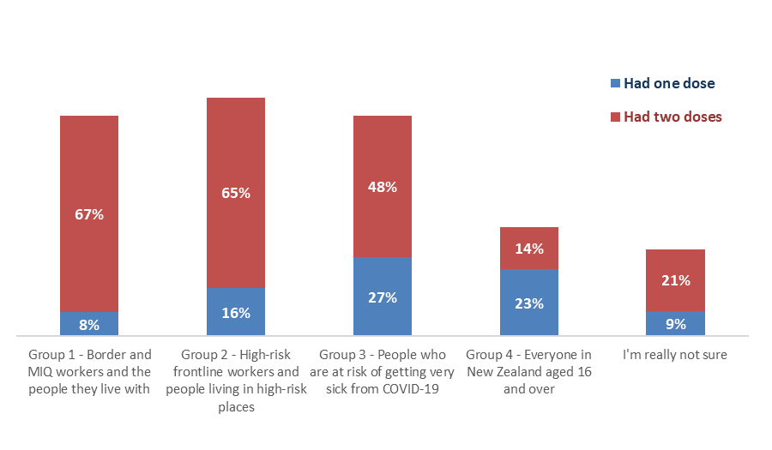
Total:
Aug 2021: 37%
Jul 2021: 11%
Jun 2021: 5%
Total:
Aug 2021: 75%
Jul 2021: 48%
Jun 2021: 25%
Total:
Aug 2021: 75%
Jul 2021: 77%
Jun 2021: 60%
Total:
Aug 2021: 81%
Jul 2021: 77%
Jun 2021: 72%
N.B. Figures may not sum to totals shown owing to rounding.

Respondents were asked if they lived with impairments or long-term health conditions and if they identified as disabled.

7% (an estimated 425,000 adults) self-identified as disabled.

Response | Do you live with impairments or long-term Health conditions? |  | Do you identify as Disabled?
 | Impairment | Estimated number | Disability | Estimated number
Yes | 36% | 1,467,400 | 7% | 302,700
No | 64% | 2,623,300 | 93% | 3,788,000

Effect of new strains
In the August 2021 survey new questions were introduced about the emergence of more infectious virus strains.

1.1 Does the emergence of more infectious strains of COVID-19 put you more at risk?
All survey respondents were asked “Do you feel that the emergence of more infectious strains of COVID-19 puts you more at risk?”

Just over three-quarters (76%) of those surveyed believe that new more infectious strains of COVID-19 put them more at risk, while only 5% believe these strains pose less risk.
Less risk
5%

More risk
76%

Base total sample: n=2,334

1.2 Do these more infectious strains make people more or less likely to get vaccinated?
44% of survey participants who had not been vaccinated said they were more likely to get vaccinated with the emergence of more infectious strains of the virus. This is four times higher than those who said they were less likely to get vaccinated (11%) because of these new strains.

Base not yet vaccinated: n= 1,044
More likely to get a vaccine because of more infectious strains by gender, age and ethnicity

By current intention to get a COVID-19 vaccine, the results were:

Effect of new strains (e.g., Delta) | TOTAL | Will you get the COVID-19 vaccine?
 |  | Defin-itely | Most likely | Likely | Unlikely | Most unlikely | Defin-itely not | I'm not sure
Feel more at risk | 76% | 91% | 80% | 63% | 43% | 43% | 24% | 55%
More likely to get a COVID -19 vaccine | 44% | 58% | 63% | 43% | 18% | 13% | 4% | 23%

Vaccine uptake
The Delta outbreak and the emergence of new, more infectious strains appears to have had an effect on potential uptake.

Estimated overall uptake among the 16+ population is 86% (up 7% from 79% in July 2021; June 77% in June, May 80%, April 77% and March 2021 69%).

Including 12–15-year-olds, the potential overall 12+ population uptake is estimated at 85.5%.

16+ population | % | Estimated no.
Already vaccinated | 53% | 2,180,300
Likely to get a vaccine | 33% | 1,341,800
Potential uptake 16+ population | 86% | 3,522,100
12–15-years | % | Estimated no.
Already vaccinated | 24% | 64,070
Likely to get a vaccine (parental permission) | 53% | 141,000
TOTAL POTENTIAL UPTAKE 12+ POPULATION | 85.5% | 3,727,170

The following are overall estimates of the COVID-19 vaccine intentions of the estimated 1,910,400 New Zealanders 16+ who have not yet been vaccinated:

COVID-19 vaccine intention | May 2021  % | Jun 2021  % | Jul 2021  % | Aug 2021 % | Aug 2021  Estimated number of people 16+
Definitely | 48% | 48% | 47% | 47% | 895,900
Most likely | 20% | 16% | 14% | 14% | 270,000
Likely | 9% | 8% | 10% | 9% | 175,900
Unlikely | 4% | 3% | 4% | 3% | 53,200
Most unlikely | 4% | 6% | 5% | 7% | 130,900
Definitely not | 7% | 10% | 11% | 10% | 188,200
Unsure | 8% | 9% | 9% | 10% | 196,300

Note that:
- The intentions of those who are unvaccinated remain proportionately similar to the July results, despite more than 985,000 people getting their first vaccination between the July and the August surveys. This suggests that some of those who were previously unwilling to get a vaccine have changed their minds and are either now willing to get a vaccine or have actually had at least one dose of the vaccine.

- There is a moderate correlation between likelihood to get a vaccine and feeling more at risk from new strains of the COVID-19 virus.
- There is virtually no correlation between likelihood to get a vaccine and:
  - trust in the Ministry of Health and the Government to manage the pandemic in a way that protects all New Zealanders;
  - The management of the vaccination response to the pandemic response; or
  - The importance of everyone in New Zealand who can be, being vaccinated.

- The number of people 16+ who are not yet definitely committed one way or the other (i.e. they said they would be “Most likely” or “Likely” to get the vaccine, “Unlikely” or “Most unlikely” to get the vaccine plus those who were “Unsure”) is estimated at 826,300 – 20% of the 16+ population

Total population 16+ trends are shown below. Note that the percentage who are unlikely to get a vaccine has dropped by 5 percentage points:

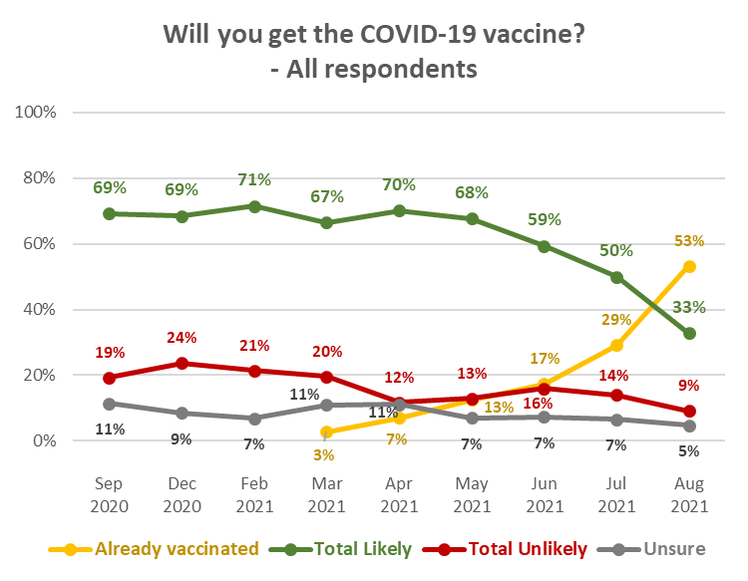

Profiles: “Total Likely”, “Total Unlikely”, and “Unsure”
The following table shows demographic characteristics of those who were not yet vaccinated and were “likely” and “unlikely” to get a COVID-19 vaccine or were not sure, to aid communications targeting. Note that these demographic characteristics are dynamic: they are likely to change as more people become vaccinated.

DEMOGRAPHY | Total Likely  to get a vaccine  (not yet vaccinated) | Total Unlikely  to get a vaccine  (not yet vaccinated) | Not sure whether  to get a vaccine  (not yet vaccinated)
Gender | No particular gender characteristics. | No particular gender characteristics. | Significantly more female (67%) than average
Age | 23% younger than average age | 4% younger than average age | 15% younger than average age.
Household Income | 6% higher than average | 20% lower than average | 8% lower than average
Personal Income | 8% lower than average | 13% lower than average | 20% lower than average
Employment status | More likely than average to be employed | Less likely to be employed | Average
Highest qualification | More likely than average to have NCEA Level 2 or Level 3. | Less likely than average to have university qualifications. | No particular educational characteristics.
Household Type | More likely than average to be in a two-parent family with one or two children at home; less likely than average to be in a couple-only or single person household.  More likely than average to have children in their household. | More likely than average to be in a single-parent household with children at home or a single-person household. Slightly less likely than average to be in a couple-only household. | Less likely than average to be in a couple-only household; more likely than average to be in a two-parent household with one or two children.
Ethnic group | More likely than average to be Asian. | More likely than average to be NZ European/Pākehā. | Less likely than average to be Indian.
DHB | No particular differences from the overall sample. | Less likely than average to be in the Auckland, Counties Manukau, Taranaki and Hutt DHB areas (and, indicatively, the West Coast DHB area). No other particular differences from the overall sample. | Less likely than average to be in the Auckland DHB area or in the lower North Island. More likely than average to be in the upper North Island (from Taupo north, excluding the Auckland region) – particularly the Bay of Plenty DHB area.,
Area Type | Slightly more likely than average to be in Large Cities, especially those who “Definitely” intend to get a vaccine. | More likely than average to be living in a Regional Town or Rural area. | No particular Area Type characteristics.
Vaccine Group | Less likely to be in Vaccine Groups 1, 2 and 3. More likely than average to be in Vaccine Group 4. | Significantly more likely to be unsure of which Vaccine Group they are in. Less likely than average to be in Vaccine Groups 1, 2 or 3. | More likely than average to be unsure of which Vaccine Group they are in. or In Group 4. Less likely than average to be in Groups 2 or 3.

Note that:
- As in previous surveys, living with impairments or long-term health conditions, or identifying as disabled, does not make a major difference to potential vaccine uptake.
- As in July, the highest percentage unlikely to get vaccinated occurred where the respondents were not sure which Vaccine Group they were in and among those in Vaccine Group 4.

Will you get the COVID-19 vaccine?  (Including those who have been vaccinated) | ALL | VACCINE GROUP
 |  | Group 1 | Group 2 | Group 3 | Group 4- | Not sure
Definitely | 22% | 7% | 8% | 14% | 31% | 12%
Most likely | 7% | 1% | 5% | 3% | 9% | 9%
Likely | 4% | 4% | 1% | 2% | 6% | 5%
Unlikely | 1% | 3% | 1% | 1% | 1% | 4%
Most unlikely | 3% | 6% | 1% | 3% | 4% | 6%
Definitely not | 5% | 0% | 4% | 2% | 5% | 20%
I'm not sure | 5% | 4% | 0% | 2% | 6% | 15%
Already vaccinated | 53% | 75% | 81% | 75% | 37% | 30%
TOTAL LIKELY plus ALREADY VACCINATED | 86% | 87% | 95% | 93% | 83% | 56%
TOTAL UNLIKELY | 9% | 10% | 6% | 5% | 10% | 29%
N (unweighted) | 2,334 | 77 | 253 | 665 | 1,234 | 105

2.1 Unlikely to get a COVID-19 vaccine and difficult to persuade
9% of respondents (estimated at 372,300 people 16+) now say they are unlikely to get a COVID-19 vaccination – down from 14% in July 2021. This has led to a reduction in the “core” who will be difficult to persuade, to 5.4% of the total 16+ population.

An estimated 145,800 (39%) of the 372,300 who are unlikely to get a COVID-19 vaccine say they either “Definitely” have all the information they need or feel they don’t need to know more. The comparable estimates in the past three surveys were 237,200 in July, 291,600 in June, 168,900 in May, 267,000 in April and 301,400 in March 2021.

Add those who “mostly” have all the information they need and the estimate rises to 219,100 or 59% of those who are unlikely to get a vaccine (July 303,900, June 392,400, May 249,300, April 320,000, and 368,900 in March 2021).

This “core” of those who will probably be difficult to persuade to get a COVID-19 vaccine has risen to 11.5% of those aged 16+ who are yet to get a vaccine (July 9.0%, June 11.6%, May 7.0%, April 8.4% and 9.4% in March 2021), but because the number who are unlikely to get a vaccine has fallen, this is now equivalent to 5.4% of the total 16+ population.

The demographic characteristics of this “difficult to persuade” group are shown in the following table, compared with the demographic characteristics of all who are unlikely to get a COVID-19 vaccine. They are generally quite similar; key differences are:

- They are older than the “Total Unlikely” group average.
- They are more likely to be living alone.
- They are less likely than average to be living in a large city and more likely to be living in a Regional Town or Rural area.

DEMOGRAPHY | “Difficult to persuade”  group | Total Unlikely  to get a vaccine
Gender | No particular gender characteristics. | No particular gender characteristics.
Age | 7% older than average age. Although they are included in the “Total Unlikely” group, they are 11% older than the “Total Unlikely” group average. | 4% younger than average age
Household Income | 21% lower than average. | 20% lower than average
Personal Income | 13% lower than average. | 13% lower than average
Employment status | Less likely to be employed. | Less likely to be employed
Highest qualification | Less likely than average to have university qualifications. | Less likely than average to have university qualifications.
Household Type | Significantly more likely than average to be in a single person household and less likely to be in a two-parent household.  Less likely than average to have children in their household. | Less likely than average to be in a couple-only household; more likely than average to be in a two-parent household with one or two children.
Ethnic group | Less likely than average to be Pasifika and more likely to be NZ European/Pākehā. | Less likely than average to be Indian.
DHB | Less likely to live in Auckland and more likely to live in the Lower North Island, particularly the Hawkes Bay and Capital and Coast DHB areas. | Less likely than average to be in the Auckland DHB area or in the lower North Island. More likely than average to be in the upper North Island (from Taupo north, excluding the Auckland region) – particularly the Bay of Plenty DHB area.,
Area Type | Significantly less likely to live in a Large City. More likely than average to be living in a Regional Town or a Rural area. | No particular Area Type characteristics.
Vaccine Group | Significantly more likely to be unsure of which Vaccine Group they are in. | More likely than average to be unsure of which Vaccine Group they are in. or In Group 4. Less likely than average to be in Groups 2 or 3.

2.2 Uptake by ethnicity
In contrast with previous surveys, Pasifika who have not yet been vaccinated are no longer the least likely to get a COVID-19 vaccine; they have been replaced by NZ European/Pākehā and Māori, plus an indication that people of “Other” ethnicities (e.g., Latin American, African, Middle Eastern) may be the least likely to get a vaccine.

Respondents of Asian and Indian ethnicity who have yet not been vaccinated are the most likely to get a vaccine.

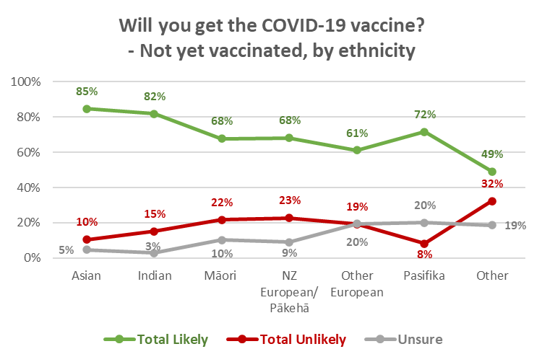

As discussed in the July report, weighting for the general population vaccination rate is unlikely to produce accurate vaccination rates by ethnic group. This has been addressed by using vaccination counts for each ethnicity and applying the intentions of those in each group who are yet to be vaccinated (shown in the chart above) to the balance of the ethnic group population.

2.2.1 Māori
Overall vaccine intention by Māori respondents who not yet been vaccinated, and the percentage that represents among all Māori, is shown in the following table. The vaccination rate of Māori has nearly doubled since the July survey, but the vaccination intentions of Māori who have not yet been vaccinated have not changed in percentage terms in comparison with the July results. This results in an increased total potential vaccine uptake.

Total potential uptake for Māori has lifted to 79% from 73% in July.

VACCINE INTENTION | July 2021 |  | August 2021
 | Māori 16+  Not yet vaccinated | All  Māori 16+ | Māori 16+  Not yet vaccinated | All  Māori 16+
Already vaccinated |  | 18% |  | 34%
Likely to get a COVID-19 vaccine | 67% | 54% | 68% | 45%
Unlikely to get a COVID-19 vaccine | 23% | 19% | 22% | 14%
Unsure | 10% | 8% | 10% | 7%
TOTAL POTENTIAL UPTAKE |  | 73% |  | 79%
Base: Māori not yet vaccinated: August 2021 n=186, July 2021 n=236.
All Māori: August 2021 n=460, July 2021 n=481
N.B. Percentages shown may not sum to 100% owing to rounding.

1.2.2 Pasifika
Overall vaccine intention by Pasifika respondents who not yet been vaccinated, and the percentage that represents among all Pasifika people, is shown in the following table.

VACCINE INTENTION | July 2021 |  | August 2021
 | Pasifika 16+  Not yet vaccinated | All  Pasifika 16+ | Pasifika 16+  Not yet vaccinated | All  Pasifika 16+
Already vaccinated |  | 26% |  | 46%
Likely to get a COVID-19 vaccine | 62% | 46% | 72% | 38%
Unlikely to get a COVID-19 vaccine | 28% | 21% | 8% | 4%
Unsure | 10% | 8% | 20% | 11%
TOTAL POTENTIAL UPTAKE |  | 72% |  | 85%
Base: Pasifika not yet vaccinated: August n=91, July 2021 n=108.
All Pasifika: August 2021 n=165, July 2021 n=157
N.B. Percentages shown may not sum to 100% owing to rounding.

Pasifika respondents who had not yet been vaccinated were much more likely to get a COVID-19 vaccine (72%) than in July (62%), and this combined with their increasing vaccination rate (46% from 26% in July) has lifted their Total Potential uptake to 85% (July 72%).

2.3 Uptake by people with impairment or who identify as disabled
August 2021 results for those living with impairments or long-term health conditions and those who identify as disabled have lifted in line with the overall general population increase in potential uptake.

Will you get a COVID-19 vaccine? (Including those who have already been vaccinated) | All respondents | Living with impairments or long-term health conditions | Identify as disabled
Definitely | 22% | 15% | 18%
Most likely | 7% | 4% | 4%
Likely | 4% | 3% | 3%
Unlikely | 1% | 2% | 1%
Most unlikely | 3% | 4% | 4%
Definitely not | 5% | 5% | 7%
I'm not sure | 5% | 3% | 3%
Already vaccinated | 53% | 64% | 61%
TOTAL LIKELY plus ALREADY VACCINATED | 86% | 87% | 86%
TOTAL UNLIKELY | 9% | 10% | 12%
N.B. Individual percentages may not sum to Total Likely or Total Unlikely owing to rounding

2.4 Uptake by age group
There was a similar percentage of “unlikely” across age groups. Those aged 16-17 years have the lowest potential uptake but are also the most unsure.

As noted in July: For 16-17-year-olds, if primary caregiver approval to get a vaccine becomes a major factor, this may result in the full potential uptake for this age group not being fully achieved (see Section 13).

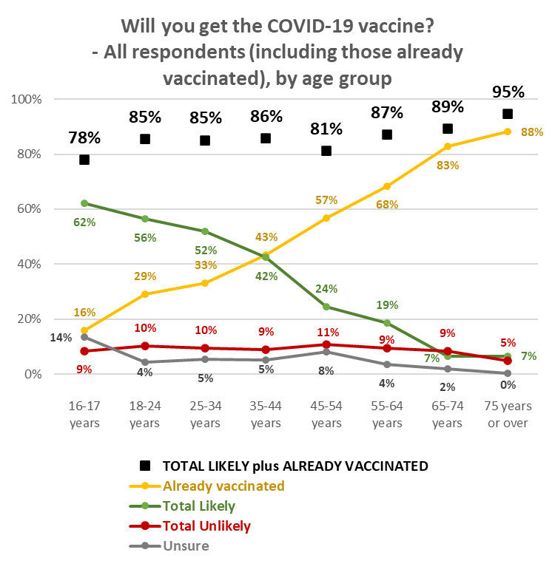

2.5 Uptake by DHB
As noted in previous reports, with a nationally representative sample, the respondent numbers within DHB areas vary in accordance with the relative population of the area. Results for some DHB areas therefore need to be treated as indications.

Vaccination rates by DHB are likely to vary in accordance with factors other than their share of the general population: ethnic mix in their area, area type (large city, regional city, regional town, rural, remote), income, employment status, all of which have an effect on vaccine uptake. Because of this potential variation, weighting for the general population vaccination rate is unlikely to produce accurate vaccination rates by DHB. This has been addressed by using vaccination counts for each DHB area and applying the intentions of those who are yet to be vaccinated in the DHB area to the balance of the DHB population.

Analysis of potential uptake by DHB is shown in the following pages, in 3 groups:
- The seven largest DHBs.
- 6 medium-sized DHB areas where subsample sizes are between 63 and 108, and are therefore relatively statistically reliable.
- The remaining 7 DHB areas where subsample sizes are generally less than 50, in line with their population proportion of the total sample. The smaller the subsample size, the less statistically reliable the results become and these should be treated as providing an indication only.

Seven largest DHBs:
- In Waitematā and Waikato DHB areas, potential uptake is marginally lower than the overall average. In Auckland and Countries Manukau DHB areas, it is slightly above average.

Will you get a COVID-19 vaccine?  (including those who have already had it) | ALL | DHBs
 |  | Waite-matā | Auckland | Counties Manukau | Waikato | Capital and Coast | Canter-  bury | Southern
Definitely | 22% | 19% | 30% | 19% | 17% | 23% | 32% | 16%
Most likely | 7% | 7% | 6% | 5% | 12% | 6% | 6% | 2%
Likely | 4% | 4% | 4% | 10% | 2% | 3% | 5% | 6%
Unlikely | 1% | 1% | 1% | 2% | 2% | 2% | 0% | 1%
Most unlikely | 3% | 4% | 3% | 3% | 1% | 3% | 4% | 6%
Definitely not | 5% | 5% | 1% | 1% | 8% | 6% | 3% | 2%
I'm not sure | 5% | 5% | 3% | 5% | 6% | 3% | 2% | 6%
Already vaccinated | 53% | 54% | 53% | 56% | 52% | 55% | 47% | 60%
TOTAL LIKELY plus ALREADY VACCINATED | 86% | 84% | 93% | 90% | 83% | 87% | 90% | 85%
TOTAL UNLIKELY | 9% | 11% | 4% | 6% | 11% | 10% | 8% | 9%
N (unweighted) | 2,334 | 300 | 249 | 196 | 203 | 266 | 290 | 147
N.B. Individual percentages may not sum to Total Likely or Total Unlikely owing to rounding.

6 DHBs with relatively statistically reliable results:
- As in July and June 2021, Northland and Bay of Plenty’s potential vaccine uptake figures continue to be below the national average.
- Bay of Plenty DHB has a slightly higher-than-average level of its population “unsure”.

Will you get a COVID-19 vaccine?  (including those who have already had it) | ALL | DHBs
 |  | North-land | Bay of Plenty | Hawke's Bay | Mid-Central | Hutt | Nelson/ Marl-borough
Definitely | 33% | 10% | 19% | 20% | 17% | 28% | 14%
Most likely | 10% | 14% | 8% | 5% | 9% | 5% | 5%
Likely | 7% | 6% | 3% | 0% | 5% | 7% | 0%
Unlikely | 3% | 3% | 0% | 0% | 4% | 0% | 1%
Most unlikely | 3% | 5% | 4% | 2% | 0% | 2% | 4%
Definitely not | 8% | 5% | 8% | 12% | 7% | 0% | 4%
I'm not sure | 7% | 8% | 13% | 4% | 4% | 6% | 6%
Already vaccinated | 29% | 50% | 45% | 57% | 53% | 51% | 66%
TOTAL LIKELY plus ALREADY VACCINATED | 86% | 80% | 75% | 82% | 85% | 91% | 85%
TOTAL UNLIKELY | 9% | 12% | 13% | 14% | 10% | 2% | 9%
N (unweighted) | 2,334 | 62 | 95 | 87 | 108 | 79 | 63
N.B. Individual percentages may not sum to Total Likely or Total Unlikely owing to rounding

DHBs with indicative results – these are presented in two groups:
Indications are that:
- Wairarapa and South Canterbury have the lowest potential uptake.
- Lakes and Taranaki have the lowest level of vaccination but have above average Total Potential Uptake.

Will you get a COVID-19 vaccine?  (including those who have already had it) | ALL | DHBs
 |  | Lakes | Tairawhiti | Taranaki | Whanganui
Definitely | 22% | 36% | 5% | 45% | 7%
Most likely | 7% | 4% | 10% | 2% | 1%
Likely | 4% | 2% | 13% | 7% | 1%
Unlikely | 1% | 0% | 0% | 0% | 6%
Most unlikely | 3% | 0% | 0% | 0% | 0%
Definitely not | 5% | 8% | 9% | 0% | 7%
I'm not sure | 5% | 4% | 6% | 0% | 0%
Already vaccinated | 53% | 46% | 57% | 46% | 77%
TOTAL LIKELY plus ALREADY VACCINATED | 86% | 88% | 85% | 100% | 86%
TOTAL UNLIKELY | 9% | 8% | 9% | 0% | 14%
N (unweighted) | 2,334 | 36 | 15 | 41 | 38
N.B. Individual percentages may not sum to Total Likely or Total Unlikely owing to rounding

Will you get a COVID-19 vaccine?  (including those who have already had it) | ALL | DHBs
 |  | Wairarapa | West Coast | South Canterbury
Definitely | 22% | 15% | 36% | 9%
Most likely | 7% | 4% | 0% | 8%
Likely | 4% | 0% | 0% | 0%
Unlikely | 1% | 6% | 0% | 0%
Most unlikely | 3% | 6% | 0% | 2%
Definitely not | 5% | 10% | 0% | 14%
I'm not sure | 5% | 0% | 12% | 9%
Already vaccinated | 53% | 58% | 52% | 58%
TOTAL LIKELY plus ALREADY VACCINATED | 86% | 78% | 88% | 75%
TOTAL UNLIKELY | 9% | 22% | 0% | 16%
N (unweighted) | 2,334 | 26 | 10 | 23
N.B. Individual percentages may not sum to Total Likely or Total Unlikely owing to rounding.

2.6 Gains from eventual decision on getting a vaccine
2.6.1 Incremental gains
Respondents who had not yet been vaccinated and had not answered “Definitely’ when asked if they would get a COVID-19 vaccine, were then asked whether they thought they would eventually decide to actually get the vaccine. In August 2021, this group represents close to 25% of the total 16+ population – an estimated 1,014,500 people 16+.

The results were as follows:

Do you think you'll eventually decide to actually get a COVID-19 vaccine or not? | Will you get a COVID-19 Vaccine?
 | Most Likely | Likely | Unlikely | Most Unlikely | Definitely not | Unsure
% of 16+ population | 6.6% | 4.3% | 1.3% | 3.2% | 4.6% | 4.8%
Yes | 92% | 71% | 17% | 11% | 3% | 26%
No | 1% | 2% | 16% | 48% | 83% | 1%
Not sure | 7% | 28% | 67% | 41% | 14% | 73%

Because the gains and losses from the “Yes” and “No” responses this are small in percentage terms, they should be regarded as “incremental”.

Respondents who were already likely to get a vaccine and answered "Yes", when asked if
they thought they would eventually get a vaccine, do not represent an incremental gain in the “Likely to get a vaccine” group as they are already counted in that group. However, where they said “No”, that is an incremental loss for the group.

That incremental loss is estimated at 0.1% of the overall 16+ population (July 0.3%), or around 5,300 people.

Respondents who were unsure whether to get a vaccine, or were unlikely to do so, and answered "Yes", when asked if they thought they would eventually get a vaccine, represent an incremental gain in the “Likely to get a vaccine” group as they are not already counted in that group.

The incremental gain from the “unsure or unlikely” group is estimated at 2.0% of the overall 16+ population (July 2.8%), or around 80,600 people. Subtracting the incremental loss from the incremental gain gives a nett incremental gain of 1.8% of the 16+ population, or around 75,300 people. As in July, this includes around 1 in 20 of those who said they already had been offered a COVID-19 vaccine but declined it.

2.6.2 Potential for larger gains
Larger potential numbers are found among the respondents who, when asked if they would eventually get a vaccine, said they were unsure. Similar analysis shows that:
- There is a potential loss among those who are currently likely to get a vaccine of 1.7% - an estimated 67,500 people.
- There is a potential gain of 6.3% from those who are currently unlikely to get a vaccine – an estimated 258,900 people. As in July, this includes nearly 3 out of 10 of those who said they had been offered a COVID-19 vaccine but had declined it.

As commented in July, achieving that gain - and minimising the loss – relies on convincing those who are unsure whether they will eventually get a vaccine, that they should get one. Currently, this is likely to be aided to some extent by the recent Delta strain outbreak and the consequent lockdown (see Section 1.2).

Their key concerns are discussed in Section 7.

Second dose uptake
Excluding those who had said they would “Definitely not” get a COVID-19 vaccine, respondents who had indicated that they had not had any doses of the vaccine, or had only had one dose, were asked how likely they were to have a second dose. As previously commented, in general, if people are likely to get a vaccine, they will be likely to get a second dose and vice versa. This is illustrated by the following table.

Results were similar to July, June, May and April 2021: 84% overall of those who have either not been vaccinated or have only had one dose are likely to get a second dose (July 81%: the apparent increase is not statistically significant, June 81%, May 82%).

99% of those who had one dose were likely to get a second (87% “Definitely”).

Likelihood to get second dose | LIKELIHOOD TO GET FIRST DOSE
 | Definitely | Most Likely | Likely | Unlikely | Most Unlikely | Unsure | Already had one dose
Total Likely | 99% | 98% | 82% | 7% | 6% | 2% | 98%
Total Unlikely | Less than 1% | 1% | 4% | 69% | 83% | 2% | 2%
It depends if I have a reaction to the first dose | Less than 1% | 2% | 10% | 16% | 2% | 22% | 0%
Not sure | 0% | 0% | 4% | 8% | 10% | 74% | 1%
N.B. Individual percentages may not sum to 100% owing to rounding

Fourteen respondents who had already had one dose of the vaccine but said they were unsure or unlikely to get another:
- Four indicated that the experience had not been as good as they thought it could have been.
- Three indicated that they didn’t think they needed a second dose.
- Four had experienced a side effect.
- Two indicated that getting the appointment had been too difficult and one said there had been a “botch-up” with their booking.
- One said they were not sure the vaccine would be effective against the new strains (e.g., Delta).

Importance of everyone in New Zealand who is able to be vaccinated, being vaccinated
Respondents were asked “Overall, how important do you think it is it that everyone in New Zealand who is able to have a COVID-19 vaccine, actually gets one?”

Overall, 84% (July 82%, June 81%) felt that it was important that everyone in New Zealand who was able to be vaccinated, was vaccinated (“very important” 65%, up from 59% in July; “important” 14%, similar to July’s 15%; “somewhat important” 7%, the same as July). 8% overall felt that it was unimportant (July 10%), while 6% were unsure (July 8%).

The average importance rating was 4.3 out of 5.

As In July, total importance across all age groups up to 64 years was relatively consistent at close to the overall average level (and then increased where respondents were 65 year or over) suggesting that all ages believe that getting a COVID-19 vaccine is important; however, the strength of importance varied across the age groups, being lowest among 18-34-year-olds. The relative percentages who thought it was important or unimportant were:

Overall, how important do you think it is it that everyone in New Zealand who is able to have a COVID-19 vaccine, actually gets one? | AGE GROUP
 | 16-17 years | 18-24 years | 25-34 years | 35-44 years | 45-54 years | 55-64 years | 65-74 years | 75 years or over
Very important | 53% | 54% | 61% | 60% | 62% | 66% | 79% | 85%
Important | 25% | 21% | 18% | 17% | 12% | 12% | 7% | 8%
Somewhat important | 8% | 12% | 9% | 7% | 6% | 8% | 5% | 2%
Somewhat unimportant | 0% | 4% | 1% | 3% | 4% | 3% | 1% | 0%
Not very important | 5% | 4% | 3% | 1% | 1% | 1% | 1% | 1%
Not important at all | 2% | 3% | 2% | 5% | 5% | 5% | 4% | 1%
I'm really not sure | 7% | 3% | 7% | 7% | 11% | 5% | 3% | 3%
TOTAL IMPORTANT | 86% | 87% | 88% | 84% | 79% | 87% | 91% | 95%
TOTAL UNIMPORTANT | 7% | 11% | 6% | 9% | 10% | 9% | 6% | 2%
Average Importance (score out of 5; 5 being “very important”) | 4.2 | 4.1 | 4.4 | 4.2 | 4.3 | 4.3 | 4.6 | 4.8
N.B. Percentages may not sum to 100% owing to rounding

Asian and Indian respondents were the most likely to think vaccination was important. Overall importance for Māori, Pasifika, NZ European/Pākehā and Other European respondents was similar, but indications are that respondents of “Other” ethnicities are more likely than average to feel that vaccination is unimportant.

Pasifika respondents and those of “Other” ethnicities were more likely than average to be unsure of the importance of all New Zealanders who could be, being vaccinated.

Overall, how important do you think it is it that everyone in New Zealand who is able to have a COVID-19 vaccine, actually gets one? | ETHNIC GROUP
 | Asian | Indian | Māori | NZ European/ Pākehā | Other European | Pasifika | Other
Very important | 64% | 71% | 60% | 64% | 64% | 65% | 58%
Important | 19% | 18% | 18% | 14% | 17% | 15% | 0%
Somewhat important | 9% | 8% | 9% | 7% | 6% | 7% | 8%
Somewhat unimportant | 2% | 1% | 2% | 2% | 1% | 4% | 6%
Not very important | 1% | 1% | 2% | 2% | 0% | 1% | 2%
Not important at all | 2% | 1% | 4% | 5% | 4% | 0% | 16%
I'm really not sure | 2% | 0% | 6% | 6% | 8% | 9% | 10%
TOTAL IMPORTANT | 92% | 97% | 86% | 85% | 87% | 86% | 67%
TOTAL UNIMPORTANT | 6% | 3% | 8% | 9% | 5% | 5% | 24%
Average Importance (score out of 5; 5 being “very important”) | 4.4 | 4.5 | 4.3 | 4.3 | 4.4 | 4.5 | 3.7
N.B. Percentages may not sum to 100% owing to rounding

As in July and June, importance dropped as likelihood to get a vaccine dropped, but some of those who are unsure or unlikely to get a vaccine think that it is important that everyone who is able to have a COVID-19 vaccine actually does so. These are more likely to be people who:

- Have an existing health condition which prevents them from taking a vaccine.
- Need to be assured about the vaccine’s safety.
- Would like to make sure that others who need it can get it first.
- Would rather wait and see if others who have taken it suffer any side effects.
- Are concerned that the vaccine may not be effective against new variants.

Overall, how important do you think it is it that everyone in New Zealand who is able to have a COVID-19 vaccine, actually gets one? | LIKELIHOOD TO GET VACCINE
 | Definitely | Most Likely | Likely | Unlikely | Most Unlikely | Definitely not | Unsure
Very important | 80% | 31% | 10% | 3% | 4% | 2% | 12%
Important | 16% | 44% | 32% | 20% | 7% | 1% | 6%
Somewhat important | 3% | 15% | 42% | 19% | 16% | 7% | 16%
Somewhat unimportant | 1% | 2% | 4% | 14% | 10% | 5% | 8%
Not very important | 0% | 0% | 4% | 26% | 18% | 7% | 6%
Not important at all | 0% | 0% | 2% | 5% | 11% | 63% | 2%
I'm really not sure | 0% | 7% | 7% | 13% | 33% | 14% | 50%
TOTAL IMPORTANT | 99% | 90% | 83% | 42% | 27% | 10% | 35%
TOTAL UNIMPORTANT | 1% | 2% | 10% | 45% | 40% | 76% | 16%
Average Importance (score out of 5; 5 being “very important”) | 4.9 | 4.3 | 3.5 | 2.5 | 2.1 | 0.5 | 3.3
N.B. Percentages may not sum to 100% owing to rounding

As reported in July, respondents in Vaccine Group 4 and those who were not sure what Vaccine Group they were in placed lower importance on everyone being vaccinated.

Making the decision to get a COVID-19 vaccine
Respondents who had not yet been vaccinated were asked to think about how they would decide whether or not to take an approved COVID-19 vaccine. They were shown a list of potential thoughts and asked which occurred to them, if any.

Key thoughts that occurred to more than 20% of respondents in August were:
- I worry there will be unknown side effects (37%).
- It is too soon to see whether there are any long-term effects from the vaccine (36%).
- Concern that the vaccine may not be effective against new strains of the virus (34%).
- I worry how the side effects may affect me (32%).
- I worry what might happen if I have an adverse reaction to the vaccine (26%).
- I worry it might affect my health in other ways (25%).
- I'd rather wait, to see if it causes any problems for others (22%).

The August results are very similar to those recorded in the July survey wave with only one factor changing appreciably:
- I am concerned that the vaccine may not be effective against new strains of the virus (34%, up from 29% in July ↑)
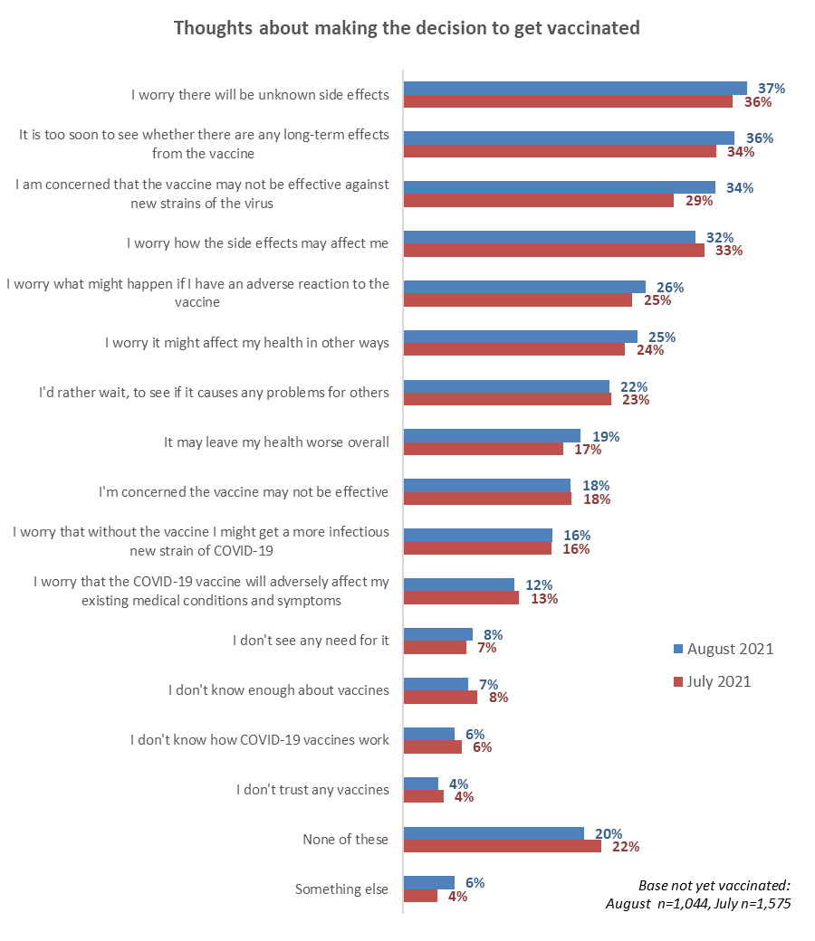
↑

Top 8 concerns for Māori respondents.
With the outbreak of the Delta variant of the virus one week before the August survey started, levels of concern for Māori respondents have lifted appreciably for six out the eight concerns below, and particularly for ‘I'm concerned the vaccine may not be effective’.

Māori:  Thoughts? | June 2021 | July 2021 | August 2021 | Change % points
I worry there will be unknown side effects | 48% | 32% | 36% | + 4
I worry how the side effects may affect me | 44% | 25% | 35% | +10 ↑
I am concerned that the vaccine may not be effective against new strains of the virus |  | 23% | 34% | +11↑
I'm concerned the vaccine may not be effective | 28% | 16% | 34% | +18↑
I worry what might happen if I have an adverse reaction to the vaccine | 34% | 21% | 29% | +8↑
I worry it might affect my health in other ways | 37% | 21% | 26% | +5↑
It may leave my health worse overall | 25% | 16% | 24% | +8↑
I worry that the COVID-19 vaccine will adversely affect my existing medical conditions and symptoms | 20% | 14% | 13% | -1

Top 8 concerns for Pasifika respondents.
Four of the eight concerns lifted for Pasifika people compared with the July results, especially “worry there will be unknown side effects”.

Pasifika:  Thoughts? | June 2021 | July 2021 | August 2021 | Change % points
I worry there will be unknown side effects | 46% | 33% | 43% | +10↑
I worry how the side effects may affect me | 36% | 36% | 42% | +6↑
I worry it might affect my health in other ways | 41% | 32% | 31% | -1
I am concerned that the vaccine may not be effective against new strains of the virus |  | 27% | 27% | -
I worry what might happen if I have an adverse reaction to the vaccine | 49% | 21% | 27% | +6↑
I'm concerned the vaccine may not be effective | 28% | 20% | 27% | +7↑
It may leave my health worse overall | 21% | 18% | 18% | -
I don't know enough about vaccines | 31% | 18% | 19% | +1

As in previous survey surveys, concerns rose as likelihood to get a vaccine decreased.

Top eight concerns  August 2021 results | LIKELIHOOD TO GET VACCINE
 | Definitely | Most Likely | Likely | Unlikely | Most Unlikely | Definitely not | Unsure
I worry there will be unknown side effects | 21%↓ | 40% | 52%↑ | 55%↑ | 53%↑ | 54%↑ | 61%↑
I am concerned that the vaccine may not be effective against new strains of the virus | 33% | 35% | 34% | 15%↓ | 41%↑ | 26%↓ | 43%↑
I worry how the side effects may affect me | 19%↓ | 37%↑ | 47%↑ | 37%↑ | 51%↑ | 38%↑ | 47%↑
I worry what might happen if I have an adverse reaction to the vaccine | 18%↓ | 21%↓ | 42%↑ | 18%↓ | 44%↑ | 35%↑ | 40%↑
I worry it might affect my health in other ways | 11%↓ | 23% | 35%↑ | 27% | 52%↑ | 47%↑ | 46%↑
I'd rather wait, to see if it causes any problems for others | 6%↓ | 24% | 35%↑ | 37%↑ | 52%↑ | 43%↑ | 42%↑
It may leave my health worse overall | 8%↓ | 13%↓ | 27% | 22% | 44%↑ | 49%↑ | 28%
It is too soon to see whether there are any long-term effects from the vaccine | 15%↓ | 42%↑ | 51%↑ | 51%↑ | 65%↑ | 60%↑ | 61%↑
Arrows denote 5% above or below the overall result.

By age:
- The 5 key overall concerns applied for all age groups.
- The number of concerns per person increased as age increased.

Thought | AGE GROUP
 | 16-17 years | 18-24 years | 25-34 years | 35-44 years | 45-54 years | 55-64 years | 65-74 years | 75 years or over
I worry there will be unknown side effects | 39% | 35% | 32%↓ | 39% | 38% | 46%↑ | 37% | 43%↑
The vaccine may not be effective against new strains of the virus | 28%↓ | 31% | 30% | 36% | 36% | 48%↑ | 27%↓ | 38%
How the side effects may affect me | 27%↓ | 28% | 29% | 32% | 38%↑ | 34% | 34% | 43%↑
What might happen if I have an adverse reaction | 25% | 24% | 19%↓ | 24% | 30% | 45%↑ | 31% | 30%
Will the vaccine affect my health in other ways | 14%↓ | 20% | 19%↓ | 27% | 32%↑ | 37%↑ | 38%↑ | 27%
It is too soon to see whether there are any long-term effects from the vaccine | 39% | 27% | 28% | 35% | 44% | 52% | 50% | 47%
Arrows denote 5% above or below overall result.

Indications are that people who live with impairments or long-term health conditions, or who identify as disabled, were more concerned than average about:
- Whether the vaccine will adversely affect their existing medical conditions and symptoms.
- How the side effects would affect them.
- What might happen if they have an adverse reaction to the vaccine.
- Whether the vaccine might affect their health in other ways.
- Whether the vaccine may leave their health worse overall.

Main influences on vaccine decision
All those who had not yet been vaccinated were asked to select from a list up to three things what would make them more likely to take a COVID-19 vaccine when they are offered one.

The four main specific influences selected were:
- Helping protect the health of my family/whānau (27%).
- The vaccine has gone through rigorous trials (26%).
- Helping reduce the risk of further lockdowns and economic harm (23%).
- The benefits would outweigh the risks (also 23%).
Four main themes emerged regarding what would encourage people to take a COVID-19 vaccine:
- Helping others/altruism;
- Medical assurance;
- Benefits for them personally; and
- information about the vaccine.

Interestingly, ‘helping others’ involved four of the top eight influences selected and in general is ahead of ‘benefits for me’. Appealing to peoples’ desires to help others should be prominent in messaging about the vaccination rollout.

Base not yet vaccinated: August survey n=1,044

Other influences mentioned
Four percent (41 people) mentioned influences other than those listed. Examples of their comments include:
- Wanting more information/debate
Proven scientific data from overseas sources
Comprehensive factual publication of all adverse reactions from taking vaccine
Open, transparent debate on the science (as opposed to government propaganda)
- Wanting more long-term testing
Still too newly invented to prove it's safe
Time to ensure no long-term side effects
- Comments from who reject the vaccine (“anti-vaxxers”)
There is no virus
I believe vaccinations are wrong
If Jesus comes with the rapture I still won't
There are other medicines that can cure COVID and do not have the side effects of the jab
1,000 lawyers and 10,000 doctors oppose it worldwide
Conspiracy of ‘big pharma’
It is criminal to urge the injecting of anyone under 40 years but especially children
The vaccine helps create new variants.

As reported in July, key influences were in different orders for various demographic groups and for the various likelihoods to get a vaccine (see tables for Q30 in attached table set).

To assist with messaging, the following show the top 3 influences by respondent age group, gender, the type of area they are living in and likelihood to get a vaccine.

AGE GROUP
16-17  years | 18-24  years | 25-34  years | 35-44  years | 45-54  years | 55-64  years | 65-74  years | 75 years or over
Helping to protect all New Zealanders (37%). | Helping to end the COVID-19 pandemic more quickly (28%). | Helping protect the health of my family/whānau and those closest to me (33%). | Helping protect the health of my family/whānau and those closest to me (31%). | Has been through extensive, properly conducted, clinical trials (40%). | Has been through extensive, properly conducted, clinical trials (29%). | Information about side-effects (31%). | Doing the best thing for my own health (56%).
Helping to end the COVID-19 pandemic more quickly (31%). | Helping protect the health of my family/whānau and those closest to me (27%). | Helping reduce the risk of COVID-19 infection and the prospect of further lockdowns and economic harm (28%). | Has been through extensive, properly conducted, clinical trials (28%). | The benefits of taking the vaccine would outweigh any risks (23%). | The benefits of taking the vaccine would outweigh any risks (33%). | The benefits of taking the vaccine would outweigh any risks (21%). | Information on the effectiveness of the COVID-19 vaccine on new strains of the virus (47%).
Being vaccinated will protect me from the effects of COVID-19 (27%). | Helping to protect all New Zealanders (27%). | Helping to protect all New Zealanders (27%). | Information about side-effects (21%). | Information about side-effects (22%). | Information about side-effects (33%). | Has been through extensive, properly conducted, clinical trials (41%). | The benefits of taking the vaccine would outweigh any risks (33%).

GENDER
Male | Female
Helping protect the health of my family/whānau and those closest to me (24%). | Has been through extensive, properly conducted, clinical trials (31%).
Helping to protect all New Zealanders (24%). | Helping protect the health of my family/whānau and those closest to me (28%).
Helping reduce the risk of COVID-19 infection and the prospect of further lockdowns and economic harm (24%). | The benefits of taking the vaccine would outweigh any risks (25%).
N.B. No results are shown for “Gender Diverse” owing to the small base (n=6).

AREA TYPE
Large Cities | Provincial Cities | Provincial Towns | Rural but not remote | Rural and remote*
Helping protect the health of my family/whānau and those closest to me (27%). | Has been through extensive, properly conducted, clinical trials (27%). | Has been through extensive, properly conducted, clinical trials (31%). | Has been through extensive, properly conducted, clinical trials (27%). | Has been through extensive, properly conducted, clinical trials (56%).
The benefits of taking the vaccine would outweigh any risks (25%). | Helping to protect all New Zealanders (25%). | Helping protect the health of my family/whānau and those closest to me (31%). | Helping reduce the risk of COVID-19 infection and the prospect of further lockdowns and economic harm (26%). | Helping reduce the risk of COVID-19 infection and the prospect of further lockdowns and economic harm (31%).
Helping to protect all New Zealanders (23%). | The benefits of taking the vaccine would outweigh any risks AND  Information about side-effects (both 22%). | Helping to protect all New Zealanders (22%). | Information about side-effects (24%). | Helping me to travel internationally once again (31%).
* Indication only, small base (n=204).

Those living with impairments or long-term health conditions and who had not yet been vaccinated selected the following key influences:
- “Has been through extensive, properly conducted, clinical trials” (32%).
- “Information about side-effects” (27%).
- “Helping protect the health of my family/whānau and those closest to me” (26%).
- “The benefits of taking the vaccine would outweigh any risks” (24%).
- “Doing the best thing for my own health” (21%).
- “Helping reduce the risk of COVID-19 infection and the prospect of further lockdowns and economic harm” (20%).

Those who identify as disabled selected the following key influences:
- “Being vaccinated will protect me from the effects of COVID-19” (31%).
- “Information about side-effects” (27%).
- “The benefits of taking the vaccine would outweigh any risks” (24%).
- “Helping protect the health of my family/whānau and those closest to me” (23%).
- “Has been through extensive, properly conducted, clinical trials” (22%).
- “Helping reduce the risk of COVID-19 infection and the prospect of further lockdowns and economic harm” (20%).

Reasons for being unsure or unlikely to get vaccinated
The 290 people who said they definitely would not get vaccinated or were unsure or unlikely were asked why they felt this way.

The top three reasons for people to be unsure, unlikely or opposed were the same as in all previous surveys, and the fourth reason is the same as in July 2021 (this was a new option added in July):

- Believing it is too soon to know if there are long-term effects (66%; July 62%, June 59%).
- Needing assurance of the vaccine’s safety (42%; July 46%, June 39%).
- Wanting to wait and see if others suffer side effects (41%, the same as July and June).
- The vaccine may not be effective against new variants (36%; July 31%).

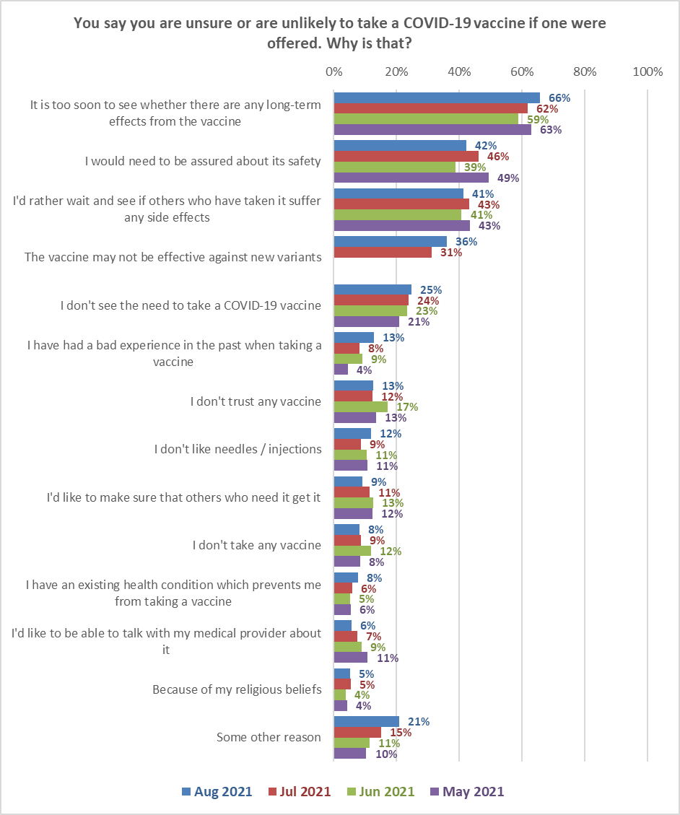
Base: Aug 2021 n=290, Jul 2021, n=435; Jun 2021, n=272; May 2021, n=216.

21% mentioned some other reason. Their comments are shown below.

Views about the vaccine or political reasons
It is a weaponised vaccine - Aimed at Deleting World Population.
This is not a vaccine, it’s a genetic experiment.
I don’t trust our current government.

Side effects
Injections are questionable for heart, stroke, and they can be inefficient indeed.
01-.02% Chance of death, 1-2% chance of injury, High chance of LT risks.
I have a friend whose friend died from the vaccine jab.

Existing medical conditions
I have multiple reactions to past vaccines and a history of adverse drug reactions and an anaesthesia alert history.
My autoimmune condition puts me at risk of a bad adverse reaction which makes the whole thing difficult
I have a high risk of blood clotting and have been advised not to get it due to having Lupus.
My mother won't let me, she's anti-vax. We also have had family allergies to vaccines so I’d have to talk to a doctor.
Risk of exacerbating existing condition.
After Polio vaccine made me very ill was advised by Dr not to get vaccine.
I am immune compromised due had having cancer twice which has decreased my immunity and no one is answering my question about its effects on the immune compromised.
Mixed 'expert' advice as to whether it is recommended for people with the disease I have.
I have had 3 anaphylactic fits.

Trust
After conducting personal research, I don’t trust Pfizer.

Development time/Still in trial
Everything has been so rushed that not enough thought and research carried out before the vaccine was implemented. The only driving factor has been stamping out the virus at all costs to keep the economy going and getting back our freedoms. No thought given to what we are injecting in our bodies and the long-term effects, if any.
It has taken many years to come up with vaccines and then all of a sudden there is a vaccine for COVID
Still a trial and don't wish to be part of the experiment - remember Thalidomide?
That Pfizer counts it as a clinical trial until 2023 is concerning.
The human tests for this genetic therapy have not finished. This experimental 'leaky' 'vaccine' is not as effective compared to my normal immune system against the different variants that will show up in the future. Side effects and death associated with the "vaccines" are unacceptable. I would prefer to get COVID naturally and have a lifetime immunity than take the jab. All other vaccinations are alright, this one is not.
Will consider it when the trial is finished in 2023.
Not Finish Trials yet

Cautious
I’m pregnant and unsure of the long-term effects on my baby and myself.
I'm currently breastfeeding my baby and I want to make sure that it is safe for him.
I'm really unsure about the vaccine.
I am trying to conceive so I am not comfortable with getting the vaccine just yet.

Denial
The COVID virus has not been isolated therefore there is no virus and the PCR tests are a fraud.

Safety and efficacy
The lack of robust information being provided about the vaccine’s overall effectiveness, and the misleading information overstating the safety.
Government, MoH and MSM are lying to us regards the safety and effectiveness of Comirnaty.
It might be shedding.
Contains graphene oxide, a known toxin to the human body.
I do not like the metals that are in the vaccine.

It is unnecessary
I believe vaccines are wrong.
I may have already had COVID (I have certainly been exposed) - which would negate the need for a vaccine, and I would only accept the Novavax if I don't have antibodies already.
The so-called "pandemic" is a manufactured crisis. I will not voluntarily take a "vaccine" that's been manufactured in response to a non-existent threat.
It doesn’t stop the spread and doesn’t stop you getting it, so there’s no point in it.
Let nature take its course.
I'm not at all concerned if I catch any variant of COVID. Any symptoms I'll get checked immediately, track and trace, Isolate.
I prefer to rely on my own immune system which I actively maintain

Effectiveness
The vaccine doesn’t really appear to be effective?
It doesn't prevent people from getting or passing on the Delta variant.
“Doesn’t stop you from passing COVID on to others and also doesn’t stop you from contracting COVID.

Other
I honestly want to take the vaccine but because of all the media blast on COVID vaccine problems it makes me feel hesitant to get it. why do we only receive bad reports on the COVID vaccine via new article and personal social media platforms and not government agencies? it seems to me because of how pro-vax gov-agencies are the information they provide is so biased... I feel like if they were more informative of both positive and negative instances that have occurred from getting the vaccine, I would want to get the vaccine more. Also, I've read articles saying that people were injected with saline solutions instead of the vaccine, people who got vaccinated still got infected... all this provided by non-government agency sources.
I simply don't think NZ should go down the path of opening up like other countries especially if the new dominant mutations become more dangerous (as well as more contagious), as we seem to be seeing with Alpha, then Delta and now possibly Lambda too. A foolhardy approach.
Vegetarian
Far too many lies, propaganda, heavy political pressure.
Jesus is the way the truth and the life.
Still waiting for a cure to the Spanish Flu
I work from home and shop online - the person I share a house with is fully vaccinated. I am not against vaccines generally and do think it's safe, but needing at least 2 and likely later booster dose/s as well pretty much rules it out for me with my current lowish level of risk. I dislike going to doctors / similar at best of times (last time went to one was over 10 years ago). However, IF they had a bus coming to the town and people could just roll up and get vaccinated, I would likely do it - make it easy for people - send vaccinators to them where you can, especially big employers and rural areas
I have volunteered to take part in a trial vaccine [Valneva] of which I had first jab today

Key differences in the reasons given by the ‘unsure’ and ‘unlikely or definitely not’ groups are shown in the next chart. Only differences of more than five percentage points are shown.
The ‘unsure’ group is likely to be more persuadable than people who say they are unlikely to get vaccinated or definitely will not. For these unsure people, the following messages are likely to resonate:

- Assurance that the vaccine is safe.
- Messages from those who have already been vaccinated re little or no side effects.
- Having a discussion with their GP or health provider.

Messages about the effectiveness of the COVID-19 vaccine against new strains will be likely to resonate with both the unsure and those who are currently unlikely to get a vaccine.
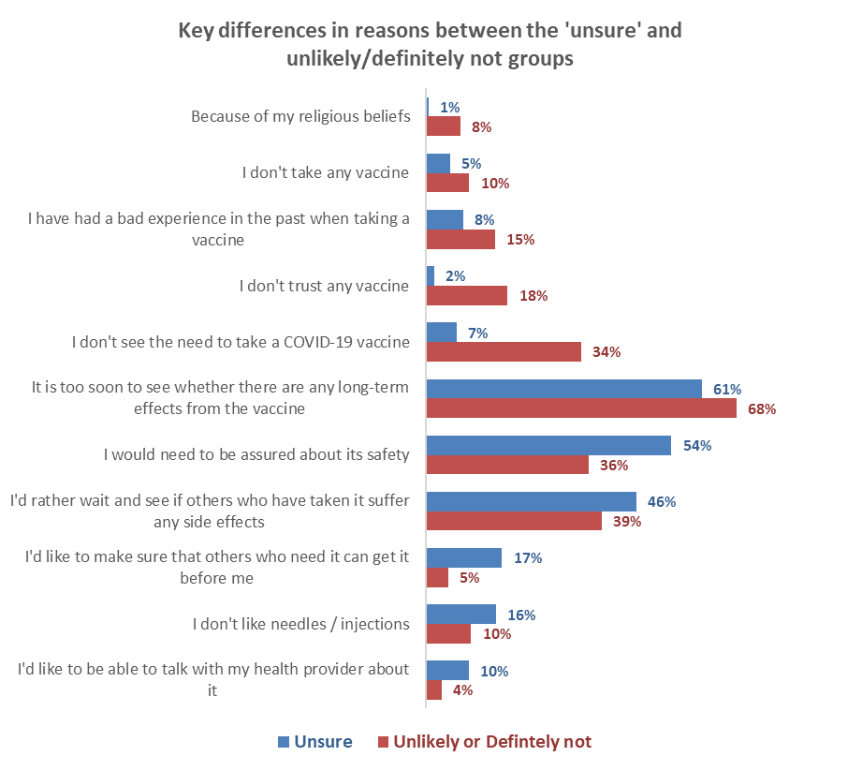
Reasons mentioned more often by the ‘unlikely and ‘definitely not’ group
Reasons mentioned more often by the ‘unsure’ group

Attitudes of those who have not been vaccinated
In the following section, results are shown for those who have not been vaccinated (either once or twice).

8.1 When people would most like to get vaccinated
Those who had not been vaccinated were asked ‘Ideally, when would you most like to get a COVID-19 vaccine this year?’

Compared with July results, there is a significant increase among those who want to be vaccinated immediately. This has increased the percentage of unvaccinated people who want to be vaccinated by September from 46% to 50% (an estimated 960,000 people 16+). This increase is likely prompted by the Delta variant COVID-19 outbreak and the Level 4 lockdown that was announced on 17 August (the August survey commenced on 24 August, a week after the national Level 4 lockdown).

Base: Have not been vaccinated: July n=1,575, August n=1,044

Groups who are more and less likely to want to take the vaccine immediately are shown below:

Want to be vaccinated immediately | %
Flatting or boarding | 48% ↑
Students | 38% ↑
Professionals /senior government officials | 36% ↑
With a postgraduate degree | 34% ↑
Aged 18-34 | 30% ↑
Males | 29% ↑
Total | 25%
Females | 22%↓
Clerical/ sales employee | 19%↓
Live rurally but not remotely | 19%↓
Business Proprietor/ self-employed | 18%↓
Home-maker (not otherwise employed) | 16%↓
Retired/ superannuitant | 16%↓
Those with the lowest education levels  (no school qualification or School Certificate/NCEA Level 1) | 16%↓
Not sure of my vaccine group | 15%↓
From a single person household | 14%↓
Aged 65 or more | 9% ↓
Results for sample sizes of n=50 or more

8.2 Preferred ways to get vaccinated
Respondents who had not yet been vaccinated and had not made a booking were asked to select their preferred ways to be vaccinated. They could select more than one option.

From a small base (39 people) just over half of those aged under 16 or 17 (53%) would prefer to be vaccinated at the same time as their parents. Four out of ten (41%) would like to be able to go with other family/whānau members regardless of age, while only three out of ten (30%) would prefer to go on their own.

Base not yet vaccinated and have not made a booking: n=683

Support for the plan to offer vaccines to all New Zealanders aged 12 years or over
All those surveyed were asked ‘In general, do you support or oppose the changed plan to offer vaccines to all New Zealanders aged 12 years or over from 1 September and extend the gap between doses?’

Support for this plan (76%) is almost eleven times higher than opposition (7%).

Total opposed
7%
Total support
76%
Base total sample: n=2,334
Groups who are more and less supportive of this plan are as follows:

Support the plan to offer vaccines to all New Zealanders aged 12 years or over from 1 September and extend the gap between doses | %
Of Indian ethnicity | 85%↑
Retired/ superannuitant | 84%↑
Aged 65 or more | 84%↑
In vaccine group 3 | 83% ↑
Flatting or boarding | 83% ↑
Teacher/ Nurse/ Police or other trained service worker | 83%↑
Have an undergraduate degree | 83%↑
Total | 76%
Those with the lowest education levels  (no school qualification or School Certificate/NCEA Level 1) | 70%↓
Unemployed/ beneficiary | 69%↓
Rural, but not remote place of residence | 68%↓
Labourer/ agricultural or domestic worker | 67%↓
Business proprietor/ self-employed | 67%↓
Home-maker (not otherwise employed) | 64%↓
Aged under 18 years | 59%↓
Not sure what vaccine group I am in | 48%↓
Results for sample sizes of n=50 or more

Support for the Level 4 lockdown
The August 2021 survey began one week after New Zealand went into Level 4 lockdown due to the outbreak of the Delta variant of COVID-19 in the community. The full survey sample was asked “New Zealand is currently in Level 4 lockdown because of an outbreak of the COVID-19 Delta strain. How strongly do you support or oppose that approach?”

Around five out of six people (83%) support the lockdown, with only 11% opposed.

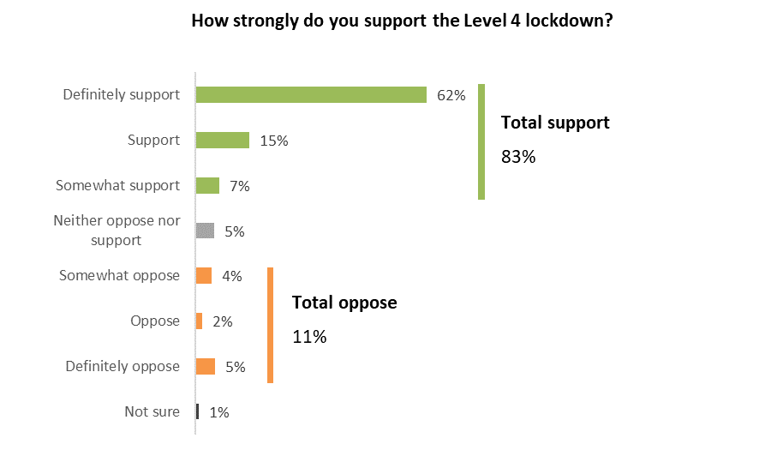
Base total sample: n=2,334

Groups who are more and less supportive of the Level 4 lockdown are as follows:

Support the Level 4 lockdown  (total somewhat support, support and definitely support) | %
In an extended family | 94%↑
Aged 75 or over | 89%↑
Female | 86%↑
Total | 83%
Male | 79%↓
No formal school qualification | 76%↓
Business managers/ executives | 75%↓
Professionals /senior government officials | 75%↓
Of Indian ethnicity | 73%↓
Results for sample sizes of n=50 or more

Support for the current lockdown was high across New Zealand. Lowest support (but still majority support) was indicated in Wairarapa (support for the Level 4 Lockdown by DHB area is shown below):

DHB Area | Support for lockdown %
ALL | 83%
Northland | 86%
Waitemata | 82%
Auckland | 80%
Counties Manukau | 81%
Waikato | 83%
Lakes | 87%
Bay of Plenty | 88%
Tairawhiti | 94%
Taranaki | 96%
Hawke's Bay | 79%
Whanganui | 87%
MidCentral | 79%
Hutt | 82%
Capital and Coast | 81%
Wairarapa | 68%
Nelson/Marlborough | 82%
West Coast | 86%
Canterbury | 84%
South Canterbury | 82%
Southern | 82%

Information about the COVID-19 vaccine

11.1 Do unvaccinated people have enough information to decide whether or not to take the COVID-19 vaccine?
Those who had not received a second dose of the COVID-19 vaccination were asked if they had all the information they needed to decide whether or not to take the COVID-19 vaccine. The latest August results are compared with the previous two surveys in the chart below.

The proportion who felt they definitely or mostly have enough information was much the same as the in the past two survey waves, as was the proportion of those who say they need more information or they don’t quite have enough information.
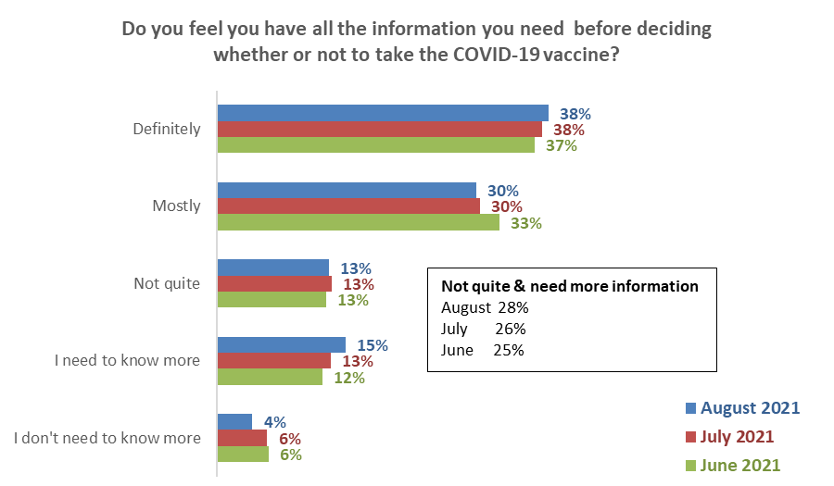
Definitely & mostly
August 68%
July 68%
June 69%
Base: Not yet vaccinated: June n=1,105, July 2021 n=1,575, August n=1,044
Some totals are affected by rounding.
Those who need more information are more likely than average to be from the following groups:
Do not have quite enough & need more information | August 2021 Results
Total | 28%
Pasifika ethnicity | 45% ↑
Not sure of their vaccine group | 43% ↑
Home-maker (not otherwise employed) | 40% ↑
Aged 45 to 54 | 39% ↑
Māori ethnicity | 38% ↑
No formal qualification or school certificate/NCEA Level One | 36% ↑
Not employed | 33% ↑

11.2 What else do people need to know to help them decide whether to get the COVID-19 vaccine?
Respondents who had not been vaccinated and who gave the following responses to the previous question: “I mostly have enough information to decide”, “Not quite enough information” and “I need to know more” were asked to say in their own words what else they needed to know to help them decide whether or not to get vaccinated.
Main themes from their comments are illustrated in the following chart. These are compared with results from the previous survey wave in July where the same question was asked.
As in previous surveys, the two main things people said they need to know are:
- Information on the long-term effects of the vaccine, based on longer and/or more clinical studies (24%, up from 19% in July)
- Information on side effects and risks (19%, down from 34% in July).
Note that queries about booster shots is a new theme, with 3% of responses in August.
Not a significant theme
↓
↓
↓
↑
↑
↓
Base: July 2021 n=432 people who responded to this question, August n=457 people.
NB. Totals add to more than 100% as people could provide multiple responses.
Examples of verbatim comments
Verbatim comments illustrating each type of information need are included below…

Information on long-term effects/ based on longer/more clinical studies
I am getting it as a precaution for my grandchild. But I am worried about long term effects. (Male, Aged 75 years or over).
I don't feel it has been trialled for long enough to see the side-effects/benefits. (Male, Aged 35-44 years).
It seems to have been produced very quickly. I don't know if anyone can know the long-term effects of this vaccine. (Male, Aged 35-44 years).
Just keen to see outcome; a new vaccine made that quickly worries me. (Female, Aged 35-44 years).
Lengthy evidence-based datasets from clinical trials on people of all nationalities, age groups and demographics. (Male, Aged 65-74 years)
Long term effects, as it is not a normal vaccine type, and not had the usual strict testing as it has been rolled out under emergency, making us the population the test cases (Female, Aged 35-44 years).
Long term effects on fertility/ future pregnancies (Female, Aged 65-74 years).

Information on side effects/risks
Actual current data about the vaccine reactions and side effects. (Female, Aged 35-44 years).
I am concerned that the vaccine will have complications for my health in the future. (Female, Aged 45-54 years).
I don't need any more information; I will definitely get the vaccination. Just not aware of any side effects from the vaccine. (Female, Aged 25-34 years).
Percentage of people with reactions/side effects. (Female, Aged 18-24 years).
Slightly worried about side effects. (Female, Aged 25-34 years).
The number of adverse reactions to the vaccine both as a number and a percentage of doses administered, and whether most reactions are after the first or second jabs, and how debilitating those reactions can be. (Male, Aged 18-24 years).
What to do if I get side effects. (Male, Aged 55-64 years).
Transparent information about risks .(Male, Aged 65-74 years).
Ideally, I would have more information about the side effects and adverse reactions profile. (Female, Aged 75 years or over).
What are possible major side effects and how likely are they? Does blood type impact on the likelihood of major side effects (type D and blood clotting)? (Female, Aged 16-17 years).

Facts on success rate/effectiveness/ingredients/international results
Access to scientific studies. (Female, Aged 35-44 years).
Actual factual transparent documents regarding vaccine safety. (Female, Aged 55-64 years).
Further clinical studies and a range of doctors/health practitioners’ opinions. (Female, Aged 45-54 years).
How effective it really is, especially against new variants like Delta, how many boosters we may need etc, safety around this. (Female, Aged 45-54 years).
How the Sars-cov-2 virus mutates and how it affects the rest of the world. Looking at Israel which has high vaccination rates and still has a problem it still looks too risky to depend on vaccines. (Male, Aged 16-17 years).
I want to know more about the real time statistics of the effects of the COVID vaccine and how effective it is to people within my age and for children as well. (Male, Aged 35-44 years).
More about the testing and the current developments being made on the vaccine. (Female, Aged 18-24 years).

General information - how it works/ how long it will last/ do I need to take again/ effectiveness against new strains/ where and when it will happen/brand of vaccine etc
How long does it last? (Female, Aged 65-74 years).
Best timing between shots, some idea of the point in time where the Government will change the current border restrictions i.e., criteria 80% of population vaccinated. (Male, Aged 75 years or over).
Does it include animal-derived ingredients? (Female, Aged 16-17 years).
Does it stop me from transmitting to others? (Female, Aged 65-74 years).
Exactly what is in the vaccine and how has it been tested? Have they finished all the clinical trials? I don't support animal testing anyway. (Female, Aged 55-64 years).
How this vaccine compares to other more traditional vaccines. (Male, Aged 25-34 years).
I would like to understand more about how the vaccine protects me from the virus. (Male, Aged 45-54 years).
If I was to suffer bad side effects, would I receive income if I couldn't work. (Male, Aged 65-74 years).
Is it a cure, or does it just prolong getting the virus in the future? (Male, Aged 45-54 years),
Impact on children in early life when vaccine is given during pregnancy (Male, Aged 55-64 years),
Is it alive? (Female, Aged 55-64 years),
Origin of the virus, (Male, Aged 35-44 years),
The different types available and which are available in my district (Male, Aged 45-54 years),
The procedure of getting a shot under different alert levels. (Female, Aged 35-44 years),
What is FDA approved? Which strain does the vaccine cover - Delta or the normal COVID? (Female, Aged 75 years or over),
What to expect at the vaccination centre? I have social anxiety so new places and protocols around people make me stressed and medical environments tend to exacerbate it. (Female, Aged 35-44 years),

Will it work for my health condition?
I am currently pregnant and have had miscarriages/complications when trying to get pregnant. I am concerned that this might have an effect. (Female, Aged 35-44 years).
I have a number of allergies and don't know how the vaccine is likely affect them. (Male, Aged 65-74 years).
I have severe reactions to antibiotics and other meds so I’m a bit wary about having a vaccine. (Male, Aged 65-74 years).
Its effect on people with autoimmune issues in the liver. (Female, Aged 25-34 years).
Want to know if it’s safe for people with asthma and COPD. (Male, Aged 55-64 years).
What the risks are with someone who already has decreased lung function. (Female, Aged 65-74 years).
Whether it’s safe for me with a history of anaphylaxis and previous reactions to vaccinations. (Female, Aged 55-64 years).

Don't know/ just want more information
I don’t know what else I need to know, I just want to wait and see if the vaccine is as good as it could be, or if it will be improved (Female, Aged 25-34 years)
I know I should get it, but I don't really know how it works (Female, Aged 75 years or over)
Just everything I don't know much about it (Female, Aged 45-54 years)
Not sure. I'm operating on trust in our government (Female, Aged 25-34 years)
Nothing/I know enough already/will get vaccinated
Don't feel I need to know any more than I do now (Male, Aged 55-64 years)
Have already decided to get it but don’t know much about it (Male, Aged 25-34 years)
I will get it, but don't know much about it (Female, Aged 35-44 years)
Not much. Info so far has been more than substantial (Male, Aged 75 years or over)
Nothing as I know it will be the only thing that can stop the lockdowns (Male, Aged 75 years or over)

Assurance it is safe/ it will work for me
Assurance that it will not cause an anaphylactic fit (Female, Aged 35-44 years)
Basically, whether it's completely safe to use or not and I don't think that can be decided on until more time has passed (Female, Aged 75 years or over)
Is it perfectly safe? (Male, Aged 18-24 years)
Safety and efficacy (Female, Aged 35-44 years)
Whether or not it is safe for me to have it (Female, Aged 55-64 years)
Genuinely safe and effective (Male, Aged 35-44 years)

Information on booster shots
How effective it is after x amount of time, boosters required, likelihood of reopening borders (Female, Aged 45-54 years)
Is it annual to take it or just a booster every x years? (Male, Aged 45-54 years)
What are the long-term health implications, and will I need an annual booster? (Female, Aged 65-74 years)
Whether or not continual "boosters" will be necessary (Female, Aged 55-64 years)
Whether we will need to get booster shots every year (Male, Aged 35-44 years)

Assurance by GP/ health professional/ government agency
I need to be able to talk to a doctor. My family has had severe allergic reactions to other vaccines. I need to know that it would safe for me specifically (Male, Aged 35-44 years)
I need to speak to someone who really knows what they are talking about (Female, Aged 18-24 years)
Phone consult with my GP (Male, Aged 45-54 years)

Other
Basically, as a Māori woman, most of my community are divided because we don't know very much about the vaccine and our wellbeing for the future. (Female, Aged 35-44 years).
Everyone is calling it a vaccine, but after listening to lots of doctors (pro-vaccine) explain how it works, it actually sounds like a totally new medical advancement. (Female, Aged 65-74 years).
I will not accept an mRNA gene therapy, I will only accept a real vaccine such as Novavax. (Male, Aged 35-44 years).
I don’t think the government tell me all the truth So I keep researching as the media cannot be relied upon to tell me the truth. (Male, Aged 45-54 years).
I have been trying to book for weeks but keep getting an error saying there is no availability within 75km... the only barrier to me getting the vaccination is the bloody website, not because I don't want to. (Male, Aged 45-54 years).
I need honesty and open debate without shutting down opposing views. (Female, Aged 25-34 years).
I want to get the vaccine, that isn't the issue, it is the injection (needle) that I have a problem with, if there was another way to get the vaccine, then I would be in straight away. I just need to talk myself into the injection. (Female, Aged 45-54 years).
I will only get it if I have to travel overseas to visit my family. (Female, Aged 18-24 years).
More interested in the Novavax Vaccine than the Pfizer one. NZ has ordered it, but not sure on an ETA for delivery. (Female, Aged 45-54 years).
What restrictions are going to be put on me if I don't get vaccinated? (Female, Aged 25-34 years).

11.3 Preferred information sources
Respondents who had not yet been vaccinated were asked “What's the best way for you to get information on the COVID-19 vaccine?”

The top three preferred sources in August are websites (48%), email (44%) and TV News (31%).

There were a number of significant changes compared with July, with websites, social media and online news media all increasing, at the expense of email and text. It is likely that these changes reflect the Delta variant outbreak which took place a week before the survey began i.e., people sought mass media sources to keep up-to-date with breaking news.

Base not yet vaccinated: July n=1,575, August n=1,044

11.4 Sources of official information about the vaccine
All respondents were asked where they had seen official COVID-19 information and advertising in the past 30 days. Results from the latest August 2021 survey are compared with those recorded in June and July 2021 in the table below.

August results showed a sharp increase in the top six sources of official information and advertising, led by social media (+ 18 percentage points) and news websites (+15 points). No doubt this is due to people accessing information and advertising regarding the latest wave of COVID infections and the Level 4 lockdown that was announced on 17 August (the August survey wave commenced on 24 August, a week after the national lockdown).

In which media have you seen official COVID-19 information and vaccine advertising in the past 30 days? | June  2021 | July  2021 | August  2021 | August to July  Difference  % points
TV | 62% | 64% | 74% | + 10 ↑
Social media | 33% | 34% | 52% | + 18 ↑
News websites | 22% | 24% | 39% | + 15 ↑
Radio | 26% | 29% | 35% | + 6 ↑
YouTube | 19% | 18% | 25% | + 7 ↑
On demand TV | 16% | 18% | 23% | + 5 ↑
Newspapers – Daily | 22% | 17% | 20% | + 3
Local/Community newspapers | 15% | 15% | 13% | - 2
Newspapers – Weekend | 10% | 9% | 11% | + 2
Letterbox / leaflet | 8% | 9% | 7% | - 2
Billboards | 5% | 9% | 9% | -
Bus / train advertising | 5% | 8% | 8% | -
Somewhere else | 2% | 2% | 2% | -
I haven't seen any of these advertisements | 9% | 11% | 5% | - 6 ↓
Base n= | 1,467 | 2,509 | 2,334

11.5 Impact of seeing an official COVID-19 vaccine advertisement
Those who had seen official COVID-19 vaccine information or advertising in the previous 30 days were asked what impact this had had, from a list of possible options.

14% said this official advertising had increased their likelihood to get a vaccine. This compares with 18% in July (June 11%, May 20%).

The same nett percentage of respondents as in July said the advertising made no difference to their decision; a nett 43% (July 43%, June 46%; May 31%):

39% said it made them feel they made the right decision to get vaccinated, up from 34% in July while 14% said the advertising made them feel better about this decision (July 11%, June 14%, May 18%).

Base: have seen official advertising n=2,214
Made me more likely to get vaccinated:
Total 20% in August cf. 18% in July but includes 3% with a marginal increase in likelihood
Reinforced my decision August 53%
July 44%
Made no difference:
August nett 43%
July nett 43%
Less likely 3% (July 4%)

Likelihood to take the vaccine after seeing or hearing official advertising analysed by gender and age
The next table shows ‘more likely’ and ‘less likely’ responses to taking the vaccine by gender and age in the August survey wave.

In terms of likelihood to take the vaccine, exposure to official information/advertising had the most nett positive impact on those under 35 years.

KEY:
4 points or more higher than the average is highlighted in bold blue font

Impact of seeing official advertising in the last 30 days | ALL | GENDER* |  | AGE
 |  | Male | Female | 16-17 years | 18-24 years | 25-34 years | 35-44 years | 45-54 years | 55-64 years | 65-74 years | 75 years or over
Made me absolutely certain I will get a vaccine | 4% | 5% | 4% | 5% | 7% | 7% | 3% | 4% | 4% | 3% | 3%
Made me much more likely to get a vaccine | 3% | 3% | 2% | 5% | 3% | 4% | 2% | 3% | 1% | 1% | 4%
Made me more likely to get a vaccine | 5% | 5% | 4% | 10% | 8% | 7% | 4% | 4% | 3% | 2% | 2%
Made me slightly more likely to get a vaccine | 3% | 3% | 2% | 3% | 7% | 1% | 4% | 3% | 1% | 1% | 1%
Total positive impacts | 14% | 16% | 12% | 24% | 24% | 19% | 13% | 13% | 9% | 6% | 10%
Made me feel less likely to get a vaccine | 3% | 4% | 3% | 3% | 3% | 3% | 4% | 6% | 3% | 2% | 1%
NETT POSITIVE IMPACT | 11% | 12% | 10% | 20% | 21% | 16% | 9% | 8% | 6% | 5% | 10%
Base – Seen official advertising n= | 2,214 | 1,029 | 1,175 | 61 | 246 | 376 | 423 | 347 | 337 | 261 | 163
* The gender diverse group is excluded due to a small sample n=10.
Some nett totals are different from adding the individual results, due to rounding.

Experiences of those who have already been vaccinated
1,290 people in the survey had received at least one vaccine dose – this represents 53.3% of the total (those aged 16 or more). This result is up from 29.2% in the July survey

12.1 Did you receive enough information about your vaccination?
Very positively, 97% of those who had been vaccinated said they received enough information.

This is similar to the July result (95%)
Respondents who had been vaccinated but said they had not received enough information were asked to comment on what else they would have liked to know. In general, they would have liked to know:

Side effects
Actual and potential side effects.
Why we went with Pfizer, known side effects.
Side effects and how long it takes to get the vaccines. I waited a very long time in a very long queue.
I would have liked more information on the side effects.
I would have liked more information about the possible side effects on the form that I signed before getting my vaccine.

Long-term effects
I am Māori and live with a chronic respiratory condition; however, I was not included in the category 3 rollout. My respiratory condition is the side effect of having treatment for Leukaemia as a teenager. As a result, I am wary of putting any drugs into my body that I know nothing about. The message I am hearing and seeing through all sources available to me is that the vaccine is safe but how do they know when the vaccine has only been available for a short period of time and there is no long-term history on the impact of getting the COVID vaccination.
Long-term effects, of course not available yet given the reasonably short time frame for research.

What vaccination would be given/number of doses required and when
What shot will be given, why cards are needed and why they weren’t filled in.
Do I need to get another shot?
How many weeks apart before the 2nd vax would have been beneficial.
Do I need to get another shot?

Efficacy
The efficacy of the vaccine is questionable as there are doubts regarding its long-term impact - it has been rushed.
What's contained in the vaccine.
Statistics data of 1 dose of vaccine might be enough immunity to Delta COVID.
How far away is an effective vaccine against all strains of COVID 19 from being produced?
I would like to know what everyone wants to know. Is it effective and will it protect us from all COVID strains?

Protection
I would have liked to know that the vaccination doesn't fully protect you from the virus and that I could still carry and pass on to other people even if I had both doses.

How it was made/made so fast and its ingredients
Tell us how they made this vaccine so fast.
Must admit didn't really read any information because I thought it's got to be done so why worry about it.

Effect with current conditions and medicines
I wanted to know how it might affect my meds and my health issues.
Effects on other people with my conditions, and effect on possibility to reproduce.

Any information would have been beneficial
Only told why we should get the vaccination, not really what the side effects are and what are the percentages of getting sick, and that it does not stop you from getting COVID or passing it on. All the facts need to be told just not the good facts also the negative.
Anything specific on it. I got an email saying “Do you want to do it”?. Go to this website. Nothing specific on the actual vaccine I was getting.
Something which provided an alternative and sensible view compared to what the nutter outside handed me before I walked in!
I'd like to know quite a lot more.
I had to source further information to verify what was presented was correct. There is a lot of mis- information.
I have friends that are hesitant to get it. I would like info to give to them so they know there is no significant risk of getting it.

Booking comments
The booking system is problematic. I was told to change my booking and rebook for late August. The only booking I could get was early October. Instead, I walked into a walk-in clinic and got it during Level 4.
There was some confusion if my vaccination would go ahead in the second day of lockdown.
Most people in the community were aware that they could go to get their vaccine despite not being in the designated groups (which I am also not a part of) but knowing that there are walk-in/no appointment necessary clinics would have made it a whole lot easier for myself, and a lot of peers to get their vaccines earlier. Particularly if they were being offered.
I had to find the vaccination station and book without any help from any government agency.
Financial comp if I suffer complications?
Do I need to get another shot?
An info booklet about how it works.

Other comments
Precisely when my name was called and by phone call or letter.
NZ Sign Language please.
Must admit didn't really read any information because I thought it's got to be done so why worry about it.
I had more information that I need it.

12.2 How invited to make a booking
People who had been vaccinated at least once were asked how they were invited to make a booking.

Text (25%) and email invites (18%) are the main methods mentioned in the August survey.
Compared with the July results, there is a greater proportion of text and email invites as well as people who have not been invited at all. By contrast, invites through work, by phone calls and as a result of being a household contact of a Group One person have decreased.

Work invitations were in first place in July but are now in third place.

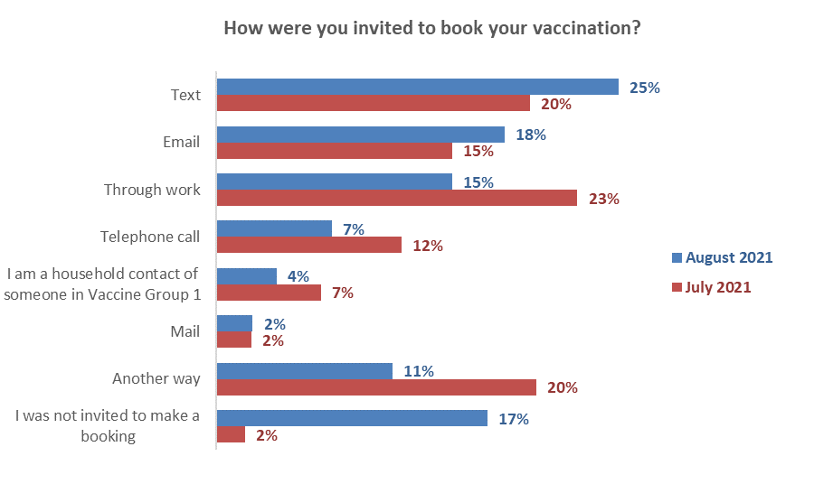
↓
↓
↓
↑
↓
↑
↑
Base: Vaccinated with at least one dose July n=934, August n=1,290

Other ways invited to make a booking
11% of vaccinated people said they were invited by another way, other than the ways listed in the survey.

The main response to this question was that they called the booking centre themselves, so technically these people should have selected the option – ‘I was not invited to make a booking’. Some comments from these people included:

I contacted them, then they phoned with an appointment
I made my own appointment
I rang the advertised number and booked.
Other responses to this question included:
- Being contacted by an iwi or Pasifika health provider.
- Contacted by a hospital.
- Through a colleague, friend or family member.
- Through my retirement village.
- Through social media.
- Through my GP.

12.3 How people actually made the booking
People who had been vaccinated at least once were asked how they made their booking.
Online bookings have increased sharply compared with the July results and now represent almost four out of ten bookings (36%) driven by a very strong increase in “Book my Vaccine” online bookings (now 31% of all bookings). This is at the expense of phone, clinic (including ‘walk in’) and work bookings which have all declined.
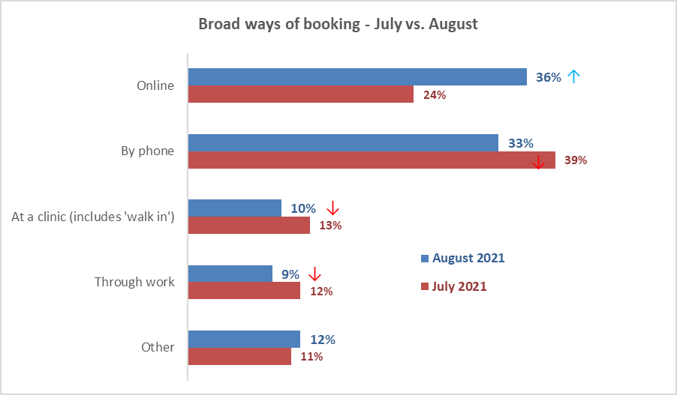
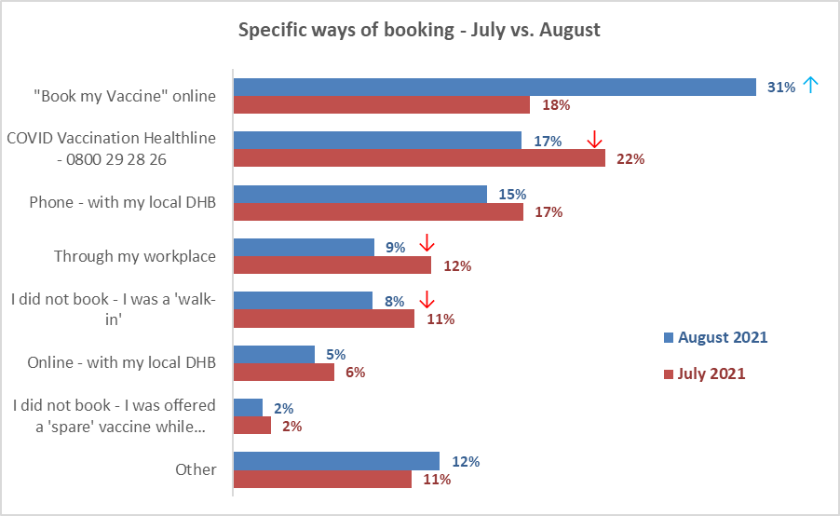
Base: vaccinated with at least one dose July n=934, August survey n=1,290

Other ways of booking
12% of vaccinated people mentioned another way of booking. Their main responses included:
- Through my doctor or my local medical centre (the main other method mentioned).
- Through a pharmacy.
- Through my marae/ through local whānau/Māori health provider.
- Through a friend or colleague.
- Through a Facebook contact.
- Via email.
- Arranged by retirement village.
- Through work (I work at a vaccination centre).
- I was jabbed overseas.

12.4 Ease of making a booking
Those who had been vaccinated and had made a booking in the past 30 days (i.e., since “Book My Vaccine” was launched) were asked ‘overall, how easy or difficult was it to make your vaccination booking?’

There was little change from July, which had shown more significant change in comparison with June.

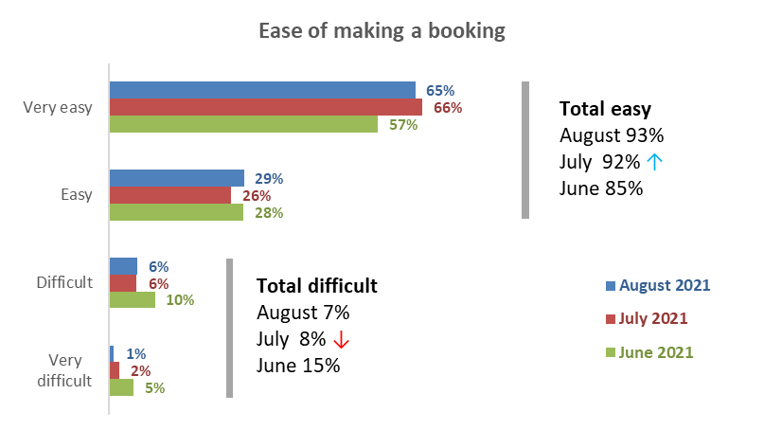
Base vaccinated with at least one dose: August 446 (booked in past 30 days), July n=934, June n=367 (July and June: All who had booked)

By main method of booking, Book My Vaccine appeared to have the highest “Very Easy” rating.
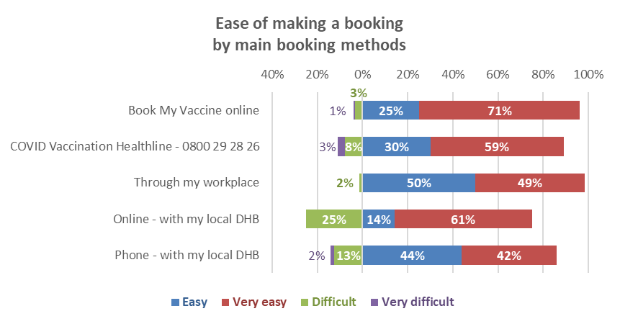

Reasons why the booking was difficult
Only 30 out of the 446 respondents who had booked in the past 30 days had difficulty with their booking. They were asked to indicate why, from a list of twenty reasons. The next chart shows the reasons selected by at least 10% of this group.

Because of the small base, these results should be regarded as indications only.

A wide range of reasons were selected, with the top three reasons involving:
- The 'Book My Vaccine' online system did not work (36%). This is around 2% of all who had booked in the past 30 days.
- Could not get the time or place they had wanted (32%). This is around 2% of all who had booked in the past 30 days.
- Not being given a booking for their second dose when booking their first (15%). This is around 1% of all who had booked in the past 30 days.

Unlike the July survey, no respondents had found booking centre staff unhelpful.

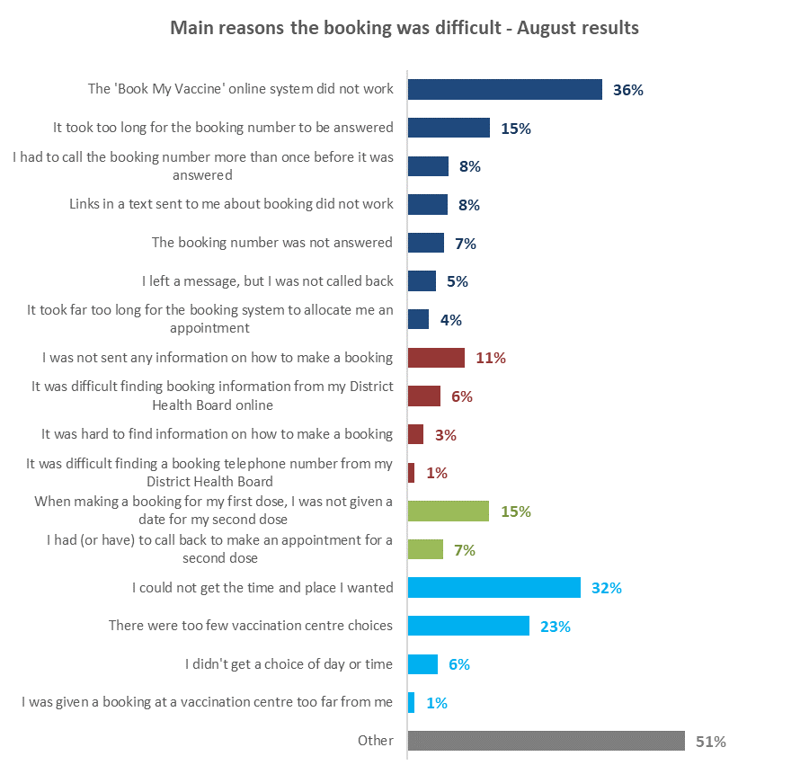
Difficulty making the appointment
Finding booking information
Arranging a second dose
Lack of choice
Base found the booking difficult n=30. Multiple choices were allowed.

‘Other’ reasons for finding the booking difficult included the following examples:
Walk-in and had to wait 1 hour.
Waited in a line for an hour then someone attended me. then just saying please write you detail we will text you the time and a date. lol waste of time. could have done over the phone. saved an hour and driving with my kids.
There was confusion over whether they had called me or not :).
The system itself for booking was easy, but trying to make an appointment, there was no indication local clinics were booked out, just an inability to find any available appointments. Had to go through 4 or 5 locations before finding any sign it wasn't the calendar/system not working.
Online booking would not work, called Healthline and could not understand person on phone and took ages to set appointment for 1st dose, 2nd was lockdown so cancelled, got text for 2nd but no time or date.
I was waiting for my Health Centre to contact me as they said don't ring us, we'll ring you. I then mentioned that to my Dr in that Health Centre & they booked me in.
I was in group two but wasn’t contacted and it took three calls to the booking number to finally.
I was given too much conflicting information.
I qualified for group 3 but I was working in various rest homes (14) and needed upgrading to group 2.I was told by govt help line that I needed my GP to upgrade me but GP said they were unable to do this. I was sent backwards and forwards getting nowhere then in desperation I contacted Auckland DHB and someone contacted me who was then most helpful and got me a booking. She totally agreed and said I needed to be in group 2. All worked out in the end but it was not easy.
I had to contact my DHB to let them know I was Group 3 eligible. After that, the process was fine.
First dose booking was not confirmed. We I followed up was, advised it was never booked. Had to make an alternative much later date.
Was given information on my nearest vax centre, made email contact as directed only to be rung 3 days later to say they no longer did vaccinations. I then had to restart the whole [process with another provider.
I was trying to book for me and my partner, the instructions were complicated and as we have different My Health accounts, we in the end booked different days as in the time we changed computers the times on the first date were full.
Booked for 1st and 2nd dose on the same phone call but they cancelled my second dose a week before it was due. Took 30+ minutes to call and rebook and didn't have any times similar to the original booking.
It was administrative chaos initially and I almost gave up!
Spent 5hrs on booking line trying to get injection at same time as wife, to no avail.
I spoke to 3 people on the booking line. The 3rd person was very helpful and booked both appointments.
The local DHBs were slow off the mark, although it's working better now.
The booking times were in the middle of the day.
The booking date was too far in the future.
Dates/Times came up online and then disappeared.
Never received the email confirmation and therefore got held up when I arrived at the time I had been allocated on the phone.
I couldn't pick any of the locations to have the vaccine.
Only got vaccination by accompanying my wife who did get a booking.
Second dose booked then it was cancelled.
Very disorganised.
I had to book both vaccinations at once but they didn't have any spaces available after my first so delayed me from getting my first.
Process just cumbersome. The MOH and DHBs could not agree on the correct process.

Reasons why the booking was easy
In total 416 people out of the 446 who had booked in the past 30 days had found it easy to make a booking. These people were asked to select why this was easy from a list of reasons.

The main reasons for the booking being easy included:
- The online booking system worked well (65%).
- I got the time and place I wanted (54%).
- It was easy to book my second vaccination (44%).
- I was able to make bookings for both first and second doses at the same time (41%).
- I found the booking number easily (30%)

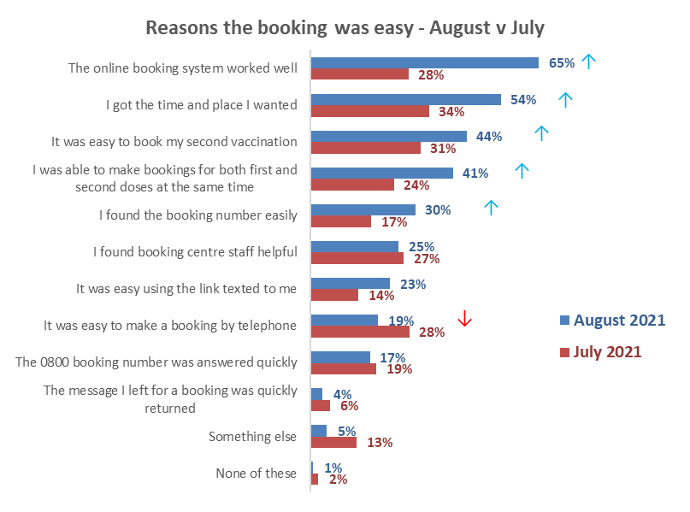
Base found the booking easy n=852

Other reasons the booking was easy
The main ‘other’ reasons the booking was easy included:
- My work arranged the booking.
- Someone else did it for me.
- My retirement village organised it.
- Easy to rebook if appointment had to be changed.
- I was already at the medical centre.

12.5 Rating the booking experience
All those who had been vaccinated with at least one dose and had booked in the past 30 days were asked to rate their experience of 1) being invited to book, and 2) actually booking their vaccine appointment. These questions used a scale from ‘0’ (very poor) to ‘10’ (excellent).

In August 54% of vaccinated people rate their experience of ‘actually booking’ their vaccination as 10 out of 10 (excellent) compared with 43% who rate ‘being invited to book’ 10 out of 10.

Compared with the July results, August ratings for ‘actually booking’ the appointment are now ahead of ‘being invited to book’, with mean ratings of 8.5 and 7.7 respectively, a difference of 0.8 points. In July the mean results were 8.4 and 8.0 respectively for these measures, a difference of 0.4 points.

The new “Book My Vaccine” national booking system was launched on July 28, 2021. 86% of those who said they had booked online had used the new system.

“Book My Vaccine”: rated above all other methods of booking

Range of ratings | Being invited  to book | Actually  booking | Used Book My Vaccine
0 to 4 (poor) | 13% | 6% | 4%
5 to 7 (moderate) | 20% | 17% | 15%
8 to 10 good | 63%↓ (70% in July) | 77%↑ (71% in July) | 81%
Mean rating | 7.7 ↓ (8.0 in July) | 8.5 (8.4 in July) | 8.8

Base: Had at least one dose, booked in past 30 days n=446

Rating being invited to book by invitation method
Vaccinated people are most satisfied with text invites, with this method receiving 54% excellent ratings (10 out of 10). Those who didn’t receive an invitation are the least satisfied group (26% excellent ratings).

Ratings for actually booking by how people booked
Vaccinated people are most satisfied with booking online with 57% excellent ratings (10 out of 10).
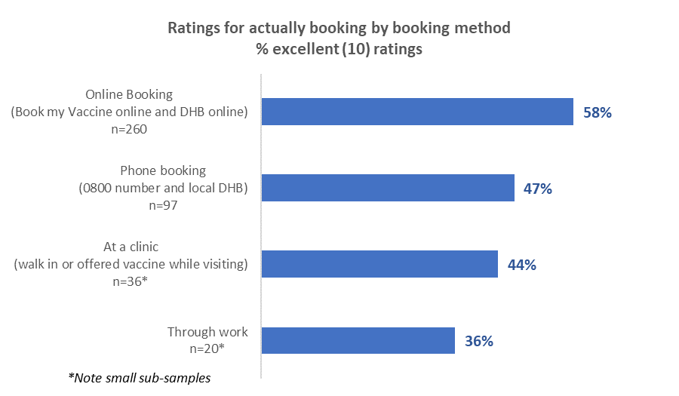

12.6 Assessing the appointment experience
People who had been vaccinated were shown a list of possible experiences they may have had in the course of their appointment, some positive and some negative. The next two charts show their positive and negative experiences.

As in previous survey waves, peoples’ positive experiences far outweigh their negative experiences.

Compared with July, positive results recorded in August have increased for all 7 measures, with the biggest increases for ease of getting to the centre (+9 percentage points), correct information in my records (+6 points) and ease of parking (+5 points).

Negative experiences have a very similar pattern to July, with the biggest problem involving centre staff not knowing who the person was when they arrived at the vaccination centre. This applied to around one in eight people (12%) coming to their appointment in the August survey.

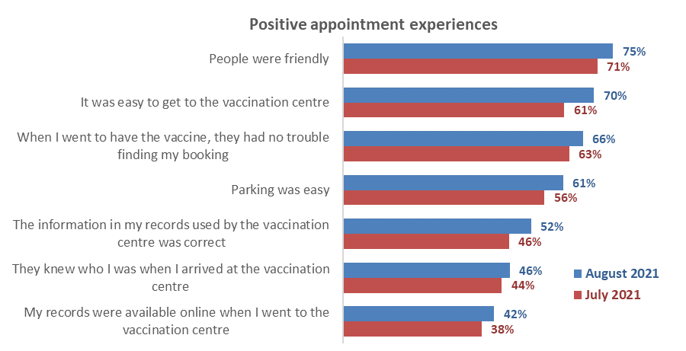
↑
↑
↑
↑
↑
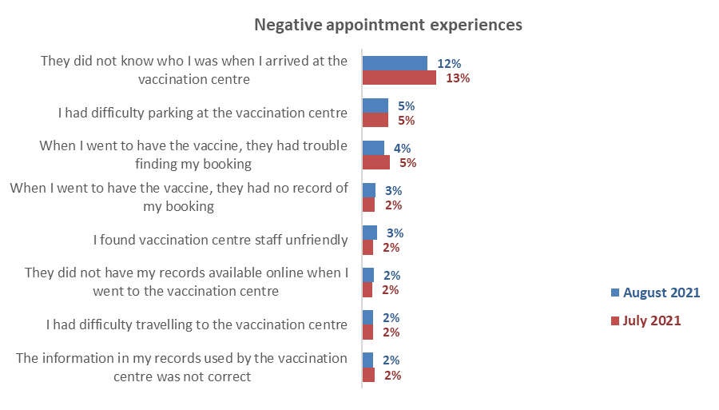
Base for both charts: vaccinated with at least one dose: August n=1,290, July n=934

‘Other’ experiences of being vaccinated
Seven percent of those who were vaccinated reported some ‘other’ experience of being vaccinated (other than the experiences listed in the question). The responses from these 94 people were in the following categories:

Good/great customer service
It was quick and easy, and the staff were amazing.
Professional.
The staff were amazing, made the process very smooth and easy.
Mass vaccination event at MIT was very well organised.
It was extremely well organised; you could see that the extensive planning had led to smooth operation and it made me proud to be a New Zealander.
Drive through vaccination was a good idea and ran smoothly and quickly.
My vaccination place was primarily geared for Māori and Pasifika but were more than helpful to me.
As a person with mobility issues, my mobility scooter and I were put to the front of the queue.

Encountered some issues
I didn’t expect to have to wait outside, I would have bought a coat if I’d known.
Unorganized long wait.
Quite a long wait - 1½ hours despite being booked.
Staff rushed us all and didn’t care.
Address stated in text message for vaccination centre was wrong.
Social distancing was not adhered to.
Staff could not locate booking, but we had a printout as proof so were accepted.
I had to repeat the same information several times to several different people. Staff were super friendly, but the process seemed frustratingly inefficient.
It was over complicated and time consuming. Drive through is the way forward.
There was a massively long line waiting to get a vaccine and the whole process took approx. 2.5 hours.

12.7 Satisfaction with the care people received when they were vaccinated
All those who had received at least one dose of the vaccine were asked to rate six aspects of the care they received, using a ‘0’ to ‘10’ scale, from totally dissatisfied to totally satisfied.

The results are extremely positive with mean ratings ranging from 8.7 out of 10 for ‘The location of the vaccination centre’ to 9.5 for ‘The person who vaccinated me’.

All six measures below recorded slightly higher mean ratings in August than in July.

Areas rated | Range of ratings Aug 2021 |  |  | Mean rating  Aug 2021 | Mean rating  July 2021
 | 0-4  (Poor)  % | 5-7 (Moderate)  % | 8-10 (Good)  %
The location of the vaccination centre | 5% | 12% | 83% | 8.9 | 8.7
The way in which the vaccination centre was laid out | 3% | 12% | 83% | 8.9 | 8.8
The staff I saw when I first arrived | 2% | 10% | 87% | 9.1 | 9.0
Finding my booking details | 3% | 9% | 84% | 9.1 | 8.9
The person who vaccinated me | 1% | 6% | 91% | 9.5 | 9.3
The way in which I was monitored after I had been vaccinated | 2% | 10% | 86% | 9.2 | 9.1
Base: vaccinated with at least one dose: July 2021 n=934, August 2021 n=1,290.

Mean ratings by ethnicity – August 2021
While ratings were high across the board, as the next table shows, the following ethnic groups gave relatively higher ratings: Māori, NZ European/ Pākehā, Other European and Pasifika.

By contrast, Asian and Indian people gave relatively lower ratings.

Mean ratings out of ten | Asian | Indian | Māori | NZ European/ Pākehā | Other European | Pasifika
The location of the vaccination centre | 8.1↓ | 7.8↓ | 9.2↑ | 9.0↑ | 8.9 | 8.9
The way in which the vaccination centre was laid out | 8.0↓ | 8.2↓ | 9.2↑ | 9.0↑ | 9.1↑ | 8.9
The staff I saw when I first arrived | 8.1↓ | 8.2↓ | 9.3↑ | 9.2↑ | 9.2↑ | 9.2↑
Finding my booking details | 8.0↓ | 8.1↓ | 9.4↑ | 9.2↑ | 9.2↑ | 9.2↑
The person who vaccinated me | 8.5 | 8.6 | 9.5↑ | 9.6↑ | 9.6↑ | 9.5↑
The way in which I was monitored after I had been vaccinated | 8.3 | 8.5 | 9.4↑ | 9.2↑ | 9.2↑ | 9.2↑
KEY: ↑ Mean ratings of 9.0 or more ↓ Mean ratings of 8.2 or less

12.8 Were people’s language needs met through the process?
All those who had received at least one dose of the vaccine were asked whether their language needs were met throughout the booking and vaccination process.
In August 92% of vaccinated people said their language needs had definitely been met, while 95% said definitely or mostly.  This is very similar to the July result  - 90% of needs definitely met  - 96% definitely or mostly met | 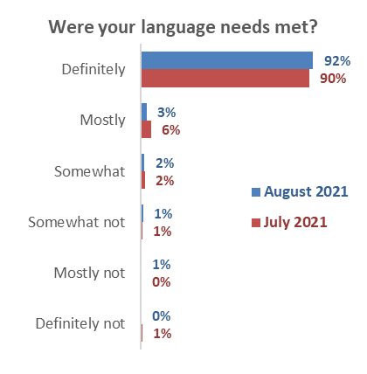  Base: vaccinated with at least one dose:  July n=934 August n=1,290
Language needs met by ethnicity – August results
People of Asian descent are relatively less likely to say their language needs were definitely met (69%) compared with those of Māori descent (95%), NZ European/ Pākehā descent (also 95%) and Other European people (97%).

Were your language needs met throughout your booking and vaccination process? | Asian | Indian | Māori | NZ European/ Pākehā | Other European | Pasifika
Definitely | 69% | 86% | 95% | 95% | 97% | 90%
Mostly | 15% | 6% | 3% | 2% | 3% | 2%
Definitely and mostly | 84% | 92% | 98% | 97% | 100% | 92%
Somewhat | 6% | 6% | 1% | 2% | 0% | 0%
Somewhat not | 5% | 2% | 0% | 1% | 0% | 3%
Mostly not | 0% | 0% | 1% | 0% | 0% | 5%
Definitely not | 5% | 0% | 0% | 0% | 0% | 0%
N (unweighted) - Received at least one dose of vaccine | 75 | 70 | 274 | 867 | 102 | 114

12.9 Were people’s disability or impairment needs catered for through the process?
69% of those with a disability or impairment said their needs were definitely met (July 68%) and 13% said they were “mostly” met (July 12%).  18% gave low ratings from ‘somewhat’ to ‘definitely not (July 20%)’. | 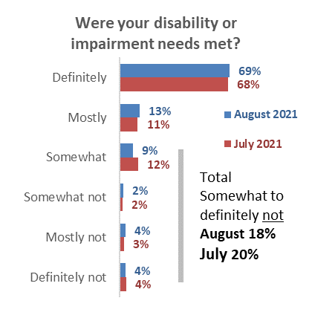  Base: Have an impairment or disability and vaccinated at least once: July n=461, August n=496

12.10 Likelihood of recommending vaccination to others
People who had been vaccinated were asked ‘Overall, does the experience you had when making bookings for and having a COVID-19 vaccine make you more or less likely to recommend vaccination to others?’

The latest August results show a positive lift in those who are more likely to recommend vaccination to others compared with July. Now, almost three-quarters (73%) say they their experience made them more likely to recommend vaccination. There is a corresponding fall in those who said their experience made no difference (24% in August cf. 29% in July).

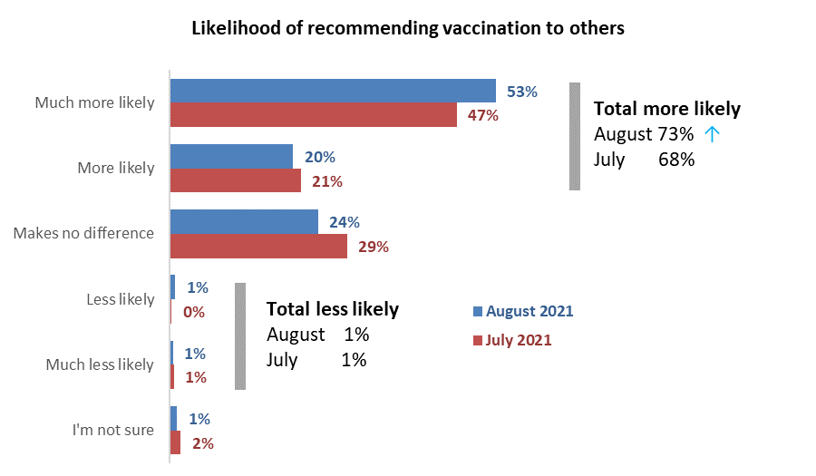
↓
↑
Base vaccinated with at least one dose: July n=934, August n=1,290
Note rounding affects some of the totals.

12.11 Suggested improvements to the vaccination process
The 1,290 people in the survey who had been vaccinated at least once were asked an open-ended question, ‘Thinking about your experience of the whole vaccination process (from booking to getting the vaccine), is there anything that you think could be improved?’

Of these people, 952 either suggested improvements or said they were very happy with their experience and had no suggestions.

The themes identified are shown in the chart below, with the three main themes being:
- Very happy – no suggestions (60%, up strongly from 42% in July – a great result)
- Vaccination centre suggestions (23% cf. 25% in July)
- Booking suggestions (13%, down from 19% in July).
↓
↓
↑
Base vaccinated at least once: July n=539 people who commented, August n=952 people

These suggestions are analysed further below, with verbatim quotations illustrating the types of comments made.

Very happy - no suggestions
I was very satisfied with the service starting from when I booked it towards the end of the process. Keep up the friendly and the best service to the public. (Female, Aged 55-64 years).
I'd just like to say, I arrived at my second vaccination site, walking with my walking frame, as I recently had had an accident, the staff were very helpful & fully supportive. Allowing me the time & space to walk into the centre on my own. Very impressed. Thank you. (Female, Aged 55-64 years).
It all went easily, and the people involved were working hard despite the cold conditions. (Female, Aged 65-74 years).
It was a smooth and non-anxious experience and if I had to go through it again, I would not hesitate. (Female, Aged 75 years or over).
It was extremely efficient and easy - no problem at all. Very well organised and efficient. (Female, Aged 75 years or over).
It was genuinely amazing. Competent, friendly...everyone was smiling. (Female, Aged 65-74 years).
My experience was awesome Everything went through with ease and successfully. (Male, Aged 45-54 years).
It was super slick. (Male, Aged 25-34 years).

Vaccination centre - suggested improvements
General comments
We shouldn't have to wait outside in the cold for hours. But we couldn't do anything but just to wait and be patient. (Female, Aged 18-24 years).
Too crowded in winter in a cold tent. (Female, Aged 45-54 years).
Disorderly at venue. (Female, Aged 45-54 years).
Let GPs and pharmacies administer the vaccines. My doctor knows me best and won't give me saline instead! The big vaccination centres feel very impersonal. (Male, Aged 55-64 years).
Ministry of Health should get off their backsides and get people attending their own medical centres as much as possible. (Male, Aged 55-64 years).
Misinformation between Doctors, MOH, Healthline. (Female, Aged 35-44 years).
Should be open 7 days. (Male, Aged 45-54 years).
Re the process
Small waiting area, insufficient seats, crowded. Some people can't stand for long periods but were given seats by more able ones. Everybody was in the senior/vulnerable category, so it should have been obvious that more space and seating would be required. (Female, Aged 65-74 years).
The system finally worked but it was very "trial and error" and showed a lack of preparedness to begin with. The Northland DHB were disorganised at first and had clearly not prepared for the tasks required. (Male, Aged 65-74 years).
Speed of vaccination, the 5 steps to confirm, provide information, wait and check in for first appointment was redundant. (Male, Aged 35-44 years).
Layout was a bit confusing. Would have liked a “follow the blue line” approach rather than arrows posted on walls. (Female, Aged 65-74 years).
Better flow of traffic at the Centre. Bookings made but still an hour before getting seen and jabbed. Didn't feel like there was a need to book - at least keep to the times of the bookings. (Male, Aged 35-44 years).
What’s the point of making a booking if they don't take people in order? (Male, Aged 25-34 years).
I think experience has now shown that the process can be speeded up through shorter post-vac waiting times. The new in-car vax should also speed the process. It would be good if testing/vax stations were combined for both to be available simultaneously. (Female, Aged 75 years or over).
It was a bit disjointed - a pr- entry check in, reception holding area, check in area, waiting area then holding area. Streamlining to just check in then waiting would have been so much better. (Female, Aged 35-44 years).
Improve waiting time at clinic
Despite having a booking, I was surprised at the wait time to be vaccinated (Female, Aged 55-64 years)
How is it I can book a time to be vaccinated, then still be sitting there waiting to get it 45 minutes later? (Male, Aged 45-54 years)
Just the waiting time beforehand. My spinal issues mean that I cannot sit for long in many places. The chairs were awful, and I was almost in tears when I was called after waiting 25 mins. Then I had to sit for a further 20 after the vaccine. The extra pain stayed with me for days (Female, Aged 35-44 years)
The wait times were irritating as there was no order in terms of the times booked - people who were booked later than me were somehow prioritised in the queue. It should have been done by time slots. (Female, Aged 25-34 years)
Customer care – should be friendly and helpful
I wish the people who gave us the vaccine would explain better what they are doing. Also, the person who vaccinated me was not wearing gloves and I don't know if that's normal or not. (Female, Aged 25-34 years)
Replace the security guard with a friendly face (Female, Aged 55-64 years)
Staff less grumpy with each other - workplace culture (Female, Aged 55-64 years)
Staff not to rush us being vaccinated. Even after saying I have a fear of needles and would like to get vaccinated with my husband together, the attitude wasn’t friendly at all! (Female, Aged 35-44 years)
The only thing to improve would be when we had our shots and went through to the waiting room we seemed to get forgotten about (Female, Aged 35-44 years)
Re refreshments
Cup of tea/coffee and a biscuit would have been nice. Iwi offered these to all my whānau who were jabbed. I was contacted through my doctor’s clinic, so got my vax through Pākehā channels. Was definitely a clinical experience in that regard. (Female, Aged 35-44 years).
I was really impressed that they offered fruit after the injection. So often sweets are given, and this reinforces that if something a little unpleasant is about to happen give sweets. Kids are just as happy with a stamp or sticker. (Female, Aged 75 years or over).
Supply coffee! (Male, Aged 55-64 years).
Use of masks/ social distancing
I would have preferred better/two metre or more social distancing for everyone. (Female, Aged 35-44 years).
Better spacing in the waiting room, although there was no COVID at home at this stage. (Female, Aged 55-64 years).
Mask wearing a must. (Female, Aged 55-64 years).
Re location of clinic
As I live in the Auckland City Centre, it is the most densely populated area of New Zealand. They really need to establish another vaccination centre in the city centre in addition to the Atrium on Elliot facility. Not just for the many thousands of residents here but for the wider Auckland population. (Male, Aged 35-44 years).
Don’t put it at the Crowne Plaza right next to MIQ. It’s just stupid. (Female, Aged 25-34 years).
Elliot St location is difficult to access and there are no signs until you have found the vaccine centre. (Male, Aged 65-74 years).
Had to drive a long way to the nearest centre (1 hour drive). Would have been easier if local GPs had been added to vaccination locations earlier, this would have been local for me and my husband. (Female, Aged 65-74 years).
Had to travel for over 1 hour each way to get to the centre. Should have been more locations for smaller towns etc. (Male, Aged 55-64 years).
I would like to have had the vaccination at my local medical centre instead of travelling to another town nearby. (Female, Aged 65-74 years).

Problems for those in wheelchairs
Overall was very good. My only complaint was that considering it was a vaccination centre which is meant to be catering for everyone, it was very poorly laid out for anyone in a wheelchair. The doorways were very narrow and definitely not easy for someone in a wide wheelchair. In fact, you couldn’t - I had to get out of the wheelchair get through the doorway, my carer then had to fold my wheelchair up to get it through the doorway on both entry and exit. (Female, Aged 65-74 years).
The location was rather crowded with people, so a lot had to move so I could get through in my wheelchair. (Male, Aged 45-54 years).
The waiting rooms were quite small for my wheelchair to fit in. Not great for social distancing. (Male, Aged 18-24 years).
Re parking
Better location parking-wise could have been chosen (Male, Aged 55-64 years)
More parking available or letting us know where all the available car parks were in the area. (Female, Aged 35-44 years).
Re signage
Better signs outside mall to show where the centre was. I had to ask someone how to get there. (Male, Aged 45-54 years).
It was running an hour late, so lots of queuing. A sign saying what the queue is for would have helped - some thought it was for the adjacent supermarket! A sign saying “Appointments Only” would have helped. (Male, Aged 45-54 years).
Resourcing
Centre overwhelmed by sheer numbers. (Male, Aged 65-74 years).
More people should be involved to reduce the stress levels of the people working. (Female, Aged 55-64 years).
Information
Maybe give people information on paper after vaccine given with what side effects to look out for etc. (Female, Aged 35-44 years).
Language issues
I think there should be options for all different languages so that no one misses out. (Female, Aged 25-34 years).
Re record keeping
The record keeping. I filled in a paper form at vaccination centre. If that gets lost there is no record of me being vaccinated. (Male, Aged 45-54 years).

Booking-related
General comments
Booking system is bit unorganized (Male, Aged 45-54 years)
The information regarding timing of vaccination. It was only because my own GP told me of the arrival of vaccine doses that I knew. There needs to be a definite date set that general population can expect to receive their vaccinations - therefore some real accountability. (Female, Aged 55-64 years).
Could be better set up, booking could be easier, should be done by GPs / pharmacies to distribute to more people easier. (Male, Aged 35-44 years).
Forget bookings. Anybody and everybody should be able to get the vaccine as soon as they want it. Walk-ins only. Forget the silly booking system. (Male, Aged 55-64 years).
Other than the jab itself, everything must be improved. The booking software needs to be re-written. A central database showing the vaccinations each person has received must be available. When I tried to cancel my first appointment it cancelled the entire booking rather than one appointment. I asked the staff at the vaccination centre to cancel my first appointment and they were not able to do it. The software was unable to associate a booking with a person. The entire process needs to be analysed, documented and software written to support it i.e., making and changing appointments, having the jabs and recording the vaccinations that a person has received, not just for COVID but all vaccinations e.g., yellow fever, measles etc). (Male, Aged 65-74 years).
Speed up the booking process
Speed up booking. (Female, Aged 25-34 years).
I initially tried to book over the phone, but the wait time was too long so I ended up booking online. (Male, Aged 25-34 years).
Have experienced and fast staff on the computer. This took the longest time in the process. (Female, Aged 55-64 years).
The booking process was too difficult as I spent over 3 hours waiting (3 separate times) just to book. Online booking should've been available from group one. (Female, Aged 35-44 years).
The booking process wasn't easy. I had to ring back 3 times. One time I was on hold for 17 minutes. (Male, Aged 25-34 years).
Difficulty arranging second vaccination
I left my details after the first vaccine but never received a call to arrange a second dose. I had to call to arrange a second vaccine and they said they did not have my details on the system which is pretty poor when I had to fill out a form with details the first time. (Female, Aged 25-34 years).
My second booking took forever to get through to the person on the phone. She couldn't understand what I was saying. I spent about three quarter of an hour trying to tell her that I needed a second appointment. To tell you the truth people who cannot understand you should not be given this responsibility. (Male, Aged 75 years or over).
The only problem I had was getting the second vaccination. When I had my first one, I was told to make sure I check my email and phone to receive the second one which they told me it would be in 3 weeks but after 4 weeks I called them to ask about my second vaccination, they had no record of my first one! However, she took my details and booked me, so consequently it was 10 weeks wait to get the second one but at the end of the day I am pleased that I am fully vaccinated. (Male, Aged 75 years or over).
Co-ordination of information with the vaccination centre
Better communication from the health authorities to the vaccination centres with online bookings. (Male, Aged 65-74 years).
Booking team and vaccination team need to talk more. (Female, Aged 35-44 years).
Computerised systems that talk to each other from booking to vaccination centre. (Female, Aged 35-44 years).
The notification and booking systems were really bad and seemed in no way to be connected to the actual vaccination centre, which turned out to be very good. (Female, Aged 65-74 years).
Problems with the online system
I tried to cancel one booking on-line due to getting a call up earlier than scheduled. The system could not deal with this and both bookings had to be cancelled. (Male, Aged 45-54 years).
The online system was hopeless. After 3 hours I gave up. My grandson made me ring and make an appointment, because otherwise would not have bothered. Told them when I went for vaccination, I wanted to go to my usual health centre. They were awesome. (Female, Aged 65-74 years).
The online booking system was a fail, while the phone was positive. (Female, Aged 45-54 years).
Difficulty booking with partner
Booking was very hard. Trying to get a booking together almost impossible - so had to book different times and dates. (Female, Aged 75 years or over).
Had to go through the whole process twice to book for both of us - it would have been good to be asked 'do you want to book for any other members of your household?' (Female, Aged 65-74 years).
Confusion/ lack of consistent information with various booking systems
A bit confusing having both the 0800 system and the local healthcare system working in parallel. I ended up booked with each because my husband booked on the 0800 and I booked through our healthcare centre when they texted and then rang. I didn't realise they were two systems! (Female, Aged 75 years or over).
Seemed to be a lack of appointments on Book my Vaccine, however when I phoned there were heaps. (Female, Aged 25-34 years).

Check if people have a disability
Checking on disabilities when booking. (Female, Aged 35-44 years).
Don’t insist on making second appointment when booking the first
I couldn't book just one at a time - had to book together. (Male, Aged 18-24 years).
Essential worker not given the earliest available booking
I’m an essential worker - I was supposedly booked at the earliest available slot however I was able to use the code and find an earlier booking 2 weeks earlier myself. When the vaccination was made available to all essential workers of all ages this was not advertised well. (Female, Aged 35-44 years).
Improved confirmation message
More communication as to confirming my booking. (Male, Aged 65-74 years).

Re invitations to be vaccinated
Landline phone call to contact people who don't have mobile phones to arrange appointment. (Female, Aged 65-74 years).
My daughter was not in Groups 1, 2, or 3, but she got invited to book and I did not. (Female, Aged 75 years or over).
Nobody told me when I will get my second dose. (Female, Aged 35-44 years).
Non-existent communication from DHB regarding vaccination. (Male, Aged 45-54 years).
They promised those in band 3 would be contacted in May. Mine arrived in July. (Male, Aged 75 years or over).
We are both over 75 and no one phoned or got in touch to tell us to book; a casual acquaintance told us what to do. (Male, Aged 75 years or over).

Vaccination rollout should have been faster
Being able to get vaccinated sooner. (Male, Aged 75 years or over).
Rollout too slow. I am immuno-compromised and should have had vaccine months ago. (Female, Aged 65-74 years).
Should have been available sooner. (Male, Aged 55-64 years).
Should have been 6 months ago - rollout too slow. (Male, Aged 45-54 years).
The DHBs needed to get through the vaccinations of the groups 1 to 3 a lot quicker. (Female, Aged 55-64 years).
Vaccinations should have been organized months ago, NZ definitely not at front of queue – hopeless. (Female, Aged 65-74 years).
Vaccinations should have started a lot earlier with greater pace. Should have been given options to get vaccinated earlier when you are in a priority group - booking system was not helpful in getting an earlier date. GPs should have been able to vaccinate much earlier. (Male, Aged 55-64 years).

Other suggestions/ comments
Given the criticism I would jump start the whole process. Just vaccinate quickly with none of the checks and balances. I would speed it up even if errors were made. The error rate would be acceptable. But that's politics. You would be criticised for too much caution or not enough (e.g., the fuss that five may or may not have got a saline injection or someone’s time between injections was too short. (Male, Aged 65-74 years).
I know from my Dr why it was important for me to get vaccinated while I was pregnant, as it meant my baby would get some antibodies, but many people I know did not know this and are too scared to get it in case it hurts their baby. (Female, Aged 25-34 years).
I noticed an improvement when I received my second dose and from what I have heard a lot more improvements are happening, experience is a great teacher, well done people. (Female, Aged 75 years or over).
Make it illegal to publish lies about the vaccine. (Female, Aged 55-64 years).
I thought it was weird that it was not public knowledge that vaccinations are given to anyone at the end of the day if there are spare vaccines. (Male, Aged 35-44 years).

Attitudes to children aged 12 to 17 being vaccinated
All respondents were asked if they were primary caregivers for young people aged 12-15 years or 16-17 years.

84% said they were not caregivers and were excluded from the rest of the questions around vaccines and younger people. 13% of the sample were primary givers for 12–15-year-olds, and 6% primary caregivers for 16–17-year-olds.

Each of these caregiver groups were asked:
- For how many young people they were a caregiver (a separate question for the caregivers of each age group).
- If they would allow their young people to get the vaccine (again, a separate question for the caregivers of each age group).

13.1 Would you allow the children for whom you are the primary caregiver to take the vaccine?

Caregivers of 12–15-year-olds
Primary caregivers of 12–15-year-olds were asked ‘If a COVID-19 vaccine is approved for use in children aged between 12-15, would you allow the children for whom you are the primary caregiver to take the vaccine?’

The following chart shows responses to this question compared with the June, May and April 2021 survey.

73% said that they would ‘definitely’ or ‘likely’ allow children of this age to be vaccinated (July 67%, June 59%, May 55%, April 2021 56%) and 6% said their 12–15-year-olds had already had a vaccine or were booked for a vaccine.

14% said they were unlikely to left their 12-15-year-olds get a COVID-19 vaccine or would ‘Definitely not’ allow it. (July 21%, June 30%, May 26%, April 2021 22%). The unsure dropped to 6% from 12% in July and June 2021.
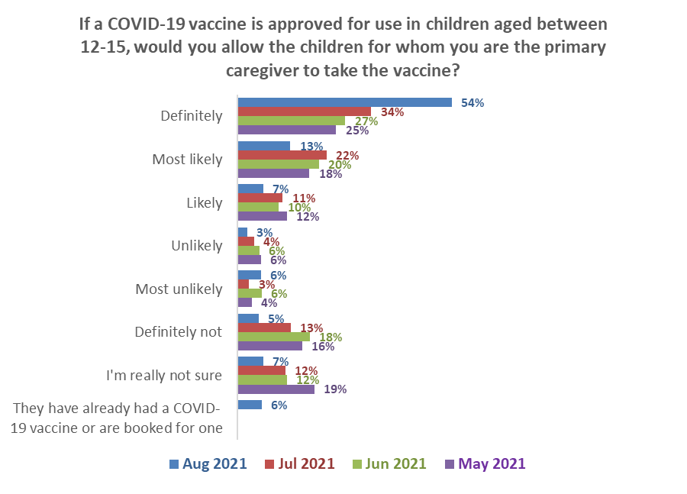Base (Caregivers for 12- to 15-year-olds):
Definitely not & unlikely
August 2021 14% ↓
July 2021 21%
June 2021 30%
May 2021 26%
Definitely & likely
August 2021 73% ↑
July 2021 67%
June 2021 59%
May 2021 55%

August 2021 n=315, July n=310

The overall average number of 12–15-year-olds reported by their caregivers was 1.50. Caregivers who would allow their 12–15-year-olds to get a COVID-19 vaccine reported a slightly lower average of 1.46. This means that the overall percentage of 12–15-year-olds who will be allowed to get a vaccine will be slightly lower than the caregiver percentage shown in the chart above.

The proportions of caregivers of 12-15-year-olds and caregivers of 16–17-year-olds who are likely to allow their young people to get a vaccine are now effectively the same.

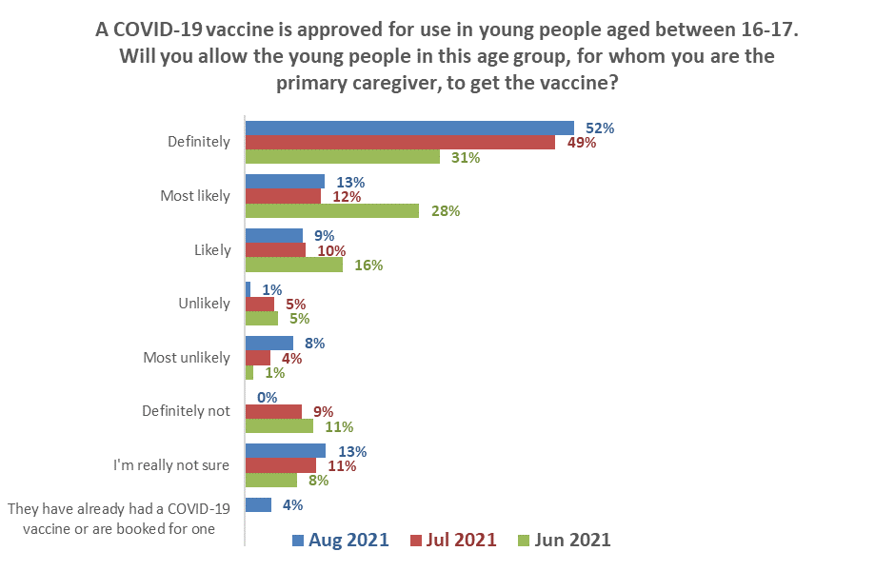
Definitely & likely
August 2021 74% ↑
July 2021 71%
June 2021 74%
Definitely not & unlikely
August 2021 9% ↓
July 2021 18%
June 2021 18%
Base (Caregivers for 16- to 17-year-olds): August n=163, July n=175
The overall average number of 16–17-year-olds reported by their caregivers was 1.59. Caregivers who would allow their 16–17-year-olds to get a COVID-19 vaccine reported a slightly lower average of 1.51. This means that the overall percentage of 16–17-year-olds who will be allowed to get a vaccine will be lower than the caregiver percentage shown in the chart above.

Overall, it is estimated that caregivers would allow around 77% of their 12–15-year-olds who have not already been vaccinated and 75% of their 16–17-year-olds to get a vaccine. This is calculated as follows (figures are rounded to the nearest 10):

 | 12–15-year-olds | 16–17-year-olds
Average number overall per caregiver | 1.50 | 1.59
Population estimate | 264,560 | 125,370
Estimated number of caregivers | 176,490 | 78,980
Percent of caregivers allowing vaccination | 73.4% | 74.2%
Number of caregivers allowing vaccination | 129,540 | 58,600
Average young people per caregiver allowing vaccination | 1.464 | 1.51
Estimated number of 16-17s allowed to get vaccine or already vaccinated | 205,070 | 93,870
Percent of population estimate | 77% | 75%
Caregiver ethnic groups except for NZ European/Pākehā are relatively small and comments by ethnic group are indicators.

Results indicate that Māori were more likely than average to allow their 16–17-year-old taiohi to get a COVID-19 vaccine but less likely than average to allow their 12–15-year-old tamariki to get vaccinated. This is a reversal of the July result.

More caregivers across all ethnicities were not sure than in July.

Will you allow the young people for whom you are the primary caregiver, to get the vaccine? | ETHNIC GROUP
 | Asian | Indian | Māori | NZ European/ Pākehā | Other European | Pasifika | Other *
16–17-year-olds
Would allow | 82% | 67% | 81% | 72% | 88% | 73% | 40%
Would not allow | 6% | 4% | 5% | 10% | 12% | 4% | 11%
Not sure | 10% | 29% | 11% | 12% | 0% | 23% | 42%
12–15-year-olds
Would allow | 86% | 77% | 70% | 73% | 81% | 78% | 66%
Would not allow | 7% | 15% | 13% | 15% | 6% | 15% | 0%
Not sure | 7% | 9% | 11% | 6% | 0% | 6% | 27%
* Indication only; small base: Caregivers of 16-17s, n=5, caregivers of 12-15s n=7

13.2 Reasons for being unsure or unlikely to encourage COVID-19 vaccination for younger people
Primary caregivers of younger people (either 16-17- or 12–15-year-olds) who said they were unsure or unlikely to encourage these children to be vaccinated were asked to select their reasons for this from a list presented to them. The table below compares the overall August results with those from July, June, May and April 2021.

As shown in the table:
- The main response – It is too soon to see whether there are any long-term effects for children from the vaccine” increased by 17 percentage points to 65% after increasing by 7 percentage points in July (July 48%; June 41%; May 50%; April 43%).
- ‘I would need to be assured about its safety in children’ increased by 7 percentage points to 58% (July 51%, June 52%, May 59%, April 60%).
- “I don't see the need for children to get a COVID-19 vaccine” increased by 9 percentage points to 26% (July 17%, June 22%, May 23%, April 13%).
- “Children I care for have had a bad experience in the past when taking a vaccine” (14%, July 6%, June 4%, May 3%, April 2021 5%).
- “I don’t trust any vaccine” reduced by 5 percentage points to 6% (July 11%; June 15%; May 9%; April 10%).

Reasons for being unsure or unlikely | Apr | May | Jun | Jul | Aug | Difference
 | 2021 | 2021 | 2021 | 2021 | 2021 | % points
It is too soon to see whether there are any long-term effects for children from the vaccine | 43% | 50% | 41% | 48% | 65% | +17 ↑
I would need to be assured about its safety in children | 60% | 59% | 52% | 51% | 58% | +7 ↑
I'd rather wait and see if others who have taken it suffer any side effects | 21% | 28% | 30% | 32% | 30% | -2
I don't see the need for children to get a COVID-19 vaccine | 13% | 23% | 22% | 17% | 26% | +9 ↑
Children I care for have had a bad experience in the past when taking a vaccine | 5% | 3% | 4% | 6% | 14% | +8 ↑
I'd like to be able to talk with my health provider about it | 22% | 17% | 11% | 10% | 10% | 0
I personally don't take any vaccine | 7% | 10% | 10% | 8% | 8% | -2
I don't allow the children I care for to take any vaccine | 10% | 9% | 15% | 8% | 8% | 0
I don't trust any vaccine | 12% | 10% | 7% | 11% | 6% | -5 ↓
Because of my religious beliefs |  | 4% | 0% | 2% | 6% | 4
I'd like to make sure that others who need it can get it before my child/children | 9% | 6% | 6% | 6% | 4% | -2
Children I care for have an existing health condition which prevents them from taking a vaccine | 8% | 5% | 7% | 6% | 4% | -2
It is too hard to get them to a place to be vaccinated |  |  | 0% | 3% | 3% | 0
I won't be able to afford a COVID-19 vaccine for the children I care for | 3% | 2% | 0% | 1% | 0% | -1
Some other reason | 10% | 11% | 9% | 13% | 11% | -2
Multiple answers were allowed
Bases: August n-81, July n=127; June n=62. May and April results were from caregivers of 12–15-year-olds only

“Other reasons” mentioned included:
0.00000001% of children die from the China virus.
1) When the Pfizer clinical trial ends in 2023. 2) To see the results or reactions in vaccinated people over time.
After a couple years will see what happens to others before my child or myself take COVID anything.
At 15 she is able to research and make her own decision.
Children do not die from COVID, but they do die from the mRNA vaccine. Children have a much better immune system and are quite able to deal with any cold including COVID.
I’ve already had my first dose - how do I book my child?
It’s their choice.
My children are also unvaccinated.
One of my kids has an allergy - haven't checked if he'll be OK yet.
Still no long-term test results for vaccine and younger people seem more likely to have adverse reaction compared to low risk from infection.

Reasons for not allowing 16–17-year-olds to get a vaccine were much the same as for 12–15-year-olds. Comparisons are shown in the following table:

You say you are unsure or are unlikely to encourage COVID-19 vaccination for the young people for whom you're the caregiver if this were offered. Why is that? | ALL | For which of these groups of young people are you the primary caregiver?
 |  | Aged 12-15 | Aged 16-17
It is too soon to see whether there are any long-term effects for children from the vaccine | 65% | 68% | 64%
I would need to be assured about its safety in children | 58% | 62% | 51%
I'd rather wait and see if others who have taken it suffer any side effects | 30% | 27% | 32%
I don't see the need for children to get a COVID-19 vaccine | 26% | 26% | 21%
Children I care for have had a bad experience in the past when taking a vaccine | 14% | 15% | 16%
I'd like to be able to talk with my health provider about it | 10% | 11% | 9%
I personally don't take any vaccine | 8% | 5% | 11%
I don't allow the children I care for to take any vaccine | 8% | 8% | 3%
I don't trust any vaccine | 6% | 5% | 6%
I'd like to make sure that others who need it can get it before my child/children | 6% | 6% | 2%
Children I care for have an existing health condition which prevents them from taking a vaccine | 4% | 5% | 0%
It is too hard to get them to a place to be vaccinated | 4% | 2% | 6%
Because of my religious beliefs | 3% | 2% | 6%
I won't be able to afford a COVID-19 vaccine for the children I care for | 0% | 0% | 0%
Some other reason | 11% | 8% | 13%
N (unweighted) - Unsure or unwilling to allow 16-17s or 12-15s to get a COVID-19 vaccine | 81 | 62 | 33

Noticed information on COVID-19 vaccines which was not true
All respondents were asked if they had come across what they believed to be misinformation on COVID-19 vaccines.
Half of those interviewed (51%) said they had seen or heard what they believed to be misinformation, while 31% said they had not. 18% were unsure. |  | 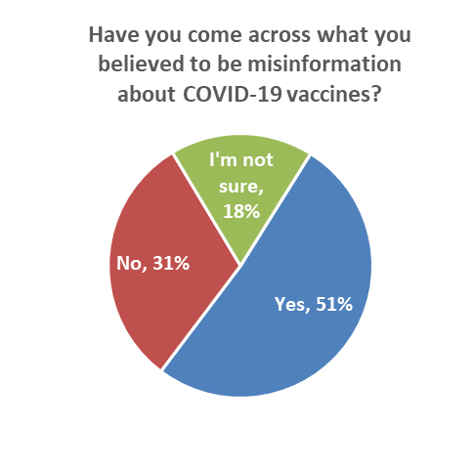  Base: All respondents, n=2334
Social media (70%), friends or family (40%), and mainstream print media (33%) were the main sources of this incorrect information. | 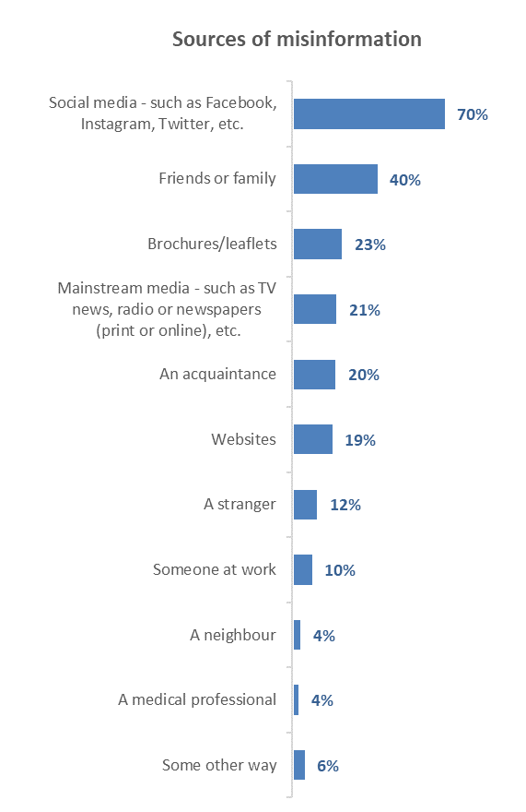
Base: Heard or saw something thought to be misinformation, n=1,275
Those who had already been vaccinated and those who said they would “Definitely” or “Definitely not” get a vaccine were more likely than others to have seen or heard what they perceived as misinformation.

In the case of those who are unlikely to get a vaccine, the sources of misinformation contain an above average level of “Mainstream media” (57%) – particularly among those who will “Definitely not” get a vaccine (70%).

How did you receive the misinformation? | ALL | TOTAL LIKELIHOOD TO GET VACCINE
 |  | Total Likely | Total Unlikely | Unsure | Already vaccinated
Social media - such as Facebook, Instagram, Twitter, etc. | 70% | 77% | 59% | 64% | 68%
Friends or family | 40% | 43% | 34% | 37% | 39%
Brochures/leaflets | 23% | 25% | 20% | 16% | 23%
Mainstream media - such as TV news, radio or newspapers (print or online), etc. | 21% | 13% | 57% | 30% | 20%
An acquaintance | 20% | 19% | 12% | 29% | 22%
Websites | 19% | 19% | 30% | 29% | 16%
A stranger | 12% | 13% | 3% | 9% | 13%
Someone at work | 10% | 13% | 4% | 3% | 9%
A neighbour | 4% | 3% | 5% | 2% | 5%
A medical professional | 4% | 2% | 21% | 3% | 2%
Some other way | 6% | 4% | 19% | 5% | 6%
N (unweighted) | 1,275 | 394 | 93 | 35 | 753

14.1 What made respondents think it was misinformation
An open-ended question was asked of the 1,275 people who noticed something in the past thirty days that they felt was untrue about the COVI-19 vaccines. In total, 1,185 people responded to this question; of these, 699 responses were from people who had already been vaccinated.

Key themes and illustrative comments from respondents who have not yet been vaccinated follow, as they will potentially be the most affected by misinformation. The general mix of perceived misinformation was summed up by this respondent observation

I think there is misinformation on both sides. The official channels do not share the adverse reactions to the vaccines declaring they are totally safe and that is creating fear and conspiracy theories to take hold. It has ever been the case with vaccination. We need balanced reporting and information. (Female, Aged 65-74 years).

Key themes:

Contrary to official information
Went against science (Female, Aged 16-17 years).
Was clearly wrong, conflicted with official Government information (Male, Aged 18-24 years).
Warned it was being issued. Contrary to official Government information. (Male, Aged 45-54 years).

Deaths
They said 100 people in NZ have died from an adverse reaction from the vaccine. I think that amount would be hard to cover up to be honest. (Female, Aged 25-34 years).
Our government, along with national/overseas media are over exaggerating the numbers. Also trying to tell us that there are no serious side-effects when people are dying post injection. (Male, Aged 65-74 years).
People still dying after getting vaccinated (both dose). (Female, Aged 18-24 years).

Denial
They said that COVID-19 was fake. (Female, Aged 18-24 years)
Trying to say COVID is a hoax, that the government is lying to us, that the vaccine is harmful. (Female, Aged 35-44 years).
My friend strongly disagrees of the Corona virus & the jab as well as the government lockdown decision. He told everyone that the corona virus is the cold/flu & continued flouting (the rules) & visiting friends... (Male, Aged 45-54 years).
Random 'facts' from 'doctors' about how COVID is fake... courtesy of a church pamphlet. (Female, Aged 25-34 years).
They don’t believe in COVID, LOL. (Female, Aged 16-17 years).

Unsubstantiated
What was said was hearsay based on what they'd seen shared on social media, which had been re-shared, etc. etc. No facts to back it up. I believe people are scared and the misinformation that gets spread is taking advantage of that. (Male, Aged 25-34 years).
Weird facts that didn’t logically make sense e.g., 5g (Male, Aged 18-24 years).
Rumours that are not proven fact. Panic buying instigated by media scare mongering. Very distrustful of media and their opinions. (Female, Aged 55-64 years).
Was strongly one sided and had lots of assumptions and things that I knew weren't true. (Male, Aged 25-34 years).
It's not rooted in fact or science, or backed up peer-reviewed research (Male, Aged 25-34 years),
Its stupid shit designed to take advantage of stupid people, (Male, Aged 25-34 years),
It would be very hard to confirm that what they said was true, (Male, Aged 25-34 years),
It was wrong, (Female, Aged 35-44 years),
It was very anti-science. (Male, Aged 35-44 years).
It did not make sense. People were rationalizing their reasons not to get the vax or use the app because basically they are just lazy people. (Male, Aged 65-74 years)
It was stupidly wrong and ignorant (Female, Aged 35-44 years)
It was stupid information (Gender diverse, Aged 18-24 years)
Because the things they say are so outlandish and ridiculous (Female, Aged 35-44 years)
It causes aids. (Male, Aged 25-34 years)
Propaganda or personal opinion not backed up by credible evidence. (Female, Aged 25-34 years).
The tone of the article was very dramatic, like 'we know a secret you don't' which seemed more like a conspiracy theory than a genuine attempt to educate. I also have a science background and know how vaccines work, so I am generally happy with them anyway and would need better evidence to be convinced otherwise. I also didn't trust the authority of the source, and when I went to the website advertised, it was very 'click-baity' and seemed to want to sell me things rather than outright tell me information. (Female, Aged 25-34 years)
All nonsense the information. They couldn’t back it up. (Male, Aged 35-44 years).
All conspiracy talk and no actual proof or evidence. (Male, Aged 18-24 years).
A lack of credible sources. (Male, Aged 35-44 years).
It was information regarding the vaccine being an experiment, and everyone was a guinea pig that it was being practiced on. (Female, Aged 45-54 years)
It was in contradiction to what I know to be true about vaccines. It also seemed unlikely because aspects of their story were conspiratorial and exaggerated e.g., that governments are killing people who speak up about COVID-19. (Female, Aged 25-34 years)
It was full of non-factual information and unsubstantiated claims and felt very much like a conspiracy theorist speaking. (Male, Aged 55-64 years)
Traced back "facts" to far right political memes with no validated fact checking. No credible sources. (Female, Aged 35-44 years).
People were using pre-existing conditions such as neural degenerative diseases and saying they were side effects of the vaccine - which was not the case, as doing further research of my own on these people I uncovered they had these symptoms long before COVID was around and with their diseases time will progress them - they also hadn’t received the vaccine and just used it to scare people out of getting it. (Female, Aged 18-24 years).
People taking horse dewormer. (Male, Aged 18-24 years)

Conspiracy theories
Told that it was created to depopulate the world. (Female, Aged 25-34 years)
Things like microchips being in the vaccine. (Female, Aged 25-34 years)
The messages on the signs and the fact that the people holding them were hiding behind the signs - both misinformation and wacko conspiracy theories. (Male, Aged 65-74 years)

Anti-government
They were anti vax and had lots of conspiracies about the vaccine and governments (Female, Aged 18-24 years)
It made claims that I know to be incorrect (e.g., that the vaccines are untested), and which were in some cases nonsensical (e.g., that there's not really an outbreak at all, it's just the government trying to make us all do whatever they say without argument for unstated nefarious reasons). (Female, Aged 35-44 years)
The language was very anti govt, anti-vaccine and scare mongering. (Female, Aged 35-44 years)
The polio vaccine is up to 99% effective, yet the China virus vaccines are nowhere near this. Where is the media on calling out Cindy, St Ash and the other "experts" when they go on with this dribble (sic)? Oh, that's right Cindy gave the >$100 million of taxpayer money to only say nice things about her and her cohorts... (Male, Aged 35-44 years)

Side effects
It claimed that the vaccine had all sorts of side effects that were being “covered up” with zero evidence of such a claim. (Male, Aged 25-34 years)
People discussing apparent 'side effects' in the US such as microchips and magnets being included in the vaccines (Female, Aged 25-34 years)

Safety
Inaccurately reporting safety data. (Female, Aged 25-34 years)
I think the WHO is covering up adverse reactions to the vaccines. (Female, Aged 25-34 years)

Harmful
Saying the vaccine was harmful and obvious conspiracy theories. (Male, Aged 18-24 years).
Saying the vaccine contains harmful substances designed to kill the receipts of the vaccine within 6 months. (Male, Aged 16-17 years).

Vaccine not effective
Saying the vaccine isn’t effective at all; won’t save us, just harms us. (Female, Aged 18-24 years).
Provided a sense that vaccines aren't safe for the entire population or reduced the effects of COVID-19. (Male, Aged 45-54 years)
Unsubstantiated nonsense, claiming vaccines didn't work. (Male, Aged 25-34 years)

Believability of Official/Government statements
It came from the government. (Male, Aged 35-44 years).
Conflicting messages from government. High vaccination gives us more options but PM made it clear high rates won't stop lockdowns as vaccine doesn't stop you contracting disease or passing it on. Only reason to have it is to mitigate effects of disease when we do get it. (Male, Aged 55-64 years)
It goes completely against the science. The government should not be spreading false information. Also saying it is safe in pregnancy when there have not even been 9 months since vaccinations began... The word thalidomide comes strongly to mind! There is some serious corruption at high levels to say it is safe in pregnancy when there is literally inadequate data to make any statement either for or against safety in pregnancy. (Male, Aged 45-54 years)
Being told it was safe and effective even though knowing people in my circle having massive reactions and liver, kidney problems and death (Male, Aged 25-34 years)
They are not telling the truth, plain and simple; they are lying to us and the reason people are being heavily censored is because they don't want the truth getting out. If they had nothing to worry about, they would ignore comments made contrary to their narrative, we know when we are spot on, they 'tell' us when we get censored. I prefer to follow the science not a politician. (Female, Aged 65-74 years)
The official NZ COVID-19 site does NOT explain any of the risks involved in having the vaccine, nor does it advise of any long-term health problems which may occur from having the vaccine. (Male, Aged 45-54 years)
Only giving one sided information. Not enough information about adverse effects the vaccine is having for people. Not told just how many people are in hospital or in ICU. (Female, Aged 35-44 years).
None of this makes any sense at all. People should be able to choose to get medical treatment so when there is coercion to do this then I know something isn't right. I now totally distrust the government and the media. (Female, Aged 75 years or over)
I have seen raw data that either supported the information yet was flawed/deceptive in some way, or that did not support the information or that I interpreted differently. Other instances that I considered 'misinformation' was when authorities stated things as being the truth, when in reality there is currently no way for anyone to know that with any certainty given the data we currently have. I know for a fact that this is just their best guess, yet it is being stated in such a way that indicates it as scientific fact. That is disingenuous at best and purposefully misleading at worst. (Female, Aged 45-54 years).
Speculation presented as fact. On both sides of the aisle there is absolute certainty within their conviction, yet despite lack of actual evident proof (that holds reasonable scientific weight through extensive trials/fool-proofing) no amount of propaganda will convince me to blindly follow until I can see true promise in results and research. I know propaganda towards pro-vax isn't exactly misinformation but at the very least it can come across disingenuous when presented as 100% certified and sorted. It is as if they need to match the level from the polarity of anti-vax misinformation. I think some anti-vaxers may have initially started out much like myself in their hesitancy, but the rabbit holes of excessive conspiracy theorising and then adding a sense of confirmation bias leads them to be headstrong and they end up diluting their genuine concerns/facts with speculative points introduced to them as fact, when sometimes it is simply done so by a person/group who has an agenda or just consumed by nihilism and "trolling' when initially produced for presentation. As much as it's hard in this world to rule anything out within conspiratorial possibilities, if it has no sense of credibility backed with extensive evident proof then to present anything as truth is misinformed tribal propaganda. Sadly, those on either side generally follow their heart due to caring and the confirmation bias makes one blind to contradicting possibilities. (Male, Aged 35-44 years).

Overall comments
Misinformation is a misnomer really. I've seen many people on all sides of the spectrum guessing. It's often their best guess but it's still a guess because you know what?....... nobody knows much about what is going to happen so I don't think any of it is particularly misinformation but more guess work and I really have no idea what is going to happen. Just like everyone else. (Male, Aged 45-54 years)
I find it pretty hard to believe that governments or people in high places are trying to control anyone through a pandemic. That anyone would try to control, or wipe out whole populations through sterilisation etc. Plus, all sorts of other, what to me sounds so unreasonable and improbable. It is very hard to argue against it though, so generally I choose to alter the line of conversation. (Female, Aged 55-64 years)
Although I am hesitant to get the vaccine, I understand many red tapes were cut to get this vaccine out faster. The whole world worked together, unlike many other vaccines that took longer. Misinformation talks about how it was too fast because of a sinister plan or that the vaccine is "now ineffective because of a new strain", and conspiracy theories of microchips etc. Statistically, it's a higher risk of going to the hospital without the vaccine to protect against any strain than if you have the vaccine and get COVID anyway. (Female, Aged 18-24 years).

Finally, “misinformation” and “official information” may be confusing some people:
What I have seen on Facebook and other places all contradicts each other, I no longer know what to trust, even stuff from the government and health organisations can contradict. I have never been so confused in my life. (Female, Aged 35-44 years)

14.2 Effect of misinformation
Respondents who had not yet had a CXOVID-19 vaccine were asked whether their decision to take or not take a COVID-19 vaccine would be influenced by something they saw or heard which they initially believed to be misinformation.

A nett 11% would not take a vaccine if something they initially thought was misinformation alarmed them looked credible. 30% of those people would then go on to look for official information.

(A similar question, but dealing solely with social media posts, was asked in March 2021. At that time, 16% of respondents would not get a vaccine if a social media post or video alarmed them or an anti-vaccine post or video looked credible. 32% of these people would have gone on to look for official information).

The effect was slightly lower on those who are “Unlikely” and lower still on those who are “Likely” to take a vaccine.

It has less effect on those who will “Definitely” or “Most likely” take a vaccine but they would look for official information if a social media post or video about COVID-19 alarmed them.

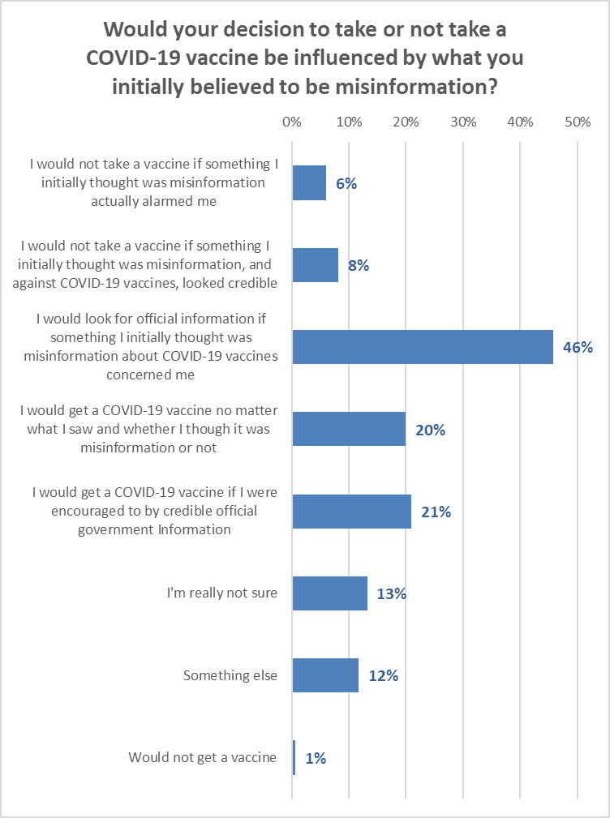

The overall effect of misinformation is shown in the following table. “Potential Overall Impact” is the percentage of those who:
- Had seen or heard misinformation.
- Would not take a COVID-19 vaccine if something they saw or heard that they initially thought was misinformation alarmed them or looked/sounded credible; and
- Would NOT then look for official information.

The initial effect of misinformation was most pronounced on those who are currently “Likely” to get a vaccine, but an above average proportion of those people will look for official information.

If something respondents initially thought was misinformation alarmed them or looked credible… | All | Will you get the COVID-19 vaccine?
 |  | Defin-  itely | Most likely | Likely | Un-likely | Most unlikely | Defin-itely not | Not sure
Nett not take vaccine | 12% | 7% | 10% | 28% | 17% | 25% | 16% | 17%
% of those who would not take vaccine if misinformation alarmed them or looked credible, who would then look for official information | 30% | 27% | 11% | 52% | 43% | 62% | 13% | 16%
POTENTIAL OVERALL IMPACT (% of group) | 4% | 3% | 4% | 5% | 4% | 4% | 7% | 5%

Indications are that Asian and Indian respondents were the most likely to not take the vaccine if alarmed by misinformation they thought was credible. However, they subsequently behaved quite differently: only 18% of Asian respondents who were alarmed by misinformation would seek official information, whereas 31% of Indian respondents would seek official information.

Māori and NZ Europeans/Pākehā were the least likely to be affected by misinformation.

If something respondents initially thought was misinformation alarmed them or looked credible… | All | Will you get the COVID-19 vaccine?
 |  | Asian | Indian | Māori | NZ Euro-pean/ Pāke-hā | Other Euro-pean | Pasi-fika | Other
Nett not take vaccine | 12% | 22% | 19% | 9% | 9% | 13% | 17% | 5%
% of those who would not take vaccine if misinformation alarmed them or looked credible, who would then look for official information | 30% | 18% | 31% | 37% | 36% | 33% | 32% | 0%
POTENTIAL OVERALL IMPACT (% of group) | 4% | 6% | 4% | 3% | 3% | 5% | 5% | 3%

Trust in the management of the pandemic and rating of the vaccination response
All respondents were asked:
- how much they trusted the Ministry and Government to manage the COVID-19 pandemic in a way which best protected them and other New Zealanders.
- how they thought the vaccination response to the COVID-19 pandemic was being managed in New Zealand.

15.1 Management of the pandemic
The average trust in the Ministry of Health and Government to manage the pandemic, on a scale of 0 to 5 (with 5 being highest) has risen to 3.8 out of 5, comparable with April 2021.

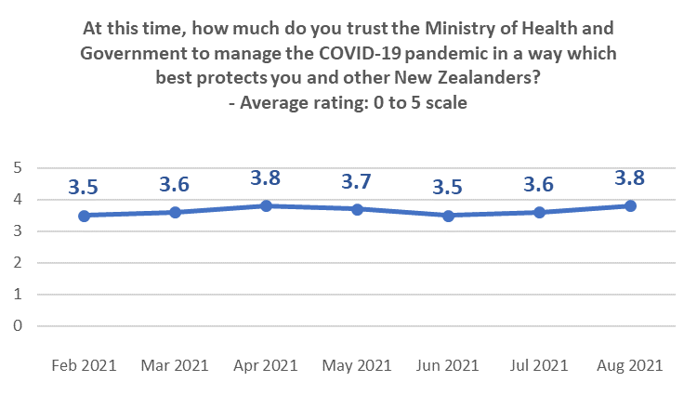

There is a moderate correlation between trust in the Ministry of Health and Government to manage the COVID-19 pandemic and respondent rating of the “importance of everyone in New Zealand who can be vaccinated, actually being vaccinated”.

15.2 Management of the vaccination response
August’s average rating of the vaccination response (on a scale of 0 to 10, 10 being highest) has improved to be the highest it has been since May 2021.

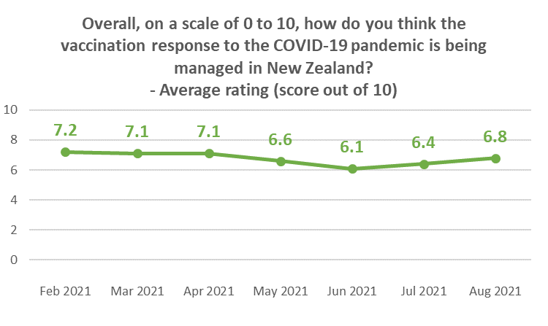

Ratings of 7 and above have increased and ratings of 0 to 4 have further decreased...

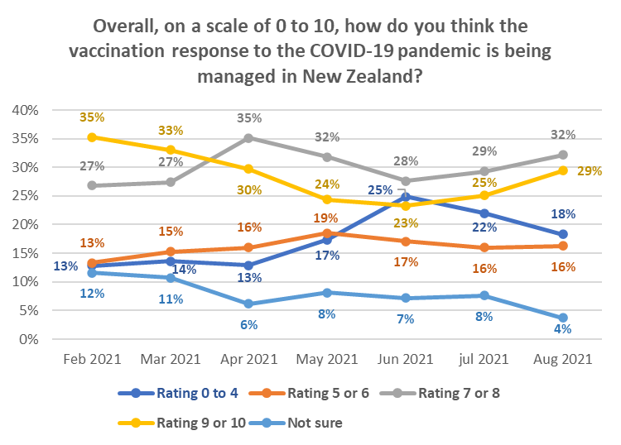

Lower than average ratings come from:
- Those with household income more than $100,000 per annum. The average rating of those with household income of less than $20,000 per year, who were reported in July as being below the overall score, are now above the overall score.
- Those with personal income of more than $150,000 per annum.
- Farm owners/managers (indication only, because of the small base).
- People living in “rural and remote” areas (indication, because of the smaller base).
- Those who aren’t sure which Vaccine Group they are in.
- Those who were not sure when they wanted to get the vaccine.
- Those who are unlikely to get a COVID-19 vaccine - particularly those who said they would “Definitely not” get it (average rating of 3.2 out of 10 – although this is up from 2.6 in July).
- Those who think vaccination is not important – particularly those who think it is “not important at all” (2.2 out of 10).

The 65% of respondents who think that vaccination is “very important” rated the vaccination response at 7.4 out of 10.

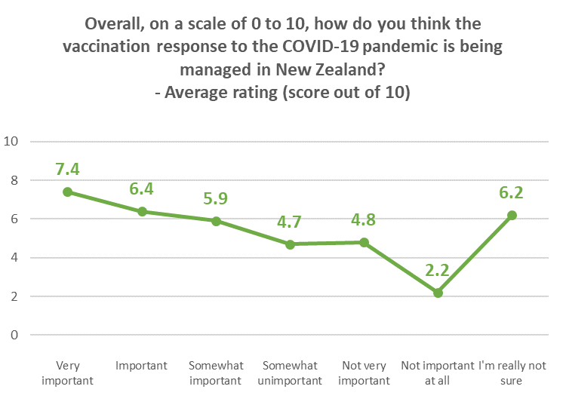

APPENDIX 1 - SAMPLE
2,334 people aged 18+ who are members of the nationwide HorizonPoll and Horizon Research Māori panels and two third-party respondent panels (used for source diversity), responded to this online survey between 24 and 29 August 2021.

The total sample is weighted on age, gender, employment status, personal income and region to match the adult population at the most recent census and the overall percentage of New Zealanders 16+ vaccinated as at 11:59pm on 29 August 2021.

At a 95% confidence level, the survey has a maximum margin of error of ±2.0% overall.

Sub-sample respondent counts and maximum margins of error (which occur when there is a 50%/50% answer) are shown below.

 | All respondents |  |  | Not yet vaccinated
 | Count | Maximum  sub-sample margin of error |  | Count | Maximum  sub-sample margin of error
TOTAL | 2,334 | ±2.0% |  | 1,044 | ±3.0%
GENDER
Male | 1,096 | ±3.0% |  | 469 | ±4.5%
Female | 1,228 | ±2.8% |  | 569 | ±4.1%
Gender Diverse | 10 | ±31.0% |  | 6 | ±40.0%
AGE GROUP
Under 18 years | 63 | ±12.3% |  | 52 | ±13.6%
18-24 years | 264 | ±6.0% |  | 180 | ±7.3%
25-34 years | 408 | ±4.9% |  | 252 | ±6.2%
35-44 years | 445 | ±4.6% |  | 246 | ±6.2%
45-54 years | 368 | ±5.1% |  | 147 | ±8.1%
55-64 years | 352 | ±5.2% |  | 98 | ±9.9%
65-74 years | 269 | ±6.0% |  | 48 | ±14.1%
75 years or over | 165 | ±7.6% |  | 21 | ±21.4%
IMPAIRMENT, LONG-TERM HEALTH CONDITIONS OR DISABLED
Impairment or long-term health conditions | 752 | ±3.6% |  | 267 | ±6.0%
Identify as disabled | 150 | ±8.0% |  | 57 | ±13.0%

 | All respondents |  |  | Not yet vaccinated
 | Count | Maximum  sub-sample margin of error |  | Count | Maximum  sub-sample margin of error
AREA TYPE
Large city | 1,312 | ±2.7% |  | 591 | ±4.0%
Regional City | 339 | ±5.3% |  | 145 | ±8.1%
Regional town | 397 | ±4.9% |  | 185 | ±7.2%
Rural, but not remote | 253 | ±6.2% |  | 102 | ±9.7%
Rural and remote | 33 | ±17.1% |  | 20 | ±21.9%
ETHNIC GROUP
Asian | 173 | ±7.5% |  | 98 | ±9.9%
Indian | 123 | ±8.8% |  | 53 | ±13.5%
Māori | 460 | ±4.6% |  | 186 | ±7.2%
NZ European/ Pākehā | 1,585 | ±2.5% |  | 718 | ±3.7%
Other European | 165 | ±7.6% |  | 63 | ±12.3%
Pasifika | 205 | ±6.8% |  | 91 | ±10.3%
Other | 29 | ±18.2% |  | 15 | ±25.3%
DHB AREA
Northland | 62 | ±12.4% |  | 28 | ±18.5%
Waitemata | 300 | ±5.7% |  | 148 | ±8.1%
Auckland | 249 | ±6.2% |  | 102 | ±9.7%
Counties Manukau | 196 | ±7.0% |  | 80 | ±11.0%
Waikato | 203 | ±6.9% |  | 98 | ±9.9%
Lakes | 36 | ±16.3% |  | 13 | ±27.2%
Bay of Plenty | 95 | ±10.1% |  | 50 | ±13.9%
Tairawhiti | 15 | ±25.3% |  | 6 | ±40.0%
Taranaki | 41 | ±15.3% |  | 21 | ±21.4%
Hawke's Bay | 87 | ±10.5% |  | 36 | ±16.3%
Whanganui | 38 | ±15.9% |  | 10 | ±31.0%
MidCentral | 108 | ±9.4% |  | 48 | ±14.1%
Hutt | 79 | ±11.0% |  | 37 | ±16.1%
Capital and Coast | 266 | ±6.0% |  | 114 | ±9.2%
Wairarapa | 26 | ±19.2% |  | 13 | ±27.2%
Nelson/ Marl-borough | 63 | ±12.3% |  | 23 | ±20.4%
West Coast | 10 | ±31.0% |  | 5 | ±43.8%
Canterbury | 290 | ±5.8% |  | 145 | ±8.1%
South Canterbury | 23 | ±20.4% |  | 8 | ±34.6%
Southern | 147 | ±8.1% |  | 59 | ±12.8%

Contact
For more information about this survey, please contact:

Grant McInman, telephone 021 076 2040, email gmcinman@horizonresearch.co.nz.
Graeme Colman, telephone 021 84 85 76, email gcolman@horizonresearch.co.nz.

APPENDIX 2 - PROFILE BY LIKELIHOOD TO GET A COVID-19 VACCINE

 | DEMOGRAPHIC PROFILE:  Likelihood to get a COVID-19 vaccine |  |  | All |  | Will you get a COVID-19 vaccine?
 |  |  |  |  |  | Definitely |  | Most likely |  | Likely |  | Unlikely |  | Most unlikely |  | Definitely not |  | I'm not sure |  | Already vaccin-ated
 |  |  |  | 100% |  | 22% |  | 7% |  | 4% |  | 1% |  | 3% |  | 5% |  | 5% |  | 53%
GENDER
 |  | Male | 49% |  | 49% |  | 43% |  | 54% |  | 39% |  | 38% |  | 57% |  | 32% |  | 50%
 |  | Female | 51% |  | 50% |  | 56% |  | 46% |  | 61% |  | 63% |  | 43% |  | 67% |  | 49%
 |  | Gender diverse | 1% |  | 1% |  | 1% |  | 0% |  | 0% |  | 0% |  | 0% |  | 1% |  | 0%
AGE GROUP
 |  | 16-17 years | 4% |  | 6% |  | 12% |  | 11% |  | 12% |  | 1% |  | 3% |  | 11% |  | 1%
 |  | 18-24 years | 13% |  | 20% |  | 30% |  | 19% |  | 12% |  | 22% |  | 10% |  | 12% |  | 7%
 |  | 25-34 years | 14% |  | 23% |  | 18% |  | 24% |  | 30% |  | 13% |  | 11% |  | 16% |  | 9%
 |  | 35-44 years | 19% |  | 28% |  | 20% |  | 18% |  | 11% |  | 23% |  | 19% |  | 21% |  | 16%
 |  | 45-54 years | 14% |  | 10% |  | 11% |  | 12% |  | 19% |  | 14% |  | 19% |  | 24% |  | 15%
 |  | 55-64 years | 15% |  | 9% |  | 7% |  | 10% |  | 10% |  | 14% |  | 18% |  | 11% |  | 19%
 |  | 65-74 years | 12% |  | 3% |  | 3% |  | 1% |  | 6% |  | 10% |  | 14% |  | 5% |  | 19%
 |  | 75 years or over | 9% |  | 2% |  | 0% |  | 6% |  | 0% |  | 4% |  | 7% |  | 0% |  | 14%
 |  | AVERAGE AGE (years) | 46.8 |  | 36.7 |  | 33.1 |  | 36.9 |  | 37.4 |  | 42.8 |  | 48.8 |  | 39.9 |  | 54.2
 |  | % difference from overall average |  |  | --21.4% |  | --29.3% |  | --21.2% |  | --20.0% |  | --8.4% |  | +4.3% |  | --14.6% |  | +15.9%

 | DEMOGRAPHIC PROFILE:  Likelihood to get a COVID-19 vaccine |  |  | All |  | Will you get a COVID-19 vaccine?
 |  |  |  |  |  | Definitely |  | Most likely |  | Likely |  | Unlikely |  | Most unlikely |  | Definitely not |  | I'm not sure |  | Already vaccin-ated
 |  |  |  | 100% |  | 22% |  | 7% |  | 4% |  | 1% |  | 3% |  | 5% |  | 5% |  | 53%
HOUSEHOLD INCOME
 |  | Less than $20,000 per year | 11% |  | 14% |  | 14% |  | 13% |  | 5% |  | 13% |  | 18% |  | 11% |  | 9%
 |  | Between $20,001 and $30,000 per year | 11% |  | 7% |  | 9% |  | 8% |  | 2% |  | 20% |  | 16% |  | 7% |  | 13%
 |  | Between $30,001 and $50,000 per year | 18% |  | 14% |  | 17% |  | 14% |  | 29% |  | 21% |  | 22% |  | 21% |  | 19%
 |  | Between $50,001 and $70,000 per year | 14% |  | 15% |  | 10% |  | 20% |  | 12% |  | 16% |  | 12% |  | 13% |  | 13%
 |  | Between $70,001 and $100,000 per year | 15% |  | 16% |  | 13% |  | 11% |  | 30% |  | 11% |  | 6% |  | 15% |  | 16%
 |  | Between $100,001 and $150,000 per year | 12% |  | 13% |  | 14% |  | 10% |  | 5% |  | 4% |  | 11% |  | 12% |  | 12%
 |  | Between $150,001 and $200,000 per year | 4% |  | 6% |  | 4% |  | 3% |  | 0% |  | 2% |  | 3% |  | 2% |  | 5%
 |  | More than $200,000 per year | 3% |  | 4% |  | 3% |  | 5% |  | 3% |  | 4% |  | 0% |  | 1% |  | 3%
 |  | Don't know/ prefer not to say | 12% |  | 12% |  | 17% |  | 17% |  | 14% |  | 10% |  | 12% |  | 18% |  | 11%
 |  | AVERAGE HOUSEHOLD INCOME ($) | $69,270 |  | $74,560 |  | $71,060 |  | $70,980 |  | $67,350 |  | $55,460 |  | $51,970 |  | $63,880 |  | $69,610
 |  | % difference from overall average |  |  | +7.6% |  | +2.6% |  | +2.5% |  | --2.8% |  | --19.9% |  | --25% |  | --7.8% |  | +0.5%
PERSONAL INCOME
 |  | Less than $20,000 per year | 39% |  | 45% |  | 48% |  | 52% |  | 23% |  | 35% |  | 45% |  | 49% |  | 34%
 |  | Between $20,001 and $30,000 per year | 14% |  | 10% |  | 18% |  | 6% |  | 13% |  | 24% |  | 21% |  | 12% |  | 15%
 |  | Between $30,001 and $50,000 per year | 21% |  | 20% |  | 16% |  | 12% |  | 37% |  | 20% |  | 15% |  | 18% |  | 24%
 |  | Between $50,001 and $70,000 per year | 6% |  | 6% |  | 3% |  | 8% |  | 5% |  | 4% |  | 6% |  | 4% |  | 6%
 |  | Between $70,001 and $100,000 per year | 6% |  | 7% |  | 3% |  | 6% |  | 4% |  | 3% |  | 3% |  | 3% |  | 6%
 |  | Between $100,001 and $150,000 per year | 3% |  | 3% |  | 1% |  | 4% |  | 4% |  | 1% |  | 2% |  | 2% |  | 4%
 |  | Between $150,001 and $200,000 per year | 1% |  | 1% |  | 1% |  | 1% |  | 1% |  | 1% |  | 0% |  | 1% |  | 1%
 |  | More than $200,000 per year | 1% |  | 0% |  | 0% |  | 0% |  | 3% |  | 0% |  | 0% |  | 1% |  | 1%
 |  | Don't know/ prefer not to say | 10% |  | 8% |  | 10% |  | 12% |  | 11% |  | 11% |  | 8% |  | 12% |  | 10%
 |  | AVERAGE PERSONAL INCOME ($) | $34,090 |  | $32,890 |  | $25,670 |  | $32,110 |  | $43,020 |  | $29,280 |  | $26,160 |  | $27,300 |  | $37,280
 |  | % difference from overall average |  |  | --3.5% |  | --24.7% |  | --5.8% |  | +26.2% |  | --14.1% |  | --23.3% |  | --19.9% |  | +9.4%

 | DEMOGRAPHIC PROFILE:  Likelihood to get a COVID-19 vaccine |  |  | All |  | Will you get a COVID-19 vaccine?
 |  |  |  |  |  | Definitely |  | Most likely |  | Likely |  | Unlikely |  | Most unlikely |  | Definitely not |  | I'm not sure | Already vaccin-ated
 |  |  |  | 100% |  | 22% |  | 7% |  | 4% |  | 1% |  | 3% |  | 5% |  | 5% | 53%
EMPLOYED
 |  | Yes | 65% |  | 72% |  | 63% |  | 65% |  | 55% |  | 61% |  | 58% |  | 66% |  |  | 63%
 |  | No | 35% |  | 28% |  | 37% |  | 36% |  | 45% |  | 39% |  | 42% |  | 34% |  |  | 37%
OCCUPATION
 |  | Professional/Senior Government Official | 6% |  | 7% |  | 6% |  | 6% |  | 8% |  | 6% |  | 0% |  | 3% |  |  | 7%
 |  | Business Manager/Executive | 5% |  | 6% |  | 3% |  | 4% |  | 0% |  | 2% |  | 5% |  | 7% |  |  | 6%
 |  | Business Proprietor/Self-employed | 8% |  | 6% |  | 2% |  | 8% |  | 12% |  | 11% |  | 12% |  | 11% |  |  | 8%
 |  | Teacher/Nurse/Police or other trained service worker | 10% |  | 8% |  | 8% |  | 5% |  | 6% |  | 5% |  | 5% |  | 7% |  |  | 12%
 |  | Clerical/Sales Employee | 12% |  | 13% |  | 15% |  | 15% |  | 10% |  | 11% |  | 5% |  | 15% |  |  | 12%
 |  | Farm Owner/manager | 1% |  | 0% |  | 0% |  | 0% |  | 0% |  | 2% |  | 0% |  | 1% |  |  | 1%
 |  | Technical/mechanical/Skilled Worker | 8% |  | 8% |  | 10% |  | 9% |  | 4% |  | 8% |  | 7% |  | 14% |  |  | 8%
 |  | Labourer/Agricultural or Domestic Worker | 6% |  | 9% |  | 5% |  | 11% |  | 10% |  | 10% |  | 15% |  | 8% |  |  | 4%
 |  | Home-maker (not otherwise employed) | 6% |  | 7% |  | 9% |  | 6% |  | 12% |  | 19% |  | 8% |  | 8% |  |  | 5%
 |  | Student | 11% |  | 21% |  | 27% |  | 9% |  | 12% |  | 3% |  | 7% |  | 7% |  |  | 6%
 |  | Retired/Superannuitant | 15% |  | 4% |  | 2% |  | 6% |  | 6% |  | 8% |  | 14% |  | 7% |  |  | 24%
 |  | Unemployed/Beneficiary | 7% |  | 7% |  | 9% |  | 13% |  | 6% |  | 12% |  | 14% |  | 5% |  |  | 5%
 |  | Don't know/prefer not to say | 5% |  | 5% |  | 6% |  | 9% |  | 14% |  | 3% |  | 8% |  | 6% |  |  | 3%

 | DEMOGRAPHIC PROFILE:  Likelihood to get a COVID-19 vaccine |  |  | All |  | Will you get a COVID-19 vaccine?
 |  |  |  |  |  | Definitely |  | Most likely |  | Likely |  | Unlikely |  | Most unlikely |  | Definitely not |  | I'm not sure | Already vaccin-ated
 |  |  |  | 100% |  | 22% |  | 7% |  | 4% |  | 1% |  | 3% |  | 5% |  | 5% | 53%
HIGHEST QUALIFICATION
 |  | Postgraduate degree (Masters' degree or PhD) | 11% |  | 9% |  | 7% |  | 7% |  | 3% |  | 8% |  | 3% |  | 15% |  |  | 13%
 |  | Undergraduate (Bachelor) degree | 25% |  | 28% |  | 25% |  | 24% |  | 3% |  | 16% |  | 21% |  | 20% |  |  | 26%
 |  | Vocational qualification (includes trade certificates, diplomas etc) | 24% |  | 21% |  | 16% |  | 19% |  | 41% |  | 37% |  | 24% |  | 21% |  |  | 26%
 |  | University Bursary or 7th form | 9% |  | 13% |  | 10% |  | 14% |  | 7% |  | 13% |  | 5% |  | 11% |  |  | 6%
 |  | Sixth form/UE/NCEA Level 2 | 12% |  | 14% |  | 27% |  | 13% |  | 20% |  | 14% |  | 19% |  | 14% |  |  | 9%
 |  | NCEA Level 1 or School Certificate | 8% |  | 6% |  | 7% |  | 12% |  | 8% |  | 9% |  | 13% |  | 10% |  |  | 9%
 |  | No formal school qualification | 8% |  | 6% |  | 8% |  | 9% |  | 8% |  | 2% |  | 12% |  | 5% |  |  | 8%
 |  | Prefer not to say | 3% |  | 3% |  | 1% |  | 3% |  | 10% |  | 1% |  | 3% |  | 5% |  |  | 2%
HOUSEHOLD TYPE
 |  | Single person household | 14% |  | 10% |  | 7% |  | 12% |  | 8% |  | 17% |  | 24% |  | 12% |  |  | 16%
 |  | Couple only (no children/none at home) | 27% |  | 20% |  | 12% |  | 11% |  | 32% |  | 20% |  | 19% |  | 18% |  |  | 35%
 |  | Two parent family, one or two children at home | 26% |  | 30% |  | 27% |  | 31% |  | 19% |  | 19% |  | 24% |  | 40% |  |  | 23%
 |  | Two parent family, three or more children at home | 9% |  | 10% |  | 16% |  | 17% |  | 10% |  | 5% |  | 12% |  | 10% |  |  | 8%
 |  | One parent family, one or two children at home | 6% |  | 6% |  | 9% |  | 8% |  | 4% |  | 13% |  | 9% |  | 8% |  |  | 5%
 |  | One parent family, three or more children at home | 1% |  | 1% |  | 3% |  | 3% |  | 6% |  | 6% |  | 1% |  | 1% |  |  | 1%
 |  | Flatting or boarding - not a family home | 9% |  | 16% |  | 14% |  | 9% |  | 10% |  | 8% |  | 10% |  | 1% |  |  | 6%
 |  | Extended family | 5% |  | 4% |  | 10% |  | 5% |  | 6% |  | 6% |  | 1% |  | 3% |  |  | 5%
 |  | Prefer not to say | 3% |  | 3% |  | 3% |  | 4% |  | 5% |  | 6% |  | 1% |  | 8% |  |  | 2%
 |  | Children in Household | 42% |  | 47% |  | 55% |  | 59% |  | 39% |  | 43% |  | 45% |  | 59% |  |  | 36%

 | DEMOGRAPHIC PROFILE:  Likelihood to get a COVID-19 vaccine |  |  | All |  | Will you get a COVID-19 vaccine?
 |  |  |  |  |  | Definitely |  | Most likely |  | Likely |  | Unlikely |  | Most unlikely |  | Definitely not |  | I'm not sure | Already vaccin-ated
 |  |  |  | 100% |  | 22% |  | 7% |  | 4% |  | 1% |  | 3% |  | 5% |  | 5% | 53%
ETHNIC GROUP
 |  | Asian | 6% |  | 9% |  | 10% |  | 14% |  | 7% |  | 5% |  | 3% |  | 4% |  |  | 5%
 |  | Indian | 4% |  | 4% |  | 6% |  | 5% |  | 4% |  | 4% |  | 2% |  | 1% |  |  | 4%
 |  | Māori | 18% |  | 16% |  | 19% |  | 16% |  | 26% |  | 15% |  | 18% |  | 17% |  |  | 20%
 |  | NZ European/Pākehā | 58% |  | 59% |  | 57% |  | 52% |  | 58% |  | 65% |  | 68% |  | 54% |  |  | 57%
 |  | Other European (includes Australian, South African, British etc) | 6% |  | 6% |  | 2% |  | 3% |  | 4% |  | 6% |  | 5% |  | 10% |  |  | 7%
 |  | Pasifika | 7% |  | 6% |  | 6% |  | 8% |  | 1% |  | 4% |  | 2% |  | 12% |  |  | 7%
 |  | Other | 1% |  | 1% |  | 0% |  | 2% |  | 1% |  | 2% |  | 3% |  | 3% |  |  | 1%

 | DEMOGRAPHIC PROFILE:  Likelihood to get a COVID-19 vaccine |  |  | All |  | Will you get a COVID-19 vaccine?
 |  |  |  |  |  | Definitely |  | Most likely |  | Likely |  | Unlikely |  | Most unlikely |  | Definitely not |  | I'm not sure | Already vaccin-ated
 |  |  |  | 100% |  | 22% |  | 7% |  | 4% |  | 1% |  | 3% |  | 5% |  | 5% | 53%
DHB
 |  | Northland | 3% |  | 1% |  | 6% |  | 4% |  | 6% |  | 4% |  | 3% |  | 5% |  |  | 3%
 |  | Waitemata | 14% |  | 14% |  | 17% |  | 16% |  | 17% |  | 21% |  | 17% |  | 18% |  |  | 12%
 |  | Auckland | 11% |  | 13% |  | 9% |  | 9% |  | 5% |  | 8% |  | 3% |  | 6% |  |  | 12%
 |  | Counties-Manukau | 9% |  | 7% |  | 7% |  | 20% |  | 14% |  | 7% |  | 2% |  | 8% |  |  | 9%
 |  | Waikato | 10% |  | 8% |  | 19% |  | 4% |  | 12% |  | 4% |  | 19% |  | 12% |  |  | 10%
 |  | Lakes | 2% |  | 2% |  | 1% |  | 1% |  | 0% |  | 0% |  | 3% |  | 1% |  |  | 2%
 |  | Bay of Plenty | 5% |  | 4% |  | 6% |  | 3% |  | 1% |  | 6% |  | 8% |  | 12% |  |  | 5%
 |  | Tairawhiti | 1% |  | 0% |  | 1% |  | 1% |  | 0% |  | 0% |  | 1% |  | 0% |  |  | 1%
 |  | Taranaki | 1% |  | 3% |  | 1% |  | 3% |  | 0% |  | 0% |  | 0% |  | 0% |  |  | 1%
 |  | Hawke's Bay | 4% |  | 3% |  | 3% |  | 0% |  | 0% |  | 3% |  | 10% |  | 3% |  |  | 4%
 |  | Whanganui | 2% |  | 0% |  | 0% |  | 0% |  | 6% |  | 0% |  | 2% |  | 0% |  |  | 3%
 |  | Midcentral | 4% |  | 3% |  | 5% |  | 5% |  | 11% |  | 0% |  | 6% |  | 3% |  |  | 4%
 |  | Hutt | 3% |  | 3% |  | 2% |  | 4% |  | 0% |  | 2% |  | 0% |  | 3% |  |  | 3%
 |  | Capital and Coast | 8% |  | 8% |  | 7% |  | 5% |  | 11% |  | 6% |  | 10% |  | 5% |  |  | 8%
 |  | Wairarapa | 1% |  | 1% |  | 1% |  | 0% |  | 5% |  | 2% |  | 2% |  | 0% |  |  | 1%
 |  | Nelson-Marlborough | 3% |  | 2% |  | 2% |  | 0% |  | 2% |  | 4% |  | 3% |  | 4% |  |  | 4%
 |  | West Coast | 1% |  | 1% |  | 0% |  | 0% |  | 0% |  | 0% |  | 0% |  | 1% |  |  | 0%
 |  | Canterbury | 13% |  | 19% |  | 12% |  | 14% |  | 4% |  | 17% |  | 8% |  | 6% |  |  | 12%
 |  | South Canterbury | 1% |  | 0% |  | 1% |  | 0% |  | 0% |  | 0% |  | 2% |  | 2% |  |  | 1%
 |  | Southern | 7% |  | 5% |  | 2% |  | 11% |  | 7% |  | 14% |  | 3% |  | 9% |  |  | 7%
 |  | North Island | 76% |  | 73% |  | 83% |  | 75% |  | 87% |  | 65% |  | 84% |  | 78% |  |  | 76%
 |  | Auckland | 33% |  | 35% |  | 33% |  | 45% |  | 36% |  | 36% |  | 22% |  | 32% |  |  | 33%
 |  | Upper North Island excluding Auckland | 20% |  | 16% |  | 31% |  | 12% |  | 19% |  | 15% |  | 33% |  | 30% |  |  | 20%
 |  | Lower North Island | 23% |  | 22% |  | 19% |  | 18% |  | 32% |  | 13% |  | 30% |  | 15% |  |  | 24%
 |  | South Island | 24% |  | 27% |  | 17% |  | 25% |  | 13% |  | 36% |  | 16% |  | 22% |  |  | 24%

 | DEMOGRAPHIC PROFILE:  Likelihood to get a COVID-19 vaccine |  |  | All |  | Will you get a COVID-19 vaccine?
 |  |  |  |  |  | Definitely |  | Most likely |  | Likely |  | Unlikely |  | Most unlikely |  | Definitely not |  | I'm not sure | Already vaccin-ated
 |  |  |  | 100% |  | 22% |  | 7% |  | 4% |  | 1% |  | 3% |  | 5% |  | 5% | 53%
AREA TYPE
 |  | Large city | 55% |  | 60% |  | 52% |  | 59% |  | 44% |  | 55% |  | 41% |  | 57% |  |  | 55%
 |  | Regional city | 13% |  | 12% |  | 13% |  | 10% |  | 10% |  | 11% |  | 17% |  | 13% |  |  | 14%
 |  | Regional town | 18% |  | 19% |  | 16% |  | 18% |  | 29% |  | 24% |  | 16% |  | 19% |  |  | 18%
 |  | Rural, but not remote | 11% |  | 8% |  | 13% |  | 10% |  | 10% |  | 9% |  | 26% |  | 8% |  |  | 12%
 |  | Rural and remote | 2% |  | 2% |  | 6% |  | 3% |  | 7% |  | 1% |  | 1% |  | 3% |  |  | 1%
 |  |  | 13% |  | 9% |  | 18% |  | 12% |  | 17% |  | 10% |  | 27% |  | 11% |  |  | 13%
VACCINE GROUP
 |  | Group 1 - Border and MIQ workers and the people they live with | 3% |  | 1% |  | 1% |  | 3% |  | 8% |  | 6% |  | 0% |  | 2% |  |  | 4%
 |  | Group 2 - High-risk frontline workers and people living in high-risk places | 9% |  | 3% |  | 6% |  | 2% |  | 8% |  | 2% |  | 7% |  | 0% |  |  | 14%
 |  | Group 3 - People who are at risk of getting very sick from COVID-19 | 30% |  | 19% |  | 13% |  | 11% |  | 11% |  | 25% |  | 10% |  | 12% |  |  | 42%
 |  | Group 4 - Everyone in New Zealand aged 16 and over | 53% |  | 74% |  | 73% |  | 78% |  | 57% |  | 58% |  | 60% |  | 70% |  |  | 37%
 |  | Not sure | 5% |  | 3% |  | 7% |  | 6% |  | 15% |  | 10% |  | 23% |  | 16% |  |  | 3%

Based on official figures supplied by the Ministry of Health for people with at least one dose of the COVID-19 vaccine as at 11:59pm 30 August 2021.
The “Other” ethnic group, which includes Middle Eastern, Latin American, African, etc., has not been estimated because of the small base (n=15 not yet vaccinated).
Includes those who said they would be “Most likely” or “Likely” to get the vaccine, those who said they were “Unlikely” or “Most unlikely” to get the vaccine and those who were unsure.
Whole percentages quoted do not sum to the reported total owing to rounding.
“Indian” includes Indian, Pakistani, Bangladeshi, Sri Lankan
“Other European” means ethnic Europeans from other countries such as anywhere in Europe, Ireland, the British Isles, Australia, South Africa, Canada, etc.
“Indian” includes Indian, Pakistani, Bangladeshi, Sri Lankan
“Indian” includes Indian, Pakistani, Bangladeshi, Sri Lankan
Indication only; small base.
“Indian” includes Indian, Pakistani, Bangladeshi, Sri Lankan.
The decline from the estimated 1.5 million in July is related to the increased percentage of the population who have been vaccinated.
Includes Latin American, African, Middle Eastern.
Stats NZ “Infoshare” population estimates as at Q2 2021.
Relatively small bases.

