Horizon Research
COVID-19 Vaccine
April 23 - May 2, 2021

In association with the School of Population Health
University of Auckland

Contents
EXECUTIVE SUMMARY 1
KEY FINDINGS 1
ADDITIONAL SUMMARY INFORMATION 5
REPORT 8
1. VACCINE UPTAKE 8
1.1 Uptake by ethnicity 12
1.1.1 Trend: Māori 13
1.1.2 Trend: Pasifika 14
1.2 Uptake by people with impairment or who identify as disabled 14
1.3 Uptake by age group 15
1.4 Uptake by DHB 16
2. Second dose uptake 18
3. Vaccine information 19
3.1 Overall 19
3.2 By ethnic group 20
3.3 By Age 21
3.4 By DHB 21
4. Vaccination status 23
4.1 By ethnic group 23
4.2 By DHB 23
5. Making the decision to get a COVID-19 vaccine 26
6. Main influences on vaccine decision 28
7. Reasons for not taking a COVID-19 vaccine 30
8. Side-effects 34
9. Attitudes to taking a COVID-19 vaccine 38
9.1 Concerns it may be too soon to understand the long-term side effects of the COVID-19 vaccine 38
9.2 What people need to know to be more assured about the vaccine’s safety 43
9.3 Impact of the vaccine brand on decisions to accept the vaccine 49
10. Key things that would convince people to definitely take the vaccine 52
11. Attitudes of those who have already been vaccinated 57
11.1 Experiences during the vaccination process 57
11.2 Would you recommend getting vaccinated to people you know 59
11.3 Would you like information from the Ministry of Health to help you advise others to get the COVID-19 vaccine? 59
12. What people believe 61
12.1 Continuing protective behaviour, being able to pass on COVID-19 after vaccination and free vaccine 61
12.2 Other statements 63
13. Impacts on likelihood to get a vaccine 66
13.1 Role model impact on those who are less than “Definitely” getting the vaccine 66
13.2 Impact of hearing about adverse reactions 68
13.3 Impact of social media posts 69
13.4 Impact of what others say about the COVID-19 vaccine 72
13.4 Misinformation 76
13.5 Impact of misinformation 83
14. Vaccination of 12- to 15-year-olds 86
14.1 Vaccination likelihood 86
14.2 Reasons for not wanting 12-15 year olds vaccinated 88
15. Vaccination groups 92
16. Risk-based approach to vaccine roll-out 93
17. Trust in the management of the pandemic and rating the vaccination response 94
18. Where information on the COVID-19 vaccine has been seen 95
APPENDIX 1 – SAMPLE 98
APPENDIX 2 – PROFILE OF THOSE LIKELY TO GET A COVID-19 VACCINE 99

EXECUTIVE SUMMARY
These results are from an online survey of 1,387 New Zealand respondents aged 16 years of age or over. The survey was conducted between 23 April and 2 May 2021.

The sample is weighted on age, gender, employment status, highest educational qualification, personal income and region to match the 16+ population and at the most recent census. Although the survey was not specifically weighted on ethnicity, the weighted sample was in line with population ethnic mix.
At a 95% confidence level, the survey has a maximum margin of error of ±2.7% overall.

KEY FINDINGS
Uptake
- Potential uptake has increased to 77% (including those who have already been vaccinated) from 69% in March 2021 (also including those who have already been vaccinated). This increase appears to be driven both by a reduction in people stating that they are unlikely to get a vaccine and an increase in the number vaccinated.
- Overall, 3,147,200 out of the estimated 4,082,500 New Zealanders aged 16+ say they are likely to get vaccinated or have already been vaccinated.
- The “core” of those who are unlikely to be persuaded to get a COVID-19 vaccine is now at 8.4% of those who have not yet been vaccinated, equivalent to 7.8% of the total 16+ population.

- In general, if people are likely to get a vaccine, they will be likely to get a second dose and vice versa. But acceptance of a first dose does not mean universal acceptance of a second: 82% of those who are likely to get a vaccine are likely to get a second.
- 89% of those who had one dose were likely to get a second. 7%, however, said they were unlikely to get a second:

- Those who are unsure or unlikely to get a COVID-19 vaccine list these reasons:
  - It is too soon to see whether there are any long-term effects from the vaccine (60%)
  - I would need to be assured about its safety (51%)
  - I'd rather wait and see if others who have taken it suffer any side effects (42%)
  - I'd like to make sure that others who need it can get it before me (21%)
  - I don't trust any vaccine (20%).

In making a decision to get vaccinated, New Zealanders will think about:
- Whether there will be unknown side effects (38%)
- How the side effects may affect them (35%)
- What might happen if they have an adverse reaction to the vaccine (28%)
- Whether the vaccine may affect their health in other ways (26%), while
- 37% think it is too soon to see whether there are any long-term effects from the vaccine.
They will be influenced by:
- Helping to protect all New Zealanders (51%)
- Helping reduce the risk of COVID-19 infection and the prospect of further lockdowns and economic harm (51%)
- Helping to end the COVID-19 pandemic more quickly (50%)
- Helping protect the health of my family/whānau and those closest to me (49%)
- Being vaccinated will protect me from the effects of COVID-19 (48%)
- Doing the best thing for my own health (46%)
- The benefits of taking the vaccine would outweigh any risks 45%
- Vaccination is free - for both doses (45%)

Those who don’t want to get vaccinated or who are unsure say that:
- It is too soon to see whether there are any long-term effects from the vaccine (60%)
- I would need to be assured about its safety (51%)
- I'd rather wait and see if others who have taken it suffer any side effects (42%).

Those who say they will “Definitely not” get the vaccine have three other reasons:
- I don't trust any vaccine (33%)
- I don't see the need to take a COVID-19 vaccine (25%)
- I don't take any vaccine (25%).

Impacts on getting a vaccine
- Brand of vaccine (other than the Pfizer/BioNTech vaccine) will impact on an estimated 557,500 (17%) of those who are either likely to get a vaccine or are unsure.
- 14% overall (574,500) of those who have not yet had two doses of the COVID-19 vaccine will decide not to get the vaccine when it is offered if they hear of someone in New Zealand having an adverse reaction.
- A nett 17% (693,900) would not take a vaccine if a social media post or video alarmed them or an anti-vaccine post or video looked credible.
- 9% of those who had seen something they thought was misinformation (estimated at 141,500 New Zealanders 16+) would not get a vaccine if the misinformation they saw actually alarmed them.
- What people say about the vaccine, including reports in the media, has the highest negative impact: a nett 33% of those who have not yet been vaccinated (1,259,000 New Zealanders 16+) would not get a vaccine if someone told them something which alarmed them about a COVID-19 vaccine or where they heard media commentators or the media in general making negative comments about the vaccine.

Side-effects and safety
- 26% of respondents say they know what the side-effects will be after taking a COVID-19 vaccine:
  - Blood clots are top (29%). The Pfizer/BioNTech vaccine may not be prone to blood clotting, but it should not be assumed that people know that.
  - Aching, flu-like or cold-like symptoms (28%)
- When respondents talk about safety, the two main things they say they need to know about are:
  - Information on side effects and risks particularly in relation to blood clots.
  - Information on the long-term effects of the vaccine, based on longer and/or more clinical studies (this is particularly the case for those who are unlikely to get vaccinated.
- Those who won't get vaccinated largely want to wait for more long-term data.

What would convince people who are not definitely convinced to definitely take the vaccine
These people want:
- To know that the vaccine is proven effective and guaranteed safe with no major side effects
- Reassuring information about side effects
- General information e.g., on repeat doses, how long it will last, how it works, ingredients, etc.
- Long term efficacy established/ more studies conducted to capture long term effects

It should not be assumed that those who say they are “most likely” or “likely” to get a vaccine will do so without being encouraged or their decision positively reinforced.

What New Zealanders believe
- 81% believe that the COVID -19 vaccine is free for both doses.
- After getting a COVID-19 vaccine:
  - 68% believe that they will still have to continue with protective behaviours.
  - 44% believe they can still pass on the virus.
- 66% believe that people in New Zealand can choose whether or not to get vaccinated.
- 65% believe that vaccines will be rolled out to people in New Zealand using a risk-based approach - those at the greatest risk of getting COVID-19 can get vaccinated early.
- 61% believe that COVID-19 vaccines will play a critical role in protecting New Zealanders' health and wellbeing – but those who are unlikely to accept a vaccine are much less likely to believe that.

People who have already been vaccinated
- 97% said they had been provided with enough information prior to their vaccination.
- 59% were fully informed before they got vaccinated
- 90% are prepared to recommend getting vaccinated to people they know.
- 37% would like information from the Ministry of Health to help them inform others.

Vaccination of 12–15-year-olds
- 56% of caregivers of children aged 12-15 years are likely to allow the children to be vaccinated (an estimated 967,400 adults).
- The key concern for those who won’t allow vaccination for their 12–15-year-old is child safety.

Vaccine rollout
- Overall, there is 69% approval of the risk-based approach to the vaccine roll-out. Only 5% disapprove.
- There is some residual confusion about what vaccination group people are in, particularly with groups 1 and 2.

Ratings of the management of the pandemic and the vaccine response
- Average rating trust in the Ministry of Health and the Government to manage the pandemic continues to rise: average score is 3.8 out of 5.
- Average rating of the vaccination response is 7.1 out of 10, no change from March 2021.

ADDITIONAL SUMMARY INFORMATION

Uptake
The following are overall estimates of the COVID-19 vaccine intentions of those New Zealanders 16+ who have not yet been vaccinated:

- Total likely to get vaccinated: 2,861,300:
Definitely | 39% | 1,583,800
Most likely | 19% | 763,300
Likely |  | 514,400

- Total unlikely to get vaccinated: 477,600:
Definitely not | 183,700
Most unlikely | 155,100
Unlikely | 138,800

- Unsure: 457,200

71% of Māori have either been vaccinated or are likely to get vaccinated, up from 64% in March 2021. 17% are unlikely to get vaccinated (18% in March 2021; the difference is not statistically significant) and 12% are now unsure, compared with 18% in March 2021.

Despite being less likely than other ethnic groups to get a COVID-19 vaccine, trend analysis shows that Māori are increasingly more likely to get a COVID-19 vaccine.

79% of Pasifika now say they have already been vaccinated or are likely to get vaccinated, up from 59% in March 2021. Only 9% are now unsure, compared with 32% in March 2021.

Those aged 65+ are more likely to get a COVID-19 vaccine, but all other age groups are relatively even in vaccination intention. Those aged 35-44 years are the most likely to have already been vaccinated.

The vaccine had been offered to 16% of the sample (an estimated 645,000 New Zealanders). An estimated 253,100 people have had the vaccine offered buy have yet to book. An estimated 49,000 have had the vaccine offered but declined.

Unlikely to get a vaccine: Communication points
- The reasons selected by those who are unsure whether they will get a COVID-19 vaccine or not, suggest that they are particularly cautious and need to be assured of the safety of the vaccine.
- Those who are “unlikely” or “most unlikely” to get a COVID-19 vaccine also show caution, but are also more likely than average to have had a bad experience in the past when taking a vaccine.
- Those who say they will definitely not get a COVID-19 vaccine are the most likely to have selected “I don’t trust any vaccine” and I don’t take any vaccine”. They also selected “I don’t see the need to take a COVID-19 vaccine” at an above-average level

Side Effects
Respondents who said they knew what the side effects of the COVID-19 vaccine were reported five major side-effects:
- Blood clots: 29%. This represent 16% overall of those who have yet to vaccinated and while the Pfizer/BioNTech vaccine may not be not prone to this side-effect, it should not be assumed that these people know that.
Awareness of this potential side-effect increased with increasing age and was higher among females than males. Awareness is also higher (43%) among those who are unlikely to get a COVID-19 vaccine, but is still at 27% among those who are likely or unsure.
- Aching, flu-like or cold-like symptoms: 29%. More of those who were likely to get a COVID-19 vaccine were aware of this.
- Localised pain or soreness: 23%. More of those who were likely to get a COVID-19 vaccine or who were unsure were aware of this than those who were unlikely to get vaccinated.
- Fever/elevated temperature: 16%.
- Makes you unwell/gives you nausea: 10%. This represents a range of perceptions from nausea after injection to the vaccine making you unwell on a more sustained basis.

What “It is too soon to see whether there are any long-term effects” means to respondents
Concerns were broadly the same whether respondents were likely, unlikely or unsure about getting a COVID-19 vaccine, with four main concerns expressed:
- Side effects may take a while to observe/ there has been no long-term testing
- The vaccine is not proven as its development was rushed
- I worry about blood clots and other side effects from the vaccine
- Being vaccinated could damage my health/make me sick/ make me infertile/I could die

Impact of vaccine brand on decision to accept a vaccine.
17% of those who were likely (definitely, most likely or likely) to get a COVID-19 vaccine, or were unsure whether to do so, an estimated 557,500 New Zealanders 16+, said that brand would have an impact on their decision. Specifically:

- 30% will only accept the Pfizer/BioNTech vaccine.
- 22% will reject brands causing blood clots.
- 19% will reject the AstraZeneca vaccine.
- 6% will reject the Johnson & Johnson vaccine.
- 16% will prefer the brand that is most effective/has the least side effects.

Impact of “role models”
41% of those who had not yet been vaccinated, excluding those who had definitely made up their minds to be vaccinated, would be helped to make their decision if Dr Bloomfield was to get a COVID-19 vaccine. 34% would be encouraged by the Prime Minister getting a vaccine.

- In general, role model impact decreases markedly as likelihood to get a COVID-19 vaccine decreases.
- If TV or radio personalities, sports stars and other well-known/high profile people are shown to have the vaccine, that will have significantly less impact than the Director General of Health and the Prime Minister having it. In particular, it has a much lower level of impact on those who say they will “definitely not” get a vaccine or are “unlikely” to do so.

REPORT

Respondents were asked if they had been offered an opportunity to get their COVID 19 vaccine. The responses were:
Have you already been offered an opportunity to get your COVID-19 vaccination?
No | 84%
Yes - I have already had two doses | 2%
Yes - I have already had one dose | 5%
Yes - I have not had the first dose, but my appointment is booked | 1%
Yes - but I have not had the first dose and have not booked an appointment yet | 6%
Yes, but I declined to have the vaccine | 1%

Respondents were asked if they lived with impairments or long-term health conditions and if they identified as disabled.

Impairment or long-term health conditions appear to be quite widespread in the community:

In confidence, do you live with impairments or long-term health conditions? | % | Estimated number
Yes | 37% | 1,514,400
No | 63% | 2,567,600

9% (an estimated 351,100 adults) identified as disabled.

In confidence, do you identify as disabled? | % | Estimated number
Yes | 9% | 351,100
No | 91% | 3,730,900

22% of those who said they were living with impairment also said they identified as disabled

VACCINE UPTAKE
Potential uptake has increased to 77% (including those who have already been vaccinated) from 69% in March 2021 (also including those who have already been vaccinated). This increase appears to be driven by a reduction in people stating that they are unlikely to get a vaccine and an increase in the number vaccinated.

Overall, it is projected that 3,147,200 out of the 4,082,500 New Zealanders aged 16+ are likely to get vaccinated or have already been vaccinated.

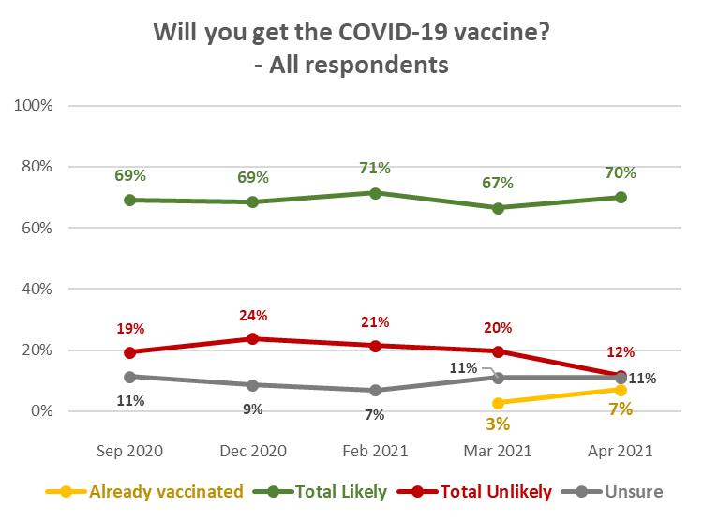

The percentage who are unlikely to get vaccinated has dropped from 20% in March 2021 to 12% (an estimated 477,600). Those who are unsure remain at 11% overall (estimated 457,200).

The following are overall estimates of the COVID-19 vaccine intentions of those New Zealanders 16+ who have not yet been vaccinated:

- Total likely to get vaccinated: 2,861,300:
Definitely | 39% | 1,583,800
Most likely | 19% | 763,300
Likely |  | 514,400

- Total unlikely to get vaccinated: 477,600:
Definitely not | 183,700
Most unlikely | 155,100
Unlikely | 138,800

- Unsure: 457,200

Profiles: “Total Unlikely” and “Unsure”
The following are profiles of those who were “unlikely” to take a vaccine or were not sure, to aid communications targeting. These are similar to the profiles reported in December 2020 and February 2021. These profiles will differ from those in previous reports; as the percentage of those who are unlikely to get a COVID-19 vaccine contracts, so the profiles for those who are unlikely to get a vaccine will become more reflective of the core who will not be persuaded to get a vaccine.

Overall, those who are unlikely to take an offered COVID-19 vaccine were:
- More likely to be female than male
- 6% younger than average age
- Likely to have lower household income: around 17% lower, on average, than respondents overall
- Likely to have lower personal income: around 16% lower than the overall average. 75% of them have personal income under 50,000 per annum
- Likely to have lower educational qualifications than those who are likely to take a vaccine if offered: 51% have sixth form/UE/NCEA Level 2 or less, compared with an overall average of 44%
- Significantly more likely to have children in their household: 60% compared with 32% for those who would definitely have a COVID-19 vaccine and 45% overall. Specifically, they are more likely to be in a two-parent household with three or more children at home or a one-parent household with one or two children at home
- 47% are in the North Island excluding Auckland, in comparison with 42% for respondents overall and 42% for those who are likely to take a vaccine
- Less likely than average to be living in Auckland
- More likely than average to be Māori.

Those who are unsure whether they would take an offered COVID-19 vaccine were:
- More likely to be female than male
- Close to average age
- More likely to be on lower household and personal incomes than respondents overall (household incomes around 26% lower, on average, and personal incomes around 28% lower, on average). In contrast, all those who said they would be likely to have a COVID-19 vaccine (“definitely” plus “most likely” plus “likely”) have higher household and personal incomes than respondents overall (around 3% higher, on average)
- More likely to have lower educational qualifications than those who are likely to take a vaccine if offered: 57% have sixth form/UE/NCEA Level 2 or less, compared with 42% of all those who are likely to take a vaccine
- There were no apparent location or ethnic differences
- Less likely to be living in Auckland, particularly the Waitematā and Counties-Manukau DHB areas
- More likely to be living in the Upper North Island (Taupo north), excluding Auckland – particularly in the Waikato DHB area.

Note that the highest percentage unlikely to get vaccinated is in vaccination Group 4.

Will you get the COVID-19 vaccine?  (including those who have had it) | ALL | After reading the above, which group do you fall into?
 |  | Group 1 - Border and MIQ workers and the people they live with | Group 2 - High-risk frontline workers and people living in high-risk places | Group 3 - People who are at risk of getting very sick from COVID-19 | Group 4 - Everyone in New Zealand aged 16 and over
Definitely | 39% | 22% | 19% | 57% | 35%
Most likely | 19% | 8% | 12% | 13% | 23%
Likely | 13% | 10% | 13% | 10% | 14%
Unlikely | 3% | 3% | 1% | 2% | 5%
Most unlikely | 4% | 6% | 5% | 3% | 4%
Definitely not | 5% | 0% | 0% | 5% | 5%
I'm not sure | 11% | 4% | 11% | 8% | 13%
Already vaccinated | 7% | 48% | 39% | 3% | 1%
TOTAL LIKELY plus ALREADY VACCINATED | 77% | 88% | 83% | 83% | 73%
TOTAL UNLIKELY | 12% | 9% | 6% | 10% | 14%
N (unweighted) | 1,387 | 57 | 147 | 385 | 798

Note that:
- Living with impairments or long-term health conditions does not make a major difference to potential vaccine uptake.
- Those who identify as disabled are more unsure than average, but less likely than average to be resistant to getting a COVID-19 vaccine.

1.1 Uptake by ethnicity
All ethnic groups have similar levels of vaccination intention except for Māori and those who self-categorised themselves as “Other”.

“Total Likely plus Already Vaccinated” figures have been added to the chart to indicate the current potential vaccination rates.

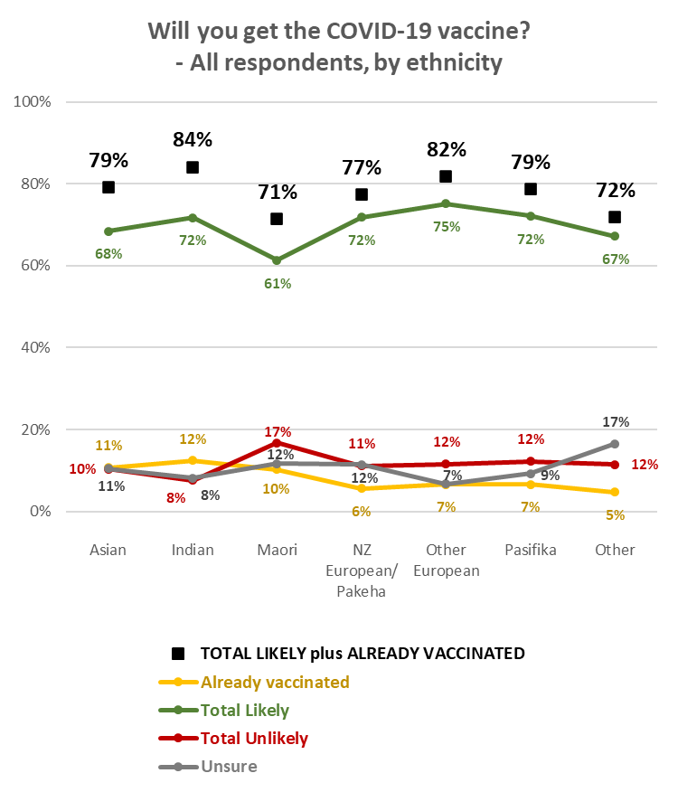

Despite being less likely than other ethnic groups to get a COVID-19 vaccine, trend analysis shows that Māori are increasingly more likely to get a COVID-19 vaccine.

Trend: Māori
71% of Māori have either been vaccinated or are likely to get vaccinated, up from 64% in March 2021.

17% are unlikely to get vaccinated (18% in March 2021; the difference is not statistically significant) and 12% are now unsure, compared with 18% in March 2021.

23% of Māori respondents had been offered a COVID-19 vaccine:
- 10% have had at least one dose
- 10% have been offered a COVID-19 vaccine and have either booked or not rejected it
- 3% have declined to get vaccinated.

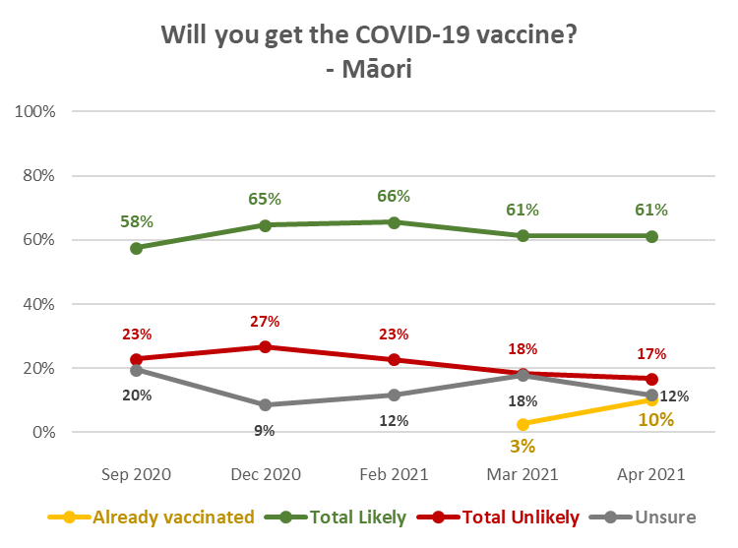

Trend: Pasifika
79% of Pasifika now say they have already been vaccinated or are likely to get vaccinated, up from 59% in March 2021.

Only 9% are now unsure, compared with 32% in March 2021.

29% of Pasifika have been offered a COVID-19 vaccine:
- 6% have had at least one dose
- 20% have been offered a COVID-19 vaccine and have either booked or not rejected it
- 3% have declined to get vaccinated.

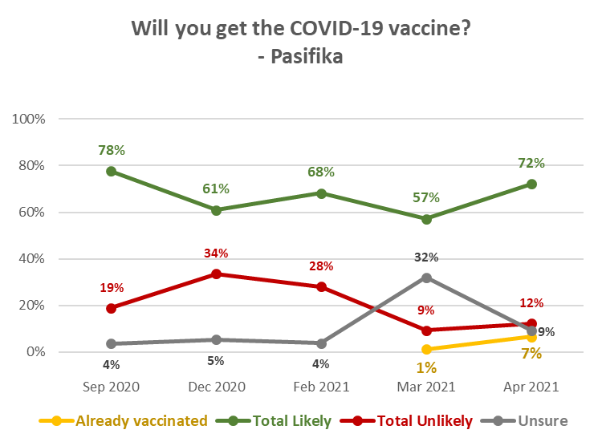

Uptake by people with impairment or who identify as disabled
Those who identified as disabled are more likely to be unsure about getting a COVID-19 vaccine, but less likely to reject getting vaccinated. The reasons for them being unsure are shown in Section 7.

Will you get a COVID-19 vaccine? (including those who have already been vaccinated) | All respondents | Living with impairments or long-term health conditions |  | Identify as disabled
Definitely | 39% | 42% | 40%
Most likely | 19% | 17% | 16%
Likely | 13% | 9% | 2%
Unlikely | 3% | 2% | 2%
Most unlikely | 4% | 4% | 2%
Definitely not | 5% | 5% | 5%
I'm not sure | 11% | 13% | 22%
Already vaccinated | 7% | 8% | 12%
TOTAL LIKELY plus ALREADY VACCINATED | 77% | 77% | 70%
TOTAL UNLIKELY | 12% | 11% | 8%

Uptake by age group
Those aged 65+ are more likely to get a COVID-19 vaccine, but all other age groups are relatively even in vaccination intention. Those aged 35-44 years are the most likely to have already been vaccinated.
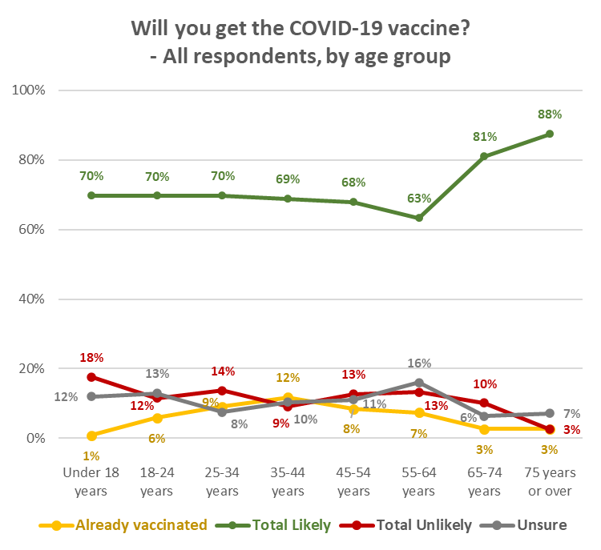

1.4 Uptake by DHB
With a nationally representative sample, the respondent numbers within DHB areas vary in accordance with the relative population of the area. Results for some DHB areas therefore need to be treated as indications.

Analysis by DHB is shown below, in three groups:
- The seven largest DHBs.
- 3 DHB areas where subsample sizes are between 50 and 60, and are therefore relatively statistically reliable.
- 10 DHB areas where subsample sizes are less than 50, in line with their population proportion of the total sample. The smaller the subsample size, the less statistically reliable the results become and these should be treated as providing an indication only.

Seven largest DHBs:
- Waikato DHB has a potential uptake below the national average.
- A below-average 3% of respondents in the Capital and Coast DHB area indicated that they had already been vaccinated.
- Waitematā, Waikato and Capital and Coast DHBs all have populations with above average “Unlikely to get a vaccine” results.
- Southern DHB has an above average level of those who are unsure.

Will you get a COVID-19 vaccine?  (including those who have already had it) | ALL | DHBs
 |  | Waite-matā | Auckland | Counties Manukau | Waikato | Capital and Coast | Canter-  bury | Southern
Definitely | 39% | 39% | 41% | 42% | 33% | 49% | 38% | 24%
Most likely | 19% | 20% | 20% | 18% | 16% | 16% | 18% | 17%
Likely | 13% | 13% | 16% | 11% | 9% | 6% | 16% | 23%
Unlikely | 3% | 8% | 2% | 4% | 4% | 1% | 2% | 7%
Most unlikely | 4% | 2% | 1% | 6% | 6% | 9% | 3% | 4%
Definitely not | 5% | 6% | 1% | 3% | 6% | 7% | 5% | 1%
I'm not sure | 11% | 5% | 11% | 9% | 18% | 9% | 12% | 12%
Already vaccinated | 7% | 8% | 8% | 8% | 7% | 3% | 5% | 10%
TOTAL LIKELY plus ALREADY VACCINATED | 77% | 79% | 85% | 79% | 66% | 74% | 78% | 75%
TOTAL UNLIKELY | 12% | 16% | 3% | 12% | 16% | 17% | 10% | 13%
N (unweighted) | 1,387 | 170 | 156 | 127 | 135 | 120 | 172 | 73

3 DHBs with relatively statistically reliable results:
- All of these DHBs have potential uptake at or above the national average.
- Northland appears to have some polarisation, with a lower level of their population “unsure” and a higher-than-average level of “total unlikely” (including 12% who say they will “definitely not”.

Will you get a COVID-19 vaccine?  (including those who have already had it) | ALL | DHBs
 |  | Northland | Bay of Plenty | MidCentral
Definitely | 39% | 49% | 46% | 37%
Most likely | 19% | 9% | 25% | 35%
Likely | 13% | 3% | 5% | 15%
Unlikely | 3% | 1% | 4% | 3%
Most unlikely | 4% | 5% | 5% | 4%
Definitely not | 5% | 12% | 1% | 1%
I'm not sure | 11% | 6% | 13% | 5%
Already vaccinated | 7% | 17% | 1% | 2%
TOTAL LIKELY plus ALREADY VACCINATED | 77% | 77% | 78% | 88%
TOTAL UNLIKELY | 12% | 17% | 9% | 7%
N (unweighted) | 1,387 | 57 | 57 | 55

DHBs with indicative results – these are presented in two groups of 5:
Indications are that:
- Lakes, Tairawhiti and, particularly Wairarapa, have lower likely uptake than average.
- Lakes, Tairawhiti, Whanganui, Hutt, South Canterbury and particularly Wairarapa, have much higher than average uncertainty about getting a COVID-19 vaccine.

Will you get a COVID-19 vaccine?  (including those who have already had it) | ALL | DHBs
 |  | Lakes | Tairawhiti | Taranaki | Hawke's Bay | Whanganui
Definitely | 39% | 68% | 15% | 43% | 49% | 28%
Most likely | 19% | 1% | 6% | 24% | 17% | 13%
Likely | 13% | 0% | 20% | 11% | 14% | 29%
Unlikely | 3% | 0% | 6% | 2% | 1% | 5%
Most unlikely | 4% | 6% | 9% | 0% | 2% | 4%
Definitely not | 5% | 9% | 0% | 8% | 6% | 2%
I'm not sure | 11% | 14% | 21% | 6% | 5% | 18%
Already vaccinated | 7% | 2% | 23% | 6% | 6% | 0%
TOTAL LIKELY plus ALREADY VACCINATED | 77% | 71% | 64% | 84% | 85% | 70%
TOTAL UNLIKELY | 12% | 14% | 15% | 10% | 10% | 12%
N (unweighted) | 1,387 | 21 | 15 | 34 | 44 | 32

Will you get a COVID-19 vaccine?  (including those who have already had it) | ALL | DHBs
 |  | Hutt | Wairarapa | Nelson/  Marl-  borough | West Coast | South Canterbury
Definitely | 39% | 33% | 4% | 39% | 25% | 28%
Most likely | 19% | 17% | 44% | 11% | 13% | 38%
Likely | 13% | 9% | 0% | 16% | 30% | 0%
Unlikely | 3% | 3% | 0% | 0% | 0% | 0%
Most unlikely | 4% | 5% | 3% | 4% | 3% | 0%
Definitely not | 5% | 0% | 13% | 4% | 13% | 11%
I'm not sure | 11% | 25% | 36% | 1% | 12% | 23%
Already vaccinated | 7% | 9% | 0% | 25% | 3% | 0%
TOTAL LIKELY plus ALREADY VACCINATED | 77% | 68% | 48% | 91% | 72% | 66%
TOTAL UNLIKELY | 12% | 8% | 16% | 8% | 17% | 11%
N (unweighted) | 1,387 | 44 | 14 | 31 | 14 | 16

Second dose uptake
In general, if people are likely to get a vaccine, they will be likely to get a second dose and vice versa. But acceptance of a first dose does not mean universal acceptance of a second.

Likelihood to get second dose | LIKELIHOOD TO GET FIRST DOSE  EXCLUDES THOSE WHO HAVE ALREADY HAD AT LEAST ONE DOSE
 | Definitely | Most Likely | Likely | Unlikely | Most Unlikely | Definitely not | Unsure
Total Likely | 99% | 96% | 88% | 9% | 4% | 0% | 2%
Total Unlikely | 0% | 0% | 2% | 65% | 90% | 100% | 3%
It depends if I have a reaction to the first dose | 1% | 3% | 9% | 4% | 3% | 0% | 19%
Not sure | 0% | 0% | 1% | 22% | 3% | 0% | 77%

Those who have already been vaccinated
89% of those who had already one dose were likely to get a second. 7%, however, said they were unlikely to get a second for multiple reasons. Although this sub-sample is too small for complete statistical reliability, indications for the reasons are:
- 6 out of 10 had experienced side effects
- 4 out of 10 found getting to the appointment too difficult
- 3 out of 10 thought the experience was not as good as it could have been, and
- 1 out 10 didn’t think they needed another dose.

Vaccine information

3.1 Overall
Respondents who had not yet received a COVID-19 vaccine were asked whether they felt they had all the information they needed before deciding whether or not to take the COVID-19 vaccine?

As shown in the following chart, there has been minimal change since February 2021.
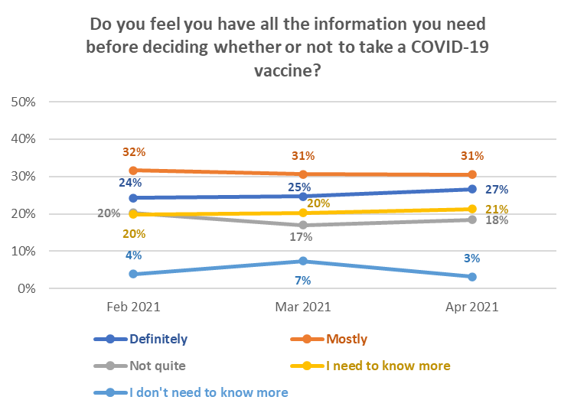
Males are more confident than females that they “Definitely” have all the information they need to make a decision on getting a COVI-19 vaccine.

Overall, whether people have all the information they need before making a decision to get the COVID-19 vaccine depends on their current likelihood to get vaccinated:

Have all the information needed before deciding whether or not to get COVID-19 vaccine? | LIKELIHOOD TO GET VACCINE
 | Definitely | Most Likely | Likely | Unlikely | Most Unlikely | Definitely not | Unsure
Definitely | 50% | 12% | 6% | 2% | 2% | 43% | 2%
Mostly | 36% | 49% | 24% | 15% | 8% | 11% | 8%
Not quite | 7% | 23% | 35% | 43% | 29% | 3% | 27%
I need to know more | 4% | 16% | 35% | 36% | 57% | 24% | 58%
I don’t need to know more | 3% | 1% | 0% | 4% | 4% | 19% | 5%

The results suggest that it should not be assumed that those who said they were “most likely” or “likely” to get a vaccine do not need more information or their decision positively reinforced.

Note that 97% of those who had already been vaccinated said they had been provided with enough information. Two respondents who felt they had not been provided with enough information, left comments:

“How and when I will be notified of my second vaccine appointment.”
“Some true facts about what the vaccine is or is not.”

An above average level of those who have impairments and those who identify as disabled “definitely” have all the information they need to make the decision.

3.2 By ethnic group
Māori are the mostly likely to say they have all the information they need to make a decision.

Have all the information needed before deciding whether or not to get COVID-19 vaccine? | ETHNIC GROUP
 | Asian | Indian | Māori | NZ Euro-pean/ Pakeha | Other Euro-pean | Pasifika | Other
Definitely | 18% | 23% | 35% | 27% | 27% | 30% | 14%
Mostly | 43% | 29% | 22% | 31% | 35% | 23% | 20%
Not quite | 19% | 28% | 18% | 17% | 16% | 25% | 18%
I need to know more | 19% | 14% | 21% | 22% | 19% | 22% | 38%
I don’t need to know more | 1% | 5% | 4% | 3% | 2% | 0% | 10%

An estimated 267,000 (56%) of the 477,600 who are unlikely to get a COVID-19 vaccine say they either “Definitely” have all the information they need or feel they don’t need to know more. This is a higher percentage than in March (38%) and February (29%), but note that this is a higher percentage of a reduced estimated number who are unlikely to get a vaccine. The comparable March 2021 estimate was 301,400.

Add in those who “mostly” have all the information they feel they need and the estimate rises to 320,000 or 67% of those who are unlikely to get a vaccine (estimated at 368,900 in March 2021).

This “core” of those who will not be persuaded to take a COVID-19 vaccine has dropped from 9.4% in March 2021 to an estimated 8.4% of the 16+ population who are yet to get a vaccine, equivalent to 7.8% of the total 16+ population.

3.3 By Age
Below 65 years, “Mostly” having all the information needed is higher than “Definitely”
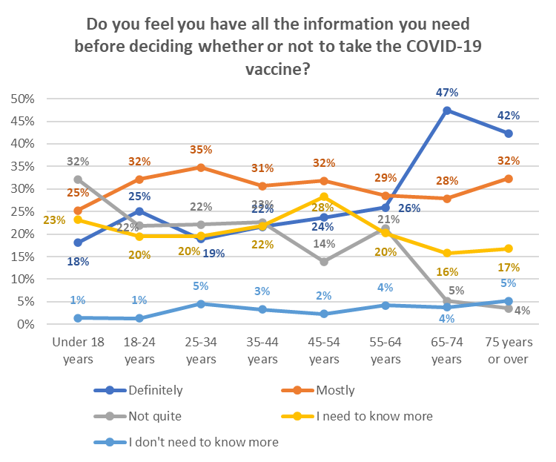

3.4 By DHB
Seven largest DHBs:
- Waikato, Canterbury and particularly Southern DHBs have an above average level of their populations that “Need to know more”.

Do you feel you have all the information you need before deciding whether or not to take the COVID-19 vaccine? | ALL | DHBs
 |  | Waitemata | Auckland | Counties Manukau | Waikato | Capital and Coast | Canterbury | Southern
Definitely | 27% | 23% | 29% | 25% | 21% | 41% | 23% | 22%
Mostly | 31% | 37% | 43% | 29% | 28% | 29% | 27% | 21%
Not quite | 18% | 20% | 14% | 23% | 20% | 13% | 22% | 22%
I need to know more | 21% | 17% | 11% | 20% | 26% | 13% | 26% | 35%
I don't need to know more | 3% | 4% | 3% | 3% | 4% | 4% | 2% | 0%
N (unweighted) | 1,270 | 154 | 142 | 110 | 127 | 113 | 158 | 65

3 DHBs with relatively statistically reliable results:
- Northland appears to have the highest level of “Definitely” having all the information their population needs to make a vaccine decision.
- Bay of Plenty has an above average level of “Mostly”.

Do you feel you have all the information you need before deciding whether or not to take the COVID-19 vaccine? | ALL | DHBs
 |  | Northland | Bay of Plenty | MidCentral
Definitely | 27% | 51% | 19% | 34%
Mostly | 31% | 21% | 48% | 22%
Not quite | 18% | 12% | 14% | 24%
I need to know more | 21% | 15% | 17% | 21%
I don't need to know more | 3% | 3% | 2% | 0%
N (unweighted) | 1,270 | 50 | 56 | 52

DHBs with indicative results –presented in two groups of 5:
Indications are that:
- A higher-than-average level of people in Lakes, Tairawhiti, Taranaki and, particularly Wairarapa, “Need to know more”.

Do you feel you have all the information you need before deciding whether or not to take the COVID-19 vaccine? | ALL | DHBs
 |  | Lakes | Tairawhiti | Taranaki | Hawke's Bay | Whanganui
Definitely | 27% | 51% | 7% | 26% | 41% | 23%
Mostly | 31% | 14% | 16% | 24% | 17% | 32%
Not quite | 18% | 0% | 20% | 6% | 18% | 22%
I need to know more | 21% | 35% | 53% | 41% | 20% | 17%
I don't need to know more | 3% | 0% | 5% | 4% | 5% | 6%
N (unweighted) | 1,270 | 20 | 12 | 32 | 41 | 32

Do you feel you have all the information you need before deciding whether or not to take the COVID-19 vaccine? | ALL | DHBs
 |  | Hutt | Wairarapa | Nelson/ Marlb orough | South Canterbury | West Coast
Definitely | 27% | 15% | 2% | 40% | 20% | 23%
Mostly | 31% | 39% | 26% | 25% | 38% | 17%
Not quite | 18% | 24% | 12% | 7% | 24% | 31%
I need to know more | 21% | 19% | 46% | 15% | 18% | 16%
I don't need to know more | 3% | 2% | 13% | 14% | 0% | 14%
N (unweighted) | 1,270 | 39 | 14 | 24 | 16 | 13

Vaccination status
As noted in the preamble to this report, the vaccine had been offered to 16% of the sample (an estimated 645,000 New Zealanders). An estimated 253,100 people had been offered the vaccine offered but had yet to book. An estimated 49,000 had been offered the vaccine but had declined.

Have you already been offered an opportunity to get your COVID-19 vaccination?
No | 84%
Yes - I have already had two doses | 2%
Yes - I have already had one dose | 5%
Yes - I have not had the first dose, but my appointment is booked | 1%
Yes - but I have not had the first dose and have not booked an appointment yet | 6%
Yes, but I declined to have the vaccine | 1%
Note that rounding means these whole reported percentages do not add to 16%.

4.1 By ethnic group
Results by ethnic group are shown below. 10% of Māori said they had already been vaccinated.

Have you already been offered an opportunity to get your COVID-19 vaccination? | ETHNIC GROUP
 | Asian | Indian | Māori | NZ Euro-pean/ Pakeha | Other Euro-pean | Pasifika | Other
No | 76% | 78% | 78% | 89% | 78% | 71% | 73%
Yes - I have already had two doses | 3% | 4% | 3% | 2% | 2% | 1% | 3%
Yes - I have already had one dose | 8% | 8% | 7% | 4% | 5% | 5% | 2%
Yes - I have not had the first dose, but my appointment is booked | 1% | 0% | 2% | 1% | 6% | 6% | 1%
Yes - but I have not had the first dose and have not booked an appointment yet | 9% | 9% | 7% | 4% | 10% | 14% | 19%
Yes, but I declined to have the vaccine | 3% | 0% | 3% | 1% | 0% | 3% | 3%

4.2 By DHB
Seven largest DHBs:
- Counties Manukau DHB was ahead of the other large DHBs in terms of offering vaccination to its population.
- Capital and Coast has the highest level across the country of people declining a vaccination when it was offered.

Have you already been offered an opportunity to get your COVID-19 vaccination? | ALL | DHB
 |  | Waitematā | Auckland | Count-ies Manu-kau | Waikato | Capital and Coast | Canterbury | Southern
No | 84% | 85% | 87% | 80% | 84% | 89% | 85% | 84%
Yes - I have already had two doses | 2% | 2% | 5% | 5% | 1% | 1% | 1% | 2%
Yes - I have already had one dose | 5% | 5% | 3% | 4% | 7% | 1% | 4% | 8%
Yes - I have not had the first dose, but my appointment is booked | 1% | 0% | 1% | 2% | 2% | 0% | 1% | 1%
Yes - but I have not had the first dose and have not booked an appointment yet | 6% | 7% | 3% | 9% | 5% | 2% | 8% | 4%
Yes, but I declined to have the vaccine | 1% | 0% | 1% | 1% | 2% | 7% | 0% | 0%
N (unweighted) | 1,387 | 170 | 156 | 127 | 135 | 120 | 172 | 73

3 DHBs with relatively statistically reliable results:
- Northland was also ahead of the other DHBs in this group, with 33% of their population having been offered a vaccine.
- 6% of respondents in the Northland DHB area reported having declined a vaccine when offered.

Have you already been offered an opportunity to get your COVID-19 vaccination? | ALL | DHB
 |  | Northland | Bay of Plenty | MidCentral
No | 84% | 67% | 87% | 94%
Yes - I have already had two doses | 2% | 0% | 1% | 1%
Yes - I have already had one dose | 5% | 17% | 0% | 1%
Yes - I have not had the first dose, but my appointment is booked | 1% | 3% | 2% | 2%
Yes - but I have not had the first dose and have not booked an appointment yet | 6% | 7% | 10% | 2%
Yes, but I declined to have the vaccine | 1% | 6% | 0% | 0%
N (unweighted) | 1,387 | 57 | 57 | 55

DHBs with indicative results –presented in two groups of 5:
Indications are that:
- Tairawhiti and Nelson/Marlborough appear to have offered vaccinations to a higher proportion of their population.
- Whanganui and Nelson/Marlborough appear to have the highest level of people to declining to have a vaccination when offered.

Have you already been offered an opportunity to get your COVID-19 vaccination? | ALL | DHB
 |  | Lakes | Tairawhiti | Taranaki | Hawke's Bay | Whanganui
No | 84% | 82% | 56% | 87% | 94% | 80%
Yes - I have already had two doses | 2% | 0% | 16% | 5% | 3% | 0%
Yes - I have already had one dose | 5% | 2% | 7% | 1% | 3% | 0%
Yes - I have not had the first dose, but my appointment is booked | 1% | 2% | 0% | 0% | 1% | 2%
Yes - but I have not had the first dose and have not booked an appointment yet | 6% | 15% | 21% | 7% | 0% | 13%
Yes, but I declined to have the vaccine | 1% | 0% | 0% | 0% | 0% | 5%
N (unweighted) | 1,387 | 21 | 15 | 34 | 44 | 32

Have you already been offered an opportunity to get your COVID-19 vaccination? | ALL | DHB
 |  | Hutt | Waira-rapa | Nelson/ Marl-borough | West Coast | South Canterbury
No | 84% | 84% | 100% | 62% | 97% | 100%
Yes - I have already had two doses | 2% | 2% | 0% | 3% | 3% | 0%
Yes - I have already had one dose | 5% | 7% | 0% | 22% | 0% | 0%
Yes - I have not had the first dose, but my appointment is booked | 1% | 4% | 0% | 9% | 0% | 0%
Yes - but I have not had the first dose and have not booked an appointment yet | 6% | 4% | 0% | 1% | 0% | 0%
Yes, but I declined to have the vaccine | 1% | 0% | 0% | 4% | 0% | 0%
N (unweighted) | 1,387 | 44 | 14 | 31 | 14 | 16

Making the decision to get a COVID-19 vaccine
All respondents who had not yet been vaccinated were asked to think about how they would decide whether or not to take an approved COVID-19 vaccine. They were shown a list of potential thoughts and asked which occurred to them, if any.

There were five key thoughts that occurred to more than 20% of respondents:
- Whether there would be unknown side effects (38%)
- How the side effects may affect them (35%)
- What might happen if they had an adverse reaction to the vaccine (28%)
- Whether the vaccine may affect their health in other ways (26%), while
- 37% think it is too soon to see whether there are any long-term effects from the vaccine.

Note that 20% were also concerned that the vaccine may not be effective.

People who live with impairments or long-term health conditions, or who identify as disabled, are more concerned than average about whether the vaccine will adversely affect their existing medical conditions and symptoms and whether it will leave their health worse overall. Those who identify as disabled are also more worried than average that there will be unknown side effects and how the side-effects may affect them.

Concern rose as likelihood to get a vaccine decreased and peaked where respondents were unsure whether to get vaccinated or not. 46% of those who would definitely not get vaccinated worried that a COVID-19 vaccine may leave their health worse overall.

Thought | LIKELIHOOD TO GET VACCINE
 | Definitely | Most Likely | Likely | Unlikely | Most Unlikely | Definitely not | Unsure
Will there be unknown side effects? | 21% | 43% | 51% | 52% | 42% | 48% | 64%
How the side effects may affect me | 18% | 37% | 50% | 46% | 34% | 53% | 61%
What might happen if I have an adverse reaction | 15% | 29% | 34% | 39% | 36% | 44% | 50%
Will the vaccine affect my health in other ways | 9% | 25% | 48% | 36% | 28% | 46% | 52%
It is too soon to see whether there are any long-term effects from the vaccine | 16% | 39% | 55% | 67% | 58% | 55% | 58%

- The 5 key overall concerns applied for all age groups except 65-74 and 75 or more, where:
  - 18% of 65-74s are concerned the vaccine may not be effective
  - 23% of those 75 years or over worry that the COVID-19 vaccine will adversely affect their existing medical conditions and symptoms
- 16–17-year-olds have a higher level of concern about the COVID-19 vaccine than 18–24-year-olds
- Levels of concern generally increase from 18 years up to 64 years and then decline.

Thought | AGE GROUP
 | Under 18 years | 18-24 years | 25-34 years | 35-44 years | 45-54 years | 55-64 years | 65-74 years | 75 years or over
Will there be unknown side effects? | 51% | 30% | 47% | 37% | 34% | 47% | 24% | 30%
How the side effects may affect me | 43% | 28% | 28% | 34% | 36% | 46% | 27% | 25%
What might happen if I have an adverse reaction | 31% | 18% | 23% | 24% | 29% | 40% | 25% | 20%
Will the vaccine affect my health in other ways | 29% | 19% | 18% | 26% | 32% | 34% | 17% | 27%
It is too soon to see whether there are any long-term effects from the vaccine | 57% | 21% | 45% | 30% | 34% | 47% | 31% | 35%

These 5 key concerns are generally also the key concerns for each ethnic group; however, for respondents of Asian, Indian, Pasifika and “Other” ethnicities “I'd rather wait, to see if it causes any problems for others” is top 5 ranked, coming ahead of “Will the vaccine affect my health in other way” and also ahead of “What might happen if I have an adverse reaction” for Asian respondents. This is probably a means of coping with their other concerns.

Main influences on vaccine decision
Respondents were asked what would most influence their decision to take a COV ID-19 vaccine.

Key influences are:
- Helping to protect all New Zealanders (51%)
- Helping reduce the risk of COVID-19 infection and the prospect of further lockdowns and economic harm (51%)
- Helping to end the COVID-19 pandemic more quickly (50%)
- Helping protect the health of my family/whānau and those closest to me (49%)
- Being vaccinated will protect me from the effects of COVID-19 (48%)
- Doing the best thing for my own health (46%)
- The benefits of taking the vaccine would outweigh any risks (45%)
- Vaccination is free - for both doses (45%)

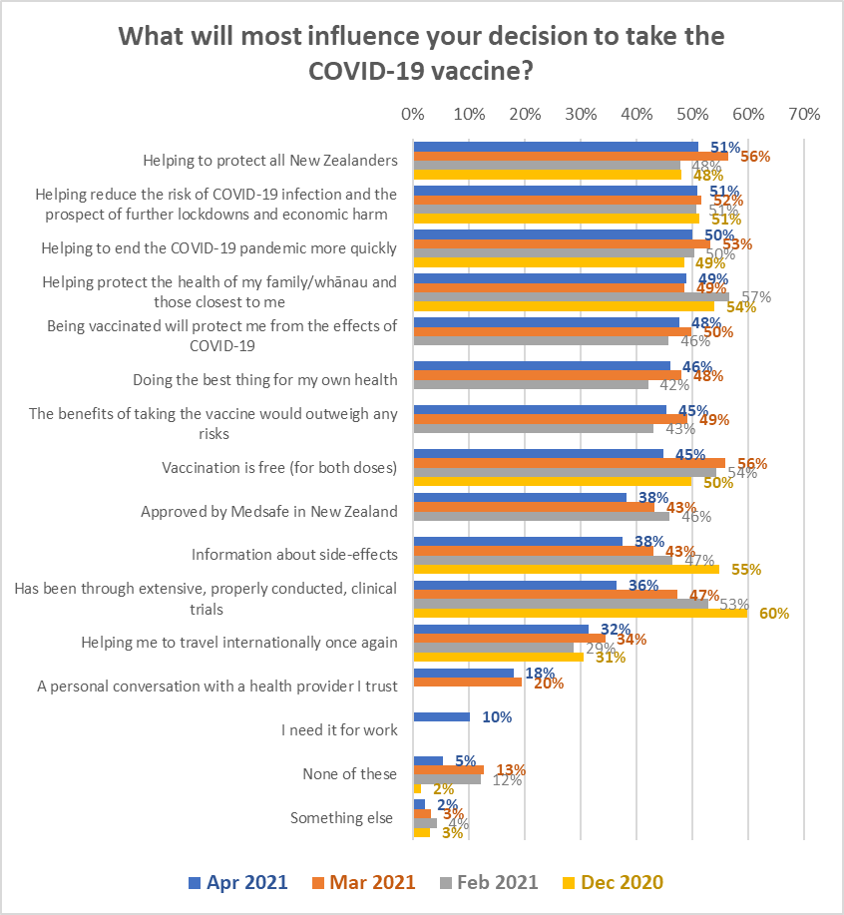
All of the key influencing factors, however, decline in importance as likelihood to take a vaccine declines.

Overall, the concern relating to trials has fallen significantly from 60% in December 2020 to 36% in April/May 2021.

Note that the information about the side effects, vaccination being free and the vaccine having been through extensive trials, is the top motivation for those who are unsure of whether to get the vaccine or not.

Motivation | LIKELIHOOD TO GET VACCINE
 | Definitely | Most Likely | Likely | Unlikely | Most Unlikely | Definitely not | Unsure
Helping to protect all New Zealanders | 74% | 55% | 40% | 12% | 14% | 4% | 21%
Helping reduce the risk of COVID-19 infection and the prospect of further lockdowns and economic harm | 71% | 58% | 38% | 14% | 14% | 2% | 27%
Helping to end the COVID-19 pandemic more quickly | 67% | 56% | 39% | 27% | 12% | 2% | 32%
Helping protect the health of my family/whānau and those closest to me | 67% | 53% | 38% | 20% | 11% | 6% | 32%
Being vaccinated will protect me from the effects of COVID-19 | 65% | 50% | 39% | 25% | 12% | 4% | 28%
Doing the best thing for my own health | 62% | 48% | 35% | 18% | 25% | 10% | 31%
The benefits of taking the vaccine would outweigh any risks | 61% | 43% | 42% | 27% | 17% | 7% | 32%
Vaccination is free (for both doses) | 56% | 44% | 36% | 19% | 26% | 5% | 49%
Approved by Medsafe in New Zealand | 46% | 37% | 42% | 19% | 23% | 4% | 34%
Information about side-effects | 22% | 42% | 53% | 38% | 50% | 14% | 70%
Has been through extensive, properly conducted, clinical trials | 34% | 37% | 40% | 33% | 42% | 16% | 46%

Those who live with impairments or long-term health conditions and those who identify as disabled are more likely than average to respond to a personal conversation with a health provider they trust and to the knowledge that vaccination is free for both doses. They are less likely to be motivated by vaccination helping them to “travel internationally once again”. In other respects, they are similar to the overall pattern.
Different ethnic groups have the motivations in a different order, as shown in the following charts. Note that Pasifika are likely to be motivated by more of these factors (an average of 7) and communications to the Pasifika community should take that into account.

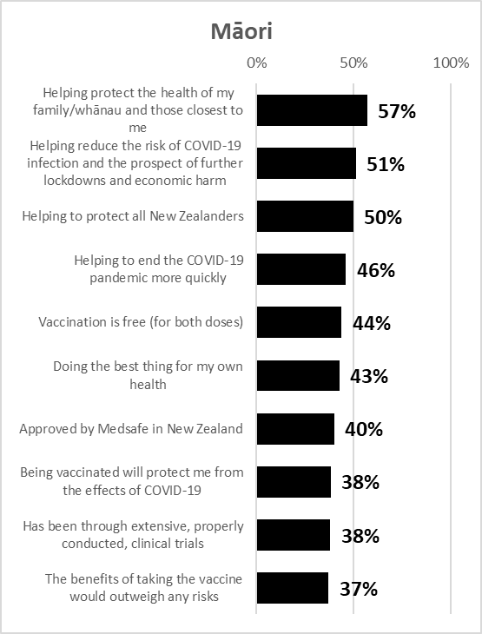
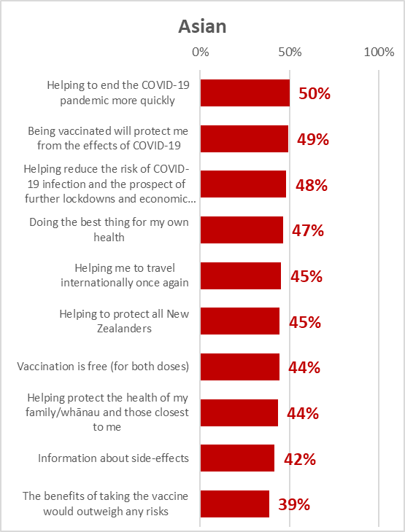
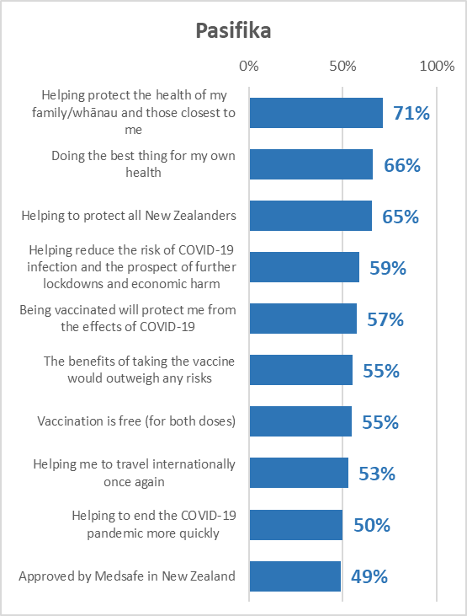
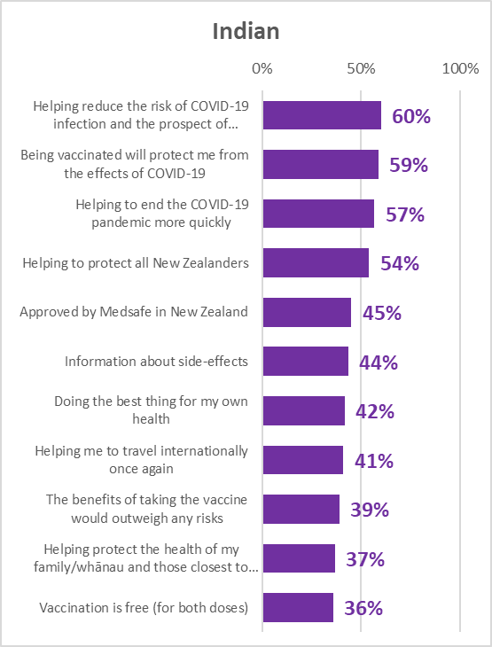

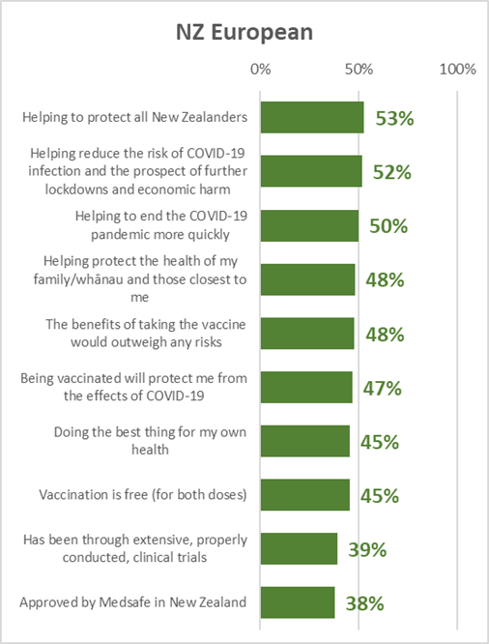
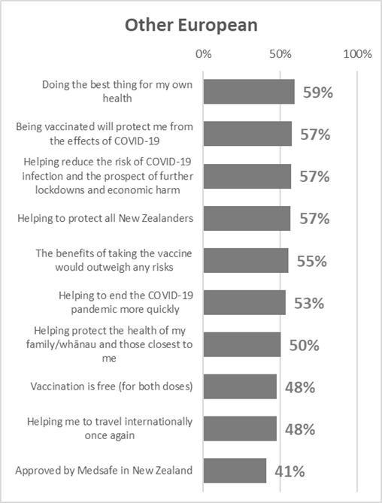

There were insufficient respondents in the “Other” ethnic group for statistical reliability.

Reasons for not taking a COVID-19 vaccine
The who said they were unlikely to get a COVID-19 vaccine or were unsure whether to do so were asked why that was.

As in all past COVID-19 vaccine surveys, a need to be assured about safety is a primary reason together with concern about side effects and long-term effects.

Note that “I don’t see the need to take a COVID-19 vaccine” has declined in importance from 4th ranking in September 2020 to 7th in April 2021.

Those who are unsure whether to be vaccinated or not were the most likely to select “I’d like to be able to talk with my medical provider about it”.

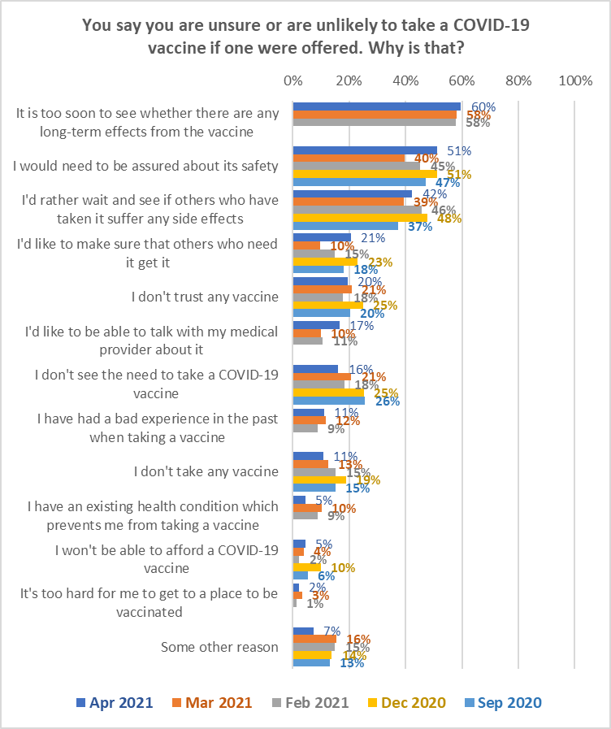

The following table indicates reasons where those who live with impairments or long-term medical conditions, or who identify as disabled, differ from the overall result.

Reasons for being unsure or unlikely to get a COVID-19 vaccine | Overall result | Living with impairment or long-term health conditions | Identify as disabled
I would need to be assured about its safety | 51% | 54% | 60%
I don't trust any vaccine | 20% | 28% | 3%
I have had a bad experience in the past when taking a vaccine | 11% | 5% | 19%
I have an existing health condition which prevents me from taking a vaccine | 5% | 12% | 17%
I'd like to be able to talk with my health provider about it | 17% | 26% | 31%

Communication points
Note that:
- The reasons selected by those who are unsure whether they will get a COVID-19 vaccine or not, suggest that they are particularly cautious and need to be assured of the safety of the vaccine (results outlined in red).
- Those who are “unlikely” or “most unlikely” to get a COVID-19 vaccine also show caution but are also more likely than average to have had a bad experience in the past when taking a vaccine. Note that those who are “unlikely” are also the most likely to say that they don’t see the need to take a COVID-19 vaccine (results outlined in yellow).
- Those who say they will definitely not get a COVID-19 vaccine are the most likely to have selected “I don’t trust any vaccine” and I don’t take any vaccine”. They also selected “I don’t see the need to take a COVID-19 vaccine” at an above-average level (results outlined in blue).

You say you are unsure or are unlikely to take a COVID-19 vaccine if one were offered. Why is that? | ALL | Will you get a COVID-19 vaccine?
 |  | Unlikely | Most unlikely | Definitely not | I'm not sure
It is too soon to see whether there are any long-term effects from the vaccine | 60% | 53% | 61% | 38% | 70%
I would need to be assured about its safety | 51% | 53% | 46% | 19% | 66%
I'd rather wait and see if others who have taken it suffer any side effects | 42% | 53% | 26% | 16% | 56%
I'd like to make sure that others who need it can get it before me | 21% | 15% | 19% | 2% | 31%
I don't trust any vaccine | 20% | 13% | 16% | 33% | 18%
I'd like to be able to talk with my health provider about it | 17% | 5% | 6% | 2% | 30%
I don't see the need to take a COVID-19 vaccine | 16% | 29% | 8% | 25% | 12%
I have had a bad experience in the past when taking a vaccine | 11% | 17% | 17% | 8% | 9%
I don't take any vaccine | 11% | 1% | 4% | 25% | 11%
I have an existing health condition which prevents me from taking a vaccine | 5% | 2% | 5% | 2% | 6%
I won't be able to afford a COVID-19 vaccine | 5% | 2% | 8% | 2% | 5%
It's too hard for me to get to a place to be vaccinated | 2% | 1% | 0% | 0% | 4%
None of these | 4% | 0% | 5% | 5% | 4%
Some other reason | 7% | 2% | 3% | 23% | 5%
N (unweighted) | 271 | 49 | 50 | 51 | 121

“Some other reasons” (highest among those who will “definitely not” get a vaccine) included:

“A lady died from a blood clot after taking it and it is said DMX died from it to (sic).

“Have been taking Flu jab over 50 years off and on and every time I have side effects for over a week and then they say it’s a different flu strain. I have more faith in drugs Ivermectin, Hydroxychloroquine and vitamin d-c Zinc to keep me healthy.”

“I am not going to be a guinea pig.”
“I don't believe COVID should be stopped, the world is over populated”

“Some questions have come forth about the legality.”

“I don't know what is in it and the main funder of the vaccine wants to depopulate the planet and has already been successfully prosecuted for administrating adverse medications one being a modified polio vaccine the other being a contraceptive IM injection and is now creaming the profits from a modified virus and crimes against humanity.”

“I have a feeling that proves to me it is not safe and even if it is proven safe by scientists these scientists (are) most likely the same bought and paid for scientists that say 1080 is safe, which is one of the biggest scams in NZ history.”

“If I have it, how long will it lasts for and will I have to have it again.”
“I'm pretty sure I've already had COVID. There are very few fit healthy people under 55 who have died from COVID”.

“I’m scared of needles.”
“I’m unsure of what is in it.”

“Don't like the authoritarian element.”
“It should be accurately named - the WuFlu vaccine”

“No assurance or role model from nation leaders and political figures.”
“Peer pressure.”

“Really concerned if it will affect my current health and add to my conditions.”
“I have a rare auto immune disorder that flairs and a vaccine could put me over the edge... I don’t think I would be strong enough to survive it!”
“Risk for me outweighs the benefits.”

“Is a bit like Russian Roulette, not fully approved, Medsafe has 50 odd concerns to be answered.”
“They are un proven experimental vaccines with results of long-term studies not due until 2023.”
“It is an EXPERIMENTAL drug (and can only be given due the current state of emergency). Hasn't had human trials. Won't stop me getting COVID, or passing it in to others.”

Side-effects
Respondents who had not yet had a COVID-19 vaccine were asked if they knew what the side-effects could be after getting the COVID-19 vaccine.

Overall, 26% of respondents said they knew the side effects. More respondents did not know the potential side-effects than knew them:

Do you know what the side effects could be after getting the COVID-19 vaccine? | Likelihood to get vaccine
 | Total likely to get vaccine | Total unlikely to get vaccine | Unsure whether to get vaccine
Yes | 27% | 28% | 15%
No | 45% | 48% | 56%
Not sure | 28% | 24% | 29%

Respondents who said they knew the side-effects, or who were unsure, were asked in an open response question what they thought they were. 6% of those who initially said they knew the side effects, said that they didn’t know or could not remember when asked what the side effects were.

Overall, female respondents reported more side effects than males. Under 18s were aware of more side-effects, on average, than respondents in other age groups. In general, respondents mentioned multiple side-effects they were aware of.

Thematic analysis was conducted and the results were cross-analysed by how likely people said they were to be vaccinated (likely, unlikely and unsure) as shown in the following chart.

Five key side-effects were reported:
- Blood clots: 29%. This represent 16% overall of those who have yet to get vaccinated and while the Pfizer/BioNTech vaccine may not be prone to this side-effect, it should not be assumed that these people know that.
Awareness of this potential side-effect increased with increasing age and was higher among females than males. Awareness is also higher (43%) among those who are unlikely to get a COVID-19 vaccine, but is still at 27% among those who are likely or unsure.
- Aching, flu-like or cold-like symptoms: 29%. More of those who were likely to get a COVID-19 vaccine were aware of this.
- Localised pain or soreness: 23%. More of those who were likely to get a COVID-19 vaccine or who were unsure were aware of this than those who were unlikely to get vaccinated.
- Fever/elevated temperature: 16%.
- Makes you unwell/gives you nausea: 10%. This represents a range of perceptions from nausea after injection to the vaccine making you unwell on a more sustained basis.
Those who were unlikely to get a vaccine were more likely to report a side effect of the vaccine was deaths.

24% said they thought there were no side effects - primarily those who were unsure about the side-effects.

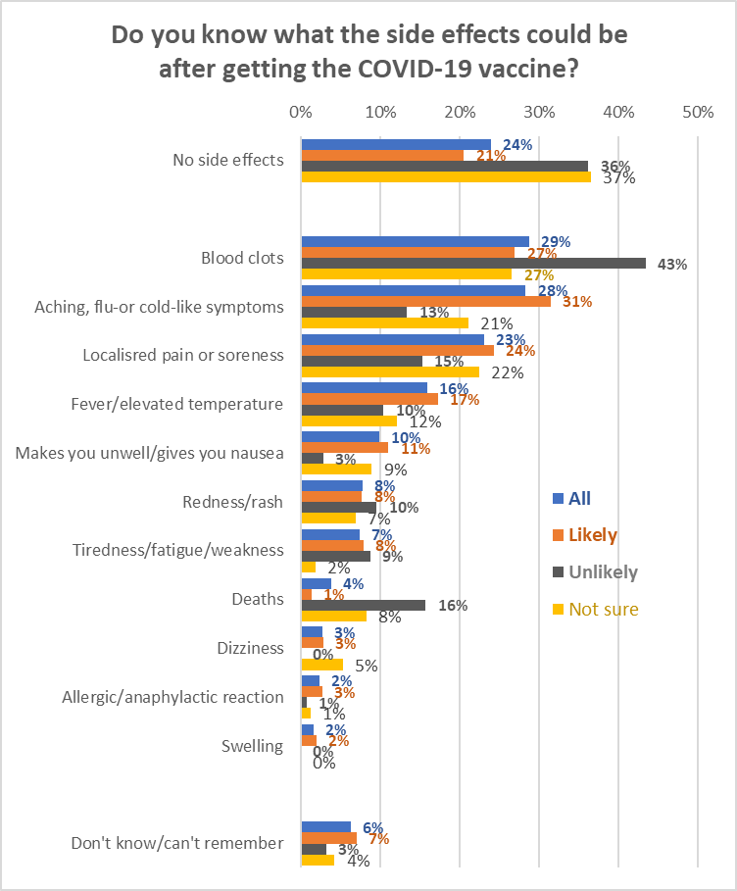

Examples of verbatim comments follow:

Blood clots
“Blood clotting, heart issues, exacerbating COVID symptoms.” (female 55-64 years, unlikely to be vaccinated)
“Have been blood clots, tiredness, discomfort etc.” (male 65-74 years, likely to be vaccinated)
“Blood clots. Potential infertility for those wanting to have children. Anaphylaxis.” (female 55-64 years, unlikely to be vaccinated)
“Blood clots in some cases; fever” (male 25-34 years, unlikely to be vaccinated)
“There is a variety of effects including feeling unwell, blood clots, feeling tired, achy or low on energy.” (female 45-54 years, likely to be vaccinated)
“Currently some flu like symptoms. I do believe there is a risk of blood clotting and then the long-term effects that no one knows about yet.” (female 45-54 years, unlikely to be vaccinated)

Aching, flu-like or cold-like symptoms
“Possible cold or flu-like symptoms, ranging from very mild to more extreme (with fever and body aches).” (female 45-54 years, likely to be vaccinated)
“Mild flu like symptoms for one or two days.” (male 65-74 years, likely to be vaccinated)
“Flu like symptoms, blood clots, aches and lethargy.” (female 35-44 years, unlikely to be vaccinated)

Localised pain or soreness
“Possible temporary soreness at the vaccination site.” (male 65-74 years, likely to be vaccinated)
“Sore arm and possibly being under the weather for a few days.” (female 65-74 years, likely to be vaccinated)
“Pain or swelling at the injection site. Feeling tired or fatigued. Headache. Muscle aches. Chills joint pain fever redness at the injection site. Nausea.” (male 25-34 years, likely to be vaccinated)
“Pain at the injection site, mild fever, headache, flu like symptoms, blood clots...” (female 35-44 years, unlikely to be vaccinated)
“Lethargy, pain at injection site, blood clotting.” (female 55-64 years, unsure whether to get a vaccine)

Fever/elevated temperature
“Feverishness, aches, general feeling of ‘flu type symptoms.” (female 65-74 years, likely to be vaccinated)
“May run a fever, feel sick. May have flu like symptoms.” (female 45-54 years, likely to be vaccinated)
“Fever.” (female 25-34 years, unsure whether to get a vaccine)
“Arm pain and other injection site reactions. Possible fever, chills, muscle aches, headache, fatigue.” (male 45-54 years, likely to be vaccinated)

Makes you unwell/gives you nausea
“Blood clots. Nausea. Aches. Generally feeling very unwell.” (female 18-24 years, likely to be vaccinated)
“Feeling unwell, headaches, maybe nausea, fatigue>” (female 75 years or over, likely to be vaccinated)
“Maybe pain at injection site. Maybe feeling unwell for a day or 2. Very low chance of serious reactions.” (male 65-74 years, likely to be vaccinated)

Attitudes to taking a COVID-19 vaccine

9.1 Concerns it may be too soon to understand the long-term side effects of the COVID-19 vaccine
Those who had indicated that it was "too soon to see whether there are any long-term effects from the vaccine" (both those who are likely to get a vaccine and those who are unlikely to so/ unsure) were asked an open-ended question about the nature of their concerns. Thematic analysis was conducted and the results were cross-analysed by how likely people said they were to be vaccinated (likely, unlikely and unsure) as shown in the following chart.
Concerns were broadly the same for the three groups in terms of likelihood, with four main concerns expressed:
- Side effects may take a while to observe/ there has been no long-term testing
- The vaccine is not proven as its development was rushed
- I worry about blood clots and other side effects from the vaccine
- Being vaccinated could damage my health/make me sick/ make me infertile/I could die.

Differences in these concerns in terms of likelihood to be vaccinated are examined in the next table…
Concerns about the long-term side effects of the COVID-19 vaccine | Likelihood of being vaccinated
 | Likely | Unlikely |  | Unsure |  | Comments
Side effects may take a while to observe/ no long-term testing | 43% ↑ | 32% |  | 32% |  | For all three groups the lack of long-term testing is the main concern, particularly for those likely to get vaccinated
Vaccine not proven/ rushed development | 16% | 7% ↓ |  | 28% ↑ |  | The rushed development of vaccines is less concerning for the unlikely group, but more concerning for the unsure group
I worry about blood clots/ side effects | 12% | 17% ↑ |  | 13% |  | Those unlikely to get vaccinated worry more than other groups about side effects such as blood clots
It could damage my health/make me sick/ make me infertile/I could die | 9% ↓ | 13% |  | 12% |  | People who are likely to be vaccinated are somewhat less likely to worry about damage to their health
I want to be sure/ wait a while/don't know enough | 7% | 7% |  | 4%
I have underlying health condition/s | 3% | 3% |  | 4%
Will it work with new virus strains? | 2% | 3% |  | 3%
It might lower my immunity/ affect my immune system | 1% | 0% |  | 3%
How long will vaccination last? | 1% | 2% |  | 3%
Other | 14% | 25% ↑ |  | 17% |  | Those unlikely to be vaccinated were more likely to mention ‘other concerns’
Base (people who commented) | 274 |  | 60 |  | 78
NB. Totals add to more than 100% as people could provide multiple responses.
Examples of verbatim comments follow:
Side effects may take a while to observe/ no long-term testing
“Concerned about side effects that are only present a couple or several years later.” (female 35-44 years, likely to be vaccinated)
“How can anyone know if there are long term effects when the vaccine has only been produced in recent months?” (male 75 and over, likely to be vaccinated)
“The vaccine hasn’t been around for long and I’m not sure if there are any effects you can get in the long run.” (female aged under 18 years, unlikely to be vaccinated)
“There has simply not been enough time to survey and analyse how the vaccine may or may not affect people years in the future. Work on these vaccines hasn't even been happening for more than two years, and so it cannot be certain what any long-term side effects may be.” (female aged under 18 years, unlikely to be vaccinated)
“I feel that there hasn’t been enough research undertaken over a longer period of time to reassure me of the vaccine’s effectiveness.” (female aged 35-44 years, unsure about being vaccinated)
“So far, no long-term clinical trials. I don't trust the drug companies Too many serious stuff-ups from drugs not trialled long enough and released too soon as "safe" and most of them are only in it for the dollar.” (male aged 65-74 years, unsure about being vaccinated)
Vaccine not proven/ rushed development
“I'm just worried it has all happened so fast that we really haven't tested it for long enough.” (female aged 25-34 years likely to be vaccinated)
“Just because it did get pushed through quickly, but I do trust the trials that have been done.” (female aged 25-34 years, likely to be vaccinated)
“I believe all brands rushed their vaccines, and I don't think it has been tested safely enough due to the speed of clinical trials.” (male aged 25-34 years, unlikely to be vaccinated)
“Too quickly developed.” (male aged 25-34 years, unlikely to be vaccinated)
“I feel the vaccine has been rushed through and not trialled enough and I'm not sure of the long-term effects of the vaccine. Feel like a bit of a guinea pig to be honest, as no one does actually know the long-term side effects.” (female aged 45-54 years, unsure about being vaccinated)
“I feel there's been a bit of a rush to see who 'can get there first' with the vaccine and I really don't feel that we have conclusive results.” (male aged 55-64 years, unsure about being vaccinated)
I worry about blood clots/ side effects
“It's a mild concern that side effects are unknown, but it will not deter me from getting the vaccine.” (female aged 65-74 years, likely to be vaccinated)
“Some side effects have already been raised; i.e., blood clots. I have concern that the trials have been rushed and we can't be 100% sure of any long-term side effects.” (female aged 35-44 years, likely to be vaccinated)
“Organ failure, cancer, impaired immune system, higher risk of virus getting stronger as variants are vaccine resistant.” (male aged 65-74 years, unlikely to be vaccinated)
“There are many reports coming in of adverse effects around the world, along with concerns about possible under-reporting of these side-effects.” (male aged 65-74 years, unlikely to be vaccinated)
“Many concerns including it hasn't been approved by Medsafe, not enough trials, too many people experiencing bad side effects etc.” (female aged 25-34 years, unlikely to be vaccinated)
“I worry about hearing it may cause blood clots to the brain. There are too many vaccines too soon.” (female aged 55-64 years, unsure about being vaccinated)
“There have been side effects from the vaccine in other countries.” (female aged 55-64 years, unsure about being vaccinated)

It could damage my health/make me sick/ make me infertile/I could die
“Dying prematurely.” (female aged 35-44 years, likely to be vaccinated)
“What if there are fertility implications?” (female aged 18-24 years, likely to be vaccinated)
“I already have issues with fertility and I am not yet finished having children. It is not known the side effects of this vaccine on our hormones, or long-term effects possibly on healthy conception of children etc.” (female aged 35-44 years, unlikely to be vaccinated)
“My friend had a vaccine and it had a 0.001% chance of it going wrong and it went wrong, so I’m a bit concerned.” (female aged under 18 years, unlikely to be vaccinated)
“There have been people die from taking the vaccine.” (male aged 35-44 years, unlikely to be vaccinated)
“I worry about getting sick after the injections and making my health worse while now it is OK. I could spend the rest of my life and not catch COVID or suffer from the side effects so why would I inject it into my life?” (male aged 55-64 years, unsure about being vaccinated)

I want to be sure/ wait a while/don't know enough
“I am waiting to see how the vaccinated ones go.” (female aged 75 or over, likely to be vaccinated)
“I don’t know enough about the vaccine, to feel safe enough to take it.” (female aged 35-44 years, unlikely to be vaccinated)
“I would just rather wait a little while.” (female aged 18-24 years, unsure about being vaccinated)

I have underlying health condition/s
“I have mental health issues. I'm not sure how it will affect me.” (female aged 35-44, likely to be vaccinated)
“I have COPD and high blood pressure. I don't need to risk getting worse at my age.” (male aged 55-64 years, unlikely to be vaccinated)
“This is in relation to my existing conditions.” (female aged 45-54 years, unlikely to be vaccinated)
“I have a lung disease and want to make sure it is going to work with no side effects.” (male aged 35-44 years, unsure about being vaccinated)

Will it work with new virus strains?
“Higher risk of virus getting stronger as variants are vaccine resistant.” (female aged 35-44 years, unlikely to be vaccinated)
“Well, the virus keeps mutating. Will one vaccine be enough, or will we forever have to have different vaccines. There’s not enough info.” (female aged 65-74 years, unlikely to be vaccinated)

It might lower my immunity/ affect my immune system
“Could lower my overall immunity against viruses.” (female aged 25-34 years, unsure about being vaccinated)

How long will vaccination last?
“We don't know the contents of the vaccine and I have heard that it only lasts for 8 months.” (female aged 55-64 years, unlikely to be vaccinated)

Other
“It may kill me getting it but that's life. I’m a New Zealander and it's the right thing to do to help our country stay safe.” (male aged under 18 years, likely to be vaccinated)
“I am not unduly worried about the long-term side effects, but there was a time we thought thalidomide was safe.” (female aged 45-54 years, likely to be vaccinated)
“Economic concerns are driving the whole process and decisions on acceptable negative outcomes are being made by politicians whom I have no reason to trust.” (male aged 65-74 years, unlikely to be vaccinated)
“The research I have done shows it does not make you immune to catching COVID” (male aged 35-44 years, unlikely to be vaccinated)
“The creators haven't done the right empirical studies and most of their genetically modified products are inferior.” (male aged 55-64 years, unsure about being vaccinated)

9.2 What people need to know to be more assured about the vaccine’s safety
Those who raised the issue of safety of the vaccine (both those who are likely to get a vaccine and those who are unlikely to so/unsure) were asked what they would need to know or see to be assured of the vaccine’s safety. Results are depicted in the chart below and are again analysed by being Likely, Unlikely or Unsure about getting vaccinated.
The two main things people said they need are:
- Information on side effects and risks particularly in relation to blood clots
- Information on the long term effects of the vaccine, based on longer and/or more clinical studies (this is particularly the case for those who are unlikely to get vaccinated as highlighted in the chart).

NB. Totals add to more than 100% as people could provide multiple responses.
The following table analyses how people need to be assured by their stated likelihood to get vaccinated...

What people need to be assured of the safety of the COVID-19 vaccine | Likelihood of being vaccinated
 | Likely | Unlikely | Unsure | Comment
Information on side effects/risks/blood clots | 29% | 11% ↓ | 25% | Those who are unlikely to get vaccinated are relatively less likely to say they need information on side effect of the vaccine
Information on long term effects based on longer/more clinical studies | 20% | 44% ↑ | 21% | By contrast, those who are unlikely to get vaccinated are strongly more likely to want reassurance on the long term effects of the vaccine
Facts on success rate/ effectiveness/ingredients | 15% ↑ | 6% | 8% | People who say they are likely to be vaccinated are more likely to need “the facts”, to know whether the vaccine is safe for their medical condition/s and to be reassured by experts such as their GP or a government agency
Will it work for my health condition? | 8% ↑ | 1% | 5%
Assurance by GP/ health professional/ govt agency | 7% ↑ | 2% | 3%
Assurance it is safe/ it will work for me | 6% | 9% | 20% ↑ | The “unsure group” particularly needs to know the vaccine is safe for them
General information - How it works/ how long it will last/ do I need to take again? | 4% | 0% | 5%
Will it work for COVID variants? | 1% | 1% | 0%
Don't know | 2% | 1% | 3%
Other | 16% | 29% ↑ | 19% | Those unlikely to be vaccinated were relatively more likely to mention other reassurance needs
Base (people who commented) | 393 | 107 | 78

Again, verbatim comments illustrating each type of need are included below…
Information on side effects/risks/blood clots
“It would be good to see if it adversely affects people who have had it already i.e., the blood clot saga.” (female aged 55-64 years, likely to be vaccinated)
“Particularly concerned about side effects” (female aged 65-74 years, likely to be vaccinated)
“I need to know what allergic reactions others have had and why.” (female aged 75 years and over, unlikely to be vaccinated)
“I would like to know how effective it is and ALL of the side effects. I want information to be transparent and not to be forced into taking it.” (female aged 35-44, unlikely to be vaccinated)
“Side effects - is it like a flu jab? Will it affect me in any way - my kidneys, liver etc?” (female aged 45-54 years, unsure about being vaccinated)

Information on long term effects based on longer/more clinical studies
“Because it is a new vaccine, we don’t know the long-term effectiveness or adverse effects.” (male aged 65-74 years, likely to be vaccinated)
“More time to see if any other side effects.” (male aged 35-44 years, likely to be vaccinated)
“This vaccine was developed in a short span of time - it hasn't been around long enough to prove it's safe.” (female aged under 18 years, unlikely to be vaccinated)
“Long term side effect data collected on people who have had the vaccine. Has there been incidental diagnoses of other medical conditions such as auto immune disease, fertility problems etc?” (female aged 35-44 years, unlikely to be vaccinated)
“Not all side-effects are immediate. It may take years before we know if the vaccines are safe. It may also be that they do not provide long-term protection.” (male aged 65-74 years, unlikely to be vaccinated)
“I don't feel enough trials have been done to see the long term side effects that it could possibly cause.” (female aged 45-54 years, unsure about being vaccinated)
“I would like to wait a few months to see if there are not too many side effects, and if it will help to fight the pandemic.” (female aged 35-44 years, unsure about being vaccinated)

Facts on success rate/ effectiveness/ingredients
“A proven track record of success in places where it has been rolled out on a larger scale.” (male aged 35-44 years, likely to be vaccinated)
“I feel that there should be more information on the chemicals behind the vaccine so those with specific allergies can be notified.” (female aged 18-24 years, likely to be vaccinated)
“Need to see every single ingredient in it not just some, need to see whether it is effective or not.” (female aged 65-74 years, unlikely to be vaccinated)
“Data on how other people coped with the vaccine.” (male aged 55-64 years, unsure about being vaccinated)

Will it work for my health condition?
“Effect on heart attack survivors.” (female aged 45-54 years, likely to be vaccinated)
“I am currently pregnant so wanting more info regarding that.” (female aged 25-34 years, likely to be vaccinated)
“I am on warfarin, and I’m in a group of like-minded people all over the world. I’m seeing how it affects them if at all.” (female aged 55-64 years, likely to be vaccinated)
“More information on is it safe for people with auto immune disorders to take.... if it will put me into a flare-up, that will put me in hospital again. If people around me are vaccinated will that help protect me or do I become a hermit?” (female aged 45-54 years, unlikely to be vaccinated)
“I have allergies to other things and don't know if I will have an adverse reaction to the vaccine.” (female aged 75 or over, unsure about being vaccinated)

Assurance by GP/ health professional/ govt agency
“A thorough talk with a health care provider on the medicines I am currently taking and whether they have been ticked off by the scientists as absolutely safe.” (male aged 65-74 years, likely to be vaccinated)
“Good info re side effects and adverse reactions from a trusted source i.e., Medsafe.” (female aged 45-54 years, likely to be vaccinated)
“Need personal assurance from my GP.” (male aged 55-64 years, likely to be vaccinated)
“I would need to consult with my doctor.” (female aged 55-64 years, unlikely to be vaccinated)
“Fully tested and approved by government agencies.” (female aged 35-44 years, unsure about being vaccinated)

Assurance it is safe/ it will work for me
“Just that it has been through enough trials and governments around the world trust it and are using it.” (female aged 18-24 years, likely to be vaccinated)
“Proof the risk of the vaccine outweighs catching COVID. Little chance of catching COVID as it stands currently.” (male aged 35-44 years, unlikely to be vaccinated)
“I want to make sure it is safe and it works properly before I take it.” (female under 18 years, unsure about being vaccinated)
“Need to be assured that it's safe.” (male aged 35-44 years, unsure about being vaccinated)

General information - How it works/ how long it will last/ do I need to take again?
“I would like a pamphlet of the pros and cons of taking the vaccine and if this is needed to travel internationally.” (female aged 25-34 years, likely to be vaccinated)
“More information about it in general. I haven’t received any information and don’t watch the news.” (female aged 25-34 years, unsure about being vaccinated)

Will it work for COVID variants?
“Ability to contain all 3 strains of COVID entering our border now.” (male aged 65-74 years, likely to be vaccinated)

Other
“If I'm offered an mRNA vaccine, I'd feel more confident than if I was offered the AstraZeneca which potentially may trigger blood clots, but as yet the evidence for that is inconclusive. I'd accept either but with caution.” (female aged 55-64 years, likely to be vaccinated)
“More information on TV and social media.” (female aged 65-74 years, likely to be vaccinated)
“See if it really works to protect against COVID. So far, a person who had two doses got COVID - why??” (female aged 45-54 years, likely to be vaccinated)
“It would be good to speak to some of those people who have already had the vaccination.” (female aged 55-64 years, likely to be vaccinated)
“There is always a chance that you will be the unlucky person that has a bad reaction. Scared at the moment.” (female aged 55-64 years, unsure about being vaccinated).

9.3 Impact of the vaccine brand on decisions to accept the vaccine
Respondents who were likely (definitely, most likely or likely) to get a COVID-19 vaccine, or were unsure whether to do so, were asked whether the brand of COVID-19 vaccine had any impact on the decision to accept the vaccine.

45% (an estimated 1,481,900 New Zealanders 16+) said that the brand of the COVID-19 vaccine would not have an impact on their decision to accept the vaccine.
Another 39% (an estimated 1,279,300) are unsure, while around one in six (17%, an estimated 557,500 New Zealanders 16+) said that the brand would affect their decision.
Base n=1,119 respondents

Brand is more important for those under 65 years, those in vaccination Groups 2 and 4, those who don’t live with impairments or long-term health conditions and those who don’t identify as disabled.

The following table shows the results by likelihood to get a vaccine:

Does the brand of the COVID-19 vaccine have any impact on your decision to accept the vaccine? | LIKELIHOOD TO GET VACCINE
 | Definitely | Most Likely | Likely | Unsure
Yes | 16% | 20% | 16% | 14%
No | 60% | 30% | 34% | 30%
Not sure | 24% | 50% | 50% | 56%

Comments from those who said the brand would have an impact
Those who answered, “Yes, the brand would have an impact on my decision” were asked what impact the brand would have. The following chart summarises their comments.

Three out of ten people (30%) who said the brand would have an impact on their decision to accept vaccination said they would only accept the Pfizer brand; 22% would reject brands associated with blood clots and other problems and 19% said they would reject the AstraZeneca vaccine.
Reduced base n=213 (who made comments)

Note that among those for whom the brand of vaccine would have an impact:
- Those who said they would “definitely” get a vaccine are more likely than other groups to only accept the Pfizer/BioNTech vaccine (42%) and 21% would specifically reject the AstraZeneca vaccine. 14% would reject brands causing blood clots and 11% prefer the most effective brands/least side effects.
- 29% of those who said they would “most likely” get a vaccine would only accept the Pfizer/BioNTech vaccine. 29% would reject brands causing blood clots or problems and 16% would specifically reject the Astra Zeneca vaccine. 16% said they would prefer the most effective brands/least side effects.
- Preference for the Pfizer/BioNTech vaccine was not an issue for any of those who were “likely” to get a vaccine. 38% said they would prefer the most effective brands/least side effects and 22% said they would reject brands causing blood clots or problems. 19% specifically rejected the AstraZeneca vaccine and 13% specifically rejected the Johnson & Johnson vaccine.
- 41% of those who were unsure whether to get vaccinated or not said they would reject brands causing blood clots/problems and 24% specifically rejected the AstraZeneca vaccine. 12% said they preferred the most effective brands/least side effects. 18% said they would only accept the Pfizer/BioNTech vaccine.

Examples of peoples’ comments follow:

Will only accept Pfizer (as a named brand)
“At this stage I only trust Pfizer.” (male aged 65-74)
“I am most convinced about the BioTech Pfizer vaccine.” (male aged 65-74)
“I feel confident in the Pfizer jab.” (female aged 55-64)
“I trust the Pfizer vaccine over the alternatives.” (female aged 18-24)

Will reject brands causing blood clots/problems
“I do not want the one that causes blood clots.” (female aged 65-74)
“I don't want the blood clotting vaccine.” (male aged 45-54)
“I heard some overseas had impacts.” (male aged 25-34)

Will reject AstraZeneca (as a named brand)
“I would be cautious of AstraZeneca.” (male aged 18-24)
“My family have history of blood clots so I will not be getting the Oxford AstraZeneca.” (male aged 65-74)
“Wouldn't accept the Astra Zeneca vaccine based on recent reports of blood clots and deaths linked to it.” (male aged 25-34)

Prefer the most effective brands/ least side effects
“Want to make sure I’m getting the safest, I don't want to die because I did the right thing and got vaccinated.” (male aged 55-64)
“Would prefer the more effective ones.” (female aged 18-24)

Will reject Johnson & Johnson (as a named brand)
“I definitely wouldn't take the Johnson and Johnson one. I don't trust that to be good enough.” (female aged 25-34)
“If it is Johnson and Johnson, I wouldn’t be interested.” (female aged 55-64)

Other comments
“I need a vegan friendly vaccine.” (male aged 55-64)
“I want it to be Medsafe approved.” (female aged 55-64)
“I want the one that Jacinda has ordered for NZ.” (female aged 65-74)

Key things that would convince people to definitely take the vaccine
All those interviewed except people who said they are ‘definitely going to’ and ‘definitely not going to’ get vaccinated, or who had already been vaccinated, were asked to state the key thing that would convince them to definitely get the vaccine. In other words, the question is not asked of those who have already formed a hard position on whether they will choose to be vaccinated or not. In total, n=554 people responded to this question. Their comments are again analysed according to whether they are Likely, Unlikely or Unsure about getting vaccinated. The next graph summarises their responses.
NB. Totals add to more than 100% as people could provide multiple responses.
The next table shows differences in these comments by likelihood to get vaccinated…
Key things that would convince people to definitely take the vaccine? | Likelihood of being vaccinated
 | Likely  & Most Likely | Unlikely  & Most Unlikely | Unsure | Comment
Vaccine is proven effective and guaranteed safe with no major side effects | 39%↑ | 26% | 32% | The “Likely and Most Likely group” are relatively more likely to want to know the vaccine is safe and effective and to have reassuring information on side effects
Reassuring information about side effects | 18% ↑ | 3% | 4%
General information e.g., on repeat doses, how long it will last, how it works, ingredients? Etc. | 7% | 3% | 6%
Long term efficacy established/ more studies conducted to capture long term effects | 6% ↓ | 27% ↑ | 16% | The “Unlikely and Most Unlikely group” are more likely to mention the need to know the long-term effects of the vaccination. This group is also more likely to say they will definitely take the virus if it is mandatory (including compulsory to travel overseas or to work)
Made mandatory across NZ, or to travel overseas, or to work | 6% | 10% ↑ | 4%
Reassuring information about long term effects of the vaccine | 2% | 3% | 2%
If NZ / my neighbourhood gets another outbreak | 1% | 0% | 3%
If Prime Minister and politicians are vaccinated in public | 0% | 0% | 2%
Nothing | 1% | 9% | 3%
Don't know | 4% | 6% | 10%
Other | 21% | 18% | 14%
Base (people who commented) | 345 | 89 | 113

Respondents who live with impairments or long-term health conditions are primarily interested that the vaccine is proven effective and about the long-term efficacy of the vaccine. They are also interested in the mechanics of getting vaccinated.

Verbatim comments relating to these themes follow. Note that the likely and unlikely groups are as defined in the introduction to this section.

Vaccine is proven effective and guaranteed safe with no major side effects
“100 % knowledge that there will be no harm to the human body.” (Male aged 55-64 years likely to be vaccinated)
“Assurance of safety.” (Male aged 75 years or over likely to be vaccinated)
“Government tells me it is safe.” (Male aged 35-44 years likely to be vaccinated)
“Honesty up front from the health professionals with all information that has come from those that have had their vaccines for some time and if they have still got COVID-19.” (Female aged 65-74 years likely to be vaccinated)
“If it is proven to give herd immunity then I would get the vaccine. At the moment I don't even get a flu jab and never get the flu.” (Male aged 45-54 years unlikely to be vaccinated)
“That it works. That it won’t cause me harm.” (Female aged 65-74 years unlikely to be vaccinated)
“100% certainty of no harm to myself or my family.” (Female aged 35-44 years unsure about getting vaccinated)
“A bit more evidence it is safe.” (Female aged 45-54 years unsure about getting vaccinated)

Reassuring information about side effects
“How many vaccinated people had bad side effects.” (Male aged 45-54 years likely to be vaccinated)
“If the side-effects are known to be minuscule.” (Female aged 25-34 years likely to be vaccinated)
“Knowing that most people are able to have the vaccine without side effects.” (Female aged 18-24 years likely to be vaccinated)
“That the side effects are minimal for seniors.” (Female aged 65-74 years likely to be vaccinated)
“Like to know about any other side effects that haven't been told to us and safety of the vaccine.” (Female aged 55-64 years unsure about getting vaccinated)

General information e.g. on repeat doses, how long it will last, how it works, ingredients, etc.
“More information on what’s in it, how it works and what the possible side effects are - there has been far too little information provided and it makes you not trust it.” (Female aged 35-44 years likely to be vaccinated)
“More clarity specific to me about when it will be available, where I'd get it and which vaccine it would be, together with details of no side effects relevant to the specific vaccine.” (Female aged 55-64 years likely to be vaccinated)
“The ingredients.” (Female aged 25-34 years unlikely to be vaccinated)
“I want to know how long it will last for and if I have to have it again later on.” (Male aged 55-64 years unsure about getting vaccinated)
“What it does? What it’s made up of? And how does it affect us? How does it work??” (Female aged 35-44 years unsure about getting vaccinated)

Long term efficacy established/ more studies conducted to capture long term effects
“Extensive clinical trials and long-term observations.” (Female aged 18-24 years likely to be vaccinated)
“Time and seeing how effective it is against all variants.” (Female aged 35-44 years likely to be vaccinated)
“Believable proof of 100% efficacy and absolutely no side effects after years of proper testing.” (Male aged 65-74 years unlikely to be vaccinated)
“Verified long term study on impact.” (Female aged 45-54 years unlikely to be vaccinated)
“Time to see how it will work.” (Male aged 55-64 years unlikely to be vaccinated)
“More time and research... not to feel like I have to take it.” (Female aged 35-44 years unlikely to be vaccinated)
“Time to see the long-term effects.” (Female aged 65-74 years unsure about getting vaccinated)

Made mandatory across NZ, or to travel overseas, or to work
“I want to travel overseas. If I can only do that with vaccines, I'll do it.” (Female aged 45-54 years likely to be vaccinated)
“If it’s made mandatory.” (Male aged 25-34 years likely to be vaccinated)
“Compulsory.” (Male aged 35-44 years unlikely to be vaccinated)
“If I had to have it to be able to travel.” (Female aged Under 18 years unlikely to be vaccinated)
“Mandatory.” (Female aged 25-34 years unsure about getting vaccinated)

Reassuring information about long term effects of the vaccine
“Knowing all the long-term side effects.” (Female aged 35-44 years likely to be vaccinated)
“Knowing the long-term side effects.”. (Female aged 45-54 years unlikely to be vaccinated)
“What long term effects on the body there could be. It is too new to actually know that. I feel it has been rushed through as well, due to current circumstances so not enough testing/checking/safety has been done on the vaccine.” (Female aged 45-54 years unsure about getting vaccinated)

If NZ / my neighbourhood gets another outbreak
“If COVID escapes into the community from all the arrivals with it.” (Female aged 65-74 years likely to be vaccinated)
“Outbreak of COVID” (Female aged 65-74 years likely to be vaccinated)

If Prime Minister and politicians are vaccinated in public
“Seeing Bloomfield and Hipkins and Arden get vaccinated live on TV.” (Female aged 45-54 years likely to be vaccinated)

Nothing
“There is no one thing that would convince me at this stage. It's mostly personal preference not to have it due to other conditions I have and possible complications of them.” (Female aged 45-54 years unlikely to be vaccinated)

Other
“Having the assurance that I will receive the Pfizer and not the AstraZeneca vaccine.” (Female aged 55-64 years likely to be vaccinated)
“If there was definitely no problem for my future babies.” (Female aged under 18 years likely to be vaccinated)
“If you could get it in a pill.” (Male aged 45-54 years likely to be vaccinated)
“Minimising the risk of me being a transmission vector in the community. I don’t want to get sick; I don’t want to give COVID-19 to anyone else; and I don’t want to be the host of any possible mutations.” (Male aged 18-24 years likely to be vaccinated)
“More honesty by those pushing the vaccines. My trust level for them all continues to dissipate.” (Male aged 55-64 years unlikely to be vaccinated)
“Has to be halal.” (Male aged 35-44 years unlikely to be vaccinated)
“I don’t see the need for a vaccine for something that has a 99.3-99.8% survival rate.” (Male aged 45-54 years unlikely to be vaccinated)
“If others in my family take it.” (Male aged 18-24 years unsure about getting vaccinated)
“Pfizer needs to come clean and just answer the questions Medsafe have asked.” (Male aged 55-64 years unsure about getting vaccinated)

Attitudes of those who have already been vaccinated
117 respondents, who said they had already been vaccinated, were asked a series of questions about their experience and whether they would be prepared to recommend getting vaccinated to others.

Results for this group are outlined below.

11.1 Experiences during the vaccination process
From a prompted list, people were asked which things they experienced or felt about the vaccination process. Their feedback is as follows…

Waiting times
- 38% said they did not have to wait for their vaccination
- 36% had to wait for 10 minutes or more

These responses do not add up to 100%, probably as there was no middle option given i.e. waiting up to 10-minutes. We believe it is reasonable to assume that the remaining people (26%) waited for up to 10-minutes.

Positive experiences
The chart below shows the proportion of vaccinated people who had positive experiences in a range of areas. Main responses were being fully informed (59%) and interacting with friendly people (58%).

Base n=117

More negative experiences
Only a very small proportion of vaccinated people reported negative experiences. Key negatives included people without a booking jumping the queue and the experience was not as professional as expected (both 6% of the total).

Base n=117

Other experiences
5% mentioned other experiences, as follows:
“I had a reaction after the vaccination.”
“I am in the first group but I was not contacted so I walked in and got vaccinated.”
“I didn’t have an appointment but was advised by my employer to go in as a walk-in customer.”
“I had to chase to get my appointment, received no emails and was turned away at my first appointment. When I received my first dose it was a very good experience but the lead up was appalling.”
“I was vaccinated by the NZDF. Gold standard vaccination centre!”
“My nurse said it would sting but I didn’t feel it.”

11.2 Would you recommend getting vaccinated to people you know
Nine out of ten who had been vaccinated said they would recommend getting vaccinated to people they know…
Base n=117

To whom would you recommend vaccination?
Three-quarters (76%) said they would recommend getting vaccinated to everyone.
I would recommend it to everyone | 76%
I would recommend it to some people but not to everyone | 17%
I would only recommend it to my friends and family | 11%
I would only recommend it to people I work with | 5%
I would not recommend it to anyone | 2%
Base (would recommend) n=110

11.3 Would you like information from the Ministry of Health to help you advise others to get the COVID-19 vaccine?
Just over a third (37%) said they would like this information.
Yes | 37%
No | 48%
Not sure | 14%
Base (nett would recommend) n=108
The 48 people who said they would like information to help advise others to get the COVID-19 vaccine, selected the ways they would prefer to receive this information from a list of options.
Main preferred options are:
- Email (40%)
- Social media (39%)
- In my newspaper (35%)

The total adds to more than 100% as multiple responses were allowed.

What people believe
All respondents, including those who had already been vaccinated, were presented with three sets of statements and asked which of each set they thought was true.

12.1 Continuing protective behaviour, being able to pass on COVID-19 after vaccination and free vaccine

Continuing with protective behaviours after vaccination
As in March 2021, 7 out of 10 thought they will still have to continue with protective behaviours after getting a COVID-19 vaccination.

Continuing with protective behaviours (like physical distancing, QR code scanning, sanitising and mask wearing on public transport) after being vaccinated | March 2021 | April 2021
I won’t need to continue | 10% | 12%
I will need to continue | 70% | 68%
Not sure | 21% | 20%

- Males (15%) were more likely than females (9%) to believe they would not have to continue with protective behaviour. They were also slightly more unsure (21%) than females (18%).
- Younger people (under 35 years) were more likely than average (18% compared with an overall average of 12%) to believe they would not have to continue with protective behaviour.

By ethnicity, the results are:

Continuing with protective behaviours (like physical distancing, QR code scanning, sanitising and mask wearing on public transport) after being vaccinated | ETHNIC GROUP
 | Asian | Indian | Māori | NZ Euro-pean/ Pakeha | Other Euro-pean | Pasifiak | Other
I won’t need to continue | 10% | 13% | 14 | 12 | 8 | 14 | 12
I will need to continue | 72% | 69% | 69 | 67 | 82 | 63 | 64
Not sure | 18% | 18% | 17 | 21 | 10 | 23 | 24

Passing on the virus after being vaccinated
There was a slight lift in the percentage who think they will still be able to pass on the virus after being vaccinated. 36% of the 16+ population, however, remain unsure.

Passing on the virus after being vaccinated | March 2021 | April 2021
I won’t be able to | 20% | 20%
I will still be able to | 40% | 44% ↑
Not sure | 40% | 36% ↓

- Males (21%) were more likely than females (18%) to believe they would not to be able to pass on the COVID-19 virus to others once vaccinated.
- Younger people (under 35 years) and those in the 65-74 years age group were slightly more likely than average (22% compared with an overall average of 20%) to believe they would not be able to pass the vaccine on to others once vaccinated. 30% of 16–17-year-olds believed that.
- 19% of those who had already been vaccinated believed they would not be able to pass on the virus to others once vaccinated.

By ethnicity, the results are:

Passing on the virus after being vaccinated | ETHNIC GROUP
 | Asian | Indian | Māori | NZ Euro-pean/ Pakeha | Other Euro-pean | Pasifika | Other
I won’t be able to | 24% | 27% | 13 | 20 | 13 | 24 | 16
I will still be able to | 45% | 48% | 52 | 47 | 56 | 41 | 43
Not sure | 31% | 25% | 35 | 38 | 31 | 35 | 41

COVID-19 Vaccines are free
New Zealanders are increasingly understanding that the COVID-19 vaccine is free. 83% of Māori now understand this, as do 82% of Pasifika (NZ European/Pakeha 81%; “Other European” 80%; Asian 83%; Indian 86%):

However, 15% of the population 16+ is still unsure, and 11% of those who have already been vaccinated still think they will have to pay.

COVID-19 vaccines offered in New Zealand are: | March 2021 | April 2021
Free for everyone | 74% | 81%
I will have to pay for it |  | 4%
Not sure |  | 15%

Note that as likelihood to get a COVID-19 vaccine decreases, people become increasingly unsure about whether the vaccine is free.

COVID-19 vaccines offered in New Zealand are | LIKELIHOOD TO GET VACCINE
 | Definitely | Most Likely | Likely | Unlikely | Most Unlikely | Definitely not | Unsure
Free for everyone | 93% | 85% | 73% | 61% | 60% | 57% | 60%
I will have to pay for it | 2% | 2% | 10% | 2% | 11% | 5% | 4%
Not sure | 5% | 13 | 17% | 37% | 29% | 38% | 36%

12.2 Other statements
All respondents were shown a list of statements based on the list measured in the March 2021 survey. Comparisons with the March results are shown in the following chart:

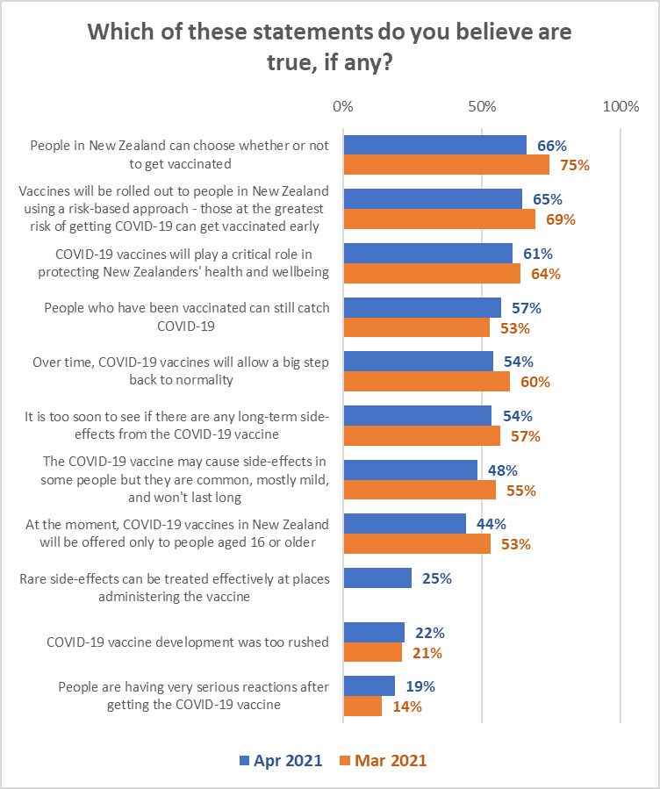

5% overall thought that none of the statements were true.
Responses to these statements vary by likelihood to get the vaccine:

Which of these statements do you believe are true, if any? | LIKELIHOOD TO GET VACCINE
 | Defin-itely | Most Likely | Likely | Un-likely | Most Unlikely | Defin-itely not | Unsure | Already vaccin-ated
COVID-19 vaccines will play a critical role in protecting New Zealanders' health and wellbeing | 81% | 69% | 51% | 22% | 26% | 7% | 32% | 71%
Over time, COVID-19 vaccines will allow a big step back to normality | 71% | 61% | 48% | 28% | 15% | 11% | 24% | 60%
The COVID-19 vaccine may cause side-effects in some people but they are common, mostly mild, and won't last long | 61% | 49% | 37% | 32% | 29% | 9% | 35% | 60%
Rare side-effects can be treated effectively at places administering the vaccine | 37% | 18% | 11% | 15% | 14% | 4% | 11% | 47%
COVID-19 vaccine development was too rushed | 6% | 18% | 31% | 45% | 56% | 66% | 46% | 10%
People are having very serious reactions after getting the COVID-19 vaccine | 8% | 16% | 24% | 41% | 33% | 62% | 31% | 12%

The following table shows results by ethnicity. Note that:

- “People in New Zealand can choose whether or not to get vaccinated” is below average for Asian and Indian ethnicities.
- “Vaccines will be rolled out to people in New Zealand using a risk-based approach - those at the greatest risk of getting COVID-19 can get vaccinated early” is below average for Asian and Indian ethnicities.
- “People who have been vaccinated can still catch COVID-19” is below average for Indian respondents.

Which of these statements do you believe are true, if any? | ALL | ETHNIC GROUP
 |  | Asian | Indian | Maori | NZ Euro-pean/ Pakeha | Other Euro-pean | Pasifika | Other
People in New Zealand can choose whether or not to get vaccinated | 66% | 56% | 52% | 68% | 70% | 70% | 69% | 52%
Vaccines will be rolled out to people in New Zealand using a risk-based approach - those at the greatest risk of getting COVID-19 can get vaccinated early | 65% | 58% | 50% | 63% | 68% | 77% | 65% | 40%
COVID-19 vaccines will play a critical role in protecting New Zealanders' health and wellbeing | 61% | 56% | 60% | 60% | 62% | 71% | 62% | 57%
People who have been vaccinated can still catch COVID-19 | 57% | 60% | 47% | 58% | 58% | 65% | 58% | 56%
Over time, COVID-19 vaccines will allow a big step back to normality | 54% | 51% | 57% | 53% | 54% | 63% | 43% | 57%
It is too soon to see if there are any long-term side-effects from the COVID-19 vaccine | 54% | 54% | 30% | 57% | 55% | 61% | 47% | 61%
The COVID-19 vaccine may cause side-effects in some people but they are common, mostly mild, and won't last long | 48% | 50% | 42% | 46% | 49% | 52% | 47% | 28%
At the moment, COVID-19 vaccines in New Zealand will be offered only to people aged 16 or older | 44% | 40% | 43% | 45% | 48% | 42% | 40% | 42%
Rare side-effects can be treated effectively at places administering the vaccine | 25% | 24% | 21% | 23% | 25% | 26% | 30% | 15%
COVID-19 vaccine development was too rushed | 22% | 28% | 20% | 25% | 21% | 25% | 29% | 29%
People are having very serious reactions after getting the COVID-19 vaccine | 19% | 20% | 15% | 23% | 18% | 26% | 30% | 20%
None of these are true | 5% | 3% | 4% | 4% | 5% | 0% | 3% | 5%
N (unweighted) | 1387 | 669 | 311 | 1,422 | 4,982 | 670 | 307 | 189

Impacts on likelihood to get a vaccine
The survey assessed a range of potential impacts on likelihood to get a COVID-19 vaccine:
- “Role models” getting vaccinated.
- Hearing about adverse reactions.
- Social media posts.
- What others say about the vaccine.
- Misinformation.

The impacts of these are discussed below

13.1 Role model impact on those who are less than “Definitely” getting the vaccine
Respondents who had not yet been vaccinated, excluding those who had definitely made up their minds to be vaccinated, were shown a list of people and asked “If the following people got the vaccine, which ones would help you make the decision to take it yourself?”

Overall results are shown in the chart below.

Points to note:
- In general, role model impact decreases markedly as likelihood to get a COVID-19 vaccine decreases.
- If TV or radio personalities, sports stars and other well-known/high profile people are shown to have the vaccine, that will have significantly less impact than the Director General of Health and the Prime Minister having it. In particular, it has a much lower level of impact on those who say they will “definitely not” get a vaccine or are “unlikely” to do so.

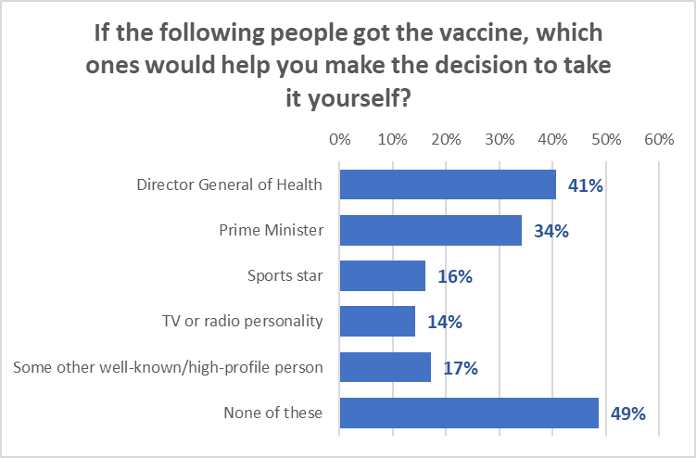
Base: Yet to get a vaccine excluding those who will definitely get vaccinated (n=687)

Impact of these role models is most effective on those who are likely to get a vaccine (possibly reinforcement of their decision).

Any of these potential role models getting vaccinated will not have an impact on around 73% of those who are unlikely to get a COVID-19 vaccine and 57% of those who are unsure (these people are more likely to responds to factual messages about safety).

If the following people got the vaccine, which ones would help you make the decision to take it yourself? | ALL | Likelihood to get a vaccine
 |  | Most likely | Likely | Unlikely | Most unlikely | Defin-itely not | I'm not sure
Director General of Health | 41% | 53% | 53% | 26% | 12% | 4% | 34%
Prime Minister | 34% | 42% | 39% | 24% | 27% | 6% | 33%
Sports star | 16% | 18% | 20% | 5% | 18% | 3% | 17%
TV or radio personality | 14% | 14% | 22% | 7% | 16% | 4% | 13%
Some other well-known/high-profile person | 17% | 16% | 21% | 6% | 5% | 7% | 26%
None of these | 49% | 36% | 36% | 66% | 66% | 89% | 57%
N (unweighted) | 687 | 440 | 266 | 71 | 66 | 58 | 189

Each of these potential role models will have significantly less impact on Māori than on other ethnicities.

If the following people got the vaccine, which ones would help you make the decision to take it yourself? | ALL | Ethnic Group
 |  | Asian | Indian | Maori | NZ Euro-pean/ Pakeha | Other Euro-pean | Pasifika | Other
Director General of Health | 41% | 50% | 65% | 32% | 39% | 40% | 45% | 47%
Prime Minister | 34% | 44% | 56% | 28% | 32% | 35% | 43% | 47%
Sports star | 16% | 22% | 19% | 14% | 15% | 13% | 32% | 9%
TV or radio personality | 14% | 24% | 21% | 6% | 14% | 6% | 18% | 11%
Some other well-known/high-profile person | 17% | 20% | 35% | 13% | 17% | 4% | 23% | 36%
None of these | 49% | 38% | 18% | 58% | 53% | 48% | 33% | 37%
N (unweighted) | 687 | 154 | 73 | 199 | 622 | 63 | 49 | 50

13.2 Impact of hearing about adverse reactions
Respondents who had not yet had two doses of the vaccine were asked how they would react if they heard of someone in New Zealand having a serious side-effect from taking the COVID-19 vaccine.

Overall impacts are:

Quantified, those who are likely to decide not to get a vaccine as a result of hearing of someone in New Zealand having a serious side-effect from taking the COVID-19 vaccine are:

Likelihood to get vaccine | % | Estimated number
Definitely | 5% | 82,100
Most likely | 6% | 47,200
Likely | 14% | 71,800
Unlikely | 63% | 86,500
Most unlikely | 47% | 72,100
Definitely not | 40% | 73,600
Not sure | 26% | 117,900
Already had one dose | 12% | 23,300
TOTAL | 14% | 574,500

By ethnicity, total numbers of those who are likely to decide not to get a vaccine (note that this does not take into account likelihood to get a vaccine) are:
Ethnic group | % | Estimated number
Asian | 21% | 77,500
Indian | 11% | 22,200
Maori | 16% | 99,800
NZ European/Pakeha | 12% | 290,300
Other European | 13% | 30,600
Pasifika | 9% | 25,500
Other | 30% | 30,400
N.B.: Estimated totals for ethnic groups sum to more than 576,000 because of blended ethnicities

The impact of hearing about someone in New Zealand having a serious side-effect from getting a COVID-19 vaccine is likely to be above average in Auckland, Counties-Manukau, Waikato and Bay of Plenty DHB areas. Indications are that it will also be above average in the Hutt DHB area.

7 largest DHBs
DHB | Nett impact:  %
Waitematā | 14%
Auckland | 17%
Counties Manukau | 17%
Waikato | 19%
Capital and Coast | 8%
Canterbury | 16%
Southern | 15%

3 DHBs with relatively statistically reliable results:
DHB | Nett impact:  %
Northland | 10%
Bay of Plenty | 20%
MidCentral | 1%

Other DHBs: Indicative results
DHB | Nett impact:  %
Lakes | 10%
Tairawhiti | 10%
Taranaki | 9%
Hawke's Bay | 14%
Whanganui | 11%
Hutt | 26%
Wairarapa | 13%
Nelson/Marlborough | 4%
West Coast | 14%
South Canterbury | 16%

13.3 Impact of social media posts
All respondents were asked if they thought their decision to take or not take a COVID-19 vaccine would be (or was, for those who were already vaccinated) influenced by social media posts.

A nett 17% (a similar result to March 2021) would not take a vaccine if a social media post or video alarmed them or an anti-vaccine post or video looked credible (an estimated 693,900 New Zealanders 16+). As in March, only 1 in 3 of this sub-group would then go on to look for official information.

- 36% overall (an estimated 1,477,700 New Zealanders 16+) would take the vaccine no matter what a social media post or video said (Māori 35%, Pasifika 54%)
- 25% overall (1,004,200) would take the vaccine if they were encouraged to by a credible official government social media post or video (Māori 21%, Pasifika 12%)
- 45% overall (1,828,700) would look for official information if a social media post concerned them (Māori 43%, Pasifika 37%).

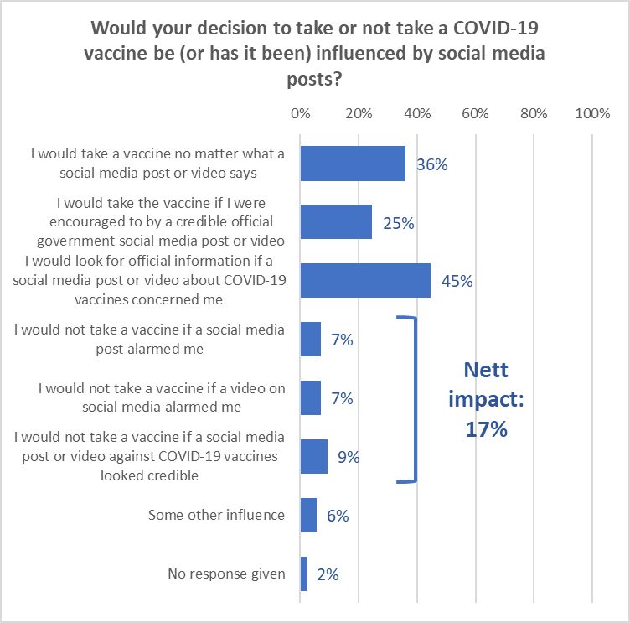

Note that posts or videos that “look credible” have the most impact: 9% (383,700) would not take a vaccine if a social media post or video against COVID-19 vaccines looked credible, compared with Just over 7% (293,900) who would not take a vaccine if a social media post alarmed them and 7% (289,800) would not take a vaccine if a video on social media alarmed them.

The nett effect of social media posts/videos is highest among those age under 35 years, and declines with increasing age.

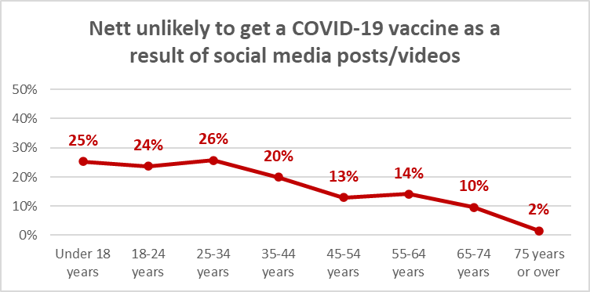

Quantified, the nett numbers of those who are likely to decide not to get a vaccine as a result of a post or video on social media are:

Likelihood to get vaccine | Nett impact: % | Nett impact:  Estimated number
Definitely | 5% | 78,000
Most likely | 10% | 73,600
Likely | 30% | 157,100
Unlikely | 42% | 57,900
Most unlikely | 32% | 49,100
Definitely not | 41% | 76,200
Not sure | 31% | 141,400
Already vaccinated | 21% | 60,600
TOTAL | 17% | 693,900

Note that:
- 21% of those who had already been vaccinated said they had previously been influenced to refuse a vaccine by a social media post or video.
- The impact is significantly higher in percentage terms once likelihood to get a vaccine drops below “most likely.

By ethnicity, total numbers of those who are likely to decide not to get a vaccine (note that this does not take into account likelihood to get a vaccine) are:
Ethnic group | Nett impact: % | Nett impact:  Estimated number
Asian | 32% | 126,700
Indian | 22% | 46,700
Maori | 18% | 119,200
NZ European/Pakeha | 14% | 360,800
Other European | 15% | 39,600
Pasifika | 16% | 51,600
Other | 23% | 25,800
N.B.: Estimated totals for ethnic groups sum to more than 693,900 because of blended ethnicities

The impact of social media posts and videos is likely to be above average in Counties-Manukau, Canterbury and Southern DHB areas. Indications are that it will also be above average in the Taranaki, Wairarapa and West Coast DHB areas.

7 largest DHBs
DHB | Nett impact:  %
Waitematā | 14%
Auckland | 18%
Counties Manukau | 21%
Waikato | 16%
Capital and Coast | 15%
Canterbury | 20%
Southern | 28%

3 DHBs with relatively statistically reliable results:
DHB | Nett impact:  %
Northland | 10%
Bay of Plenty | 15%
MidCentral | 11%

Other DHBs: Indicative results
DHB | Nett impact:  %
Lakes | 15%
Tairawhiti | 3%
Taranaki | 22%
Hawke's Bay | 15%
Whanganui | 3%
Hutt | 18%
Wairarapa | 26%
Nelson/Marlborough | 0%
West Coast | 47%
South Canterbury | 16%

13.4 Impact of what others say about the COVID-19 vaccine
Respondents who had not already been vaccinated were asked if they thought their decision to take or not take a COVID-19 vaccine would be influenced if someone told them something which alarmed them about a COVID-19 vaccine or where they heard media commentators or the media in general making negative comments about the vaccine.

What others say, including reports in the media, has potentially more negative impact than social media posts or videos.

A nett 33% of those who have not yet been vaccinated (estimated at 1,259,000 New Zealanders 16+) would not get a vaccine if someone told them something which alarmed them about a COVID-19 vaccine or where they heard media commentators or the media in general making negative comments about the vaccine. 4 out of 10 of this sub-group would then go on to look for official information.

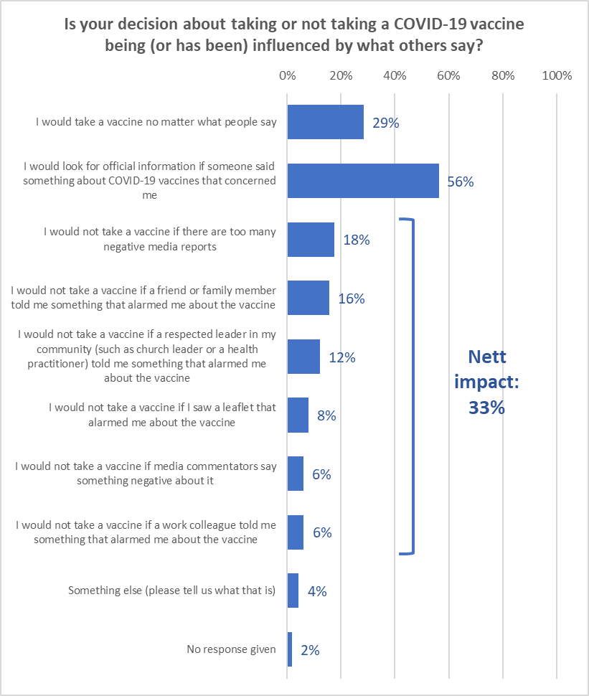

- 29% overall (an estimated 1,163,400 New Zealanders 16+) would take the vaccine no matter what people said.
- 56% overall (2,298,200) would look for official information if someone said something about COVID-19 vaccines that concerned them.

Younger people are more likely to be discouraged to take a vaccine by what people say. The level of discouragement drops as age increase.

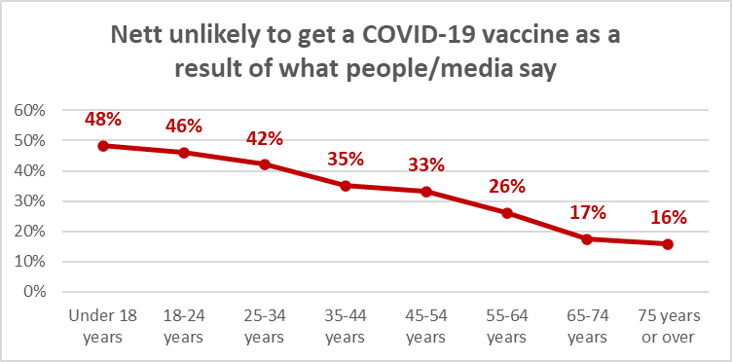

The nett numbers of those who are likely to decide not to get a vaccine as a result what others say are shown below:

Likelihood to get vaccine | Nett impact: % | Nett impact:  Estimated number
Definitely | 13% | 187,800
Most likely | 47% | 333,800
Likely | 52% | 247,800
Unlikely | 59% | 75,700
Most unlikely | 32% | 46,400
Definitely not | 61% | 103,000
Not sure | 63% | 264,500
TOTAL | 33% | 1,259,000

Note that only those who will “definitely” get a vaccine will have a low impact by what people say or said they had previously been influenced to refuse a vaccine by a social media post or video.

In general, what others say has more impact on Asian and Indian ethnic groups than others
- Overall, 18% would not take a vaccine if there are too many negative media reports. 25% of Asians feel that way, 18% Māori, 21% “Other European” and 16% Pasifika)
- 16% (would not take a vaccine if a friend or family member told them something that alarmed them about the vaccine. This has much more impact among Asian (28%) and Indian (27%) ethnic groups than among Māori (16%) and Pasifika (20%) and especially “Other Europeans” (11%).
- 12% would not take a vaccine if a respected leader in their community (such as church leader or a health practitioner) told them something that alarmed them about the vaccine. This impacts Pasifika (9%) marginally less than other ethnic groups.
- 8% would not take a vaccine if they saw a leaflet that alarmed them about the vaccine. Asian respondents, however, are twice this rate (16%), Indian ethnic respondents were 11%).
- 6% would not take a vaccine if a work colleague told them something that alarmed them about the vaccine. Asian respondents are 13%.
- 6% would not take a vaccine if media commentators said something negative about it. Asian respondents are 14%, Indian 11%.

The total numbers of those who are likely to decide not to get a vaccine as a result of what people say by ethnic group (note that this does not take into account likelihood to get a vaccine) are:
Ethnic group | Nett impact: % | Nett impact:  Estimated number
Asian | 53% | 214,800
Indian | 43% | 91,200
Maori | 33% | 222,300
NZ European/Pakeha | 29% | 747,600
Other European | 33% | 89,300
Pasifika | 26% | 85,600
Other | 42% | 45,700
N.B.: Estimated totals for ethnic groups sum to more than 1,259,000 because of blended ethnicities

The impact of what people say is likely to be above average in Auckland and Canterbury DHB areas, but is at average level in the other of the 7 large DHBs. Indications are that it will also be above average in the Tairawhiti, Wairarapa and Hutt areas.

7 largest DHBs
DHB | Nett impact:  %
Waitematā | 35%
Auckland | 42%
Counties Manukau | 33%
Waikato | 32%
Capital and Coast | 27%
Canterbury | 39%
Southern | 30%

3 DHBs with relatively statistically reliable results:
DHB | Nett impact:  %
Northland | 18%
Bay of Plenty | 27%
MidCentral | 36%

Other DHBs: Indicative results
DHB | Nett impact:  %
Lakes | 9%
Tairawhiti | 62%
Taranaki | 30%
Hawke's Bay | 21%
Whanganui | 33%
Hutt | 42%
Wairarapa | 54%
Nelson/Marlborough | 14%
West Coast | 46%
South Canterbury | 32%

13.4 Misinformation
All respondents were asked a set of questions about “misinformation”; they were told that “Misinformation is what you believe is false, incorrect or misleading information”.

38% (an estimated 1,555,200 New Zealanders 16+) had encountered what they believed to be misinformation. They were asked the source of the misinformation, with social media being the main source, followed by friends and family and then mainstream media.

Females were more likely than males to have come across something they believed to be information, as were those who lived with impairments or health conditions (43%) and those who identified as disabled (51%).

Incidence by likelihood to get a vaccine and ethnic group is shown below:

Misinformation about COVID-19 vaccines | LIKELIHOOD TO GET VACCINE
 | Defin-itely | Most Likely | Likely | Un-likely | Most Unlikely | Defin-itely not | Unsure | Already vaccin-ated
Come across what they believed to be misinformation about COVID-19 vaccines | 47% | 32% | 30% | 21% | 40% | 38% | 16% | 63%

Misinformation about COVID-19 vaccines | ETHNIC GROUP
 | Asian | Indian | Māori | NZ Euro-pean/ Pakeha | Other Euro-pean | Pasifika | Other
Come across what they believed to be misinformation about COVID-19 vaccines | 27% | 34% | 47% | 40% | 41% | 24% | 40%

Misinformation was encountered every day by 15%, with nearly 6 out of 10 saying they encountered it at least every few weeks.

How they knew it was misinformation
Respondents who had seen something they believed to be information were what made them think it was misinformation. Overall, the large majority appeared to have applied a high degree of “common sense” in judging whether what they had heard was misinformation of not. Some respondents commented that they had also checked with official sites after hearing some of the information.

Thematic analysis indicated the following:

Exaggerated/unrealistic/rubbish
“It was too stupid and farfetched to be true.”
“Because it was obviously not based on science. Conspiracy theory rubbish.”
“Over exaggerated side effects occurring overseas with vaccines that haven't been bought for NZ.”
“It was alarmist, exaggerated and lacking facts.”
“The over exaggerated numbers of people with reactions to the vaccine which was actually a minority but made to look bigger by the media.”
“It linked to a totally ludicrous and unsourced YouTube video.”
“It was not the same message as I had been reading / seeing in mainstream media or from the government and was very exaggerated
“Some of it was ridiculous and conspiracy theories, some was media passing on what they heard and raising their own thoughts.”
“Bunch of weirdos outside Wellington Railway Station speaking obvious crap.”
“Exaggerated findings, often backed up by dodgy sources.”
“It sounded absurd.”

Contrary to official advice/science
“Govt websites stated otherwise. The person was directed to the website and agreed they’d been listening to, and passing on, rubbish info.”
“Contrary to reliable scientific advice, found not to be true, or was from an ideological perspective.”
“It was all in contradiction to what doctors and scientists were saying.”
“It was contrary to what the Ministry of Health and Dr Bloomfield were staying. The sources we questionable or non-existent. Emotive rather than science based.”
“It contradicted other information provided.”
“Because it contradicted medical/scientific findings.”
“Contradicted what I had heard from reliable people.”
“It was completely contrary to all the other information available, and made no logical sense.”
“Because couldn't find anything on the official medical website about it.”
“It contradicts WHO.”
“The information given is contradictory to that from officials and health professionals e.g., MOH, the PM, sane doctors.”

No evidence or scientific backing
“No evidence presented, not backed up by reliable sources. Often completely misunderstands how vaccines work, also often misunderstands technology - irrational. Sometimes describes a conspiracy, refers to other "conspiracies", demonstrates a general paranoia and a lack of social responsibility.”
“Because it was obviously not based on science. Conspiracy theory rubbish.”
“The people spreading negative misinformation about the COVID vaccine are always negative about mainstream views or are conspiracy theorists. They are ignorant of the Science behind vaccines.”
“No evidence-based and biased.” Because it was negated heavily by the scientific and medical communities.”
“No scientific basis to the things that were said.”
“Did not include scientific information to back up the claims.”
“The information is at odds with scientific and WHO advice.”
“Contrary to reliable scientific advice, found not to be true, or was from an ideological perspective.”

Received messages about implanting tracking devices/microchips with the vaccine
“Because I don't think it is conceivable that someone would put a tracking device into your arm with the vaccine.”
“Because it was clearly nonsense. Saying things like: 'they will implant you with a tracking chip' etc.”

Conspiracy theories
“Because it was fear-mongering, based on ignorance of science and of the facts I know to be true about vaccines in general - facts that are based on well-researched findings. The people I hear such misinformation from are ALWAYS people who don't do proper, intelligent research about anything and prefer to believe unscientific, illogical conspiracy theories, which they generally get from American media.”
“Rubbish about COVID being a conspiracy.”
“Media has published a lot of the conspiracy theories as reporting. I listened to a doctor on Talk Radio who was clearly an anti vaxxer.”
“They think it's all a big government conspiracy”
“I have known the person to align with conspiracy theory beliefs. - The social media articles quote organizations that are known to be connected to other conspiracy theories.”
“Because it was linked to other conspiracy theories and other outlandish statements.
There was no basis in science, shrouded in conspiracy theory ideas, promulgated by right wing ideologies and supporters, illogical/irrational propositions etc.”
“Social media is the evil here. Incorrect facts and conspiracy theories are bandied about and things are misinterpreted.”
“I have read many scientific papers and trust them! The nonsense I heard was real conspiracy theory idiocy.”
“The two separate people who provided the information are conspiracy theorists - they probably think we have aliens amongst us. Consequently, I take everything they say with a grain of salt. Very rarely do they have any actual facts to back up their opinions”
“Religious lead conspiracy theories proffered by loonies.”

Other comments
“The news is constantly telling us to take the vaccination because we won’t catch COVID-19. That is not a proven fact. The proven facts are it is less likely to give you strong symptoms if you catch COVID-19. So, the likelihood is once the borders are open the vaccination may have very little effect against catching COVID-19 regardless, and there is no research to suggest if you do catch COVID-19 after having a vaccination what your symptoms are going to be like or the effects. So, it’s a load of shit. This whole campaign is emotionalised, rushed propaganda, and I’m extremely disappointed for many reasons about critical thinking that’s going on in the circumstances. So, if the media can’t even get the messages right we have no hope. The Ministry of Health needs to rebrand the whole lot because there’s gonna be a lot of extremely disappointed New Zealanders who are vaccinated who catch COVID. Plus, all the studies that the Ministry is quoting and they have come out and the various media outlets are saying that the vaccination is 95% affective - against what? So, it’s just extremely poor reporting and statistical manipulation designed to fool a whole lot of people into thinking they need this vaccination.”

“Honestly, I've heard so much random stuff about these vaccines, I couldn't tell you. but like, some of this stuff can't be true. At one point my mother told me there was a microchip in it that would track me or sterilize me or something. Oh, or that it would kill off like 99% of the population to stop over population- I think freemasons were involved? That because it was an RNA vaccine it would change my DNA so I wasn't human and so I wouldn't be protected by the Geneva convention or have any human rights. For the most part it's just that information is so clearly wrong - the other stuff is saying that it's dangerous, that's harder to know if it is misinformation and I don't really trust the government, but I know that I'm likely to be biased against taking a vaccine so I just kind of ignore that and hope it's not true. Like, I don't feel safe taking it, but I assume that's just paranoia because so many people are being insane about it, so I'm going to get vaccinated anyway. idk - I'm not a doctor.”

What the misinformation was
Respondents who had seen something they believed to be information were asked how they knew it was misinformation. The appeared to have a high degree of “common sense” in judging whether what they had heard was misinformation of not. Some respondents commented that they had checked with official sites after hearing some of the information.

Thematic analysis was conducted. This analysis indicated that the main themes were:

Tracking devices/microchips implanted with the vaccine
“That the government was inserting tracking devices and tracking us with the vaccine.”
“It will affect our genes, it has a microchip, it is compulsory.”
“Trackers in vaccines.”
“Implanting chips, will make you sick, used as a way to control the population etc.”
“mRNA can alter DNA, microchip in vaccine, experimental vaccine, vaccine can be transmitted to unvaccinated people by respiration etc, etc, etc.”
“That the vaccine implants the ability for people to track your movements”
“The vaccine has microchips inside it. The vaccine could trigger humans to become zombies. The vaccine gives humans cancer. Etc etc.”

Side effects and adverse reactions
“Exaggerated side effects... and conspiracy theory issues - these mainly originated from North American mainland sources.”
“Not necessary. Causes lots of side effects - usual anti vax propaganda.”
“That it's safe, no side effects, that other proven treatments have been discounted (ridiculed), lack of long-term trails ...” (this respondent said they would “definitely not” get a vaccine)
“Causes horrendous side effects and even death. Hundreds are dying from the vaccine.”
“That side effects are rare but we don't know side effects.”
“Wild accusations about side effects and micro-chips.”
“adverse effects, multipharma control.”
“I can't recall exactly and basically scrolled past it in social media feeds, etc, however much was extolled about the vaccine being rushed and that the risks of serious side effects were higher than suggested, and that they were poorly understood.”
“That there were more people dying after taking the vaccine due to side effects.”
“That there are serious side effects and every chance one may die having been vaccinated.”
“Overemphasis of side effects and incorrect assumptions regarding the vaccine development process.”

COVID is a hoax
“COVID is a hoax, side effects are being hidden, chips in the vaccine, government trying to control everyone, controlled government killing.”
“Some of them say the vaccine is a hoax, that it is a placebo to make people think its working when it’s not.”
“Children and young people can't get it; it's not real, it's being used to collect data on people, general craziness not based on scientific information.”
“That it is harmful; COVID is a hoax; It is a way of the Government controlling our lives.”
“The COVIOD is a hoax and vaccine is produced from embryos.”

Deaths from vaccine
“The reactions/side effects. The death rate after being immunized.”
“Death rates from vaccine side effects.”
“Government covering up deaths, vaccines being unsafe, untested, and unnecessary. COVID not being any worse than a cold. Vaccines being a microchip delivery device.”
“The amount of deaths around the world that it has caused.”
“That it could kill you.”
“That everyone was dying or very sick afterwards.”
“How its all a fake scandal and the drugs going to kill people and control them.”
“Vaccines have had fatal effects”
“20% of people in the world are dying because of the Vaccine”
“Prince Phillip died a few weeks after getting the vaccine which likely caused his death.”
“Was saying millions died from the vaccine, and alter human DNA.”

Not effective
“That the vaccines are ineffective and dangerous to my health, minimising risk from the virus itself.”
“That it is safe and effective.” (this respondent said they would “definitely not” get a vaccine)
“Various things: e.g., vaccines were not effective for older people, were not effective for younger people, caused blood clots, and so on.”
The vaccines weren't any good, they had micro-chips within them, it was a way of controlling people, they were not effective against COVID and it was a money-making venture by pharmaceutical companies.”
“Causes cancer, it turns you into paedophiles, it is not effective.”
“That the vaccine is ineffective, that it will give you COVID-19.”
“Saying the vaccines were dangerous and ineffective.”

You can get COVID-19 from the vaccine
“Side effects, risk of getting COVID from the vaccine.”
“Statements that the vaccine has the live virus in it.”
“Will give you COVID.”
“You can get COVID from the vaccine.”
“Vaccine can give you COVID19, vaccine doesn't work because someone was "immunized" and still contracted the virus (inoculations are not 100% guarantee of immunity and so this doesn't indicate a failure of the vaccine - just bad luck).”
“All sorts: live virus been put into you , chemical nasties , and also it’s a way of being controlled by people above us.”

It causes health/long-term problems
“Causes long-term effects.”
“Dangerous long-term effects.”
“That the mRNA in the vaccine can have a long-term effect on my own DNA.”
“That it was bad for your health”
“Vax was in some way bad for you.”
“Vaccine causing miscarriage if you stand next to someone who has had it.”

13.5 Impact of misinformation
Respondents who had seen something they thought was misinformation were asked how they would be influenced by that misinformation.

9% of those who had seen something they thought was misinformation (estimated at 141,500 New Zealanders 16+) would not get a vaccine if the misinformation they saw actually alarmed them. A quarter of this sub-group would then go on to look for official information.

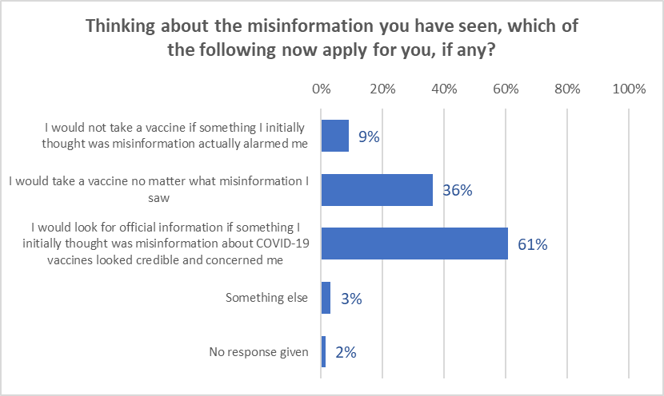

- 36% overall (an estimated 564,500 New Zealanders 16+) would take the vaccine no matter what misinformation they saw.
- 61% overall (945,600) would look for official information if someone said something about COVID-19 vaccines that concerned them.

The impact on those who live with impairments or health conditions, and those who identify as disable is as follows:

Thinking about the misinformation you have seen, which of the following now apply for you, if any? | All | Live with impairments or health conditions | Identify as disabled
I would not take a vaccine if something I initially thought was misinformation actually alarmed me | 9% | 7% | 15%
I would take a vaccine no matter what misinformation I saw | 36% | 43% | 51%
I would look for official information if something I initially thought was misinformation about COVID-19 vaccines looked credible and concerned me | 61% | 55% | 46%
Something else | 3% | 5% | 6%
No response given | 2% | 1% | 1%

Note that 18–24-year-olds are more likely to be discouraged to take a vaccine by seeing misinformation. The level of discouragement drops as age increases.

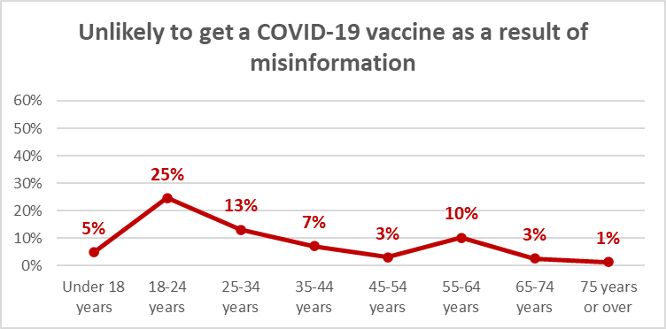

The numbers of those who are likely to decide not to get a vaccine as a result of seeing misinformation that alarmed them is as follows:

Likelihood to get vaccine | Impact:  % | Nett impact:  Estimated number
Definitely | 3% | 22,300
Most likely | 3% | 7,300
Likely | 29% | 44,900
Unlikely | 48% | 13,600
Most unlikely | 13% | 8,400
Definitely not | 21% | 14,300
Not sure | 17% | 11,900
Already vaccinated | 11% | 18,800
TOTAL (Seen misinformation) | 9% | 141,500

The total numbers of those who are likely to decide not to get a vaccine as a result seeing misinformation, by ethnic group (note that this does not take into account likelihood to get a vaccine), are:
Ethnic group | Impact:  % | Nett impact:  Estimated number
Asian | 20% | 21,300
Indian | 6% | 4,600
Maori | 10% | 29,900
NZ European/Pakeha | 9% | 89,200
Other European | 1% | 1,000
Pasifika | 3% | 2,500
Other | 23% | 10,200
N.B.: Estimated totals for ethnic groups sum to more than 1,259,000 because of blended ethnicities

The following figures show the impact of misinformation on the populations in DHB areas is likely to be above average in Auckland and Canterbury DHB areas, but is at average level in the other of the 7 large DHBs. Indications are that it will also be above average in the Tairawhiti, Wairarapa and Hutt areas. Note that these figures have been adjusted % of total population (not just those who have seen misinformation) to show the overall impact on DHBs.

7 largest DHBs
DHB | Nett impact:  %
Waitematā | 3%
Auckland | 4%
Counties Manukau | 2%
Waikato | 2%
Capital and Coast | 4%
Canterbury | 7%
Southern | 3%

3 DHBs with relatively statistically reliable results:
DHB | Nett impact:  %
Northland | 0%
Bay of Plenty | 3%
MidCentral | 3%

Other DHBs: Indicative results
DHB | Nett impact:  %
Lakes | 8%
Tairawhiti | 3%
Taranaki | 4%
Hawke's Bay | 4%
Whanganui | 1%
Hutt | 2%
Wairarapa | 0%
Nelson/Marlborough | 0%
West Coast | 17%
South Canterbury | 0%

Vaccination of 12- to 15-year-olds
All respondents were asked “If a COVID-19 vaccine is approved for use in children aged between 12-15, would you allow the children for whom you are the primary caregiver to take the vaccine?”

14.1 Vaccination likelihood
42% of respondents overall (an estimated 1,714,400 New Zealanders 16+) said they were caregivers for a 12–15-year-old child or children. Of those, 56% (an estimated 967,400 adults) were likely to allow the children to be vaccinated.

This is an increase on the 49% in September 2020 and 44% in December 2020 who said that “if an approved COVID-19 vaccine becomes available for younger children” they would have it given to a child or children for whom they were the caregiver (note that the question in the earlier surveys was not specific about the age of the children).

22% of caregivers (an estimated 535,700 adults), down from 33% in December 2020 and 27% in September 2020, said they were unlikely to have a COVID-19 vaccine given to a child and 22% were unsure.

As in the December 2020 survey, Indian respondents were the most willing to let their 12–15-year-olds be vaccinated; “Other Europeans” and people of “Other” ethnic groups the least likely.

Māori willingness to have a child for whom they were the caregiver vaccinated has lifted to 56% from 39% in December 2020: 34% “definitely”, 14% “most likely” and 8% “likely”

Pasifika willingness to have their 12-15 year olds vaccinated has doubled from the December 2020 result, and is now at 58%: 26% “definitely”, 21% “most likely” and 11% “likely”..

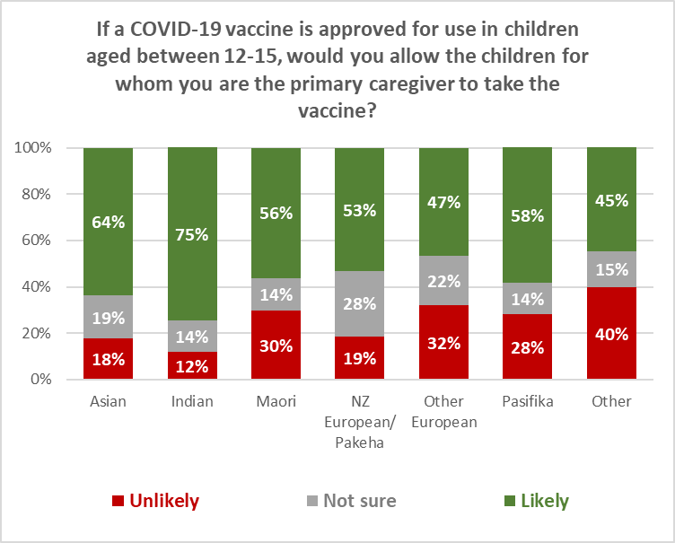

Willingness to give a 12–15-year-old a COVID-19 vaccine es as the willingness to accept a COVID-19 vaccine themselves declines; this was evident in December and September 2020.

85% of the caregivers who would “definitely” accept a COVID-19 vaccine themselves would have it given to the child/children for whom they are caregivers (89% in December 2020, 86% in September). 5% would not have it given and 9% were unsure.

6% of those who would “definitely not” accept a COVID-19 vaccine themselves would have a COVID-19 vaccine given to the child/ children for whom they are caregivers.
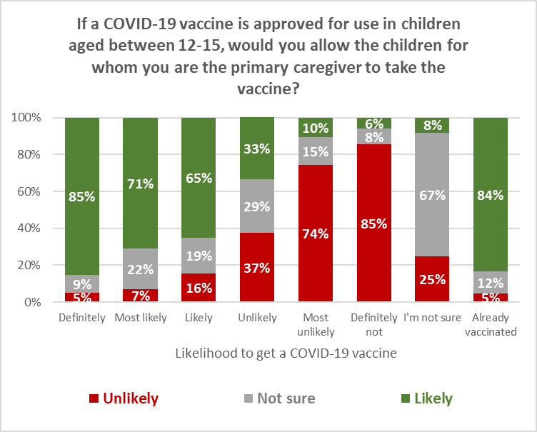

14.2 Reasons for not wanting 12-15 year olds vaccinated
Respondents who said they were unlikely to allow a 12-15 year old for whom they were the caregiver to be vaccinated, or were unsure whether they would do so, were asked why that was.

As shown in the following chart, the vaccine’s safety for the children was the top concern.

22% wanted to talk with their health provider about it before deciding whether to allow the child to be vaccinated.

43% said it was too soon to see if there were any long-term effects for children from the vaccine.

Regardless of whether they will get vaccinated themselves, child safety is paramount for those who say they would not allow their 12-15 year old to get a COVID-19 vaccine.

Note that 20% of those who will “definitely” get vaccinated themselves selected “I don’t trust any vaccine” as a reason for not allowing their 12-15 year old to be vaccinated, and 36% of them want to be able to talk with their health provider first.

You say you are unsure or are unlikely to encourage COVID-19 vaccination for those children for whom you're the caregiver if this were offered. Why is that? | ALL | Likelihood to take vaccine including those who have had it
 |  | Definitely | Most likely | Likely | Unlikely | Most unlikely | Definitely not | I'm not sure | Already vaccinated
I would need to be assured about its safety in children | 60% | 35% | 80% | 77% | 50% | 60% | 33% | 69% | 67%
I personally don't take any vaccine | 7% | 16% | 0% | 2% | 9% | 0% | 6% | 12% | 0%
I don't allow the children I care for to take any vaccine | 10% | 8% | 5% | 3% | 3% | 5% | 18% | 16% | 23%
I don't trust any vaccine | 12% | 20% | 0% | 0% | 10% | 17% | 31% | 9% | 0%
I don't see the need for children to take a COVID-19 vaccine | 13% | 0% | 3% | 7% | 15% | 21% | 23% | 12% | 32%
Children I care for have an existing health condition which prevents them from taking a vaccine | 8% | 2% | 0% | 4% | 0% | 6% | 12% | 17% | 0%
Children I care for have had a bad experience in the past when taking a vaccine | 5% | 8% | 0% | 0% | 0% | 0% | 2% | 16% | 0%
It is too hard to get them to a place to be vaccinated | 0% | 0% | 0% | 1% | 0% | 0% | 0% | 0% | 0%
I won't be able to afford a COVID-19 vaccine for the children I care for | 3% | 0% | 0% | 0% | 3% | 15% | 3% | 0% | 0%
I'd rather wait and see if others who have taken it suffer any side effects | 21% | 13% | 11% | 16% | 35% | 32% | 14% | 30% | 0%
It is too soon to see whether there are any long-term effects for children from the vaccine | 43% | 15% | 40% | 48% | 43% | 50% | 46% | 43% | 63%
I'd like to make sure that others who need it can get it before my child/children | 9% | 2% | 5% | 8% | 0% | 17% | 3% | 17% | 0%
I'd like to be able to talk with my health provider about it | 22% | 36% | 20% | 3% | 17% | 15% | 8% | 36% | 65%
Some other reason (please tell us what that is) | 10% | 10% | 8% | 19% | 0% | 0% | 22% | 5% | 23%
N (unweighted) | 222 | 34 | 54 | 60 | 44 | 71 | 65 | 106 | 22

Safety for the child is the top reason across all ethnic groups for not allowing their 12–15-year-old to get a COVID-19 vaccine.

You say you are unsure or are unlikely to encourage COVID-19 vaccination for those children for whom you're the caregiver if this were offered. Why is that? | ALL | ETHNIC GROUP
 |  | Asian | Indian | Maori | NZ Euro-pean/ Pakeha | Other Euro-pean | Pasifika | Other
I would need to be assured about its safety in children | 60% | 70% | 38% | 68% | 60% | 31% | 72% | 93%
It is too soon to see whether there are any long-term effects for children from the vaccine | 43% | 32% | 20% | 33% | 51% | 19% | 43% | 66%
I'd like to be able to talk with my health provider about it | 22% | 20% | 30% | 26% | 23% | 0% | 23% | 28%
I'd rather wait and see if others who have taken it suffer any side effects | 21% | 9% | 15% | 18% | 25% | 23% | 10% | 26%
I don't see the need for children to take a COVID-19 vaccine | 13% | 6% | 29% | 6% | 12% | 30% | 15% | 9%
I don't trust any vaccine | 12% | 2% | 0% | 35% | 7% | 23% | 15% | 7%
I don't allow the children I care for to take any vaccine | 10% | 4% | 0% | 24% | 6% | 4% | 38% | 0%
I'd like to make sure that others who need it can get it before my child/children | 9% | 11% | 7% | 22% | 7% | 0% | 0% | 4%
Children I care for have an existing health condition which prevents them from taking a vaccine | 8% | 0% | 0% | 15% | 7% | 0% | 10% | 0%
I personally don't take any vaccine | 7% | 4% | 0% | 4% | 10% | 4% | 4% | 7%
Children I care for have had a bad experience in the past when taking a vaccine | 5% | 0% | 0% | 11% | 5% | 4% | 0% | 0%
I won't be able to afford a COVID-19 vaccine for the children I care for | 3% | 0% | 0% | 0% | 1% | 30% | 4% | 0%
It is too hard to get them to a place to be vaccinated | 0% | 0% | 2% | 0% | 0% | 0% | 0% | 0%
Some other reason | 10% | 0% | 0% | 17% | 8% | 23% | 0% | 19%
N (unweighted) | 222 | 53 | 26 | 127 | 263 | 23 | 29 | 18

Vaccination groups
As in March 2021, respondents were asked about their vaccine groups: first, without an explanation of the 4 groups (to see if they were aware of which group they were in), and second, with an explanation of the groups.

96% of those who initially thought they were in Group 4 were actually in that group. 63% of those who initially thought they were in Group 3 were actually in that group, but there continues to be a degree of misapprehension among those who thought they were in Groups 1 or 2, as shown below.

After reading the above, which group do you fall into? | ALL | Without looking it up, do you know which group you are in?
 |  | Group 1 | Group 2 | Group 3 | Group 4 | I really don't know
Group 1 - Border and MIQ workers and the people they live with | 4% | 33% | 6% | 0% | 0% | 1%
Group 2 - High-risk frontline workers and people living in high-risk places | 10% | 20% | 29% | 7% | 1% | 5%
Group 3 - People who are at risk of getting very sick from COVID-19 | 26% | 21% | 47% | 63% | 3% | 24%
Group 4 - Everyone in New Zealand aged 16 and over | 60% | 27% | 18% | 31% | 96% | 69%
N (unweighted) | 1387 | 36 | 124 | 242 | 366 | 502

Risk-based approach to vaccine roll-out
Overall, 69% of respondents approved of the risk-based approach to vaccine roll-out (66% in March 2021).

Approval was strong across all ethnic groups.

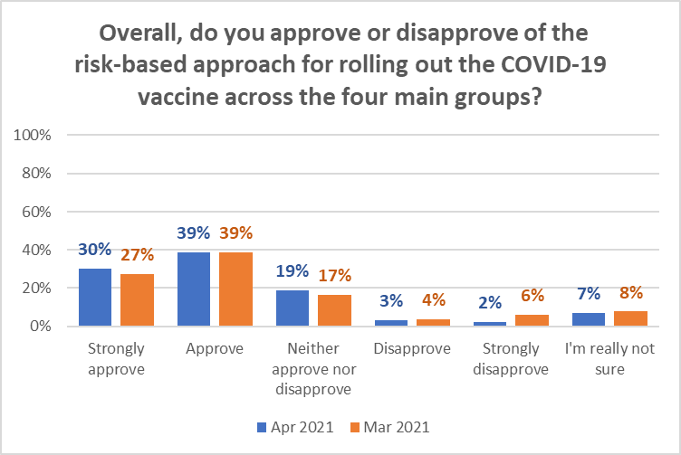

Note how approval declines as likelihood to get a vaccine decreases.

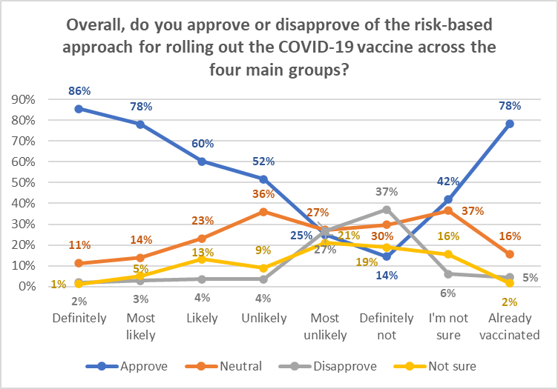

Trust in the management of the pandemic and rating the vaccination response
All respondents were asked:
- how much they trusted the Ministry and Government to manage the COVID-19 pandemic in a way which best protected them and other New Zealanders; and
- how they thought the vaccination response to the COVID-19 pandemic was being managed in New Zealand.

The average results are shown below:

- The average trust in the Ministry of Health and Government to manage the pandemic continues to rise:

At this time, how much do you trust the Ministry of Health and Government to manage the COVID-19 pandemic in a way which best protects you and other New Zealanders? | Feb 2021 | Mar 2021 | Apr 2021
Average trust out of 5 | 3.5 | 3.6 | 3.8

- The average rating of the vaccination response is steady:

Overall, on a scale of 0 to 10, how do you think the vaccination response to the COVID-19 pandemic is being managed in New Zealand? | Feb 2021 | Mar 2021 | Apr 2021
Average rating out of 5 | 7.2 | 7.1 | 7.1

Where information on the COVID-19 vaccine has been seen
All respondents were asked where they had seen, heard or found information on the COVID-19 vaccine to date.

As shown in the following chart, 49% overall had sourced information on the vaccine from Television New Zealand.

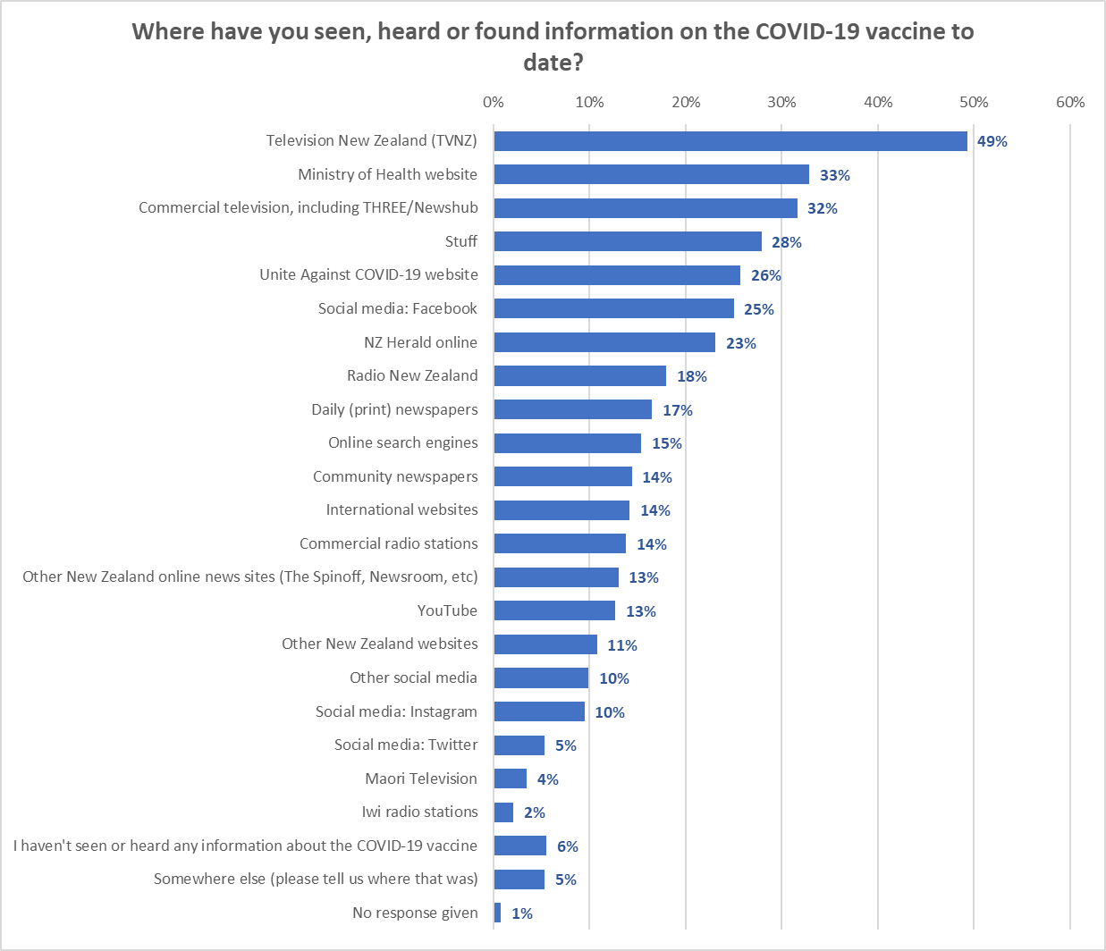

Sourcing information from Television New Zealand generally increases with age.

Facebook is the highest information source for 18–24-year-olds, as shown below. 65–74-year-olds have an average of 5.2 different sources and those 75 years or over have 4.9, compared with san overall average of 3.8

Where have you seen, heard or found information on the COVID-19 vaccine to date? | ALL | AGE GROUP
 |  | Under 18 years | 18-24 years | 25-34 years | 35-44 years | 45-54 years | 55-64 years | 65-74 years | 75 years or over
Television New Zealand (TVNZ) | 49% | 39% | 32% | 30% | 47% | 52% | 54% | 74% | 75%
Ministry of Health website | 33% | 20% | 33% | 26% | 28% | 31% | 37% | 49% | 39%
Commercial television, including THREE/Newshub | 32% | 34% | 15% | 16% | 28% | 32% | 40% | 47% | 50%
Stuff | 28% | 22% | 19% | 28% | 28% | 26% | 27% | 38% | 43%
Unite Against COVID-19 website | 26% | 28% | 32% | 30% | 28% | 26% | 21% | 25% | 6%
Social media: Facebook | 25% | 22% | 35% | 27% | 20% | 24% | 23% | 25% | 28%
NZ Herald online | 23% | 27% | 27% | 27% | 19% | 23% | 17% | 29% | 29%
Radio New Zealand | 18% | 13% | 17% | 19% | 11% | 12% | 21% | 32% | 26%
Daily (print) newspapers | 17% | 6% | 10% | 9% | 8% | 9% | 20% | 39% | 53%
Online search engines | 15% | 19% | 16% | 18% | 16% | 15% | 12% | 19% | 11%
Community newspapers | 14% | 5% | 10% | 9% | 5% | 11% | 17% | 37% | 32%
International websites | 14% | 15% | 12% | 19% | 11% | 10% | 15% | 21% | 20%
Commercial radio stations | 14% | 17% | 10% | 12% | 9% | 10% | 16% | 22% | 25%
Other New Zealand online news sites (The Spinoff, Newsroom, etc) | 13% | 9% | 17% | 10% | 12% | 13% | 10% | 20% | 13%
YouTube | 13% | 24% | 28% | 20% | 11% | 8% | 6% | 4% | 5%
Other New Zealand websites | 11% | 10% | 11% | 9% | 11% | 14% | 7% | 15% | 8%
Other social media | 10% | 12% | 15% | 11% | 10% | 10% | 8% | 7% | 7%
Social media: Instagram | 10% | 29% | 21% | 12% | 7% | 5% | 4% | 7% | 1%
Social media: Twitter | 5% | 4% | 10% | 7% | 10% | 4% | 3% | 1% | 0%
Maori Television | 4% | 0% | 1% | 3% | 5% | 3% | 3% | 6% | 10%
Iwi radio stations | 2% | 0% | 2% | 2% | 3% | 3% | 2% | 3% | 3%
I haven't seen or heard any information about the COVID-19 vaccine | 6% | 8% | 8% | 5% | 5% | 4% | 7% | 3% | 4%
Somewhere else | 5% | 7% | 5% | 6% | 4% | 6% | 7% | 2% | 5%
No response given | 1% | 1% | 2% | 0% | 0% | 1% | 1% | 3% | 0%
N (unweighted) | 1,387 | 53 | 154 | 207 | 242 | 242 | 239 | 166 | 84

Note that, by ethnicity:
- Pasifika are using more sources than other ethnic groups (4.7) to get information. They are low consumers of print newspapers, but are above average uses of Stuff and NZ Herald online.
- Māori are slightly lower than average users of the Unite Against COVID website and low users of international websites. They are above average users of the Ministry of Health website and community newspapers.
- Respondents of Indian ethnicity are the highest users of Facebook, which is their predominant source of information about COVID-19 vaccines. They are significantly lower than average users of the Ministry of Health or Unite Against COVID-19 websites.
- Asian respondents are above average users of social media and the highest users of YouTube for COVID-19 vaccine information.

Where have you seen, heard or found information on the COVID-19 vaccine to date? | ALL | ETHNIC GROUP
 |  | Asian | Indian | Maori | NZ Euro-pean/ Pakeha | Other Euro-pean | Pasifika | Other
Television New Zealand (TVNZ) | 49% | 35% | 29% | 49% | 51% | 58% | 58% | 31%
Ministry of Health website | 33% | 23% | 22% | 38% | 32% | 36% | 57% | 34%
Commercial television, including THREE/Newshub | 32% | 22% | 29% | 34% | 32% | 31% | 40% | 19%
Stuff | 28% | 19% | 27% | 23% | 30% | 19% | 47% | 44%
Unite Against COVID-19 website | 26% | 29% | 15% | 22% | 27% | 29% | 36% | 18%
Social media: Facebook | 25% | 30% | 37% | 25% | 24% | 22% | 25% | 10%
NZ Herald online | 23% | 35% | 25% | 17% | 22% | 22% | 41% | 9%
Radio New Zealand | 18% | 14% | 20% | 24% | 17% | 20% | 17% | 4%
Daily (print) newspapers | 17% | 12% | 15% | 23% | 17% | 14% | 8% | 7%
Online search engines | 15% | 16% | 29% | 18% | 13% | 14% | 12% | 22%
Community newspapers | 14% | 13% | 10% | 22% | 13% | 10% | 16% | 9%
International websites | 14% | 18% | 18% | 8% | 13% | 21% | 23% | 20%
Commercial radio stations | 14% | 14% | 6% | 16% | 14% | 15% | 8% | 9%
Other New Zealand online news sites (The Spinoff, Newsroom, etc) | 13% | 14% | 12% | 14% | 13% | 16% | 17% | 12%
YouTube | 13% | 27% | 21% | 11% | 10% | 10% | 17% | 20%
Other New Zealand websites | 11% | 9% | 10% | 12% | 10% | 9% | 21% | 25%
Other social media | 10% | 11% | 10% | 10% | 9% | 12% | 12% | 20%
Social media: Instagram | 10% | 15% | 27% | 7% | 9% | 7% | 9% | 19%
Social media: Twitter | 5% | 9% | 8% | 6% | 5% | 7% | 4% | 2%
Maori Television | 4% | 2% | 2% | 12% | 2% | 2% | 3% | 1%
Iwi radio stations | 2% | 3% | 4% | 3% | 1% | 3% | 2% | 1%
I haven't seen or heard any information about the COVID-19 vaccine | 6% | 5% | 4% | 7% | 6% | 5% | 1% | 4%
Somewhere else | 5% | 3% | 0% | 5% | 6% | 9% | 0% | 8%
No response given | 1% | 0% | 0% | 2% | 1% | 2% | 0% | 0%
N (unweighted) | 1,387 | 140 | 78 | 260 | 875 | 108 | 59 | 43

APPENDIX 1 – SAMPLE

1,387 people aged 16+ who are members of the nationwide HorizonPoll and Horizon Research Māori panels and two third-party respondent panels (used for source diversity), responded to this online survey between 23 April and 2 May 2021. 16–17-year-olds competed the survey with parental permission.

The total sample is weighted on age, gender, employment status, highest educational qualification, personal income and region to match the adult population at the most recent census.

At a 95% confidence level, the survey has a maximum margin of error of ±2.6% overall.

Contact
For more information about this survey, please contact:

Grant McInman, telephone 021 076 2040, email gmcinman@horizonresearch.co.nz.
Graeme Colman, telephone 021 84 85 76, email gcolman@horizonresearch.co.nz.

APPENDIX 2 – PROFILE OF THOSE LIKELY TO GET A COVID-19 VACCINE

DEMOGRAPHIC PROFILE:  Likelihood to get a COVID-19 vaccine |  | All | Will you get a COVID-19 vaccine?
 |  |  | Definitely | Most likely | Likely | Unlikely | Most unlikely | Definitely not | I'm not sure | Already vaccinated
 |  | 100% | 39% | 19% | 13% | 3% | 4% | 5% | 11% | 7%
GENDER
 | Male | 49% | 54% | 50% | 47% | 29% | 52% | 43% | 43% | 40%
 | Female | 51% | 46% | 50% | 52% | 71% | 48% | 57% | 56% | 60%
 | Gender diverse | 0% | 1% | 0% | 1% | 0% | 0% | 0% | 0% | 0%
AGE GROUP
 | 16-17 years | 7% | 4% | 9% | 13% | 30% | 0% | 5% | 8% | 1%
 | 18-24 years | 13% | 12% | 15% | 13% | 10% | 19% | 10% | 15% | 11%
 | 25-34 years | 11% | 9% | 10% | 16% | 19% | 9% | 11% | 7% | 14%
 | 35-44 years | 17% | 15% | 17% | 19% | 13% | 18% | 8% | 16% | 27%
 | 45-54 years | 18% | 16% | 20% | 17% | 15% | 23% | 20% | 18% | 21%
 | 55-64 years | 19% | 18% | 17% | 17% | 10% | 22% | 31% | 28% | 20%
 | 65-74 years | 10% | 17% | 6% | 3% | 5% | 7% | 13% | 6% | 4%
 | 75 years or over | 6% | 9% | 6% | 3% | 0% | 1% | 2% | 4% | 2%
 | AVERAGE AGE (years) | 45.8 | 49.7 | 43.6 | 40.4 | 34.2 | 44.9 | 49.0 | 45.2 | 44.6
 | % difference from overall average |  | +8.6% | --4.9% | --11.8% | --25.4% | --2.1% | +7% | --1.3% | --2.6%

DEMOGRAPHIC PROFILE:  Likelihood to get a COVID-19 vaccine |  | All | Will you get a COVID-19 vaccine?
 |  |  | Definitely | Most likely | Likely | Unlikely | Most unlikely | Definitely not | I'm not sure | Already vaccinated
 |  | 100% | 39% | 19% | 13% | 3% | 4% | 5% | 11% | 7%
HOUSEHOLD INCOME
 | Less than $20,000 per year | 11% | 10% | 6% | 15% | 15% | 7% | 15% | 26% | 4%
 | Between $20,001 and $30,000 per year | 10% | 11% | 10% | 8% | 13% | 18% | 19% | 4% | 11%
 | Between $30,001 and $50,000 per year | 17% | 20% | 19% | 10% | 6% | 19% | 22% | 15% | 17%
 | Between $50,001 and $70,000 per year | 13% | 13% | 13% | 10% | 18% | 21% | 16% | 15% | 12%
 | Between $70,001 and $100,000 per year | 15% | 13% | 20% | 24% | 9% | 12% | 7% | 9% | 17%
 | Between $100,001 and $150,000 per year | 13% | 13% | 13% | 13% | 12% | 14% | 10% | 9% | 15%
 | Between $150,001 and $200,000 per year | 5% | 6% | 4% | 3% | 6% | 1% | 0% | 1% | 11%
 | More than $200,000 per year | 3% | 3% | 3% | 2% | 0% | 2% | 0% | 1% | 7%
 | Don't know/ prefer not to say | 13% | 12% | 14% | 15% | 20% | 6% | 11% | 20% | 7%
 | AVERAGE HOUSEHOLD INCOME ($) | $69,960 | $72,650 | $73,430 | $69,310 | $64,570 | $63,330 | $48,770 | $51,810 | $91,180
 | % difference from overall average |  | +3.8% | +5% | --0.9% | --7.7% | --9.5% | --30.3% | --25.9% | +30.3%
PERSONAL INCOME
 | Less than $20,000 per year | 38% | 36% | 35% | 41% | 44% | 32% | 49% | 50% | 24%
 | Between $20,001 and $30,000 per year | 14% | 16% | 11% | 12% | 20% | 26% | 11% | 9% | 11%
 | Between $30,001 and $50,000 per year | 21% | 20% | 26% | 24% | 10% | 15% | 20% | 17% | 30%
 | Between $50,001 and $70,000 per year | 7% | 7% | 8% | 7% | 3% | 15% | 5% | 5% | 10%
 | Between $70,001 and $100,000 per year | 6% | 7% | 7% | 3% | 10% | 1% | 1% | 3% | 10%
 | Between $100,001 and $150,000 per year | 3% | 3% | 2% | 2% | 2% | 3% | 1% | 1% | 5%
 | Between $150,001 and $200,000 per year | 1% | 1% | 1% | 0% | 0% | 0% | 0% | 0% | 1%
 | More than $200,000 per year | 1% | 1% | 0% | 0% | 0% | 0% | 0% | 0% | 2%
 | Don't know/ prefer not to say | 10% | 9% | 10% | 11% | 11% | 9% | 13% | 15% | 7%
 | AVERAGE PERSONAL INCOME ($) | $33,760 | $35,850 | $35,750 | $30,050 | $29,460 | $31,650 | $24,350 | $24,260 | $46,820
 | % difference from overall average |  | +6.2% | +5.9% | --11% | --12.7% | --6.3% | --27.9% | --28.1% | +38.7%
DEMOGRAPHIC PROFILE:  Likelihood to get a COVID-19 vaccine |  | All | Will you get a COVID-19 vaccine?
 |  |  | Definitely | Most likely | Likely | Unlikely | Most unlikely | Definitely not | I'm not sure | Already vaccinated
 |  | 100% | 39% | 19% | 13% | 3% | 4% | 5% | 11% | 7%
EMPLOYED
 | Yes | 66% | 64% | 67% | 71% | 63% | 73% | 48% | 62% | 83%
 | No | 34% | 36% | 33% | 29% | 37% | 27% | 52% | 38% | 17%
OCCUPATION
 | Professional/Senior Government Official | 4% | 5% | 5% | 4% | 4% | 3% | 1% | 1% | 9%
 | Business Manager/Executive | 5% | 5% | 5% | 3% | 4% | 7% | 2% | 5% | 8%
 | Business Proprietor/Self-employed | 7% | 7% | 8% | 7% | 10% | 5% | 7% | 3% | 8%
 | Teacher/Nurse/Police or other trained service worker | 10% | 9% | 8% | 12% | 2% | 15% | 8% | 6% | 27%
 | Clerical/Sales Employee | 13% | 13% | 10% | 16% | 16% | 17% | 16% | 13% | 12%
 | Farm Owner/manager | 1% | 1% | 1% | 1% | 1% | 1% | 0% | 0% | 1%
 | Technical/mechanical/Skilled Worker | 6% | 5% | 9% | 7% | 7% | 6% | 5% | 6% | 6%
 | Labourer/Agricultural or Domestic Worker | 9% | 9% | 9% | 14% | 8% | 12% | 5% | 7% | 8%
 | Home-maker (not otherwise employed) | 5% | 5% | 4% | 4% | 15% | 8% | 19% | 4% | 2%
 | Student | 13% | 11% | 17% | 13% | 19% | 12% | 4% | 22% | 8%
 | Retired/Superannuitant | 12% | 17% | 10% | 6% | 0% | 2% | 12% | 12% | 5%
 | Unemployed/Beneficiary | 8% | 7% | 6% | 8% | 2% | 12% | 21% | 18% | 1%
 | Don't know/prefer not to say | 6% | 5% | 7% | 6% | 13% | 1% | 2% | 4% | 7%

DEMOGRAPHIC PROFILE:  Likelihood to get a COVID-19 vaccine |  | All | Will you get a COVID-19 vaccine?
 |  |  | Definitely | Most likely | Likely | Unlikely | Most unlikely | Definitely not | I'm not sure | Already vaccinated
 |  | 100% | 39% | 19% | 13% | 3% | 4% | 5% | 11% | 7%
HIGHEST QUALIFICATION
 | Postgraduate degree (Masters' degree or PhD) | 7% | 8% | 7% | 6% | 7% | 3% | 3% | 3% | 9%
 | Undergraduate (Bachelor) degree | 17% | 20% | 16% | 14% | 15% | 21% | 12% | 9% | 30%
 | Vocational qualification (includes trade certificates, diplomas etc) | 14% | 15% | 16% | 12% | 11% | 14% | 15% | 8% | 17%
 | University Bursary or 7th form | 6% | 6% | 8% | 8% | 7% | 2% | 3% | 5% | 3%
 | Sixth form/UE/NCEA Level 2 | 21% | 18% | 27% | 15% | 31% | 33% | 29% | 21% | 17%
 | NCEA Level 1 or School Certificate | 16% | 12% | 14% | 24% | 13% | 11% | 24% | 32% | 9%
 | No formal school qualification | 12% | 15% | 10% | 11% | 12% | 9% | 8% | 13% | 8%
 | Prefer not to say | 6% | 6% | 3% | 10% | 5% | 8% | 7% | 9% | 7%
 |  | 44% | 36% | 49% | 47% | 50% | 46% | 56% | 57% | 29%
HOUSEHOLD TYPE
 | Single person household | 18% | 19% | 14% | 20% | 4% | 14% | 18% | 21% | 17%
 | Couple only (no children/none at home) | 24% | 30% | 26% | 19% | 14% | 10% | 13% | 22% | 24%
 | Two parent family, one or two children at home | 26% | 25% | 28% | 26% | 35% | 13% | 24% | 25% | 35%
 | Two parent family, three or more children at home | 9% | 6% | 12% | 11% | 24% | 28% | 5% | 7% | 9%
 | One parent family, one or two children at home | 7% | 5% | 6% | 8% | 9% | 13% | 24% | 10% | 6%
 | One parent family, three or more children at home | 2% | 1% | 2% | 1% | 3% | 0% | 2% | 3% | 0%
 | Flatting or boarding - not a family home | 7% | 10% | 5% | 4% | 5% | 7% | 4% | 6% | 4%
 | Extended family | 3% | 3% | 4% | 2% | 2% | 14% | 3% | 2% | 4%
 | Prefer not to say | 3% | 2% | 2% | 9% | 4% | 1% | 6% | 5% | 2%
 | Children in Household | 45% | 37% | 48% | 46% | 71% | 54% | 55% | 44% | 50%

DEMOGRAPHIC PROFILE:  Likelihood to get a COVID-19 vaccine |  | All | Will you get a COVID-19 vaccine?
 |  |  | Definitely | Most likely | Likely | Unlikely | Most unlikely | Definitely not | I'm not sure | Already vaccinated
 |  | 100% | 39% | 19% | 13% | 3% | 4% | 5% | 11% | 7%
ETHNIC GROUP
 | Asian | 8% | 8% | 8% | 10% | 15% | 8% | 1% | 8% | 12%
 | Indian | 4% | 3% | 5% | 7% | 6% | 2% | 2% | 3% | 7%
 | Maori | 18% | 18% | 14% | 13% | 8% | 29% | 34% | 19% | 26%
 | NZ European/Pakeha | 57% | 59% | 61% | 54% | 62% | 40% | 56% | 59% | 44%
 | Other European (includes Australian, South African, British etc) | 6% | 7% | 7% | 5% | 2% | 12% | 3% | 4% | 5%
 | Pasifika | 4% | 5% | 3% | 3% | 4% | 8% | 0% | 3% | 4%
 | Other | 3% | 1% | 2% | 9% | 4% | 1% | 4% | 4% | 2%

DEMOGRAPHIC PROFILE:  Likelihood to get a COVID-19 vaccine |  | All | Will you get a COVID-19 vaccine?
 |  |  | Definitely | Most likely | Likely | Unlikely | Most unlikely | Definitely not | I'm not sure | Already vaccinated
 |  | 100% | 39% | 19% | 13% | 3% | 4% | 5% | 11% | 7%
DHB
 | Northland | 4% | 5% | 2% | 1% | 1% | 5% | 10% | 2% | 9%
 | Waitemata | 13% | 13% | 13% | 12% | 30% | 5% | 16% | 6% | 14%
 | Auckland | 11% | 11% | 12% | 13% | 6% | 3% | 1% | 11% | 13%
 | Counties-Manukau | 10% | 11% | 10% | 9% | 11% | 15% | 7% | 8% | 12%
 | Waikato | 10% | 8% | 9% | 7% | 11% | 15% | 14% | 16% | 10%
 | Lakes | 2% | 3% | 0% | 0% | 0% | 3% | 3% | 2% | 0%
 | Bay of Plenty | 5% | 6% | 7% | 2% | 5% | 6% | 1% | 6% | 1%
 | Tairawhiti | 1% | 0% | 0% | 1% | 1% | 2% | 0% | 2% | 3%
 | Taranaki | 2% | 3% | 3% | 2% | 1% | 0% | 4% | 1% | 2%
 | Hawke's Bay | 3% | 4% | 3% | 3% | 1% | 2% | 4% | 1% | 2%
 | Whanganui | 3% | 2% | 2% | 6% | 4% | 3% | 2% | 4% | 0%
 | Midcentral | 4% | 4% | 8% | 5% | 3% | 4% | 0% | 2% | 1%
 | Hutt | 3% | 2% | 2% | 2% | 2% | 3% | 0% | 6% | 3%
 | Capital and Coast | 6% | 7% | 5% | 3% | 1% | 14% | 9% | 5% | 2%
 | Wairarapa | 1% | 0% | 2% | 0% | 0% | 1% | 3% | 3% | 0%
 | Nelson-Marlborough | 2% | 2% | 1% | 3% | 0% | 2% | 2% | 0% | 8%
 | West Coast | 1% | 1% | 1% | 2% | 0% | 1% | 3% | 1% | 1%
 | Canterbury | 14% | 13% | 13% | 18% | 8% | 10% | 16% | 15% | 10%
 | South Canterbury | 1% | 1% | 2% | 0% | 0% | 0% | 2% | 2% | 0%
 | Southern | 6% | 4% | 6% | 11% | 13% | 7% | 2% | 7% | 9%
 | North Island | 76% | 79% | 77% | 66% | 79% | 81% | 75% | 75% | 72%
 | Auckland | 34% | 35% | 35% | 34% | 47% | 23% | 24% | 26% | 38%
 | Upper North Island excluding Auckland | 20% | 22% | 17% | 10% | 18% | 29% | 28% | 26% | 21%
 | Lower North Island | 22% | 22% | 25% | 22% | 15% | 29% | 22% | 24% | 13%
 | South Island | 24% | 21% | 23% | 34% | 21% | 19% | 26% | 25% | 28%

The "Other" ethnicity category includes people of Middle Eastern, South and Central American and African ethnicity
Numbers, and totals, vary slightly due to rounding.
Likely = Definitely, Most likely and Likely. Unlikely = Unlikely, Most unlikely and Definitely not
Likely = Definitely, Most likely and Likely. Unlikely = Unlikely, Most unlikely and Definitely not
Likely = Definitely, Most likely and Likely. Unlikely = Unlikely, Most unlikely and Definitely not
Likely = Most likely and Likely. Unlikely = Unlikely and Most unlikely. This is a different definition from previously.

