Horizon Research
COVID-19 Vaccination and Māori
14-21 October, 2021

In association with the School of Population Health
University of Auckland
Prepared for: The Ministry of Health

Contents
EXECUTIVE SUMMARY 1
DETAILED FINDINGS 10
1. Vaccine uptake 10
2. Motivations to get vaccinated, make a booking or be definitely or likely to get vaccinated 14
3. Perceptions of those who have not been vaccinated 17
3.1 Is the COVID-19 vaccine free? 17
3.2 Do Māori who are not vaccinated and not booked have enough information to decide whether or not to get a COVID-19 vaccine? 18
3.3 What else do people need to know to help decide whether to get the COVID-19 vaccine? 21
3.4 Main barriers to getting vaccinated 24
3.5 Factors holding back the unvaccinated 27
3.6 Positive motivators to get vaccinated 31
3.7 Timing to get vaccinated 34
3.8 Preferred booking method 35
3.9 Preferred booking choices 36
3.10 Preferred ways to access a COVID-19 vaccine 37
3.11 Most comfortable places for friends and whānau to get vaccinated 38
3.12 With whom would Māori most like to get vaccinated? 40
4. Importance of various groups being vaccinated to manage the pandemic in the future 41
5. Impacts on intention to get a vaccine 44
5.1 Getting vaccinated at the same time as other whānau/family members 44
5.2 Incentives 45
5.3 Vaccine certificate to attend events 48
5.4 Timing of vaccination to get a vaccine certificate 49
5.5 Activities/events that would drive vaccination 49
6. Māori health provider 52
7. Attitudes to children aged 12 to 17 being vaccinated 54
7.1 Allowing the tamariki/taiohi to get the COVID-19 vaccine 54
7.2 Reasons for being unsure or unlikely to encourage COVID-19 vaccination for younger people 56
8. Information about the COVID-19 vaccine 59
8.1 Trusted media sources to deliver information on COVID-19 vaccines to Māori 59
8.2 Trusted people to deliver information on COVID-19 vaccines to Māori 60
9. Noticed information on COVID-19 vaccines which was not true 61
10. Did vaccinated respondents have enough information before they got the vaccine? 65
11. Trust in the management of the pandemic and rating of the vaccination response 66
APPENDIX 1 - SAMPLE 69
APPENDIX 2 - PROFILE BY LIKELIHOOD TO GET A COVID-19 VACCINE 71
APPENDIX 3 – MISINFORMATION COMMENTS (Section 9) 77
APPENDIX 4 – TABLES Attached

EXECUTIVE SUMMARY
These results are from an online survey of 799 Māori resident in Aotearoa/New Zealand and aged 18 years of age or over. The survey was conducted between 14 and 21 October, 2021.

The sample is weighted on:
- Age, gender and region to match the HSU data as at 11:59 pm on 21 October 2021, supplied by the Ministry of Health.
- The percentage of Māori who have had two doses and the percentage who have had one dose, to match the HSU data as at 11:59 pm on 21 October 2021, supplied by the Ministry of Health.
- Employment status to match Statistics New Zealand figures for the 18+ Māori population.

At a 95% confidence level, the survey has a maximum margin of error of ±3.5% overall.

The sample is structured as follows:

Sub-Group | Weighted % | Sub-group margin of error
Total vaccinated | 66% | ±3.8%
Total not vaccinated | 34% | ±8.7%

Where appropriate in the report, comparisons are made with the results of two Horizon surveys of Māori 18+ conducted on February 16-19 and July 14-18, 2021.

KEY FINDINGS
Overall, the results show that there is no one single solution that will motivate all of the remaining eligible unvaccinated Māori population to be more likely to get a vaccine.

The messaging that will resonate with those who say they are likely to get vaccinated is quite different from that which will resonate with those who currently say they are unsure, or unlikely to get a vaccine. Little is likely to encourage those who currently say they will “Definitely not” get a vaccine, to actually get one.

Vaccine uptake
Of those not vaccinated who had not booked:
- 25% said they were likely to get vaccinated (an indicated 39,800 Māori 18+). Of these, 1% (an indicated 1,400 Māori 18+) said they would “Definitely” get a COVID-19 vaccine.
- 24% said they were unlikely to get vaccinated (an indicated 38,500 Māori 18+); and
- 27% (an indicated 43,000 Māori 18+) said they would “Definitely not” get vaccinated. Combined, these two groups represent an indicated 81,500 Māori 18+ who, potentially, may remain unvaccinated.
- 24% said they were not sure whether they would get vaccinated (an estimated 38,500 Māori 18+).

66% of Māori 18+ in the total sample had already had at least one dose of the vaccine. Total Māori 18+ who are either vaccinated, booked, or likely to get a vaccine is therefore estimated at 75% of the 18+ Māori population, equivalent to 364,840 Māori (based on the population 18+ from the HSU data).

This compares with 69% in the July 2021 Māori survey and 65% in the February 2021 survey. Including 12–15 -year-olds and 16-17-year-olds, the potential overall 12+ population uptake is estimated at 74.5%.

18+ population | % | Estimated no.
Already vaccinated | 66% | 321,840
Booked | 1% | 3,200
Likely to get a vaccine | 8% | 39,800
Potential uptake 18+ population | 75% | 364,840
16-17 years | % | Estimated no.
Already vaccinated | 61% | 16,200
Likely to get a vaccine (estimated by parental permission) | 5% | 1,300
Potential uptake 16-17 years | 66% | 17,500
12–15-years | % | Estimated no.
Already vaccinated | 59% | 35,400
Likely to get a vaccine (estimated by parental permission) | 13% | 7,900
Potential uptake 12-15 years | 72% | 43,300
TOTAL POTENTIAL UPTAKE 12+ POPULATION | 74.5% | 425,640

Motivations to get vaccinated, make a booking or be definitely or likely to get vaccinated
The five main motivations include:

- It is important to protect my whānau (60%)
- It's the right thing to do (56%)
- To help prevent COVID-19 spreading through my community/hapori (56%)
- To help protect vulnerable New Zealanders (55%)
- To help prevent COVID-19 from causing lockdowns and loss of jobs and other damage (52%)

Six of the eight main reasons are altruistic, involving caring for one’s iwi/whānau/rohe or community, rather than oneself.

Perceptions of those who have not been vaccinated
Is the vaccine free?
91% know the vaccine is free, 6% are unsure and 3% said they would have to pay.

Even though most Māori think the vaccine is free, there is some confusion about whether they will need to pay for the visit if they get their vaccination from their GP or health provider. 2% of those who think the vaccine is free also think they will have to pay for the visit, and, of those who are unsure whether the vaccine is free, 14% think they will have to pay for the visit to a GP or health provider if they get the vaccine there.

Do unvaccinated people have enough information to decide whether or not to take the COVID-19 vaccine?
20% said they definitely had enough information and a further 17% specifically said they did not need to know any more. The remaining 64% still require some level of information.

What else do unvaccinated people need to know to help decide whether to get the COVID-19 vaccine?
Main themes from an open-ended question include:
- Information on the long-term effects of the vaccine, based on longer and/or more clinical studies (27%).
- Information on the side effects and risks (15%).

Main barriers to getting vaccinated
Respondents who were not vaccinated and not booked and were either unsure whether they would get a COVID-19 vaccine or said they were unlikely to get one, were asked why that was.

The five main reasons were:
- It is too soon to see whether there are any long-term effects from the vaccine (56%).
- The COVID 19 vaccines were developed too quickly/not tested enough (48%).
- It won't stop me completely from getting COVID-19/getting sick (44%).
- I'm not sure yet that a COVID-19 vaccine would be safe (41%).
- I don’t trust the COVID-19 vaccine (40%).

Factors holding unvaccinated respondents back
Respondents who were not vaccinated and not booked were also asked what was holding them back from getting a vaccine (from a prescribed list covering various emotional and physical aspects that have been mentioned). For some, there are further barriers which are emotive in nature and relate to being pressured, and feeling anxious and overwhelmed. Verbatim comments also indicate some are fearful.

Campaign delivery could consider ways to account for these feelings in terms of messages and providing information in person (from qualified people they prefer). Indications are that access was also an issue for one in five of those who say they are likely to get a vaccine: they said they either need to have transport provided to a vaccination venue or to have the vaccine brought to them. Indicatively, most of these people are in Northland.

The main aspects holding them back are:
- There's too much social pressure to get vaccinated (30%).
- I'm under enough pressure coping with everyday life to think about getting the vaccine (21%).
- I'm feeling overwhelmed by the pandemic (15%).
- I'm feeling too anxious about the pandemic and the vaccine (12%).
- I'm feeling paralysed because I haven't been able to find the information that I want on the vaccine (10%).

Those who say there is “too much social pressure”, they are “under enough pressure coping with everyday life” or “feeling overwhelmed by the pandemic” are generally:
- Younger than the average age – primarily under 35 years of age.
- Slightly more likely than average to be male.
- Lower income.
- Less likely to be in Auckland.
- More likely to be worried about long-term effects of the vaccine, safety, “the vaccine was developed too quickly” and “It won’t stop me getting COVID-19/getting sick”.

Detail on what would encourage these pressured groups to get vaccinated in provided in Section 3.5 of this report.

Positive motivators to get vaccinated
Main motivators include more information on possible side effects (29%); evidence the vaccine won’t cause serious adverse reactions (26%); a conversation with a trained person who can discuss my concerns and factually answer my questions (20%), and more information about the number of people in Aotearoa and around the world that have safely taken the vaccine (19%).

Having two-way conversations and dialogue was seen as more motivating than receiving one-way recommendations from various parties.

Practical solutions that break down access barriers will encourage some: If my doctor or health provider sets up a clinic to give vaccine (11%), a financial incentive to cover my time to get a vaccine (15%), if I can get it at work (7%), if free public transport is provided to get to a vaccination centre (7%), if vaccinators come to my home to give it to me (7%), or if I can get it at a local school (6%). These are all solutions that are more likely to encourage those who are already likely to get vaccinated; they have limited effect on those who are unsure and minimal effect on those who are unlikely to get a vaccine or will definitely not get a vaccine.

When would unvaccinated people like to get vaccinated?
In the current October survey, only 11% say they intend to get vaccinated this year. 42% declined to give a date, saying they do not intend to get vaccinated (July, 17%).

Preferred booking method
The preferred booking options were:
- Using the Book My Vaccine site (14%)
- Booking directly at their local GP, pharmacy or hauora provider (13%)
- Going to a pop-up or walk-up venue (13%)
- Needing a vaccinator to come to their home (6%)

Preferred booking choices
The ability to choose a specific time (20%), to change the booking (18%), and to choose the day of the week (15%) are most preferred.

Preferred ways to access a COVID-19 vaccine
A range of options will be needed for the remaining unvaccinated. “Through my doctor” (23%) is the most preferred way to access a vaccine, followed by a “Māori health provider service such as Whānau Ora” (8%). Other ways to get a vaccine supported by at least five percent include: at my home, practice nurse, District Health nurse, at school with tamariki, ‘pop-up’ vaccination clinic (malls, shopping centres, schools), and ‘pop-up clinics’ at marae.

Just over half of Māori (55%) respondents know there is a Māori health provider in their area. Of these, 32% go to it. A nett 40% off those who go to a Māori health provider in their area for their primary health care would feel comfortable getting a COVID-19 vaccine there.
Most comfortable place for friends and whānau to get a vaccine
Respondents who had already been vaccinated or were booked to get a vaccine were asked where they thought their friends and whānau would be most comfortable getting the COVID-19 vaccine.

The three top recommended people and places are:
- A doctor/general practitioner (53%)
- ‘Pop-up’ clinics (44%)
- A local ‘homely’ clinic (42%).

Nearly 4 out of 10, however (38%) said that they thought their friends and whānau would be most comfortable “anywhere they did not have to book”, suggesting this more spontaneous approach where they just turn up, rather than having to go through a more formal process of having to book, may be crucial to increasing Māori vaccination. Particular places mentioned by those who believe their friends and whānau will be more comfortable “anywhere they don’t have to book” are:
- 'Pop-up' vaccination clinic (e.g., malls, shopping centres, schools) (68%).
- Clinics at marae and other community sites (66%).
- Mobile clinic (like the 'Shot Bro', 'Shot Cuzz' buses) (63%).
- Māori health provider service (62%).
- Kaupapa Māori Vax Now Centre (52%).
- At work (51%).

With whom would people most like to get vaccinated?
Three main responses are: going by myself (18%), with other members of my whānau/ family regardless of age (18%), and walking into a vaccination place when I see one (14%).

Importance of COVID-19 vaccination
At least two thirds of respondents rated the importance of COVID-19 vaccination for themselves, their wider circle, and the general population very important or important.

Overall, how important do you think it is it that | Very important or important %
You get a vaccine | 70%
Everyone in your whānau who is able to have a COVID-19 vaccine, actually gets one | 68%
Your friends get a COVID-19 vaccine | 67%
Everyone in your community/hapori who is able to have a COVID-19 vaccine, actually gets one | 67%
Everyone in your iwi or hapū, who is able to have a COVID-19 vaccine, actually gets one? | 67%
Everyone in your workplace who is able to have a COVID-19 vaccine, actually gets one | 67%
Everyone in New Zealand who is able to have a COVID-19 vaccine, actually gets one | 71%
Impacts on intention to get a vaccine

Getting vaccinated at the same time as other whānau/family members
Respondents being able to get vaccinated at the same time as their family, tamariki, or those they support does not motivate any of the “unlikely” to get vaccinated. Its greatest impact is on Māori who will “Most likely” or “Likely” get vaccinated (6% further encouraged) and those who are unsure. There is a potential incremental gain of 2% from those who are currently “unsure”.

Incentives
Respondents who had not been vaccinated and were not booked were asked ‘Which of the following incentives, if any, would make you definitely decide to get the COVID-19 vaccine?’

59% of respondents said that no incentive would encourage them to get vaccinated.

$100 cash payment (19%), $100 gift card vouchers (18%), and supermarket vouchers (15%) were the most popular incentives and are likely to encourage more of those who are unsure, or unlikely to get a vaccine, to actually get one. These incentives also appear likely to accelerate vaccination among those Māori who are “Most likely” or “Likely” to get a vaccine.

Influence of vaccine certificate to attend events
Overall, the need to have a vaccination certificate to attend high-risk events could encourage another 3,600 Māori aged 18+ to get vaccinated and accelerate the decision of a further 33,800 who are “likely” to get a vaccine.

Unvaccinated respondents (booked and not booked) were asked if they would get vaccinated so they could get a certificate in order to attend events (places where there is a high risk of being infected with COVID-19).

33% will get vaccinated to attend events. These are nearly all people who are currently likely to get a vaccine. 15% are unsure if they would get vaccinated to attend events, and 53% would not get vaccinated even if they cannot attend events.

Getting a vaccine certificate to attend events is likely to encourage those who are already likely to get a vaccine to definitely get one. It has little impact on those who are unsure or unlikely to get a vaccine.

Timing of vaccination to get a vaccine certificate
Having considered the requirement for vaccination certificates, 18% of unvaccinated respondents indicated that they were likely to get vaccinated by the end of November, with a further 9% in December. 9% would wait until sometime in 2022 and 35% were not sure when they would get a vaccine.

Activities/events that would drive vaccination
Being able to attend family related activities (whanau gatherings 19%, funerals/ tangihanga 14%) has the most influence, but predominantly with those who are already likely to get a vaccine.

Vaccine certificates for overseas air travel is likely to encourage those who are currently unlikely to get a vaccine to actually get one. Vaccination by those who are currently unsure will be maximised by requiring vaccine certificates for a package of domestic air travel, overseas private travel, and family events such as funerals/tangihanga, family/whānau gatherings and weddings.

This combination will also maximise vaccination of those who are likely to get a vaccine but are not yet definite. However, the ability to use a vaccine certificate to attend outdoor concerts is the major single attraction for this group.

Almost half of respondents (47%) say that they don’t care where they cannot go, they will not get vaccinated.

20% of respondents said that they would get vaccinated anyway.

Trusted information sources and Misinformation
Leading sources trusted to deliver information on COVID-19 vaccines to Māori were: TVNZ (77%), New Zealand mainstream online news services (76%), Ministry of Health: health.govt.nz (74%), Māori Television (64%) and Radio New Zealand (59%).

The most trusted people are personal GPs (69%), the Director General of Health - Dr Ashley Bloomfield (62%), the Prime Minister - Jacinda Ardern (54%), nurses and registered nurse practitioners (47%), and medical specialists (50%).

46% of all respondents had seen or heard information on COVID-19 vaccines which they felt was not true (“misinformation”) (July, 29%). As in July, social media was the predominant place to see misinformation (63%).

The unvaccinated say their main sources of misinformation are mainstream print and online media (61%), social media (61% - though this is no different from the rest of the population), television (46%), and radio (41%). This indicates a strong distrust of mainstream media, regardless of whether it is print, online, television or radio. Māori news services (regardless of the medium) are also listed at about double the rate of the rest of the population for misinformation.

Vaccinating youth and tamariki
75% of parents/caregivers of 12–15-year-olds and 79% of parents/caregivers of 16–17-year-olds say they will allow their tamariki/taiohi to be vaccinated.

If a vaccine is approved for 5-11-year-olds, 57% of their parents/caregivers say they will allow their tamariki to be vaccinated.

As In July, concern about safety for their tamariki (51%) and the long-term effects of the vaccine (45%) were the predominant reasons for hesitation in allowing tamariki/taiohi to get a COVID-19.

Trust
The following tables show average trust in the Ministry of Health and Government to manage the COVID-19 pandemic “in a way which best protects you and other New Zealanders” and an overall rating of the management of the vaccination response to the COVID-19 pandemic.

Average ratings are consistent with the July Māori survey ratings but are below the September general population survey average ratings.

At this time, how much do you trust the Ministry of Health and Government to manage the COVID-19 pandemic in a way which best protects you and other New Zealanders? | Māori survey |  | General population September 2021  Overall result
 | July  2021 | October 2021
Average trust out of 5 | 3.4 | 3.4 | 3.7

Overall, on a scale of 0 to 10, how do you think the vaccination response to the COVID-19 pandemic is being managed in New Zealand? | Māori survey |  | General population September 2021  Overall result
 | July  2021 | October 2021
Average rating out of 10 | 6.0 | 6.2 | 6.8

DETAILED FINDINGS
These results are from an online survey of 799 Māori resident in Aotearoa/New Zealand and aged 18 years of age or over. The survey was conducted between 14 and 21 October, 2021.

The sample is weighted on:
- Age, gender and region to match the HSU data as at 11:59 pm on 21 October 2021, supplied by the Ministry of Health.
- The percentage of Māori who have had two doses and the percentage who have had one dose, to match the HSU data as at 11:59 pm on 21 October 2021, supplied by the Ministry of Health.
- Employment status to match Statistics New Zealand figures for the 18+ Māori population.

At a 95% confidence level, the survey has a maximum margin of error of ±3.5% overall.

The survey sample was structured as follows:

Sub-Group | No. respondents | Weighted % | Sub-group margin of error
Had two doses | 541 | 45% | ±4.2%
Had one dose | 132 | 21% | ±8.5%
Total vaccinated | 673 | 66% | ±3.8%
Booked | 29 | 9% | ±18.2%
Not booked | 97 | 25% | ±10.0%
Total not vaccinated | 126 | 34% | ±8.7%
N.B. Percentages do not sum to 100% owing to rounding

Note that in projecting total potential uptake, the number who were booked was adjusted to reflect the MOH booking rate of 0.67% of the population as at 21/10/2021.

Vaccine uptake
Of those who said they had not been vaccinated and had not booked (adjusted to 33% of the Māori 18+ population):
- 25% said they were likely to get vaccinated (an indicated 39,800 Māori 18+). Of these, 1% (an estimated 1,400 Māori 18+) said they would “Definitely” get a COVID-19 vaccine.
- 24% said they were unlikely to get vaccinated (an indicated 38,500 Māori 18+); and
- 27% (an indicated 43,000 Māori 18+) said they would “Definitely not” get vaccinated. Combined, these two groups represent an indicated 81,500 Māori 18+ who, potentially, may remain unvaccinated.
- 24% said they were not sure whether they would get vaccinated (an estimated 38,500 Māori 18+).

66% of Māori 18+ in the total sample had already had at least one dose of the vaccine. Total Māori 18+ who are either vaccinated, booked, or likely to get a vaccine is therefore estimated at 75% of the 18+ Māori population, equivalent to 364,840 Māori (based on the population 18+ from the HSU data).

This compares with 69% in the July 2021 Māori survey and 65% in the February 2021 survey.

Taking into account the “parental permission” estimates shown in Section 9, the potential uptake for the 12+ Māori population 12+ is estimated at 74.5%, or 425,640 Māori (±8,580; i.e., within a range 73.0% to 76.0% of the 12+ Māori population. This range estimate is based on the margins of error of the “Likely to get a vaccine” calculations for each age group: 18 year or over, 16-17 years and 12-15 years.

Including 12–15 -year-olds and 16-17-year-olds, the potential overall 12+ population uptake is estimated at 74.5%.

18+ population | % | Estimated no.
Already vaccinated | 66% | 321,840
Booked | 1% | 3,200
Likely to get a vaccine | 8% | 39,800
Potential uptake 16+ population | 75% | 364,840
16-17 years | % | Estimated no.
Already vaccinated | 61% | 16,200
Likely to get a vaccine (estimated by parental permission) | 5% | 1,300
Potential uptake 16-17 years | 66% | 17,500
12–15-years | % | Estimated no.
Already vaccinated | 59% | 35,400
Likely to get a vaccine (estimated by parental permission) | 13% | 7,900
Potential uptake 12-15 years | 72% | 43,300
TOTAL POTENTIAL UPTAKE 12+ POPULATION | 74.5% | 425,640

Profiles: “Total Likely”, “Total Unlikely”, and “Unsure”
The following table shows demographic characteristics of those who were not yet vaccinated and were “likely”, not sure and “unlikely” to get a COVID-19 vaccine or said they were definitely not getting one, to aid communications targeting. (Please note: Because of the small base who are unvaccinated, these demographic characteristics are indications).

DEMOGRAPHY | Total Likely  to get a vaccine | Not sure whether  to get a vaccine | Total Unlikely  to get a vaccine | Definitely not getting a vaccine
Gender | Slightly more male (50%) than average | Significantly more female (71%) than average | Slightly more male (53%) than average | More female (64%) than average
Age | 8% younger than average age | 14% younger than average age: 54% of those who are unsure are under 35 years of age. | 3% younger than average age | 3% younger than average age
Household Income | 32% lower than average | 12% lower than average | 13% lower than average | 37% lower than average
Personal Income | 28% lower than average | 26% lower than average | 14% lower than average | 31% lower than average
Employment status | Lower than average (45% employed) | Average rate of employment | Average rate of employment | Lower than average (39% employed, 33% unemployed or beneficiaries).
Highest qualification | No particular educational qualification characteristics. | No particular educational qualification characteristics. | No particular educational qualification characteristics. | More likely than average to have school-level qualifications only.
Household Type | Less likely than average to be in a two-parent family household | Less likely than average to be in a single person or one-parent household.  More likely to be in a two-person household with children. | Less likely than average to be in a couple-only household. | More likely than average to be in a single-person household. Less likely to be in a couple-only household. More likely to have children in their household.
DHB | No particular differences from the overall sample. | More likely to be in Auckland, particularly the Waitematā and Counties Manukau DHB areas. | More likely to be in Lower North Island DHB areas. | More likely to be in Lower North Island DHB areas and less likely than average to be living in Auckland.
Area type | More likely than average to be in a provincial town. | More likely than average to be in a provincial city. | Slightly more likely than average to be in a provincial town.

What’s holding them back? | Total Likely  to get a vaccine | Not sure whether  to get a vaccine | Total Unlikely  to get a vaccine | Definitely not getting a vaccine
Key things holding them back from getting a vaccine | Not got around to it (34%).  Can’t easily travel to get vaccinated (20%).  Feeling overwhelmed by the pandemic (18%).  Too much social pressure (16%).  Feeling too anxious about the pandemic (14%). | Too much social pressure (49%).  Under enough pressure coping with everyday life (36%).  Feeling paralysed because I haven't been able to find the information that I want on the vaccine (18%).  Feeling overwhelmed by the pandemic (17%).  Feeling too anxious about the pandemic (16%).  Not feeling feel comfortable going to a vaccination centre (14%).  Pregnant and would rather wait until after the baby is born (11%). | None of the factors measured in the “Are any of these holding you back?” question (45%).  Too much social pressure (43%).  Under enough pressure coping with everyday life (28%).  Feeling overwhelmed by the pandemic (19%).  Feeling paralysed because I haven't been able to find the information that I want on the vaccine (19%).  Feeling too anxious about the pandemic (13%). | None of the factors measured in the “Are any of these holding you back?” question (63%).  Too much social pressure (15%).  Under enough pressure coping with everyday life (11%).

Motivations to get vaccinated, make a booking or be definitely or likely to get vaccinated
Those who were already vaccinated, were booked to get a COVID-19 vaccine, or were definitely getting/likely to get vaccinated were asked what had convinced them to make that decision.

Five motivators were mentioned by over half of this group:
- It is important to protect my whānau (60%).
- It's the right thing to do (56%).
- To help prevent COVID-19 spreading through my community/hapori (56%).
- To help protect vulnerable New Zealanders (55%).
- To help prevent COVID-19 from causing lockdowns and loss of jobs and other damage (52%).

Six of the eight main reasons are altruistic – i.e., caring for one’s iwi/whānau/rohe or community, rather than oneself.
General reasons
About me/my needs
Altruistic reasons
KEY
Base: already vaccinated, have a booking or definitely/likely to get vaccinated n=719
Relative importance of motivators for various demographic groups

What convinced you to do that? | Total % | More likely to mention than the total
It is important to protect my whānau | 60% | - Clerical/ sales employee 71%.  - Live with impairments or long-term health conditions 70%.  - No formal school qualification 69%.
It's the right thing to do | 56% | - Retired/ Superannuitant 74%.  - Teacher/ nurse/ police or other trained service worker 69%.  - With an undergraduate (Bachelor) degree 68%.  - No formal school qualification 68%.
To help prevent COVID-19 spreading through my community/hapori | 56% | - Retired/ Superannuitant 73%.
To help protect vulnerable New Zealanders | 55% | - Clerical/ sales employee 67%.  - Professional /Senior Government Official 66%.
To help prevent COVID-19 from causing lockdowns and loss of jobs and other damage | 52% | - Teacher/ nurse/ police or other trained service worker 70%.  - Clerical/ sales employee 62%.  - With an undergraduate (Bachelor) degree 60%.
To keep people safe in my iwi/rohe | 49% | - Retired/ Superannuitant 59%.
It is important to protect my hauora (health and physical wellbeing, mental, social and spiritual wellbeing) | 48% | - Teacher/ nurse/ police or other trained service worker 58%.
To protect our whakapapa for future generations | 47% | - Professional /Senior Government Official 57%.
I trust New Zealand's vaccines approval system (Medsafe) to make sure the vaccine is safe for me and my whānau | 44% | - Retired/ Superannuitant 62%.
I want to be able to do whatever I want to do this summer/next year | 39% | - Professional /Senior Government Official 53%  - Couple with no children at home 50%  - With an undergraduate (Bachelor) degree 49%
I want my freedom back | 39% | - Professional /Senior Government Official 53%  - Couple with no children at home 52%.  - With an undergraduate (Bachelor) degree 48%.
To help protect my income and my whānau's income | 36% | - Technical/ Mechanical/ Skilled Worker 57%.  - Teacher/ nurse/ police or other trained service worker 54%.  - Female 44%.
I want to be able to travel overseas | 35% | - With an undergraduate (Bachelor) degree 45%.
I want to be able to attend events like concerts and festivals | 30% | - With an undergraduate (Bachelor) degree 40%.
I want to get a vaccine certificate/ passport | 30% | - Retired/ Superannuitant 41%.
I want the borders to open up | 27% | - Retired/ Superannuitant 39%.  - Professional /Senior Government Official 46%.
I need it to be able to work | 24% | - Teacher/nurse/ police or other trained service worker 54%.  - Female 28%.
Some respondents who had been vaccinated or were booked said they had not had enough information before they got the vaccine or made the decision to book for one (see section 10). These people had a different set of motivators from those who definitely had enough information before booking or getting vaccinated.

In the following table, the top 5 motivators for each group are shaded. Protecting their whānau and protecting vulnerable New Zealanders are common to most groups.

Would you tell us what has convinced you to make the decision to get vaccinated?? | Did you have all the information you needed before deciding whether or not to get the COVID-19 vaccine?
 | Definitely | Mostly | Not quite | I needed to know more | I'm not sure
It is important to protect my hauora (health and physical wellbeing, mental, social and spiritual wellbeing) | 61% | 44% | 20% | 23% | 24%
It is important to protect my whānau | 73% | 58% | 42% | 48% | 26%
To keep people safe in my iwi/rohe | 63% | 41% | 22% | 38% | 27%
To protect our whakapapa for future generations | 58% | 43% | 30% | 30% | 24%
To help protect vulnerable New Zealanders | 69% | 53% | 39% | 33% | 16%
To help prevent COVID-19 spreading through my community/hapori | 69% | 52% | 29% | 29% | 27%
To help prevent COVID-19 from causing lockdowns and loss of jobs and other damage | 64% | 51% | 19% | 45% | 31%
To help protect my income and my whānau's income | 43% | 39% | 19% | 30% | 16%
It's the right thing to do | 72% | 54% | 29% | 29% | 30%
I want to be able to travel overseas | 39% | 40% | 29% | 22% | 13%
I want to get a vaccine certificate/ passport | 39% | 26% | 18% | 22% | 5%
I want the borders to open up | 36% | 28% | 11% | 11% | 5%
I trust New Zealand's vaccines approval system (Medsafe) to make sure the vaccine is safe for me and my whānau | 65% | 39% | 8% | 5% | 20%
I want to be able to do whatever I want to do this summer/next year | 46% | 39% | 34% | 27% | 25%
I want to be able to attend events like concerts and festivals | 34% | 33% | 23% | 24% | 5%
I want my freedom back | 43% | 40% | 32% | 22% | 26%
I need it to be able to work | 27% | 21% | 22% | 23% | 28%

The top 5 motivators for those who are currently booked are more oriented to “about me/my needs” with only the top one being “altruistic”:
- It is important to protect my whānau (41%).
- I want my freedom back (35%).
- To help protect vulnerable New Zealanders (34%).
- I want to be able to attend events like concerts and festivals (33%).
- I want to be able to travel overseas (31%).

The top 5 motivators for those who are not vaccinated, not booked and either definitely, most likely or likely to get a vaccine are as follows (3 of these are “altruistic” and 2 “about me/my needs”):
- To help prevent COVID-19 spreading through my community/hapori (41%).
- To keep people safe in my iwi/rohe (34%).
- It is important to protect my hauora (health and physical wellbeing, mental, social and spiritual wellbeing) (34%).
- I want my freedom back (30%).
- To help prevent COVID-19 from causing lockdowns and loss of jobs and other damage (30%).

Protecting their whānau, and believing that “It is the right thing to do”, the top two reasons overall, are in 7th and 9th place respectively for this “likely to get vaccinated” group.

Perceptions of those who have not been vaccinated
In the following section the attitudes of unvaccinated people are presented. NB. Because the sample size is small (n=96), it is not possible to reliably cross-analyse the results by demographics or other factors.

3.1 Is the COVID-19 vaccine free?
Respondents who had not been vaccinated and were not booked were shown a number of statements about the vaccine and asked which of these are true. They could select more than one statement as being true.

91% know the vaccine is free, 6% are unsure and 3% said they would have to pay.

There was a much lower response to the statements about paying for GP or health provider vaccinations with only 21% selecting one of the two statements as true. This could indicate that people are unsure about this area. Still, six times more people said they would not have to pay for vaccination by a GP or health provider compared with having to pay (18% vs. 3%).

Even though most Māori think the vaccine is free, there is some confusion about whether they will need to pay for the visit if they get their vaccination from their GP or health provider.

2% of those who think the vaccine is free also think they will have to pay for the visit, and, of those who are unsure whether the vaccine is free, 14% think they will have to pay for the visit to a GP or health provider if they get the vaccine there.

Base: not vaccinated, not booked n=96

3.2 Do Māori who are not vaccinated and not booked have enough information to decide whether or not to get a COVID-19 vaccine?
Those who were not vaccinated and not booked were asked if they have all the information they need to decide whether or not to take the vaccine. This question was also asked in previous surveys of Māori respondents conducted in February and July 2021 (but included those who were booked) and also in the general population survey conducted in September. This allows comparisons to be made between the results for the three surveys.

Māori survey results October 2021
In this latest survey, 20% of respondents said they definitely had enough information and a further 17% specifically said they did not to know any more. The remaining 64% still require some level of information.

A decline in having enough information compared with previous surveys of unvaccinated Māori
The proportion who says they definitely have enough information has decreased by 18% from July (31%) to October 2021 (20%). There was a large increase in those who say they don’t need to know more (up from 4% to 17%).

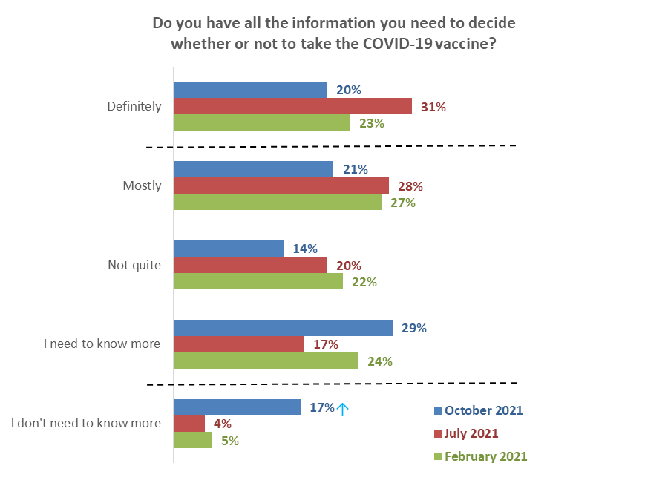
Potential information gaps
Oct 2021 64%
July 2021 65%
Feb 2021 73%
Base: not vaccinated Feb 2021 n=547, July 2021 n=415, October 2021 not vaccinated, not booked n=96.

Results for Māori in October 2021 compared with the general population in September 2021
A comparison with the results from the September 2021 general population COVID-19 vaccine survey indicates that Māori are generally in line with the overall population: they have much the same need for information as the population overall.

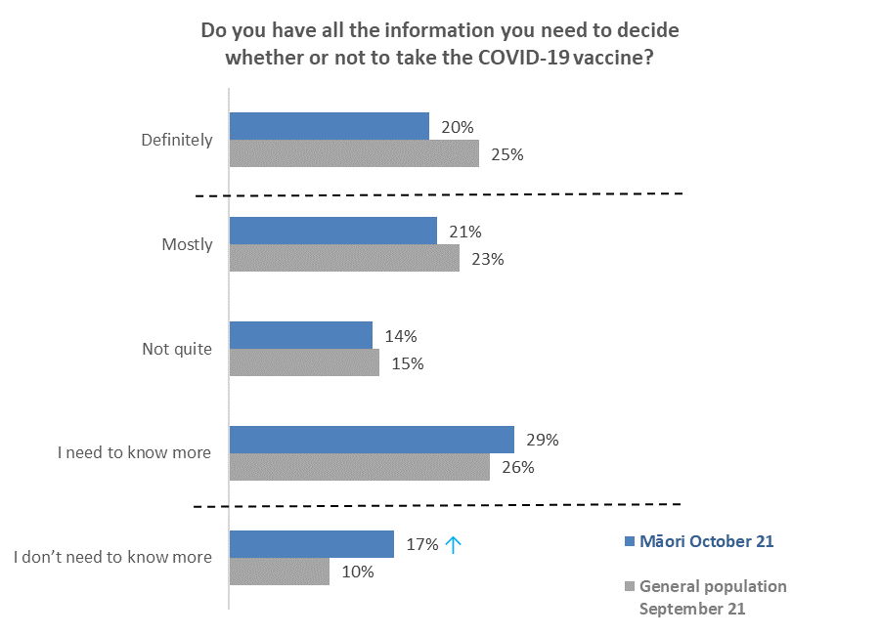
Potential information gaps
Māori Oct 2021 65%
General population
Sept 2021 64%
Base: General population September 2021 not vaccinated. n=414,
Māori Oct 2021(not vaccinated, not booked n=96.

3.3 What else do people need to know to help decide whether to get the COVID-19 vaccine?
An open-ended question asked what else people need to know to decide to get vaccinated. This question was asked of 61 people who had not been vaccinated, were not booked and who gave the following responses to the previous question: “I mostly have enough information to decide”, “Not quite enough information” and “I need to know more”. In total, 57 people answered this question.

The two main things unvaccinated Māori said they need to know are:
- Information on the long-term effects of the vaccine, based on longer and/or more clinical studies (27%).
- Information on the side effects and risks (15%).

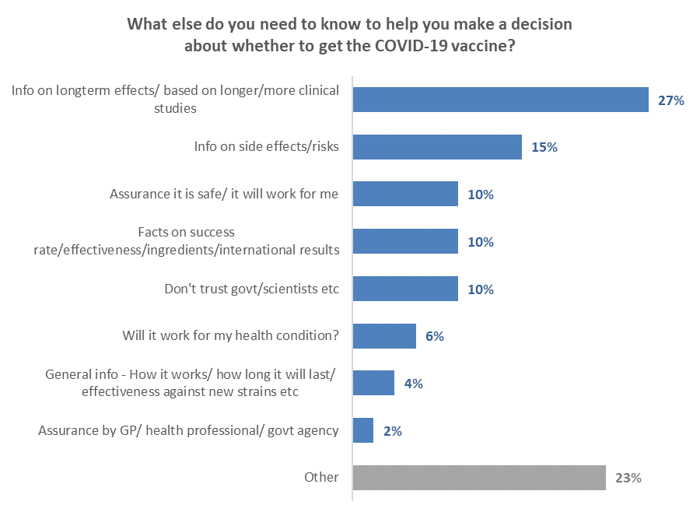
Base: not vaccinated, not booked, do not have enough information n=57
↑
↓
NB. The total adds to more than 100% as multiple responses were allowed.

Verbatim comments illustrating each type of information include:

Information on long-term effects/ based on longer/more clinical studies
Don’t know long term side effects possible, RNA vaccine is not safe enough in my opinion (Male Aged 25-34 years).
How effective the vaccine is remains to be seen. I would need more time to understand the efficacy and any long-term side effects (Female Aged 35-44 years).
The final results on safety and long-term effects which are missing as the trial doesn't officially finish until 2023 (Female Aged 35-44 years).
What long term effects it has on people? (Female Aged 35-44 years).
Information on side effects/risks
Effects on pregnant people and their unborn (Female Aged 25-34 years).
I need to see the effects (Male Aged 18-24 years).
I want to know of any and all side effects of near and distant future (Male Aged 25-34 years).
Side effects and how effective is it? (Male Aged 35-44 years).
Assurance it is safe/ it will work for me
Is it really safe? (Female Aged 35-44 years).
Whether it is safe (Female Aged 25-34 years).
Facts on success rate/effectiveness/ingredients/international results
All data from all countries esp. children/teenage data and pregnant women data (Male Aged 45-54 years).
I would like to know what’s in it (Female Aged 35-44 years).
What's actually in it and true statistics showing what the effects have been on people globally and nationally to date (Female Aged 45-54 years).
Don't trust government/scientists etc
I don’t believe politicians, scientists, pharmaceutical people are telling the truth (Female Aged 55-64 years).
Why are they pushing it when you can still get and spread the virus? (Female Aged 18-24 years).
The government needs to take a more educational approach rather than a coercive one, especially if all they claim is true - that it is necessary, safe and effective. Why would a government who has done all they can to educate people, about a necessary, safe and effective vaccine, need to then force vaccination on its population? (Female Aged 25-34 years).
I’m still unsure, I don’t really trust the government (Female Aged 35-44 years).
Will it work for my health condition?
I am disabled with peripheral neuropathy and had a bad reaction to a flu shot some years ago. No one can guarantee that this will not happen again if I receive the COVID-19 vaccination (Female Aged 75 years or over).
General info - How it works/ how long it will last/ effectiveness against new strains
Hearing other information about the Pfizer vaccine (Male Aged 55-64 years).
What kind of vaccine does my country have (Male Aged 18-24 years).
Assurance by GP/ health professional/ govt agency
I will talk to my doctor (Female Aged 35-44 years).
Other
Can the vaccine come to my door? (Male Aged 55-64 years).
How does one know what one doesn’t know? (Female Aged 45-54 years).
My gut feeling is to not have the vaccine but as a teacher I have to have it to keep working (Female Aged 65-74 years).
The vaccine is not as effective as we're led to believe. People will/are still getting COVID-19. (Female Aged 35-44 years).
This is not a vaccine and is still being trialled throughout the world. Not enough data (Male Aged 55-64 years).
I want to know why it is being pushed as the only option. Mandatory masks would also work and in my mind provide more protection than the vaccine against getting COVID (Female Aged 45-54 years).

3.4 Main barriers to getting vaccinated
The 73 not vaccinated and not booked respondents who said they were unsure, unlikely to get vaccinated, or would definitely not get vaccinated, were asked to choose their reasons from a list presented to them. Multiple choices were allowed.

The three main reasons are:

- It is too soon to see whether there are any long-term effects from the vaccine (56%)
- COVID-19 vaccines were developed too quickly/ not tested enough (48%)
- It won't stop me completely from getting COVID-19/ getting sick (44%).

The top twelve reasons in the following chart were selected by more than 20% of respondents:

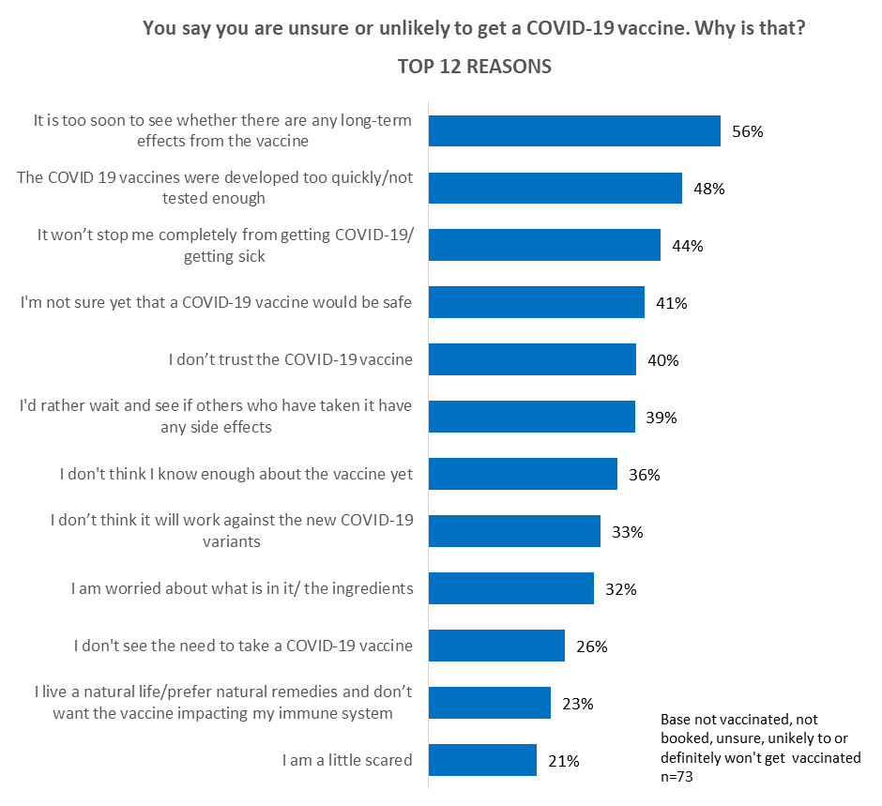

Other reasons selected were:
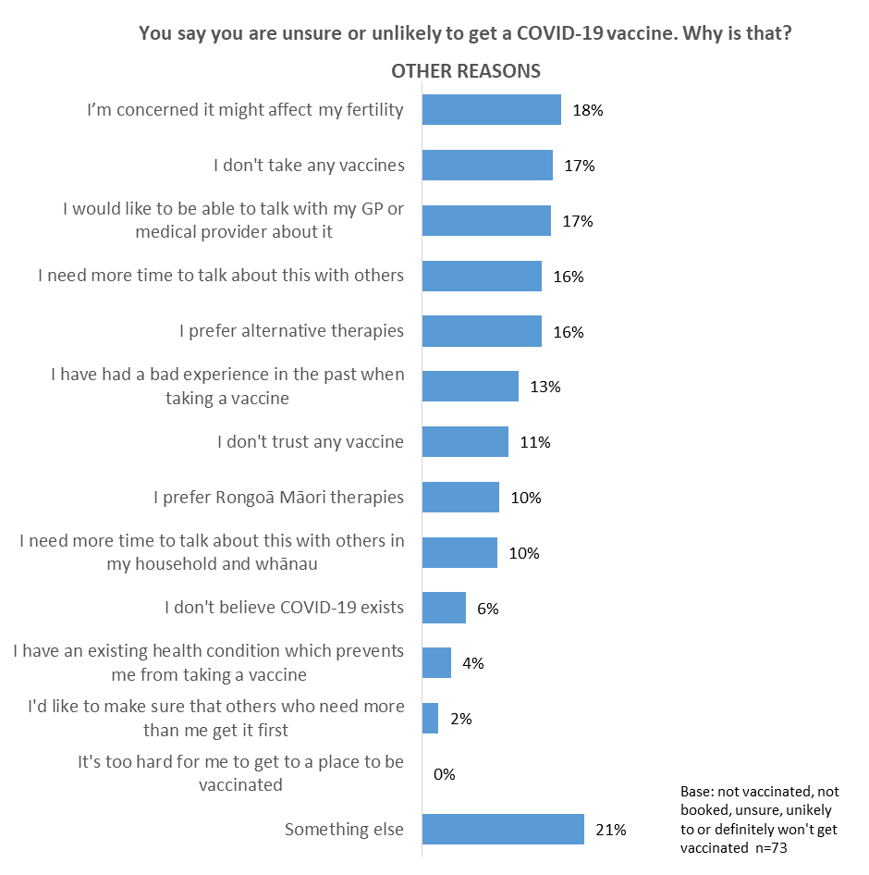
Note that no respondents said “It’s too hard for me to get to a place to be vaccinated”. The supplementary question, asking why that was, therefore had no responses.

Other concerns
The following verbatim quotations illustrate the concerns of the 15 people who selected ‘Something else’.

Worried about side effects
Varicose veins and vaccine blood clotting.
Currently pregnant and unsure of side effects.
I am concerned about the side effects e.g., myocarditis, stroke, blood clots, seizures, haemorrhage, anaphylaxis, death.

Impacts on my freedom
I have autonomy over my own body.
I don't think the consequences concerning my freedom to participate in public participation is just.
It’s just no jab, no job for free KFC and threats of freedom taken away.

Conspiracy theories
The whole COVID thing is a scam at best.
It’s all about POWER CONTROL.

Vaccine not proven
Is still undergoing trials.
Is experimental, trial finishes Jan 2023.

Fear
What if I am the one who dies?
A lot scared.

Cultural concerns
Wairua reasons.

Religious reasons
Being a Christian I trust that God will keep His promises to keep me safe.

Rejection
I will never get it.

3.5 Factors holding back the unvaccinated
Those who had not been vaccinated and were not booked to get a vaccine were asked to select factors which they felt were holding them back. Multiple selections were allowed.

While four out of ten respondents (40%) said that none of the things listed were holding them back, six out of ten selected at least one factor.

The top five all relate to being pressured and feeling anxious and overwhelmed:
- There's too much social pressure to get vaccinated (30%).
- I'm under enough pressure coping with everyday life to think about getting the vaccine (21%).
- I'm feeling overwhelmed by the pandemic (15%).
- I'm feeling too anxious about the pandemic and the vaccine (12%).
- I'm feeling paralysed because I haven't been able to find the information that I want on the vaccine (10%).
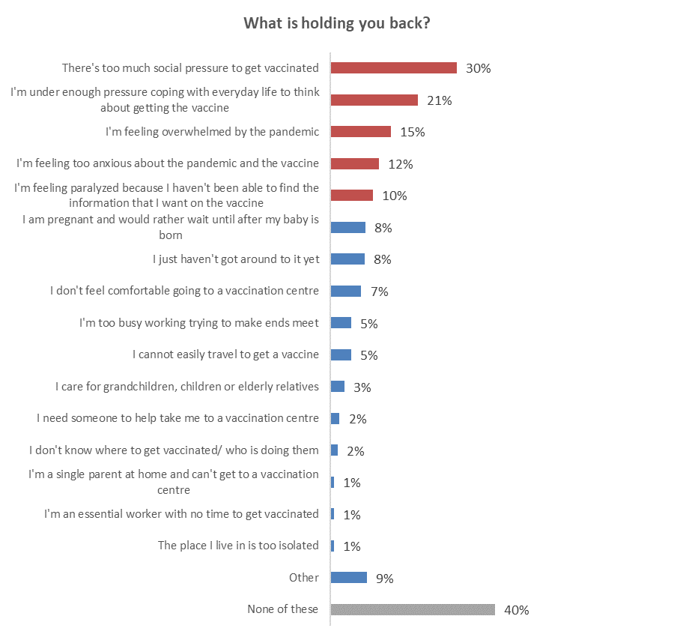
Emotive responses – feeling pressured and overwhelmed
Base: not vaccinated, not booked n= 95
The top 5 things holding back the various groups among the unvaccinated are (indicatively, because the bases are small):

- Likely to get vaccinated:
  - I just haven't got around to it yet (34%).
  - I cannot easily travel to get a vaccine (20%). This suggests that one in five of those likely to get a vaccine either need to have transport provided to a vaccination venue or need the vaccine brought to them. Indicatively, most of these people are in Northland.
  - I’m feeling overwhelmed by the pandemic (18%).
  - There’s too much social pressure to get vaccinated (16%).
  - I'm feeling too anxious about the pandemic and the vaccine (14%).

- Unsure whether to get a vaccine:
  - There’s too much social pressure to get vaccinated (49%).
  - I’m under enough pressure coping with everyday life to think about getting the vaccine (36%).
  - I'm feeling paralysed because I haven't been able to find the information that I want on the vaccine (18%).
  - I’m feeling overwhelmed by the pandemic (17%).
  - I'm feeling too anxious about the pandemic and the vaccine (16%).

- Unlikely to get vaccinated – these people have the same top 5 reasons as the unsure:
  - There’s too much social pressure to get vaccinated (43%).
  - I’m under enough pressure coping with everyday life to think about getting the vaccine (28%).
  - I'm feeling paralysed because I haven't been able to find the information that I want on the vaccine (19%).
  - I’m feeling overwhelmed by the pandemic (19%).
  - I'm feeling too anxious about the pandemic and the vaccine (13%).

- Definitely won’t get a vaccine (these percentages are much smaller because 63% of this group said that none of the options were holding them back):
  - There’s too much social pressure to get vaccinated (16%).
  - I’m under enough pressure coping with everyday life to think about getting the vaccine (11%).
  - I don't know where to get vaccinated/ who is doing them (6%).
  - I am pregnant and would rather wait until after my baby is born (6%).
  - I'm feeling too anxious about the pandemic and the vaccine (5%).

Profiles: “Too much social pressure”, “Under pressure coping with everyday life”, and “Feeling overwhelmed by the pandemic”
The following table shows demographic characteristics of those who said “There's too much social pressure to get vaccinated”, “I'm under enough pressure coping with everyday life to think about getting the vaccine” and “I'm feeling overwhelmed by the pandemic”. These were the only three answers for which there were sufficient respondents to be able to create indicative profiles. There is some commonality between these three groups.

DEMOGRAPHY | There's too much social pressure to get vaccinated | I'm under enough pressure coping with everyday life to think about getting the vaccine | I'm feeling overwhelmed by the pandemic
Gender | Average gender mix. | More male (59%) than average | More male (57%) than average
Age | 16% younger than average age | 31% younger than average age. 8 out of 10 are under 35 years of age. | 22% younger than average age: 7 out of 10 are under 35 years of age.
Household Income | 13% lower than average | 36% lower than average | 50% lower than average
Personal Income | 24% lower than average | 35% lower than average | 42% lower than average
Employment status | Average rate of employment | Slightly higher than average (70% employed) | Average rate of employment
Highest qualification | No particular educational qualification characteristics. | No particular educational qualification characteristics. | More likely to have higher than school level qualifications.
Household Type | Less likely than average to be in a couple-only household. | Less likely than average to be in a couple-only household. | Less likely than average to be in a two-parent household.
DHB | Less likely to be in Auckland; more likely to be in other Upper North Island DHB areas. | Less likely to be in Auckland; more likely to be in other Upper North Island DHB areas. | Less likely to be in Auckland; more likely to be in the South Island.
Area type | No particular are type characteristics. | No particular are type characteristics. | More likely than average to be in a city.
Not getting a vaccine because… | Too soon to see if there are any long-term effects from the vaccine (86%).  Rather wait and see (63%).  Not sure that a COVID-19 vaccine is safe (61%).  COVID_19 vaccine developed too quickly (58%).  It won’t stop me getting COVID-19/getting sick (53%).  Don’t trust the COVID-19 vaccine (36%).  Don’t see the need to get a COVID-19 vaccine (31%) | Too soon to see if there are any long-term effects from the vaccine (79%).  Rather wait and see (67%).  Not sure that a COVID-19 vaccine is safe (57%).  Don’t trust the COVID-19 vaccine (48%).  It won’t stop me getting COVID-19/getting sick (59%).  COVID_19 vaccine developed too quickly (39%).  Don’t trust the COVID-19 vaccine (48%).  Need more time to talk about it (47%) | Too soon to see if there are any long-term effects from the vaccine (73%).  Rather wait and see (73%).  Not sure that a COVID-19 vaccine is safe (60%).  Don’t trust the COVID-19 vaccine (69%).  It won’t stop me getting COVID-19/getting sick (67%).  COVID_19 vaccine developed too quickly (56%).  Don’t trust the COVID-19 vaccine (69%).  Don’t see the need to get a COVID-19 vaccine (41%)  Need more time to talk about it (36%)

ENCOURAGEMENT | There's too much social pressure to get vaccinated | I'm under enough pressure coping with everyday life to think about getting the vaccine | I'm feeling overwhelmed by the pandemic
Things that would make them more likely to get a COVID-19 vaccine. | Evidence the vaccine I am offered is unlikely to cause a serious adverse reaction (51%).  More information on possible side effects (45%).  Being able to choose a specific time when booking (38%). | Evidence the vaccine I am offered is unlikely to cause a serious adverse reaction (44%).  More information on possible side effects (48%).  Being able to choose a specific time when booking (44%). | Evidence the vaccine I am offered is unlikely to cause a serious adverse reaction (62%).  More information on possible side effects (53%).  Being able to choose a specific time when booking (50%).
Most prefer to get vaccinated at… | My doctor (general practitioner) (38%).  Māori health provider service (e.g., Whänau Ora) (15%). | My doctor (general practitioner) (47%).  Māori health provider service (e.g., Whänau Ora) (15%).  Pop up clinics at churches (13%).  At school with my tamariki (13%). | My doctor (general practitioner) (24%).  Māori health provider service (e.g., Whänau Ora) (19%).  Pop up clinics at churches (19%).  At school with my tamariki (17%).
Most encouraged to get a vaccine by… | $100 cash payment to everyone getting the vaccine (21%).  Supermarket vouchers (20%).  Vaccine certificate for overseas travel to see friends or family, or for a holiday (14%).  Vaccine certificate for funerals/ tangihanga (12%).  Vaccine certificate for family/ whanau gatherings (21%). | $100 cash payment to everyone getting the vaccine (36%).  $100 gift card voucher (30%).  Supermarket vouchers (20%).  Vaccine certificate for overseas travel to see friends or family, or for a holiday (15%).  Vaccine certificate for funerals/ tangihanga (21%).  Vaccine certificate for family/ whanau gatherings (23%).  Vaccine certificate for outdoor concerts (21%)  Vaccine certificate for weddings (14%) | $100 cash payment to everyone getting the vaccine (29%).  $100 gift card voucher (29%).  Supermarket vouchers (20%).  Vaccine certificate for overseas travel to see friends or family, or for a holiday (18%).  Vaccine certificate for funerals/ tangihanga (19%).  Vaccine certificate for family/ whanau gatherings (31%).  Vaccine certificate for outdoor concerts (21%)  Vaccine certificate for weddings (18%)

3.6 Positive motivators to get vaccinated
All those who had not yet been vaccinated were asked to select from a list of things that would make them more likely to take a COVID-19 vaccine when they are offered one.

Information is the most influential area, particularly about possible side effects of the vaccine, followed by conversations with experts and/or those with a te Ao Māori point of view.

Conversations with experts rank ahead of recommendations from a range of sources.

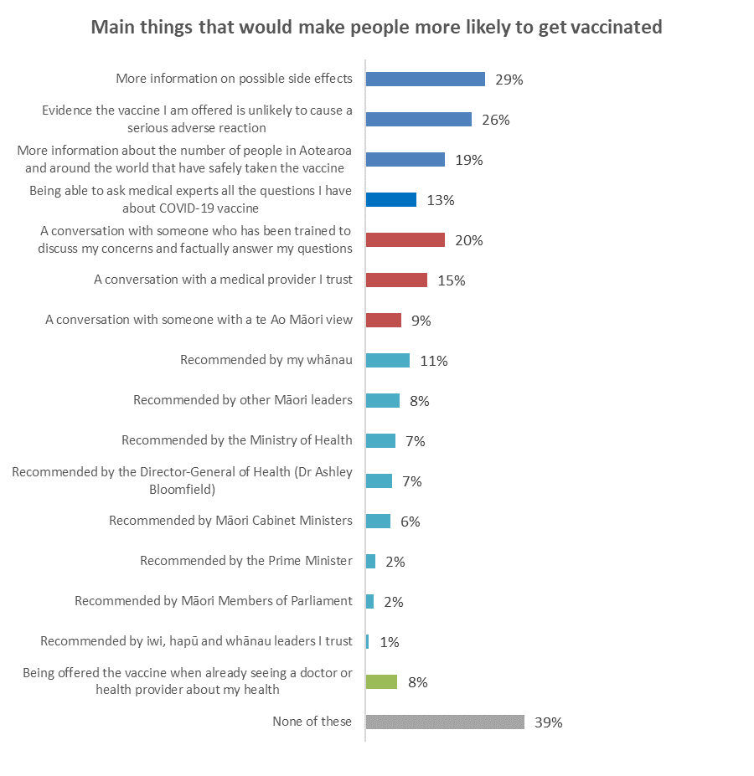
2.Conversations
3.Recommendations
4.Medical visit
Base not vaccinated: n=125

1.Information

Practical solutions to encourage vaccination
Respondents who were unvaccinated were asked which options, from a list, would make them more likely to get a COVID-19 vaccine.

There were differences between those who are currently likely to get a vaccine, those who are currently unlikely to get a vaccine and those who are unsure. The analysis indicates that the options listed would be more effective in encouraging/reinforcing their decision to get a vaccine among those who are currently likely (i.e., “Most likely” or “Likely”) to get a vaccine than in encouraging the Unsure or those who are unlikely to get a vaccine to actually get one.

- 67% of the unsure and 73% of those who are currently unlikely to get a vaccine would not be motivated by any of the options on the list.
- Those who were currently likely to get a vaccine would be more likely to respond to:
  - A financial incentive to cover their time to get a vaccine (19%).
  - Time off work to get a vaccine (18%).
  - Knowing that Medsafe has approved the vaccine for use in New Zealand (16%).
  - If their whānau (14%) or friends (13%) take it.
  - If vaccinators come to their home to give a COVID-19 vaccine to them (12%).
- Few of those who are currently unlikely to get a vaccine (this includes those who say they will definitely not get a vaccine) would respond to any of the options, the more prominent ones (5% or more) being:
  - If their friends take it (6%). Note that whānau taking it is less important to them (3%) than their friends taking it.
  - If their doctor or health provider sets up a clinic to give vaccines (6%).
  - If their church or spiritual advisor says it is OK to take it (5%).
- Only 6 of the options trigger a response from those who are currently unsure whether to get a vaccine or not:
  - A financial incentive to cover their time to get a vaccine (10%).
  - If their church or spiritual advisor says it is OK to take it (9%).
  - If their friends (7%) or whānau (5%) take it.
  - Knowing that Medsafe has approved the vaccine for use in New Zealand (7%).
  - If Māori leaders they trust take the vaccine (5%)

The following table gives indications of the practical solutions that may work effectively with the different groups among those who are not vaccinated. The solutions that may work more effectively are those which are above the average level - outlined in green. The options outlined in grey for those who say they will definitely not get a vaccine are not above average level but could have some effect.

Overall, what would make you more likely to get a COVID-19 vaccine when you have the chance to get one? | ALL | Not Vaccinated
 |  | Booked | Total  Likely | Total Unlikely | Definitely not | Unsure
A conversation with a medical provider I trust | 15% | 27% | 19% | 6% | 0% | 18%
A conversation with someone who has been trained to discuss my concerns and factually answer my questions | 20% | 32% | 10% | 26% | 5% | 18%
A conversation with someone with a Te Ao Māori view | 9% | 11% | 10% | 6% | 10% | 5%
More information on possible side effects | 29% | 21% | 28% | 40% | 18% | 46%
Evidence the vaccine I am offered is unlikely to cause a serious adverse reaction | 26% | 22% | 22% | 38% | 12% | 40%
Being able to ask medical experts all the questions I have about COVID-19 vaccine | 13% | 23% | 6% | 15% | 0% | 12%
Being offered the vaccine when already seeing a doctor or health provider about my health | 8% | 17% | 17% | 0% | 0% | 0%
More information about the number of people in Aotearoa and around the world that have safely taken the vaccine | 19% | 20% | 14% | 19% | 12% | 34%
Recommended by the Ministry of Health | 7% | 19% | 5% | 0% | 7% | 0%
Recommended by the Prime Minister | 2% | 9% | 0% | 0% | 0% | 0%
Recommended by Māori Cabinet Ministers | 6% | 19% | 0% | 6% | 0% | 0%
Recommended by Māori Members of Parliament | 2% | 7% | 0% | 0% | 0% | 0%
Recommended by the Director-General of Health (Dr Ashley Bloomfield) | 7% | 14% | 3% | 6% | 5% | 0%
Recommended by my whānau | 11% | 33% | 4% | 6% | 0% | 0%
Recommended by iwi, hapū and whānau leaders I trust | 1% | 0% | 0% | 0% | 0% | 5%
Recommended by other Māori leaders | 8% | 20% | 5% | 6% | 0% | 5%
None of these | 39% | 16% | 36% | 48% | 70% | 36%
N (unweighted) | 125 | 29 | 24 | 22 | 27 | 23

3.7 Timing to get vaccinated
Those who had not yet been vaccinated and not booked were shown the following introductory text:

“The Government is offering a COVID-19 vaccine to everyone in Aotearoa aged 12 or older.
You can be vaccinated at any time — there’s no cut-off.
A second dose of the vaccine will be offered three to six weeks after the first dose.
The vaccine is free.”

They were then asked when they would most like to get a COVID-19 vaccine this year.

Almost eight out of ten (79% in total) said they either won’t get vaccinated (42%) or are not sure when this will happen (37%). In July 17% of the unvaccinated group said they would not get vaccinated, compared with 42% in the October survey.

Only 11% in the October survey say they intend to get vaccinated this year.

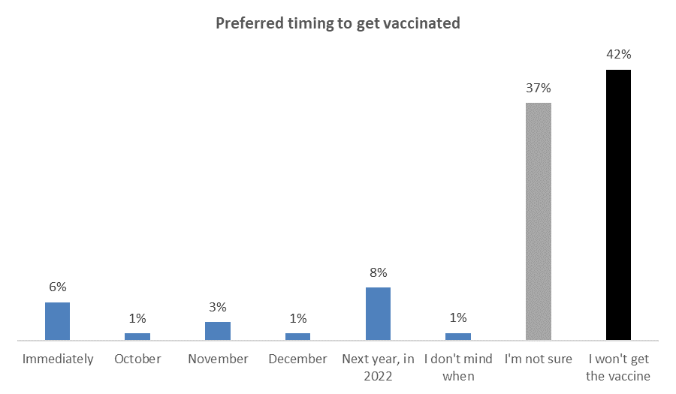
This year
Total 11%
Base: not vaccinated, not booked n=96

3.8 Preferred booking method
Unvaccinated people who were not booked to get a vaccine were asked to select their preferred booking method.

Almost half (47%) of this group said they do not intend to get vaccinated.

The three preferred methods are fairly equal:
- Using the My Vaccine site (14%).
- Booking directly at their local GP, pharmacy or hauora provider (13%).
- Going to a pop-up or walk-up venue (13%).

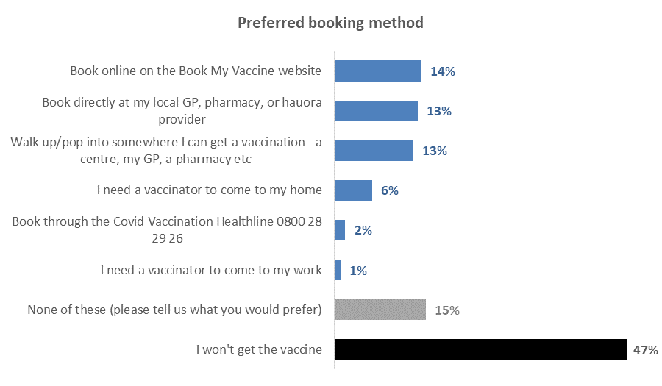
Base: not vaccinated and not booked n=96

Comments from the 14 people who selected ‘none of these methods’ included:
I need the info first.
I would prefer it wasn't experimental.
I will decide when I am comfortable. And it would be at my GP clinic, nowhere else whatsoever!
I would prefer not to, but will have to if forced to by law and restrictions.
I won't get it unless there is an effective control for source of infection.

3.9 Preferred booking choices
Those who were not vaccinated and not booked were asked how they would prefer to book.

Again, almost half (49%) say they won’t get vaccinated.

The top choices, mentioned by 15% or more, are the ability to choose:
- A specific time (20%)
- To change the booking (18%)
- A day of the week (15%)
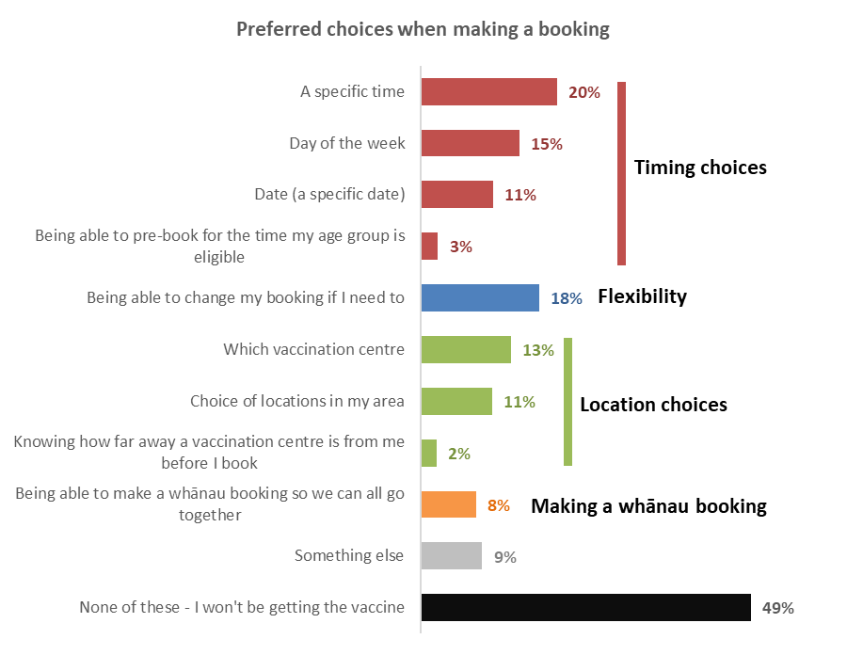
Base not vaccinated, not booked: n=96.

3.10 Preferred ways to access a COVID-19 vaccine
Those who were not vaccinated and not booked were shown a list and asked, ‘From which of these places and people would you most like to access a COVID-19 vaccine, if any?’

Just over half (51%) said they won’t get vaccinated. By far the most preferred option is my doctor (23%), followed by a Māori health provider service such as Whānau Ora (8%).

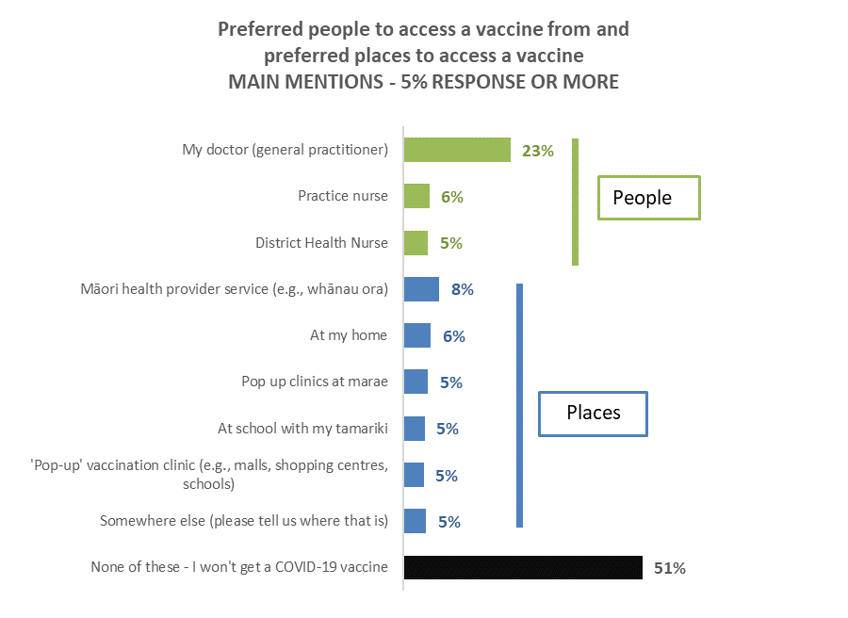
Other places to access a vaccine (with less than 5% of mentions)
A pharmacy | 4%
At my workplace | 4%
24-hour pop-up clinics (so I can go at a time which suits me best) | 4%
Hospital | 4%
Pop up clinics at churches | 4%
Mobile clinic (like the 'Shot Bro', 'Shot Cuzz' buses) | 3%
Kaupapa Māori Vax Now Centre | 3%
At a local school | 3%
When I am out at nightclubs or other hospitality venues | 3%
A local clinic which is more homely than a medical centre | 3%
Clinics at marae and other community sites | 2%
Retirement village/rest home | 1%
At sports clubs | 1%
Universities, Polytechnics or other tertiary education providers | 1%
Base not vaccinated, not booked: n=96
Places

3.11 Most comfortable places for friends and whānau to get vaccinated
Respondents who were already vaccinated, or were booked, were asked to choose, from a list of 21 people and places, where, if anywhere, they thought their friends and whānau would be most comfortable getting the COVID-19 vaccine.

The top three are:
- A doctor (53%)
- ‘Pop-up’ clinics (44%)
- A local homely clinic (42%).

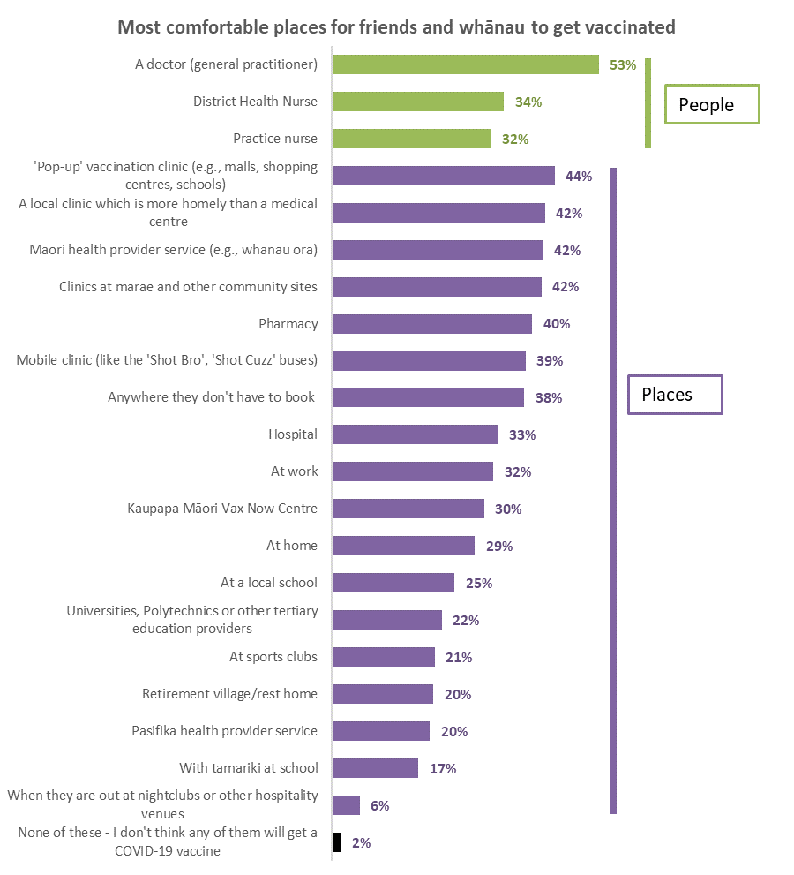
Base already vaccinated or booked: n=699

38% said that their friends or whānau would probably be most comfortable “Anywhere they don’t have to book”, suggesting this more spontaneous approach where they just turn up rather than having to go through a more formal process of having to book may be crucial to increasing Māori vaccination. Respondents who selected that option were asked to say where they thought their friends and whānau would be most comfortable getting a vaccine – as long as they didn’t have to book. The results show a marked difference from the overall results – differences of more than 20% are highlighted below.

From which of these places, if any, do you think your friends and whānau would be most comfortable getting the COVID-19 vaccine? | Overall | Anywhere they don't have to book | Difference
'Pop-up' vaccination clinic (e.g., malls, shopping centres, schools) | 44% | 68% | 23%
Clinics at marae and other community sites | 42% | 66% | 24%
A doctor (general practitioner) | 53% | 65% | 12%
Mobile clinic (like the 'Shot Bro', 'Shot Cuzz' buses) | 39% | 63% | 25%
Māori health provider service (e.g., Whānau Ora) | 42% | 62% | 20%
A local clinic which is more homely than a medical centre | 43% | 62% | 19%
Pharmacy | 40% | 54% | 14%
Kaupapa Māori Vax Now Centre | 30% | 52% | 22%
At work | 32% | 51% | 19%
Practice nurse | 32% | 45% | 13%
At home | 29% | 45% | 16%
District Health Nurse | 34% | 42% | 8%
At a local school | 25% | 41% | 16%
Universities, Polytechnics or other tertiary education providers | 22% | 40% | 18%
Hospital | 33% | 38% | 5%
Pasifika health provider service | 20% | 34% | 15%
At sports clubs | 21% | 33% | 12%
With tamariki at school | 17% | 32% | 15%
Retirement village/rest home | 20% | 32% | 12%
When they are out at nightclubs or other hospitality venues | 6% | 10% | 4%
None of these - I don't think any of them will get a COVID-19 vaccine | 2% | 0% | -2%
N (unweighted) | 698 | 312

3.12 With whom would Māori most like to get vaccinated?
Respondents who are not vaccinated, not “definitely not” getting a vaccine and were not booked were asked to select from a list their preferred ways to get a vaccine – by themselves or with others.
While 41% said “none of these”, there were three main preferences:
- Going by myself (18%).
- At the same time as other members of my whānau/ family regardless of age (18%).
- Walking into a vaccination place when I see one (14%).

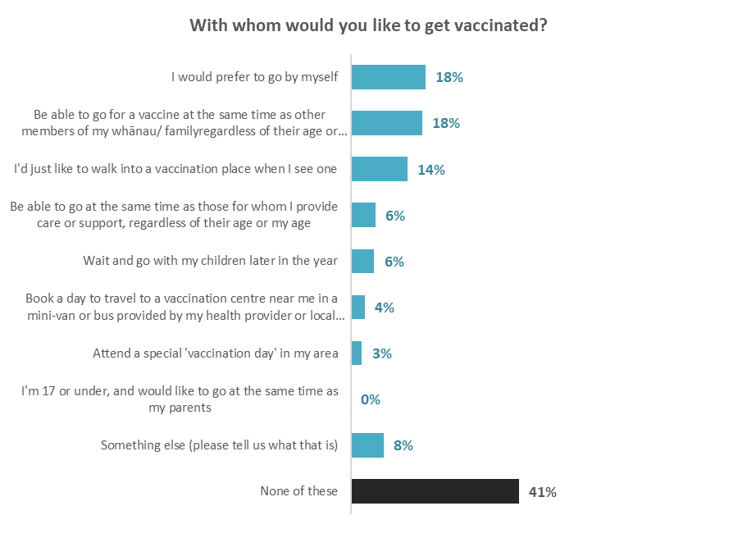
Base: not vaccinated, not “definitely not” getting a vaccine, not booked n=68

Importance of various groups being vaccinated to manage the pandemic in the future
Using a 6-point rating scale from ‘not important at all’ to ‘very important’, all survey participants were asked to rate the importance of seven groups of people getting vaccinated to help manage the pandemic.
The importance of getting vaccinated for each group is rated as very similar, with around seven out of ten people giving ratings of very important or important:

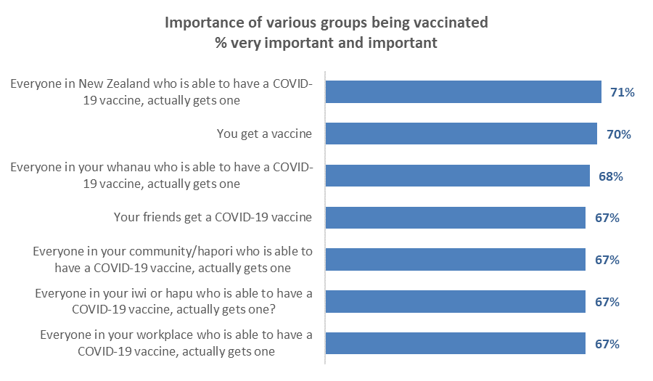

Average importance scores were calculated for each of the options, using the following points allocation (respondents who had not given a response were excluded from the overall calculation):
Very important: | 5
Important: | 4
Somewhat important: | 3
Somewhat unimportant: | 2
Not very important: | 1
Not important at all: | 0

All overall average importance scores were equivalent as shown in the following table.

Importance | Overall, how important do you think it is that:
 | You get a COVID-19 vaccine? | Everyone in your whānau who is able to have a COVID-19 vaccine, actually gets one? | Your friends get a COVID-19 vaccine? | Everyone in your commun-ity/ hapori who is able to have a COVID-19 vaccine, actually gets one? | Everyone in your iwi or hapū who is able to have a COVID-19 vaccine, actually gets one? | Everyone in your workplace who is able to have a COVID-19 vaccine, actually gets one? | Everyone in Aotearoa who is able to have a COVID-19 vaccine, actually gets one?
Very important | 53% | 52% | 50% | 51% | 51% | 50% | 52%
Important | 17% | 16% | 17% | 16% | 15% | 17% | 19%
Somewhat important | 11% | 13% | 12% | 12% | 13% | 12% | 10%
Somewhat unimportant | 5% | 7% | 7% | 8% | 7% | 6% | 6%
Not very important | 4% | 4% | 7% | 5% | 5% | 6% | 4%
Not important at all | 9% | 8% | 7% | 9% | 9% | 8% | 9%
TOTAL IMPORTANT | 81% | 81% | 79% | 79% | 79% | 79% | 81%
TOTAL NOT IMPORTANT | 18% | 19% | 21% | 22% | 21% | 20% | 19%
AVERAGE IMPORTANCE - SCORE OUT OF 5 | 3.7 | 3.8 | 3.7 | 3.7 | 3.7 | 3.7 | 3.7
N (unweighted) - All respondents | 617 | 617 | 617 | 617 | 617 | 617 | 617

Rating of the importance of any of these groups being vaccinated were much lower than the overall results for:
- Respondents who were unsure whether to get a vaccine: average importance ratings of 2.4 out of 10.
- Respondents who said they were unlikely to get a vaccine: average importance ratings of 1.6 out of 10.
- Respondents who said they would definitely not get a vaccine: average importance ratings of 0.5 out of 10.

An average of 5% of those who may not want to get vaccinated themselves think it is important for others to do so.

Which demographic groups are more and less likely to find these factors are important?
Across the full sample, the average importance rating for the seven factors is 68% very important or important. The table below shows groups with an appreciably higher or lower average importance rating.

People who are from the Waikato, disabled, unemployed, or labourer/ agricultural or domestic workers are less likely than average to think getting vaccinated is important.

Demographic groups | Average very important and important ratings for seven factors
Retired/ superannuitant | 89%↑
Teachers/ nurses/ police or other trained service worker | 81%↑
Professionals /senior government officials | 80%↑
From Otago | 79%↑
Couple with no children at home | 78%↑
From Wellington (urban areas) | 78%↑
With a postgraduate degree (Masters or PhD) | 75%↑
Have impairments or long-term health conditions | 75%↑
Total | 68%
From the Waikato | 63%↓
Disabled | 63%↓
Unemployed | 61%↓
Labourer/ agricultural or domestic workers | 53%↓
NB. Only groups with at least n=50 people are included above

Impacts on intention to get a vaccine
Unvaccinated respondents who were not booked were asked what impact getting vaccinated at the same time as other whānau/family members; incentives, or vaccine certificates would have on their decision to get vaccinated.

5.1 Getting vaccinated at the same time as other whānau/family members
Respondents being able to get vaccinated at the same time as their family, children, or those they support does not motivate any of the “unlikely” to get vaccinated. Its greatest impact tis on Māori who will “Most likely” or “Likely” get vaccinated (6% further encouraged) and those who are unsure. For most of the unvaccinated, vaccination without their family doesn’t make a big difference to their decision.

21% of not vaccinated, not booked respondents said the ability to get a vaccine with their family is likely to influence them, but 60% of respondents said that being able to get a COVID-19 vaccine at the same time as their whānau/family would not encourage them to get vaccinated. 19% were unsure.
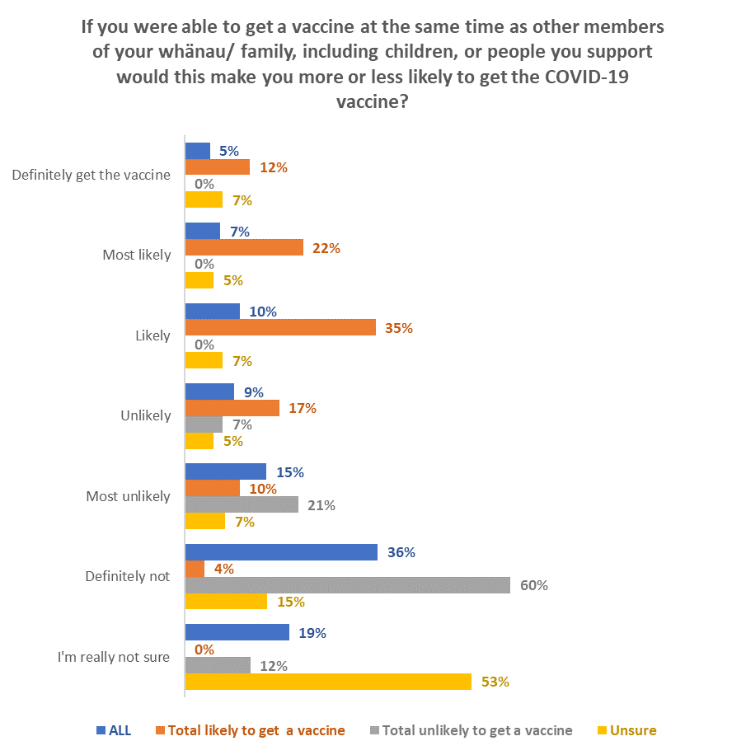
LIKELY
to have an impact:
Overall: 21%
Total “Likely”: 69%
Total “Unlikely”: 0%
Unsure: 19%
UNLIKELY
TO HAVE AN IMPACT
Overall: 60%
Total “Likely”: 31%
Total “Unlikely”: 88%
Unsure: 28%
Base: unvaccinated, not booked n=96

Being able to go at the same time as whanau/ family is likely to encourage an additional 7,700 Māori aged 18+ to get vaccinated and may encourage 28,900 to accelerate their vaccination timing :

Able to get a vaccine at the same time as whānau/family | Incremental gain
 | % 18+ Māori popn | Estimated No. Māori
Further encourage the "Likely" to get a vaccine | 6% | 28,900
Encourage the "Unlikely" to get a vaccine | 0% | 0
Encourage the "Unsure" to get a vaccine | 2% | 7,700

Males are more likely to say that being vaccinated with their family will NOT make a difference (63% and females 57%).

Around 60% of unvaccinated Māori in the Auckland Metro area are unlikely to respond to getting vaccinated with their whānau/family.

5.2 Incentives
Respondents who had not been vaccinated and were not booked were asked ‘Which of the following incentives, if any, would make you definitely decide to get the COVID-19 vaccine?’

59% of respondents said that no incentive would encourage them to get vaccinated.

$100 cash payment (19%), $100 gift card vouchers (18%), and supermarket vouchers (15%) were the most popular incentives and, for Māori, are likely to encourage more of those who are unsure, or unlikely to get a vaccine, to actually get one. In addition, these incentives appear likely to accelerate vaccination among those Māori who currently say they are “Most likely” or “Likely” to get a vaccine.
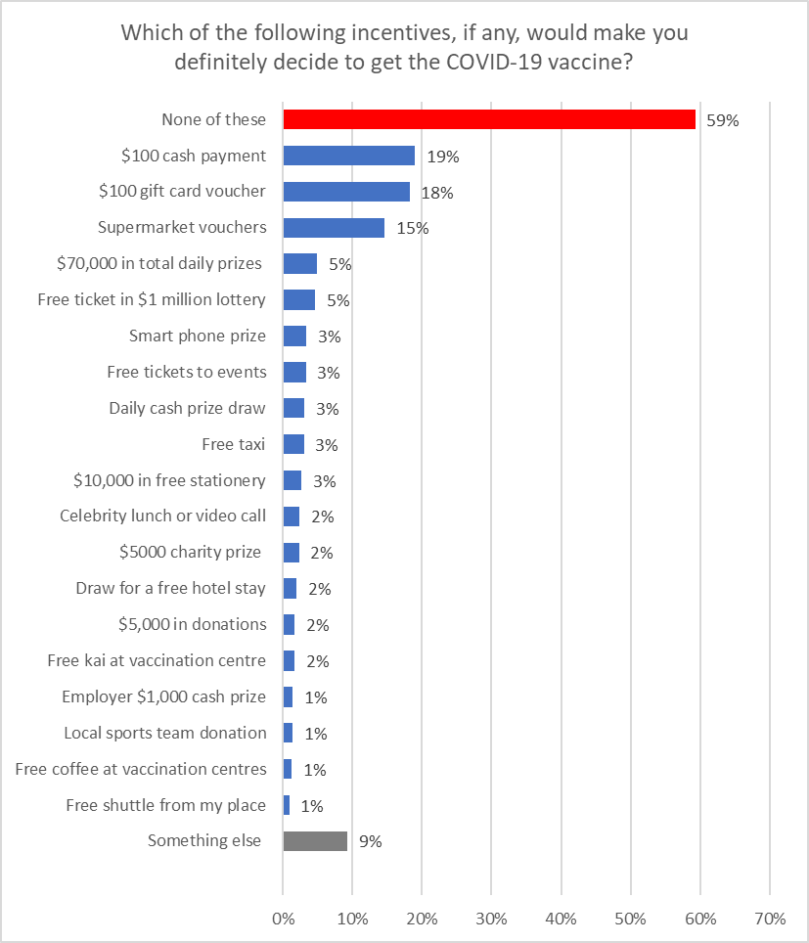
Base: unvaccinated, not booked n=96

Females are less motivated by incentives than males (66% say “none of these” compared with 51% for males).

The older someone is, the less likely they are to say that an incentive will influence them (the sample size is small for each age group, but the trend seems clear).

Which incentives, if any, are the most likely to make you decide to get the COVID-19 vaccine? | AGE GROUP
 | 18-24 years | 25-34 years | 35-44 years | 45-54 years | 55-64 years | 65-74 years | 75 years or over
None of these | 46% | 61% | 43% | 74% | 85% | 100% | 100%

Indications are that the potential gains from incentives among Māori adults are:

Incentive | Likely to get a vaccine but not definite |  | Unlikely to/definitely won’t get a vaccine |  | Unsure
 | Incremental shift to "Definite" |  | Incremental gain |  | Incremental gain
 | %  18+ Māori popn | Estimated no. Māori | %  18+ Māori popn | Estimated no. Māori | %  18+ Māori popn | Estimated no. Māori
$100 cash payment to everyone getting the vaccine | 2.7% | 13,300 | 2.2% | 10,700 | 1.8% | 8,600
$100 gift card voucher | 3.0% | 14,600 | 2.2% | 10,500 | 1.2% | 6,100
Supermarket vouchers | 2.5% | 12,000 | 0.6% | 2,800 | 2.1% | 10,000
$70,000 in total daily prizes at a drive through vaccination centre | 0.8% | 3,900 | 0.9% | 4,300 | 0.0% | 0
Free ticket in $1 million lottery | 1.1% | 5,200 | 0.5% | 2,200 | 0.0% | 0
Smart phone prize | 0.3% | 1,400 | 0.9% | 4,200 | 0.0% | 0
Free tickets to festivals and other events | 0.6% | 2,800 | 0.6% | 2,800 | 0.0% | 0
Daily cash prize draw by the vaccination centre I go to | 1.1% | 5,300 | 0.0% | 0 | 0.0% | 0
Free taxi | 0.6% | 2,700 | 0.4% | 2,100 | 0.0% | 0
$10,000 in free stationery for a school which gets the most votes at a vaccination centre | 0.0% | 0 | 0.5% | 2,200 | 0.4% | 2,200
Lunch or video call with a sports player or celebrity | 0.4% | 1,700 | 0.4% | 2,100 | 0.0% | 0
$5000 prize given to a local charity you choose | 0.8% | 3,700 | 0.0% | 0 | 0.0% | 0
Draw for a free hotel stay | 0.4% | 1,700 | 0.0% | 0 | 0.3% | 1,400
$5,000 in donations to schools you choose | 0.6% | 2,800 | 0.0% | 0 | 0.0% | 0
Free kai at vaccination centres | 0.6% | 2,800 | 0.0% | 0 | 0.0% | 0
Free coffee at vaccination centres | 0.0% | 0 | 0.4% | 2,100 | 0.0% | 0
Donation to a local sports team for every dose given in your area | 0.0% | 0 | 0.5% | 2,200 | 0.0% | 0
$1,000 cash prize draw by my employer | 0.0% | 0 | 0.5% | 2,200 | 0.0% | 0
Free shuttle from my place | 0.3% | 1,500 | 0.0% | 0 | 0.0% | 0

5.3 Vaccine certificate to attend events
Overall, the need to have a vaccination certificate to attend high-risk events could encourage another 3,600 Māori aged 18+ to get vaccinated and accelerate the vaccination timing of 33,800.

Unvaccinated respondents (booked and not booked) were asked if they would get vaccinated so they could get a certificate to attend events (places where there is a high risk of being infected with COVID-19).

53% of respondents either reject vaccination (33%) or are unlikely to get vaccinated (20%) even if they cannot attend events:

33% will get vaccinated to be able to attend events (these are nearly all from those who are currently likely to get a vaccine) and 15% are unsure.

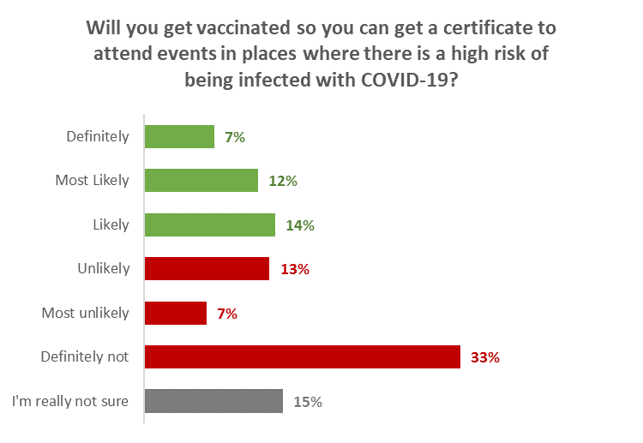
Unlikely
53%
Likely
33%
Base: All unvaccinated (booked and not booked), n=125.

The impact in terms of the whole 18+ Māori population is estimated as follows:

Will you get vaccinated so you can get a certificate to attend events in places where there is a high risk of being infected with COVID-19? | Incremental gain
 | % of 18+ Māori popn | Estimated No. Māori
Further encourage the "Likely" to get a vaccine | 7% | 33,800
Encourage the "Unlikely" to get a vaccine | 0% | 1,500
Encourage the "Unsure" to get a vaccine | 0% | 2,100

5.4 Timing of vaccination to get a vaccine certificate
All unvaccinated respondents were next asked when they would be likely to get a COVID-19 vaccine in order to get a vaccine certificate.

18% said they would get vaccinated by the end of November. Over half of respondents say that they are unsure when they will get a vaccine (35%) or that they will not get vaccinated (30%).

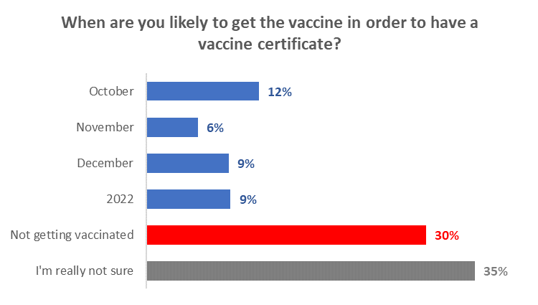
18% by end of November
Base: all not vaccinated (booked and not booked) n=125

Females are more likely to say they’re not really sure (40% compared with 30% for males) and also slightly more likely to say they won’t get it (31% compared with 27% for males).

The older the unvaccinated respondent, the surer they were about not getting vaccinated.

 | AGE GROUP
 | 18-24 years | 25-34 years | 35-44 years | 45-54 years | 55-64 years | 65-74 years | 75 years or over
Not getting vaccinated | 20% | 19% | 35% | 29% | 57% | 62% | 100%
I’m not really sure | 42% | 35% | 46% | 28% | 4% | 26% | 0%

5.5 Activities/events that would drive vaccination
All unvaccinated respondents were asked whether they would get vaccinated in order to get a vaccination certificate to do a list of activities or attend events.

Almost half of respondents (47%) say that they don’t care where they cannot go, they will not get vaccinated. 20% of respondents said that they would get vaccinated anyway.

Family related activities (gatherings 19%, funerals 14%) have the highest influence. The influence is higher among those who are already likely to get a vaccine.
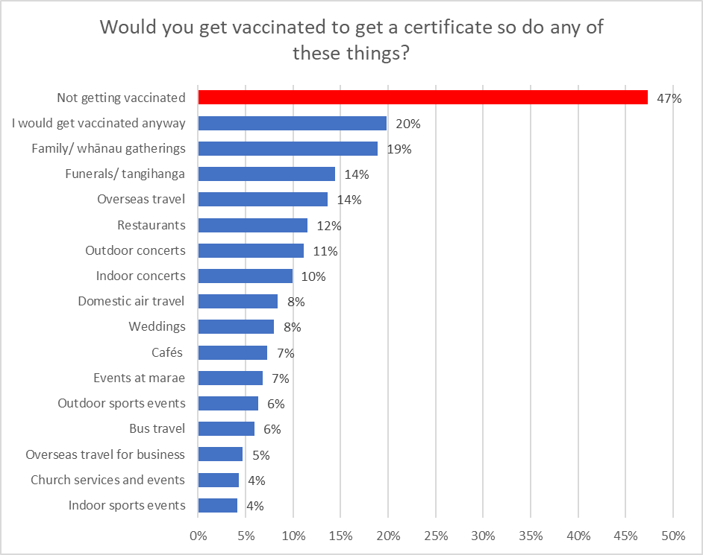
Base: not vaccinated (booked and not booked) n=120.

Females are more likely to not care where they cannot go and will not get vaccinated (51% compared with males at 42%).

Again, the older the unvaccinated respondent, the surer they are about not getting vaccinated.

 | AGE GROUP
 | 18-24 years | 25-34 years | 35-44 years | 45-54 years | 55-64 years | 65-74 years | 75 years or over
Not getting vaccinated | 41% | 34% | 54% | 48% | 72% | 72% | 100%

Requiring vaccine certificates for overseas air travel is likely to drive more of those who are currently unlikely to get a vaccine to actually get one.

Vaccination by the currently unsure will be maximised by requiring vaccine certificates for domestic air travel plus overseas private travel plus family events such as funerals/tangihanga, family/whānau gatherings and weddings.

This combination will also maximise vaccination of those who are likely to get a vaccine but are not yet definite; however, the ability to use a vaccine certificate to attend outdoor concerts is the major single attraction for this group.

Indications are that the potential gains from activity/event restrictions are as follow:

Being able to go to these places, or travel in this way | Likely to get a vaccine but not definite |  | Unlikely to/definitely won’t get a vaccine |  | Unsure
 | Incremental shift to "Definite" |  | Incremental gain |  | Incremental gain
 | %  16+ popn | Estimated number | %  16+ popn | Estimated number | %  16+ popn | Estimated number
Bus travel | 0.4% | 1,800 | 0.6% | 2,700 | 0.0% | 0
Domestic air travel | 0.0% | 0 | 0.6% | 3,000 | 0.4% | 1,800
Overseas private travel to see friends or family, or for a holiday | 1.5% | 7,400 | 1.1% | 5,200 | 1.1% | 5,500
Nett Domestic air travel or overseas travel | 1.5% | 7,400 | 1.1% | 5,200 | 1.1% | 5,600
Overseas business | 0.0% | 0 | 0.9% | 4,400 | 0.0% | 0
Nett overseas private or business travel | 1.5% | 7,400 | 1.5% | 7,300 | 1.1% | 5,600
Nett Domestic air travel, overseas travel or overseas travel for business | 1.5% | 7,400 | 1.5% | 7,300 | 1.1% | 5,600
Cafés | 0.0% | 0 | 0.6% | 3,000 | 0.4% | 2,200
Restaurants | 1.2% | 5,600 | 0.6% | 3,000 | 0.8% | 4,000
Nett Cafés and Restaurants | 1.2% | 5,600 | 0.6% | 3,000 | 0.8% | 4,000
Nett Domestic air travel or overseas travel PLUS Cafés and Restaurants | 3.3% | 16,000 | 1.5% | 7,300 | 1.6% | 7,700
Indoor concerts | 0.7% | 3,300 | 0.4% | 2,100 | 0.8% | 4,000
Outdoor concerts | 2.1% | 10,100 | 0.6% | 3,000 | 0.8% | 4,000
Nett Concerts | 2.1% | 10,100 | 1.1% | 5,100 | 0.8% | 4,000
Nett Domestic air travel or overseas travel PLUS Concerts | 3.3% | 16,000 | 1.5% | 7,300 | 1.6% | 7,700
Indoor sports events | 0.7% | 3,500 | 0.0% | 0 | 0.0% | 0
Outdoor sports events | 0.4% | 1,800 | 0.0% | 0 | 0.5% | 2,200
Nett Sports Events | 0.7% | 3,500 | 0.0% | 0 | 0.4% | 2,200
Funerals/ tangihanga | 2.1% | 10,300 | 0.6% | 3,000 | 1.1% | 5,400
Family/ whānau gatherings | 2.1% | 10,000 | 0.9% | 4,500 | 1.7% | 8,300
Weddings | 1.0% | 4,700 | 0.6% | 3,000 | 0.8% | 4,000
Nett Funerals/Family gatherings/Weddings | 2.8% | 13,800 | 0.9% | 4,500 | 1.7% | 8,300
Nett Domestic air travel or overseas private travel PLUS Funerals/Family gatherings/Weddings | 3.8% | 18,300 | 1.4% | 6,700 | 2.2% | 10,600
Church services and events | 0.0% | 0 | 0.0% | 0 | 0.0% | 0
Events of more than 50 to 100 people at marae | 1.0% | 4,700 | 0.6% | 3,000 | 0.5% | 2,200

Māori health provider
Just over half of Māori (55%) know there is a Māori health provider in their area, although 36% are not sure.
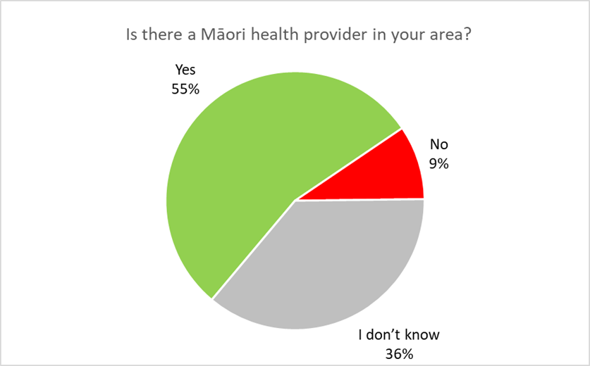
Base: All respondents n=795

Females have higher knowledge than males (59% and 50% for males) which may be related to the higher proportion of females who are caregivers for children.

Those under 25 years have lower knowledge (only 32% say “yes”) and they have the highest “I don’t know” at 46%. “I don’t know” decreases by age (42% under the age of 45, 26% above).

This is mostly related to the presence of children in the household.

Those who identify as disabled are more likely to know there is one (63% compared to 54% who don’t) as do those who live with impairments or long-term health conditions (61% and 51% for those who don’t).

Canterbury, Wellington and Auckland have higher “I don’t know” responses (49%, 42% and 43%) respectively.

32% of those that know that there is a Māori health provider in their area go to it for their primary health care. A nett 40% of those who use a Māori health provider in their area for their primary healthcare say they would be comfortable getting a COVID-19 vaccine there (i.e., they chose either “My doctor (general practitioner)” or “Māori health provider service”).

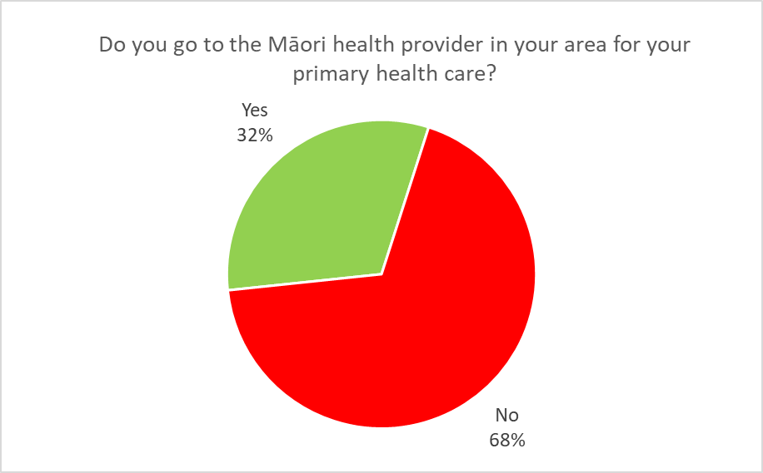
Base: go to Māori health provider in local area for primary health care n=469

Males are more likely to go to a Māori health provider (40% compared to females 25%), as are people who identify as disabled (46% and 30% for those not) and Aucklanders (48% and 29% outside Auckland).

By combining the two questions, 17% of the Māori population goes to a Māori health provider, 37% know there is one in their area but don’t go, 36% don’t know, and 10% say there isn’t one in their area.

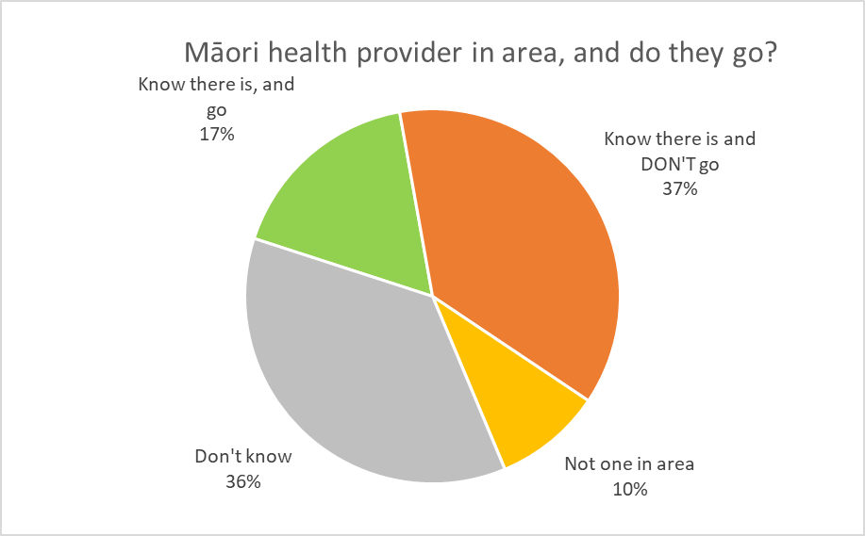
Base: go to Māori health provider in local area for primary health care n=469

Attitudes to children aged 12 to 17 being vaccinated

7.1 Allowing the tamariki/taiohi to get the COVID-19 vaccine
All respondents were asked if they were a parent or caregiver for young people aged 5-11 years, 12-15 years or 16-17 years.

28% said they were a parent or caregiver for 5-11-year-olds, 18% a parent or caregiver for 12–15-year-olds and 9% a parent or caregiver for 16–17-year-olds. The average number of young people aged 12-17 years per caregiver was 1.79.

Each of these caregiver groups were asked if they would allow their young people to get the vaccine.

Overall, it is estimated that caregivers would allow 60,760 young people aged 12-17 (70.5% of the estimated total number of Māori aged 12-17 years) to get a COVID-19 vaccine.
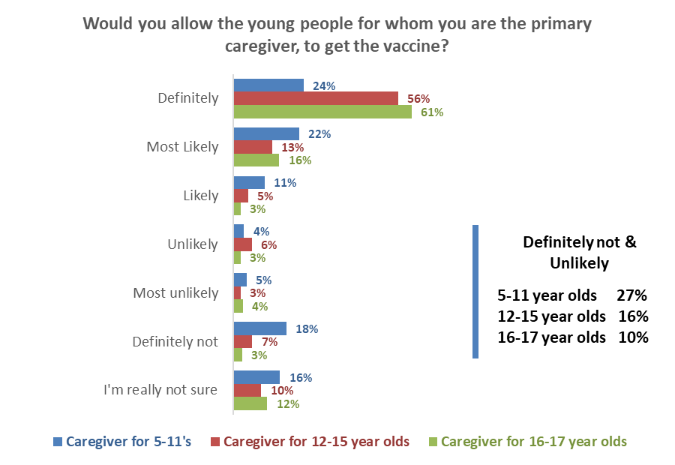
Definitely & Likely
5–11 year olds 57%
12-15 year olds 75%
16–17 year olds 79%

N.B. Numbers shown may not add to totals shown or 100% owing to rounding
Bases: Caregivers of children aged 5 to 112 years: n= 175
Caregivers of children aged 12 to 15 years: n=130
Caregivers of children aged 16 to 17 years: n=75

If a COVID-19 vaccine becomes available for use with 5–11-year-olds, is it estimated that caregivers will allow 65,000 5–11-year-olds (56% of the estimated total of Māori aged 5-11 years) to get a COVID-19 vaccine.

The intention to allow COVID-19 vaccinations for 5–11-year-olds is:
- Higher for males (72%) than females (45%).
- Higher for those in paid employment (60% compared to 48% for those not), although this may be gender-related.
- Higher for those 35 to 44 years old (59%) compared to those 25 to 34 years old (51%).
- More likely for those in large cities (67%) compared to those not (48%) although this may be an Auckland effect, as caregivers in Auckland are more likely (77% likely).

The intention to allow COVID-19 vaccinations for 12-15-year-olds is:
- Slightly higher for males than females (77% and 72% for females) which may echo the extra concern females have over the safety of the vaccine.
- More likely for those currently in paid employment (84% versus 64% for those not in paid employment).
- There is some evidence that higher education makes people more likely (88% for people with some tertiary education, and 69% for those not.)
- Higher for those in cities (85%) compared with those living outside cities (61%).

The intention to allow COVID-19 vaccinations for 16-17-year-olds is also higher for males (85%) than females (74%). Further sub-group analysis results in sample sizes being too small.

7.2 Reasons for being unsure or unlikely to encourage COVID-19 vaccination for younger people
Parents/caregivers of younger people who said they were unsure or unlikely to encourage these children to be vaccinated were asked to select their reasons for this from a list.

As In July, concern about safety for their tamariki and the long-term effects of the vaccine were predominant: 51% safety in general; 45% concerned about the long-term effects.

Owing to the low sample size of subgroups, it is difficult to determine significant differences but Indications are that:
- In general, safety is more of a concern for females than males: “I would need to be assured about its safety for tamariki” (55% versus 44% for males) and “it is too soon to see whether there are any long-term effects for tamariki from the vaccine” (52% versus 32% for males).
- Those who are unsure about allowing their 5–11-year-olds or 12–15-year-olds are more concerned about safety than those who say they would not allow their tamariki to be vaccinated.
- Those who will not allow their 5–11-year-olds or 12–15-year-olds to be vaccinated are more likely than average to say that they don’t trust any vaccine. Those who are unsure whether to allow vaccination for their tamariki – of any age group – have a significantly lower incidence of this.
- Caregivers of 16–17-year-olds were more likely to say they did not trust any vaccine and did not take any vaccines themselves.

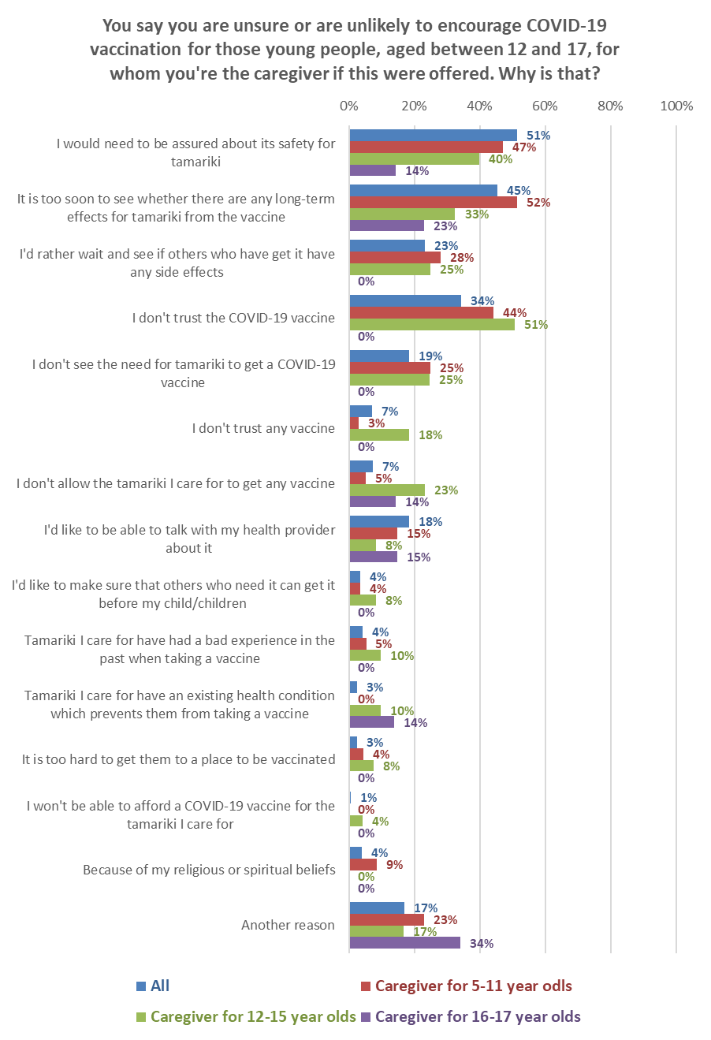
6.Other
4.Prior experience or conditions
4.Concern for others
3.Personal conversation
2.Generally anti-vaccine
1.Safety and effects of the vaccine
N.B: Small bases, results are indicative only.
Bases: All n=79. Caregivers for:5-11-year-olds, 58; 12–15-year-olds n=23; 16–17-year-olds n=12.
Multiple answers were allowed

Other reasons given were:

There is absolutely no health reason to, and many health reasons not to.
Kids are not dying from COVID.

It's something for OUR family to discuss, not for government to decide.

It's their choice.

It's his choice.

I'm not going to force my son to make a decision he doesn't want to make.

Because my grandson’s mother goes out to sea and I will wait till I get the OK from her, or leave it up to her to make that decision.

At this stage they don’t need or want it. I won’t be pushing it in them.

When they are old enough to make an informed decision, they can do it and make that decision for themselves.

I feel that if all who are 12 and up get vaccinated then there should be no need for u12s to have it.

Not really tested.

I believe obtaining the antibodies to fight the disease naturally should be a recognizable form of treatment.

My child has a severe aversion to needles.

The risk for kids from COVID is miniscule; we should not be putting our tamariki in harm’s way "for the greater good"!!!

Information about the COVID-19 vaccine

8.1 Trusted media sources to deliver information on COVID-19 vaccines to Māori
All respondents were asked to select (from a list) which media sources they trust to deliver information on COVID-19 vaccines to Māori.

The leading sources trusted to deliver information on COVID-19 vaccines to Māori were: TVNZ (77%), New Zealand mainstream online news services (76%), Ministry of Health: health.govt.nz (74%), Māori Television (64%) and Radio New Zealand (59%).

Media source | All  respondents | Unvaccinated respondents
TVNZ (Television One or Two) (including Te Karere) | 77% | 68%
New Zealand mainstream online news services (examples NZ Herald, Stuff) | 76% | 61%
Ministry of Health: health.govt.nz | 74% | 64%
Māori Television (including Te Ao, Tapatahi) | 64% | 45%
Radio New Zealand | 59% | 42%
THREE (including The Hui) | 55% | 42%
Unite against COVID-19 website: COVID-19.govt.nz | 54% | 31%
Iwi radio stations | 50% | 40%
NZ commercial radio stations | 49% | 50%
Daily NZ newspapers (e.g., NZ Herald, Waikato Times, Dominion Post, Otago Daily Times, The Press) | 48% | 39%
Facebook | 47% | 50%
Closed online groups for whānau, iwi, hapū, hapori/community or Te Ao Māori groups (on Facebook or other platforms) | 46% | 36%
Other Māori radio stations | 44% | 32%
Iwi websites | 42% | 32%
NZ community papers | 41% | 34%
Karawhiua (a new website and campaign with trusted information for Māori - developed by Te Puni Kōkiri) | 40% | 25%
World Health Organisation website | 34% | 28%
YouTube | 33% | 42%
Community websites | 30% | 27%
Instagram | 29% | 41%
International online news services (BBC, Guardian, CNN) | 26% | 31%
TikTok | 22% | 28%
Overseas television channels (Aljazeera, CNN, BBC) | 19% | 31%
Podcasts | 16% | 19%
Web - international | 15% | 23%
Twitter | 14% | 15%
Blogs | 12% | 11%
WeChat | 7% | 10%

The top 5 for the unvaccinated were TVNZ (68%); Ministry of Health: health.govt.nz (64%); New Zealand mainstream online news services (61%); Facebook (50%); and NZ commercial radio stations (50%). Māori Television is in 6th place, on 45%.

8.2 Trusted people to deliver information on COVID-19 vaccines to Māori
People trust their GP the most to deliver information to them (69%) reinforcing the strong relationship they have with their doctor.

The Director General of Health and The Prime Minister are also well trusted (62% and 54% respectively.)

Other medical specialists and nurses are also trusted (50% and 47%).

Trusted people to deliver information on COVID-19 vaccines to Māori | All  respondents | Unvaccinated respondents
My general practitioner (GP) | 69% | 45%
Director General of Health - Dr Ashley Bloomfield | 62% | 28%
The Prime Minister - Jacinda Ardern | 54% | 28%
Medical specialists | 50% | 37%
Nurses and registered nurse practitioners | 47% | 25%
My Māori health provider | 44% | 32%
Whānau | 44% | 49%
Health and other front line care providers | 40% | 28%
Pharmacy | 37% | 27%
Friends | 36% | 50%
Government telephone health line - (e.g., Healthline: 0800 number) | 36% | 19%
My local District Health Board | 34% | 20%
Māori Cabinet Ministers | 32% | 14%
Iwi or Māori leaders | 31% | 11%
Māori Members of Parliament | 30% | 12%
Members of Parliament | 22% | 17%
My local Member of Parliament | 22% | 13%
Cabinet Ministers | 21% | 12%
Community organisations | 21% | 16%
My employers | 18% | 17%
People I work with | 18% | 17%
Church, religious or faith leaders | 12% | 8%
Sports people | 12% | 10%
Social influencers | 10% | 11%

The top five people for those unvaccinated are friends (50%) and whānau (49%) first, then their GP (45%), other medical specialists (37%) and their Māori health provider (32%).

Trust in the Director General of Health and the Prime Minister is less than half for the unvaccinated than it is overall (28% for both versus 62% and 54% respectively overall).

Social influencers, sports people and spiritual leaders are the least trusted to deliver information on COVID-19 to Māori, both overall and for those who are unvaccinated.

Noticed information on COVID-19 vaccines which was not true
46% said they had seen or heard information on COVID-19 vaccines in the past 30 days which they felt was not true (July survey, 29%).

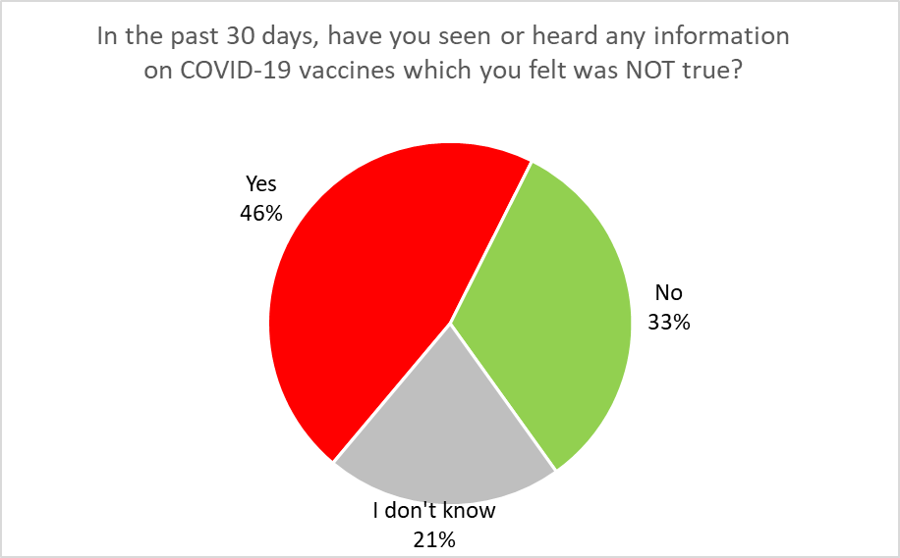
Base: all respondents, n=786

Note that:
- Females are more likely to say they have encountered untrue information (51% to males 41%), as are those in paid employment (47% compared to 36%).
- This exposure to misinformation also appears higher for those aged 35 to 64 years (51%) compared to those either younger or older, at 41%.
- There appears to be an education effect as well, with those having post-secondary education more likely to say they had seen or heard misinformation (54%) than for those with secondary or lower education (31%).
- Those vaccinated are also more likely to have seen misinformation (50% compared to 41% who are unvaccinated.). This has also been a trend from recent general population surveys.

The list of possible places to have seen misinformation was expanded for the October survey in comparison with the July survey (for example, “From friends, workmates or acquaintances”, which in July was a source for 31% of those who had seen or heard what they regarded as misinformation, was split into 3: “From friends”, “From workmates” and “From others I know”)

As in July, however, the predominant place they had seen misinformaiton was social media.

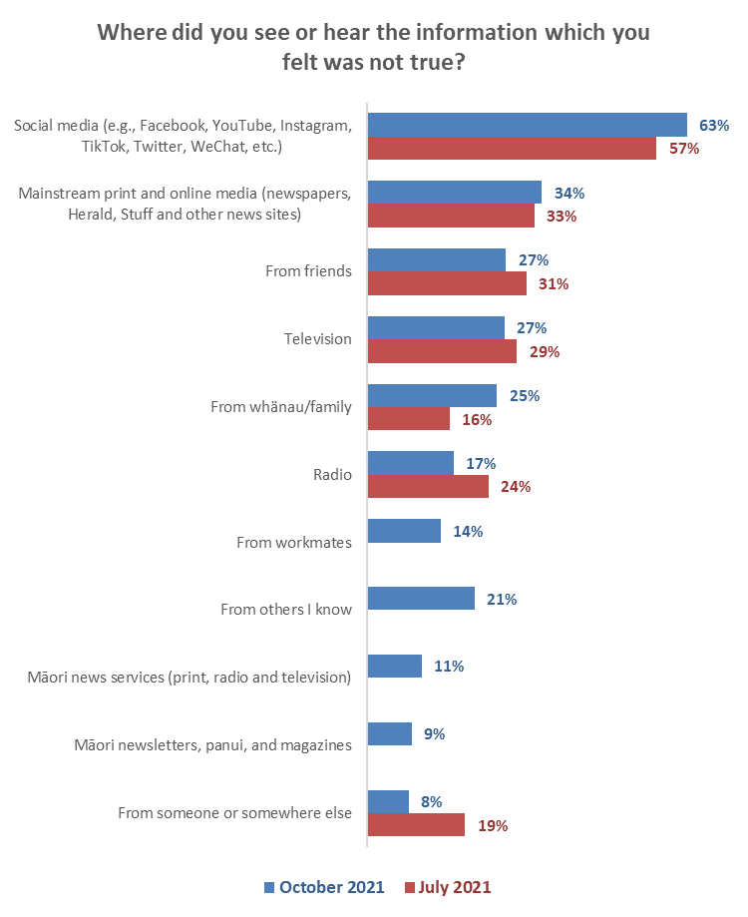
Included workmates and acquaintances in July
Base: saw or heard information they felt was not true n=380
Note that:
- For seeing misinformation on social media:
  - There does not appear to be any difference by gender or age.
  - Those in paid employment are more likely to have seen or heard something they regarded as misinformation (63%, compared to 55% who are not in paid employment).
  - Those outside of large cities are also more likely (67% compared to 56% for those in.)
  - Māori who identify as disabled are less likely to have seen “misinformation” on social media (41% compared to 65% for those who do not identify as disabled).
  - Similarly, Māori who are living with long-term health conditions or impairments are less likely to have seen “misinformation” on social media (54% versus 68% for those without impairments).
  - Those unvaccinated are no more or less likely to say they saw the misinformation on social media than anyone else.
- The unvaccinated and un-booked say their main sources of misinformation are mainstream print and online media (61%), social media (61% - though this is no different from the rest of the population), television (46%) and radio (41%). This indicates a strong distrust of mainstream media, regardless of whether it is in print, online, on television or on the radio. Māori news services (regardless of the medium) are also listed at about double the rate of the rest of the population.

What did people see or hear that they felt was not true about the vaccines?
An open-ended question was asked of the 380 people who noticed something in the past 30 days that they felt was untrue about the COVI-19 vaccines. In total, 364 people responded to this question and the main themes from their comments are illustrated in the next graph.

There was a wide range of comment on what had been heard that respondents felt was not true. Most of the false information was about the vaccine itself, or those promoting an anti-vaccination message.

General comments about “anti vaxxers”
“Vaccine haters with wrong information influencing people what the vaccine will do.”
“Just random moronic bullshit.”
“Anti-vaxxer co-worker talking about the apparent dangers of the vaccine.”
“According to my ex-partner 50% of people who have received the COVID vaccine have died, not sure where he heard this rubbish but he told my grown-up son who also thought it was nonsense but my ex is spreading this view to people he knows.”
“My ex-daughter-in-law is an avid anti vaxxer that tells her 15-year-old son (my grandson) the most outrageous stories - the govt was going around kidnapping small children from South Auckland and giving them the vaccine, half of the population of China who had the vaccine has died, teenagers will end up with myocarditis among other things. She has sent me a [90 minute] video (that I haven't watched) about a top scientist who is suing the government and when he wins the case in 4 months my grandson will not need the vaccine. The list is endless and totally mind boggling.”
“Conspiracy anti vax nutters on the news and a lot more on Facebook. It’s there constantly all the time, its bonkers how nutty some of these people are and what they will believe.”

Side effects and adverse reactions
“That the vaccine will turn everyone into zombies. That the vaccine is untested and unreliable.”
“Vaccines have hidden side effects; they are injecting poisons or trackers into your system. We want to keep our freedoms. Don't make it mandatory.”
“Individuals claiming side effects with no clear link to vaccination.”
“Side effects - korero from anti vax.”
“Not safe Causes death Long term suffering.”
“That people are dying and getting sick from the vaccine.”

General misinformation
“The vaccination contains garden manure.”
“The statistics about the number of deaths in the community if we had not locked down Auckland when we did. These were in the [thousands] and seemed completely unrealistic.”
“Protests sending the wrong information and religious groups pushing their own agenda.”
“Stats from unproven science.”
“Horse tranquiliser as a medicine.”
“Confusing dialogue, they did not get to the point with valid statements.”

Social media
“People who are against the vaccine go on a lot of social media sites and they tell people all of the 'things' that are 'wrong' with the vaccine.”
“Social Media.”
“Social media, I have only heard from others as I am not on social media myself.
all sorts of rubbish on social media - I have not bothered to remember what it is.
“In Israel, the most sick and hospitalised people are the vaccinated (a post on social media). The vaccine is harmful to unborn children (a post on social media).” “Another post on social media claiming doctors are against the vaccine.”

Deaths from the vaccine
“You become magnetised. You are injected with a little disc so that you can be traced. You will die from having the jab.”
“Some random crap posted on Facebook. About vaccine deaths and linking death rate to once the country got the jab.”
“The vaccine will kill you.”
“The vaccine is untested; The vaccine is deadly; Kids can’t get COVID-19.”

Microchip or tracking implants
“That it had microchips in it.”
“Silly conspiracy theories about implanting microchips and extreme side effects “that aren't even physically possible.”
“Youth thinking there was a microchip in the vaccine.”
“Microchip in it, too many people died from vaccine, don't believe anything govt tells us, is only about me and my choice.”

Government, political or MoH (4%)
“We were led to understand by government - 'some time' ago and for some time - that the rate of vaccinations was in hand and that there was sufficient vaccine available. This was patently untrue and now there is a panic mode.”
“What is in the vaccine, why government want us to have it.”
“Government and Radio stations stating that vaccine was only way to stay safe from COVID and that the vaccine is safe.”
“That the vaccine was safe!!!!!! That the vaccine saves lives!!!!!!! And everything the government is trying to ram down our throats.”

A full list of comments is included in Appendix 3.

Did vaccinated respondents have enough information before they got the vaccine?
Vaccinated respondents and those who were not vaccinated and not booked were asked whether they had all the information they needed before deciding whether or not to get the COVID-19 vaccine.

Overall, 51% said they had definitely had all the information they needed and a further 33% said they mostly had all the information they needed. But 15% did not have all the information they needed at the time of their vaccination or booking and a further 2% were unsure: an estimated total of 82,400 Māori 18+.

As shown in the following table, the decision to get a vaccine was made despite respondents feeling they needed more information: 50% overall felt that they had all the information they needed before deciding to get a vaccine. Bookings have been made despite only 17% of people who are unvaccinated and booked believing that they had all the information they needed.

However, only 4% overall (7% for those booked) said they needed to know more.

Did you have all the information you needed before deciding whether or not to get the COVID-19 vaccine? | ALL | Have you had a COVID-19 vaccination?
 |  | Yes  - I have had two doses | Yes  - I have had one dose | No - but I have an appoint-ment booked
Definitely | 50% | 67% | 31% | 17%
Mostly | 33% | 24% | 45% | 46%
Not quite | 11% | 5% | 15% | 29%
I needed to know more | 4% | 3% | 6% | 7%
I'm not sure | 2% | 2% | 4% | 2%
N (unweighted) | 700 | 539 | 132 | 29

Trust in the management of the pandemic and rating of the vaccination response
All respondents were asked:
- How much they trusted the Ministry and Government to manage the COVID-19 pandemic in a way which best protected them and other New Zealanders.
- How they thought the vaccination response to the COVID-19 pandemic was being managed in New Zealand.

The average trust in the Ministry of Health and Government to manage the pandemic in a way that best protects all New Zealanders, on a scale of 0 (Totally distrust) to 5 (Totally trust) remained at July’s figure of 3.4 out of 5: halfway between “Somewhat trust” and “Mostly trust”.

This score is lower than the overall September general population score of 3.7 out of 5 (the same scale was used).

As in July, those who think that vaccination is “important” or “very important” rate their trust above the overall average.

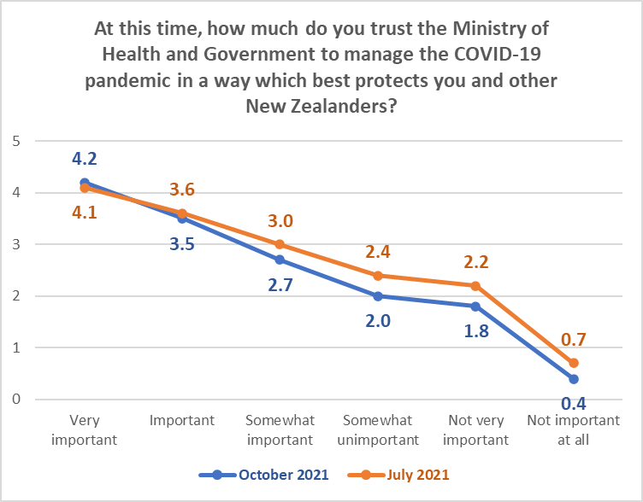
Bases: All respondents: October 2021, n=774; July 2021 n=617

There are indications that Māori in the Tairāwhiti, Wairarapa, West Coast and South Canterbury DHB areas may have lower than average trust in the Ministry of Health and Government to manage the pandemic in a way that best protects all New Zealanders

Management of the vaccination response
The average rating of the management of the vaccination response on a scale of 0 (Very poor) to 10 (Excellent) was 6.2 out of 10, slightly above July’s 6.0 average rating.

12% of Māori rated the vaccination response as “Very poor”. Of these:

- Nearly 3 out of 10 had said they would “Definitely” get vaccinated, and one in five wanted to be vaccinated immediately, indicating some impatience.
- A further one in five were not sure when they would prefer to get the vaccine and 2 out of 5 did not want to be vaccinated.

As in July, the average rating of the management of the vaccination response dropped as the importance respondents placed on “everyone in Aotearoa who can be, being vaccinated”, dropped. The ratings were similar to the overall ratings from the June 2021 general population survey.

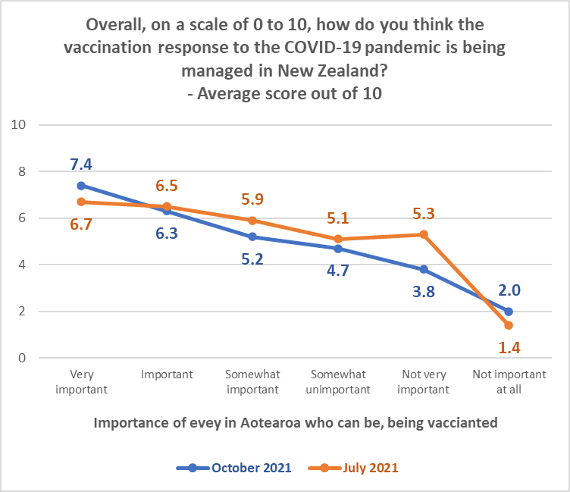

There are indications that Māori in the Lakes, Hawkes Bay and West Coast DHB areas rate the management of the vaccination response below the overall average. In contrast, Indications are that Māori in Counties Manukau, Bay of Plenty, Tairāwhiti, Hutt, Canterbury and (marginally) Northland, rate the management of the vaccination response above the overall average.

APPENDIX 1 - SAMPLE
799 Māori aged 18+ who are members of the nationwide HorizonPoll and Horizon Research Māori panels and two, third-party respondent panels, responded to this online survey between 14 and 21 October 2021.

The sample is weighted on:
- Age, gender and region to match the HSU data as at 11:59 pm on 21 October 2021, supplied by the Ministry of Health.
- The percentage of Māori who have had two doses and the percentage who have had one dose, to match the HSU data as at 11:59 pm on 21 October 2021, supplied by the Ministry of Health.
- Employment status to match Statistics New Zealand figures for the 18+ Māori population.

At a 95% confidence level, the survey has a maximum margin of error of ±3.9% overall.

Sample details are as follows:

GENDER | Count | Weighted % | HSU  %
Female | 445 | 47% | 47%
Male | 351 | 53% | 53%
Another gender | 2 | < 1%

AGE GROUP | Count | Weighted % | HSU  %
18-24 years | 84 | 18% | 19%
25-34 years | 127 | 24% | 23%
35-44 years | 165 | 20% | 17%
45-54 years | 129 | 14% | 17%
55-64 years | 145 | 12% | 14%
65-74 years | 115 | 10% | 7%
75 years or over | 34 | 3% | 3%

EMPLOYMENT STATUS | Count | Weighted %
In paid employment | 418 | 63%
Not in paid employment | 199 | 37%

AREA TYPE | Count | Weighted %
Large city | 324 | 42%
Regional City | 139 | 17%
Regional town | 188 | 23%
Rural, but not remote | 130 | 16%
Rural and remote | 15 | 3%

Contact
For more information about this survey, please contact:

Andrew Stevenson, telephone 021 464 307, email andrew.stevenson@horizonresearch.co.nz Grant McInman, telephone 021 076 2040, email gmcinman@horizonresearch.co.nz.
Graeme Colman, telephone 021 84 85 76, email gcolman@horizonresearch.co.nz.

APPENDIX 2 - PROFILE BY LIKELIHOOD TO GET A COVID-19 VACCINE
Note: The figures are indicative, owing to a small base.

DEMOGRAPHIC PROFILE:  Likelihood to get a COVID-19 vaccine |  | All | Will you get a COVID-19 vaccine?
 |  |  | All likely (“Definitely”, “Most likely”, “Likely”) | All Unlikely  (“Unlikely”, “Most unlikely”) | Definitely not” | Unsure
GENDER
 | Male | 47% | 50% | 53% | 32% | 29%
 | Female | 53% | 50% | 47% | 64% | 71%
 | Gender diverse | 1% | 0% | 0% | 5% | 0%
AGE GROUP
 | 18-24 years | 18% | 24% | 24% | 16% | 18%
 | 25-34 years | 24% | 5% | 23% | 23% | 36%
 | 35-44 years | 20% | 49% | 20% | 28% | 19%
 | 45-54 years | 14% | 9% | 7% | 12% | 20%
 | 55-64 years | 12% | 10% | 10% | 15% | 7%
 | 65-74 years | 10% | 3% | 12% | 6% | 0%
 | 75 years or over | 3% | 0% | 4% | 0% | 0%
 | AVERAGE AGE (years) | 42.2 | 38.5 | 40.8 | 40.7 | 36.4
 | % difference from overall average |  | --8.6% | --3.2% | --3.4% | --13.7%

DEMOGRAPHIC PROFILE:  Likelihood to get a COVID-19 vaccine |  | All |  | Will you get a COVID-19 vaccine?
 |  |  |  | All likely (“Definitely”, “Most likely”, “Likely”) |  | All Unlikely  (“Unlikely”, “Most unlikely”) |  | Definitely not” |  | Unsure
HOUSEHOLD INCOME
 | Less than $20,000 per year |  | 11% |  | 16% |  | 9% |  | 27% |  | 14%
 | Between $20,001 and $30,000 per year |  | 13% |  | 11% |  | 14% |  | 23% |  | 4%
 | Between $30,001 and $50,000 per year |  | 11% |  | 14% |  | 6% |  | 15% |  | 15%
 | Between $50,001 and $70,000 per year |  | 15% |  | 10% |  | 15% |  | 11% |  | 17%
 | Between $70,001 and $100,000 per year |  | 15% |  | 5% |  | 7% |  | 7% |  | 11%
 | Between $100,001 and $150,000 per year |  | 16% |  | 10% |  | 4% |  | 10% |  | 13%
 | Between $150,001 and $200,000 per year |  | 4% |  | 0% |  | 4% |  | 0% |  | 4%
 | More than $200,000 per year |  | 3% |  | 0% |  | 3% |  | 2% |  | 0%
 | Don't know/ prefer not to say |  | 12% |  | 33% |  | 39% |  | 5% |  | 22%
 | AVERAGE HOUSEHOLD INCOME ($) |  | $73,690 |  | $50,190 |  | $64,170 |  | $46,390 |  | $64,930
 | % difference from overall average |  |  |  | --31.9% |  | --12.9% |  | --37% |  | --11.9%
PERSONAL INCOME
 | Less than $20,000 per year |  | 22% |  | 23% |  | 18% |  | 41% |  | 31%
 | Between $20,001 and $30,000 per year |  | 15% |  | 18% |  | 18% |  | 17% |  | 3%
 | Between $30,001 and $50,000 per year |  | 12% |  | 6% |  | 6% |  | 15% |  | 21%
 | Between $50,001 and $70,000 per year |  | 16% |  | 11% |  | 10% |  | 6% |  | 17%
 | Between $70,001 and $100,000 per year |  | 11% |  | 5% |  | 3% |  | 8% |  | 4%
 | Between $100,001 and $150,000 per year |  | 8% |  | 3% |  | 4% |  | 0% |  | 4%
 | Between $150,001 and $200,000 per year |  | 2% |  | 0% |  | 3% |  | 2% |  | 0%
 | More than $200,000 per year |  | 1% |  | 0% |  | 0% |  | 2% |  | 0%
 | Don't know/ prefer not to say |  | 13% |  | 33% |  | 39% |  | 10% |  | 22%
 | AVERAGE PERSONAL INCOME ($) |  | $51,240 |  | $36,740 |  | $44,010 |  | $35,550 |  | $37,860
 | % difference from overall average |  |  |  | --28.3% |  | --14.1% |  | --30.6% |  | --26.1%

DEMOGRAPHIC PROFILE:  Likelihood to get a COVID-19 vaccine |  |  | All | Will you get a COVID-19 vaccine?
 |  |  |  | All likely (“Definitely”, “Most likely”, “Likely”) | All Unlikely  (“Unlikely”, “Most unlikely”)” | Definitely not” | Unsure
EMPLOYED
 | Yes | 63% |  | 45% | 68% | 39% | 64%
 | No | 37% |  | 55% | 32% | 61% | 36%
OCCUPATION
 | Professional/Senior Government Official | 7% |  | 0% | 0% | 10% | 4%
 | Business Manager/Executive | 7% |  | 9% | 5% | 0% | 5%
 | Business Proprietor/Self-employed | 6% |  | 0% | 10% | 0% | 23%
 | Teacher/Nurse/Police or other trained service worker | 10% |  | 12% | 0% | 8% | 8%
 | Clerical/Sales Employee | 10% |  | 3% | 20% | 4% | 9%
 | Farm Owner/manager | 2% |  | 0% | 0% | 5% | 0%
 | Technical/mechanical/Skilled Worker | 10% |  | 3% | 16% | 4% | 8%
 | Labourer/Agricultural or Domestic Worker | 8% |  | 3% | 11% | 10% | 17%
 | Home-maker (not otherwise employed) | 8% |  | 17% | 15% | 19% | 9%
 | Student | 6% |  | 13% | 0% | 6% | 0%
 | Retired/Superannuitant | 9% |  | 7% | 4% | 2% | 0%
 | Unemployed/Beneficiary | 13% |  | 20% | 17% | 33% | 4%
 | Don't know/prefer not to say | 5% |  | 12% | 4% | 0% | 15%

DEMOGRAPHIC PROFILE:  Likelihood to get a COVID-19 vaccine |  |  | All | Will you get a COVID-19 vaccine?
 |  |  |  | All likely (“Definitely”, “Most likely”, “Likely”) | All Unlikely  (“Unlikely”, “Most unlikely”)” | Definitely not” | Unsure
HIGHEST QUALIFICATION
 | Postgraduate degree (Masters' degree or PhD) | 10% |  | 10% | 0% | 10% | 11%
 | Undergraduate (Bachelor) degree | 17% |  | 10% | 18% | 12% | 11%
 | Vocational qualification (includes trade certificates, diplomas etc) | 25% |  | 22% | 33% | 14% | 14%
 | University Bursary or 7th form | 10% |  | 9% | 5% | 21% | 6%
 | Sixth form/UE/NCEA Level 2 | 11% |  | 7% | 16% | 8% | 17%
 | NCEA Level 1 or School Certificate | 9% |  | 3% | 9% | 17% | 8%
 | No formal school qualification | 13% |  | 16% | 17% | 17% | 19%
 | Prefer not to say | 5% |  | 23% | 3% | 3% | 14%
 |  | 30% |  | 19% | 30% | 45% | 31%
HOUSEHOLD TYPE
 | Single person household | 17% |  | 28% | 21% | 29% | 0%
 | Couple only (no children/none at home) | 21% |  | 15% | 5% | 8% | 10%
 | Two parent family, one or two children at home | 25% |  | 5% | 13% | 30% | 40%
 | Two parent family, three or more children at home | 10% |  | 19% | 13% | 16% | 20%
 | One parent family, one or two children at home | 7% |  | 3% | 4% | 8% | 0%
 | One parent family, three or more children at home | 3% |  | 16% | 5% | 5% | 3%
 | Flatting or boarding - not a family home | 8% |  | 5% | 15% | 0% | 12%
 | Extended family | 6% |  | 3% | 4% | 4% | 8%
 | Prefer not to say | 3% |  | 5% | 20% | 0% | 7%
 | Children in Household | 46% |  | 44% | 34% | 59% | 63%

DEMOGRAPHIC PROFILE:  Likelihood to get a COVID-19 vaccine |  |  | All | Will you get a COVID-19 vaccine?
 |  |  |  | All likely (“Definitely”, “Most likely”, “Likely”) | All Unlikely  (“Unlikely”, “Most unlikely”)” | Definitely not” | Unsure
DHB
 | Northland | 5% |  | 8% | 0% | 6% | 5%
 | Waitemata | 9% |  | 11% | 7% | 4% | 11%
 | Auckland | 8% |  | 0% | 6% | 4% | 3%
 | Counties-Manukau | 6% |  | 11% | 4% | 2% | 15%
 | Waikato | 17% |  | 22% | 9% | 10% | 15%
 | Lakes | 2% |  | 0% | 4% | 5% | 4%
 | Bay of Plenty | 5% |  | 0% | 7% | 0% | 20%
 | Tairawhiti | 1% |  | 0% | 0% | 3% | 0%
 | Taranaki | 4% |  | 3% | 9% | 0% | 4%
 | Hawke's Bay | 3% |  | 3% | 4% | 7% | 9%
 | Whanganui | 2% |  | 4% | 0% | 7% | 0%
 | Midcentral | 2% |  | 4% | 3% | 0% | 0%
 | Hutt | 2% |  | 0% | 6% | 0% | 0%
 | Capital and Coast | 6% |  | 7% | 9% | 11% | 0%
 | Wairarapa | 5% |  | 3% | 8% | 12% | 0%
 | Nelson-Marlborough | 3% |  | 4% | 0% | 0% | 0%
 | West Coast | 2% |  | 0% | 4% | 8% | 0%
 | Canterbury | 7% |  | 7% | 16% | 13% | 4%
 | South Canterbury | 1% |  | 14% | 0% | 0% | 12%
 | Southern | 11% |  | 8% | 7% | 8% | 5%
 | North Island | 78% |  | 75% | 74% | 72% | 84%
 | Auckland | 23% |  | 21% | 17% | 11% | 28%
 | Upper North Island excluding Auckland | 30% |  | 30% | 20% | 21% | 43%
 | Lower North Island | 25% |  | 24% | 38% | 40% | 13%
 | South Island | 22% |  | 33% | 7% | 4% | 0%

DEMOGRAPHIC PROFILE:  Likelihood to get a COVID-19 vaccine |  |  | All | Will you get a COVID-19 vaccine?
 |  |  |  | All likely (“Definitely”, “Most likely”, “Likely”) | All Unlikely  (“Unlikely”, “Most unlikely”)” | Definitely not” | Unsure
AREA DESCIPTION
 | Large City | 43% |  | 52% | 33% | 30% | 43%
 | Provincial city | 18% |  | 11% | 14% | 15% | 20%
 | Provincial town | 19% |  | 18% | 37% | 35% | 16%
 | Rural but not remote | 16% |  | 18% | 10% | 17% | 21%
 | Rural and remote | 4% |  | 1% | 7% | 4% | 0%

APPENDIX 3 – MISINFORMATION COMMENTS (Section 9)

What were the main things you saw or heard, that you felt were not true or you had doubts over?
"1/ COVID delta is roaming the community "looking" for unvaccinated people (prime-minister tv) as if COVID had sentience and is a serial killer 2/ +90% vaccination rate will eliminate the virus in all vaccinated people and only unvaccinated {10%} will get COVID.” - Male, 45-54 years.
"A bunch of Americans saying that the vaccine was bad & alters your DN etc.” - Female, 35-44 years.
"A chip in the vaccine?” - Female, 35-44 years.
"a link between the vaccine and 5G. That the vaccine contains COVID. That it is part of some form of worldwide conspiracy. That it is suspicious that the vaccine was developed so quickly. That mandating compulsory vaccination takes away personal choice without the balance of the fact that one person's personal choice impacts on others personal choice.” - Male, 45-54 years.
"According to my ex-partner 50% of people who have received the COVID vaccine have die not sure where he heard this rubbish, but he told my grown-up son who also thought it was nonsense but my ex is spreading this view to people he knows.” - Female, 35-44 years.
"After receiving vaccine, you can become sterile. Getting very sick after getting vaccine Your body becomes magnetic Having faith in Jesus Christ will protect you.” - Female, 65-74 years
"All antivax information and international web stories encouraging anti vax.” - Female, 65-74 years.
"All of it.” - Female, 35-44 years.
"All sorts of rubbish on social media - I have not bothered to remember what it is.” - Male, 65-74 years.
"All the common disinformation :(.” - Male, 35-44 years.
"All the conspiracy theories, that governments are withholding information, that they are trying to kill us off that the side effects are horrendous, that the vaccine makes you magnetic that there are secret ingredients that we don't know about the list goes on.” - Male, 65-74 years.
"All the Govt & media. I only believe those scientists & Doctors brave enough to speak their truth that COVID 19 is NOT a virus.” - Female, 65-74 years.
"All the misinformation out there.” - Female, 75 years or over.
"All you need is an immune system.” - Male, 25-34 years.
"Alternative interpretations of Medsafe data. That the pandemic has been purposely blown out of proportion in order to control the population.” - Female, 35-44 years.

“Anti vaccers still going on about Bill Gates & misinformation -Social media not as bad as before but some still there -Too many scientists coming out and talking sometimes confusing what PM says. The media are a total nuisance, instead of promoting the vaccine more they are talking about the so called 5,000 cases that may occur in 2022 in Northland. Keep presenting the figures of all ethnic groups as the 5m forge forward to get vaccinated. That is positive news. Nga mihi ki a koutou katoa.” - Female, 75 years or over.
"Anti-vaccination conspiracy.” - Female, 65-74 years.
"Anti- vaccs protests.” - Female, 45-54 years.
"Anti vax circular.” - Male, 35-44 years.
"Anti vax misinformation spread on social media about fertility being effected and the vaccine not working because you can still catch COVID.” - Female, 35-44 years.
"Anti vax posts from friends on Facebook.” - Female, 55-64 years.
"Anti vaxx fake science that preys on people fears. Very bad.” - Female, 35-44 years.
"Anti vaxxer Co-worker talking about the apparent dangers of the vaccine.” - Male, 25-34 years.
"Anti vaxxers spouting their usual bullshit. These people are completely mad.” - Female, 65-74 years.
"Anti-lockdown protesters perspectives.” - Male, 45-54 years.
"Antivax bullshit.” - Female, 45-54 years.
"Antivaxxers who appear to be trying to undermine the government.” - Male, 65-74 years.
"B Tamaki doing what he is doing. A Mayor not being responsible to her community.” - Male, 65-74 years.
"Being injected with a tracking device; that the vaccine is dangerous.” - Male, 65-74 years.
"Can cause death, infertility, heart palpitations.” - Female, 35-44 years.
"Car and people walking around town.” - Female, 18-24 years.
"Causes death Magnetises.” - Female, 65-74 years.
"Causes kids with three heads, physical deformities on the person if you take it, over hundred people in nz have died of taking vaccination, the vaccine will go into the cells and cause physical deformities for future generations.” - Female, 45-54 years.
"Chips in the vaccine.” - Male, Under 18 years.
"Comments, opinions on social media.” - Female, 55-64 years.
"Confusing dialogue, they did not get to the point with valid statements.” - Female, 55-64 years.
"Conspiracy anti vax nutters on the news and a lot more on Facebook Its they’re constantly all the time, its bonkers how nutty some of these people are and what they will believe.” - Male, 35-44 years.
"Conspiracy theories and the epidemic doesn't exist.” - Male, 55-64 years.
"Conspiracy Theories are true- they are not The Vaccines are not safe.” - Female, 55-64 years.
"Conspiracy theories which are not true.” - Female, 55-64 years.
"Conspiracy theories, etc: - govt chip in vaccine to track the population - the government hasn't done its research on the vaccine - that its unsafe.” - Male, 25-34 years.
"Conspiracy theories.” - Male, 35-44 years.
"COVID IS DANGEROUS AND HAS A CHIP IN IT. GOVT IS INJECTING PEOPLE SO THEY CAN CONTROL PEOPLE.” - Female, 55-64 years.
"COVID is fake, a government conspiracy, dangerous.” - Female, 45-54 years.
"Crap on Facebook - from unsubstantiated sources and claims about the vaccine.” - Female, 55-64 years.
"Crap on Facebook, Instagram about that vaccination makes you magnetic and it makes you infertile etc.” - Female, 45-54 years.
"Deaths - media perceives COVID 19 is responsible for all deaths so far, however, we are aware that some cases have underlying conditions. The Labour Government is blamed for everything and anything, e.g., businesses that can't operate under level 3 - this is our 2nd time around perhaps they should have been looking outside the box to alter how they deliver their product. Check points not working (as infected people are getting through) - who is providing this service, not the govt. If Joe Blows out there is not willing to cooperate, is that the fault of the govt?? To vaccinate or not - personal choice, however, keep your distance from my whanau. Have huge doubts about the large gathering held by church group earlier this month - and the leader not aware that he was breaking the law?? None of them would want to be tested if they don't believe they need the vaccine. Not everyone has side effects from the vaccine - my household age range 12yo to 83yo (10 of us) with no problems. Depending on who you listen to, 1 in 20 is likely to have side effects according to social media. There are a few other things that have been bothering me of late, but I can't think of them at the moment. Every morning I watch one news and every day the govt is blamed for anything from paying rent, for travel, restaurants etc to not enough sites or vaccine whatever. Perhaps I am walking around in rose-coloured glasses, but if so, for me, it’s all about keeping MY whanau safe in the best possible way I know. And if that means following all the other sheep, so be it.” - Female, 55-64 years.
"Deaths from the vaccine, negative effects on babies, ppl who say they have a strong immune system.” - Female, 35-44 years
"Don't know.” - Female, 55-64 years
"Every time either Ardern or Bloomfield opened their mouths to tell the truth.” - Male, 55-64 years
"Everything to do with COVID.” - Male, 18-24 years
"Facebook comments.” - Female, 55-64 years
"Facebook groups, people feed off each other, plant doubt, negative and nasty comments, it's awful and rampant!” - Female, 45-54 years
"Facebook is full of misinformation.” - Male, 35-44 years
"Facebook messages from antivaxxers.” - Female, 65-74 years
"Facebook posts by anti vaxxers, saying things like, the government's trying to use the vaccine to wipe out indigenous people, that I will become magnetic or that they have put a microchip inside me.” - Female, 35-44 years
"Facebook posts, people saying the vaccine will make you sick, contains tracking etc.” - Female, 35-44 years
"Facebook rubbish.” - Male, 35-44 years
"Facebook.” - Female, 18-24 years
"Fake virus vaccine will make you sick.” - Female, 45-54 years
"False comments like injecting things into you, fertility issues.” - Female, 65-74 years
"Fear mongers on social media, friends.” - Male, 35-44 years
"Feel current COVID case numbers are not the total case numbers affected & same for icu number & Hospital number of cases.” - Female, 45-54 years
"Followers of Brian Tamaki claiming the WHO and individuals such Bill Gates are seeking world domination. I could go on with their unsubstantiated and dangerous claims.” - Male, 35-44 years
"Friends of mine are scared and think it contains chemicals which aren't supposed to be in your body.” - Female, 45-54 years
"Gene altering vaccine.” - Male, 55-64 years
"General media coverage is biased extremely pro vaccine. We need a balanced view, not scare monger tactics from our brain washed politicians.” - Male, 45-54 years
"Government and Radio stations stating that vaccine was only way to stay safe from COVID and that the vaccine is safe.” - Female, 35-44 years
"Graphene oxide being in the vaccines. A lot of the cardiac issues were not being reported in the hospitals and therefore not reported to governments.” - Female, 35-44 years
"History repeating itself Spanish Flu, government transparency No other option to accept the narrative, mandatory jab for teachers Jan 2022 Unvaccinated people get sick don't expect to get treated in hospital taxes are fitting the bill Educated Dr's frontline, Scientist specialise disease and coroner ambiguities.” - Female, 45-54 years
"Hit the delete button once I reach it.” - Female, 65-74 years
"Horse tranquiliser as a medicine.” - Male, 45-54 years
"How long it was tested for and what was in it - live virus.” - Female, 35-44 years
"How safe is the vaccine.” - Male, 25-34 years
"Huge amount of ridiculous misinformation on the web.” - Female, 65-74 years
"I asked my local doctor if the vaccine effects Māori medicine and they did not have any information for me.” - Female, 18-24 years
"I can't remember.” - Female, 18-24 years
"I don't believe anything that anyone says about vaccinations. I definitely don't trust ANY information coming from the government (Prime Minister), or social media or any type of media for that matter.” - Female, 65-74 years
"I don’t have doubts. I don’t believe any media either side of the fence. [I] am sick of seeing, hearing about the bloody vaccine!” - Female, 35-44 years
"I don't know I was worried that I could die or feel really sick for the rest of my life but it turns out I'm not I'm completely fine.” -, Male, 25-34 years
"I feel the government have tried to hide a few of their mistakes - Female, 25-34 years
"I feel we should all get the vaccine.” - Female, 25-34 years
"I have stopped engaging on Facebook because it spreads disinformation.” - Female, 45-54 years
"I heard that the vaccine is actually a tracker so the govt can track you, but I study pharmacy, so I know that’s just ridiculous. also, if people think like that, they post it on their phone which is more of a tracker than a needly.” - Female, 18-24 years
"I know it's definitely not true, that we lose our freedom through vaccination. You are free to choose vaccination or not but must also face the consequences of either choice.” - Female, 45-54 years
"I’ve heard that the vaccine had some sort of effect to ruin the female reproductive system.” - Female, 18-24 years
"In Israel, the most sick and hospitalised people are the vaccinated (a post on social media). The vaccine is harmful to unborn children (a post on social media). Another post on social media claiming doctors are against the vaccine.” - Female, 35-44 years
"In one of our Community Newspapers. On TV where a self-prescribed cult leader (bishop) ranted. And other antivaxxers on the web.” - Female, 55-64 years
"Individuals claiming side effects with no clear link to vaccination.” - Male, 55-64 years
"Information that was anti vaccine, saying it contains poisons, isn’t effective etc.” - Male, 18-24 years
"it causes cancer, the government want to depopulate the world COVID 19 is fake and it’s all about control, within 5 years everyone vaccinated will die.” - Male, 25-34 years
"It causes infertility and causes people to be metallic.” - Male, 55-64 years
"It gives you COVID cause paralysis and swelling of the whole arm.” - Female, 25-34 years
"It is not 100% safe.” - Male, 65-74 years
"It kills you.” - Male, 18-24 years
"It was hoax - Super Govts trying to take over - poison in the vaccine.” - Female, 55-64 years
"It was untruthful.” - Male, 18-24 years
"It wasn’t safe, it’s causing deaths.” - Female, 35-44 years
"it’s good.” - Male, 45-54 years
"Jacinda Ardennes saying people aren't dying from the vaccine.” - Female, 45-54 years
"Jacinda Ardern.” - Male, 25-34 years
"Junk science/conspiracy theory/vaccine is experimental.” - Female, 55-64 years
"Just general conspiracy theorists spouting off about nonsense without actual proof to back it up with.” - Male, 25-34 years
"Just general Facebook people with wrong info.” - Male, 45-54 years
"Lack of testing of the safety of the vaccine due to being developed too quickly.” - Female, 45-54 years
"Large numbers of people who were fully vaccinated were hospitalized or had died.” - Male, 35-44 years
"Level 3 I don’t understand how long she will lock people.” - Male, 25-34 years
"Magnet.” - Female, 25-34 years
"Magnetic arm; shedding, etc.” - Male, 35-44 years
"Magnetic body lol, 5g tracking bots lol, will kill you.” - Male, 55-64 years
"Magnetic chips inside the vaccine, made of baby foetus.” - Female, 45-54 years
"Magnetism, deaths, gov conspiracy.” - Female, 35-44 years
"Magnetism.” - Male, 45-54 years
"Magnets in vaccine, the 1% killing us all, leaving middle class in poverty so the rich can take over the world killing off native people to land grab.” - Female, 55-64 years
"Magnets.” - Female, 65-74 years
"Magnets.” - Female, 65-74 years
"Mainly a bunch of garbage coming from anti vaxxers over social media from the US. Things like fertility and pregnancy issues with the vaccine, how it was unsafe because they are vulnerable etc.” - Female, 18-24 years
"Mainstream media, government officials, politicians, friends, family, GPs who haven't had their practicing certificates stripped from them, Ministry of Health, COVID19.govt.nz.” - Male, 25-34 years
"Makes breasts bigger.” - Female, 18-24 years
"Many of the hilarious conspiracies' i.e., makes you magnetic gives you diabetes. All those types.” - Male, 35-44 years
"Many things on social media stating conspiracy theories about the vaccines.” - Male, 35-44 years
"Many things!” - Female, 35-44 years
"Māori nurse told me it can’t be trusted the vaccine that is. online heaps of whanau all following that dysentery church, Tamaki.” - Female, 65-74 years
"Masks will protect you; Vaccinations will protect your whakapapa; contracting COVID will help build your immunity.” - Female, 55-64 years
"Microchip.” - Male, 18-24 years
"Microchip in it, too many people died from vaccine, don’t believe anything govt tells us, Is only about me and my choice.” - Female, 55-64 years
"Microchips, we are going to die from it.” - Female, 25-34 years
"Misguided reasons for not being vaxxed stupid uninformed reasons. Makes me think they are just too scared of injections.” -Female, 65-74 years
"Misinformation from Antivaxxers.” - Female, 55-64 years
"Misinformation on getting the jab or not. Media at fault.” - Male, 55-64 years
"Misinformation on social media Some media misinformation.” - Female, 65-74 years
"Misinformation spread online and via word of mouth re vaccine not being effective.” - Female, 25-34 years
"Miss information on advice about vaccine. Conspiracy theories.” - Male, 65-74 years
"Mortality rate of the vaccine isn't being portrayed in the media.” - Female, 25-34 years
"My ex-daughter-in-law is an avid anti vaxxer that tells her 15-year-old son (my grandson) the most outrageous stories - the govt was going around kidnapping small children from South Auckland and giving them the vaccine, half of the population of China who had the vaccine has die teenagers will end up with myocarditis among other things. She has sent me a 1-1/2-hour video (that I haven't watched) about a top scientist who is suing the government and when he wins the case in 4 months my grandson will not need the vaccine. The list is endless and totally mind boggling.” - Female, 65-74 years
"National Party, Winston Peters.” - Female, 45-54 years
"Needle is left in you. Government tracking you. These came from my teenagers also. Fortunately, I put them right.” - Male, 45-54 years
"No actual data to make comparison of safety for children aged 12yrs.” - Female, 55-64 years
"No doubt.” - Male, 25-34 years
"No or lack of Māori vax stat reporting through mainstream media.” - Female, 35-44 years
"Not allowing those in the medical and scientific industry who are opposed to the vaccine speak.” - Female, 55-64 years
"Not effective, unsafe for certain peoples.” - Female, 25-34 years
"Not needed.” - Male, 35-44 years
"Not official advice Facebook sent or shared by anti-vaccinators.” - Female, 55-64 years
"Not safe Causes death Long term suffering.” - Female, 55-64 years
"Not to get the vaccine, it’s not safe, impinges on people’s rights.” - Female, 65-74 years
"Not true, viruses have been eradicated by vaccination. Not enough info about COVID COVID’s whakapapa approach or solution that one size fits all e.g., I have a very strong immune system after getting jab my arm has broken out in a rash, I wish I had stuck to my guns as I believe my IS is compromised now. Softening down about side effects. Death numbers supposedly due to COVID not broken down enough e.g., got irritated hearing Māori health was easily compromised due to chronic diseases they have so did they die of COVID and if so how. So much more but what the hell. There’s no such thing as my freedom of choice.” - Female, 65-74 years
"Not wearing a mask. Large gathering of people okay +50.” - Female, 55-64 years
"Number of recovered cases.” - Female, 25-34 years
"NZ News Media, all media are deliberately and maliciously misinforming the public for political reasons. They are endangering the lives of New Zealanders and should be held accountable. The current govt were democratically elected - NZ Media were not elected to do anything but report and they do this in all manner of dishonesty in order to denigrate the govt we the people voted for. The govts COVID response is the best in the world and yet our dishonest media report the opposite. They are treacherous traitors. Complaints to the Broadcasting Standards Commission go nowhere - that in itself is dishonest - there should be an independent enquiry and they need to cease with the lies.” - Female, 65-74 years
"On both sides. For and against.” - Female, 35-44 years
"On Shine TV: they said the lockdowns and vaccines were an attempt to control the population by the Govt and world leaders.” - Female, 45-54 years
"On social media people sharing an uneducated opinion.” - Female, 18-24 years
"Our choice to have the vaccine.” - Female, 35-44 years
"Paranoia about the effects of the vaccine.” - Female, 45-54 years
"People claiming to have become a magnet like really.” - Female, 55-64 years
"People dying from getting the vax. Vax is still a trial drug.” - Male, 55-64 years
"People dying from side effects; jab makes you magnetised; jab puts a tracker inside you.” - Female, 65-74 years
"People getting very sick for up to 5 weeks.” - Female, 45-54 years
"People had a heart attack after having the jab.” - Female, 65-74 years
"People in the street who bang on about not enough information out there for them to make an informed decision. Are they dumb or what? The vaccine contains microchips. They don't know what's in the vaccine yet could be taking drugs and/or vaping etc.” - Male, 75 years or over
"People making thing up on the internet to support their views.” - Female, 35-44 years
"People on social media saying that school kids could catch the virus from vaccinated teachers.” - Female, 35-44 years
"People saying dumb things like it’s not real or the vaccine kills or it’s not worth getting it because the virus isn’t real and the government is controlling us.” - Male, 45-54 years
"People sharing links to anti vaccine / the government control people and jabs shouldn’t be mandatory which I hide delete or report.” - Female, 55-64 years
"People who are against the vaccine - go on a lot of social media sites and they tell people all of the 'things' that are 'wrong' with the vaccine.” - Female, 25-34 years
"Personal opinions of people not qualified to give advice.” - Female, 65-74 years
"Possible death from the vaccine.” - Female, 25-34 years
"Posts on social media.” - Male, 35-44 years
"Promoting ivermectin as a COVID cure.” - Male, 55-64 years
"Protests sending the wrong information and religious groups pushing their own agenda.” - Male, 55-64 years
"Ridiculous and uninformative comments from Tamaki (pseudo bishop), a group of midwives who should be better trained in factual information and who are leaving their job because they don't believe vaccinations.” - Female, 65-74 years
"Rubbish about the millions of people that have died from the vaccine- billboards held by idiots on the side of the road.” - Female, 55-64 years
"Safe (it’s not true we do not know enough, it needs 5 to 10 years for a vaccine to be fully approved) protect my whānau ( not true 25% of people dying in France from COVID are vaccinate you still transmit the virus when vaccinated) open border (government will find out that after 3 months people has to be vaccinated again, my family in France had to get 4 shots already since February) side effects (at least 70% of people i know got COVID had side effects vomiting, difficulty breathing, extreme fatigue. Not reassuring.” - Male, 25-34 years
"Safe and effective.” - Male, 55-64 years
"Sars is the virus but labs used gain of function techniques to increase its potential for chemical warfare.” - Male, 55-64 years
"Server reactions.” - Male, 18-24 years
"Shedding, mind control, 5G tracking, everyone vaccinated dying of CJD in a few years, vaccine doesn’t work, ivermectin is a perfect cure, ivermectin is risk free to take, vaccine will kill me outright, sars-cov-2 is not a serious illness etc etc ad nauseum.” - Male, 25-34 years
"Shedding, not working, it being fake, propaganda a way for government to control us.” - Female, 25-34 years
"Side effects - korero from anti vax.” - Male, 55-64 years
"Side effects are not fully reported death rates from the vax are not properly reported. Vaxxed people are super spreaders, and they are, everything is covered up like we are stupid children. Jacinda has lied she said it would not be mandatory other countries are opening up and we are in a bloody [Communist] state. News reports are not stating how many cases are vaxxed leaving people to assume it’s all non vaxxed. Non vaxxed are treated like lepers and there is no choice any more it’s fucked the NZ I have contributed taxes to is fucked and Jacinda is a liar.” - Female, 55-64 years
"Side effects of the vaccine COVID isn’t real, it’s a chip inserted into you it makes you magnetic it changes your DNA it’s a hoax.” - Female, 45-54 years
"Side effects of vaccine (outside those reported by officials) and that were being controlled by the vaccines.” - Male, 35-44 years
"Side effects that some people were experiencing.” - Female, 55-64 years
"Side effects which couldn't be true.” - Male, 45-54 years
"Side effects.” - Female, 45-54 years
"Silly conspiracy theories about implanting microchips and extreme side effects that aren't even physically possible.” - Female, 25-34 years
"So much about every conspiracy, pharmacy, big brother, freedom.” - Female, 55-64 years
"Social media anti vax information.” - Female, 55-64 years
"Social media conspiracy theories.” - Male, 55-64 years
"Social media rubbish. Individuals being interviewed and their social opinions being broadcast. Individuals who own businesses wanting Govt to ensure they have a way out of this extraordinary predicament and blaming COVID and the response to it as the reason for their predicament and the need for Govt to help them without realising the full impact of that response if Govt were to do that. Politicking getting in the way of action. Concerns that the advisory committee set up by Govt was not part of the final conversation that led to some of the announcements made by the PM on Monday.” - Male, 65-74 years
"Social media I have only heard from others as I am not on social media myself.” - Male, 45-54 years
"Social media news reports.” - Female, 35-44 years
"Social media. Mainstream news on television.” - Female, 25-34 years
"Social Media.” - Female, 75 years or over
"Social media.” - Female, 25-34 years
"Social media.” - Female, 25-34 years
"Social media post.” - Female, 45-54 years
"Some of the information presented is misleading. For example, a graph showing the percentage of people hospitalised with COVID with the vaccine vs no vaccine. This graph fails to accommodate those who were not actually eligible for the vaccine at that time. The majority of information about COVID assumes that vaccination is the ONLY option. Which it is not. There is a monopoly of Western medical approach as the only solution to COVID. All other health approaches have been made invisible and excluded from the conversation. Why are we not talking about Traditional Chinese medicine, Ayurveda and Rongoa Māori approaches to COVID?” - Female, 35-44 years
"Some people stretching the truth about people getting COVID who have already been vaccinated. I really liked the graphs that Harkanwal Singh has been producing for The Spinoff, especially the one that showed how many of the people who tested positive for COVID and how many had been vaccinated at the different stages and how many had been hospitalised.” - Female, 55-64 years
"Some random crap posted on Facebook. About vaccine deaths and linking death rate to once the country got the jab.” - Male, 18-24 years
"Something about infection rates doubling for a certain age group after getting the vaccine.” - Male, 25-34 years
"Source of information.” - Female, 45-54 years
"Statistics from health organization nz, and information from Dr Bloomfield and other professors.” - Female, 55-64 years
"Stats from unproven science.” - Male, 35-44 years
"Stories that are too extreme in the outcomes.” - Female, 45-54 years
"Stuff posted on social media by others.” - Female, 35-44 years
"Super Saturday.” - Male, 35-44 years
"Tamaki and his stupid protest Family who have health issues TV front of house being negative.” - Female, 65-74 years
"Tamaki 's followers.” - Female, 65-74 years
"That 50k people got COVID in a week.” - Female, 18-24 years
"That a lot of people are having negative reactions to the vaccine.” - Male, 35-44 years
"That if affects reproducing.” - Female, 18-24 years
"That is was developed quickly and can cause magnetic responses in people.” - Female, 45-54 years
"That it alters your DNA.” - Female, 35-44 years
"That it can kill you.” - Female, 55-64 years
"That it causes death.” - Male, 35-44 years
"That it contained foreign material.” - Male, 65-74 years
"That it doesn’t work.” - Male, 35-44 years
"That it had microchips in it.” - Male, 18-24 years
"That it hadn't been thoroughly tested - all of the early emergency approved vaccines including Pfizer, Modern AstraZeneca J&J were thoroughly tested before administration and have been further tested via the administration of the vaccines to millions of people prior to the vaccine roll out NZ.” -E, Female, 35-44 years
"That it has zero impact on fertility how can they know?” - Female, 45-54 years
"That it is not trialled enough Government controlling us.” - Female, 35-44 years
"That it makes you magnetic.” - Female, 35-44 years
"That it might not help if the virus evolves.” - Female, 35-44 years
"That it tracks you via a microchip.” - Male, 25-34 years
"That it was a gene altering tool.” - Male, 25-34 years
"That it was a hoax.” - Male, 18-24 years
"That it was going to be optional.” - Female, 35-44 years
"That it was the way of the Government controlling us with are microchip in the needles of the vaccination. Also, G5 in the Vaccination and if you stand to close to power lines you will die. Also, Brian Tamaki saying it's the mark of the beast 666 control over humans from the Government.” - Male, 45-54 years
"That it wasn't safe, COVID-19 is just like the flu.” - Male, 25-34 years
"That more people who are vaccinated have died More from the flu have died than COVID They put a chit in your arm.” - Male, 35-44 years
"That people are dying and getting sick from the vaccine.” - Female, 35-44 years
"That people think the vaccine doesn't help you to stop the spread and that it only helps yourself.” - Female, 18-24 years
"That taking ivermectin cures COVID-19.” - Female, 25-34 years
"That the COVID 19 vaccine is safe. That it is safe for pregnant women and for children. Nobody has any midterm to long term information so nobody can claim it is safe!” - Female, 35-44 years
"That the vaccination being used in NZ has ended up causing the death of a large number of people. Also, that the vaccine used in NZ the manufacturers will not say what is in the vaccine. Also, that COVID 19 is like having a slight cold or flu.” - Female, 55-64 years
"That the vaccine alters your DNA. That it’s a conspiracy by Bill Gates.” - Male, 65-74 years
"That the vaccine can make you infertile and will give cerebral palsy.” - Female, 55-64 years
"That the vaccine contains the virus, is magnetic is micro chipped & causes a lot of deaths.” - Female, 45-54 years
"That the vaccine doesn’t work.” - Female, 55-64 years
"That the vaccine had a magnetic field or nanobytes etc.” - Female, 55-64 years
"That the vaccine has an effect on fertility in women.” - Male, 35-44 years
"That the vaccine has magnetic properties that cause metal objects to stick to your arm, that the virus is a creation of the biblical lucifer.” - Female, 45-54 years
"That the vaccine is not safe.” - Female, 45-54 years
"That the vaccine is safe for all people, that it has been thoroughly tested and reactions are minor. That the Government will not forcibly require vaccinations and there will be no consequences for those that choose not to be vaccinated.” - Male, 35-44 years
"that the vaccine kills.” - Male, 25-34 years
"That the vaccine made you magnetic.” - Female, 55-64 years
"That the vaccine tracks your movement, its unsafe for pregnant women and loads of other crap.” - Female, 18-24 years
"That the vaccine was safe!!!!!! That the vaccine saves lives!!!!!!! And everything the government is trying to ram down our throats.” - Female, 35-44 years
"That the vaccine will affect you in the long run, it makes you magnetic the vaccine has microchips in it, it’s about making money.” -Female, 25-34 years
"That the vaccine will kill you or make you disabled for life. That the vaccine is not effective.” - Male, 25-34 years
"That the vaccine will turn everyone into zombies. That the vaccine is untested and unreliable.” - Male, 75 years or over
"That there had been several unreported deaths related to the vaccine Saw this on someone’s Facebook post.” - Male, 55-64 years
"That there is bad ingredients in the vaccine, that it’s not freedom of choice to get the vaccine, that it’s being forced on us.” - Female, 18-24 years
"That there was 5G in the vaccines.” - Female, 45-54 years
"That there were no significant side effects.” - Male, 55-64 years
"That there would be no bad reaction to injection. Not correct as myself, granddaughter and several friends have had reaction.” - Female, 75 years or over
"That they cause on going health problems.” - Male, 55-64 years
"Those vaccines are safe.” - Male, 55-64 years
"Those vaccines don't work, and that more people are dying from getting vaccines than we are being told.” - Female, 45-54 years
"Those vaccines make people sterile. That they are not tested properly. That the contain antifreeze.” - Female, 45-54 years
"That you will get COVID.” - Female, 65-74 years
"The antivaxxers. If they should contract, they will be looking at themselves wondering what to do.” - Male, 55-64 years
"The COVID virus was being injected into you. It was going to stay inside you.” - Female, 55-64 years
"The efficacy of the vaccine.” - Male, 25-34 years
"The fact that we might not need to wear masks due to because so cautious.” - Male, 18-24 years
"The far-out anti vax info. It’s really harmful.” - Female, 35-44 years
"The figures, places are all made up.” - Female, 55-64 years
"The government telling lies.” - Male, 45-54 years
"The government feels the need to hold information back to lobby their campaign of getting everybody vaccinated.” - Female, 55-64 years
"The health issues caused by vaccine.” - Female, 55-64 years
"The immunisation has some kind of chemical which glows when a light is put to the vaccination spot or veins in your arm.” - Female, 45-54 years
"The increase of police brutality.” - Female, 25-34 years
"The local druggy’s.” - Male, 65-74 years
"The news, they confuse us, and it's hard to determine whether they are telling the truth.” - Female, 35-44 years
"The number of people who will die if not vaccinated and the number of hospitalisations seems very exaggerated.” - Female, 65-74 years
"The person said she was some scientists and completely adverse to vaccination for COVID sent to me by a friend. Fortunately have a scientist (2) in the whanau. Who were able to send to me a fact truth about it which I sent back to my friend.” - Male, 55-64 years
"The statistics about the number of deaths in the community if we had not locked down Auckland when we did. These were in the 1000â€™s & seemed completely unrealistic.” - Female, 25-34 years
"The vaccination contains garden manure.” - Female, 55-64 years
"The vaccination provides you with 'full immunity' (was written in this survey), this is not true based on all data and information from other sources. The vaccination only lessens your symptoms, not fully removes them. One of my partners friends said "the vaccination will kill you in five years, there was no time testing for any resulting implications before it was released for human trials." While the last part is true, I don't believe that celebrities and A-listers would get the vaccine if it was going to kill them, so it must be safe in the most part.” - Female, 18-24 years
"The vaccine affects immune systems, fertility. Is responsible for a variety of side effects. Does not work. Is made up by the government.” - Female, 55-64 years
"The vaccine causes birth defects.” - Male, 25-34 years
"The vaccine causes infertility.” - Female, 45-54 years
"The vaccine changes DNA and it was rushed in the making. COVID isn't real and is for the government to control the people.” -, Male, 25-34 years
"The vaccine has 12 ingredients including nanochips which can track your every move.” - Female, 55-64 years
"The vaccine is a poison.” - Female, 35-44 years
"The vaccine is unsafe and deadly.” - Female, 45-54 years
"The vaccine is untested; The vaccine is deadly; Kids can’t get COVID-19;.” -, Male, 35-44 years
"The vaccine makes you magnetic that it has tracking chips in it, that it will make you into a zombie soldier. Just random moronic bullshit.” - Male, 35-44 years
"The vaccine will kill you.” - Male, 18-24 years
"There’s only one dominating message pushing pharmaceutical synthetic vaccinations. There us no alternative being explored or researched in the naturopathy or Rongoa space as an option.” - Male, 55-64 years
"There's so much and too much to highlight individually.” - Female, 35-44 years
"They are live vaccines. It's a way of culling the world etc. They alter your DNA It magnetises you.” - Female, 55-64 years
"They said more people had died from the vaccine than from COVID Also said it was affecting young women’s cycles.” - Female, 45-54 years
"Things about being injected with a chip, that it will impact DNA etc.” - Male, 35-44 years
"Things coming over Facebook that are clearly fearmongering and often obviously outrageously untrue yet so many believe it.” - Female, 45-54 years
"Thousands of people dying from the vaccine; people being turned away from cancer treatment because they were unvaccinated.” - Male, 35-44 years
"tiktok saying there is side effects of your chest getting bigger. ha-ha.” - Female, 25-34 years
"Today there were anti vaccine people out at Mount Maunganui. One of their signs said something about Apartheid and the vaccines. I have no idea what that meant. They also had signs with stats about bad reactions to the vaccine. I am also fb friends with a few Destiny people. Have thought about unfriending them due to their negativity toward being vaccinated.” - Female, 45-54 years
"today’s news on tv one said that next year COVID will increase to 1000 or more cases if that is true why is the vaccination not working?” - Male, 75 years or over
"TOO GOOD.” - Female, 35-44 years
"Too many to say. That the story of the two COVID-19 positive women who went to Northland was made up by Police so more Northlanders would get the vaccination. That most people received a saline vaccination, and "they" chose who to give the actual one to, which helps the spread of the disease. I could go on.” - Male, 45-54 years
"Too much to say. I avoid it now.” - Female, 35-44 years
"Tracker in your arm. Magnet I your arm. Don't trust the government. The vaccine is bullshit.” - Female, 45-54 years
"TV One.” - Male, 75 years or over
"Tv.” - Female, 35-44 years
"untested magnetize unsafe, government conspiracy,” - Female, 55-64 years
"Vaccinated catch and spread just as much or close to non-vaccinated.” - Female, 45-54 years
"Vaccine causes infertility, Govt conspiracy to track people/use data for other purposes.” - Male, 65-74 years
"Vaccine causes long term health effects.” - Male, 35-44 years
"Vaccine has magnetism compounds in it.” - Female, 55-64 years
"Vaccine haters with wrong information influencing people what the vaccine will do.” - Female, 45-54 years
"Vaccine ingredients, reactions.” - Female, 45-54 years
"Vaccine is dangerous.” -, Male, 75 years or over
"Vaccine is not safe Vaccine is not needed.” - Female, 55-64 years
"Vaccine kills people.” - Female, 25-34 years
"Vaccine makes autism.” - Male, 25-34 years
"Vaccine numbers.” - Male, 65-74 years
"Vaccine was not effective.” -, Male, 25-34 years
"Vaccines affect foetus and future mums.” - Male, 55-64 years
"Vaccines are not good for you. COVID's fake, etc..” - Male, 45-54 years
"Vaccines have hidden side effects, they are injecting poisons or trackers into your system. We want to keep our freedoms. Don't make it mandatory.” - Female, 75 years or over
"Vaccines were dangerous. COVID doesn’t exist.” - Male, 55-64 years
"Vague unproven stories about people who got sick from vaccines.” - Female, 65-74 years
"Vote for ACT.” - Male, 55-64 years
"We are part of an experiment. Really don't know what or who to believe.” - Female, 35-44 years
"We were led to understand by government - 'some time' ago and for some time - that the rate of vaccinations was in hand and that there was sufficient vaccine available. This was patently untrue and now there is a panic mode.” - Male, 65-74 years
"We would be magnetize we could be wire but knew this was all b/s so no doubts at all about getting vaxed.” - Male, 65-74 years
"Whanau.” - Female, 45-54 years
"What is in the vaccine, why government want us to have it.” - Female, 45-54 years
"What's in the vaccine, how it may affect you, that COVID is common cold and can be fought without vaccine.” - Female, 35-44 years
"When my mum said she was going to buy me a gaming laptop.” - Male, 18-24 years
"You become magnetised. You are injected with a little disc so that you can be traced. You will die from having the jab.” - Female, 65-74 years
"You finished your game and it in a movie was a little different.” - Male, 25-34 years
"You will die if you get it.” - Female, 55-64 years
"Youth thinking there was a microchip in the vaccine.” - Male, 35-44 years
"Yuck.” - Another gender, 25-34 years

Small base for those who are unvaccinated and not booked, but see footnote 3 below.
These numbers are estimated on the HSU count of the 18+ Māori population as at 21/10/2021. This is 73,700 fewer Māori 18+ than shown in Statistics NZ’s population projection for Māori 18+ of 558,500 in 2021 which was used for the July 2021 survey of Māori.
Calculated from a MOH booking rate of 0.67% of the population as at 21/10/2021.
The indicated estimate is ±8,580 (i.e., within a range 73.0% to 76.0%), based on the maximum margins of error of the “Likely to get a vaccine” calculations for each age group: 18 years or over, 16-17 years and 12-15 years.
These numbers are estimated on the HSU count of the 18+ Māori population as at 21/10/2021. This is 73,700 fewer Māori 18+ than Statistics NZ’s population projections for Māori 18+ of 558,500 in 2021 which were used in the July 2021 survey of Māori.
Calculated from a MOH booking rate of 0.67% of the population as at 21/10/2021.
Indications: small base
It is likely that the unvaccinated are now consolidating on those who had no intention of getting vaccinated in the first place.
There are some slight differences due to rounding.
These estimates are based on the HSU numbers as at 21/10/2021.
Indications only, small base numbers.

