Section A:
Ready to vaccinate

Section A: Ready to vaccinate - summary of changes
Version | Date | Section | Summary of Changes
61.0 | 12/06/24 | 3.8 Onsite Clinical functions | Added ensuring consumers are informed of myocarditis and pericarditis risk, symptoms, the need to seek medical review and how to access this is included in obtaining of consent to receive vaccination.

Section guidance
This section should be read and interpreted in conjunction with the Standards.
This section provides operational guidance, including equity, site considerations, onboarding, vaccination workforce, IPC guidance, ordering, planning, vaccine handling and storage, logistics, and site closure; to ensure consistent, equitable and quality vaccination.

Purpose
This section is designed to be applicable from the preparation of a vaccination site (from the selection and setting up of a suitable site), through to the closing of a site.

Appendices relevant to this section
- Appendix A: Site checklist
- Appendix B: New facility/site setup
- Appendix C: Facility/site closure
- Appendix D: Logistics and Inventory Management
- Appendix E: NIP logistic overview/ cheat sheets

Equity
Providers must ensure vaccination sites are accessible to all members of the community and there is equitable opportunity for Māori and Pacific people, other ethnic communities, and disabled people.

Equitable access
Reasonable steps must be taken to improve access and reduce potential inequalities. Steps to enable equitable access may include:
- Providing access to translation and interpretation services to support the consent and immunisation processes. For more information on interpreter services see https://www.healthnavigator.org.nz/languages/i/interpreter-services/
- Ensuring key written material and any signage is in easy-to-read formats.
- Providing supporting literature available in a range of languages and resources/support for those who have low health literacy. This may include access to New Zealand Sign Language (NZSL) if needed.
- Considering how the service delivery model caters for the support people consumers may bring to the vaccination event (such as friends, whānau, carers).
- Encouraging site staff to greet consumers in Te Reo or the language the consumer uses where possible.

Te Tiriti and Māori
Actively incorporate Te Tiriti o Waitangi considerations, including:
- ensuring Māori are not disadvantaged
- mitigating the impact to Māori as a result of COVID-19
- establishing and maintaining effective partnerships with Māori stakeholders including iwi, hapū and whānau
- seeking Māori-specific advice from the outset
- resourcing and investing where it is required the most
- starting and ending the day with a karakia.

Māori and Pacific peoples
- Ensure as far as reasonably practicable, the site workforce reflects the demographic make-up of the likely consumer group or local area.
- Consider which site locations can best meet the community’s needs in terms of both ease of access and comfort or familiarity with the location (such as marae, churches).
- Where drive-in sites are planned, ensure consumers can attend the site if they do not have a car or have access to a non-drive-in site.
- Build early and regular engagement with Māori and Pacific partners into the service delivery model to ensure design to the community’s needs.

Disability and/or Impairments
Ensure access for disabled consumers and others, including venue accessibility and accessible information. For more information on venue accessibility, see the Ministry’s website. Equity steps and processes to follow include:
- Designing site support processes to support consumers with visual impairments or are hard of hearing. For example, providing a card to ask consumers advise site staff if they have a hearing impairment to ensure their needs can be met during the vaccination or any follow up interactions.
- For Deaf or hard of hearing consumers, there may be a need to arrange a New Zealand Sign Language (NZSL) Interpreter. Information on working with NZSL Interpreters can be found at https://www.odi.govt.nz/nzsl/tools-and-resources/
- Ensuring staff are educated in disability equity issues and know how to employ a rights-based approach. A 30-minute Disability Equity eLearn is available through the Ministry’s LearnOnline website.
- Enabling consumers to access appropriate support and accommodations they may need for a successful vaccination, for example, are there any measures as a site or team that can be implemented to support mobility constraints, or accommodate individuals, families and whānau if a consumer has an anxiety or phobia, or may need a quiet and low stimulation environment?
- Supported decision-making is an important process for consumers needing support to make decisions. This may be due to a consumer’s communication needs, learning disability, acquired brain injury, neurodiverse needs, mental health issues or other cognitive or physical condition.
- Supported decision-making is a way for consumers to make their own decisions based on their will and preferences, so they have control of their life, ensuring the consumer needing support is at the centre of decision making that concern them. Training on supported decision making is available on IMAC’s website.

Site considerations

Environmental considerations and safety controls at the vaccination site
Assess the layout of the building or area identified for vaccination delivery to ensure features are in place supporting appropriate IPC implementation to meet current required standards for the site location. This is to ensure protection for consumers as well as site staff.
For current advice, refer to COVID-19: Infection prevention and control recommendations for health and disability care workers – Health New Zealand Te Whatu Ora - Health New Zealand.

Business continuity
A business continuity plan is required for each site to guide recovery from events that may interrupt service delivery such as a power failure.
Hard copies of the following forms should be available on site in the event of the AIR vaccinator portal or integrated Patient Management System (PMS) being unavailable:
- Vaccination recording form
- Consent form
See the Key documentation – Te Whatu Ora – Health New Zealand to download copies of the forms.
Note: Any hard copy forms must be entered as soon as practicable and in any event by close of business on the following day. Ensure any printed copies of information are locked away when not in use.

Site access and traffic management
Waka Kotahi NZ Transport Agency has provided the following advice to support site location and traffic management planning.
In addition to the considerations below, the Waka Kotahi Journey Planner is useful for assessing how people will safely access your sites. Similarly, regional council websites also contain valuable information about local public transport provision.

Access considerations
When choosing your location, consider how easily people might be able to access the site. For example, consider the following:
- How easily people with mobility issues can access your site
- Is a public transport stop within 500m of your site?
- Are there multiple routes and/or multiple modes of public transport within 500m?
- Does the site provide cycling or walking access?
- Is adequate parking available for people using a private vehicle?
- Are there opportunities to locate the site in place that will reduce the number of additional trips people need to make?
- Is any additional signage required to direct people to the location of the centre?
- How would consumers living in areas not serviced by public transport reach your site?

Traffic management considerations
Consider how the numbers of people receiving vaccines increases will impact the traffic network. For example, consider:
- How will the increase in road users impact vehicle congestion?
- How many different routes can consumers use to access the site?
- The impact to current levels of congestion at different times of the day.
- Is the site close to major arterial roads or state highways, which may give greater access?
- Does your site location provide easy access to public transport to mitigate impacts on road congestion?
- Are there any planned roadworks, road closures, or events that may impact access?
- Will any potential queues to your facility affect access to key services such as emergency services, health centres or schools?
- Could you provide multiple small sites instead of a few major locations servicing large numbers of people to better disperse demand across the transport system?
- Can your booking system be used to manage demand on the facility and consider peak traffic times?

Site physical security
Each vaccination site must provide for:
- Staff safety
- Consumer safety
- Visitor safety
- Vaccine security including storage facilities and in-transit
- Information security – particularly paper-based information such as spreadsheets
- Contingency plans addressing a disturbance/potential protest event.
A documented risk assessment should be conducted for every individual vaccination site. This should include, but is not limited to, the following considerations:
- How will staff travel to the vaccination location?
- Will secure parking be provided for vaccinators and administrators?
- How is site access controlled?
- How is the vaccine transported to and from the vaccination site?
- How is the vaccine securely stored at the vaccination site?
- How are consumables, including items such as needles, securely stored at the vaccination location?
- How is hard copy information (if any) securely stored at the vaccination site?
- How staff respond to disruptions

Planning for adverse events
Consumers who have a history of allergy or hypersensitivity, following administration of vaccines or injectable medicines, will require additional monitoring at the time of receiving their first vaccine dose. Similarly, consumers who experienced an adverse event after receiving their first dose of the vaccine may require clinical monitoring at the time of the second dose.
NPHS Health New Zealand Te Whatu Ora expects vaccination sites to have appropriate protocols, equipment, settings, and workforce in place to support those who may require enhanced care following vaccination. Consider arranging any enhanced or additional consumer care requirements at the time of booking, or prior to these consumers attending a vaccination site.
It is recommended simulation scenarios are used to prepare staff to respond to adverse events.

Mobile vaccination set up
Mobile vaccination teams may be established to reach vulnerable families or small communities to address equity needs for the community being vaccinated.
When setting up a mobile vaccination team, it is important an appropriate operating model is in place and includes the following:
- Equipment and connectivity: Ensure mobile vaccination teams have the required equipment, both medical equipment and technology, to enable the use of the AIR vaccinator portal or PMS onsite. Check the connectivity at the site before attending.
- AIR vaccinator portal recording: Ensure the mobile team know the name of their facility and team (site) to select in AIR.
- Planning: Establish a location plan for the mobile team with the appropriate logistics in place. Ensure a record is kept of where and when the mobile team has been vaccinating and notification to local services as required eg emergency services, local iwi etc.
- Vaccine storage and transport: All appropriate and standard cold chain requirements must be met when transporting and storing vaccine. See guidance on transporting and storing vaccine in the Vaccine storage and handling section below for more information.
- Business continuity: Ensure a business continuity plan is in place for the team to manage unexpected events and appropriately record vaccination events, such as having a stock of printed event forms on hand if access to the AIR vaccinator portal or PMS is unavailable and managing unexpected events.
- Site readiness: Refer to the Site readiness and closure section below for completing a dry run with your mobile team before commencing vaccinations.

Preparing
the vaccination workforce

Vaccinating the workforce
Before commencing vaccinations, the Programme recommends all staff are provided with an opportunity to ensure they are up to date with all vaccinations including any eligible COVID-19 doses.

Clinical leadership
Every vaccinating site or service should have a named lead clinician each shift. This lead should be an appropriately experienced clinician who is able to lead the vaccination team, manage and investigate adverse events and incidents, and provide onsite clinical advice.

Preparation and planning phase
- Appoint an appropriate team member as the IPC lead for the service.
- Identify an adequate number of vaccinators and administrators to ensure sufficient staff and time is available to support correct implementation of IPC practices required to cover any staff absences and provide for consumers requiring any extra support.

Quality and safety
There is an expectation that each District has quality and safety oversight of the vaccination Programme rollout through their existing quality and safety and/or clinical governance mechanisms. For clarity, this includes adverse events, complaints, and incident management.
Note: In this context, ‘adverse event’ does not refer to an adverse reaction following immunisation.

Occupational health and safety requirements
Appropriate occupational health and safety policies and procedures are required for each site. This will include an accessible needlestick injury protocol which staff are familiar with.

Staff training and reference materials
Training will be provided to AIR vaccinator portal users and vaccinators through a combination of eLearning modules and quick step guides. The AIR system how-to guides are available online within the AIR vaccinator portal Help Centre tab for continued availability and reference.
The eLearning modules and quick step guides include:
AIR Vaccine System Toolkit https://www.tewhatuora.govt.nz/our-health-system/digital-health/the-aotearoa-immunisation-register-air/key/#air-general-information
- Aotearoa NZ COVID-19 vaccinator online course (eLearning) https://www.immune.org.nz/catalogue/aotearoa-nz-covid-19-vaccinator
- Vaccine storage & transport (eLearning) https://www.immune.org.nz/catalogue/2021-vaccine-storage-and-transport
- Inventory management (eLearning) https://www.immune.org.nz/catalogue/managing-inventory-in-the-covid-19-imms-register-v1

In addition to these training materials, staff have access to a range of reference materials. Please refer to the IMAC website for vaccinator training materials. These include:
- IMAC written resources: https://covid.immune.org.nz/faq-resources/written-resources. This includes COVID-19 vaccinator guidelines and instructions for preparing doses.
- IMAC video resources: https://covid.immune.org.nz/faq-resources/video-resources
- IMAC FAQs: available on the IMAC website at: https://covid.immune.org.nz/faq
- The Immunisation Handbook: provides clinical guidance for administering vaccines. IMAC has also prepared a COVID-specific chapter in the Handbook. This information is updated regularly. See https://www.health.govt.nz/publication/immunisation-handbook-2020
See the Ordering site collateral section below for details regarding collateral to be given to consumers.

Access to training on managing inventory and using the AIR vaccinator portal
Staff should complete the IMAC training by registering at lms.immune.org.nz to complete the inventory portal and vaccinator E Learning modules. Those who need to record COVID-19 vaccinations using the AIR vaccinator portal should also complete the relevant AIR training module.

On site functions
NPHS Health New Zealand Te Whatu Ora has identified the following functions for the onsite team. Note that someone with a clinical role (such as a vaccinator) may perform non-clinical functions, particularly in smaller sites.
The list below outlines the functions required to assist workforce planning. It is not intended to be a prescriptive list of all functions and expectations of different roles.

Clinical functions
- Preparing the vaccination dose
- Obtaining consent to receive the vaccination and ensuring consumers are informed of myocarditis and pericarditis risk, symptoms, the need to seek medical review and how to access this
- Asking health questions prior to administering the vaccine
- Vaccinating the consumer
- Monitoring consumers in an observation area for any adverse events
- Attending to adverse events and recording them
Staff performing clinical functions must be appropriately trained by the Immunisation Advisory Centre (IMAC).

Non-clinical functions
- Greeting consumers and answering questions
- Identifying any accommodations and additional support consumers may require, such as mobility support, low sensory/quiet spaces, interpreters (including New Zealand Sign Language interpreters)
- Confirming consumer identity
- Entering consumer information into the AIR vaccinator portal or integrated PMS
- Ensuring the up-to-date consumer collaterals are in stock including consent form and vaccine information fact sheets
- Directing the consumer to the Privacy Statement
- Recording the vaccine details in the AIR vaccinator portal or integrated PMS
- Advising the consumer when they can depart the observation area
- Completing or arranging daily cleaning of the site
- Arranging collection of medical waste
- Decommissioning the site when it is no longer needed
- Providing reporting back to NPHS Health New Zealand Te Whatu Ora or Health District or provider leads as needed.

Workforce modelling
The size of the vaccination site and volume of vaccinations expected to be delivered on site will determine the size of the workforce required. The following tables outline staffing models for consideration as the vaccination workforce is planned.
Note: The framework below is only a suggestion and site workforce requirements will depend on matters such as expected site volumes, the service delivery model adopted and the likely needs of the consumers (for example, low health literacy or low English skills), more support throughout the process may be required which may in turn affect timing and resourcing.
Refer to Appendix 4 in the Immunisation Handbook for further guidance on criteria for authorised vaccinators and minimum staff and equipment requirements for the provision of vaccination services.

Table 3.1 – activities and associated staffing
Waiting room | Immunisation event | After the event
Activity  - Consumer checked in to the site, any additional support required by consumer is arranged. | - Consumer and vaccinator will have a clinical conversation about the vaccination and consumer will provide consent.  - Immunisation occurs.  - Administrator will enter details into AIR vaccinator portal or integrated PMS as the vaccinator performs the vaccination. | - Consumers must  remain onsite for  15 mins after the event for monitoring.
Staffing  - 1 x Administrator | Staffing  - 1 x Administrator  - 1 x Vaccinator | - 1 x Registered health professional minimum specifications in Appendix 4.2 of the Immunisation Handbook.  - 1 x support person with CPR training
Based on the activities and staffing numbers above, NPHS Health New Zealand Te Whatu Ora recommends the following site staffing numbers:

Table 3.2 – site staffing number recommendations
If 20 vaccinations/day | If 120 vaccinations/day | If 360 vaccinations/day
Staffing  - 2 x vaccinators working at the site who will undertake all roles | Staffing  - 1 x Admin in waiting room  - 3 x Vaccinators  - 3 x Admin support  - 1 x Vaccinator drawing up  - 1 Registered Health Professional and  1 x Support person monitoring during observative period | Staffing  - 1 x Admin in waiting room  - 9 x Vaccinators  - 9 x Admin support  - 3 x Vaccinators drawing up  - 2 x Registered Health Professionals and  1 x Support person monitoring during observative period
Note 1: If Vaccinating Health Workers are being used, there must be one (1) dedicated vaccination clinical supervisor for every six (6) Vaccinating Health Workers.
Note 2: Dedicated vaccination clinical supervisors are not simultaneously responsible for any other roles or processes that prevent them from being immediately available while supervising Vaccinating Health Workers.
Note 3: Health Districts and providers will need to be prepared to adjust their site staffing requirements as administering the COVID-19 vaccine will likely vary from these assumptions as delivery progresses and lessons learned

Mobile and home vaccinator workforce
For fixed sites, providers should consider the number of vaccinators and administrators that are needed for home or mobile vaccinations to ensure safety of both consumers and staff. Staff delivering home vaccination will need to meet the standards as set out in the COVID-19 Vaccine and Immunisation Programme Service Standards and have completed the required training.

Infection prevention and control (IPC)
For the latest Ministry guidelines on IPC please see the following link. These principles and recommendations have been derived from the World Health Organization (WHO) guidance.
This guidance is intended for policy makers, immunisation Programmes and IPC Lead for vaccination delivery venues.

Key IPC principles for COVID-19 vaccine deployment
Standard precautions to be applied during any vaccination activity are also valid for COVID-19 vaccine delivery, considering the population to be vaccinated consists of individuals not presenting signs and symptoms of infection.
National guidance and protocols for IPC measures should be consulted and adhered to when developing site operational guidelines.

Local IPC guidance
Include the following details, when developing your local IPC guidance and standard operating procedures for COVID-19 vaccination:
- Screening policies for COVID-19 signs and symptoms for staff and consumers arriving for vaccination along with clear exclusion criteria.
- Key IPC measures to be taken by anyone in the vaccination area or clinic.
- Key IPC measures for safely administering COVID-19 vaccines.
- Cleaning and disinfection of the environment.
- Appropriate waste management, taking into consideration the increase of waste associated with COVID-19 vaccination activities. Where possible, include environmentally sound approaches to manage both general and medical waste at point of use, segregation, disposal, and collection.
- Visual reminders emphasising hand hygiene, safe injection practices, respiratory hygiene, and other IPC measures.
- Training materials for relevant staff.
- Communication material to inform and educate consumers.

IPC supplies
Ensure there is a continuous and sufficient supply of the following as required to conform to current guidelines:
- PPE, including eye protection and long-sleeve fluid resistant gowns and gloves for
the vaccination team’s protection in the event of dealing with a vaccine adverse event or other incidents such as support to an unwell consumer or clean-up of body fluids.
- Other IPC supplies including alcohol-based hand sanitisers, thermo-scans for temperature screening, tissues, waste bins and bin liners, sharps disposal bins, cleaning and disinfection products, visual reminders, and signage and physical barriers to aid spatial separation.
Identify a suitable secure area for storage of supplies.

Aotearoa Immunisation Register
The Aotearoa Immunisation Register (AIR) vaccinator portal is a centralised, browser-based system that can be used to record vaccination details. Users with access to an integrated Practice Management System (PMS) should continue to record vaccination details in their PMS.
The AIR will replace the National Immunisation Register (NIR) and the COVID-19 Immunisation Register (CIR) in November 2023.

Signing up to the AIR vaccinator portal
Key information relating to the use of the AIR vaccinator portal are identified and defined below:

STEP 1 Appoint an AIR facility manager.

STEP 2 Facility managers use this link HERE to commence sign up. During the sign up process they select ‘Facility Manager’ as their role. The facility manager commences training.

STEP 3 The facility manager notifies the rest of their workforce and sends them sign up details, including the site's HPI-F code.

STEP 4 Workforce signs up using this link HERE and commences training.

STEP 5 The facility manager approves the workforce, giving access to AIR at their site.

After the facility manager is authorised, they will be provided with details to disseminate to their workforce including a user sign-up link. This should be shared with users after the facility manager has already signed up. Users can choose to sign up using My Health Account - MHA or their email. This becomes the way they continue to login into the AIR.
For any questions or support on new user onboarding, please find the contact details of your local AIR administrator listed below.

Te Tai Tokerau Northland | nir@northlanddhb.org.nz
Te Toka Tumai Auckland | nir@adhb.govt.nz  0800 929 999
Waitematā | nir@waitematadhb.govt.nz  0800 929 999
Counties Manukau | kidslink@middlemore.co.nz  0800 454 375 or 09 259 6994
Waikato | nir_coordinators@waikatodhb.health.nz  0800 100 273 option 1
Hauora a Toi Bay of Plenty | imms@bopdhb.govt.nz  0800 829 002
Te Matau a Māui Hawke’s Bay | nirhb@hbdhb.govt.nz  0800 729 100
Te Pae Hauora o Ruahine o Tararua MidCentral | NIR.OIS@midcentraldhb.govt.nz  06 350 4566 or 06 350 4568
Tairāwhiti | 06 869 2092 ext. 8732 or 0800 935 524
Lakes | NIRTeam@lakesdhb.govt.nz  027 223 2406
Taranaki | TDHB.RegionalScreeningTeam@tdhb.org.nz  06 753 7702
Whanganui | nir@wdhb.org.nz
Wairarapa | nir@tuora.org.nz  06 261 8316
Capital, Coast and Hutt Valley | nir@tuora.org.nz  04 886 5020 or 04 260 6611
RES-NIR@huttvalleydhb.org.nz
04 570 9797
Nelson-Marlborough | programme.support@nmdhb.govt.nz  03 543 7912
Waitaha Canterbury/South Canterbury | nircanterbury@cdhb.health.nz  03 337 8928 or 03 337 8966
Southern | nir@southerndhb.govt.nz  0800 787 998.
Te Tai o Poutini West Coast | nirwestcoast@wcdhb.health.nz  03 769 7531

Where the consumer has an NHI number
AIR is linked to consumers’ NHI numbers, meaning any consumer with an NHI will automatically be available in AIR (they will have a AIR profile).

Where the consumer does not have an NHI number
Where a consumer does not have an NHI you should, create a new NHI number for that consumer. If you do not have the ability to create an NHI number in Health UI, contact the Ministry contact centre on 0800 855 066 to request an NHI number be set up.
When contacting the centre:
- Provide the payee number for the Health District or hospital
- Identify the COVID-19 vaccination clinic
- Provide the name of the consumer
- Once the NHI is created, make sure it is linked to AIR using the NHI retrieval function. Retrieving the NHI will create a person profile in AIR which can then be used to create immunisation case records as normal.
Note: It is not mandatory to collect information on the consumer’s residency status when setting up new NHI numbers. Experience has demonstrated that collecting residency information can be a barrier for consumers both in their uptake and receipt of healthcare services.

AIR vaccinator portal support
If the site team is using the AIR vaccinator portal and requires support, they should contact their AIR administrator in the first instance before contacting the AIR ServiceDesk.
AIR vaccinator portal how-to guides are available (see the Staff training and reference materials section above).

Logistics

Logistics
NPHS Health New Zealand Te Whatu Ora will maintain the Inventory portal to support ongoing monitoring of inventory and demand. Appendix D shows the current process for distributing the vaccine to vaccination sites. Appendix E provides National Immunisation logistics overview/ cheat sheets.

Logistics support
NPHS Health New Zealand Te Whatu Ora provides two levels of customer support.
- Level one is NPHS Health New Zealand Te Whatu Ora’s IT helpdesk.
The helpdesk deals with log-in and access issues and can be contacted by email: help@imms.min.health.nz or by phone on 0800 223 987.
- Level two is the National Immunisation logistics customer services team.
This team can assist with support for order placing and approval, inventory management, and use of the Inventory portal. NPHS Health New Zealand Te Whatu Ora’s logistics customer service can be contacted by email: vaccinelogistics@tewhatuora.govt.nz or by phone on 0800 335 778.

Inventory Portal reports
- The Inventory Portal provides a centralised place for operational reporting, including demand forecast, inventory management (including stock on hand), and orders approved for sites.
- These operational reports can be generated for providers by the NPHS Health New Zealand Te Whatu Ora logistics customer services team.

Quality Assurance Approval Step of Orders
Supplier orders made by Inventory users at a Health District level will be sent to their Quality Assurance (QA) user to be reviewed and approved before being sent to Health New Zealand Te Whatu Ora for approval. The QA user can add and remove products from the order as well as edit the quantity of these products in the order. The QA user can also reject the order or accept the order. Accepting the order will send it through to NPHS Health New Zealand Te Whatu Ora Logistics team for approval. Each Health District and Provider using the inventory portal will need to have dedicated QA users to review these orders. If a supplier order is created by a QA user, it will go straight to NPHS Health New Zealand Te Whatu Ora logistics team for approval.
Further detail about how to log into the Inventory Portal can be found in Inventory management (eLearning) https://www.immune.org.nz/catalogue/managing-inventory-in-the-covid-19-imms-register-v1

Equipment ordering

Ordering IT equipment
Provide the IT requirements, outlined in table 7.1 below, at vaccination sites to ensure staff can access the AIR vaccinator portal or integrated PMS. Before starting vaccinations, ensure all IT equipment has been tested, and all staff have received the necessary training to use the devices. Advise each site team where they can access additional IT support (for hardware issues), including after-hours support if your vaccination site is operating outside standard business hours.

Table 7.1 – IT requirements
Requirement | Details
Network | - A secure network (Wi-Fi, hard wired, or 4G) with connectivity to the device running AIR vaccinator portal (or PMS) and Inventory, and to the user’s mobile phone or computer.  - Site Wi-Fi specifications:  Coverage ranging to reception, vaccination and waiting areas  Highly available network (such as fibre and 4G backup)
Internet Browser | - Chrome is the recommended internet browser. Other browsers support the AIR vaccinator portal, but Internet Explorer is not supported (use Microsoft Edge if needed).
Computer or  Tablet Device | - Any laptop from the last five years should be compatible with AIR vaccinator portal (or PMS) and Inventory providing  it has the appropriate browser access.  - For further information see: https://help.salesforce.com/articleView?id=sf.getstart_browser_recommendations.htm&type=5
Mobile Phone | - AIR vaccinator portal and Inventory users require an iOS or Android mobile phone to download the Salesforce Authenticator application. This can be downloaded from the App Store on iOS and the Play Store on Android.  - You can scan the QR code on the right to locate the Salesforce Authenticator app in the relevant App Store.

Ordering personal protective equipment (PPE)

Table 7.2 – information required when ordering PPE
Details | Process
PPE provided will be based on the current COVID-19 COVID-19 IPC guidelines (see section 4 above) | - Order via the existing PPE portal via HealthCare Logistics or Onelink  - Rapid Antigen Test kits can also be ordered through the PPE portal  - If you are new or currently do not hold contingency stock, please contact COVID.healthsupplychain@health.govt.nz to discuss your requirements

Ordering site collateral
Te Whatu Ora – Health New Zealand has prepared immunisation collateral to support the vaccination programme. Always check that you are using the latest version.
You can access immunisation collateral using the NIP Dropbox, HealthEd or by ordering printed collateral from Bluestar (see below for how to sign up).
Pre-printed copies of some resources can be ordered via the Bluestar Portal here:
BlueStar Portal homepage (https://portal.bluestar.co.nz/login/moh_vaccine).
If you’re not already registered, you can register on the BlueStar Portal by
- Below the login details, select ‘Need to Register?’.
- Complete the online registration form (include your clinic/practice/pharmacy name and your contact details).
- You will receive an email confirming your registration.
- Click the button in the email to 'Activate' your registration.
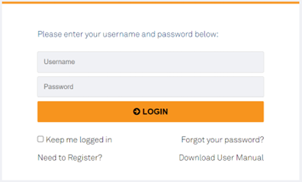

Once you have been set up as a user. You will receive an email from Bluestar with log on details. Access can take a few working days.
IMAC has also prepared a consent video which can be displayed in site reception areas if desired. This video is available on the IMAC website.
Note: An interpreter may be arranged to be available on site to assist consumers who speak languages other than English, including New Zealand Sign Language. See the Equitable access section above for more information about interpreters.
Some collateral items have been translated and are available on Dropbox and/or Bluestar.

Table 7.3 – site collateral ordering and purpose
Collateral | Purpose | How to Order
COVID-19 informed consent suite, which includes:  HP8590 What you need to know about the COVID-19 vaccination  HP7565 COVID-19 vaccination consent form  HP8591 After the COVID-19 vaccination  HP7568 Privacy statement | To share with consumers on site or before attending the vaccination site | Download directly from the NIP Dropbox.  Some items are available in hard copy via Bluestar portal.
COVID-19 vaccine FAQs | To provide answers to FAQs | Available on the Ministry’s website
Vaccination recording form | For use if AIR is unavailable | Available from the Health New Zealand Te Whatu Ora website
Consent form (which includes fields to capture required consumer data) | For use if AIR is unavailable | Download directly from the NIP Dropbox.
Adverse Event Reporting | To provide information, and to enable accurate record keeping | Available on the Centre for Adverse Reactions Monitoring (CARM) website:  https://pophealth.my.site.com/carmreportnz/s/https://report.vaccine.covid19.govt.nz/
Vaccine Error Reporting Form | To enable accurate record keeping | Contact the Health District communications manager
Vaccination station material | Promotional material to support vaccination site set up | Order via Bluestar
Instructions for the Preparation and Administration of vaccines | For vaccinators and staff on site | Included in vaccine shipments and are available on the IMAC website.
‘Where to get help’ poster | To provide information simply and quickly | Contact the Health District communications manager

Table 7.4 – site and facility set up for vaccine delivery
Information required | Details | Process
Site and facility  set up information | - Site and facility information must be provided to NPHS Health New Zealand Te Whatu Ora five (5) days in advance of any initial deliveries. | - Use the New facility site set up form (found in Appendix B) to submit site or facility details  - Return the completed form via email to  help@imms.min.health.nz

Ordering Interwaste vial disposal bins
As part of site preparations, Interwaste must be contacted to arrange the delivery of an Interwaste vial disposal bin (see the Disposal of consumables, vaccine, and vaccine packaging section below).
Contact Interwaste on 0800 102 131 (business hours) as soon as the site is approved. Provide at least five business days’ notice before the container is required to arrive. Interwaste will collect the relevant details such as the site manager’s name and contact details, the delivery date for the first container, and the site delivery address information.

Inventory management
The Inventory Portal provides a centralised place for vaccine and consumables orders, managing stock on hand (SOH), arranging transfers, and recording consumption and wastage of unopened vaccine vials.
NPHS Health New Zealand Te Whatu Ora logistics team will continue to monitor demand and allocation using data from the Inventory Portal. Key data monitored includes:
- Stock on hand (daily stock takes)
- Stock movements, including ordering, transfers, wastage, consumption, and stock adjustments
- Stock consumption
- Stock waste
- Quarantine of and repacking of stock.
Please contact your regional liaison if you have feedback on the immunisation process or recommendations for operational improvements.

Operational reporting
Health Districts or providers should report significant events at sites such as a significant adverse reaction, or adverse events affecting consumers to Health New Zealand Te Whatu Ora.

Vaccine storage and handling

Vaccine security
To ensure the security of the vaccine, the following minimum standards must be met:
- If the vaccine is to be stored overnight at the vaccination site, the building should be in a controlled-access environment (such as Maritime Port).
- If the building is not in a controlled-access environment (such as a community hall), the building should be able to be secured and have a monitored alarm.
- In the event of the vaccines being stored at a vaccination site without controlled access and not a building (such as a tent), an overnight onsite security guard must be present.

Differentiation of vaccines
Syringe labels are transitioning to vaccine labels for use with punctured vials and drawn up syringes to differentiate between vaccines and identify use by time. Rolls of 100 stickers can be ordered as a standalone product through the inventory portal.
Vaccine Labels
Label for Comirnaty Omicron XBB.1.5 30mcg/0.3mL multi-dose vial dark-grey cap vaccine (12+ yrs) | 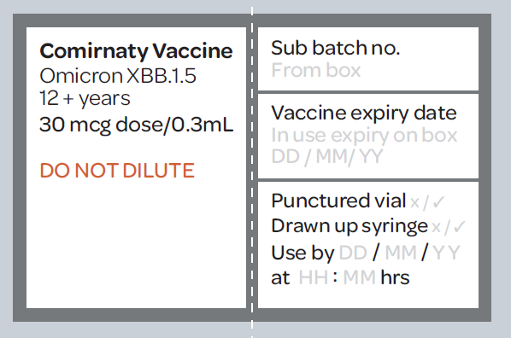
Label for Comirnaty Omicron XBB.1.5 30mcg/0.3mL single-dose vial light-grey cap vaccine (12+ yrs)
Label for Comirnaty Omicron XBB.1.5 10mcg/0.3mL single-dose vial blue cap vaccine (5 to 11 yrs) | 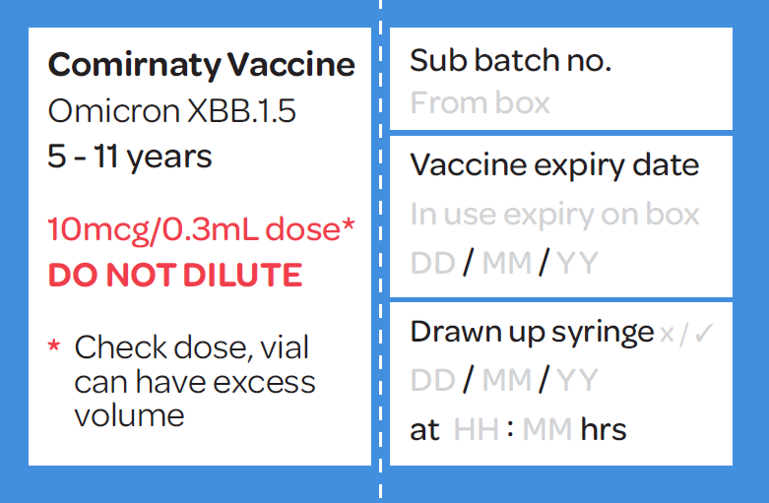
Label for Comirnaty 3mcg/0.2mL multi-dose vial maroon cap vaccine (6 months to 4 yrs) | 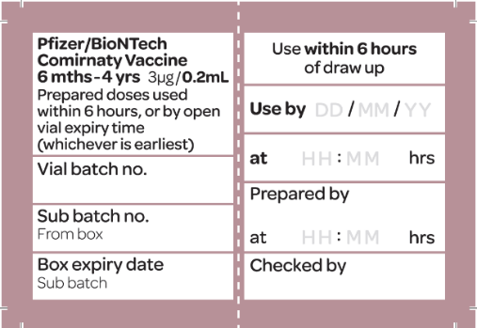
Label for Nuvaxovid 0.5mL multi-dose vial vaccine (12+ years)  Note: Nuvaxovid 0.5mL multi-dose vial vaccine (12+ years) will not be available from 1 May 2024. There will be no Novavax vaccine available until the Nuvaxovid XBB.1.5 vaccine is approved. | 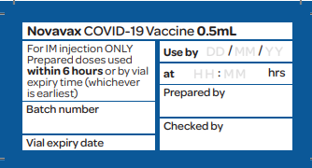

Vaccine packaging
Comirnaty Omicron XBB.1.5 30mcg/0.3mL multi-dose vial dark-grey cap vaccine (12+ yrs)  Pack size: 10 vials per pack | 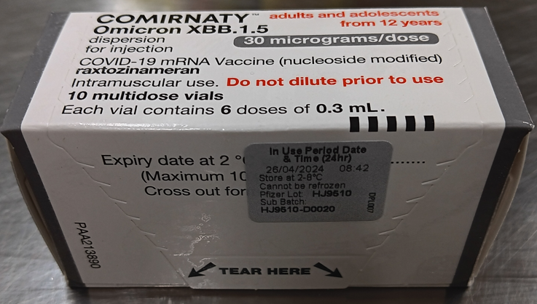
Comirnaty Omicron XBB.1.5 30mcg/0.3mL single-dose vial light-grey cap vaccine (12+ yrs)  Pack size: 10 vials per pack | 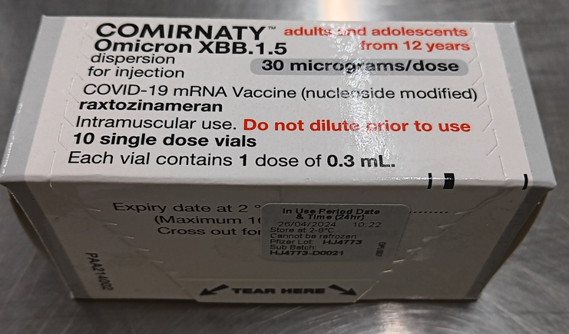
Comirnaty Omicron XBB.1.5 10mcg/0.3mL single-dose vial light blue cap vaccine (5 to 11 yrs)  Pack size: 10 vials per pack | 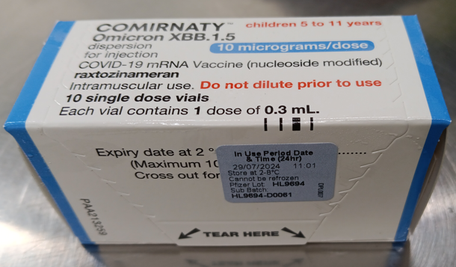
Comirnaty 3mcg/0.2mL multi-dose vial (dilute to use) maroon cap vaccine (6 months to 4 yrs)  Pack size: 10 vials per pack  Note: Comirnaty 3mcg maroon cap vaccine (6 months - 4 years) is available in 2 vial and 5 vial packs. 10 vial packs are currently not available to order. | 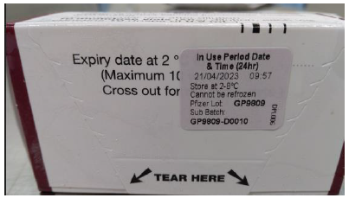
Comirnaty 3mcg/0.2mL multi-dose vial (dilute to use) maroon cap vaccine (6 months – 4 yrs)  Pack size: 2 and 5 vials per pack | 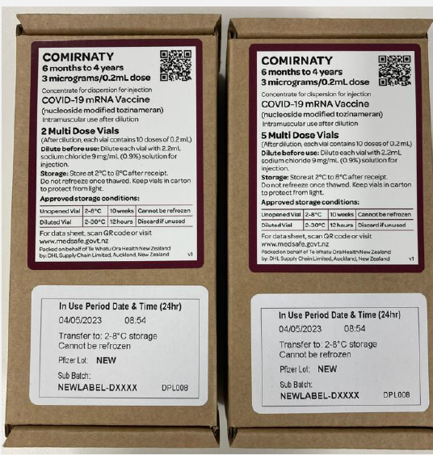
Nuvaxovid 0.5mL multi-dose vial vaccine (12+ years)  Pack size: 10 vials per pack  Note: Nuvaxovid 0.5mL multi-dose vial vaccine (12+ years) will not be available from 1 May 2024. There will be no Novavax vaccine available until the Nuvaxovid XBB.1.5 vaccine is Medsafe approved. | 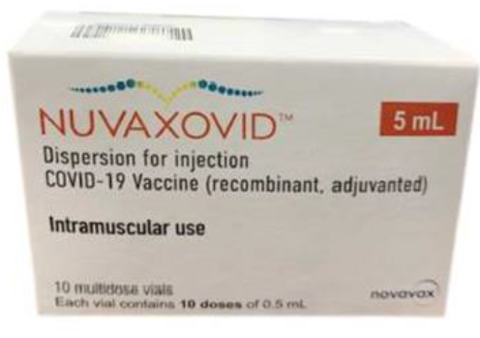
Note: The sub-batch labels on the vaccine pack for Comirnaty vaccines are colour coded to assist with differentiation.

Cold chain storage
All facilities must hold cold chain accreditation as per the National Standards for Vaccine Storage and Transportation for Immunisation Providers 2017 (the National Standards). The cold chain accreditation expiry date and back up fridge for each facility must be recorded in the Inventory Portal.
Vaccine must be stored and transported in cold chain accredited conditions. NPHS Health New Zealand Te Whatu Ora requires any individuals responsible for handling the vaccine to have completed the appropriate cold chain training.
Further information on cold chain management is available in section 2.1 of the Immunisation Handbook. See also the manufacturer’s specifications for approved product handling, available at: https://medsafe.govt.nz/COVID-19/status-of-applications.asp
See shelf life of vaccines in the table below. Storage should protect from light.

Table 8.1 – vaccine shelf life
Vaccine type | State | At +2°C to+8°C | At ambient temperature
Comirnaty Omicron XBB.1.5 30mcg/0.3mL multi-dose vial dark-grey cap vaccine (12+ yrs) | Vaccine is prediluted | Up to 10 weeks after removal from the ULT freezer.  Note: Please always follow the ‘in-use’ expiry date label on the vaccine pack. Vaccines can be administered on day of expiry (up to midnight). The expiry date on the vial is only relevant to ULT freezer storage. | Punctured vial up to 12 hours (8°C to 30°C)  Up to 6 hours when drawn up into syringe or by time written on the vial (whichever is earliest) (up to 30°C)
Comirnaty Omicron XBB.1.5 30mcg/0.3mL single-dose vial light-grey cap vaccine (12+ yrs) | Vaccine is prediluted | Up to 10 weeks after removal from the ULT freezer.  Note: Please always follow the ‘in-use’ expiry date label on the vaccine pack. Vaccines can be administered on day of expiry (up to midnight). The expiry date on the vial is only relevant to ULT freezer storage. | Punctured vial up to 12 hours (8°C to 30°C)  Up to 6 hours when drawn up into syringe or by time written on the vial (whichever is earliest) (up to 30°C)
Comirnaty Omicron XBB.1.5 10mcg/0.3mL single-dose vial light blue cap vaccine (5 to 11 years.) | Vaccine is prediluted | Up to 10 weeks after removal from the ULT freezer.  Note: Please always follow the ‘in-use’ expiry date label on the vaccine pack. Vaccines can be administered on day of expiry (up to midnight). The expiry date on the vial is only relevant to ULT freezer storage. | Puncture vial up to 2 hours (8°C to 30°C)  Up to 6 hours when drawn up into syringe or by time written on the vial (whichever is earliest) (up to 30°C)
Comirnaty 3mcg/0.2mL multi-dose vial (dilute to use) maroon cap vaccine (6 months to 4 years) | Undiluted | Up to 10 weeks after removal from the ULT freezer.  Note: Please always follow the ‘in-use’ expiry date label on the vaccine pack. Vaccines can be administered on day of expiry (up to midnight). The expiry date on the vial is only relevant to ULT freezer storage. | Let vial get to ambient temperature before puncturing (not cold to touch)  Punctured vial up to 12 hours (8°C to 30°C)
 | Diluted | Up to 12 hours in vial (or until the end of the day it was prepared on) | Up to 6 hours when drawn up into syringe or by time written on the vial (whichever is earliest) (up to 30°C)
Nuvaxovid 12+ yrs  Note: Nuvaxovid 12+ years will not be available from 1 May 2024. There will be no Novavax vaccine available until the Nuvaxovid XBB.1.5 vaccine is Medsafe approved. | Unopened | Up to 12 months (refer to expiry on pack as shelf life may have been extended) | Up to 6 hours (up to 25°C)
 | Punctured vial | Up to 6 hours | Up to 6 hours (up to 25°C)  Up to 6 hours when drawn up into syringe or by time written on the vial (whichever is earliest) (up to 25°C)

Process for Refrigeration Failure or Temperature Excursion.
In the event of refrigeration failure which results in a temperature excursion of the vaccine, follow the steps below.

Table 8.2 – refrigeration failure process
Step 1
Label the vaccines ‘not for use’ and in the event:
- The refrigerator is currently running within the +2°C to +8°C range, the labelled vaccines are to be retained in your refrigerator. | - The refrigerator is not within the +2°C to +8°C range, reversible causes should be considered (door open, power interruption). If no cause found, the labelled vaccines are to be packed into a chilly bin, with a temperature monitoring device and transported to the nearest back-up provider (details for this are in your cold chain policy and in the Inventory Portal).
Step 2
Contact your local cold chain coordinator for advice and further actions.
Their contact details should be on your cold chain policy, but they can also be found on
https://www.immune.org.nz/resources/regional-advisors-and-local-coordinators
Step 3
Document the steps and actions taken.

Movement of vaccine
Vaccine can be moved around a vaccination facility carefully if required. Avoid any unnecessary movement or handling. Care should be taken to not shake or drop vial packs or individual vials during transportation, preparation, or administration.
Note: If vials are dropped, or there is another reason for concern about whether the vaccine is still viable, contact IMAC for advice on 0800 IMMUNE (466 863), option 1 (health professionals) and then option 2 (COVID-19 vaccinator support).

Repacking vaccine at Health District facilities
Re-packing only applies to Comirnaty vaccines.
- Who can re-pack vaccines?
Only a Health District hospital pharmacy department can repack the vaccine packs down to distribute to a vaccinator or site. This function is actioned under their hospital pharmacy’s Licence to operate Pharmacy and only able to do so for supply within their Health District. In this circumstance, Health District means within the Health District legal entity.
- Who cannot re-pack vaccines?
Health District hospital pharmacy departments are not able to re-pack the vaccine packs for supply to providers outside of their Health District.
- What if a hospital pharmacy is required to repack the vaccine packs?
The Health District hospital pharmacy department will need a packing licence issued to them by Medicines Control.

Transportation of vaccine to other locations

Permissible Stock Movement
Sites who have received their vaccine stock from a Health District Pharmacy can contact the pharmacy to organise a stock movement. The Health District Pharmacy can move whole packs, under their wholesale license. Note: all movements must comply with the National Standards for Vaccine Storage and Transportation for Immunisation Providers 2017.
This has significant resource implications for the Health District Pharmacy therefore tight stock management is important to minimise waste. If a stock transfer is necessary, plan ahead to provide maximum time to support Health District Pharmacy processes.
A provider may take their own vaccine offsite for outreach/home visiting purposes. All cold chain requirements must be met.
No other transportation of vials is permissible.

Restrictions on Transport Durations

For Comirnaty vaccines:
There is no limit on the transit time of an unopened vials transported at 2°C to 8°C however, normal shelf-life limits apply.

For Nuvaxovid (12+ years) vaccine:
There is no limit on the transit time of an unopened vial of the Nuvaxovid vaccine transported at 2°C to 8°C however, shelf-life limits apply.
Note: Nuvaxovid 0.5mL multi-dose vial vaccine (12+ years) will not be available from 1 May 2024. There will be no Novavax vaccine available until the Nuvaxovid XBB.1.5 vaccine is Medsafe approved.

Transportation of diluted or drawn-up vaccine

Transportation of pre-drawn syringes
The syringes must be appropriately labelled (content, volume, batch, and expiry). It is recommended that labels designed for each vaccine are used. Best practice is to transport the vial and draw up as needed.

Bulk preparation of pre-drawn syringes
The bulk preparation of pre-drawn vaccine to be transported to another location is regarded as compounding and is not permitted unless it is undertaken in an approved facility (such as a hospital pharmacy aseptic unit, or a third-party commercial compounder) with appropriate checks, documentation, and regulator audit.
Note: It is recommended that a vaccine dose is administered as soon as possible after drawing up into a syringe. The maximum storage time in a syringe is 6 hours between +2 and +30°C.

Vaccine and consumables ordering and delivery

Vaccine ordering

Inventory order
Contact help@imms.min.health.nz for access to Inventory Portal. Vaccine stock (inventory) can be ordered using the Inventory Portal in two ways:
- Direct from the national distribution hubs using a supplier order (see section below),
or
- From another vaccine site using a transfer order (see section below).
See the Standard Operating Procedure (SOP) for order fulfilment at this SOP for order fulfilment link.

Supplier order
This is an order where the stock will come directly from a national distribution hub and the order must be approved by NPHS Health New Zealand Te Whatu Ora team. Users must be associated with a location to place a supplier order.
Further details regarding how to log into the Inventory portal can be found in the quick guides, videos and detailed training guide at this link.
See the Standard Operating Procedure (SOP) for order fulfilment at this SOP for order fulfilment link.

Cancelling orders
Orders can be cancelled before they are approved by NPHS Health New Zealand Te Whatu Ora. This is to allow corrections to an order that might be incorrect or orders that are no longer required.

Transfer orders
This is a transfer between two locations. It is used routinely to transfer stock between Health District Hospital Pharmacies and mobile vaccination sites. For fixed vaccination sites, the transfer order process is only used for surge/back-up transfers for delivery from Health District Hospital Pharmacies, or end of day returns between two locations. Users must be associated with a location to place a transfer order.
See the Standard operating procedure (SOP) for inventory management on this SOP for inventory management link.

Table 9.1 – ordering information required
Details
- Each site will be allocated a day of the week for delivery. High volume sites may have more than one designated delivery day per week.
- The inventory portal will only allow orders for deliveries on the allocated delivery day(s).
- For the Pfizer Comirnaty Vaccine, a facility should consider the size of the packs they are ordering and their ability to break down packs to avoid unnecessary vaccine movement or wastage.
- Vaccine orders must be made through the inventory portal.
- Vaccine orders must be submitted before the cut off time before your allocated delivery day (see table below).
If an order is not placed before the cut off time before your allocated delivery day, the Health District will need to submit a request for an ‘out-of-cycle’ delivery to NPHS Health New Zealand Te Whatu Ora CST Logistics Desk.
- To avoid out of cycle deliveries, please plan to place orders regularly – target having no less than 3 weeks stock on hand (based on recent demands) at all times to ensure you cover short term demand peaks, or delivery issues relating to emergency events eg; earthquakes, wild weather, etc…)
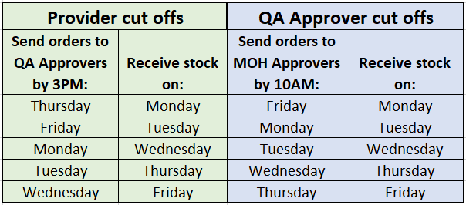

Vaccine delivery schedule
- How often can I receive vaccine deliveries?
A site is assigned a designated delivery day on the standard delivery schedule. This is based on the logical routes the courier provider follows and helps manage delivery costs for the programme. This allows for a minimum of 1 delivery per week every week as needed. By arrangement, if a site is located in a metropolitan area and has ongoing high levels of vaccination, an additional delivery day can be organised.
- Can my delivery schedule change?
The schedule will be discussed and agreed with Health Districts or providers and can be reviewed when required.
- What if I miss the cut off (by 10am the day before) for ordering vaccines?
If you need to order vaccine urgently prior to your next designated delivery day, notify your Health District and they will need to send an ‘out-of-cycle’ delivery request to the CST Logistics Desk (please ensure you target a minimum of 3 weeks stock on hand to help avoid this issue!).
- Where will the vaccine be shipped to?
To the location agreed with the Health District or provider.
- How will I know what vaccines I am due to receive?
The Inventory Portal shows designated delivery days and incoming orders.
- What if I receive a shipment I am not expecting or don’t receive a shipment when I am expecting one?
Delivery tracking will be managed centrally by NPHS Health New Zealand Te Whatu Ora. Please contact NPHS Health New Zealand Te Whatu Ora logistics customer services team.

Vaccine unit sizes and dimensions
 | Unit Size | Unit Dimensions
Comirnaty XBB.1.5 30mcg (12 + years) dark grey cap Multi-dose vials (6 doses per vial) | 10 multi-dose vial packs | 37mm x 47mm x 89mm
Comirnaty XBB.1.5 30mcg (12 + years) light grey cap Single-dose vials | 10 single-dose vial packs | 37mm x 47mm x 89mm
Comirnaty XBB.1.5 10 mcg (5-11 years) light blue cap Single-dose vials | 10 single-dose vial packs | 37mm x 47mm x 89mm
Comirnaty 3 mcg (6 months – 4 years) maroon cap | 10 multi-dose vial packs (not available, can be ordered in 2 vial and 5 vial packs) | 37mm x 47mm x 89mm
 | 5 multidose vial packs | 130mm x 65mm x 45mm
 | 2 multidose vial packs | 130mm x 65mm x 45mm
Nuvaxovid (12+ years)  Note: Nuvaxovid (12+ years) will not be available from 1 May 2024. There will be no Novavax vaccine available until the Nuvaxovid XBB.1.5 vaccine is Medsafe approved. | 10 multidose vial packs | 92mm x 36mm x 62mm

Table 9.2 – Consumables order as required*
Item | Purpose | Carton size
Biohazard Yellow Bags | Disposal of waste | 50
Sharps Containers – 15 L | Disposal of sharps | Singles
Antiseptic Swabs | Vial top disinfectant | 200
Non-Woven Swab | Swab | 100
Dermaplast Sensitive Injection Plaster | Plaster | 250
10 mL Saline | Diluent | 100 x 10mL
BD 3 mL Syringe | Drawing-up syringe for saline | 100
Nipro 25G Standard Needle | Drawing up needle for saline | 100

Table 9.3 – Administration syringes and needles
Item |  | Vaccine | Carton size
BD Flu Plus 0.1-1mL Syringe and 23G 1" LDS Needle |  | Nuvaxovid (12+ years) | 200
SOL-M 1ml Syringe + 25Gx16mm Needle |  | Comirnaty (6 months - 4 years)  Comirnaty (5 -11 years) | 100
Unifix 1 mL Syringe | Administration syringe | Comirnaty (12+ years) | 100
Vernacare LDS Orange Needle 25Gx25mm | Administration needle standard |  | 100
Vernacare LDS Blue Needle 23Gx38mm | Administration needle for larger arms |  | 100
*Consumables are currently only available to order through the Inventory Portal for use with COVID-19 vaccines.

Delivery to sites

Figure 9.1 – delivery security
Warehouse/distribution provider | Health District facility or vaccination facility |  | Vaccination site
Role of NPHS Health New Zealand Te Whatu Ora | Role of Health District |  | Vaccine handover
NPHS Health New Zealand Te Whatu Ora will arrange secure transportation of the large quantities of vaccine from the vaccine distribution provider to the cold chain storage facility (such as Health District facility or vaccination site) using a NPHS Health New Zealand Te Whatu Ora-contracted courier. | - If the vaccine is transported to a Health District cold chain storage facility, secure transportation of the vaccines from that facility to the vaccination sites becomes the responsibility of the relevant Health District or provider.  - In the event vaccines are to be transported from a local facility to the vaccination site, the unique circumstances of such transportations should be considered in the site risk assessment.  - In the event couriers or authorised personnel (such as vaccinators, administrators, or security) are conducting the transport, NPHS Health New Zealand Te Whatu Ora recommends there should be direct travel to the vaccination site (that is, no transit points). |  | Note:  There should be a local procedure in place to ensure the person responsible for transporting the vaccine can be identified. This is to ensure the Health District, or provider has complete confidence they are handing over the vaccine for delivery to the appropriate person. There is no requirement for the person to be a vaccinator.
Temperature controlled shipper boxes that may be used for vaccine transportation from warehouse/distribution provider
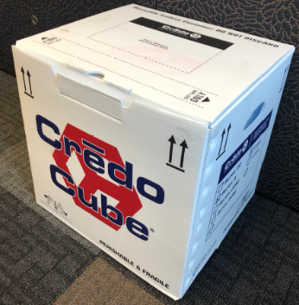 |  | 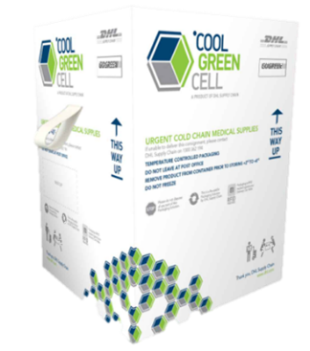
Credo Cube |  | Cool Green Cell (CGC)
Note the placement of the all-in-one Google Scout temperature/ tracking device is on top of the vaccine pack in the Credo shipper box.  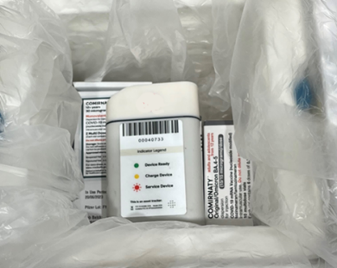 |  | Please note placement of the all-in-one TrackIT V3 temperature/ tracking device with LCD screen is on the inside of the CGC shipper box.  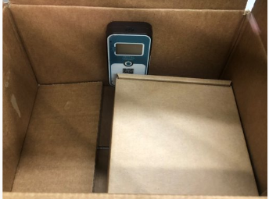

Delivery temperature and expiry dates
Check the sub batch label on the vaccine pack for the expiry date of the vaccine.

Vaccine stock/inventory management
- Stock should be used on a first to expire first out (FEFO) basis, to ensure waste due to expiry is minimised.
- If there is any concern that a site has excess stock, this should be reported to the Health District who can arrange redistribution.
- Sites should hold a minimum of three (3) weeks of stock cover.

Process
Site stock on hand should be managed through the Inventory Portal.
- Once stock is delivered to a site:
  - Check and verify batch details against details on the packing slip and order record. Report any discrepancy to the CST Logistics Desk.
  - Mark stock as receipted in the Inventory Portal once the site has accepted the stock.
- Check the vial and follow in-use expiry on vaccine packs. Due to vaccine expiry extensions, vial expiry may have passed, but the vaccine is still viable.
  - During the preparation of doses and document this on the drawn-up doses label
  - Before administration of the vaccine
  - At the end of the day check stock
- Discard any expired vaccines and record this as waste in the Inventory Portal (see section ‘Recording vaccine waste’).
- Any consumption and wastage must be recorded in the Inventory portal daily.
- Once consumption is recorded in the Inventory Portal, all remaining stock on site must be checked against the stock showing in the Inventory Portal to ensure that there are no discrepancies.
- Any discrepancies must be investigated and captured in the Inventory Portal as stock adjustment.
For more detail see the Standard operating procedure (SOP) for inventory management on this SOP for inventory management link.

Table 9.4 – site delivery and receipt process
Step | Action
Health District/provider logistics lead provides site contact and delivery details | Site checklist  The site checklist must be completed prior to the site commencing vaccinations (see Appendix A).
Site contact
- The Health District or provider logistics lead must provide NPHS Health New Zealand Te Whatu Ora with:
  - a site contact (a named role and a phone/mobile number)
  - detailed delivery instructions, including address and any special instructions (such as separate entrances and so on).
- Submit this information using the New facility/ site set-up form (Appendix B) at least 5 days prior to ordering vaccines for that site.
Availability of site contact
- The site contact should be regularly available on site to accept deliveries. This will minimise the administration involved changing the site contact person, for example.
- Please notify urgent site contact changes to NPHS Health New Zealand Te Whatu Ora logistics team.
Cold chain accreditation
- NPHS Health New Zealand Te Whatu Ora recommends individuals handling vaccines are cold chain accredited; however, this is not a requirement.
Vaccine distribution provider packs and ships vaccine | Ship under cold chain conditions  - The vaccine distribution provider will pack and ship the vaccine under cold chain conditions in shipper boxes, depending on delivery destination, at +2°C to+8°C.
Site contact receives the package | The courier will hand the package to the site contact. Before signing for the package, the site contact will:  - Confirm the shipper box is addressed to them/their site.  - Open the packing slip provided on the packaging, and conduct a check of the order immediately while the courier is present (see below).
Site contact checks the temperature datalogger  Google Scout Temperature Reading  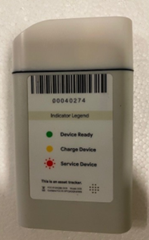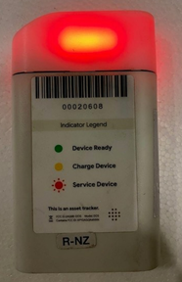  If the temperature datalogger shows:  No light  - Temperature is within limits  Red light  - Temperature breach has occurred  Battery indicator on side of Google Scout is for HCL use only.  TrackIT V3 Temperature Reading  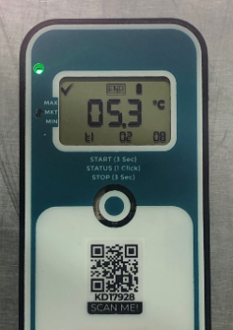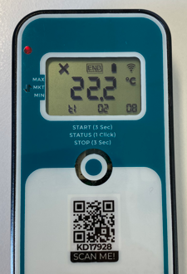  If the temperature datalogger shows:  Green light and √  - Temperature is within limits  Red light and X  - Temperature breach has occurred  If the screen is not displaying on the TrackIT device press the button once. | Check for a temperature breach  The site contact must follow the process below:  - Read the temperature datalogger immediately after opening the shipper box (before removing the vaccine packs).  - Do not attempt to stop the temperature datalogger.  - Leave the datalogger in the shipper box.  In the event of a temperature breach  - Quarantine the shipment in cold chain conditions.  - Return the shipper box with temperature datalogger inside to the courier.  - Contact the Logistics Customer Support Service Team immediately.  Temperature breach – next steps  The Health New Zealand Te Whatu Ora logistics team will advise the site contact on the next steps, such as the need to re-order and use of quarantined vaccines once the temperature report has been reviewed.
Site contact conducts  visual check | Visual check  - The site contact will open the shipper box and the internal packaging and conduct a visual check of the outer packaging of the vaccine pack/s to check for damage and/or leakage. If there is no damage store directly in the fridge.  - Each site should check the packing slip to make sure all vaccines have been received.  - If there are any signs of damage to the outer packaging, inspect the vials inside the vaccine pack/s:  - Broken vials or waste needs to be recorded in the Inventory Portal but only to the unopened vial stage.  - Vaccine wasted in opened vials is not required to be recorded in the Inventory Portal.  - Please see the Standard Operating Procedures in the Inventory orders section regarding how to record vial consumption and waste.
Site contact signs for vaccine package | Vials intact  - Where the vials are intact and there are no concerns, the site contact will sign for the package.
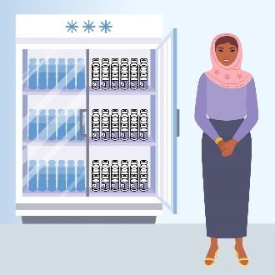  Site contact stores vaccine in cold chain accredited conditions | Store vaccine  The site contact will then store the vaccine packs in cold chain conditions, not the shipper box (Credo/CGC ),until the expiry date and time marked on the vaccine pack is reached. Any vials no longer viable must be disposed of following the disposal process detailed below.
Receipting orders | When a vaccine or consumables order is received, it must be receipted into the Inventory Portal. This enables the movement of the stock from in transit to available for use in the stock on hand.  Further details regarding how to use the Inventory portal and be found in the Inventory management (eLearning) https://www.immune.org.nz/catalogue/managing-inventory-in-the-covid-19-imms-register-v1  See the Standard Operating Procedure (SOP) for order fulfilment at this SOP for order fulfilment link.
- Shipper boxes and temperature monitoring equipment should be taken away by the NZ Post courier driver after the vaccine packs have been removed from the shipper box and checked against the packing slip.  - The NZ Post delivery driver will typically wait 5 minutes to take the empty Credo or CGC packaging away.  - If the driver has left before the Credo/CGC can be handed back, please follow the insert instructions included in the packaging to arrange pick up. | - Pre-paid stickers will be included with the delivery for returns.  - The number on the instructions should be called to arrange collection.  - Any fault or damage to the packaging equipment should be reported at the time of return.  Note: Ensure correct removal or crossing-out of the original courier label and original address details to avoid any confusion.

Vaccine and consumables assets and asset management
An asset is an instance of vaccine stock and vaccine consumables, such as: 10 vial pack of vaccine or consumables.
Assets at a location can be updated through:
- Stock re-work
- Stock adjustment
- Quarantine stock
- Recording consumption, or
- Stock on hand.
Asset management can be completed on the Inventory Portal.

Recording consumption
It is important to record the consumption of vaccine stock and consumables as stock in consumed or, as a minimum, as part of the daily stocktake. The purpose of this is to give an accurate local, regional, and national view of vaccine stock on hand.
Consumption can be recorded in two ways:
- Consumption – entering directly what has been consumed.
- Stock on hand – entering a physical count of the stock on hand as part of the daily stock take.

Recording vaccine waste
It is important for vaccine sites to record vaccine waste in the Inventory Portal only to the unopened vial level (the recording of vaccine wasted at the opened vial level is yet to be determined). This is so that waste can be tracked at a local, regional, or national level.
Further details regarding how to use the Inventory Portal can be found in Inventory management (eLearning) https://www.immune.org.nz/catalogue/managing-inventory-in-the-covid-19-imms-register-v1
See the Standard operating procedure (SOP) for inventory management at this SOP for inventory management link.

Table 9.5 – asset management recommended practice
Recommended practice | Details
Collation of site inventory and operations | Health Districts or providers may wish to collate daily reporting back from sites on inventory and/or operations to aid the supply of information back to NPHS Health New Zealand Te Whatu Ora via the Inventory Portal.
Continuous process improvement | NPHS Health New Zealand Te Whatu Ora welcomes feedback on the immunisation process or recommendations for operational improvements.  Please contact your regional liaison to pass on your feedback

Disposal of consumables, vaccine, and vaccine packaging
Vaccine disposal and other inventory management topics (outlined below) are available as eLearning modules.

Disposal of consumables
Health Districts and providers are responsible for the disposal of consumables. Consumables should be disposed of according to existing procedures (such as disposal into sharps bin and/or biohazard bags). Local procedures are to be followed to arrange collection of the sharps bin and other medical waste.

Disposal of damaged, empty, and expired vaccine vials
When a possible cold chain excursion occurs providers must contact their immunisation coordinator before disposing of any vaccines as per the National Standards for Vaccine Storage and Transportation for Immunisation Providers 2017.
Damaged, empty, and expired vaccine vials must be disposed in a Interwaste vial disposal bin and recorded as wastage in the Inventory portal.
As part of site preparations, Interwaste must be contacted at least 5 business days in advance of your site going live to request a vial disposal bin to be delivered to the site. Contact Interwaste on 0800 102 131 (their call centre is available
from 8am-5pm weekdays). For more information see the Ordering Interwaste vial disposal bin section above.
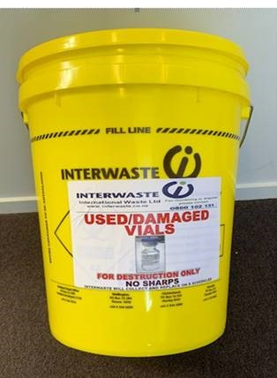

Figure 10.1 – disposal bin
Interwaste will provide a 20-litre sized container in which to dispose expired (full), empty, broken, or damaged vials. Please note, expired vials should be defaced before disposal. When the container is almost full, contact Interwaste on 0800 102 131 to arrange its pick-up. Interwaste will deliver a new disposal container at the same time they remove the existing container. Interwaste will destroy the vials in an appropriate manner.
Ensure the lid of the Interwaste disposal container remains closed when not in use.

Disposal of vaccines drawn up but not administered and empty vaccine syringes
Vaccine doses that have been drawn up but not administered must be disposed of in a sharps bin. Similarly, empty/used vaccine syringes should be disposed of in the sharps bin. Seal and remove sharps bins when filled and stored in a secure area for transportation and final disposal.
Manage sharps waste as per NZS 4304:2002 Management of Healthcare Waste.

Vaccine packaging disposal
Ensure all packaging that the vaccine is sent in is appropriately destroyed to ensure packages cannot be replicated.
The vaccine pack must be securely destroyed. It can be disposed of in a secure document destruction bin if one is available or a biohazard bag. Packaging must not be disposed of in household waste collection or recycling centres.

Site readiness and closure

Site setup form and site checklist
Complete the site checklists included in Appendix A to assess whether the vaccination site is ready to commence vaccinations. Site checklists, upon completion, must be signed by the Health District or provider chief executive, or their delegate, to approve the site is ready. The checklist is then submitted to either the regional account manager or NPHS Health New Zealand Te Whatu Ora’s logistics team. Primary care providers may be asked to submit site checklists to their Health District rather than NPHS Health New Zealand Te Whatu Ora directly.
The new facility/ site set up form (v1.7) form (see Appendix B) must be submitted
at least five days prior to the site commencing vaccinations. This information is used to set up the facility or site in the Inventory portal and ensure deliveries are made to the correct address.
Care is required to provide accurate information on this form.

Completing a dry run
NPHS Health New Zealand Te Whatu Ora recommends a site trial or dry run before beginning vaccinations on site to ensure staff are familiar with their roles and consumer flow can be tested. NPHS Health New Zealand Te Whatu Ora logistics team do not provide dry run packs however, an optional order of consumables can be ordered from NPHS Health New Zealand Te Whatu Ora’s logistics team which can be used to complete a dry run.

Facility/site closure form
Complete the facility/site closure form (see Appendix C) as a part of the site and facility closure protocol, and to assess and return stock.
A stocktake of all consumables relating to the COVID-19 Vaccination Rollout must be completed upon site/facility closure. Submit the completed facility and site closure form to NPHS Health New Zealand Te Whatu Ora’s logistics team and your Health District logistics Lead. This should be submitted a week before the closure or as soon as the closure of the location is known.

Facility moving location
Facilities are where vaccines are shipped to, stored, and subsequently distributed to sites. Sites are where vaccines are administered.
Facility Moving Location | New Facility Set-up Required
If a facility needs to move their physical location, and there will be continuity of the Cold Chain Accreditation (CCA), the facility can complete part four of the Facility/Site Set-up form (see Appendix B) confirming Health District approval for the move and that CCA will be in place for the new facility. | If Cold Chain Accreditation (CCA) cannot be transferred to the new location and requires reassessment, please:  - Complete the Facility/Site Closure Form (see Appendix C) and associated procedures.  - Complete the new Facility/Site Set-up form (see Appendix B) and associated procedures which will allow the facility to be set up in the Inventory portal for delivery to the new address.  - Ensure that CCA for the new location has been assessed and approved.
- Cold chain must be maintained during a facility move.
- The only circumstance where vaccines can be delivered to an alternative address to that already set up in the Inventory Portal, is where it is delivered to the nominated address for cold chain fridge back-up (recorded in the Inventory Portal).

Becoming a COVID-19 Vaccination site

Onboarding
Becoming a COVID-19 vaccination site can be complex, involving engagement with both your local Health District and/or PHO and NPHS Health New Zealand Te Whatu Ora. To ensure consumer safety, vaccination sites will need an appointed Clinical Site Lead to navigate the onboarding process. The Clinical Site Lead is accountable for meeting clinical safety and quality standards at their site, as well as supporting planning, clinical governance, quality, and safety management processes.
Primary Care providers are a critical component of the New Zealand COVID-19 vaccination rollout.

Additional resources
The following supporting documents can be found on the Health New Zealand Te Whatu Ora website and in the links below:
- Child health COVID-19 resources and professional development
- User Onboarding Journey for Book My Vaccine (also known as NIBS)
- User Onboarding Journey for the AIR vaccinator portal

Aide-Memoire Infection prevention and control (IPC) principles and procedures for COVID-19 vaccination activities, 15 January 2021. https://apps.who.int/iris/handle/10665/338715

