BioNTech/Pfizer COVID-19 Vaccine and Immunisation Programme
Planning blueprint: Workplace sites

Version 9, Issue 2
09 July 2021

Version 0.1

Version 0.1

Version 0.1

Version 0.1 - DRAFT

Version 0.1

Version 0.1

Version 0.1

Version 0.1 - DRAFT

Version 0.1

Version 0.1

Version 0.1

Version 0.1 - DRAFT

Version 0.1

Version 0.1

Version 0.1

Version 0.1 - DRAFT

Version 0.1

Version 0.1

Version 0.1

Version 0.1 - DRAFT

Version 0.1

Version 0.1

Version 0.1

Version 0.1 - DRAFT

Version 0.1

Version 0.1

Version 0.1

Version 0.1 - DRAFT

Version 0.1

Version 0.1

Version 0.1

Version 0.1 - DRAFT

Version 0.1

Version 0.1

Version 0.1

Version 0.1 - DRAFT

Version 0.1

Version 0.1

Version 0.1

Version 0.1 - DRAFT

Version 0.1

Version 0.1

Version 0.1

Version 0.1 - DRAFT

Version 0.1

Version 0.1

Version 0.1

Version 0.1 - DRAFT

Version 0.1

Version 0.1

Version 0.1

Version 0.1 - DRAFT

Version 0.1

Version 0.1

Version 0.1

Version 0.1 - DRAFT

Version 0.1

Version 0.1

Version 0.1

Version 0.1 - DRAFT

Version 0.1

Version 0.1

Version 0.1

Contents

1. Purpose 3
2. Service model 3
3. Early planning considerations 5
4. Information for Vaccination providers 8
5. Information for Workplaces/Employers 16
Appendix 1: Guidance on delivery models for Māori, Pacific, ethnic communities and disability groups 19

- Purpose
This document provides guidance to commissioning agencies (the Ministry of Health and District Health Boards), vaccination providers and workplaces/employers in their planning for vaccine delivery to Group 4 in workplaces. It is designed to help workplaces/employers and vaccination providers decide if they can participate in this programme, and if so what planning considerations do they need to consider before rolling out on-site vaccination.

- Service model
The COVID-19 Vaccine and Immunisation Programme (CVIP) has the following success goals to achieve balanced decision making:
- Honours and upholds Te Tiriti o Waitangi principles.
- Quality and safety – vaccines and immunisation processes are clinically and culturally safe, backed by a strong evidence base, appropriate kaupapa and capability.
- Experience – renewed/increased trust and confidence in the health sector and immunisation, underpinned by positive experiences at system, programme and whānau/individual levels.
- Equity – Māori, Pacific and people with disabilities achieve equitable immunisation outcomes. Everyone in New Zealand and the Pacific has equal opportunity to access the vaccine.
- Access – New Zealand’s and Pacific’s immunisation needs are met at the right time and place with minimal waste.
Offering different service models is one way the programme can work towards these success goals. The four service delivery models for the CVIP are:
- community sites (in existing healthcare facilities e.g. general practice, community pharmacy, Hauora practices, urgent care)
- hospital sites
- temporary sites (e.g. workplace, marae, church)
- fixed sites (e.g. community hubs).
Workplaces are ‘temporary sites’ designed to enable employers and vaccination providers to leverage their experience and resources to vaccinate workers at a time and place convenient to them. This model is considered important to drive uptake, by making access convenient and easy (such as in rural communities) and supports equity of access for Māori and Pasifika populations.
It is considered an effective model, as demonstrated by the annual influenza campaign and the rollout of the Pfizer vaccine by occupational health vaccination providers to workplaces in Groups 1 and 2.

The Ministry of Business, Innovation and Employment has published guidance for employers on supporting the vaccination campaign at https://www.employment.govt.nz/leave-and-holidays/other-types-of-leave/coronavirus-workplace/covid-19-vaccination-and-employment/
The Public Service Commission has issued guidance for public sector agencies, which includes the line “Vaccines should be administered in the workplace where possible”.
https://www.publicservice.govt.nz/resources/covid-19-workforce-vaccinations-guidance/
This model is for delivery as part of the Group 4 rollout that will start from late July 2021.
  - Eligibility criteria for workplaces/employers
Workplaces must:

Either;

be considered one of the largest workplaces/employers (by size of workforce) and have enough workers per site to be vaccinated. As a guide, an indication is workplaces with 1,000+ employees, with the ability to vaccinate several hundred staff per site, or

for smaller workplaces/employers – support a DHBs’ equity goals of targeting workplaces with high Māori, Pacific or ethnic populations and those harder to reach (e.g. due to rurality or shift work). Note even for smaller workplaces/employers – there is a minimum requirement of 70 vaccinations per site per day
And;

have had a successful vaccine programme previously delivered onsite

be able to provide staff to undertake specified roles and responsibilities as outlined in the Workplace Model Planning Blueprint – particularly the logistical tasks to support worker engagement, recall processes, and cultural and religious safety.

  - Families/Visitors/Neighbouring Businesses to Sites
It is recommended that family and visitors are not part of the workplace/employer site vaccinations to prevent any public/crowd control issues, ensure compliance with the Health and Safety at Work Act is maintained, and Public Liability risks are managed. As the employer and provider gain experience with the Pfizer vaccination processes, in conjunction with the vaccination providers commissioning agency, they may reconsider this position.

- Early planning considerations
There are some notable differences between the Pfizer vaccine and other vaccine programmes, such as influenza, that both workplaces/employers and vaccination providers should be aware of. The following considerations have been shared by occupational health vaccination providers who delivered the Pfizer vaccine in Group 2 eligible workplaces:
- The Pfizer vaccine is a national roll out with the goal of offering vaccination all peoples in Aotearoa New Zealand within a set timeframe.
- It requires the administration of two doses separated by at least 21 days. This requires the onsite delivery to be replicated twice.
- It is a delicate vaccine:
  - Nationally, it is stored at ultra-low temperatures and cannot be refrozen once thawed.
  - It is transported to vaccination providers at +2C to +8C and has 31 days of expiry at this temperature.
- It has different logistical constraints:
  - It is provided in boxes of five, 15, 195 vials.
  - Each vial contains multiple doses (six or seven) and sites must be able to administer at least 30 doses per day if moving in mobile chilly bins and if cold chain is maintained.
- Due to the price per dose and other associated costs, there needs to be a minimum number of doses delivered in a sitting to be viable for vaccination providers, this is approximately 70.
- There are additional administration and information requirements;
  - Vaccination providers need to be prepared to answer more questions on the vaccine than they experience in other vaccine programmes.
  - Recording every vaccination in the COVID-19 Immunisation Register (CIR) is mandatory and must be done on the same day as the vaccination.
- There are additional workforce requirements:
  - A three-person team’s minimum needed at a site (two clinicians, one administration) instead of one nurse for Influenza.
- There are additional physical location considerations;
  - Workplace staff need to stay in active observation for at least 20 minutes post vaccination event – there needs to be adequate space to allow for this.
  - There needs to be dedicated private and appropriate space available for the drawing up of doses to ensure vaccination providers can concentrate on this process given there are multiple doses to draw per individual vial, and maintain adequate IPC protocols.
  - Privacy for workplace staff as they will be answering people’s questions and recording details in the CIR.
  - Suitable area for stage two observation, as required (including access to stretcher/bed and privacy screening). (refer Programme Standards).
- There are additional vaccine transport considerations;
  - Vaccination providers may need to assess the suitability of existing chilly bins and ensure they meet the standards for their use.
  - Prepared doses cannot be transported to other sites.
  - How many people can be catered for?
It is expected that vaccination providers and workplaces/employers work together to determine the best throughput plan for each site. As each workplace is likely to have different needs and variables, the following information is to support joint planning and decision making related to individual site throughput.
- Financial minimum viable product (MVP)
Based on initial assessment of the financial MVP, no less than 70 vaccinations can be administered in a session (day). Variables will change depending on individual vaccination provider and workplace/employer constraints. A tool has been developed to assist vaccination providers calculate the MVP for each situation.
- Logistical constraints
If the number of workers vaccinated per session, for whatever reason, drops below the financial MVP then the following applies:
  - Based on pack size, a minimum of 30 vaccinations, per vaccine delivery, will need to be administered, as the minimum delivery is five vials containing six doses.
  - To mitigate possible vaccine delivery delays, it is recommended the 30 vaccinations are planned to be completed within 1 day.
- Infection, prevention and control (IPC) requirements
IPC requirements are critical considerations for planning.
Once the vaccine has been diluted, it must be administered within six hours. Any prepared doses not used within this time period must be discarded.
It is recommended vaccination providers are vigilant of vaccine expiry times and factor in time for date-stamping.
- Physical site
The number and size of available rooms onsite.
Physical capacity of waiting rooms to meet the 20-minute minimum of the post-vaccination observation period should be considered when estimating throughput.
- Vaccination provider workforce
The number of vaccinators available through the provider, trained first aid and support staff, in relation to the number of people being vaccinated.
The current average number of doses delivered per vaccinator per hour is 12.

- Workplace/employer operating hours
The business hours the workplace/employer deem appropriate and the flexibility of the vaccination provider.
The workplace/employer’s workers working hours will determine available numbers of workers per session. For example, there could be 500 workers, but they work shifts and therefore only a portion may be available during the same period. Shift workers who cannot be interrupted need to be taken into account.
Workplaces/employers may need to give vaccination providers with access to workplaces after hours.
Further planning to manage people returning for their second dose and new people, such as new workers, getting their first dose.

- Information for vaccination providers
Vaccination providers must submit a delivery plan to their commissioning agency as part of pre-contracting due diligence. Content in this document will assist in the planning required to develop that plan.
Planning for this model should be done in conjunction with the Programme Standards and Operating Guidelines.
The document map below outlines where this document sits in relation to the wider suite of resources.
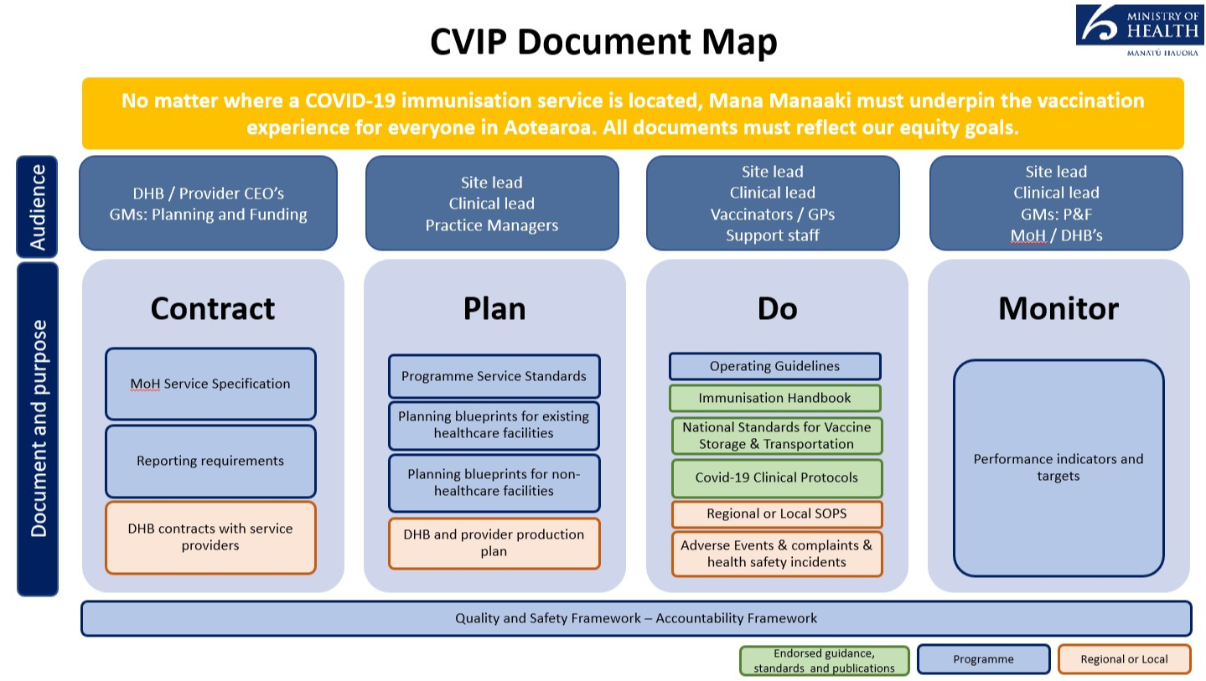

  - Commissioning of vaccination providers
A vaccination provider will either be commissioned by the Ministry of Health (MoH) or a District Health Board (DHB).
- MOH will only commission existing occupational health vaccination providers who can serve workplaces/employers that are geographically spread across multiple DHB boundaries.
- DHBs will utilise any workforce/provider to best serve workplaces/employers residing in their geographical boundary.
MoH and DHBs will operate an ‘open book’ process to collaborate on what vaccination providers are being commissioned to serve what workplaces. They are responsible for designing, communicating and implementing how vaccination providers will be commissioned and how workplaces/employers can engage in the programme. They are also responsible for the on-boarding of new providers into the programme.
Both commissioning agencies should consider equity, accessibility and acceptability when commissioning vaccination providers.
  - Eligibility criteria for vaccination providers;
Vaccination providers must:
- be established vaccination providers with a Health Provider Index number
- have experience in delivering a vaccine programme
- have a workforce that can ensure cultural and religious safety of workplace staff; they must have clearly defined clinical quality and equity leads.
- be able to comply with the Programme Standards, Service Specifications, Immunisation Handbook and Operating Guidelines including:
    - existing cold chain accreditation
    - active clinical quality and safety oversight mechanisms
    - mandatory use of the National Booking System and call centre
    - Deliver to the set Price per Dose
- be able to operate with agility, as the programme evolves, and be prepared to engage in the development of the programme.

  - Providing a safe and quality vaccination experience
No matter where a COVID-19 vaccination service is located, mana manaaki must underpin the vaccination experience for everyone in Aotearoa New Zealand. This includes a culturally and clinically safe vaccination experience.
A ‘one size fits all’ approach to service delivery will not work for our priority population groups. Different considerations will be required dependent on a consumer’s health and/or disability, where they live, and how they access services. Refer to Appendix 1 for guidance on delivery models for Māori, Pasifika, ethnic communities and disability groups.
  - Clinical quality management systems and governance
Clinical safety and quality requirements are sourced from the MoH Immunisation Handbook, Operating Guidelines, and Programme Service Standards. It is expected that vaccination providers delivering the workplace model have active clinical governance and systems in place, including a defined quality and safety lead. In addition, each DHB region must have appropriate quality and safety oversight of the vaccination programme rollout through their existing quality and safety and/or clinical governance mechanisms. Vaccination providers contracted directly to the Ministry must also have clearly documented clinical quality and safety assurance people and processes (as per the documents above – Immunisation Handbook, Operating Guidelines, Service Standards), including reporting mechanisms for review of significant events and accountable clinical leads and quality leads.
Vaccination providers must submit a delivery plan to their commissioning agency that includes;
- an overview of existing clinical quality and safety systems; at a minimum, this includes oversight of adverse events, complaints, risk and incident management (note: in this context, ‘adverse event’ does not refer to an adverse reaction following vaccination)
- names and contact details for clinical lead(s) and quality manager(s), and details of their clinical governance/quality and safety groups within their organisation including frequency of meetings and responsibilities.

  - Business Continuity Planning
Business Continuity Plans should be in place to; manage disruption to systems (CIR, Booking, Internet access etc), manage impact to business as usual in the event of surge demand and manage impact in the event of COVID-19 alert level changes or vaccine loss or wastage. Refer to the Operating Guidelines for additional guidance.
In the event of COVID-19 alert level changes, vaccination providers will follow all government direction regarding continuation or not of the Pfizer vaccine programme.
  - Vaccination workforce
Vaccination workforce decisions should be considered in alignment with the Operating Guidelines, the Immunisation Handbook and clinical resources provided by the Immunisation Advisory Centre (IMAC).
  - Vaccination Training
MoH has partnered with IMAC to provide the mandatory training required to administer the COVID-19 vaccine. This includes clinical training for the Pfizer vaccine and non-clinical training for using CIR. Evidence of completion of mandatory training is required, as well as any training undertaken to be an authorised vaccinator.
Commissioning agencies may seek to supplement this training by providing practical observation of operating vaccination centres if appropriate.
  - Planning for booking appointments
Workplaces/employers and vaccination providers will need to collaborate and be flexible with regards to appointment timings and what is feasible for both parties at any given site. This is especially the case with workplaces with shifts and where it is difficult to take workers out of work.
  - Engagement and invitation
The workforce model has a fixed population group to serve. Workplaces/employers are responsible for engagement and communication with their workers. Vaccination providers are responsible for communicating when and where they will be onsite and when there are any changes to planned bookings/sessions.
  - Booking appointments
Vaccination providers are responsible for managing appointment bookings. It is mandatory for providers to use the CVIP National Booking System.
MoH recommends all sites open bookings at least one week before vaccinations start to allow the provider to supply an accurate order of vaccine and consumables, and ensure adequate time to communicate with workers at the workplace. Having a clear idea of the number of bookings will also allow vaccination providers to staff sites to meet demand.
However, it is highly likely that workplaces will need to open bookings well in advance of one week, depending on individual business planning needs. Workplaces/employers and vaccination providers will need to collaborate and be flexible with regards to appointment timings. This is especially the case with workplaces with shifts and where it is difficult to take workers out of work.
MoH recommends second appointments are booked with vaccination providers while individuals are onsite for their first dose.
  - Worker follow up
If a worker either:
- did not respond to the initial invite
- did not attend the first dose booked appointment
- do not have a second dose booked
- did not attend the second dose booked appointment.
As the vaccination provider runs the booking process/system, they are responsible for worker follow up with the direct support of the workplace/employer. Where this requires the sharing of individual data to an employer, such as who has had a vaccination and who has not, consent must have been obtained from employees prior.
  - Second dose follow up
Vaccination providers should consider how demand planning will cater for individuals who only receive a single dose at the workplace vaccination site – for example, they choose to get their second dose at a different location or got their first dose elsewhere.
  - Administering leftover vaccines
Wastage through leftover vaccine should be actively minimised by planning a back-up or standby list. Vaccination providers are responsible for administering vaccine before expiry. Any wastage must be reported in the CIR and mitigated for future vaccination events.
Workplaces/employers are responsible for managing a process to invite non-booked workers to utilise leftover vaccines.
  - Onsite functions
The table below outlines the required onsite functions and responsible parties.
Depending on the operating hours and size of the site, the number of people filling roles in these function areas may vary; however, the functions across sites won’t change.
Functions on site | Responsible / accountable for
Site operations | Responsible for onsite inventory management.
 | Should any assistance be required, provide or access another basic life support trained adult onsite to manage and/or deliver the appropriate response.
Clinical oversight | Nominated COVID-19 clinical on-site lead who will coordinate all vaccination activities including vaccine logistics (ordering, receiving and storage). (Note: this is not the same role as the over-arching clinical lead with a local governance role, as per the Programme Standards).  Must have vaccination experience in order to be responsible for all clinical aspects of the vaccination site which can include:  - providing on-site clinical advice and guidance including managing any adverse events following vaccine (AEFI)  - ensuring that equipment and medications for the management of medical emergencies, including anaphylaxis, is available, consistent with the programme Service Standards, and considers specifics of the site (i.e. remoteness)  - running a closed ‘dry run’ session with provider staff  - leading team huddles pre- and post-vaccination clinics  - submitting significant event analysis reporting to the relevant DHB and/or the Centre for Adverse Reaction Monitoring (CARM) as necessary.
Welcoming (including registration) | Confirm the NHI number and workplace staff details.  Provides information to gain informed consent.  Checks that workplace staff are well.
Vaccination preparation | Dilutes and draws up vaccine in line with established IPC protocols and vaccine preparation guidance.  Second person checks the processes and vaccine dose and confirms vaccine vial information.
Vaccination administration | Confirm identity (does not require being shown an identifying document).  Ensures workplace staff are ready for vaccination, aware of potential side effects, conducts the pre-vaccination clinical assessment, etc.  Gains informed consent.  Administers vaccine.
Post vaccination monitoring | Observe individuals post vaccination to monitor for possible adverse event. Should any assistance be required, this function will manage and/or deliver the appropriate response and liaise with emergency providers as appropriate.
  - Adverse events
The provider-nominated site clinical lead is responsible for the clinical management of vaccine related adverse events at the place of vaccination. Vaccine-related adverse events must be recorded and reported to CARM and to the workplace/employer lead. These can be reported through:
- the CIR for adverse events during the observation period.
- the CARM website for any post event presentation after the workplace staff member has left the site.
Further functionality on CARM reporting and other systems for ease of access is being explored.
Refer to the Programme Standards for information on emergency equipment required on site.
  - Vaccination provider workforce capacity
Vaccination providers should consider how to manage their BAU activities while delivering COVID vaccinations, including how sustainable it is to deliver BAU activities alongside vaccinations.
  - Vaccine and consumables logistics
The Operating Guidelines have specific information on vaccine supply chain and onsite storage requirements for the Pfizer vaccine, including that fridges must have the ability to detect temperature breaches.
Commissioning agencies and their respective vaccination providers must agree a delivery plan of the vaccine and consumable stock reflective of the anticipated throughput.
The first initial vaccination sessions at a new site should be at a reduced scale to test systems and processes before scaling vaccine administrations later.
It is essential that supply is planned for within a 31-day expiry time. Delivery planning must factor in the following logistics constraints:
- Minimum six people must be vaccinated within six hours.
- Minimum 30 vaccinations need to occur within 1 day.
Stock deliveries can be made seven days a week. Stock is delivered in packs of five vials (30 doses), 15 vials (90 doses) or a tray (1170 doses) at standard 2-8˚C cold chain.
Stock must be ordered two days in advance to ensure provision for the variances in demand that can occur daily.
An identified person at each site must manage vaccine and consumable stock. This will allow for effective management of vaccine and consumables with the ability to order new stock.
  - Onsite IT requirements and support
Every vaccination given must be recorded in the CIR.
The supporting equipment and infrastructure to access the CIR is outlined in the Operating Guidelines and includes access to high-speed internet, a laptop, computer or tablet, and a separate smartphone.
Currently, each person accessing the CIR requires a non-public email address. This is required to mitigate security concerns on access to the CIR and supporting information.
Vaccination providers should ensure there is an available Superuser (someone who is a frequent and competent system user) to provide local support.
  - Consumables
Consumables listed in the Operating Guidelines will be provided directly to sites from the distribution provider. Other consumables not specified in the Operating Guidelines should be covered by vaccination providers within the provided funding.
In the event of COVID-19 alert level changes, PPE is to be sourced through existing channels.
  - Other equipment requirements
Minimum equipment standards for management of medical emergencies are outlined in the Programme Standards document. Additional equipment provided for use at the site must take into consideration the accessibility of the site to emergency services, remoteness, and the skill sets of on-site vaccination providers.
  - Physical locations
Vaccination providers must ensure the workplace/employer site is appropriate for use according to the Programme Standards and Operating Guidelines.
When choosing the physical site for vaccinations at the workplace, consideration needs to be taken about whether the physical space available will support the volume planned for the site and the end-to-end administration process.
How the site is arranged, and the throughput, will depend on a range of factors, including the size of the site.
Space must be available for people to remain on site for at least 20 minutes after their vaccination so they can be observed. Space and appropriate equipment must be available for stage two recovery observation, as outlined in the Programme standards.
Emergency vehicle access must be identified in case of an adverse event.
There must be consideration of how a space may be rearranged or throughput reduced in the event of COVID-19 alert level changes. The site must be set up so it is easy to see most areas used for the immunisation process and provider staff must be able to communicate easily if they need help.
  - Site readiness self-assessment check list
Vaccination providers must complete the ‘site readiness checklist’ and submit to their respective commissioning agency.

  - Funding and reporting
Vaccination providers cannot charge workplaces/employers for any costs associated with the delivery of the Pfizer vaccine.
The MoH set Price per Dose (PPD) (both for during and after business hours) for varying providers and reporting requirements are available in the relevant service specifications.
The PPD for Occupational Health Providers is $33.91 for ordinary hours, and $46.59 for after hours. Both prices are inclusive of recalls.
"Out of hours" is defined as:

(a) 8pm to 8am the next day, Monday to Thursday; or

(b) 5pm Friday to 8am Monday; or

(c) any Public Holiday.
Where a DHB commissions a primary care provider, the approved PPD for primary care will be applied.
From 1 July 2021, an automated PPD payment solution will be implemented based on the events recorded in CIR. When an immunisation event is appropriately recorded in CIR, the combination of contract, provider and site will be used to automatically determine the payment amount due and the contracted party will receive payment for the service automatically. It will be not be necessary to generate and send additional invoices for PPD services.
Where a contract is not on a PPD basis, or where there are special payment arrangements outside of the national PPD pricing arrangement, these will usually be managed on an invoice basis.
Full terms and conditions for payment of COVID-19 vaccinations services will be specified in individual contracts with the commissioning agency.

- Information for Workplaces/Employers
  - Supporting providers
Workplaces/employers need to work alongside the vaccination provider serving their workers. This includes inputting into and agreeing the delivery plan vaccination providers must provide their commissioning agency, which will include the volume of workers to be vaccinated and the booking schedule and approach.
It will be critical for workplaces/employers to consider physical locations that vaccination providers will need. This includes consideration about whether the physical space available will support the volume planned for the site, including the space for the minimum for the 20-minute active observation area, emergency vehicle access, and consideration of how a space may be rearranged or throughput reduced in the event of COVID-19 alert level changes.
Workplaces/employers also need to provide onsite support, such as access to high-speed internet and support during the vaccination sessions as laid out below.
  - Planning for booking appointments
Workplaces/employers and vaccination providers will need to collaborate and be flexible with regards to appointment timings and what is feasible for both parties at any given site. This is especially the case with workplaces with shifts and where it is difficult to take workers out of work.
  - Engagement and invitation
The workforce model has a fixed population group to serve. Workplaces/employers will need to communicate to workers through existing employer channels to promote the opportunity, provide information about who the vaccination provider is and when/where they will be onsite and how to book.
Workplaces/employers are strongly encouraged to work directly with Māori, Pacific and ethnic staff in their workplace to ensure communication and engagement is tailored appropriately.
  - Booking appointments
Vaccination providers will manage booking systems. It is mandatory for all providers to use the CVIP National Booking System. Workplaces/employers will need to support workers who need assistance with making a booking.
MoH recommends second appointments are booked with vaccination providers while individuals are onsite for their first dose.
  - Worker follow up
If a worker(s) either;
- did not respond to the initial invite
- did not attend the first dose booked appointment
- do not have a second dose booked
- did not attend the second dose booked appointment.
Workplaces/employers will need to provide support to the vaccination provider to provide follow up. Where this requires the sharing of individual data such as who has had a vaccination and who has not, consent must have been obtained from the employee prior for this data to be shared with their employer.
  - Administering leftover vaccines
Wastage through leftover vaccine should be actively minimised by planning a back-up or standby list. Where vaccine is available due to booked staff not turning up, the workplace/employer needs to have a process in place to invite other workers on site to take up the opportunity.
  - Onsite functions
The table below outlines the required onsite functions that workplaces/employers are responsible for:
Functions on site | Responsible / accountable for
Traffic and site management (non-clinical) | Manage traffic and people flow in and out of the carpark and venue (if required).  Oversight and management (including health and safety) of site. Ensure facilities meet the Programme Standards by way of adequate facilities, such as bathroom access.
Hauora support | Across the vaccination pathway (from welcoming to post-vaccination monitoring), provide support for the wellbeing of the people seeking a vaccine.
Welcoming (including registration) | Meet people and manage flows of people to keep social distancing regardless of COVID-19 alert level.  Identify whether there are additional supports or considerations required to facilitate an inclusive, safe and accessible experience for workers. Refer Appendix 1.  Ask if second dose appointment has been made in advance, encourage staff to book for this if not.
Post vaccination monitoring | Sign off workers as fit for work and able to return to work, or sent them home if unwell.

  - Adverse events
If a vaccine related adverse event occurs on-site while the worker is under the care of the vaccination provider, that provider is responsible for the clinical care and reporting of the event. Refer to vaccination provider section for more information.
Vaccine-related adverse events must be reported to a nominated workplace/employer lead in the event a notification to WorkSafe is required.
Where an employee experiences a vaccine related adverse event after they have completed the required 20 minute observation period, and the provider is no longer on site, the employee or employer can call Healthline on 0800 358 5453, or if they are concerned about their safety, call 111. Tell them they’ve had a COVID-19 vaccination so they can assess them properly. More information about adverse events and how to report them, is available on the MoH Website https://www.health.govt.nz/our-work/diseases-and-conditions/covid-19-novel-coronavirus/covid-19-vaccines/covid-19-vaccine-side-effects-and-reactions.
Liability for the CVIP is consistent with other onsite vaccination programmes, such as influenza.

Appendix 1: Guidance on delivery models for Māori, Pacific, ethnic communities and disability groups
The following examples show how an equitable approach to Māori, Pacific, ethnic and disabled communities may be incorporated into vaccination site planning and operations. Note that these are examples of equitable practices to support your planning, not a checklist of requirements that you must meet.
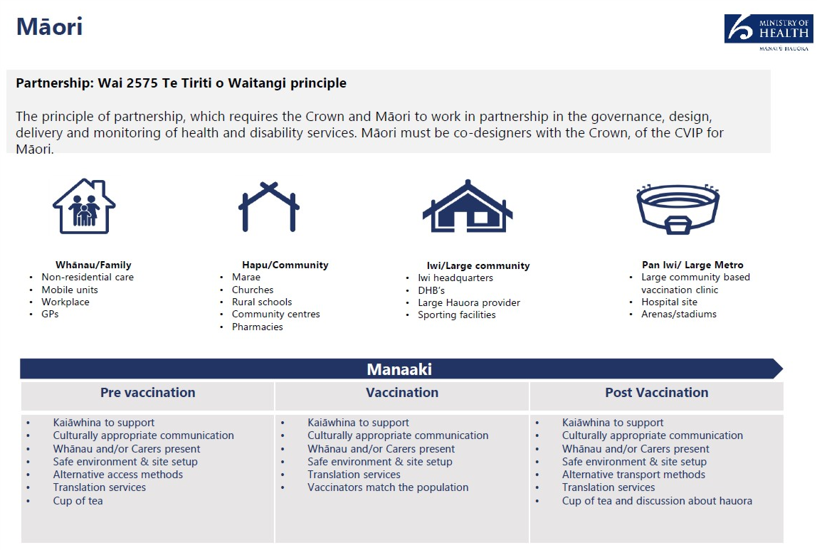

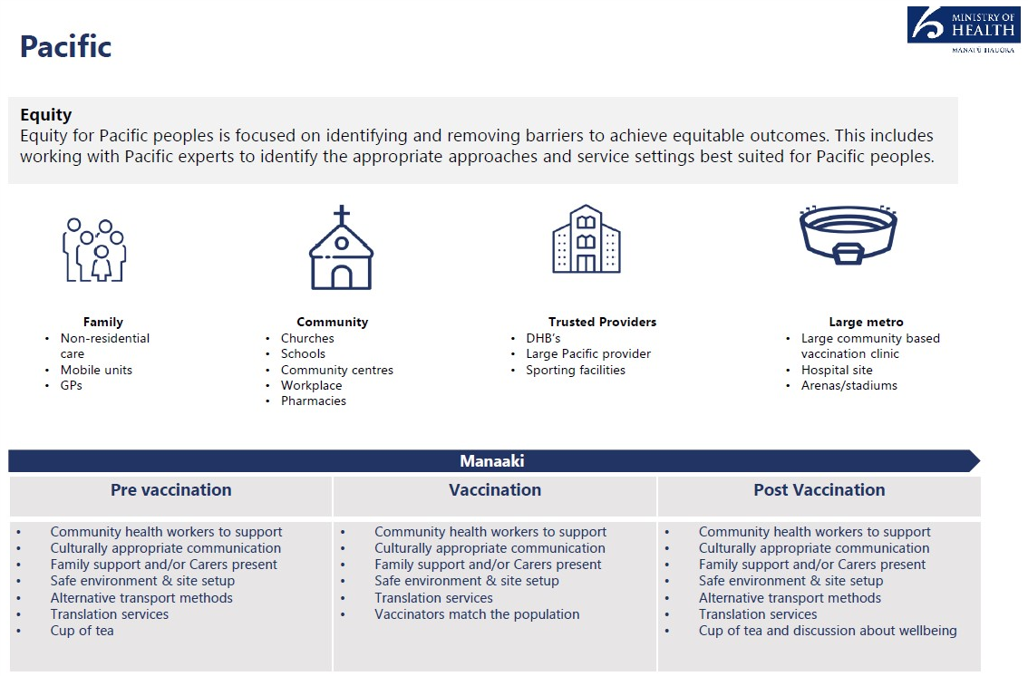
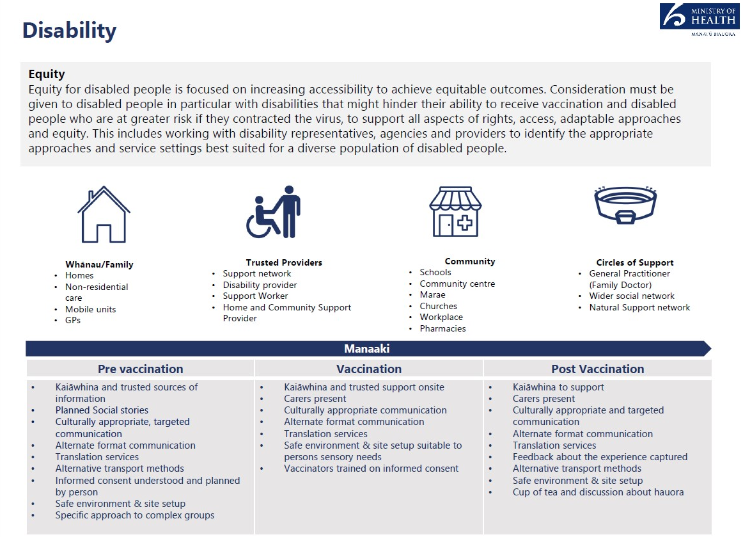
In order to deliver an equitable vaccination programme, vaccination services and settings must be inclusive and accessible vaccination options for disabled people and their communities. This includes consideration of accessibility across the vaccination journey, for example, providing early information on the benefits of vaccination and awareness of service delivery options and associated accessibility features.
All vaccination sites (with the exception of mobile sites delivering to specific groups) must meet accessibility standards.
Core components include
- Appropriate disability specific accommodations in all sites.
- Alternate formats translations of all public facing communications and engagement.
- Developed supported decision-making process in alignment to of the Health and Disability Code Of Rights (Right 7).
Ethnic Communities
Equity for ethnic communities can be achieved by targeting members of the community who cannot ordinarily be reached because of communications barriers and lack of understanding of the health system. The target approach involves enagaging with community leaders and stakeholders, including faith and religious leaders, local champions, and engagement teams who can encourage and relay key information on the vacine rollout.

Family | Community | Trusted vaccination providers | Large Metro
GPs  Mobile sites in local communities | Churches, Mosques,  Temples and Gurdwara  Community centres  Workplaces  Schools  Pharmacies  Ethnic media platforms  English for Speakers of Other Languages (ESOL) programme Centres | DHBs  Large ethnic vaccination providers | Community base event vaccination clinic  Hospital sites

Pre vaccination | Vaccination | Post Vacination
- Community/religious leaders and regional enagagement teams to support community health workers  - Appropriate cultural and religious communiications  - Family and community leaders support  - Alternative communication formats and channels  - Safe environment and site set up especially for Muslim women  - Translation service | - Some Vaccinators match the population  - Appropriate cultural and religious communiications  - Family and community leaders support  - Alternative access method  - Safe environment and site set up especially for Muslim women  - Translation service | - Appropriate culutural and religious communiications  - Family and community leaders support  - Alternative communication formats  and channels  - Safe environment and site set up especially for Muslim women  - Translation service

https://report.vaccine.covid19.govt.nz/s/
NZS 4121:2001 Design for access and mobility: Buildings and associated facilities. Ministry of Health guidance

