Reducing Disparity of Access to Kidney Transplantation Between Regions

National Renal Transplant Leadership Team
Author: Nick Cross, Clinical Director
National Renal Transplant Service

Date: 19 April 2022
Executive Summary 2
Recommended Actions 3
Why is Increasing Kidney Transplantation desirable for New Zealand? 4
What are the key barriers to further increases in kidney transplantation in NZ? 5
How are kidney transplantation services currently arranged? 5
How does deceased donation work in relation to kidney transplantation? 8
What have been the key reasons for recent success in overall increase in transplantation rates? 9
Where are the current challenges? 10
Why should DHBs invest in staff to manage recipient and live donor pathways? 12
Summary 16
Glossary 17
References 17

Executive Summary

This document has been produced by the National Renal Transplant Service (NRTS), with oversight from the National Renal Transplant Leadership Team (NRTLT).

The intention is to provide senior district health board funders with background and advice to enable decision making oriented at increasing access for underserved populations to kidney transplantation in New Zealand.

It will also be shared with Health NZ and the Māori Health Authority as an example of the work undertaken by clinical networks such as NRTS/NRTLT.

Key Points:
- Maximising kidney transplantation for patients with end stage kidney disease (ESKD) is beneficial for patient outcomes and reduces costs of treatment, due to high costs of the alternative treatment, long term dialysis.

- The key constraint is both live and deceased donor availability.

- Although there has been steady progress in NZ as a whole, with kidney transplants increasing from around 110 per annum (prior to 2012) to 221 in 2019, with continued excellent clinical outcomes, further increases are possible.

- Variability exists between DHBs in terms of proportion of ESKD who are treated with transplantation due to patient case-mix, and a range of local and regional issues, including variable approaches.

- Increasing transplantation activity has occurred at all referring DHBs between 2012 and 2019, but variably so.

- While variability between DHBs is expected based on population differences, variation in rates of improvement is most likely to be explained by service variation.

- Services crucial to kidney transplantation outcomes are provided within all DHBs in New Zealand, with the majority of the activity occurring outside of the three DHBs providing acute transplantation services.

- Service delivery is dependent on DHB investment in staff and appropriate prioritisation of access to diagnostic and therapeutic services required prior to live kidney donation and kidney transplantation.

Recommended Actions

The National Renal Transplant Service has three actions that DHB leaders and funders could undertake that we expect would further increase access to transplantation:

- Identification of Clinical Leads in Kidney Transplantation within each referring DHB and transplanting DHB, with protected clinical time available and responsibility for service development and increasing access to kidney transplantation within their region.

- Review of dedicated pretransplant Transplant Nurse Coordinator positions within each referring and transplanting DHB, to ensure sufficient staff with the appropriate mix of skills, including in interacting with underserved populations (including Māori and Pacifika, and remote populations) to process potential based on numbers of patients commencing ESKD per annum; with additional investment where staff are lacking.

- Establish annual review and feedback between clinical, management and funder teams within DHBs of progress in transplantation access and barriers to increasing access, within groups by age, gender ethnicity and regionality particularly:

  - Kidney transplantation per ESKD patient (for example, number of kidney transplantation operations per 100 incident end stage renal failure patient), compared to historical achievement.

  - Proportion of ESKD of dialysis patients transplanted or active on the deceased donor kidney transplant waiting list within 6 months of reaching ESKD, compared to historical achievement.

Why is Increasing Kidney Transplantation desirable for New Zealand?

Kidney transplantation is best care for many patients with end stage kidney disease, delivering better outcomes at lower cost than the alternative (dialysis).

Increasing access to kidney transplantation is highly desirable because kidney transplantation is better treatment for many patients with end stage kidney disease (ESKD) than the alternative (chronic dialysis treatment) for three reasons:
- On average, patients live substantially longer following kidney transplantation compared to dialysis patients considered well enough to be suitable for kidney transplantation (i.e., on the deceased donor waiting list).

- Kidney transplant recipients experience substantial improvements in quality of life (related to reduction in symptoms experience by patients undergoing chronic dialysis, and lower time demands).

- Kidney transplantation leads to substantial direct (dialysis costs) and indirect (reduction in comorbidity/admissions) health care expenditure savings, as well as broader societal costs (for example, higher probability of employment compared to chronic dialysis). Recently, the New Zealand Institute of Economic Research estimated cost savings over the first six years of transplant compared to dialysis care of more than $470,000 per patient, largely composed of elimination of dialysis costs.

Kidney transplantation is very successful in NZ and largely eliminates the need for future dialysis, in patients who are transplanted.

Kidney transplants are very successful treatment internationally, and in New Zealand in particular. At one year, more than 95% of kidneys are working, and the median time of graft function (time to lose half of transplanted kidneys) is in the order of 15-18 years (ANZDATA), which compares favourably to the USA and the UK. In part, this may be due to relative scarcity of deceased donor organs, leading to survivor bias (healthier patients survive on the waiting list to reach transplant).

For the vast majority, a single kidney transplant will eliminate the need for future dialysis. Over the period 2010-2019, kidney transplants were lost at a rate of 5.15 per 100 graft years, with slightly more than half lost due to death of the recipient. Only around 2.5% of transplant patients annually therefore need to return to long term dialysis (or receive a subsequent transplant). Live donor transplants are slightly more successful on average than deceased donor transplants (longer graft survival), but the absolute difference is very small, particularly compared to the costs and harms associated with dialysis. From a population and health system perspective, maximising kidney transplantation from either donor source is an excellent objective.

What are the key barriers to further increases in kidney transplantation in NZ?

Donor organ availability is the key constraint for increasing kidney transplantation.

Kidneys are available from two sources:

- Deceased donors, who are identified from within intensive care unit (ICU) populations by deceased donation experts (ICU clinical staff working with Organ Donation New Zealand (ODNZ) staff)

- Live donors, who are healthy individuals assessed and managed by nephrology/renal medicine services prior to donation.

There are around 3000 people on long term dialysis in NZ (at 31 December 2020), and around 450 who are considered suitable for a kidney transplant but who do not have a suitable live donor and are therefore actively waiting on the deceased donor kidney transplant waiting list. On average, recipients of deceased organs have waited for 2-3 years on dialysis prior to receiving a kidney. Patients are counselled therefore to assist identifying potential living kidney donor from within their circle of family, friends and acquaintances. Such potential living donors who come forward are assessed for suitability at referring and transplanting centres. Where a donor is identified and assessed prior, a live donor transplantation may be able to be undertaken prior to dialysis being required (a pre-emptive transplant).

While there are important other potential constraints to providing rapid increases in kidney transplantation (for example, theatre access, or specialist surgical staff at transplanting DHBs), a doubling of the numbers of kidney transplants between 2012 and 2019 (see below) was able to be accommodated by current structures and funding models.

How are kidney transplantation services currently arranged?

Individual recipient and live donors’ access to transplantation/donation require multiple integrated health care services, driven by expert clinicians within renal medicine/nephrology departments.

Kidney transplantation operations (live donor nephrectomy and live and deceased donor kidney transplantation) occur in three DHBs in New Zealand (Canterbury, Capital & Coast and Auckland). Transplant programs are generally led by subspecialised nephrologists (sometimes designated Transplant Nephrologists) from within Renal Medicine/Nephrology departments at these DHBs working closely together with Transplant Coordinators (senior nursing positions), and close collaboration with surgical teams (Transplant and Vascular Surgeons, with Urologists performing live donor nephrectomies). Teams within the transplanting DHBs work very closely together to coordinate health services.

Referring centre renal medicine department clinicians (medical and nursing staff (coordinators) employed at non-transplanting DHBs Northland, Waitemata, Counties Manukau, Waikato, Hawke’s Bay, Taranaki, Midcentral, Nelson-Marlborough, Southern, and recently at Bay of Plenty) and diagnostic and clinical services they access locally, play a vital role in ensuring opportunities for donation and transplantation are explored with their patients with chronic kidney disease as they progress towards ESKD. The large majority of potential kidney transplant recipients are cared for outside of the transplanting DHBs. For example, in 2019, of the 656 new individuals commenced renal replacement therapy, 489 (75%) were within non-transplanting DHBs.

While review of recipients and live donors, and agreement to proceed is the responsibility of transplant centre clinicians, assessment initiation, referrals to diagnostic and other clinical services, interpretation of testing, counselling of recipients and donors is all handled within referring units and transplanting units by medical and nursing staff employed by those DHBs.

Funding for clinical activity related to recipient care and that of live kidney donors comes from within overall population-based funding to DHBs, with exceptions below.

Kidney transplantation is also reliant on small additional national programs run mostly from within DHBs that have small amounts of additional centralised ‘top sliced’ funding (funding directly to DHBs from the MOH for specific services provided).

The New Zealand Transplantation and Immunogenetics Laboratory (NZTIL) based in Auckland (within the NZ Blood Service) provides specialised testing for live and deceased donors and recipients, maintains the register of suitable recipients for deceased donor transplantation (the ‘waiting list’), and administers the allocation algorithm (which determines which recipient receives which kidney). NZTIL staff interact with transplant coordinators around the country to maintain recipients on the waiting list, including managing temporary suspensions (due to health events). There are 450 individual patients actively waiting for a deceased donor kidney currently, with a further 150 previously active but currently suspended. Laboratory activities undertaken there are paid for by DHBs based on whoever testing is performed on. Expert support for allocation is provided by a subset of transplant nephrologists employed at ADHB with skills and interest in the area.

The Australian and New Zealand Paired Kidney Exchange Program (ANZKX) is jointly funded by the Australian and New Zealand governments. NZ based staff are employed via Auckland DHB to arrange and coordinate exchanges. Kidney exchange facilitates transplantation of kidneys from directed donors who are incompatible with their intended recipient by arranging coordinated donations and transplants between pairs, including between Australia and New Zealand.

“Donor Liaison Coordinators” have been funded directly from the MOH to DHBs on temporary contracts since September 2014. These are transplant coordinator positions. These positions were conceptualised initially to work directly with potential live donors only, but the funding was used variably by DHBs to support recipient and live donor workups, depending on the prior staffing establishment (with knowledge and agreement of the ministry). For many DHBs, the term ‘transplant coordinator’ is used to cover both live kidney donor and potential kidney recipient work undertaken by senior nurses.

Funding levels were set simply with referring centres receiving 0.5 FTE (of a senior staff nurse grade) with transplant centres receiving 1.0FTE. This did not and does not reflect relative need for additional positions at the point the funding was established. The funding levels have not been reviewed, but funding has been renewed (often very late before expiry of terms leading to a loss of staff in some instances) and is due to expire in June 2022.

Individual DHBs may or may not have supported coordinator positions with additional funding since the establishment of this funding stream.

National Renal Transplant Service have been funded since September 2014 via contracting between the MOH and individual DHBs. NRTS is hosted at Canterbury DHB.

The National Renal Transplant Service is a small program aimed at increasing access to kidney transplantation in NZ and was established in 2014. NRTS provides clinical leadership, strategic oversight, direction and support for implementation of initiatives to improve access to renal transplants. Dr Nick Cross has been the Clinical Director since inception. This program is provided via a Ministry of Health contract held by Canterbury District Health Board, including direct funding for Dr Cross’s time.

During the same period (2014 to current), direct funding for transplant coordination (termed ‘donor liaison coordinators’ by the MOH) has been available for the 11 DHBs with nephrology departments (as at 2014), at a rate of 0.5 FTE (Registered Nurse 2014 rates, not increased) for non-transplanting DHBs (Southern, Hawke’s Bay, Midcentral, Taranaki, Waikato, Counties Manukau, Waitemata, and Northland) and 1.0FTE for transplanting DHBs (Auckland, Capital & Coast and Canterbury).

The National Renal Transplant Leadership Team is a clinical network which meets two-monthly (full meetings six-monthly, operational subgroup meetings four times per year between) to provide clinical governance strategic direction to the NRTS and clinical teams working in kidney transplantation. Funding for administration of NRTLT is via NRTS. Most members are DHB employees and provide their time for meetings with the support of their DHBs.

How does deceased donation work in relation to kidney transplantation?

Deceased donation is organisationally and clinical separate, but extremely important for overall kidney transplantation success.

Deceased donation is voluntary in NZ. By definition, deceased donation occurs after a person has died, but the clinical circumstances which are required for a person to be a suitable donor mean that donors must die in intensive care units. Only a tiny fraction of deaths in NZ are clinically suitable for organ donation. The next of kin/family are asked to assent to the donation. A deceased donor undergoes a surgical procedure to remove organs suitable for transplantation (including kidneys). The surgery is performed by a specialised surgical team (the retrieval team) employed by Auckland District Health Board. They travel to the location of the donor, and the retrieval surgery is performed at any DHB with an operating theatre location in NZ.

Organ Donation New Zealand employs donor coordinators (nurses) and medical specialist advisors (Intensive Care specialists) to provide expert advice and facilitate deceased donation within intensive care units in New Zealand. ODNZ has previously been provided via a MOH contract held by Auckland DHB, but recently it moved to be provided by the New Zealand Blood Service, as part of 2017’s Increasing Deceased Organ Donation and Transplantation: A national strategy.

Deceased donation is non-directed. This means that the donor and their family do not in any way specify who receives the organs that are donated.

Live donation is mostly directed donation. This means that a live donor comes forward to volunteer to be assessed as a donor for a specific individual recipient (e.g., a spouse). If they are medically suitable and consent, the kidney will be removed and used for transplantation for the benefit of that individual only. Around 10% of live donors are ‘non-directed’ (i.e., they come forward without a recipient in mind).

Deceased donor kidneys and non-directed live donors are allocated using an agreed algorithm (governed by NRTLT, and administered by NZTIL)

What have been the key reasons for recent success in overall increase in transplantation rates?

New Zealand is delivering increasing numbers of kidney transplants due to a coordinated and dedicated clinical network, and direct funding of key staff via MOH contracts, but relies on DHB decision makers to fund the vast bulk of the service delivery.

Kidney transplantation has been increasing in New Zealand over the last 7 to 8 years, from an average of around 110 transplants per year in the ten years prior to 2012 to more than 200 in 2019. Transplants per million population divided by donor source and including 5 year rolling averages are in figure 1. The COVID epidemic has affected numbers somewhat in 2020 (and is expected to again in 2021).

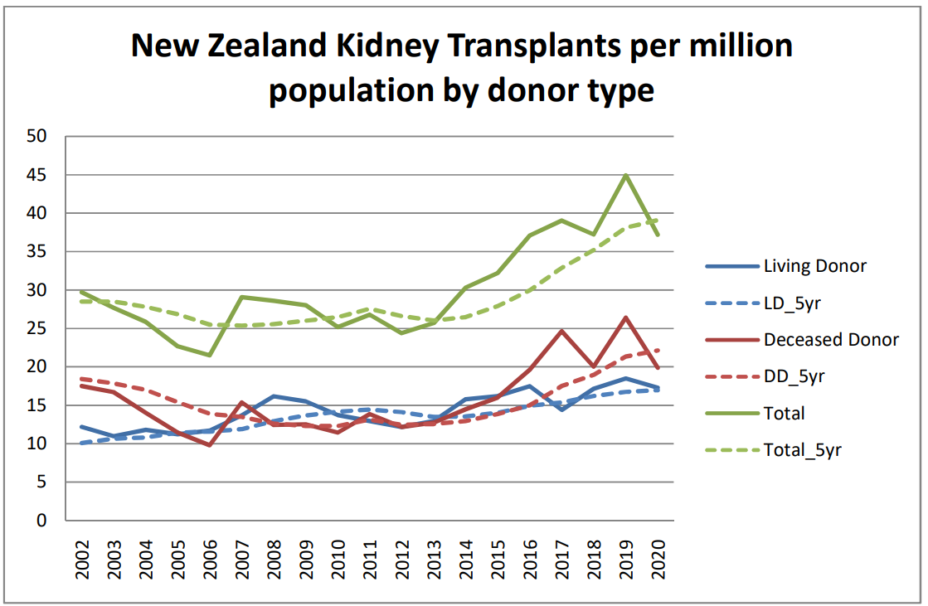
Figure 1: New Zealand Kidney Transplant Rate per million population 2002-2020, by donor source (annual and 5 year rolling) from “Kidney Transplant Activity New Zealand 2020”, NRTS

Increases in both live and deceased donor kidneys have occurred over this time.

Where are the current challenges?

Inequity of access exists by region and ethnicity, which needs to continue to be addressed

Access to transplantation varies by DHB, and by ethnicity, likely for multiple reasons including case mix. Sicker patients on dialysis are less likely to be treated with transplantation. Diabetes and age are both associated with very high rates of vascular disease in ESKD populations for example, so DHBs with older or more diabetic populations (including those with higher Māori and Pacifika populations) may experience lower transplantation rates. Further adjusted data is currently being sought via a research project led by NRTS funded in part by the Health Research Council and involving several members of the NRTLT (in addition to others).

Yet improvements have been seen across most if not all DHBs in recent years, and in different ethnicities. As population and case mix changes have not occurred within DHBs or within ethnicities, improvements in access within strata suggest that improvements relate to process changes – and further improvements in underserved populations are to be expected with further incremental change.

Figure 2 contains transplants per 100 incident ESKD patients, grouped by transplanting region by donor source between 2012 and 2020. ARTG (Auckland Regional Transplant Group) includes DHBs from the Northern part of NZ, who are almost always transplanted in Auckland. WGTN includes DHBs who receive services from Capital and Coast DHB from the middle of the country, and SITG (South Island Transplant Group) for the majority of the South Island (excluding Nelson-Marlborough).

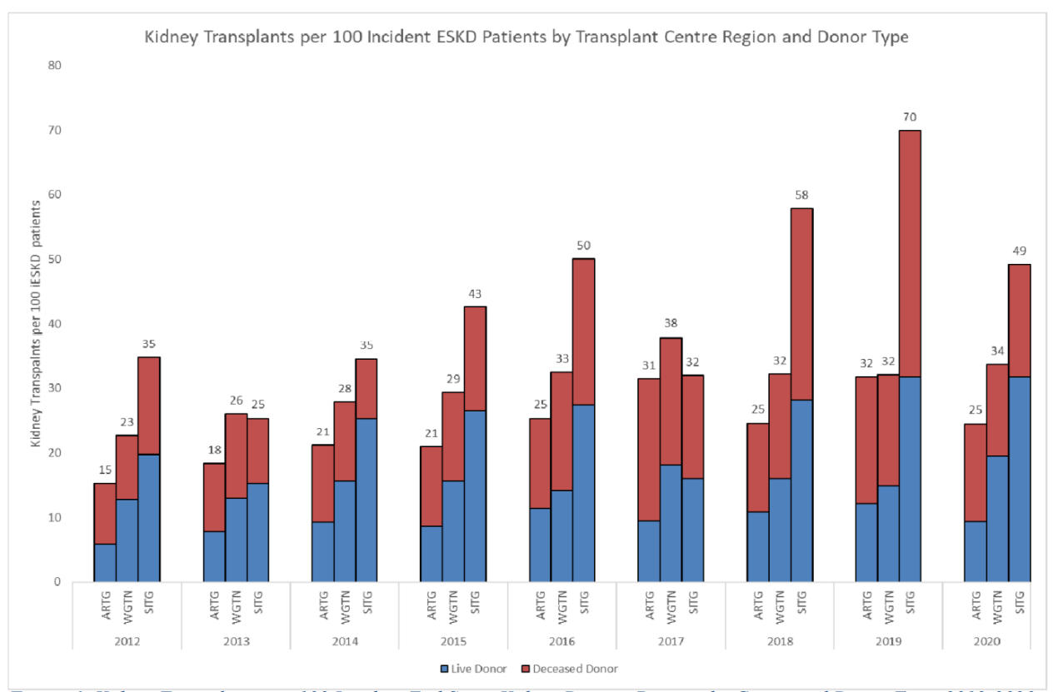
Figure 2: Kidney Transplants per 100 Incident End Stage Kidney Disease Patients by Centre and Donor Type, 2012-2020. From “Kidney Transplant Activity New Zealand 2020”, NRTS
Figure 3 shows kidney transplantation rates by ethnicity per 100 incident ESKD patients of that ethnicity for NZ, unadjusted by comorbidity. Over the most recent 7 years, Māori, Pacifika and Other (non-Māori, non-Pacific, non-Asian) transplantation rates have increase similarly.

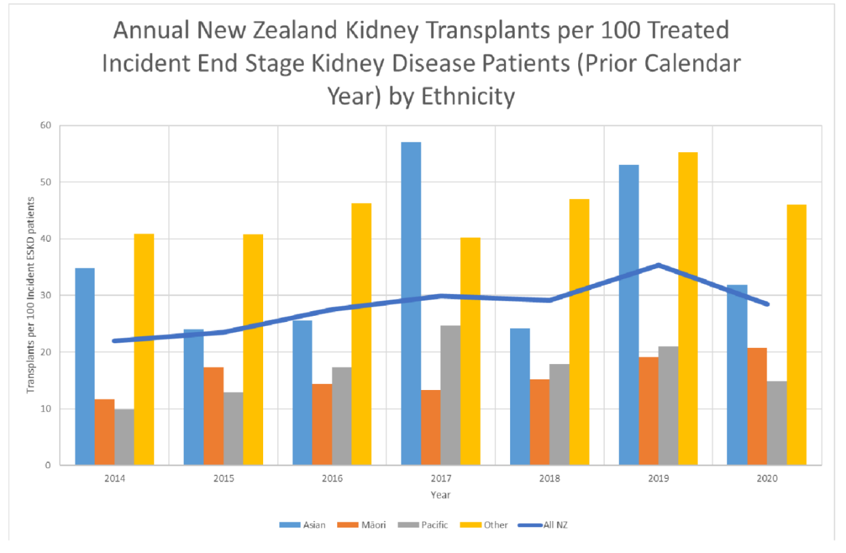
Figure 3: Annual Kidney Transplants per 100 treated incident end stage kidney disease by ethnicity 2014-2020.From “Kidney Transplant Activity New Zealand 2020”, NRTS

Why should DHBs invest in staff to manage recipient and live donor pathways?

A process mapping project by NRTS in 2018 identified key attributes of highly functioning referring centres.

NRTS undertook work in 2018 to identify practice variations and identified features in common with high performing units (both referring and transplanting DHBs):
- Identified, skilled, responsible staff with sufficient time to undertake assessments – transplant (or donor liaison) coordinators, and senior medical officers (SMO)
- Leadership from an SMO to drive change towards a culture of ownership of the problem of achieving transplantation within nephrology services
- Local support from associated departments to appropriately prioritise testing (e.g., radiology, psychological medicine, cardiology)
- Clear processes, with IT infrastructure to support assessments

Transplant coordinator roles

Transplant coordinators (TC) work closely with SMOs to facilitate complex longitudinal assessments of potential kidney recipients for the deceased donor waiting list, or live donor transplantation (where a live donor is available). TC also facilitate assessments of potential live kidney donors.

In some centres, TC also provide follow-up care for recipients and donors, particularly soon after transplant.

The precise mix of work depends in part on the design of services and the size and characteristics of population served. Larger populations on dialysis will generate more work for assessments of recipients and potential live kidney donors. Sufficient coordinator employment, training and support is required to achieve efficient assessment, which in turn leads to higher transplant numbers.

There is a delay in deceased donor numbers occurring following successful assessments as recipients on average have been waiting 2-3 years before a kidney becomes available. Therefore, an improvement in assessment efficiency and effectiveness shows up in an increase in the waiting list for individual referring DHBs, 2-3 years before an increase in deceased donation outcomes can be expected.

Roughly one in three potential live kidney donors approaching kidney transplant units will progress to donate. Most donors come from recipients whānau, so populations that have higher proportion of diabetes and other comorbidities that are contraindications to kidney donation may generate lower proportion of successful donations for each approach. This nevertheless generates work for transplant coordinators.

We recommend that the term ‘donor liaison coordinators’ be retired as it is confusing and unnecessarily prescriptive (if taken to mean ‘only work with live donors’). We recommend the term ‘transplant coordinator’. Where units are large enough to require multiple individuals, workflow considerations may mean that individual coordinators predominantly work with potential recipients or potential donors. The generic term ‘transplant coordinator’ could include ‘living kidney donors’ or ‘kidney recipients’ where a distinction was desirable. What is important from a funding perspective is that there are sufficient overall transplant coordinators to ensure that potential recipients and live kidney donors are able to be assessed in a timely fashion.

In addition to numbers on dialysis, transplant coordinator workload in preparing recipients and live donors relates biopsychosocial complexity of patients starting dialysis, not number of patients transplanted.

Assessments for recipient and donor suitability typically consume 6-12 months, depending on waiting times for individual components and clinical circumstances. Ideally, assessments proceed ‘just in time’ so that recipients are able to be transplanted (where a live donor is available) or listed for deceased donor transplantation at the point their kidney function deteriorates to the point they would otherwise need to start dialysis imminently. For most patients, they have been managed within nephrology services for many months or years prior to that point.

Starting assessments too early is wasteful, because patients may not proceed to ESKD in their lifetimes, they may become unsuitable prior to reaching ESKD due to changing health status, or assessments may no longer be relevant if too much time has passed required reassessment. Managing the timing and tempo of assessments is the key role of the transplant or donor liaison coordinator, with input from nephrologists.

Transplant coordinators are also involved with maintenance of individuals on the waiting list. This includes coordination of suspensions/reactivations on the waiting list and reassessments after acute illnesses.

Coordinators are also often involved with the care of recently transplanted recipients and ongoing monitoring and care of prior live kidney donors.

The ideal number of coordinators for each unit will depend on multiple factors including the biopsychosocial complexity of patients under assessment and management. For example, patients with high health literacy and familiarity with navigation of health systems may require relatively little interaction to maintain patients on assessment pathways. This is likely to be a key determinant of differences in transplant rates by ethnicity which associates with health system access. Where assessments are taking too long to complete, or individual patients are struggling to complete requirements, additional coordination support, including culturally appropriate support, may increase successful assessments, as measured by successful waitlisting in patients soon after commencement of dialysis and/or live donor transplantation.

Currently, donor liaison coordinator funding (provided by direct MOH contracting) has not increased since it was initiated in 2014, and was not targeted by workload in this way. Since 2014, overall new patients reaching ESKD per year in NZ have increased by 27% (from 557 in 2014 to 704 in 2020).

DHBs who see increased access to transplantation as desirable should consider whether current coordinator staffing is adequate for optimal assessment rates (time spent in assessment) and outcomes (proportions of suitable recipients listed at dialysis commencement or transplanted before dialysis).

NRTS recommends the following for each referring centre transplant coordinator establishment (including ‘donor liaison coordinator’ roles where they remain separate):

- at least two individuals be employed (fractional appointments may be appropriate in smallest units)

- a minimum total of at least 1.0FTE Clinical Nurse Specialist position per 30 individuals commencing dialysis per annum

- consideration of additional FTE where there is a high proportion of higher needs individuals (e.g., high Māori and/or Pacifika ESKD population, lower health engagement populations).

Based on observed dialysis starts in 2021 the table below suggests minimum recommended transplant coordinator FTE (before consideration of any additional staffing to support Māori and/or Pacifika populations:

DHB | New End Stage Kidney Disease Patients (ESKD) (2021) | Suggested minimum total transplant coordinator FTE at 1 per 30 ESKD per year (excluding weighting for high Māori/Pacifika populations)
Northland | 35 | 1.0
Waitemata | 62 | 2.0
Counties | 136 | 4.5
Waikato | 144 | 5.0
Taranaki | 18 | 1.0
Hawkes Bay | 31 | 1.0
MidCentral | 42 | 1.5
Southern | 30 | 1.0

Transplanting DHBs assess local recipients and donors as referring centres, but also require additional FTE depending on duties within model of care. Transplant centre coordinators have significant additional duties such as arranging formal multidisciplinary meetings, arranging theatres, admissions and logistics for patients and transported live donor organs, and management of transplant follow-up. More than half of coordinator time may be spent on working on ‘additional transplant centre’ activities.

We recommended transplant coordinator establishment at each transplant centre relates numbers of new ESKD patients at that DHB at 1 FTE per 30 ESKD patients PLUS 1 FTE per 60 ESKD in all centres referring patients to that transplant centre:

DHB | New ESKD Patients (2021) in local unit | New ESKD Patients (2021) in respective referring units | Suggested minimum total transplant coordinator (excluding weighting for high Maori/Pacifika populations)
 |  |  | FTE at 1 per 30 new ESKD patients per year (local unit) | FTE at 1 per 60 new ESKD patients per year (all referring units) | Total Recommended FTE
Auckland | 78 | 473 | 2.5 | 8.0 | 10.5
Capital & Coast | 76 | 149 | 2.5 | 2.5 | 5.0
Canterbury | 52 | 82 | 1.5 | 1.0 | 2.5

Clinical leadership to increase transplantation within referring and transplanting DHBs starts with identifying SMO leadership and supporting work to develop pathways

Process mapping identified clinical leads who were developing a culture of expectation of increasing transplantation as an important part of units increasing access. Referring centre clinicians at high performing centres were focussed on attracting diagnostic and other resourcing from within their DHBs to support completion of assessments and referrals (at referring centres) or encouraging and problem solving around referral and acceptance pathways for referring centres (at transplanting centres) were generating increased listings, and ultimately increased transplantation rates. Many clinicians with strong leadership traits were doing this with limited support. It is also very important for clinicians at referring and transplanting centres to interact with each other to develop a collaborative and agreed approach.

Transplantation and donation assessments are, by their nature, deferrable relative to acute work, and development of process even more so. In busy centres with insufficient protected time and responsibility allocated to SMOs for supporting coordinators, assessment and referral processes, or service improvement aspects related to incoming referral workload remain deprioritised.

Hence NRTS recommends DHBs identify SMOs as “Clinical Leads” or similar in Kidney Transplantation, and where appropriate protect their time by allocating appropriate ‘tenths’ to that role within departments.

Key roles and responsibilities of this SMO would include:
- Maximising access to kidney transplantation for patients with ESKD in their unit (within their DHB and within DHBs referring to their DHB for kidney transplant services including assessments of potential recipients and live donors)
- Improving outcomes for patients receiving kidney transplants and for potential live kidney donors assessed in their unit (within their DHB and within DHBs referring to their DHB for kidney transplant services)
- Reducing timeliness for assessment pathways (within their DHB and within DHBs referring to their DHB for kidney transplant services including assessments of potential recipients and live donors)
- Developing clinically appropriate support services for living kidney donors and potential kidney recipients
- Engagement with NRTS/NRTLT to support development of local, regional and national transplant clinical governance structures.
- Regular measurement and feedback of performance of kidney transplantation programmes (locally, regionally and nationally).

A recommended starting appointment would be 0.4FTE SMO time at transplanting DHBs and 0.2FTE SMO time at referring DHBs to “Clinical Lead’ in kidney transplantation.

Summary

DHB funders who are motivated to increase access for kidney transplantation for their populations should consider funding
- Appropriate FTE for transplant coordinators, related to ESKD population in their DHBs (referring centres) and both their DHBs and relevant referring DHBs (transplant centres) and;
- Identifying and funding Clinical Leads in Kidney Transplantation.
- Committing to annual review of progress towards nationally agreed aims within clinical, managerial and funder teams.

Dr Nick Cross
Clinical Director, NRTS
nick.cross@cdhb.health.nz

Glossary

Estimated glomerular filtration rate (eGFR). A number derived from laboratory measurement of creatinine and patient demographics representing the combined ability of the person’s kidneys to remove wastes from the body. Used to define stages of chronic kidney disease. Normal is around 100 (lower with age in adults).

Chronic kidney disease (CKD). Defined as reduced eGFR (<60) present for at least 3 months. Caused by a range of conditions, many of which are progressive over months or years.

End stage kidney disease (ESKD). Severe CKD, such that a person has symptoms and signs and/or eGFR < 15. Also called renal or kidney failure. Will lead to death without treatment over a time period that may vary from days to months, depending on the circumstances.

Renal replacement therapy (RRT). A collective term for dialysis and kidney transplantation used to treat ESKD.

References

National Renal Transplant Service. “Improving Live Donor and Kidney Recipient Process” Continuous Improvement Resource 2018 available at: https://www.health.govt.nz/system/files/documents/pages/nrts_continuous_improvement_resource_-_dec_2018.pdf

National Renal Transplant Service. “Kidney Transplant Activity New Zealand 2020”. Available at: https://www.health.govt.nz/system/files/documents/pages/kidney_transplant_activity_-_nz_-_2020_final.pdf
Ministry of Health. 2017. Increasing Deceased Organ Donation and Transplantation: A national strategy. Wellington: Ministry of Health. Accessible at https://www.health.govt.nz/system/files/documents/publications/increasing-deceased-organ-donation-and-transpantation_.pdf

ANZDATA Registry. 44th Report, Chapter 2: Prevalence of Kidney Failure with Replacement Therapy. Australia and New Zealand Dialysis and Transplant Registry, Adelaide, Australia. 2021. Available at: http://www.anzdata.org.au

