Kidney Transplant Activity New Zealand

2019 Calendar Year

Data Collection
Author: Nick Cross, Clinical Director
National Renal Transplant Service
Date: 5 June 2020
Data is provided directly to the National Renal Transplantation Service (NRTS) from Clinical Directors at the three Transplanting District Health Boards (DHBs), and from individual units via the Australian and New Zealand Dialysis and Transplantation Registry (ANZDATA), and checked against data provided by Organ Donation New Zealand.

Kidney Transplants in 2019
There were 221 recipients of kidney transplants in New Zealand in 2019.

These included 91 living donor and 130 deceased donor kidney transplants. Three deceased donor recipients received a dual transplant (two kidneys each from a single deceased donor). There were eight living donor kidney transplants as part of kidney exchanges, including two transplants as part of the Australian and New Zealand Kidney Exchange (involving other transplants in Australia).

This is the largest total number of kidney transplant recipients in New Zealand in a calendar year. The previous largest total was 187 in 2017.
There were more live donor transplants in NZ (91) than any prior year, surpassing 84 in 2018.

There were more deceased donor kidney transplants (130) than any prior year, surpassing118 in 2017.

At the estimated population of 4.92 million (StatsNZ at 30 June 2019), the transplant rate was 44.9per million population (pmp). This is thehighest total transplant rate pmp (the previous highest was 39.0 in 2017).

The three DHBs that provide kidney transplant procedures are in Auckland, Wellington and Christchurch. Services are arranged geographically around the transplant centres, with client DHBs referring most patients to their nearest transplant centre (see appendix). Numbers of transplants performed in each centre are provided in table 1.

Table 1: Transplant Characteristics by Transplant Centre
 | Auckland | Wellington | Christchurch | Overall | Pmp
Kidney Transplants | 138 | 41 | 42 | 221 | 44.9
Deceased donor, n (%) | 87(63) | 21 (51) | 22(52) | 130(54) | 26.1
Living donor, n (%) | 51 (37) | 20 (49) | 20 (48) | 91(46) | 18.5

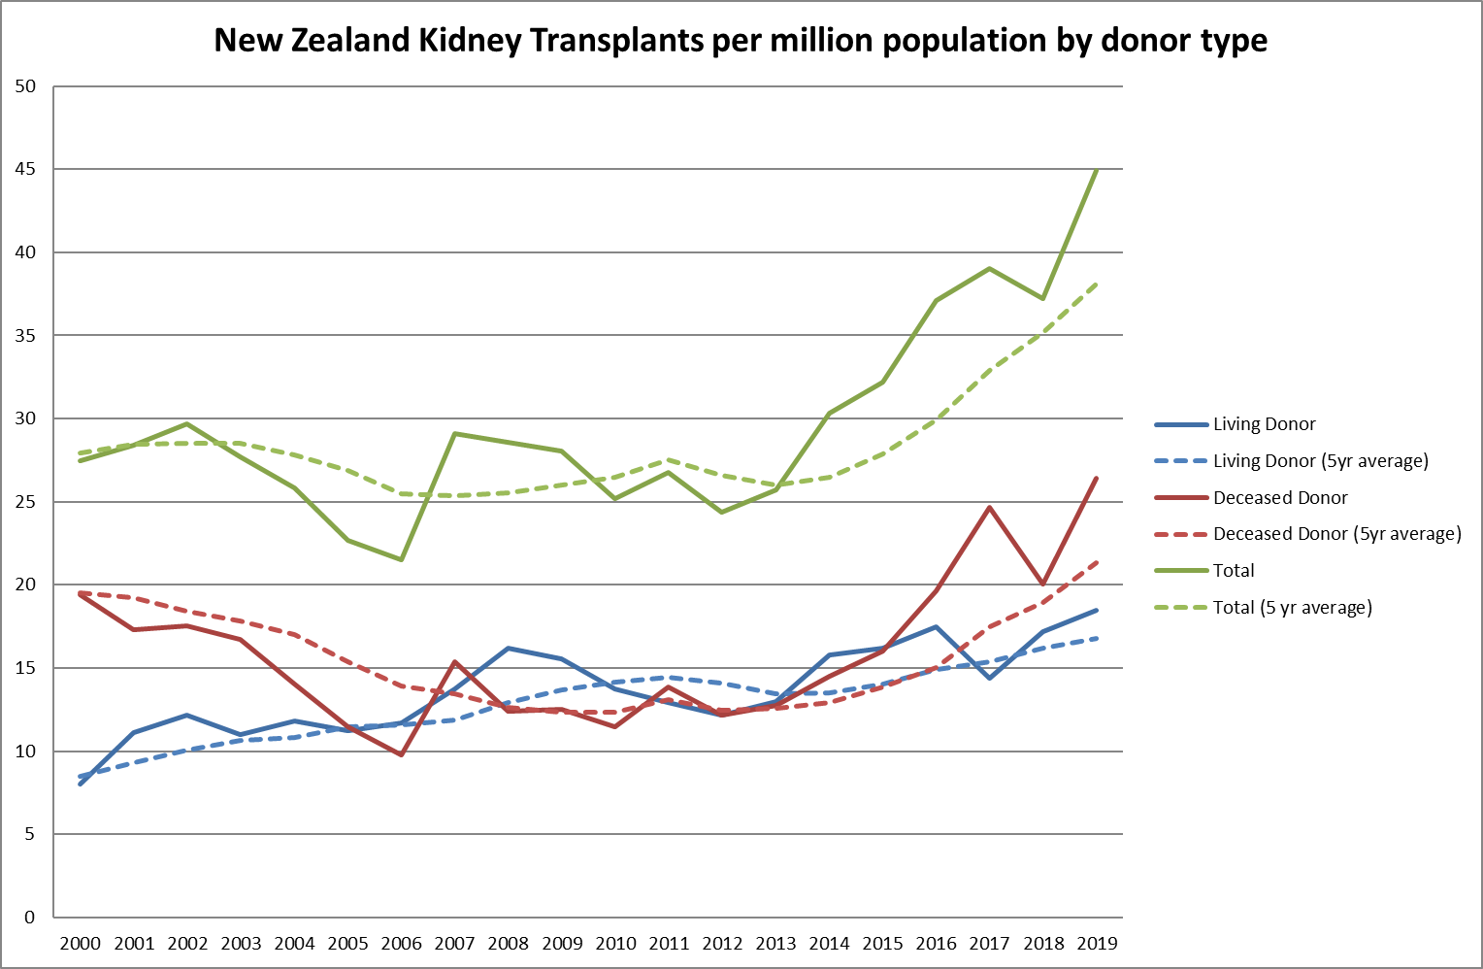
Figure 1: New Zealand Kidney Transplant Rate per million population 2000-2019, by donor source (annual and 5 year rolling average)
There has been an overall increase in the total kidney transplant rate per million population since 2013, as represented by the five year moving average, with year by year variability (figure 1).With the exception of live donor kidney transplantation 2017, the rate of live and deceased donor transplantation increase relative to the 5 year moving average since 2013.

Annual Target Progress
The initial target for the National Renal Transplant Service was to “increase the volume of live donor transplantation by 10 per annum from a base of approximately 110 live and deceased donor transplants per annum to 160 per annum in 2018/19”. The Ministry and the National Renal Transplant Service plan to release future indicative volumes to DHBs in the first half of 2020.

Table 2: Target and Observed Kidney Transplantation in NZ, by Donor Source and Year
Year | Target |  | Observed
 | Live Donor | Total | Live Donor | Total
2004 |  |  | 48 | 105
2005 |  |  | 46 | 93
2006 |  |  | 49 | 90
2007 |  |  | 58 | 123
2008 |  |  | 69 | 122
2009 |  |  | 67 | 121
2010 |  |  | 60 | 110
2011 |  |  | 57 | 118
2012 |  |  | 54 | 108
2013 |  |  | 59 | 116
2014 | 70 | 120 | 72 | 138
2015 | 80 | 130 | 74 | 147
2016 | 90 | 140 | 82 | 172
2017 | 100 | 150 | 69 | 187
2018 | 110 | 160 | 84 | 182
2019 | 110 | 160 | 91 | 221

Notes:

- NRTS was established in September 2014. Data from 10 years prior are presented for context.
- Total transplants = numbers of recipients of live donor + deceased donor kidney transplants, including recipients of kidneys with or without other organs at the same operation.

Transplants per 100 End Stage Kidney Disease Patients in NZ
This year, we present transplants per 100 cumulative incident end stage kidney disease patients at 31 December for the year prior (iESKD). These are patients commencing chronic dialysis or having a kidney transplant as their first treatment for end stage kidney disease in the 12-month period to 31 December of the year prior, as reported by ANZDATA.

Overall, there were 36 kidney transplants per 100 iESKDpatients in New Zealand in 2018. This has been steadily increasing in the last five calendar years, despite a steady and significant increase (around 25%) in iESKD patients (table 3).

Table 3: NZ Numbers of transplants per 100 Incident End Stage Kidney Disease (iESKD) Patients, 2012-2019
Year | iESKD Pts (31 Dec year prior) | Transplants per 100 iESKD patients
2012 | 489 | 22
2013 | 524 | 22
2014 | 559 | 25
2015 | 557 | 26
2016 | 565 | 30
2017 | 579 | 32
2018 | 618 | 29
2019 | 619 | 36

This data table reflects a transplant rate increase from around 1 in 5 iESKD patients in 2012 to 1 in 3 in 2019.

In Figure 2 this information is presented graphically by donor source (live donor and deceased donor).

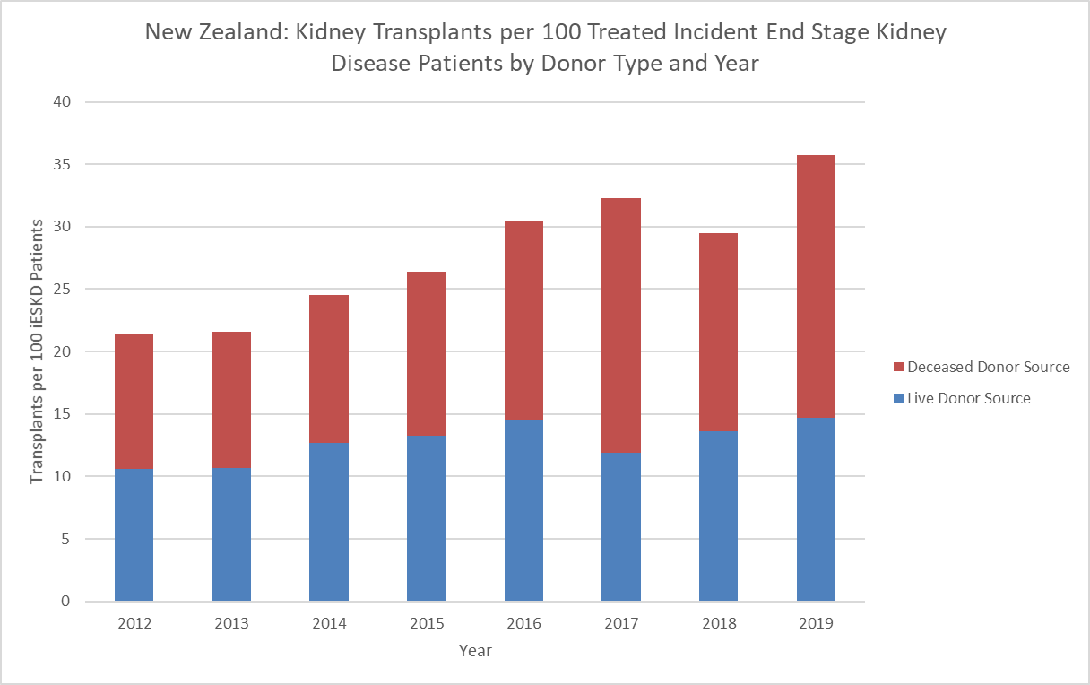
Figure 2: Kidney Transplants per 100 Treated Incident End Stage Kidney Disease Patients (New Zealand)

Kidney transplantation and ethnicity in New Zealand
Kidney transplantation varies by ethnicity in New Zealand. The reasons for this variability may relate to socioeconomic, geographic, clinical and demographic determinants of suitability and ability to access transplantation that vary between ethnic groups. The data presented here are unadjusted for these confounders, so comparisons between groups are likely to be flawed.

Rates of kidney transplantation per 100 incident end stage kidney disease patients (iESKD) are presented for three groups, Māori, Pacific and Asian people, compared to the overall rate in New Zealand, by year between 2014 and 2019 (figure 3).

Transplant rates have been increasing to a similar degree across all groups. For example, rates among Māori have increased from 11.8 per 100 iESKD patients in 2014 to 19.3 per 100 iESKD in 2019 (a 1.6 fold increase). In the same period, the overall rate for all NZ patients increased from 22.1 to 35.7 (also a 1.6 fold increase). This may suggest that improvements in access have been similarly distributed by ethnicity.

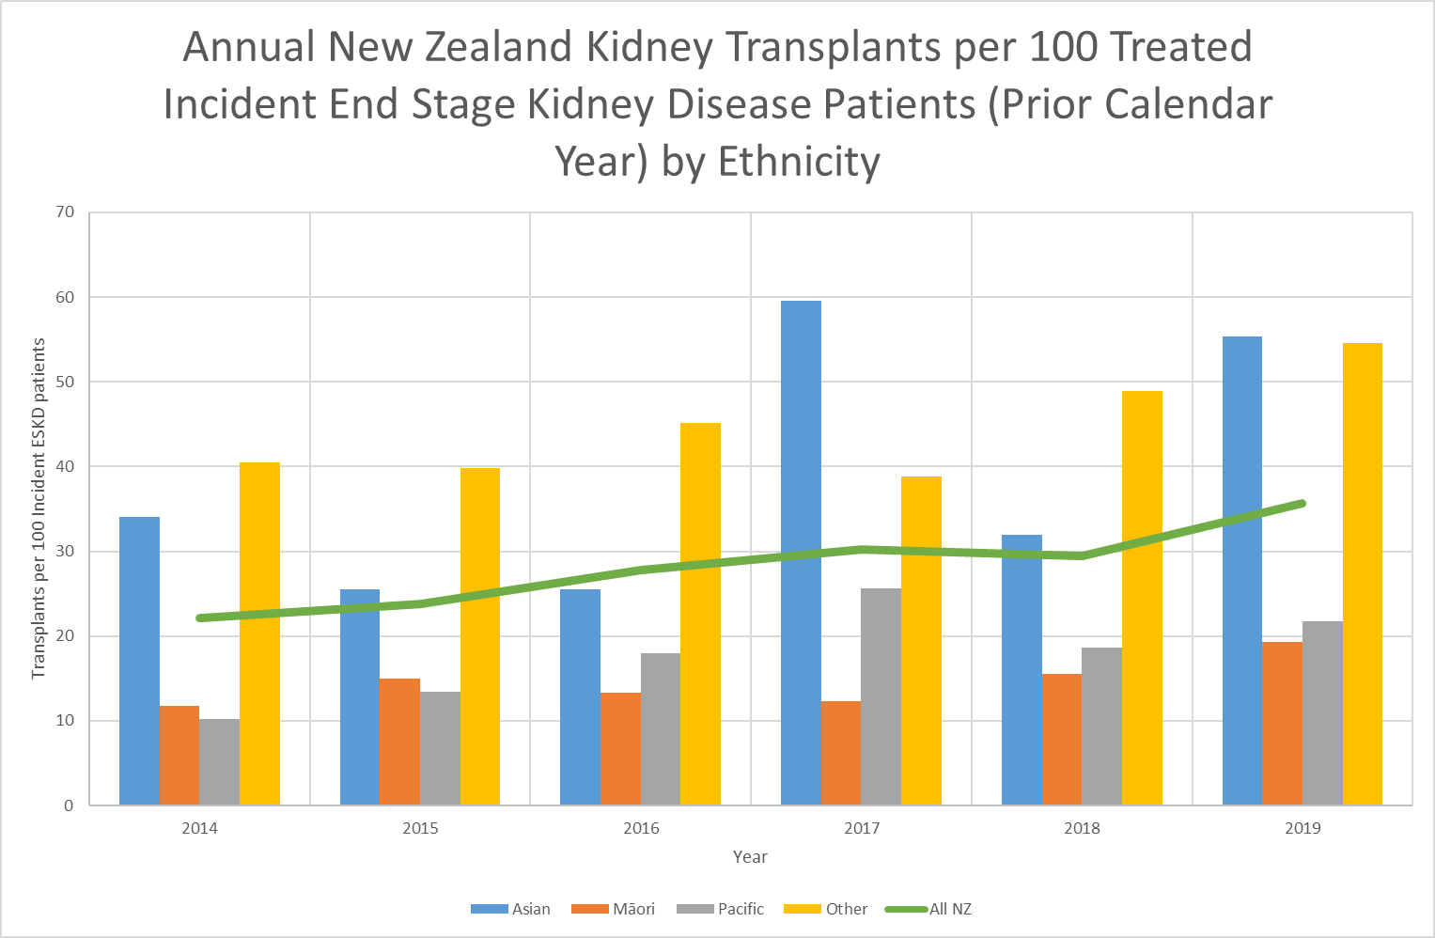
Figure 3: Annual Kidney Transplants per 100 treated incident end stage kidney disease patients (prior calendar year) by ethnicity, 2014-2019

Transplants per 100 End Stage Kidney Disease Patients by Dialysis DHB and Kidney Transplant Region

It should be noted that no attempt is made to adjust for case-mix at different DHBs, so comparisons between regions or units may be confounded. Also, due to small numbers at individual units, random variability may be responsible for year to year changes in transplantation rate within regions or units, particularly smaller units.

Table 4: Transplants per 100 iESKD Patients by Transplant Centre, DHB of Domicile and Donor Type
 | Deceased Donor | Living Donor | Total | iESKD | Transplants per 100 iESKDPatients
 |  |  |  |  | All | Living Donor
Starship | 4 | 8 | 12 | 11 | 109 | 73
Auckland Region DHBs | 84 | 52 | 136 | 428 | 32 | 12
Northland | 7 | 8 | 15 | 41 | 37 | 20
Waitemata | 13 | 7 | 20 | 66 | 30 | 11
Auckland | 15 | 5 | 20 | 66 | 30 | 8
Counties Manukau | 19 | 10 | 29 | 104 | 28 | 10
Waikato (includes BOP, Lakes, Tairawhiti) | 20 | 14 | 34 | 127 | 27 | 11
Taranaki | 6 | 0 | 6 | 13 | 46 | 0
Wellington Region DHBs | 22 | 19 | 41 | 128 | 32 | 15
Hawke’s Bay | 4 | 2 | 6 | 18 | 33 | 11
MidCentral (includes Whanganui) | 4 | 5 | 9 | 23 | 39 | 22
Capital & Coast (includes Wairarapa, Hutt, Nelson/Marlborough) | 14 | 12 | 26 | 87 | 30 | 14
Christchurch Region DHBs | 24 | 20 | 44 | 63 | 70 | 32
Canterbury (includes West Coast, South Canterbury) | 17 | 13 | 30 | 33 | 91 | 39
Southern | 7 | 7 | 14 | 30 | 47 | 23
Total | 130 | 91 | 221 | 619 | 36 | 15

Notes on table 4:
- DHB of domicile is the recipients’, at discharge from hospital. Living donors may come from different DHBs to their recipients.
- Transplants per 100 incident end stage kidney disease (iESKD) patients in the 12 months to 31 December 2018, per ANZDATA.
- Paediatric patients <=16 years, managed via Starship and transplanted in Auckland, are reported separately and in Auckland Renal Transplant Group’s figures.

Transplant centre and individual dialysing DHBs transplant rate per 100 incident end stage kidney disease patients over the period 2012-2019 are presented in Appendix 2.

Multi-organ Transplantation (all performed in Auckland)
In 2019, there were four simultaneous pancreas-kidney transplants performed (DHB of Domicile: 2 x Waikato, 1 x Hawkes Bay, 1 x Canterbury).There were three dual transplants (two kidneys used for one recipient, typically related to donor factors). These are included in table 2.

ABO Incompatible Kidney Transplants (ABOi)
ABOi are now performed at each centre, with Wellington performing their first ABOi in 2019. All centres use a similar protocol, developed in Auckland. All ABOi are living donor transplants. ABOi is an important programme that enables additional directed donations where there is no option for an ABO compatible donor, including kidney exchange.

There were 17ABOi in 2019(10in Auckland, 4 in Christchurch and 3in Wellington). Encouragingly, most DHBs are accessing ABOi transplantation for their recipients including Auckland (1), Canterbury (3), Capital & Coast (2), Counties Manukau (3), MidCentral(1), Southern (1),Waikato (4) and Waitemata (2).

Kidney Exchange
In October 2019, cooperation commenced between the Australian Paired Kidney Exchange and the New Zealand Kidney Exchange, now known as the Australian and New Zealand Paired Kidney Exchange (ANZKX).

Where a willing, acceptable kidney donor is incompatible with their recipient, the pair are encouraged to enter the Australian and New Zealand Kidney Exchange. This facilitates additional live donor transplants by providing exchanges between compatible pairs within the exchange. Occasionally, it may be clinically appropriate to undertake exchange transplantation involving compatible pairs. Exchange transplants may take place within or between transplant centres, including centres in Australia.

In 2019, there were 7 individuals in New Zealand who received kidneys via the exchange programmes, including patients from Counties Manukau (2), Hawke’s Bay (1), Waikato (3) and Waitemata (1) DHBs.

Non-Directed Living Kidney Donors

New Zealand has a high rate of non-directed living kidney donation (live donors who donate anonymously to a recipient on the deceased donor waiting list at the centre where they have their kidney removed). In 2019 there were 11 non-directed live kidney donors (3 in Wellington, and 4 in each of Christchurch and Auckland). Where the live donor is agreeable, units are encouraged to offer non-directed donors to the ANZKX programme to generate exchange chains, with the final kidney being allocated the deceased donor waiting list, restricted to the unit in NZ which removes the non-directed donor’s kidney.

Acknowledgements
NRTS would like to gratefully acknowledge the broad contribution complex health system that provides kidney transplant services in New Zealand, including nurses and nurse coordinators, doctors, allied health staff, managerial staff across a range of clinical services including but not limited to Nephrology, Intensive Care and diagnostic services at all District Health Boards.

We also gratefully acknowledge the work and contributions of Organ Donation New Zealand, the National Renal Transplant Leadership Team, the Ministry of Health, ANZDATA and the New Zealand Blood Service.

We also would like to most gratefully acknowledge the organ donors and their families, without whom there would be no transplantation.

Appendix1: Transplantation Service Arrangement in New Zealand
Within New Zealand there are three types of district health boards (DHBs), with respect to provision of transplantation services:

- Transplanting DHBs – these DHBs provide kidney transplantation services for their local population and several other DHBs. These DHBs also have comprehensive dialysis services. There are three of these.
- Referring DHBs with “comprehensive” dialysis services. These DHBs provide their own dialysis services without any involvement from other DHBs. There are eight of these.
- Referring DHBs without comprehensive dialysis services. These DHBs are dependent on referring or transplanting DHBs for at least part of their dialysis service. There are nine of these.

Please note that “comprehensive” is an arbitrary distinction. For example, Nelson/Marlborough provides many dialysis services, with support from Wellington for some elements only, but is included in Capital and Coast DHB’s figures.

Three district health boards (Auckland, Capital and Coast and Canterbury) provide kidney transplantation procedures (living and deceased donor transplants) regionally (labelled “Auckland Renal Transplant Group”, “Wellington Renal Transplant Service” and “South Island Kidney Transplant Committee”). Assessment of recipients and potential living donors is complex and is, at least partially, provided by referring DHBs in most cases. Referring DHBs send patients to a single transplant centre for routine transplants. Auckland DHB provides multi-organ transplants (kidney plus another organ) and paediatric transplantation for the entire country.

The arrangements of DHBs into three regional transplantation services are shown in Figure 1. Some patients are, therefore, dependent on services provided via three DHBs for access to transplantation.

Transplanting DHBs provide the immediate after care following transplantation, with recipients and donors returning to their DHB of domicile for long term care.

Figure 3: Arrangement of DHBs for Provision of Kidney Transplantation Services
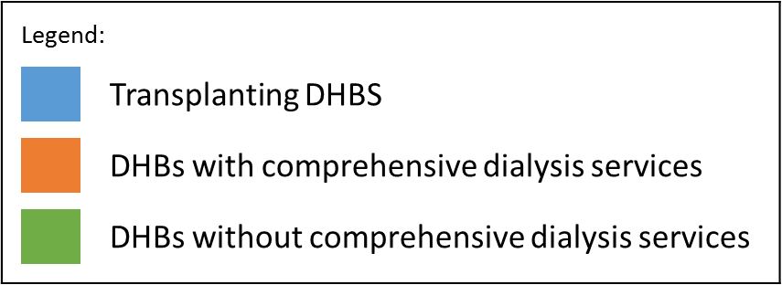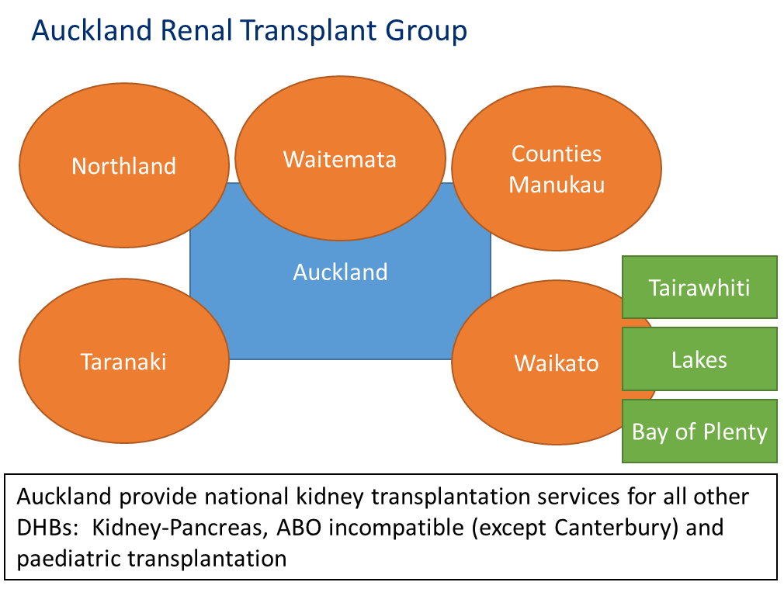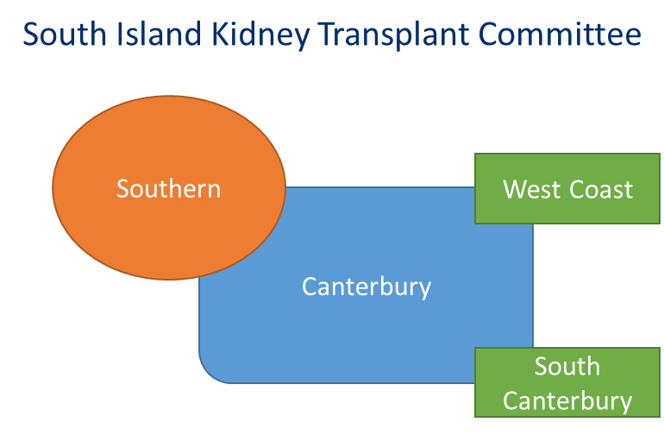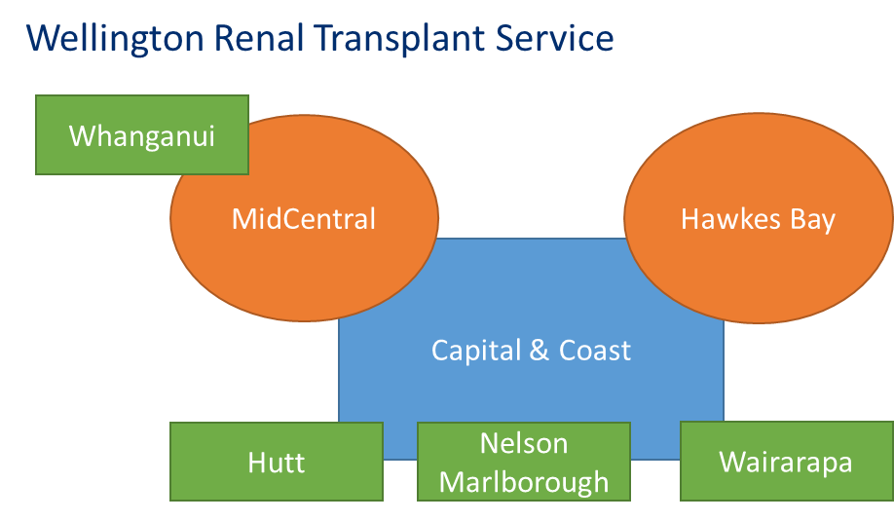

Appendix 2: Transplants per 100 Incident End Stage Kidney Disease Patients by Dialysing DHB and Kidney Transplant Region (2012-2019)
It should be noted that no attempt is made to adjust for case-mix at different DHBs, so comparisons between regions or units may be confounded. Also, due to small numbers at individual units, random variability may be responsible for year to year changes in transplantation rate within regions or units, particularly smaller units.

Attribution of transplants to regions

Attribution to region is by referring dialysis DHB of the recipient at the point of discharge from transplantation event, but very occasionally at the point of referral for transplantation where patients change DHB on discharge.

DHBs are grouped by their local transplant service. Small numbers of transplants may have occurred at another transplant centre but will be grouped with the local centre. For example, a transplant undertaken in Wellington for a patient from Southern DHB will appear in the South Island Transplant Region figures.
