New Zealand

Dialysis Standards and Audit

Incorporating data from the

New Zealand Peritoneal Dialysis Registry

2006

Report for New Zealand Nephrology Services on behalf of the National Renal Advisory Board

Kelvin Lynn
Chair, Audit and Standards Subcommittee

January 2008

Establishment of a national quality assurance framework to improve the delivery of dialysis services to the New Zealand dialysis population.

Table of Contents

Acknowledgments 4
Introduction 5
The process of data collection 6
New Zealand Dialysis Audit Report 2006 7
Graph: Incident patients 2006………………………………………………………………….7
Graph: Prevalent patients 31 Dec 2006………………………………………………………...8
Graph: Vascular access prevalent patients 2004-2006 - use of fistulae………………………..9
Graph: Vascular access 2004-2006 - use of catheters 10
Graph: Starting HD with permanent vascular access 2004-2006 - fistula or graft 11
Graph: Non-late referred with permanent access 2004-2006 12
Graph: PD catheters functioning at one year 2004-2006 13
Graph: Peritonitis in PD patients 2004-2006 14
Graph: Duration of HD session 2005-2006…………………………………………………..15
Table: Duration and frequency of HD 2005-2006……………………………………………16
Graph: Haemoglobin concentration 2005-2006………………………………………………17
Extract from NZ Peritoneal Dialysis Registry Report 2006………………………………….18
Commentary 23
References…………………………………………………………………………………….27
Appendix A: Circulation list 28
Appendix B: Working Party 29
Appendix C New Zealand Dialysis Audit Report 2006 Summary………………………… 30

Acknowledgments

- Associate Professor John Collins and the staff of the New Zealand Peritoneal Dialysis Registry
- Professor Graeme Russ, Dr Stephen McDonald of the Australian and New Zealand Dialysis Registry
- New Zealand Ministry of Health
- Clinical Directors, data collectors and staff of the Renal Units in New Zealand
- Peter Dini, Department of Nephrology, Christchurch Hospital

Introduction

The National Renal Advisory (NRAB) presents its third annual audit report of the New Zealand dialysis care standards. As in the past, the 2006 report incorporates data from the New Zealand Peritoneal Dialysis (NZ PD) Registry established and maintained by Assoc Prof John Collins at Auckland Hospital.
The Standards and Audit Subcommittee of the NRAB has not made any substantial changes in the data being reported. The collection and collation of data for this report is critically dependent on the goodwill and hard work of renal units and the staff of the Australian and New Zealand Dialysis and Transplant (ANZDATA) and NZ PD Registries.
Despite the work done with the Service Specification Project Team for the DHB Funding and Performance Directorate of the Ministry of Health last year the goal of having the dialysis care standards appended to the Tier Two Renal Service Specifications in the Ministry of Health’s National Service Framework library has not been achieved. Further discussions between the MOH and the NRAB continue. The standards are available for review by health professionals and the public on the New Zealand Kidney Foundation website http://www.nzkidneyfoundation.co.nz/.
The section of the report incorporating data provided directly from renal units to the Subcommittee is again incomplete but some units are making a concerted effort to address this issue.
The Department of Nephrology at Christchurch Hospital provides support for the production of this report and I am again indebted to the help of Peter Dini, Systems Manager.

The process of data collection

The 2006 Report includes data from the 2006 ANZDATA and NZ PD Registry Reports and from some renal units’ audit programmes. The timing of data collection and reporting for these two Registries means that the New Zealand Audit Report cannot be distributed until their work is completed in the second half of the year following original data collection. Once both Registries have complete unit data the reports of enquiries related to the New Zealand audit programme can be produced quickly.
The National Renal Advisory Board would appreciate feedback on this report. Comments can be sent to Johan Rosman, Chair of NRAB, JRosman@middlemore.co.nz or Kelvin Lynn, kelvin.lynn@cdhb.govt.nz
The audit data is shown in tabular and graphic form in the following pages. You may note minor changes in the data for 2004 and 2005 which result from corrections and updates to the ANZDATA and NZ PD databases.
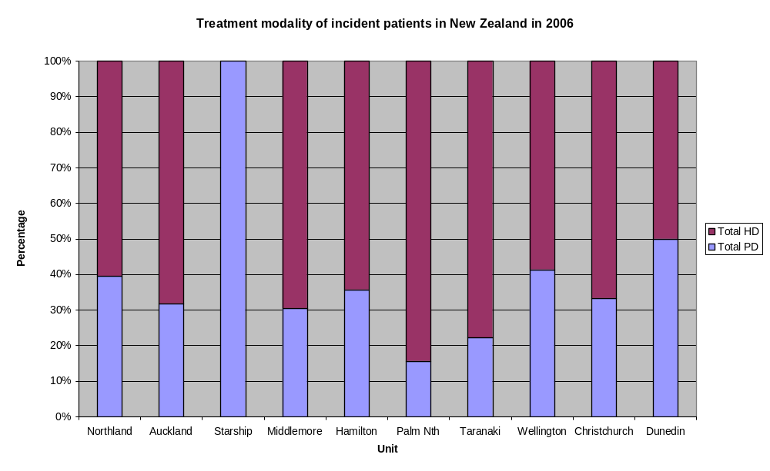
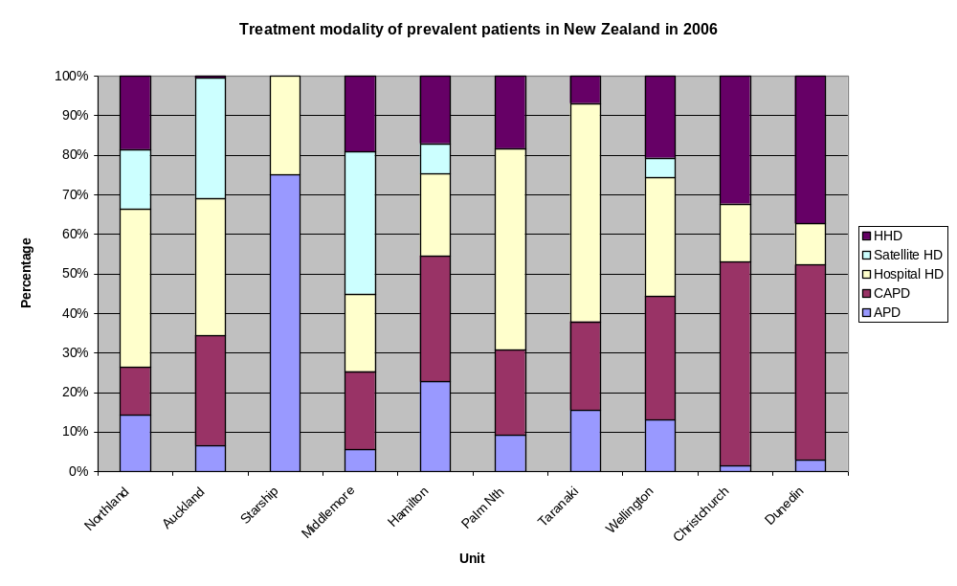
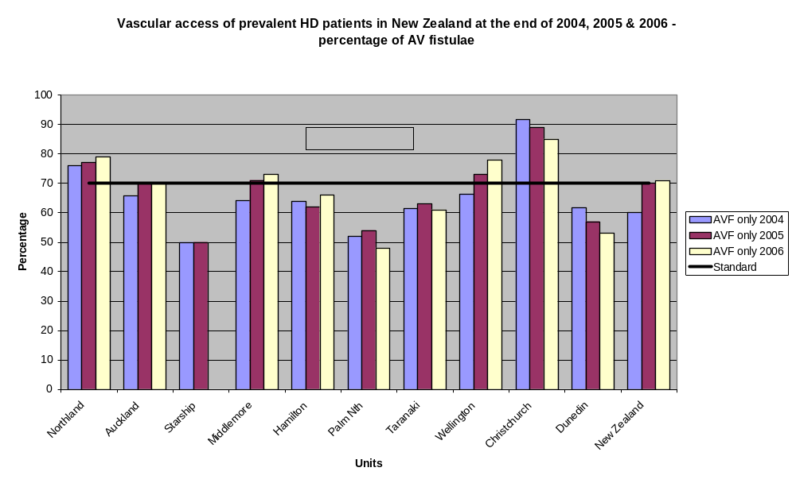
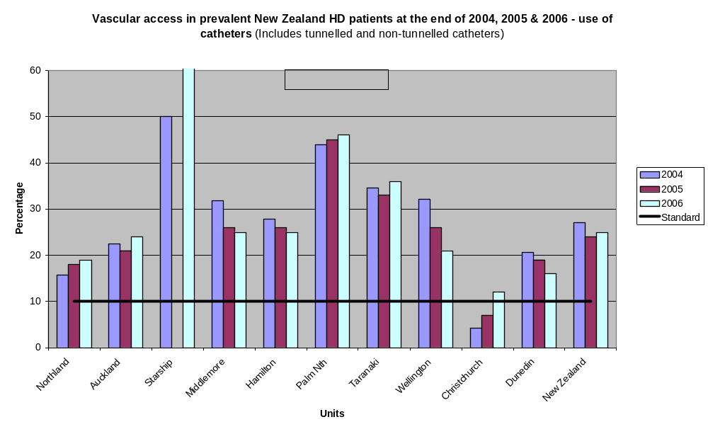
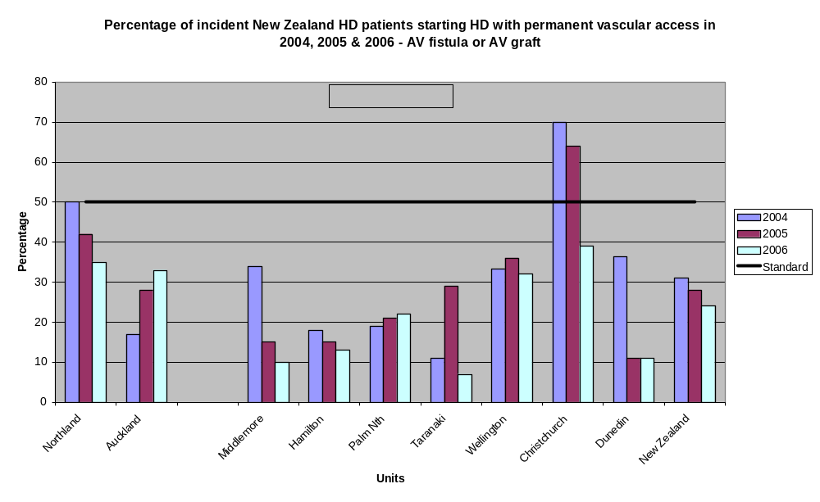
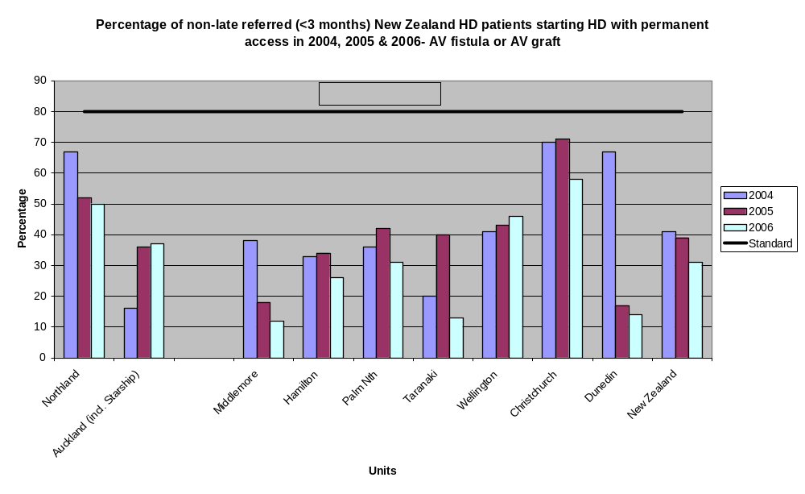
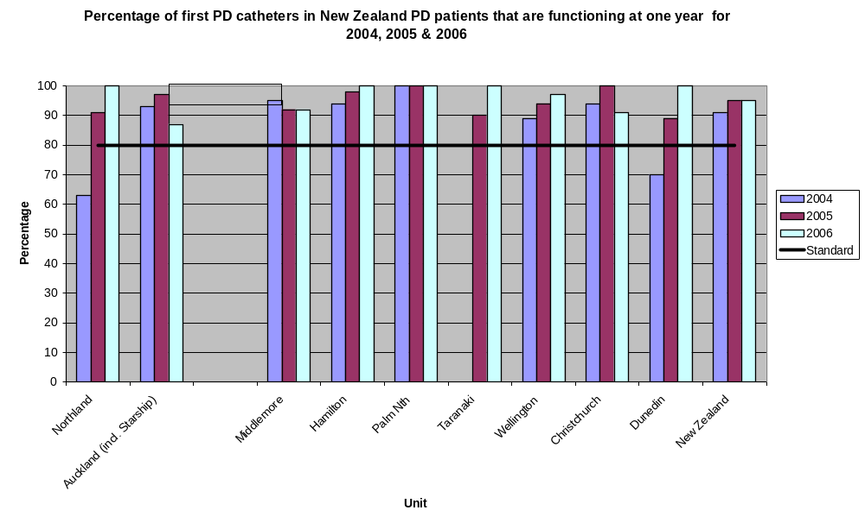
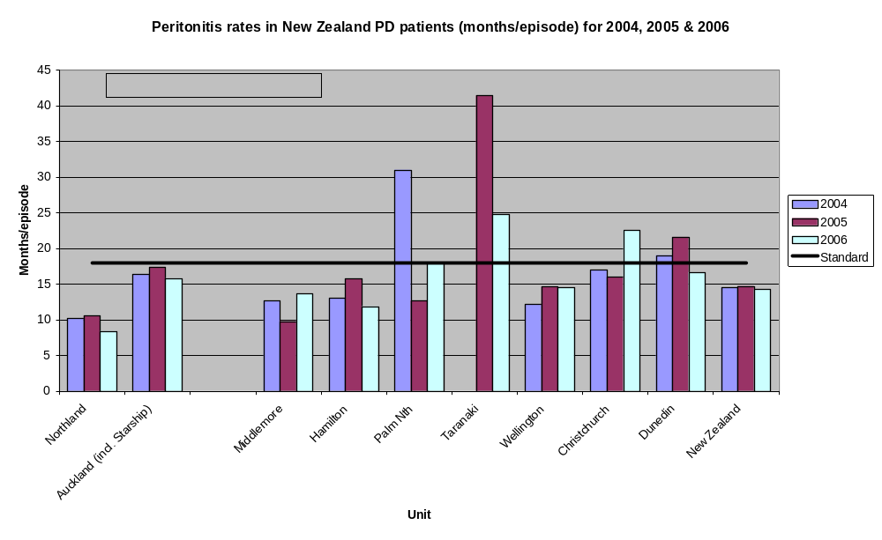
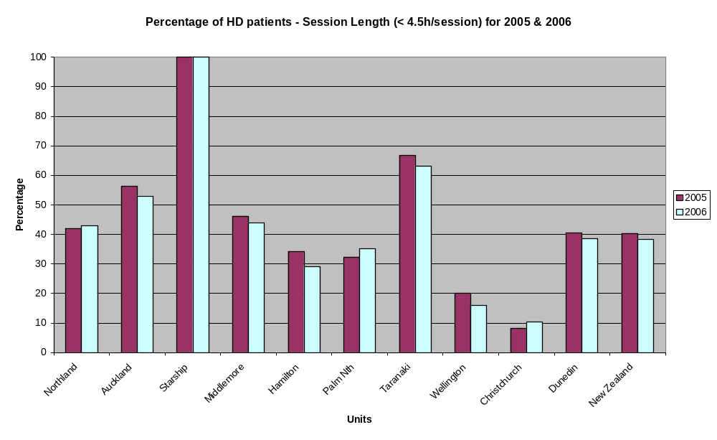

< 3/week3 3181421173 x weekly32271,0101,0801.0421,107> 3/week161854657083Total51481,0821,1591,1331,207
Dialysis frequency and duration of session 2005 and 2006
Duration of dialysis treatmentDialysis frequency< 4 hours> 4 hoursTotal
20052006 2005200620052006

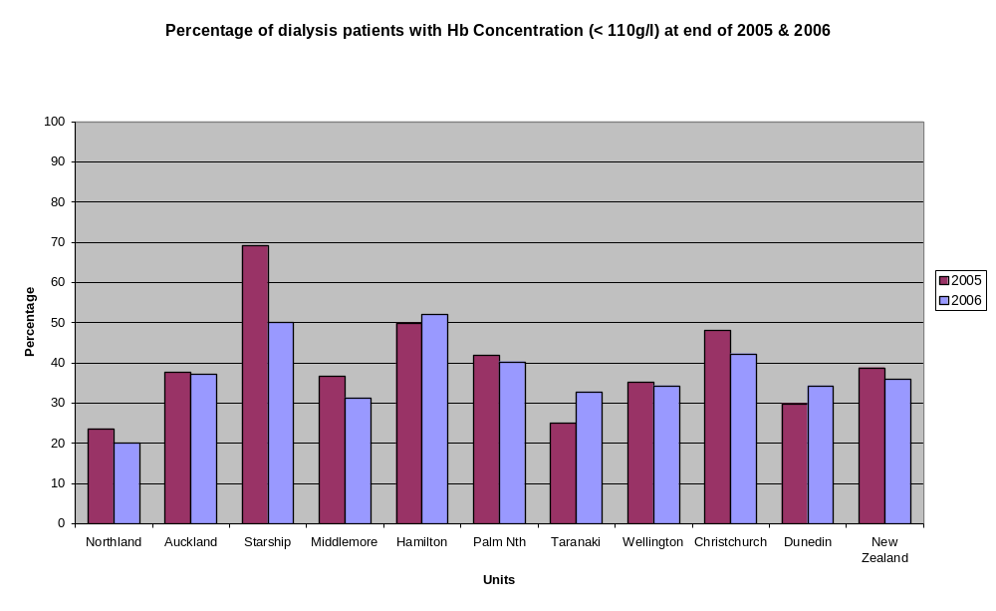
Extract from the 2006 New Zealand Peritoneal Dialysis Registry Report
Section 1. Peritoneal catheter survival
(Audit standard - >80% of first PD catheters functioning at 1 year.)
Peritoneal catheter insertions were not included in this analysis if the following occurred in the first year: the patient died with the catheter in situ, the patient recovered renal function and discontinued PD, the patient was transplanted or the patient was lost to follow up.
(shaded box = standard not achieved)
Northland
 | 2000 | 2001 | 2002 | 2003 | 2004 | 2005 | 2006
No. of 1st catheter insertion | 14 | 12 | 27 | 12 | 10 | 12 | 20
Censored | 1 | 3 | 6 | 2 | 2 | 1 | 0
Catheter failed within 1 year | 3 | 5 | 6 | 3 | 3 | 1 | 0
Catheter function over 1 year | 10 | 4 | 15 | 7 | 5 | 10 | 20
Percentage | 77% | 44% | 71% | 70% | 63% | 91% | 100%
No. of subsequent catheter insertion | 7 | 1 | 3 | 1 | 3 | 4 | 6
Censored | 2 | 0 | 0 | 0 | 0 | 0 | 0
Catheter failed within 1 year | 3 | 0 | 2 | 0 | 2 | 2 | 0
Catheter function over 1 year | 2 | 1 | 1 | 1 | 1 | 2 | 6
Percentage | 40% | 100% | 33% | 100% | 33% | 50% | 100%
Total insertions | 21 | 13 | 30 | 13 | 13 | 16 | 26

Auckland
 | 2000 | 2001 | 2002 | 2003 | 2004 | 2005 | 2006
No. of 1st catheter insertion | 66 | 59 | 60 | 39 | 48 | 48 | 59
Censored | 8 | 9 | 9 | 8 | 6 | 9 | 6
Catheter failed within 1 year | 10 | 9 | 6 | 5 | 3 | 1 | 7
Catheter function over 1 year | 48 | 41 | 45 | 26 | 39 | 38 | 46
Percentage | 83% | 82% | 88% | 84% | 93% | 97% | 87%
No. of subsequent catheter insertion | 20 | 14 | 17 | 9 | 10 | 12 | 17
Censored | 0 | 0 | 8 | 2 | 1 | 3 | 5
Catheter failed within 1 year | 7 | 1 | 6 | 0 | 1 | 1 | 5
Catheter function over 1 year | 13 | 13 | 3 | 7 | 8 | 8 | 7
Percentage | 65% | 93% | 33% | 100% | 89% | 89% | 58%
Total insertions | 86 | 73 | 77 | 48 | 58 | 60 | 76

Middlemore
 | 2000 | 2001 | 2002 | 2003 | 2004 | 2005 | 2006
No. of 1st catheter insertion | 45 | 43 | 30 | 39 | 41 | 44 | 40
Censored | 5 | 10 | 4 | 6 | 4 | 5 | 1
Catheter failed within 1 year | 4 | 3 | 6 | 5 | 2 | 3 | 3
Catheter function over 1 year | 36 | 30 | 20 | 28 | 35 | 36 | 36
Percentage | 90% | 91% | 77% | 85% | 95% | 92% | 92%
No. of subsequent catheter insertion | 13 | 5 | 2 | 7 | 4 | 7 | 2
Censored | 1 | 0 | 0 | 1 | 1 | 1 | 0
Catheter failed within 1 year | 3 | 2 | 2 | 2 | 1 | 2 | 1
Catheter function over 1 year | 9 | 3 | 0 | 4 | 2 | 4 | 1
Percentage | 75% | 60% | 0% | 67% | 67% | 67% | 50%
Total insertions | 58 | 48 | 32 | 46 | 45 | 51 | 42

Hamilton
 | 2000 | 2001 | 2002 | 2003 | 2004 | 2005 | 2006
No. of 1st catheter insertion | 58 | 70 | 65 | 40 | 53 | 54 | 67
Censored | 12 | 6 | 6 | 3 | 1 | 5 | 3
Catheter failed within 1 year | 4 | 5 | 4 | 0 | 3 | 1 | 0
Catheter function over 1 year | 42 | 59 | 55 | 37 | 49 | 48 | 64
Percentage | 91% | 92% | 93% | 100% | 94% | 98% | 100%
No. of subsequent catheter insertion | 22 | 11 | 11 | 12 | 17 | 14 | 6
Censored | 4 | 0 | 3 | 3 | 3 | 1 | 1
Catheter failed within 1 year | 6 | 4 | 1 | 5 | 4 | 1 | 0
Catheter function over 1 year | 12 | 7 | 7 | 4 | 10 | 12 | 5
Percentage | 67% | 64% | 88% | 44% | 71% | 92% | 100%
Total insertions | 80 | 81 | 76 | 52 | 70 | 68 | 73

Palmerston North
 | 2000 | 2001 | 2002 | 2003 | 2004 | 2005 | 2006
No. of 1st catheter insertion | 15 | 9 | 12 | 14 | 20 | 11 | 15
Censored | 2 | 1 | 0 | 1 | 5 | 0 | 1
Catheter failed within 1 year | 0 | 0 | 2 | 0 | 0 | 0 | 0
Catheter function over 1 year | 13 | 8 | 10 | 13 | 15 | 11 | 14
Percentage | 100% | 100% | 83% | 100% | 100% | 100% | 100%
No. of subsequent catheter insertion | 1 | 1 | 0 | 1 | 2 | 2 | 1
Censored | 0 | 0 | 0 | 0 | 0 | 0 | 1
Catheter failed within 1 year | 1 | 1 | 0 | 0 | 0 | 0 | 0
Catheter function over 1 year | 0 | 0 | 0 | 1 | 2 | 2 | 0
Percentage | 0% | 0% | 0% | 100% | 100% | 100% | 0%
Total insertions | 16 | 10 | 12 | 15 | 22 | 13 | 16

Taranaki
 | 2000 | 2001 | 2002 | 2003 | 2004 | 2005 | 2006
No. of 1st catheter insertion | 0 | 0 | 0 | 0 | 0 | 10 | 8
Censored | 0 | 0 | 0 | 0 | 0 | 0 | 1
Catheter failed within 1 year | 0 | 0 | 0 | 0 | 0 | 1 | 0
Catheter function over 1 year | 0 | 0 | 0 | 0 | 0 | 9 | 7
Percentage | 0% | 0% | 0% | 0% | 0% | 90% | 100%
No. of subsequent catheter insertion | 0 | 0 | 0 | 0 | 0 | 2 | 3
Censored | 0 | 0 | 0 | 0 | 0 | 0 | 0
Catheter failed within 1 year | 0 | 0 | 0 | 0 | 0 | 1 | 0
Catheter function over 1 year | 0 | 0 | 0 | 0 | 0 | 1 | 3
Percentage | 0% | 0% | 0% | 0% | 0% | 50% | 100%
Total insertions | 0 | 0 | 0 | 0 | 0 | 12 | 11

Wellington
 | 2000 | 2001 | 2002 | 2003 | 2004 | 2005 | 2006
No. of 1st catheter insertion | 42 | 57 | 40 | 52 | 43 | 39 | 35
Censored | 4 | 8 | 2 | 6 | 8 | 5 | 2
Catheter failed within 1 year | 3 | 1 | 2 | 4 | 4 | 2 | 1
Catheter function over 1 year | 35 | 48 | 36 | 42 | 31 | 32 | 32
Percentage | 92% | 98% | 95% | 91% | 89% | 94% | 97%
No. of subsequent catheter insertion | 7 | 3 | 0 | 2 | 6 | 9 | 6
Censored | 1 | 1 | 0 | 0 | 0 | 0 | 0
Catheter failed within 1 year | 1 | 0 | 0 | 0 | 0 | 1 | 2
Catheter function over 1 year | 5 | 2 | 0 | 2 | 6 | 8 | 4
Percentage | 83% | 100% | 0% | 100% | 100% | 89% | 67%
Total insertions | 49 | 60 | 40 | 54 | 49 | 48 | 41

Christchurch
 | 2000 | 2001 | 2002 | 2003 | 2004 | 2005 | 2006
No. of 1st catheter insertion | 21 | 19 | 28 | 28 | 18 | 27 | 24
Censored | 6 | 7 | 4 | 3 | 2 | 3 | 1
Catheter failed within 1 year | 1 | 1 | 1 | 2 | 1 | 0 | 2
Catheter function over 1 year | 14 | 11 | 23 | 23 | 15 | 24 | 21
Percentage | 93% | 92% | 96% | 92% | 94% | 100% | 91%
No. of subsequent catheter insertion | 5 | 4 | 1 | 4 | 5 | 1 | 4
Censored | 4 | 0 | 0 | 1 | 2 | 0 | 0
Catheter failed within 1 year | 0 | 1 | 1 | 1 | 2 | 1 | 0
Catheter function over 1 year | 1 | 3 | 0 | 2 | 1 | 0 | 4
Percentage | 100% | 75% | 0% | 67% | 33% | 0% | 100%
Total insertions | 26 | 23 | 29 | 32 | 23 | 28 | 28

Dunedin
 | 2000 | 2001 | 2002 | 2003 | 2004 | 2005 | 2006
No. of 1st catheter insertion | 9 | 20 | 19 | 12 | 13 | 11 | 13
Censored | 4 | 9 | 3 | 4 | 3 | 2 | 1
Catheter failed within 1 year | 1 | 2 | 3 | 2 | 3 | 1 | 0
Catheter function over 1 year | 4 | 9 | 13 | 6 | 7 | 8 | 12
Percentage | 80% | 82% | 81% | 75% | 70% | 89% | 100%
No. of subsequent catheter insertion | 4 | 6 | 1 | 3 | 5 | 12 | 8
Censored | 0 | 0 | 0 | 1 | 0 | 4 | 1
Catheter failed within 1 year | 1 | 0 | 0 | 0 | 1 | 3 | 2
Catheter function over 1 year | 3 | 6 | 1 | 2 | 4 | 5 | 5
Percentage | 75% | 100% | 100% | 100% | 80% | 63% | 71%
Total insertions | 13 | 26 | 20 | 15 | 18 | 23 | 21

New Zealand
 | 2000 | 2001 | 2002 | 2003 | 2004 | 2005 | 2006
No. of 1st catheter insertion | 270 | 289 | 281 | 236 | 246 | 256 | 281
Censored | 42 | 53 | 34 | 33 | 31 | 28 | 16
Catheter failed within 1 year | 26 | 26 | 30 | 21 | 19 | 11 | 13
Catheter function over 1 year | 202 | 210 | 217 | 182 | 196 | 217 | 252
Percentage | 75% | 73% | 77% | 77% | 91% | 95% | 95%
No. of subsequent catheter insertion | 79 | 45 | 35 | 39 | 52 | 63 | 53
Censored | 12 | 1 | 11 | 8 | 7 | 7 | 8
Catheter failed within 1 year | 22 | 9 | 12 | 8 | 11 | 15 | 10
Catheter function over 1 year | 45 | 35 | 12 | 23 | 34 | 41 | 35
Percentage | 57% | 78% | 34% | 59% | 76% | 73% | 78%
Total insertions | 349 | 334 | 316 | 275 | 298 | 319 | 334

Section 3.Peritonitis
Peritonitis Frequency Tables
(Audit standard > 18 patient months/episode)
(shaded box = standard not achieved)
Northland
 |  | 2000 |  | 2001 |  | 2002 |  | 2003 |  | 2004 |  | 2005 | 2006
Patients on PD as at year end |  | 30 |  | 26 |  | 37 |  | 36 |  | 18 |  | 22 | 34
Months on PD |  | 445.10 |  | 327.05 |  | 378.00 |  | 438.20 |  | 417.93 |  | 264.09 | 343.19
Peritonitis episodes |  | 31 |  | 39 |  | 39 |  | 45 |  | 41 |  | 25 | 41
Patients with peritonitis |  | 23 |  | 26 |  | 23 |  | 21 |  | 22 |  | 17 | 28
Months per episode |  | 14.36 |  | 8.39 |  | 9.69 |  | 9.74 |  | 10.19 |  | 10.56 | 8.37
Auckland
 | 2000 |  | 2001 |  | 2002 |  | 2003 |  | 2004 |  | 2005 |  | 2006
Patients on PD as at year end | 140 |  | 158 |  | 148 |  | 147 |  | 129 |  | 123 |  | 150
Months on PD | 1539.48 |  | 1810.55 |  | 1860.55 |  | 1791.82 |  | 1818.03 |  | 1494.56 |  | 1719.7
Peritonitis episodes | 93 |  | 112 |  | 99 |  | 87 |  | 111 |  | 86 |  | 109
Patients with peritonitis | 61 |  | 78 |  | 76 |  | 61 |  | 72 |  | 61 |  | 82
Months per episode | 16.55 |  | 16.17 |  | 18.79 |  | 20.60 |  | 16.38 |  | 17.38 |  | 15.78
Middlemore
 | 2000 |  | 2001 |  | 2002 |  | 2003 |  | 2004 |  | 2005 |  | 2006
Patients on PD as at year end | 106 |  | 106 |  | 93 |  | 84 |  | 88 |  | 98 |  | 111
Months on PD | 1251.74 |  | 1278.01 |  | 1198.06 |  | 1037.35 |  | 1051 |  | 1169.07 |  | 1311
Peritonitis episodes | 89 |  | 81 |  | 87 |  | 71 |  | 83 |  | 120 |  | 96
Patients with peritonitis | 57 |  | 54 |  | 51 |  | 39 |  | 47 |  | 59 |  | 49
Months per episode | 14.06 |  | 15.78 |  | 13.77 |  | 14.61 |  | 12.66 |  | 9.74 |  | 13.66
Hamilton
 |  | 2000 |  | 2001 |  | 2002 |  | 2003 |  | 2004 |  | 2005 | 2006
Patients on PD as at year end |  | 169 |  | 183 |  | 202 |  | 214 |  | 193 |  | 200 | 193
Months on PD |  | 2044.80 |  | 2046.45 |  | 2328.17 |  | 2467.91 |  | 2565.8 |  | 2313.42 | 2190.27
Peritonitis episodes |  | 198 |  | 198 |  | 206 |  | 207 |  | 197 |  | 147 | 185
Patients with peritonitis |  | 114 |  | 116 |  | 114 |  | 115 |  | 114 |  | 89 | 104
Months per episode |  | 10.33 |  | 10.34 |  | 11.30 |  | 11.92 |  | 13.02 |  | 15.74 | 11.84
Palmerston North
 |  | 2000 |  | 2001 |  | 2002 |  | 2003 |  | 2004 |  | 2005 | 2006
Patients on PD as at year end |  | 44 |  | 31 |  | 42 |  | 48 |  | 42 |  | 45 | 37
Months on PD |  | 544.51 |  | 417.69 |  | 408.91 |  | 526.63 |  | 619.7 |  | 506.61 | 448.81
Peritonitis episodes |  | 19 |  | 23 |  | 32 |  | 23 |  | 20 |  | 40 | 25
Patients with peritonitis |  | 15 |  | 11 |  | 26 |  | 17 |  | 15 |  | 18 | 18
Months per episode |  | 28.66 |  | 18.16 |  | 12.78 |  | 22.90 |  | 30.99 |  | 12.67 | 17.95

Taranaki
 |  |  | 2000 |  |  | 2001 |  |  |  | 2002 |  |  | 2003 |  |  |  | 2004 | 2005 |  |  | 2006
Patients on PD as at year end |  |  | 0 |  |  | 0 |  |  |  | 0 |  |  | 0 |  |  |  | 0 | 23 |  |  | 24
Months on PD |  |  | 0.00 |  |  | 0.00 |  |  |  | 0.00 |  |  | 0.00 |  |  |  | 0 | 248.55 |  |  | 272.59
Peritonitis episodes |  |  | 0 |  |  | 0 |  |  |  | 0 |  |  | 0 |  |  |  | 0 | 6 |  |  | 11
Patients with peritonitis |  |  | 0 |  |  | 0 |  |  |  | 0 |  |  | 0 |  |  |  | 0 | 6 |  |  | 10
Months per episode |  |  | 0.00 |  |  | 0.00 |  |  |  | 0.00 |  |  | 0.00 |  |  |  | 0.00 | 41.43 |  |  | 24.78
Wellington
 |  | 2000 |  |  | 2001 |  |  |  | 2002 |  |  | 2003 |  |  |  | 2004 |  |  | 2005 |  |  | 2006
Patients on PD as at year end |  | 94 |  |  | 110 |  |  |  | 0 |  |  | 122 |  |  |  | 109 |  |  | 120 |  |  | 113
Months on PD |  | 1154.11 |  |  | 1262.95 |  |  |  | 0.00 |  |  | 1250.16 |  |  |  | 1496.43 |  |  | 1372.75 |  |  | 1380.7
Peritonitis episodes |  | 53 |  |  | 50 |  |  |  | 0 |  |  | 59 |  |  |  | 123 |  |  | 94 |  |  | 95
Patients with peritonitis |  | 44 |  |  | 37 |  |  |  | 0 |  |  | 43 |  |  |  | 72 |  |  | 61 |  |  | 62
Months per episode |  | 21.78 |  |  | 25.26 |  |  |  | 0.00 |  |  | 21.19 |  |  |  | 12.17 |  |  | 14.60 |  |  | 14.53
Christchurch
 |  | 2000 |  |  | 2001 |  |  |  | 2002 |  |  | 2003 |  |  |  | 2004 |  |  | 2005 |  |  | 2006
Patients on PD as at year end |  | 53 |  |  | 49 |  |  |  | 56 |  |  | 59 |  |  |  | 48 |  |  | 61 |  |  | 70
Months on PD |  | 614.63 |  |  | 586.00 |  |  |  | 599.21 |  |  | 672.03 |  |  |  | 797.6 |  |  | 688.23 |  |  | 766.04
Peritonitis episodes |  | 63 |  |  | 36 |  |  |  | 32 |  |  | 38 |  |  |  | 47 |  |  | 43 |  |  | 34
Patients with peritonitis |  | 30 |  |  | 19 |  |  |  | 22 |  |  | 27 |  |  |  | 25 |  |  | 23 |  |  | 20
Months per episode |  | 9.76 |  |  | 16.28 |  |  |  | 18.73 |  |  | 17.69 |  |  |  | 16.97 |  |  | 16.01 |  |  | 22.53
Dunedin
 |  | 2000 |  |  | 2001 |  |  |  | 2002 |  |  | 2003 |  |  |  | 2004 |  |  | 2005 |  |  | 2006
Patients on PD as at year end |  | 28 |  |  | 34 |  |  |  | 32 |  |  | 31 |  |  |  | 30 |  |  | 28 |  |  | 38
Months on PD |  | 254.34 |  |  | 334.58 |  |  |  | 355.95 |  |  | 427.35 |  |  |  | 399.13 |  |  | 388.35 |  |  | 349.31
Peritonitis episodes |  | 15 |  |  | 16 |  |  |  | 19 |  |  | 16 |  |  |  | 21 |  |  | 18 |  |  | 21
Patients with peritonitis |  | 13 |  |  | 12 |  |  |  | 15 |  |  | 11 |  |  |  | 12 |  |  | 14 |  |  | 16
Months per episode |  | 16.96 |  |  | 20.91 |  |  |  | 18.73 |  |  | 26.71 |  |  |  | 19.01 |  |  | 21.58 |  |  | 16.63
New Zealand
 | 2000 |  |  | 2001 |  |  |  | 2002 |  |  | 2003 |  |  |  | 2004 |  |  | 2005 |  |  |  | 2006
Patients on PD as at year end | 664 |  |  | 697 |  |  |  | 610 |  |  | 741 |  |  |  | 657 |  |  | 720 |  |  |  | 770
Months on PD | 7848.71 |  |  | 8063.28 |  |  |  | 7128.85 |  |  | 8611.45 |  |  |  | 9312 |  |  | 8446 |  |  |  | 8781.57
Peritonitis episodes | 571 |  |  | 560 |  |  |  | 518 |  |  | 546 |  |  |  | 643 |  |  | 575 |  |  |  | 617
Patients with peritonitis | 357 |  |  | 353 |  |  |  | 327 |  |  | 334 |  |  |  | 379 |  |  | 348 |  |  |  | 389
Months per episode | 13.75 |  |  | 14.40 |  |  |  | 13.76 |  |  | 15.77 |  |  |  | 14.48 |  |  | 14.69 |  |  |  | 14.23
Note: The 2002 result does not include Wellington

Commentary
Demography

- There continues to be a substantial variation between units in regard to initial and prevalent dialysis modality; particularly in the proportion of patients on centre dialysis.
- The number of incident patients continues to rise annually.
- The numbers of prevalent haemodialysis and peritoneal dialysis patients both increased in 2006.
Haemodialysis adequacy, frequency and duration of treatment
- There has been a fall in the number of haemodialysis patients receiving less than 4.5 hours dialysis per session from 457 (40%) to 357 (38%, when compared to 2005.
- Twenty-four patients on thrice weekly dialysis are receiving less than 4 hours dialysis for each treatment session: a substantial reduction in patient number compared to 2005.
Vascular access for haemodialysis
- Eight of ten units again achieved the standard for optimal vascular access (arteriovenous (AV) fistula + graft) for prevalent patients but none for incident patients or the more stringent standard for non-late presenting patients.
- There has been an increase in the number of prevalent haemodialysis patients using a central venous catheter (CVC) for dialysis and no renal unit has <10% of their patients using this form of vascular access. At 31 Dec 2006, 300 haemodialysis patients (25% of all New Zealand haemodialysis patients) were using a CVC for vascular access with the range being 12 to 46% of haemodialysis patients across units.
- A significant proportion of patients who received haemodialysis for up to 90 days before starting on peritoneal dialysis used a CVC. There is no way from the Registry data to know whether there was an intention during the pre-dialysis phase of care that peritoneal dialysis would be the starting treatment modality. In 2006, there were 72 such patients who had up to 90 days haemodialysis before changing to peritoneal dialysis and all but two had a CVC as vascular access. Thirty-one of these patients (43%) were late presenters.
- The continuing high rates of CVC use in some units are of concern because of the evidence that patient survival is inferior with this form of access when compared with an AV fistula. Although the data are sparse, it appears that the rates of blood stream infections related to CVCs are well within the international recommendations.
- Disappointingly, the current audit results in regard to vascular access do not provide any reassurance that there have been substantial changes in the co-ordination of, and capacity to provide, timely vascular access. This indicates a problem with the predialysis co-ordination of vascular access services and requires a multidisciplinary approach to finding a solution. A recent analysis of haemodialysis vascular access from ANZDATA for 2000 to 2005 also notes a decline in the use of arteriovenous fistulae and an increase in CVC use for incident and prevalent patients¹.

Peritoneal dialysis
- The number of first peritoneal dialysis catheters functioning at year end continues to be excellent with all units achieving the standard.
- Peritonitis rates vary considerably. Four units either achieve or are very close to the standard of at least 18 patient months/episode of peritonitis. Units with a large proportion of Maori and Pacific patients have inferior results (see the 2005 report for more in depth analysis)
Anaemia management
- Dialysis patients with the anaemia of chronic renal failure and a haemoglobin concentration < 100g/L are entitled to receive subsidised epoietin. Many units have revised their treatment target to 100 – 120 g/L in the light of recent publications examining the risks of a higher treatment target, particularly in patients with cardiac disease^{2,3} and on consideration of Clinical Practice Guidelines⁴.
- The proportion of dialysis patients with a haemoglobin concentration < 110g/L in 2006 fell to 36% (707 patients). In the light of the alteration in treatment target it may be useful to report the number of patients with a haemoglobin concentration < 100g/L in the next report.
Data provided by renal units
- Waiting times for the provision of arteriovenous fistulae varies amongst the four units that provided data. This audit standard has been difficult to report on as the nature of referral to a vascular surgeon varies, the rate of progression of kidney disease may slow after referral and, in some cases, the patient has asked for a deferment of surgery.
- Four units provided data on dialysis catheter related blood stream infections and all had rates < 4/1000 catheter days.
References
- Moist LM, Chang SH, Polkinghorne KR, McDonald SP. Trends in Hemodialysis Vascular Access From the Australia and
New Zealand Dialysis and Transplant Registry (ANZDATA) 2000 to 2005. Am J Kidney Dis 2007; 50: 612-21

- Singh AK et al. Correction of anemia with Epoetin Alfa in chronic kidney disease. N Engl J Med 2006; 355: 2085-98.

- Drueke TB et al . Normalization of hemoglobin level in patients with chronic kidney disease and anemia. . N Engl J Med 2006; 355: 2071-84

- KDOQI Clinical Practice Guidelines and Clinical Practice Recommendations for Anaemia in Chronic Kidney Disease: 2007 Update of Hemoglobin Target. Am J Kidney Dis 2007; 50: 471-530

Appendix A: Circulation list

The National Renal Advisory Board

Standards and Audit Subcommittee

Heads of New Zealand Renal Units

Chief Executive Officers of DHBs with Renal Units

New Zealand Peritoneal Dialysis Registry

Australia and New Zealand Dialysis Registry

New Zealand Ministry of Health (Director General)
Australian and New Zealand Society of Nephrology

Renal Society of Australasia, New Zealand Branch

New Zealand Kidney Foundation

Board of Nephrology Practice New Zealand
Patient support groups/societies
Appendix B

Members of the Standards and Audit Working Party

Kelvin Lynn, Chair
Anne de Bres (resigned Nov 2003)
Adrian Buttimore
Brenda Clune (resigned Nov 2004)
Mark Marshall
Jenny Walker
Tafale Maddren

