New Zealand

Dialysis Standards and Audit

2004

Report for New Zealand Nephrology Services on behalf of the National Renal Advisory Board

Kelvin Lynn
Chair, Audit and Standards Subcommittee

November 2005

Establishment of a national quality assurance framework to improve the delivery of dialysis services to the New Zealand dialysis population.

Members of the Standards and Audit Working Party

Kelvin Lynn, Chair
Anne de Bres (resigned Nov 2003)
Adrian Buttimore
Brenda Clune (resigned Nov 2004)
Mark Marshall
Jenny Walker
Tafale Maddren

Table of Contents

Acknowledgments 3
Introduction 4
Standards and Audit 6
A. Access to Dialysis 6
Recommendations 6
B. Vascular Access (VA) 7
Recommendation on Type of VA 7
Recommendations on VA at commencement of HD 7
Recommendations on Central Venous Catheters (CVC) 8
C. Peritoneal Dialysis (PD): 9
Recommendations on APD 9
Recommendations on peritoneal dialysis catheters 9
Recommendations on peritoneal dialysis fluids 9
Recommendations on Peritonitis 9
The process of data collection 10
New Zealand Dialysis Audit Report 2004 11
Graph: Vascular access - AV fistulae and AV grafts - Prevalent HD patients 13
Graph: Vascular access - use of catheters 14
Graph: Starting HD with permanent vascular access 15
Graph: Non-late referred with permanent access 16
Graph: Temporary CVC before starting PD 17
Graph: PD catheters functioning at one year 18
Graph: Peritonitis in PD patients 19
Commentary 20
Appendix A: Literature reviewed 21
Appendix B: Circulation list 22

Acknowledgments

- Associate Professor John Collins and the staff of the New Zealand Peritoneal Dialysis Registry
- Professor Graeme Russ, Dr Stephen McDonald, and Victoria Shtangey of the Australian and New Zealand Dialysis Registry
- New Zealand Ministry of Health
- Clinical Directors, data collectors and staff of the Renal Units in New Zealand
- Department of Nephrology, Christchurch Hospital

Introduction

At the National Renal Advisory (NRAB) meeting on 8 December 2000 a number of objectives were agreed, including establishment of standards of practice and a process of audit for all forms of renal care. The aim of this process was to improve the care of patients with kidney failure, not to seek to apportion blame where standards were not being met.
A project group chaired by Associate Professor John Collins was formed to address this. The document resulting from this work was eventually incorporated as an appendix to the draft Tier Two Renal Service Specifications produced in April 2003. No further meetings of the NRAB where held until 10 April 2003. At this meeting it was agreed to reconvene the Standards and Audit Working party with new membership and continue the original work with the exception of eligibility for access to renal replacement programmes. This project was to be addressed by another working group.
All renal units in New Zealand were consulted during the development of this document and, where possible, their comments included. The Working Party reviewed available documents pertinent to standards for dialysis services (Appendix A)
The Working Party on Standards and Audit resolved the following:
- It was not appropriate, nor feasible, to attempt to develop a New Zealand equivalent of other practice guidelines such as CARI or K/DOQI.
- International guidelines were of value to individual clinicians and departments but did not need to be formally adopted by the NRAB.
- It was not intended to produce a comprehensive best practice manual.
- It was agreed that development of workforce standards was necessary to support safe practice but that this was not within the scope of the Working Party.
- Any data collection for audit should be simple and not duplicate other processes.
- Where possible, data already being collected for other purposes (eg. ANZDATA) should be used.
- Data obtained from audit should be relevant to patient care and inform any changes in the delivery of renal failure services.
- Facilities standards were necessary, particularly to guide the establishment of dialysis facilities in DHBs where there have not been renal services.
- It was agreed that a national annual audit of these clinical standards should be carried out under the auspices of the NRAB.
- All renal units should have a Quality Improvement programme and submit data to ANZDATA Registry and the New Zealand Peritoneal Dialysis Register
These standards will form an appendix to the Tier Two Renal Service Specifications (www2.moh.govt.nz/nsfl)

Standards and Audit

Access to Dialysis

Recommendations

- All centres providing dialysis treatments must do so under the direct supervision of a vocationally registered and credentialled nephrologist.
- All centres must provide access to both haemodialysis and peritoneal dialysis.
- All centres to provide access to both independent (home/self care) and dependent (incentre/caregiver assisted) haemodialysis.
- All centres must offer either directly, or indirectly, a conservative care program for those who decline an offer of dialysis.
- All centres must ensure that patients have access to transplantation services.
- All centres must offer at least a 3 times a week haemodialysis schedule for those with minimal residual renal clearance.
- Haemodialysis treatment duration, frequency and modality should be determined according to clinical need. These modalities may include, but are not necessarily limited to, daily or nocturnal schedules, and high flux dialysis.
- Haemodialysis services must be provided to patients by appropriately
qualified medical, nursing, technical, and clerical personnel.

- Clinical dialysis staff and technicians should be certified by New Zealand Board of Nephrology Practice

Audit data and standards

- ANZDATA reports on dialysis modality for incident and prevalent patients (ANZDATA)
- No patients dialysing for less than four hours per session or less than three times weekly and Kt/V less than 1.2 or urea reduction rate (URR) <65%. (ANZDATA)

Vascular Access (VA)

Recommendation on Type of VA

- Centres must have access to appropriate vascular surgical services.
- An arteriovenous fistula (AVF) is the VA of choice.
- Preference should be given to formation of an AVF before placement of an arteriovenous graft (AVG) or permanent central venous catheter (CVC) (preferred order of provision).

Audit data and standards

- At least 70% of prevalent HD patients dialysing via AVF. (ANZDATA).
- Less than 10% of HD patients dialysing using a central venous catheter (CVC) as their permanent access. (ANZDATA)

Recommendations on VA at commencement of HD

- New haemodialysis patients should optimally have a functioning AVF or AVG at commencement of dialysis.
- Patients should be referred for vascular access formation when the eGFR (MDRD) is <25mls/min or within 6 months of anticipated need for dialysis.

Audit data and standards

- More than 50% of incident patients commencing dialysis with functioning AVF and AVG. (ANZDATA)
- More than 80% of non-late referrals commencing dialysis with a functioning arteriovenous fistula or graft .(ANZDATA)
- Less than 20% of patients on vascular surgery waiting list greater than 2 months from date of referral. (Renal Units)
- Estimated glomerular filtration rate (eGFR) by modified MDRD equation at time of referral for first vascular access formation. (Renal Units)

Recommendations on Central Venous Catheters (CVC)

- If it is anticipated that a CVC will be required for more than 3 weeks a tunnelled cuffed catheter is preferable to a non-tunnelled line.
- Placement should ideally be with ultrasound or fluoroscopy guidance.

Audit data and standards

- Incidence of <4 episodes of CVC blood stream infection per 1000 catheter days. (Renal Units)
[Defined by the following: a) Use of central CVC for haemodialysis, b) BSI is considered to be associated with a central line if the line was in use during the 48-hour period before development of the BSI. If the time interval between onset of infection and device use is >48 hours, there should be compelling evidence that the infection is related to the central line.]

Peritoneal Dialysis (PD):

Recommendations on APD

- Automated Peritoneal Dialysis (APD) should be available as an alternative to Continuous Ambulatory Peritoneal Dialysis (CAPD) for patients with inadequate solute clearances or ultrafiltration failure (high transporter membrane type) on CAPD or for significant psychosocial reasons.

Audit data

- Percentage of total PD patients on APD. (ANZDATA)

Recommendations on peritoneal dialysis catheters

- New peritoneal dialysis patients should have a peritoneal dialysis catheter placed 2-4 weeks prior to requiring dialysis.
- Centres must have access to appropriate Surgical and/or Radiological services for catheter implantation.

Audit data and standards

- Less than 20% of patients requiring interim haemodialysis via a temporary CVC before starting PD. (ANZDATA)
- More than 80% of catheters functioning at 1 year. (NZPD Registry)

Recommendations on peritoneal dialysis fluids

- Icodextrin peritoneal dialysate should be available for use when clinically indicated.
Audit

- Percentage of total PD patients using Icodextrin. (Renal Units)

Recommendations on Peritonitis

- Units must have policies and procedures to minimise the rate of peritonitis on APD/CAPD.

The process of data collection

The NRAB agreed at the meeting held on 27 Oct that the Standards and Audit Subcommittee would produce an annual report and that, at least initially, the Subcommittee Chair would author this with support from the Department of Nephrology, Christchurch Hospital.
The ANZDATA and New Zealand PD Registries are able to provide most, but not all, of the data required. Some data related to initial vascular access provision and catheter-associated blood stream infections can only be obtained from individual units at present. During 2005 the Standards and Audit Subcommittee carried out a feasibility assessment of collecting this data from units. This process revealed that some units had inadequate provision of technology and staff for collection and reporting of these data.
The 2004 Report includes data from the 2004 ANZDATA and NZ PD Registry Reports. The timing of data collection and reporting for these two Registries means that the New Zealand Audit Report will be distributed in the second half of the year following.
It is hoped that Unit data (see Standards and Audit p6) for 2005 will be included in the 2006 Report.
The National Renal Advisory Board would appreciate feedback on this report. Comments can be sent to either Grant Pidgeon, chair of NRAB, Grant.Pidgeon@ccdhb.org.nz or Kelvin Lynn, kelvin.lynn@cdhb.govt.nz

The audit data is shown in tabular and graphic form in the following pages.

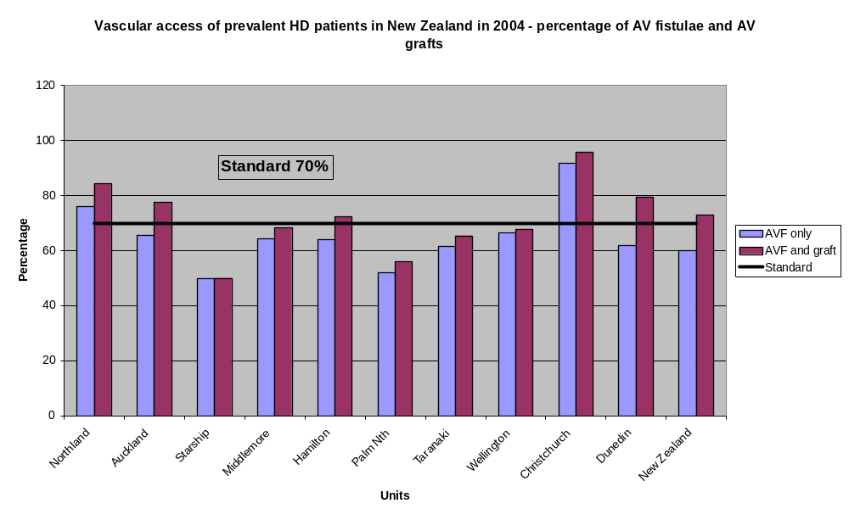
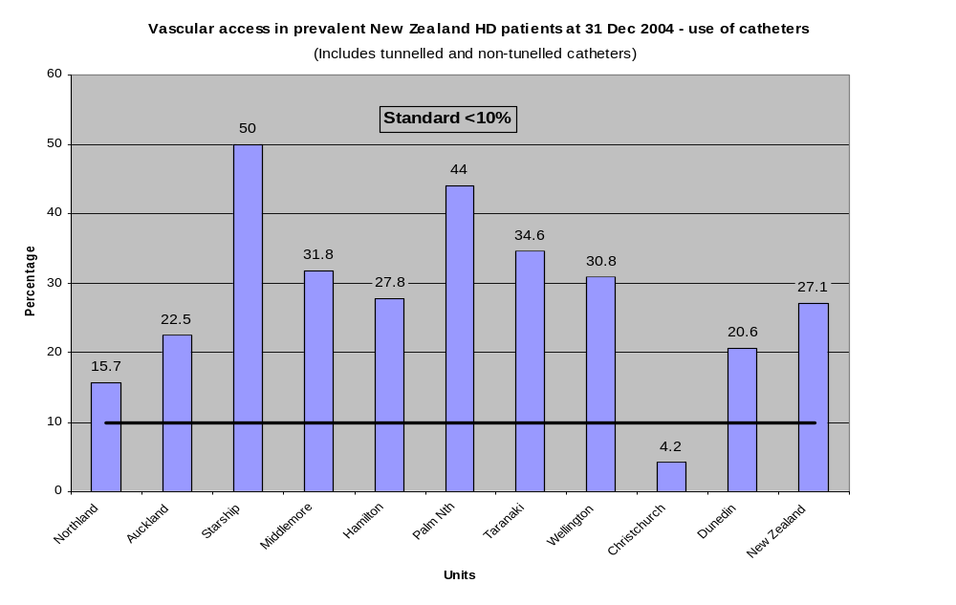
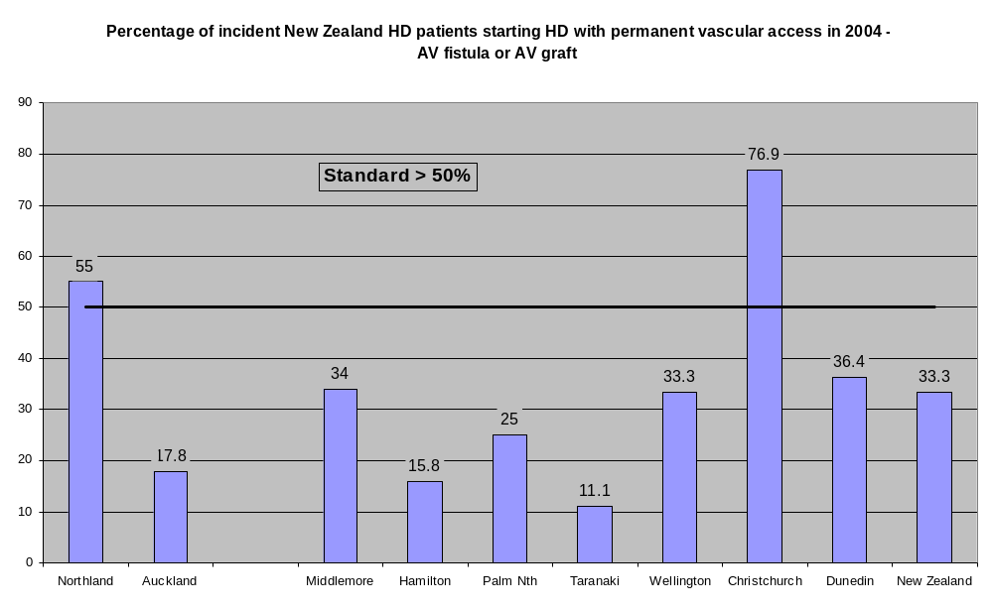
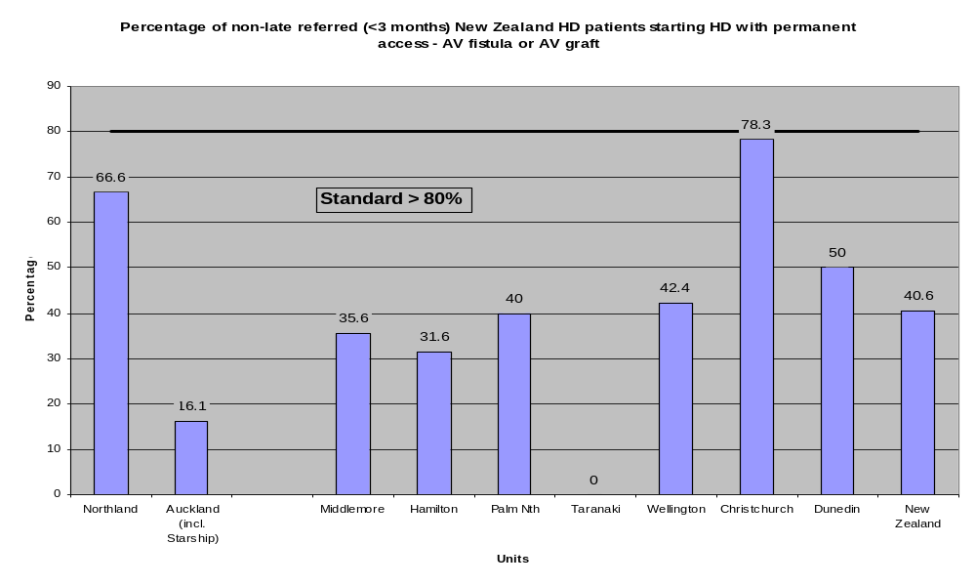
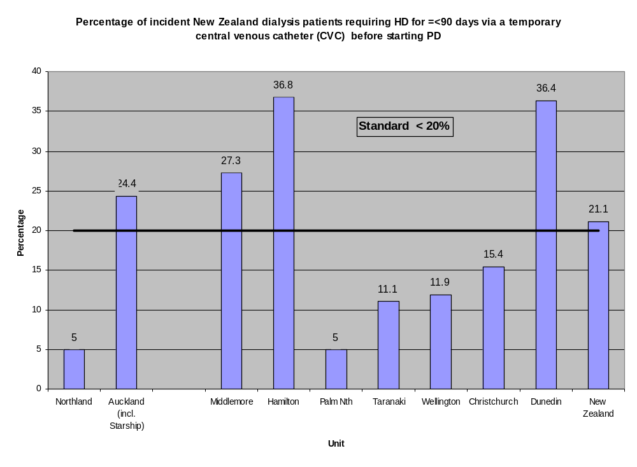
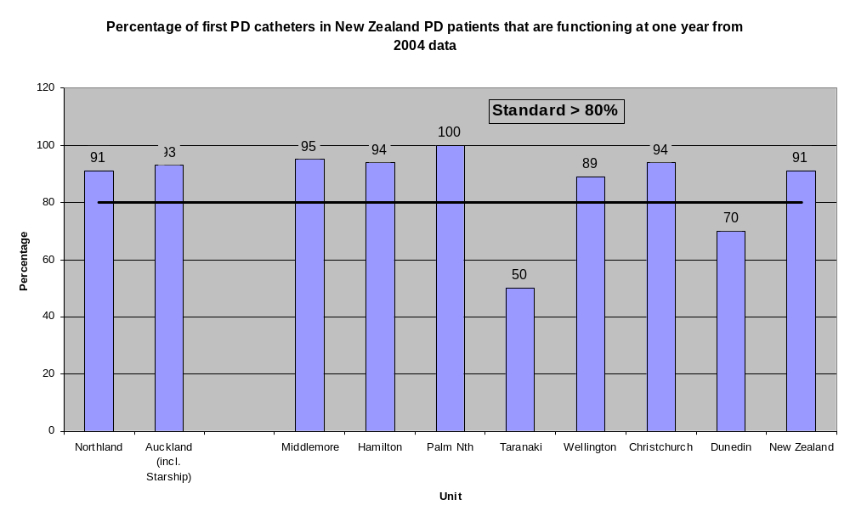

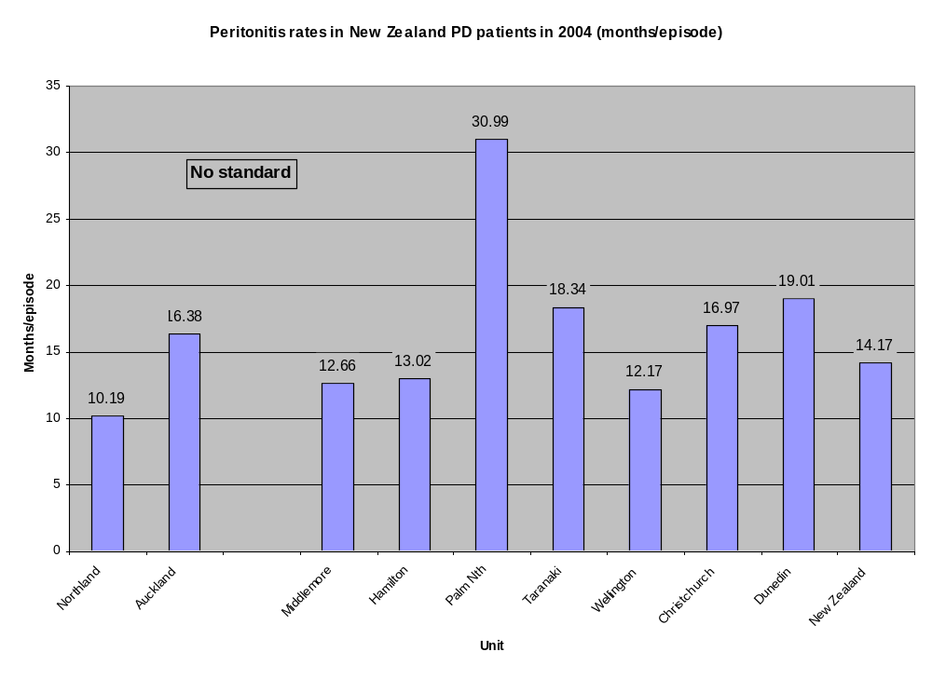

Commentary
- There is substantial variation between units regarding initial and prevalent dialysis modality.
- Most units have at least one patient on dialysis at the end of 2004 receiving haemodialysis of insufficient duration/frequency or dose (as assessed by urea clearance).
- With the exception of two units, provision of the optimal vascular access for incident and prevalent haemodialysis patients is below the audit standard in the New Zealand.
- The high rates of central venous catheter use are of concern because of the evidence that survival is inferior with this form of access when compared with an AV fistula.
- These findings should prompt a review of the organisation and provision of surgical and radiological services.
- One quarter of PD patients are using APD
- One year survival of PD first PD catheters is excellent
- Peritonitis rates vary considerably with only one unit achieving a rate of > 24 months/episode. The International Society of Peritoneal Dialysis has suggested that all units should be able to limit PD-associated peritonitis to at least 24 months per episode.

Appendix A: Literature reviewed

- Australia and New Zealand Dialysis and Transplantation Registry (ANZDATA) reports
- www.anzdata.org.au
- The Dialysis Outcomes Practice Patterns Study (DOPPS) reports and publications
- www.dopps.org
- Recommendations of the National Renal Workforce Planning Group 2002 (British Renal Society)
- www.renal.org
- Caring for Australians with Renal Impairment (CARI) Guidelines
- www.kidney.org.au/cari/
- National Kidney Foundation Kidney Disease Outcomes Quality Initiative (K/DOQI )
- www.kidney.org/professionals/kdoqi/index.cfm
- Treatment of adults and children with renal failure 2002
- A Vision for the future of Renal Services (The Renal Association) (www.renal.org/Standards/standards.html)
- Guidelines for Satellite Dialysis Units, Victoria, 1999
- The College of Physicians and Surgeons of Ontario. Independent Health Facilities Clinical Practice Parameters and Facility Standards - Haemodialysis
Second Edition, June 2001: 1-62.

- Centers for Disease Control and Prevention. Recommendations for preventing transmission of infections among chronic hemodialysis patients. MMWR 2001;50 (No.
RR-5): 1-63.
- Centers for Disease Control and Prevention. Guidelines for the Prevention of Intravascular Catheter-Related Infections. MMWR 2002;51(No.RR-10):28.
- ANSI/AAMI RD52:2004 -- Dialysate for hemodialysis (www.aami.org).

Appendix B: Circulation list

The National Renal Advisory Board

Standards and Audit Subcommittee

Heads of New Zealand Renal Units

Chief Executive Officers of DHBs with Renal Units

New Zealand Peritoneal Dialysis Registry

Australia and New Zealand Dialysis Registry

New Zealand Ministry of Health
Australian and New Zealand Society of Nephology

Renal Society of Australasia, New Zealand Branch

New Zealand Kidney Foundation

New Zealand Board of Nephrology Practice

Transplant Subcommittee responsible for standards and audit related to transplantation
Source of data in brackets e.g. ANZDATA
DOPPS have established from polled DOPPS 1 and 2 data that facility catheter use > 10% of treatments is associated with a relative mortality risk of 1.36
MDRD equation. GFR (ml/min/1.73m²)= 0.021 x serum creatinine^{-1.154} (µmol/L) x age^{-0.203} (x 0.742 if female)
Late referrals defined as referral to a nephrologist less than 3 months before 1st treatment. It is acknowledged that it is difficult to achieve late referral rates less than 30%
Centers for Disease Control and Prevention. Guidelines for the Prevention of Intravascular Catheter-Related Infections. MMWR 2002;51(No.RR-10):28.

